**1. Background and Preliminary Results**

ç

**Figure 1 ⎟** **The axoneme structure.** The ciliary cytoskeleton is composed of 9 doublet MTs that are arranged around two singlet MTs, known as the central pair (bottom). Each doublet MT complex is composed of a 13-protofilament MT, known as the A-tubule, that is connected to a 10-protofilament MT, known as the B-tubule. The B-tubule meets the A-tubule at the inner junction (IJ) and the outer junction (OJ) Both tubules are decorated with various MIPs in their lumen (indicated by different colors). Inset image adapted from Ma et al., 2019.

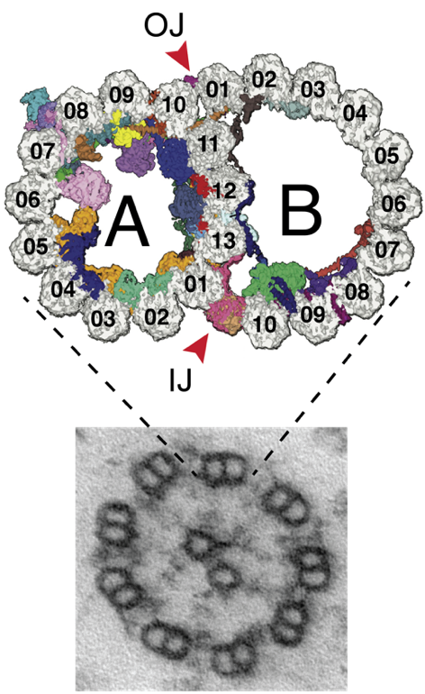

**Cilia** and flagella are appendage-like organelles that are found in almost all eukaryotic cells and are involved in various cellular processes, including motility, sensing, and development (Avidor-Reiss et al., 2004; Li et al., 2004; Mitchell, 2017; Satir and Christensen, 2007). The scaffold of the cilium is a microtubule (MT)-based structure known as the axoneme. In most motile cilia, the axoneme has a 9+2 architecture: nine MT doublets surround two MT singlets, known as the central pair (Ishikawa, 2017; Nicastro et al., 2006; Porter and Sale, 2000). The doublet is composed of a 13-protofilament MT (A-tubule) that is attached through the inner and outer junctions to a 10-protofilament MT structure (B-tubule) (**Fig. 1**) (Nicastro et al., 2011; Sui and Downing, 2006). Interestingly, the inner junction is formed by filaments of PACRG and FAP20 that bind in alternating order (Khalifa et al., 2020), while the outer junction is formed by non-canonical tubulin interactions.

Over 600 proteins are found in the cilia, many of which bind to the axoneme (Pazour et al., 2005). Structural studies have revealed that axonemal complexes and MT inner proteins (MIPs) bind in a periodic manner along the doublet’s external surface and lumen, respectively (Bui et al., 2008; Ichikawa et al., 2017; Ma et al., 2019; Nicastro et al., 2006; Pigino et al., 2011). Thus, each MT that constitutes the doublet is decorated with a distinct cohort of proteins (see the MIPs in **Fig. 1**), although all axonemal MTs are constituted from the same building block—tubulin. Strikingly, the underlying mechanisms that determine this differential organization of ciliary proteins remain unknown.

**We hypothesize that different geometries (diameters) of the axonemal MTs affect the spatial organization of MIPs in the cilia.** It is well established thatcytoplasmicαβ-tubulin subunits self-assemble to form MT structures of predominantly13protofilaments (Tilney et al., 1973). Yet, tubulin can also assemble MTs with different numbers of protofilaments both *in vivo* and *in vitro* (Chaaban and Brouhard, 2017; Chrétien and Wade, 1991; Savage et al., 1989; Ti et al., 2018). Microtubules comprising the axonemal doublets exhibit different arrangements: A-tubules have 13 protofilaments, while B-tubules contribute an additional 10 protofilaments, resulting in a 15-protofilament structure (**Fig. 1**) (Ichikawa et al., 2017; Sui and Downing, 2006). This phenomenon demonstrates the flexibility of the lateral contacts between adjacent protofilaments. Changes in the lateral contacts (i.e., the angle between two protofilaments) can be recognized by a few MT-associated proteins that bind between protofilaments, as in the case of doublecortin that recognizes the 13-protofilament curvature (Bechstedt and Brouhard, 2012; Moores et al., 2004). Nevertheless, in the case of cilia, the underlying mechanisms that dictate protein organization remain largely undetermined.

**DNA origami** is a method that allows the construction of nanoscale objects with custom forms and shapes (Douglas et al., 2009a; Rothemund, 2006). DNA origami nanostructures are formed via self-assembly of one long DNA “scaffold” strand with a large number of short “staple” oligonucleotides. Each staple binds two or more specific domains on the scaffold strand, thus folding it in a predictable manner into a more compact structure (**Fig. 2**). Due to the predictability of Watson-Crick DNA base pairing, the origami structure can be rationally designed *in silico*, and the folding of the desired product is extraordinarily reliable. Importantly, individual locations on the DNA origami surface are addressable, meaning, it is possible to attach specific functional groups to specific locations on the origami surface via DNA hybridization. DNA origami structures with nanometer precision have previously been used to test the effect of geometry on enzymatic reaction cascades (Fu et al., 2012) and on the activation of cellular receptors (Hellmeier et al., 2021). In the proposed project, we will harness the unique potential of DNA origami “nanoseeds” to control the geometry of tubulin assembly and precisely dictate the curvature of *in vitro*-assembled MTs (cf. section 3).

**Figure 2 ⎟** **DNA Origami**. The principle of 3D DNA origami folding (top) and resulting structures as observed by transmission electron microscopy imaging (bottom) (Douglas et al., 2009a).

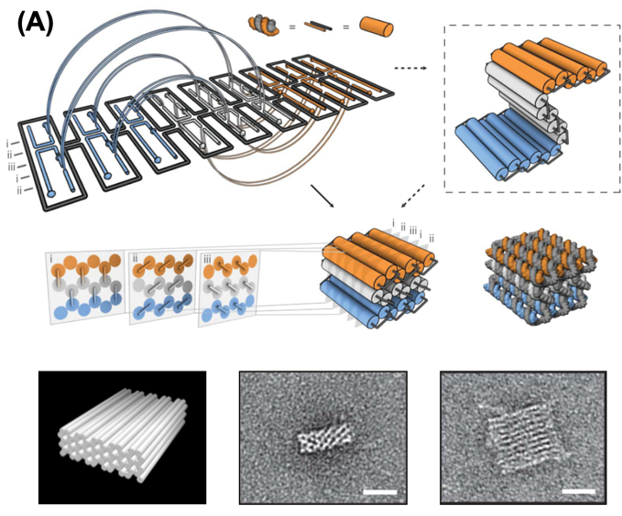

**Preliminary Results**

***Purification of axonemal tubulins***

Axonemal MTs differ from cytoplasmic MTs in their post-translational modification (PTM) profile and composition of tubulin isotypes, which may consequently affect their interactions with MIPs (Alper et al., 2013; Podolski et al., 2014; Sirajuddin et al., 2014). **Until recently, only cytoplasmic tubulin purification assays were available. However, we have recently developed the first biochemical assay for the purification of functional axonemal tubulin from *Chlamydomonas reinhardtii*** (Orbach and Howard, 2019). Unlike other organisms, *C. reinhardtii* has only a single tubulin isotype (James et al., 1993; Youngblom et al., 1984). Additionally, much of our knowledge of MIP organization is based on structural studies in *C. reinhardtii* (**Fig. 1**).

To solubilize the cytoskeleton structure of the cilia, the stability of isolated axonemes was tested against salts from the Hofmeister series. Treated axonemes were imaged using transmission electron microscopy (TEM) and, following their characterization, sodium nitrate (NaNO3) was selected as the solubilizing salt. Solubilization of the axoneme with this salt occurs in a stepwise manner due to the axoneme stability’s intrinsic gradient. Thus, sequential salt treatments solubilize first the central pair and subsequently the B-tubule (**Fig. 3**). In this way, tubulins from the central pair and B-tubule can be solubilized and purified separately, while leaving the A-tubule intact. This assay will enable us to study axonemal MTs and isolate the effect of MT geometry from other MT features which may affect protein interaction and thus be involved in protein organization.

**Figure 3 ⎟** TEM micrographs of axonemes showing stepwise solubilization following: (I) no treatment, (II) one cycle of NaNO3 that solubilizes the central pair, (III) two NaNO3 cycles that solubilize the outer junction of the B-tubule, and (IV) five NaNO3 cycles, that solubilize the B-tubule while leaving the A-tubule intact. Scale bar: 100 nm.

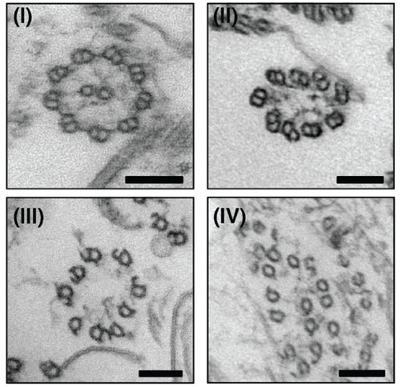

***Generation of DNA-protein hybrid structures***

One of the main challenges of the proposed project is the generation of DNA origami-MT hybrid structures with high fidelity. The Krieg lab has expertise in DNA origami design and conjugation methods for attaching proteins to DNA origami. Krieg et al. have developed methods for the production of sequence-optimized scaffold DNA (Krieg and Shih, 2018; Minev et al., 2019), which is critical for the assembly of origami structures with direct binding sites that offer sufficiently high fidelity. **Figure 4** shows images of a sequence-optimized DNA origami 6-helix bundle (blue) that is linked to an active enzyme (red) (Atabay and Krieg et al., in preparation). The protein is typically functionalized with an oligonucleotide that specifically binds to a sequence-optimized domain on the DNA origami. The high efficiency of origami–protein binding has been demonstrated by gel electrophoresis, and structures are additionally validated by negative-stain TEM. Several protocols have been developed for the reliable attachment, purification, and characterization of such hybrid nanostructures. The design of the DNA origami will be related to the previously folded and characterized, rigid, barrel-shaped origami geometries, as shown in Fig. 5A and 5B.

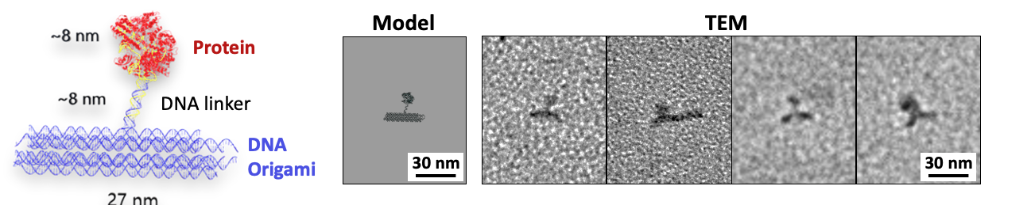

**Figure 4** **⎟** A DNA origami-protein complex that was designed and characterized in the Krieg lab (unpublished results). Left: Predicted 3D structure. Right: Model and experimental validation by TEM imaging. The *de novo* synthesis of sequence-optimized scaffold strands enables improved control over origami size and increased functionalization efficiency.

**2. Objectives and Merits**

The overarching goal of the proposed study is to determine the role of MT geometry in ciliary protein organization. While the structure of the doublet MTs has been known for years, **the role of MT geometry remains unexplored**. This is due to the challenge of actively modifying the number of protofilaments in the MT lattice *in vivo* or *in vitro*. To address this challenge, we will apply an interdisciplinary approach and utilize the DNA origami method to reconstitute MTs with a controlled number of protofilaments. We will isolate the effect of geometry from other properties that can affect MT interaction with MIPs, PTMs, or tubulin isotypes usingto . The proposed study has three aims:

* **Aim #1**: We will develop DNA–MT hybrids by attaching a specific number of tubulin subunits to DNA origami nanostructures. The nanostructures will serve as nucleation seeds (nanoseeds) for the reconstitution of MTs with a distinct number of protofilaments.
* **Aim #2**: We will build a small library of MIPs that bind to the A- and B-tubules. Proteins will be fluorescently labeled and their interaction with MTs of varying protofilament numbers (i.e., curvatures) will be investigated using TIRF microscopy.
* **Aim #3**: We will perform single-particle cryo-EM studies to determine the average curvature of DNA–MT hybrids. Additionally, we will structurally characterize the effect of the MT curvature on the interaction with MIPs.

Expected Significance: The proposed research will advance our understanding of the mechanisms that determine ciliary organization, structure, and function. It will enable us to examine, for the first time, the role of the MT doublet, which has remained an enigma for so many years. Moreover, it will pave the way to understanding pathologies that are related to the assembly of cilia, such as primary ciliary dyskinesia (PCD), in which the assembly process of the cilia is disrupted. We expect that our DNA–MT hybrid structure will provide a significant foundation for the investigation of the many unanswered questions related to cilia and the geometry of MTs. Further research includes the intraflagellar transport (IFT) system that moves along the A- and B-tubules (Stepanek and Pigino, 2016), mechanosensory cells that have 15-protofilament MTs, and blood platelets that alter their protofilament number upon cell activation.

**3. Detailed Description of Joint Research**

**Aim #1: Developing a DNA origami nanoseed platform to allow active control of MT assembly geometry**

Current techniques for polymerizing MTs with a controlled number of protofilaments are limited to 13- and 14-protofilaments only (using axonemes as nucleation templates and the GTP analog GMPCPP, respectively) (Wieczorek et al., 2015). In the proposed project, we will develop new technology that will enable us to reconstitute MTs with a controlled number of protofilaments. **We will use DNA origami nanostructures as artificial nucleation templates—*DNA nanoseeds*—that will mimic the activity of the cellular MT nucleator γ-tubulin ring complex (γ-TuRC)** (Kollman et al., 2011). To this end, the Krieg group will design several barrel-shaped DNA nanoseed structures with 12 to 16 anchoring strands. An example of such an origami structure is shown in **Fig. 5A**. These structures will enable the attachment of the same number of tubulin subunits (**Fig. 5B**). Nanoseed structures with 13 and 15 anchoring strands will be used for reconstitution of MT with curvatures identical to the A- and B-tubules, while nanoseeds with 12, 14, and 16 anchoring strands will be used to extrapolate the effect of curvature on MIP binding.

In order to isolate the DNA–MT hybrid from the MT polymerization tube at a later stage, the structures will also include functional biotin groups. Origami structures will be designed using caDNAno software (Douglas et al., 2009b), and further adapted with custom scripts. Sequence-optimized scaffold strands will first be generated with a Python script developed in-house, and subsequently synthesized using a PCR-derived protocol (Minev et al., 2019). DNA nanoseeds will be characterized initially by the Krieg lab by employing gel electrophoresis and transmission electron microscopy (TEM). The presence of a correct number of anchoring points will be determined by the hybridization of complementary oligonucleotides modified with gold nanoparticles (Wilner et al., 2011) and TEM imaging. To complement this characterization, bleaching studies using TIRF microscopy and super-resolution imaging with DNA paint will be performed by the Orbach lab (Jungmann et al., 2014; Ketterer et al., 2018).

**Figure 5** **| DNA-origami platform for seeded growth of MTs** (**A**) Schematic and TEM micrograph of DNA nanostructures (Krieg & Shih, 2018). (**B**) Scheme of the suggested 24 nm DNA nanoseed with DNA strands (red) for the binding of 15 tubulin subunits. (**C**) Site-specific modification of α-tubulin with a DNA strand that is complementary to the anchoring strands of the DNA nanoseed. CPA: Carboxypeptidase A; TTL: Tubulin Tyrosine Ligase. (**D**) Schematic of the reconstitution assay: Modified tubulin will be hybridized with the same orientation to the DNA nanoseeds. The tubulin subunits will not grow during this step due to the low tubulin concentration in the solution (below the critical concentration). Next, a high concentration of axonemal tubulin will be added to reconstitute the DNA–MT hybrid with a controlled number of protofilaments. Based on these results, we will further test the possibility of reconstituting doublet MTs in a stepwise manner by adjusting the DNA nanoseeds and the assembly of the PACRG-FAP20 inner junction (IJ).

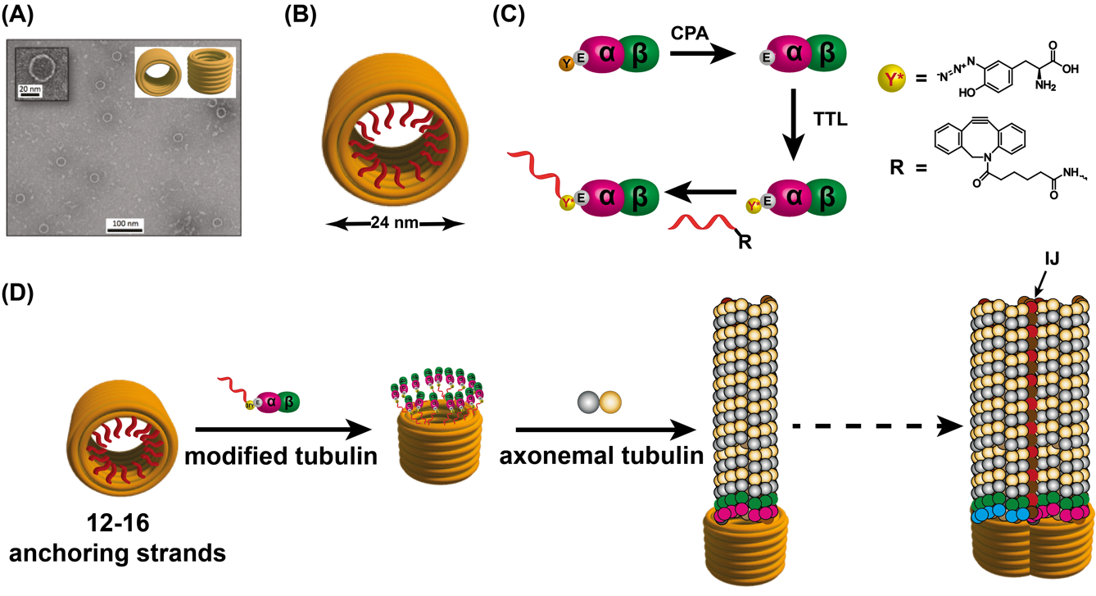

To attach tubulin subunits to the DNA nanoseeds, the Orbach group will perform site-specific modification of α-tubulin (Banerjee et al., 2010) (**Fig. 5C**), which will ensure that all the subunits are attached with a similar polarity of β-tubulin outwards. Purified tubulin will first be de-tyrosinated with carboxypeptidase A (CPA), and then re-tyrosinated with 3-azido-tyrosine by tyrosine ligase (TTL) (Kuo et al., 2022). All tyrosination states, before and after treatments, will be probed by commercially available antibodies (Orbach and Howard, 2019). The resulting tubulin will then be allowed to react with a dibenzocyclootyne (DBCO)-modified oligonucleotide, which is complementary to the anchoring strands in the DNA nanoseeds, to form DNA-labeled tubulin. Functional tubulin will be purified by polymerization-depolymerization cycles, as described in section 1 (Peloquin et al., 2005).

DNA–MT hybrids with various numbers of anchoring strands will be assembled by hybridization between the binding sites on the DNA nanoseeds and the modified tubulin, followed by the addition of free unmodified axonemal tubulin (**Fig. 5D**). Routine and preliminary structural verification by TEM will be performed by the Krieg lab at IPF. The dynamic properties will be characterized by a TIRF microscopy assay in the Orbach lab at Bar Ilan University (Gell et al., 2010; Vitre et al., 2008) (cf. aim #3). After initial screening and optimizations, high-resolution 3D structural models of the DNA origami, DNA origami-MT nanoseed complexes, nanoseed-nucleated MTs, and unseeded MTs will be obtained via single-particle cryo-TEM by the Böttcher lab at the University of Würzburg (cf. aim #3).

Based on the feasibility of the proposed approach, we will consider the development of doublet MT scaffolds for further investigation. To this end, we will generate DNA nanoseeds with a contour similar to that of the doublet MT. Since the inner junction is formed by non-tubulin proteins (**Fig. 1**), the DNA nanoseeds will include a different anchoring strand at this position that will enable us to attach either recombinant PACRG or FAP20 (Dymek et al., 2019), labeled with a complementary DNA strand. The versatility of the DNA sequence may also enable us to reconstitute MT doublets in a stepwise manner as we use different anchoring sequences for the A- and B-tubule and the inner junction (**Fig. 5D**).

**Aim #2: Investigating the effect of MT curvature on MIP interaction using TIRF microscopy**

Several classes of MIPs bind along the MT doublets in class-specific manners (Ma et al., 2019). **We hypothesize thatMIPs that bind between protofilaments of the MTs recognize the lateral curvature.** Therefore, we will examine filamentous MIPs (fMIPs) that bind to the cleft between protofilaments, and globular MIPs that bind directly to the MT surface and penetrate the cleft (**Fig. 6**(. A few MIPS have been partially characterized by other authors and we will use these characterizations in our study (Kirima and Oiwa, 2018; Owa et al., 2019). Specifically, we will test the FAP127, FAP53, and FAP85 proteins that are associated with the A-tubule, as well as FAP112, FAP45, and FAP52 proteins that bind to the B-tubule. All proteins will be expressed, purified, and fluorescently labeled by the Orbach group. To avoid possible steric hindrances that can occur in the confined space of the MT lumen, all tags will be removed from the MIPs.

**Figure 6 ⎟** **Positions of MIPs on the doublet MTs**. A-tubule MIPs include FAP127 (blue), FAP85 (brown), and FAP53 (green), while the B-tubule MIPs are FAP112 (cyan), FAP52 (magenta), and FAP45 (red). PDB: 6U42.

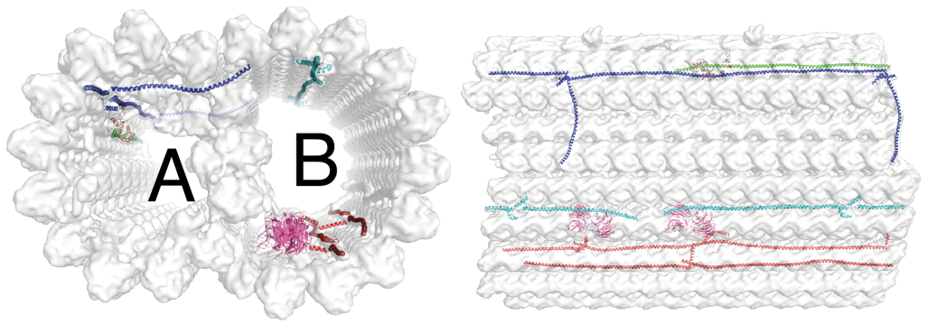

To determine whether MT geometry affects the spatial organization of MIPs, we will analyze the interaction between the labeled MIPs and reconstituted axonemal MTs with distinct numbers of protofilaments (DNA–MT hybrids), using the TIRF microscopy assay (**Fig. 7**). Accordingly, biotin-functionalized DNA nanoseeds, bound to DNA-tagged tubulin, will be immobilized on a neutravidin-coated surface of a microscope imaging chamber. Axonemal tubulin and fluorescently-labeled MIP will be perfused into the imaging chamber and the propensity of the different MIPs to interact with DNA–MT hybrids will be evaluated by quantifying the mean fluorescence intensity per unit length (Bechstedt and Brouhard, 2012; Zhu et al., 2017). A similar approach will be applied to the reconstituted doublet MT by performing stepwise assembly. This will allow us to examine the differences in fluorescence intensity following the addition of a second tubule. We expect that differences in the interactions of MIPs with the MTs will also affect the dynamic properties of the MTs. Thus, we will analyze how the different MIPs affect the growth and shrinkage rates of the MTs, as well as the rate of conversion between the growth and shrinkage phases (catastrophe) and between the shrinkage and growth phases (rescue) (Gell et al., 2010). It should be noted that in the case of the reconstituted doublet, it will be impossible to follow the dynamic properties due to the high proximity of the tubules to each other. Controls for the different microscopy assays will include 13- and 14-protofilament MTs that will be reconstituted from recombinant human γTuRC (courtesy of the Luders lab) and GMPCPP-stabilized MTs seeds, respectively (Wieczorek et al., 2015; Zimmermann et al., 2020). Additionally, we will use the non-axonemal protein doublecortin, which recognizes the lateral curvature of 13-protofilament MTs, and kinesin-1, which has no preference for MTs with different curvature (Bechstedt and Brouhard, 2012). We expect that A-tubule MIPs will bind to 13-protofilament reconstituted MTs, and to a lower degree, to the 14-protofilament reconstituted MTs. In contrast, we expect that B-tubule MIPs will bind to a lower degree to the 13-protofilament reconstituted MTs and to a higher degree to the 14-protofilament reconstituted MTs. Consequently, we expect to see changes in the dynamic properties of the MTs.

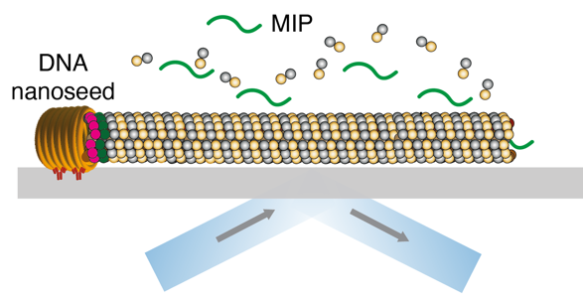

***Figure 7***⎟ **Schematic of the TIRF microscopy experimental design**. Axonemal MTs grow from a DNA nanoseed, which is immobilized to the coverslip. The MTs grow in the presence of the fluorescently-labeled MIPs that will be quantified.

As a complementary approach, we will examine the interaction of MIPs with MT doublets in which the B-tubule structure has been impaired. We will characterize axonemes with a partial B-tubule structure and without any B-tubule structure (**Fig. 8**). To this end, MT doublets will be isolated from *C. reinhardtii* andtreated with sodium nitrate (NaNO3) solution (see *Preliminary Results*). The impaired doublets will be collected and their interaction with labeled MIPs will be analyzed as described above. It should be noted that during the salt treatment, most of the ciliary proteins that bind to the doublets are released into the solution and therefore, the impaired doublets will be free to bind to labeled MIPs. Also, we may use the CC-5582 mutant, which has an open B-tubule structure and can provide better access for the MIPs to enter (Dymek et al., 2019). We expect B-tubule MIPs will bind only in the presence of an intact or partial B-tubule structure, but not the A-tubule structure. In contrast, the A-tubule MIPs will not bind to the B-tubule and enter the A-tubule lumen only by diffusion.

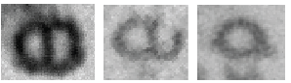

***Figure 8*****⎟** *Intermediate states of doublet MTs after 0, 2, and 5 cycles of NaNO3treatment (from left to right).*

**Aim #3: Single-particle cryo-EM studies of DNA–MT hybrids with and without bound MIPs**

*Structure of DNA nanoseeds:* The structure of the DNA nanoseeds with and without attached tubulin (aim #1) will be determined by cryo-EM and single-particle image analysis. Images will be acquired semi-automatically with the Krios G3 electron microscope in Würzburg and will be reconstructed with Relion (Nakane et al., 2018) following established single-particle strategies. We will examine the structures by multi-body refinement and focused classification to understand whether the DNA nanoseeds have the expected number of tubulins attached and whether these tubulins assemble into a ring-like seed for the MT. A similar characterization will be performed for the DNA nanoseed of doublet MTs.

*Structure of DNA–MT hybrids:* We will extend our general workflow for the reconstruction of helical assemblies toward DNA–MT hybrids (Makbul et al., 2021; Song et al., 2019). For the image analysis, we will use the helical and single-particle functionalities of Relion following an established Relion-based pipeline for processing of MTs (Cook et al., 2020; He and Scheres, 2017). The pipeline enables the assignment of the number of protofilaments in a MT and the localization of the seam in non-helical MTs. For the analysis, the MTs are divided into smaller segments along the MT axis. These segments will be treated as individual single particles that are classified into groups of segments with similar structural properties. To determine whether the DNA nanoseeds provide a nucleation scaffold for MTs with a distinct number of protofilaments, each class of segments will be reconstructed into a 3D map. The 3D maps will also reveal whether the seeded MTs have the same structure as seedless MTs. While we expect that this is generally true, it is also possible that seeding forces the nascent MTs into atypical, strained conformations that could potentially relax with increasing distance from the seed. By analyzing the metadata of the different classes (identity of the MT, distance from the seed), we will establish whether the arrangement of tubulin in DNA–MT hybrids varies along the MT axis. To describe the tubulin arrangement within a MT segment, we will fit the atomic models of tubulin to the segments and determine the transformation matrices between the different copies of tubulin within a segment. Thus, an accurate description of the local MT curvature, together with parameters such as tube diameter, compaction, lattice rise, and twist, will be achieved and compared with other types of MTs (e.g., different numbers of protofilaments, MT-doublets). The twist between adjacent protofilaments (**Fig. 9**) is characteristic of the curvature of MTs with a certain number of protofilaments and can be used to group MTs accordingly. The fitted tubulin models will be real-space refined with Phenix (Afonine et al., 2018) and Coot (Casañal et al., 2020) into their respective 3D maps to establish whether tubulin undergoes specific conformational changes that depend on the local curvature of the MT and the arrangement of the neighboring tubulins.

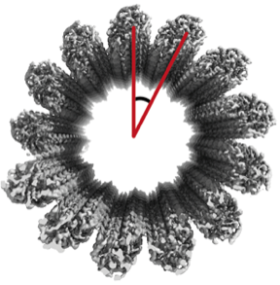

***Figure 9 |*** *Curvature of MT defined by angle between adjacent protofilaments.*

Importantly, in our analysis, we will put special focus on the novel seeding mechanism with the DNA-origami scaffold. We expect that the DNA scaffold and the emerging MT are linked with some flexibility that generates structural variability between the scaffold and the MT. Multi-body refinement of the seed and the emerging MT will show the degree of flexibility and whether the linkage is strained and introduces local distortions in the MT. In this case, the length of the DNA-protein linkers and the diameter of the DNA ring will be fine-tuned (aim #1) to relieve the strain and to reduce the distortions in the emerging MTs.

*Structures of DNA–MT hybrids (aim #1) with bound MIPs (aim #2)*: Based on the TIRF microscopy assays, the structure of optimized DNA–MT hybrids with selected bound MIPs (aim #2) will be determined similarly as described for the DNA–MT hybrids. Focused classifications and refinement on specific regions of the MT segments will allow us to locate the MIPs within the MTs and determine high-resolution maps of the MIPs followed by atomic model building with Phenix (Afonine et al., 2018) and Coot (Casañal et al., 2020). The comparison of structures of MIPs in MT segments with different numbers of protofilaments and/or different arrangements will show whether certain MIPs bind to MTs with certain curvatures, whether MIPs’ binding changes the conformation of the tubulin, and whether MIPs adapt their own structure to the symmetry restraints imposed by the MTs. We expect that different MIPs fall into different categories such as (1) selective for curvature; (2) adaptable to curvature; and (3) reshaping curvature.

Since **MIPs may also affect the number of protofilaments,** we will examine their influence on MT assembly in the absence of seeds and in the presence of MIPs only. The number of protofilaments of the reconstituted MTs will be determined by cryo-TEM (Wade et al., 1990) and their effect will be taken into account in our analyses.

**4. Qualifications of the Investigators and the Facilities at Their Disposal**

The Böttcher group has more than 30 years of experience in cryo-electron and single-particle image processing on various biological systems, as documented in more than 90 publications. The host institute houses cutting-edge facilities for light microscopy, mass spectrometry, protein expression and characterization, and cryo-EM. The cryo-EM facility, headed by Bettina, includes a Krios G3 electron microscope with a Falcon III direct electron detector for high-resolution imaging. In addition, a Tecnai T12 electron microscope enables screening of vitrified and stained samples, together with equipment for sample preparation. Her lab has five dedicated workstations for image processing. It also includes wet-lab space with equipment for the expression, purification, and characterization of proteins.

The Krieg group is a junior research lab,established in 2020, and focuses on DNA nanotechnology. Elisha has developed two methods for the scalable production of sequence-optimizedDNA origami nanostructures (Krieg and Shih, 2018; Minev et al., 2019). While the vast majority of reported DNA origami structures rely on a scaffold that is derived from the M13 bacteriophage genome, sequence-optimized origami provides more reliable binding sites. This is crucial, as its proper function as a well-defined nanoseed requires the highest degree of tubulin attachment efficiency. The Krieg group has expertise in the attachment of proteins to DNA origami, as described in the *Preliminary Results*. The lab contains equipment for experiments in molecular biology and chemical synthesis. The host institute includes free-of-charge facilities for characterization and structural validation of DNA origami, proteins, and protein-origami complexes. The facilities include state-of-the-art atomic force microscopes, transmission electron microscopes, and asymmetric flow field-flow fractionation. Further, as a member of the Dresden Concept network of research institutes, the group has access to the equipment of 33 partner institutes.

The Orbach lab was established at Bar Ilan University in October 2021. The lab personnel have extensive knowledge, experience, and facilities to purify functional axonemal tubulins on small and large scales. The lab recently purchased a Nikon Eclipse Ti2-E TIRF microscope system equipped with a Photometrics BSI camera. Additionally, the host institute includes state-of-the-art research facilities with an advanced microscopy unit, as well as chromatography and spectroscopy facilities which will be used for the proposed study. Ron has developed the biochemical assay for the purification of axonemal tubulins and will be fully involved in this project. Furthermore, he is also very familiar with DNA-based systems, with over 20 papers deriving from his PhD. Thus, he offers unique knowledge that can help bridge the gap between the MT and DNA nanotechnology worlds.

**5. Mode of Cooperation**

The proposed project requires expertise in the areas of microtubules, DNA nanotechnology, bio-conjugate chemistry, and cryo-EM. A successful outcome necessitates the specific expertise of the three subgroups and their close interdisciplinary collaboration (**Fig. 10**). The development of the DNA origami nanoseed platform (led by PI Krieg) will simultaneously proceed to protein expression and bioconjugation developments (led by PI Orbach). High-resolution structural elucidation of DNA-MT complexes and their precursors will rely on intensive single-particle cryo-EM studies (led by PI Böttcher). The structural data obtained by the Böttcher lab will be further complemented by TIRFM measurements in the Orbach lab (**Fig. 11**).

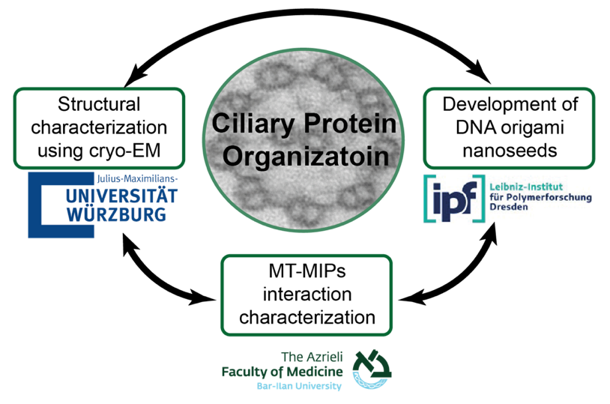

**Figure 10 ⎟ Collaboration between the groups.** The proposed study is on the interface between biochemistry (BIU), nanotechnology (IPF), and structural biology (JMU).

We plan to start the collaboration with a 2-day kick-off meeting in Israel, in which all three PIs and their students (*The Ciliary Protein Organization Group*) will get to know each other and discuss all aspects of the project. On this occasion, a student from the Krieg lab will stay as a guest in the Orbach lab for another week to perform common experiments on ssDNA-tubulin conjugation. The collaboration among the three groups will be nurtured by regular meetings:

* Once a week, the PIs will meet with their respective students to discuss the progress and further experimental steps (2- or 3-person subgroup meetings).
* Once a month, all project participants will meet virtually, update each other on their status, and discuss the next steps (7-person group meetings).
* Once or twice a year, the students will meet in person. These meetings will provide the opportunity for direct discussions, sample transport, and experiments. Most typically, students from the Orbach and Krieg labs will visit the Böttcher group for on-site assembly and cryo-EM characterization of the various macromolecular complexes.

Towards the end of the project, we also plan common attendance (and presentations of our results) at conferences, in particular NanoIsrael in Jerusalem and the EMBL MT meeting in Germany.

**Figure 11⎟ Gantt chart of the proposed project.** Each of the colors represents one the partners: the Krieg group – blue; the Orbach group – yellow (PhD student) and orange (post-doc); the Böttcher group – green. Mixed bar colors indicate collaboration amongst the groups or involvement of a PhD student and a post-doc on the same task (Orbach lab).