**Supplementary materials.**

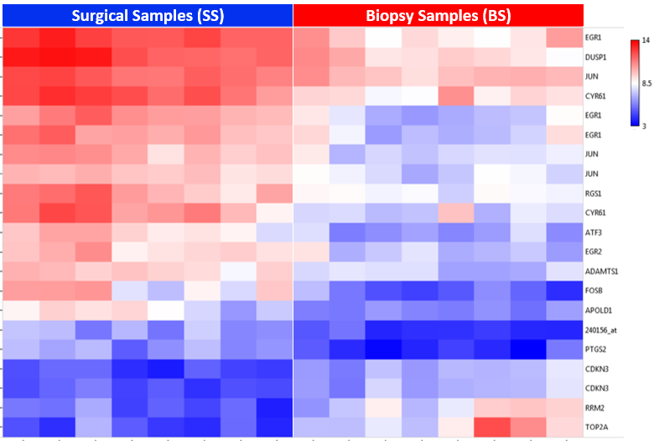

**Supplementary Figure 1. Heatmap of pCR patients (BS vs SS).** Blue areas, low gene expression; red areas, high gene expression. Top row, SS tissues are denoted by the blue header (left heatmap) and BS tissues are denoted by the red header (right heatmap). Each individual column represents a different patient sample and each row, a single probe. Official symbols for gene or probe identification are displayed along the right margin.

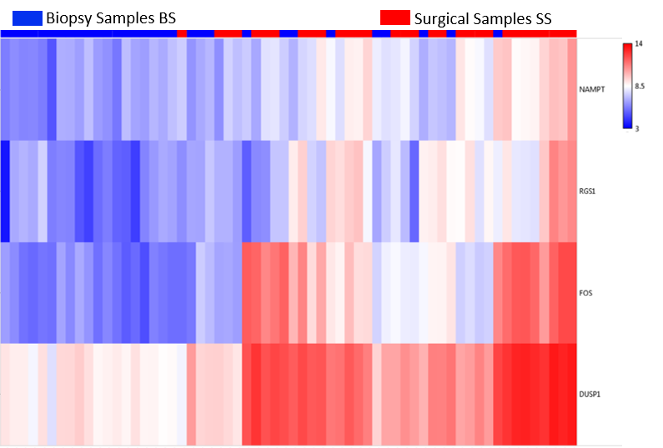

**Supplementary Figure 2. Heatmap of non-pCR patients (BS vs SS).** Blue areas, low gene expression; red areas, high gene expression. Top row, BS tissues are denoted in each column by a blue header and SS tissues by a red header. Each column represents a different sample, and each row is for a single probe. Official symbols for gene or probe identification are displayed along the right margin.

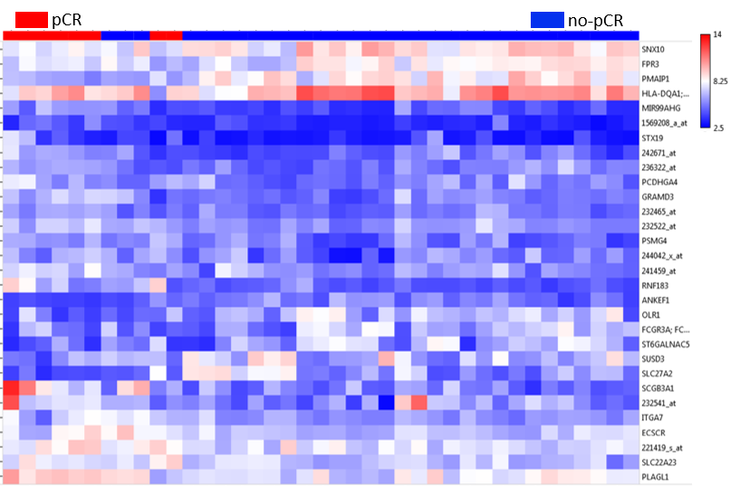

**Supplementary Figure 3**. **BS tissue comparisons between non-pCR (*n* = 31) and pCR (*n* = 8).** Profile of 30 probes representing 21 genes (11 overexpressed and 10 underexpressed in pCR, FC: +2, *P* value: ≤ .01). Blue areas, low gene expression; red areas, high gene expression. Top row, non-pCR patients are denoted in each column by a blue header and pCR patients by a red header. Each column represents a different patient sample and each row, a single probe. Official symbols for gene or probe identification are displayed in the right margin.

|  |  |
| --- | --- |
| A | B |
| C | D |

|  |  |
| --- | --- |
| E | F |
| G | H |

**Supplementary Figure 4. Box plots showing validation by qPCR (*NUSAP1*, *KIAA0101*, *DST*, and *MME*).** **A and B** represent expression levels of *NUSAP1* and *KIAA0101*, respectively, as analyzed by qPCR. **C and D** represent expression levels of *NUSAP1* and *KIAA0101*, respectively, according to the expression signal after normalization with RMA from the microarray data. **E and F** represent expression of *DST* and *MME* analyzed by qPCR, respectively. **G and H** represent expression levels of *DST* and *MME*, respectively, according to the expression signal after normalization with RMA from the microarray data. Blue lines, the pCR patient group; red lines, the non-pCR patient group. Unpaired *t*-test with Welch's correction was used for comparisons.



**Supplementary Figure 5.** **Expression levels of *NUSAP1* according to the molecular subtype after NCT (SS).** LA, luminal A; LB, luminal B; TN = triple negative. One-way ANOVA and the Holm–Sidak multiple comparisons test were used for comparisons.

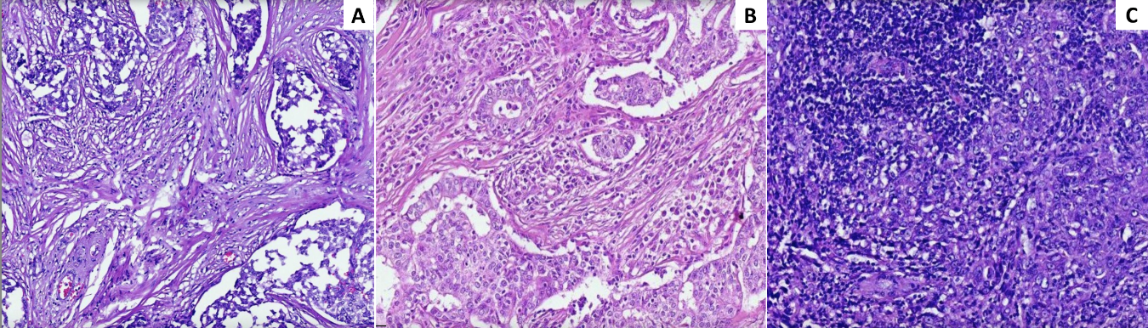

**Supplementary Figure 6.** **Microscopic evaluation of TILs.** **A** Low TILs, 10×. Fibrous stroma is observed between the tumor cells, with little lymphoplasmacytic infiltrate at a percentage of 5%. **B** Moderate TILs, 10×. Moderate lymphoplasmacytic infiltrate is seen in the tumoral stroma at a percentage of 30%. **C** High TILs, 10×. Dense lymphoplasmacytic infiltrate observed in the stroma between the neoplastic cells in the upper left area in a percentage of 80%.

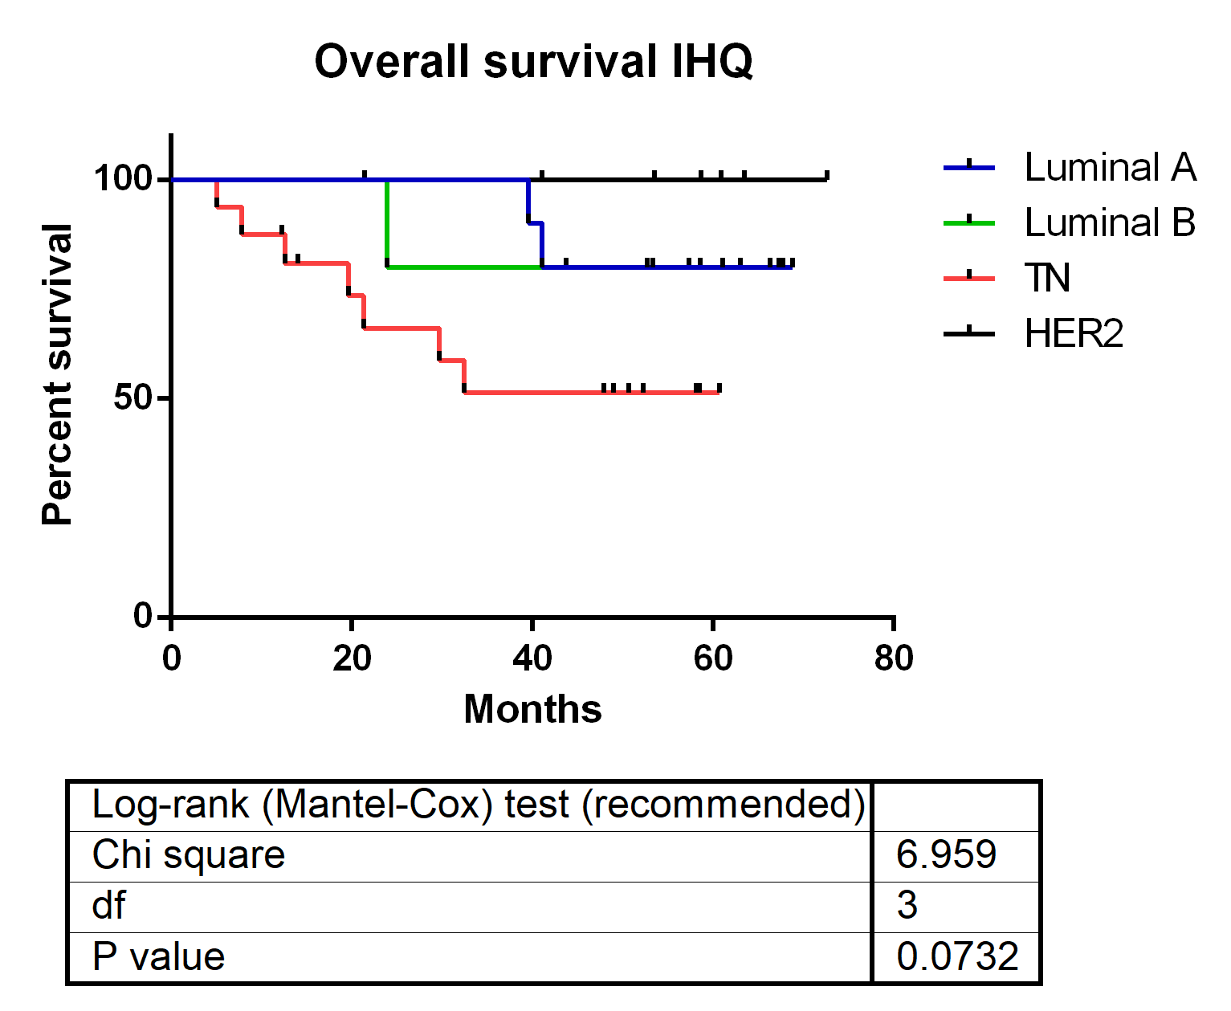**Supplementary Figure 7.** **Overall survival according to the molecular subtype after NCT (SS).** LA = luminal A, LB = luminal B, TN = triple negative. Log-rank (Mantel–Cox) test was used for comparisons.

**Supplementary Table 1.** Probes differentially expressed in pCR and non-pCR surgical samples.

|  |  |  |  |  |  |  |  |
| --- | --- | --- | --- | --- | --- | --- | --- |
| **ID** | **Cx: NR Avg (log2)** | **Cx: pCR Avg (log2)** | **Fold Change** | ***p*-val** | **FDR P-val** | **Gene Symbol** | **Description** |
| 206825_at | 5.61 | 9.57 | -15.5 | 0.0002 | 0.0243 | *OXTR* | oxytocin receptor |
| 206742_at | 4.39 | 8.18 | -13.86 | 3.92E-06 | 0.0049 | *FIGF; PIR-FIGF* | c-fos induced growth factor (vascular endothelial growth factor D); PIR-FIGF readthrough |
| 230867_at | 4.8 | 8.1 | -9.84 | 0.0002 | 0.0274 | *COL6A6* | collagen, type VI, alpha 6 |
| 214023_x_at | 4.74 | 7.45 | -6.54 | 7.30E-05 | 0.0186 | *TUBB2B* | tubulin, beta 2B class IIb |
| 222717_at | 5.7 | 8.39 | -6.48 | 0.0002 | 0.0279 | *SDPR* | serum deprivation response |
| 235236_at | 3.21 | 5.86 | -6.29 | 2.50E-05 | 0.0124 | *FAM196B* | family with sequence similarity 196, member B |
| 1552509_a_at | 4.21 | 6.77 | -5.93 | 0.0002 | 0.029 | *CD300LG* | CD300 molecule-like family member g |
| 223541_at | 4.98 | 7.49 | -5.7 | 6.60E-06 | 0.0067 | *HAS3* | hyaluronan synthase 3 |
| 240717_at | 3.11 | 5.61 | -5.68 | 7.51E-10 | 2.05E-05 | *ABCB5* | ATP binding cassette subfamily B member 5 |
| 1556427_s_at | 5.89 | 8.2 | -4.95 | 0.0001 | 0.021 | *LRRN4CL* | LRRN4 C-terminal like |
| 1553243_at | 5.33 | 7.56 | -4.72 | 0.0002 | 0.0255 | *ITIH5* | inter-alpha-trypsin inhibitor heavy chain family, member 5 |
| 210432_s_at | 3.77 | 5.94 | -4.51 | 0.0001 | 0.0213 | *SCN3A* | sodium channel, voltage gated, type III alpha subunit |
| 1558820_a_at | 5.1 | 7.2 | -4.3 | 0.0002 | 0.025 | *CCDC178* | coiled-coil domain containing 178 |
| 229118_at | 4.13 | 6.18 | -4.12 | 0.0001 | 0.0214 | *PRRG3* | proline rich Gla (G-carboxyglutamic acid) 3 (transmembrane) |
| 203435_s_at | 6.16 | 8.17 | -4.02 | 6.74E-06 | 0.0067 | *MME* | membrane metallo-endopeptidase |
| 230644_at | 4.48 | 6.47 | -3.97 | 7.98E-05 | 0.0193 | *LRFN5* | leucine rich repeat and fibronectin type III domain containing 5 |
| 228368_at | 5.33 | 7.31 | -3.96 | 1.43E-06 | 0.0028 | *ARHGAP20* | Rho GTPase activating protein 20 |
| 203951_at | 6.91 | 8.86 | -3.86 | 0.0001 | 0.0241 | *CNN1* | calponin 1, basic, smooth muscle |
| 229308_at | 5.2 | 7.14 | -3.85 | 9.59E-05 | 0.0204 | *ANKRD29* | ankyrin repeat domain 29 |
| 229357_at | 7.65 | 9.54 | -3.71 | 0.0002 | 0.0276 | *ADAMTS5* | ADAM metallopeptidase with thrombospondin type 1 motif 5 |
| 216918_s_at | 4.46 | 6.34 | -3.69 | 0.0001 | 0.0213 | *DST* | Dystonin |
| 203434_s_at | 5.96 | 7.82 | -3.62 | 0.0002 | 0.0279 | *MME* | membrane metallo-endopeptidase |
| 235335_at | 3.32 | 5.16 | -3.57 | 1.57E-08 | 0.0002 | *ABCA9* | ATP binding cassette subfamily A member 9 |
| 1556936_at | 3.39 | 5.2 | -3.5 | 7.34E-06 | 0.0068 | *GAS1RR* | GAS1 adjacent regulatory RNA |
| 204482_at | 7.2 | 8.94 | -3.35 | 7.82E-05 | 0.0192 | *CLDN5* | claudin 5 |
| 204793_at | 6.56 | 8.29 | -3.31 | 0.0002 | 0.0244 | *GPRASP1* | G protein-coupled receptor associated sorting protein 1 |
| 206030_at | 4.26 | 5.98 | -3.3 | 0.0001 | 0.0235 | *ASPA* | Aspartoacylase |
| 214505_s_at | 5.64 | 7.36 | -3.29 | 0.0002 | 0.0292 | *FHL1* | four and a half LIM domains 1 |
| 223496_s_at | 4.75 | 6.43 | -3.21 | 0.0002 | 0.0257 | *CCDC8* | coiled-coil domain containing 8 |
| 226303_at | 5.2 | 6.82 | -3.08 | 8.80E-05 | 0.0199 | *PGM5* | phosphoglucomutase 5 |
| 236359_at | 5.54 | 7.13 | -3.03 | 0.0001 | 0.0231 | *SCN4B* | sodium channel, voltage gated, type IV beta subunit |
| 201563_at | 8.23 | 6.54 | 3.23 | 0.0002 | 0.0244 | *SORD* | sorbitol dehydrogenase |
| 222067_x_at | 7.06 | 5.31 | 3.38 | 0.0002 | 0.0287 | *HIST1H2BD* | histone cluster 1, H2bd |
| 217755_at | 7.74 | 5.97 | 3.42 | 9.34E-05 | 0.0204 | *HN1* | hematological and neurological expressed 1 |
| 201690_s_at | 11.17 | 9.39 | 3.43 | 3.72E-05 | 0.0145 | *TPD52* | tumor protein D52 |
| 218782_s_at | 6.82 | 4.99 | 3.56 | 0.0001 | 0.0227 | *ATAD2* | ATPase family, AAA domain containing 2 |
| 204092_s_at | 6.76 | 4.73 | 4.06 | 0.0003 | 0.0297 | *AURKA* | aurora kinase A |
| 201689_s_at | 9.54 | 7.42 | 4.32 | 1.47E-05 | 0.01 | *TPD52* | tumor protein D52 |
| 222740_at | 6.97 | 4.84 | 4.39 | 0.0002 | 0.0257 | *ATAD2* | ATPase family, AAA domain containing 2 |
| 204285_s_at | 7.69 | 5.55 | 4.4 | 0.0001 | 0.021 | *PMAIP1* | phorbol-12-myristate-13-acetate-induced protein 1 |
| 214710_s_at | 7.35 | 4.99 | 5.11 | 8.16E-05 | 0.0194 | *CCNB1* | cyclin B1 |
| 202503_s_at | 9.08 | 6.55 | 5.75 | 9.19E-05 | 0.0204 | *KIAA0101-* | KIAA0101/PCLAF |
| 201688_s_at | 7.75 | 5.2 | 5.85 | 3.47E-06 | 0.0047 | *TPD52* | tumor protein D52 |
| 223229_at | 7.2 | 4.63 | 5.91 | 6.98E-05 | 0.0183 | *UBE2T* | ubiquitin conjugating enzyme E2T |
| 202954_at | 7.91 | 5.33 | 5.96 | 0.0002 | 0.0264 | *UBE2C* | ubiquitin-conjugating enzyme E2C |
| 219978_s_at | 6.79 | 4.2 | 6.01 | 0.0003 | 0.0298 | *NUSAP1* | nucleolar and spindle associated protein 1 |
| 209773_s_at | 7.75 | 5.11 | 6.25 | 0.0001 | 0.0218 | *RRM2* | ribonucleotide reductase M2 |
| 201890_at | 8.37 | 5.46 | 7.52 | 0.0001 | 0.0226 | *RRM2* | ribonucleotide reductase M2 |