COURSE BOOK



## Customer Relationship Management

DLBCRM01



Overall learning objectives

##### Introduction 9



This **Customer Relationship Management** course will start by providing you with an overview of the fundamental principles of this subject area. For example, you will learn about theoretical approaches to CRM, the economic importance of customer relationships, and constructs such as the customer lifecycle and customer relationship cycle. You will also learn about the different categories of customer satisfaction and loyalty, how to measure them, and how to classify **customer value**. Building on this basic understanding of the importance of customers, you will then become acquainted with customer retention tools, opportunities to deploy them, and how to monitor their success.

[www.iubh.de](http://www.iubh.de/)

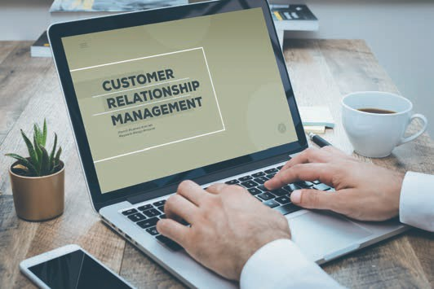

# Unit 1

## Basics of CRM

#### LEARNING OBJECTIVES

After completing this unit, you will understand…

…what CRM is.

…the economic importance of customers.

…the role CRM plays in marketing.

DL-D-DLBCRM01-L01

1. Basics of CRM

### Introduction

Customer relationship management (CRM) is a term that you have probably already heard of. But what do we actually mean by these three words, which combined refer to their own subject area mean? CRM is firstly about “customers” – or more specifically, individuals with differing needs and ideas. The next aspect, “relationship”, refers in general terms to a space with a high degree of interaction, one that does not come into being by itself, but must instead be built up and maintained. Last but not least, “management” refers to the planning, strategic, and goal-oriented aspect of the subject area. CRM is thus a highly complex topic that has many interesting facets to consider.

Consider the following example: The fictitious company “bags for mobile urbans” (b4mu) was recently founded and produces luggage that is sustainable, reliable, and durable, but also trendy, along with accessories for trend-conscious people who travel extensively for work and pleasure. The company founders want to inspire others with their products and transform their customers into fans of the new brand. However, none of them have any previous marketing experience, and the young entrepreneurs only have experience of maintaining relationships in a non-business context. This is reason enough to delve into this important field and to learn about the fundamentals of...

* + what CRM actually covers,
  + the importance of CRM for the company’s success, and
  + how CRM should be integrated into the company’s marketing strategy.

### CRM terminology and goals

Markets have always been dynamic places, and they change in line with the consumers themselves and their purchasing behaviors. It is a two-way reciprocal relationship that repeatedly challenges companies to track and analyze the market and their own customers, and to use market analysis tools in a market- and target-group-oriented manner with up-to-date information. In the struggle to acquire proﬁtable customers, companies can gain valuable competitive advantages over the competition through the successful use of customer relationship tools (Holland 2016, 296).

Customer relationship management is defined in many different ways in the literature. On the one hand, CRM has been defined as a customer-oriented, comprehensive, and technology-supported management concept. However, other authors view CRM as a tool for customer data processing (Bruhn 2016c, 14). Under the latter framework, CRM is simply a tool for processing customer data, covering the entire process from collection to analysis and archiving. At b4mu,

Basics of CRM

the young entrepreneurs discuss both interpretations and quickly agree that accepting one approach to the exclusion of the other would be insufficient, since neither a purely strategic nor a purely technology-based approach is likely to yield promising results in the long term.

**CRM** should therefore be understood as the act of focusing corporate structures, processes, and activities on the customer in order to identify and establish proﬁtable customer relationships. These relationships can be intensified or suspended and re‑established later if necessary (Götz & Krafft 2013, 583).

From this point of view, CRM should be understood as a process that seeks to initiate and consolidate proﬁtable customer relationships, retain the customer, recovering them, or even end the relationship when it is no longer advantageous for the company. At the same time, CRM must not be understood as a new type of direct marketing or just another term for customer satisfaction, customer orientation, or customer proximity, or in short as a purely IT-based solution (Rapp 2005, 53). The goal is to develop CRM strategies that determine which customer groups can and should be addressed and how to do so on the basis of clearly deﬁned goals. To do this, of course, you need to know who your company’s customers are, what their interests are, and where they can be reached. In contrast to long-established companies, a young company like b4mu currently has little customer experience and still needs to learn about the market and its customers. But regardless of whether you are a young or an established company, one thing is clear: Businesses need to know and understand their customers in order to approach them in an appropriate manner. Ideally, companies should therefore collect all available information about their customers and synthesize it to create a holistic picture, which is known as the **single customer view.** However, a strategy in and of itself is not sufficient to ensure success. It cannot be effective without the necessary organizational integration, the development of processes for customer analysis, and the selection of suitable CRM systems, as well as following through on their implementation (Leusser, Hippner & Wilde 2011a, 17 et seq.).

b4mu is starting to gain a better understanding of CRM, but they would still like to find out more precisely what specific goals can be achieved by applying CRM. At their core, CRM activities are about creating proﬁtable customer relationships. They aim to create and expand customer satisfaction in order to lay the foundations for customer relationships and therefore to retain customers over the long term and boost their added value for the company. As such, companies need to find out who the most proﬁtable customers are for the company and what offer should be made to them in order to retain them. In addition to existing customers, it is also important to identify potential new customers, approach them, acquire them, and then retain them over the long term. According to Rapp, CRM pursues three main goals (Rapp 2005, 45):

* Increasing the **share of wallet** of each individual customer
* Optimizing customer relationships from an economic point of view, and
* Acquiring new, proﬁtable customers.

CRM

CRM is a management process designed to not only create customer relationships, but also to maintain and manage them over the long term.

Single customer view

This refers to the outcome of taking a holistic view of the customer information available to the company.

Share of wallet This refers to the proportion of the customer’s total expenditures in a particular area (e.g., on clothing) that are spent at a spent at a particular supplier (e.g., brand of

pants).

Proﬁtable customers

Profitable customers are those customers who are loyal to the company, purchase products from it more than once, and make a long-term contribution to the company’s success.

### The economic importance of the customer

“A company does not grow simply because it sets itself the goal of growing, but rather because it constantly evolves to address the needs of customers” (Werner 2018, 413). This quote from Götz Werner, the founder of dm-Markt, immediately strikes a chord with the young entrepreneurs at b4mu. After all, there are no sales without customers, and the company has no future without sales. This is an extremely succinct way of summing up the importance of the customer, and it suggests that it is important to have a lot of customers. But should all customers be regarded the same way? Should a one-off customer be valued as highly as a loyal repeat customer? Rapp uses an eloquent example to explain the importance of customers: A business owner looks at the numbers of new acquisitions by their salespeople and finds that some of them have been able to attract an outstanding number of new customers. However, when they compare the salespeople’s revenues, the numbers paint a different picture. The salesperson who makes fewer new acquisitions but constantly cultivates their existing customer base contributes more to the company’s profits than their colleague who has the highest numbers in new customer acquisition (Rapp 2005, 23 et seq.). CRM consistently provides support for the argument that acquiring new customers is far more expensive than cultivating existing customers, to the extent that it seems incontrovertible. But it is not just a question of the cost of customer-acquisition measures. You also have to factor in what it means to have a customer base that keeps buying loyally, regularly, and reliably from you over the long term. You can tell even without running the numbers that it is these customers in particular that are the decidedly proﬁtable ones.

The young company b4mu has many unanswered questions: Who exactly are these customers? When and where does the relationship with the customer begin? Does someone become a customer as soon as they enter a store for the first time or see the company’s offerings, e.g., in an advertisement or on the website? Or do they only become a customer after a transaction has taken place, such as, for example, when they purchase a bag or another product from the company? But another question also arises: How long does a customer remain a customer? Is there an expiration date on customers? And when exactly does a customer transition from a one-time buyer to a repeat buyer? And why should someone commit themselves to the company and their as-yet nascent brand at all instead of deciding anew every time they make a purchase which product to buy and which company to buy it from? The CRM literature makes very simple differentiations and provides a basic orientation by dividing customers into the categories of “potential”, “current”, and “lost”. It is on these categories that the CRM measures are concentrated.

Basics of CRM

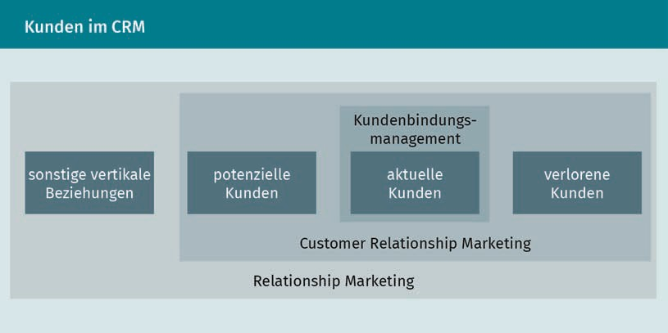

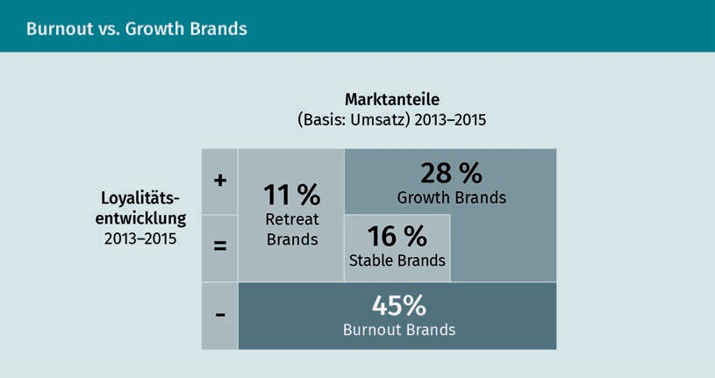The b4mu team certainly recognizes the value of CRM measures, but they are skeptical as to whether it is really still possible for customers to be retained and become loyal to a company, since studies show that consumer loyalty to brands has subsided. However, the picture these studies paint is heterogeneous. Successful brands boast a high proportion of repeat customers (51%), while other brands are left with a higher number of occasional customers (about two-thirds). A further surprising result emerged when buyers of branded goods were classified according to the company’s market-share development and buyer churn criteria. The majority of manufacturer brands were identified as “**burnout brands**”, i.e., brands that are losing an above-average number of regular customers and therefore also market share over time (Haller 2018, 290 et seq.).

Burnout brands These are brands that are losing an above-average number of regular customers and, as a result, have also sustained losses in market share.

Regular customers   
These are buyers who regularly source their needs from the same supplier/vendor, e.g., who always buy groceries from the same

brand stores.

Seller’s market

In a seller’s market, demand is greater than supply.

Buyer’s market

In a buyer’s market, supply is greater than demand.

At b4mu, this is interpreted to mean that the company should clearly focus on retaining and caring for **regular customers** instead of just focusing on acquiring new ones. Undoubtedly, a young company must start by building up a solid customer base, but right from the outset, a business should not only aim to acquire customers, but also to retain them over the long term. And for that to succeed, the company must (as mentioned above) get to know and understand its customers. If a company does not know why someone is loyal to their brand or (on the contrary) not loyal, why they buy from them repeatedly or only once, or why the brand is recommended or criticized, then the company cannot react appropriately in order to either retain the customer or recover them.

Customers (and especially regular customers) have a special value for the company, defined, from the company’s perspective, as the contribution of either an individual customer or of an entire customer group to the achievement of the company’s goals. However, this contribution is not only calculated on the basis of past or future sales to customers, it also takes account of indirect contributions, such as recommendations (Leusser, Hippner & Wilde 2011a, 22 et seq.). Customer value is measured over the long term, since companies need to not only take a current snapshot of the customer but also to evaluate their future potential. The managers at b4mu are well aware of the future importance of their customers. Young customers who are still in school, for example, may today opt for the company’s inexpensive “youth line”, but if they develop loyalty to the company, they will become the profitablecustomers of tomorrow when they move up to the “professional line”, the company’s exclusive collection. Research has shown that investing in customer retention pays off, because the amount of profit that can be made from individual customers increases the longer the customer relationship lasts (Leusser, Hippner & Wilde 2011a, 25). The customer value therefore not only refers to individual transactions, but also has to take the relationship aspect into account.

### From transactional to relationship-oriented marketing

Businesses need to align themselves with the market, which can sometimes be a benevolent partner, such as the **seller’s market** of the 1950s. At that time, marketing was mainly distribution-oriented, and the sellers could more or less dictate the prices and conditions themselves. But there are also markets that are not as favorable. A saturated market requires an intensive analysis of market conditions and customers. A great deal has changed in today’s **buyer’s market**, and various aspects have become more prominent over the years, including the focus on the **Unique Selling Proposition (USP)** and the increasing awareness ever since the 1980s of the importance of customers and cultivating relationships with them. The realization that a profitable company is not just one that makes a profit,

Basics of CRM

but one that also carefully maintains the quality of its customer relationships has led to an increasing importance being placed on relationship management (Lucco et al. 2015, 18 et seq.).

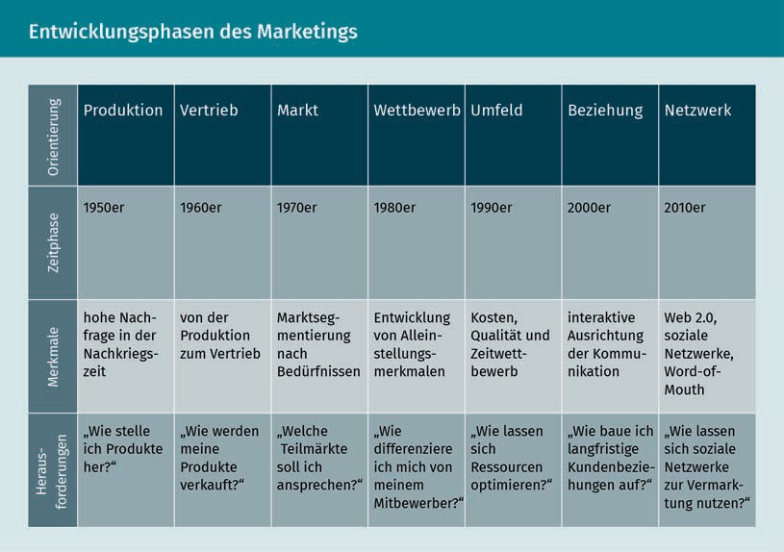

Marketing has long since ceased to be equated with sales or advertising, and this short-sighted view has increasingly been replaced by companies taking a market- and customer-oriented orientation. Instead of engaging in individual transactionswith the customer, the focus is now on managing customer relationships. These changes and the development of this type of **relationship-oriented marketing** has passed through three phases. Whereas customer satisfaction was viewed as key in the 1990s, the focus then shifted to customer loyalty management, before culminating ultimately in customer relationship management (Ergenzinger & Thommen 2005, 437).

Unique selling proposition

This refers to the unique feature of a product/brand.

Relationship-oriented marketing

Relationship-oriented marketing targets the needs of customers.

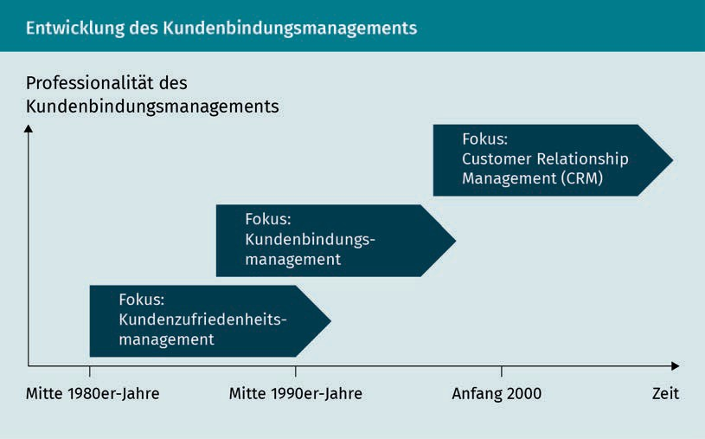

At b4mu, they wonder whether this relationship orientation has led to a fundamental redefinition of marketing or whether the relationship orientation is actually just the result of continuous evolution in the field of marketing. When comparing the distinguishing features of transactional and relationship marketing, as Bruhn has done, the latter assumption is reinforced:

|  |  |  |
| --- | --- | --- |
| Comparison of transactional and relationship marketing | | |
| Distinguishing criteria | Transactional marketing | Relationship marketing |
| Period | Short-term outlook | Longevity |
| Marketing object | Product | Product and interaction |
| Marketing goal | Customer acquisition through marketing mix | Customer acquisition, customer retention, and customer recovery |
| Marketing strategy | Performance presentation | Dialog |

Basics of CRM

|  |  |  |
| --- | --- | --- |
| Distinguishing criteria | Transactional marketing | Relationship marketing |
| Economic success and control parameters | Profit, contribution margin, revenue, and costs | Plus: Customer contribution margin and **customer value** |

The comparison shows that relationship-oriented marketing not only takes the provider’s services into account, it also heavily incorporates the needs of the customer, and it combines these two elements. The advantages of a relationship orientation are increased profitability (e.g., through savings from not having to acquire as many new customers), growth (e.g., by increasing **cross-buying effects**), and better security (e.g., through better planning security afforded by more stable customer relationships) (Bruhn 2016c, 17).

### CRM tasks and structure

CRM is a systematic process that puts the customer at the center of the corporate strategy. As explained above, CRM cannot be reduced to either communicative or technology-based approaches. Rather, its potential is only clear when viewed as a holistic, integrative approach. Rapp’s five-phase model presents a systematic approach in which the essential processes of the CRM method should build on one another in order to establish long-term customer relationships (Rapp 2005, 54 et seq.).

Cross-buying effect If a customer makes repeated purchases from the same company and/or buys other products from a company after making a purchase, this is referred to as the cross-buying effect.

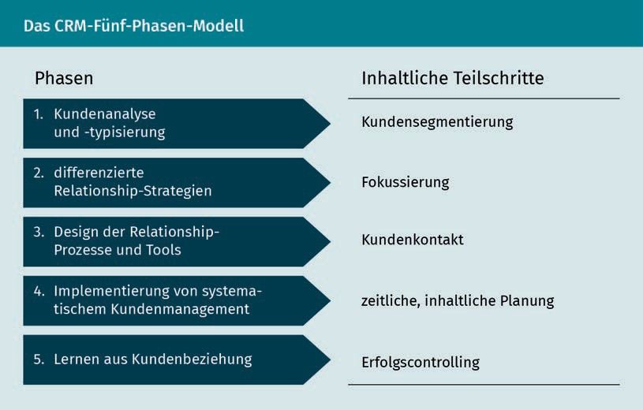

The tasks that the company must accomplish are customer acquisition, customer retention, and customer recovery.

However, the young business owners of b4mu now wonder whether CRM can be applied in the same way at every company and in every industry and market. There is certainly a fair amount of disagreement around this question. Consider the following scenario: You have just bought some balloons to use as party decorations. Do you associate them with a specific manufacturer? Or what about consumable products like garbage bags, toilet paper, candles, or the like? And how does your opinion change when it comes to longer-lasting products like clothing, smartphones, laptops, or cars? And how do you think about personal care products or groceries? The extent to which a product is directly associated with a manufacturing company and how exactly the customer relationship with the company is perceived vary not just at the product level, but also at the level of the individual consumer. Customer engagement, or the emotional involvement that the consumer experiences when making a purchase, is an important factor for the customer relationship. When it comes to everyday products (low involvement), the customer is significantly less involved than, for example, when buying a car (high involvement), where the purchase decision is influenced by many factors. Not only does the product itself play an important role here, but factors such as brand image, quality, and price are also important. However, it is also abundantly clear that companies cannot assume a standardized customer. Rather, they must research their customer specifically. This information is largely based on data about customers, which can be generated not only using market analyses, but also through customer-speciﬁc databases. For example, companies want to know which customers buy what, where and how customers shop, and what their preferences are (Rapp 2005, 74). This information forms the basis for needs-based actions and campaign planning.

b4mu would like to find out more about its current and future customers, and it is considering how it can obtain this knowledge and what it needs to consider when determining the most comprehensive possible picture of its customer. The idea that the only requirement for good customer-data collection is a good IT solution is short-sighted. Of course, solid data-collection tools and the associated databases are essential, but we must not forget that the usefulness of any database lies in the data analysis that it facilitates and that in turn allows suitable measures to be derived from the findings. Therefore, the company must develop an appropriate strategy that determines the information and data that are actually needed and also focuses particularly on ensuring that the company’s processes are customer-oriented (Rapp 2005, 75).

Regardless of the industry or product, the purpose of CRM, as a customer-oriented approach to corporate management, is to comprehensively factor in developments in consumer behavior or sales market structures in order to derive economic benefits. CRM succeeds in doing this by generating customer satisfaction and customer loyalty, and by forming long-term customer relationships. But it takes more than just developing the right strategies to apply CRM successfully to all areas. Company management and employees must thoroughly internalize the principles of customer orientation

Basics of CRM

and appreciate their significance. Ideally, this is achieved by formulating appropriate goals and guiding principles and integrating them into the corporate culture (Schumacher & Meyer 2004, 19 et seq.).

The b4mu managers are now wondering how the multitude of tasks involved can be appropriately structured on both the strategic and operational levels. In both the literature and in practice, a distinction is usually drawn between the analytical, operational, and communicative CRM approaches. These three areas cover data collection and evaluation, planning measures derived from these activities, and the use of the relevant supporting technologies (Schumacher & Meyer 2004, 20 et seq.). In order to initiate successful CRM activities, companies not only need to master certain standalone issues, but also to strike an effective balance between analysis, strategy, and implementation.

Summary

Companies must overcome the challenges of constantly changing markets and consumer purchasing behavior in order to successfully assert their claim to market share. The use of customer relationship tools provides an opportunity to gain competitive advantages. CRM represents a management process that is geared towards creating proﬁtable customer relationships and maintaining these relationships in order to create a long-term relationship between the customer and the company. The CRM approach is a holistic process that develops and implements strategies on the basis of clearly deﬁned goals that serve to optimize customer relationships from an economic point of view. To achieve this, companies must know and understand their customers so that they can create the most comprehensive possible picture of the customer. This single customer view provides the basis for developing suitable CRM measures.

Customer retention and cultivation are essential to the company’s economic outlook, especially in these times of declining customer loyalty. This is because the loss of (regular) customers often leads to a loss of market share in the medium term. It is clear that investing in customer loyalty pays off, since it has been proven that the profit that can be made from individual customers increases with the length of the customer relationship. These findings are also clearly reflected when a company moves from transaction-oriented to relationship-oriented marketing. The focus on customer needs can be understood as the logical next evolution in marketing. The advantages of this relationship orientation can be seen in increased profitability, growth, cross-buying effects, and in greater planning security for the company.

Since companies cannot assume a generic profile for their customers, they need to research specific details about their customers. This information is gained from studying the totality of all customer data, and it provides the basis for

needs-based action and campaign planning. It cannot be overstated that customer data collection should not be regarded as something that can be easily solved using an IT solution: Only a well-grounded analysis of the data can provide the insights that lead to the adoption of suitable measures, and such an analysis should be supported by appropriate processes that are firmly integrated into the company (e.g., complaints management, service offerings, etc.). Company management and employees must thoroughly internalize the principles of customer orientation and appreciate their significance.



# Unit 2

## Theoretical approaches to CRM

#### LEARNING OBJECTIVES

After completing this unit, you will understand…

…the fundamental kinds of theoretical approaches to CRM.

…what communicative aspects are relevant.

…why engaging with the issue of relationships is important for successful CRM.

DL-D-DLBCRM01-L02

1. Theoretical approaches to CRM

### Introduction

If you already deal with CRM, then you know that there is often more than one way of looking at it, since the discussion draws in viewpoints from different disciplines. The topic can be approached from the perspectives of behavioral science, communication theory, and economics, and we will examine these in more detail in this lesson. Fundamentally, CRM is about customer relationships, and there are important theoretical foundations of relationship marketing that we can explore. Here we will demonstrate the significance of developing closer customer relationships. The benefits of customer relationship management are presented using different approaches. An approach that is more grounded in economics focuses on the monetary importance of customer relationships, while the behavioral science approaches look at the origin and importance of relationships. Psychological processes, such as trust, commitment, or customer satisfaction must be taken into account, as these are an important basis for creating customer loyalty. These relationship-oriented strategies have been developed from transaction cost theories, which support the idea that a customer-oriented business approach yield benefits.

### Approaches from neoclassical, neoinstitutional, and organization theory

Due to the interdisciplinary nature of the subject area, the theoretical basis of CRM can be found in different academic fields. If we wish to emphasize customer relationships, we must determine the value of these relationships, how they come about, and also how the company must react to a customer orientation from an organizational perspective. By analogy with marketing research, relationships can therefore be assigned to the following theoretical approaches (Bruhn 2016c, 22):

* + Neoclassical theoretical approaches
  + Neoinstitutional theoretical approaches
  + Neobehavioral theoretical approaches, and
  + Theoretical approaches based in organization theory.

The neoclassical and neoinstitutional theoretical approaches are rooted in microeconomic theories of economics. Utility and profit theories can be classified under the neoclassical approach. The utility theory explains the behavior of the customer in relation to the company’s services. In simple terms, we can agree that a customer uses services when they personally expect to obtain a greater benefit from them. A relationship with the company is therefore only relevant for the customer if they can expect to derive a benefit from them.

Theoretical approaches to CRM

Profit theory focuses on the behavior of the company in terms of the services that it offers to the consumer and selects the actions that maximize profit. This means that the customer is evaluated based on the value they provide to the company, and the company decides to process data about each customer or customer segment based on the economic advantage they can derive from doing so. For example, models such as the customer lifetime value can be used to evaluate the customer. If you consider these approaches critically, you will notice that they are unable to take account of how customer relationships change over time, and they are also unable to differentiate between different types of customer relationship (Bruhn 2016c, 24).

The neo-institutional approach believes that the function of marketing is to promote transactionsor customer interaction, and accordingly, its purpose is to reduce uncertainties and build trust. The following theoretical explanations can be used to establish a CRM strategy that is oriented toward relationships (Bruhn 2016c, 24 et seq.):

* Informational economics (focus: impact of informational uncertainty)
* Principal-agent approach (focus: uncertainty and informational asymmetries in socioeconomic relationships)
* Transaction-cost approach (focus: costs incurred from the coordinating of a business relationship), and
* Relational-contracting approach (focus: contractual design of exchange relationships).

Each of these four approaches make their own important contributions to how to evaluate customer relationships, but they do not offer a comprehensive, in-depth explanation.

As companies have become increasingly oriented towards customers, changes in their organizational structures have been taking place, a process that started many years ago. It has become clear that it is not enough to establish direct contact with the customer at a single point (usually sales). A distinct customer management approach therefore attempts to coordinate all of the company’s customer-speciﬁc measures and also to implement this organizationally.

**Resource dependency theory** and the resource-based view approach provide the theoretical underpinnings here. Resource dependency theory focuses on ensuring the company’s survival through the provision of the appropriate resources. The customer is therefore considered an important resource, and the relationship between provider and customer is seen as symbiotic. The company’s output requires the customer’s input (Bruhn 2016c, 49). Simply stated: The company can only generate revenue if the customer buys something! The resource-based view approach focuses on existing resources or resources to be generated that help establish customer relationships. These relationships are not only created through direct transactions, but also through the intention of the company to create such

Resource dependency theory

Resource dependency theory deals with the inﬂuence of external resources on business actions and behavior.

relationships. In contrast to the behavioral science approaches, these theoretical considerations focus on the companies and not the behavior of the customers (Bruhn 2016c, 51).

From a practical point of view, companies try to implement a customer orientation approach across departmental boundaries. However, the associated structural changes present potential internal conflicts of interest, such as, for example, between product development or sales. In order to ensure that a comprehensive customer orientation is deployed throughout the organization, the conditions necessary to ensure its acceptance must be fostered within the company. The formation of interdisciplinary working groups, made up of experts from different departments (from the product and sales managers to logistics experts) and tasked with coordinating the company’s processes with the customer’s needs, has previously yielded promising results (Köhler 2018, 324 et seq.).

### Approaches from a neobehavioral perspective

The paradigm shift from transaction- to relationship-oriented marketing has made maintaining economically attractive customer relationships increasingly important. But where do these relationships come from, and how can we explain why they come into being?

Neobehavioral approaches provide explanations for many of our questions about customer relationships, and they help us to consider and understand consumers and their behavior. From a behavioral perspective, there are various useful theoretical approaches to explaining the customer’s reasons for establishing and maintaining relationships. Recognized psychological approaches include (Bruhn 2016c, 34 et seq.):

Learning theories   
There are various learning theories. When attempting to understand customer behavior, researchers often apply a

reinforcement approach, which is where behaviors are changed as the result of positive or negative consequences.

* **Learning theory** (reinforcement principle)
* Risk theory (avoidance of negative consequences)
* Dissonance theory, or
* Involvement theory.

As one of the various approaches provided by learning theory, the reinforcement principle is often used as a basis for relationship management. Changes in behavior are explained as reactions to positive or negative consequences. So, if the customer perceives something as good or sees a positive benefit to the interaction, they will act the same way again in the future. So, in the case of this type of customer relationship, the product will be bought again. On the other hand, if the customer perceives something rather negatively, they will avoid the action again in the future, e.g., by not buying the product again (Bruhn 2016c, 34). This approach can be further differentiated if learner involvement is taken into account. If the level of involvement is low (that is, in simple terms, the customer feels little connection to the product or company), the customer absorbs the information at a mostly unconscious level. The **mere exposure hypothesis** assumes that the target group’s perception changes positively if

Theoretical approaches to CRM

it comes into contact with the reference object (i.e., the product or company) as often as possible. On the other hand, when there is a high level of involvement, more complex learning processes are assumed, since information acquisition and processing is not unconscious, but rather based on rational calculation (Bruhn 2016c, 34).

The risk theory is based on the knowledge that customers want to keep the risk associated with the purchase of products as low as possible. Imagine you are buying a new car. However, you are not just looking to acquire a safe and reliable means of transportation, but also a certain social status. What if your purchase fails to achieve this kind of recognition from friends, acquaintances, and colleagues, and instead you are even criticized for your decision? This is just one example of the types of risk that buyers want to avoid. The literature distinguishes between the functional, financial, social, and psychological risks of purchased services. When it comes to customer relationships, this means that risks are minimized for the customer if they can rely on the provider and the purchasing process and trusts them (Bruhn 2016c, 34 et seq.).

The behavioral effects are a product of the psychological effects on the customer. De facto customer loyalty is achieved when the customer is not only satisfied with the company and its offerings, but when this positive attitude towards the company translates into active behavior, such as making another purchase, acquiring other products from the company (cross-buying), or recommending the company to a friend. Unlike the purely psychological effect, this type of behavioral effect can also be directly observed or measured by the company (Bruhn 2016a, 242).

Another area that should be mentioned in passing (though we do not have space to elaborate on it here) is the socio-psychological approach. Here, according to Bruhn, the following approaches are relevant for evaluating relationships (Bruhn 2016c, 38):

* + Interaction and network approaches,
  + Exchange, incentive-contribution, and **equity theory**, and
  + Penetration theory.

The creation of added value on the part of companies and customers plays an important role in relationship building. Long-term relationships are only established and maintained if they provide a recognizable benefit to the partners involved. One of those benefits is the building of trust. Let’s take a closer look at customer relationships. They can be understood as the interactions between companies and current and potential customers, and they should be differentiated from individual transactions, e.g., one-off purchases. The relationships that arise from repeated interactions between customers and companies are built on both factual and emotional foundations. Mutual positive experiences build trust over time. This trust ensures that customers behave accordingly, which is reflected in purchases, additional purchases, or recommendations (Stauss 2011, 321 et seq.). Relationship building is a long-term process and cannot be achieved through one-off expressions of trust.

Mere exposure hypothesis

The mere exposure hypothesis assumes that the repeated perception of a thing/information leads to a positive evaluation.

Equity theory

Equity theory is a process theory that attempts to explain how motivation arises.

### Approaches from a communications standpoint

Commitment In the CRM context, commitment refers to customers’ connection/identiﬁcation with a company/brand.

Communication is an important part of relationship-building, as it provides opportunities to build trust and **commitment**. Relationships are a two-way process and arise through interactions between customers and companies, i.e., through the exchange of content, such as services, but also the exchange of information. The importance of communication in relationship management has already been proven by various studies, and a comparison of all customer loyalty tools revealed that communication is the most important tool for maintaining customer relationships (Bruhn 2016a, 230 et seq.).

New challenges for communication policy have arisen not just through the change in the communication landscape, but also through the reorientation of marketing from transaction- to relationship-oriented thinking. Communication policy always has various goals to fulfill. In addition to sales policy goals, a customer-oriented company must also focus on the task and goal of creating and maintaining supplier-customer relationships. In order to meet this challenge, communication must be geared to the needs of the target groups, the creation of benefits for providers and customers, and dialog. Orienting the communication towards needs is a decisive factor for success across all phases of customer retention. It is only if the exchange partner’s information interests are recognized and the communication measures meet their needs that the exchange or dialog will be intensified, therefore allowing relationships to be built. Ideally, communication should not be addressed to the larger target group, but rather to the individual customer so that this person receives the information they need and the company receives important information from the customer in return. But can a company enter into dialog with each of its customers in a manner that addresses them individually and personally? Undoubtedly, only a very small number of companies have the capabilities to do this.

In general, relationship marketing is always about creating proﬁtable customer relationships that promise added value for both the provider and the customer. The added value for the customer can be seen not only in the economic beneﬁts but also in the psychological beneﬁts (reliability of a relationship) or in the satisfaction of the need for belonging (as members of a community). Communication should be focused on maximizing the benefit for the company. Establishing customer clubs or buildingbrand communities, for example, can help to meet the various needs of customers. Viewed in this way, communication functions not only as a mediator of information, but as a relationship builder. However, when it comes to the question posed above as to whether each customer can then be addressed individually, it is best to direct communication towards those customers who have been classified as proﬁtable over the long term. However, it is also important for the company to avoid squandering its efforts through more general, mass-mediated communication. Instead, it should focus on establishing interaction- and dialog-oriented communication with (profitable) customers, because relationships are only established through reciprocal communication (Bruhn 2016a, 232).

Theoretical approaches to CRM

Interaction- and dialog-oriented communication is understood as a two-way communication process. This means that the communication partners involved have the opportunity to establish direct contact and exchange information with each other. However, it is important here to make a distinction between asymmetrical and **symmetrical two-way communication**. As was illustrated in Grunig and Hunt’s PR models from the 1980s, two-way communication cannot automatically be equated with dialog. With asymmetrical two-way communication, the recipient can provide feedback in response to the information sent, but cannot influence the behavior of the sender, i.e., by prompting a reply/reaction. It is only when the feedback is received, accepted, and taken into account in the communication situation, i.e., there is a change in behavior due to an understanding being reached between the communication partners, that it is possible to describe this exchange as symmetrical two-way communication (Grunig 1989, 29). If companies want to build real relationships with their customers, they must engage in appropriate communication on an equal footing in order to initiate processes that seek to achieve understanding. Bruhn summarizes this multi-stage and dialog-oriented communication process in the model presented below (Bruhn 2016a, 233).

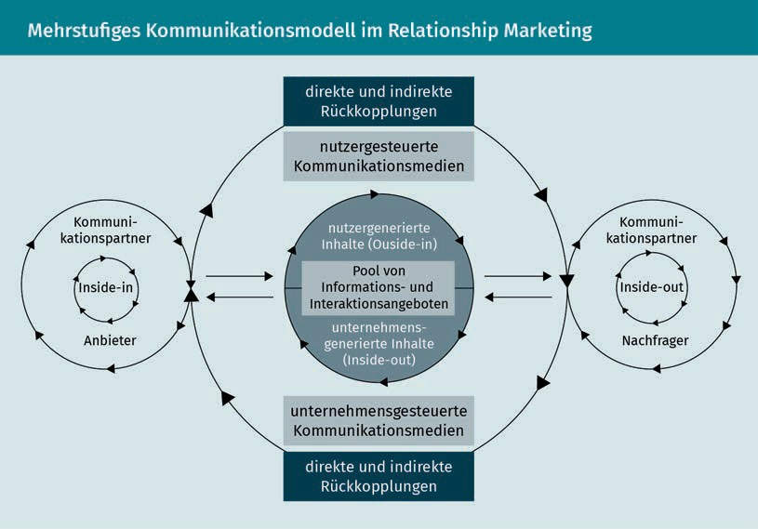

The dialog orientation, which the field of PR has long been aware of, can supplement or even replace one-sided communication processes in order to assist relationship building. This offers several advantages. The customer can initiate this dialog themselves, and they do not have to wait for the company to approach them. Communication can be designed as a pull process and not just as a **push** one. Creating feedback channels that enable

Symmetrical two-way communication

Symmetrical two-way communication not only permits feedback but also actively accepts it.

Push communication

Push communications are those messages and information that are presented to a consumer unsolicited, such as online ads, TV spots, or posters, for example.

two-way dialog to be established is particularly important for establishing this type of pull process. For companies, however, this also means that they must be willing to listen to customers and recognize opportunities for actively incorporating customer opinions into their own planning activities! Bruhn derives four relationship-oriented perspectives from this two-way communication structure (Bruhn 2016a, 234):

* Inside-in perspective
* Inside-out perspective
* Outside-in perspective, and
* Outside-out perspective.

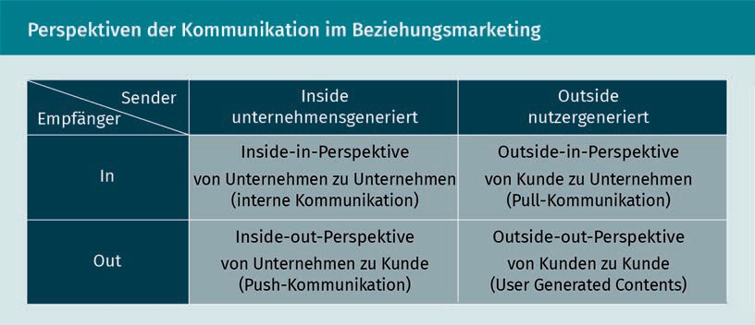

Communication plays an important role in the task of initiating the supplier-customer relationship, but it must also facilitate that relationship and moderate the dialog. In order for communication to be successful, it must be long-term and needs-based, but also benefit- and dialog-oriented. On the one hand, communication must recognize needs and initiate individual dialog (means-goal relationship). On the other hand, companies receive important information about the customer through this dialog, which in turn forms the basis for individualized and tailor-made offerings (goal-means relationship) (Bruhn 2016a, 231 et seq.). When it comes to communication policy, this relationship orientation is expressed as a focus on customer needs instead of product or service features.

Summary

As an interdisciplinary topic, CRM is built on various theoretical foundations. Since customer relationships must be regarded as an essential element of CRM, these relationships must be comprehensively evaluated in terms of their origin and significance, and also the opportunities they afford. Neoclassical, neoinstitutional, neobehavioral, and organizational theoretical approaches are used to explain these different aspects. These approaches look at customer relationships from different angles, but they do not

Theoretical approaches to CRM

provide holistic explanations of multifaceted CRM. Although neobehavioral approaches do not offer a comprehensive theoretical model, they are nonetheless very important for understanding relationships. The behavioral perspective helps to explain client-side reasons for entering into and maintaining relationships. Learning theoryand risk theory in particular help to explain how relationships are established, what such relationships mean for providers and customers, and what benefits they offer. After all, the creation of added value, i.e. a recognizable benefit, plays an important role in relationship building. One of those benefits is the building of trust, which is the basis for customer loyalty, and which ensures that the customer behaves in the way desired by the company, such as by making repeat purchases, additional purchases, or recommendations.

Communication plays a crucial role in relationship-building, as trust and commitment can be built through interaction and dialog between customers and companies. In order for this to succeed, the communications policy of the company must be crafted appropriately: A key success factor is maintaining a needs orientation. A real exchange between customers and companies is only possible if the communication measures are geared towards the information interests and the dialog is established via suitable channels that support symmetrical two-way communication. Real dialog also provides a number of advantages for the company, since customer requests can be recognized and integrated into the company’s own planning activities.



# Unit 3

## The customer lifecycle and customer relationship cycle

#### LEARNING OBJECTIVES

After completing this unit, you will understand…

…what a life cycle concept is.

…the significance of customer relationships from the point of view of the requester and the provider.

DL-D-DLBCRM01-L03

1. The customer lifecycle and customer relationship cycle

### Introduction

Relationships are not merely static objects. Quite the opposite in fact, they are dynamic. They arise, develop, and come to an end. Just like relationships in our private lives, customer relationships are not designed with a specific expiration date in mind. Rather, the duration and quality of the relationships depend on many different factors. Consider a simple example: Every morning you buy bread rolls from the bakery around the corner. The offerings are good, the prices are right, and the staff is friendly, so you have no reason to seek out a different bakery. But what if you did? What happens if you move, and can therefore no longer patronize the same bakery? Despite the previous stability of the supplier-customer relationship, you will probably be forced to end the relationship.

No matter how good the product may be, it loses its value if it no longer suits the customer’s life and therefore no longer provides any personal benefit (Rapp 2005, 43). As we can clearly see in the bakery example, a wide variety of scenarios in the supplier-customer relationship must be taken into account, all of which have an impact on the duration and quality of the relationship. However, the circumstances influencing the customer are not always a direct result of the customer’s communications with the company, but can also often be indirect, as the following example clearly shows:

A customer buys furniture for their new apartment from a well-known furniture store and arranges to have the new furniture delivered because the delivery service promises to bring the purchased merchandise to the apartment. The customer is then informed by the delivery service of the exact time of delivery, and they are pleased that everything has been arranged so smoothly. The goods are to be delivered to the customer’s fifth-floor apartment in an old apartment building three days later. But then the delivery arrives late, the delivery people are unfriendly, and they claim that the furniture can only be delivered to the curb. The merchandise is only brought up to the apartment after the customer engages in a lengthy conversation and cites the delivery conditions. Is the customer’s anger directed entirely at the delivery service, or does the experience reflect negatively on the furniture store as well? And what do you think would be the consequences of the customer sharing these types of experiences with others? A previously good supplier-customer relationship could possibly come to an end as a result of such an experience. This clearly shows how many factors must be taken into account as part of the customer relationship and how quickly trust can be undermined or lost, for example.

### Customer life cycle

Customer needs often also change depending on their current life phase. These needs are partly age-dependent (customer age cycle) and partly dependent on their individual life circumstances (**customer life phase cycle**) (Bruhn 2016c, 60). These circumstances can be of a ﬁnancial nature or stem from life-changing events, they can be positive or negative (e.g., job loss), and anticipated (e.g.,

The customer lifecycle and customer relationship cycle

retirement) or unexpected. For example, the birth of a child creates an enormous change in the consumer behavior of the parents. Apart from redesigning their apartment or possibly even moving to a new residence with a more child-friendly environment, the new parents must buy diapers, children’s clothing, and other equipment, such as strollers or baby slings, for example. On the other hand, some of these products are only purchased once or only over a short period of time. This is a simple but clear example of how customer needs can change. Today, however, it has also become more difficult to distinguish between the classic life phases, and the reliability of assigning these phases to specific age groups may be limited. The life phases are increasingly shifting or being reordered. For example, a young woman may want to start developing her career in the immediate future and postpone planning a family until later. Life models may have changed, but if companies develop an orientation towards different “life circumstances”, this will definitely help them recognize the needs of their consumers. These customer life phase cycles are often presented as follows:

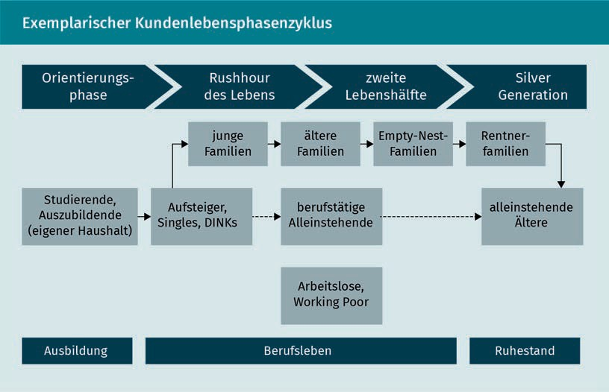

The customer life phase cycles help to explain and identify customer needs depending on the consumer’s individual life phase, because moving from one phase to another is often associated with changes in consumer behavior. The young family in the example mentioned above has different needs than an **empty-nest family**. And, of course, young couples without children, also known as DINKs (“Double Income, No Kids”), have other interests, desires, and needs than, for example, the Silver Generation, the group of people who have actively reached the life phase that comes after work and children. When planning their marketing, companies consider the age- or life-phase-dependent needs of customers in order to identify current cross-selling potential or to tailor their offerings to the respective needs of their customers, for example. In addition, considering these factors enables the company to determine the future needs of the customers and their

Customer life phase cycle

The customer life phase cycle is based on the different phases of people’s lives and their associated consumer requirements.

Empty-nest families Empty-nest families are families whose children have left the parental household.

Empty-nest families Empty-nest families are families whose children have left the parental

household.

Empty-nest families Empty-nest families are families whose children have left the parental

household.

potential value for the company. If we consider the young family with a baby again, this consumer will only be of interest to a diaper manufacturer for a limited period of time. However, if the company also offers items for older children, the customer can be sold these additional products in the future through relevant marketing. Another example: A student opens a free student account at a bank. And while investing or purchasing real estate are likely to be of little interest during this life phase, there will often come life phases after graduation when these offers will be more relevant. The student is therefore a proﬁtable customer for the bank when considered from a long-term perspective and can be approached over time with offers that are appropriate to their life phase.

Viewed in this way, the customer’s life phases also have an inﬂuence on the phases of the customer’s relationship with the company, which can be seen as a dynamic process as described in more detail below.

### Customer relationship cycle

Just like relationships in our private lives, relationships between companies and their customers also go through different phases. The search for a suitable partner starts with the initial phase of getting to know each other, usually followed by a strengthening and deepening of the relationship that express a stronger emotional bond. If one of the partners distances themselves emotionally, this signals the beginning of the end of the relationship. The other partner may also try to maintain the relationship or to recover the lost partner. It is very important to consider these different phases, because they require companies to vary their behavior and actions accordingly. Again, this is similar to how we respond to developments in our private relationships. During the acquisition phase, the company must address the customer differently than, for example, in the retention or recovery phase (Lucco et al. 2015, 96 et seq.). And all of these measures are not limited to short-term contacts with the customer. Rather, they should aim to foster and manage long-term customer relationships.

The customer lifecycle and customer relationship cycle

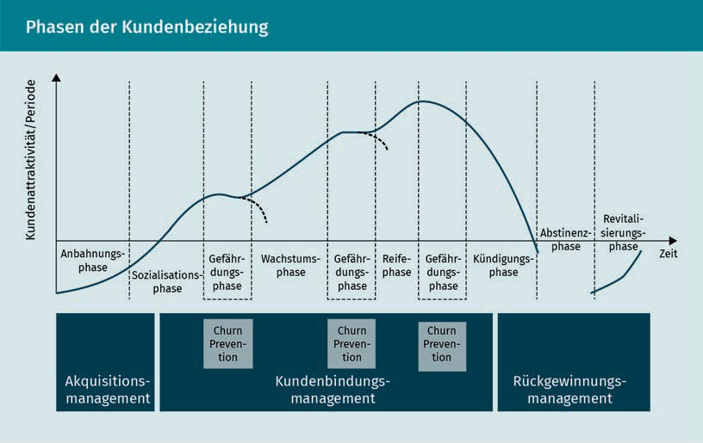

This model represents an ideal-typical course of the customer relationship over time, and it was developed by analogy with the product lifecycle. Looking at it through the lens of the customer relationship cycle provides a systematic framework for analyzing customer relationships so as to derive measures for customer loyalty management (Stauss 2011, 322). The tasks of CRM in the phases of the customer relationship life cycle can be represented as follows:

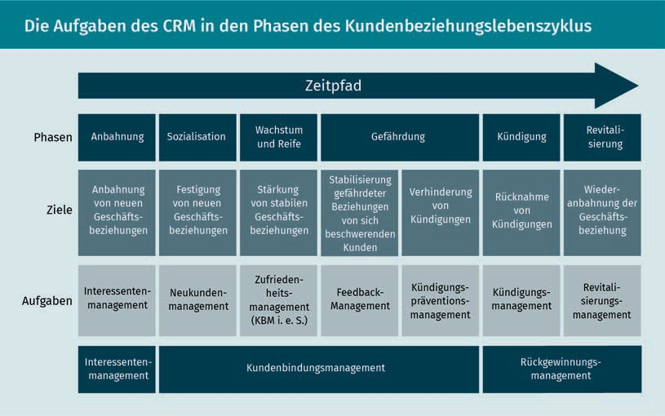

The company’s activities must be aligned with each phase in order to address the customer’s needs in that phase and thereby to establish and ensure their stable customer loyalty over the long term. However, we must not ignore the importance of considering the benefit of the relationship in the light of supply and demand, which may vary during the different phases of the relationship. Companies can clearly see the benefits resulting from these measures. In heavily simplified terms, acquiring a new customer, along with engendering a new loyalty to the company or recovering them, generates revenue from this customer. But what are the benefits for the company of forging relationships with customers across their various life phases? In addition to the purely monetary incentives, customer satisfaction and loyalty also represent important added value.

### Customer relationships considered in light of supply and demand

The supplier analyzes customer relationships to identify what is needed in order to ensure customer loyalty and what impact this customer loyalty has on demand. Does the loyal customer buy more, or does their cross-selling behavior increase? Is the customer even more confident in their decision to buy from the supplier, or do they recommend the company even more frequently, for example? Clearly the processes that shape customer loyalty need to be understood. It is only by understanding these processes that the ways of approaching the customer can be understood so as to enable the company to influence the customer relationship and ideally to retain the customer (**customer retention**) (Gröppel-Klein, Königstorfer & Terlutter 2013, 45).

Customer retention Customer retention means, on the one hand, the retention measures undertaken by companies and, on the other hand, the customer behavior patterns that generate loyalty.

On the one hand, customer retention refers to the measures taken by the company to build customer relationships, but on the other it also describes the customer behavioral patterns that inspire their loyalty to the company. Viewed in this way, customer retention is a multidimensional construct that describes both previous and intended customer behavior, as shown in the following figure (Leusser, Hippner & Wilde 2011a, 29):

The customer lifecycle and customer relationship cycle

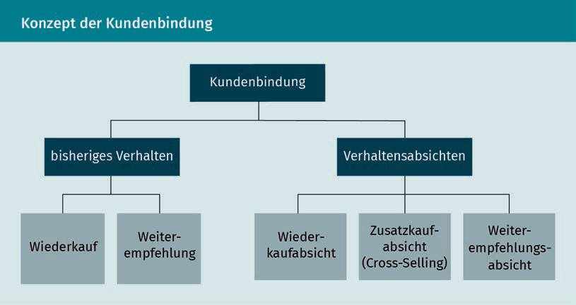

This illustrates that the customer should not only be considered in terms of their pure purchasing behavior, but also in terms of their attitudes, which can be measured by how often they recommend the company. These attitudes capture not only previous consumer behavior, but also their future intended actions (Homburg, Becker & Hentschel 2013, 109 et seq.).

Suppliers therefore try to manage customer relationships based on the insights they have gained into customer behavior, and as part of customer loyalty management, they deploy customer loyalty tools to produce positive effects for the company.

Hotel accommodation provides a useful illustration of how customer loyalty is formed from the consumer’s point of view and what effects it has over time: A business traveler arrives at a hotel for the first time. Since they are satisfied with the service they receive, they choose the hotel again the next time they visit the area. They also remember that there is a restaurant in the hotel, so they eat there on the evening of their arrival, as it saves them the time it would take to go to another restaurant. The restaurant also meets their expectations, and so the hotel becomes even more attractive in their eyes. They now actively recommend the hotel to their business partners. Unfortunately, because of a trade fair taking place in the area, they have to pay a higher room rate on their third visit, but they are still so enthusiastic about the hotel’s offering, since it fully satisfies their requirements and meets their expectations, that they are willing to pay the extra price.

A company can measure customer loyalty based on the following factors:

* Repeat purchases of products or services
* Purchase of additional services (cross-buying)
* Recommendations, or even
* Repeat purchases despite a price increase.

As the hotel example makes clear, consumer expectations play a decisive role in the development of customer retention and loyalty, but the company can also make an important contribution and take a proactive approach in customer relationships by making the right offer, providing high-quality service (reflecting customer orientation), and by meeting the customer’s needs and expectations.

Reference potential A customer’s reference potential reflects their importance as an opinion leader and decision-maker for third

parties.

It is in the interest of companies to build long-term proﬁtable relationships. On the one hand, the customer’s profitability for the company can be measured in direct monetary terms. But on the other hand, the customer is important as a supplier of information or for their **reference potential,** i.e. their likelihood to provide recommendations. Consequently, companies must find out which customer relationships are relevant here, because not every customer is automatically a long-term proﬁtable customer. Just think about how often you have purchased a product or used a service just once. And can you remember what the reasons for doing so? Was it perhaps a spontaneous purchase during a business trip because you forgot something, or perhaps your expectations were not met, your needs changed, etc.? Or perhaps you fundamentally lacked the willingness to enter into a relationship with a company at all because you only desired transactional contact (a pure sales process) with it (Bruhn 2016a, 243)? As you can see, there are many reasons for establishing or not establishing a relationship, and we are unable to provide an exhaustive inventory of them here. Viewed in this way, many relationships fail before they even begin. Or to reframe it more positively, these relationships are simply not of a nature that makes them suited to being built up and intensified.

Summary

Relationships do not automatically arise in either our private or business lives. Rather, they develop through a dynamic process. The quality and duration of a relationship depends on various factors, which can usually be determined from the conditions of the relevant personal phase of the customer’s life and their resulting needs. When considering the supplier-customer relationship, these conditions and needs, which can lead to the establishment of a customer relationship, are particularly relevant for companies to consider. When a company knows these relationship factors, they are able to develop appropriate, goal-oriented measures that allow them to actively shape customer relationships.

The customer life cycle is used as a guide for analyzing customer relationships. It helps the company to understand what needs people have in which phases of their life. The needs of a young family are significantly different than, for example, those of a couple in their prime. In addition to the customer lifecycle, the relationship between supplier and customer is also understood as a cyclical process, and it can be represented in an ideal-typical manner in the model of the customer relationship cycle, which was developed based on the

The customer lifecycle and customer relationship cycle

product life cycle. The supplier-customer relationship can be divided into three phases: the acquisition/initiation phase, the customer retention phase, and the recovery phase.

There are various tasks that CRM needs to perform within the customer relationship lifecycle, spanning prospect management, management of new customers and satisfaction, management of defection prevention, and revitalization management. In all phases of the supplier-customer relationship, the needs of the customer in that phase must be satisfied as effectively as possible by the supplier so as to maximize the goal of long-term and stable customer loyalty.

For the supplier, a stable customer relationship not only contributes to monetary success through increased profits, but it also boosts planning security, offers information advantages, and takes full advantage of the reference potential. The customer’s loyalty to the company can be measured by their repeat purchase behavior, cross-selling potential, and recommendation behavior. The customer often evaluates the benefits of the relationship with the company in terms of price advantages, reliability, and their trust in the offerings.

Since a customer relationship does not automatically arise from every transaction, and not every supplier-customer relationship becomes a long-term relationship, companies must identify the relationships that they wish to intensify through appropriate customer retention measures. The essential willingness of both companies and consumers to enter into these relationships is always a factor here.



# Unit 4

## Customer satisfaction and loyalty

#### LEARNING OBJECTIVES

After completing this unit, you will understand…

…what customer satisfaction is.

…how customer satisfaction and customer loyalty are related.

…how customer satisfaction can be measured.

DL-D-DLBCRM01-L04

1. Customer satisfaction and loyalty

### Introduction

The field of marketing pays a certain amount of attention to customer satisfaction, as customer satisfaction has already been proven to be and has long been recognized as an inﬂuencing factor on customer behavior. Customer satisfaction affects customer behavior, particularly with regard to repeat and additional purchases and recommendations by customers, but also with regard to their complaints and the possibility of their returning as a customer (Homburg & Stock-Homburg 2012, p. 19).

But what is customer satisfaction exactly? Can customers only be satisfied or dissatisfied? What facets are there to customer satisfaction? How does satisfaction come about in the first place, or how does a satisfied customer become a dissatisfied one? And also, how can a company turn an unsatisfied customer back into a satisfied one? And what role does loyalty play? Does such a thing even still exist?

There are many questions that need to be answered when it comes to customer satisfaction. When considering it, factors from both the customer’s and the company’s perspective must also be taken into account. From the customer’s point of view, these inﬂuencing factors are closely linked to customer expectations; and from the company’s point of view, there are product and service-related factors. A simple example: A customer buys an anti-dandruff shampoo and applies it. It turns out to work as expected and promised by the supplier. The customer’s expectations have been met, and possibly even exceeded, and therefore they are satisfied. If the product does not work as expected, the opposite effect is more likely to occur, and the customer will feel dissatisfied. A supplier can help boost its customer satisfaction by ensuring the quality of its products or associated services. In the case of shampoo, for example, the supplier may offer a money-back guarantee if the product does not work as expected.

### Customer satisfaction as a condition for long‑term customer loyalty

As you are probably well aware from your own experience, satisfaction and loyalty are closely linked in both private and business relationships. If you remain dissatisfied with something for a long enough time, your loyalty will weaken or even disappear entirely. Imagine that you signed up for membership of a fitness center. At first you are thrilled with the offering, equipment, and service, but then the opening hours change, then a short time later the sauna area closes, and then you can only receive trainer assistance for an extra charge. Though you were able to adjust to the changed opening hours, you were not happy about the closure of the sauna area, and you were really disappointed with the new fees. Your loyalty is lost, and you are now about to cancel your membership. If you reflect further on this example,

Customer satisfaction and loyalty

you can see that you would certainly not recommend this fitness center. From the company’s perspective, you are not only a lost customer, but also a lost ambassador! It is a double loss.

Theory assumes and practice shows that customer satisfaction is a determining factor for customer loyalty, as the example above clearly shows. There are various theories and concepts that are applied when thinking how customer satisfaction is developed. The **confirmation-disconfirmation (C/D) paradigm** is often used to operationalize customer satisfaction. Under this paradigm, customer satisfaction is understood to be the positive result “of a psychological comparison process between the customer’s expectations and the service level that they actually perceive” (Leusser, Hippner & Wilde 2011a, 30). Basically, the extent to which a customer’s expectations have been met must be measured. The customer’s expectation acts as the comparison standard (target service), which they use as the benchmark when evaluating the experience actually received whilst using the product or service (actual service). If the perceived service satisfies the benchmark, the service is confirmed as satisfactory. This is referred to as confirmation. The confirmation level of satisfaction is achieved when the perceived service and the benchmark are in absolute agreement, i.e., when the customer’s expectations of the service match the actual perception of the service. If the customer’s expectations are exceeded, then this is called positive disconfirmation; if the expectations are not met, this is negative disconfirmation (Homburg & Stock-Homburg 2012, 19 et seq.). To put it a little more simply: If the customer perceives an offering positively and sees that their expectations are fulfilled or exceeded, this creates customer satisfaction. The fact that customer satisfaction has a long-term effect on customer loyalty has long been accepted (Bruhn 2016a, 242).

Conﬁrmation-disconfirmation paradigm

The confirmation-disconfirmation paradigm describes the process by which customer satisfaction is created.

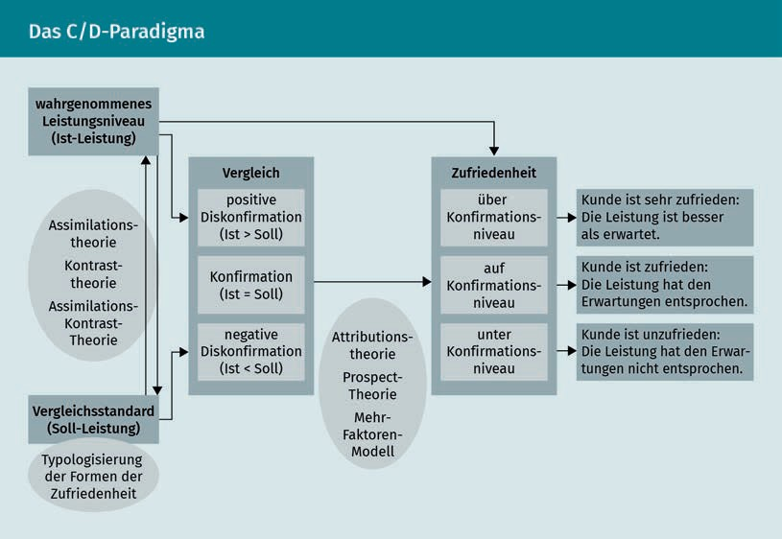

The C/D paradigm presented here should be understood as an integrative framework that can be used to classify additional and more specific approaches that help to explain customer satisfaction. These more specialized approaches include assimilation theory, contrast theory, and assimilation-contrast theory, among others. These theories shed light on the subsequent changes in the benchmark and/or the perceived service in the event of a discrepancy between the target and actual service. The focus here is, therefore, on the change in the benchmarks over time. Additional in-depth models deal with the connection between the fulfillment of expectations and the level of satisfaction. Attribution theory, combined with the multi-factor model of customer satisfaction, shows that the relationship between expectation fulfillment and satisfaction is influenced by subjective perception and the type of service (Homburg & Stock-Homburg 2012, 23).

In addition to the question of how customer satisfaction can be evaluated, the consequences of customer satisfaction or dissatisfaction for a company or for customer loyalty must also be clarified. In addition to equity theory, learning theories and risk theories can also be applied in this context. Homburg and Stock-Homburg summarize the basic propositions of these theories as follows (2012, 37):

Customer satisfaction and loyalty

* Equity theory focuses on the fairness of exchange relationships. It is assumed that satisfaction ratings are based on the interpretation of fairness regarding the costs invested in a transaction/business relationship and the resulting benefits.
* Instrumental learning theory assumes that behaviors are learned by the customer on the basis of rewarding (satisfaction) or punishing (dissatisfaction) previous behavior. Satisfaction leads to an increase in the previous behavior (loyalty), while dissatisfaction leads to a reversal of the behavior (e.g., change of supplier).
* Social learning theories are based on the assumption that customers learn behaviors by observing reference persons. If the customer observes loyal behavior, then the customer adopts this behavior and also behaves loyally.
* Risk theory assumes that the customer tries to minimize the perceived risk. One situation that is compatible with these theories is when customers are loyal to a supplier whose services they have been satisfied with in the past.

Regardless of which theory is applied, the goal is to determine the extent to which customer satisfaction influences customer loyalty and can thus, for example, help motivate customers to buy products from the company more frequently as a result of higher satisfaction (repurchasing behavior) or show a preference for the company’s new or other products when making purchasing decisions (cross-buying). Their positive attitude also means they will also be happy to recommend the company to others. It is also assumed that loyal customers are willing to accept higher prices.

### Measuring customer satisfaction

In addition to understanding the inﬂuence of customer satisfaction, we also need to determine what options are available for measuring customer satisfaction. There is a large number of approaches available, and they can be roughly divided into objective and subjective methods. While the objective methods relate to monetary variables such as revenue and profit or market share, the focus of the subjective methods is on recording the satisfaction felt by the customer. In the case of subjective methods, a distinction is made between event-related and feature-related methods. The event-related methods only take one or more specific event(s) into account. An event in this context is understood as every time a customer comes into contact with the company. For example, events such as the customer contacting the service department with an inquiry about the product they purchased or a complaint, set-up question, etc. are taken into account, and the customer’s satisfaction with this specific event in particular is scrutinized. This is why this approach is also called the spot approach. This approach may be appropriate for evaluating certain events and then improving them. However, the approach is not particularly able to provide a more comprehensive determination of customer satisfaction, which needs to also take other points of contact with the customer (**customer touchpoints**) into account (Fürst 2012, 127 et seq.). It is only able to produce a selective image of the customer as opposed to a single customer view.

Customer

touchpoints

This term designates all points and interfaces that a customer uses to contact a company.

Conjoint analysis The conjoint analysis approach is an indirect survey that is used to analyze the importance of various factors that influence purchase decisions.

Characteristic-based methods are able to measure customer satisfaction more comprehensively, and they can be divided into implicit and explicit methods. Fürst explains that the implicit procedures are based on determining perceived service deficits through an analysis of customer complaints. However, since various studies show that not all dissatisfied customers actually complain to the company, the findings from this analysis method should be viewed critically (Fürst 2012, 128).

Methods that question customers directly concerning various aspects of customer satisfaction are more suitable than those that just ask a one-dimensional query concerning a single aspect (e.g., satisfaction with the service). A multi-attribute (multi-dimensional) measurement that assesses direct satisfaction is a highly valid and widespread form of measurement. In contrast to other multi-attribute methods, this form of measurement does not compare service assessments before and after purchase or measure expectations separately (Fürst 2012, 129). A careful data collection system process needs to be designed before the measurement is implemented and the data generated is analyzed. Care must be taken to ensure that the measurement results are valid. The overall customer satisfaction (customer satisfaction index, CSI), i.e. the mean of the indicators used in the survey, is rated on a scale. The higher the CSI value, the greater the customer satisfaction. In order to identify explanations for the level of CSI determined, and thus also the basis for possible courses of action to improve customer satisfaction, it is useful to look at the CSI in a more differentiated way. According to Fürst, the following differentiation criteria may be considered (Fürst 2012, 139):

* Customer type (private individual or corporate customer)
* Socio-demographic characteristics of the contact person
* Regional place of origin of the customer
* Position of the contact person
* Customer industry, and
* Customer value (economic importance of the customer from the supplier’s point of view).

One weakness of this approach, however, is that customers do not attach the same importance to all areas, and what is considered relevant for customer satisfaction varies. Further evaluations e.g., using multiple regression analysis, causal analysis, or **conjoint analysis** can provide important insights in order to initiate appropriate improvement measures (Fürst 2012, 142).

Generally speaking, what is clear is that the methods for surveying customer satisfaction must be chosen carefully, and evaluating the results should not only be based on the CSI but should instead always be connected to an assessment of the importance of the various inﬂuencing factors.

Customer satisfaction and loyalty

### Achieving customer loyalty through customer satisfaction

It is assumed that customer satisfaction has an effect on customer loyalty. However, there is

dispute as to whether the connection is linear or non-linear. Regardless of which camp you belong to, however, everyone acknowledges that the relationship between customer satisfaction and loyalty is shaped by various inﬂuencing factors, such as the market environment, product, the type of business relationship, and also the actual customer, and that these serve to strengthen or weaken this relationship (Homburg, Becker & Hentschel 2013, 121 et seq.).

A loyal customer can be recognized by the fact that they take repeated advantage of the company’s offerings, i.e., they demonstrate regular follow-up and repeat purchasing behavior, as well as by the fact that they recommend the company to others. In this context, another important concept is that of the regular customer, i.e., a loyal customer with a customer-company relationship that can be described as long-term. From the customer’s point of view, customer loyalty only arises when the customer can see a benefit to the relationship with the supplier. This consists not only in the customer satisfaction demonstrated, but also in the **“**customer value**”** that is perceived from the customer’s point of view. The customer value describes the value that the customer attaches to the relationship with the company, e.g., the perceived good value for money or the consistent quality of the company’s offerings. At the same time, customer loyalty is not only influenced by rational considerations. It is also shaped by habitual factors, such as convenience, lack of information about alternative offerings, or risk aversion (Schumacher & Meyer 2004, 30 et seq.).

However, customer loyalty is not predominantly characterized by these chance coincidences, it can also be evaluated in close connection with the degree of customer satisfaction. The more satisfied the customer, the more loyal they are. A neutral area exists in customer assessments and perceptions of satisfaction and dissatisfaction, and in this area not much can be done to sway customer loyalty either way. This is also known as the “zone of indifference” between customer satisfaction and customer dissatisfaction. The perceived actual service in this area largely corresponds to the expected target service, and there are no strong deviations from this expectation in either a positive or negative direction (Schumacher & Meyer 2004, 31).

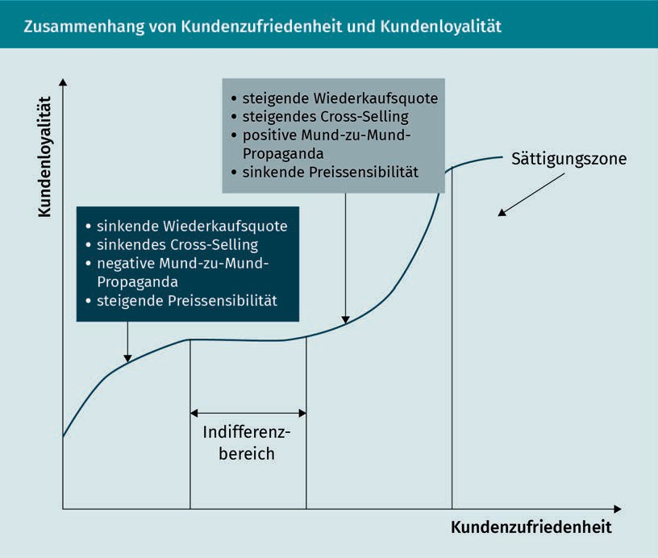

Customer loyalty can be established even in this situation. Loyal customers can be addressed even more intensively with attempts to retain them in order to create a commitment between the company and the customer that is not only based on rational inﬂuence factors, but also on an emotional bond.

### Creating customer satisfaction and loyalty

The transition to digital technologies has inﬂuenced marketing in various ways. Current information and communication technologies have allowed for greater transparency, especially with regard to the opportunities for generating knowledge about the market or customers. Companies can reach and also interact with customers via various new channels. At the same time, customers are able to easily obtain comprehensive information about the offerings on the market, to compare them, and to find out the opinions of other customers. The credibility of this information and how it is perceived has been discussed from different perspectives, and critical observers assume that the level of trust in this information has decreased. These developments have also inﬂuenced customer loyalty, which seems to have lost its importance for the customers themselves. It is therefore conceivable that the loss of trust in information conveyed through media could cause the customer’s own experiences to become more important to the establishment of trust

Customer satisfaction and loyalty

in the future, and identity to play an important role in the market- and customer-orientation of companies. Trust in a company is also in part dependent on ensuring that the customer does not feel exploited, instead experiencing the company’s actions in such a way that they feel their own needs are heard and addressed. It is certainly not an easy undertaking for companies to meet the customer’s expectation of not being exploited. Loss of trust can result from the company’s handling of customer data, which companies should proactively reduce (Kenning 2018, 91 et seq.).

The counterpart to the satisfied customer is the dissatisfied customer. Measures, such as a well-organized complaints management system, should be put in place to prevent dissatisfaction from arising in the first place. **Complaint management** begins with the customer’s ability to contact the company; this contact channel should not only be advertised as a communication channel for complaints, but also as a way for customers to offer praise and suggestions. It is important that the company offer contact and interaction options that facilitate dialog with the customer. This enables the company to respond to both complaints andpraise and recognition at an early stage. The possible negative effects of complaints can often be mitigated and intercepted with an appropriate and timely reaction, minimizing or even avoiding complaint costs. In addition, companies must learn to recognize that complaints and suggestions always contain important information that can be used to improve service and product quality (Lucca et al. 2015, 108).

In addition to complaint management, employees within a customer-oriented company must also be encouraged, and even required, to have a customer orientation in their actions, since a high level of customer orientation on the part of employees has a guaranteed positive effect on customer satisfaction. Customer-oriented approaches include two dimensions: customer-oriented attitude and customer-oriented behavior. Viewed in this way, customer orientation takes place in the mind, since it is an attitude, but it is also expressed in the behavior of the employee exhibited towards the customer. And this behavior, such as, for example, friendly interaction, service orientation, or helpfulness, is what the customer perceives. Of course, the customer can also perceive unfriendly service, incompetence, or a lack of accommodation on the part of the company. No matter how customer-oriented the mindset may be, if the customer does not experience it positively, it will not have a positive influence on the customer’s attitude towards the company (Stock-Homburg 2012, 277).

Price fairness and **customer integration** are seen as additional opportunities for the company to have a positive inﬂuence on customer satisfaction. Interestingly, relatively little attention is paid to the importance of price as an indicator of customer satisfaction from the standpoint of fostering customer satisfaction. The main focus is usually on the service dimension, i.e., the question of whether the product meets the needs of the customer, rather than on the question of whether the price is perceived as reasonable. Though we do not have space to delve into this subject in detail here, the success of major discounters, such as Aldi or Lidl in particular, shows that customers perceive good value for money to be a great benefit (Hermann et al. 2012, 301). Customer

Complaint management

Complaint management encompasses all of the measures that a company takes when it receives a customer complaint.

Customer integration Customer integration is the involvement of the customer in a company’s service provision or innovation process.

integration can begin at various points of contact between companies and customers. Essentially, customer integration seeks to proactively involve the customer in the company. This involvement should go beyond merely stating the customer’s needs and should actually inform the company’s decisions. Customer input can be incorporated into product development or even into an innovation process. When exploring the experience of how customers can be integrated into innovation processes, it was found that involving customers helps ensure that the design of the product addresses customer needs. At the same time, it was found that customers who are involved in the innovation process have greater satisfaction (Piller 2012, 397 et seq.).

Companies can actively ensure that they are perceived positively and increase customer satisfaction at various customer touchpoints. As the different areas make clear, however, a certain amount of attention must be paid to ensuring that the company has a comprehensive customer orientation, which not only forms an integral part of the mindset of management and employees, but which can also be experienced directly by the customer.

Summary

Customer satisfaction is inﬂuenced by various factors that both the customer and the company need to consider. From the customer’s perspective, customer satisfaction is closely related to expectations about the product or service. Customer satisfaction is therefore also framed as a process of comparing expectations with the actual perception of a service. If the service received meets expectations or even exceeds them, this is referred to as “confirmation” or “positive disconfirmation”. If expectations are not met, this is referred to as “negative disconfirmation”. The confirmation-disconfirmation paradigm is understood as an integrative framework that can be used to understand more in-depth approaches to customer satisfaction.

For companies, it is important to explore not only customer satisfaction, but also the consequences of customer satisfaction. There is a consensus that customer satisfaction has a decisive inﬂuence on customer loyalty and retention. This, in turn, has an inﬂuence on the repeat purchase behavior, cross-selling potential, or recommendation behavior of customers.

Various methods are available for measuring customer satisfaction, which can be roughly divided into objective and subjective methods. In the subjective processes, a distinction is made between event-related and feature-related processes, which attempt to record the customer’s perceived level of satisfaction. Multi-attribute measurements of customer satisfaction, which can be used to help draw a holistic picture of the customer, appear to be the most suitable. Customer satisfaction is recorded as a CSI value: The higher this value, the higher the customer

Customer satisfaction and loyalty

satisfaction. However, this value should not be used as the sole indicator of customer satisfaction. Rather, other known influencing factors should be taken into account when interpreting it (e.g., industry or socio-demographic background).

The inﬂuence of customer satisfaction on customer loyalty is undisputed. The particularly interesting question is what this customer satisfaction means for the buying behavior or recommendation behavior of the customer. While satisfied customers have higher repeat purchase rates or greater cross-selling potential, the opposite effects occur for dissatisfied customers. Given that the curve that illustrates customer loyalty in relation to customer satisfaction is saddle-shaped, it can be assumed that between the ranges of the more dissatisfied customer and the satisfied customer exists the phase of the indifferent customer, in which neither positive nor negative influences on the buying behavior can be identified.

Although customer satisfaction is a very subjective construct from the customer’s point of view, companies have various opportunities to positively influence customer satisfaction and thus create loyalty. Customers are not the only ones that can use modern information and communication technologies to their benefit. The same technologies also offer companies great opportunities to enter into dialog and interact with customers in order to build long-term trust. It is also possible to generate knowledge about customers, recognize dissatisfaction, and use this knowledge proactively to take appropriate measures to maintain or restore customer satisfaction. Complaint management is particularly important here in order to prevent customers from becoming dissatisfied in the first place.

Since it is undisputed that customer-oriented employees have a positive influence on customer satisfaction, the company must make this customer orientation a requirement, but it can also adopt measures to promote it. This is important because the company not only needs to integrate such an idea into the minds of the employees, it also needs to create the framework that will allow employees to behave appropriately towards customers. The company needs to do more than merely pay lip-service to a customer-orientation in order to enable it to positively impact customer satisfaction.



# Unit 5

## Customer loyalty management

#### LEARNING OBJECTIVES

After completing this unit, you will understand…

… the benefits and effects of customer loyalty management.

…what recognized strategies are available.

…what tools can be used.

DL-D-DLBCRM01-L05

1. Customer loyalty management

### Introduction

Customer loyalty is not a new topic, and the question of customer repeat purchasing behavior has also been considered in academia for at least 100 years. The perspectives on the debate have changed over time. Since the 1990s, the need for companies to assume a customer orientation has been increasingly emphasized, and the terms “customer loyalty management” and “customer relationship management” (CRM), which is the term used in practice, have been coined (Homburg & Bruhn 2013, 7). Accordingly, there is significant interest in achieving a high level of customer loyalty. In order to ensure the success of this approach, attempts have been made to identify the various determinants of customer loyalty. As a result of numerous studies, satisfaction, quality, commitment, and trust have been identified as success factors. However, we must critically examine whether these factors still affect customer loyalty to the same extent in the current market environment (Grohmann, Heumann & Wangenheim 2013, 83). Below, we will demonstrate…

* + …what thinking in terms of customer relationships means
  + …why a customer loyalty management system should be established, and
  + …what tools are available for marketing.

### Benefits and effects of customer loyalty management

“Customer loyalty is understood to mean all psychological awareness processes or observable behavior of the customer in which the customer maintains or intensifies their relationship with the company as a result of certain factors that determine their loyalty” (Bruhn & Georgi 2013, 679).

Following this very comprehensive definition of the terminology, we now need to investigate what conceivable reasons make customers willing to commit themselves to a company. When it comes to these causes, a distinction is often made between habitual, voluntary, and involuntary loyalties, which, for example, Meyer and Oevermann have subdivided into five further aspects (see Homburg & Bruhn 2013, 11):

* + Situational causes of loyalty
  + Contractual causes of loyalty
  + Economic causes of loyalty
  + Technical-functional causes of loyalty, and
  + Psychological causes of loyalty.

It should hardly be necessary to point out that voluntary or **habitual loyalties** are preferable to involuntary ones. The opportunities afforded by customer relationship management are deployed by customer-oriented companies to enable them to actively shape these relationships. Customer

Customer loyalty management

loyalty management systematically analyzes and plans the measures required to approach potential and current customers with the aim of establishing, maintaining, and intensifying relationships. Customer loyalty management is also responsible for implementing and monitoring these measures (Homburg & Bruhn 2013, 8). Customer loyalty management is primarily concerned with the **endogenous causes of loyalty** (e.g., customer satisfaction or barriers to switching) and attempts to inﬂuence these in the interests of the company. Of course, it is in the interests of the company to derive economic benefit from the customer, such as, for example, by concluding long-term contracts. However, companies must strive for long-term customer loyalty, in particular through achieving customer satisfaction (Bruhn & Georgi 2013, 679). This approach is based on the view that customer satisfaction leads to higher customer loyalty and thus the economic success of the company. Even if this approach appears theoretically very plausible and the connection between customer satisfaction and economic success has been shown in various studies, it must be pointed out that this is not a universal law. It is therefore advisable in all cases to review customer retention activities in terms of their profitability (Bruhn & Georgi 2013, p. 679 et seq.).

Customer loyalty, understood as a psychological construct, can be seen as a sense of connectedness to a person or a company, but also as an obligation. Customer loyalty is therefore also differentiated into connectedness and commitment. The loyalty is not necessarily positive, since it can also have negative aspects if a loyalty that is assumed to be voluntary is transformed into a feeling of involuntary commitment, which tends to have negative connotations. Think of customer contractual ties to companies like mobile phone service providers. As long as you are satisfied with the arrangement, this is not a problem. But if something bothers you, the offering no longer suits you, or other reasons cause you to be dissatisfied, you may not be able to cancel the contract or you may be left committed to the company until the end of the contract period.

|  |  |
| --- | --- |
| Behavioral effects: connectedness vs. commitment | |
| Connectedness | Commitment |
| Voluntary customer loyalty that is shown to be positive and based on customer satisfaction and the quality of the relationship as well as commitment to the company | The future freedom of choice of the customer (both positive and negative) is restricted |

It is not only contracts and their terms that inﬂuence customer loyalty. Customer loyalty may also vary depending on the product, because it is determined by various factors. It is also questionable whether something

Habitual loyalties

Habitual loyalties are those loyalties that arise on the basis of habits.

Endogenous causes of loyalty

These are the causes of loyalty that can be traced to external influences and can be described as “determined by the consumer”, such as, e. g., customer satisfaction.

like customer loyalty exists at all for products like deodorant, yogurt, etc., since these are low-involvement products, or whether customer loyalty can only be built up with higher levels of involvement.

Numerous studies have identified the following success factors as responsible for these relationships:

* + Service quality: Relates to the quality of objectively and subjectively perceived characteristics
  + Service value: Price can be understood as the level of sacrifice required or from a best value for money perspective
  + Trust: Willingness to rely on the product/service
  + Commitment: Emotional connectedness
  + Relationship quality: Trust and familiarity, and
  + Satisfaction.

In the context of customer loyalty management, these factors create customer loyalty or reinforce it. Real customer loyalty is characterized by attitudinal and behavior-related components, i.e., perception on the one hand, and actual behavior on the other (Grohmann, Heumann & Wangenheim 2013, 83 et seq.).

When looking at customer loyalty, it often seems like the customer is a very strange being and that some customer behavior does not always appear logical and understandable. Many customers remain loyal to a bank over the long term even if they are not always satisfied, because switching to another bank involves assuming the risks of uncertainties or costs. In this case, the customer has a high level of behavioral loyalty despite a possibly low attitudinal loyalty (Grohmann, Heumann & Wangenheim 2013, 93). The causes are cognitive, affective, and dispositional aspects that vary significantly depending on the individual person, i.e., the rational perception, the emotional feeling, and the specific intention triggered to buy and act that precedes the behavior.

Customer loyalty management is based on the insight that systematic customer loyalty contributes to the economic success of the company. Since customer loyalty is a very complex construct and the development of customer loyalty depends on various factors, customer loyalty management must take these requirements into account in particular in order to be able to achieve the goal of building, maintaining, and intensifying customer relationships.

### Customer loyalty strategies

Customer loyalty strategies are closely linked to considerations arising from the customer life cycle or customer relationship life cycle, i.e., the cycle in which the customer’s (possible) relationship with the company exists. The customer relationship cycle can be divided into the acquisition/initiation phase, the customer discovery phase, and the recovery phase. Examining the customer journey,

Customer loyalty management

which a key element of customer loyalty, is also important when it comes to customer loyalty management. The **customer journey** tries to represent the customer’s points of contact and touchpoints with the company, from the creation of a need to the search for information about the purchase and beyond. The stages that the customer goes through before making a purchase decision can be very short or very long, or they can even be skipped altogether. It is important for companies to generate as much knowledge as possible about what information the consumer needs at the various stages in order to be able to initiate appropriate measures. While the focus is initially on attracting attention in order to arouse interest, this interest must then be served in order to help the customer make a purchase decision. And once the purchase has been made, it is important to reinforce the customer’s decision. Viewed from this perspective, we can see that this is where customer loyalty management comes in.

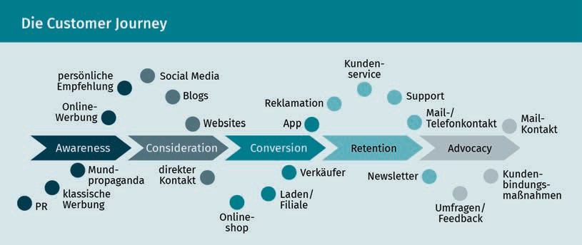

Let’s return to the customer relationship life cycle. Since companies act and address customers differently during the various phases of this customer relationship life cycle, customer retention strategies may also be considered in relation to these phases. In the customer acquisition phase, for example, it is all about encouraging and winning over the customer. The retention phase focuses on fostering connectedness and a sense of commitment to the company. Recovery strategies include measures to make amends to the customer or improve the offering, and should the relationship be terminated, a distinction is made between hidden and open termination (Lucco et al. 2015, 98; Bruhn 2016c, 145).

Concrete measures are then derived from the various customer loyalty management strategies. Here, the company needs to clarify which customers must be retained (e.g., based on a certain customer value), how the retention should be implemented (geographically, technically, or economically), what tools can be used (e.g., customer card, bonus system, exclusive and outstanding service), how often and at what point in time customers should be addressed, who may be useful partners (e.g., transport companies and event organizers), and what specific services or types of added value are offered to the customer (e.g., conversion of bonus program points into benefits in kind, upgrades, etc.) (Lucco et al. 2015, 107).

Customer journey This term describes the customer’s path from the first contact with the company/product to the purchase and subsequent contact points.

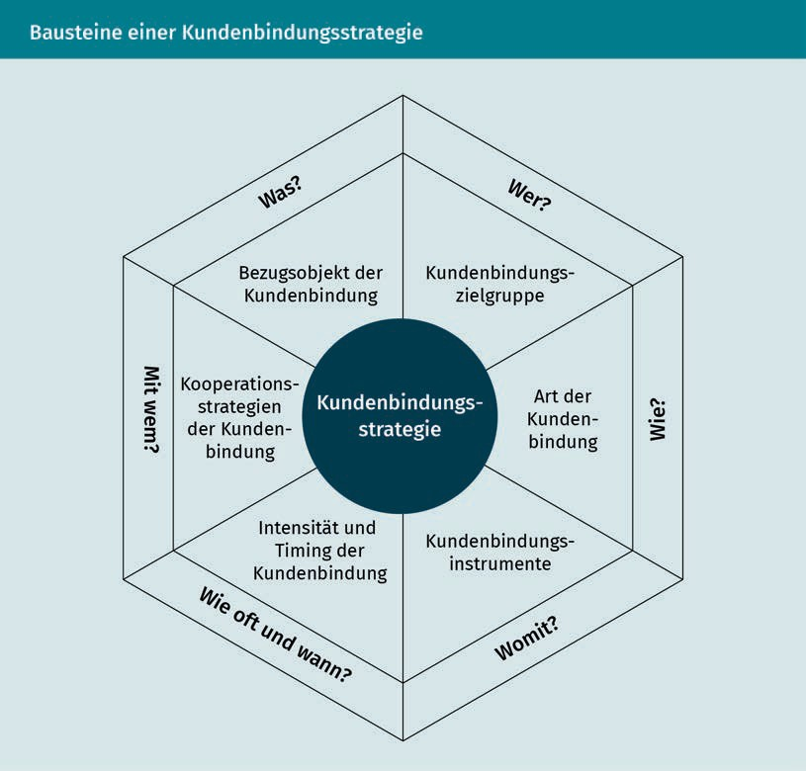

As mentioned several times above, the ultimate purpose of the customer retention strategies and measures is to contribute to the company’s economic success. If we now look at the chain of effects of customer loyalty (as is clearly shown in the following figure), we can once again clearly see that it is the result of a complex process.

Customer loyalty management

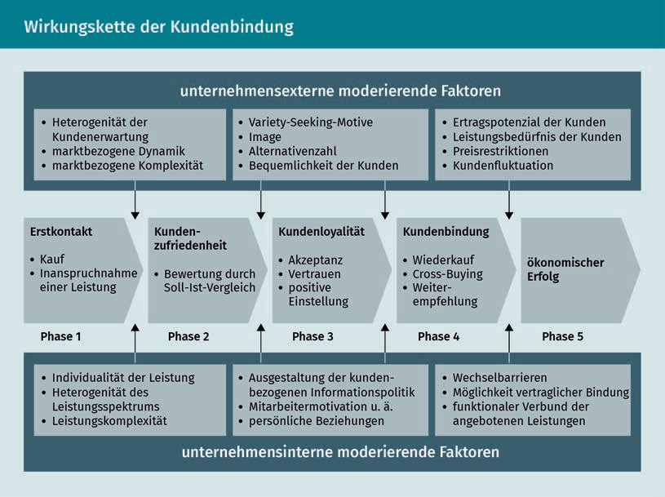

This chain of effects represents the ideal-typical sequence, and it cannot be assumed that every customer will go through all of the phases and that they will automatically become a loyal customer. We do not have room here to discuss in detail all the reasons why and where the chain of effects might be interrupted, but we should be aware of the fact that the supplier-customer relationship is not carved in stone. On the contrary, it is a rather fragile construct.

### Customer loyalty measures and tools

When selecting the tools to use in customer loyalty management based on the different retention phases, it is important to consider...

* …what tools can be used to acquire new customers
* …how customers can be retained
* …how to retain or recover customers who have churned or are about to terminate their relationship with the company, and
* …what is the most appropriate way to end a relationship.

In marketing, the three phases of a customer relationship are also known as the 3Rs, i.e. **recruitment**, retention, and recovery. Bruhn therefore recommends aligning the marketing tools with these 3Rs as part of the company’s relationship orientation.

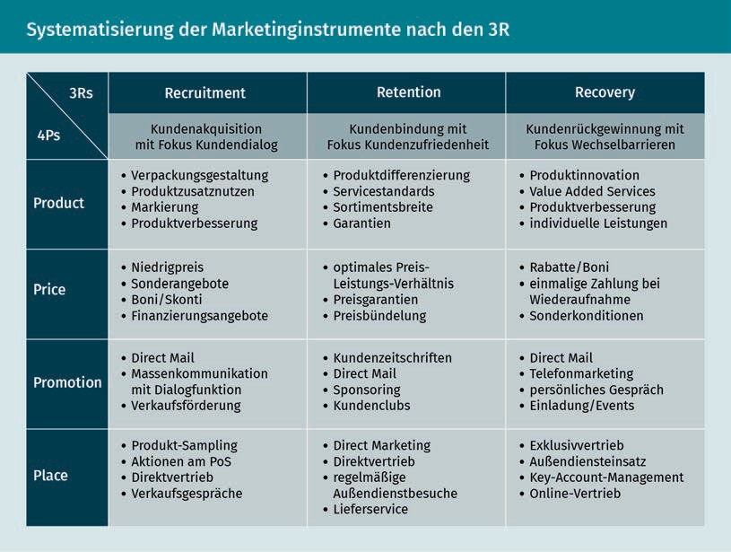

Recruitment Recruitment, i.e., the acquisition phase, encompasses all measures related to customer acquisition.

During the acquisition (recruitment) phase, the focus is on promoting interaction and dialog through appropriate tools, since it is assumed that this will increase the success of acquisition measures (Bruhn 2016b, 32). During this phase, it is important to create incentives and turn potential customers into new customers. Motivational strategies that attempt to persuade the customer to make a purchase by creating incentives, such as offering price discounts, special offers, or competitions, are useful here. Online or offline campaigns that convey appropriate messages can be used to achieve this. The counterpart to motivation is persuasion. The persuasion strategy relies on argumentation. This strategy can be put into action at the point of sale, for example, by offering trial services or the opportunity to test products, and testimonials are also highly effective here (Lucco et al. 2015, 98 et seq.). Although these factors cannot be directly influenced by the company, their importance is once again made clear in the context of the company’s strategic considerations as well.

In the retention phase, the aim is to increase customer satisfaction using suitable tools. Companies often make use of measures such as customer clubs, customer cards, or customer magazines (Bruhn 2016b, 32). Customer clubs, such as the Ikea Family Card or the Media Markt Club Card, for example, offer members attractive added value in the form of discounts, exclusive offers, benefits, loyalty gifts, or services, such as delivery and installation services at club prices. In the retention phase, a distinction is made between the commitment strategy and the connectedness strategy. The commitment strategy aims to ensure that the customer does not switch to another supplier. A distinction is made between:

Customer loyalty management

* Economic loyalty (e.g., achieved using rebate systems, customer cards, etc.)
* Contractual loyalty (e.g., achieved using contractual periods)
* Technical or functional loyalty (e.g., incompatibility with other offers), and
* Geographical loyalty (dependence on a special supplier due to spatial proximity/accessibility: e.g., the baker “round the corner”) (Lucco et al. 2015, 100).

When pursuing a loyalty strategy, however, companies should emphasize the voluntary nature of the relationship and try to ensure that the customer identifies with the company and its offerings in such a way that it does not even occur to the customer to think about changing providers. This is also often referred to as “real” customer loyalty. This type of emotional bond can be established by offering customer-specific services (**customization**). These services contribute to a sense that the customer’s expectations are being more than met and help foster a sense of trust in the supplier (Lucco et al. 2015, 100 et al.).

Finally, the recovery phase deploys appropriate measures to try to retain dissatisfied customers, those wishing to defect, or customers who have already churned (Bruhn 2016b, 32). But what action should be taken if the customers are already on the verge of leaving or have already ended the relationship with the company, i.e., are no longer customers? This is often a gradual process. The customer buys a service, finds it satisfactory, uses it frequently to begin with, but then they use it much less over time or stop using the service completely. Let’s consider a practical example: You ﬁnd a new ice cream parlor, are enthusiastic about the selection, go there regularly at first, but eventually your interest wanes and you forget about the ice cream parlor again. There can be a wide variety of reasons why an offering that was initially perceived as very good loses the interest of the consumer. And it may not necessarily have anything to do with the customer changing their basic opinion of the offering. In the example of the ice cream parlor especially, many possibly relevant factors are immediately apparent: The summer weather started out well enough, but then got worse and worse. The customer decided to start a diet, or moved to another part of the city and therefore does not pass by the ice cream parlor anymore. These are just a few of the many possible reasons, but they illustrate that it is important to identify why the customer churned so that the company can initiate appropriate measures to recover them. If the customer is dissatisfied with the offering, it can help to compensate them or improve the product. However, it is also important to analyze whether it is worth investing in a customer who wishes to defect from the company or has already churned. Consider another example: You are a supplier of plastic bottles to a drinks supplier, which is now switching to glass bottles. Clearly it would be fruitless to try to recover this customer. The recovery process should therefore always be structured as follows (Lucco et al 2015, p. 102 et seq.):

Customization

The adaptation of a product to suit individual customer interests is referred to as customization.

Return on regain

investment A metric that measures the return on each dollar invested in recovering a customer.

* A recovery analysis (analysis of the reasons for customer dissatisfaction or defection and determination of the customer’s value)
* Recovery activities (e.g., rectification, price reduction, additional services, etc.), and
* Recovery monitoring (the company must clarify whether the expenses were worth it through a calculation of the **return on regain investment**).

Despite all efforts made to ensure customer loyalty to the company, there will always be situations where a relationship ends. As already mentioned, the reasons for this do not necessarily have anything to do with the company’s product range, but can in fact often be explained by a change in customer’s needs. Fundamentally, a distinction is made between indirect and direct dissolution of customer relationships. When a relationship is ended for reasons that are not explicitly stated, this is described as indirect. This indirect termination may be initiated by either the customer or the company if, for example, the customer is reclassified as no longer profitable. Conversely, a direct termination is understood as one that is openly announced, which can be either amicable or not (accompanied by an accusation of blame).

|  |  |  |
| --- | --- | --- |
| Strategies for ending customer relationships | | |
|  | Customer-oriented | Company-oriented |
| Indirect | “Fading away” | “Cost escalation” |
| (dissolution of the customer | (dwindling end to the relationship, | (search for |
| relationship is not | letting it | a path towards “re-profitability”, |
| explicitly announced) | die) | signaling) |
| Direct | “Mutual state of the | “Fait accompli” |
| (dissolution of the customer | relationship talk” | (ending of the relationship |
| relationship is | (consensual | without compromises or possibly with |
| explicitly announced) | conversation) | accusations) |

When a (business) relationship comes to an end, it is advisable for the parties

to separate amicably. This is about more than just safeguarding the good feelings of the partners. Imagine terminating a contract with your gym early because of a surprise move to another city. The operator offers to accommodate you, and it does not insist on continued payment of the membership fees in accordance with the contractually agreed notice period for early termination. What impact do you think such a positive experience will have on you? You would certainly recommend this provider to others even after ending your relationship with them, whereas if your experience is negative, this would probably not be the case.

Customer loyalty management

And apart from the effects of positive word-of-mouth recommendations, you can never rule out the possibility that the other party will not resume a terminated supplier-customer relationship, just as with relationships in your private life.

Summary

Customer loyalty, understood as a psychological process by which the customer develops a conscious preference or as the observable behavior of customers, is quite simply the outcome of the interaction of various inﬂuencing factors that prompt the customer to establish, maintain, intensify, or conversely to end a supplier-customer relationship. There are various well-known causes, e.g. contractual commitments, economic or technical-functional reasons, that have an inﬂuence on customer loyalty. The task of customer management is to have a positive influence on the creation, maintenance, and intensification of customer loyalty and to proceed analytically and according to a plan in order to enable goal-based measures to be derived. Trust, commitment, quality, and satisfaction are identified as success factors that help to cement customer loyalty, since they bring about or promote customer loyalty through targeted customer management. When looking at the reasons that engender customer loyalty, it also becomes clear that they are often highly individual cognitive, affective, and dispositional aspects that customer loyalty management must take into account.

Customer loyalty management is also based on the customer relationship lifecycle, or the cycle by which the customer comes into contact with the company, is retained, and becomes loyal to it, or conversely, potentially ends the relationship with the company. Appropriate strategic approaches are available during the customer acquisition, customerretention, and customer recovery phases, as well as during the relationship termination phase, from which measures tailored to the situation and target group can be derived. Bruhn has systematized the marketing tools in line with the 3Rs (recruitment, retention, and recovery), which show what tools can be used from a relationship-oriented perspective. During the acquisition phase, the focus is on motivation and interaction, the retention phase is designed to increase customer satisfaction, the recovery phase targets customers who have expressed a desire to defect or have already churned, and in the termination phase the relationship should be concluded “on good terms”. All of the areas have one thing in common: the goal of retaining customers over the long term and promoting the economic success of the company.



# Unit 6

## Customer value and customer portfolio management

#### LEARNING OBJECTIVES

After completing this lesson, you will...

…be aware of different methods for customer valuation.

…understand the significance of customer portfolios.

…know what one- and two-dimensional customer segmentation means.

DL-D-DLBCRM01-L06

1. Customer value and customer portfolio management

### Introduction

Is it not enough just to have customers? Why is it important to calculate the customer value at all? Customers must be acquired, retained, or recovered, that is the main task of CRM. But all of these measures must be performed efficiently, and they must be worthwhile. Investing in the “wrong” customers provides little benefit to the company over the long term. Imagine you are a manufacturer of plastic bottles. A beverage manufacturer is terminating its contract with you, not because they are dissatisfied, but because they have committed to using glass bottles in the future. Measures to recover the customer will simply not bear fruit here. Of course, this is an extreme example, but also one that clearly shows how important it is to check whether it is sensible to continue investing in a customer. The customer value can serve as a general guide here. To put it simply: It is only worth investing in a customer if they can potentially be identified as a long-term proﬁtable customer. But what exactly is customer value, and how can this customer value or the value of the customer relationship be determined?

### Basics of customer valuation

Customer value represents an important point of orientation for companies when it comes to their CRM activities. In order to promote the economic success of the company by assuming a long-term customer orientation and promoting loyalty, not only does the company have to collect a great deal of information about its customers, but it must identify the customers or groups of customers that it is worth investing in through CRM activities. In purely business terms, these are the customer groups from whom a positive contribution margin can be generated both today and in the future (Leusser, Hippner & Wilde 2011a, 28).

Customer value The customer value is the net benefit that the customer derives from a provider-customer relationship.

The **customer value** can be viewed from either the customer’s or the supplier’s perspective. The concept of customer value, a widespread idea in this context, refers to the customer’s point of view and includes the net benefit that the customer attributes to a business relationship. This customer benefit is the benefit actually perceived by the customer, e.g., due to the good value for money or the quality of an offering. Customer value must be distinguished from customer satisfaction, which can be viewed as a process of comparing expectations and the actual perception of the service. Customer satisfaction is also an important component of customer loyalty, which too can be understood as a reflection of customer benefit. From the supplier’s point of view, customer value is understood as a customer’s contribution to achieving the company’s goals, both monetary and non-monetary (Günter & Helm 2011, 274). When valuing customers from the supplier’s point of view, the relevant frame of reference must always be taken into account. It must be clarified whether the entire customer relationship, a single customer group, a specific customer segment, or an individual customer relationship should be looked at and

Customer value and customer portfolio management

valued. The time frame is also relevant. Is the company concerned with actual values, i.e., the current state, or about potentially expected (future) value contributions from customers (Günter & Helm 2011, 274)?

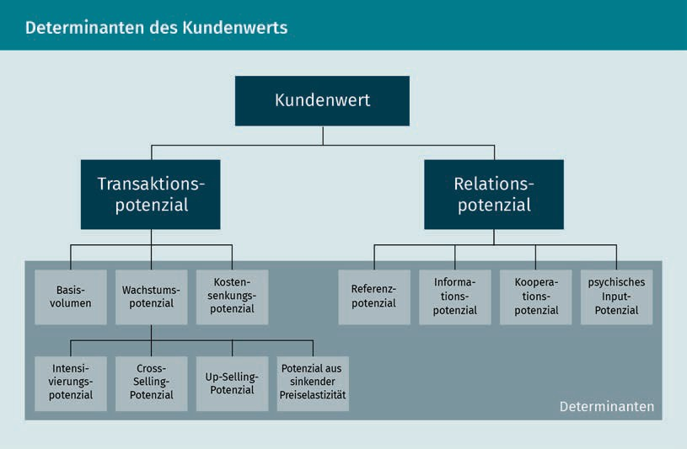

The figure shows that when considering the customer value, on the one hand the transactionsbetween the supplier and the customer should be taken into account. The term “transactions”,here,refers to the quantity of the customer’s current and future purchases and potential increases in them. On the other hand, the company must not only take into account the relationship potential of the customer, including their potential as a recommender within their personal relationship network (**reference potential**), but must instead also evaluate their potential as a supplier of information to the company (Leusser, Hippner & Wilde 2011a, 26).

When considering transactions, the basic volume represents the range that is derived from the **purchase history** and can therefore be considered to express the intensity of an existing customer relationship. The assumption is that intensive customer relationships can be considered as expressing habitual buying behavior, and these customers are immune to competitive offers. Consider a simple example: A customer always buys the same muesli. Since they like it, they don’t have to think long and hard about a buying decision in the store. They are satisfied, their needs and requirements for muesli are covered, and there is no reason to develop an interest in or buy other products. In this case, the customer will not be tempted by a cheaper offer from the competition since it may not match their taste preferences. Information about the basic transaction volume is also relevant when analyzing a customer’s growth potential since repeat purchase behavior and cross- and **up-selling potential** must be considered in relation to this. Long-standing, regular customers will often buy other products from the company, or, if household income increases, they will also be able to afford

Reference potential The reference potential reflects the extent to which a customer can influence the purchasing decisions of third parties.

Purchase history

The purchase history records when, what, and to what extent a customer has purchased from a company.

Up-selling potential The up-selling potential considers the chance of being able to offer and sell higher quality/higher priced products to the customer in the future.

Customer contribution

margin   
The customer contribution margin is calculated by deducting all the costs attributable to the customer from the revenue achieved from the

customer.

higher-priced offerings from the company. If someone starting their career decides to buy a small car from a supplier, then after a few years in their profession they may be able to afford a medium-sized or even luxury vehicle.

But what is the point of looking at the value of a customer? In addition to answering the question of whether to invest in the customer or not, it is even more useful to ask whether the customer value can be increased. The factors that inﬂuence customer value therefore need to be determined and careful customer analyses performed, and promising market and customer segments also need to be identified and efforts made to increase the profitability of the customer relationships. Conversely, however, this can also mean that in the worst case scenario unprofitable relationships have to be ended, because a high degree of customer orientation also requires a focusing of customers (on those that are worthwhile from a company perspective) (Günter & Helm 2011, 282).

### Customer valuation process

There are various recognized methods for calculating customer value. Some focus on revenue and identifying the top-selling customers. Other approaches are based on the amount of marketing funds that are invested in a customer group. Such rather one-dimensional procedures can provide an initial orientation, but they do not help establish a more comprehensive understanding of the customer value (Rapp 2005, 79). The customer value should not only reflect the customer’s status as a buyer, it should also consider their role as an opinion leader, information supplier, etc. At the same time, the calculation also needs to take into account the company’s costs for customer retention measures. After all, what use is it if a customer regularly buys a company’s products, but the associated acquisition and customer loyalty costs exceed the revenue from these purchases?

Below, we will consider the various ways of calculating the customer value. The most well-known methods are:

* Customer contribution margin
* ABC analysis
* Customer lifetime value, and
* Customer portfolio analysis.

###### Customer contribution margin

The **customer contribution margin** analysis is an extension of the customer revenue analysis, and it also includes costs that arise in individual customer relationships or in customer groups, since calculations that are limited to customer revenue reveal little about the proﬁtability of the customer relationship. The aim of the customer contribution margin calculation is to show what contribution margin a customer is responsible for, i.e., the extent to which the customer covers the company’s overheads and contributes to

Customer value and customer portfolio management

profits. To perform the calculation, all costs that can be attributed to a customer (e.g., advertising costs, sales costs, etc.) are deducted from the revenue generated from the customer. This is also where one of the challenges becomes apparent: how exactly to determine the costs incurred for the customer. For example, advertising costs are attributed to individual customers using an arbitrary formula. The current, expected, or absolute customer contribution margin can be calculated, depending on what the calculations are attempting to achieve (Bruhn 2016c, 314).

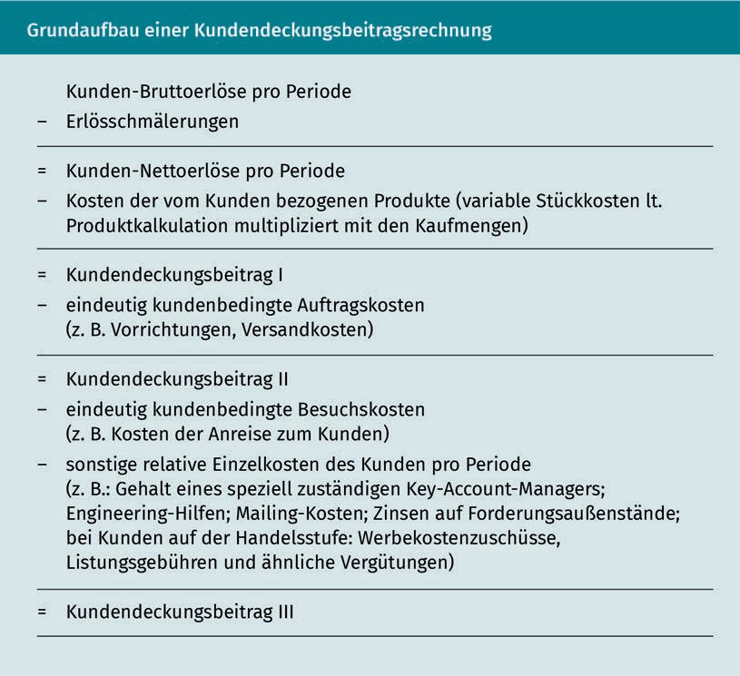

If data about the customer-associated costs is available, this calculation provides a good way of evaluating customer-oriented measures. However, we can also see the limitations of this approach from the fact that customer contributions do not take account of customer reference or information potential, since there is no cost or revenue data associated with these variables (Günter & Helm 2011, 279).

###### ABC analysis

The ABC analysis is a one-dimensional process that classiﬁes customers according to their revenue and profit contributions. It can be formulated simply: This calculation determines the share of the total revenue that the individual customer is responsible for. Depending on the sales volume, the customer is assigned to a value class ranging from A (largest revenue) to C (smaller revenue) (Günter & Helm 2011, 276).

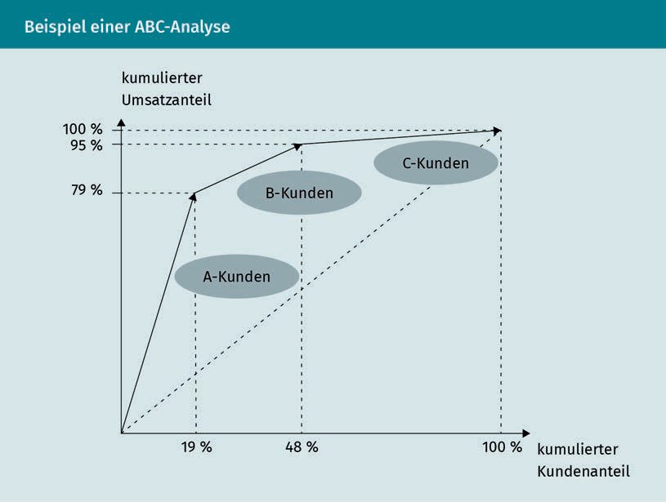

As this example shows, the ABC analysis often confirms the 80/20 rule, i.e. that 20% of customers account for 80% of total revenue. However, the customers responsible for the largest revenues are not necessarily the customers who are automatically prioritized, since the ABC analysis often only represents an initial starting point for customer classification (Günter & Helm 2011, 276). An evaluation of which customers should be prioritized in the future cannot be conclusively identified from a revenue perspective alone. It is conceivable that the “A” customers of a supplier of high-priced luxury items make the largest revenue contribution, but their needs are very exclusive, and their customer care is consequently very expensive, and therefore lower-revenue customer groups must also be invested in.

Customer value and customer portfolio management

###### Customer lifetime value

A key figure that is used to determine the customer value is the CLV: the **customer lifetime value**. The calculation of the customer lifetime value is usually based on dynamic investment calculation approaches. The entire duration of the customer relationship is included in the calculation of the customer value. Both past data and expected future revenue are taken into account. The company can use the calculated CLV as a benchmark. The higher the CLV, the more proﬁtable the customer is, or the more justified investments in the customer are. The CLV can be determined using the net present value method, and the value is calculated as shown in the following figure:

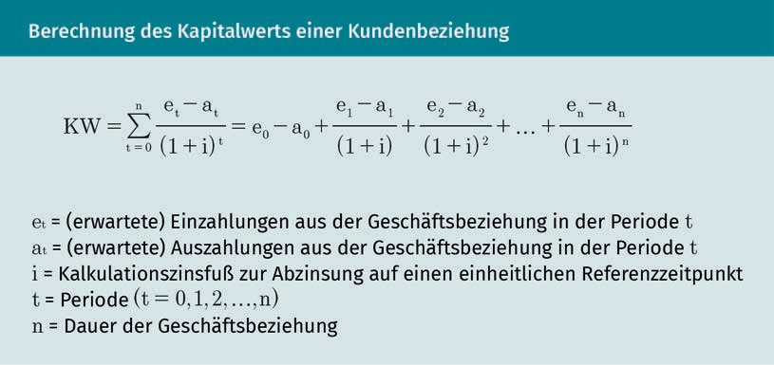

By considering both current data and future customer success potential, the CLV takes into account the dynamics of customer relationships and can therefore be regarded as an important economic monitoring variable for relationship-oriented marketing (Bruhn 2016c, 328 et seq.).

One thing that must always be included to some extent is the human factor. The various approaches presented for calculating a customer’s value show that, in addition to the cost and revenue factors, the customer contributions that result from their recommendations and from the information or cross-buying potential must also be factored in. The individual approaches to measuring customer value provide varying levels of meaningfulness. When selecting a method, the respective company objective should therefore be taken into account, and the selected method must be critically examined (Günter & Helm 2011, 280).

### Customer segmentation and customer portfolios

Customer portfolios can provide a highly differentiated picture of current and potential customer contributions. These two-dimensional methods contrast the different pre-economic and economic dimensions. For example, the company can determine

Customer lifetime value

The customer lifetime value is a key figure that calculates the contribution margin of the customer over the period of the customer’s life cycle.

“which customers will produce a profit (economic variable) based on their customer satisfaction and customer loyalty (pre-economic variables)” (Bruhn 2016c, 329 et seq.). Ultimately, customer portfolios are used to comprehensively analyze and understand customers and to document their strategic importance as a basis for information measures that are aligned with corporate goals.

Customer

segmentation Customer segmentation assigns customers to groups that are as homogeneous as possible, thereby providing the basis for customer

analysis.

Success chains   
The basic idea of a success chain is to draw connections between the content of related

variables.

**Customer segmentation** can provide the basis for the creation of customer portfolios. This helps companies to better “understand” customers by categorizing and assigning them to certain segments, and therefore to formulate precise customer-related economic goals based on each customer segment. Segmentation attempts to create customer groups that are as homogeneous as possible within their segment, i.e., that are similar in their attitudes, expectations, or even market reactions. However, there are differences between the customer segments. This segmentation allows companies to put their efforts into one or more of these customer segments in a targeted manner and to meet their respective needs (Bruhn 2016b, 58 et seq.; Bruhn 2016c, 119 et seq.). Customers cannot simply be pigeonholed into overly broad categories. Doing so would not provide an appropriate way of addressing the target group. Take the food industry as an example: It is safe to assume that everyone needs to eat, so does that mean that a company in this industry should address pretty much everyone? Probably not, since here the specific product, the corresponding market environment, etc. all play a role. Without such segmentation, it is highly likely that the company will waste their marketing budget. Therefore, the company has to find out how the customer groups differ from each other and how the customers are similar. Let’s stay with our food industry example and pick out a product like yogurt. Children love this product as much as college students, families, and pensioners do, so it does not make sense to differentiate by age. Where should you start? Think about eating habits, quality, and price awareness when consuming food, etc.

The segments can then be displayed within portfolios. According to Bruhn, relationship-specific criteria should also be used as the basis for relationship-oriented segmentation. The segmentation is based on the three phases of CRM: the acquisition, retention, and recovery phases, and within these phases, companies will focus on the respective **success chains** that arise from the different customer requirements within the phases. To put it slightly more simply: The success chain in the customer acquisition phase is based on the goal of acquiring new customers. To achieve this, the company must arouse the customer’s interest and, ideally, this interest should lead to a purchase of the product. The success chain begins with the measure (communication) that is intended to achieve a psychological effect (interest) in order to trigger a behavioral effect (purchase) that represents an economic effect (revenue) for the company.

Let’s look at the customer portfolios created through this approach using the example of the customer retention phase. The success chain is as follows: Measures -> customer satisfaction -> customer loyalty = economic success. This approach allows customer segments to be filtered out that differ in terms of their ability to achieve speciﬁc relationship-oriented goals. As a result, companies can respond appropriately to the identified requirements in the respective phases. But this can also be used to show why success chains are broken

Customer value and customer portfolio management

or do not produce the desired success. For example, a customer may show little loyalty despite being very satisfied. When looking at the links in the success chain, a distinction is made between one-dimensional and two-dimensional segmentation (Bruhn 2016c, 124 et seq.).

Applying one-dimensional and two-dimensional segmentation allows different customer portfolios to be created for each of the links considered in the success chain based on the three areas of CRM, namely the customer acquisition, customer retention, and customer recovery phases.

One-dimensional segmentation focuses on one link in the success chain. The following figure shows the customer portfolios that are created when oriented towards the “customer satisfaction” link in the customer retention phase and that relate to dimensions that inﬂuence customer satisfaction, such as commitment vs. connectedness:

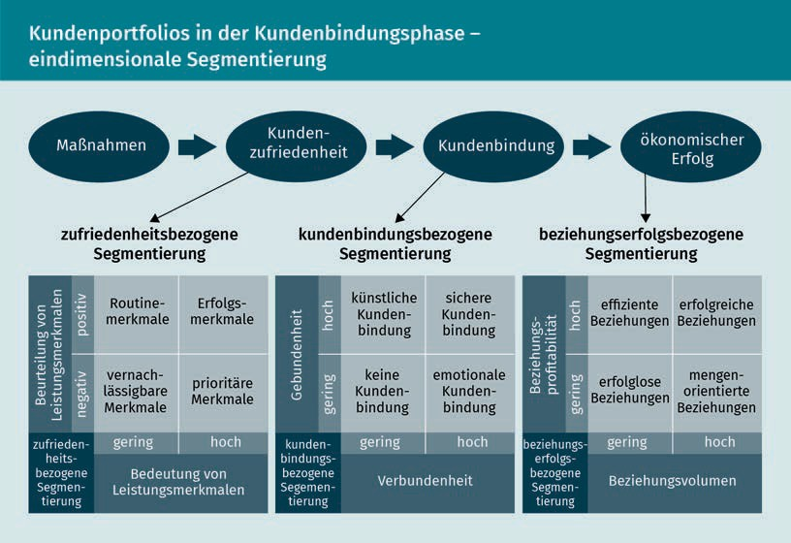

If we take a closer look at the area of customer loyalty-related segmentation, we see that commitment and connectedness are defined here as dimensions that have an inﬂuence on customer loyalty and that allow four types of customer loyalty to be identified (Bruhn 2016c, 126):

* Artificially loyal customers (high level of commitment and low level of connectedness, e.g., in the case of a contractual commitment),
* Securely loyal customers (high levels of loyalty and connectedness, e.g., in the case of contractual commitment and emotional attachment),
  + Non-loyal customers (neutral customers), and
  + Emotionally attached customers (high connectedness with no commitment).

Consider the following example: Artificial loyalty usually arises from a contractual commitment. Fitness clubs offer different packages and prices for short- and long-term memberships. The monthly fee is usually cheaper if the customer opts for a longer-term contract. The customer can thus weigh up what a longer commitment would be worth to them in terms of price. Additional services (e.g., free training sessions with a personal coach) may also be offered to long-term customers to make this type of loyalty more rewarding. Even if the customer is considered to be artificially loyal, they can still be so convinced by the offering and develop such an emotional bond with the provider that a sense of connectedness can be assumed.

Two-dimensional segmentation considers two links in the success chain and differentiates between four customer types in the portfolio based on two dimensions, an example of which can be seen in the customer retention phase area of the following illustration (Bruhn 2016c, 128 et seq.).

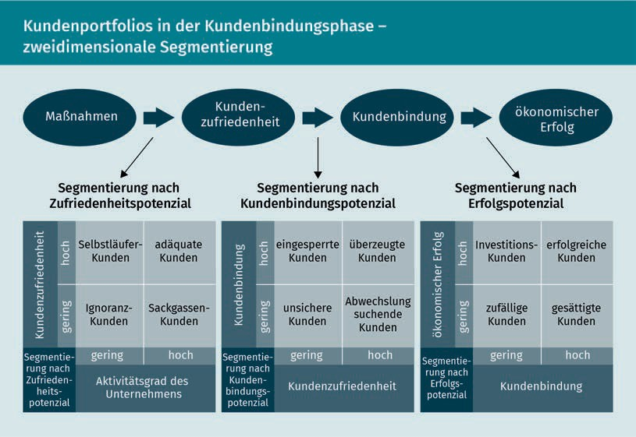

The basis of the segmentation for current customers shown here is the success chain measure -> customer satisfaction -> customer loyalty -> economic success, which leads to segmentation based on satisfaction potential, customer loyalty potential, and success potential. Again, similarly to how we conducted the one-dimensional segmentation, let’s look at the area of customer loyalty. We can evaluate to what extent customer satisfaction results in customer loyalty in order to identify four customer types based on the level of connection (Bruhn 2016c, 132 et seq.):

Customer value and customer portfolio management

* Locked-in customers (high retention and low satisfaction, e.g., retention due to lack of alternatives),
* Convinced customers (high level of satisfaction and high loyalty, often even without a contract),
* Uncertain customers (low level of satisfaction and loyalty), and
* Switching customers (high satisfaction but little loyalty: **variety-seeking** behavior).

If the analysis and evaluation of the customer portfolio determine that there is a close connection between satisfaction and customer loyalty and that there are many convinced customers, it can be concluded that measures to increase satisfaction may also increase the level of emotional attachment and possibly the willingness to enter into a contractual relationship (Bruhn 2016c, 133).

But what is the purpose of assessing and evaluating the portfolio? As has often been stated, it is in the interest of companies to invest in the right customers, i.e., proﬁtable customers. Ideally, not only should these customers be retained over the long term, but also the value of these customer relationships should be increased. A central task of CRM is to determine the actual and potential value contributions of customers and to boost the optimization of these contributions. To do this, the factors that inﬂuence the customer value must be recognized, and the corresponding customer segments must be identified in order to address the worthwhile customer groups more intensively. This shows that not only a precise customer value assessment is important, but also careful segmentation in order to identify both value-adding and value-impairing areas so that the company can act accordingly. This means expanding value-adding areas and either making value-impairing areas profitable again or, if necessary, ending customer relationships, as the following figure shows:

Variety seeking

Variety seeking denotes the customer’s desire for different suppliers. Even though they may be satisfied with an offering, they might choose another supplier.

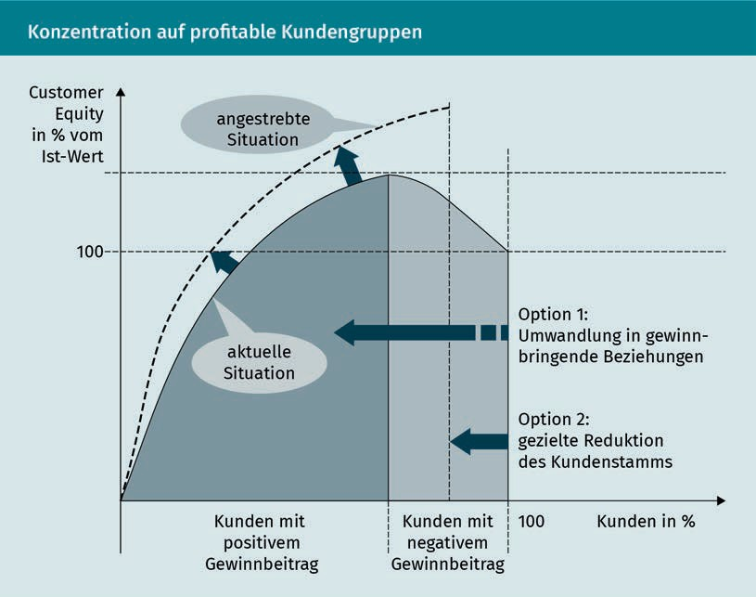

Ideally, this type of value-oriented model of customer loyalty must set clear goals. These objectives range from setting a customer satisfaction level to achieving a certain level of customer loyalty or a targeted customer value for each customer segment (Günter & Helm 2011, 282 et seq.). The elements of how the customer valuation is performed should also be taken into account when developing CRM concepts in order to establish customer relationships that are based on the customer value as it is analyzed and the underlying factors (high or low value). In this context, it must again be clearly emphasized that neither customer acquisition nor customer loyalty is an end in itself, but rather that investing in each individual customer relationship must be justified from an economic point of view (Günter & Helm 2011, 284).

Summary

Falling within the scope of CRM activities, customer value is an important guide for companies and may be viewed from both the customer’s and the supplier’s points of view. From the customer’s point of view, customer value expresses the benefits of an offering as actually perceived by the customer. From the supplier’s point of view, the customer value reflects that customer’s contribution to the achievement of corporate goals, both monetary and non-monetary. A clear frame of reference must always be used to calculate customer

Customer value and customer portfolio management

value. For example, are all customers included or only a specific customer segment, and should the current value be included or should the future potential also be factored in? On the one hand, the value can be determined based on the transactionsor, to put it more simply, on the purchases that are made by a customer and expected from them in the future. However, the valuation must also consider the relational potential, i.e., the importance of the customer as an informant, referrer, and inﬂuencer. In addition to the pure valuation, it is important for companies to also identify the factors that inﬂuence customer value in order to make customer relationships proﬁtable.

There are various one-dimensional and multi-dimensional methods that can be used to determine customer value. Some methods focus on purely revenue-oriented figures, while others mostly focus on investments in customers, and others again include various factors in the calculation to obtain a more comprehensive value. The one-dimensional methods include the customer contribution margin calculation or the ABC analysis. The multidimensional methods are the customer lifetime value, customer segmentation, and customer portfolio. The different methods have their own strengths and weaknesses depending on the company’s objective. The CLV gives a single figure that provides information about the advantages of a customer relationship, but it only refers to the monetary significance and not to the reference potential of the customer.

Segmentation attempts to identify homogeneous customer groups and to represent them in customer portfolios. Mirroring the CRM process, customer segmentation takes place during the acquisition phase, the customer retention phase, and the customer recovery phase, since different needs must be taken into account in the three phases and customer segments are based on other inﬂuencing factors. One-dimensional segmentation focuses on the inﬂuence of individual links in the CRM success chain. Two-dimensional segmentation considers two links in the success chain and thus determines, for example, four customer types by considering the connection between customer satisfaction and customer loyalty.

The purpose of CRM is to determine current and potential value contributions from customers and to help to optimize customer relationships by maximizing their positive economic contribution to the company, hence the importance of determining this value, but also of the analyzing the inﬂuencing factors. Companies want to determine which customer segments they should invest in over the long term and how to act in order to expand value-adding areas or make value-impairing areas proﬁtable. This is important because customer loyalty is not an end in itself, it must also be justified from an economic point of view.



# Unit 7

## CRM strategies and tools

#### LEARNING OBJECTIVES

After completing this unit, you will understand…

…the features and tasks of CRM strategies.

…what phase-dependent strategies are.

…what other options and tools can be used.

DL-D-DLBCRM01-L07

1. CRM strategies and tools

### Introduction

CRM spans two quite extensive areas of interest and must fulfill a variety of tasks. Considered from one standpoint, CRM is an integrated information system, but we must also not forget that it is also a customer-oriented corporate **strategy**. No matter which basic understanding is applied, the task of CRM is building, strengthening, or restoring customer relationships. In order to achieve this goal, a comprehensive understanding of the customers and their needs and of the opportunities for inﬂuencing the relationships is essential. To be meaningful, the customer analysis must be based on an evaluation of the available data, which in turn is collected and evaluated using technical solutions. CRM represents an interplay between a company’s strategic customer orientation and the use of the CRM systems needed to generate, collect, and evaluate customer data so that this information can be used strategically and converted into measures to promote the economic success of the company. To achieve this, CRM strategies must be developed that enable targeted action to be taken.

### Characteristics and tasks of CRM strategies

Attention   
This refers to the customer’s focused perception of stimuli from the environment, such as, e.g., company messages.

To identify the strategic options available to a company, we first need to define the various goals of CRM, and these goals will vary between the different phases of CRM. If the aim of the acquisition phase is to win over new customers, then we can identify goals such as **attention**, interest, awareness, and intention to buy. During the customer retention phase, the goals are satisfaction, arousing interest in other products and services, and ensuring long-term loyalty. In the recovery phase, the focus is on rekindling the customer’s interest, restoring trust, demonstrating reliability, etc., and the goal of the termination phase is achieving an amicable separation. Since the tasks and objectives of CRM vary between the different phases of customer acquisition, customer retention, customer recovery, and relationship termination, the strategic approaches also vary between the phases. The first aim of the strategies is to assess the starting position, e.g., using SWOT, life cycle, and portfolio analyses, in order to derive the necessary “direction of travel”. If, for example, it turns out that an above-average number of customers are switching to the competition, the reasons for this must be analyzed, and customer retention or customer recovery strategies initiated. CRM strategies are thus planned but creativity is applied in their deployment so that solutions can be developed based on the problem situation (Bruhn 2016c, 146 et seq.).

However, these strategies are not applied to all churned customers. Instead, this is where looking at the customer value or the customer portfolios comes into play: Which customers does the company want to build relationships with?

CRM strategies and tools

Which investments in customers can be considered worthwhile? What do customers expect from the company, and what should relationships look like in the future? Answers to these questions provide initial clarity regarding the company’s possible strategic orientation, because ultimately it is not just a matter of the supplier choosing the right strategy from their point of view, but of thinking about a strategy that will be accepted by the customers. Relationships are not one-sided and cannot be initiated by just one of the partners.

In summary, CRM strategies are based on a corporate objective and define a framework for action under which customer groups can be processed and which allows tools to be selected that can shape customer relationships and increase not only customer satisfaction and customer loyalty, but also customer value. These strategies must be integrated into the company in terms of organization and personnel mindsets (Georgi & Mink 2011, 59 et seq.). But what strategic options are available in CRM?

### Phase-dependent CRM strategies and tools

Following the idea of selecting a strategic orientation based on the customer relationship cycle, the strategic approaches need to be appropriate to the corresponding customer requirements in the acquisition, retention, recovery, and termination phases.

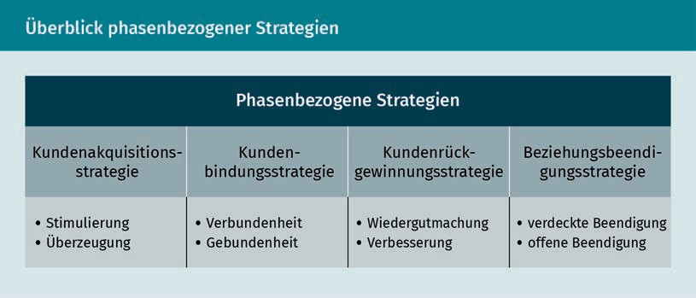

The strategy is developed as normal. Once the initial situation, the market, and competition analysis are complete, the goal and target group (customer segmentation) are then defined, and this in turn is followed by the development of a strategy for shaping customer relationships. The tools for doing so can then be derived from these completed stages. Last but not least, a system for monitoring their effectiveness must be considered.

Strategy

In an economic context, the planned behavior of companies is referred to as their strategy.

###### Customer acquisition strategy

In the customer acquisition phase, the company needs to target new customers and win them over. They do this by arousing interest and increasing awareness, but also by building a positive image, i.e., exerting certain psychological effects on the customer, which are intended to ultimately lead to an (initial) purchase. A customer acquisition strategy pursues various goals, such as expanding the customer base, acquiring customers to compensate for natural fluctuation (i.e., customer churn), or opening up new markets (Bruhn 2016c, 146).

Persuasion strategy

This term describes the use of suitable tools to achieve the desired customer

attitude.

Testimonials Feedback from (mostly well-known) people in the form of an unambiguous positive opinion of a product included in advertising is classified as a testimonial.

In the phase of initiating new customer relationships, the motivation and persuasion strategy is used. The motivation strategy tries to create incentives that encourage customers to make impulse purchases. The **persuasion strategy** is less reliant on trying to motivate such an immediate impulse to act. Instead, it attempts to persuade through arguments and information. The goal is to make the customer understand that their needs and expectations can be satisfied by the supplier’s offerings. If the strategies lead the customer to make a purchase, then the socialization phase follows. Here, familiarization strategies can help introduce the customer to the company. Since it is at this point that the foundations for the future of the relationship is laid, this is an extremely important phase, as trust can be created and any desire to immediately bolt for the offering of a competitor must be counteracted (Georgi & Mink 2011, 74). Depending on whether the strategies are intended to create direct and immediate incentives (e.g., through special offerings or service or product samples) or more indirectly through **testimonials** by raising image or brand awareness (e.g., in advertising), we can distinguish between factual and symbolic strategies, from which six types of strategy for the initiation phase can be derived.

CRM strategies and tools

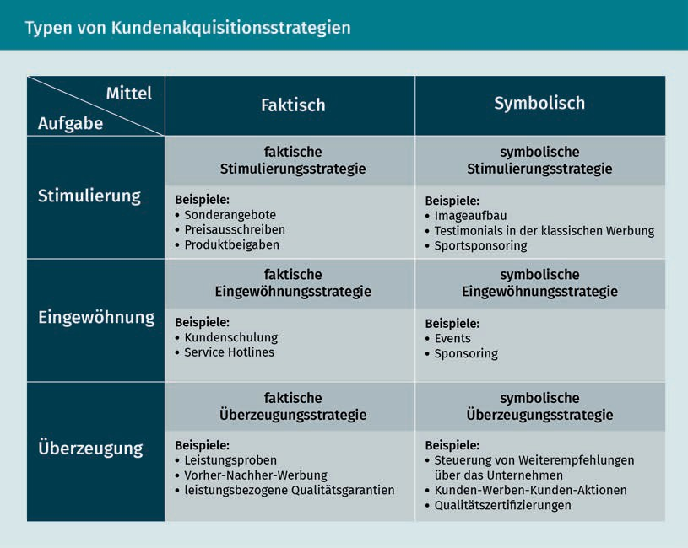

Depending on which customer acquisition goals are being pursued, the strategies may focus on customer segments that have already been established, or alternatively on new customer segments or new markets (Bruhn 2016c, 147).

###### Customer retention strategies

During the customer retention phase, the goal is to both build up and maintain relationships. Accordingly, a distinction can be made between a growth phase and a maturity phase. While still in the growth phase, the company must select strategies that help foster a customer relationship that is just beginning to achieve “healthy” growth. The strategies in the maturity phase ensure that the existing relationship is continued and stabilized over the long term (Georgi & Mink 2011, 75 et seq.). Applying a metaphor from the natural world, we can visualize this process using the example of a tomato plant: After germination, the plant needs a lot of care until it grows big and strong, so that it can be transplanted from the nursery pot into a larger garden bed. And then comes the far more difficult part: The plant must be protected from extreme environmental influences and, if it is bearing a lot of fruit, it must be supported so that it does not snap, thereby losing the harvest.

Customer retention strategies aim to boost satisfaction and establish a high level of loyalty in order to increase purchase frequency, exploit cross- and up-selling potential, and encourage recommendations by customers, but also

to increase customer value. When implementing the measures, we must not forget that they can also have negative consequences. Customers who are not addressed can feel disadvantaged, or customers can build up very high expectations when they learn about customer retention offers (Bruhn 2016c, 149).

One of the strategic options available in the customer retention phase is the connectedness strategy, which aims, on the one hand, to achieve customer loyalty via psychological determinants, such as the quality of the relationship or customer satisfaction. On the other hand, the retention strategy also tries to build up and strengthen customer loyalty by erecting barriers to change. Both strategies are divided in terms of their timeframes into short-term and long-term approaches. Thus, short-term connectedness strategies include offering discounted products and services, for example, but also a surprise gift or a free service in connection with a purchase (e.g., free delivery or installation service). In contrast, a short-term retention strategy uses short- to medium-term barriers to switching (e.g., a three-month trial contract) to promote customer loyalty (Bruhn 2016c, 150).

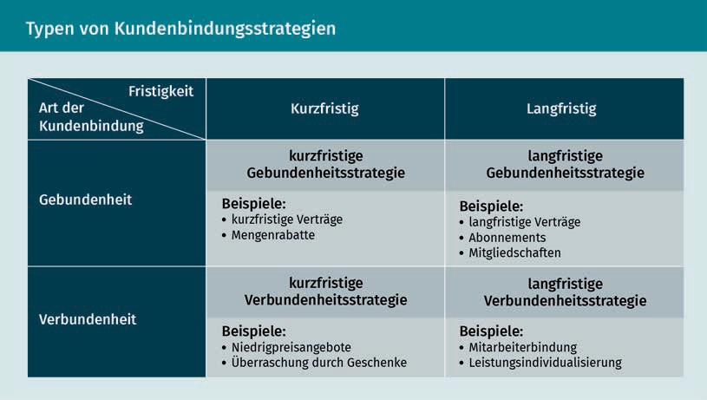

Once the customer retention phase has expired, a great advantage exists in that the supplier and customer have already gotten to know each other, the initial hurdles in building the relationship have already been cleared, and both parties have gained experience in dealing with each other that they can draw on later.

###### Customer recovery strategy

Various types of customer need to be monitored during the customer recovery phase, There are customers who have expressed their desire to defect but have not yet reached a final decision as to whether to turn their backs on the company. And then there are

CRM strategies and tools

customers who wish to defect and are already determined to do so, e.g., they have already terminated an existing contract by the due date. The third and final type of customer in this phase is the customer who has actually ended the relationship, such as one whose contractual commitment has already expired, for example. From a strategic point of view, the lost interest must be rekindled. To do this, however, the company needs to know why the customer has lost interest or satisfaction and how their perception of the company can be restored, especially in terms of image and quality (Georgi & Mink 2011, 77). The customer’s reasons for defecting can be of a very personal nature, such as relocation or a change in life situation, but they can also be due to competition (e.g., better offers from the competition). But the company itself is also responsible if poor quality, high prices, or poor service “drive away” customers.

The type of customer also influences which recovery strategy is appropriate. A customer who has expressed a desire to defect is more likely to be recovered using an emotional appeal, while a customer who has already churned is more likely to reconsider their decision based on factual information. The different customer types and response options for the company allow us to identify four types of customer recovery strategies:

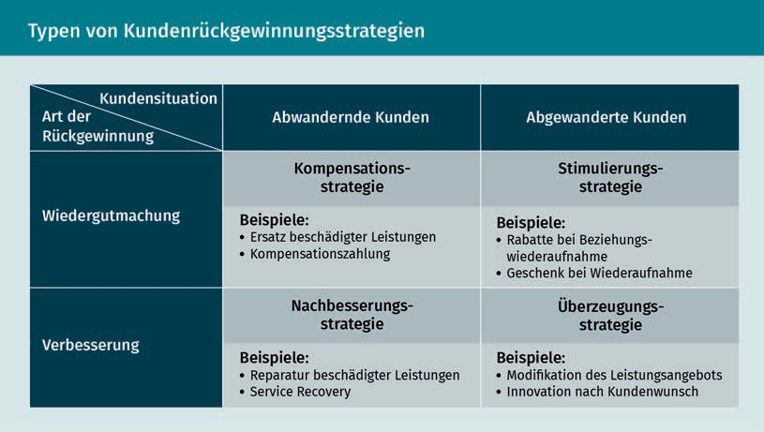

Of course, when choosing a strategy, it is not only possible to distinguish between customers who are willing to defect and those who have already done so. For example, a rectification strategy is only plausible if such a recovery is even possible, e.g. if an electrical device is destroyed by a battery fire, it can only be replaced and not repaired. If, on the other hand, you are dissatisfied with your mobile phone contract because it does not offer a certain rate option that is important to you, the provider may possibly avoid an imminent churn by making immediate improvements (ideally free of charge).

###### Strategies for terminating the relationship

If a customer relationship can no longer be maintained despite all efforts, or if the supplier has economic reasons for terminating the relationship, then an open or a covert approach can be chosen depending on the strategy adopted. In the case of an open termination, the termination of the business relationship is communicated directly to the customer. For example, an insurance company may choose to terminate an insurance policy. The company can choose to terminate the policy without further justification (fait accompli strategy) or alternatively by providing an explanation to the customer (declared termination strategy). It is also conceivable that an agreement might be possible that would allow the contract to continue (consensual negotiations strategy) under certain conditions. And last but not least, the insurer could propose conditions to the policyholder that would allow the policy to be continued, but which would have to be accepted by the policyholder without the option for negotiation (non-negotiable take-it-or-leave-it strategy) (Bruhn 2016c, 156).

Under the covert strategy, on the other hand, the customer is not directly informed of the termination of the business relationship. However, this strategy has nothing to do with the reticence of companies not wanting to openly communicate the termination of a relationship, it can in fact ultimately become necessary for tactical and economic reasons. If a previously good customer is no longer of interest to the company due to reasons of strategic realignment, for example, the customer should not be left annoyed by the termination of the business relationship (de-escalation strategy) (Bruhn 2016c, 155). However, such a scenario is only conceivable if the customer can continue to use their previous services. If, for example, a hotelier buys certain tableware for the restaurants in their hotel chain and regularly adds to it, but the supplier then decides that they will only produce for the private customer market going forward and removes the catering line from its offerings, the customer may be able to be supplied with pieces for a while using the residual stock, but the end of the relationship is foreseeable. Therefore, a passive withdrawal would be difficult to achieve here. Fundamentally, a distinction is made between passive and active withdrawal, and in addition to the de-escalation strategy, we have also mentioned the escalation, “letting go”, and withdrawal strategies, though we will not discuss these further here.

### Further options and tools

The following illustration gives a good insight into the tools and measures that should be used in connection with a phase-related orientation for a company’s CRM:

CRM strategies and tools

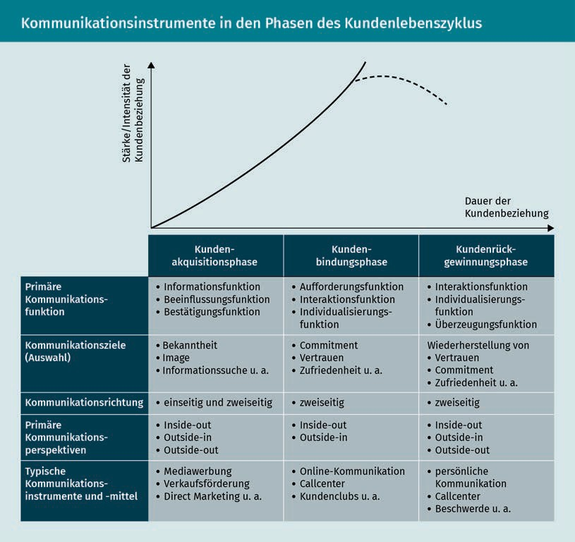

In addition to the phase-related options, there are also other CRM tools that can be used in different phases or across phases in addition to the ones listed above. These include quality, complaint, service, and customer value management tools (Georgi & Mink 2011, 78).

Quality management has a direct effect on customer satisfaction and is therefore a prerequisite for building customer relationships. Quality management always has an internal and external orientation. Within the company, it should be focused on productivity and error rates, and when it comes to the customer orientation, it should target profit, market share, or repeat purchases and cross-selling potential. Quality management tools are selected based on the quality planning and quality controlling systems. The quality strategy relates to the supplier’s products and services, which must be based on the specified quality standards (Georgi & Mink 2011, 78).

Complaint management is an important task for CRM. Things do not always run smoothly, and customers occasionally have cause for complaint, whether justified or unjustified. A complaint is the articulation of a customer’s dissatisfaction with the company. And since these complaints cannot simply be swept under the rug but rather must be taken very seriously, the issue of complaint management has received increasing attention in recent years. An organized approach must be taken to the acceptance, processing, and handling of these complaints. The following complaints process is key to establishing a comprehensive complaints management system:

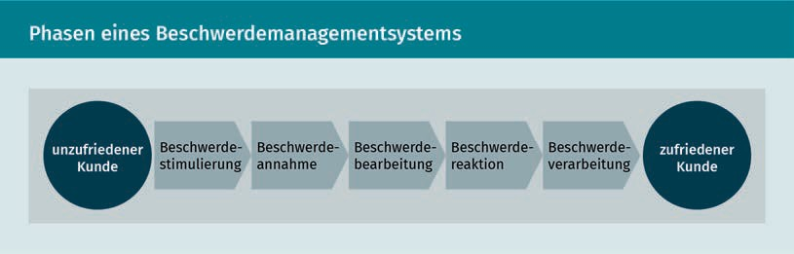

Value-added 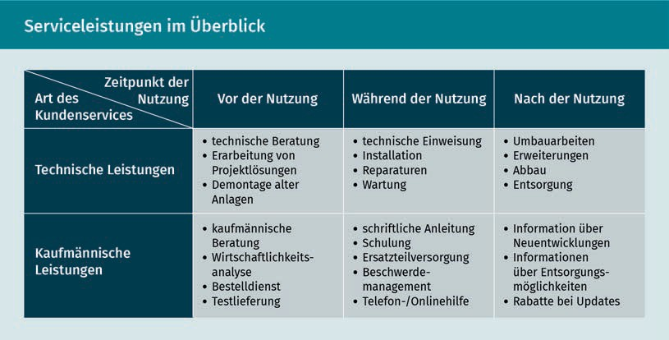services  
Value-added services are a company’s offerings and services that provide the customer with added value beyond o the actual product (e.g., an installation service when buying a washing machine).

Service management deals with all factors that have an inﬂuence on customer satisfaction and loyalty beyond the pure product. The tools range from customer service, technical and commercial services, and warranties to delivery service and offerings (Georgi & Mink 2011, 79) that are not directly related to the product, i.e., “**value-added services**”, such as childcare services in well-known furniture stores.

CRM strategies and tools

Since the value of the customer is an important factor for the supplier, it should also be taken as a basis for decisions about marketing and CRM activities. In order to derive suitable cross-phase tools for monitoring customer value, dynamic methods for determining the value should be used and incorporated into a comprehensive customer value management system.

There are a variety of measures that can be derived from the tools mentioned here. Communication measures in particular are useful not only for helping to build relationships, but also for nurturing them. The measures range from classic dialog marketing and customer clubs (“loyalty programs”) to customer magazines. All of the measures are aimed at increasing the exchange of information between suppliers and customers, not only in order to inform customers about offerings, but also for the purposes of promoting dialog and thus generating more information about the customer. This information allows the company on the one hand to craft an individualized customer approach, **customize** products, and boost use of the supplier’s services (repeat and multiple purchases, cross- and up-selling), and on the other hand to erect barriers to switching to a competitor. However, in order to be able to make a long-term contribution to customer retention, the measures must always be selected in light of the strategic aspects and in a goal-oriented manner, and therefore long-term authentic and credible dialog must be maintained with the customer.

Summary

Customization   
This term describes the strategy of adapting products and services to individual customer interests.

The purpose of strategies is to identify, based on careful analysis, a path that will help the company pursue its formulated goals. Since the tasks and goals in CRM vary according to the various phases of the customer relationship cycle, the strategic options are considered and developed on the basis of each phase in order to establish customer relationships in the most effective manner possible. These strategies must also be integrated into the company both in terms of the organization and the human resources assigned.

The phase-related strategies can be divided as follows:

* The customer acquisition strategy for encouraging and winning over (potential) customers
* The customer retention strategy for building and strengthening customer relationships
* The customer recovery strategy for addressing customers seeking to defect and already churned customers, and
* The relationship termination strategy for terminating (or possibly conditionally maintaining) customer relationships.

Additional phase-spanning tools are used in CRM to supplement the phase-based strategies, primarily quality, complaint, service, and customer value management. All of these areas represent important tasks, since it is not only quality, but also successful complaint and service management that can have a positive inﬂuence on customer satisfaction

and thus customer loyalty to the supplier. Targeted and target-group-oriented measures can be derived from these strategies, which can be used to achieve strategic goals at the operational level.



# Unit 8

## CRM implementation and monitoring

#### LEARNING OBJECTIVES

After completing this unit, you will understand…

…the requirements, stumbling blocks, and challenges associated with implementing CRM.

…what the terms “operational” and “analytical” CRM mean.

…what options are available for monitoring effectiveness.

DL-D-DLBCRM01-L08

1. CRM implementation and monitoring

### Introduction

Taking a customer orientation has become increasingly important. Companies are now setting up customer clubs, establishing systems for complaint management, and measuring customer satisfaction. And yet, the effect of these measures is often not to increase the level of customer loyalty. Why is that? Have the companies applied the wrong measures or simply set the wrong goals for themselves? In most cases, it has more to do with the fact that even though companies realize the importance of customer relationships, they implement a customer orientation through individual measures rather than by applying integrated concepts. Information management in particular lags behind expectations. Data is collected, but often not adequately analyzed or sufficiently cross-referenced. Customers come into contact with companies at various touchpoints, including in store, via the website, customer support, the complaints department, or via third parties. One of the greatest challenges is not just to collect all this information, but to synthesize it in a targeted manner. In addition, CRM must be strongly integrated into company management and employee culture both strategically and operationally, and both operational and analytical CRM must be closely interwoven and build on one another. In addition to providing the necessary technical support in the form of IT solutions, it is also important for the company to institute a customer-oriented corporate culture, for example.

In order to achieve successful implementation, companies must therefore take a holistic view of the strategic orientation, human resource management, information management, and the structural and process organization, and they must also take adequate effectiveness monitoring into account.

### Organization, management, and company culture

CRM cannot just be dropped into place as a one-size-fits-all package or pursued as a side project. If it is to be implemented successfully, it must be closely integrated into the basic strategic orientation of the company, which must be committed to customer orientation and must consistently align its activities with the market. CRM is more than a package of measures and must therefore also be integrated into the company organizationally. Numerous studies have found that one of the main reasons for the failure of CRM projects is the failure to adapt organizational structures and generally a lack of planning and goal setting. Organizational adjustments, the involvement of top management, a high level of employee loyalty to the company, the appropriate execution of planning and monitoring measures, and the design of incentive systems have also been cited as important factors for successful implementation. The earlier the employees are involved in the process, the more successful the implementation will be (Götz & Krafft 2013, 592 et seq.). In addition to executives and employees, the quality of information management is also very important for successful implementation, of course. This is because

CRM implementation and monitoring

meaningful insights for the development of efﬁcient packages of measures can only be generated from “good” data. **Knowledge management** has also shown itself to provide useful support here, since not only does data need to be collected carefully and purposefully, but the processing and derivation of the required actions is also key to successfully implementing CRM activities. Knowledge management provides the interface between the IT infrastructure for data collection and the development of effective and efﬁcient customer management (Götz & Krafft 2013, 591).

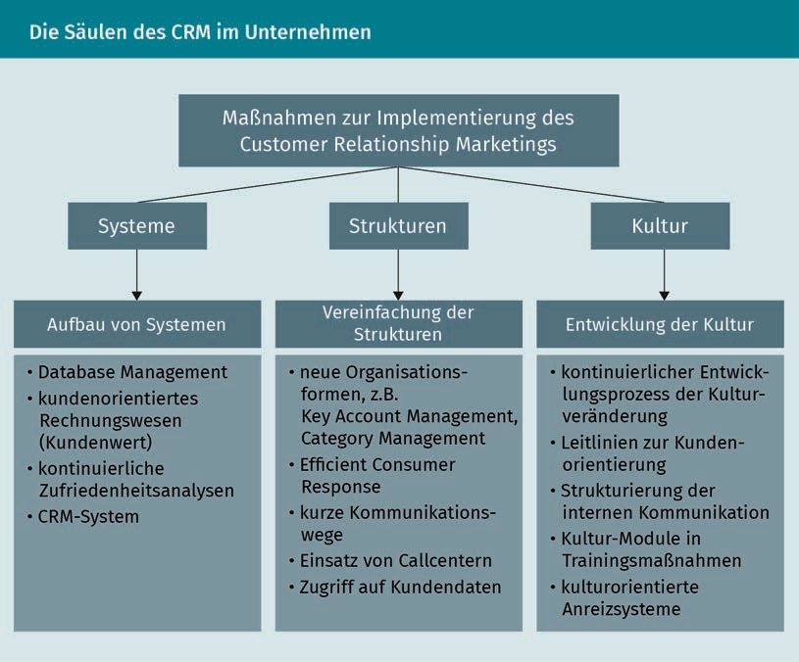

But now we must ask whether CRM can be implemented equally in all sectors and industries. The success of CRM strategies usually also depends on purchasing behavior, and this may be quite different for different products or in different industries. It is also worth considering, for example, whether loyalty measures might make customers who always buy the same product out of pure habit more likely to rethink their habitual actions. In other words, the measures may backfire and cause the company to potentially lose these customers (Götz & Krafft 2013, 608). Can customer relationships be established and maintained equally across all industries, or what needs to be taken into account when looking at different sectors or different products?

Knowledge management   
This refers to all measures implemented in order to utilize existing knowledge within a company.

###### Customer relationships in the consumer goods sector

Brand communities Brand communities are communities that grow out of consumers’ loyalty to a

brand.

Capital goods These are assets that the company uses to produce or further process other goods.

Customer involvement plays a particularly important role in the consumer goods sector. The brand-customer relationship often takes the place of a supplier-customer relationship. Think of the products you purchase in your everyday life, such as yogurt, shampoo, deodorant, etc. These are products with low cognitive involvement. Here, brand and product policy or sales promotion measures, along with loyalty programs, have greater potential to make a noticeable contribution to customer retention. When it comes to making product purchasing decisions with a high level of cognitive involvement or, more simply, a higher need for information and deliberative purchasing behavior, such as with cars, PCs, furniture, etc., CRM measures that can support and reinforce the purchase decision will have a positive inﬂuence on customer loyalty (Götz & Krafft 2013, 608). There are many well-known measures that can be used to strengthen the customer’s sense of connection with a brand, to create a “we” feeling, or to create barriers to churn. Flagship stores, brand events, **brand communities**, social media communication, live trade fairs and events, and also viral marketing and crowdsourcing are some of the frequently used measures.

###### Customer relationships in the capital goods and service sectors

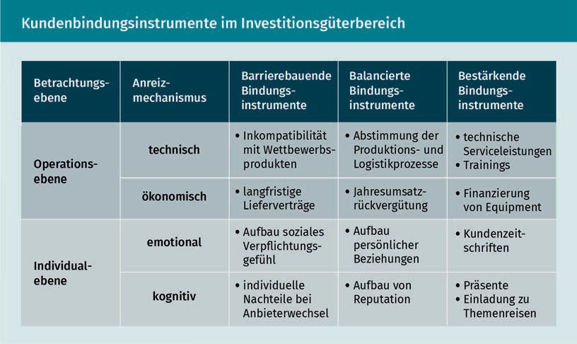In the **capital goods** and service sectors, customers have a high need for information. Investments must be carefully weighed, since they are usually associated with a high ﬁnancial risk and, in addition to ﬁnancial aspects, there are technical factors, contract terms, etc. that must also be taken into account.

CRM implementation and monitoring

In the case of services, it only becomes clear when the service is used and the interaction takes place on-site whether the customer’s expectations are being met. In both areas, it is important to build trust and not to disappoint the customer over the medium to long term. An intensive relationship management process should therefore be initiated right from the acquisition phase in the B2B and service sectors, with personal communication playing an important role in customer care. Customer retention tools/measures include consulting services, training courses, maintenance and repair services, financing, and customized offers.

Now, the desire of companies to intensify customer relationships is all well and good, but customers must also be willing to enter into these relationships. It is not hard to observe customers having reservations about the CRM measures that companies implement. Various measures come in for criticism, especially when considered in the context of discussions about data protection and providing greater transparency for customers or where there is a fear of manipulation. These worries or critical assessments can mean that customers, for example, do not take part in **customer programs**, customer loyalty cards are rejected, or even that customers deliberately submit false information to the company (Götz & Krafft 2013, 609). However, in this context, we must also ask whether, given that many customers are deluged with loyalty offers, customers have not grown tired of them. The flood of customer loyalty cards means that customer wallets are bulging with all the excess pieces of plastic. Migros Switzerland had an interesting idea many years ago: Instead of the usual plastic card in the credit card format, the store also offered several stickers with a bar code that you can stick on another card or a simple slip of paper, etc., to save space.

On the one hand, endogenous factors, i.e. the ones that the company can control, have to be taken into account when implementing measures. At the same time, the exogenous factors, such as customer needs and requirements, also cannot be ignored. During implementation, however, it is not only strategic, organizational or personnel considerations that must be taken into account, but also technological aspects, such as the introduction of IT-based CRM systems.

### CRM process architecture

When implementing a CRM strategy, a company must ensure, as we showed above, that the necessary conditions have been established in all of the relevant departments so that measures can ultimately be designed in such a way as to enable a holistic customer relationship to be fostered. This is a complex task that requires a structure that affords the requisite scope of action and interaction between the various actors. The following overview of a possible CRM system architecture shows the different areas and the connections at a glance:

Customer programs Measures such as customer clubs, discount systems, etc., instituted by companies to retain customers are called “customer programs”.

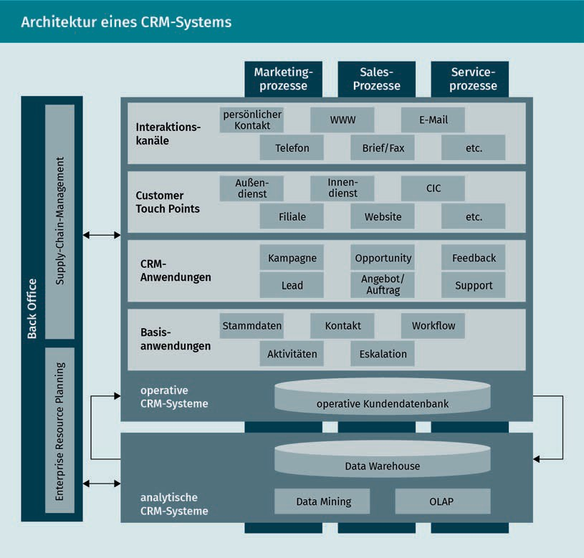

This overview clearly shows how complex the relationship construct between customer and company is and how many different customer touch points have to be taken into account. Since customers make personal contact, for example, by visiting company offices, phoning the call center, placing online orders, or simply by submitting an inquiry via the website, all of this information has to be synthesized in one place and then not only filed away, but also understood in context. It is not just about the technical solution for data processing, but also about the targeted use of this data and the knowledge that can be derived from combining this accumulated data with an analysis of it.

You can see that this process requires a great deal of effort (of a technical and organizational nature). Customer databases are the key way of bundling together all this information from the various transactionswith the customer. In addition to the master data, such customer databases also contain information on all transactions, such as purchases, returns, complaints, but also customer suggestions and a repository of all contacts made via email, phone, etc. But having collected the various data, can you then obtain a comprehensive picture of the customer at the push of a button? Unfortunately, it is not quite that simple, because this data must first be analyzed and evaluated in its overall context.

CRM implementation and monitoring

And here too, the human factor continues to play a decisive role. Imagine you are checking into a hotel. The room you are offered is on the second floor, and there is no elevator in this area of the hotel. You have just had a sports-related accident, and climbing stairs is still difficult for you and not conducive to your recovery. So you request another room. That night you realize that your room is unfortunately directly above the hotel bar, and you are unable to sleep a wink because of the noise. The next morning, you ask to move to another room, and after looking at your customer records, the receptionist replies rather curtly that yesterday you refused the room that was assigned to you and that you have already been given another room. So how should a scenario be factored into CRM and data collection? The information by itself that the guest wanted another room lacks context or leaves others with quite a lot of room for interpretation, e.g., that the guest is one of those perpetual complainers than can never be pleased, etc. This example shows that the data must be meaningful and allow for clear conclusions in order to limit the room for interpretation. In our example, it would have been sufficient to record the reason for the room change or, if this would be too time-consuming, to train the staff to ask again why the first room did not meet the guest’s expectations: A friendly “May I just ask again why you didn’t like the room yesterday?” or “Oh, did the new room fail to completely meet your expectations?” makes it clear that the guest is appreciated and thus helps contribute to customer satisfaction and loyalty.

In order for CRM to bear fruit, the system must not only be accepted by management, it must also receive a high level of commitment from the employees, along with adequate IT support in the form of data collection measures. To ensure this, communication, human resource management, remuneration, and control systems must be implemented. The communication systems must cover all areas of market-oriented communication with customers, from the website to the call center to engagement over social media. HR management must ensure that there are appropriate working conditions. Or, to put it simply, care must be taken to ensure that employees feel comfortable, support the company’s ideas, and are supported by appropriate overall working conditions, such as fair pay and reasonable working hours, which provide proper incentives. The more comfortable the employee feels at the company, the better prepared they are for their duties, and the more familiar they are with their scope of action, the better they can react to customer needs. Imagine an employee who feels that they are badly treated by their employer, underpaid, and that the company is not an ethical enterprise to work for. Do you think that such an employee would be able to represent the company positively to the outside world? In this situation, a customer’s complaint will fall on receptive ears. It does not bear imagining what would happen if this story continued.

### Operational and analytic CRM processes

In order for a company to not only collect data, but to collect data that can actually be used, the company must clarify what it needs to know about its customers, i.e., what data specifically should be collected. And then, of course, it must clarify how and where it can collect this data and how the data generated by a salesperson can be merged with the information collected by the customer service department.

Operational CRM   
Operational CRM refers to customer-oriented measures, such as establishing contact with customers and generating

leads.

Under this system, the idea is not to look at the customer through the company’s individual interfaces, but rather to learn about and connect all of the points of contact. **Operational CRM** encompasses all processes that are involved in handling customer transactionswith the aim of arriving at a uniform image of the customer (single customer view). Six core CRM processes can be derived from these tasks: In the marketing process, campaign and lead management is followed by opportunity and offering/order management in the sales process. This is where the sales department can leverage the insights gained to allow for targeted offers to be made that should ideally result in an order or purchase. After the product has been sold or the service has been provided, feedback and support management follow as part of the service process. Here, it is important to process customer feedback (both positive and negative) and to offer and monitor appropriate customer support. Suitable supporting IT systems can and should be deployed and used to support these operational processes (Leusser, Hippner & Wilde 2011a, 42 et seq.).

Analytical CRM is then required in order to monitor the customer-oriented operational processes. Its task is to collect, analyze, and optimize data. Essentially, the idea is to refine the customer data collected and make it more meaningful.

As explained above, it is important for CRM to not only look at data from one area of the company, but also to identify as precisely as possible where, how, and why a customer contacted the company, what the customer bought, and what conclusions can be drawn from this. Is a customer who has bought warm winter boots also interested in vacation offers in winter sports regions, or are they more interested in snow shovels or children’s sleds? The question is does the customer has an affinity for winter sports, or are they a homeowner who has to shovel the snow from their sidewalk? Or perhaps they are a parent who wants to take their children sledding? Association or sequence analyses are used to tease out these connections, but we will not be discussing them in detail here.

When collecting customer data, a distinction is made between **identification data**, description data (typically key figures, such as the number of customers and product group revenue), and transaction data:

CRM implementation and monitoring

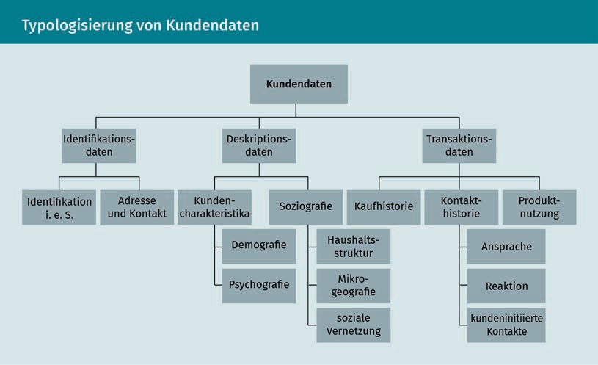

In order for a company to draw a meaningful picture of the customer, the necessary and target-oriented data always needs to be collected, i.e., the data that allows conclusions to be drawn. The **psychographic data** is of particular interest here. You need to capture what motivates customers; what values, motives, and attitudes they hold, how they consume, and what their purchasing intentions are. This is a difficult undertaking, because people have very individual preferences: Not all 20-year-old women in Munich automatically have the same purchasing behavior, and people over 70 are not necessarily unversed in technology. Obtaining meaningful data and analyzing it correctly is a major challenge. How can we overcome this challenge in practice?

Ideally, the data and associated evaluations should be collected directly and individually by the company’s own employees, but that is only possible at smaller companies. The larger the company and the more customers it has, the more complex the task of data collection becomes. In this case, for example, feedback forms or online surveys are used to collect data. A company can establish a good basis for analysis when it is able to combine customer demographic and psychographic data with data from the operational CRM, i.e., information about customer **transactions** that reveals the relationships of exchange between the customer and the company and the exact communication channels they have used to make contact with the company (contact history).

The operational and analytical CRM approaches therefore provide mutual support to each other and cannot be viewed separately. Recall once again the basic goal of CRM systems: to assemble a uniform picture of the customer in order for the company to act and present itself in a customer-oriented and holistic manner. For example, the analytical tasks of customer value analysis

Identification data Identification data includes customer address and contact information as well as the customer number, name, title, and form of address.

Psychographic data

Psychographic data records information about customer preferences. This data ranges from lifestyle, values, and desires to the customer’s willingness to take risks and assume commitments.

Transactions

Customer transactions include completed purchases as well as the entire contact history and information on the customer’s product usage behavior.

and customer characterization and segmentation, along with the target group or migration analysis, support the operational processes, as can be clearly seen from the following figure:

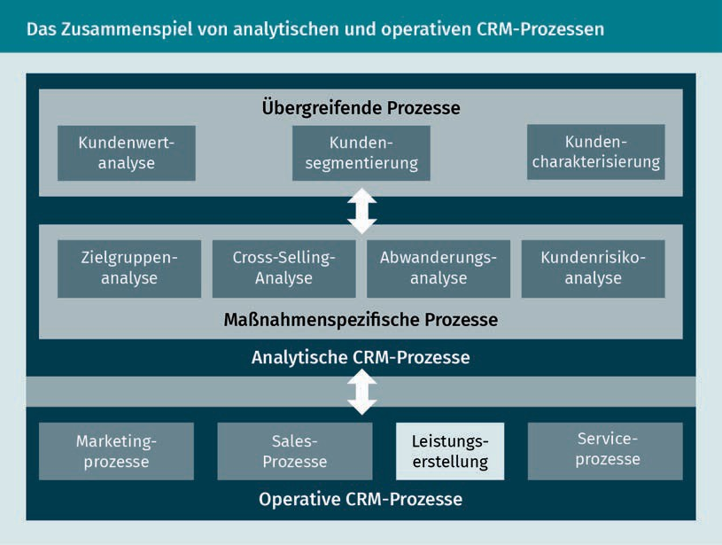

### Data processing

So now we come to the data processing itself, which forms the basis of analytical CRM. **Data warehouses** and analysis tools, such as data mining or online analytical processing tools (OLAP for short), are frequently used to process this data.

Data warehouse A data warehouse is a database that collects and organizes data from all areas of a company for the purposes

of analysis.

While the data warehouse provides data storage, i.e., it is the place to which data from all areas of the company is sent and where it is then classified and sorted, the analytical tools are designed to process this data (Rentzmann et al. 2011, 133).

OLAP provides descriptive but not explanatory data. A typical question might be about the volume of sales over a certain period and in a particular place. Descriptive data, such as customer numbers or product groups, may be very important from a business point of view, but it tells us nothing about the reasons for the customer’s purchase or

CRM implementation and monitoring

the relationship components, so it is important to evaluate the data collected holistically. This is where data mining comes into play, because its focus is on the explanatory data that can be used in all areas of the CRM process.

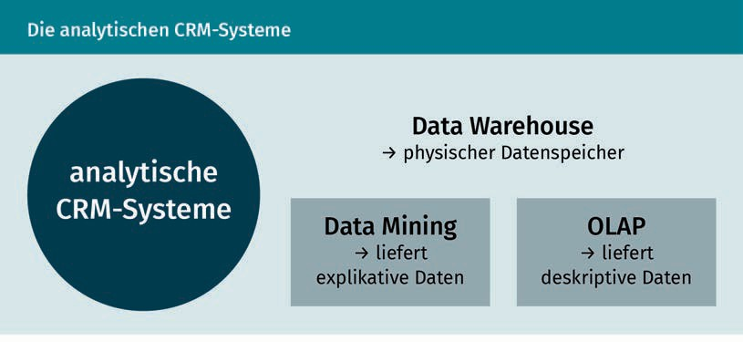

But what do we mean by “data mining”? Data mining is a (frequently automated) process for drilling down into data collected in order to show possible connections between customer behavior and customer-oriented business processes.

The term itself contains the key action: mining, which is the uncovering of precious raw materials from a large amount of rock, but in our case it is about sifting the really important information from the mass of data (Rentzmann et al. 2011, 135). This process is usually automatic and divided into six steps, recognized as the “Cross-Industry Standard Process for Data Mining”, or **CRISP-DM** for short. You might be wondering: If it is an automatic process, then it almost sounds as if it would be enough to input a mountain of data and then automatically obtain the relationship patterns as the output. However, it is not quite that easy, as a large proportion of the work (around 60%) goes into the selection and preparation of the relevant databases. The term “automatic” actually only applies to the statistical pattern extraction (Hippner, Grieser & Wilde 2011, 790 et seq.).

Data mining is used in all CRM process steps. The evaluated data can be used in both the customer acquisition and customer retention phases, and even for complaint management. In complaint management, recognizing information and service needs that are insufficiently satisfied allows the company to react accordingly, so that, for example, dissatisfaction does not lead to customer defection (Hippner, Grieser & Wilde 2011, 803 et seq.).

In order to make data usable and to generate insights relevant to decision-making, the greatest challenge for companies is probably to consider and analyze the existing customer data across all areas of the company. Data mining can help to segment customers, to classify them according to purchasing behavior or the likelihood of defection, or to identify cross-selling potential.

CRISP-DM

The CRISP-DM is an open and widely used analytical model for data mining.

Information gained in this way provides a good basis for customer relationship management and is indispensable for successful CRM (Hippner, Grieser & Wilde 2011, 805).

### Opportunities for effectiveness monitoring

Of course, a strategic CRM also needs a monitoring system. But the question here is what exactly should be monitored: the choice of strategy, the application of the right tools or the right IT system solutions for data collection and analysis, the institution of a successful organizational culture, the functionality of processes, the effectiveness of the measures, or anything else related to CRM? In any case, a monitoring system must look both internally and externally and should comprehensively check to what extent the CRM activities are being successful and contributing to customer satisfaction and loyalty, and whether monetary and non-monetary objectives can be achieved. Understood in this way, the monitoring process takes place at the strategic and operational level and checks, in the simplest terms, whether the correct strategic approach has been chosen and whether the tools used and the measures developed from them are target-oriented. At one level, an effectiveness check determines whether the goals set are attainable, but it also allows the results to be integrated into future planning in order to optimize CRM activities. A comprehensive control process supports the company management by providing well-founded insights into strategies, processes, and effects.

In order to be able to monitor effectiveness, the company must know what goals or effects the company wishes to achieve. In the case of relationship management, Bruhn (2016c) differentiates between the pre-economic effects (psychological goals and behavioral goals) and the economic effects (economic goals), as clearly illustrated in the following figure:

CRM implementation and monitoring

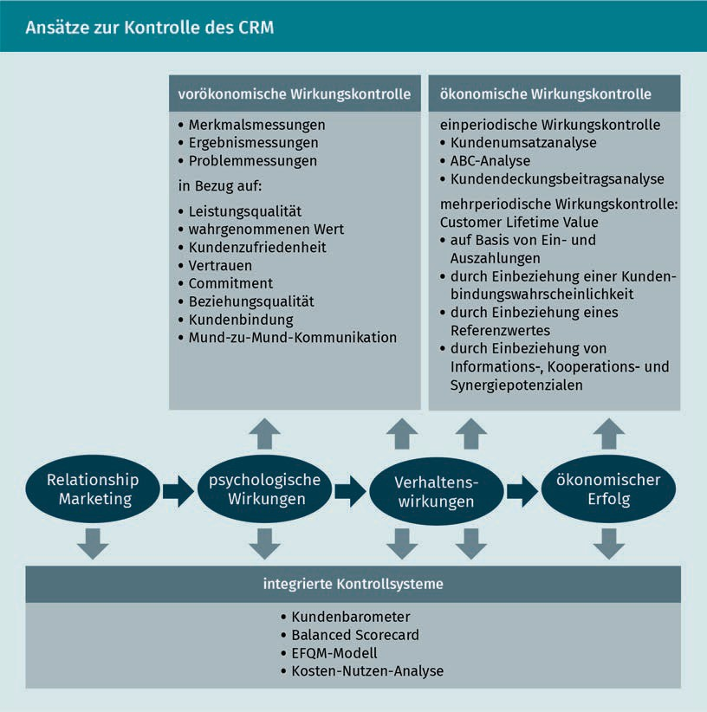

When selecting a suitable set of tools for measuring the various impacts, the results that the company requires must be taken into account, and it must be ensured that the results are reliable, valid, complete, and up-to-date.

If, for example, aspects such as customer satisfaction, trust, or the quality of the relationship or behavioral effects, such as customer loyalty or word-of-mouth communication, need to be checked as part of the pre-economic monitoring process, then characteristic-oriented, event-oriented, or problem-oriented controls could be used (Bruhn 2016c, 290).

A characteristic-oriented control for measuring psychological parameters can therefore be used to measure relationship quality or customer satisfaction. Since such psychological constructs are not directly observable or measurable,

the data collection must focus on indicators that reflect or influence the construct. After the data is collected, the results can be interpreted and used (Bruhn 2016c, 290).

To illustrate, let’s consider how customer loyalty is measured. While factual behavior, i.e., actual behavior, can usually be determined using objective and customer-related data, behavioral intentions must be determined in a different way. It can be measured by surveying customers to obtain data about repeat selection (intention) or cross-buying (intention) indicators, but also about their willingness (intention) to give recommendations or accept or tolerate price increases (Bruhn 2016c, 298).

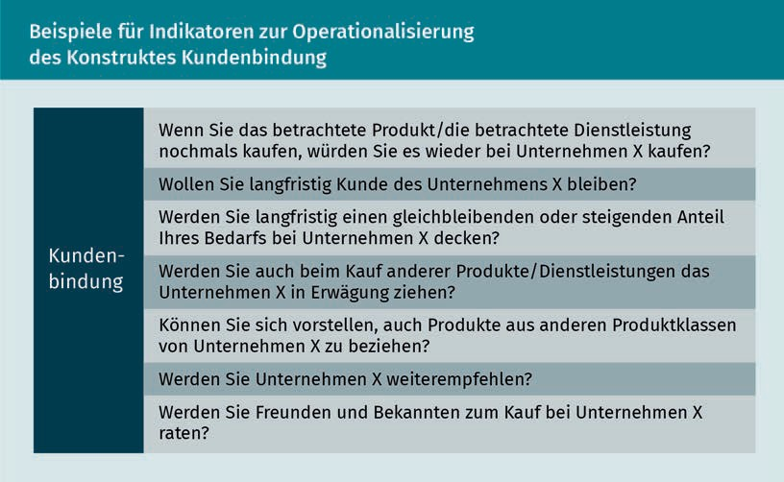

After the data is collected, it must then be put to use. Individual aspects, such as factors influencing customer loyalty or comprehensive insights into customer loyalty in general, can be examined in detail. The results can also be related to other data, for example, in order to examine whether customer loyalty has been increased through the application of a specific measure. And last but not least, measures to increase customer loyalty should be derived from the findings. The results of measuring such characteristics can be very useful for identifying potential for improvement and thus for initiating measures that will contribute to achieving the company’s CRM goals in the future (Bruhn 2016c, 299 et seq.).

CRM itself often seems like a complex construct, with this complexity being reflected in the effectiveness monitoring measures, which must be based on all the various tasks, requirements, and processes. But we can also conclude without any further justification that a comprehensive focus on the customer, their needs and individual requirements pays off for companies in the long term, because a customer who feels that they are being taken seriously and whose needs are both recognized and

CRM implementation and monitoring

satisfied is a customer who will purchase the company’s service again or would be happy to recommend the company to friends, acquaintances, and family.

Summary

There are both endogenous and exogenous factors that have a decisive influence on whether CRM can be successfully implemented at a company. In order for CRM to bear fruit, the system must not only be accepted by management, but must also receive a high level of commitment from the employees, as well as adequate IT support in the form of data collection measures. To achieve this, communication, human resource management, remuneration, and control systems must be implemented.

The prerequisites for the successful implementation of CRM also include the development of an IT-supported solution for data collection and processing. In addition to a purely technical solution, companies need to know what data is required in order to draw a uniform picture of their customer. Ultimately, it is not the amount of data that is decisive, but rather the quality of the data.

The customer data collected is divided into identification, description, and transaction data. The analytical CRM collects, structures, and analyzes the customer data and provides the basis for decision-making for the customer-oriented operational CRM. Both areas depend on and support each other and cannot be viewed in isolation from one another.

Data processing is about collecting the data, on the one hand, and evaluating it, on the other. As the repository for data, the data warehouse collects data that can be processed using data mining or OLAP and that can then be used as the basis for customer relationship management.

A corresponding monitoring system must then be instituted in order to check the effectiveness and usefulness of the CRM. At the strategic and operational levels, the company must check whether both the approach adopted and the tools and measures utilized to promote customer loyalty have been effective. However, the findings are also used for the forward-looking planning of all CRM activities. The speciﬁc requirements and objectives of the company must always remain the focus of any effectiveness review so that monitoring tools can be selected that deliver meaningful and usable insights to support successful customer loyalty management and ensure a comprehensive customer orientation.



# Appendix 1

## Bibliography

Bibliography

Advidera (2019): *Customer-journey*. (URL: https://[www.advidera.com/glossar/customer-](http://www.advidera.com/glossar/customer-) journey/ [Accessed on: 07/08/2019]).

Backhaus, K./Voeth, M. (2009): *Industriegütermarketing* [Marketing of Capital Goods]. 9th edition, Vahlen, Munich.

Bruhn, M. (2016a): *Kommunikationspolitik im Relationship Marketing* [Communications Policy in Relationship Marketing]. In: Bruhn, M./ Esch, F.-R./Langner, T. (eds.): Handbuch Strategische Kommunikation. Grundlagen – Innovative Ansätze – Praktische Umsetzungen [Handbook of Strategic Communication: Fundamentals – Innovative Approaches – Practical Implementations]. 2nd edition, Springer Gabler, Wiesbaden, pp. 229–257.

Bruhn, M. (2016b): *Marketing. Grundlagen für Studium und Praxis* [Marketing. Basics for Study and Practice]. 13th edition, Springer Gabler, Wiesbaden.

Bruhn, M. (2016c): *Relationship Marketing. Das Management von Kundenbeziehungen* [Relationship Marketing. Managing Customer Relationships]. 5th edition, Vahlen, Munich.

Bruhn, M./Georgi, D. (2013): *Wirtschaftlichkeit des Kundenbindungsmanagements* [Profitability of Customer Loyalty Management]. In: Bruhn, M./Homburg, C. (eds.): Handbuch Kundenbindungsmanagement [Handbook of Customer Loyalty Management]. 8th edition, Springer Gabler, Wiesbaden, pp. 677–708.

Ergenzinger, R./Thommen, J.-P. (2005): *Marketing. Vom klassischen Marketing zu Customer Relationship Management und E-Business* [From Classic Marketing to Customer Relationship Management and E-business]. 2nd edition, Versus, Zürich.

Fürst, A. (2012): *Verfahren zur Messung der Kundenzufriedenheit im Überblick* [Overview of Methods for Measuring Customer Satisfaction]*.* In: Homburg, C. (ed.): Kundenzufriedenheit. Konzepte – Methoden – Erfahrungen [Customer Satisfaction. Concepts – Methods – Experiences]. 8th edition, Gabler, Wiesbaden, pp. 123–153.

Georgi, D./Mink, M. (2011): *Konzeption von Kundenbeziehungsstrategien* [Designing Customer Relationship Strategies]. In: Hippner, H./ Hubrich, B./Wilde, K. D. (eds.): Grundlagen des CRM. Strategie, Geschäftsprozesse, IT-Unterstützung [Basics of CRM. Strategy, Business Processes, and IT Support]. 3rd edition, Gabler, Wiesbaden, pp. 57–90.

Götz, O./Krafft, M. (2013): *Erfolgreiche Implementierung von CRM-Strategien* [Successful Implementation of CRM Strategies]*.* In: Bruhn, M./Homburg, C. (eds.): Handbuch Kundenbindungsmanagement [Handbook of Customer Loyalty Management]. 8th edition, Springer Gabler, Wiesbaden, pp. 578–616.

Gröppel-Klein, A./Königstorfer, J./Terlutter, R. (2013): *Verhaltenswissenschaftliche Aspekte der Kundenbindung* [Behavioral Aspects of Customer Loyalty]. In: Bruhn, M./Homburg, C. (eds.): Handbuch Kundenbindungsmanagement [Handbook of Customer Loyalty Management]. 8th edition, Springer Gabler, Wiesbaden, pp. 43–79.

Grohmann, M./Heumann, C./Wangenheim, F. (2013): *Determinanten der Kundenbindung* [Determinants of Customer Loyalty]*.* In: Bruhn, M./Homburg, C. (eds.): Handbuch Kundenbindungsmanagement [Handbook of Customer Loyalty Management].

8th edition, Springer Gabler, Wiesbaden, pp. 81–100.

Grunig, J. (1989): *Symmetrical Presuppositions as a Framework for Public Relations Theory*. In: Botan, C. H./Hazleton, V. (1989): Public Relations Theory. Hillsdale, New York, pp. 17–44.

##### Appendix 1

113

Bibliography

Günter, B./Helm, S. (2011): *Kundenbewertung im Rahmen des CRM* [Customer Valuation as Part of CRM]*.* In: Hippner, H./ Hubrich, B./Wilde, K. D. (eds.): Grundlagen des CRM. Strategie, Geschäftsprozesse, IT-Unterstützung [Basics of CRM. Strategy, Business Processes, and IT Support]. 3rd edition, Gabler, Wiesbaden, pp. 271–292.

Haller, P. (2018): *Herausforderungen an die Markenführung* [Challenges of Brand Management]. In: Bruhn, M./Kirchgeorg, M. (eds.): Marketing weiterdenken. Zukunftspfade für eine marktorientierte Unternehmensführung. [Rethinking Marketing. Ways Forward for Market-Oriented Corporate Management]. Springer Gabler, Wiesbaden, pp. 285–300.

Hermann, S. et al. (2012): *Preisfairness als Schlüssel zur Kundenzufriedenheit* [Price Fairness as the Key to Customer Satisfaction]*.* In: Homburg, C. (eds.): Kundenzufriedenheit. Konzepte – Methoden – Erfahrungen [Customer Satisfaction. Concepts – Methods – Experiences]. 8th edition, Gabler, Wiesbaden, pp. 299–323.

Hippner, H./Grieser, L./Wilde, K. D. (2011): *Data Mining – Grundlagen und Einsatzpotenziale in analytischen CRM-Prozessen.* [Data Mining – Basics and Potential Applications of Analytical CRM Processe*s*] In: Hippner, H./Grieser, L./Wilde K. D. (eds.): Grundlagen des CRM. Strategie, Geschäftsprozesse, IT-Unterstützung [Basics of CRM. Strategy, Business Processes, and IT Support]. 3rd edition, Gabler, Wiesbaden, pp. 784–810.

Holland, H. (2016): *Dialog Marketing. Ofﬂine- und Online-Marketing, Mobile und Social Media-Marketing* [Dialog Marketing. Offline and Online Marketing, Mobile and Social Media Marketing]. 4th edition, Franz Vahlen, Munich.

Homburg, C./Becker, A./Hentschel, F. (2013): *Der Zusammenhang zwischen Kundenzufriedenheit und Kundenbindung* [The Connection between Customer Satisfaction and Customer Loyalty]*.* In: Bruhn, M./Homburg, C. (eds.): Handbuch Kundenbindungsmanagement [Handbook of Customer Loyalty Management].8th edition, Springer Gabler, Wiesbaden, pp. 101–134.

Homburg, C./Bruhn, M. (2013): *Kundenbindungsmanagement – Eine Einführung in die theoretischen und praktischen Problemstellungen* [Customer Loyalty Management – An Introduction to Theoretical and Practical Problems]. In: Bruhn, M./Homburg, C. (eds.): Handbuch Kundenbindungsmanagement [Handbook of Customer Loyalty Management]. 8th ediition, Springer Gabler, Wiesbaden, pp. 3– 39.

Homburg, C./Stock-Homburg, R. (2012): *Theoretische Perspektiven zur Kundenzufriedenheit* [Theoretical Perspectives on Customer Satisfaction]. In: Homburg, C. (eds.): Kundenzufriedenheit. Konzepte – Methoden – Erfahrungen [Customer Satisfaction. Concepts – Methods – Experiences]. 8th edition, Gabler, Wiesbaden, pp. 17–52.

Kenning, P. (2018): *Marketing weiter denken?! – Fünf Postulate* [Rethinking Marketing?! Five Postulates]. In: Bruhn, M./Kirchgeorg,

M. (eds.): Marketing Weiterdenken. Zukunftspfade für eine marktorientierte Unternehmensführung. [Rethinking Marketing. Ways forward for Market-Oriented Corporate Management]. Springer Gabler, Wiesbaden, pp. 79–97.

Köhler, R. (2018): *Organisatorische Herausforderungen für die marktorientierte Unternehmensführung unter veränderten Rahmenbedingungen* [Organizational Challenges for Market-Oriented Corporate Management in a Changed Environment]*.* In: Bruhn, M./Kirchgeorg, M. (eds.): Marketing weiterdenken. Zukunftspfade für eine marktorientierte Unternehmensführung. [Rethinking Marketing. Ways forward for Market-Oriented Corporate Management]. Springer Gabler, Wiesbaden, pp. 318–333.

Leusser, W./Hippner, H./Wilde, K. D. (2011a): *CRM – Grundlagen, Konzepte und Prozesse* [CRM Basics, Concepts, and Processes]*.* In: Hippner, H./Hubrich, B./Wilde, K. D. (eds.): Grundlagen des CRM. Strategie, Geschäftsprozesse, IT-Unterstützung [Basics of CRM. Strategy, Business Processes, and IT Support]. 3rd edition, Gabler, Wiesbaden, pp. 15–56.

[www.iubh.de](http://www.iubh.de/)

Leusser, W./Hippner, H./Wilde, K. D. (2011b): *Kundeninformationen als Basis des CRM* [Customer Information as the Basis of CRM]*.* In: Hippner, H./Hubrich, B./Wilde, K. D. (eds.): Grundlagen des CRM. Strategie, Geschäftsprozesse, IT-Unterstützung [Basics of CRM. Strategy, Business Processes, and IT Support]. 3rd edition, Gabler, Wiesbaden, pp. 732–755.

Leusser, W./Rühl, D./Wilde, K. D. (2011): *IT-Unterstützung von Marketing-Prozessen* [IT Support of Marketing Processes]In: Hippner, H./Hubrich, B./Wilde, K. D. (eds.): Grundlagen des CRM. Strategie, Geschäftsprozesse, IT-Unterstützung [Basics of CRM. Strategy, Business Processes, and IT Support]. 3rd edition, Gabler, Wiesbaden, pp. 602–650.

Link, J./Münster, J./Gary, A. (2011): *CRM-Controlling* [CRM Monitoring]*.* In: Hippner, H./Hubrich, B./Wilde, K.

D. (eds.): Grundlagen des CRM. Strategie, Geschäftsprozesse, IT-Unterstützung [Basics of CRM. Strategy, Business Processes, and IT Support]. 3rd edition, Gabler, Wiesbaden, pp. 158–181.

Lucco, A. et al. (2015): *Marketing. Konzepte – Instrumente – Aufgaben* [Marketing Concepts, Tools, and Objectives]*.* 3rd edition, Versus, Zürich.

Piller, F. T. (2012): *Kundenintegration im Innovationsprozess als Schlüssel zur Kundenzufriedenheit* [Customer Integration into the Innovation Process as the Key to Customer Satisfaction]*.* In: Homburg, C. (eds.): Kundenzufriedenheit. Konzepte – Methoden – Erfahrungen [Customer Satisfaction. Concepts – Methods – Experiences]. 8th edition, Gabler, Wiesbaden, pp. 395–424.

Rapp, R. (2005): *Customer Relationship Management. Das Konzept zur Revolutionierung der Kundenbeziehungen* [Customer Relationship Management. The Concept to Revolutionize your Customer Relationships]*.* 3rd edition, Campus, Frankfurt/Main.

Rentzmann, R. et al. (2011): *IT-Unterstützung durch CRM-Systeme* [IT Support through CRM Systems]. In: Hippner, H./ Hubrich, B./Wilde, K. D. (eds.): Grundlagen des CRM. Strategie, Geschäftsprozesse, IT-Unterstützung [Basics of CRM. Strategy, Business Processes, and IT Support]. 3rd edition, Gabler, Wiesbaden, pp. 130–155.

Schumacher, J./Meyer, M. (2004): *Customer Relationship Management strukturiert dargestellt. Prozesse, Systeme, Technologien* [The Structure of Customer Relationship Management. Processes, Systems, and Technologies] Springer, Berlin.

Stauss, B. (2011): *Der Kundenbeziehungs-Lebenszyklus* [The Customer Relationship Life Cycle]. In: Hippner, H./Hubrich, B./ Wilde, K. D. (eds.): Grundlagen des CRM. Strategie, Geschäftsprozesse, IT-Unterstützung [Basics of CRM. Strategy, Business Processes, and IT Support]. 3rd edition, Gabler, Wiesbaden, pp. 320–341.

Stock-Homburg, R. (2012): *Kundenorientierte Mitarbeiter als Schlüssel zur Kundenzufriedenheit* [Customer-Oriented Employees as the Key to Customer Satisfaction]*.* In: Homburg, C. (eds.): Kundenzufriedenheit. Konzepte – Methoden – Erfahrungen [Customer Satisfaction. Concepts – Methods – Experiences]. 8th edition, Gabler, Wiesbaden, pp. 273–298.

Werner, G. W. (2018): *Warum und wozu Konsuminteressen wecken?* [Why Should you Stimulate Consumer Interests, and to What End?]In: Bruhn, M./Kirchgeorg, M. (eds.): Marketing weiterdenken. Zukunftspfade für eine marktorientierte Unternehmensführung. [Rethinking Marketing. Ways Forward for Market-Oriented Corporate Management]. Springer Gabler, Wiesbaden, pp. 411–416.