COURSE BOOK



## Customer Relationship Management

DLBCRM01



Overall Study Goals

##### Introduction 9



This **Customer Relationship Management** course provides you with an initial overview of the most important basics of this subject area. For example, you will learn approaches to explaining CRM, the economic importance of customer relationships, and such constructs as the customer lifecycle and customer relationship cycle. You will also learn how to classify and measure customer satisfaction and loyalty as well as to classify **customer value**. Building on this basic understanding of the importance of customers, you will become familiar with customer retention tools, opportunities to deploy them, and success monitoring.

[www.iubh.de](http://www.iubh.de/)

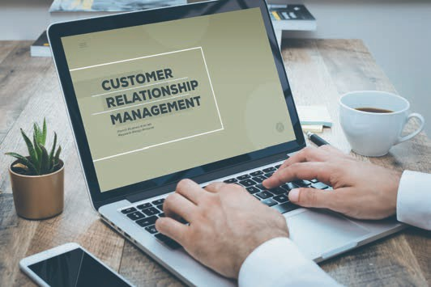

# Unit 1

## Basics of CRM

#### STUDY GOALS

After completing this unit, you will understand …

… what is meant by CRM.

… the economic importance that is placed on customers.

… what role CRM plays in marketing.

DL-D-DLBCRM01-L01

1. Basics of CRM

### Introduction

Customer relationship management – or CRM for short – is a term that you probably have already heard before. But what do these three words, which designate their own subject area, actually stand for? CRM is first all about customers – or, even more specifically, individuals with differing needs and ideas. The next aspect, "relationship," generally describes a very interactive area whose significance is not self-evident. What is clear is that relationships have to be built up and maintained. Last but not least, "management" stands for the planning, strategic, and goal-oriented aspect of the subject area. CRM is thus a highly complex area that has many interesting facets to consider.

Consider the following example: The fictitious company "bags for mobile urbans" (b4mu) was recently founded and produces sustainable, functional, and durable luggage that is also trendy as well as accessories for trend-conscious people who travel a lot for work and pleasure. The company founders want to inspire others with their products and turn customers into fans of the new brand. However, none of them has any previous marketing experience, and the young entrepreneurs only have relationships with people they know personally. This is reason enough to delve into this important field of action and to find out the fundamentals of ...

* + what CRM actually stands for,
  + the importance of CRM for the company's success, and
  + how CRM should be classified in marketing.

### Terms and Goals of CRM

Markets have always been somewhat dynamic, and they change in line with the consumers themselves and their purchasing behaviors. It is a two-way reciprocal relationship that repeatedly challenges companies to track and analyze the market and their own customers as well as to use tools to analyze the market in a market- and target-group-oriented manner on the basis of up-to-date information. In the struggle to win over proﬁtable customers, companies can gain valuable competitive advantages over the competition through the successful use of customer relationship tools (Holland 2016, 296).

Customer Relationship Management is defined in many different ways in the literature. On the one hand, CRM has been defined as a customer-oriented, comprehensive, and technology-supported management concept. However, other authors have viewed CRM as a tool for customer data processing (Bruhn 2016c, 14). Under the latter framework, CRM is simply a tool for processing customer data, extending from collection to analysis and archiving. At b4mu,

Basics of CRM

the young entrepreneurs discuss both interpretations and quickly agree that accepting one approach to the exclusion of the other would not be enough, since neither a purely strategic nor a purely technology-led approach is likely to yield promising results in the long term.

**CRM** should therefore be understood as the focusing of corporate structures, processes, and activities on the customer in order to identify and establish proﬁtable customer relationships. They can be intensified or ended and resumed later as needed (Götz/Krafft 2013, 583).

From this point of view, CRM should be understood as a process aimed at initiating and consolidating proﬁtable customer relationships, retaining the customer, winning them back, or even ending the relationship when it is no longer advantageous for the company. At the same time, CRM must not be understood as a new type of direct marketing or just another term for customer satisfaction, orientation, or proximity, or in short as a purely IT-based solution (Rapp 2005, 53). CRM strategies, which determine which customer groups can and should be addressed and how, should be developed on the basis of clearly deﬁned goals. To do this, of course, you need to know who your company's customers are, what their interests are, and where they can be reached. In contrast to long-established companies, a young company like b4mu still has little customer experience and still needs to learn the market and its customers. But regardless of whether you are a young or an established company, one thing is clear: Businesses need to know and understand their customers in order to properly address them. Ideally, companies therefore collect all known information about their customers and synthesize it to create a holistic picture, which is known as the **"uniform customer approach."** However, it is not best to pursue a single strategy alone. The strategy cannot be effective without the necessary organizational integration, the development of processes for customer processing or the selection of suitable CRM systems, and following through on their implementation (Leusser/Hippner/Wilde 2011a, 17 et seq.).

b4mu is starting to gain a better understanding of CRM, but they would still like to find out more precisely which specific goals can be achieved using a CRM. Essentially, CRM activities are about creating proﬁtable customer relationships. Customer satisfaction should be built up and expanded in order to create the basis for customer relationships so that customers can be retained over the long term and their added value for the company can be boosted. Therefore, companies need to find out who the most proﬁtable customers are for the company and what should be offered to them in order to retain them. In addition to existing customers, it is also important to identify potential new customers, address them, win them over, and then retain them over the long term. According to Rapp, CRM pursues three main goals (Rapp 2005, 45):

* Increasing the **Share of Wallet** of Each Individual Customer
* Optimizing Customer Relationships from an Economic Point of View and
* Acquiring New, Proﬁtable Customers

CRM

As a management process, CRM is designed to not only create customer relationships, but to care for and manage them over the long term.

"Uniform Customer Approach“

This term describes the result of taking a holistic view of the customer information available to the company.

Share of Wallet This term the describes the proportion of the customer's total expenditures in a particular area (e.g., on clothing) that are spent at a spent at a particular supplier (e.g., brand of

pants).

Proﬁtable Customers

Profitable customers are those customers who are loyal to the company, purchase products more than once from it, and make a long-term contribution to the company's success.

### The Economic Significance of the Customer

"A company does not grow simply because it sets itself the goal of growing, but because it constantly evolves to address the needs of customers" (Werner 2018, 413). This quote by Götz Werner, the founder of dm-Markt, immediately struck a chord with the young entrepreneurs at b4mu. After all, there are no sales without customers, and the company has no future without sales. That is an extremely succinct way of summing up the customer's importance. That insight speaks for the fact that it is important to have a lot of customers. Yet, should all customers be regarded the same way? Is a one-time customer to be valued just as much as a loyal repeat customer? Rapp uses an example to explain the importance of customers very well: A business owner looks at the numbers of new acquisitions by their sales people and finds that some of them have been able to attract an outstanding number of new customers. However, when they compare the turnover of the sales people, the numbers paint a different picture: The salesperson who makes fewer new acquisitions but constantly cultivates their existing customer base contributes more to the company's profit than the colleague who has the best numbers in new customer acquisition (Rapp 2005, 23 et seq.) Support for the argument that the acquisition of new customers is far more expensive than cultivating existing customers can be found again and again in CRM, and we can assume that this insight is as good as a proven fact. But it's not just the cost of customer acquisition measures: you also have to factor in what it means to have a customer base that keeps buying loyally, regularly, and reliably from you over the long term. You can tell even without running the numbers that these customers in particular are the clear proﬁtable ones.

The young company b4mu has many unanswered questions: So, who exactly are these customers? When and where does the relationship with the customer begin? Is the customer already a customer when they enter a store for the first time or see the company's offerings, e.g., in an advertisement or on the website? Or is the customer only a customer after a transaction has taken place, such as, for example, when they purchase a bag or another product from the company? But the question also arises as to how long does a customer retain their status as such? Is there an expiration date for customers? And when exactly is a customer's classification changed from a one-time buyer to a repeat buyer, or why should someone commit themselves to the company and their still nascent brand at all instead of deciding anew at the time of every purchase which product to buy and from which company? The CRM literature makes very simple differentiations and provides a basic orientation by dividing customers into potential, current, and lost ones. It is on these categories that the CRM measures are concentrated.

Basics of CRM

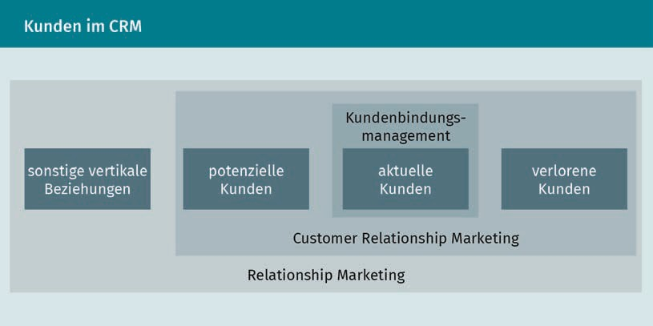

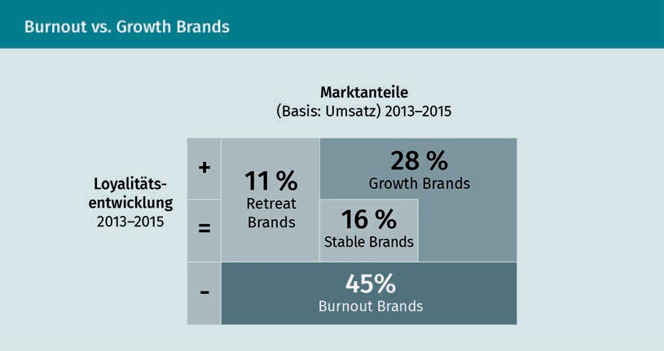The b4mu team certainly recognizes the value of CRM measures, but it is skeptical as to whether customers can really still be retained and made loyal to a company, since studies show that consumer loyalty to brands has subsided. However, these studies also present a heterogeneous picture: Successful brands boast a high proportion of repeat customers (51%), while other brands are left with a higher number of occasional customers (about two-thirds). A further surprising result was obtained when buyers of branded goods were classified according to the company's market-share development and buyer churn criteria: The majority of manufacturer brands were identified as "**burnout brands**," i.e., brands that have an above-average number of **regular customers** and have also lost market share over time (Haller 2018, 290 et seq.).

Burnout Brands These are brands that lose an above-average number of regular customers and, as a result, have also sustained losses in market share.

Regular Customers These are buyers who regularly source their needs from the same supplier/vendor, e.g., who always buy groceries from the same

brand stores.

Seller's Market

In a so-called seller's market, demand is greater than supply.

Buyer's Market

In a so-called buyer's market, supply is greater than demand.

At b4mu, this situation is also interpreted to mean that the company should clearly focus on retaining and caring for **regular customers** instead of just focusing on acquiring new ones. A young company must first certainly build up a solid customer base, but from the start a business should have the goal of not only winning over customers, but also retaining them over the long term. And for that to succeed, the company must (as was mentioned above) get to know and understand its customers. If a company does not know why someone is loyal to their brand or (on the contrary) not loyal, why they buy repeatedly from them or only once, or why the brand is recommended or criticized, then the company cannot react appropriately to either retain the customer or win them back.

Customers (and especially **regular customers**) place a special value on the company, and the company can interpret this either as the contribution of an individual customer or of an entire customer group to the achievement of the company's goals. However, this contribution is not only calculated on the basis of past or future sales by customers, but it also takes account of indirect contributions, such as recommendations (Leusser/Hippner/Wilde 2011a, 22 et seq.). **Customer value** is measured over the long term, since you must not only take a current snapshot of the customer, but you must also evaluate their future potential. The managers at b4mu are well aware of the future significance of their customers: Young customers who are still in school, for example, may today opt for the company's inexpensive "youth line," but if they develop loyalty to the company, they will become the **profitable customers** of tomorrow when they move up to the "professional line" consisting of the company's exclusive collection. Research has shown that investing in customer retention pays off, because the amount of profit that can be made from individual customers increases the longer the customer relationship lasts (Leusser/Hippner/Wilde 2011a, 25). The **customer value** therefore not only refers to individual transactions, but it also has to take into account the relationship aspect.

### From Transactional to Relationship-Oriented Marketing

Businesses need to align themselves with the market, and that market is sometimes a benevolent partner—such as the **seller’s market** in the 1950s: At that time, marketing was mainly distribution-oriented, and the sellers could more or less dictate the prices and conditions themselves. But there are also markets that are not as favorable: A saturated market requires an intensive analysis of market conditions and customers. A lot has changed in this **buyer's market**, and various aspects have come into focus over the years, including the focus on the **Unique Selling Proposition (USP)** and the increasing awareness ever since the 1980s of the importance of customers and cultivating relationships with them. The realization that a profitable company is not just one that makes a profit,

Basics of CRM

but it is also one that carefully maintains the quality of its customer relationships has meant that increasing importance is placed on relationship management (Lucco et al. 2015, 18 et seq.).

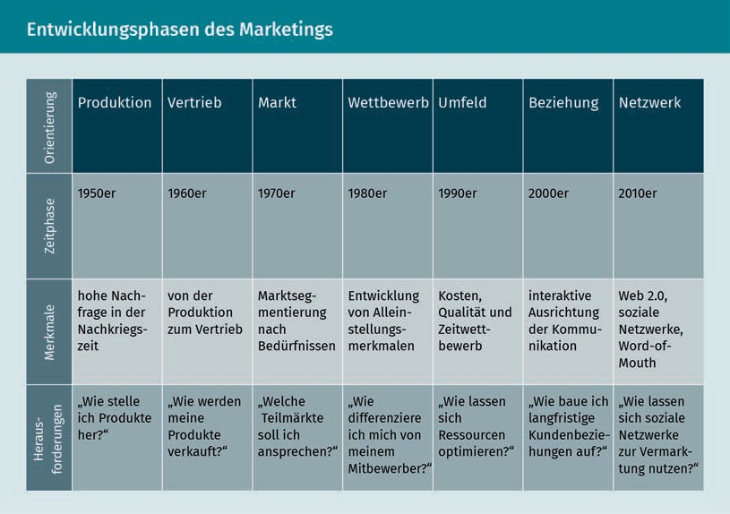

Marketing has long since ceased to be equated with sales or advertising, and this short-sighted view has increasingly been replaced by a market- and customer-oriented corporate orientation. Instead of engaging in individual **transactions** with the customer, the focus is now on controlling customer relationships. These changes and the development of such a **relationship-oriented marketing** has proceeded through three phases. While the focus in the 1990s was still on customer satisfaction, this shifted to customer loyalty management and culminated in customer relationship management (Ergenzinger/Thommen 2005, 437).

Unique Selling Proposition

This term designates the unique feature of a product/brand.

Relationship-Oriented Marketing

Relationship-oriented marketing targets the needs of customers.

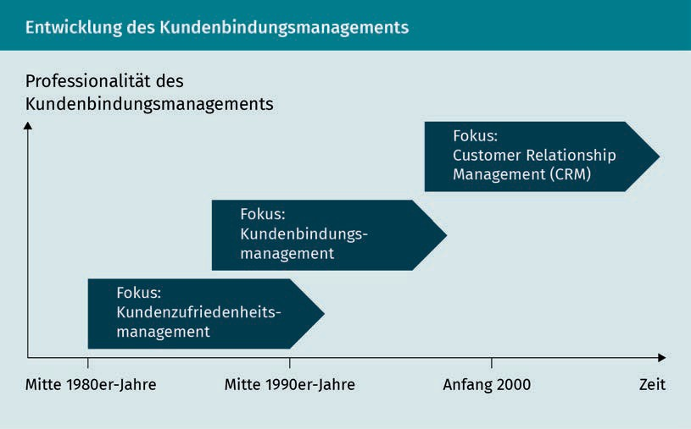

At b4mu, one wonders whether this relationship orientation led to a redefinition of what marketing is or whether the relationship orientation is not simply the result of the continuous evolution of the field of marketing. When comparing the distinguishing features of transactional and relationship marketing, as Bruhn has done, the latter assumption is reinforced:

|  |  |  |
| --- | --- | --- |
| A Comparison of Transactional and Relationship Marketing | | |
| Distinguishing criteria | Transactional marketing | Relationship marketing |
| Consideration period | Short-term outlook | Longevity |
| Marketing object | Product | Product and interaction |
| Marketing goal | Customer acquisition through marketing mix | Customer acquisition, customer retention, and customer recovery |
| Marketing strategy | Performance presentation | Dialog |

Basics of CRM

|  |  |  |
| --- | --- | --- |
| Distinguishing criteria | Transactional marketing | Relationship marketing |
| Economic success and control parameters | Profit, contribution margin, sales, and costs | In addition: Customer contribution margin and **customer value** |

The comparison shows that **relationship-oriented marketing** not only takes into account the services of the provider, but to a large extent it incorporates the needs of the customer and combines both aspects. The advantages of a relationship orientation are increased profitability (e.g., through savings from not having to acquire as many new customers), growth (e.g., by increasing **cross-buying effects**), and better security (e.g., through better planning security afforded by more stable customer relationships) (Bruhn 2016c, 17).

### CRM Tasks and Structure

CRM is a systematic process that puts the customer at the center of corporate strategy. As explained above, CRM can neither be reduced to communicative nor technology-based approaches. Rather, it is only promising when viewed as a holistic, integrative approach. Rapp's five-phase model presents a systematic approach in which the necessary processes of the CRM method should build on one another for the purpose of establishing long-term customer relationships (Rapp 2005, 54 et seq.).

Cross-Buying Effect If a customer makes repeated purchases from the same company and/or buys other products from a company after making a purchase, this is referred to as the cross-buying effect.

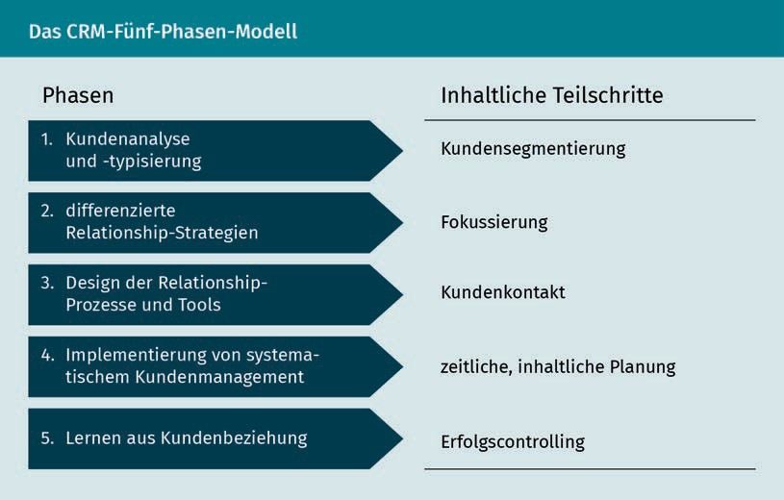

The tasks that the company must accomplish are customer acquisition, customer retention, and customer recovery.

However, the young business owners of b4mu now wonder whether CRM can be applied in the same way at every company and in every industry and market. This is definitely a disputed question. Think about the following scenario: You just bought some balloons to use as party decorations. Do you associate them with a specific manufacturer? Or what about when it comes to such consumable products as garbage bags, toilet paper, candles, or the like? And how does your opinion change for such durable products as clothing, smartphones, laptops, or cars? And what is your thinking about personal care products or groceries? The extent to which a product is directly associated with the manufacturing company and how exactly the customer relationship with the company is perceived vary not just at the product level, but also at the level of the individual consumer. Customer involvement, or the emotional involvement that the consumer experiences when making a purchase, is an important factor for the customer relationship. When it comes to everyday products, the involvement is significantly lower (low involvement) than, for example, when buying a car (high involvement), where the purchase decision is shaped by many factors: Not only does the product itself play an important role here, but such factors as brand image, quality, and price do so as well. However, it is also abundantly clear that companies cannot assume a generalized customer. Rather, they must specifically research their customer. This knowledge is largely grounded in data about customers, which can be generated not only using market analyses, but also through customer-speciﬁc databases. For example, companies want to know which customers buy what, where and how customers shop, and what their preferences are (Rapp 2005, 74). This knowledge forms the basis for needs-based actions and campaign planning.

b4mu would like to find out more about its current and future customers, and it is considering how it can obtain this knowledge and what it needs to take into account in order to determine the most comprehensive picture of its customer. Anyone who still thinks that all that is needed for good customer data collection is a good IT solution is short-sighted: Of course, solid data collection tools and corresponding databases are required, but it must not be forgotten that the usefulness of any database lies in the data analysis that it facilitates, so that suitable measures can be derived from the findings. Therefore, the company must develop a reasonable strategy, which determines the information and data that are actually needed and also pays special attention to ensuring that the company processes are customer-oriented (Rapp 2005, 75).

Regardless of the industry or product, CRM, as a customer-oriented approach to corporate management, is designed to comprehensively consider developments in consumer behavior or sales market structures so that economic benefits can be derived. CRM succeeds by ensuring customer satisfaction and customer loyalty as well as by forming long-term customer relationships. But it takes more than just developing the right strategies to apply CRM successfully to all areas: Company management and employees must deeply internalize the principles of customer orientation

Basics of CRM

and appreciate their significance. Ideally, this is done by formulating appropriate goals and guiding principles and anchoring them in the corporate culture (Schumacher/Meyer 2004, 19 et seq.).

The b4mu managers are now wondering how the multitude of tasks can be meaningfully structured on the strategic as well as on the operational sides. In the literature as well as in practice, a distinction is usually drawn between the analytical, operational, and communicative CRM approaches. These three areas cover data collection and evaluation, the resulting planning of measures, and the use of respective supporting technologies (Schumacher/Meyer 2004, 20 et seq.). In order to be able to initiate successful CRM activities, companies not only need to master certain individual areas, but they must also strike a successful balance between analysis, strategy, and implementation.

Summary

Companies must face the challenges of constantly changing markets and consumer purchasing behavior in order to successfully assert their claim for market share. The use of customer relationship tools provides an opportunity to gain competitive advantages over the competition. CRM stands for a management process that is geared towards creating proﬁtable customer relationships and maintaining these relationships in order to create a long-term relationship between the customer and the company. The CRM approach is a holistic process that develops and implements strategies on the basis of clearly deﬁned goals that serve to optimize customer relationships from an economic point of view. In order to achieve this, companies must know and understand their customers in order to be able to create the most comprehensive possible picture of the customer. This "uniform customer approach" provides the basis for the development of suitable CRM measures.

Customer retention and cultivation are essential to the company's economic outlook, especially in these times of declining customer loyalty. That is due to the fact that the loss of **(regular) customers** often leads to a loss of market share in the medium term. Investing in customer loyalty pays off, since it has been proven that the profit that can be made from individual customers increases with the length of the customer relationship. These findings can also clearly be seen when a company moves from transaction-oriented to **relationship-oriented marketing**. The focus on customer needs can be understood as a logical further outgrowth of marketing. The advantages of this relationship orientation can be seen in increased profitability, growth, **cross-buying effects**, but also greater planning security for the company.

Since companies cannot assume a generic profile for their customers, they need to research specific knowledge about their customers. This knowledge is gained from studying the totality of all customer data, and it provides the basis for

needs-based action and campaign planning. It cannot be overstressed that customer data collection should not be regarded as something that can be easily solved an IT solution: Only a well-grounded analysis of the data can provide the insights that lead to the adoption of suitable measures, and such an analysis should be supported by appropriate processes that are well anchored at the company (e.g., complaints management, service offerings, etc.). Company management and employees must deeply internalize the principles of customer orientation and appreciate their significance.



# Unit 2

## Theoretical Explanatory Approaches to CRM

#### STUDY GOALS

After completing this unit, you will understand …

… what are the fundamental kinds of theoretical explanatory approaches to CRM.

… which communicative aspects are relevant.

… why addressing relationships is important for successful CRM.

DL-D-DLBCRM01-L02

1. Theoretical Explanatory Approaches to CRM

### Introduction

If you deal with CRM, then you know that there is often more than just one way of looking at it, since the discussion draws in viewpoints from different viewpoints. The topic can be approached with behavioral science, communication theory, as well as also economic explanatory approaches, and we will examine these in more detail in this lesson. Basically, CRM is about customer relationships. There are important theoretical foundations of relationship marketing that we can explore. Here we will demonstrate the significance of developing closer customer relationships. The benefits of customer relationship management are presented using different approaches. An approach that is more grounded in economics focuses on the monetary importance of customer relationships, while the behavioral science approaches look at the origin and importance of relationships. Psychological processes, such as trust, commitment, or customer satisfaction must be taken into account, as these are important as the basis for creating customer loyalty. These relationship-oriented strategies have been developed from transaction cost theories, which argue in favor of the benefits of a customer-oriented business approach.

### Explanatory Approaches from Neoclassical, Neoinstitutional, and Organizational Theory

The theoretical basis of CRM can be found in different scientific fields due to the interdisciplinary nature of the subject area. If one foregrounds customer relationships, it is important to find out what value these relationships have, how such relationships come about, but also how the company must react organizationally to customer orientation. By analogy with marketing research, relationships can therefore be assigned to the following theoretical approaches (Bruhn 2016c, 22):

* + Neoclassical theoretical approaches
  + Neoinstitutional theoretical approaches
  + Neobehavioral theoretical approaches
  + Theoretical approaches based in organization theory

The neoclassical and neoinstitutional theoretical approaches are rooted in microeconomic theories of economics. Utility and profit theories can be classified under the neoclassical approach. The utility theory explains the behavior of the customer in relation to the company benefits. To put it simply, we can agree that a customer uses services when they personally expect to obtain a greater benefit from them. Relationships with the company are therefore only relevant for the customer if they can expect to derive a benefit from them.

Theoretical Explanatory Approaches to CRM

Profit theory focuses on the behavior of the company with an eye to the services that it offers to the consumer and selects the actions that maximize profit. This means that the customer is evaluated based on the value they provide to the company, and the company decides to process data about the respective customer or customer segment based on the economic advantage they can derive from doing so. For example, models such as the customer lifetime value are used to evaluate the customer. If you take a critical look at these approaches, then you will notice that they are unable to take account of how customer relationships change over time, and they are also unable to differentiate between different types of customer relationships (Bruhn 2016c, 24).

The neo-institutional approach believes that the function of marketing is to promote **transactions** or customer interaction and, according to this understanding, serves to reduce uncertainties and build trust. The following theoretical explanations can be used to establish CRM that is oriented on relationships (Bruhn 2016c, 24 et seq.):

* Informational economics (focus: function of informational uncertainty)
* Principal-agent approach (focus: uncertainty and informational asymmetries of socioeconomic relationships)
* Transaction cost approach (focus: costs incurred from coordinating a business relationship)
* Relational-contracting approach (focus: contractual design of exchange relationships).

These four approaches make their own important contributions to consider when evaluating customer relationships, but they do not offer a comprehensive, in-depth explanation.

As companies have become increasingly oriented towards customers, this has led to changes in the organizational structures of companies that started many years ago. It became clear that it is not enough to establish direct contact with the customer, which is typically anchored at a single point (usually sales). A distinctive customer management approach therefore attempts to coordinate all of the company's customer-speciﬁc measures and also to implement this organizationally.

**Resource dependency theory** and the resource-based view approach provide the theoretical underpinnings. **Resource dependency theory** focuses on ensuring the company's survival by providing it with the appropriate resources. The customer is therefore viewed as an important resource, and the relationship between provider and customer is seen as symbiotic: The company output requires the input of the customer (Bruhn 2016c, 49). Simply put: The company can only generate revenue if the customer buys something! The resource-based view approach focuses on existing resources or resources to be generated that contribute to establishing customer relationships. These relationships are not only created through the direct transaction, but through the intention of the company that wishes to create such

Resource Dependency Theory

Resource dependency theory deals with the inﬂuence of external resources on business actions and behavior.

relationships. In contrast to the behavioral science approaches, these theoretical considerations focus on the companies and not the behavior of the customers (Bruhn 2016c, 51).

From a practical point of view, companies try to implement a customer orientation approach across departmental boundaries. However, the associated structural changes offer potential for internal conflicts of interest, such as, for example, between product development or sales. In order to ensure that a comprehensive customer orientation is deployed throughout the organization, the necessary conditions for acceptance must be fostered within the company. The formation of interdisciplinary working groups, which are made up of experts from different departments (from the product and sales managers to logistics experts) and whose task is to coordinate processes at the company with the customer's needs, has already yielded promising results (Köhler 2018, 324 et seq.).

### Explanatory Approaches From a Neobehavioral Perspective

Due to the paradigm shift from transaction- to relationship-oriented marketing, maintaining economically attractive customer relationships is becoming increasingly important. But where do these relationships come from, and how can we explain why they happen?

Neobehavioral approaches provide explanations for many of our questions about customer relationships, and they help us to consider and understand consumers and their behavior. From a behavioral perspective, there are various suitable theoretical approaches for explaining the customer's reasons for establishing and maintaining relationships. Known psychological approaches include (Bruhn 2016c, 34 et seq.):

Learning Theories There are various learning theories. When attempting to understand customer behavior, researchers often use the

reinforcement approach: Accordingly, behaviors are changed as the result of positive or negative consequences.

* **Learning theory** (reinforcement principle)
* Risk theory (avoidance of negative consequences)
* Dissonance theory, or also
* Involvement theory

As part of the various approaches to **learning theory**, the reinforcement principle is often used as a basis for the relationship management. Changes in behavior are explained as reactions to positive or negative consequences. So, if the customer perceived something as good or saw a positive benefit to the interaction, they will act the same way again in the future. Thus, in the case of such customer relationships, the product will be resold. On the other hand, if the customer perceived something rather negatively, they will avoid the action again in the future, e.g., by not buying the product again (Bruhn 2016c, 34). This approach can be further differentiated if learner involvement is taken into account. If the level of involvement is low (that is, simply put, the customer feels little connection to the product or company), the customer absorbs the information rather unconsciously. According to the **mere exposure hypothesis**, it is assumed that the target group's perception changes positively if

Theoretical Explanatory Approaches to CRM

it comes into contact with the reference object (i.e., the product or company) as often as possible. On the other hand, when there is a high level of involvement, more complex learning processes are assumed, since information acquisition and processing is not unconscious, but rather based on rational calculation (Bruhn 2016c, 34).

The risk theory is based on the knowledge that customers want to keep the risk associated with the purchase of products as low as possible. Imagine you are buying a new car. However, you are looking to acquire not just a safe and reliable means of transportation, but also a certain social status. But what if your purchase fails to achieve this kind of recognition from friends, acquaintances, and colleagues and instead you are even criticized for your decision? This is just one example of the types of risk that buyers want to avoid. The literature distinguishes between functional, financial, social, and psychological risks of purchased services. For customer relationships, this means that risks are minimized for the customer if the customer can rely on the provider and the purchasing process and trusts them (Bruhn 2016c, 34 et seq.).

The behavioral effects are a product of the psychological effects on the customer: De facto customer loyalty is achieved when the customer is not only satisfied with the company and its offerings, but when this positive attitude towards the company translates into active behavior, such as making another purchase, acquiring other products from the company (cross-buying), or recommending the company to a friend. In contrast to the purely psychological effect, this type of behavioral effect can also be directly observed or measured by the company (Bruhn 2016a, 242).

Another area that should be mentioned in passing (though we do not have space to elaborate on it here) is the socio-psychological explanatory approach, whereby according to Bruhn the following approaches are relevant for assessing relationships (Bruhn 2016c, 38):

* + Interaction and network approaches,
  + Exchange, incentive-contribution, and **equity theory**
  + Penetration theory

The creation of added value on the part of companies and customers plays an important role in relationship building. Long-term relationships are only established and maintained if they provide a recognizable benefit for the partners involved. One of those benefits is the building of trust. Let's take a closer look at customer relationships: They can be understood as the interactions between companies and current and potential customers, and they should be differentiated from individual transactions, e.g., one-time purchases. The relationships that arise from repeated interactions between customers and companies are grounded at both the factual and emotional levels. Reciprocal positive experiences build trust over time. This trust ensures that customers behave accordingly, which is reflected in purchases, additional purchases, or recommendations (Stauss 2011, 321 et seq.). Relationship building is a long-term process and cannot be achieved through one-off endorsements.

Mere Exposure Hypothesis

The mere exposure hypothesis assumes that the repeated perception of a thing/information leads to a positive evaluation.

Equity theory

Equity theory is a process theory that attempts to explain how motivation arises.

### Explanatory Approaches Considered From a Communications Standpoint

Commitment In the CRM context, commitment stands for the connection/identiﬁcation of customers with a company/brand.

Communication makes a significant contribution to relationship building thanks to opportunities to build trust and **commitment**. Relationships are a two-way process and arise through interactions between customers and companies, i.e., the exchange of content, such as services, but also information. The importance of communication in relationship management has already been proven by various studies, and it has been discovered from a comparison of all customer loyalty tools that communication is the most important to maintaining customer relationships (Bruhn 2016a, 230 et seq.).

Not just the change in the communication landscape, but also the redirection of marketing from transaction- to relationship-oriented thinking has brought challenges for communication policy. Communication policy must always fulfill various goals. In addition to sales policy goals, the focus of a customer-oriented company is also on the task and goal of creating and maintaining supplier-customer relationships. In order to meet this challenge, communication must be geared to the needs of the target groups, the creation of benefits for providers and customers, and dialog. A needs orientation is a decisive success factor across all phases of customer retention. Only if the exchange partner's information interests are recognized and the communications measures meet their needs will the exchange or dialog be intensified, therefore allowing for relationship building to take place. Ideally, communication is not addressed to the larger target group, but rather to the individual customer so that this person can be provided with the necessary information and the company receives important information from the customer in return. But can a company enter into dialog with each of its customers to address them individually and personally? It should go without saying that only a very few companies have the capabilities to do this.

In general, relationship marketing is always about creating proﬁtable customer relationships that promise added value for both the provider and the customer. The added value for the customer can be seen not only in the economic beneﬁts, but also in the psychological beneﬁts (reliability of a relationship) or in the satisfaction of the need for belonging (as members of a community). Communication should be focused on maximizing the benefit for the company. By establishing customer clubs or building **brand communities**, for example, the various needs of customers can be met. Viewed in this way, communication functions not only as a mediator of information, but as a relationship builder. However, to answer the question posed above of whether each customer can now be addressed individually, it is best to direct communication towards those customers who are classified as proﬁtable over the long term. However, it is also important for the company to avoid squandering its efforts through more general, mass-mediated communication. Rather, it should focus on establishing interaction- and dialog-oriented communication with (profitable) customers, because relationships are only established through reciprocal communication (Bruhn 2016a, 232).

Theoretical Explanatory Approaches to CRM

Interaction- and dialog-oriented communication is understood as a two-way communication process. This means that the involved communication partners have the opportunity to get in direct contact and exchange information with each other. However, in this context, it is important to make a distinction between asymmetrical and **symmetrical two-way communication**. As was illustrated in Grunig and Hunt's PR models from the 1980s, two-way communication should not automatically be equated with dialog. With asymmetrical two-way communication, the recipient can provide feedback in response to the sent information, but it does not influence the behavior of the sender, i.e., by prompting a reply/reaction. It is only when the feedback is received, accepted, and taken into account in the communication situation, i.e., there is a change in behavior due to the reaching of an understanding between the communication partners, that it is possible to speak of **symmetrical two-way communication** (Grunig 1989, 29). If companies want to build real relationships with their customers, they must engage in appropriate communication on an equal footing in order to initiate processes that seek to achieve understanding. Bruhn summarizes this multi-stage and dialog-oriented communication process in the model presented below (Bruhn 2016a, 233).

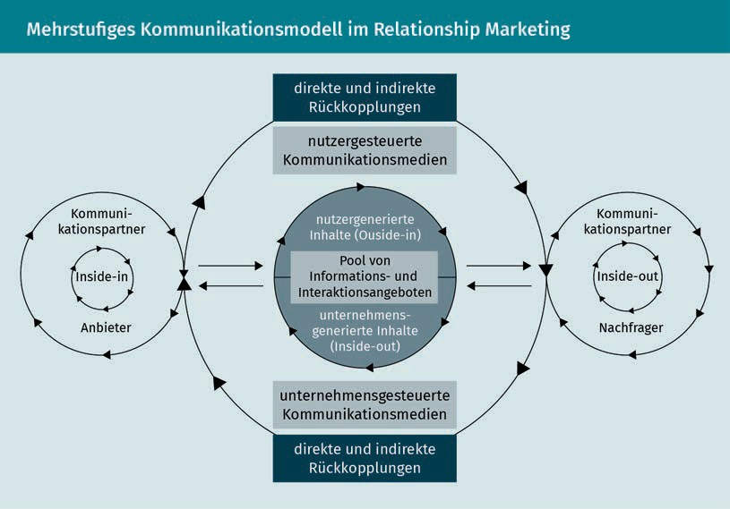

The dialog orientation, which has long been known in the field of PR, can supplement or even replace one-sided communication processes in order to assist relationship building. Advantages: The customer can initiate this dialog themselves, and they do not have to wait for the company to approach them. Communication can be designed as a pull process and not just as a **push** one. The creation of feedback channels that provide the opportunity to initiate

Symmetrical Two-Way Communication

Symmetrical two-way communication not only allows for feedback, but it also actively incorporates it.

Push Communication

Push communications are those messages and information that are presented to a consumer unsolicited, such as online ads, TV spots, or posters, for example.

two-way dialog is particularly important for establishing such a pull process. For companies, however, this also means that they must be willing to listen to customers and recognize opportunities for actively incorporating customer opinions in their own planning activities! Bruhn derives four relationship-oriented perspectives from this two-way communication structure (Bruhn 2016a, 234):

* Inside-in perspective
* Inside-out perspective
* Outside-in perspective
* Outside-out perspective

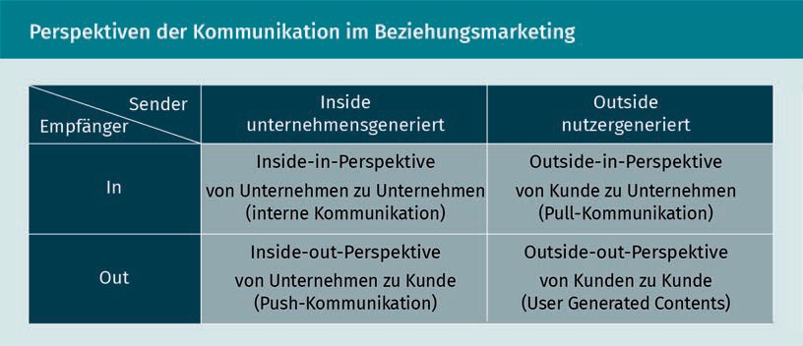

Communication has the important task of initiating the supplier-customer relationship, but also of implementing it and moderating the dialog. In order for communication to be successful, it must be long-term, needs-based, but also benefit- and dialog-oriented. On the one hand, communication must recognize needs and initiate individual dialog (means-goal relationship). On the other hand, companies receive important information about the customer through this dialog, which in turn forms the basis for individualized and tailor-made offerings (goal-means relationship) (Bruhn 2016a, 231 et seq.). In communication policy, this relationship orientation means focusing on customer needs instead of product or service features.

Summary

CRM as an interdisciplinary topic is based on various theoretical foundations. Since customer relationships must be regarded as an essential element of CRM, a comprehensive evaluation of the origin, the significance, but also the opportunities afforded by these relationships is of fundamental importance. Neoclassical, neoinstitutional, neobehaviorial, and organizational theoretical approaches are used to explain these different aspects. These approaches look at customer relationships from different angles, but they do not

Theoretical Explanatory Approaches to CRM

provide holistic explanations of multifaceted CRM. Even if neobehavioral approaches do not offer a comprehensive explanatory model, they are nonetheless very important for understanding relationships. The behavioral perspective helps to explain client-side reasons for entering into and maintaining relationships. **Learning theory** and risk theory in particular help to explain how relationships are formed, what meaning such relationships have for providers and customers, and what benefits they create. After all, the creation of added value, or a recognizable benefit, plays an important role in relationship building. One of those benefits is the building of trust. This trust is the basis for customer loyalty and ensures that the customer behaves in the way desired by the company, such as by making repeat purchases, additional purchases, or recommendations.

Communication plays a crucial role in relationship building, as trust and **commitment** can be built through interaction and dialog between customers and companies. In order for this to succeed, the communications policy of the company must be crafted appropriately: A key success factor is maintaining a needs orientation. A real exchange between customers and companies only succeeds if the communication measures are geared to the information interests and the dialog is established via suitable channels that support **symmetrical two-way communication**. Real dialog also produces a number of advantages for the company, since customer requests can be recognized and integrated into the company's own planning activities.



# Unit 3

## The Customer Lifecycle and Customer Relationship Cycle

#### STUDY GOALS

After completing this unit, you will understand …

… what a life cycle concept is.

… the significance of customer relationships from the point of view of the requester and the provider.

DL-D-DLBCRM01-L03

1. The Customer Lifecycle and Customer Relationship Cycle

### Introduction

Relationships do not just exist out there in static space. On the contrary, they are dynamic: They arise, develop, and are terminated again. Just like relationships in our private lives, customer relationships are not designed with a specific expiration date in mind. Rather, the duration and quality of the relationships depend on many different factors. Let's consider a simple example: Every morning you buy bread rolls from the bakery around the corner. The offerings are good, the prices are right, and the staff is friendly – so you have no reason to seek out a different bakery. Or maybe you do? What happens if you move, and thus you can no longer patronize the same bakery? Despite the previously very stable supplier-customer relationship, you will probably be forced to end the relationship.

No matter how good the product may be, it loses its value if it no longer suits the customer's life and therefore no longer provides any personal benefit (Rapp 2005, 43). As we could clearly see in the bakery example, a wide variety of scenarios in the supplier-customer relationship must be taken into account, which have an impact on the duration and quality of the relationship. However, the circumstances influencing the customer are not always a direct result of the customer's communications with the company, but they are also often indirect, as the following example clearly shows:

A customer buys furniture for their new apartment from a well-known furniture store and arranges to have the new furniture delivered, because the delivery service promises to bring the purchased merchandise to the apartment. The customer is then informed by the delivery service of the exact time of delivery, and they are pleased that everything has been arranged so smoothly. The goods are to be delivered to the customer's 5th-floor apartment in an old apartment building three days later. But then the delivery service arrives after the agreed time, the delivery people are unfriendly, and they claim that the furniture can only be delivered to the curb. The merchandise is only brought up to the apartment after the customer engages in a lengthy conversation and cites the delivery conditions. Is the customer only angry at the delivery service, or does the experience reflect negatively on the furniture store as well? And what do you think, what consequences does this have when the customer shares these types of experiences with others? A previously good supplier-customer relationship could possibly come to an end as a result of such an experience. It should be clear how many factors must be taken into account as part of the customer relationship and how quickly trust can be undermined or lost, for example.

### Customer Life Cycle

Customer needs often also change depending on the their current life phase. These needs are partly age-dependent (customer age cycle) and partly dependent on their respective life circumstances (**customer life phase cycle**) (Bruhn 2016c, 60). These circumstances can be of a ﬁnancial nature or stem from life-changing events, they can be positive or negative (e.g., job loss) as well as anticipated (e.g., ,

The Customer Lifecycle and Customer Relationship Cycle

beginning of retirement) or unexpected. For example, the birth of a child results in an enormous change in the consumer behavior of the parents. Apart from redesigning their apartment or possibly even moving to a new residence with a more child-friendly environment, the new parents must buy diapers, children's clothing, and other equipment, such as strollers or baby slings, for example. However, some of these products are only purchased once or only for a short period of time. This is a simple but clear example of how customer needs can change. Yet, today it has also become more difficult to distinguish between classic life phases, or these phases may only be able to be assigned to specific age groups to a limited extent. These life phases are increasingly shifting or being arranged differently. For example, a young woman may want to start developing her career right now and postpone planning a family until later. Life models have changed, but if companies develop an orientation towards different “life circumstances,” this will definitely help them to be able to recognize the needs of the consumers. These **customer life phase cycles** are often presented as follows:

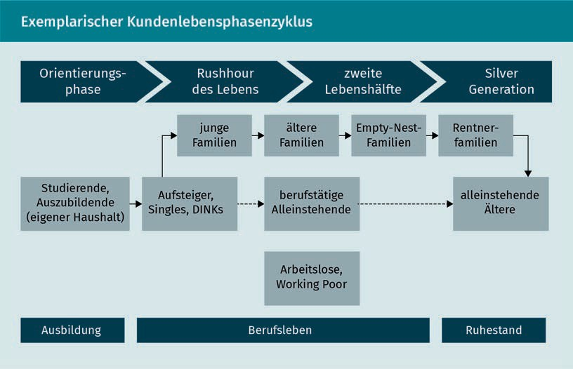

The **customer life phase cycles** help to explain and identify customer needs depending on the consumer's respective life phase: This is because the change of phases is often associated with changes in consumer behavior. As was already described above, for example, the young family has different needs than an **empty-nest family**. And, of course, young couples without children—who are also known as DINKs (Double Income, No Kids)—have other interests, desires, and needs than, for example, the Silver Agers, which are the group of people who have actively reached the life phase following work and children. In marketing, companies consider the age- or life-phase-dependent needs of customers to identify current cross-selling potentials or to tailor their offerings to the respective needs of their customers, for example. In addition, by considering these factors, the company can determine the future needs of the customer and their

Customer Life Phase Cycle

The customer life phase cycle is based on the different phases of people's lives and the associated consumer requirements.

Empty-Nest Families Empty-nest families are families whose children have left the parental household.

Empty-Nest Families Empty-nest families are families whose children have left the parental

household.

Empty-Nest Families Empty-nest families are families whose children have left the parental

household.

potential value for the company. If we consider the young family with a baby again, then this consumer will only be of interest to the diaper manufacturer for a limited period of time. However, if the company also offers items for older children, the customer can be sold these additional products in the future through relevant marketing. Another example: A student opens a free student account at a bank. And while investments or purchasing real estate are likely to be of little interest during this life phase, there are often life phases after graduation when these offers will be more relevant. The student is therefore a proﬁtable customer for the bank when considered from a long-term perspective and can be approached over time with offers that are appropriate to their life phase.

Viewed in this way, the customer's life phases also have an inﬂuence on the phases of the customer's relationship with the company, which can be seen as a dynamic process that is described in more detail below.

### Customer Relationship Cycle

Just as is true of the relationships in our private lives, the relationships between companies and their customers also go through different phases: The search for a suitable partner starts with the initial phase of getting to know each other that is usually followed by a strengthening and deepening of the relationship, which is an expression of a stronger emotional bond. If one of the partners distances themselves emotionally, this signals the beginning of the end of the relationship. The other partner may try at the same time to maintain the relationship or to win back the lost partner. It is very important to consider these different phases, because they mean that companies should practice different behavior and actions. Again, these actions are similar to how we respond to developments in our private relationships. During the acquisition phase, the company must address the customer differently than, for example, in the retention or win-back phase (Lucco et al. 2015, 96 et seq.). And all of these measures are not limited to short-term contacts with the customer. Rather, they are designed to foster and manage long-term customer relationships.

The Customer Lifecycle and Customer Relationship Cycle

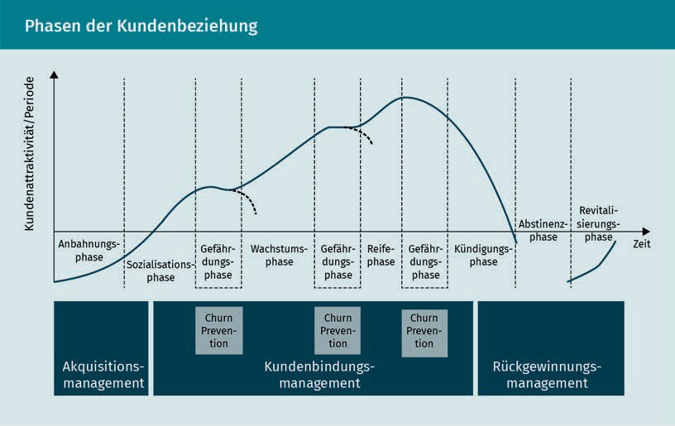

This model represents an ideal-typical course of the customer relationship over time, and it was developed by analogy with the product lifecycle. The consideration of the customer relationship cycle facilitates the systematic analysis of customer relationships for the purpose of deriving measures for customer loyalty management (Stauss 2011, 322). The tasks of the CRM in the phases of the customer relationship life cycle can be represented as follows:

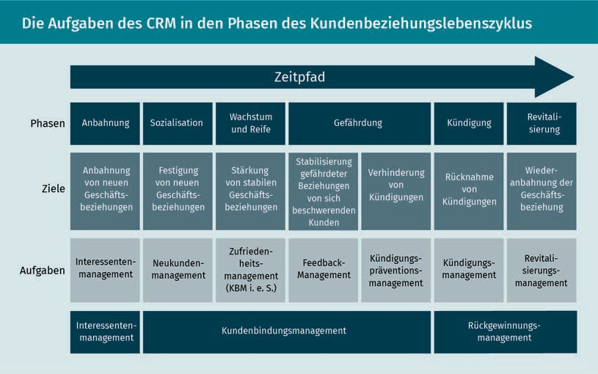

Depending on the phase, the company's activities must be geared to address the customer's respective needs in order to establish and ensure stable customer loyalty over the long term. However, the importance of considering the benefit of the relationship in light of supply and demand, which may vary during the different phases of the relationship, should not be ignored. Companies can clearly see the benefits resulting from these measures. In very simplified terms, winning over a new customer along with engendering a new loyalty to the company or winning them back generates sales from this customer. But what are the benefits for the company of forging relationships with customers across their various life phases? In addition to the pure monetary incentives, customer satisfaction and loyalty also represent important added value.

### Customer Relationships Considered in Light of Supply and Demand

The supplier analyzes customer relationships to identify the what is needed to ensure customer loyalty and what is the impact of this customer loyalty on demand: Does the loyal customer buy more, or does their cross-selling behavior increase? Is the customer even more convinced of their decision to buy from the supplier, or do they recommend the company even more frequently, for example? The processes that shape customer loyalty must therefore be understood. It is only by understanding these processes that the ways of approaching the customer can be understood so that the company can influence the customer relationship and retain the customer (**customer retention**) (Gröppel-Klein/Königstorfer/Terlutter 2013, 45).

Customer Retention Customer retention means, on the one hand, the retention measures undertaken by companies and, on the other hand, the customer behavior patterns that lead to loyalty.

On the one hand, **customer retention** stands for the measures taken by the company to shape customer relationships, but it also describes the behavioral patterns of customers that lead to their loyalty to the company. Viewed in this way, **customer retention** is a multidimensional construct that describes previous as well as intended customer behavior, as shown in the following figure (Leusser/Hippner/Wilde 2011a, 29):

The Customer Lifecycle and Customer Relationship Cycle

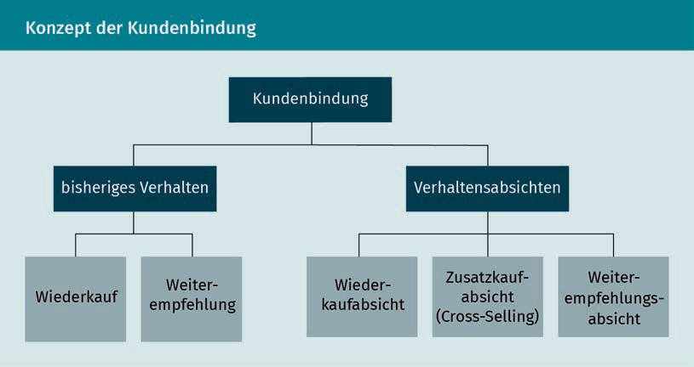

This representation takes into account that the customer should not only be considered in terms of their pure purchasing behavior, but also in terms of their attitudes, which can be measured by how much they recommend the company. These attitudes capture not only previous consumer behavior, but also their future intended actions (Homburg/Becker/Hentschel 2013, 109 et seq.).

Suppliers therefore try to control customer relationships based on the insights they have gained into customer behavior and, within the framework of customer loyalty management, they use customer loyalty tools in such a way that it produces positive effects for the company.

If we look at the area of hotel accommodations, it is easy to describe how customer loyalty is formed from the consumer's point of view and what effects it has over time: A business traveler arrives at a hotel for the first time. Since he is satisfied with the offer, he chooses the hotel again the next time he visits the area. Since he remembers that there is also a restaurant in the hotel, he eats there on the evening of his arrival, since it saves him time from having to go to another restaurant. The restaurant also meets his expectations, and so the hotel becomes even more attractive in his eyes. He now actively recommends the hotel to his business partners. Unfortunately, he will have to pay a higher room rate on his third visit due to a trade fair, but he is still so enthusiastic about the hotel's offering, since it satisfies his requirements and matches his expectations perfectly, that he is willing to pay the extra price.

A company can measure customer loyalty based on the following factors:

* Repeat purchases of products or services
* Purchase of additional services (cross-buying)
* Recommendations, or even
* Repurchase despite a price increase.

As the hotel example makes clear, consumer expectations play a decisive role in the development of **customer retention** and loyalty, but the company can also make an important contribution and take the proactive position in customer relationships by making the right offer, providing service (reflecting customer orientation), as well as meeting the customer's needs and expectations.

Reference Potential A customer's reference potential reflects their importance as an opinion leader and decision-maker for third

parties.

It is in the interest of companies to build long-term proﬁtable relationships. On the one hand, the customer's profitability for the company is measured in direct monetary terms. But on the other hand, the customer is important as an information supplier or for their **reference potential** to provide potential recommendations. And that also means that companies must find out which customer relationships are suitable for this, because not every customer is automatically a long-term proﬁtable customer. Just think about how often you have purchased a product or used a service just once. And can you remember what were the reasons for this? Was this perhaps due to the fact that this was a spontaneous purchase during a business trip because something was forgotten, or perhaps your expectations were not met, your needs changed, etc.? Or perhaps you fundamentally lack the willingness to enter into a relationship with a company at all, since you only desire transactional contact (a pure sales process) with the company (Bruhn 2016a, 243)? As you can see, there are many reasons, and we are unable to provide an exhaustive inventory of them here. Viewed in this way, many relationships fail before they even begin. Or to look at it more positively: they are simply not suitable to be built up and intensified.

Summary

Relationships do not automatically arise in either our private or business lives. Rather, they develop in accordance with a dynamic process. The quality and duration of a relationship depends on various factors, which can usually be determined from the conditions of the respective personal phase of the customer's life and their resulting needs. When considering the supplier-customer relationship, these conditions and needs, which can lead to a customer relationship, are particularly relevant for companies to consider. When a company knows these relationship factors, they are able to develop appropriate, goal-oriented measures that allow them to actively shape customer relationships.

The customer life cycle is used as a guide to analyze customer relationships. This customer life cycle helps the company to understand what needs people have in which phases of their life. The needs of a young family are significantly different than, for example, those of a couple in their prime. In addition to the customer lifecycle, the relationship between supplier and customer is also understood as a cyclical process, and it can be ideally represented in the model of the customer relationship cycle, which was developed based on the

The Customer Lifecycle and Customer Relationship Cycle

product life cycle. The supplier-customer relationship can be divided into three phases: The acquisition/initiation phase, the customer retention phase, and the win-back phase.

There are various tasks that the CRM needs to perform within the customer relationship lifecycle, ranging from management of prospects, new customers and satisfaction, defection prevention, and revitalization. In all phases of the supplier-customer relationship, the respective needs of the customer must be satisfied as best as possible by the supplier so that the goal of long-term and stable customer loyalty can be best achieved.

For the supplier, a stable customer relationship not only contributes to monetary success through increased profits, but it also boosts planning security, offers information advantages, and takes full advantage of the **reference potential**. The customer's loyalty to the company can be measured by their repeat purchase behavior, cross-selling potential, and recommendation behavior. The customer often evaluates the benefits of the relationship with the company in terms of price advantages, reliability, and their trust in the offerings.

Since a customer relationship does not automatically arise from every transaction, and not every supplier-customer relationship leads to long-term customer relationships, companies must identify the relationships that they wish to intensify through appropriate customer retention measures. In doing so, it must always be taken into account that both companies and consumers must be fundamentally willing to enter into these relationships.



# Unit 4

## Customer Satisfaction and Loyalty

#### STUDY GOALS

After completing this unit, you will understand …

… what constitutes customer satisfaction.

… what is the relationship between customer satisfaction and customer loyalty.

… how customer satisfaction can be measured

DL-D-DLBCRM01-L04

1. Customer Satisfaction and Loyalty

### Introduction

Some attention is paid to customer satisfaction as part of marketing, since customer satisfaction has already been proven and has long been recognized as an inﬂuencing factor on customer behavior. Customer satisfaction affects customer behavior, particularly with regard to repeat and additional purchases, recommendations by customers, but also their complaints and possible return as a buyer (Homburg/Stock-Homburg 2012, p. 19).

Though, what exactly is customer satisfaction? Are there only satisfied or unsatisfied customers? What facets does the term include? How does satisfaction come about in the first place, or how does a satisfied customer become a dissatisfied one? And then there is also the question of how can a company turn an unsatisfied customer into a satisfied one again? And what role does loyalty play? Does such a thing even still exist?

There are many questions that need to be answered in connection with customer satisfaction. When considering customer satisfaction, there are certain factors from both the customer and the company perspective that should always be considered. From the customer's point of view, these inﬂuencing factors are closely linked to customer expectations; and from the company's point of view, there are product and service-related factors. A simple example: A customer buys an anti-dandruff shampoo and applies it. It turns out to work as expected and promised by the supplier. The customer's expectations have been met, and possibly even exceeded, and therefore they are satisfied. If the product does not work as expected, the opposite effect is more likely to occur and the customer will feel dissatisfied. A supplier can help boost their customer satisfaction by ensuring the quality of its products or corresponding services: like in the case of shampoo, the supplier may offer a money-back guarantee, for example, if the product does not work as expected.

### Customer Satisfaction as a Condition for Long-Term Customer Loyalty

As everyone probably knows from their own experience, satisfaction and loyalty are closely linked in both private and business relationships. If I remain dissatisfied with something for a long enough time, my loyalty will weaken or even disappear entirely. Imagine that you signed up for a membership to a fitness club. At first you are thrilled with the offering, equipment, and service, but then the opening hours change, shortly thereafter the sauna area closes, and then you can only receive trainer assistance for an extra charge. Though you were still able to adjust the changed opening hours, you were not happy about the closure of the sauna area, and the new fees really made you disappointed. Your loyalty is lost, and you are now about to cancel your membership. If you think more about this example,

Customer Satisfaction and Loyalty

then you realize that you would certainly not recommend this fitness club. From the company's perspective, you are not only a lost customer, but also a lost ambassador! It is a double loss.

Theory assumes and practice shows that customer satisfaction is a determining factor for customer loyalty, as the example above clearly shows. There are various theories and concepts that are taken into account about how customer satisfaction is developed. The **confirmation-disconfirmation (C/D) paradigm** is often used to operationalize customer satisfaction. According to this, customer satisfaction is understood to be the positive result “of a psychological comparison process between the customer's expectations and the service level that they actually perceive” (Leusser/Hippner/Wilde 2011a, 30). Basically, the extent to which a customer's expectations have been met must be measured. The customer's expectation is the comparison standard (target service), which they use as the comparison benchmark when evaluating the experience that the customer actually receives when using the product or service (actual service). If the perceived service satisfies the comparison benchmark, the service is confirmed as satisfactory. This is referred to as confirmation. The confirmation level of satisfaction results when the perceived service and the comparison benchmark are in absolute agreement, i.e., when the customer’s expectations of the service match the actual perception of the service. If the customer's expectations are exceeded, then this is called positive disconfirmation; if the expectations are not met, this is negative disconfirmation (Homburg/Stock-Homburg 2012, 19 et seq.). To put it a little more simply: If the customer perceives an offering positively and sees that their expectations are fulfilled or exceeded, this creates customer satisfaction. Whether customer satisfaction has a long-term effect on customer loyalty has long been disputed (Bruhn 2016a, 242).

Conﬁrmation-Disconfirmation Paradigm

The confirmation-disconfirmation paradigm describes the process of customer satisfaction.

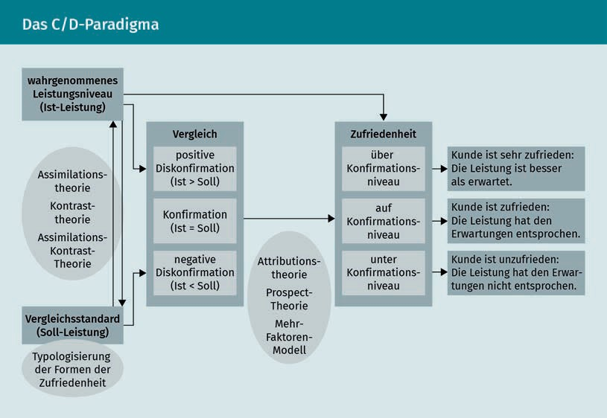

The **C/D paradigm** presented here should be understood as an integrative framework that can be used to classify additional and more specific approaches that help to explain customer satisfaction. These more specialized approaches include assimilation theory, contrast theory, and assimilation-contrast theory, among others. These theories shed light on the subsequent changes in the comparison benchmark and/or the perceived service in the event of a discrepancy between the target/actual service. The change in the comparison benchmarks over time is therefore the focus of consideration here. Additional in-depth models deal with the connection between the fulfillment of expectations and the level of satisfaction. Attribution theory in combination with the multi-factor model of customer satisfaction shows that the relationship between expectation fulfillment and satisfaction is influenced by subjective perception and the type of service (Homburg/ Stock-Homburg 2012, 23).

In addition to the question of how customer satisfaction can be evaluated, it must also be clarified what consequences customer satisfaction or dissatisfaction can have for a company or for customer loyalty. In addition to **equity theory**, **learning theories** and risk theories can also be applied in this context. Homburg and Stock-Homburg summarize the basic propositions of these theories as follows (2012, 37):

Customer Satisfaction and Loyalty

* **Equity theory** focuses on the fairness of exchange relationships. It is assumed that satisfaction ratings are based on the interpretation of fairness regarding the costs invested in a transaction/business relationship and the resulting benefits.
* **Instrumental** **learning theory** assumes that behaviors are learned by the customer on the basis of rewarding (satisfaction) or punishing (dissatisfaction) previous behavior. Satisfaction leads to an increase in the previous behavior (loyalty), while dissatisfaction leads to a reversal of the behavior (e.g., change of supplier).
* **Social** **learning theories** are based on the assumption that customers learn behaviors by observing reference persons. If loyal behavior is observed, then the customer adopts this behavior and also behaves loyally.
* Risk theory assumes that the customer tries to minimize the perceived risk. One situation that is compatible with these theories is that customers are loyal to a supplier whose services they have been satisfied with in the past.

Regardless of which theory is followed, it is a question of investigating the extent to which customer satisfaction influences customer loyalty and can thus, for example, help motivate customers to buy products from the company more frequently due to higher satisfaction (repurchasing behavior) or show a preference for the company's new or other products when making purchasing decisions (cross-buying). Therefore, they will also be happy to recommend the company to others due to their positive attitude. It is also assumed that loyal customers are willing to accept higher prices.

### Measuring customer satisfaction

In addition to knowing about the inﬂuence of customer satisfaction, you should also determine which options are available for measuring customer satisfaction. The large number of approaches can be roughly divided into objective and subjective methods. While the objective methods relate to monetary variables such as turnover and profit or the market share, the focus of the subjective methods is on recording the satisfaction felt by the customer. In the case of subjective methods, a distinction is made between event-related and feature-related methods. The event-related procedures only consider one or more specific events, whereby an event should be understood as the customer's contact with the company. For example, events such as the customer contacting the service department related to an inquiry about the purchased product or a complaint, initial installation, etc. are considered, and the customer's satisfaction with this special event in particular is examined. This approach is therefore also called the spot approach. The approach may be suitable for evaluating certain events and subsequently improving them. However, the approach is not very suitable for a more comprehensive determination of customer satisfaction, which should take into account other points of contact with the customer (**customer touchpoints**) (Fürst 2012, p. 127f.). It is only able to produce a selective image of the customer as opposed to a "uniform customer approach."

Customer

Touchpoints

This term designates all points and interfaces that a customer uses to get in touch with the company.

Conjoint Analysis The conjoint analysis approach is an indirect survey that is used to analyze the importance of various factors influencing purchase decisions.

Characteristic-related methods are suitable for measuring customer satisfaction more comprehensively, and these can be divided into implicit and explicit methods. Fürst explains that the implicit procedures are based on the determination of perceived service deficits that result from an analysis of customer complaints. However, since various studies show that not all dissatisfied customers also complain to the company, the findings from this analysis method should be viewed critically (Fürst 2012, 128).

Methods that question customers directly concerning various aspects related to customer satisfaction are more suitable than those that just ask them to answer a one-dimensional query concerning a single aspect (e.g., satisfaction with the service). A multi-attribute (multi-dimensional) measurement that assesses direct satisfaction is a very valid and widespread form of measurement. In contrast to other multi-attribute methods, this form of measurement does not compare service assessments before and after purchase or separately measure expectations (Fürst 2012, 129). A careful data collection concept is designed before being implemented, and the generated data is analyzed. It must be ensured that the measurement results are valid. The value of overall customer satisfaction (Customer Satisfaction Index, CSI), as the mean of the indicators used in the survey, is scaled: The higher the CSI value, the greater the customer satisfaction. In order to provide explanations for the respective level of CSI and thus also the basis for possible courses of action to improve customer satisfaction, it makes sense to look at the CSI in a more differentiated way. According to Fürst, the following differentiation criteria may be considered (Fürst 2012, 139):

* Customer type (private individual or corporate customer)
* Socio-demographic characteristics of the contact person
* Regional place of origin of the customer
* Position of the contact
* Customer industry
* **Customer value** (economic importance of the customer from the supplier's point of view).

A weakness of this survey, however, is that customers do not attach the same importance to all areas, and what is considered relevant for customer satisfaction varies. Further evaluations e.g., using multiple regression analysis, causal analysis, or **conjoint analysis** can provide important insights to initiate appropriate measures for improvement (Fürst 2012, 142).

Generally speaking, it is clear that the methods for surveying customer satisfaction must be chosen carefully, and the evaluation of the results should not only be based on the CSI, but always in connection with the assessment of the importance of the various inﬂuencing factors.

Customer Satisfaction and Loyalty

### Achieving Customer Loyalty Through Customer Satisfaction

It is assumed that customer satisfaction has an effect on customer loyalty. However, it is

disputed whether the connection is linear or non-linear. Regardless of which camp you are a member of, everyone acknowledges that the relationship between customer satisfaction and loyalty is shaped by various inﬂuencing factors, such as the market environment, product, the type of business relationship, and also the actual customer, and these serve to strengthen or weaken this relationship (Homburg/Becker/Hentschel 2013, 121 et seq.).

A loyal customer can be recognized by the fact that they take repeated advantage of the company's offerings, i.e., they demonstrate regular follow-up and repeat purchasing behavior, as well as in how they recommend the company to others. In this connection, there is also the concept of the regular customer, i.e., a loyal customer with a customer-company relationship that can be described as long-term. From the customer's point of view, customer loyalty only arises when the customer can see a benefit to the relationship with the supplier. This consists not only in the demonstrated customer satisfaction, but also in the so-called "**customer value**" that is perceived from the customer's point of view. The **customer value** describes the value that the customer attaches to the relationship with the company, e.g., the perceived good value for money or the consistent quality of the company's offerings. However, customer loyalty is not only influenced by rational considerations. It is also shaped by habitual influences, such as convenience, lack of information about alternative offerings, or aversion to risk (Schumacher/Meyer 2004, 30 et seq.).

However, customer loyalty is not predominantly characterized by these chance coincidences, but it can be evaluated in close connection with the degree of customer satisfaction. The more satisfied the customer, the more loyal they are. There is a neutral area in customer assessments and perceptions of satisfaction and dissatisfaction, and in this area not much can be done to sway customer loyalty. This is also known as the "indifference area" between customer satisfaction and customer dissatisfaction: The perceived actual service in this area largely corresponds to the expected target service, and there are no strong deviations from this expectation in either a positive or negative direction (Schumacher/Meyer 2004, 31).

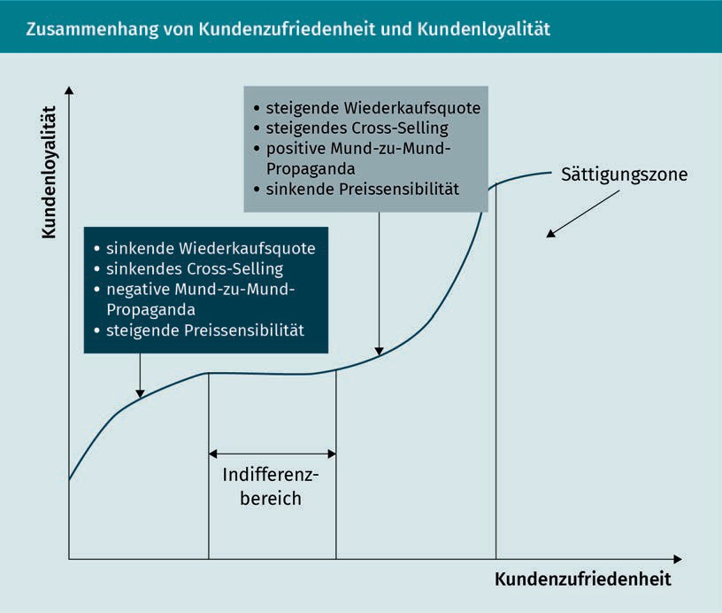

There is also a type of customer loyalty that can be established in this situation. The loyal customer can be addressed even more intensively when trying to retain them in order to create a **commitment** between the company and the customer that is not only based on rational inﬂuence factors, but also on an emotional bond.

### Engendering Customer Satisfaction and Loyalty

The transition to digital technologies has inﬂuenced marketing in various ways. Current information and communication technologies have allowed for greater transparency, especially with regard to the opportunities for generating knowledge about the market or customers. Companies can reach customers via various new channels or also interact with customers. At the same time, customers are able to easily obtain comprehensive information about the offerings on the market, to compare them, and to find out the opinions of other customers. The credibility of this information and how it is perceived has been discussed in very different ways, and critical observers assume that the level of trust in this information has decreased. These developments have also inﬂuenced customer loyalty, which seems to have lost its importance for the customers themselves. It is therefore conceivable that, due to the loss of trust in information that is conveyed through media, the customer's own experiences in building trust could gain in importance

Customer Satisfaction and Loyalty

in the future, and identity could play an important role in the market and orienting companies towards the customer. Trust in a company is also in part dependent on ensuring that the customer does not feel exploited. Rather, it is important that they experience the company's actions in such a way that their own needs are heard out and addressed. It is certainly not an easy undertaking for companies to meet the customer's expectation of not being exploited. Loss of trust can result from the company's processing of customer data, which companies should proactively reduce (Kenning 2018, 91 et seq.).

The counterpart to the satisfied customer is the dissatisfied customer. Measures, such as a well organized complaints management system, should be in place to prevent dissatisfaction from arising in the first place. **Complaint management** begins with the customer's ability to contact the company, where this contact option should not only be advertised as a communication channel for complaints, but also as a way for customers to offer praise and suggestions. It is important that the company offer contact and interaction options that facilitate dialog with the customer. In this way, the company can respond to complaints as well as praise and recognition at an early stage. Possible negative effects of complaints can often be mitigated and intercepted with an appropriate and timely reaction, and complaint costs are minimized or even avoided. In addition, companies must learn to recognize that complaints and suggestions always contain important information that can be used to improve service and product quality (Lucca et al. 2015, 108).

In addition to **complaint management**, employees at a customer-oriented company must also be encouraged and even required to have a customer orientation, since a high level of customer orientation on the part of employees has a guaranteed positive effect on customer satisfaction. Customer-oriented approaches include two dimensions: customer-oriented attitude and customer-oriented behavior. Viewed in this way, customer orientation takes place in the head, since it is an attitude, and, on the other hand, it represents the behavior of the employee exhibited towards the customer. And this behavior, such as, for example, friendly interaction, service orientation, or helpfulness, is what the customer perceives. Of course, the customer can also perceive unfriendly service, incompetence, or a lack of accommodation on the part of the company. No matter how customer-oriented the mindset may be, if the customer does not experience it positively, it will not have a positive influence on the customer's attitude towards the company (Stock-Homburg 2012, 277).

Price fairness and **customer integration** are seen as additional opportunities for the company to have a positive inﬂuence on customer satisfaction. Interestingly, relatively little attention is paid to the importance of price as an indicator of customer satisfaction from the standpoint of fostering customer satisfaction. The main focus is usually on the service dimension, i.e., the question of whether the product meets the needs of the customer, but not on the question of whether the price is perceived as reasonable. Though we do not have space to delve into this subject in detail here, the success of large discounters, such as Aldi or Lidl in particular, shows that customers perceive a great benefit from a good value for money (Hermann et al. 2012, 301). **Customer**

Complaint Management

Complaint management encompasses all of the measures that a company takes in connection with a customer complaint.

Customer Integration Customer integration is the involvement of the customer in the company service provision or innovation process.

**integration** can begin at various points of contact between companies and customers. Basically, **customer integration** seeks to proactively involve the customer. This involvement should go beyond a mere statement of needs and actually inform the company's decisions. Customer input can be incorporated in product development or even in an innovation process. When exploring the experience of how customers can be integrated in innovation processes, it was found that involving customers helps ensure that the design of the product addresses customer needs. At the same time, it was found that customers who are involved in the innovation process have greater satisfaction (Piller 2012, 397 et seq.).

Companies can actively ensure that they are perceived positively and increase customer satisfaction at various **customer touchpoints**. As the different areas make clear, however, a certain amount of attention must be paid to ensuring that the company has a comprehensive, customer-oriented orientation, which not only forms an integral part of the mindset of management and employees, but it can also be experienced directly by the customer.

Summary

Customer satisfaction is inﬂuenced by various factors that both the customer and the company need to consider. From the customer's perspective, customer satisfaction is closely related to expectations about the product or service. Customer satisfaction is therefore also viewed as a process of comparing expectations with the actual perception of a service. If the service received meets expectations or even exceeds them, this is referred to as confirmation or positive disconfirmation. If expectations are not met, this is referred to as negative disconfirmation. The **confirmation-disconfirmation paradigm** is understood as an integrative framework that can be used to understand more in-depth approaches to customer satisfaction.

For companies, it is not only important to explore customer satisfaction, but also the consequences of customer satisfaction. It is recognized that customer satisfaction has a decisive inﬂuence on customer loyalty and retention. This, in turn, has an inﬂuence on the repeat purchase behavior, cross-selling potential, or recommendation behavior of customers.

Various methods are available to measure customer satisfaction, which can be roughly divided into objective and subjective methods. A distinction is made between event-related and feature-related processes in the subjective processes that attempt to record the customer's perceived level of satisfaction. Multi-attribute measurements of customer satisfaction, which can be used to help draw a holistic picture of the customer, appear to be the most suitable. Customer satisfaction is recorded as a CSI value: The higher this value, the higher the customer

Customer Satisfaction and Loyalty

satisfaction. However, this value should not be used as the sole indicator of customer satisfaction. Rather, it should be interpreted while taking into account other known influencing factors (e.g., industry or socio-demographic background).

The inﬂuence of customer satisfaction on customer loyalty is undisputed. What is particularly interesting is what this customer satisfaction means for the buying behavior or recommendation behavior of the customer. While satisfied customers have higher repeat purchase rates or greater cross-selling potential, these effects are the opposite for dissatisfied customers.

Given the saddle-shaped curve that illustrates customer loyalty in relation to customer satisfaction, it can be assumed that between the ranges of the rather dissatisfied customer and the satisfied customer is the phase of the indifferent customer, in which neither positive nor negative influences on the buying behavior can be identified.

Even if customer satisfaction is a very subjective construct from the customer's point of view, companies have various opportunities to positively influence customer satisfaction and thus engender loyalty. It is not just customers that can use modern information and communication technologies to their benefit, but they also offer companies great opportunities to enter into dialog and interact with customers so that they can build long-term trust. It is also possible to generate knowledge about customers, recognize dissatisfaction, and use this knowledge proactively to take appropriate measures to maintain or restore customer satisfaction. **Complaint management** is particularly important here in order to prevent customers from becoming dissatisfied in the first place.

Since it is known with certainty that customer-oriented employees have a positive influence on customer satisfaction, the company must demand this customer orientation, but it can also adopt measures to promote it: Because it is not only important to anchor such an idea in the minds of the employees, but also to create the framework that allows employees to behave appropriately towards customers. A customer-orientation should be more than something that is paid lip-service to so that it can have a positive effect on customer satisfaction.



# Unit 5

## Customer Loyalty Management

#### STUDY GOALS

After completing this unit, you will understand …

… what are the reasons for and effects of customer loyalty management.

… which known strategies are available.

… which tools can be used.

DL-D-DLBCRM01-L05

1. Customer Loyalty Management

### Introduction

Customer loyalty is not a new topic, and academia has also been dealing with the question of customer repeat purchase behavior for a good 100 years. The perspective on the debate has changed over time. Since the 1990s, the need for companies to assume a customer orientation has been increasingly pointed out, and the terms customer loyalty management and customer relationship management (CRM), which is the term used in practice, have been coined (Homburg/Bruhn 2013, 7). Accordingly, there is significant interest in achieving a high level of customer loyalty. In order to ensure the success of this approach, an attempt was made to identify the various determinants of customer loyalty: As a result of numerous studies, satisfaction, quality, **commitment**, and trust were identified as success factors. However, whether these factors still affect customer loyalty to the same extent in the current market environment must be critically questioned (Grohmann/Heumann/Wangenheim 2013, 83). In what follows we will demonstrate…

* + … what thinking in terms of customer relationships means.
  + … why customer loyalty management should be established.
  + … which tools are available for marketing.

### Reasons and Effects of Customer Management

“Customer loyalty is understood to mean all psychological awareness processes or observable behavior of the customer in which the customer maintains or intensifies their relationship with the company as a result of certain factors that determine their loyalty” (Bruhn/Georgi 2013, 679).

Following this very comprehensive definition of the terminology, we now need to investigate the conceivable reasons that make customers willing to commit themselves to a company: When it comes to these causes, a distinction is often made between **habitual**, voluntary, or involuntary **loyalties**, which, for example, Meyer and Oevermann have subdivided into five further aspects (see Homburg/Bruhn 2013, 11):

* + Situational causes of loyalty
  + Contractual causes of loyalty
  + Economic causes of loyalty
  + Technical-functional causes of loyalty
  + Psychological causes of loyalty

It should hardly be necessary to point out that voluntary or **habitual causes of loyalty** should be preferred to involuntary ones. In order to actively shape these relationships, customer-oriented companies fall back on the opportunities afforded by customer relationship management. Customer

Customer Loyalty Management

Loyalty Management systematically analyzes and plans the required measures to address potential and current customers with the aim of establishing, maintaining, and intensifying relationships. In addition, customer loyalty management is responsible for implementing and monitoring these measures (Homburg/Bruhn 2013, 8). Customer Loyalty Management is primarily concerned with the **endogenous causes of loyalty** (e.g., customer satisfaction or barriers to switching) and attempts to inﬂuence these in the interests of the company. Of course, it is in the interests of the company to derive economic benefit from the customer, such as, for example, by concluding long-term contracts. However, companies must strive for long-term customer loyalty, in particular through achieving customer satisfaction (Bruhn/Georgi 2013, 679). This approach results from considerations that customer satisfaction leads to higher customer loyalty and thus the economic success of the company. Even if this approach appears theoretically very plausible and the connection between customer satisfaction and economic success has been shown in various studies, it must be pointed out that this is not a universal law. It is therefore advisable in any case to review **customer retention** activities in terms of their profitability (Bruhn/Georgi 2013, p. 679 et seq.).

Customer loyalty, understood as a psychological construct, can be seen as a connectedness to a person or a company, but also as an obligation. Customer loyalty is therefore also differentiated into connectedness and commitment. The loyalty is not necessarily positive, since it can also have negative aspects if what was assumed as a voluntary loyalty is transformed into a feeling of involuntary commitment that tends to have negative connotations. Think of customer contractual ties to companies like mobile phone service providers. As long as you are satisfied with the arrangement, this is not a problem. But if something bothers you, the offering no longer suits you, or other reasons cause you to be dissatisfied, you may not be able to cancel the contract or you may be left committed to the company until the end of the contract period.

|  |  |
| --- | --- |
| Behavioral Effects: Connectedness vs. Commitment | |
| Connectedness | Commitment |
| Voluntary customer loyalty that is positively documented and based on customer satisfaction and the quality of the relationship as well as **commitment** to the company | The future freedom of choice of the customer (both positive and negative) is restricted. |

It is not only contracts and their terms that inﬂuence customer loyalty. Customer loyalty may also vary depending on the product, because customer loyalty is determined by various factors. It is also questionable whether something

Habitual Causes of Loyalties

Habitual causes of loyalties are those develop habits.

Endogenous Causes of Loyalty

These are the causes that can be traced to external influences

"determined by the consumer," such as, e. g., customer satisfaction.

like customer loyalty exists at all for such products as deodorant, yogurt, etc., since these are low-involvement products, or whether customer loyalty can only be built up with increasing involvement.

Numerous studies have identified the following success factors that are responsible for these relationships:

* + Service quality: Understanding of the quality of objectively and subjectively perceived characteristics
  + Service value: Price can mean sacrifice or best value for money
  + Trust: Willingness to rely on the product/service
  + **Commitment**: Emotional connectedness
  + Relationship quality: Trust and familiarity
  + Satisfaction

In the context of customer loyalty management, these factors lead to customer loyalty or reinforce it. Real customer loyalty is characterized by attitudinal and behavior-related components—i.e., perception, on the one hand, and actual behavior, on the other (Grohmann/Heumann/Wangenheim 2013, 83 et seq.).

When dealing with the topic of customer loyalty, the thought often comes to mind that the customer is a very strange being and that some customer behavior does not always appear logical and understandable. Many customers remain loyal to a bank over the long term even if they are not always satisfied, because switching to another bank involves assuming the risks of uncertainties or costs. In this case, the customer has a high level of behavioral loyalty despite a possibly low attitudinal loyalty (Grohmann/Heumann/Wangenheim 2013, 93). The causes are cognitive, affective, and dispositional aspects that vary significantly depending on the individual person, i.e., the rational perception, the emotional feeling, and the triggered specific intention to buy and act that precedes the behavior.

Customer loyalty management is based on the knowledge that systematic customer loyalty contributes to the economic success of the company. Since customer loyalty is a very complex construct and the development of customer loyalty depends on various factors, customer loyalty management must take these requirements into account in particular in order to be able to achieve the goal of building, maintaining, and intensifying customer relationships.

### Strategies for Customer Loyalty

Customer loyalty strategies are closely linked to considerations related to the customer life cycle or customer relationship life cycle—i.e., the cycle in which a customer has a (possible) relationship with the company. The customer relationship cycle can be divided into the acquisition/initiation phase, the customer discovery phase, and the win-back phase. The examination of the customer journey,

Customer Loyalty Management

which is decisive for customer loyalty, is also of importance in connection with customer loyalty management. The **customer journey** tries to show the customer's points of contact and **touchpoints** with the company, from the creation of a need to the search for information about the purchase and beyond. The stages that the customer goes through before making a purchase decision can be very short or very long, or they can even be skipped altogether. It is important for companies to generate as much knowledge as possible about what information the consumer needs at the various stages in order to be able to initiate appropriate measures. While the focus at the beginning is on attracting attention in order to arouse interest, these interests must subsequently be addressed in order to help the customer make a purchase decision. And once the purchase has been made, it is important to help reinforce the customer's decision. Viewed in this way, this is where customer loyalty management comes in.

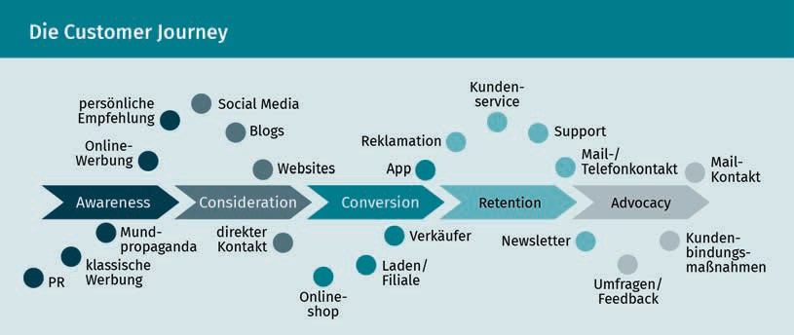

Let's return to the customer relationship life cycle. Since companies act and address customers differently during the various phases of this customer relationship life cycle, **customer retention** strategies may also be viewed in relation to these phases. In the customer acquisition phase, for example, it is all about encouraging and winning over the customer. The retention phase focuses on fostering connectedness and a sense of commitment to the company. Win-back strategies include measures to make amends with the customer or improve the offering, and in case the relationship is terminated, a distinction is made between hidden and open termination (Lucco et al. 2015, 98; Bruhn 2016c, 145).

Concrete measures are then derived from the various strategies for customer loyalty management. For this purpose, it must be clarified which customers must be retained (e.g., based on a certain **customer value**), how the retention should be performed (geographically, technically, or economically), which tools can be used (e.g., customer card, bonus system, exclusive and outstanding service), how often and at what point in time customers should be addressed, with whom partnerships may be established (e.g., transport companies and tour operators), and what specific services or types of added value are offered to the customer (e.g., conversion of bonus program points into benefits in kind, upgrades, etc.) (Lucco et al. 2015, 107).

Customer Journey This term describes the customer's path from the first contact with the company/product to the purchase and subsequent contact points.

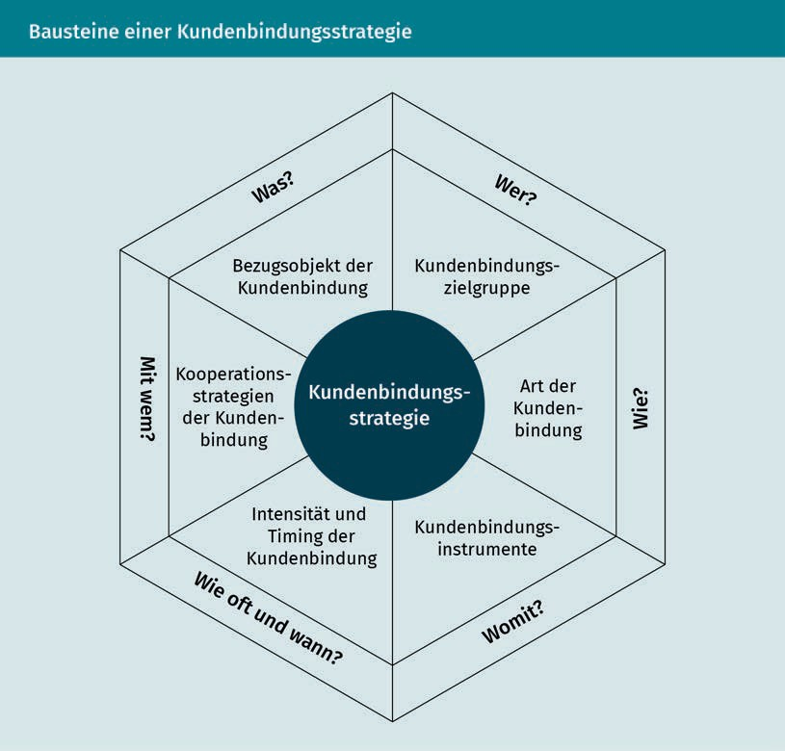

The **customer retention** strategies and measures should ultimately contribute to the company's economic success, as has already been stated repeatedly. If you now look at the chain of effects of customer loyalty (as is clearly shown in the following figure), it can once again clearly be seen that it is the result of a complex process.

Customer Loyalty Management

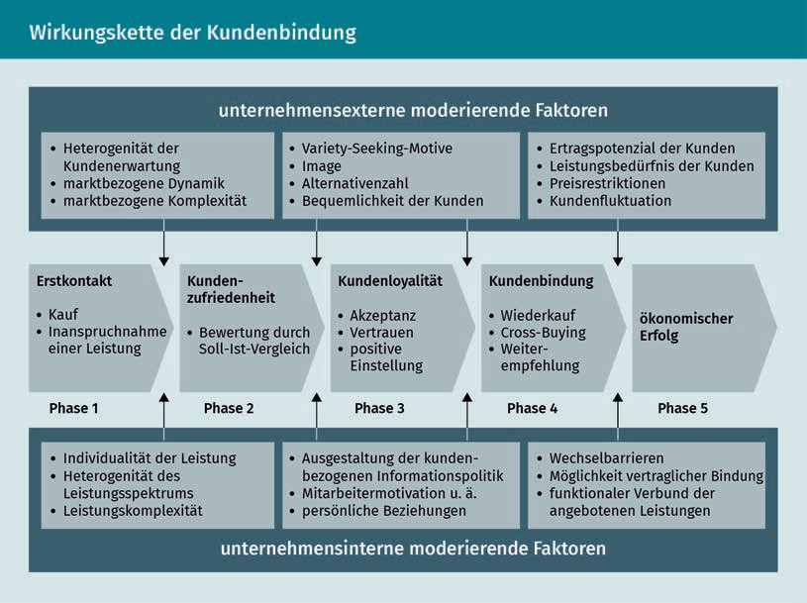

This chain of effects represents the ideal-typical course, and it can hardly be assumed that every customer goes through all phases and automatically becomes a loyal customer. We do not have room here to discuss in detail all the reasons why and where the chain of effects might be interrupted, but we should be aware of the fact that the supplier-customer relationship is not carved in stone. It is rather a somewhat fragile construct.

### Customer Loyalty Measures and Tools

When selecting the tools for use in customer loyalty management, based on the different retention phases, it is important to consider...

* … which tools can be chosen to win over new customers.
* … how customers can be retained.
* … how to retain or win back customers who have churned or are about to terminate their relationship with the company.
* … what is the appropriate way to end a relationship.

In marketing, the three phases of a customer relationship are also known as the 3Rs—**recruitment**, retention, and recovery. Bruhn therefore recommends aligning marketing tools with these 3Rs as part of the relationship orientation.

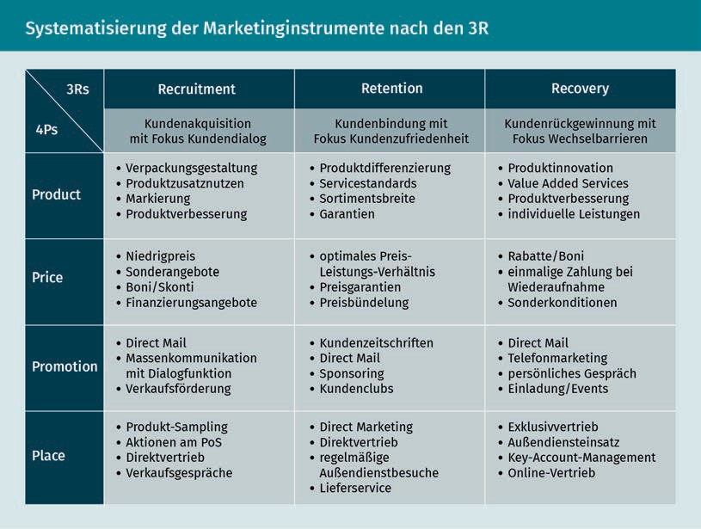

Recruitment Recruitment, i.e., the acquisition phase, encompasses all measures related to customer acquisition.

During the acquisition (**recruitment**) phase, the focus is on promoting interaction and dialog through appropriate tools, since it is assumed that this can increase the success of acquisition measures (Bruhn 2016b, 32). During this phase, it is important to create incentives and turn potential customers into new customers. Motivational strategies that attempt to persuade the customer to make a purchase by creating incentives, such as offering price discounts, special offers, or competitions, are suitable for this purpose. Online or offline campaigns that convey appropriate messages can be used for this purpose. The counterpart to motivation is persuasion. The persuasion strategy relies on argumentation: At the point of sale, this strategy can be put into action, for example,

by offering trial services or the opportunity to test products, and testimonials are also highly convincing here (Lucco et al. 2015, 98 et seq.). Although these factors cannot be directly influenced by the company, their importance is also made clear once again in the context of the company's strategic considerations.

In the retention phase, customer satisfaction should be increased using suitable tools. Companies often use such measures as customer clubs, customer cards, or customer magazines (Bruhn 2016b, 32). Customer clubs, such as the Ikea Family Card or the Media Markt Club Card, for example, offer members interesting added value in the form of discounts, exclusive offers, benefits, loyalty gifts, or services, such as delivery and installation services at club prices. In the retention phase, a distinction is made between commitment strategy and connectedness strategy. The commitment strategy aims to ensure that the customer does not switch to another supplier. A distinction is made between:

Customer Loyalty Management

* Economic loyalty (e.g., achieved using rebate systems, customer cards, etc.)
* Contractual loyalty (e.g., achieved using contractual periods)
* Technical or functional loyalty (e.g., incompatibility with other offers) and
* Geographical loyalty (dependence on a special supplier thanks to spatial proximity/accessibility: e.g., the baker "on the corner") (Lucco et al. 2015, 100).

When pursuing a loyalty strategy, however, companies should emphasize the voluntariness of the relationship and seek to make sure that the customer identifies with the company and its offerings in such a way that it does not even occur to the customer to think about changing providers. This is also often referred to as “real” customer loyalty. Such an emotional bond can be established by offering customer-specific services (**customization**). These services contribute to a sense that the customer's expectations are more than met and help foster a sense of trust in the supplier (Lucco et al. 2015, 100 et al.).

Finally, the win-back phase uses suitable measures to try to retain dissatisfied customers, those desiring to defect, or customers who have already churned (Bruhn 2016b, 32). But what should be done if the customers are already on the verge of leaving or have already ended the relationship with the company, i.e., are no longer customers? This is often a gradual process: The customer buys a service, finds it satisfactory, uses it frequently at the beginning, but then they use it much less over time or stop their use of the service completely. Let's consider a practical example: You ﬁnd a new ice cream parlor, are enthusiastic about the selection, go there regularly at first, but eventually your interest wanes and you forget about the ice cream parlor again. There can be a wide variety of reasons why an offering that was initially perceived as very good is no longer of interest to the consumer. And it may not necessarily have to do with the fact that the customer changed their basic opinion of the offering. Especially in the example of the ice cream parlor, many factors that could play a role are immediately apparent: The summer started out well enough, but then got worse and worse. The customer decided to start a diet or moved to another part of the city and therefore does not pass by the ice cream parlor anymore. These are just a few of the many possible reasons, but they illustrate that it is important to identify why the customer churned so that the company can initiate appropriate measures to win them back. If the customer is dissatisfied with the offering, it can help to compensate them or improve the product. However, it is also important to analyze whether it is worthwhile investing in a customer who wishes to defect from the company or has already churned. Let's consider another example: You are a supplier of plastic bottles to a drinks supplier, which is now switching to glass bottles. It hardly needs any further explanation that it would be fruitless to try to win back this customer. The recovery process should therefore always be structured as follows (Lucco et al 2015, p. 102 et seq.):

Customization

The adaptation of a product to suit individual customer interests is referred to as "customization."

Return on Regain

Investment A metric that shows how much is gained for each dollar invested in winning back a customer.

* A recovery analysis (analysis of the reasons for customer dissatisfaction or defection and determination of the customer's value),
* Recovery activities (e.g., rectification, price reduction, additional services, etc.), and
* Recovery monitoring (it must be clarified whether the expenses were worth it: Calculation of the **return on regain investment**).

Despite all efforts to ensure customer loyalty to the company, there will always be a situation where a relationship ends. As already mentioned, the reasons for this do not necessarily have to do with the company's product range, but they can often be explained by a change in customer's needs. Basically, a distinction is made between indirect and direct dissolution of customer relationships. When a relationship is ended for reasons that are not explicitly stated, this is described as indirect. This indirect termination may be initiated by either the customer or the company when, e.g., the customer is classified as no longer profitable. In contrast to this, a direct termination is understood as one that is openly announced, which can be either amicable or not (accompanied by an accusation of blame).

|  |  |  |
| --- | --- | --- |
| Strategies for Ending Customer Relationships | | |
|  | Customer-oriented | Company-oriented |
| Indirect | "Fading away" | "Cost escalation" |
| (Dissolution of the customer | (dwindling end to the relationship, | (search for |
| relationship is not | letting it | a path to "re-profitability", |
| directly announced) | die) | signaling) |
| Direct | "Mutual state of the | "Fait accompli" |
| (Dissolution of the customer | relationship talk" | (ending of the relationship |
| relationship is | (consensual | without compromises or |
| directly announced) | conversation) | accusations) |

When a (business) relationship comes to an end, it is advisable for the parties

to separate “with dignity”. It's about more than just safeguarding good feelings on the part of the partner. Imagine terminating a contract with your gym early because of a surprise move to another city. The operator offers to accommodate you, and it does not insist on continued payment of the membership fees in accordance with the contractually agreed notice period for early termination. What impact do you think such a positive experience will have on you? You would certainly recommend this provider to others even after ending your relationship with them, whereas in the case of a negative experience this would probably not be the case.

Customer Loyalty Management

And apart from the effects of positive word-of-mouth recommendations, you can never rule out that the other party will not resume a terminated supplier-customer relationship, just like is true of relationships in your private life.

Summary

Customer loyalty, understood as a psychological process by which the customer develops a conscious preference or as the observable behavior of customers, is quite simply the outcome of the interaction of various inﬂuencing factors that prompt the customer to establish, maintain, intensify, but also to end a supplier-customer relationship. There are various well-known causes—such as contractual commitments, economic or technical-functional reasons—that have an inﬂuence on customer loyalty. The task of customer management is to have a positive influence on the creation, maintenance, and intensification of customer loyalty and to proceed analytically and in a planned manner in order to be able to derive measures that can be used to achieve goals. Trust, **commitment**, quality, and satisfaction are identified as success factors that help to cement customer loyalty, since they bring about or promote customer loyalty through targeted customer management. When looking at the reasons that lead to customer loyalty, it also becomes clear that these are often very individual cognitive, affective, and dispositional aspects that customer loyalty management must take into account.

Customer loyalty management is also based on the customer relationship lifecycle, or the cycle by which the customer comes into contact with the company, is retained, and made loyal to it, but may also end the relationship with the company again. Appropriate strategic approaches are available during the customer acquisition, **customer retention**, and customer recovery phases as well as during the relationship termination phase, from which measures tailored to the situation and target group can be derived.

Bruhn has systematized the marketing tools along the 3Rs (**recruitment**, retention, and recovery), which show which tools can be used in a relationship-oriented manner. During the acquisition phase, the focus is on motivation and interaction, the retention phase is designed to increase customer satisfaction, the win-back phase targets customers who have expressed a desire to defect or have already churned, and in the termination phase the relationship should be concluded “on good terms.” All areas have one thing in common: the goal of retaining customers over the long term and promoting the economic success of the company.



# Unit 6

## Customer Value and Customer Portfolio Management

#### STUDY GOALS

After completing this lesson, you will...

… know different methods for customer evaluation.

… understand the significance that customer portfolios have.

… learn what is meant by one- and two-dimensional customer segmentation.

DL-D-DLBCRM01-L06

1. Customer Value and Customer Portfolio Management

### Introduction

Isn't it enough just to have customers? Why is it important to calculate the **customer value** at all? Customers must be won over, retained, or brought back—that is the main task of CRM. But all of these measures must be performed efficiently, and they must be worthwhile. Investing in the “wrong” customers provides little benefit to the company over the long term. Imagine you are a manufacturer of plastic bottles. A beverage manufacturer is terminating the contract with you—not because they are dissatisfied, but because they are committed to using glass bottles in the future. Measures to win back the customer simply will not bear fruit here. Sure, this is an extreme example, but also one that makes it clear how important it is to check whether it makes sense to continue investing in a customer. The **customer value** can generally serve as a guide here. To put it simply: It is only worth investing in a customer if they can potentially be identified as a long-term proﬁtable customer. But what exactly is **customer value**, and how can this **customer value** or the value of the customer relationship be determined?

### Basics of Customer Evaluation

The **customer value** represents an important point of orientation for companies as part of CRM activities. In order to promote the economic success of the company by assuming a long-term customer orientation and promoting loyalty, not only does the company have to collect a lot of knowledge about its customers, but it must identify the ones or groups of customers in which it is worthwhile to invest through CRM activities. In purely business terms, these are the customer groups with whom a positive contribution margin can be generated both today and in the future (Leusser/Hippner/Wilde 2011a, 28).

Customer Value The customer value is the net benefit of a provider-customer relationship that the customer derives.

The **customer value** can be viewed from either the customer or the supplier perspective. The concept of **customer value**, which is well known in this context, describes the customer's point of view and considers the net benefit that the customer attributes to a business relationship. This customer benefit is the benefit actually perceived by the customer, e.g., due to the good value for money or the quality of an offering. **Customer value** must be distinguished from customer satisfaction, which can be viewed as a process of comparing expectations and the actual perception of the service. Customer satisfaction is also an important component of customer loyalty, which can also be understood as a reflection of customer benefit. From the supplier's point of view, **customer value** is understood as a customer's contribution to achieving the company's goals, including both monetary and non-monetary (Günter/Helm 2011, 274). When evaluating customers from the supplier's point of view, the respective frame of reference must always be taken into account. It must be clarified whether the entire customer relationship, a single customer group, a specific customer segment, or an individual customer relationship should be addressed and

Customer Value and Customer Portfolio Management

evaluated. The time frame is also relevant: Is the company concerned about actual values, i.e., the current state, or about potentially expected—future—value contributions from customers (Günter/Helm 2011, 274)?

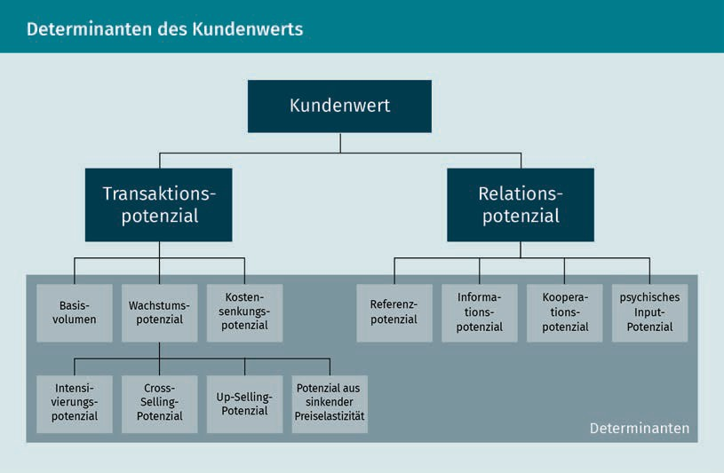

The figure shows that when looking at the **customer value**, the **transactions** between the supplier and the customer are taken into account, whereby these **transactions** relate to the quantity and potential for increases in the customer's current and future purchases. Not only is the relationship potential of the customer, including their potential as a recommender within their personal relationship network (**reference potential**), taken into account, but also their potential as an information supplier for the company is also weighed (Leusser/Hippner/Wilde 2011a, 26).

When considering transactions, the basic volume represents the area that is derived from the **purchase history** and can therefore be weighted as an expression of the intensity of an existing customer relationship. The idea is that intensive customer relationships can be viewed as habitual buying behavior, and these customers are immune to competitive offers. Consider a simple example: The customer always buys the same muesli. Since they like it, they don't have to think long and hard about a buying decision in the store. They are satisfied, their needs and requirements for muesli are covered, and there is no reason to develop an interest in or buy other products. In this case the customer will not be tempted by a cheaper offer from the competition, since it may not match their taste preferences. Knowledge of the basic transaction volume is also relevant for the analysis of the growth potential, since repeat purchase behavior and cross- and **up-selling potential** must be considered in relation to this. Long-standing, regular customers will often buy other products from the company, or, if household income increases, they can also afford

Reference Potential The reference potential reflects the extent to which a customer can influence the purchasing decisions of third parties.

Purchase History

The purchase history records when, what, and to what extent a customer has purchased from a company.

Up-Selling Potential The up-selling potential considers the chance of being able to offer and sell higher quality/higher priced products to the customer in the future.

Customer Contribution

Margin The customer contribution margin is calculated by deducting all the costs attributable to the customer from the sales achieved from the

customer.

higher-priced offerings from the company. If someone starting their career decides to buy a small car from a supplier, then after a few years in the profession they may be able to afford a medium-sized or even luxury vehicle.

But what is the point of looking at the value of a customer? In addition to answering the question of whether to invest in the customer or not, it should be even more interesting to ask whether the **customer value** can be increased. It is therefore necessary to determine the factors that inﬂuence **customer value** and to perform careful customer analyses, but also to identify and work on promising market and customer segments in order to make customer relationships proﬁtable. Conversely, however, this can also mean that unprofitable relationships have to be ended in the worst case scenario, because a high degree of customer orientation also requires a customer focus (which is worthwhile from a company perspective). (Günter/Helm 2011, 282).

### Customer Evaluation Procedure

There are various known methods for calculating **customer value**. Some focus on sales and identifying the top-selling customers. Other approaches are based on the amount of marketing funds that are invested in a customer group. Such rather one-dimensional procedures can provide an initial orientation, but they do not help establish a more comprehensive understanding of **customer value** (Rapp 2005, 79). The **customer value** should reflect the customer's status not only as a buyer, but it should also consider their role as an opinion leader, information supplier, etc. However, the calculation should also take into account the company's costs for the **customer retention** measures. After all, what use is it if a customer regularly buys a company's products, but the costs of acquisition and customer loyalty exceed the revenue from these purchases?

But now let's consider the various ways of calculating the **customer value**. The most well-known methods are:

* Customer contribution margin,
* ABC analysis,
* Customer lifetime value, and
* Customer portfolio analysis

###### Customer Contribution Margin

The customer contribution margin analysis is an extension of the customer sales analysis, and it also includes costs that arise in individual customer relationships or in customer groups, since calculations that are limited to customer sales say little about the proﬁtability of the customer relationship. The customer contribution margin calculation should show what contribution margin a customer is responsible for

—i.e., the extent to which the customer covers the company’s overheads and contributes to

Customer Value and Customer Portfolio Management

profits. For the calculation, all costs that can be attributed to a customer (e.g., advertising costs, sales costs, etc.) are deducted from the revenue generated from the customer. This is also where one of the problem areas becomes apparent: The exact determination of the costs incurred by the customer. For example, advertising costs are attributed to individual customers using an arbitrary formula. Depending on the objective of the calculations, the current, the expected, or the absolute customer contribution margin can be calculated (Bruhn 2016c, 314).

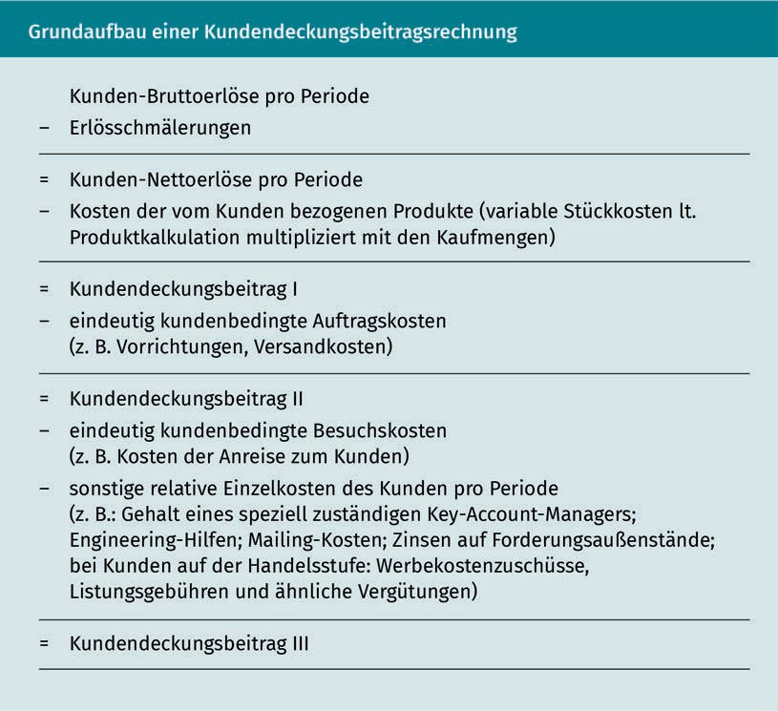

If data about the customer-associated costs is available, this calculation provides a good way of evaluating customer-oriented measures. However, since customer contributions do not take account of customer reference or information potential, since there is no cost or revenue data associated with these variables, the limitations of the approach are also evident (Günter/Helm 2011, 279).

###### ABC Analysis

The ABC analysis is a one-dimensional process that classiﬁes customers according to their sales and contribution margins. It can be formulated simply: This calculation determines the share of the total turnover that the individual customer is responsible for. Depending on the sales volume, the customer is assigned to one of the value classes A (largest sales), B, or C (lower sales) (Günter/Helm 2011, 276).

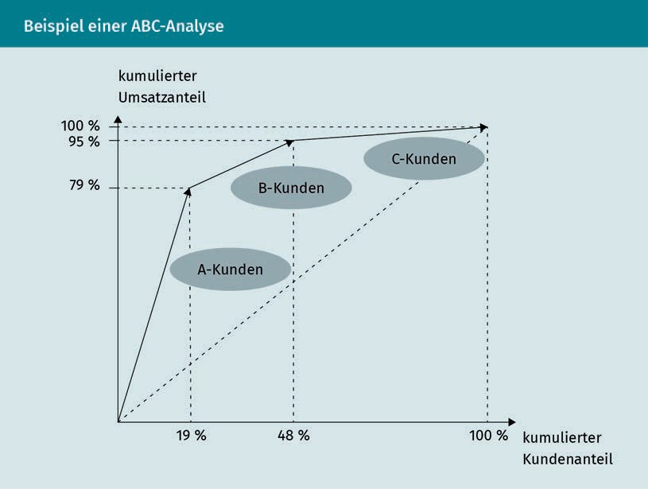

As this example shows, the ABC analysis often confirms the 80/20 rule, namely that 20% of customers account for 80% of total sales. However, the customers responsible for the greatest turnover do not have to be the customers who are automatically prioritized, since the ABC analysis often only represents an initial starting point for customer classification (Günter/Helm 2011, 276). An evaluation of which customers should be prioritized in the future cannot be conclusively clarified from only a sales perspective: It would be conceivable that the "A" customers of a supplier of high priced luxury items make the largest contribution to sales, but their needs are very exclusive, and their customer care is consequently very expensive. This means that investment in customer groups that produce fewer high sales must also be made.

Customer Value and Customer Portfolio Management

###### Customer Lifetime Value

A key figure that is used to determine the **customer value** is the CLV: the customer lifetime value. The calculation of the customer lifetime value is usually based on dynamic investment calculation approaches. The entire duration of the customer relationship is included in the calculation of the **customer value**: Past data as well as expected future sales are taken into account. The company can use the calculated CLV as a benchmark: the higher the CLV, the more proﬁtable the customer is, or the more justified are investments in the customer. The CLV can be determined using the net present value method, and the value is calculated as shown in the following figure:

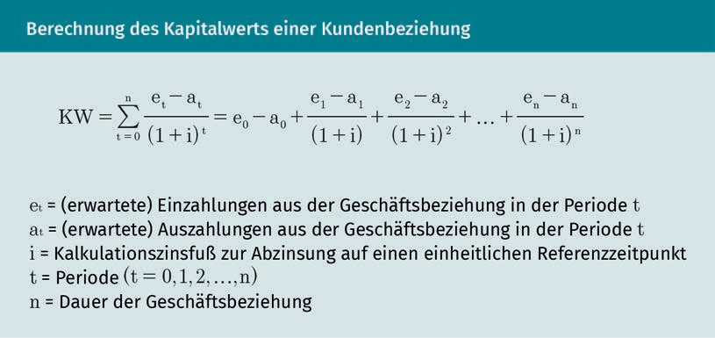

By considering both current data as well as future customer potential for success, the CLV takes into account the dynamics of customer relationships and can therefore be regarded as an important economic control variable of relationship-oriented marketing (Bruhn 2016c, 328 et seq.).

One thing must always be considered to some extent: the human factor. The various presented approaches for calculating a customer's value show that, in addition to the cost and revenue factors, the customer contributions that result from their recommendations and from the information or cross-buying potential must also be factored in. The individual approaches to measuring **customer value** have varying significance. When selecting a method, the respective company objective should therefore be taken into account, and the selected method must be critically examined (Günter/Helm 2011, 280).

### Customer Segmentation and Customer Portfolios

Customer portfolios can provide a very differentiated picture of current and potential customer contributions. These two-dimensional methods contrast the different pre-economic and economic dimensions. For example, it can be determined

Customer Lifetime Value

The customer lifetime value is a key figure that calculates the contribution margin of the customer over the period of the customer's life cycle.

“which customers will produce a profit (economic variable) based on their customer satisfaction and customer loyalty (pre-economic variables)” (Bruhn 2016c, 329 et seq.). Ultimately, customer portfolios are used to comprehensively analyze and understand customers and to record their strategic importance in order to derive measures from the obtained knowledge in accordance with corporate goals.

Customer

Segmentation Customer segmentation assigns customers to groups that are as homogeneous as possible, thereby providing the basis for customer

processing.

Success Chains The basic idea of a success chain is to draw connections between the content of related

variables.

Customer segmentation can provide the basis for the creation of customer portfolios. This helps companies to better "understand" customers by categorizing and assigning them to certain segments

and thereby to precisely formulate the customer-related economic goals according to the respective customer segment. With segmentation, an attempt is made to form customer groups that are as homogeneous as possible within their segment—i.e., that are similar in their attitudes, expectations, or even market reactions. However, there are differences between the customer segments. This segmentation makes it possible for companies to work on one or more of these customer segments in a targeted manner and to meet their respective needs (Bruhn 2016b, 58 et seq.; Bruhn 2016c, 119 et seq.). Customers cannot simply be pigeonholed into oversized categories, or otherwise this would not make it possible to address the target group properly. Let’s take the food industry as an example: It's safe to assume that everyone needs to eat, so does that mean that a company in this industry should address pretty much everyone? Probably not, since here the specific product, the corresponding market environment, etc. all play a role. Without such segmentation, it is highly likely that the company will waste their marketing budget. Therefore, the company has to find out how the customer groups differ from each other and how the customers are similar. Let's stay with our food industry example and pick out a product like yogurt: Children loves this product as much as college students, families, and pensioners do. Therefore,

it would not make sense to differentiate by age. Where should you start? Think about eating habits, quality, and price awareness when consuming food, etc.

The segments can then be displayed within portfolios. According to Bruhn, relationship-specific criteria should also be used as the basis for relationship-oriented segmentation. The segmentation is based on the three phases of CRM: the acquisition, retention, and recovery phases, and within these phases, companies will focus on the respective success chains that result from the different customer requirements within the phases. To put it somewhat more simply: The success chain in the customer acquisition phase is based on the goal of winning over new customers. To do this, the company must arouse the customer's interest and, ideally, this interest should lead to a purchase of the product. The success chain begins with the measure (communication) that is intended to achieve a psychological effect (interest) in order to trigger a behavioral effect (purchase) that represents an economic effect (sales) for the company.

Let's look at the customer portfolios resulting from this approach using the example of the **customer retention** phase. The success chain is as follows: Measures -> customer satisfaction -> customer loyalty = economic success. This approach makes it possible to ﬁlter out customer segments that differ in terms of their ability to achieve speciﬁc relationship-oriented goals. As a result, companies can respond appropriately to the identified requirements in the respective phases. But it can also be shown why success chains are broken

Customer Value and Customer Portfolio Management

or do not produce the desired success. For example, a customer may show little loyalty despite being very satisfied. When looking at the links in the success chain, a distinction is made between one-dimensional and two-dimensional segmentation (Bruhn 2016c, 124 et seq.).

Corresponding to the three areas in CRM, different customer portfolios can be derived for the respective considered links in the success chain, namely for customer acquisition, **customer retention**, and the customer recovery phase with one-dimensional and two-dimensional segmentation.

The one-dimensional segmentation is based on a link in the success chain. The following figure shows the customer portfolios that result in an orientation on the link "customer satisfaction" in the **customer retention** phase and that relate to dimensions that inﬂuence customer satisfaction, such as commitment vs. connectedness:

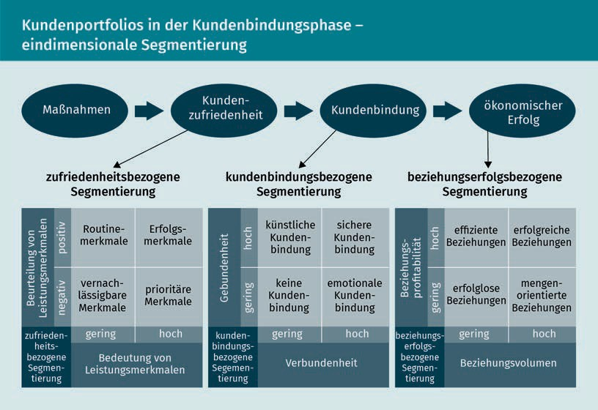

Let's take a closer look at the area of customer loyalty-related segmentation: Commitment and connectedness are defined here as dimensions that have an inﬂuence on customer loyalty, which lead to the identiﬁcation of four types of customer loyalty (Bruhn 2016c, 126):

* Artificially loyal customers (high level of commitment and low level of connectedness, e.g., in the case of a contractual commitment),
* Assuredly loyal customers (high levels of loyalty and connectedness, e.g., in the case of contractual commitment and emotional attachment),
  + Unloyal customers (neutral customers), and
  + Emotionally attached customers (high connectedness without commitment).

Consider the following example: Artificial loyalty usually arises from a contractual commitment. Fitness clubs offer different packages and prices for short- and long-term memberships. The monthly fee is usually cheaper if the customer opts for a longer-term contract. The customer can thus weigh up what a longer commitment would be worth to them in terms of price. Furthermore, additional services (e.g., free training sessions with a personal coach) may be offered to long-term customers to make this type of loyalty more rewarding. Even if the customer is considered to be artificially loyal, they can still be so convinced to opt in favor of the offering and to develop an emotional bond with the provider, thus allowing for a sense of connectedness to develop.

The two-dimensional segmentation considers two links in the success chain and differentiates between four customer types in the portfolio based on two dimensions, which can also be seen in the area of the **customer retention** phase of the following illustration (Bruhn 2016c, 128 et seq.).

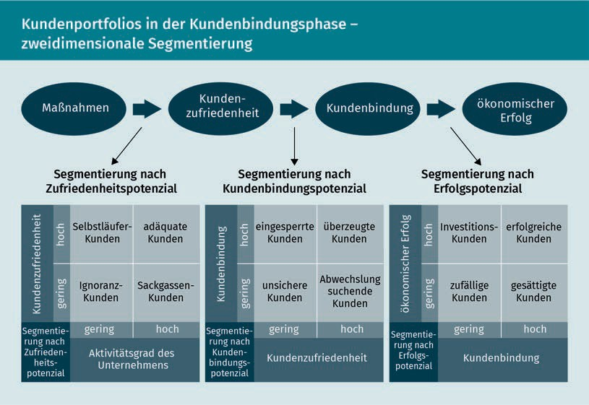

The basis of the segmentation for current customers shown here is the success chain measure -> customer satisfaction -> customer loyalty -> economic success, which leads to segmentation according to satisfaction potential, customer loyalty potential, and success potential. Again, similarly to how we conduct one-dimensional segmentation, let's take a look at the area of customer loyalty: It is assessed to what extent customer satisfaction results in customer loyalty in order to identify four customer types based on the level of connection (Bruhn 2016c, 132 et seq.):

Customer Value and Customer Portfolio Management

* Locked-in customers (high retention and low satisfaction, e.g., retention due to lack of alternatives),
* Convinced customers (high level of satisfaction and high loyalty—often even without a contract),
* Uncertain customers (low level of satisfaction and loyalty),
* Switching customers (high satisfaction but little loyalty: variety-seeking behavior).

If it is now determined during the analysis and evaluation of the customer portfolio that there is a close connection between satisfaction and customer loyalty and that there are many convinced customers, it can be concluded that measures to increase satisfaction may also increase the level of emotional attachment and possibly the willingness to enter into a contractual relationship (Bruhn 2016c, 133).

But to what end is the portfolio considered and evaluated? As has often been stated, it is in the interest of companies to invest in the right customers, i.e., proﬁtable customers. Ideally, these customers should not only be retained over the long term, but the value of these customer relationships should be increased. A central task of CRM is to determine the actual and potential value contributions of customers and to boost optimization. To do this, the factors that inﬂuence the **customer value** must be recognized and the corresponding customer segments must be identified in order to more intensively address the worthwhile customer groups. This makes it clear what role not only a precise **customer value** assessment, but also careful segmentation plays in order to identify value-adding as well as value-impairing areas so that the company can act accordingly. This means expanding value-adding areas and either making value-impairing areas profitable again or—if necessary—ending customer relationships, as the following figure shows:

Variety Seeking

Variety seeking denotes the customer's desire for different suppliers. Even though they may be satisfied with an offering, they will choose another supplier.

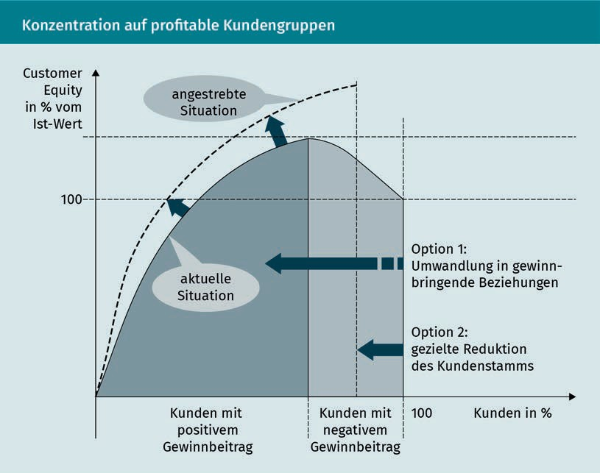

Ideally, such a value-oriented model of customer loyalty must set clear goals: These objectives range from setting a customer satisfaction level to achieving a certain level of customer loyalty or a targeted **customer value** for each customer segment (Günter/Helm 2011, 282 et seq.). Elements of how the customer performs their evaluation should also be taken into account when developing CRM concepts in order to design customer relationships based on the analyzed **customer value** and the underlying factors (high or low value). In this context, it must again be clearly emphasized that neither customer acquisition nor customer loyalty is an end in itself, but that investment in each individual customer relationship must be justified from an economic point of view (Günter/Helm 2011, 284).

Summary

Falling within the scope of CRM activities, **customer value** is an important orientation point for companies that may be viewed from both the customer and the supplier points of view. From the customer's point of view, it is the **customer value** that expresses the benefits of an offering that the customer actually perceives. From the supplier's point of view, the **customer value** represents a value that reflects their contribution to the achievement of corporate goals, including monetary and non-monetary. A clear frame of reference must always be used to calculate customer

Customer Value and Customer Portfolio Management

value: For example, are all customers considered or only a specific customer segment, and should the current value be included or also the future potential? On the one hand, the value can be assessed based on the **transactions** or—to put it more simply—on the purchases that are made and expected in the future by a customer. However, the evaluation must also consider the relational potential, i.e., the importance of the customer as an informant, referrer, and inﬂuencer. In addition to the pure valuation, it is important for companies to also identify the factors that inﬂuence **customer value** in order to make customer relationships proﬁtable.

There are various known one-dimensional and multi-dimensional methods that can be used to determine **customer value**. Some methods focus on purely sales-oriented figures, while others largely consider investments in customers and still others include various factors in the calculation to get a more comprehensive value. The one-dimensional methods include the customer contribution margin calculation or the ABC analysis. The multidimensional methods are the customer lifetime value, customer segmentation, and customer portfolio. The different methods have their own strengths and weaknesses depending on the company's objective. The CLV gives a single number that provides information about the advantages of a customer relationship, but it only refers to the monetary significance and not to the **reference potential** of the customer.

Segmentation attempts to identify homogeneous customer groups and to represent them in customer portfolios. Based on the phases of the CRM process, customer segmentation takes place during the acquisition phase, the **customer retention** phase, and the customer win-back phase, since different needs are taken into account in all three phases and customer segments are based on other inﬂuencing factors. One-dimensional segmentation focuses on the inﬂuence of individual links in the CRM success chain. Two-dimensional segmentation considers two links in the success chain and thus determines, for example, four customer types by considering the connection between customer satisfaction and customer loyalty.

Based on the fact that CRM should determine current and potential value contributions from customers and should help to optimize customer relationships by maximizing their positive economic contribution to the company, the importance of the value determination, but also the analysis of the inﬂuencing factors, becomes clear. Companies want to find out in which customer segments they should invest over the long term and how to act in order to expand value-adding areas or make value-impairing areas proﬁtable. This is because customer loyalty is not an end in itself, but it must also be justified from an economic point of view.

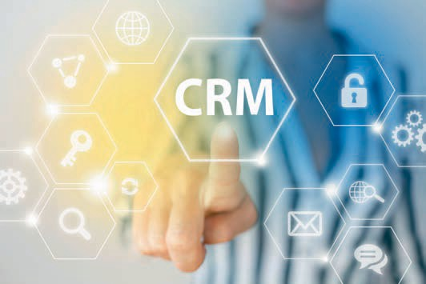

# Unit 7

## CRM Strategies and Tools

#### STUDY GOALS

After completing this unit, you will understand …

… what are the features and tasks of CRM strategies.

… what is meant by phase-dependent strategies.

… which other options and tools can be used.

DL-D-DLBCRM01-L07

1. CRM Strategies and Tools

### Introduction

CRM covers two quite extensive areas and must fulfill different tasks. Considered from one standpoint, CRM is an integrated information system, but we should also not forget that it is also a customer-oriented corporate strategy. No matter which basic understanding is followed, CRM has the task of building, strengthening, or restoring customer relationships. In order to achieve this goal, a comprehensive knowledge of the customers and their needs as well as the opportunities for inﬂuencing the relationships is essential. A meaningful analysis of the customers is based on the evaluation of informational materials, which in turn are collected and evaluated using technical solutions. CRM represents an interplay between a company's strategic customer orientation and the use of the necessary CRM systems to generate, collect, and evaluate customer data in order to use this knowledge strategically and convert it into measures that promote the economic success of the company. In order for this to succeed, CRM strategies must be developed that enable targeted action.

### Characteristics and Tasks of CRM Strategies

Attention This refers to the customer's focused perception of stimuli from the environment, such as,

e.g., company

messages.

When determining what strategic options there are, we first need to define the various goals that the CRM should pursue. And these goals will differ from each other in the different phases of CRM. If the aim of the acquisition phase is to win over new customers, then we can enumerate such goals as attention, interest, awareness, and intention to buy. During the **customer retention** phase, the goals are satisfaction, arousing interest in other products and services, and ensuring long-term loyalty. In the win-back phase, the focus is on rekindling the customer's interest, restoring trust, demonstrating reliability, etc., and the termination phase is about achieving an “amicable” separation. Since the tasks and objectives of CRM vary across the different phases of customer acquisition, **customer retention**, customer recovery, and relationship termination, the strategic approaches also differentiate between customer acquisition, **customer retention**, customer recovery, and relationship termination strategies. On the one hand, the strategies are tasked with assessing the starting position, e.g., using SWOT, life cycle, and portfolio analyses, in order to derive the necessary "marching direction" from this. If, for example, it turns out that an above-average number of customers are switching to the competition, the reasons must be analyzed accordingly and **customer retention** or customer win-back strategies initiated. CRM strategies are thus planned but also creatively deployed so that solutions can be developed from the problem situation (Bruhn 2016c, 146 et seq.).

However, these strategies are not applied to all churned customers, but this is where the consideration of the **customer value** or the customer portfolios comes into play: Which customers does the company want to build relationships with?

CRM Strategies and Tools

Which investments in customers can be considered worthwhile? What do customers expect from the company, and what should relationships look like in the future? Answers to these questions provide initial clarity for the company's possible strategic orientation, because ultimately it is not just a matter of the supplier choosing the right strategy from their point of view, but of thinking about a strategy that will be accepted by the customers. Relationships are not one-sided and cannot be initiated by just one of the involved partners.

In summary, CRM strategies are based on a corporate objective and define a framework for action under which customer groups can be processed and that allows tools to be selected that can shape customer relationships and increase not only customer satisfaction and customer loyalty, but also **customer value**. These strategies must be anchored in the company in terms of organization and personnel mindsets (Georgi/Mink 2011, 59 et seq.). But what strategic options are available in CRM?

### Phase-Dependent CRM Strategies and Tools

Following the idea of strategic orientation based on the customer relationship cycle, the strategic approaches should do justice to the corresponding customer requirements in the acquisition, retention, win-back, and termination phases.

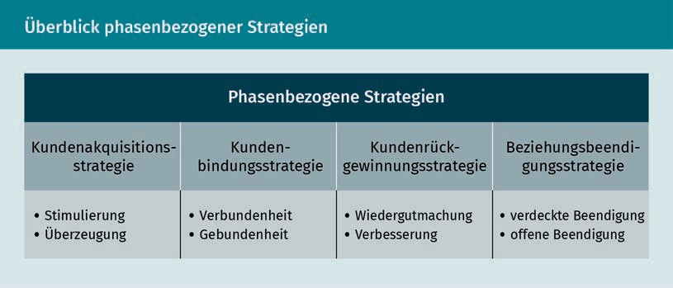

Strategy development follows the usual procedure: After clarification of the initial situation, the market, and competition analysis, the goal and target group (customer segmentation) are then defined, and this in turn is followed by the development of a strategy for the design of customer relationships. The tools can then be derived from these completed stages. Finally, last but not least, an effectiveness check must be taken into account.

Strategy

In an economic context, the planned behavior of companies is referred to as strategy.

###### Customer Acquisition Strategy

In the customer acquisition phase, the company needs to target new customers and win them over. This succeeds by arousing interest, increasing awareness, but also by building a positive image – i.e., exercising certain psychological effects on the customer, which should ultimately lead to an (initial) purchase. A customer acquisition strategy pursues various goals, such as expanding the customer base, acquiring customers to compensate for natural fluctuation (i.e., customer churn), or opening up new markets (Bruhn 2016c, 146).

Persuasion Strategy

This term describes the use of suitable tools to achieve the desired customer

attitude.

Testimonials Feedback from (mostly well-known) people in the form of an unambiguous positive opinion of a product in advertising is classified as testimonials.

In the new customer relationship initiation phase, the motivation and persuasion strategy is used. The motivation strategy tries to create incentives for customers that encourage them to make impulse purchases. The persuasion strategy is less reliant on trying to motivate such an immediate impulse to act. Rather, attempts are made to persuade through arguments and information. You want to make the customer understand that their needs and expectations can be satisfied by the supplier's offerings. If the strategies lead the customer to make a purchase, then the so-called socialization phase follows. Here, familiarization strategies can help introduce the customer to the company. Since this is when the foundation stone for the further course of the relationship is laid, this is an extremely important phase, since trust can be created and any desire to immediately bolt for the offering of a competitor must be counteracted (Georgi/Mink 2011, 74). Depending on whether the strategies are intended to create direct and immediate incentives (e.g., through special offerings or service or product samples) or more indirectly through testimonials by raising image or brand awareness (e.g., in advertising), we can distinguish between factual and symbolic strategies, from which six strategy types can be derived during the initiation phase.

CRM Strategies and Tools

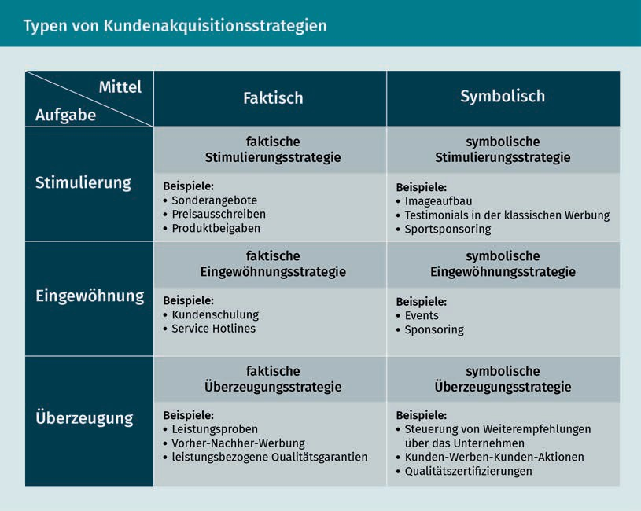

Depending on which customer acquisition goals are being pursued, the strategies can focus on customer segments that have already been worked out, but also on new customer segments or new markets (Bruhn 2016c, 147).

###### **Customer Retention** Strategies

During the **customer retention** phase, relationships should be built up, strengthened, but also maintained. Accordingly, a distinction can be made between a growth phase and a maturity phase. While still in the growth phase, the company must select strategies that help foster a customer relationship that is just beginning to achieve “healthy” growth. The strategies in the maturity phase ensure that the existing relationship is continued and stabilized on a long-term footing (Georgi/Mink 2011, 75 et seq.). In reaching for an analogy with nature, we can visualize this process very well using the example of a tomato plant: After germination, the plant needs a lot of care until it grows big and strong, so that it can be transplanted from the nursery pot into the large garden bed. And then comes the far more difficult part: The plant must be protected from extreme environmental influences and, if it is bearing a lot of fruit, it must be supported so that it does not snap, thereby losing the harvest.

**Customer retention** strategies aim to boost satisfaction and establish a high level of loyalty in order to increase purchase frequency, exploit cross- and **up-selling potential**, and encourage recommendations by customers, but also

to increase **customer value**. When implementing the measures, it must always be considered that these measures can also have negative consequences: Customers who are not addressed can feel disadvantaged, or customers can build up very high expectations when they learn about **customer retention** offers (Bruhn 2016c, 149).

One of the strategic options available in the **customer retention** phase is the connectedness strategy, which aims to achieve customer loyalty via psychological determinants, such as the quality of the relationship or customer satisfaction. On the other hand, this retention strategy tries to build up and strengthen customer loyalty by erecting barriers to change. Both strategies are divided into short-term and long-term approaches in terms of their timeframes. Thus, short-term connectedness strategy include offering discounted products and services, for example, but also a surprise gift or a free service in connection with a purchase (e.g., free delivery or installation service). In contrast, a short-term retention strategy uses short- to medium-term barriers to switching (e.g., a three-month trial contract) to promote customer loyalty (Bruhn 2016c, 150).

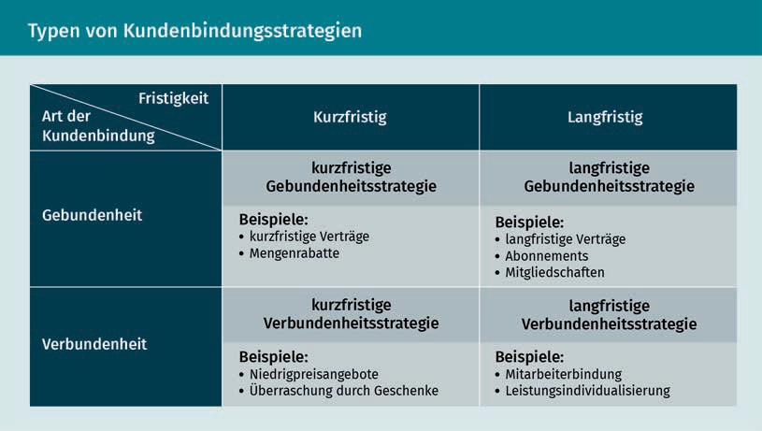

Once the **customer retention** phase has expired, a great advantage can be seen in the fact that the supplier and customer have already gotten to know each other, the initial hurdles in building the relationship have already been cleared, and both parties gain experience in dealing with each other that they can draw on later.

###### Customer Recovery Strategy

Various customer types must be monitored during the customer recovery phase, There are customers who have expressed their desire to defect, but have not yet finally decided whether to turn their backs on the company. And then there are

CRM Strategies and Tools

customers who wish to defect and already determined to do so, e.g., they have already terminated an existing contract by the due date. Finally, the third type of customer in this phase is the customer who actually ends the relationship, such as one whose contractual commitment has already expired, for example. From a strategic point of view, the lost interest must be rekindled. To do this, however, the company needs to know why the customer has lost interest or satisfaction and how the perception of the company can be improved again—especially of the image and quality (Georgi/Mink 2011, 77). The customer's reasons for defecting can be of a very personal nature, such as relocation or a change in life situation, but they can also be due to competition (e.g., better offers from the competition). But the company itself is also responsible if poor quality, high prices, or poor service "drive away" customers.

The type of customer also influences the respective recovery strategy: The customer who has expressed a desire to defect is more likely to be won back using an emotional appeal, while the customer who has already churned is more likely to reconsider their decision based on factual information. The different customer types and response options of the company lead to four types of customer recovery strategies:

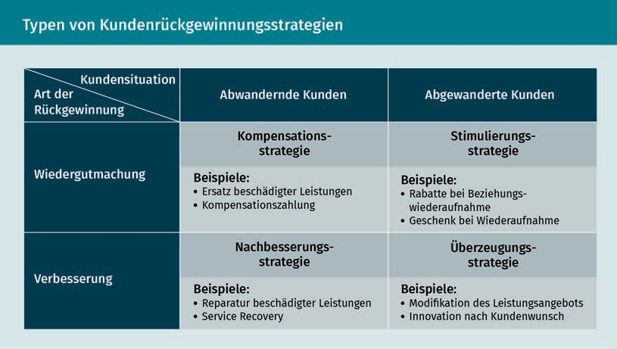

Of course, when choosing a strategy, it is not only possible to distinguish between customers who are willing to defect and those who have already done so. For example, an improvement strategy can only be selected if such a recovery is even possible: For example, if an electrical device is destroyed by a battery fire, it can only be replaced and not repaired. If, on the other hand, you are dissatisfied with your mobile phone contract because it does not offer a certain rate plan option that is important to you, the provider may possibly avoid an imminent churn by making immediate improvements (at best free of charge).

###### Strategies for Ending the Relationship

If a customer relationship can no longer be maintained despite all efforts, or if the supplier has economic reasons for terminating the relationship, then an open or a covert approach can be chosen depending on the adopted strategy. In the case of an open termination, the end of the business relationship is communicated directly to the customer: It is conceivable that an insurance company chooses to terminate an insurance policy, for example. The company can choose to terminate the policy without further justification (strategy of fait accompli) or also by providing an explanation to the customer (strategy of declared termination). In addition, it is conceivable that an agreement might be able to be reached to continue the contract (strategy of consensual negotiations) under certain conditions. And last but not least, the insurer could propose conditions to the insured that would allow the policy to be continued, but which would have to be accepted by the insured without the option for negotiation (take-it-or-leave-it strategy without negotiation) (Bruhn 2016c, 156).

Under the covert strategy, on the other hand, the customer is not directly informed of the end of the business relationship. However, this strategy has nothing to do with the reticence of companies not wanting to openly communicate the goal of a relationship, but it can ultimately become necessary for tactical and economic reasons. If a previously good customer is no longer of interest to the company due to reasons of strategic realignment, for example, they should not be left annoyed by the termination of the business relationship (strategy of de-escalation) (Bruhn 2016c, 155). However, such a scenario is only conceivable if the customer can continue to use their previous services. If, for example, a hotelier buys a certain tableware for the restaurants of their hotel chain and regularly adds to it, but the supplier then decides that they will only produce for the private customer market going forward and removes the catering line from its offerings, the customer may be able to be supplied with pieces for a while using residual stock, but the end of the relationship is foreseeable. Therefore, a passive withdrawal would hardly be conceivable here. Basically, a distinction is made between passive and active withdrawal, and in addition to the strategy of de-escalation, we also know about the strategies of escalation, “letting go”, and withdrawal, but we will not be discuss these further here.

### Additional Options and Tools

The following illustration gives a good insight into the tools and measures that should be used in connection with a phase-related orientation for your CRM:

CRM Strategies and Tools

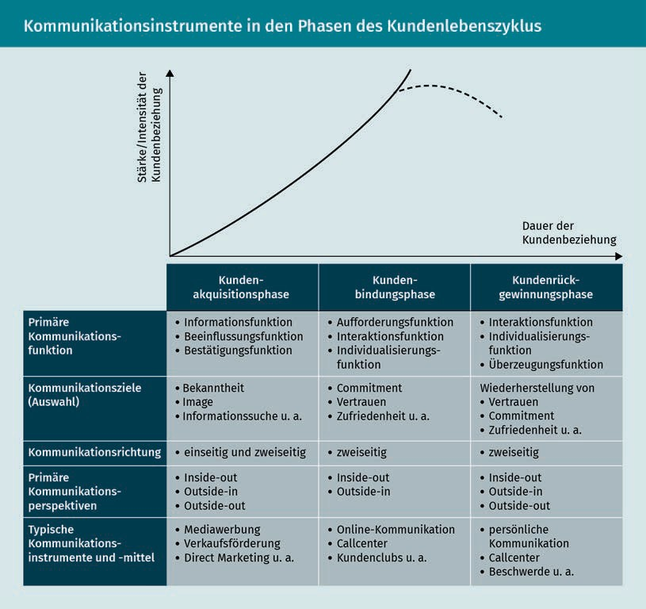

In addition to the phase-related options, there are also other CRM tools that can be used in different phases or across phases in addition to the ones listed above. These include quality, complaint, service, and **customer value** management tools (Georgi/Mink 2011, 78).

Quality management has a direct effect on customer satisfaction and is therefore a prerequisite for building customer relationships. Quality management is always directed both inwards and outwards. Within the company, it should be focused on productivity and error rates, and with regard to customer orientation, it should target profit, market share, or repeat purchases and cross-selling potential. The selected quality management tools are based on quality planning and quality controlling. The quality strategy relates to the supplier's products and services, which must be based on the specified quality standards (Georgi/Mink 2011, 78).

**Complaint management** is an important task for the CRM. Things don't always run smoothly, and customers occasionally have cause for complaint, whether justified or unjustified. A complaint is the articulation of a customer's dissatisfaction with the company. And since these complaints cannot simply be swept under the rug, but rather must be taken very seriously, this subject has increasingly been raised in **complaint management** in recent years. The acceptance, processing, as well as handling of these complaints should be carried out according to plan. In order to establish a comprehensive complaints management system, the following complaints process should be taken into account:

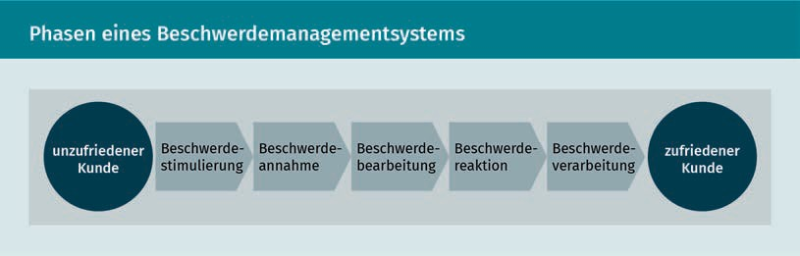

Value Added

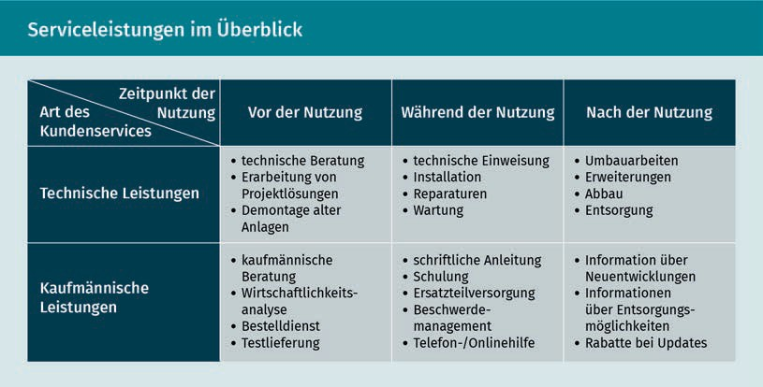Services Value-added services are a company's offerings and services that provide the customer with added value to the actual product (e.g., an installation service when buying a washing machine).

Service management deals with all factors that have an inﬂuence on customer satisfaction and loyalty beyond the pure product. The tools range from customer service, technical and commercial services, and warranties to delivery service and offerings (Georgi/Mink 2011, 79) that are not directly related to the product, i.e., the so-called **value-added services**, such as childcare services in well-known furniture stores.

CRM Strategies and Tools

Since the value of the customer is an important factor for the supplier, it should also be considered as a basis for decisions about marketing and CRM activities. In order to derive suitable cross-phase tools for controlling **customer value**, dynamic methods for determining value should be used and incorporated into comprehensive **customer value** management.

There are a variety of measures that can be derived from the tools mentioned here. Communication measures in particular are suitable not only for helping to build relationships, but also for nurturing them. The measures range from classic dialog marketing and customer clubs (so-called loyalty programs) to customer magazines. All of the measures are aimed at increasing the exchange of information between suppliers and customers not only in order to inform customers about offerings, but also for purposes of promoting dialog and thus generating more knowledge about the customer. On the one hand, this knowledge about the customer makes it possible to craft an individualized customer approach, **customize** products, and boost use of the supplier's services (repeat and multiple purchases, cross- and up-selling), but also to erect barriers to switching to a competitor. However, in order to be able to make a long-term contribution to customer retention, the measures must always be selected while considering strategic aspects and in a goal-oriented manner, and therefore long-term authentic and credible dialog must be maintained with the customer.

Summary

Customization This term describes the strategy of adapting products and services to individual customer interests.

Strategies are geared towards identifying a path based on careful analysis that helps the company to achieve the formulated goals. Since the tasks and goals in CRM vary according to the various phases of the customer relationship cycle, the strategic options are considered and developed depending on the phase in order to optimally design customer relationships. These strategies must also be anchored both organizationally and personally at the company.

The phase-related strategies can be divided as follows:

* The customer acquisition strategy for encouraging and winning over (potential) customers.
* The customer retention strategy for building and strengthening customer relationships.
* The customer recovery strategy for addressing customers seeking to defect and already churned customers.
* The relationship termination strategy for liquidating (or possibly conditionally maintaining) customer relationships.

Additional phase-spanning tools are used in the CRM to supplement the phase-related strategies. Essentially, these are quality, complaint, service, and **customer value** management. All of these areas represent important tasks, since quality, but also successful complaint and service management can have a positive inﬂuence on customer satisfaction

and thus customer loyalty to the supplier. Targeted and target-group-oriented measures can be derived from these strategies, which can be used to achieve strategic goals at the operational level.



# Unit 8

## CRM Implementation and Monitoring

#### STUDY GOALS

After completing this unit, you will understand …

… which requirements, stumbling blocks, and challenges are associated with implementing CRM.

… what do we mean by the terms operational and analytical CRM.

… which opportunities for effectiveness control can be utilized.

DL-D-DLBCRM01-L08

1. CRM Implementation and Monitoring

### Introduction

Customer orientation has become increasingly important: Companies set up customer clubs, deal with **complaint management**, or measure customer satisfaction. And yet the effect of these measures often does not increase the level of customer loyalty. Why is that? Have the companies applied the wrong measures or simply set the wrong goals for themselves? In most cases, it has more to do with the fact that though companies realize the importance of customer relationships, they implement a customer orientation using individual measures rather than with integrated concepts. Information management in particular lags behind expectations: This is because data is collected, but often not adequately analyzed or brought together accordingly. Customers come into contact with companies at various **touchpoints**: This can be in the store, via the website, customer support, the complaints department, or via third parties. One of the greatest challenges is not just to collect all this information, but to synthesize it in a targeted manner. In addition, a CRM must be strategically and operationally firmly anchored in company management and employee culture, and both operational and analytical CRM must work closely together and build on one another. In addition to providing the necessary technical support in the form of IT solutions, it is also important for the company to institute a customer-oriented corporate culture, for example.

In the case of successful implementation, companies must therefore take a holistic view of the strategic orientation, human resource management, information management, and the structural and process organization, and they must also take adequate effectiveness control into account.

### Organization, Management, and Company Culture

CRM cannot just be dropped into place as a one-size-fits-all package or pursued on the side. If it is to be implemented successfully, it must be closely integrated into the basic, strategic orientation of the company, which is committed to customer orientation and consistently aligns company activities with the market. CRM is more than a package of measures and must therefore also be anchored organizationally in the company. Numerous studies have found that one of the main reasons for the failure of CRM projects can be found in the failure to adapt organizational structures, but also fundamentally in the lack of planning and goal setting. Organizational adjustments, the involvement of top management, a high level of employee loyalty to the company, and the appropriate execution of planning and control measures and the design of incentive systems have also been cited as important success factors for successful implementation. The earlier the employees are involved in the process, the more successful the implementation will be (Götz/Krafft 2013, 592 et seq.). In addition to executives and employees, the quality of information management of course is also very important for successful implementation. That is because

CRM Implementation and Monitoring

meaningful insights for the development of efﬁcient packages of measures can only be generated from “good” data. **Knowledge management** has also turned out to provide helpful support here, since not only should data be carefully and purposefully collected, but the processing and derivation of the need for action is an important part of the implementation of successful CRM activities. **Knowledge management** provides the interface between the IT infrastructure for data collection and the development of effective and efﬁcient customer management (Götz/Krafft 2013, 591).

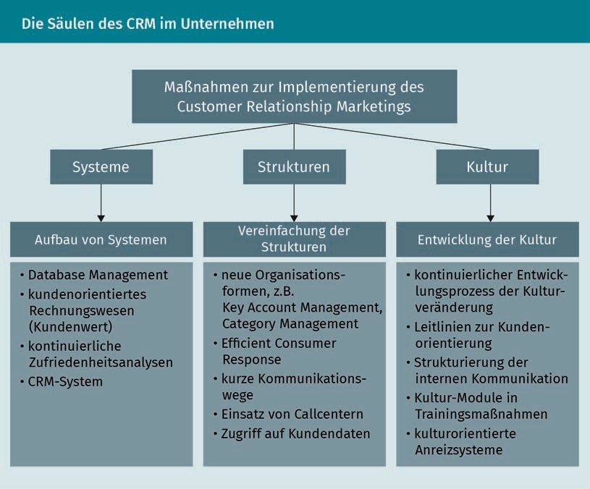

But now the question is whether CRM can be implemented equally in all areas and industries. The success of CRM strategies usually also depends on purchasing behavior, and this may be quite different for different products or in different industries. It is also questionable, for example, whether loyalty measures might not make customers who always buy the same product out of pure habit more likely to rethink their habitual actions. In other words, the measures may backfire and cause the company to potentially lose these customers (Götz/Krafft 2013, 608). Can customer relationships be established and maintained equally across all industries, or what needs to be taken into account in different sectors or with different products?

Knowledge Management This represents the totality of measures for the utilization of existing knowledge within a company.

###### Customer Relationships in the Consumer Goods Sector

Brand Communities Brand communities are communities that grow out of the consumer's loyalty to the

brand.

Capital Goods These are assets that the company uses to produce or further process other goods.

In the consumer goods sector, customer involvement plays a particularly important role. The brand-customer relationship often takes the place of a supplier-customer relationship. Think of the products in your everyday life, such as yogurt, shampoo, deodorant, etc. These are products with low cognitive involvement: Here, brand and product policy or sales promotion measures, but also loyalty programs, have greater potential to make a noticeable contribution to customer retention. When it comes to making product purchasing decisions with a high level of cognitive involvement or, to put it simply, a higher need for information and deliberative purchasing behavior, such as the case with cars, PCs, furniture, etc., CRM measures that can support and reinforce the purchase decision will have a positive inﬂuence on customer loyalty (Götz/Krafft 2013, 608). There are many well known measures that are used to strengthen the customer's sense of connection with a brand, to create a “we” feeling, or to create barriers to churn. Flagship stores, brand events, **brand communities**, social media communication, live trade fairs and events, but also viral marketing and crowdsourcing are some of the frequently used measures.

###### Customer Relationships in the Capital Goods and Service Sectors

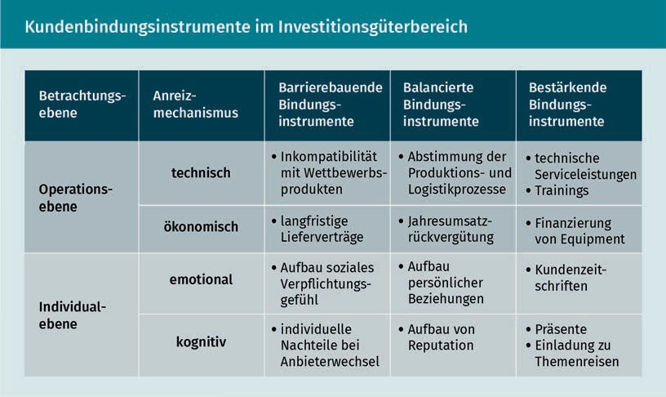In the **capital goods** and service sectors, customers have a high need for information. Investments must be carefully weighed, since they are usually associated with a high ﬁnancial risk and, in addition to ﬁnancial aspects, there are technical factors, contract terms, etc. that must also be taken into account.

CRM Implementation and Monitoring

In the case of services, it only becomes clear when the service is used and the interaction takes place there whether the customer's expectations are being met. In both areas, it is important to build trust and not to disappoint the customer over the medium to long term. An intensive relationship management process is therefore already initiated in the acquisition phase in the B2B and service sectors, whereby personal communication is one of the important measures for customer care. Customer retention tools/measures include: consulting services, trainings, maintenance and repair services, and also financing and customized offers.

Now, the desire of companies to intensify customer relationships is all well and good, but customers must also be willing to enter into these relationships. It is certainly easy to observe the reservations customers have about the CRM measures of companies: Various measures are viewed critically, especially when considered in the context of discussions about data protection and providing greater transparency for customers or when there is a fear of manipulation. These worries or critical assessments can mean that customers, for example, do not take part in **customer programs**, customer loyalty cards are rejected, or even that customers deliberately submit false information to the company (Götz/Krafft 2013, 609). However, in this context it must also be questioned whether, given that many customers are deluged with loyalty offers, customers have not grown tired of them. The flood of customer loyalty cards means that customer wallets are bulging from all of the excess pieces of plastic. Migros Switzerland had an interesting idea many years ago: Instead of the usual plastic card in the credit card format, the store also offered several stickers with a bar code that you can stick on another card or a simple slip of paper, etc., to save space.

On the one hand, endogenous factors, meaning the ones that the company can control, have to be taken into account during implementation; but the exogenous factors, such as customer needs and requirements, also cannot be ignored. During implementation, however, not only strategic, organizational or personnel considerations, but also technological aspects, such as the introduction of IT-based CRM systems, must be taken into account.

### CRM Process Architecture

When implementing a CRM strategy, it must be ensured, as we showed above, that the necessary conditions are established in all involved areas so that measures can ultimately be designed in such a way that a holistic customer relationship can be fostered. It is a complex task that requires a structure that affords the requisite scope of action and interaction between the various actors. The following overview of a possible CRM system architecture shows the different areas, but also the connections at a glance:

Customer Programs Measures such as customer clubs, discount systems, etc., instituted by companies to retain customers are called customer programs.

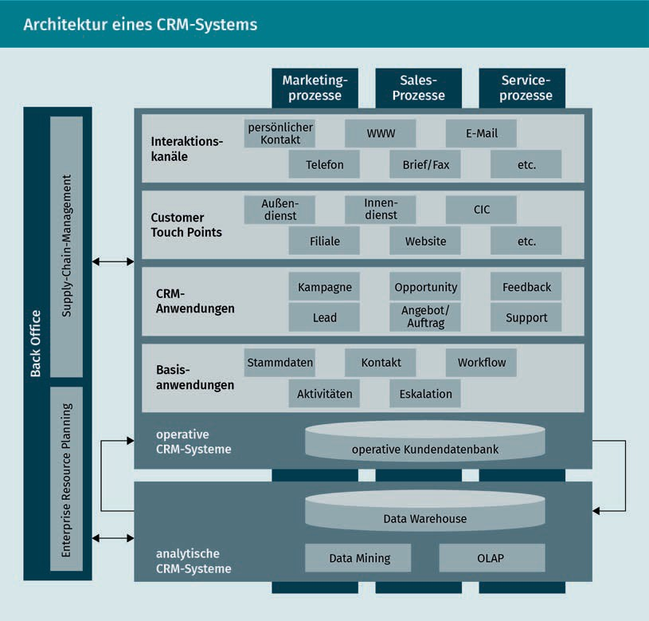

This overview clearly shows how complex the relationship construct between customer and company is and how many different customer touch points have to be taken into account. Since customers make personal contact, for example, by visiting company offices, calling the call center, placing online orders, or just by submitting an inquiry via the website, all of this information has to be synthesized in one place and then not only filed away, but also understood in context. It's not just about the technical solution for data processing, it's also about the targeted use of this data and the knowledge that can be derived from combining these data materials with their analyses.

You can see that this process requires a great deal of effort (of a technical and organizational nature). Customer databases provide the basis for bundling this information from the various **transactions** with the customer. In addition to the master data, such customer databases also contain information on all transactions, such as purchases, returns, complaints, but also customer suggestions and a collection of all contacts made via e-mail, phone, etc. But can you now obtain a comprehensive picture of the customer with a short click after collecting the various data? Unfortunately, it is not quite that simple, because this data must first be analyzed and evaluated in the overall context.

CRM Implementation and Monitoring

And here the human factor continues to play a decisive role: Imagine you are checking into a hotel. The room you are offered is on the second floor, and there is no elevator in this area of the hotel. You have just had a sports accident, and climbing stairs is still difficult for you and not conducive to allowing your injury to heal. Therefore, you request another room. That night you realize that your room is unfortunately directly above the hotel bar, and you were unable to sleep a wink because of the noise. The next morning, you ask to get another room, and after looking at your customer data, the receptionist replies rather curtly that yesterday you refused the room that was assigned to you and that you were already given another room. So what would such a scenario mean for CRM and data collection? The information by itself that the guest wanted another room lacks context or leaves others with quite a lot of room for interpretation, e.g., that the guest is one of those perpetual complainers than can never be pleased, etc. The example shows: The data must be meaningful and allow for clear conclusions to limit the room for interpretation. In our example, it would have been sufficient to record the reason for the room change or, if this would be too time-consuming, to train the staff to ask again why the first room did not meet the guest's expectations: A friendly "May I just ask again why you didn't like the room yesterday?" or "Oh, did the new room fail to completely satisfy your expectations?" makes it clear that the guest is appreciated and thus helps contribute to customer satisfaction and loyalty.

In order for CRM to bear fruit, the system must not only be accepted by management, but it must also receive a high level of **commitment** from the employees as well as adequate IT support in the form of data collection measures. To ensure this, communication, human resource management, remuneration, and control systems must be implemented. The communication systems cover all areas of market-oriented communication with customers, from the website to the call center to engagement over social media. HR management must ensure that there are appropriate working conditions—or to put it simply: Care must be taken to ensure that employees feel comfortable, support the company's ideas, and are supported by appropriate overall working conditions, such as, for example, fair pay and reasonable working hours, which provide proper incentives. The more comfortable the employee feels at the company, the better prepared they are for their job duties, and the more they know their scope of action, the better they can react to customer needs. Imagine an employee who feels that they are badly treated by their employer, underpaid, and that the company is not an ethical enterprise to work for. Do you think that such an employee is able to represent the company positively to the outside world? In this situation, a customer's complaint will fall on receptive ears—it's hard to imagine what would happen if we continued this story.

### Operational and Analytic CRM Processes

In order for a company not only to collect data, but to collect data that can be made usable, it must be clarified what the company needs to know about its customers, i.e., which data should specifically be collected. And then, of course, it must be clarified how and where this data can be collected by the company and how the data generated by a seller can be merged with the information collected by the service department.

Operational CRM Operational CRM stands for customer-oriented measures, such as establishing contact with customers and generating

leads.

Under this system, it's not about looking at the customer through the company's individual interfaces, but rather learning about and connecting all points of contact. **Operational CRM** encompasses all processes that are involved in handling customer **transactions** with the aim of arriving at a uniform image of the customer (uniform customer approach). Six core CRM processes can be derived from these tasks: In the marketing process, campaign and lead management in the sales process is followed by opportunity and offering/order management. This is where sales can leverage gained insights that allow for targeted offers to be made that ideally result in an order or purchase. After the product has been sold or the service has been provided, feedback and support management follow as part of the service process. Here it is important to process customer feedback (including both positive and negative) and to offer and monitor appropriate customer support. Suitable supporting IT systems can and should be deployed and used to support these operational processes (Leusser/Hippner/Wilde 2011a, 42 et seq.).

Analytical CRM is now required to control the customer-oriented operational processes. Its task is to collect, analyze, and optimize data. Basically, the point is to refine the collected customer data and make it more meaningful.

As was already explained above, it is important for CRM to not only look at data from one area of the company, but to know as precisely as possible where, how, and why a customer contacted the company, what the customer bought, and what conclusions can be drawn from this: Is a customer who has bought warm winter boots also interested in vacation offers in winter sports regions, or are they more interested in snow shovels or children's sleds? The question is whether customer has an affinity for winter sports or are they a homeowner who has to dig out the sidewalk, or perhaps they are a parent who wants to take the children sledding? Association or sequence analyses are used to tease out these connections, but we will not be discussing them in detail here.

When collecting customer data, a distinction is made between **identification**, description (descriptive data tends to be key figures, such as the customer number and product group turnover), and transaction **data**:

CRM Implementation and Monitoring

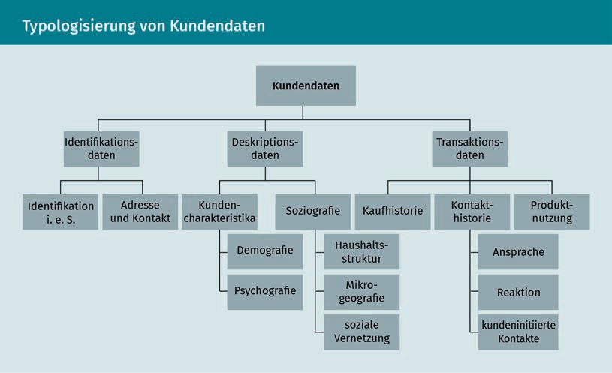

In order for a company to draw a meaningful picture of the customer, the necessary and target-oriented data must always be collected, i.e., the data that allows for conclusions to be drawn. The **psychographic data** is of particular interest here. You want to capture what motivates customers; what values, motives, and attitudes they have; how they consume; and what their intentions to buy are. This is a difficult undertaking, because people have very individual preferences: Not all 20-year-old women in Munich automatically have the same purchasing behavior, and people over 70 are not necessarily unversed in technology. Obtaining meaningful data and analyzing it correctly is a major challenge. How do you overcome this challenge in practice?

Ideally, the data and associated assessments should be collected directly and personally by the company's own employees, but that only works at smaller companies. The larger the company and the more customers it has, the more complex the task of data collection becomes. Here, for example, feedback forms or online surveys are used to collect data. When the company can combine data from the **operational CRM**, that is, information about customer **transactions** that lays bear the exchange relationships that the customer has with the company and the exact communication channels they have used to make contact with the company (contact history) with customer demographic and **psychographic data**, this provides a good basis for analysis.

The **operational** and analytical **CRM** approaches therefore mutually reinforce each other and cannot be viewed separately from one another. Recall once again the basic goal of CRM systems: It's about assembling a uniform picture of the customer in order for the company to act and appear in a customer-oriented and holistic manner. For example, the analytical tasks of **customer value** analysis,

Identification Data So-called identification data includes customer address and contact information as well as the customer number, name, title, and form of address.

Psychographic Data

Psychographic data record information about customer preferences. This data ranges from lifestyle, values, and desires to the customer's willingness to take risks and assume commitments.

Transactions

Customer transactions include completed purchases as well as the entire contact history and information on the customer's product usage behavior.

customer characterization and segmentation, and the target group or migration analysis support the operational processes, as can be clearly seen from the following figure:

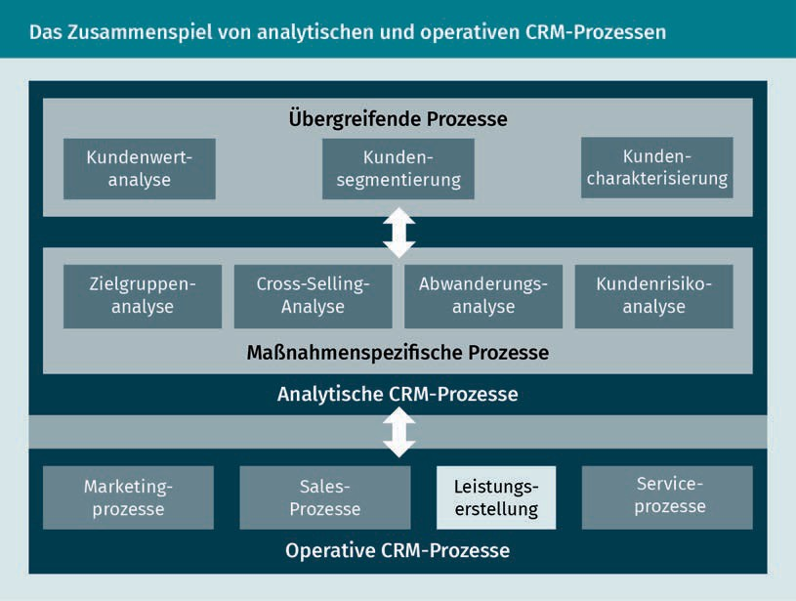

### Data Processing

So now we come to data processing itself, since it forms the basis of analytical CRM. **Data warehouse** and analysis tools, such as data mining or online analytical processing tools (OLAP for short), are frequently used to process this data.

Data Warehouse A data warehouse is a database that collects and organizes data from all areas of a company for purposes

of analysis.

While the **data warehouse** provides data storage, i.e., it is the place where data from all areas of the company is sent and then classified and sorted, the analytical tools are designed to process this data (Rentzmann et al. 2011, 133).

OLAP provides descriptive but no explanatory data. A typical question might be about the volume of sales over a certain period and in a particular place. Since descriptive data, such as customer numbers or product groups, may be very important from a business point of view, but they tell us nothing about the reasons for the customer's purchase or

CRM Implementation and Monitoring

the relationship components, it is important to evaluate the data materials holistically. This is where data mining comes into play, because the focus here is on the explanatory data that can be used for all areas of the CRM process.

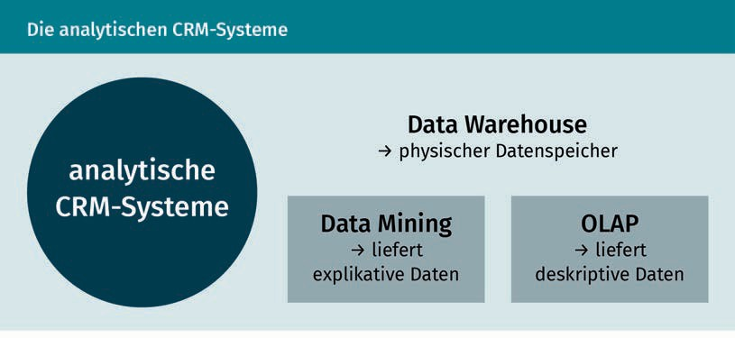

However, what do we mean by data mining? Data mining is a (frequently automated) process for penetrating data materials in order to show possible connections between customer behavior and customer-oriented business processes.

The term itself contains the key action here: mining, which is the uncovering of precious raw materials from a large amount of rock, but in our case it is the finding of the really important information in the big data jungle (Rentzmann et al. 2011, 135). This process is usually performed automatically, is divided into six steps, and has established itself as the so-called Cross-Industry Standard Process for Data Mining, or **CRISP-DM** for short. You might ask yourself: if it is an automatic process, then it almost sounds as if it would be enough to input a mountain of data and then automatically obtain the relationship patterns as the output. However, it is not quite that easy, as a large proportion of the work (around 60%) goes into the selection and preparation of the relevant databases. The term "automatic" actually only refers to the statistical pattern extraction (Hippner/Grieser/Wilde 2011, 790 et seq.).

Data mining is used in all CRM process steps. The evaluated data can be used in both the customer acquisition and customer retention phases as well as even for **complaint management**. In **complaint management**, by recognizing information and service needs that are insufficiently satisfied, the company can react accordingly, so that, for example, dissatisfaction does not lead to customer defection (Hippner/Grieser/Wilde 2011, 803 et seq.).

In order to make data usable and to generate insights relevant to decision-making, the greatest challenge for companies is probably to consider and analyze the existing customer data across all areas of the company. Data mining can help to segment customers, to classify them according to purchasing behavior or the likelihood of defection, or to identify cross-selling potentials.

CRISP-DM

The CRISP-DM is an open and widely used analytical model for data mining.

Knowledge gained in this way provides a good basis for customer relationship management and is indispensable for successful CRM (Hippner/Grieser/Wilde 2011, 805).

### Opportunities for Effectiveness Control

Of course, a strategic CRM also needs a control system. But now the question arises as to what exactly should be “controlled”: Choosing the right strategy, using the right tools or the right IT system solutions for data collection and analysis, the institution of a successful organizational culture, the functionality of processes, the effectiveness of the measures, or anything else related to CRM? In any case, a control system must be both internally and externally oriented and should comprehensively check to what extent the CRM activities are successful and contribute to customer satisfaction and loyalty, and whether monetary and non-monetary objectives can be achieved. Understood in this way, the control process takes place at the strategic and operational level and checks – to put it quite simply—whether the correct strategic approach has been chosen and whether the tools used and the measures developed from them are target-oriented. On the one hand, an effectiveness check determines whether the set goals are attainable, but it also serves to allow the results to flow into future planning in order to optimize CRM activities. A comprehensive control process supports the company management by providing well-founded insights into strategies, processes, and effects.

In order to be able to control effects, it must be known which goals or effects the company wishes to achieve. In the case of relationship management, Bruhn (2016c) differentiates between the pre-economic effects (psychological goals and behavioral goals) and the economic effects (economic goals), which can be clearly seen in the following figure:

CRM Implementation and Monitoring

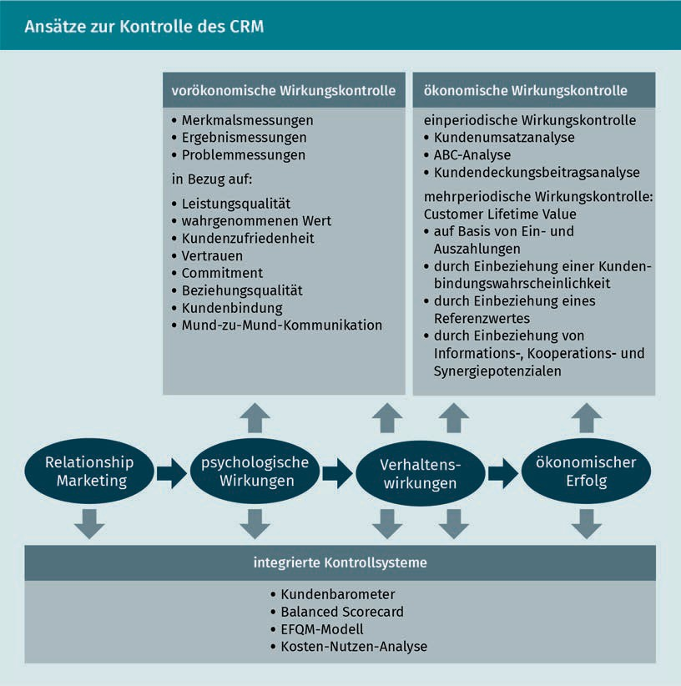

When selecting a suitable set of tools for measuring the various impacts, the company's respective requirements for the results must be taken into account, and it must be ensured that the results are reliable, valid, complete, and up-to-date.

If, for example, such aspects as customer satisfaction, trust, or the quality of the relationship or behavioral effects, such as customer loyalty or word-of-mouth communication, are to be checked as part of the pre-economic control process, characteristic-oriented, event-oriented, or problem-oriented controls could be used (Bruhn 2016c, 290).

A characteristic-oriented control for measuring psychological parameters can therefore be used to measure relationship quality or customer satisfaction. Since such psychological constructs are not directly observable or measurable,

data collection must focus on indicators that reflect the construct or influence the construct. After data collection is completed, the results are interpreted and used (Bruhn 2016c, 290).

To illustrate, let's consider how customer loyalty is measured: While factual behavior—i.e., actual behavior—can usually be determined using objective and customer-related data, behavioral intentions must be determined in a different way. This can be measured by surveying customers to obtain data about repeat selection (intention) and cross-buying (intention) indicators, but also about their willingness (intention) to give recommendations or accept or tolerate price increases (Bruhn 2016c, 298).

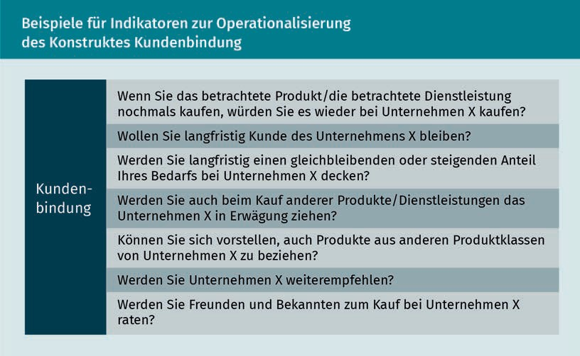

After the data is collected, the data must now be made usable: Individual aspects, such as factors influencing customer loyalty or comprehensive insights into customer loyalty in general, can be worked out in detail. The results can also be related to other data, for example, to examine whether customer loyalty has increased through the application of a specific measure. And last but not least, measures should be derived from the findings that can help to increase customer loyalty. The results of measuring such characteristics can be very useful for identifying potential for improvement initiating measures that will contribute to achieving the CRM goals in the future (Bruhn 2016c, 299 et seq.).

CRM itself repeatedly presents itself as a complex construct, which also shapes the effectiveness controls, which are based on various tasks, requirements, and processes . The following can also be stated without the need for any separate calculation: A comprehensive focus on the customer, their needs and individual requirements pays off for companies in the long term, because a customer who feels that they are being taken seriously and whose needs are not only recognized, but

CRM Implementation and Monitoring

also satisfied is a customer who will purchase the company's service again or would be happy to recommend this company to friends, acquaintances, and family.

Summary

There are both endogenous and exogenous factors that have a decisive influence on whether CRM can be successfully implemented at the company. In order for CRM to bear fruit, the system must not only be accepted by management, but it must also receive a high level of **commitment** from the employees as well as adequate IT support in the form of data collection measures. To ensure this, communication, human resource management, remuneration, and control systems must be implemented.

The necessary prerequisites for the successful implementation of a CRM also include the development of an IT-supported solution for data collection and processing. In addition to a purely technical solution, companies need to know what data is required in order to draw a uniform picture of their customer. Ultimately, it is not the amount of data that is decisive, but rather the quality of the data.

The collected customer data is divided into **identification**, description, and transaction **data**. The analytical CRM collects, structures and analyzes the customer data and provides the basis for decision-making for the customer-oriented **operational CRM**. Both areas depend on and support each other and cannot be viewed in isolation from one another.

Data processing is about collecting the data, on the one hand, and evaluating it, on the other. As the repository for data, the **data warehouse** collects data that can be processed using data mining or OLAP and which can then be used as the basis for customer relationship management.

A corresponding control system must now be instituted in order to check the effectiveness and usefulness of the CRM. At the strategic and operational levels, it must be checked whether both the adopted approach and the utilized tools and measures to promote customer loyalty were effective. However, the findings are also used for the future-oriented planning of all CRM activities. The speciﬁc requirements and objectives of the company must always remain the focus of an effectiveness check so that control tools can be selected that deliver meaningful and usable insights that support successful customer loyalty management and ensure a comprehensive customer orientation.



# Appendix 1

## Bibliography

Bibliography

Advidera (2019): *Customer-journey*. (URL: https://[www.advidera.com/glossar/customer-](http://www.advidera.com/glossar/customer-) journey/ [Accessed on: 07/08/2019]).

Backhaus, K./Voeth, M. (2009): *Industriegütermarketing* [Capital goods marketing]. 9th edition, Vahlen, Munich.

Bruhn, M. (2016a): *Kommunikationspolitik im Relationship Marketing* [Communications policy in relationship marketing]. In: Bruhn, M./ Esch, F.-R./Langner, T. (eds.): Handbuch Strategische Kommunikation. Grundlagen – Innovative Ansätze – Praktische Umsetzungen [Handbook of strategic communication: basics – innovative approaches – practical implementations]. 2nd edition, Springer Gabler, Wiesbaden, pp. 229–257.

Bruhn, M. (2016b): *Marketing. Grundlagen für Studium und Praxis* [Marketing. Basics for study and practice]. 13th edition, Springer Gabler, Wiesbaden.

Bruhn, M. (2016c): *Relationship Marketing. Das Management von Kundenbeziehungen* [Relationship marketing. Managing customer relationships]. 5th edition, Vahlen, Munich.

Bruhn, M./Georgi, D. (2013): *Wirtschaftlichkeit des Kundenbindungsmanagements* [Profitability of customer loyalty management]. In: Bruhn, M./Homburg, C. (eds.): Handbuch Kundenbindungsmanagement [Handbook of customer loyalty management]. 8th edition, Springer Gabler, Wiesbaden, pp. 677–708.

Ergenzinger, R./Thommen, J.-P. (2005): *Marketing. Vom klassischen Marketing zu Customer Relationship Management und E-Business* [From classic marketing to customer relationship management and e-business]. 2nd edition, Versus, Zürich.

Fürst, A. (2012): *Verfahren zur Messung der Kundenzufriedenheit im Überblick* [Overview of methods for measuring customer satisfaction]*.* In: Homburg, C. (ed.): Kundenzufriedenheit. Konzepte – Methoden – Erfahrungen [Customer satisfaction. Concepts – methods – experiences]. 8th edition, Gabler, Wiesbaden, pp. 123–153.

Georgi, D./Mink, M. (2011): *Konzeption von Kundenbeziehungsstrategien* [Thinking through customer relationship strategies]. In: Hippner, H./ Hubrich, B./Wilde, K. D. (eds.): Grundlagen des CRM. Strategie, Geschäftsprozesse, IT-Unterstützung [Basics of CRM. Strategy, business processes, and IT support]. 3rd edition, Gabler, Wiesbaden, pp. 57–90.

Götz, O./Krafft, M. (2013): *Erfolgreiche Implementierung von CRM-Strategien* [Successful implementation of CRM strategies]*.* In: Bruhn, M./Homburg, C. (eds.): Handbuch Kundenbindungsmanagement [Handbook of customer loyalty management]. 8th edition, Springer Gabler, Wiesbaden, pp. 578–616.

Gröppel-Klein, A./Königstorfer, J./Terlutter, R. (2013): *Verhaltenswissenschaftliche Aspekte der Kundenbindung* [Behavioral aspects of customer loyalty]. In: Bruhn, M./Homburg, C. (eds.): Handbuch Kundenbindungsmanagement [Handbook of customer loyalty management]. 8th edition, Springer Gabler, Wiesbaden, pp. 43–79.

Grohmann, M./Heumann, C./Wangenheim, F. (2013): *Determinanten der Kundenbindung* [Determinants of customer loyalty]*.* In: Bruhn, M./Homburg, C. (eds.): Handbuch Kundenbindungsmanagement [Handbook of customer loyalty management].

8th edition, Springer Gabler, Wiesbaden, pp. 81–100.

Grunig, J. (1989): *Symmetrical Presuppositions as a Framework for Public Relations Theory*. In: Botan, C. H./Hazleton, V. (1989): Public Relations Theory. Hillsdale, New York, pp. 17–44.

##### Appendix 1

113

Bibliography

Günter, B./Helm, S. (2011): *Kundenbewertung im Rahmen des CRM* [Customer evaluation as part of CRM]*.* In: Hippner, H./ Hubrich, B./Wilde, K. D. (eds.): Grundlagen des CRM. Strategie, Geschäftsprozesse, IT-Unterstützung [Basics of CRM. Strategy, business processes, and IT support]. 3rd edition, Gabler, Wiesbaden, pp. 271–292.

Haller, P. (2018): *Herausforderungen an die Markenführung* [Challenges of brand management]. In: Bruhn, M./Kirchgeorg, M. (eds.): Marketing weiterdenken. Zukunftspfade für eine marktorientierte Unternehmensführung. [Rethinking marketing. Ways forward for market-oriented corporate management]. Springer Gabler, Wiesbaden, pp. 285–300.

Hermann, S. et al. (2012): *Preisfairness als Schlüssel zur Kundenzufriedenheit* [Price fairness as the key to customer satisfaction]*.* In: Homburg, C. (eds.): Kundenzufriedenheit. Konzepte – Methoden – Erfahrungen [Customer satisfaction. Concepts – methods – experiences]. 8th edition, Gabler, Wiesbaden, pp. 299–323.

Hippner, H./Grieser, L./Wilde, K. D. (2011): *Data Mining – Grundlagen und Einsatzpotenziale in analytischen CRM-Prozessen.* [Data mining – The basics and potential applications of analytical CRM processe*s*] In: Hippner, H./Grieser, L./Wilde K. D. (eds.): Grundlagen des CRM. Strategie, Geschäftsprozesse, IT-Unterstützung [Basics of CRM. Strategy, business processes, and IT support]. 3rd edition, Gabler, Wiesbaden, pp. 784–810.

Holland, H. (2016): *Dialog Marketing. Ofﬂine- und Online-Marketing, Mobile und Social Media-Marketing* [Dialog marketing. Offline and online marketing, mobile and social media marketing]. 4th edition, Franz Vahlen, Munich.

Homburg, C./Becker, A./Hentschel, F. (2013): *Der Zusammenhang zwischen Kundenzufriedenheit und Kundenbindung* [The connection between customer satisfaction and customer loyalty]*.* In: Bruhn, M./Homburg, C. (eds.): Handbuch Kundenbindungsmanagement [Handbook of customer loyalty management].8th edition, Springer Gabler, Wiesbaden, pp. 101–134.

Homburg, C./Bruhn, M. (2013): *Kundenbindungsmanagement – Eine Einführung in die theoretischen und praktischen Problemstellungen* [Customer loyalty management – An introduction to theoretical and practical problems]. In: Bruhn, M./Homburg, C. (eds.): Handbuch Kundenbindungsmanagement [Handbook of customer loyalty management]. 8th ediition, Springer Gabler, Wiesbaden, pp. 3– 39.

Homburg, C./Stock-Homburg, R. (2012): *Theoretische Perspektiven zur Kundenzufriedenheit* [Theoretical perspectives on customer satisfaction]. In: Homburg, C. (eds.): Kundenzufriedenheit. Konzepte – Methoden – Erfahrungen [Customer satisfaction. Concepts – methods – experiences]. 8th edition, Gabler, Wiesbaden, pp. 17–52.

Kenning, P. (2018): *Marketing weiter denken?! – Fünf Postulate* [Rethinking marketing?! Five postulates]. In: Bruhn, M./Kirchgeorg,

M. (eds.): Marketing Weiterdenken. Zukunftspfade für eine marktorientierte Unternehmensführung. [Rethinking marketing. Ways forward for market-oriented corporate management]. Springer Gabler, Wiesbaden, pp. 79–97.

Köhler, R. (2018): *Organisatorische Herausforderungen für die marktorientierte Unternehmensführung unter veränderten Rahmenbedingungen* [Organizational challenges for market-oriented corporate management in a changed environment]*.* In: Bruhn, M./Kirchgeorg, M. (eds.): Marketing weiterdenken. Zukunftspfade für eine marktorientierte Unternehmensführung. [Rethinking marketing. Ways forward for market-oriented corporate management]. Springer Gabler, Wiesbaden, pp. 318–333.

Leusser, W./Hippner, H./Wilde, K. D. (2011a): *CRM – Grundlagen, Konzepte und Prozesse* [CRM basics, concepts, and processes]*.* In: Hippner, H./Hubrich, B./Wilde, K. D. (eds.): Grundlagen des CRM. Strategie, Geschäftsprozesse, IT-Unterstützung [Basics of CRM. Strategy, business processes, and IT support]. 3rd edition, Gabler, Wiesbaden, pp. 15–56.

[www.iubh.de](http://www.iubh.de/)

Leusser, W./Hippner, H./Wilde, K. D. (2011b): *Kundeninformationen als Basis des CRM* [Customer information as the basis of CRM]*.* In: Hippner, H./Hubrich, B./Wilde, K. D. (eds.): Grundlagen des CRM. Strategie, Geschäftsprozesse, IT-Unterstützung [Basics of CRM. Strategy, business processes, and IT support]. 3rd edition, Gabler, Wiesbaden, pp. 732–755.

Leusser, W./Rühl, D./Wilde, K. D. (2011): *IT-Unterstützung von Marketing-Prozessen* [IT support of marketing processes]In: Hippner, H./Hubrich, B./Wilde, K. D. (eds.): Grundlagen des CRM. Strategie, Geschäftsprozesse, IT-Unterstützung [Basics of CRM. Strategy, business processes, and IT support]. 3rd edition, Gabler, Wiesbaden, pp. 602–650.

Link, J./Münster, J./Gary, A. (2011): *CRM-Controlling* [CRM monitoring]*.* In: Hippner, H./Hubrich, B./Wilde, K.

D. (eds.): Grundlagen des CRM. Strategie, Geschäftsprozesse, IT-Unterstützung [Basics of CRM. Strategy, business processes, and IT support]. 3rd edition, Gabler, Wiesbaden, pp. 158–181.

Lucco, A. et al. (2015): *Marketing. Konzepte – Instrumente – Aufgaben* [Marketing concepts, tools, and objectives]*.* 3rd edition, Versus, Zürich.

Piller, F. T. (2012): *Kundenintegration im Innovationsprozess als Schlüssel zur Kundenzufriedenheit* [Customer integration in the innovation process as the key to customer satisfaction]*.* In: Homburg, C. (eds.): Kundenzufriedenheit. Konzepte – Methoden – Erfahrungen [Customer satisfaction. Concepts – methods – experiences]. 8th edition, Gabler, Wiesbaden, pp. 395–424.

Rapp, R. (2005): *Customer Relationship Management. Das Konzept zur Revolutionierung der Kundenbeziehungen* [Customer relationship management. The concept for revolutionizing your customer relationships]*.* 3rd edition, Campus, Frankfurt/Main.

Rentzmann, R. et al. (2011): *IT-Unterstützung durch CRM-Systeme* [IT support through CRM systems]. In: Hippner, H./ Hubrich, B./Wilde, K. D. (eds.): Grundlagen des CRM. Strategie, Geschäftsprozesse, IT-Unterstützung [Basics of CRM. Strategy, business processes, and IT support]. 3rd edition, Gabler, Wiesbaden, pp. 130–155.

Schumacher, J./Meyer, M. (2004): *Customer Relationship Management strukturiert dargestellt. Prozesse, Systeme, Technologien* [The structure of customer relationship management. Processes, systems, and technologies] Springer, Berlin.

Stauss, B. (2011): *Der Kundenbeziehungs-Lebenszyklus* [The customer relationship life cycle]. In: Hippner, H./Hubrich, B./ Wilde, K. D. (eds.): Grundlagen des CRM. Strategie, Geschäftsprozesse, IT-Unterstützung [Basics of CRM. Strategy, business processes, and IT support]. 3rd edition, Gabler, Wiesbaden, pp. 320–341.

Stock-Homburg, R. (2012): *Kundenorientierte Mitarbeiter als Schlüssel zur Kundenzufriedenheit* [Customer-oriented employees as the key to customer satisfaction]*.* In: Homburg, C. (eds.): Kundenzufriedenheit. Konzepte – Methoden – Erfahrungen [Customer satisfaction. Concepts – methods – experiences]. 8th edition, Gabler, Wiesbaden, pp. 273–298.

Werner, G. W. (2018): *Warum und wozu Konsuminteressen wecken?* [Why should you stimulate consumer interests, and to what end?]In: Bruhn, M./Kirchgeorg, M. (eds.): Marketing weiterdenken. Zukunftspfade für eine marktorientierte Unternehmensführung. [Rethinking marketing. Ways forward for market-oriented corporate management]. Springer Gabler, Wiesbaden, pp. 411–416.