Dispersal eliminates the legacy effects of substrate history on microbial function

Elsa Abs1, Michaeline B. N. Albright2, Steven D. Allison1,3

1. Department of Ecology and Evolutionary Biology, University of California, Irvine, California 92697 USA
2. BioScience Division, Los Alamos National Laboratory, Los Alamos, New Mexico
3. Department of Earth System Science, University of California, Irvine, California 92697 USA

## Abstract

Microbial community responses to environmental change are primarily studied with respect to climate, although substrate quality, which is also associated with global change, may represent a stronger selective force when acting on soil microbes. Here, we conducted substrate transplant simulations with a mathematical trait-based model of microbial litter decomposition (DEMENTpy) to assess the legacy effects of past substrate quality and the impact of selection by a new substrate on community decomposition activity. Simulations were run with different dispersal treatments ranging from no dispersal to dispersal from communities long-adapted to the new substrate. We found that the legacy effects were evident with substrate change for native communities differing in composition, and we found that protein content was the only selective force that was strong enough to affect community composition. Legacy effects disappeared with dispersal when dispersers came from substrates similar to the transplanted substrate. Together, our simulations demonstrate that we can expect substrate quality changes associated with global change to lead to legacy effects on substrate degradation when these shifts involve an increase in protein content and limited or functionally redundant microbial dispersal.

## Introduction

Global change may cause important shifts in plant composition [(Franklin et al. 2016)](https://paperpile.com/c/jyKzcy/AsKn), and aboveground vegetation diversity strongly influences underground microbial community composition and decay functionality, largely through the effects of litter quality [(Zak et al. 2003)](https://paperpile.com/c/jyKzcy/zObKF). However, it remains elusive as to how microbial communities will respond to changes in litter quality induced by global change, and how these responses will, in turn, affect soil carbon and nutrient cycling. The local and regional dispersal of microbes may play a role in the resilience and adaptation of microbial communities to litter change [(Shade et al. 2012)](https://paperpile.com/c/jyKzcy/ItZ2O).

Dispersal has been studied in ecological contexts, primarily with a focus on its role as a mediator of microbiome assembly [(Evans, Martiny, and Allison 2017; Walters and Martiny 2020)](https://paperpile.com/c/jyKzcy/WVKjS+E5hIE). Dispersers can represent up to 60% of the biomass of a community and can consist of mixtures of individuals from nearby to thousands of kilometers away [(Van der Gucht et al. 2007)](https://paperpile.com/c/jyKzcy/jKvh2). The effect of such dispersal on microbiome function, however, is less well understood. Albright et al. [(Albright et al. 2020)](https://paperpile.com/c/jyKzcy/jSz3) found that the identities of resident community members and distant dispersers were stronger determinants of community function (respiration, degradation) than was the intensity of dispersal (amount of dispersers, frequency). Regional dispersal can facilitate an influx of new taxa, introducing functions that are absent in the resident community and that enhance carbon and nutrient cycling.

Even fewer studies have explored the impact of dispersal on microbiome function in the context of environmental change. Empirical studies employing transplant-based climate change simulations have found that microbial communities and functions exhibit characteristics associated with both the past climate, owing to legacy effects, and the new climate owing to contemporary environmental selection [(Glassman et al. 2018)](https://paperpile.com/c/J9vMGS/d8iv). Wang et al. were able to reproduce these climate-driven legacy effects on community composition and soil organic carbon (SOC) decomposition [(Wang and Allison 2021)](https://paperpile.com/c/J9vMGS/RphV). They found that dispersal removed the legacy effects of drought on soil organic decay even in cases of severe drought. Local dispersal in their experiment allowed for extinct data to never fully go extinct, and therefore to recolonize after drought. Both of these studies were performed on unique substrates, highlighting the need for further studies of substrate legacies.

Many studies have shown that substrate quality shapes its decomposition [(Schnecker et al. 2019; ChapinIII, Matson, and Vitousek 2011)](https://paperpile.com/c/jyKzcy/jR7pl+pM9eX). More recent work has demonstrated that past substrates can also strongly influence the decomposition of the present substrate. By conducting a common garden experiment using microbial communities collected from sites with different aboveground vegetation that were tested for their ability to decompose the same substrate, Strickland et al. demonstrated that past substrate makeup determines microbial community composition, which in turn determines microbial functionality when exposed to that same substrate [(Strickland et al. 2009)](https://paperpile.com/c/jyKzcy/sU96C). As global models already integrate aboveground vegetation functional dynamics, we here propose to increase our understanding of microbial functional dynamics as they relate to litter substrate chemistry in preparation for the connection of both of these dynamics in Earth system models.

To investigate the effects of the dispersal of microbes of different substrate origins on transplanted communities, we utilized the DEMENT (Decomposition Model of Enzymatic Traits) mechanistic numerical model of litter decomposition by microbes. This tool was developed to model the current understanding of the driving processes at play in the microbial decomposition of organic matter in order to reveal their limitations. As the composition of a microbial community is an important determinant of its function, DEMENT includes the representation of diverse taxa with distinct traits, enzymes with distinct production costs and activity kinetics, and 12 substrate components that differ in the C, N, and P ratios, including hemicellulose, lignin, and nucleic acids.

Although little is known regarding the impact of dispersal on microbial function in the context of changes in litter quality, we formulated a few hypotheses based on transplant and drought experiments [(Wang and Allison 2021; Albright et al. 2020)](https://paperpile.com/c/jyKzcy/lnWM+jSz3). We hypothesized that substrate chemistry would select for distinct community assemblies that have discrete functions. We further hypothesized that those differences in community composition associated with different litter types are responsible for legacy effects on substrate degradation in transplanted communities, and that those legacy effects would disappear in presence of dispersers originating from substrates chemically similar to the new substrate (Figure 1).

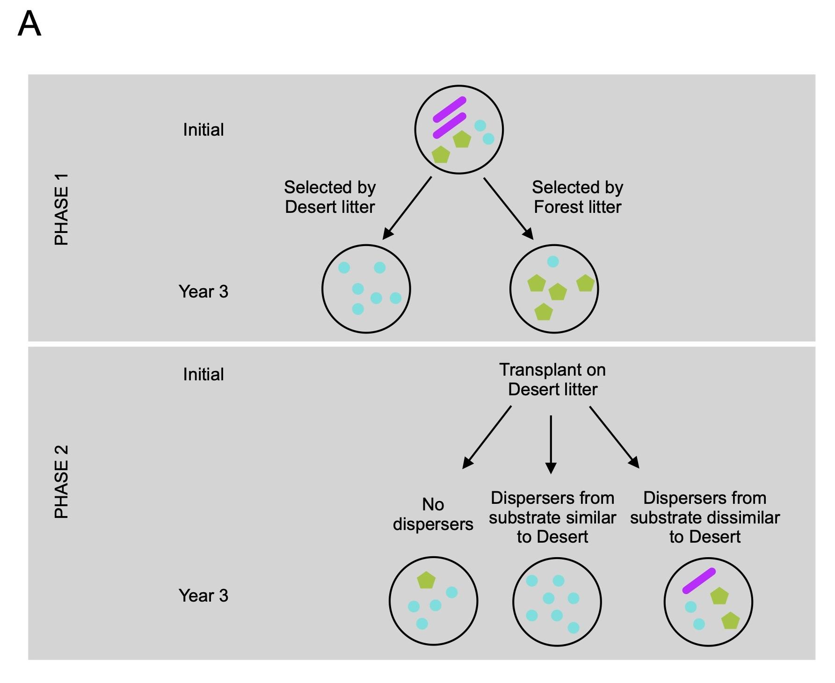

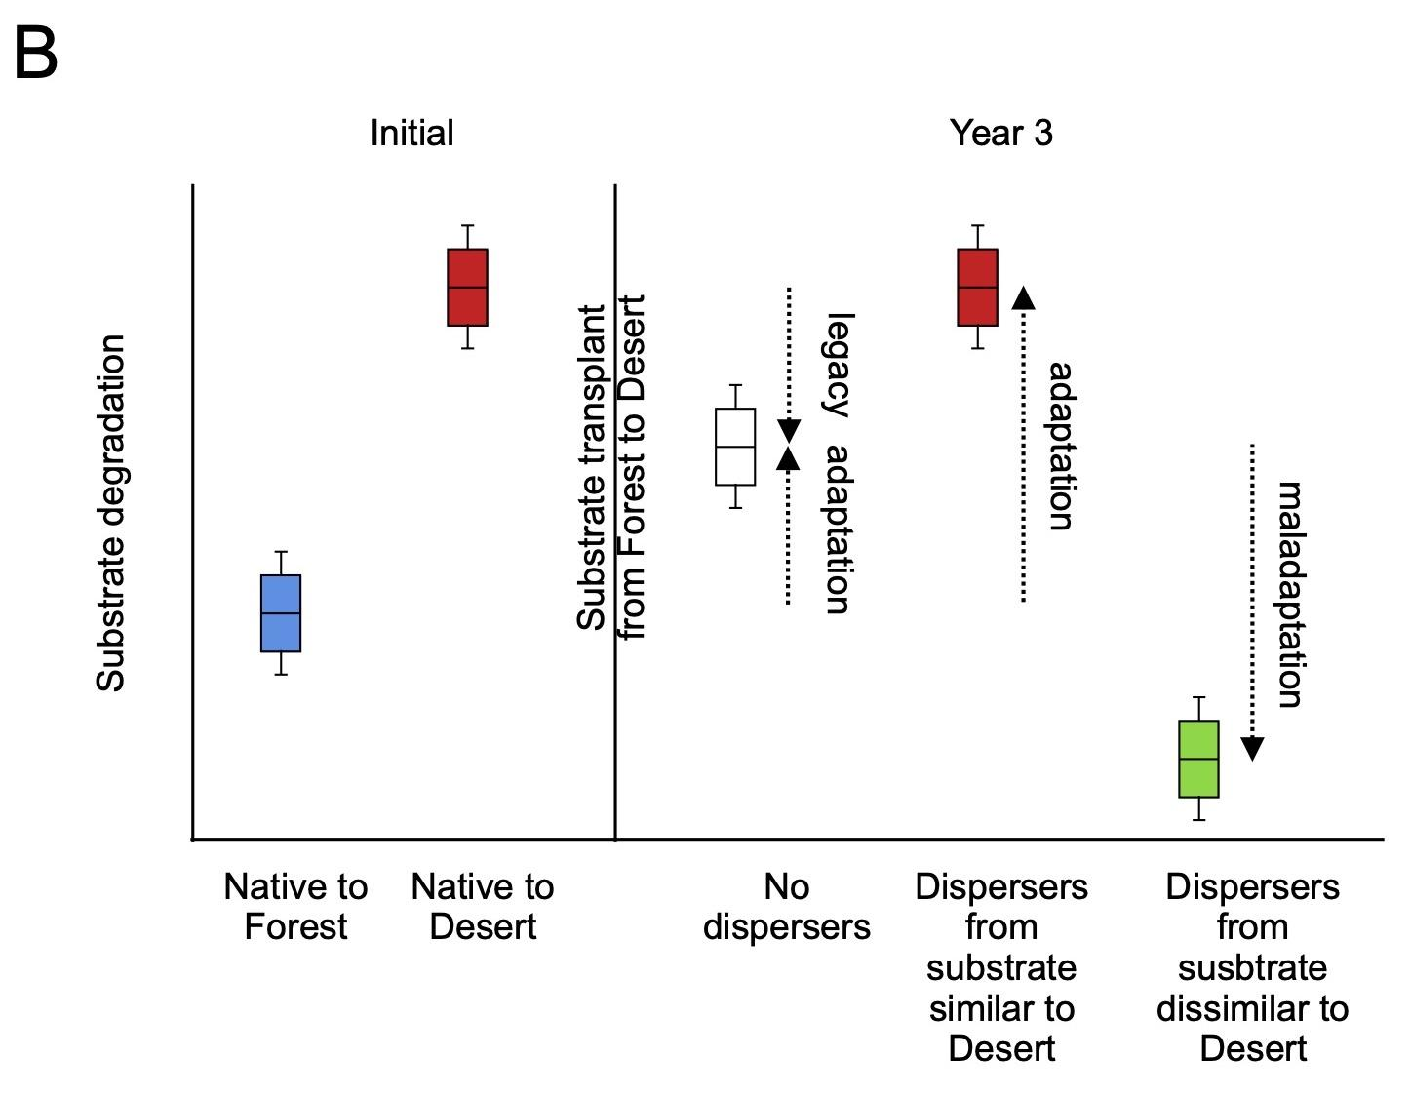

**FIGURE 1.** **Conceptual illustration of the key hypotheses of the present study.** This study was developed to model the effect of substrate change and dispersal treatments on (A) microbial community composition (phases 1 and 2), and (B) substrate degradation (phase 2), as illustrated by a community native to forest litter transplanted onto desert litter. We hypothesized that forest litter will select for different taxa than desert litter. When transplanting forest native communities onto desert litter, the change in substrate will change the composition of the community leading such that its substrate degradation activity will ultimately be closer to that of communities native to desert litter (contemporary selection by the environment). However, the loss or lack of taxa adapted to desert litter during the first phase on forest litter will not allow for full contemporary selection (legacy effect), unless we incorporate dispersers derived from a substrate similar to desert litter. Conversely, adding dispersers from a site with more dissimilar substrate chemistry will adversely impact substrate degradation (maladaptation).

## Material and Methods

#### Model description

DEMENT is a spatially explicit individual- and trait-based microbial model that simulates leaf litter decomposition emerging from both cell-level physiology and community-level interactions [(Allison 2012)](https://paperpile.com/c/jyKzcy/o8fYp). We used the more recent Python version of the code, DEMENTpy, which incorporates explicit drought tolerance genes [(Wang and Allison 2021)](https://paperpile.com/c/jyKzcy/lnWM). We initialized the simulation on a spatial grid of 100 x 100 boxes (1–10 μm on a side) representing the surface of a litter substrate. The 14 compounds that compose leaves, such as cellulose or lignin, were initially homogeneously distributed on the grid. In our study, we randomly placed 100 taxa onto this grid that differed in their trait values, such as their monomer maximal uptake rates or the number and type of enzymes they produce. Bacterial taxa had an initial biomass of 1 mg.cm-3 and a 1% probability of occupying each grid box. Fungal taxa had an initial biomass of 25 mg.cm-3 and a 0.04% probability of occupying each grid box. As such, at the start of the simulation, there were an average of 0.52 taxa and 1 mg.cm-3 of biomass (bacteria or fungi) per grid box.

Each day during the simulation, these microbes produced enzymes, substrate compounds were decomposed into monomers, and these monomers diffused on the grid. Microbes then took up these monomers, grew, produced metabolites, reproduced, and/or died. Each taxon was assigned the production of one or more types of enzyme. Each enzyme was assigned zero, one, or several substrate compounds to degrade. Each substrate compound was decomposed into one type of monomer. Taxa membrane transporters were monomer-specific. A taxon was assumed to possess the transporter type(s) for the enzyme(s) it produces. Reproduction occurred every time the initial biomass of a taxon was doubled, with one daughter cell staying in the same grid box, and the other randomly moving to one of the four adjacent grid boxes. Taxa also produced osmolytes that determined their probability of death depending on soil moisture.

Temperature and moisture were held constant for this study. Enzyme kinetics depend on temperature as per the Arrhenius equation. Each year, the assembled microbial community was placed on fresh litter substrate, with a reinitialized substrate distribution, no monomers, and no enzymes. There was no additional substrate input between day 0 and day 365. DEMENT simulates 6 years of an individual-based complex community on a grid of 1 mm2 in 20 hours. A more detailed description of the model is available in the study published by Wang and Allison [(Wang and Allison 2021)](https://paperpile.com/c/jyKzcy/lnWM).

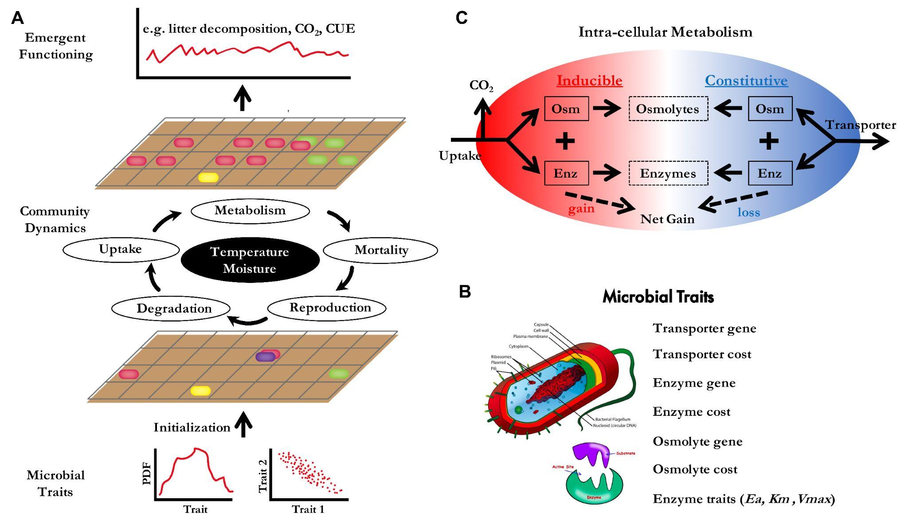

**SUPPLEMENTAL FIGURE 1.** **Schematic overview of the DEMENT model**. The DEMENT model represents microbial growth implicitly as the difference between uptake and loss processes (respiration, metabolite production, stoichiometric rebalancing). (Reproduced from Wang and Allison 2021)

#### Litter substrate chemistry

To test whether litter substrate chemistry affects microbial community composition and function, we allowed 10 communities to randomly assemble on each of 5 different substrates (phase I in Figure 2). The chemistry parameters for this simulation were derived from Baker et al. [(Baker and Allison 2017)](https://paperpile.com/c/jyKzcy/ypcik) and correspond to the leaf litter chemistry of 5 sites along a Californian elevation gradient (desert, scrubland, grassland, pine oak, subalpine) (Figure S2). These are the same sites as the ones used for the climate transplant experiment performed by Glassman et al. We calculated average annual substrate decay rates and relative taxa abundance. Preliminary runs revealed that both outputs stopped varying by year 3 of the simulation, and we thus compared the average community composition and decay rates over year 3.

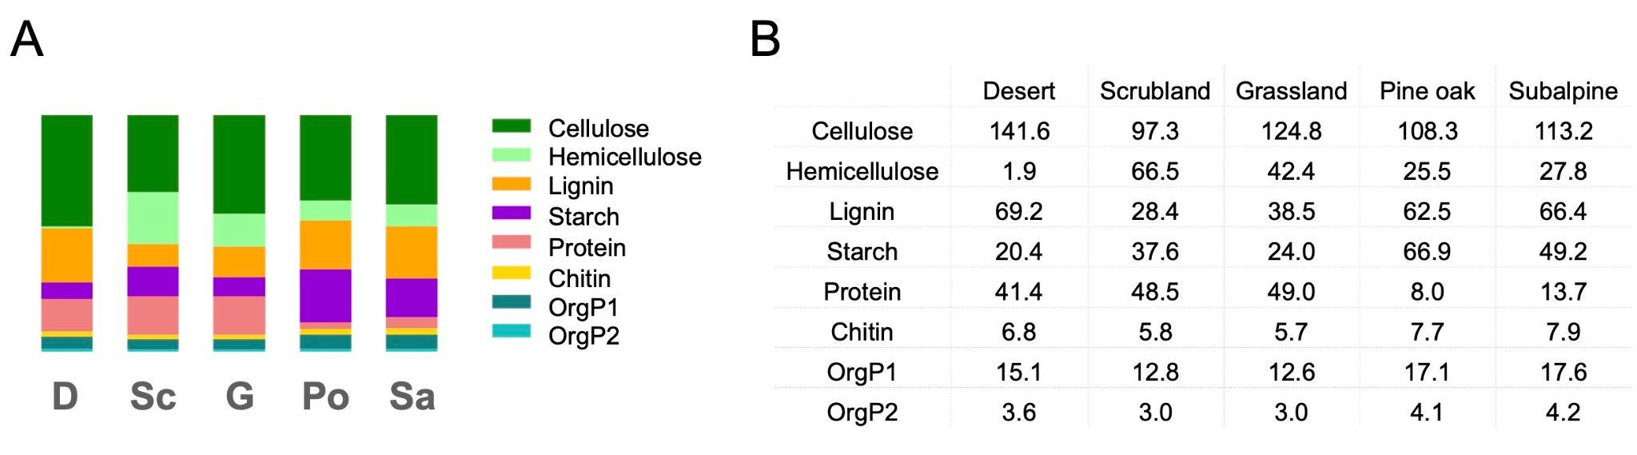

**SUPPLEMENTAL FIGURE 2.** **Leaf litter substrate chemistry**. Both figures represent the sum of C, N, and P density (mg.cm-3); (A) bar plots, (B) individual values. The 5 bars correspond to 5 sites along an elevation gradient in California. Colors correspond to the different substrate components. Data are derived from Baker et al. (2017) and have been normalized such that the sum of C, N, and P density was equal between sites (300 mg.cm-3).

#### Dispersal

To test the effect of dispersal following a change in litter substrate chemistry, we initialized a new set of simulations using each of the 50 microbial communities assembled in phase I (phase II in Figure 2). To simulate changes in leaf substrate chemistry, we transplanted each community to 1 of the other 4 substrates. To simulate dispersal, we merged the community with a pool of dispersers equivalent to 40% of the size of one of the final communities from phase I. Dispersers could come from the same community (local dispersal), or from a different one (regional dispersal). We also ran a simulation using transplanted communities with no dispersers as a control experiment. As in phase I, assembly stabilized around years 2–3, so we stopped the simulations at the end of year 3. We then compared substrate decay rates and relative taxa abundance averaged over year 3 among substrate chemistry and dispersal treatments.

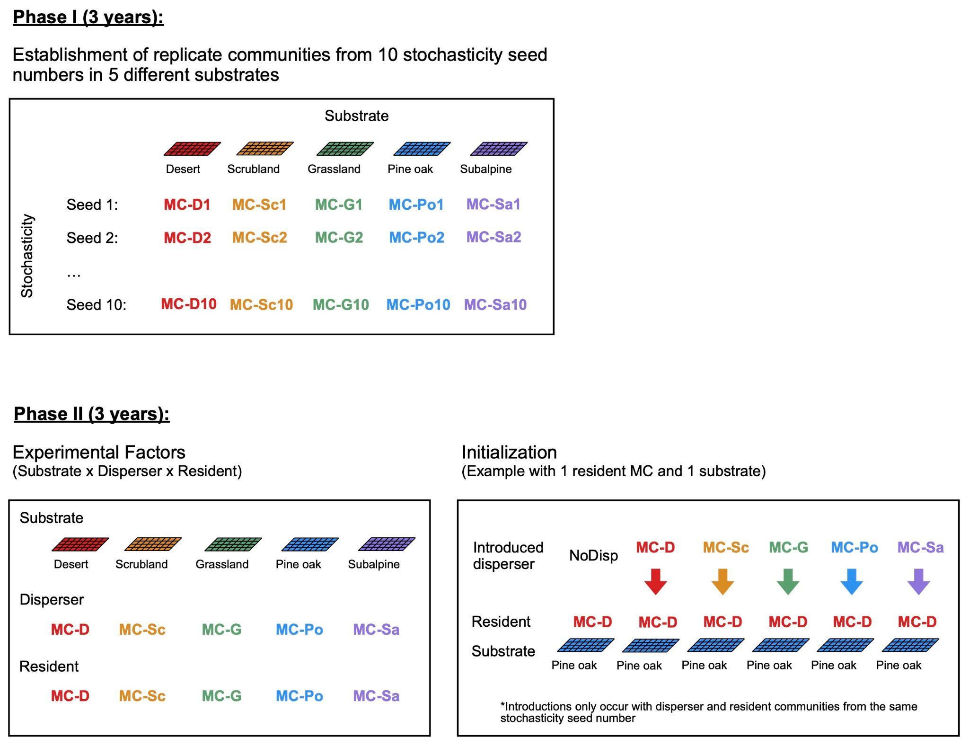

**FIGURE 2.** **Conceptual framework of the simulation experiment.** The experimental setup used to test the factors driving the relationship between dispersal and microbial community composition and function in the context of substrate change. In phase I, 50 microbial communities were created from 10 randomly assembled communities run on 5 different substrates for 3 years, by which time community composition had stabilized, under standardized climatic conditions (soil temperature = 15.7°C, soil moisture = -0.1 MPa). In phase II, we performed disperser introductions at baseline (t0) in each of the 50 communities generated in phase I, and we simulated the activities of these communities for 3 years on substrates different from those on which they were run in phase I (n = 5 residents x 4 substrates x (5 dispersers + 1 control) x 10 seeds = 1200 simulations).

## Results

#### Dispersal eliminates the legacy effects of substrate change on protein decay

Substrate quality has no significant impact on overall decay or total biomass (Figure S3), but it does affect the decay of two substrate components: hemicellulose and protein. Hemicellulose decay levels are lower in desert litter relative to other substrates, although the biomass of hemicellulose degraders in desert communities is not significantly different from that in other substrate communities (Figure 3a–b). In contrast, protein decay is decreased in pine oak and subalpine litter as these substrates contain lower protein levels, with this reduction being accompanied by a reduction in the biomass of protein degraders in both of these communities relative to other substrate communities (Figure 3c–d).

When we proceeded to test substrate transplants between substrates that differ in hemicellulose and/or protein decay levels, two different patterns were revealed. In the case of a shift in hemicellulose content, hemicellulose decay at the end of the 3-year simulation was the same as that for communities native to the final litter composition (Figure 3a, desert-to-scrubland substrate transplant). Consistently, the biomass of hemicellulose degraders is the same in native and transplanted communities (Figure 3b). When substrate shifts from low to high protein content, however, protein decay after 3 years remains the same as it did prior to substrate change despite higher protein availability (Figure 3c, pine oak-to-desert substrate transplant).

The biomass of protein degraders exhibited the same response as did the protein degradation activity, with the biomass of protein degraders in pine oak communities transplanted onto desert substrate remaining the same as in the native pine oak communities despite an increase in protein availability (Figure 3d). This substrate legacy effect on community composition and function was eliminated, however, when dispersers from protein-rich communities (desert, scrubland, grassland) were added, while it was unchanged by the addition of dispersers from protein-poor communities (pine oak, subalpine) (Figure 3e). In line with these results, disperser communities derived from protein-rich substrates contain significantly higher protein degrader biomass relative to disperser communities derived from protein-poor substrates (Figure 3f).

#### 

**SUPPLEMENTAL FIGURE 3.** **The effects of substrate on litter average decay rate (A) and total microbial biomass (B).** Average litter decay rate was calculated as the average decay rate of the 12 chemical substrates weighted by their average total (C+N+P) mass over the grid for year 3.

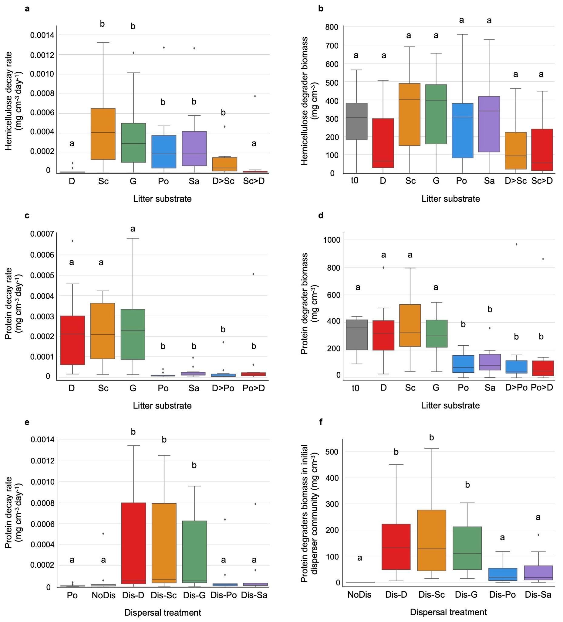

**FIGURE 3.** **The effects of substrate, substrate change, and dispersal on decay and biomass. (a)** Hemicellulose decay averaged over the grid and over year 3 for 5 substrates; desert (D), scrubland (Sc), grassland (G), pine oak (Po), and subalpine (Sa); and for 2 substrate transplants: desert to scrubland (D>Sc: hemicellulose-poor to hemicellulose-rich) and scrubland to desert (Sc>D: hemicellulose-rich to hemicellulose-poor). **(b)** The biomass of hemicellulose degraders at baseline (day 0 of phase I), and averaged over the grid and over year 3 of phase I for each substrate, and over year 3 of phase II for the 2 substrate transplants (D>Sc and Sc>D). **(c)** Protein decay averaged over the grid and over year 3 for the 5 substrates, and for 2 substrate transplants: desert to pine oak (D>Po: protein-rich to protein-poor) and pine oak to desert (Po>D: protein-poor to protein-rich). **(d)** The biomass of protein degraders at baseline (day 0 of phase I), and averaged over the grid and over year 3 of phase I for each substrate, and over year 3 of phase II for the 2 substrate transplants (D>Po and Po>D). **(e)** Protein decay averaged over the grid and over year 3 of phase I on Po, and over year 3 of phase II with all disperser treatments: no disperser (NoDis), dispersers from desert communities (Dis-D), dispersers from scrubland communities (Dis-Sc), dispersers from grassland communities (Dis-G), dispersers from pine oak communities (Dis-Po), and dispersers from subalpine communities (Dis-Sa). **(f)** Biomass of protein degraders in initial disperser communities for all disperser treatments.

#### Strong facilitation is evident among protein degraders

We found that the growth rate of protein degraders increases exponentially with their initial biomass (Figure 4a), with a threshold at 140 mg.cm-3 such that if their initial biomass is under 140 mg.cm-3, their growth is negative or zero, whereas above 140 mg.cm-3, their growth is positive. This explains why we observed a legacy effect for communities native to protein-poor substrates, but not for dispersers derived from protein-rich substrates that contain more protein degraders. We observed no significant relationship between the total initial microbial biomass of non-protein degraders and the growth rate of protein degraders (Figure 4b). These results suggest that the interaction between protein degraders is positive, and that the effect of non-protein degraders on protein degraders at the community level is neutral.

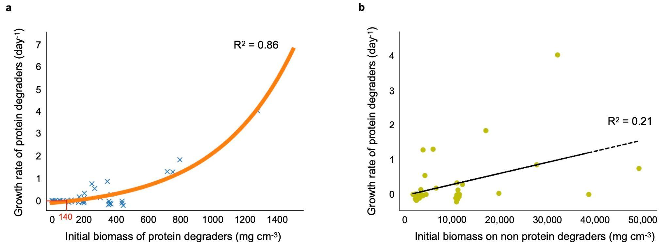

**FIGURE 4.** **Effect of the initial biomass of (a) protein degraders, and (b) non-protein degraders on protein degrader growth rates.** Growth rates were calculated as log(final biomass/initial biomass)*1/T, where T is the duration of the simulations (1095 days). Protein degrader growth rates were an exponential function of their initial biomass (R2 = 0.86 vs. R2 of a linear fit = 0.63) (a), whereas there was no significant relationship with the total initial microbial biomass of non-protein degraders (b).

## Discussion

While we often focus on temperature and moisture in the attempt to predict future soil microbial decay in the context of global change and dispersal [(Wang and Allison 2021)](https://paperpile.com/c/jyKzcy/lnWM), increasing evidence indicates that changes in plant composition will happen on ecological timescales and will influence soil microbe-mediated carbon and nutrient cycling. Transplant experiments represent an ideal means of quantifying the effects of both legacy and contemporary selection by the environment [(Chase, Weihe, and Martiny 2021; Albright and Martiny 2018)](https://paperpile.com/c/jyKzcy/hMYCX+EeVrl). Here, we reproduced this approach with an individual trait-based model to quantify the impact of past and present selection by substrate chemistry on litter decay, and the interaction between these effects and community dispersal. We found that legacy effects are only evident when changes in community composition are involved. For example, while hemicellulose content and decay rates differed among the 5 utilized litter types, the composition in hemicellulose degraders did not, and there were no legacy effects after transplant. Conversely, protein content affects both protein decay rates and the composition of protein degrading taxa, and in this context there were legacy effects that were evident after transplant. Consistent with our hypothesis, these legacy effects disappeared when dispersal induced a shift in community composition. However, we did not observe any instances of dispersal causing maladaptation, in contrast with our hypothesized model.

We found that the amount of protein alone is not sufficient to predict the growth of protein degraders, as such growth was also dependent on both initial protein degrader biomass and the total microbial initial biomass. All taxa are able to take up NH4, but that is the only source of nitrogen for taxa that do not degrade the nitrogen-containing substrate components that are common in this system wherein microbes are specialists and can degrade at most 3 of the 12 substrate components. This makes mineralized nitrogen a public good such that taxa that degrade nitrogen organic compounds serve as cooperators, whereas taxa that do not function as cheaters with respect to inorganic nitrogen. This explains why we observed the decreased growth of protein degraders with rising initial total microbial biomass.

Our results also demonstrated positive frequency-dependent selection (PFDS), as the fitness of protein degraders increases when their initial abundance is higher. Frequency-dependent selection is expected in microbial communities because strong selection, structuring, and cooperation-dependent growth are common in microbial populations [(Ross-Gillespie et al. 2007)](https://paperpile.com/c/jyKzcy/jOIN). Both negative and positive frequency-dependent selection have been observed in cooperative microbial communities with potential cheating [(Rendueles, Amherd, and Velicer 2015; Healey, Axelrod, and Gore 2016)](https://paperpile.com/c/jyKzcy/PP6I+wLhD). Note that our tests only employed an initial protein degrader frequency of 0 to 0.1. It is thus possible that we would observe negative frequency-dependent selection at higher frequencies. Even so, our results demonstrate that, whereas Healey et al. simplified fitness as being flat at low frequencies, we found it to instead be exponential, meaning that the growth of cooperators will accelerate with high initial abundance when rare.

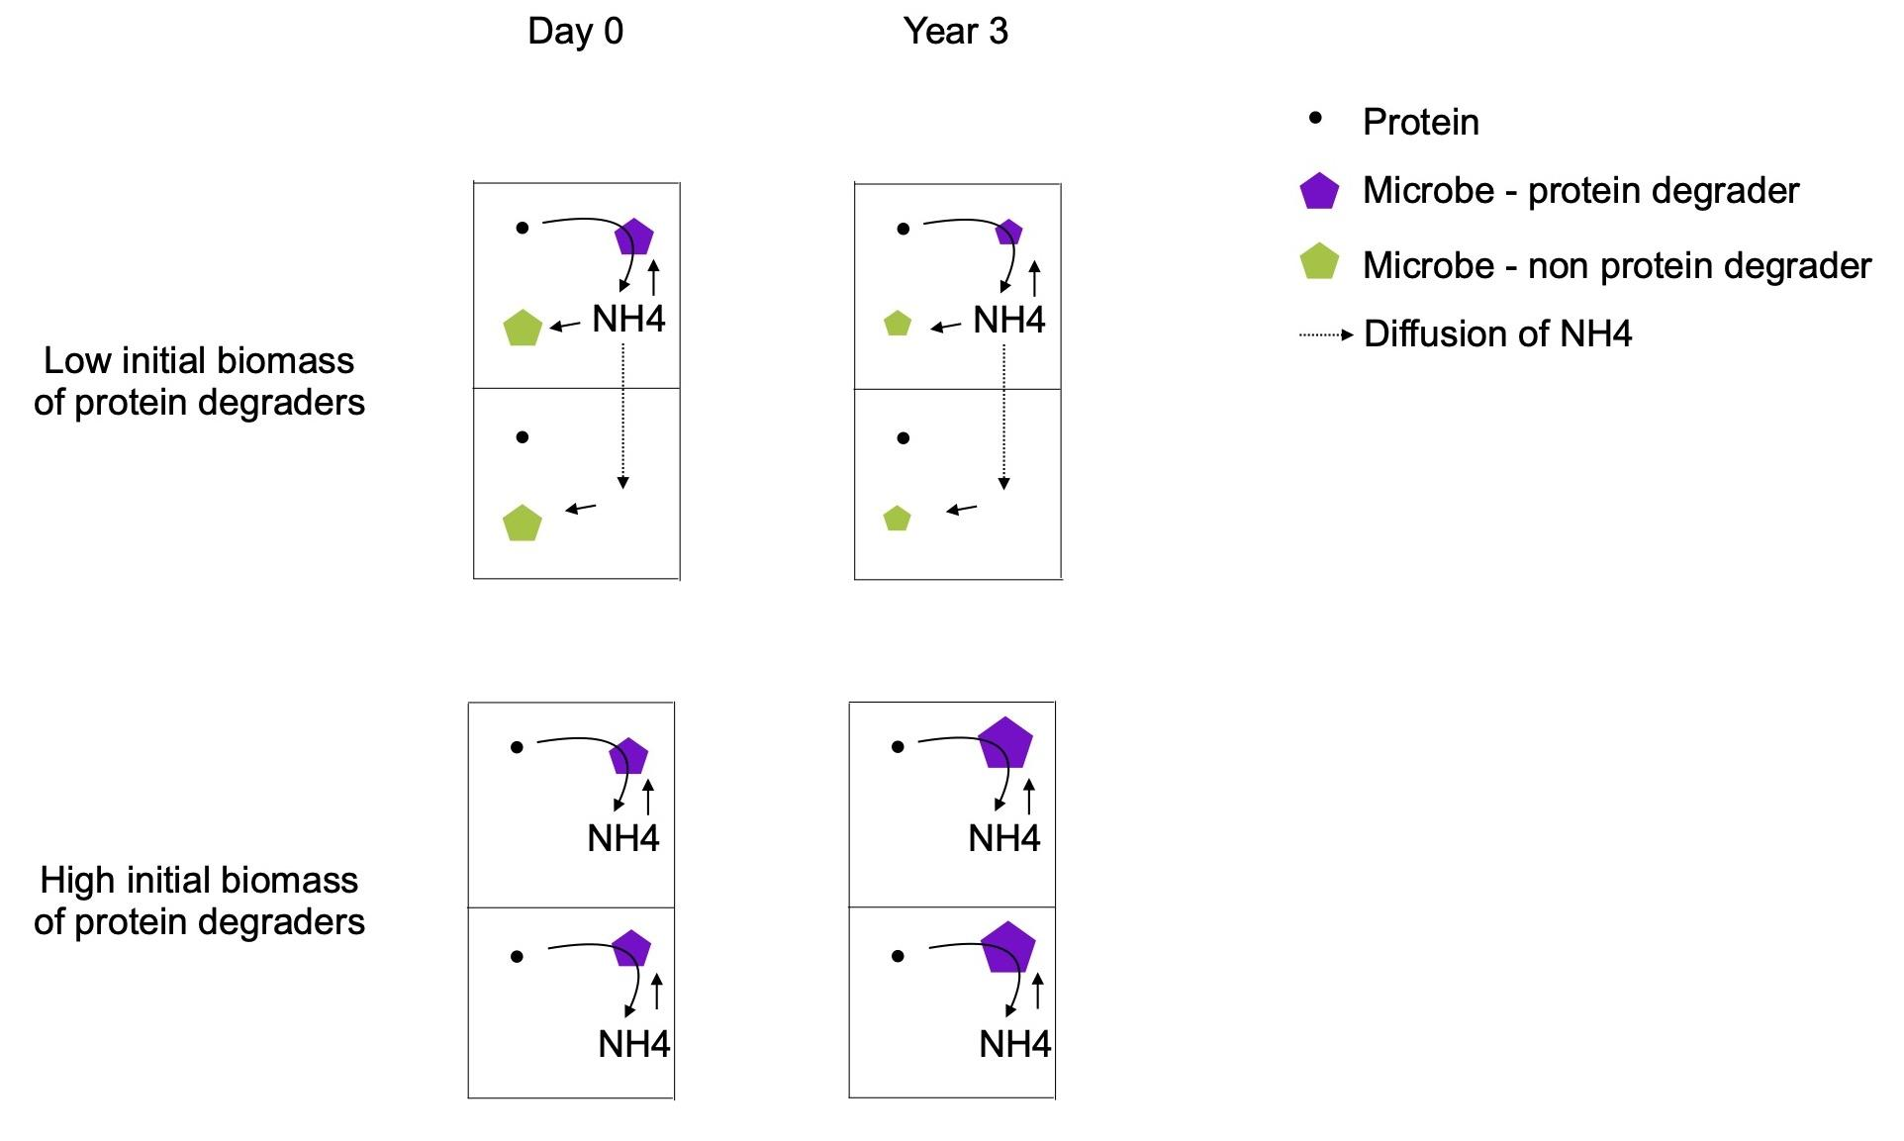

**FIGURE 5.** **Conceptual illustration of the results of the present study.** This schematic overview represents the effect of the initial biomass of protein degraders (purple) on their growth rate. Two representative grid boxes are shown. There is a spatial structure between grid boxes but not within a grid box, meaning substrate components and monomers are equally accessible for all taxa within a box. Exchanges between boxes are only of taxa (only between adjacent grid boxes and when biomass exceeds twice its initial size, not represented here) and monomers (excess monomers are divided evenly across the whole grid) and occur at the end of each day. The NH4 that protein degraders release is shared between taxa proportionally to their biomass, and excess will diffuse throughout the entire grid. When the frequency of protein degraders (purple, cooperators) is low and the relative abundance of non-protein degraders (green, cheaters) is high (top), NH4 will primarily benefit non-protein degraders such that the benefit-to-cost ratio of nitrogen mineralization for protein degraders is low, leading to a zero or negative growth rate. In contrast, when the frequency of protein degraders is high and the relative abundance of non-protein degraders is low (bottom), diffusing NH4 will primarily benefit protein degraders such that the benefit-to-cost ratio for nitrogen mineralization is high and the growth rate of protein degraders is strongly positive.

Previous work using soil carbon models has already demonstrated that microbial community trait eco-evolution in response to environmental change modifies carbon decay [(Abs, Leman, and Ferrière 2020)](https://paperpile.com/c/jyKzcy/3ZJM). However, these researchers did not observe any dependence on the initial trait value akin to the legacy effect that we observed here. This is because they worked at a higher organization level, with the microbial trait in question being the allocation to enzyme production and the function being the decay rate of the soil organic pool. Our results and other studies working at a finer scale [(Wang and Allison 2021)](https://paperpile.com/c/jyKzcy/lnWM), in contrast, show that with explicit representation of microbial taxa and soil organic compounds, we can reveal the legacy effect of initial community structure on decay activity in response to environmental change that has been observed empirically [(Martiny et al. 2017)](https://paperpile.com/c/jyKzcy/EJlv).

For this study, we made some assumptions that should be explored more in future studies. For example, we made microbial functional groups specialists by allowing them to degrade at most 3 substrate components out of 14 possible components. If we parameterized the opposite such that microbes are able to produce all types of enzymes and have access to all substrate components, we would expect no discriminatory selection of specific taxa, and therefore no greater differences in community composition between substrates as compared to within one substrate. We would similarly not expect substate change or dispersal to have any impact on community composition, and specific substrate decay rates would only be determined by the content of that substrate. In the future, we can potentially investigate whether we can determine the degree of specialism under which substrate protein content no longer selects for differences in community composition.

Understanding the effect of substrate and dispersal on soil microbial community functionality has numerous potential implications. Because microbial activity releases nutrients such as mineralized nitrogen that plants require for growth, there has been significant research interest in performing microbial inoculation as a means of increasing crop yields, although at present it remains unclear which microbes should be used for this purpose [(O’Callaghan 2016)](https://paperpile.com/c/jyKzcy/KhSD). Our results demonstrate that adding N-rich organic matter may not be sufficient to stimulate the growth of already present N mineralizers without the inoculation of additional N mineralizers. Land managers and stakeholders can also potentially leverage microbial inoculation as a means of enhancing soil carbon sequestration [(Metting et al. 2001; Trivedi, Anderson, and Singh 2013)](https://paperpile.com/c/jyKzcy/pul1B+MXFPf), with the goal of this field of research being to establish the most cost-efficient means of modifying microbiome cycling activity to promote the storage of additional carbon in the soil while reducing CO2 or CH4 release into the atmosphere. Our results suggest that the management of abiotic conditions (water, temperature, nutrients) may need to be coupled with the inoculation of specific functional groups of microbes to achieve this goal. Finally, another potential application for these results is the use of probiotics to improve human health via facilitating digestion or protecting against pathogens [(Zhou et al. 2020)](https://paperpile.com/c/jyKzcy/ooYQ). For those working to establish the criteria that maximize the efficiency of probiotics, our results suggest that high quantities of the specific functional group of interest will improve colonization success, coupled with a controlled diet and knowledge of the historical diet of that patient.

## References

[Abs, Elsa, Hélène Leman, and Régis Ferrière. 2020. “A Multi-Scale Eco-Evolutionary Model of Cooperation Reveals How Microbial Adaptation Influences Soil Decomposition.” *Communications Biology* 3 (1): 520.](http://paperpile.com/b/jyKzcy/3ZJM)

[Albright, Michaeline B. N., and Jennifer B. H. Martiny. 2018. “Dispersal Alters Bacterial Diversity and Composition in a Natural Community.” *The ISME Journal* 12 (1): 296–99.](http://paperpile.com/b/jyKzcy/EeVrl)

[Albright, Michaeline B. N., Sanna Sevanto, La Verne Gallegos-Graves, and John Dunbar. 2020. “Biotic Interactions Are More Important than Propagule Pressure in Microbial Community Invasions.” *mBio* 11 (5). https://doi.org/](http://paperpile.com/b/jyKzcy/jSz3)[10.1128/mBio.02089-20](http://dx.doi.org/10.1128/mBio.02089-20)[.](http://paperpile.com/b/jyKzcy/jSz3)

[Allison, S. D. 2012. “A Trait-Based Approach for Modelling Microbial Litter Decomposition.” *Ecology Letters* 15 (9): 1058–70.](http://paperpile.com/b/jyKzcy/o8fYp)

[Baker, Nameer R., and Steven D. Allison. 2017. “Extracellular Enzyme Kinetics and Thermodynamics along a Climate Gradient in Southern California.” *Soil Biology & Biochemistry* 114 (November): 82–92.](http://paperpile.com/b/jyKzcy/ypcik)

[ChapinIII, F. Stuart, Pamela A. Matson, and Peter M. Vitousek. 2011. *Principles of Terrestrial Ecosystem Ecology*. Springer, New York, NY.](http://paperpile.com/b/jyKzcy/pM9eX)

[Chase, Alexander B., Claudia Weihe, and Jennifer B. H. Martiny. 2021. “Adaptive Differentiation and Rapid Evolution of a Soil Bacterium along a Climate Gradient.” *Proceedings of the National Academy of Sciences of the United States of America* 118 (18). https://doi.org/](http://paperpile.com/b/jyKzcy/hMYCX)[10.1073/pnas.2101254118](http://dx.doi.org/10.1073/pnas.2101254118)[.](http://paperpile.com/b/jyKzcy/hMYCX)

[Evans, Sarah, Jennifer B. H. Martiny, and Steven D. Allison. 2017. “Effects of Dispersal and Selection on Stochastic Assembly in Microbial Communities.” *The ISME Journal* 11 (1): 176–85.](http://paperpile.com/b/jyKzcy/WVKjS)

[Franklin, Janet, Josep M. Serra-Diaz, Alexandra D. Syphard, and Helen M. Regan. 2016. “Global Change and Terrestrial Plant Community Dynamics.” *Proceedings of the National Academy of Sciences of the United States of America* 113 (14): 3725–34.](http://paperpile.com/b/jyKzcy/AsKn)

[Healey, David, Kevin Axelrod, and Jeff Gore. 2016. “Negative Frequency-Dependent Interactions Can Underlie Phenotypic Heterogeneity in a Clonal Microbial Population.” *Molecular Systems Biology* 12 (8): 877.](http://paperpile.com/b/jyKzcy/wLhD)

[Martiny, Jennifer Bh, Adam C. Martiny, Claudia Weihe, Ying Lu, Renaud Berlemont, Eoin L. Brodie, Michael L. Goulden, Kathleen K. Treseder, and Steven D. Allison. 2017. “Microbial Legacies Alter Decomposition in Response to Simulated Global Change.” *The ISME Journal* 11 (2): 490–99.](http://paperpile.com/b/jyKzcy/EJlv)

[Metting, F. Blaine, Jeffrey L. Smith, Jeffrey S. Amthor, and R. Cesar Izaurralde. 2001. “Science Needs and New Technology for Increasing Soil Carbon Sequestration.” In *Storing Carbon in Agricultural Soils: A Multi-Purpose Environmental Strategy*, edited by Norman J. Rosenberg and Roberto C. Izaurralde, 11–34. Dordrecht: Springer Netherlands.](http://paperpile.com/b/jyKzcy/pul1B)

[O’Callaghan, Maureen. 2016. “Microbial Inoculation of Seed for Improved Crop Performance: Issues and Opportunities.” *Applied Microbiology and Biotechnology* 100 (13): 5729–46.](http://paperpile.com/b/jyKzcy/KhSD)

[Rendueles, Olaya, Michaela Amherd, and Gregory J. Velicer. 2015. “Positively Frequency-Dependent Interference Competition Maintains Diversity and Pervades a Natural Population of Cooperative Microbes.” *Current Biology: CB* 25 (13): 1673–81.](http://paperpile.com/b/jyKzcy/PP6I)

[Ross-Gillespie, Adin, Andy Gardner, Stuart A. West, and Ashleigh S. Griffin. 2007. “Frequency Dependence and Cooperation: Theory and a Test with Bacteria.” *The American Naturalist* 170 (3): 331–42.](http://paperpile.com/b/jyKzcy/jOIN)

[Schnecker, Jörg, Timothy Bowles, Erik A. Hobbie, Richard G. Smith, and A. Stuart Grandy. 2019. “Substrate Quality and Concentration Control Decomposition and Microbial Strategies in a Model Soil System.” *Biogeochemistry* 144 (1): 47–59.](http://paperpile.com/b/jyKzcy/jR7pl)

[Shade, Ashley, Hannes Peter, Steven D. Allison, Didier L. Baho, Mercè Berga, Helmut Bürgmann, David H. Huber, et al. 2012. “Fundamentals of Microbial Community Resistance and Resilience.” *Frontiers in Microbiology* 3 (December): 417.](http://paperpile.com/b/jyKzcy/ItZ2O)

[Strickland, Michael S., Ernest Osburn, Christian Lauber, Noah Fierer, and Mark A. Bradford. 2009. “Litter Quality Is in the Eye of the Beholder: Initial Decomposition Rates as a Function of Inoculum Characteristics.” *Functional Ecology* 23 (3): 627–36.](http://paperpile.com/b/jyKzcy/sU96C)

[Trivedi, Pankaj, Ian C. Anderson, and Brajesh K. Singh. 2013. “Microbial Modulators of Soil Carbon Storage: Integrating Genomic and Metabolic Knowledge for Global Prediction.” *Trends in Microbiology* 21 (12): 641–51.](http://paperpile.com/b/jyKzcy/MXFPf)

[Van der Gucht, Katleen, Karl Cottenie, Koenraad Muylaert, Nele Vloemans, Sylvie Cousin, Steven Declerck, Erik Jeppesen, et al. 2007. “The Power of Species Sorting: Local Factors Drive Bacterial Community Composition over a Wide Range of Spatial Scales.” *Proceedings of the National Academy of Sciences of the United States of America* 104 (51): 20404–9.](http://paperpile.com/b/jyKzcy/jKvh2)

[Walters, Kendra E., and Jennifer B. H. Martiny. 2020. “Alpha-, Beta-, and Gamma-Diversity of Bacteria Varies across Habitats.” *PloS One* 15 (9): e0233872.](http://paperpile.com/b/jyKzcy/E5hIE)

[Wang, Bin, and Steven D. Allison. 2021. “Drought Legacies Mediated by Trait Trade‐offs in Soil Microbiomes.” *Ecosphere*  12 (6). https://doi.org/](http://paperpile.com/b/jyKzcy/lnWM)[10.1002/ecs2.3562](http://dx.doi.org/10.1002/ecs2.3562)[.](http://paperpile.com/b/jyKzcy/lnWM)

[Zak, Donald R., William E. Holmes, David C. White, Aaron D. Peacock, and David Tilman. 2003. “Plant Diversity, Soil Microbial Communities, and Ecosystem Function: Are There Any Links?” *Ecology* 84 (8): 2042–50.](http://paperpile.com/b/jyKzcy/zObKF)

[Zhou, Zhao, Xin Chen, Huakang Sheng, Xiaolin Shen, Xinxiao Sun, Yajun Yan, Jia Wang, and Qipeng Yuan. 2020. “Engineering Probiotics as Living Diagnostics and Therapeutics for Improving Human Health.” *Microbial Cell Factories* 19 (1): 56.](http://paperpile.com/b/jyKzcy/ooYQ)