COURSE BOOK



Online and Social Media Marketing

## DLMWOM01





DL-D-DLMWOM01–L03

34 Unit 3

# Overview of Traditional Online Marketing Tools

An overview of the most significant traditional tools in online marketing is presented in the following section. Alongside these, mobile and social media marketing are also available as modern online marketing options, and will be presented in the following two sections.

### Display Advertising

Landing Page A landing page is a reduced website specifically created for an advertising activity that is optimized for an advertising medium, campaign, or intended audience.

Display advertising is one of the traditional online marketing tools and is often referred to as online advertising. This is likely because it is similar to traditional advertising in magazines, newspapers, or even on television and at the cinema. As in these traditional forms of advertising, in display advertising, an ad is created, usually including visuals and a slogan, which is subsequently placed on external platforms and presented to consumers. Display advertising is connected by a hyperlink to the website or the **landing page** of the company placing the advertisement. A landing page is a reduced website specifically created for an advertising activity and optimized for a particular advertising medium, campaign, or intended audience.

As in traditional advertising, display advertising is often billed according to the thousand contact price (TCP) based on visual contacts, or the cost-per-mille (CPM). Alternatively, for example, a performance-based model is billed on the basis of the number of interactions in the form of clicks. Compared with conventional advertising, however, display advertising is generally more cost-effective, more efﬁcient and also more transparent due to the many options for control and optimization (Lammenett 2014, p. 217).

Display advertisements can be classified according to their size and shape, their degree of animation, their position on the website, and their display time (Kreutzer/Rumler/Wille-Baumkauff 2020, p. 179–183). This classification is briefly described below:

* Size and shape: with regard to size, for example, a distinction is made between the Full banner as a traditional motif at the top of the page, measuring 468 x 60 pixels, and its larger variant, the Super banner at 728 x 90 pixels. In terms of shape, a distinction can be made between the Skyscraper and the Rectangle, among others. The figure below provides an overview of various display advertising formats.

[www.iubh.de](http://www.iubh.de)

## Unit 3 35

The Online Marketing Mix

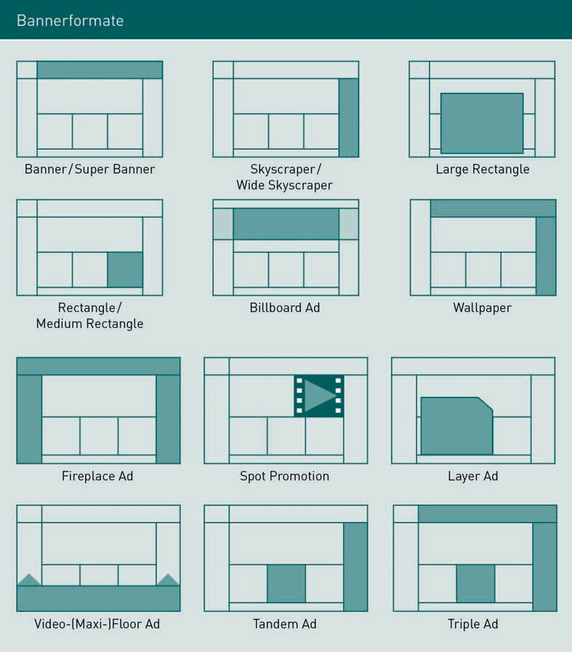

* + Degree of animation: an advertising banner can be static, i.e., it simply consists of a graphic that is connected to a website or landing page by a hyperlink. Alongside this, animated banners that display different static graphics one after another are also available, the movement being intended to increase user attention. Rich Media banners represent a step up from animated banners by integrating multimedia content such as video or audio elements. In addition, there are Nano Site banners, which represent a mini website the size of the banner, as well as Transactive banners that also enable customer transactions, such as sales services, to be performed within the banner space. An advantage of the latter two formats is that the user does not need to leave the advertiser’s website to receive more information.

[www.iubh.de](http://www.iubh.de/)

36 Unit 3

Interstitial An interstitial is an advertising format that is displayed while a user is visiting a website and that overlays the website.

Prestitial A prestitial is displayed before a website is visited. The use of the actual page that the user is trying to access is only enabled after a certain period of time or after a click.

Targeting This enables optimized delivery of digital advertising to pre-deﬁned intended audiences, as well as reduced scatter loss.

* Position on the web page: here, a distinction is primarily made according to whether the advertising is integrated within or outside an editorial section. While Full banners or Skyscrapers are, by their very definition, to be seen at the margin of the page Rectangles can appear in an editorial section. This increases visibility as well as user attention. In addition, pop-ups and layers offer the option to use an advertising format that overlays the content of the website.
* Display timing: **interstitials** and **prestitials** are the most important with regard to display timing. An interstitial is an advertising format that is displayed during a user’s visit to a website, overlaying it. Since it interrupts the use of the website, it is also called *interrupt advertising*. A prestitial works in a similar way, but it is displayed before the website is visited. In this case, the use of the actual page that the user is trying to access is only enabled after a certain period of time or after a click.

The use of display advertising can be controlled in a targeted manner. The advertiser can determine the environment in which the banner is placed and select the medium or the various advertising media to suit the advertising objectives. For example, an image campaign for a new high-fashion brand will have a better impact in the online edition of *Vogue* magazine than in the trade magazine of an allotment gardeners’ association. Media planning and selection of the individual advertising media function in a similar way to media planning in the print sector.

In the case of display advertising, the timing of the ad display can also be determined, and the advertiser has the option of specifying how the delivery is to be spread over a day, week, or a campaign period (Kreutzer/Rumler/Wille-Baumkauff 2015, p. 125).

### Targeting

Online advertising is automatically modulated according to individual targeting specifications. The German Association for the Digital Economy (BVDW) deﬁnes **targeting** as follows: “Targeting means the automated and target-oriented control of advertising media on the basis of various parameters. Targeting serves to optimize the delivery of digital advertising to pre-deﬁned intended audiences, as well as to reduce scatter loss.” (BVDW 2014, p. 5). For advertisers, this offers attractive opportunities for targeted and efﬁcient advertising placement. Kreutzer/Rumler/Wille-Baumhoff (2020, p. 189–192) distinguish between several targeting variants that can also be used in combination, a selection of which is presented here:

* Sociodemographic targeting: online advertising is delivered according to user characteristics such as age, gender, income, or occupational status. Sociodemographic user data is based on voluntary self-disclosure by users, for example, through online surveys.
* Geotargeting/IP targeting: the targeting here is based on the regional origin of the IP address, so that advertising can be delivered according to location.

[www.iubh.de](http://www.iubh.de/)

## Unit 3 37

The Online Marketing Mix

* + Technical targeting: this is based on technical information regarding hardware and software. Display ads can, for example, be delivered according to the user’s browser, screen resolution, or operating system.
  + Content targeting/context targeting: online advertising is targeted according to the content of the website on which the banners are displayed. The advertiser determines the editorial environment for the ads by using keywords or catchwords. This makes it possible to place the banner ad of a clothing company next to an article about current trends in summer fashion, for example.
  + Semantic targeting: here, too, online advertising is delivered in a thematically appropriate environment. However, semantic targeting goes one step further than content targeting. It does not simply scan websites for the keywords they contain, but rather comprehensively analyzes the content of a page so that it can be classified in terms of the contextual meaning of the content. A significant advantage for the advertiser is that the risk of misplacement due to, say, a thematically suitable but negative environment, is minimized.
  + Behavioral targeting: this targeting variant is based on the internet user’s surfing behavior. Cookies can be used to analyze the interests and needs underlying the user’s previous usage behavior. Intended audiences can be differentiated according to the thematic environments in which they have browsed in the past, such as automotive websites or furniture manufacturers. Advertising is then delivered according to the user’s behavioral proﬁle. A special form of behavioral targeting is **re-targeting**. In this context, internet users are tagged, usually by cookies, when they visit websites, and are later identiﬁed by them when they visit other websites. The products and services from the other websites are then displayed to the users once again. This means that users who have carried out certain activities, but have not completed the transaction desired by the website operator, can still be converted at a later date (Online-Marketing.de GmbH 2015). For example, with re-targeting, a user who placed an item in their shopping cart the day before without buying it can be shown an ad for that particular item on another website.

In the context of other online marketing tools, there are other special targeting variants such as keyword targeting in search engines and social targeting in social networks.

The delivery of display advertising, according to the targeting specifications and the performance evaluation, is carried out by means of **ad servers**. An ad server provides the technical infrastructure for online advertising (Kreutzer/Rumler/Wille-Baumkauff 2020, p. 187f.).

Re-targeting

Re-targeting is a special form of behavioral targeting. Users are shown products and services from websites they have visited previously.

[www.iubh.de](http://www.iubh.de/)

38 Unit 3

Ad server

The delivery of display advertising according to the targeting specifications and performance evaluation is carried out by means of ad servers.

Organic Search Results

Organic search results are ranked by the search engine’s search algorithm and cannot be bought.

Search Engine Result

Pages (SERPs) Search engine result pages are the results pages of search engines. They include both paid and organic results.

### Search Engine Marketing

Another traditional online marketing tool is search engine marketing, which is designed to attract website visitors via search engines (Lammenett 2019, p. 181f.). It comprises two groups of measures, both of which relate to search engines such as Google, Yahoo, and Bing. First, there is search engine advertising (SEA), which generates paid search entries on search engines; second, there is search engine optimization (SEO), which includes measures that contribute to a better ranking of a website in **organic search results.** Organic search results are search results that are ranked by the search engine algorithm and cannot be bought.

**Search engine result pages** (SERPs) include both paid and organic results. The figure below illustrates these results for the leading search engine Google:

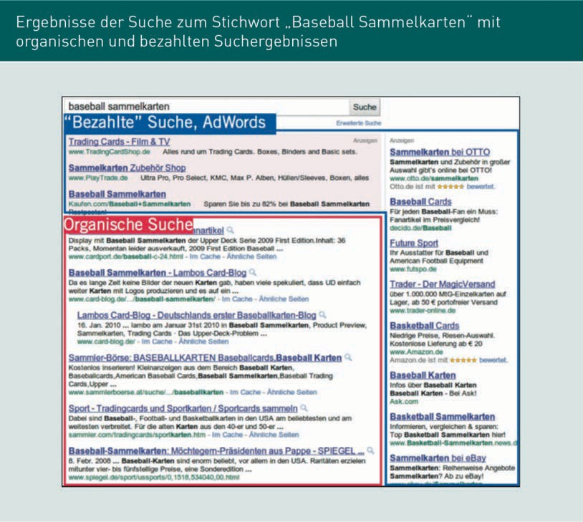

## Unit 3 39

The Online Marketing Mix

### Search Engine Advertising (SEA)

SEA is also known as keyword advertising and refers to the placement of paid advertisements on search engine results pages. The best-known and most widely used provider of SEA is Google, with its Google Ads service (Lammenett 2019, p. 35f.). With SEA, in contrast to banner advertising, the advertiser only incurs costs when the user actually clicks on the ad. This form of remuneration is referred to as **cost-per-click** (CPC). The ad spaces are allocated by auction, and the company with the highest bid for its keyword also receives the best placement within the paid search results. The advertiser uses an online tool to place and design the ads.

Kreutzer (2021, pp. 247–260) identifies the following six key tasks that a company must manage in connection with SEA:

* Development of campaign idea and definition of campaign objectives: the advertising company must first deﬁne what is to be achieved by the ad. From direct sales to increasing website trafﬁc, there are various options here depending on the company’s individual goals.
* Deﬁnition of relevant search terms and the definition of keywords: first, the advertising company must define the relevant search terms for which the ad is to appear. At the same time, exclusionary keywords must also be deﬁned. If these keywords are used, the ad will not be shown. Such an exclusionary keyword can be the word “free”, which can prevent bargain hunters from being addressed.
* Development of the ad and, if necessary, ad upgrades: the format and textual scope of search engine advertising are severely limited. An SEA ad usually contains a title, brief ad text and a link. As a result, the advertiser is required to formulate the advertising message convincingly, in just a few words.
* Deﬁnition of campaign budget: the advertiser must specify the amount of money they wish to spend in total or for a specific period. For example, with Google AdWords, the daily budget and a bid-per-click must be specified when placing ads.
* Selection of search engines: in addition to the market leader, Google AdWords, other search engines, such as Yahoo and Bing, offer keyword advertising.
* Monitor the results: the advertising company must examine the parameters used (e.g., keywords used or ad design) regularly in order to be able to track the advertising effect on the intended audiences. Depending on its effectiveness, the campaign can then be optimized, stopped, or allowed to continue.

The figure below shows an example of a work step in the Google Ads online tool.

Cost-per-click (CPC) With the cost-per-click (CPC) form of remuneration, the advertiser only incurs costs if the user actually clicks on the ad.

[www.iubh.de](http://www.iubh.de/)

40 Unit 3

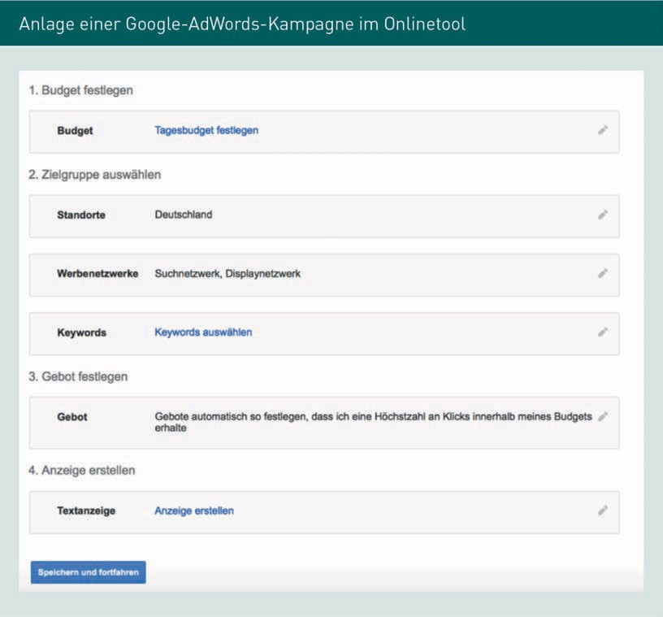

### Search Engine Optimization (SEO)

While SEA involves achieving a good ranking in paid search results, search engine optimization seeks to improve a ranking within organic search results.

Organic search results are determined by the relevance of a website with regard to the search terms entered by the user. Search engines determine this relevance by means of complicated and secret search algorithms. While there are a large number of specific SEO measures that improve a ranking, Kreutzer (2021, p. 296) is correct when he fundamentally recommends:

“If you want to achieve a good ranking in the SERPs of search engines in the long term, you should provide relevant, up-to-date, and preferably unique content!”

In principle, there are two ways to carry out search engine optimization. First, companies can design their own website in such a way that it is better rated by search engines. This is called **on-page** optimization, which comprises various technical, content-related, and structural measures.

[www.iubh.de](http://www.iubh.de/)

## Unit 3 41

The Online Marketing Mix

Examples include the selection of the URL, page programming, qualitative optimization of website content, and design of the page navigation. The second approach, **off-page** optimization, refers to measures that occur outside the company’s own website. The focus here is on backlinks that lead from other pages to one’s own. These are intended to convey a high level of relevance and a good reputation for the company’s own site, to the search engines. It is also assumed that social signals, such as shares and likes on Facebook or retweets on Twitter, have a positive impact on search engine rankings.

The cost structure of search engine optimization differs greatly from that of SEA. Whereas the latter is paid for on the basis of performance, SEO costs are incurred regardless of clicks, user reactions, and performance rankings. In addition, search engine optimization is a continual process, particularly since search engines’ algorithms change regularly.

### Email Marketing

Email marketing is the online counterpart to the ofﬂine sending of advertising materials. Companies send emails with promotional content to customers and interested parties for marketing purposes.

According to Kreutzer (2021, pp. 337–341), it is possible to identify the following four variants of marketing emails:

* Trigger emails: as the term *trigger* suggests, trigger emails always have a specific occasion that triggers the sending of an email. Accordingly, this type of email marketing is not periodic, but linked to specific events. Examples of trigger emails are an automated message of congratulations on a customer’s birthday, an indication that a certain number of points has been reached in bonus programs, or a welcome email after a customer registers on a website.
* Transaction emails: these emails accompany a transaction or business process between a company and its customers. Examples are order confirmations or invoices.
* Aftersales emails: this email marketing variant is used after a successful purchase. For example, additional information on product use is provided or tips on additional offers are given.
* E-newsletters: newsletters bear a certain resemblance to customer magazines published in print format and are emails sent out on a regular basis. They contain audience-specific information that has been, to a greater or lesser extent, editorially prepared, for customers and interested parties. In contrast to the variants mentioned above, the newsletters are usually sent to a group of addressees on a large-scale.

On-Page Optimization On-page optimization is an area of search engine optimization that involves making one’s own website more search engine friendly.

Off-Page Optimization Off-page optimization involves measures that occur outside the user’s own page, such as setting backlinks.

[www.iubh.de](http://www.iubh.de/)

42 Unit 3

Emails play a major role in the everyday lives of people around the world. According to a survey on the use of private email addresses by Aris on behalf of Bitkom, only seven percent of people with internet access do not have a private email address, while more than half of those surveyed have two or more addresses (Bitkom 2014). Nevertheless, the potential group of addressees in email marketing is limited by the fact that it is legally necessary for customers to agree in writing to receive emails before they can be added to a distribution list and receive emails from companies.

Content is King

This is a widely used saying that highlights the importance of content in online marketing.

Bounce Rate A bounce rate indicates the ratio of undeliverable mails to the total number of emails sent.

In order to achieve high open and click rates in email, and particularly newsletter marketing, as well as to retain subscribers, it is important to provide information that is relevant to the intended audience. The **content is king** principle, which was well known by the nineties, applies here. This principle states that content is most important when it comes to the success of, in this case, newsletters. Relevant content piques readers’ interest, attracts attention, and is also more likely to be shared and recommended on the social web. Accordingly, email, and particularly newsletter, marketing are characterized by relatively low costs in terms of dispatch and software, but this is offset by higher costs for the editorial preparation of attractive content (Schwarz 2014, p. 414).

There are various special software solutions for sending marketing emails, which have both basic and additional functions. The following points are relevant to selecting appropriate software (Kreutzer 2021, pp. 370–373):

* Is it possible to personalize the salutation and subject line?
* Is it possible to customize the content on a modular basis?
* Does the program allow bounces from mailings to be managed (bounce management)?
* Does the program support multiple languages?
* Does the program contain an interface to the content management system?
* What are the overall costs associated with using the software? How high are its license, maintenance, and training fees?

The software solutions usually enable dispatch results to be tracked, with key performance indicators, such as the number of successfully delivered emails, open rates, and click rates, determined during this process. **Bounce rates**, i.e., the ratio of undeliverable emails to the total number of emails sent, also play a role. Undeliverable emails can be caused by full inboxes, invalid email addresses, or even spam firewalls.

An important building block of email marketing is the acquisition of email addresses. Companies can use various sources and strategies to obtain email addresses and the consent required to use them. These sources include the company’s website, catalog orders, surveys, social network, and other advertising formats. If the company’s own email address database is not sufficiently large, there are also numerous service providers who offer addresses for sale or for rent (Kreutzer 2012, p. 282f.).

[www.iubh.de](http://www.iubh.de/)

## Unit 3 43

The Online Marketing Mix

### Afﬁliate Programs

Afﬁliate programs work in much the same way as sales partnerships in the offline world. The *afﬁliate* or partner advertises on its own website the products or services of the advertising company, which is also referred to as a *merchant*.

In general, the afﬁliate only receives remuneration or commission in the event of success, for example, when a contract is concluded, an order is placed, or a download is made. This partnership is usually brokered by an afﬁliate network (Lammenett 2019, p. 65f.). The figure below illustrates the basic operating principle of afﬁliate programs.

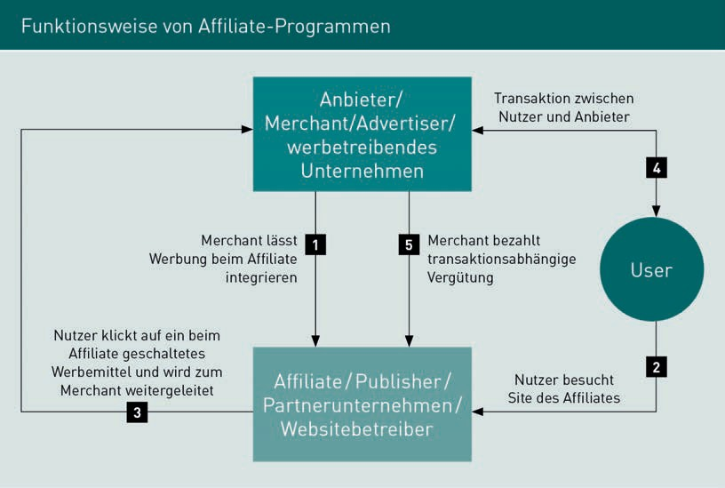

The merchant provides the afﬁliate with advertisements and links, which the afﬁliate then embeds on its website. The advertisements are given an individual partner code that enables them to be tracked so that customer transactions made with the merchant can later be assigned to the afﬁliate (Lammenett 2014, p. 46).

There are many different remuneration models for afﬁliate programs, which can also be combined together. The following list presents common commission models (Lammenett 2014, pp. 56–58):

* + With **pay-per-sale** (PPS), the merchant pays a commission for each purchase made as a result of the partner’s advertising activities. The amount of the commission varies and depends on the merchant’s objective, as well as on the industry.

[www.iubh.de](http://www.iubh.de/)

44 Unit 3

Pay-per-sale (PPS) With pay-per-sale, the merchant pays a commission for each purchase made as a result of the partner’s advertising activities.

Pay-per-lead (PPL) With pay-per-lead, the partner receives ﬁxed remuneration as soon as a lead or qualiﬁed customer contact is established.

Pay-per-click (PPC) With pay-per-click, remuneration is paid to the partner if a user has actually clicked on the merchant’s advertisement and thus reached the merchant’s website.

For books and food, the commission is typically between 5% and 15%, while travel providers pay 2.5% to 5%, and software providers up to 22%.

* With **pay-per-lead** (PPL), the partner receives ﬁxed remuneration as soon as a lead or qualiﬁed customer contact is established. This form of remuneration is primarily used for products for which direct sales via the internet are unusual, for example, products that require explanation, such as insurance. In addition, compensation is often paid per contact if the potential initial sales of the product are too low, for example, in the case of opening an account. A lead can be the contact address of a prospective customer or an order of advertising materials, as well as the conclusion of a contractual relationship. The remuneration rates per lead vary widely and can range from 0.60 euros for a contest entrant to 132 euros for the conclusion of a VDSL contract.
* With **pay-per-click** (PPC), remuneration is paid to the partner if the user has actually clicked on the merchant’s advertisement and thus reached its website. The usual payment rates here are between 0.03 and 0.25 euros.
* In the case of lifetime commission, the partner receives remuneration for all the transactions of the customer they refer. The customer is assigned to the afﬁliate partner when they make their first purchase and the information is stored accordingly in their customer file. In this way, subsequent purchases can also be assigned and remunerated. Cookies can also be used for implementing lifetime commission.

Various types of advertisements are used in afﬁliate marketing, with some of them represented in the following forms and formats (Lammenett 2019, pp. 77–81):

* When using text links, a pre-formulated text is included on the partner page, leading directly to the merchant’s website.
* Banners and buttons are also frequently used as advertisements.
* In the context of product databases, a complete product page is integrated at the partner, which updates itself automatically. This makes it possible, for example, for the afﬁliate to integrate an online store with the merchant’s products on its site. Common technical implementation options for this are CSV files and an XML interface.
* Smart content refers to dynamic advertisements that are integrated into an action box on the afﬁliate page. The merchant can feed changing advertising messages into these action boxes without having to involve the partner in the updating process.
* It is also possible to integrate fillable forms into the partner page as advertisements. Examples include an insurance calculator that makes it possible to calculate conditions on an afﬁliate page, or a search form similar to that shown in the illustration below.

[www.iubh.de](http://www.iubh.de/)

## Unit 3 45

The Online Marketing Mix



* + Video ads can also be included on afﬁliate sites as advertisements.
  + A page peel is a dynamic advertisement that is hidden behind a *dog-ear* in the upper right corner of a page. When the user moves their mouse over the fold, the page opens up and the advertising message, including a link to the merchant, is visible.

# Mobile Marketing

Mobile marketing refers to marketing measures using wireless telecommunications and mobile devices. In most cases, the end devices are smartphones (Lammenett 2019, p. 46). Mobile marketing has been recording high growth rates for some time and will likely be even more significant in the future as mobile internet use continues to increase.

The changed parameters of user communication and information searches go hand-in-hand with new opportunities for companies, as well as challenges. Providers’ online presence must be adapted to the screens of mobile devices. Mobile features such as apps open up new possibilities for customer acquisition and loyalty, and traditional online marketing tools such as banner advertising or email marketing have also achieved a new quality on mobile devices. **Location-based services** (LBS) play an important role in mobile marketing. They are location-oriented services that are utilized by the user while on the move. The user’s geographic position, as determined by their mobile device, is applied in this process. One example of an LBS is the option of displaying restaurants near one’s own location on a smartphone.

Mobile marketing offers a wide range of potential. One particular opportunity results from the high media penetration that can be achieved since it has the highest values of any media, compared to TV and radio, for example. The fact that a cell phone can be carried virtually everywhere by its user, and so contact can theoretically be established with the intended audience at any location, is also to be noted. Thanks to localization technologies, the user’s location can be determined and marketing campaigns tailored accordingly. Since cell phones, and particularly smartphones, are generally used by only one person, this opens up an array of opportunities for individualizing and personalizing marketing messages.

Location-based Ser- vices (LBS)

These are location-based services that are utilized by the user while on the move.

[www.iubh.de](http://www.iubh.de/)

48 Unit 3

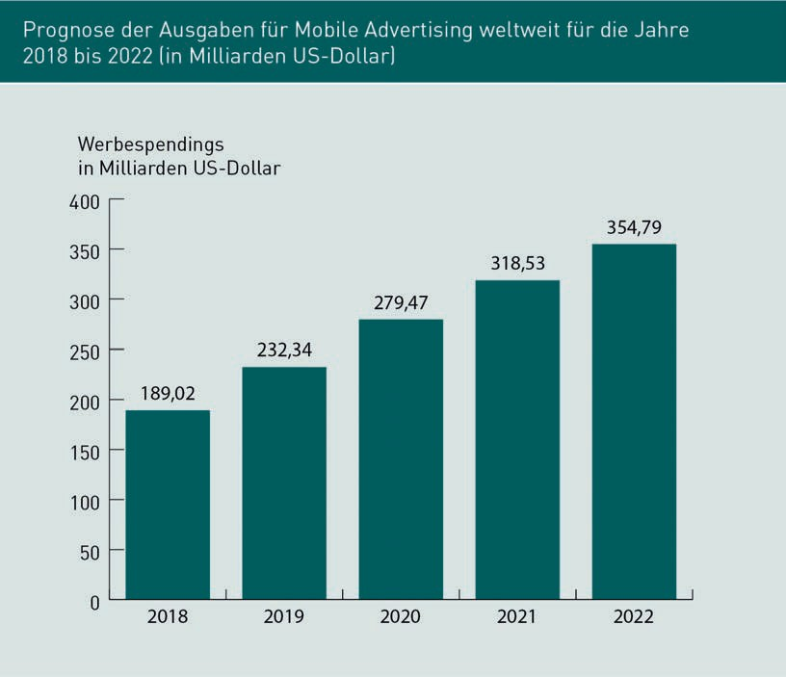

Mobile devices can also be used as a response channel for ofﬂine actions and campaigns. SMS and MMS are provided as an option for contacting the company, and consumers can participate in competitions or request product information (Holland 2014, p. 446f.).

# Social Media Marketing

Social media marketing is still a relatively young discipline. It began with the rise of social networks and is now effectively a must-do for companies. The term covers a broad spectrum of activities and measures that should be embedded within a company’s strategy.

Social media marketing refers to marketing activities on social networks. Lammenett (2019, p. 45) describes it as “a form of online marketing that aims to achieve branding and sales goals through engagement with one or various so-called social media offerings.”

[www.iubh.de](http://www.iubh.de/)

## Unit 3 49

The Online Marketing Mix

The technical framework for social media marketing is always changing. For example, the major social networks regularly make changes to marketing options, layout specifications, and sets of rules. One specific example is Facebook’s contest guidelines, which deﬁne how a company must conduct contests. These guidelines have undergone several changes in the past, but failure to comply with such guidelines can lead to the deletion of a fan page, which is why it is important for marketing departments to stay up to date in this respect.

Social media marketing measures can be divided into passive and active social media marketing. **Passive social media marketing** involves utilizing the activities and content of others to achieve business goals. This often involves analyzing user and competitor activity, which is used for operational and strategic planning. Passive or reactive social media marketing includes social media monitoring and social media guidelines. **Active social media marketing**, or proactive social media marketing, revolves around the strategic and cross-functional management of social media marketing efforts to achieve company goals. This involves actively creating content and establishing a dialog with the user (Rauschnabel et al. 2012, p. 42).

### Social Media Monitoring

Social media monitoring is part of passive social media marketing and should precede active measures as a basis for planning. In a figurative sense, it is comparable to the media monitoring carried out by press offices or a press review. A fitting deﬁnition is as follows: “Social media monitoring refers to the systematic, continuous, and subject-specific search, collection, processing, analysis, interpretation, and archiving of content from social media on topics relevant to management. It aims to provide an organization with a continuous overview of market trends in its own and adjoining markets—both in relation to its own company and to market participants in horizontal and vertical competition” (Rauschnabel 2014, p. 7). There are numerous free tools available for social media monitoring, as well as additional, fee-based professional tools.

### Social Media Guidelines

Social media guidelines are also part of passive social media marketing. They are created by companies and organizations to provide rules and guidelines for the professional and private behavior of employees on social networks. Social media guidelines can contain both recommendations and mandatory instructions.

Passive Social Media Marketing Passive social media marketing involves utilizing the activities and content of others to achieve company goals. Social media monitoring and social media guidelines are part of passive or reactive social media marketing.

Active Social Media Marketing

Active social media marketing includes the strategic and cross-functional management of marketing measures on social media. Content is actively created and a dialog is established with the user.

[www.iubh.de](http://www.iubh.de/)

50 Unit 3

Social media guidelines should be drawn up and developed on an interdisciplinary basis, with cooperation between various departments such as HR, marketing, and upper management. The specific design should be adapted to the company in question on an individual basis.

The below figure presents an example from the German Caritas Association’s Social Media Guidelines (Short Version).

[www.iubh.de](http://www.iubh.de/)

## Unit 3 51

The Online Marketing Mix

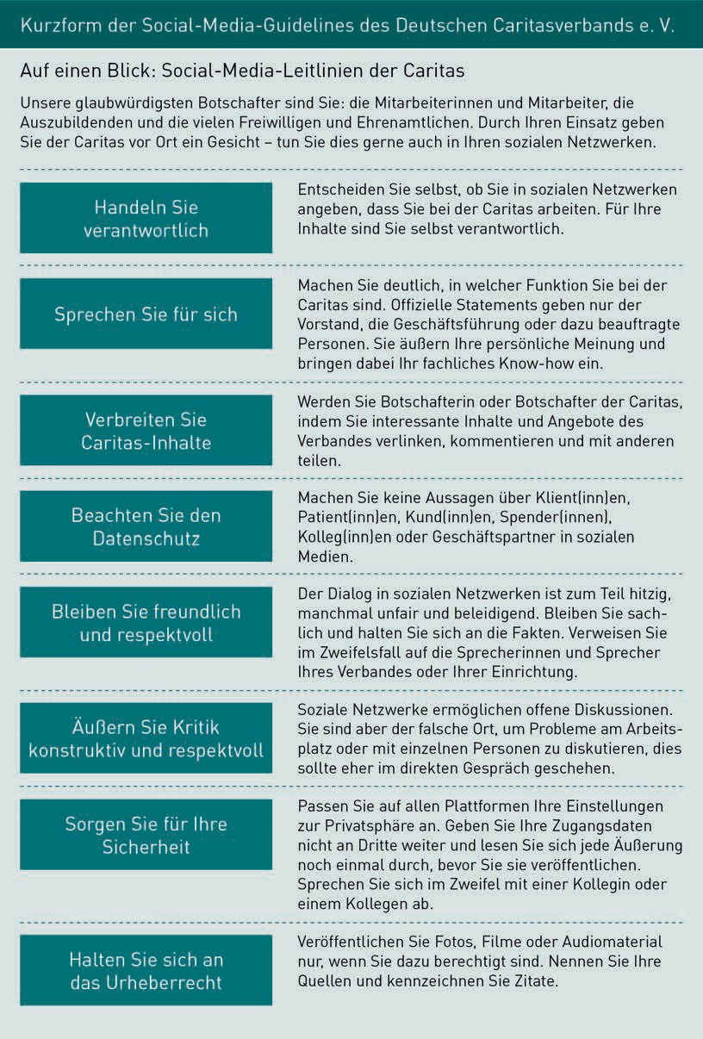

[www.iubh.de](http://www.iubh.de/)

52 Unit 3

### Presence on Social Media Platforms

If a company wants to engage in active social media marketing, it can maintain one or more proﬁles on social media platforms. Private social networks and business networks are available for this purpose and can be selected depending on the company’s strategic direction, specific goals and their marketing’s intended audiences. Social media proﬁles are free of charge with the most common providers, as the platform operators usually ﬁnance themselves through advertising revenues. Nevertheless, companies must take the considerable effort and expense of social media marketing into account. This is primarily incurred for the conceptual and content-related design and maintenance of social media presences. These presences should be well thought out since, similar to a company website, a social media presence can be a contact point for various stakeholder groups such as customers, the press, suppliers, capital providers, and employees.

One of the most important social media platforms is undoubtedly the Facebook network, founded by Mark Zuckerberg in 2004. Facebook is the social media platform with the most active users worldwide, currently around 3.3 billion monthly active users (AllFacebook 2021). In Europe, its reach is 54% (HubSpot 2020), and even 69.1% in North America (Sproutsocial 2021). A broad target audience can be reached with Facebook, and the network is the first choice for many B2C, as well as B2B companies, when it comes to operating a company page on social media.

On Facebook, companies have the option of setting up a fan page to which Facebook users can connect via a “like”. The fans of the page then receive news from the company in their news feed. When setting up a Facebook presence, companies face a wide range of operational and strategic questions, from the selection and design of a suitable proﬁle and cover image in terms of format and design, to a decision on the international design. It is possible, for example, to operate a single English-language Facebook presence, to set up several country-specific pages, or to publish posts in different languages as part of a single fan page.

Facebook uses an algorithm known as EdgeRank to decide which content users see in their news feed, and in which order. The evaluation of a status update is different for each user. Aspects such as afﬁnity, i.e., how often the user has interacted with similar posts, the popularity of the post among other users, and how recent it is are all taken into account. As with Google’s PageRank, the exact way EdgeRank works is secret. Company updates are, in principle, less effective in terms of EdgeRank than posts made by private users. It is therefore particularly important for advertisers to maintain a high quality of posts on a fan page and to encourage users to interact with them.

[www.iubh.de](http://www.iubh.de/)

## Unit 3 53

The Online Marketing Mix

Alongside Facebook, many companies maintain a social media presence on Twitter. This microblogging provider was founded in 2006 and offers users the opportunity to publish short text messages with a maximum of 280 characters. Nowadays, users can also tweet photos and videos in addition to text. Twitter had around 288 million monthly active users in March 2015 (We Are Social 2015). On Twitter, it is common to add hashtags to the short text messages. A hashtag is a word that is marked using the hash sign (#) and can thus act as a topic ﬁlter. In the context of Twitter campaigns, such hashtags can be used to bundle every tweet into one campaign, as well as track user tweets.

The video portal **YouTube** is owned by Google and offers users the opportunity to publish their own videos. This video portal has more than two billion users worldwide and thus an extremely broad reach (YouTube 2021). Companies can set up their own YouTube channel and post videos on relevant topics, such as advertising videos, a virtual tour of company premises or a video interview with management. YouTube videos can be embedded on other platforms, such as websites, blogs, or social networks like Facebook, giving users the opportunity to increase the reach of the videos, to network them with other platforms and, at the same time, to compile all their videos in one central location.

**Pinterest** was founded in 2010, so it is still comparatively young. However, it has seen impressive and steady growth in recent years. On this social network, users can post photos (and videos) on their own pinboards. Users can either upload the images themselves, share them from other users’ pinboards, or pin them from any website. The images are automatically linked back to the original website. The platform has a very visual character and has primarily appealed to women in the past. In 2014, its global share of women was around 80%, with topics such as food, fashion, interior design, vacations, and DIY products ranking high on the popularity scale (Schmidt 2014).

Like Pinterest, the social network **Instagram** was founded in 2010 and focuses on visual content. Users can also publish photos and videos there. Unlike Pinterest, however, Instagram users primarily share their own images. These can be edited by users with the help of various filters that, for example, can give a photo a nostalgic look. The photos are square, in the style of the Kodak Instamatic and Polaroid cameras. Instagram was purchased by Facebook in 2012, and by December 2014, it had 300 million monthly active users worldwide (Instagram 2014). It then reached the one trillion mark in January 2018 (Business of Apps 2021). Instagram is characterized by a predominantly young user group (GlobalWebIndex 2014), meaning that a presence on this platform is particularly suitable for companies with a correspondingly young target audience. Instagram was originally designed as a purely mobile application and is still used almost exclusively on mobile devices.

YouTube

The video portal YouTube offers private individuals and companies the opportunity to publish their own videos.

Pinterest

This was founded in 2010 and offers users the opportunity to post photos (and videos) on personal pinboards.

Instagram

The social network Instagram was founded in 2010. Users can post photos and videos there.

[www.iubh.de](http://www.iubh.de/)

54 Unit 3

Blog A blog is a diary kept on the internet at a specific web address in which one or more authors, called bloggers, regularly publish contributions.

Corporate Blog A company’s blog is referred to as a corporate blog. Corporate blogs are used for both internal and external communication.

Referral Trafﬁc Referral trafﬁc involves the number of visits to a company’s own website that are generated by links from other websites, and not by direct accesses to the URL or search engines.

**Blog** is the abbreviation for weblog and describes a diary kept at a specific web address, in which one or more authors, called bloggers, regularly publish contributions. Blog posts can usually be commented on by their readers. In contrast to the social media platforms discussed previously, a blog represents a platform that is owned by a company. A Facebook page or a YouTube channel can only be designed within the framework of the general terms and conditions of the network operators. By extension, a blog offers marketers more freedom to design the measures they wish to take. On Facebook, for example, a personal fan page can be deleted by Facebook at any time if rules such as contest guidelines are violated. Nevertheless, it is generally more difficult to distribute content and build up reach with a blog than on social networks. Companies' blogs are referred to as **corporate blogs**; they are used for both internal and external communication.

Practical Example: Daimler Magazine

The automobile manufacturer Daimler runs a successful corporate blog, Daimler Magazine. The blog has around 40,000 monthly visits and is filled with content by more than 400 authors, primarily employees. The blog’s intended audience includes job applicants, customers, suppliers, and shareholders, as well as the company’s own employees, who make up between 25 and 50% of its readership. 40% of readers arrive at the site via links, with the company intranet and corporate website being the primary trafﬁc suppliers. Another 40% ﬁnd the Daimler blog via search engines, and about 20% access the blog by specifically using its URL. The blog posts are also shared on social media platforms such as Facebook and Twitter. While the **referral trafﬁc** from these is relatively low, it brings in a steady stream of new readers. The main goal of the blog is to create transparency, provide a behind-the-scenes look at Daimler as a company, and engage in dialog with key stakeholders. Important topics are employer branding as well as crisis communication (Jodeleit 2012, p. 280ff.).

A wiki, such as on Wikipedia, is a website published on the internet that can be edited by its users. In general, these are online encyclopedias, with Wikipedia being the most-used online reference work and the sixth most-visited website in the world (o. V. 2015a). There are also company articles on Wikipedia that usually provide an overview of the history and business structure of the organization in question. However, the possibilities for companies to take action themselves and revise articles or correct errors are limited. Writing from a neutral standpoint is a basic principle of Wikipedia, and companies that revise their own contributions are encouraged to do so openly and transparently. In addition, however, it is possible to edit other specialized contributions and thus generate links to one’s own website.

[www.iubh.de](http://www.iubh.de/)

## Unit 3 55

The Online Marketing Mix

XING and LinkedIn are two social networks that focus on business contacts. LinkedIn has a stronger international presence, while XING is used more in German-speaking countries. Both platforms offer the capability of setting up company proﬁles and publishing news. Due to their focus on business topics, XING and LinkedIn are primarily relevant for employer branding and the B2B sector.

In addition to the networks described above, there are numerous other social media platforms that can be used for online marketing purposes, such as Snapchat, which is successfully used for storytelling by brands such as Spiegel Online, Sky Sport or Sixt, or the TikTok network, which is a platform for short smartphone videos, that is also used for positioning by companies such as BMW or the cosmetics brand, MAC. New networks are added regularly due to the highly dynamic nature of the online world. However, marketing departments should generally make well-founded strategic considerations before setting up a proﬁle on a new network and becoming active. While new platforms are often popular and trendy, building up a community and fan base on them involves expert skills that should not be underestimated. A new network should therefore only be approached when it is certain that the commitment will be long-term.

### Community Building and Management

After a proﬁle has been set up on a social network, it is necessary to build and manage a readership or community. The community can be built in various ways. Ideally, these approaches would mesh with each other, the exact options and strategies differing depending on the platform at hand. On Twitter, for example, it is common to follow similar accounts and to speculate that they will follow one’s own proﬁle in return. This is not possible with a Facebook page. Nevertheless, some foundational options for community building can be identiﬁed. In order to make people aware of a new page, advertising is often carried out within the social networks and is referred to as social advertising. There are a number of ad variants on Facebook, one of which is specifically geared toward generating fans: Page likes ads. The advertiser has numerous targeting options with social ads, and by extension can align the ad placement with their intended audience. Particularly detailed options are available based on the wealth of user information from social networks, such as with Facebook. Contests are another way to attract new fans to one’s site, but it is important to observe the platform-specific rules and regulations when carrying out contests. It is also a good idea for a company to link their social media platforms to each other and to their other significant pages, such as their own website.

The figure below shows the value that selected German banks assigned to a Facebook fan. For Volksbank, a fan had a value of 1.68 euros in Quarter 1, 2015. This value was measured on the basis of factors such as loyalty, spending, and recommendations (Social Bench 2015).

Social Advertising Social advertising refers to advertising on social networks.

[www.iubh.de](http://www.iubh.de/)

56 Unit 3

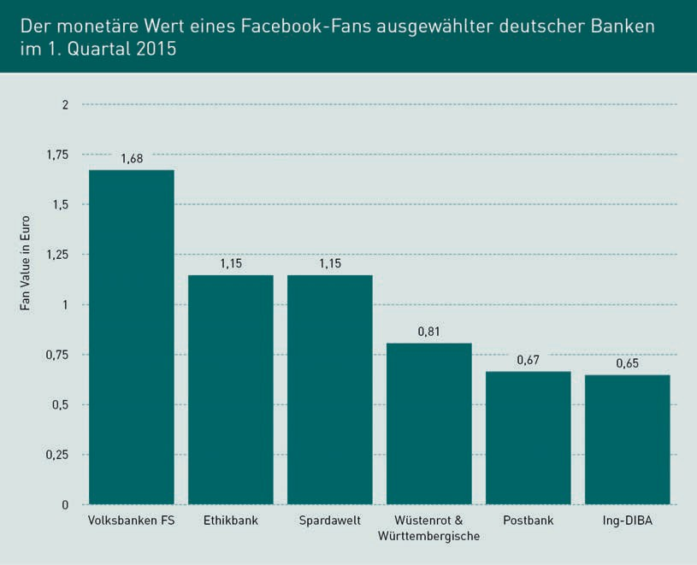

Content The term content stands for the content of any online presence and includes texts, images, videos, or other content.

Community Manager

A community manager is responsible for moderating, activating, and expanding virtual communities.

The published content and the thematic concept of the proﬁle play a fundamental role, both for community building and for the long-term success of a page. It is when users, fans, and followers like this content that they will interact with it, read it, share it, and spread it further (Schwarz 2014, p. 423). In specialist circles, the *content is king* statement has become commonplace, whereby **content** stands for the content of any online presence and includes texts, images, videos, or other content. The question of what constitutes promising content must be answered individually for each site, based on the relevant goals and intended audiences. The tracking and controlling tools provided to site operators by social platforms offer a wide range of options for identifying posts and contributions that perform well or poorly and for optimizing them on an ongoing basis.

A **community manager** is entrusted with tasks such as the moderation, activation, and expansion of communities. The community manager acts as a kind of mediator between the site operator and the users and fans of a social media proﬁle, putting a page’s posts and tweets online, answering user questions, and monitoring discussions among users. Important components of the successful moderation of user contributions are short response times to user feedback, appreciative communication with users, and an approach oriented toward the intended audience.

[www.iubh.de](http://www.iubh.de/)

## Unit 3 57

The Online Marketing Mix

### Editorial Plan

The content, contributions, and posts on the various social media platforms should be centrally planned and coordinated. This is generally done with the help of a social media editorial plan. Future topics and the persons responsible are entered in this plan, and how a topic will be featured on the various social networks is established. A well-developed editorial plan is the basis for efﬁcient planning and monitoring of social media activities.

Since social media platforms are often operated by several team members in parallel, the editorial plan supports coordination within the team. In addition to the organizational aspect, an editorial plan also serves as a tool for developing and implementing a thematic strategy. This involves, for example, working out how strategically important topics can be subdivided into different subtopics and how a topic is featured on the various social media platforms. The rotation of posts and news, which should vary depending on the network at hand, is also determined in this plan. Furthermore, planning the successive posts enables a dramatic composition to be developed and different posts to be interconnected.

Individual topics and updates should not be published in the same way on the various platforms. Instead, they should be edited in a network-specific manner. On Twitter, for example, the number of characters is severely limited, while on Instagram it is customary to add several hashtags to a single post. A post published on a corporate blog, for example, can be distributed on Twitter with a short teaser text and enhanced on Facebook with a question for the community.

[www.iubh.de](http://www.iubh.de/)

58 Unit 3

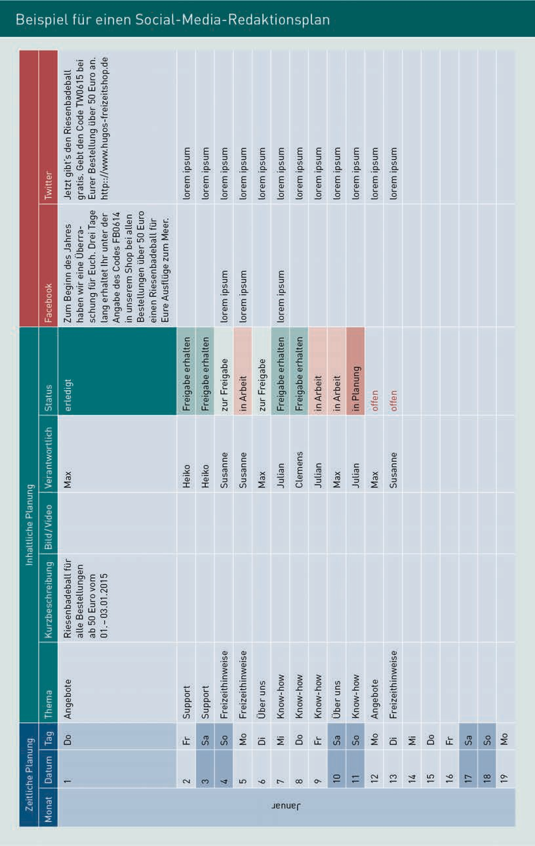

[www.iubh.de](http://www.iubh.de/)

## Unit 3 59

The Online Marketing Mix

# Assessment of Alternative Online Marketing Tools, Considering their Potential Applications and Limitations

The online marketing tools presented above should be deployed on the basis of a company’s specific goals, intended audiences, and requirements. The alternative tools available are suitable for different purposes and goals, to varying degrees.

Display advertising is a traditional push tool in which the flow of information from the sender to the recipient is actively controlled. Since banner advertising can reach a large number of potential customers, it is suitable for new customer acquisition and branding. New products and services can be made known to the market through display advertising, while the targeting and retargeting options enable specific audiences to be addressed. Banner advertising can achieve valuable branding effects through integrating and combining images, audio, and moving images (Lammenett 2014, p. 327).

However, one phenomenon that limits the effect of banners is known as **banner blindness**. This refers to the fact that users often automatically blank out advertising banners and thus do not notice the advertising messages on them. This scientifically proven phenomenon is based on habituation effects that occur due to intensive banner placement. As a result, click rates on banners have fallen continuously in recent years and were at 0.05% across all banner formats in 2020 (Kreutzer/Rumler/Wille-Baumkauff 2020, p. 185).

Another relevant factor is the growing use of **ad blockers**. The reason for this is that display advertising is often perceived as annoying by internet users. An ad blocker is a tool that recognizes and filters out advertising on websites so that the corresponding content is not downloaded in the first place. As a result, the user is shown the website without advertising, which also makes the page load faster (Kreutzer/Rumler/Wille-Baumkauff 2020), p. 176f.). According to a 2013 study by Fittkau & Maaß Consulting on the reactions of internet users who feel annoyed by repeated online advertising, 41% of respondents block advertising in their browser using an ad blocker (Fittkau & Maaß Consulting 2013).

Search engine marketing starts at a point where the user is already interested, which, in turn, leads them to use a search engine and enter relevant keywords. Accordingly, a major advantage of SEM is that the user already has a need for the product or service in question, which, in contrast to display advertising, does not need to be inspired first. Following the rules of pull communication, the activity starts with the potential customer. Internet users use search engines to learn about products and services and prepare for purchase decisions. For this reason, SEM is more likely than advertising formats such as display advertising to turn the user into a buyer and generate sales for the advertiser (Lammenett 2014, p. 328).

Banner Blindness The term banner

blindness refers to the phenomenon that users often automatically blank out advertising banners and thus do not notice the advertising messages on them.

Ad Blocker

An ad blocker is a tool that filters out advertising on internet sites so that the user is shown the website without advertising.

[www.iubh.de](http://www.iubh.de/)

60 Unit 3

Users can be taken directly to the product offering by clicking on a search engine link. This makes search engine marketing well-suited to acquiring new customers and increasing profits (Lammenett 2014, p. 328). In addition, search engines are fundamentally of enormous importance in today’s internet landscape, and Kreutzer, Rumler, and Wille-Baumkauff (2020, p. 156) describe search engine marketing as “a must for every company,” regardless of whether it sells its wares online or ofﬂine.

Black Hat SEO Black Hat SEO refers to techniques that aim to improve search engine rankings with measures that violate the guidelines of search engine operators.

First, the limits of what can be achieved with search engine marketing are partly down to highly competitive keywords. It is difficult to achieve a good ranking in results lists with such keywords. This is nevertheless essential, since searchers are primarily interested in hits on the first page of the search engine (Kreutzer 2021, p. 242f.). Second, search engine optimization is a time-consuming and costly process that does not produce tangible results immediately and must also be implemented on an ongoing basis. Search engine optimization (SEO) can only be used to a limited extent for new products and services, since the search volume for the new keywords is probably low and search terms are lacking. SEO agencies have developed various techniques over the years to trick search engine crawlers and artificially improve their position in the SERPs. However, such manipulative techniques, which go by the name **Black Hat SEO**, are punished by Google and similar providers.

Since email marketing requires the recipient’s consent to receive emails, this tool is primarily aimed at existing customers and interested parties. Accordingly, an important goal is to strengthen customer loyalty through regular communication. Content that is relevant and appealing to the recipients can keep their interest in the company and its offerings high, and enhance its image. Newsletters are also well suited to supporting sales by presenting new products and other products that are potentially relevant to the customer, as well as opening up opportunities for more-selling, cross-selling, and up-selling. Email marketing should not replace existing tools. Rather, it should be used to supplement other tools and increase the frequency of contact, without simultaneously leading to a significant increase in costs (Schwarz 2014, p. 423f.).

The age of the intended audience can be a limitation in email marketing activities and campaigns. For example, the use of email services among young people continues to decline in favor of social media. As a consequence, this intended audience can only be reached with email marketing to a limited extent and when email is used, it can make sense to link it with social media applications (Kreutzer 2021, p. 342). According to a survey conducted by GfK Enigma in 2014, only 34% of the girls and 35% of the boys surveyed use the email function on their smartphones every day or several times a week (Medienpädagogischer Forschungsverbund Südwest 2014).

[www.iubh.de](http://www.iubh.de/)

## Unit 3 61

The Online Marketing Mix

Advertising emails are frequently perceived by recipients as annoying and a nuisance. In particular, mass mailings of unsolicited commercial emails, known as spam, have tarnished the image and perception of email branding (Kreutzer 2012, p. 280). In light of this, the importance of relevant and high-quality content is also made clear.

In afﬁliate marketing, the advertiser usually incurs costs only if the campaign is successful. This is an advantage for companies that should not be underestimated, particularly since merely displaying banners can have positive branding effects in itself. Similar to display advertising, afﬁliate marketing enables the intended audience to be addressed precisely, as well as potential areas for customer acquisition and branding goals to be targeted. However, afﬁliate marketing must also contend with similar hurdles such as banner blindness and ad blockers.

In mobile marketing, many of the traditional online marketing tools are used in the context of this new channel. For example, banner ads are placed, email marketing is conducted, traditional websites are adapted for mobile use, and social media platforms are used from the smartphone and tablet. Accordingly, comparable application potential and limitations can be identiﬁed in each case. Great potential is offered by the broad reach of mobile devices. Location-based services, which provide a speciﬁc additional benefit for consumers, also open up far-reaching opportunities for advertisers.

Activities on popular social media platforms are primarily aimed at achieving customer loyalty and branding goals, as communication functions through the pull effects. The interactivity inherent in the media has a positive impact on consumer involvement and the psychological anchoring of content. Social media activities have enormous potential in terms of content being disseminated virally by users themselves.

Virality is also a risk of social media activities. The virality of a medium can lead to what are known as **shitstorm**s. A shitstorm is characterized by users spreading negative news and information about a company virally and voicing (sometimes harsh) criticism. In such situations, professional crisis communication is of great importance.

The social media world is characterized by a high level of transparency, in which scandals, as well as product defects or managerial misconduct, can be made public by users at lightning speed. Therefore, honest and authentic user communication (and company management) is crucial. In the process of this communication, companies must be willing to cede control and allow consumers more influence.

Social advertising also provides advertisers on social media with a tool that can be used in a way similar to traditional banner advertising. This means that new customer acquisition goals can be pursued and users can also be redirected to external websites. Social signals such as likes and tweets benefit SEO and can lead to better rankings in organic search results.

Shitstorm

A shitstorm is characterized by users spreading negative news and information about a company virally and voicing (sometimes harsh) criticism.

[www.iubh.de](http://www.iubh.de/)

**Capitalization – The first word of a sentence is capitalized & punctuated as usual. Each bullet point answer begins with capitalization and ends with a period. Bullet point answers that complete a sentence with the question above are not capitalized, but end with a period (…).**

**Self-check questions**

**3.2**

1. What are the two primary groups of measures in search engine marketing?

*A distinction is made between search engine optimization (SEO) and search engine advertising (SEA).*

1. What are the different variants of marketing emails?

In addition to *trigger emails*, where there is always a specific reason for sending the email, a distinction can be made between *transaction emails*, which accompany a business process, and *after-sales emails*, which are used after a successful sale. *E-newsletters* also play an important role and are usually sent to a larger group of addressees.

1. What is the role of the merchant and the affiliate in affiliate programs?

*The affiliate partner advertises the merchant’s products or services on its own website. As the advertising company, the merchant provides the affiliate with the advertising material and remunerates the affiliate partner’s activities.*

**3.4**

1. To which group of social media marketing measures do social media guidelines belong and what purpose do they serve?

Social media guidelines are part of *passive* social media marketing. They serve to provide employees with *rules* and *guidelines* for *professional* and *private* behavior on social media.

1. What is EdgeRank?

*EdgeRank is an algorithm that Facebook uses to determine which content is displayed to which users in their news feed, and in which order.*

1. What does the term *content* mean in an online marketing context?

*The term content stands for the content of any online presence and includes texts, images, videos, and other content.*

**3.5**

1. What is banner blindness?

*The term banner blindness refers to the phenomenon that users often automatically blank out advertising banners and thus do not perceive the advertising messages on them.*