**Das Sender-Empfänger-Modell im Internet**

**The Sender-Receiver Model on the Internet**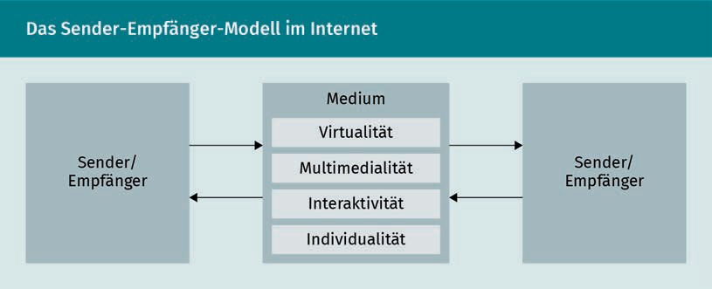

|  |  |
| --- | --- |
| Sender/Empfänger | Sender/Receiver |
| Medium | Medium |
| Virtualität | Virtuality |
| Multimedialität | Multimedia |
| Interaktivität | Interactivity |
| Individualität | Individuality |

**Der elektronische Wertschöpfungsprozess**

**The Electronic Value Creation Process**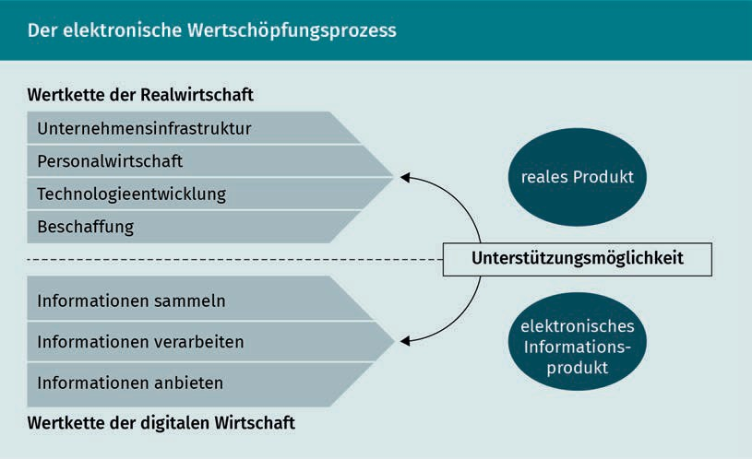

|  |  |
| --- | --- |
| Wertkette der Realwitschaft | Real economy value chain |
| Unternehmensinfrastruktur | Company infrastructure |
| Personalwirtschaft | Human resources |
| Technologieentwicklung | Technology development |
| Beschaffung | Procurement |
| Informationen sammeln | Collect information |
| verarbeiten | Process information |
| anbieten | Offer information |
| Der digitalen Wirtschaft | Digital economy value chain |
| Reales Produkt | Real product |
| Unterstützungsmöglichkeiten | Support options |
| Elektronisches Informationsprodukt | Electronic information product |

**Unterteilung des Onlinemarketings**

**Online Marketing Breakdown**

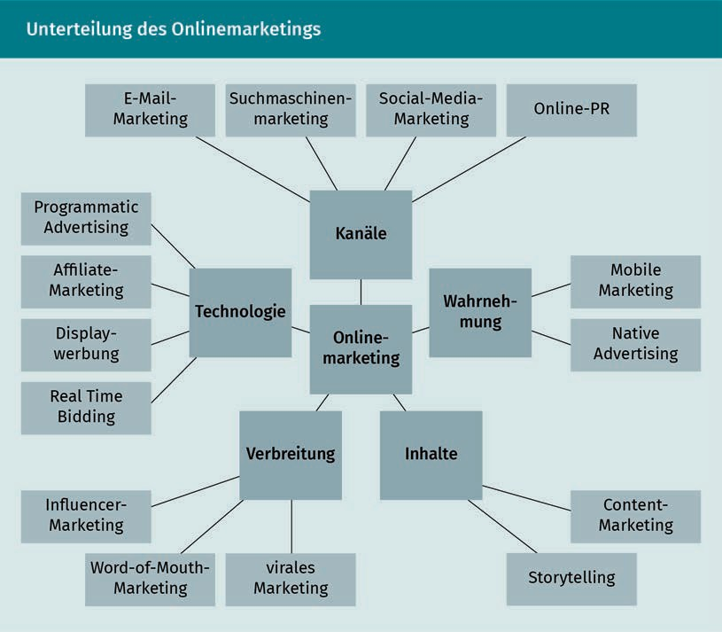

|  |  |
| --- | --- |
| E-Mail-Marketing | Email marketing |
| Suchmaschinenmarketing | Search engine marketing |
| Social-Media-Marketing | Social media marketing |
| Online-PR | Online PR |
| Mobile Marketing | Mobile marketing |
| Native Advertising | Native advertising |
| Content-Marketing | Content marketing |
| Storytelling | Storytelling |
| Virales Marketing | Viral marketing |
| Word-of-Mouth-Marketing | Word-of-mouth marketing |
| Influencer-Marketing | Influencer marketing |
| Real Time Bidding | Real time bidding (RTB) |
| Displaywerbung | Display advertising |
| Affiliate-Marketing | Affiliate marketing |
| Programmatic Advertising | Programmatic advertising |
| Kanäle | Channels |
| Wahrnehmung | Perception |
| Inhalte | Content |
| Verbreitung | Distribution |
| Technologie | Technology |
| Online Marketing | Online marketing |

**Grundkonzept des Affiliate-Marketings**

**Basic Concept of Affiliate Marketing**

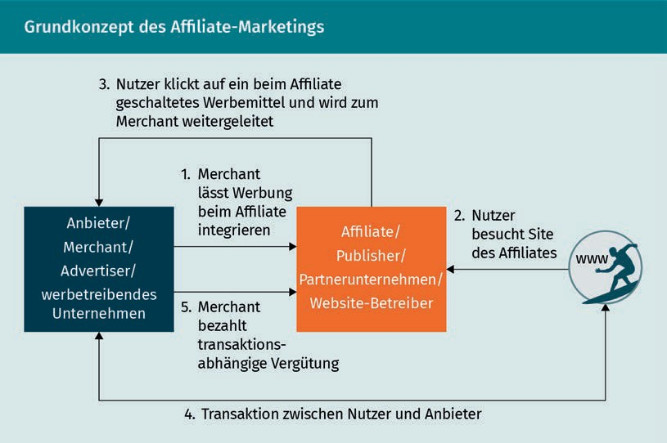

|  |  |
| --- | --- |
| Nutzer klickt auf ein beim Affiliate geschaltetes Werbemittel und wird zum Merchant weitergeleitet | User clicks on an ad placed with the affiliate and is redirected to the merchant |
| Merchant lässt Werbung beim integrieren | Merchant has advertising integrated with affiliate |
| Anbieter/ Merchant/ Advertiser/ werbetreibendes Unternehmen | Supplier/Merchant/Advertiser/Advertising Company |
| Publisher/ Partnerunternehmen/ Website-Betreiber | Publisher/Partner Company/Website Operator |
| Nutzer besucht Site des | User visits affiliate site |
| Bezahlt transaktionsabhängige Vergütung | Pays transaction-based remuneration |
| Transaktion zwischen Nutzer und Anbieter | Transaction between user and supplier |

**Closed Loop des Onlinemarketing**

**Online Marketing Closed Loop**

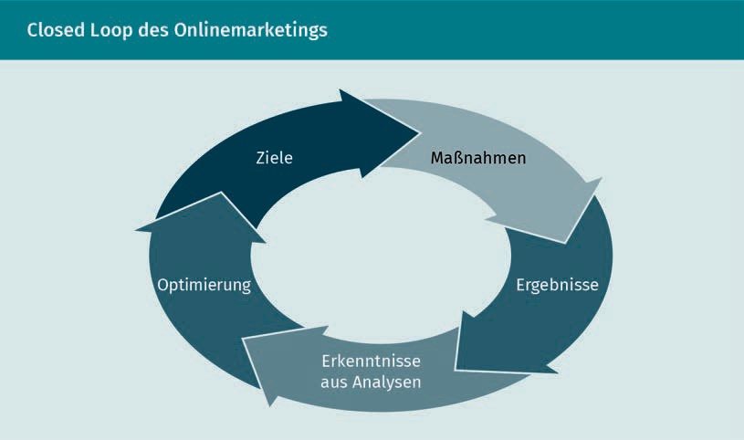

|  |  |
| --- | --- |
| Ziele | Goals |
| Maßnahmen | Measures |
| Ergebnisse | Results |
| Erkenntnisse aus Analysen | Findings from analyses |
| Optimierung | Optimization |

**Kanäle für die einzelnen Phasen im Kaufprozess**

**Channels for the Individual Phases in the Buying Process**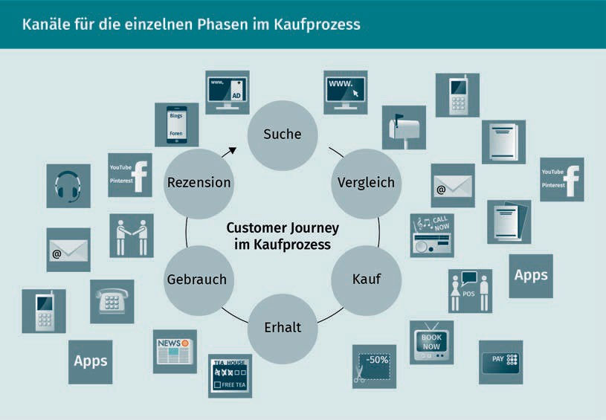

|  |  |
| --- | --- |
| Suche | Search |
| Vergleich | Compare |
| Kauf | Buy |
| Erhalt | Receive |
| Gebrauch | Use |
| Rezension | Review |
| Costumer Journey im Kaufprozess | Customer journey in the buying process |
| Apps | Apps |

**Grundkonzept des A/B-Testings – Beispiel Website-Optimierung**

**Basic Concept of A/B Testing – Website Optimization Example**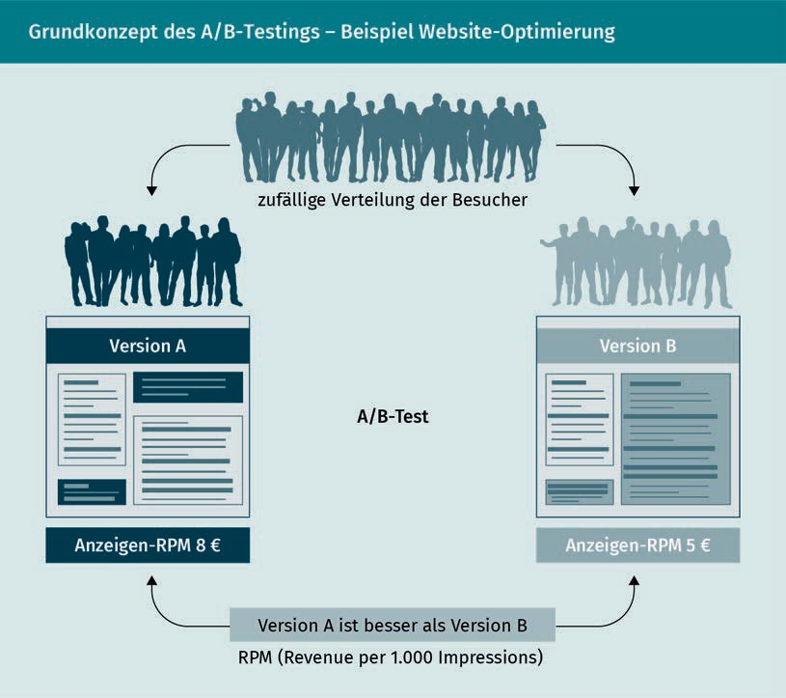

|  |  |
| --- | --- |
| Zufällige Verteilung der Besucher | Random distribution of visitors |
| Version B | Version B |
| Anzeigen-RPM | Ad RPM |
| Versions A ist besser als Version B | Version A is better than version B |
| RPM (Revenue per 1.000 Impressions) | RPM (Revenue per 1,000 impressions) |
| Anzeigen-RPM | Ad RPM |

**Prozesse des Kampagnenmanagementes**

**Campaign Management Processes**

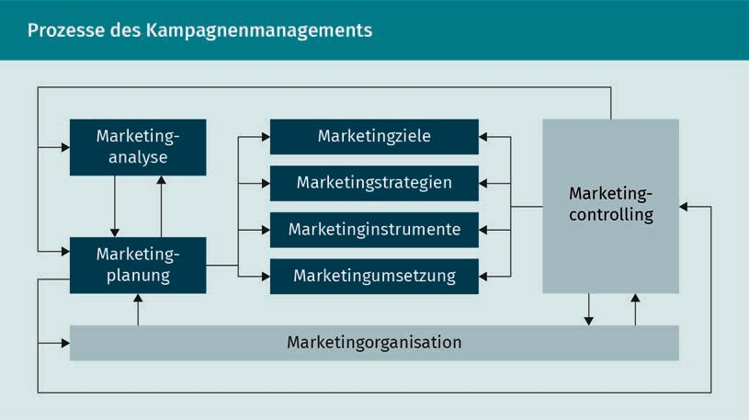

|  |  |
| --- | --- |
| Marketinganalyse | Marketing analysis |
| Marketingplanung | Marketing planning |
| Marketingziele | Marketing goals |
| Marketingstrategien | Marketing strategies |
| Marketinginstrumente | Marketing tools |
| Marketingumsetzung | Marketing implementation |
| Marketingcontrolling | Marketing controlling |
| Marketingorganisation | Marketing organization |

**Bestandteile des Interfacedesigns**

**Interface Design Components**

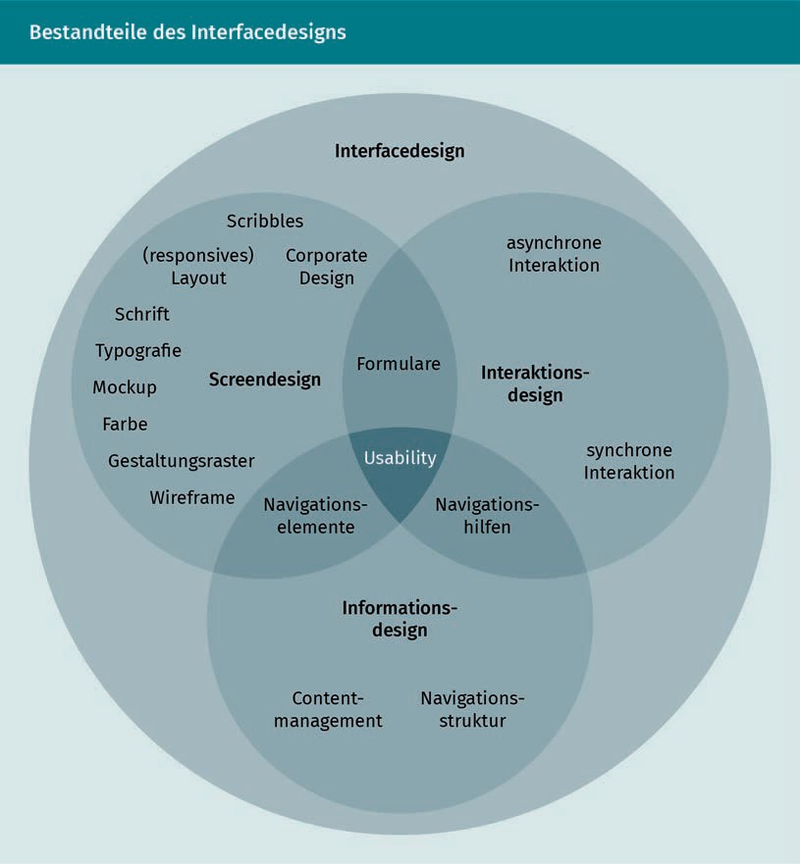

|  |  |
| --- | --- |
| Interfacedesign | Interface design |
| Asynchrone Interaktion | Asynchronous interaction |
| Interaktionsdesign | Interaction design |
| Synchrone interaction | Synchronous interaction |
| Navigationshilfen | Navigation aids |
| Usability | Usability |
| Formulare | Forms |
| Scribbles | Scribbles |
| Corporate Design | Corporate design |
| Screendesign | Screen design |
| Navigationseleente | Navigation elements |
| Wireframe | Wireframe |
| Gesaltungsraster | Design grid |
| Farbe | Color |
| Mockup | Mockup |
| Typografie | Typography |
| Schrift | Font |
| 8responsives) Layout | (responsive) Layout |
| Informationsdesign | Information design |
| Navigationsstruktur | Navigation structure |
| Contentmanagement | Content management |

**Corporate Website als zentrale Schnittstelle**

**Corporate Website as a Central Interface**

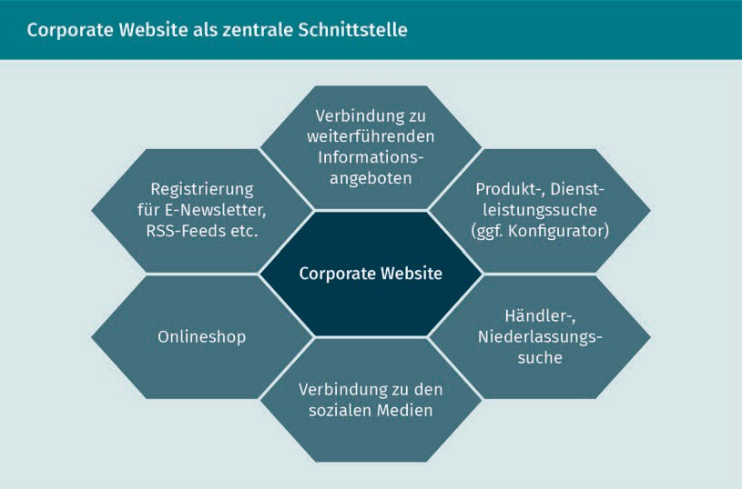

|  |  |
| --- | --- |
| Verbindung zu weiterführenden Informationsangeboten | Connection to further information offers |
| Produkt-, Dienstleistungssuche (ggf. Konfigurator) | Product, service search (configurator, if necessary) |
| Händler-, Niederlassungssuche | Dealer, branch search |
| Verbindung zu den sozialen Medien | Connection to social media |
| Onlineshop | Online store |
| Registrierung für E-Newsletter, RSS- Feeds etc. | Registration for e-newsletters, RSS feeds, etc. |
| Corporate Website | Corporate website |

**Verkäufer-Käufer-Kommunikation im Onlineshop**

**Buyer-Seller Communication in an Online Store**

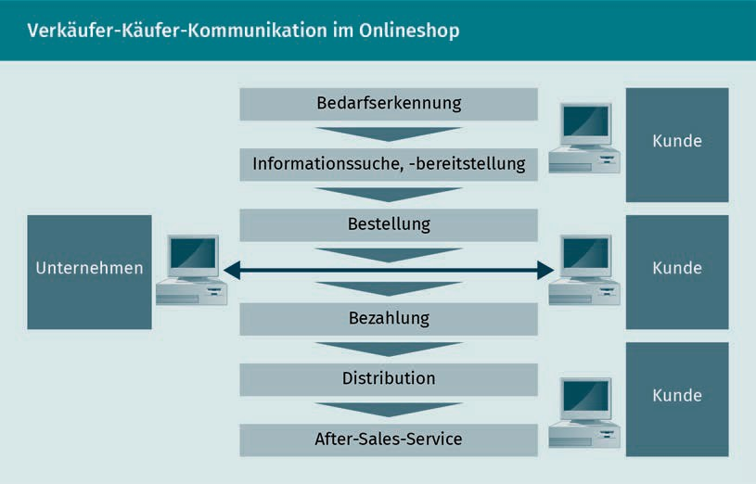

|  |  |
| --- | --- |
| Unternehmen | Company |
| Bedarfserkennung | Needs identification |
| Informationssuche, -bereitstellung | Information search, provision |
| Bestellung | Order |
| Bezahlung | Payment |
| Distribution | Distribution |
| After-Sales-Service | After-sales service |
| Kunde | Customer |

**Klassifizierung von Mobile Moments**

**Classification of Mobile Moments**

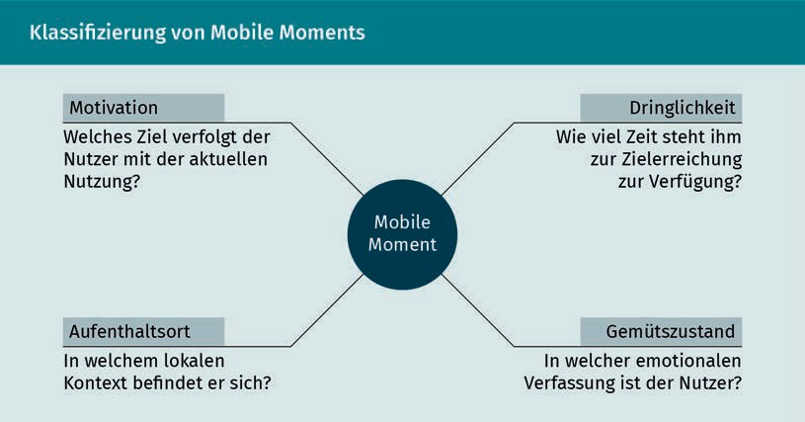

|  |  |
| --- | --- |
| Motivation | Motivation |
| Welches Ziel verfolgt der Nutzer mit der aktuellen Nutzung? | What is the user's goal during their current use? |
| Dringlichkeit | Urgency |
| Wie viel Zeit steht ihm zur Zielerreichung zur Verfügung? | How much time do they have available to achieve the goal? |
| Gemütszustand | State of mind |
| In welcher emotionalen Verfassung ist der Nutzer? | What emotional state is the user in? |
| Aufenthaltsort | Location |
| In welchem lokalen Kontext befindet er sich? | What local context are they in? |
| Mobile Momente | Mobile moment |

**Zusammensetzung des Onlinerechts**

**Composition of Online Law**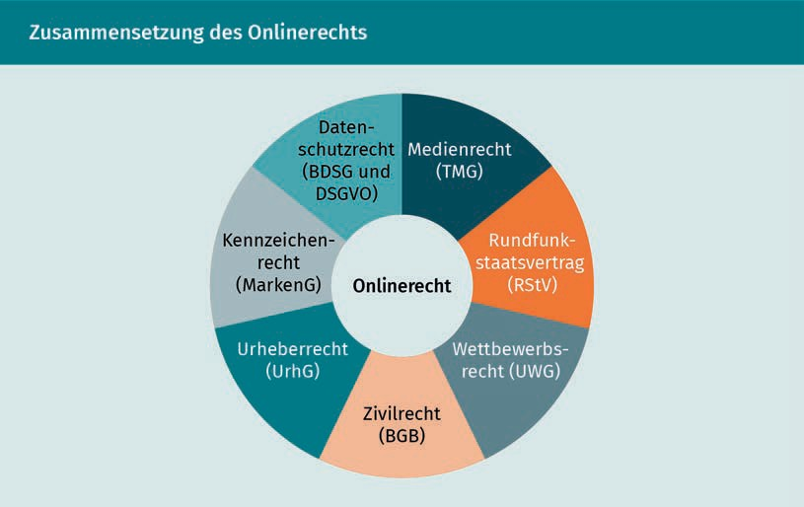

|  |  |
| --- | --- |
| Datenschutzrecht (BDSG und DSGVO) | Data protection law (German BDSG and EU GDPR) |
| Medienrecht (TMG) | Media law (TMG) |
| Rundfunkstaatsvertrag (RStV) | Interstate broadcasting treaty (RStV) |
| Wettbewerbsrecht (UWG) | Competition law (UWG) |
| Zivilrecht (BGB) | Civil law (BGB) |
| Urheberrecht (UrhG) | Copyright (UrhG) |
| Kennzeichenrecht (MarkenG) | Trademark law (MarkenG) |
| Onlinerecht | Online Law |

**ASIDAS – die weiterentwickelte AIDA-Formel**

**ASIDAS – The Further Developed AIDA Formula**

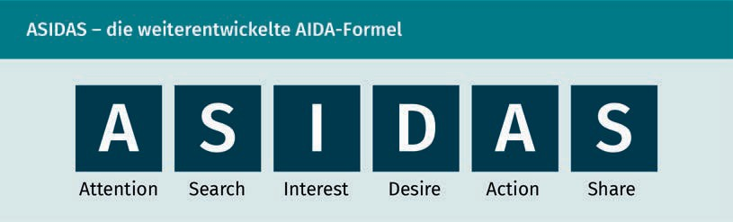

**Der Informationskreisel zur Kundenbindung**

**The Information Circle for Customer Loyalty**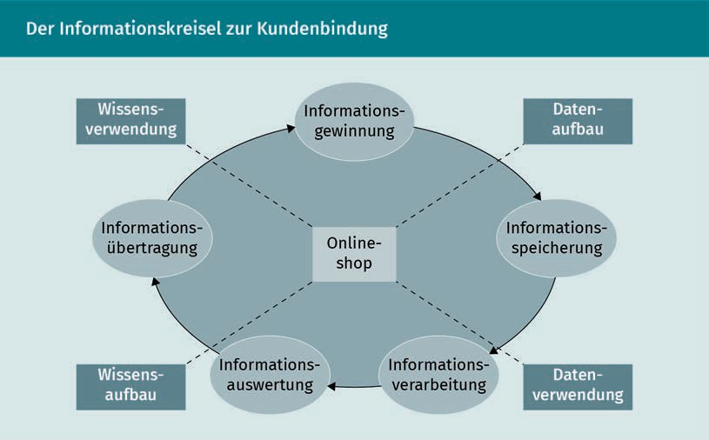

|  |  |
| --- | --- |
| Wissensverwendung | Knowledge usage |
| Informationsgewinnung | Information retrieval |
| Datenaufbau | Data structure |
| Informationsspeicherung | Information storage |
| Daterverwendung | Data usage |
| Informationsverarbeitung | Information processing |
| Informationsauswertung | Information evaluation |
| Wissensaufbau | Knowledge structure |
| Informatonsübertragung | Information transfer |
| Onlineshop | Online store |

**Phasen des Kundenbeziehungslebenszyklus**

**Customer Relationship Life Cycle Phases**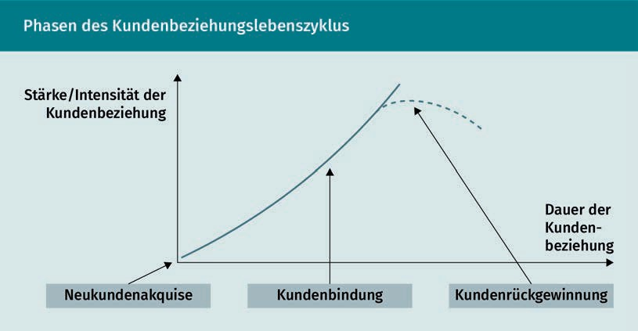

|  |  |
| --- | --- |
| Stärke/Intensität der Kundenbeziehung | Strength/intensity of the customer relationship |
| Neukundenakquise | New customer acquisition |
| Kundenbindung | Customer loyalty |
| Kundenrückgewinnung | Customer recovery |
| Dauer der Kundenbeziehung | Duration of the customer relationship |