In Brief

Piano Man

In the words of the classic hit, 'A man should be able to play the piano.' This man certainly can! “This man” is Eliad Sharony, pianist, composer, and a truly lovely person. For the past nine years, he has lived in Hamburg, studied music at the same school as Justus Frantz, and fallen in love with the Hanseatic City. “I truly feel at home here,” the virtuoso pianist told us. “We feel at home when he plays for us,” all the visitors to the VIP tent at the Betty Barclay Cup replied. “When Eliad touches the keys, the sun shines even in the grayest Hamburg weather,” a hostess from the VIP tent gushed. No sooner had she said it than she returned to her bar to continue listening. By engaging Sharony, the organizers achieved a fantastic coupe. But even the piano itself is a sensation. Sharony is playing a real Steinway, the

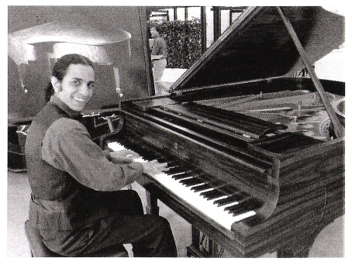

ELIAD SHARONY AT THE STEINWAY & SONS PIANO

best of the best – and it’s valued at more than 70,000 euro! A true treasure from the storied makers, Steinway & Sons.