COURSE BOOK



## Purchasing, Procurement and Distribution

DLBLOISCM102

Learning Objectives

##### Introduction 9



This course is intended as an introduction to the concepts, organizational principles, strategies and tools used in purchasing, procurement and distribution. The efficient, effective organization of these aspects is pivotal to an optimum supply chain.

Students will learn to develop and execute complex tasks in these specialist fields and their related process structures within the overall context of the supply chain. We begin by exploring the development and execution of the complex strategies, concepts and processes involved in purchasing and procurement, including the interdependencies between different procurement strategies and procedures.

We will also examine the tasks, agents, strategies and operational processes involved in distribution and the dynamics between them. Students will discover that even diametrically opposed concepts can sometimes be successfully combined for optimum market servicing.

The course will also explore the particular features of transactional processes on the capital goods markets versus the consumer goods markets, each of which calls for very distinct marketing strategies and measures, highlighting the need for a cross-functional perspective in supply chain management. Product distribution, industrial plant/system distribution and supplier distribution are three distinct business segments with very specific features, each of which requires its own approach.



# Unit 1

## Purchasing and Procurement

#### STUDY GOALS

After working through this unit, you will be familiar with ...

... The importance of purchasing and procurement

... The various procurement strategies

... The different processes involved in procurement

... Selection and assessment options for suppliers

... The potential of IT and communications technology in procurement

... The different organizational approaches to procurement

DL-D-DLBLOISCM102-L01

1. Purchasing and Procurement

### Case Study

Jaspers AG is a leading publishing house specializing in business studies, information technology, mechanical engineering and biology. It employs a workforce of more than 700 people at four locations in Germany and is actively involved in the acquisition of other small publishers. As part of an ongoing restructuring project, the management is keen to optimize its procurement processes and make them more efficient.

The publisher’s procurement requirements are many, including computers, office materials, software and IT, real estate, cleaning products, printing presses and much more. The Head of Procurement has adopted a re-engineering approach and is considering ways of integrating e-sourcing solutions into the company. A well-known management consulting firm has recommended the introduction of a desktop purchasing system (DPS). The Head of Procurement, Dr. Bredenwischer, now faces the challenge of integrating the DPS into the existing IT landscape and deciding which items he is able and willing to source via the new system.

Apart from the DPS, he is interested in exploring the electronic marketplace as a platform for sharing information with suppliers about inventories, capacities and costs. The option of conducting virtual negotiations, submitting availability inquiries and participating in auctions via electronic marketplaces also appeals to him.

However, he wonders how secure these new electronic systems are and needs to do some more research into the acquisition and running costs of these new systems to gauge whether they are actually financially viable for his company.

He also has no experience of updating multi-supplier catalogs and wonders how long it might take his current procurement team to familiarize themselves and work effectively with the new systems. Many of the older staff have never worked outside of conventional procurement management systems and are understandably somewhat apprehensive about the changeover.

Dr. Bredenwischer’s only option is to appoint a management consultant who will conduct an in-depth analysis of the opportunities and risks of these new electronic procurement solutions. He also needs accurate costings before presenting a budget to the board. The Head of Procurement is in a difficult situation.

Purchasing and Procurement

### Definition of “Procurement” and “Procurement Processes”

Procurement is concerned with controlling and maintaining the company’s **supply** of consumables, raw materials and supplies in line with the principles of profitability.

Purchasing is responsible for all input factors entering production as well as for raw materials and supplies. Purchasing and procurement must ensure that the company’s demands for supplies are met in the right quantities, at the right time, in the required quality and at the best price (Krampf 2012, p.5).

The following text uses these two terms interchangeably. The supply function of procurement comprises multiple phases:

Supply

The function of purchasing and procurement is supply.

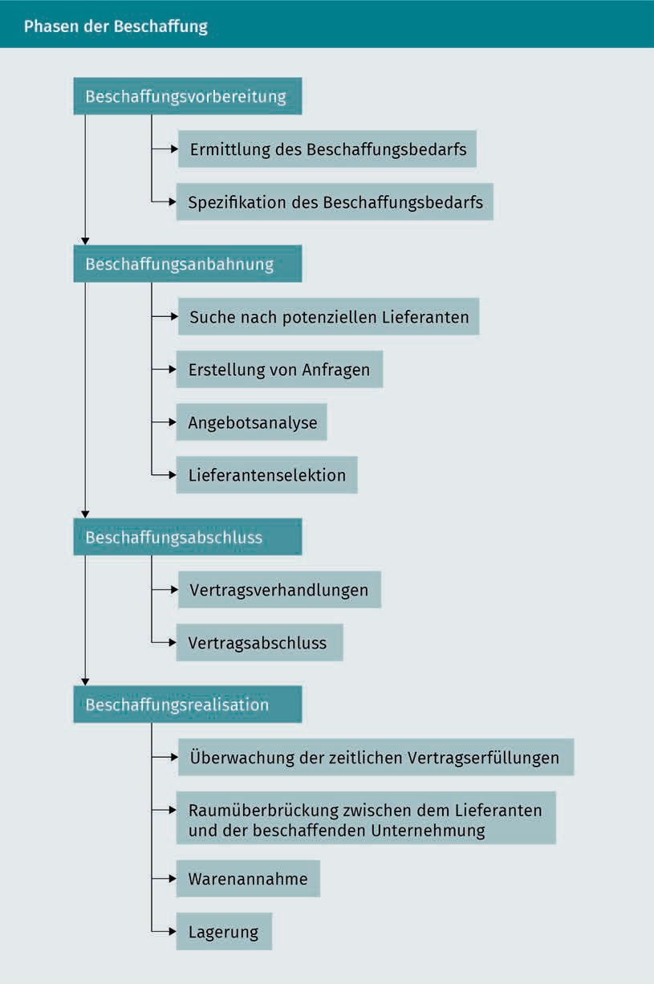

Purchasing and Procurement

As in other departments, the objectives of procurement are derived from the corporate objectives. There are two distinct categories of objectives relating to procurement (cf. Piontek 2016a, page 11):

* Material objective: To safeguard the long-term supply of items needed for the manufacture of goods
* Financial objective: To optimize the costs and benefits associated with the supply of materials and thereby maximize profits.

The material objective focuses on ensuring the supply and quality of materials required for production, while the financial objective is defined more broadly and can be broken down as follows: maximizing performance and cost-cutting potential by optimizing procurement costs,stock availability and the effects of procurementon liquidity,as well as protecting the company’s independence and positioning in the procurement market. Conflicts can easily arise between these distinct objectives, particularly between “maximizing quality” on the one hand and “optimizing procurement costs” on the other (Kaluza 2007, p. 23).

Procurement objectives may be categorized as either strategic objectives or tactical/operational objectives:

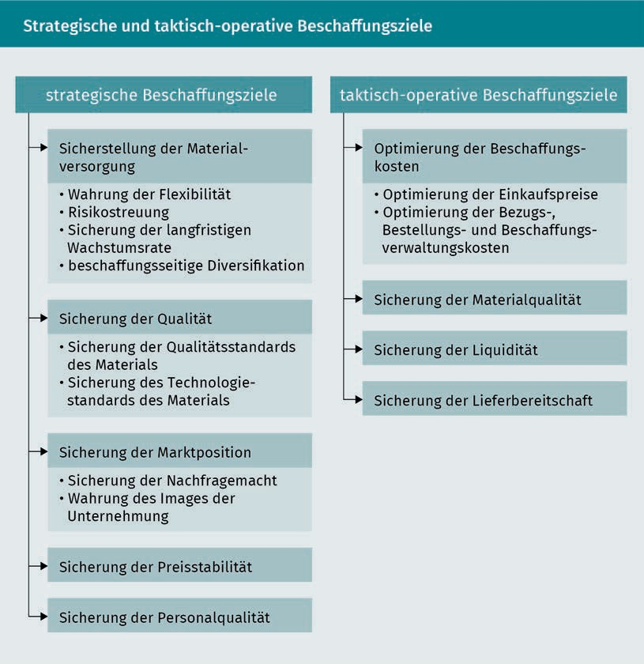

The requirement to “reduce procurement costs” includes minimizing the cost price of individual items as well as reducing the functional costs associated with procurement. Conversely, the requirement to “increase procurement quality” aims to minimize the deviations between demand and supplier performance for maximum compatibility.

The requirement to “maximize procurement reliability” implies selecting the line of action with the least (objective or subjective) likelihood of undesirable change. This goal aims therefore to avoid disruption (Piontek 2016a, p. 13).

Conversely, the requirement to “maximize procurement flexibility” seeks to overcome potential disruptions by selecting the line of action with the most options in the event of external or internal changes (Piontek 2016a, p. 13).

Purchasing and Procurement

When planning procurement objectives and strategies, the first step is to define the principal procurement objective in line with the company’s overall strategic goals. The subsequent step is to assign secondary objectives while ensuring compatibility between the procurement objectives and other functional objectives. Strategy planning can follow a similar approach, i.e. first define a principal strategy in line with the procurement objective, then assign secondary strategies.

### Make-or-Buy Decisions

Make-or-buy refers to the complex decision of whether to manufacture a product or service in-house or source it externally. A buy decision leads to outsourcing. Companies will often opt for a buy decision if they have limited capacity, do not own the relevant patents, or are likely to face changes in demand levels. Make-or-buy decisions generally entail certain costs or investments and may lead to reliable long-term cooperation between companies. A buy decision must be based on a detailed cost analysis and quality assessment of the future supplier/service-provider.

There are many different motivations for a buy decision and hence the partial outsourcing of production (including the relevant planning and support processes, where applicable) (Piontek 2002, pp. 15-17).

###### Focus on core competencies

A company’s core competencies tend to be resource advantages which, in the longer term, set it apart from its competitors in the eyes of the customer. These may include specialist knowledge (knowledge resources) or particular process abilities. Core competencies may be defined as follows (Piontek 2016a, p. 87):

* They give customers added benefits.
* They help distinguish a company from its competitors.
* They create the basis for a broad spectrum of products.
* They are often difficult to imitate.
* They are advantageous when tapping into new markets.

Companies must identify their core competencies because these are pivotal processes for adding value. By focusing selectively on its core competencies, a company can maximize its key potential for success. Conversely, this means that all aspects outside of its core competencies should be outsourced to third parties.

This will help to make its in-house operations more transparent, allow it to focus more of its attention on its customers, and create significant scope for minimizing its (fixed) costs (Piontek 2016a, p. 87).

###### Acquiring expertise

Companies do not have sufficient expertise to compete successfully in all areas. A lack of expertise in a particular segment may prompt it to outsource selected tasks to an external service-provider or company specializing in that field.

As well as having additional in-depth knowledge, the supplier/service-provider is usually able to deploy their resources more efficiently, resulting in shorter response times, higher service standards, a stronger customer focus and greater innovativeness. As specialists they may be more successful than their customer in a particular field and therefore may contribute to the latter’s success.

###### Flexibility

**Outsourcing** is an opportunity for companies to incorporate innovations more rapidly into their business. Conversely, companies with a lack of expertise and excessive complexity may be slow to react and adjust to new situations.

Outsourcing is also an opportunity to collaborate with a partner whose core expertise allows them to adapt more rapidly to changes in their sector, thereby securing competitive advantages and cost benefits for the outsourcing company. When there are fluctuations in demand, the supplier/service-provider can allocate spare capacity to their clients, thereby minimizing unused capacity and losses.

###### Potential cost savings

Outsourcing An outsourcing decision may cut costs – but may equally have the opposite effect.

Outsourcing has the potential to cut costs if the service-provider is in a position to generate and supply items more cheaply because its overheads, staff costs and material costs are lower. Lower overheads are usually associated with fewer managers and less coordination work. More favorable staffing and remuneration structures coupled with a more uniform utilization of personnel capacity help to lower personnel costs and use resources more cost-effectively through best use of capacity and effective pooling of resources.

Purchasing and Procurement

One of the main reasons for outsourcing services is the associated variability of fixed costs. With in-house manufacturing, companies must have suitable technical and personnel capacity available even if it is not being utilized. By contrast, outsourced capacity does not incur costs unless it is utilized. The correlations are illustrated by the following (somewhat oversimplified) diagram. Technical and personnel capacity must be increased to keep pace with growing demand, leading to a sharp rise in fixed costs.

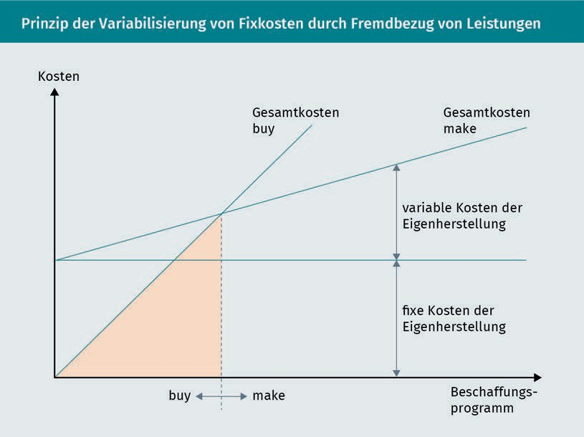

When considering costs, it is important to include the transaction costs associated with the changeover to outsourcing, such as the increased need for coordination, inspections, adjustments to accommodate the service-provider’s systems, invoicing and monitoring of agreements.

However, a buy decision may also entail numerous problems (Piontek 2016a, p. 88):

* The more complex tasks and services become, the greater the risk of becoming dependent on the service-provider. Once a decision has been made to outsource services, it can be difficult to reverse, which may prove tricky if the anticipated benefits fail to materialize. Dependency can also affect the service-provider. By limiting their business to a small group of customers, they are at risk of becoming very dependent on them and losing out on alternative sources of revenue.

Both sides face risks, but these can be minimized by adopting an open and collaborative approach to the partnership.

* + The risk of losing specialist expertise is particularly critical if the outsourced activities are core services or supplementary processes where the core competency goes unrecognized. If a company gives up its own strengths too readily, it may find its valuation adversely impacted, because these are the very strengths that set it apart from its competitors. To minimize this risk, companies should be aware of the depth of knowledge associated with the outsourced service and how closely it aligns with its core business.
  + Outsourcing does not necessarily save costs and may even result in higher overall costs if the company miscalculates its own and other related costs. Incorrect cost accounting and offsetting may lead a company to miscalculate its own manufacturing costs and make outsourcing appear attractive. For example, if a company is committed to a zero-defect strategy or simultaneous engineering (where development and production processes are organized synchronously with the supplier), an effective exchange of information and a “simultaneous warning light” system are crucial considerations.

Outsourcing projects may also entail additional transport, insurance and process costs and increased quality assurance costs, which must be taken into account.

Other risks include:

* + More interfaces
  + Additional planning work
  + The cost of letting staff go and related social compensation plans
  + Teething problems.

However, the aforementioned risks can be minimized or even eliminated by following these rules:

* + Select suppliers based on their competency
  + Involve the service-provider in the planning phase
  + Adopt a cooperative approach to workforce downsizing
  + Specify interfaces precisely
  + Clearly define the obligations to be met by both sides
  + Balance opportunities and risks fairly
  + Consider transaction costs
  + Make long-term decisions

Purchasing and procurement

### Insourcing and Outsourcing Strategies

The term “outsourcing” means transferring operations, or parts thereof, to external service-providers. Reducing the service scope in this way can help to alleviate uncertainties relating to deadlines and volumes and allow the company to scale back its inventories. An extensive service scope entailing large numbers of different processes creates increased complexity associated with

* Production based on sales forecasts (make to stock)
* Technical and disposition-related problems in the event of changes
* Extensive space requirements
* Long throughput times
* Time-consuming materials handling, warehousing and transportation.

As well as the make or buy decision, companies must also decide how to incorporate the outsourced services into their institutional structures. This in turn determines the strength of cooperation with and commitment to an external partner. Possible structures include a subsidiary, shareholding company (internal outsourcing) or entirely separate company (external outsourcing). Outsourcing strategies may be roughly classified as follows:

* Internal outsourcing means relocating selected processes and services within a Group, strategic alliance or joint venture. Depending on the institutional incorporation of this partnership, this may entail equity investments or the establishment of joint service companies.
* External outsourcing can be classified into long-term, short-term, medium-term and spontaneous collaboration, depending on the duration of the agreement. We also distinguish between selective, complete and business process outsourcing, depending on the level of outsourcing. Selective outsourcing means outsourcing only selected aspects to a partner company, which then becomes responsible for the correct delivery of that specified sub-function only. Complete outsourcing means outsourcing an entire segment to a third company, including the transfer of resources, orders and management responsibility.
* Business process outsourcing means outsourcing an entire business process to an external company which then assumes complete responsibility for that business process. If the external service-provider has a direct involvement in the buyer’s risks and success, this is known as **co-sourcing**.

Co-sourcing

Co-sourcing is when the buyer and supplier share the risks and profits on a partnership basis.

Internal sourcing Internal sourcing refers to the spatial integration of suppliers.

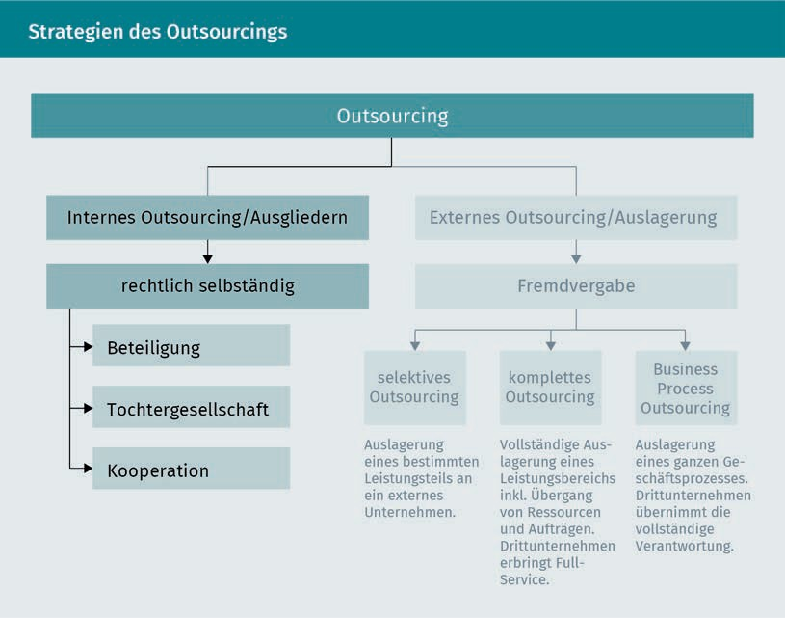

Strictly speaking, insourcing means combining different supply chain activities into one company. The following are examples of insourcing (see Piontek 2016b, p. 66):

* Expanding or adding new business activities
* Reincorporating services into the company that were previously contracted out (re-insourcing)
* Integrating the supplier’s services on-site at the client’s premises (**internal sourcing**)

While the first two examples refer to in-house production or manufacturing, the third refers to a very particular form of cooperation with the supplier in order to gain control of an extended section of the supply chain without foregoing the flexibility and fixed cost benefits of outsourcing.

From this perspective, internal sourcing could be considered an intermediate format somewhere between a supply chain partnership and in-house production and is becoming increasingly popular in the automotive industry. Rather than becoming comprehensive manufacturing plants, factories are reinterpreted as structures of numerous small, flexible modules (manufacturing segments) which simply move to the location with the best blend of production conditions.

Purchasing and Procurement

Insourcing distinguishes between four different strategy variants (Piontek 2016b, p. 67):

* + In variant one, the supplier’s staff autonomously assemble modules on the buyer’s existing production or assembly lines. By linking directly into their production requirements, the buyer can exercise effective control and limit the degree of freedom afforded to the supplier.
  + In variant two, the supplier relocates their own equipment to vacant space at the buyer’s premises or alternatively, purchases equipment from them. Modules are assembled and fitted into the end product in collaboration with the buyer’s own personnel. The transfer of ownership reduces the buyer’s opportunities for control.
  + Creating an industrial park is the third insourcing variant. Several of the buyer’s core suppliers relocate their customer-specific production operations to the immediate vicinity of the buyer’s own production facilities. The greater the distance from the production site, the more limited the buyer’s opportunities for control become.
  + The fourth and final variant is for the buyer and supplier to jointly set up an assembly or parts production company with shared costs and the joint deployment of personnel.

The different insourcing variants are illustrated below.

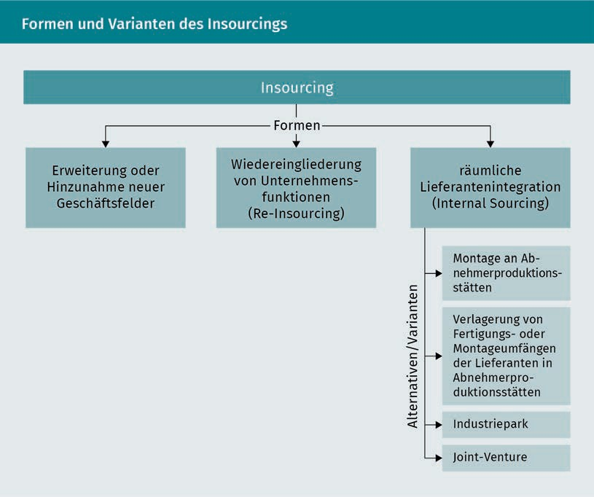

From the buyer’s/OEM’s perspective, there are several motivating factors for internal sourcing (spatial integration of suppliers), as follows (Piontek 2002, p. 21f.):

* + - Improved opportunities for control and influence: a key motivator for vertical supplier integration is the opportunity for superior control and influence over the insourced section of the value chain. If production or quality problems arise, the buyer can intervene directly and solve the problem in collaboration with the supplier’s employees.
    - Capacity maximization: close collaboration with the supplier and spatial integration helps to improve coordination processes within production, reduce buffer stocks, shorten throughput times, and maximize capacity utilization. The buyer can balance out headcount fluctuations and capacity bottlenecks by borrowing staff from less busy divisions.
    - Know-how gain: collaboration and partnership between the two workforces at the same production facility fosters innovation and pools expertise. The supplier and the buyer are able to combine their shared CIPs (continuous improvement processes).

Purchasing and procurement

* + Improved communications: shorter communication lines and fewer organizational interfaces leads to improved communications, shorter response times and greater flexibility. Problems can be analyzed and rectified immediately in a face-to-face discussion.
  + Business process optimization: while the supplier retains responsibility for their services, it becomes possible to create end-to-end business processes and minimize interfaces in production, logistics and administration.
  + Cost cutting: cost cutting is another motivating factor for internal sourcing. Positioning the supplier on site at the buyer’s premises saves on transport costs.
  + Reducing fixed costs: selling machinery and systems to the supplier enables the buyer to further reduce their fixed costs.
  + Influencing transaction costs: while savings can be achieved with production-related communication and coordination costs, there are also higher one-off transaction costs associated with researching, selecting and negotiating with suitable insourcing partners.
  + Reduction of stock levels: shorter throughput times allow companies to scale back their stock levels of materials and semi-finished goods and minimize warehousing costs.

### Procurement Concepts and Strategies

Procurement strategies refer to the concepts and methods used by companies to achieve their supply-related and supply chain objectives. As we have seen, vertical cooperation with suitable suppliers is the crucial lever for optimizing the supply chain. The following aspects should be considered when devising a procurement strategy (Piontek 2016a, p. 16):

* + The market
  + The supplier
  + The product
  + Inventories
  + Capacity control
  + Processes.

The procurement strategy focus is determined by the weighting of these individual aspects. There are also various types of sourcing (Piontek 2016a, p. 16):

* + Single sourcing and multiple sourcing
  + Modular sourcing and system sourcing
  + Process sourcing
    - Stock sourcing and just-in-time sourcing
    - Conventional sourcing and e-sourcing
    - Local and global souring.

The different types of sourcing may be categorized according to supplier basis (single vs. multiple sourcing), procured items (component sourcing, modular/system sourcing and process sourcing), procurement timing (stock sourcing and just-in-time sourcing), procurement handling (conventional sourcing and e-sourcing) and procurement region (local and global sourcing).

Single sourcing means sourcing a single procurement item from just one supplier. These days, system and modular suppliers deliver entire assemblies and highly complex system components, rather than large volumes of individual components or parts. Suppliers are therefore required to perform a wide range of activities (including development tasks, selection of upstream suppliers, scheduling, coordination functions) in close collaboration with the buyer. Suppliers will often even develop their own independent, complex, tried-and-tested supply concept for the buyer’s production stream. The supplier accepts full responsibility for this concept and will be heavily penalized (contractual penalties) for any delays and quality deficiencies. With such high levels of dependency and trust, it is clear that buyers can only collaborate with one supplier per system.

When delivery volumes are split among multiple suppliers, this is known as order splitting or multiple sourcing, as a way of minimizing the risk of supply interruptions. It also has the effect of intensifying competition between suppliers. It avoids dependency on a single supplier and helps to ramp up procurement flexibility. If a buyer switches from single sourcing to multiple sourcing, the close and trusting relationship becomes more distant. It is neither possible nor desirable to maintain close relationships with large numbers of suppliers for each procured item.

When increasing the pool of suppliers, it is useful to focus on consolidating existing suppliers as well as developing relationships with new ones. Whether a potential supplier already offers the item in question is less relevant than whether they exhibit the required potential to deliver it. This may mean investigating whether they have the requisite technologies and skills and are able to commit to exceptional reliability. To boost supply capabilities and depress prices, buyers can also “play off” suppliers against one another by referencing an even lower offer from a competitor during contractual negotiations. A multiple-sourcing strategy is always appropriate for less complex, standard products which generally comply with widely used standards.

Purchasing and Procurement

The items procured may be individual, loose components (such as small parts), entire modules or modular systems (modular/system sourcing) or entire process chains (process sourcing).

In modular system sourcing, the buyer outsources a wide range of value activities to the supplier. As well as being responsible for the autonomous development, manufacturing and assembly of high-quality assemblies and product groups, the supplier also adds value with a range of services such as assembly line feeding, final assembly at the buyer’s premises, quality control and maintenance. Delivering high-quality modules and systems (such as entire motors, front ends, brake systems) allows the buyer to significantly reduce their own production depth, scale back inventories, appoint fewer specialists and concentrate on their own core competencies. Reducing the number of suppliers also reduces the complexity of supplier relationships and boosts transparency in manufacturing, but on the other hand, it also increases dependency on suppliers and reduces the buyer’s level of expertise.

From the buyer’s perspective, modular sourcing may be characterized as follows ( Krampf 2012, p. 89):

* + Procurement of a limited number of modules or systems
  + Fewer suppliers
  + A pyramid-shaped supplier structure
  + Considerably less information and control effort required for procurement and production processes
  + (Pre-)assembly, quality assurance and assembly line feeding are outsourced to the supplier.

In process sourcing, the buyer procures the entire process chain from the supplier. In other words, the process chain itself is the sourcing dimension, and value creation activities are closely linked between buyer and supplier, leading to intensive coordination and collaboration between the process chain partners. Process sourcing can be broken down into the following stages:

* + Integration of logistics into the supply chain (assembly line feeding is the supplier’s responsibility)
  + The supplier makes capacity available for the buyer to use (i.e. machine capacity and other resources are reserved for the buyer to use as and when required).
  + Integration of know-how into the supply chain (the supplier is responsible for autonomous development of the procured items)
  + Integration of disposal into the supply chain (the supplier also ensures the legally compliant disposal of procured items after use)

With stock procurement, the buyer procures more goods and materials than are currently needed and stockpiles them to secure supply.

By contrast, with just-in-time procurement, the supplier delivers the required parts or products directly to the buyer’s factory synchronously with production. In other words, the items are not delivered until they are actually needed on the production line. As a rule, only suppliers that can guarantee reliable production with short lead times can achieve this.

The buyer and supplier enter into a long-term agreement (sales agreement) spanning several years, contractually obligating the supplier to adhere to the timelines and deliver directly to the buyer’s production site. An EDI (Electronic Data Interchange) connection is ideal for facilitating fast, smooth communications.

A just-in-time strategy also requires:

* + - 100% quality assurance from the supplier
    - Spatial proximity of the supplier to the buyer’s factory
    - A high degree of flexibility on the part of the supplier
    - The use of standard containers
    - Prioritization of the flow of materials by the supplier’s production team
    - Trust-based cooperation with guaranteed data privacy.

Just-in-sequence Just-in-sequence refers to the carefully timed delivery of parts to the

production line.

The just-in-time strategy is often implemented as a **just-in-sequence** concept, whereby the delivery of parts and components is tied directly to the production line, synchronously with the buyer’s prescribed production sequence. The key benefit of this approach is that it minimizes capital tie-up with minimal stock levels while still ensuring adequate availability of the parts and materials needed for production. Production fluctuations in the buyer’s factory have a minimal impact on stock levels in the logistics chain. It also enables the buyer to respond very rapidly to customer requests for variation of supply (Krampf 2012, p. 93). The just-in-sequence concept demands exceptional coordination between all value-adding processes. The just-in-sequence concept is usually refined still further by the supplier making personnel available to carry out final assembly on the buyer’s production line.

The just-in-time procurement concept has various pros and cons:

Purchasing and Procurement

|  |  |
| --- | --- |
| Pros and cons of just-in-time | |
| Pros | Cons |
| Collaboration between partners based on trust | Buyers may become dependent on certain suppliers |
| Reduced logistics and inventory costs | More deliveries mean higher transport costs |
| Reduced space requirements | Risk of quality impairments (With shorter throughput times, the client has no time to inspect incoming goods and must rely on the supplier.) |
| Shorter throughput times | Adverse environmental impacts associated with more deliveries, plus the risk of traffic jams and accidents |
| Early quality controls by the supplier mean improved quality. |  |
| Any vulnerabilities in the order handling process are identified and eliminated. |  |

**Global sourcing** draws on a range of procurement marketing tools to systematically tap into global markets. Procurement concepts need long-term planning, from the initial intensive market research and complex contractual negotiations through to the challenges of warehousing and transportation. Adopting a more global focus will also impact national suppliers by exposing them to greater competition.

“Globalization is an essential part of consistently focusing a company’s procurement process on maximizing its development potential. There are distinct differences between global sourcing and conventional international procurement, because the former entails a strategic transactional framework which the latter lacks.” (Piontek 2016a, p. 20)

Global sourcing

Global sourcing requires a long-term (strategic) transactional framework.

### Procurement Market Research

Procurement market research refers to the planned, systematic exploration of the conditions and operations prevailing on the relevant procurement markets. It requires a systematic analysis of macroeconomic and microeconomic information about known and unknown suppliers. In some cases, the research process may be simplified by analyzing existing data (secondary procurement market research). Primary procurement market research means collating new information about suppliers and their markets. This may prove costly and is sometimes combined with sales market research as a way of cutting costs.

The objectives of procurement market research are as follows:

* To create a high level of transparency about the markets’ financial potential
* To supply decision-makers with pertinent information from the international procurement markets
* To ensure the optimum, long-term supply of materials (tapping into new procurement sources, identifying substitutes for feedstock, avoiding supply bottlenecks) by widening the procurement radius
* To promptly anticipate future developments in procurement markets which may be mutually influential
* To collate information that will help plan the future

Procurement market research focuses primarily the following key areas (Krampf 2012, p. 152):

* Market economy factors: a company’s procurement opportunities abroad depend on the market supply, demand among competitors (procurement competition on the domestic and international markets) and the various institutions involved in procurement channels. From a market economy perspective, procurement market research can therefore be divided into supply-related research, demand-related research among competitors (including demand from other substituting branches of industry) and procurement channel-related research at home and abroad.
* Research methods: a market analysis is a snapshot of the procurement market at a given moment in time, while market monitoring focuses on a longer time frame, examining past developments and forecasting the future of the procurement market.
* Regularity: given its high importance, international procurement often entails carrying out case-by-case and continuous procurement research in parallel. The chosen strategy (meeting basic supply or additional demand from overseas markets) will determine the type of procurement market research required.

Purchasing and Procurement

* + Intensity: when considering the intensity of procurement market research, we distinguish between markets at the company’s own production level (own markets) and upstream markets.
  + Information spectrum: A distinction is made between product- andsupplier-related information requirements and those that are country specific, depending on the specified requirements of procurement market research.
* Product-related information requirements include component parts, quality, manufacturing processes, characteristics and potential uses of the procured items.
* Supplier-related information requirements include size (turnover), production range, customer base, order volume and capacity.
* Country-related information requirements cover the quantity and size of the procurement regions, infrastructure, economic system, foreign trade volumes, debt, trade barriers and any peculiarities relating to a country’s ethnological composition.

The different types of information required in procurement market research may be classified as follows (Piontek 2016a, p. 26):

* + Information about demand
  + Information about pursued goals and strategies
  + Information about procurement markets
  + Information about the company’s own portfolio of markets and suppliers
  + Information about the tools used
  + Information about monitoring results.

The following diagram illustrates the content of a procurement information program:

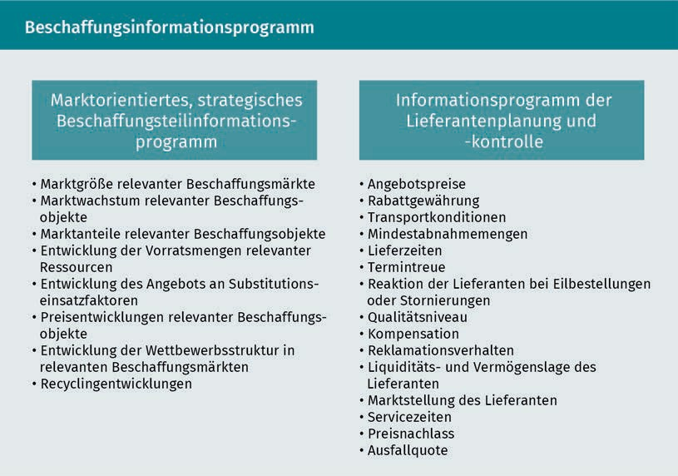

### Supplier Management

Supplier management is responsible for optimizing the supplier/buyer relationship and for building and cultivating a core pool of suppliers. The emphasis is on suppliers who see themselves as value creation partners and offer exceptional stability, performance capabilities, commitment and future potential. The aims of supplier management are as follows (Piontek 2016b, p. 82):

* To objectively gage supplier reliability
* To identify suppliers’ sourcing capabilities
* To increase the security of supply
* To establish a pool of suppliers
* To identify supplier requirements
* To identify supplier achievements
* To speed up the order placement process
* To practise supplier monitoring
* T0 promote and develop suppliers

Supplier management is a form of process management focusing on the following sub-processes (Janker 2008 p. 33):

* Supplier identification
* Supplier limitation

Purchasing and Procurement

* + Supplier evaluation
  + Supplier selection
  + Supplier monitoring
  + Supplier promotion
  + Supplier development

Initially, supplier identification aims to identify suppliers who are capable of delivering the procured item based on an analysis of potential, rather than a concrete evaluation. Procurement market research is tasked with identifying new suppliers who meet the specified requirements. This is easier when the supplier database already contains a sufficient number of suitable pre-assessed suppliers. Otherwise, new suppliers must be found, who meet the specified requirements. The following are useful for supplier identification:

* + Market reports
  + Electronic trade directories
  + Invitations to tender
  + Unsolicited supplier applications via the purchasing homepage
  + Third-party references
  + Benchmarking
  + Trade fairs and exhibitions
  + Electronic marketplaces

Supplier limitation entails reviewing suppliers’ suitability to meet relevant procurement requirements. Where there are many potential candidates, these will need to be shortlisted for the subsequent supplier evaluation. Shortlisted suppliers may be classified according to various criteria, such as the value of the procured items, delivery frequency, price level, risk potential, distance, qualification level and so on (Large 2006, p. 225f.; Heß 2008, p. 261). In a subsequent step, the shortlist can then be whittled down based on knockout criteria (price, delivery time, service etc.) in order to eliminate any suppliers that do not satisfy the minimum requirements.

The main aim of **supplier assessment** is to collate, select, process and evaluate information and data to create transparency about future supplier potential. The criteria for analysis include the following (Piontek 2016b, p. 84):

* + Service potential
  + Volume potential
  + Quality potential
  + Research potential
  + IT potential

Supplier assessment

Supplier assessment incorporates both quantitative and qualitative techniques.

* + - Cooperation potential
    - Financial potential
    - Environmental potential
    - Logistics potential
    - Trust potential

Any changes in the suppliers’ performance characteristics should likewise be continuously updated and monitored, including:

* + - The supplier’s market and industry position
    - The supplier’s ownership and share structure
    - The supplier’s resource situation
    - The supplier’s innovative potential
    - The supplier’s financial situation and credit rating
    - Type and scope of expertise and core competencies
    - Delivery reliability (adherence to delivery dates and quality)
    - Corporate image
    - International experience

A variety of methods and approaches, both qualitative and quantitative, may be used to evaluate suppliers (Piontek 2016b, p. 84). Qualitative approaches are based on an evaluation of subjective assessments. These documented subjective opinions provide a plausible basis for decision-making. Qualitative approaches may be differentiated according to the presentation format and consolidation of the criteria as follows:

* + - Grading systems
    - Point scoring models
    - Cost/benefit analysis
    - Profile analysis
    - Supplier gap analysis
    - Portfolio analysis
    - Supplier typologies e.g. based on certificates
    - Checklists
    - Concept competitions
    - Supplier days
    - Audits

Quantitative procedures help to make supplier selection more objective with the aid of numerical and monetary assessment criteria. Models include:

* + - Price and cost analyses
    - Total cost of ownership (TCO)
    - Indicator system
    - Balance sheet analysis

Purchasing and Procurement

In specific **supplier selections**, there are two consecutive levels of selection (Piontek 2016b, p. 85):

1. Strategic supplier selection: a supplier is chosen for their long-term potential for success. The supplier is deemed a reliable value creation partner with the capacity to influence the buyer’s key strategic success potential. The value-adding partner receives a long-term contract.
2. Operational supplier selection: a supplier is selected according to short-term operational criteria (such as price, delivery times and delivery volumes) for a specific procurement item. They enter into a short-term agreement with the buyer.

Supplier monitoring has to perform the continuous review and oversight of suppliers. Suppliers must meet their targets and be integrated into the target agreement process. They should also be involved in identifying different types of waste and be incorporated into various supplier support programs.

Supplier support involves advising and actively supporting the supplier with complex operational issues they cannot resolve themselves. Individual supplier support tools may be applied to a range of problems experienced by suppliers, primarily relating to their own production sector. The buyer supports and advises suppliers on a range of rationalization, technology migration or quality optimization projects by contributing their own specialist know-how and thereby helping to ensure the success of these measures. This may include sharing expertise and even loaning specialist personnel. Value analysis teams are deployed across companies to boost efficiency, particularly in the production sector. As well as offering support with production, the buyer may also assist with procurement, sales and financing. Supplier support can identify any deficits such as a lack of expertise, inadequate capacity or missing patents, and work with the supplier to develop specific solutions.

### Information and Communication Systems in Purchasing and Procurement

Online ordering and electronically assisted procurement activities can speed up supply rates as well as enhancing price transparency and providing the buyer with real-time information about order handling and delivery status. E-sourcing provides support throughout all procurement administration and operational phases.

Supplier selection Supplier selection may be either short-term (operational) or long-term (strategic).

Various operational activities such as writing proposals, generating purchase orders, confirming quotes and processing invoices are automated, freeing up the buyer to focus their attention elsewhere. Strategic procurement activities such as procurement market research, controlling and supplier relationship management (SRM) also become much simpler and more effective with electronic support.

Electronic procurement is particularly effective at achieving operational improvements in the following areas (Piontek 2016b, p. 1):

C-parts Low-value parts are known as

C-parts.

* Merchandise tracking & tracing
* Automated procurement and electronic payment handling using a purchasing card
* Electronic handling of ordering processes
* Standardization of procurement processes
* Optimization of **C-part** management with faster procurement
* Supplier relationship management (intensification of supplier relationships).

The following tools and concepts are well-established in the successful implementation of e-sourcing (Piontek 2016b, p. 227).

###### Desktop Purchasing System (DPS)

DP systems (DPS) are multi-supplier catalogs made available to buyers by the company or a service-provider and tailored to their requirements. Pre-qualified suppliers are listed together with extensive information about their products and prices, classified into product and material groups to enable the buyer to quickly select and order items online according to their specified criteria.

Multi-supplier catalogs are made available to buyers via an intranet and configured to suit the individual user, who then fills their electronic shopping cart and places an order or combines it with orders from other departments. If the shopping cart does not meet the rules previously defined by Central Purchasing (e.g. if it exceeds the budget), the order will automatically be submitted for review and, where applicable, an electronic approval process initiated. Orders are not forwarded to the supplier until approved.

The key to successful operation of an e-procurement system is to harmonize the company’s own ERP (enterprise resource) system with the supplier’s external systems and business processes.

The functions and potential applications of DP systems are outlined below

(Piontek 2016b, p. 227):

Purchasing and Procurement

* + Based on a uniform user interface, DP systems provide access to all relevant supplier information.
  + DP systems may be integrated into the buyer’s own ERP system.
  + DP systems are implemented by the buyer.
  + All procurement processes are supported.
  + Relevant individuals in the approval workflow are notified by email.
  + Incoming quotes are ranked in order according to the procurement objectives.
  + Dynamic pricing is supported via auctions and tenders.
  + Availability checks, warehouse stocks and prices can be retrieved in real time.

###### Provider systems

Alternatively, e-catalogs can also be made available by a content provider (**broker**). There are two categories of services offered by content providers (Piontek 2016b, p. 228):

1. Content broking: In content broking, catalog maintenance is completely outsourced. The content broker decides which suppliers are included in the MSPC (multiple supplier product catalog). For example, Commerce One offers a content broker service in conjunction with its marketplace, payable on a per-transaction basis.
2. Content service: The service-provider fills the MSPC with data and then makes it available to the purchasing company. MSPC is an electronic procurement catalog made up of numerous individual supplier catalogs. The main role of the content service is to aggregate this data and improve its quality.

Content managers support a wide range of procurement processes:

* + Upload and authorize e-catalogs
  + Automate updates to catalog data
  + Integrate data into an e-catalog format
  + Classify products and services

###### Online reverse auctions

Electronic reverse auctions invite suppliers to submit online quotes for a specific product at a specified time. Provided the quality is the same, the order will go to the supplier offering the cheapest price. Price quotes are dynamic, in other words, suppliers can modify their prices several times until the auction ends. Procurement costs can be significantly reduced by selecting the cheapest supplier.

Broker

The online broker more or less takes over the procurement functions.

In this way, the buyer triggers direct competition between suppliers and determines the rules by which they must compete. Rather than negotiating with each supplier individually, suppliers bid against one another within a predefined time window, giving the buyer a precise overview of quotes and price/performance ratios in “real time.” In a reverse auction, the supplier who can manufacture and deliver the products at the lowest price wins the contract. The Internet is an inexpensive and cost-effective platform for auctions; it eliminates the need to make telephone calls, set up meetings, and travel to and attend on-site meetings. Internet auctions also attract more bidders and therefore lead to cheaper prices.

###### Electronic freight exchanges

An electronic freight exchange is used to balance out shipping demands, i.e. shippers can book spare freight capacity at haulage companies and freight forwarders in exchange for a fee, while haulage companies and freight forwarders can advertise spare capacity. Electronic freight exchanges also offer a wide range of value-added services, including credit checks, risk analyses and merchandise tracking.

Buyers can use the freight exchange to select the haulage company with the cheapest, most effective solution to their requirements (Schulte 2e01e6, p. 384f.).

This helps to significantly reduce the number of empty runs. For example, if a shipment from Bremen to Munich has no return load and an order for this destination is found in the freight exchange, the haulage company or freight forwarder can improve their vehicle capacity utilization and, ultimately, their margins.

The electronic freight exchange is also more profitable for buyers, because they will usually get discounted freight rates. The service-provider would rather accept a reduced rate than send back an empty truck.

Generally speaking, electronic freight exchanges are not used for regular shipments from A to B but come into their own for covering sudden peaks in demand with flexible forwarding. They could therefore be described as spot markets (short-term markets).

The value of an electronic freight exchange is determined by daily supply and demand. The more haulage companies and freight forwarders advertise on the exchange, the greater the choice available, and hence the greater the opportunities and incentive to find a suitable order and partner.

Purchasing and Procurement

Apart from minimizing empty runs and maximizing value-added services, other benefits of the freight exchange include the opportunity to build new, long-term business relationships.

###### Electronic marketplaces

Electronic marketplaces are virtual spaces where large numbers of buyers and suppliers can negotiate and collaborate online. Electronic markets provide buyers with the opportunity to exchange large volumes of data with suppliers, automate transactions and procure many value-added services. A distinction is made between horizontal and vertical marketplaces. Horizontal marketplaces transcend different industries, while vertical marketplaces focus on industry-specific goods and services.

Buyers can use all the conventional economic functions of a competitive market without having to be physically present. Supplier selection, contractual negotiations, invoice handling and supplier monitoring are fast and efficient. Furthermore, electronic markets offer countless options for collaborating with suppliers, including the joint development of new projects and products in virtual development spaces (the “Supply On” marketplace is a good example).

The wide range of information available on electronic marketplaces gives buyers access to extensive data about their suppliers’ credit rating, previous customer reviews, and industry and customs information.

These marketplaces also support connection of the companies’ own ERP systems to the marketplace system via various interfaces to accelerate information flows and ensure that order data is posted automatically. This also allows the materials flow between supplier and buyer to be displayed in real time.

### Organization of Procurement

Procurement requires a suitable framework structure to regulate the associated responsibilities and competencies. In particular, it is important to clarify how tasks are divided between the central procurement department and local procurement units. There are three basic organizational structures which may be used:

###### Centralized procurement

A central procurement department (parent company) is responsible for developing procurement plans and strategies with binding effect for the local procurement units (subsidiaries). Head office is responsible for overall decisions and general procurement and warehousing tasks in the interests of the entire company.

Subsidiaries are only involved in tactical procurement decisions and may make operational decisions themselves (see table “Decision-making levels”).

The centralization of procurement helps to create an overview of the entire procurement market. It also increases the company’s market power with larger procurement volumes, enabling it to negotiate better prices. Synergy effects can be achieved with bulk orders. On the other hand, centralized solutions may lead to longer order times, and may therefore be better suited to subsidiaries with identical or similar demands for homogeneous goods.

|  |  |  |
| --- | --- | --- |
| Decision-Making Levels | | |
| Purchase decision-making levels | Critical success factors in purchasing | Responsibility |
| Strategic decisions   * Define success factors * Draw up supplier and product specifications * Long-term demand planning * Long-term purchasing policy | * Purchasing power or partnerships * Product risk * Supplier risk | Central procurement |
| Tactical decisions   * Medium-term supplier selection * Negotiations * Performance measurement criteria | * Agreed targets * Supplier certification * Supplier incentives / contributions | Local / central |

Purchasing and Procurement

|  |  |  |
| --- | --- | --- |
| Purchase decision-making levels | Critical success factors in purchasing | Responsibility |
| Operational decisions   * Orders * Call-off orders * Deadline tracking * Invoice handling | * Lead times * Delivery reliability * Performance monitoring * Payment terms | Local purchasing |

###### Local procurement

With this option, the local purchasing departments assume most of the procurement tasks and responsibilities themselves, while the central procurement department acts in an advisory/coordinating role and procures only those goods that are centrally required.

This solution is appropriate where the purchasing program comprises a heterogeneous range of goods which the subsidiaries are able to locate and purchase more rapidly themselves. Because the purchasing volume per subsidiary tends to be small, their potential power is limited.

###### Polycentric solution

The key consumers of selected material/product groups are identified, and one subsidiary takes the lead on their behalf when purchasing selected items. In this way, responsibility for procurement is delegated to the subsidiary with the greatest interest in a particular materials category, which then procures them on behalf of the entire Group. In this way, even small subsidiaries can take advantage of lower prices.

The key consumers tend to have the best supplier contacts and are well-informed about the relevant products and markets, allowing them to secure the best purchasing conditions without any intervention by head office.

Summary

Procurement and purchasing should contribute to the security of supply as well as helping to lower costs. Conflicts of interest can arise due to the many different strategic and tactical/operational objectives pursued.

The first challenge faced by procurement departments in relation to materials management and control is to decide which goods to source externally and which to produce in-house, making allowance for a host of qualitative and quantitative criteria.

If an outsourcing decision is made, an appropriate outsourcing strategy will then need to be determined and the most suitable supplier integration format (internal sourcing) considered.

The remaining sourcing strategies must take into account the timeframe of the supplier’s involvement (for example, just in time) and the complexity of the procured item (e.g. modular sourcing). A decision must also be made regarding the geographical extent of procurement (e.g. global sourcing).

The purpose of procurement market research is to systematically analyze the relevant conditions and transactions on the procurement markets. In the interests of transparency, it is important to collate as much information as possible about the suppliers and their markets.

Supplier management entails countless sub-processes, with an emphasis on supplier evaluation and selection as well as on strengthening relationships with suppliers.

Information and communications systems offer a range of new technologies aimed at supporting and optimizing procurement processes, ranging from multi-supplier catalogs to complex electronic marketplaces.

Finally, it is necessary to clarify how procurement will be organized and the degree of centralization in procurement decision-making.

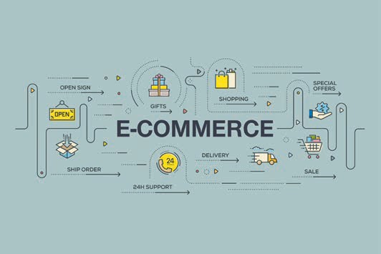

# Unit 2

## Fundamental Principles of Distribution

#### STUDY GOALS

On completion of this unit, you will be familiar with ...

... The vast potential of distribution

... The importance of distribution and related tasks

... The different distribution strategies

... The particular importance of distribution logistics

... The tasks of operational distribution.

DL-D-DLBLOISCM102-L02

1. Fundamental Principles of Distribution

### Case study

The importance of e-commerce as a new distribution channel has grown since the early 2000s. Not only has this led to changes in purchasing behavior, it has also directly impacted freight forwarding, particularly in urban areas. Online trade relies on delivering merchandise to the end customer and the associated logistical processes. New delivery concepts are being devised to handle rising numbers of consignments with smaller quantities per order and integrate them into existing structures in high-density areas. The idea here is to ease the transport pressures in towns and cities.

In 2016, online retail sales in Germany recorded a new high of €52.7 billion, a year-on-year market volume growth of 12.5%. E-commerce now makes up around 11% of the entire retail volume. Online marketplaces such as Amazon and Ebay still hold the lion’s share, with half of all online sales. However, multi-channel marketing is also promising success, accounting for almost one-third of online revenues in 2016 (just under €17 billion).

### Distribution Tasks

Distribution covers a broad range of tasks. It is much more than just bridging time and space. Distribution encompasses all decisions involved in solving economic, legal, communicative and (in particular) logistical problems associated with the distribution of products and services. Distribution therefore encompasses both acquisition-related and physical tasks.

Distribution policy aims to optimize the structure of a distribution system while also maintaining performance (Piontek 1995, p. 32).

* Firstly, this involves defining the channels and routes via which the manufacturer’s goods will reach the end customer. This entails selecting suitable distribution agents to perform this task.
* Secondly, decisions must be made regarding physical distribution logistics by defining the modes of transport, vehicles, delivery and capabilities, and the number and locations of sales and distribution depots in order to achieve the best possible distribution of services.

Fundamental Principles of Distribution

Distribution functions may be classified into macroeconomic and microeconomic tasks. The macroeconomic functions are illustrated below:

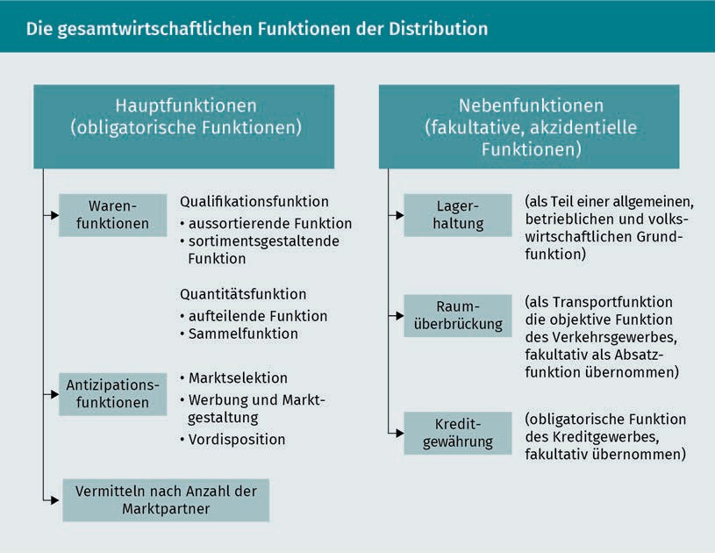

The above macroeconomic function descriptions are too abstract for decision-making purposes, and microeconomic distribution functions are more intelligible from a business perspective. Specifically, these are:

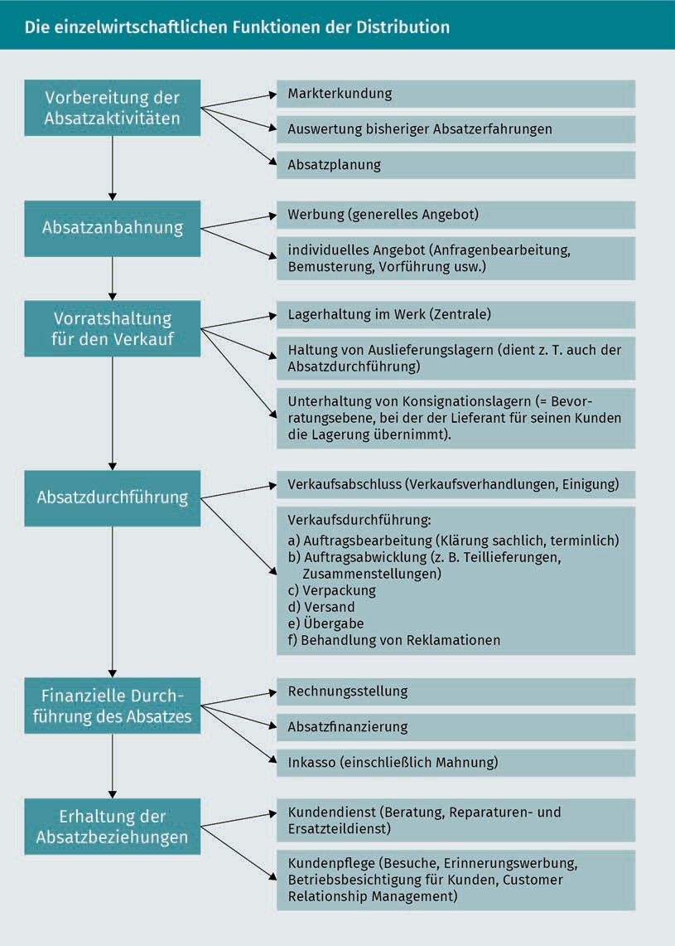

When defining the distribution range , a distinction is made between distribution density and distribution level.

Fundamental Principles of Distribution

* Distribution density is the ratio between the number of transactions with a particular brand in a defined sales region and the geographical size of that region.
* Distribution level is the ratio between the number of transactions with a particular brand and the total number of sales outlets. Numerical distribution and weighted distribution are the two best-known indicators.

### Operational Distribution Agents

The requirements placed on operational distribution agents have grown relentlessly in recent years (Schulte 2016, p. 695):

* Industrial and trading companies face ever-greater demands from customers regarding delivery times. Call-off rates have increased, and deliveries are being broken down into multiple parts for short-term delivery.
* Customers are demanding greater delivery reliability. With buffer stock levels reduced, any missing or delayed deliveries will incur significant out-of-stock costs. Service standards are now pivotal to companies’ competitive strategies.
* There are also increasing demands in terms of delivery flexibility. As demand in many markets changes ever more rapidly, more frequent modifications are being made to production ranges, which affect the entire value creation chain.
* Many companies have significantly expanded the breadth and depth of their product ranges, which in turn increases the complexity of material and merchandise flows.
* Product lifecycles have shortened, while at the same time, the rates of product change have accelerated. The combination of these two factors necessitates more frequent modifications to material and merchandise flows.

The following distribution agents can generally be distinguished (Specht & Fritz 2005, p. 47ff.):

1. Industrial companies
2. Marketing and trading companies
3. Sales syndicates and cooperatives
4. Wholesalers and retailers in a range of company and consortium formations (including market events for consumers, wholesale markets etc.)
5. Consumer purchasing groups
6. Commercial agents, commission agents, commercial brokers, brokers
7. Market research and advertising agencies, advertising media, banks, information offices, insurance companies, customer service workshops, freight forwarding companies, haulage companies, warehouses, trade fairs, exhibitions, exchanges, auctions etc.

Channel policy A channel policy entails selecting sales channels and

distribution agents.

The primary task of a **channel policy** is to select the correct channel from the various alternatives available in a given sub-market. The channel policy requires decisions to be made on the following:

* The length of the channel, i.e. the number of marketing levels between manufacturer and consumer
* The depth of the channel, i.e. the different types of distributors and trading companies at each marketing level
* The breadth of the channel, i.e. the number of similar sales agents and outlets within the various types of agencies and trading companies
* The distribution system, i.e. the nature of cooperation between the manufacturer and the distributors within the sales channel

The selection of suitable distributors and sales channels is governed by many different factors (Ahlert 2002, p. 174; Piontek 1995, p. 126f.):

* The extent of functions by intermediaries in the channel
  + The extent of process activities by intermediaries such as customer advice, customer support, logistical activities, financial management
  + The quality of these process activities
* Sales channel-specific revenues
  + Sales volume per channel
  + Maximum pricing per channel
  + Order mix in terms of materials (composition of the range)
  + Sales structure (number and size of orders relative to the number of channels)
* Costs and capital tie-up per channel
* Potential future sales
  + Average annual growth rates achievable per sales intermediary
  + Type and duration of contracts with intermediaries
* Market presence of distributed items
  + Distribution density (number of stores relative to the population size or geographical area of a sales region)
  + Level of distribution (number of stores relative to potential outlets in a sales region (or the number required by the manufacturer or expected by the consumer)
  + Likelihood of a product being available at a given location
  + Number of outlets that stock the product relative to the total number of outlets
* Channel image
  + Item’s look and feel at the final stage of the channel
  + Reputation of the store from a potential customer’s perspective
* Flexibility of the channel

Fundamental Principles of Distribution

* + Time needed to build the channel
  + Willingness and ability of agents to adapt to strategy changes by the manufacturer
  + Required level of loyalty from the manufacturer to the channel
* Distribution of power within the channel
  + Manufacturer’s relative position of power within the channel
  + Willingness of intermediaries to coordinate their conduct and make sales commitments (willingness to cooperate)

### Distribution Logistics

**Distribution logistics** (transfer sector) is tasked with bridging the space and time disparities between production/availability of the goods and demand/consumption. Distribution logistics is the link between the supply of goods and their removal from the market. It is a sub-system of distribution and must follow its directives.

The supply of goods refers to the finished product at the end of the production process, while removal from the market refers to an action by the buyer/consumer i.e. the purchase itself. Distribution logistics aspires to optimize distribution within the constraints dictated both by the product itself as well as the transport technology, infrastructure, costs and other relevant factors. It therefore entails setting up and operating channels for the flow of goods (i.e. the logistical infrastructure) (Schulte 2016, p. 695).

Essentially, the logistics system for distribution includes the following input:

* Planning of warehouses, warehousing, transportation, packaging and order fulfilment
* Information from systems required for target achievement
* Control measures which regulate the system through feedback.

The following illustrates the links between operational logistics (which are largely controllable) and the output of distribution logistics (which is not fully definable).

Distribution logistics Distribution logistics is a sub-system of distribution.

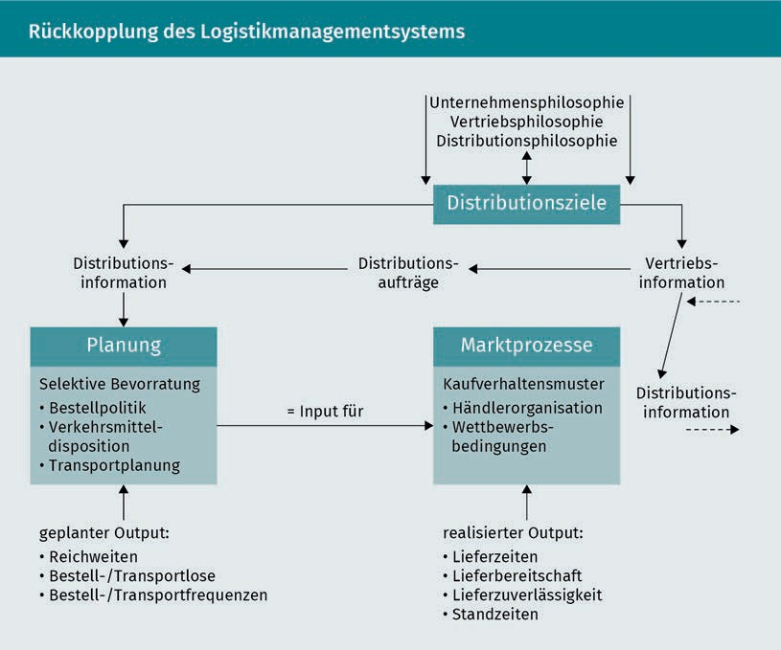

The distribution system incorporates all operational tasks which make use of the operational services available on the market. Distribution logistics is a sub-system of the overall logistics system which controls the flow of products from the company to the end consumer and steers the flow of individual goods to the various sales markets. Increasing importance is ascribed to control measures such as warehousing, order picking, packaging and transportation in line with corporate objectives. As product ranges continue to expand and the market becomes increasingly segmented, coupled with the trend towards a buyer’s market, interest focuses increasingly on the issues and tasks associated with a company’s distribution systems. As well as price, quality and functionality, a product’s market value is largely determined by its temporal, regional and quantitative availability. As the market-focused stage in a company’s logistics activities, the distribution system is therefore a crucial element of performance.

As such, logistical efforts to identify and implement the best distribution system should focus on the service structure. There are countless criteria, the weighting of which will vary depending on the particular task. The service structure is therefore defined by a large number of functions (Ehrmann 2017, p. 532; Piontek 1995, p. 52f).

Fundamental Principles of Distribution

###### Order fulfillment

**Order fulfilment** is defined as the forwarding, data processing and monitoring of orders from the time of ordering by the customer through to the receipt of shipment documents and invoices. This definition centers around the customer order as a pivotal element of the supplier’s distribution logistics and the customer’s procurement logistics. Order fulfilment entails a flow of information which precedes and accompanies the goods and allows the flow of goods to be planned, steered and monitored.

###### Optimization of the delivery service

The delivery service is classed as a service function during the sales phase through the sales process, and encompasses all services from order placement through to warehousing of the merchandise at the customer’s premises. It is important to distinguish the delivery service from the pre-sales and after-sales service. It comprises four elements: delivery time, delivery reliability, delivery quality and delivery flexibility.

###### Transport function

Transport is the physical movement of goods between locations by vehicle. In relation to distribution policy, logistical decision-making must address a range of issues associated with selecting the correct mode of transport and the most cost-effective process. The objective here is to build an optimum transport chain, which may be either direct or a mix. The mode of transport is selected based on a number of criteria such as transport costs, flexibility, transport speed and delivery time reliability.

###### Storage

The purpose of storage is to balance out consecutive processes occurring at different times or at different speeds, and in particular, to cushion any disruptions within and outside of the company.

Procurement and distribution warehouses are a good illustration of the differences between storage processes. Procurement warehouses are designed with a capacity to suit production requirements, while distribution warehouses are designed with the customer in mind, both in terms of their location and the services they offer.

Order fulfillment Customer-friendly order fulfilment is the primary objective of distribution logistics.

### Distribution Structures

The structure of a distribution system is primarily determined by the regional arrangement of warehouses and their areas of responsibility. A distinction is made between vertical structure and horizontal structure. The vertical structure is defined by the number of warehousing stages (organizational allocation to individual warehouses), while the horizontal structure is defined by the number of warehouses per warehousing stage (Schulte 2016, p. 695f.).

###### Vertical distribution structure

The distribution depot is the warehousing stage at the bottom of the warehousing hierarchy ascribed directly to customers, and for this reason its location is always decentralized. It allows the distribution system to make merchandise available in geographical proximity to regional markets and demand hubs. This warehousing level need not stock a company’s entire product range; often only high sales-volume items are stocked at decentralized locations.

###### Horizontal distribution structure

Horizontal distribution structure

The horizontal distribution structure is defined by the number of warehouses at each distribution level.

The following aspects are generally decisive when defining the **horizontal distribution structure:**

The number of warehouses at the highest level (factory warehouse) often equates to the number of production sites, because each production site will usually have its own finished goods store. However, in some instances it may well be more cost-effective to combine multiple factory warehouses into one central warehouse, for more efficient handling using state-of-the-art warehousing technology. As well as balancing volumes, this also helps to balance out the product mix.

A distribution system should never have too many central warehouses, otherwise the centralization effect will be lost. As regional warehouses (special-focus warehouses) perform similar tasks to central warehouses in the distribution context, albeit confined to precisely defined sales regions, the rule of thumb regarding the number of central warehouses also applies by analogy to regional warehouses.

The number of warehouses at the lowest level (distribution depots) will usually depend on the terms and conditions of the delivery service. For example, the number of warehouses will directly impact the delivery times promised to customers.

Fundamental Principles of Distribution

Conversely, the number of warehouses determines the proportion of the customer base which can be serviced within the prescribed delivery time (Ehrmann 2017, p. 531).

As well as deciding on the number of central and regional warehouses, it is also necessary to define the number of distribution depots. The number of distribution depots can be scaled back if central and regional warehouses are able to perform the space and time balancing function, provided the delivery service in that region does not suffer (see illustration below).

Many logistics operators provide an overnight service, delivering directly to customers overnight from the central warehouse.

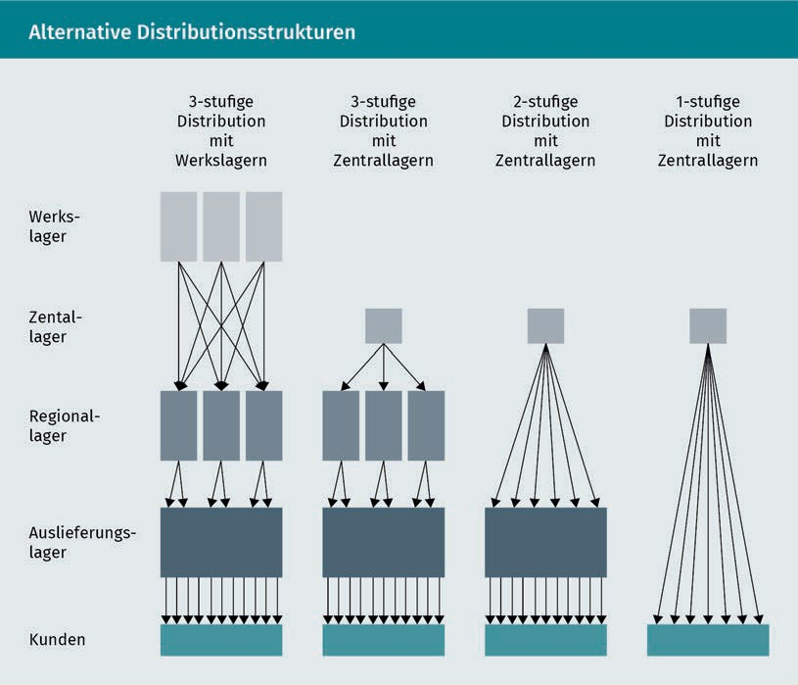

### Distribution Strategies

Distribution strategies must be derived from the company’s marketing strategies.

Marketing strategies in particular can become “set in stone”, so distribution strategies must be carefully thought out and safeguarded if they are to deliver the effective sales channels envisaged by the goal-driven sales process.

Distribution strategies are subject to several limiting factors (Piontek 1995, p. 74):

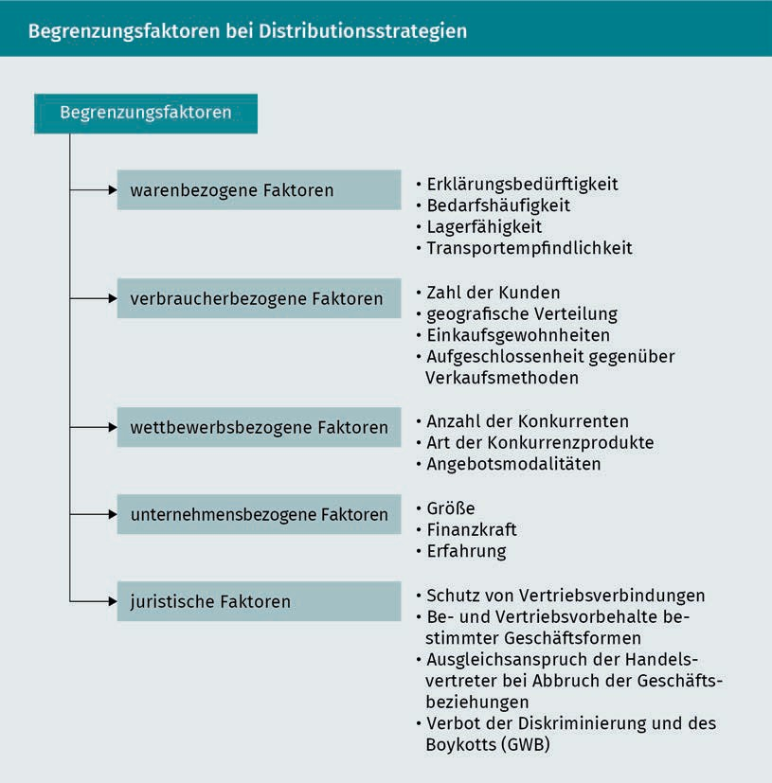

Distribution strategies may be sub-divided into the following categories (Specht/Fritz 2005, p. 73ff; Piontek 1995, p. 74f):

###### Segmentation strategies

A segmentation strategy entails grouping distribution agents and end clients on the basis of various factors, including:

Fundamental Principles of Distribution

* Standard of sales
* Annual turnover
* Purchase volume
* Order frequency
* Payment practices
* Transportation
* Warehousing
* Service
* Consulting.

###### Selection/differentiation strategies

This type of distribution strategy defines the sales channels, number and type of sales intermediaries, and the preferred approach. The number of intermediaries between the manufacturer and the end consumer, if any, may depend on the following criteria:

* Quantity, size and geographical distribution of customers
* Product-specific factors (perishable goods tend to need shorter channels)
* In-house factors such as market knowledge, financial resources and corporate image
* Environmental factors such as legal requirements or restrictions

A distinction is also made between different intensity levels, as follows (Schulte 2013, p. 468):

* Intensive distribution: The goal is to make a product available everywhere on the market. To achieve this target, the company will supply an unlimited number of dealers (assuming an appropriate willingness among dealers. Discounters, for example, will only include products with a leading market share in their range.). Intensive distribution is required for products that entail little search and procurement effort, where customer willingness for substitution is high.
* Selective distribution: Qualitative limits are placed on the number of sales outlets. Only selected intermediaries who meet the manufacturer’s requirements (such as shop size and location; willingness to maintain certain stock levels; acceptance of turnover requirements) will stock the product. Selective distribution requires more independent input from the dealer.
* Exclusive distribution: A manufacturer’s products are limited to just one intermediary per sales region and is often subject to compliance with strict requirements (such as being prohibited from selling competitor products; a guaranteed minimum turnover; complex warehousing; independent marketing efforts; own service organization).

Exclusive distribution is typically used for specialist products such as designer-label fashion, high-end cosmetics, certain brands of car, exclusive entertainment electronics etc.

###### Stabilization strategies

This strategy is aimed at ensuring the long-term stability of a distribution system. In contrast to a push strategy, a constant pull strategy has a stabilizing effect on intensive distribution, because the push strategy relies on the accumulation of high stock levels without specific orders, so they cannot always be sold. These two fundamental concepts are differentiated as follows:

* + 1. The push concept (bring principle) is based on the idea of selling products into the channel, speculating that they will be purchased immediately by the end customer. Intermediaries rely on high stock levels to be able to sell the products rapidly. The key focus of this concept is on personal selling, and intermediaries are awarded high margins, backed up by targeted sales promotion measures to ensure that the products are sold.
    2. The pull concept is based on the idea that powerful advertising among end consumers will build up a demand pull, obliging the intermediary to include the product in their range. It is also known as a classic brand-name product concept.

###### Internationalization strategies

The global marketing strategy will of course determine the distribution strategy. A situational analysis combined with target and strategy planning allows the company to define a general approach for its international activities. Allowing for general provisions, it must then devise strategic concepts for individual markets. which reflect the political, economic, socio-cultural and industry-specific conditions in that particular country.

International markets generally call for adapted concepts to maximize market potential. However, a differentiated approach can be costly. Often only minor variations in the marketing mix, e.g. with the packaging, are admissible for regional or national sub-markets, and global brands are marketed internationally with a largely uniform strategy.

Improved and intensified transport and communication processes have helped reduce the distance between markets and allowed companies to develop global distribution strategies.

Fundamental principles of distribution

From a macroeconomic perspective, these reduced distances and more widespread use of global marketing concepts have produced greater interconnection between the world’s economic, technological, social and political structures.

With new transport and communication options shortening the perceived distance between distribution channels, companies are keen to optimize their global strategy and are making a conscious choice to accept sub-optimum activities at a national level in the interests of globalized distribution.

###### Image-building strategies

Distribution channels, marketing stages and sales intermediaries must also be assessed from an image perspective. As well as their objective capabilities, the intermediary’s business image is also pivotal and should reflect the products it is selling as well as the self-image of its potential consumers.

### Operational Distribution Management

Short-term distribution management entails multiple tasks. The main ones are outlined below (Backhaus & Voeth 2014, p. 270f.).

###### Optimizing the order fulfilment processes

Within distribution policy, order fulfilment processes only arise when the order is shipped to the customer from the warehouse. At this stage, the order forwarding, order preparation and order execution tasks are already complete. Order forwarding is carried out by the sales force according to the form of order generation. During order preparation, this order is then adapted to in-house requirements and supplemented with additional information. Order execution converts the order into an order confirmation, comprisingvarious internal processing documents (such as shipping documents). Orders are compiled (picked) and shipped based on the order information and distribution policy decisions already mentioned. After order picking, supplementary information relating to the weight, packaging, type of position and availability date of the goods is then added to the documentation. The shipping documents (bill of lading, delivery note, packing list etc.) are compiled and the optimum transport mode and shipping route ascertained. Given the complexity of the data processed and stored during order fulfilment, it is advisable to use electronic data processing (e.g. barcode or RFID) to ensure a fast, comprehensive information flow.

###### Selecting a sales intermediary

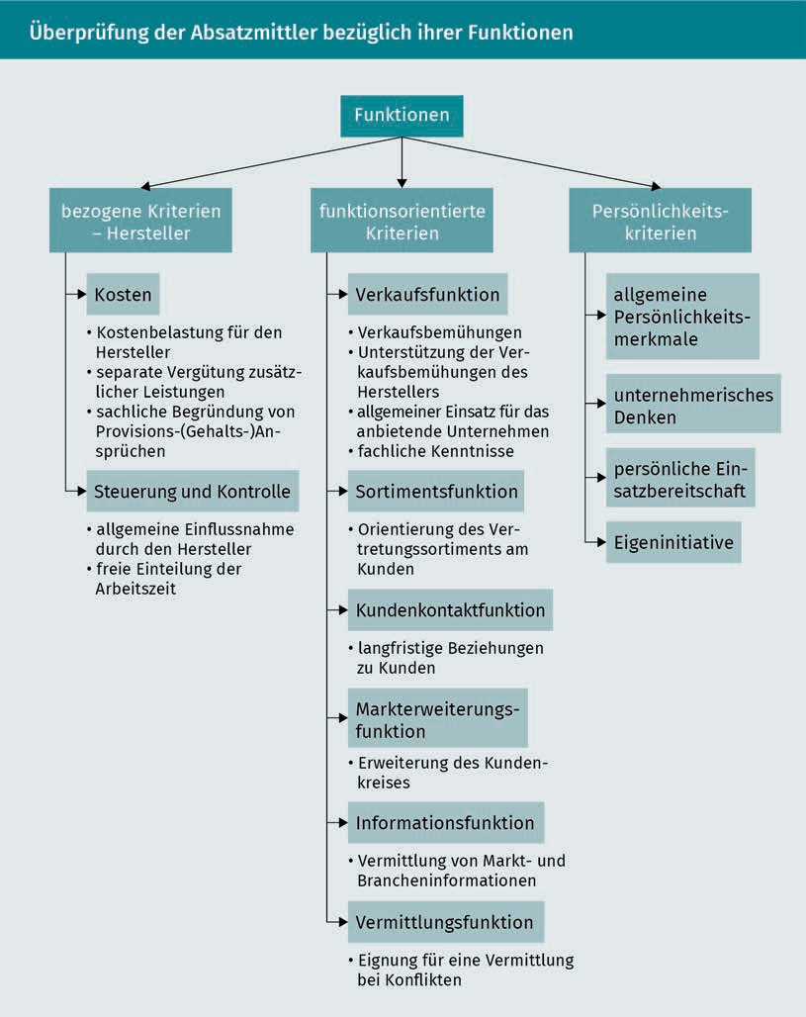Sales intermediary The choice of sales intermediary is governed by qualitative and quantitative

features.

**Sales intermediaries** should not be selected solely on the basis of quantitative features such as cost and delivery times, but also with a view to qualitative criteria. The first step is to review sales intermediaries with regard to the following key functions:

Fundamental Principles of Distribution

###### Selecting a depot

Stock levels in the distribution process are often referred to as depots. Depots are warehousing locations inserted into the product’s physical route from manufacturer to end consumer. They may take the form of finished goods stores or distribution agent (forwarding company) warehouses. The comments below refer to local, regional and central distribution depots, which may be classified into four types depending on their function (Schulte 2016, p. 734f.):

1. Transshipment warehouses that function as handling stations (cross docking).
2. Distribution depots, not only for transshipment but also for the storage of goods as specified by the client.
3. Distribution centers: depots with an adequate presence in close proximity to the market (such as repair workshops, sales offices or distribution departments).
4. Distribution and processing centers: an extended form of distribution warehouse which performs product processing such as assembly, bottling etc.

The depot’s main objective is to offer a high-quality delivery service and improve competitiveness with other more favorably positioned competitors. To meet this goal, the company must first identify an optimum location in line with its sales policy. This entails various decisions regarding the different stages and number of distribution depots and whether to opt for a localized or centralized warehouse structure. There is no “one size fits all” solution to suit all cases.

###### Make-or-buy distribution logistics

The decision to outsource or insource transportation and other logistical services is pivotal to distribution logistics. The buyer must decide whether to use the factory’s own vehicles or to transfer these services to a haulage or forwarding company.

Optimum transport

system Choosing the optimum transport system entails other quantitative features as well as costs.

Apart from financial considerations, other aspects also determine these types of decisions. Continuous availability and customer service are often cited as arguments in favor of using in-house vehicles.

Developing an **optimum transport system** presupposes the availability of comprehensive information about all influencing criteria. Whatever the buyer’s priorities when developing a logistics concept, a clear overview of the related costs and services is essential before opting to use the in-house vehicle fleet.

An assessment of cost-effectiveness should include the following information:

* Fixed costs for individual vehicles
* Operating costs for individual vehicles
* Overall costs for individual vehicles
* Capacity utilization level for individual vehicles
* Scheduling versatility of fleet

Other criteria must be taken into account alongside the cost aspects (Czenskowsky & Piontek 2012, p. 70):

* Regularity of arrivals
* Minimal transport damage
* Transport speed
* Transport volume
* Cushioning of peaks
* Opportunities for return shipments
* Customer service
* Administrative effort
* Transport costs and freight

Summary

Distribution is about much more than simply bridging space and time. It encompasses a wide range of tasks, all related to the distribution of goods and services. As well as macroeconomic functions, various microeconomic functions must also be considered.

The primary task of distribution is the selection of distribution agents, which depends on a wide range of factors.

Distribution logistics should be organized as a sub-system of distribution management, with the focus on achieving a customer-friendly delivery service.

It is also necessary to define the vertical and horizontal distribution structure. The chosen distribution strategy will determine the long-term focus and organization of distribution. Distribution managers must be skilled at combining different types of strategy. Ultimately, operational (short-term) distribution management should be organized in such a way that order fulfilment, the choice of sales intermediaries and distribution depots and the transport system are fixed.



# Unit 3

## Distribution of Capital Goods

#### STUDY GOALS

On completion of this unit, you will be familiar with ...

... The differences between capital goods marketing and other marketing disciplines

... The specific types of capital goods marketing

... The particular features of each basic type of capital goods marketing

... The particular restrictions on the distribution of capital goods and the opportunities available

... How to assess the potential of capital goods distribution

DL-D-DLBLOISCM102-L03

1. Distribution of Capital Goods

### Case Study

Many suppliers have seen their business change and become fiercely competitive. The automotive sector has undergone a radical transformation, and the changes are still ongoing as the debate surrounding electric vehicles continues. The growing globalization of markets, constant competitive and cost pressures plus the environmental issues make it increasingly difficult to secure long-term success.

Suppliers are feeling this pressure and many of them find that it is no longer enough to simply be a supplier of components; they must become systems suppliers if they want to remain in the automotive supply chain.

Although this new form of supply business enables longer-term business relations, even big names like Magna International Inc. have found that they needed to completely reorganize their logistical processes.

Many automotive manufacturers require physical proximity to their factories as a requirement of entering into a long-term relationship with a supplier. This becomes particularly difficult as more and more automotive companies set up production in eastern Europe and Asia, attracted by the low wage and ancillary costs.

For suppliers to survive in this business, not only do they need an international production network; they must also offer wide-ranging expertise in the areas of development, quality and logistics.

Magna International Inc. meets these requirements, thanks to its financial resources and extensive network of affiliated companies. Although it still supplies components, the company’s main focus is on the manufacture and supply of entire modules and systems, such as four-wheel and regular drive systems, interior fittings, vehicle frames and chassis systems, tank and cooling systems and mirror systems. Magna is also involved in general automotive development and production processes and delivers finished cars, leaving the OEM free to focus on marketing and distribution of the finished products.

### Capital Goods Marketing

Capital goods marketing is aimed at industrial companies and public-sector organizations rather than individual consumers and is dedicated to the sale of production goods Essentially, this is B2B marketing, whereby non-consumers purchase products (such as machinery and equipment) in order to manufacture other products (Backhaus & Voeth 2014, p. 11).

Distribution of Capital Goods

**Business-to-business (B2B)** marketing encompasses all areas of marketing not relating to consumer goods or private end users. Put simply, there are companies on both sides of these market transactions, never private consumers.

This very important distinction between two sub-sections of marketing raises a number of issues. On closer examination, it becomes apparent that there are major differences between capital goods marketing and consumer goods marketing, and they should therefore be treated separately. For example, capital goods marketing may be characterized as follows (Pförtsch & Godefroid 2013, p. 23):

* When planning its activities, capital goods marketing must consider its direct customers (companies) as well as making allowance for the requirements of downstream stages.
* Purchasing is carried out by cross-functional **buying centers** made up of conventional buyers as well as controllers, technical specialists, legal advisers etc.
* Capital goods tend to have a long service life, which in turn leads to long-term contractual commitments including value-added services such as maintenance, delivery of spare parts and consulting.
* Engineers are involved early in the process, to guarantee the required level of technical support throughout all phases of procurement decision-making and enable the accurate assessment of manufacturer quotes.
* Targeted marketing is usually difficult to implement, because the buying center often includes very different individuals with wide-ranging information requirements who are often geographically separate from one another.
* The supplied goods tend to be customer-specific products requiring extensive explanation.
* Unlike consumer goods marketing, the partners in the business transaction are not anonymous, so personal relationships and interaction criteria must also be taken into account.
* Capital goods are also sold to the public sector, which requires the observance of various public-sector restrictions and framework conditions such as laws, regulations, subsidies and taxes.
* Smaller producers are often compelled to sell their capital goods on the global market because there is insufficient demand at a national level. This entails high marketing costs.

The basic types of capital goods marketing may be classified into four different business types (Pförtsch & Godefroid 2013, p. 30 f.):

B2B

Business-to-business means a business relationship between two companies.

Buying center

A buying center is a group of people charged with making procurement decisions.

1. The product business refers to the relatively standardized manufacturing and marketing of capital goods which are used by the buyer in isolation.
2. The industrial plant business (or project business) refers to comprehensive hardware or software bundles, the elements of which are combined into functioning systems by the buyer.
3. The systems business uses engineering and project management to combine functional units into complex systems. Service and software elements are always included. Pre-sales and after-sales service are essential to the systems business.
4. The component supply business is characterized by more long-term business relationships. The supplier delivers services that are in turn utilized by the customer (e.g. in the automotive industry.)

The following diagram classifies these basic business types into four dimensions: individual transaction/procurement alliance and individual customer/anonymous market:

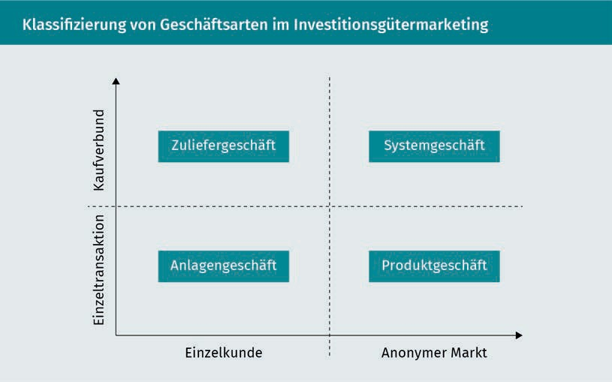

In an anonymous market, standardized products are offered to potential clients in large numbers on comparatively unknown markets. In these situations, many aspects of consumer goods marketing must be taken into account.

Individual orders mean marketing for individual, but particularly large orders (especially in the industrial plant business). The vertical axis in this diagram distinguishes between individual transactions and jointly procured transaction processes (by a procurement alliance).

Distribution of capital goods

### Product Business

The **product business** has some affiliations to the consumer goods business. Specifically, it is comprised of two areas (Pepels 1999, p. 174):

* Parts: This includes parts (e.g. microprocessors), components (e.g. ABS units, lighting systems in passenger cars, electric locomotive motors) and spares which are readily integrated into other products without any major processing or reworking or which are combined to create a new product. Crucially, they retain their identity. The customer procures individual elements and combines them to create a larger unit. The parts may either be manufactured in-house or (more usually) sourced externally.
* Aggregates: The difference between an aggregate and a system element lies solely in the marketing process, rather than in the product architecture. Unlike system elements, aggregates can function independently without other products. System elements must be combined with other products before they can function. Individual aggregates need not necessarily be integrated into larger systems because they deliver customer benefits in their own right (e.g. photocopiers, cranes). Aggregates are usually commodities which can be used individually, perform specific sub-functions, and can be combined with other products to create complex systems or sold separately. Unlike parts, aggregates may be used autonomously (e.g. office equipment, commercial vehicles) or integrated into a system unit. In contrast to the systems business, aggregates are often procured in large quantities.

There are major differences relating to distribution which set it apart from consumer goods marketing, as illustrated by the following table:

Product business The product business distinguishes between parts, components and aggregates.

|  |  |  |
| --- | --- | --- |
| Comparison of distribution policies in B2C and B2B | | |
| Factor | Consumer goods marketing | Business-to-business marketing |
| Importance of distribution policy in the marketing mix | Important, because consumers mainly assess product quality and manufacturer image via the trade; advertising also plays a major role | Very important, because communication tools are less significant |
| Control over distribution channels | Trade dominates | Manufacturers dominate |

|  |  |  |
| --- | --- | --- |
| Factor | Consumer goods marketing | Business-to-business marketing |
| Depth of channels | Often multiple stages (wholesale, retail) | No or very few stages |
| Proportion of business from indirect sales | Very high; direct sales are minimal | Rather low; direct sales predominate |
| Customer selection of sales channel | High, because the same product is offered by multiple retailers | Minimal, because products are usually sourced via one or a few alternative sales channels |
| Importance of warehousing | Very high, because most consumer goods are taken away immediately by the buyer | Lower, because delivery times are standard, although punctual delivery by the agreed date is important |
| Personal selling | Only relevant in a few sectors | Extremely important across almost all sectors |
| Existence and importance of key accounts | Rather low | Very high |

Within the product business, there are a range of distribution channels available:

* + Management board members
  + Travelers
  + Factory-affiliated selling company
  + Sales branches
  + Sales affiliates
  + Manufacturer’s own channels such as telephone sales
  + Catalogues
  + Internet trade
  + Commercial agents
  + Production-linked trade
  + Distance selling via distribution partners.

Distribution of Capital Goods

### Industrial Plant Business

The industrial plant business entails the sale of complex projects. The buyer takes delivery of an individual hardware system or hardware/software combination which has been custom-produced or manufactured in small batches. Often, the individual products are assembled at the customer’s premises (e.g. refinery, iron and steel works) on a project-specific basis. The industrial plant business is usually a self-contained project, with no further expansions or additional stages planned.

The distinguishing features of the industrial plant business are as follows (Pepels 1999, p. 167):

* Manufacturing to order, i.e. the individual features are set out in customer- specific technical and functional specifications.
* Value dimension of a single order, i.e. the industrial plant is costly and entails major risks. As a result, contractual negotiations can be difficult and lengthy.
* Internationalism: Because the industrial plant business requires cooperation between supply and demand specialists in different countries, international management is needed.
* Discontinuity of incoming orders: Because industrial plant has a long service life and the number of potential customers is very limited, incoming orders are irregular, making it difficult to plan capacity utilization.
* Cooperative organization of suppliers: Multiple suppliers are involved, because a single company would not usually have sufficient capacity or the full range of core skills. Inter-organizational management of cooperation and coordination processes is therefore needed.
* Long-term nature: The time frame between the initial inquiry, preparation of the quote, delivery of the service and project sign-off is lengthy, both for production and use.
* Service aspect: The complexity of industrial plant projects necessitates a wide range of ancillary services such as consultancy, technical support, staff training etc.
* Order modifications mid-way through processing: As the order is being executed and fulfilled, new insights or technical requirements will often arise, and orders will need to be modified and amended.
* Know-how disparities between the supplier and client; this is often compensated on the demand side by consultants (engineering firms).

Fulfilment of the order occurs when the industrial equipment is distributed. This includes order generation, transmission and placement followed by information, delivery methods, inventory scheduling, production planning, document forwarding, order picking, selection of transport modes and invoicing.

A smooth-running delivery service, short delivery times and a high level of delivery accuracy in line with requirements can help to win new business. Successful project completion is a vital reference when acquiring new orders.

Direct sales channel Most industrial plant is distributed directly.

Industrial plant is generally sold via **direct sales channel** and requires a highly qualified sales expert with extensive technical knowledge. As sales opportunities are often limited and distributed over a wide area, a broader sales market is needed to achieve viability. Distribution areas can therefore become a bottleneck for smaller and medium-sized suppliers with limited access to information about globally dispersed demand and equally limited opportunities for regular after-sales servicing of these markets. There is also the problem of dependency on specific sectors and the inability to balance out cyclical downturns in a limited supply situation.

Direct sales channels may be classified into the following institutions/individuals:

* Management board
* Sales engineers (in-house personnel)
* Representatives in selected regions/countries
* The supplier’s own regional and country sales organizations
* (Partial) production overseas with a corresponding sales/service department

### Systems Business

Systems business is when one or more companies sell a combined bundle of industrial plant-related services to meet a complex demand. This could include a combination of both system components and sub-systems (Pepels 1999, p. 162):

* System components are items that cannot function expediently without interacting with other system parts (e.g. CD drive).
* Sub-systems can be used effectively in isolation (e.g. laptop).

The systems business is characterized, firstly, by the fact that services are devised for the anonymous market rather than for specific customers. Admittedly, on the consumer side, the procurement process may be highly individualized to accommodate the nature, extent or timing of follow-up purchases that are inherent to the system. However, providers in the systems business develop their offerings ahead of the marketing process, so the development process and basic market image are not tailored to a specific demand. Instead, suppliers target their approach at anonymous markets or market segments rather than individual customers.

Distribution of Capital Goods

Whilst the product and project businesses are characterized by the fact that customers buy services without influencing other purchase decisions, purchases in the systems business are made in conjunction with, and following on from, other services (Backhaus & Voeth 2014, p. 449).

### Component Supply Business

The component supply business supplies customers with components which they then integrate into their products more or less unchanged. In many industries there is a close partnership between suppliers and customers. Suppliers are often given precise guidelines for the development of new components. Logistical relationships are also close (**JIT** = just in time). Because customers often collaborate with just one or two suppliers for a particular component, it is crucial for a supplier to ensure they are selected, otherwise they will lose out on business for the entire life span of that model (Pförtsch & Godroid 2013, p. 33).

Collaboration may entail intensive cross-functional collaboration between the process chains of both buyer and supplier. By integrating the process chains, the aim is to maximize valuecreation and synergies. We distinguish between the following:

**Production-centered supply**

The supplier makes production capacity available to the buyer for them to incorporate into their own production schedules. The buyer must guarantee a certain level of capacity utilization, or else cover part of the supplier’s fixed costs. This quasi-mutual balancing of capacity is only feasible with a drastic reduction in the number of suppliers. Suppliers then benefit from a long-term framework agreement but also become highly dependent as they must tailor their production and distribution capacity to their customer’s needs.

The supplier also has a high level of responsibility to synchronize product deliveries with the customer’s own production and time frame. They must also provide various value-added services such as assembly line feeding, assembly work and quality assurance tasks. Through intensive mutual collaboration, the idea is for the supplier to tailor their deliveries to the customer and achieve a lean inventory.

**Logistics-integrated supply**

The supplier delivers according to the buyer’s production sequence, sometimes in perfect sync. Suppliers are also expected to organize other logistical processes such as transportation, container management and packaging.

JIT

JIT (just in time) is when delivery is synchronized with production.

**Expertise-integrated supply**

The supplier provides research, development and design activities which are tailored to the customer’s needs (technical and functional specifications). The supplier is therefore integrated into the early phases of the product lifecycle and often organizes their own production to be synchronous with the customer (simultaneous engineering, SE). The supplier is also influenced during the development and design phases by the target prices and costs dictated by the buyer.

**Disposal-integrated supply**

In the final phase, the supplier also takes care of waste disposal and recycling tasks (e.g. catalytic converters) and assumes responsibility for the entire product lifecycle, from initial product development through to the final phases of disposal.

The ever more rapid pace of planning and control activities by all partners in the supply chain coupled with rising cost pressures have created the need for new forms of cooperation. The real challenge here is to broaden the factory-centric perspective and integrate supply chain processes and procedures across organizational boundaries. The use of suitable software is one way of achieving this. The requirements placed on those involved will vary, both in terms of the processes themselves and from an IT perspective.

Relationships between suppliers and automotive manufacturers have undergone a radical transformation in recent years. In the past, the automotive industry relied on suppliers of parts. The manufacturers buffer-stored the delivered parts and then incorporated them into the assembly line as required. A growing number of variants and the associated escalation in the number of parts pushed this system to its limits, and eventually led to new assembly concepts. Parts were combined into assemblies and delivered in sequence by system suppliers (tier 1).

These days, the individual partners in the supply chain are organized sequentially in a pyramid shape. Each partner translates the customer’s requirements into their own optimum production range, then orders the relevant materials from a supplier. The dynamic behavior of modern supply chains is characterized by this sequential pyramid-shaped structure, the focus on direct suppliers (tier 1) and local optimization of value creation partners.

As illustrated by the following diagram of the supply side, there are three main categories of suppliers based on their product range:

Distribution of Capital Goods

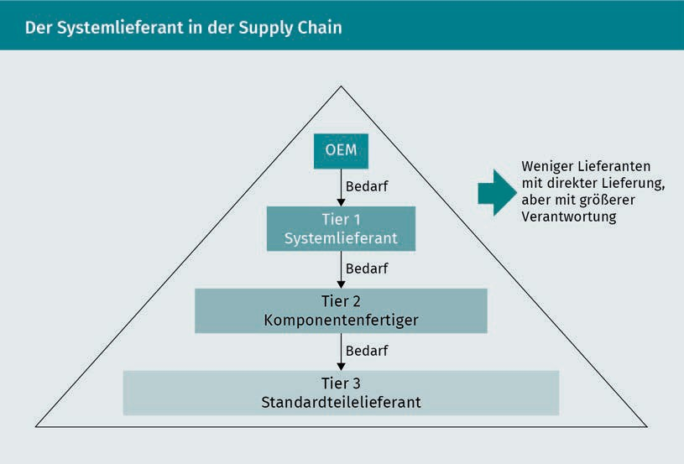

Summary

Capital goods marketing is all about selling special products, systems and services to organizations. Although capital goods marketing is not fundamentally different from consumer goods marketing, there are nevertheless substantial differences in terms of distribution.

The distribution and logistics concepts will need to be adapted to suit the product, systems, industrial plant or component supply business.

The industrial plant business is the most challenging, but the systems and component supply businesses also call for extensive, in-depth agreements with the customer. The component supply business often leads to the emergence of limited supply chain partnerships which can permanently affect distribution.



# Unit 4

## Trends and Digitalization in Procurement and Distribution

#### STUDY GOALS

On completion of this unit, you will be familiar with ...

... The potential and opportunities afforded by electronic markets

... Ways to optimize inter-company collaboration with strategic suppliers

... Ways to assess the development and potential of e-commerce

... Possible future cost-cutting potential in procurement and distribution

DL-D-DLBLOISCM102-L04

1. Trends and Digitalization in Procurement and Distribution

### Case Study

Mr Fisher is a dedicated photography expert and has been considering a freelance career in this field for some time. He recently read a newspaper article about the success of this year’s “winter academy for business entrepreneurs” and decided to attend next year’s event. After various discussions with friends and acquaintances, he applied for the forthcoming summer academy with the idea of setting up an electronic trading platform on the Internet (virtual or horizontal marketplace) for second-hand digital and film photography equipment. As an emerging IT expert, you have been approached by Mr Fisher to help him flesh out the idea for his company. You draw up a concept which will be presented to the judging panel at the summer academy.

### Electronic Marketplaces

As we have previously learned, e-markets are virtual spaces for the online handling of business transactions and for joint planning and cooperation between market players via the Internet. Multiple buyers, suppliers or service-providers are given access to a virtual room. E-markets support almost the entire value chain and offer a platform for the exchange of information, purchase transactions, and a range of value-added services (Krampf 2012, p. 56). Because e-markets will have an even greater influence on procurement and distribution in future and will accelerate the growth of B2B commerce, this area merits more in-depth examination.

Depending on the objective and specification, electronic marketplaces may be divided into buyer-oriented and supplier-oriented marketplaces, as well as horizontal and vertical marketplaces (Piontek 2016b, p. 217):

SC

SC stands for

supply

chain.

* Buyer-oriented marketplaces: these tend to be operated by one large buyer or a consortium of buyers. Purchasing alliances throughout the **SC** use these types of marketplaces because they support cheaper, more effective procurement processes. The companies in the consortium often originate from the same sector and forge alliances with a view to boosting their market power and merging processes. Buyers have access to a shared link to their suppliers, based on standardized processes with buyers, suppliers and trading companies, which define and implement the marketplace.

Trends and Digitalization in Procurement and Distribution

The aims of a buyer-oriented marketplace are lower costs, higher productivity, superior quality and accelerated processes.

* + Supplier-oriented marketplaces: a marketplace made up of one large or several smaller sellers who combine their activities and processes to cut costs. Rather than competing against one another, the aim is to create a platform with lean processes. Other companies from the sector may be permitted to market their services on the marketplace in exchange for a fee.
  + Horizontal marketplaces: these marketplaces connect large numbers of suppliers and buyers across multiple (but not all) industries. They focus on standard products from suppliers in different industries. They usually involve indirect and maintenance materials such as office equipment or **MRO** items. The benefits of a horizontal marketplace lie in its ability to optimize and boost the efficiency of procurement processes with a strong product focus.
  + Vertical marketplaces: Vertical marketplaces are primarily confined to the goods and services of one or a limited number of sectors, usually in a single industry. They provide a platform where manufacturers, suppliers and sub-suppliers can work together and optimize their processes. Vertical marketplaces are ideal for performing supply chain management functions and facilitating collaboration between companies. They concentrate on direct materials with a strong focus on solution-finding.

Electronic markets give customers access to a wide range of services plus a wealth of interesting general information (content), specialist publications, archives and databases and relevant news stories. User analyses and comments are also available here.

The next level begins with the development of a virtual community to promote interaction and communication between users. Community functions include discussion forums and expert chats where participants can exchange information.

E-markets offer a wide range of opportunities for each individual subscriber to individualize their offerings and added-value services. This process is known as customization. The electronic shopping cart can be individually configured, the product catalog restricted to certain products and value-added services, and customized newsletters sent out.

MRO

Maintenance, repair and operations

The electronic marketplace is also conducive to intensive collaboration, for example when developing new products and standards, planning shared inventories and capacities or performing joint calculations. This intensive collaboration helps to streamline and accelerate many of the agreements between buyers and their suppliers.

Growing importance is also attached to networking and interconnectivity with service-providers, subscribers from related industries and other electronic marketplaces, with a view to integrating their services into the marketplace.

Tracking & tracing The process of tracking merchandise.

Other value-added services offered on electronic marketplaces include customer assessment and monitoring of transactions, online credit checks, customs management, bonus and discount schemes, communities, handling of customer returns, **tracking & tracing**, individual reporting services, data warehousing, Web-based freight control, Web-based scheduling of shipments and deliveries, and options for integrating the in-house IT infrastructure via various interfaces in the relevant e-market.

The marketplace offers the following services as standard:

* E-procurement (digital handling of business processes between companies)
* Multi-supplier catalogs (all registered supplier catalogs where a buyer can place an order)
* Auctions (bid processes)
* Document management
* User administration
* Order management
* Invoicing
* Logistical services (order fulfilment, monitoring)
* Financial services (financing, insurance).

### Supplier Cooperation: Supplier Relationship Management (SRM)

Close collaboration between a buyer and their supplier is known as supplier relationship management (SRM) and entails the management and cultivation of supplier relationships. Supplier relationship management essentially involves establishing and cultivating supplier relationships with a view to selectively broadening the supply chain to include upstream suppliers and service-providers while focusing on their customers’ particular needs. Intensive collaboration with suppliers and service-providers aspires to faster, better development, production and procurement of systems at a lower cost (Piontek 2016b, p. 88).

Trends and Digitalization in Procurement and Distribution

Supplier Relationship Management is the outcome of constant refinements to strategic supplier management and a partnership with suppliers and service-providers. The main aim of supplier relationship management is not so much to optimize current supplier conditions as to take the partnership to the next level with a view to the future (also known as supplier collaboration). A close and intensive relationship with suppliers is vital for maintaining willingness to reach an agreement as well as cooperation should problems arise. Like profits and losses, opportunities and risks should also be evenly distributed within the context of a win/win partnership.

SRM can be seen as the upstream element of supply chain management (SCM) and is the opposite of customer relationship management (CRM).

Supplier relationship management entails a cooperative approach, incorporating the organization of strategic and operational procurement processes as well as supplier management. Growing numbers of IT-assisted tools and techniques (such as platforms, apps and clouds) are being developed by the IT sector to intensify exchange, collaboration and joint planning.

SRM incorporates various different types of collaboration, as outlined below (Piontek 2016b, p. 89):

* + Key Supplier Management: a particular form of supplier relationship management, in which collaboration is far-reaching, even extending to the definition of joint goals and harmonization of strategies. This requires an intensive exchange of information, cooperative decision-making systems and creation of the necessary organizational requirements. Mutual trust, dependency and escalation management systems and the review of procurement targets to encourage long-term supplier relationships are essential requirements for focusing on key suppliers. Wherever possible, key suppliers should be leaders in their respective fields. The company buys a strategic product or group of products solely from their key supplier (single sourcing) and concentrates solely on that supplier. A focus on all-in costs and the balancing of mutual interests are pivotal aspects.
  + International supplier relationship management: globalization is opening up new opportunities for companies on the procurement market. High transport costs usually mean that the global procurement market is subdivided into regional procurement markets, with varying supplier structures and power balances between buyers and suppliers. Furthermore, the resources required for supplier relationship management are not always available in the same way. Geographical distance from the supplier, plus language barriers and cultural differences can make it more difficult to build relationships and can lead to conflicts and relationship breakdowns.

For this reason, international supplier management entails higher travel and communication costs and is often more time-consuming. As a result, there are higher barriers to exiting the supplier relationship and a risk of dependency. Nevertheless, international supplier relationship management can help to minimize the specific risks of international business relationships by building commitment and trust. It can also help to maximize the benefits derived from the supplier relationship. The international harmonization of prices poses a particular challenge. If companies and suppliers have decentralized structures, supplier relationship management should negotiate at a centralized level to harmonize prices.

SRM is supported by a host of supplier development programs. There are various supplier development and support tools available, which may be applied across many different divisions. The main focus of supplier development is production. By advising the supplier on rationalization measures, quality assurance programs, technology changeovers or process optimization, the buyer can contribute their own specialist know-how and boost success levels. This may extend to sharing their expertise and even temporarily loaning specialist staff. Cross-company value analysis teams may be deployed in the production sector to boost efficiency and optimize processes. As well as providing support with production, the buyer may also assist with purchasing, work scheduling, inventory management, sales, research and development. They may also provide financial support in the form of interest-free loans to suppliers.

Summary

Current trends in procurement and distribution are many and varied. The use of electronic marketplaces looks to become ever more widespread by encouraging intensive collaboration between market partners. The opportunities offered by electronic marketplaces are wide-ranging, particularly for the design and optimization of joint products, standards and projects. Electronic marketplaces also offer significant cost-cutting potential.

As collaboration with strategic suppliers becomes ever more important, it is vital to cultivate close and intensive relationships within the framework of supplier relationship management (SRM). Partnerships should be organized with a view to future requirements. Supplier development programs offer countless opportunities for encouraging and supporting a company’s suppliers.



# Appendix 1

## List of References

82 Appendix1

List of References

Ahlert, D. (2002): *Distributionspolitik* [Distribution Policy]*.* 2nd edition, Kohlhammer, Stuttgart.

Backhaus, K./Voeth, M. (2014): *Industriegütermarketing* [Capital Goods Marketing]*.* 10th edition, Vahlen, Munich.

Czenskowsky, T./Piontek, J. (2012): *Logistikcontrolling: Marktorientiertes Controlling der Logistik und der Supply Chain.* [Logistics Controlling: Market-Oriented Controlling of Logistics and the Supply Chain]*.* Deutscher Betriebswirte Verlag, Gernsbach.

Ehrmann, H. (2017): *Logistik.* [Logistics]*.* 9th edition, Kiehl Verlag, Ludwigshafen.

Heß, G. (2008): *Supply-Strategien in Einkauf und Beschaffung. Systematischer Ansatz und Praxisfälle* [Supply Strategies for Purchasing and Procurement: A Systematic Approach with Case Studies]*.* Gabler, Wiesbaden.

Ihde, G. (2001): *Transport, Verkehr, Logistik* [Transport and Logistics]*.* 3rd edition, Vahlen, Munich.

Jahns, C./Moser, R. (2003): *Outsourcingmanagement* [Outsourcing Management. SMG, Stuttgart.

Schulte, C. (2007): *Konzeption eines erfolgsorientierten Beschaffungscontrolling: Theoretische Betrachtungen und empirische Untersuchungen* [Concept for Success-Driven Procurement Controlling: Theories and Empirical Studies]*.* TCW Verlag, Munich.

Krampf, P. (2012): *Beschaffungsmanagement: Eine praxisorientierte Einführung in Materialwirtschaft und Einkauf* [Procurement Management: a Practical Introduction to Materials Management and Procurement]*.* Vahlen, Munich.

Large, R. (2006): *Strategisches Beschaffungsmanagement: Eine praxisorientierte Einführung. Mit Fallstudien* [Strategic Procurement Management: A Practical Introduction with Case Studies]*.* Gabler, Wiesbaden.

Pepels, W. (1999): *Business-to-Business-Marketing: Handbuch für Vertrieb, Technik, Service.* Luchterhand [Business-to-Business Marketing Handbook for Sales, Engineering and Service], Neuwied.

Pförtsch, W./Godefroid, P. (2013): *Business-to-Business-Marketing* [Business-to-Business Marketing]*.* NWB, Herne.

Piontek, J. (2016b): *Bausteine des Logistikmanagements: Supply Chain Management. E- Logistics. Logistikcontrolling. Green Logistics. Logistikinstrumente* [Elements of Logistics Management: Supply Chain Management. E-Logistics. Logistics Controlling. Green Logistics. Logistics Tools]*.* 5th edition, NWB Ver- lag, Herne/Berlin.

Piontek, J. (2016a): *Beschaffungscontrolling* [Procurement Controlling]*.* 5th edition, De Gruyter, Munich.

Piontek, J. (2002): *Produktion* [Production]. Kohlhammer, Stuttgart.

Piontek, J. (1995): *Distributionscontrolling* [Distribution Controlling]*.* Oldenbourg, Munich.

Schulte, C. (2016): *Logistik: Wege zur Optimierung der Supply Chain* [Logistics: Approaches for Optimizing the Supply Chain]*.* 7th edition, Vahlen. Munich.

Schulte, C. (2013): *Logistik: Wege zur Optimierung der Supply Chain* [Logistics: Approaches for Optimizing the Supply Chain]*.* 6th edition, Vahlen, Munich.

Specht, G./Fritz, W. (2005): *Distributionsmanagement* [Distribution Management*.* 4th edition, Kohlhammer, Stuttgart.