**New potential marine food source – Light-induced pigment synthesis and antioxidant activity in endosymbiotic jellyfish (*Cassiopea andromeda*)**

**Holger** **Kühnhold1, 4, Monika Schreiner2, 4, Andreas Kunzmann1,4, Karin Springer3**

*1Leibniz Centre for Tropical Marine Research (ZMT), Fahrenheitstraße 6, 28359 Bremen, Germany*

*2Leibniz Institute of Vegetables and Ornamental Crops (IGZ), Theodor-Echtermeyer-Weg 1, 14979 Großbeeren, Germany*

*3University Bremen, Marine Botany*

*4Food4Future (F4F), c/o Leibniz Institute of Vegetables and Ornamental Crops (IGZ), Theodor-Echtermeyer-Weg 1, 14979 Großbeeren, Germany*

**Abstract**

Given its efficient biomass production and high nutritional value, the microalgae carrying upside-down jellyfish *Cassiopea andromeda* represents a promising marine species for innovative aquaculture-based farming as a food source. In this study, the effects of various levels of light intensity and narrow-band and narrow-band UVB exposure on light-harvesting pigments and antioxidant activity (AOA) in *C. andromeda* were investigated. This analysis revealed the prevalence of peridinin and chlorophyll *a* pigments, suggesting that valuable peridinin-chlorophyll *a*-proteins (PCP) dominate the *C. andromeda* light-harvesting complex. Over two- and four-week treatment intervals, two and four weeks treatment time, pigment synthesis and the ratio of photosynthetic pigments were significantly correlated with changes in the intensity of photosynthetically active radiation (PAR) ranging from 50 to 800 µmol photons m-2 s-1, while AOA was not affected. Over these same time periods, increases in both pigment synthesis and AOA were only achieved with daily exposure to narrow-band UVB (λ = 285 ± 10 nm) radiation (1.3 KJ m-2 day-1) in combination with 200 µmol photons m-2 s-1 PAR. Together, the results of this study provide a foundation for the further development of a novel indoor, environmentally controlled *C. andromeda* aquaculture system suitable for supplying a functional marine food source in urban and semi-urban settings.

**Introduction**

The more effective utilization of aquatic food sources is vital to global food security and nutrition, particularly in the Global South (Ahern et al., 2021). Many marine resources have the potential to provide health-promoting nutrients without a concomitant risk of reducing key resources such as arable land or freshwater (Duarte et al., 2009; Béné et al., 2015; Hilborn et al., 2018; Troell et al., 2019), offering an opportunity to improve the resilience of global food systems (Troell et al., 2014; Béné et al., 2019).

Jellyfish are a biomass source that may be amenable to sustainable exploitation as a novel food source (Edelist et al., 2021). The nutritional and pharmacological value of several jellyfish species has been extensively studied (Leone et al., 2013, 2015; De Rinaldis et al., 2021), and many jellyfish serve as hosts to symbiotic microalgae that exhibit particularly rich nutritional profiles, as the proteinaceous animal tissue is enriched with nutritive algae components (Leone et al., 2015). In this regard, the upside-down jellyfish *Cassiopea andromeda* is a particularly promising candidate species, as members of this species harbor densely packed microalgal symbionts belonging to the dinoflagellate family Symbiodiniaceae (*Symbiodinium spp.*) (Lambert et al., 2012). Dinoflagellates are considered a potential source of peridinin carotenoids, which occur in form of peridinin-chlorophyll *a*-proteins (PCPs) (Carbonera et al., 2014). In dinoflagellates, PCPs are the primary components of the light-harvesting complex (LHC), with structural properties very similar to those of fucoxanthin (Supasri et al., 2021). PCPs extracted and purified from dinoflagellates (*Symbiodinium tridacnidorum* CS-73) exhibited significant antioxidant, antitumor, and anti-inflammatory activities (Supasri et al., 2021). PCPs may thus represent novel bioactive compounds with strong utilization potential with potential for their incorporation into functional foods and nutraceuticals. In addition to PCPs and other dinoflagellate-derived antioxidants, jellyfish possess other macromolecules and compounds such as proteins, phenols, and enzymatic antioxidants that can lead to high antioxidant activity (AOA) (e.g. Leone et al., 2013, 2019; De Domenico et al., 2019). The utilization of jellyfish such as *C. andromed*a as a supplementary food source may thus contribute to a diet with enhanced endogenous antioxidant capacity, which has been linked to many health benefits (e.g. Zampelas and Micha, 2015).

In *C. andromeda*, dinoflagellates are endosymbionts that reside in the jellyfish mantle tissue, primarily in the appendages. The resultant strongly interdependent organism-unit is referred to as a ‘holobiont’. As the *C. andromeda* ‘holobiont’ (hereafter referred to as *C. andromeda*) is specialized to provide optimal growing conditions and protection for the dinoflagellates, these microalgae can readily proliferate in this host habitat. Accordingly, *C. andromeda* holds promise as a resource for PCP production that may offer value as a supplement for functional foods and nutraceuticals. In order to fully exploit the potential of *C. andromeda* for PCP and antioxidant production, enhancing the concentrations of these target compounds is the key refinement strategy to substantially valorizethis largely untapped marine biomass. Like all photoactive organisms, *Symbiodinium spp.* species alter the number and ratio of photosynthetic pigments to adjust their capacity for light harvesting (Hennige et al., 2011). Given that peridinin and Chlorophyll *a* pigments dominate the LHC in endosymbiotic dinoflagellates, particular levels or wavelengths of ambient light may trigger the synthesis of these PCP-forming pigments in *C. andromeda*. Moreover, antioxidants function as endogenous mediators of reactive oxygen species (ROS) removal and protect against photoinhibition (Hennige et al., 2011). Accordingly, light stress such as that imposed by high-intensity photosynthetically active radiation (PAR) can be used to enhance AOA in algae (e.g. Magnusson et al. 2015; Sommer et al. 2021). In the confines of microalgal aquaculture, different light treatments including variations in PAR intensity, spectral composition, light flashing, and UVB exposure are utilized to enhance the production of targeted photosynthetic active compounds (Begum et al., 2015; Ljubic et al., 2020). Several studies have suggested that lower light intensities lead to the increased synthesis of accessory pigments (e.g. Wyman and Fay, 1987; Grossmann et al., 1993; Chauhan and Pathak, 2010), whereas higher light intensities result in the enhanced expression of phycocyanin, phycoerythrin (Madhyastha and Vatsala, 2007), astaxanthin (Imamoglu et al., 2009), and β-carotene (Pisal and Lele, 2005) in microalgae and cyanobacteria. Varying light spectra and UVB irradiation have also been applied to enhance the synthesis of phycobiliproteins (Fatma, 2009) and the production of vitamin D3 (Ljubic et al., 2020) in cyanobacterial and microalgal systems. Recent studies of UVB exposure in various terrestrial plant species have highlighted the regulatory properties of ecologically-relevant UVB irradiation, which can trigger distinct changes in the levels of secondary plant metabolites such as carotenoids, chlorophylls, and flavonoids, ultimately leading to the desirable accumulation of these protective compounds for human dietary intake (Schreiner et al. 2009, 2012). Thus, the question arises as to whether targeted low-dose UVB radiation can be used as an emerging technology to generate pigment-enriched food sources not only in terrestrial organisms but also in marine organisms.

At present, considerable knowledge gaps remain regarding the impact of various light applications on *C. andromeda*, particularly in the context of health-promoting properties such as pigment synthesis and AOA levels. Therefore, the aims of this study were to assess the effects of a broad range of PAR intensities (50 – 800 photons µmol m-2 s-1) and low doses of narrow-band UVB (λ = 285 ± 10 nm) irradiation (1.3 KJ m-2 day-1) in combination with a mild PAR intensity (200 photons µmol m-2 s-1) on (1) the content and ratio of the PCP forming pigments chlorophyll *a* and peridinin and on (2) the overall AOA in adult *C. andromeda* medusa cultured indoors in recirculating aquaculture systems (RAS).

**Materials and Methods**

**Jellyfish culture**

Adult *Cassiopea* *andromeda* medusae were sourced from an established jellyfish culture bred from polyps within the aquaria facilities of the Leibniz Centre of Tropical Marine Research (ZMT), Bremen, Germany. Incubation experiments were conducted in experimental tanks (ETs) in the Marine Experimental Ecology unit (MAREE) of the ZMT. The individual ETs function as recirculating aquaculture systems with a water volume of ~120 L, with an upper culture unit and a sump tank equipped with a biofilter system and a protein skimmer below. The temperature and salinity were set at 26°C and 35 SA, respectively, with these conditions being controlled and regulated automatically through submerged sensors. The ETs were each illuminated with an Aquaillumination Hydra FiftyTwo HD (AI Hydra 52 HyperDrive, USA) lamp with seven types of LEDs, emitting the full spectrum of photoactive radiation (380 – 680 nm).

In total, 52 visually healthy (i.e. no signs of pitched bells or lost oral arms, etc.) *Cassiopea andromeda* specimens with initial body weights of 111.4 ± 35.7 g and diameters of 10.3 ± 1.3 cm were randomly allocated into 6 ETs. Within these ETs, the animals were individually housed in plastic containers (length 16 cm, width 12 cm, height 12 cm). These containers were fixed just below the water surface, to maintain the same horizontal position and vertical distance under the lamps. This setup allowed for the recognition of individual jellyfish and the precise control of PAR emission on a per-animal basis. Slits on the sides of these plastic containers allowed the exchange of water within the container and the surrounding tank. Over the acclimation and experimental phase, the ETs were cleaned once per week. This included the scratching off of biofilms and the siphoning of feed residues and other particles. During cleaning, approximately one-third of the water volume was exchanged with filtered seawater. In addition, the bacterial film that accumulated at the surface of the water was removed daily with a fine mesh, to prevent the refraction of light through this layer. *C.* *andromeda* individuals were target fed daily with 1 mL of dense freshly hatched brine shrimp *Artemia* nauplii solution using a plastic pipette. One hour after feeding, remaining food residues and any fecal matter were removed from the plastic containers via siphoning with a small plastic pipette. The small plastic boxes were regularly rotated in order to exclude any potential confounding effects associated with different positioning within these tanks. For acclimation purposes, the jellyfish were kept for three weeks in the ETs at a constant PAR intensity of 100 µmol photons m-2 s-1 with 12:12 h light/dark cycle. Light intensities (Li-250A, LI-COR, USA) and spectra (RAMSES ACC-VIS spectroradiometer, TriOS, Germany) were determined at the bottom of the plastic containers.

**Light treatment conditions**

After the acclimation phase, four animals were collected for initial sampling. Subsequently, the PAR intensities in five ETs were changed in steps of no more than 100 µmol photons m-2 s-1 per day, until the desired light treatment conditions of 50, 200, 400, and 800 µmol photons m-2 s-1 were reached. Above one of the ETs that reached a final PAR intensity of 200 µmol photons m-2 s-1, UVB-LEDs (λ=285 ± 10 nm) emitting a dose of 1.3 KJ m-2 day-1 were installed. Once the target treatment conditions had been reached, these six different light manipulations remained constant over a four-week period. The sixth ET served as control at the two sampling time points (after two and four weeks of treatment), with a constant PAR intensity of 100 µmol photons m-2 s-1 throughout the acclimation and experimental phase (see spectral composition for all treatments in the Appendix).

**Physiological parameter measurements**

The umbrella pulsation rate, photosynthetic efficiency (maximum quantum yield), and wet weight were quantified for each individual *C. andromeda* medusa at the beginning and end of the experiment. Umbrella pulsations were counted over 15 s, and this number was extrapolated to determine the number of umbrella pulses per minute. To exclude potential stress reactions, umbrella pulsations were counted before taking the organisms out of the tanks for further analyses. *C. andromeda* were then removed by hand from the ETs and placed into small glass containers filled with seawater derived from their tanks. In these containers, the animals were kept in darkness for 5 min, to dark adapt the endosymbiotic dinoflagellates before the variable Chl *a* fluorescence measurements (Schreiber et al., 1995; Maxwell and Johnson, 2000). In this way, the photosynthetic performance of the endosymbiotic dinoflagellates was determined by measuring the maximum quantum yield of photosystem II (photosynthetic efficiency; Fv/Fm), using a portable pulse amplitude modulation (PAM) chlorophyll fluorometer (Diving-PAM, Walz, Effeltrich, Germany). Subsequently, the organisms were placed on absorbent tissues for 5 s to remove excess water before determining the wet weight of the jellyfish on a digital scale (Sartorius, Germany). The relative growth rate (RGR) was calculated based on wet biomass weight using the formula:

$$RGR = \frac{\ln{W2-\ln{W1}}}{ΔT}$$

Where W1 is the starting mass, W2 is the increase in mass over the course of the entire experiment, and ΔT is the length of the experiment.

**Sampling and preparation for analyses**

For the analyses of pigments and AOA, four *C. andromeda* each were sampled after the acclimation phase, after two weeks, and after four weeks (at the end of the experimental period). At each of these time points, whole animals were snap-frozen in liquid N2 and stored at -80°C. Prior to lab-based analyses, the sampled organisms were lyophilized for 72 h at 1 mbar (ALPHA 1-4 LD plus; Christ GmbH, Osterode, Germany) and then ground to powder for 20 s using a benchtop homogenizer (FastPrep-24, MP Biomedicals, Germany). For the counting of endosymbiotic algae cells ~20 mg of homogenized sample was resuspended in 50 µl distilled water. To prevent cellular clumping, resuspended sample solutions were ultrasonicated prior to cell counting.

**Pigment analyses**

For pigment analyses, 140 mg of lyophilized sample material was weighed into Eppendorf tubes, after which the pigments therein were extracted in 1 mL of cold 90% acetone for 24 h at 4°C in the dark. After centrifugation (2500g, 4°C, 5 min) and filtration (0.45 µm nylon syringe filters, Nalgene, USA), pigment analyses were performed using reversed-phase high-performance liquid chromatography (HPLC). Pigments (chlorophyll *a*, peridinin, chlorophyll *c*2, diadinoxanthin, and β-carotene) were separated on a LaChromElite system equipped with a chilled autosampler L-2200 and a DAD detector L-2450; VWR-Hitachi, Germany) with a LiChropher 100-RP-18 guard cartridge, applying a gradient according to Wright et al. (1991). Peaks were detected at 440 nm, identified, and quantified via co-chromatography with appropriate standards (obtained from DHI Lab Products, Denmark). Pigment concentrations were expressed as µg g-1 *C. andromeda* dry weight and as pg cell-1 of endosymbiotic microalgae.

**Antioxidant activity measurements**

To measure AOA, 200 mg of lyophilized sample was dissolved in 1 mL ethanol (70%) and extracted in a water bath (47°C) for 4 h, vortexing hourly. Prior to this analysis, samples were centrifuged (2500 g, 20°C) for 5 min. The AOA was determined using a modified version of the ABTS•+ assay described by Re et al. (1999), also known as the Trolox Equivalent Antioxidant Capacity (TEAC) assay, with Trolox (6-hydroxy-2,5,7,8-tetramethylchroman-2-carboxylic acid) serving as a standard. A 2.45 mM ABTS+ stock solution was obtained by oxidizing 7.0 mM of ABTS+ with potassium disulfate (K2S2O8) for 16 h. A working solution with a consistent photometrically measured absorption of 0.7 ± 0.02 at a wavelength of 734 nm (UV/VIS-spectrophotometer, Thermo Scientific Genesys 140/150, Fisher Scientific GmbH, Schwerte, Germany) was obtained via dilution with absolute ethanol. For the AOA analysis, 1 mL of this ABTS+ working solution was added to 10 μL of sample extract, and deradicalization was measured after 6 min. AOA of the samples was expressed as Trolox Equivalents (mmol TE 100 g-1 DW) after adjusting for the appropriate dilution factor. All chemicals were purchased from Sigma (Aldrich/Merck KGaA, Darmstadt, Germany).

**Statistical analysis**

To compare potential changes in the measured parameters over time, the *C. andromeda* specimens (n = 4) that were analyzed and sampled initially (following the acclimation phase) served as a reference. To determine the effects of the different light irradiances, the different treatments (50 – 800 µmol photons m-2 s-1 and 200 µmol photons m-2 s-1 + UVB) were compared with one another (n = 4 per treatment), with the treatment that was the continuation of the acclimation condition (100 µmol photons m-2 s-1) serving as the control for these analyses. Statistical analyses were conducted using R (version 3.4.3; R Core Team 2019). After confirming that data conformed to a normal distribution, differences over time and between treatments were compared using analyses of variance (ANOVAs). A p-value < 0.05 was the threshold for statistical significance. *Post-hoc* Tukey tests were used for pairwise comparisons among treatment groups.

**Results**

**Analyses of *C. andromeda* physiological and photosynthetic performance**

Initially, the relative growth rate (RGR), umbrella pulsation rates, and photosynthetic efficiency (Fv/Fm) values for the medusae in different treatment groups were analyzed (Table 1). No significant differences in RGR were observed for *C. andromeda* treated with varying levels of light intensity (50 – 800 µmol photons m-2 s-1). In contrast, additional UVB exposure at 200 µmol photons m-2 s-1 PAR resulted in a significant reduction in RGR significantly (n < 0.01; n = 4). The umbrella pulsation rate of *C. andromeda* revealed a clear positive correlation with light intensities. Compared to the initial values the pulsation rates increased significantly (n < 0.05; n = 4) for all specimens that were exposed to elevated light intensities (200 – 800 µmol photons m-2 s-1) for four weeks, with the pulsation rate of *C. andromeda* adapted to 800 µmol photons m-2 s-1 having almost doubled (n < 0.01; n = 4) relative to that of *C. andromeda* raised under the lowest light intensity (50 µmol photons m-2 s-1). UVB treatment did not affect umbrella pulsation rates. After four weeks, the photosynthetic performance, measured as Fv/Fm remained in a very narrow range (mean values: 0.66 – 0.67) for *C. andromeda* treated with relatively low light intensities from 50 – 200 µmol photons m-2 s-1 and additional UVB exposure, with no significant change from the mean initial Fv/Fm value (0.68 ± 0.02) under these conditions. In contrast, at relatively high light intensities of 400 – 800 µmol photons m-2 s-1, Fv/Fm tended to decrease after a four-week exposure period. At 400 µmol photons m-2 s-1 the mean Fv/Fm dropped to 0.62 ± 0.02, while the lowest mean value (0.58 ± 0.02) was reached at the highest light intensity of 800 µmol photons m-2 s-1. This latter Fv/Fm value was significantly lower (n < 0.05; n = 4) compared to the initial mean and the values in all other treatment groups other than the 400 µmol photons m-2 s-1 group following a four-week treatment period.

Table 1: Relative growth rate (RGR), umbrella pulsation rate, and photosynthetic efficiency (Fv/Fm) values for *C. andromeda* specimens treated with different levels of light irradiation intensity (50 – 800 µmol photons m-2 s-1) and UVB (1.3 KJ m-2 day-1). Values are given for the initial sampling and for the different treatments after four weeks of exposure, and are expressed as means ± SD from four medusae. Asterisks (*) denote significant differences based on one-way ANOVAs (n = 4; p < 0.05) followed by Tukey´s HSD.

Table 2: Concentrations of chlorophyll *a*, peridinin, chlorophyll *c2,* and diadinoxanthin detected in initially sampled *C. andromeda* specimens. Values are expressed as means **±** SD from four medusae.

**Detection of light-harvesting pigments**

Analyses of light-harvesting pigments (LHP) in *C. andromeda* revealed the presence of chlorophyll *a*, chlorophyll *c2*, and the two carotenoids peridinin and diadinoxanthin (Table 2). β-carotene and diatoxanthin were also detected, but only in negligible amounts. Pigment quantification revealed chlorophyll *a* and peridinin as the dominant LHPs in *C. andromeda*, both on a per jellyfish dry weight and a per microalgal cell basis.

**The effects of light intensity and UVB exposure on chlorophyll *a*, peridinin, and AOA**

Relative to the initial chlorophyll *a* concentrations (per jellyfish dry weight), these levels only rose in *C. andromeda* exposed to the 50 µmol photons m-2 s-1 or UVB + 200 µmol photons m-2 s-1 after a two-week exposure period (Fig.1). Chlorophyll *a* levels in the other treatment groups decreased below the initial values with increasing light intensity. After two weeks, the control (100 µmol photons m-2 s-1) and elevated light treatments (200 – 800 µmol photons m-2 s-1) exhibited significantly lower chlorophyll *a* levels compared to the 50 µmol photons m-2 s-1 and UVB + 200 µmol photons m-2 s-1 treatment groups (p < 0.01). After four weeks, the mean chlorophyll *a* concentration had more than doubled at the lowest level of light intensity as compared to initial levels, with this group exhibiting the highest chlorophyll *a* content (p < 0.01) compared to all other treatments with the exception of UVB + 200 µmol photons m-2 s-1. Chlorophyll *a* concentrations in all elevated light treatment groups (200 – 800 µmol photons m-2 s-1) dropped significantly (p < 0.01) below initial and control levels after four weeks, reaching the lowest concentrations at the highest levels of light intensity (800 µmol photons m-2 s-1). Throughout the experiment, jellyfish that were exposed to UVB + 200 µmol photons m-2 s-1 exhibited significantly higher (p < 0.01) chlorophyll *a* concentrations relative to jellyfish in the 200 µmol photons m-2 s-1 treatment group. The comparison of chlorophyll *a* concentrations per cell of endosymbiotic microalgae revealed a very similar pattern as compared to the changes in chlorophyll *a* content per jellyfish dry weight. However, this increase in chlorophyll *a* was less pronounced on a per microalgal cell basis, and was only evident after a four-week exposure period. However, an overall decrease (p < 0.01 or p < 0.05) in chlorophyll *a* concentrations at light levels above the control intensity and a significant (p < 0.01) increase in chlorophyll *a* content following exposure to 200 µmol photons m-2 s-1 + UVB was also detected on a per microalgal cell basis.

The overall changes in peridinin concentrations strongly paralleled those for chlorophyll *a* concentrations, both on a per jellyfish dry weight and per microalgal cell basis (Fig. 2). Specifically, peridinin concentrations dropped after two weeks (p < 0.01) in those jellyfish that were treated with elevated light intensities (200 – 800 µmol photons m-2 s-1), compared to all other treatment groups. After four weeks, peridinin concentrations under elevated light intensities remained significantly lower (p < 0.01), continuously decreasing with rising light intensity. Conversely, peridinin levels increased (p < 0.01) at the lowest light intensity (50 µmol photons m-2 s-1), reaching significantly higher levels as compared to the control treatment.

Fig. 1. Chlorophyll *a* concentrations in *C. andromeda* specimens treated with different light intensities (50 – 800 µmol photons m-2 s-1) and 200 µmol photons m-2 s-1 + UVB (1.3 KJ m-2 day-1). White boxes show the values upon initial sampling, while colored boxes show the values for these different light treatments after an exposure time of two weeks (left) and four weeks (right). Chlorophyll *a* concentrations are presented on a per jellyfish dry weight (A) and per endosymbiotic microalgal cell basis(B). Boxes represent the interquartile range with lowest and highest percentiles (lines), while dots indicate outliers. Small letters indicate significant differences between treatments and stars denote significant differences over time (between 2 and 4 weeks) within treatments. Significant differences are based on one-way ANOVAs (n = 4; p < 0.05) followed by Tukey´s HSD test.

Throughout the experiment (after 2 and 4 weeks), the peridinin concentrations (per jellyfish dry weight and per microalgal cell) were significantly higher (p < 0.01) in *C. andromeda* treated with 200 µmol photons m-2 s-1 + UVB as compared to those treated with 200 µmol photons m-2 s-1 in the absence of UVB exposure.

The chlorophyll *a* to peridinin ratio (CPR) trended upwards when light intensities exceeded the control level of 100 µmol photons m-2 s-1 (Fig. 3A). After two weeks, the CPR was significantly higher in the endosymbiotic microalgae receiving 400 and 800 µmol photons m-2 s-1 compared to those receiving 50 µmol photons m-2 s-1. After four weeks, the CPR exhibited the significantly (p < 0.01) highest levels throughout the experiment, compared to the initial, control and lowest light treatment. UVB irradiation did not affect CPR.

Fig. 2. Peridinin concentrations in *C. andromeda* specimens treated with different light intensities (50 – 800 µmol photons m-2 s-1) and 200 µmol photons m-2 s-1 + UVB (1.3 KJ m-2 day-1). White boxes show the values upon initial sampling, while colored boxes show the values for the different light treatments after two weeks (left) and four weeks (right) of exposure. Peridinin concentrations are presented on a per jellyfish dry weight (A) and per endosymbiotic microalgae cell basis(B). Boxes represent the interquartile range with lowest and highest percentiles (lines), while dots indicate outliers. Small letters indicate significant differences between treatments and stars denote significant differences over time (between 2 and 4 weeks) within treatments. Significant differences are based on one-way ANOVAs (n = 4; p < 0.05) followed by Tukey´s HSD test.

No significant changes in overall AOA, as measured in Trolox equivalents (TE; mmol per 100 g dried *C. andromeda*), were observed between any of the tested light intensities (50 – 800 µmol photons m-2 s-1) nor over time (Fig. 3B). Only those jellyfish that were exposed to 200 µmol photons m-2 s-1 + UVB (λ=285 ± 10 nm) irradiation (1.3 KJ m-2 day-1) exhibited significantly elevated AOA after two and after four weeks.

Fig. 3. (A) The ratio of chlorophyll *a*/peridinin based on the concentrations per microalgal cells (pg cell-1) and (B) antioxidant activity expressed in Trolox Equivalents (TE mmol g-1 dry weight) in *C. andromeda* treated with different levels of light intensity (50 – 800 µmol photons m-2 s-1) and 200 µmol photons m-2 s-1 + UVB (1.3 KJ m-2 day-1). White boxes show the values upon initial sampling, while colored boxes display the values for the different light treatments after two weeks (left) and four weeks (right) of exposure. Boxes represent interquartile ranges with lowest and highest percentiles (lines), dots indicate outliers. Small letters indicate significant differences between treatments. Significant differences are based on one-way ANOVAs (n = 4; p < 0.05) followed by Tukey´s HSD test.

**Discussion**

**The effects of light exposure on *C. andromeda* performance**

In this study, the photosynthetic efficiency of *C. andromeda* confirmed the functionality of its LHC despite changes in light intensity across the 50 – 800 µmol photons m-2 s-1 range and exposure to narrow-band UVB (λ=285 ± 10 nm) irradiation (1.3 KJ m-2 day-1). Although the Fv/Fm values dropped clearly at elevated light intensities of 400 and 800 µmol photons m-2 s-1, the maximum quantum yield of photosystem II was always within a photosynthetically active range (Fv/Fm = 0.58 – 0.68). This suggests that these indoor-raised *C. andromeda* were readily able to cope with changing light conditions. Similarly, wild *C. andromeda* individuals exhibit a high degree of photosynthetic plasticity, with photosynthetic saturation reportedly being reached at 800 and 400 µmol photons m-2 s-1, and photosynthetic compensation occurring around 200 and 50 µmol photons m-2 s-1 PAR in studies published by Mammone et al. (2021) and Welsh et al. (2009), respectively. With respect to umbrella pulsation, *C. andromeda* showed a clear trend towards increased activity with rising light intensity. This umbrella pulsation allows *C. andromeda* to create a jet stream, which can be linked to feeding, nutrient and gas exchange, and the removal of excreta (Battista et al., 2022). Increased umbrella pulsation may thus be indicative of increased metabolic activity at higher PAR intensities. While RGR would be expected to reflect changes in energy turnover, the RGR of the jellyfish exposed to 50 – 800 µmol photons m-2 s-1 did not differ. Overall, the mean RGRs observed in the tested range of light intensity manipulations were rather low and exhibited very large standard deviations. The poor growth performance of the medusa during this experiment may be a repercussion of spatial containment in the culture system. In the absence of such spatial restriction, these lab-cultured *C. andromeda* exhibit RGRs that are at least one order of magnitude higher as compared to the present results (unpublished data). This indicates that the measured RGRs were not representative of changes in PAR intensity. However, compared to all other treatments, the jellyfish that were exposed to narrow-band UVB irradiation in addition to 200 µmol photons m-2 s-1 shrank significantly over the experimental period. These UVB-treated jellyfish produced notably more mucus than the jellyfish that were only exposed to PAR intensity changes, suggesting that the protective responses of *C. andromeda* against UVB irradiation led to a disintegration of jellyfish mantle tissue.

**Quantification of protective pigments and antioxidants in *C. andromeda***

In this study, the primary photosynthetic pigments detected in *C. andromeda* were chlorophyll *a* and *c2* as well as the carotenoids peridinin and diadinoxanthin. This finding is consistent with the pigment profile reported in other endosymbiotic dinoflagellates (Hennige et al., 2009; Roth, 2014) and that has also been identified in other jellyfish holobionts, including *Cotylorhiza tuberculata* (Enrique-Navarro et al., 2022). Overall, the PCP-forming pigments chlorophyll *a* and peridinin dominated the LHC of *C. andromeda*. Under control conditions (100 µmol photons m-2 s-1) the mean concentration of chlorophyll *a* and peridinin in these microalgae ranged from 2 - 2.7 pg cell-1 and 1 - 1.5 pg cell-1, respectively. Chlorophyll *a* levels measured in other jellyfish holobionts were slightly lower than those reported in this study, including 1.33 pg cell-1 in *C. tuberculata* (Enrique-Navarro et al., 2022), 1 – 2.21 pg cell-1 in *Cassiopea xamachana* (Vodenichar, 1995; Verde and McCloskey, 1998; Estes et al., 2003), 2 – 2.1 pg cell-1 in *Linuche unguiculata* (Kremer et al., 1990; Wilkerson and Kremer, 1990), 2 pg cell-1 in *Mastigias sp.* (McCloskey et al., 1994). When calculated as pigment concentration per *C. andromeda* dry weight, mean chlorophyll *a* and peridinin contents ranged from 71 – 127 µg g-1 dry weight (DW) and from 38 – 78 µg g-1 DW, respectively, under control conditions in this study. Leone et al. (2013) reported much higher peridinin levels of 385 ± 49.6 µg g-1 DW in the *C. tuberculata* holobiont. However, it should be considered that comparisons of total pigment concentrations are difficult, because differences in sample processing and handling can lead to marked variations in the final data. Recent trial assays, optimized for *C. andromeda*, revealed mean chlorophyll *a* and peridinin concentrations ranging from 380 – 450 µg g-1 dry DW and 320 – 420 µg g-1 DW, respectively (unpublished data). Overall, *C. andromeda* possesses viable amounts of health-promoting pigments, implying strong protective potential. The uptake of pigments is crucial for the human diet, as these health-promoting components are exclusively synthesized by plants and algae. This means that sufficient levels of pigments such as carotenoids need to be obtained exogenously for conversion into functional metabolites that are indispensable for human cells (e.g. Chuyen and Eun, 2017). With respect to AOA, *C. andromeda* exhibited considerable mean levels thereof under control conditions (from 92 - 94 TE mmol 100 g-1 DW). The AOA levels measured in this study are substantially higher than the mean AOA levels of 1.63 ± 0.125 and 2.94 ± 0.28 TE mmol 100 g-1 measured recently by De Rinaldis et al. (2021) in dried *C. andromeda* umbrella and oral arms, respectively. However, the AOA levels of *C. andromeda* found in the current study are in a similar range to the AOA levels reported for different microalgae such as *Haematococcus pluvialis* (up to 197.4 TE mmol 100 g-1 dried supercritical H2O extract) (Rodríguez-Meizoso et al. 2010), *Dunaliella salina* (up to 111.8 TE mmol 100 g-1 dried hexane extract) (Herrero et al. 2006), and *Chaetoceros* sp. (102.9 TE mmol 100 g-1 dried dichloromethane extract) in terms of superoxide radical neutralization capacity (Guzman et al. 2001). The present data highlight the great potential of *C. andromeda* as a novel source of antioxidants for biofunctional purposes. Given that antioxidants are key mediators of endogenous ROS removal, a diet rich in antioxidants has been linked with many health benefits (e.g. Halliwell, 2000; Zampelas and Micha, 2015).

**Triggering pigment synthesis and AOA with different irradiances of PAR and UVB exposure**

This study was developed to explore whether the synthesis of the PCP-forming pigments chlorophyll *a* and peridinin can be specifically triggered through the manipulation of ambient light, including PAR intensity changes and UVB exposure, with an additional focus on whether these controlled LHC adjustments induced both pigment changes and changes in overall AOA. The results of these analyses indicated that adult *C. andromeda* medusae exhibited significantly elevated concentrations of the PCP-forming light-harvesting pigments chlorophyll *a* and peridinin with decreasing PAR intensity. This finding provides the first evidence indicating that the total yield of PCP from *C. andromeda* biomass can be considerably enhanced through exposure to lower PAR intensities. Similar results were also found in a study by Supasri et al. (2021), where the extracted *Symbiodinium* strain (*S. tridacnidorum* CS-73) exhibited the highest PCP synthesis rates at the lowest PAR levels (30 µmol photons m-2 s-1). Low-dose UVB exposure (1.3 KJ m-2 day-1) in combination with 200 µmol photons m-2 s-1 led to significantly increased pigment levels in *C. andromeda*. This discovery contradicts the generally accepted assumption that UV radiation leads to photoinhibition in endosymbiotic cnidaria as a result of damage to the photosynthetic apparatus (e.g. Weis, 2008; Enrique-Navarro et al., 2022). Similarly, in the microalgae *Nannochloropsis oceanica* the concentrations of chlorophylls and carotenoids decreased significantly with increasing UVB (312 nm) dose, ranging from 3 – 22 KJ m-2 day-1 (Ljubic et al., 2020). To clarify whether the measured changes in µg pigment per *C. andromeda* dry weight were triggered via PAR intensity- and UVB-induced pigment synthesis, within individual endosymbiont cells, and not by variations in microalgae cell density in the *C. andromeda* tissue, the measured concentration of chlorophyll *a* and peridinin were also quantified on a per microalgal cell basis (pg microalgal cell-1). Although less pronounced, the effects of PAR intensity and UVB on the amounts of chlorophyll *a* and peridinin per microalgae cell, followed the same significant trend of increasing pigment concentration with decreasing light intensity and UVB exposure, which was also detectable in total pigment quantities per jellyfish dry weight. Thus, it can be concluded that the measured differences in pigment quantities resulted from LHC adjustments in the endosymbiotic microalgae within the *C. andromeda* mantle tissue in response to the environmental light manipulations. Moreover, a significant shift in the ratio of chlorophyll *a* and peridinin in the endosymbiotic microalgae due to PAR intensity changes was observed, which indicated that targeted PAR intensity exposure changed not only total pigment concentrations, but also relative pigment composition. These results shed new light on the debate regarding the extent to which ambient light changes can affect Symbiodiniaceae in Cnidaria holobionts, despite protection through the host tissue. In preliminary experiments, ambient light spectral changes were not found to strongly affect these light-harvesting pigments in *C. andromeda* endosymbionts (unpublished data), supporting the assumption that optical properties of cnidarian tissue, in terms of scattering and absorption of the ambient light, shelter the endosymbionts from sub-optimal light conditions (Kühl et al., 1995; Roth, 2014). However, this study demonstrated for the first time that the pigment synthesis in *C. andromeda* endosymbionts can be significantly manipulated through PAR intensity changes and UVB exposure. The increased pigment synthesis at low PAR intensities can be explained as a response of the microalgae to increased light-energy yield. In contrast, the enhanced pigment synthesis observed in response to UVB exposure is very surprising. Given that the UVB-treated *C. andromeda* endosymbionts exhibited no photoinhibition in form of decreased Fv/Fm values, the increased pigment synthesis was not a stress response of the microalgae but rather a triggered form of UVB protection as has been demonstrated in terrestrial plants (Schreiner et al. 2017). In contrast, the UVB-exposed jellyfish host exhibited a dramatic stress response in the form of mucus production and shrinking. This suggests that most of the severe UVB stress was absorbed by the jellyfish tissue, raising the question of to what extent UVB intensity and spectral composition actually reached these endosymbionts.The tissue of cnidarian holobionts is known to possess UV-absorbing properties that can protect the endosymbionts therein (Enrique-Navarro et al., 2022; Higuchi et al., 2010). Moreover, mycosporine-like amino acids (MAA), which are known as functional UV sunscreen, were found in cnidarian holobionts (Banaszak and Lesser, 2009). In the endosymbiotic jellyfish *Cassiopea xamachana*, MAAs were synthesized by its own symbionts under UV (280 – 400 nm) exposure (Banaszak and Trench, 1995). Accounting for the different UV-protection strategies of Cnidaria holobionts, it can be assumed that only a fraction of the actual 1.3 KJ m-2 day-1 UVB dose reached the endosymbionts in this experiment. Hence, this underlines that a UVB shielding response created pigment-promoting conditions within the host mantle tissue, which may explain the increased pigment levels under UVB exposure. Since only the jellyfish host showed significant stress symptoms in response to UVB, whereas Fv/Fm values indicated no sign of photoinhibition in the endosymbionts, it can be assumed that the significantly enhanced AOA levels in UVB-treated *C. andromeda* primarily reflect damage to the host tissue. Interestingly, these AOA levels did not correlate positively with changes in pigment concentrations. This suggests that PCP-forming pigments are not the dominant driver of AOA levels in *C. andromeda*. Recent analyses have also the presence of vitamin E (Alpha- and Gamma- Tocopherol) and vitamin K1 (Phyllochinon) in *C. andromeda* (unpublished data), raising the possibility that these may represent more dominant mediators of AOA.

**Conclusions**

Radical food innovations will be pivotal to the nourishment of a growing world population without transgressing planetary boundaries. The exploration of underutilized marine resources such as endosymbiotic jellyfish may be a promising pathway to the development of novel, sustainable, and risk-resilient future foods. In this study, we demonstrate the feasibility of the indoor RAS culture of *C. andromeda* as a potential strategy to produce new health-promoting food ingredients. Moreover, we show for the first time that state-of-the-art LED technology can be utilized to manipulate the synthesis of light-harvesting pigments and AOA in *C. andromeda* in order to systematically valorize this biomass for dietary purposes. The implementation of modular, light-optimized RAS for *C. andromeda* cultivation might also represent a new opportunity for alternative nutrient provisioning in urban and sub-urban surroundings. Given that the inclusion of antioxidants, chlorophyll, and carotenoid-based formulations in human diets is emerging as a new focus for the promotion of a healthy lifestyle, *C. andromeda* enriched in chlorophyll *a*, peridinin, and AOA may represent a promising source of antioxidant and anti-lipoperoxidant compounds with utilization potential as a supplement for functional foods, nutraceuticals, or as an effective biological probe for therapeutic purposes.

**References**

Ahern, M., Thilsted, S. H. and Oenema, S. with inputs from Inputs from, Barange, M., Vannuccini, S., Zhou, X., Ward, A., Penarubia, O., Garrido-Gamarro, E., Kühnhold, H., Mohammed, E. and Cartmill, M. K. (2021). The Role of Aquatic Foods in Sustainable Healthy Diets. UNSCN Discussion paper.

Banaszak, A. T., and Trench, R. K. (1995). Effects of ultraviolet (UV) radiation on marine microalgal-invertebrate symbioses. II. The synthesis of mycosporine-like amino acids in response to exposure to UV in *Anthopleura elegantissima* and *Cassiopeia xamachana*. J. Exp. Mar. Bio. Ecol. 194, 233–250.

Banaszak, A. T., and Lesser, M. P. (2009). Effects of solar ultraviolet radiation on coral reef organisms. Photochem. Photobiol. Sci. 8, 1276–1294.

Battista, N., Gaddam, M.G., Hamlet, C.L., Hoover, A.P., Miller, L.A., Santhanakrishnan, A. (2022). The Presence of a Substrate Strengthens the Jet Generated by Upside-Down Jellyfish. Front. Mar. Sci., 9, 847061.

Begum, H., Yusoff, F. M., Banerjee, S., Khatoon, H., and Shariff, M. (2016). Availability and utilization of pigments from microalgae. Critical reviews in food science and nutrition, 56(13), 2209-2222.

Béné, C., Barange, M., Subasinghe, R., Pinstrup-Andersen, P., Merino, G., Hemre, G., Williams, M. (2015). Feeding 9 billion by 2050 – Putting fish back on the menu. Food Security, 7, 261–274.

Béné, C., Oosterverr, P., Lamotte, L., Brower, I.D., de Haan, S., Prager, S.D., Talsma, E.F., Khoury, C.K. (2019). When Food Systems Meet Sustainability: Current Narratives and Implications for Actions. World Development, 113, 116–130.

Carbonera, D.; Di Valentin, M.; Spezia, R.; Mezzetti, A. (2014). The unique photophysical properties of the Peridinin-Chlorophyll-a-Protein. Curr. Protein Peptide Science, 15, 332–350.

Chauhan, U. K., and Pathak, N. (2010). Effect of different conditions on the production of chlorophyll by *Spirulina platensis*. J Algal Biomass Utln, 1(4), 89-99.

Chuyen, H. V. and Eun, J. B. (2017). Marine carotenoids: Bioactivities and potential benefits to human health. Critical reviews in food science and nutrition, 57(12), 2600-2610.

Coulombier, N., Jauffrais, T., and Lebouvier, N. (2021). Antioxidant compounds from microalgae: A review. Marine drugs, 19(10), 549.

De Domenico, S., De Rinaldis, G., Paulmery, M., Piraino, S., Leone, A. (2019). Barrel Jellyfish (*Rhizostoma pulmo*) as Source of Antioxidant Peptides. Mar. Drugs 17, 134.

De Rinaldis, G., Leone, A., De Domenico, S., Bosch-Belmar, M., Slizyte, R., Milisenda, G., Santucci, A., Albano, C., Piraino, S. (2021). Biochemical Characterization of *Cassiopea andromeda* (Forsskål, 1775), Another Red Sea Jellyfish in the Western Mediterranean Sea. Marine Drugs, 19(9), 498

Duarte, C.M., Holmer, M. & Olsen, Y. 2009. Will the oceans help feed humanity? BioScience, 59(11), 967–976.

Edelist, D., Angel, D. L., Canning-Clode, J., Gueroun, S. K., Aberle, N., Javidpour, J., Andrade, C. (2021). Jellyfishing in Europe: Current Status, Knowledge Gaps, and Future Directions towards a Sustainable Practice. Sustainability, 13(22), 12445.

Enrique-Navarro, A., Huertas, E., Flander-Putrle, V., Bartual, A., Navarro, G., Ruiz, J., Malej, A., Prieto, L. (2022). Living Inside a Jellyfish: The Symbiosis Case Study of Host-Specialized Dinoflagellates, “Zooxanthellae”, and the Scyphozoan *Cotylorhiza tuberculata*. Front. Mar. Sci. 9:817312.

Estes, A. M., Kempf, S. C., and Henry, R. P. (2003). Localization and quantification of carbonic anhydrase activity in the symbiotic scyphozoan *Cassiopea xamachana*. Biol. Bull. 204, 278–289. doi: 10.2307/1543599

Fatma, T. (2009). Screening of cyanobacteria for phycobiliproteins and effect of different environmental stress on its yield. Bulletin of environmental contamination and toxicology, 83(4), 509-515.

Grossman, A. R., Schaefer, M. R., Chiang, G. G., Collier, J. L. (1993). Environmental effects on the light-harvesting complex of cyanobacteria. Journal of bacteriology, 175(3), 575-582.

Guzman, S., Gato, A., & Calleja, J. M. (2001). Antiinflammatory, analgesic and free radical scavenging activities of the marine microalgae *Chlorella stigmatophora* and *Phaeodactylum tricornutum*. Phytotherapy Research: An International Journal Devoted to Pharmacological and Toxicological Evaluation of Natural Product Derivatives, 15(3), 224-230.

Halliwell, B. (2000). The antioxidant paradox. The Lancet, *355*(9210), 1179-1180

Hennige, S. J., Suggett, D. J., Warner, M. E., McDougall, K. E., and Smith, D. J. (2009). Photobiology of Symbiodinium revisited: Bio-physical and bio-optical signatures. Coral Reefs 28, 179–195.

Hennige, S. J., McGinley, M. P., Grottoli, A. G., & Warner, M. E. (2011). Photoinhibition of *Symbiodinium spp.* within the reef corals *Montastraea faveolata* and *Porites astreoides*: implications for coral bleaching. Marine Biology, 158(11), 2515-2526.

Herrero, M., Jaime, L., Martín-Álvarez, P. J., Cifuentes, A., and Ibáñez, E. (2006). Optimization of the extraction of antioxidants from *Dunaliella salina* microalga by pressurized liquids. Journal of agricultural and food chemistry, 54(15), 5597-5603.

Higuchi, T., Fujimura, H., Hitomi, Y., Arakaki, T., Oomori, T., and Suzuki, Y. (2010). Photochemical formation of hydroxyl radicals in tissue extracts of the coral *Galaxea fascicularis*. Photochem. Photobiol. 86, 1421–1426.

Hilborn, R., Banobi, J., Hall, S.J., Pucylowski, T., Walsworth, T.E. (2018). The environmental cost of animal source foods. Frontiers in Ecology and the Environment, 16(6), 329–335.

Imamoglu, E., Dalay, M. C., Sukan, F. V. (2009). Influences of different stress media and high light intensities on accumulation of astaxanthin in the green alga *Haematococcus pluvialis*. New biotechnology, 26(3-4), 199-204.

Kremer, P., Costello, J., Kremer, J., Canino, M. (1990). Significance of photosynthetic endosymbionts to the carbon budget of the scyphomedusa *Linuche unguiculata*. Limnol. Oceanogr. 35, 609–624.

Kühl, M., Cohen, Y., Dalsgaard, T., Jørgensen, B. B., and Revsbech, N. P. (1995). Microenvironment and photosynthesis of zooxanthellae in scleractinian corals studied with microsensors for O2, pH and light. Mar. Ecol. Ser. 117, 159–172.

Lampert, K.P., Bürger, P., Striewski, S., Tollrian, R. (2012). Lack of association between color morphs of the Jellyfish *Cassiopea andromeda* and zooxanthella clade. Marine Ecologiy, 33, 364–369.

Leone, A., Lecci, R.M., Durante, M., Piraino, S. (2013). Extract from the zooxanthellatae jellyfish *Cotylorhiza tuberculata* modulates gap junction intercellular communication in human cell cultures. Mar. Drugs 2013, 11, 1728–1762.

Leone, A., Lecci, R., Durante, M., Meli, F., Piraino, S. (2015). The bright side of gelatinous blooms: Nutraceutical value and antioxidant properties of three mediterranean jellyfish (Scyphozoa). Mar. Drugs 13, 4654–4681.

Leone, A., Lecci, R.M., Milisenda, G., Piraino, S. (2019). Mediterranean jellyfish as novel food: Effects of thermal processing on antioxidant, phenolic, and protein contents. Eur. Food Res. Technol. 245, 1611–1627.

Ljubic, A., Jacobsen, C., Holdt, S. L., Jakobsen, J. (2020). Microalgae *Nannochloropsis oceanica* as a future new natural source of vitamin D3. Food Chemistry, 320, 126627.

Madhyastha, H. K., and Vatsala, T. M. (2007). Pigment production in *Spirulina fusiformis* in different photophysical conditions. Biomolecular engineering, 24(3), 301-305.

Magnusson, M., Mata, L., Wang, N., Zhao, J., de Nys, R., Paul, N. A. (2015). Manipulating antioxidant content in macroalgae in intensive land-based cultivation systems for functional food applications. Algal research, 8, 153-160.

Mammone, M., Ferrier-Page´s, C., Lavorano, S., Rizzo, L., Piraino, S., Rossi, S. (2021). High photosynthetic plasticity may reinforce invasiveness of upside-down zooxanthellate jellyfish in Mediterranean coastal waters. PLoS ONE, 16(3), e0248814.

Maxwell, K., and Johnson, G. N. (2000). Chlorophyll fluorescence—a practical guide. Journal of experimental botany, 51(345), 659-668.

McCloskey, L. R., Muscatine, L., Wilkerson, F. P. (1994). Daily photosynthesis, respiration, and carbon budgets in a tropical marine jellyfish (*Mastigias sp.*). Mar. Biol. 119, 13–22.

Pisal, D. S., and Lele, S. S. (2005). Carotenoid production from microalga, *Dunaliella salina*.

R Core Team (2019) R: A language and environment for statistical computing. R Foundation for Statistical Computing, Vienna, Austria. Retrieved from <http://www.r-project.org/>).

Re, R., Pellegrini, N., Proteggente, A., Pannala, A., Yang, M., Rice-Evans, C. (1999). Antioxidant activity applying an improved ABTS radical cation decolorization assay. Free radical biology and medicine, 26(9-10), 1231-1237.

Rodríguez-Meizoso, I., Jaime, L., Santoyo, S., Señoráns, F. J., Cifuentes, A., and Ibáñez, E. (2010). Subcritical water extraction and characterization of bioactive compounds from *Haematococcus pluvialis* microalga. Journal of pharmaceutical and biomedical analysis, 5*1*(2), 456-463.

Roth, M. S. (2014). The engine of the reef: Photobiology of the coral-algal symbiosis. Front. Microbiol. 5:422.

Roth, M. S., Latz, M. I., Goericke, R., and Deheyn, D. D. (2010). Green fluorescent protein regulation in the coral Acropora yongei during photoacclimation. J. Exp. Biol. 213, 3644–3655.

Schreiber, U. B. W. N., Bilger, W., Neubauer, C. (1995). Chlorophyll fluorescence as a nonintrusive indicator for rapid assessment of in vivo photosynthesis. In Ecophysiology of photosynthesis (pp. 49-70). Springer, Berlin, Heidelberg.

Schreiner, M. A., Krumbein, I. Mewis, C. Ulrichs, S. Huyskens-Keil. 2009. Short-term UV-B radiation effects on secondary metabolism in different organs of *Tropaeolum majus* L. Innovative Food Emerging Technol. 10, 93–96.

Schreiner, M. A., Mewis, I. Huyskens-Keil, S, Jansen, M.A.K., Zrenner, R., Winkler, J. B., O’Brien, N., Krumbein, A. 2012. UV-B induced secondary plant metabolites - potential benefits for plant and human health. Crit. Rev. Plant Sci. 31, 229-240.

Schreiner, M. A., Wiesner, M., Baldermann, S., Hanschen, F. S., Neugart, S. 2017. UV-B induced changes in secondary plant metabolites. In: The role of UV-B radiation in plant growth and development. CABI press, Oxford, UK (Ed. B. R. Jordan). 39-57. ISBN 978 1 78064 859 0.

Sommer, J., Kunzmann, A., Stuthmann, L. E., Springer, K. (2022). The antioxidative potential of sea grapes (*Caulerpa lentillifera*, Chlorophyta) can be triggered by light to reach comparable values of pomegranate and other highly nutritious fruits. Plant Physiology Reports, 1-6.

Supasri, K. M., Kumar, M., Segečová, A., McCauley, J. I., Herdean, A., Padula, M. P., O´Meara, T., Ralph, P. J. (2021). Characterisation and Bioactivity Analysis of Peridinin-Chlorophyll *a*-Protein (PCP) Isolated from *Symbiodinium tridacnidorum* CS-73. Journal of Marine Science and Engineering, 9(12), 1387.

Troell, M., Naylor, R. L., Metian, M., Beveridge, M., Tyedmers, P. H., Folke, C., Arrow, K. J., Barret, S., Crépin, A., Ehrlich, P. R., Gren, Å. Kautsky, N., Levin, S. A., Nyborg, K., Österblom, H., Polasky, S., Scheffer, M., Walker, B. H., Xepapadeas, T., de Zeeuw, A. (2014). Does aquaculture add resilience to the global food system? Proceedings of the National Academy of Sciences of the United States of America, 111(37), 13257–13263.

Troell, M., Jonell, M., Crona, B. 2019. Scoping report: The role of seafood in sustainable and healthy diets: The EAT-Lancet Commission report through a blue lens. Stockholm: https://eatforum.org/content/uploads/2019/11/Seafood_Scoping_Report_EAT-Lancet.pdf).

Verde, E. A., and McCloskey, L. R. (1998). Production, respiration, and photophysiology of the mangrove jellyfish *Cassiopea xamachana* symbiotic with zooxanthellae: Effect of jellyfish size and season. Mar. Ecol. Prog. Ser. 168, 147–162.

Vodenichar, J. S. (1995). Ecological Physiology of the Scyphozoan *Cassiopea Xamachana*. Ph.D thesis, Athens, USA: University of Georgia.

Weis, V. M. (2008). Cellular mechanisms of Cnidarian bleaching: stress causes the collapse of symbiosis. J. Exp. Biol. 211, 3059–3066.

Welsh, D.T., Dunn, R.J.K., Meziane, T. (2009). Oxygen and nutrient dynamics of the upside- down jellyfish (*Cassiopea sp.*) and its influence on benthic nutrient exchanges and primary production. Hydrobiologia, 635, 351–362.

Wilkerson, F. P., and Kremer, P. (1992). DIN, DON and PO4 flux by a medusa with algal symbionts. Mar. Ecol. Prog. Ser. 90, 237–250.

Wright, S. W., Jeffrey, S. W., Mantoura, R. F. C., Llewellyn, C. A., Bjørnland, T., Repeta, D., & Welschmeyer, N. (1991). Improved HPLC method for the analysis of chlorophylls and carotenoids from marine phytoplankton. Marine ecology progress series, 183-196.

Wyman, M., and Fay, P. (1987). Acclimation to the natural light climate. Cyanobacteria/editors, P. Fay and C. Van Baalen.

Zampelas, A. and Micha, R. (2015). Antioxidants in health and disease (p. 341). Taylor & Francis.

**Tables and Figures**

Tab. 1

|  |  |  |  |  |  |  |  |  |
| --- | --- | --- | --- | --- | --- | --- | --- | --- |
| **Light Treatment** | 100 (initial) | 50 | 100  (control) | | 200 | 200  + UVB | 400 | 800 |
| **Parameter** |  | | | | | | | |
| RGR (x10-3) |  | **2.3**  **± 2.8** | **0.8**  **± 5** | **0.65**  **± 0.9** | | **- 33.9\***  **± 15.2** | **-0.07**  **± 6.7** | **0.8**  **± 3.5** |
| Umbrella pulsation (min-1) | **25.5**  **± 3** | **23**  **± 3.5** | **27**  **± 4** | **34.5**  **± 4.5** | | **34.5**  **± 4.2** | **35.5**  **± 8.7** | **43\***  **± 6.7** |
| Fv/Fm | **0.68**  **± 0.02** | **0.67**  **± 0.009** | **0.67**  **± 0.01** | **0,66**  **± 0.01** | | **0.67**  **± 0.02** | **0.62**  **± 0.02** | **0.58\***  **± 0.02** |

Tab. 2

|  |  |  |  |  |
| --- | --- | --- | --- | --- |
| **Pigment** | **Chlorophyll a** | **Peridinin** | **Chlorophyll c2** | **Diadinoxanthin** |
| µg g-1 dw  pg cell-1algae | **104 ± 18.3**  **2.7 ± 0.1** | **70.3 ± 43.5**  **1.5 ± 0.3** | **53.2 ± 3.1**  **1.2 ± 0.2** | **16 ± 17.3**  **0.27 ± 0.25** |

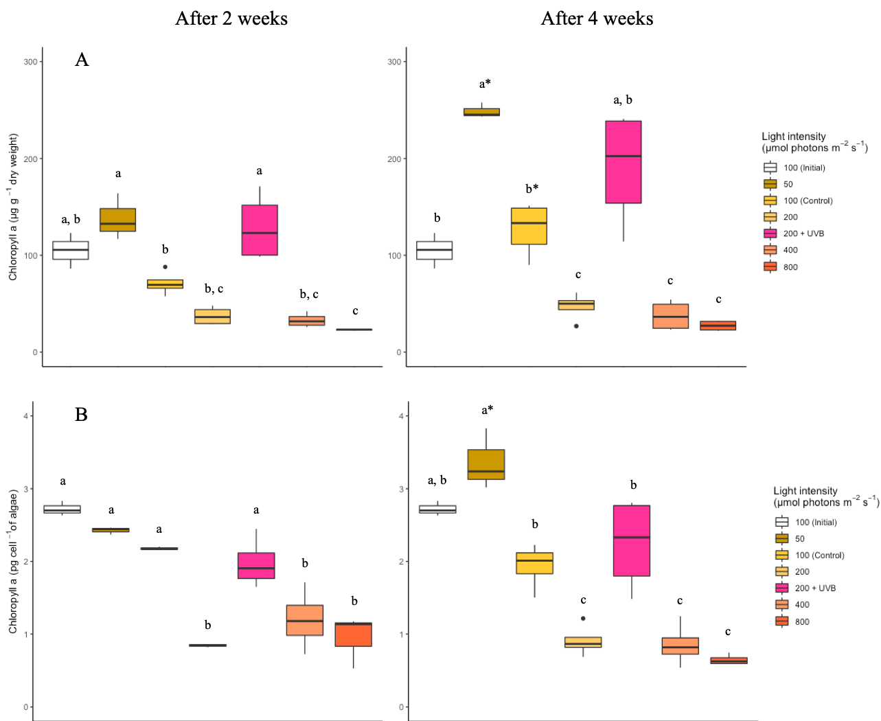

Fig. 1

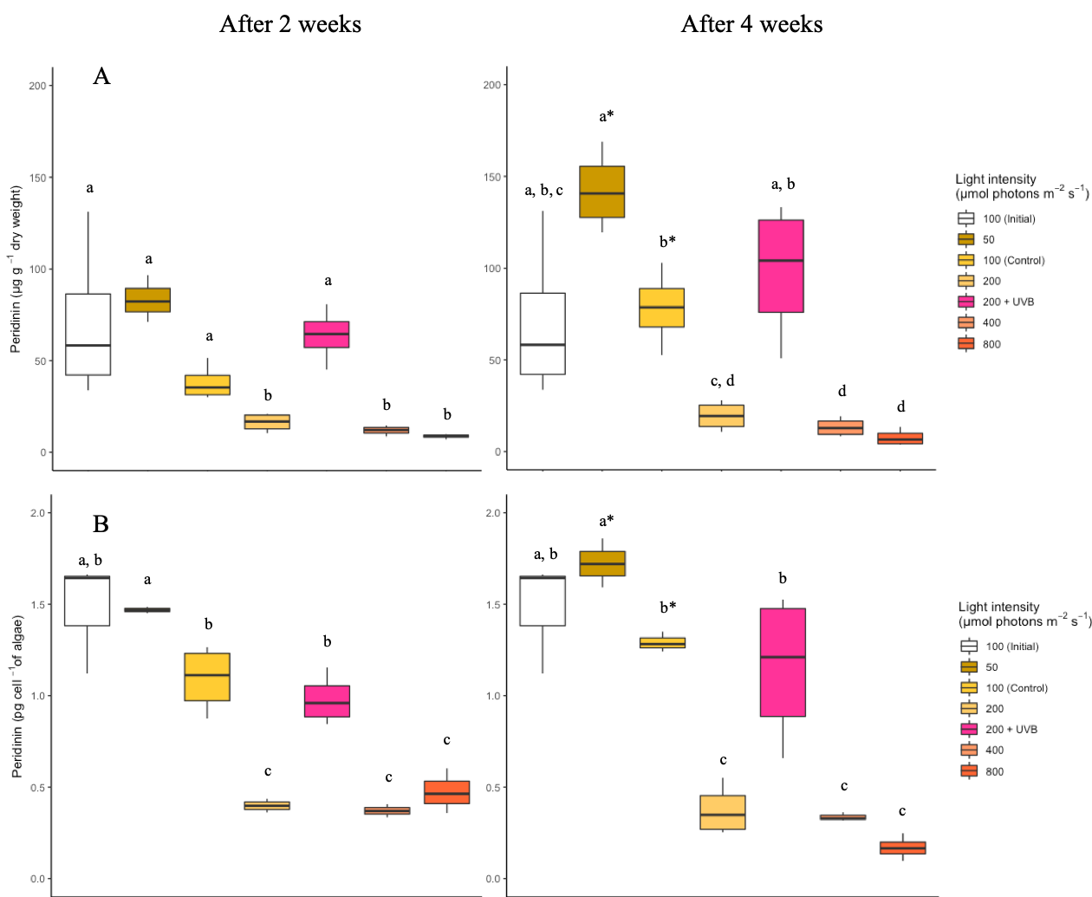

Fig. 2

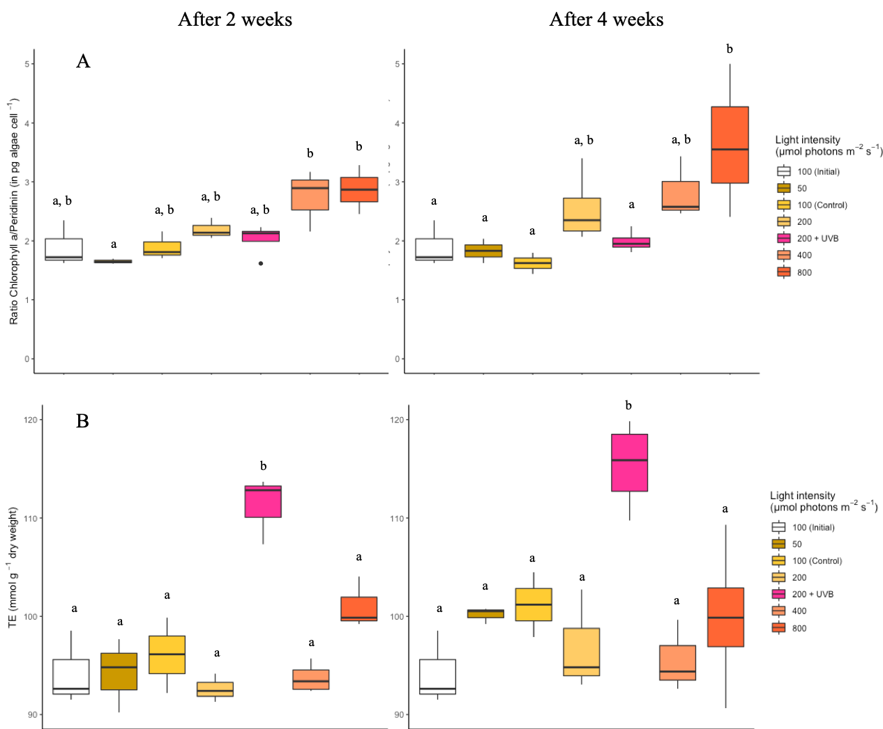

Fig. 3