**1.2**

|  |  |
| --- | --- |
| Cloudy | Bewölkung |
| Sprinkler | Rasensprenger |
| Rain | Regen |
| Wet grass | Nasser Rasen |

**1.3**

|  |  |
| --- | --- |
| Visit Asia | Asienreise |
| TBC | Tuberkulose |
| Xray result | Röntgendiagnose |
| TBC or cancer | Tuberkulose oder Krebs |
| Smoker | Rauchen |
| Lung cancer | Lungenkrebs |
| Bronchitis | Bronchitis |
| Dyspnea | Dyspnoe |

**2.1**

|  |  |
| --- | --- |
| Sociology soctorates vs. noncommercial space launches | Soziologische Doktortitel und nichtkommerzielle Raketenstarts im Zeitverlauf |
| Sociology soctorates (US) | Soziologische Doktortitel (USA) |
| Non-commercial space launches (Worldwide) | Nichtkommerzielle Raketenstarts (weltweit) |
| Space launch | Raketenstarts |
| Sociology doctorates | Doktortitel |

**2.3**

|  |  |
| --- | --- |
| Cholesterol | Cholesterin |
| Exercise | Sportliche Betätigung |

**2.4**

|  |  |
| --- | --- |
| Time | Zeitachse |

**2.5**

|  |  |
| --- | --- |
| Undirected graph | Ungerichteter Graph |
| Directed graph | Gerichteter Graph |
| Cyclic graph | Zyklischer Graph |
| Acyclic graph | Azyklischer Graph |

**2.6**

|  |  |
| --- | --- |
| Smoking | Rauchen |
| Yellow fingers | Gelbe Finger |
| Lung cancer | Lungenkrebs |

**2.7**

|  |  |
| --- | --- |
| Genetic factor | Genetische Veranlagung |
| Environmental factor | Umwelteinflüsse |
| Cancer | Krebs |
| Surgery | Chirurgischer Eingriff |

**2.9**

|  |  |
| --- | --- |
| Measurement error | Messfehler |
| Mismeasured variable | Falsch gemessene Variable |

**2.14**

|  |  |
| --- | --- |
| A to C | Von A nach C |
| B to C | Von B nach C |
| A via C to B | Von A über C nach B |

**2.15**

|  |  |
| --- | --- |
| B to A | Von B nach A |
| A via B to C | Von A über B nach C |

**3.1**

|  |  |
| --- | --- |
| Court order (CO) | Richterliche Verfügung (RV) |
| Captain (C) | Kommandant:in (K) |
| Death (D) | Tod (T) |

**3.2**

|  |  |
| --- | --- |
| Court order (CO) | Richterliche Verfügung (RV) |
| Captain (C) | Kommandant:in (K) |
| = True | = Wahr |
| = False | = Falsch |
| Death (D) | Tod (T) |

**3.3**

|  |  |
| --- | --- |
| Before do-Operator | Vor Verwendung des do-Operators |
| After do-Operator | Nach Verwendung des do-Operators |

**3.4**

|  |  |
| --- | --- |
| Model | Modell |
| Counterfactual for a student | Kontrafaktische Analyse für eine spezifische Testperson |
| Encouragement | Förderprogramm |
| Homework | Übungsaufgaben |
| Exam score | Examensnote |

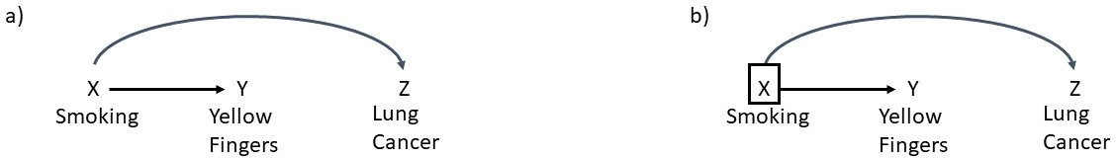**4.1**

|  |  |
| --- | --- |
| Smoking | Rauchen |
| Yellow fingers | Gelbe Finger |
| Lung cancer | Lungenkrebs |

**5.5**

|  |  |
| --- | --- |
| Smoking | Rauchen |
| Birth weight | Geburtsgewicht |
| Birth defects | Geburtsfehler |
| Child mortality | Säuglingssterblichkeit |

**5.6**

|  |  |
| --- | --- |
| Cholesterol | Cholesterin |
| Exercise | Sportliche Betätigung |

**5.7**

|  |  |
| --- | --- |
| Gender | Geschlecht |
| Medicine | Medikament |
| Recovery | Gesundung |

**5.8**

|  |  |
| --- | --- |
| Blood pressure | Blutdruck |
| Medicine | Medikament |
| Recovery | Gesundung |

**5.9**

|  |  |
| --- | --- |
| Disease | Krankheit |
| Hospitalization | Einlieferung ins Krankenhaus |

**5.10**

|  |  |
| --- | --- |
| Experience | Erfahrung |
| Education | Bildungsgrad |
| Salary | Gehalt |