Article
Age Defies Expectations: How Age is Related to Assessments of Urgency Inferred from Medical Test Results
Firstname Lastname ¹, Firstname Lastname ² and Firstname Lastname ^{2,}*
Citation: Lastname, F.; Lastname, F.; Lastname, F. Title. Future Internet 2022, 14, x. https://doi.org/10.3390/xxxxx
Academic Editor: Firstname Lastname
Received: date
Accepted: date
Published: date
Publisher’s Note: MDPI stays neutral with regard to jurisdictional claims in published maps and institutional affiliations.

Copyright: © 2022 by the authors. Submitted for possible open access publication under the terms and conditions of the Creative Commons Attribution (CC BY) license (https://creativecommons.org/licenses/by/4.0/).
¹ Affiliation 1; e-mail@e-mail.com
² Affiliation 2; e-mail@e-mail.com
* Correspondence: e-mail@e-mail.com; Tel.: (optional; include country code; if there are multiple corresponding authors, add author initials)
Abstract: The successful incorporation of digital technologies into primary care relies on laypersons' accurate interpretation of test results. Designers need to create patient portals that help people of all ages self-manage various health conditions. In this article, we will examine how the format in which test results are presented via the patient portals affects how people of different ages interpret their urgency and how they respond to these interpretations of urgency. We distributed an online questionnaire to more than 300 participants who were asked to assess the urgency of seven hypothetical health conditions and state the course of action they were inclined to follow. Our study reveals that age significantly predicts perceptions of severity and, consequently, the chosen courses of action. Those aged 60-80 tend to be more accurate in their interpretations of severity than those aged either 31-59 or 18-30 and are less affected by the format in which tests are presented. The severity-doctor association in a numeric presentation was significantly higher than this association in a graphic presentation. However, participants tended to be more confident in their assessments when the lab tests were presented in the numeric format, than when presented in the graphic format. In general, while not knowing can drive people to immediately call their doctor, being doubtful of one’s assessment can lead people to defer responsibility to their doctor or wait and see how the condition progresses. Finally, we discuss the study's implications for the design of patient portals to minimize possible overuse and underuse of care.
.
Keywords: e-health literacy, patient-portal, numeracy, graphic literacy, verbal skills

1. Introduction
COVID-19 has expedited the introduction of a wide variety of digital health tools designed to enable home examination, remote diagnosis, and remote monitoring of acute and chronic conditions [1]. Often patients view their lab results in these portals before their family physician does. Thus, the type of scrutiny that was once the preserve of healthcare providers is gradually being transferred to patients. This requires new types of e-health proficiencies and skills. The successful incorporation of these technologies into primary care relies on the integration of lay expertise into health care delivery. The direct patient use of test data is consistent with trends toward patient-centered care and the medical home concept – each aims to achieve greater patient involvement in both medical decision-making and health self-management [2], [3], [4].
Numerous studies evidence patients' difficulties in comprehending, interpreting, and correctly responding to personalized health information [5]. Failure to accurately assess the severity of a health condition can result in both underuse and overuse of medical services. Underuse leaves populations and patients vulnerable to avoidable disease and suffering. Overuse can cause avoidable financial harm from wasted resources that could be better spent on services that promote health [6], [7], [8]. How then can Electronic Patient Records (EPR) help ensure that the right care is received by the right patients in the right setting and at the right time? We argue that overuse and underuse of services are partly due to an inappropriate presentation of the information in the patient portals [4], [9].
Electronic Patient Records or patient portals are ”a secure online system to support a wide range of patients' needs relating to personal health information management, including viewing lab results and medications, refilling prescriptions, scheduling appointments, downloading and completing forms, and reading educational material” [10]. Patient portals can provide patients with tools to effectively manage their health care, as well as an effective means to communicate with care team members in a timely fashion. Patient portal use has been shown to improve appointment adherence [11], [12]. Encouraging results were described relating to the enhancement of preventive behaviors and improved control of chronic conditions such as diabetes parameters and asthma flares. However, conflicting results were described concerning blood pressure control, mental health conditions, and medication adherence [13]. Moreover, Goldzweig et al. [14] show an increased number of outpatient visits and hospitalizations among portal users. A more recent meta-analysis found evidence to the contrary. Carini and colleagues [13] show a decrease in the utilization of in-person services and hospitalizations among portal users, which may indicate the patient portals’ contribution to enhancing preventive behaviors. The authors partially attribute the discrepancy between studies to the providers’ and patients’ gradual adaptations to the patient portals. Nevertheless, they conclude their review by suggesting that the benefits of digitalization remain highly contextual and that the use of technology does not always lead to an improvement in patient care and the efficient provision of health services. They recommend that scholars identify a set of features with proven efficacy to improve the development and implementation of patient-oriented portals(Carini, Villani, Pezzullo, Gentili, Ricciardi, Boccia, 2021). With this task in mind, our first aim was to examine how accurate our respondents were in assessing the severity of the health condition they were presented with based on the presentation of lab results in the portal.
Patient portals have the potential to positively impact health literacy when they enable patients to identify, understand, and apply personalized health information [15]. Yet, despite having increased access to their health data, patients do not always understand this information or its implications [15]. McEwan and her colleagues [15] argue that test results are not always displayed in a way that is easy for the patient to understand. Even with normal ranges clearly shown, laypersons find it difficult to understand the implications of abnormal results [15] (p. 836). However, despite the ubiquitous use of patient portals in different care settings, our understanding of how portals might influence the health literacy of their users is still limited. To fill this knowledge gap, our second aim is to examine how the format in which the lab results are presented (numeric or graphic) is related to levels of accuracy and assessments of the health conditions’ severity.
Numerous studies have shown that the format in which test results are presented to laypersons can affect their perceptions of risk, perceived urgency, and inclination to contact health care providers [16], [4], [17], [9], [18]. Health numeracy refers to the ability to understand and apply information that is conveyed with numbers, tables and graphs, probabilities, and statistics to facilitate communicating with health care providers effectively, taking care of one's health, and participating in medical decisions [19]. Graph literacy denotes the ability to understand basic graphical representations used to present quantitative information [20].
Mancuso [21] identified operational competence and autonomous competence as two out of six antecedents of health literacy. Operational literacy encompasses the skills of reading and numeracy to comprehend health information. Autonomous competence refers to the ability to apply this information to one’s context [21] (p. 249). While several studies associate overuse and underuse of healthcare services with health literacy, economic status [22], and poor-quality communication between patients and healthcare providers [23], others positively associate health anxiety with increased utilization of primary, somatic specialist, and mental specialist healthcare use [24]. Our third aim is therefore to examine how numeric and graphic presentation of the lab results are related to respondents’ confidence in their assessments of severity, and how confidence is related to choosing a course of action. Self-management, contends Mancuso, includes decisions and actions taken by the individual to improve health. And so, we studied how the respondents’ assessments of the severity of the health condition were related to their choice of a course of action.
Finally, since older adults are likely to suffer from multiple chronic conditions, they need to manage an increasing amount of health information. At the same time, cognitive and motoric limitations may hamper their use of these systems [10]. They are, therefore, of particular interest to healthcare professionals and system designers who are looking to improve patient engagement.
On the other hand, young adults also constitute an important target group for e-health literacy initiatives because their understanding of their role in improving or maintaining their mental and physical health tends to be lower than in the older adult population [25], [26]. They are also at a crucial stage of development in terms of physical, emotional, and cognitive changes as they are developing more autonomy and forming behavior patterns [27], [28]. However, not much is known about how age is related to the interpretation of lab results. Which format is most effective in aiding patients to accurately assess the health condition’s severity and decide on an adequate course of action? The literature draws a rather complex picture, in which age plays a prominent, yet underexplored role [19], [29]. Van Weert and her colleagues [18] have shown that though participants, young and old, preferred graphs to tabular formats, the gist knowledge derived from the table format was higher than the one derived from the graph. This effect was even stronger among the older group of participants. They concluded that even though laypersons often prefer familiar and straightforward design formats such as clock charts and pie charts to tables, these formats do not necessarily improve understanding. However, Zikmund-Fisher and his colleagues [4] found that when numeric information was presented in a table format, many people were unable to distinguish between values that represent minor non-urgent deviations from those that are more clinically concerning. They showed that using simple line graphics to represent test results increased the sensitivity to variations in test values [4], [19]. Taha and colleagues [30] similarly found that older patients faced difficulties in understanding health texts involving numeric concepts, even if their level of health literacy was relatively high. They thus suggested that tables displaying numeric information in the portal need to be supplemented with an audio and/or video explanation to help patients understand and interpret different types of numeric information.
Though considering age, these studies tend to focus on the elderly and neglect the information needs of young and middle-aged adults. Inspired by these studies, we examined how respondents of three age groups interpreted the severity of various health conditions based solely on the format in which the test results were presented. We then modeled the effect of age on severity assessments, confidence in the accuracy of these assessments, and a chosen course of action for each format (graph and numeric).

2. Methods

2.1 Procedure and Design
The authors presented each of the respondents with seven scenarios. Each contained a short description of the protagonist’s name and age. In each scenario, a series of symptoms had led the family doctor to request a lab test or series of tests. The lab results were presented either in a numeric or a graph format. In both formats, the participants could deduct the range of normal values, the protagonist’s present position within that range, and his or her past results. The lab tests (blood work or cultures) were ordered to investigate or test for one of the following: low hemoglobin, streptococcus (a throat infection), or a routine cholesterol check. We chose these conditions and tests because they are relatively common, are likely to require continued monitoring or follow-up, likely to be only moderately serious, and, in most cases, potentially applicable to both men and women.
Each participant was asked to consider three scenarios in which the lab results were presented in a graph format and four in which the lab results were presented in a numeric format. Figure 1 exemplifies one such scenario.
For each scenario, we asked the participants to assess the severity of the hypothetical patient's condition, how confident they were in their assessment, and the course of action they would follow if they were the patient. The seven scenarios were each associated with lab results, which we extracted from authentic patient portals.
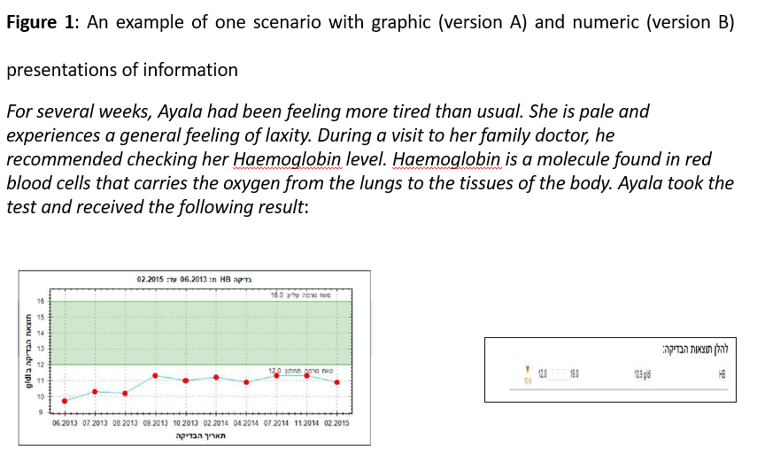
We recruited participants through convenience sampling, which is commonly employed in healthcare-related surveys (e.g., [31]-[34]). We asked each respondent to virally distribute the anonymous link of the questionnaire to others in their network (snowball sampling). The link was operative for two weeks, and we monitored the response rate daily. By the end of the data collection period, the link was distributed to over 387 individuals. We let the respondents know that the questionnaire was anonymized and that the purposes of the study were purely academic. We also informed them that they could stop completing the questionnaire at any time without consequence. The academic institution’s research authority approved the research and its tools. 46 people clicked on the link but did not attempt the survey. 38 respondents did not respond to all seven scenarios. 284 responders who are laypersons and 26 health professionals (doctors or nurses) returned fully completed questionnaires. Approximately 78% of those who began the survey (i.e., who completed the demographic questions) submitted usable answers – a satisfactory percentage, given that the questionnaire was relatively long and contained seven scenarios. Missing data analysis revealed that missing values were random for most variables. A Pearson Chi-Square Test showed that those who did not complete the questionnaire differed from those who did in their health status (X2 (3, N = 273) =9.97 value, p < 0.002). Finally, we applied a binomial test of equal proportions or a two-proportion z-test to determine the minimum required sample size. In this study, a random sample of 43 pairs (where the mean difference is 0.22 and the standard deviation of the difference is 0.5) would allow us to declare with 80% power that the mean of the paired differences is significantly different from zero (i.e., a two-sided p-value is less than 0.05).

2.2. Measurements

2.2.1. Independent Variables
Format – We presented the participants with four scenarios in which the results were presented in a numeric format, and three in a graph format. These presentations were extracted from authentic Electronic Patient Records. We asked two physicians to ascertain the scenarios’ validity. Both formats contained similar information: the present value or measure, the range of values that constitute the norm, and patients’ past values. In both formats, values that were found outside the normal range were colored red. We performed a Pearson correlation to assess the level of similarities between the two formats. Comparing the two formats in terms of accuracy revealed r(255) = .342, p = 0.000. Comparing the two formats in terms of severity assessments revealed r(255) = .296, p = 0.000. The formats are thus sufficiently different to warrant separate consideration.
Wellness – We asked respondents to state their health status. The participants were first asked to rate their general physical well-being (1=very poor; 5=excellent). They were then asked to state if they suffered from a chronic condition of some sort (1=yes; 2=no). Finally, they were asked if they suffered from a debilitative condition of some sort (1=yes; 2=no).
Use of EPR systems – The participants were presented with a list of procedures available via the patient portal and were asked to report how often they used each one (1=never; 6=very frequently) see Figure 2.
Attitudes toward the medical establishment and health beliefs – The participants were asked a series of nine questions about attitudes toward self-care and responsiveness to medical or health recommendations. Reliability analysis was carried out to assess participants’ level of EPR use, comprising eight items. Cronbach’s alpha showed the questionnaire reached an acceptable reliability of α = 0.88. All items appeared to be worthy of retention, resulting in a decrease in the alpha if deleted. The respondents were asked to indicate how much they agree with each statement on a five-point Likert-type scale from strongly disagree to strongly agree. Typical statements included: “Usually I comply with my doctor’s orders”, “I am suspicious of doctors’ recommendations”). In addition, seven items measured beliefs about health and healthcare. Cronbach’s alpha showed the questionnaire reached a reliability of α = 0.620.
Resilience – A construct composed of 15 statements, each testing the level of emotional strength – the capacity to recover quickly from difficulties. The respondent is asked to indicate how far he or she agrees with each statement on a five-point Likert-type scale from strongly disagree to strongly agree. Typical statements included: “I am an optimistic person who believes that everything will turn out for the best”, “I expect things to work out”). Cronbach’s alpha reliability coefficient was 0.85.

2.2.2. Dependent Variables

Severity of the health condition – For each scenario, the participants were asked to indicate how serious they believed the condition was ranging from 1=not at all serious to 4 = very serious.
Accuracy – We calculated how much each participant diverted from the average score given by the professionals who responded to the survey. Seventeen physicians and nine nurses completed the questionnaire. We performed a paired sample t-test to test differences in severity assessments between the professionals and laypeople. A two-tailed p-value equaled 0.0035. By conventional criteria, this difference is considered statistically significant, thus indicating the validity of this measure [mean difference = -0.4386, 95% confidence interval, difference range from -0.7022 to -0.1749, t = 3.6245]. The professionals’ mean scores provided the benchmark from which to calculate accuracy. The measure was calculated by subtracting the mean score of the professionals from the mean score of the respondents (laypersons). The smaller the result, the more accurate the respondent.
Confidence – After the respondents assessed the severity of the condition, they were asked how confident they were in their response on a scale from 1= to a small extent to 4 = to a large extent. Cronbach’s alpha reliability coefficient was 0.832.
Knowing – Participants who, based on the data they received, were unsure of the conditions’ gravity could pick the fifth option in the gravity scale, namely “don’t know”. A choice of the “don’t know” response indicated that the participant had difficulty interpreting the lab results and was uncertain of their meaning.
Chosen Course of Action – After the respondents assessed the severity of the condition, they were asked to indicate how likely (from 1= to a small extent to 5= to a large extent) they were to follow each of the following courses of action if they were the protagonist: immediately call my doctor to verify the results, search the Internet, wait for my doctor to contact me, or wait for my next scheduled visit to the doctor.

2.2.3. Demography and Control

Demographic measures collected were age, gender, HMO membership, income, education, religiosity, family status, and country of birth (see Table 1). To offset differential response rates by age, we divided the respondents into three distinct age samples (18–30, 31–59, and 60 and older). Income was measured on a three-point scale (“The average income is 10,000 NIS [about $3000 a month]. Is your income higher than, equal to, or less than 10,000 a month?”).

3. Hypothesis

3.1 If the numeric and graph formats are equally coherent, we expect similar effects on the respondents’ level of accuracy

3.2 If the numeric and graph formats are equally coherent, we expect similar effects on the respondents’ perceptions of severity

3.3 If the numeric and graph formats are equally coherent, we expect similar effects on the respondents’ confidence in their assessments. We expected to find that the lower the level of confidence the more respondents will search the Internet, and/or immediately call the doctor.

4. Results

4.1. Descriptive Statistics

Analyses were performed using SPSS version 25. Significance levels were set at p < 0.05. Descriptive statistics were used to describe the sample characteristics. Table 1 presents the distribution of the key demographic variables. Regarding education, our sample has a relatively high proportion of educated participants. However, it should be noted that 50% of all Israeli citizens aged 25-64 have either a tertiary or academic education. [35]. Four respondents claimed to be in poor health (1.8%) and 98% reported being in good, very good, or excellent health. Fifty-five respondents (18%) reported suffering from a chronic illness, and 22 respondents (5%) reported suffering from some type of physical limitation. Being in good or very good health was negatively correlated with age (r[310]=-0.492, p<0.01). Age was also negatively correlated with resilience (r[284]=-0.148, p=0.012). Most indicated that they felt responsible for keeping healthy (M=4.85, std=0.468, on a 5-point scale where 1=not at all, 5=very much agree), and maintaining a healthy lifestyle was important for them (M=4.69, std=0.57; 1=strongly disagree, 5=strongly agree). They also reported generally complying with their doctor’s recommended regime (M=4.36, std=0.844). When asked how they respond when they feel sick, 50% of the respondents who answered this question (N=155) said they turn to their doctor for a consultation, while 25% (N=77) turn to a family member, 22.7% (N=68) consult medical websites for information, and only 2.3% (N=18) consult online health forums.
As for EPR use, 71% of our participants (N=220) reported that they frequently access their lab results via the EPR. Ten percent (N=30) claimed to have never viewed their lab results via the EPR, and an additional 7.7% (N=23) of our participants were not aware of being able to view their lab results via the EPR. There was a significant main effect of age on EPR use (F(2, 277)=4.718, p<0.000). Participants aged 18–30 were significantly less inclined to consult the EPR than those aged 31–59 and those aged 60+. (p<0.000).
----Table 1 ---

4.2. Accuracy Assessments Among Young, Middle-aged, and Old Age Participants.

First, we assessed the respondents’ general level of accuracy in assessing the severity of the presented health conditions. Linear regression was used to test if accuracy can be significantly predicted by age, gender, socio-economic status, education, resilience, and attitude toward the healthcare system. The overall regression was statistically significant (R2 = 0.67, F(7, 240) = [3.536], p = 0.001). Age [B=-0.01, p =0.02], gender [B= -0.029, p=0.035], and income [B= -0.021, p=0.019] predicted accuracy. Women tended to be more accurate than their male counterparts. The older the participants the more accurate they were, and the higher the income, the higher the accuracy.
The proportion of subjects who accurately assessed the severity of the health condition differs by age, X2 (4, N = 267) = 22.01, p < 0.00 (see Table 2 and Fig 2). 64.6% of those aged 18-30 tended to overestimate the severity of the health condition. They constitute 43.4% of all the respondents who overestimated the seriousness of the health condition. 35.9% of those aged 31-59 underestimated the severity of the health condition. They constitute 67.8% of all those who underestimated the seriousness of the health results. Among those aged 60-80, 46.3% overestimated the seriousness of the health condition but they only constitute 20.5% of those who did so. Those aged 60-80 constituted 35% of all those who accurately assessed the severity of the health condition (See Table 2, Fig 3).
----Table 2 and Fig 2 –
Overall, in the graph format 49.6% (N=113) of the respondents underestimated the severity of the health condition, 19.7% (N=45) underestimated it, and 30.7% (N=70) accurately assessed the severity [X2 (4, N = 246) = 21.093, p < 0.00]. In the numeric condition, the proportion of those who underestimated the severity of the health condition rose to 59% (N=154), and the proportion of those who underestimated it rose to 25.3% (N=66). The proportion of those who accurately assessed the conditions decreased to 15.07% (N=41) [X2 (4, N = 261) = 19.487, p < 0.00] (Table 3). A paired sample t-test to examine differences in accuracy between the graph and numeric conditions corroborated that, on average, participants were more inaccurate (M=0.134, std = 0.088) in the numeric condition than in the graph condition (M=0.126, std=0.047). The difference, 1.30, 95% Cl [0.79-1.8] was statistically significant, t(6)=6.298, p< 0.01.
--- Table 3 ---
In terms of accuracy, each age group was affected differently by each of the formats. In the graph format, 36.1% of those aged 18-30 tended to overestimate the severity of the health conditions. They constituted 57.8% of all those who overestimated the severity of the condition. 54.10% of those aged 31-50 underestimated the seriousness of the condition. They constituted 53.1% of all those who underestimated the severity of the health condition, while 66.7% of those aged 60-80 underestimated the health conditions’ severity, and they constituted 12.9% of all those who accurately interpreted the results [X2 (4, N = 248) = 21.093, p < 0.00] (see Table 2). When the results were presented in the numeric format, 43.8% of those aged 18-30 overestimated the severity of the health condition, and they constituted 22.7% of all those who overestimated the severity of the condition. Those aged 31-50 constituted 57.1% of all those who underestimated the severity of the health condition, while those aged 60-80 constituted 24.4% of all those who accurately interpreted the results [X2 (4, N = 246) = 21.093, p < 0.00] (Fig 3).
----Fig 3 ---

4.3. Assessment of Severity Based on the Presentation Format.

Since patients cannot know if they are accurate in their assessments of severity when they decide on a course of action; their perception of severity (how serious they think the condition is) may be key to understanding the overuse and underuse of health services. We, therefore, tested differences in severity assessments in each of the formats. A paired sample t-test revealed that on average, participants tended to assess the health conditions as more severe (M=0. 514, std = 0.049) when the lab tests were presented in the graphic format than when presented in the numeric format (M=0.48, std=0.100). The difference, 0.932, 95% Cl [0.44-1.42] was statistically significant, t(6)=4.18, p< 0.01.But as we shall see, this difference was only true when the health conditions were judged to be mild (see Figure 3).
----Fig 4---
A one-way between subjects ANOVA was conducted to compare the level of severity between age groups in each of the formats. In both formats, there was a significant effect of age on severity at the p<0.05 level. In the graph format, those aged 18-30 (M=0.561; std=0.203) tended to perceive the health conditions as more serious than those aged 31-59 (M=0. 493, std= 0.184) and those aged 60-80 (M=0.486, std=0.184) [F(2, 245) = 3.588-, p = 0.00]. A similar trend was viewed in the numeric format [F(2, 273) = 10.518, p< 0.00]. Those aged 18-30 tend to perceive the health conditions as more serious (M=0.554; std=0.187) than those aged 31-59 (M=0.419, std=0.163) and those aged 60-80 (M=0.486, std=0.165). Finally, there was a slight difference between participants’ inclination to search the Internet when presented in the graphic format (M=0.686, std=0.05) and the numeric format (M=0.669; std=0.028). The difference, 0.752, 95% Cl [0.265-1.238] was statistically significant, t(6)=4.532, p=0.04.

4.4. Confidence Based on the Presentation Format

After the respondents assessed the severity of the health conditions, they were asked to report how confident they were in their assessments. A paired sample t-test revealed that, on average, participants tended to be more confident in their assessments when the lab tests were presented in the numeric format (M=0. 509, std = 0.199) than when presented in the graphic format (M=0.478, std=0.182). The difference, -0.229, 95% Cl [-0.036- 0.07] was statistically significant, t(252)=-2.975, p< 0.01. Linear regression was used to test if confidence can be significantly predicted by age, gender, socio-economic status, education, resilience, and attitude toward the healthcare system. The overall regression was insignificant. Moreover, confidence was not related to immediately calling a doctor (r=0.30, p> 0.60), or searching the Internet (r=0.49, p=0.431). In the graph format, confidence was weakly related to accuracy (r=139, p<0.05). In the numeric format, confidence was similarly related to accuracy (r= 135, p<0.01).
The participants were more confident in their assessments when the results were presented in the numeric format (M=0.5199, std=0.017) than when presented with results in the graph format (M=0.483; std=0.667). The difference 0.92, 95%Cl [0.4-1.44] was statistically significant, t(6)=4.385, p=0.05. Correspondingly, participants reported less difficulty in assessing the gravity of the health conditions when presented with the numeric format (M=0.1, std = 0.03) than with the graphic format (M=1.148, std= 0.676). The difference 1.307, 95% Cl [0.83-1.78] was statistically significant, t(6)=6.73, p< 0.01. In the graph format “not knowing” was positively correlated with immediately calling the doctor (N=250, r=0.141, p=0.001), and even stronger in the numeric format (N=259, r=.150, p=0.001) suggesting that the more one does not know how to interpret the results, the more they will opt to immediately call the doctor. It is, therefore, possible that while not knowing can drive people to immediately call their doctor to schedule a visit, being doubtful of one’s assessment can lead people to defer responsibility to their doctor or wait and see how the condition progresses.
The above results may indicate differences in the way the participants responded to results presented in each of the formats. While their interpretations of the results were more accurate in the graphic format, they felt more confident in their assessments when presented with the numeric format. Moreover, they felt more in need of clarifications either from the Internet or their doctors when presented with results in the graphic format. Even though we did not find a relationship between confidence and immediately calling the doctor, it is worrying that overall 43.4% (N=23) of those who overestimated the severity of their condition were doubtful of their assessments, 32.3% (N=42) of those who underestimated the severity (N=42) were highly confident in their assessments, and 54.1% (N=20) of those who accurately assessed the severity were doubtful of being correct in their assessments. These findings may suggest that the presentation of the lab results is not coherent enough to eradicate doubt and that they may instill a false sense of confidence.

4.5. Structural Equation Modeling Explaining the Relationship Between Age, Perceptions of Severity, and a Chosen Course of Action in Both Formats.

We used SEM to model the factors that may explain how the format in which the lab results are presented is related to perceptions of severity and to choosing a course of action. Two models were evaluated. In the first model, a course of action (immediately calling a doctor and searching the Internet) was explained by a series of background variables: age (Q4), resilience (hosen), and attitudes (attitudes toward the medical establishment and health beliefs). The perceived severity of the health condition (SEV_total) was thought to function as a mediator variable in the model, related to the background variables (age, hosen, and attitude) and impacting the chosen course of action (doctor / Internet). Confidence was thought to mediate the relationship between the background variables and the chosen course of action. Model 1 fit the data well: the fit indices exceeded 0.90, and the RMSEA was significant (p = 0.00).
The results from Model 1 are presented in Fig. 5. The significant results (trimmed model) are presented in diagrams with the specifications of the main statistical measures: regression weights and multiple correlation coefficients (see Table XXX). The model predicted XXX of the variance of the choice of a course of action. In this model, both age (β = -0.15) and attitudes toward the medical establishment (β = -0.13) negatively predicted resilience But neither resilience nor attitudes predicted the perceptions of severity. Age, on the other hand positively predicted the perception of severity (β = -0.15). Perceptions of severity predicted immediately calling the doctor (β = 0.12), but not Internet search. Confidence, the mediator variable in the model, did not predict the course of action, nor was it related to perceptions of severity. The model predicted XXX of the variance of the choice of a course of action.
In the second model, the fit indices exceeded 0.90, and the RMSEA was significant (p = 0.00). Age directly predicted both the perceived severity in the graph format (β = -0.-11) and the perceived severity in the numeric format (β = -0.15). The perceived severity in both conditions – graph and numeric – predicted immediately calling the doctor. In this model, it appears that in the numeric format, the relationship between perceptions of severity and immediately calling the doctor (β = 0.35) is stronger than in the graph format (β = 0.27). To examine whether the relationship between perceived severity and calling a doctor is stronger in the numeric format than in the graph format, we constrained these effects to equality and evaluated the difference in chi-square value. Results indicated that the constrained model was significantly different from the unconstrained model (Δχ2 = 4.46, p = 0.034), which suggests that the severity-doctor association in the numeric presentation is significantly higher than this association in the graphic presentation.
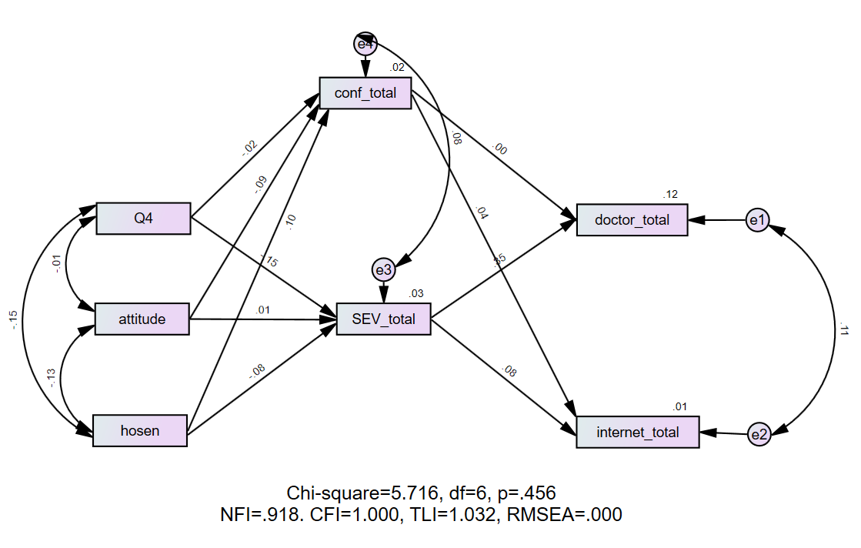
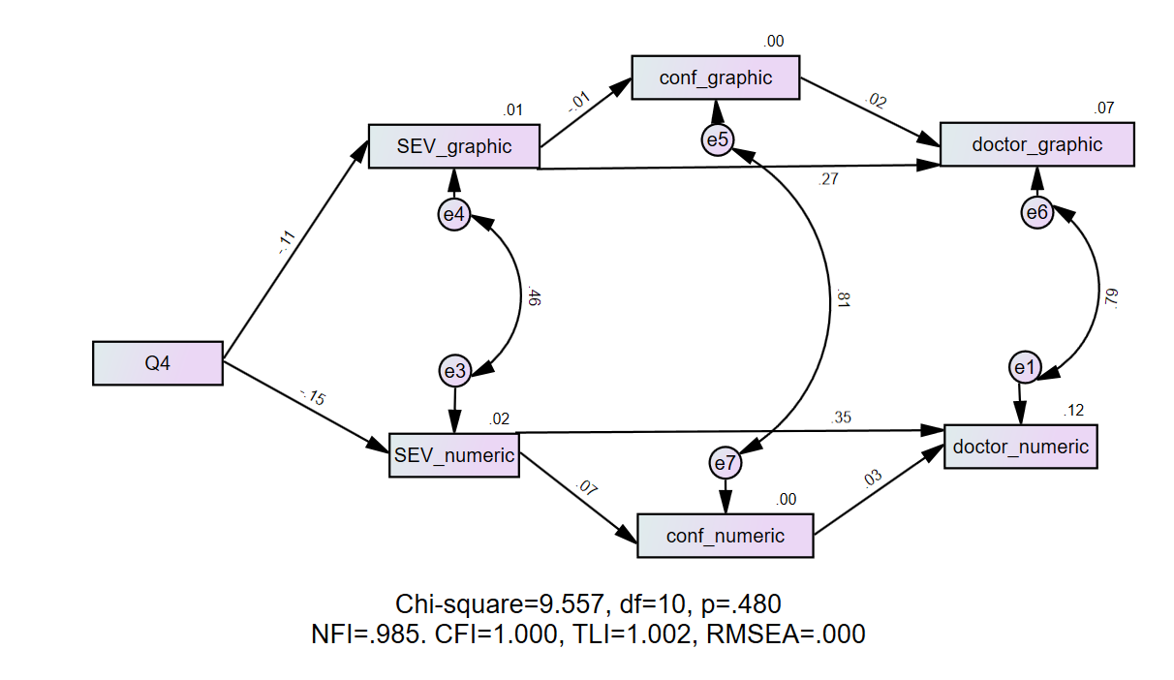

5. Discussion
Numeracy and graph literacy have been shown to be especially critical for users to accurately interpret and act on the personalized health information contained in patient portals [19]. After controlling for health literacy, numeracy and graph literacy are strongly predictive of people’s ability to accurately read their health condition. To realize the potential benefits of patients’ access to their personalized information, the patient portals need to clearly convey the meaning of results and, when needed, indicate required action [36]. Recent studies have reached an understanding that to improve the users’ level of literacy, designers need to present laboratory results in ways that are adapted to the people who use them [34], [37]. How then can systems convert the potentially meaningless data of results into information that can effectively engage patients in meaningful action?
To attempt an answer, we devised a study that allowed us to analytically disentangle barriers related to digital literacy (the skills required to operate the multiple features of the patient portal) from barriers related to graph and numeric literacy. Moreover, contrary to studies that relied on self-reports of skills and preferences, this work assessed the respondents’ performance as they grappled with the interpretation of authentic, rather than contrived, presentations of lab results [19], [34]. Nevertheless, addressing hypothetical scenarios meant that the participants lacked the personal relevance that such test results have for patients attempting to manage these conditions in real life. It is therefore possible that our results may not accurately reflect how people respond to their personalized health information. To minimize this effect we carefully chose common health conditions. We assumed that many of our respondents were familiar with at least some of the conditions. We also assumed that in real life there are many scenarios in which patients with no prior knowledge of a given laboratory test might view laboratory results in a patient portal. We, therefore, believe that our study design successfully simulated realistic circumstances. However, we encourage scholars to examine the effect of presentation format on more serious health conditions.
This study confirms patients’ difficulties in interpreting laboratory test results, with many patients underestimating the need for action, even when abnormal values were highlighted or grouped. It also shows that participants found it particularly difficult to interpret medium-risk clinical scenarios (see [34]). Our findings are consistent with Zikmund-Fisher et al.’s [38] finding that graphics help patients distinguish between urgent and non-urgent deviations in laboratory test results, independent of the type of presentation used.
This paper adds to existing knowledge by revealing a complex relationship between the format of the presentation, perceptions of severity, and choosing a course of action. Participants tended to attribute higher severity to health conditions whose lab tests were presented in the graphic format, than to those presented in the numeric format. But the severity-doctor association in the numeric presentation was significantly higher than this association in the graphic presentation. This may suggest that while assessments of severity have a dramatic effect on immediately calling the doctor, the equivocality of the information also carries weight in the decision. Chua, Yates, and Shah [39] found that when risk statistics are presented pictorially (in a graph format), people appear to regard them as less risky than when presented numerically. Possibly the type of graphs studied here induces a cognitive effect that focuses users’ attention on the condition’s progression over time and less on the present status. It is also possible that the graph makes diversions from the norm more difficult to assess. The higher number of “do not know” answers in the graph scenarios versus the numeric scenarios, coupled with a lower level of confidence in the graph scenarios compared to that of the numeric scenarios, strengthens our assumption. From an interface design perspective, it might be advisable to highlight the pieces of information that are most relevant for patients and filter those that are less relevant. It may also be advisable to add a clearly stated and personalized recommendation advising patients on how to appropriately respond to the findings, thereby reducing unnecessary anxiety.
This study shows that participants of different ages respond differently to results based on the format in which the test results are presented. First, we found that both assessments of accuracy and severity were dependent on age. Second, compared to the younger age groups, those aged 60-80 were less affected by the format in which the test results were presented. An older person’s tendency to accurately interpret the lab results could be attributed to their life experience and to their tendency to show preferential fixation toward positive stimuli, whereas young adults show preferential fixation toward negative stimuli displaying fear [40]. Such age-related positivity in information processing can be an important effect that should be explored further in future studies. However, this may suggest that for those aged 60-80 digital literacy is more of a barrier than numeracy and graph literacy [41].
Graphs, tables, and charts could be made easier to interpret if coupled with a brief and concise verbal explanation, using language that is familiar to readers. Moreover, instead of indicating a diversion from the norm, it might be more helpful to indicate an overall level of urgency and include a recommendation for the type of follow-up required (e.g., a consultation with a doctor, more tests, or certain types of monitoring). Addressing these concerns is key to designing health information technologies that can improve laypersons’ engagement and self-care, and reduce both under- and over-utilization of health services.

References
- Bayram, M., Springer, S., Garvey, C. K., & Özdemir, V. COVID-19 digital health innovation policy: A portal to alternative futures in the making. OMICS: A Journal of Integrative Biology 2020, 24(8), 460-469.
- Zikmund-Fisher, B. J., Exe, N. L., & Witteman, H. O. Numeracy and literacy independently predict patients’ ability to identify out-of-range test results. Journal of Medical Internet Research 2014, 16(8), e3241.
- Brewer, Gilkey, Lillie, 2019
- Zikmund-Fisher, B. J., Scherer, A. M., Witteman, H. O., Solomon, J. B., Exe, N. L., Tarini, B. A., & Fagerlin, A. Graphics help patients distinguish between urgent and non-urgent deviations in laboratory test results. Journal of the American Medical Informatics Association 2017, 24(3), 520-528.
- Baldwin, J. L., Singh, H., Sittig, D. F., & Giardina, T. D. Patient portals and health apps: Pitfalls, promises, and what one might learn from the other. Healthcare 2017, Sep: Vol. 5, No. 3, pp. 81-85.
- Brownlee, S., Chalkidou, K., Doust, J., Elshaug, A. G., Glasziou, P., Heath, I., … & Korenstein, D. Evidence for overuse of medical services around the world. The Lancet 2017, 390(10090), 156-168.
- Vandenbosch, J., Van den Broucke, S., Vancorenland, S., Avalosse, H., Verniest, R., & Callens, M. Health literacy and the use of healthcare services in Belgium. Journal of Epidemiology and Community Health 2016, 70(10), 1032-1038.
- Goto, E., Ishikawa, H., Okuhara, T., & Kiuchi, T. Relationship of health literacy with utilization of health-care services in a general Japanese population. Preventive Medicine Reports 2019, 14, 100811.
- Tao, D., Yuan, J., Shao, F., Li, D., Zhou, Q., & Qu, X. Factors affecting consumer acceptance of an online health information portal among young internet users. CIN: Computers, Informatics, Nursing 2018, 36(11), 530-539.
- Kim, S., & Fadem, S. Communication matters: Exploring older adults’ current use of patient portals. International Journal of Medical Informatics 2018, 120, 126-136.
- Kipping, S., Stuckey, M. I., Hernandez, A., Nguyen, T., & Riahi, S. A web-based patient portal for mental health care: benefits evaluation. Journal of Medical Internet Research 2016, 18(11), e6483.
- Sun, R., Burke, L. E., Saul, M. I., Korytkowski, M. T., Li, D., & Sereika, S. M. Use of a patient portal for engaging patients with type 2 diabetes: patterns and prediction. Diabetes Technology & Therapeutics 2019, 21(10), 546-556.
- Carini, E., Villani, L., Pezzullo, A. M., Gentili, A., Barbara, A., Ricciardi, W., & Boccia, S. The impact of digital patient portals on health outcomes, system efficiency, and patient attitudes: updated systematic literature review. Journal of Medical Internet Research 2021, 23(9), e26189.
- Goldzweig, C. L., Orshansky, G., Paige, N. M., Towfigh, A. A., Haggstrom, D. A., Miake-Lye, I., ... & Shekelle, P. G. Electronic patient portals: evidence on health outcomes, satisfaction, efficiency, and attitudes: a systematic review. Annals of Internal Medicine 2013, 159(10), 677-687.
- MacEwan, S. R., Gaughan, A., Hefner, J. L., & McAlearney, A. S. Identifying the role of inpatient portals to support health literacy: Perspectives from patients and care team members. Patient Education and Counseling 2021, 104(4), 836-843.
- Ancker, J. S., Senathirajah, Y., Kukafka, R., & Starren, J. B. Design features of graphs in health risk communication: a systematic review. Journal of the American Medical Informatics Association 2006, 13(6), 608-618.
- Morrow et al., 2017.
- van Weert, J. C., Alblas, M. C., van Dijk, L., & Jansen, J. Preference for and understanding of graphs presenting health risk information. The role of age, health literacy, numeracy and graph literacy. Patient Education and Counseling 2021, 104(1), 109-117.
- Ruiz, J. G., Andrade, A. D., Hogue, C., Karanam, C., Akkineni, S., Cevallos, D., ... & Sharit, J. The association of graph literacy with use of and skills using an online personal health record in outpatient veterans. Journal of Health Communication 2016, 21(sup2), 83-90.
- Galesic, M., & Garcia-Retamero, R. Graph literacy: A cross-cultural comparison. Medical Decision Making 2011, 31(3), 444-457.
- Mancuso, J. M. Health literacy: a concept/dimensional analysis. Nursing & Health Sciences 2008, 10(3), 248-255.
- Zhang, Y., Zhou, Z., & Si, Y. When more is less: What explains the overuse of health care services in China? Social Science & Medicine 2019, 232, 17-24.
- Green, A. R., Tung, M., & Segal, J. B. Older adults’ perceptions of the causes and consequences of healthcare overuse: a qualitative study. Journal of General Internal Medicine 2018, 33(6), 892-897.
- Norbye, A. D., Abelsen, B., Førde, O. H., & Ringberg, U. Health anxiety is an important driver of healthcare use. BMC Health Services Research 2022, 22(1), 1-12.
- Massey, P. M., Prelip, M., Calimlim, B. M., Quiter, E. S., & Glik, D. C. Contextualizing an expanded definition of health literacy among adolescents in the health care setting. Health Education Research 2012, 27(6), 961-974.
- King, C., Cianfrone, M., Korf-Uzan, K., & Madani, A.. Youth engagement in eMental health literacy. Knowledge Management & E-Learning: An International Journal 2015, 7(4), 646-657
- Manganello, 2008.
- Wong, Zimmerman, Parker, 2010.
- Chin, Madison, Gao, Graumlich, Conner-Garcia, Murray, Morrow, 2017.
- Taha, Sharit, Czaja, 2012.
- Huang, Chang, Khurana, 2012.
- Norgaard, Furstrand, Klokker, Karnoe, Batterham, Kayser, Osborne, 2015.
- Irizarry, Shoemake, Nilsen, Czja, Beach, Dabbs, 2017.
- Fraccaro, P., Vigo, M., Balatsoukas, P., Van Der Veer, S. N., Hassan, L., Williams, R., … & Peek, N. Presentation of laboratory test results in patient portals: influence of interface design on risk interpretation and visual search behaviour. BMC Medical Informatics and Decision Making 2018, 18(1), 1-12.
- OECD Report – Education Level – Israel, 2019.
- Witteman and Zikmund-Fisher, 2019.
- Bar-Lev and Beimel, 2020.
- Zikmund-Fisher et al., 2016.
- Chua, H. F., Yates, J. F., & Shah, P. Risk avoidance: Graphs versus numbers. Memory & Cognition 2006, 34(2), 399-410.
- .Isaacowitz, Wadlinger, Goren, & Wilson, 2006a, 2006b.
- Tuan, W. J., Mellott, M., Arndt, B. G., Jones, J., & Simpson, A. N. Disparities in use of patient portals among adults in family medicine. The Journal of the American Board of Family Medicine 2022, 35(3), 550-569.

