**Cooling of CO2-rich geothermal fluids: A mechanism for cave systems formation**

Roi Roded,1* Einat Aharonov,2* Amos Frumkin,2 Nurit Weber,3 Boaz Lazar,2 and Piotr Szymczak4

1Hydrology and Water Resources, The Hebrew University, Jerusalem, Israel

2Institute of Earth Sciences, The Hebrew University, Jerusalem, Israel

3Department of Earth and Planetary Sciences, The Weizmann Institute of Science, Rehovot, Israel

4Institute of Theoretical Physics, Faculty of Physics, University of Warsaw, Warsaw, Poland

**Corresponding authors:** E.A. ([einatah@mail.huji.ac.il](mailto:einatah@mail.huji.ac.il)), R.R. ([roi.roded@mail.huji.ac.il](mailto:roi.roded@mail.huji.ac.il))

**Abstract** (<250 words)

Rock-groundwater interactions may substantially alter the shape and size of voids in the rocks comprising Earth’s upper crust. In carbonate aquifers, these interactions often lead to intense dissolution and the formation of extensive karstic cave systems. Recent studies show that a large portion of the known karst systems was formed by groundwaters ascending from depth(“*hypogenic karst*”) rather than by CO2-loaded meteoric water that infiltrated from the surface (“*epigenic karst*”). The hypogenic karstic cave systems often make up giant and complex mazes of caves with passages reaching hundreds of kilometers and have significantly impacted the human environment, economy, and culture since the dawn of humanity. Despite the importance of the hypogene karstic cave systems, the mechanisms of their formation have remained elusive and ill-constrained. To address this issue, we provide herein geological, geochemical, and theoretical evidence that many hypogene karst systems were most likely formed by the interaction of carbonate country rocks with CO2-rich geothermal groundwater that rapidly ascended from depth. As the water cools, carbonate solubility increases (due to its retrograde solubility), inducing rock dissolution and cave formation on relatively short geological timescales. A numerical simulation based on this scenario produces maze-like hypogenic karst cave systems very similar to those observed in field studies and constrains the range of feasible hydrological, geological, and geochemical conditions. These conditions are very common in Earth’s crust, suggesting that the scenario proposed herein for the formation of extensive hypogene karstic caves may be ubiquitous worldwide.

**Significance Statement** (<120 words)

Studies reveal that many of the known karst and giant and intricate cave systems in Earth’s upper crust were formed by deep-origin ascending groundwater rather than by percolating rainwater. Nevertheless, the processes responsible for the formation of such systems have remained largely obscure. This study provides geological observations and numerical simulations that show that many such cave systems may have formed from the dissolution of carbonate country rocks during the cooling of CO2-rich geothermal groundwater on timescales of 104 yr. Such a process may reduce CO2 outgassing from the continental crust into the atmosphere on a timescale shorter (or similar to) the glacial-interglacial period, which we suggest investigating as a possibly overlooked pathway in the global CO2 cycle.

**Introduction**

Earth’s upper crust is a dynamic geo-environment that is constantly shaped by strong temperature, pressure, and chemical gradients (1, 2). These forces cause groundwater motion that transports various elements that interact with country rocks, leading to a host of geological processes such as the replacement of minerals in the original rocks and precipitation or dissolution, which modify the rocks. In particular, dissolution can lead to large voids and caves (“*speleogenesis*”) (3, 4). The best-known cave-formation process involves the dissolution of carbonate rocks by downward infiltration of CO2-rich meteoric waters (“*epigenic karst*”) (5–7). However, in recent decades it has become apparent that many known caves, and some of the most voluminous and complex cave systems worldwide (with cumulative passages up to hundreds of kilometers long and shafts up to hundreds of meters deep), are not linked to surface characteristics such as topography, drainage systems, and downward flow (5, 8, 9). Observations show that this type of cave forms as an isolated cavity through the interaction between country rocks and water rising from a depth of over 1 km (“*hypogenic karst*”) (2, 8). At a later stage, these systems were exposed by erosion, which removed the mass of rock above the caves (10, 11).

Beyond the phenomena of speleogenesis, hypogenic fluid-rock interactions may extensively enhance the porosity (11, 12). The increasing volume of the porosity space enhances the flow of pore fluids in which various gases are dissolved (e.g., the “corrosive gas” CO2). This positive feedback between flow and reaction provides an important mechanism that controls the geophysical properties of shallow and deep carbonate aquifers and reservoirs (6, 13–15). These processes are relevant to a range of geoengineering applications, including sustainable management of water resources (5, 11), geothermal energy use (16, 17), CO2 geological storage (18), and mitigation of induced-seismicity (19, 20) and sinkhole hazards (2, 8).

The evidence for the abundance of the “*hypogenic karst*” phenomenon raises the question of what hydrogeological and geochemical mechanisms are responsible for its formation. This study provides a quantitative answer to this question that involves a feasible *dynamic hydro*-*thermo-geochemical scenario*. This scenario involves (I) an aggressive (undersaturated with respect to the major mineral of the country rock) solution that causes *large-scale dissolution of the country rock* and (II) a hydrodynamic groundwater transport setup that leads to *speleogenesis by localized dissolution* and (III) accounts for the observed *natural cave morphologies*, including intricate networks of passages. The details of the formation of these networks and the underlying physics, which often differ markedly from that of their epigenic counterparts (9, 11), have remained a matter of debate, and the resolution of this debate may prove crucial to understanding hypogenic karst formation (9, 21–24).

Previous studies commonly attribute the aggressiveness of groundwater-forming hypogenic karst in carbonates to “*mixing corrosion*” (i.e., mixing of CaCO3 saturated solutions of different compositions to produce an undersaturated solution) and to condensation of undersaturated water on rock walls above the groundwater table (“*condensation corrosion*”), commonly involving corrosive sulfuric vapors (25–29). Here, we suggest a largely overlooked source of aggressiveness: the so-called “*retrograde solubility*.” This mechanism for the dissolution of carbonate minerals like calcite and dolomite is generated by the cooling of geothermal fluids of deep origin in which the solubility increases as the temperature decreases. The cooling of the deep-origin fluids turns them into *undersaturated* solutions with respect to carbonate minerals, triggering the dissolution of the rocks. This mechanism was discussed in earlier studies (see, e.g., Ref. 31) but was considered negligible and only capable of producing diffuse and dispersed karst and thus not likely to produce well-developed hypogenic karst and cave systems (9, 11, 31). In contrast with these earlier estimates, the present study shows that the cooling mechanism, in particular in CO2-enriched fluids, produces highly aggressive solutions that drive continuous dissolution. This dissolution may form large hypogene cave systems on geologically short timescales and produce the observed natural cave morphologies.

In what follows, we first present a conceptual model that is based on a case study of a large group of hypogene caves in a confined carbonate aquifer (10). The model has two main ingredients: hot incoming CO2-rich water and a confined and permeable soluble layer. Next, thermodynamic calculations show that the cooling of these groundwaters and the retrograde solubility of the calcite minerals can produce aggressive solutions capable of rapidly dissolving a substantial portion of the country rock. Subsequently, numerical simulations are used to evaluate the conditions for localized dissolution during the cooling of geothermal waters and the feasibility of the conceptual model. Finally, the results of these calculations are used to construct a numerical network model that simulates the formation of maze-like cave structures like those observed in our case study and that are characteristic of hypogene caves.

The different components of the proposed mechanism (i.e., elevated temperature and CO2 concentration at depth, ascending flow through fractures and faults, and a certain confinement of the soluble layer) are ubiquitous and globally widespread. Thus, this mechanism likely played a major role in forming cave systems worldwide, including very extensive hypogene karst systems like those in the Black Hills of South Dakota (30, 32), the Buda thermal karst cave systems in Hungary (33), and the cave systems throughout Europe (34–37), Brazil (38, 39), Southern Africa (40) and in many other locations worldwide (41).

**Conceptual Model and Analyses**

**Conceptual Model.** The conceptual model describes a scenario in which groundwater originates from a deep aquifer (>1 km), where it is heated and considerably enriched with CO2 (9, 28, 42). This hot groundwater ascends in a pipe-like manner through permeable sub-vertical faults and fractures, driven by artesian or tectonic pressures and buoyancy forces (2, 43). Such pipe-like water flow arises either at fault or fracture-plane intersections (44–46) or at flow conduits that naturally occur on the rough surfaces of fractures (17, 47). The rapidly ascending fluids maintain their heat and temperature until they approach a flow barrier (e.g., an aquiclude layer), which diverts their flow sideways and radially (in roughly a plane around the conduit) within the permeable bedding horizon of the soluble rock layer (48, 49). During their radial flow, the fluids cool rapidly by transferring heat to the rock below and above. Given the retrograde solubility of carbonate minerals, the rapidly cooling groundwater becomes undersaturated, significantly increasing the solubility of the aquifer’s rocks. After a short geological time, the localized dissolution forms a large cave surrounding the conduit’s inlet (see “cave feeder” in Fig. 1A).

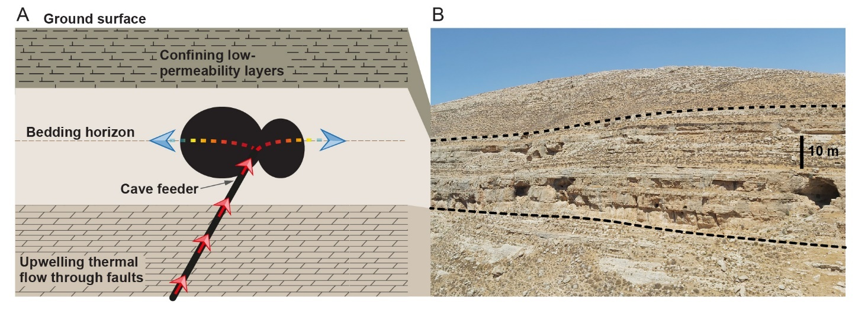

**Fig. 1.** The formation of hypogene caves depicted by (A) a conceptual model and (B) the field appearance. (A) Thermal, CO2-enriched groundwater upwells rapidly through a conduit pathway in a fault and/or fractures (red arrows) and is diverted sideways upon approaching a confining low-permeability layer to the permeable bedding horizons in a soluble layer (dashed brown line), where it flows slowly. The temperature of the water remains high during the rapid flow through the narrow fault conduit (red arrows) and then drops quickly when the water slows during its radial flow and transfers heat to the rock below and above (color-gradient arrows). The rapid cooling of the water leads to significant undersaturation with respect to calcite, inducing localized dissolution of the rock and cave formation (black ellipses). (B) Field appearance of hypogene caves in carbonate rocks located near Jerusalem, Israel (photograph by R.R.). A confining low-permeability layer overlays the main karstic layer (bordered by dashed lines).

This conceptual model is consistent with the configuration and morphological features of many hypogenic cave systems (see, e.g., Refs. *31*, *33*–*42*). In particular, this setting also applies to the group of caves in our case study (Fig. 1B; *10*). This group comprises dozens of extended caves located along the fold system adjacent to the Dead Sea Transform in Israel. Large, rooted faults at the base of the folds are assumed to facilitate the upwelling of thermal flow. The caves commonly develop along prominent bedding horizons in limestone formations overlaying massive limestone and dolostone layers (>400 m thick). The cave-forming rock layer is overlaid by low-permeability layers comprising mainly soft chalk and marl horizons-rich limestone. The cave systems usually present a maze-like pattern with occasional chamber caves. The maze caves develop via relatively uniform dissolution of the network of conduits formed by the intersection of the horizon and subvertical fracture network (10, 50).

The groundwater that formed this karst probably originated from a large, deep (1 to 2 km) sandstone aquifer, as evinced by mineral assemblages and the temperature and composition of local spring systems, although a shallower origin from a carbonate aquifer cannot be excluded (<1 km depth; *10*). Tectonic and hydrological events constrain the karst-formation period to within a window of several million years (Oligocene–early Miocene). Karst formation was terminated by the Neogene uplifting and deepening of the Dead Sea Transform, which disconnected the far-field groundwater flow, water-level drop, and cave dewatering. A detailed description of the caves and their geological setting is provided by Frumkin et al. (10) and references therein.

**Model Analyses.** Geochemical calculations were used to estimate the dissolution capacity of cooling thermal waters, and the results were incorporated into numerical models to describe (I) heat transport and dissolution in a confined-bedding horizon [the axisymmetric horizon dissolution model (AHD), as described in *Materials and Methods*], and (II) channelized dissolution and cave-pattern formation using a network model [described in section S5 of the Supporting Information (SI)].

The numerical AHD model depicts a simple physical system (Fig. 2): fluid discharges through a central inlet of a radius *r*0, representing the channelized upwelling. The fluid enters radially into a permeable bedding horizon at a constant temperature *T*in and volumetric flow rate *Q* (Fig. 2A). In the horizon, we assume a uniform flow, dissolution, and axisymmetry (channelized flow and dissolution are considered in a subsequent section). Furthermore, flow in the rock matrix is neglected because we assume orders-of-magnitude contrasts in permeability (5, 51).

Basal heat flow and the initial background geothermal gradient are assumed to be negligible compared with the heat input of the ascending fluid. The low-permeability caprock is sufficiently thick to act as a thermal insulator, so heat transfer to the surface is negligible. When this is not the case, the cooling rate increases, and dissolution and speleogenesis may occur even closer to the inlet.

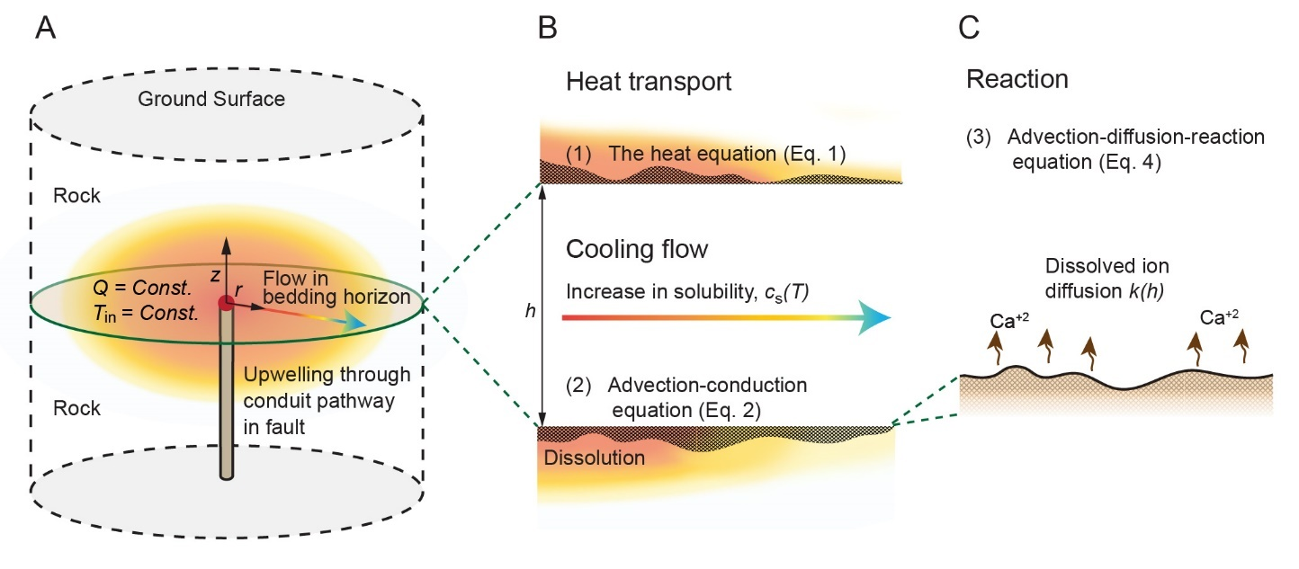

**Fig. 2.** Schematic diagram of AHD model geometry and the settings: (A) Fluid discharges from a pipe through an inlet of radius *r*0 (red point) with total flow rate *Q* and temperature *T*in. The flow is distributed radially, where it cools by transferring heat to the rock below and above (color-gradient arrow). (B) Heat transport in the bedding horizon and the rock and its effect on calcite solubility (magnified). Heat transport is governed by conduction in the rock and by advection-conduction in the fluid, with a heat exchange term *Θ* accounting for conduction between the rock and fluid. As the fluid cools, the concentration at saturation (solubility) *c*s(*T*) increases, inducing carbonate dissolution, which alters the horizon aperture *h*. (C) The calcite dissolution reaction at the horizon surface. An advection-diffusion-reaction equation assumes fully-transport-limited dissolution of Ca2+ ions that depends on the surface-to-fluid mass-transfer coefficient *k*(*h*).

The model further assumes closed-system conditions and the following: fluid pressure *p* in the aquifer exceeds the CO2 partial pressure *P*CO2 in the thermal water (*p* > *P*CO2), so no gas phase forms (i.e., bubbles). This is facilitated by the confinement above the cave-forming layer; otherwise, degassing of CO2 near the water table can lead to calcite supersaturation and precipitation (27, 52). The volumetric flow rate from the cave feeder (i.e., fluid inlet) remains constant because the cavities are formed as isolated voids, and the overall permeability of the system remains constant (9, 47). This last assumption breaks down if speleogenesis occurs near the surface (15, 47). However, our case study deals with dissolution under a thick impermeable rock section; for reactive-transport calculations, a stationary reactive-transport equation, neglecting the transient term, is justified given the large differences in the characteristic timescales between solute transport and mineral dissolution (see section S2 in the SI).

Section S3 of the SI presents a theoretical analysis of dissolution in a uniform horizon due to heat exchange with the rock and fluid cooling. The results then serve to validate the numerical model presented here and are implemented in a finite-difference code (see sections S4 and S2.3 of the SI). Tables S1 and S4 list the notation for the physical parameters and their values, respectively.

**Results and Discussion**

**Geochemical Calculations.** The CO2 partial pressure *P*CO2 of porewater in confined aquifers increases with both temperature and pressure (i.e., with depth), and generally is much higher in sedimentary aquifers than in crystalline aquifers (42). Elevated *P*CO2 of groundwater in deep-seated aquifers is maintained over time by large CO2 fluxes originating, for example, from deep magmatic bodies and from the decomposition of sedimentary organic matter (42, 53, 54). Using the PHREEQC (v.3.7.0) software package (55) and assuming closed system conditions, under which no degassing occurs (section S1 of the SI), we calculate herein *P*CO2 and the saturation conditions in groundwaters from sandstone and carbonate aquifers for different temperatures, pressures, and *P*CO2.

The results reveal that the saturation concentration *c*s of calcium ions depends strongly on the initial *P*CO2 and temperature (Fig. S1B). In particular, assuming high *P*CO2 initially, *c*s increases dramatically as the geothermal water cools, leading to a highly aggressive dissolution process. The calculations suggest that less than 300 yr are required to form a hypothetical 6-m-diameter hemisphere-shaped cave within a limestone rock in contact with slowly flowing water (*Q* = 1 m3/day) when it is cooled by ∆*T* = 65 °C (see dotted line in Fig. 3A). This can be shown by using a simple equation that estimates the volume of dissolved solid to be *V = Qt*∆*c*s(*m*CaCO3*/ρ*r), where *t* is the time, ∆*c*sis the difference between the solubilities under cold and warm conditions, *m*CaCO3 is the molar mass of calcite, and *ρ*r = 2200 kg/m3 is the rock density. The calculation assumes that the groundwater came from a sandstone aquifer with *P*CO2 = 0.5 MPa, which corresponds to a temperature ≳85 °C and a depth of about 3 km. In such conditions, the solubility *c*s increases by over 12 mmol/kg H2O as the water cools to 20 °C (see dotted lines in Fig. S1). For comparison, under atmospheric pressure and epigenic karst conditions, a typical value of *c*s is much smaller: about 2 mmol/kg H2O (7).

The calculations demonstrate that, even for a small temperature difference of ∆*T* = 5 °C and with *P*CO2 as low as 0.001 MPa, the hypothetical cave can form within several tens of thousands of years (see dashed line in Fig. 3A). Here, in agreement with our case study, we consider upwelling from a sandstone aquifer about 2 km deep (with *T* = 60 °C) with *P*CO2 ≈ 0.03 MPa [point (i) on the dashed line in Fig. S1] that discharges into a shallow limestone aquifer and cools to 20 °C (see section *Conceptual Model*). Under these conditions, the saturation concentration of calcium can change by ∆*c*s ≈ 3 mmol/kg H2O, twice the ∆*c*s of groundwater originating from a carbonate aquifer [point (ii) on dashed lines in Fig. S1].

Overall, the thermodynamic calculations indicate that groundwater cooling and retrograde solubility of carbonate minerals lead to extensive hypogene-karst formation within very short geological periods. Furthermore, if, as suggested in the literature (2, 10), the time interval for the formation of hypogenic karst is several millions of years, then the hydrogeological conditions to form the extensive cave systems observed worldwide in the geological section are rather mild, requiring only a small drop in the temperature and a small CO2 partial pressure *P*CO2 of the ascending hydrothermal water.

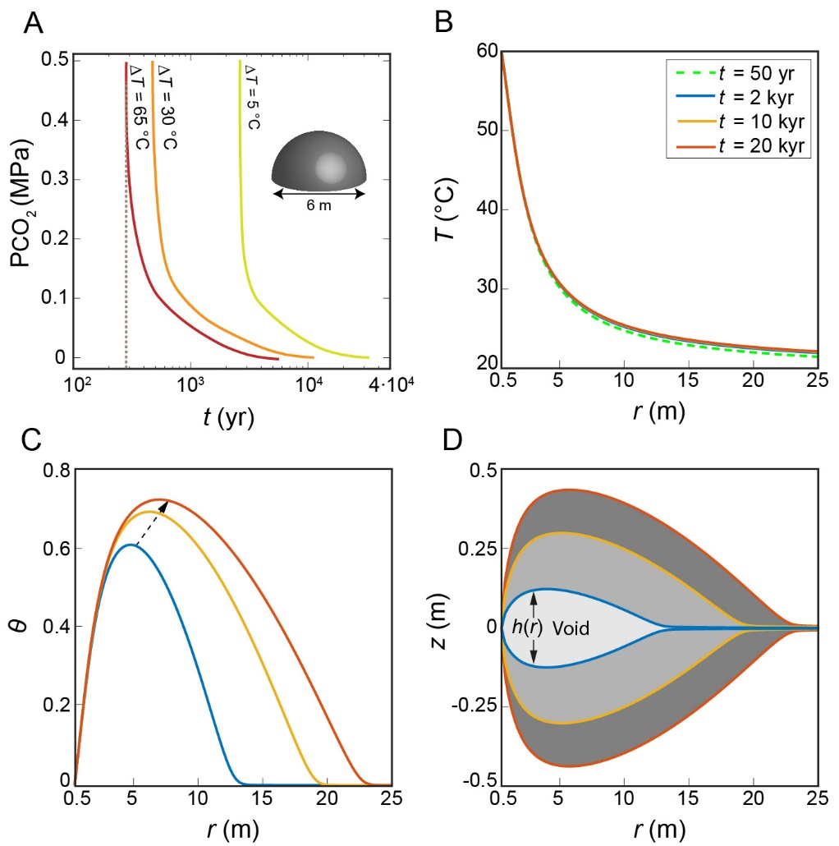

**Fig. 3.** (A) Calculated plots of *P*CO2 versus time *t* for dissolving a 6-m-diameter hemisphere-shaped hypothetical cave in a limestone rock. The cave is fed by slowly flowing groundwater (1 m3/day) of different cooling ranges: ∆*T* = 65, 30, and 5 °C (see text). The plots show that a cave can form within 300 yr (dotted line) under favorable conditions, or in several tens of thousands of years for very mild conditions (dashed line). (B)–(D) Results from the AHD model for temperature *T*, degree of undersaturation *θ* (see text for definition), and cave profile and aperture *h* (the vertical distance between the curves) versus the radial distance *r* from the inlet at different times during cave development. (B) *T* shows a rapid cooling of the water, approaching a quasi-steady thermal state after about 50 yr (see text). (C) *θ* increases sharply with distance (due to high cooling and advective rates), reaches a maximum, and then decreases downstream because of the dissolution reaction. (D) the cave aperture *h* develops substantially with time and lateral extent *r* (grayscale). In accordance with *θ*, a pronounced maximum appears in *h* a few meters from the inlet.

**Cave Formation by Cooling and Localized Dissolution.** The results obtained by solving Eqs. **1**–**7** (*Materials and Methods*) in the setting described in Fig. 2 show that, during the radial flow within the horizon, the geothermal groundwater cools relatively quickly (from 60 °C at the inlet to 25 °C at *r* ≈ 10 m; Fig. 3B). The rapid cooling is promoted by the radial discharge from a localized low-discharge source, which allows the fluid to reach a quasi-steady thermal state after about 50 yr.[1]* The fluid is hot and saturated with respect to the calcite at the inlet, *c* = *c*s(*T*in), but the undersaturation *θ* first increases with *r* as the fluid moves away from the inlet, and then, after several meters, reaches a maximum and decreases thereafter (Fig. 3C; here, *θ* = [*c*s**(***T*(*r*)**)**− *c*(*r*)]*/*∆*c*s0, where ∆*c*s0= *c*s(*T*0)− *c*s(*T*in), and *T*0 is the initial temperature). Undersaturation along the flow path is controlled by the interplay between three variables: (I) dissolution that reduces undersaturation, (II) progressive cooling that increases undersaturation, and (III) advection that transports reaction products (i.e., calcium ions) outward and helps maintain undersaturation. Here, the effect of fluid velocity and advection decays with distance as 1/*r*.

The high advection and cooling rates near the inlet cause a buildup of undersaturation. Further downstream, cooling and advection rates are much lower, and undersaturation decreases due to the dissolution reaction. Accordingly, the cave profile develops a pronounced maximum several meters from the inlet (Fig. 3D). Over time, the widening cave aperture *h* (the vertical distance between the lines, see the gray regions in Fig 3D) reduces the diffusion rate. Given that the reaction is transport limited [see Eq. (5) below], this reduces the dissolution rate, which in turn increases the undersaturation.

The flow rate *Q* significantly affects karst formation, particularly in terms of the aspect ratio of the dissolution cavity, as demonstrated by the plots of dissolution focusing *η* versus total fluid volume *V*f discharged over time *t* (*V*f = *Qt*; see cave shapes for three different values of *Q* in Fig. 4). The degree of dissolution focusing *η* is defined as *η = h*p*/l*v, which is the ratio of the maximum cave height *h*p to its length *l*v for *h* > 1.01*h*0, where *h*0 is the size of the initial aperture of the bedding horizon (see Fig. 4). The plots show that *η* decreases (caves become more elongated) with increasing volumetric flow rates. This is because (I) a higher *Q* transports heat further downstream, leading to more gradual cooling and the development of the undersaturation profile; and (II) a higher *Q* accelerates the advection of undersaturated fluid, promoting dissolution farther from the inlet.

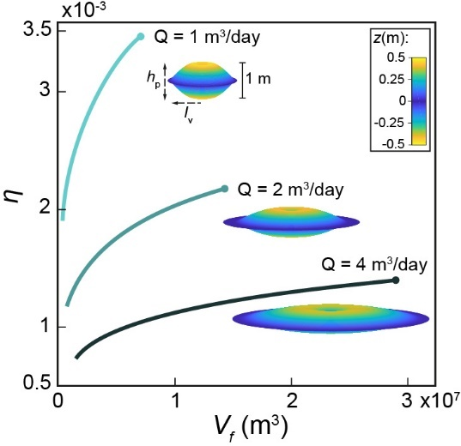

**Fig. 4.** Degree of dissolution focusing *η* (see text) versus the integrated fluid discharge volume *V*f over time intervals *t* (*V*f = *Qt*). The plots are for three different volumetric flow rates *Q* = 1, 2, and 4 m3/day for *t* = 1 to 20 kyr. The curves show that lowering *Q* increases *η*, indicating increasingly localized dissolution, as indicated by the three-dimensional visualizations of the caves after 20 kyr (the vertical cave dimension *h*p is exaggerated by a factor of 30 relative to the cave length *l*v).

Consequently, a void takes the shape of a cave (high *η*) at relatively low flow rates, whereas at high flow rates dissolution is diffused (low *η*), resulting only in a change in porosity in the aquifer (9, 56). Such low flow rates are typical of geothermal fluids sourced from depth (>1 km) that discharge as thermal seepages and springs (21, 43, 57), corroborating the idea that the cooling of such fluids forms caves. Note, however, that in contrast with the slow fluid flow as the fluid enters the horizon and radially diverges (Fig. 2A), the vertical velocity of the ascending geothermal fluid is high due to channelized ascent through a narrow conduit.

**Time Scales for Speleogenesis and Origin of Thermal Water.** The results indicate that speleogenesis and the formation of human-size passages due to cooling of CO2-rich geothermal flow occur over several tens of thousands of years (Fig. 3D), which is comparable to (and even shorter than) the typical timescales of epigenic speleogenesis (7, 11). Given reasonable timescales, this mechanism forms extensive cave systems known worldwide for cumulative passage lengths of hundreds of kilometers [e.g., the Jewel and Wind caves in South Dakota (30)]. This contrasts with the general dogma rooted in earlier works that estimated a much longer timescale of 106 yr for hypogene cave formation (9, 11, 21). Specifically, early calculations by Palmer of dissolution due to rising thermal waters assumed rather low cooling rates and thermal gradients (5 °C/100 m). He concluded that “only under the most favorable conditions can dissolution by cooling of thermal water produce caves of traversable size. Even then, times on the order of 105 to 106 yr are required.”

The geological setting of our case study suggests that the geothermal fluids that formed the caves ascended from a deep sandstone aquifer (10, 58). The sandstone aquifer is hotter and its groundwaters have a substantially higher CO2 partial pressure *P*CO2 than the overlying carbonate aquifer (see *Conceptual Model* and section S1 of the SI). The caves in our case study were estimated to form within a time window of several million years (10). According to our calculations, this time interval far exceeds the time required for the high *P*CO2, high-temperature groundwaters ascending from the deep sandstone aquifer to form similar-sized caves in the area of the case study. The time window of several million years is even longer than the time required for the low *P*CO2, low-temperature groundwaters originating from the shallower carbonate aquifer to form these caves. In fact, our calculations indicate that these caves may have formed within several million years, even by groundwaters that are only several degrees warmer than the country rocks.

**Fundamental Conditions for the Formation of Caves.** Localized dissolution and hypogene cave formation require both (I) a substantial physico-geochemical driving force (cooling and high *P*CO2) and (II) an appropriate confined hydrogeological setup, as described above (e.g., Fig. 1A). Under these conditions, the upwelling pipe-like flow spreads radially within the confined layer and quickly cools, inducing the speleogenesis observed along bedding horizons.

Previous models of hypogene karst assumed unconfined conditions for which thermal flow upwells through a fault and discharges at the surface as springs. These studies found diffuse dissolution (31, 56) or localized dissolution only near the surface (17). We argue that the confined hydrological conditions, which our conceptual model requires, are ubiquitous: ascending hydrothermal flow often encounters a confining layer on its way upward through a thick heterogeneous sedimentary sequence (9, 41). In fact, hypogene cave systems immediately under or in close proximity to confinement are prevalent worldwide (32–40). Furthermore, although unconfined flow near Earth’s surface may also cool rapidly (due to proximity to the cooled surface), and may be expected to promote localized dissolution (17), CO2 outgassing at shallow depths, close to the surface, should drive supersaturation with respect to calcite and thus promote precipitation instead of dissolution (e.g., speleothems), as observed in many caves (2, 27).

**Cave Morphology and Pattern Formation.** Previous sections discuss the formation of caves under confining layers along bedding horizons by cooling geothermal flows and reproduce the fundamental field observations of our case study. This section shows that the characteristic cave shape predicted by the AHD model is consistent with field observations and briefly analyzes the pattern of cave passages. Small-scale morphologic features that are characteristic of hypogene processes (e.g., smooth walls, cupolas, and solution pockets) are usually inconclusive indicators (21, 59) and thus are not discussed here.

At most cave locations it is impossible to identify cave feeders because they are covered by debris and sediment. However, such cave feeders have been identified and carefully mapped in two hypogene karst systems in Israel, the Ashalim and Berenike, which are within the area of our case study (Fig. 5; *59*, *61*). This allows us to compare the results of the numerical model with the morphology of these caves (Fig. 3D). The Ashalim cave includes feeders and dissolution features along a prominent oblique fracture or fault (dash-dotted red line in Fig. 5A), comprising the backbone of the three-dimensional-maze cave (58). While feeders and dissolution along the fracture appear clearly in many parts of the cave, the largest chambers and their ceiling peaks (see points A.1–A.5 in Fig. 5A) are located away (up to 20 m) from the fracture and feeders. Similarly, the Berenike cave reveals a characteristic convex profile with the most spacious region (see point B.1 in Fig. 5B) appearing approximately 10 m from the inlet, with diminishing passage sizes further downstream (61). These previously enigmatic findings are consistent with the results of our numerical model, which predicts that the maximum cave height is several meters from the feeder (Fig. 3D).

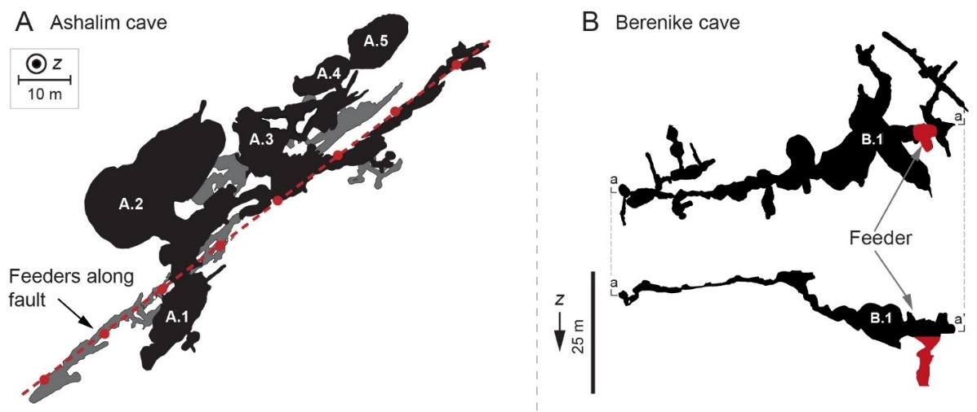

**Fig. 5.** Morphology of two hypogenic caves with identified feeders. (A) Plan view (normal to the *z* direction, z) of the Ashalim cave where feeders are visible at the lower level along a fracture (dashed-dotted red line). Note that the largest chambers (denoted A.1–A.5) and their maximum ceiling height (not shown) are located several meters to 20 m from the fracture and feeders. The gray zones mark overlapping lower levels (58). (B) Plan view of the upper level of the Berenike cave (top) and its vertical profile a-a′ (bottom). Note that the largest hall (denoted B.1) is located approximately 10 m from the feeder (red region), with the passage size gradually decreasing downstream (60).

Finally, we present results from an extended AHD numerical network model that simulates the formation of a maze-cave system with multiple closed loops (Fig. 6A). This numerical model simulates a point injection of geothermal fluid (red dot in the center of Fig. 6A) into a dissolving network of conduits in a fractured bedding horizon and considers cooling and retrograde solubility as the source of aggressiveness of the solution (see section S5 of the SI for details). The model uses the fact that the temperature distribution rapidly becomes almost time-invariant (Fig. 3B). The maze pattern of the passages in the simulation results (Fig. 6A) is a typical morphological characteristic of hypogene karst caves observed worldwide (9, 21), as also demonstrated by the Chariton cave map (Fig. 6B; *10*).

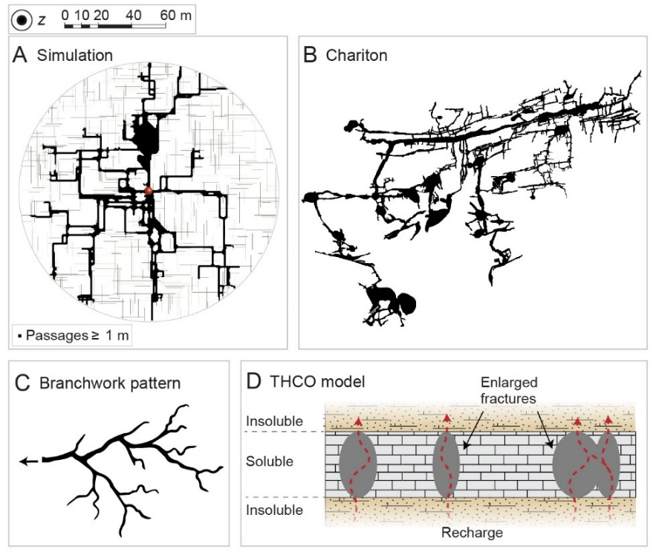

**Fig. 6.** (A) Plan view (normal to the *z* direction, z) of simulation results. The simulated maze developed over 43 kyr and is based on a network model for dissolution by cooling fluids within a fractured bedding horizon (the thin gray lines represent initial model fractures, the red point marks the inlet, and the black represents passages ≥1 m wide). Note that the simulation produces a typical maze-like pattern characterized by numerous closed loops. Figures S4 and S5 of the SI show schematic diagrams of the network model and the progression of speleogenesis up to the final state shown in panel A. (B) A map of Chariton cave showing its typical maze-like pattern (feeders are not identified; *10*). (C) Schematic presentation of a branched network pattern typical of epigenic caves. These branched-network caves develop from many source points (recharge zones) on the surface that interact with the carbonate country rocks, forming a drainage-basin-like pattern that resembles a river and its tributaries (6, 7, 61). (D) Schematic diagrams of the THCO model (see text).

Maze-pattern caves differ notably from other speleological patterns and especially from the characteristic ramified branched-network patterns of epigenic karst, which are not evident in hypogenic karsts (see Fig. 6C; *6*, *9*, *11*). Several alternative mechanisms have been proposed to form maze caves and have long been debated (these are summarized in Refs. *8*, *22*). If the cave is hydrologically linked to the surface (i.e., epigenic origin), then mazes may form as a result of intense flooding, leading to the uniform dissolution of a fracture network (51, 62). Other mechanisms involve diffuse and distributed recharge of the cave-forming layer (9, 11, 21, 63, 64), such as the commonly invoked concept of *transverse hypogenic cave origin* (THCO; *64*, *66*, *67*).

According to the THCO model, an ascending fluid forms a hypogene maze within a “soluble” rock layer sandwiched between permeable but insoluble rock layers (Fig. 6D). This setting sustains an upward-distributed flow within the soluble strata and precludes the channelized flow that can develop due to preferential dissolution (6, 67). The vertical and distributed flow discharges via multiple feeders, enlarging all major fractures in the soluble layer at comparable rates. The best-known example described by the THCO model is the giant gypsum caves in Ukraine (65). However, this mechanism often cannot explain the hypogene-maze-cave formation, such as in aquifers confined by an impermeable caprock layer, or the formation of caves in soluble carbonate rock successions (see, e.g., Refs. *33*–*41*). Furthermore, in many cases, the THCO model is not supported by field observations because multiple ceiling and floor feeders are not observed (10, 41, 50). Thus, the geological setting of the mechanism proposed here for the formation of maze caves (i.e., by cooling of CO2-rich hydrothermal fluids discharging from a feeder within a confined aquifer) is apparently more general and ubiquitous and thus is likely to have formed many of the hypogenic karst systems worldwide.

In accordance with the results shown in Fig. 4, the maze pattern in Fig. 6A was obtained by using a low volumetric flow rate (2 m3/day) that is typical of geothermal fluids sourced from depth (43, 57, 68). For higher flow rates, a more uniform maze structure develops around the inlet, whereas lower flow rates and diffusion-dominant chamber caves develop. Here, the formation of large halls in the simulation (see bulky black regions in Fig. 6A) results from the merging of adjacent passages and resembles some of the halls observed in natural maze caves (see, e.g., Fig. 6B; *10*). Finally, note that the formation of a maze pattern in the simulations requires only that the initial fractures be hydraulically connected. The spatial distribution of these initial fractures mainly controls the pattern properties (e.g., number of loops) and their statistics.

**Summary and Conclusions**

This study shows that, under common conditions, large karst caves may form in carbonate rocks in Earth’s upper crust when channelized CO2-rich geothermal flow discharges into a confined aquifer. In contrast with previous estimates, we show herein that this process stemming from cooling and the retrograde solubility of carbonates may be a common mechanism by which caves form on short geological timescales (tens of thousands of years). Numerical simulations of this process reproduce very well the major characteristics of cave morphology, including the typical maze pattern of hypogene karst caves. In particular, the results show that such cave patterns form because of the discharge and subsequent lateral flow of CO2-rich hydrothermal fluids into a bedding horizon. This mechanism explains the formation of maze caves in confined conditions and soluble rock successions. Such conditions are ubiquitous, so this scenario is likely to be applicable to many large maze-cave systems around the world, such as in the Black Hills of South Dakota (30), the Buda thermal karst in Hungary (33), and many others (41).

From a wider viewpoint, the results suggest that Earth’s geothermal heat loss by upper-crust advective circulations (68, 69) in conjunction with the large deep-seated CO2 fluxes induce dissolution in upper-crust carbonate strata to form extensive karstic cave systems. In turn, this process may reduce CO2 outgassing from the continental crust into the atmosphere (70) and constitute a link to the midterm carbon cycle (longer than the fast biogenic pathway but presumably shorter than the glacial-interglacial time scale), which remains for future upscaling.

**Materials and Methods**

**Heat Transport.** Heat transport through rock confining the horizon above and below (Fig. 2) is governed by the heat equation, which in polar coordinates takes the form

$$\frac{∂T}{∂t}=\frac{α_{r}}{r}\frac{∂}{∂r}\left(r\frac{∂T}{∂r}\right)+α_{r}\frac{∂^{2}T}{∂z^{2}}, [1]$$

where *T* is the temperature, *t* is time, and *r* and *z* are the radial and vertical coordinates, respectively, and both have their origin at the inlet. The quantity *α*r= *K*r*/*(*ρ*r*C*pr) is the thermal diffusivity, where the subscript r denotes rock, *K* is the thermal conductivity, *ρ* is the density, and *C*p is the heat capacity at constant pressure (16).

Assume that, along the horizon, heat transport in the fluid is governed by advection and conduction and that complete mixing occurs along the horizon aperture. The “depth-averaged” heat-transport equation can then be written as

$$\frac{∂\left(hT\right)}{∂t}=-\frac{1}{r}\frac{∂\left(rqT\right)}{∂r}+\frac{α_{f}}{r}\frac{∂}{∂r}\left(hr\frac{∂T}{∂r}\right)-Θ\left(r,t\right), [2]$$

where *q* is the fluid velocity integrated over the horizon aperture *h* [L2/T] and calculated from the total volumetric flow rate *Q* using *q* = *Q*/(2*πr*), and *α*f is the thermal diffusivity of the fluid (17, 31). The function *Θ* accounts for the heat exchange between the flow within the horizon and the rock above and below and is calculated by using Fourier’s law, with continuous temperature assumed at the fluid-solid interface:

$$Θ=-\frac{2Κ_{r}}{ρ_{f}C_{p_{f}}}\frac{∂T}{∂|z|}. [3]$$

The absolute value accounts for conduction to the rock both above and below the horizon. The complete mixing approximation can be validated *a posteriori* and is justified because the transverse temperature gradients in the horizon remain relatively small throughout speleogenesis.

**Reactive Transport.** The depth-averaged solute transport advection-diffusion-reaction equation in the horizon is

$$0=-q\frac{∂c}{∂r}+\frac{D}{r}\frac{∂}{∂r}\left(hr\frac{∂c}{∂r}\right)+Ω\left(r,t\right), [4]$$

where *c* is the depth-averaged dissolved-calcite-ion concentration [M/L3], *D* is the molecular diffusion coefficient, and Ω is the reaction term (17, 71). The transient term in Eq. (4) is neglected, and the quasistatic approach is justified by the separation of timescales between mineral dissolution and the relaxation of solute concentration (see section S2 of the SI).

Here, the initial CO2 partial pressure *P*CO2 is relatively high and the kinetics are rapid, so the rate-limiting step for the reaction is the diffusion of reaction products away from the mineral surface so that undersaturation is sustained. Consequently, the reaction rate can be calculated from the transport rate alone, regardless of kinetics (31, 72). The reaction term Ω is proportional to the difference between *c*s (i.e., *c* at calcite saturation or equilibrium at the given conditions) and *c*:

$$Ω=2k\left(h\right)ε\left[c_{s}\left(T\right)-c\right], [5]$$

where *k*(*h*) is the mass-transfer coefficient [L/T] and is inversely proportional to the aperture *h*, *ε* is a geometrical correction term that accounts for the aperture inclination that develops following dissolution, and the factor of two accounts for the upper and lower surfaces. Section S2 of the SI provides the explicit expression for *k*(*h*) and the complete derivation of Eq. (5) and its justification.

The saturation concentration *c*s depends on the temperature and is expressed as a Taylor expansion to account for retrograde solubility:

$$c_{s}\left(T\right)=c_{s}\left(T_{0}\right)-β\left(T-T_{0}\right), [6]$$

where the constant *β* is evaluated from the data presented in section S1 of the SI and *T*0 is the reference (ambient) temperature. Finally, the change in the horizon aperture is calculated by using

$$\frac{∂h}{∂t}=\frac{Ω}{υc_{sol}}, [7]$$

where *ν* is a stoichiometric constant and *c*sol is the soluble-solid concentration within the solid rock (73).

**Initial and Boundary Conditions.** The initial conditions are uniform temperature *T*0 = 20 °C. The boundary conditions at the horizon inlet (*r* = *r*0) are constant volumetric flow rate *Q* of the fluid with a temperature *T*in = 60 °C and initially zero undersaturation, *θ* = 0, where *θ* = [*c*s**(***T*(*r*)**)**− *c*(*r*)]*/*∆*c*s0with ∆*c*s0= *c*s(*T*0)− *c*s(*T*in). We model conditions of a large domain so that no substantial heat transport occurs near the boundaries (*r* → *∞* and|*z*| → *∞*). In practice, *z* and *r* are limited to 1 km. The upper surface is assigned a constant temperature *T*0. At the horizon outlet (*r* = 1 km), the temperature and concentration are calculated by using the thermal and solute conservation equations (2) and (4) for a free-flow boundary. The remaining boundaries are assumed to be thermally insulating, so zero conductive heat flux crosses these boundaries.

**Acknowledgments:** We thank P. Lu for sharing the field data used in Figs. S1A and S1B and Langford for fruitful discussions and field assistance.

**Funding:** National Science Centre (Poland) Grant 2016/21/B/ST3/01373 (P.S.). ISF Grant #910/17 (E.A.). The carbonate system software used in this manuscript was based on a PHREEQC code developed for the "Salt Ages" project funded by the ISF grant #695/19 (B.L.). Israel Water Authority student's scholarship (R.R.).

**Author contributions:** Conceptualization: R.R., E.A., P.S. Numerical analysis: R.R. Theoretical analysis: E.A., R.R., P.S. Field aspects and trips guiding: A.F. Geochemical analysis: N.W., B.L. Writing—original draft: R.R. Writing—review & editing: R.R., E.A., P.S., A.F., N.W., B.L.

**Competing interests:** Authors declare that they have no competing interests.

**Data and materials availability:** All data are available from the corresponding author upon request.

References

1. M. Dentz, T. Le Borgne, D. R. Lester, F. P. de Barros, “Mixing in groundwater” in *The Handbook of Groundwater Engineering*, (CRC Press, 2016), pp. 401–430.

2. A. Klimchouk, “Types and settings of hypogene karst” in *Hypogene Karst Regions and Caves of the World*, (Springer, 2017), pp. 1–39.

3. B. Jamtveit, Ø. Hammer, Sculpting of rocks by reactive fluids. *Geochemical Perspectives* **1**, 341–342 (2012).

4. J. De Waele, F. Gutierrez, *Karst Hydrogeology, Geomorphology and Caves* (John Wiley & Sons, 2022).

5. D. Ford, P. D. Williams, *Karst hydrogeology and geomorphology* (John Wiley & Sons, 2013).

6. P. Szymczak, A. J. C. Ladd, The initial stages of cave formation: Beyond the one-dimensional paradigm. *Earth and Planetary Science Letters* **301**, 424–432 (2011).

7. W. Dreybrodt, F. Gabrovšek, D. Romanov, *Processes of a Speleogenessis [sic]: A Modeling Approach* (Založba ZRC, 2005).

8. P. Audra, A. N. Palmer, Research frontiers in speleogenesis. Dominant processes, hydrogeological conditions and resulting cave patterns. *Acta Carsologica* **44** (2015).

9. A. Klimchouk, “Speleogenesis—Hypogenе” in *Encyclopedia of Caves*, (Elsevier, 2019), pp. 974–988.

10. A. Frumkin, B. Langford, S. Lisker, A. Amrani, Hypogenic karst at the Arabian platform margins: Implications for far-field groundwater systems. *GSA Bulletin* **129**, 1636–1659 (2017).

11. A. N. Palmer, Origin and morphology of limestone caves. *Geological Society of America Bulletin* **103**, 1–21 (1991).

12. L. Luquot, P. Gouze, Experimental determination of porosity and permeability changes induced by injection of CO2 into carbonate rocks. *Chemical Geology* **265**, 148–159 (2009).

13. E. Aharonov, M. Spiegelman, P. Kelemen, Three-dimensional flow and reaction in porous media: Implications for the Earth’s mantle and sedimentary basins. *Journal of Geophysical Research: Solid Earth* **102**, 14821–14833 (1997).

14. E. Aharonov, E. Tenthorey, C. H. Scholz, Precipitation sealing and diagenesis: 2. Theoretical analysis. *J. Geophys. Res. Solid Earth* **103**, 23969 (1998).

15. R. Roded, P. Szymczak, R. Holtzman, Wormholing in anisotropic media: Pore‐scale effect on large‐scale patterns. *Geophysical Research Letters*, e2021GL093659 (2021).

16. F. Stauffer, P. Bayer, P. Blum, N. M. Giraldo, W. Kinzelbach, *Thermal use of shallow groundwater* (CRC Press, 2019).

17. A. Chaudhuri, H. Rajaram, H. Viswanathan, Early‐stage hypogene karstification in a mountain hydrologic system: A coupled thermohydrochemical model incorporating buoyant convection. *Water Resources Research* **49**, 5880–5899 (2013).

18. G. Dávila, L. Luquot, J. M. Soler, J. Cama, Interaction between a fractured marl caprock and CO2-rich sulfate solution under supercritical CO2 conditions. *International Journal of Greenhouse Gas Control* **48**, 105–119 (2016).

19. H. Rattez, M. Veveakis, Weak phases production and heat generation control fault friction during seismic slip. *Nature communications* **11**, 1–8 (2020).

20. G. Zhai, M. Shirzaei, M. Manga, X. Chen, Pore-pressure diffusion, enhanced by poroelastic stresses, controls induced seismicity in Oklahoma. *Proceedings of the National Academy of Sciences* **116**, 16228–16233 (2019).

21. A. N. Palmer, Distinction between epigenic and hypogenic maze caves. *Geomorphology* **134**, 9–22 (2011).

22. P. Audra, L. Mocochain, J.-Y. Bigot, J.-C. Nobécourt, Morphological indicators of speleogenesis: hypogenic speleogens. *Hypogene speleogenesis and karst hydrogeology of artesian basins (pp. 17À22). Simferopol: Ukrainian Institute of Speleology and Karstology (Special Paper 1)* (2009).

23. M. D. Covington, M. Perne, Consider a cylindrical cave: A physicist’s view of cave and karst science. *Acta Carsologica* **44** (2016).

24. G. Kaufmann, F. Gabrovšek, D. Romanov, Deep conduit flow in karst aquifers revisited. *Water Resources Research* **50**, 4821–4836 (2014).

25. K. De Vriendt, M. Pool, M. Dentz, Heterogeneity‐Induced Mixing and Reaction Hot Spots Facilitate Karst Propagation in Coastal Aquifers. *Geophysical Research Letters* **47**, e2020GL087529 (2020).

26. J. De Waele, *et al.*, Sulfuric acid speleogenesis (SAS) close to the water table: examples from southern France, Austria, and Sicily. *Geomorphology* **253**, 452–467 (2016).

27. Y. Dublyansky, “Hydrothermal caves” in *Encyclopedia of Caves*, (Elsevier, 2019), pp. 546–552.

28. F. Gabrovšek, W. Dreybrodt, Early hypogenic carbonic acid speleogenesis in unconfined limestone aquifers by upwelling deep-seated waters with high CO 2 concentration: a modelling approach. *Hydrology and Earth System Sciences* **25**, 2895–2913 (2021).

29. J. E. Mylroie, “Coastal caves” in *Encyclopedia of Caves*, (Elsevier, 2019), pp. 301–307.

30. M. J. Bakalowicz, D. Ford, T. Miller, A. Palmer, M. Palmer, Thermal genesis of dissolution caves in the Black Hills, South Dakota. *Geological Society of America Bulletin* **99**, 729–738 (1987).

31. B. J. Andre, H. Rajaram, Dissolution of limestone fractures by cooling waters: Early development of hypogene karst systems. *Water Resources Research* **41** (2005).

32. A. N. Palmer, “Hypogenic versus epigenic aspects of the Black Hills caves, South Dakota” in *Hypogene Karst Regions and Caves of the World*, (Springer, 2017), pp. 601–615.

33. S. Leél-Őssy, “Caves of the buda thermal karst” in *Hypogene Karst Regions and Caves of the World*, (Springer, 2017), pp. 279–297.

34. S. Galdenzi, “The thermal hypogenic caves of Acquasanta Terme (Central Italy)” in *Hypogene Karst Regions and Caves of the World*, (Springer, 2017), pp. 169–182.

35. S. Galdenzi, M. Menichetti, “Hypogenic Caves in the Apennine Mountains (Italy)” in *Hypogene Karst Regions and Caves of the World*, (Springer, 2017), pp. 127–142.

36. B. P. Onac, V. Drăgușin, “Hypogene caves of Romania” in *Hypogene Karst Regions and Caves of the World*, (Springer, 2017), pp. 257–265.

37. P. Audra, “Hypogene caves in France” in *Hypogene Karst Regions and Caves of the World*, (Springer, 2017), pp. 61–83.

38. A. S. Auler, T. A. Souza, “Hypogene Speleogenesis in the Vazante Group, Minas Gerais, Brazil” in *Hypogene Karst Regions and Caves of the World*, (Springer, 2017), pp. 841–852.

39. A. S. Auler, *et al.*, “Origin and evolution of Toca da Boa Vista and Toca Da Barriguda cave system in north-eastern Brazil” in *Hypogene Karst Regions and Caves of the World*, (Springer, 2017), pp. 827–840.

40. J. Martini, “Hypogene Karst in Southern Africa” in *Hypogene Karst Regions and Caves of the World*, (Springer, 2017), pp. 865–878.

41. A. Klimchouk, A. N. Palmer, J. De Waele, A. S. Auler, P. Audra, *Hypogene karst regions and caves of the world* (Springer, 2017).

42. A. Coudrain-Ribstein, P. Gouze, G. de Marsily, Temperature-carbon dioxide partial pressure trends in confined aquifers. *Chemical Geology* **145**, 73–89 (1998).

43. R. Roded, E. Shalev, D. Katoshevski, Basal heat-flow and hydrothermal regime at the Golan-Ajloun hydrological basins. *Journal of Hydrology* **476**, 200–211 (2013).

44. D. Craw, Fluid flow at fault intersections in an active oblique collision zone, Southern Alps, New Zealand. *Journal of Geochemical Exploration* **69**, 523–526 (2000).

45. S. Micklethwaite, S. F. Cox, Progressive fault triggering and fluid flow in aftershock domains: Examples from mineralized Archaean fault systems. *Earth and Planetary Science Letters* **250**, 318–330 (2006).

46. G. I. Tripp, J. R. Vearncombe, Fault/fracture density and mineralization: a contouring method for targeting in gold exploration. *Journal of Structural Geology* **26**, 1087–1108 (2004).

47. P. Szymczak, A. J. C. Ladd, Wormhole formation in dissolving fractures. *J. Geophys. Res. Solid Earth* **114**, 1–22 (2009).

48. W. Dreybrodt, Processes in karst systems, physics, chemistry, and geology (1988).

49. M. Filipponi, P.-Y. Jeannin, L. Tacher, Evidence of inception horizons in karst conduit networks. *Geomorphology* **106**, 86–99 (2009).

50. A. Frumkin, I. Fischhendler, Morphometry and distribution of isolated caves as a guide for phreatic and confined paleohydrological conditions. *Geomorphology* **67**, 457–471 (2005).

51. G. Kaufmann, J. Braun, Karst aquifer evolution in fractured rocks. *Water resources research* **35**, 3223–3238 (1999).

52. P. Meakin, B. Jamtveit, Geological pattern formation by growth and dissolution in aqueous systems. *Proceedings of the Royal Society A: Mathematical, Physical and Engineering Sciences* **466**, 659–694 (2010).

53. G. Ceriotti, C. Geloni, M. Dalla Rosa, A. Guadagnini, G. Porta, Probabilistic modeling of field-scale CO 2 generation by carbonate–clay reactions in sedimentary basins. *Hydrology and Earth System Sciences* **25**, 3539–3553 (2021).

54. P. Lu, P. Luo, G. Zhang, S. Zhang, C. Zhu, A mineral-water-gas interaction model of pCO2 as a function of temperature in sedimentary basins. *Chemical Geology* **558**, 119868 (2020).

55. D. L. Parkhurst, C. Appelo, “Description of input and examples for PHREEQC version 3: a computer program for speciation, batch-reaction, one-dimensional transport, and inverse geochemical calculations” (US Geological Survey, 2013).

56. G. D. Jones, Y. Xiao, Geothermal convection in South Atlantic subsalt lacustrine carbonates: Developing diagenesis and reservoir quality predictive concepts with reactive transport models. *AAPG bulletin* **97**, 1249–1271 (2013).

57. N. Weber, *et al.*, The circulation of the Dead Sea brine in the regional aquifer. *Earth and Planetary Science Letters* **493**, 242–261 (2018).

58. A. Frumkin, B. Langford, Arid hypogene karst in a multi-aquifer system: hydrogeology and speleogenesis of Ashalim Cave, Negev Desert, Israel. *Geological Society, London, Special Publications* **466**, 187–200 (2018).

59. J. E. Mylroie, J. R. Mylroie, Diagnostic features of hypogenic karst: is confined flow necessary in *NCKRI Symposium*, (2009), pp. 12–26.

60. M. Ullman, “Human selection and exploitation patterns of complex karstic caves during the later prehistory of the southern Levant. PhD in progress.,” The Hebrew University. (2020).

61. S. Worthington, D. Ford, Self‐organized permeability in carbonate aquifers. *Groundwater* **47**, 326–336 (2009).

62. A. D. Howard, C. G. Groves, Early development of karst systems: 2. Turbulent flow. *Water Resources Research* **31**, 19–26 (1995).

63. C. Rehrl, S. Birk, A. Klimchouk, Conduit evolution in deep-seated settings: Conceptual and numerical models based on field observations. *Water Resources Research* **44** (2008).

64. T. Clemens, D. Hückinghaus, M. Sauter, R. Liedl, G. Teutsch, Simulation of the evolution of maze caves in *Proceedings, 12th International Congress of Speleology*, (1997), pp. 65–68.

65. A. Klimchouk, “Ukraine giant gypsum caves” in *Encyclopedia of Caves*, (Elsevier, 2019), pp. 1082–1088.

66. A. Klimchouk, Speleogenesis in gysum. *International Journal of Speleology* **25**, 5 (1996).

67. E. Aharonov, J. A. Whitehead, P. B. Kelemen, M. Spiegelman, Channeling instability of upwelling melt in the mantle. *J. Geophys. Res. Solid Earth* **100**, 20433 (1995).

68. G. Garven, Continental-scale groundwater flow and geologic processes. *Annual Review of Earth and Planetary Sciences* **23**, 89–117 (1995).

69. J. H. Davies, Global map of solid Earth surface heat flow. *Geochemistry, Geophysics, Geosystems* **14**, 4608–4622 (2013).

70. J. B. Martin, Carbonate minerals in the global carbon cycle. *Chemical Geology* **449**, 58–72 (2017).

71. P. Szymczak, A. J. C. Ladd, Reactive-infiltration instabilities in rocks. Fracture dissolution. *Journal of Fluid Mechanics* **702**, 239–264 (2012).

72. F. Golfier, *et al.*, On the ability of a Darcy-scale model to capture wormhole formation during the dissolution of a porous medium. *J. Fluid Mech.* **457**, 213–254 (2002).

73. R. Roded, E. Aharonov, R. Holtzman, P. Szymczak, Reactive flow and homogenization in anisotropic media. *Water resources research*, p.e2020WR027518. (2020).

1. * **See, e.g., the solution for a continuous point source in infinite space given in Ref.** (16) **(Eq. 3.24, pg. 114).**