**SETD6 mediated lysine methylation of PPARg in the regulation of lipid droplet formation and steatosis.**

1. **Scientific Background**

*Lysine methylation* ***-*** Among other well-studied post-translational modifications, lysine methylation is emerging as a critical player in the regulation of many cellular signaling pathways. Disruption of these pathways is thought to fundamentally impact the initiation and progression of many cellular processes, leading to the development of disease [1]. Lysine methylation has been studied in depth in the context of histones. However, in recent years it became evident that in addition to histone methylation, the methylation of non-histone proteins has emerged as an essential modification that impacts diverse processes such as cell cycle control, DNA repair, senescence, differentiation, metabolism, and tumorigenesis [2-8]. Methylation of lysine residues is performed by protein lysine (K) methyltransferases (PKMTs) [9, 10]. There are over 60 candidate members of this enzyme family, the vast majority of which contain a conserved SET domain responsible for its enzymatic activity [9, 11]. A lysine residue can be mono-, di- or tri-methylated. Each state of methylation can create a unique signature that can act to recruit specific trans-acting factors ("readers") through particular protein domains, thus triggering specific downstream signaling pathways [12]. The large number of enzymes devoted to placing methyl groups on lysine residues argues for the presence of numerous protein substrates in addition to the few that have already been characterized [13, 14].

In the last few years, we have identified and characterized the enzymatic activity, substrate specificity, crystal structure, and cellular and physiological functions of the novel PKMT SETD6 [15-29]. As a mono-methyltransferase, SETD6 participates in the NFkB cascade [22, 23], the NRF2 oxidative stress response [18], the Wnt signaling [26, 27], nuclear hormone receptor signaling [30], transcription regulation via methylation of BRD4 [28] and TWIST1 [16], and embryonic stem cell differentiation [31]. All of these processes were shown to be vital to metabolism and fatty liver diseases.

*Obesity and steatosis:* Obesity is defined by the World Health Organization (WHO) as an abnormal or excessive fat accumulation that presents a health risk. It is characterized by the calculation of Body Mass Index (BMI) and is composed of two components: weight divided by squared height (kg/m2). The normal range of BMI is between 18.5 to 24.9, overweight is 25 to 29.9, and the obesity range is a BMI equal to or higher than 30. Obesity is the most commonly associated condition for hepatic steatosis, which eventually may lead to the initiation and progression of non-alcoholic fatty liver disease (NAFLD).NAFLDis the most common chronic liver disorder worldwide and is present in approximately 25% of the world's general population [32]. It is a spectrum of liver diseases caused by an abnormal accumulation of triglycerides (TG) in hepatocytes. NAFLD is defined by the presence of steatosis in more than 5% of the liver volume or weight [33].

Lipid droplets are the primary storage organelle for neutral lipids in the cell [34]. Their accumulation in the liver is the initial and prerequisite step for the progression of NAFLD. This lipid accumulation often occurs in obesity, and when the adipose tissue exceeds its lipid storage capacity, these lipids spill into the liver. In 30% of patients, inflammation or oxidative stress can lead to non-alcoholic steatohepatitis (NASH). The disease can proceed to cirrhosis and hepatocellular carcinoma, which finally require liver transplantation [35].

In preliminary experiments, we identified that the expression levels of SETD6 in adipose tissue in people with a BMI > 30 are higher than those with a BMI < 30 (Fig. 1A). These results suggesta potential link between SETD6 cellular activity and obesity***.*** Obesity is a significant risk factor for chronic diseases such as diabetes type 2, cardiovascular diseases, musculoskeletal disorders, and cancer [36-39]. A linear relationship was found between increased BMI and a greater risk of developing NAFLD and NASH [40]. Additionally, a meta-analysis of 21 cohort studies demonstrated that obesity had been identified as an independent risk factor, with a 3.5-fold increased risk of developing NAFLD [41]. These correlations may imply that SETD6 might have a role in the regulation of these processes**.** To further explore a possible link between SETD6 and liver disease initiation, we performed additional metabolic measurements for 50 subjects with low and high SETD6 expression (Fig. 1B). These experiments, which were performed in collaboration with Prof. Assaf Rudich from BGU, revealed that subjects with elevated levels of SETD6 were associated with higher serum glutamic pyruvic transaminase (SGPT) levels and higher insulin resistance (HOMA-IR) levels. Both have previously been identified as strong risk factors for impaired liver function [42-45].

**Figure 1. *SETD6 expression correlates with obesity related phenotypes* (A)** Western blot of SETD6 and β-actin (loading control) were measured from obese and non-obese visceral fat (VF). **(B-C)** Quantification of SGTP **(B)** and HOMA-IR **(C)** levels were measured in people with high compared to low SETD6 protein expression levels. High SETD6 protein levels are defined as a threshold greater than the average levels of SETD6 plus standard deviation from visceral fat (VF) of 50 obese and non-obese subjects. * p<0.05, ***p<0.001

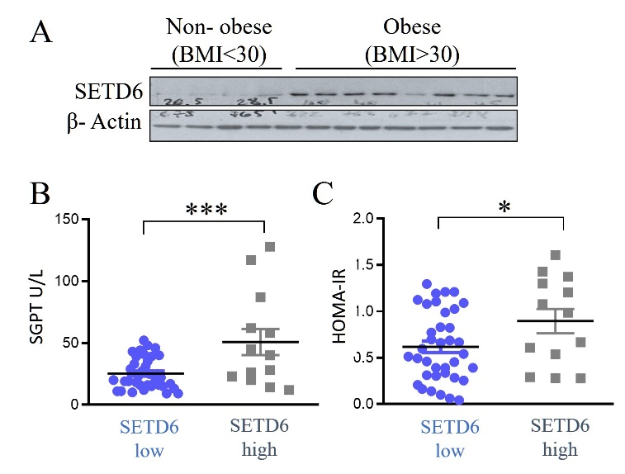

*Lysine methylation in steatosis* - In recent years, the link between lysine methylation and lipid droplet formation and steatosis has been studied in depth in the context of histones, chromatin structure alterations, and the regulation gene expression programs [46-51]. However, the role of lysine methylation and protein lysine methyltransferases (PKMTs) in the regulation of non-histone proteins in lipid droplet formation and steatosis remains largely unexplored.

To examine the potential role of SETD6 in liver cells, we performed an RNA-seq experiment comparing the expression signature of hepatic HepG2 control (two independent gRNAs) and SETD6 KO cells derived from three independent gRNAs. The efficiency of SETD6 KO in these cells is shown in Fig. 2A**.** 302 differentially expressed genes were identified (common genes for CRISPR clones, p-value ≤ 0.1; FC ≥ 1.5) (Fig. 2B). Of these 302 genes, 166 genes were downregulated, and 136 were upregulated. KEGG enrichment analysis (using the DAVID tool [52]) for the downregulated genes revealed significant enrichment of genes involved in lipid metabolism (red bars) and additional cancer-related pathways (blue bars). We and others have previously shown that SETD6 participates in these lipid metabolism and cancer-related pathways (**Fig. 2C).** These results were validated by direct qPCR on representative up- and downregulated target genes (data not shown). No significant enrichment in the DAVID analysis was observed in the upregulated genes. It seems, therefore, that SETD6 may positively regulate lipid metabolism. However, knowledge of the overall mode of action of SETD6 in these processes is lacking.

**Figure 2: *RNA-seq for SETD6 wt and KO HepG2 cells.* (A)** Representative western blot of SETD6 knockout in HepG2 cells using the CRISPR/Cas9 system. **(B)** Heat map of the expression pattern from RNA-seq of HepG2 control (CT, two clones) Color gradient represents upregulated (yellow) or downregulated (blue) genes **(C)** KEGG enrichment analysis for the down regulated genes. Red bars - genes involved in lipids metabolism. Blue bars - pathways that were linked before to SETD6 cellular activity. Pathways are presented according to the statistical significance of their enrichment.

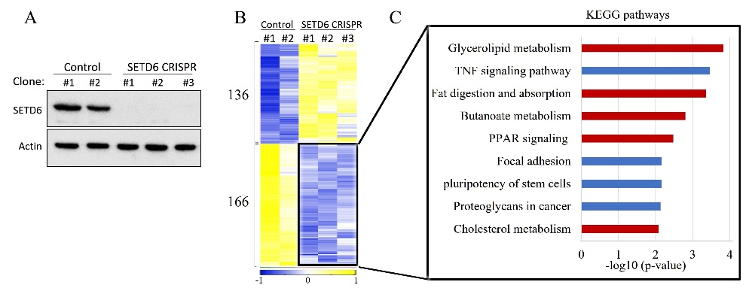

Interestingly, the KEGG analysis displays an enrichment of the PPAR signaling pathway, which may suggest potential functional crosstalk between SETD6 and one of the PPAR family members*.* This family is part of the nuclear receptor family and functions as transcription factors activated by ligands. The family consists of three PPAR isotypes: PPARα, PPARβ/δ, and PPARγ, with highly conserved DNA and ligand binding domains [53, 54]. This domain enables the binding to consensus DNA sequences called peroxisome proliferator response elements (PPREs), and they are usually found in a gene’s promoter region [55]. Despite their similar protein domain structures and mechanism of action, PPARs are encoded by different genes and activated by different ligands. Their distribution in tissues is different and they play diverse biological roles [29]. PPARα is highly expressed in oxidative tissues, such as liver, skeletal muscle, brown adipose tissue (BAT), heart, and kidney [32]. It participates mainly in the fasted state and regulates the transcription of rate-limiting enzymes required for peroxisomal and mitochondrial beta-oxidation [29]. PPARβ/δ is ubiquitously expressed [32] and mainly studied in skeletal muscle [33]. It was found to promote mitochondrial biogenesis and glucose uptake by increasing PGC-1α [34], and similar to PPARa it was shown to have anti-inflammatory effects. PPARγ is expressed predominantly in white and brown adipose tissues and macrophages [25], [32]. It controls fat storage by transcriptionally regulating genes involved in adipogenesis, adipose differentiation, and lipid metabolism [25]. PPARγ appears to be the major isoform in hepatocytes that contributes to fat accumulation and lipid droplet formation. The direct role of PPARγ in liver lipid homeostasis is to uptake free fatty acids from circulation and store them in lipid droplets [56].

To gain a deeper understanding of the involvement of the PPAR family member, we performed a ChIP-X Enrichment Analysis (CHEA), a gene-set enrichment analysis tool to identify the putative binding of transcription factors to a given set of target genes. This method is based on published data such as ChIP-chip, ChIP-seq and ChIP-PET experiments [57]. We applied CHEA on downregulated gene sets in the SETD6 KO cells. The RNA-seq results are shown in Fig. 2. Out of the 166 downregulated genes, the CHEA identified significant binding enrichment for PPARa and PPARg (Fig. 3).While 25 genes were unique to PPARa, we could observe 45 genes which are specific for PPARg transcriptional activation and 15 shared genes between them. While SETD6 might regulate both proteins, it seems that PPARg might serve a more dominant role in regulating these processes. This data may indicate a potential functional cellular crosstalk between PPARg and SETD6 in liver cells.

**Figure 3: CHEA analysis for PPARa and PPARg shared and distinct target genes.**

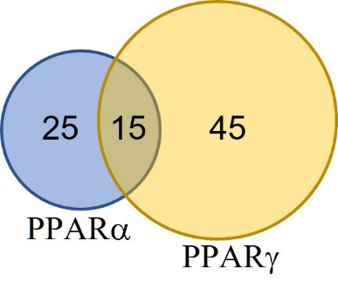

Based on these results and the preliminary data shown below, **the main goal** of the present research proposal is to decipher the cellular functional crosstalk between SETD6 and PPARg in lipid droplet formation and steatosis. We wish to elucidate the biochemical, molecular, and physiological relevance of PPARg methylation in these processes.

1. **Hypothesis, Objectives, and Rationale**

In this research proposal, we will test the specific hypothesis that SETD6 function and SETD6-mediated methylation of PPAR positively regulates lipid droplet formation and steatosis***.*** To address this hypothesis, we propose three specific objectives:

**Aim 1: To decipher the molecular and biochemical regulation of PPARg by SETD6.**

Our preliminary studies strongly suggest that SETD6 binds and methylates K170 of *PPARg*. Here, we will use biochemi­cal and cellular approaches to define the regulatory interaction between these proteins. Specifically, we will characterize *PPARg* methylation by SETD6 *in vitro* and in cells and utilize proteomic tools to identify specific methyl lysine “readers” that recognize methylated *PPARg* at K170.

**Aim 2: To investigate the cellular effect of SETD6-mediated PPARg methylation in liver lipid droplet dynamics and hepatic steatosis.**

We have established a live cell imaging platform to monitor lipid droplet formation and steatosis in liver cells dynamically. Using this system, we found that SETD6 positively regulates lipid droplet formation. Here we will utilize biochemi­cal, molecular, and cellu­lar approaches to define the downstream phenotypic consequences of *PPARg* methylation. We will apply these methods in physiological and pathological settings using several hepatic cell lines, primary hepatocytes, and mouse models with high and low-fat diets after manipulating SETD6 and PPARg expression.

**Aim 3: To elucidate the role of PPARg**g **K170me in transcriptional regulation.**

Here will apply genomic approaches (RNAseq, ChIP seq, etc.) to determine how the methylation of *PPARg*  alters transcriptional programs associated with lipid droplet formation and steatosis. In addition,our previous bioinformatics analyses revealed that the SETD6 promoter has several PPARg binding sites, which may suggest a positive feedback loop mechanism. We will utilize cellular and molecular biology approaches to test the hypothesis that *PPARg* directly regulates the transcription activation of SETD6 in a methylation-dependent manner.

1. **Significance and Innovation**

Lysine methylation is poised to take its place alongside other well-characterized PTMs as an essential and universal signaling mechanism with critical roles in diverse cellular processes. In this proposal, we will combine classical biochemical and cellular approaches with cutting-edge genomic and proteomic tools to elucidate the role of lysine methylation of non-histone proteins in lipid droplet formation and steatosis. This proposal brings together two fields of research – methylation signaling and metabolism – and has broad implications for both basic and translational research. Successful completion of the proposed aims can provide fundamental insights into the role of lysine methylation in the progression of steatosis and identify possible targets for therapeutic intervention.

1. **Detailed description of the proposed research and preliminary results**

**Aim 1: To decipher the molecular and biochemical regulation of PPARg by SETD6.**

Our preliminary data suggest a potential crosstalk between SETD6 and PPARg. We performed a series of preliminary investigations to explore this possibility further to assess the functional link between SETD6 and *PPARg*. To this end, we cloned, purified, and expressed the recombinant proteins, and evaluated their potential *in vitro* interaction using ELISA [21, 28]. We detected a direct interaction between recombinant *PPARg* and SETD6. MBP-RelA served as our positive control and BSA and PBS were used as negative controls for these experiments. (Fig. 4A and 4B). Given the PKMT activity of SETD6 and its direct physical interaction with *PPARg* *in vitro*, we hypothesized that SETD6 methylates *PPARg.* In an *in vitro* methylation assay containing recombinant His- *PPARg*, His-SETD6, and tritium labeled SAM (S- adenosyl-methionine, the methyl donor), we found that SETD6 methylates *PPARg* (Fig. 4C). This preliminary experiment provides strong support for the notion that SETD6 methylates *PPARg*. In an attempt to map the methylation site, we performed a non-radioactive methylation assay followed by mass spectrometry analysis (Proteomic unit, Weizmann Institute of Science). Among the 39 lysine residues found in *PPARg*, lysine 170 was identified by mass spectrometry to be mono-methylated (Fig. 4D). For validation, we generated *PPARg* mutants at lysine 170 to arginine (K170R) using site-directed mutagenesis which was validated by sequencing. In a radioactive methylation assay, a dramatic decrease in the methylation signal was observed for the K170R mutant compared to WT *PPARg* (Fig. 4E). We concluded from these experiments that SETD6 methylates PPARg primarily on lysine 170.

**Figure 4: *SETD6 binds and methylates PPARg on K170 in vitro* (A)** ELISA-based analysis of the interaction between recombinant GST-SETD6 and the indicated recombinant proteins. ****p < 0.0001 **(B)** Coomassie stain for the recombinant proteins used in A.**(C)** *In vitro* methylation assay in the presence of 3H-labeled SAM and the indicated purified proteins. Coomassie stain of the recombinant proteins used in the reactions is shown at the bottom. **(D)** Schematic representation of PPARg molecular structure and its domains. The methylated residue (K170) identified by mass spectrometry is shown in red. **(E)** Similar to C with the indicated recombinant purified proteins.

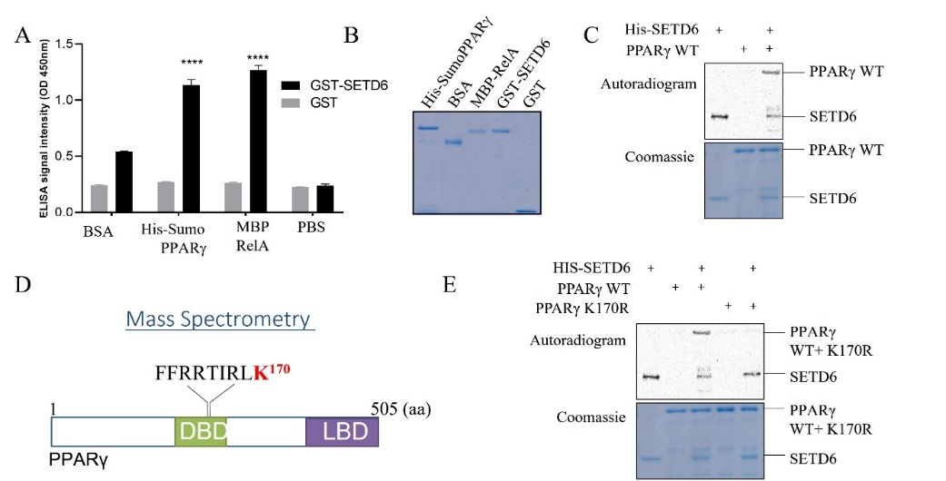

**Cellular biochemical analysis –**  Our preliminary *in vitro* experiments showing that SETD6 binds and methylates *PPARg* suggest that SETD6 also associates with *PPARg* in cells (Fig. 4). *PPARg* is a transcription factor and localized primarily to the nucleus [55]. To test if *PPARg* binds SETD6 in cells we immunoprecipitated endogenous *PPARg* from the chromatin of HepG2 cells followed by western blot analysis (Fig. 5A). To test if *PPARg* is methylated in cells, we immunoprecipitated endogenous *PPARg* (beads serve as control) from the chromatin fraction of HepG2 cells. We followed this by western blot with al pan-methyl antibody that we previously validated [24] (Fig. 5B). The results suggest that *PPARg* is methylated in cells. Furthermore, immunoprecipitation of all methylated proteins in the cells using a pan-methyl antibody from control and SETD6 KO revealed that over-expressed Flag-PPARg is methylated in a SETD6-dependent manner (Fig. 5C). To test if PPARg is methylated at K170, we will perform similar experiments in cells stably expressing WT or K170R *PPARg* in the presence and absence of SETD6. We will also subject the cellular methylation reactions to mass spectrometry (with the support of the lab of Dr. Benjamin A. Garcia, University of Pennsylvania - see letter of support) to validate the methylation site and to determine the extent of methylation (mono-, di-, or trimethylation) of the residue marked by SETD6. The mass spectrometry experiments will also allow us to quantitively estimate the amount of methylated *PPARg* *in vitro* and in cells. To further assess *PPARg* methylation in cells, we will generate site- and state-specific anti-methyl antibodies. The specificity of the antibodies will be validated by our peptide array technology and by dot-blot experiments, with which we have extensive experience [23, 24] (see also the alternative strategies section below). We will use these antibodies to confirm *PPAR* methylation in cells. First, we will over-express SETD6 and look for changes in *PPARg* methylation. Second, we will determine whether *PPARg* methylation is reduced in SETD6 knockout cells. In both cases, we will confirm the specificity of the results by over-expressing a *PPARg* mutant (K170R) that cannot be methylated. We will also utilize the specific methyl antibodies in biochemical fractionation [18, 26] and immunohistochemistry [23] experiments to determine the cellular localization of methylated *PPARg*. After validation of the methylation site, we will use the CRISPR system to knock-in the targeted lysine at 170 to arginine (K170R) and to alanine (K170A). The knock-in clones will be validated by sequencing as we have previously done [16, 28]. Obtaining these clones will eliminate residual activity by endogenous *PPARg*. To ensure that our findings are representative of a broader phenomenon, not restricted to cancer-transformed liver cells, we will further validate our findings in additional types of hepatic cell lines. These cell lines will include mouse liver AML12 cells and L02 (human fetal liver cell line), which were used before to study hepatic steatosis [58-61]. As described in detail in aim 2, below, to better mimic *in vivo* conditions, we will also utilize primary hepatocyte mouse cells and mouse models subjected to low and high-fat diets.

**Figure 5: *SETD6 binds and methylates PPARg in cells* (A)** Endogenous PPARg was immunoprecipitated from chromatin isolated HepG2 cells followed by western blot with the indicated antibodies. (**B)** PPARg was immunoprecipitated from the chromatin followed by western blot analysis with the indicated antibodies. **(C)** Flag-PPARg was over-expressed followed by immunoprecipitation using pan-methyl antibody in control (CT) and SETD6 KO cells followed by western blot with the indicated antibodies.

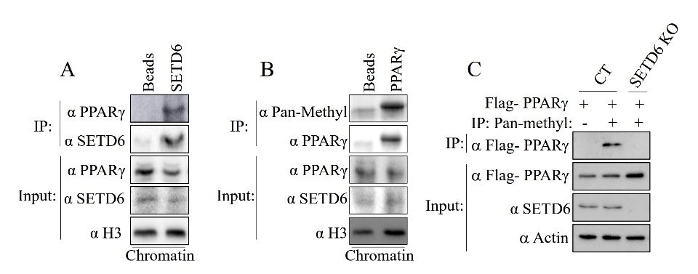

**To identify *PPAR****g* **K170me1 "reader" –** A key step in understanding a given methylation event's regulatory and functional consequence is to identify specific methyl lysine binders or “readers”. These trans-acting factors bind to methylated lysine residues and play a fundamental role in transducing various biological responses [62]. To identify these novel readers, we will utilize a high-throughput proteomic array technique based on the ProtoArray system we have developed [24] and used successfully in a few recent studies from our lab and others [21, 26, 63-65]. This system contains more than 9,500 highly purified recombinant human proteins expressed in insect cells as N-terminal GST fusion proteins. These proteins are then immobilized on nitrocellulose-coated glass microscope slides at spatially defined positions. The proteins printed on ProtoArrays are purified under native conditions to maintain their structural conformations. To identify new methyl lysine binders among the printed proteins, the ProtoArrays will be probed with unmodified or methylated *PPARg* fluorescent peptides labeled with the Alexa 647 fluorophore, followed by scanning and analysis with GenePix Pro 7.0 software (Fig. 6). As the proteins printed on the array are fully annotated, any positive hits will be examined bioinformatically to identify potentially relevant protein domains. These candidate protein domains will be cloned for further validation experiments. The criteria for selecting the candidate proteins will be: 1) proteins that contain a known methyl-lysine binding domain (PHD, MBT, Tudor, Chromo-domain, etc. [66, 67]); 2) proteins that are expressed in liver cell models based on the Human Protein Atlas (<http://www.proteinatlas.org/>) and; 3) candidates that were shown to be involved in the various signaling pathways in lipid metabolism and that participate in the signaling pathways that were enriched in our genomic analysis (Fig. 2).

**Figure 6**: Experimental procedure to identify binders using the protoarray system.

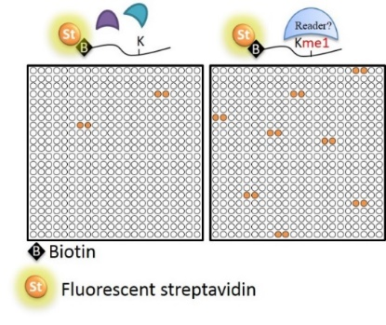

To test the specificity of each interaction, we will perform *in vitro* peptide pull-down assays, in which biotinylated and methylated *PPARg* peptides and an unmodified peptide control will be immobilized onto streptavidin-conjugated beads. This step will be followed by incubation with a purified GST-tagged candidate domain and western blot analysis with an anti-GST antibody. A pull-down assay will be performed using full-length candidate binding proteins and pre-methylated *PPARg* to test the interaction between full-length methylated *PPARg* and the candidate binders [23]. Finally, cell interactions will be confirmed using over-expression and knockdown approaches, followed by immunoprecipitation and western blot analysis using an antibody that recognizes the “reader” and the *PPARg* methylation-specific antibody. To further explore the specificity with which the "reader" interacts with methylated *PPARg*, we will utilize the *PPARg* K170R mutant—which cannot be methylated by SETD6—*in vitro* and in cells.

**Expected Outcomes, Potential Problems, & Alternative Strategies for Specific Aim 1**

Discovering and characterizing the proteins that sense and transduce *PPARg* methylation will be critical for dissecting the impact of SETD6-mediated *PPARg* methylation in steatosis and has the potential to provide a mechanistic explanation for this cellular crosstalk (see also aim 3, below). If we are unable to raise a specific antibody that recognizes methylated *PPARg*, we will use a pan-methyl antibody or the pan-methyl-specific MBT affinity reagent approach that we already validated in our lab [16, 18, 21, 26]. If we are unable to validate the readers identified by the ProtoArray approach (Fig. 6), we will exploit the CADOR array platform [68], which we have used successfully to identify the ankyrin repeat of GLP as a specific RelAK310me1 binder [23]. In a complementary strategy, we will incubate cell lysates with streptavidin-column-bound biotinylated un-methylated or methylated *PPARg* peptide followed by mass spectrometry, as previously described [69] and was successfully implemented in our lab (data not shown). *PPARg* has two spliced isoforms, PPARg1 and g2. In our experiments, we used the g2 isoform because it was shown to be more dominant in hepatocytes of NAFLD patients. Given the conservation of K170 in the g1 isoform and the two family members PPARα and PPARβ/δ [70], we will also clone them and test whether they are methylated by SETD6 using the systems described above.

**Aim 2**: **To investigate the cellular effect of SETD6-mediated *PPARg* methylation in liver lipid droplet dynamics and hepatic steatosis.**

It was previously shown that both oleic and palmitic acids are the most abundant fatty acids in NAFLD patients. These fatty acids contribute the most to the disease's pathogenesis and exhibit steatosis morphologies [70]. To replicate this condition in cells, we established a live imaging system to monitor the accumulation of lipid droplets in live cells. This system allows us to quantify and to study the kinetics of this process (Fig. 7). To this end, HepG2 cells were treated with oleic acid (OA) as the primary fatty acid responsible for lipid accumulation. We used BODIPY 493/503, a green fluorescent dye that stains neutral lipids to quantify OA accumulation. Hoechst dye was used to identify the nuclei and quantify cell counts, enabling the Mean GFP calculation. First, we designed a calibration experiment for 20 hours to determine the appropriate OA concentration. We incubated HepG2 cells with three different concentrations of OA: 300, 600, and 900 µM. A 900µM concentration of DMSO served as a control treatment since OA is dissolved in DMSO. While the 300 µM and 600 µM of OA accumulation reached a plateau over time, the 900 µM of OA showed a linear curve. The DMSO treated cells exhibited a decline in OA accumulation, indicating that the BODIPY dye is specific to neutral lipids staining (Fig 7B). Representative images for all three OA concentrations of the experiment are demonstrated in Figure 7C. While 300 µM and 600 µM of OA accumulation maintained the morphology of HepG2 cells, the 900 µM of OA displayed a lipotoxic effect on the cells (Fig. 7C). In future experiments, we will work with OA concentrations of 300 µM and 600 µM as they displayed optimal staining conditions and did not affect the morphology of the cells.

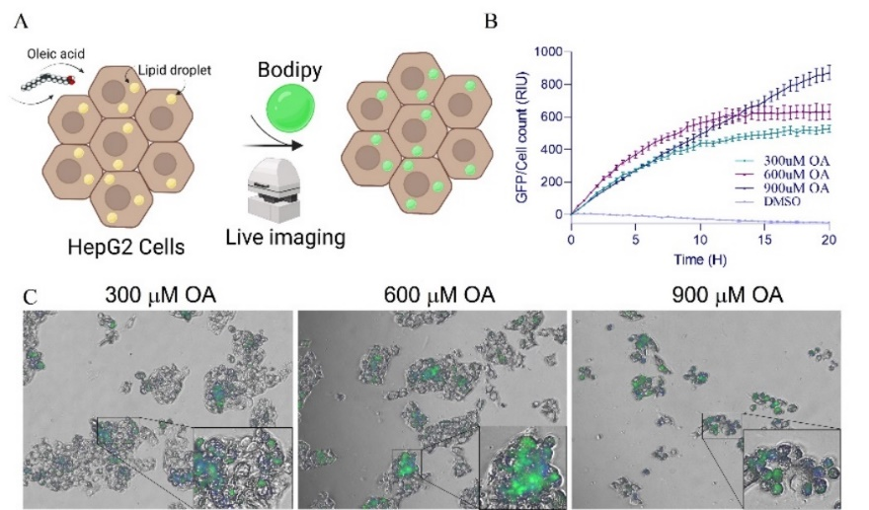

**Figure 7: *Optimization of lipid droplet formation system* (A)** Illustration of the system. HepG2 cells are treated with oleic acid (OA) and stained with Hoechst (nucleus) and BODIPY (neutral lipids), followed by live cell imaging. represented in blue and green colors, respectively. **(B)** OA accumulation curve of HepG2 cells over 20 hours challenged with 300 µM, 600 µM, and 900 µM of OA. 900 µM DMSO served as a control treatment. Mean GFP was calculated as GFP divided by cell count. Data is analyzed from five beacons per well, with three wells per OA or DMSO treatment. **(C)** Representative Images of last time point (20 H) with three concentrations of OA. Scale bar indicates 200 µm with a magnified area of interest.

Our preliminary results suggest that depletion of SETD6 in HepG2 cells led to a decrease in the transcription activation of genes involved in lipid metabolism (Fig. 2). We then decided to study the effect of SETD6 expression on lipid droplet formation. To this end, HepG2 control and SETD6 KO cells were treated with OA, stained with BODIPY, and the mean GFP level was monitored by the live imaging system described above (Fig. 8). The results demonstrate that the CT cell line had accumulated significantly more OA over time than SETD6 KO1 and KO2 cells. Representative images of HepG2 CRISPR CT, KO1, and KO2 cells at an 18.5-hour time point are shown. These data suggest that SETD6 expression increases lipid droplet formation in HepG2 cells and is consistent with our working hypothesis. In future experiments, we will test the hypothesis that this positive effect is mediated by *PPARg* methylation at K170*.* We will utilize this system and perform these experiments in 1) stably reconstituted SETD6 KO cells with wild-type SETD6 or the catalytically inactive mutant SETD6 Y285A [23] or cells with a knock-in of Y285A; along with 2) cells stably expressing Flag- *PPARg* wild-type and Flag-*PPARg* K170R, which cannot be methylated by SETD6 or after knock-in of K170R; and 3) after genetically manipulating the expression of the "reader" (over-expression and depletion as described in aim 1). As mentioned above, we will perform these experiments also in mouse liver AML12 cells and L02 cell lines. To better resemble *in vivo* models, we will also perform these experiments in primary mouse hepatocytes isolated from 8–12 weeks old mice by liver perfusion, which were shown before to serve as a good model for steatosis [71]. Knock-down and over-expression of SETD6/*PPARg*/reader will be achieved by adenovirus infection (25 × 106 PFU/mL) [72]. All the experiments in these cells will be performed in the absence or presence of rosiglitazone - a specific *PPARg* agonist [73]. Primary cells will also be isolated from the mice with low and high-fat diets (see below). Prof. Ido Goldstein (HUJI), who has vast experience with this approach [72, 74], kindly agreed to escort us in these experiments (see collaboration letter).

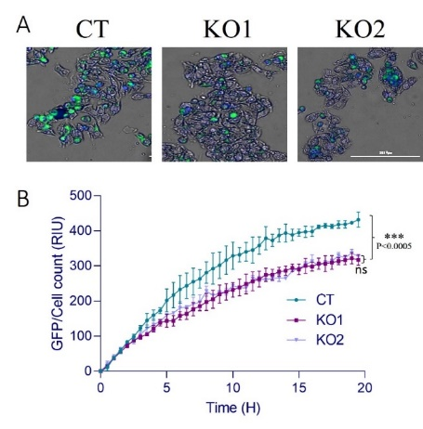

**Figure 8: *SETD6 positively regulates lipid droplet formation in HepG2 cells* (A)** Representative images of HepG2 CRISPR CT, KO1, and KO2 (20 H time point) challenged with 300uM of OA and stained with Hoechst (Nucleus) and BODIPY (neutral lipids). **(B)** Mean GFP was calculated as GFP divided by cell count. Data is analyzed from three beacons per well in three wells. Statistical analysis was performed using one-way ANOVA.

Mouse models: To gain a deeper understanding of the role of SETD6 in liver disease-associated phenotypes in a more physiological context, we will extend the study to mouse models with low and high-fat diets to induce steatosis (REF). We will employ eight mice per condition in at least two independent experiments. We will use adeno-associated virus serotype 8 (AAV8) to manipulate the expression of SETD6 (overexpression and KD by siRNA/shRNA): we will utilize *PPARg* WT and K170R mutant specifically in the liver via intravenous injection of the tail vein [75]. The AAV8 vectors will be controlled by the alpha 1-anti-trypsin (hAAT) promoter, shown before, to restrict transgene expression to hepatocytes [76, 77]. All vectors are available for purchase from Vector Biolabs (Malvern, PA). We will then biochemically measure total TG and cholesterol content using commercially available kits. To gain tissue level resolution, we will histologically stain liver sections using haematoxylin and eosin (H&E) and oil red staining to measure lipid accumulation [78, 79]. In addition, we will perform biochemical analysis to measure total cholesterol, TG, and the abidance of the hepatic enzymes alanine amino transferase (ALT), aspartate aminotransferase (AST), and alkaline phosphatase (ALP) in the serum. All of these measurements serve as hallmarks for liver damage and steatosis [80]. These experiments will be performed in collaboration with Prof. Assaf Rudich and Prof. Yoram Etzion, both of whom have vast experience with this approach (REF) (see collaboration letters).

**Expected Outcomes, Potential Problems, & Alternative Strategies for Specific Aim 2**

The expected outcome of this aim will be the elucidation of the cellular effects of SETD6-mediated *PPARg* methylation in the progression of steatosis. We expect that *PPARg* methylation at K170 will positively affect lipid droplet formation in all the different cellular models we plan to use. Given the delicate balance between *PPARg*-mediated lipid droplet formation and *PPARa*-mediated oxidative phosphorylation, we envision a fundamental role for SETD6 in determining the ratio between these two proteins and their cellular activity. This molecular switch interplay may be determined by many available tools (Seahorse, etc.) researchers have used before [81]. In this case, if oleic acid will not be potent enough to induce lipid droplet formation in the primary cells of mice, we will optimize and use palmitic acid instead [82].

**Aim 3: To elucidate the role of PPARg K170me in transcriptional regulation.**

Given the role of *PPARg* in the transcriptional activation of genes associated with steatosis and that SETD6 positively regulates this process (See Figs. 2 and 8 above), we hypothesized that both proteins might be involved in gene expression regulation. To explore this hypothesis, we examined the location of K170 within the *PPARg* protein. This analysis revealed that K170 is located at a strategic point within the zinc fingers in the DNA binding domain (DBD) of *PPARγ* (Fig. 9A). Biochemical fractionations of the chromatin fraction revealed that WT *PPARg* binds stronger to the chromatin compared to mutant *PPARg* K170R which cannot be methylated by SETD6 (Fig. 9B). The expression levels of WT and K170R *PPARg* in whole cell lysate were similar (data not shown). We hypothesized that the methylation of *PPARg* at K170 by SETD6 in liver cells regulates its recruitment to the DNA to positively regulate transcriptional programs linked to lipid droplet formation and steatosis. This hypothesis is based on: 1) our RNA seq experiments (Fig. 2); 2) the fact that SETD6 binds *PPARg*  at chromatin; and 3) previous reports have shown that *PPARg* directly activates lipid droplets and steatosis-related target genes. To address this hypothesis, we first focused on two *PPARγ* target genes MOGAT1 and PLIN2; both are known to be involved in the lipid droplet formation process [56]. MOGAT1 is a rate-limiting enzyme involved in incorporating fatty acids into triglycerides and characterizes the fatty-acid esterification step. PLIN2 surrounds the [lipid droplet](https://en.wikipedia.org/wiki/Lipid_droplet) and assists in the storage of neutral lipids within the lipid droplets. We took advantage of a previous genomic analysis (ChiP-seq and ATAC-seq) performed in HepG2 cells [83], a similar cellular system that we used in our RNA-seq preliminary experiments. This analysis confirmed that *PPARg* is enriched at the promoters of MOGAT1 and PLIN2 ([GSE95940](https://www.ncbi.nlm.nih.gov/geo/query/acc.cgi?acc=GSE95940)) in an open chromatin state (ATAC seq ERX2868847) along with enrichment for H3K4me3 and H3K27ac ([GSE51334](https://www.ncbi.nlm.nih.gov/geo/query/acc.cgi?acc=GSE51334)) in that genomic region (Fig. 10A). We can also confirm this pattern in many of the differentially expressed genes we identified in the RNA-seq experiment presented in Fig. 2(data not shown). In a qPCR experiment, we found that MOGAT1 and PLIN2 are expressed in control HepG2 cells: However, their expression was significantly reduced in the SETD6 depleted cells (Fig. 10B**)**, suggesting that this effect is SETD6 dependent. In future experiments, we will perform RNA-seq in SETD6 wild-type and SETD6-KO HepG2 cells. This will be done with or without stable over-expression of wildtype and K170R *PPAR* or via using K170R knock-in cells. To complement these experiments, we will also perform ChIP-seq experiments using antibodies for SETD6 that we have validated for use in ChIP-seq experiments (data not shown) along with antibodies targeting methylated *PPARg* and the "reader". Commercially available antibodies of known repressive (H3K9me2, H3K27me3) or activating (H3K4me, H3Ac) histone marks that were shown before to be altered in steatosis [84, 85] will be used to monitor changes in chromatin modification states at the target genes identified in our RNA-seq experiment. We will perform these experiments under rosiglitazone stimulation which induces *PPARg* transcription activity, and under non-stimulating conditions. These experiments will also be performed in several other cellular models described above (AML12, LO2, and primary hepatocyte mouse cells).

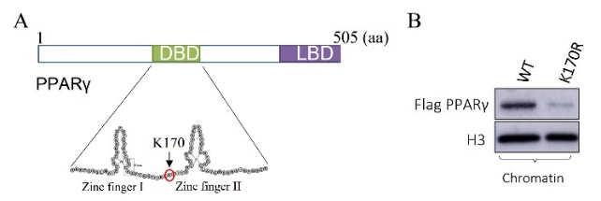

**Figure 9: *PPARg methylation at K170 may regulate its association with the DNA.* (A)** A schematic illustration of the zinc fingers of PPARγ2 in the DBD. K170 is marked in a red circle. **(B)** Isolated chromatin fraction from HepG2 cells stably expressing flag-tagged WT or K170R PPARg followed by western blot analysis with the indicated antibodies.

**Figure 10: *PPARg positively regulates lipid droplet formation target genes in a SETD6 dependent manner.* (A)** Capture of a genome browser ([GSE95940](https://www.ncbi.nlm.nih.gov/geo/query/acc.cgi?acc=GSE95940) and showing the enrichment of PPARG on two representative genes in HepG2 cells with open chromatin state represented by H3K4me3, H3K27ac and ATAC-seq track (ERX2868847). **(B)** qPCR of the indicated target genes in control and SETD6 KO cells. mRNA levels were normalized to GAPDH and then to CT cells. One-way ANOVA analysis was performed, error bars are S.E.M. **p < 0.01.

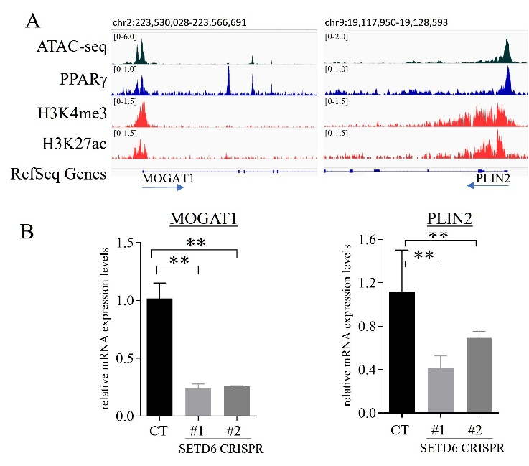

The expression signature (RNA-seq) and ChIP-seq profile changes will be compared to 1) data obtained from our preliminary RNA-seq results (Fig. 2); 2) data we will obtain from the different cell types (described above); and 3) available database data of *PPARg* expression; 4) genomic occupancy analysis performed in liver disease cell models and from 5) available patients databases such as the NIDDK Central Repository (https://repository.niddk.nih.gov/studies/nafld_adult/. The computational and statistical analyses of the genomic data will be performed by Dr. Liron Levin, Head of the Bioinformatics Core Facility at BGU (support letter is attached). Candidate genes will be further validated by direct quantitative RT-PCR and direct ChIP experiments [16, 23, 28]. These experimental approaches will help us establish a genomic foundation for understanding the role of SETD6-mediated PPAR  methylation in regulating gene expression programs for lipid droplet formation.

**To test PPARγ regulates SETD6 as part of a potential feedback loop mechanism.**

By exploring the JASPAR database [86] – an open-access database of non-redundant transcription factors binding profiles – we identified that the SETD6 promoter sequence contains six predicted PPRE response elements which can serve as putative binding sites recognized by PPAR (yellow boxes). Most of these predicted binding sites were found to be clustered at the ~1000 bp of the SETD6 promoter sequence (Fig. 11A). The existence of these putative PPREs may suggest that PPARγ may regulate SETD6 through binding to the SETD6 promoter region***.*** Analysis of publicly available ChIP-seq databases have revealed that *PPAR* binds to the SETD6 promoter region in an open chromatin state (ATAC-seq [black]) within active promoter regions, as indicated by the H3K4me3 and H3K27ac tracks (red) (Fig. 11B). To validate these findings, we performed a direct ChIP-DNA and tested the enrichment of endogenous *PPARg* on the SETD6 promoter in HepG2 cells using primers designed based on the bioinformatics data presented in Fig. 11A**.** As shown in Fig. 11C, *PPARg* is specifically enriched at the SETD6 locus. Therefore, we inferred that PPARg may regulate the expression of SETD6*.* Indeed, our preliminary data suggest that SETD6 mRNA levels significantly increase in HePG2 cells with over-expression of *PPARg* (Fig. 11D). Consistent with this, treatment of cells with rosiglitazone that specifically induces *PPARg* transcription activity also led to an increase in the expression level of SETD6 (Fig. 11E). These results suggest that PPARg binds to the SETD6 promoter region and can positively regulate its expression.

**Figure 11: *PPARg is enriched at SETD6 promoter* (E)** SETD6 promoter contains six predicted PPREs binding site (JASPAR) which suggests that PPARγ may regulate SETD6 through binding to the SETD6 promoter region. **(B)** Capture of a genome browser showing the enrichment of PPARg at the SETD6 Promoter in HepG2 cells with open chromatin state represented by H3K4me3, H3K27ac, and ATAC-seq tracks. Right: Six putative PPREs binding sites were predicted using the JASPAR database, shown in cyan boxes. **(C)** ChIP assay with PPARg antibody or beads as negative control in HepG2 cells followed by qPCR with primers flanking the predicted binding site at the SETD6 promoter. Graphs show % input of the quantified DNA. **(D+E)** RNA was extracted from HepG2 cells transfected with control or Flag-PPARγ WT (**C**) plasmids or treated with 10µM Rosiglitazone (Rosi) for 24 hours (**D**). Transcript levels of the SETD6 were determined by qPCR. mRNA levels were normalized to GAPDH and then to overexpressed as empty or without rosiglitazone treatments, respectively. Error bars are SEM. Statistical analysis was performed for three experimental repeats using one-way ANOVA (*p < 0.05, ****p < 0.0001).

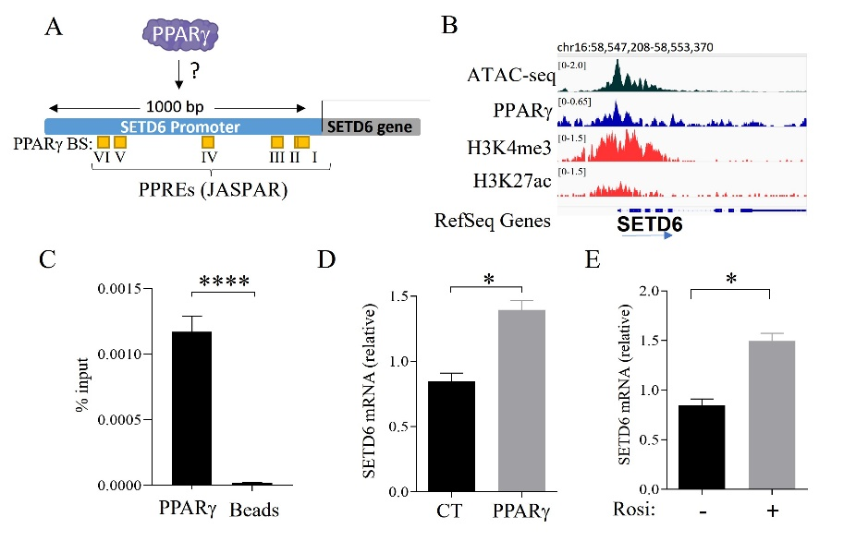

Furthermore, these results may suggest the possibility of an autoregulatory positive feedback loop between PPARg and SETD6 which is mediated by PPARg methylation at K170.To confirm that *PPARg* binds to the promoter region of SETD6 encoding gene, we will take advantage of the luciferase reporter-­based assay we have been working on before within the lab [18, 23]. To this end will first amplify by PCR the SETD6 promoter sequence (~1000 bp upstream from the TSS of SETD6 gene) and clone it upstream to a luciferase reporter gene. We will use this construct for transfection experiments in cells stably expressing WT or a *PPARg* K170R mutant in control and SETD6 KO cells. Renilla plasmids will be used in these experiments as a transfection and normalization control. Our bioinformatics analysis using the JASPAR tool [86] have identified six predicted *PPARg* binding sites within the SETD6 promoter in two main clusters. Four of them are located up to 600 bp, and the other two are spread between 660-1000 bp upstream of the TSS, respectively. To roughly map *PPARg* binding sites, we will clone truncated fragments of the SETD6 promoter upstream of the luciferase gene. After identification of the binding region, we will clone promoter regions with deletions and point mutations in candidate fragments to narrow *PPARg*  primary site/s. These experiments will allow us to map to a PPARg binding site and assess whether this association is SETD6 and methylated K170 dependent. To complement these experiments and to provide evidence for a direct interaction with the identified regions, we will perform an EMSA (Electrophoretic-Mobility Shift Assay). We will then determine the binding capabilities of both recombinant *PPARg* WT and K170R: We will do this by using several 32P labeled synthesized sequences probes which will be chosen from the luciferase experiments described above and are based on the *PPARg* binding sites identified with the JASPAR bioinformatic tools (Fig. 11A) (See support letter from XXXX). We will then perform ChiP-DNA similar to the experiment described above to compare the occupancy enrichment of stably expressed WT vs. K170R *PPARg* to the specific genomic location. We plan to endogenously edit the potential PPAR*g* sites at the SETD6 promoter using the CRISPR knock-in system to validate this working hypothesis further. Finally, the mRNA expression level of SETD6 will be monitored by qPCR using the same experimental systems described above. These experiments will be performed under basal and in response to rosiglitazone stimulation.

**Expected Outcomes, Potential Problems, & Alternative Strategies for Specific Aim 3**

We anticipate obtaining a direct correlation between PPARg methylation and the activation transcriptional programs and pathways linked to lipid droplet formation and steatosis. While we have good experience with ChIP-seq experiments, we know that ChIP for transcription factors can suffer from low signaling and require ChIP-grade antibodies. In such a case, we will use the Cut&Run platform [87], which was recently implemented in our lab and provides higher signaling to noise and does not require fixation, which helps antibody recognition. If the EMSA experiments yield dirty results, we will utilize the AlphLisa approach (PerkinElmer) – a bead-based luminescent amplification assay that offers excellent sensitivity to detect protein-DNA interactions.

1. **Resources**

The proposed research will be performed in the Department of Microbiology, Immunology and Genetics at Ben-Gurion University (BGU) and the National Institute of Biotechnology in the Negev (NIBN). These facilities are fully equipped with the instrumentation required for the biochemical, cellular, and physiological studies that constitute the proposed research. My lab currently consists of 10 members: four PhD students; three master’s students; three undergraduate students; and one lab manager holding a PhD degree. The 100-square-meter laboratory is currently equipped to accommodate all the molecular biology and cellular studies described in this proposal. These experiments include: gel electrophoresis, immunoblotting, FPLC with a variety of columns, PCR cyclers, real-time PCR machine, sonicators, several centrifuges, deep freezers (−20 ºC and −80 ºC), scintillation counters, cold rooms, autoclaves, and temperature-controlled growth rooms. In addition, we possess a tissue culture room with all the equipment necessary to carry out tissue culture work, including two biological hoods, three incubators, an optical and fluorescent microscope, a live cell imaging system, and a liquid nitrogen dewar to store frozen cells. In addition, departmental equipment and the NIBN are available if needed. The NIBN houses four service units—Genomics, Proteomics, Microscopy and Bioinformatics—each headed by a skilled scientist. These units include state-of-the art equipment, such as MALDI-TOF, LC/MS, and FACScan cytometer. Additional resources including DNA and peptide synthesis facilities and DNA sequencing are also available.

Collaboration letters:

Ido Goldstein (HUJI)- primary hepatocytes

Assaf Rudich – Mouse work and metabolism

Kyle Bigger – masspec

Ben Garcia- masspec

Liron Levin- Bioinformatics

Tali Haran- EMSA

1. **References**

1. Greer, E.L. and Y. Shi, *Histone methylation: a dynamic mark in health, disease and inheritance.* Nat Rev Genet, 2012. **13**(5): p. 343-57.

2. Chiang, C., et al., *The Epigenetic Regulation of Nonhistone Proteins by SETD7: New Targets in Cancer.* Front Genet, 2022. **13**: p. 918509.

3. Rubio-Tomas, T., *The SMYD family proteins in immunology: An update of their obvious and non-obvious relations with the immune system.* Heliyon, 2021. **7**(6): p. e07387.

4. Bhat, K.P., et al., *Epigenetics and beyond: targeting writers of protein lysine methylation to treat disease.* Nat Rev Drug Discov, 2021. **20**(4): p. 265-286.

5. Di Blasi, R., et al., *Non-Histone Protein Methylation: Biological Significance and Bioengineering Potential.* ACS Chem Biol, 2021. **16**(2): p. 238-250.

6. Sugeedha, J., J. Gautam, and S. Tyagi, *SET1/MLL family of proteins: functions beyond histone methylation.* Epigenetics, 2021. **16**(5): p. 469-487.

7. Lukinovic, V., et al., *Lysine Methyltransferases Signaling: Histones are Just the Tip of the Iceberg.* Curr Protein Pept Sci, 2020. **21**(7): p. 655-674.

8. Levy, D., *Lysine methylation signaling of non-histone proteins in the nucleus.* Cell Mol Life Sci, 2019. **76**(15): p. 2873-2883.

9. Albert, M. and K. Helin, *Histone methyltransferases in cancer.* Semin Cell Dev Biol, 2010. **21**(2): p. 209-20.

10. Kouzarides, T., *Chromatin modifications and their function.* Cell, 2007. **128**(4): p. 693-705.

11. Arrowsmith, C.H., et al., *Epigenetic protein families: a new frontier for drug discovery.* Nat Rev Drug Discov, 2012. **11**(5): p. 384-400.

12. Peterson, C.L. and M.A. Laniel, *Histones and histone modifications.* Curr Biol, 2004. **14**(14): p. R546-51.

13. Shi, Y. and J.R. Whetstine, *Dynamic regulation of histone lysine methylation by demethylases.* Mol Cell, 2007. **25**(1): p. 1-14.

14. Yeates, T.O., *Structures of SET domain proteins: protein lysine methyltransferases make their mark.* Cell, 2002. **111**(1): p. 5-7.

15. Admoni-Elisha, L., et al., *Structure-function conservation between the methyltransferases SETD3 and SETD6.* Biochimie, 2022. **200**: p. 27-35.

16. Admoni-Elisha, L., et al., *TWIST1 methylation by SETD6 selectively antagonizes LINC-PINT expression in glioma.* Nucleic Acids Res, 2022.

17. Chang, Y., et al., *Structural basis of SETD6-mediated regulation of the NF-kB network via methyl-lysine signaling.* Nucleic Acids Res, 2011. **39**(15): p. 6380-9.

18. Chen, A., et al., *SETD6 is a negative regulator of oxidative stress response.* Biochim Biophys Acta, 2016. **1859**(2): p. 420-7.

19. Duchin, S., et al., *A continuous kinetic assay for protein and DNA methyltransferase enzymatic activities.* Epigenetics Chromatin, 2015. **8**: p. 56.

20. Feldman, M. and D. Levy, *Peptide inhibition of the SETD6 methyltransferase catalytic activity.* Oncotarget, 2018. **9**(4): p. 4875-4885.

21. Feldman, M., et al., *The methyltransferase SETD6 regulates Mitotic progression through PLK1 methylation.* Proc Natl Acad Sci U S A, 2019. **116**(4): p. 1235-1240.

22. Kublanovsky, M., A. Aharoni, and D. Levy, *Enhanced PKMT-substrate recognition through non active-site interactions.* Biochem Biophys Res Commun, 2018. **501**(4): p. 1029-1033.

23. Levy, D., et al., *Lysine methylation of the NF-kappaB subunit RelA by SETD6 couples activity of the histone methyltransferase GLP at chromatin to tonic repression of NF-kappaB signaling.* Nat Immunol, 2011. **12**(1): p. 29-36.

24. Levy, D., et al., *A proteomic approach for the identification of novel lysine methyltransferase substrates.* Epigenetics Chromatin, 2011. **4**: p. 19.

25. Martin-Morales, L., et al., *SETD6 dominant negative mutation in familial colorectal cancer type X.* Hum Mol Genet, 2017. **26**(22): p. 4481-4493.

26. Vershinin, Z., et al., *PAK4 Methylation by SETD6 Promotes the Activation of the Wnt/beta-Catenin Pathway.* J Biol Chem, 2016. **291**(13): p. 6786-95.

27. Vershinin, Z., M. Feldman, and D. Levy, *PAK4 methylation by the methyltransferase SETD6 attenuates cell adhesion.* Sci Rep, 2020. **10**(1): p. 17068.

28. Vershinin, Z., et al., *BRD4 methylation by the methyltransferase SETD6 regulates selective transcription to control mRNA translation.* Sci Adv, 2021. **7**(22).

29. Weil, L.E., et al., *Oligomerization and Auto-methylation of the Human Lysine Methyltransferase SETD6.* J Mol Biol, 2018. **430**(21): p. 4359-4368.

30. O'Neill, D.J., et al., *SETD6 controls the expression of estrogen-responsive genes and proliferation of breast carcinoma cells.* Epigenetics, 2014. **9**(7): p. 942-50.

31. Binda, O., et al., *SETD6 monomethylates H2AZ on lysine 7 and is required for the maintenance of embryonic stem cell self-renewal.* Epigenetics, 2013. **8**(2): p. 177-83.

32. Younossi, Z.M., et al., *Global epidemiology of non-alcoholic fatty liver disease-Meta-analytic assessment of prevalence, incidence, and outcomes.* Hepatology, 2016. **64**(1): p. 73-84.

33. Abd El-Kader, S.M. and E.M. El-Den Ashmawy, *Non-alcoholic fatty liver disease: The diagnosis and management.* World J Hepatol, 2015. **7**(6): p. 846-58.

34. Meyers, A., T.M. Weiskittel, and P. Dalhaimer, *Lipid Droplets: Formation to Breakdown.* Lipids, 2017. **52**(6): p. 465-475.

35. Wong, R.J., et al., *Non-alcoholic steatohepatitis is the second leading etiology of liver disease among adults awaiting liver transplantation in the United States.* Gastroenterology, 2015. **148**(3): p. 547-55.

36. Perez-Carreras, M., et al., *Non-alcoholic fatty liver disease in patients with intestinal, pulmonary or skin diseases: Inflammatory crosstalk that needs a multidisciplinary approach.* World J Gastroenterol, 2021. **27**(41): p. 7113-7124.

37. Wang, Y., et al., *Natural histories of metabolite BMI phenotypes and their impacts on cardiovascular disease risk over a decade-long follow-up.* Obes Res Clin Pract, 2021. **15**(6): p. 579-586.

38. Yerushalmy-Feler, A., et al., *BMI in the lower and upper quartiles at diagnosis and at 1-year follow-up is significantly associated with higher risk of disease exacerbation in pediatric inflammatory bowel disease.* Eur J Pediatr, 2021. **180**(1): p. 21-29.

39. Liu, Z., et al., *Causal relationships between NAFLD, T2D and obesity have implications for disease subphenotyping.* J Hepatol, 2020. **73**(2): p. 263-276.

40. Loomis, A.K., et al., *Body Mass Index and Risk of Nonalcoholic Fatty Liver Disease: Two Electronic Health Record Prospective Studies.* J Clin Endocrinol Metab, 2016. **101**(3): p. 945-52.

41. Li, L., et al., *Obesity is an independent risk factor for non-alcoholic fatty liver disease: evidence from a meta-analysis of 21 cohort studies.* Obes Rev, 2016. **17**(6): p. 510-9.

42. Dai, W., et al., *Prevalence of non-alcoholic fatty liver disease in patients with type 2 diabetes mellitus: A meta-analysis.* Medicine (Baltimore), 2017. **96**(39): p. e8179.

43. Katsiki, N., D.P. Mikhailidis, and C.S. Mantzoros, *Non-alcoholic fatty liver disease and dyslipidemia: An update.* Metabolism, 2016. **65**(8): p. 1109-23.

44. Wu, S.J., et al., *Increased levels of systolic blood pressure within the normal range are associated with significantly elevated risks of non-alcoholic fatty liver disease.* Medicine (Baltimore), 2015. **94**(19): p. e842.

45. Marchesini, G., et al., *Non-alcoholic fatty liver, steatohepatitis, and the metabolic syndrome.* Hepatology, 2003. **37**(4): p. 917-23.

46. Pande, P., X.B. Zhong, and W.W. Ku, *Histone Methyltransferase G9a Regulates Expression of Nuclear Receptors and Cytochrome P450 Enzymes in HepaRG Cells at Basal Level and in Fatty Acid Induced Steatosis.* Drug Metab Dispos, 2020. **48**(12): p. 1321-1329.

47. Kim, D.H., et al., *Critical Roles of the Histone Methyltransferase MLL4/KMT2D in Murine Hepatic Steatosis Directed by ABL1 and PPARgamma2.* Cell Rep, 2016. **17**(6): p. 1671-1682.

48. Podrini, C., et al., *MacroH2A1 isoforms are associated with epigenetic markers for activation of lipogenic genes in fat-induced steatosis.* FASEB J, 2015. **29**(5): p. 1676-87.

49. Cai, Q., et al., *Mechanism and Therapeutic Opportunities of Histone Modifications in Chronic Liver Disease.* Front Pharmacol, 2021. **12**: p. 784591.

50. Li, X., et al., *The methyltransferase METTL3 negatively regulates non-alcoholic steatohepatitis (NASH) progression.* Nat Commun, 2021. **12**(1): p. 7213.

51. Yin, Q., et al., *RPA1 controls chromatin architecture and maintains lipid metabolic homeostasis.* Cell Rep, 2022. **40**(2): p. 111071.

52. Huang da, W., B.T. Sherman, and R.A. Lempicki, *Systematic and integrative analysis of large gene lists using DAVID bioinformatics resources.* Nat Protoc, 2009. **4**(1): p. 44-57.

53. Wang, Y.X., *PPARs: diverse regulators in energy metabolism and metabolic diseases.* Cell Res, 2010. **20**(2): p. 124-37.

54. Evans, R.M., G.D. Barish, and Y.X. Wang, *PPARs and the complex journey to obesity.* Nat Med, 2004. **10**(4): p. 355-61.

55. Li, Z., et al., *PPARgamma phase separates with RXRalpha at PPREs to regulate target gene expression.* Cell Discov, 2022. **8**(1): p. 37.

56. Lee, Y.K., et al., *Hepatic lipid homeostasis by peroxisome proliferator-activated receptor gamma 2.* Liver Res, 2018. **2**(4): p. 209-215.

57. Lachmann, A., et al., *ChEA: transcription factor regulation inferred from integrating genome-wide ChIP-X experiments.* Bioinformatics, 2010. **26**(19): p. 2438-44.

58. Xu, R., et al., *The methyltransferase METTL3-mediated fatty acid metabolism revealed the mechanism of cinnamaldehyde on alleviating steatosis.* Biomed Pharmacother, 2022. **153**: p. 113367.

59. Ramos, M.J., et al., *In vitro models for non-alcoholic fatty liver disease: Emerging platforms and their applications.* iScience, 2022. **25**(1): p. 103549.

60. Guo, T., et al., *S-adenosylmethionine upregulates the angiotensin receptor-binding protein ATRAP via the methylation of HuR in NAFLD.* Cell Death Dis, 2021. **12**(4): p. 306.

61. Ding, H.R., et al., *Protective Properties of FOXO1 Inhibition in a Murine Model of Non-alcoholic Fatty Liver Disease Are Associated With Attenuation of ER Stress and Necroptosis.* Front Physiol, 2020. **11**: p. 177.

62. Levy, D. and O. Gozani, *Decoding chromatin goes high tech.* Cell, 2010. **142**(6): p. 844-6.

63. Lukinovic, V., et al., *SMYD3 impedes small cell lung cancer sensitivity to alkylation damage through RNF113A methylation-phosphorylation crosstalk.* Cancer Discov, 2022.

64. Mazur, P.K., et al., *SMYD3 links lysine methylation of MAP3K2 to Ras-driven cancer.* Nature, 2014. **510**(7504): p. 283-7.

65. Cohn, O., et al., *Chromatin associated SETD3 negatively regulates VEGF expression.* Sci Rep, 2016. **6**: p. 37115.

66. Wilkinson, A.W. and O. Gozani, *Histone-binding domains: strategies for discovery and characterization.* Biochim Biophys Acta, 2014. **1839**(8): p. 669-75.

67. Franklin, K.A., C.E. Shields, and K.A. Haynes, *Beyond the marks: reader-effectors as drivers of epigenetics and chromatin engineering.* Trends Biochem Sci, 2022. **47**(5): p. 417-432.

68. Kim, J., et al., *Tudor, MBT and chromo domains gauge the degree of lysine methylation.* EMBO Rep, 2006. **7**(4): p. 397-403.

69. Metzger, E., et al., *Assembly of methylated KDM1A and CHD1 drives androgen receptor-dependent transcription and translocation.* Nat Struct Mol Biol, 2016. **23**(2): p. 132-9.

70. Fougerat, A., et al., *Peroxisome Proliferator-Activated Receptors and Their Novel Ligands as Candidates for the Treatment of Non-Alcoholic Fatty Liver Disease.* Cells, 2020. **9**(7).

71. Takeichi, Y., et al., *Non-alcoholic fatty liver disease in mice with hepatocyte-specific deletion of mitochondrial fission factor.* Diabetologia, 2021. **64**(9): p. 2092-2107.

72. Goldberg, D., et al., *Hormone-controlled cooperative binding of transcription factors drives synergistic induction of fasting-regulated genes.* Nucleic Acids Res, 2022. **50**(10): p. 5528-5544.

73. Lee, S.M., et al., *Rosiglitazone Requires Hepatocyte PPARgamma Expression to Promote Steatosis in Male Mice With Diet-Induced Obesity.* Endocrinology, 2021. **162**(11).

74. Charni-Natan, M. and I. Goldstein, *Protocol for Primary Mouse Hepatocyte Isolation.* STAR Protoc, 2020. **1**(2): p. 100086.

75. Kattenhorn, L.M., et al., *Adeno-Associated Virus Gene Therapy for Liver Disease.* Hum Gene Ther, 2016. **27**(12): p. 947-961.

76. Anguela, X.M., et al., *Nonviral-mediated hepatic expression of IGF-I increases Treg levels and suppresses autoimmune diabetes in mice.* Diabetes, 2013. **62**(2): p. 551-60.

77. Zincarelli, C., et al., *Analysis of AAV serotypes 1-9 mediated gene expression and tropism in mice after systemic injection.* Mol Ther, 2008. **16**(6): p. 1073-80.

78. Mehlem, A., et al., *Imaging of neutral lipids by oil red O for analyzing the metabolic status in health and disease.* Nat Protoc, 2013. **8**(6): p. 1149-54.

79. Kleiner, D.E., et al., *Design and validation of a histological scoring system for non-alcoholic fatty liver disease.* Hepatology, 2005. **41**(6): p. 1313-21.

80. Berlanga, A., et al., *Molecular pathways in non-alcoholic fatty liver disease.* Clin Exp Gastroenterol, 2014. **7**: p. 221-39.

81. Lu, Q., et al., *Metabolic Changes of Hepatocytes in NAFLD.* Front Physiol, 2021. **12**: p. 710420.

82. Mashek, D.G., *Hepatic lipid droplets: A balancing act between energy storage and metabolic dysfunction in NAFLD.* Mol Metab, 2021. **50**: p. 101115.

83. Consortium, E.P., *An integrated encyclopedia of DNA elements in the human genome.* Nature, 2012. **489**(7414): p. 57-74.

84. Choi, Y., et al., *Liver-Specific Deletion of Mouse CTCF Leads to Hepatic Steatosis via Augmented PPARgamma Signaling.* Cell Mol Gastroenterol Hepatol, 2021. **12**(5): p. 1761-1787.

85. Bysani, M., et al., *ChIP-seq in steatohepatitis and normal liver tissue identifies candidate disease mechanisms related to progression to cancer.* BMC Med Genomics, 2013. **6**: p. 50.

86. Castro-Mondragon, J.A., et al., *JASPAR 2022: the 9th release of the open-access database of transcription factor binding profiles.* Nucleic Acids Res, 2022. **50**(D1): p. D165-D173.

87. Skene, P.J. and S. Henikoff, *An efficient targeted nuclease strategy for high-resolution mapping of DNA binding sites.* Elife, 2017. **6**.