**I. Introduction - Project State of the art**

**1. HIV transcriptional control as a key for the establishment of the viral reservoir**

The introduction of antiretroviral therapy (ART) has significantly limited the spread of the human immunodeficiency virus (HIV) and had a profound positive clinical impact on infected patients. However, a complete cure for HIV infection remains out of reach, as the transcriptionally silent but replication-competent provirus that is integrated into the host genome persists in a long-lived cellular reservoir, which is comprised primarily of resting memory resting CD4+ T cells, as well as cells of myeloid lineages (1-3). This reservoir is highly stable and is refractory to both ART and to the effects of the immune response, thus posing a major obstacle to the eradication of HIV infection (4-7). As T cell activation can trigger latent provirus transcription, one strategy that has been proposed to eliminate this HIV reservoir is a “Shock-and-Kill” strategy, which utilizes latency-reversing agents (LRAs) to modulate chromatin architecture and activate resting HIV-infected T cells while exposing them to the immune system and to the effects of ART (8-10). Alternatively, a “Block and Lock” approach frees infected individuals from therapy by silencing HIV transcription and inducing a deep state of latency. However, despite promising outcomes, both strategies have regretfully failed to achieve significant clinical efficacy, mainly in resting CD4+ T cells, highlighting the need for alternative therapies capable of eliminating the viral reservoir (11-17).

Successfully eliminating this HIV reservoir necessitates a detailed understanding of the molecular events that control its establishment and maintenance. Epigenetic constraints and the suppression of proviral gene transcription are important facets of HIV latency (18, 19). Low levels of basal and elongating transcription factors in the infected T cell, together with the absence of the viral trans-activator of transcription (Tat), further ensure that proviral transcription remains below detectable thresholds (20, 21). Gene transcription of the integrated provirus and the genome of its host cell are synchronized and proceed through stages of initiation, elongation, and termination. In both systems, promoter-proximal pausing and the release of RNA Polymerase II (Pol II) for productive elongation are key rate-limiting steps, which are regulated by positive and negative factors (22, 23). These include pausing-inducing factors comprised of the DRB sensitivity-inducing factor (DSIF) complex and the Negative elongation factor (NELF) complex and elongation factors including positive transcription elongation factor b (P-TEFb) and super elongation complex (SEC). HIV-Tat orchestrates transcriptional elongation by recruiting P-TEFb and SEC to the viral promoter (24-26). Both complexes act synergistically to facilitate elongation, with Cdk9 phosphorylating Spt5, NELF, and the carboxy-terminal domain (CTD) of Pol II to enhance pause-release, while the catalytic subunit of SEC, ELL2, prevents Pol II backtracking and increases transcriptional processivity (27, 28). While many studies have focused on metazoan transcriptional control and the contribution of HIV to this field, the mechanisms that control HIV transcription repression and latency are still not completely understood, and host factors that regulate viral latency have yet to be identified (29).

**2.**  **Non-coding RNAs and their roles in the regulation of HIV gene expression and latency**

Despite the accumulated knowledge regarding the roles that host proteins play in the regulation of HIV transcription and viral latency, our understanding of how the cellular non-coding transcriptome, particularly long non-coding RNA (lncRNAs), contributes to these processes is limited.LncRNAs are transcripts with longer than 200 nucleotides that lack protein-coding capacity. There are over 200,000 cell type-specific lncRNAs that have been identified to date (30-33), but the functions of most of these transcripts are poorly understood. Characterized lncRNAs are closely associated with various biological processes including cell cycle regulation, the immune response, and stem cell pluripotency (34-36). It is thus not surprising that lncRNA transcription is often perturbed in many human disease states, including cancer and neurodegenerative disorders (37). In the context of HIV, roles for only a few host ncRNAs have been documented (38). These include the 7SK ncRNA that forms a multi-protein-RNA complex that sequesters P-TEFb in its inactive form (39); NEAT1 [nuclear enriched abundant transcript 1] that forms nuclear paraspeckles and inhibits HIV production (40, 41); NRON [non-coding repressor of nuclear factor of activated T cells (NFAT)] that disrupts HIV gene expression through the inhibition of NFAT activity at the viral promoter (42) and the degradation of Tat (43); HEAL that forms a complex with the RNA-binding protein FUS, and promotes p300-mediated HIV replication (44); MALAT1 [metastasis-associated lung adenocarcinoma transcript 1] that suppresses PRC2, thereby alleviating the epigenetic silencing on the HIV promoter (45); and NF-κB-interacting lncRNA (NKILA) that represses NF-kB signaling (46). ***While these findings establish the potential of host cell lncRNAs as regulators of HIV transcription, significant gaps in our knowledge still remain concerning the mechanistic roles that lncRNAs play as modulators of HIV latency in the context of CD4+ T cell activation***.

**3. Preliminary Work**

**3.1 Identification of lncRNAs that are differentially expressed following T cell stimulation**

In preliminary work conducted to support this proposal, we monitored changes in the transcriptome of Jurkat-derived HIV-infected J-Lat 6.3 cells by RNA sequencing (RNA-Seq) in response to T cell activation. This CD4+ T cell line serves as a model for studying HIV latency, as it harbors a silent integrated HIV provirus that encodes for a GFP reporter, which is transcriptionally repressed under basal/unstimulated conditions and reactivated following T cell stimulation (47). J-Lat 6.3 cells were stimulated with PMA and ionomycin (P/I), which potently activate CD4+ T lymphocytes, and were then sorted into populations that expressed active HIV (GFP+; P1), or carried latent provirus (GFP-) (**Fig. 1A**). RNA from both cell populations was isolated and libraries from each group were generated for next generation sequencing (**Fig. 1B**). As expected, T cell stimulation induced a pronounced change in the expression of mRNAs, miRNAs, snoRNAs, snRNAs, and lncRNAs in these cells. In total, 3490 annotated transcripts were identified that were significantly and differentially expressed in active *versus* latent cells. Of these, 2400 transcripts corresponded to protein-coding genes, while 843 were lncRNAs, of which, 468 were upregulated (enriched in cells expressing HIV) and 375 were downregulated (enriched in cells carrying latent HIV provirus) upon T cell activation (**Fig. 1C**). We further assessed the relative expression of the highly ranked lncRNA candidates in primary CD4+ T cells by qRT-PCR. For most tested lncRNAs, a strong shift in expression was confirmed when comparing resting and stimulated conditions of primary CD4 T cells (**Fig. 1D**). Notably, mRNAs previously reported to affect HIV were identified using our screening approach including HSP90 (48), ESR-1 (49), and IFI16 (50). Similarly, lncRNAs with reported effects on HIV replication and latency including HEAL (44) and NRON (43) were also identified via this assay, demonstrating the potential of this screening approach. ***Overall, the broad goal of this proposal will be to explore and validate the functional relevance of these lncRNAs as regulators of HIV infection in resting primary CD4+ T cells that are the physiologic cell targets of latent HIV***.

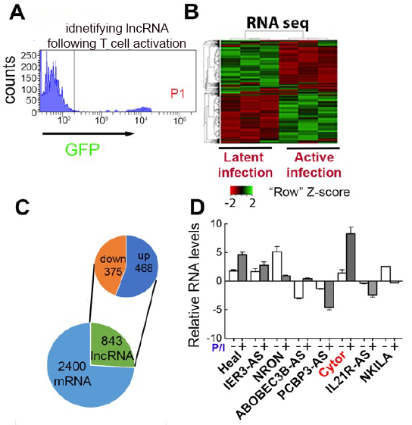

**Figure 1: RNA-seq identification of ncRNAs differentially expressed during latent and active HIV infection**

**)A(** FACS histogram of stimulated J-Lat 6.3 cells. GFP (+) cells exhibiting HIV reactivation (P1 region) were sorted from GFP (-) cells harboring latent HIV.

**)B (**Heatmap of differential transcript expression patterns (a 2-fold change between active versus latent with adjusted p-value < 0.05; n=3.

**(C)** Numbers ofdifferentially expressed mRNAs and lncRNAs, up and downregulated in cells exhibiting HIV reactivation.

**)D)** RNA levels of top lncRNA candidates in primary CD4+ T cells that were untreated (-), or stimulated with PMA/ionomycin (P/I; +) and analyzed by RT-qPCR. Data were normalized to GAPDH. Data are means ± SD for cells from 2 donors.

Among the lncRNA candidates that were most differentially expressed between active versus latent HIV- infected J-Lat 6.3 cells and primary CD4 T cells, we identified **Cytoskeleton Regulator RNA (Cytor)** - also known as LINCRNA 00152. Cytor expression was strongly induced in HIV-infected CD4+ T cell lines and primary cells upon T cell stimulation (**Fig. 1D**). Cytor is an intergenic 828 nucleotide lncRNA located on chromosome 2p11.2. It is highly conserved in primates and rodents, but less so in lower organisms. Cytor is mainly expressed in the cytoplasm, but previous reports (including our analysis - see below **Fig. 7**) show that it is also expressed in the nucleus, and it functions as an oncogene that is up-regulated in multiple human cancers (51). Cytor also acts as an endogenous sponge for several micro-RNAs by binding them and inhibiting their activity in a manner that can promote malignancy. Interestingly, Cytor reportedly regulates cellular actin dynamics and cytoskeletal reorganization in fibroblasts (52). However, the functional importance of Cytor in CD4+ T cells and in the context of HIV infection have not been studied.

**3.2 Manipulation of Cytor expression** –As our screening approach identified lncRNAs that were differentially expressed following the activation of HIV-infected Jurkat T cells, we next conducted gain-and loss-of-function studies in these cells to test whether Cytor plays a role in the regulation of HIV gene expression. To achieve Cytor overexpression, cells were transduced with a lentivirus that drives the expression of Cytor exons 1, 4, and 5, which are the most abundantly expressed in humans. Following antibiotic selection, resistant J-Lat 6.3 T cells were subjected to RT-qPCR and confirmed a 6-fold increase in Cytor RNA expression levels relative to control cells that expressed an empty vector (**Fig. 2A**; blue bar). Cytor knockdown (KD) was also achieved by transducing J-Lat 6.3 cells with a lentivirus encoding a Cytor-targeting small-hairpin RNA (shRNA), resulting in an 80% drop in Cytor RNA expression relative to control cells expressing a scrambled shRNA as measured by RT-qPCR (**Fig. 2A**; green bar). Parallel FACS-based analyses of GFP expression in J-Lat 6.3 infected cells, as a measure of HIV transcription, revealed that in the absence of T cell activation, a 4-fold increase in GFP expressing cells was evident in Cytor overexpressing cells relative to control cells (**Fig. 2B**; blue bar). Additionally, a 4-fold decrease in HIV-GFP expressing cells was observed in the unstimulated Cytor KD cell population relative to control cells expressing a scramble shRNA (**Fig. 2B**; green bar). Similar effects of Cytor overexpression (2-fold change over control cells) and depletion (5-fold over control cells) were observed based on HIV-GFP expression following the activation of J-Lat 6.3 cells (**Fig. 2C**). Introducing a control scramble shRNA had no effects on transduction efficiencies or on HIV-GFP expression, supporting the efficient transduction rates in our cells. Finally, when the re-establishment of latency after activation was monitored over time based on a gradual decrease in HIV-GFP expression in stimulated J-Lat 6.3 T cells, reduced Cytor levels were associated with a more rapid establishment of latency, while Cytor overexpressing cells retained their GFP expression for an extended period of time (**Fig. 2D**). ***These results suggest that in J-Lat 6.3 T cells, Cytor expression activates HIV gene expression and can 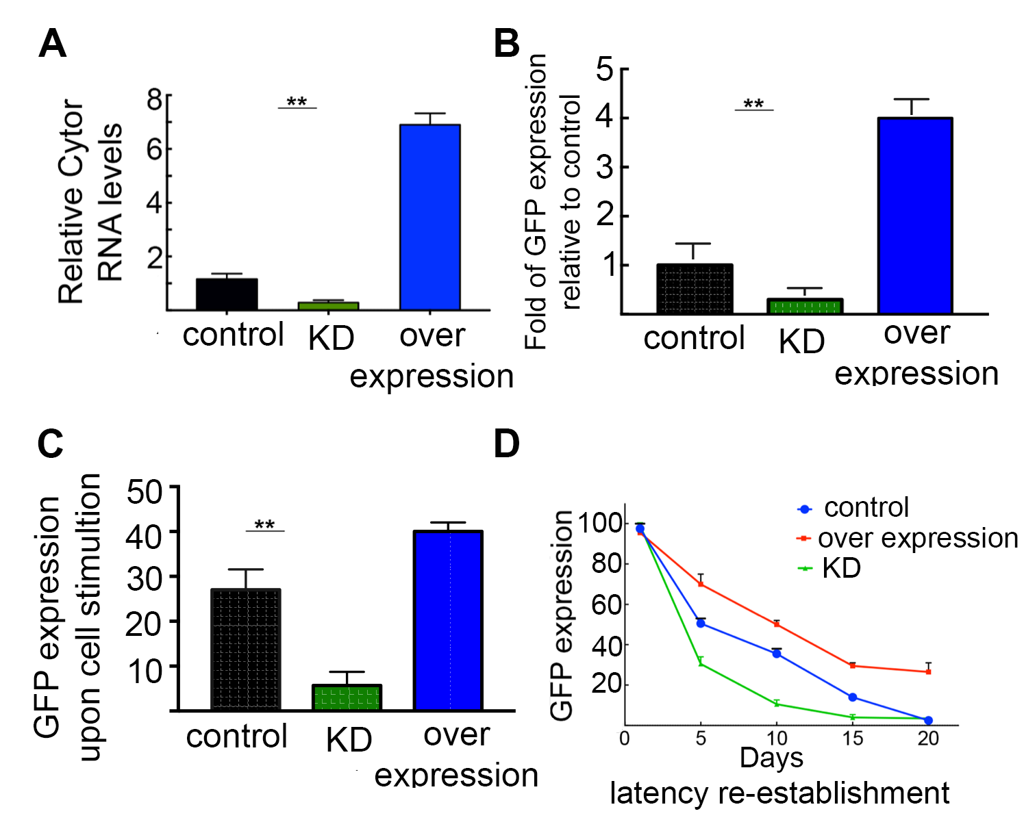significantly impact latency establishment and reversal*.**

**Figure 2: Modulation of Cytor expression and effects on HIV gene expression.**

(**A**) RT-qPCR measuring Cytor RNA levels in J-Lat 6.3 T cells where Cytor is depleted (KD; green bar), or overexpressed (blue bar). RNA levels were normalized to GAPDH and presented relative to control shRNA scramble expressing cells - set to 1. n=3; data are means± SD; ** P≤0.05.

(**B**) FACS analysis showing the percentage of cells expressing HIV-GFP+ in unstimulated J-Lat 6.3 T cells in which Cytor was overexpressed (blue bar) or knocked down (green bar). Data are shown as fold of change in GFP expression relative to control cells that express empty vector or scramble shRNA. n=2; data are means± SD; ** P≤0.05

(**C**) FACS analysis of cells expressing HIV-GFP in P/I stimulated J-Lat 6.3 cells expressing control oligonucleotides, or in which Cytor was overexpressed (blue), or knocked down (green). Data are mean ± SD percentages of GFP+ cells. n=3; ** P≤0.05.

(**D**) Kinetics of latency re-establishment in control J-Lat 6.3 cells expressing scramble shRNA (blue), Cytor KD (green), or cells overexpressing Cytor (red). Cells were reactivated and sorted to achieve 100% GFP (+) purity. n=3; mean± SD.

**3.3 Recruitment of Cytor to the HIV promoter and association with the cell transcription elongation complex** – To elucidate the mechanisms by which Cytor affects HIV gene expression, we monitored Cytor occupancy at the HIV promoter using a Chromatin Isolation by RNA Purification (ChIRP) approach (53), followed by a qPCR analysis of the chromatin fraction of J-Lat 6.3 HIV-infected T cell lines using primers that amplify the viral promoter. A pool of anti-sense (AS) DNA oligos that enriched chromatin associated with endogenous Cytor was used, thereby revealing that Cytor specifically occupies the HIV promoter even in unstimulated cells. This association was further enhanced following T cell activation (**Fig. 3A**). The use of a pool of control lacZ AS oligos verified the specificity of this assay. Moreover, no Cytor recruitment was observed at a control cellular gene desert locus. In line with these results, we also employed chromatin immunoprecipitation (ChIP)-qPCR to monitor levels of phosphorylated Ser2 (Ser2P) and Ser5 (Ser5P) in the RNA Pol II-CTD at the HIV promoter following the manipulation of Cytor expression. On the CTD, Ser2P is catalyzed by Cdk9/P-TEFb and serves as a marker for Pol II pause-release and elongation (54-56), while Ser5P marks the initiation of transcription and is primarily catalyzed by Cdk7/TFIIH. According to our analysis, KD of Cytor led to a decrease in Ser2P levels on the viral promoter without affecting Ser5P (**Fig. 3B**). The depletion of Cytor expression also lowered the levels of histone marks that are associated with active genes (H3K4me3 and H3k27Ac) at the HIV promoter (**Fig. 3C**).

**3.4 Identifying endogenous protein partners of Cytor** –To identify novel Cytor protein interactors, we next performed RNA antisense purification (RAP) followed by mass spectrometry (MS). Briefly, J-Lat 6.3 cell lysates were incubated with an AS biotinylated Cytor probe, followed by streptavidin-mediated immunoprecipitation (IP). A biotinylated scramble probe served as a negative control, and a 7SK nRNA biotinylated probe was used to confirm associations with P-TEFb. Subsequent MS analyses identified several candidate proteins that potentially interact with Cytor. These included the Cyclin T1 subunit of P-TEFb and AFF4 subunit of SEC. As these results were consistent with a scenario in which a physical association between Cytor and P-TEFb drives HIV gene expression, we confirmed these MS results in RNA pull-down assays, using *in vitro* transcribed biotinylated Cytor probe. The results suggested that Cytor associates with P-TEFb, via an unknown mechanism. 7SK probe served as a positive control for binding 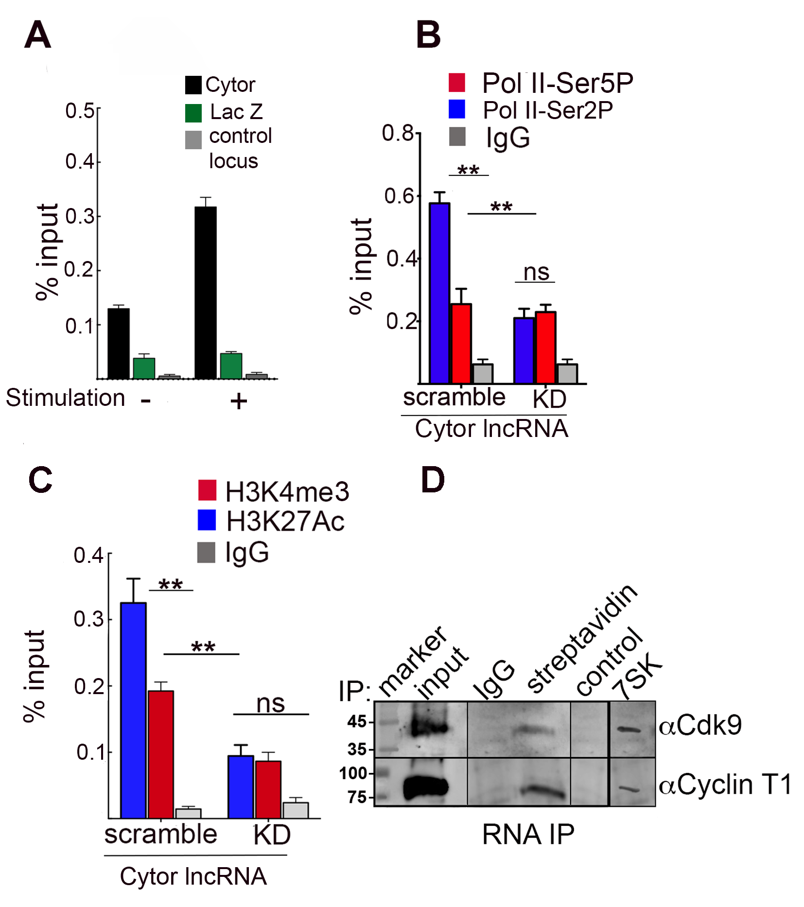to P-TEFb (**Fig. 3D**).

**Figure 3: Cytor occupies the HIV promoter, modifies histone markers and Pol II occupancy, and associates with P-TEFb.**

(**A**) ChiRP-qPCR analysis of chromatin crosslinked fractions from J-Lat 6.3 cells. Cytor or control lacZ antisense biotinylated oligos were incubated with ChiP material from unstimulated or PI/I stimulated cells. Following the washing of streptavidin beads and elution of associated DNA, qPCR was conducted with primers specific for the HIV promoter (n=4; mean± SD; **P≤0.05 calculated between the two probes and between unstimulated and stimulated states). The GAPDH promoter served as a control unrelated locus.

(**B, C**) ChIP-qPCR analysis in control or Cytor knockdown (KD) J-Lat 6.3 cells, monitoring Poll-Ser2P or Ser5P at the HIV promoter (**B**); or the H3K4me3 and H3K27Ac histone activation marks at the HIV promoter (**C**). Non-specific IgG served as a control. Primers specific for the HIV promoter were used for qPCR. Percentage of input data are means ± SD; n=3; **P≤0.05 calculated between scramble and KD, Ser5P and Ser2P, or H3K4me3 and H3K27Ac.

(**D**)RNA pull-down followed by Western blotting. Lysates from J-Lat 6.3 cells were incubated with an *in vitro* transcribed biotinylated Cytor probe, and reactions were pulled down with streptavidin beads. Eluted RNP complexes were subjected to SDS-PAGE and Western blotting with indicated antibodies. Non-specific IgG served as a control. Biotinylated scramble RNA was used as a control for RNA-IP. 7SK probe was used to confirm an association with P-TEFb. Input is 5% of the total cell lysate (57).

**3.5 The effects of Cytor on changes in actin dynamics induced by CD4+ T cell activation** – While the above observations suggest that Cytor directly associates with P-TEFb to activate gene transcription, it may also exert its effects indirectly by controlling the expression of its downstream targets. It has previously been reported that Cytor controls cellular actin dynamics and cytoskeleton reorganization in fibroblasts (52), but no similar analysis has been performed in CD4+ T cells. Thus, we initially sought to explore whether *Cytor plays a role in the activation of CD4*+ *T cell lines and in HIV gene expression through the modulation of cellular actin dynamics*. Indeed, T cell activation is coupled with rapid polymerization of cytoplasmic actin into filaments just beneath the plasma membrane, in a process that facilitates the signaling cascades that ultimately lead to the activation of transcription factors including NF-kB and NF-AT, which in turn enhance HIV transcription (58). For these analyses, we established a close collaboration with Oliver Fackler who is a leading expert in the field of HIV infection and actin remodeling (Heidelberg; Germany; see attached letter). Employing protocols established in the Fackler lab, we visualized disrupted actin remodeling events following the modulation of Cytor expression (59, 60). Jurkat CD4+ T cells were incubated on T cell stimulatory surfaces coated with anti-CD3/CD28 antibodies, fixed, and monitored for cell spreading and F-actin-rich ring formation at the cellular periphery by phalloidin staining. Depletion of Cytor expression reduced the number of cells that responded to T cell activation with appropriate spreading and F-actin polymerization (**Fig. 4A-D**). A detailed analysis of the various morphotypes revealed that reduced Cytor levels were associated with less frequent coordinated actin polymerization, while the frequency of cells that failed to spread despite 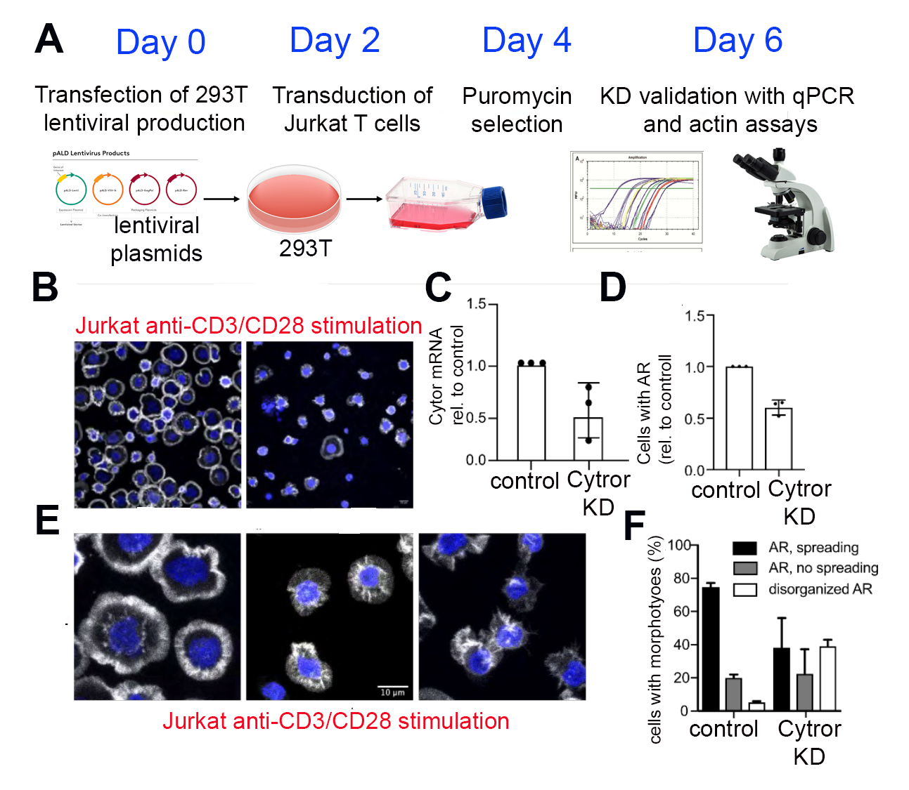efficient actin polymerization was unaffected (**Fig. 4E**).

**Figure 4: Cytor is required for TCR-induced actin remodeling.**

(**A)** Experimental flow for Cytor KD in Jurkat cells.

(**B**) Images of F-actin organization for control and Cytor KD Jurkat cells after contact with anti-CD3/28 coated surfaces.

(**C**) Relative Cytor RNA levels in Cytor KD Jurkat cells relative to control cells.

(**D**) Amounts of Cytor KD cells with proper cell spreading and circumferential F-actin relative to control cells (mean ± SD, 100 cells per experiment/condition, n=3).

(**E**) Representative images of morphotypes observed for Jurkat cells after anti-CD3/28 surface stimulation.

(**F**) Quantification of the morphotypes shown in E (mean ± SD, 100 cells per experiment/condition, n=3).

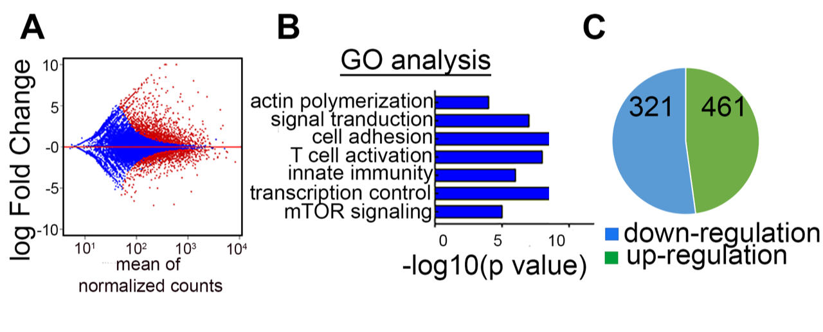***These results suggest that the effects of Cytor on HIV transcription may be linked to its effects on cellular actin dynamics****.* Consistently, we conducted an RNA-Seq analysis comparing Cytor KD and control J-Lat 6.3 cells. This experiment revealed that differentially expressed genes were enriched in Gene Ontology (GO) terms associated with actin polymerization, cell adhesion, T cell activation, and transcriptional control (**Fig. 5**). While these results remain to be validated in primary cells, ***we*** ***hypothesize that the effects of Cytor on T cell actin dynamics and T cell activation could be mediated by the deregulation of Cytor target genes***.

**Figure 5: Identification of Cytor target genes by RNA-Seq.**

**(A)** MA plot of the expression pattern of genes from an RNA-Seq analysis of Cytor KD vs. control J-Lat 6.3 cells. Red and blue dots represent significantly and non-significantly differentially expressed genes, respectively.

**(B**) Gene Ontology for enrichment of Cytor gene targets (DAVID).

**(C**) Pie chart of RNA-Seq results showing up- and downregulated genes upon Cytor depletion.

**3.6 A toolbox for studying the role of Cytor in HIV latency in resting CD4+T primary cell**s –

A bottleneck for mechanistic studies of the role of Cytor in HIV gene expression and latency is the ability to manipulate its expression in suitable cellular latency models without simultaneously affecting latency status in these cells. In cell lines such as HIV-infected J-Lat 6.3 cells, we have already established the efficient overexpression and knockdown of Cytor (**Fig. 2**). While these approaches will continue to be helpful, particularly for proof-of-principle and biochemical analyses, the activation state of these immortalized and thus dividing cell lines does not mirror that of physiologically relevant primary resting CD4+ T cells that constitute the latent HIV reservoir. However, resting CD4+ T cells are extremely refractory to genetic manipulation and to HIV infection (61) - a barrier that so far has only been overcome by manipulating activated CD4+ T cells and waiting until they return to a resting state following stimulus removal. We thus adopted the gold-standard primary CD4+ T cell model used to study HIV latency in which activated primary CD4+ T cells are infected and cultured without stimulation until latency is established, and then reactivated to score for latency reversal (62, 63). As these post-activation CD4+ T cells are not true resting cells, and this procedure likely impacts HIV gene expression and latency reversal, we have also implemented new experimental protocols from our collaborators in Germany that enable genetic manipulation in truly resting primary cells (**Fig. 6A**) (64). Using this approach, an efficient 98% CRISPR-mediated gene knockout of one or several genes can be achieved in bulk populations of resting primary CD4+ T cells (**Fig. 6B**). As this procedure does not cause any T cell activation, it should be amenable to use when studying the effects of 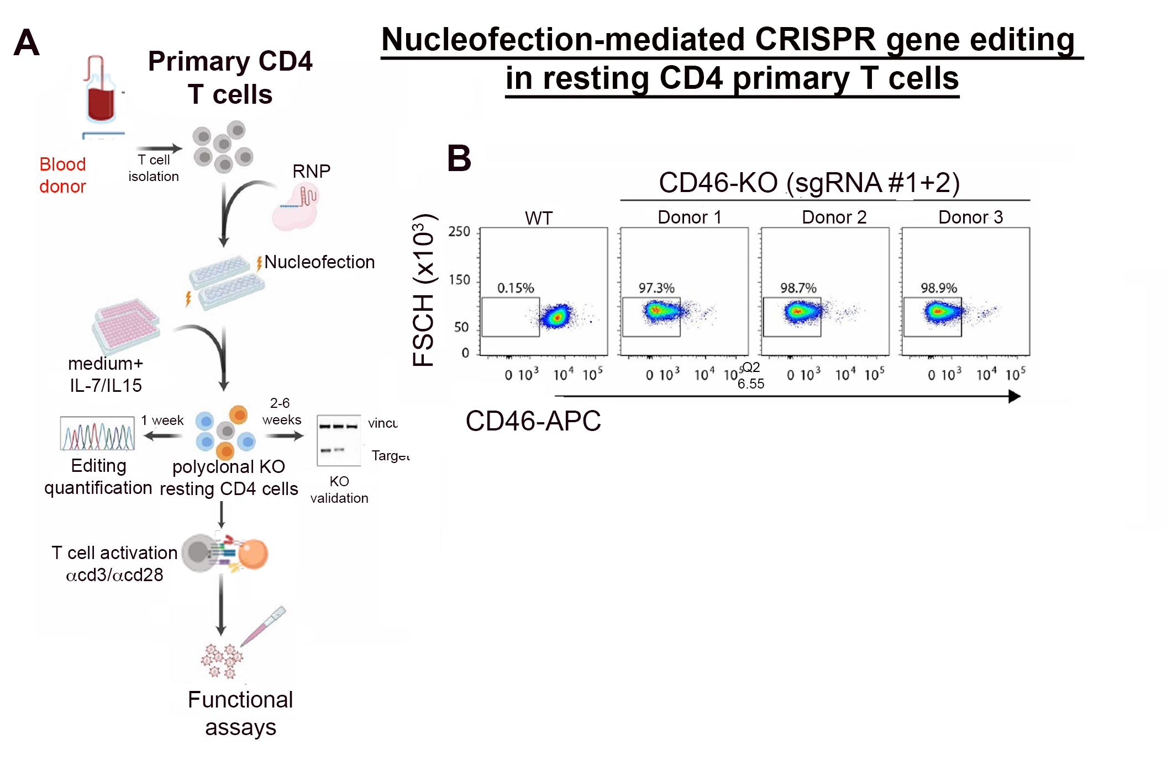Cytor on T cell activation and on the establishment and reversal of HIV latency in truly resting primary CD4+ T cells (64) (SA1 below).

**Figure 6: CRISPR-mediated gene editing in resting CD4 primary T cells.**

(**A**). Schematic overview of the workflow used to achieve knockout in primary resting CD4+ T cells via nucleofection-based CRISPR gene editing (64).

(**B**) FACS-based evaluation of CD46 KO efficiency in cells from 3 different donors. Obtained from Albanese et al., 2021(64).

We initially monitored levels of P-TEFb that are associated with Cytor in primary CD4 T cells by RIP and found that upon cell stimulation, levels of Cdk9 and Cyclin T1 that associate with Cytor are increased relative to those associated with 7SK, which has been reported to be associated with inactive P-TEFb (39). Additionally, we also followed the localization of Cytor in primary CD4+ T cells by conducting cell- fractionation combined with qPCR, thereby monitoring Cytor and 7SK ncRNA levels in the cytoplasm and nucleus under resting or stimulated conditions. Through this approach, we found that Cytor is expressed in the cytoplasm and nucleus and that its relative nuclear expression is elevated upon T cell stimulation (**Fig. 7**).

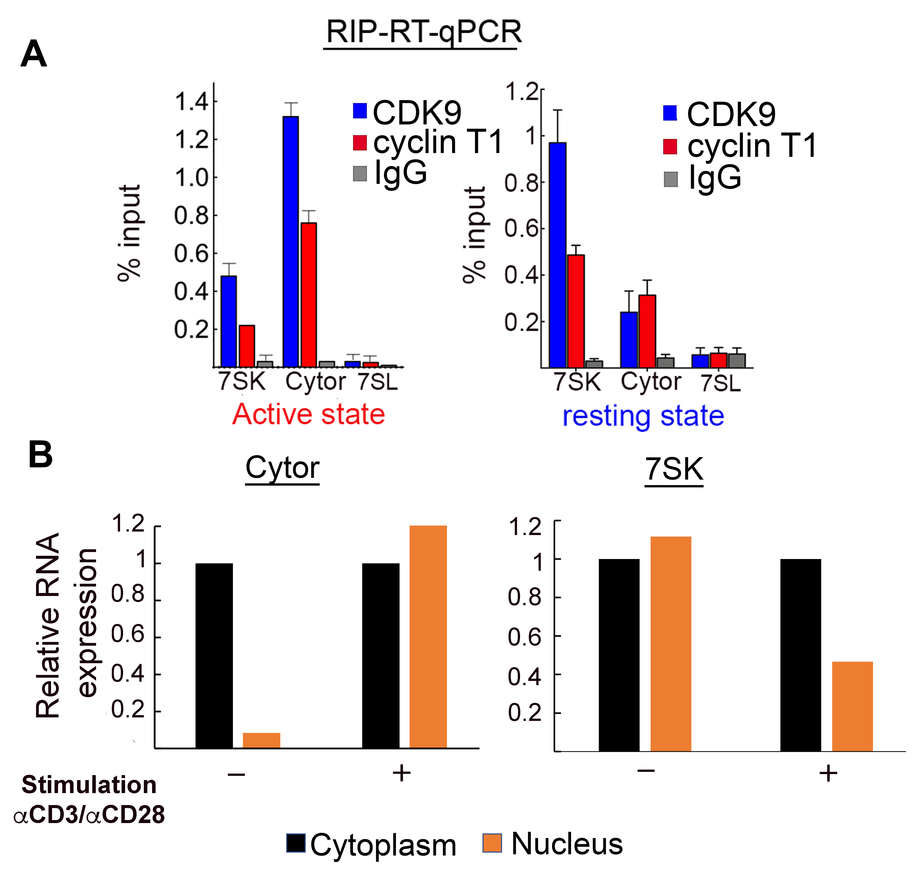

**Figure 7: Cytor associates with P-TEFb and is translocated to the nucleus upon the stimulation of primary CD4**+ **T cells.**

**(A)** Stimulated or resting primary CD4 T cells were subjected to RNA-IP (RIP) followed by RT-qPCR with P-TEFb antibodies. Specific primers to the indicated lncRNA were used for amplification.

**(B)** Following stimulation of primary cells, nuclear and cytoplasmic fractions were isolated and subjected to RT-qPCR to measure Cytor or 7SK ncRNA levels. Data were normalized to 7SL RNA in each of the fractions; RNA levels in resting cells for each lncRNA were set to 1.

Next, to examine the role of Cytor in primary CD4+ T cells, we depleted Cytor expression in stimulated CD4+ T primary cells using lentivirus encoding Cytor-shRNA. We achieved an 80% decrease in Cytor expression relative to control scramble shRNA expressing cells (**Fig. 8B**). We then transduced KD or control primary cells with HIVGKO, which codes for a codon-optimized GFP reporter under the control of the HIV-1 LTR promoter and mKO2 under the control of the constitutive promoter EF1a in the context of expression of all viral proteins (received from Eric Verdin) (65). HIVGKO infection can be analyzed by FACS to monitor transduction efficiency and the effects of Cytor on latency establishment and reversal in primary CD4+ T cells. We found that the depletion of Cytor in stimulated HIV-infected primary CD4+ T cells resulted in a decrease 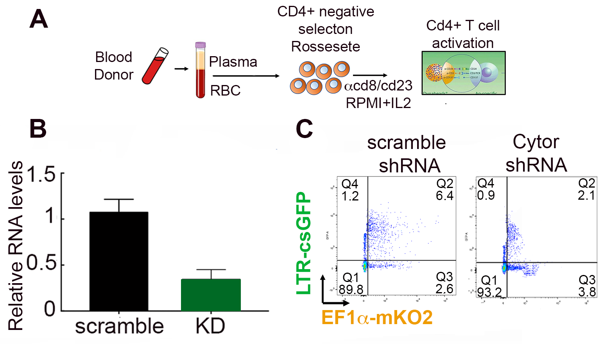in HIV gene expression and promoted latency while having only minor effects on mKO2 expression (**Fig. 8C**).

**Figure 8: Cytor depletion in primary CD4**+ **T cells suppresses HIV infection and promotes latency establishment**

1. Overview of the workflow using primary CD4+ T cells.
2. Depletion of Cytor in stimulated primary CD4+ cells using an shRNA-expressing lentivirus.
3. FACS analysis showing effects of Cytor KD on HIVGKO infection in primary CD4 T cells.

**II. Working hypothesis, research objectives, hypothesis, and expected significance**

Therapeutic reversal of HIV latency and elimination of the reservoir represents the final frontier for curing HIV-infected individuals. However, current strategies aimed at eradicating the latent reservoir have failed in clinical settings, and the inability to design effective therapeutic options that control HIV latency partly reflects gaps in our understanding of how HIV gene expression and viral latency are regulated. The emerging role of lncRNAs as regulators of cellular gene expression has not yet been carefully studied in the context of T cell activation and HIV gene expression. Building on our preliminary findings in CD4+ T cells lines and primary cells, ***we*** ***hypothesize that Cytor activates HIV gene expression by directly recruiting P-TEFb and the host transcriptional elongation machinery to the HIV promoter while simultaneously affecting T cell activation and actin remodeling through target gene regulation, thereby indirectly enhancing HIV transcription and suppressing viral latency.*** Based on the above findings, we propose the following model of Cytor function in T cells:

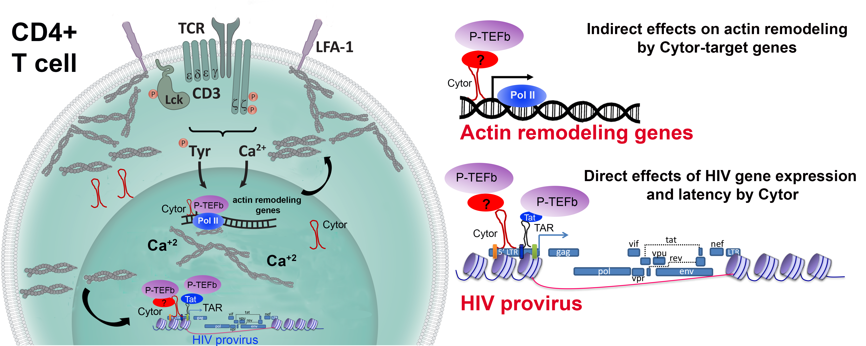**Figure** **9: Working model for Cytor functions**

Following T cell activation, levels of Cytor are elevated both in the cytoplasm and the nucleus. Cytor is recruited to the HIV promoter by directly binding to P-TEFb (or another factor), leading to the overall activation of viral gene expression. Other cellular-Cytor target genes include actin remodeling genes that further promote indirect actin polymerization and the activation of transcription. Nuclear actin also interacts with Pol II and the elongation complex, promoting gene expression.

We will test this hypothesis with the following specific aims*:*

**Specific Aim 1 (SA1)** – **Determine the physiological relevance of Cytor functions in primary CD4**+ **T cells and its effects on HIV latency**. Our preliminary observations relied on studies performed in an immortalized HIV-infected CD4+ T cell line that do not reflect the activation state of the physiologic cell target of latent HIV within the reservoir - resting primary CD4+ T cells. **SA1** will place our study in a clinically relevant context and extend our findings regarding the functions of Cytor in the regulation of HIV gene expression and latency to resting primary CD4+ T cells, which are the gold-standard targets for studies of HIV infection and the control of latency. By establishing protocols for Cytor gene manipulation in primary resting CD4+ T cells, we expect to achieve a comprehensive understanding of the role of Cytor in these cells, clarifying its significance in the establishment and reversal of HIV latency.

**Specific Aim 2 (SA2)** *–* **Study the direct molecular mechanisms by which Cytor activates HIV gene expression**. **SA2** will confirm the direct interactions between P-TEFb and endogenous Cytor in primary CD4+ T cells. Under unstimulated and stimulated cell states, we will address whether Cytor is recruited to the HIV promoter and whether it activates HIV transcription via directly associating with P-TEFb. Cytor interactions with P-TEFb will be also assessed globally to clarify the broader roles that Cytor plays in the control of gene activation by recruiting P-TEFb to promoter regions. Direct interactions between Cytor and Cyclin T1/P-TEFb will be explored in-vitro and the interplay between Cytor, HIV-Tat, TAR RNA, and the 7SK ncRNA will be investigated to fully understand the regulation of P-TEFb activity by cellular lncRNAs and the transcription of proviral HIV. Through these experiments, we expect to elucidate the mechanisms by which Cytor controls HIV gene expression and latency in primary CD4+ T cells.

**Specific Aim 3 (SA3)** – **Explore whether the indirect effects of Cytor on T cell activation and actin remodeling are linked to the control of HIV gene expression in primary CD4**+ **T cells**. We will rely on RNA-Seq and ChIRP-Seq analyses to identify new Cytor target genes in primary CD4+ T cells. The involvement of these target genes in the regulation of T cell activation, actin remodeling, and HIV gene expression by Cytor will be investigated through gain- and loss-of-function assays in T cell lines and primary CD4+ cells. Insights from this SA will provide a foundation for studies in which the functions of Cytor can be manipulated in primary CD4+ T cells to determine whether its effects on HIV transcription and latency are indirectly and mechanistically linked to T cell activation and actin remodeling.

**Expected Significance and Innovation**

Our proposal includes important innovative approaches that will advance the current understanding of the regulation of T cell activation, actin remodeling, and HIV gene expression and latency. When completed, these studies will significantly expand our knowledge regarding the functions of lncRNAs as regulators that can fine-tune these clinically-relevant processes, providing new tools to successfully manipulate HIV infection and eliminate the HIV reservoir. Key aspects of this proposal include the following research areas:

* + - 1. **lncRNA-mediated regulation of HIV transcription and latency** – The function of ncRNAs, and particularly lncRNAs, in the control of HIV infection is an area of evolving research interest, providing exciting opportunities to understand how these lncRNAs govern the establishment and maintenance of the HIV reservoir. Our preliminary work identified several lncRNAs that are up/down-regulated in HIV-infected T cells following T cell activation. Their relevance to the regulation of HIV gene expression and latency will be validated in primary T cells through gain- and loss-of-function assays. One hit, Cytor, activates HIV transcription by associating with the host P-TEFb. We will explore the direct effects of Cytor on HIV gene expression and viral latency, clarifying its importance as a regulator of HIV gene expression and providing a new mechanism for lncRNA-mediated recruitment of the cellular elongation machinery to promoters. As other lncRNAs were identified in our screen, those with the strongest shift in expression following T cell stimulation will be the focus of future studies of how lncRNAs globally affect cellular and HIV-related gene expression.
      2. **Roles of lncRNAs in T cell activation, actin remodeling, and the control of gene expression** – Our data suggest that Cytor affects HIV and global gene expression in Jurkat CD4+ T cells and that these effects are indirectly linked to cellular actin dynamics and T cell activation. We will conduct a comprehensive study of the role of Cytor in these processes, providing new insights into the principles of T cell activation, actin remodeling, and global transcriptional control by lncRNAs. We will identify gene targets of Cytor and characterize their indirect effects on these processes. These findings will broaden our knowledge regarding the interplay between lncRNAs and the T cell response to HIV infection.
      3. **Clinical implications for treating the latent HIV reservoir** – Identified lncRNAs and their partners may represent targets for novel therapeutic interventions to combat HIV and by targeting the cellular reservoir. We envision that manipulating Cytor expression may be incorporated into either “Block and Lock” as well as "Shock and Kill" strategies to improve clinical efforts to eliminate the viral reservoir or induce latency. Integrating such approaches with cutting-edge RNA-targeting strategies and new delivery tools will provide a foundation for opportunities to develop RNA-based therapeutics to eliminate the HIV reservoir.

## III. Work Program including detailed research description

**Specific Aim 1 – Determine the physiological relevance of Cytor functions in primary CD4**+ **T cells and its effects on HIV latency.**

Our preliminary results reveal a link between Cytor and T cell activation, as Cytor is a novel activator of HIV gene expression that directly associates with P-TEFb and suppresses latency establishment (**Fig 2, 3**). Alternatively, Cytor may exert effects on HIV gene transcription indirectly by regulating Cytor-target genes that mediate T cell activation and actin remodeling. Cytor depletion reduces the number of cells that respond to T cell activation with proper spreading and actin polymerization, in addition to broadly affecting downstream cellular gene expression (**Fig. 4-5**). Additional preliminary analyses conducted using HIV-infected primary CD4+ T cells show that Cytor depletion inhibits HIV gene expression and upon primary cell stimulation associates with Cytor (**Fig. 7-8**). The experiments described below will extend our findings into resting CD4+ primary cells, as we will assess which indirect Cytor-mediated effects on gene expression, T cell activation, and actin dynamics are evident in these physiologically relevant cells.

**1a.  *Manipulate Cytor expression and characterize its functions in the establishment of HIV latency in primary CD4***+ ***T* cells –** Unlike immortalized CD4+ T cell lines that carry stable clones of latent HIV provirus, latently infected primary cells need to be generated *de novo*. Since HIV-1 does not productively infect resting cells, this requires first activating these cells with aCD3/aCD28 and IL-2, followed by their infection, and returning to a post-activation resting state of latency after removal of the T cell stimulus. Such a primary cell infection model is available in our laboratory. The activation of cells, in addition to rendering them permissive to HIV, also makes them susceptible to shRNA-lentiviral transduction to mediate Cytor depletion (**Fig. 7&8**). However, the usefulness of this approach is limited by the gradual decrease in shRNA expression as cells return to a quiescent state. Therefore, we will alternatively employ a nucleofection-based CRISPR approach in resting CD4+ T cells to first generate Cytor-KD cells that will be activated and infected with HIV to study the establishment of latency. To induce/deplete Cytor expression, CRISPR interference/activation (CRISPRi/CRISPRa) approaches will be conducted in primary resting CD4+ T cells. This CRISPRi/a strategy is analogous to the CRISPR-knockout strategy of cellular genes already established in our lab (**Fig. 6**), and is thus expected to result in functional depletion/activation after appropriate optimization. Cytor expression over time will be quantified by RT-qPCR to define the kinetics of its regulatory role in primary cells. We will carefully evaluate which of the two approaches, shRNA or CRISPR, can be most effectively combined with HIV infection to achieve a robust reduction in Cytor levels. Infection will rely on HIVGKO, as it results in the best infection rates in primary CD4+ T cells in our hands (65). Once efficient control over Cytor expression has been achieved, we will conduct a detailed kinetic quantitative analysis of reporter expression (viral gene expression and integration via Alu-PCR), and these results will be correlated with the parallel characterization of T cell activation, actin rearrangement, Pol II/P-TEFb promoter occupancy, and epigenetic marking analogous to the cell-line based studies presented in our preliminary results. All experiments will be conducted with cells from at least four donors to control for donor-donor variability.

**1b. *Effect of Cytor on HIV latency reversal*** **–** To quantitatively assess the role of Cytor in HIV latency reversal, latently infected post-activation resting CD4+ T cells will be reactivated as described above. Reactivation of latently infected cells will be preceded by FACS sorting to remove cells expressing GFP prior to reactivation. The re-emergence of GFP expression in response to LRAs will be studied to assess the role of Cytor in HIV latency reversal. We anticipate that based on our preliminary findings, we will obtain experimental conditions that will allow us to modify HIV gene expression in primary human CD4+ T cells via the modulation of Cytor expression. Nevertheless, this approach will only provide information regarding the reversal of latency in cells that were highly activated only a few days prior and thus may not have fully reached a resting state. To place our study in a clinically relevant context, we will test whether Cytor expression can enhance or even replace current reactivation protocols for therapeutic latency reversal. To this end, the two most effective LRA-activation approaches will be applied to primary CD4+ T cells isolated from HIV patients undergoing therapy and the amount of spontaneous or LRA-induced reactivation will be assessed. We will monitor viral transcripts, protein synthesis, and the release of via particles. LRAs with the best-described efficacy will include the PKC agonists byrostatin 1 and prostratin, as well as histone deacetylation inhibitors (10, 66, 67). Levels of Cytor will be determined in these cells by RT-qPCR and compared to those in cells from healthy donors or patients not receiving HAART. To minimize the bias that may arise due to patient heterogeneity, the geometric means of two reference genes, β-actin and GAPDH, will be used to normalize Cytor levels (68). Patient blood samples and ethical approvals are available through Soroka Medical Center.

**Expected outcomes, potential pitfalls, and alternative strategies.**

We will establish the clinical relevance of Cytor as an activator of HIV gene expression in resting CD4+ T primary cells. Primary cells are available for only a few weeks, and so will need to be isolated regularly, with Cytor expression then being manipulated and validated. As a quality control analysis between individual experiments, the targeted genomic region will be amplified, subcloned, and sequenced. In addition, alternative HI.fate HIV clones with improved infection levels relative to primary CD4+ T cells are available in the lab (69). Changes in Cytor levels may affect other steps in the HIV life cycle such that viral gene expression may be low even if transcription is unaffected. Therefore, we will normalize proviral DNA in cells and measure GFP mRNA levels. The frequency of patient-derived peripheral CD4+ T cells that carry HIV proviral DNA is below 1% (64). Given the high efficacy of our nucleofection-based CRISPR approach in resting CD4+ T cells, we expect our experimental design to be feasible, allowing us to test the effects of Cytor KD on HIV gene expression in HIV patient cells.

**Specific Aim 2 – Study the direct molecular mechanisms by which Cytor activates HIV gene expression**.

Our preliminary data indicate that Cytor activates HIV gene expression and suppresses latency via the direct recruitment of P-TEFb to the HIV promoter. This gives rise to the *hypothesis that Cytor activates HIV transcription by directly binding to Cyclin T1 and recruiting P-TEFb and the cell elongation transcription complex to the HIV promoter, thereby modulating Pol II occupancy, chromatin changes, and overall HIV gene activation.*

***2a. Characterize interactions between Cytor and P-TEFb at the HIV promoter in primary CD4***+ ***cells*** –

Our preliminary data were generated in CD4+ T cell lines. While we will continue to rely on these cells for our subsequent experiments, and the goal of this aim will be to extend our findings by validating interactions between endogenous Cytor and P-TEFb in primary CD4+ T cells. Stimulated primary CD4+ T cells will be transduced with HIV and gradually returned to a resting state. We will then examine Cytor-P-TEFb interactions under resting or stimulated conditions, employing assays described below. As our binding pull-down assay was performed with an *in vitro* transcribed biotinylated Cytor probe (**Fig. 3D**), which may not fold properly in cells, we will confirm interactions between endogenous Cytor and P-TEFb subunits (Cyclin T1, T2a T2b and K) using an RNA AS purification (RAP) assay. For this, we will use biotinylated AS DNA oligos that will pull down endogenous Cytor, followed by Western blotting to detect P-TEFb subunits. Cytor levels in the IP fraction will be confirmed by RT-qPCR. Control AS probes will include scrambled oligos that will not hybridize with Cytor and probes targeting the 7SK ncRNA, which binds P-TEFb. Computational structural analyses will aid in the identification of accessible regions within Cytor that do not complement and that should thus be available to hybridize with these probes. We will also follow P-TEFb levels that are associated with Cytor in primary CD4+ T cells under resting and stimulated conditions. This will be combined with cell fractionation to monitor the transition of P-TEFb-associated Cytor between the nucleus and the cytoplasm. For this, we will perform an RNA-IP (RIP) assay using anti-P-TEFb, followed by RT-qPCR-mediated amplification of endogenous Cytor. The association of the 7SK ncRNA with P-TEFb will be similarly monitored, while the unrelated signal recognition particle RNA (7SL) will serve as a negative control **(Fig 7A)**. The dynamics of Cytor localization between the cell fractions in primary cells will be also monitored by RNA-FISH using a labeled Cytor probe. ChIP-qPCR will be performed in cells in which Cytor expression is depleted/overexpressed to monitor P-TEFb levels at the HIV promoter, and validate whether Cytor plays a role in P-TEFb recruitment to this promoter region.

***2b. Analysis of direct binding between Cyclin T1/P-TEFb and Cytor*** **–** We will confirm direct binding between Cytor and P-TEFb *in vitro*. *We hypothesize that Cytor directly binds to Cyclin T1 and recruits P-TEFb to the HIV promoter*. RNA pulldown assays will be conducted using *in vitro* transcribed Cytor RNA and recombinantly purified His-tagged cyclin T1 that will be IPed with an anti-His antibody, after which Cytor will be detected by RT-qPCR. To control the specificity of the binding reaction, cyclin T1 mutants will be tested, including one that is depleted of its RNA/TAR binding domain and a cyclin T1 mutant carrying a C261Y point mutation that cannot bind to TAR RNA (70),. A scramble-RNA probe will serve as a negative control for these assays. To complement this approach, we will conduct an electrophoretic mobility shift assay (EMSA) using recombinant GST-Cyclin T1, mutant versions thereof that cannot bind RNA, and a Cytor-labeled probe. A mutant Cytor probe will be also tested as a control. Although these studies rely on an *in vitro* transcribed Cytor probe, which may not fold properly and may lack proper cellular modifications, these experiments will nonetheless provide evidence for direct binding between Cytor and P-TEFb.

***2c. Analyze genome-wide Cytor-P-TEFb interactions* –** To establish the global association between P-TEFb and Cytor, we will initially use ENCODE RNA-Seq and CLIP-Seq analyses of CD4+ T primary cells to monitor P-TEFb and Cytor occupancy. As a proof-of-concept, we have integrated publically available Cdk9, Pol II, and H3K4me3 ChIP-seq data from primary T cells and found that genes that are significantly down-regulated in our RNA-Seq analyses of Cytor-depleted cells (**Fig. 5**) are characterized by high levels of Cdk9/P-TEFb (**Fig. 10**). These Cytor-target genes include MLST8 (mTOR pathway), Tubb (actin polymerization), and RelB (transcriptional control). P-TEFb ChiP-Seq will be conducted and will be overlapped with the Cytor ChIRP-Seq dataset (**see SA 3a**) to confirm P-TEFb-Cytor co-occupancy genome-wide. Furthermore, P-TEFb-ChIP-Seq in control or Cytor KD cells will verify whether Cytor controls global P-TEFb recruitment*.* Given our preliminary ChIP-qPCR results (**Fig. 3**) that demonstrate the involvement of Cytor in histone activation markers depositing and Pol II occupancy at the HIV promoter, we will employ ChIP-seq in the context of Cytor depletion to define global epigenetic histone changes and Pol II recruitment to Cytor target genes.

**Figure 10: Potential Cytor-gene targets exhibit P-TEFb enrichment.**

A genome browser view of Pol II, H3K4me3 and P-TEFb/CDK9 ChIP-seq data from Jurkat cells for the indicated genes that were downregulated upon Cytordepletion and were found to diplay high levels of P-TEFb.

***2d. Investigate the interplay between Cytor Tat and 7SK ncRNA* –** As cyclin T1 is recruited to the HIV promoter via Tat and TAR RNA, and this interaction could mask the contribution of Cytor to the recruitment of P-TEFb to the viral promoter, we will evaluate the involvement of Tat in these Cytor-mediated effects. We will first employ an EMSA approach to investigate the possible recruitment of Cytor by Tat, using a labeled TAR probe and an unlabeled Cytor probe that will super-shift the Tat-TAR complex. Control experiments without Tat will cover the possibility of TAR-Cytor non-specific RNA interactions. A scrambled probe will serve as a negative control probe. To strengthen the interplay between Cytor and Tat in the recruitment of P-TEFb in HIV-infected cells, the effects of Cytor on HIV transcription will be tested with a virus that does not express Tat or a mutated Tat that does not bind cyclin T1. Additionally, Tat trans-activation will be monitored in Jurkat cells under conditions of Cytor overexpression or depletion. We will then test whether Tat associates with Cytor by performing RIP experiments using a Tat-specific antibody, followed by RT-qPCR based detection of endogenous Cytor. Alternatively, pull-down assays using an AS Cytor biotinylated probe will clarify whether Tat co-precipitates with Cytor in HIV-infected cells. We will then extend our experiments presented in **Fig. 7** to the interplay between 7SK ncRNA and Cytor, monitoring the association of P-TEFb with 7SK in Cytor KD cells and following P-TEFb activity. Glycerol gradient analyses combined with Western blotting or RT-qPCR will detect free/active and inactive P-TEFb, respectively associated with either Cytor or 7SK ncRNAs. Similar experiments will also be performed for other transcription machinery proteins that may reside in each of the complexes together with P-TEFb in the context of Cytor manipulation of expression.

**Expected outcomes, potential pitfalls, and alternative strategies**

To address biases associated with the positions of the integrated provirus in J-Lat 6.3 cells, other primary HIV-infected T cell models will be tested (71). If our initial approaches are unsuccessful, alternative RNA binding assays will use tagged MS2 or S1 probes. For the IP approaches, the specificity of the antibodies is critical for success, and extensive optimization will thus be required. If we fail to confirm our cyclin T1 hypothesis, we will test interactions between Cytor and other cyclin subunits including Cyclin T2a, T2b, or K using a similar approach. Cyclin K is of particular interest, as it is the only one that is recruited to promoters and activates transcription via RNA (72). Interactions between Cytor and SEC/AFF4 that were identified in our MS analysis will alternatively be investigated. AFF4 directly binds Cyclin T1/P-TEFb, and its C-terminal domain binds RNA (73-78),. SEC expression vectors were already obtained from the Zhou lab (UC Berkeley) (79). If analyses of the direct effects of Cytor are unsuccessful, indirect effects will also be studied (see SA3).

**Specific Aim 3 – Explore whether the indirect effects of Cytor on T cell activation and actin remodeling are linked to HIV gene expression control in primary CD4**+ **T cells**

***3a. Identify and characterize downstream targets genes of Cytor* –** Our RNA-Seq analysis using J-Lat 6.3 T cells identified genes that were differentially expressed following Cytor depletion (**Fig. 5**). As we have established our ability to KD Cytor expression in activated primary CD4+ T cells (**Fig. 8**), we will confirm these RNA-Seq data in primary cells. Global ChIRP-Seq will also be conducted in primary HIV-infected cells under resting or stimulated conditions using AS DNA tiling probe that will cover the entire Cytor gene to globally identify Cytor-target genes (80). This will allow us to narrow down our candidate gene list for future investigation, and to determine the occupancy of Cytor on the promoters of these gene targets. Recognition motifs within promoters or enhancers that Cytor may bind to will be identified. This approach will enable us to address key mechanistic questions regarding the binding of Cytor to DNA, while also verifying whether its recruitment is sequence-specific. For top genes, a gain- and loss-of-function experimental scheme will be conducted and the role of Cytor-regulated genes in the regulation of CD4+T cell activation, actin remodeling, and HIV gene transcription will be monitored. Target genes found to play a role in the regulation of HIV transcription and/or T cell activation/actin dynamics will be then also subjected to mechanistic studies following the modulation of Cytor expression to detect effects of Cytor on viral and/or cellular promoters. CLIP-Seq will complement the above experiments, allowing us to identify domains within Cytor that interact with its target genes and reveal the sequences that are occupied by Cytor (81, 82).

***3b. Investigating the impact of Cytor on actin remodeling and T cell activation in primary cells*** **–** Cytoplasmic (83) and nuclear actin dynamics have been shown to affect HIV transcription through unknown mechanisms (84),(52). Our preliminary results suggest that Cytor regulates actin polymerization in the cytoplasm and spreading of CD4+ T Jurkat cells in response to T cell activation (**Fig. 4**). In this sub-aim, ***we will focus on the possibility that Cytor affects actin remodeling and the response of CD4***+ ***T cells to stimulation through the regulation of Cytor target genes, the products of which are involved in actin remodeling and T cell activation such that Cytor indirectly activates HIV gene expression***. We will continue our collaboration with the Fackler lab to validate the effects of Cytor on CD4+ T cell activation and actin dynamics in primary CD4+ T cells. Cytor will be depleted in resting CD4+ T cells and then cellular responses to T cell activation and actin remodeling will be studied. As an additional, not mutually exclusive possibility, Cytor may directly act on actin in the nucleus to impact transcription by altering the function of actin monomers in Pol II complexes (85-87). Indeed, independent actin remodeling events at the plasma membrane and in the nucleus support T cell activation (58). We will therefore evaluate both events and characterize the impact of Cytor on actin dynamics in response to T cell stimulation, coupling these two events to the control of gene expression. These experiments will be conducted in primary resting CD4+ T cells with reduced or increased Cytor levels, studying their responses to cell stimulation. Parameters to be quantified will include T cell activation markers and proliferation state (surface markers and dye dilution by FACS); Ca2+ release (live cell imaging); cytoplasmic and nuclear actin dynamics (live imaging); production of T cell cytokines (flow cytometry, ELISA); TCR signaling cascades (phosphorylation of signaling intermediates and composition of TCR signaling micro-clusters); and activation of transcription factors such as NF-kb or NF-AT (58, 60). Cytor target genes that were identified in our global analysis will be evaluated based on the definition of the specific actin remodeling events and screened to better understand the effects of Cytor on protein expression and/or localization. Genes that are affected by the depletion of Cytor will be tested for their role as mediators of the effects of Cytor on actin dynamics and T cell activation in cells in which expression of these genes will be manipulated. Parallel KO of Cytor target genes and Cytor will be conducted to gain a comprehensive understanding of the role of Cytor in the activation and actin remodeling of primary resting CD4+ T cells.

**Expected outcomes, potential pitfalls. and alternative strategies**

We will define the role of Cytor as a regulator of HIV gene expression mediated through Cytor target genes. The indirect contribution of Cytor and its target genes to HIV gene expression and latency through the regulation of T cell activation and actin remodeling will be investigated. We cannot exclude the possibility that Cytor does not mediate its effects via T cell activation, and we will thus explore alternative scenarios. Cytor pairs with miRNAs (88)(51) that bind to the HIV promotor to regulate viral gene transcription. Cytor also regulates the Wnt/b-Catenin (89), NF-kB (90), and JAK/STAT pathways that activate HIV. These will be considered as alternative mechanisms of Cytor function. The need for high cell numbers for global sequencing analyses may hamper our efforts, especially as the frequency of patient-derived peripheral CD4+ T cells that carry proviral DNA is low. Alternative protocols with lower cell numbers are available (Cut and Run). Otherwise, analyses will be performed in T cell lines. As Cytor has oncogenic properties, we will also monitor cell activation, proliferation, and differentiation.

**E. Resource**s

The research will be performed in the Department of Microbiology of Ben-Gurion University (BGU) Israel. Our lab space is 60 m2 and outfitted with the required equipment for this study: PCR thermocyclers, real-time qPCR instruments, gel electrophoresis devices, centrifuges, and freezers. Our tissue culture room is equipped with a biological hood, CO2 incubators, and light and fluorescence microscopse. BGU has excellent core facilities including genomics, proteomics, and bioinformatics units. These are headed by skilled researchers and incorporate state-of-the-art equipment. Our team is comprised of a technician, two MSc., two Ph.D. students, and two undergraduate students.

**Bibliography:**

1. Finzi D, Hermankova M, Pierson T, Carruth LM, Buck C, Chaisson RE, Quinn TC, Chadwick K, Margolick J, Brookmeyer R, Gallant J, Markowitz M, Ho DD, Richman DD, Siliciano RF.1997. Identification of a reservoir for HIV-1 in patients on highly active antiretroviral therapy. Science 278:1295-300.

2. Perelson AS, Neumann AU, Markowitz M, Leonard JM, Ho DD.1996. HIV-1 dynamics in vivo: virion clearance rate, infected cell life-span, and viral generation time. Science 271:1582-6.

3. Le Douce V, Herbein G, Rohr O, Schwartz C.2010. Molecular mechanisms of HIV-1 persistence in the monocyte-macrophage lineage. Retrovirology 7:32.

4. Chun TW, Carruth L, Finzi D, Shen X, DiGiuseppe JA, Taylor H, Hermankova M, Chadwick K, Margolick J, Quinn TC, Kuo YH, Brookmeyer R, Zeiger MA, Barditch-Crovo P, Siliciano RF.1997. Quantification of latent tissue reservoirs and total body viral load in HIV-1 infection. Nature 387:183-8.

5. Pasternak AO, Psomas CK, Berkhout B.2021. Predicting Post-treatment HIV Remission: Does Size of the Viral Reservoir Matter? Front Microbiol 12:648434.

6. Mbonye U, Karn J.2017. The Molecular Basis for Human Immunodeficiency Virus Latency. Annu Rev Virol 4:261-285.

7. Ho YC, Shan L, Hosmane NN, Wang J, Laskey SB, Rosenbloom DI, Lai J, Blankson JN, Siliciano JD, Siliciano RF.2013. Replication-competent noninduced proviruses in the latent reservoir increase barrier to HIV-1 cure. Cell 155:540-51.

8. Siliciano RF, Greene WC.2011. HIV latency. Cold Spring Harb Perspect Med 1:a007096.

9. Deeks SG.2012. HIV: Shock and kill. Nature 487:439-40.

10. Archin NM, Liberty AL, Kashuba AD, Choudhary SK, Kuruc JD, Crooks AM, Parker DC, Anderson EM, Kearney MF, Strain MC, Richman DD, Hudgens MG, Bosch RJ, Coffin JM, Eron JJ, Hazuda DJ, Margolis DM.2012. Administration of vorinostat disrupts HIV-1 latency in patients on antiretroviral therapy. Nature 487:482-5.

11. Deeks SG, Lewin SR, Ross AL, Ananworanich J, Benkirane M, Cannon P, Chomont N, Douek D, Lifson JD, Lo YR, Kuritzkes D, Margolis D, Mellors J, Persaud D, Tucker JD, Barre-Sinoussi F, International ASTaCWG, Alter G, Auerbach J, Autran B, Barouch DH, Behrens G, Cavazzana M, Chen Z, Cohen EA, Corbelli GM, Eholie S, Eyal N, Fidler S, Garcia L, Grossman C, Henderson G, Henrich TJ, Jefferys R, Kiem HP, McCune J, Moodley K, Newman PA, Nijhuis M, Nsubuga MS, Ott M, Palmer S, Richman D, Saez-Cirion A, Sharp M, Siliciano J, Silvestri G, Singh J, Spire B, Taylor J, et al.2016. International AIDS Society global scientific strategy: towards an HIV cure 2016. Nat Med 22:839-50.

12. Margolis DM, Archin NM, Cohen MS, Eron JJ, Ferrari G, Garcia JV, Gay CL, Goonetilleke N, Joseph SB, Swanstrom R, Turner AW, Wahl A.2020. Curing HIV: Seeking to Target and Clear Persistent Infection. Cell 181:189-206.

13. Ndung'u T, McCune JM, Deeks SG.2019. Why and where an HIV cure is needed and how it might be achieved. Nature 576:397-405.

14. Chen IP, Ott M.2020. Turning up the heat on HIV-1. Proc Natl Acad Sci U S A 117:16109-16111.

15. Dufour C, Gantner P, Fromentin R, Chomont N.2021. The multifaceted nature of HIV latency. J Clin Invest 131.

16. Board NL, Moskovljevic M, Wu F, Siliciano RF, Siliciano JD.2022. Engaging innate immunity in HIV-1 cure strategies. Nat Rev Immunol 22:499-512.

17. Moranguinho I, Valente ST.2020. Block-And-Lock: New Horizons for a Cure for HIV-1. Viruses 12.

18. Verdikt R, Hernalsteens O, Van Lint C.2021. Epigenetic Mechanisms of HIV-1 Persistence. Vaccines (Basel) 9.

19. Blazkova J, Trejbalova K, Gondois-Rey F, Halfon P, Philibert P, Guiguen A, Verdin E, Olive D, Van Lint C, Hejnar J, Hirsch I.2009. CpG methylation controls reactivation of HIV from latency. PLoS Pathog 5:e1000554.

20. Ott M, Geyer M, Zhou Q.2011. The control of HIV transcription: keeping RNA polymerase II on track. Cell Host Microbe 10:426-35.

21. Krasnopolsky S, Kuzmina A, Taube R.2020. Genome-wide CRISPR knockout screen identifies ZNF304 as a silencer of HIV transcription that promotes viral latency. PLoS Pathog 16:e1008834.

22. Luse DS, Parida M, Spector BM, Nilson KA, Price DH.2020. A unified view of the sequence and functional organization of the human RNA polymerase II promoter. Nucleic Acids Res 48:7767-7785.

23. Core L, Adelman K.2019. Promoter-proximal pausing of RNA polymerase II: a nexus of gene regulation. Genes Dev 33:960-982.

24. Barboric M, Fujinaga K.2016. The two sides of Tat. Elife 5:e12686.

25. Zhou Q, Li T, Price DH.2012. RNA polymerase II elongation control. Annu Rev Biochem 81:119-43.

26. Adelman K, Lis JT.2012. Promoter-proximal pausing of RNA polymerase II: emerging roles in metazoans. Nat Rev Genet 13:720-31.

27. Luo Z, Lin C, Shilatifard A.2012. The super elongation complex (SEC) family in transcriptional control. Nat Rev Mol Cell Biol 13:543-7.

28. Yamaguchi Y, Shibata H, Handa H.2013. Transcription elongation factors DSIF and NELF: promoter-proximal pausing and beyond. Biochim Biophys Acta 1829:98-104.

29. Dutilleul A, Rodari A, Van Lint C.2020. Depicting HIV-1 Transcriptional Mechanisms: A Summary of What We Know. Viruses 12.

30. Hon CC, Ramilowski JA, Harshbarger J, Bertin N, Rackham OJ, Gough J, Denisenko E, Schmeier S, Poulsen TM, Severin J, Lizio M, Kawaji H, Kasukawa T, Itoh M, Burroughs AM, Noma S, Djebali S, Alam T, Medvedeva YA, Testa AC, Lipovich L, Yip CW, Abugessaisa I, Mendez M, Hasegawa A, Tang D, Lassmann T, Heutink P, Babina M, Wells CA, Kojima S, Nakamura Y, Suzuki H, Daub CO, de Hoon MJ, Arner E, Hayashizaki Y, Carninci P, Forrest AR.2017. An atlas of human long non-coding RNAs with accurate 5' ends. Nature 543:199-204.

31. Iyer MK, Niknafs YS, Malik R, Singhal U, Sahu A, Hosono Y, Barrette TR, Prensner JR, Evans JR, Zhao S, Poliakov A, Cao X, Dhanasekaran SM, Wu YM, Robinson DR, Beer DG, Feng FY, Iyer HK, Chinnaiyan AM.2015. The landscape of long noncoding RNAs in the human transcriptome. Nat Genet 47:199-208.

32. Quinn JJ, Chang HY.2016. Unique features of long non-coding RNA biogenesis and function. Nat Rev Genet 17:47-62.

33. Ulitsky I, Bartel DP.2013. lincRNAs: genomics, evolution, and mechanisms. Cell 154:26-46.

34. Kaikkonen MU, Adelman K.2018. Emerging Roles of Non-Coding RNA Transcription. Trends Biochem Sci 43:654-667.

35. Agirre X, Meydan C, Jiang YW, Garate L, Doane AS, Li ZN, Verma A, Paiva B, Martin-Subero JI, Elemento O, Mason CE, Prosper F, Melnick A.2019. Long non-coding RNAs discriminate the stages and gene regulatory states of human humoral immune response. Nature Communications 10.

36. Liu MH, Zhang HY, Li Y, Wang R, Li YW, Zhang HB, Ren D, Liu HY, Kang CS, Chen J.2018. HOTAIR, a long noncoding RNA, is a marker of abnormal cell cycle regulation in lung cancer. Cancer Science 109:2717-2733.

37. DiStefano JK.2018. The Emerging Role of Long Noncoding RNAs in Human Disease. Methods Mol Biol 1706:91-110.

38. Postler TS, Pantry SN, Desrosiers RC, Ghosh S.2017. Identification and characterization of a long non-coding RNA up-regulated during HIV-1 infection. Virology 511:30-39.

39. Nguyen VT, Kiss T, Michels AA, Bensaude O.2001. 7SK small nuclear RNA binds to and inhibits the activity of CDK9/cyclin T complexes. Nature 414:322-5.

40. Trypsteen W, Mohammadi P, Van Hecke C, Mestdagh P, Lefever S, Saeys Y, De Bleser P, Vandesompele J, Ciuffi A, Vandekerckhove L, De Spiegelaere W.2016. Differential expression of lncRNAs during the HIV replication cycle: an underestimated layer in the HIV-host interplay. Sci Rep 6:36111.

41. Zhang Q, Chen CY, Yedavalli VSRK, Jeang KT.2013. NEAT1 Long Noncoding RNA and Paraspeckle Bodies Modulate HIV-1 Posttranscriptional Expression. Mbio 4.

42. Imam H, Bano AS, Patel P, Holla P, Jameel S.2015. The lncRNA NRON modulates HIV-1 replication in a NFAT-dependent manner and is differentially regulated by early and late viral proteins. Scientific Reports 5.

43. Li J, Chen C, Ma X, Geng G, Liu B, Zhang Y, Zhang S, Zhong F, Liu C, Yin Y, Cai W, Zhang H.2016. Long noncoding RNA NRON contributes to HIV-1 latency by specifically inducing tat protein degradation. Nat Commun 7:11730.

44. Chao TC, Zhang Q, Li Z, Tiwari SK, Qin Y, Yau E, Sanchez A, Singh G, Chang K, Kaul M, Karris MAY, Rana TM.2019. The Long Noncoding RNA HEAL Regulates HIV-1 Replication through Epigenetic Regulation of the HIV-1 Promoter. mBio 10.

45. Qu D, Sun WW, Li L, Ma L, Sun L, Ji X, Li TS, Hou W, Wang JH.2019. Long noncoding RNA MALAT1 releases epigenetic silencing of HIV-1 replication by displacing the polycomb repressive complex 2 from binding to the LTR promoter. Nucleic Acids Research 47:3013-3027.

46. Wang H, Liu Y, Huan C, Yang J, Li Z, Zheng B, Wang Y, Zhang W.2020. NF-kappaB-Interacting Long Noncoding RNA Regulates HIV-1 Replication and Latency by Repressing NF-kappaB Signaling. J Virol 94.

47. Jordan A, Bisgrove D, Verdin E.2003. HIV reproducibly establishes a latent infection after acute infection of T cells in vitro. EMBO J 22:1868-77.

48. Anderson I, Low JS, Weston S, Weinberger M, Zhyvoloup A, Labokha AA, Corazza G, Kitson RA, Moody CJ, Marcello A, Fassati A.2014. Heat shock protein 90 controls HIV-1 reactivation from latency. Proc Natl Acad Sci U S A 111:E1528-37.

49. Das B, Dobrowolski C, Luttge B, Valadkhan S, Chomont N, Johnston R, Bacchetti P, Hoh R, Gandhi M, Deeks SG, Scully E, Karn J.2018. Estrogen receptor-1 is a key regulator of HIV-1 latency that imparts gender-specific restrictions on the latent reservoir. Proceedings of the National Academy of Sciences of the United States of America 115:E7795-E7804.

50. Hotter D, Bosso M, Jonsson KL, Krapp C, Sturzel CM, Das A, Littwitz-Salomon E, Berkhout B, Russ A, Wittmann S, Gramberg T, Zheng Y, Martins LJ, Planelles V, Jakobsen MR, Hahn BH, Dittmer U, Sauter D, Kirchhoff F.2019. IFI16 Targets the Transcription Factor Sp1 to Suppress HIV-1 Transcription and Latency Reactivation. Cell Host Microbe 25:858-872 e13.

51. Liang J, Wei X, Liu Z, Cao D, Tang Y, Zou Z, Zhou C, Lu Y.2018. Long noncoding RNA CYTOR in cancer: A TCGA data review. Clin Chim Acta 483:227-233.

52. Van Grembergen O, Bizet M, de Bony EJ, Calonne E, Putmans P, Brohée S, Olsen C, Guo M, Bontempi G, Sotiriou C, Defrance M, Fuks F.2016. Portraying breast cancers with long noncoding RNAs. Sci Adv 2:e1600220.

53. Chu C, Qu K, Zhong FL, Artandi SE, Chang HY.2011. Genomic maps of long noncoding RNA occupancy reveal principles of RNA-chromatin interactions. Mol Cell 44:667-78.

54. Bartkowiak B, Liu P, Phatnani HP, Fuda NJ, Cooper JJ, Price DH, Adelman K, Lis JT, Greenleaf AL.2010. CDK12 is a transcription elongation-associated CTD kinase, the metazoan ortholog of yeast Ctk1. Genes Dev 24:2303-16.

55. Blazek D, Kohoutek J, Bartholomeeusen K, Johansen E, Hulinkova P, Luo Z, Cimermancic P, Ule J, Peterlin BM.2011. The Cyclin K/Cdk12 complex maintains genomic stability via regulation of expression of DNA damage response genes. Genes Dev 25:2158-72.

56. Greifenberg AK, Honig D, Pilarova K, Duster R, Bartholomeeusen K, Bosken CA, Anand K, Blazek D, Geyer M.2016. Structural and Functional Analysis of the Cdk13/Cyclin K Complex. Cell Rep 14:320-31.

57. Bertani S, Sauer S, Bolotin E, Sauer F.2011. The noncoding RNA Mistral activates Hoxa6 and Hoxa7 expression and stem cell differentiation by recruiting MLL1 to chromatin. Mol Cell 43:1040-6.

58. Tsopoulidis N, Kaw S, Laketa V, Kutscheidt S, Baarlink C, Stolp B, Grosse R, Fackler OT.2019. T cell receptor-triggered nuclear actin network formation drives CD4(+) T cell effector functions. Sci Immunol 4.

59. Stolp B, Imle A, Coelho FM, Hons M, Gorina R, Lyck R, Stein JV, Fackler OT.2012. HIV-1 Nef interferes with T-lymphocyte circulation through confined environments in vivo. Proc Natl Acad Sci U S A 109:18541-6.

60. Abraham L, Bankhead P, Pan XY, Engel U, Fackler O.2012. HIV-1 Nef limits communication between LAT and Slp-76 to reduce formation of Slp-76 signaling microclusters. Journal of Immunology 188.

61. Pan X, Baldauf HM, Keppler OT, Fackler OT.2013. Restrictions to HIV-1 replication in resting CD4+ T lymphocytes. Cell Res 23:876-85.

62. Ananth S, Morath K, Trautz B, Tibroni N, Shytaj IL, Obermaier B, Stolp B, Lusic M, Fackler OT.2019. Multifunctional Roles of the N-Terminal Region of HIV-1SF2Nef Are Mediated by Three Independent Protein Interaction Sites. J Virol 94.

63. Baldauf HM, Stegmann L, Schwarz SM, Ambiel I, Trotard M, Martin M, Burggraf M, Lenzi GM, Lejk H, Pan X, Fregoso OI, Lim ES, Abraham L, Nguyen LA, Rutsch F, Konig R, Kim B, Emerman M, Fackler OT, Keppler OT.2017. Vpx overcomes a SAMHD1-independent block to HIV reverse transcription that is specific to resting CD4 T cells. Proc Natl Acad Sci U S A 114:2729-2734.

64. Albanese M, Ruhle A, Mittermaier J, Mejias-Perez E, Gapp M, Linder A, Schmacke NA, Hofmann K, Hennrich AA, Levy DN, Humpe A, Conzelmann KK, Hornung V, Fackler OT, Keppler OT.2022. Rapid, efficient and activation-neutral gene editing of polyclonal primary human resting CD4(+) T cells allows complex functional analyses. Nat Methods 19:81-89.

65. Battivelli E, Dahabieh MS, Abdel-Mohsen M, Svensson JP, Tojal Da Silva I, Cohn LB, Gramatica A, Deeks S, Greene WC, Pillai SK, Verdin E.2018. Distinct chromatin functional states correlate with HIV latency reactivation in infected primary CD4(+) T cells. Elife 7.

66. Laird GM, Bullen CK, Rosenbloom DI, Martin AR, Hill AL, Durand CM, Siliciano JD, Siliciano RF.2015. Ex vivo analysis identifies effective HIV-1 latency-reversing drug combinations. J Clin Invest 125:1901-12.

67. McKernan LN, Momjian D, Kulkosky J.2012. Protein Kinase C: One Pathway towards the Eradication of Latent HIV-1 Reservoirs. Adv Virol 2012:805347.

68. Tyagi M, Pearson RJ, Karn J.2010. Establishment of HIV latency in primary CD4+ cells is due to epigenetic transcriptional silencing and P-TEFb restriction. J Virol 84:6425-37.

69. Ratnapriya S, Harris M, Chov A, Herbert ZT, Vrbanac V, Deruaz M, Achuthan V, Engelman AN, Sodroski J, Herschhorn A.2021. Intra- and extra-cellular environments contribute to the fate of HIV-1 infection. Cell Rep 36:109622.

70. Garber ME, Wei P, KewalRamani VN, Mayall TP, Herrmann CH, Rice AP, Littman DR, Jones KA.1998. The interaction between HIV-1 Tat and human cyclin T1 requires zinc and a critical cysteine residue that is not conserved in the murine CycT1 protein. Genes Dev 12:3512-27.

71. Shukla M, Kizito F, Mbonye U, Nguyen K, Dobrowolski C, Karn J.2022. A Reliable Primary Cell Model for HIV Latency: The QUECEL (Quiescent Effector Cell Latency) Method. Methods Mol Biol 2407:57-68.

72. Lin X, Taube R, Fujinaga K, Peterlin BM.2002. P-TEFb containing cyclin K and Cdk9 can activate transcription via RNA. J Biol Chem 277:16873-8.

73. Schulze-Gahmen U, Upton H, Birnberg A, Bao K, Chou S, Krogan NJ, Zhou Q, Alber T.2013. The AFF4 scaffold binds human P-TEFb adjacent to HIV Tat. Elife 2:e00327.

74. Shilatifard A, Duan DR, Haque D, Florence C, Schubach WH, Conaway JW, Conaway RC.1997. ELL2, a new member of an ELL family of RNA polymerase II elongation factors. Proc Natl Acad Sci U S A 94:3639-43.

75. He N, Chan CK, Sobhian B, Chou S, Xue Y, Liu M, Alber T, Benkirane M, Zhou Q.2011. Human Polymerase-Associated Factor complex (PAFc) connects the Super Elongation Complex (SEC) to RNA polymerase II on chromatin. Proc Natl Acad Sci U S A 108:E636-45.

76. He N, Liu M, Hsu J, Xue Y, Chou S, Burlingame A, Krogan NJ, Alber T, Zhou Q.2010. HIV-1 Tat and host AFF4 recruit two transcription elongation factors into a bifunctional complex for coordinated activation of HIV-1 transcription. Mol Cell 38:428-38.

77. Core LJ, Lis JT.2008. Transcription regulation through promoter-proximal pausing of RNA polymerase II. Science 319:1791-2.

78. Sobhian B, Laguette N, Yatim A, Nakamura M, Levy Y, Kiernan R, Benkirane M.2010. HIV-1 Tat assembles a multifunctional transcription elongation complex and stably associates with the 7SK snRNP. Mol Cell 38:439-51.

79. Wu J, Xue Y, Gao X, Zhou Q.2020. Host cell factors stimulate HIV-1 transcription by antagonizing substrate-binding function of Siah1 ubiquitin ligase to stabilize transcription elongation factor ELL2. Nucleic Acids Res 48:7321-7332.

80. Chu C, Chang HY.2016. Understanding RNA-Chromatin Interactions Using Chromatin Isolation by RNA Purification (ChIRP). Methods Mol Biol 1480:115-23.

81. Ule J, Jensen K, Mele A, Darnell RB.2005. CLIP: a method for identifying protein-RNA interaction sites in living cells. Methods 37:376-86.

82. Guil S, Soler M, Portela A, Carrere J, Fonalleras E, Gomez A, Villanueva A, Esteller M.2012. Intronic RNAs mediate EZH2 regulation of epigenetic targets. Nat Struct Mol Biol 19:664-70.

83. Cameron PU, Saleh S, Sallmann G, Solomon A, Wightman F, Evans VA, Boucher G, Haddad EK, Sekaly RP, Harman AN, Anderson JL, Jones KL, Mak J, Cunningham AL, Jaworowski A, Lewin SR.2010. Establishment of HIV-1 latency in resting CD4+ T cells depends on chemokine-induced changes in the actin cytoskeleton. Proc Natl Acad Sci U S A 107:16934-9.

84. Lusic M, Marini B, Ali H, Lucic B, Luzzati R, Giacca M.2013. Proximity to PML nuclear bodies regulates HIV-1 latency in CD4+ T cells. Cell Host Microbe 13:665-77.

85. Philimonenko VV, Zhao J, Iben S, Dingova H, Kysela K, Kahle M, Zentgraf H, Hofmann WA, de Lanerolle P, Hozak P, Grummt I.2004. Nuclear actin and myosin I are required for RNA polymerase I transcription. Nat Cell Biol 6:1165-72.

86. Hofmann WA, Stojiljkovic L, Fuchsova B, Vargas GM, Mavrommatis E, Philimonenko V, Kysela K, Goodrich JA, Lessard JL, Hope TJ, Hozak P, de Lanerolle P.2004. Actin is part of pre-initiation complexes and is necessary for transcription by RNA polymerase II. Nat Cell Biol 6:1094-101.

87. Percipalle P.2013. Co-transcriptional nuclear actin dynamics. Nucleus 4:43-52.

88. Zhang XX, Tao WG.2019. Long Noncoding RNA LINC00152 Facilitates the Leukemogenesis of Acute Myeloid Leukemia by Promoting CDK9 Through miR-193a. DNA and Cell Biology 38:236-242.

89. Yue B, Liu C, Sun H, Liu M, Song C, Cui R, Qiu S, Zhong M.2018. A Positive Feed-Forward Loop between LncRNA-CYTOR and Wnt/beta-Catenin Signaling Promotes Metastasis of Colon Cancer. Mol Ther 26:1287-1298.

90. Zhang J, Gao FF, Xie J.2021. LncRNA linc00152/NF-kappaB feedback loop promotes fibroblast-like synovial cells inflammation in rheumatoid arthritis via regulating miR-103a/TAK1 axis and YY1 expression. Immun Inflamm Dis 9:681-693.