1. **Introduction - Project State of the art**

**1. HIV transcriptional control as a key to the establishment of a viral reservoir**

The advent of antiretroviral therapy (ART) has limited the spread of human immunodeficiency virus (HIV) and had a profound positive impact on clinical outcomes in infected patients. However, a complete cure for HIV infections remains out of reach, as the transcriptionally silent but replication-competent provirus is integrated into the host genome and persists in a long-lived cellular reservoir comprised primarily of resting memory CD4+ T cells. This reservoir is highly stable and refractory to both ART drugs and the effects of the immune response, thus posing as a major obstacle to the eradication of HIV infections1,2. As T cell activation or other forms of extracellular stimulation can trigger latent provirus transcription3, one strategy that has been proposed to eliminate this HIV reservoir is a “Shock-and-Kill” strategy, which utilizes latency-reversing agents (LRAs) to modulate chromatin architecture and activate resting infected T cells while exposing them to the immune system and the effects of ART4-6. Alternatively, a “Block-and-Lock” approach that silences HIV transcription and induces a deep state of latency has been explored. However, despite promising outcomes, both strategies have failed to achieve significant clinical efficacy, highlighting the need for alternative therapies capable of eliminating this viral reservoir7-9.

Successfully eliminating the HIV reservoir necessitates a detailed understanding of the molecular events that control its establishment and maintenance. Epigenetic constraints and the suppression of proviral gene transcription are important facets of HIV latency programs. Low levels of basal and elongating transcription factors in infected T cell, together with the absence of the viral trans-activator of transcription (Tat), further ensure that proviral transcription remains below detectable thresholds10,11. ***Thus, understanding the molecular mechanisms that drive HIV latency and identifying host factors that control this process are essential***12,13.

Both the integrated provirus and its host undergo similar stages of the transcriptional cycle, including initiation, elongation, and termination. In both systems, the key rate-limiting steps include promoter-proximal pausing and the release of RNA Polymerase II (Pol II) to facilitate productive elongation. These steps are regulated through the interplay between pausing-inducing factors, the DRB sensitivity-inducing factor (DSIF) complex, the negative elongation factor (NELF) complex, and elongation factors including positive transcription elongation factor b (P-TEFb) and the Super Elongation Complex (SEC). In the case of HIV, Tat orchestrates transcriptional elongation by recruiting P-TEFb and SEC to the viral promoter14-16. The synergistic effects of these factors then facilitate elongation, with Cdk9 phosphorylating Spt5, NELF, and the carboxy-terminal domain (CTD) of Pol II to enhance pause-release, while the catalytic subunit of SEC, ELL2, prevents Pol II backtracking and increases transcriptional processivity17-19. While many studies have focused on metazoan transcriptional control and the contribution of HIV to this field, the mechanisms that promote HIV transcriptional repression and viral latency are still not completely understood20.

**2.**  **Non-coding RNAs and their roles in the regulation of HIV latency and gene expression**

Despite the accumulated knowledge regarding the roles that host proteins play in the regulation of HIV transcription and viral latency, our understanding of how the non-coding transcriptome, particularly long non-coding RNAs (lncRNAs), contribute to this process is limited.LncRNAs are transcripts longer than 200 nucleotides that lack protein-coding capacity. There are over 200,000 cell type-specific lncRNAs that have been identified to date21-24, but the functions of most of these transcripts are poorly understood25. Many characterized lncRNAs are closely associated with various key biological processes including cell cycle regulation, the immune response, and stem cell pluripotency26,27,28. It is thus not surprising that lncRNA transcription is often perturbed in many human disease states, including cancer and neurodegenerative disorders29. In the context of HIV, roles for only few host lncRNAs have been documented. These include the 7SK lncRNA that forms a multi-protein-RNA complex that sequesters P-TEFb in its inactive form30; NEAT1 [nuclear enriched abundant transcript 1] that supports the formation of nuclear paraspeckles and inhibits HIV production31,32; NRON [non-coding repressor of nuclear factor of activated T cells (NFAT)] that disrupts HIV gene expression through the inhibition of NFAT activity at the viral promoter33 and the degradation of Tat34; HEAL that forms a complex with the RNA-binding protein FUS and promotes p300-mediated HIV replication35; and MALAT1 [metastasis-associated lung adenocarcinoma transcript 1] that suppresses PRC2, thereby alleviating the epigenetic silencing of the HIV promoter36. ***While these findings establish the potential of host cell lncRNAs to regulate HIV transcription, significant gaps in our knowledge remain concerning the mechanistic roles that lncRNAs play as modulators of HIV latency in the context of CD4 T cell activation***.

**3. Preliminary Work**

**3.1 Identification of the lncRNA CYTOR as a candidate regulator of HIV latency**

In preliminary work conducted to support this proposal, we employed an RNA-Seq approach to monitor T cell activation-associated changes in the transcriptome of Jurkat-derived HIV-infected J-Lat 6.3 cells. This CD4+ T cell line serves as a model for studies of HIV latency, as it harbors a silent integrated HIV provirus that encodes a GFP reporter which is transcriptionally repressed under basal/unstimulated conditions and reactivated following T cell stimulation37. J-Lat 6.3 cells were stimulated with PMA and ionomycin (P/I), which potently activate CD4+ T lymphocytes, and cells were then sorted into populations that expressed active HIV (GFP+; P1) or carried latent provirus (GFP-) (**Fig. 1A**). RNA from both cell populations was isolated and libraries from each group were generated for next generation sequencing (**Fig. 1B**). As expected, T cell stimulation induced a pronounced change in the expression of lncRNAs and other transcripts including mRNAs, miRNAs, snoRNAs, and snRNAs. In total, 3490 annotated transcripts were identified that were significantly differentially expressed (log2 fold change [FC] > 2, adjusted P < 0.05) when comparing active and latent cells. Of these, 2400 transcripts corresponded to protein-coding genes, while 843 were lncRNAs, of which 468 were upregulated (enriched in cells expressing HIV) and 375 were downregulated (enriched in cells carrying latent HIV provirus) upon T cell activation (**Fig. 1C**). We further monitored the relative expression of the most highly ranked lncRNA candidates in primary CD4+ T cells by qPCR. For most tested lncRNAs, a strong shift of expression was confirmed when comparing resting and stimulated cells in these validation experiments. Notably, mRNAs previously reported to affect HIV were identified using our screening approach, including HSP9038, ESR-1 estrogen receptor39, and IFI1640. Importantly, lncRNAs with reported effects on HIV replication and latency – HEAL35 and NRON34 were also identified through this assay, demonstrating the potential of this screening approach (**Fig. 1D**). ***Overall, the goal of this proposal is to validate the functional relevance of these lncRNAs as regulators of HIV infection in resting and activated primary CD4+ T cells that are the physiologic cell targets of HIV and a suitable model for studying HIV latency***.

Among the lncRNA candidates that were most differentially expressed between active versus latent HIV-infected J-Lat 6.3 cells, we identified **the Cytoskeleton Regulator RNA (CYTOR)** - also known as the long intergenic non-coding (linc) RNA 00152. CYTOR expression was strongly induced in HIV-infected CD4 T cell lines and primary cells upon T cell activation (**Fig. 1D**), and it was thus considered a candidate regulator of HIV gene transcription and viral latency. CYTOR is an intergenic 828 nucleotide lncRNA located on the (+) strand of chromosome region 2p11.2. It is highly conserved in primates, but less so in other organisms. CYTOR is mainly expressed in the cytoplasm, but previous reports (including our analysis) show it is also expressed in the nucleus, and it functions as an oncogene that is up-regulated in multiple human cancers and associated with poor prognosis41. CYTOR also acts as an endogenous sponge for several micro-RNAs (miRNAs), acting by binding to these non-coding RNAs and inhibiting their activity in a manner that ultimately promotes malignancy. Interestingly, CYTOR reportedly regulates cellular actin dynamics and cytoskeletal reorganization in fibroblasts42. However, the functional importance of CYTOR in CD4+ T cells and in the context of HIV infection have not been studied.

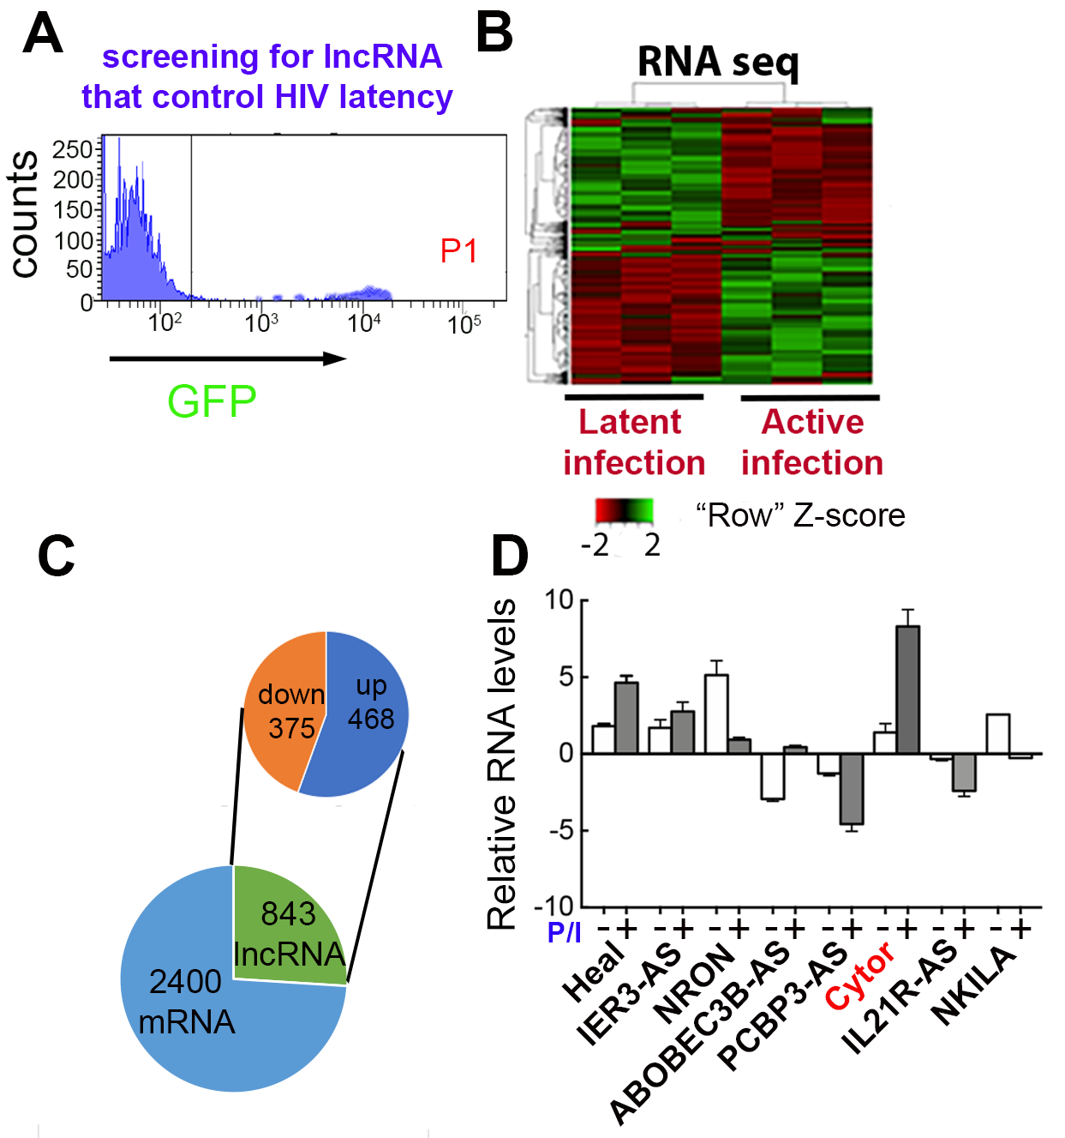

**Figure 1: RNA-Seq identificaiton of ncRNAs differentially expressed during latent and active HIV infection.**

**)A(** FACS histogram of stimulated J-Lat 6.3 cells. GFP (+) cells exhibiting HIV reactivation (P1 region) were sorted from GFP (-) cells harboring latent HIV.

**)B (**Heatmap of differential transcript expression pattern expressions in 3 replicate samples of activated or latent J-Lat 6.3 cells.

**(C)** Numbers of differentially expressed mRNAs and lncRNAs up- and downregulated in cells exhibiting HIV reactivation.

**)D)** Measuring RNA levels of top lncRNA candidates in primary CD4+ T cells that were untreated (-), or stimulated with PMA/ionomycin – P/I (+) qPCR. Data were normalized to GAPDH. Data are means ± SD for cells from 2 donors.

As our screening approach identified lncRNAs that were differentially expressed following the activation of HIV-infected Jurkat T cells, we next conducted gain- and loss-of-function studies in these cells to test whether CYTOR plays a role in the regulation of HIV gene expression. CYTOR was overexpressed by transducing cells with a lentivirus encoding exons 1, 4, and 5 of this lncRNA, which are the most abundantly expressed in humans. Following antibiotic selection, qPCR analyses of resistant J-Lat 6.3 T cells confirmed a 6-fold increase in CYTOR expression relative to control cells that expressed empty vector (**Fig. 2A**; blue bar). CYTOR knockdown was achieved by transducing J-Lat 6.3 cells with a lentivirus encoding a CYTOR-specific small hairpin RNA (shRNA), resulting in an 80% drop in CYTOR expression as measured by qRT_PCR relative to levels in control cells expressing a scrambled control oligonucleotide (**Fig. 2A**; green bar). Parallel FACS-based analyses of GFP expression in these J-Lat 6.3 infected cells as a measure of HIV transcription revealed that in the absence of T cell activation, a 4-fold increase in GFP expression was evident in CYTOR overexpressing cells relative to control cells (**Fig. 2B**; blue bar). Additionally, a 4-fold decrease in HIV-GFP expression was observed in unstimulated CYTOR-knockdown (KD) cells relative to control cells that express scramble control shRNA (**Fig. 2B**; green bar). Similar effects of CYTOR overexpression (2-fold change over control) and depletion (5-fold change over control) were observed based on HIV-GFP expression following the activation of J-Lat 6.3 cells (**Fig. 2C**). Transduction with a control scramble shRNA had no effects on transduction efficiencies or HIV-GFP expression. These results also supported efficient transduction rates in our cells. When re-establishment of latency post activation was monitored over time based on gradual reductions in HIV-GFP expression, reduced CYTOR levels were associated with the more rapid establishment of latency, while CYTOR over-expressing cells retained their GFP expression for an extended period of time (**Fig. 2D**). ***These results suggest that in J-Lat 6.3 T cells, CYTOR expression activates HIV gene expression and can significantly impact latency establishment and reversal*.**

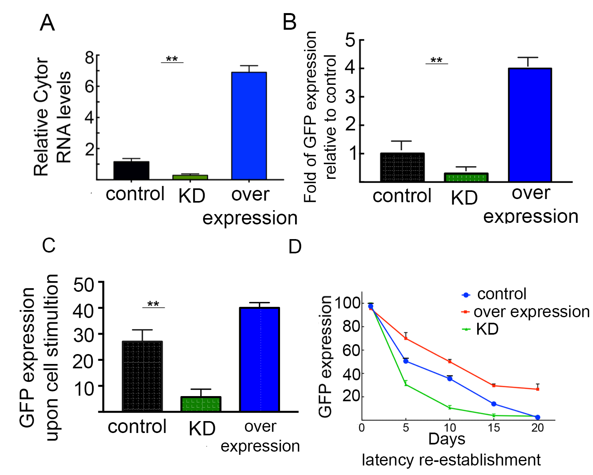**Figure 2: Modulation of CYTOR expression and effects on HIV gene expression.**

(**A**) qPCR analyses of CYTOR RNA levels in J-Lat 6.3 T cells where CYTOR is depleted (KD; green bar), or overexpressed (blue bar). RNA levels were normalized to GAPDH and presented relative to control cells (set to 1). n=3; mean± SD; ** P ≤ 0.05.

(**B**) FACS analysis showing the percentage of HIV-GFP+ expression in unstimulated J-Lat 6.3 T cells that either over-express CYTOR (blue bar), or where CYTOR expression is KD (green bar). Data are shown as fold change in GFP expression relative to control cells that express empty vector or scramble shRNA. n=2; mean± SD; ** P ≤ 0.05

(**C**) FACS analysis of HIV-GFP expression in P/I stimulated J-Lat 6.3 cells expressing a control oligonucleotide or in which CYTOR was overexpressed (blue) or knocked down (green). Data are mean percentages ± SD of GFP+ cells. n=3; ** P≤0.05.

(**D**) Kinetics of latency re-establishment in control J-Lat 6.3 cells (blue), CYTOR KD cells (green), or cells overexpressing CYTOR (red). Cells were reactivated and sorted to achieve 100% GFP (+) purity. n=3; mean± SD.

To further elucidate the mechanisms by which CYTOR affects HIV gene expression, we monitored CYTOR occupancy on the HIV promoter using a Chromatin Isolation by RNA Purification (ChIRP) approach, followed by qPCR analyses of the chromatin fraction of J-Lat 6.3 HIV-infected T cell lines using primers that amplify the viral promoter. We used an anti-sense (AS) DNA oligo targeting endogenous CYTOR and thereby found that CYTOR specifically occupies the HIV promoter even in unstimulated cells. This association was further enhanced following T cell activation (**Fig. 3A**)43. A control lacZ anti-sense oligo verified the specificity of this assay. Moreover, no CYTOR occupancy was observed at a control cellular gene locus. In line with these results, we also employed chromatin immunoprecipitation (ChIP)-qPCR to monitor levels of phosphorylated Ser2 (Ser2P) and Ser5 (Ser5P) of the RNA Pol II-CTD on the HIV promoter following the manipulation of CYTOR expression. This CTD Ser2 phosphorylation is catalyzed by Cdk9/P-TEFb and serves as a marker for Pol II pause-release and elongation44-46, while Ser5P marks the initiation of transcription and is primarily catalyzed by Cdk7/TFIIH. According to our analysis, CYTOR KD led to a decrease in Ser2P levels on the viral promoter without affecting Ser5P (**Fig. 3B**). Moreover, reducing CYTOR expression lowered the levels of H3K4me3 and H3k27Ac, which are the respective promoter and enhancer histone markers associated with active genes (**Fig. 3C**). in both experiments a control locus.

**3.2 Associations between CYTOR and the transcriptional elongation complex**

To identify novel CYTOR-protein interactions, we performed RNA pull-downs followed by mass spectrometry (MS) analyses to detect these interacting proteins. Briefly, J-Lat 6.3 cell lysates were incubated with an anti-sense biotinylated CYTOR probe, followed by streptavidin-mediated immunoprecipitation (IP). A biotinylated-scramble probe served as control, and a 7SK probe confirmed association with P-TEFb. Subsequent MS analysis identified many protein candidates that potentially interact with CYTOR. These included the Cyclin T1 subunit of P-TEFb and the SEC component AFF4. As these results were consistent with a scenario in which a physical association between CYTOR and P-TEFb drives HIV gene expression, we confirmed these results via RNA IP (RIP) using a biotinylated CYTOR probe. The results suggested that CYTOR associates with P-TEFb (**Fig. 3D**), via an unknown mechanism. 7SK probes served as a positive control for association with P-TEFb.

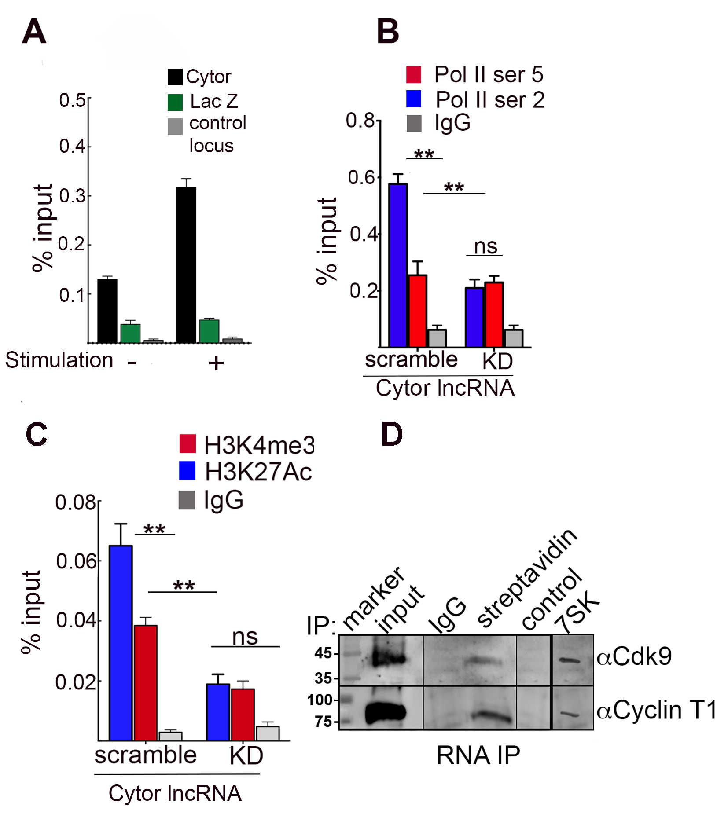**Figure 3: CYTOR occupies the HIV promoter, modifies histone markers and Pol II occupancy, and associates with P-TEFb.**

(**A**) ChiRP-qPCR analysis of chromatin crosslinked fractions from J-Lat 6.3 cells. CYTOR or control lacZ anti-sense biotinylated oligos were incubated with ChiP material from unstimulated or PI/I stimulated cells. Following washing and elution, bead-associated DNA was subjected to qPCR with primers specific for the HIV promoter (n=4; mean± SD; ** P≤0.05 calculated between the two probes and between unstimulated and stimulated states). The GAPDH promoter served as a control locus.

(**B, C**) ChIP-qPCR analyses of control or CYTOR knockdown (KD) J-Lat 6.3 cells were used to analyze Pol-Ser2P or Ser5P on the HIV promoter (**B**), or the H3K4me3 and H3K27Ac histone marks (**C**). Non-specific IgG served as a control. Primers specific for the HIV promoter were used for qPCR. Percentage of input mean data are means ± SD, n=3; **P ≤ 0.05 calculated between scramble and KD, Ser5P and Ser2P, or H3K4me3 and H3K27Ac.

(**D**)RNA immunoprecipitation (IP) followed by Western blotting. Lysates from J-Lat 6.3 cells were incubated with an in-vitro transcribed biotinylated CYTOR probe, and reactions were pulled-down with streptavidin beads. Eluted RNP complexes were subjected to SDS-PAGE and Western blotting with indicated antibodies. Nonspecific IgG served as control. Biotinylated scramble RNA was used as a control for RNA-IP. Input is 5% of the total cell lysate47.

**3.3 The indirect effects of CYTOR on changes in actin dynamics induced by CD4+ T cell activation**

While the above results suggest that CYTOR directly associates with P-TEFb to activate gene transcription, it may also exert its effects indirectly by controlling the expression of its downstream targets. It has previously been shown that CYTOR regulates cellular actin dynamics and cytoskeletal reorganization in fibroblasts42, but no similar analyses have been performed in CD4+ T cells. Thus, we initially sought to explore whether CYTOR plays a role in CD4+ T cell activation and HIV gene expression through the modulation of cellular actin dynamics. T cell activation results in the rapid polymerization of cytoplasmic actin into filaments just beneath the plasma membrane in a process that facilitates signaling that ultimately leads to the activation of transcription factors including NF-kB and NFAT that enhance HIV transcription48. For this aim, we established a close collaboration with Oliver Fackler, who is a leading expert in the field of HIV infection and actin remodeling following T cell activation (Heidelberg; Germany; see attached letter). Employing established protocols in the Fackler lab, we visualized actin remodeling events following the modulation of CYTOR expression49,50. Jurkat CD4+ T cells were incubated on T cell stimulatory surfaces coated with anti-CD3/CD28 antibodies, fixed, and evaluated for cell spreading and F-actin-rich ring formation at the cellular periphery by phalloidin staining. CYTOR knockdown reduced the number of cells that responded to T cell activation with appropriate spreading and F-actin polymerization (**Fig. 4A-D**). A detailed analysis of the various morphotypes revealed that reduced CYTOR levels were associated with less frequent coordinated actin polymerization, while the frequency of cells that failed to spread despite efficient actin polymerization was unaffected (**Fig. 4E**). ***These results suggest the possibility that the effects of CYTOR on HIV transcription are linked to its effects on cellular actin dynamics****.*

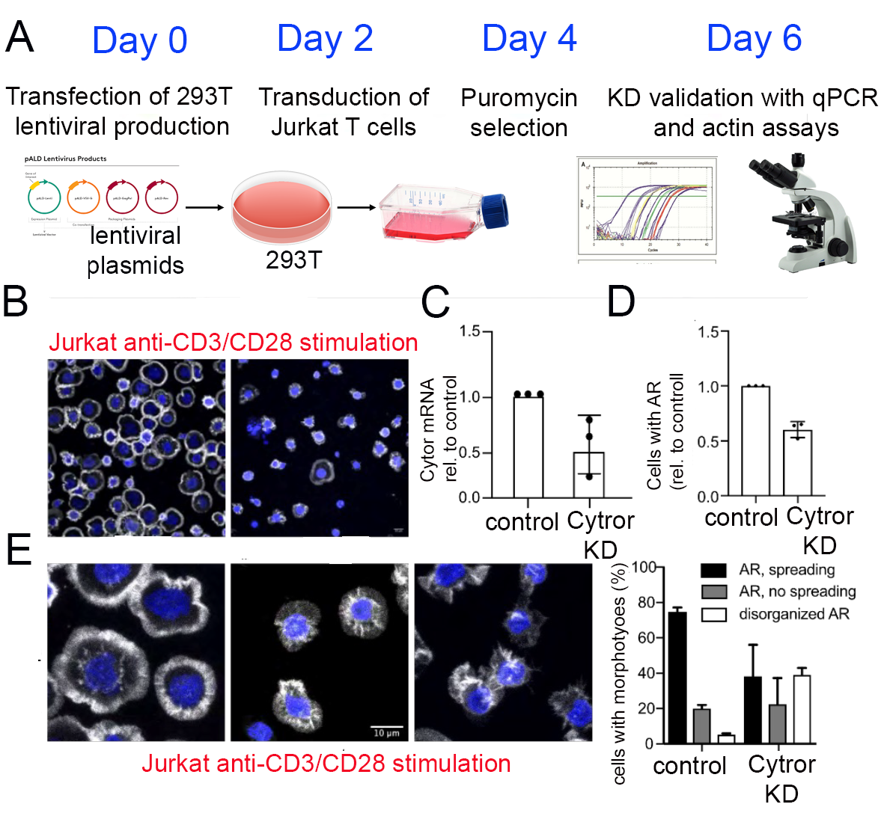

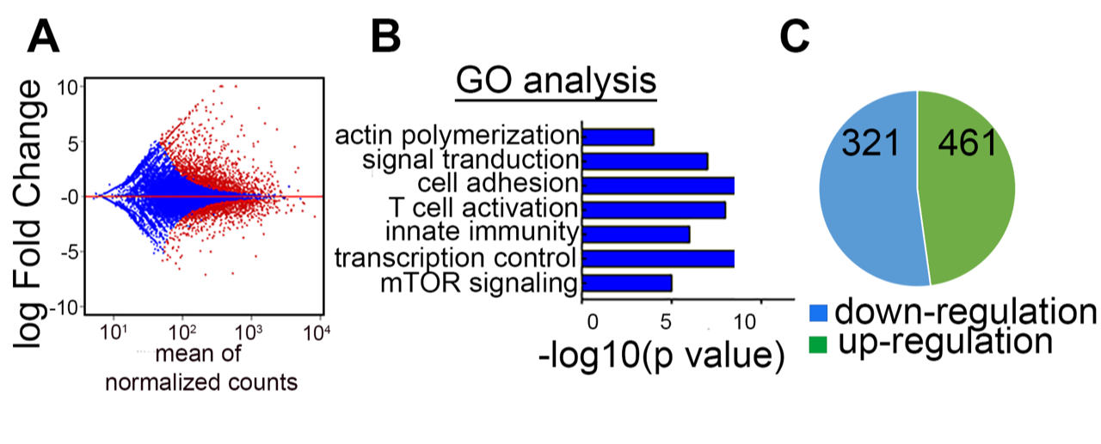We further conducted an RNA-Seq analysis comparing CYTOR KD and control J-Lat 6.3 cells. This experiment revealed that differentially expressed genes were enriched in Gene Ontology (GO) terms associated with actin polymerization, cell adhesion, T cell activation, and transcriptional control . While these results remain to be validated in primary T cells, based on these preliminary data we ***hypothesize that the effects of CYTOR on T cell actin dynamics may be mediated by the deregulation of CYTOR target genes***. **3.4 A toolbox for studying the role of CYTOR as a regulator of HIV latency in resting primary CD4+T cells**

**Figure 5: Identification of CYTOR target genes by RNA-Seq.**

**(A)** MA plot of the expression pattern from RNA-Seq analysis of CYTOR KD versus control J-Lat 6.3 cells. Red and blue dots present significantly and insignificantly expressed genes, respectively.

**(B**) Gene Ontology for enrichment of CYTOR gene targets (DAVID).

**(C**) Pie chart of RNA-Seq showing up and down regulated genes upon CYTOR depletion.

**Figure 4: CYTOR is required for TCR-induced actin remodeling.**

(**A)** Experimental flow for CYTOR KD in Jurkat cells.

(**B**) Representative images of F-actin organization for control and CYTOR KD Jurkat cells after contact with anti-CD3/28 coated surfaces.

(**C**) Relative CYTOR mRNA levels in CYTOR KD Jurkat cells relative to control cells.

(**D**) Amounts of CYTOR KD cells with proper cell spreading and circumferential F-actin relative to control cells (mean± SD, 100 cells per experiment/condition, n=3).

(**E**) Representative images of morphotypes observed for Jurkat cells after anti-CD3/28 surface stimulation.

(**F**) Quantification of the morphotypes shown in E (mean± SD, 100 cells per experiment/condition, n=3).

A bottleneck for mechanistic studies on the role of CYTOR in HIV gene expression and latency is the ability to manipulate its expression in appropriate cellular latency models without simultaneously affecting latency status in these cells. In cell lines such as HIV-infected J-Lat 6.3 cells, we have already established efficient overexpression and knock-down of CYTOR (**Fig. 2**). While these approaches are valuable, particularly for proof-of-principle and biochemical analyses, the activation state of these immortalized and thus dividing cell lines does not mirror that of physiologically relevant primary resting CD4+ T cells that constitute the latent HIV reservoir. However, resting CD4+ T cells are extremely refractory to genetic manipulation and HIV infection51 - a barrier that so far has only been overcome by manipulating activated CD4+ T cells and waiting until they return to a resting state following stimulus removal. We thus adopted the gold-standard primary CD4+ T cell model used to study HIV latency in which activated primary CD4+ T cells are infected and cultured without stimulation until latency is established, and then reactivated to score for latency reversal52,53. As these post-activation CD4+ T cells are not true resting cells and this procedure likely impacts HIV gene expression and latency reversal, we have implemented experimental protocols from our collaborators in Germany that permit genetic manipulation in resting primary cells (**Fig. 6A**)54. With this approach, the efficient 98% CRISPR-mediated knockout of one or more genes can be achieved in bulk populations of truly resting primary CD4+ T cells (**Fig. 6B**). As this procedure does not cause any T cell activation, it should be amenable to study effects of CYTOR on T cell activation and establishment and reversal of HIV latency in resting primary CD4+ T cells54 (see SA1).

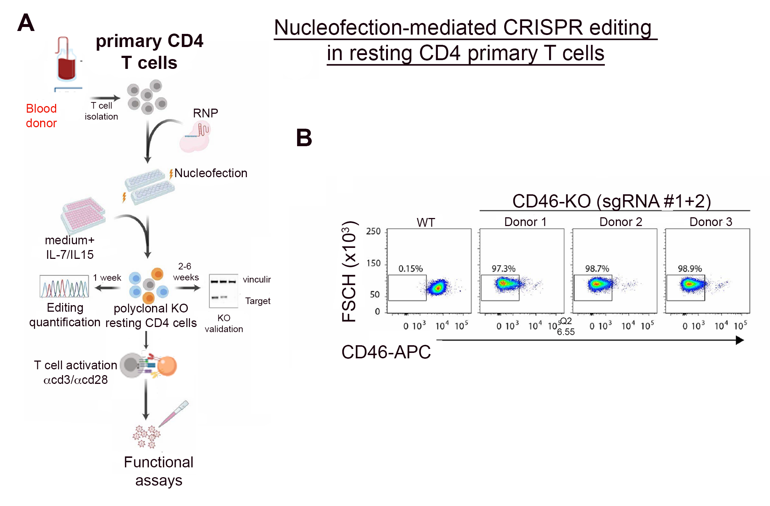**Figure 6: CRISPR-mediated gene editing in resting primary CD4+ T cells.**

(**A**). Schematic depiction of nucleofection-based CRISPR gene editing in primary human resting CD4+ T cells54.

(**B**) FACS-based evaluation of CD46 KO efficiency in cells from 3 different donors. Obtained from Albanese et al., 202154.

1. **Working hypothesis, research objectives hypothesis, and expected significance**

The therapeutic reversal of HIV latency and elimination of the latent reservoir represents the most promising means of curing HIV-infected individuals. However, current strategies aimed at eradicating the latent reservoir have failed in clinical settings. This inability to design effective therapeutic options that control HIV expression partly reflects gaps in our understanding of how HIV gene expression and viral latency are regulated. Many detailed studies have provided insight regarding how Pol II, the host transcriptional machinery, and epigenetic modifications regulate HIV gene expression. However, the emerging role of lncRNAs as regulators of cellular gene expression has not yet been carefully studied in the context of T cell activation and HIV gene expression, and this may represent a key gap in knowledge limiting the establishment of a comprehensive understanding of the steps responsible for the establishment of viral latency. Our preliminary results suggest that CYTOR is a novel activator of HIV gene expression that associates with P-TEFb and suppresses the establishment of latency. CYTOR was able to both directly influence HIV gene transcription and to indirectly regulate actin polymerization in CD4+ T cell lines, in addition to having broad effects on the expression of downstream genes (**Fig. 4-5**). Building on these findings, ***we hypothesize that CYTOR activates HIV gene expression by directly recruiting P-TEFb and the host transcriptional elongation machinery to the HIV promoter. We further posit that CYTOR can indirectly regulate T cell activation and actin remodeling, thereby enhancing HIV transcription and modulating viral latency.*** We propose the following specific aims to test these hypotheses:

**Specific Aim 1 (SA1) - Determine the physiological functions of CYTOR in primary CD4+ T cells and its effects on HIV latency**. Our preliminary data are based on studies performed using an immortalized HIV-infected CD4+ T cell line. These cells are dividing cells, and thus do not reflect the true activation state of the physiologic cellular targets of HIV - resting CD4+ primary T cells. In **SA1**, we will therefore extend our findings to primary CD4+ cells, as they are gold-standard targets for studies of HIV infection and the control of gene expression and latency. To place our study in a clinically relevant context, we will confirm the effects of CYTOR on HIV gene expression and latency, and in particular, will employ our above-described toolbox to assess the physiological relevance of CYTOR in resting primary CD4+ T cells. By establishing protocols for CYTOR gene manipulation in these resting cells, we expect to gain comprehensive insight into the role of CYTOR in these cells such that we can evaluate its clinical significance in the establishment and reversal of HIV latency.

**Specific Aim 2 (SA2)** *-* **Study the direct molecular mechanisms by which CYTOR activates HIV gene expression**. For this Aim, we will continue to rely on HIV-infected T cell-line models for our proposed experimental design owing to their amenability to genetic manipulation and transduction. In **SA2**, we will confirm the interactions between endogenous P-TEFb and CYTOR in primary CD4+ T cells. Under basal/unstimulated and stimulated conditions, we will address whether CYTOR is recruited to the HIV promoter and whether it activates HIV transcription via associating with P-TEFb. CYTOR interactions with P-TEFb will be also analyzed globally to better understand whether CYTOR plays a general role in the control of gene expression by recruiting P-TEFb to promoter regions. Direct interactions between CYTOR and Cyclin T1/P-TEFb will be also explored. Finally, the interplay between CYTOR with HIV-Tat, TAR RNA, and the 7SK lncRNA will be investigated to more fully understand the regulation P-TEFb activity and HIV gene expression. Through these experiments, we expect to elucidate the mechanisms by which CYTOR controls HIV gene expression and latency in primary CD4+ T cells.

**Specific Aim 3 (SA3)** - **Explore indirect effects of CYTOR on T cell activation, actin remodeling, and the expression of HIV or cellular genes.** Wewill rely on RNA-seq and ChIRP-seq analyses to identify CYTOR target genes in primary CD4+ T cells. The involvement of these target genes in the CYTOR-mediated regulation of T cell activation, actin remodeling, and HIV gene expression will be investigated through gain- and loss-of-function assays in T cell lines and primary CD4+ cells. Mechanistic insights from this SA will provide a foundation for studies in which the functions of CYTOR can be manipulated in primary CD4+ T cells to study whether its indirect effects on HIV transcription and latency are mechanistically linked to T cell activation and actin remodeling. Based on these Aims, we propose a model of the functions of CYTOR in T cells (**Fig. 7**).

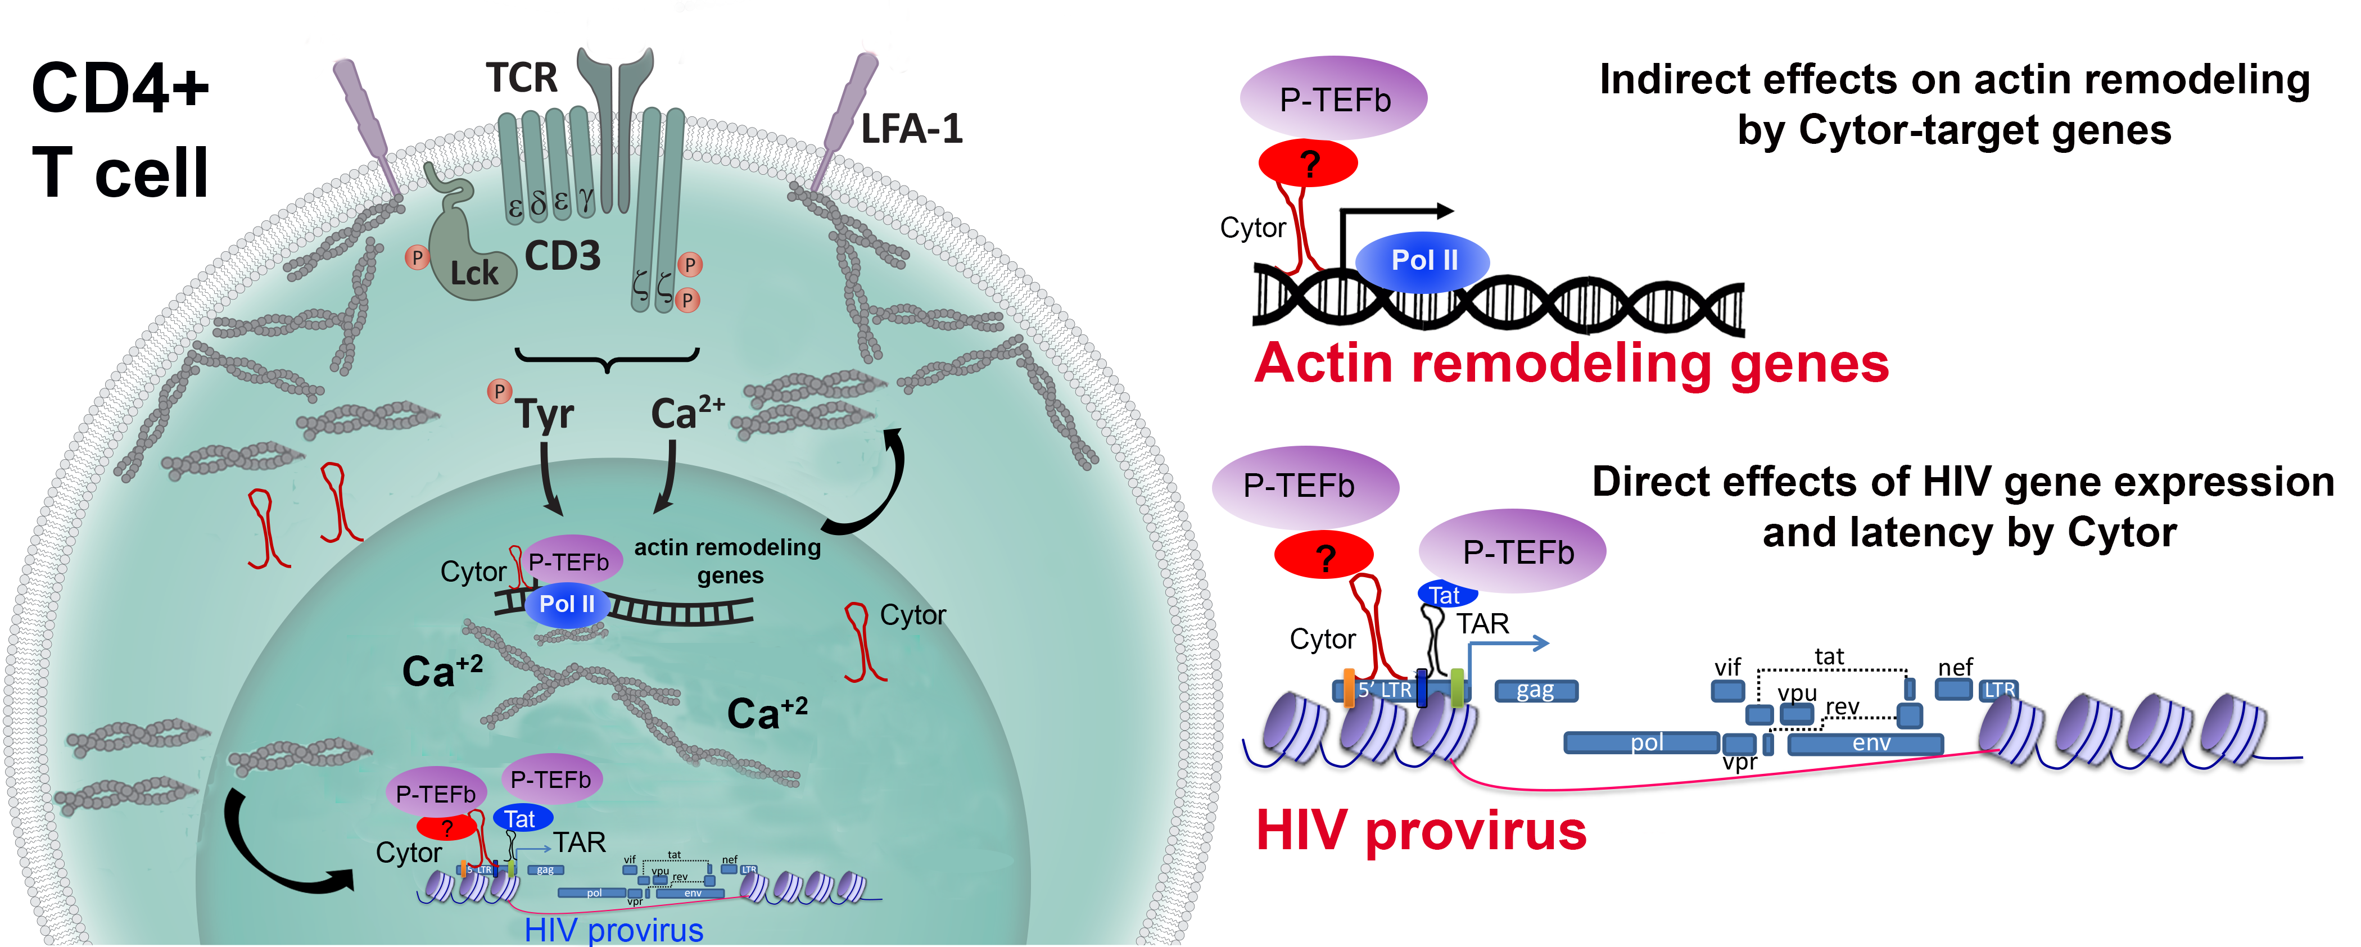**Figure** **7: Working model for CYTOR functions.**

Following T cell activation, levels of CYTOR are elevated both in the cytoplasm and the nucleus. CYTOR is recruited to the HIV promoter by directly binding to P-TEFb or another factor, leading to the overall activation of viral gene expression. Other cellular-CYTOR target genes include actin remodeling genes that further promote indirect actin polymerization and the activation of transcription. Nuclear actin also interacts with Pol II and the elongation complex, promoting gene expression.

1. **Expected Significance and Innovation**

Our proposed studies include innovative approaches that will advance the current understanding of the regulation of HIV transcription, latency, T cell activation, and actin remodeling. When completed, these studies will significantly expand our knowledge of the functions of lncRNAs as regulators of these clinically relevant processes, providing new tools to manipulate the HIV infection status of target cell populations. Key innovative aspects of this proposal include the following research areas:

* + - 1. **lncRNA-mediated regulation of HIV transcription and latency** – The functions of ncRNAs, and particularly lncRNAs, in the control of HIV infections are an area of actively evolving research interest, providing exciting opportunities to understand how these lncRNAs govern the establishment and maintenance of the viral latent reservoir. Our preliminary work identified several lncRNAs differentially expressed in HIV-infected T cells following T cell activation that may represent candidates to control HIV infection. Our top candidate, CYTOR, activates HIV transcription by associating with the host transcriptional elongation machinery. Here, we will further study CYTOR functions and its effects on HIV transcription and latency, thereby clarifying the importance of this new regulator of HIV infection and gene expression.
      2. **The role of lncRNAs in T cell activation, actin remodeling, and the control of gene expression** - Our data suggest that CYTOR affects HIV and global gene expression in CD4+ T cells and that these effects are linked to cellular actin dynamics and T cell activation. We will conduct a comprehensive exploration of the role of CYTOR in these processes, providing new insights into the principles of T cell activation and global gene transcriptional control. We will identify downstream genic targets of CYTOR, addressing their indirect effects on T cell activation, actin remodeling, and the control of HIV infection. These findings will broaden our knowledge regarding the interplay between lncRNAs and the T cell response to HIV infection, thus identifying new regulators of HIV infection. As other lncRNAs were identified in our screen, these will be the focus of future studies aimed at more broadly expanding our understanding of how lncRNAs regulate gene expression.
      3. **Clinical implications for treating the latent HIV reservoir** - Identified lncRNAs and their protein partners may represent targets amenable to therapeutic interventions aimed at treating HIV patients and eliminating cells that serve as a viral reservoir. Although the reversal of HIV latency is a promising approach for curing HIV infection, no such strategies have achieved clinical success to date, reflecting gaps in our knowledge regarding how HIV latency is established and maintained. We believe that the therapeutic manipulation of CYTOR expression may be incorporated into both “Block-and-Lock” and "Shock-and-Kill" strategies. Integrating these approaches with cutting-edge RNA-targeting tools will provide a foundation for new opportunities to develop RNA-based therapeutics capable of eradicating HIV.

## D. Work Program including detailed research description

**Specific Aim 1 - Determine the physiological functions of CYTOR in primary CD4+ T cells and its effects on HIV latency**

Our preliminary observations reveal a link between CYTOR and T cell activation, actin remodeling, and the control of HIV gene expression. Specifically: **1**) CYTOR activates HIV transcription, while its depletion suppresses reactivation of latent HIV (**Fig. 2**); **2**) CYTORassociates with P-TEFb in cells and occupies the HIV promoter (**Fig. 3**); **3**) the knockdown of CYTOR reduces Ser2 Pol II-CTD enrichment on the HIV promoter and decreases levels of the activating H3K4me3 and H3K27Ac histone marks (**Fig. 3**), and **4**) CYTOR knockdown reduces the number of cells that responded to T cell activation with proper spreading and F-actin polymerization (**Fig. 4**). These findings were obtained in cell line model systems due to their amenability to efficient experimental manipulation. However, J-Lat 6.3 cells are immortalized dividing cells that are not suitable for studying latent HIV in resting primary CD4+ T cells. In this Aim, we thus intend to translate our findings regarding the functions of CYTOR into resting primary CD4+ T cells to better model the latent HIV reservoir. We will therefore assess which aspects of the observed CYTOR-mediated effects on gene expression control, T cell activation, and actin dynamics are recapitulated in these physiologically relevant cells. All experiments will be conducted with cells from at least four donors to better control for donor-donor variability.

**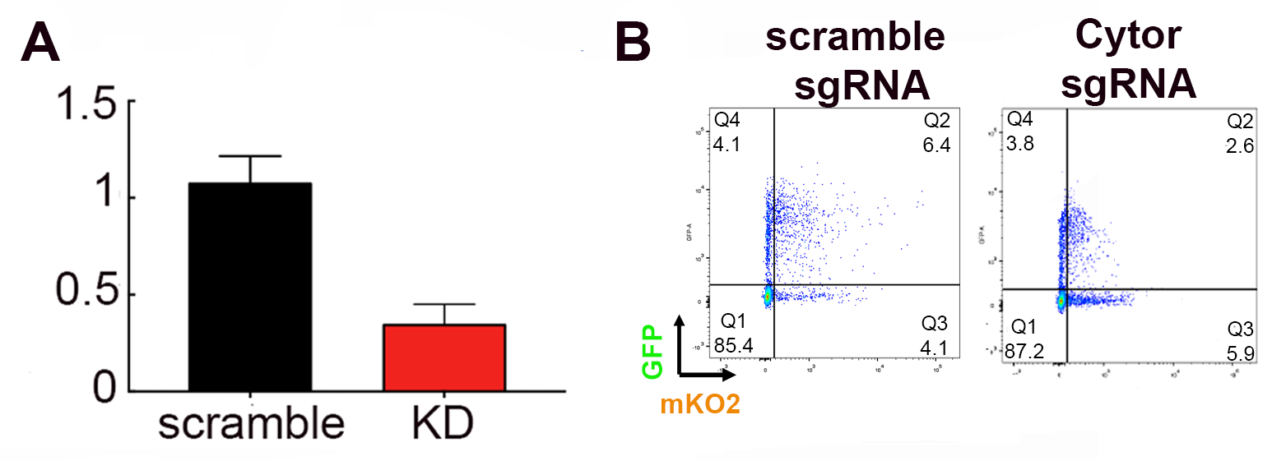*1a. Analyze the role of CYTOR in primary CD4+ T cells*** - In a preliminary experiment, we depleted CYTOR expression in stimulated primary CD4+ T cells, using a lentivirus encoding a CYTOR-specific shRNA. We achieved an 80% decrease in CYTOR levels relative to control scramble shRNA expressing cells (**Fig. 8A**). We then transduced KD and control primary CD4+ cells with HIVGKO, which codes for a codon-switched eGFP under the control of the HIV-1 LTR promoter and mKO2 under the control of the constitutive EF1a promoter (a gift from the lab of Eric Verdin)55. HIVGKO allows for the straightforward FACS-based monitoring of the effects of CYTOR on latency establishment and reversal in primary CD4+ T cells while also permitting analyses of transduction efficiency. We found that the depletion of CYTOR in stimulated HIV-infected primary CD4+ cells resulted in a decrease in HIV gene expression while having almost no effect on mKO2 reporter expression (**Fig. 8B**). For this Aim, we will explore the direct and indirect effects of CYTOR on HIV gene expression and viral latency and how they are linked to T cell activation and actin remodeling in primary CD4+ T cells.

**Figure 8: CYTOR manipulation of expression in activated CD4 T cells**

**(A**) KD of CYTOR in primary CD4 stimulated cells.

(**B**) Effects of CYTOR KD in stimulated CD4 primary cells infected with HIVGKO.

**1b. *Characterize the functions of CYTOR in the establishment of HIV latency in primary CD4+ T* cells -** We will manipulate CYTOR expression in primary resting T cells that are infected with HIV using either CRISPR-nucleofection or shRNA-based approaches (**Figs. 6, 8**). Unlike immortalized CD4+ T cell lines for which stable clones carrying latent HIV provirus are available, latently infected primary cells need to be generated *de novo*. Since HIV-1 does not productively infect resting cells, this requires first activating these cells followed by the return to a post-activation resting state of latency following the removal of the T cell stimulus. The activation of these cells, in addition to rendering them permissive to HIV infection, will make them susceptible to shRNA-lentiviral transduction to facilitate CYTOR depletion. However, the usefulness of this approach is limited by the gradual decline in shRNA expression as cells return to a quiescent state. Therefore, we will alternatively employ a nucleofection-based CRISPR approach in resting primary cells (**Fig. 6**) to generate CYTOR-KO cells that then will be activated and infected with HIV to study the establishment of latency. We will carefully evaluate which of these two approaches can be most effectively combined with HIV infection to achieve a robust reduction in CYTOR levels. Primary cells will be transduced with HIVGKO55. After efficient CYTOR expression control has been achieved, we will conduct a detailed kinetic analysis of viral reporter expression, HIVGKO, and integration (Alu PCR). This analysis will allow us to monitor HIV infection and the role of CYTOR in the establishment of latency. Importantly, our results will also be correlated to the characterization of T cell activation, actin rearrangement, Pol II/P-TEFb promoter occupancy, and epigenetic marking in analogy to the cell-line-based studies.

**1c. *Evaluate the effects of CYTOR on HIV latency reversal*** - To quantitatively assess the role of CYTOR in HIV latency reversal, post-activation resting CD4+ T cells will be reactivated following FACS sorting to remove those cells already expressing GFP prior to reactivation. The re-emergence of GFP expression in response to LRAs will be studied to provide an assessment of the role of CYTOR in HIV latency reversal. We expect that it will be challenging to obtain sufficient numbers of reactivated cells at the end of the infection/KO and latency establishment/reversal procedures. In addition, this approach will provide information regarding the reversal of latency in cells that had been fully activated only a few days before and that may thus have not fully reached a resting state. To study a more physiologically relevant scenario and to place our study in a clinically relevant context, we will test whether CYTOR expression can enhance or replace current reactivation protocols for therapeutic latency reversal in CD4+ T cells isolated from HIV patients undergoing treatment (obtained from a Soroka Center patient cohort). Although the frequency of patient-derived peripheral CD4+ T cells that carry HIV proviral DNA is low (< 1%), efficient latency reversal can be readily achieved54. Given the high efficacy of our nucleofection-based approach in resting CD4 T cells54, we expect to test the effects of CYTOR KD on HIV gene expression in HIV patient cells. Our preliminary results in cell lines show that the depletion of CYTOR suppresses latent HIV reactivation (**Fig. 2D**). We will therefore attempt to knockdown CYTOR in primary CD4+ T cells isolated from HIV patients undergoing therapy, and to assess the levels of spontaneous or LRA-induced reactivation. Tested LRAs will include the PKC agonists byrostatin 1 and prostratin or histone deacetylation inhibitors6,56,57. Levels of CYTOR expression will be determined by qPCR and compared to those from healthy donors, or patients not receiving therapy. To minimize the bias that may arise due to heterogeneity among patients, geometric means of two reference genes, β-actin and GAPDH will be used to normalize CYTOR expression levels58. Collectively, these results will provide a foundation for a promising new clinical approach to the reversal of HIV latency.

**Expected outcomes, potential pitfalls, and alternative strategies**

We will establish the clinical relevance of CYTOR as an activator of HIV transcription in resting CD4+ T primary cells. However, CYTOR has reported oncogenic properties, we will monitor cell activation, proliferation, and differentiation. Primary cells will be available for experiments for only a few weeks, and thus will be isolated routinely, with CYTOR expression then being manipulated with appropriate validation in all cases. CYTOR depletion may alternatively be achieved using a CRISPR interference approach. Changes in CYTOR expression may also affect other steps of the HIV life cycle such that viral gene expression may be low even if transcriptional activity is unaffected. To overcome this, proviral DNA will be measured and GFP mRNA will be monitored.

**Specific Aim 2 - Study the direct molecular mechanisms by which CYTOR activates HIV gene expression**

Our preliminary data indicate that CYTOR activates HIV gene expression and suppresses the entry of CD4+ T cell lines into a period of viral latency. Furthermore, CYTOR associates with P-TEFb and occupies the HIV promoter. In this Aim, these initial observations will be confirmed in primary CD4+ T cells. ***We hypothesize that CYTOR activates HIV transcription by directly binding Cyclin T1 and recruiting P-TEFb and the cellular elongation transcription complex to the HIV promoter, thereby modulating Pol II promoter occupancy, changes to the chromatin landscape, and overall HIV gene activation.***

***2a. Characterize interactions between CYTOR and P-TEFb at the HIV promoter in primary CD4+ cells*** – Our preliminary data were generated using CD4_+ T cell lines. While we will continue to rely on these cells for our experiments, however, the goal of this will be to confirm our findings in a more physiologically relevant cell system by validating interactions between endogenous CYTOR and P-TEFb in primary CD4+ T cells. Stimulated primary CD4+ T cells will be transduced with HIV and will be allowed to gradually return to a resting state after several weeks of reductions in IL-2 levels. We will then examine CYTOR-P-TEFb interactions in resting or stimulated cells. Our preliminary RIP assays were performed with an *in vitro* CYTOR probe (**Fig. 3D**), which may not fold properly, we will confirm interactions between endogenous CYTOR and P-TEFb subunits (Cyclin T1, T2a T2b, and K) using an RNA antisense purification (RAP) assay with biotinylated antisense (AS) oligos that can precipitate endogenous CYTOR, after which P-TEFb subunits will be detected by Western blotting. CYTOR levels in the IP fraction will be confirmed by qPCR. Control AS probes will include scrambled oligos that will not hybridize with CYTOR and a probe targeting the lncRNA 7SK, which binds P-TEFb. Computational analyses will aid in the identification of accessible regions within CYTOR that do not complement such that they will hybridize with CYTOR sequences. A complementary experimental approach will entail a RIP assay using antibodies specific for each Cyclin T subunit, followed by qPCR to amplify endogenous CYTOR with similar analyses of 7SK interactions with P-TEFb as a positive control, and the unrelated lncRNA 7SL as a negative control. The dynamics of CYTOR enrichment/localization between the cytoplasmic and nuclear cell fractions will be monitored by employing biochemical cell fractionation approaches combined with the abovementioned analytical approach. RNA-fluorescence in situ hybridization (FISH) using a labeled CYTOR probe will be used to confirm these results, assessing the transition of CYTOR between cell fractions under stimulated and resting conditions. CLIP-qPCR will complement these experiments, enabling the identification of domains within CYTOR that interact with P-TEFb and reveal the sequences of the HIV promoter occupied by this lncRNA59,60. ChIRP-qPCR will also be conducted in primary HIV-infected cells under resting or stimulated conditions (**Fig. 3A**). Western blotting will be used to validate interactions between endogenous CYTOR and its protein partners. Finally, ChIP-qPCR will be performed in cells in which CYTOR is knocked down or overexpressed to monitor P-TEFb levels on the HIV promoter, thus validating whether CYTOR affects P-TEFb recruitment to the viral promoter. Overall, these approaches will yield insights that will support experiments in which recruitment of CYTOR to the HIV promotor and/or its interaction with P-TEFb will be specifically disrupted (e.g. through mutation of the HIV promotor, or using Cyclin T1 isoforms that do not interact with CYTOR).

***2b. Analyses of direct binding between Cyclin T1/P-TEFb and CYTOR*** - We will also confirm direct binding between CYTOR and P-TEFb *in vitro*. ***We hypothesize that CYTOR directly binds to Cyclin T1 and recruits P-TEFb to the HIV promoter***. RNA pulldown assays will be conducted using *in vitro-*transcribed CYTOR RNA and recombinantly purified His-tagged cyclin T1 that will be immunoprecipitated with an anti-His antibody, after which CYTOR will be detected by qPCR. As controls to gauge the specificity of this binding reaction, several cyclin T1 mutants will be used, including one that is depleted of its RNA/TAR binding domain, or cyclin T1 carrying a C261Y point mutation that disrupts binding to TAR RNA61,62. A scramble-sequence RNA probe will serve as a negative control for these assays. Alternatively, a biotinylated CYTOR probe will be incubated with recombinant purified cyclin T1 or mutant isoforms thereof, followed by streptavidin IP and extensive washing. CYTOR binding will then be documented by qPCR. To complement this approach, we will perform an electrophoretic mobility shift assay (EMSA) using recombinant GST-Cyclin T1, mutant isoforms thereof, and a CYTOR labeled probe. A mutant CYTOR probe will be also tested as a control. While these experiments will utilize *in vitro* transcribed CYTOR RNA, which may not fold or be modified in the same manner as in cells, these experiments will nonetheless provide strong evidence for the direct binding between ***A picture containing chart
***CYTOR and P-TEFb in the context of HIV activation.

**Figure 9: Potential CYTOR gene targets exhibit P-TEFb enrichment**

A Genome Browser view of Pol II, H3K4me3, and P-TEFb/CDK9 ChIP-Seq data from Jurkat cells for the indicated genes that were downregulated upon CYTORdepletion and were found to exhibit P-TEFb enrichment.

***2c. Analyze genome-wide CYTOR-P-TEFb interactions* –** To more broadly establish a correlation between P-TEFb and CYTOR, we will employ computational analyses based on ENCODE RNA-Seq data for the cytoplasmic and nuclear fractions of CD4+ T cells. As a proof-of-concept, we have already integrated publically available Cdk9, Pol II, and H3K4me3 ChIP-Seq data from primary T cells, and found that select genes were significantly downregulated in our RNA-Seq analysis of CYTOR-depleted cells exhibited Cdk9/P-TEFb enrichment (**Fig. 9**). These CYTOR target genes include MLST8, Tubb, and RelB, which are respectively associated with the mTOR pathway, actin polymerization, and transcriptional activity. ChIRP-qPCR will establish CYTOR occupancy of these CYTOR target genes, and the detection of overlap between these results and P-TEFb ChiP-Seq results will confirm genome-wide P-TEFb-CYTOR co-occupancy. These P-TEFb-ChIP-Seq analyses in control or CYTOR-depleted cells will validate our hypothesis that *P-TEFb is globally recruited by CYTOR to specific gene promoters.* Given our preliminary ChIP-qPCR results (**Fig 3**) that demonstrate the involvement of CYTOR in the regulation of histone activation markers depositing and Pol II occupancy, we will also employ ChIP-seq in the context of CYTOR depletion to define epigenetic histone changes and Pol II occupancy around identified CYTOR-target genes.

***2d. Investigate the interplay between CYTOR, Tat, and 7SK*** - As cyclin T1 is recruited to the HIV promoter via Tat and TAR and this interaction could mask the contribution of CYTOR in the recruitment of P-TEFb to the viral promoter, we will further evaluate the involvement of Tat in any CYTOR-mediated phenotypes. We will employ an EMSA approach to investigate the possible Tat-mediated CYTOR recruitment using a labeled TAR RNA probe and unlabeled CYTOR that should super-shift the Tat-TAR complex. An EMSA with dual staining for RNA (SYBR Green) and protein (SYPRO Ruby) will elucidate the RNA/P-TEFb species in the detected complex63. A scrambled probe will serve as a negative control. To confirm the interplay between CYTOR and Tat in the recruitment of P-TEFb in HIV-infected cells, CYTOR effects on HIV transcription will be tested with a virus that does not express Tat, or with mutated Tat that does not bind to cyclin T1. Additionally, Tat trans-activation will be monitored in cells under conditions where CYTOR is overexpressed or depleted. We will then test whether Tat associates with CYTOR by performing RIP experiments using a Tat-specific antibody, followed by the qPCR-mediated detection of CYTOR. Alternatively, pull-down assays performed using a biotinylated anti-sense CYTOR probe will clarify whether CYTOR co-precipitates with Tat in HIV-infected cells. We will also explore interactions between the 7SK lncRNA and CYTOR in the context of P-TEFb binding and the complex transition between active and inactive P-TEFb. Such experiments will be performed under active or resting conditions using primary CD4+ T cells. A biochemical glycerol gradient analysis, followed by Western blotting and qPCR will be used to measure free/active and inactive P-TEFb and associated interactions with CYTOR or 7SK. Cell fractionation analyses will further be used to monitor CYTOR levels in the cytoplasm and nucleus in the presence or absence of stimulation and the interactions between Cdk9, CYTOR, and 7SK under these conditions.

**Expected outcomes, potential pitfalls, and alternative strategies**

Our preliminary observations were performed in J-Lat 6.3 T cell lines. To address biases associated with the position of proviral HIV integration in these immortalized cells, other HIV-infected T cell line models will be tested. The interactions between lncRNAs and their protein partners are often transient, and may thus be challenging to detect. If our initial approaches are unsuccessful, alternative RNA binding assays will include RNA probes with MS2 or S1 RNA tags. For any of the above IP approaches, antibody specificity will be essential for success, and we will thus extensively optimize these analyses. The low levels of CYTOR expression may represent an experimental challenge, but in our preliminary experiments we successfully detected CYTOR RNA levels in primary cells (**Fig. 2D**). If our hypothesis pertaining to cyclin T1 interactions is ultimately not supported, we will test interactions between CYTOR and other cyclin subunits including Cyclin T2a, T2b, or K using a similar experimental approach. Cyclin K will be of particular interest, as it is the only cyclin that is recruited to promoters and activates transcription via RNA64. Interactions between CYTOR and SEC/AFF4 were detected in our MS analysis, and will also be subject to follow-up. AFF4 directly binds to Cyclin T1 and its CTD can bind to RNAs65-70,71. We have already obtained SEC expression vectors from the Zhou lab (UC Berkeley) to support these follow-up experiments.

**Aim 3 - Explore indirect effects of CYTOR on T cell activation, actin remodeling, and the expression of HIV or cellular genes**

***3a. Identify and characterize downstream targets genes of CYTORs*** – In our RNA-Seq analysis detailed above using J-Lat 6.3 T cells, we identified genes that were differentially expressed following CYTOR depletion (**Fig. 5**). As we already have established our ability to knock out CYTOR expression in activated primary CD4+ T cells (**Fig. 8**), in this Aim we will confirm these RNA-seq results in primary cells. To comprehensively identify DNA sequences of downstream target genes that are reproducibly and significantly regulated by CYTOR, we will conduct a global ChIRP-Seq analysis using antisense-DNA tiling probes that will cover the entire CYTOR gene and will thereby selectively retrieve new CYTOR target genes72 in primary CD4+ cells (n=2). Specific recognition motifs within promoters or enhancers that CYTOR associates with will be identified. This approach will enable us to address key mechanistic questions regarding the binding of CYTOR to DNA, while also verifying whether its recruitment to promoters is sequence-specific. This ChIRP-Seq strategy will complement the RNA-Seq analyses performed in J-Lat and primary cells, enabling us to narrow down our candidate gene list for future investigation. The expression of the top 10 genes that were differentially expressed upon CYTOR depletion/overexpression in primary cells will be validated by qPCR, in addition to employing a similar functional loss- and gain-of-function experimental scheme as in our preliminary result section. Their effects on T cell activation and HIV gene activation will be studied in cells in which each gene has been knocked down/overexpressed, and the occupancy of CYTOR on promoter sequences associated with these gene targets will be confirmed by ChIRP-qPCR. Those genes that are identified as potential regulators of HIV transcription and/or T cell activation/actin dynamics, will be subject to further mechanistic studies. We will monitor the role of these CYTOR target genes in the context of CYTOR, with top candidate genes being subjected to functional analyses and manipulation of expression in cells in which CYTOR is knocked down or overexpressed.

***3b. Investigating the indirect effects of CYTOR on actin remodeling and T cell activation*** - Cytoplasmic73 and nuclear actin dynamics74,42 have been shown to affect HIV transcription through unknown mechanisms. Our preliminary results suggest that CYTOR regulates actin polymerization in the cytoplasm and the spreading of CD4+ T Jurkat cells in response to T cell activation (**Fig. 4**). In this Sub-Aim, we will continue our collaboration with the Fackler lab and assess how CYTOR indirectly affects primary CD4+ T cell actin dynamics, T cell activation, and subsequent HIV gene expression. ***We will focus on the possibility that CYTOR indirectly affects actin remodeling and the response of CD4 T cells to stimulation, which are a result of the deregulation of CYTOR target genes - the products of which are involved in actin remodeling***. An additional, not mutually exclusive possibility, is that CYTOR may directly act on actin in the nucleus to impact gene transcription directly, e.g. by altering the function of actin monomers in Pol II complexes75-77. Importantly, the Fackler lab has recently demonstrated that independent actin remodeling events at the plasma membrane and in the nucleus critically determine T cell activation48. We will therefore evaluate both events and comprehensively characterize the impact of CYTOR on actin dynamics in response to T cell stimulation, coupling this to a functional analysis of T cell activation and the functional role of CYTOR. These experiments will initially be conducted in Jurkat T cells, and once a robust workflow for generating CYTOR KO primary resting CD4+ T cells has been established, their responses to P/I or anti-CD3/CD28 stimulation will be assessed. Analyzed readouts will include T cell activation and proliferation (surface markers and dye dilution measured by flow cytometry); Ca2+ release (live cell imaging); cytoplasmic and nuclear actin dynamics (live cell imaging); production of major T cell cytokines (flow cytometry, ELISAs); TCR signaling cascades (determined by the phosphorylation of signaling intermediates and formation and composition of TCR signaling micro-clusters); and the activation of transcription factors such as NF-kb or NFAT48,50. Similarly, CYTOR target gene candidates that were identified through our RNA-Seq analysis be evaluated based on the definition of the specific actin remodeling event and screened to better understand the effects of CYTOR on protein expression and/or localization. Genes that are affected by the depletion of CYTOR will be tested for their roles as mediators of the effects of CYTOR on CD4+ T cell actin dynamics and T cell activation in cells in which expression of these genes has been silenced or enhanced. The role of CYTOR will be investigated with a focus on T cell activation and actin remodeling in primary CD4+ T cells. Parallel knockout of candidate CYTOR target genes and CYTOR will additionally be performed to gain a more comprehensive understanding of the functions of CYTOR in primary resting CD4+ T cell activation and actin remodeling.

**Expected outcomes, potential pitfalls, and alternative strategies**

We will define the indirect effects of CYTOR that occur via the regulation of a range of target genes. The relationship between this regulatory role of CYTOR and HIV gene expression/latency will be investigated. Genome-wide protocols are well-established in our lab and will support the above experiments.We cannot exclude the possibility that CYTOR does not exert its effects through P-TEFb, and we will therefore explore alternative scenarios if the P-TEFb hypothesis has to be rejected. CYTOR is known to interact with miRNAs and to promote cancer78,41, and miRNAs bind the HIV promotor to regulate gene expression.

**E. Resources**:

The research will be performed in the Department of Microbiology of Ben-Gurion University (BGU) in Israel. Our lab space is 60 m2 and is outfitted with the required equipment for this study: PCR thermocyclers, real-time qPCR instruments, gel electrophoresis, immune-blot apparatuses, centrifuges, and freezers. A designated tissue culture room is equipped with a biological hood, CO2 incubators, and light and fluorescent microscopes. BGU has excellent core facilities including sequencing, genomics, proteomics, and bioinformatics units. All are headed by highly skilled PhD level researchers. These units also include state-of-the-art equipment, such as MALDI-TOF and FACScan cytometer instruments. My team currently includes a research assistant, one MSc. and two PhD students, as well as two undergraduate students.

**Bibliography:**

1 Finzi, D. *et al.* Latent infection of CD4+ T cells provides a mechanism for lifelong persistence of HIV-1, even in patients on effective combination therapy. *Nat Med* **5**, 512-517, doi:10.1038/8394 (1999).

2 Chun, T. W. *et al.* Quantification of latent tissue reservoirs and total body viral load in HIV-1 infection. *Nature* **387**, 183-188, doi:10.1038/387183a0 (1997).

3 Mbonye, U. & Karn, J. The Molecular Basis for Human Immunodeficiency Virus Latency. *Annu Rev Virol* **4**, 261-285, doi:10.1146/annurev-virology-101416-041646 (2017).

4 Siliciano, R. F. & Greene, W. C. HIV latency. *Cold Spring Harb Perspect Med* **1**, a007096, doi:10.1101/cshperspect.a007096 (2011).

5 Deeks, S. G. HIV: Shock and kill. *Nature* **487**, 439-440, doi:10.1038/487439a (2012).

6 Archin, N. M. *et al.* Administration of vorinostat disrupts HIV-1 latency in patients on antiretroviral therapy. *Nature* **487**, 482-485, doi:10.1038/nature11286 (2012).

7 Deeks, S. G. *et al.* International AIDS Society global scientific strategy: towards an HIV cure 2016. *Nature medicine* **22**, 839-850, doi:10.1038/nm.4108 (2016).

8 Margolis, D. M., Garcia, J. V., Hazuda, D. J. & Haynes, B. F. Latency reversal and viral clearance to cure HIV-1. *Science* **353**, aaf6517, doi:10.1126/science.aaf6517 (2016).

9 Margolis, D. M. *et al.* Curing HIV: Seeking to Target and Clear Persistent Infection. *Cell* **181**, 189-206, doi:10.1016/j.cell.2020.03.005 (2020).

10 Ott, M., Geyer, M. & Zhou, Q. The control of HIV transcription: keeping RNA polymerase II on track. *Cell Host Microbe* **10**, 426-435, doi:10.1016/j.chom.2011.11.002 (2011).

11 Coiras, M., Lopez-Huertas, M. R., Perez-Olmeda, M. & Alcami, J. Understanding HIV-1 latency provides clues for the eradication of long-term reservoirs. *Nature reviews. Microbiology* **7**, 798-812, doi:nrmicro2223 [pii]

10.1038/nrmicro2223 (2009).

12 Krasnopolsky, S., Kuzmina, A. & Taube, R. Genome-wide CRISPR knockout screen identifies ZNF304 as a silencer of HIV transcription that promotes viral latency. *PLoS Pathog* **16**, e1008834, doi:10.1371/journal.ppat.1008834 (2020).

13 Krasnopolsky, S. *et al.* Fused in sarcoma silences HIV gene transcription and maintains viral latency through suppressing AFF4 gene activation. *Retrovirology* **16**, 16, doi:10.1186/s12977-019-0478-x (2019).

14 Barboric, M. & Fujinaga, K. The two sides of Tat. *Elife* **5**, e12686, doi:10.7554/eLife.12686 (2016).

15 Zhou, Q., Li, T. & Price, D. H. RNA polymerase II elongation control. *Annu Rev Biochem* **81**, 119-143, doi:10.1146/annurev-biochem-052610-095910 (2012).

16 Adelman, K. & Lis, J. T. Promoter-proximal pausing of RNA polymerase II: emerging roles in metazoans. *Nat Rev Genet* **13**, 720-731, doi:10.1038/nrg3293 (2012).

17 Luo, Z., Lin, C. & Shilatifard, A. The super elongation complex (SEC) family in transcriptional control. *Nat Rev Mol Cell Biol* **13**, 543-547, doi:10.1038/nrm3417 (2012).

18 Peterlin, B. M. & Price, D. H. Controlling the elongation phase of transcription with P-TEFb. *Mol Cell* **23**, 297-305, doi:10.1016/j.molcel.2006.06.014 (2006).

19 Yamaguchi, Y., Shibata, H. & Handa, H. Transcription elongation factors DSIF and NELF: promoter-proximal pausing and beyond. *Biochim Biophys Acta* **1829**, 98-104, doi:10.1016/j.bbagrm.2012.11.007 (2013).

20 Dutilleul, A., Rodari, A. & Van Lint, C. Depicting HIV-1 Transcriptional Mechanisms: A Summary of What We Know. *Viruses* **12**, doi:10.3390/v12121385 (2020).

21 Hon, C. C. *et al.* An atlas of human long non-coding RNAs with accurate 5' ends. *Nature* **543**, 199-204, doi:10.1038/nature21374 (2017).

22 Iyer, M. K. *et al.* The landscape of long noncoding RNAs in the human transcriptome. *Nat Genet* **47**, 199-208, doi:10.1038/ng.3192 (2015).

23 Quinn, J. J. & Chang, H. Y. Unique features of long non-coding RNA biogenesis and function. *Nat Rev Genet* **17**, 47-62, doi:10.1038/nrg.2015.10 (2016).

24 Ulitsky, I. & Bartel, D. P. lincRNAs: genomics, evolution, and mechanisms. *Cell* **154**, 26-46, doi:10.1016/j.cell.2013.06.020 (2013).

25 Mercer, T. R., Dinger, M. E. & Mattick, J. S. Long non-coding RNAs: insights into functions. *Nature Reviews Genetics* **10**, 155-159, doi:10.1038/nrg2521 (2009).

26 Liu, M. H. *et al.* HOTAIR, a long noncoding RNA, is a marker of abnormal cell cycle regulation in lung cancer. *Cancer Sci* **109**, 2717-2733, doi:10.1111/cas.13745 (2018).

27 Kaikkonen, M. U. & Adelman, K. Emerging Roles of Non-Coding RNA Transcription. *Trends Biochem Sci* **43**, 654-667, doi:10.1016/j.tibs.2018.06.002 (2018).

28 Agirre, X. *et al.* Long non-coding RNAs discriminate the stages and gene regulatory states of human humoral immune response. *Nat Commun* **10**, doi:ARTN 821

10.1038/s41467-019-08679-z (2019).

29 DiStefano, J. K. The Emerging Role of Long Noncoding RNAs in Human Disease. *Methods Mol Biol* **1706**, 91-110, doi:10.1007/978-1-4939-7471-9_6 (2018).

30 Nguyen, V. T., Kiss, T., Michels, A. A. & Bensaude, O. 7SK small nuclear RNA binds to and inhibits the activity of CDK9/cyclin T complexes. *Nature* **414**, 322-325, doi:10.1038/35104581 (2001).

31 Trypsteen, W. *et al.* Differential expression of lncRNAs during the HIV replication cycle: an underestimated layer in the HIV-host interplay. *Sci Rep* **6**, 36111, doi:10.1038/srep36111 (2016).

32 Zhang, Q., Chen, C. Y., Yedavalli, V. S. R. K. & Jeang, K. T. NEAT1 Long Noncoding RNA and Paraspeckle Bodies Modulate HIV-1 Posttranscriptional Expression. *mBio* **4**, doi:ARTN e00596-12

10.1128/mBio.00596-12 (2013).

33 Imam, H., Bano, A. S., Patel, P., Holla, P. & Jameel, S. The lncRNA NRON modulates HIV-1 replication in a NFAT-dependent manner and is differentially regulated by early and late viral proteins. *Scientific reports* **5**, doi:ARTN 8639

10.1038/srep08639 (2015).

34 Li, J. *et al.* Long noncoding RNA NRON contributes to HIV-1 latency by specifically inducing tat protein degradation. *Nat Commun* **7**, 11730, doi:10.1038/ncomms11730 (2016).

35 Chao, T. C. *et al.* The Long Noncoding RNA HEAL Regulates HIV-1 Replication through Epigenetic Regulation of the HIV-1 Promoter. *Mbio* **10**, doi:10.1128/mBio.02016-19 (2019).

36 Qu, D. *et al.* Long noncoding RNA MALAT1 releases epigenetic silencing of HIV-1 replication by displacing the polycomb repressive complex 2 from binding to the LTR promoter. *Nucleic Acids Res* **47**, 3013-3027, doi:10.1093/nar/gkz117 (2019).

37 Jordan, A., Bisgrove, D. & Verdin, E. HIV reproducibly establishes a latent infection after acute infection of T cells in vitro. *EMBO J* **22**, 1868-1877, doi:10.1093/emboj/cdg188 (2003).

38 Anderson, I. *et al.* Heat shock protein 90 controls HIV-1 reactivation from latency. *Proc Natl Acad Sci U S A* **111**, E1528-1537, doi:10.1073/pnas.1320178111 (2014).

39 Das, B. *et al.* Estrogen receptor-1 is a key regulator of HIV-1 latency that imparts gender-specific restrictions on the latent reservoir. *P Natl Acad Sci USA* **115**, E7795-E7804, doi:10.1073/pnas.1803468115 (2018).

40 Hotter, D. *et al.* IFI16 Targets the Transcription Factor Sp1 to Suppress HIV-1 Transcription and Latency Reactivation. *Cell Host Microbe* **25**, 858-872 e813, doi:10.1016/j.chom.2019.05.002 (2019).

41 Liang, J. *et al.* Long noncoding RNA CYTOR in cancer: A TCGA data review. *Clin Chim Acta* **483**, 227-233, doi:10.1016/j.cca.2018.05.010 (2018).

42 Van Grembergen, O. *et al.* Portraying breast cancers with long noncoding RNAs. *Science advances* **2**, e1600220, doi:10.1126/sciadv.1600220 (2016).

43 Chu, C., Qu, K., Zhong, F. L., Artandi, S. E. & Chang, H. Y. Genomic maps of long noncoding RNA occupancy reveal principles of RNA-chromatin interactions. *Mol Cell* **44**, 667-678, doi:10.1016/j.molcel.2011.08.027 (2011).

44 Bartkowiak, B. *et al.* CDK12 is a transcription elongation-associated CTD kinase, the metazoan ortholog of yeast Ctk1. *Genes Dev* **24**, 2303-2316, doi:10.1101/gad.1968210 (2010).

45 Blazek, D. *et al.* The Cyclin K/Cdk12 complex maintains genomic stability via regulation of expression of DNA damage response genes. *Genes Dev* **25**, 2158-2172, doi:10.1101/gad.16962311 (2011).

46 Greifenberg, A. K. *et al.* Structural and Functional Analysis of the Cdk13/Cyclin K Complex. *Cell Rep* **14**, 320-331, doi:10.1016/j.celrep.2015.12.025 (2016).

47 Bertani, S., Sauer, S., Bolotin, E. & Sauer, F. The noncoding RNA Mistral activates Hoxa6 and Hoxa7 expression and stem cell differentiation by recruiting MLL1 to chromatin. *Mol Cell* **43**, 1040-1046, doi:10.1016/j.molcel.2011.08.019 (2011).

48 Tsopoulidis, N. *et al.* T cell receptor-triggered nuclear actin network formation drives CD4(+) T cell effector functions. *Sci Immunol* **4**, doi:10.1126/sciimmunol.aav1987 (2019).

49 Stolp, B. *et al.* HIV-1 Nef interferes with T-lymphocyte circulation through confined environments in vivo. *Proc Natl Acad Sci U S A* **109**, 18541-18546, doi:10.1073/pnas.1204322109 (2012).

50 Abraham, L., Bankhead, P., Pan, X. Y., Engel, U. & Fackler, O. HIV-1 Nef limits communication between LAT and Slp-76 to reduce formation of Slp-76 signaling microclusters. *Journal of Immunology* **188** (2012).

51 Pan, X., Baldauf, H. M., Keppler, O. T. & Fackler, O. T. Restrictions to HIV-1 replication in resting CD4+ T lymphocytes. *Cell Res* **23**, 876-885, doi:10.1038/cr.2013.74 (2013).

52 Ananth, S. *et al.* Multifunctional Roles of the N-Terminal Region of HIV-1SF2Nef Are Mediated by Three Independent Protein Interaction Sites. *J Virol* **94**, doi:10.1128/JVI.01398-19 (2019).

53 Baldauf, H. M. *et al.* Vpx overcomes a SAMHD1-independent block to HIV reverse transcription that is specific to resting CD4 T cells. *Proc Natl Acad Sci U S A* **114**, 2729-2734, doi:10.1073/pnas.1613635114 (2017).

54 Albanese, M. *et al.* Rapid, efficient and activation-neutral gene editing of polyclonal primary human resting CD4(+) T cells allows complex functional analyses. *Nat Methods* **19**, 81-89, doi:10.1038/s41592-021-01328-8 (2022).

55 Battivelli, E. *et al.* Distinct chromatin functional states correlate with HIV latency reactivation in infected primary CD4(+) T cells. *Elife* **7**, doi:10.7554/eLife.34655 (2018).

56 Laird, G. M. *et al.* Ex vivo analysis identifies effective HIV-1 latency-reversing drug combinations. *J Clin Invest* **125**, 1901-1912, doi:10.1172/JCI80142 (2015).

57 McKernan, L. N., Momjian, D. & Kulkosky, J. Protein Kinase C: One Pathway towards the Eradication of Latent HIV-1 Reservoirs. *Adv Virol* **2012**, 805347, doi:10.1155/2012/805347 (2012).

58 Tyagi, M., Pearson, R. J. & Karn, J. Establishment of HIV latency in primary CD4+ cells is due to epigenetic transcriptional silencing and P-TEFb restriction. *J Virol* **84**, 6425-6437, doi:10.1128/JVI.01519-09 (2010).

59 Ule, J., Jensen, K., Mele, A. & Darnell, R. B. CLIP: a method for identifying protein-RNA interaction sites in living cells. *Methods* **37**, 376-386, doi:10.1016/j.ymeth.2005.07.018 (2005).

60 Guil, S. *et al.* Intronic RNAs mediate EZH2 regulation of epigenetic targets. *Nat Struct Mol Biol* **19**, 664-670, doi:10.1038/nsmb.2315 (2012).

61 Garber, M. E. *et al.* The interaction between HIV-1 Tat and human cyclin T1 requires zinc and a critical cysteine residue that is not conserved in the murine CycT1 protein. *Genes Dev* **12**, 3512-3527, doi:10.1101/gad.12.22.3512 (1998).

62 Taube, R., Lin, X., Irwin, D., Fujinaga, K. & Peterlin, B. M. Interaction between P-TEFb and the C-terminal domain of RNA polymerase II activates transcriptional elongation from sites upstream or downstream of target genes. *Mol Cell Biol* **22**, 321-331, doi:10.1128/MCB.22.1.321-331.2002 (2002).

63 Yap, K. L. *et al.* Molecular interplay of the noncoding RNA ANRIL and methylated histone H3 lysine 27 by polycomb CBX7 in transcriptional silencing of INK4a. *Mol Cell* **38**, 662-674, doi:10.1016/j.molcel.2010.03.021 (2010).

64 Lin, X., Taube, R., Fujinaga, K. & Peterlin, B. M. P-TEFb containing cyclin K and Cdk9 can activate transcription via RNA. *J Biol Chem* **277**, 16873-16878, doi:10.1074/jbc.M200117200 (2002).

65 Schulze-Gahmen, U. *et al.* The AFF4 scaffold binds human P-TEFb adjacent to HIV Tat. *Elife* **2**, e00327, doi:10.7554/eLife.00327 (2013).

66 Shilatifard, A. *et al.* ELL2, a new member of an ELL family of RNA polymerase II elongation factors. *Proc Natl Acad Sci U S A* **94**, 3639-3643, doi:10.1073/pnas.94.8.3639 (1997).

67 He, N. *et al.* Human Polymerase-Associated Factor complex (PAFc) connects the Super Elongation Complex (SEC) to RNA polymerase II on chromatin. *Proc Natl Acad Sci U S A* **108**, E636-645, doi:10.1073/pnas.1107107108 (2011).

68 He, N. *et al.* HIV-1 Tat and host AFF4 recruit two transcription elongation factors into a bifunctional complex for coordinated activation of HIV-1 transcription. *Mol Cell* **38**, 428-438, doi:10.1016/j.molcel.2010.04.013 (2010).

69 Core, L. J. & Lis, J. T. Transcription regulation through promoter-proximal pausing of RNA polymerase II. *Science* **319**, 1791-1792, doi:10.1126/science.1150843 (2008).

70 Sobhian, B. *et al.* HIV-1 Tat assembles a multifunctional transcription elongation complex and stably associates with the 7SK snRNP. *Mol Cell* **38**, 439-451, doi:10.1016/j.molcel.2010.04.012 (2010).

71 Chen, Y. & Cramer, P. Structure of the super-elongation complex subunit AFF4 C-terminal homology domain reveals requirements for AFF homo- and heterodimerization. *J Biol Chem* **294**, 10663-10673, doi:10.1074/jbc.RA119.008577 (2019).

72 Chu, C. & Chang, H. Y. Understanding RNA-Chromatin Interactions Using Chromatin Isolation by RNA Purification (ChIRP). *Methods Mol Biol* **1480**, 115-123, doi:10.1007/978-1-4939-6380-5_10 (2016).

73 Cameron, P. U. *et al.* Establishment of HIV-1 latency in resting CD4+ T cells depends on chemokine-induced changes in the actin cytoskeleton. *Proc Natl Acad Sci U S A* **107**, 16934-16939, doi:10.1073/pnas.1002894107 (2010).

74 Lusic, M. *et al.* Proximity to PML nuclear bodies regulates HIV-1 latency in CD4+ T cells. *Cell Host Microbe* **13**, 665-677, doi:10.1016/j.chom.2013.05.006 (2013).

75 Philimonenko, V. V. *et al.* Nuclear actin and myosin I are required for RNA polymerase I transcription. *Nature cell biology* **6**, 1165-1172, doi:10.1038/ncb1190 (2004).

76 Hofmann, W. A. *et al.* Actin is part of pre-initiation complexes and is necessary for transcription by RNA polymerase II. *Nature cell biology* **6**, 1094-1101, doi:10.1038/ncb1182 (2004).

77 Percipalle, P. Co-transcriptional nuclear actin dynamics. *Nucleus* **4**, 43-52, doi:10.4161/nucl.22798 (2013).

78 Zhang, X. X. & Tao, W. G. Long Noncoding RNA LINC00152 Facilitates the Leukemogenesis of Acute Myeloid Leukemia by Promoting CDK9 Through miR-193a. *DNA and Cell Biology* **38**, 236-242, doi:10.1089/dna.2018.4482 (2019).