|  |
| --- |
| IU International University |
| Fundamentals of Product Management |
| DLBPROGPM01 |

# Learning Objectives

The **Fundamentals of Product Management** coursestarts by providing an overview of the goals and tasks of this management discipline, one that is of great importance to companies. This includes an explanation of the relevant terms as well as the categorization of value creation within organizations as a success factor for market cultivation. Furthermore, you will become acquainted with the fundamentals and methods of market analysis, as well as the goal of strategically positioning products as the basis for the successful market presence of service bundles. A bundle of measures can also be characterized by its process orientation and be designed according to the principles of agile product management. Ideas and the resulting innovations are the basis of successful products. Therefore, idea and innovation management, market testing, and market launch strategies, as well as tasks along the stages in the product life cycle, are also part of the learning objectives within this course. A focus on competitors and customers is the cornerstone of companies’ activities relating to product policy, and the efficiency and effectiveness of product management thus also reflect the quality of market cultivation as a whole. Overall, this also presupposes well-functioning interaction management as a supporting activity.

# Unit 1—Introduction to Product Management

Study Goals

On completion of this unit, you will be able to ...

... name the characteristics of product management.

... differentiate between products based on their type and industry focus.

... explain the role of product managers and their importance.

... describe the positioning of product management within a company.

# 1. Introduction to Product Management

### Introduction

When digitalization, globalization, and innovation are discussed these days, the focus is typically on what companies offer in the form of products and the services that accompany them. In this context, intense competition ensures that management plays an increasingly decisive role with regard to the marketability, and thus the market success, of a particular offering. The significance of product management has therefore rapidly increased in recent years. It has developed into an asset of corporate management, particularly in regard to strategic tasks that concern companies’ longer-term market cultivation and ability to innovate. The increase in networking, the concentration on the supply side, and the **vulnerability** in demand behavior require a management approach to products and services that simultaneously reacts to the continuously changing market requirements through agility and a strategic foundation. This raises the following underlying questions:

**Vulnerability**The susceptibility of demand to change

in business and society.

* What forms of product management meet market requirements and how do products differ in terms of their type and industry focus?
* What is the importance of the role of a product manager?
* How can product management be positioned within a company to meet the demands of customers and the competition?

## 1.1 Product Management Concept, Goals, and Tasks

“Great companies are built on great products” (Fischer, 2021). Here, the author is quoting Elon Musk, founder of Tesla, who can currently be considered a technology leader in the field of e-mobility. The statement confirms how closely a particular view of a company is connected to the assessment of its benefits and, in particular, its products. We doubtless all know of several companies that we perceive to be leaders in their markets due to their remarkable products; these products may have been introduced decades ago. With the car manufacturer Tesla, this applies to a company that has only been a part of the competitive landscape for a few years. Why has it succeeded in this form? It can certainly be said that Tesla was not, and is not, viewed as just another supplier of traditional automobiles, but rather as a new supplier of marketable vehicles that has focused on an alternative type of engine.

This has also been highlighted by the fact that the German automotive industry suddenly fell into turmoil after decades of successful market cultivation, even though the barriers to entry for new companies wishing to manufacture vehicles are very high due to the enormous investment required for production infrastructure. Almost simultaneously, other groups were hit by crises because they had deceived customers by manipulating technology—think of Volkswagen, for example—or they were no longer able to survive on their own when faced with more intense competition and now needed to seek their future success in collaboration with other brands as part of a larger group structure—as is the case with OPEL, for example. Of course, it remains to be seen how the automotive market will develop in the longer term, since the current transformation in this sector is still in full swing. Nevertheless, the examples provided demonstrate how differently products and their characteristic features can also determine the position of companies as a whole. It is therefore only logical that product management has a special significance within a company. Important terms and connections that serve as a basis when exploring product management are presented in the following.

### Terms and Connections in the Product Management Context

When approaching an understanding of what a particular management domain encompasses, it is first useful to familiarize oneself with the terms and sub-terms used within that field of knowledge. In this case, these would be the terms *product* and *management*. The meaning of the second, rather neutral term is quickly clarified, since the **management** of a company typically relates to a company’s leadership as a body within a company. By extension, it refers to all the individuals who assume management tasks within a company. In this course, a manager is, therefore, a person who acts according to certain principles in the context of their professional role and the functional area to which they belong. These actions include:

**Management**

Refers to leadership personnel, as well as to all the management tasks within a company.

* organizing and planning,
* setting goals and deciding on or preparing decisions,
* delegating and coordinating,
* informing and evaluating, and
* controlling.

The term *management* therefore has a dual meaning, referring to the manager themselves as well as the management tasks they perform. In turn, the term **product** can be interpreted by using the previous reference to market, company, and competition. By extension, it refers to items that are created in production processes, and can be offered in markets by companies to consumers and/or other companies, and acquired by them.

**Product**

An item that is created in a production process and can be offered and acquired in particular markets.

At the same time, it is also known that, in the context of services and the tangible or intangible character of products, the term *product* can be interpreted in both a narrower (tangible, material) and a broader (intangible) sense. The vast market of computer games is an example of this. Product management can now also be defined when the content of both terms is combined.

In line with this, **product management** is a management concept oriented toward goals that aim at controlling and coordinating the development and offering of marketable products, as well as the tasks necessary for market cultivation.

**Product management**

A management function that shapes the market presence of a product from its market entry to market exit.

Again, the content-related elements of the terms *product* and *management* are to be found here. The fact that product management is extended to include market cultivation tasks makes it clear that this management discipline spans the “life” of a product from development to market exit. Alongside this, the functional orientation of management is assumed in relatively broad terms (control and coordination). The implied “lifelong support” is also described by the term **product life cycle**, which can be viewed in this context as a staged progression of a product’s market presence, oriented toward the development of demand for a product from its market entry (beginning of the staged progression) to the elimination of its supply (end of the staged progression).

**Product life cycle**

Staged progression of demand for a product from market entry to market exit.

**Companies as demanders**

When considering market activity, supermarkets serve as an example that clearly demonstrates the great diversity of products to be found. As consumers, we demand a wide variety of products to meet our daily needs: for living, for vacations, or for entertainment. But companies not only offer products—they also demand them. As corporate consumers, they also need products and services to meet their daily needs: for equipping offices, for production and manufacturing, or—as commercial trading companies—not for their own use, but rather for resale as part of the distribution chain stretching from manufacturing companies to consumers.

Products are therefore at the center of economic trade between consumers and companies. The companies offering the products go to great lengths to optimize their economic success by offering a range of products that is in high demand due to that fact it satisfies customers’ desires in the best possible way. In retail, the entire range of products or product groups is referred to as the **product mix** of the companies offering them. It is precisely this diversity that means the management skills necessary for supporting the product mix need to be bundled together. In turn, it also means that product management as an organizational form, along with other management disciplines, successfully supports companies of nearly all sizes and industries in cultivating their respective markets (Herrmann & Huber, 2013, p. 1). In industry, the terms *products* or *wares* are not typically used: instead, the discussion is of goods that are manufactured through a company’s **production program.** Similarly, in sales, the term *industrial goods* is typically used when these are not necessarily deployed as “finished” products, but are also components of other goods as parts in a production process. One example is the batteries that need to be installed in motor vehicles—as is the case with Tesla—as a source of propulsion.

**Brand**

Perceptions that a consumer or buyer associates with a specific product or good.

**Product mix**

All or some (partial mix) of the products (wares) offered by a commercial enterprise.

In certain economic and supply areas, we also associate more than just a neutral term with a product. Thus, a paper tissue is termed a “Kleenex” or a banana a “Chiquita”, even if the product in question is being sold by other companies (Herrmann & Huber, 2013, p. 2). This blending of the product and the **brand** is particularly important in product management when it comes to marketing activities; the brand can be seen as contributing to a company’s competitive edge. In this instance, product policy measures are referred to in connection with competitive positioning. The intention of these measures is to lead to consumers or buyers associating specific ideas with a specific product or ware that, from the consumer’s point of view, give this product or ware an advantage over competing offerings.

**Production program**

All the products (goods) produced by an industrial or manufacturing company.

The connection between product and brand makes it clear that private or commercial users can base their selection process for a purchase on various criteria, which in turn correspond to the characteristics of the offerings on the sales side. Thus, products can also be ranked according to these characteristics and criteria as well as the selection process.. A categorization that has been in longstanding use is based on

**Convenience goods**

Goods/wares for daily use that tend to be purchased at short notice and without a substantial selection process.

* purchase effort **(convenience goods)**,
* information and market transparency **(shopping goods)**, and

**Shopping goods**

Goods/wares for non-daily use, the acquisition of which involves a major selection process.

* the attractiveness of the product category **(specialty goods)**.

By extension, this also assists with the targeted selection of product policy measures. A relatively small amount of time is expended on the acquisition of **convenience goods**,such as foodstuffs, since there is typically a sufficiently large supply and buyers are even able to choose between several alternatives. The effort required for the purchase is therefore low. In contrast, this is not really the case with **shopping goods**, since, e.g., with clothing and electrical goods, the purchase is made less frequently and various offerings are compared. In order to make a decision, information must therefore first be obtained, certainly in the form of other consumers’ experiences, and the products on offer must be viewed. The purchase of **specialty goods**, for example, a condominium or a mobile home, is even more specific. Here, the time intervals are much longer and the choice is made after a more comprehensive and individual consideration of benefits. It is common for larger financial outlays to be involved here, even in the case of private purchases, which can correspondingly increase the level of attention paid to ensuring a feeling of certainty during a decision-making stage.

**Specialty goods**

Goods/wares that are very rarely purchased and are acquired after a more extensive selection process.

This distinction is similar to the categorization of products, according to which prospective buyers pay more or less attention to the alternatives depending on their characteristics and/or price point (Herrmann & Huber, 2013, pp. 5–6). When exploring the selection process for a specific product, a hierarchy in the typification can also be identified, as illustrated in the following figure below.

Typisierung und Hierarchie von Produkt/Marke

As consumers, we understand these terms, although we do not consciously make these considerations in this order for our daily purchases. The situation becomes slightly more complex with respect to business customers or products that are purchased by companies from companies. The term **business-to-business (B2B)** has become established for this type of business relationship; the market cultivation measures carried out by companies for corporate consumers or business customers are summarized by the term *business-to-business marketing* (B2B marketing). The business relationship between companies and end consumers is referred to as **business-to-consumer (B2C)**, with the corresponding market cultivation logically part of business-to-consumer marketing (B2C marketing). The selection process outlined in the figure above is not as easy to represent for the B2B sector due to the complexity of business relationships and the variety of products and goods. In general, other decision-making situations and other financial scales are present here, which is why investment decisions are also mentioned in this context. A decisive role is played in this field by companies’ buying behavior, which differs from that of normal consumers because corporate purchasing is organizationally institutionalized. There are departments that organize purchasing in such a way that product management on the supply side also plays a corresponding role in market cultivation. The complexity and variety, and thus also the quality and intensity, of the challenges for product management depend, above all, on several general conditions, which also, in essence, result from the industry and the size of the company at hand.

**Business-to-consumer (B2C)**

The business relationship between companies and private individuals (consumers).

**Business-to-Business (B2B)**

The business relationship between companies.

**Example chemical company: Product and service**

If the example of a chemical company that purchases a system for process technology is considered, this system is also a product in the broader sense. However, in this case, it is more of a complete service bundle consisting of the system components and various **services.** It is only in the rarest of cases that the system is to be used without project planning, and the order will typically also need to be based on detailed performance specifications. This combination of a product (system) and a service (project planning) is not unusual in the B2B sector. The level of complexity increases even further if the companies accepting and using the service themselves need to participate in project planning to even be able to achieve the desired result, a functioning system. This would be a typical procedure for industrial plant engineering.

**Services**

In contrast to tangible goods, these are intangible goods that are part of service bundles or stand-alone services.

This example highlights the importance of service and customer integration in these kinds of business relationships. It is therefore clear that a service is a type of intangible good that often complements the product, enables its use, or accompanies its use. We, as consumers, are also familiar with this from our own purchases when, for instance, the installation of technical equipment in our home or the maintenance of technical devices complement the use of the products purchased. In these cases, the service is connected to the product for which it is provided. However, this connection need not exist when considering, e.g., financial services or advice provided by consulting companies. If services comprise and/or complement a company’s offering, this automatically has consequences for what the organization of product management encompasses.

Intangibility is not only characteristic of services. There are also intangible products that are used, e.g., in the form of application software as well as computer games. Here, too, there are special features that present product management with specific tasks. Software is distributed via license models. This means that users generally acquire a right to use software via a **license model**, which can even be limited to a particular time period. In addition, in combination with a contract supplement, the rights of use can also be extended to include future versions of the software. These kinds of maintenance contracts ensure that users can use versions of the software that have been debugged or modified to meet legal requirements. Product management must pay due attention to these special features and monitor the runtime version as the **release** of thesoftware and as the basis for licensing during the development process. The fact that this circumstance does not always meet with users’ approval has been shown, e.g., in the further development of Microsoft’s Office software or operating systems.

**Release**

The runtime version of a piece of software that represents a particular stage of development.

**License model**

A contractual agreement for the use of software.

The spread of the internet has greatly facilitated software distribution and maintenance. Applications can be easily downloaded and then installed directly on the user’s goal system. Software updates are also largely automated. This has become increasingly important due to the rise in cybercrime and is already common practice with popular operating systems. It is also essential to regularly update protection software (virus scanners) if this protection is to be fully effective. The licensing model chosen for the above reasons is typically a subscription that is renewed to avoid periods without protection.

**App**

An application that is used on computers, smartphones, and tablets.

Software licensing has increased tremendously with the capabilities of mobile communication via smartphones and tablets. Applications, which are referred to as **apps** for short,can be selected in virtual stores and installed on the goal system via a download. A special form of distribution is therefore required and must also be considered in product management. A separate market has emerged for this type of application, which, in addition to the private sector, has also increasingly reached customer companies, e.g., when a company’s field service uses mobile applications to document maintenance work or personnel time recording is carried out via an app on employees’ smartphones.

In connection with software development, there are certainly a number of young companies that have succeeded from their beginning as app or game developers or, since success cannot be guaranteed, have failed to make it as newcomers in an intensely competitive environment. A company that is still at the beginning of its life is referred to as a **start-up**. Here, the fact that a company, and typically also the product and/or the service that it offers, is not yet firmly established within the market presents great challenges in terms of product management, too. The founders often underestimate the enormous time and, equally, the financial expenditure that are connected with market cultivation. Such companies often fail because the innovative top performance that might be present in a product is not perceived by potential customers or corporate consumers due to overly costly and thus insufficient sales activities. In this instance, product management that looks after a pre-established brand within a corporate structure is much simpler. Here, market cultivation, financial resources, and the further development of a brand are likely an integral part of product mix or portfolio planning, which is continuously processed and coordinated as part of corporate planning.

**Start-up**

A company at the beginning of its life, i.e., shortly after entering the market.

**Support for start-ups by established corporations**

In the context of digitalization, it can also be observed that corporations identify innovative products and encourage the loyalty of the companies offering these innovative products, which are often at a very early stage, through shareholder participation, as well as through providing them with the conditions necessary for the successful marketing of the product. The creative capacity of the small organization is retained and the market presence of the corporation is a significant help in giving them a competitive edge.

However, **small and medium-sized enterprises (SMEs)** that generally wish to retain their independence must make their own efforts in product management to help their offerings succeed. For this purpose, external experts are often called in to provide support in the various stages, whether engineering service providers in development or marketing agencies in sales, for instance.

**Small and medium-sized enterprises (SMEs)**

According to an EU recommendation, these have fewer than 250 employees with annual sales of no more than 50 million euros.

The previous explanations clearly demonstrate that product management can face very different challenges based on the various general conditions at play in companies. A company’s performance will depend on how it coordinates and controls the strategic and operational dimensions of its organizational task by correctly selecting its goals and accurately and appropriately resolving the tasks at hand.

**Procter & Gamble**

American and international consumer goods group with annual sales of over 60 billion US dollars.

### Product Management Goals and Tasks

Product management and its conceptual elements are nearly 100 years old and date back to the American company **Procter & Gamble**:

**Origins of product management**

The success of a new personal care series did not materialize and the goals initially set for sales and market share were not achieved. It also turned out that the departments involved in the internal processes were not coordinating well with each other. Instead, they were separated from each other as a result of departmental thinking with different priorities and views. A young executive—later to become the company’s managing director—was then asked to take charge of the personal care range and to optimize and coordinate all the external and internal activities related to this. He completed this task with great success, and the company subsequently rolled out this management approach across the firm: product management for product groups and individual products being clearly assigned a member of staff (product manager) was born.

It then became widely applied throughout the consumer goods industry and other industries followed, making product management a widespread management discipline today and one of the most important subfields of the overall organization. Likewise, a growing number of small and medium-sized enterprises (SMEs) are increasingly using product management successfully (Aumayr, 2019, p. 2). With this example of the origin of product management, the definition of this management discipline can also be expanded to include the aspects mentioned therein and state that product management “focuses on the need for cross-functional and cross-departmental control and coordination of products or product groups” (Aumayr, 2019, p. 6).

The example of the origins of product management has also shown that only a holistic view of the product with the relevant

* market,
* production, and
* market cultivation

perspectives can enable product success. Several subgoals for product management, with overarching task coordination, can be derived from this (Aumayr, 2019, p. 6):

1. Product management with the goal of a long-term strategic orientation to secure the product’s market position (sales).
2. Product management with the goal of flexibly manufacturing market-oriented product variants without long production lead times (production).
3. Product management with the goal of an orientation toward customer benefits and short development times until products are ready for the market (research and development).
4. Product management with the goal of a competitive pricing strategy and investments in product enhancements (finance and accounting).

For this purpose, the figure below shows the perspectives and goals for each of the following: the market as the competitive arena, production as the origin of innovation and functionality, and market cultivation as the orchestration of the tools of tasks and measures.

Perspektiven und Ziele des Produktmanagements

**Strategy**

The underlying, long-term behavior of a company in its market with the aim of achieving long-term goals.

Strategic positioning is demonstrated here. This also falls under product management and underlines its importance for the company as a whole, since the goal of carrying out the task is also to develop **strategies** that can serve as the basis of market cultivation and thereby also concretize and operationalize the focus on a company’s customers and competition. This part of product management should not be underestimated, since it is very hard indeed to subsequently rectify mistakes made here. Those who get “into the game” with the wrong strategy will have difficulty compensating for this shortcoming with any specific tactics.

The various tasks in product management are strongly oriented toward a control loop that begins with analysis and is repeated via control and optimization at the end. The individual activities include the following subtasks (Herrmann & Huber, 2013, p. 3–4):

* **Analysis:** highly effective product management also requires a comprehensive level of information about the general conditions that exist internally and externally. Strengths, weaknesses, and the performance potential of one’s own organization must be known and, above all, realistically assessed. Opportunities and risks, which are identified in the external relationship with partner companies on the market, customers, and competitors, are also the basis of a **focus on** **customers and competitors.** Customer needs, the paths to these customers, as well as the efficiency and the offerings of competing companies, are at the forefront here. The situation must, therefore, be comprehensively analyzed. The continuous monitoring of the market and the control of the knowledge gained are part of the standard repertoire of product management.

**Focus on customers and competitors**

The alignment of a company’s market cultivation with customer needs and the behavior of its competitors.

* **Conceptual planning:** after extensive analysis, the content of conceptual planning can be determined. Creativity and an innovative approach are required here. This is a particularly sizeable challenge for the development of new products, since it is common for financial exertion to increase the risk. Customer needs and other requirements, together with pre-existing and pre-formulated product ideas, must be transformed into customer benefits and clear product specifications. The product concept and product positioning must be closely aligned with the expectations of the intended audience within the market to achieve the differentiation from the competition that is necessary for success. The goal is a **business plan** that also includes determinations for the necessary market cultivation measures**.** Action plans for operational implementation are drawn up based on the business plan, which plays a central role in this. The business plan is also one of the instruments with which a company’s **business model** is transferred into the specific tasks of market cultivation.

**Business plan** Includes complete documentation of all the areas of conceptual planning for a product.

**Business model** The manner in which companies seek to create value and generate income within the market.

* **Implementation/coordination:** once developed, the product concept must prove its suitability. To do so, the product concept is implemented into operational practice, which is an important focus of product management tasks. However, not everything can be implemented independent of the rest of the process, quite the contrary. Internal departments and external market partners must be also coordinated so all the measures can be integrated on the basis of the plans made. In the process, communications-related tasks and logistical functions in sales must be considered in equal measure.
* **Optimization:** processes do not always run in the ideal way. Weaknesses in execution must therefore be identified and analyzed so optimizations can be undertaken to rectify the situation. This applies to all the stages of the product life cycle. However, smaller companies can have particular difficulty with this continuous optimization, since it can require a considerable amount of resources. Too often, they focus on the beginning and on product development, while the later stages are followed less closely. This can then take its toll when competitors exploit obvious weaknesses of other companies presenting their offerings, thus severely endangering the success of their products. A customer and competitor-focused approach is therefore the sensor of market cultivation in a product management approach that continuously monitors the life cycle of products and can immediately react with suitable measures in the event of problems with competitors.

The subtasks listed above can only be completed if the competency profile of the organization responsible for them also enables them to be put into practice. Planning and control tasks for important processes can only succeed if method-related support is provided; this should therefore also be part of the organizational structure in product management. Expertise, creativity, and inventiveness, as well as a willingness to act in a solution-oriented manner, characterize the people active in this area.

### Self-Check Questions

1. Why is the management of products of particular importance at companies?

The products of companies offering them and their characteristic features also determine the position of these companies as a whole. It is therefore only logical that the management of products should have a special significance within a company.

1. How are product management and the product life cycle connected?

Product management means the management function that accompanies the entire *product life cycle* from market entry to *market exit.*

1. Which subtasks are part of the product concept control loop? Mark the correct answers.

* Analysis (C)
* Conceptual planning (C)
* Sales (I)
* Implementation (C)
* Coordination (C)
* Disposal (I)
* Optimization (C)

## 1.2 Role and Competencies of Product Managers

### Role of Product Managers

The management role of product managers is closely linked to the product management content description. The significance of product management has grown along with its expansion, since product managers are responsible for the planning, coordination, market cultivation, and related controlling of the products and services they are in charge of. These responsibilities span the stages from market launch through to market exit and therefore also include the further development of products and service bundles. Their interface management across several functional areas considers nearly all matters that affect the prospects of marketing success through its customer and competition orientation. The demands on this role are also increasing due to the massive changes in the general conditions, which include, for example, the intensification of international division of labor, as well as the digital transformation. The latter aspect particularly ensures a further increase in the value of product policy measures in companies in two respects:

**Digital Transformation and Product Management**

**Smart products**

Intelligent products and components that are able to network, communicate with each other, and exchange data.

On the one hand, **smart products** play a very important role in connection with digitalization. On the other, we can observe that the use of digital elements is also increasingly leading to a development toward digital product management. Accordingly, methods and software-supported tools are used to design product management along the market stages according to modern concepts, such as those just introduced in connection with change management in the digital transformation.

With such a portfolio, being a product manager is one of the most interesting positions within a company, although the scope of tasks can vary greatly depending on the size of the company and the industry. For product managers, their position within the company also depends on the actual performance of tasks. Depending on the share of strategic and operational activities, the hierarchical categorization will also occur in management. In one company, for example, product managers may be strategic managers of major product areas, while in another company, they may *only* be coordinators of more operational tasks to harmonize cross-departmental cooperation. In both cases, they are the dynamic drivers on the path to product success.

With the product management content description, as roughly provided above, we have already identified the main tasks that are also characteristic of the product manager role profile. As the relevant bodies, they are responsible for a specific product, product area, or program area within the company. Since they cannot provide all the services necessary for the development and marketing of products and services themselves, they must work together with the specialized departments and coordinate them. For product development, this is typically the research and development department or a development area in production and manufacturing, where the development work from the prototypical preliminary versions to the marketable product takes place. This role often also includes the responsibility for an entire product mix or product program area, as is common, e.g., in industrial companies. We have already referred to the analysis required for this to identify market demand developments and customer needs in connection with this.

**Big data**

The use of technologies for processing and evaluating large volumes of data.

**Data analytics**

These aim to extract insight from data in order to optimize business processes.

Information and knowledge of the details of competitive market activity are the foundations of successful market cultivation. In these times of **big data** and **data analytics,** data-driven activities in connection with market research are of particular importance. If market positioning is not successful, the characteristics of products can be as good and innovative as they are, but still fail. Product managers must then ensure that the characteristic elements of a product can also generate attention within the market.

To do this, they must design market communication so that the relevant intended audiences are reached and made aware of the benefits of the products. Here, it is important to use all channels that support the intended audience approach. Market cultivation is then about **multi-channel communication,** which should lead the sales efforts to success. The repertoire extends from the traditional approach by sales staff through to the management of media platforms to guide a community of customers and users of the products offered. Strategic and operative communication tasks also characterize the role profile of product managers. Market cultivation is very expensive, particularly in highly competitive market environments. The budgeting of the measures must therefore be carried out carefully and substantiated in detail within the business plan.

**Multi-channel communication**

The simultaneous use of multiple channels in market and customer communication.

The basis for product managers’ optimization work is the tracking of measures and results along the life cycle stages of products using the relevant controls. Likewise here, the data basis plays a major role, since product managers must be able to justify their decisions to the division or executive management in a substantive manner. The initial business planning of products is particularly essential here, since the risk of failure should naturally be minimized. A careful analysis of the market environment and a company’s own strengths and weaknesses are indispensable components of this initial consideration. By extension, product managers must also have the necessary sensitivity to correctly assess market situations. Overly ambitious goals can lead to a quick end for the product, since the upper management expectations can be disappointed by actual market developments very early on. This also demonstrates that there is a very real corporate policy dimension that product managers should not underestimate.

The content of previous role profile descriptions has shown that product managers must handle an enormous variety of tasks and must also take the respective strategic and operational matters into consideration while do so. Depending on the proportion of strategic and operational tasks, an understanding of roles is thus also formed and can be characterized according to the figure below.

Charakteristik der Rolle von Produktmanager:innen

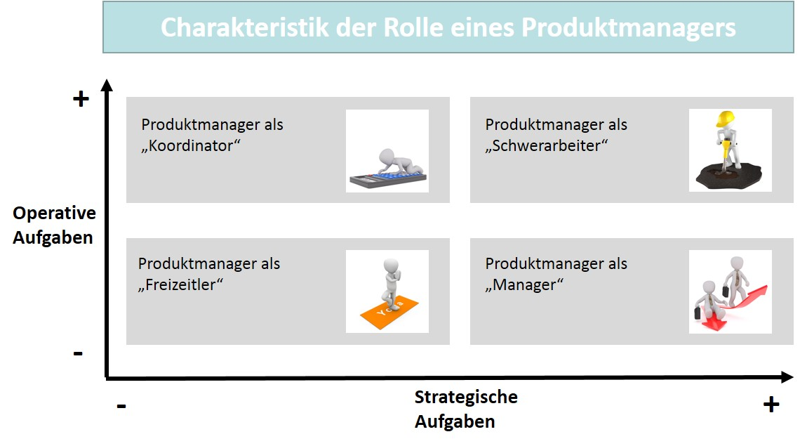

The four roles can be interpreted as follows (Aumayr, 2019, pp. 24–25):

* **Product manager as a *heavy worker*:** in this role description, the strategic and operative dimensions are equally high, since in addition to the strategic responsibility, product managers also must carry out the tasks of operative implementation in their area. Whether this dual role is sensible is questionable, since the likelihood that product managers will be overburdened between the two areas of responsibility is high. It is not uncommon for product managers to end up in this position when they are defenseless against the delegation of tasks and there is no understanding of this enormous burden by the management. However, this also shows that an intellectually and professionally mature personality can ensure a certain independence and indeed prevent the overburdening described.
* **Product manager as a *free time worker*:** special circumstances would need to exist in order for this role description with a low task load in both dimensions to even be possible in practice.
* **Product manager as a *coordinator*:** this role description is clearly located in the operational profile and the question arises as to whether the product manager function should denote the activity here at all. In job descriptions, we also find the terms *product coordinator*, *product management specialist,* or neutral descriptions such as *product management assistant*. If the strategic dimension within the role profile is underdeveloped, the responsibility for the results defined for the products on the market, e.g., revenue, contribution margin, or market share, naturally also has its limits. Depending on the operational focus, the role profile and thus the product management are then also categorized in an organizational structure.
* **Product manager as a *manager*:** here, we have the ideal formulation of the role of product manager when it comes to the importance assigned to the position due to its relevance to market success. First, they are strategically comprehensive and thus fully responsible for the results of their products or product groups. However, it should also follow here that their accomplishments are rewarded accordingly. With this categorization of the role within the organization, a company also gives due recognition its importance. In practice, this understanding of the role is becoming increasingly more prevalent in many sectors of the economy.

These explanations confirm that, based on the goals and tasks of product management, the role of product managers can also be described in terms of content on the basis of the strategic and operational dimensions. In order to be able to fill the role to the advantage of the entire organization, an equivalent competency profile must also be assigned to the role. It is only in this way that a recognition of the responsibility in this essential area of customer and competition-oriented market cultivation can be achieved.

### Competencies of Product Managers

Factors determining the content of the competencies that product managers should have result from the general conditions, as determined by the economic sector, the industry or branch of industry, as well as by the company itself and its product portfolio. Product managers also work more strongly in strategic or operational product management, and for both sub-areas, it is necessary for them to know their product and/or service very well and are able to develop an understanding of the value proposition that customers associate with their offering. This requires a thorough knowledge of the industry, which in combination with a business management profile provides a solid foundation. The industry essentially determines the market, and an understanding of the market structures and the actors or the acting companies naturally facilitates the selection of the instruments that product management can use for market cultivation. This is all the more important as a differentiated view of product management is directed toward the individual life cycle stages of products. In combination with an existing knowledge of methods, product managers can then use those instruments available in a coordinated **marketing mix** for each stage. Accordingly, the competency profile of product managers must also take the know-how that makes this market orientation possible into account. It is therefore not uncommon to find the term *product marketing* in job advertisements for product management.

**Marketing mix**

The coordination of different marketing measure to support a company’s strategies

and to approach the intended audience(s).

It is precisely the cooperation across departmental boundaries that makes product managers the communicative hub in an organization. In addition to specialist knowledge, they must also have general social and interdisciplinary competencies if they are to successfully use their communication and negotiation skills while cooperating with other stakeholders within the company, since it is particularly the different interests of the specialist departments involved that can jeopardize product success. Product managers must therefore also have empathy to be able to counteract interpersonal reservations. Alongside all this, they should be able to argue and convince objectively, as this prevents frictional losses in their interface management.

Products are often also an expression of a company’s ability to innovate. This presupposes that the people involved in product management also have an overall attitude that is open to innovation. In principle, critical companions who hesitate or express reservations are not undesirable as such, but as product managers they can have a rather unfavorable influence on the time dimension of marketability in intensive competition.

Due to globalization and the international division of labor, intercultural competencies and appropriate language skills have become commonplace in the documentation of competency profiles in management positions that work closely with the market. The special requirements that often exist in technical product management are also reflected in job advertisements, which then often mention industrial engineering or technical business administration training and degree courses as desirable qualifications. More recently, however, corresponding focuses in undergraduate programs or courses of study with curriculums that are completely tailored to the disciplines of product management have also been preparing students for work in product management. While focusing on the already established goals and perspectives of product management, the figure below summarizes the elements of the competency profile once again.

Kompetenzprofil der Produktmanager:innen

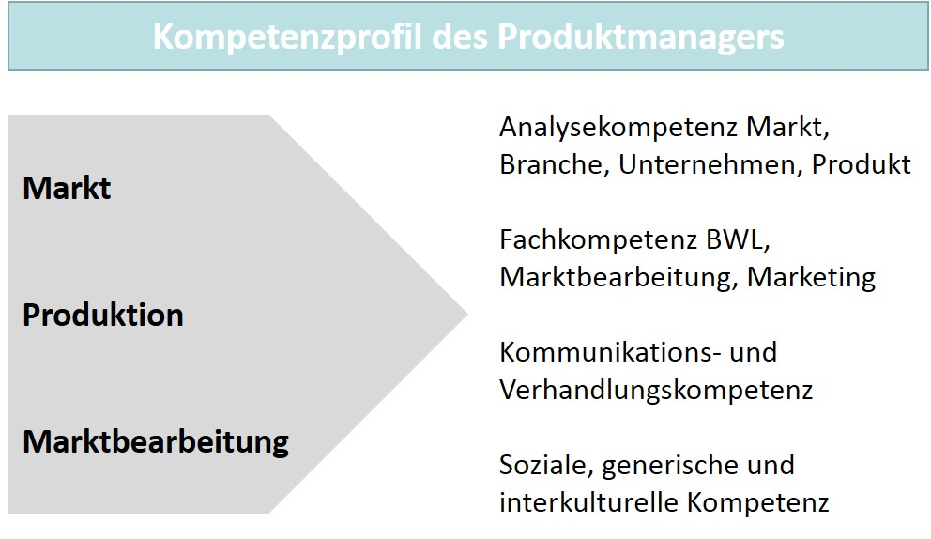

**Project organization**

An organizational form for the management and solution of unique tasks (projects) within a company.

### Product, Project and Functional Manager Comparison

There are also other management roles within a company that are highly valued. For example, the increase in **project organization** has led to the role of project managers becoming very important within companies. The challenges posed to companies by competition, including the ability to react, are increasingly leading to the implementation of projects for the execution and solution of unique tasks, and **project managers** are responsible for the planning, coordination, and control of these projects. In terms of content, entirely different problems can be addressed, which distinguishes this organization from product management. Thus, project managers are first and foremost methodological specialists for the management of projects and do not necessarily belong to specific disciplines in terms of content.

**Functional managers**

The managers in operational functional areas (departments) who plan, coordinate, and control the execution of functions.

**Project manager**

The person responsible for the planning, coordination, and controlling of projects.

The situation is similar with the management of the functions that are needed along the product life cycle in order to implement product development all the way to marketing. **Functional managers** working in this area are explicitly identified as experts in their field and their roles are defined in such a way that they are able to optimally control the technical solution of tasks as experts in specific disciplines. This also differs from product managers, who are responsible for controlling and guiding the future of products and services on an interdisciplinary basis, i.e., across a variety of specialist disciplines.

However, the interface function of product management means that product and functional management must cooperate closely together within the company. This is also made clear by the fact that the functional organization, as an expression of the division of labor in a company along the value chain, is overlapped by the product management organization. This gives rise to a separate organizational form for product management, also known as a **matrix organization.**

Matrixorganization im Produktmanagement

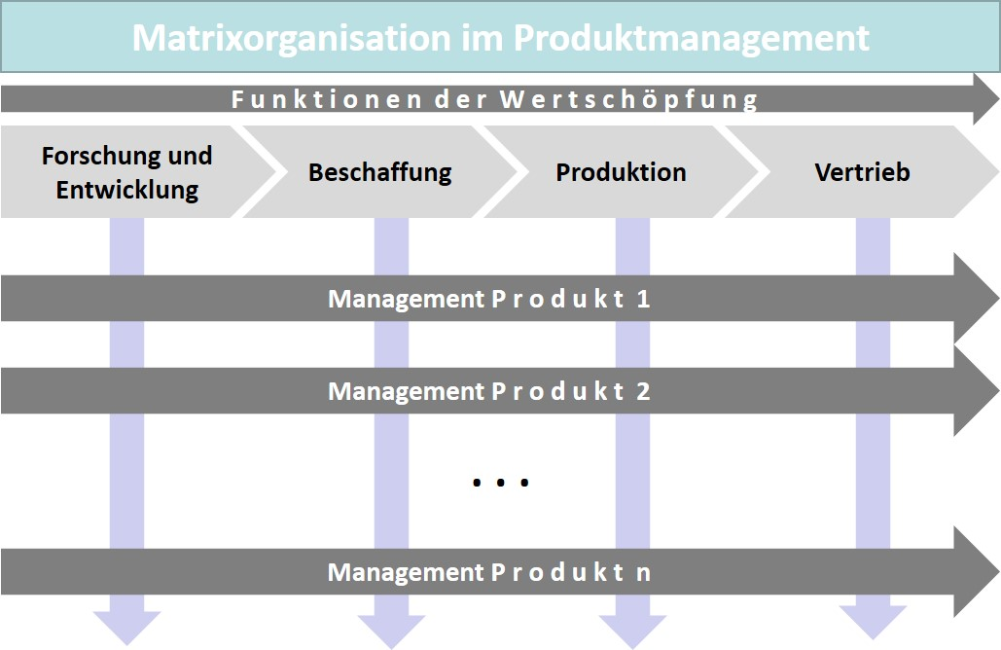

**Matrix organization**

An organizational structure in which the organization arranged according to functions and the organization arranged according to products overlap.

The figure also clearly shows how product mangers and functional managers differ in the understanding of their roles. While functional managers are function specialists who have the corresponding knowledge in their specialist and task area, product managers combine knowledge of their product with knowledge of the target market identified for it. The focus is now likely to be on the second component (market), which is certainly more in line with the intensification of competition and market orientation (Aumayr, 2019, pp. 3–4).

Reference to the particularities of digital transformation has already been made in several instances. In the context of the tasks and role description of product managers, this naturally means that the challenges of digitalization are becoming increasingly significant. This equally applies to the competency profile, for which modern training and study courses related to product management also teach the fundamentals of digitalization and the resulting change management.

### Self-Check Questions

1. Which role does market communication play for product managers? Mark the correct answers.

* Product managers must ensure that the characteristic elements of their product also generate attention within the market. To do this, they must design market communication so that the relevant competitors and rivals are reached and made aware of the benefits of the products. (I)
* Product managers must ensure that the characteristic elements of a product also generate attention within the market. To do this, they must design market communication so that the relevant intended audiences are reached and made aware of the benefits of the products. (C)
* Product managers do not have tasks related to market communication, since this is exclusively related to the function of advertising. (I)
* Product managers support research and development in marketing activities. (I)

1. Which applies to the matrix organization? Mark the correct answers.

* The organization arranged according to product and the organization arranged according product group overlap. (I)
* The organization arranged according to function and the organization arranged according product overlap. (C)
* It is an organization exclusively arranged according to products. (I)
* It is an organization exclusively arranged according to function. (I)

## 1.3 Product Management Positioning within a Company

### General Conditions for Positioning

In connection with an understanding of the role of product managers, the problems that can arise with regard to an incorrect positioning of this task within a company have been clarified. The double burden of assigning too many strategic and operational activities at the same time is a good example of this. This also applies, and even more so, if product management as a whole is not clearly integrated within a company and too much latitude for description in terms of content is allowed. There is then a danger that all tasks fall to product management that are unpopular elsewhere or whose corporate policy dimension makes caution more advisable. The distinction between strategic and operational design is already difficult because the differences between the two timeframes, day-to-day business versus medium/long-term design, can overwhelm management. Actionism and improvisation are then often the organizational means, since an orderly hierarchy of priorities is lacking. In particular, strategic ambiguity can subsequently generate such a level of turmoil that the overall market success of products is jeopardized.

In our understanding, product management is a professional switch point as well as a communicative hub between different service departments whose contributions accompany the entire product life cycle from market analysis through to product and service development and over to offering streamlining. The main task of product management is to harmonize the different interests of the process participants and stakeholders and of course, the customers and users, and represent them in the requirements for product and services in a way that is equally suitable for production and marketing. This task has strategic and operational components that must be considered in the way it is managed. The effectiveness achieved here represents the quality of the organizational anchoring of the product management discipline within a company. Therefore, all decisions within organizational development that provide this anchor with stability must be seen as fundamental decisions. The result of a decision then also determines the orientation, as already indicated in the role description, as well as the requirements profile for product managers.

### Operational and Strategic Product Management

Strategic product management aims at the long-term success of a company’s offerings. It must therefore be closely aligned with the strategic attitude of an offering company, so that its uniqueness also leads to a competitive clout.

**Strategy in product management examples**

If, for example, a company is in an intense price competition because the (low) price is the competitive edge in its market environment, it would not be sensible to position itself among premium products. This would therefore be strategically incorrect and drop out of the competition. Conversely, this also applies to a competition characterized by a demand for premium products. Here, offering products that are inferior from the customer’s point of view would also miss the mark, even if an attractive price in this situation might falsely suggest a competitive advantage.

Strategic decisions for a company and, derived from this, for product management therefore tend to relate to long-term determinations that fundamentally have the competitive dimensions in mind.

In contrast, operational product management is driven more by day-to-day business and supports the functional activities necessary for smooth production and market cultivation. Accordingly, is not decoupled from the strategic foundation but rather quite clearly anchored in it. The operational determinations for the process-organizational needs thus follow a company’s strategic principles of its product policy. Which content elements in product management are associated with a high or low resource usage is accordingly determined by the character of a company’s competitive positioning.

Produktmanagement und Strategie

Ein Bild, das Text enthält.

As in other management disciplines, however, the distinction between operational and strategic tasks in product management is not always clear. Thus, even product managers with a more strategic focus also have operational components in their activities, and their strategic view also applies to the day-to-day management tasks as a kind of organizational framework.

The figure below shows the focus of the operational involvement of product managers during a product launch, since it generally makes sense here to provide operational support to the functional units involved. For example, the sales activities for new products must be accompanied in an advisory manner, since the product knowledge may not yet be widely distributed. Despite training, the sales organization may not always be able to argue the key benefits of the new offering that may be significant in the competitive environment. Sales support in product management can then mainly relate to the following operational activities (Aumayr, 2019, pp. 26–27):

* Advisory support for customer contact.
* Coaching for the sales organization (online, offline).
* Presentation of reference examples to important customers.
* Ad-hoc sales training as needed.

Operatives Produktmanagement

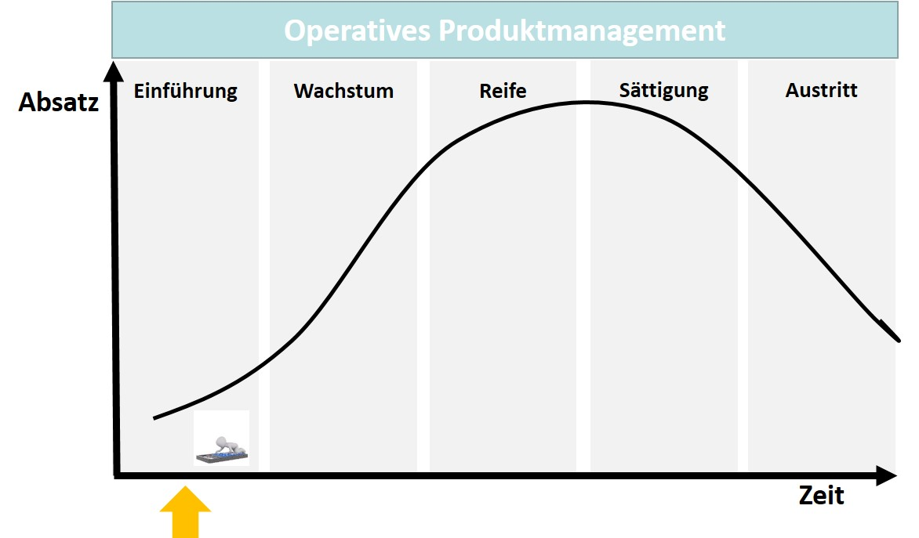

**Secondary organization**

A supplement to primary organizational structures with overarching organizational units in order to solve specific problems.

### Product Management as a Secondary Organization

In connection with product managers and their role in the organization, product management has been explained in terms of organizational structure and by way of example. The matrix organization presented here means that product management as a horizontally controlled **secondary organization** is added to the essentially function-oriented and vertically controlled **primary organization.** However, this perhaps ideal-typical organization of product management, which is attached to the management directly parallel to other functional areas, does not necessarily need to exist in practice. The (secondary) assignment can also take place selectively, i.e., as a supplement to already existing functional areas or departments.

For example, product management could be assigned to the marketing/sales area, which could have the advantages that …

* … the interface with the customers is developed,

**Primary organization**

The hierarchical vertically oriented basic structure of an organization consisting of positions and departments.

* the sales arguments are transparent, and
* the market and product knowledge is extensive and available (Aumayr, 2019, p. 84).

However, the disadvantages here could be that …

* … the strategic focus falls short,
* the sales pressure to succeed prevails,
* solutions that are too specific to the customer are favored,
* the existing customers or corporate consumers are favored over the new customers, and
* the market launch has absolute preference.

Some of the disadvantages mentioned above could be avoided by assigning them to technical/logistical areas, since here:

* ... the development work is kept in view and
* product knowledge can be built that includes the development and sales areas (Aumayr, 2019, p. 86).

However, disadvantages also exist here if …

* … the knowledge regarding the needs of the customers and the market is lacking,
* the solutions follow technical feasibility too closely,
* the products therefore exclusively consider technical concerns, and
* individual solutions obscure the view of simple, and thus uniform, concepts.

It is clear that a large number of determining factors must be examined when anchoring product management within the organization. Nevertheless, not all conceivable variants can lead to the same success. The clear assignment on the basis of a coordination of the functional contributions and an orientation toward the life cycle makes a holistic view appear as ideal. The matrix organization is not incorrect in this respect. To what extent other forms are more suitable must be clarified by an analysis of the specific general conditions. In any event, it is not sensible to have an organizational form that ignores factual motives and only focuses on the protection of established corporate forces. Then the hurdles to market success are not raised by the competition, but rather by the company’s own organizational mistakes.

### Self-Check Questions

1. Why is it important to structure the strategic and operational elements of product management in a sensible way?

The distinction between strategic and operational arrangement in product management is not easy, since the differences between day-to-day business and medium/long-term design are not always clear to management. Actionism and improvisation could spread if an orderly process hierarchy is lacking. In particular, strategic ambiguity can subsequently generate such a level of turmoil that the overall market success of products is jeopardized.

Summary

The view of a company and thus its image are connected to the assessment of its benefits and its products. This underlines the importance of a management of these benefits and products that concerns itself with the monitoring and coordination of a product throughout its entire life cycle.

The connection between product and brand makes it clear that customers can base their selection process for a purchase on various criteria, which in turn correspond to the characteristics of products and services on offer. Products can also be ranked according to these characteristics and criteria as well as the selection process. A common categorization is based on the effort required for purchase (convenience goods), on information and market transparency (shopping goods), and on the attractiveness of the product category (speciality goods). This becomes more difficult when it comes to business customers or corporate consumers, since in the business-to-business sector, other decision-making situations and other financial scales typically exist, which is why investment decisions are also mentioned in this context. A decisive role is played in this field by companies’ buying behavior, which differs from that of normal consumers because corporate purchasing is organizationally institutionalized In addition, product management also acts differently in differently organized companies (start-up, SME, corporation), since each organizational form and each stage in which companies find themselves each have specific requirements.

Product management comprises the subtasks of analysis, conceptual planning, implementation/coordination, and optimization, with which we can also associate with the role of product managers. They are responsible for the planning, coordination, market cultivation, and the related controlling of the products and services they are in charge of. In doing so, they must handle an enormous variety of tasks and also take strategic and operational concerns into consideration. Factors determining the content of the competencies that product managers should have result from the general conditions as they are determined by the economic sector, the industry or the branch of industry, as well as by the company itself and its product portfolio.

In addition to specialist knowledge, product managers must also have general social and interdisciplinary competencies if they want to successfully use their communication and negotiation skills while cooperating with other stakeholders within the company. However, their interface function means that product and functional management must cooperate closely together within the company. The main task of product management is to harmonize the different interests of the process participants and stakeholders and to represent them in the requirements for product and services in a way that is equally suitable for production and marketing.

Strategic product management aims at the long-term success of a company’s offerings. It must therefore be closely aligned with a company’s basic strategic attitude so that uniqueness also leads to a competitive clout. Operational product management is more focused on the day-to-day and supports the functional activities necessary for smooth production and market cultivation. A proven organizational form for product management is the matrix organization. The extent to which other forms are more suitable must be clarified through an analysis of specific conditions.

# Unit 2—Market and Company Analyses

Study Goals

On completion of this unit, you will be able to ...

... describe the content focus and the implementation of market analyses.

... explain the content focus and the implementation of company analyses.

... show the content focus and the implementation of integrated analysis methods.

... describe the content focus and the implementation of business model analyses.

# 2. Market and Company Analyses

### Introduction

Operational decisions in connection with market cultivation must be based on a foundation that allows a realistic assessment of the existing market situation and future developments. The importance of product strategy decisions for the competitiveness of companies requires an exact determination of the position with regard to expectations within the market, the structure of corporate consumers, and competitive behavior. It is also necessary to analyze one’s own strengths and weaknesses if the work in product management is to contribute to a lasting competitive advantage. Market and company analysis are therefore part of the necessary substructure for the decisions to be made by product management during the product life cycle and with regard to a fundamental market-oriented focus. The following underlying questions therefore arise for the design and methodology of market, company, and business model analyses:

* What are the market analyses focuses and how can we carry them out with methodological support?
* What are the company analyses focuses and how can we carry them out with methodological support?
* How can we use integrated methods for market and company analysis and methods for business model analysis?

## 2.1 Market Analysis Methods

### Market Analysis to Determine the Company Position

Even in our daily dealings with decisions that affect our family situation or the situation in our job or studies, as much as possible we want to make our determination in such a way that we can be sure that we have sufficiently considered the significant influences on our decisions and their consequences. Data and information are typically necessary to succeed in this. It is not uncommon for us to need to obtain this information first, since not all decision-making situations are so clear to us that we can simply rely on our existing knowledge.

This equally applies to companies that need to determine their market position with the help of data and information in order to make decisions regarding their range of products and services. In order to obtain the correct answers to their analysis questions, they naturally need to know the goals they are pursuing with their decisions. This is because they want as reliable an information base as possible that shows them past developments and also allows them to “look into the future”. Such views of the future are called **forecasts.** In product management, the analyses typically refer to ...

**Forecasts**

The predictions regarding future developments in a particular decision field (e.g., sales market).

* ... the intended audience, i.e., the customers and their needs,
* the competing companies, i.e., so likewise offering companies, and
* general conditions and factors that also have an influence on the market activities.

Market analyses can be a one-time event if there is a specific reason to make market events transparent for a company’s own interests. However, companies that continuously scrutinize their competitive position, i.e., that also regularly collect information, will always have an eye on the factors that are important to them and can also react to developments within the market at short notice. Given the intensity of competition that is observed in many sectors today, continuous market analysis is likely to become a standard set of tools for companies. In the context of big data and data science, the rapid processing of large volumes of data is no longer a technical issue, but the high quality of the analysis results is not yet commonplace, particularly in the case of complicated contexts.

### Market Analysis as a Decision Basis in Product Management

Strategic decisions in management cannot do without analyses. A critical and future-oriented analysis reveals the strengths, weaknesses, opportunities, and threats of companies. It is clear that a company and an environmental analysis must be the basis for this, since the internal and external perspectives must be considered. The internal analysis addresses the strengths, weaknesses, resources and competencies, while the external analysis addresses the environment in which the company operates (Großklaus, 2014, p. 35).

Particularly in product management, resilient and reliable information about customers or corporate consumers and competitors is crucial to a customer and competition-oriented approach to market cultivation. The relevance of this market orientation and the risk of failure justify “the proactive, timely, and thorough collection of internal and external information” for risk reduction and allow for the “informed making of decisions” in product management possible in the first place (Herrmann & Huber, 2013, p. 35). In this way, an information basis is created for a process that extends from the determination of goals through to the planning of specific measures and their control. This can be supplemented by a self-assessment regarding the opportunities and risks of one’s own resources so that the market cultivation potentials are recognizable (Herrmann & Huber, 2013, p. 35). The figure below illustrates the orientation of the market analysis on the two pillars of market orientation: customers and competition.

Produktmanagement und Marktanalyse

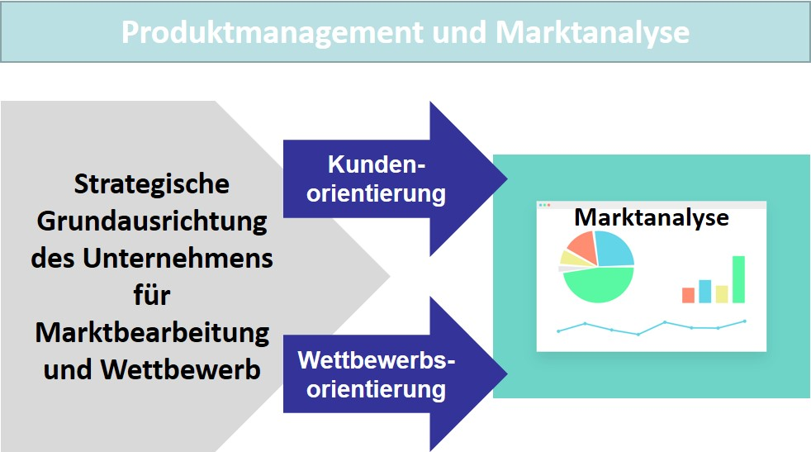

Accordingly, a modern understanding of market orientation also leads to customer and competition-oriented product management and to the most accurate possible alignment of measures to the market, which also accounts for the significance of target market factors for sales success. Today’s competition leaves very few alternatives, since the speed and effect of measures ensure that existing market opportunities can be converted into a company’s success better or even earlier. This also means that after an initial market analysis, ongoing market monitoring must also be carried out to ensure that a company’s own level of knowledge remains up to date. This procedural **market research** is thus also a prerequisite for an accurate positioning of the company and the other actors or operating companies in its competitive environment (internal and external view) as well as to the prevailing general conditions (Herrmann & Huber, 2013, pp. 35–36). Market research can rely on its own data collection and/or use and evaluate already existing data and information sources. In both cases, specific methods are used depending on the research objective.

**Market research**

The methodically supported collection, analysis, and interpretation of information regarding market activities.

When it is then a matter of examining the market specifically for the purpose of determining a position with regard to product strategy decisions, various research methods have proved their worth and are explained below.

#### Analysis of the environment

Various criteria can be selected to describe the environment or surroundings of a company. Criteria that are indicators of change are of particular interest and this is particularly relevant for companies in their market cultivation, since factors that also affect their own market position can be derived from them. Significant changes result from (Herrmann & Huber, 2013, p. 49) ...

* ... **social developments**, such as those currently evident in connection with climate change or the international division of labor,
* **macroeconomic developments**, such as demographic change with an increasing importance of aged consumer groups,
* **political developments**, such as the regulation of certain markets (energy sector, health),
* **legal/statutory requirements**, such as those applicable to advertising or for contractual regulations (termination of subscription contracts),
* **technological developments**, such as new standards relating to digitalization (networks, protocols).

A similar strategic orientation is provided by the PESTEL framework, whose six analysis areas (political, economic, social, technological, environmental, legal) are derived from the global environment. The aim here is to identify the indicators/factors that have a greater influence on the success of an overall strategic orientation. The global environment and factors that are also independent of a particular industry are in the forefront as analysis variables that cannot be influenced or can hardly be influenced (Reisinger et al. , 2017, p. 59).

PESTEL-Framework

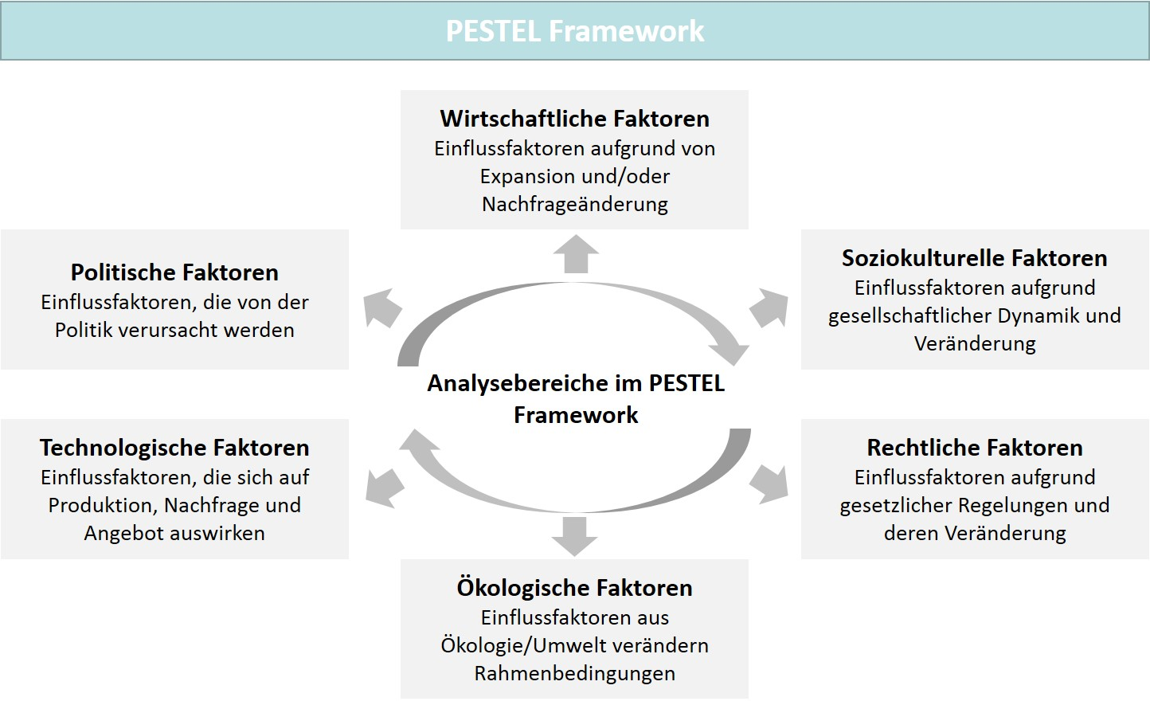

**Strategic foresight**

The monitoring of developments in the business environment on the basis of relevant indicators.

If companies wish to take these developments into consideration, of course they must have the knowledge at an early stage so they can still influence the effects and consequences in the form of opportunities and risks that they see for their own actions. One method suitable for this is **strategic foresight.**

The underlying principle of this method is based on signals that can be indicators of specific developments and can be recognized within a company. Strategic foresight helps companies build up knowledge about socio-economic and technological developments in order to better understand the future and long-term prospects. A company’s goal is to identify development lines and trends in the needs of customers and intended audiences at an early stage and take these into account in its strategic orientation. In addition, a company will also use methods and instruments to systematically identify trends (Müller-Stewens & Müller, 2009, pp. 239–240). If signals are identified in this form, further investigations can follow in order to describe the suspected trends in greater detail.

The indicators, which are then used as signal generators, typically originate from companies’ internal or external information space. These indicators can be taken from the functional areas or refer to overall key figures. An example here is statistics from sales/field sales or from production/manufacturing. Key external indicators can be generated from statistics that relate to macroeconomic observations or global reporting, such as annual economic reports, industry statistics, or United Nations publications. With regard to project management, the indicators …

* … product age structure,
* product range breadth,
* product range structure (revenue drivers, innovations), and
* problem products (competitive weakness, end of technology cycle) ...

... can be significant to a company as a whole. Area-related indicators with the same goals can originate from ...

* ... research and development (number of patents, development costs), or
* from the sales area (revenues, inventories, prices) (Herrmann & Huber, 2013, pp. 50–51).

The quality of the analysis of strategic foresight depends on the informative value of the investigation carried out. If the indicators primarily refer to general facts, the derived measures and their effectiveness can only promote a specific goal to a limited extent.

Another method of analysis involves obtaining insight by means of interviewing experts and their own summary analysis. The usefulness of this technique, which is referred to as the **Delphi method**, is more of a heuristic character, since in addition to the real information content, the opinion obtained is also decisive. The experts who are to be interviewed are questioned individually and in writing about a problem context in several rounds, whereby a subsequent round begins with the experts being informed of the results of the previous round (see figure below). This leads to the different expert opinions on the probability of occurrence of specific future events being confronted with one another. Over the course of several runs, a gradual convergence of the expert statements can lead to a focusing of the assessments, since the opinions formulated and exchanged also make the experts’ views more distinct. This does not necessarily lead to a harmonious overall result, but can also generate poles of opinion that then oppose each other. Users of this method assume that experts in a particular field of knowledge are better able to assess future developments and that a set of qualified opinions in a multi-stage process of exchange leads to an even more reliable result. Nevertheless, it must also be critically noted that consensus-building is not necessarily accompanied by an equally weighted reasoning of different opinions. A consensus can also be reached when experts join a majority opinion or an opinion leader (Maier, 2018).

**Delphi method**

Analysis technique in which experts are interviewed and the information and opinions obtained are evaluated.

Delphi-Methode zur Umfeldanalyse

Ein Bild, das Tisch enthält.

A major advantage of the Delphi method is the probable high quality of the forecasts derived, since experts in the thematized problem area are interviewed and the company thus receives results on the basis of which more precise measures can be planned. In addition to the criticism of the disadvantages of collective consensus-building already formulated, it should also be noted that radical—and thus potentially very innovative—positions of experts may be lost in this process or fail due to the pressure to reach a consensus, but in terms of their value, they may well express a market-relevant opinion that is then not taken into account (Herrmann & Huber, 2013, pp. 52–53).

**Scenario analysis**

Description of alternative (future) states in order to derive recommendations for action for a problem under investigation.

With **scenario analysis,** there is a method of analysis that creates alternative visions of the future based on possible developments, which are evaluated and integrated into the considerations for determining recommendations for action. The dynamics of changes in a company’s environment lead to the presentation of several alternative development options, since clear paths cannot be identified due to uncertainties. The time horizon of such forecasts is five or more years, but it can be more than ten years in certain industries. The figure below shows what is known as a **scenario funnel** as it is typically developed in this method. The uncertainty increases over time, which in turn increases the number of possible alternatives and the range of future scenarios. This leads to the funnel-shaped representation with the edges as the two opposing extreme scenarios (E1, E2) and the trend scenario (T) in between, which depicts a continuity of the current development. Disturbances, e.g., in the form of crises, influence the trend and deflect it in a different direction. The corrective measures that are then undertaken are intended to compensate for this diversion and lead the development back into a desired and promising trajectory, and thus to an acceptable scenario (T1) for a company (Reisinger et al. , 2017, p. 91).

**Scenario funnel** Typical representation of three basic scenario types representing the complexity and uncertainty

of future developments.

Szenariotrichter und -analyse

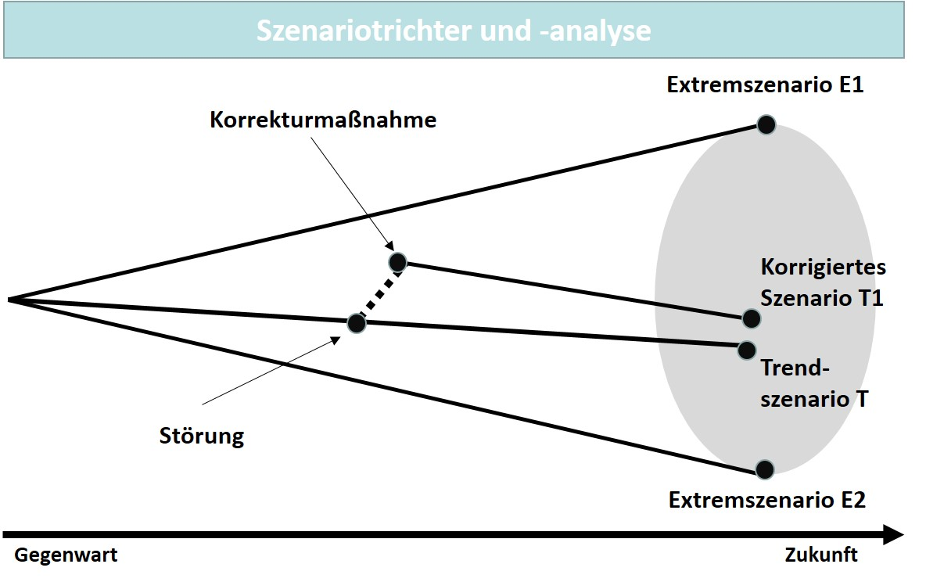

**Procedure Scenario Analysis**

At the beginning of the consideration, the field of investigation is clearly distinguished from other fields. Then the influencing factors relevant to the object of investigation are identified and structured. It is important here that all areas of influence are considered, and without forming subjective focuses. Each structured area of influence is then assigned suitable factors, which can be determined by research in databases or by brainstorming. The list of factors is then methodically reduced to a manageable number of factors for which a major influence on the field of investigation can be stated. Then possible future states for these factors can be determined, which requires creativity and imagination, as well as specialist knowledge. This then results in future projections and/or alternative state options and in turn, alternative and consistent option bundles that can be checked for contradictions and, if necessary, methodically adjusted. Now there is a coherent basis for the development of the future scenarios. In general, only a few of these scenarios are concretely formulated in order to keep the complexity and information density manageable. The next step is to identify the disturbances (events) that could have a largely favorable or unfavorable effect on the scenarios described. Their effect is integrated into the future scenarios, which also makes it possible to describe the consequences for a company’s development.

Management now has a foundation for decision-making and is sensitized to potential turmoil in the future. Consequently, great care is needed in the application of the method, so qualitatively deficient preliminary work does not lead to incorrect conclusions and perhaps even to strategic mistakes. By considering several scenarios, this method is useful for companies whose environment is subject to more radical change. Scenario analyses allow the derivation of target strategies that fit the identified scenarios and can not only consider a final state, but also the development from the present into the future (Herrmann & Huber, 2013, pp. 53–55).

#### Market analysis with the use of methods

In addition to the environment, the market plays a key role in a company in the narrower sense, since here it is primarily a matter of the competitive situation and intensity, as well as questions with regard to ...

* ... identification of the relevant competing companies, which not only include those already known, but also those that will be active on the market in the future,
* analysis of the potential for market growth,
* transparency of barriers to market entry or exit,
* investigation of the suppliers and retail companies situation, and
* determining the market position of individual products (Herrmann & Huber, 2013, p. 57).

**Industry analysis** Method of analyzing factors that determine market activity within an industry.

A traditional method of market analysis is the **industry analysis** according to Porter, which focuses on the influencing factors that only affect companies in a specific industry (Porter, 1985). An industry is defined as the group of companies that can substitute each other from a customer’s view. The competitive situation in an industry decisively determines the strategic situation of an individual company. And in contrast here to the global environment, it can exert more influence. Therefore, the distinction of an industry is of great importance. As early as the 1980s, Michael Porter positioned the observation of an industry’s structure at the center of strategic planning considerations as a major factor influencing the success of a company. In his opinion, the success of a company is essentially determined by its industry attractiveness. As in the figure below, he sees the competitive forces as ...

* ... the market entry activities of new competing companies,
* the threat of substitution through substitute products,
* the bargaining power of corporate consumers,
* the bargaining power of suppliers, and
* rivalry among existing competing companies (Herrmann & Huber, 2013, p. 58).

Kraftfelder im Branchenwettbewerb nach Porter

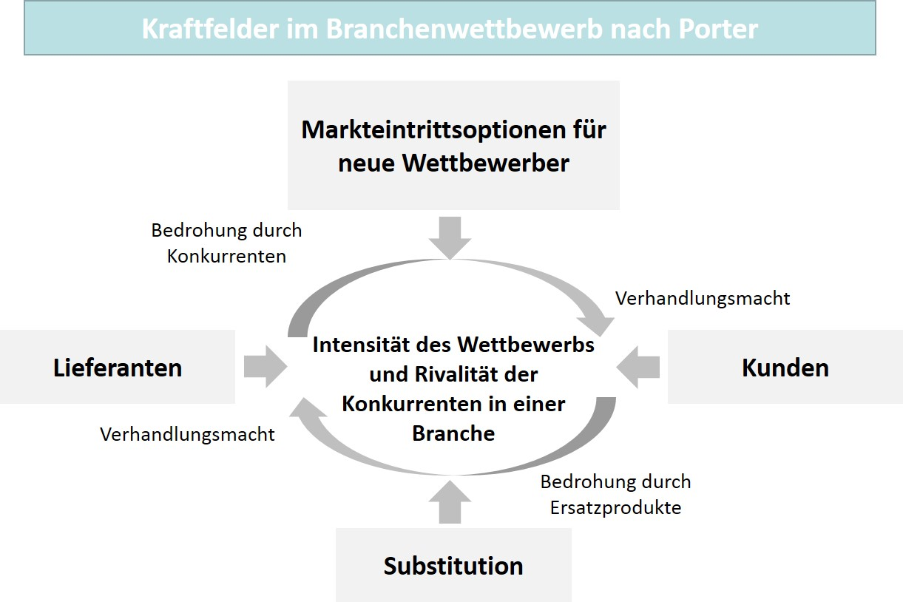

These five forces therefore have a significant influence on companies’ market cultivation, since the influences originating from them must be considered in market cultivation, which the explanations below demonstrate with specific examples (Herrmann & Huber, 2013, pp. 58–59).

Industry newcomers can often enter an interesting industry with new capacities and with financial strength. Their financial advantage can lead to downward pressure on prices, thereby reducing the profits of rival companies. This threat depends on whether there are barriers that can prevent the competing company from entering the industry. Protection is offered, e.g., by advantages due to **economies of scale** thatlead to a reduction in unit costs in the case of large manufacturing volumes, which newly offering firms cannot initially achieve in this way. Product differentiation, in the form of branding and additional services, for example, is also useful, since offsetting these can at least mean high investment for the new company in competition. Offsetting in the form of a cheaper offering could also make market entry unattractive. Further barriers can be built up in the form of ...

**Economies of scale**

The competitive advantages through cost distribution across a very large output volume.

* ... switching costs (investments made by customers when changing suppliers),
* blocking of sales channels (e.g., exclusion from online commerce),
* specific cost advantages (patents, access to raw materials, location advantage),
* government restrictions (certifications, licenses, industry rules), and/or
* retaliation (price cuts, increased marketing).

Customers or corporate consumers in an industry can also have a negative effect on profitability if they use their market power to reduce prices or demand more benefit for the same prices. Their influence is particularly strong when ...

* ... they are concentrated or account for a share of sales that is critical to a company’s survival,
* the products to be purchased have a high cost element,
* they are standard or not highly differentiated products, making it easier to switch suppliers,
* the customers or the corporate consumers could also produce the products themselves (example: private label instead of manufacturer’s brand),
* the product quality is not significant, and/or
* the customers or the corporate consumers know the supplier’s costs.

For their part, the supplying companies can negatively influence industry profits through price and/or quality changes. They then have a strong negotiating position if ...

* ... the industry of the supplying companies is more concentrated,
* the corporate consumers are not highly relevant to the supplying companies,
* the supplier product is competitively relevant for the corporate consumers,
* the supplying companies’ products are differentiated, or are not easily substituted, and/or
* the supplying companies may threaten to enter the corporate consumer (buyer) market.

The model presented with the five forces has the advantage that, in addition to a description of the status quo, it also allows a view in the direction of potential developments. However, a disadvantage here is that a company’s relationships in the different directions are always interpreted as threat scenarios and an option for cooperation is not considered (Herrmann & Huber, 2013, p. 60).

With the **value net**, the perspective of cooperation is given greater consideration. The model represents an extension of Porter’s five forces analysis by combining competition and cooperation. The combination of these two terms is referred to as *coopetition*. It involves the following four actors: Customers/corporate consumers, suppliers, competitors, and complementary companies, which can also offer a benefit to a company through cooperation. An example of this is the joint activities of competing companies in automobile production, e.g., in engine development or battery production in connection with the production of electrically powered vehicles. Companies can also cooperate with customers and consuming or supplying companies. An example within the scope of value creation is when access to shared data from production leads to an optimization of the flow of goods through lower storage costs. Complementary companies can also add services to an offering, which can increase the attractiveness of companies offering consumer goods. For example, insurance services to cover possible damage when consumers use technical devices for a specific period of time are common (Herrmann & Huber, 2013, pp. 61–62).

**Value net**

The competitive advantages through cooperation with other competitors.

When it comes to the products offered in a market, the life cycle and thus also a **life cycle analysis** play a key role. They are based on the principle that products (product life cycle) or markets (market life cycle) pass through specific temporal stages that differ in terms of sales and profit potential. If these stages are analyzed, conclusions can be drawn about the market situation and recommendations for action can be generated for market cultivation measures. The life cycle consists of …

**Life cycle analysis**

A method of analysis that examines the temporal stages of the existence of markets and/or products.

* … the launch or emergent stage,
* the growth stage,
* the maturity stage,
* the saturation stage, and
* the decline or negative growth stage (Herrmann & Huber, 2013, pp. 63–64).

The launch stage begins with the introduction of the product and is characterized by initially low sales and revenue. In addition to the development costs, there are investments for sales and advertising, for example, which generally lead to losses. In the growth stage, revenue will cover or exceed costs and profits will be generated. The product reaches the broad mass of its demanders, but then more competing companies appear, which leads to price pressure. In the maturity stage, sales reach their maximum, the product is known within the market, and there is less expenditure on advertising. However, the growth gradually slows down noticeably as the demanders have become more price sensitive. In order to remain attractive in competition, the offering companies must take more product policy measures. The maturity stage is followed by the saturation stage, in which sales also reach their maximum. Growth is no longer achievable and demand can hardly be increased, even with price reductions. During this stage, product policy measures must be intensified in order to keep the product on the market. If, however, an extension of the lifetime is no longer possible or if the measures do not work, the decline stage follows. This is when sales and revenue continue to decrease and the income hardly justifies product policy measures. The offering companies are then called upon to strategically reorient themselves (Herrmann & Huber, 2013, pp. 64–65).

Even if the life cycle model is viewed critically as an ideal-typical form of progression, important insight can arise from it, since the stage orientation will always call for the market presence of products to be questioned repeatedly and likewise in connection with the time dimension. It is then essential to recognize the important signals which, for example, can give indications of a stage change. This is the only way to address product policy requirements in good time and implement operational measures. In an intensely competitive environment, carelessness can lead to the product drifting into the decline stage more quickly than expected and the income expectation being disappointed to the detriment of the company as a whole.

This once again documents the importance of market and environmental analyses as the foundation of product policy decision-making and operational implementation in product management. Only through this can companies initially find a firm strategic footing that can support their own strengths and compensate for their weaknesses.

### Self-Check Questions

1. Which statements with regard to Porter’s competitive forces are correct? Mark the correct answers.

* Market entry activities of new competing companies are not problematic for the firm. (I)
* Substitute products pose a risk of substitution. (C)
* Supply companies are always in a weak bargaining position. (I)
* Customers can use their negotiating power against supplying companies. (C)

## 2.2 Methods for Company Analysis

The market and the general conditions under which the market plays out are the areas of influence that shape a company when it comes to its market cultivation, which primarily focuses on the range of products and services. In addition, the company must also consider the internal view, i.e., the features that it can present as strengths to potential customers or corporate consumers companies, or that it must improve as identified weaknesses of its organization. It is easily forgotten that this must also be an object of analysis, since companies are all too often so convinced of their strengths that they do not question anything else in this direction. Also not infrequently, there is a fear of comparison with competing companies, since there are concerns that this could result in a need for action that cannot always be communicated in a positive way. Successes are easier to communicate within the company; competitive disadvantages, on the other hand, often raise questions about responsibility and are therefore not so easy to place in the focus of strategic discussions. Nevertheless, a market-oriented company must understand this topic as a self-evident task, so that ignorance alone does not become a decisive competitive disadvantage. The methods explained below represent a set of tools that can be used to answer the important questions of companies’ analytical consideration on a factual basis.

For example, **gap analysis** provides important insight into the future trajectory of specific dimensions of companies’ business development. The trajectories to be examined can be based on various assumptions in order to arrive at a bundle of options. The gap in goal achievement identified in this process for a specific indicator, e.g., revenue, must be interpreted and translated into instruction with suggestions for suitable measures to close the gap. This way of presenting development trajectories is similar to the scenario technique; the graphic visualization can also be presented in a comparable way (Herrmann & Huber, 2013, p. 66).

**Gap analysis**

A method of analysis that examines the future development of business on the basis of various assumptions.

Gap-Analyse

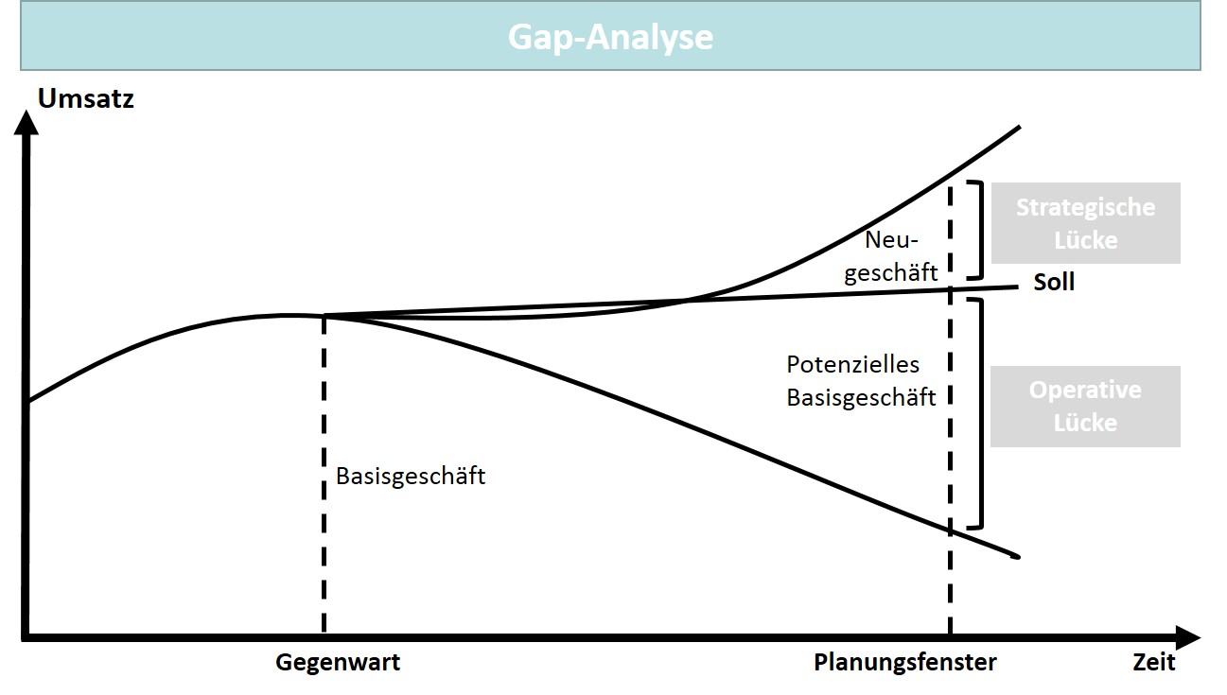

The overall gap can be divided into an operational and a strategic gap. The target line is the development line of the business that will be reached if the existing potentials are optimally utilized. The upper line represents the difference in the form of the strategic gap, which also includes the potential increases to be expected in the future. Accordingly, the object of action must initially be the operational gap, since its upper limit (target line) is actually achievable if the company makes optimal use of its potential, which should take the form of product policy measures. To close the strategic gap, strategically supported measures that must go beyond those planned for the core business are also necessary. An example of a strategic measure would be business expansion by exporting to other countries. However, it should then be considered that a company thereby also enters into new risks, which must be additionally assessed in an analytical consideration. An essential advantage of the gap analysis is the fact that companies must specify and quantify their objectives. It must be viewed critically that …

* ... the performance indicators are derived from past values, whose development course will not necessarily continue,
* the strengths and weaknesses of a company are hardly considered as sources for gap filling or formation,
* the defensive strategies (disinvestment and withdrawal) are not considered, and
* the competitive situation is not explicitly considered (Herrmann & Huber, 2013, pp. 67–68).

A further method in the strategic view of companies is the **core competence analysis.** A company has a core competence if it has the long-term ability to form competitive advantages within the market on the basis of this competence. These particular capabilities necessarily involve resources and/or other conditions that are not readily available to competing companies. Beyond the application of methods, the focus on core competencies also represents a certain philosophy of growth. According to this philosophy, companies particularly grow when they expand their business by using existing core competencies. Conversely, it is considered detrimental when companies seek growth in areas that are new to them even though they do not possess usable core competencies in these areas. This type of growth leads to a situation where large companies—particularly corporate groups—also reveal their core competencies in their corporate structure. They also take over competing companies, e.g., to further consolidate their competitive advantage. Then they subsequently dispose of parts of these companies if they do not fit the company’s defined competency profile. One example is the sale of Linde’s actually quite successful forklift division a few years ago and the subsequent concentration on the industrial gases sector. The changes within Daimler’s corporate structure over the past decades also prove that such philosophies of concentration and risk diversification are repeated again and again in the economy in a wave-like manner. The importance of core competencies is thus recognizably demonstrated.

**Core competence analysis**

A method of analysis that identifies the competencies of a company, the exploitation of which can lead to competitive advantages.

The value of a core competence is determined by its effect on the customer relationship and in relation to the capabilities of competing companies. If, for example, customers do not attach any particular value to the product characteristics resulting from the special competence of a particular offering company, then this company is more likely to be at a competitive disadvantage. If product characteristics valued by customers can be offered by several companies on the basis of their competences, a competitive situation of parity prevails. A competitive advantage arises when an offering company’s competency profile places it in a position to be preferred by customers, either temporarily or permanently. This advantage is particularly strong when imitation and substitution cannot foreseeably threaten the supplier’s position. This also makes it clear that companies must continuously invest in a competitive advantage once it has been achieved to be able to maintain that competence advantage. In addition to material resources, an organization’s knowledge also plays a key role. Consequently, the design of learning processes in companies in this regard is also of great importance (Herrmann & Huber, 2013, p. 69).

Because the development of core competencies can take years, a stable and continuous pursuit of such a goal is necessary here. In connection with digitalization, we hear time and again about **disruptive innovations** that make the paradigms of existing markets appear outdated. This shows that the dynamics in a market can also very quickly lead to previously successful competencies abruptly losing their effect. This is all the more reason to choose and develop the right core competencies with care.

**Disruptive innovation**

An innovation (product) that reshapes the rules of the game in a market and threatens previous business models as a result.

With the **value chain analysis,** a method is available that serves to directly identify potentials for achieving competitive advantages for a company. Accordingly, it represents a way of professionally organizing the search for core competencies. It is actually an analysis of the value chain and goes back to the American scientist Michael Porter, who presented this method as early as 1980.

**Value chain analysis**

The identification of core competencies through an analysis of the process landscape (value creation) of companies.

The fundamental approach is the view of a company as a process landscape with input and output factors and a transformation process in between. The execution of processes from inbound to outbound logistics and customer service also determines costs, revenue, and therefore profit. Porter divides the process landscape into primary and secondary activities, each of which contributes to value creation and supports the creation of a product with a customer benefit and value (Porter, 1985, pp. 11–15).

Wertekette nach Porter

Ein Bild, das Tisch enthält.

The value chain analysis involves identifying the resources and core competencies along the value chain that are suitable for achieving a competitive advantage. Each individual activity contributes to value creation, incurs costs, and must therefore also be considered individually. By means of a cost/benefit analysis, cost and value-driving factors can be revealed and used for further categorization. The activities that make a particularly high positive value contribution are suitable for inclusion in the core competency portfolio; the activities that are cost-intensive are suitable for outsourcing, e.g., by external suppliers or service providers. This customer and value orientation is an advantage of the value chain analysis, but it can also be critically countered that ...

* ... the division into primary and secondary activities seems questionable and not sufficiently clear-cut,
* the secondary functions are not adequately differentiated,
* the quantification of benefits is rather difficult,
* the function orientation is overly predominant at the expense of a process orientation,
* the basic model structure is not easily representable for many industries, and
* the model is overly oriented toward industrial production (Herrmann & Huber, 2013, pp. 70–71).

In contrast to the value chain analysis, the **strengths-weaknesses analysis** also has a comparative character, since different periods can be comparatively evaluated with regard to strengths and weaknesses and in addition, comparisons can also be made with competing companies. Strategic strengths are competitive advantages and thus also represent core competencies. Weaknesses, on the other hand, are possible sources of competitive disadvantages, which makes their equalization necessary. The strengths-weaknesses analysis has three steps. To begin, the company potentials are determined. This can also be done by means of core competency analysis or value chain analysis. Future developments, e.g., in the form of new technologies that the company is researching, should also be taken into account. Then these potentials are evaluated by making a comparison with the key competing companies, which presupposes a corresponding availability of data and information. Alternatively, a period comparison as an internal view is also possible. At the end, the result of the comparison can be presented graphically as a strengths/weaknesses profile (see figure below). However, despite all the advantages of comparative analysis, it should be remembered that this is a subjective self-assessment by the company (Herrmann & Huber, 2013, pp. 72–73).

**Strengths-weaknesses analysis**

The identification of a company's strengths yet to be utilized and weaknesses yet to be equalized.

Stärken-Schwächen-Profil

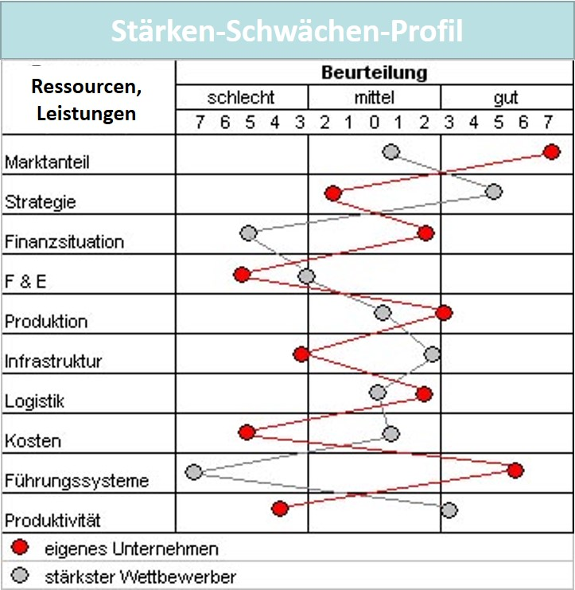

The strengths-weaknesses analysis likewise has advantages and disadvantages, but provides a good overview of a company’s position in comparison to its key competitors. However, since the overview only relates to parts of the organization and value creation, it lacks an overall view of what is happening within the market. Since, the view is subjective as noted above, the result may need to be qualified.

Another circumstance to be considered is that strengths and weaknesses cannot always be viewed in isolation, since there may also be dependencies and interdependencies between the basic factors. The recommendations for action derived from a profile must therefore take this into account.

**Benchmarking**

A method of analysis based on a company’s comparison with its competitors.

The analysis of strengths and weaknesses can also be seen as preparatory work for another method—**benchmarking**.This tool is used to compare a company with its competitors on the basis of standardized variables (benchmarks). The comparison can be carried out holistically, i.e., for the company as a whole, and/or for the areas, products, or processes relevant to product management (Herrmann & Huber, 2013, p. 73). The underlying idea in the method’s approach is to determine the differences, investigate the reasons for them, and identify the possible improvements. The method has several procedural steps (Wübbenhorst, 2018):

1. Selection of the object to be analyzed and compared (product area, product, process).
2. Selection of a benchmark company with an adequate similarity to ensure comparability.
3. Data collection through an analysis of secondary information or primary data collection.
4. Identifying the gaps in deliverables output and their sources.
5. Determination and implementation of measures for improvement.

The following advantages and disadvantages speak for or against the use of this method in product management (Herrmann & Huber, 2013, pp. 75–76):

Advantages:

* Performance is evaluated in a relative comparison with competing companies.
* There is an orientation toward the best.
* The reference values are real and are therefore also potential goal positions.
* An opportunity to identify new strategic positioning exists.
* Non-monetary values can also be considered.

Disadvantages:

* The availability of valid information to determine the relevant key numbers of competing companies is problematic.
* The comparability of the reference objects is not always readily available.
* Better solutions must not only be imitated, but adapted.
* Not only the differences, but their sources must be discovered.

### Self-Check Questions

1. Why is a self-analysis important for companies and what can still stand in the way of it?

A company must also engage in an internal view, i.e., with the features that it possesses as strengths and weaknesses. Weaknesses, in particular, must then be equalized. However, companies are all too often so convinced of their strengths that they do not question their weaknesses. The identification of weaknesses can also be politically problematic, since it raises the question of responsibility.

1. Which are the advantages of benchmarking in product management? Mark the correct answers.

* A performance evaluation is carried out through comparison with competing companies. (C)
* The comparison is positive since it is only compared with rival companies that are less successful in competition. (I)
* The reference values of the comparison are real and therefore also potential goal positions. (C)
* Only monetary values are considered in the comparison. (I)

## 2.3 Integrated Methods for Market and Company Analysis

The isolated consideration of market/environmental developments as well as the internal view and resource situation of companies can be methodically supported by an entire range of model and analysis tools. If the two fields of analysis, market and company, are combined and integrated, additional insight can be gained, since each of the development lines can be checked against each other and thus mutually dependent constellations can also be evaluated.

Important interpretive overlaps then arise for...

* ... the market situation and the core competencies of a company,
* a company’s resources with regard to future market developments, and
* a company’s product and offering portfolio and its accuracy of fit with the general conditions of the market (Herrmann & Huber, 2013, p. 76).

Very similar to the strengths and weaknesses analysis is the **SWOT analysis** as an integrated method that links the **o**pportunities and **t**hreats, as they result from the company environment, with the **s**trengths and **w**eaknesses from the company’s point of view. This produces a profile that can also be used for comparison with competing companies. The SWOT analysis, which has been around since the 1960s, provides four strategic options by combining profile dimensions (opportunities, threats, strengths and weaknesses) (see figure below). Suitable methods of market, competition, and company analysis can also be used for each of the sub-analyses (Reisinger et al. , 2017, pp. 93–95).

**SWOT analysis**

A method for defining measures with which the identified opportunities can be exploited and threats avoided.

SWOT-Analyse

Ein Bild, das Tisch enthält.

The content of the resulting strategies can be explained as follows (Reisinger et al. , 2017, pp. 93–95):

* **SO strategies** aim to identify opportunities that complement a company’s strengths. As such, they represent an ideal combination.
* **WO strategies** aim to eliminate internal weaknesses so that specific market opportunities can be exploited. If the weaknesses can be converted into strengths, another ideal case exists (SO strategies).
* **ST strategies** are suitable for utilizing a company’s strengths to counter market threats (defense strategy).
* **WT strategies** lead to defensive behavior, since the combinations here are critical. Ultimately, a company must try to reduce their weaknesses and avoid market threats.

The SWOT analysis has the advantage of being very easy to understand and having a transparent structure. The analysis of strengths, weaknesses, opportunities, and threats can, as already mentioned, be carried out via preliminary analyses or can also be supported with further checklists. As a rule, individual business areas, product areas, or individual products are chosen as the object of investigation in a SWOT analysis. An overall view of the company is hardly possible (Herrmann & Huber, 2013, p. 78).

Another integrated representation is provided by the **portfolio analysis**, which is also an instrument of strategic positioning with the goal of finding suitable strategies for individual business areas. The starting point is an initial inventory of a company’s products and/or services.

**Portfolio analysis**

An analysis method with the goal of strategic positioning of business units.

The strategic business units (SBUs) or strategic business areas (SBAs) that are the focus of analysis are market or customer-related combinations of a company’s offerings and intended audiences that require their own market cultivation since they are in a specific competitive situation. This can be the case for individual products or product groups. A portfolio consisting of several such business units can be examined with the goal of identifying the success options, opportunities, and threats that exist for a company as a result of the existing business unit combination in its portfolio. This gives rise to the sub-questions for the portfolio and the business units regarding ...

* ... the allocation or withdrawal of financial resources,
* the financial balance between the business units, and
* the development of the portfolio by acquiring new or disposing of existing business units (Herrmann & Huber, 2013, pp. 79–80).

**Relative market share**

The ratio of a company’s sales/revenue from a particular period compared to the sales/revenue of the strongest competitor within the market.

An example of a portfolio is the Boston Consulting Group (BCG) growth-share matrix. The market dimension as an external reference is represented by market growth, the corporate dimension is indicated by the **relative market share,** which shows the ratio between the company’s own market share and the market share of the strongest competing company (Großklaus, 2014, p. 74):

BCG-Portfolio

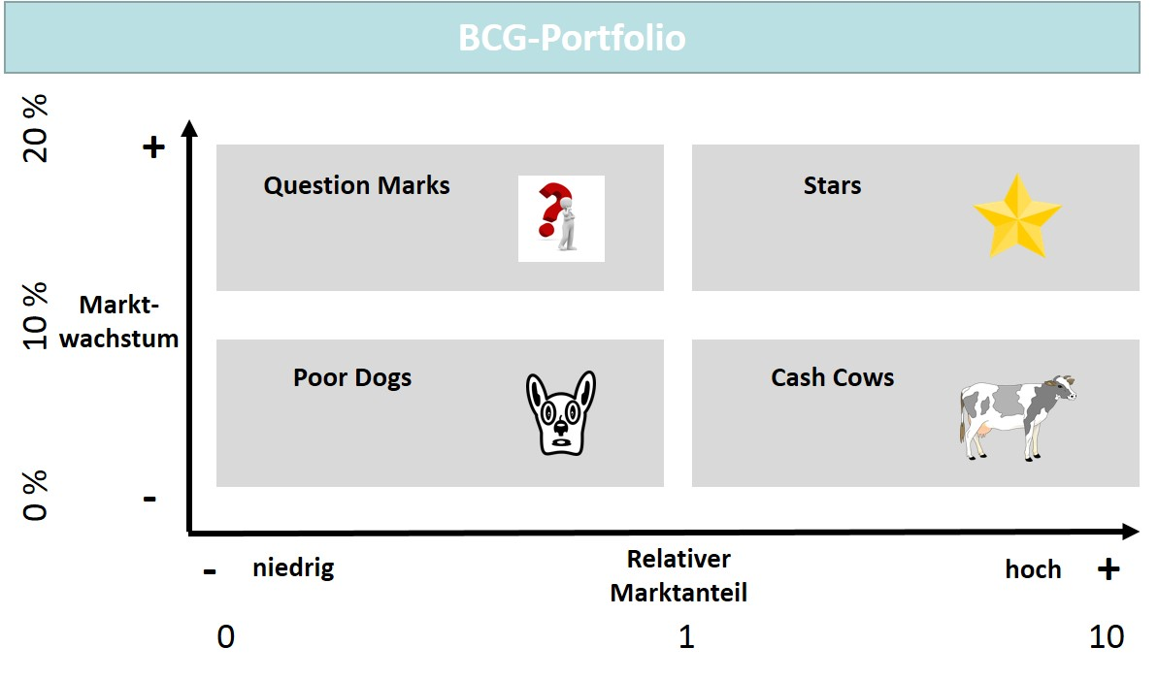

Stars, for example, are business areas whose market environment is very attractive (high growth) and in which they themselves occupy a strong position within the market compared to competing companies (high relative market share). Cash cows, on the other hand, are the company’s most important source of income, since they have already achieved a high market share, but the market growth is not attractive for competing companies to invest more in this market. The development of question marks must be awaited, since they still must compete against rival offerings in an attractive environment, while poor dogs occupy a critical position with regard to the two dimensions of market and company. The strategic requirements can then be derived from the market situations interpreted in this way (Großklaus, 2014, pp. 74–76):

* **Stars** are attractive and very profitable business areas, but they require investment to maintain or expand their position. They are in the implementation stage and it is worth reinvesting their income to strengthen the profile, image, and market position. If this succeeds, stars can become cash cows.
* **Question marks** are units that can achieve strong growth, but also require investment to do so, since the market share is still small, resulting in low income. Growth must therefore be financed by the cash cows. If a breakthrough is not achieved, they can fall back into the poor dogs position. Question marks are still in the introductory stage and have yet to become stars, which requires investment in their recognition.
* **Cash cows** generate the resources that are available for investment, e.g., in question marks. However, they also have their own financial needs to be able to maintain their market position. Part of the realized surpluses should therefore be reinvested in the profile and, if necessary, in an adaptation to be able to maintain the market-leading position for as long as possible. In It is not uncommon for fierce predatory and price wars to take place in this situation.
* **Poor dogs** have a low relative market share and insufficient market growth. If a profit situation exists, investments to expand in the direction of question marks and stars should be examined. If such a revival does not succeed, it is often the case that only the costs can be reduced and the remaining possible contribution margins can be realized. If this also no longer exists, typically the only option is elimination from the range of services.

The BCG matrix makes it clear that a useful categorization of business areas can be undertaken with two dimensions, even if the distinction of the (only) four basic positions may not be easy. In addition, further disadvantages in portfolio analyses are also noted below: (Herrmann & Huber, 2013, p. 82):

* It is often difficult to make a distinction between the relevant market and business areas.
* The selection and valence of the categorization criteria and the determination of the basic positions is challenging in practice.
* Data quality must be high so that minor changes do not lead to incorrect recommendations for strategic direction.
* A constancy of the environmental conditions is necessary, but somewhat rare in practice.
* The rather static view of a portfolio takes too little account of existing market dynamics.
* Mutual dependencies between the business units are not considered.

Despite the disadvantages described above, portfolios are very popular in corporate practice because they can generate a good understanding of the relationships between the market and the company, at least in product management. In addition, given a certain stability of the positions, they are certainly a guiding support in the selection of strategically sensible measures to increase the success of products and services.

### Self-Check Questions

1. What is true of the BCG matrix in terms of the market dynamics that are typically present?

The rather static view of the portfolio presented in the BCG matrix takes too little account of existing market dynamics.

## 2.4 Business Model Analysis

Products and services impressively represent the market view and are objects of market cultivation, as well as part of companies’ business models. In connection with the analysis of market and company, the business models as a link between internal value creation and marketing must, of course, also be analytically scrutinized when it comes to the strategic and operational measures in product management. However, there is no department for business models or clear model documentation within a company that could provide a complete picture for this area. This is because it involves different components or sub-models in a business model. The internal processes of value creation play a major role in business model analysis, since they are the reflection of the company’s positioning on its competitive advantages within the market. The products and services as a result of value creation are offered in order to generate income, and this is undertaken according to particular rules resulting from a company’s revenue model, as well as the paradigms of the target market. A company can sell its products and services, or contractually rent them out, and it can offer these services to consumers or other companies according to the customary procedures in the target market.

**Efficiency**

As a focus in competition, this means that the offering companies with cost-optimized value creation can offer lower-priced products.

The term *business model* actually originates from business informatics and has been increasingly applied to business administration in recent years, which also justifies the analysis approach. As already stated in the context of value creation and competition, the analysis of business models consequently involves the analysis of “selected aspects of the resource transformation of the company, as well as its exchange relationships with other market participants” (Becker et al. , 2021, p. 268). The term is also popular today because the analysis of business models is quite often followed by a transformation through a digitalization of particular areas of the business model (Becker et al. , 2021, p. 268). As a rule, this involves an increase in customer orientation and/or also an improvement in efficiency in service generation, which in turn confirms the proximity to the competitive dimensions of **effectiveness** and **efficiency.** Companies can therefore play out their advantages in their market if they also make price margins possible via efficiency advantages in their value creation in order to be able to present more favorable offerings. Discounters are a good example here, since they have a high efficiency in product mix design and logistics/distribution and can therefore offer lower prices compared to specialist retailers. In contrast, if companies are more focused on the effectiveness of their market cultivation, they want to convince their customers with outstanding products and, if necessary, also with a supplementary range of services. A good example of this are companies that offer premium products and achieve customer loyalty through brand management and service, even at higher offering prices. Business models thus contain the levels of intervention through which companies want to achieve and consolidate their competitive advantage, which can also lead to adjustments and reorientations. Depending on the scope of change, this can lead to slightly adapted business models, as well as to completely new and radical approaches if a completely new combination of components actually changes the previous conditions and structures of a market. These extensive changes then also open up great opportunities for new companies to successfully enter the market if they can act without regard to a familiar and thus often cumbersome market cultivation.

**Effectiveness**

As a focus in competition, this means that the companies offering their products want to retain their customers with superior products and better service.

So when we ask the question about the content elements of a business model and accordingly also about the content and scope of a **business model analysis**, we will revisit the customers and target markets and the customer benefits that we as a company want to generate with our offering. And as a company participating within the market, which in turn must finance itself through the income from its market transactions, we must also find a revenue model in connection with pricing that can support our expenditure of resources for the generation of products and services (Jodlbauer, 2020, pp. 1–2). These relationships are illustrated by the magic triangle of a business model according to Gassmann et al. (2021, p. 9), as shown in the figure below. The triangle is *magical* because optimizing one of the dimensions also respectively leads to design questions regarding the other dimensions (Gassmann et al. , 2021, p. 9). In practice, business model optimization therefore has a complexity that also leads to greater challenges in the implementation of business model changes.

**Business model analysis**

A method for determining the strengths and weaknesses of a company with regard to its value creation, its market development, and its revenue model.

Das magische Dreieck eines Geschäftsmodell mit vier Dimensionen

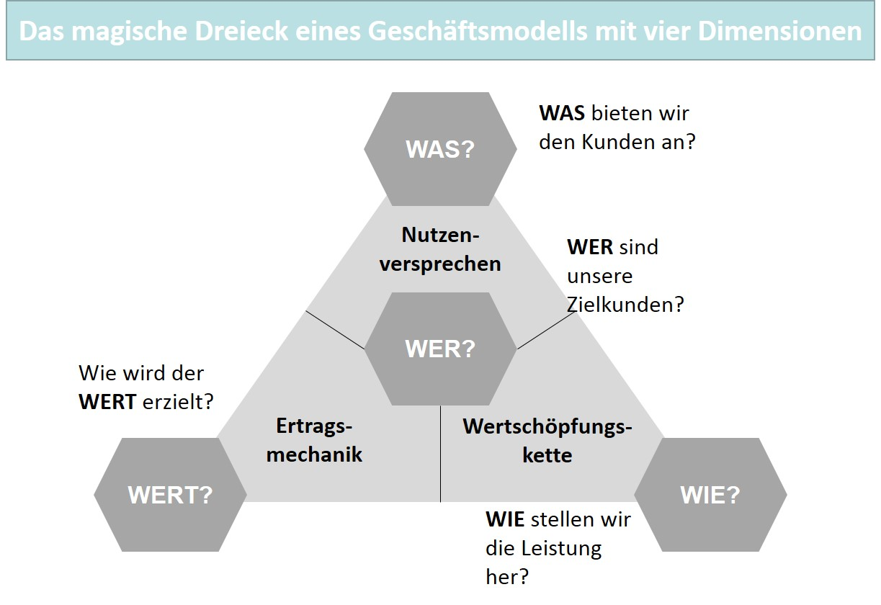

Business model analyses are important tools when a business model must be changed or adapted due to the dynamics of competition. Then there are process models and tools that can accompany such change measures for the development and renewal of business models in a creative way. Examples of such analysis and design recommendations are the process model according to Jodlbauer (2020) and the tools of business model generation according to Osterwalder & Pigneur (2011). It is clear that there is and can be no simple method for the direct analysis and evaluation of business models. We again encounter the areas of analysis as we have already identified them as relevant for product management and can therefore also refer to the analysis of company, market, and environment for a business model analysis in the context of product management. With regard to business model innovation, however, the integrated analysis view leads to explicit conclusions that can go beyond the tasks of product management. If the business model changes are also more strongly oriented toward the product policy measures, the partial analyses required for this naturally also play an extraordinary role in the integrated view.

### Self-Check Questions

1. What is the connection between product management and business model analysis?

Analyses of the intended audience, the company, and the environment are necessary for decision-making in product management and they can also be part of a business model analysis.

1. What are the four key questions in the *magic triangle* of a business model?

The four questions are in the direction of the target customers (WHO), the offering (WHAT), the added value (HOW) and the earnings (VALUE).

Summary

Companies that need to determine data and information for their decision-making can use various analysis methods to obtain the most reliable information base possible. For example, different criteria can be chosen in order to describe the environment or the surroundings of a company. A strategic orientation of this kind is provided by the PESTEL framework, whose six areas of analysis (political, economic, social, technological, environmental, legal) result from the global environment. Another suitable method is strategic early detection, the fundamental principle of which is based on signals indicating weaknesses that can be the source of particular developments. If such signals are detected at an early stage, they can be interpreted and in some cases, there will still be enough time for a reaction. In contrast, the usefulness of the Delphi method is more of a heuristic character because in addition to the real information content, the pattern of opinions obtained is also decisive. With scenario analysis, there is an analysis method that creates alternative visions of the future on the basis of possible developments, which are evaluated and integrated into the considerations for determining recommendations for action.

A traditional method of market analysis is the industry analysis according to Porter, which focuses on the influencing factors that only affect companies in a specific industry. Here, the competitive situation and the effective five forces in an industry decisively determine the strategic situation of an individual company. And in contrast to the global environment, a company can exert more influence in its own competitive environment. With the value net, the perspective of cooperation is also considered as an extension of the five forces analysis. When it comes to the products offered in a market, the life cycle and thus its analysis play a key role. It is based on the principle that products (product life cycle) or markets (market life cycle) pass through certain temporal stages, which are distinguished by different sales and profit potentials.

In addition to the market, the company must also engage in its internal view. For example, gap analysis provides important insight into the future trajectories of specific dimensions of companies’ business development. The trajectories to be examined can be based on various assumptions to arrive at a bundle of options for action. The identified gap in goal achievement for a specific indicator must be interpreted and responded to with suggestions for closing the gap. Another method is the core competence analysis. A company has a core competence if it has the long-term ability to form competitive advantages within the market on the basis of this competence. With value chain analysis, a method is also available that serves to directly identify potentials. It therefore represents a way of professionally organizing the search for core competencies.

In contrast to the value chain analysis, the strengths and weaknesses analysis also has a comparative character, since different periods can be comparatively evaluated with regard to strengths and weaknesses and in addition, comparisons can be made with competing companies. This analysis can also be seen as a preparatory work for another method—benchmarking. This tool is used to compare a company with its competitors on the basis of standardized variables (benchmarks).

If the two fields of analysis, market and company, are combined and integrated, additional insight can be gained. For example, the SWOT analysis is very similar to the strengths-weaknesses analysis as an integrated method that links the opportunities and threats, as they result from the company environment, with the strengths and weaknesses of the organization. This results in a profile that can also be used for a comparison with competing companies. Portfolio analysis provides another integrated view with the goal of finding suitable strategies for individual business areas. An example of this is the Boston Consulting Group (BCG) growth-share matrix, whose external reference is represented by market growth and whose corporate dimension is indicated by relative market share.

While the analyses of target market, company, and environment that are common for product management tend to stand side by side, the integrated view of a business model analysis leads to valuable, as well as overarching results, particularly in the context of the planned transformation of a business model, e.g., in connection with digitalization.

# Unit 3—Product Strategy

Study Goals

On completion of this unit, you will be able to ...

... determine the foundations and prerequisites for strategic decisions in product management.

... describe the effect of formulated market cultivation goals and the targeted positioning based on these decisions.

... carry out the selection and evaluation of product strategies on the basis of the strategic goal as well as design these strategies.

# 3. Product Strategy

### Introduction

If the product policy decision-making is on a solid foundation as the result of careful analyses, the specific market objectives for the range of products and services can be formulated. In conjunction with the position determination, product strategies are then selected and evaluated, which provide the fundamental orientation for the determination of goals on the basis of measures to be planned. In terms of market orientation, they must therefore be determined on the basis of customer benefit aspects and in alignment with the competitive dimensions of effectiveness and efficiency. Product strategies are the driver of market cultivation when it comes to satisfying the needs of customers and gaining competitive advantages over the competition. The following underlying questions therefore arise for the design and methodology of strategic work in product management:

* What fundamentals and prerequisites are relevant and determining for strategic decisions in product management?
* How do the goals formulated for market cultivation and the targeted positioning of the offering within the market affect these decisions?
* How does selecting and evaluating product strategies on the basis of the general conditions and the strategic goals lead to the achievement of goals?

## 3.1 Fundamentals of Product Strategy

In many areas, even in everyday interaction, there is often talk of strategies or strategic determinations when it is a matter of specifying a fundamental direction of activity for a particular project. A familiar example is sports, where strategy and tactics are repeatedly mentioned, particularly for team sports, when certain game variations are explained. So then we hear about an attack or defense strategy, or even a forward defense as a strategy against the particular game variations of key opponents. Strategic determinations in order for a company to fundamentally orient their own approach in competition with other companies also exist in business when companies in a market compete for the same intended audience and position their products and services against each other. This fundamental orientation is necessary to be able to carry out the subsequent market cultivation measures in a coordinated manner and thus with the highest possible degree of effectiveness. The strategic determinations ensure that companies remain focused in the medium and long term and do not improvise their market activities through uncertainty rather than planning and organizing them.

**Strategy**

The fundamental and long-term combination of measures by companies to achieve long-term goals.

For corporate planning, we can therefore define **strategy** “as the fundamental, long-term behavior (combination of measures) of a company and relevant sub-areas with regard to their environment to achieve the long-term goals” (Gillenkirch & Müller-Stewens, 2018). For product management as a key part of a company, this means that the **product strategy** must include the appropriate and long-term combinations of product policy measures in order to also be able to achieve the long-term goals. In simpler terms, we can formulate that medium to long-term planning must be undertaken in product management, which aims to successfully position the company’s products and services in the sales market. Accordingly, product strategy determinations represent the guard rails for the development of product policy measures and must, in the sense of market orientation, consider the needs of potential customers, and the challenges of competition with other companies offering products, as well as environmental dynamics. It is precisely the dynamics of change that continually present the designers of these guard rails with new situations that must be mastered, which makes product policy strategy work a demanding management activity.

**Product strategy**

The medium to long-term planning for the positioning of a promising product.

When discussing goals, we can name the overarching goal of ensuring and, if possible, also increasing the competitiveness of products and services. In the intense competitive environment that we currently see in many sectors of the economy, product strategy as an instrument derived from corporate strategy is therefore of extraordinary importance. Dynamics and the pursuit of goals clarify the character of product strategy determination as a process that begins with the analysis of the environment, market, and company and concludes with the selection and evaluation of suitable product strategies. Then, action plans can be drawn up, the organizational necessities implemented, and success measured (see figure below). Of course, the action plans must be adjusted if deviations from the target results are identified. In the case of major gaps, the fundamental strategic orientation may also need to be questioned. Ideally, such a situation will not occur after a thorough analysis prior to the strategy determination. However, in connection with disruptive changes within the market, there is certainly also a need to scrutinize strategic elements more closely once they have been determined and, if necessary, to correct them to be able to counter the new paradigms that may have been established within the market by new competing companies.

Produktstrategiefindung als Prozess

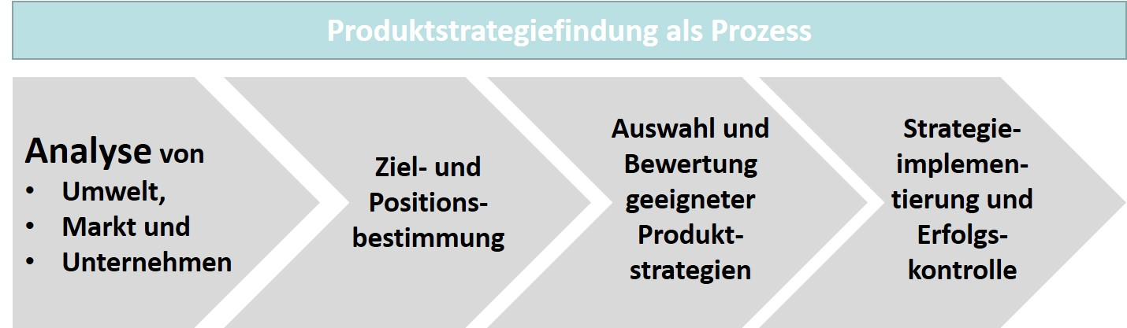

Consequently, analysis as a starting point is absolutely vital. For a company, it supports the determination of goals and positioning, since it provides essential clarifications with regard to the general conditions. In particular, the competitive dimensions of efficiency and effectiveness are examined here in terms of their strength. Here, it is important for product management to be able to include the relevant variables, such as socio-cultural and demographic, as well as technological factors, in the strategic considerations. Purchasing power and buying behavior, in addition to the core competencies of competing companies, are examples of the competitive forces and thus also the object of the initial analysis work, which must also include an internal view for a company to evaluate its own strengths and weaknesses. The necessary analyses are supported by a suitable set of methodological instruments that is available to product management.

The successful positioning of products and services in a competitive market is the result of extensive analysis, decision-making, planning, and implementation processes. In this process sequence, which is characterized by market orientation, the product strategy ensures that the characteristics of the products offered meet the benefit expectations and that the positioning therefore contributes to the success of the company.

For product management, there are several strategic options that can promote the necessary fundamental decisions to determine relevant markets and the way in which they are addressed. These alternative options must be evaluated according to a company’s own goals to be able to select the correct product strategy for its own portfolio (Herrmann & Huber, 2013, p. 86).

### Self-Check Questions

1. Why does the market cultivation of companies also require fundamental and thus strategic determinations?

A fundamental orientation is necessary to be able to carry out the subsequent market cultivation measures in a coordinated manner. The strategic determinations ensure that companies also remain focused in the medium and long term and do not improvise their market activities through uncertainty rather than planning and organizing them.

## 3.2 Goals and Positioning

### Goal System and Operationalization

We already know that a selection of product strategies is only possible on the basis of extensive analyses, particular those of the market and the company. However, since different strategies can also point in different directions, it is necessary to have a solid orientation for correct navigation within the market. The chosen direction can therefore only be taken with certainty if the intended goal is also achieved in the end and a company’s own positioning respectively follows a clear strategic compass. Accordingly the determination of goals and positioning are also part of the tools of the trade for product managers if they want to navigate strategically within their market.

In a competitive environment, of course, we are not dealing with only one or with “the” goal, rather this is typically with a goal system as a “set of goals, i.e., desired events or states of existence, between which relationships exist”, whereby we can still distinguish between individual and collective goal systems (Gillenkirch, 2018a). If we consider this for a **company goal system,** which must meet the demands of the stakeholders associated with it, then it is accordingly a collective goal system, the structure of which represents “the unique goal systems of the individual” stakeholders, “that reflect their personal interests within a company” (Gillenkirch, 2018b). The stakeholders primarily include the capital providers, the customers or corporate consumers, the suppliers, and the employees of a company. In connection with a hierarchical categorization of a company’s goal system, we can determine a concretization of the respective goal levels starting from the normative goal, which will be primarily found in a company’s mission statement and in the corporate purpose described therein, through to the goals of operative market cultivation, as shown in the figure below:

**Company goal system**

The collective goal system resulting from stakeholders' interests.

Zielhierarchie von Unternehmen

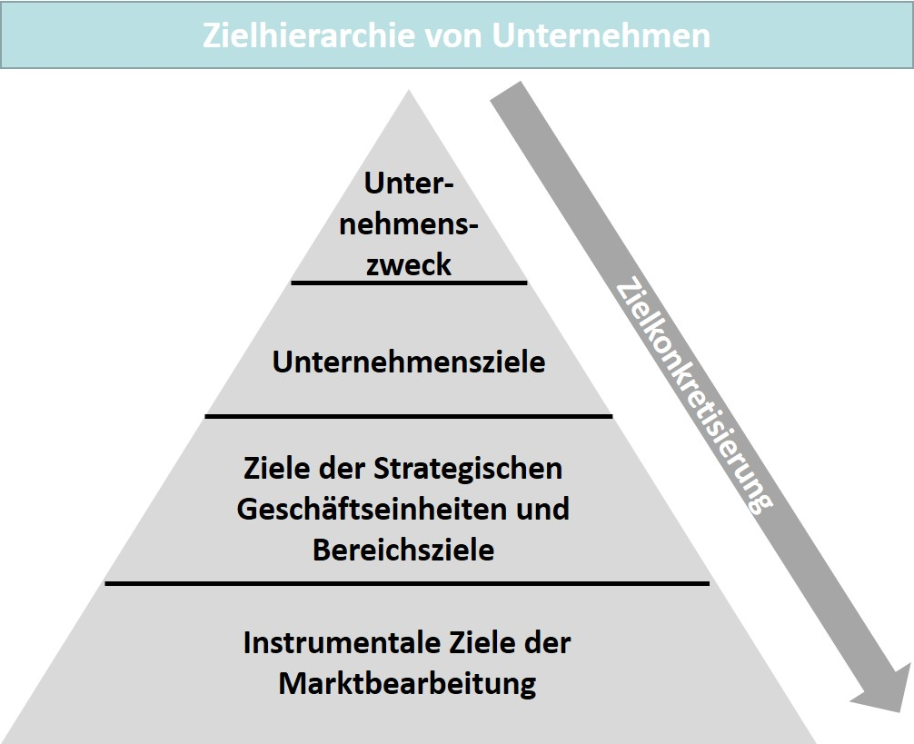

Examples of goals for the individual levels are presented below (Herrmann & Huber, 2013, p. 87):

* Company goals: increase sales to 20 % of market volume within three years.
* Goals of the electric passenger cars strategic business unit: sales increase of 15 % next year.
* Industry goals development: reduction of development times for model revision by 10 %.
* Instrumental market cultivation goals: market launch of a new model variant station wagon within the next two years, or price adjustment of e-vehicles by +3 % in the next year, or an advertising budget increase of 5 % annually.

**Operationalization of goals**

The establishment of measurability of the achievement of goals.

The examples show how important it is to concretize goals. They must be formulated so that the degree of goal achievement can also be determined using a measurement of states and value ranges. Navigating the competition is therefore dependent upon how precisely the specification of the goal, the pursuit of the goal and the path to the goal can be verified and coordinated. This concretization is also called an **operationalization of goals** according to the dimensions:

* **goal content** (precise/understandable description of content),
* **goal extent** (degree of goal achievement),
* **time reference** (duration and deadlines), and
* **scope** (business unit or area) (Herrmann & Huber, 2013, p. 88).

The concept of smart goals can also be taken from project management. Here, *smart* is the abbreviation for the character of goals that should be **s**pecific, **m**easurable, **a**ccepted, **r**ealistic, and **t**ime-bound.

### Determine Target Market and Positioning

A focus in the market activities, as we strive for it according to the principles of market orientation, i.e., in the direction of our customers and in the direction of our competitors, now gives us two goal areas. First, we must define our customers as an intended audience and describe them in the market in a distinguishable way, and then we must determine how we want to compete with our competitors. The analysis we have already carried out for the market, environment, and our company should be of great help to us here.

First, we need a market definition to determine the relevant market for us. On the one hand, this can be done “on the demand side by looking at the substitution relationships between goods (substitution gap), on the other hand, there may be a technical-functional linkage on the supply side” (Mecke et al. , 2018). Accordingly, market definition has the primary objective of identifying the complex relationships between the agents (offerors, demanders) and the supply of goods and, after an analysis of the connections, methodically define them by means of …

* ... an offeror-related perspective,
* a product-related perspective, or
* a demand-related perspective (Herrmann & Huber, 2013, p. 90).

Thedefinition based on customers is also referred to as **market segmentation.** It is the most relevant method for product management because it focuses on the customers and their needs and benefit expectations. It leads to a “Division of the overall market according to specific criteria into buyer groups or segments that are to be as similar as possible (homogeneous) and as dissimilar as possible (heterogeneous) to one another in terms of their buying behavior or characteristics relevant to buying behavior” (Kirchgeorg, 2018). Market segmentation is a prerequisite for determining the segments of interest to a company and then positioning itself in terms of competitive strategy. For our market-oriented product management, it therefore makes sense to place the needs of consumers at the center of segmentation. The satisfaction of needs is then the starting point for product policy activities (Herrmann & Huber, 2013, p. 92).

**Market segmentation**

A breakdown of the overall market into buyer groups or market segments.

The discussion on goal systems mentioned the operationalization of goals as a prerequisite, which now also applies to the goals of market segmentation. The **segmentation criteria** and characteristics to be selected for this purpose must also be measurable, relevant to buying behavior, selective, and stable over time, in addition to the sufficient economic usability of the segments described using them. In practice, the three categories …

**Segmentation criteria**

The characteristics of market segments that make them distinguishable from one another.

* … social demographics,
* psychography, and
* buying behavior …

… result in a meaningful arrangement (Herrmann & Huber, 2013, pp. 92–93).

One field of activity in social research is social demographics, which describes groups on the basis of sociodemographic characteristics. Important variables include income, age, gender, marital status, and educational level. These data play a key role, for example, in defining the intended audiences of insurance companies, since they may result in different premium allocations. Psychographic factors, such as thematic beliefs and values, lifestyle, and social status, as well as activities, e.g., in connection with civic engagement or leisure time, are similarly closely linked to the individuals exhibiting the characteristics. Psychographic characteristics often allow conclusions to be drawn about consumer behavior and thus ideally complement the sociodemographic criteria to form a comprehensive customer profile. For example, involvement in the environmental movement is likely to suggest a preference for alternative energies and e-mobility. In contrast to the first two categories, the buying behavior criteria can be found closer to the purchase transaction. A typical example is the usage context that buyers see for themselves in connection with a particular product, but also the purchase frequency, e.g., if users intend to make a one-time or regularly recurring purchase.

Marktsegmente und Zielgruppenauswahl

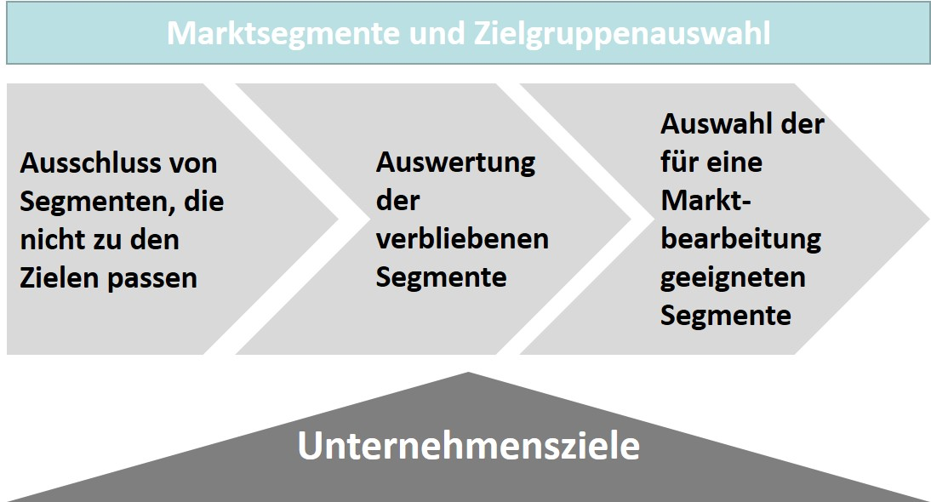

The figure above shows the progression of activities required for a final determination and selection of suitable market segments and thus intended audiences. The process is based on the company goals, since the product policy measures must, of course, fit in with the overarching strategic determinations of the company as a whole. The segments that cannot meet the criteria that apply on the basis of the goal system are therefore removed from the selection process in the first step. The remaining market segments must then be examined for their suitability to a worthwhile and intended audience-oriented market cultivation, and only those target groups selected as suitable are then the object of product management activities. The attractiveness, which is to be ensured in this way, can be verified according to the aspects …

**Market potential and volume**

The theoretically possible (potential) and the

actual (volume) demand.

* … **market potential and volume** of the segments,
* intensity of the competing companies’ activities within the market segments,
* internal homogeneity of the segments,
* attainability of the intended audience through a company’s market cultivation, and
* profitability of the market segments (Herrmann & Huber, 2013, pp. 95–97).

The attractiveness of the segments is, however, only one side of the market-analytical view, since again here the situation of the company or, more precisely stated, the position of its offerings within the market and in comparison with its competitors must be additionally considered. Product positioning as a result of the product policy measures taken so far, “which aim at the position of a product in the perception space of the demanders that is considered favorable”, is thus an important step to be able to initiate, e.g., the necessary steps in product management for a change in position (Markgraf, 2018). Accordingly, the goal of product positioning is primarily to “achieve differentiation from competitor products” and to present the “benefits(s) of one’s own company ... as distinctively as possible” (Herrmann & Huber, 2013, p. 97). Of course, the decisive factor for an impression on demanders is the subjective benefit that they attribute to a product, and for which they are also prepared to accept the associated costs when making a purchase. We speak here of a **unique selling proposition (USP)**, which is intended to secure the demand for a product that is necessary for its positioning, as well as economic, success. Differentiation from the competition can be achieved in product management by emphasizing certain features that …

**Unique selling proposition (USP)**

A value proposition to buyers that differentiates a product from competing offerings.

* … should promote the consumers’ buying decision,
* are also perceived by consumers as differentiation criteria,
* can exist in the long term, and
* are also profitable for the company (Herrmann & Huber, 2013, pp. 97–98).

If a company’s own products and those of the competition are then ranked on the basis of their respective differentiating features, the positioning options that are still unoccupied from the consumers’ point of view can be identified (Herrmann & Huber, 2013, p. 99). This comparison can also be represented graphically if specific feature categories are used as dimensions in the representation. The figure below presents an example of what is known as a **perceptual map** for four beverages, which are classified according to their intended audience (older/younger) and their market presence (tradition/trend).

**Perceptual map**

A graphical representation of the consumers’ product perception of consumers.

Beispielhafte Perceptual Map für Getränk

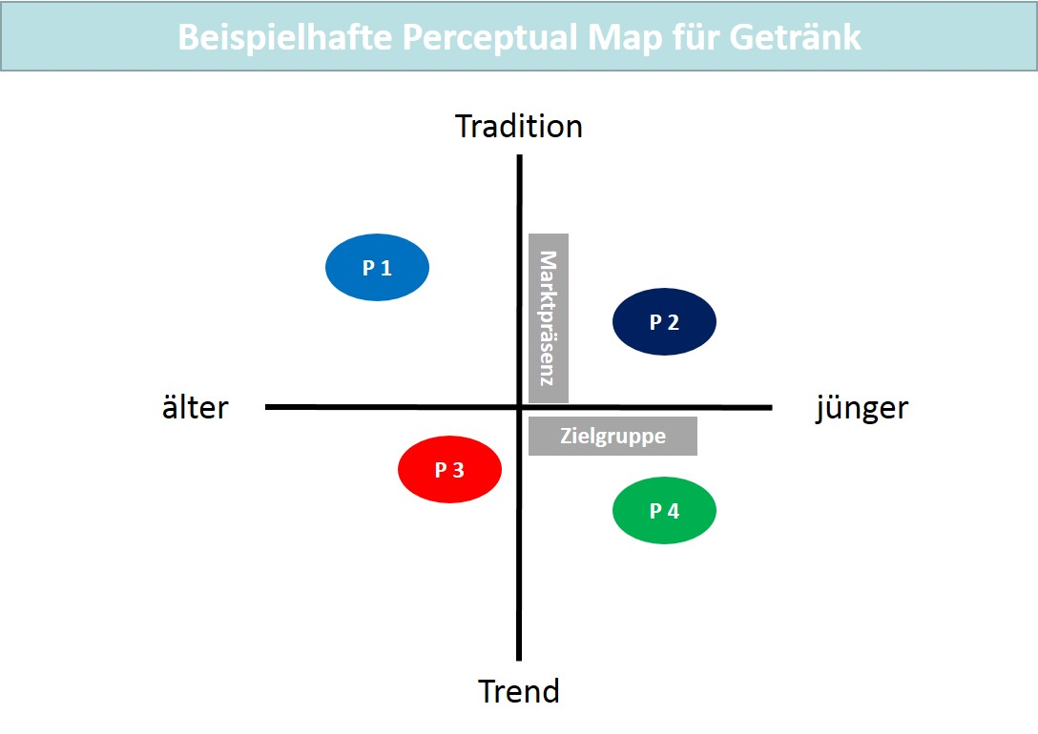

The categorization of the products results from consumer surveys in which they can indicate their evaluations, e.g., in the form of scale rankings. The results of such evaluations can then also be visualized in the graphics for different product characteristics. Once a company has described a perception space in this way, it can define a desired position for its product or reposition itself in an existing gap (Herrmann & Huber, 2013, pp. 102–103). The next figure below shows a repositioning of the P1 product with a shift in the trend/younger direction.

Beispielhafte Perceptual Map für Getränk

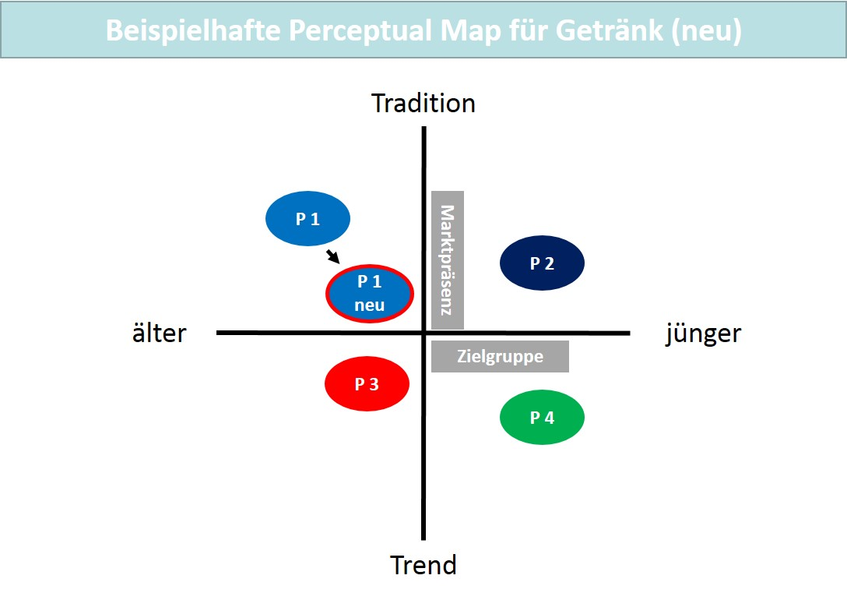

Of course, the features by which product offerings can be differentiated are industry-specific and cannot be transferred so easily to other competitive scenarios. However, four levels can be distinguished and understood as a type of meta-differentiation (Herrmann & Huber, 2013, p. 104):

* **Rational benefits** mean differentiation based on functional product characteristics, services, or price differences. A good example of this is the offerings for mobile phone tariffs and the associated hardware (phones, watches, etc.) from telecommunications companies on the internet.
* **Emotional benefits** mean that a company can argue an additional benefit to the customer beyond the product characteristics. Luxury brands (vehicles, watches) particularly differentiate themselves through their image.
* **Social benefits** mean that the product benefits that users can claim for themselves through their display of product purchases in public. One example is trend brands in young consumers’ clothing (pants, shoes).
* **Structural benefits** provide structures that include access to networks that also enable business contacts, one example is Xing.

Once the position is determined for a product, it still needs to be communicated. This means that the way in which consumers process the information presented to them about offerings must be taken into account. There are three aspects that must be considered (Herrmann & Huber, 2013, pp. 104–108):

* **Priming** means the context in which a product is embedded during its presentation. Sporting goods are likely to be presented with a sporting theme in the background, while a clothing brand that is quite traditional may be more suited to a serious setting or background story. If particular features are to be emphasized, they must also be made clear through the symbolism of the advertising narrative. Price aggressiveness may therefore also be associated with a visual emphasis, as evidenced by the bold representations on websites.
* **Alignable assortment** describes the behavior of consumers when there are several similar products to choose from. Depending on the character of the product characteristics, comparison and selection can then turn out to be difficult in various ways. Continuously pronounced characteristics, e.g., the performance data of a vehicle or a machine, make ranking possible and accordingly simplify the differentiation. The decision is more difficult for the consumer when the product variants are not comparable in this way. This difference in decision-making must be considered in product management.
* **Regret** refers to the regret that consumers express after a purchase if they believe that they have made a wrong decision. The risk is greater if the selection process was already fraught with considerable uncertainty.

The statement regarding the goal system and positioning make it clear that product management with a market-oriented focus appropriately considers the market conditions of a market, but that it also has a complex task. It is precisely the subjective element in the expectation and fulfillment of benefits that product management must take into account that leads to a multitude of factors, each of which can determine the success or failure of an offering. *Preferences*, *uncertainties*, *rankings*, *selection process*, etc. are the terms that represent the totality of activities in product management and require its comprehensiveness and homogeneity in the application of tools.

### Self-Check Questions

1. According to which categories can the market segmentation criteria be arranged? Mark the correct answers.

* Social demographics (C)
* Price (I)
* Psychography (C)
* Psycho demographics (I)
* Offering (I)
* Buying behavior (C)

## 3.3 Evaluation and Selection of Product Strategies

Once a company has determined the position of its products and, if necessary, also defined new positions, suitable specific strategies must be identified to guide the appropriate market cultivation in a manner that allows the goals to be achieved. To determine the strategic options available for this purpose, the dimensions of market orientation, i.e., customers and competing companies, as well as cross-company approaches can be considered once again.

**Product strategies**

The customer-oriented, competition-oriented, or cross-company strategic orientations within companies’ market cultivation.

This results in three basic models for **product strategies** as fundamental strategic orientations (Herrmann & Huber, 2013, pp. 108–110):

* **Customer-oriented strategies** focuson demand and refer to the identified customer or market segments and the communication with the demanders. Examples are market field, market stimulation, market segmentation, and market area strategies.
* **Competition-oriented strategies** describe the strategic orientation of a company toward its competitors. Examples here are cost leadership, differentiation, focusing, and outpacing.
* **Cross-company strategies** aim at merging with and thus creating a network of companies. This can be realized horizontally via strategic alliances or vertically/diagonally via strategic networks across companies.

### Customer-Oriented Product Strategies

**Market field strategy**

A strategic orientation that considers specific product-market combinations.

A classic among **market field strategies** is the product-market typology of strategies according to Harry Igor Ansoff (1965). In his product-market matrix, he categorizes growth options according to new or current products and according to new or current markets.

Produkt-Markt-Matrix nach Ansoff

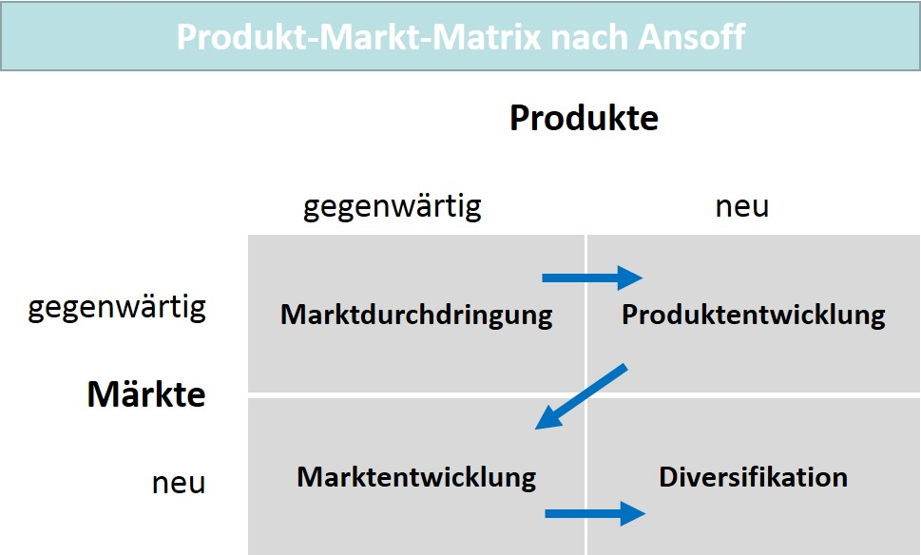

Four possible strategic orientations follow from the typology (Reisinger et al. , 2017, pp. 111–116):

* **Market penetration** is intended to increase the market share within the markets already served and with products already on offer. Existing capabilities, experience with already successful products, and sales opportunities are further expanded. This growth strategy therefore appears to involve nominal risk. This can be achieved through additional/intensified product utilization, the development of new areas of application, and by winning/reclaiming customers. The instruments for achieving this goal are primarily an increase in sales activities: more advertising, more aggressive pricing and conditions, and a strengthening/increasing of sales channels. Nevertheless, this strategy has limits in already saturated markets.
* Strategic approaches for **product development** are primarily product innovations, i.e., new products and service bundles, product variations of existing offerings and/or product improvements through an adjustment or expansion of product quality or product features. This is particularly helpful when products are in the maturity stage or in dynamic industries with an associated pressure to change in product development. However, the risks here are also not insignificant, particularly due to the considerable use of resources compared to market penetration.
* **Market development** is intended to open up new markets with existing products. The markets can be differentiated regionally, nationally, and internationally. Such a strategy is important when the existing markets no longer offering growth potential and/or there are still untapped markets. Opportunities are opened up here in connection with globalization. However, companies must then also recognize the paradigms of a cultural and political character that are associated with these new markets. The risk is therefore somewhat higher compared to market penetration.
* **Diversification** is intended to place the company in a situation where it can grow with new products in new markets. This strategy involves a high degree of risk, particularly if it is intended to improve stagnant business results. One option here is to create a range of complementary products, i.e., goods that are in common demand and provide a common benefit (example: printers and consumable ink cartridges). Another option is to complement a bundle with services. Synergies with existing business units are an advantage here, allowing resources and skills to be used jointly. Yet another option is to create entirely new business units in equally new areas without any connection to the existing business model. Exploiting synergies is then only nominally possible and therefore the risk is rather high, since the new market and its paradigms mean uncharted territory for a company. Diversification has been a frequently chosen strategic approach for decades, particularly for large companies, since this strategy can also mean risk minimization if profitable business units can support the unprofitable ones. In present day, there is more of a tendency to only work in profitable business areas using existing core competencies.

The arrows in the figure above illustrate a possible strategy sequence which, in the course of time, primarily fulfills risk minimization.. First, the product development path is chosen in a known market, and when applicable, is additionally secured by the fact that the new product uses a similar or identical technical basis compared to the existing offering (product family). Only after that does an expansion into a new market environment take place with such an expanded portfolio; perhaps as an expansion into neighboring countries as a moderate internationalization strategy. It is only in the subsequent growth step that new products be offered in new markets and diversification accordingly undertaken.

Product managers have two options for a **market stimulation strategy**. Selecting a preference strategy means that companies primarily focus on a comprehensive satisfaction of customers, e.g., by offering additional benefits with their product. Here, customer preference is not based on price attractiveness, but rather on high quality, brand, or additional services. In connection with this additional benefit, the offering also tends to be categorized higher in terms of price. Premium brands in the automotive sector or luxury goods in the textile and jewelry sectors are examples of this. In contrast, selecting a price-quantity strategy is associated with aggressive price competition, which excludes other preference policy measures. The offering price is the focus of market communication and the higher unit prices are intended to more than offset the lower profit per unit. A good example here is the market of discounters in food retail, where Aldi, Lidl, and others engage in actual price battles (Herrmann & Huber, 2013, pp. 112–113).

**Market parceling strategy**

Strategic orientation that leads to a differentiated or undifferentiated market approach.

**Market stimulation strategy**

A strategic orientation that does not focus on price or price-benefit aspects.

The **market parceling strategy** leads to a fundamental orientation of market cultivation, which provides for a complete or partial coverage of the market in combination with the differentiation of measures. Product management can choose a mass market or a market segmentation strategy, which leads either to an undifferentiated processing of the entire market or a differentiated processing of defined market segments. However, an entire market can only be cultivated in a meaningful way if it is homogeneously structured with regard to the needs of the consumers. Fragmented markets, in which the consumers have very differentiated needs, are particularly suitable for the market segmentation strategy. In conjunction with the differentiation of measures, this then results in four combinations and thus market parceling strategies that can be selected in product management (see figure below). In the case of undifferentiated market cultivation, existing market segments in the product market may not be taken into account. A uniform strategy and a uniform market cultivation are chosen for the entire product market. This approach is suitable, for example, if the intensity of competition is low. A concentrated and undifferentiated market cultivation also has the entire market as a goal, but existing differences in the needs are considered. When a differentiated market cultivation is selected, the division of the entire market into segments is necessary, whereby all segments are cultivated in a differentiated manner, which also requires a corresponding allocation of resources. If this is not the case, the segments chosen must be developed in a selectively differentiated manner. The company then concentrates on parts of the market (Herrmann & Huber, 2013, pp. 113–114).

Marktparzellierungsstrategien

Ein Bild, das Tisch enthält.

**Market area strategies** take geographical conditions into account in their fundamental strategic orientation and therefore have a local and regional, supra-regional and national, or multinational and international/global effect. Companies quite often decide this based on the development over time and an associated expansion of their market activities. This generally takes several years and does not necessarily lead to a further stage if, for example, more intense competition or a major investment backlog in product development hinders the momentum. A certain pressure arises when, for example, the markets previously served are saturated and the only option left for growth is national, international, or global expansion. If production capacity also increases due to a parallel expansion of manufacturing facilities, production cost advantages and other economic aspects can also have a positive effect on success if the attractiveness of the market and acceptable market entry conditions are present (Herrmann & Huber, 2013, pp. 114–115).

**Market area strategy**

A market cultivation orientation that takes geographical circumstances, from regional to global, into account.

### Competition-Oriented Product Strategies

Competition-oriented strategies focus on the position of a company in relation to its competitors. Particularly with the intensification of competition due to the internationalization of the activities of many companies and, at the same time, ever shorter product life cycles mean that a company's own competitive advantages are an important design task in product management. For this reason we also speak of **competitive strategies,** the most prominent example of which is the strategy of the same name according to Michael Porter (Porter, 1985). The dimensions of the target object (market or market segment) and the competitive advantage sought can be used to define three competitive strategic orientations (see figure below).

**Competitive strategies**

The orientation of market cultivation toward the target object (market/market segment) and the competitive advantage sought.

Wettbewerbsstrategien nach Porter

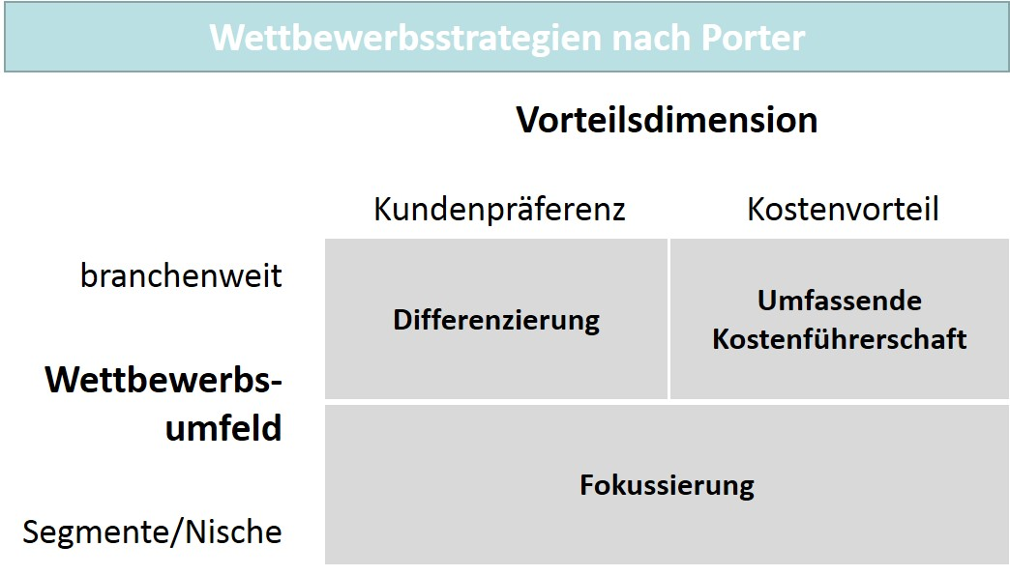

With the strategy of cost leadership, a company aims to achieve the lowest costs in an industry. Examples here are also the discounters, as well as the low-cost airlines in which Ryanair is the market leader. The prerequisites for this are high unit numbers and a standardization of the offerings. In the case of the discounter, for example, this occurs through house brand merchandise and the limitation of the number of articles in the product mix. In contrast, the differentiation strategy relies on the superiority of products through design, brand/image, or a specific technology and superior services with a simultaneous high price policy and high margins. Both strategies target the entire industry, which is not the case with focusing due to concentration on specific market segments or even niches. In most cases, there is a restriction to selective consumer groups, regions, or sales channels. Within the market segments, positioning is then again based on costs or differentiation by means of competitively relevant product characteristics. At minimum here, a combination of the two competitive dimensions is also conceivable, which is conceptually expressed with outpacing. Accordingly, Porter’s competitive strategies cannot be viewed as independent of the customer-oriented basic strategies (Herrmann & Huber, 2013, pp. 116–117).

Porter’s recommendations also indicate that a company can only be successful overall with a sound strategic positioning and this can only be achieved if it is able to gain large market shares with the chosen advantage dimension or can better exploit its market with small market shares compared to the competition. Positions in between trap the company in the competition and reduce success.

**Strategic alliance**

A cooperation between companies at the same value creation stage.

### Cross-Company Product Strategies

Corporate cooperation and networks can also represent a certain strategic orientation. On the one hand, companies can enter into **strategic alliances** (horizontal cooperation), and on the other hand, **strategic networks** (vertical or lateral cooperation). Horizontal cooperation occurs when companies at the same level of the value chain work together. An example is retail companies that cooperate with the goal of joint purchasing in order to optimize conditions. There is also the case of automotive companies cooperating in certain technology areas, e.g., in the production of drive technology. In contrast, vertical cooperation occurs with the cooperation between companies at different value creation stages. Examples here are cooperations between manufacturing companies in the automotive industry and supplier companies. When the cooperating companies come from different industries, this is a lateral or diagonal cooperation. For example, when selling automobiles, the manufacturing companies can also offer an insurance service through a cooperation with an insurance company. Vertical and lateral/diagonal cooperation also leads to an interconnection of the different value creation contributions, which is why these are strategic networks. Optimization across the value creation stages can also include the coordination of the flows of goods, finance, and information, which can be realized by means of a joint **supply chain management (SCM).**

**Supply chain management (SCM)**

The coordination of goods, finance, and information flows in a value creation network.

**Strategic network**

A cooperation between companies at different value creation stages or in different industries.

Kooperationsformen und SCM-Integration

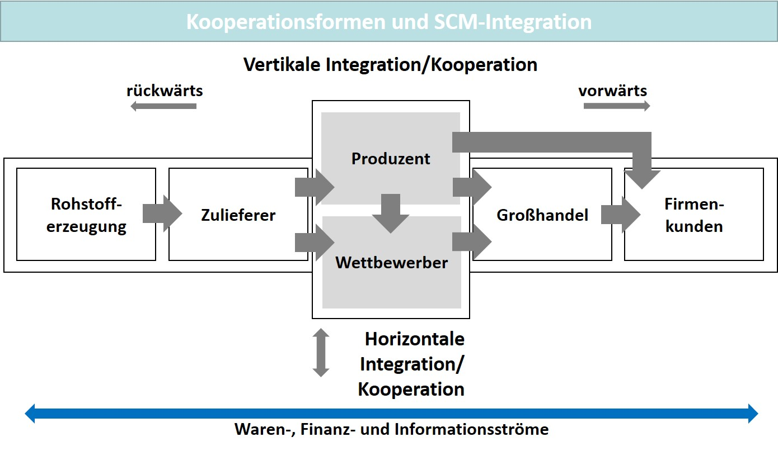

### Evaluation and Selection

The previous explanations have shown that the set of strategic options available in product management requires that those responsible decide on the correct strategy. Decision-making should then be carried out using appropriate criteria that can be evaluated quantitatively and qualitatively. However, the general conditions must be strictly observed so that ...

* … the strategy options are consistent (free from contradiction and conflict, and with goal system conformity),
* the strategy content is also coherent in itself (sensibility, appropriateness, suitability for the intended audience), and
* the strategies are feasible (suitability of competences, resources, competition), and
* the economic efficiency is ensured (Herrmann & Huber, 2013, p. 119).

The qualitative evaluation primarily serves to determine the suitability of the various strategy options. In addition, quantitative considerations can lead to an assessment of the financial consequences of the alternatives. This includes the forecasted values for sales and revenue, as well as statements on other quantitative variables supported by investment calculations, which can have an influence on the strategy selection. The appropriate strategy alternative is selected on the basis of the evaluation carried out in this manner. The product policy instruments are then used for strategy implementation and results monitoring (Herrmann & Huber, 2013, p. 120).

### Self-Check Questions

1. Which statements are correct? Mark the correct answers.

* Customer-oriented strategies focus on demand and relate to the identified customer or market segments. (C)
* Cost leadership, differentiation, and focus are customer-oriented strategies. (I)
* Competition-oriented strategies describe the strategic orientation of a company toward its competitors. (C)
* Market field strategies are among the competitive strategies. (I)

1. Which specific strategic orientations result from Ansoff’s product-market typology? Mark the correct answers.

* Market penetration (C)
* Price differentiation (I)
* Product development (C)
* Market development (C)
* Product reduction (I)

Summary

Once a company has determined the position of its products, suitable strategies must be selected and evaluated to guide the appropriate market cultivation in a manner that allows the goals to be achieved. For this purpose, there are three basic models of market cultivation in the form of customer-oriented, competition-oriented or cross-company strategies. The customer-oriented strategies include the market field strategy with a strategic orientation that considers specific product-market combinations and the market stimulation strategy that does not focus on price or price-benefit aspects. With the market parceling strategy, a company commits itself to a differentiated or undifferentiated market cultivation, while a market area strategy is a market cultivation orientation that takes geographical circumstances, from regional to global, into account.

The competitive strategies include the competition-oriented strategies that orient the market cultivation toward the target object (market/market segment) and the competitive advantage sought. An example is the competitive strategy according to Porter with the customer preference and cost advantage dimensions.

Cross-company strategies include strategic alliances as cooperations between companies at the same value creation stage and strategic networks as cooperations between companies at different value creation stages or in different industries.

The decision-making process for strategy selection should be based on suitable criteria that can be evaluated quantitatively and/or qualitatively. The general conditions must ensure that strategy options are consistent, that the strategy content is also coherent, and that the feasibility of the strategies and their economic efficiency is ensured. The qualitative evaluation primarily serves to determine the suitability of the various strategy options. In addition, quantitative considerations can lead to an assessment of the financial consequences of the alternatives. This includes estimates of sales and revenue, as well as statements on other quantitative variables supported by investment calculations, which can have an influence on the strategy selection. After strategy selection, the product policy instruments are used for strategy implementation and results monitoring.

# Unit 4—Process-Oriented Product Management

Study Goals

On completion of this unit, you will be able to ...

... design and accompany product management measures for the product life cycle stages.

... determine the content focus and purpose of roadmaps in product management.

... structure the product development process as a prerequisite for the market success of products.

... describe the effect of the two modern management approaches in product management, agile product management and lean product management.

# 4. Process-Oriented Product Management

### Introduction

Companies become visible within the market through their offerings in the form of products and services. These offerings also represent their innovative strength and competitiveness. Product management must therefore handle the coordination of processes ranging from strategic analysis to product planning and market cultivation. In modern companies, a process-oriented organization is a prerequisite for the success of this management work oriented toward the product life cycle, and accordingly, process-oriented product management is also part of competitiveness and market orientation. The following underlying questions for its concrete design and methodology therefore arise:

* What measures in product management design and accompany the product life cycle and what is the focus and purpose of product roadmaps?
* How do product development processes work and how are they designed in terms of content?
* What is the effect of using modern management approaches (agile product management, lean product management) in product management?

## 4.1 Design of the Product Life Cycle

### Life cycle model and stages

The dynamics of the target markets represent a major challenge for product management. Dynamics means change. As a rule, this means that the product management tools used in market cultivation must also continually adapt to these changes. The changing character of markets also requires a process-oriented approach in product management. Consequently, the view of the product considers the relevant temporal milestones of development and market launch, while the market stages must remain in the focus of action plans relating to product policy even after market entry. This stage-oriented view of a company’s offering in combination with the continuous analysis of market conditions and foreseeable changes characterize process-oriented product management as the basis for market success and ensuring a company’s own competitiveness. The market orientation designed in this way therefore holds the life cycle concept as the core of market cultivation that functions much like a framework.

Lebenszyklusmodell

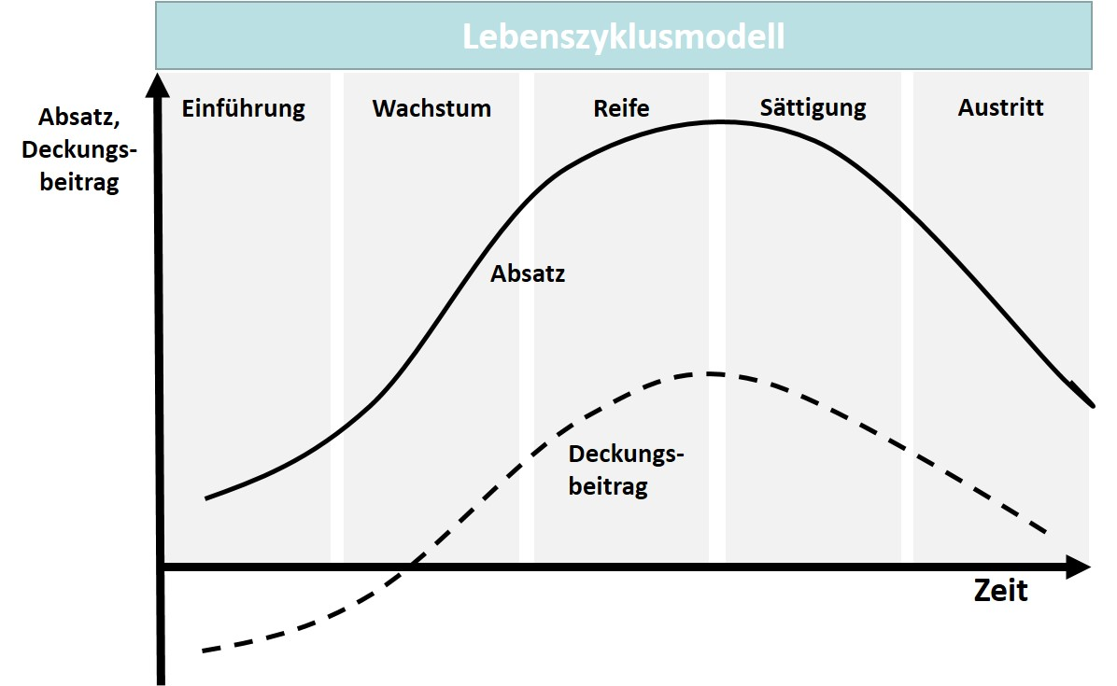

The life cycle model in the figure above shows the sales development of a product over time with an ideal division into different life cycle stages. In addition, the **product contribution margin** is shown over the course of the life cycle, since it provides a more meaningful reflection of the market situation, while also taking expenditures into account. The exact characteristic of progression always depends on the product and its target market and can therefore have a specific curve. The duration of the life cycle stages is also likely to be different in each case when comparing different products (Aumayr, 2019, p. 268).

**Product contribution margin**

This is calculated from the price of the product less its variable costs.

The life cycle begins with the launch stage, in which the sales of a product are still rather low and the contribution margin is low or even negative due to the high costs. During the growth stage, the sales and contribution margin increase more strongly and the market cultivation measures undertaken subsequently show effect and ensure market success. The growth rates and contribution margins for the product decline in the maturity and saturation stages. The exit stage is then typically characterized by the fact that the contribution margin has become negative and a recovery is virtually impossible (Aumayr, 2019, pp. 268–269).

To be able to make statements on the development, alongside the product, the market life cycle is naturally also of interest as the result of aggregating the life cycles of the specific products offered in this market. This enables the company’s own product to be categorized and evaluated, for example, by means of a comparison. In the figure below, a product initially has very sluggish sales within the market, while the market life cycle itself shows a strong growth. Only after the use of product policy measures, e.g., through more advertising, does the situation improve for the company’s own product.

Markt- und Produktlebenszyklus

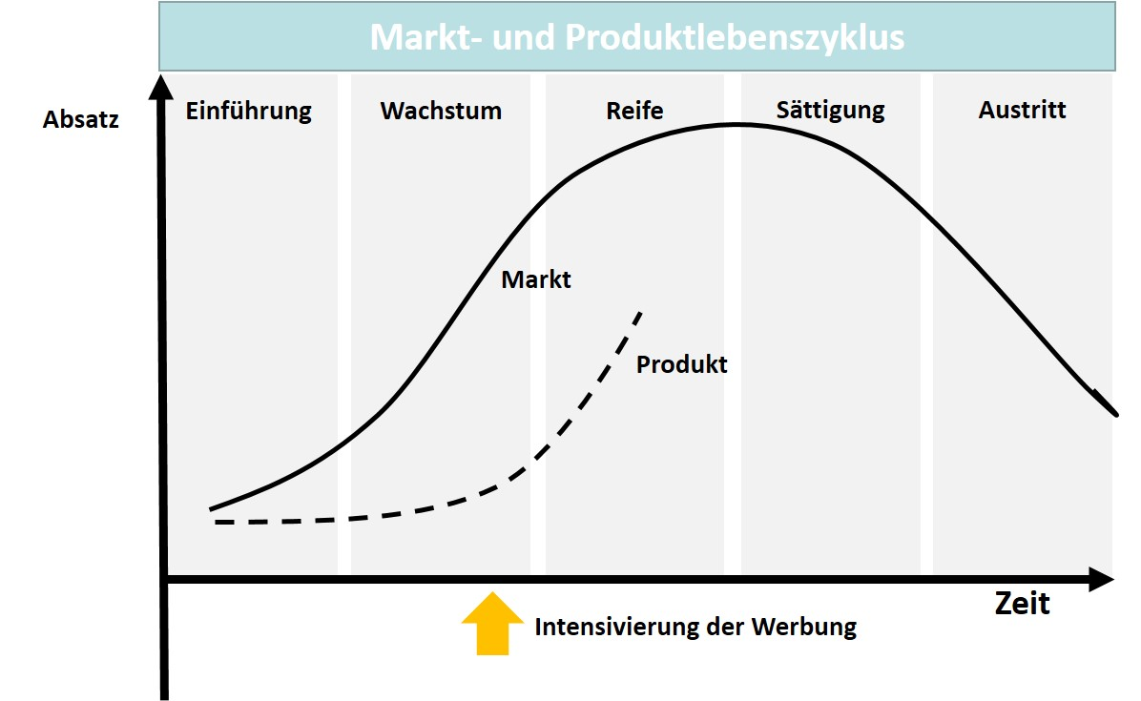

An interesting application possibility for a combined view is shown in the illustration of a life cycle matrix below. While Product 1 (P1) has already reached and almost passed saturation according its own life cycle, the market life cycle is still clearly in an earlier stage. Conversely, Product 2 (P2) is still in the maturity stage, while the market life cycle is already in a later stage. The attractiveness of the products can therefore clearly be evaluated differently when compared to the market.

Lebenszyklusmatrix

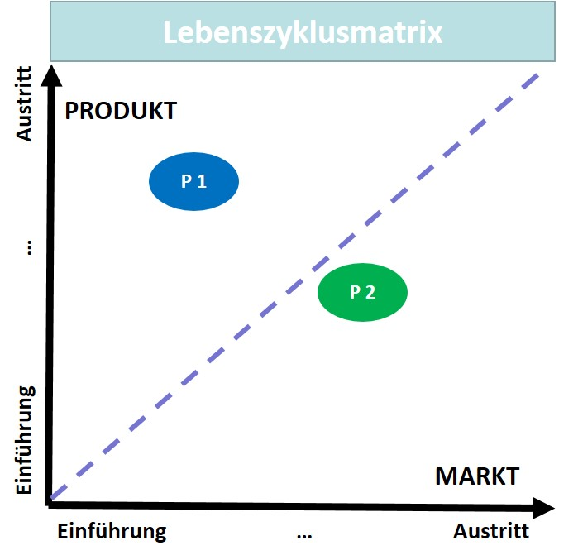

Since the contribution margin can also differ from stage to stage, it is useful to compare product contribution margins and their life cycle stages in a portfolio. Supply structures can be optimized in this way if, for example, products can be selected in early stages and eliminated in late stages. In addition to the absolute position in the life cycle, the contribution margin also allows **profitability** to be taken into account**,** which can make sense when comparing several products in portfolio management.

**Profitability**

The ability of an undertaking to make a profit on a continuing basis.

Another interesting analysis for a company is the age structure of its products by categorizing them in the life cycle stages and determining the shares in percent. In connection with the revenue and the contribution margin, a statement can then also be made about the situation in which the company finds itself with regard to the portfolio structure. High contribution margins and sufficient products in the growth stage are an indication that the company is prepared for the future. The incomes can be used to make necessary investments in new products and to increase or maintain their attractiveness. At the same time, products that are no longer profitable are then removed from the portfolio if they have yet to cause financial damage through unnecessary preservation measures (Aumayr, 2019, pp. 273–276).

Highly innovative companies are characterized, for example, by the fact that they generate a higher share of their revenue through products that tend to be newer. However, the disadvantage is that such a portfolio view leads to the conclusion that a downright innovation race must ensue. After all, there is tremendous pressure on competing companies, since they must continually invest in new products. Conversely, it is not necessarily the wrong product policy if there are products with a corresponding share of revenue that have already been on the market for many years. It may also be that the product policy measures ensure that a product achieves a strong position within the market and can also hold it for a very long time. Traditional brands are an example of this.

Erstkäufer:innen in Kundengruppen

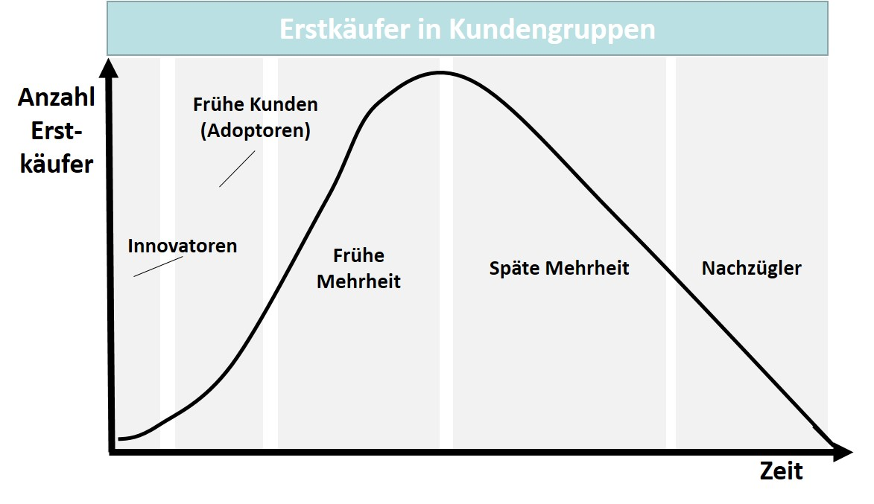

The product policy measures must be adjusted to take the circumstances in the product life cycle into account (see figure “First-time Buyers in Customer Groups”). In the launch stage, growth is still low and due to the launch costs, the contribution margins are likely to be low, perhaps even negative. The competition primarily revolves around customers who, as innovators, are quite often pioneers in a market. Of course, the reference potential of these **lead users** is interesting, and so it is primarily the task of product management to ensure recognition and intensify sales. Somewhat later are the customers who react very early to innovations and consider a purchase (early adopters). In terms of numbers, the most interesting are the early and late majorities, i.e., a large number customers who have the certainty in a product environment that they are purchasing an already established product. An even later group is made up of customers who, as laggards, are trailing somewhat behind the development. Companies that understand their customer structure in the manner described above will then concentrate their product policy activities on the respective groups that are more likely to achieve greater sales success depending on their life cycle stage as innovators, early customers, early or late majorities, and laggards (Aumayr, 2019, pp. 277–279).

**Lead user**

The leading users in their market whose demands are quite ahead of those of other market participants.

The criteria and characteristics of market cultivation are assigned to the life cycle stages in the table below. The goals of the instruments used are listed at the bottom. An important criterion here is also the competitive situation, since the intensity of market cultivation by competing companies naturally represents a significant driver for the costs of a company’s own activities. It can even form decisive advantages or disadvantages.

|  |  |  |  |  |
| --- | --- | --- | --- | --- |
| **Product Life Cycle Stages—Goals and Criteria** | | | | |
| **Criteria** | **Launch** | **Growth** | **Maturity/**  **Saturation** | **Exit** |
| **Sales growth** | Low | Increasing rapidly | Stagnant | Decreasing |
| **Costs** | Launch costs  (high) | Development (medium/high) | Maintenance costs (medium/low) | Development costs  (low) |
| **Contribution margins** | Low/negative | Growing/high | Stable/sinking | Decreasing strongly/ negative |
| **Customer types/market segments** | Innovators | Early adopters/early majority | Late majority | Laggards |
| **Competing companies** | Few/none | Increasing | Stable | Decreasing |
| **Goals** | Make the product known, induce first-time purchases | Gaining market share | Profit optimization, inventory protection | Cost  reduction, downsizing |

### Product Life Cycle and Strategies

The relationships explained also provide important information as to how products can be introduced into a market. The pioneer strategy is an orientation for companies that want to be the first to enter a product market. Pioneer companies have the advantage of being able to still shape the market, which can be promoted by the fact that the product characteristics are then viewed as standard by consumers. In this way, a pioneer company can also create barriers to entry that deter potential competition. Examples are retailer loyalty programs or agreements with leading companies on the consumer side. Conversely, the early market entry strategy aims to secure market entry by only making its presence felt once the launch stage has already begun. A late entrant strategy even relies on the fact that the launch stage is almost over and thus aims at an even greater risk avoidance, since the market cultivation only starts with the growth stage. We all know the term *flop*, which means the failed market launch of a product. This is exactly what early and late entrants want to avoid as much as possible (Aumayr, 2019, p. 279). The table below shows different strategies in the course of the life cycle stages, of which the beginning and end of each must be planned in product management.

|  |  |  |  |  |
| --- | --- | --- | --- | --- |
| **Product Life Cycle Stages and Strategies** | | | | |
| **Strategy focus** | **Launch** | **Growth** | **Maturity/**  **Saturation** | **Exit** |
| **Product mix** | Basic product mix | Expansion to full product mix | Item focus, cherry picking | Selective item  elimination |
| **Price** | Price skimming strategy | Transition to high price strategy | Pricing like competition | Selective price cuts |
| **Distribution** | Selective distribution | Consolidation of distribution channels | Intensive distribution | Eliminate distribution channels |
| **Communication** | Recognition level | Image advertising/  product advertising | Product advertising (USP) | Maintenance advertising |
| **Sales promotion** | Intensive (retail) | Intensive (customers) | Selective | Sell-off |
| **Needs type** | Generate reference customers, innovators | New demand | Brand change, replacement need, customer loyalty | Potential expansion |

Each of the strategy focuses represent a part of the instruments that are used in the course of the different stages. In the product mix policy, a company typically starts with a basic product mix that can be expanded during the growth stage. When saturation begins, the focus turns to specific items that are doing well, while at the end of the cycle, the unsuccessful items can be eliminated. The selection of pricing strategy is particularly important, since customers generally react to price changes to a greater or lesser extent. When introducing innovative products that are in high demand, a head start can also be used to choose an optimization in terms of price, here it is the **price skimming strategy**. The rather high prices associated with an attractive product are only gradually lowered. In particular, technical product lines with successive generations, each representing better performance data, have such a ripple effect in pricing. In an attractive market environment with growth, the price can also tend to be increased, which follows a **high price strategy.** If sales reach saturation, care must then be taken to ensure that the price is also aligned with the price of competing offerings in the more intense competition that is likely to exist. In the last stage of the cycle, a **selective price reduction** can ensure that demand for a product that is no longer as successful increases somewhat again or falls less sharply. The use of the other instruments also follows the respective situation of the products in the life cycle stages. For example, distribution becomes more intensive with increasing success and more selective with decreasing success, and the expenditure for market communication focuses on the recognition of an offering at the beginning, while at the end of the cycle only maintenance advertising is undertaken.

**Price skimming strategy**

Profit maximization with a relatively high price that is successively lowered over time.

**High price strategy**

High prices for products that are in high demand.

**Selective price reduction**

Price reductions in the event of falling demand for specific products.

Life cycle analysis provides key insight that greatly facilitates the design of product policy instruments for market cultivation in the relevant policy areas, from the product portfolio through to the needs type, in connection with the buying behavior of customers. What is known as the AIDA formula is very suitable for this design approach. Here, attention (A = Attention) must first be generated so that interest (I = Interest) is created and the desire (D = Desire) to buy the product arises. The purchase (A = Action) itself is then the ideal conclusion. Of course, this representation is simplified and in reality must be supplemented with the special features that additionally characterize a buying process (Aumayr, 2019, p. 280).

### Self-Check Questions

1. Mark the correct statements.

* The life cycle model shows the sales development of a product over time and in stages. (C)
* The life cycle begins with the growth stage, when sales of the product are still rather low. (I)
* Sales growth is highest during the maturity stage. (I)

1. Why is an analysis of the age of products based on a life cycle observation in product management of interest?

The age analysis categorizes the products into the life cycle stages and determines the shares in percent. In connection with the revenue and the contribution margin, a statement can then be made about the situation in which the company finds itself with regard to the portfolio structure. High contribution margins and sufficient products in the growth stage are an indication that the company is prepared for the future. Products that are no longer profitable are eliminated from the portfolio if they have yet to cause financial damage through unnecessary measures.

## 4.2 Product Roadmaps

Strategic planning is always strongly oriented toward the medium to long-term development of the management discipline in focus. Since this perspective is always fraught with uncertainty, clear determinations are not without risk, but are nevertheless necessary, since at the same time, the orientation toward strategic guard rails is a prerequisite for successful operational planning and implementation of measures. Strategic planning techniques are therefore also necessary to be able to present the goal systems, measures, and the milestones to be achieved in an integrated manner. For product management, the **product roadmap** offers itself as such an integrated view that depicts the main goals and the product-strategic determinations in a temporal plan progression. The dimension of time is important here because all activities must be continuously verified with regard to the fundamental strategic orientation relevant for competitiveness on the basis of the respective given market situation and a company’s own goals so problems can be identified and the resources for the necessary measures can be appropriately allocated.

**Product roadmap**

This maps the future development of a product in an action plan and is oriented toward the goals.

A roadmap cannot contain all the details of a plan, but rather only the elements that are to ensure medium and long-term success are a focus. If this is to be mapped professionally, of course it is also necessary to involve the stakeholders, since it is precisely the strong coordination of contributions from research/development through to marketing that is perhaps the most important success factor in a roadmap (Aumayr, 2019, pp. 306–307). The figure below shows a roadmap example from software development with milestones, project stages from planning through to the approval of a final release state, and accompanying measures, such as the website for communication with the public.

Produkt-Roadmap (Beispiel)

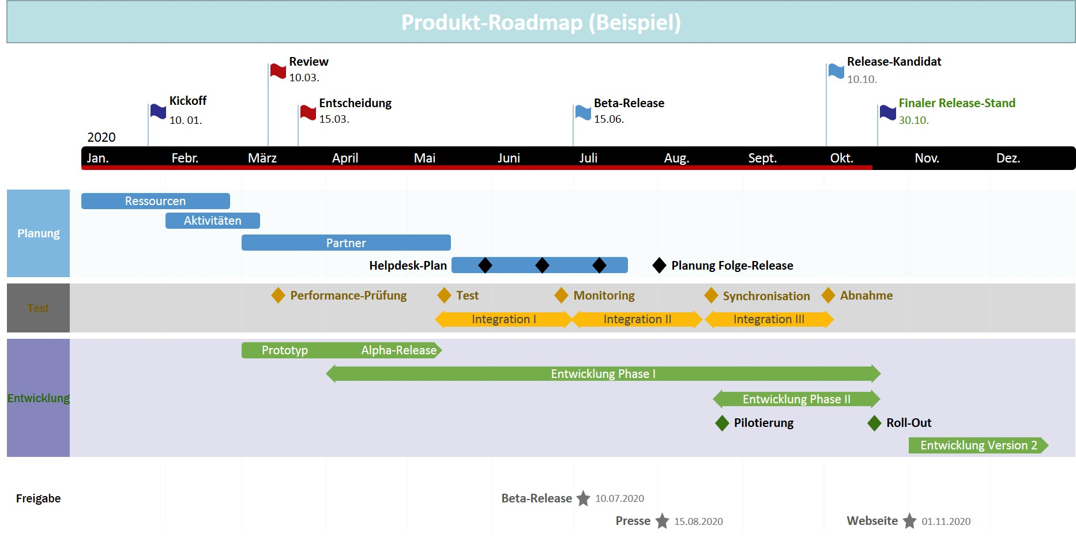

The illustration shows that the roadmap does not include each of the individual plans itself, but offers an integrated overall view. The sub-plans are therefore still project-related for the traditional stages and control views of a project organization. The roadmap therefore represents a planning superstructure for orientation.

The contents that a roadmap should generally include are (Aumayr, 2019, p. 308):

* process stages or steps,
* milestones for important sub-steps,
* designations for the content elements, and
* the chronological order of the activities.

Product roadmaps can show when new release states or new functions will be available. If the product management uses this tool primarily to guide the internal coordination of the functional areas, it is an internal roadmap. If the roadmap is part of the market or customer communication, this involves an external roadmap (which, of course, builds on the internal version in terms of content). In addition to the product roadmap, there is also the technology roadmap, which shows the technological trends and developments in the sector or industry. The market/strategy roadmap is used to show the planned product-market combinations over time, while product development roadmaps are used simultaneously in product management and development. Vision/mission roadmaps visualize the general market and industry trends to prove the accuracy of fit of a company’s product (Aumayr, 2019, pp. 309–313).

As part of communication, roadmaps are also an instrument that addresses different intended audiences. Management expects information on the planned development of a product portfolio to be able to specifically assess their own decisions on resource requirements. Conversely, the accepted roadmap also provides those responsible for the product with the certainty that they are on the right track and can expect support within the company. Due to its strategic orientation, the time perspective of the roadmap is extended to up to five years. The departments involved also need the information from the roadmap for their own planning. Externally, the roadmap is aimed at customers, market partner companies from the retail sector, system partners, and integrators, as well as other players within the market, such as consulting companies. The legally binding character of addressing these external intended audiences should not be viewed uncritically, since publication also raises expectations with regard to goal fulfillment. In product management, attention should therefore be paid to the exactness of statements, but also mark the roadmap as non-binding to prevent complications (Aumayr, 2019, pp. 313–315).

In practice, hybrid roadmaps have become increasingly established as a combination of different roadmap types, e.g., the combination of product, market, and technology roadmaps. Dependencies and connections between the partial representations can therefore be visualized quite well in an overview. This supports the work in product management even better, since more complex issues can be made transparent (Aumayr, 2019, p. 315).

### Self-Check Questions

1. What content should a roadmap have?

Process stages or steps, milestones for important sub-steps, designations for the content elements, and the chronological order of the activities.

## 4.3 Agile Product Management and Lean Product Management

”Agility is the dexterity, nimbleness, or agility of organizations and people or in structures and processes” (Bendel, 2019). This definition particularly assumes a flexibility of organizations with regard to challenges and changes. Why is this actually worth emphasizing? Companies are institutions whose organization is determined for the long term so that operations and processes can be planned in detail and executed continuously. We primarily associate this with the stability and quality of a process execution. Conversely, **agility** also means that processes can and should be interrupted and changed when key parameters that determine the process have changed. In connection with product management, this can be, e.g., changed customer desires and requirements due to new competitive conditions. This can go so far that products are also no longer offered. Companies that are flexible in this way are also guided by the fundamental principles of agility in product management (Bendel, 2019).

**Agility**

The ability of organizations to react flexibly to changes in the general conditions in the process design.

We use the term **lean management** to describe a management approach that is particularly characterized by its focus on “the goals of customer orientation and cost reduction for the entire management of the company” (Voigt, 2018). To achieve its goals, lean management relies on specific fundamental principles in internal and cross-company process design through ...

**Lean management**

A management approach that pursues the goals of customer orientation and cost reduction using specific fundamental principles.

* ... a team-oriented work organization with task decentralization,
* cooperation with partner companies within the value chain,
* an integration of product and process planning and development, and
* an informational networking with partner companies within the market (Voigt, 2018).

Accordingly, agility and lean management are also suitable approaches for allowing process orientation in product management to be effective through market-oriented goals and flexibility in the use of the instruments to achieve them.

### Agile Product Management

Development processes and their organizational and operational project design are traditionally supported methodically, whereby in most process models, stage-structured and thus chronologically ordered process steps are planned. One example of this is what is known as the waterfall model.

”The **waterfall model** is a sequential process model that organizes development based on successive stages. It has been ... called the ‘waterfall model’ because the results of one stage always flow into the following one” (Kuhrmann, 2012). There are “feedback loops between each stage, but only with the respective adjacent, preceding stage” (Kuhrmann, 2012). When this method is used in product management, an analysis stage first determines the product characteristics and stakeholder requirements to be developed. In the subsequent stage, a concept for product development is then created based on the accepted requirements, which forms the basis for planning in the development stage. After an extensive testing stage, the product can then be delivered to the client or presented in a market (Hoffmann, 2020, pp. 1–2). The figure below shows the stage sequence and the feedback loops between the successive steps. Due to the stage sequence and structure, product development has a rather simple organizational structure. However, this is at the expense of customer orientation, among other things, since user aspects are only included in the process at the beginning in the analysis stage. Requirements can then only be changed with difficulty or not at all during further development (Kuhrmann, 2012).

**Waterfall model**

A stage-oriented process model for product development with feedback loops with the respective preceding stage.

Wasserfallmodell im Produktmanagement

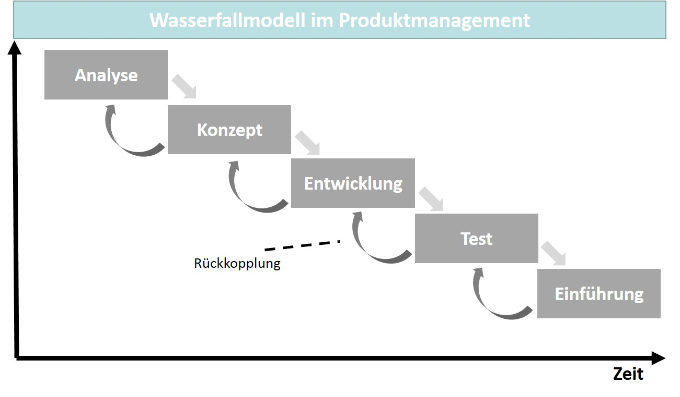

A process model of this type is sufficient support for projects with reliable planning certainty right from the beginning. However, if there are still uncertainties, e.g., in connection with the requirements as identified during the analysis, this approach can prove to be insufficient because subsequent changes are very difficult to implement. For product management, market changes, as well as technological developments or changes in legal requirements, play a role here if the expectations of the product do indeed change along the chosen development path. In extreme cases, the product might not be launched on the market or may require revision after a short period of time, which hardly seems possible given the intensity of competition today. To prevent this, product development is already being undertaken in an agile manner in many companies today. The product is developed step by step along the entire development path, with feedback being obtained from the respective stakeholders, and in this case, primarily the customers, which leads to a continuous validation of the development. The result of such feedback loops then influences further product development (Hoffmann, 2020, p. 3).

Agile Produktentwicklung

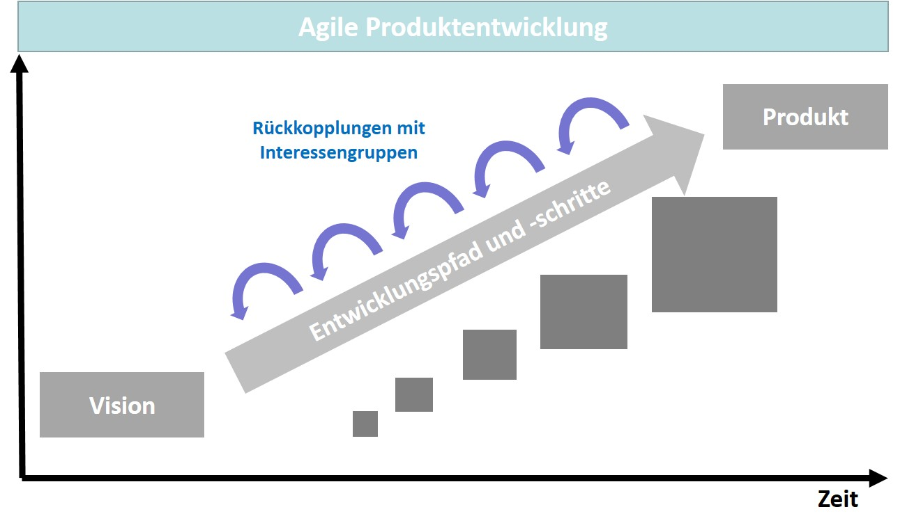

The goal of **agile product management** is a functioning product that meets the requirements to ensure a successful market launch. Close cooperation with customers and the willingness to consider changes in requirements even during the ongoing development process are core elements of the process model, as schematically outlined in the figure above. However, this does not mean that an agile approach is carried out haphazardly, but merely that the flexibility for changes that serve the goal is maintained over the duration of the process and can thus contribute significantly to the success of the development (Hoffmann, 2020, p. 4).

**Agile product management**

An approach that integrates stakeholders into the development process at all times.

The expenditure required for agile teamwork in product management should pay off, particularly in the long term, since the agile way of working can handle complex requirements better and take the different focuses of different customer groups into account. The different focuses typically result from specific expectations, socio-cultural backgrounds, or even developmental leaps of technologies and target markets (Gaida, 2021, p. 50). In its approach, such agility in product management is initially a philosophy that must be implemented in practice through the specific use of methods. Over the course of time, a number of methods have been developed for this purpose and are presented below.

**Scrum**, for example, is a process model that originally comes from agile software development. Due to their complexity, software projects in particular are rarely detailed and plannable from the beginning, which is why planning is refined step by step in this method. The product to be developed in this way is defined by its characteristics, which are determined in a product backlog in a list ordered by priority. The product backlog is initially incomplete and is dynamically expanded or reduced. The development itself then takes place in what are known as sprints, which have varied durations, e.g., one or several weeks. In a sprint, the requirements that were selected from the product backlog and transferred to the sprint backlog are realized. The result of a sprint is then a usable subsystem for the realized range of functions. After each sprint, the just completed range of functions is validated/evaluated in order to incorporate the experience gained into product improvements as needed (Siepermann, 2018).

**Scrum**

A method for agile project planning and the development of systems.

The scrum approach explicitly integrates the users’ requirements into the product development. Compared to the traditional process, this requires greater commitment and at the same time, product development has greater responsibility and more creative freedom. This can also mean that certain requirements are not implemented if this turns out to be sensible in the course of validation. This is also a deviation from traditional development work, in which a defined range of functions is typically also fully implemented. There are two specific roles for organizational responsibility. Scrum masters are responsible for adherence to the scrum process, and product owners for the requirements and the use of results. The method also includes elements of quality management, since these aspects must also be considered in practice (Gaida, 2021, p. 52). **Product owners** are therefore comparable to project managers who maintain the connection with stakeholders and are responsible for the planning components of cost, schedule, and system functionality. They accept the deliverable supplied by development and prioritize and administer the requirements in the product backlog (Siepermann, 2018). **Scrum masters** tend to be coaches who support the team to ensure that the methodological sub-areas can be effective. Their tasks as contact persons include the removal of obstacles, moderation, and monitoring performance (Böhm, 2019, p. 38).

**Scrum master**

The role in the scrum model that is responsible for method compliance and team coaching.

**Product owner**

The role in the scrum model that is responsible for requirements management.

A second method that plays a relevant role in the field of agility is **Kanban,** a “system developed in Japan for flexible, decentralized production process control; ‘Kanban’ literally means ‘card’ and refers to the identification card located at each final product, assembly, and individual part used in the operation” (Siepermann et al. , 2018).

**Kanban**

A system for controlling processes in product development.

The goal of the Kanban system is to carry out the individual work steps so that ...

* ... no overload occurs in an operation,
* the flow rate is maximized, and
* the overall result corresponds to an optimum (Böhm, 2019, p. 31).

In terms of content, the following principles are maintained (Böhm, 2019, p. 31):

* The system load is based on the process that has the highest lead time.
* Subsequent operations take the new processing elements from the previous process.
* The number of individual jobs in one process is limited.
* Individual elements are selected to be minimally small.

Accordingly, Kanban is not a system for optimizing teamwork, but rather for optimizing the system as a whole and for the lead time and quantity with a focus on the steps of product creation (Böhm, 2019, p. 31). So, in contrast to scrum, it is not so much the team performance that counts, but rather the efficiency and effectiveness in the work steps to optimize the overall system. Thus, there are also no explicit roles, as is the case in scrum with the scrum master and product owner.

At the heart of the Kanban system is the Kanban board, which visualizes the work, lead time, and potential obstacles that can lead to a pile-up. The work steps in the columns on the board depend on a specific task (Böhm, 2019, p. 33). The Kanban system connects two adjacent work steps/processes at a time to form a control loop and is based on the pull principle. So, only when a work step requires something, is it also generated in an upstream work step (Siepermann et al. , 2018).

When it comes to companies wanting to play out their strengths in a market-oriented competitive environment, traditional methods and process models are increasingly reaching their limits. They must therefore find new forms of work and cooperation that keep them on a growth path while minimizing their risk. Here, agile working is a methodical approach to also gain the ability in product management to ...

* ... be flexible,
* learn as an organization,
* be creative in design, and
* react flexibly and quickly ...

... to be able to meet the challenges. Customer orientation is the focus when agile organizations optimally adapt their resource usage and the deliverables output processes to the actual need. In connection with the agile methods used in the context of product development, there are two other popular methods, lean start-up and design thinking.

The American Silicon Valley entrepreneur Eric Ries is considered the inventor of the **lean start-up** method. Rather than starting with a lengthy conceptual planning stage, continuous prototyping begins immediately. In this way, no time is lost and any weaknesses that arise are remedied step by step. At the same time, developments within the market are monitored and if market or industry trends, legal regulations, or other influences affect product development, these can be reacted to and addressed immediately in the ongoing process. The lean start-up control loop thus consists of the three stages …

**Lean start-up**

An agile method with the three stages: build, measure, and learn.

* **… build:** prototyping as a minimal version and decision to start/continue.
* **measure:** observe partial results and collect feedback, and
* **learn:** make adjustments based on knowledge gained (Ehmann, 2019, p. 36).

**Design thinking** follows a highly practice-oriented and rather generalistic approach. The focus is on the customer and accordingly, customer orientation, customer centricity, and customer enthusiasm are the three fundamental attitudes of this method. From the beginning, the customers are integrated into the development process that consists of six steps. The steps of understanding, observing, and defining the perspective represent what is known as the problem space, in which it is a matter of analyzing the customers and their needs and understanding what problems they have. The steps of generating ideas, developing prototypes, and testing then represent what is known as the solution space (Ehmann, 2019, pp. 21–23).

**Design thinking**

An agile method with problem and solution spaces.

If the traditional and agile methods presented are arranged in a matrix according to the degree of familiarity with the needs and the technological solution approach, the result is a ranking as shown in the figure below. Traditional project management is sufficient in a familiar environment, while the use of agile methods is more appropriate as the level of difficulty increases due to unknown sub-areas. Design thinking particularly shows its strengths when the solution approaches (solution space) can only be developed from a description of the problem space after thorough analysis. The interventions then tend to take place in a chaotic environment.

Methodeneinsatz im Innovationsprozess

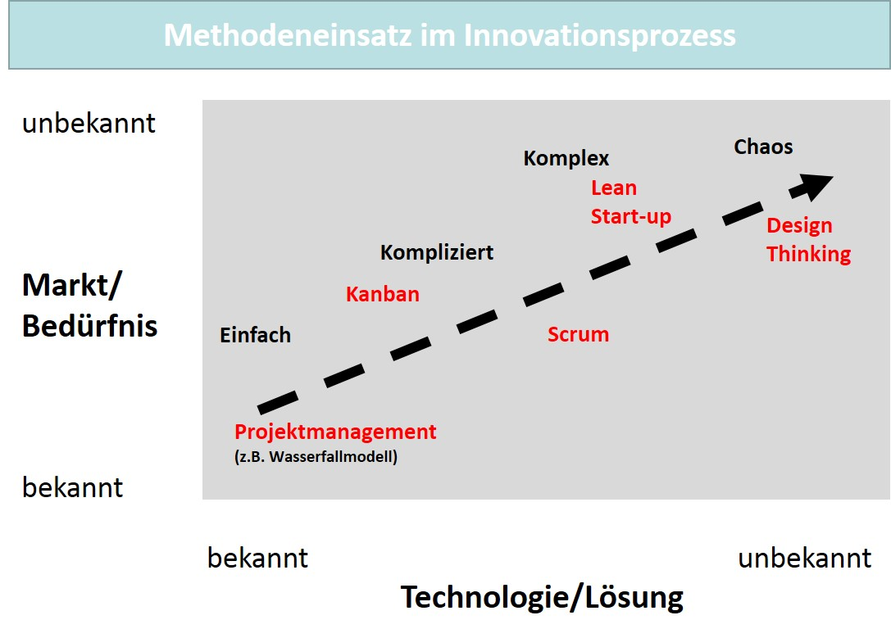

### Lean Product Management

In order to be able to anchor lean management in a company, it is necessary to align the organization as well as the culture accordingly, so the changes do not fail because corporate cultural imprints remain unnoticed. But changing the corporate culture is not easy, since the structures representing it are typically already tradition and have grown over many years. They can be found in the approaches to problem solving and in the modes of interaction practiced within the company (Helmold, 2021, p. 27). However, the intensity of competition, global developments (climate change), or sudden pandemic conditions change the general conditions for companies so significantly that the previously applicable rules and their accompanying success factors only apply to a limited extent. New management approaches are increasingly a means for many companies and for nearly all economic branches and industries to operate successfully even under these circumstances. Lean processes and systems that are flexibly oriented to needs are becoming the core of long-term competitiveness, for which the main challenges of today are …

* … customized and individual products and services,
* short lead times, and
* a flexible requirements management.

Transformation processes as well as a cultural adaptability are indispensable to meeting these challenges (Helmold, 2021, p. 32).

An example of a lean management method is **Kaizen,** also a Japanese management concept, which aims at improvement in small steps. Employees are extensively involved in the company’s activities and should continuously improve all aspects of value creation, i.e., particularly processes, products, and the systemic and organizational infrastructure. For this purpose, they show appropriate attention and interest in the customers’ requirements and the market. Kaizen focuses on improving teamwork and the commitment of all employees to a company’s goals and culture. A tool that can methodically support Kaizen quite well is the PDCA cycle for the control and continuous improvement of processes and products. It consists of the steps …

**Kaizen**

A management method for the continuous improvement of work steps.

* … **Plan (P)** with the analysis of the current situation and plan definition.
* **Do (D)** with the implementation of the defined solution.
* **Check (C)** with the verification/validation of the improvements.
* **Act (A)** with a definition of countermeasures in the event of goal deviation thereby creating a standardization of the best solution (Helmold, 2021, pp. 37–39).

Kaizen und PDCA-Zyklus im Lean Management

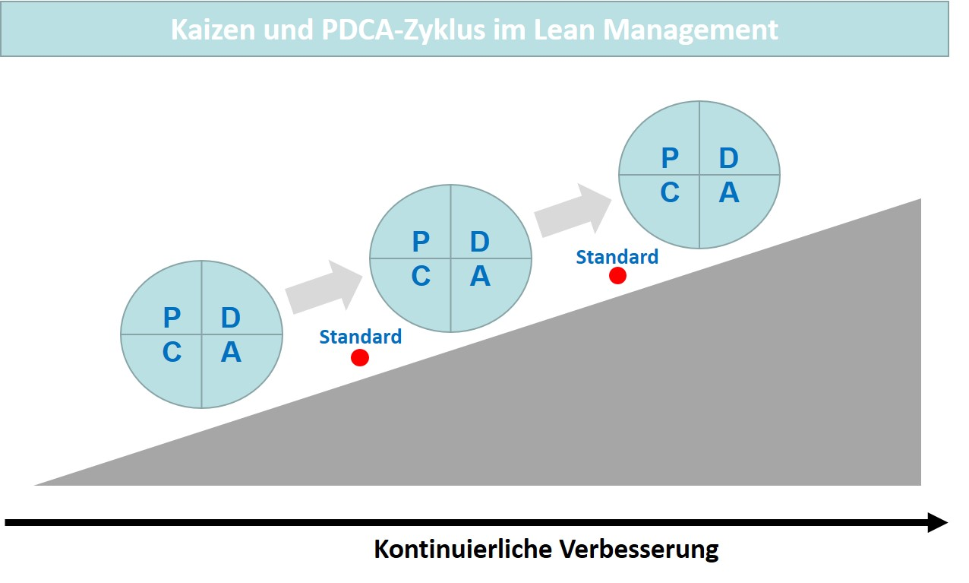

Kaizen as a method of continuous improvement can be used in many contexts of operational process design, but has limitations when the improvement is quite a leap and accordingly has the character of an innovation. This also limits its suitability for product management. Nevertheless, lean product development has its justification in the context of lean management, since it is also an application of the lean approach as it was first developed for manufacturing—as lean manufacturing. Lean always refers to producing something and spending less time and money on it. Again, the focus is on identified customer value, which should be produced without waste. “Lean product development makes it possible to design product development according to specific principles, thus reducing expenditure and optimizing customer benefits” (Helmold, 2021, pp. 113–114).

**Lean product management**

The application of lean management principles in product management.

If the principles of lean product development and lean management are nowapplied to the other stages in the product life cycle, the concept of **lean product management** emerges.

Lean Product Management

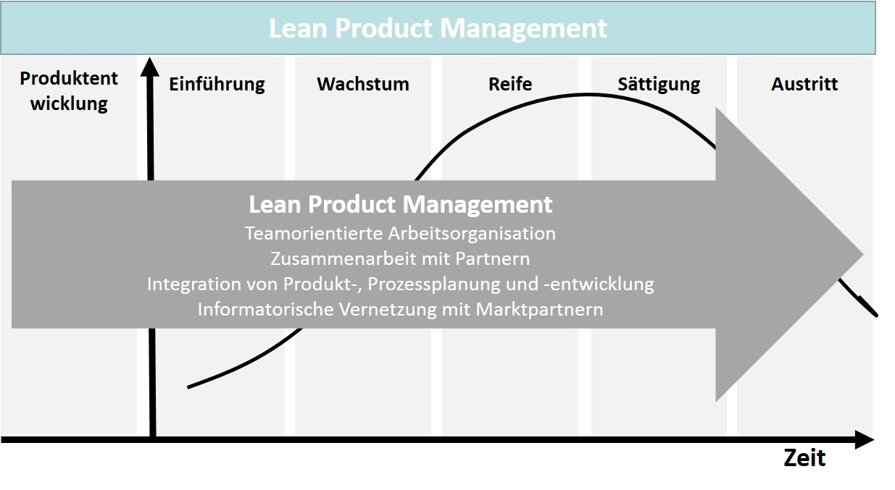

In addition to agility, the principles of lean management can also be implemented considerably well in product management. Here, too, the focus is on customer orientation and, in combination with innovative product development, competitiveness is strengthened. The result is a company that is market-oriented and aligned according to modern management concepts and is quite capable of meeting the current challenges.

### Self-Check Questions

1. What are the benefits of agility and lean management for the company?

Agility provides a company the ability to react flexibly to changes in the general conditions in the process design. With lean management, a company uses a method that pursues the goals of customer orientation and cost reduction with specific fundamental principles.

## 4.4 Product Development Process

### Product Development in Stages

The previous discussions and conceptual ideas, e.g., in connection with the life cycle of products, make it clear that it is very important today to also design the actual product development as a stage upstream of the market launch as flexibly and efficiently as possible. It must be considered here that product development also has a processual character and in itself also involves a sequence of development steps, each of which must be determined in terms of content and method and must be oriented toward a goal. The specific design and duration of the stages depend on the product itself, which makes it difficult to provide a general description of the content. Nevertheless, it is important that the correct focus is established in each stage taking into account the analyses of intended audiences and markets that has been carried out. In the following, the stages are first explained in general terms and then a specific model is presented that makes the product development process methodically plannable and designable. The explanations do not refer to a specific model from the literature, but rather the basic assumptions are based on the process model by Gericke et al. (2021, pp. 70–72).

The first stage of product development involves analyzing and identifying the needs of the intended audience for which the product is intended. Product ideas can then be generated from this which, as initial concept drafts, convert the benefit aspects into requirements. Idea generation and requirements definition must also be supported methodically, since idea management has become an important sub-discipline in product management due to the intensity of competition. If good and suitable results are achieved here, the chance of market success at least potentially exists.

The second stage of product development takes over the suitable product concept from the idea management of the start stage and verifies it against the technical specifications that are available as requirements and whose feasibility must now be investigated. The technical feasibility must be ensured so that the subsequent development does not need to be stopped or economically burdened with unplanned and thus additional investments. Verifying the concept is therefore also a key element of quality assurance within product development. The transparency of the concept also makes it possible to take an early look in the direction of the market. It is already useful at this stage to assess the economic expectations that result from the market analyses. The expected sales, for example, can be compared with the projected market data and the market development also allows assertions to be made about the future market situation. In a market environment that is already foreseeably saturated, different conclusions will be reached compared to those that are likely to be reached for attractive and growing markets. This means that illusory expectations and the associated goals that are difficult to achieve can also be corrected. Conversely, very positive expectations can also lead to an acceleration of processes.

If the product concept can be approved, nothing stands in the way of developing a prototypical initial product version. In this third stage of the product development process, which is therefore often referred to as *prototyping*, a demonstrable version is created with which a testing of specific requirements is already possible. In addition, contact with the users’ and obtaining their opinions can provide additional certainty. In modern development environments, prototype versions can also be generated entirely virtually and support the simulation of functions and runtime behavior as a **digital twin.** Digitalization thus provides product development with valuable tools that can accelerate the development process while ensuring its quality. Two special forms are associated with software development:

**Digital twin**

The virtual image of a real product that allows a simulation of the functionality.

* A **click dummy** is an interactive prototype version of a website, program, or app that can be used to simulate use cases even if the range of functions is not yet complete. Together with the future users, important tests on user guidance can take place at an early stage and the development risk can be minimized.
* With what are known as **mock-ups,** entire web applications can be prototypically tested in a design stage. This results in the design and user guidance being optimized without furnishing the costly functionality. Modern development environments, e.g., editors in app development, use this function to ensure that navigation through the application is transparent at a very early stage.

Up to the actual market launch, concept corrections may still be necessary on the basis of the experience gained in prototypical use. These are carried out in the fourth stage of a concept revision to create the final state of the product version with which the market launch is then also to be carried out. In practice, prototyping and this revision can be in one stage or can be repeated in a loop until the final state is reached. Ultimately, the actual product development should follow at the end as a production process or roll-out. In the figure below, the general process flow of product development described above is also graphically summarized.

Produktentwicklung in Stagen

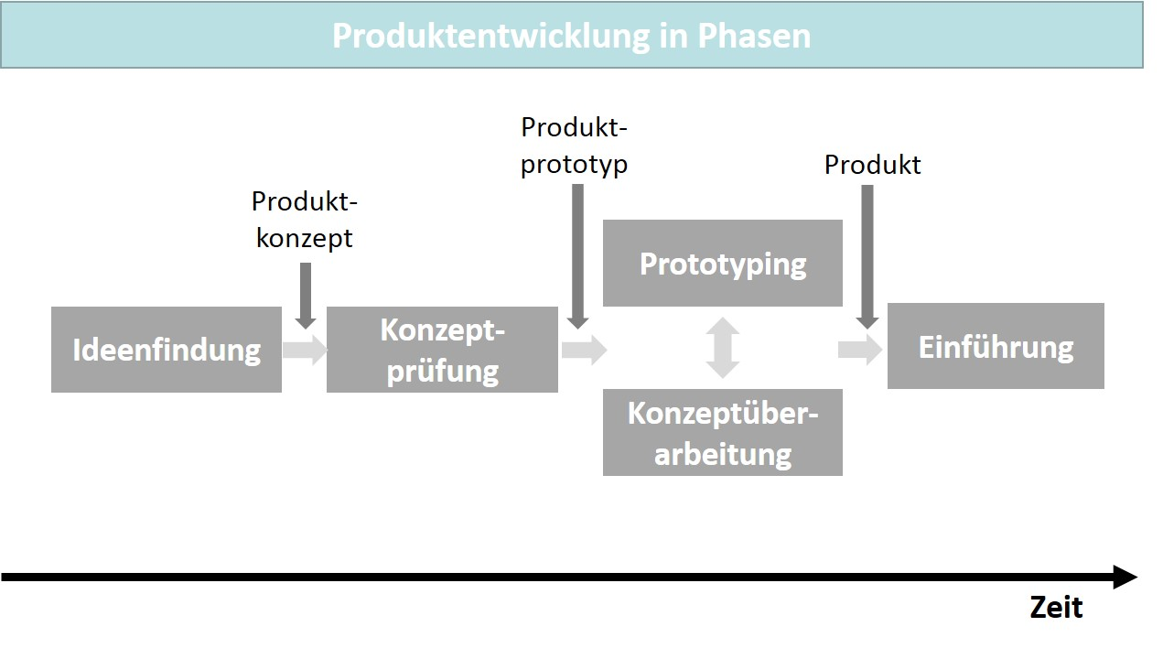

The general stages explained can be interpreted as a typical sequence of stages in product development. Over time, very different models have been developed for this process flow, which have then also become established in practice, often in connection with specific use cases, industries or technologies. One such model is presented below.

### Stage-Gate Model for Product Development according to Cooper

The development of new products is one of the riskiest activities in companies. However, companies that invest heavily in new products are also respected and are typically rated higher by investors. Innovative companies are also statistically more successful. They realize a significant part of their sales with young products, whose share of total sales is relatively larger compared to not-so-innovative companies (Cooper, 2017, pp. 13–14). This clearly proves that innovative companies demonstrate better performance in their market cultivation and that this is also directly related to their innovative strength.

Five developments can be used to illustrate how innovation strength is driving competition today and that companies cannot stand on the sidelines of this innovation race (Cooper, 2017, pp. 17–20):

* **Technological progress:** human knowledge is increasing at a rapid pace.Thanks to the internet in particular, more and more information is available and access to knowledge sources is easily possible regardless of time and location. At the same time, the speed of technological developments is increasing rapidly.
* **Changing needs on the customer side:** the intended audiences for products and services are no longer as stable as they once were. The customer and market segments are continually in a dynamic state, which causes problems for the offering companies (fragmentation of demand).
* **Ever shorter product life cycles:** while in the past many products were only renewed or replaced after ten years, much shorter supply cycles are now common. New competitors as well as new technological options are increasing the pressure on innovation management in companies.
* **Increasing globalization:** for many years, the success of companies depended on the extent to which they were successful in their country of origin. Today, companies increasingly do not have a connection to a specific country, but rather production facilities and company headquarters can be located in very diverse countries.
* **Internet diffusion and relevance:** the internet, itself a remarkable innovation, has become the enabler of a multitude of new business models, as well as a driving force in business process innovation.

The developments noted above are reminiscent of the VUCA acronym, which refers to volatility, uncertainty, complexity, and ambiguity and is used to describe the supposed traits of the modern business world. In connection with companies, these four phenomena are typically related to digitalization and the search for strategies and concepts to meet the associated challenges (Bendel, 2021).

**Stage-gate model**

The process model for product development with development stages and milestones (gates).

Cooper’s **stage-gate model** of product development is particularly suitable for companies that derive their motivation for product development from these general conditions and contexts. It uses milestones (gates), each of which are also decision points for the progress of the development. Individual parts can also be omitted or overlap, which, in combination with the interdisciplinary process work, leads to a very flexible process that also includes idea generation and market launch. “Stage-gate ... is a conceptual and operational map for moving new product projects from idea to launch and beyond—a blueprint for managing the new product development process to improve effectiveness and efficiency” (Cooper, 2017, p. 99). This statement proves the direct proximity of the model to the competitive dimensions of effectiveness and efficiency. The figure below illustrates the stages and milestones, as well as their meaning.

Stage-Gate-Modell nach Cooper

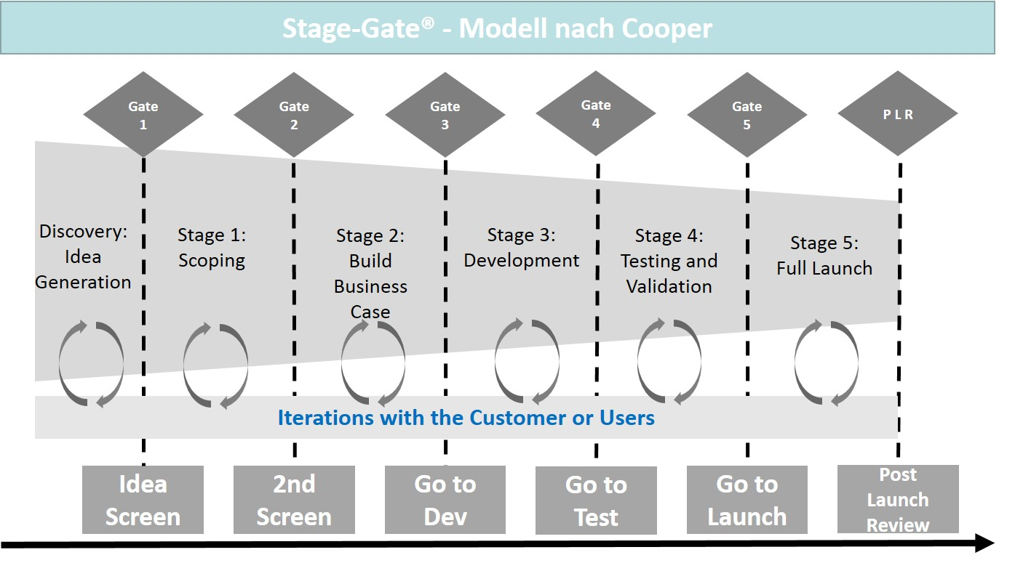

The individual stages represent the activities. The milestones (gates) ensure that the next stage is only began if the goal for which the milestones stand has also been achieved. In terms of content, the stages represent the following measures (Cooper, 2017, pp. 119–121):

* **Discovery**: preliminary work to discover market opportunities and generate ideas.
* **Scoping**: here, this is the investigation of a project that has a concept verification character.
* **Build the business case**: at this stage, the development project is extensively conceptualized and its state is verified, which includes technical feasibility and marketability, and also contains an action plan in the form of a business plan.
* **Development**:this involves the detailed design and development of the product, as well as the production process.
* **Testing and validation**:the content in this stage includes market testing and the validation of the technical requirements and the suitability of the product for sale.
* **Full Launch**: this is where production and market cultivation begin with the product management instruments.

All stages are directly related to the requirements of the customers or users, since these are included in the test criteria and are taken into account within the milestones (iterations with the customer or users). Alongside the processes, there is also an organizational recommendation with a role model (Cooper, 2017, pp. 137–138):

* **Project team**: interdisciplinary core team drawn from several functional areas for process execution.
* **Project manager**: team leader with responsibility for resources and planning, as well as for internal/external coordination.
* **Project manager**:optional role for methodical support in a project. A frequent role combination with project management.
* **Gatekeeper**:interdisciplinary decision-making body to release/block the next stage.
* **Process manager**: person responsible for the process with a support function in the processes and the process progress.
* **Executive sponsor:** mentor from the leadership/management of a company with a support function for the project management in conflict situations.

A special feature of the Cooper process model presented is the cross-divisional character of the measures at each stage as a combination of tasks from the functional areas of a company involved. Each stage concludes with a verification of the criteria as a milestone, whereby the verification criteria represent the requirements placed on the product and can also be viewed as success factors for marketing.

Despite the flexibility and interdisciplinary approach, the product definition is brought into a stable state on the basis of the requirements, so that the step of the actual product development can follow reliably. However, in today’s world of market changes or the emergence of new technological processes, situations may well arise in which changes to the product definition may even become necessary at a later point in time.

Because stage-gate processes tend to provide for a fixed and sequential series of planning and implementation activities, they quite often have limits in their accuracy of fit for requirements related to digitalization. Particularly for radical or disruptive solutions, process performance needs to be more flexible, since it is not possible to consistently maintain a finalization of activities from step to step. In practice, for example, this leads to companies separating out the development of digital business models, since the established stage-gate processes often filter out all project approaches that do not fit the predefined rules at early stages. Potentially valuable approaches can therefore remain unconsidered in the long run because they cannot be integrated into the stage provided for in the process in accordance with the rules. This can result in many innovations not even making it through the stage-gate filters (Rath, 2020, pp. 133–134).

It would therefore be highly desirable if the Cooper model presented could also take these aspects into account. Leading industrial companies have been interested in agile process models for some time, since software development already relies on agility and, in connection with the digital transformation, the topic of software is also becoming increasingly important for industrial companies. A hybrid model that combines the stage-gate philosophy with the agile development method could therefore make the advantages of both directions available to users. The model integrates the agile scrum method with its sprints into the project management of the stages in the stage-gate model. The results and goals of the individual stages thus follow the concept elements of agile management according to scrum more and are even leaner, more flexible, and less granular compared to the traditional model approach. There are already companies that have piloted the hybrid **agile stage-gate model** and can move into a stage of implementation. These include General Electric (GE) and the LEGO Group, for example. These companies come from different backgrounds and are already using the stage-gate model in product development. Combining it with agile methods also makes sense here, since companies are also increasingly focusing on combining hardware and software in connection with the digitalization of their business models (Cooper & Sommer, 2018, pp. 19–20).

**Agile stage-gate model**

This combines the advantages of scrum with the stage-gate model for product development.

Agile Stage-Gate-Modell

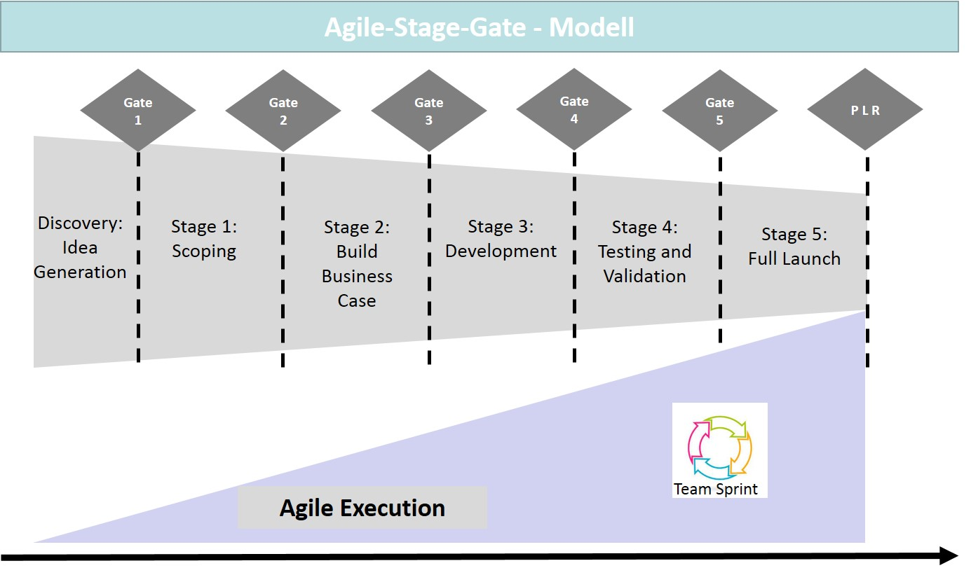

Practice has shown that the integration of scrum cannot and need not succeed equally in all stages of product development. The advantages of the approach in the early stages can be countered by disadvantages in the later stages, when the short-term interventions are not compatible with the more constant necessities of traditional product development. Companies may then carry out a model extension precisely for the process steps for which they expect the most benefits (Cooper & Sommer, 2018, pp. 25–25). Overall, the first companies to apply this did indeed show that the hybrid approach can make product management more successful, even in traditional development environments. Nevertheless, companies must first go through several trial runs be able to follow their own way of implementation, as well as to ensure compatibility with their use of resources and with their organization.

### Self-Check Questions

1. Which product development stages take place successively? Mark the correct answers.

* Idea generation, concept testing, concept revision, prototyping, launch. (I)
* Idea generation, concept testing, prototyping, concept revision, launch. (C)
* Idea generation, idea testing, idea revision, prototyping, launch. (I)

1. How do stage-gate and agile-stage-gate models differ from each other?

The stage-gate model is a process model for product development that has a traditional stage progression with development stages and milestones (gates). The agile stage-gate model combines the advantages of scrum as an agile method for project planning with the stage-gate model for product development.

Summary

In product management, process orientation is primarily reflected in the life cycle design for products and services. This stage-oriented view of an offering, in combination with the continuous analysis of market conditions and foreseeable changes, characterizes process-oriented product management as the basis for market success and ensuring a company’s own competitiveness. In this context, product life cycle and market life cycle analyses provide indications of the effectiveness of product policy measures.

Strategic planning techniques are also necessary to be able to present the goal systems, measures, and the milestones to be achieved in an integrated manner. For product management, the product roadmap offers itself as such an integrated view that depicts the main goals and the product-strategic determinations in a temporal plan progression. A roadmap cannot contain all the details of a plan, but rather only the elements that are to ensure medium and long-term success are a focus. If product management primarily uses this to manage the internal coordination of functional areas, it is an internal roadmap. If the roadmap is part of market or customer communication, this is referred to as an external roadmap, which, of course, builds on the internal version in terms of content.

Agility and lean management are also suitable approaches for allowing process orientation in product management to be effective through market-oriented goals and flexibility in the use of instruments. The goal is a functioning product that meets the requirements in order to ensure a successful market launch. Close cooperation with customers and the willingness to consider changes in requirements even during the ongoing development process are core elements of the process model. Scrum, which originated in agile software development, is a good example of this. A second method that plays a relevant role in the field of agility is Kanban, a system for controlling processes in product development. In contrast, Kaizen is an example of a lean management method that aims to improve in small steps. If the principles of lean product development and lean management are applied to the other stages in the product life cycle, the concept of lean product management emerges.

It must be considered that product development prior to market launch also has a processual character and in itself also involves a sequence of development steps, each of which must be determined in terms of content and method and must be oriented toward a goal. Idea generation, concept testing, prototyping, and concept revision take place before the actual product development and market launch. The stage-gate model is a process model that combines development stages and milestones (gates) and can support product development in the described stage-oriented sequence quite flexibly, but also reaches its limits in terms of the development of digital business models. Above all, the rigid sequence of process steps stands in the way of a culture of innovation that, in the case of radical or disruptive solutions, also enables trial and error and questioning throughout the entire development process. For this reason, the agile stage-gate model is a sensible extension and combines the advantages of scrum with the stage-gate model.

# Unit 5—Idea Generation and Product Validation

Study Goals

On completion of this unit, you will be able to ...

... show the importance of ideas in innovation management.

... design idea management in such a way that product concepts and improvements can be derived from it, with which companies remain competitive.

... secure the developed product concepts by testing and validation.

... describe the management of requirements as an important sub-discipline of product management.

... allow product concepts to flow into specific requirements that place the identified customer benefit aspects at the center of product development.

... prepare a product launch through product and market testing and thus also ensure its success.

# 5. Idea Generation and Product Validation

### Introduction

To arrive at marketable and therefore competitive product concepts, companies must generate and test numerous ideas. Good product concepts do not arise automatically, but must be verified and validated at a very early stage to secure the typically high investments on the path to a market-ready product. Only then can the specific requirements be defined and finalized as a basis for development. The results are then subjected to product and market testing, with which companies can check the quality of the expected product—and in coordination with the customer expectations, thus also the marketability. The following underlying questions for the process design from the outlined idea management through to the market testing therefore arise:

* How must idea management be designed so that sufficient product concepts can be generated in this way, and how can these be sufficiently verified through validation?
* How can the concepts be transformed into marketable requirements that take sufficient consideration of customer benefits?
* What is the benefit of product and market testing for securing the actual market launch and processing, and how can they be carried out?

## 5.1 Idea Generation

### Innovation as a Driver of Economic Dynamism

The German economy is traditionally one of the economies that reinvest a significant share of its revenues in the creation and improvement of products. It can be deduced from this fact that prosperity in Germany also depends to a significant extent on the innovative strength of German companies. Currently, we are also hearing this in social and political discussion when it comes to the upcoming transformation of the German economy due to the change in climate and the reorientation in primary energy production that has become necessary as a result (energy turnaround). Technical progress should also be a pillar that supports this transformation process in a relevant way, and new technologies should, above all, be the main drivers of this change. However, new developments cannot be forced, they are rather the result of creativity and inventiveness and these particularly depend on how ideas can be turned into concrete innovations and product developments. This means that if as many high-quality ideas are generated as possible, then it is more likely that these will also result in useful product concepts. In turn, these concepts can be used to develop products that can be utilized within the market. For product management, **idea generation** is also the starting point for the development path that leads to the creation of competitive offerings in the form of products and services.

**Innovations**

The new or improved products and services resulting from ideas and proposed solutions that are successfully launched on the market.

**Idea generation**

The development of ideas and proposed solutions as a basis for new or improved products and services.

In the context described, the term *idea* is therefore also closely linked to the term *innovation*. **Innovations** are the core of competitiveness in many markets and are therefore of utmost importance to the companies offering them. Innovations ensure the survival of companies and are the absolute success factor, particularly in technology-driven market scenarios, since progress and thus also the competitiveness of products can be directly measured by the technologies. However, innovation is not static, but rather dynamic. This means that companies compete to innovate, thereby creating a pressure and race to innovate, since the limited lifespan of products forces companies to be active if they do not want to lose this competitive race in the long run. Innovation also means risk, since new products have no guarantee of success. They can even fail at market launch and become investment ruins that can put an entire company in a financially dangerous position. It is therefore essential that even the search for innovation ideas must consider the target customer benefit, which should distinguish innovative providers in particular. In fact, the importance of innovation is continually increasing, since technological progress is incredibly dynamic, even radical innovations are brought to market very quickly and may not only endanger the established business models of existing companies, but in some cases even eliminate them. Those who do not keep up in the innovation race have little chance, since once they have fallen behind, it is generally no longer possible to catch up. The intensity of competition is therefore heightened from several directions at once, if globalization with the increase in the number of competing companies in a market is also taken into account as a further amplifier. Consumers can easily obtain information and the distribution of the products is no longer a hurdle, even across national borders and intercontinentally. This means that if companies do not want to and cannot fight in a price competition with ever decreasing margins, ideas and the resulting innovations are an indispensable prerequisite for success in competition (Herrmann & Huber, 2013, p. 123).

Of course, innovations are not only associated with products, but also with services or certain process technologies, e.g., when it involves innovative processes. The music industry is also a very striking example when it comes to innovative changes due to digitalization. While music publishers were once responsible for distributing sound media via retailers, today’s productions can be distributed via the internet. Consumers can purchase licenses for use via download or choose from a range of specialized services via subscriptions in exchange for regular fees and play any music titles via streaming. Similar business models are pursued by services for offering films and TV series via the television at home, of which Netflix is a well-known example.

Since the customer’s assessment of the benefit of a product or service is subjective, a product or service can only be considered an innovation if the consumer perceives it as such. Nevertheless, innovations do not always must result from the creative power of a company’s own development department. They can also be acquired, licensed, or, for the purpose of acquiring knowledge, an entire company can be purchased if this means that the existing innovation capability is retained in the new corporate constellation (Herrmann & Huber, 2013, p. 124).

### Ideas as a Prerequisite for Innovation

Innovations are based on ideas, but even in a company these do not necessarily have to come from a research and development department. Other groups are also quite capable of deriving new solutions to problems from their activities. For example, employees in customer service and sales can evaluate the desires and complaints of users and draw from them to generate suggestions for improvements with a high degree of practical relevance. Employees from production can contribute in a similarly effective way when they encounter problems in the course of their work, for which they can then quite often already present solutions, at least in their own minds. New employees should not be underestimated either, as they often notice problem areas that are not at all obvious to colleagues because they are accustomed to particular conditions (Franken & Franken, 2020, pp. 317–318). Alongside these internal sources of ideas, external sources can also be drawn upon. First, there are a company’s customers, whose potential as idea generators has been increasingly in focus for years. For companies, this is based on the consideration that the risk of a product development can also be minimized by the fact that the offering is aimed at satisfying the needs of customers, which almost guarantees an orientation toward customer benefits. A second aspect concerns the availability of such sources of ideas, since they are nearly permanently and continuously available (Herrmann & Huber, 2013, p. 126). The table below lists key internal and external sources.

|  |  |
| --- | --- |
| Sources for Product Ideas | |
| **Internal sources** | **Sources external to the company** | |
| Customer service/field services  Company suggestion system  Incentives through reward  Scouting time  Skunkworks  Innovation workshops | Lead user analyses  Focus groups  In-depth interviews  Tool kits  Product configuration  Complaint analysis  Innovation circles  Buying ideas  Trend analyses  Trade fair visits and patent analyses  Competition research |

Employees in the customer and field services typically have very close contact with customers and an accordingly in-depth understanding of customer needs, since they come into contact with them almost daily. This group is therefore the intended audience for a company suggestion system, which can also be firmly established within the company by means of an idea management system. However, it is important that such systems do not lose their appeal if the suggestion system involves an unnecessarily large amount of bureaucracy, since this can have a negative effect on employee motivation. Suggestions should therefore be very easy to initiate. An important point for increasing motivation can be an appropriate appreciation of the ideas submitted. For example, a reward in the form of a bonus has a positive effect. This type of incentive can take the form of a cash payment or also non-cash prizes and awards. Managers play a key role, since their communication with employees can also promote their engagement. The principle of scouting time is a special form of incentive. Here, a company makes part of its work time available for employees to work on their own ideas. Another special form is *skunkworks*, in which company employees join together to form a project group that can also move outside the usual rules to develop creative ideas. Special workshops can also be organized to generate concentrated ideas within a defined period of time. Appropriate **creativity techniques** are then used to develop proposals in the group, which can lead to the development of solutions to technological problems, the determination of market potential, or even the development of new business models (Herrmann & Huber, 2013, pp. 127–134).

**Creativity techniques**

The methods that support the search for and generation of creative solutions to defined problems.

When it comes to external sources of useful ideas in product management, the focus is on customers. A very well-known method for integrating them into the innovation process is **lead user analysis.** It is based on the assumption that lead users have a special interest in acquiring new and, in particular, innovative products. In addition to their role as trendsetters, as is often the case for consumers, lead users in the industrial context are often dependent on innovative products in order to be successful in their competitive environment. It therefore makes sense to utilize these users as a source of information, since their need can likely also be seen as a trend in the field that other companies will follow. Lead users are characterized by a great deal of specific knowledge with regard to the products that they purchase. Many lead users even go out of their way to suggest solutions for product improvement and are motivated when it comes to cooperatively designing new features for the products. Lead users often seek out pre-production models whose suitability and accuracy of fit for their own use can be verified at a very early stage. The manufacturing and offering companies can now rely on the fact that the needs of the lead users can be seen as exemplary for an entire user group. If these needs can be identified and used in product development, this can be a competitive advantage, since the needs of leading customers quite often also determine the trend in an industry (Herrmann & Huber, 2013, pp. 134–137). A good example here is the range of standard software for operational process support. As a rule, the manufacturing companies involve larger user companies at a very early stage in order to plan the first versions of the software with these companies. Then the user companies can still influence the design of the functionality and take advantage of the benefits of the new software and the manufacturing company has greater certainty that the future range of functions can also satisfy the needs of user companies in an exemplary manner.

**Lead user analysis**

The analysis and integration of the ideas and needs of the leading users within product development

Schritte einer Lead-User-Analyse

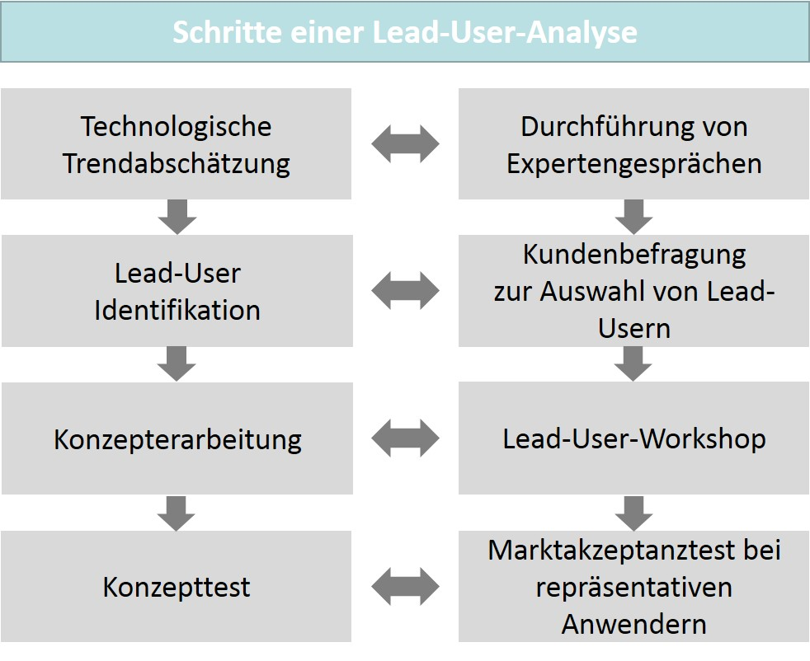

The figure above shows the process and the individual steps of a lead user analysis. In the first step, an assessment of the identified technological trends takes place, since the lead users and users are also dependent on and shaped by the prevailing technological trends. After determining the characteristic criteria for the goal, the actual selection of the lead user candidates can take place. This can be methodically supported by a survey. Then the actual exchange of information typically takes place in workshops with suitable representatives of the company and the lead users. The verification of the transferability of the results determined there to the entire object of investigation (market or industry) then represents the evaluation. This step is important, since the results must first and foremost meet the market requirements (Herrmann & Huber, 2013, pp. 138–140). However, the obvious advantages of the lead user method are also countered by potential disadvantages. Too strong an attachment to a few market-leading customers can lead to an unhealthy dependency when the needs of the market actually change, but the lead users initially remain in a niche of product use to delay these changes. Companies that rely on this method must therefore still align their sensors with all other developments within the market, as well as in the competition, so they do not miss important changes that can very quickly lead to a competitive disadvantage in today’s dynamic environment.

A methodological approach that somewhat mitigates the disadvantages described above is the establishment of **focus groups.** Here, each customer or user can actually be selected. The great advantage lies in the options for interacting with customers and users on the basis of very different tasks and problems about which there may be little or no knowledge (Herrmann & Huber, 2013, p. 143). In contrast to this group-oriented approach, an in-depth interview is only concerned a single interviewee. This means that individual views can also be addressed in a very specific way, which should also be the aim with this method (Herrmann & Huber, 2013, p. 144). **Tool kits** are used when customers can freely design products themselves or order them according to their own specifications. Today, this method can be implemented quite well by internet-based applications that can be operated intuitively (Herrmann & Huber, 2013, p. 145).

**Tool kits**

Tools with which customers can create the design of products themselves.

**Configurators**

Tools with which customers can determine the configuration of products themselves.

**Focus group**

The analysis of ideas and solutions through interaction with users.

Product configurations, which can also be carried out by customers or users, often via the Internet, are similarly innovative. A popular example is the **configurators** of automobile manufacturers that allow prospective customers to individually determine the design of the desired vehicle by selecting features on several levels (body, interior, colors, etc.). For the companies, however, this also entails an enormous amount of work, since in addition to constantly adapting the configurator to the current parameters of the product, the manufacturing processes must also offer the necessary flexibility. The evaluation of complaints is also a useful source of ideas and product improvements, since they often already contain approaches to solving problems. A targeted method here is innovation circles in the form of regular meetings with customers, where product ideas and innovative suggestions can be worked out together. The observation of users during the use of the products and when problems occur, i.e., a kind of laboratory environment (living lab) that is even easier to implement in reality. Of course, ideas can also be bought, but this can be very expensive depending on the product area. Options include transferring ownership or licensing. This method can make sense if, for example, there is a lack of know-how or time for a company’s own developments. Clearly less expensive, however, are trend analyses, which can result from continuous observation of the market. The trends are then the impetus for generating new ideas. Observation of the market and the environment is therefore always advantageous, whereby even visits to trade fairs and patent analyses can provide indications of innovative ideas. In particular, the activities of direct competitors, as well as the actions of companies in other or related areas, are of interest when a company is looking for new product ideas (Herrmann & Huber, 2013, pp. 149–155).

### Idea Management in Practice—Two Examples

Innovative companies typically also maintain a company suggestion system to encourage their employees to support innovation management with ideas and suggestions for improvement. What if this motivation were not even necessary because employees, as what are known as **intrapreneurs,** activate their idea potential even without extrinsic incentives? Studies suggest that idea management can promote this development, which would also give idea management a function in personnel development. Employees could therefore be intrinsically motivated to think about the company as a whole, independently of the narrow environment at their workplace, to support corporate innovation management as intrapreneurs in such a way that they look for improvement opportunities that are valuable for the company on their own initiative (Suchsland & Kloyer, 2019, p. 52).

**Intrapreneur**

Employees who are intrinsically motivated to support innovation management as “entrepreneurs within the company”.

This conclusion is understandable when considering that the needs relating to social and self-actualization are gaining in importance today and employees are increasingly striving for fulfillment in their jobs, which means that the intrinsic motivation component is also becoming more important. However, intrinsic motivation is difficult to generate in a targeted manner and guiding it in terms of organizational goals is also challenging (Suchsland & Kloyer, 2019, p. 55).

Personnel development and innovation/idea management must work together to promote the ability and motivation of employees to develop organization-related ideas. The view of those involved should be broadened and go beyond the job-related search field so that entrepreneurial thinking is strengthened entirely in the sense of intrapreneurship. Of course, employees have different initial requirements, and it will not be possible to achieve the desired goal of intrapreneur in every case. However, recognition, rewards, and encouragement, as well as a moderate and mindful expansion of the scope for action and decision-making, can help to generate a sense of achievement and reduce mistrust of integrated idea management. It will not always be possible to realize the ideal-typical development, since disappointment over rejected suggestions, negative behavior from superiors, or envy from colleagues can also represent obstacles (Suchsland & Kloyer, 2019, pp. 59–60).

In the healthcare sector, approximately one-third of sales worldwide are generated with products that are less than three years old. This underscores how important innovation and thus also idea management are here, since the increasing demands result from a growing awareness of the population for health and well-being and particularly from the aging of societies in various regions. The coronavirus pandemic has also made it clear that development capacities around the world are very quickly competing for short-term development success. In this example, it is a vaccine and this can also be associated with enormous economic success. It is therefore evident that, particularly in this environment, the question of optimizing idea management arises (Rupprecht, 2019, p. 193).

One of the most economically significant sub-areas of the healthcare industry is medical technology, which ensures that technical knowledge is transferred to the field of medicine. The products and procedures developed in this way help with healing or improve the quality of life. According to estimates, there are approximately 400,000 different products in this industry, and Germany is the third largest sales and production market worldwide. One significant player is Ottobock SE & Co. KGaA from Duderstadt with approximately 7,000 employees and global market leadership in technical orthopedics (Rupprecht, 2019, p. 195).

A well-known market research institute states the current trends for the medical technology sector as follows (Rupprecht, 2019, pp. 196–197):

* Digital solutions for process automation in production, as well as in communication between market partners (consuming and supplying companies, patients, organizations).
* Customer orientation through individualization of products and services for patients and consumers as an integrated service bundle.

Ottobock has relied on institutionalized idea management as part of its corporate policy for over fifty years. The initial company suggestion system was upgraded in 2011 by a newly created position for idea management and then continuously developed further. First, there is what is known as spontaneous idea management as an IT-supported idea exchange, where spontaneously generated ideas can be presented to selected reviewers. Idea management acts as a consulting and support body and ensures networking of all participants. In what are known as idea groups, the suggestions are jointly analyzed and evaluated. Direct contact optimizes processing times, creates synergies, and breaks down barriers. Due to the small production series in medical technology, the suggestions must always be intensively examined in terms of cost-benefit aspects to ensure that implementation is truly worthwhile. This does not make the work less challenging, since many ideas may fail to clear this hurdle and lead to disappointment. The second pillar is systematic idea generation, in which employees search for ideas in a structured and topic-related manner. In this way, solutions are sought that are actually needed, which also increases the motivation for the employees’ commitment. Organizationally, various formats are then worked with, such as campaigns or workshops. Current topics are digitalization, lean work, and customer orientation. For a company, this also provides an opportunity to communicate strategic concerns (Rupprecht, 2019, pp. 197–199).

The explanations on intrapreneurship and idea management in medical technology emphasize the relevance of ideas as an innovative starting point for the conception of products and services. The search for ideas must therefore be carried out systematically using various methods, whereby internal and external sources can be considered in an equally meaningful way. The management of ideas and the generation of concept approaches are therefore among the key activities in product management.

### Self-Check Questions

1. Which internal company sources can be used to generate ideas? Mark the correct answers.

* Scouting time (C)
* Tool kits (I)
* Complaint analysis (I)
* Skunkworks (C)
* Innovation circle (I)
* Innovation workshops (C)

1. Why is the importance of innovations increasing and which developments, among others, can be used to identify this?

The importance of innovations is continually increasing, since technological progress is incredibly dynamic and even radical innovations are brought to market very quickly. This means that the established business models of existing companies are not only at risk, but may even be eliminated. Those who do not keep up in the innovation race have little chance of catching up. The intensity of competition is also increasing due to globalization with the growing number of competing companies in a market.

## 5.2 Idea and Concept Evaluation

When operating a systematic and method-supported idea management, sufficient conceptual approaches should be generated, the verification and validation of which is also worthwhile with regard to the development of marketable products. It is then more likely to be a problem of filtering the right ideas and then validating them with a suitable evaluation scheme or method. It may even be possible to build up a portfolio of ideas, the prioritization of which, i.e., the ranking of the implementation of ideas, is the focus of consideration. It will then be possible to identify the right concepts by questioning the effect that can be achieved with the use of a company’s own resources in the development process. Conversely, the idea evaluation should also ensure that the concept approaches generated in this way do not lead to undesirable developments, the negative financial effects of which could put a company’s business model in a dangerous position. If strategic guidelines also must be questioned as a result, this can very quickly lead to failure in the competition as a whole. The concept evaluation ...

* … accordingly precedes a development release,
* must include a validation of the benefit aspects, and

**Idea evaluation**

The analysis and validation of concept approaches for product development.

* must ensure the comparability of the various concepts.

As a result, success potentials, risks, and feasibility are equally integrated as testing perspectives, which also adequately fulfills the competitive dimensions of effectiveness and efficiency.

Accordingly, two serious mistakes can be made in **idea evaluation** and the subsequent selection of suitable conceptual approaches. On the one hand, the wrong idea or the wrong conceptual approach can be selected, which ultimately fails. And on the other hand, a potentially successful idea could be rejected, the implementation of which could have led to market success. Thus, revenue and profits are not realized and instead, failure with an existing inferior concept approach may leave the company in distress or require a restart of development with all the associated risks. Careful validation and selection of concept proposals is therefore so relevant that it should ideally be done in two stages: after an initial and rough evaluation, then a second and finer screening and analysis should be undertaken. Accordingly, an initial selection of suitable ideas is best carried out by means of a **rough screening,** which can be methodologically supported, e.g., with checklists and the selection criteria contained therein (Herrmann & Huber, 2013, p. 163). The table below contains meaningful evaluation/selection criteria and exemplary variables/statistics that can be considered for the selection.

**Rough screening**

Pre-selection of ideas based on different selection criteria.

|  |  |
| --- | --- |
| **Selection Criteria in Rough Screening** | |
| **Selection criteria** | **Examples** |
| Market evaluation criteria | Market volume, market growth, market potential, market entry barriers |
| Customer evaluation criteria | Need fulfilment, willingness to pay, responsiveness |
| Economic evaluation criteria | Revenue, contribution margin |
| Technical evaluation criteria | Technical feasibility, quality, range of functions |
| Timing evaluation criteria | Time-to-market, product life cycle |
| Competition-related evaluation criteria | Number of competing companies, behavior of competitors, price wars |
| Trade-related evaluation criteria | Trade power, acceptance in trade |
| Company-related evaluation criteria | Synergy effects, fit with company goals, fit with company image |
| Legal evaluation criteria | Legal restrictions, existing patent rights, own patent protection |
| Environmental evaluation criteria | Social considerations, environmental considerations |

Such a pre-selection of ideas and concepts can be made even more selective to take a different weighting of the selection criteria into account. For this purpose, the criteria are first given a weighting factor, after which the evaluation is carried out on the basis of an allocation of points or a grading scale. Multiplying weighting factors and scoring and summing up the partial results produces a ranking of the ideas. These **scoring models** require a great deal of care, since the weighting and evaluation/grading should be carried out by experts, but the danger of a very subjective perspective must still be recognized. In practice, general and specific selection methods can also be used and combined (Herrmann & Huber, 2013, pp. 164–166).

**Scoring model**

The pre-selection of ideas based on a mathematical model with weighting factors for the various selection criteria.

Once a manageable number of concept ideas has been identified through rough screening, more detailed **fine selection** procedures must be undertaken for the final selection. For this purpose, for example, the benefit analysis and the risk analysis are suitable, which allow a more in-depth evaluation compared to the pre-selection methods. In a benefit analysis, the characteristics/functions of a product are assigned a partial benefit. A total benefit is then obtained by adding up the partial benefits, which results from a defined concept approach. By comparing the benefits, a ranking similar to a scoring model can be determined. At the same time, the benefit analysis also leads to insight that is significant to the product development process, since a functional consideration is already possible here taking the characteristics and their benefits/costs into account. In comparison, a risk analysis has the goal of being able to better evaluate the risk of concept alternatives. Risk assessment is important because the success of a product is determined by the combination of many influencing factors and their probabilities of occurrence must therefore be estimated. A multidimensional consideration then creates a risk profile for the alternatives, which in turn can be used to make the final selection (Herrmann & Huber, 2013, pp. 166–167). In practice, benefit and risk analysis can also be applied in combination to utilize the market value based on the benefit representation as well as the market risk based on the risk factor assessment in an integrated way for decision making. The figure below summarizes the process of concept testing and validation.

**Fine selection**

The final selection of ideas based on suitable analysis methods, such as benefit or risk analysis.

Prozess der Konzeptauswahl und -validierung

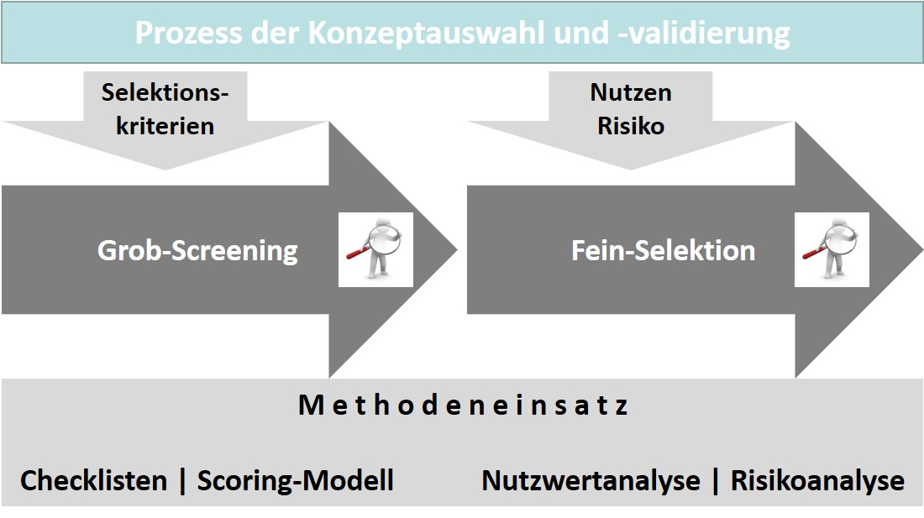

The selection of ideas or the selection of the best and most promising concept ideas is a complex activity, assuming that a nearly unmanageable number of concept approaches could exist in a company at the beginning of the product development considerations. Moreover, it is extremely difficult to assess the determining success criteria, parameters, and risk factors in advance and predict their future development. Alongside market-oriented and rather objective assessments, subjective corporate cultural and organization-specific elements also play a role. Accordingly, it makes sense that this stage and its processual design in product management should also be supported methodically. The approaches described for coarse screening and fine selection provide an important orientation for this.

### Self-Check Questions

1. What two mistakes can be made in an idea evaluation?

On the one hand, the wrong idea or the wrong conceptual approach can be selected, which ultimately fails. On the other hand, a potentially successful idea could be rejected, the implementation of which could have led to market success.

## 5.3 Product Requirements

### From Idea to Requirement

An idea for a product concept is not yet a description of the specific requirements as they are placed on a marketable product. Rather, the concept idea must be substantiated through the definition of requirements and transformed into a resilient product concept. While the idea can still allow an entire range of creative maneuvering room, requirements must be reliable as specifications for actual product development and must not prove to be inadequate or even faulty in the course of development. Corrections to the product concept are not problematic if they are made early enough to ensure that a significant amount of resources has not already been unnecessarily invested in the realization. This circumstance is often not considered and due to corrections, developments become more expensive or they miss the time goal. The latter can, of course, also lead to major problems in an intensely competitive environment, if, for example, an advantage once acquired in the customer perception is lost as a result. Therefore, **requirements management** also plays a key role in product management. Requirements management is to be seen as the process that determines the ...

**Requirements management**

The management, improvement. and planning of product properties.

* ... administration,
* improvement, and
* planning ...

... of the functional characteristics that determine the success of a product. The requirements are thus an essential part of the interests of stakeholders, most importantly the customers and users.

This is why a manufacturing company will always exercise great care in defining the requirements so that the desires and needs of its users and potential intended audiences are considered. The product fulfils its purpose if its quality can ensure commercial success in this respect. To this end, the offering company must systematically consider the customer perspective in product management and evaluate the resulting requirements, then prioritize them if necessary. Systematic typically means here that a simple survey will not be sufficient, since the complexity of customer expectations and the considerations associated with a buying intention cannot be captured by a survey with adequate reliability. Simple surveys often tend to overvalue an isolated criterion, e.g., the price, while the characteristics that actually determine the purchase are barely addressed. These disadvantages can be ruled out with suitable methods of determination (Herrmann & Huber, 2013, p. 169).

### Requirements Management with Methods

A popular method for recording and structuring requirements is, for example, the **Kano method,** which was developed by the Japanese educator, Noriaki Kano, as early as 1978. According to this method, there are primarily three important groups of requirements (Herrmann & Huber, 2013, p. 170):

**Kano method**

A framework for capturing and structuring requirements.

* **Basic features** are self-evident and are only noticed by the user if they are not present.
* **Performance features** are explicitly expected by users and therefore play a major role in determining their satisfaction.
* **Enthusiasm features** are, as the name suggests, able to excite the consumer, since they are not actually expected.

The categorization into the requirement variants makes it clear that with an already high degree of fulfilment of basic requirements it makes sense to increasingly focus on performance and enthusiasm requirements, since satisfaction can be further raised with these. Of the enthusiasm requirements, those that have a specific significance for customers/users are particularly interesting, since it can then be assumed that their realization will also lead to a rather high-performance product offering from the customer’s view (Herrmann & Huber, 2013, pp. 170–172).

While the selection of ideas using the two stages of coarse screening and fine selection described above always focuses on individual attributes and features of a product concept, a **conjoint analysis** is based on entire service bundles, i.e., completely described products that customers are asked to evaluate and assess. If the preference for a service bundle is known, conclusions can be drawn about individual attributes and features that were key to this decision. There are many products, particularly in the consumer goods sector, for which the attractiveness within the market is determined by the overall view that customers and potential consumers have of the product. Today, automobiles belong to a certain class, have certain engines, and are characterized by design elements that are often associated with the brand, i.e., the manufacturing company, and shape its product range as a whole. Even for certain foods, such as beverages, a combination of quite different attributes and features often have an effect on the intended audience, and it is only through a more detailed examination that which characteristics these are can be revealed and for which part of the intended audience they form a respective focus of attraction. For example, the advantages and disadvantages and thus the price-performance ratio of different product concepts can be determined by surveying consumers if this makes their purchasing preference clear. Such analyses can also be used to determine what price sensitivity exists in the intended audience. If particular performance features increase, the price of a product typically increases as well. For more powerful product variants, it is now possible to examine how the influence of the price component on the buying decision changes with an increasing price and simultaneously increasing performance. In the case of automobiles, for example, this can mean that customers are quite prepared to pay a higher price for higher performance. An increase in price sensitivity is only observed in the case of larger fluctuations. Of course, companies can make very good use of this in their communication with customers and optimize the sales value. The example also clearly shows how much the sales opportunities depend on the consumers’ assessment of the benefits. Subjective benefit expectations and the offering must largely overlap if the chances of the company making the offering are to be high (Herrmann & Huber, 2013, pp. 175–181).

**Conjoint analysis**

A method for identifying preferences for completely described product alternatives.

**Quality function deployment (QFD)**

An analysis method to design products, their features and functions in such a way that they meet the decisive customer requirements.

The **quality function deployment (QFD)** method can also be used to optimize product performance features if they have a decisive influence on customer satisfaction. The method is implemented in several steps and derives information from the identified customer requirements that helps to map the requirements in the product design/development in features and/or functions. In addition, the competition’s products and services, as well as the experiences from the sales department can be considered and evaluated. The relationships between the individual content elements of the QFD are represented graphically in what is known as the **house of quality** (also see the figure below). This method is primarily used in traditional technical product development and is also used as part of operational quality management in many companies. The origin of the method also lies in Japan, where it was developed as early as the 1960s by economist, Yoji Akao, and introduced in the automotive industry. The methodical starting point is formed by the product features that are of great importance from the customer’s point of view. These are first identified and then further systematized, e.g., with the aid of conjoint analysis, on the basis of their features and functional characteristics. In the next step, these features from the customer’s point of view are translated into constructive features from the developer’s point of view. Ideally, customers will then see that their expectations have been reflected in the product characteristics. A survey can also be used to discover the intensity of this link and compare it with studies of competitor offerings. The more clearly customer expectations are reflected in the product characteristics, the more positive the effect on customer satisfaction will be (Herrmann & Huber, 2013, pp. 194–196).

**House of quality**

A graphic representation of the elements of the QFD and their relationships to each other.

House of Quality (Projektplanung und -entwicklung)

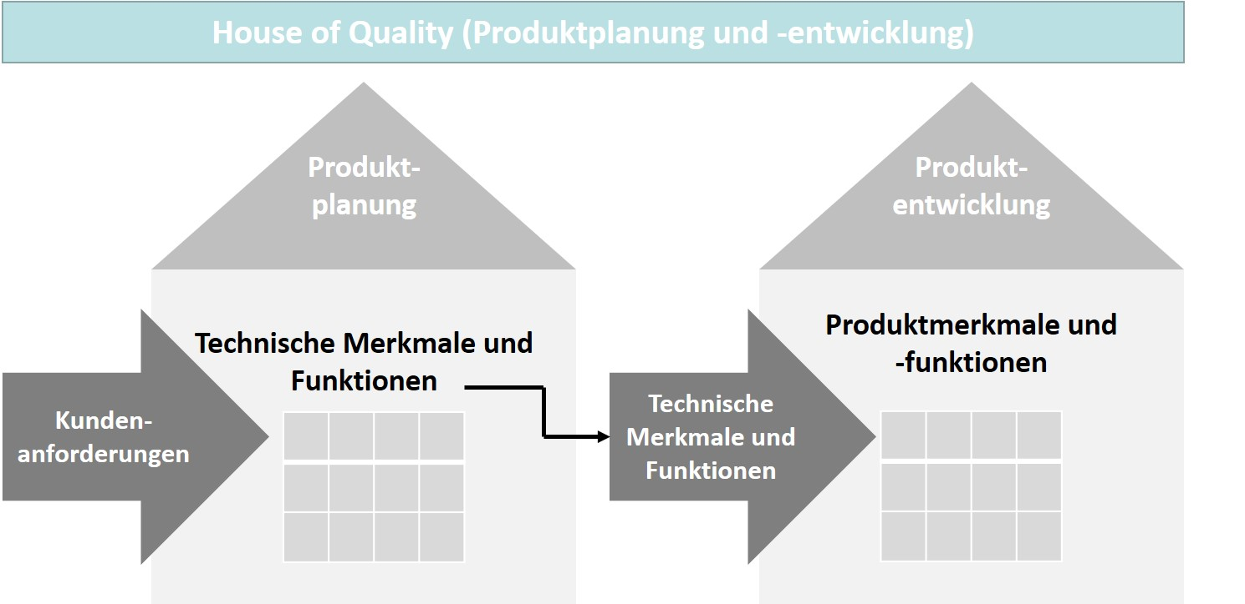

The figure above shows the two steps of a QFD with the focus on planning and development in the house of quality representation. In the planning stage, customer requirements are converted into technical features and functions, from which the specific product features and functions are then derived by means of further investigations into feasibility, dependency/interdependency and competition in the development stage.

Due to the origin of this method from the industrial environment, the central characteristic also arises: a stronger orientation of the approaches to the technological properties of products. Of course, this can also be raised as a point of criticism, since it may mean that other subjective needs of the demanders are excluded from a conversion (Herrmann & Huber, 2013, p. 197). One example that can be cited here is environmental compatibility, which has certainly been a defining and important criterion among product users for some time, but is not always reflected as an equally important technical criterion in product design. For example, drive technology for automobiles has only become a focus of attention in recent years, even though e-mobility was already available as an alternative and more environmentally compatible technical concept to replace conventional fuel combustion. The competitive situation first had to change extensively as a result of serious changes on the supplier side, with completely new manufacturers exclusively focusing on electric drives. However, if this supposed disadvantage is taken into account more strongly from the outset through an appropriate dimension in the selection of customer requirements, the QFD method can also ensure comprehensive integration of customer benefit expectations in product management.

Users can be even more involved in requirements management if they are given the opportunity to develop their own solutions to problems. With suitable tools, this can also be realized via the internet and the users can be asked to convert the requirements that are important to them into a **user design approach.** In innovation management, this can be supported methodically and, for example, a creative group work can be organized in which specific user design drafts are created. This method has also become very popular in software development for user interfaces in agile project management as User Experience Design (UX Design). Of course, it is important that the interfaces that users utilize for their design work offer an appropriate level of comfort so that the choices they make when compiling their combinations of requirements actually correspond to the expectations and demands made on the product characteristics.

**User design approach**

A method for the integration of users in the innovation process.

Through a user design, the offering companies can introduce a vast number of features into the requirements definition. Different user points of view can also determine interesting interrelationships between different product features, which in turn can have an influence on product design. Of course, only combinations that have actually been created are then included in a further selection, since, for example, theoretically conceivable feature bundles that meet an abstract usage goal, are intentionally not to be exploited (Herrmann & Huber, 2013, p. 202).

Product requirements must be documented once they have been determined as completely as possible through the application of the method, since without a detailed list and description of the requirements, the scope of the product cannot be reliably defined. A requirements specification is a suitable form of documentation, the content of which is oriented toward the product requirements …

* … from the customer’s point of view, considering the purchase-decision factors,
* from an environmental point of view,
* from the company point of view,
* from the sales point of view,
* from the market partner and supplier companies point of view, as well as
* on the product profiles for the target market segments.

Comprehensible and uniform determinations for the product development process are established by means of a binding requirements specification that is accessible to all those involved. This helps in avoiding misunderstandings, undesirable developments can be minimized, and communication within the product project planning can be optimized. Of course, each requirements specification must be created individually for a specific product. In general, standardization can only take place in the use of tools to support cooperative documentation and product data management (Herrmann & Huber, 2013, pp. 202–203).

### Self-Check Questions

1. Which features are addressed in the kano model? Mark the correct answers.

* Performance features (C)
* Customer features (I)
* Basic features (C)
* Enthusiasm features (C)
* Quality features (I)

1. Which method can be used to determine preferences for a product variant described in detail by the offering company? Mark the correct answers.

* Quality function deployment (I)
* Conjoint analysis (C)
* House of quality (I)
* User design (I)

## 5.4 Product and Market Testing

### Tests Reduce Risks

Product concepts, such as those resulting from requirements management and then flowing into the development process, go through several stages of verification until they are implemented and are typically based on a constructed test scenario. Only the verification of a marketable product with regard to its practical use provides the company the certainty that the development can become a success.

Because the costs of a product development increase continuously and are often disproportionately spread over the stages of development up to market launch, corrections in the process must be made as early as possible in order to prevent this cost increase from degenerating into an unnecessary consumption of resources. The expenses for the market launch in particular are often enormous, for example, due to the advertising measures, and a wrong investment here can have dramatic consequences. Of course, it would also be problematic if potentially successful products were removed from the portfolio even before market launch due to incorrect estimates of success. Product tests before market launch are therefore extremely important for product management (Herrmann & Huber, 2013, pp. 205–206).

Due to the diversity of products and the different focuses and areas of use, an enormous variety of product test variants is conceivable. Similar to the certification of processes and products in practice, product tests can also be divided into two main categories. On the one hand, they can already start in the concept stage, thus also referring to product concepts and having a virtual character. On the other hand, partial or full-scale tests with the real product version can be carried out even before market launch. Today, the possibilities of virtualization are of impressive quality, which is why products can be fully tested in the form of digital twins in virtual test environments in many cases. However, this effort cannot be equally justified for all product types, and virtualization also has limits with regard to the testability of certain criteria. Tests can and must therefore also take place in real environments; in the laboratory, however, under test conditions, anonymously with regard to the product name, comparatively or as a single test. The spectrum is therefore very wide. Some types of tests even become popular when they include, for example, well-known brands as test objects, as evidenced by the blind taste test for the two brands Pepsi and Coca-Cola. Important advantages of product tests are the flexibility of execution and the calculable costs. The test results typically provide valuable information that can be further exploited in requirements management. However, if the test conditions differ too much from the real purchase situations, this often relativizes the quality of the results (Herrmann & Huber, 2013, pp. 207–211).

### Economic Efficiency is a Prerequisite for Success

As expected, requirements management focuses the concept elements on the functional, and in the technical context, on the technological characteristics of the products. However, marketability is no less dependent on economic feasibility, which results in the need for economic feasibility studies. The financial sciences are familiar with the methods for this which, depending on the initial situation, are more or less ideally suited to represent the economic conditions of successful commercial marketing in mathematical models. Some of these are briefly explained below (Herrmann & Huber, 2013, p. 211).

Investment appraisal methods assume that the resulting cash inflows and outflows can be estimated on the basis of the sales volumes of products. Static methods of investment appraisal refer to a period, e.g., a sales year, and represent approximate methods that can be carried out with little expenditure. Examples are the **profitability and amortization calculations.** The profitability is calculated by dividing the average profits by the average capital invested; the payoff period or time is calculated by dividing the project-related investment by the average outflow/inflow of financial resources of the project. The static methods do not take into account the time factor and are therefore limited in their usefulness. Moreover, only average values are included in the calculation, while the real time fluctuations of inflows and outflows are not considered. The dynamic methods of investment appraisal compensate for this disadvantage, since they consider the distribution of cash flows over time in the calculation in order to reflect future developments. An example is the **net present value method**, which is based on the estimation of costs and incomes associated with development, introduction, and marketing. In addition, environmental data on market growth, market share, and pricing trends can influence the calculation. At the same time, however, these forecasted variables are a frequently voiced criticism of this method due to its subjective appraisal.

**Profitability and amortization calculations**

The static methods of investment appraisal.

**Net present value method**

A dynamic method of investment appraisal.

The **break-even analysis** follows an entirely different approach**.** For this, the sales volume is first determined, in the realization of which the costs correspond to the incomes achieved. This is what is known as break-even point (see figure below). Exceeding this point leads to profit; falling below it leads to losses. The break-even point therefore makes it clear when the critical sales volume is reached. The basis for the calculation of the break-even volume is the contribution margin calculation (Herrmann & Huber, 2013, pp. 211–215). The contribution margin of a product is calculated as the difference between the sales revenue and its variable unit costs. Dividing the total fixed costs by the contribution margin results in the number of units at which the break-even point is reached.

**Break-even analysis**

The point at which the cost of a development equals the income from sales.

Break-Even-Analyse

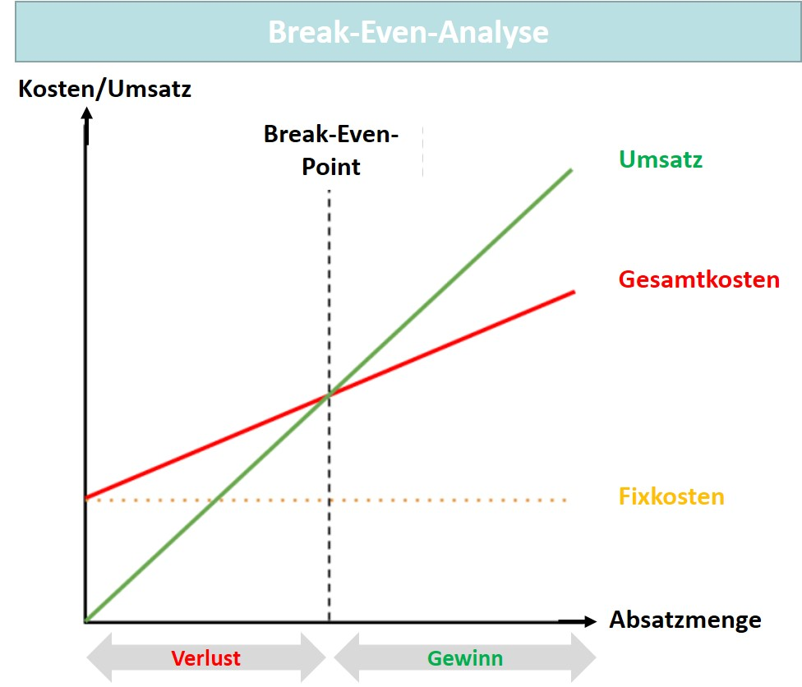

The example below shows a calculation of the number of units for the break-even point using specific numeric values.

Break-Even-Analyse (Beispiel)

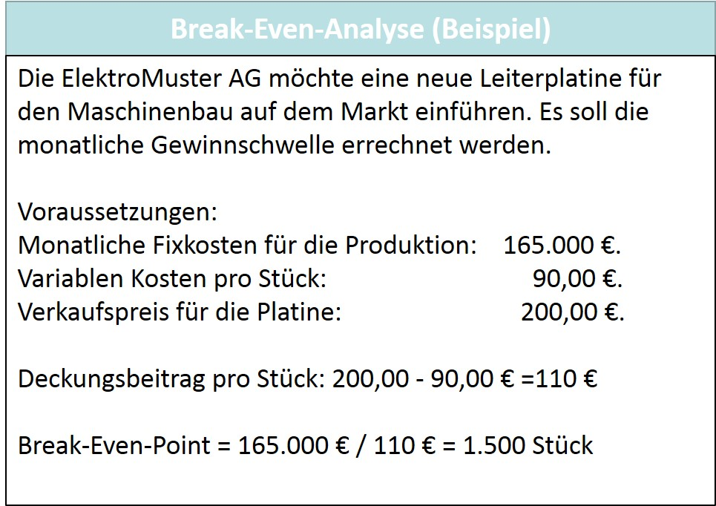

Break-even analysis is not ideal due to its planning character and similarity to the amortization calculation, since it is typically very difficult to estimate the costs of future sales periods in advance (Herrmann & Huber, 2013, p. 215).

For the most part, product testing determines and verifies the prospects of success of products from the perspective of the product itself, its characteristics, and its quantitative parameters, as the example of break-even analysis shows. This generally involves remaining in the field of forecasting, whereas **market testing** also uses the market environment as a field of investigation. A major advantage over traditional product testing is also the use of other instruments, such as pricing and communications policy, for market cultivation in the limited terrain of the test market. If necessary, this can also be a virtual environment in which a real product is presented, or as a comprehensive virtual scenario, even if the product itself is only presented virtually in concept form. Thus, the spectrum of testing options extends from simulation in the experimentally set up test market to field testing in the real test market environment, e.g., in a specific region (Herrmann & Huber, 2013, pp. 215–217).

**Market testing**

Product testing in a real/virtual market environment.

### Self-Check Questions

1. Which calculations belong to the static methods of investment appraisal? Mark the correct methods.

* Break-even point calculation (I)
* Profitability calculation (C)
* Amortization calculation (C)
* Net present value method (I)

Summary

Product concepts must be verified and validated at a very early stage to secure the typically high investments in developments based on them. Idea generation is the starting point for product management to develop competitive products and services. Alongside internal sources of innovative ideas, external sources can also be drawn upon. Idea management also uses creativity techniques, and methods for integrating customers and users are also employed. One example is lead user analysis. It is based on the assumption that lead users have a special interest in acquiring new and, in particular, innovative products. Focus groups are also used to analyze ideas and solutions through interaction with users, while tool kits are tools that allow customers to design products themselves, and product configurators are used by customers to determine the configuration of products themselves.

The verification and validation of concept approaches can initially be carried out by means of rough screening as a pre-selection of ideas, for example with a scoring model based on weighting factors for different selection criteria. With a manageable number of concept ideas, the more detailed procedures of fine selection, such as benefit and risk analysis, can then be used for the final selection. After this, requirements management plays a key role in product management, since it involves the administration, improvement, and planning the functional characteristics that determine the success of a product. Methodologically, the Kano model, conjoint analysis, or quality function deployment (QFD) can be used for this purpose. In contrast, the user design approach is based on a method for the integration of users into the innovation process. A requirements specification is a suitable form of documentation for product requirements.

The product tests suitable for testing a marketable product can be categorized into two main categories. In the first, they can already start in the concept stage, thus also referring to product concepts and have a virtual character. And in the second, partial or full-scale tests with the real product version can be carried out even before the market launch. Marketability also depends on a positive profitability analysis, which can be verified with static and dynamic methods of investment calculation, or with the break-even analysis. Market acceptance tests by means of market testing also include the market environment as a field of investigation.

# Unit 6—Market Launch

Study Goals

On completion of this unit, you will be able to ...

... describe the fundamentals, prerequisites, and general conditions for a market entry of products.

... determine and substantiate appropriate market entry strategies, taking companies’ resources and possible barriers to entry into account.

... explain suitable sales concepts and their organizational conditions for a market entry.

# 6. Market Launch

### Introduction

Good ideas can be converted into product concepts, but then the market entry must be successfully designed and converted into a competitive market cultivation if companies want to survive with these products and services in the long term. This requires strategic considerations that must take the specifics of the market and its competitive framework into account, particularly the existing entry barriers. Distribution concepts are also indispensable for ensuring that the intended audience has access to the offering and that it is distributed in the long term. Market cultivation must then be organized so that strategic concerns and the distribution orientation are ideally coordinated with one another. The following underlying questions therefore arise for the specific design, from the general conditions and strategic considerations through to the production and sales concepts:

* What are the fundamentals, prerequisites, and general conditions that determine the chances of success for a product’s market entry?
* What strategic decisions must accompany a market entry?
* How must sales be organized so that market entry is successful from a distribution perspective?

## 6.1 Fundamental Principles of Market Entry

While product development through to requirements management and product and market testing are indeed preliminary stages of the market cultivation that then follows through the product lifecycle stages, the market launch is naturally of such high importance that its structural planning must begin in parallel with product development. In particular here, the requirements specification supports the coordination between the two planning and development lines because this documentation contains both the customer requirements as the basis for product development as well as the content and general conditions for market entry planning. Product management carries out the coordination tasks, is the contact person for the development department and is itself involved in planning when it comes to the market launch. In general, market entry must also include an operational goal, which could, for example, result from measuring success using a break-even analysis in order to define cost recovery as a milestone goal. After that, the market growth of a product should then ideally begin (Aumayr, 2019, pp. 303–304).

The term **market entry** is initially associated with the introduction of new products onto the market. However, in addition to the introduction of genuinely new products, this can also be the introduction of existing products onto a new target market, e.g., in the case of an expansion of market cultivation abroad. Although both cases are similar, they also make it clear that the fundamental principles and general conditions can differ greatly in some cases. Accordingly, there can be no standard approach that could serve as a guideline for this task. On the contrary, disregarding the specific circumstances could lead to a market entry failure despite high investments because key competitive factors were not considered. When planning the market launch, the insight gained from the market, company, and environmental analysis must therefore be incorporated, particularly in the structuring and content design. For product management, this does not in any way mean a relaxation in the carrying out of tasks, but rather an intensification, since in addition to the operational aspects, strategic concerns must in turn be taken into account. Depending on the market situation, intended audience, and competition, suitable market entry strategies must be defined in order to ensure that the customer and competitive orientation of market cultivation is fully effective. What are the specific questions that need to be addressed?

**Market entry**

The introduction of new or existing products onto new or existing markets.

The conceptual points and those based on the analysis must particularly take the following general conditions and prerequisites into account. (Aumayr, 2019, pp. 304–305):

* **Market and intended audience information** on the expected market potential and growth, as well as on the intended audience structure.
* **Product benefit aspects** forappropriate positioning by combining technology, price and service/support.
* **Competitive situation** for the assessment of the competitive strength, market positions already achieved, as well as the opportunities/threats and strengths/weaknesses of the market players.
* **Partner companies on the market** for the organization of development, sales, and financing.
* **Product policy goals** in combination with costs, scope of services and, if necessary, release planning.
* **Development environment** with the technical description, usable resources and general conditions.
* **Production forms and capacities** with quantities, costs, and requirements.
* **Sales forms** with time planning and scheduling, distribution channels, and tools, as well as support.
* **Environment** with product portfolio preferences and resource conflict management, if necessary.
* **Financing and economic efficiency** with cost considerations for development, marketing, and sales, as well as measurement of economic efficiency using suitable methods.
* **Risk management** with a consideration of technology, economics, market, and company.

It is particularly these aspects above that parameterize the market launch and strategically and operationally form the tasks that build upon it. The figure below summarizes the key elements of the dimensions that determine the market launch. On the basis of strategic definitions for the market launch, the company must first ensure the production of the offerings and their sales availability. In addition to this, continuous market cultivation then begins with the instruments of product management and is oriented toward the challenges placed before it by the product life cycle.

Bestimmungsfaktoren der Markteinführung

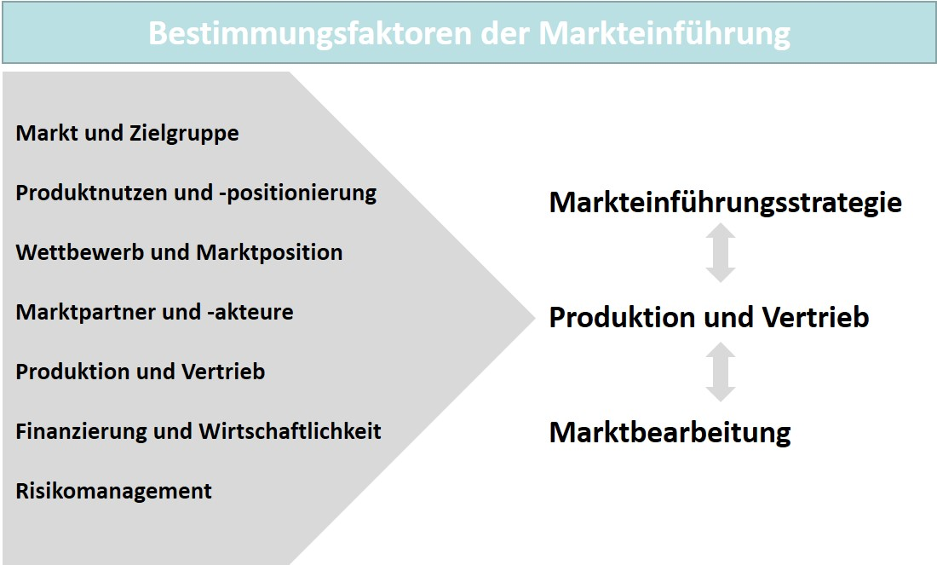

The focuses defined by considerations prior to a market entry are to be particularly viewed in connection with the target market, the intended audiences, and the competitive conditions. Companies must therefore act with special care here with a view toward defining the appropriate strategies for market entry. The determination of the market segments, the observation of the conditions and forces prevailing in the competition, and their meticulous analysis are important prerequisites for the success of a company’s own market cultivation. The relevant determining factors can be used, for example, to identify barriers that may stand in the way of a company’s market entry. The importance of access to sales markets is also shown by the international developments of the recent past. As a particular example, the Chinese market has been a guarantor of growth and great sales opportunities for many years, particularly so for foreign companies, and is now increasingly being viewed in the context of political effects. The conflict between China and the USA is only one example; other developments also affect the European economic area with its dependencies on the sale and purchase of goods, particularly all raw materials and energy. For internationally oriented companies, the influences of international economic policy are therefore playing an increasingly significant role alongside the economic challenges.

**Market entry barriers**

Factors that make market entry difficult or impossible.

Porter (1980) identifies several circumstances that can play a key role in the formation of **market entry barriers** and collectively relate to the areas of competition, market, customers, and politics (Herrmann & Huber, 2013, p. 245):

* **Competitive cost advantages**,since the cost of producing goods decreases when the number of units produced increases (the competing companies’ economies of scale).
* **Competitive cost advantages**,for example, when the government subsidizes the production of goods.
* **Competitive advantages of the competition** due to an offering that is superior in function and/or image (e.g., brand).
* **High capital investment for market entry**,if market-specific conditions/circumstances must be taken into account (e.g., cultural hurdles abroad).
* **High switching costs for customers**, if competitive products have already led to dependencies (e.g., high training costs).
* **Access to key sales channels**, ifrigid structures can hinder an entry (e.g., entrenched relationships between companies operating within the market).
* **Government policies** (e.g., legislation, tariffs, standards).

But these barriers do not necessarily need to be permanent. There is an entire range of measures that can also ease the competitive situation (again). The free trade agreements concluded in recent years, for example, are legislative measures to prevent foreign companies from being kept out of a market. One example of this is customs agreements that facilitate the exchange of goods. The liberalization of market structures can also make it easier for companies to operate in a market if, for example, the state withdraws from certain areas of supply. This applies to privatization measures in countries that affect the telecommunications sector or even the transport sector. In the USA in particular, care is taken to ensure that a market-dominating position of companies does not jeopardize competition and possibly progress as well. Microsoft and Facebook are examples of companies that have been critically discussed in recent years due to the concentration of certain services or have also led to specific measures by the supervisory authorities. Overall, companies must clarify the aspects discussed and underlying prerequisites for a market entry and only then follow up with specific measures for the entry and market cultivation. If diligence is lacking here, the risk of a false start or even a failure of the ambitions with the product increases.

### Self-Check Questions

1. What determining factors for market entry represent market attractiveness? Complete the following sentence with the correct factors.

Market attractiveness is represented by the *market potential* and *market growth*.

1. Which barriers can prevent a product’s market entry? Mark the barriers to entry.

* Cost advantages of competition (C)
* High switching costs for customers (C)
* High prices (I)
* Access to important sales channels (C)
* Sales partners (I)
* Legislation (C)

## 6.2 Market Entry Strategies

After clarifying the prerequisites, general conditions, and goals of the market launch, strategic considerations must be made that define the impact direction of a successful market launch on the basis of the fundamentals developed. Regardless of other planning elements, the timing of a market entry is relevant. Particularly in combination with the already existing competitive situation, strategy alternatives arise for the so-called timing of the market entry.

**Pioneer (first mover)**

The role of a company as the first to offer in a new market or market segment.

The question of timing is therefore also of greater significance since, depending on the resources available to the company, the roles of **pioneer (first mover)**, i.e., first supplier, or successor or **follower**, i.e., additional supplier, can be occupied more or less successfully. The barriers to market entry already discussed are also important here, since cost advantages, for example, also depend on how long a company has already been cultivating the market and has also already been able to secure cost advantages through larger production and sales volumes. If the market dynamics and the innovation race are taken into account, then the pioneer role and thus that of the first offering company in a new market or market segment is likely to be associated with greater advantages. In particular, it should be possible to exploit the maneuvering room for product pricing, since this only involves dealing with demand. This pricing strategy is also called **skimming strategy**. Here, the price is only lowered as far as it is necessary for additional development of the intended audience. This is also favorable in terms of economic efficiency considerations, e.g., in connection with the amortization period. Additional advantages lie in the potentially higher profit and the option to build recognition and a good product image within the competition. The pioneer company is typically perceived as an innovator and may even be able to set a standard with its product. However, these advantages can also be countered by disadvantages. If the new product fails, then there will inevitably also be damage to the company’s image, which could even have a negative effect on other offerings. In general, if a company wants to win the innovation race, it will also need to make greater financial efforts. The question then arises as to the extent that these costs can be covered by the additional incomes generated by pioneer status. It is not uncommon for the marketing of a product to degenerate into very intensive advertising and sales activities, since a great deal of persuasion is necessary in a new market environment or even because a market emergence must be supported. A pioneer company can also always fail due to misjudgments if its expectation is not met by the actual customer behavior (Herrmann & Huber, 2013, pp. 246–247). The table below summarizes the advantages and disadvantages mentioned above.

**Skimming strategy**

The pricing policy of a pioneer company in a new market or market segment.

**Follower**

The role of a company as an additional supplier in a new market or market segment.

|  |  |
| --- | --- |
| Chancen und Risiken der Pionierstrategie | |
| Opportunities | Risks |
| * Positive image or preference building through technology leadership * Creation of customer loyalty * Monopolistic advantages of market cultivation * Cost advantages through experience curve effect and economies of scale * Establishment of possible market barriers and standards * Securing key distribution channels | * Image loss if technology not fully developed * High costs and high resource usage in market cultivation * Lack of experience regarding market conditions and market exit barriers * Uncertainty regarding the development of demand * Lack of experience with the functionality of the product in use by customers |

A follower company can pursue three options. It can choose a **me-too strategy** with a nearly identical product to the pioneer company’s offering. However, the follower company can also make a more or less modified offering compared to the pioneer company or even strive for a strong differentiation with its own innovation. The early follower company is more dangerous for the pioneer company, since it can use an existing offering as a benchmark or even offer it in an improved quality. Improvements that enable a broader marketing are often the reason why follower companies are able to achieve great market success, even though the technology base developed by the pioneer company for this purpose resulted in the actual market acceptance. In information technology, this phenomenon has already occurred in the workplace printers sector as well as in telecommunications in the mobile communications sector. But it need not be limited to that. A follower company can also analyze the sales activity of the pioneer company and develop superior distribution channels or occupy the interesting market niches that have subsequently developed within the market established by the pioneer company. Nevertheless, there are still disadvantages and risks in this role. Low recognition and an image disadvantage can be a major challenge. The pioneer company’s sales cooperations also make the distribution efforts of the follower company more expensive or ineffective. These can be entry barriers that the follower company may find difficult or impossible to overcome. Without relevant sales, the cost advantages cannot be realized and the follower strategy therefore appears to be unpromising. Nevertheless, this can prove to be worthwhile for financially strong companies with the staying power to compete. There are also market developments that suddenly make success possible, e.g., when general conditions change or leading companies leave for reasons unrelated to competition. But then the market entry as a late follower company is not really planned, but rather the consequence of extraordinary developments (Herrmann & Huber, 2013, pp. 247–248). There are some company examples that can be mentioned in relation to the two strategies: Apple as a pioneer with its iPod, iPhone, and iPad products or Amazon as a leading global online mail order company. A well-known Amazon follower is the German online mail order company Zalando. Another pioneer is Nestlé’s Nespresso brand for portioned coffee. Generics in the pharmaceutical market are again examples of the successful imitation of drugs. The table below summarizes the advantages and disadvantages mentioned above.

**Me-too strategy**

A market entry strategy of a follower company to offer an identical product in a market or market segment compared to the pioneer company.

|  |  |
| --- | --- |
| Chancen und Risiken der Folgerstrategie | |
| Opportunities | Risks |
| * Possibility to improve the pioneer product * Possibility to analyze the relevant distribution channels * Utilization of the pioneer company’s market building achievement | * Low recognition and less well-known image make market entry difficult * Exclusive occupation of key distribution channels by the pioneering company * Low market share and thus virtually no realization of cost degression effects |

The timing of market entry is also dependent on the corporate strategy, since the market entry strategy must fit the basic strategic approach. In connection with this, the company’s resources are also relevant, since they allow the timing and content to be determined. Of course, the product is also the focus of the decision to enter the market, since it is only a high degree of innovation that makes the role of the pioneer company and therefore the switching costs for the customers and a standardization function possible. The production technology is also relevant, since new production processes are often necessary to be able to exploit special technological features. In addition to know-how, financial resources must also be raised. And last but not least, customers and the market play a key role in the decision-making process, since e.g., potential customers must be available in large numbers in order to justify a pioneering strategy. The market sizes must be right to be able to prove the economic efficiency of the investments and also determine the extent to which, for example, a follow-up strategy can still be worthwhile. On the one hand, high growth represents the attractiveness of the market, but on the other hand, it is also associated with the danger of new competition being attracted to it. This can also mean a loss of advantage for a pioneering company. It is also at risk when market dynamics are high and there is a risk of constant fragmentation of needs and preferences. Accordingly, the advantages of the pioneer company are more likely to be built and maintained in a stable market environment. The state can also intervene in competition with subsidies and thus help certain products to achieve a better position. This can currently be observed in the area of climate neutrality in business, e.g., when specific surcharges ensure higher prices for more environmentally harmful products and processes. The intensity of competition is also an additional condition for the choice of entry strategy, depending on the general conditions of the market. In this context, one difference between consumer and industrial goods markets is also the fact that in industrial goods markets, the focus is on the buying behavior of organizations and greater financial risks are therefore associated with strategic choices (Herrmann & Huber, 2013, pp. 249–252).

These explanations make it clear that there is an entire range of influencing factors whose content orientation determines success or failure in market entry. If we focus on the competitive dimensions of efficiency and effectiveness, attention is directed to price as well as to the quality of products. In connection with quality, the innovation race, for example, essentially also determines risk, since the maturity of products can extend the development time and/or make it more expensive. At the same time, it is not unusual for functional problems with products that are quickly thrown onto the market end up leading to supply distortions that can have a very negative effect on a supplying company as a whole. In contrast, above-average quality has the potential to enable companies to set the standard for an entire product range and thus protect themselves against competition. In addition, an innovative offering often results in a reference price: here, too, the pioneering company is in an advantageous position, since those following it must base their pricing policy on this. With price reductions or increases, the pioneering company can then exert its influence and make it more difficult for the competition to operate within the market, depending on the market situation (Herrmann & Huber, 2013, p. 254).

If an offering company wants to develop several markets, it must determine a temporal and, if necessary, also spatial sequence for the respective market entry. With the **waterfall strategy,** it aims to enter the target markets sequentially, which means that the entries are made one after the other with a time delay. The reason for this choice of strategy is risk minimization, which is particularly relevant in connection with foreign markets. The waterfall strategy is therefore a more cautious approach, which is particularly suitable for target markets that are structurally or culturally very different. Of course, it is not feasible for every company to develop different markets at the same time, also in view of the financial resources that are required for this. The **sprinkler strategy**, which favors simultaneous introduction in several target markets, is oriented differently. The aim is to achieve rapid market penetration and particularly to minimize the competition’s ability to react, which may of course be necessary in the case of simple products with a high risk of imitation. In practice, the two forms of strategy are rarely found in an exclusive form, but rather are typically combinations of the waterfall and sprinkler strategies, since these take better account of the particularities of the markets and general conditions under which the companies operate, also in terms of their resources (Herrmann & Huber, 2013, p. 255).

**Waterfall strategy**

A sequential, i.e., time-delayed, entry into several target markets.

**Sprinkler strategy**

The simultaneous entry into several target markets.

The limitation that were also explicitly mentioned in the last section apply to all strategic determinations in market entry. Companies must take the circumstances of the target markets and intended audiences into account and combine the resulting strategic alternatives with the resource view in order to optimize the efficiency of market cultivation and at the same time, also pay attention to the economic efficiency of the measures. Under and overextension of these two sides of the same coin have a detrimental effect on the chances of success. For product management, these strategic goal setting and planning activities are therefore also essential building blocks of its market-oriented organization and process execution as a whole.

### Self-Check Questions

1. Which are the different roles for a company with regard to the timing of market entry for a new product? Mark the correct roles.

* Pioneer (C)
* Producer (I)
* Developer (I)
* Follower (C)
* Inventor (I)

1. Which are the different strategies for addressing multiple target markets with one product in terms of timing? Mark the correct strategies.

* Waterfall strategy (C)
* Skimming strategy (I)
* Me-too strategy (I)
* Sprinkler strategy (C)

## 6.3 Sales

In addition to the strategic decisions regarding timing and other fundamental orientations related to market entry, companies must also make decisions about how and in what form they enter a market. This is of secondary interest if a company is already represented with offerings and its products are to reach consumers through existing sales channels. Nevertheless, very different approaches may be appropriate with regard to the sales organization and the institutionalization of distribution, particularly if there are new aspects associated with the product and/or market that force a decision to be made in this respect. These particularities must then be brought into line with a company’s own resources so that market entry can succeed. After all, economic efficiency also plays a role, since cooperative organizational solutions, for example, also result in a distribution of earnings options and can therefore have a relevant effect on the design of prices and conditions.

A company must first decide whether it wants to act alone or in cooperation with other players who are active on the market. Considering that an independent organization is also associated with high investments, this is a very important determination. Additional considerations arise due to the possibility of control, which can be exercised more comprehensively within its own responsibility. Taking these conditional aspects into account, the company can decide on various design options. As already mentioned, entering the market via a separate company, a separate production facility or a new company set up specifically for this purpose is generally resource-intensive, but at the same time ensures the highest degree of controllability. Often, the establishment of a new company in connection with a new offering also involves the bundling of development activities for the new offering in this organization. It is precisely this bundling of development expertise and new knowledge that can then provide the decisive advantage in competition. Conversely, the new organization may have to compensate for acceptance shortcomings on the part of the consumers. In addition to a start-up, the acquisition of a young company can therefore also be advantageous to enable it to act more quickly and also to take advantage of an already existing foundation of trust within the market. A rather moderate risk would also be the purchase or licensing of products, whereby the revenue model and customer loyalty options must be taken into account. Mergers of companies are a relatively higher risk, since in addition to the core motivation of successful joint marketing, corporate cultural differences must also be considered. These difference can represent an excessive risk, as evidenced by well-known and failed mergers, for example, Daimler and Chrysler in the 1990s. (Herrmann & Huber, 2013, pp. 257–258).

**Direct sales**

This means that the producing company sells directly to its customers.

A company can circumvent the high investments associated with its own production facility through **direct sales** or **direct export** ofservices provided in existing production operations. With independent sales, the company is then not dependent on cooperation with external sales organizations for sales. The deliverable is marketed directly through the company’s own branches, which is more common in the capital goods sector, for example, since the products often require more detailed explanation. However, there may be particularities that suggest the establishment of production facilities and/or subsidiaries. Proximity to the sales market is an important aspect that is often accompanied by considerations of positioning production and sales close to the sales market. On the one hand, the efficiency of an international division of labor plays a role here if, for example, automobiles are also manufactured in a country whose labor costs are favorable. On the other hand, reasons of acceptance can also be decisive if a rather national economic policy in the new market makes export sales more difficult. In connection with digitalization and the spread of the internet, purely **virtual organizations** can now present themselves worldwide and use intelligent applications to enable products to be ordered from almost anywhere in the world. Even the infrastructures required for digitalization then no longer need to be maintained by the company itself, but rather can be hired from service companies. This type of distribution has made Amazon, for example, one of the largest and most valuable companies in the world (Herrmann & Huber, 2013, pp. 258–259).

**Virtual companies**

A temporary network of companies linked by information and communication technologies.

**Virtual organization**

This means that a supplying company uses the internet as an infrastructure for its sales.

**Direct export**

This means that the producing company acting as an exporting company directly supplies a foreign market.

**Indirect sales**

This means that the producing company sells to its customers via third parties.

There are also options for a cooperative approach as an equally sensible alternative to shaping the market entry completely on a company’s own. This is particularly useful when companies want to draw on the expertise and competencies of partner companies within the market whose efficiency exceeds their own capabilities. At the same time, investments can therefore be kept below an economically justifiable limit. **Indirect sales** or indirect exports are sales forms that provide for trade organizations between the company and its customers. This is accompanied by a certain loss of control, since the interface with the consumers is no longer directly accessible. At the same time however, costs are eliminated and market entry can often take place more quickly. Indirect sales or indirect distribution are carried out by a legally independent sales intermediary; this is typically a wholesale and/or retail company. Variants in which the sales intermediary also has a voice in product design or requires market entry premiums are not entirely straightforward. **Indirect export** involves transferring the foreign business to another, also legally independent organization that specializes in foreign trade as an export company. For companies operating in this way, the financial advantage and relative independence in the design of this distribution channel are important. Of course, this also means a correspondingly lower level of commitment to the market and customers. An assignment of **distribution licenses** for product offerings is similarly cost-optimal. One example here is contract manufacturing, where one company transfers stages of production to another company (Herrmann & Huber, 2013, pp. 259–260).

**Joint venture**

A joint venture formed is by several companies that are independent of each other.

**Indirect export**

This means that the producing company commissions an export company for the foreign business.

**Franchising**

A distribution system based on cooperation, in which franchisees

are allowed to use a business concept of the franchisor for a fee.

**Distribution license**

This means that the producing company may license production and/or distribution to another company.

In a further stage of development, this can lead to a **joint venture** in which several partners cooperate contractually, thereby sharing the risks and profits. The parties involved in the cooperation can be institutionalized in very different ways in terms of geography and corporate law. It is also possible for competing companies to cooperate in order to jointly develop markets abroad, as is often the case, for example, with automobile manufacturers. With a joint venture, private companies can also develop regulated markets through cooperation with state-owned companies. The Chinese market is a well-known example of this. A joint venture is an attractive option for medium-sized and smaller companies in particular. **Franchising** isalso a form of cooperation. The franchisee pays a fee to the producing company for which they receive the right to use certain services. In the foodservice industry, the US company McDonald’s is probably the best-known example of this form of distribution. The franchisees operate the restaurants according to the franchisor’s specifications and are supported by the franchisor in their communication. The franchisor has the advantage of a high flexibility and fast market penetration with a calculable financial expenditure. The franchisees consequently have a corresponding financial risk, but benefit from the system and the know-how of the producing company. Strategic networks and strategic alliances are also quite comparable with the joint venture, since in both cases cooperation is also the basis of the organizational market entry design. In strategic networks, companies from different stages of the value chain cooperate, while in strategic alliances potentially competing companies work together. The greatest motivation for this is often the financial scale of the necessary investment, which would respectively overburden a single company. In terms of resources, expensive and innovative development projects can often only be carried out in this way. A currently popular form of cooperation between companies is the **virtual company**. They work as a network, whereby the participating companies are not hierarchically connected. The information technology infrastructure is the basis for a rather project-related and thus temporary cooperation. The contractual bundling of the networked core competencies is handled flexibly, but the virtual company appears as a single entity to those demanding the offerings. This can be attractive for an international market entry, since the virtual company is not subject to the legal framework conditions of the target countries, which can reduce political and legal problems and hurdles when cooperating with international partners (Herrmann & Huber, 2013, pp. 260–262).

The explanations have shown that there are very different forms for the design of the sales organization and distribution when entering the market, which primarily differ in …

* … the goal,
* in the resources required, and
* in controllability.

As a result, solutions often arise from a compromise that considers the special general conditions of the markets and customers, as well as the suppliers and partner companies on the market according to the existing restrictions.

### Self-Check Questions

1. Which cooperative sales and export options do companies have when designing market entry? Mark the correct options.

* Direct sales (I)
* Indirect export (C)
* Direct export (I)
* Indirect sales (C)

1. Which overarching determining factors influence the selection of sales form when entering the market? Mark the factors.

* Price level (I)
* Controllability (C)
* Resources/investment (C)
* Number of competing companies (I)

Summary

Market entry is of extreme importance, since is not only associated with the introduction of new products onto the market, but also the introduction of already existing products onto a new target market, e.g., in the case of an expansion of market cultivation abroad. Although both cases are similar, they also make it clear that the fundamental principles and general conditions can differ greatly in some cases. It is therefore essential to consider the conditions and prerequisites relevant to market entry. Examples are market and intended audience information, product benefit aspects, competitive situation, sales forms, financing, and economic efficiency, as well as overall risk management. In addition, there are typically barriers to market entry in the areas of competition, market, customers, and politics. Companies offering a product or service must therefore clarify the basic requirements for market entry and only then follow up with specific measures for the entry and market cultivation. A lack of diligence increases the risk of a false start or even a failure of the ambitions with the product.

Regardless of general content-related planning elements, the timing of a market entry is relevant. In combination with the competitive situation, strategy alternatives arise here for the so-called timing. Possible roles for offering companies are then those of pioneer or follower. In particular, pioneer companies are likely to be able to exploit the maneuvering room for product pricing, since they must only deal with demand. With the skimming price strategy, the price is only lowered as far as is necessary for additional development of the intended audience. This is clearly favorable in terms of economic efficiency considerations for market entry. The follower companies have three options. They can choose a me-too strategy with a nearly identical product to the pioneer company’s offering. However, it is also possible to make a more or less modified offering compared to the pioneer or even to aim for strong differentiation with an innovation of their own.

If companies want to enter several markets at the same time, they must determine a temporal and, if necessary, also spatial sequence for the respective market entry. With the waterfall strategy, they aim for a sequential entry onto the target markets, i.e., one after the other and with a time delay. The sprinkler strategy has a different orientation, preferring a simultaneous introduction in several target markets, which results in a rapid market penetration and minimizes the competitors’ ability to react. In practice, combinations of waterfall and sprinkler strategies can typically be found.

There are also different approaches with regard to the sales organization. A company can circumvent the high investments associated with its own production facility through direct sales or the direct export of deliverables provided in existing production operations. Indirect sales or indirect exports are sales forms that provide for trade organizations between the company and its customers. However, cost reduction is accompanied by a certain loss of control. Indirect exporting provides for the transfer of foreign business to another organization that specializes in foreign trade as an exporter. An allocation of distribution licenses for product offerings is similarly cost-optimal. The joint venture is also interesting considering the sharing of risks and profits and involves several partners cooperating contractually. Franchising is also a form of cooperation in which the franchisees pay a fee to the franchisor in return for which they receive the right to use specific services. A popular form of cooperation between companies is virtual companies. As a network based on an information technology infrastructure, they typically work together on a project-related basis and therefore on a temporary basis. The contractual bundling of the networked core competencies is handled flexibly, but the virtual company appears as a unit to those demanding the offerings.

# Unit 7—Product Management after Market Launch

Study Goals

On completion of this unit, you will be able to ...

... describe and substantiate the strategic decisions in product management related to the last stage in the product life cycle.

... explain suitable measures for control in product management and the associated variables (metrics) in terms of content and substantiate their use in relation to the situation.

... explain the activities in product management for the coordination and control of interfaces with other areas and for the management of relationships with stakeholders.

# 7. Product Management after Market Launch

### Introduction

Against the background of shorter innovation cycles, market-oriented product management must also intensively handle the last stage of the product life cycle in order to optimize the success of its market cultivation. The strategic considerations required for this play a key role. For the product management process as a whole, it is additionally relevant that suitable instruments for success monitoring and appropriate metrics are used. This is important because product management must design a large number of interfaces with other areas and also focus on relationships with key stakeholders. The following underlying questions for the design of these tasks in product management therefore arise:

* What strategic decisions in particular can optimize the last stage in the product life cycle in a market-oriented manner and to the benefit of companies?
* How must the decisions and measures in product management be controlled and how can their success be measured?
* How must the management of the interfaces with other areas and the relationships to the stakeholders important in product management be designed?

## 7.1 Product Strategies at the End of a Product Life Cycle

Product management accompanies the life cycle of its products and services throughout all stages of market cultivation, from market launch to market exit. The product life cycle model has the advantage that it makes both internal processes and market-oriented planning easier to design. Above all, the life cycle curve allows conclusions to be drawn about the success of measures in product management, but it also provides indications as to the directions in which these measures should develop. In this context, the fundamental strategic assumptions play a key role which, particularly toward the end of the life cycle stages, can once again ensure the success of products or maintain the prospect of success. Companies initially aim for a long maturity stage, since this period of market presence should also be the most profitable for a product. The product is successfully introduced onto the market and revenue reaches high levels. Saturation slowly sets in toward the end of this stage and is expressed as a decrease in revenue and profits. Due to declining customer interest, there is then a risk that a product’s sales will plummet unless stabilizing measures are taken to delay the imminent **decline stage.** Of course, there are also products that do not disappear from the market at all because they have achieved a position over many years, sometimes decades, that can hardly or not at all be threatened by competing or new offerings. One of the examples often mentioned in this context is the Coca-Cola beverage brand, whose dominant market position has been attacked by the competing product Pepsi-Cola for decades with more or less success. The fact that such market-leading positions cannot be maintained in the long term is demonstrated by the case of Nokia, a company that dominated the market for mobile telephones for many years as an innovator, but then increasingly lost of its success due to massive efforts on the part of the competition. Today, Nokia hardly plays a role at all in this market environment. However, these two examples clearly show that measures to prolong a successful market presence are among the most important tasks in market-oriented product management. The Nokia case particularly draws attention to the strategy with which companies offering products should actually act, even more so in the late stages of the product life cycle, in order not to completely lose a position once it has been achieved. The following explanations show how companies can and should act in these situations.

**Decline stage**

The stage in the life cycle in which the sales volume, revenue, and profit of a product gradually decrease.

Even after a successful market launch, companies’ market cultivation goals are oriented toward (Herrmann & Huber, 2013, p. 369) …

* … an extension of product life cycles,
* the securing of an achieved market position,
* the increase in revenue and profits,
* the optimization of market and customer potentials, and
* the improvement of the value creation situation and thus
* the output of deliverables production processes.

The indicators that provide evidence of a need for action are the information that essentially represents product success. These include sales figures, market shares, revenue and profit growth, as well as the qualitative evaluations of customer loyalty and brand loyalty. Following this, modifications of deliverables, for example, can then represent the appropriate measures (Herrmann & Huber, 2013, p. 369).

One type of modification is **product variation**, in which the basic functionality, intended use, and application capabilities of the product are retained, but the design, color, shape, material and quality characteristics, or even services in the form of after-sales service and financing, as well as specific additional services and an additional benefit are modified. The motivation for these modifications is typically the changing expectations and needs of the intended audiences over time. Legal changes in the form of mandatory features with regard to environmental compatibility or due to safety standards can also force the offering companies to make such adaptations. On the one hand, suppliers can use the changes they initiate to consolidate the position they have achieved within the market. And on the other hand, this strategy also gives them the maneuvering room to reposition their product if necessary to avoid certain competitive forces or to address a specific intended audience more intensively (Herrmann & Huber, 2013, pp. 369–370). A well-known example is the modifications to the design in a “facelift” of automobiles to be able to follow current trends, even in an already established model and before a model change. Technical devices are also often partially modified by means of product variation, e.g., in order to increase battery capacities and thus operating times. In the context of electromobility, this can currently be observed for the battery charge range of a vehicle.

**Product variation**

The technical or aesthetic modification of products that have already been launched on the market.

**Product relaunch**

The modification of products that have already been launched on the market in order to revive them or make them more interesting again for the intended audience.

While ongoing measures for product adaptation as a type of product maintenance are normal in many areas, a company pursues even more far-reaching goals with a **product relaunch.** In addition to the actual and typically more extensive product modification, other marketing instruments are also used simultaneously. Relevant price reductions or an expansion of the sales channels must be supported by a communicative effort in such a way that the consumers are also informed quickly and comprehensively, since the product relaunch is a reaction to negative developments that one would like to correct as quickly as possible (Herrmann & Huber, 2013, p. 371). The relaunch should therefore be motivated by the market. The modifications that only have internal reasons and disregard the realities of competition are not without risk. This form of product variation is very popular for branded items in the consumer goods sector. For example, they are adapted to trends that follow the spirit of the times and arise as a result of certain social developments. The current discussions on climate change and its negative consequences, for example, have led to many products addressing the topic of sustainability more strongly and taking up the ongoing reasoning in different forms with a relaunch of the brand. However, this can also have very negative consequences if independent bodies can make the questionability of the positive presentation credible. It is referred to as **greenwashing** if the characteristics advertised in connection with sustainability do not correspond to reality. Ultimately, the additional incomes resulting from the product variation or relaunch must at least exceed the costs of the measures required to achieve this, since this is the only way to achieve or maintain overall profitability.

**Greenwashing**

Measures taken by a company to create a positive image in connection with sustainability without any real basis.

A special type of variant is **product differentiation**, since here, the product is not brought into an adapted and modified state and thus also replaced by the product variant, but rather one or more product variants additionally supplement the product range. Here, too, the automotive sector offers very clear examples. Many successful vehicle models can be purchased in different variants. The traditional categorization is into sedan, station wagon, van and coupé or cabriolet versions. While the station wagon typically represents the family car, the coupé and cabriolet tend to appeal to sporty drivers, and the van was, at least in the past, more of a commercial vehicle. Of course, this categorization no longer applies to all models. Sports wagons and family coupés have long since further refined the differentiation structure. Likewise in the laundry detergent segment, there are variants for different laundry or wash cycle categories—for example Ariel liquid, Ariel powder, Ariel Color, etc. Furthermore, the well-known beer brands are now also bottled for different intended audiences, which has led to, e.g., Bitburger Premium Pils, Bitburger Alcohol-free or Bitburger 0.0% in the offering.

**Product differentiation**

This means that several product variants are launched on the market at the same time in order to address different intended audiences.

These examples demonstrate that product differentiation is a proven and suitable instrument for addressing specific intended audiences. However, there are also problem areas that need to be considered here. For example, the timing is important, but the number of variants and the degree of change caused by a variant are also critical as determinants for the success of product differentiation. Carrying out differentiation in order to prevent stagnation or even decline in sales success for the product is advisable. However, more variants generally also lead to higher complexity costs, which is also likely to apply to more extensive changes to the basic product. The needs of the demanders, the cost aspects described, and the competitive situation therefore play a greater role when the question of differentiation arises. If the product variant can be used to draw customers away from the competition, the question may be more easily answered. This **participation effect** has a positive effect, whereas a **substitution effect,** i.e., switching from one product variant to another variant of the same company, merely creates an internal competition within the supplier and thus the risk of cannibalization (Herrmann & Huber, 2013, p. 372).

**Participation effect**

This means that a product variant attracts new customers away from the competition.

Today in particular, the services surrounding a product offering are becoming increasingly important. It therefore makes sense to use these services as a differentiating feature. A service is linked to the actual product in such a way that a service bundle is created from these two components, which is seen as an attractive unit in competition. In addition to the direct economic goals of increasing revenue and profits, profiling aspects can also be the driving force behind this type of service design. New customer segments can be addressed if their expectations suggest such a complete offering of product and service. Companies can differentiate themselves from the competition by means of additional services (Herrmann & Huber, 2013, pp. 374–375). In connection with the digital transformation, these additions are currently a popular option for business model extension, since this is made easier by means of the virtualization of services. The establishment of internet applications in the form of online shops or community solutions for product user groups can now be achieved with manageable investments using corresponding standard software packages and hosting services. Technical products generally require services when it comes to maintenance and repair. That is why these additional services have been around for quite some time. They are hardly suitable for competitive differentiation when nearly all companies in a market segment can offer this additional benefit. If, however, further offerings in the form of pick-up and/or delivery services or insurance services can be added, competitive advantages can arise for the offering companies that can integrate such components.

**Substitution effect**

This means that one product variant attracts customers of another variant (cannibalization).

With a **product diversification,** a company will leave their usual market cultivation sphere and undertake an attempt to increase the market success and additionally achieve a certain risk diversification. The major challenges …

**Product diversification**

Adding new products to a company's product range to serve new intended audiences.

* … sales stagnation,
* intensification of competition, and
* product life cycle shortening …

… suggest this strategy, since it allows

* previous experience,
* specific knowledge of markets, market research and marketing, and
* managing complexity costs resulting from variant diversity ...

… to be transferred to new business areas. Diversification combines the fundamental decisions about product and market development, as in the figure below, which leads to a new product or a new intended audience (Herrmann & Huber, 2013, p. 376–377).

Zusammenhang zwischen Produkt und Markt

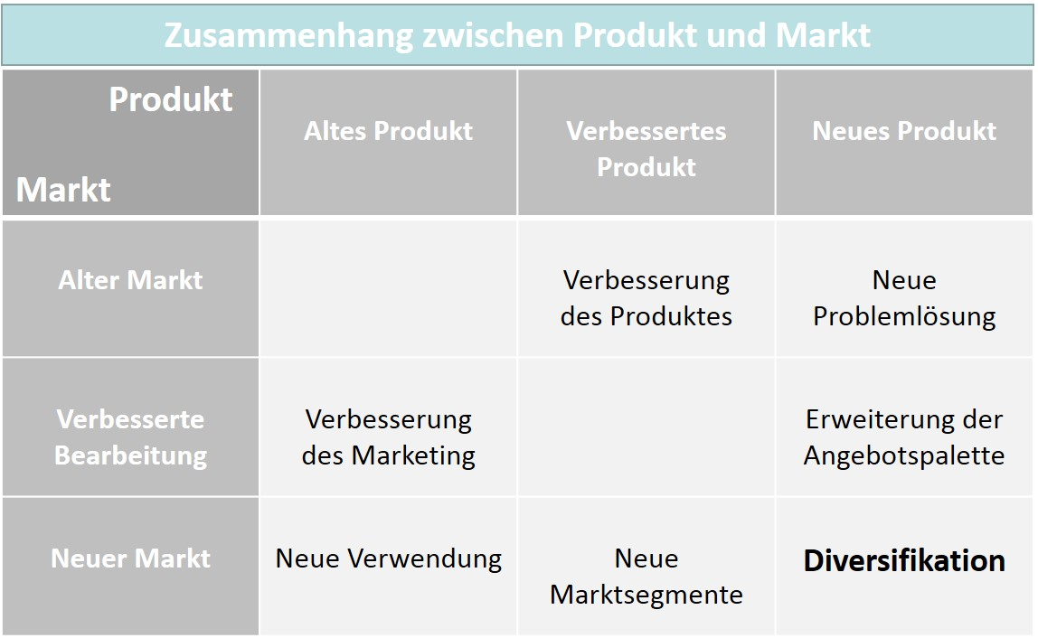

Accordingly, diversification is not a direct product-specific measure, since it does not involve modification of the existing product. Quite often, however, product range areas are expanded with the intention of also making the existing product range more attractive (again).

A potentially somewhat unpleasant measure in the final life cycle stage is **product elimination**. In most cases, a product has already consumed many resources by then and a comprehensive analysis has shown that the activities required for revitalization would no longer make economic sense. In order to be able to keep the resource requirements of the remaining products competitive, products that cannot guarantee success within the market must then also be removed from the product range (Herrmann & Huber, 2013, p. 378). However, even if analysis results based on key figures suggest the elimination of products, this is not automatically the right step. Certain products may have a strategic importance for the company or, in connection with a specific technology, may determine the knowledge base of a company in a relevant way. Thus, there may indeed be reasons to assess the qualitative arguments more highly and keep a product in the range. A product elimination could also bring the size of the product mix below a critical level and the company offering the product could lose the esteem of its customers. If the consequential damage due to elimination exceeds the gain in resources, this can also economically justify the retention of the product in the product mix.

**Product elimination**

The removal of a product from a company’s offering.

With product variation and differentiation, a company certainly has strategic options to once again increase or at least stabilize product success in the last stages of the life cycle. While product diversification tends to lead away from the previous positioning, economically substantiated product elimination would be the ultimate solution if other attempts at revitalization are ruled out or fail.

### Self-Check Questions

1. Which product strategy measures directly target an existing product? Mark the measures.

* Product variation (C)
* Product diversification (I)
* Product differentiation (C)
* Product elimination (C)

## 7.2 Success Monitoring and Metrics in Product Management

As in any other management process, strategic and operational planning in product management must be supported by key figures and other information. Thus, controlling in product management has an important task, the carrying out of which makes success measurable and in turn, can serve as a starting point for further optimizations. Controlling in **product management** therefore includes the activities that can be used to measure, evaluate, and monitor the contribution of products to a company’s success. The goals of the controlling function are typically based on the product life cycle and the subgoals of the stages defined therein, from product development and market launch through to elimination at the end of a product life cycle. The results of the measurements are used to draw conclusions which in turn form the basis for action in market cultivation and product policy activities. This creates a type of control loop, as the figure below illustrates. In addition to the evaluation of individual products, decisions regarding the product portfolio are also put to the test, since as a result of the measurement of the contribution to success of products, product management also gains important insight regarding product mix and product range planning that has a direct effect on the design of deliverables output and thus on value creation as a whole.

**Success monitoring in product management**

The activities for measuring, evaluating, and monitoring the contribution of products to a company's success.

Regelkreis des Controllings im Produktmanagement

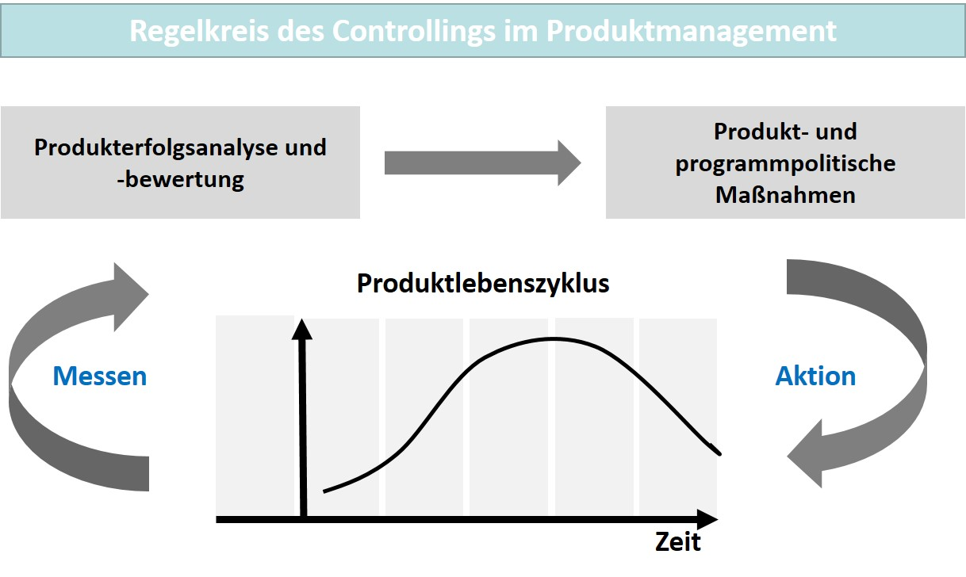

With controlling in product management, product success can not only be measured, but also controlled. The basis for this is information, performance indicators, and specific key figures, which must be collected and evaluated according to the controlling object. Examples of key questions in the controlling of products are ...

* ... the profit achieved by individual products,
* the total revenue share of a product category,
* the size of the market share, and
* the profitability of an offering.

These questions are relevant to deciding whether a product must be taken off the market or whether changes in price, design, and communication are necessary to ensure its continued or renewed success. But this is not only important in product management, since marketing, sales, and management also benefit from success monitoring. However, the stage in the life cycle in which the respective product is located determines the relevance of particular key figures. Alongside this, the strategic goal can also be additionally important, e.g., if an offering must remain on the market due to strategic interests, even though the commercial success criteria actually suggest an elimination (Fleig, 2021, p. 2). The main goals of controlling in product management are thereby (Fleig, 2021, p. 3):

* Transparency of target achievement for the products.
* Target/actual comparisons for early identification of relevant deviations.
* Planning certainty for an expansion or restriction in the product mix or product range, as well as a determination of the manner of these changes.
* Evaluation of product ideas and concepts with regard to successful market cultivation.
* Substantiated determination of the strategic importance of products for the company as a whole.
* Derivation of measures from product controlling to improve the situation.

For product management, the market variables particularly represent the quantitative success monitoring aspect. This is the basis for product planning and provides the specific values to safeguard product range and sales planning. The analysis side particularly requires a determination of product contribution margin to be able to assess the significance of certain offerings in terms of their contribution to the success of the company as a whole. The important market parameters for products are the following variables related to a specific time period (Aumayr, 2019, pp. 214–217):

* **Market capacity** as the “theoretically possible demand for a product or service”.
* **Market potential** as the “actual demand for a product or service”.
* **Market volume** as the “sum of products or services already sold on the product market”.
* **Market share** as the “share of products or services (a company’s product and the competitor’s products) within the market volume”.

If, for example, an industry has 300 production companies that can theoretically demand a particular machine and of these, 240 companies actually need such a machine for their specific production, then the market potential with 240 companies is 80 % of the market capacity of 300 companies. If 180 companies already have the machine in use, then 75 % of this supply area is already covered, i.e., saturated. The remaining 25 % is therefore the market attractiveness, since additional growth of the market volume is still possible on this scale. If a certain supplier already has 45 machines in use with customers, it covers 25 % of the market volume on a proportional basis. It therefore has a relevant market share, but its dimension must be put into perspective by comparison with competing companies. It could therefore be the market leader if its market share is not exceeded, but it would be a smaller player in competition compared with a competitor with sales of 90 machines and thus a 50 % market share. Due to market dynamics, these figures can only represent the point in time at which they were collected. They are therefore related to a specific date. For a period-oriented view and planning based on it, the variables used must also adequately meet the planning character of the evaluation.

To a greater or lesser extent, market capacity and potential can change due to the influence of specific developments. This can be easily explained using the example of machinery for production and manufacturing. Due to an economic downturn, companies in the affected industry may cease operations. This will inevitably reduce market capacity. However, it could also turn out that the economic pressures of a downturn will cause companies to invest more in streamlining in order to increase productivity. This may mean that even more companies engage in technical upgrading of their production, thereby increasing market their capacity. The investment activity then also increases the market potential and companies offering the demanded technology have better sales opportunities compared to the previous periods. The differentiation of the purchasing motivation is also relevant to the market volume. This can result from a genuine **new demand** if the thus far unrealized market potential increases demand. However, it can also be the result of a **replacement demand** due to technical wear and tear, whereby a part of the market volume is merely replaced. For new demand, however, it is also true that the purchasing process lasts for a longer period of time, which means that market saturation is also only reached with a delay. The **sales volume** of a time period thus results from the new need and the actually realized replacement need, since the replacement investment does not necessarily need to be made if there are other reasons for not doing so. Accordingly, the sales volume is also the variable that can be used in planning in product management planning (Aumayr, 2019, pp. 218–220).

**New demand**

The share of untapped market potential.

**Replacement demand**

The share of market volume that is replaced.

**Sales volume**

The sum of new demand and the actually realized replacement demand.

For sales planning, product management must now determine the periods that can realistically represent its own planning horizon. In general, these are short, medium and long-term considerations for the next two, three or more years in comparison to the previous and the next period (following year). Here, it is clear how difficult such planning truly is against the background of a rapidly changing market environment. Empirical data and forecasts based on the market research carried out must be combined in such a way that sensible and realistic planning is possible. If no planning were done, the results achieved would be purely random and product management would be more of a game of chance. This highlights the importance of analyzing the market, the competition, and a company’s own situation. Market-oriented product management therefore always has the opportunity to identify mistakes, justify deviations, and then learn from the insight and make planning more reliable. The strategic focus is also important here. It is not sensible to set operational goals based on strategic assumptions that have little or no validity for a company. One common mistake, for example, is to align the strategic focus too little on the specifics that determine the company’s own market and therefore its success. For instance, an international perspective in the analysis is not wrong, but it can lead to erroneous conclusions if the company’s own sales performance primarily depends on the specifics of the regional or national market served. A realistic assessment of new and replacement need is also essential, since the assessment of growth rates changes significantly in qualitative terms if a market environment leans increasingly heavily or almost exclusively toward replacement purchase in terms of demand (Aumayr, 2019, pp. 221–224).

If the market and sales figures are known or have been estimated on the basis of planning, an income statement can be prepared showing the expected incomes and costs of the products are listed. This indicates which contribution margins can be expected from a comparison of the cost and income side and thus the extent to which a product contributes to the overall success of the company. With regard to product mixes and product ranges, the degree to which the sales and production program structures make sense can also be made transparent, as well as adequately meet the strategic significance for the company and/or the market. For the cost estimates, product management must of course request the cooperation and input of the departments and divisions involved. The investment risk must be estimated for products already launched on the market, which can be accomplished by a profit/loss analysis. New products in particular must prove that they will reach the point where they make a positive contribution to the company’s success within an economically acceptable period of time. This is where the considerations of the break-even point (profit threshold) and the payoff period then play a role (Aumayr, 2019, p. 225).

One calculation method for sales planning, for example, is the **return on sales**. It indicates what percentage of the sales revenue represents the profit markup on the calculated unit costs.

**Return on sales**

The percentage ratio between the profit and sales revenue of a product range.

**Example: Calculation of the unit price**

For example, if the unit cost calculation gives an amount of €24 and the return on sales is to be 20 %, the unit price must be calculated with €30, since 20 % of €30 sales price is €6.

Companies naturally want to reach the break-even point quickly with a product, which can lead to unrealistic return on sales expectations. A price calculation can then miss the market expectations in such a way that the product is not a sales success. If the price must then be lowered, this can have a negative effect on the product image in the long term. This makes it clear that a price calculation must consider the competitive environment and should not be based strictly on optimizing the profit or payoff period.

Another method for revenue planning is the **return on investment** target value.

**Return on investment**

The percentage ratio between the profit and capital investment of a product range.

**Example: calculation of return on investment**

For the example, with a unit cost of €24 and an assumption that the planned sales volume is 100,000 units and the invested capital can be stated as €2 million, then a target return on investment of 20 % would be €400,000 in total and thus €4 per unit. The sales price is then the sum of the unit costs and the return on investment markup of €28.

**Example: Calculation of break-even**

For the last example, if the variable costs per unit are assumed to be €20 and the fixed costs for a sales volume of 100,000 units are therefore €400,000, then the contribution margin per unit would be exactly €8 and consequently 50,000 units would need to be sold in order to cover the fixed costs. This number of units would then be the break-even point.

Collecting and measuring key figures is typically associated with expenditure. A certain amount of data is always required to achieve a high-quality analysis, but at the same time, the processing effort increases with the amount of data. Success monitoring in product management must therefore be oriented in such a way that how the degree of differentiation of the necessary key figures is to be selected is decided on a case-by-case basis. This applies to the products, the period under consideration, and the markets. How this selection is determined depends on which goals and options for courses of action are associated with it (Fleig, 2021, p. 11).

The key figures that make success in competition measurable are of central importance for product management. In addition to the company’s own market share, the market share structure is also of interest, e.g., since it indicates the extent to which market shares are distributed among a few or many companies (market concentration). Also when, for example, the strongest competing company can be analyzed, significant insight can result from this observation. The innovative strength in competition can be derived on the basis of the age of the products in competition. This is important for an offering company if the competition is strongly characterized by the technological progress of the offerings. Companies must not miss technological leaps, since this can result in elimination from the competition (Fleig, 2021, p. 16).

However, in addition to quantitative parameters, qualitative aspects also play a key role. These include product features such as dimensions and materials, performance and consumption figures, functions for users, compatibility in a technical context, or modern design variants as well as services and payment conditions. In order to make a competitive comparison, it is typically necessary to evaluate information from the competition. Data sources can be product documents and websites, as well as trade fair visits and test purchases. Of course, this is more difficult in the business-to-business sector, since such information is hardly accessible or not at all, or can only be obtained with difficulty (Fleig, 2021, p. 17).

The analysis of a product’s key performance indicators should always be viewed in conjunction with the lifecycle stage that the product is currently in. New and very recently launched products cannot yet demonstrate the profitability that is expected for already established offerings. Profits only begin to emerge during growth and the product may later come under more pressure again due to increasing and competing offerings. Analysis and market cultivation must therefore always correspond, since the success factors are utilized entirely in the sense of the control loop diagram in the figure above to take suitable measures that further secure the success of the products or also reactivate them if competitive setbacks and influencing factors have promoted an unfavorable development. The key figures and metrics presented in this section represent the most important evaluation benchmarks and are even more diverse in product management practice and further differentiated for structural investigations.

In the context of digital products and services, there are performance metrics that specifically correspond to the prevailing business models. Examples are website visits with the verification of conversion rates, i.e., the acquisition of actual customers after visiting a website. A well-known method for optimizing this type of customer acquisition and retention results from the AARRR model developed by Dave McClure, a U.S. entrepreneur and investor. This abbreviation stands for **A**cquisition, **A**ctivation, **R**etention, **R**eferral, and **R**evenue.

**Example: Deployment of the AARRR model through cloud services**

The business models of certain cloud services can be used to explain the model well. On the internet today, it is not uncommon to be able to initially use a particular cloud service with a free version that is often combined with the creation of an account. The products offered are usually limited in performance and after a certain period of use, or after reaching a capacity limit, users must switch to a business version with a license fee model. A customer connection is developed through the free usage, which can substantially lower the hurdle with the later licensing for a purchase. The stages of the model are run through one after the other, whereby cloud services often support collaboration, and thus the referral stage has a greater significance, particularly in terms of customer loyalty. Examples include Dropbox with a collaborative cloud storage area, Zoom with a collaboration platform (video conferencing), or Microsoft with its Power App environment for business collaboration. Marketing instruments can be used at all stages to support the achievement of each goal. Channel usage ranges from simple email messages to direct communication via blogs and communities. The activities can then be measured and verified on the basis of conversion rates “from user to customer” (Gassner, 2021, pp. 70–78).

### Self-Check Questions

1. Which target variables are particularly suitable for income planning? Mark the relevant variables.

* Return on sales (C)
* Market share (I)
* Return on investment (C)
* Market potential (I)
* Break-even point (C)

## 7.3 Interface and Stakeholder Management

If the main task of product management were to be named, then successful product development would certainly be in first place. This would indeed be an extremely tough assignment, since a whole host of subtasks in planning, organization, and coordination must be carried out. Like almost no other discipline, product management is an activity at the interface of several relevant sub-disciplines at once. Some of these must be designed to follow the product life cycle and some are general and overarching. While product management depends on others to achieve its goals, there are also stakeholders who direct their demands to product management and primarily link their expectations to market success.

There is the management, which expects those responsible to ensure that the corporate strategy is also reflected in the strategic goals of product management. Conversely, product management naturally demands that its resources also meet these goals. Production is an important partner of product management, from research and development through to continuous quality assurance of manufacturing. Meeting the demands for product quality and, at the same time, ensuring that product specifications do not overburden production performance are the standards by which this relevant interface must be structured. For market cultivation, the focus is on cooperation with the sales organization. Sales expects compliance with the value propositions made to customers, and product management assumes that sales fulfills the tasks assigned to it by market cultivation in a competitive and customer-oriented manner. Accordingly, product management acts as a bridge between sales and production. The service area is closely linked to sales activities and can be the decisive factor in differentiating a company from the competition on the customer side. In connection with the digitalization of business models, this is now often the decisive component from a strategic perspective. And last, but not least, finance is interested in the success of product management. To this end, it monitors market variables and performance factors and, due to its controlling function, provides key information that should lead to the optimization of interface activities and market cultivation in product management. The figure below summarizes these primary interfaces and relationships.

Produktmanagement und Bereichsschnittstellen

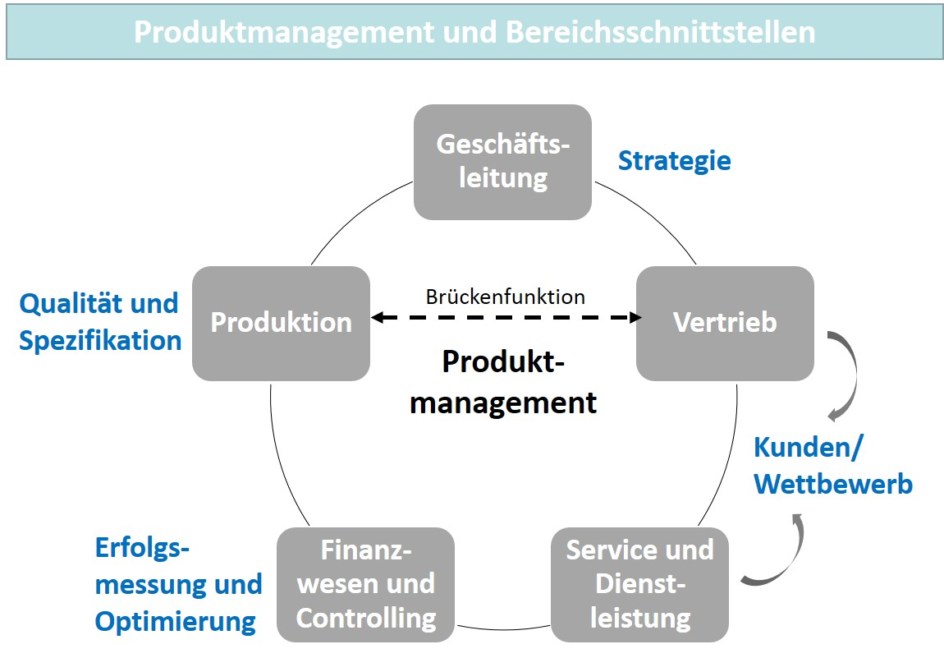

Interface activities can also result in conflicts of interest that product management must handle. In general, sales is more short-term in its goals, since success lies in closing the customer deal in the current period. Product management, on the other hand, has a long-term orientation toward the goal of ensuring the market success of its products on a sustained basis. Product management would like to be able to provide customers with up-to-date and technologically current offerings in order to maintain the attractiveness of its products. A quick response to changes in requirements is also part of market orientation. However, the ability to plan in production is a prerequisite, particularly in order to ensure the quality of production. Long-term and reliable general conditions should also apply to this, which, as a result, does not always correspond to the desired customer orientation. This also commonly leads to conflicts with the development department, whose striving to optimize technical properties can result in the time of market launch no longer being in line with the competitive orientation. The demands of finance for financial stability and cost recovery can also collide with the flexibility in pricing and conditions policy then demanded by product management when competition intensifies (Aumayr, 2019, p. 6).

Due to the close connection between product management and the functional areas, there is always a risk that tasks that should actually be carried in a functional area remain in product management, or are even delegated to product management by the functional area. This leads to an overburdening of those responsible, and it is not uncommon for activities to be carried out in an unspecialized manner, since the product managers lack the necessary expertise. In order not to fall behind in the performance of their own tasks, these *external tasks* must be avoided and referred back to the responsible departments. The motivation in the other functional areas can be different. In addition to intentional delegation, there may be a lack of knowledge to carry out the activities themselves. A lack of clarity about the exact delineation of tasks can also be the reason, or product management would like to do as many things as possible due to a lack of trust in the functional areas or because their own technical expertise originates in a particular functional area (Aumayr, 2019, p. 9–23).

**Stakeholder management**

The active design of stakeholder relationships in product management.

If product management wants to satisfy numerous stakeholders, the interfaces to these stakeholders must be actively designed. **Stakeholder management** conducted in this way identifies the needs and motivations of the stakeholders and takes them into account in its own planning and coordination tasks. By doing this, product success is also significantly influenced by promoting the positive influences of the stakeholders and eliminating or avoiding the negative influences. Stakeholder management is therefore an activity that continuously accompanies product management. Of course, this cannot mean that all desires expressed by stakeholders will be adopted and fulfilled. Product management is responsible for success and failure and therefore also has the skills to harmonize the formulated interests and only prescribe those measures that can increase product success or prevent failure. Stakeholder management is therefore an entity that is not only capable of maintaining contacts, but must also promote the correct goals and measures. Its organization in product management depends on how the interfaces are also served in the project planning processes from product development through to marketing measures. This can be regular participation in coordination meetings, as well as active participation in the coordination of suitable measures for market cultivation in the individual life cycle stages. The overall organization and embedding of product management therein provide the direction and the general conditions here.

### Self-Check Questions

1. Which stakeholders are particularly relevant for product management? Mark the relevant stakeholders.

* Management (C)
* Competition (I)
* Sales and marketing (C)
* Supplying companies (I)
* Production (C)

Summary

Due to the ever shorter product life cycles, product management must also handle the last stage in the product life cycle more intensively in order to optimize the success of its market cultivation. Strategic considerations play a key role in this process, since decreasing customer interest means that there is a risk that a product’s sales will drop to the point where it enters the decline stage. Measures to prolong a successful market presence are therefore among the most important tasks in product management. The indicators that provide evidence of a need for action are the information that essentially represents the product success. This includes sales figures, market shares, revenue and profit growth, as well as qualitative evaluations of customer loyalty and brand loyalty. Subsequently, product modifications, among other things, can represent the appropriate measures.

One type of modification is product variation. The basic functionality, the intended use, and the application capabilities of the product are retained, while the design, color, shape, material and quality characteristics or even services and specific additional services are modified. With a product relaunch, a company pursues even more far-reaching goals. In addition to the actual and typically more extensive product modifications, other marketing instruments are also used to revive or present the product in a new way.

A special type of variant is product differentiation, since here, the product is not brought into an adapted and modified state, but rather one or more product variants additionally supplement the product range. A substitution effect, i.e., the switching from one product variant to another variant of the same company, can lead to cannibalization in the offering.

Product diversification is a change in the product range that goes beyond modification, whereby new products are added to a company’s range in order to address new intended audiences. Product elimination means the removal of a product from a company’s offering if economic and/or strategic concerns do not conflict with this and an improvement in the competitive situation no longer appears possible.

In order to make such decisions, controlling has an important task: it makes success measurable and in turn, can serve as a starting point for further optimizations. This is because success monitoring includes the measures with which the contribution of products to the company’s success can be measured, evaluated, and monitored. Key aspects are the profit achieved by individual products, revenue shares of product categories, and the profitability of an offering. Important market parameters are market capacity, market potential, market volume, and market share. Calculation methods for the revenue planning of products in the context of the income statement are the return on sales and the return on investment calculations. In the context of digital products and services, there are also specific methods that can be used to determine the success of market cultivation measures. One example is the AARRR model according to Dave McClure.

Product management is an activity at the interface of several relevant sub-disciplines, some of which must follow the product life cycle and some of which must be designed in a general and overarching way. While product management depends on others to achieve its goals, there are also stakeholders who direct their demands to product management and primarily link their expectations to market success. If product management wants to satisfy the numerous stakeholders, the interfaces to these stakeholders must be actively designed. Stakeholder management identifies the needs and motivations of the stakeholders and takes them into account in its own planning and coordination tasks, since product success is significantly influenced by promoting the positive influence of the stakeholders and eliminating or avoiding the negative ones.