|  |
| --- |
| IU International University |
| Fundamentals of Product Management |
| DLBPROGPM01 |

# Learning Objectives

The **Fundamentals of Product Management** coursestarts by providing an overview of the goals and tasks of this management discipline, one that is of great importance to companies. This includes an explanation of the relevant terms as well as the categorization of value creation within organizations as a success factor for market cultivation. Furthermore, you will become acquainted with the basics and methods of market analysis, as well as the goal of strategically positioning products as the basis for the successful market presence of service bundles. A bundle of measures can also be characterized by its process orientation and be designed according to the principles of agile product management. Ideas and the resulting innovations are the basis of successful products. Therefore, idea and innovation management, market tests, and market launch strategies, as well as tasks along the phases in the product life cycle, are also part of the learning objectives within this course. A focus on competitors and customers is the cornerstone of companies’ activities relating to product policy, and the efficiency and effectiveness of product management thus also reflect the quality of market cultivation as a whole. Overall, this also presupposes well-functioning interaction management as an supporting activity.

# Unit 1 – Introduction to Product Management

Study Goals

On completion of this unit, you will be able to...

... name the characteristics of product management.

... differentiate between products based on their type and industry focus.

... explain the role of product managers and their importance.

... describe the positioning of product management within a company.

# 1. Introduction to Product Management

### Introduction

When digitalization, globalization, and innovation are discussed these days, the focus is usually on what companies offer in the form of products and the services that accompany them. In this context, intense competition ensures that management plays an increasingly decisive role with regard to the marketability, and thus the market success, of a particular offering. The significance of product management has therefore rapidly increased in recent years. It has developed into an asset of company management, particularly in regard to strategic tasks that concern companies’ longer-term market development and ability to innovate. The increase in networking, the concentration on the supply side, and the **vulnerability** in demand behavior require a management approach to products and services that simultaneously reacts to the continuously changing market requirements through agility and a strategic foundation. This raises the following underlying questions:

**Vulnerability**The susceptibility of demand to change

in business and society.

* What forms of product management meet market requirements and how do products differ in terms of their type and industry focus?
* What is the importance of the role of a product manager?
* How can product management be positioned within a company to meet the demands of customers and the competition?

## 1.1 Product Management Concept, Goals, and Tasks

“Great companies are built on great products” (Fischer, 2021). Here, the author is quoting Elon Musk, founder of Tesla, who can currently be considered a technology leader in the field of e-mobility. The statement confirms how closely a particular view of a company is connected to the assessment of its performance and, in particular, its products. We doubtless all know of several companies that we perceive to be leaders in their markets due to their remarkable products; these products may have been introduced decades ago. With the car manufacturer Tesla, this applies to a company that has only been a part of the competitive landscape for a few years. Why has it succeeded in this form? It can certainly be said that Tesla was not, and is not, viewed as just another supplier of traditional automobiles, but rather as a new supplier of marketable vehicles that has focused on an alternative type of engine.

This has also been highlighted by the fact that the German automotive industry suddenly fell into turmoil after decades of successful market cultivation, even though the barriers to entry for new companies wishing to manufacture vehicles are very high due to the enormous investment required for production infrastructure. Almost simultaneously, other groups were hit by crises because they had deceived customers by manipulating technology—think of Volkswagen, for example—or they were no longer able to survive on their own when faced with more intense competition and now needed to seek their future success in collaboration with other brands as part of a larger group structure—as is the case with OPEL, for example. Of course, it remains to be seen how the automotive market will develop in the longer term, since the current transformation in this sector is still in full swing. Nevertheless, the examples provided demonstrate how differently products and their characteristic features can also determine the position of companies as a whole. It is therefore only logical that product management has a special significance within a company. Important terms and connections that serve as a basis when exploring product management are presented in the following.

### Terms and Connections in the Product Management Context

When approaching an understanding of what a particular management domain encompasses, it is first useful to familiarize oneself with the terms and sub-terms used within that field of knowledge. In this case, these would be the terms *product* and *management*. The meaning of the second, rather neutral term is quickly clarified, since the **management** of a company usually relates to a company’s leadership as a body within a company. By extension, it refers to all the individuals who assume management tasks within a company. In this course, a manager is, therefore, a person who acts according to certain principles in the context of their professional role and the functional area to which they belong. These actions include:

**Management**

Refers to leadership personnel, as well as to all the management tasks within a company.

* organizing and planning,
* setting goals and deciding on or preparing decisions,
* delegating and coordinating,
* informing and evaluating, and
* controlling.

The term *management* therefore has a dual meaning, referring to the manager themselves as well as the management tasks they perform. In turn, the term **product** can be interpreted by using the previous reference to market, company, and competition. By extension, it refers to items that are created in production processes, and can be offered in markets by companies to consumers and/or other companies, and acquired by them.

**Product**

An item that is created in a production process and can be offered and acquired in particular markets.

At the same time, it is also known that, in the context of services and the tangible or intangible character of products, the term *product* can be interpreted in both a narrower (tangible, material) and a broader (intangible) sense. The vast market of computer games is an example of this. Product management can now also be defined when the content of both terms is combined.

In line with this, **product management** is a management concept oriented toward goals that aim at controlling and coordinating the development and offering of marketable products, as well as the tasks necessary for market cultivation.

**Product management**

A management function that shapes the market presence of a product from its market entry to market exit.

Again, the content-related elements of the terms *product* and *management* are to be found here. The fact that product management is extended to include market cultivation activities makes it clear that this management discipline spans the “life” of a product from development to market exit. Alongside this, the functional orientation of management is assumed in relatively broad terms (control and coordination). The implied “lifelong support” is also described by the term **product life cycle**, which can be viewed in this context as a phased progression of a product’s market presence, oriented toward the development of demand for a product from its market entry (beginning of the phased progression) to the elimination of its supply (end of the phased progression).

**Product life cycle**

Phased progression of demand for a product from market entry to market exit.

**Companies as demanders**

When considering market activity, supermarkets serve as an example that clearly demonstrates the great diversity of products to be found. As consumers, we demand a wide variety of products to meet our daily needs: for living, for vacations, or for entertainment. But companies not only offer products—they also demand them. As corporate consumers, they also need products and services to meet their daily needs: for equipping offices, for production and manufacturing, or—as commercial trading companies—not for their own use, but rather for resale as part of the distribution chain stretching from manufacturing companies to consumers.

**Brand**

Perceptions that a consumer or buyer associates with a specific product or good.

Products are therefore at the center of economic trade between consumers and companies. The companies offering the products go to great lengths to optimize their economic success by offering a range of products that is in high demand due to that fact it satisfies customers’ requests in the best possible way. In retail, the entire range of products or product groups is referred to as the **product line** of the companies offering them. It is precisely this diversity that means the management skills necessary for supporting the product line need to be bundled together. In turn, it also means that product management as an organizational form, along with other management disciplines, successfully supports companies of nearly all sizes and industries in cultivating their respective markets (Herrmann & Huber, 2013, p. 1). In industry, the terms *products* or *wares* are not usually used: instead, the discussion is of goods that are manufactured through a company’s **production program.** Similarly, in sales, the term *industrial goods* is usually used when these are not necessarily deployed as “finished” products, but are also components of other goods as parts in a production process. One example is the batteries that need to be installed in motor vehicles—as is the case with Tesla—as a source of propulsion.

**Production program**

All the products (goods) produced by an industrial or manufacturing company.

**Product line**

All or some (partial line) of the products (wares) offered by a commercial enterprise.

In certain economic and supply areas, we also associate more than just a neutral term with a product. Thus, a paper tissue is termed a “Kleenex” or a banana a “Chiquita”, even if the product in question is being sold by other companies (Herrmann & Huber, 2013, p. 2). This blending of the product and the **brand** is particularly important in product management when it comes to marketing activities; the brand can be seen as contributing to a company’s competitive edge. In this instance, product policy measures are referred to in connection with competitive positioning. The intention of these measures is to lead to consumers or buyers associating specific ideas with a specific product or ware that, from the consumer’s point of view, give this product or ware an advantage over competing offerings.

The connection between product and brand makes it clear that private or commercial users can base their selection process for a purchase on various criteria, which, in turn, correspond to the characteristics of the offerings on the sales side. Thus, products can also be ranked by these characteristics and criteria, along with the selection process. A classification that has been in longstanding use is based on

**Convenience goods**

Goods/wares for daily use that tend to be purchased at short notice and without a substantial selection process.

* purchase effort **(convenience goods)**,
* information and market transparency **(shopping goods)**, and
* the attractiveness of the product category **(specialty goods)**.

**Shopping goods**

Wares/goods for non-daily use, the acquisition of which involves a major selection process.

By extension, this also assists with the targeted selection of product policy measures. A relatively small amount of time is expended on the acquisition of **convenience goods**,such as foodstuffs, since there is usually a sufficiently large supply and buyers are even able to choose between several alternatives. The effort required for the purchase is therefore low. In contrast, this is not really the case with **shopping goods**, since, e.g., with clothing and electrical goods, the purchase is made less frequently and various offerings are compared. In order to make a decision, information must therefore first be obtained, certainly in the form of other consumers’ experiences, and the products on offer must be viewed. The purchase of **specialty goods**, for example, a condominium or a mobile home, is even more specific. Here, the time intervals are much longer and the choice is made after a more comprehensive and individual consideration of benefits. It is common for larger financial outlays to be involved here, even in the case of private purchases, which can correspondingly increase the level of attention paid to ensuring a feeling of certainty during a decision-making phase.

**Specialty goods**

Wares/goods that are very rarely purchased and are acquired after a more extensive selection process.

This distinction is similar to the classification of products, according to which prospective buyers pay more or less attention to the alternatives depending on their characteristics and/or price point (Herrmann & Huber, 2013, pp. 5-6). When exploring the selection process for a specific product, a hierarchy in the typification can also be identified, as illustrated in the following figure below.

Typisierung und Hierarchie von Produkt/Marke

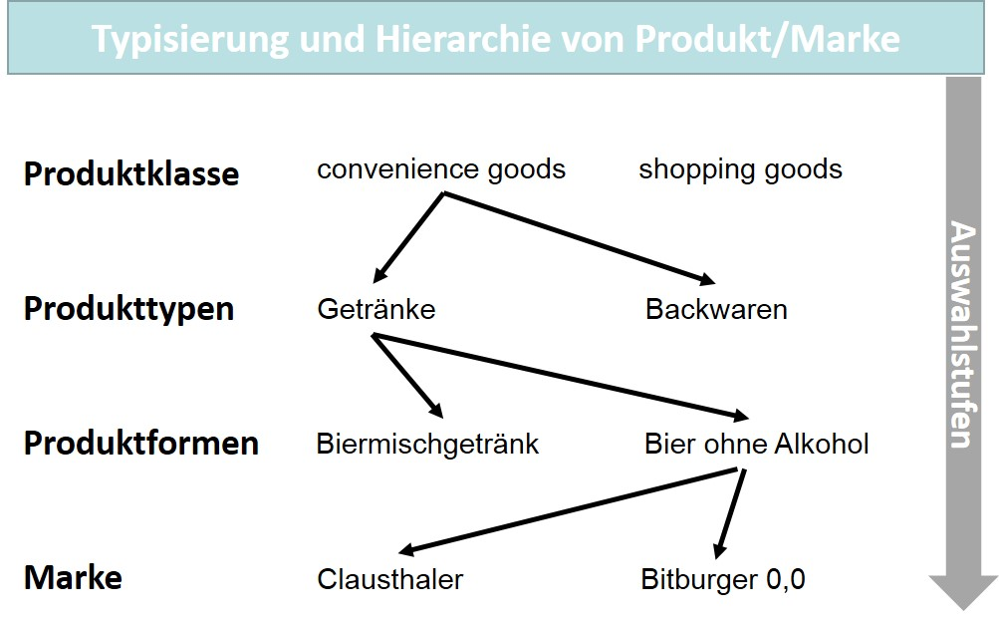

As consumers, we understand these terms, although we do not consciously make these considerations in this order for our daily purchases. The situation becomes slightly more complex with respect to business customers or products that are purchased by companies from companies. The term **business-to-business (B2B)** has become established for this type of business relationship; the market cultivation measures carried out by companies for corporate consumers or business customers are summarized by the term *business-to-business marketing* (B2B marketing). The business relationship between companies and end consumers is referred to as **business-to-consumer (B2C)**, with the corresponding market cultivation logically part of business-to-consumer marketing (B2C marketing). The selection process outlined in the figure above is not as easy to represent for the B2B sector due to the complexity of business relationships and the variety of products and goods. In general, other decision-making situations and other financial scales are present here, which is why investment decisions are also mentioned in this context. A decisive role is played in this field by companies’ purchasing behavior, which differs from that of normal consumers because corporate purchasing is organizationally institutionalized. There are departments that organize purchasing in such a way that product management on the supply side also plays a corresponding role in market cultivation. The complexity and variety, and thus also the quality and intensity, of the challenges for product management depend on several boundary conditions, above all, which also, in essence, result from the industry and the size of the company at hand.

**Business-to-consumer (B2C)**

A business relationship between companies and private individuals (consumers).

**Business-to-Business (B2B)** Business relationship between companies

**Example: a chemical company’s product and service**

If the example of a chemical company that purchases a system for process technology is considered, this system is also a product in the broader sense. However, in this case, it is more of a complete service bundle consisting of the system components and various **services.** It is only in the rarest of cases that the system is to be used without project planning, and the order will usually also need to be based on detailed performance specifications. This combination of a product (system) and a service (project planning) is not unusual in the B2B sector. The level of complexity increases even further if the companies accepting and using the service themselves need to participate in project planning to even be able to achieve the desired result, a functioning system. This would be a typical procedure for industrial plant engineering.

**Services**

In contrast to tangible goods, these are intangible goods that are part of service bundles or stand-alone services.

This example highlights the importance of service and customer integration in these kinds of business relationships. It is therefore clear that a service is a type of intangible good that often complements the product, enables its use, or accompanies its use. We, as consumers, are also familiar with this from our own purchases when, for instance, the installation of technical equipment in our home or the maintenance of technical devices complement the use of the products purchased. In these cases, the service is connected to the product for which it is provided. However, this connection need not exist when considering, e.g., financial services or advice provided by consulting companies. If services comprise and/or complement a company’s offering, this automatically has consequences for what the organization of product management encompasses.

Intangibility is not only characteristic of services. There are also intangible products that are used, e.g., in the form of application software as well as computer games. Here, too, there are special features that present product management with specific tasks. Software is distributed via license models. This means that users generally acquire a right to use software via a **license model**, which can even be limited to a particular time period. In addition, in combination with a contract supplement, the rights of use can also be extended to include future versions of the software. These kinds of maintenance contracts ensure that users can use versions of the software that have been debugged or modified to meet legal requirements. Product management must pay due attention to these special features and monitor the runtime version as the **release** of thesoftware and as the basis for licensing during the development process. The fact that this circumstance does not always meet with users’ approval has been shown, e.g., in the further development of Microsoft’s Office software or operating systems.

**Release**

The runtime version of a piece of software that represents a particular stage of development.

**License model**

Contractual agreement for the use of software.

The spread of the internet has greatly facilitated software distribution and maintenance. Applications can be easily downloaded and then installed directly on the user’s target system. Software updates are also largely automated. This has become increasingly important due to the rise in cybercrime and is already common practice with popular operating systems. It is also essential to regularly update protection software (virus scanners) if this protection is to be fully effective. The licensing model chosen for the above reasons is usually a subscription that is renewed to avoid periods without protection.

Software licensing has increased tremendously with the capabilities of mobile communication via smartphones and tablets. Applications, which are referred to as **apps** for short,can be selected in virtual stores and installed on the target system via a download. A special form of distribution is therefore required and must also be considered in product management. A separate market has emerged for this type of application, which, in addition to the private sector, has also increasingly reached customer companies, e.g., when a company’s field service uses mobile applications to document maintenance work or personnel time recording is carried out via an app on employees’ smartphones.

**App**

An application that is used on computers, smartphones, and tablets.

In connection with software development, there are certainly a number of young companies that have succeeded from the off as app or game developers or, since success cannot be guaranteed, have failed to make it as newcomers in an intensely competitive environment. A company that is still at the beginning of its life is referred to as a **start-up**. Here, the fact that a company, and usually also the product and/or the service that it offers, is not yet firmly established in the market presents great challenges in terms of product management, too. The founders often underestimate the enormous time and, equally, the financial expenditure that are connected with market development. Such companies often fail because the innovative top performance that might be present in a product is not perceived by potential customers or corporate consumers due to overly costly and thus insufficient sales activities. In this instance, product management that looks after an pre-established brand within a corporate structure is much simpler. Here, market cultivation, financial resources, and the further development of a brand are likely an integral part of product line or portfolio planning, which is continuously processed and coordinated as part of corporate planning.

**Start-up**

A company at the beginning of its life, i.e. shortly after entering the market.

**Support for start-ups by established corporations**

In the context of digitalization, it can also be observed that corporations identify innovative products and encourage the loyalty of the companies offering these innovative products, which are often at a very early stage, through shareholder participation, as well as through providing them with the conditions necessary for the successful marketing of the product. The creative capacity of the small organization is retained and the market presence of the corporation is a significant help in giving them a competitive edge.

However, **small and medium-sized enterprises (SMEs)** that generally wish to retain their independence must make their own efforts in product management to help their offers succeed. For this purpose, external experts are often called in to provide support in the various phases, whether engineering service providers in development or marketing agencies in sales, for instance.

**Small and medium-sized enterprises (SMEs)**

According to an EU recommendation, these have fewer than 250 employees and annual sales of no more than 50 million euros.

The previous explanations clearly demonstrate that product management can face very different challenges based on the various boundary conditions at play in companies. A company’s performance will depend on how it coordinates and controls the strategic and operational dimensions of its organizational task by correctly selecting its goals and accurately and appropriately resolving the tasks at hand.

**Procter & Gamble**

American and international consumer goods group with annual sales of over 60 billion US dollars.

### Product Management Goals and Tasks

Product management and its conceptual elements are nearly 100 years old and date back to the American company **Procter & Gamble**:

**Origins of product management**

The success of a new personal care series did not materialize and the goals initially set for sales and market share were not achieved. It also turned out that the departments involved in the internal processes were not coordinating well with each other. Instead, they were separated from each other as a result of departmental thinking with different priorities and views. A young executive—later to become the company’s managing director—was then asked to take charge of the personal care range and to optimize and coordinate all the external and internal activities related to this. He completed this task with great success, and the company subsequently rolled out this management approach across the firm: product management for product groups and individual products being clearly assigned a member of staff (product manager) was born.

It then became widely applied throughout the consumer goods industry and other industries followed, making product management a widespread management discipline today and one of the most important subfields of the overall organization. Likewise, a growing number of small and medium-sized enterprises (SMEs) are increasingly using product management successfully (Aumayr, 2019, p. 2). With this example of the origin of product management, the definition of this management discipline can also be expanded to include the aspects mentioned therein and state that product management “focuses on the need for cross-functional and cross-departmental control and coordination of products or product groups” (Aumayr, 2019, p. 6).

The example of the origins of product management has also shown that only a holistic view of the product with the relevant

* market,
* production, and
* market development

perspectives can enable product success. Several sub-goals for product management, with overarching task coordination, can be derived from this (Aumayr, 2019, p. 6):

1. Product management with the goal of a long-term strategic orientation to secure the product’s market position (sales).
2. Product management with the goal of flexibly manufacturing market-oriented product variants without long production lead times (production).
3. Product management with the goal of an orientation toward customer benefits and short development times until products are ready for the market (research and development).
4. Product management with the goal of a competitive pricing strategy and investments in product enhancements (finance and accounting).

For this purpose, the following figure shows the perspectives and goals for each of the following: the market as the competitive arena, production as the origin of innovation and functionality, and market cultivation as the orchestration of the tools of tasks and measures.

Perspektiven und Ziele des Produktmanagements

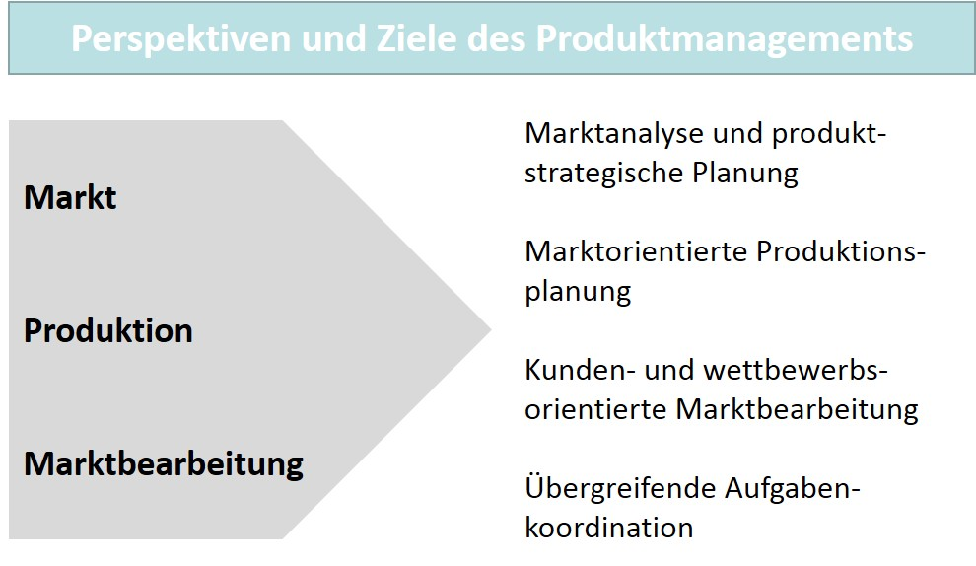

**Strategy**

The underlying, long-term behavior of a company in its market with the aim of achieving long-term goals.

Strategic positioning is shown here. This also falls under product management and underlines its importance for the company as a whole, since the goal of carrying out the task is also to develop **strategies** that can serve as the basis of market cultivation and thereby also concretize and operationalize the focus on a company’s customers and competition. This part of product management should not be underestimated, since it is very hard indeed to subsequently rectify mistakes made here. Those who get “into the game” with the wrong strategy will have difficulty compensating for this shortcoming with any specific tactics.

The various tasks in product management are strongly oriented toward a control loop that begins with analysis and is repeated via control and optimization at the end. The individual activities include the following subtasks (Herrmann & Huber, 2013, p. 3–4):

* **Analyze:** highly effective product management also requires a comprehensive level of information about the boundary conditions that exist internally and externally. Strengths, weaknesses, and the performance potential of one’s own organization must be known and, above all, realistically assessed. Opportunities and risks, which are identified in the external relationship with partner companies on the market, customers, and competitors, are also the basis of a **focus on** **customers and competitors.** Customer needs, the paths to these customers, as well as the efficiency and the offerings of competing companies, are at the forefront here. The situation must, therefore, be comprehensively analyzed. The continuous monitoring of the market and the control of the knowledge gained are part of the standard repertoire of product management.

**Focus on customers and competitors**

Alignment of a company’s market development with customer needs and the behavior of its competitors.

* **Conceptual planning:** after extensive analysis, the content of conceptual planning can be determined. Creativity and an innovative approach are required here. This is a particularly sizeable challenge for the development of new products, since it is common for financial exertion to increase the risk. Customer needs and other requirements, together with pre-existing and pre-formulated product ideas, must be transformed into customer benefits and clear product specifications. The product concept and product positioning must be closely aligned with the expectations of the intended audience in the market to achieve the differentiation from the competition that is necessary for success. The goal is a **business plan** that also includes specifications for the necessary market development measures**.** Action plans for operational implementation are drawn up based on the business plan, which plays a central role in this. The business plan is also one of the instruments with which a company’s **business model** is transferred into the specific tasks of market development.

**Business plan** Includes complete documentation of all the areas of conceptual planning for a product.

**Business model** The manner in which companies seek to create value and generate income in the market.

* **Implement/coordinate:** once developed, the product concept must prove its suitability. To do so, the product concept is implemented into operational practice, which is an important focus of product management tasks. However, not everything can be implemented independently of the rest of the process: quite the contrary. Internal departments and external market partners must be also coordinated so all the measures can be integrated on the basis of the plans made. In the process, communications-related tasks and logistical functions in sales must be considered in equal measure.
* **Optimize:** processes do not always run in the ideal way. Weaknesses in execution must therefore be identified and analyzed so that optimizations can be undertaken to rectify the situation. This applies to all the phases of the product life cycle. However, smaller companies can have particular difficulty with this continuous optimization, since it can require a considerable amount of resources. Too often, they focus on the beginning and on product development, while the later phases are followed less closely. This can then take its toll when competitors exploit obvious weaknesses of other companies presenting their offerings, thus severely endangering the success of their products. A customer- and competitor-focused approach is therefore the sensor of market cultivation in a product management approach that continuously monitors the life cycle of products and can immediately react with suitable measures in the event of problems with competitors.

The subtasks listed above can only be completed if the competence profile of the organization responsible for them also enables them to be put into practice. Planning and control tasks for important processes can only succeed if method-related support is provided; this should therefore also be part of the organizational structure in product management. Expertise, creativity, and inventiveness, as well as a willingness to act in a solution-oriented manner, characterize the people active in this area.

### Self-Check Questions

1. Why is the management of products of particular importance at companies?

The products of companies offering them and their characteristic features also determine the position of these companies as a whole. It is therefore only logical that the management of products should have a special significance within a company.

1. How are product management and the product life cycle connected?

Product management means the management function that accompanies the entire *product life cycle* from market entry to *market exit.*

1. Which subtasks are part of the product concept control loop? Mark the correct answers.

* Analysis (C)
* Conceptual planning (C)
* Sales (I)
* Implementation (C)
* Coordination (C)
* Planning (I)
* Optimization (C)