## Smart Devices I

**DLBINGSD01**

### Overall learning objectives

###### Introduction **9**

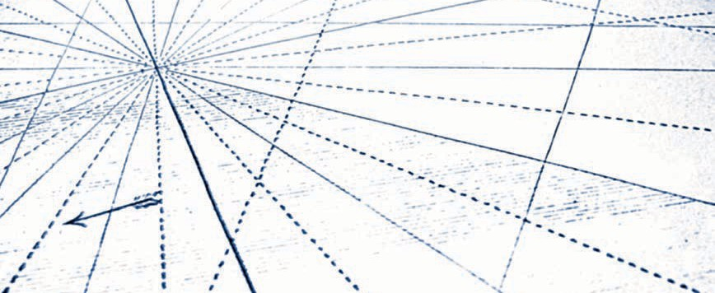

In the **Smart Devices I** course, students are introduced to the features and applications of smart devices. The application possibilities in the context of Industry 4.0 are specifically emphasized. To this end, not only are current trends in micro-systems technology to be addressed, but also assistance functions in production, for example by using data goggles or other wearables. Besides the typical technological features, the course also teaches the fundamentals of various interfaces that a smart device uses to interact with its environment. They include, on the one hand, the typically wireless system interfaces to other devices and the varying possibilities for regulating the devices via a user interface. The course concludes with a classification of smart devices in the field of ubiquitous computing.

After taking the course, students will ..

* ... have an overview of the historical development toward smart devices.
* ... be able to classify and distinguish different types and examples of smart devices with regards to their properties.
* ... be aware of typical features of smart devices.
* ... be aware of different communication standards that smart devices are able to use to communicate with their environment.
* ... be aware of different approaches that can be used to control smart devices.
* ... be able to classify smart devices as elements of ubiquitous computing.

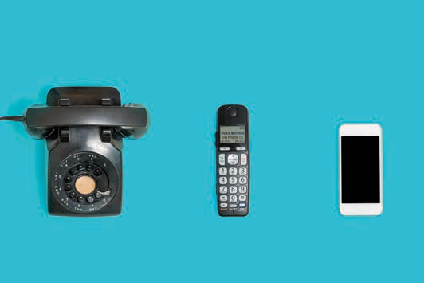

# Lesson 1

## Overview and meaning

##### STUDY GOALS

After working through this lesson, you will know ..

... how smart devices have developed historically.

... which technologies preceded smart devices.

... what role smart devices play in the Internet of Things.

... what potential smart devices have.

DL-D-DLBINGSD01-L01

### Overview and meaning

#### Introduction

We live in an increasingly digital world populated by a plethora of digital devices. These serve to support and automate human tasks and activities ever increasingly, enrich interpersonal social interaction, and improve physical interaction in the world around us. The physical world environment is increasingly digitally instrumented and equipped with embedded sensors and control devices. These can detect our location and automatically adapt to it. This eases the use of localized services, such as opening doors and turning on lights as we approach them. Positioning systems are able to determine our current location as we move. They can be linked to other information services. Devices such as non-contact keys or cards can be used to gain access to protected services located in the surrounding area. E-paper and e-books enable us to download up-to-date information in a wireless way onto flexible digital paper without having to visit a physical bookshop. Even electronic circuits can be distributed to special printers and printed on a paper-like substrate.

It has been a long journey from the first concept of a tablet 50 years ago to a fully networked production plant. Besides technological challenges, user acceptance and data privacy are also issues that have had to or still have to be clarified for widespread use. Although speech-controlled intelligent computer assistants like those in "Star Trek" used to be science fiction for a relatively long time, we can already find such and similar devices - as smart devices - in many households today. This lesson will help you achieve an overview of the historical development of assistance systems, which technological hurdles had to be overcome for the propagation of smart devices and how the Internet of Things is related to smart devices.

#### Historical development of smart devices

In 1968, the first concept of a lightweight portable computer for children was developed by Alan Kay. In 1972, four years later, this concept was presented for the first time in Boston. It took another 20 years before this became implemented. This concept strongly influenced the development of PCs, today's laptops and graphical user interfaces (Dalakov 2013).

1992 saw the presentation of the first smartphone prototype. This smartphone, called "Simon", developed by IBM and produced together with BellSouth Cellular. It already had a touchscreen, icons to tap and today's standard functions like clock, calendar, e-mail and calculator. At that time, however, mobile

Overview and meaning

phone networks were not yet capable of transmitting data. Even the first web browser were still waiting to be developed. The device was way ahead of its time and disappeared again just two years after it was introduced (Sager 2012).

1998 saw the introduction of the Internet Protocol version 6 **(IPv6)** by the "Internet Engineering Task Force" (IETF). When compared to its predecessor IPv4, the new version has a much larger address space, which means that significantly more end devices can be addressed than with IPv4. Without this expansion of the address space, the development of smart devices or Internet of Things (IoT) in the form we know today would not have been possible. Now 2128 end devices (computers, laptops, smartphones, sensors, switches, etc.) can be addressed directly. That is more than three hundred forty sextillion pieces (Laudon/Laudon/Schoder 2015).

In 2004, Microsoft attempted to make a new information service: Smart Personal Object Technology (SPOT). This was a dedicated frequency modulated (FM) radio network in the U.S. and Canada. This idea was to inform users about clocks developed by third-party manufacturers with weather data or stock market prices. Although a great deal of marketing went into this new technology, it was discontinued just four years after its introduction (Mentor 2013).

Steve Jobs introduced the first iPhone in 2007. Since then, smartphones have become commonplace in German households. In 2016, 54 million people living in Germany over the age of 14 had a smartphone, that is 78 percent. The trend was already significantly increasing in the years before. While in 2015 the share was 65 per cent, it has doubled since 2012. In the 14- to 49-year-old group, there is market saturation at around 93 percent (Veltkamp 2017).

In 2011, the promoter group "Communication of the Research Union Economy - Science" proposed the future project Industry 4.0 to the Federal Government in its recommendations for action. The Fourth Industrial Revolution is what we are talking about here. We have seen a shift from mechanical production with steam engines to mass production with first electrical, then electronic support to networked, fully automated and individualized production (Kagermann 2011).

Also in 2011, Apple introduced and launched the Siri voice assistant. At first this was only available on smartphones, six years on Siri can be found in almost all Apple devices. Siri is software that recognizes and processes naturally spoken language and the intension is to fulfill the functions of a personal assistant. Comparable competing products now exist, such as Google's Google Assistant, Microsoft's Cortana, Samsung's S Voice, or Amazon's Alexa (Konrad 2018).

2013 saw the introduction of Google Glass, a "mini-computer worn on the head" by the company Google, which belongs to the smart device class "wearables". Glass here is referring to the glass prism located in the peripheral field of view, which discreetly displays information. The device represents a technical milestone for IT experts, but from a data protection point of view it deeply cuts into the privacy of users and people in the surrounding area. All recorded data is

IPv6

With IPv6, 2128 End devices can be addressed directly. That is over three hundred and forty sextillion pieces.

stored on Google's servers. Even inconspicuous spying is possible, he said. However, visionaries see a broad area of application for the product in the entrepreneurial environment (Pitscheneder 2017).

Amazon Echo was introduced in 2015, this is an audio device developed by Amazon as a digital interface to the virtual and personal voice assistant Amazon Alexa. Various Internet services can be queried and used with this wizard. It is very intuitive to operate, the device has a long range with its seven microphones using far-field voice recognition, and multiple devices are able to be linked. The device can be activated by voice command, just like in "Star Trek". The activation is processed on the device and only then switches online. There is still criticism from data privacy advocates (Floemer 2018).

#### Technological pioneers for smart devices

Several technological hurdles had to be overcome before any smart devices, as we know them today, could become established. Comparable computing power of a smartphone in 1982 still required a room-sized mainframe computer. The smartphones of today have more computing power than all of NASA's computers combined in 1969, when two astronauts landed on the moon (Kaku 2011). In this learning cycle, you will learn more about the most important developments.

Processor power

Moore's Law Gordon Moore is the originator of Moore's Law, which describes the exponential increase in the processing power and decrease in the cost of computer technology

.

As early as 1956, Gordon Moore wrote that since the introduction of microprocessor chips in 1959, the number of components (mostly transistors) per chip has doubled every year. Later, Moore reduced his statement to a doubling every two years, thus establishing the **Moore's Law** (Laudon/Laudon/Schoder 2015).

Since then three variations of Moor's law have become established, which do not originate from Moor himself:

* The performance of microprocessors doubles every 18 months.
* Computer performance doubles every 18 months.
* The price of computer-based IT processing halves every 18 months.

It is not possible for Moore's Law to apply indefinitely with conventional technologies. Nevertheless, there is every reason to believe that the exponential growth in the number of transistors per chip and the increase in processor performance with exponential reduction in computer costs will continue in the foreseeable future (Laudon/Laudon/ Schoder 2015).

Overview and meaning

Digital Mass Storage

Along with increasingly faster, cheaper, and smaller processors, developments in mass storage technology are also contributing to the change in IT infrastructure. This means that smart devices can be seen as a forerunner. The capacity of hard disk drives grew exponentially in the period from 1980 to 2008. From 1980 to 1990, the total annual capacitive growth rate was 25 percent; after 1990, growth increased to more than 65 percent per year. Growth refers to the storage space of hard disks while real space requirements remain the same, for example gigabytes per square inch (Laudon/Laudon/Schoder 2015).

This growth is unbroken and necessary. In 2016, 16.1 zetabytes (ZB) of digital data were generated worldwide. Forecasts predict a tenfold increase, to 163 ZB, by 2025 (Statista 2018b). Most of the data generated is backed up on magnetic storage (keyword Big Data).

Storage space is not only getting smaller, but it also costs less. The cost per kilobyte has fallen exponentially since 1955 (the first use of magnetic storage devices) - the capacity of digital storage has doubled on average every

15 months per US dollar. While the cost per kilobyte in 1955 was still around

10,000 US dollars (magnetic drum memory), in 1980 it was only one US dollar (floppy disk memory). In 2016, one million kilobytes (1 GB) could be stored for one U.S. dollar (Laudon/Laudon/Schoder 2015).

|  |  |
| --- | --- |
| **Data volumes in comparison** | |
| Value | Metric |
| 1.000 | KB Kilobyte |
| 1.0002 | MB Megabyte |
| 1.0003 | GB Gigabyte |
| 1.0004 | TB Terabyte |
| 1.0005 | PT Petabyte |
| 1.0006 | EB Exabyte |
| 1.0007 | ZB Zettabyte |
| 1.0008 | YB Yottabyte |

Decreasing communication costs

The costs of communication via the Internet and telephone networks have developed in a logarithmic manner. In 1995, it cost two U.S. dollars to transmit one kilobit (125 bytes) over the Internet. Today, the cost is only about two cents (for infrastructure, electricity, etc.). Admittedly, the costs for transmitting the amount of data are in the cent range. However, as data volumes increase disproportionately, ever faster Internet connections and greater bandwidths must also become available. The faster an Internet connection (25 Mbit/s or 1Tbit/s), the more data can be transferred in the same period of time, but the more expensive the communication becomes. All in all, it can be said that the costs of communication have fallen (Laudon/Laudon/Schoder 2015).

Sensors

Smart devices can process digital information and exchange it with other devices. They can also have the ability to generate information or interact with their surroundings (Poslad 2009).

Sensors are needed to generate information. These are technical components for the qualitative or quantitative measurement of chemical or physical quantities and features (such as temperature, light, acceleration, electricity, pulse frequency, volume, etc.). When smart devices interact with their surroundings, they are referred to as smart actuators. These can be LEDs, beepers, switches or similar. Sensors and actuators have also become smaller, less expensive, more accurate, and more durable in recent decades (Laudon/Laudon/Schoder 2015).

Energy supply

An unsolved technical problem and limiting factor for the mobility of smart objects continues to be the supply of energy. Accumulators and batteries are becoming smaller and more powerful. Nevertheless, this development is significantly slower than those referred to above, which leads to shorter periods of operation as performance increases (Laudon/ Laudon/Schoder 2015).

#### Smart Devices in the Internet of Things

The Internet of Things (: IoT for short) is a digital overlay of information on the physical world. Objects and places can become part of the IoT in two ways. One way is that digital information can be linked for physical locations. Another ways is the connection of smart devices to the Internet enables the so-called IoT application (Valhouli 2010).

Overview and meaning

The Internet of Things began in 1991 with a networked coffee machine. At that time, a coffee machine at a university was monitored with the help of a camera connected to the Internet. Three times a minute, a new image was transmitted so that the amount of coffee in the can could be checked. This way, the scientists did not have to go to the coffee machine first to see if there was any coffee left, saving themselves time. The application ran for ten years and was switched off in 2001. Compared to traditional video surveillance, it was possible for anyone in the world with Internet access to view the fill level of the coffee machine. This setup was a very visionary approach at the time and is considered a "proof of concept" for IoT applications. So, the question was no longer "is it possible?" but whether such applications generate enough customer value to make their implementation worthwhile. This question is still much debated in practice today.

A direct customer benefit can initially be divided into four categories. This involves looking at the various IoT applications in different ecosystems and from different perspectives:

* + **On the road**, for example, networked devices or vehicles (smart mobility). Pervasive "smart" networking is seen here, bringing physical and digital life closer together.
  + **At home**, for example, networked apartments (smart home). Here, intelligent buildings create added value by improving energy efficiency and security, as well as health and education.
  + **In the city**, for example, networked cities (smart cities). Here, inner- and intra-urban networking creates added value through intelligent traffic management, smart energy grids and security.
  + **In the countryside**, for example, networked agriculture. Innovations in agriculture can lead to an increase in efficiency and achieve higher yields with reduced costs.

The use or application scenarios of IoT may also be divided into different industry sectors. According to the GSMA (global industry association of mobile operators), these can be divided into "smart environment", "smart life" and

"smart enterprises" (GSMA 2014).

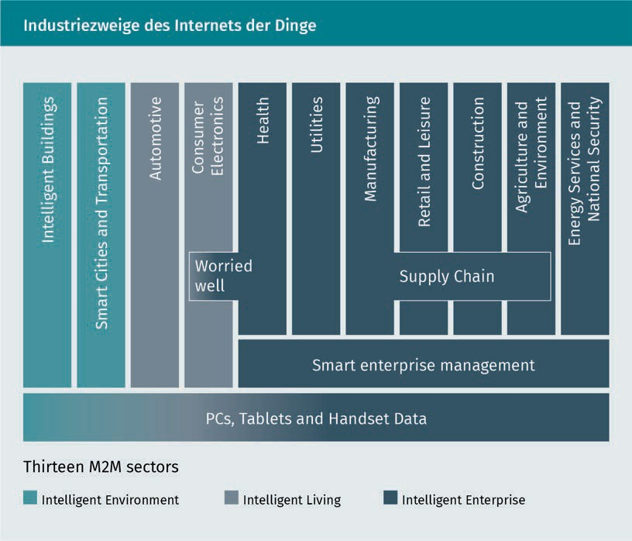

Market potential and forecasts

In 2010, there were approximately 1.5 billion Internet-capable PCs and just over one billion Internet-capable smartphones. At that time, a market potential of 100 billion devices was predicted within the following 5-10 years. Eight years later, things are looking more realistic. Admittedly, the number has risen sharply. But from today's perspective, this figure will be "only" 75 billion by 2025 (Statista 2018a).

Overview and meaning

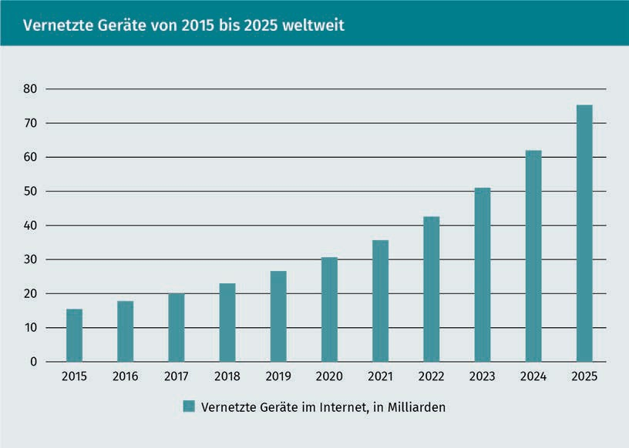

Criticism of IoT Applications

Even though it is possible to transform an object into a "smart" object, that does not automatically mean that it is also meaningful, in other words that it generates added value. In the late 1980s, cars "talked" to their drivers. For example, an open door was indicated with the help of a voice output and not, as is common today, with graphic elements and a warning tone. It would also have been more cost-effective to purchase more coffee machines in the example before. The important thing with such concepts is to satisfy the actual need - not to solve a problem. Technology should be a means to an end, not an end in and of itself, and subject to the "Law of the Instrument" (Valhouli 2010).

The Law of the Instrument - also known as "Maslow's Hammer" - states that people who are well versed in one tool or approach tend to use that tool even when another would be more appropriate. Put another way: "The man with the hammer sees a nail in every problem" (McRaney 2012).

**Summary**

Digital devices have become an indispensable part of our everyday lives. Increasingly, humans and machines are merging to interact with each other in an automated way.

A number of hurdles had to be overcome before this could happen. 50 years ago, the first concept for a portable computer was introduced. The first products were ahead of their time, as there was no infrastructure to enable meaningful use. It took 40 years to turn the concept of a smartphone into a market-ready product, the iPhone. Meanwhile, even personal voice assistants - as known from "Star Trek" - have made their way into our private households. In the industrial sector, too, technological advances and networking have led to revolutions and are changing established markets through Industry 4.0 approaches.

To do this, a number of technological prerequisites had to be met first. The performance of computers and their components doubles every 18 months, with costs halving over the same period. Here we speak of Moor's law. Sensors, energy supply and other areas also had to evolve to meet the requirements for smart devices.

The Internet of Things as an insertion/connection of information into/with the physical world in conjunction with smart devices is an exciting area to develop new markets and generate customer benefits. These customer benefits are divided into different categories, including networked devices, networked cities and different industries (for example, automotive, trade or energy). The market potential is huge. However, care must be taken to ensure that technology does not become an end in itself.

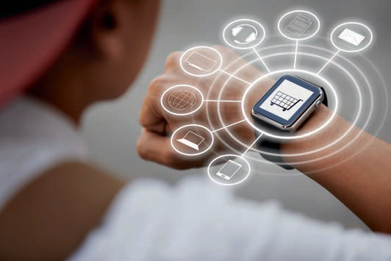

# Lesson 2

## Features and areas of application

##### LEARNING OBJECTIVES

After working through this lesson, you will know ..

... which typical features smart devices have.

... which specific devices are smart devices.

... which smart devices have an application in micro-systems engineering.

... in which applications smart devices are used.

DL-D-DLBINGSD01-L02

### Features and areas of application

#### Introduction

In the history of computers, the trend has gone from "a few people per computing machine (data centers)" to "one person per computer (personal computers)" to "multiple computers per person" (smart devices, PCs, etc.). There are now a large number of different smart devices. These have different features and belong to different classes. Smart devices are multipurpose devices and can be used as a portal for application services. Such applications may reside locally on the device (e.g., apps) or remotely on servers (e.g., websites). Smart devices often belong to a specific user. The device consists of, among other things, the control and the user interface. Smart devices are multi-functional because they facilitate access to multiple functions at runtime and simplify interoperability. The tradeoff, however, is reduced openness of the system; hardware components can be difficult to maintain or update (Posland 2009).

#### Typical features and classification

Smart devices are often mobile and belong to the class of mobile devices. Mobile devices are, for example, communication, multimedia entertainment or document processing devices designed to be transported by their human owners, such as mobile phones, game consoles, etc. Mobile devices can be divided into the following classes (Poslad 2009):

* + - **Accompanying:** These are devices that are wearable or handheld and are not attached or implanted on the body.
      * **Portable:** For example, laptop computers that are designed for two-handed operation while seated. These are generally the devices with the highest resources (e.g., memory or performance).
      * **Handheld:** Devices are typically held and operated with one hand, with multiple applications such as communication, audio/video recording and playback, and mobile office. These are low-resource devices.
    - **Wearable:** Devices in the shape and size of accessories and jewelry can often be operated hands-free (i.e., they do not need to be explicitly held for operation) and operate autonomously, such as watches that act as personal information managers, earpieces that serve as audio transceivers, eyeglasses that serve as visual transceivers, and contact lenses. These are low-resource devices.
    - **Implanted or embedded:** These are often used for medical reasons to enhance human functions, such as a pacemaker. They can also be used to improve the abilities of physically and mentally impaired people. Implants can be silicon-based macro- or micro-integrated circuits or they can be carbon-based, e.g., nanotechnology.

Features and areas of application

Five different characteristics and features can be identified for smart devices. These characteristics give rise to different application potentials, depending on how pronounced they are (Poslad 2009):

* Ubiquity/omnipresence,
* Embedding,
* Intuitive interaction,
* Adaptivity,
* Proactivity.

The individual points are described in more detail below.

Ubiquity is generally understood to mean omnipresence. In the case of smart devices, this refers to data and information and that these can be captured and provided simultaneously. In order to implement this, sensors are needed to measure and capture the environment. However, the collected data and information are transmitted and distributed via the Internet or other networks. Furthermore, a wide variety of output media are usually required so that the data or prepared information can be displayed elsewhere (Poslad 2009).

Embedding intelligent devices is another feature of smart devices. There are several possible ways as to how to implement the embedding. For example, standard PCs can be used to perform temperature measurements. However, the cost-benefit factor as well as the over dimensioning (space consumption, computing power, etc.) for such a simple measurement are out of proportion. The sensor values can also be falsified if the ideal measuring device is not used for each measurement. For example, the standard PC is itself a heat source, which means that the temperature to be measured changes during this measurement. A solution needed to be developed for this, which resulted in embedding the required features in objects, in other words, in smart devices. This embedding can be done by using small processors and data storage devices, which have a small power source and can be connected to the Internet via network modules. The lower power consumption results in less heat generation, which has less influence on the measured values. Smart devices are thus embedded in the environment and are virtually invisible (Poslad 2009).

Intuitive interaction leads to a new kind of operating possibilities. The question arises as to how devices can be operated which, while being able to communicate independently and at any time, are practically invisible. This requires that the functionality and usability remain recognizable to the user or can be implemented in an automatic and intuitive manner. There is a field of research called human-machine interaction available for research into the design of various implementation options. In the real world, we regularly use automatic-intuitive systems, for example, a sliding door that opens automatically by means of a sensor, or an escalator that only starts up when the user steps on it - and this without an explicit command. These examples demonstrate the essential concepts of the implementation of human-machine interaction: implicit operation of information systems. However, the controller

of smart home applications using voice control has now also arrived in households and works in an intuitive way, but usually still has to be explicitly controlled (if the temperature is to be increased, this has to be communicated explicitly). In the field of intuitive interaction, other behaviors of people such as looks, facial expressions, gestures, or movements are used in addition to speech (Poslad 2009).

Adaptivity in this context means proactive and context-dependent changes of the services or functionalities of smart devices. The simplest examples here are location-dependent settings of language or time zones. The display lighting changes to a warmer light in the evening. Depending on the position data, location-based Google hints are displayed. There is an automatic screen lock when making telephone calls. At certain times, during appointments or at certain locations, a "do not disturb mode" can be set. Depending on the light intensity, the display brightness changes automatically. Automatic settings and services of the device depending on the user's position, health or emotional state, plans and tasks, or other factors of the surroundings are also possible (Poslad 2009).

As soon as a smart device automatically offers or executes a service for its user, it is referred to as proactivity. This combines adaptive adjustments of applications in the background and anticipated interaction with the device's services. The proactive offer is ideally provided only needed. The smart device must be capable of correctly identifying the user's context and intent. A proactive sliding door would only open when someone really wants to go through it. Today's automatic sliding doors open also if someone just walks past the door. In addition, the proactive automatic activation of an emergency call as soon as a person falls unconscious to the ground can save valuable minutes and save lives in the future. Yet, distinguishing properly between such a person and another who slumps down jerkily on a sofa to rest becomes difficult for an automatic system. Identifying situations and making the right decisions is still one of the challenges in realizing a networked world today (Poslad 2009).

Classification

Smart devices are becoming smaller and smaller, easier to operate and lighter in weight, and cost less to produce and run. A common classification based on size was introduced as early as 1991. This is shown in the following table. Different device shapes with different features are defined depending on their size (Weiser 1991).

Features and areas of application

|  |  |  |
| --- | --- | --- |
| **Size comparison of the device shapes** | | |
| Device shape | Size | Feature |
| Tabs | < 10 cm | Concealable |
| Pads | 10 cm < 100 cm | Portable |
| Boards | > 100 cm | Installable |

We primarily consider computers to be the multi-application-supporting personal computers (PCs), that is, devices with some sort of screen display for data output, a keyboard, and some sort of pointing device for data input. As humans, we routinely interact with many other devices that contain individual embedded computers, such as household devices, and with complex computers that have multiple installed embedded systems (Poslad 2009). This classification was created as early as 1991, and devices developed later (such as the iPad) can have a similarity to these three classes. According to this classification , devices that are in the centimeter range or smaller are called tabs. These can be concealed due to their size or worn directly on the body (keyword "wearables"). Somewhat larger, but still smaller than 100 cm are so-called pads or handhelds. These are portable, but are not permanently attached to the body. Larger than pads are boards which can only be built in, i.e., smartboards, touchscreen monitors or similar. (Poslad 2009).

The 1991 classification refers exclusively to flat objects with a visual display. A more refined classification has since been made. Smart devices without a display can thus be greatly miniaturized. Such greatly miniaturized objects are called "Micro Electro-Mechanical Systems" (MEMS). Here, devices ranging in size from only a few nanometers to micrometers or even millimeters make up the Smart Dust class. Devices, belonging to the smart skin category, are made of thin fabric based on light-emitting and conductive polymers (cue organic computing devices) and can be embedded in more flexible uneven display surfaces and products such as clothing or curtains. In addition, MEMS can be "brushed" onto surfaces , changing physical structures into networked surfaces. Smart clays are ensembles of MEMS that are formed into arbitrary three-dimensional shapes called artifacts (Poslad 2009).

#### Example devices

In this section, some example devices are presented.

Smart Watch

A smart watch is a mostly digital and "smart" wristwatch with a small display that can be operated similar to a smartphone. In addition, a smart watch can be connected to a smartphone via Bluetooth, for example. Besides displaying time and date, other information can be displayed. These can include incoming messages, e-mails, calls or other notifications (push notifications). Sensors can also be used to measure various data, such as pulse, step rate or position, and transmit them to the smartphone. There are fitness wristbands that use sensors to record heart rate and transmit this to a smartphone, but they do not offer any other functionality besides displaying the time. The latest smart watches have integrated SIM cards. This allows the watches directly send and receive messages, make calls, or receive notifications, even if it is not connected to a smart phone (Bendel 2018).

The central output and input of the device is the display. This is realized as a touchscreen. A microphone and a speaker serve as further interfaces. This can be used to interact with a voice assistant, make phone calls and play music. Hints can be transmitted to the user very discreetly via vibration. Both the user interface and the range of functions can be expanded using preinstalled and downloadable apps. Such watches are Internet-enabled and interact with the user and other devices. Thus, making them part of the Internet of Things. The smart watch can look like an ordinary watch and have a normal dial (Bendel 2018).

Smart Glasses

Data glasses, also called smart glasses, superimpose information in the user's field of vision. These are small computers in the form of eyeglasses or computers attached to eyeglass frames. Such glasses are comparable to smartphones in terms of performance, can independently use mobile apps, take and display pictures and videos, and collect and retrieve information. With data glasses, a distinction is made between augmented reality (AR) and virtual reality (VR). With AR, contextual information about the environment is displayed directly above specific objects. AR data glasses are currently rarely seen in private consumer electronics. With VR, a computer-generated virtual world is displayed in real time. VR glasses are gradually gaining acceptance in the private environment for computer games. In the commercial sector however, there are many applications for both types, with AR including manufacturing equipment and airline passenger service for air travel, and VR in the design of real estate, furniture, and the like, as well as in the simulation of complex situations in aerospace (Gerardus 2018).

Google Glass is probably the best-known AR glasses. This was introduced in June 2012 and was available as a developer version from February 2013 onward. As of April 2014, a beta version was also available for purchase by end users. Due to low demand and major

Features and areas of application

privacy concerns, sales were discontinued in 2015. The glasses consist of a 640 x 320-pixel microdisplay with prism projector. Here images can be displayed in the form of slides. The glasses have Android as their operating system. The glasses are very light with only 54 grams. It has touch and eye controls as well as a bone speaker and microphone (Levin 2015, pp. 65-114).

Driven by innovative start-ups, developments in smart glasses have picked up speed again in recent years. This has resulted in the next generation of smart glasses. Thanks to companies like Vuzix, Everysight, Vigo Technologies or others, new promising solutions for augmented reality, health sensing, fitness tracking or face recognition are being developed. We can assume that this generation of smart glasses is going to have the potential to become the standard for everyone in the next five to ten years - not least because the purchasing costs have also become more moderate.

Smart Clothes

Increasingly small hardware means that electronic functions can now be incorporated into clothing. In the past, only a few applications were possible. Nowadays, there is a wide range of intelligent textile products, also called "smart clothes" or "wearables". Smart clothes have already made inroads in the five markets of health, safety and security, information and communication, sports and leisure, and work and surveillance (Werner 2017).

Health monitoring functions are necessary for many diagnoses or therapies. This is often taken over by rather uncomfortable devices. Monitoring blood pressure or heart rate over a long period of time is uncomfortable and impractical with outdated technology. The latest developments mean that this task can be performed by special clothing. Smart T-shirts can measure bodily functions and can be easily integrated into everyday life without being a nuisance. If necessary, automated warnings and emergency calls can be sent. This is beneficial for elderly or impaired individuals, but also for patients during rehabilitation (Werner 2017).

One application example of smart clothing for safety and protection is in motorcycling. Here, airbag systems are integrated to cushion the fall in the event of an accident and protect vital body regions. Unusual accelerations are detected by motion sensors. The airbags in the helmet and jacket are triggered via a compressed air cartridge. The clothing may also be equipped with GPS sensors. Using Bluetooth coupling with the smartphone or a direct telephone connection, an emergency call can be made automatically if an accident occurs. The acceleration and motion data can be used to estimate the severity of the accident (Werner 2017).

The information and communications industry regularly features innovative garments equipped with additional functions. Years ago, there were already jackets with integrated MP3 players. Today, there are helmets for skiers that display

information in the visor, such as current speed, distance traveled and elevation gain. Thanks to built-in headphones and microphone, music can be listened to, phone calls can be made or the voice assistant can be controlled while driving. Information from the smartphone is also shown on the display, so messages or e-mails can be read. Here, too, the safety functions mentioned above are possible thanks to acceleration sensors and automated emergency calls (Werner 2017).

Headsets

There are intelligent headsets that, controlled via the smartphone, can block out the surroundings via noise cancellation or let the user hear sounds from the surroundings via "situational awareness". This is a crucial safety factor on the road when wearing headsets and listening to music or talking on the phone. Suitable for noisy environments and thanks to noise cancellation, a quiet, undisturbed, and relaxed atmosphere can be created. A microphone is built into each earpiece for this purpose. These pick up the ambient sounds (Werner 2017).

Smartphone

The smartphone is probably the best-known smart device currently available on the market. In 2007, the first iPhone came onto the market. Unlike other mobile phones, smartphones are mainly optimized for operating various applications and not necessarily for making phone calls. This is why there are high-resolution touch-sensitive displays instead of numeric keypads and a small display. In addition, smartphones have various sensors such as movement, photo (RGB and black and white), position, magnetic field, light, and proximity sensors, as well as GPS receivers. Gradually, applications have become established that enable mobile working directly using the smartphone. Larger devices are also referred to as phablets, which are larger than smartphones but smaller than tablets (Adam/ Ludwig/Mühe 2013).

Smart boards

Smart boards are intelligent interactive electronic boards (whiteboards). A software enables users to use the smart board for different purposes. In addition, cameras and sensors are used to respond to interactions. Users can then use the projected applications directly with their fingers on the smart board, as you would with a mouse. As with a normal blackboard, writing can be done directly on the smart board. The smart board recognizes this so that the notes can be saved and used in other documents (Laudon/Laudon/ Schoder 2015).

Features and areas of application

#### Smart Devices in micro-systems engineering (MEMS)

Micro-Electro-Mechanical Systems, or MEMS, are tiny integrated devices or systems that are created using a special manufacturing technology that combines mechanical and electrical components. MEMS are usually very small, so their components can only be seen under a microscope. Today, levers, gears, pistons, engines and even steam engines have already been manufactured. MEMS are manufactured using stacked integrated circuit (IC) processes and can range in size from a few micrometers to a few millimeters. These appliances (or systems) have the ability to sense, control, and actuate on a micro-millimeter scale, in addition to producing effects. The following figure gives an idea of the order of magnitude. The term of MEMS is misleading, because they do not necessarily have to be mechanical micro machines or systems. In the literature, MEMS also describes the manufacturing technology and a paradigm for the design of complex mechanical devices and systems as well as their integrated electronics (o. V. 2002).

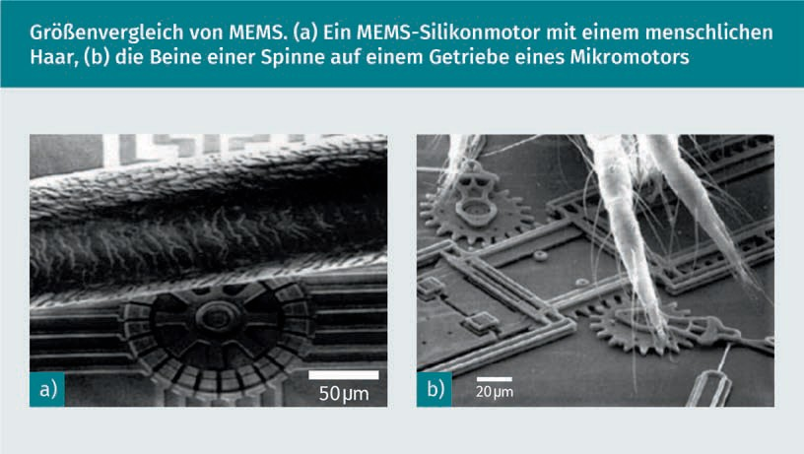

Markets and Applications

The interdisciplinary nature of MEMS leverages design, engineering, and manufacturing expertise from a broad and diverse range of technical fields including integrated circuit manufacturing engineering, mechanical engineering, materials science, electrical engineering, chemical and chemical process engineering, and fluid technology, optics and instrumentation, and packaging. The complexity of MEMS is also reflected in the extensive range of markets and applications that include MEMS devices. MEMS are used in systems that are applied in the automotive, medical, electronics, communications, and defense sectors. The potential in these sectors is enormous. Current MEMS appliances include accelerometers

for airbag sensors, inkjet printheads, read/write heads for computer board drives, projection display chips, blood pressure sensors, optical switches, microvalves, biosensors, and many other products, all of which are manufactured and shipped in high commercial volumes (o. V. 2002).

|  |  |  |  |  |
| --- | --- | --- | --- | --- |
| **Different application areas of MEMS** | | | | |
| Automobile | Electronics | Medicine | Communication | Defense |
| Internal navigation sensors | Hard disk read heads | Blood pressure sensors | Fiber optic network components | Ammunition guidance |
| Climatic compressor sensor | Inkjet print heads | Muscle stimulators and drug delivery systems | HF relays, switches, and filters | Surveillance |
| Brake force sensors and acceleration sensors for the suspension | Projection television | Implanted pressure sensors | Projection displays in portable communication devices and instruments | Reinforcement systems |
| Sensors for fuel level and vapor pressure | Earthquake sensors | Prosthetics | Voltage controlled oscillators (VCOs) | Embedded sensors |
| Airbag sensors | Avionics pressure sensors | Miniature analysis devices | Splitter and coupler | Data memory |
| "Smart" tires | Mass data storage systems | Cardiac pacemaker | Tuneable laser | Aircraft control |

Features and areas of application

Micro-fabrication 2.0

MEMS has been identified as one of the most promising technologies for the 21st century and has the potential to revolutionize both industrial and consumer products by combining silicon-based microelectronics with specialized processing technology. The techniques enabled by MEMS and microsystems-based devices have the potential to dramatically impact all of our lives. If semiconductor micro-fabrication is considered the first revolution in micro-fabrication, MEMS is the second revolution (o. V. 2002).

Technical Structure of MEMS

In its most general form, MEMS consist of micro- to millimeter-sized structures, sensors, actuators, and electronics. These components are all built into one and the same silicon chip. Micro-sensors detect changes in its environment such as mechanical, thermal, magnetic, chemical or electromagnetic information. Microelectronics process this information and signal the micro actuators to respond, creating some change in the environment (o. V. 2002).

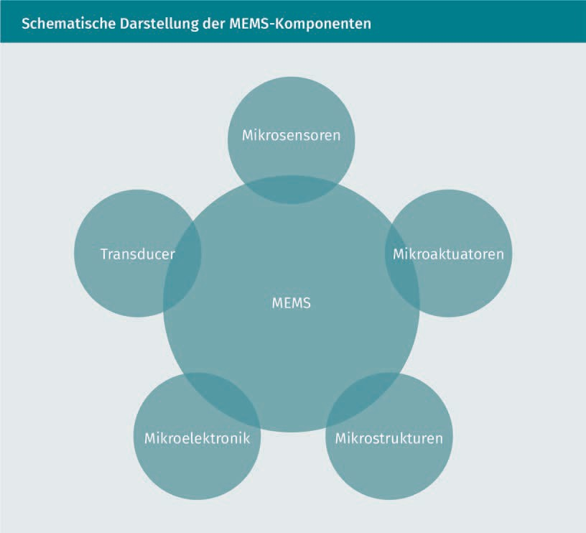

**Transducer (converter)**

The main component of MEMS are the transducers (converters) that convert one type of signal or energy into another form. The term "transducer" thus describes both actuators and sensors, is very generic and is often used in the field of MEMS (o. V. 2002).

**Sensor**

A sensor is a device that measures information from its environment and converts it into an electrical signal. In theory, of course, normal sensors and MEMS sensors are the same. In practice, however, the possibilities differ significantly. MEMS sensors have a wide range of measurable quantities:

* mechanical (force, pressure, speed, acceleration, position),
* thermal (temperature, entropy, heat flow),
* chemical (concentration, composition, reaction rate),
* radiation (electromagnetic wave intensity, phase, wavelength, polarization, reflection, refractive index, transmission),
* magnetic (field intensity, flux density, magnetic moment),
* electrical (voltage, current, charge, resistance, capacitance, polarization).

Features and areas of application

**Actuators**

An actuator is a device that converts an electrical signal into an action. It can generate a force to manipulate itself, other mechanical devices or the environment to perform some useful functions.

#### Other fields of application

In the smart home environment, there are many possible uses for smart devices. The purpose of smart home applications is to make the everyday lives of residents' simpler, safer and more energy-efficient. Devices and building elements are networked to achieve this. Heating, doors, windows, blinds can be integrated just as electronic and household appliances. Modular systems are frequently constructed. A central control unit, also a smart device, has the flexibility to be expanded to include other elements. Thanks to the networking of the modular devices, different functionalities are created. Through the combination of heating thermostat with a window sensor, the thermostat can be turned off when the window is opened. This saves heating costs, thereby paying off the purchase. It is important to have a concept when purchasing smart home products as to which operations make sense in which areas for the requirements set. These could be different or combined with regard to security, energy or comfort (Stolpen/Weber 2017).

With smart devices in hospitals, a distinction is first made between clinical and non-clinical operation. Non-clinical operations include maintenance, building services or logistics. There is a steadily growing need for IoT technologies to monitor and automate processes. Storage systems can independently reorder a lack of utensils. Plants and devices report errors or maintenance dates automatically. As in smart home applications, intelligent and networked control systems can reduce heating and electricity consumption. In clinical operations, on the other hand, there are much higher demands on data integrity and security, since personal data can be processed here. Such data is subject to special legal regulations. Workflows can be optimized with the aid of staff tracking within the hospital. Intelligent and networked beds can automatically provide data on current utilization. The information aggregated in this way can ensure that help gets to the patient faster in the event of an emergency. An electronic medical record can be directly supplemented with new results and further data, without manual intervention. Connected medical devices, or CMDs as they are known in the industry, facilitate the reduction of errors in many areas of work processes. Networked devices should ideally deliver time savings on the one hand, but also prevent errors in manual entries on the other. With the aid of smart device networking in the healthcare sector, patients' vital signs can also be monitored regardless of where they are. The data obtained can then be used for clinical decisions such as drug selection and selecting the correct dosage. This allows patients to be treated

even if the attending physician is not on site. This can improve medical care in rural areas and could even make it possible to immediately consult experts for treatment (o. V. 2018).

In the smart energy market of the future, analog electricity meters will be replaced by networked smart meters. These smart meters offer added value for customers firstly and electricity suppliers secondly. Customers can access current electricity consumption in real time using a web application. Electricity suppliers can use the consumption data to react more quickly to consumption peaks and, thanks to the data obtained, develop better models for forecasting electricity consumption. With the analog electricity meters, a classic, centrally controlled system with passive consumers is possible. Using smart meters, a decentralized system with active integrated consumers is possible. In contrast to analog electricity meters, consumers can also become producers in such a system (Sioshansi 2011).

**Summary**

Smart devices are assigned various characteristics and features. They differ from mobile devices in some respects, but at the same time have some similarities. Thus, smart devices are characterized by their ubiquity, embedding, intuitive interaction, adaptivity, and proactivity. These are the most important features to consider when designing smart devices. There are also different size classes, from boards to smart clays.

There are many well-known and widely used smart devices such as smartphone, smart watch, smart glasses, but also less common ones such as smart clothes. Smart devices are also being used more and more in production to achieve increases in efficiency.

In micro-systems engineering, smart devices in the micrometer range have now also become established, making it possible to establish smart environments.

Smart devices are now finding use in many fields of application. In this way, everyday life can be made easier with the aid of smart home applications. In the production of the future, fully automated systems will be introduced. Smart devices could save lives in hospitals in the future . Even the energy market is being revolutionized.