## Smart Devices I

**DLBINGSD01**

### Overall Learning Objectives

###### Introduction **9**

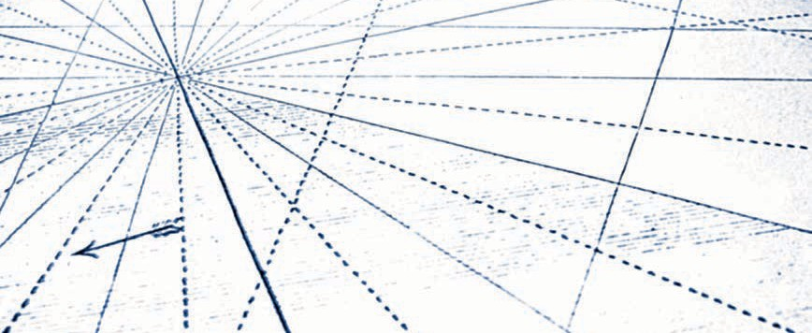

In the course, **Smart Devices I,** students are introduced to the features and applications of smart devices. The possible applications in the context of Industry 4.0 are specifically emphasized. To this end, not only are current trends in micro-systems technology addressed, but also assistance functions in production, for example by using smart spectacles or other wearables. In addition to the more conventional technological features, the course also teaches the fundamentals of the various interfaces that a smart device uses to interact with its environment. These include both the typical wireless interfaces to other devices and the various possibilities for regulating the devices via a user interface. The course concludes with a classification of smart devices in the field of ubiquitous computing.

After taking the course, students will …

* ... have an overview of the historical development of smart devices.
* ... be able to classify and distinguish different types and examples of smart devices and their properties.
* ... be aware of the typical features of smart devices.
* ... be aware of the different communication standards that smart devices are able to use to communicate with their environment.
* ... be aware of the different approaches that can be used to control smart devices.
* ... be able to classify smart devices as elements of ubiquitous computing.

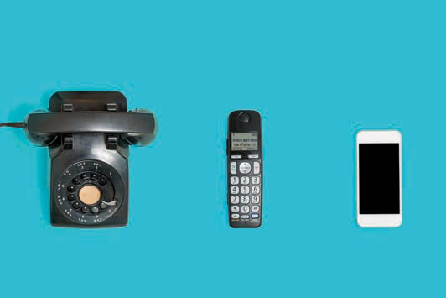

# Lesson 1

## Overview and Importance

##### STUDY GOALS

After working through this lesson, you will know ..

... how smart devices have developed historically.

... what technologies preceded smart devices.

... what role smart devices play in the Internet of Things.

... what potential smart devices have.

DL-D-DLBINGSD01-L01

### Overview and Importance

#### Introduction

We live in an increasingly digital world populated by a plethora of digital devices. These serve to support and automate an increasing number of human tasks and activities, to enrich interpersonal social interaction, and improve physical interaction in the world around us. The physical world environment is to an increasing extent digitally instrumented and equipped with integrated sensors and control devices. These can detect our location and automatically adapt to it. This facilitates the use of localized services, such as opening doors and turning on lights as we approach them. Positioning systems are able to determine our current location as we move, and can be linked to other information services. Devices such as contactless keys or cards can be used to gain access to protected services located in the surrounding area. E-paper and e-books enable us to download up-to-date information in a wireless way onto flexible digital paper without having to visit a physical bookshop. Even electronic circuits can be sent to special printers and printed on a paper-like medium.

It has been a long journey from the first concept of a tablet 50 years ago to a fully networked production plant. Besides technological challenges, user acceptance and data privacy are also issues that have had to, or still have to, be clarified for widespread use. Although speech-controlled intelligent computer assistants like those in the television series, "Star Trek," were science fiction for a long time, we can already find such or similar devices - as smart devices - in many households today. This lesson will give you an overview of the historical development of assistance systems, and show you what technological hurdles had to be overcome for the expansion of smart devices and how the Internet of Things is related to smart devices.

#### Historical Development of Smart Devices

In 1968, the first concept of a lightweight portable computer for children was developed by Alan Kay., Four years later, in 1972, this concept was presented for the first time in Boston. It was another 20 years before it was brought to fruition. This concept strongly influenced the development of PCs, today's laptops and graphical user interfaces (Dalakov 2013).

1992 saw the presentation of the first smartphone prototype. This smartphone, called "Simon," was developed by IBM and produced together with BellSouth Cellular. It already had a touchscreen, icons to tap and today's standard functions like clock, calendar, e-mail and calculator. At that time, however, mobile

Overview and importance

phone networks were not yet capable of transmitting data. Even the first web browsers were still waiting to be developed. The device was way ahead of its time and disappeared again just two years after it was introduced (Sager 2012).

1998 saw the introduction of the Internet Protocol version 6 **(IPv6)** by the "Internet Engineering Task Force" (IETF). When compared to its predecessor IPv4, the new version had a much larger address space, which meant that significantly more end devices could be addressed than with IPv4. Without this expansion of the address space, the development of smart devices or the Internet of Things (IoT) in the form we know it today would not have been possible. Now 2128 end devices (computers, laptops, smartphones, sensors, switches, etc.) can be addressed directly. That is more than three hundred and forty sextillion devices (Laudon/Laudon/Schoder 2015).

In 2004, Microsoft attempted to create a new information service: Smart Personal Object Technology (SPOT). This was a dedicated frequency modulated (FM) radio network in the U.S. and Canada. The idea was to make users aware of clocks developed by third-party manufacturers with weather data or stock market prices. Although a great deal of marketing went into this new technology, it was discontinued just four years after its introduction (Mentor 2013).

In 2007, Steve Jobs introduced the first iPhone. Since then, smartphones have become commonplace in many households. For example, in 2016, 54 million people over the age of 14 living in Germany had a smartphone, i.e. 78%. The trend was already increasing significantly in the years before. While in 2015 the share was 65%, it has doubled since 2012. In the 14 to 49-year-old group, there is market saturation at around 93 percent (Veltkamp 2017).

In 2011, the promoter "Communication of the Research Union for Economy & Science" proposed, in its recommendations for action to the Federal Government, the future project, Industry 4.0. What this amounts to is the Fourth Industrial Revolution, from mechanical steam-driven production to mass production with first electrical, then electronic support, the shift has now been made to networked, fully automated and individualized production (Kagermann 2011).

Also in 2011, Apple introduced and launched the Siri voice assistant. At first this was only available on smartphones, but six years on Siri can be found in almost all Apple devices. Siri is software that recognizes and processes naturally spoken language with the aim of fulfilling the functions of a personal assistant. Comparable competing products have since been developed, such as Google's Google Assistant, Microsoft's Cortana, Samsung's S Voice, or Amazon's Alexa (Konrad 2018).

2013 saw the introduction of Google Glass, a "mini-computer worn on the head" by the company Google, which belongs to the smart device class "wearables". Glass here refers to the glass prism located in the peripheral field of view, which discreetly displays information. The device represents a technical milestone for IT experts, but from a data protection point of view it cuts deeply into the privacy of users and people in the surrounding area. All recorded data is

IPv6

With IPv6, 2128 End devices can be addressed directly. That is over three hundred and forty sextillion pieces.

stored on Google's servers. Even covert spying is possible. However, visionaries see a broad area of application for the product in the entrepreneurial environment (Pitscheneder 2017).

In 2015, Amazon Echo was introduced, an audio device developed by Amazon as a digital interface to the virtual and personal voice assistant Amazon Alexa. Various Internet services can be queried and used with this wizard, which is very intuitive to operate. The device has a long range with its seven microphones using remote-field speech recognition. It can be linked to multiple devices and activated by voice command, just like in "Star Trek". The activation is processed on the device and only then switches online. However, there is still criticism from data privacy advocates (Floemer 2018).