## Smart Devices I

**DLBINGSD01**

### Overall Learning Objectives

###### Introduction **9**

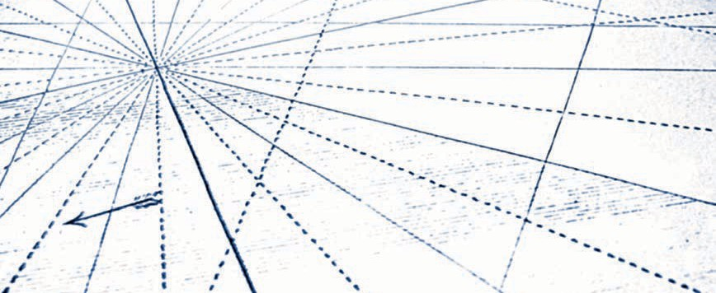

In the **Smart Devices I** course, students are introduced to the features and applications of smart devices. The application possibilities in the context of Industry 4.0 are specifically emphasized. To this end, not only are current trends in micro-systems technology to be addressed, but also assistance functions in manufacturing, for example by using data goggles or other wearables. Besides the typical technological features, the course also teaches the fundamentals of various interfaces that a smart device uses to interact with its environment. They include, on the one hand, the typically wireless system interfaces to other devices and the varying possibilities for regulating the devices via a user interface. The course concludes with a classification of smart devices in the field of ubiquitous computing.

After taking the course, students will..

* ... have an overview of the historical development toward smart devices.
* ... be able to classify and distinguish different types and examples of smart devices with regards to their properties.
* ... be aware of typical features of smart devices.
* ... be aware of different communication standards that smart devices are able to use to communicate with their environment.
* ... be aware of different approaches that can be used to control smart devices.
* ... be able to classify smart devices as elements of ubiquitous computing.

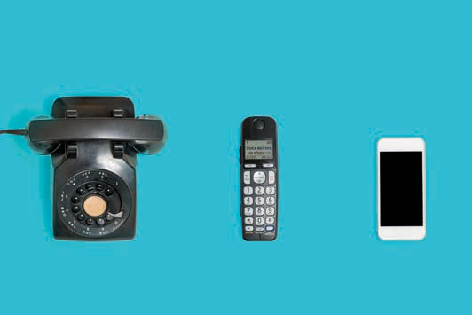

# Lesson 1

## Overview And Meaning

##### STUDY GOALS

After working through this lesson, you will know..

... how smart devices have developed historically.

... which technologies preceded smart devices.

... what role smart devices play in the Internet of Things.

... what potential smart devices have.

DL-D-DLBINGSD01-L01

### Overview And Meaning

#### Introduction

We live in an increasingly digital world populated by a plethora of digital devices. These serve to support and automate human tasks and activities ever increasingly, enrich interpersonal social interaction, and improve physical interaction in the world around us. The physical world environment is increasingly digitally instrumented and equipped with embedded sensors and control devices. These can detect our location and automatically adapt to it. This eases the use of localized services, such as opening doors and turning on lights as we approach them. Positioning systems are able to determine our current location as we move. They can be linked to other information services. Devices such as non-contact keys or cards can be used to gain access to protected services located in the surrounding area. E-paper and e-books enable us to download up-to-date information in a wireless way onto flexible digital paper without having to visit a physical bookshop. Even electronic circuits can be distributed to special printers and printed on a paper-like substrate.

It has been a long journey from the first concept of a tablet 50 years ago to a fully networked manufacturing plant. Besides technological challenges, user acceptance and data privacy are also issues that have had to or still have to be clarified for widespread use. Although speech-controlled intelligent computer assistants like those in "Star Trek" used to be science fiction for a relatively long time, we can already find such and similar devices - as smart devices - in many households today. This lesson will help you achieve an overview of the historical development of assistance systems, which technological hurdles had to be overcome for the propagation of smart devices and how the Internet of Things is related to smart devices.

#### Historical Development Of Smart Devices

In 1968, the first concept of a lightweight portable computer for children was developed by Alan Kay. In 1972, four years later, this concept was presented for the first time in Boston. It took another 20 years before this became implemented. This concept strongly influenced the development of PCs, today's laptops and graphical user interfaces (Dalakov 2013).

1992 saw the presentation of the first smartphone prototype. This smartphone, called "Simon", developed by IBM and produced together with BellSouth Cellular. It already had a touchscreen, icons to tap and today's standard functions like clock, calendar, e-mail and calculator. At that time, however, mobile phone networks were not yet capable of transmitting data. Even the first web browser were still waiting to be developed. The device was way ahead of its time and disappeared again just two years after it was introduced (Sager 2012).

Overview And Meaning

1998 saw the introduction of the Internet Protocol version 6 **(IPv6)** by the "Internet Engineering Task Force" (IETF). When compared to its predecessor IPv4, the new version has a much larger address space, which means that significantly more end devices can be addressed than with IPv4. Without this expansion of the address space, the development of smart devices or Internet of Things (IoT) in the form we know today would not have been possible. Now 2128 end devices (computers, laptops, smartphones, sensors, switches, etc.) can be addressed directly. That is more than three hundred forty sextillion pieces (Laudon/Laudon/Schoder 2015).

In 2004, Microsoft attempted to make a new information service: Smart Personal Object Technology (SPOT). This was a dedicated frequency modulated (FM) radio network in the U.S. and Canada. This idea was to inform users about clocks developed by third-party manufacturers with weather data or stock market prices. Although a great deal of marketing went into this new technology, it was discontinued just four years after its introduction (Mentor 2013).

Steve Jobs introduced the first iPhone in 2007. Since then, smartphones have become commonplace in German households. In 2016, 54 million people living in Germany over the age of 14 had a smartphone, which is 78 percent. The trend was already significantly increasing in the years before. While in 2015 the share was 65 per cent, it has doubled since 2012. In the 14- to 49-year-old group, there is market saturation at around 93 percent (Veltkamp 2017).

In 2011, the promoter group "Communication of the Research Union Economy - Science" proposed the future project Industry 4.0 to the Federal Government in its recommendations for action. The Fourth Industrial Revolution is what we are talking about here. We have seen a shift from mechanical manufacturing with steam engines to mass manufacturing with first electrical, then electronic support to networked, fully automated and individualized manufacturing (Kagermann 2011).

Also in 2011, Apple introduced and launched the Siri voice assistant. At first this was only available on smartphones, six years on Siri can be found in almost all Apple devices. Siri is software that recognizes, and processes naturally spoken language and the intension is to fulfill the functions of a personal assistant. Comparable competing products now exist, such as Google's Google Assistant, Microsoft's Cortana, Samsung's S Voice, or Amazon's Alexa (Konrad 2018).

2013 saw the introduction of Google Glass, a "mini-computer worn on the head" by the company Google, which belongs to the smart device class "wearables". Glass here is referring to the glass prism located in the peripheral field of view, which discreetly displays information. The device represents a technical milestone for IT experts, but from a data protection point of view it deeply cuts into the privacy of users and people in the surrounding area. All recorded data is

IPv6

With IPv6, 2128 End devices can be addressed directly. That is over three hundred and forty sextillion pieces.

stored on Google's servers. Even inconspicuous spying is possible, he said. However, visionaries see a broad area of application for the product in the entrepreneurial environment (Pitscheneder 2017).

Amazon Echo was introduced in 2015, this is an audio device developed by Amazon as a digital interface to the virtual and personal voice assistant Amazon Alexa. Various Internet services can be queried and used with this wizard. It is very intuitive to operate, the device has a long range with its seven microphones using far-field speech recognition, and multiple devices are able to be linked. The device can be activated by voice command, just like in "Star Trek". The activation is processed on the device and only then switches online. There is still criticism from data privacy advocates (Floemer 2018).

#### Technological Pioneers For Smart Devices

Several technological hurdles had to be overcome before any smart devices, as we know them today, could become established. Comparable computing power of a smartphone in 1982 still required a room-sized mainframe computer. The smartphones of today have more computing power than all of NASA's computers combined in 1969, when two astronauts landed on the moon (Kaku 2011). In this learning cycle, you will learn more about the most important developments.

Processor power

Moore's Law Gordon Moore is the originator of Moore's Law, which describes the exponential increase in the processing power and decrease in the cost of computer technology

.

As early as 1956, Gordon Moore wrote that since the introduction of microprocessor chips in 1959, the number of components (mostly transistors) per chip has doubled every year. Later, Moore reduced his statement to a doubling every two years, thus establishing the **Moore's Law** (Laudon/Laudon/Schoder 2015).

Since then, three variations of Moor's law have become established, which do not originate from Moor himself:

* The performance of microprocessors doubles every 18 months.
* Computer performance doubles every 18 months.
* The price of computer-based IT processing halves every 18 months.

It is not possible for Moore's Law to apply indefinitely with conventional technologies. Nevertheless, there is every reason to believe that the exponential growth in the number of transistors per chip and the increase in processor performance with exponential reduction in computer costs will continue in the foreseeable future (Laudon/Laudon/ Schoder 2015).

Overview And Meaning

Digital Mass Storage

Along with increasingly faster, cheaper, and smaller processors, developments in mass storage technology are also contributing to the change in IT infrastructure. This means that smart devices can be seen as a forerunner. The capacity of hard disk drives grew exponentially in the period from 1980 to 2008. From 1980 to 1990, the total annual capacitive growth rate was 25 percent; after 1990, growth increased to more than 65 percent per year. Growth refers to the storage space of hard disks while real space requirements remain the same, for example gigabytes per square inch (Laudon/Laudon/Schoder 2015).

This growth is unbroken and necessary. In 2016, 16.1 zettabytes (ZB) of digital data were generated worldwide. Forecasts predict a tenfold increase, to 163 ZB, by 2025 (Statista 2018b). Most of the data generated is backed up on magnetic storage (keyword Big Data).

Storage space is not only getting smaller, but it also costs less. The cost per kilobyte has fallen exponentially since 1955 (the first use of magnetic storage devices) - the capacity of digital storage has doubled on average every

15 months per US dollar. While the cost per kilobyte in 1955 was still around

10,000 US dollars (magnetic drum memory), in 1980 it was only one US dollar (floppy disk memory). In 2016, one million kilobytes (1 GB) could be stored for one U.S. dollar (Laudon/Laudon/Schoder 2015).

|  |  |
| --- | --- |
| **Data volumes in comparison** | |
| Value | Metric |
| 1.000 | KB Kilobyte |
| 1.0002 | MB Megabyte |
| 1.0003 | GB Gigabyte |
| 1.0004 | TB Terabyte |
| 1.0005 | PT Petabyte |
| 1.0006 | EB Exabyte |
| 1.0007 | ZB Zettabyte |
| 1.0008 | YB Yottabyte |

Decreasing Communication Costs

The costs of communication via the Internet and telephone networks have developed in a logarithmic manner. In 1995, it cost two U.S. dollars to transmit one kilobit (125 bytes) over the Internet. Today, the cost is only about two cents (for infrastructure, electricity, etc.). Admittedly, the costs for transmitting the amount of data are in the cent range. However, as data volumes increase disproportionately, ever faster Internet connections and greater bandwidths must also become available. The faster an Internet connection (25 Mbit/s or 1Tbit/s), the more data can be transferred in the same period of time, but the more expensive the communication becomes. Overall, it can be said that the costs of communication have fallen (Laudon/Laudon/Schoder 2015).

Sensors

Smart devices can process digital information and exchange it with other devices. They can also have the ability to generate information or interact with their surroundings (Poslad 2009).

Sensors are needed to generate information. These are technical components for the qualitative or quantitative measurement of chemical or physical quantities and features (such as temperature, light, acceleration, electricity, pulse frequency, volume, etc.). When smart devices interact with their surroundings, they are referred to as smart actuators. These can be LEDs, beepers, switches or similar. Sensors and actuators have also become smaller, less expensive, more accurate, and more durable in recent decades (Laudon/Laudon/Schoder 2015).

Energy Supply

An unsolved technical problem and limiting factor for the mobility of smart objects continues to be the supply of energy. Accumulators and batteries are becoming smaller and more powerful. Nevertheless, this development is significantly slower than those referred to above, which leads to shorter periods of operation as performance increases (Laudon/ Laudon/Schoder 2015).

#### Smart Devices in the Internet of Things

The Internet of Things (: IoT for short) is a digital overlay of information on the physical world. Objects and places can become part of the IoT in two ways. One way is that digital information can be linked for physical locations. Another ways is the connection of smart devices to the Internet enables the so-called IoT application (Valhouli 2010).

Overview And Meaning

The Internet of Things began in 1991 with a networked coffee machine. At that time, a coffee machine at a university was monitored with the help of a camera connected to the Internet. Three times a minute, a new image was transmitted so that the amount of coffee in the can could be checked. This way, the scientists did not have to go to the coffee machine first to see if there was any coffee left, saving themselves time. The application ran for ten years and was switched off in 2001. Compared to traditional video surveillance, it was possible for anyone in the world with Internet access to view the fill level of the coffee machine. This setup was a very visionary approach at the time and is considered a "proof of concept" for IoT applications. So, the question was no longer "is it possible?" but whether such applications generate enough customer value to make their implementation worthwhile. This question is still much debated in practice today.

A direct customer advantage can initially be divided into four categories. This involves looking at the various IoT applications in different ecosystems and from different perspectives:

* + **On the road**, for example, networked devices or vehicles (smart mobility). Pervasive "smart" networking is seen here, bringing physical and digital life closer together.
  + **At home**, for example, networked apartments (smart home). Here, smart buildings create added value by improving energy efficiency and security, as well as health and education.
  + **In the city**, for example, networked cities (smart cities). Here, inner- and intra-urban networking creates added value through intelligent traffic management, smart energy grids and security.
  + **In the countryside**, for example, networked agriculture. Innovations in agriculture can lead to an increase in efficiency and achieve higher yields with reduced costs.

The use or application scenarios of IoT may also be divided into different industry sectors. According to the GSMA (global industry association of mobile operators), these can be divided into "smart environment", "smart life" and

"smart enterprises" (GSMA 2014).

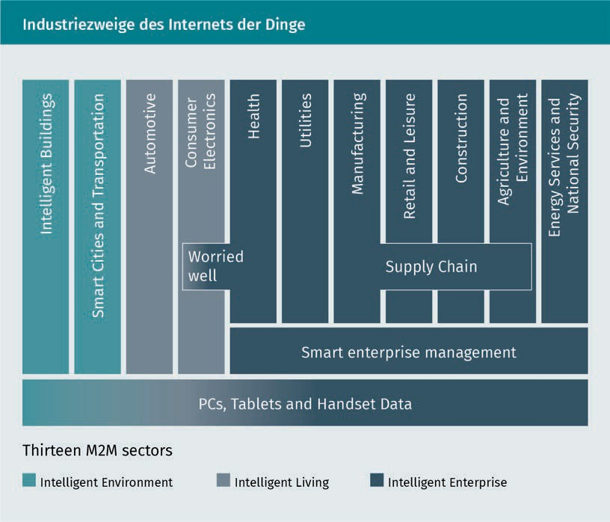

Market potential and forecasts

In 2010, there were approximately 1.5 billion Internet-capable PCs and just over one billion Internet-capable smartphones. At that time, a market potential of 100 billion devices was predicted within the following 5-10 years. Eight years later, things are looking more realistic. Admittedly, the number has risen sharply. But from today's perspective, this figure will be "only" 75 billion by 2025 (Statista 2018a).

Overview and meaning

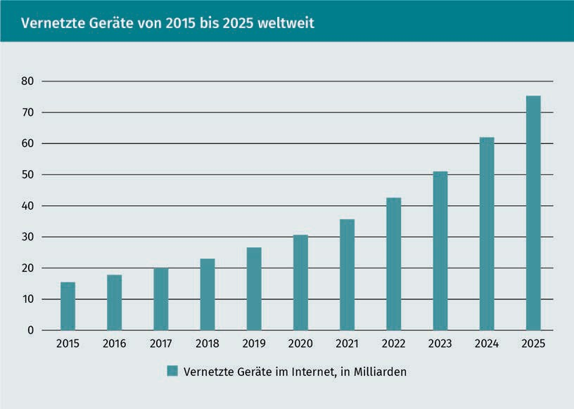

Criticism of IoT Applications

Even though it is possible to transform an object into a "smart" object, which does not automatically mean that it is also meaningful, in other words that it generates added value. In the late 1980s, cars "talked" to their drivers. For example, an open door was indicated with the help of a voice output and not, as is common today, with graphic elements and a warning tone. It would also have been more cost-effective to purchase more coffee machines in the example before. The important thing with such concepts is to satisfy the actual need - not to solve a problem. Technology should be a means to an end, not an end in and of itself, and subject to the "Law of the Instrument" (Valhouli 2010).

The Law of the Instrument - also known as "Maslow's Hammer" - states that people who are well versed in one tool or approach tend to use that tool even when another would be more appropriate. Put another way: "The man with the hammer sees a nail in every problem" (McRaney 2012).

**Summary**

Digital devices have become an indispensable part of our everyday lives. Increasingly, humans and machines are merging to interact with each other in an automated way.

A number of hurdles had to be overcome before this could happen. 50 years ago, the first concept for a portable computer was introduced. The first products were ahead of their time, as there was no infrastructure to enable meaningful use. It took 40 years to turn the concept of a smartphone into a market-ready product, the iPhone. Meanwhile, even personal voice assistants - as known from "Star Trek" - have made their way into our private households. In the industrial sector, too, technological advances and networking have led to revolutions and are changing established markets through Industry 4.0 approaches.

To do this, a number of technological prerequisites had to be met first. The performance of computers and their components doubles every 18 months, with costs halving over the same period. Here we speak of Moor's law. Sensors, energy supply and other areas also had to evolve to meet the requirements for smart devices.

The Internet of Things as an insertion/connection of information into/with the physical world in conjunction with smart devices is an exciting area to develop new markets and generate customer advantages. These customer advantages are divided into different categories, including networked devices, networked cities and different industries (for example, automotive, trade or energy). The market potential is huge. However, care must be taken to ensure that technology does not become an end in itself.

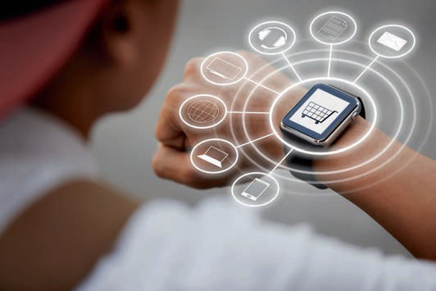

# Lesson 2

## Features And Areas Of Application

##### LEARNING OBJECTIVES

After working through this lesson, you will know..

... which typical features smart devices have.

... which specific devices are smart devices.

... which smart devices have an application in micro-systems engineering.

... in which applications smart devices are used.

DL-D-DLBINGSD01-L02

### Features And Areas Of Application

#### Introduction

In the history of computers, the trend has gone from "a few people per computing machine (data centers)" to "one person per computer (personal computers)" to "multiple computers per person" (smart devices, PCs, etc.). There are now a large number of different smart devices. These have different features and belong to different classes. Smart devices are multipurpose devices and can be used as a portal for application services. Such applications may reside locally on the device (e.g., apps) or remotely on servers (e.g., websites). Smart devices often belong to a specific user. The device consists of, among other things, the control and the user interface. Smart devices are multi-functional because they facilitate access to multiple functions at runtime and simplify interoperability. The tradeoff, however, is reduced openness of the system; hardware components can be difficult to maintain or update (Posland 2009).

#### Typical Features And Classification

Smart devices are often mobile and belong to the class of mobile devices. Mobile devices are, for example, communication, multimedia entertainment or document processing devices designed to be transported by their human owners, such as cell phones, game consoles, etc. Mobile devices can be divided into the following classes (Poslad 2009):

* + - **Accompanying:** These are devices that are wearable or handheld and are not attached or implanted on the body.
      * **Portable:** For example, laptop computers that are designed for two-handed operation while seated. These are generally the devices with the highest resources (e.g., memory or performance).
      * **Handheld:** Devices are typically held and operated with one hand, with multiple applications such as communication, audio/video recording and playback, and mobile office. These are low-resource devices.
    - **Wearable:** Devices in the shape and size of accessories and jewelry can often be operated hands-free (i.e., they do not need to be explicitly held for operation) and operate autonomously, such as watches that act as personal information managers, earpieces that serve as audio transceivers, eyeglasses that serve as visual transceivers, and contact lenses. These are low-resource devices.
    - **Implanted or embedded:** These are often used for medical reasons to enhance human functions, such as a pacemaker. They can also be used to improve the abilities of physically and mentally impaired people. Implants can be silicon-based macro- or micro-integrated circuits, or they can be carbon-based, e.g., nanotechnology.

Features And Areas Of Application

Five different characteristics and features can be identified for smart devices. These characteristics give rise to different application potentials, depending on how pronounced they are (Poslad 2009):

* Ubiquity/omnipresence,
* Embedding,
* Intuitive interaction,
* Adaptivity,
* Proactivity.

The individual points are described in more detail below.

Ubiquity is generally understood to mean omnipresence. In the case of smart devices, this refers to data and information and that these can be captured and provided simultaneously. In order to implement this, sensors are needed to measure and capture the environment. However, the collected data and information are transmitted and distributed via the Internet or other networks. Furthermore, a wide variety of output media are usually required so that the data or prepared information can be displayed elsewhere (Poslad 2009).

Embedding intelligent devices is another feature of smart devices. There are several possible ways as to how to implement the embedding. For example, standard PCs can be used to perform temperature measurements. However, the cost-advantage factor as well as the over dimensioning (space consumption, computing power, etc.) for such a simple measurement are out of proportion. The sensor values can also be falsified if the ideal measuring device is not used for each measurement. For example, the standard PC is itself a heat source, which means that the temperature to be measured changes during this measurement. A solution needed to be developed for this, which resulted in embedding the required features in objects, in other words, in smart devices. This embedding can be done by using small processors and data storage devices, which have a small power source and can be connected to the Internet via network modules. The lower power consumption results in less heat generation, which has less influence on the measured values. Smart devices are thus embedded in the environment and are virtually invisible (Poslad 2009).

Intuitive interaction leads to a new kind of operating possibilities. The question arises as to how devices can be operated which, while being able to communicate independently and at any time, are practically invisible. This requires that the functionality and usability remain recognizable to the user or can be implemented in an automatic and intuitive manner. There is a field of research called human-machine interaction available for research into the design of various implementation options. In the real world, we regularly use automatic-intuitive systems, for example, a sliding door that opens automatically by means of a sensor, or an escalator that only starts up when the user steps on it - and this without an explicit command. These examples demonstrate the essential concepts of the implementation of human-machine interaction: implicit operation of information systems. However, the controller

of smart home applications using voice control has now also arrived in households and works in an intuitive way, but usually still has to be explicitly controlled (if the temperature is to be increased, this has to be communicated explicitly). In the field of intuitive interaction, other behaviors of people such as looks, facial expressions, gestures, or movements are used in addition to speech (Poslad 2009).

Adaptivity or adjustment in this context means proactive and context-dependent changes of the services or functionalities of smart devices. The simplest examples here are location-dependent settings of language or time zones. The display lighting changes to a warmer light in the evening. Depending on the position data, location-based Google hints are displayed. There is an automatic screen lock when making telephone calls. At certain times, during appointments or at certain locations, a "do not disturb mode" can be set. Depending on the light intensity, the display brightness changes automatically. Automatic settings and services of the device depending on the user's position, health or emotional state, plans and tasks, or other factors of the surroundings are also possible (Poslad 2009).

As soon as a smart device automatically offers or executes a service for its user, it is referred to as proactivity. This combines adaptive adjustments of applications in the background and anticipated interaction with the device's services. The proactive offer is ideally provided only needed. The smart device must be capable of correctly identifying the user's context and intent. A proactive sliding door would only open when someone really wants to go through it. Today's automatic sliding doors open also if someone just walks past the door. In addition, the proactive automatic activation of an emergency call as soon as a person falls unconscious to the ground can save valuable minutes and save lives in the future. Yet, distinguishing properly between such a person and another who slumps down jerkily on a sofa to rest becomes difficult for an automatic system. Identifying situations and making the right decisions is still one of the challenges in realizing a networked world today (Poslad 2009).

Classification

Smart devices are becoming smaller and smaller, easier to operate and lighter in weight, and cost less to produce and run. A common classification based on size was introduced as early as 1991. This is shown in the following table. Different device shapes with different features are defined depending on their size (Weiser 1991).

Features And Areas Of Application

|  |  |  |
| --- | --- | --- |
| **Size comparison of the device shapes** | | |
| Device shape | Size | Feature |
| Tabs | < 10 cm | Concealable |
| Pads | 10 cm < 100 cm | Portable |
| Boards | > 100 cm | Installable |

We primarily consider computers to be the multi-application-supporting personal computers (PCs), that is, devices with some sort of screen display for data output, a keyboard, and some sort of pointing device for data input. As humans, we routinely interact with many other devices that contain individual embedded computers, such as household appliances, and with complex computers that have multiple installed embedded systems (Poslad 2009). This classification was created as early as 1991, and devices developed later (such as the iPad) can have a similarity to these three classes. According to this classification, devices that are in the centimeter range or smaller are called tabs. These can be concealed due to their size or worn directly on the body (keyword "wearables"). Somewhat larger, but still smaller than 100 cm are so-called pads or handhelds. These are portable, but are not permanently attached to the body. Larger than pads are boards which can only be built in, i.e., smartboards, touchscreen monitors or similar. (Poslad 2009).

The 1991 classification refers exclusively to flat objects with a visual display. A more refined classification has since been made. Smart devices without a display can thus be greatly miniaturized. Such greatly miniaturized objects are called "Micro Electro-Mechanical Systems" (MEMS). Here, devices ranging in size from only a few nanometers to micrometers or even millimeters make up the Smart Dust class. Devices, belonging to the smart skin category, are made of thin fabric based on light-emitting and conductive polymers (cue organic computing devices) and can be embedded in more flexible uneven display surfaces and products such as clothing or curtains. In addition, MEMS can be "brushed" onto surfaces, changing physical structures into networked surfaces. Smart clays are ensembles of MEMS that are formed into arbitrary three-dimensional shapes called artifacts (Poslad 2009).

#### Example Devices

In this section, some example devices are presented.

Smart Watch

A smart watch is a mostly digital and "smart" wristwatch with a small display that can be operated similar to a smartphone. In addition, a smart watch can be connected to a smartphone via Bluetooth, for example. Besides displaying time and date, other information can be displayed. These can include incoming messages, e-mails, calls or other notifications (push notifications). Sensors can also be used to measure various data, such as pulse, step rate or position, and transmit them to the smartphone. There are fitness wristbands that use sensors to record heart rate and transmit this to a smartphone, but they do not offer any other functionality besides displaying the time. The latest smart watches have integrated SIM cards. This allows the watches directly send and receive messages, make calls, or receive notifications, even if it is not connected to a smart phone (Bendel 2018).

The central output and input of the device is the display. This is realized as a touchscreen. A microphone and a speaker serve as further interfaces. This can be used to interact with a voice assistant, make phone calls and play music. Hints can be transmitted to the user very discreetly via vibration. Both the user interface and the range of functions can be expanded using preinstalled and downloadable apps. Such watches are Internet-enabled and interact with the user and other devices. Thus, making them part of the Internet of Things. The smart watch can look like an ordinary watch and have a normal dial (Bendel 2018).

Smart Glasses

Data glasses, also called smart glasses, superimpose information in the user's field of vision. These are small computers in the form of eyeglasses or computers attached to eyeglass frames. Such glasses are comparable to smartphones in terms of performance, can independently use mobile apps, take and display pictures and videos, and collect and retrieve information. With data glasses, a distinction is made between augmented reality (AR) and virtual reality (VR). With AR, contextual information about the environment is displayed directly above specific objects. AR data glasses are currently rarely seen in private consumer electronics. With VR, a computer-generated virtual world is displayed in real time. VR glasses are gradually gaining acceptance in the private environment for computer games. In the commercial sector however, there are many applications for both types, with AR including manufacturing plant and airline passenger service for air travel, and VR in the design of real estate, furniture, and the like, as well as in the simulation of complex situations in aerospace (Gerardus 2018).

Google Glass is probably the best-known AR glasses. This was introduced in June 2012 and was available as a developer version from February 2013 onward. As of April 2014, a beta version was also available for purchase by end users. Due to low demand and major

Features And Areas Of Application

privacy concerns, sales were discontinued in 2015. The glasses consist of a 640 x 320-pixel microdisplay with prism projector. Here images can be displayed in the form of slides. The glasses have Android as their operating system. The glasses are very light with only 54 grams. It has touch and eye controls as well as a bone speaker and microphone (Levin 2015, pp. 65-114).

Driven by innovative start-ups, developments in smart glasses have picked up speed again in recent years. This has resulted in the next generation of smart glasses. Thanks to companies like Vuzix, Everysight, Vigo Technologies or others, new promising solutions for augmented reality, health sensing, fitness tracking or face recognition are being developed. We can assume that this generation of smart glasses is going to have the potential to become the standard for everyone in the next five to ten years - not least because the purchasing costs have also become more moderate.

Smart Clothes

Increasingly small hardware means that electronic functions can now be incorporated into clothing. In the past, only a few applications were possible. Nowadays, there is a wide range of intelligent textile products, also called "smart clothes" or "wearables". Smart clothes have already made inroads in the five markets of health, safety and security, information and communication, sports and leisure, and work and surveillance (Werner 2017).

Health monitoring functions are necessary for many diagnoses or therapies. This is often taken over by rather uncomfortable devices. Monitoring blood pressure or heart rate over a long period of time is uncomfortable and impractical with outdated technology. The latest developments mean that this task can be performed by special clothing. Smart T-shirts can measure bodily functions and can be easily integrated into everyday life without being a nuisance. If necessary, automated warnings and emergency calls can be sent. This is advantageous for elderly or impaired individuals, but also for patients during rehabilitation (Werner 2017).

One application example of smart clothing for safety and protection is in motorcycling. Here, airbag systems are integrated to cushion the fall in the event of an accident and protect vital body regions. Unusual accelerations are detected by motion sensors. The airbags in the helmet and jacket are triggered via a compressed air cartridge. The clothing may also be equipped with GPS sensors. Using Bluetooth coupling with the smartphone or a direct telephone connection, an emergency call can be made automatically if an accident occurs. The acceleration and motion data can be used to estimate the severity of the accident (Werner 2017).

The information and communications industry regularly features innovative garments equipped with additional functions. Years ago, there were already jackets with integrated MP3 players. Today, there are helmets for skiers that display information in the visor, such as current speed, distance traveled and elevation gain. Thanks to built-in headphones and microphone, music can be listened to, phone calls can be made, or the voice assistant can be controlled while driving. Information from the smartphone is also shown on the display, so messages or e-mails can be read. Here, too, the safety functions mentioned above are possible thanks to acceleration sensors and automated emergency calls (Werner 2017).

Headsets

There are smart headsets that, controlled via the smartphone, can block out the surroundings via noise cancellation or let the user hear sounds from the surroundings via "situational awareness". This is a crucial safety factor on the road when wearing headsets and listening to music or talking on the phone. Suitable for noisy environments and thanks to noise cancellation, a quiet, undisturbed, and relaxed atmosphere can be created. A microphone is built into each earpiece for this purpose. These pick up the ambient sounds (Werner 2017).

Smartphone

The smartphone is probably the best-known smart device currently available on the market. In 2007, the first iPhone came onto the market. Unlike other mobile phones, smartphones are mainly optimized for operating various applications and not necessarily for making phone calls. This is why there are high-resolution touch-sensitive displays instead of numeric keypads and a small display. In addition, smartphones have various sensors such as movement, photo (RGB and black and white), position, magnetic field, light, and proximity sensors, as well as GPS receivers. Gradually, applications have become established that enable mobile working directly using the smartphone. Larger devices are also referred to as phablets, which are larger than smartphones but smaller than tablets (Adam/ Ludwig/Mühe 2013).

Smart Boards

Smart boards are intelligent interactive electronic boards (whiteboards). A software enables users to use the smart board for different purposes. In addition, cameras and sensors are used to respond to interactions. Users can then use the projected applications directly with their fingers on the smart board, as you would with a mouse. As with a normal blackboard, writing can be done directly on the smart board. The smart board recognizes this so that the notes can be saved and used in other documents (Laudon/Laudon/ Schoder 2015).

Features And Areas Of Application

#### Smart Devices In Micro-systems Engineering (MEMS)

Micro-Electro-Mechanical Systems, or MEMS, are tiny integrated devices or systems that are created using a special manufacturing technology that combines mechanical and electrical components. MEMS are usually very small, so their components can only be seen under a microscope. Today, levers, gears, pistons, engines and even steam engines have already been manufactured. MEMS are manufactured using stacked integrated circuit (IC) processes and can range in size from a few micrometers to a few millimeters. These appliances (or systems) have the ability to sense, control, and actuate on a micro-millimeter scale, in addition to producing effects. The following figure gives an idea of the order of magnitude. The term of MEMS is misleading, because they do not necessarily have to be mechanical micro machines or systems. In the literature, MEMS also describes the manufacturing technology and a paradigm for the design of complex mechanical devices and systems as well as their integrated electronics (o. V. 2002).

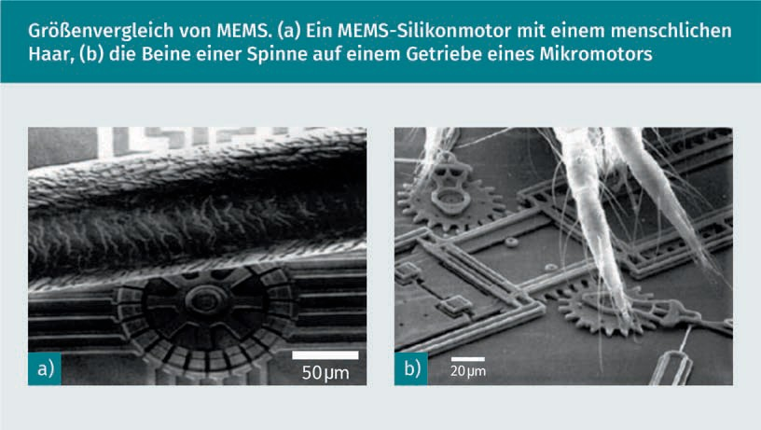

Markets and Applications

The interdisciplinary nature of MEMS leverages design, engineering, and manufacturing expertise from a broad and diverse range of technical fields including integrated circuit manufacturing engineering, mechanical engineering, materials science, electrical engineering, chemical and chemical process engineering, and fluid technology, optics and instrumentation, and packaging. The complexity of MEMS is also reflected in the extensive range of markets and applications that include MEMS devices. MEMS are used in systems that are applied in the automotive, medical, electronics, communications, and defense sectors. The potential in these sectors is enormous. Current MEMS appliances include accelerometers for airbag sensors, inkjet printheads, read/write heads for computer board drives, projection display chips, blood pressure sensors, optical switches, microvalves, biosensors, and many other products, all of which are manufactured and shipped in high commercial volumes (o. V. 2002).

|  |  |  |  |  |
| --- | --- | --- | --- | --- |
| **Different application areas of MEMS** | | | | |
| Automobile | Electronics | Medicine | Communication | Defense |
| Internal navigation sensors | Hard disk read heads | Blood pressure sensors | Fiber optic network components | Ammunition guidance |
| Climatic compressor sensor | Inkjet print heads | Muscle stimulators and drug delivery systems | HF relays, switches, and filters | Surveillance |
| Brake force sensors and acceleration sensors for the suspension | Projection television | Implanted pressure sensors | Projection displays in portable communication devices and instruments | Reinforcement systems |
| Sensors for fuel level and vapor pressure | Earthquake sensors | Prosthetics | Voltage controlled oscillators (VCOs) | Embedded sensors |
| Airbag sensors | Avionics pressure sensors | Miniature analysis devices | Splitter and coupler | Data memory |
| "Smart" tires | Mass data storage systems | Cardiac pacemaker | Tunable laser | Aircraft control |

Features And Areas Of Application

Microfabrication 2.0

MEMS has been identified as one of the most promising technologies for the 21st century and has the potential to revolutionize both industrial and consumer products by combining silicon-based microelectronics with specialized processing technology. The techniques enabled by MEMS and microsystems-based devices have the potential to dramatically impact all of our lives. If semiconductor microfabrication is considered the first revolution in microfabrication, MEMS is the second revolution (o. V. 2002).

Technical Structure of MEMS

In its most general form, MEMS consist of micro- to millimeter-sized structures, sensors, actuators, and electronics. These components are all built into one and the same silicon chip. Microsensors detect changes in its environment such as mechanical, thermal, magnetic, chemical or electromagnetic information. Microelectronics process this information and signal the micro actuators to respond, creating some change in the environment (o. V. 2002).

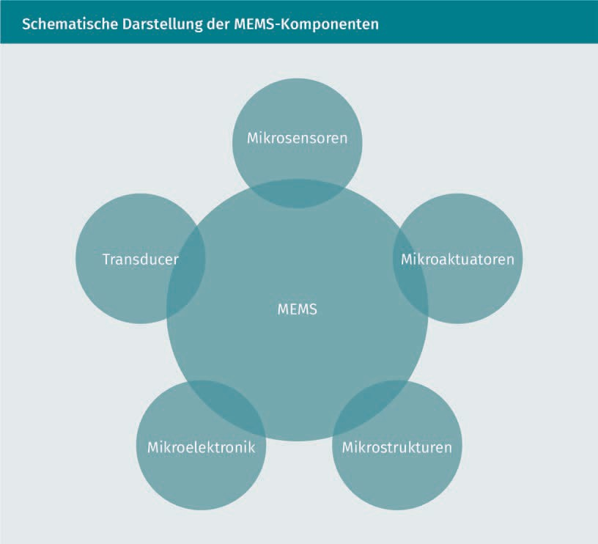

**Transducer (converter)**

The main component of MEMS are the transducers (converters) that convert one type of signal or energy into another form. The term "transducer" thus describes both actuators and sensors, is very generic and is often used in the field of MEMS (o. V. 2002).

**Sensor**

A sensor is a device that measures information from its environment and converts it into an electrical signal. In theory, of course, normal sensors and MEMS sensors are the same. In practice, however, the possibilities differ significantly. MEMS sensors have a wide range of measurable quantities:

* mechanical (force, pressure, speed, acceleration, position),
* thermal (temperature, entropy, heat flow),
* chemical (concentration, composition, reaction rate),
* radiation (electromagnetic wave intensity, phase, wavelength, polarization, reflection, refractive index, transmission),
* magnetic (field intensity, flux density, magnetic moment),
* electrical (voltage, current, charge, resistance, capacitance, polarization).

Features And Areas Of Application

**Actuators**

An actuator is a device that converts an electrical signal into an action. It can generate a force to manipulate itself, other mechanical devices or the environment to perform some useful functions.

#### Other Areas Of Application

In the smart home environment, there are many possible uses for smart devices. The purpose of smart home applications is to make the everyday lives of residents' simpler, safer and more energy-efficient. Devices and building elements are networked to achieve this. Heating, doors, windows, blinds can be integrated just as electronic and household appliances. Modular systems are frequently constructed. A central control unit, also a smart device, has the flexibility to be expanded to include other elements. Thanks to the networking of the modular devices, different functionalities are created. Through the combination of heating thermostat with a window sensor, the thermostat can be turned off when the window is opened. This saves heating costs, thereby paying off the purchase. It is important to have a concept when purchasing smart home products as to which operations make sense in which areas for the requirements set. These could be different or combined with regard to security, energy or comfort (Stolpen/Weber 2017).

With smart devices in hospitals, a distinction is first made between clinical and non-clinical operation. Non-clinical operations include maintenance, building services or logistics. There is a steadily growing need for IoT technologies to monitor and automate processes. Storage systems can independently reorder a lack of utensils. Plants and devices report errors or maintenance dates automatically. As in smart home applications, intelligent and networked control systems can reduce heating and electricity consumption. In clinical operations, on the other hand, there are much higher demands on data integrity and security, since personal data can be processed here. Such data is subject to special legal regulations. Workflows can be optimized with the aid of staff tracking within the hospital. Smart and networked beds can automatically provide data on current utilization. The information aggregated in this way can ensure that help gets to the patient faster in the event of an emergency. An electronic medical record can be directly supplemented with new results and further data, without manual intervention. Connected medical devices, or CMDs as they are known in the industry, facilitate the reduction of errors in many areas of work processes. Networked devices should ideally deliver time savings on the one hand, but also prevent errors in manual entries on the other. With the aid of smart device networking in the healthcare sector, patients' vital signs can also be monitored regardless of where they are. The data obtained can then be used for clinical decisions such as drug selection and selecting the correct dosage. This allows patients to be treated even if the attending physician is not on site. This can improve medical care in rural areas and could even make it possible to immediately consult experts for treatment (o. V. 2018).

In the smart energy market of the future, analog electricity meters will be replaced by networked smart meters. These smart meters offer added value for customers firstly and electricity suppliers secondly. Customers can access current electricity consumption in real time using a web application. Electricity suppliers can use the consumption data to react more quickly to consumption peaks and, thanks to the data obtained, develop better models for forecasting electricity consumption. With the analog electricity meters, a classic, centrally controlled system with passive consumers is possible. Using smart meters, a decentralized system with active integrated consumers is possible. In contrast to analog electricity meters, consumers can also become producers in such a system (Sioshansi 2011).

**Summary**

Smart devices are assigned various characteristics and features. They differ from mobile devices in some respects, but at the same time have some similarities. Thus, smart devices are characterized by their ubiquity, embedding, intuitive interaction, adaptivity, and proactivity. These are the most important features to consider when designing smart devices. There are also different size classes, from boards to smart clays.

There are many well-known and widely used smart devices such as smartphone, smart watch, smart glasses, but also less common ones such as smart clothes. Smart devices are also being used increasingly in manufacturing to achieve increases in efficiency.

In micro-systems engineering, smart devices in the micrometer range have now also become established, making it possible to establish smart environments.

Smart devices are now finding use in many fields of application. In this way, everyday life can be made easier with the aid of smart home applications. In the manufacturing of the future, fully automated systems will be introduced. Smart devices could save lives in hospitals in the future . Even the energy market is being revolutionized.

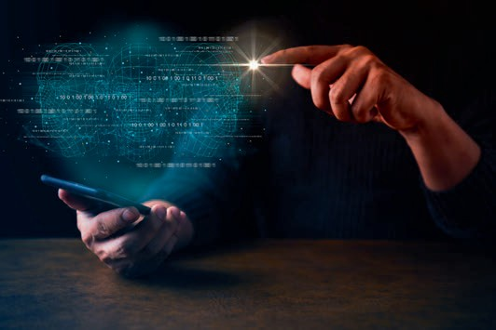

# Lesson 3

## Technological Equipment

##### LEARNING OBJECTIVES

After working through this lesson, you will know..

... how smart sensors differ from conventional sensors.

... which radio interfaces are available and how they work.

... what role processors play.

... the challenges facing processor development for smart devices.

DL-D-DLBINGSD01-L03

### Technological Equipment

#### Introduction

People have an increasing desire to have access to information anytime and anywhere. This requires not only mobile and portable devices, but also adequate communication systems and software infrastructures. Sensor miniaturization is possible because of advances in semiconductor industry technologies, and the emerging field of microsensors has grown rapidly over the past decade. Further developments in other areas have also been crucial to the development of today's smart devices. They consist of various components, which are becoming smaller, cheaper, and more powerful.

#### Processors

Processors are at the core of all smart devices, and they are becoming ever more powerful, power-efficient, smaller, and more efficient. An important area of research and development in the field of processor technology, especially for smart devices, is the development of integrated network components. Power consumption plays a very important role for networked and embedded applications. A new generation of "low-power" processors is being developed for such applications. Networking technologies are constantly advancing to enable an ever-increasing number of interconnected smart devices that share information and work together as part of a large system. In addition to power consumption and other aspects, reliability is also an important issue in the development of processors for smart devices. For applications in the medical, security, or transportation industries, it is essential that computing power is guaranteed at all times and for all given conditions - especially when little or no direct human intervention is possible (Laudon/Laudon/Schoder 2015).

Processors come in many types and with many uses. While producers' attention is focused on high-performance processors for servers and workstations, by actual count they are a small percentage of the processors produced in any given year. In fact, so-called micro-controllers, also called "controllers" or "embedded controllers", are the dominant process- or types, accounting for the majority of processors manufactured (Laudon/Laudon/ Schoder 2015).

A Central Processing Unit (CPU) is the electronic circuitry in a computer. A CPU executes the instructions of a computer program. This is done by performing basic arithmetic, logic, control, and input/output operations. Conventionally, the term

"CPU" refers to a processor, more specifically its processing unit and control unit (Control Unit CU), distinguishing these core elements of a computer from external components such as main memory and I/O circuitry. I/O stands for input/output and represents the input and output of commands (Laudon/Laudon/Schoder 2015).

Technological Equipment

The shape, design and implementation of CPUs have changed throughout their history, but their basic operation remains virtually unchanged. Main components of a CPU include..

* the arithmetic-logic unit (ALU), which performs arithmetic and logical operations,
* the processor register, which supplies the operations to be calculated to the ALU and stores the results of ALU operations, and
* a control unit that controls the flow of all operations and communication for input and output of commands and data.

Most modern CPUs are microprocessors, meaning they are contained on a single integrated circuit (IC). If there are other components on the IC besides the CPU, such as memory or peripheral interfaces, they are also called micro-controllers or SoC (System-on-a-Chip). Smart devices use a multi-core processor, which is a single chip containing two or more CPUs referred to as "cores" (Laudon/Laudon/Schoder 2015).

#### Sensors

The term "microsensor" is commonly used today to describe a miniature device that converts a non-electrical quantity such as pressure, temperature or gas concentration into an electrical signal. Physical quantities can be measured with a sensor. These are usually converted into analog electrical signals. An analog electrical signal is an electrical voltage measured in volts. For example, the level of voltage varies from 0 to 5 volts. There is a direct correlation between physical quantity and electrical voltage. A sensor could be designed to output a voltage of 0 volts at a temperature of 0 °C and a voltage of 5 volts at a temperature of 100 °C. This can be realized by a resistor circuit. The resistance coefficient, which is changed by the temperature, regulates the voltage output (Gardner/Varadan/Awadelkarim 2001).

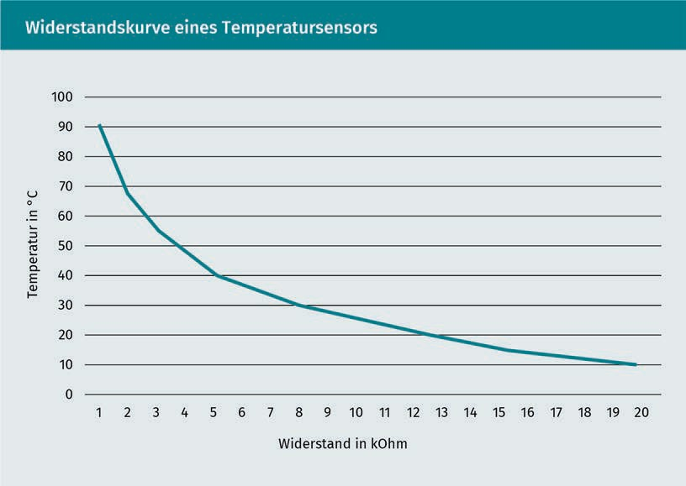

However, this does not yet form a smart sensor. But what is the difference between a normal sensor as described above and a smart or intelligent sensor? The following figure illustrates the differences between..

* + - a simple microsensor (a),
    - an integrated sensor with pre-processor (b) and
    - a stand-alone sensor with pre-processor and processor (c).

shown schematically. The dashed lines in the figure illustrate the complete sensor including the integrated elements (Gardner/Varadan/Awadelkarim 2001).

Technological Equipment

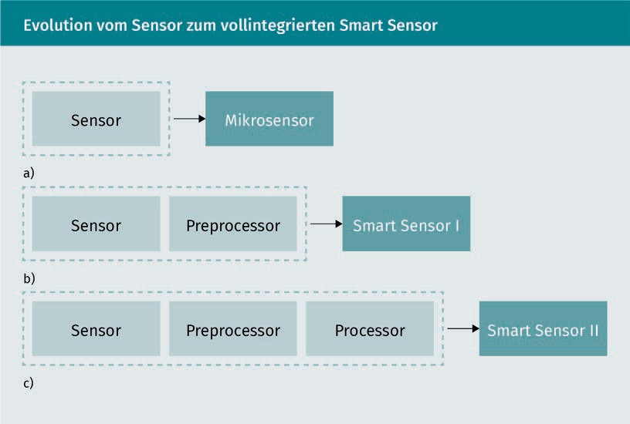

The integration of processors in the two types of smart sensors is desirable if one or more of the following conditions apply:

* integration lowers the manufacturing costs of the sensor.
* integration increases the performance of the sensor.
* the sensor would not work without integration.

In addition to these conditions, integration can also be sought if a large market potential is seen (number of units in the millions) and manufacturing costs can thus be kept low, or if added value is created by integration and the higher price can thus be justified (Gardner/Varadan/Awadelkarim 2001).

A very early definition, according to Breckenridge and Husson in 1978, is as follows: "A smart sensor has a data processing interface and an automated filtering function that detects and eliminates abnormal or unusual values. The sensor contains a changeable algorithm and a certain amount of storage space. Other desirable features are that the sensor can be coupled with other sensors or that it adapts to changes in environmental conditions [author's transl]" (Breckenridge/Husson 1978).

Meanwhile, learning functions are also being implemented in smart sensors. Sensors lose accuracy over time. This may be the case due to contamination or other environmental conditions. Networking with other sensors and embedding artificial intelligence or neural networks results in different classes for different areas of application (see also the following table). Different types of smart sensors, starting with the simplest type, are presented here (Gardner/Varadan/Awadelkarim 2001).

|  |  |  |  |
| --- | --- | --- | --- |
| **Different classes of smart sensors** | | | |
| No. | Class | Description | Example |
| 1 | Signal compensation | The device automatically compensates for environmental conditions such as temperature, air pressure, etc. | temperature compensating acceleration sensor |
| 2 | Structural compensation | Physically designed to reduce signal-to-noise for increased functionality. | resistive gas sensor pair with different geometry |
| 3 | Self-testing | The sensor tests itself and has self-diagnostic functions. | ADC chips |
| 4 | Multisensing | The sensor combines identical or different sensors to increase performance. | electronic nose (Gardner/Bartlett 1999) |
| 5 | Neuromorphism | The sensor shares characteristics with biological structures such as neural networks. | "Cellular automata" and VLSI chips. |

Most smart microsensors are currently produced for the automotive industry. The most important of these are silicone-based pressure sensors for air, intake, exhaust, fuel, tire or hydraulic pressure, for example. There is powerful competition in terms of price and performance. Over the last few years, a great deal of effort has been put into reducing costs, but more and more functions have also been integrated. The following figure shows the layout of a smart silicone-based pressure sensor. The chip combines a special pressure sensor, the analog interface, an 8-bit analog-to-digital converter, a micro-controller and a built-in storage space (EPROM = Erasable Programmable Read Only Memory, electronically programmable memory) (Gardner/Varadan/Awadelkarim 2001).

Technological Equipment

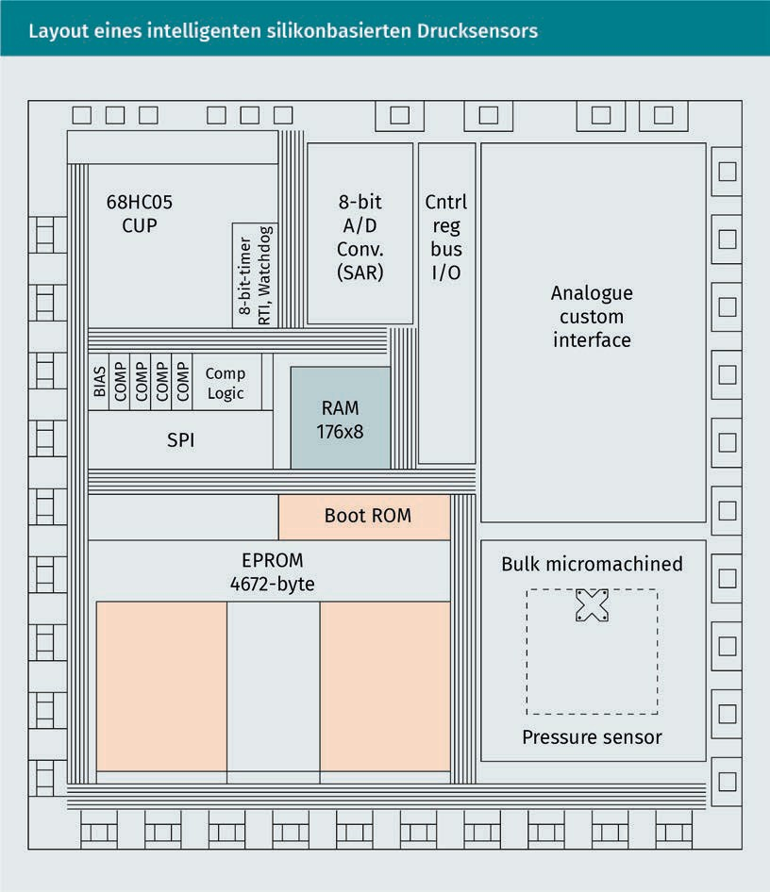

#### Radio Interfaces

There are many different wireless interfaces, such as Bluetooth, WLAN, cellular communication, Z-Wave, Zig Bee, or QIVICON (Postscapes 2019; Agrawal/Zeng 2015). Each of these technologies have different advantages and disadvantages, different power levels and transmission rates, some of which are presented below.

Bluetooth

Bluetooth was developed in 1998 for wireless data exchange over short distances and high data volumes. Bluetooth and other network protocols have been standardized by the Institute of Electrical and Electronics Engineers (IEEE). Since 2002, Bluetooth has belonged to the IEEE 802.15 group of Wireless Personal Area Network (WPAN) as industry standard IEEE 802.15.1. One advantage of Bluetooth is that it is already very widespread. Bluetooth had already been installed in more than one billion devices by 2006. It is also available by default in most smartphones. The fourth generation of the Bluetooth standard Bluetooth Low Energy (BLE) is characterized by low energy consumption (Kriwan 2017).

Several Bluetooth-enabled devices communicate with each other via a so-called piconet. The different operating modes of a piconet are shown in the following figure. Here, all devices of a piconet share one physical channel. At least one of the devices acts as the master. This redefines the frequency for each data transmission. Bluetooth transmits in the license-free Industry, Scientific and Medical (ISM) band between 2.40-2.48 GHz. Originally, a master could serve up to seven active slaves. With Bluetooth 4.0, this limitation was increased to a theoretical number of several billion receivers (n =232) through a 32-bit access address, according to technical details on Bluetooth.com5. A master can store inactive slaves in the so-called park mode. A slave can only be connected to one master at a time (Kriwan 2017).

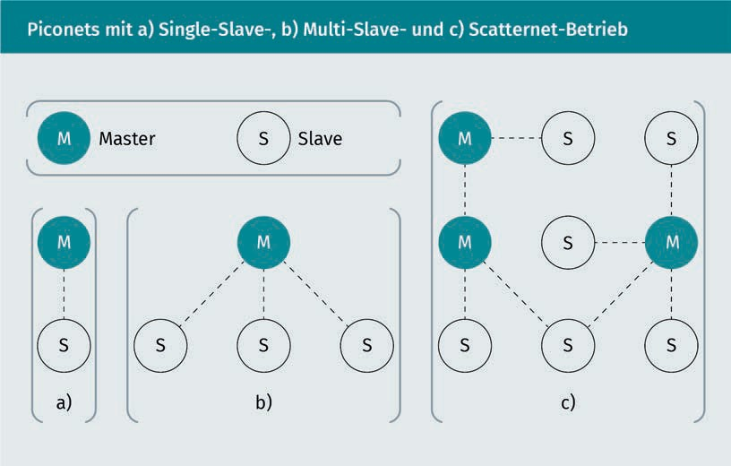

Technological Equipment

Wireless Local Area Network (WLAN)

A so-called Wireless Local Area Network (WLAN) is used to establish wireless access to a local area network (LAN). Mobile devices such as smartphones, laptops, tablets, etc., but also stationary devices such as PCs have wireless access to the Internet via a base station, for example, or the option of communicating directly with each other. A WLAN router or bridge serves as the base station (see following figure). But a laptop or smartphone can also be used as a base station. The data transmitted by a base station (access point) is usually encrypted, although there are different types of encryption. In a study conducted in 2006, 61% of 2,500 base stations measured were classified as secure. In a recent study, approximately 3,300 base stations were tested for the type of encryption used. Of the 1,478 access points found in residential areas, around 25% were not secured or inadequately secured. In one business district, approximately 40% of 1,815 base stations were classified as insecure. Networks that are classified as insecure are those that have WEP or no encryption (Kriwan 2017).

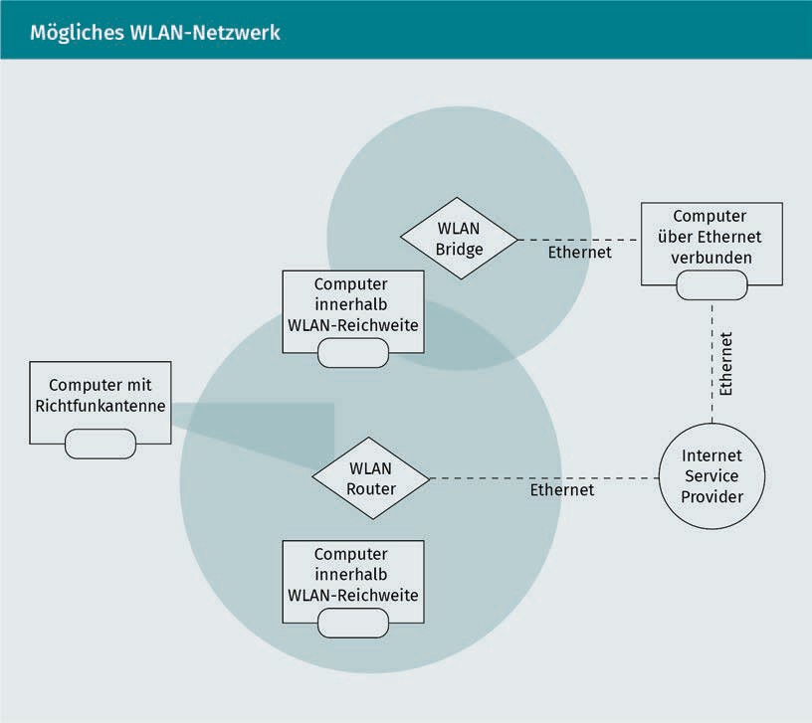

At least one base station is required for a network. The WLAN standard is defined in the IEEE-family 801.11. As with Bluetooth, it transmits in the license-free 2.4 GHz ISM band. Depending on the frequency used, structural conditions of the building and the signal strength of the base station, different ranges are possible. These are usually between 50 and 100 meters. Depending on the standard and the number of connected devices, transmission rates between 10 and 100 Mbps are typical, although higher rates are also possible (Kriwan 2017).

Cellular Communication

As a result of the increasingly widespread application of Internet-enabled smart devices, the demands on cellular networks are rising continuously. What use would our smartphone be without mobile Internet? If there is also no WLAN access, it would probably be less "smart" than we are used to. But data is also transmitted via cellular communications for parking ticket machines or charging stations for electric cars. The cellular networks currently in use are operated worldwide in three different generations in parallel and overlapping: 2G, also known as GSM, GPRS or EGDE, was established in Europe in the early 1990s and later used worldwide. GSM is the second generation of cellular radio technologies with the main task of transmitting voice. The use of data transmission was not foreseen at that time. For this reason, the GSM cellular networks have been expanded over time to include GPRS (General Packet Radio Service) and EDGE (Enhanced Data Rates for GSM Evolution). Cellular communication modems to be used worldwide must support the four frequency bands 850 MHz, 900 MHz, 1,800 MHz and 1,900 MHz The next generation 3G was built eight years after the introduction of GSM. UMTS, CDMA2000 and TD-SCDMA are the most commonly used of the 3G networks. In the 3G networks, greater emphasis was placed on high data transmission. Unlike 2G networks, there are several competing technologies worldwide that are also not compatible with each other. The fourth generation is the LTE (Long Term Evolution) standard. Compared to previous generations, there is significantly higher data speed, lower latency and improved energy efficiency. LTE is the global high-speed mobile technology with industrial-grade cellular communication components (Penttinen 2017).

Work is already taking place with the technical implementation of the next generation of cellular communications (5G). In keeping with expectations, the new generation increases the transmission speed (up to 10 GBit/s) and differs from the previous generations primarily in that, with planned latency times of less than 1ms transmissions, completely new areas of application become possible - especially in the industrial sector, which has special demands for real-time transmission.

Technological Equipment

**Summary**

Smart devices support people in their everyday lives and require a wide range of technological aids, including miniature sensors and microprocessors. These technological aids can also be smart themselves; for example, smart sensors that are very widely used in the automotive industry. Sensors measure the physical environment and convert the measured values into the digital world. This allows other devices to work with these readings.

Wireless communication is required to enable communication between the different devices. Again, there are several ways to do this. Bluetooth is a variant for exchanging data at close range. WLAN is a widely used standard that enables stable communication over several meters. If a greater range is required, the cellular network is used.

Smart devices are characterized and distinguished from normal devices by the fact that they can independently calculate data and results and reach their own decisions. Processors are used for this, which are becoming ever smaller and less expensive. These so-called CPUs have a variety of components, such as a logic unit or a register, so that the respective tasks can be performed in the best possible way.

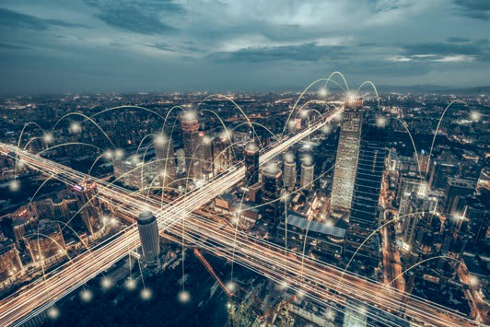

# Lesson 4

## Communication And Networking

##### LEARNING OBJECTIVES

After working through this lesson, you will know..

... what types of networks there are and how they work technically.

... whether and how different types of networks can communicate with each other.

... which demands there are for middlewares for smart devices.

... what challenges Industry 4.0 faces from the perspective of communication and networking.

DL-D-DLBINGSD01-L04

### Communication And Networking

#### Introduction

The Internet is the best-known Wide Area Network (WAN) in the world. This is a worldwide conglomeration of computers, servers, and other Internet-enabled devices. But large corporations or federal agencies also have their own networks shielded from the Internet, which enable communication over very long distances. If several office buildings within urban areas are connected with their own fiber optic cables, for example, this is referred to as a metropolitan area network (MAN). These two network types will not be discussed further for the subject of smart devices.

Local networks are known as "Local Area Networks" (LAN) and enable communication in a delimited area. The Personal Area Network (PAN) is located within a person's close radius or range and networks all devices in that area. A Body Area Network (BAN) is the interconnection of devices attached to the body of a human, such as a patient or an animal (for example, birds).

Communication and networking

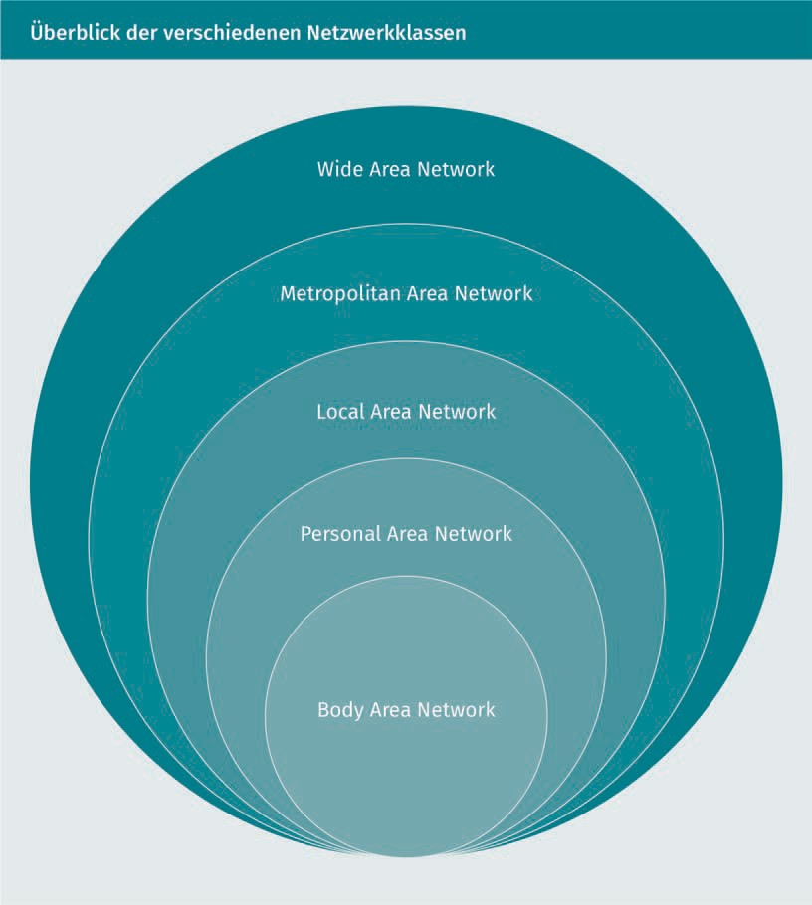

The different network classes can also be classified according to their possible ranges:

|  |  |  |
| --- | --- | --- |
| **Classification of network classes by distance** | | |
| Distance between devices | Devices are located.. | Network type |
| 1 m | ... within reach. | PAN or BAN |
| 10 m | ... in the same room. | LAN |

|  |  |  |
| --- | --- | --- |
| Distance between devices | Devices are located.. | Network type |
| 100 m | ... in the same building. | LAN |
| 1 km | ... at the same campus. | LAN |
| 10 km | ... in a city. | MAN |
| 100 km | ... in a country. | WAN |
| 1,000 km | ... on the same continent. | WAN |
| 10,000 km | ... on the planet. | WAN (Internet) |

#### Local Area Networks

Local Area Networks (LAN) consist of a large number of different devices that are connected by cable or wireless within a large area (apartment, building, campus, etc.). This usually requires high data volume, as the number of devices can vary greatly (Tanenbaum/Wetherall 2012).

LANs are created by connecting various electronic devices within an organization, allowing local processing and simultaneous access to other devices connected to the network (message transmission between stations without the use of a central host computer, access to various file storages, etc.). The total distance of a LAN can be up to several kilometers. Large universities and companies with several buildings on a campus or company premises in particular have closed LANs that extend over several kilometers (Laudon/Laudon/Schoder 2015).

LANs are usually structured according to the principle of a star topology, which means that all devices are connected to a central communication unit. However, there is also the possibility of ring-shaped networking, in which several switches are connected to each other to create larger LANs. In practice, there is little difference for users or even application developers. The topology of LANs is based on point-to-point connections. Each computer communicates with each other using the Ethernet protocol via so-called switches (Tanenbaum/Wetherall 2012).

Communication And Networking

Classic LANs are wired and are usually based on coaxial or twisted-pair cables, but fiber optic cables are also used. If the networks are wire-bound, they must be adapted to the existing (building) structure. The cables must be laid. If there is no connection at a location where a network connection is currently required, it must be subsequently installed or configured. This means they rarely offer a high degree of flexibility or interchangeability. However, modern wired LANs ensure a higher bandwidth than WLANs. Network security is also higher than with WLANs (Laudon/Laudon/Schoder 2015).

Wireless local area networks are known as WLANs (Wireless Local Area Networks). It is now very easy to set up and operate WLANs. Therefore, wireless local area networks are increasingly an efficient and cost-effective alternative for companies and private households (Laudon/Laudon/Schoder 2015).

#### Personal Area Networks

The networking of personal devices within a few meters of one or more people is referred to as a personal area network (PAN). A PAN occurs, for example, when two or more people want to exchange data directly via their carried devices (wireless) without relying on an Internet connection. This can be done, for example, via WLAN, infrared, Bluetooth, but also via a wired USB interface. A PAN also occurs when using wireless headphones or a smartwatch connected to a smartphone (Laudon/Laudon/Schoder 2015).

As a rule, Bluetooth is used for setting up a PAN. This standard was developed specifically for such application scenarios. Bluetooth is the widely used name for the 802.15 wireless networking standard, which is used to create small PANs. This allows up to eight devices to be connected within a radius of 10 to 100 meters using low-power radio-based communication. Via such networks, the connected devices can communicate directly with each other, but can also be controlled by each other. Therefore, with a PAN, no additional infrastructure is usually required, it can be activated at any time, and the group of participants is known at all times, providing a high level of security. This facilitates manageable, energy-saving and cost-effective approaches for different application scenarios across many different types of devices (Laudon/Laudon/Schoder 2015).

Depending on the communication technology, there are different ways of networking individual devices in personal networks. Meanwhile, three variants have proven to be effective: Star topology, cluster tree and mesh topology (see following figure). All three variants consist of a PAN coordinator that acts as a master and keeps track of the individual devices. Fully operational devices, but also those with a reduced range of capabilities, can be integrated into the network (Laudon/Laudon/Schoder 2015).

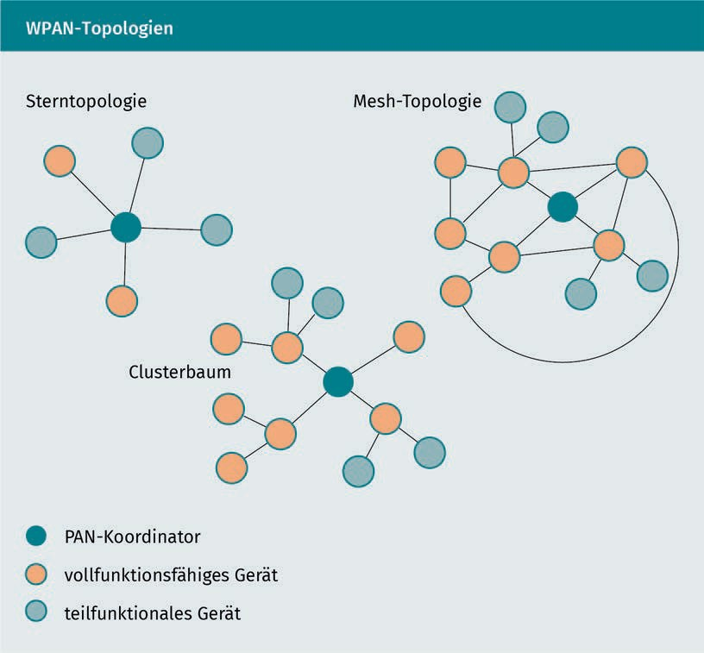

In the star topology, all devices are connected directly to the PAN coordinator. No direct communication is able to take place between the individual devices. As an example, a laptop can function as a PAN coordinator, to which the keyboard, mouse, headphones and other devices are connected (Laudon/Laudon/Schoder 2015).

The cluster tree is an extension of the star topology. Fully functional devices can also be set up as a connecting module to other devices in this case. However, the PAN coordinator is mainly responsible for communication. One example that could be given is a connection between a PC and a printer via a wireless connection, where the printer has a direct connection to a scanner, and the PC does not need a direct connection to the scanner, but can still be addressed via the printer (Laudon/Laudon/Schoder 2015).

Communication And Networking

Complex connections are covered with a mesh topology. The PAN coordinator often assumes a background role in this case, because even fully functional devices can establish communications with other devices. This is the case when, for example, a smartphone is paired to a laptop, which has a connection to a smartwatch at the same time. The laptop in turn serves as PAN coordinator as in the first example to keyboard, mouse, etc. (Laudon/Laudon/Schoder 2015).

#### Body Area Networks

Body area networks are special applications of wireless technologies in connection with smart devices. Wireless body area networks (WBANs), for instance, are also often referred to specifically as wireless networks that are close to the body. Wireless networking should be the focus point here, as wired networking in this area would be a hindrance in some applications, while in others wireless is necessary for the scenario. When it comes to WBANs, it is important to meet the special demands that arise when telecommunications technologies are used close to the user's body. The first applications of this technology can be found in the healthcare sector, but also in other industries (Laudon/Laudon/Schoder 2015).

In WBAN applications, the focus is on mobility. This means that users can move freely without any connected smart devices restricting their freedom of movement. Energy consumption is also usually particularly low. Nevertheless, WBAN devices can implement complex and reliable applications with high device density. These applications are specifically designed to meet the needs of the human body and serve as an interface to other networks, whether personal area networks or local area networks (Laudon/ Laudon/Schoder 2015).

Various wireless technologies can be used for communication between individual devices and to other networks. Low power Wi-Fi, Bluetooth, ZigBee and IEEE 802.15.6 are often used. The focus is always on the radiation exposure caused by the technology used, which should be as low as possible to avoid any harm to the human body (Laudon/Laudon/ Schoder 2015).

WBAN Architecture

WBAN is designed to allow a wide variety of devices, mostly sensors, to automatically connect to other devices or applications that are located inside or outside the human body. This reduces the manual administration effort to a minimum and reduces the susceptibility to errors. This means that even untrained persons can put the devices into operation. A simple WBAN architecture is shown schematically in the following figure. This architecture can be divided into different sectors (Arefin/Ali/Haque 2017).

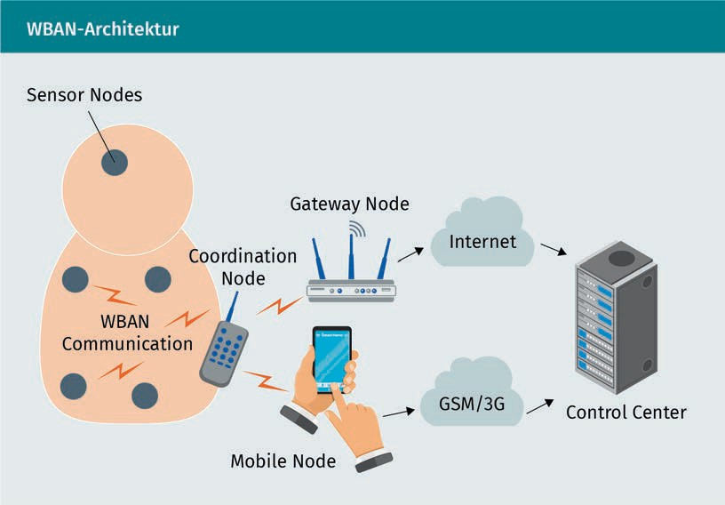

The first sector shows the various sensor nodes that are attached to or inside the human body. These nodes are mostly low-cost and low-power nodes with internal and physiological sensors, which are placed at strategic points. These sensors can be used to continuously monitor and record movement or vital parameters such as pulse, blood pressure, electrical activity of the heart muscle (electrocardiogram, ECG), sugar levels, etc. The environment can also be monitored via such devices. There are large monitoring systems already in use based on wired or wireless connections. Any wired connection in a monitoring system, but also the device size can create problems and be bulky for a person, limiting their mobility. Therefore, WBAN is an effective and efficient solution for such scenarios, especially in the medical field. Here, patients are continuously monitored, and high mobility can quickly save life-saving time (Arefin/Ali/Haque 2017).

The second field is the Coordination Node. This connects all sensor nodes via a wireless communication interface (WBAN Communication). The coordination node can also be referred to as a Central Communication Unit (CCU). The CCU handles collecting the information from each sensor node and sending it to the next area. No communication standard is prescribed for the communication between CCU and next area. For example, WLAN, Wi-Fi, GSM, 3G, 4G or WPAN are possible. Specifically in the medical field, WMTS (Wireless Medical Telemetry Service) and Ultra-Wide Band have become popular, which are used specifically for monitoring sensors close to the body due to low-power transmission (Arefin/Ali/Haque 2017).

Communication And Networking

The third field is the interface of the coordination node to a control center via either a gateway node or a mobile node. The gateway node transmits the data directly over the Internet. A cell phone can transmit the data via SMS over the telephone network or via GSM/3G or similar, thus increasing the mobility of the monitored person. A PC or a router can also be configured as a gateway node (Arefin/Ali/ Haque 2017).

The fourth and last field is the Control Center. Here the information is collected, stored, correlated, and abstracted. By means of various applications, this data can be viewed and analyzed. Analysis or alerts can also be sent to the individual over the wireless connection (Arefin/Ali/Haque 2017).

Smart Device Requirements for WBAN

There are several requirements for smart devices to meet the needs of WBAN applications. These are portability, reliability, security, and interoperability (Arefin/Ali/Haque 2017).

To achieve non-invasive and inconspicuous continuous monitoring, portability is a very important issue. These sensors must be light and small. The size and weight of the sensors are mainly determined by the size and weight of the batteries. But the capacity of a battery is directly proportional to its size (Arefin/Ali/Haque 2017).

Reliable communication in WBANs is of utmost importance for any WBAN application. Therefore, the developer should aim for a reliable communication technology that ensures uninterrupted communication and optimal throughput. A careful tradeoff between communication and computation is very important for a reliable system design (Arefin/Ali/Haque 2017).

Another important issue is the security of the network. All wireless medical sensors must meet privacy requirements and provide data integrity and authentication (Arefin/Ali/Haque 2017).

Wireless medical sensors should allow users to easily build a robust WBAN. Standards that guide this interaction of wireless medical sensors are expected to advantage competition among manufacturers and eventually lead to more accessible systems (Arefin/Ali/Haque 2017).

#### Middleware for Smart Devices

Middleware, widely used in traditional distributed systems, are fundamental tools for the design and implementation of smart devices from different manufacturers as well as smart environment applications. They provide general and specific abstractions ( such as object computation models, communication between objects, sensory/actuator interfaces, recognition services, knowledge management) through which smart devices and their related applications can be built rapidly and easily. Middleware provide standardized interfaces that can be used by different devices in a scalable manner (Fortino et al. 2014).

In recent years, the Internet of Things (IoT) has become increasingly important in both the academic and industrial worlds. IoT is a concept that describes a vision in which everyday objects are connected to the Internet as well as identified and potentially communicate with other devices. Smart devices can be defined as real-world artifacts augmented by functions for computing, communicating, sensing, and storing. Their importance lies in the enabling capabilities they have to make physical environments intelligent or to provide novel cyberphysical services to humans. In recent years, several middlewares for smart devices have been proposed (Fortino et al. 2014).

The architecture for IoT can be divided into five layers, namely..

* + - Device Layer,
    - Network Layer,
    - Middleware Layer,
    - Application Layer and
    - Business Layer.

The device layer consists of physical objects for collecting information from the environment. The network layer is responsible for securely transmitting information from sensor devices to the information processing system. The middleware layer is responsible for service management and serves as an intermediate layer to create an interface between the lower-level layers (physical and network) and the higher level (application and business logic). The application layer is responsible for the proper operation of the provided application. The business layer is responsible for managing the entire IoT system, including applications and services (Fortino et al. 2014).

Communication and networking

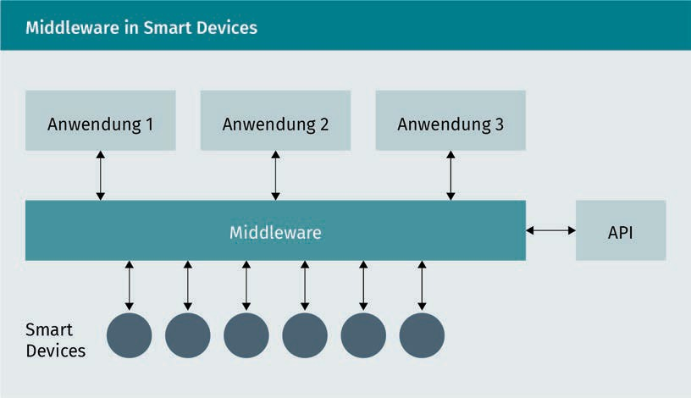

The development of smart devices poses many problems, especially in terms of communication between other smart devices, interfaces to sensors and actuators, knowledge management, and distribution of computing power. To facilitate the development process, research is focused on defining new frameworks and middlewares for the "rapid prototyping" of smart devices. These middlewares typically provide a well-defined platform and application programming interface (API) through which new smart devices can be programmed and deployed (Fortino et al. 2014).

Middlewares for smart devices have to meet various requirements. Some of them are listed below:

* **Heterogeneity and application development:** Applications that use smart devices should be able to be implemented or programmed independently of the specifications of specific smart device manufacturers. For example, if an application is based on a "smart chair", it should be able to use other smart chairs produced by different manufacturers. In addition, the application should be able to use smart devices that will be built in the future. This means that a standardized approach must be used or, should this not be possible (since standardization is a lengthy process), software-layering-based (dynamic) adaptation techniques between the application layer and the smart device layer must be used (Fortino et al. 2014).
* **Adaptability of smart devices:** Smart devices can be used to offer various services. The type and number of smart devices used may vary for different services. This variation can also occur with the same service. Accordingly, the service cannot be uniquely identified on the basis of the smart devices used. It also becomes difficult to define standardized interfaces for the respective services. The requirement for smart device adaptability emphasizes the need for adjustment services and adaptable smart devices.

To meet this requirement in the creation of a service, dynamic operations must be developed to add, modify, and delete the various smart devices (Fortino et al. 2014).

* + **Smart Device Management:** Effective management of smart devices is critical for complex IoT applications. The more smart devices interact with each other in a distributed manner, the more time-consuming it becomes to manage them manually. Such IoT applications should therefore be designed in such a way that they are able to automatically adapt dynamically. It is also conceivable that different smart devices can be automatically and continuously connected to and disconnected from the IoT application for different application purposes. This means that variations, but also failures, can be compensated for at any time. This requires a check of the match between the connected smart devices and the application requirements. This check is usually performed at runtime. So-called discovery services are of strategic importance in this dynamic context. Smart devices are searched for, found and called up according to their static and dynamic features. These are, in broad terms, the requirements for a management system for complex IoT applications with smart devices (Fortino et al. 2014).
  + **Evolution of applications with smart devices:** Applications and smart devices should be easily and rapidly prototyped and updated through appropriate mechanisms. To create a new IoT application, it should be possible to easily and quickly try out potential smart devices as a prototype in order to evaluate the potential of the utilized smart device at an early stage. When utilizing an early prototype, a decision can be made very quickly as to whether the smart device is worth considering. Good middleware is needed so that the various smart devices can be connected easily. Since the application is constantly evolving due to the frequent replacement of smart devices during the development phase and new insights are always being gained, this is referred to as an evolution. This evolution can be controlled by programming, by learning, or by both. In particular, evolution by learning is usually based on intelligent self-evolving components (application-level components and smart devices) that are able to self-direct their development based on a learning model (e.g., software agents) (Fortino et al. 2014).

The smart home can be mentioned as a typical application example. With the proliferation of smart home products from various vendors, configuring and installing these products and developing applications for home users to meet their needs with data from connected devices is quite a challenge. This challenge can be solved with the aid of middleware (Fortino et al. 2014).

Communication And Networking

#### Open Core Interface

In Industry 4.0, manufacturing technologies and the IT world are interconnected. In this context, the importance of software in mechanical engineering is rising. Bosch Rexroth, an industrial company in the field of drive and control technology, has developed Open Core Engineering (OCE) as a solution for this. Here, possibilities are shown to merge PLC automation and the technologies of the IT world. A PLC is a programmable logic controller, a device that is used to control or regulate a machine or system and is programmed on a digital basis. OCE consists of software tools, function packages, open standards and the "Open Core Interface" (OCI). A function package is a bundled and self-contained package (archive) that can be used in a software but cannot be compiled individually and that provides functions for specific tasks (Bürger/Tragl 2017).

Using OCE, manufacturing solutions for Industry 4.0 can be built up in a modular way. This allows rigid manufacturing chains to be broken up and replaced. The main focus here is on the efficiency of manufacturing small and very small quantities (batch size). In the following, we will look at why OCE is needed and what challenges are posed to Industry 4.0 applications from the perspective of communication and networking (Bürger/Tragl 2017).

Challenges Of Industry 4.0 From The Perspective Of Communication And Networking

The industry is in a state of upheaval. The framework conditions for manufacturing companies are changing in all industrial sectors. Product life cycles are becoming shorter and shorter, which means that the quantities being manufactured are also becoming lower. Hard work is being done to make the machines so flexible that even the lower quantities can be manufactured economically. As a result, mechanical engineering companies will have to rethink their approach. Manufacturing chains that used to be rigid and expensive must now be modular and cost-efficient. Individual processing stations are flexibly combined in order to be able to manufacture different products. There is also a need for ways to network the company's IT with the factory floors and the individual machines. These new challenges mean that companies have to develop new core expertise in the shortest possible time in order to continue to operate successfully in the market. Jeff Immelt, former CEO of General Electric, once put it this way: "If you went to bed last night as an industrial company you're going to wake up [as] a software & analytics company" (Immelt 2014). Today, future technologies such as robots, big data, artificial intelligence or the Internet of Things are on the agenda of every second company in the mechanical engineering sector and are leading to increasing digitalization of manufacturing (PwC 2018).

Not only mechanical engineering companies, but also manufacturing companies need to rethink. In this sector, networking is becoming increasingly important. The pioneer for new manufacturing models is often the automotive industry.

Until the 1990s, engine manufacturing was based on transfer lines. These were firmly chained stations for the highly efficient manufacture of large numbers of a single type of engine. The growing variety of models with decreasing product life cycles at the same time demanded a high degree of flexibility. In order to meet the increasing demands, the rigid manufacturing chains were converted to flexible manufacturing cells. This new type of manufacturing allows different models to be manufactured on the same manufacturing line (Bürger/Tragl 2017).

In the food industry or in web printing, machines used to be driven by central actuators and via complicated and wear-prone mechanical equipment. For each product changeover, the machines had to be shut down and switched manually with wrenches. Electronic shafts have been developed to provide greater flexibility in this area. These could also be synchronized during operation by using software. This synchronization is controlled using PLC. The decentralized and smart drives are networked via data lines. The PLC specifies the setpoints and controls the systems. The mechanical manual work is completely eliminated, the machines can be synchronized more precisely and much faster. Upgrades to new products can often be achieved with just the click of a mouse. The necessary steps are taken over by the software. New manufacturing lines or stations are connected to the control system via data cable, automatically recognized, and integrated. So that this integration can run fully automatically, the modules and the entire manufacturing plant must communicate via open standards and open interfaces (Bürger/Tragl 2017).

After the integration and automation of the new manufacturing plants, the task now is to integrate them into the company's IT system fully automatically and without human intervention. The goal of the Industry 4.0 vision is a value chain that requires no human interaction from ordering by the customer through manufacturing to delivery to the customer. From a manufacturing perspective, the necessary steps have already been taken. In order to be able to manufacture batch sizes of 1 economically, however, the ordered product must also be transferred from the company's IT system to manufacturing via secure channels. However, the two worlds are so fundamentally different that this has proven to be a major challenge (Bürger/Tragl 2017).

For years, companies have relied on standard software for both company IT and product control. This is written by various providers in different programming languages and relies on different protocols and interfaces. Stand-alone solutions are not very common. This is understandable from an economic point of view, as established and cost-efficient solutions can be used here. However, companies lose flexibility because there is no access to the program code and adjustments are time-consuming and expensive (Bürger/Tragl 2017).

Communication And Networking

Open Core Interface As a Bridge Between PLC and IT

The described development in the manufacturing world significantly slows down innovations and poses obstacles to the further development of software. This gives machine manufacturers completely new degrees of freedom. Firstly, a new interface technology for programming control software with the programming languages of the IT world is made possible. It also opens the control core of the software for extended access. This is the first time that factory automation has been consistently networked with company IT. Software functions can be developed and implemented more easily and quickly, and completely new concepts of manufacturing modularization and networking can be tried out, discarded, adapted, tested, expanded, and operated, which immensely increases the power of innovation (Bürger/ Tragl 2017).

The Open Core Interface serves as a bridge between PLC and IT automation. It is a combination of a functional control interface and a software development kit (SDK) for various programming environments, operating systems, and target devices. This means that applications written in "high level" programming languages on external devices gain completely new flexible access to the operations of controllers and actuators of machines (Bürger/Tragl 2017).

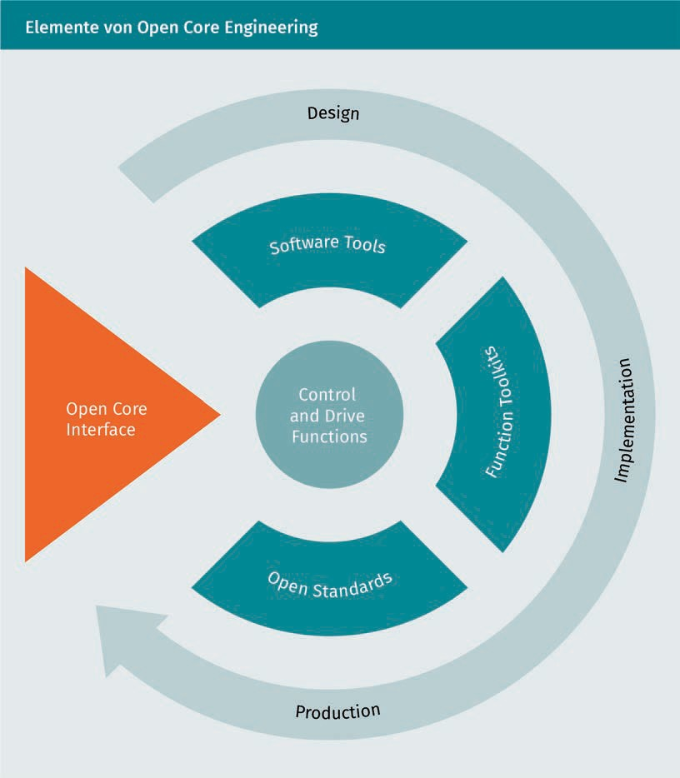

The C++ programming language serves as the basis of the OCI. The applications can be run directly in the real-time environment of the controllers. This enables innovation in the following four dimensions:

* Smart devices are integrated with individual applications with the machines.
* Rapid control prototyping simplifies programming and commissioning.
* Machines and company IT can be networked.
* Using individual operations in the real-time environments of the controllers as well as external devices increases both flexibility and productivity.

Communication And Networking

The innovations developed can be quickly and easily integrated into existing and new machines (Bürger/Tragl 2017).

Open Core Interface and Smart Devices

Smart devices have opened up a large market, and not just in consumer electronics. There is also very great potential in mechanical engineering to use the mobile IT technologies of smartphones and tablets, as well as other devices. This allows the communication between humans and machines to be redesigned. Interactions become faster, more intuitive, and more flexible. In the customer environment, there is a wealth of application scenarios for accessing machine information. In this way, operating data can be recorded or read out. Service, diagnosis and maintenance can take place and be supported via mobile devices. Smart devices also enable a new type of machine guidance (Bürger/Tragl 2017).

The Open Core Interface supports the most common operating systems for mobile devices. Native apps can be developed that, unlike web-based solutions, do not require web servers or an active Internet connection. These applications run completely autonomously on the end device, place only a minimal load on the control system, and allow maximum flexibility. The devices can connect to several control devices in parallel and access various applications of the control system at the same time. Thanks to the Open Core Interface, mechanical engineering companies can implement smart device applications independently, innovate on their own, protect their own know-how, shorten the time-to-market, and flexibly offer custom solutions (Bürger/Tragl 2017).

**Summary**

There are various options for the communication and networking of smart devices. First of all, the network possibilities are differentiated into different orders of magnitude.

In the smallest, body area networks connect devices that are attached directly to the body. In personal area networks, all devices that are in the immediate vicinity of the owner are networked. Home networks and the like are called local area networks and can even extend over several kilometers. When larger areas and different networks are connected, they are referred to as metropolitan area networks. The best-known wide area network, but not the only one, is the Internet. Here, various machines are networked worldwide and communicate with each other.

Communication between smart devices also requires a middleware layer to enable applications for the Internet of Things. This makes it possible to connect various smart devices from different manufacturers to form unified applications.

In the context of using programmable logic controllers (PLCs), a common standard is the Open Core Interface for such middleware.

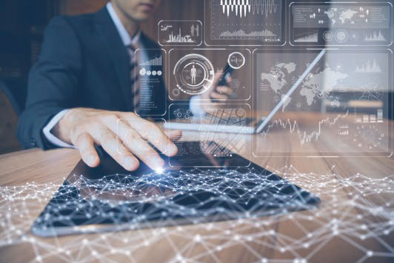

# Lesson 5

## User Interfaces

##### LEARNING OBJECTIVES

After working through this lesson, you will know..

... what types of touchscreens there are and how they work.

... how gesture control works and the challenges it brings.

... how voice control works and the challenges it brings.

... how multimodal controls differ from conventional controls.

DL-D-DLBINGSD01-L05

### User Interfaces

#### Introduction

Regarding information technology, the user interface (UI) is everything that is planned into an information device that a person can interact with. These can be screens, keyboards, a mouse, and the appearance of a desktop. It is also the way a user interacts with an application or website. The growing reliance on mobile and web applications has prompted companies to place a higher priority on the user interface to improve the overall user experience.

The UI interface is often discussed in conjunction with user experience (UX), which can include the aesthetic appearance of the device, response time, and the content presented to the user in the context of the user interface. An increasing focus on creating an optimized user experience has led some companies to create positions for UI and UX experts.

In earlier computers, there were very few user interfaces except for a few buttons on the operator console. Many of these early computers used punched cards made using key punch machines as the primary input method for computer programs and data. These have long been outdated, but are still used today, for example, in some dialers.

The user interface developed with the introduction of the command line interface, which initially appeared as an almost blank screen with one line for user input. Users relied on a keyboard and a set of commands to control the exchange of information with the computer. This command line interface led to one in which menus (lists of choices written in text) predominated.

Finally came the Graphical User Interface (GUI), which originated primarily at Xerox's Palo Alto Research Center, was adopted and improved by Apple Computer, and effectively standardized by Microsoft in their Windows operating systems. Elements of a GUI include windows, pull-down menus, buttons, scroll bars, and icons. With the increasing use of multimedia as part of the GUI, sound, speech, moving images, and virtual reality are increasingly becoming the GUI for many applications.

The increasing popularity of mobile applications has also affected the user interface, resulting in a so-called mobile user interface. Mobile UI is specifically concerned with creating usable, interactive interfaces on the smaller screens of smartphones and tablets, as well as enhancing special features such as touch controls.

User Interfaces

#### Touch Control

We regularly and unconsciously use touchscreens in our everyday lives. Cell phones, tablets, computers, ATMs, ticket machines and more can now be operated with touch panels. This input interface allows the user to interact with a computer or smart device without using a keyboard or mouse. There are several types of touchscreens, the most common being:

* + - wire resistive,
    - surface capacitive,
    - projected capacitive,
    - SAW (Surface Acoustic Wave ) and
    - infrared.

These five types are briefly presented below, along with their advantages and disadvantages (o. V. 2014).

Wire Resistive Touchscreens

Today, wire resistive touchscreens are the most widely used touch technology. Such a touchscreen consists of a glass plate and a film screen, each covered with a thin transparent metal layer. There is a narrow gap between the covered glass plate and the covered film screen, which is held by spacers. When a user touches it, the two metallic layers form a contact, creating an electrical flow. The contact point is determined by this voltage change. Resistive touchscreens are used for common smart devices such as tablets, smartphones, but also in fully automatic coffee machines or in the automotive industry (o. V. 2014).

This technology allows this type of touchscreen to be used with almost any object, be it a finger, a finger in a glove, a stylus, etc. There is also a tactile sensation as the thin film yields. Also advantageous are the very low manufacturing costs (the lowest compared to the other technologies). The low energy consumption and resistance to liquids and contaminants (dust, oil, grease, moisture) are also reasons why this technology is most frequently used (o. V. 2014).

In contrast to the other technologies, wire resistive touchscreens have a lower screen sharpness. Also, the outer polyester film is susceptible to damage from scratches, impacts, and sharp objects (o. V. 2014).

Surface Capacitive

After wire resistive, surface capacitive touchscreens are the second most popular touch-sensitive screens on the market. With this type, a transparent conductive electrode layer is placed on a glass plate. This layer, in turn, is protected by a protective cover. A finger touching the screen triggers a reaction through the static electrical capacity of the human body, transferring a portion of the electrical charge from the screen to the user. This leads to a decrease in capacity, which is detected by sensors at the corners of the screen. This allows the position of the point of contact to be determined. Capacitive touchscreens are also used for tablets or smartphones, but also for restaurant cash registers (o. V. 2014).

In contrast to Wire Resistive, Surface Capacitive Touchscreens have a much better image sharpness and a more robust screen. Resistance to surface contaminants and liquids (dust, oil, grease, water droplets) is also excellent. The high-scratch resistance of this technology is particularly advantageous for mobile devices (o. V. 2014).

However, this requires touching with a bare finger or with capacitive pen. There is also a sensitivity to electromagnetic interference (o. V. 2014).

Projected Capacitive

Projected capacitive touchscreens are similar to surface capacitive touchscreens. The touchscreen consists of a glass panel as a base for two electrode films and a protective layer. An IC chip generates a three-dimensional electrostatic field. Touching with fingers changes the ratios of electrical currents. The touch points can be determined by a computer (o. V. 2014).

However, this technology has significant advantages. Operation is possible not only with a bare finger, but also with several fingers (multi-touch activation) and with thin cotton or surgical gloves. The image sharpness is also outstanding. The screen is even more scratch-resistant and resistant to surface contaminants and liquids (dust, oil, grease, moisture) (o. V. 2014).

As with Surface Capacitive Touchscreens, Projected Capacitive Touchscreens are also sensitive to electromagnetic interference. Even if multiple fingers are detected, only touches over exposed fingers or at least with thin surgical or cotton gloves can be detected (o. V. 2014).

User Interfaces

SAW Surface Monitors

SAW (Surface Acoustic Wave)monitors are very different from the technologies already presented. Invisible grids of ultrasonic waves are generated on the surface. Along the sides of the glass plate is a series of piezoelectric transducers and receivers. These generate the ultrasonic waves. Touching the plate changes the waves at this point. This change in the waves is registered by the transducers received. The point of contact can be determined from this information (o. V. 2014).

Since only the glass plate and no other layers are necessary between the monitor and the viewer, such touchscreens have excellent image sharpness, even better scratch resistance and a very long service life (o. V. 2014).

Such screens, on the other hand, do not work with certain objects (pen, credit card or fingernail). Another disadvantage is that water droplets can lead to false triggering. Soiling on the screen can result in areas that are insensitive to touch until the soiling has been removed (o. V. 2014).

Infrared Touchscreen Monitors

Similar to SAW, infrared touchscreen monitors do not overlay the display with additional glass panels or a foil sandwich. Instead of ultrasonic waves, infrared waves are monitored between the emitter and receiver. The invisible grid of light beams is interrupted when touched, sensors register the location of the interruption, and the point of contact can be determined. This variant is often used for bank terminals (o. V. 2014).

Of all touch technologies, this has the highest image sharpness and the highest light transmission. The service life is almost unlimited. The surface is insensitive to scratches (o. V. 2014).

Since the infrared rays can easily be deflected above the glass, accidental activation can occur. The light beam can be deflected by dust, oil or grease deposits on the screen or frame. This can lead to malfunctions. The screen is thus sensitive to water, snow and rain. However, incorrect inputs or malfunctions can also occur with any ambient light interference. Compared to other technologies, this is expensive (o. V. 2014).

#### Gesture Control

A gesture is a "spontaneous or conscious movement of the body, especially of the hands and head, which accompanies or replaces someone's words [and expresses a certain inner attitude]." (Duden). It can represent both interpersonal communication and human-machine interaction, such as using a mouse or gesture recognition. Just about all computer-based systems have gesture-based input capabilities. Smartphones are controlled by fingers or pens, computers by mouse or (multi-)touchpads, game consoles by gesture recognition via cameras or infrared (Buxton 2009).

With a mouse, gesture controls are possible in that, for example, moving the mouse quickly in a circle with the hand enlarges the mouse pointer on the screen so that it can be found more easily. Also counted as a mouse gesture is the interaction when a window is quickly moved back and forth with the mouse, causing all other windows to close.

Every physical action involves some kind of gesture. Moreover, the nature of this gesture is usually an important component in determining the quality of the feeling for the action. That being said, the purpose of this section is to discuss interactions in which the gesture is what is to be articulated and recognized, rather than the consequence of what is to be expressed (Buxton 2009).

Below we describe the four different types of gestures, as there are different levels of gradation. Not all gestures can currently be used to communicate with a computer (Rimé/Schiaratura 1991):

1. **Symbolic gestures** occur in every culture and have the same meaning everywhere. If you form an "OK" with your hands, it is clear in almost all countries. Sign language also falls into this category.
2. **Indexical gestures** occur most frequently in human-machine interactions. They draw the user's attention to specific events or objects in the environment. An example of an indexical gesture is, for instance, the index finger for "Put that there".
3. **Iconic gestures** are used to convey information about the size, shape, or orientation of an object. Such gestures are made in speech when someone says: "The plane flew like this " and at the same time describes this with a gesture.
4. **Mime gestures** are used to show the use of movement of an invisible tool or object. An example of an indexical gesture is, for instance, the index finger for "Put that there".

Current interaction with computers is free of gestures compared to everyday language use and is mainly performed using mouse pointers, fingers or simple commands. Although people can use gestures in the everyday world, few gestures can be used uniquely in human-computer

User Interfaces

interaction. It also takes a long time to learn the input gestures in such a way that the gestures are recognized and can be translated for the computer. Advanced gesture recognition interfaces typically use indexicality or symbolic gesture recognition. It can also be difficult for a computer system to distinguish between a gesture in normal speech and a gesture as input (Buxton 2009).

Computer-based gesture recognition can be implemented at different levels of maturity. Simple systems can recognize some symbolic gestures. More complex and sophisticated systems can perform full sign interpretations. Other systems recognize static, dynamic or static-dynamic hand movements. Common to all systems is that each gesture is assigned only one meaning at a time (Buxton 2009).

#### Voice Control

Voice control is a mechanism for giving commands to a computer by means of speech. Voice control consists of speech recognition on the one hand and the application as a control mechanism on the other. Speech recognition is about recognizing one or more speakers from spoken words or sentences and putting them into a form that machines can understand. The control mechanism executes the commands assigned to the respective terms (Haleem 2009).

Filtering and recognizing speech from an audio recording is a challenging task. Depending on the speaker, the different variables that make up human speech vary:

* + - amplitude,
    - pitch and
    - phonetic stress (sounds and acoustic features).

If the human ear is used as a model for speech recognition, it becomes clear that pitch can be seen as the most important feature of audio signals. The pitch is directly dependent on the frequency of the signal (i.e., the number of oscillations per time unit). The frequencies are perceived by the inner ear, which is a kind of frequency analyzer. In the inner ear, stimuli are broken down into many sinusoidal components. These components stimulate the basilar membrane at various points. Hair cells are connected to this membrane with neurons, which are excited depending on the different characteristics of the frequency. Specific vibration frequencies stimulate hair cells precisely tuned to that frequency and trigger the associated nerve impulses (Haleem 2009).

Next to pitch, volume, together with the intensity of the sound signal, are considered the second most important feature of human hearing. The perceived sound intensity is directly dependent on the frequency and intensity of the sound.

This was discovered in the 1930s through psychoacoustic experiments. Generally, it can be said that the ear reacts differently to different frequencies. The differences are particularly pronounced in the upper and lower frequency ranges (Haleem 2009).

Using the human ear as a model, voice capture devices can be designed to capture speech and digitize it for voice control. Speech is captured with a microphone and transferred to the computer in raw speech waveforms. This raw data is sampled via an analog-to-digital converter and digitally encoded. Special filters separate the speech from other signals such as background noise, etc. Further windowing, scaling and data compression are performed on the extracted speech from the audio recording to enhance the components of the spectral representation that are useful for speech recognition. This reduces the amount of information that the pattern matching algorithm must process (Haleem 2009).

The pattern matching algorithm processes so-called speech frames. This is a certain number of speech parameters in a certain time interval. The speech frames are compared by the algorithm with speech templates or generative speech models. In this comparison, the match between the speech frame and the speech template or models is calculated (pattern matching). The best results are cached:

Pattern matching is used when comparing two speech signals. The speech signal can be represented as the set of numbers that represent certain mnemonic features of the speech. For further processing, a vector is constructed from these numbers by assigning each measured value to a component of the vector. As an example, consider an air conditioning system that measures temperature and relative humidity in an office. If the parameters are measured every minute and the temperature is entered in the first component and the humidity in the second component of a vector, the result is a large set of two-dimensional vectors. These vectors describe how the air in the office changes over time. Such vectors are called feature vectors. They can be interpreted in a two-dimensional vector space. Thus, a two-dimensional dependence between humidity and temperature in the office can be drawn. Each measuring point represents a specific time. In the speech signal, multidimensional feature vectors are compared to extrapolate the content [Translated by the author]" (Haleem 2009).

The speech signal, given as a command signal in real time, is passed through the speech recognizer and compared with the stored templates. The minimum difference from the stored template of the particular word leads to the generation of the code indicating that the particular word was spoken. This word can perform a software function. This allows language to be used to perform a specific action (Haleem 2009).

User Interfaces

#### Multimodal Control

Further development and progress in various research areas such as computer vision, signal processing or sensor technology have created new opportunities to revise or redevelop traditional user interface concepts or input devices. Researchers and interaction designers are working intensively on such new developments: Interactive surfaces, tangible user interfaces, digital "augmented" pens, voice input, gestural interactions, and other natural or expressive interaction technologies are combined and integrated to create new multimodal interfaces. These new multimodal interfaces present designers and researchers with various critical challenges, for example in the area of design or interaction for actual use (König/ Rädle/Reiterer 2010).

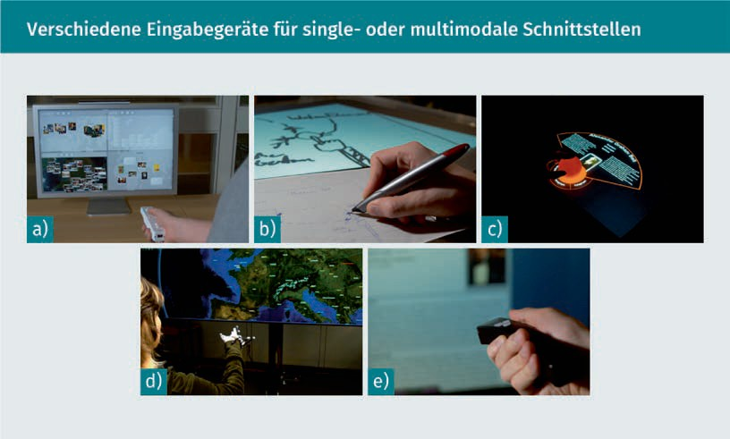

The figure shows various input devices for single and multimodal interfaces (König/Rädle/Reiterer 2010):

1. With a physical game controller, the end user can control the absolute direction of objects. Movement and gesture recognition are also possible and have now been integrated into all common game consoles (e.g., XBox, Playstation).
2. Digital pens can be used in a very natural way, such as for digital sketching. What is written or drawn is either stored on the pen or transferred directly to a computer.
3. Large multi-touch surfaces can be extended with physical so-called tokens, thus narrowing the gap between the real and digital worlds.
4. Finger and hand gestures, which are recognized by cameras and motion sensors, are technically more complex but more intuitive to use.
5. Classic laser pointers can also be used to make flexible inputs from a distance.

The development of traditional graphical user interfaces was mostly solved exclusively by software components. For multimodal interfaces, development includes both software and hardware components. Various development tools are available for the specific interaction modalities. These are usually limited to special hardware environments, have special requirements and other dependencies. Multimodal input interfaces require the use of different hardware platforms, operating systems, programming languages and software frameworks. The interaction designer must master these. With "single-modality interfaces," interaction designers can usually focus on a specific device, reducing the scope of development. In the meantime, there are so-called developer kits for many different use cases, which provide basic functions and thus simplify the development effort even for multimodal interfaces (König/Rädle/Reiterer 2010).

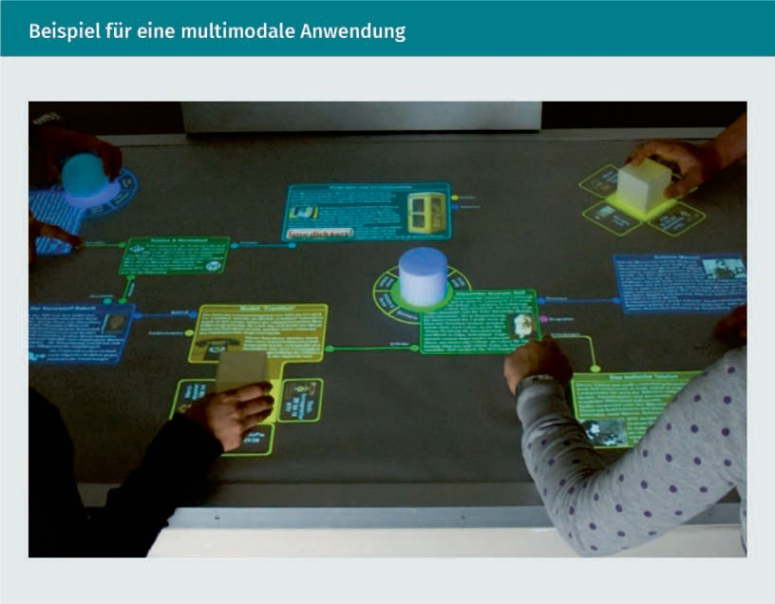

In the context of surface computing, several touch-sensitive displays are combined conceptually and technically. This combination creates a user experience based on natural and direct touch interaction. In such a scenario, mobile handhelds (e.g., Apple iPhone), multi-touch tables (e.g., Microsoft Surface) and large high-resolution wall displays (e.g., eyevis Cubes) can be combined for collaborative work and visual information organization.

User Interfaces

To enable multimodal input and context-aware use, speech recognition, mobile eye tracking, and freehand gestures can also be integrated. The digital and physical worlds are combined with digital pens for interactive sketching and with interactions through physical marks on the various multi-touch displays (König/Rädle/Reiterer 2010).

**Summary**

User interfaces are essential for the interaction between humans and machines. These have changed significantly in recent decades. Whereas in the past it was punch cards, today it is highly interactive interfaces via various options.

These days, screens are no longer purely display devices, but are also used as input devices. Meanwhile, these also provide direct feedback on the input. There are different types here, which have more or less become established and have different advantages and disadvantages.

Machines can be interacted with not only via screens with touch controls, but also by means of gestures. Gestures are in turn divided into different types, resulting in different interaction possibilities.

Interaction is also possible by means of speech. Speech recognition is a big challenge, considering the many different languages and dialects.

If several input options are linked or completely newly developed, we speak of multimodal control. There are many challenges here that go beyond the usual user interface development.

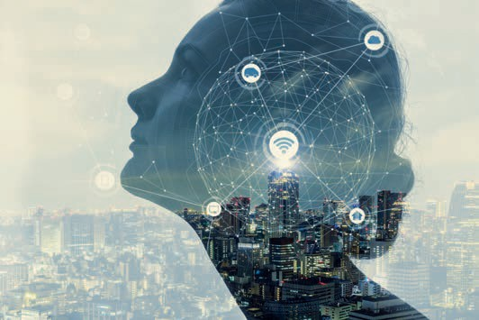

# Lesson 6

## Ubiquitous Computing

##### LEARNING OBJECTIVES

After working through this lesson, you will know..

... which goals ubiquitous computing pursues, and which features ubiquitous systems have.

... what types of context sensitivity there are and what problems they face.

... what role the autonomy of ubiquitous systems plays.

... what smart device management can look like.

DL-D-DLBINGSD01-L06

### Ubiquitous Computing

#### Introduction

The word "ubiquitous" means that something exists or appears everywhere, it is omnipresent. Ubiquitous computing (UbiCom) is a combined term describing the omnipresence of computer-based information systems. Such systems are designed to make information and tasks available anytime and anywhere. Intuitive use by users should also be supported, and this support should be as invisible as possible (Friedewald et al. 2010).

#### Goals And Basic Features Of Ubiquitous Systems

From a technical point of view, ubiquitous computing is merely another stage in the further development of mobile communication and individualized information. Wired and wireless networks are available in large parts of the world for data transmission at several megabits per second. The transmission of multimedia content is now an everyday occurrence both at work and at home. As well as the use of mobile or stationary devices. Near ubiquitous coverage of wireless networks and increasing user acceptance is enabling piecemeal integration of computer systems into the physical environment. These integrated computer systems are gradually becoming less disruptive to the environment. The electronic circuits and appliances used or required are also becoming smaller, cheaper, and more reliable. The energy required for manufacturing is also becoming less. It can be deduced from this that the integrated systems will become more numerous, more invisible, and better networked. Interaction between humans and machines is becoming more personalized and context-aware. Personalization models embedded in our mobile devices communicate with other services and devices to provide customized services (Friedewald et al. 2010).

Almost all services are now dependent on computer support, for example in the areas of nutrition, infrastructure, consulting, trade, transport, and health. Service access points were originally designed for use by human users. These accessed isolated services and information and performed actions. If several such services wanted to be combined, separate access devices and networks were used. Today, on the other hand, various services are provided via more integrated, interoperable and ubiquitous services and networks. Nowadays, data networks can be used to access the Internet as well as video and voice services simultaneously (Friedewald et al. 2010). In telecommunications, this is referred to as "triple play" (voice, data, video) or "quadruple play" (triple including cellular communication). These designations refer to both infrastructural areas such as IP telephony, video-on-demand,

Ubiquitous Computing

TV, and radio over the same network as well as on electronic components. This greatly facilitates the provision of ubiquitous services. In the late 1990s, a smart TV would have needed a TV, radio, Internet and telephone connection to cover the same functionality, as each service was provided via a separate network. Today, a WLAN connection is all that is needed (Hofbauer 2008).

Ubiquitous computing (UbiCom) is now found in a great many different devices: Phones, cameras, game consoles, ATMs, vehicle control systems, cell phones, electronic calculators, household appliances, and computer periphery devices such as routers and printers. UbiCom makes use of embedded computer systems. These are completed and have predefined tasks which they are to perform. The devices can be optimized by designers for these tasks. This reduces costs and size and enables mass manufacturing. This leads to a further reduction in costs, since mass-produced parts can be used. The devices can also be designed multifunctionally to cover multiple functions and tasks (Friedewald et al. 2010).

The complexity of UbiCom systems increases with the number of dynamic or static connection options. This complexity should be reduced to a minimum so that the systems can be used more effectively. For example, to make systems more useful without becoming more complex, they can be more closely linked to the physical environment and surroundings. This so-called context-awareness leads to an autonomous scope of action in which the systems involved are allowed to move and act without human intervention. Here, the right balance must always be found between the autonomy of the systems and the management or possibility of control by humans. When operating complex systems, it is currently not possible to do without humans completely (Friedewald et al. 2010).

#### Examples Of Ubiquitous Systems

In this learning cycle, various application examples are presented, which are located in the human and physical world. The examples are intended to illustrate the bandwidth, advantages, and challenges of ubiquitous systems.

The first scenario focuses on a system where audio-video content is recorded, associated user contexts are automatically detected, and the recordings are automatically annotated. The second scenario presents a 21st century transport service in which plans adapt to the current state of the environment. The last scenario focuses on the food trade. Here, analog objects such as food are digitally networked with a computer system to monitor use (Poslad 2009).

Personal Memories

Photography used to be a very laborious craft. Before there were digital cameras, photographers used various techniques to choose the right setting for the analog camera. First, the light intensity had to be determined by a light measurement. From this value, the camera's aperture and shutter speed were set. The lens of the camera was focused manually. The handling of the pictures taken has also changed. In the past, photos were stored sequentially on a recording medium (film). For a new exposure, this film was wound onto the next blank section. Once all the blank sections were full, the film was sent to a specialized company for film processing. The latter used special equipment to convert the recorded film into a special format so that it could be viewed (photo). If further copies were to be made, this also had to be done by a specialized company. The archiving of the photos was also done manually and was relatively time-consuming (Poslad 2009).

Nowadays, these activities are performed fully automatically by smart digital cameras. The camera focuses and exposes the scene fully automatically. The images are usually always in focus and optimally illuminated. Also, when shooting, the camera is aware of what is in the scene (object detection) and who (face detection). Depending on the environment, different exposure settings are automatically selected (night or daytime shots, cloudy or sunny, buildings, people or nature, etc.). Also, people are automatically placed in focus. The camera can be set to take a photo only when all the people in the scene are laughing. The current scene is shown on the integrated display and in the viewfinder and overlaid with other relevant information. The captured photo is immediately stored on a digital medium and can be immediately shown on the integrated display. In addition to the image, contextual information such as location (based on GPS data), date and time, as well as other data such as exposure information, etc. are stored as metadata (Poslad 2009).

The recorded content can be shared and exchanged immediately via various interfaces such as Bluetooth or WLAN. Either directly with other devices or indirectly via social networks. Content can also be archived on external content databases that are specifically optimized for audiovisual content. During archiving, the metadata is saved as well. Such databases may also have facial and other recognition capabilities to supplement the metadata. The database stores the metadata in a structured way. These are used for later searching and sorting (e.g., to show all photos of a certain person or place). Today's cameras are networked and detect other types of devices, such as printers, smart TVs or projectors. The camera can automatically connect to the found devices to exchange the data. The connected devices can exchange their information and share and complement their different functions (Poslad 2009). This scenario has shown that the world of photography has changed a lot.

Ubiquitous Computing

Adaptive Transport Services

In transportation, static schedules were available at specific locations and terminals until the 20th century. Delays had no influence on the available timetables. Neither the passengers nor the inspectors could see whether the timetable corresponded to the actual arrival time. If there were any deviations from the timetable, drivers could use manual systems to inform them of delays based on designated waypoints. This information was then passed on to the passengers manually (Poslad 2009).

This manual data processing is already fully automated in the traffic service of the 21st century and is available ubiquitously via distributed systems. The current position is determined via automated positioning technologies such as GPS and compared with the digitized schedule information. Each route is divided into segments and combined with the required travel time. Using the current position of the vehicle and a forecast function with the segments as a basis together with historical data, the approximate arrival time can be estimated. The smaller the segments and the more historical data available, the more accurate the forecast can be. Often, other data is used for the forecast (e.g., other trains on the same route, since any delay can have a direct impact on the schedules of other trains). Current arrival times and position information can be made available ubiquitously and accessed via smartphones, terminals, and computers. This means that passengers can call up the most up-to-date timetable at any time (Poslad 2009).

Food Management

Manual food management in the home environment consists of non-networked devices that do not know anything about the owners. Shopping lists must be written and managed independently. The current stock level must be kept in view independently by the consumer. A next-generation fully networked ubiquitous food management system takes over (semi-)automated tasks. Household appliances are to a large extent networked with each other and with other devices. The new household appliances also have sensors and cameras to determine the current fill level of the refrigerator, for example. With these sensors, it is also possible to read the expiration dates, ingredients or content information via barcodes or text recognition. This information can be used to automatically create cooking recipes or place reorders based on the food available. However, a warning can also be sent to the smartphone when the minimum shelf life expires. It is also possible to monitor the total amount of food or the amount of fat, salt, sugar, etc. that someone has consumed automatically (Poslad 2009).

Shopping behavior in the supermarket will also change. The current fill level of the refrigerator and the food to be purchased are known via the smartphone. Scanning the groceries automatically updates the digital shopping list. Any incompatibilities can also be pointed out immediately. This also makes it possible to settle purchases via smartphone (Poslad 2009).

#### Context Sensitivity

Context sensitivity means that a system or application reacts differently depending on the situation. Ubiquitous systems that recognize and process the context of their users via sensors can offer their services in an optimal manner, in the best case even without direct user intervention. The goal of UbiCom systems is not to support globally available omnipresence or to network and link all systems that are networkable into one giant ubiquitous domain. The goal of UbiCom systems is context-sensitive generality, which only allows situational access (Lanzer 2012).

This has several advantages: Firstly, this leads to a strong reduction of resources, which are necessary for the provision. Making all ubiquitous services available would be very costly (energy consumption, storage space usage, etc.). Secondly, this increases clarity, as only useful services are offered. The third advantage is that the provision of situational services is less demanding on the user. An excess of all kinds of information and data would overload the user. Fourth, this reduction supports the user so that they can focus their attention on decision making and does not have to act hastily (Lanzer 2012).

The context sensitivity supported by UbiCom systems can be divided into three different types:

* + - Physical Context: The physical context refers to natural events such as location, time, temperature, precipitation, light intensity, etc.
    - Human Context: Human context is often referred to as user context or person context, and it constrains the possible interactions of even certain individuals, depending on their identity, preferences, task requirements, and prior knowledge. Also, certain people can be divided into different user groups or user models.
    - ICT (Information and Communication Technology) context: An ICT component of a distributed system knows the other services offered, which can be available either internally or externally as well as locally or remotely.

Context-aware UbiCom systems initially focus and concentrate on the physical context with a reference to user models and specific tasks. For example, ubiquitous computers use location to provide optimal services to their users. In the example of the context-aware camera already mentioned, printers or monitors available on the network are displayed. This is often referred to as context-awareness, but on closer inspection it is merely a special form of context-awareness. With the camera, it is an ICT context (Lanzer 2012).

Ubiquitous Computing

With a camera, there are different implementations of the physical, human, and ICT contexts. A context-aware camera uses pattern and face recognition to detect people who are in the grid. The camera can be set to focus on faces automatically (physical context). The camera can also be configured to display the names of the respective persons in addition to the faces - as far as they are known to the camera. All photos can then be displayed on the camera for the known persons. The more photos the camera has taken of a particular person, the more accurate the mapping becomes (human context). A context-aware camera is furthermore also able to offer monitors or printers that are available in the network as well as context-awareness in order to display or print the photos (ICT context) (Lanzer 2012).

Theoretically and in practice, there are many examples of applications for the various contexts (physical, human, ICT). In practice, however, there are often limitations to what is technically feasible. The physical context is often dependent on the current position, which is determined using GPS. In the wild, location determination is possible to within a few meters using GPS. Inside buildings, however, the situation is different due to the lack of reception quality of the GPS signal; precise location determination is only possible with great inaccuracy or not at all. Context-aware systems thus often have less idea of the physical context in practice than is theoretically possible. Also, due to increasingly strict data privacy regulations, determining the human context is becoming increasingly difficult or should be handled with caution due to legal restrictions. Even with the physical context, the risk of devices being hacked or tampered with is high, especially in public networks, as they share information over the network (Lanzer 2012).

Context-aware systems aim to support users. Such systems adapt to constantly changing conditions without the user having any direct influence on them, being aware of them, or being able to keep up with the speed of adjustments. Context-sensitive systems move between a minimum of necessary control and a maximum of possible relief for the user. And at the same time, every person is different. Too much automated relief may make some users uncomfortable if they want more control over the systems they use (Lanzer 2012).

A distinction is made between active and passive context-aware systems. There are context-sensitive, time-critical applications where the reaction time of the automatic system is significantly higher than that of humans. Purely active context-aware applications are used in this case. It is a good idea to hand over control completely to the system. If the systems do not technically act with a better reaction time than the human in every situation, or if there are legal requirements, manual intervention by the human must still be possible. In modern cars, there are increasingly smart devices such as an automatic collision avoidance system or a brake assistant. If an obstacle is detected by this system, the brakes are applied automatically. Despite the possible human intervention, such applications fall under active systems. Braking is possible by humans before system intervention to avoid an accident (Lanzer 2012).

Passive context-aware systems are those that can be configured, have no direct influence on human action, or provide cues. A classic passive system is a navigation system that calculates a route based on the current position and the previously entered destination and displays it on a screen. With any deviation from the route, a hint is given, or a new route is calculated (Lanzer 2012).

When designing such systems, the question must always be asked whether an active intervention of the system is purposeful or possible or whether a passive system is sufficient. It is also always necessary to clarify how much control and privacy a person is willing to give up, how and where the context is kept, who has access to the information, and where the data must be distributed (Lanzer 2012).

#### Autonomy

Autonomy describes a feature of ubiquitous systems and refers to the independent execution of actions. Autonomous systems may be connected to other systems or environments. However, the control of the system is autonomous and independent. Such systems can also make decisions independently of other systems or be self-determined and self-sufficient. In addition, the systems are divided into goal and rule orientation. Either they are designed to achieve goals, define the way to get there differently, and are self-organizing. Or they execute predefined rules (Poslad 2009).

So-called software agent systems are autonomous and are designed to dynamically process assigned goals. Instead of controlling certain interactions at a low software level, users need only specify tasks and goals at a higher level. The planning and execution of the low-level tasks is performed by the software agent system. This reduces complexity for the user. If the system recognizes that certain goals or tasks cannot be fulfilled with the current framework conditions, it is able to adapt these framework conditions to the new requirements and to reschedule. Such planning problems are often solved by means of artificial intelligence, since a purely rule-based system would become too complex (Poslad 2009).

Ubiquitous Computing

Many ubiquitous system interactions cannot be completely user-centric and must be partially fully automated. Computers are integrating more and more into our environments. New user interfaces also simplify interaction with the machines. Nevertheless, certain actions must be performed autonomously (Poslad 2009):

1. Systems are becoming more complex, faster, more reliable, and more secure. It may be that human intervention and interaction in the system becomes a bottleneck in the operation of the system.
2. Complex systems can often no longer be designed so that people are part of the regular operation. It is also possible that the complexity of the system is so high that it is incomprehensible to humans. The speed can also be so high that human intervention is no longer possible. The solution paths of artificial intelligences are now so complex that they are often no longer comprehensible by humans.
3. There is a possibility that people's cognitive and haptic abilities may be overtaxed. Autonomous systems are able to make many decisions in less time and more reliably, and to process, store, and retrieve a greater amount of data.
4. It is also possible for multiple networked autonomous systems to be networked as a smart collective and solve even more complex tasks or achieve goals without the intervention of humans.

Networking systems at the network level is a relatively simple task and is now possible fully automatically. At a higher level, however, this networking is more difficult. Building, maintaining, and networking individual systems into large, open, heterogeneous, and complex collectives requires uniform standards, heterogeneous data sources, and coordinated interfaces. Different data schemes must be linked or abstracted independently of each other in order to aggregate the data across the board. Also, for full autonomy, autonomous maintenance must be considered in the design of the services right from the start. The systems should therefore be designed in such a way that they can be autonomously set up, adapted, maintained, and, if necessary, dismantled and restructured. For this, autonomous systems should be able to recognize the state of their environment (context sensitivity), create smart behavioral models from this environmental picture, and adapt actions to this model and the changing context (Poslad 2009).

A relatively simple example is a printer in a large office that can autonomously order toner and paper. The order is calculated and executed based on the current fill level, current and past user behavior, supplier inventory, and delivery time. The goal here is that no stock of paper and toner needs to be kept in the office itself, and supplies are always sent at the right time without direct human influence (Poslad 2009).

#### Smart Device Management

When operating applications with smart devices, a management system is necessary depending on the complexity. Various data are generated, which must be collected and processed. The making of operational and strategic decisions must be monitored and managed in order to actively maintain or modify system operations. A management system may include various administrative activities and concern operating system management and subtypes such as security management. In order to maintain the operation of a system with smart devices, different functions are required, which can be divided into the following three main management activities:

1. Monitoring: Certain events are monitored by a management system,

For example, battery status of the devices or the network load.

1. Prevention: To increase the stability of the systems, certain control mechanisms are built in to respond to certain events by changing configurations and policies, such as reducing the power of the device when the battery is low.
2. Correction: Causes of malfunctions are eliminated by the management system, insofar as they are possible. If a device fails, the system adapts to this failure. If the battery of the device is empty, the service provided can be temporarily taken over by other devices or the information provided can be estimated or modeled using other variables.

UbiCom systems are considered a subtype of ICT systems for operational management. This means that existing management systems can also be used to manage smart devices and UbiCom systems. However, classic ICT management systems cannot always cover all the necessary tasks. Such a management system must be able to take into account the three different contexts. It is also possible that the connected devices implement their own management solutions, which should be addressed by the higher-level system. Furthermore, both autonomous creation and resolution are expected from the management system. This resolution should happen in a sustainable in the physical and human environments in addition to the virtual. This resolution must be taken into account as early as the service design stage and has a direct impact on the creation, planning, and design process (Poslad 2009).

The subject of management for ubiquitous smart devices is relatively complex. A wide variety of requirements are placed on such a system. These differ depending on the field of operation and the environment. UbiCom components can be deployed in virtual, user-centric or smart environments. There are special requirements for interaction with humans and between humans and machines (Poslad 2009).

Ubiquitous Computing

There are different requirements for the management of smart devices in virtual environments. The management system focuses mainly on data processing and the networks. Open, dynamic, heterogeneous and volatile services and resources have to be managed and monitored here just like the hardware and software functions. The different devices in the network have different processes, interfaces, and protocols. When managing virtual environments, logging of metadata is also necessary (Poslad 2009).

In contrast, there are other and different requirements for the management system for user-centric environments. The digital content must be translated and converted into the analog world. This also applies in the other direction. Implicit human-machine interaction requires separate management with individual users. For the end user, maintenance costs should nevertheless be as low as possible. Smart device management should be a component of lifelong and application-centric activities (Poslad 2009).

In addition to the requirements for virtual and user-centric environments, there are others for smart and physical environments. The embedded systems have individual and specialized tasks that need to be managed. Tiny smart devices (smart dust) can get lost or leave the predefined area, leading to special challenges. Systems must be loosely coupled, dependencies must be reduced, and the complete life cycle of smart devices (including disposal) must be covered (Poslad 2009).

Aside from looking at the environments individually, linking them together creates new challenges. Smart interactions between people, the devices and the environment place certain demands on the management system. Interactions can occur in different activities, in different environments, and across different devices. The systems can also be open and freely accessible. It is also possible for complex systems to interact with individual or social networks. This leads to a distinction for the management system between local or global networks (Poslad 2009).

Admittedly, the above requirements are only a very small glimpse into the complex world of management systems for smart devices and ubiquitous systems. However, the abundance of requirements and the different views and perspectives as well as the different environments show the challenges that such a management system has to master (Poslad 2009).

**Summary**

Omnipresence or ubiquity is about something existing or appearing always and everywhere. The combined term "ubiquitous computing" describes systems that make information and tasks available everywhere and support intuitive human use.

In UbiCom systems, a large number of computers, telephones, cameras, ATMs, etc. are networked. Such systems are becoming increasingly complex and are becoming increasingly interconnected with the physical world. There are many challenges here that need to be mastered.

Ubiquitous computers can use their location and physical situation or context to optimize their services for users. This is sometimes referred to as context awareness in general, but more accurately refers to physical context awareness.

To be able to manage these complex systems, management systems with special requirements are needed

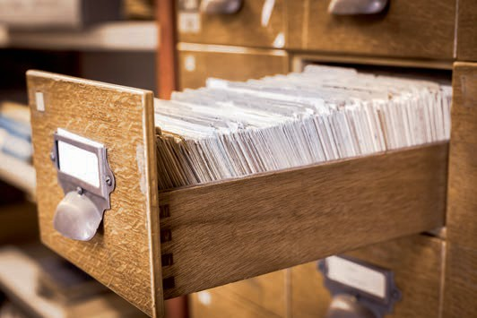

# Appendix 1

## Bibliograph

### Bibliograph

**Adam, F./Ludwig, P./Mühe, M. (2013):** *Wie beeinflussen Smartphones und Tablets das soziale Leben?* University of Frankfurt. (URL: <http://www.uni-frankfurt.de/45074138/> Vortrag-Tablets-Muehe-Ludwig-Adam.pdf [last access: 10.08.2018]).

**Agrawal, D. P./Zeng, Q. A. (2015):** *Introduction to Wireless and Mobile Systems*. 4. Edition, Cengage Learning, Boston.

**Arefin, M. T./Ali, M. H./Haque, A. K. M. F. (2017):** *Wireless Body Area Network: An Overview and Various Applications*. In: Journal of Computer and Communications, 5th Issue year., issue 7,

pp. 53-64.

**Bendel, O. (2018):** *Smartwatch*. In: Gabler Wirtschaftslexikon. (URL: https://wirtschafts- lexikon.gabler.de/definition/smartwatch-54075/version-277129 [last accessed: 10.08.2018]).

**Breckenridge, R. A./Husson, C. (1978):** *Smart sensors in spacecraft: the impact and trends*. Proceedings of the AIAA/NASA Conference on Smart Sensors, Hampton (VA). ECS Transactions.

**Bürger, T./Tragl, K. (2017):** *SPS-Automatisierung mit den Technologien der IT-Welt verbinden*. In: Vogel-Heuser, B./Bauernhansl, T./ten Hompel, M. L. (Eds.): Handbuch Industrie 4.0. Vol. 1: Manufacturing. 2. Edition, Springer Vieweg, Berlin, pp. 207-218.

**Buxton, B./Billinghurst, M. (2018):** *Gesture Based Interaction*. (URL: http://www.billbux- ton.com/input14.Gesture.pdf [last accessed: 06.01.2019]).

**Dalakov, G. (2013):** *The Dynabook of Alan Kay*. (URL <http://history-computer.com/> ModernComputer/Personal/Dynabook.html [last accessed: 10.08.2018]).

**Floemer, A. (2018):** *Was mit euren Sprachaufnahmen von Amazon Echo und Google Home passiert und wie ihr sie löschen könnt*. (URL: https://t3n.de/news/alexa-echo- google-assistant-sprachaufnahmen-loeschen-verwalten-881818/ [last accessed: 06.01.2019]).

**Fortino, G. et al. (2014):** *Middleware for Smart Objects and Smart Environments: Overview and Comparison*. In: Fortino, G./Trunfio, P. (Eds.): Internet of Things Based on Smart Objects. Technology, Middleware and Applications. Springer Switzerland, Cham et al, pp. 1-28.

**Friedewald, M. et al. (2010):** *Ubiquitäres Computing. Das „Internet der Dinge“ – Grundlagen, Anwendungen, Folgen*. edition sigma, Berlin.

**Gardner, J./Bartlett, P. (1999):** *Electronic noses. Principles and applications*. Oxford University Press, Oxford.

Bibliography

**Gardner, J./Varadan, V./Awadelkarim, O. (2001):** *Microsensors, MEMS, and Smart Devices*. John Wiley & Sons, Hoboken (NJ).

**Gerardus, B. (2018):** *Smartglasses – A Clear and Concise Reference*. CreateSpace Independent Publishing Platform.

**GSMA (2014):** *Understanding the Internet of Things (IoT)*. GSMA, July 2014. (URL: https:// [www.gsma.com/iot/wp-content/uploads/2014/08/cl_iot_wp_07_14.pdf](http://www.gsma.com/iot/wp-content/uploads/2014/08/cl_iot_wp_07_14.pdf) [last accessed: 06.12.2018]).

**Haleem, M. S. (2009):** *Voice controlled automation system*. In: Proceedings of the 12th IEEE International Multitopic Conference.

**Hofbauer, C. (2008):** *Geschäftsmodelle Quadruple Play – Eine Einschätzung der Entwicklung in Deutschland*. Gabler GWV, Wiesbaden.

**Immelt, J. (2014):** *"If you went to bed last night as an industrial company you're going to wake up a software & analytics company."* Tweet. (URL: https://twitter.com/general- electric/status/520209881375072257 [last accessed: 09.01.2019]).

**Kagermann, H. (2011):** *Industrie 4.0: Mit dem Internet der Dinge auf dem Weg zur 4. industriellen Revolution*. (URL <http://www.vdi-nachrichten.com/Technik-Gesellschaft/> Industry-40-With-Internet-Things-Way-4-Industrial-Revolution [last accessed: 10.08.2018]).

**Kaku, M. (2011):** *Physics of the Future: How Science Will Shape Human Destiny and Our Daily Lives by the Year 2100*. Doubleday, New York.

**König, W. A./Rädle, R./Reiterer, H (2010):** *Interactive Design of Multimodal User Interfaces. Reducing technical and visual complexity*. In: Journal on Multimodal User Interfaces, 3rd Issue year, issue 3, pp. 197-213.

**Konrad, T. (2018):** *Apples Siri: Die Rechtspopulistin unter den digitalen Assistenten?* (URL: https://[www.giga.de/apps/siri/news/apples-siri-die-rechtspopulistin-unter-den-](http://www.giga.de/apps/siri/news/apples-siri-die-rechtspopulistin-unter-den-) digital-assistants/ [last accessed: 06.01.2019]).

**Kriwan, A. (2017):** *Indoor-Lokalisierung zur Prozessoptimierung in Radiologiepraxen: Entwicklung eines Frameworks zur Optimierung von Arbeitsprozessen in Radiologiepraxen*. AV Akademikerverlag, Saarbrücken.

**Lanzer, W. (2012):** *Kontextsensitive Services für mobile Endgeräte. Spezifizierung und Evaluation eines Steuerungsmodells im Mobile Marketing*. Gabler, Wiesbaden.

**Laudon, K./Laudon, J./Schoder, D. (2015):** *Wirtschaftsinformatik. Eine Einführung*. Pearson Education Germany, Munich.

**Levin, M. (2015):** *Fashion with Function – Designing for Wearables*. In: Follett, J. (Ed.): Designing for Emerging Technologies – UX for Genomics, Robotics, and the Internet of Things. O'Reilly Media, Beijing et al, pp. 65-114.

**McRaney, D. (2012):** *Maslow’s Hammer*. (URL: https://[www.psychologytoday.com/intl/](http://www.psychologytoday.com/intl/) blog/you-are-not-so-smart/201203/maslows-hammer [last accessed: 06.01.2019]).

**Mentor, J (2013):** *2004 Microsoft SPOT Watch Smartwach Review*. (URL: https:// wear.guide/2004-microsoft-spot-watch-smartwatch/ [last accessed: 06.01.2019]).

**O. V. (2002):** *An Introduction to MEMS (Micro-electromechanical Systems)*. PRIME Faraday Partnership. (URL: https://[www.lboro.ac.uk/microsites/mechman/research/ipm-](http://www.lboro.ac.uk/microsites/mechman/research/ipm-) ktn/pdf/Technology_review/an-introduction-to-mems.pdf [last accessed: 13.12.2018]).

**O. V. (2014):** *The 5 Types of Touch Screen Technology*. Tru-Vu. (URL: https://www.control- design.com/assets/14WPpdf/1407TouchScreenBasicsComparisons.pdf [last accessed: 10.08.2018]).

**O. V. (2018):** *Internet der Dinge im Krankenhaus*. (URL: https://[www.if-krankenhaus.de/](http://www.if-krankenhaus.de/) fokusthemen/facility-management-4-0/internet-der-dinge-im-krankenhaus.html [last accessed: 10.08.2018]).

**Penttinen, J. T. J. (2017):** *Wireless Communications Security*. John Wiley & Sons, Hoboken (NJ).

**Pitscheneder, T. (2017):** *Google Glass: Die Datenbrille ist zurück – mit einem Haken*. (URL: https://[www.computerbild.de/artikel/cb-News-Internet-Google-Glass-Enter-](http://www.computerbild.de/artikel/cb-News-Internet-Google-Glass-Enter-) prise-18557485.html [last accessed: 06.01.2019]).

**Poslad, S. (2009):** *Ubiquitous Computing: smart devices, environment, and interactions*. John Wiley & Sons, Hoboken (NJ).

**Postscapes (2019):** *IoT Standards and Protocols: An overview of protocols involved in Internet of Things devices and applications. Help clarify with IoT layer technology stack and head-to-head comparisons*. (URL: https://[www.postscapes.com/internet-of-things-](http://www.postscapes.com/internet-of-things-) protocols/ [last accessed: 08.01.2019]).

**PWC (2018):** *Schwerpunkt: Digitalisierung und neue Technologien.* In: PwC Maschinenbau-Barometer Q2/2018. (URL: https://[www.pwc.de/de/industrielle-produktion/pwc-](http://www.pwc.de/de/industrielle-produktion/pwc-) machinery-barometer-q2-2018.pdf [last accessed: 09.01.2019]).

**Rimé, B./Schiaratura, L. (1991).** *Gesture and speech*. In: Feldman, R. S./Rimé, B. (Eds.): Fundamentals of nonverbal behavior. Cambridge University Press, New York, pp. 239-281.

**Sager, I. (2012):** *Before iPhone and Android Came Simon, the First Smartphone*. (URL <http://www.businessweek.com/articles/2012-06-29/before-iphone-and-android-came-> simon-the-first-smartphone [last accessed: 10.08.2018]).

Bibliography

**Sioshansi, P. (2011):** *Smart Grid: Integrating Renewable, Distributed and Efficient Energy*. Academic Press Verlag, Waltham (MA)/Kidlington.

**Statista (2018a):** *Number of Machine-to-Machine (M2M) connections worldwide from 2014 to 2021 (in billions)*. (URL: https://[www.statista.com/statistics/487280/global-m2m-](http://www.statista.com/statistics/487280/global-m2m-) connections/ [last accessed: 10.08.2018]).

**Statista (2018b):** *Prognose zum Volumen der jährlich generierten digitalen Datenmenge weltweit in den Jahren 2016 und 2025 (in Zettabyte)*. (URL: https://de.statista.com/statis- tik/data/study/267974/survey/forecast-world-generated-data-volume/ [last accessed: 10.08.2018]).

**Stolpen, C./Weber, T. (2017):** *Home Smart Home. Der praktische Einstieg in die Hausautomation*. Hanser, München.

**Tanenbaum, A. S./Wetherall, D. J. (2012):** *Computernetzwerke*. 5th Edition, Pearson, Munich.

**Valhouli, C. A. (2010):** *The Internet of things: Networked objects and smart devices*. The Hammersmith Group, New York/Bradford (MA). (URL: https://www.theinternetof- things.eu/sites/default/files/Rob van Kranenburg/networked_objects.pdf [last accessed: 10.08.2018]).

**Veltkamp, N. (2017):** *Mobile Steuerungszentrale für das Internet of Things*. (URL: https:// [www.bitkom.org/Presse/Presseinformation/Mobile-Steuerungszentrale-fuer-das-Inter-](http://www.bitkom.org/Presse/Presseinformation/Mobile-Steuerungszentrale-fuer-das-Inter-) net-of-Things.html [last accessed: 10.08.2018]).

**Weiser, M. (1991):** *The computer for the twenty-first century*. In: Scientific American,

265. Issue year, issue 3, pp. 94-104.

**Werner, M. (2017):** *Smart Clothes*. (URL: https://[www.planet-wissen.de/gesellschaft/](http://www.planet-wissen.de/gesellschaft/) fashion/hightech_clothes/pwiesmartclotheselectronicstowear100.html [last accessed: 10.08.2018]).