## 1.a. Scientific background

Figure 1: The effect of shipping noise on the foraging of *Orcinus orca* shows that their prey detection capabilities rapidly deteriorate as they gets closer to a vessel.

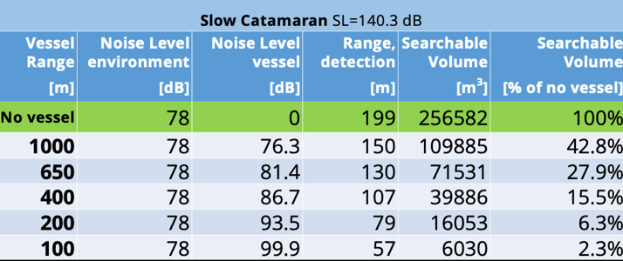

With the growing increase in human marine exploration and excavation, our seas have become noisier than ever driven by an over 50% increase in commercial vessels (in terms of deadweight) (UNCTAD, 2022). In Israel, recent demands have led to a 20% increase in commercial shipping traffic (UNCTAD, 2022) and the development of new seaport infrastructure to accommodate larger commercial vessels (Israports, 2022). With broadband noise in the 50 Hz - 10 kHz range and source levels ranging from 150-180 dB (Hatch, et al., 2008; Zhanga, Forlanda, Johnsena, Pedersena, & Dongb, 2020), there is a clear need to further study the environmental effects of such noise generation.

The impacts of underwater radiated noise (URN) pollution on different components of the marine ecosystem ranging from mussels to marine mammals have been widely explored across disciplines [9]. Several reports (e.g., [21, 16, 22, 23]) have suggested that blunt tissue trauma resembling a blast injury and behavioral changes reflected by social stability and foraging capability have the potential to afflict aquatic animals that come into close proximity to a vessel projecting high sound intensities from its thrusters or onboard machinery. The responses of a given aquatic animal to anthropogenic noise fall into five main categories [11]: (I) audibility, which depends on the animal’s detection threshold [12]; (II) behavioral responses reflected by alterations in the intensity, frequency, and intervals of the animal’s vocalizations [13] and by stress behaviors; (III) masking of sounds required for communication, localization, and foraging (see Figure 1 for *Orcinus orca*) [14]; (IV) physiological auditory threshold shifts due to fatigue in the hair cells of the inner ear [15]; and (V) physical damage (injury) to the auditory system [16]. In addition, there are direct risks associated with physical disturbances, as in the cases of sea turtles [17] and large baleen whales [18] colliding with vessels, partly because they have difficulty with low frequency sounds from boats [19]. Because of these effects, shipping-related URN is considered a source of pollution and should be monitored regularly via vessel noise measurements. Standards have thus been established to limit the transmitted acoustic power per exposure time [8], and regulatory organizations such as the CMS, CBD, ASCOBANS, and ACOOBAMS have passed resolutions aimed at reducing underwater noise produced by ships and other manmade sources. On the regional scale, the EU’s Marine Strategy Framework Directive (MSFD) obligates EU members to act in order to reduce the impact of underwater noise on marine life [120,121]. **However, the magnitude of noise from ships remains under-explored, especially along the coasts of Israel, and a quantitative study examining the extent of shipping URN has yet to be thoroughly conducted**. The main barrier to such studies is the establishment of a proper approach to evaluating the propagation of noise from a vessel to an appropriate receiver.

Shipping URN includes high-power impulsive transient waves generated by the vessel upon ignition [83], as well as cavitation noises, which are relatively stationary continuous-wave signals caused by the collapse of vapor bubbles near the propeller (Figure 2). These result in (1) low-frequency cavitation noise (~50 Hz) distributed over a huge area, which impacts the communication of large marine mammals including baleen whales and dolphins; (2) noise from 4-stroke engines (around 200-800 Hz) that are independent of speed, with a medium distribution likely to impact toothed whales; and (3) high-frequency cavitation noise with higher harmonics due to the Lloyd's mirror effect [73] (1 kHz-10 kHz, speed-dependent) that can carry significant quantities of acoustic energy likely to impact small mammals and fish.

Figure 2: Cavitation from a boat’s propelling system

When measuring shipping URN, a simple and efficient method is needed to isolate the anthropogenic component from the overall ambient sound. Methods for discriminating between URN and ambient noise generally assume that, while the ambient noise is diffuse, its anthropogenic component is directional, and can thus be extracted by array processing [84]. Relying on the expected relationship between the natural ambient sound level and the intensity of the wind-driven sea surface agitation [85], alternative sound level estimation methods have been developed based on model fitting for the dependence between the sound levels and wind speed [63], followed by data assimilation and model calibration [86]. Procedures for measuring the URN of vessels are described in the ANSI/ASA S12.64-2009 and ISO 17208-2:2019 standards, and in 2014, the IMO approved a set of guidelines aimed at reducing underwater noise from commercial vessels by improving the design, construction, and maintenance of ships. Key issues common to these standards are the requirement of a vessel's cooperation in measuring its URN and the need to conduct the measurement in a “noise range” that is free of interference using a large subsea infrastructure comprised of arrays of hydrophones [****]. In these noise ranges, the tested vessel is instructed to sail along a designated route in a well-explored area, and to follow fixed maneuvers. As a result, the standards do not need to offer means with which to identify the vessel and evaluate its location. From the perspective of physical acoustics, the acoustical properties of the range and its frequency response are assumed to be known or non-varying such that their influence can be readily compensated for even when not comprehensively modeled. As such, the current standards do not account for the acoustic propagation and scattering effects on a given vessel's URN, and they also fail to mitigate acoustic interference. As such, these current protocols (ISO 17208-2:2019) are impractical as a means of monitoring a vessel’s URN on a daily basis, and they are very poorly suited to estimating the cumulative effects of noise pollution generated by a given vessel.

In an uncontrolled environment, estimating the propagation losses between the source and the receiver requires the use of appropriate computational models (e.g., a waveguide modal propagation model) that account for the region's bathymetry (which can be extracted from echo-sounder data), seasonal/hourly sound speed profile(s) (obtained either from direct measurements or archival data), and bottom parameters [87]. Characteristics of the bottom and surface roughness, as well as volume inhomogeneities (e.g., internal waves) should also be incorporated into the model. However, the bottom parameters remain subject to relatively high degrees of uncertainty, making it desirable to be able to extract these properties from the recorded noise, following a general approach reported by [88,89].

Exploiting shipping and other noise sources to measure the properties of an acoustic medium, rather than using active sound sources, has been a focus of growing scientific interest. In [90], the authors studied the use of a shipping lane as a continuous acoustic source for the passive detection of the Ushant thermal front. In [87], geoacoustic inversion of tugboat noise via near-field-matched-field processing was conducted, with the noise being recorded on a horizontal array towed by the same ship. In [91], the broadband source spectrum of a passing ship and the compressional wave speed in the seafloor sediments were estimated using acoustic data collected by a bottom-moored autonomous underwater vehicle in very shallow water. In [92], inversion solutions were extracted from noise measurements of surface ship sources on an L-shaped array in the 2006 Shallow Water experiment. In [93], Bayesian geoacoustic inversion was applied to low-frequency narrow-band acoustic data, from a quiet surface ship, recorded on a bottom-moored horizontal line array in shallow water. **One major challenge will be adopting these approaches to the regular evaluation of the properties of sediment along channels that depend on the location of vessels of opportunity based on their unique noise profiles.** In this context, our earlier works show that correlating long-term measurements of noise from two synchronized hydrophones enables the evaluation of the sum of forward- and back-propagated Green's functions [94,95]. In turn, the inverse problem from receiver to source can be solved by the mode filtering of this noise correlation function [88,89].

In this project, we propose to design methods and protocols to assess the source URN levels produced by detected vessels of opportunity and to construct a continuously-updating database of source level values. Using *in situ* recordings, we will construct maps showing the cumulative effects of currently present ships on overall shipping noise pollution levels. Shipping URN maps are a common tool used to both evaluate stress factors for marine animals [96] and plan subsea and near-shore maritime construction projects [97]. Noise maps are also used to characterize URN and distributions thereof [98], as well as the impacts of different vessels on such noise [99]. In addition to the challenges of accurately modeling acoustic propagation discussed above, we have also identified a knowledge gap pertaining to the accurate estimation of the URN produced by a single vessel due to the presence of multiple vessels and the contribution of non-shipping noise, particularly near ports and shipping lanes. To this end, we will develop novel techniques to separate undesired noise from non-shipping URN sources to accurately model sound propagation, including estimating the sediment parameters by which they are governed, and to account for the effects of a receiver's environment (typically in shallow waters near a harbor) on its directivity modeling. A novel tracking mechanism will match the reports from vessels’ automatic identification systems (AIS) with their acoustic records to identify source vessels and their positions. AIS information has often been explored in marine applications [100]. In the context of shipping URN, AIS is used to attribute peaks in the DEMON response to identify passing vessels [101], or to predict noise levels by modeling URN levels [102]. To characterize URN recordings, AIS information can be used to model the spatial distribution of noises [103]. As in this project, other reports have described the use of AIS data to position vessels in the context of transmission loss calibration [104, 105]. However, vessel passages are assumed to be sporadic, whereas in this report we will address the challenge of identifying a single vessel when there are multiple nearby AIS tags. Reverse propagation models will be designed on-the-fly for the estimation of seabed characteristics in order to translate the received vessels' URN levels into corresponding source levels. **We will implement and deploy three recording units for two 6-month periods** across key locations along the Israeli coastline.

## 1.b. Research Objectives

Our goal in this project is to explore the degree of noise pollution along the Israeli shoreline. Long-term shipping noise measurements will be carried out in three locations, and methods will be developed to accurately evaluate URN levels and construct noise maps. These maps will serve as an efficient visualization tool for the monitoring of shipping noise, its geographical spread, and its endurance. Comparing the measured shipping to fixed thresholds such as temporary hearing threshold shifts (TTS) and permanent threshold shifts (PTS) [106], we will be able to validate our **hypothesis that shipping URN is a widespread form of pollution along the shores of Israel.** Our results will be disseminated to the marine regulation authority in Israel along with suggestions regarding how to reduce shipping URN levels through legislation and positive incentives. The objectives of this project are:

1. Develop techniques for identifying vessels of opportunity: automatic detection of an approaching vessel; localization and identification of a vessel via the AIS.
2. Design approaches to measuring the URN of a given vessel: removal of ambient and transient noise interference and measurement of the received URN level.
3. Establish techniques for source and projected noise level estimation: on-the-fly estimation of seabed characteristics from measured noise; evaluation of propagation losses using recovered channel properties; accounting for significant scattering effects on the receiver's effective directivity; compensating for directivity and propagation losses to compute URN source levels; projection of vessels' URN via forward wave propagation.
4. System implementation and measurements: deploy acoustic recorders in three key locations for 12 months; utilize the resultant data for: 1) model calibration; 2) URN measurement scheme performance studies; 3) applicability demonstration through noise map construction. The maps will quantify the extent to which shipping noise disturbs marine animals.
5. Develop methodologies and provide a policy package: We will formulate a policy package to monitor shipping URN and to encourage ship owners to reduce their vessel’s URN by disseminating noise pollution data to the public, offering positive incentives, and enforcing legislation.

## 1.c. Working hypothesis

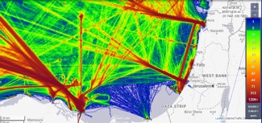

Figure 3: Density of shipping activity in the Eastern Mediterranean basin. Red color indicates higher stress.

**Our main hypothesis is that the levels of shipping URN along the Israeli shoreline are a major source of disturbance.** We argue that this is true not only proximal to ports, but also along shipping routes (Figure 3). To explore the magnitude of these disturbances, we will explore approaches to measuring the shipping URN of vessels of opportunity and will perform long-term data collection in key locations along the Israeli coast, while identifying and accounting for other anthropogenic sounds such as drilling, pile driving, and ambient noise in the area.

## 1.d. Significance and innovation

**The primary impact of the project will be environmental, with the goal of influencing URN monitoring standards.** Our work will develop cost-effective solutions to accurately measure shipping URN. While it is widely accepted that shipping URN impacts marine life, methodological barriers prevent the adoption of noise emission tests as a component of the annual safety testing for vessel registration, and extant systems are extremely expensive and are primarily used by naval forces to measure their vessels’ acoustic signatures. Linking noise levels to the numbers, types, and speeds of ships will be a necessary step when assessing potential noise impacts and is expected to lead to the development of mitigative measures and regulatory limits. The impacts of our work will thus include:

* Research: To improve the quality of *in situ* analyses of vessel URN signatures, our project will extend the current state-of-the-art with respect to localizing the acoustical centers of vessels of opportunity based on adaptive beamforming techniques and the fusion of AIS data, removing non-shipping URN from the estimated URN while assessing source levels through accurate modeling of propagation to the receiver. As it is not unusual for vessel noise to be higher at greater distances from a recorder than at a closer range, a greater understanding of the factors that influence sound transmission losses (as per WP 3) will be a great benefit.
* Regulations: Our project will provide a means for legislative authorities to incorporate noise emission testing into periodic safety testing for vessel registration. Notably, the developed methods will be proposed to the International Organization for Standardization (ISO) and to the American National Standards Institute and the Acoustical Society of America (ANSI/ASA). The developed techniques and the resultant noise maps could be used to quantify noise mitigation techniques.
* Conservation: Auditory weighting functions will enable the conversion from the measured noise levels to those. Converting the predicted noise maps to auditory weighting functions as perceived by marine animals [107] will be necessary to assess the impact of URN on marine mammals.
* Commercial: As a vessel’s noise is indicative of its performance, the developed noise monitoring system may be of value for ship maintenance and damage assessment efforts. We anticipate that, with limited effort, a prototype could be designed to target the large vessel health-monitoring market and the future market centered around the measurement of levels of vessel noise pollution.

The novelty of our work will be five-fold: 1) A new technology for the detection, localization, and identification of a noise-emitting vessel; 2) A novel method allowing for the estimation of sediment parameters based on noise measurement, allowing for the accurate characterization of the waveguide and the calculation of waveguide mode filtering; 3) Development and extension of fast algorithms for scattering analyses, Green's function tabulation, and rapid reconstruction in complex environments that can be applied to comprehensively model receiver directivity in realistic underwater scenarios; 4) A new method for accurately measuring a vessel of opportunity's URN, incorporating noise mitigation from non-shipping sources and adequately accounting for sound propagation and scattering; and 5) A first attempt and potential experimental proof-of-concept for the estimation of URN generated by passing vessels of opportunity.

## 1.e. Detailed description of the proposed research

### 1.e.i Scientific design & methods:

Our proposed approach to measuring the URN of vessels of opportunity and noise map generation comprises four work packages (WPs). WP1, corresponding to Objective 1, will focus on the detection, identification, and classification of a vessel of opportunity. WP2, corresponding to Objective 2, will focus on measuring the URN produced by vessels. WP3, corresponding to Objective 3, will center on the estimation of vessels’ URN source levels that will be projected to arbitrary locations of interest and aggregated into regional noise maps. Lastly, WP4, corresponding to Objectives 4 and 5, will be dedicated to implementing and testing the developed methods. For this project, we will conduct both short-term experiments with rented vessels for the sake of ground-truthing and model calibration, and long-term data collection in three locations across the shores of Israel. The project's main components are illustrated in Figure **** and are described below.

WP 1: Vessel Detection and Identification

To detect an approaching vessel, we will search for an expected characteristic signature: a cyclostationary response corresponding to thruster operation [119]. This process will employ a deep neural network configured to identify peaks within the DEMON analysis [108] over a sliding time window of measurement. This detection will be followed with an entropy detector designed to identify stationary signals by locating time-domain changes in the ambient noise. Then, relying on our previously developed approach for acoustic characterization [109, 110], a clustering solution will verify that the detected signals are related to shipping URN. To that end, rather than setting a detection threshold that, in close proximity to harbors, may suffer from a high false positive rate, we will instead verify detection by clustering the posterior levels of the recorded samples into ‘noise’ and ‘signal’ sets. The clustering will entail expectation-maximization-based parameter estimation that will use the spectral entropy samples as inputs. Based on our recent work on clustering shipping noise [111,112], this algorithm will be initialized by dictionary learning.

Once a vessel has been acoustically detected, we will identify its type and location. This information is provided by the vessel's AIS, and is logged in databases (see [82]). Unlike the current use of sporadic AIS information to identify vessels and calculate transmission loss, the need to apply URN measurements proximal to ports where multiple AIS tags are constantly being reported will necessitate the identification of the projecting vessel within the AIS information. To match the detected vessel to its log, we will use the acoustic receiver array to compute the vessel's speed from its time-series Doppler shift and a time-series of its measured bearing. Considering the tracks of all vessels within a 10 km radius around the acoustic units as potential matches, we will employ a target motion analysis (TMA) tracker to find the most probable track that fits the measured speed and trajectory. Extending our previous work in [114], the TMA will include a grid search centered on the acoustic recorder, with a resolution relative to the separation of bearing measurements. Similar to our developed SYMBIOSIS system [65], these measurements will be obtained by a 4-hydrophone tetrahedral array with a 0.1 m edge length. **The array will also be used to separate different sources, thus allowing for URN estimation also when signals from multiple vessels are received**. Assuming the source is sufficiently distant from the monitoring station, we will avoid the ambiguities expected due to the small number of sensors by making use of the time difference of arrival (TDoA) among the signals received by each hydrophone.

WP 2: Measurement of a Vessel's Noise at the Recorder

To determine the detected vessel's URN level, we will eliminate all the non-shipping noise components from the recorded signal. Using the vessel's bearing estimations, ambient noise will be mitigated via standard beamforming. However, mitigating transient signals will require their accurate identification. Relying on our recent work mitigating acoustic interference for underwater acoustic communications [115] and detection [116], we will develop a fast algorithm for mitigating such interference in the time domain. The removal of the impulse-like snapping shrimp noises will be carried out by adapting the Schur filter [47] to detect stationary signals by extracting intrinsic characteristics from the signals. In particular, instead of thresholding the filter's output, which does not account for time-dependencies between the noise samples and may, thus, lead to false alarms, we will extend our previous work [116] and employ a maximum-likelihood approach using a factor graph. As illustrated in Figure 4, relating to the filter's output samples as observations, and the decisions of their source as hidden nodes for belief propagation, our method will identify interference while relating to connections between consecutive samples. To mitigate wideband sonar and narrowband pinger signals, we will use our proven approach [117]. The identified transients will then be subtracted from the received signal.

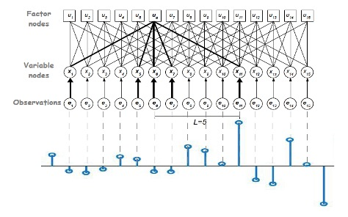

Figure 4: Illustration of the factor graph approach to identifying impulse-like signals.

To eliminate the contribution of anthropogenic sound to estimates of shipping URN levels, we will differentiate the data from two mutually synchronized hydrophones. When defining ${TL}_{i}$ as the transmission loss from the vessel to hydrophone $i$, and $SL$ as the vessel’s URN level, this approach yields the term $ΔRL=SL\left({TL}_{1}-{TL}_{2}\right)$, in which ambient noise has been canceled. This system of equations can be solved for each measurement in time; first for the unknown transmission loss using singular value decomposition (SVD), and then for the unknown mean URN level. The developed methodology will be tested at sea using recordings from calibrated acoustic sources.

After the noise cancellation, the received intensity will be calculated in the common 63 Hz and 125 Hz 1/3-octave bands while averaging the noise levels over time. Higher frequency bands will also be estimated to assess the potential impact of shipping noise up to 50 kHz on marine mammals. To this end, we will evaluate noise intensities in the frequency domain while employing a moving average filter to smooth power estimates over time. Measured URN will depend on the vessel’s speed. As this speed is recorded in the vessel’s AIS data, we can use available functions (e.g., [73]) to model the effect of speed on URN and to **generate noise maps corresponding to different nominal vessels’ speeds**.

WP 3: Estimation of URN Source Level

Given a vessel's location and measured noise intensity, we can evaluate its URN source level. To this end, two components of the sonar equation need to be computed accurately: (i) the propagation (or transmission) loss and (ii) the receiver's effective array pattern (directivity index). The former requires comprehensive models that account for the region's bathymetry (extracted from existing maps), sound speed profile (regularly measured), and sediment properties. These are particularly challenging to measure and approaches to extracting them from noise measurements will be a key focus of this WP. The extracted properties can then be used with various wave propagation models. As to the effective array pattern, it should account for significant reflections by large objects in the receiver's vicinity as well as those from the sediment and surface. Models and fast algorithms suited to this purpose will be another major focus of this WP.computation will be another major task of this WP. Calibration of these physical models, following early measurements in WP4, will be carried out for vessels of known source levels measured in regions of high certainty with respect to the acoustic channel parameters.

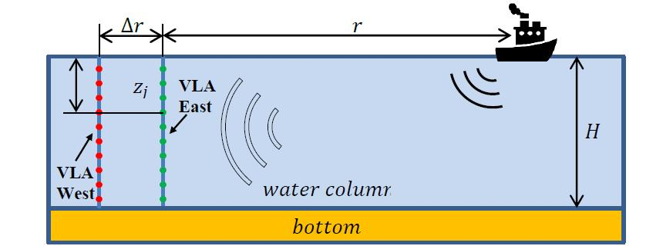

Figure 5: Schematic overview of sediment characterization experiments.

Novel techniques will be developed to estimate the environmental properties required for propagation modeling using shipping noise itself, with an emphasis on sediment parameters. Our method will function with either a vertical line array (VLA) receiver, two synchronized VLAs (see Figure 5), a single hydrophone, or two synchronized hydrophones (SHRUs). For a single VLA, we will record the sound field produced by a moving vessel over some time interval, typically several dozen minutes. By relying on knowledge of the vessel's exact position, we will be able to extract the dependence of parameters of the waveguide modes on the distance (ship – VLA). Using algorithms similar to [118], we will solve the inverse problem to estimate the sound speed in sediment. For the case of two synchronized VLAs placed several dozen meters apart, we will compare the amplitudes of the modes of the two VLAs. These should be similar due to the rather short distance between arrays. The modal attenuation coefficients can be extracted from the difference in the modal amplitudes near the cut-off frequency and will be used as inputs for the inversion algorithm. The advantage of this method is that it does not require knowledge of the vessel's exact position.

For the case of a single hydrophone, mode filtering will be performed by using a measurement of the dispersion curves of the waveguide modes for a wide frequency band, using the arrival times of modal pulses. Then, using the estimated location of the vessel from its AIS, we can implement an inversion scheme to extract the sediment properties after extracting the modal parameters as a function of distance to the vessel. Combining this approach with the two VLA strategy, we can use a pair of synchronized hydrophones to obtain the dispersion curves of each of the waveguide modes. Then, via comparisons near the cut-off frequencies of each mode, we can extract the attenuation coefficients for use with the inversion algorithm to obtain the sediment properties.

Using the extracted sediment properties, WP3 will include the implementation of pertinent sound propagation computing schemes. Possible methods to be used for the propagation model are the ray approximation, the parabolic equation (PE) method, and modal decomposition. These will be used for both inverse propagation (computing a vessel's source level from the URN level measured via WP2) and forward propagation (projection of the source URN level to arbitrary locations to form noise maps). For the latter, we will consider current regulations for acoustic emissions [8] to determine the regions most affected by the URN of detected vessels. **Noise maps will be produced by aggregating the contributions from the various vessels detected in this study.**

WP 4: *In situ* Measurements and Policy-Making

To demonstrate and study the performance of the developed methods, we will implement an acoustic recorder for long-term data collection. The recorder will be deployed for both short-term sea experiments and long-term data collection. The short-term measurements will be used to calibrate and tune the numerical models of WP3 (estimation of sediment properties). The long-term deployments will include data collection for two 6-month periods in three key locations off the shores of Israel: near the Haifa and Ashdod ports and across from the Achziv shore. The port locations will serve as examples of noisy industrial environments with heavy marine traffic. The Achziv location will be used to demonstrate a monitoring operation in a marine protected area. Another reason for choosing these sites is their differences in the properties of these habitats. Specifically, in Ashdod there is primarily a soft bottom while Haifa and Achziv present with rockier conditions in the vicinity of the shipping lanes. We will be offsetting the potential effect of depth by choosing three sites with the same bottom depth. In all locations, the instruments will be placed on a submerged mooring 2 m above the seabed at a water depth of up to 30 m. Scientific scuba divers from our team will both deploy and service the units periodically and retrieve the collected data. During these deployments, AIS data will be collected by designated receivers already placed in the University of Haifa.

The recording units will include the four array hydrophones (manufactured by Colmar, Inc.) arranged in a tetrahedral array. The housing will encapsulate batteries sufficient for 6-months of continuous data collection, a low-power (1.5W) NVIDIA Jetson NANO controller with data acquisition for the detection of vessels and the recording of their raw acoustic signature, and a pre-amplifier for each hydrophone. From their acoustic signatures, the URN of the detected vessels will be extracted offline in the frequency range up to 50 kHz to assess the potential impact of URN on marine mammals. This will be implemented in a JULIA environment, which we used successfully during our H2020 SYMBIOSIS project [65].

WP4 will also include a policy package to disseminate our results to legislative authorities. The policy analysis will include an economic assessment of the resulting benefits to ecosystem services (e.g., fisheries, wildlife tourism) and the quantification of benefits to biodiversity. A cost-benefit analysis and decision-support tools will be developed in the form of a cost-benefit equation. Through our experience in exploring maritime policy and strategy, we will explore financial incentives for ship owners by ranking vessel types according to their noise levels and giving quiet vessels priority entrance to the port.

### 1.e.ii Research team

The project's primary investigator will be Prof. Roee Diamant, who leads the Underwater Acoustic and Navigation Laboratory (ANL). Prof. Diamant is an expert on underwater sensing technologies and has developed algorithms for underwater acoustic detection, marine navigation, underwater localization, underwater acoustic communication, and machine learning applications for pattern recognition. He has vast experience conducting sea experiments and a strong background leading projects in both academia and industry. Prof. Diamant also runs the University of Haifa’s marine observatory THEMO (see [68,69]), where long-term acoustic recording is conducted, and has two decades of experience in subsea engineering and conducting sea experiments. His team has already developed a novel technique for estimating the URN of Nobel Energy’s gas pipeline, and took part in an exploration led by the Israeli Ministry of Energy to identify the risks of shipping URN to aquatic animals and to develop technological solutions for their protection.

Collaborating with Prof. Diamant will be Prof. Boris Katsnelson of the Dept. of Marine Geosciences, University of Haifa), who is an expert in underwater acoustics and acoustical oceanography, and Prof. Shaul Horev, who is the head of the Haifa Research Center for Maritime Policy and Strategy, and studies strategic, geographic, and legal issues in the maritime domain. Prof. Katsnelson will assist in solving the acoustic inverse problems and with the characterization of the seabed from the URN recordings. Prof. Horev will manage dissemination efforts, transmitting the scientific data collected for the project to legislative offices. H will also analyze the cost-benefit equation for reducing URN levels. An external collaborator will be Dr. Junio Fabrizio Borsani from the Institute for Environmental Protection and Research (ISPRA) of the Italian Ministry of the Environment. Dr. Borsani is a zoologist with 35 years of experience in underwater acoustics with the Italian Navy and with the Woods Hole Oceanographic Institution. He is the chair of the EU Technical Group on Underwater Noise (TG NOISE), whose focus is on methods for the measuring and monitoring of shipping URN. He will assist in identifying policy gaps and building an implementation roadmap.

### 1.e.iii Preliminary Results

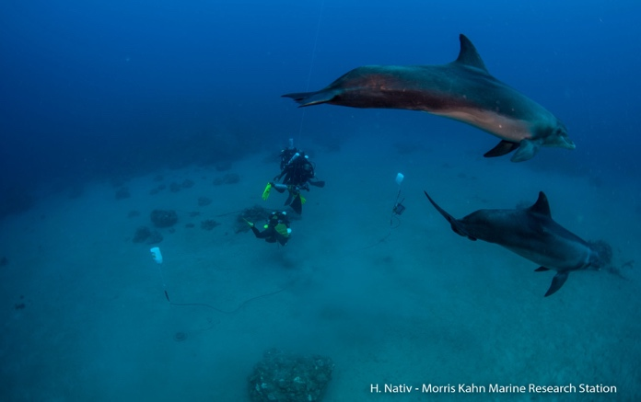

Figure 6: The deployment setup with dolphins inspecting the instruments. Eilat, July 2021.

We have conducted preliminary research on four items, which we regard as key to reducing the risks associated with the proposed research: 1) acoustic array structures for bearing estimates from wideband signals; 2) estimation of wideband noise levels; 3) remote sensing for sediment analyses; and 4) recorder implementation. The configuration of the recording array (required for WP4) was tested. In comparison to planner arrays and sparse arrays, the tetrahedron structure exhibited advantages in terms of the white noise gain (increased signal-to-noise ratio), with reduced ambiguity in directional findings at the manageable cost of increased beam width. The beam patterns for this configuration when scanning at 0°(broadside) and 45° are shown in Figure 8.

**Figure 7: Pipeline noise level and Wenz Curves [81] plus 10 dB (black line). Sea-state 1. X-axis: frequency [Hz]. Y-axis: acoustic intensity dB//1uPa/Hz**

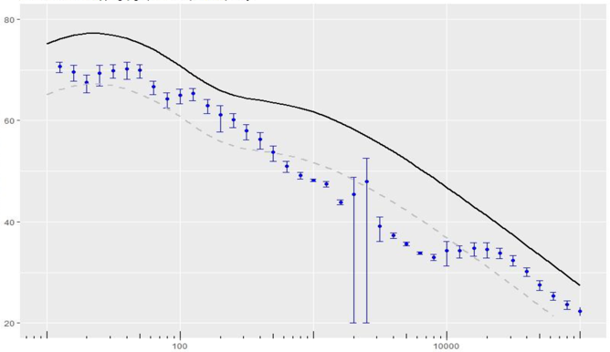

Preliminary results for estimating URN levels (required for WP2) have been collected when measuring the URN from the TAMAR MARI-B underwater gas pipe, which, like a vessel, is a large acoustic source. This steel gas pip is 30” in diameter and mounted on the seabed at a depth of roughly 70 m, partly covered by sand at the bottom, with exposed joints every 10 m. The noise is mainly due to turbulence in the gas. The setup includes two acoustic JASCO AMAR receivers, positioned by an ROV at distances 5 m and 10 m from the pipe, respectively, continuously recording raw acoustic data from a single hydrophone at a high sampling rate for 4 days. This activity was performed in collaboration with Nobel Energy (now Chevron). The employed methodology is illustrated in Figure 9. Data processing included: 1) power spectral conversion, 2) windowing and averaging, 3) a quieting filter for shipping noise and snapping shrimp noise, and 4) cancellation of ambient noise levels by subtracting site 1 data from site 2 data. The evaluating source power level (SPL) was compared across the frequency domain with the Wenz model [71] for ambient noise level at sea-state 0 (wind speed < 1 knot). Figure 6 shows that the pipeline’s noise was well below the ambient noise level, which demonstrates the effectiveness of this methodology for measurements with a low SNR.

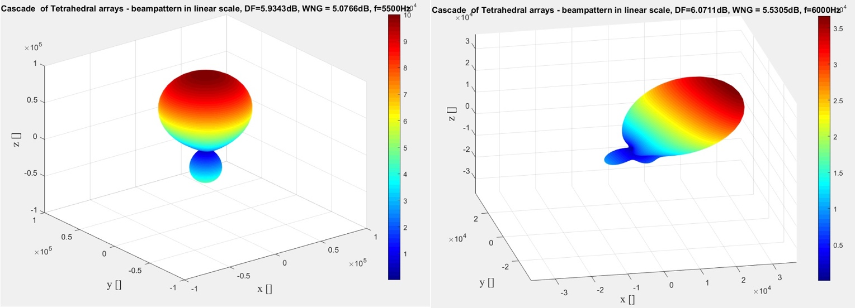

Figure 8: Computed beam pattern for a tetrahedral 4-hydrophone array. Left: broadside. Right: 45 degrees.

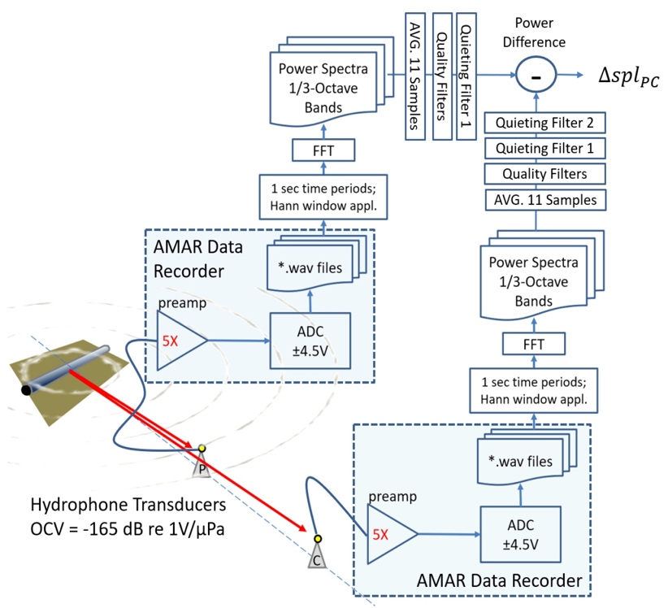

Figure 9: A block diagram for calculating the URN of a gas pipeline

For WP3, to verify the practicability of our suggested solution for estimating sediment characteristics, we performed preliminary data collection using an R/V set moving along a known trajectory. By comparing the measured and calculated sound fields, we verified the applicability of the proposed methodology and waveguide model by testing the content of gas deposits in the Kinneret (Sea of Galilee) using shipping noise. A moving R/V was used as a low-frequency noise source with a wideband spectrum. As a receiving system, two synchronized 27 m VLAs of 10 hydrophones each were deployed (Figure 9). These spanned the lower part of the water column, with intervals of 3 m. The VLAs were fixed in the center of the lake with 40 m between them. The R/V moved along a straight line connecting the VLAs at up to 1 km from the arrays. A mode-filtering procedure using two synchronized arrays such as that proposed herein was successfully employed to extract the complex eigenvalues (including modal attenuation) for each mode. The extracted attenuation coefficients demonstrated a considerable increase around the cut-off frequency for all normal modes, revealing that the sound speed at the bottom is much lower than that in the water, and that all the modes are leaky. The advantage of this scheme is that there is no need to know the position of the ship.

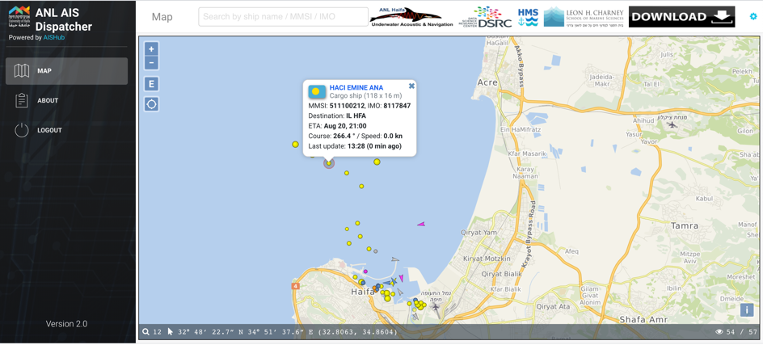

Figure 10: Snapshot from the AIS logger web-front

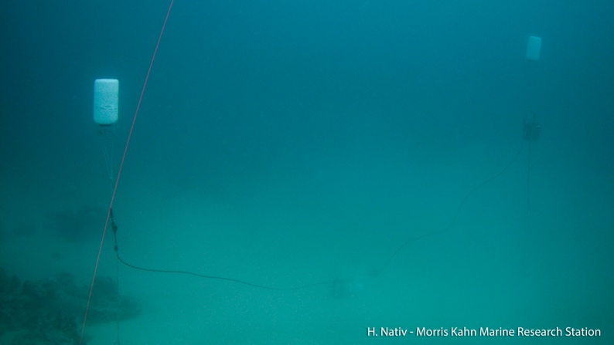

Figure 11: A photo of the preliminary version of the recorder, as deployed in Eilat at depth of 50 m

To test the data provided by AIS for locating vessels, we set up an AIS receiver on the roof of the University of Haifa, Israel, which continuously tracked the AIS recordings of passing vessels. The recorded data is shared at [82]. Figure 10 shows a snapshot from this system; collected data includes the vessel’s track, its type, and its speed and load. Figure 5 shows shipping routes collected over a 12-month period from AIS data across the shores of Israel. In the Figure, the shipping lanes are shown by the higher intensity recorders marked in red; yet evidence of intense shipping activity is shown with almost no shipping-free zones. This result emphasizes the need for the monitoring of shipping URN.

Figure 12: (Upper) Bathtub curves of a ship’s presence. Bottom of curve indicates closest approach time of the vessel. (Lower) Narrowband noise from a fishing boat.

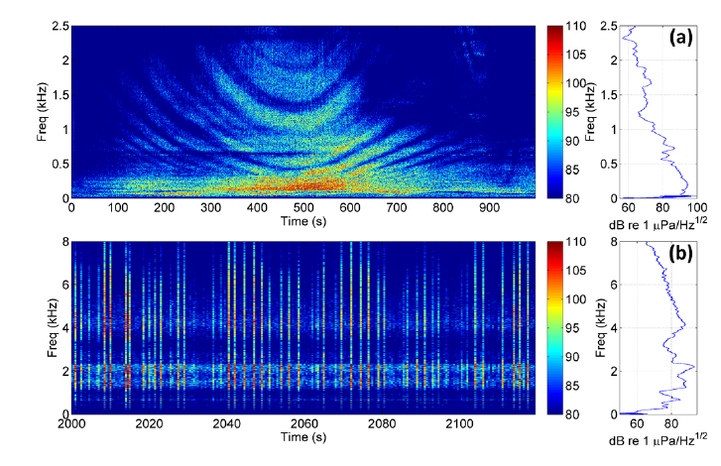

Finally, to demonstrate our ability to design an acoustic recorder (relevant to WP4), we designed and constructed a device that continuously records acoustic data. This self-designed recorder was then encapsulated within a self-designed housing alongside a high-power battery, a low-power Raspberry Pi Zero computer integrated with a data acquisition card (sampling at 96k samples per sec), a pre-amplifier, and a hydrophone. The recorder was deployed for one month across the shores of Eilat, Israel, at a depth of 50 m. A picture of the recorder in its deployment site is shown in Figure 11. A preliminary 5 hour test in Northern Israel included a recorder at a depth of 2 0m that continuously recorded acoustic data. The evaluated track traversed through the main shipping lane entering the Haifa port and covered a roughly 5 km distance. Manual analysis identified several vessels and linked them to AIS recordings. Figure 12 shows a time-frequency curve of a large 100 m-long container ship roughly 4.5 km from q recorder with a URN of 110 dB Re. 1uPa^2/Hz extending beyond the 25 kHz. Noise from a fishing boat (1 km away) is shown, including high-intensity transients. In our project, this design will be extended to record from 4 hydrophones, over longer deployment periods.

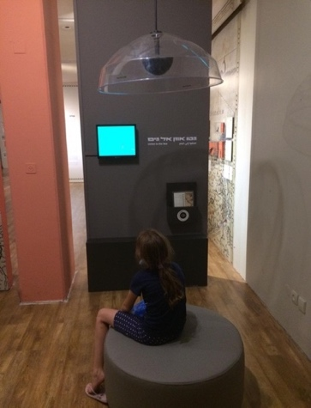

Figure 13: The display in the Haifa Maritime Museum on the impacts of shipping URN.

Raising Public Awareness

In order to effectively counter the impact of shipping noise on marine life, decision-makers must actively strive to increase public awareness and regulation while working closely with neighboring countries and regional actors. Thus, an important part of our project is the dissemination of our results to legislative authorities and the general public. The project's outcomes and results will be presented in key venues including top scientific journals (i.e., IEEE TMC, IEEE TGRS, IEEE JOE, and JASA). Furthermore, we plan to hold demonstrations of our URN estimation capabilities at conferences such as "Breaking the Surface" and "Oceans". In Year II, we will also hold a workshop with international speakers focused on the project outcomes. With respect to legislative efforts, the PIs recently joined the steering committee of the International Offshore Petroleum Environment Regulators to build a worldwide network for the sharing of advanced technologies for monitoring sound and detecting aquatic animals at risk from artificial noise pollution.

A preliminary public awareness effort was made by establishing a year-long display in the Haifa Maritime Museum (Figure 13). The display exposes visitors to sounds made by marine mammals and vessels and demonstrates the impacts of shipping URN by playing vocalizations of marine mammals recorded in the presence of high levels of shipping URN.

### 1.e.iv Infrastructure

The PI’s lab is equipped with all instruments required for the project: 11 GTI M18 hydrophones for recording, 6 recording units capable of recording for up to two weeks; 2 acoustic arrays and a vector sensor for multichannel recordings; 2 low-frequency projectors (500-1500Hz, 3-8kHz) to mimic acoustic interference; a small boat for near-to-shore data collection; a 128-core AMD server with 8 units of DDR4 16 Gb RAM for data analysis; diving equipment; 4 floaters with extended WiFi connections as beacon platforms; an acoustic tank and saltwater pool to test and calibrate sensors; and THEMO moorings on the edge of the continental shelf to obtain temperature and water current meta-data.

The team has been given access by the Israeli Shipping Authority and the Israeli Nature and Park Authority to deploy acoustic sensors near and beyond shipping lanes and in marine-protected areas. Three additional self-made acoustic recorders will be built, and high-end memory sticks and a battery for long-term operation will be purchased. Rugged laptops are needed to download data on-site. We also require the rental of small boats on a monthly basis and the purchase of scuba diving equipment.

### 1.e.v Expected Results & Pitfalls

We expect to draw categorical conclusions about the magnitude of shipping URN in the Eastern Mediterranean basin that will be visualized using constructed noise maps. These results will be measured in terms of sound intensities along with areas of high acoustic interference above the established thresholds for anthropogenic noise affecting marine fauna. Considerable changes in sound intensity are expected near and beyond shipping lanes. Potential project pitfalls and contingencies are described below:

|  |  |
| --- | --- |
| Description of Risk (L=likelihood, I=impact) | Contingency Plan |
| Failure to separate the noise of a single vessel from ambient shipping URN. (L: medium, I: high) | Add recording elements to perform the localization of noise sources using a long baseline. |
| Significant numbers of vessels detected but not present in the AIS database. (L: low, I: medium) | Approach the Israeli navy to receive RADAR footage of vessels. |
| Heavy storms; damage to recording systems during long-term deployment. (L: medium, I: medium) | Dismount units in the case of an anticipated storm. |
| Imprecise environmental information hampers predictions of acoustic propagation loss to ground-truth the solution for sediment prediction. (L: low, I: high) | Conduct controlled experiments for the transmission of acoustic signals in a grid around the fixed recording units. |
| Low visibility of the project (L: low; I: medium) | Rely on the open access of methodology and data. Use of stakeholder groups to disseminate our results. |

## Bibliography

[1] Ketten, Darlene R. "Sonars and strandings: are beaked whales the aquatic acoustic canary." Acoustics Today 10, no. 3 (2014): 46-56.

[2] Ketten, Darlene R. Experimental measures of blast and acoustic trauma in marine mammals. WOODS HOLE OCEANOGRAPHIC INST MA BIOLOGY DEPT, 2004.

[3] Ketten, Darlene R. "Underwater ears and the physiology of impacts: Comparative liability for hearing loss in sea turtles, birds, and mammals." Bioacoustics 17, no. 1-3 (2008): 312-315.

[4] McCauley, Robert D., Ryan D. Day, Kerrie M. Swadling, Quinn P. Fitzgibbon, Reg A. Watson, and Jayson M. Semmens. "Widely used marine seismic survey air gun operations negatively impact zooplankton." Nature Ecology & Evolution 1, no. 7 (2017): 0195.

[5] DeRuiter, Stacy L., and Kamel Larbi Doukara. "Loggerhead turtles dive in response to airgun sound exposure." Endangered Species Research 16, no. 1 (2012): 55-63.

[6] Popper, Arthur N., Anthony D. Hawkins, Richard R. Fay, David A. Mann, Soraya Bartol, Thomas J. Carlson, Sheryl Coombs, William T. Ellison, Roger L. Gentry, Michele B. Halvorsen "Sound exposure guidelines." In ASA S3/SC1. 4 TR-2014 Sound Exposure Guidelines for Fishes and Sea Turtles: A Technical Report prepared by ANSI-Accredited Standards Committee S3/SC1 and registered with ANSI, pp. 33-51. Springer, Cham, 2014.

[7] McCauley, Robert, Jane Fewtrell, Alec Duncan, Curt Jenner, Micheline-Nicole Jenner, John Penrose, Robert Prince, Anita Adhitya, Julie Murdoch, and Kathryn McKabe. "Marine seismic surveys: analysis and propagation of air-gun signals; and effects of exposure on humpback whales, sea turtles, fishes and squid. In Environmental implications of offshore oil and gas development in Australia: further research." Australian Petroleum Production and Exploration Association Journal (2003): 364-521.

[8] NATO. (2018). SONAR acoustics handbook. UComms 16 special edition. Science & Technology Organization, Centre for Maritime Research & Experimentation, La Spezia.

[9] Erbe, Christine, Sarah A. Marley, Renée P. Schoeman, Joshua N. Smith, Leah E. Trigg, and Clare Beth Embling. "The effects of ship noise on marine mammals—A review." Frontiers in Marine Science 6 (2019): 606.

[10] Sertlek, H. Ozkan, Hans Slabbekoorn, and Michael A. Ainslie. "The contribution of shipping sound to the dutch underwater soundscape: Past, present, future." In Proceedings of Meetings on Acoustics 5ENAF, vol. 37, no. 1, p. 070010. Acoustical Society of America, 2019.

[11] Erbe, Christine, Alexander MacGillivray, and Rob Williams. "Mapping cumulative noise from shipping to inform marine spatial planning." The Journal of the Acoustical Society of America 132, no. 5 (2012): EL423-EL428.

[12] Surlykke, Annemarie, Tórur Andreassen, and John Hallam. "Long-term acoustic surveying of bats." The Journal of the Acoustical Society of America 135, no. 4 (2014): 2241-2241.

[13] Reyes, M. V. R., M. Iniguez, J. Hildebrand, and M. Melcon. "Multivariate classification of echolocation clicks of Commerson's dolphins." Canadian Acoustics 40, no. 3 (2012).

[14] Clark, Christopher W., William T. Ellison, Brandon L. Southall, Leila Hatch, Sofie M. Van Parijs, Adam Frankel, and Dimitri Ponirakis. "Acoustic masking in marine ecosystems: intuitions, analysis, and implication." Marine Ecology Progress Series 395 (2009): 201-222.

[15] Finneran, James J., and Brian K. Branstetter. "Effects of noise on sound perception in marine mammals." In Animal communication and noise, pp. 273-308. Springer, Berlin, Heidelberg, 2013.

[16] Carretta, James V., Marcia Muto, Justin Greenman, Kristin Marie Wilkinson, Justin Viezbicke, Daniel D. Lawson, V. T. Helker, and Jason Earl Jannot. "Sources of human-related injury and mortality for US Pacific west coast marine mammal stock assessments, 2012-2016." (2018).

[17] Casale, P., Broderick, A.C., Camiñas, J.A., Cardona, L., Carreras, C., Demetropoulos, A., Fuller, W.J., Godley, B.J., Hochscheid, S., Kaska, Y., Lazar, B., Margaritoulis, D., Panagopoulou, A ., Rees, A.F., Tomas, J., Türkozan, O. (2018). Mediterranean sea turtles: current knowledge and priorities for conservation and research. Endangered Species Research 36: 229–267

[18] Sèbe, Maxime, A. Kontovas Christos, and Linwood Pendleton. "A decision-making framework to reduce the risk of collisions between ships and whales." Marine Policy 109 (2019): 103697.

[19] Calleson, C. Scott, and R. Kipp Frohlich. "Slower boat speeds reduce risks to manatees." Endangered Species Research 3, no. 3 (2007): 295-304.

[20] MAGLIO, Alessio, Gianni PAVAN, Manuel CASTELLOTE3 Silvia FREY, Medjber BOUZIDI, Bruno CLARO, Nicolas ENTRUP, Mahmoud FOUAD, Fabrice LEROY, and Johannes MUELLER. "Overview of the noise hotspots in the ACCOBAMS area." Final Report to the ACCOBAMS Secretariat (2015).

[21] Gordon, J., Gillespie, D., Potter, J., Frantzis, A., Simmonds, M.P., Swift, R., Thompson, D. (2003). A review of the effects of seismic surveys on marine mammals. Marine Technology Society Journal 37: 16-34.

[22] Nelms, S.E., Piniak, W.E.D., Weir, C.R., Godley, B.J. (2016). Seismic surveys and marine turtles: An underestimated global threat? Biological Conservation 193: 49-65.

[23] BOEM, (2016). Environmental impact statement for geological and geophysical activities in the Gulf of Mexico.

[24] Castellote, Manuel, and Carlos Llorens. "Review of the effects of offshore seismic surveys in cetaceans: are mass strandings a possibility?." In The effects of noise on aquatic life II, pp. 129-143. Springer, New York, NY, 2016.

[25] Erbe, Christine, Colleen Reichmuth, Kane Cunningham, Klaus Lucke, and Robert Dooling. "Communication masking in marine mammals: A review and research strategy." Marine pollution bulletin 103, no. 1-2 (2016): 15-38.

[26] Finneran, James J., Donald A. Carder, and Sam H. Ridgway. "Temporary threshold shift (TTS) in bottlenose dolphins (Tursiops truncatus) exposed to tonal signals." The Journal of the Acoustical Society of America 110, no. 5 (2001): 2749-2749.

[27] Daily, Gretchen C., Stephen Polasky, Joshua Goldstein, Peter M. Kareiva, Harold A. Mooney, Liba Pejchar, Taylor H. Ricketts, James Salzman, and Robert Shallenberger. "Ecosystem services in decision making: time to deliver." Frontiers in Ecology and the Environment 7, no. 1 (2009): 21-28.

[28] López, B. D. (2011). Whistle characteristics in free-ranging bottlenose dolphins (Tursiops truncatus) in the Mediterranean Sea: Influence of behavior. Mammalian Biology, 76(2), 180-189.

[29] Herzing, Denise L. "Vocalizations and associated underwater behavior of free-ranging Atlantic spotted dolphins, Stenella frontalis and bottlenose dolphins, Tursiops truncatus." Aquatic Mammals 22 (1996): 61-80.

[30] Pirotta, Enrico, Nathan D. Merchant, Paul M. Thompson, Tim R. Barton, and David Lusseau. "Quantifying the effect of boat disturbance on bottlenose dolphin foraging activity." Biological Conservation 181 (2015): 82-89.

[31] Thomas, Len, and Tiago A. Marques. "Passive acoustic monitoring for estimating animal density." Acoustics Today 8, no. 3 (2012): 35-44.

[32] Mellinger, David K., Kathleen M. Stafford, Sue E. Moore, Robert P. Dziak, and Haru Matsumoto. "An overview of fixed passive acoustic observation methods for cetaceans." Oceanography 20, no. 4 (2007): 36-45

[33] Küsel, Elizabeth T., Tessa Munoz, Martin Siderius, David K. Mellinger, and Sara L. Heimlich. "Marine mammal tracks from two-hydrophone acoustic recordings made with a glider." Ocean Science 13, no. 2 (2017): 273.

[34] Buckstaff, Kara C. "Effects of watercraft noise on the acoustic behavior of bottlenose dolphins, Tursiops truncatus, in Sarasota Bay, Florida." Marine mammal science 20, no. 4 (2004): 709-725.

[35] Dede, Ayhan, Ayaka Amaha Öztürk, Tomonari Akamatsu, Arda M. Tonay, and Bayram Öztürk. "Long-term passive acoustic monitoring revealed seasonal and diel patterns of cetacean presence in the Istanbul Strait." Marine Biological Association of the United Kingdom. Journal of the Marine Biological Association of the United Kingdom 94, no. 6 (2014): 1195

[36] Rako, Nikolina, Caterina Maria Fortuna, Draško Holcer, Peter Mackelworth, Maja Nimak-Wood, Grgur Pleslić, Linda Sebastianutto, Ivica Vilibić, Annika Wiemann, and Marta Picciulin. "Leisure boating noise as a trigger for the displacement of the bottlenose dolphins of the Cres–Lošinj archipelago (northern Adriatic Sea, Croatia)." Marine pollution bulletin 68, no. 1-2 (2013): 77-84

[37] Goold, John C. "Acoustic assessment of populations of common dolphin Delphinus delphis in conjunction with seismic surveying." JOURNAL-MARINE BIOLOGICAL ASSOCIATION OF THE UNITED KINGDOM 76 (1996): 811-820

[38] Borelli, Da, Tb Gaggero, Ec Rizzuto, and Ca Schenone. "Analysis of noise on board a ship during navigation and manoeuvres." Ocean Engineering 105 (2015): 256-269.

[43] IMO, ME. "Guidelines for the reduction of underwater noise from commercial shipping to address adverse impacts on marine life." (2014).

[39] Merchant, N. D. (2019) ‘Underwater noise abatement: Economic factors and policy options’, Environmental Science and Policy. Elsevier Ltd, 92, pp. 116–123.

[40] Song, Hongjian, Feng Xu, Bangyou Zheng, Ying Xiang, Juan Yang, and Xudong An. "An automatic identification algorithm of Yangtze finless porpoise." In 2015 IEEE International Conference on Signal Processing, Communications and Computing, pp. 1-5. IEEE, 2015.

[41] Erbs, Florence, Simon H. Elwen, and Tess Gridley. "Automatic classification of whistles from coastal dolphins of the southern African subregion." The Journal of the Acoustical Society of America 141, no. 4 (2017): 2489-2500.

[42] Oswald, Julie N., Jay Barlow, and Thomas F. Norris. "Acoustic identification of nine delphinid species in the eastern tropical Pacific Ocean." Marine mammal science 19, no. 1 (2003): 20-037

[43] Esfahanian, Mahdi, Hanqi Zhuang, and Nurgun Erdol. "On contour-based classification of dolphin whistles by type." Applied Acoustics 76 (2014): 274-279.

[44] Padfield, Nick. "Exploring the classification of acoustic transients with machine learning." In Proceedings of ACOUSTICS, vol. 10, no. 13. 2019.

[45] Siddagangaiah, Shashidhar, Chi-Fang Chen, Wei-Chun Hu, Tomonari Akamatsu, Megan McElligott, Marc O. Lammers, and Nadia Pieretti. "Automatic detection of dolphin whistles and clicks based on entropy approach." Ecological Indicators 117 (2020): 106559.

[46] Caruso, Francesco, Giuseppe Alonge, Giorgio Bellia, Emilio De Domenico, Rosario Grammauta, Giuseppina Larosa, Salvatore Mazzola, Giorgio Riccobene, Gianni Pavan, Elena Papale, "Long-term monitoring of dolphin biosonar activity in deep pelagic waters of the Mediterranean Sea." Scientific Reports 7, no. 1 (2017): 1-12.

[47] I. Schur. "On power series which are bounded in the interior of the unit circle. i." In I. Schur Methods in Operator Theory and Signal Processing, pp. 31-59. Birkhäuser, Basel, 1986.

[48] Peso Parada, Pablo, and Antonio Cardenal-López. "Using Gaussian mixture models to detect and classify dolphin whistles and pulses." The Journal of the Acoustical Society of America 135, no. 6 (2014): 3371-3380.

[49] Ioana, Cornel, Cédric Gervaise, Yann Stéphan, and Jerôme I. Mars. "Analysis of underwater mammal vocalisations using time–frequency-phase tracker." Applied Acoustics 71, no. 11 (2010): 1070-1080.

[50] Gillespie, Douglas, Marjolaine Caillat, Jonathan Gordon, and Paul White. "Automatic detection and classification of odontocete whistles." The Journal of the Acoustical Society of America 134, no. 3 (2013): 2427-2437.

[51] Gruden, Pina, and Paul R. White. "Automated tracking of dolphin whistles using Gaussian mixture probability hypothesis density filters." The Journal of the Acoustical Society of America 140, no. 3 (2016): 1981-1991.

[52] Mellinger, David K., Stephen W. Martin, Ronald P. Morrissey, Len Thomas, and James J. Yosco. "A method for detecting whistles, moans, and other frequency contour sounds." The Journal of the Acoustical Society of America 129, no. 6 (2011): 4055-4061.

[53] Urazghildiiev, Ildar R., and Christopher W. Clark. "Acoustic detection of North Atlantic right whale contact calls using spectrogram-based statistics." The Journal of the Acoustical Society of America 122, no. 2 (2007): 769-776.

[54] Gillespie, Douglas, David K. Mellinger, Jonathan Gordon, David McLaren, Paul Redmond, Ronald McHugh, Philip Trinder, Xiao‐Yan Deng, and Aaron Thode. "PAMGUARD: Semiautomated, open source software for real‐time acoustic detection and localization of cetaceans." The Journal of the Acoustical Society of America 125, no. 4 (2009): 2547-2547.

[55] Erbe, Christine, and Andrew R. King. "Automatic detection of marine mammals using information entropy." The Journal of the Acoustical Society of America 124, no. 5 (2008): 2833-2840.

[56] Shkury, Guy, Joel Bud, Yotam Zuriel, Aviad Scheinin, and Roee Diamant. "Robust Automatic Detector And Feature Extractor For Dolphin Whistles." In OCEANS 2019-Marseille, pp. 1-7. IEEE, 2019.

[57] Helffrich, Jerome, and Sean A. Fulop. "Phase-locked loops in acoustic analysis." The Journal of the Acoustical Society of America 141, no. 5 (2017): 3916-3916.

[58] Carlosena, Alfonso, and Antonio Mànuel-Lázaro. "Design of high-order phase-lock loops." IEEE Transactions on Circuits and Systems II: Express Briefs 54, no. 1 (2007): 9-13.

[59] Hildebrand, John A. Workshop on the Detection, Classification, Localization and Density Estimation of Marine Mammals Using Passive Acoustics-2015. University of California San Diego La Jolla United States, 2015.

[60] Roee Diamant,” Clustering Approach for Detection and Time of Arrival Estimation of Hydrocoustic Signals,'' IEEE Sensors Journal, vol. 16, no. 13, pp. 5308-5318, 2016

[61] Roee Diamant, Dror Kipnis (#), Michele Zorzi, ”Clustering of Continuous Acoustic and Seismic Signals for Detection, Time-of-Arrival, and Parameter Estimation,'' IEEE Transactions on Geoscience and Remote Sensing, vol. 56, Num. 2, pp. 1017-1029, 2018

[62] Talmon Alexandri, Roee Diamant, ”A Reverse Bearings Only Target Motion Analysis (BO-TMA) for Improving Autonomous Underwater Vehicle (AUV) navigation accuracy", IEEE Transactions on Mobile Computing, vol. 18., Issue 3, pp. 494-506, 2019.

[63] Mustonen, Mirko, Aleksander Klauson, Thomas Folégot, and Dominique Clorennec. "Natural sound estimation in shallow water near shipping lanes." The Journal of the Acoustical Society of America 147, no. 2 (2020): EL177-EL183.

[64] Testolin, Alberto, and Roee Diamant. "Combining Denoising Autoencoders and Dynamic Programming for Acoustic Detection and Tracking of Underwater Moving Targets." Sensors 20, no. 10 (2020): 2945

[65] Diamant, Roee, Victor Voronin, and Konstantin G. Kebkal. "Design Structure of SYMBIOSIS: An Opto-Acoustic System for Monitoring Pelagic Fish." OCEANS 2019, pp. 1-6. IEEE, 2019.

[66] Alexandri, Talmon, Ziv Zemah Shamir, Eyal Bigal, Aviad Scheinin, Dan Tchernov, and Roee Diamant. "Localization of acoustically tagged marine animals in under-ranked conditions." IEEE Transactions on Mobile Computing (2019).

[67] Dubrovinskaya, Elizaveta, Paolo Casari, and Roee Diamant. "Bathymetry-aided underwater acoustic localization using a single passive receiver." The Journal of the Acoustical Society of America 146, no. 6 (2019): 4774-4789.

[68] Diamant, Roee, Anthony Knapr, Shlomo Dahan, Ilan Mardix, John Walpert, and Steve DiMarco. "THEMO: The Texas A&M‐University of Haifa‐Eastern Mediterranean Observatory." In 2018 OCEANS-MTS/IEEE Kobe Techno-Oceans (OTO), pp. 1-5. IEEE, 2018.

[69] Diamant, Roee, Ilan Shachar, Yizhaq Makovsky, Bruno Miguel Ferreira, and Nuno Alexandre Cruz. "Cross-Sensor Quality Assurance for Marine Observatories." Remote Sensing 12, no. 21 (2020): 3470.

[70] Caron, David D. "The International Whaling Commission and the North Atlantic Marine Mammal Commission: the institutional risks of coercion in consensual structures." The American Journal of International Law 89, no. 1 (1995): 154-174.

[71] Mellinger, David K., and Christopher W. Clark. "MobySound: A reference archive for studying automatic recognition of marine mammal sounds." Applied Acoustics 67, no. 11-12 (2006): 1226-1242.

[72] Urick, Robert J. "Principles of underwater sound 3rd edition." Peninsula Publising Los Atlos, California 22 (1983): 23-24.

[73] C. Audoly and V. Meyer, “Measurement of radiated noise from surface ships-influence of the sea surface reflection coefficient on the Lloyd’s mirror effect,” 2017

[74] Namdari, Alireza, and Zhaojun Li. "A review of entropy measures for uncertainty quantification of stochastic processes." Advances in Mechanical Engineering 11, no. 6, 2019.

[75] Scheinin A., Kerem D., Lojen S., Liberzon J., Spanier E. Resource partitioning between common bottlenose dolphin (Tursiops truncatus) and the Israeli bottom trawl fishery? Assessment by stomach contents and tissue stable isotopes analysis. J Mar Biol Assoc UK 94, (2014): 1203−1220

[76] Esch, H. Carter, Laela S. Sayigh, James E. Blum, and Randall S. Wells. "Whistles as potential indicators of stress in bottlenose dolphins (Tursiops truncatus)." Journal of Mammalogy 90, no. 3 (2009): 638-650.

[77] Michael B. Porter and Homer P. Bucker, ``Gaussian beam tracing for computing ocean acoustic fields,'' J. Acoust. Soc. Amer. 82, 1349--1359 (1987)

[78] Ori Galili, “Deciphering Distribution Differences Between Tursiops truncatus and Delphinus delphis along the Mediterranean Coastal Shelf of Israel through Habitat Preference Modeling”, MsC Thesis,  Faculty of Natural Sciences, University of Haifa

[79] Cook, M. L., Sayigh, L. S., Blum, J. E., & Wells, R. S. (2004). Signature–whistle production in undisturbed free–ranging bottlenose dolphins (Tursiops truncatus). Proceedings of the Royal Society of London. Series B: Biological Sciences, 271(1543), 1043-1049

[80] Tyack, Peter L. "Studying how cetaceans use sound to explore their environment." In Communication, pp. 251-297. Springer, Boston, MA, 1997

[81] Janik, V. M. (2009). Acoustic communication in delphinids. In M. Naguib & V. M. Janik (Eds.), Advances in the study of behavior (Vol. 40, pp. 123-157). Burlington: Academic Press.

[82] Roee Diamant, The AIS database of the ANL”. http://anlais.haifa.ac.il/@signalk/freeboard-sk/

[83] Jensen, Frants Havmand, Lars Bejder, Magnus Wahlberg, N. Aguilar Soto, M. Johnson, and Peter Teglberg Madsen. "Vessel noise effects on delphinid communication." Marine Ecology Progress Series 395 (2009): 161-175.

[84] Berdnikova, Julia, Aleksander Klauson, Mirko Mustonen, and Mihkel Tommingas. "Underwater ship noise pattern detection and identification." The Journal of the Acoustical Society of America 142, no. 4 (2017): 2686-2686.

[85] McDonald, Mark A., John A. Hildebrand, and Sean M. Wiggins. "Increases in deep ocean ambient noise in the Northeast Pacific west of San Nicolas Island, California." The Journal of the Acoustical Society of America 120, no. 2 (2006): 711-718.

[86] Häggmark, Lars, Karl-Ivar Ivarsson, Stefan Gollvik, and Per-Olof Olofsson. "Mesan, an operational mesoscale analysis system." Tellus A: Dynamic Meteorology and Oceanography 52, no. 1 (2000): 2-20.

[87] Battle, David J., Peter Gerstoft, William A. Kuperman, William S. Hodgkiss, and Martin Siderius. "Geoacoustic inversion of tow-ship noise via near-field-matched-field processing." IEEE journal of oceanic engineering 28, no. 3 (2003): 454-467

[88] Tan, Tsuwei, Oleg A. Godin, Adrien Lefebvre, Wandrille Beaute, Boris G. Katsnelson, and Marina Yarina. "Characterizing the seabed by using noise interferometry and time warping." In Proceedings of Meetings on Acoustics 176ASA, vol. 35, no. 1, p. 070001. Acoustical Society of America, 2018.

[89] Tan, Tsu Wei, Oleg A. Godin, Boris G. Katsnelson, and Marina Yarina. "Passive geoacoustic inversion in the Mid-Atlantic Bight in the presence of strong water column variability." The Journal of the Acoustical Society of America 147, no. 6 (2020): EL453-EL459

[90] Chailloux, C., B. Kinda, J. Bonnel, C. Gervaise, Y. Stephan, J. Mars, and J. P. Hermand. "Modelling of ambient noise created by a shipping lane to prepare passive inversion: application to Ushant." In Proceedings of the 4th Underwater Acoustics Measurements Conference (UAM 2011), vol. 26. 2011.

[91] Crocker, Steven E., Peter L. Nielsen, James H. Miller, and Martin Siderius. "Geoacoustic inversion of ship radiated noise in shallow water using data from a single hydrophone." The journal of the acoustical society of America 136, no. 5 (2014): EL362-EL368.

[92] Stotts, Steven A., Robert A. Koch, Sumedh M. Joshi, Vian T. Nguyen, Vincent W. Ferreri, and David P. Knobles. "Geoacoustic inversions of horizontal and vertical line array acoustic data from a surface ship source of opportunity." IEEE Journal of Oceanic Engineering 35, no. 1 (2010): 79-102.

[93] Tollefsen, Dag, and Stan E. Dosso. "Bayesian geoacoustic inversion of ship noise on a horizontal array." The journal of the acoustical society of America 124, no. 2 (2008): 788-795

[94] Qin, Ji-Xing, Boris Katsnelson, Oleg Godin, and Zheng-Lin Li. "Geoacoustic inversion using time reversal of ocean noise." Chinese Physics Letters 34, no. 9 (2017): 094301.

[95] Godin, Oleg A., B. G. Katsnelson, Jixing Qin, Michael G. Brown, N. A. Zabotin, and Xiaoqin Zang. "Application of time reversal to passive acoustic remote sensing of the ocean." Acoustical Physics 63, no. 3 (2017): 309-320.

[96] Maglio, Alessio, Cristiano Soares, Medjber Bouzidi, Friedrich Zabel, Yanis Souami, and Gianni Pavan. "Mapping Shipping noise in the Pelagos Sanctuary (French part) through acoustic modelling to assess potential impacts on marine mammals." Sci. Rep. Port-Cros Natl. Park 185 (2015): 167-185

[97] Erbe, Christine, Alexander MacGillivray, and Rob Williams. "Mapping cumulative noise from shipping to inform marine spatial planning." The Journal of the Acoustical Society of America 132, no. 5 (2012): EL423-EL428

[98] Farcas, Adrian, Claire F. Powell, Kate L. Brookes, and Nathan D. Merchant. "Validated shipping noise maps of the Northeast Atlantic." Science of the Total Environment 735 (2020): 139509

[99] Jansen, Erwin, and Christ de Jong. "Experimental assessment of underwater acoustic source levels of different ship types." IEEE journal of oceanic engineering 42, no. 2 (2017): 439-448

[100] Svanberg, Martin, Vendela Santén, Axel Hörteborn, Henrik Holm, and Christian Finnsgård. "AIS in maritime research." Marine Policy 106 (2019): 103520.

[101] Merchant, Nathan D., Enrico Pirotta, Tim R. Barton, and Paul M. Thompson. "Monitoring ship noise to assess the impact of coastal developments on marine mammals." Marine Pollution Bulletin 78, no. 1-2 (2014): 85-95

[102] Redfern, Jessica V., Leila T. Hatch, Chris Caldow, Monica L. DeAngelis, Jason Gedamke, Sean Hastings, Laurel Henderson, Megan F. McKenna, Thomas J. Moore, and Michael B. Porter. "Assessing the risk of chronic shipping noise to baleen whales off Southern California, USA." Endangered Species Research 32 (2017): 153-167.

[103] Merchant, Nathan D., Matthew J. Witt, Philippe Blondel, Brendan J. Godley, and George H. Smith. "Assessing sound exposure from shipping in coastal waters using a single hydrophone and Automatic Identification System (AIS) data." Marine pollution bulletin 64, no. 7 (2012): 1320-1329

[104] Karasalo, Ilkka, Martin Östberg, Peter Sigray, Jukka-Pekka Jalkanen, Lasse Johansson, Mattias Liefvendahl, and Rickard Bensow. "Estimates of source spectra of ships from long term recordings in the Baltic Sea." Frontiers in Marine Science 4 (2017): 164.

[105] Zhang, Guosong, Tonje Nesse Forland, Espen Johnsen, Geir Pedersen, and Hefeng Dong. "Measurements of underwater noise radiated by commercial ships at a cabled ocean observatory." Marine Pollution Bulletin 153 (2020): 110948.

[106] Clark, Christopher W., William T. Ellison, Brandon L. Southall, Leila Hatch, Sofie M. Van Parijs, Adam Frankel, and Dimitri Ponirakis. "Acoustic masking in marine ecosystems: intuitions, analysis, and implication." Marine Ecology Progress Series 395 (2009): 201-222.

[107] Southall et al., 2019. Marine mammal noise exposure criteria: undated scientific recommendations for residual hearing effects. Aquatic Mammals, 45: 125-232

[108] Gao, Yujin, Tim Cain, and Patrick Cooper. "Automatic detection of underwater propeller signals using cyclostationarity analysis." Mechanical Systems and Signal Processing 146 (2021): 107032.

[109] Diamant, Roee. "Clustering approach for detection and time of arrival estimation of hydrocoustic signals." IEEE Sensors Journal 16, no. 13 (2016): 5308-5318.

[110] Diamant, Roee, Dror Kipnis, and Michele Zorzi. "A clustering approach for the detection of acoustic/seismic signals of unknown structure." IEEE Transactions on Geoscience and Remote Sensing 56, no. 2 (2017): 1017-1029.

[111] Atanackovic, Lazar, Ruoyu Zhang, Lutz Lampe, and Roee Diamant. "Statistical shipping noise characterization and mitigation for underwater acoustic communications." In *OCEANS 2019-Marseille*, pp. 1-7. IEEE, 2019

[112] Atanackovic, Lazar, Vala Vakilian, Dryden Wiebe, Lutz Lampe, and Roee Diamant. "Stochastic Ship-Radiated Noise Modelling Via Generative Adversarial Networks." In Global Oceans 2020: Singapore–US Gulf Coast, pp. 1-8. IEEE, 2020.

[114] Alexandri, Talmon, and Roee Diamant. "A reverse bearings only target motion analysis for autonomous underwater vehicle navigation." IEEE Transactions on Mobile Computing 18, no. 3 (2018): 494-506

[115] Zhou, Yuehai, and Roee Diamant. "A Parallel Decoding Approach for Mitigating Near–Far Interference in Internet of Underwater Things." IEEE Internet of Things Journal 7, no. 10 (2020): 9747-9759.

[116] Kipnis, Dror, and Roee Diamant. "A factor-graph clustering approach for detection of underwater acoustic signals." IEEE Geoscience and Remote Sensing Letters 16, no. 5 (2018): 702-706

[117] Diamant, Roee. "Robust interference cancellation of chirp and CW signals for underwater acoustics applications." IEEE Access 6 (2018): 4405-4415.

[118] Lunkov, Andrey A., and Boris G. Katsnelson. "Using discrete low-frequency components of shipping noise for gassy sediment characterization in shallow water." The Journal of the Acoustical Society of America 147, no. 5 (2020): EL428-EL433

[119] Wilson, Jason K. Maritime surveillance using a wideband hydrophone. NAVAL POSTGRADUATE SCHOOL MONTEREY CA, 2007

[120] Markus, T., Pablo, P., & Sánchez, S. (2018). Managing and Regulating Underwater Noise. In M. Salomon, & T. Markus, Handbook On Marine Environment Protection, pp. 971-995, New York: Springer.

[121] EU. (2008, June 17). Marine Strategy Framework Directive. Retrieved from EUR-Lex: https://eur-lex.europa.eu/legal-content/EN/TXT/?uri=celex%3A32008L0056