IU

Fundamentals of Physics
DLBWINGP01_E

Learning Objectives
The main purpose of engineering is to find practical, technical solutions to society’s challenges. These solutions are robust, reliable, and sustainable thanks to the scientific knowledge and mathematical background acquired in the study of engineering. The foundation of this knowledge is physics.
An interesting component of this course is the diversity and quasi-independence between the different disciplines encountered in engineering. After an introductory chapter on the main quantities and relevant units used in physics, we will examine mechanics from different sides: equilibrium and motion of rigid bodies either applying laws of forces and moments or laws of work and energy, equations related to fluids, free and forced vibrating motions of bodies and wave characteristics, heat and energy interaction with either solids, fluids, or gases and the relevant governing laws. Vibration and wave theories will help tackle themes of light and optics, since many aspects are similar.
In modern engineering, it is rare to work with systems that are purely mechanical or ‘’passive’’ without having an active control that is globally responsible for any triggering motion. For this reason, the present course devotes a considerable part to electricity and magnetism where many important topics such as direct and alternating current, voltage, resistance, circuits, and electrostatic and magnetic fields will be discussed.
Modern physics is closely related to chemistry, where atomic, molecular, and nuclear science offer huge horizons for low-cost, low-impact energy production.

Unit 1 – Introduction

Study Goals
On completion of this unit, you will be able to
- understand the meaning of technical terminologies in physics.
- understand the main compound physical quantities.
- assign to each physical quantity the corresponding unit.
- use unit prefixes appropriately.

Introduction

Introduction
Physics is a branch of science that studies matter, its properties, its structure, its motion, its behavior, and its interactions with other constituents in the universe. It aims to understand, qualitatively and quantitatively, how material bodies in our surroundings interact and behave so that some aspect of human activity may benefit. For instance, solar and wind energy, made possible by they study of physics, are an economic, sustainable, and clean alternative to fuel and gas in electricity production. The medical community owes the availability of many medical devices (computed tomography scanners, blood pressure tester, echography apparatuses, etc.) to engineers and physicists.
Qualitatively, physics consists of analyzing the reasons and consequences of the behavior and interactions of material bodies, such as a bulb that illuminates when the switch is turned on: this is due to a circuit closure that allows a flow of electrons (current) generated by an electrical tension delivered by an electric source to reach the bulb. Quantitatively, physics establishes mathematical relationships (known as “laws”) between the different “quantities” that govern an observed phenomenon such as the equation relating the voltage (U), the current (I), and the resistance (R) leading to the bulb illuminating (i.e., $U=R⋅I)$. In light of what has been said, physics deals “experimentally” with measurements of quantities and “numerically” with calculations of those quantities.
The present chapter will detail the different disciplines belonging to physics, as well as the basic quantities used and the relevant units and unit prefixes when needed.

1.1 Physics Overview
One distinguishes seven main disciplines in physics, which may overlap in many practical applications but are studied separately for beginners. Those different disciplines will be discussed throughout the different units of the present textbook.
Motion: The change in a body’s position from one location to another one.
- Mechanics. The branch of engineering that studies the motion status of bodies. It consists of two fields: “statics”, dealing with bodies at rest said to be in “static equilibrium”; and “dynamics”, dealing with bodies in either accelerated or decelerated motions. Motions could be either “rectilinear” when the path is straight, or “curvilinear” when the trajectory is curved.
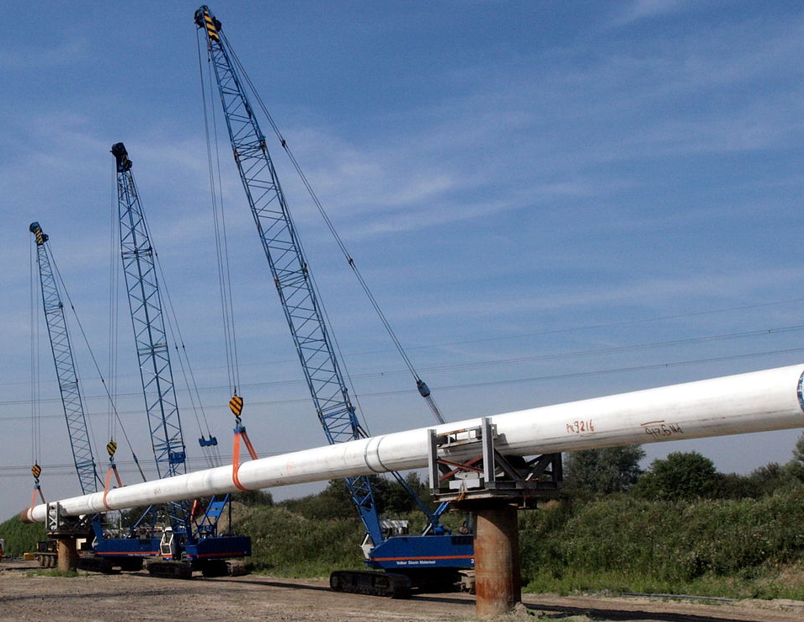
Figure 1.1.1 Pipe lifted by three cranes
The figure above illustrates a long pipe to be lifted by three cranes through tension in cables. In the position shown, the system is in static equilibrium. Once the lifting operation starts, the pipes will move and change to a dynamic status. Mechanics laws involving many physical quantities govern both statuses of the pipe.
- Thermodynamics. The branch of engineering that studies the effect of change in “temperature”, “volume” and “pressure” on the behavior of a substance and the influence on the interaction of this substance with its surroundings. This influence is quantified by amounts of “heat” and “work” exchanged between constituents.

Figure 1.1.2 Air Conditioner in an appartment
A famous example from thermodynamics is illustrated in the figure above showing an air- conditioning device where heat exchange between hot air and cold refrigerant in the coils of the evaporator of the machine occurs indoors, while another heat exchange occurs outdoors between the hot refrigerant within the compressor and condenser and the air outside. The change in pressure, temperature, volume, and physical status of the refrigerant (hydrofluorocarbon) has been applied practically to cool the apartment.
- Electricity and Magnetism. The branch of engineering that studies the status of “charged particles” and their motions and interactions, which produce “power”. This is responsible for starting motors, turning on laptops, charging mobile phones, etc. In addition, the flow of electric particles creates a “magnetic field”. When the lines of a magnetic field are cut by a metallic rotor, electricity is generated.
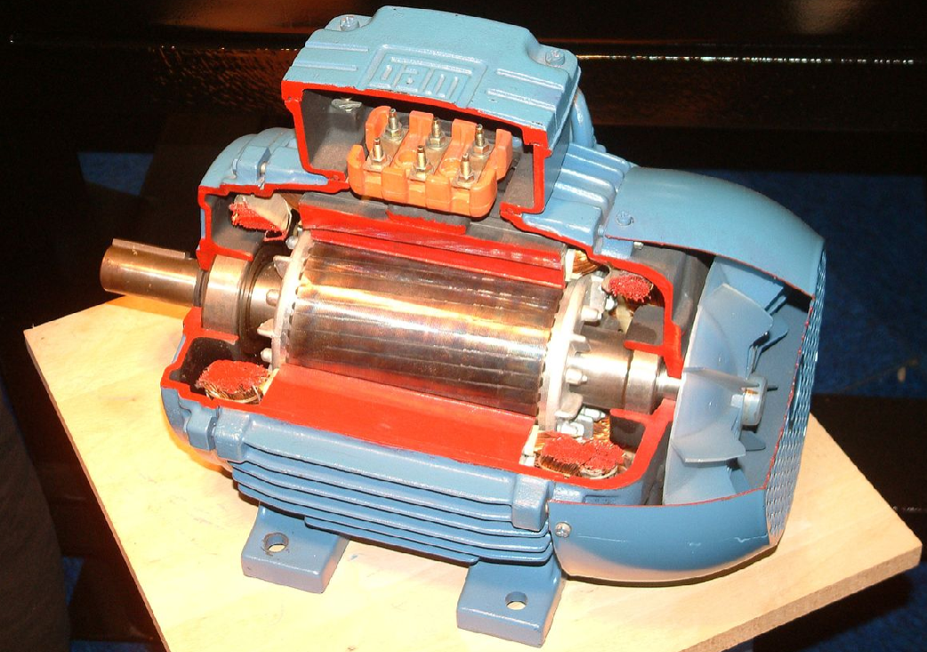
Figure 1.1.3 Quarter section of an electric motor
The electric motor is one of the most famous applications associated with this branch of physics. The internal components of this motor are shown through the cut made in the blue housing in the above figure. When connected to electricity, current flows through metallic wire coils located within two poles of a magnet generating lines of magnetic field. These lines interact with the circulating electric current to create an electromagnetic force able to rotate the output shaft of the motor. Thus, the input electrical energy has been converted into an output mechanical energy.
- Vibrations and Waves. The branch of engineering that studies oscillating systems (i.e., those having repetitive and periodic motion) and measures the characteristics of these “oscillations”. The form of oscillation propagation in time and space is known as a “wave”.
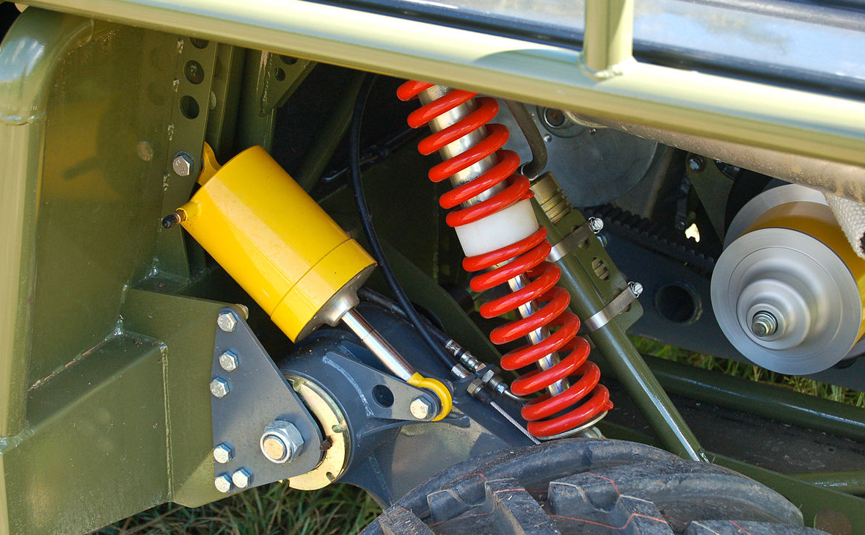
Figure 1.1.4 Car suspension
An interesting example illustrating this discipline is the car suspension shown in the above figure consisting of a stiff spring and hydraulic damping piston-cylinder system. This package is essential to absorb high amounts of wavy displacements induced to the body of the car and transmitted to the passengers when traveling on a bumpy road. This protects the car’s chassis and makes the travel comfortable for the driver and the passengers.
- Light and Optics. The branch of physics that describes the properties of light either in its wave form (like mechanical, electrical, or magnetic waves) or in its corpuscular form (groups of moving particles). It studies the deviation of light resulting either from reflection, refraction, transmission, diffraction, or interference when passing though optical devices such as lenses, mirrors, prisms, or slits. An image can be considerably altered when viewed using these devices.
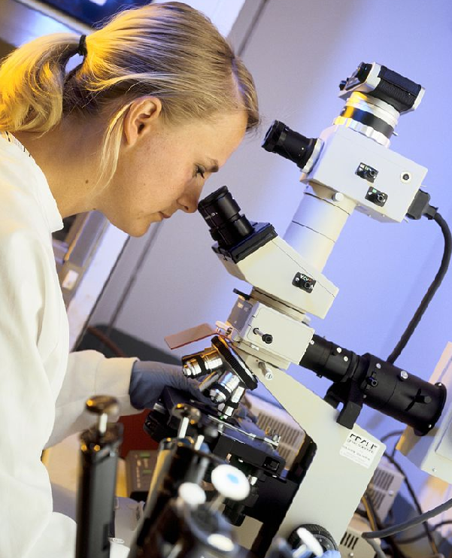
Figure 1.1.5 Scientist using a microscope
The optics community has provided many useful devices to a variety of scientific disciplines, such as medicine and chemistry. Many scientific tests now depend upon these optical devices.

- Atomic and Nuclear Physics. This field in physics overlaps considerably with chemistry. Besides studying the classical morphology and characteristics of atoms, this discipline examines the energetic aspect of atoms such as interactions between their electric clouds and light photons and their nuclei where, besides the huge energy delivered from certain reactions, many radiation types are also generated such as X-rays and light.
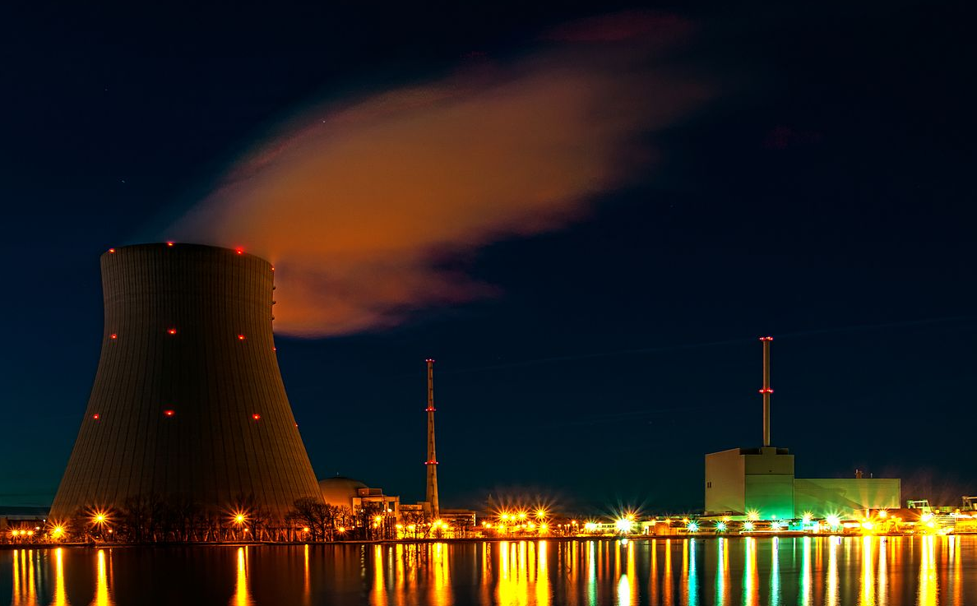
Figure 1.1.6 Nuclear power plant feeding Isar in Bavaria with electricity
An example of an application in this discipline is depicted in the above figure showing a huge nuclear power plant feeding Isar, a region in Bavaria, Germany, with electricity without the use of combustible fuel.
- Relativity. Known also as Einstein’s theory or modern physics, relativity is a theory of gravity postulating that a gravity field is a four-dimensional space-time field that curves or warps upon the mass of the moving object. This discipline is out of the scope of the present textbook.

Self-Check Questions
- Please list a practical example for each of the following disciplines:
- Mechanics: Pump transferring water at high pressure
- Thermodynamics: Calorimeter keeping drink at a constant desired temperature
- Vibrations: Scanner for medical detection of heart performance

1.2 Physical Quantities and Units

Definition
A “physical quantity” is an amount that can be measured and expressed by a value. To distinguish types of physical quantities, a letter or group of letter symbols is added near the value called a “unit". Many measured values of the same physical quantity can then be compared. (Walker, 2014)
In physics, there are only seven main quantities or “basic quantities". All the other available quantities are derived from several basic quantity combinations; these are termed “compound quantities”.
Many international organizations assign their own units to the relevant measured quantities. In each case the conversion from one system of units to the other is possible. In the present textbook, the system of units to be adopted is the International System (SI), also called the “metric system”.
International System of Units: This is a standard used worldwide to unify units assigned to scientific measurements.

The Basic Quantities
Below are the seven basic quantities used in physics:
- Length. A physical quantity for evaluating the location of an object measured relative to a determined reference and/or the dimensions of this object. Its unit is the “meter” (m). (Hibbeler, 2010)
- Time. The quantification of a succession of events or a variable status event. When an action or a process remains unchanged it is said to be “time independent”. Its unit is the “second” (s). (Hibbeler, 2010)
- Temperature. The quantification of the level of heat stored within an object. Its unit is the “kelvin” (K). (Walker, 2014)
- Mass. The quantification of the amount of material contained in a substance. Mechanically, it represents the resistance of a body against a change in linear velocity. Its unit is the “kilogram” (kg). (Hibbeler, 2010)
- Electric current. The rate of flow of electric charges within a circuit. Its unit is the “ampere” (A). (Ohanian, 2007)
- Luminous intensity. The amount of visible light emitted per unit time and per unit solid angle. Its unit is “candela” (Cd). (Britannica, 2022)
- Amount of substance. The ratio of the number of particles in a substance (atoms, molecules, etc.) to the Avogadro Number N_{A}. Its unit is the “mole” (mol). (Ohanian, 2007)
Avogadro number: package of 6.02⋅ 10²³ particles. Avogadro is the last name of the Italian chemist.

The Compound Quantities
In what follows, only the key compound quantities in each discipline will be listed. Other ‘’secondary’’ quantities will come throughout the textbook within the corresponding section related to the unit being studied.
Mechanics
- Force. The ‘’push’’ or ‘’pull’’ action applied on a body by its surroundings, either by direct contact or at a distance. Its unit is the “newton” (N=kg⋅ m⋅ s⁻²). (Hibbeler, 2010)
- Moment. The ability ofa couple of forces to produce rotation or a single force to rotate about a fixed axis. Its unit is the “newton-meter” (N⋅ m=kg⋅ m²⋅ s⁻²). (Hibbeler, 2010)
- Displacement. The instantaneous position of a body on a trajectory measured from a reference. Its unit is “meter” (m) for linear displacement and “radian” (rad) for angular displacement. (Hibbeler, 2016)
- Velocity. The rate of change of the displacement per unit time. Its unit is “meters per second” (m⋅s⁻¹) for a linear velocity and “radian per second” (rad⋅s⁻¹) for an angular velocity. (Hibbeler, 2016)
- Acceleration. The rate of change of the velocity per unit time. Its unit is “meters per second squared” (m⋅s⁻²) for a linear acceleration and “radian per second squared” (rad⋅s⁻²) for an angular acceleration. (Hibbeler, 2016)
- Gravity. The acceleration by which the earth attracts a body in free fall. It has a constant value g = 9.81 m/s². This value changes when the gravity field changes, i.e., when the reference planet changes. (Hibbeler, 2010)
- Weight. The attractive force applied by the gravity field on a body. It is equal to the product of the body’s mass by the gravity acceleration (i.e., W = m⋅ g). Its unit is the newton. (N=kg⋅ m⋅ s⁻²). (Hibbeler, 2010)
- Mass moment of inertia. The resistance of a rigid body against a change of angular acceleration. Its unit is “kilogram⋅ meter squared” (kg⋅ m²), (Hibbeler, 2016)
- Area. The planar region occupied by a substance. Its unit is “meter squared” (m²). (Knight, 2016)
- Volume. The space occupied by a substance. Its unit is “meter cubed” (m³). (Knight, 2016)
- Pressure. The force applied by a body per unit area of contact. Its unit is the “pascal” (Pa=kg⋅ m⁻¹⋅ s⁻²). (Knight, 2016)
- Density. The mass of a unit volume of a substance. It is an intrinsic property of each material. The inverse of the density is called “specific volume”. The unit of density is “kilograms per meter cubed” (kg⋅m⁻³). (Knight, 2016)
- Stiffness. The resistance of an elastic body against length change. Its unit is “newtons per meter” (N/m = kg⋅ s⁻²). (Hibbeler, 2010)
- Viscosity. The resistance of a fluid against flow. Its unit is “poiseuille or pascal⋅ second” (Pa=kg⋅ m⁻¹⋅ s⁻¹). (Knight, 2016)
- Stress. The distribution of an internal force over the internal area of a body; it can be either normal to the area or tangential within the area. Its unit is “pascal” (Pa=kg⋅ m⁻¹⋅ s⁻²). (Hibbeler, 2011)
- Strain. The relative change in dimension of a loaded body with respect to its original dimension. This quantity is “dimensionless”. (Hibbeler, 2011)
- Modulus of Elasticity. The resistance of a body to strain once subjected to a certain stress level. It is an intrinsic property of each material. Its unit is “pascal” (Pa=kg⋅ m⁻¹⋅ s⁻²). (Hibbeler, 2011)
Thermodynamics
- Energy. The capacity of a body to develop work in any form. Examples include electrical, mechanical, thermal, and magnetic. Its unit is the “joule” (N⋅ m=kg⋅ m²⋅ s⁻²). (Moran, 2018)
- Power. The rate of energy per unit time. Its unit is “watts”. (W=kg⋅ m²⋅ s⁻³). (Moran, 2018)
- Heat. The amount of energy transferred between two bodies of differing temperatures. It passes from the warmer body to the cooler body. Its unit is the “joule” (J=kg⋅ m²⋅ s⁻²). (Moran, 2018)
- Enthalpy. The energy released or absorbed due to a reaction or a change in the pressure and volume of a substance. Its unit is the “joule” (J=kg⋅ m²⋅ s⁻²). (Moran, 2018)
- Entropy. The amount of disorder within a substance. Amount of energy stored within a substance unable to produce work. Its unit is “joules per kelvin” (J/ K=kg⋅ m²⋅ s⁻²⋅ K⁻¹). (Helmenstine, 2021)
- Specific heat capacity. The heat energy needed to increase by one unit the temperature of a unit mass of a substance. It is an intrinsic property of each material. Its unit is “joules per kilogram and per kelvin” (J/kg⋅ K= m²⋅ s⁻²⋅ K⁻¹). (Walker, 2014)
- Thermal conductivity. The ability of a substance to transfer heat in its space within a gradient of temperature due to the random mobility of its molecules. It is an intrinsic property of each material. Its unit is “watt per meter and per kelvin” (W/m⋅ K= kg⋅ m⋅ s⁻³⋅ K⁻¹). (Walker, 2014)
Electricity and Magnetism
- Electric Tension. Also referred to as the voltage of potential difference, this is the amount of work needed to displace charged particles from a reference point to a target point. Its unit is “volt” (V=kg⋅ m²⋅ s⁻³⋅ A⁻¹). (Knight, 2016)
- Electric charge. The capacity of electrons and protons (charged particles) to apply attractive or repulsive force. Its unit is “coulomb” (C=A⋅ s). (Ohanian, 2007)
- Electrostatic field. A measure of the disturbances generated by electric charges in a space when they apply mutual electric forces. Its unit is “newton per coulomb” (N/C= kg⋅ m⋅ s⁻³⋅ A⁻¹). (Ohanian, 2007)
- Magnetic flux density. The quantity measuring the intensity and the direction of a magnetic field emitted around a magnet; it is also referred to as magnetic induction. Its unit is the “tesla” (T=kg⋅ s⁻²⋅ A⁻¹). (Walker, 2014)
- Magnetic flux. The distribution of the magnetic flux density over a unit area. Its unit is the “weber” (Wb=kg⋅ s⁻²⋅ m⁻²⋅ A⁻¹). (Walker, 2014)
- Resistivity. The intrinsic property of a material to resist the flow of electric charges. Its unit is “ohm⋅ meter” (Ω⋅ m=kg⋅ m³⋅ s⁻³⋅ A⁻²). (Walker, 2014)
- Electric Resistance. The ability of a component to resist the flow of an electric current. Its unit is the “ohm” (Ω=kg⋅ m²⋅ s⁻³⋅ A⁻²). (Walker, 2014)
- Capacitance. The amount of electric charge stored by a conductor for each unit of voltage. Its unit is “farad” (F=kg⁻¹⋅ m⁻²⋅ s⁴⋅ A⁻²). (Ohanian, 2007)
- Inductance. The magnetic flux linkage produced by a magnetic inductor for each unit of electric current. Its unit is the “henry” (H=kg⋅ m²⋅ s⁻²⋅ A⁻²). (Walker, 2014)
Vibrations and Waves
- Frequency. The number of cycles or oscillations developed by an oscillating system per unit of time. Its unit is the “hertz” (Hz = s⁻¹). This number of cycles can be converted to angular unit radians, in which case the specific term becomes angular or circular frequency expressed in “radians per second” (rad/s=s⁻¹). (Rao, 2011)
- Period. The time needed by a system to cover one cycle or one oscillation. Its unit is the “second” (s). (Rao, 2011)
- Amplitude. The maximum displacement value covered by a system during oscillations. Its unit is “meters” (m) for linear oscillations and “radians” (rad) for angular oscillations. (Rao, 2011)
- Phase angle. The angular value representing a practical time shift of a wave relative to a reference wave. Its unit is the “radian” (rad). (Rao, 2011)
- Wavelength. The distance between two points of a wave separated by a period. Its unit is the “meter” (m). (Rao, 2011)
- Viscous damping constant. The resistance applied by a fluid to reduce amounts of oscillations. Its unit is “newton-meter per second” (N.m/s = kg.s⁻¹) for linear damping and “newton-meter⋅ second per radian” (N.m⋅ s/rad = kg.m²⋅ s⁻¹) for angular damping. (Rao, 2011)
Light and Optics
- Celerity. The speed of light measured in a vacuum. It has a constant value of c = 3⋅ 10⁸ m/s. (Ohanian, 2007)
- Wave number. The number of cycles of a light wave traveling a unit distance. In other words, it represents a spatial frequency. Its unit is m inverse (m⁻¹). (Walker, 2014)
Atomic and Nuclear Physics
- Half-life. the time needed by a radioactive mass to reduce by half. Its unit is the “second” (s). (Knight, 2016)
- Activity. The number of disintegrations of radioactive nuclei per unit time. Its unit is “becquerel” (Bq = s⁻¹). (Knight, 2016)

Unit Prefixes
If a quantity exhibits very large or very small numbers, it would be useful to reduce the number of digits by replacing some of the zeros in the number with prefix letters before the main unit symbol in SI. For example, when the duration of an impact is 0.003 s we can write 3x10⁻³ s or 3 ms (milli-seconds); the letter ‘’m’’ (for milli-) added to the main unit ‘’s’’ (for seconds) is a prefix. Another example could be given for a force of 5,000,000 N this could be written as 5x10⁶ N or 5 MN (mega-newton); the letter M (for mega-) added to the main unit N (for newtons) is a prefix. The first example reflects a submultiple case (negative power of 10) while the second one illustrates a multiple case (positive power of 10).
The table below summarizes all prefixes used for multiples and submultiples (Walker, 2014):
Table 1.1 Unit Prefixes
Multiple/Submultiple | Exponential notation | Nomenclature | Symbol
1,000,000,000,000,000,000,000,000 | 10²⁴ | yotta | Y
1,000,000,000,000,000,000,000 | 10²¹ | zetta | Z
1,000,000,000,000,000,000 | 10¹⁸ | exa | E
1,000,000,000,000,000 | 10¹⁵ | peta | P
1,000,000,000,000 | 10¹² | tera | T
1,000,000,000 | 10⁹ | giga | G
1,000,000 | 10⁶ | mega | M
1,000 | 10³ | kilo | k
100 | 10² | hecto | h
10 | 10¹ | deka | da
0.1 | 10⁻¹ | deci | d
0.01 | 10⁻² | centi | c
0.001 | 10⁻³ | milli | m
0.0000001 | 10⁻⁶ | micro | μ
0.0000000001 | 10⁻⁹ | nano | n
0.000000000001 | 10⁻¹² | pico | p
0.000000000000001 | 10⁻¹⁵ | femto | f
0.000000000000000001 | 10⁻¹⁸ | atto | a
0.000000000000000000001 | 10⁻²¹ | zepto | z
0.000000000000000000000001 | 10⁻²⁴ | yocto | y

Here are two examples showing the conversion of units to SI units:
36 km/h = 36⋅ (1000 m)/ (3600 s) = 10 m/s
500 cm2 = 500⋅ (0.01 m)2 = 0.05 m2

Self-Check Questions
- The specific weight denotes the weight of the unit volume of a substance. Express this unit in terms of the basic quantities’ units.
N/m³ = kg⋅ m⋅ s⁻²/m³ = kg⋅ m⁻²⋅ s⁻².
- Answer by true or false and justify your answer.
The mass of a proton is 1.6726⋅10⁻²⁷ kg. This value is the same as 1.6726 yg.
True since 1.6726⋅10⁻²⁷ kg is equivalent to 1.6726⋅10⁻²⁴ g and each 10⁻²⁴ denotes 1 yocto (y)
Summary
Physics is a branch of science that deals with matter in the universe, its constituents, structure, properties, and interaction with surroundings. It is based on qualitative analysis of observed phenomena, quantitative experimental measurements, and numerical calculations of quantities related to the observed phenomena. To distinguish between types of quantities, each one is assigned a unit near its measured or calculated value. This unit is designated by one or more letters. If values are considerably large or small, additional symbolic letters, called prefixes, are added to the unit symbol in order to reduce the number of digits in the original value of the quantity.
There are seven basic quantities in physics and thus seven basic units: length (m), time (s), temperature (K), mass (kg), electric current (A), luminous intensity (Cd), and amount of substance (mol). Any other quantity is derived from a combination of other basic quantities.
Physics is an essential background for any engineering discipline whose goal is to either solve or simplify technical problems that will serve the community.
There are seven disciplines in physics: mechanics, thermodynamics, electricity and magnetism, vibrations and waves, light and optics, atomic and nuclear physics, and relativity.

Unit 2 – Mechanics

Study Goals

On completion of this unit, you will be able to
- understand the concept of the main static and dynamic quantities.
- apply the different principles of mechanics to solve any related problem.
- calculate the stress and strain using Hooke’s elastostatics law.
- analyze the static and dynamic status of fluids.

Mechanics

Introduction
“Mechanics” is a branch of engineering that studies the status of objects either at rest or in motion. The reason behind a status resides in a combination of actions, known as “forces” and/or “moments”, applied to the object of interest. Both solids and fluids constitute materials of interest in mechanics. One may distinguish two fields in mechanics: “statics”, which deals with the “equilibrium” of “bodies”, that is, with bodies having zero velocity; and “dynamics”, which studies the motions of bodies. Dynamics consists of two essential parts: “kinematics”, which is interested in monitoring the “displacement”, “velocity”, and “acceleration” of bodies, and “kinetics”, which studies forces and moments that cause motion. Another important component of dynamics is the energetic aspect, which consists of the “work” developed by a force or moment as well as the different types of “energy” generated during the motion.
Both rest and motion status are governed by mathematical conditions known as the classical laws of mechanics: these consist of equations of equilibrium for bodies at rest, and principles of inertia, work, and energy for bodies in motion.
All these theories deal with external loads applied to bodies. However, equilibrium is kept within any body due to internal loads that are generated within the material of the body. These loads develop “stresses”. In addition, since solids have elastic behavior in general, stresses will induce geometric changes known as “strains”. Elastostatics is the field that studies this aspect in solid bodies.
Finally, we will close the unit with a discussion of fluid mechanics, which exhibits different behaviors than solid mechanics, as we shall see.

2.1 Statics of Solid Bodies

Particle and Rigid Body
For the sake of simplified analysis, a solid body may be idealized by either a “particle” or a “rigid body” representation. A particle is a representation of a solid having a considerable mass but a negligible size when measured with respect to a bigger reference (Beer, 2012); a particle is only capable of translational motion along any direction in space. A rigid body is a representation of a solid having both considerable mass and size (Beer, 2012); a rigid body can translate and rotate keeping the same size and shape (with negligible deformations) under the applied loading. To analyze either the equilibrium or the motion of a solid body, it is necessary to sketch all the efforts applied to this body that are responsible for its present status; this sketch is termed the “free body diagram” (FBD).
The difference between these models can be clarified with an example: if a car is considered the main solid in question, when it is analyzed relative to a very large bridge this car is modeled as a particle; however, if the car is being pulled by a winch the car is modeled as a rigid body since the size of the winch is comparable to that of the car.

Newton’s Basic Axioms
‘’Mechanics is based on only a few laws of nature which have an axiomatic character. These are statements based on numerous observations and regarded as being known from experience. The conclusions drawn from these laws are also confirmed by experience.” (Gross D. H., 2013, p. 1). Therefore, familiarity with Newton’s three laws of mechanics is of high importance.
Axiom: statement describing a physical fact based on experience without proof.
Axiom I: The Principle of Equilibrium
When a body is originally at rest or moving along a straight line with a constant velocity and then is subjected to a balanced system of forces, it will maintain its original status before the application of the balanced forces. (Hibbeler, 2010)
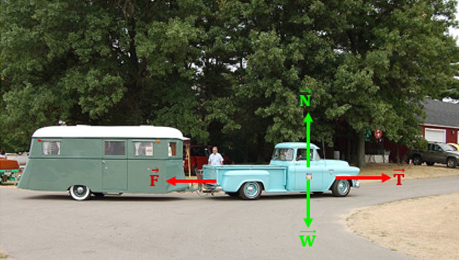
Figure 2.1 House-trailer connected to a truck
In the figure above, weight is $\vec{W}$ and the normal reaction of the floor is $\vec{N}$ . If the traction force $\vec{T}$ of the motor cannot overcome the resisting force $\vec{F}$ applied by the house-trailer on the truck, both $\vec{T}$ and $\vec{F}$ will cancel each other out; as a result, the truck will remain in the same position, i.e., at rest.
Axiom II: The Principle of Inertia
If a body of mass m is subjected to an unbalanced system of forces of resultant $\vec{F}$, it will move with an acceleration $\vec{a}$ in the same direction as $\vec{F}$ and whose magnitude is proportional to the magnitude of $\vec{F}$ through the mass m. (Hibbeler, 2010)
 | $$\vec{F}=m⋅\vec{a}$$ | (2.1)

The figure below shows an automobile under a system of three forces, the weight $\vec{W}$, the normal reaction of the floor $\vec{N}$, and the traction force of the motor $\vec{T}$. As W and N are balanced forces, the resultant force is equivalent to T, which is responsible for increasing the velocity of the automobile and thus inducing an accelerated motion.
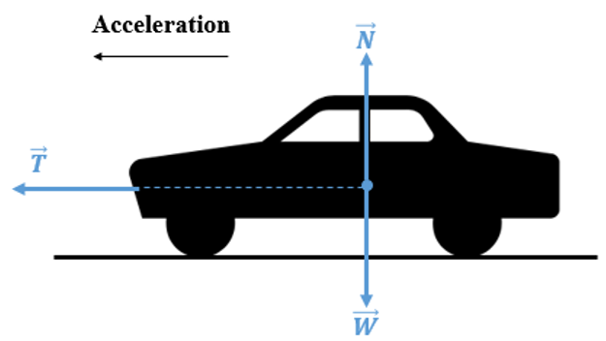
Figure 2.2 Automobile in motion under traction force
Axiom III: The Principle of Action and Reaction
When two particles interact they apply onto each other a force of equal magnitude but opposite direction.
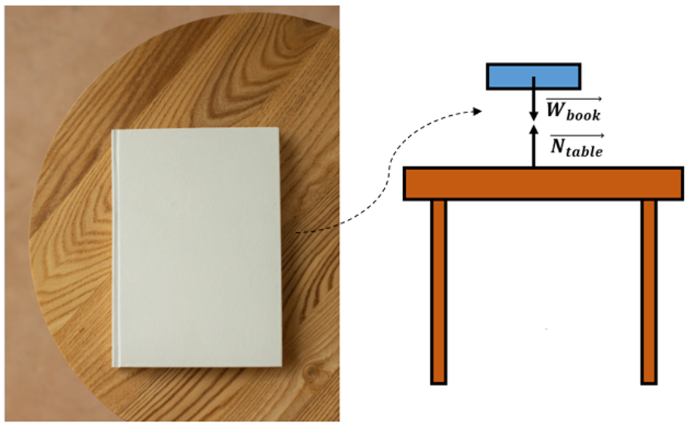
Figure 2.3 Book resting on a table
This axiom is illustrated in the figure above where a book, the first body, is resting on a table, the second body. his system is in a state of equilibrium because the book applies its weight (vertically downward) onto the table while the table reacts by applying a normal reaction (vertically upward) onto the book equal in magnitude to the weight of the book.

Force
Definition and Representation
A force is an action exerted by a body on another neighboring body (Beer, 2012) applied by direct contact or at a specified distance. Mathematically, a force is represented by a “vector”, which is determined by a “point of application”, a “direction”, a “sense”, and a “magnitude”. Hence, these four elements are needed to define the force, denoted by its symbol under a rightward-directed arrow: $\vec{F}$.
The figure below on the left illustrates an example of a force: it is the action applied to raise the crate through a cable around a pulley. The figure below to the right shows the vector representation of this force $\vec{F}$ including its four elements:
- The point of application. The point of the cable at which the force is acting. Mathematically, it is the origin of the vector. (Hibbeler, 2010).
- The direction. The angular amount by which the line of action of the force (i.e., along the cable) is inclined with respect to the horizontal. Mathematically, it is quantified by the algebraic angle θ formed between the horizontal line (oriented from left to right) and the line of action of the force (Gross D. H., 2013): this angle is considered positive when oriented counterclockwise and negative for a clockwise orientation.
- The sense. The orientation of the vector force; in the below figure on the right, the sense is downward.
- The magnitude. The amount or the intensity of the applied force measured in newtons (N). Its symbol is the same as the vector force but without the arrow above. One must not confuse the vector, which is a “geometric” representation, and its magnitude, which is a numerical value. F is the magnitude of $\vec{F}$.
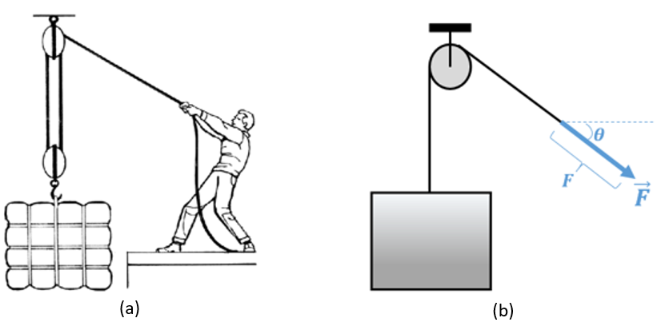
Figure 2.4 Tensile force in cable for crate lifting (a), Vector representation of this force (b)
It should be noted that the weight of the crate is another force applied by the gravity field of the crate. In general, the weight vector is applied at the “center of gravity” of the body and has a vertical direction, a downward sense, and a magnitude equal to the product of the body’s mass and the gravitational acceleration (g = 9.81 m/s² on earth). This is illustrated in equation (2.2).
 | $$\vec{W}=m⋅\vec{g}$$ | (2.2)

Types of Force
External force. A system is said to be subjected to an “external force” when a force is applied by any component surrounding the system either directly or at a distance (Hibbeler, 2010). The figure below shows a global system consisting of a table and a book resting on that table. This system is subjected to the attraction force of gravity, which is the total weight of the book and the normal reaction forces applied by the floor on the table’s legs.
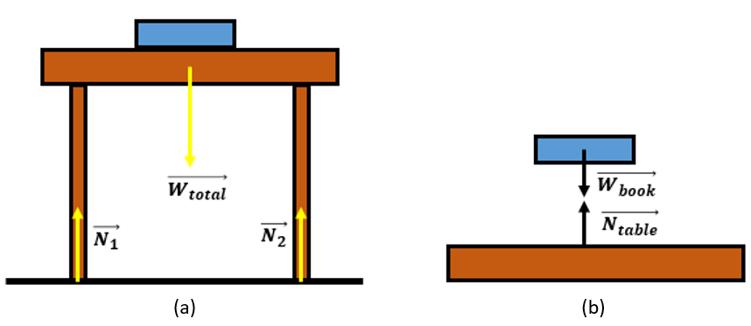
Figure 2.5 External forces applied on the system table-book (a), Internal forces between table and book
Internal force. A component of a global system is said to be subjected to an “internal force” when this force is applied by any ‘’neighbor’’ component belonging to the same global system (Hibbeler, 2010). This means that internal forces do not appear unless the system is ‘’split’’ into many components, or a body is ‘’virtually cut’’ into two portions, which appear as mutual forces between components or portions. This is illustrated in the figure above on the right. Where the table-book system is split into two components, the internal forces appear: these consist of the book’s weight applied onto the table and the normal reaction applied by the table onto the book. Those two forces are collinear, equal, and opposite according to Axiom III.
Concentrated force. When a force is applied to a region of a body that is minutely small relative to the overall size of the body, i.e., assimilated to a point, the force is said to be “concentrated” (Gross D. H., 2013). The figure below shows the weights of a patient and their bed represented as concentrated forces since they are applied on the supporting floor, which is hugely large compared to the sizes of the bed and the patient.
Distributed force. When the loading is applied along a considerable space of the body (or even along the entire body) and not at any specific points, it is said to be “distributed” (Gross D. H., 2013). A loading could be distributed over either a volume space (N/m³) or a surface area (N/m²) or a line (N/m). In the below figure on the right, the weight of the patient is applied onto the bed, the length of which is comparable to the patient’s length, thus the weight of the patient is distributed along the entire length. A force distribution can be either “uniform” or non-uniform.
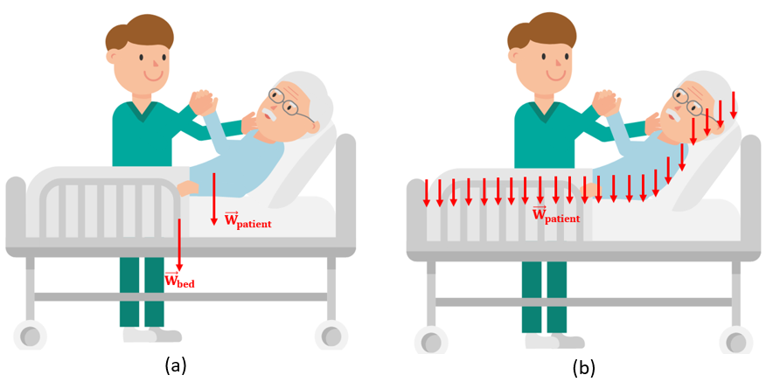
Figure 2.6 Weights as concentrated forces (a), as distrubted forces (b)
Resultant of Forces
“Concurrent forces” are concentrated forces having a common point of application, i.e., the same vector origin (Hibbeler, 2010). For a solid modeled as a particle, this common origin represents the particle itself. Despite that sometimes the visualization of the drawn forces on a body modeled as particles shows the contrary, one might slide the forces along their lines of actions until they intersect at the same origin; this will not change the effect of those forces on the particle.
The “resultant” is a theoretical force that replaces a group of physical forces acting on a body and keeps the same effect as the original group to be replaced (Hibbeler, 2010). Mathematically, this resultant $\vec{R}$ is determined by the vector sum of all forces to be replaced following the equation (2.3) below:
 | $$\vec{R}=\sum_{i=1}^{i=n}{{\vec{F}}_{i}}$$ | (2.3)

The simplest case to start with resides in two forces $\vec{F_{1}}$ and $\vec{F_{2}}$ concurrent at an origin O and shifted by an angle θ. The magnitudes F₁ and F₂ are well known. The resultant $\vec{R}= \vec{F_{1}}$ + $\vec{F_{2}}$ is constructed graphically as shown in the figure below. The middle sketch in this figure illustrates the standard force vector diagram to draw $\vec{R}$ . The last sketch in this figure is an equivalent scheme to this graphical method; it is known as “the parallelogram law”. It consists of drawing from the tip of $\vec{F_{1}}$ a parallel and equal segment to $\vec{F_{2}}$ and then from the tip of $\vec{F_{2}}$ a parallel and equal segment to $\vec{F_{1}}$. The result of those two operations is a parallelogram. The diagonal drawn from the origin O represents the resultant $\vec{R}$. Nevertheless, the graphical approach at this stage is not sufficient anymore; the “four elements” of the vector $\vec{R}$ must be determined in a precise manner. This is achieved by applying the sines theorem in equation (2.4) and the “generalized Pythagorean theorem” in equation (2.5) where $α=180°-θ$.
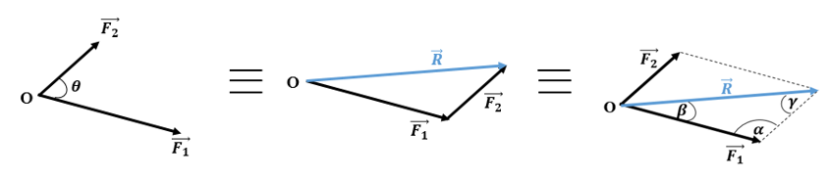
Figure 2.7 Parallelogram law for resultant determination
 | $$\frac{R}{\sin{α}}=\frac{F_{2}}{\sin{β}}=\frac{F_{1}}{\sin{γ}}$$ | (2.4)
 | $$R=\sqrt{F_{1}^{2}+F_{2}^{2}-2⋅F_{1}⋅F_{2}⋅\cos{α}}$$ | (2.5)

It should be noted that, for the case of multi-concurrent forces, the parallelogram rule is applied between the resultant of the first two forces and the third force; this process is repeated through the inclusion of the last force.
An alternative method to find the direction and the magnitude of the resultant consists of applying the “Cartesian formulation method”. It is known that any vector in the space exhibits three “scalar components” along the three axes of a direct orthonormal Cartesian frame reference (xyz). The Cartesian notation of any force vector $\vec{F_{i}}$ is written as: $\vec{F_{i}}=F_{i,x}\vec{i}+F_{i,y}\vec{j}+F_{i,z}\vec{k}$; when this notation is substituted in equation (2.3) and identified member by member, the three scalar components of the resultant are then calculated from equations (2.6).
 | $$R_{x}=\sum_{i=1}^{i=n}{F_{i,x}}$$  $$R_{y}=\sum_{i=1}^{i=n}{F_{i,y}}$$  $$R_{z}=\sum_{i=1}^{i=n}{F_{i,z}}$$ | (2.6)

The magnitude R of the resultant is then calculated by the “Pythagorean formula” depicted in equation (2.7) while the direction angles are determined from the inverse of the cosine directions as shown in equations (2.7)(2.8).
$$R=\sqrt{R_{x}^{2}+R_{y}^{2}+R_{z}^{2}}$$ | (2.7)
$$α=\cos^{-1}{\frac{R_{x}}{R}}$$  $$β=\cos^{-1}{\frac{R_{y}}{R}}$$  $$γ=\cos^{-1}{\frac{R_{z}}{R}}$$ | (2.8)
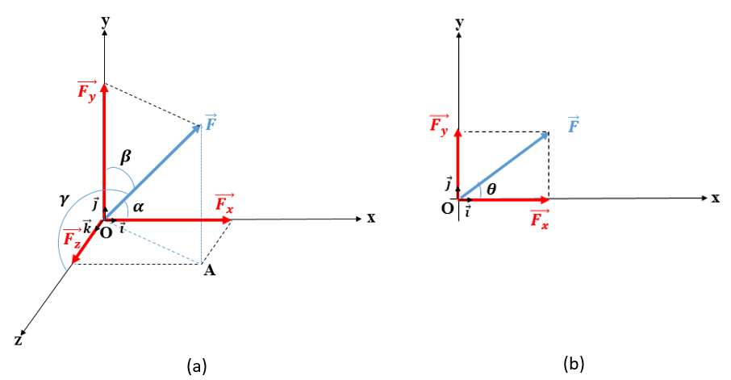
Figure 2.8 Scalar components and direction angles of a force in 3D (a), 2D (b)
The above figure shows the scalar components and the three direction angles of a general force vector located in a Cartesian orthonormal frame reference (xyz).
It should be noted that the three cosine directions must satisfy the relationship (2.9) (Hibbeler, 2010):
 | $$\cos^{2}{α}+\cos^{2}{β}+\cos^{2}{γ}=1$$ | (2.9)

If the force vector lies in a planar Cartesian frame reference (xy), all z-components in the equations (2.6)-(2.8) vanish, and the three direction angles reduce to one “algebraic angle” θ measured from the x-axis to the force. In that case, $α=θ$ and $β=90°-θ$. (See the xy graph in the figure above)
Decomposition of a Force
Decomposition is the inverse procedure of the resultant construction of forces. It consists of replacing a single force with two other forces for a “two-dimensional” case (2D) or by three other forces for a “three-dimensional” case (3D). These new forces are known as “components” of the original force. The decomposition of a force occurs by “projections” of the vector along two (for 2D case) or three (for 3D case) predefined directions. The graph to the left in the figure above shows the three scalar components of a force in the space; the planar components are depicted in the graph to the right above.

Equilibrium of Particles
All forces applied on a particle are concurrent at the particle itself providing the possibility of an ‘’exclusive’’ translational motion in case the resultant of those forces is not zero. The static equilibrium of a particle means practically that this particle is not able to move in translation and hence rotation does not play any role in a particle’s static equilibrium. To prevent the translation along the three directions x, y, and z the three scalar components of the resultant of the applied forces vanish simultaneously; this induces a system of three equations known as “equations of equilibrium” given by the set (2.10):
 | $$\sum_{i=1}^{i=n}{F_{i,x}}=0$$  $$\sum_{i=1}^{i=n}{F_{i,y}}=0$$  $$\sum_{i=1}^{i=n}{F_{i,z}}=0$$ | (2.10)

Moment
Moment of a Couple
In mechanics, the term “couple” denotes a pair of two parallel vector forces, opposite in sense, equal in magnitude, and separated by a distance d called “arm”. (Beer, 2012)
When a couple is applied to a solid object, it tends to produce rotation. The figure below illustrates an example, where a couple is applied on the lug wrench to unscrew the tire’s nut. The couple is applied at the extremities of the wrench while the arm represents the length separating those extremities.
Cross product: Operation between two vectors $\vec{a}$ and $\vec{b}$ resulting in a third one, perpendicular to the others and forming with them a direct 3D base of a reference frame. It is calculated by the following determinant:
$$\vec{a}×\vec{b}=\left|\begin{matrix}\begin{matrix}\vec{i} \\ a_{x} \\ b_{x}\end{matrix} & \begin{matrix}\vec{j} \\ a_{y} \\ b_{y}\end{matrix} & \begin{matrix}\overset{⃡}{k} \\ a_{z} \\ b_{z}\end{matrix}\end{matrix}\right|$$
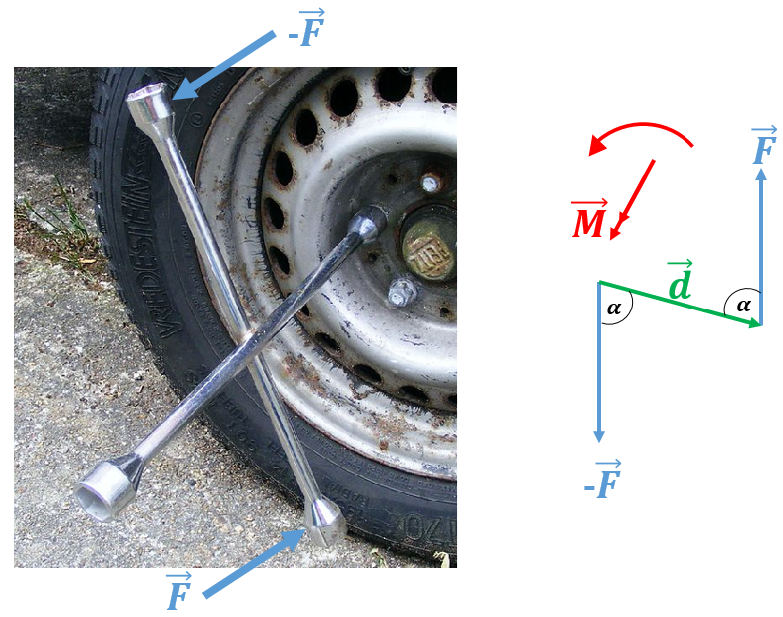
Figure 2.9 Couple for nut unscrewing
The “moment of a couple” known also as “torque” is defined as a physical quantity measuring the ability of a couple to produce rotation. Its unit is the newton-meter (N.m). Mathematically, the moment of a couple, like the force, is also a vector, drawn as a “double arrow” and determined by the “cross product” between the arm vector $\vec{d}$ (oriented from $-\vec{F}$ to $\vec{F}$ ) and the force $\vec{F}$ of the couple as expressed in equation (2.11). According to the definition of the cross product, the direction and the sense are found from the right-hand rule, while the magnitude is calculated from equation (2.11) inspired by the cross product theory. It should be noted that the magnitude of the moment is algebraic: it is positive when rotation occurs “counterclockwise” (ccw) and negative for a “clockwise” (cw) rotation. The vector moment of a couple has no specific origin; it is a “free vector”. (Hibbeler, 2010)
 | $$\vec{M}=\vec{d}×\vec{F}$$  $$M=d⋅F⋅\sin{(\vec{d},\vec{F})}$$ | (2.11)

Moment of a force about an Axis
The “moment of a force” about a point not belonging to the line of action of the force, or an axis passing through this point and orthogonal to the plane formed by the force and the point, is defined as a physical quantity measuring the ability of this force to produce rotation about the point (i.e., the axis). Its unit is the newton-meter (N.m). (Hibbeler, 2010)
The distance separating the point of application of the force from the point of rotation O is the “arm” denoted by the “position vector” $\vec{r}$ while the distance d is measured from O to the line of action of the force. (Hibbeler, 2010) The vector formulation and the magnitude of the moment of a force about a point (i.e., an axis) are given by equation (2.12):
 | $$\vec{M_{O}}=\vec{r}×\vec{F}$$  $$M_{O}=r⋅F⋅\sin{(\vec{r},\vec{F})}$$ | (2.12)

Figure 2.10 Moment of an a force to open a door about its hinge | Figure 2.11 Right-hand rule for vector moment
The figure above on the left illustrates an example of the moment about an axis: the girl applies an opening force out of the door’s plane at the handle which is distant from the hinge, i.e., the fixed axis; this allows the door to open. As the distance between the force and the axis decreases, the opening operation becomes more difficult because a greater force will be needed. The figure above on the right illustrates the right-hand rule to determine the vector moment; its origin O is the trace of the axis of rotation (i.e., the intersection of this axis with the plane involving the arm and the force). The sign convention is the same as in the case of a couple’s moment.
Resultant of Parallel Forces
A system of forces is “parallel” when none of their lines of action intersect at any point. (Beer, 2012) A system of parallel forces may consist of either concentrated or distributed forces (volumetric, areal, or linear distribution). This is illustrated in the figures below.
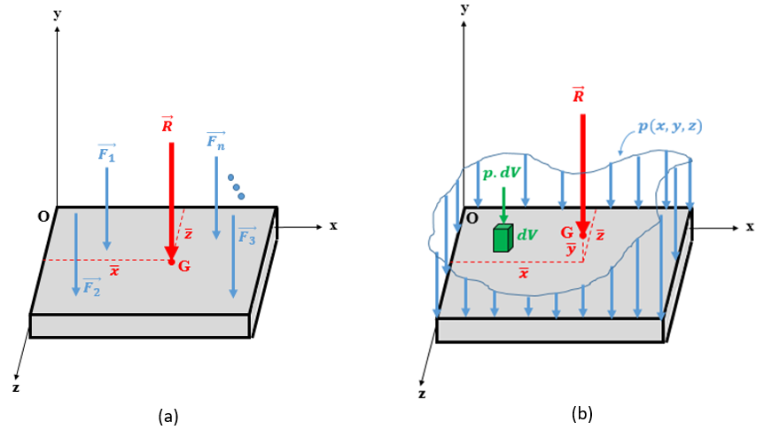
Figure 2.12 Prallel concentrated forces (a), Parallel distributed forces (b)
It is obvious that the resultant should have the same direction as the original parallel forces. This means that the vector sum is the same as the algebraic sum of all the forces’ magnitudes. To find the position of the point of application G of the resultant: the resultant must keep the same moments as the original system about the two Cartesian axes forming the plane on which those forces are acting, that is, the moment of the resultant about the x-axis, $\overline{z}⋅R$ , must be the same as the moments of all the forces $\vec{F_{i}}$ about x. The same concept applies to moments about the z-axis.
For concentrated forces, the resultant is determined by equations (2.13)-(2.15)
 | $$R=\sum_{i=1}^{i=n}{F_{i}}$$ | (2.13)
 | $$\overline{x}=\frac{\sum_{i=1}^{i=n}{x_{i}⋅F_{i}}}{R}$$ | (2.14)
 | $$\overline{z}=\frac{\sum_{i=1}^{i=n}{z_{i}⋅F_{i}}}{R}$$ | (2.15)

For distributed forces, the resultant is determined by equations (2.16)-(2.18), which are derived from equations (2.13)-(2.15) by replacing the discrete sum with an integral:
 | $$R=\iiint{p\left(x,y,z\right)dV}$$ | (2.16)
 | $$\overline{x}=\frac{\iiint{x⋅p\left(x,y,z\right)dV}}{R}$$ | (2.17)
 | $$\overline{z}=\frac{\iiint{z⋅p\left(x,y,z\right)dV}}{R}$$ | (2.18)

Equilibrium of Rigid Bodies
Bearings
A bearing is a physical member connected to the main rigid body to prevent its motion along one or many directions. A “translational motion” is blocked by applying a “force” along the direction of prevention, while a “rotational motion” is blocked by applying a “couple moment” about the axis along which the rotation is prevented. To generalize, one introduces the concept of “degrees of freedom” (DOF), which represents a direction along which a rigid body may move, either in translation or rotation. Depending on its type, a bearing may block one or multiple degrees of freedom. The forces and/or couples applied by bearings are classified as external forces but they are reactive forces, those “reactions” are unknowns. The external forces applied on the rigid body are active forces, those are known.
As examples of bearings or supports, one can cite cables, planar supports, pins/ hinges, rollers, and fixed supports. Their respective symbols and reaction components are shown in the figures below.
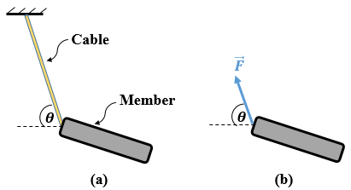
Figure 2.13 Member supported by a cable (a), Reaction of a cable (b)
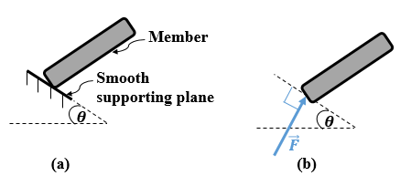
Figure 2.14 Member supported by a smooth plane (a), Reaction of a smooth plane (b)
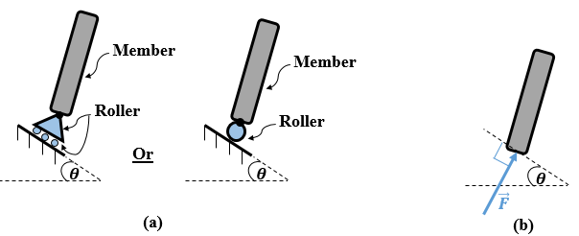
Figure 2.15 Member supported by a roller (a), Reaction of a roller (b)
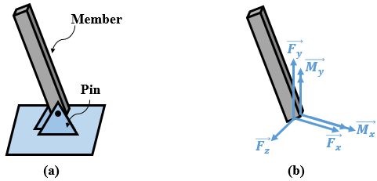
Figure 2.16 Member supported by a pin (a), Reactions of a pin (b)
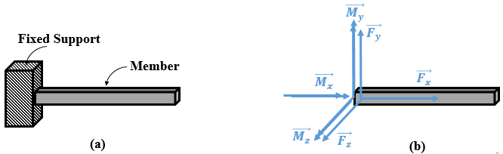
Figure 2.17 Fixed supported member (cantilever) (a), reactions of a fixed support (b)
It should be noted that for a planar loading case acting in an x-y Cartesian reference, the reaction forces along the z-axis and reaction moments about the x- and y-axes are removed.
Equations of Equilibrium
It is well known that a rigid body can translate along any direction (like a particle), but it can also rotate about any point in space. This results in the vector condition $\sum{\vec{F_{i}}=\vec{0}}$ no longer being sufficient for static equilibrium since it does not prevent the rigid body from rotating. In addition to this condition, one must also ensure that the resulting vector moment of all the moments applied to the body also vanishes. Mathematically, another vector equation, $\sum{\vec{M_{i/A}}=\vec{0}}$, must be satisfied where A is an arbitrary point in the space through which three imaginary directions parallel to the reference directions x, y, and z may pass. By switching to the Cartesian notation, six scalar equations of equilibrium ensure the static equilibrium of a rigid body in the space as follows:
 | $$\sum_{i=1}^{i=n}{F_{i,x}}=0$$  $$\sum_{i=1}^{i=n}{F_{i,y}}=0$$  $$\sum_{i=1}^{i=n}{F_{i,z}}=0$$  $$\sum_{i=1}^{i=n}{M_{i,x/A}}=0$$  $$\sum_{i=1}^{i=n}{M_{i,y/A}}=0$$  $$\sum_{i=1}^{i=n}{M_{i,z/A}}=0$$ | (2.19)

This set of equations (2.19) solves six unknowns, i.e., six total component reactions must be developed by the bearings supporting the rigid body, otherwise, the system may be either “unstable” or “indeterminate”.
Application 2.1. A particle of weight 100 N is held in equilibrium by two ropes AB and AC as shown in the figure below. If the angle α is set to 30$°$, calculate the tensile force in each of the cables.
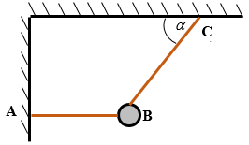
Figure 2.18 Particle held by two cables
Solution 2.1. The FBD of the particle is illustrated in the below figure
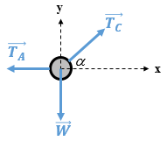
Figure 2.19 FBD solution of application 2.1
Applying planar equations of equilibrium (2.10):
$$\sum{F_{y}=0⇒-W+T_{C}⋅\sin{α}=0⇒T_{C}=100⋅2}⇒T_{C}=200 N$$
$$\sum{F_{x}=0⇒-T_{A}+T_{C}⋅\cos{α}=0⇒T_{A}=200⋅\cos{30}⇒T_{A}=173.2 N}$$
Application 2.2. A 500 N square plate is hinged at A and held by a cable BC joining a hook B to a point C of the wall as shown in the figure below. Determine the reactions at hinge A and the tension developed in cable BC.
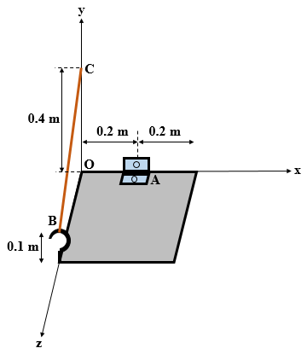
Figure 2.20 Solid plate supported by a hinge and a cable

Solution 2.2. The FBD of the isolated door is shown in the figure below. There are six unknown reaction components. If the system is stable, then one is facing a stable determinate system. By default, the senses of the components of the reaction at the hinge are chosen to be positively oriented in the Cartesian axes. The weight, vertically descending, is parallel and opposite to the y-axis and is applied at the center of the square.
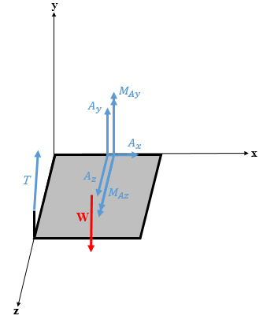
Figure 2.21 FBD solution of application 2.2
However, before applying the six equations of equilibrium (2.19) note that the tension of the cable is neither parallel nor orthogonal to any of the three Cartesian axes, and hence its components, as well as the components of its vector moment about A, should be expressed. The coordinates of A, B, and C are: A(0.2, 0, 0); B(0, 0.1, 0.4); C(0, 0.4 ,0).
The components and the magnitudes of the direction vector $\vec{BC}$ and the position vector $\vec{AB}$ are found from equation (2.7) as follows:
$$\vec{BC}=\left(\begin{aligned}0 \\ 0.3 \\ -0.4\end{aligned}\right) m ; BC=0.5 m$$
$$\vec{AB}=\left(\begin{aligned}-0.2 \\ 0.1 \\ 0.4\end{aligned}\right) m ; AB=0.458 m$$
From the components of the direction vector $\vec{BC}$ and its magnitude, the cosine directions of the cable’s tension $\vec{T}$ and then its scalar components can be found from equation (2.8):
$$\cos{α}=0; \cos{β}=\frac{3}{5}; \cos{γ}=\frac{-4}{5}⇒\vec{T}=\left(\begin{aligned}T_{x}=0 \\ T_{y}=\frac{3}{5}T \\ T_{z}=\frac{-4}{5}T\end{aligned}\right)$$
From the components of the position vector $\vec{BC}$and those of $\vec{T}$, the components of the moment of $\vec{T}$ about A become:
$${\vec{M}}_{\vec{T}/A}=\left|\begin{matrix}\vec{i} & \vec{j} & \vec{k} \\ -0.2 & 0.1 & 0.4 \\ 0 & \frac{3}{5}T & \frac{-4}{5}T\end{matrix}\right|⇒{\vec{M}}_{\vec{T}/A}=\left(\begin{aligned}\frac{-1.6}{5}T \\ \frac{-0.8}{5}T \\ \frac{-0.6}{5}T\end{aligned}\right)$$
Applying the six equations of equilibrium one calculates:
$$\sum{F_{x}=0⇒A_{x}+T_{x}}=0⇒A_{x}=0$$
$$\sum{F_{y}=0⇒A_{y}+T_{y}+W_{y}}=0⇒A_{y}+\frac{3}{5}T=500$$
$$\sum{F_{z}=0⇒A_{z}+T_{z}}=0⇒A_{z}-\frac{4}{5}T=0$$
$$\sum{M_{x/A}=0⇒\left(500\right)⋅(0.2)}-\frac{1.6}{5}T=0⇒T=312.5 N$$
$$\sum{M_{y/A}=0⇒M_{Ay}}-\frac{0.8}{5}T=0⇒M_{Ay}=50 N.m$$
$$\sum{M_{z/A}=0⇒M_{Az}}-\frac{0.6}{5}T=0⇒M_{Az}=37.5 N.m$$
Since T is calculated, A_{y} and A_{z} can be found from the second and third equations:
A_{y} = 312.5 N; A_{z} = 250 N
The positive signs of the answers designate that they act in the orientations drawn in the FBD.

Self-Check Questions
1. Choose the correct answer.
A worker is tightening a screw with a screwdriver with a handle diameter of 3 cm applying a couple of 3 N. The moment developed measured in N⋅cm is:
9 -9 -1 1
2. Which Newton’s axiom applies to a system consisting of a person holding a baby? Axiom III: the baby applies its vertical downward weight while the person holding the baby is applying a vertical upward reaction with the same magnitude.
3. Answer true or false and justify.
The resultant of two concurrent perpendicular forces of 40 N and 30 N magnitudes forms an angle of 42.5$°$ with the larger force. False because $θ=\tan^{-1}{\frac{30}{40}}=36.87°$

Dynamics: Kinematics and Kinetics

Kinematics
This branch of dynamics is concerned with analyzing the “position”, “velocity”, and “acceleration” of a moving body. (Hibbeler, 2016)
Position. Rectilinear motion is characterized by a straight-line path. By definition, the position of a moving body is the “algebraic distance” separating the body from a reference point known as the “origin”. Mathematically speaking, to measure a position, a single coordinate axis coincident with the rectilinear path is used as shown in the figure below (Walker, 2014, p. 12); the “position vector” of the body is the vector joining the origin O to the body; its algebraic magnitude, or the “abscissa”, denotes its position (see figure top right). At any instant t of the motion, a position value x(t) is recorded; a graph summarizing all the positions at all instants can be plotted.
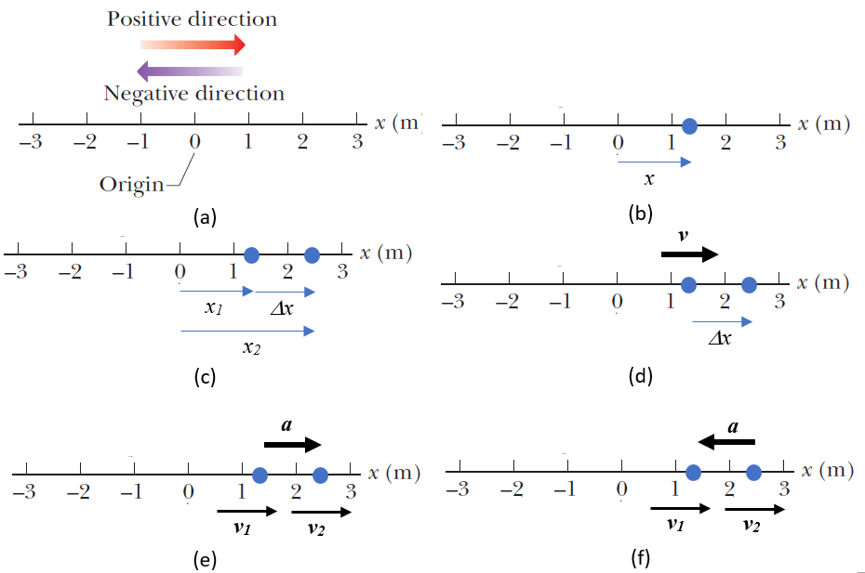
Figure 2.22 Coordinate axis (a), Position (b), Displacement (c), Velocity (d), Acceleration (e), Deceleration (f)
Displacement. This is a vector quantity characterizing the change between an initial and a final position of a moving body as shown in the middle left figure above; its magnitude $Δx=x_{2}-x_{1}$ is algebraic depending on the sense of the vector, i.e., it is positive when the sense is similar to the sense of the coordinate axis. (Hibbeler, 2016). Alternatively, ‘’the “traveled distance” is a “positive scalar” that represents the total length of the path over which the particle travels’’. (Hibbeler, 2016, p. 5)
Velocity. The “average velocity” denotes the rate of change of a body’s position Δx per unit time interval Δt; it is calculated by equation (2.20) and expressed in m/s.
 | $$v_{avg}=\frac{Δx}{Δt}$$ | (2.20)

The “instantaneous velocity” denotes the limit of the average velocity for an arbitrarily small interval of time; $v=\lim_{Δt→0}{Δx/Δt}$; mathematically speaking, this is the first derivative of the displacement with respect to the time (equation (2.21)):
 | $$v=\frac{dx}{dt}$$ | (2.21)

Since dt is a positive scalar quantity, the vector velocity has the same sense as the vector displacement as shown in the middle right figure above. The magnitude of the velocity vector is called “speed”. Moreover, the average speed denotes the ratio of the total traveled distance d_{tot} to the elapsed time Δt; it is a positive scalar quantity. (Hibbeler, 2016)
 | $${sp}_{avg}=\frac{d_{tot}}{Δt}$$ | (2.22)

Acceleration. The “average velocity” denotes the rate of change of a body’s velocity $Δv=v_{2}-v_{1}$ per unit time interval Δt; it is calculated by equation (2.23) and expressed in m/s².
 | $$a_{avg}=\frac{Δv}{Δt}$$ | (2.23)

The “instantaneous acceleration” denotes the limit of the average acceleration for an arbitrarily small interval of time; $a=\lim_{Δt→0}{Δv/Δt}$; mathematically speaking, this is the first derivative of the velocity with respect to time (equation (2.24)(2.21)):
 | $$a=\frac{dv}{dt}$$ | (2.24)

Since the velocity itself is the first derivative of the displacement, it follows that the acceleration is the second derivative of the displacement with respect to time:
 | $$a=\frac{d^{2}x}{dt^{2}}$$ | (2.25)

Since dt is a positive scalar quantity, the vector acceleration’s sense depends on the variation of the vector velocity: if the velocity is increasing the motion is said to be accelerated, (see bottom left figure above) thus the acceleration is positive and has the same sense as the velocity. If the motion is slowing down it is said to be decelerated, (bottom right figure above) thus the acceleration is negative and has the opposite sense as the velocity. If the velocity is constant, the acceleration is then zero.
By eliminating dt from equations (2.21) and (2.24) and equating one gets a relationship between the kinematics quantities independent of the time:
 | $$a⋅dx=v⋅dv$$ | (2.26)

For the particular case where the acceleration is “constant” a = a_{c} and considering the “initial conditions” x(t=0) = x₀ and v(t=0) = v₀, then integrating respectively equations (2.24), (2.21) and (2.26) one obtains the kinematic equations of a “uniformly accelerated motion”:
 | $$v=a_{c}⋅t+v_{0}$$ | (2.27)
 | $$x= \frac{1}{2}a_{c}⋅t^{2}+v_{0}⋅t+x_{0}$$ | (2.28)
 | $$v^{2}-v_{0}^{2}=2⋅a_{c}⋅(x-x_{0})$$ | (2.29)

It should be noticed that a direct application of this special case is the “free fall” of any object where the constant acceleration denotes the gravitational constant g.
Curvilinear motion.
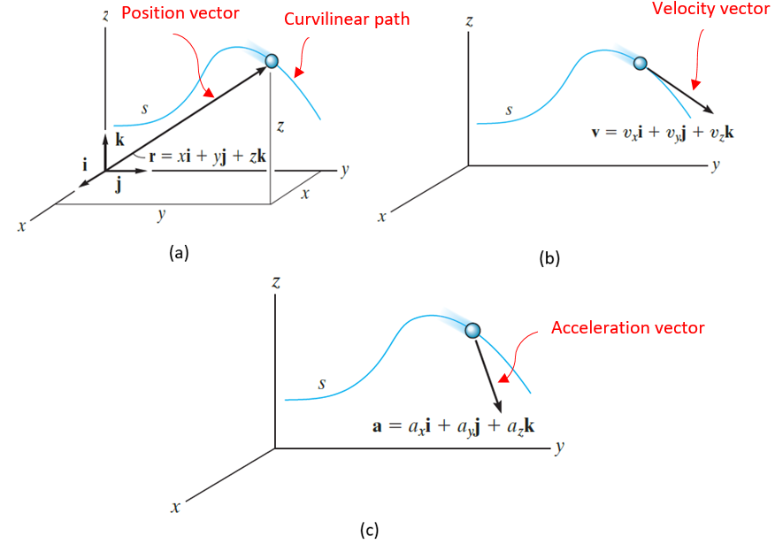
Figure 2.23 Position vector (a), Velocity vector (b), Acceleration vector (c)
On a curved path, the position of a moving particle at each instant t can be measured by three coordinates x(t), y(t), and z(t) which are the three components of the position vector $\vec{r}(t)$ as illustrated in the figure above, top left (Hibbeler, Engineering Mechanics. Dynamics, 2016, p. 36). Since the velocity vector is the first derivative of the position vector, it remains always tangent to the path as shown in the figure top right (Hibbeler, 2016, p. 36). The bottom figure above (Hibbeler, 2016, p. 37) shows the acceleration vector, being the first derivative of the velocity vector or the second derivative of the position vector. The magnitude of each of these three kinematic quantities is calculated from the “Pythagorean theorem” while the “cosine directions” determine their respective directions in the space.
 | $$\vec{r}=x\vec{i}+y\vec{j}+z\vec{k}$$ | (2.30)
 | $$\vec{v}=\dot{x}\vec{i}+\dot{y}\vec{j}+\dot{z}\vec{k}$$ | (2.31)
 | $$\vec{a}=\ddot{x}\vec{i}+\ddot{y}\vec{j}+\ddot{z}\vec{k}$$ | (2.32)

Normal and tangential components.
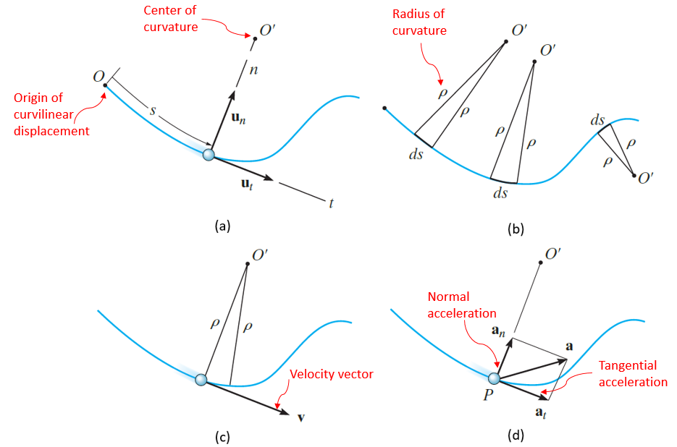
Figure 2.24 Curvilinear position (a), Radius of curvature (b), Velocity (c), Acceleration (d)
This is an alternative method for monitoring the motion of a particle on a curvilinear path. The curvilinear abscissa s(t) is measured from a fixed origin O on the path as shown in the top left figure above (Hibbeler, 2016, p. 56) while the vector’s velocity and acceleration are expressed within a variable orthonormal reference ($\vec{n},\vec{t})$ where $\vec{n}$ is normal to the path, i.e., along the radius of curvature ρ (the top right figure above, (Hibbeler, 2016, p. 56)) and $\vec{t}$ is tangential to the path; $\vec{u_{n}}$ and $\vec{u_{t}}$ are their respective unit vectors. Since the velocity vector is always tangential to the path, it has a component acting along $\vec{u_{t}}$ with a magnitude equal to the first derivative of s(t). The vector acceleration develops two components: the normal, or centripetal, component $\vec{a_{n}}$ , which expresses the rate of change in the direction of the velocity ($v^{2}/ρ$), and the tangential component $\vec{a_{t}}$ expressing the rate change of the magnitude of the velocity ($\dot{v}$). (the bottom two figures above, (Hibbeler, 2016, pp. 56-57)).
 | $$\vec{v}=\dot{s}{\vec{u}}_{t}$$ | (2.33)
 | $$\vec{a}=\ddot{s}{\vec{u}}_{t}+\frac{{\dot{s}}^{2}}{ρ}{\vec{u}}_{n}$$ | (2.34)
 | $$a=\sqrt{a_{n}^{2}+a_{t}^{2}}$$ | (2.35)

Projectile. This is a particle moving along a “parabolic path” in the plane, under its own weight exclusively, due to an inclined initial velocity v₀. The coordinates of its starting point are (x₀,y₀) while the acceleration is constant and equal to the gravity field as shown in the figure below (Hibbeler, 2016, p. 41); since this has a downward sense it will introduce a negative sign into the projectile’s equations. The components of the initial velocity vector are $v_{0x}=v_{0}⋅\cos{θ}$ ; $v_{0y}=v_{0}⋅\sin{θ}$.
Applying equations (2.27)-(2.28) for horizontal and vertical motions, one gets:
 | $$x=v_{0}\cos{θ}⋅t+x_{0}$$ | (2.36)

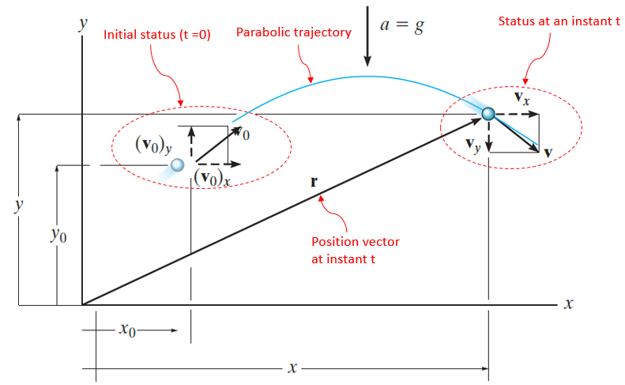
(a)
(b)
Figure 2.25 Analysis scheme of a projectile (a), Projectile example (b)
 | $$y=-\frac{1}{2}g⋅t^{2}+v_{0}\sin{θ}⋅t+y_{0}$$ | (2.37)
 | $$v_{y}=-g⋅t+v_{0}\sin{θ}$$ | (2.38)

Eliminating the time t from equation (2.36) and substituting into equation (2.37) one obtains the equation (2.39) of the parabolic path:
 | $$\tilde{y}=-\frac{g}{2{(v_{0}\cos{θ})}^{2}}{\tilde{x}}^{2}+\tan{θ}⋅\tilde{x}$$ | (2.39)
where: $\tilde{x}=x-x_{0}$ and $\tilde{y}=y-y_{0}$
The photograph above illustrates a practical example of a projectile’s motion: the path of a ball in the air thrown by a player and oriented toward the basket.

Kinetics of a Particle
A particle is capable of translational motion only. The equation of motion in this case is Newton’s second axiom illustrated in the figure below and in equation (2.1) where $\vec{F}=\sum{\vec{F_{i}}}$. This equation is applicable within a “Newtonian” or “inertial reference” meaning that it is either at rest or in constant velocity motion.
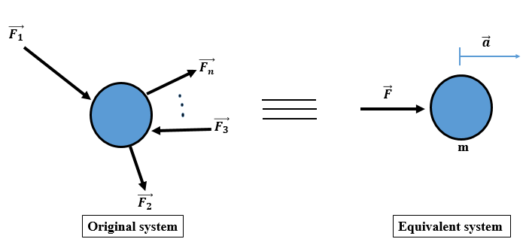
Figure 2.26 Accelerated particle under a resultant force
By projecting equation (2.1) along the three Cartesian axes of the reference (xyz), one obtains three equations (2.40)-(2.42) as follows:
 | $$\sum{F_{x}}=ma_{x}$$ | (2.40)
 | $$\sum{F_{y}}=ma_{y}$$ | (2.41)
 | $$\sum{F_{z}}=ma_{z}$$ | (2.42)

If the motion is planar, equation (2.42) will be omitted.
An alternative set of motion equations could be established in the reference ($\vec{n},\vec{t})$ thus:
 | $$\sum{F_{t}}=ma_{t}$$ | (2.43)
 | $$\sum{F_{n}}=ma_{n}$$ | (2.44)

Kinetics of a Rigid Body
It is worth remembering that a rigid body is capable of translation and rotation. In parallel with the linear kinematic quantities, one may define similar quantities related to rotation: the angular displacement denoted by θ (rad), the angular velocity $ω=\dot{θ}$ (rad/s), and the angular acceleration $α=\ddot{θ}$ (rad/s²)
Mass Moment of Inertia
By definition, the mass moment of inertia of a rigid body I represents the resistance of this body to change in angular velocity. Mathematically, it is the “integral of the “second moment” about an axis of all the elements of mass dm which compose the body” as illustrated in the figure below left.
 | $$I=\int{r^{2}dm}$$ | (2.45)

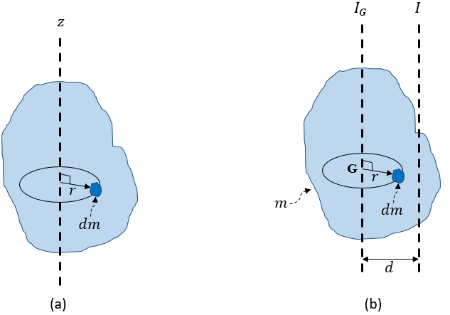
Figure 2.27 Moment of inertia about an axis (a), about an axis parallel to the central axis (b)
According to the equation (2.45), two bodies having the same mass may not have the same inertial resistance to rotation; besides the mass, this property depends on “how far” the different “small portions” of this body are from the rotation axis; in other words, as the size of the body increases, its moment of inertia also increases. This is expressed in kg.m².
The “parallel axes theorem”, or the “Huygens-Steiner’s theorem”, (also known as “Steiner’s theorem”) allows the calculation of the moment of inertia about an axis parallel to a central axis (Hibbeler, 2016) (i.e., the axis is passing through the center of gravity G, see figure above on the right) according to equation (2.46):
 | $$I=I_{G}+md^{2}$$ | (2.46)

The “radius of gyration” k of a rigid body represents the theoretical distance at which a very long and very thin rectangular strip having the same mass as the rigid body, should be placed from an axis, such that this strip reaches the same mass moment of inertia as the real body:
 | $$k=\sqrt{\frac{I}{m}}$$ | (2.47)

Table 2.1 Mass Moment of Inertia of Regular Bodies
Name | Shape | I_{G}
Disk/Cylinder |  | $$\frac{mR^{2}}{2}$$
Plate |  | $$\frac{m(a^{2}+b^{2})}{12}$$
Sphere |  | $$\frac{2mR^{2}}{5}$$
Slender bar |  | $$\frac{mL^{2}}{12}$$

If the mass moment of inertia of a particle of mass m located at a distance r from an axis is calculated by $I=m⋅r^{2}$ (Hibbeler, 2016), other bodies’ inertias are not so evident; The table above summarizes the mass moment of inertia about the central axes of some standard-shaped bodies.
Kinetic Equations of Motion
The kinetic analysis of rigid bodies will be limited to planar motion in the scope of the present book. In other words, one should expect two “translational” and one “rotational” equations of motion.
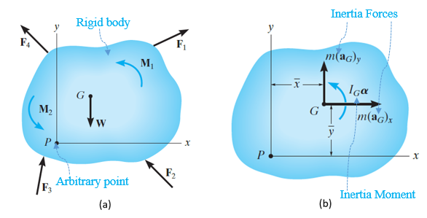
Figure 2.28 FBD of a rigid body in motion (a), Equivalent Kinetic Diagram (b)
The left and right members of Newton’s equations of motion are, respectively, illustrated in the left and right figures above (Hibbeler, 2016, p. 425):
 | $$\sum{F_{x}}=ma_{Gx}$$ | (2.48)
 | $$\sum{F_{y}}=ma_{Gy}$$ | (2.49)
 | $$\sum{M_{G}}=I_{G}α$$ | (2.50)

If the body is pivoted about point P (i.e., P is a “fixed axis”) where G is far from the pivot P at a distance r_{G}, the three equations of motion become:
 | $$\sum{F_{n}}=mω^{2}r_{G}$$ | (2.52)
 | $$\sum{F_{t}}=mαr_{G}$$ | (2.53)
 | $$\sum{M_{P}}=I_{P}α$$ | (2.54)

Application 2.3. A ball is kicked by a goalkeeper at an initial velocity of 20 m/s at 60$°$measured from the horizontal reference. Calculate the highest altitude reached by the ball and the time needed by the ball to touch the pitch again.
Solution 2.3. Let x₀=y₀=0 (the origin is coincident with the goalkeeper’s position).
Mathematically, the maximum height means the maximum ordinate y is found by vanishing its first derivative in equation (2.39) with respect to x:
$$\frac{9.81}{400⋅(\frac{1}{4})}x_{m}=\tan{60}⇒x_{m}=17.656 m⇒y_{m}=15.29 m$$
The ball touched the pitch: $y=0⇒x_{pitch}=\frac{2⋅400⋅\left(\frac{1}{4}\right)⋅\tan{60}}{9.81}=35.312 m$
From equation (2.37): $t_{pitch}=\frac{35.312}{10}=3.53 s$.
Application 2.4. A motor needs 5 seconds to reach a stable speed of 3000 RPM to deliver power to a disk of 40 cm diameter, 10 mm thickness, and 7200 kg/m³ density. Calculate the torque developed by the motor.
Solution 2.4. The angular velocity measures $ω=3000⋅\frac{2π}{60}=314.16 rad/s$ , thus the angular acceleration becomes: $α=\frac{314.16}{5}=62.832 rad/s^{2}$.
The moment of inertia of the disk is $I_{G}=\frac{mR^{2}}{2}=\frac{1}{2}ρVR^{2}=\frac{π}{2}ρhR^{4}=0.181 kg⋅m^{2}$
The torque is found by Newton’s second law in equation (2.50):
$$T=I_{G}⋅α=0.181⋅62.832=11.37 N⋅m$$

Self-Check Questions
1. Answer by true or false and justify your answer.
The free fall motion is a particular projectile where θ = - 90$°$. True, since the initial velocity vector is vertical and downward thus no horizontal component for the motion: the path is linear, particularly vertical.
2. Choose the correct answer.
A small ball is attached to a wire of length 30 cm. A person is holding the other end of the wire and rotating the system at a constant angular velocity of 4 rad/s. What is the acceleration of the ball in m/s²?
0 1.2 4.8 6
Details: The ball travels along a circular path whose center is the wire’s end held by the person’s fingers and whose radius is equal to the wire’s length. Since the angular velocity is constant and the radius of curvature is constant, the tangential acceleration is zero and thus the whole acceleration reduces to the normal component: $a=\frac{v^{2}}{R}=\frac{{(ωR)}^{2}}{R}=Rω^{2}=4.8 m/s^{2}$

3. Answer the following question.
What is the expression of the moment of inertia of a slender rod of mass m and length L about its extremity? The distance between the center G and the extremity is L/2. According to Steiner’s theorem, $I_{ext}=I_{G}+m{(\frac{L}{2})}^{2}=\frac{mL^{2}}{12}+\frac{mL^{2}}{4}$ ⇒Iext=mL23 .

Dynamics: Work, Energy, Impulse, and Momentum

Work
Work of a Force
Mechanical work is a scalar value developed when a force applied on a body causes its displacement in the direction of the force. It is expressed in joules (J).
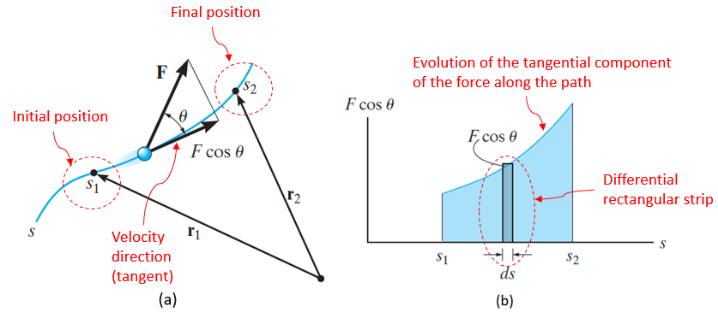
Dot product: the dot product of two vectors is a scalar number obtained by multiplying together the magnitudes of both vectors by the cosine of their angle. In other words, it is the product of the magnitude of a vector and the scalar projection of the other vector along the line of the first vector.
Figure 2.29 Work of a force: physical aspect (a), Graphical aspect (b)
This figure on the left (Hibbeler, 2016, p. 180) shows a force $\vec{F}$ moving a particle along a path where the position is changing from $\vec{r_{1}}$ to $\vec{r_{2}}$. The differential position vector $d\vec{r}$ has a magnitude ds. The angle between the direction lines of $\vec{F}$ and $d\vec{r}$ is denoted by θ. The work W_{m1-2} developed to move the body from position 1 to position 2 is the “dot product” between the force and the displacement:
 | $$W_{m1-2}=\int_{\vec{r_{1}}}^{\vec{r_{2}}}{\vec{F}}⋅d\vec{r}=\int_{s_{1}}^{s_{2}}{F⋅\cos{θ}}⋅ds$$ | (2.55)

One can interpret equation (2.55) as the product of the component of the force acting along the displacement line (i.e., $F⋅\cos{θ}$) and the magnitude of the displacement. For an acute angle θ, the work is positive since the force and the displacement act in the same sense, while the opposite occurs for an obtuse angle θ. For a right angle θ, the force does not develop any work.
The graphical interpretation of equation (2.55) is illustrated in the above figure on the right (Hibbeler, 2016, p. 180): the work is the area under the diagram of the force component $F⋅\cos{θ}$ as a function of the displacement.
Work of a Weight
Since the weight of a body is constant in direction (vertical), sense (descending), and magnitude ($W=m⋅g$), the quantity $ds⋅\cos{θ}$ in equation (2.55) will be the differential vertical displacement dh (i.e., height) and the expression of the work becomes:
 | $$W_{m,W}=-W⋅(h_{2}-h_{1})$$ | (2.56)

If the body displaces upward the work is negative, while in the opposite case the work is positive.
Work of a Wpring Force
The following figure Figure 2.30 (Hibbeler, 2016, p. 477) shows that the displacement of the body is always opposite to the force in the spring $F_{s}=k⋅s$, meaning that the work is always negative.
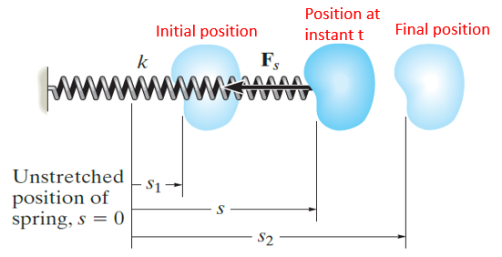
Figure 2.30 Work of a force developed in an elastic spring
Replacing F_{s} in equation (2.55) and solving the integral one gets:
 | $$W_{m,sp}=-\frac{1}{2}k⋅({s_{2}}^{2}-{s_{1}}^{2})$$ | (2.57)

Work of a Couple
Inspired by the work of a force, “when the body rotates in the plane through a finite angle θ measured in radians, from θ₁ to θ₂, the work of a couple moment is:” (Hibbeler, 2016, p. 478)
 | $$W_{m1-2}=\int_{θ_{1}}^{θ_{2}}{M⋅}dθ$$ | (2.58)

Energy
Kinetic Energy
A body of mass m and moment of inertia I_{G} develops a kinetic energy E_{k} when it translates at a linear velocity v_{G} and rotates at an angular velocity ω as illustrated in the below figure (Hibbeler, 2016, p. 475). Kinetic energy is a positive scalar quantity calculated by equation (2.59) and expressed in joules (J).
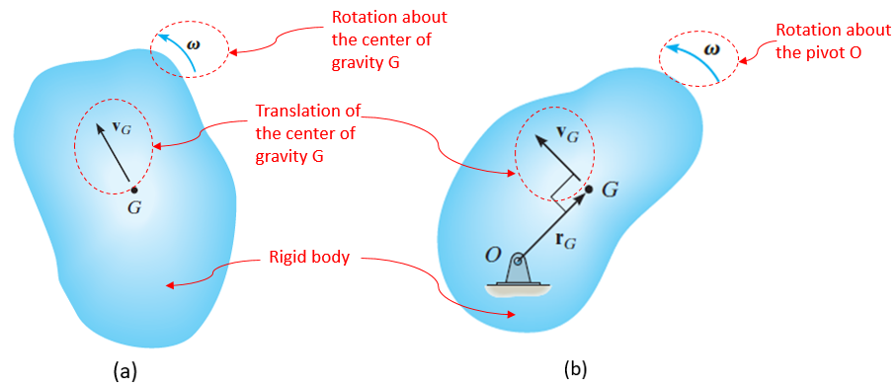
Figure 2.31 General motion of a body (a), Rotation about a fixed axis (b)

 | $$E_{k}=\frac{1}{2}m{v_{G}}^{2}+\frac{1}{2}I_{G}ω^{2}$$ | (2.59)

In the particular case where the body rotates about a fixed pivot O as illustrated above on the right (Hibbeler, 2016, p. 475), the velocity of the center of gravity G could be written as: $v_{G}=r_{G}⋅ω$ and applying the parallel axes theorem: $I_{O}=I_{G}+m{r_{G}}^{2}$, equation (2.59) becomes:
 | $$E_{k}=\frac{1}{2}I_{O}ω^{2}$$ | (2.60)

In case the motion of the body is pure translation, it is sufficient to set $ω=0$ in equation (2.59).
Potential Energy
If the work of a force depends only on the initial and final positions of the body, in other words, independent of the shape of the path, the corresponding force is termed “conservative”, e.g., the weight of a body or the force in a spring. (Hibbeler, 2016).
Potential energy E_{p} is the energy developed by a conservative force quantifying the ability to change the position of the body with respect to a reference level line called “datum”.
Gravitational Potential Energy.
If the body is above the datum, the potential energy of the weight is considered positive since it needs positive work to reach the datum again. For a body below the datum, the potential energy of the weight is considered negative since it needs negative work to move toward the datum. At the datum, the potential energy is zero. This is illustrated in the figure below (Hibbeler, 2016, p. 213).
Since y is considered positive above the datum, the expression of the gravitational potential energy E_{p,g} is:
 | $$E_{p,g}=m⋅g⋅y$$ | (2.61)

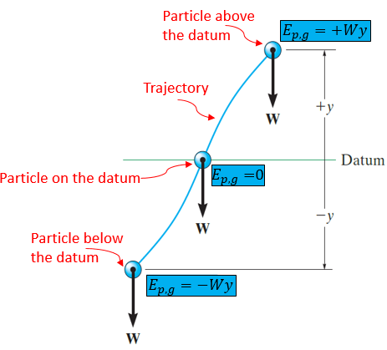
Figure 2.32 Potential energy of the weight
Elastic Potential Energy.
This is the energy stored in an elongated or compressed spring needed to be used as work in order to return the spring to its unstretched position (i.e., datum).
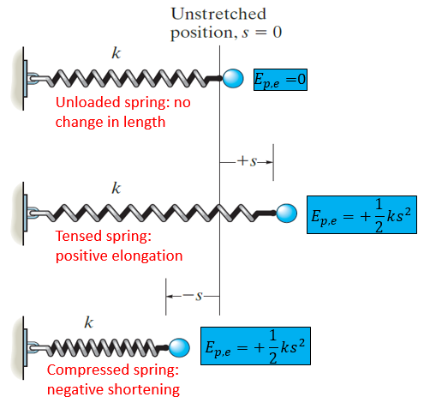
Figure 2.33 Elastic potential energy
It is always positive since the work needed to bring the body back to an undeformed spring is positive (i.e., force in the spring and displacement of the body are in the same sense). This is illustrated above (Hibbeler, 2016, p. 214). It is calculated using equation (2.62) and expressed in joules (J).
 | $$E_{p,e}=\frac{1}{2}k⋅s^{2}$$ | (2.62)

In summary, the work done by external forces to move from position 1 to position 2 is opposite to the difference in potential energies between the final and initial positions.
Mechanical Energy
This is the sum of the kinetic and potential energy of a body.
 | $$E_{m}=E_{k}+E_{p}$$ | (2.63)

Principle of Work and Energy
For a body moving along a curvilinear path, only the tangential components of the external forces develop work since they act along the displacement direction while the normal components are perpendicular to the path, meaning that they develop zero work.
Combining equations (2.53) (where $αr_{G}=v_{G}$) and (2.26) then integrating between position 1 to position 2 we get:
$$\sum{\int_{s_{1}}^{s_{2}}{F_{t}ds}=\int_{v_{1}}^{v_{2}}{m⋅v⋅dv}}=\frac{1}{2}m{v_{2}}^{2}-\frac{1}{2}m{v_{1}}^{2}$$
The first term in this latter equation is the sum of the works of the external forces developed when moving from position 1 to 2 hence:
 | $$E_{k1}+\sum{W_{m1-2}}=E_{k2}$$ | (2.64)

Equation (2.64) represents the mathematical formulation of the principle of work and energy which states that the initial kinetic energy of a system plus the sum of works done by all external forces during the motion of the system are equal to its final kinetic energy. (Hibbeler, 2016)
Conservation of Energy
In the absence of non-conservative forces such as friction, damping, or loss, one can write $\sum{W_{m1-2}=E_{p1}-E_{p2}}$; substituting in equation (2.64) one obtains:
 | $$E_{k1}+E_{p1}=E_{k2}+E_{p2}$$ | (2.65)

This equation shows that the mechanical energy between an initial and a final position is conserved under the condition that non-conservative forces are not acting on the system.
Power
The power generated by an engine, a motor, or a machine denotes the amount of work developed per unit time. (Hibbeler, 2016).
Mathematically, this definition is formulated by the first derivative of the work with respect to time. Power is expressed in watts (W), equivalent to J/s. Another famous unit used (not in SI) is “horsepower” (hp) where: 1 hp = 746 W.
 | $$P=\frac{dW_{m}}{dt}$$ | (2.66)

On the other hand, knowing that: $dW_{m}=\vec{F}⋅d\vec{r}$ and $\vec{v}=\frac{d\vec{r}}{dt}$ , a new formulation of the power could be derived; it consists of the dot product of the vector force and vector velocity:
 | $$P=\vec{F}⋅\vec{v}$$ | (2.67)

Power is an important property for selecting motors or pumps needed to supply some output devices with motion, such as disks, turbines, and fans. However, due to friction and losses between contact surfaces of many elements within such systems, the input power generated by the source will not fully reach the output; some power will be lost at the contacts between components. This phenomenon needs to be quantified through the concept of “efficiency”, which is the ratio of the output power to the input power and is always less than 1:
 | $$η=\frac{P_{out}}{P_{in}}$$ | (2.68)

Impulse and Momentum
Linear Impulse
This is a vector quantity measuring the effect of a force within the time during which this force is applied: $\vec{I}=\int{\vec{F}⋅dt}$. (Hibbeler, 2016). Since time is a positive scalar, the vector impulse has the same direction and sense as the applied force. The linear impulse is expressed in N⋅ s.
Angular Impulse
This is a vector quantity measuring the effect of a moment about a point within the time during which this moment is applied: $\vec{I_{O}}=\int{\vec{M_{O}}⋅dt}=\int{(\vec{r}×\vec{F})⋅dt}$. (Hibbeler, 2016). Since time is a positive scalar, the vector impulse has the same direction and sense as the applied moment. The angular impulse is expressed in N⋅ m⋅ s.
Linear Momentum
The linear momentum of a body is the vector quantity measuring the ability of its matter to translate by a vector velocity of its center of gravity. Mathematically, it is expressed by $\vec{L}=m⋅\vec{v_{G}}$. Since mass is a positive scalar, the vector linear momentum has the same direction and sense as the applied force. Its magnitude is $L=m⋅v_{G}$ and is expressed in kg⋅ m/s. (Hibbeler, 2016)
Angular Momentum
The angular momentum of a body is the vector quantity measuring the ability of its inertia mass to rotate by a vector angular velocity about an axis. Mathematically, it is the “moment of the linear momentum” about the axis of interest as shown below (Hibbeler, 2016, p. 280).
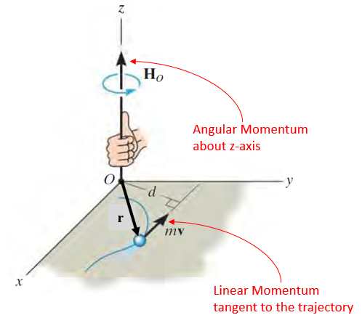
Figure 2.34 Angular Momentum about z-axis
The vector formulation and the magnitude can be written as follows:
 | $${\vec{H}}_{O}=\vec{r}×m\vec{v}$$ | (2.69)
 | $$H_{O}=m⋅v⋅d$$ | (2.70)

The unit of angular momentum is kg.m²/s.
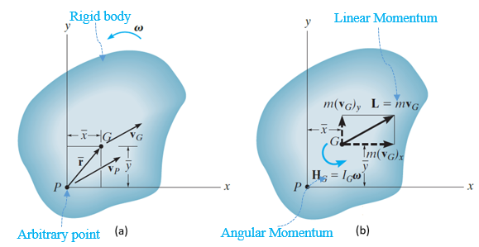
Figure 2.35 Kinematics of a moving body (a), Body Momentum Diagram (b)

If the body is pivoted about point P (i.e., P is a fixed axis denoted by O in that special case) the angular momentum becomes:
 | $$H_{O}=I_{O}ω$$ | (2.72)

and the magnitude of the angular momentum about the center of gravity G is:
 | $$H_{G}=I_{G}ω$$ | (2.73)

Principle of Linear Impulse and Momentum
Going back to Newton’s second law of translation, and replacing the acceleration with the first derivative of the velocity, one obtains:
$$\sum{\vec{F}}=m⋅\vec{a}⇒\sum{\vec{F}}=m⋅\frac{d\vec{v}}{dt}⇒\sum{\vec{F}}⋅dt=m⋅d\vec{v}$$
Integrating this latter equation between positions 1 and 2 yields:
$$\sum{\int_{t_{1}}^{t_{2}}{\vec{F}⋅dt}}=\int_{\vec{v_{1}}}^{\vec{v_{2}}}{m⋅} d\vec{v}$$
$$m\vec{v_{1}}+\sum{\int_{t_{1}}^{t_{2}}{\vec{F}⋅dt}}=m\vec{v_{2}}$$
This latter equation represents the mathematical formulation of the principle of linear impulse and momentum which states that the initial linear momentum of a system plus the sum of linear impulses done by all external forces during the motion of the system are equal to its final linear momentum. (Hibbeler, 2016)
Three scalar equations can be derived from this latter vector formulation:
 | $$mv_{1x}+\sum{\int_{t_{1}}^{t_{2}}{F_{x}⋅dt}}=mv_{2x}$$ | (2.74)
 | $$mv_{1y}+\sum{\int_{t_{1}}^{t_{2}}{F_{y}⋅dt}}=mv_{2y}$$ | (2.75)
 | $$mv_{1z}+\sum{\int_{t_{1}}^{t_{2}}{F_{z}⋅dt}}=mv_{2z}$$ | (2.76)

As a practical example, consider the case of a worker trying to hit a nail with their hammer into a piece of wood; at first they hold the nail, i.e., the initial linear momentum is zero, but then the impulse applied by the hammer’s impact induces in the nail a linear momentum to move and penetrate the wood.
Conservation of Linear Momentum
“Impulsive forces” are forces having huge magnitudes during very short durations sufficient to cause momentum change. “Non-impulsive forces” are not able to change linear momentum considerably (such as the weight of a system) (Hibbeler, 2016). For a system of interacting bodies, if the external impulses balance each other between two durations t₁ and t₂, the linear momentum of the whole system remains unchanged:
 | $$\sum{m_{i}\vec{v_{Gi,1}}}=\sum{m_{i}\vec{v_{Gi,2}}}$$ | (2.77)

As an example, one can discuss the short duration of interaction between a racket and a tennis ball, which constitutes a system of two bodies: in this short duration the action and reaction impulses cancel each other out (the weight of the bodies is non-impulsive during this short duration) thus the linear momentum of this system before impact is the same after impact, however, there has been an “exchange“ of momenta between the racket and the ball; this increases the momentum of the ball to give it motion sustainability.
Principle of Angular Impulse and Momentum
Going back to Newton’s second law of rotation in the plane, and replacing the angular acceleration with the first derivative of the angular velocity, one obtains:
$$\sum{M}=I_{G}⋅α⇒\sum{M}=I_{G}⋅\frac{dω}{dt}⇒\sum{M}⋅dt=I_{G}⋅dω$$
Integrating this latter equation between positions 1 and 2:
$$\sum{\int_{t_{1}}^{t_{2}}{M⋅dt}}=\int_{ω_{1}}^{ω_{2}}{I_{G}⋅} dω$$
 | $$I_{G}ω_{1}+\sum{\int_{t_{1}}^{t_{2}}{M⋅dt}}=I_{G}ω_{2}$$ | (2.78)
This equation represents the mathematical formulation of the principle of angular impulse and momentum which states that the initial angular momentum of a system plus the sum of angular impulses done by all external moments during the motion of the system are equal to its final angular momentum. The same equation applies also if the body rotates about a fixed axis O. (Hibbeler, 2016)
One may state the example of starting the fan of a ventilator: if it is initially at rest (i.e., zero angular momentum), starting the motor means that an angular impulse has been imparted to the fan, which is connected to the motor by a coupling and a shaft; this impulse is converted into an angular momentum responsible for rotating the fan and generating air flow.
Conservation of Angular Momentum
In the absence of any angular impulse on a system, the angular momentum does not change between two instants t₁ and t₂:
 | $$\sum{H_{Oi,1}}=\sum{H_{Oi,2}}$$ | (2.79)

To continue with the ventilator example, a few seconds after the motor’s start (transient regime), the system reaches a permanent regime with a constant speed, meaning that no extra angular impulse is supplied. Thus the angular momentum imparted at the end of the transient regime remains the same during the steady working regime of the ventilator.
Impact
“Impact” is a short-time collision between two bodies each moving at a certain velocity. During impact, a large impulsive force will develop between colliding bodies to induce new velocities.
As illustrated in the figure below, the vector velocities just before impact are indexed by “1“ (two magnitudes and two directions known) while after impact they are indexed by ‘‘2‘‘ (two magnitudes and two directions unknown).
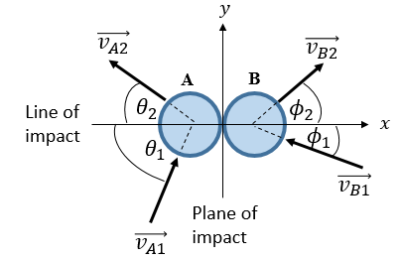
Figure 2.36 Impact initial and final velocities
Upon the developed impulse, both particles deform gradually during impact until reaching a maximum deformation status, then they repulse each other before a complete separation just after impact. In the most general case, particles absorb a portion of the momentum to deform and give back the other portion, this phenomenon is known as “restitution”. It is quantified by a “coefficient of restitution” given by equation (2.80):
 | $$e=\frac{v_{Bx,2}-v_{Ax,2}}{v_{Ax,1}-v_{Bx,1}}$$ | (2.80)

The denominator is known since it characterizes the initial status before impact. The coefficient of restitution e is also known for each impact case. This will lead to a first equation relating the unknowns $v_{Ax,2}$ and $v_{Bx,2}$. For a fully elastic impact, the coefficient of restitution is equal to 1. For a fully plastic impact, the coefficient of restitution is equal to 0.
The figure below shows the diagrams of impulse and momentum on both bodies during impact along both directions x and y. Applying conservation of momentum of the system along the line of impact, i.e., the x-axis, one gets another equation relating the unknowns $v_{Ax,2}$ and $v_{Bx,2}$.
 | $$m_{A}v_{Ax,1}+m_{B}v_{Bx,1}=m_{A}v_{Ax,2}+m_{B}v_{Bx,2}$$ | (2.81)

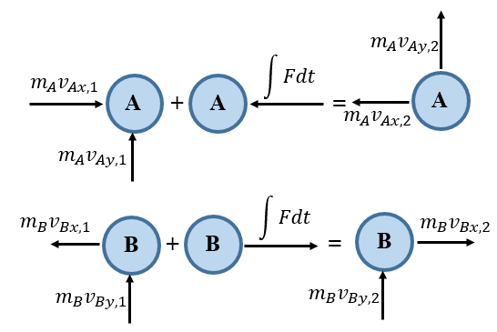
Figure 2.37 Impulse and momentum diagrams during impact
Finally, the linear momentum is conserved along the y-axis perpendicular to the line of action of the impact. This allows finding the other unknowns $v_{Ay,2}$ and $v_{By,2}$.
 | $$v_{Ay,1}=v_{Ay,2}$$ | (2.82)
 | $$v_{By,1}=v_{By,2}$$ | (2.83)

Application 2.5. Car A of mass 1.6 Tons driving at 72 km/h collides with car B of mass 1 Ton driving at 54 km/h as shown in the figure below.
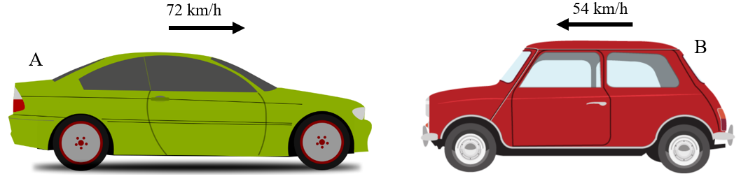
Figure 2.38 Impact between two cars
Determine the velocities of both cars for a coefficient of restitution of 0.3. Also, calculate the average magnitude of the force developed between them if the impact duration is 0.9 s.
Solution 2.5. Algebraic velocities before impact: $v_{A1}=72 km/h=20 m/s$ and $v_{B1}=-54 km/h=-15 m/s$
Coefficient of restitution: $0.3=\frac{v_{B2}-v_{A2}}{35}⇒v_{B2}-v_{A2}=10.5$
Conservation of linear momentum:
$1600⋅v_{A2}+1000⋅v_{B2}=1600⋅\left(20\right)-1000⋅\left(15\right)⇒1.6⋅v_{A2}+v_{B2}=1.7$
Solving both equations: $v_{A2}=-3.385 m/s=-12.18 km/h$; $v_{B2}=5.085 m/s=18.306 km/h$.
To calculate the average developed force, apply the principle of linear impulse and momentum at car A:
$$1600⋅20-F_{av}⋅\left(0.9\right)=1600⋅\left(-3.385\right)⇒F_{av}=41.57 kN$$
Application 2.6. A child of mass 6 kg is sitting on the seat of a swing having mass 3 kg. The length of the rope is 1 m.

Figure 2.39 Baby on a swing
The child’s mother pulls the swing back by an angle of 30$°$ from the vertical line, i.e., the equilibrium position, then releases the swing. Calculate the velocity and the tension in the cable when the child first passes the vertical position.
Solution 2.6. The figure below illustrates positions 1 and 2 of the swing.
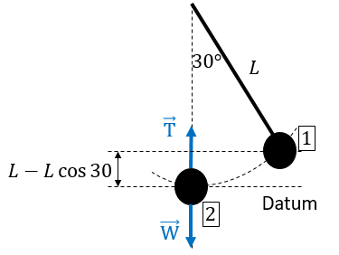
Figure 2.40 Pendulum idealization of the system Kid + Swing
All applied forces being conservative, the principle of conservation of energy can be applied:
$$E_{k1}+E_{p1}=E_{k2}+E_{p2}$$
$$\frac{1}{2}⋅9⋅0^{2}+9⋅9.81⋅1⋅\left(1-\cos{30}\right)=\frac{1}{2}⋅9⋅{v_{2}}^{2}+9⋅9.81⋅0$$
$$v_{2}=1.621 m/s$$
Applying equation (2.44) at position 2 we have:
$$T-\left(9⋅9.81\right)=9⋅\frac{{1.621}^{2}}{1}⇒T=112 N$$

Self-Check Questions
            - Complete the following sentence.
A slender bar of mass 4 kg and length 1.2 m pivoted at its extremity is released from its horizontal position. The mechanical energy measures 23.544 J while it reaches a maximum velocity of 2.971 m/s.
Details: Due to the conservation of energy principle, the mechanical energy can be calculated at any instant, particularly at the initial instant when the bar was held horizontally; its velocity, i.e., kinetic energy, is zero, while its potential energy is maximum and equal to the mechanical energy. If the datum is selected at the lowest position of the center of gravity (when the bar is in vertical position) and passing through this center of gravity, the height to be traveled is half the length of the bar, thus $E=4⋅0.6⋅9.81=23.544 J$.
The maximum velocity is reached when the potential energy vanishes according to the principle of the conservation of energy. This happens when the bar passes by the horizontal position: $E=T_{max}⇒23.544=\frac{1}{2}I_{pivot}ω^{2}$
$$⇒\left(\frac{1}{12}⋅4⋅{1.2}^{2}+4⋅{0.6}^{2}\right)\frac{{v_{G}}^{2}}{{\left(\frac{1.2}{2}\right)}^{2}}=47.088⇒v_{G}=2.971 m/s$$

2. Choose the correct answer
A player executes a penalty kick by imparting a velocity of 22 m/s to a 400 g ball. If the impact duration measures 0.2 s, what is the average force in N applied by the player?
11 22 44 66
Details: The ball was initially at rest on the pitch, thus its initial linear momentum is zero. Its final momentum just after the impulse (i.e., kick-off of the player) is calculated as $L_{2}=22⋅0.4=8.8 kg.m/s$.
Applying the principle of impulse and momentum (equations (2.74)-(2.76)):
$$0+F_{av}⋅0.2=8.8⇒F_{av}=44 N.s$$

3. Answer by true or false and justify your answer.
A motor of 20 kW power rotating at 1500 RPM develops a torsional moment of 14 N.m. False, since the angular velocity in SI measures $1500⋅\frac{2π}{60}=50π rad/s$; thus the torque measures $\frac{20000}{50π}=127 N.m$

Elastostatics

Stress
Consider a straight piece of cross-sectional area A subjected to two equal and opposite axial forces of magnitude F.
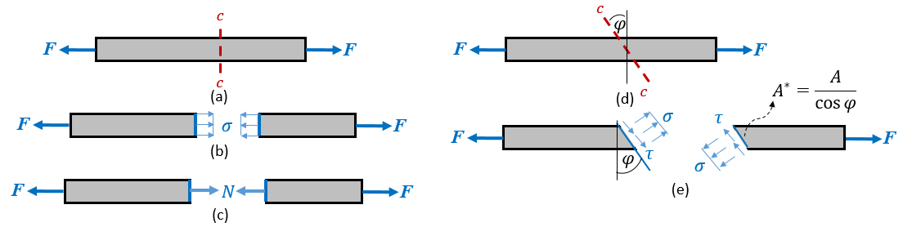
Figure 2.41 Cross section (a), Normal stress (b), Internal axial force (c), Oblique section (d), Normal and shear stresses (e)
The line joining the centroids of all consecutive cross-sections is the “longitudinal axis”, which is coincident with the x-axis of a Cartesian orthonormal frame (xy). The applied external forces generate internal ones. Those appear once the piece is virtually sectioned. The figure above, top left, shows the section a-a which is termed “cross-section” since it is perpendicular to the longitudinal axis. To ensure the equilibrium of each cut portion, internal force must be applied at the cut to balance the remaining external force (in the case of the middle image on the left above the remaining external force at each portion is F). Indeed, internal efforts are developed under a form of distribution through all points forming the section (see the middle left image above); this distribution of internal efforts is known as “stress” expressed in Pa. In the case of a cross-section, developed stress is perpendicular to the cross-section hence it is termed “normal stress” and denoted by the symbol σ. The integration of the stress distribution along the area leads naturally to the internal force. The bottom left image above shows the internal force, which is an “axial force”, denoted by the symbol N. According to the assumptions of Barré de Saint Venant (Hibbeler, 2011), axial force leads to a “uniform distribution” of normal stresses, meaning that all points develop the same value of normal stress on the cross-section if they are separated from the point of application of the external force by a distance equal to a lateral dimension of the piece. Practically, after the cut one isolates either the left or the right portion, sketches the remaining external forces as well as internal forces, then calculates the axial force from the equation $\sum{F_{x}=0}⇒N=F$. Finally, the normal stress is determined: σ is positive when “tensile” and negative when “compressive”.
 | $$σ=\frac{N(x)}{A(x)}$$ | (2.84)

However, an oblique virtual cut by an angle $φ$ with respect to the cross-sectional cut may also be applied as shown for cut c-c in the uppermost figure on the right above. In that case, the area of this oblique plane becomes $A^{*}=A/\cos{φ}$ and two components of internal forces will be developed: a normal component F_{n} acting perpendicular to c-c and a tangential component F_{t} acting within the place of the cut made by c-c. It should be noted that either the left or the right portion will lead to the same magnitudes of components; however, their senses are opposite due to Newton’s third axiom. These magnitudes are calculated from the equilibrium equations $\sum{F_{normal}=0⇒F_{n}=F\cos{φ}}$ and $F_{tangential}=0⇒F_{t}=F\sin{φ}$. In oblique cases, two types of stresses are developed: a normal stress σ which is the distribution of F_{n} over the oblique plane, and a tangential or shear stress τ which is the distribution of F_{t} over this oblique plane. These distributions are depicted in the bottom right image in the figure above.
 | $$σ=\frac{F_{n}(x)}{A^{*}(x)}=\frac{F}{A}\cos^{2}{φ}$$ | (2.85)
 | $$τ=\frac{F_{t}(x)}{A^{*}(x)}=\frac{F}{A}\sin{φ}\cos{φ}$$ | (2.86)

Strain
In general, most solid materials exhibit “elastic behavior”, meaning that they deform by small amounts once they are subjected to mechanical loads; they return to their original sizes once these loads are removed.
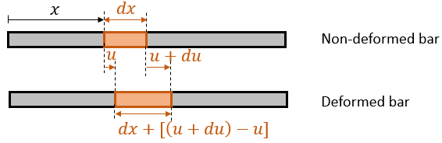
Figure 2.42 Bar before and after deformation
Going back to the axially loaded straight bar, each differential portion of original length dx at the unloaded status will then either elongate or shorten upon the sense of the axial force $\vec{F}$ (i.e., “tensile” or “compressive”) as shown in the figure above. The left extremity of the differential element having an abscissa x displaces by an amount u, while the other extremity of abscissa x+dx displaces by u+du. Thus, the final length of this differential element becomes dx+(u+du-u) = dx+du. By definition, the normal strain at an element is the ratio of its change in length to its original length; mathematically it is the first derivative of the displacement with respect to the relevant spatial variable (here, it is the abscissa x). The normal strain denoted by the symbol ε is dimensionless and is naturally caused by a normal stress σ.
 | $$ε=\frac{du}{dx}$$ | (2.87)

It should be noticed that, since most standard solid materials exhibit high stiffness leading to high resistance and deformation, the values of elongation/shortening, and hence the related strain levels, are small. In general, strain levels are not uniform throughout all elements, however, in the case of an axially loaded bar, normal strain is assumed to be constant along the length. One may then measure the whole change in length Δl of the entire bar (see figure below) to calculate ε. It is positive for elongation and negative for contraction.
 | $$ε=\frac{Δl}{l}$$ | (2.88)

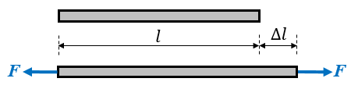
Figure 2.43 Uniform normal strain

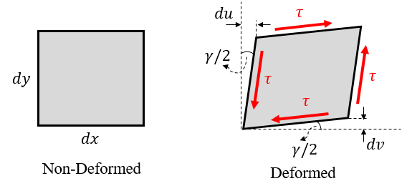
Figure 2.44 Shear distortion
In addition, consider a differential member of area dx⋅ dy subjected to shear strain τ as illustrated in the figure above. The element, originally rectangular, will deform in shape to become a parallelogram. Shear stress has caused a change in angle relative to the original non-deformed element (i.e., 90$°$); this change is termed shear strain or shear distortion and is denoted by the symbol γ and expressed in rad, which is practically dimensionless. It is assumed that the shear strain is distributed equally between rotations of the horizontal and vertical sides of the rectangle; this justifies the existence of the angle γ/2 above. As stated earlier, solid deformations are tiny, thus the trigonometric tangent of γ could be approximated by the value of γ itself thus:
 | $$γ=\frac{du}{dy}+\frac{dv}{dx}$$ | (2.89)

If the shear strain is uniform, it can be calculated by subtracting 90$°$ (i.e., the original angle of the rectangle) from the final angle of the parallelogram. The shear strain γ is positive for an acute parallelogram angle (as shown in the figure) and negative for an obtuse parallelogram angle.

Hooke’s law
Hooke’s law expresses the relationship between the applied normal stress and the resulting normal strain in a solid material.
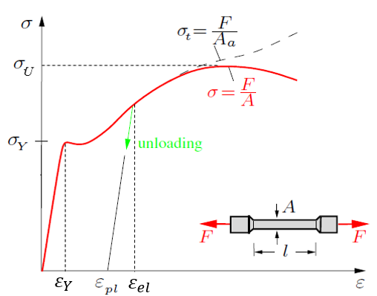
Figure 2.45 Stress-Strain curve of a ductile material
This relationship is established experimentally by loading axially a bone-shaped specimen as shown in the figure above (Gross D. H., 2018, p. 15). The wide parts of the specimen are used for gripping, thus the ‘’thinner part’’ will be tested; its initial length l is known as gauge length. A is its initial cross-sectional area. The value of F is increased by a constant amount within a constant interval of time at a very low speed for each value of F, the elongation Δl is also recorded. The increment of F and the related measurements continue until a complete fracture of the specimen. For each recorded value of F and Δl, the corresponding normal stress and normal strain are calculated such that $σ=F/A$ and $ε=Δl/l$. The stress-strain diagram is plotted as shown in the above figure; this is called the “law of behavior” of the material.
By analyzing the diagram, one remarks that for low strain levels, the stress increases in a linear manner indicating a proportionality between them; this corresponds to a “linear elastic behavior” of the material. The mathematical relationship between stress and strain is known as Hooke’s law.
 | $$σ=E⋅ε$$ | (2.90)

E denotes the slope of the straight line thus it is constant in this interval. E is termed the “modulus of elasticity”, also known as “Young’s modulus” after the scientist Thomas Young. It is an intrinsic property of a material, expressing its ability to resist deformation under a certain level of applied stress. In other words, it expresses the theoretical amount of stress needed to cause a strain equal to unity (i.e., elongation reaches the initial length). It is expressed in Pa.
The material regains its initial length once the applied loading is removed.
Hooke’s law remains valid as long as the stress level remains under the particular value σ_{Y}, termed “yield strength”, which is also an intrinsic property of the material. It expresses the highest value of stress that might be applied without altering the elasticity. Beyond this limit, the strain increases at an almost constant level of stress before increasing again with the stress at decreasing slopes. Above yield strength the material enters a “plastic behavior” region which is considered an “unsafe” region in engineering mechanics; the “safety” interval of operation must remain in the elastic region. However, the stress is still increasing with the strain, but in a non-linear manner, until reaching its highest level denoted by σ_{U}, termed “ultimate strength”. In this region, when the load is removed only a part of the strain is given back while another part is retained permanently: it is the “plastic strain”. The plastic behavior between yield and ultimate strength is known as strain hardening, where the stress and the strain are related as follows:
 | $$σ=K⋅ε^{n}$$ | (2.91)

The strain hardening modulus K and the strain hardening exponent n depend on the type of material.
Beyond the ultimate strength, the strain continues its increment despite the stress decreasing; the material’s behavior is diverging where the cross-sectional area decreases remarkably until complete fracture: this second part of the plastic behavior is termed “necking”.
Ductile material: material exhibiting a large amount of plastic strain before fracture.
Brittle material: material that fractures at the end of the elastic behavior without plasticity.
This entire plastic behavior is obtained for “ductile materials”. The law of behavior of “brittle materials” exhibits only a linear relationship with a higher slope and higher strength; fracture occurs at this highest point.
It should be noted that, despite the cross-sectional area decreasing during the test as F increases, the normal stress is calculated relative to the initial cross-sectional area: this is known as engineering stress and it is used as a conventional value. “True stress” is calculated by dividing each level of force by the actual real value of the area, which decreases throughout the test. This quantity is rarely used in mechanics.
Similar to the tensile test, a shear test can be carried out. The obtained diagram τ-γ is similar to the stress-strain curve figure above. The slope of the linear elastic behavior denoted by G is called the “shear modulus” or “Coulomb’s modulus” or “modulus of rigidity”. Hooke’s law for shear stress is:
 | $$τ=G⋅γ$$ | (2.92)

Poisson’s Ratio
Due to the elasticity of the material, an axial elongation (along the x-axis) parallel to the applied tensile normal stress is accompanied by a contraction of the transverse side (along the y-axis) of the specimen as illustrated in this figure. (Gross D. H., 2018, p. 86)
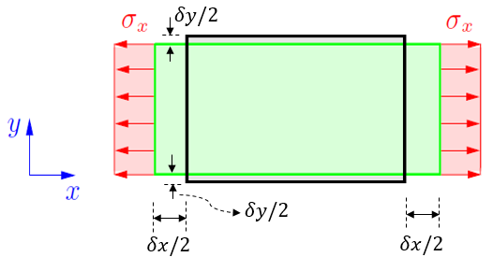
Figure 2.46 Axial and transverse strains
By definition, Poisson’s ratio ν denotes the absolute value of the ratio of the lateral strain to the axial strain. It is a dimensionless intrinsic property of the material. For non-porous solids, this ratio varies between 0.25 and 0.34. A maximum value of 0.5 is measured for uncompressible materials. (Hibbeler, 2011)
 | $$υ=-\frac{ε_{lateral}}{ε_{axial}}$$ | (2.93)

The modulus of elasticity E, the shear modulus G, and Poisson’s ratio ν are termed “engineering constants” of materials. For particularly isotropic materials, those constants are not independent; they are related by equation (2.94).
Isotropic material: material whose properties are independent of the direction.
 | $$G=\frac{E}{2⋅(1+υ)}$$ | (2.94)

Application 2.7. A man of mass 80 kg is sitting on a steel chair having four identical legs of 70 cm length each and a squared cross-section of 100 mm². If the weight of the man is supposed to be distributed uniformly on the four legs, calculate the final length and final cross-sectional area of each leg. For steel E = 200 GPa; ν = 0.3.
Solution 2.7. Each leg is compressed by an axial force $F=\frac{9.81⋅80}{4}=196.2 N$.
The normal compressive stress developed is: $σ=-\frac{196.2}{100}=-1.962 MPa$
The axial strain is calculated by Hooke’s law: $ε_{axial}=-\frac{1.962}{200000}=-9.81⋅{10}^{-6}$
The change in length: $ΔL=70⋅\left(-9.81⋅{10}^{-6}\right)=-0.0006867 cm$
The final length of each leg: $L_{f}=70-0.0006867=69.9993133 cm$
The lateral strain is: $ε_{lat}=0.3⋅9.81⋅{10}^{-6}=2.943⋅{10}^{-6}$
For a squared cross-section of 100 mm², the side length measures 10 mm thus the final side length: $d_{f}=10⋅\left(1+2.943⋅{10}^{-6}\right)=10.00002943 mm$
The final cross-sectional area of each leg: $A_{f}=100.0005886 {mm}^{2}$

Self-Check Questions
- Answer by true or false and justify your answer
For a bar with a circular cross-section of 6 mm diameter and 250 MPa yield strength, the maximum allowable axial force to be applied measures about 7 kN. True since the maximum normal stress that might be developed before failure is the yield strength itself, thus: $F_{max}=250⋅π⋅3^{2}=7086.6 N ≈7 kN$.

2. Choose the correct answer.
A bar of rectangular cross-section 15 mm x 25 mm and made from a material of E = 200 GPa; ν = 1/3 is subjected to an axial tensile force of 9 kN. The shear strain at an oblique cut of 45$°$ measures …
3.2⋅ 10⁻⁴ 6.4⋅ 10⁻⁴ 8⋅ 10⁻⁵ 1.6⋅ 10⁻⁴
Details: The tangential stress is found by equation (2.86):
$$τ=\frac{9000}{15⋅25}\sin{45}\cos{45}=12 MPa$$
The shear modulus is found from equation (2.94): $G=\frac{200}{2⋅\frac{4}{3}}=75 GPa$
Applying Hooke’s law (equation(2.92)): $γ=\frac{12}{75000}=0.00016$

Fluid Mechanics

Density and Pressure
‘’A ‘fluid’ is a substance that flows’’. (Knight, 2016, p. 358). A fluid takes the shape of its container since it cannot withstand high shear stress levels. This is due to the nature of the molecular bonds in fluids. A fluid can be either a “liquid” or a “gas”. In a liquid, molecules are weakly bonded such that they can move around each other while staying close together. Hence, a liquid has a surface when it is in a container and is said to be an “incompressible” fluid. Conversely, no bonds link the molecules of a gas; they move freely in space without natural interactions. For this reason, a gas occupies the entire volume of its container and is referred to as a “compressible” fluid. (Knight, 2016). Two key properties are used for fluid analysis: “density" and “pressure”.
Density
The “density” ρ of a substance is an intrinsic property that measures the mass of a unit volume of this substance. In SI it is expressed in kg/m³. However, volumes of fluids are usually expressed in liters (L) where 1 m³ = 1000 L thus it is more convenient to express the density of a fluid in g/L which is practically equivalent to kg/m³.
 | $$ρ=\frac{m}{V}$$ | (2.95)

Pressure
The “pressure” P of a substance is a scalar quantity measuring the magnitude of the pushing force applied by this substance on a unit area of contact with a container. (see figure below, left (Knight, 2016, p. 360)). The applied force is a vector, however, the pressure is calculated from the magnitude of the force; pressure does not have one orientation. From the below figure on the right (Knight, 2016, p. 360), the force F is measured from the spring’s change in length and the area A of the piston. P is calculated from equation (2.96). In SI, the pressure is expressed in pascals (Pa).
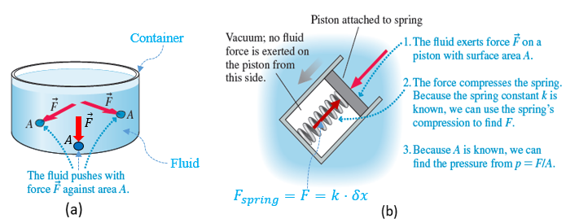
Figure 2.47 Pressure of a fluid (a), Pressure measurement (b)
 | $$P=\frac{F}{A}$$ | (2.96)

If a fluid does not touch a container’s wall(s), its pressure is zero. (Knight, 2016). Liquids develop pressure from “gravitational contribution” because the gravity field attracts the liquid downward thus pushing on the bottom of the container. Being able to flow but blocked by the walls, the liquid pushes similarly on the walls. This leads to the conclusion that the pressure of a liquid increases with the depth of the liquid column (i.e., the height of the fluid column above the point of pressure application). At a given depth level, the pressure of the fluid is identical at every point and in all directions.
To calculate the pressure of a column of liquid of height h, apply equation (2.96) where the force is equal to the weight of the liquid column while A is the cross-sectional area of the column:
$$P=\frac{W}{A}=\frac{m⋅g}{A}=\frac{ρ⋅V⋅g}{A}=\frac{ρ⋅A⋅h⋅g}{A}$$
 | $$P=ρ⋅g⋅h$$ | (2.97)

Being relatively light, the gravitational contribution for gases is negligible. For gases, it is the “thermal contribution” that develops pressure; increasing the temperature leads to an increase in molecular motion and thus more interactions with the walls of the container. (Knight, 2016)
The “atmospheric pressure” is simply the pressure of the surrounding ambient air. Close to the earth’s surface, and thus near sea level, the density and amount of air molecules are considerable, while those quantities decrease with increasing altitude until atmospheric pressure vanishes in outer space, which is called a “vacuum”. This is illustrated in the figure below. (Knight, 2016, p. 361)
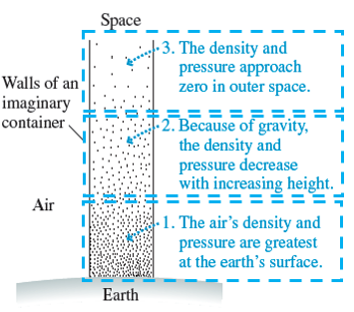
Figure 2.48 Variation of atmospheric pressure with the height
As an average value of atmospheric pressure (atm), one may consider that:
$$1 atm=101300 Pa=760 Torr$$
Torr is a unit of measure named for Evangelista Torricelli, the scientist who measured the atmospheric pressure relative to an equivalent pressure of a column of mercury. (Walker, 2014)
Barometer
The barometer is a device used to measure atmospheric pressure. We can see how the barometer works by use of a long, thin glass tube filled with a liquid (usually mercury) and sealed temporarily with the thumb. Now invert the tube and place it upside down in a beaker also containing liquid mercury and then remove the thumb. At this stage, a certain mass of mercury in the tube will run out into the beaker while the rest of the mercury in the tube stabilizes at a height h = 76 cm (assuming an atm of 1). This experiment is illustrated in the figure below (Knight, 2016, p. 366)
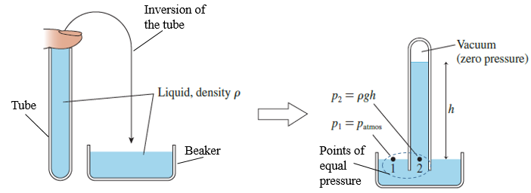
Figure 2.49 Barometer experiment
As said earlier, the pressure at a given horizontal level is the same at all points of pressure, meaning that the pressure at point 1, i.e. the atmospheric pressure, is equal to the pressure at point 2 which is equal to the pressure of the mercury column above calculated from equation (2.97). Since $ρ_{mercury}=13600 kg/m^{3}$, the atmospheric pressure becomes:
$$P_{atm}=13600⋅9.81⋅0.76=101.3 KPa=1 atm=1 bar$$
Manometer
One defines the term “gauge pressure” P_{g} as the pressure measured relative to the atmospheric pressure ; thus $P_{g}=P-P_{atm}$. A “manometer” is a device consisting of an open U-tube filled with a fluid and connected to a pressurized gas-filled tank to measure the gauge pressure of the gas. It is depicted in the figure below (Walker, 2014, p. 344).
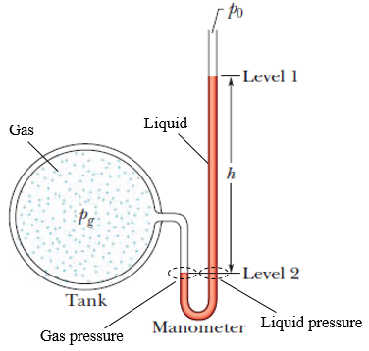
Figure 2.50 Meaurement of gage pressure by a manometer
At a given horizontal level, the pressure in both sides of the u-bend in the tube of the manometer is the same, thus:
$$P_{gaz}=P_{liquid}+P_{0}⇒P_{g}=ρ_{liquid}⋅g⋅h$$

Fluid Statics
Pascal’s Principle
‘’A change in the pressure applied to an enclosed incompressible fluid is transmitted undiminished to every portion of the fluid and to the wall of its container.’’ (Walker, 2014, p. 345).
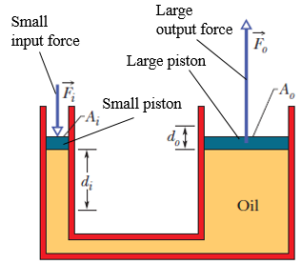
Figure 2.51 Hydraulic lifter
This principle has widespread applications such as squeezing on the bottom of the toothpaste to get it out at the opening of the tube, pushing through a piston on the liquid medicine within a syringe cylinder to inject it into the patient’s body, or a hydraulic car lifter. One of the important benefits of this principle is that we can generate a high output useful force by applying a small level of input force as shown in the figure above (Walker, 2014, p. 345).
Being at the same horizontal level, according to Pascal’s principle:
$${ΔP}_{i}={ΔP}_{o}⇒\frac{F_{i}}{A_{i}}=\frac{F_{o}}{A_{o}}$$
 | $$F_{o}=F_{i}⋅\frac{A_{o}}{A_{i}}$$ | (2.98)

Since the liquid is incompressible, the downward displaced volume at the input piston is the same as the upward displaced volume at the output piston, resulting in a higher distance traveled by the input piston:
$$V_{i}=V_{o}⇒A_{i}⋅d_{i}=A_{o}⋅d_{o}$$
 | $$d_{o}=d_{i}⋅\frac{A_{i}}{A_{o}}$$ | (2.99)

The work developed at the input and output cylinder is conserved:
$$U_{o}=F_{o}d_{0}=\left(F_{i}\frac{A_{o}}{A_{i}}\right)\left(d_{i}\frac{A_{i}}{A_{o}}\right)=F_{i}d_{i}=U_{i}$$
Archimede’s Principle
Consider a closed sack filled with a liquid and immersed in the same liquid.

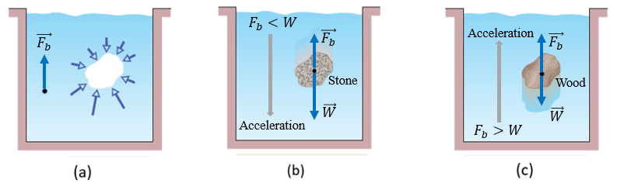
Figure 2.52 Principle of buoyant force (a), Forces on a stone in a liquid (b), Foces on wood in a liquid (c)
The sack is kept in static equilibrium, meaning that the weight of the liquid in the sack is balanced by a vertical upward force equal in magnitude to the weight of the volume of liquid enclosed in the sack. This force is the resultant of a pressure distribution around the sack; the pressure at the bottom of the sack is higher than the pressure at the top because of the height difference. the horizontal resultant is zero since at each horizontal level pressure is the same. The vertical resultant will be upward; it is termed the "buoyant” force and is denoted by $\vec{F_{b}}$ as illustrated in the leftmost image in the figure above (Walker, 2014, p. 347). Due to the static equilibrium, the magnitude of the buoyant force is equal to the weight of the fluid in the sack (Walker, 2014); however, regardless of the amount of liquid in the sack, it will occupy a volume equal to the volume of the liquid that was displaced by the sack. In the most general case, it can be stated that the buoyant force is equal to the weight of the liquid displaced by the immersed volume of the object.
If the volume of the ‘’hole’’ in the figure on the left is now filled by a stone as in the middle figure (Walker, 2014, p. 347), the buoyant force is not able to balance the weight of the stone having heavy density, thus the weight of the stone will overcome the buoyancy and the stone will sink. Conversely, by filling the ‘’hole’’ with a wooden object, which has a very light density, the buoyant force will be greater than the weight of the wood, which will accelerate upward and float on the surface of the fluid. See the above figure on the right (Walker, 2014, p. 347).
The Archimede’s principle could then be stated as follows: ‘‘When a body is fully or partially submerged in a fluid, a buoyant force $\vec{F_{b}}$ from the surrounding fluid acts on the body. The force is directed upward and has magnitude equal to the weight of the fluid that has been displaced by the body.” (Walker, 2014, p. 348)
 | $$F_{b}=ρ_{liquid}⋅V_{immersed}⋅g$$ | (2.100)

When a body floats in a liquid, its weight is equal in magnitude to the buoyant force.
 | $$F_{b}=W_{body}$$ | (2.101)

Since it is in a liquid, the buoyant force cancels out either a part of the weight (sinking case) or the total weight (floating case). It is useful to define the apparent weight of a body, which is the net weight after subtracting the effect of the buoyant force.
 | $$W_{app}=W_{body}-F_{b}$$ | (2.102)

When an object in a liquid needs to be lifted, the lifting force only needs to overcome the apparent weight instead of the entire real weight.

Fluid Dynamics
Viscosity is the resistance of a fluid against flow. It is analogous to friction for solids. (Knight, 2016).
A flow is said to be “laminar” ‘’when the velocity at each point in the fluid is constant. The flow is smooth. It does not change or fluctuate.’’ (Knight, 2016, p. 373). Otherwise, the flow is “turbulent”. The figure on the left below illustrates this difference.
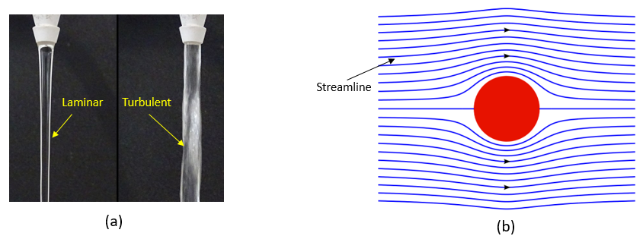
Figure 2.53 Laminar and turbulent flow of water (a), Ideal fluid streamlines (b)
An “ideal fluid” is a fluid that is “incompressible” and exhibits “non-viscous” and “laminar” flow. This is depicted in the figure above on the right.
The equation of continuity
When using a garden hose, one may notice that by reducing the flow area of the water with the thumb, the water flows faster. This means that there is a relationship between the flow velocity and the area through which the fluid flows. The analysis is based on the scheme illustrated in the figure below. (Knight, 2016, p. 374)
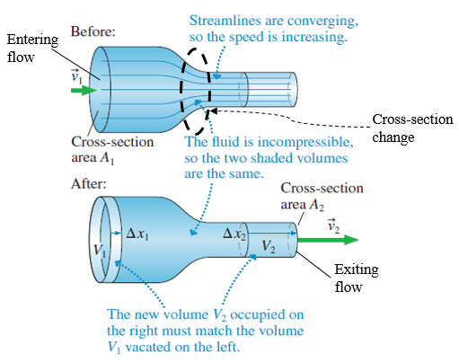
Figure 2.54 Liquid flow through a variable cross-section pipe
Let v₁ be the velocity of the fluid when it enters a wide cross-sectional area A₁ of the pipe. If during time interval Δt, an amount of the liquid travels the distance Δx₁, it would cover a volume V₁ = A₁⋅ Δx₁ = A₁⋅ v₁⋅ Δt.
Let v₂ be the velocity of the fluid when it exits a narrow cross-sectional area A₂ of the pipe. If during time interval Δt, the same amount of the liquid travels the distance Δx₂, it would cover a volume V₂ = A₂⋅ Δx₂ = A₂⋅ v₂⋅ Δt.
Since the liquid is incompressible, the volume of the liquid will remain unchanged, i.e. V₁ = V₂, which will lead to the equation of continuity (2.103).
 | $$v_{1}⋅A_{1}=v_{2}⋅A_{2}$$ | (2.103)

The product of the velocity and the area is called the “volumetric flow rate” Q_{v} and is expressed in m³/s. It quantifies the volume of fluid that flows per unit time. The “mass flow rate” Q_{m} can be deduced by multiplying the volumetric flow rate by the density of the fluid.
 | $$Q_{v}=v⋅A$$ | (2.104)
 | $$Q_{m}=ρ⋅v⋅A$$ | (2.105)

Bernoulli’s Equation
Bernoulli’s equation applies the principle of work and energy to a certain amount of fluid entering a tube under certain conditions (in blue) and exiting the tube under other conditions (in green) as shown in the figure below (Walker, 2014, p. 354).
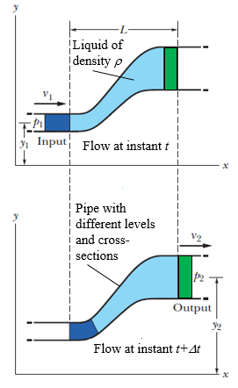
Figure 2.55 Dynamic flow of a fluid in an interval of time Δt

P₁, v₁, and y₁ are respectively the pressure, velocity, and height of the blue amount of the fluid, i.e., at the entrance of the tube. P₂, v₂, and y₂ are respectively the pressure, velocity, and height of the green amount of the fluid, i.e., at the tube’s exit.
The principle of work and energy states that:
$$E_{k1}+E_{p1}+W_{mext}=E_{k2}+E_{p2}$$
The kinetic energies are: $E_{k1}=\frac{1}{2}ρV_{1}{v_{1}}^{2}$ and $E_{k2}=\frac{1}{2}ρV_{2}{v_{2}}^{2}$
The gravitational potential energies are: $E_{p1}=ρV_{1}gy_{1}$ and $E_{p2}=ρV_{2}gy_{2}$
There are two applied external forces:
- $\vec{F_{1}}$ horizontally rightwards (with the entry flow) by the fluid just ‘’behind’’ the blue amount which ‘’pushes’’ the blue amount by a displacement Δx₁, having the same direction and sense as the force. Thus the work done is $F_{1}⋅{Δx}_{1}=P_{1}A_{1}{Δx}_{1}=P_{1}V_{1}$, and
- $\vec{F_{2}}$ horizontally leftwards (against the exit flow) by the fluid just ‘’in front of’’ the green amount which ‘’blocks’’ the green amount by a displacement Δx₂, having the same direction and opposite sense as the force. Thus, the work done is $-F_{2}⋅{Δx}_{2}={-P}_{2}A_{2}{Δx}_{2}=-P_{2}V_{2}$.
Since the liquid is incompressible, V₁ = V₂ = V. substituting in the principle of work and energy and simplifying all terms by V, one obtains equation (2.106).
 | $$P_{1}+\frac{1}{2}ρ{v_{1}}^{2}+ρgy_{1}=P_{2}+\frac{1}{2}ρ{v_{2}}^{2}+ρgy_{2}=constant$$ | (2.106)

Despite the equation appearing to be similar to the principle of conservation of energy, one should keep in mind that the indexes of the equation are not related to different statuses of the fluid; those reflect amounts calculated at two different points belonging to the same liquid streamline.
Application 2.8. A can of diameter 6 cm and height 10 cm with a density of 900 kg/m³ is pushed to the bottom of a container holding a liquid of density 1350 kg/m³. Will the can remain at the bottom once the pushing force is removed? If not, what is the acceleration of the can and the proportion of the height that exits above the surface of the fluid?
Solution 2.8. The weight of the can is $W=m⋅g=ρ_{can}⋅V_{can}⋅g$ while the buoyant force is $F_{b}=ρ_{liquid}⋅V_{imm}⋅g$. Since the can is completely submerged in the liquid its total volume and the immersed volume are equal (i.e., V_{can} = V_{imm}). And since the can’s density is lower than the liquid density, this leads to the conclusion that the buoyant force is greater than the weight of the can. Thus, the can will accelerate upward and will not remain at the bottom of the container.
Apply Newton’s second law of translation to calculate the acceleration:
$F_{b}-W=m⋅a⇒ρ_{liquid}⋅V_{imm}⋅g-ρ_{can}⋅V_{can}⋅g=ρ_{can}⋅V_{can}⋅a$
$$⇒a=g⋅\left(\frac{ρ_{liquid}}{ρ_{can}}-1\right)=9.81⋅0.5⇒a=4.905 m/s^{2}$$
At the surface of the fluid, the can will float thus: ${F'}_{b}=W⇒\frac{V_{imm}}{V_{can}}=\frac{ρ_{can}}{ρ_{liquid}}$
$$⇒1-\frac{H_{above}}{H_{can}}=\frac{2}{3}⇒\frac{H_{above}}{H_{can}}=\frac{1}{3}$$
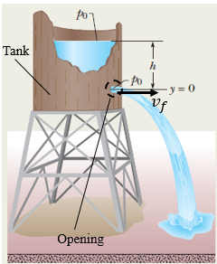
Application 2.9. The cap of an opening of diameter 1.6 cm on the side of a cylindrical water tank of diameter 1 m is removed, thus water will flow as shown in the figure, right (Walker, 2014, p. 356). The distance between the top surface of the water and the opening measures 1.2 m. Calculate the volumetric flow rate.
Solution 2.9. Apply Bernoulli’s equation between the initial status (i) at the top of the tank and the final status (f) at the opening. Atmospheric pressure p₀ exists at both statuses.
Figure 2.56 Water leakage
$$p_{0}+\frac{1}{2}ρ⋅{v_{i}}^{2}+ρ⋅9.81⋅1.2=p_{0}+\frac{1}{2}ρ⋅{v_{f}}^{2}+ρ⋅9.91⋅0$$
$${v_{f}}^{2}-{v_{i}}^{2}=23.544$$
Applying the equation of continuity: $A_{i}v_{i}=A_{f}v_{f}⇒v_{i}=v_{f}({\frac{d_{f}}{d_{i}})}^{2}=0.000256v_{f}$
Substituting in Bernoulli one finds: $v_{f}=4.852 m/s$
The volumetric flow rate becomes: $Q_{v}=π{(0.008)}^{2}⋅4.852⇒Q_{v}=0.976 L/s$

Self-Check Questions
- Choose the correct answer
What is the height of a column of oil (850 g/L) that has the same pressure as a column of water (1000 g/L) of 1.7 m?
2 m 1.7m 1.445 m 3.4 m
Details: $P_{oil}=P_{water}⇒ρ_{oil}gh_{oil}=ρ_{water}gh_{water}⇒h_{oil}=\frac{1000}{850}⋅1.7=2 m$

2. Answer the following question.
Why is the liquid used in a barometer mercury and not water? The density of mercury is 13.6 times water’s density. To balance the atmospheric pressure, the height of the water column needed, and, by extension, the minimum height of the experimental tube, is 0.76⋅ 13.6 = 10.34 m.
3. Complete the following sentence
In a five-story building where the water tanks of all apartments are placed on the roof, the water velocity through a faucet on the 2nd floor is higher than the water through a similar faucet on the 4th floor. A probable solution is to decrease the faucets’ diameters from floor to floor. Also, one may increase the pressure at the water tank by mounting a pressurizer.
Summary
A rigid body is in static equilibrium if the components of the resultant of all external forces and moments along the three axes x, y, and z vanish. For a particle, it is sufficient to satisfy zero resultant force.
Newton’s second law in translation states that a resultant force induces to a body a linear acceleration proportional to the force through the body’s mass. A similar law in rotation relates the moment to the angular acceleration through the moment of inertia. The acceleration is the first time derivative of the velocity. This latter is itself the first time derivative of the displacement.
A body moving at a velocity develops kinetic energy. When there is a change in position it develops potential energy. A force (i.e., a moment) causing a linear (i.e., angular) displacement generates work. This work causes a change in kinetic energy. Moreover, in absence of non-conservative forces, the mechanical energy of a system is conserved.
The integral of a force within a time interval produces an impulse, while the integral of an inertia force (i.e., moment) produces a linear (i.e., angular) momentum. The development of external impulses causes a change in momentum.
Normal stress is a perpendicular distribution of internal forces along a cross-section; tangential stress acts within the cross-section. The change in length of an axially loaded object relative to its original length is called axial strain. The angular change of an object under shear is termed shear strain or distortion. For an elastic behavior, stress and strain are proportional: this is Hooke’s law.
A fluid develops a pressure proportional to its height. Its velocity increases when its cross-sectional area of flow decreases. The total energy along a streamline of an ideal fluid is conserved.

Unit 3 – Thermodynamics

Study Goals

On completion of this unit, you will be able to
- understand the main thermodynamics quantities such as temperature, heat, energy, and thermal expansion.
- apply the first law of thermodynamics and evaluation of systems enthalpy.
- apply the second law of thermodynamics and evaluation of systems entropy.
- distinguish between different ways of heat transfer and their relevant calculations.

Thermodynamics

Introduction
It is all about energy! Nowadays the entire world is seeking energy sources. Energy is needed everywhere in daily life: for domestic applications such as heating, air-conditioning, food storage, and cooking, for the production of electricity, for industrial applications and manufacturing, or medical applications like human temperature or the storage temperature of medicines. The basics of energy analysis begin with “thermodynamics”. Thermodynamics is one of the most essential branches of engineering. It concerns itself with the analysis of thermal energy, i.e., the internal energy in substances.
It will be useful to start by understanding the concept of heat and temperature along with different units and related conversion equations and with all related quantities such as the coefficient of thermal expansion, specific heat, “enthalpy”, and “entropy”. Those two latter quantities are the main parameters influencing the first and the second law of thermodynamics respectively.
Moreover, it is important to close this chapter by emphasizing the concept of the transfer of heat through materials existing between “cold” and “hot” atmospheres and discussing the different methods upon which this transfer occurs: conduction, convection, and radiation. This requires awareness of some simple engineering calculations and some intrinsic properties of materials.

Temperature and Heat

Temperature
“Thermal energy” or “Internal energy” of a system quantifies how the molecules within the system are in motion and are interacting between themselves. The practical measurable value reflecting this status of internal energy is the “temperature”. (Knight, 2016). When a body is “cold” one measures a low temperature, meaning that the movement and interaction of the molecules inside the material are very limited. The body is classified as “hot” when the internal molecules are moving and interacting much more quickly, resulting in a higher temperature.
The device used to measure temperature is the “thermometer”. It consists of a column of liquid in a graduated capillary glass tube that dilates when it is in contact with a hot body, with the level of the liquid marking the temperature on the graduations. The dilatation, i.e., the length of the column of fluid, increases as long as the temperature increases. This is illustrated in the figure below (Knight, 2016, p. 494) where the fluid column (in red) is “short” for icy water and “longer” for hot water.
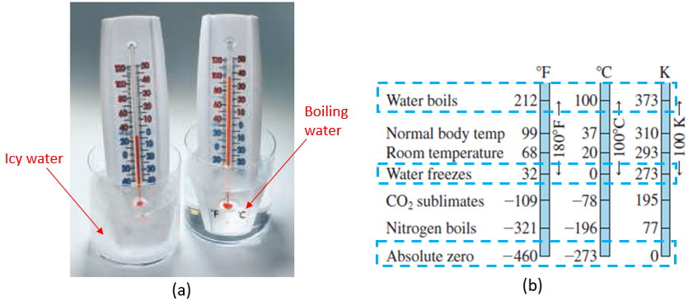
Figure 3.1 Thermometer measuring water's temperature (a), Temperature scales (b)
To specify the unit of the temperature value, a scale should be defined on the thermometer. The figure above (Knight, 2016, p. 495) shows three different scales reflecting three different unit systems: “degrees Fahrenheit” ($℉$), “degrees Celsius” ($℃$), and kelvin (K). The SI system adopts ($℃$) as the temperature unit carrying the name of the Swedish scientist Anders Celsius. The scale consists of fixing two reference points: the first corresponding to the point of water freezing to which a temperature $0℃$ is assigned, and the second corresponding to the boiling point of water, defined as $100℃$. The graduation of the scale is then set by linear subdivisions, each one corresponding to a temperature.
The “linear scale” of Fahrenheit defines water freezing at $32℉$ water boiling at $180℉$. To establish a conversion relationship between Fahrenheit and Celsius, the “slope” of the straight-line temperature function is found by $\frac{212-32}{100-0}=\frac{9}{5}℉/℃$ and since at the “abscissa” $0℃$ one measures an “ordinate” of $32℉$ the linear relationship of conversion becomes:
 | $$T_{F}=\frac{9}{5}T_{C}+32$$ | (3.1)

Repeating the same rationale for conversion Celsius-Kelvin, one finds:
 | $$T_{K}=T_{C}+273$$ | (3.2)

For gases particularly, molecules are originally openly spaced and in continuous motion filling the entire space of the container. When the temperature increases, the mobility of the molecules becomes more pronounced, and thus the pressure on the walls of the container increases. Conversely, when a gas gets colder its pressure drops. Globally, the variation between pressure and temperature is linear. In addition, all gases reach zero pressure at almost the same temperature, which is $-273℃$ (Walker, 2014), which corresponds to 0 K; this is known as the “absolute zero temperature”. It should be noted that all gases experience condensation at temperatures higher than absolute zero.
Condensation: transformation of a substance from a gaseous state to a liquid state.

Thermal Expansion
When a body is heated, its atoms and molecules displace forward to occupy a wider space; this phenomenon is known as “thermal expansion”. For solids, each side expands along a line and hence they experience linear expansion $∆L$ . Inversely, cooling causes linear contraction. The relative change in length relative to the original length L₀ of a solid $∆L/L_{0}$ is directly proportional to the change in temperature $∆T$. The coefficient of proportionality α is called the “coefficient of linear expansion”, expressed in $℃^{-1}$. Physically, it is an intrinsic property of a material that expresses the amount of axial strain a material generates when its temperature changes by $1℃$. An increase in temperature induces elongation, i.e., a positive change in length, while a drop in temperature leads to a negative change in length, i.e., contraction.
 | $$\frac{∆L}{L_{0}}=α⋅ΔT$$ | (3.3)

Since liquids assume the form of their containers, they would expand or contract volumetrically instead of linearly according to the same law as solids. The “coefficient of volumetric expansion” β is the coefficient of proportionality.
 | $$\frac{∆V}{V_{0}}=β⋅ΔT$$ | (3.4)

Since α characterizes a unidirectional expansion and β characterizes a 3D expansion, the relationship between them is:
 | $$β=3α$$ | (3.5)

This aspect of expansion is important in many applications: pipes used for cold and hot water in a heating system should be protected from this phenomenon; metallic bridges and steam pipes in power plants need expansion joints to absorb this expansion and contraction; expansion joints for metallic railways, see figure below, airplane parts that experience huge differences in temperature between $20℃$ on the ground and $-50℃$ at high altitudes. Engineering designs of all components that are subjected to temperature changes must consider this source of expansion and contraction.
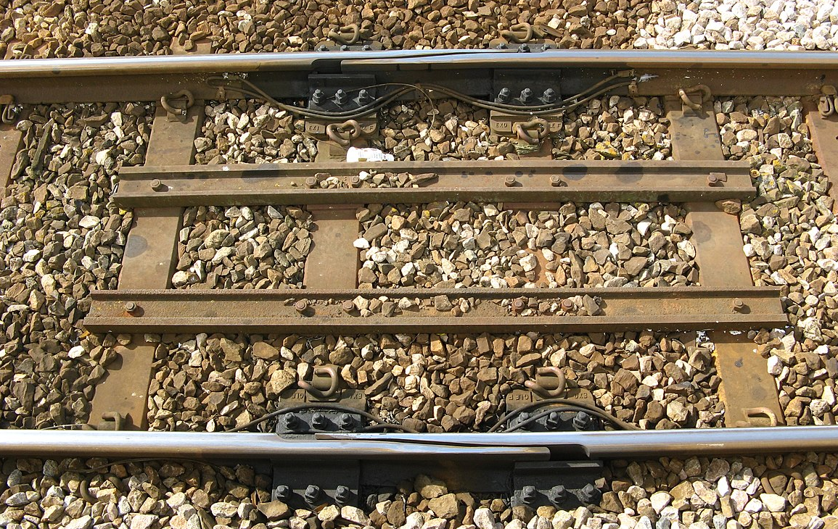
Figure 3.2 Joint expansion on a railway

Heat
‘’Heat is energy transferred between the system and the environment as they interact.’’ (Knight, 2016, p. 523). In other words, heat is a thermal interaction caused by the temperature difference between a system and its environment.
If one picks up a cold water bottle having a temperature of $10℃$ and places it on a table located in a kitchen where the ambient temperature is $23℃$ there is a temperature difference of $13℃$. Thus an amount of heat will transfer from the warmest system to the coldest system to establish thermal equilibrium; the time required for this to happen depends upon the material type and mass of the system being considered. For this reason, when one comes back after, say, one hour, the water bottle will be found to be warmer since its temperature has increased to reach the equilibrium temperature, the ambient. The inverse phenomenon occurs when a hot spaghetti dish of temperature $50℃$ is placed on the same table: in that case, heat will “quit” the warmer system, i.e., the food will experience a drop in temperature after the passage of some amount of time.
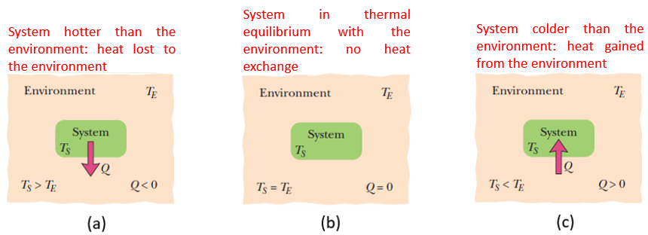
Figure 3.3 Heat exchange scenarios: heat loss (a), thermal equilibrium (b), heat gain (c)
The figure above (Walker, 2014, p. 463) illustrates the three cases where heat is exchanged between a system and the environment. The amount Q of heat exchanged is proportional to the difference in temperature between the final and initial status; the coefficient of proportionality is denoted by C and is called “heat capacity” expressed in $(J/K)$. Q is expressed in J. Another well-known unit (not belonging to SI) for Q is the calorie (Cal) where $1 Cal=4.1868 J$.
 | $$Q=C⋅(T_{f}-T_{i})$$ | (3.6)

The heat capacity C is found from the product of the mass m of the system and an intrinsic property of the system’s material called “specific heat” (c) expressed in $(J/kg⋅K)$ which denotes the amount of heat needed by a unit mass of a material to change its temperature by 1 degree. Thus the amount of exchanged heat becomes:
 | $$Q=m⋅c⋅(T_{f}-T_{i})$$ | (3.7)

State Transformation
Any material absorbs or ejects heat to get hotter or colder, except at some key temperatures where the materials experience a “change of phase” by converting either from a solid state to a liquid state (or vice-versa) or from a liquid state to a gas state (or vice-versa). The state transformation from solid to liquid is termed “melting” while the inverse process is the “freezing” phenomenon. The state transformation from liquid to gas is termed “vaporization” while the inverse process is called “condensation”. The state transformation from solid to liquid to gas induces more energy in the molecules so that they move more and more, this means that an amount of heat should be supplied. The same amount of heat should be removed to go back from a gas status to a liquid and then to a solid. This amount is called “heat of transformation”, denoted by the symbol L and expressed in (J/kg). It is an intrinsic property of each material. The “heat of fusion” L_{F} is needed for a solid-liquid transformation. The “heat of vaporization” L_{V} is needed for a liquid-gas transformation. For instance, for water, $L_{F}=333 kJ/kg$ ; $L_{V}=2256 kJ/kg$ (Walker, 2014)
 | $$Q=m⋅L$$ | (3.8)

Application 3.1. A 0.8 m Aluminum rod ($α=2.3×{10}^{-5} ℃^{-1}$) initially at $77℉$ is cooled to $32℉$. What is the change in the length of the rod?
Solution 3.1. Applying equation (3.1) at both initial and final temperatures and then calculating the difference one gets: $∆T_{F}=\frac{9}{5}∆T_{C}⇒∆T_{C}=\frac{5}{9}\left(-45\right)=-25℃$
Equation (3.3) gives: $∆L=2.3×{10}^{-5}⋅0.8⋅\left(-25\right)=-46⋅{10}^{-5}m⇒∆L=-0.46 mm$
Application 3.2. 150 kJ of heat is supplied to 500 g of ice at $-5℃$. Is this sufficient to melt the entire quantity into water? Discuss.
Given: $c_{ice}=2220 J/kg.K$ ; $c_{water}=4187 J/kg.K$; $L_{F}=333 kJ/kg$
Solution 3.2. The amount of heat needed to reach the melting point of ice ($0℃$) is calculated from equation (3.7): $Q_{1}=0.5⋅2220⋅\left(0-\left(-5\right)\right)=5550 J=5.55 kJ$.
The amount of heat needed to transform ice to water at $0℃$ is found from equation (3.8): $Q_{2}=0.5⋅333=166.5 kJ$.
This latter amount is greater than the whole supplied energy, meaning that the remaining energy ($150-5.55=144.45 kJ)$ will melt a part of the ice calculated as: $m^{'}=\frac{144.45}{333}=0.434 kg$. Thus, the final status will be a mixture of 434 g of water and 66 g of ice at $0℃$.

Self-Check Questions
            - Evaluate the absolute zero temperature in $℉$.
The absolute zero temperature (0 K) is equivalent to $-273℃$, thus in $℉$it becomes $T_{abs_0}=\frac{9}{5}\left(-273\right)+32=-459.4℉$
            - Choose the correct answer.
A piece of copper ($c=386 J/kg.K)$ of mass 100 g and at a temperature of $60℃$ is thrown into a calorimeter containing 200 g of water ($c=4187 J/kg.K)$ at $20℃$. What is the equilibrium temperature of the whole system?
$23.27℃$ $22.88℃$ $25.31℃$ $21.76℃$
Details: Let T be the equilibrium temperature. The amount of heat lost from the copper to cool it from $60℃$ to T is: $Q_{1}=0.1⋅386⋅\left(T-60\right)=38.6T-2316 (J)$
The amount of heat gained by the copper to heat it from $20℃$ to T is:$Q_{2}=0.2⋅4187⋅\left(T-20\right)=837.4T-16748 (J)$.
A calorimeter is an isolated container, thus no loss during heat exchange; as a result: $Q_{1}+Q_{2}=0⇒38.6T-2316+837.4T-16748=0⇒T=\frac{19064}{876}=21.76℃$.

First Law of Thermodynamics and Enthalpy

The First Law
The “first law of thermodynamics” is applied mainly to gases enclosed in reservoirs and changing from an initial state (i) described by the initial pressure p_{i}, initial volume V_{i}, and initial temperature T_{i} to a final state (f) characterized by the initial pressure p_{f}, initial volume V_{f}, and initial temperature T_{f}. This can be thought of as a ‘‘thermodynamic version” of the classical principle of conservation of energy. (Walker, 2014)
The principle of work and energy (equation (2.64)) can be re-written at the ‘‘microscopic scale” of the system as:
$$∆E_{k}+∆E_{p}+∆E_{th}=+W_{m,ext}$$
Where ΔE_{k} denotes the change in kinetic energy, ΔE_{p} denotes the change in potential energy, and ΔE_{th} denotes the change in “internal thermal energy” between the molecules of the system. In addition, the sum of the kinetic and potential energy gives the mechanical energy thus:
$$∆E_{mech}+∆E_{th}=W_{m,ext}$$
We define the change in internal energy of the system by $∆U=∆E_{mech}+∆E_{th}$, which involves all thermal and mechanical interactions between the parts of the system. Besides the mechanical work W_{m}=W_{m,ext} done by the external forces on the system, any external amount of heat Q absorbed or lost by the system impacts the internal energy of the system. Q was not included in the original principle of work and energy since it was established in the absence of any heat exchange. Rearranging the latter equation, one obtains the mathematical form of the first law as follows:
 | $$∆U=Q+W_{m}$$ | (3.9)

This first law could be stated as: The change in internal energy of a system ΔU is equal to the sum of external heat Q and external mechanical work W_{m} exchanged between the system and its environment. (Walker, 2014)
It should be noted that experiments have shown that either the exchanged heat Q alone or the exchanged mechanical work W_{m} depends on the path covered between the initial status (i) and the final status (f), while their total sum does not, meaning that the change in internal energy does not depend on the path between (i) and (f). This depends only on the variables (p_{i}, V_{i}, T_{i}) and (p_{f}, V_{f}, T_{f}). (Walker, 2014)
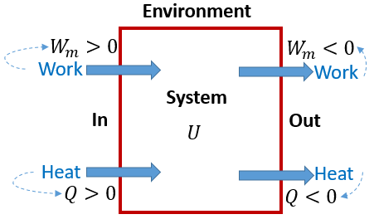
Figure 3.4 Energy diagram of a system
Figure 3.4 shows that any amount of heat absorbed by the system or mechanical work ‘‘compressing” the system is considered positive, while in the opposite case (heat released by the system) those amounts are considered negative.
One example of an application of the first law is the thermal combustion engine, in which heat is supplied to the piston-cylinder chamber where an air-gas mixture is burned in order to generate mechanical work as an output to generate motion for the automobile. Another application is the refrigerator: the input is mechanical work applied on the refrigerant in the chamber, while the output is the amount of heat removed from the refrigerator space to maintain a cool ambiance for food storage.

External Work on Gas Systems
Consider a gas enclosed within a piston-cylinder chamber. It applies a pressure p on all the chamber’s walls (see the figure below (Knight, 2016, p. 518)). This will force the piston to move rightwards unless an opposite force is applied to balance the gas force.
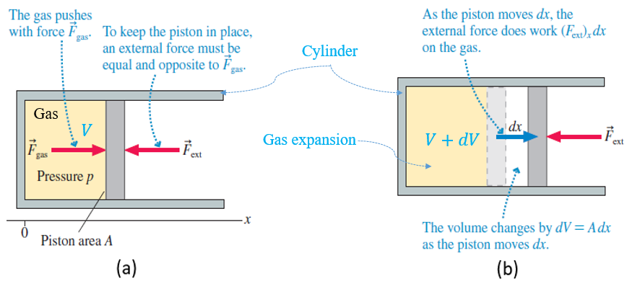
Figure 3.5 Gas within a cylinder-piston chamber: equilibrium (a), piston motion (b)
This equilibrium requires that: $F_{ext}={-F}_{gas}=-p.A$. When the piston displaces by dx, the differential work done on the gas system becomes ${dW}_{m,ext}=F_{ext}⋅dx$. Substituting the above expression for F_{ext} and knowing that $dV=A⋅dx$, the differential work becomes: ${dW}_{m,ext}=-p⋅A⋅dx=-p⋅dV$. Integrating between V_{i} and V_{f} one obtains the total external work done on the gas:
 | $$W_{m,ext}=-\int_{V_{i}}^{V_{f}}{p⋅dV}$$ | (3.10)

This equation shows that when the volume decreases (meaning the system is compressed), i.e., $V_{f}<V_{i}$, the external work done on the system by the environment is positive. This means that the work done by the system on the environment is negative. Inversely, when the volume increases (meaning the system is expanded), i.e., $V_{i}<V_{f}$, the external work done on the system by the environment is negative. This means that the work done by the system on the environment is positive.
In addition, the work done on the system could not be evaluated unless the diagram p-V is given; it is the opposite of the area under the p-V curve. This is illustrated in the figure below. (Knight, 2016, p. 519)
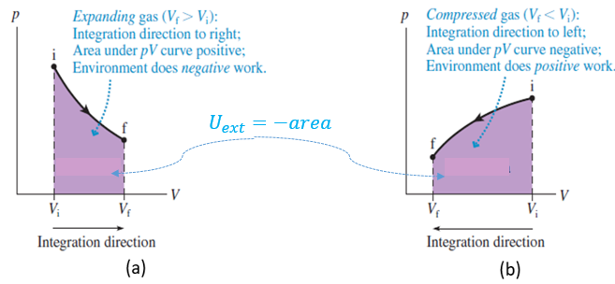
Figure 3.6 p-V diagram for expansion (a), compression (b)
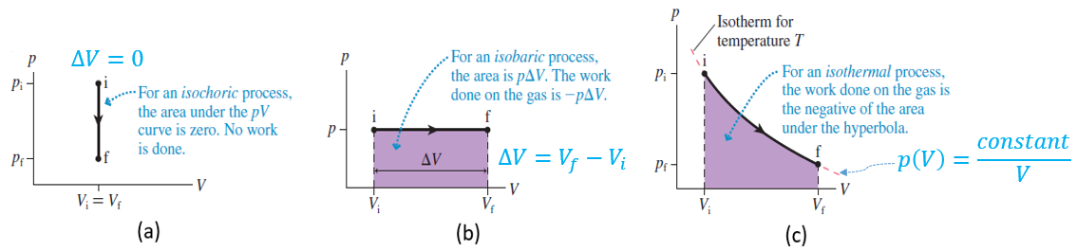
Figure 3.7 Special p-V diagrams cases: isochoric (a), isobaric (b), isothermal (c)
The figure above shows three cases of p-V diagrams:
- “Isochoric process”: the gas volume remains constant, i.e., $V_{i}=V_{f}$hence “zero external work” is developed.
Ideal gas: gas having very low density where molecules interact rarely. They satisfy the condition P⋅ V/T=constant.
- “Isobaric process”: the gas pressure remains constant, leading to an external work given by:
 | $$W_{m,ext}=-p⋅(V_{f}-V_{i})$$ | (3.11)

- “Isothermal process”: the gas temperature is constant. For an ideal gas, the p-V curve is hyperbolic, which gives the following expression of the external work:
 | $$W_{m,ext}=-p_{i}⋅V_{i}⋅\ln\left(\frac{V_{f}}{V_{i}}\right)=-p_{f}⋅V_{f}⋅\ln\left(\frac{V_{f}}{V_{i}}\right)$$ | (3.12)

- “Adiabatic process”: This process does not impact the mechanical work. In this process zero heat is exchanged with the system, hence the equation (3.9) of the first law reduces to $∆U=W_{m}$.

Enthalpy
The “enthalpy” of a system is an amount of energy consisting of the sum of the internal energy within the system and the product of its pressure and its volume (Moran, 2018). It is denoted by the symbol H and expressed in J.
 | $$H=U+p⋅V$$ | (3.13)

For an isobaric process, the first law reduces to the amount of exchanged heat between the environment and the system being equal to the change in enthalpy of the system: dH=dU+dp⋅V=dU+p⋅dV+V⋅dp=dQ-p⋅dV+p⋅dV+0=dQ.
Application 3.3. Consider 1.5 kg of water in a cylinder-piston of diameter 20 cm initially at $25℃$ and boiled until it is $115℃$ at atmospheric pressure leading to a 15 cm stroke of the piston. Calculate the change in enthalpy and internal energy of the system.
Given: $c_{steam}=2100 J/kg.K$ ; $c_{water}=4187 J/kg.K$; $L_{V}=2256 J/kg$
Solution 3.3. Since the thermodynamic process is isobaric, the change in enthalpy is just the amount of heat supplied to the system:
$$∆H=Q_{1}+Q_{2}+Q_{3}=\left(1.5⋅4187⋅75\right)+\left(1.5⋅2256\right)+(1.5⋅2100⋅15)$$
$$∆H=521.67kJ$$
At constant pressure, the transformation of water to steam leads to a volume increment pulling the piston for gas expansion, thus:
$$W_{m}=-101300⋅π⋅{\left(0.1\right)}^{2}⋅0.15=-477.4 J$$
The first law of thermodynamics gives: $ΔU=521.67-0.48=521.19 kJ$

Self-Check Questions
- Answer by true or false and justify your answer.
In an isochoric process, the change in internal energy and enthalpy is the same and is equal to the exchanged heat between the system and the environment. False, since $H=U+p⋅V⇒ΔH=ΔU+V⋅Δp+p⋅ΔV$; but when isochoric, the volume is constant hence $ΔV=0⇒ΔH=ΔU+V⋅Δp$ and not only $ΔH=ΔU$
- Choose the correct answer.
An ideal gas of initial status (p₀, V₀, T₀) is subjected to an isothermal thermodynamic process where its volume is now halved. Determine the external work done on the gas.
$-p_{0}V_{0}\ln{2}$ $p_{0}V_{0}\ln{2}$ $-0.5p_{0}V_{0}$ $0.5p_{0}V_{0}$
Details: from equation (3.12) one writes: $W_{m}=-p_{0}V_{0}\ln\left(\frac{1}{2}\right)=p_{0}V_{0}\ln{2}$.

Second Law of Thermodynamics and Entropy

Entropy
An “irreversible process” is a process that exhibits one direction path from an initial state to the final state; returning to the initial state is impossible. For instance, shaking a certain amount of sugar with a spoon within a cup of tea leads to the sugar dissolving in the tea; shaking the spoon in the opposite sense of rotation will not lead to the separation of sugar granules from the tea liquid; the initial amount of sugar cannot be retrieved.
The transfer of heat always occurs in one direction: from the hotter to the colder system; this continues until thermal equilibrium is reached. Before the hot and the cold systems interact, their respective initial states have been quite “ordered”, each of them had its own thermal equilibrium. At interaction, both hot and cold systems are “combined” to form a global system; heat will then travel from the hot to the cold environment and thus a kind of ‘’disorder’’ occurs. To add more clarity to the idea, consider the example of a cube of ice, which is a solid body where all molecules keep their fixed, well-known positions in a certain order. By melting the ice, those molecules gain more freedom to move ‘’partially’’ and thus to break this ordered stacking as ice is transformed into water; a certain amount of disorder has occurred in the system. By vaporizing water liquid, the molecules of steam gain more and more freedom to move within their container in a fully disordered and random manner. This disorder is described thermodynamically by a variable state, or function state, termed “entropy”, which depends only on the initial and final states of the system. An increase in disorder leads to an increment in entropy. Throughout an irreversible process, the amount of disorder increases thus the system’s entropy increases too.
Variable state: Also called “function state”, this is a property depending only on the initial and final states and not on the path covered between those states. Pressure, volume, temperature, internal energy, enthalpy, and entropy are all examples of variable states.
Since entropy depends exclusively on the initial and final states, it could be stated that ‘’the entropy change $∆S$ for an irreversible process that takes a system from an initial state i to a final state f is exactly equal to the entropy change for any "reversible” process that takes the system between those same two states.’’ (Walker, 2014, p. 517). Entropy change in a reversible system can be calculated by:
 | $$∆S=\int_{i}^{f}{\frac{dQ}{T}}$$ | (3.14)

Where Q is the amount of heat exchanged with the system and T is the system’s temperature during the process. The SI unit of the entropy is J/K.
For an isothermal process ($T=constant$) this equation becomes:
 | $$∆S=\frac{Q_{rev}}{T}$$ | (3.15)

The Second Law
Consider a certain amount of gas enclosed in a cylinder-piston chamber and an external compressive force being applied on the piston to decrease the chamber’s volume. This will induce an increase in pressure and thus an increase in the temperature of the gas. A possible solution to regain a constant temperature is to remove an amount of heat Q from this chamber to a connected reservoir; this implies that the entropy of the gas decreases. However, this process is quasi-static reversible and, in addition, the gas system is not closed because it has been considered at the beginning without the reservoir. The “closed system” consists of the gas and the heat reservoir, also. In that case, due to the reversibility of the process, the entropy lost by a part of the closed system, i.e., the gas, is the same amount as the one gained by the other part of the system, i.e. the reservoir; in other words, the change in entropy of the entire closed system is zero; it is an “isentropic” process. If a process is irreversible in an entirely closed system, entropy increases since irreversibility tends to favor disorder.
Quasi-static process: a thermodynamic process, which occursat a very slow rate to keep the system internally in thermodynamic equilibrium.
In light of what has been said, the second law of thermodynamics could be stated as: "If a process occurs in a closed system, the entropy of the system increases for irreversible processes and remains constant for reversible processes. It never decreases”. (Walker, 2014, p. 523)
 | $$∆S≥0$$ | (3.16)

Carnot Cycle
‘’An engine is a device that extracts energy from its environment in the form of heat and does useful work.’’ (Walker, 2014, p. 524). To run the engine properly, a “working substance” must be used, behaving like blood for human bodies. A relevant working substance is selected depending on the type of engine: an automobile engine necessitates a mixture of gasoline and air, while a steam engine needs water in both liquid and vapor states to function. To obtain the desired amount of work, the working substance must operate on a cyclic basis. The working substance absorbs heat from a hot reservoir and converts part of it into useful mechanical work, while another part is unfortunately lost to another cold reservoir. This is illustrated in the figure below (Walker, 2014, p. 525).
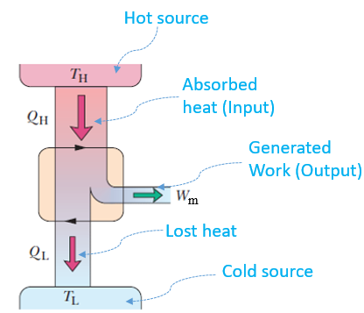
Figure 3.8 Concept of heat engine operation
In an automobile engine, for example, the input heat comes from the combustion of gasoline fed from the car’s tank, while the mechanical work produced is used to move the car forward. Some heat is lost to the ambient air.
This cycle was first established by the French engineer Nicolas Leonard Sadi Carnot. In an ideal Carnot engine, the processes are all reversible with no energy leakage.
A Carnot cycle consists of four stages as illustrated in the figure below, using a p-V diagram on the left and a T-S diagram on the right.
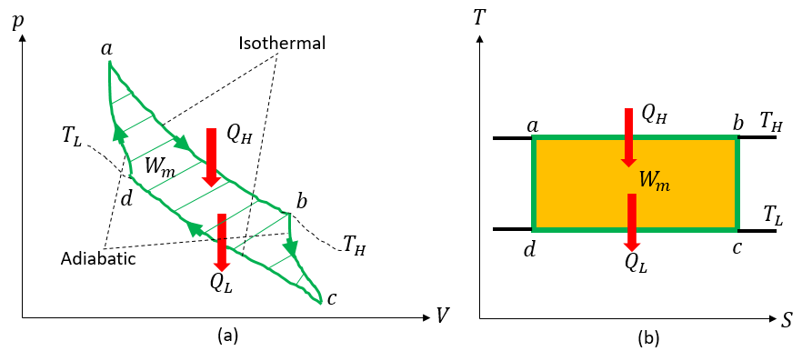
Figure 3.9 Carnot cycle in p-V diagram (a), T-S diagram (b)
- ab: isothermal expansion where an amount of heat Q_{H} is absorbed from the hot reservoir at constant temperature T_{H}.
- bc: adiabatic expansion where the temperature decreases from T_{H} to T_{L} in parallel with the compression, which means an increase in temperature; this balance leads to an adiabatic process where no heat is exchanged.
- cd: isothermal compression where an amount of heat Q_{L} is lost by the system to the cold reservoir at constant temperature T_{L}.
- da: adiabatic compression where the temperature increases from T_{L} to T_{H} in parallel with the expansion, which means a decrease in temperature; this balance leads to an adiabatic process where no heat is exchanged.
The first two stages consist of expansion, meaning negative work is done on the system, while the latter two stages produce positive work due to expansion. The net useful work generated by this cycle represents the area within this loop cycle.
Viewing these stages in the temperature-entropy T-S diagram, the isothermal stages become horizontal lines (constant temperatures) and adiabatic stages mean there is no entropy change and are thus represented by vertical lines (isentropic processes). The net mechanical work generated will be equivalent to the area of the rectangle abcd.
Applying the first law of thermodynamics, since the internal energy is a function state and at a given time the initial and final states are the same (cycle), there will be no change at the end of each cycle, one may hence write:
$${Q_{H}+Q_{L}+W}_{m}=0⇒W_{m}=-Q_{H}-Q_{L}$$
It should be noted that Q_{H} is a positive quantity since it is absorbed by the system while Q_{L} is negative since it is lost by the system. W_{m} is a negative quantity relative to the system (i.e., positive for the environment that benefits from this work).
Applying now the second law, since the engine is ideal, the total change in entropy is zero, meaning that the entropy gained in stage ab is the same as the entropy lost in stage cd; there is no change in entropy for isentropic stages bc and da. Hence:
$$\frac{Q_{H}}{T_{H}}=-\frac{Q_{L}}{T_{L}}$$
By definition, the efficiency η of the engine denotes the ratio of the useful work gained to the heat paid, hence:
 | $$η=-\frac{W_{m}}{Q_{H}}$$ | (3.17)

Combining the above equations one gets:

 | $$η=1-\frac{T_{L}}{T_{H}}$$ | (3.18)

Both temperatures are typically expressed in K. Since $T_{L}<T_{H}$ we see from equation (3.18) that the efficiency of a Carnot engine is less than 1, or less than 100%. Additionally, this efficiency depends exclusively on the temperature of the hot and cold reservoirs. The larger the difference between these two temperatures, the more efficient the engine. It should be noticed that this is an idealization of the efficiency since it takes into account only those two temperatures independently of the fluid used or the internal structure and design of the engine. In addition, one is not able to decrease T_{L} and/or increase T_{H} endlessly, as this may cause physical damage to the operating system.
Application 3.4. 20 g of sugar (c = 1250 J/kg.K) at $20℃$ are dissolved into 100 g of hot coffee (c = 1500 J/kg.K) at $60℃$. Assuming the system is thermally isolated, calculate the change in entropy. Neglect the heat of solution (i.e., the change in enthalpy generated from the dilution of a substance in a solvent)
Solution 3.4. First, let’s calculate the equilibrium temperature. For an isolated system, the amount of heat lost by the coffee is the same as the amount of heat gained by the sugar:
$$20⋅1250⋅\left(T_{f}-20\right)=100⋅1500⋅\left(60-T_{f}\right)⇒T_{f}=54.29℃$$
To apply equation (3.14), consider each substance alone subjected to a reversible process, changing its temperature from the same initial value to the same final value as in the real irreversible process.
For sugar: $∆S_{sug}=\int_{293}^{327.29}{\frac{dQ}{T}=}0.02⋅1250\int_{293}^{327.29}{\frac{dT}{T}=}2.767 J/K$
For coffee: $∆S_{cof}=\int_{333}^{327.29}{\frac{dQ}{T}=}0.1⋅1500\int_{333}^{327.29}{\frac{dT}{T}=}-2.594 J/K$
$$∆S=2.797-2.594=0.203 J/K$$

Self-Check Questions
- Choose the correct answer
What is the efficiency of a Carnot engine where the temperatures of the hot and cold reservoirs are $250℃$ and $35℃$ respectively?
$41\%$ $86\%$ $22\%$ $59\%$
Details: $T_{H}=250+273=523 K$ ; $T_{L}=35+273=308 K$
$$η=1-\frac{308}{523}=0.411=41.1\%$$
- Complete the following sentence.
A Carnot engine of 45% efficiency absorbs 2000 J from a $300℃$ hot reservoir and loses 1100 J to a cold reservoir of $42.1℃$. The work generated measures 900 J.
Details: $0.45=1-\frac{Q_{C}}{2000}⇒Q_{C}=0.55⋅2000=1100 J$
$$T_{H}=300+273=573 K⇒T_{C}=0.55⋅573=315.15 K⇒T_{C}=42.15℃$$
$$W_{m}=Q_{H}-Q_{C}=2000-1100⇒W=900 J$$

Kinetic Theory of Gases

Mole
The Italian chemist Amedeo Avogadro has proven that the number of atoms or molecules within an amount weighting the atomic number or molecular mass but in grams, remains the same for all substances. This number is known as Avogadro’s number and is denoted by N_{A}. He has found that: $N_{A}=6.02×{10}^{23}particles/mol$.
A total number N of atoms/molecules in a substance can be divided into many ‘’packages’’, each containing an Avogadro’s number of those particles; each ‘’package’’ is termed a “mole” and the total obtained number of the ‘’packages’’ is termed the “mole number”, denoted by n.
 | $$n=\frac{N}{N_{A}}$$ | (3.19)

The mass of the ‘’package’’, or mole, is termed “molar mass” and is denoted by M. In fact, its value is the same as the atomic number or molecular mass, but expressed in g. The mass m of a substance is the product of the mass of one mole M and the total number of moles n, thus:
 | $$n=\frac{m}{M}$$ | (3.20)

Ideal Gas Law
A gas is classified as an “ideal gas” if its density tends to zero. In that case, its molecular interactions are considerably reduced. (Walker, 2014). Experimentally, it has been found that ideal gases of any substance having the same number of moles n, the same temperature T, and enclosed in a container of the same volume V, exert the same pressure p on the container’s walls; those parameters satisfy the following equation (3.21), known as the ”ideal gas law”:
 | $$p⋅V=n⋅R⋅T$$ | (3.21)

Where R is the ideal gas constant. In the SI system, $R=8.314 J/mol⋅K$.
Combining equations (3.19) and (3.21), then calculating the ratio $k=\frac{R}{N_{A}}=1.38×{10}^{-23}J/K$. referred to as the “Boltzmann constant”, the other formulation of the ideal gas law becomes:
 | $$p⋅V=N⋅k⋅T$$ | (3.22)

Kinetically speaking, each gas molecule moves within its container at a speed v. One may unify the molecule’s velocity by calculating the “root-mean-square speed” abbreviated as RMS speed v_{rms}. It is calculated by extracting the square root of the average of the square of each particle’s speed; i.e., $v_{rms}=\sqrt{{(v^{2})}_{avg}}$. (Walker, 2014). The rate of change of one particle’s linear momentum is given by Δmomentum/Δt=m⋅ v/(L/v)=mv²/L, which is equivalent to the force applied, which can be expressed by the product of the pressure p and the wall area A, hence p=mv²/A⋅ L. For ideal gases, calculating the average over all particles and setting the volume V=A⋅ L and m=n⋅ M then rearranging, one finds the RMS speed as:
 | $$v_{rms}=\sqrt{\frac{3⋅R⋅T}{M}}$$ | (3.23)

The average translational kinetic energy of one molecule of gas is:
$E_{k,avg}=\frac{1}{2}⋅m⋅{v_{rms}}^{2}=\frac{1}{2}⋅m⋅\frac{3⋅R⋅T}{M}$ and since the ratio m/M is equal to Avogadro’s number N_{A}, and $k=R/N_{A}$ the final expression of E_{k,avg} is written:
 | $$E_{k,avg}=\frac{3}{2}⋅k⋅T$$ | (3.24)

An additional kinetic parameter worth defining is “the mean free path” λ. It is ‘’the average distance traversed by a molecule between collisions.’’ (Walker, 2014, p. 494). As the containing volume V decreases or the number of molecules N increases or the diameter of the molecules d increases, the probability of collision between molecules increases, and thus the mean free path value decreases. We define $λ=\frac{Length of path}{Number of collisions}=\frac{v_{avg}Δt}{(πd^{2}N/V)v_{rel}Δt}$where $v_{rel}=v_{avg}\sqrt{2}$ (Walker, 2014). Finally, the mean free path is calculated by:
 | $$λ=\frac{1}{\sqrt{2}πd^{2}(N/V)}$$ | (3.25)

N/V denotes the molecular density, or the number of molecules per unit of containing volume.

Specific Heats of an Ideal Gas
Internal Energy
For gases, the specific heat denoted by C is expressed per unit of mole instead of unit of mass (J/mol⋅ K). This property could be measured either at constant volume (C_{V}) or at constant pressure (C_{P}).
For “monoatomic” ideal gases (such as He, Ar), the internal energy could be assumed to be the sum of the average translational kinetic energies of the atoms:
$$U=n⋅N_{A}⋅E_{k,avg}=\frac{3}{2}⋅n⋅N_{A}⋅k⋅T$$
 | $$U=\frac{3}{2}⋅n⋅R⋅T=\frac{3}{2}⋅p⋅V$$ | (3.26)

Molar Specific Heat at Constant Volume
At constant volume, the change in pressure Δp leads to a change in temperature ΔT meaning that an amount of heat Q is either absorbed or desorbed by the gas, and this amount is calculated by:
 | $$Q=n⋅C_{V}⋅∆T$$ | (3.27)

It is known that at constant volume, the mechanical work done on the gas is zero, thus the first law, combined with equations (3.26)-(3.27), becomes:
 | $$∆U=n⋅C_{V}⋅∆T$$ | (3.28)

$$∆U=Q⇒\frac{3}{2}⋅n⋅R⋅ΔT=n⋅C_{V}⋅ΔT$$
 | $$C_{V}=12.471 J/mol.K$$ | (3.29)

It is experimentally proven that for diatomic ideal gases (e.g., oxygen, nitrogen), $C_{V}=2.5R=20.775 J/mol⋅K$ while for polyatomic ideal gases (e.g., carbon dioxide), $C_{V}=3R=24.93 J/mol⋅K$ (Walker, 2014).
One may conclude that in the general case the change in internal energy depends exclusively on the temperature change and not on the type of process.
Entropy in Ideal Gases
For a general reversible process from an initial state (i) to a final state (f), applying the first law in its differential form leads to an expression for entropy change (Walker, 2014) as follows:
$$dU=dQ+dW_{m}⇒dQ=dU-dW_{m}=n⋅C_{V}⋅dT+p⋅dV$$
Dividing both sides of the equation by T and replacing p with equation (3.21), one gets:
$$\frac{dQ_{rev}}{T}=n⋅C_{V}⋅\frac{dT}{T}+n⋅R⋅\frac{dV}{V}$$
Integrating both sides between (i) and (f), the final expression of change in entropy for ideal gases becomes:
 | $$ΔS=n⋅C_{V}⋅\ln{\frac{T_{f}}{T_{i}}}+n⋅R⋅\ln{\frac{V_{f}}{V_{i}}}$$ | (3.30)

Molar Specific Heat at Constant Pressure
At constant pressure, the change in pressure ΔV leads to a change in temperature ΔT meaning that an amount of heat Q is either absorbed or desorbed by the gas, and this amount is calculated by:
 | $$Q=n⋅C_{P}⋅∆T$$ | (3.31)

Remembering that the mechanical work done on the gas at constant pressure is given by $W_{m}=-p⋅ΔV$ , we can replace the right-hand side with equation (3.21) and the expression of this work becomes:
 | $$W_{m}=-n⋅R⋅∆T$$ | (3.32)

Replacing equations (3.28),(3.31), and (3.32) in the first law yields:
$$n⋅C_{V}⋅ΔT=n⋅C_{P}⋅ΔT-n⋅R⋅ΔT$$
 | $$C_{P}=C_{V}+R$$ | (3.33)

Adiabatic Expansion of an Ideal Gas
An ideal gas confined in a well-insulated piston-cylinder chamber may expand from an initial status (p_{i}, V_{i}, T_{i}) to a final status (p_{f}, V_{f}, T_{f}) without any heat exchange, meaning that it is an adiabatic process (Q=0). This is illustrated in the p-V diagram of the figure below (Walker, 2014, p. 508).
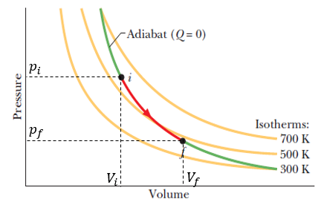
Figure 3.10 Diagram of adiabatic expansion of ideal gases
The first law in its differential form with adiabatic process becomes:
$$dU=dW_{m}⇒n⋅C_{V}⋅dT=-p⋅dV⇒n⋅dT=-\frac{p}{C_{V}}dV$$
Differentiating equation (3.21): p⋅dV+V⋅dp=n⋅R⋅dT, then replacing R with equation (3.33) and$n⋅dT=-\frac{p}{C_{V}}dV$, then multiplying both sides by C_{V}(C_{P}-C_{V}) and rearranging, we have:
$$\left(\frac{p}{C_{P}-C_{V}}+\frac{p}{C_{V}}\right)dV+\frac{V}{C_{P}-C_{V}}⋅dp=0⇒p⋅C_{P}⋅dV+V⋅C_{V}⋅dp=0$$
Dividing this equation by $p⋅V⋅C_{V}$ it becomes:
$$\frac{dp}{p}+γ\frac{dV}{V}=0$$
In this equation, one defines the specific heat ratio by:
 | $$γ=\frac{C_{P}}{C_{V}}$$ | (3.34)

Integrating the differential equation, we have: $\ln{p}+γ\ln{V}=constant⇒\ln{p⋅V^{γ}=constant}$ thus finally:
 | $$p_{i}⋅{V_{i}}^{γ}=p_{f}⋅{V_{f}}^{γ}$$ | (3.35)

In the case of a free adiabatic expansion, no heat and no work are exchanged within the system, this means that the process is isothermal (i.e., dT=0), and differentiating equation (3.21) one gets:
 | $$p_{i}⋅V_{i}=p_{f}⋅V_{f}$$ | (3.36)

Application 3.5. A closed tank of 20 L volume contains 0.5 kg of the monoatomic gas helium (${}_{2}^{4}{He}$) at a pressure of 150 bars. When heated, the gas pressure doubles. Calculate its change in entropy.
Solution 3.5. The number of moles is found from equation (3.20): $n=\frac{500}{4}=125 mol$.
The tank is closed thus the volume remains constant, meaning that the temperature changes proportionally to the pressure. Applying equations (3.29)- (3.30):
$$∆S=125⋅12.5⋅\ln{2}⇒∆S=1.083 kJ/K$$

Application 3.6. Calculate the amount of heat, the change in internal energy, and the work done on the helium in the tank.
Solution 3.6. Calculate the initial temperature from equation (3.21):
$$T_{i}=\frac{150⋅{10}^{+5}⋅20⋅{10}^{-3}}{125⋅8.314}=288.67 K$$
$$Q=125⋅12.5⋅\left(2⋅288.67-288.67\right)⇒Q=451.05 kJ$$
Since the process is isochoric, the work is zero and the internal energy change is the same as the heat absorbed.
Application 3.7. 320 g of dioxygen O₂ (${}_{8}^{16}O$) is enclosed initially in a 10 L piston-cylinder container at $45℃$. Calculate the work developed on the dioxygen by an adiabatic expansion to a chamber volume of 15 L. Also determine the final temperature. For dioxygen, C_{V}=20.785 J/mol⋅K.
Solution 3.7. The number of moles is found from equation (3.20): $n=\frac{320}{16⋅2}=10 mols$, thus the initial pressure is found from equation (3.21):
$$p_{i}=\frac{10⋅8.314⋅(273+45)}{0.01}=2643852 Pa=26.1 bars$$
The specific heat ratio is found from equation (3.33):$γ=\frac{20.785+8.314}{20.785}=1.4$.
For an adiabatic expansion equation (3.35) gives: $p⋅V^{γ}=p_{i}⋅{V_{i}}^{γ}=p_{f}⋅{V_{f}}^{γ}=constant=2643852⋅{0.01}^{1.4}=4190.223$(Pa⋅ m^{4.2} ).
Work done on the gas is given by equation (3.10) where p is in Pa and V in m³:
$$W_{m}=\int_{0.01}^{0.015}{-p⋅dV}=-4190.223\int_{0.01}^{0.015}{V^{-1.4}dV}=\frac{4190.223}{⋅0.4}{\left[V^{-0.4}\right]}_{0.01}^{0.015}$$
$$W_{m}=-9895.74 J$$
The final pressure is: $p_{f}=\frac{4190.223}{{0.015}^{1.4}}=1498681.594 Pa$
The final temperature is : $T_{f}=\frac{149868.594⋅0.015}{10⋅8.314}=270.39 K=-2.61 ℃$

Self-Check Questions
- Complete the following data for Nitrogen N₂ gas (${}_{7}^{14}N$) stored in a 70 L tank at 5 bars pressure and $20℃$ temperature:
Mass: 407.4 g
Root-mean-square speed: 510.88 m/s
Internal energy: 53.1825 kJ
Details: Equation (3.21) gives: $n=\frac{5⋅101300⋅0.07}{8.314⋅293}⇒n=14.55 mols$
Equation (3.20) gives: $m=14.55⋅\left(2⋅14\right)⇒m=407.4 g$
Equation (3.23) gives: $v_{rms}=\sqrt{\frac{3⋅8.314⋅293}{0.028}}⇒v_{rms}=510.88 m/s$
Equation (3.26) gives: $U=1.5⋅5⋅101300⋅0.07⇒U=53.1825 kJ$
- Answer by true or false and justify your answer
The enthalpy of a monoatomic ideal gas measures $\frac{5}{2}p⋅V$ .
True since $H=E_{in}+p⋅V$ and $E_{in}=\frac{3}{2}p⋅V$.

Heat: Conduction, Convection, and Radiation
It is already well known that thermal equilibrium is established when heat transfers from hot to cold systems in order to set a final equilibrium temperature. However, it remains to describe the mechanisms used to affect this heat transfer from one system to another. There are three mechanisms of heat transfer: “conduction”, “convection”, and “radiation”.

Conduction
When a body is ‘’sandwiched’’ between two environments, a hot one at a temperature T_{H} and a cold one at a temperature T_{C}, the atoms of the surface that are in contact with the hot source will gain more energy and oscillate with higher amplitudes and then collide with neighboring atoms transferring more energy to them and thus additional motion.
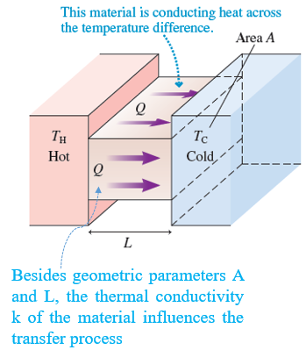
Figure 3.11 Conduction of heat
This process will be repeated from one ‘’layer’’ of atoms to the next ‘’layer’’ until covering the entire body, thus allowing this amount of heat to reach the cold source and increase its temperature. This mechanism of heat transfer is called “conduction”. (see the figure above (Knight, 2016, p. 537)).
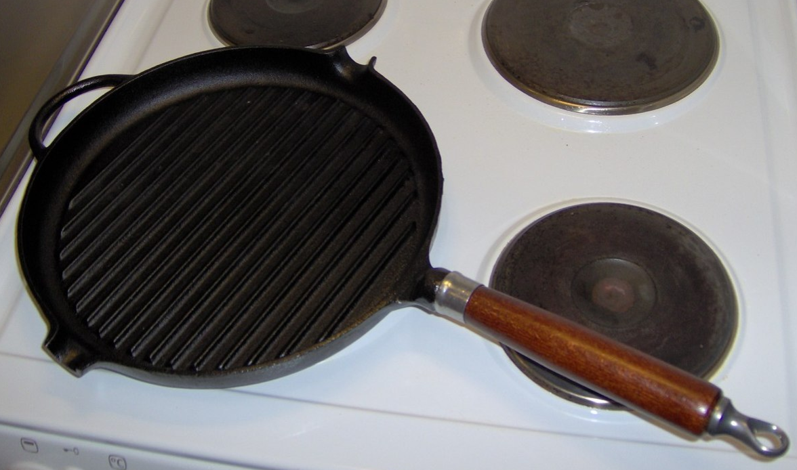
Figure 3.12 Pan heated by conduction
The photograph above illustrates a practical example of conduction used to heat food within a pan. First, the underside of the pan, in contact with the heating source, will receive an amount of heat that will be conducted through the material of the pan to reach the food. It should be noted that the type of material used for the pan is essential since not all materials have the same capacity for conduction: metallic materials are good conductors of heat while wood is not. For this reason, the handle of the pan is made of wood to avoid heating it so that it can always be held by the user’s hand. The rate of conducted heat through a body can be simulated by the amount of power transferred by conduction; it is calculated by the following relationship:
 | $$P_{cond}=k⋅\frac{A}{L}⋅ΔT$$ | (3.37)

Where k is the “coefficient of thermal conductivity” depending on the type of material exclusively and expressed in W/m.K; A is the contact area with the body, L the length of the body through which heat is conducted, and ΔT = T_{H}-T_{C} is the temperature difference between the hot and cold sources.
It is clear that the amount of power transferred increases with the material conductivity, the area of contact between the body and the source, and the temperature difference between them; however, the thicker the body, the more difficult it would be to conduct heat, and thus the rate decreases.

Convection
Convection is a process of heat transfer based on the motion of fluids with temperature differences. (Knight, 2016). Consider a fluid surrounding a body generally warmer than the fluid The part of the fluid that is in direct contact with the body gains heat (i.e., the contact part of the body becomes colder) and thus it becomes lighter than the other part of the fluid that was not in contact with the body. The warmer, lighter part rises upward leaving its place to a new amount of colder fluid that comes into contact with the body and experiences the same process. This convection mechanism repeats itself until thermal equilibrium between the body and the surrounding fluid is established.
This is why one blows on a hot cup of coffee to lower the coffee’s temperature – it increases the convection process. Also, daily climate changes are due to atmospheric convection between wind, oceans, deserts, and icy mountains.
The rate of heat transferred by convection depends on the surface of the exposed area, the temperature difference, and the convection heat coefficient h (W/m².K):
 | $$P_{conv}=h⋅A⋅ΔT$$ | (3.38)

Radiation
Radiation occurs due to the exchange of electromagnetic waves between sources of heat. A thermal radiation process is different from magnetic or nuclear radiation. This type of mechanism does not necessitate direct contact between the source and the body.
It is due to this mechanism that a car parked for many hours on a road under a hot sun gets warmer. Also, it is by radiation that during a cold night camping you can make your hands warmer by keeping them near a fire.
There is no absolute heat emitter or absorber. For instance, the human body may absorb heat from the sun by radiation, but it also emits heat into its surrounding; this process keeps the human body in thermal equilibrium. Also, the earth absorbs heat from the sun and emits heat into the atmosphere through infrared radiation. However, the presence of carbon dioxide and water vapor restricts this emission into the atmosphere, which keeps some of the heat “stored” within the surface of the earth; this is called the “amplified Greenhouse” effect. (Knight, 2016).
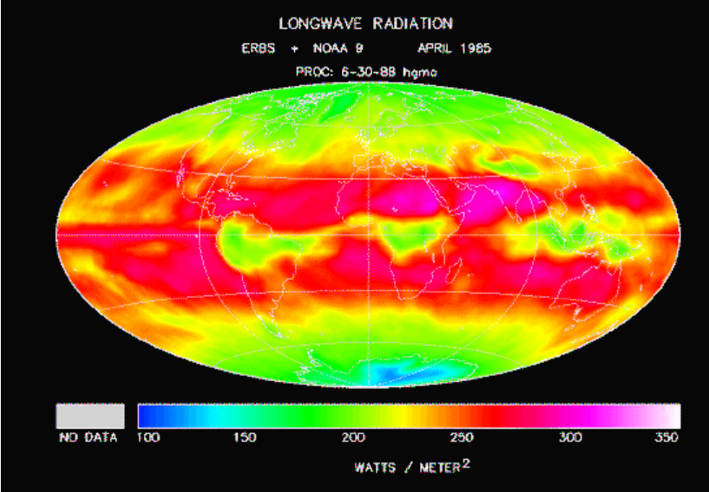
Figure 3.13 Distribution of Earth thermal radiation (NASA)
The figure above illustrates the differences in thermal radiation waves throughout the earth.
The rate of heat, i.e., the power absorbed by radiation, depends mainly on the surface area A and the absolute temperature T of the body:
 | $$P_{rad}=ε⋅σ⋅A⋅T^{4}$$ | (3.39)

Where ε is the emissivity of the surface, a dimensionless number in the interval [0,1] quantifying the surface’s radiation effectiveness. $σ=5.67×{10}^{-8}W/m^{2}⋅K^{4}$ is the Stefan-Boltzmann constant.
For an object at temperature T that exchanges heat with an environment of temperature T₀, the net radiated rate of heat is the difference between the heat emitted and the heat absorbed:
 | $$P_{rad}=ε⋅σ⋅A⋅(T^{4}-{T_{0}}^{4})$$ | (3.40)

A “perfect absorber" is a body having an emissivity equal to 1. It absorbs all radiation without emitting any. Termed a “black body”, this perfect absorber is also a perfect emitter. (Knight, 2016)
Application 3.8. A double-glass window consists of two identical 50 cm x 90 cm rectangular glass plates, each of thickness 10 mm separated by a layer of air of thickness 13 mm. The indoor and outdoor temperatures are $15℃$ and $-5℃$ respectively. The thermal conduction coefficients are k_{glass} = 1 W/m.K ; k_{air} = 0.026 W/m.K. Calculate the rate of heat traveling through the window from indoor to outdoor.
Solution 3.8. The figure below shows the conduction process through the window from inside (higher temperature T_{i}) to outside (lower temperature T_{o}):
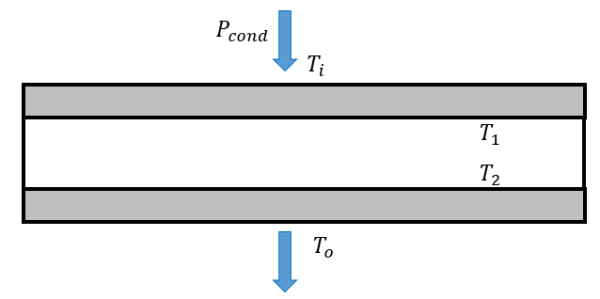
Figure 3.14 Heat conduction through double-glass window
The same power passes through the three layers thus:
$$P_{cond}=k_{g}\frac{A}{L_{g}}\left(T_{i}-T_{1}\right)=k_{a}\frac{A}{L_{a}}\left(T_{1}-T_{2}\right)=k_{g}\frac{A}{L_{g}}\left(T_{2}-T_{o}\right)$$
Considering the first and third quantities in this latter equation:
$$T_{2}=T_{o}+T_{i}-T_{1}$$
Then replacing T₂ in the second quantity and equating with the first quantity:
$$\frac{k_{g}}{L_{g}}\left(T_{i}-T_{1}\right)=\frac{k_{a}}{L_{a}}(-T_{o}-T_{i}+{2T}_{1})$$
$$T_{1}=\frac{\left(\frac{k_{a}}{L_{a}}\right)T_{o}+\left(\frac{k_{a}}{L_{a}}+\frac{k_{g}}{L_{g}}\right)T_{i}}{\left(2\frac{k_{a}}{L_{a}}+\frac{k_{g}}{L_{g}}\right)}=\frac{536+29376}{104}⇒T_{1}=287.62 K$$
$$P_{cond}=100⋅0.45⋅0.38=17.1 W$$
Application 3.9. A cubic box with side length of 30 cm and a temperature of $25℃$rests on a table in a room where the ambient temperature is $12℃$. Calculate the net rate of heat exchanged by the box for an emissivity of 0.75.
Solution 3.9. The total area exposed to the environment consists of five identical faces of the box: $A=5⋅0.3⋅0.3=0.45 m^{2}$. In addition: $T=298 K$; $T_{o}=285 K$
$$P_{net}=0.75⋅5.67×{10}^{-8}⋅0.45⋅\left({298}^{4}-{285}^{4}\right)⇒P_{net}=24.66 W$$

Self-Check Questions
- State three practical examples reflecting conduction, convection, and radiation mechanisms.
Conduction: Heat passing through the walls of a house from outdoors during summer.
Convection: In a heated room, warm air circulates upward and cold air goes downward to be heated.
Radiation: A room’s environment warming from the light of a bulb.

- Answer the following question
Mugs are used to contain hot drinks such as coffee or tea. Why are they made of ceramics but not stainless steel?
Mugs have to be held directly by hand during drinking. When a hot drink is in the mug, heat will transfer quickly from inside the mug to outside due to the low wall thickness of the mug and the high temperature difference between the drink and the atmosphere, thus the user’s hand, which is sensitive to high temperatures, will not be able to hold the mug. The solution is to choose materials having low thermal conductivity coefficients such as ceramics.

- Choose the correct answer
The power absorbed by a unit area of a black body at ambient temperature ($23℃$) measures:
423.2 W 444.8 W 435.3 W 416.4 W
Details: Since it is a black body ε = 1, and being a unit area means A = 1 m²; T = 296 K
$$P_{rad}=5.67⋅{10}^{-8}⋅{296}^{4}=435.3 W$$
Summary
Temperature is a variable state that quantifies the thermal status of a body, i.e., the motion status of the particles within the body. The type of energy supplied or removed from a body to increase or decrease this mobility of particles is called heat and is classified as thermal energy. In addition, a mechanical form of energy, called work, may also be done on a system changing its internal status. The net amount of energy stored in the particles of a system, called change in internal energy, is the sum of the thermal heat and mechanical work exchanged by the system. This is the first law of thermodynamics.
The amount of heat exchanged by a system with its environment is proportional to the system’s mass, specific heat, and difference in temperature from the environment.
The energy disorder in a system is quantified by a function state called entropy. For a closed system, the change in entropy is either zero if the process is reversible or positive if irreversible. This is the second law of thermodynamics.
An ideal gas is one having a very low density where its molecules rarely collide. For an ideal gas of pressure p, volume V, temperature T, and number of moles n the law $p⋅V=n⋅R⋅T$ is always satisfied. An ideal gas exhibits two types of specific heat: molar specific heat at constant volume and constant pressure. These are related to the ideal gas constant R.
Heat transfers between systems by one of three mechanisms: conduction due to the collision of atoms from one layer to the next, convection due to the motion of fluids having different temperatures, and radiation due to waves carrying thermal energy emitted or absorbed by the system.

Unit 4 – Electricity and Magnetism

Study Goals

On completion of this unit, you will be able to
- understand the main electrical and magnetic quantities such as voltage, current, resistance, capacitance, and inductance.
- apply laws and relationships on electric circuits to calculate relevant quantities.
- apply laws and relationships on magnetic systems to calculate relevant quantities.
- apply Ohm’s laws for alternating current circuits.

Electricity and Magnetism

Introduction
Electricity is at the heart of our daily lives. How can an elevator reach the twelfth floor of a building without electricity? How can food be stored in refrigerators without electricity? How can a car start without a battery? How can any factory produce any product without electric power? How can one turn on a computer, a laptop, or a mobile, essentials for any career, without electricity and electronics? What about medical surgery devices based on electrical power? Hundreds of similar questions may be asked and the common element in all of them is electricity and, indirectly, magnetism.
This unit starts with the main source of electric current which is the flow of electrons and thus electric and electrostatic fields. This will generate voltage and current flow, which are the triggering ‘’elements’’ of electricity. This current flow will circulate in components used in many applications such as resistances in water heaters, capacitors in mobiles and laptops, and inductances in electrical transformers. We will learn the laws and equations that govern electric circuits, considering the type and arrangement of the elements within the circuit, and also the nature of the electric current, i.e., whether it is direct or alternating. We will also examine magnetic laws and quantities and the magnetic contribution to electricity production and its influence on some useful electric components in practical applications.

The Electrostatic Field

Charge
Any substance consists microscopically of atoms. An “atom” itself consists of a “nucleus” surrounded by a cloud of particles termed “electrons”. The diameter of this cloud could be about 10⁴ times larger than the diameter of the nucleus (Knight, 2016). The nucleus itself contains two types of small particles: “protons” and “neutrons”. ‘’The atom resembles somewhat to the Solar System, with the nucleus as Sun and the electrons as planets.’’ (Ohanian, 2007, p. 695). Planets are held around the sun by a gravitational force; similarly, electrons turning around the nucleus within their orbital cloud are held by a force known as “electric force”, which is about 2⋅ 10³⁹ times stronger than the gravitational force. Not all particles exert electric force. An “electric charge” is the ability of a particle to exert electric force in the same sense that mass determines an object’s gravitational force. (Ohanian, 2007). Protons and electrons develop electric forces thus they hold an electric charge; this is not the case with neutrons, which have zero electric charge. Mathematically, the electric charge of a proton is considered to be positive, and that of an electron is considered to be negative. Since an atom is electrically neutral, the number of positive and negative charges is the same, and in absolute value each particle (proton and electron) carries the same amount of charge, expressed in SI in coulomb © and denoted by the symbol e. $e=1.6×{10}^{-19}C$. The electric force between two charges with the same sign is “repulsive”, while between two charges of opposite signs it is “attractive”. (Ohanian, 2007)
Orbital cloud: set of shells surrounding the nucleus where electrons might exist in continuous motion.
All particles have charges that are integer multiples of the “fundamental charge” e, also called a “quantum” of charge. In other words, charges of all known particles could be in absolute value 0, e, 2e, 3e, etc. Hence, a charge is said to be “quantized”.

Coulomb’s Law
‘’The magnitude of the electric force that a particle exerts on another particle is directly proportional to the product of their charges and inversely proportional to the square of the distance between them. The direction of the force is along the line joining the particles’’. (Ohanian, 2007, p. 698)
 | $$F=\frac{1}{4πε_{0}}⋅\frac{q^{'}⋅q}{r^{2}}$$ | (4.1)

Where $ε_{0}=8.85×{10}^{-12 }C^{2}/N⋅m^{2}$ is the “permittivity constant”; q and q’ are the charges of the two particles and r is the distance separating the particles.
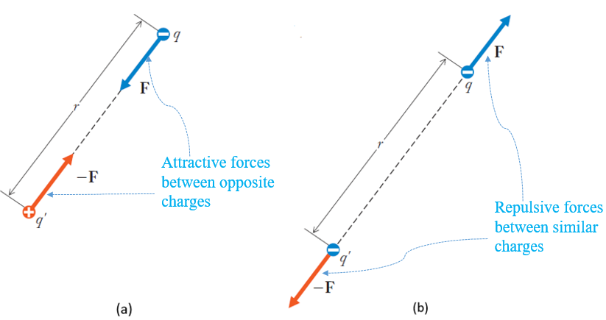
Figure 4.1 Electric force, attractive (a), Repulsive (b)
The above figure (Ohanian, 2007, p. 699) illustrates the attractive and the repulsive electric forces. The force is negative when attractive since particles are of opposite signs, while it has a positive sign when repulsive because of the same sign of the charges.
When a particle is subjected to electric forces from many other particles, the net electric force is the “vector resultant” of all the applied electric forces.

Electric Field
‘’According to the modern view, there is a physical entity that acts as mediator of force, conveying the force over the distance from one body to another. This entity is the ".” (Ohanian, 2007, p. 722)
An electric field is generated by any electrically charged body by ‘’filling’’ the ‘’free space’’ around this body source; any other body that comes into contact with this electric field is either pushed or pulled by the effect of this electric field. An electrically charged particle is assumed to remain at rest generating a static electrical field, also called an “electrostatic field”. Any other particles that enter this field will be subjected to an electrostatic force from the electrostatic field.
Mathematically speaking, this electrostatic field is represented by a vector quantity $\vec{E}$ directed radially from the charged particle and ‘’oriented outward if the charge is positive, and inward if the charge is negative’’. This is illustrated in the figure below. (Ohanian, 2007, p. 723)
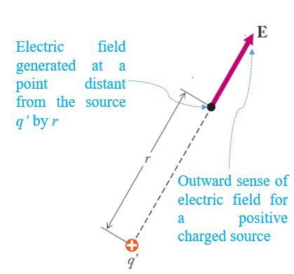
Figure 4.2 Vector representation of an electrostatic field
The magnitude of this vector is derived from equation (4.1):
$$F=q⋅(\frac{1}{4πε_{0}}⋅\frac{q'}{r^{2}})$$
The amount in parentheses represents the electrostatic field and is the mediator conveying the electric force toward the charge q. It is expressed in SI units in N/C:
 | $$E=\frac{1}{4πε_{0}}⋅\frac{q^{'}}{r^{2}}$$ | (4.2)

The electrostatic force and electrostatic field vectors are colinear:
 | $$\vec{F}=q⋅\vec{E}$$ | (4.3)

Electric Dipole
A “dipole” is a group of two charged particles having the same charge magnitude q, opposite signs, and are separated by a distance d. The lines of the electric field generated by the dipole start from the positive charge and end in the negative charge while the electrostatic field vector $\vec{E}$ is tangent to the field lines as shown in the figure below (Walker, 2014, p. 564)
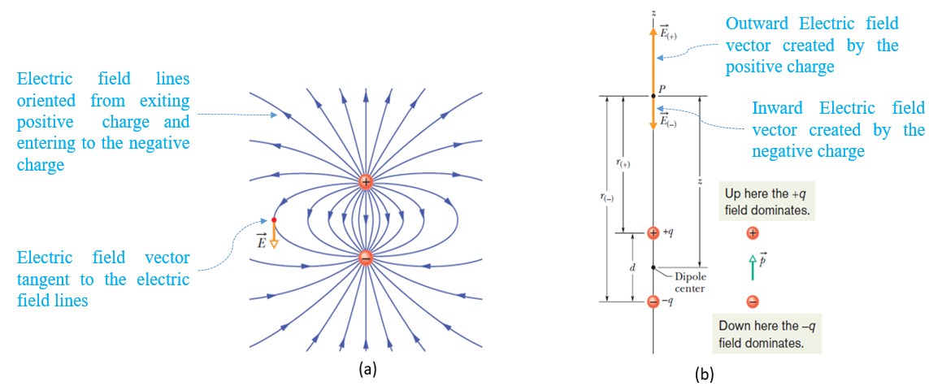
Figure 4.3 Dipole electric field lines (a), Dipole moment (b)
An electric dipole develops a vector quantity $\vec{p}$, called a dipole moment, acting along the line joining both particles and oriented from the negative to the positive charge. Its magnitude is $p=q⋅d$ expressed in C⋅ m.
 | $$\vec{p}=q⋅\vec{d}$$ | (4.4)

To establish the expression of the electrostatic field generated by a dipole, consider a point P on the dipole line, separated from the dipole center by a distance z as shown in the figure above on the right (Walker, 2014, p. 564). The net electric field represents the resultant of both electric field vectors generated by +q and –q:
$$E=E_{(+)}-E_{\left(-\right)}=\frac{q}{4πε_{0}}(\frac{1}{{r_{(+)}}^{2}}-\frac{1}{{r_{(-)}}^{2}})$$
Moreover: $r_{(+)}=z-\frac{d}{2}=z(1-\frac{d}{2z})$; $r_{(-)}=z+\frac{d}{2}=z(1+\frac{d}{2z})$
Thus ${r_{(+)}}^{2}=1-\frac{d}{z}+\frac{d^{2}}{{4z}^{2}}$; ${r_{(-)}}^{2}=1+\frac{d}{z}+\frac{d^{2}}{{4z}^{2}}$
In general, the main interest resides in the points that are quite far from the dipole center thus $z≫d⇒({\frac{d}{z})}^{2}≪1$and thus this latter amount could be disregarded in the calculations. Making this assumption in the arrangement of the expression for E and taking into account equation (4.4) as the magnitude:
 | $$E=\frac{1}{2πε_{0}}⋅\frac{p}{z^{3}}$$ | (4.5)

It should be noted that neither a charge nor a dipole is influenced by their own electrostatic fields, but should they enter into another electrostatic field they will be subjected to an electrostatic force according to equation (4.3).

Electric Flux
‘’The electric flux Φ through a surface is the amount of electric field that pierces the surface.’’ (Walker, 2014, p. 585)
A Gaussian surface is an imaginary spherical form that encloses a charged particle at the center of this sphere. The figures below (Walker, 2014, p. 586) show the electric field lines piercing the sphere’s center by charges +q and +2q. In this second case, the number of lines is doubled.
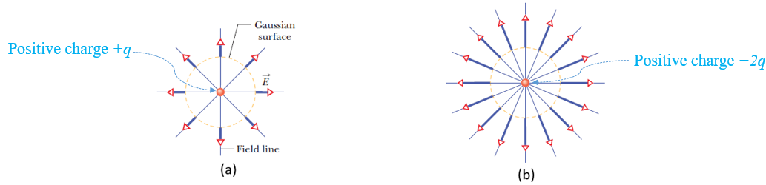
Figure 4.4 Electric field through a Gaussian surface involving, a charge +q (a), +2q (b)
For a differential surface dA of normal vector $d\vec{A}$ pierced by an electrostatic field $\vec{E}$, the differential flux denotes the dot product of both vectors:
$$dΦ=\vec{E}⋅d\vec{A}$$
The total electric flux piercing the whole surface is determined by summing all differential electric fluxes; it is expressed in N⋅ m²/C:
 | $$Φ=\int{\vec{E}⋅d\vec{A}}$$ | (4.6)

For the entire enclosed Gaussian surface, we are considering the “net flux”, by integrating along the closed loop, meaning that an algebraic summation is taking place:
 | $$Φ=\oint{\vec{E}⋅d\vec{A}}$$ | (4.7)

Gauss’ Law
Gauss’ law states that the value of the enclosed charge within a closed surface is proportional to the net electric flux that pierces this surface (Ohanian, 2007), hence:
 | $$q_{enc}=ε_{0}⋅Φ$$  $$q_{enc}=ε_{0}⋅\oint{\vec{E}⋅d\vec{A}}$$ | (4.8)

When a closed surface involves no charged particles or charged particles having zero net charge, the net electric flux is zero.
Application 4.1. The figure below on the left shows three charged particles, each of charge 2q, located at points O, A, and B. Determine the resultant force acting at particle A when q=e.
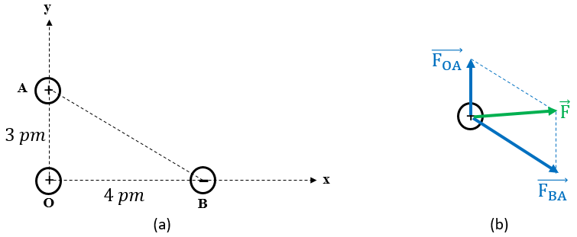
Figure 4.5 Charged particles arrangement (a), FBD of particle A (b)
Solution 4.1. Since particles O and A are both positively charged, the force applied by O at A is repulsive, while the one applied by B is attractive. This is illustrated in the diagram above on the right.
AB is the hypotenuse of the triangle AOB, thus: $AB=\sqrt{3^{2}+4^{2}}=5 pm$
The magnitudes of both electrostatic forces are found from equation (4.1):
$$F_{OA}=\frac{1}{4π⋅8.85⋅{10}^{-12}}⋅\frac{4⋅{\left(1.6⋅{10}^{-19}\right)}^{2}}{{\left(3⋅{10}^{-12}\right)}^{2}}=102.307 μN$$
$$F_{BA}=\frac{1}{4π⋅8.85⋅{10}^{-12}}⋅\frac{4⋅{\left(1.6⋅{10}^{-19}\right)}^{2}}{{\left(5⋅{10}^{-12}\right)}^{2}}=36.83 μN$$
The components of each of the forces along x and y are:
$F_{OA,x}=0$ ; $F_{OA,y}=102.307 μN$ ; $F_{BA,x}=36.83⋅\frac{4}{5}=29.464 μN$; $F_{BA,y}=-36.83⋅\frac{3}{5}=-22.1 μN$
The components of the resultant force: $F_{x}=0+29.464=29.464 μN$
$F_{y}=102.307-22.1=80.207 μN$
The magnitude of the resultant: $F=\sqrt{{29.464}^{2}+{80.207}^{2}}=85.448 μN$
The direction of the resultant with x-axis: $θ=\tan^{-1}{\frac{80.207}{29.464}}=69.83°$
Application 4.2. Consider two particles, one charged by -8q and the other by +20q, placed on a horizontal line (the positive charge is at the right, the negative one at the left) and separated by a distance of 10 cm. Calculate the electrostatic field developed at the midpoint P₁ between the charges and at a point P₂ placed 5 cm to the right of the positive charge.
Solution 4.2. At each point of interest, draw an imaginary spherical Gaussian closed surface. Thus, the first sphere encloses only -8q, thus the electrostatic field vector is oriented inward forming an angle of $180°$ with the normal surface vector. The second sphere encloses both charges with a net charge of -8q+20q = +12q, thus the electrostatic field vector is outward this time, having the same sense and direction as the normal surface vector. This is depicted in the figure below.
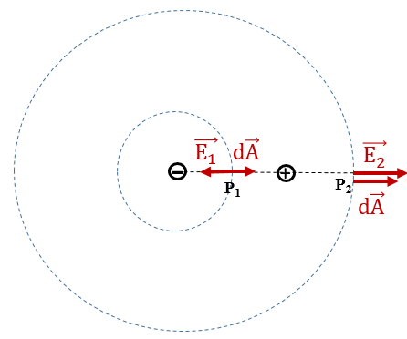

Figure 4.6 Electrostatic field vectors at P1 and P2
Applying equation (4.8) to each of the spheres, we take the integral of the dot product between the electric field vector and the differential area vector:
$$q_{enc,1}=ε_{0}\oint{E_{1}⋅dA⋅\cos{180}}⇒E_{1}=\frac{-(8⋅1.6⋅{10}^{-19})}{-4π⋅8.85⋅{10}^{-12}⋅{(0.05)}^{2}}=4.6 μN/C$$
$$q_{enc,2}=ε_{0}\oint{E_{2}⋅dA⋅\cos{0}}⇒E_{1}=\frac{+(12⋅1.6⋅{10}^{-19})}{+4π⋅8.85⋅{10}^{-12}⋅{(0.15)}^{2}}=0.767 μN/C$$

Self-Check Questions
            - Answer by true or false and justify your answer.
Two oppositely charged particles, each of charge q in absolute value separated by a distance d generate the same electrostatic field at a very far point as two oppositely charged particles, each of charge q/2 in absolute value separated by 2d.
True. According to equation (4.5), the electrostatic field magnitude is proportional to the dipole moment magnitude. Since in the two given cases, the moment is the same, p=q⋅d=(q/2)⋅(2d), the electrostatic field magnitude remains the same.

            - Choose the correct answer.
A particle of charge q produces an electrostatic field impacting another particle at a distance r. If the charge is tripled, at what distance should it be placed to keep the same electrostatic field relative to the particle of interest?
$3r$ $\frac{r}{3}$ $r\sqrt{3}$ $\frac{r}{\sqrt{3}}$

Details: $E_{1}=E_{2}⇒\frac{q}{r^{2}}=\frac{3q}{{r'}^{2}}⇒r^{'}=r\sqrt{3}$

Voltage, Current, and Resistance

Electric Potential Energy
A uniform electric field $\vec{E}$ is generated between two parallel plates oppositely charged. A positively charged particle existing in this field is subjected to an electric force causing it to move toward the negative plate as shown in the figure below, left (Knight, 2016, p. 689)
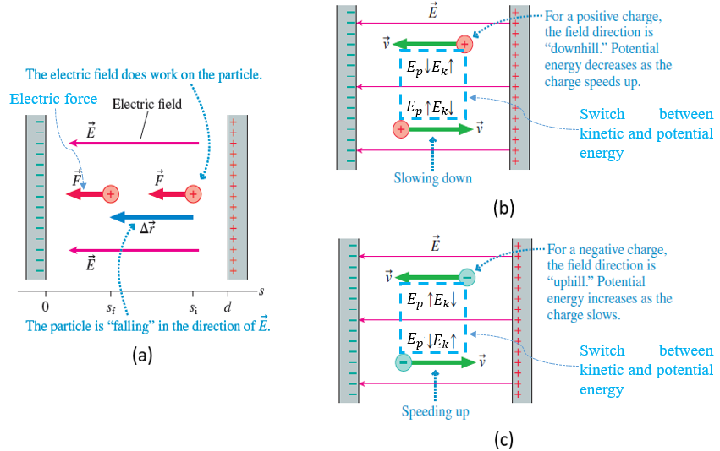
Figure 4.7 Work of an electric field (a), Energy switch on a positive charge (b), negative charge (c)
Along with the kinetic energy E_{k} stored within the particle that may increase when speeding up and decrease when slowing down, a potential energy E_{p} (electrical this time and not gravitational) is also produced and replaces the kinetic energy upon the motion of the particle toward a similarly or oppositely charged plate, as illustrated above on the right. (Knight, 2016, p. 690).
The electric force (related to the electric field according to equation (4.3)) produces electrical work W_{elec} for a displacement $Δ\vec{r}$ such that: $W_{elec}=q⋅E⋅(s_{i}-s_{f})$. As the change in electric potential energy is the opposite amount of the electric work, one writes:
$$ΔE_{p,elec}=-W_{elec}⇒E_{p,f}-E_{p,i}=q⋅E⋅s_{f}-q⋅E⋅s_{i}$$
Solving for E_{p,f} and E_{p,i}, and setting the datum of potential energy at the left plate (s =0), meaning that E_{p0} = 0, the electric potential energy becomes finally:
 | $$E_{p,elec}=q⋅E⋅s$$ | (4.9)

For two point charges q and q’ where q’ is generating the electrostatic field $\vec{E}$ of magnitude given in equation (4.2) and substituting r for s in equation (4.9) for symbols convenience, the electric potential energy expression becomes:
 | $$E_{p,elec}=\frac{1}{4πε_{0}}⋅\frac{q⋅q'}{r}$$ | (4.10)

For a dipole, the proof of the electric potential energy expression is not within the scope of this course, but we may state it as the opposite of the dot product between the dipole moment and the electrostatic field:
 | $$E_{p,elec}=-\vec{p}⋅\vec{E}$$ | (4.11)

Electric Potential
As mentioned earlier, one or a group of charged particles generate an electric field permeating the free surrounding space and exerting on any particle existing within this field an electric force equal to the product of the value of the existing charge and the magnitude of the electric field. The electric field does not depend on the charge of the particle subjected to the force; it is a property depending on the source charges (Ohanian, 2007). In addition, this particle may interact with other particles to develop an electric potential energy; like the concept of electric force, this electric potential energy is equal to the product of the value of the charge and the magnitude of a field generated by this source of charges called “electric potential”, or simply “potential”. It is denoted by the symbol V and is expressed in volt (V), carrying the name of the scientist Alessandro Volta. A volt is the ratio J/C. (Knight, 2016)
It should be noted that the potential is a property of the source charges (Knight, 2016) and independent of the charge lying within the field and storing the electric potential energy.
 | $$E_{p,elec}=q⋅V$$ | (4.12)

Now it would be useful to detect the speed increment or decrement of a charged particle within a potential field. This is depicted in the figure below. (Knight, 2016, p. 697). Although the case studied in this figure is considering a positively charged particle, the same rationale applies to a negatively charged one. When a charge moves from an initial state (i) within the potential field, to a final state (f), it is said that it is moving through a “potential difference”, also called “electric tension “or “voltage”, ΔV.
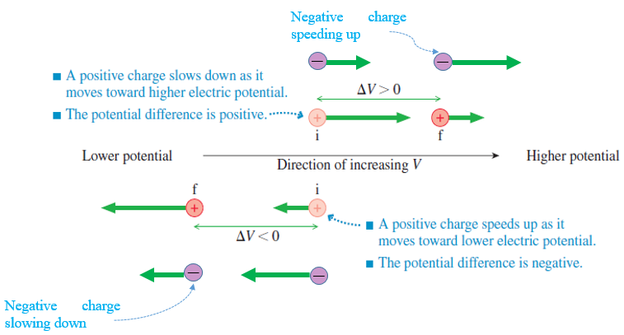
Figure 4.8 Speed of a charged particle within a potential field
When a positive charge moves toward an increasing potential, i.e., positive voltage, its electric potential energy increases as per equation (4.12); since the mechanical energy is constant, this means that its kinetic energy is decreasing and hence the particle is slowing down. The same process happens if a negative charge moves through a decreasing potential. If the positive charge moves through a decreasing potential, its motion will speed up. The principle of conservation of energy is expressed by:
 | $$E_{k,f}-E_{k,i}=-q⋅ΔV$$ | (4.13)

The potential generated by a charge q’ at a charge q far from q’ at a distance r is obtained by combining equations (4.10) and (4.12) to get:
 | $$V=\frac{1}{4πε_{0}}⋅\frac{q'}{r}$$ | (4.14)

Relationship between Voltage and Electric Field
‘’The electric potential and electric field are not two distinct quantities, but, instead, two different perspectives or two different mathematical representations of how source charges alter the space around them.’’ (Knight, 2016, p. 715)
Since the difference in electric potential energy is the opposite of the electric work, we have:
$$ΔE_{p}=-W_{elec}⇒q⋅ΔV=-q⋅\int_{i}^{f}{\vec{E}⋅d\vec{s}}$$
 | $$ΔV=-\int_{i}^{f}{\vec{E}⋅d\vec{s}}$$ | (4.15)

This relationship shows that if the electric field is known, the voltage can be deduced. Also, the potential decreases along the electric field lines.
Inversely, if we denote by E_{s} the component of the electric field along the motion line ds, one may deduce E_{s} by inverting equation (4.15):
 | $$E_{s}=-\frac{dV}{ds}$$ | (4.16)

Battery
Equation (4.15) shows that a voltage is generated when positive and negative charges are separated from each other. This separation could be either mechanical or chemical. A battery is the most widespread voltage source based on chemical reactions leading to the charges separating. It consists of two metallic plates (each from a different metal) termed “electrodes”, separated by chemical substances termed “electrolytes” (such as sulfuric acid and water in a car battery). When chemical reactions develop in the electrolytes, ions move from one electrode to the other leading to the positive charges splitting from the negative ones, each on an electrode, which induces the generation of a potential difference. The extremities of positive and negative electrodes are termed “terminals” of the battery. The battery becomes dead once the electrolytes are completely used.
Ions: atoms that have lost or gained electrons. They are charged positively in the case of electron loss, and negatively by electron gain.
The work per unit charge needed to transport the positive charges from the negative to the positive terminal is called the “electromotive force”, abbreviated emf and denoted by E. Its unit is J/C which is equivalent to V. (Knight, 2016) For an ideal battery, the potential difference at the battery terminals ΔV_{bat} is equal to the emf E.
Sometimes, the emf of a battery is not sufficient to supply the requested amount of voltage for a certain application (for example, to turn on a toy car or illuminate a small bulb) In this case, the solution is to mount multiple batteries in series, by connecting (either directly or through a conducting wire) the negative terminal of one to the positive terminal of the other. The total voltage produced will be the sum of the voltages of each battery:
 | $$ΔV=\sum_{i=1}^{i=n}{{∆V}_{i}}$$ | (4.17)

Capacitor
A "capacitor” is an electronic component consisting of two parallel and oppositely charged separated plates, which will generate a voltage at the terminals of the capacitor. A capacitor is used in many electric circuits integrated within laptops, televisions, keyboards, etc. The photograph below illustrates different types and sizes of capacitors. As a symbol within a circuit, a capacitor is represented by two parallel horizontal lines (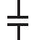).
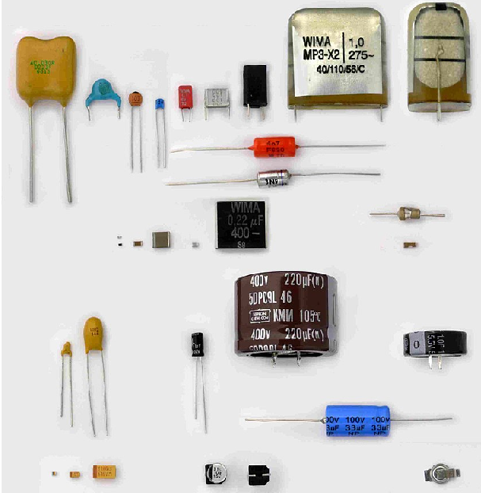
Figure 4.9 Different types of capacitors
The plates of a capacitor are charged by connecting each of them to a battery’s terminal, where positive charges will be transported from the negative plate through the electrolytes to the positive plate, creating a potential difference between both plates. When the number of positive charges on the relevant plate becomes enough to repulse extra positive charges coming from the battery’s terminal ( the same occurs on the negative plate), the capacitor is then fully charged and its
voltage becomes equal to the battery’s voltage.
Capacitance
If the positive plate is charged by +Q and the negative one by –Q, the net charge is zero, but due to the separating distance d between both plates, a potential difference ΔV is generated between the plates’ terminals proportional to the charge Q. The coefficient of proportionality denoted by C is termed “capacitance” and is a property of the capacitor plates’ area A as well as their separating distance d. In the SI system, the capacitance is expressed in farad (F). It is calculated by:
 | $$C=\frac{ε_{0}⋅A}{d}$$ | (4.18)

The amount of charge Q stored in a capacitor where a voltage ΔV_{C} is generated is given by:
 | $$Q=C⋅ΔV_{C}$$ | (4.19)

Energy Stored in a Capacitor
A capacitor needs a certain time to be charged from 0 to reach the total charge Q. We denote by q the instantaneous charge at an instant t. The voltage between the plates is found by ΔV=q/C. At an instant t+dt, the charge becomes q+dq; the change in potential electric energy dE_{p} is given by:
$$dE_{p}=ΔV⋅dq⇒dE_{p}=\frac{1}{C}q⋅dq$$
The total energy stored: $U_{C}=\int{dE_{p}}=\frac{1}{C}\int_{0}^{Q}{q⋅dq}$
 | $$U_{C}=\frac{Q^{2}}{2C}=\frac{1}{2}C{(ΔV_{C})}^{2}$$ | (4.20)

When the capacitor is discharging, this potential energy is converted into kinetic energy, resulting from the charged particle moving within the circuit, this is called “electric current”.
Arrangement of Capacitors
In an electric circuit, capacitors may be arranged either in parallel, as shown in the figure below on the left (Knight, 2016, p. 726), where top plates are connected from one side and bottom plates together on the other side, or in series where the bottom plate of a capacitor is connected to the top plate of the next one as illustrated in the figure on the right (Knight, 2016, p. 726).
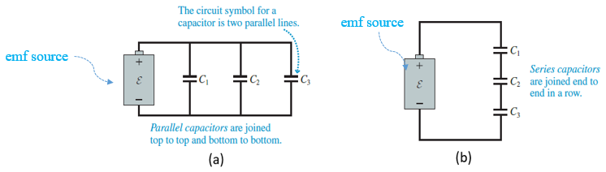
Figure 4.10 Capacitors in paralle (a), in series (b)
For the parallel scheme, all capacitors are subjected to the same voltage ΔV at their terminals where the total charge Q provided by the battery is distributed between the different capacitors. The “equivalent capacitor" is a new capacitor that replaces all the parallel capacitors under the same voltage ΔV and charged by Q, hence:
$$Q=Q_{1}+Q_{2}+Q_{3}+…+Q_{n}$$
$$C_{eq}⋅ΔV=C_{1}⋅ΔV+C_{2}⋅ΔV+C_{3}⋅ΔV+…+C_{n}⋅ΔV$$
 | $$C_{eq}=\sum_{i=1}^{i=n}{C_{i}}$$ | (4.21)

For the series scheme, all capacitors are charged by the same amount Q provided by the battery, however, the battery’s voltage ΔV is distributed between the different capacitors. The “equivalent capacitor” is a new capacitor that replaces all the parallel capacitors under the same voltage ΔV and charged by Q, hence:
$$ΔV={ΔV}_{1}+{ΔV}_{2}+{ΔV}_{3}+…+{ΔV}_{n}$$
$$\frac{Q}{C_{eq}}=\frac{Q}{C_{1}}+\frac{Q}{C_{2}}+\frac{Q}{C_{3}}+…+\frac{Q}{C_{n}}$$
 | $$\frac{1}{C_{eq}}=\sum_{i=1}^{i=n}{\frac{1}{C_{i}}}$$ | (4.22)

Electric Current
It is known that electrons are in continuous motion within their clouds surrounding the nucleus. Under a certain potential difference, protons cannot leave the nucleus, however, electrons can flow from atom to atom to circulate within the entire material. However, this flow of electrons is not the same in all materials, this depends on the atomic and molecular bonds and their distribution. Materials in which electrons flow easily throughout the whole body are classified as good “electrical conductors”; examples include certain metallic materials such as steel or copper. This is why the core of all electrical wires is made from copper. Conversely, materials in which electrons are not able to transfer from atom to atom and molecule to molecule and thus the flow of electrons is not possible, are called “electrical insulators”, such as cork or rubber. This is why the copper core of an electrical wire is covered by an insulating layer of polypropylene, to avoid the user coming into contact with the electric field.
A battery or any voltage source when disconnected or in an open loop is in electrostatic equilibrium. When a conducting wire is connected to the battery, i.e., each wire extremity is in contact with one terminal (thus creating a closed loop called an “electric circuit”), the potential difference in the battery will lead to an electric field in the wire and thus a flow of charges throughout the wire; the loop is said to be traversed by an “electric current”. An electric current can be defined as the rate of circulating charges per unit time (Ohanian, 2007). At a short instant dt, a differential amount of charge dq flows through the circuit generating an electric current I expressed in ampere (A) and given by:
Electrostatic equilibrium: a field is in electric equilibrium if the resultant electrostatic field vector is zero; $\vec{E}=\vec{0}$
 | $$I=\frac{dq}{dt}$$ | (4.23)

If the amount of flowing charge q is uniform during a certain duration t, the electric current is then constant and equation (4.23) becomes:
 | $$I=\frac{q}{t}$$ | (4.24)

Mathematical convention imposes that the current within the circuit flows from the positive to the negative terminal, which is opposite to the real sense of electron flow, which is from the negative to the positive terminal. This is illustrated in the figure below (Ohanian, 2007, p. 861)
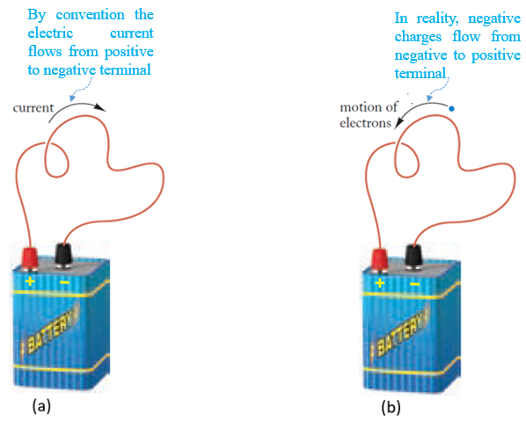
Figure 4.11 Conventional sense of the electric current (a), Real flow sense of electrons (b)
Finally, it is worth defining the “current density”, which is a vector $\vec{J}$ expressing the electric current flowing through a unit surface of a conductor. It is expressed in A/m² and related to the current by:
 | $$I=\int{\vec{J}⋅d\vec{A}}$$ | (4.25)

If the electric current is uniform and the current density has the same direction as the vector surface, the magnitude of J becomes:
 | $$J=\frac{I}{A}$$ | (4.26)

Resistor
Definition
A “resistor” is an electrical component used in an electric circuit to limit the electric current generated by a known voltage source. In an electric circuit diagram, the resistor is represented by either the symbol (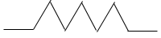) or (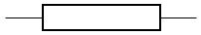). The characteristic property that quantifies the ability of a resistor to oppose the current flow is termed “resistance”, denoted by R and expressed in ohm (Ω).
The image below shows a group of resistors having different color marks, each reflecting a resistance value.
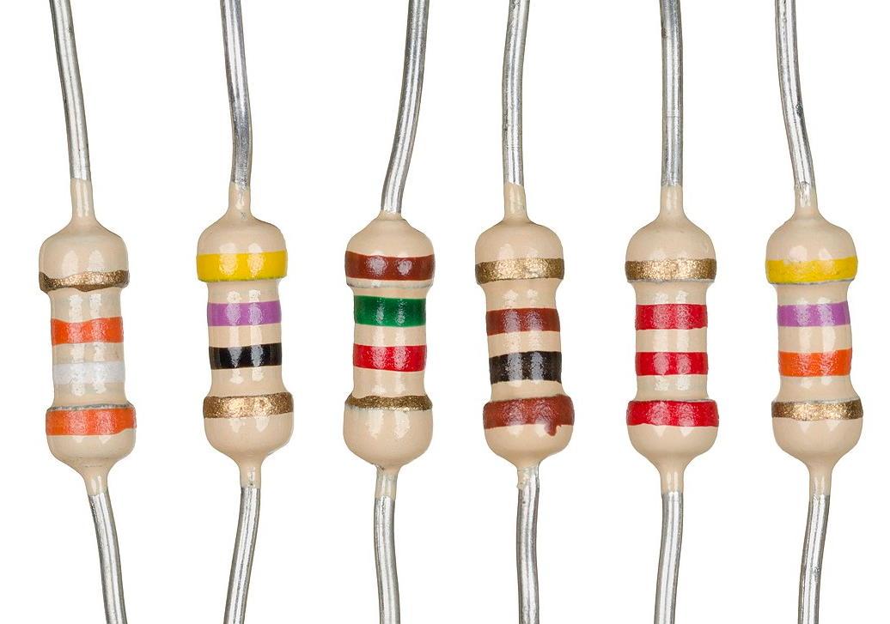
Figure 4.12 Resistors with different resistance values upon color-codes
Ohm’s Law
Ohm’s law states that a voltage ΔV developed at the terminals of a resistor delivers an electric current I passing through a resistor that is proportional to the voltage through the resistance R:
 | $$∆V=R⋅I$$ | (4.27)

Resistivity
The resistivity ρ is an intrinsic property depending exclusively on the type of material forming the conductor. It is defined as the ratio of the magnitude of the electric field to the magnitude of the current density. The inverse of the resistivity leads to a property of the material called “electrical conductivity” σ. The resistivity is expressed in (Ω⋅ m). (Knight, 2016)
 | $$ρ=\frac{1}{σ}=\frac{E}{J}$$ | (4.28)

The resistance R of a conductor depends on its resistivity and geometry. For a resistor of length L and cross-sectional area A made from a material of resistivity r, and combining equations (4.16),(4.26), and (4.28) for a uniform electric current and electric field (Knight, 2016), one obtains:
$$ρ=\frac{ΔV}{L}⋅\frac{A}{I}=\frac{R⋅A}{L}$$
 | $$R=\frac{ρ⋅A}{L}$$ | (4.29)

Power in a Resistor
Under a voltage ΔV the delivered current I involves motion of charges dq, thus a differential potential energy dE_{p} is developed during a differential time interval dt such that:
$$dE_{p}=ΔV⋅dq=ΔV⋅I⋅dt$$
The power transferred P is the rate of electrical energy (dE_{p}/dt) hence:
 | $$P=I⋅ΔV$$ | (4.30)

Since electrons move through a resistor at constant drift speed and thus exhibit no change in kinetic energy, this implies that the change in potential energy is converted into thermal energy leading to a dissipation within the resistor and a temperature increment. This is known as “Joule’s effect”. This thermal heat can be used in beneficiary applications such as water heaters for bathrooms (figure below) or electric stoves, thus avoiding using natural gas as the source of energy for cooking.
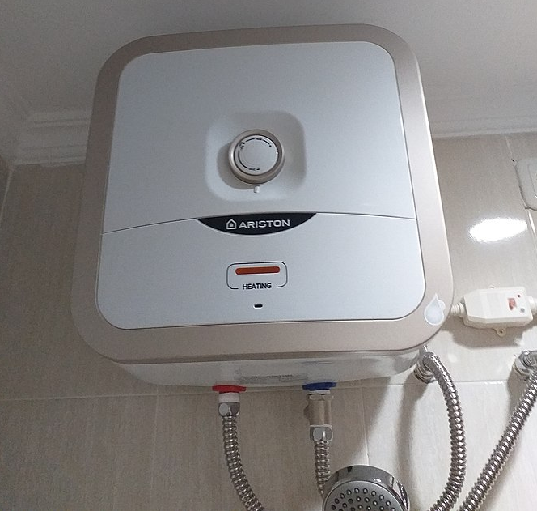
Figure 4.13 Water bathroom electric heater
Substituting equation (4.27) into equation (4.30), the dissipated power becomes:
 | $$P=R⋅I^{2}=\frac{{ΔV}^{2}}{R}$$ | (4.31)

This amount of power, expressed in watts, or kW for high values, reflects the amount of energy consumed by the user by multiplying the power by the consumption time, i.e., $E_{cons}=P⋅t_{cons}$. This energy is expressed in kilowatt-hours (kW⋅ h) and is measured for each household by an “electric-meter”. At the end of the month, the energy consumed is multiplied by the cost of 1 kW⋅ h to derive the electricity bill.
Arrangement of resistors
In an electric circuit, resistors may be arranged either in parallel, as shown in the figure below on the left, where the top terminals are connected from one side, and the bottom terminals together on the other side, or they may be arranged in series, where the bottom terminal of a resistor is connected to the top terminal of the next one as illustrated in the figure on the right.
For the parallel scheme, all resistors are subjected to the same voltage ΔV at their terminals where the total current I provided by the voltage source is distributed between the different resistors, hence this type of arrangement is called “current divider”; The “equivalent resistor” is a new resistor that replaces all the parallel resistors under same voltage ΔV and traversed by I, hence:
$$I=I_{1}+I_{2}+I_{3}+…+I_{n}$$
$$\frac{ΔV}{R_{eq}}=\frac{ΔV}{R_{1}}+\frac{ΔV}{R_{2}}+\frac{ΔV}{R_{3}}+…+\frac{ΔV}{R_{n}}$$
 | $$\frac{1}{R_{eq}}=\sum_{i=1}^{i=n}{\frac{1}{R_{i}}}$$ | (4.32)

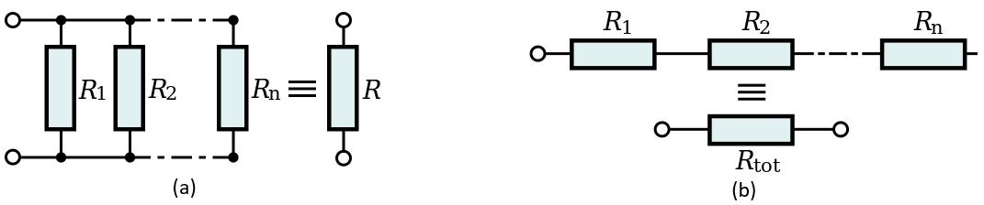
Figure 4.14 Resistors in parallel (a), in series (b)
For the series scheme, all resistors are traversed by the same total current I but the total voltage ΔV provided by the source is distributed between the different resistors, hence this type of arrangement is termed “voltage divider”; The “equivalent resistor” is a new resistor that replaces all the parallel resistors under same voltage ΔV and traversed by I, hence:
$$ΔV={ΔV}_{1}+{ΔV}_{2}+{ΔV}_{3}+…+{ΔV}_{n}$$
$$R_{eq}⋅I=R_{1}⋅I+R_{2}⋅I+R_{3}⋅I+…+R_{n}⋅I$$
 | $$R_{eq}=\sum_{i=1}^{i=n}{R_{i}}$$ | (4.33)

Application 4.3. Consider four charges occupying the vertices of the square as shown in Figure 4.15. Knowing that q₁ = -4q; q₂ = -3q; q₃ = +2q, q₄ = +5q; q = 160 nC; and d = 5 cm, calculate the electric potential energy of the system.
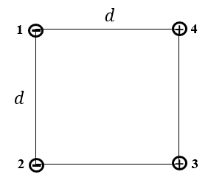
Figure 4.15 Charged particles on a square's vertices
Solution 4.3. The total electric potential energy is the sum of each energy produced between each pair of charges:
$$U=U_{12}+U_{13}+U_{14}+U_{23}+U_{24}+U_{34}$$
$$U=\frac{q^{2}}{4πε_{0}d}\left[12-\frac{8}{\sqrt{2}}-20-6-\frac{15}{\sqrt{2}}+10\right]=-93.29 mJ$$
Application 4.4. A capacitor of 10 μF capacity charged at 12 V is connected to an uncharged capacitor of 5 μF capacity. Calculate the energy stored in each capacitor.
Solution 4.4. The amount of charge stored in the first capacitor is found from equation (4.19): $Q=10⋅{10}^{-6}⋅12=0.12 mC$
When the second capacitor is charged by the connection with the first, and electrical equilibrium is established, the voltage is the same at the terminals of both capacitors (that are practically in parallel):
$$V_{1}=V_{2}⇒\frac{Q_{1}}{C_{1}}=\frac{Q_{2}}{C_{2}}⇒Q_{1}=2Q_{2}$$
The charge Q that was initially stored in totality in the first capacitor will now be distributed at equilibrium:
$Q_{1}+Q_{2}=0.12⇒Q_{2}=40 μC$ and $Q_{1}=80 μC$
The ene
rgies stored in each capacitor are found from equation (4.20):
$U_{C1}=\frac{{80}^{2}}{2⋅10}=0.32 mJ$ ;$U_{C2}=\frac{{40}^{2}}{2⋅5}=0.16 mJ$
Application 4.5. In the circuit shown in the figure below, the emf of the battery measures 12 V while the three resistors are each of 10 Ω resistance. Calculate the electric current delivered by the battery and the dissipated power in the circuit.
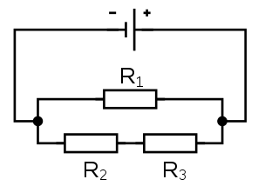
Figure 4.16 Compound arrangement of resistors
Solution 4.5. Resistors R₂ and R₃ are in series hence $R_{23}=10+10=20Ω$
This resultant resistor is in parallel with R₁ hence: $R_{eq}=\frac{10⋅20}{10+20}=\frac{20}{3}Ω$
From Ohm’s law (equation (4.27)): $I=\frac{12}{20/3}=1.8A$
Equation (4.31) gives the dissipated power: $P=12⋅1.8=21.6 W$

Self-check questions
- Complete the following sentence
On the front face of a box containing a hair drier, it is stated ‘‘1.5 KW at 220 V”. The hair drier absorbs a current of 6.82 A and has an internal resistance of 32.27 Ω.
Details: $I=\frac{1500}{220}=6.82 A$ ; $R=\frac{{220}^{2}}{1500}=32.27Ω$
- Answer by true or false an justify your answer
A battery of voltage V storing a charge Q forms a closed circuit with three identical capacitors in series. The energy stored in each capacitor measures QV/3. False, since the series capacitors store the same charge V but distribute the potential difference, hence the voltage at each capacitor measures V/3. The energy stored is:
U_{C} = (1/2)⋅ Q⋅ (V/3) = Q⋅ V/6
- An alternative unit of the electric field is:
A/s C/m J/s V/m

Details: equation (4.16) shows that the electric field is a ratio of voltage over a displacement

Analysis of Direct Current Networks

Elements of a Circuit Diagram
A “circuit diagram” is a drawing or schema showing how electrical components in a circuit are connected to form a closed loop(s) traversed by electric current(s). The aim is to achieve a practical output such as bulb lighting or water heating. Without a voltage “source” such as a battery, no electrical process would occur. The components traversed by electric current delivered from the source are called a “load”. Several key electric components along with their schematic symbols can be seen in the figure below (Knight, 2016, p. 767).
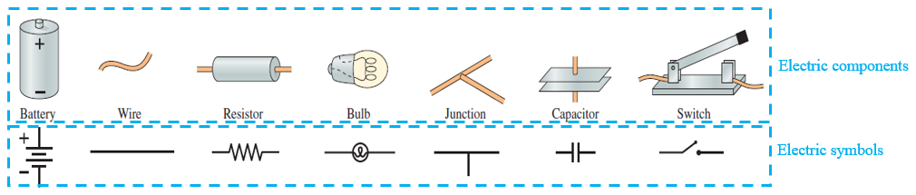
Figure 4.17 Main electric components used in circuits and their symbols

Kirchhoff’s Laws
Junction Law
Since within a circuit the total charge is conserved, the sum of input electric currents through a junction is the same as the sum of output electric currents exiting this junction. This is shown in the figure below on the left (Knight, 2016, p. 768)
 | $$\sum{I_{in}}=\sum{I_{out}}$$ | (4.34)

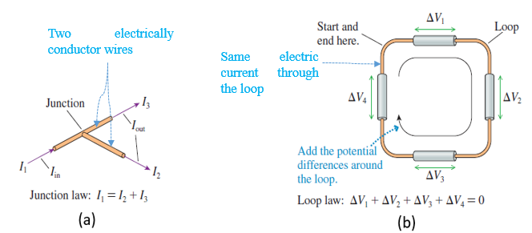
Figure 4.18 Junction law (a), Loop law (b)
Loop Law
Since within a circuit the total energy is conserved, the sum of voltages at the components’ terminals vanishes. This is shown in the figure above on the right (Knight, 2016, p. 768)
 | $${∆V}_{loop}=\sum{{∆V}_{i}}=0$$ | (4.35)

Voltage Sign
The concept of voltage as an absolute value has already been seen in Ohm’s law. However, equation (4.35) indicates that voltage can be considered either positive or negative since the global summation is zero.
The sign of the voltage is linked to the sense of the electric current. As seen earlier, the conventional sense of the current consists of a flow starting from the positive terminal of the source and entering the negative terminal, meaning that within the source itself the flow is oriented from the negative to the positive terminal. In that case, the voltage, i.e., the emf, is considered positive. Meanwhile, the current enters the positive terminal of any component (e.g., a resistor) connected to the positive terminal of the source and exits via the negative terminal In that case, the voltage is considered negative at the terminals of the component. This description is depicted in the figure below. (Knight, 2016, p. 769)
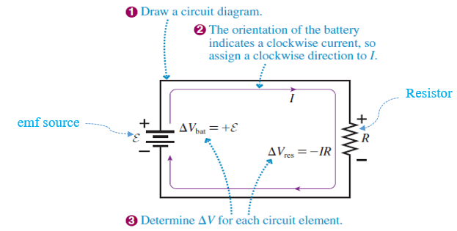
Figure 4.19 Current sense and voltage signs

Grounding
Until now, we have talked about the difference in potential between two points in an electric circuit without discussing the value of the potential itself. To do so, the negative terminal of the source must be set to 0 by connecting one extremity of a wire to this terminal and the other extremity to the earth floor or the ground where V_{ground} = 0 V. In that case if a battery source produces an emf of 12 V at its terminals one is certain that V_{negative} = 0 V and V_{positive} = 12 V. This allows us to also know the electric tension at each terminal of the other electrical components. The connection to the ground does not change the behavior of the circuit; Ohm’s and Kirchhoff’s laws remain applicable. The ground symbol is (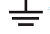).

RC Circuits
In some cases, a resistor is not connected to a direct emf source, but to a fully charged capacitor alongside a switch as shown in the leftmost figure below (Knight, 2016, p. 784). Once the switch is closed, the capacitor starts i
ts discharge by delivering an electric current to the resistor (middle figure below (Knight, 2016, p. 784)) until it is completely discharged. To charge a capacitor, an emf source must be added to the circuit as depicted in the figure on the right (Knight, 2016, p. 786). All those circuit cases are known as RC (i.e., resistor-capacitor) circuits since they involve both a capacitor and a resistor.
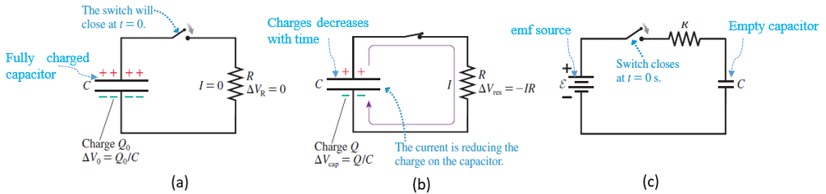
Figure 4.20 Capacitor discharge, at t=0 (a), at any instant (b), Capacitor charging (c)
Applying Kirchhoff’s loop law for the discharge case:
$$∆V_{cap}+∆V_{res}=0⇒\frac{Q}{C}-I⋅R=0$$
The current I traversing the resistor is given by I=dq/dt where dq is the differential amount of charge absorbed by the resistor; since the total charge in the circuit remains unchanged, one can write: dq=-dQ hence:
$$\frac{Q}{R⋅C}+\frac{dQ}{dt}=0⇒\frac{dQ}{Q}=-\frac{1}{RC}dt⇒\int_{Q_{0}}^{Q}{\frac{dQ}{Q}}=-\frac{1}{RC}\int_{0}^{t}{dt}$$
 | $$Q=Q_{0}e^{-\frac{t}{RC}}$$ | (4.36)

This equation shows that the charge in a capacitor decreases exponentially with time.
The denominator of the exponential decay rate, R⋅ C has a time dimension. When the time of discharge reaches this value, one gets Q = 0.37Q₀. We may then define the time constant τ, by the necessary time needed to empty 63% of the capacitor’s charge.
 | $$τ=R⋅C$$ | (4.37)

Since the voltage in the capacitor is proportional to the charge, it will thus also decrease exponentially. In addition, since the current is proportional to the voltage through Ohm’s law, this latter decreases from I₀=ΔV₀/R following the same trend:
 | $$ΔV={ΔV}_{0}e^{-\frac{t}{RC}}$$ | (4.38)
 | $$I=I_{0}e^{-\frac{t}{RC}}$$ | (4.39)

By repeating the same rationale for the charging case (E=Q_{f}/C) the loop law can be written:
$$\frac{Q_{f}}{C}=I⋅R+\frac{Q}{C}⇒\left(Q_{f}-Q\right)=RC\frac{dQ}{dt}⇒\frac{dQ}{Q_{f}-Q}=\frac{1}{RC}dt$$
Integrating from 0 to Q on the left and from 0 to t on the right, one gets:
 | $$Q=Q_{f}(1-e^{-\frac{t}{RC}})$$ | (4.40)

By deriving this latter equation with respect to time and using Ohm’s law one obtains an expression of the electric current identical to equation (4.39).

Voltmeter and Ammeter
A “voltmeter” is a device for measuring the voltage of any electric tension source of any component in an electric circuit. The “ammeter” measures the electric current passing through the component of interest. (Knight, 2016) In practice, many electric amounts can be measured using one device: the “multimeter”. This is illustrated in the figure below.
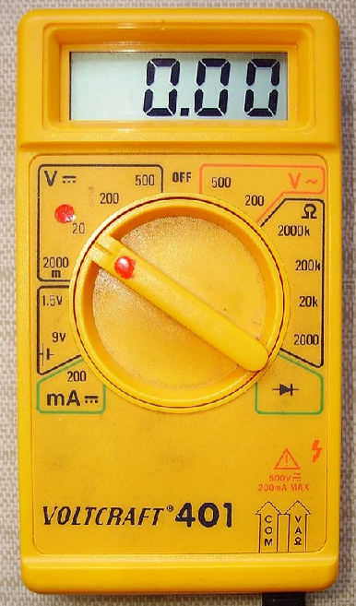
Figure 4.21 Multimeter
Application 4.6. A battery of 12 V emf supplies a network of resistors shown in the below figure. Calculate the total power generated by the battery and the currents circulating through each resistor.
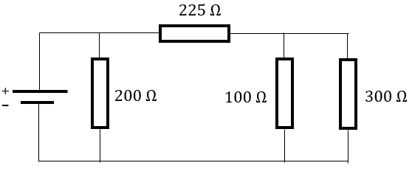
Figure 4.22 Network resistors circuit
Solution 4.6. The first step consists of reducing the four resistors to an equivalent one according to the three-stepped scheme of the figure below.
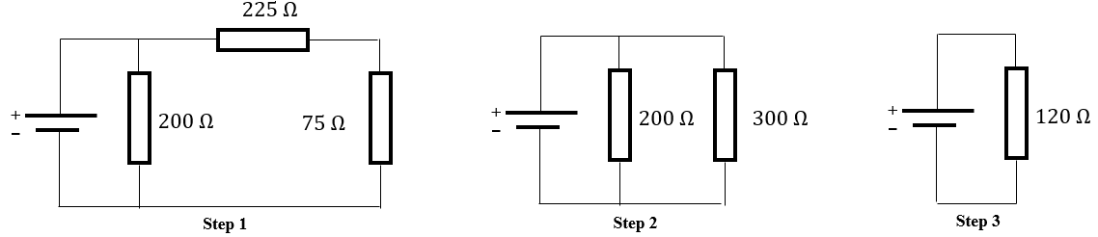
Figure 4.23 Scheme of resistors reduction
The 100 Ω and 300 Ω resistors are in parallel: $R_{eq,1}=\frac{100⋅300}{100+300}=75Ω$ (step 1)
The 225 Ω and 75 Ω resistors are in series: $R_{eq,2}=225+75=300Ω$ (step 2)
The 200 Ω and 300 Ω resistors are in parallel: $R_{eq}=\frac{200⋅300}{200+300}=120Ω$ (step 3)
Applying Ohm’s law to the equivalent resistor: $I=\frac{12}{120}=0.1 A=100 mA$
The generated power is: $P_{gen}=0.1⋅12=1.2 W$
The resistor in the original circuit is completely in parallel with the battery, thus it is subjected to an electrical tension equal to the emf; Ohm’s law gives:
$$I_{1}=\frac{12}{200}=60 mA$$
Applying the junction law of Kirchhoff, the current passing through the 225 Ω resistor is:
$$I_{2}=100-60=40 mA$$
The voltage at the 225 Ω resistor is: $ΔV_{2}=225⋅0.04=9 V$
Applying Kirchhoff’s loop law in the loop (200-225-100) Ω, one gets the voltage at the terminals of the 100 Ω resistor and by extension at the 300 Ω resistor since they are in parallel: $ΔV_{3}=12-9=3 V$
The currents through 100 Ω the 300 Ω resistors are respectively:
$I_{3}=\frac{3}{100}=30 mA$ ; $I_{4}=\frac{3}{300}=10 mA$
Note that $I_{2}=I_{3}+I_{4}$ , thus the junction law is verified.
Application 4.7. With the capacitor initially empty, the switch of a circuit is suddenly closed. Calculate the voltage and the energy within both the resistor and the capacitor after 1.5 s of switch closure.
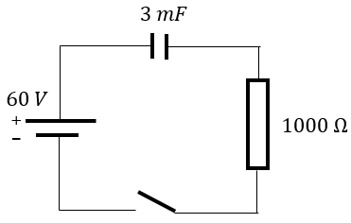
Figure 4.24 Charging a capacitor
Solution 4.7. The time constant measures $τ=0.003⋅1000=3 s$; this is the time needed to fill 63% of the total charge $Q_{f}=60⋅3⋅{10}^{-3}=0.18 C$.
Dividing equation (4.40) by C, one gets: ${ΔV}_{C,1.5}=60⋅\left(1-e^{-0.5}\right)=23.6 V$.
Kirchhoff’s loop law gives the voltage in the resistor as: ${ΔV}_{R,1.5}=60-23.6=36.4 V$.
The energy stored in the capacitor after 1.5 s is:
$$U_{C,1.5}=\frac{1}{2}⋅3⋅{10}^{-3}⋅\left({23.6}^{2}\right)=0.83544 J$$
The energy dissipated in the resistor is the integral of the power dissipated within the time interval [0-1.5], where $I=\frac{dQ}{dt}=I_{f}e^{-t/3}$:
$$U_{R,1.5}=\int_{0}^{1.5}{1000⋅I^{2}⋅dt}=1000⋅{I_{f}}^{2}\left(-\frac{3}{2}\right)⋅{\left[e^{-\frac{2t}{3}}\right]}_{0}^{1.5}=3.41 J$$

Self-Check Questions
- Complete the following sentence
A battery of 6 V emf supplies two series resistors such that the resistance of the second resistor is twice the resistance of the first. The voltage at the terminals of the first resistor measures 2 V while at the second resistor it measures 4 V.
Details: Resistors in series are traversed by the same electric current; the 6 V emf is divided between both resistors according to Ohm’s law:
$$\frac{{ΔV}_{1}}{R}=\frac{{ΔV}_{2}}{2R}⇒{ΔV}_{2}=2⋅{ΔV}_{1}$$
Using the loop law we see that: ${ΔV}_{1}+{ΔV}_{2}=6⇒{ΔV}_{1}+2{ΔV}_{1}=6⇒{ΔV}_{1}=2 V and {ΔV}_{2}=4 V$
- Choose the correct answer
A circuit consists of a fully charged capacitor of 200 μF and two resistors in parallel, each of resistance 5000 Ω. The time constant in s for discharge is:
0.25 0.5 1 2

Details: the equivalent resistance of the two parallel resistors is:
$$R_{eq}=\frac{5000⋅5000}{5000+5000}=2500 Ω$$
The time constant becomes: $τ=200⋅{10}^{-6}⋅2500=0.5 s$

The Magnetic Field

Magnet
A magnet is a solid body made from certain types of rock or metals having the ability to attract toward itself some types of metallic objects. A magnet consists of two distinct extremities: one termed the north pole (N) and anotherthe south pole (S). Two poles from the same type “repel” once they get close while two poles from opposite types “attract” once they are close. The effect of attraction or repulsion is quantified by the “magnetic force”; this is an analogous concept to the electric force discussed earlier in this unit. (Ohanian, 2007).
The core of the Earth behaves as a magnet where the geographic south pole is the magnetic north pole, and the geographic north pole coincides with the magnetic south pole. The compass needle is a small magnet that rotates about its pivot under the magnetic force applied by the earth when it approaches regions near or far from the poles of the earth.
Similar to the electrostatic field concept, a magnet produces the magnetic force by the medium of ‘’lines’’ permeating its surrounding space such that any object lying within those ‘’lines’’ will be influenced by the magnetic force; the ‘’lines’’ constitute the magnetic field. The lines emerge from the north pole and enter through the south pole.
Magnetism is not independent from electricity. Physicists have found that electric charges may develop both an electrical force (in static and dynamic statuses) and a magnetic force (when they are in motion). This leads to the conclusion that a conductor traversed by an electric current is a source of magnetic fields; hence when the compass needle gets near the electric current, it deviates due to the magnetic force as depicted in the figure below on the left (Ohanian, 2007, p. 927) The magnetic field vector, denoted by $\vec{B}$ acts tangentially to circles centered on the conducting wire; its sense is determined from the right-hand rule where the thumb is oriented with the electric current and the curling remaining fingers determine the sense of the magnetic field. This is illustrated in the figure below right. (Ohanian, 2007, p. 932).
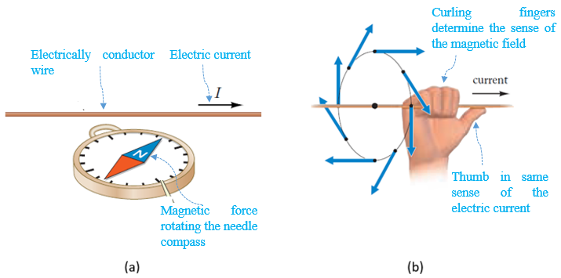
Figure 4.25 magnetic effect of an electric current (a), magnetic field lines (b)
The magnitude of the magnetic field B, expressed in tesla (T) in the SI system, is given by the following equation:
 | $$B=\frac{μ_{0}⋅I}{2πr}$$ | (4.41)

Where $μ_{0}=4π×{10}^{-7}N{⋅s}^{2}/C^{2}$ is the “permeability constant” or “magnetic constant”; and r is the radial distance from the conducting wire.
When a charge q moves at velocity vector $\vec{v}$ within a magnetic field $\vec{B}$ the magnetic force developed is given by the cross product:
 | $$\vec{F}=q⋅\vec{v}×\vec{B}$$ | (4.42)

If a is the angle between the velocity and the magnetic field vector, the magnitude of the magnetic force becomes:
 | $$F=\frac{μ_{0}⋅q⋅v⋅I⋅\sin{α}}{2πr}$$ | (4.43)

If many electric currents are generating many magnetic fields, the resultant magnetic field is the vector sum of the different field vectors related to the electric currents. This is the “superposition principle”.

Solenoid
‘’A solenoid is a conducting wire wound in a tight helical coil of many turns’’ as illustrated in the figure below on the right (Ohanian, 2007, p. 943). An electric current circulating through the coils of an ideal solenoid produces a strong uniform magnetic field parallel to the longitudinal axis of the solenoid as shown in the below figure on the right (Ohanian, 2007, p. 943). The thumb of the right-hand rule indicates the sense of the magnetic field while the other fingers curling about the coils of the solenoid follow the same sense of the flowing electric current.
Ideal solenoid: a very long solenoid having very tightly wound coils and traversed by an approximately uniform electric current
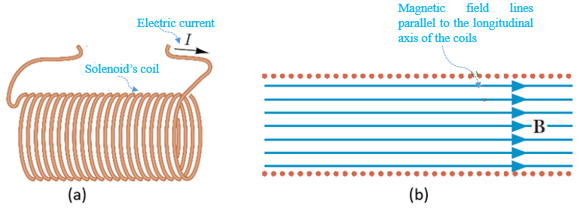
Figure 4.26 Current travelling in a solenoid's coils (a), Magnetic field in a solenoid (b)
If N is the number of wire turns, l is the solenoid’s length, and I is the electric current, the magnitude of the magnetic field is calculated by:
 | $$B=\frac{μ_{0}⋅I⋅N}{l}$$ | (4.44)

This magnetic field could be increased by inserting iron or other ferromagnetic materials in the core of the solenoid. (Ohanian, 2007).
An “electromagnet” is a solenoid with a gap at a certain number of coils such that one portion becomes a north pole while the other becomes the south pole. In this gap, loops or wires or other components could be inserted to be influenced by the magnetic field in order to develop other outputs. An electromagnet may also consist of two solenoids separated by the desired gap.

Force on a Wire
A conductor wire of length L placed within a magnetic field $\vec{B}$ at an angle α traversed by an electric current I will be subjected to a moving force $\vec{F}$ perpendicular to the plane ($\vec{L}$,$\vec{B}$) and given by:
 | $$d\vec{F}=I⋅d\vec{L}×\vec{B}$$ | (4.45)

If the wire is straight and the magnetic field is uniform, the force becomes:
 | $$\vec{F}=I⋅\vec{L}×\vec{B}$$ | (4.46)

Where the magnitude is calculated by:
 | $$F=I⋅L⋅B⋅\sin{α}$$ | (4.47)

An extension of the wire study is a closed loop placed in a uniform magnetic field through which a current circulates; two equal, parallel, and opposite magnetic forces will be generated at this loop. Since they are separated by the loop’s width, a moment (i.e., a “torque”) will be developed on the loop to create a rotational motion. This is the principle of an “electric motor”, where the input is the electric current; the magnetic field is already generated by a magnet embedded in the body of the motor, and the output is simply a mechanical torque used to rotate a disk, fan, or turbine.

The Magnetic Flux
The concept of the “magnetic flux” is similar to the electric flux. It denotes the amount of magnetic field $\vec{B}$ piercing over an area for either an open or closed surface. The magnetic flux denoted by Φ_{B} is expressed in the SI system in weber (Wb).
 | $$Φ_{B}=\int{\vec{B}}⋅d\vec{A}=\int{B⋅\cos{θ}⋅dA}$$ | (4.48)

For the case of a flat surface (the vector dA maintains the same direction) and a uniform magnetic field (B=constant), the flux becomes: $Φ_{B}=B⋅A⋅\cos{θ}$,

The Induced emf
Consider a conductor rod of length L placed within a magnetic field and moving at a certain velocity $\vec{v}$. According to equation (4.42), the electrons, each of charge –e, will be subjected to a magnetic force $\vec{F}$ that is directed in-plane and upward following the right-hand rule; this is depicted in the figure below (Ohanian, 2007, p. 995) where the lines of $\vec{B}$ are oriented in-plane, i.e., perpendicular to the circuit. As a result, the rod is now ‘’converted’’ to a source of voltage where an electric current is generated in the circuit, in which the rod can slide remaining constantly in contact with the horizontal wires of the circuit. The magnitude of the force is calculated by $F=e⋅v⋅B$; per unit charge, this force becomes equal to $v⋅B$. The work developed by this force for each charge is the product of this force and the distance by which the charge has been displaced, which is the length L of the rod, hence $L⋅v⋅B$. From an electric point of view, this work is the electromotive force E developed in the ‘’rod-source’’:
 | E$=L⋅v⋅B$ | (4.49)

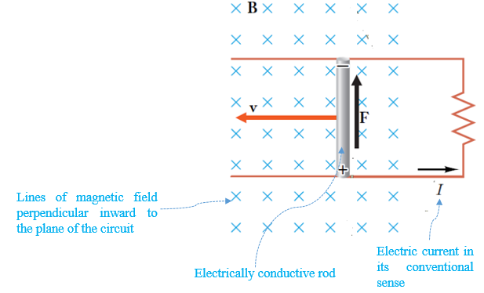
Figure 4.27 Generation of induced emf

Faraday’s Law of Induction
Consider a moving conductor rod of length L within a magnetic field perpendicular to its velocity vector. During a differential interval dt, the rod displaces by v⋅ dt and hence the change in area covered by the rod’s motion becomes L⋅ v⋅ dt. The differential change in flux is the product of the magnetic field magnitude and the change in area, hence:
$$L⋅v⋅dt⋅B={dΦ}_{B}$$
Considering equation (4.49), this latter equation becomes:
 | E$=-\frac{{dΦ}_{B}}{dt}$ | (4.50)

The minus sign has been inserted according to “Lenz’s law”, which will be detailed soon.
This latter equation represents “Faraday’s law” for magnetic induction. It could be stated as: ‘’The induced emf along any moving or fixed path in a constant or changing magnetic field equals to the rate at which the magnetic flux sweeps across the path.’’ (Ohanian, 2007, p. 999).
This law implies that by changing the magnetic flux in one way or another, an induced emf, i.e., an “induced electric current” can be generated. This law offers a method of producing electricity by magnetic flux variation, which can be achieved in several ways:
- Changing the area’s path leads to magnetic flux change.
- Changing the path’s position within the magnetic field, either by translation or rotation, leads to magnetic flux change.
- Changing the magnitude of the magnetic field leads to magnetic flux change.
All these options are illustrated in the figure below (Ohanian, 2007, p. 1000) for a closed-loop path.
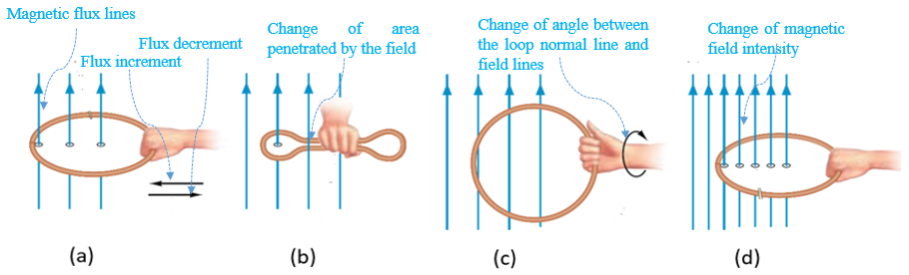
Figure 4.28 Magnetic flux change by: moving loop (a), changing loop's size (b), rotating loop (c), changing magnetic field strength (d)
Rotating the loop in the magnetic field (third figure above) constitutes the main concept of the “electromagnetic generator”, where the input is a mechanical torque for loop rotation and the output is the induced electric current and hence electricity production. ‘’Small or medium-size generators are driven by gasoline or diesel engines, large-size generators at electric power plants are driven by steam turbines of hydraulic turbines.’’ (Ohanian, 2007, p. 1000)

Lenz’s law
The induced electric current flows in the circuit in such a way that it opposes the cause of its creation, i.e., the flux change.
This law may be explained through the example shown in the figure below (Ohanian, 2007, p. 1001)
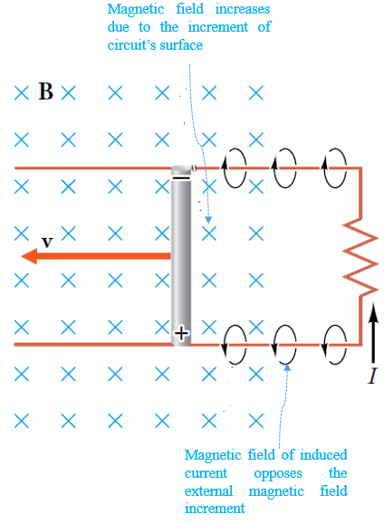
Figure 4.29 Sense of the induced electric current
If the rod displaces to the left, the area of the closed circuit (at the right) increases, thus the magnetic flux increases, hence the induced current must generate a magnetic field against the original existing one to compensate for this increment in flux. By applying the right-hand rule, i.e., fingers curling against the applied actual magnetic field, one finds that the induced current must flow counterclockwise. Conversely, the rod’s motion to the right decreases the circuit’s area and likewise the magnetic flux, and the induced current must generate a magnetic field in the same sense as the existing one to ‘’help’’ it regain the decrement of flux, which implies the clockwise sense of the current. This latter scenario shows that the induced current acts against the change in flux and not against the flux itself. Finally, Lenz’s law offers an interpretation of the negative sign in Faraday’s formula.

Inductor
The figure below on the left (Ohanian, 2007, p. 1009) shows coil 1 traversed by an electric current I₁, generating a magnetic field B₁ and hence a magnetic flux Φ_{B1}. The existence of another coil 2 of a different size than coil 1 leads to a change of the magnetic flux Φ_{B1}; according to Faraday’s law, an induced emf, i.e., an induced current I₂, is then produced in coil 2.
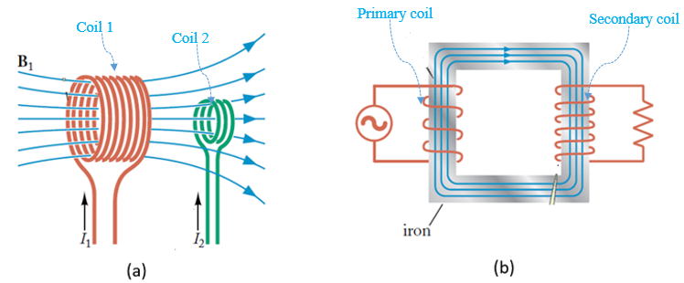
Figure 4.30 Mutual induction (a), Transformer (b)
Coil 1 is the inductor while coil 2 is being induced. The inverse may also happen. All in all, there is a mutual magnetic induction between coils 1 and 2. The geometry of the inductor-induced system (sizes, spacing, number of turns) generates a magnetic property of this system called “mutual inductance”, denoted by M, and expressed in the SI system in henry (H). Mutual inductance represents the coefficient of proportionality between the current and the generated magnetic flux acting at the inductor:
 | $$Φ_{B1}=M⋅I_{1}$$ | (4.51)

The induced emf at coil 2, becomes, according to equation (4.50):
 | E₂$=-M\frac{{dI}_{1}}{dt}$ | (4.52)

If the roles are inverted between the inductor and the induced, it will be sufficient to invert the indexes ‘’1’’ and ‘’2’’ in equation (4.52).
A practical application of this mutual induction phenomenon is the “transformer”, depicted in the figure above on the right (Ohanian, 2007, p. 1053), used to step-up or step-down the desired voltage at the output. The transformer consists of two coils, the primary having N₁ turns and the secondary having N₂ turns depending on the ratio of these two numbers, the output E₂ voltage maybe stepped up or down according to the following equation:
 | E₂$=$E₁⋅ $\frac{N_{2}}{N_{1}}$ | (4.53)

Additionally, an inductor may induce itself by changing any of the parameters influencing the magnetic flux through the inductor. According to Lenz’s law, an induced current will be generated to oppose the change of flux within the inductor itself traversed originally by a current creating the original magnetic flux; the related induced emf is then termed “back emf”.
For the self-induction phenomenon, the property related to the inductor’s geometry is called self-inductance or simply inductance. It is denoted by L and is also expressed in henry (H). Its symbol in the circuit is (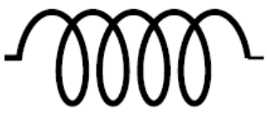). The magnetic flux and the back emf expressions could be derived from equations (4.51) and (4.52):
 | $$Φ_{B}=L⋅I$$ | (4.54)
 | $$∆V_{L}=-L\frac{dI}{dt}$$ | (4.55)

Magnetic Energy
Similar to capacitors, which store electric energy, and resistors, which dissipate thermal energy, inductors store magnetic energy.
One should start from the electric power general equation, and combine it with equation (4.55):
$P=∆V_{L}⋅I$ $=-L⋅I⋅\frac{dI}{dt}$
The negative sign denotes the energy ‘’lost’’ by the current within the inductor, thus the differential magnetic energy stored by the inductor is:
$$dU=-P⋅dt=L⋅I⋅dI$$
Integrating between the initial current value (I = 0) and the final value (I=I₀), the total energy stored in the inductor becomes:
 | $$U=\frac{1}{2}L⋅{I_{0}}^{2}$$ | (4.56)

RL Circuits
An RL (i.e., resistor-inductor) circuit is an electric circuit that comprises a resistor and an inductor in series along with an electric tension source. This is illustrated in the figure below on the left (Ohanian, 2007, p. 1015). At the start, i.e., t = 0, the electric current was I = 0. Due to the presence of the inductor, the electric current cannot increase suddenly up to its final value I₀=E/R. In fact, the self-induction phenomenon developed in the coils of the inductor generate an induced current acting against the effect of the emf source; this would ‘’slow down’’ the increment of the current in the circuit and would take a certain time to reach its final level I₀.
According to Kirchhoff’s loop law, the emf of the source is split between the terminals of the resistor and those of the inductor, hence:
$R⋅I+L⋅\frac{dI}{dt}=$E
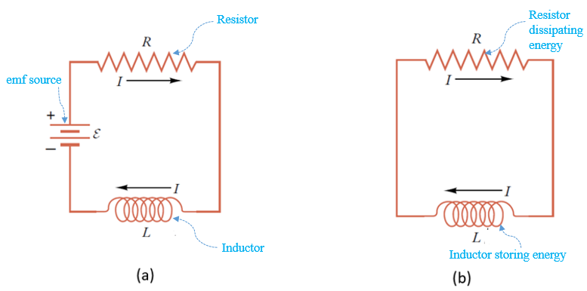
Figure 4.31 RL circuit with emf source (a), RL circuit after emf source removal (b)
Dividing both sides of the equation by R and setting $τ=L/R$ the latter equation becomes:
$$τ\frac{dI}{dt}+I=I_{0}$$
The solution to this differential equation provides the profile
of the current as a function of time. It increases exponentially as the following equation shows:
 | $$I=I_{0}(1-e^{-\frac{t}{τ}})$$ | (4.57)

The parameter τ is termed “characteristic time” and is the time needed for the current to reach 63% of its final value:
 | $$τ=\frac{L}{R}$$ | (4.58)

Now that the current has reached its steady value and it will never change with time, the voltage at the terminals of the inductor vanishes, and the entire emf of the source will be absorbed by the resistor.
At this stage, if the source is suddenly removed and the circuit is closed again as shown in the figure above on the right (Ohanian, 2007, p. 1017), the resistor will dissipate the energy stored in the inductor, which will lead to a decrease of the current from I₀=E/R to 0. Applying Kirchhoff’s loop law and solving the differential equation we have:
$$τ\frac{dI}{dt}+I=0$$
 | $$I=I_{0}e^{-\frac{t}{τ}}$$ | (4.59)

Application 4.8. A wire of length 1m and weight 1 N is part of a closed circuit parallel to the z-axis. It is traversed by a current of 6 A and immersed in a uniform magnetic field of magnitude 0.5 T. It was initially (before the current circulated) held by a vertical cable (parallel to the field lines) as shown in the figure below on the left. Calculate the angle of deviation of the holding cable with respect to the vertical once the current is switched on.

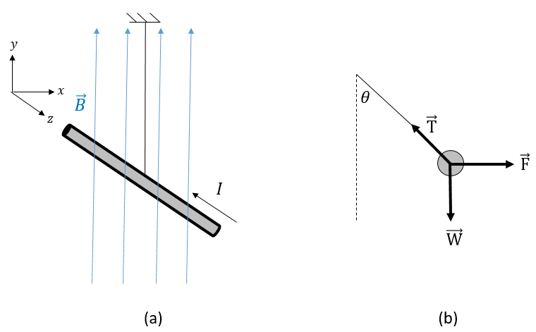
Figure 4.32 Wire held by a cable in a magnetic field (a), FBD after current flow (b)
Solution 4.8. According to equation (4.46), the right-hand rule gives a magnetic force $\vec{F}$ in the horizontal direction oriented to the right, which justifies the FBD in the figure above on the right. Equation (4.47) gives the magnitude of this force where $α=90°$ as:
$$F=1⋅6⋅0.5⋅1⇒F=3 N$$
The static equilibrium of the rod satisfies: $\vec{F}+\vec{W}+\vec{T}=\vec{0}$.
Projecting along the horizontal axis yields: $T⋅\sin{θ}=3…(eq1)$.
Projecting along the vertical axis gives: $T⋅\cos{θ}=1…(eq2)$.
Eliminate T by dividing eq1 by eq2: $\frac{(eq1)}{(eq2)}⇒\tan{θ}=3⇒θ=71.57°$.
Application 4.9. A solenoid is fabricated by tightly wrapping a 0.2 mm diameter wire into 50 coils, each of 8 cm diameter. It is then connected in series with a resistor of 10 Ω and a 20 V battery. (i) Calculate the self-inductance of the solenoid. (ii) Determine the time needed to reach a current of 1 A and the corresponding magnetic energy.
Solution 4.9. (i) for a solenoid, the magnetic field is uniform and longitudinal, hence has the same direction as the surface vector of the coils. Combining equations (4.44) and (4.48), one gets: $Φ_{B}=N⋅Φ_{1 coil}=N⋅\frac{μ_{0}⋅N⋅I⋅A}{l}$ where $l=N⋅d_{wire}$ and $A=π{r_{coil}}^{2}$.
And since $L=\frac{Φ_{B}}{I}$ one establishes a final expression of the self-inductance as:
$$L=\frac{μ_{0}π{r_{coil}}^{2}N}{d_{wire}}=\frac{4π⋅{10}^{-7}⋅π⋅{0.04}^{2}⋅50 }{0.0002}⇒L=1.6 mH$$
          - The characteristic time is: $τ=\frac{1.6⋅{10}^{-3}}{10}⇒τ=160 μs$.
The saturation current is: $I_{0}=\frac{20}{10}⇒I_{0}=2 A$.
From equation (4.57): $e^{-\frac{t}{160}}=1-\frac{1}{2}=\frac{1}{2}⇒\frac{t}{160}=\ln{2}⇒t=111 μs$.
The stored energy is: $U_{1A}=\frac{1}{2}⋅1.6⋅{10}^{-3}⋅1^{2}=800 μJ$.

Self-Check Questions
            - Answer by true or false and justify your answer.
- A charged particle moving in a plane perpendicular to a metallic rod traversed by an electric current (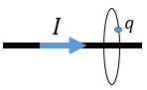), experiences a maximum magnetic force. False, because the magnetic field generated by the current acts within successive planar circles centered at the rod, which is perpendicular to those circles and hence to the magnetic field. This implies that the magnetic field vector and the velocity vector are parallel, leading to a zero magnetic force.
- In a transformer where the number of coils at the secondary is one-third of the primary, both output voltage and current are divided by three. False. The statement related to the voltage is true as per equation (4.53). However, concerning the current, the effect will be inverse to that of the voltage. The output current will be tripled in order to keep a constant power at both primary and secondary, equal to the product of the voltage times the current.

            - Choose the correct answer.
In an RL circuit where R = 100 Ω, it is found that the electric current drops by 30% after 50 μs. Calculate in mH the self-inductance in this circuit.
14 4.15 28 8.3

Details: if the current drops by 30% of its initial value, this means that it has decreased to 70% of this initial value hence I/I₀=0.7. From equation (4.59), one finds the characteristic time: τ = -50/ln(0.7)=140 μs. And from equation (4.58), the inductance gives: L=140⋅ 10⁻³⋅ 100 = 14 mH.

Alternating Current

Background
The emf sources already discussed in the previous sections deliver steady electric current in the relevant circuits; those are termed “direct current” circuits, abbreviated as “DC circuits”, and the source is named “DC source”. However, generators and power plants produce electricity based on Faraday’s law, where the magnetic flux is changed by rotating the coils to cut the magnetic field lines. ‘’As the coil spins, the emf and the induced current oscillate sinusoidally. The emf is alternately positive and negative, causing the charges to flow in one direction and then, a half cycle later, in the other.’’ (Knight, 2016, p. 906). This emf generates an “alternating current” (AC), which itself varies sinusoidally at the same frequency; the emf source is known as the “AC source”.
Frequency: number of cycles generated per unit time. It is expressed in hertz, Hz (s⁻¹)
The figure below on the left (Knight, 2016, p. 906) shows the graphical representation of a sinusoidal alternating emf, which is expressed mathematically by:
 | E$=$E₀⋅ $\cos{2πft}$ | (4.60)

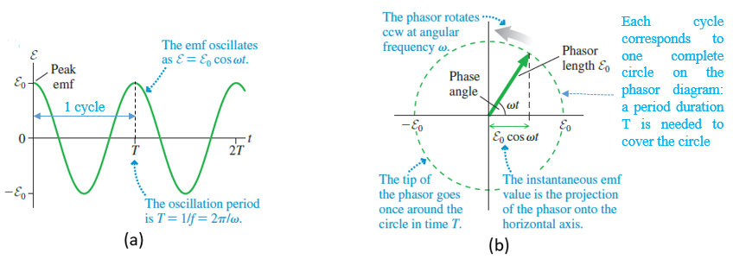
Figure 4.33 Graphical representation of alternating emf (a), Phasor (b)
E₀ is the “peak emf” or the “peak voltage” generated by the AC source; mathematically it is the “amplitude” of the sinusoidal signal. f is the linear frequency, expressing the number of cycles per second (Hz), which is equal to the inverse of the period T of oscillations. The “angular frequency” is the conversion of the linear frequency into radians per second (rad/s); $ω=2πf$.
Period: the time needed for a signal to cover 1 complete cycle.
The above figure on the right (Knight, 2016, p. 906) illustrates another method to represent an AC emf. This representation is termed “phasor”. It consists of a vector of constant magnitude equal to the peak emf having an origin coincident with the origin of a direct 2D orthonormal reference frame. This vector rotates counterclockwise (ccw) at a constant angular speed ω, hence the phase angle between the vector and the horizontal is ωt. The instantaneous alternating emf is found on this graphic through the horizontal projection of the phasor.

Resistor Circuit
The figure below on the left (Knight, 2016, p. 907) depicts an AC circuit with just a resistor.
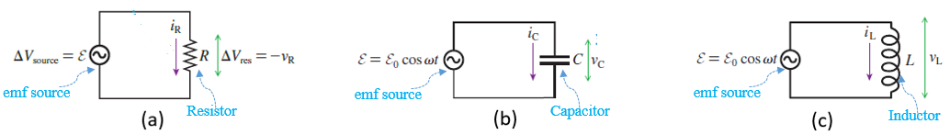
Figure 4.34 AC circuit involving a resistor (a), a capacitor (b), an inductor (c)
Applying Kirchhoff’s loop law:
$ΔV_{source}+ΔV_{R}=0⇒$E$-v_{R}=0$
According to equation (4.60), the tension v_{R} at the terminals of the resistor is sinusoidal with a magnitude V_{R}=E₀. In addition, applying Ohm’s law allows us to find the instantaneous AC in the resistor: i_{R}=v_{R}/R.
 | $$v_{R}=V_{R}\cos{2πft}$$ | (4.61)
 | $$i_{R}=I_{R}\cos{2πft}$$ | (4.62)

These two expressions prove that the voltage and current signals at the terminals of a resistor are “in phase”: both vanish or pass by maxima and minima at the same instant.

Capacitor Circuit
The middle image above (Knight, 2016, p. 908) depicts an AC circuit with just a capacitor.
Applying Kirchhoff’s loop law:
$ΔV_{source}+ΔV_{C}=0⇒$E$-v_{C}=0$
According to equation (4.60), the tension v_{C} at the terminals of the capacitor is sinusoidal with a magnitude V_{C}=E₀. In addition, the charge stored in the capacitor is proportional to the voltage across it:
$$q=C⋅v_{C}⇒q=C⋅V_{C}⋅\cos{2πft}$$
To find the current through the capacitor, derive the charge with respect to time:
$$i_{C}=\frac{dq}{dt}=-2πfCV_{C}\sin{2πft}=I_{C}\cos{(2πft+\frac{π}{2})}$$
 | $$I_{C}=2πf⋅C⋅V_{C}=ω⋅C⋅V_{C}$$ | (4.63)

The expressions of instantaneous voltage and current across a capacitor are:
 | $$v_{C}=V_{C}\cos{2πft}$$ | (4.64)
 | $$i_{C}=I_{C}\cos{(2πft+\frac{π}{2}})$$ | (4.65)

‘‘The AC current of a capacitor “leads” the capacitor voltage by π/2, or 90$°$‘‘ (Knight, 2016, p. 909)
Identifying equation (4.63) with Ohm’s law, one may define a characteristic of the capacitor theoretically similar to the resistance, called “capacitive reactance” denoted by X_{C} and expressed in ohm (Ω). However, it relates the peak voltage to peak current, but not the instantaneous ones.
 | $$X_{C}=\frac{1}{2πf⋅C}=\frac{1}{ωC}$$ | (4.66)

Inductor Circuit
The rightmost figure above (Knight, 2016, p. 913) depicts an AC circuit with just an inductor.
Applying Kirchhoff’s loop law:
$ΔV_{source}+ΔV_{L}=0⇒$E$-v_{L}=0$
According to equation (4.60), the tension v_{L} at the terminals of the inductor is sinusoidal with a magnitude V_{L}=E₀. In addition, for an inductor the voltage is proportional to the first derivative of the current:
$$L\frac{{di}_{L}}{dt}=v_{L}⇒i_{L}=\frac{V_{L}}{L}\int{\cos{2πft}dt}=\frac{V_{L}}{2πfL}\sin{2πft}$$
 | $$I_{L}=\frac{V_{L}}{2πf⋅L}=\frac{V_{L}}{ω⋅L}$$ | (4.67)

The expressions of instantaneous voltage and current across an inductor are:
 | $$v_{L}=V_{L}\cos{2πft}$$ | (4.68)
 | $$i_{L}=I_{L}\cos{(2πft-\frac{π}{2}})$$ | (4.69)

‘‘The AC current of an inductor “lags” the inductor voltage by π/2, or 90$°$‘‘ (Knight, 2016, p. 914).
Identifying equation (4.67) with ohm’s law, one may define a characteristic of the capacitor, theoretically similar to the resistance, called “inductive reactance” denoted by X_{L} and expressed in ohm (Ω). However, it relates the peak voltage to peak current, but not the instantaneous ones.
 | $$X_{L}=2πf⋅L=ω⋅L$$ | (4.70)

The Series RLC Circuit
The series RLC circuit consists of a resistor, inductor, and capacitor mounted together in series and connected to an AC emf source within a closed circuit. The leftmost figure below (Knight, 2016, p. 914) shows the RLC series circuit.
The instantaneous current circulating in all the components of the circuit is the same, i.e., i = i_{R} = i_{L} = i_{C} while the voltage of the source is distributed between the three components: E = v_{R}+v_{L}+v_{C}. The phasor construction of this latter equation is illustrated below. (Knight, 2016, p. 915)
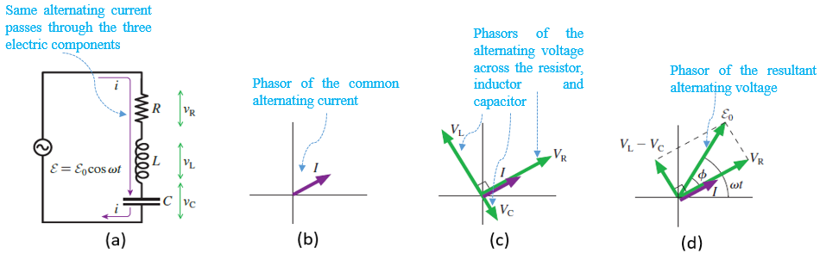
Figure 4.35 RLC circuit (a), Phasor of the current (b), Phasor of voltages at R, L and C (c), Resultant voltage (d)
As a first step, since the current is the same within R, L, and C, draw its phasor of peak value I in the planar frame reference (second image above). The next step consists of drawing the phasor of the voltages (third figure above). Across the resistor the voltage and the current are in phase, across the capacitor the voltage lags the current by π/2, while the inductor’s voltage leads the current by π/2. Finally, the resultant of the three voltages’ phasors represents the emf of the source, which is shifted by a phase angle φ from the current (fourth figure above). This angle is considered positive when it curls ccw from the current phasor to the voltage phasor. In the drawn phasor diagram, V_{L} was assumed to be greater than V_{C}, which has resulted in a positive phase angle; however, the inverse scenario might occur leading to a negative phase angle. All in all, the possible values lie between -π/2 and +π/2.
The expression of the instantaneous current can be written as:
$$i=I\cos{(ωt-ϕ)}$$
Applying the Pythagorean theorem to the right-angle triangle in the rightmost image above yields:
E₀$=\sqrt{{V_{R}}^{2}+{(V_{L}-V_{C})}^{2}}=I⋅\sqrt{R^{2}+{(X_{L}-X_{C})}^{2}}$
 | E₀$=I⋅\sqrt{R^{2}+{(Lω-1/Cω)}^{2}}$ | (4.71)

This latter equation compared to Ohm’s law leads to the deduction that the amount multiplying the current is equivalent to a resistance; this amount physically involves resistance, inductive, and capacitive reactances. This amount is called “impedance”, and is denoted by Z and expressed in ohm (Ω).
 | $$Z=\sqrt{R^{2}+{(Lω-1/Cω)}^{2}}$$ | (4.72)

Using trigonometry on the right-angle triangle in the rightmost figure above one may determine the expression of the phase angle as:
 | $$ϕ=\tan^{-1}{(\frac{Lω-\frac{1}{Cω}}{R})}$$ | (4.73)

The voltage peak across the resistor is easily determined as:
 | $V_{R}=$E₀$⋅\cos{ϕ}$ | (4.74)

Resonance
Equation (4.71) shows that at very low frequencies, $Lω≈0$ and $1/Cω≈∞$ leading to very low values of the peak electric current. Additionally, at very high frequencies, $Lω≈∞$ and $1/Cω≈0$ meaning also very low values of peak current are measured. This means that for a moderate value ω₀ of ω the peak current passes by its maximum; this happens for a minimum impedance. Since this latter consists of the sum of two squared amounts where one of them is constant and independent of the frequency, the only way to minimize the impedance is by vanishing the other amount depending on the frequency. This phenomenon is termed “resonance” and ω₀ is the “resonant frequency”. In that case I_{max} = E₀/R.
 | $$ω_{0}=\frac{1}{\sqrt{LC}}$$ | (4.75)
The phenomenon of resonance maximizes the delivered electric current from the source and hence the power generated by this source; for small resistance values in the circuit, the current’s increment is favored. ‘‘Resonance circuits are widely used in radio, television, and communication equipment because of their ability to respond to one particular frequency. ” (Knight, 2016, p. 917). It should be noted that electric current is almost worldwide generated by power plants at a frequency of 50 Hz.
Average Power
Since in AC circuits both emf and current are instantaneous, the power supplied by the source P_{source} = i⋅ E is also instantaneous. We shall examine the “average power” dissipated or stored in each of the electric components in an RLC circuit.
In the resistor, the average power dissipated per cycle is determined by:
$$P_{R}=\frac{1}{T}\int_{0}^{T}{{i_{R}}^{2}Rdt}=\frac{R⋅{I_{R}}^{2}}{T}\int_{0}^{T}{{(cos{ωt})}^{2}dt}$$
 | $$P_{R}=\frac{1}{2}R{I_{R}}^{2}$$ | (4.76)

For the capacitor and the inductor, repeating the same integration calculations for instantaneous powers p_{C}=i_{C}⋅ v_{C} and p_{L}=i_{L}⋅ v_{L} respectively, one obtains zero average powers for both: P_{C}=P_{L}=0.
Going back to equation (4.76), one may write: $P_{R}=R⋅{(\frac{I_{R}}{\sqrt{2}})}^{2}$. Identifying with the DC circuit power equation, one may conclude that a DC current equivalent to the peak AC current over $\sqrt{2}$ dissipates the same power in the same resistor. Mathematically speaking, one may write $\frac{I_{R}}{\sqrt{2}}=\sqrt{{(\frac{0+I_{R}}{2})}^{2}}$ , which represents the square root of the average squared current; this is the root-mean-square current I_{rms}. Similarly, one may define the root-mean-square of the following quantities:
I_{rms} = I_{R}/$\sqrt{2}$ ; E_{rms} = E₀/$\sqrt{2}$; V_{rms} = V_{R}/$\sqrt{2}$.
It should be noted that rms values are the values measured by voltmeters, ammeters, and multimeters. Peak values are obtained by multiplying the measured values by $\sqrt{2}$.
The average power lost within the resistor can be reformulated as:
 | $$P_{R}=R{I_{rms}}^{2}=\frac{{V_{rms}}^{2}}{R}=V_{rms}⋅I_{rms}$$ | (4.77)

The average power supplied by the source when the circuit involves solely a resistor becomes:
 | $P_{source}=I_{rms}⋅$E_{rms} | (4.78)

Power Factor
Equation (4.78) applies for a purely resistive circuit, however, when an inductor and a capacitor are involved in the circuit the phase between the voltage and the current influences the power supplied by the source; ‘‘ the current and the emf aren’t pushing and pulling together, the source delivers less energy to the circuit.‘‘ (Knight, 2016, p. 920).
The integration calculation is the same as done earlier for the resistor:
$P_{source}=\frac{1}{T}\int_{0}^{T}{i⋅}$E⋅ dt, where $i=I\cos{(ωt-ϕ)}$ and E=E₀$\cos{ωt}$
 | $P_{source}=I_{rms}⋅$E_{rms}⋅ $\cos{ϕ}$ | (4.79)

The term $\cos{ϕ}$ in this latter equation is termed the “power factor”. It reflects the energy lost due to the phase angle between the current and the voltage. Mathematically, $\cos{ϕ}<1$ means that the theoretical full power delivered by the source is decreased. As the power factor gets closer to one, the power level supplied by the source improves. The two best scenarios leading to $\cos{ϕ}=1$, and thus full power supply, occur either at resonant frequency or when capacitive and inductive reactances cancel each other out. For this reason, huge industrial motors used in factories that have an inductive electrical structure due to the use of electromagnets in their design are connected to large capacitors on the transmission line in order to get a power factor as close as possible to one.
Application 4.10. An AC source delivers an electric tension of $12\cos{80πt}$(V) to a series RLC circuit where R = 4 Ω; L = 39.8 mF, and C = 0.497 mF. Calculate the rms current, the peak voltages across each component, and the average dissipated power in the resistor.
Solution 4.10. Calculate first the capacitive and inductive reactances:
$$X_{C}=\frac{1}{80π⋅4.97⋅{10}^{-4}}=8 Ω ; X_{L}=80π⋅0.0398=10 Ω$$
The impedance is: $Z=\sqrt{4^{2}+2^{2}}=4.472 Ω$; Peak current: $I=\frac{12}{4.472}=2.683 A$
The rms current is: $I_{rms}=\frac{2.683}{\sqrt{2}}=1.897 A$
The peak voltages are: $V_{R}=2.683⋅4=10.732 V$; $V_{C}=2.683⋅8=21.464 V$; $V_{L}=2.683⋅10=26.83 V$.
The average power in the resistor is: $P_{R}=4⋅{1.897}^{2}=14.4 W$.

Self-Check Questions
- Complete the following sentence
An AC source delivers an electric tension of $110\sqrt{2}\cos{120πt}$(V) to a series RLC circuit where R = 20 Ω; L = 50 mF, and C = 100 μF. The expression of the current circulating in the circuit is $i=7.262\cos{(120πt+0.3665)} (A)$ , while the average power supplied by this source measures 746.1 W.
Details: The impedance is: $Z=\sqrt{{20}^{2}+{(18.85-26.526)}^{2}}=21.422Ω$
The phase angle is: $ϕ=\tan^{-1}{\frac{18.85-26.526}{20}}=-21°=-0.3665 rad$
The current peak is: $I=\frac{110\sqrt{2}}{21.422}=5.135\sqrt{2}=7.262 A$
The expression of the current becomes: $i=7.262\cos{(120πt+0.3665)} (A)$
The power factor is: $\cos{ϕ}=\cos{(-21)}=0.934$
The average power supplied is: $P_{source}=110⋅7.262⋅0.934=746.1 W$
- Choose the correct answer
The peak emf delivered by an AC source measures 50 V to an RLC circuit consisting of R = 20 Ω; L = 160 mF, and C = 100 μF. The resonant frequency in Hz measures:
16 625 250 40

Details: $ω_{0}=\frac{1}{\sqrt{160⋅{10}^{-3}⋅100⋅{10}^{-6}}}⇒ω_{0}=250\frac{rad}{s}⇒f_{0}=\frac{250}{2π}⇒f_{0}≈40Hz$
Summary
A charge is the ability to repel a similar entity or to attract an opposite one located at a known distance. This is achieved through an electrostatic field, permeating the surrounding free space of the charge. In an atom, electrons carry negative charges and protons positive ones, with all charges being equal in magnitude. The energy developed by charges under electrostatic forces is the potential. A group of negative charges gathered and separated from another gathered group of positive charges create a potential difference or voltage or electric tension; this property pushes electrons to flow throughout the conducting material, generating an electric current. Normally this current flows steadily in the circuit and is known as direct current (DC).
A conductor rod traversed by an electric current can attract some metallic materials: in fact, a magnetic field is generated around the rod. This field is generated in higher strength through a solenoid consisting of many tightened coils. Magnetic field lines piercing any physical surface develop a magnetic flux. The rate change in magnetic flux leads to the creation of an induced emf, hence to an induced current acting to oppose this flux change. This is Faraday’s law, the basis of electricity production based on magnetism. A change in flux may occur by rotating a closed loop within a uniform magnetic field; this generates an oscillating emf and current known as alternating current (AC).
Three main components are used in circuits: a resistor dissipating power, a capacitor storing electric energy, and an inductor storing magnetic energy. The existence of inductors and capacitors in an AC circuit decreases the average power supplied by the emf source due to the lag between instantaneous current and voltage.

Unit 5 – Vibration Theory and Waves

Study Goals

On completion of this unit, you will be able to
- calculate the natural frequency and the response of a free vibrating system.
- determine the steady state response of a forced vibrating system.
- understand the concept and types of waves and their propagation.
- apply the superposition of waves.

5. Vibration Theory and Waves

Introduction
Energy never disappears. It converts continuously from one form to another, or even switches back-and-forth and thus alternately between two distinct forms, namely between kinetic and potential. This alternating switch will lead to a repetitive motion, termed “vibrations” or “oscillations”. In some applications, repetitive motion is required, like piston strokes in internal combustion engines or repetitive cycles of motion of a child in a swing. But in other applications, this phenomenon is to be avoided, such as oscillations of a diesel engine on its chassis or vibrations of a car’s steering wheel at a certain speed.
The first half of this unit is devoted to the discussion and analysis of vibrating motions of single coordinate systems, to establish the equation of motion and deduce the natural frequency and response, and to study the system’s behavior under an external harmonic force. This analysis helps to define the status of the system and thus helps us decide whether a design should favor vibrating motion or not.
The second half of this unit is concerned with waves in general, knowing that oscillations constitute a particular case of mechanical wave signals. Longitudinal and transverse waves will be discussed, also the speed of wave propagation depending on type, as well as the Doppler effect when the wave source and wave detector are moving relative to each other. Finally, operations on multiple waves, particularly the superposition of waves, will be the last topic in this unit.

5.1 Free Oscillations

Fundamentals of Vibration
A “vibration” is a motion that repeats itself within a well-determined interval of time. It is also called an “oscillation”. (Rao, 2011). Originally, vibration motion results from an alternating switch between kinetic and potential energy. This concept can be illustrated by the example of a child on a swing. The vertical position is the position of equilibrium, and it is the lowest height of the seat, thus at this position the potential energy of gravity is zero. Initially, when one of the parents pulls back the swing’s seat but is still holding it, the potential energy at this position is maximum since the seat is at maximum height, but the kinetic energy is zero since its velocity is zero (seat held by the parent). Once released, the seat’s height decreases leading to a decrease in potential energy, at the same time the kinetic energy is increasing due to the velocity increase; passing by the vertical position, the potential energy vanishes while the kinetic energy passes by its maximum. The swing will then continue its motion by going up beyond the vertical position, the velocity and hence kinetic energy decreases while the height, and thus the potential energy, increases again, until the last highest point where the height is maximum and the velocity vanishes; in the absence of energy loss, this energy switch, and thus repetitive motion, continues. Since the mechanical energy is constant, the amount of kinetic energy lost is converted into potential energy and vice-versa. Oscillations are said to be “undamped” in that case. In case there is any energy loss (wind effect, friction at the pin of the swing, etc.) amounts of this mechanical energy are lost progressively from cycle to cycle, thus the displacement decreases until the motion dies out after many cycles. This is the case of “damped vibrations”.
Dashpot: cylinder-piston system containing a viscous fluid to dampen the piston’s translation motion (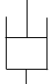)
The analysis of a vibrating system is complicated; for this reason, idealized models of those systems are employed. Any vibrating system could be modeled by connections of three types of elements: elements storing potential energy modeled by a “spring”, elements storing kinetic energy modeled by a “mass” or an “inertia”, and elements leading to energy loss modeled by a dashpot or “viscous damper”. It should be noted that there are many sources of energy loss (dry friction, hysteretic damping, etc.), however, in the scope of this textbook only viscous damping will be considered.
Hysteretic Damping: energy dissipation within the macromolecules of a damping material (rubber, silicon, etc.) due to movement of those chains from one position to another.
A linear viscous damper is characterized by a property called “damping constant” denoted by c and expressed in N.s/m or kg/s. It develops a “resistant force” against the motion proportional to the net velocity at the dashpot’s terminals: $F=c⋅\dot{x}$. The concept of this force is similar to the force in the linear spring, which is proportional to the net displacement at the spring’s terminals: $F=k⋅x$.
Oscillations are said to be “free” when the system vibrates on its own without any external source, like a swing given only an initial push without any extra force during the motion. Oscillations are said to be forced, when at each cycle of vibration extra external energy is supplied, like the parent who pushes the child in the swing at each back-and-forth moving cycle.

Dynamic Analysis
When only one coordinate is sufficient to locate the position of the vibrating system at any instant t, the system is classified as a “single degree of freedom system” (SDOF).
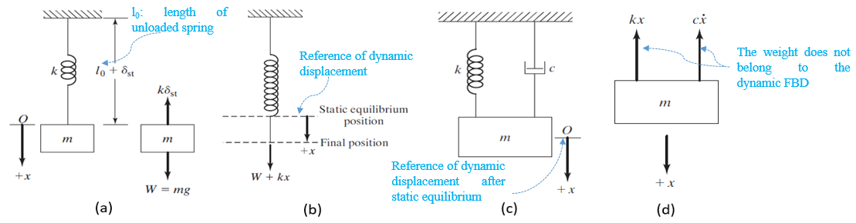
Figure 5.1 Undamped system status: static (a), dynamic (b); Damped system: dynamic (c), FBD (d)
The mathematical relationship between this coordinate and its time derivatives is termed “equation of motion”. The solution of this differential equation is called the “response” of the system. The first two images in the figure above (Rao, 2011, p. 132) illustrate the force analysis of a classical, undamped spring-mass system while a damped system analysis is depicted in the two images to the right (Rao, 2011, p. 159). The degree of freedom is the vertical translational coordinate denoted by x for dynamic motion. When the block of mass m is hung on the spring of initial length l₀, and before any vibrating motion, the spring deflects by a static amount denoted δ_{st}. The position of static equilibrium will always be the reference line from which the dynamic coordinate x is measured.
Static equilibrium for both undamped and damped systems is the same since the viscous damper effect depends on the velocity, which is zero in static cases:
$$\sum{F_{y}}=0⇒k⋅δ_{st}=m⋅g$$
Undamped Oscillations
For undamped cases apply Newton’s second law, where the spring’s force acts against the acceleration of the block:
$$\sum{F_{y}}=m\ddot{x}⇒-k⋅\left(x+δ_{st}\right)+m⋅g=m\ddot{x}$$
Substituting the static equation into this one, the final “equation of motion” can be written:
$$m\ddot{x}+kx=0$$
Note that in dynamic motion, the weight as a force does not come into play since it is balanced by the static tension of the spring. It is extremely important in the analysis not to include the weight in the dynamic calculations each time a static component cancels it out.
, the solution of this differential equation is either a cosine (or sine) function, and hence the response of a free vibrating system is harmonic.

 | $$x\left(t\right)=A⋅\cos{(ω_{n}t+ϕ)}$$ | (5.1)
Harmonic motion: repetitive motion where the displacement is proportional to the acceleration. Mathematically, this is satisfied by a sine or cosine expression.
The quantity ω_{n} denotes the angular “natural frequency” of the system, expressed in rad/s. It defines how many angular cycles in radians the system oscillates in a unit of time. The “linear frequency” f_{n}=ω_{n}/2π is the linear natural frequency: the number of cycles oscillating in a unit of time, expressed in hertz (Hz). The natural frequency is found by substituting one of the expressions (5.1) into the equation of motion, to find:
 | $$ω_{n}=\sqrt{\frac{k}{m}}$$ | (5.2)

A denotes the “maximum displacement” covered by the system during vibration; it is called the “amplitude” of oscillations. φ or φ₀ denotes the “time shift” between the time origin and the first time the system passes by the equilibrium reference (x=0) for a sine motion or the first time it passes by the maximum value (x=A) for a cosine motion; however, mathematically it is converted into an angular amount for unit compatibility and is termed “phase angle”.
If the natural frequency is a function of the configuration of the system (mass and stiffness only), the amplitude and the phase angle depend on how the oscillations have been triggered; in other words, they depend on the values of the displacement and the velocity at the start of the motion, i.e., at t = 0; those two values are termed “initial conditions” (IC), i.e., $x\left(t=0\right)=x_{0} ; \dot{x}\left(t=0\right)={\dot{x}}_{0}$. Substituting those two IC values into one of the equations and taking its first time derivative, one determines the amplitude and the phase angle and hence the response of the system.
Finally, it is worthwhile to define the natural period τ_{n} of oscillations by the time (s) needed to cover one complete cycle:
 | $$τ_{n}=\frac{1}{f_{n}}=2π\sqrt{\frac{m}{k}}$$ | (5.3)

All the aforementioned parameters are shown on the graph of the undamped response in the figure below on the right (Rao, 2011, p. 136).
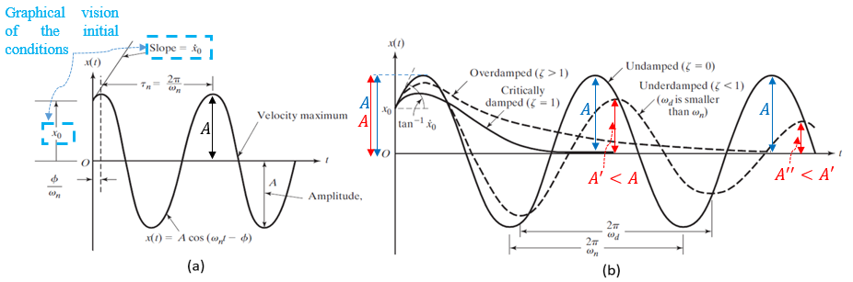
Figure 5.2 Undamped response (a), Damped responses (b)
Damped Oscillations
We will now examine the damping force developed by the viscous damper (see the rightmost figure at the beginning of the Dynamic Analysis discussion):
$$m\ddot{x}+c\dot{x}+kx=0$$
The general solution in this case can be written: $x\left(t\right)=C_{1}e^{s_{1}t}+C_{2}e^{s_{2}t}$: where $s_{1;2}=-\frac{c}{2m}±\sqrt{({\frac{c}{2m})}^{2}-\frac{k}{m}}$ . The response is harmonic when the power s of the exponential in the solution is complex since that is the only case where the exponential generates a cosine and a sine; if the power is real, the response is not harmonic. Mathematically speaking, the quantity under the radical must be negative to lead to a harmonic response, thus the value of the damping constant c that vanishes the radical in $s_{1;2}$ is called the “critical damping constant” c_{c} calculated by:
 | $$c_{c}=2\sqrt{k⋅m}=2⋅m⋅ω_{n}$$ | (5.4)
We then define a dimensionless parameter termed the “damping ratio” $ξ=\frac{c}{c_{c}}$.
When c<c_{c} (i.e., ξ<1) the damped response is harmonic since the power s becomes complex, and the vibrating system is classified as “underdamped”. When c=c_{c} (i.e., ξ=1) the damped response is not harmonic, and the vibrating system is classified as “critically damped”. When c>c_{c} (i.e., ξ>1) the damped response is not harmonic, and the vibrating system is classified as “overdamped”. In those two latter cases, the motion is “aperiodic” and the displacement dies out after a certain time, even without oscillations as depicted in the figure above on the right (Rao, 2011, p. 163). The scope of the present document is limited to the underdamped response expression.
 | $$x\left(t\right)=A⋅e^{-ξω_{n}t}⋅\cos{(ω_{d}t+ϕ)}$$ | (5.5)

Notice that two main differences exist between undamped and underdamped responses: (i) the underdamped amplitude is no longer constant; it decreases exponentially from cycle to cycle, and (ii) the frequency of oscillations is no longer ω_{n}, it is a new frequency called the damped frequency of oscillations ω_{d}. This frequency is less than ω_{n} due to the damping constant, and indeed it is actually ω_{n} modified by a factor depending on ξ as shown in equation (5.6). The graphical comparison is illustrated in the figure above on the right (Rao, 2011, p. 163). The initial amplitude and phase angle are found from the ICs as in the undamped case.
 | $$ω_{d}=ω_{n}⋅\sqrt{1-ξ^{2}}$$ | (5.6)

As an example, the rubber pads placed between the diesel engine and the chassis act as a spring-damper; they reduce the vibrating amplitude of the engine in the form of an underdamped motion. On the other hand, the hydraulic piston-cylinder placed at the top of some office doors has the role of dampening their closure in ‘’one shut’’; this is an aperiodic damped motion, or in other words, an overdamped motion.
Remark: For undamped systems, one could have applied the principle of conservation of energy as an alternative method of Newton’s law to establish the equation of motion.
$$E_{mech}=E_{k}+E_{p}=constant⇒\frac{dE_{k}}{dt}+\frac{dE_{p}}{dt}=0$$
Spring-mass system: $E_{k}=\frac{1}{2}m{\dot{x}}^{2}⇒\frac{dE_{k}}{dt}=m\dot{x}\ddot{x}$; $E_{p}=\frac{1}{2}kx^{2}⇒\frac{dE_{p}}{dt}=kx\dot{x}$
Replacing the derivatives of the energies in the conservation equation and simplifying by $\dot{x}$ one again finds the equation of motion.
Application 5.1. A block of mass 1 kg connected to a
spring of stiffness 1000 N/m is given an initial angular displacement of 3mm. Determine the response of the oscillations.
Solution 5.1.
The natural frequency of the system is: $ω_{n}=\sqrt{\frac{1000}{1}}=31.623\frac{rad}{s}⇒f_{n}=5.03 Hz$
The harmonic motion is: $x\left(t\right)=A_{}\sin\left(31.623t+ϕ_{0}\right)$
The velocity is: $\dot{x}\left(t\right)=31.623A_{}\cos{(31.623t+ϕ_{0})}$
IC: $x_{0}=3mm⇒A_{}\sin{ϕ_{0}}=3…(eq1)$
${\dot{x}}_{0}=0⇒ω_{n}A_{}\cos{ϕ_{0}}=0⇒ ϕ_{0}=±\frac{π}{2}$. From (eq1), $\sin{ϕ_{0}}>0⇒ϕ_{0}=\frac{π}{2}$
(eq1) gives $A_{}=3 mm$ , thus the response:
$$x\left(t\right)=3sin({31.623t+π/2)} (mm)$$

$$\dot{x}\left(t\right)=3×31.623\cos{(31.623t+\frac{π}{2})} (mm/s)$$
Application 5.2. A block of mass 5 kg is connected to a spring of stiffness k=500 N/m and a viscous damper of constant 50 kg/s. Calculate the period of damped vibrations.
Solution 5.2. The undamped natural frequency is: $ω_{n}=\sqrt{\frac{500}{5}}=10 rad/s$
The critical damping constant is: $c_{c}=2⋅5⋅10=100\frac{kg}{s}⇒ξ=\frac{50}{100}=\frac{1}{2}$
The damped frequency is: $ω_{d}=10⋅\sqrt{1-\frac{1}{4}}=5\sqrt{3} rad/s$
The damped period is: $τ_{d}=\frac{2π}{5\sqrt{3}}⇒τ_{d}=0.726 s$

Self-Check Questions
            - Consider the plot of free oscillations in the figure below. Deduce the following quantities if it is a cosine function:
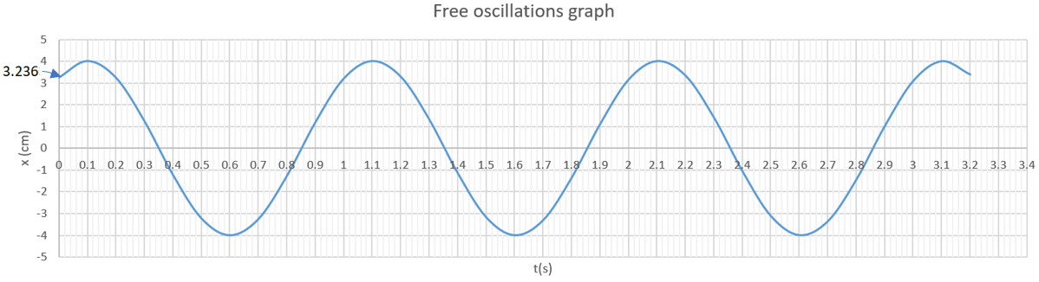
Figure 5.3 Free oscillations graphical representation

Period: 1 s ; Linear frequency: 1 Hz ; Angular frequency: 2π rad/s
Amplitude: 4 cm ; Phase angle: -π/5 rad ; Initial velocity: 14.77 cm/s
Details: From the graph, the duration separating two consecutive positive (or negative) peaks measures 1 s, this is the period. By inverting the period, one gets the linear frequency of 1 Hz. Multiplying this latter by 2π, the angular frequency is obtained. The maximum ordinate value of the plot denotes the amplitude, 4 cm. Moreover, looking at t=0, x₀ = 3.236 cm, and mathematically, x₀=4cosφ, thus the phase angle $ϕ=±\cos^{-1}\left(\frac{3.236}{4}\right)=±\frac{π}{5} rad$ .
Since the slope at t=0 is positive, the initial velocity is positive, and mathematically, ${\dot{x}}_{0}=-8π\sin{ϕ}$ must be positive, which implies that the sine amount must be negative hence φ=-π/5 rad. This gives ${\dot{x}}_{0}=-8π\sin\left(-\frac{π}{5}\right)=14.77 cm/s$.
            - Answer by true or false and justify your answer
A spring-mass-damper system of configuration (k=1000 N/m; m=2.5 kg; c=100 kg/s) is a critically damped system. True, since the critical damping constant $c_{c}=2⋅\sqrt{1000⋅2.5}=100 kg/s$is equal to the real damping constant c defined in the system.

5.2 Forced Oscillations
This vibration phenomenon occurs when an external excitation, either a force or a displacement, is applied to the system. As stated earlier, when a mother pushes her child on a swing, at each cycle she exerts an external force, hence the oscillations of the swing are “forced”. The external force, i.e., the moment for a rotation or torsion, may be of any form, however, the present course is limiting the study to a harmonic external excitation which is expressed mathematically as $F\left(t\right)=F_{0}\cos{ωt}$ or $F\left(t\right)=F_{0}\sin{ωt}$. The amplitude of this force is F₀, which is constant during the entire motion, while its frequency is ω and is completely independent of ω_{n}, the natural frequency of the system subjected to this force.
Considering the general spring-mass-damper system, the equation of motion can be written as:
$$m\ddot{x}+c\dot{x}+kx=F_{0}\cos{ωt}$$
Mathematically, the general form of the steady state response solution of this equation is written as:
$$x\left(t\right)=X\cos{(ωt-ϕ)}$$
Where the amplitude X and the phase angle φ between the force (i.e., input) and the displacement response (i.e., output) are constants of the system and are determined by substituting x(t) in the equation of motion. We present below the result of this differential equation, which the reader is invited to verify. Detailed calculations go beyond the scope of the present document.
 | $$X=\frac{δ_{0}}{\sqrt{{(1-r^{2})}^{2}+{(2ξr)}^{2}}}$$ | (5.7)
 | $$ϕ=\tan^{-1}{(\frac{2ξr}{1-r^{2}})}$$ | (5.8)

Where:
- The “static displacement” of the system is denoted by $δ_{0}=\frac{F_{0}}{k}$ , which designates the displacement of the system when the external excitation is theoretically applied steadily through its amplitude F₀ without any oscillations.
- The frequency ratio is denoted by $r=\frac{ω}{ω_{n}}$ , which represents the ratio of the exciting frequency to the natural frequency of the system.

One may notice the following points concerning the two latter relationships:
- X and Φ depend only on the configuration of the system (i.e., mass, stiffness, and viscous damper), the amplitude, and the frequency of the exciting harmonic force.
- For a moderate constant exciting frequency (i.e., r = constant), the displacement amplitude X decreases as the amount of damping (i.e., ξ level) increases; at the same time the shifting (i.e., phase angle) between the force and the response increases. This observation is expected since increasing the damping amount leads to more energy absorption hence a decrement in displacements and a delay in time. Thus the viscous damper controls the behavior.
- At very low frequencies (i.e., $r→0$), the displacement amplitude tends to a constant value equal to the static displacement while $ϕ→0$. In that case, the stiffness contribution dominates the behavior, since the spring element keeps force and displacement in phase (i.e., φ = 0).
- At very high frequencies (i.e., $r→∞$), the displacement amplitude decreases and tends to 0, while $ϕ→π$. In that case, the mass contribution dominates the behavior since at high speeds the inertia effects become more pronounced; indeed, the mass element keeps the inertia (i.e., acceleration) out of phase from the displacement (i.e., φ = π).
- When the exciting frequency equals the natural frequency (i.e., r = 1) this is called “resonance”. The amplitude X will be controlled by the amount of damping since $X=δ_{0}/2ξ$. As the damping decreases, X increases. The most dangerous case occurs when the system is totally undamped (i.e., $ξ→0$), $X→∞$. In practice, this infinity displacement means a failure or a fracture of the system. One may cite the collapse of the famous Tacoma Narrows Bridge in Washington on November 7th, 1940 due to wind-induced vibration resonance. (Rao, 2011). In resonance cases, for either undamped or damped systems the phase angle $ϕ→π/2$.
- At a well-known amount of damping (i.e., ξ = constant), the exciting frequency that maximizes the amplitude is found by $\frac{dX}{dr}=0$, which yields:
 | $$r_{m}=\sqrt{1-2ξ^{2}}$$ | (5.9)
 | $$X_{max}=\frac{δ_{0}}{2ξ\sqrt{1-ξ^{2}}}$$ | (5.10)
Monotonic function: a function that increases or decreases continuously, thus its derivative does not vanish, i.e., is never zero.
Equation (5.9) shows that the maximum exists only for $ξ<\frac{\sqrt{2}}{2}$, otherwise X decreases monotonically as the frequency increases. The same equation also shows that for the damped case, the maximum does not occur at resonance, but just below. As long as the damping level decreases, the maximum gets closer to the resonance. This maximum amplitude is an important aspect to consider since it represents, for many applications, a critical case that should be avoided as much as possible.

Practically, forced oscillations exist in many applications. One may cite oscillations that are transmitted to the ground due to a vibrating pump or an engine placed on the floor without isolation. This transmitted displacement may cause damage to other systems placed on the floor or even to the floor itself. In washing machines, when the laundry is spread non-uniformly within the cylindrical housing, at a certain speed the washing machine can vibrate so vigorously that it may move from its original position.
Application 5.3. A trailer of mass 4 kg is connected to a dashpot and a spring of stiffness 250 N/m and subjected to a harmonic external force: $F\left(t\right)=75\sin{5.4t} (mN)$ as shown in the figure below. Calculate the value of the damping constant that ensures maximum displacement and then calculate this maximum.

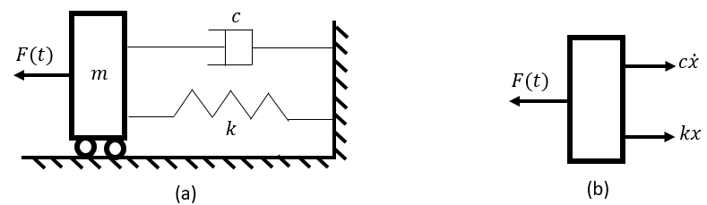
Figure 5.4 Trailer-spring-damper: system (a), FBD (b)
Solution 5.3. Applying Newton’s second law for translation (see figure above, right):
$$\sum{F_{x}=m\ddot{x}⇒-kx-c\dot{x}+F_{0}\sin{5.4t}}=m\ddot{x}$$
$$m\ddot{x}+c\dot{x}+kx=F_{0}\sin{5.4t}$$
The natural frequency is calculated as: $ω_{n}=\sqrt{\frac{k}{m}}=\sqrt{\frac{250}{4}}=7.906 rad/s$
$$⇒r_{m}=\frac{5.4}{7.906}=0.683$$
From equation (5.9):$0.466489=1-2ξ^{2}⇒ξ=0.5165$
The critical damping constant is: $c_{c}=2⋅m⋅ω_{n}=63.248 kg/s$
The damping constant is: $c_{}=ξc_{c}⇒c=0.5165⋅63.248⇒c=32.668 kg/s$
The static displacement is: $δ_{0}=\frac{F_{0}}{k_{}}==\frac{75⋅{10}^{-3}}{250}=3 ×{10}^{-4}m=0.3 mm$
From equation (5.10): $X_{max}=\frac{0.3}{\left(2⋅0.5165\right)⋅\sqrt{1-{0.5165}^{2}}}=0.339 mm$

Self-Check Questions
- Choose the correct answer
What should the damping ratio be of a spring-mass-damper system to achieve, at resonance, an amplitude equal to the static displacement increased by 60%?
0.833 0.3125 0.625 0.25

Details: at resonance, $\frac{X}{δ_{0}}=\frac{1}{2ξ}⇒\frac{δ_{0}+0.6δ_{0}}{δ_{0}}=\frac{1}{2ξ}⇒ξ=\frac{1}{3.2}=0.3125$
- Answer by True of False and justify your answer
- The phase angle of an undamped system subjected to a harmonic excitation is always 0. False, because according to equation (5.8), if the system is undamped then $\tan{ϕ=0/(1-r^{2})}$, meaning that φ is 0 only if the denominator is positive (r<1), but it is equal to 180$°$ if the denominator is negative (r>1).
- If $ξ=\sqrt{2}/2$ the static displacement coincides with the maximum displacement. True, because substituting $ξ=\sqrt{2}/2$ in equation (5.10) one obtains $X_{max}=δ_{0}$. One may also find this result by substituting this value into equation (5.9), where one gets $r_{m}=0$ meaning that the maximum occurs when the excitation acts with its static magnitude force F₀ leading to the static displacement δ₀.

5.3 Waves

Definition and Categories
A wave is the propagation of any type of disturbance throughout a medium in a repetitive, arranged, and progressive manner.
When a small rock falls into the water of a pond, a disturbance has been generated; one sees it propagating to cover a considerable part of the water surface in the form of concentric circles, with progressively increasing diameter.
One may distinguish three main categories of waves:
- “Mechanical waves” are triggered by an initial physical pulse such as a sound wave or seismic wave. They propagate in material media. (Walker, 2014)
- “Electromagnetic waves” propagate through a vacuum at constant speed c = 3⋅ 10⁸ m/s thus they do not need any physical medium. Examples include ultraviolet light, radio waves, and X-rays. (Walker, 2014)
- “Matter waves” propagate at atomic and molecular scales; they are primarily applied in high technology fields. (Walker, 2014)

Transverse and Longitudinal Waves
When a wave propagates perpendicularly to the line of travel, it is classified as transverse. An example is an ocean wave, which propagates at right angles with respect to the line of travel (i.e., the waves move up and down perpendicular to the direction of the wave’s travel). (Figure 5.6)
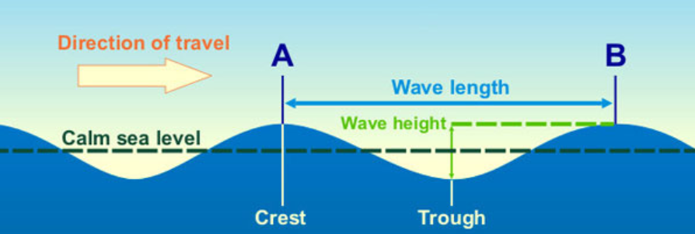
Figure 5.5 Sea water transverse wave
When the wave propagates parallel to the travel line, it is classified as longitudinal. A sound wave that travels through the air propagates in a longitudinal direction where air molecules collide with each other. (Figure 5.7)

Figure 5.6 Longitudinal sound wave

Mathematical Formulation
An ideal transverse wave is assumed to have a sinusoidal propagation. One is interested mathematically in evaluating the height of a point on the wave at any instant t traveling along a one-dimensional space variable (i.e., abscissa x). Multi-axial waves are not within the scope of this manuscript. The general sine formulation of the height (i.e., ordinate) of any point on the wave is written:
 | $$y(x,t)=y_{m}\sin{(kx-ωt+ϕ)}$$ | (5.11)

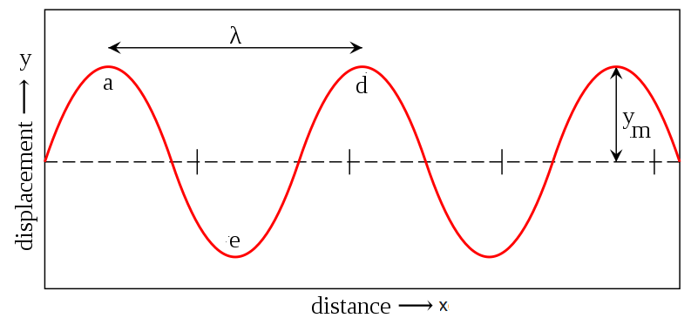
Figure 5.7 Snapshot of a transverse wave at a known instant

The figure above is not technically a plot; it is simulated as a snapshot taken at a certain instant during the wave propagation. An active graph is when a given point is considered (x = known value) and the evolution of its ordinate y is plotted with respect to time. Mathematically, the figure above has been obtained by replacing t with its known value t₀ in equation (5.11) and ‘‘plotting” y(x,t₀).
It is worth defining some wave’s characteristics:
- Each of the top points ‘a‘ and ‘d‘ (and all similar ones) in the above figure is called a “crest”.
- Each of the bottom points, such as point ‘e‘ is called a “trough”.
- The maximum ordinate of a point on the wave is the “amplitude” y_{m}, meaning that the vertical distance from crest to trough measures 2⋅ y_{m}.
- The distance between two consecutive crests (or two consecutive troughs) is termed the “wavelength”, denoted by λ.
- The number of wave “cycles” (crest-trough-crest) covering a unit length, is called the wave number; it is 1/λ.
- The “angular wave number” k (rad/m) (in equation (5.11)) becomes then:
 | $$k=\frac{2π}{λ}$$ | (5.12)

- The time needed for a crest point (or trough) to reach the location of the next crest (or trough), is known as the “period”, denoted by T.
- The number of crests (or troughs) passing by a fixed point per unit time defines the linear frequency of the wave and is denoted by f=1/T expressed in Hz.
- The “angular frequency” ω (rad/s) (in equation (5.11)) then becomes:
 | $$ω=\frac{2π}{T}$$ | (5.13)

- The “phase constant” φ is an angular value representing the space shift of the wave from the origin. A positive phase constant shifts the wave to the left, while a negative value shifts it to the right.

Speed of Propagation
The figure below (Walker, 2014, p. 397) shows two snapshots at two different instants separated by Δt. Any point A on the wave displaces by Δx during Δt. The velocity v=dx/dt (or Δx/Δt) represents the “speed of propagation” of the wave.
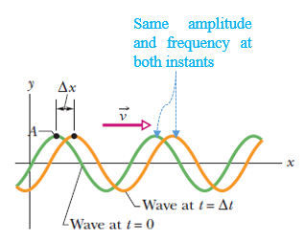
Figure 5.8 Wave propagating at a velocity v
Since the ordinate y of A remains the same during the propagation, this means that the argument of the sine expression in equation (5.11) is constant:
$$kx-ωt+ϕ=constant⇒kdx-ωdt=0⇒\frac{dx}{dt}=\frac{ω}{k}$$
 | $$v=\frac{ω}{k}=\frac{λ}{T}=λ⋅f$$ | (5.14)

It should be noted that the argument $kx-ωt+ϕ$ applies if the wave is moving rightwards, hence in a positive x-sense. If it moves leftwards, i.e., in a negative x-sense, one must replace t by –t, thus the sine expression of the wave becomes $y\left(x,t\right)=y_{m}\sin{(kx+ωt+ϕ)}$.
Application 5.4. A propagating wave is given by: $y\left(x,t\right)=4\sin{(10x-5t)} (mm)$, with time being measured in seconds. Calculate the wavelength, the period, the speed of propagation, and the maximum transverse speed (rate of change of the transverse displacement).
Solution 5.4. Wavelength: $λ=\frac{2π}{10}=0.628 mm$ ; period: $T=\frac{2π}{5}=1.257 s$
Propagation speed: $v=\frac{ω}{k}=0.5 mm/s$
Transverse velocity: $\dot{y}\left(x,t\right)=-20\cos\left(10x-5t\right)⇒{\dot{y}}_{max}=20 mm/s$

Self-Check Questions
- Answer by true or false and justify your answer
- A wave of wavelength 1 m propagates slower than a wave of wavelength 10 cm. False since the speed of propagation also depends on the period of the wave; perhaps the period of the first wave is more than 10 times less than the second wave, which would lead to a faster propagation of the first wave.
- The linear oscillation of a spring is a longitudinal wave. True, since the displacement of any point on the spring occurs parallel to the main axis of the spring’s coils.
- The value of the phase constant does not influence either the speed of propagation or the maximum transverse speed. True, since the speed of propagation depends on the wavelength and the period, while the maximum transverse speed depends on the amplitude and the period.

5.4 The Doppler Effect
The starting device from which a wave is emitted is called the “source”. Any device that receives this wave is called a “detector”.
Consider the example of a sound wave emitted from an ambulance siren as the source and detected by the ear of any person. If the ambulance is parked at a fixed position waiting for the patient with its siren switched on, it will be detected at a constant frequency by the detecting ear of a person standing on the balcony of another building located 100 m from where the ambulance is parked. When the ambulance moves forward and closer to the building, the person on the balcony will detect the siren’s sound at a higher frequency. Once the ambulance passes in front of the balcony and continues its journey, it will be moving away from the building, so the person on the balcony will hear the siren’s sound at a lower frequency.
The “Doppler effect” is a principle that evaluates the frequency of a wave when either the source or the detector, or both, move toward each other or away from each other. This effect carries the name of the Austrian scientist Johann Christian Doppler. It states that the wave’s frequency shifts upward when the source and the detector move toward each other, while it shifts downward when they move away from each other. (Walker, 2014)
f denotes the original frequency of the source’s wave, v is the speed of propagation of the wave in a medium, v_{S} is the relative speed of the moving source with respect to the medium, v_{D} is the relative speed of the moving detector with respect to the medium. (Walker, 2014) The new frequency f’ is calculated by:
 | $$f^{'}=f⋅\frac{v±v_{D}}{v±v_{S}}$$ | (5.15)

The choice between the positive and the negative sign in the numerator and the denominator separately must be taken into account such that a “toward motion shifts up” the new frequency while an “away motion shifts down” the new frequency. (Walker, 2014)
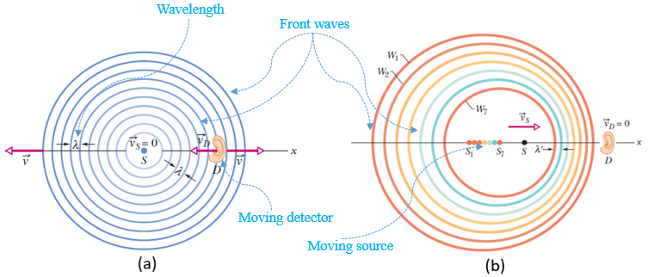
Figure 5.9 Fixed source, moving detector (a), Moving source, fixed detector (b)
Two particular scenarios illustrated in the above figure (Walker, 2014, pp. 444-445) will be analyzed by equation (5.15). The original wavelength of the sound is expressed as $λ=v/f$. In the figure on the left, the source of the sound wave is stationary, i.e., v_{S}=0, while the ear detector is moving at a speed v_{D} toward the source, meaning that in the numerator the positive sign should be kept in order to shift up the frequency:
$$f^{'}=f⋅\frac{v+v_{D}}{v}=\frac{v'}{λ}$$
This equation shows that, in this case, the increment of the new frequency is due to the speed of propagation increasing from v to v+v_{D}, while the wavelength has not been changed by the motion of the detector.
In the figure above on the right, the ear detector of the sound wave is stationary, i.e., v_{D}=0, while the sound source is moving at a speed v_{S} (shown by the instantaneous positions S_{i}) toward the detector, meaning that in the denominator the negative sign should be kept in order to shift up the frequency:
$$f^{'}=f⋅\frac{v}{v-v_{S}}=\frac{v}{λ'}$$
This equation shows that, in this case, the increment of the new frequency is due to the decrease of the wavelength from λ to λ’(i.e., the wavefronts W_{i} get closer), while the speed of propagation has not been changed by the motion of the source.
Application 5.5. A police car siren emits a sound wave at a frequency of 1000 Hz. If the police car moves at a speed of 90 km/h toward another car moving in the same sense at 72 km/h, calculate the frequency detected by the person in the second car. The speed of the sound wave measures 343 m/s.
Solution 5.5. The speed of the source is: v_{S} = 90/3.6 = 25 m/s.
The speed of the detector is: v_{D} = 72/3.6 = 20 m/s.
Since the source is moving toward the detector, its effect must be increasing the frequency; being in the denominator, one must select the minus sign. The detector is moving away (the second car is traveling in the same sense as the police car), so its effect must be decreasing the frequency; being in the numerator one must assign the minus sign. Applying equation (5.15):
$$f^{'}=1000⋅\frac{343-20}{343-25}⇒f^{'}=1015.72 Hz$$

Self-Check Questions
- Complete the following sentence
The maximum increase or decrease in the frequency occurs when the source and the detector move in opposite senses. One cannot determine a general tendency of frequency change when they move in the same sense.
- Choose the correct answer
In the air, the speed of sound is 343 m/s. A sound source of 750 Hz frequency moving at 43 m/s toward a sleeping person, emits a wavelength (in cm) of:
51.5 20 40 25.75

Details: the detector is stationary while the source moves toward the detector, meaning that its speed should be subtracted from the propagation speed to increase the frequency, hence the wavelength becomes: $λ^{'}=\frac{343-43}{750}=0.4 m=40 cm$,

5.5 Interference
When two or more waves propagate in the same medium and through the same points, they do overlap, but they do not alter each other’s travel paths (Walker, 2014). Instead, they add algebraically to generate a “resultant wave” or “net wave”. This phenomenon is called “superposition”.
For two waves $y_{1}(x,t)=y_{m1}\sin{(kx-ωt)}$ and $y_{2}(x,t)=y_{m2}\sin{(kx-ωt+ϕ)}$ of the same wavelength and same frequency, the net wave y(x,t) is determined from the algebraic addition at each instant for the same point:
 | $$y\left(x,t\right)=y_{1}\left(x,t\right)+y_{2}(x,t)$$ | (5.16)

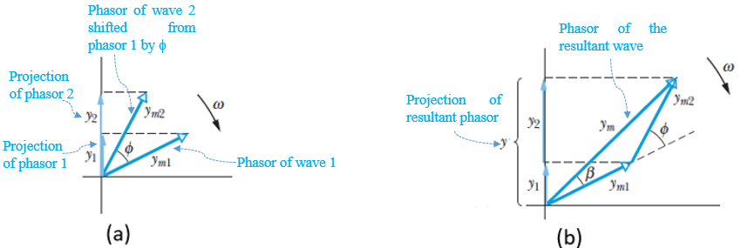
Figure 5.10 Phasors of two waves (a), Net wave phasor construction (b)
The net wave can be written as $y\left(x,t\right)=y_{m}\sin{(kx-ωt+β)}$. The unknowns y_{m} and β are found by phasor construction. The figure above on the left (Walker, 2014, p. 412) shows the phasor representation of the original waves y₁(x,t) and y₂(x,t) shifted by φ. The phasor of the net wave is the vector sum of the two original phasors as illustrated in the above figure on the right (Walker, 2014, p. 412). The unknowns are calculated from the generalized Pythagorean theorem (setting $\cos\left(π-ϕ\right)=-\cos{ϕ})$ and the sines theorem:
 | $$y_{m}=\sqrt{{y_{m1}}^{2}+{y_{m2}}^{2}+2⋅y_{m1}⋅y_{m2}⋅\cos{ϕ}}$$ | (5.17)
 | $$\frac{y_{m2}}{\sin{β}}=\frac{y_{m1}}{\sin{(ϕ-β)}}=\frac{y_{m}}{\sin{ϕ}}$$ | (5.18)

Now, considering the special case where the amplitudes of both original waves are equal, i.e., y_{m1}=y_{m2}=y_{m0}, and using the identity $\sin{a+\sin{b}=2\sin{\frac{a+b}{2}}\cos{\frac{a-b}{2}}}$ in equation (5.16), one gets:
 | $$y\left(x,t\right)=\left[2y_{m0}\cos{\frac{ϕ}{2}}\right]⋅\sin{(kx-ωt+\frac{ϕ}{2})}$$ | (5.19)

This equation represents a particular phenomenon of superposition: it is the “interference” phenomenon. ‘‘If two sinusoidal waves of same amplitude and same wavelength travel in the same direction, they interfere to produce a resultant sinusoidal wave traveling in that direction.” (Walker, 2014, p. 407)
When the original waves are in phase. i.e., φ = 0, they interfere to generate a wave with double amplitude. When they are out of phase, i.e., φ = 180$°$, they cancel each other out to obtain a zero net wave. When they are shifted by any other value of φ, an intermediate net wave is generated from the interference. These cases are illustrated in the figure below (Walker, 2014, p. 408).
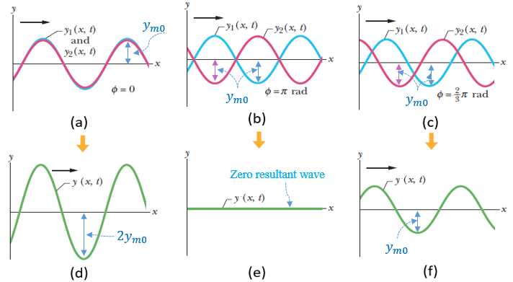
Figure 5.11 Original waves, in phase (a), out of phase (b), any phase shift (c), net resultant for, in phase waves (d), out of phase waves (e), any phase shift (f)
Application 5.6. Find the expressions of two original waves of the same amplitude of 8 cm and the same wavelength of 10 cm propagating at a speed of 5 m/s knowing that the amplitude of their resultant wave measures 8 cm.
Solution 5.6. From equation (5.19): $8=2⋅8⋅\cos{\frac{ϕ}{2}}⇒\cos{\frac{ϕ}{2}}=0.5⇒ϕ=\frac{2π}{3} rad$
The linear frequency is: $f=\frac{5}{0.1}=50 Hz⇒ω=100π rad/s$
The expressions become:
$y_{1}\left(x,t\right)=8\sin{(0.1x-100πt)}$ and $y_{2}\left(x,t\right)=8\sin{(0.1x-100πt+\frac{2π}{3})}$.

Self-Check Questions
- Choose the correct answer
Consider a wave given by $y_{1}\left(x,t\right)=0.4\sin{(5x-20πt+\frac{π}{3})}$. What should the phase constant of a second wave be so that it interferes with the first one resulting in a zero net wave?
0 π 2π/3 4π/3

Details: the total shift between both waves must be equal to p to guarantee the waves are out of phase and thus result in a zero net wave: $ϕ-\frac{π}{3}=π⇒ϕ=\frac{4π}{3} rad$ .
- Complete the following sentence
Consider $y_{1}\left(x,t\right)=\sin{(5x-20πt)}$ and $y_{2}\left(x,t\right)=0.8\sin{(5x-20πt+\frac{π}{3})}$. The resultant wave has an amplitude of 1.562 and is shifted from the first wave by a constant phase of 0.46 rad.
Details: from equation (5.17), $y_{m}=\sqrt{1+0.64+0.8}=1.562$. From equation (5.18), sinβ=0.81.562⋅sinπ3=0.444⇒β=0.46 rad.
Summary
Vibration or oscillation means a repetitive motion within a constant interval of time. It comes from an alternating switch between kinetic and potential energy during the motion. If this energy is conserved, oscillations are undamped. Otherwise, vibrations are damped.
When a system oscillates without any external source of energy, oscillations are free and occur at a natural frequency depending only on the mass and stiffness of the system. The evolution of the system’s position with the time is termed response and is generally harmonic, meaning it exhibits a sinusoidal expression. When an external energy source intervenes at each cycle, oscillations are forced. In most cases, the external excitation is harmonic having a frequency not related to the natural frequency of the system. The exciting frequency could be regulated; in this case, it equals the natural frequency and a catastrophic phenomenon occurs leading to damage and failure: this is the resonance phenomenon. The use of certain amounts of viscous damping reduces resonance damage.
A wave is a disturbance propagation through a medium in a repetitive and structured manner. Mathematically it has a sinusoidal expression depending on many characteristics. The amplitude of the wave denotes its maximum displacement; its wavelength denotes the distance separating two peaks or two valleys; its frequency denotes the number of cycles moving per unit time at a known location, and its speed of propagation denotes the rate of space traveled and is the ratio of the frequency to the wavelength.
The frequency of a wave increases when the source moves toward the detector or vice-versa and decreases when it moves away: this is known as the Doppler effect.
Multiple waves of the same wavelength and frequency overlap to lead to a new resultant wave by addition: this is known as interference.

Unit 6 – Optics and Acoustics

Study Goals

On completion of this unit, you will be able to
- distinguish between reflection and refraction of light through different types of media.
- construct images of physical objects through optical devices such as mirrors and lenses.
- analyze the interference and diffraction phenomena of light waves.
- determine the main characteristics of sound waves.

6. Optics and Acoustics

Introduction
Optics is a branch of physics concerned with the characteristics of light waves and their propagation through media. Electromagnetic waves in general, and light waves in particular, are extensively analyzed in physics due to their many useful applications. Different optical requirements demand the manufacture of different types of lenses: the observation of planets and stars requires telescopes, and the examination of atoms and molecules or blood cells requires microscopes. The analysis, design, and production of optical devices would not be possible without understanding the nature and properties of light waves. In this unit, the phenomena of reflection and refraction of light waves through different media will be examined and image construction through different types of optical devices will be discussed. Also, this unit presents the phenomena of interference, diffraction, and polarization of light waves.
Acoustics is a branch of physics concerned with the characteristics of sound waves and their propagation through media. Many practical applications require considerable knowledge of acoustics, such as the sound isolation of engines and pumps, the design of absorbers and mounting pads for motors and ducts to avoid sound transmissibility, the design of microphones and sound amplifiers, and the construction of ultrasonic devices for defects detections. This unit provides a solid background in sound waves, their propagation in different types of media, interference of sound waves, and noise level. This background will allow you to assimilate and analyze advanced topics related to optics and acoustics, perhaps ultimately leading to creative engineering designs.

6.1 Reflection

Light Wave
A “visible light wave” is a type of electromagnetic wave of short wavelength, i.e., within a range of 370-700 nm, detectable by the human eye and generated by a change of energy level of electrons under oscillations due to heat or electric current. (Ohanian, 2007). Besides visible light, there are other types of light waves, namely “infrared radiation”, “ultraviolet radiation”, and “X-rays”, within a wavelength range of 10⁻³-10⁻¹¹ m. It should be remembered that the speed of an electromagnetic wave in a vacuum is the “celerity” c = 300000 km/s.
Energy level: a series of successive orbitals or ‘shells‘ around the nucleus of an atom along which electrons are distributed and are in continuous motion. At each level, electrons dispose a certain amount of energy which increases moving further from the nucleus.
Light propagates following the principle of “geometrical optics” stating that “light propagates in a fixed direction, along a straight line (rectilinearly), while in uniform medium; and suffers changes of direction only when it encounters surface separating two different media.’’ (Ohanian, 2007, p. 1112). A propagating straight line of light is called a “ray”; a group of rays is a “light beam”. Upon encountering the separating surface between two media, a light ray may be either “reflected”, “refracted”, “absorbed”, or “transmitted”.

Flat Mirror
If the surface encountered by a light wave is smoothly polished and silvered, almost none of the wave will be able to penetrate the surface and it will “return back” but following a different direction; this phenomenon is called “reflection”. The device exhibiting this silvered surface is called a “mirror”. If this surface is flat the device is called a “flat mirror”. The angle between the ray hitting the surface of the flat mirror and the normal line to this surface is termed the “angle of incidence” θ; the angle between the reflected ray and the normal line is the “angle of reflection” θ‘. The “law of reflection” relative to a flat mirror states that the angles of incidence and reflection are equal, i.e., θ=θ’. This law is illustrated in the figure below (Ohanian, 2007, p. 1115).
Any real object such as a pencil, a ball, or a person’s hand scatters light rays coming from a source of light such as the sun or a bulb such that this object itself plays the role of a light source. When the rays coming from the object hit the surface of a flat mirror and then reflect, imagine extrapolating the rays through the mirror at the same angle of incidence of the original rays; those prolonged extrapolated rays intersect behind the mirror at a point symmetric to the real source object relative to the mirror; those rays will appear as if they were emitted from this ‘’virtual point’’ and arrive at the observer’s eye such that the observer is able to see the point, but the reality is that the rays are coming from the source object. For this reason, the point behind the mirror is called a “virtual image”. This is shown in the figure below (Ohanian, 2007, p. 1116). A flat mirror generates a virtual image from a real object having the same size as the object and located behind the mirror, which is called the plane of symmetry.
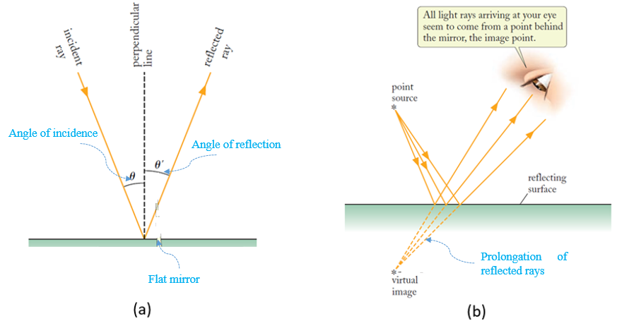
Figure 6.1 Sketch of a flat mirror with: rays angles (a), virtual image (b)

Concave Mirror
A “concave mirror” is a portion of a sphere’s surface having a reflecting, silvered surface on its inner face. The axis of the mirror is the horizontal line passing through the center of curvature of the mirror and is called the “optical axis”. (Ohanian, 2007) The law of reflection is also applicable to concave mirrors. As a result, all light rays parallel to the optical axis hit the mirror and then reflect by converging at a single point F belonging to the focal line and located at the midpoint of the sphere’s radius R. A point C is at the center of the sphere. The horizontal distance from F to the mirror is termed “focal length” f = R/2. Inversely, any incident light ray passing through the focal point will reflect parallel to the optical axis. Any incident ray passing through the center of curvature of the mirror is naturally perpendicular to the mirror and hence it reflects along the same incident direction.
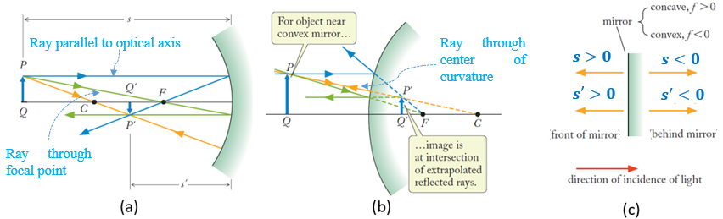
Figure 6.2 Image through a concave mirror (a), Image through a convex mirror (b), Sign convention for mirror equation (c)
A “real object” is schematized by a vertical arrow PQ perpendicular to the optical axis as shown in the figure above(Ohanian, 2007, p. 1130). Normally, one needs to form the image of two points from the object to get the entire image; since Q belongs to the optical axis, its image Q’ does also. Image P’ is the intersection of two reflected light rays incident from the source P. This forms the final image P’Q’, which is a “real image” for the concave mirror case (the leftmost image above) since reflected rays are coming from P’Q’ and will be detected by the eye as an inverted image.

Convex Mirror
A “convex mirror” is a portion of a sphere’s surface having a reflecting, silvered surface on its outer face. This type of mirror exhibits the same elements as the concave one (i.e., an optical axis, focal point, center of curvature, focal length) but they are all located behind the mirror. Also, the law of reflection and the light rays’ incidence and reflection paths are identical to those of concave mirrors. The center figure above illustrates the construction of the image P’Q’ from the real object PQ; in this case, the light rays appear to come from the image but really are not, hence P’Q’ is a virtual image. However, it has preserved the same sense as the object source.

The Mirror Equation
The mirror equation is a relationship between the object position s measured from the mirror, the image position s’ measured from the mirror, and the focal length f. These amounts are algebraic and their signs rule is illustrated in the rightmost figure above (Ohanian, 2007, p. 1131). This equation is given by:
 | $$\frac{1}{s}+\frac{1}{s'}=\frac{1}{f}$$ | (6.1)

It should be noted that when using a compound optic system, the image constructed from the first device is considered an object for the second device; the image coming from the second device is an object for the third device, and so on until the last device.
Application 6.1. An object AB of height 10 cm is placed at 25 cm from a concave mirror of focal length 50 cm. Determine the nature, position, and size of the image A’B’.
Solution 6.1. The construction of the image A’B’ is illustrated below showing a virtual direct image.
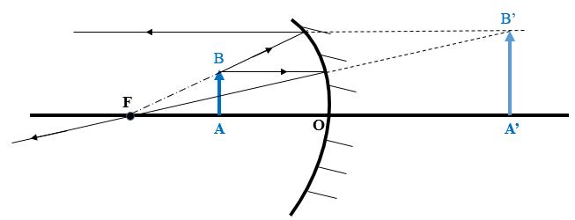
Figure 6.3 Image construction of an object close to a concave mirror
s = OA = + 25 cm; f = +50 cm. The mirror equation is written as:
$$\frac{1}{25}+\frac{1}{s'}=\frac{1}{50}⇒s^{'}= -50? cm ⇒image behind the mirror$$
By joining B’ to B the prolongation would cut the optical axis at the center of curvature C (since the incident and reflected ray are the same) hence the similar triangles give:
$$\frac{A'B'}{A'C}=\frac{AB}{AC}⇒\frac{A'B'}{150}=\frac{10}{100-25=75}⇒A^{'}B^{'}=20 cm$$

Self-Check Questions
            - Answer by true or false and justify your answer
The mirror equation does not apply to a flat mirror. False; it is applicable since for a flat mirror the radius is infinity, hence the focal distance is infinity; substituting this into the mirror equation one gets s’=-s, which means that the image is virtual (behind the mirror) and is symmetric to the object with respect to the mirror.
            - The frequency in a vacuum of a light wave of wavelength 500 nm is:
0.6 THz 6 THz 60 THz 600 THz

Details: $f=\frac{c}{λ}=\frac{3⋅{10}^{8}}{5⋅{10}^{-7}}=6⋅{10}^{14} Hz=600⋅{10}^{12}Hz=600 THz$

6.2 Refraction

Concept
A light ray propagating from a transparent medium to another transparent medium experiences at the interface surface a partial reflection while most of the light continues its path forward to the second medium but with a different speed of propagation and also a different direction. This change of speed and direction is termed “refraction”. This change in speed of propagation depends on a parameter characterizing the nature of the transparent medium called the “index of refraction”, denoted by a dimensionless quantity n. In a vacuum, the index of refraction is 1 while in another transparent material it is greater than 1. In the air, the index is very close to 1 such that one may mathematically treat a vacuum and air the same.
The speed of propagation c in a vacuum will decrease in another medium due to the index of refraction; this speed becomes v and is calculated by:
 | $$v=\frac{c}{n}$$ | (6.2)

Since the color of light does not change with the medium, this leads us to conclude that the frequency of a light wave remains constant from one medium to another and hence the wavelength of light becomes shorter with respect to its value in a vacuum, hence:
 | $$λ=\frac{λ_{vac}}{n}$$ | (6.3)

The Law of Refraction
Known also as Snell’s law, the law of refraction states that the ratio of the sines of the angle of incidence θ₁ in a medium 1 and the angle of refraction θ₂ in a medium 2 is inversely proportional to the ratio of their respective indexes of refraction n₁ and n₂: (Knight, 2016)
 | $$n_{1}⋅\sin{θ_{1}}=n_{2}⋅\sin{θ_{2}}$$ | (6.4)

One may apply this law for vacuum-material propagation where n₁1 and n₂=n>1; one gets $\sin{θ'}=\sin{θ}/n$ meaning that the refraction angle decreases as the index increases as shown in the figure below (Ohanian, 2007, p. 1121).
Another interesting application depicted in the below figure on the right (Ohanian, 2007, p. 1121) is that a light ray passing through two parallel faces of a transparent medium (e.g., glass) conserves the initial angle of incidence (i.e., entry to the medium) and the final angle of refraction (i.e., exit from the medium).
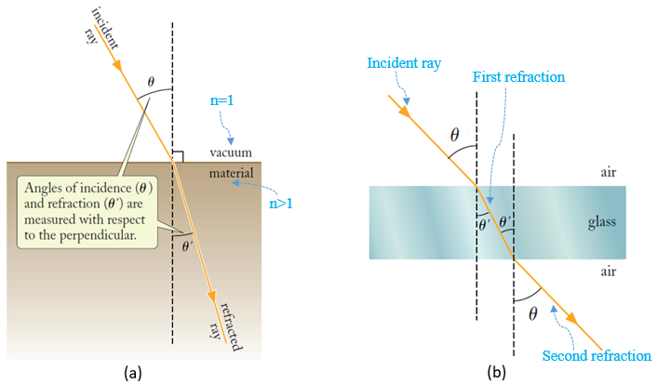
Figure 6.4 Incident and refracted rays (a), Ray through a parallel faces glass medium (b)

Thin Lenses
A “thin lens” is an optical device made of a transparent material (such as glass) consisting of either two convex surfaces (“convex” or “converging lens”) or two concave surfaces (“concave” or “diverging lens”).
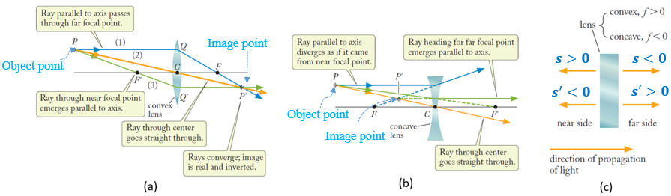
Figure 6.5 Image through a convex lens (a), Image through a concave lens (b), Sign convention for lens equation (c)
Similar to mirrors, a thin lens exhibits an optical axis but with two focal points F and F’ because of the existence of two curved surfaces; those focal points are located symmetrically from each part of the lens. The focal distance f as a function of the lens’ index of refraction n and both radii of curvature R₁ and R₂ is given by:
 | $$\frac{1}{f}=\left(n-1\right)⋅(\frac{1}{R_{1}}+\frac{1}{R_{2}})$$ | (6.5)

The image construction, like with mirrors, is made by ray tracing. Incident rays parallel to the optical axis striking the lens refract and converge (i.e., diverge) to pass by the focal point. An incident ray passing through a focal point and striking the lens refracts parallel to the optical axis. An incident ray passing by the center of curvature of the lens continues its path without refraction. Two refracting rays intersect leading to a real image; the intersection of two prolonged refracting rays leads to a virtual image. This is illustrated in the above left figure (Ohanian, 2007, p. 1137) for a convex lens and the above middle figure (Ohanian, 2007, p. 1137) for a concave lens.
The “lens equation” is similar to the mirror equation with the sign conventions shown in the rightmost figure above (Ohanian, 2007, p. 1138) for concave lenses.

Prism
A prism is a glassy triangular optic device used to separate white light into its original colored constituents. The prism’s glass material has slightly different indices of refraction such that white light, which is a combination of many colored light rays at different wavelengths, gets dispersed at different angles upon exiting the prism.
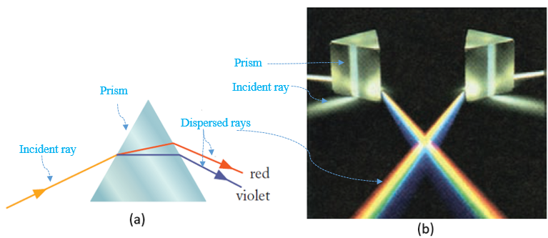
Figure 6.6 Schematic refraction in a prism (a), Coloured light obtained through a prism (b)
The figure on the left (Ohanian, 2007, p. 1126) shows schematically how a white light ray refracts in the prism at different angles depending on the wavelength of each constituent. The figure on the right (Ohanian, 2007, p. 1126) shows the seven colored rays coming from a refracted white light ray: red, orange, yellow, green, blue, blue-violet, and violet. This is exactly how a rainbow is formed when the light rays of the sun strike rain droplets, which play the role of a prism and separate the original white light into many colored rays. Each colored ray is a “spectral line”; the entire beam of colored rays is the “spectrum”.
Figure 6.7 Rock's image in water
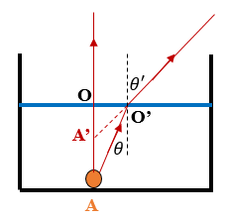
Application 6.2. A small rock is lying at the bottom of a water container and an observer above the water is looking at the rock almost through the vertical. Determine the percentage distance by which the observer sees the rock either further or closer. Given: $n_{water}=4/3$.
Solution 6.2. The image of the rock A is constructed by the intersection of two refracted rays (or their extrapolation). A perpendicular incident ray from the rock does not refract, while another inclined ray refracts by a higher angle since the index of refraction of the second medium (air) is less than that of water; thus, the virtual image A’ is constructed as shown in the figure above.
Since the eye of the observer is almost vertically above the rock, the angles of incidence and refraction are very small, thus their sines could be approximated by their tangents, hence combining the refraction law with the approximation of small angles and the trigonometry in the right-angle triangles AOO’ and A’OO’ one gets:
$$\frac{\tan{θ'}}{\tan{θ}}=\frac{AO}{A'O}=\frac{4}{3}⇒A^{'}O=\frac{3}{4}AO⇒A'A=\frac{AO}{4}⇒image seen closer by 25\%$$

Self-Check Questions
- Complete the following sentence
A light wave of wavelength 480 nm in vacuum propagates in the glass (n = 1.5) at a speed of 2⋅ 10⁸ m/s with a frequency of 625 THz.
Details: $v=\frac{3⋅{10}^{8}}{1.5}=2⋅{10}^{8}m/s$ ; $f=\frac{3⋅{10}^{8}}{480⋅{10}^{-9}}=625 THz$
- Choose the correct answer
An object located 20 cm from the front of a thin lens has an image located 25 cm behind the lens. What is, in cm, the focal distance of this latter?
-11 11 100 -100

Details: s >0 (near side) and s’>0 (far side) thus $f=\frac{20⋅25}{20+25}≈11 cm$

6.3 Optical Aberrations
An “aberration” is an anomaly in the image formation due to defects in an optical device leading to a scatter of reflected or refracted rays instead of a focus at one point. This results in blurry images. One may distinguish between aberrations with monochromatic light and polychromatic (or simply chromatic) light.
Monochromatic light: light exhibiting a wave with a single wavelength. Each wavelength characterizes a main light color.
Polychromatic light light that consists of a spectrum of waves at different wavelengths, such as white light.

Monochromatic Aberration
Spherical aberration. This occurs with curved optical devices such as lenses and curved mirrors. Refracted or reflected rays intersect at the optical axis at points closer or further from the device depending on how far from the optical axis the incident rays are.
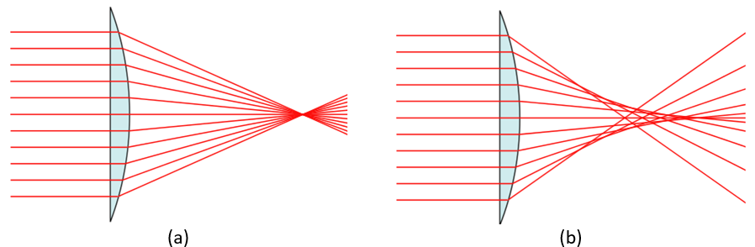
Figure 6.8 Normal refraction (a), Spherical aberration (b)
The figure above on the right shows this type of aberration compared to the normal operating case (above figure on the left). This aberration can be corrected by using a combination of concave and convex lenses or aspheric forms.
Comatic aberration. Known simply as “coma”, comatic aberration appears in images coming from off-axis sources showing many superimposed magnified blurry images seeming to have a cornet tail, as shown in the figure below. Each of the two diffracted rays, depending on their distance from the center of the device, intersect at different height points but at the same perpendicular line to the optical axis. It can be corrected directly by modifying the lens’ curvature or indirectly through additional optical devices.
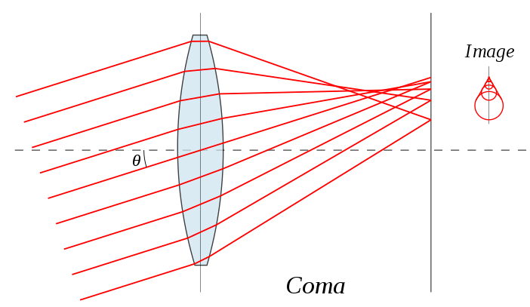
Figure 6.9 Comatic aberration
Astigmatism. This is a deviation of the focal point of a lens or a human eye (which is similar to a system of lenses) due to geometrical imperfections.
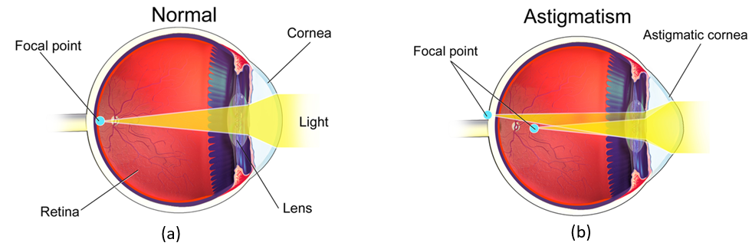
Figure 6.10 Normal view (a), Astigmatism (b)
Due to this deviation, refracted rays will converge poorly leading to a blurry image. This is illustrated for the human eye in the figure above. This aberration can be corrected by adding lenses (or eyeglasses or contact lenses for humans) that exhibit the reverse effect of this deviation, such that the resulting total optical system (original defective device + correcting lens) results in a normal non-deviated focal point and optical axis.
Field curvature. This is the formation of a curved image from a flat object source perpendicular to the optical axis. This is due to the intersection of each pair of refracted rays at distinct points and out of the focal plane as shown in the figure below. This aspect can be corrected by using a “field flattener lens” (like those in binoculars) or by inserting a focal curve for image capture (similar to the eye’s retina).
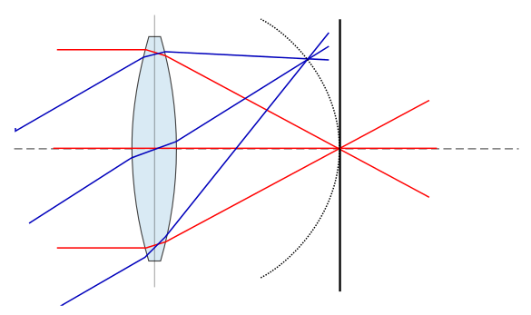
Figure 6.11 Curvature of the image field
Image distortion. This is a change in the image shape caused by a deviation in the position of one point on the image relative to another. This results in non-parallel lines in the image: magnification may increase when moving further from the central axis leading to “pincushion distortion”, or it may also decrease leading to “barrel distortion”. This can be corrected by changing the lens arrangement or properties. These are illustrated in the figure below.
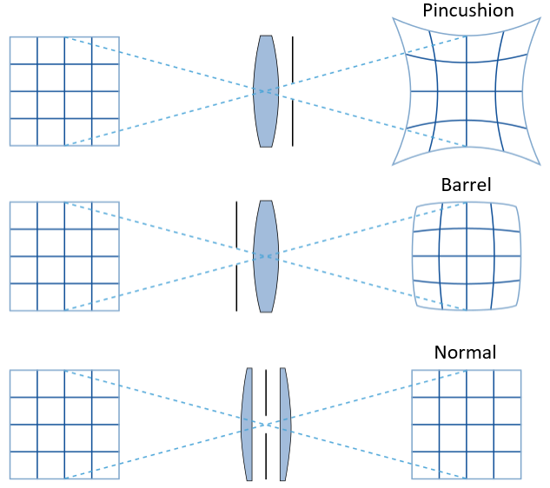
Figure 6.12 Distorted and normal images

Chromatic Aberration
This type of aberration is associated with chromatic light consisting of many colored light waves. It is defined as the inability of an optical device to focus all reflected or refracted rays at one point. Due to this mismatch, each wave with its own wavelength, i.e., its own color, refracts and focuses at a distinct point leading to “dispersion”. The figure below illustrates this chromatic aberration.
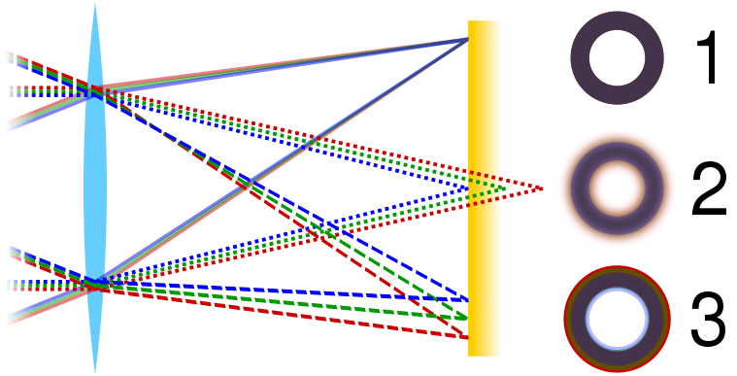
Figure 6.13 Normal, axial and tranverse chromatic aberration
One may distinguish between two types of chromatic aberration: (1) “axial” or “longitudinal aberration” when different monochromatic light waves converge at distinct points along the optical axis (Image 2 in the figure above); this type of aberration occurs with long focal length devices; and (2) “transverse” or “lateral aberration” when different monochromatic light waves converge at the same focal plane but at different heights along this plane (Image 3 in the above figure); this type of aberration occurs with short focal length devices. Image 1 above reflects a normal image. Chromatic aberration may be corrected by using “low dispersion glass” including fluorite as lens material. Another correction is to attach an extra optical glass piece (called a crown) having a high index of refraction to the original lens: this package is called an “achromatic doublet”.

Self-Check Questions
- Identify the aberration corresponding to each case below.
- A square object appears to have four curved convex sides. Barrel distortion
- A tree image appears to have many surrounding non-blurry (clear) colored layers. Lateral chromatic aberration
- A flying bird appears as two slightly shifted ones. Astigmatism.

- Answer by true or false and justify your answer
Increasing the index of refraction of a lens helps to correct astigmatism. False since astigmatism is the result of a geometric imperfection and not a material defect.

6.4 Interference and Polarization of Light Waves

Diffraction
Before discussing the phenomenon of “interference”, it will be worthwhile to briefly introduce another useful phenomenon that occurs to any type of wave, including light: “diffraction”. Its principle states that ‘’if a wave encounters a barrier that has an opening of dimensions similar to the wavelength, the part of the wave that passes through the opening will flare (spread) out -will diffract- into the region beyond the barrier.’’ (Walker, 2014, p. 949). As the size opening narrows, the diffraction’s occupied space widens. This concept constitutes a limitation of the “geometrical optics” theory, which considers that light propagates in the same medium following a straight direction; this is valid under the condition that the orifice penetrated by the light is much larger than the wavelength of the light wave.

Interference
The classical experimental set-up for light wave interference was established by the physicist Thomas Young and is shown in the figure below (Walker, 2014, p. 950).
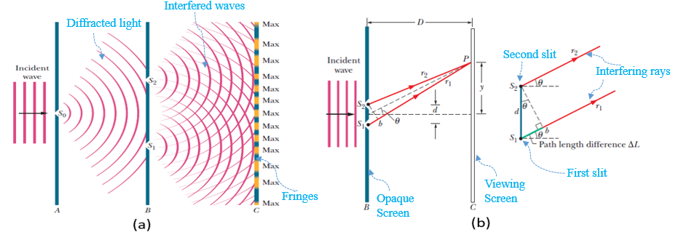
Figure 6.14 Young's experimental set-up (a), Path length difference (b)
This set-up consists of an opaque screen A containing a slit S₀ having a size comparable to the wavelength of the monochromatic incident light wave; this slit plays the role of a light source. Light will then diffract beyond screen A to hit another opaque screen B holding two slits S₁ and S₂ separated by a known distance d and playing the role of two new light sources. These are called “coherent”, which means that the phase shift between waves is constant. From each slit, light will diffract in circular waves leading to an overlap between diffracted waves; this latter phenomenon is called ”interference”. When the waves interfere, the result will appear on a viewing screen C, separated from B by a distance D that is large compared to d. This result consists of “bright and dark bands” alternately distributed along the viewing screen C. The ‘‘package” of all bands is the “interference pattern”, while each band is called an “interference fringe”. “Bright fringes” are also known as “maxima”, and dark ones are the “minima”.
The reason for the bright fringes appearing is the superposition of waves that propagate in phase; these have an additive or “constructive” effect between them leading to the maxima, while out-of-phase waves have a subtractive or “destructive” effect between them such that they cancel each other out to lead to the minima. The “central fringe”, located at the intersection between the horizontal line passing through the midpoint of S₁S₂ and the viewing screen C, is the most intensively illuminated since it results from the superposition of in-phase waves propagating without any mismatch in path length. However, any other fringe, either bright or dark, is formed from ray superposition traveling through different path lengths.
In the figure on the right above (Walker, 2014, p. 651) consider a point P coincident with any arbitrary fringe on the interference pattern and consider a ray r₁ coming from S₁ and a ray r₂ coming from S₂ intersecting at P. Since D ≫ d, those rays are considered to be parallel at the opaque screen B. We denote by θ the inclination of P with respect to the central fringe. Indeed, r₂ covers a longer path than r₁ to reach P; this “path length difference”, denoted by ΔL, is schematized by the length S₂b, where b is the intersection between the perpendicular line to r₂ issued from S₁.
From the geometry of the right-angle triangle S₁S₂b, the path length difference is:
 | $$ΔL=d⋅\sin{θ}$$ | (6.6)

To achieve a constructive interference, ΔL must be either zero or an integer multiple j of the wavelength λ, hence the inclination angles, i.e., the positions on the screen, of the bright fringes are given by:
 | $$d⋅\sin{θ}=j⋅λ$$ | (6.7)

The central fringe corresponds to j = 0, the first bright fringe to j = 1, etc.
Dark fringes form when ΔL is an odd integer multiple of half the wavelength hence:
 | $$d⋅\sin{θ}=(2j+1)⋅\frac{λ}{2}$$ | (6.8)

The first dark fringe corresponds to j = 0, the second dark fringe to j = 1, etc.

Polarization
Naturally, since a light wave is an electromagnetic wave, it consists of an electric field that oscillates in all directions. This status of the light is called “unpolarized”. “Polarization” is a process that forces the electric field to propagate only along a desired direction. This occurs by filtering the light wave; this “polarizing filter” is called a “polaroid”. The direction of the filtered wave transmitted through the polaroid is the “polarizer axis”.
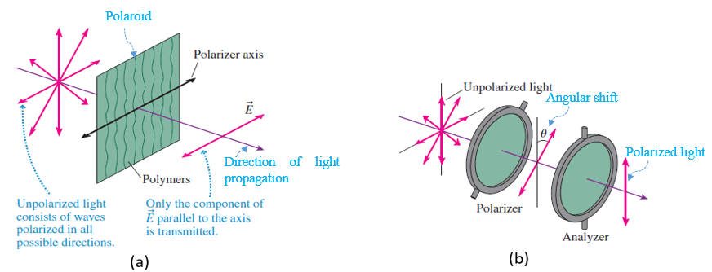
Figure 6.15 Polarizing filter (a), Polarizing intensity (b)
The figure on the right above (Knight, 2016, p. 897) shows the polarization process. The polaroid consists of a plastic plate where the polymeric macromolecules stand parallel among themselves like the vertical steel bars of a jail door; the conducting electron can oscillate parallel to the macromolecules and absorb all of the light energy; for this reason, the waves perpendicular to the macromolecular lines may continue their path past the polaroid.
However, polarization is accompanied by a drop in the intensity of the transmitted light I_{tr} elative to the intensity of the original unpolarized light I₀. Experimentally this is tested by a double filter consisting of a polarizer and an “analyzer” shifted by an angle θ as illustrated above (Knight, 2016, p. 897). When both filters are perfectly parallel ($θ=0°$) all of the light would transmit, while in a position of crossed polarizers ($θ=90°$) the light is completely blocked. (Knight, 2016). Mathematically, this is expressed in “Malus’s law”, where intensity’s unit in SI is the candela (Cd):
 | $$I_{tr}=I_{0}⋅c{os}^{2}{θ}$$ | (6.9)

Application 6.3. In a two-slits interference experiment, the viewing screen is placed 75 cm from the slits, separated by 1.5 cm through which monochromatic light of 520 nm is passing. Calculate the position of the fifth dark fringe. For small angles: $\sin{θ}≈\tan{θ}≈θ rad$.
Solution 6.3. The fifth dark fringe carries an integer number j = 4. Using equation (6.8), the angle θ is found by:
$$θ=\sin^{-1}{\frac{9⋅0.52⋅{10}^{-6}}{0.015⋅2}}≅\frac{9⋅0.52⋅{10}^{-6}}{0.015⋅2}=1.56⋅{10}^{-4}rad$$
$$y_{4}=750.tanθ≅750.θ≅750⋅1.56⋅{10}^{-4}=0.117 mm$$

Self-Check Questions
- Choose the correct answer
For a monochromatic light wave of wavelength 425 nm, the larger diffraction occurs for a slit of size:
0.5 μm 625 nm 0.02 cm 0.3 mm

Details: 625 nm = 0.625 μm ; 0.02 cm = 200 μm; 0.3 mm = 300 μm. The smaller the size, the larger the diffraction, hence the 500 nm = 0.5 μm width generates the largest diffraction; in addition, it is in the order of the wavelength which is an essential condition for diffraction to take place.

- Answer by true or false and justify your answer.
In a double polarizing filter where initially both filters have been aligned, the polarizer is rotated by 60$°$ccw and the analyzer by 30$°$cw. The light is then completely blocked. True since the net angle between both filters is 60-(-30)=90$°$, hence those are crossed polarizers.

6.5 Fundamentals of Acoustics

The Speed of Sound
Recall that “sound” is a longitudinal wave propagating through a medium by alternating tension and compression of its molecules, thus transmitting energy forward. The point from which the sound has started, i.e., emitted, is the “sound source”. Sound is emitted in all directions in the form of “wavefronts”, which are circular (or partially circular) surfaces along which sound oscillations travel. “Rays” are lines perpendicular to wavefronts indicating the direction of propagation. (Walker, 2014).
The “bulk modulus” K of a material denotes the ratio of the uniform pressure applied to the resulting relative change in volume $\frac{-∆p}{∆V/V}$; it is expressed in Pa. Knowing the modulus of elasticity (E) and Poisson’s ratio (ν) of the material, the bulk modulus is determined by the following relationship: (Hibbeler, 2011):
 | $$K=\frac{E}{3(1-2ν)}$$ | (6.10)

The speed of the sound wave through a medium is related to the bulk modulus and the density of this medium (Walker, 2014). It is determined by:
 | $$v=\sqrt{\frac{K}{ρ}}$$ | (6.11)

The Pressure of Sound
You may remember that the sound wave’s displacement y(x,t) is sinusoidal and is described by equation (5.11): $y\left(x,t\right)=y_{m}\sin{(kx-ωt+ϕ)}$. As already stated, regions of the medium where sound is propagating are alternately expanded and compressed, meaning that a sinusoidal pressure Δp(x,t) is produced. It is considered negative in the expansion case and positive in the compression case. (Walker, 2014).
According to the definition of the bulk modulus, the pressure is given by:
$$∆p=-K⋅\frac{ΔV}{V}$$
The volume of a medium element of cross-section A and length Δx is:$V=A⋅Δx$.
When the sound propagates, the net displacement of two parallel faces of the medium element becomes Δy meaning that the volume change is: $ΔV=A⋅Δy$.
Substituting this into the expression for the pressure yields:
$$∆p=-K⋅\frac{Δy}{Δx}=-K⋅\frac{∂y}{∂x}=-K⋅k⋅y_{m}\cos{(kx-ωt+ϕ)}$$
The negative sign can be converted to a π phase angle without affecting the amplitude, hence:
 | $$∆p\left(x,t\right)=p_{m}\cos{(kx-ωt+ϕ)}$$ | (6.12)

The amplitude pressure $p_{m}=K⋅k⋅y_{m}$ ; replacing K with equation (6.11) and k with ω/v, it becomes:
 | $$p_{m}=v⋅ρ⋅ω⋅y_{m}$$ | (6.13)

Interference of Sound Waves
Consider two sound sources S₁ and S₂ emitting similar waves, i.e., they have the same amplitude and frequency; those sources are said to be in phase. Normally, the emitted sounds are in phase also, thus if they travel the same path length their effects will be completely “constructive”, i.e., additive. However, when a sound ray from S₁ interferes with a sound ray from S₂ at a point P that is, for instance, closer to S₁ than S₂, those two rays have not covered the same path length. Ray form S₂ has propagated along a longer distance, hence there is a “path length difference” ΔL. This phenomenon is identical to light interference as discussed in the previous section. In this case, the scenario looks like the waves are not in phase when they interfere at P; mathematically speaking, there is a phase angle φ between ray 2 and ray 1 hence the resulting sound wave could be deduced from $y\left(x,t\right)=[2y_{m0}\cos{\frac{ϕ}{2}}]\sin\left(kx-ωt+\frac{ϕ}{2}\right)$ where the amplitude is: $y_{m}=\left|2y_{m0}\cos{\frac{ϕ}{2}}\right|$ (y_{m0} being the amplitude of each of the original waves).
The conversion from the practical path length difference to the theoretical phase angle can be deduced from the proportionality between φ and 2π on one hand, and ΔL and λ on the other hand thus: $\frac{ϕ}{2π}=\frac{ΔL}{λ}$
 | $$ϕ=\frac{ΔL}{λ}⋅2π$$ | (6.14)

“Fully “constructive” sound interference occurs when φ is zero, 2π or any integer multiple of 2π“ (Walker, 2014, p. 430), i.e., $ϕ=2jπ$ where $j=0;1;2;3;…$ Hence constructive interference is obtained when the path length difference is equal to an integer multiple of the wavelength:
 | $$ΔL=j⋅λ$$ | (6.15)

‘’Fully “destructive” sound interference occurs when φ is an odd integer multiple of π“ (Walker, 2014, p. 430), i.e., $ϕ=(2j+1)π$ where $j=0;1;2;3;…$ Hence destructive interference is obtained when the path length difference is equal to an odd integer multiple of half the wavelength :
 | $$ΔL=(2j+1)⋅\frac{λ}{2}$$ | (6.16)

Intensity of Sound
‘’The intensity I of a sound wave at a surface is the average rate per unit area at which energy is transferred by the wave through or onto the surface.’’ (Walker, 2014, p. 433). Mathematically: $I=\frac{rate of energy(power)}{intercepting area}=\frac{P}{A} (W/m^{2})$.
The differential kinetic energy dE_{k} of a differential element of mass dm through which the sound propagates can be written:
$$dE_{k}=\frac{1}{2}{\dot{y}}^{2}dm=\frac{1}{2}ω^{2}{y_{m}}^{2}\cos^{2}\left(kx-ωt\right)(ρAdx)$$
$$\frac{dE_{k}}{dt}=\frac{1}{2}ρAvω^{2}{y_{m}}^{2}\cos^{2}\left(kx-ωt\right)⇒{\left[\frac{dE_{k}}{dt}\right]}_{avg}=\frac{1}{4}ρAvω^{2}{y_{m}}^{2}$$
Assuming that, on average, the rate of change of the potential energy is the same as the rate of change of the kinetic energy, the total average rate is twice the kinetic energy rate thus: $I=\frac{2⋅{\left[\frac{dE_{k}}{dt}\right]}_{avg}}{A}$ which gives:
 | $$I=\frac{1}{2}v⋅ρ⋅ω^{2}⋅{y_{m}}^{2}$$ | (6.17)

However, the intensity of sound emitted by a source towards a point decreases as the point gets further from the source. A sound source emitting waves of power P_{s} produces a sound intensity at a point located a distance r from the source equal to the ratio of P_{s} and the area of an imaginary sphere centered at the source and whose periphery passes by the point of interest, hence:
 | $$I=\frac{P_{s}}{4πr^{2}}$$ | (6.18)

The Decibel Scale
The interval of displacement amplitudes that can be heard by the human ear is [10⁻¹¹-10⁻⁵] m, which defines a ratio range of 10⁶. In terms of intensity, and according to equation (6.17), this ratio measures 10¹². (Walker, 2014). Since this range is enormous, it is useful to express the order of this ratio exclusively using the exponent; the mathematical function extracting this exponent is the base 10 logarithm, i.e., $\log{x}$. Using this method, we conclude that the loudest sound level exceeds the quietest one by 12.
It is useful, therefore, to define the “sound level” denoted by β and expressed in “decibels” (dB) by the following relationship:
 | $$β=\left(10 dB\right)⋅\log{\frac{I}{I_{0}}}$$ | (6.19)

I₀=10⁻¹² W/m² is a standard reference sound intensity to which all other intensities are compared; this reference corresponds practically to the lowest intensity captured by the human ear, i.e., if I=I₀, β=0 dB. For instance, if I is 1000 times greater than I₀, the related sound level measures 30 dB.
Application 6.4. Consider a sound wave propagating through air generating a pressure function of $p\left(x,t\right)=22\cos{(kx-1600πt)} (Pa)$. If the air density is 1.2 kg/m³ and the sound speed measures 345 m/s, calculate the amplitude displacement, the sound intensity, and the sound level of this wave.
Solution 6.4. Applying equation (6.13), $y_{m}=\frac{22}{345⋅1.2⋅1600π}=10.57⋅{10}^{-6}m=10.57 μm$. In addition, the intensity is calculated from equation (6.17):
$$I=\frac{1}{2}⋅1.2⋅345⋅{\left(1600π\right)}^{2}⋅{\left(10.57⋅{10}^{-6}\right)}^{2}=0.58434 W/m^{2}$$
The sound level comes from equation (6.19): $β=10⋅\log{0.58434⋅{10}^{12}}=117.7 dB$.

Self-Check Questions
- Complete the following sentence
Two identical sound waves of 1000 Hz frequency and 8 μm amplitude interfere with each other in the air (at a speed of 343 m/s). The lowest (non-zero) path length differences leading respectively to constructive and destructive interferences measure 34.3 cm and 17.15 cm. The constructive amplitude measures 16 μm.
Details: constructive interference: $∆L=λ=\frac{343}{1000}=0.343 m=34.3 cm$
Destructive interference: $∆L=\frac{λ}{2}=\frac{343}{2000}=0.1715m=17.5 cm$
For the constructive case, $y_{m}=2⋅8=16μm$.
- Answer by true or false and justify your answer
A source sound with a power level equal to 160 nW produces a sound level of 35 dB at a point separated from the source by 2 m. True since the intensity of sound calculated from equation (6.19) gives 10^{-9.5} W/m2 and from equation (6.18), Ps = 4π⋅2²⋅10^{-9. 5(3.5-12)=-8.5}=15.9⋅ 10⁸W = 159 nW.
Summary
Light is an electromagnetic wave that propagates in all directions with a speed of 3⋅10⁸ m/s in a vacuum. Monochromatic light has a unique wavelength. When it consists of a spectrum of many monochromatic waves, light is polychromatic: white light is the main example. Each wavelength characterizes a light color.
According to geometrical optics theory, light propagates in a homogenous continuous medium as a straight line. When it strikes a polished silvered surface it experiences a reflection phenomenon, where the incident angle is equal to the reflection angle. Flat, concave, and convex mirrors are the main optical devices that reflect light. When a light ray strikes a transparent medium, it transmits most of its light to the new medium but with another direction and another speed; this is the refraction phenomenon. Each medium is characterized by a refraction index. As the refraction index increases, the refraction angle decreases according to Snell’s law. Parallel planes film, convergent lenses, and divergent lenses are the main optical devices that refract light. Nevertheless, due to some geometrical or material imperfection in optical devices, aberrations may generate blurry images. These can be corrected by adding other lens types or modifying the defective optical device.
When light penetrates an opening whose size is comparable to the wavelength, light diffracts to cover the larger space. Two or more diffracted light waves interfere with each other to form either bright or dark fringes upon the path length difference of light rays. Light can also be filtered to keep only one direction of propagation, referred to as polarized light.
Sound is a longitudinal wave propagating by alternately expanding and compressing regions of the medium. It exerts a sinusoidal pressure and generates an intensity ratio of the sound power to the intercepting area. The sound level is measured by the logarithm of the intensity with respect to the lowest reference intensity that can be sensed by the human ear; this measure is called the decibel.

Unit 7 – Introduction to Particle Physics

Study Goals

On completion of this unit, you will be able to
- distinguish between different historical atomic models and apply the periodic table of chemical elements.
- understand the photoelectric effect and calculate the related energy.
- establish radioactive reactions producing different types of rays and apply related calculations.
- understand fusion and fission reactions of atomic nuclei and calculate the generated energy.

7. Introduction to Particle Physics

Introduction
The atom is the smallest unit in the universe that constitutes any material; it cannot be seen with the naked eye. Sand, water, air, wood, steel, and blood cells are all made from atoms. A group of atoms bonded together forms a molecule. Each atom consists of a “nucleus” surrounded by an “electron” cloud. The analysis of atoms is an important part of physics, as atoms are constituents of all devices and materials used in physics on the one hand (lenses, conductors, gases, etc.) and are involved directly in scientific applications such as battery tension generation and light production on the other hand.

This unit starts by exposing different models proposed throughout history to describe atoms before sorting all basic chemical elements in nature within a table called the “periodic table”. The next topic focuses on the electron cloud and electron energy levels, which helps us to understand atomic interaction with light. This phenomenon is known as the “photoelectric effect” and it offers a widespread range of practical applications.

The other aspect of the atom to be studied is its nucleus. Changing the morphology of an atomic nucleus through a process termed “nuclear reaction” leads to the creation of a new chemical element, new types of beneficial rays, and the generation of a huge amount of energy that may be applied in many fields, namely in the production of electricity. Nuclear reactions consist of either partitioning a nucleus into many other ones, called a “fission” reaction, or the inverse of merging many nuclei to form a heavier one, called a “fusion” reaction.

Historical Overview of Atomic Models
Early in the study of atoms, scientists lacked sufficiently advanced experimental tools and so tried to suggest a simplified representation of an atom, which we call an “atomic model”. Those models carry the names of the researchers who established them. In the next sections, we will briefly discuss the models of Dalton, Thomson, Rutherford, Bohr, and the modern model. (Özdin, 2021)

Dalton’s Atomic Model
John Dalton proposed his atomic model in 1804, which considered the atom to be a fully filled sphere, similar to a billiard ball as shown in the figure below (Özdin, 2021, p. 8).
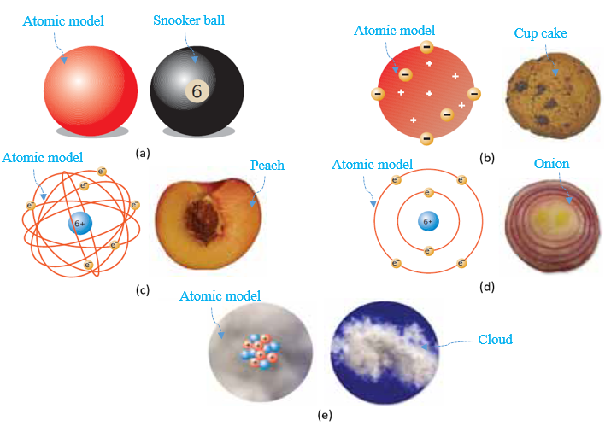
Figure 7.1 Atomic models: Dalton (a), Thomson (b), Rutherford (c), Bohr (d), Modern (e)
Atoms conserve all the properties of the substances they make up; atoms cannot be divided, and they have different masses depending on their types. No electrically charged particles exist in this model.

Thomson’s Atomic Model
In 1897, Sir Joseph John Thomson discovered the negative charges of “electrons”. Since an atom is electrically neutral, there are an equal number of positively charged particles. Neutrons were not mentioned in this model, rather, Thomson’s atom existed as a sphere of 1 A (Angstrom) radius where positive and negative charges were arbitrarily dispersed like raisins in a cupcake as illustrated in the figure above, top right (Özdin, 2021, p. 10). in this model, electron mass is too small compared to the positive charges.
Angstrom: a unit of length equal to 10⁻¹⁰ m.

Rutherford’s Atomic Model
In 1911, Ernest Baron Rutherford discovered the “nucleus” of the atom, which is the central dense region where all positive particles, called “protons” and discovered in 1919, are gathered. Electrons are moving randomly around the nucleus, like the peach fruit structure (see figure above (Özdin, 2021, p. 10)) or also like the sun-planets system in which the sun is the nucleus and the planets are the electrons). It is not until the 1930s that James Chadwick discovered the existence of neutrally charged particles, the “neutrons”, alongside the protons within the nucleus.

Bohr’s Atomic Model
In 1913, Niels Bohr analyzed the movement and distribution of electrons around the nucleus. He described electrons as moving stably and distributed on circular “shells” termed “energy levels”, each located at a known distance from the nucleus. Those levels are named either by letters (K, L, M, N, etc.) or by integer numbers (n = 1; 2; 3; etc.). This model resembles a cross-section of an onion as illustrated in the figure above (Özdin, 2021, p. 11). When an electron falls from a higher to a lower level of energy it emits a “quantum of light”.

Modern Atomic Model
In the 1920s, after a series of experiments Louis de Broglie, Werner Heisenberg, and Erwin Schrödinger proposed the existence of a “cloud of electrons” around the nucleus (see figure above (Özdin, 2021, p. 11)) where a specific electron particle has a probability of existing within this cloud. If the electron is considered as a wave, an “electron density function” is defined.

Self-Check Questions
            - Answer by true or false and justify your answer
The scenario of layers of cars turning about a traffic circle offers an additional example of Rutherford’s model. False, since cars traveling on a road have a planar motion about the traffic circle, moreover, there is no intersection between the cars’ paths, thus this example is closer to Bohr’s model.
            - Cite two differences between Thomson’s and Bohr’s models
Thomson: (i) protons and electrons are ‘’mixed’’ together; (ii) the diameter of the atom is constant.
Bohr: (i) electrons surround the protons gathered in the nucleus; (ii) electrons are distributed on many energy levels at different distances from the nucleus.

7.2 The Periodic Table of Elements

Brief History
The “periodic table” is a special table in which the “individual elements” in nature are arranged in a specific order. An “element” is a natural substance that is formed from the arrangement of identical individual atoms that are not bonded together chemically. A substance consisting of “molecules”, formed by chemically bonded atoms, is not classified as an element.
‘’Dmitri Mendeleev is often considered the ‘’father’’ of the periodic table and the studies of many scientists have also contributed to form the modern periodic table.’’ (Özdin, 2021, p. 28). In 1869, Mendeleev proposed to arrange the elements following the increasing order of their atomic mass. Between 1894 and 1900, William Ramsay added the noble gases he discovered to the periodic table which ‘’perturbated’’ Mendeleev’s arrangement. At this stage, the scientist Henry Moseley found in 1913 that the more logical increasing sequence in which to arrange the elements was by their atomic number rather than atomic mass. This led to the birth of the modern periodic table.
Noble gases: list of gases belonging to group 8A, hence having 8 peripheric electrons. They are inert monoatomic gases.
Atomic mass: characteristic number denoting the sum of protons and neutrons in a nucleus. Symbolized by A.
Atomic number: characteristic number denoting the electrons in an atom, the same as protons. Symbolized by Z.

Structure of the Periodic Table
Each box of the periodic table contains the symbol of the element (consisting of one or two letters with the first letter always being capitalized), its atomic number Z at the upper left corner of the box, and its average mass number or atomic mass A at the bottom center of the box as illustrated in the figure below (Knight, 2016, p. 1244). In this figure, the example of the element cobalt (symbol Co) is called out with Z = 27 and A = 58.9.
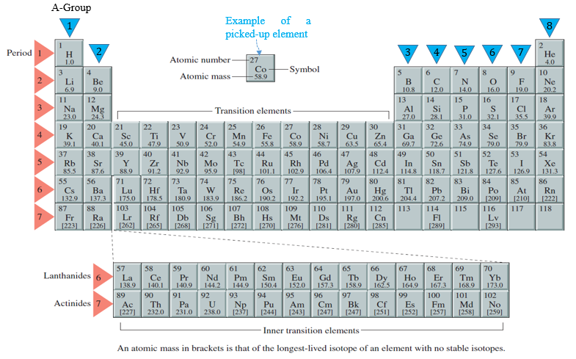
Figure 7.2 The periodic table of elements
The table consists of seven main horizontal rows, each row called a “period”. The first element in each period is a metal (except period 1, hydrogen is a gas). The last element of each period is a noble gas. The noble gas of the last period has not been found yet. The first two and the last six columns constitute the “A groups” or the “main groups”.
Each vertical column of the table is called a “group”. The term “family” can be found in some references since elements belonging to the same group exhibit similar properties. Each family is designated by a specific name reflecting its property as shown in the figure below (Özdin, 2021, p. 35) The other intermediate columns involving the transition elements (metallic) constitute the “B groups”.
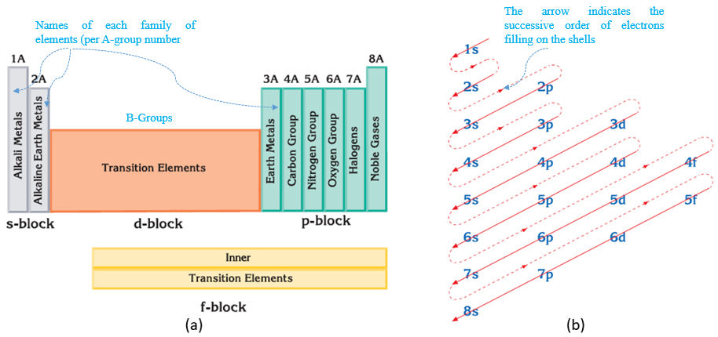
Figure 7.3 Groups of the periodic table (a), Order of orbitals filling (b)

The Orbitals
Recall that according to Bohr’s model, electrons are distributed following energy levels ordered by increasing integer numbers from the closest to the nucleus to the furthest. Hence the K level is designated by 1, L level by 2, M level by 3, N level by 4, and so on. In addition, each energy level is divided into many “sub-levels”, termed “orbitals” and are denoted by small letters s, p, d, and f. The energy level 1 consists of the s-orbital, which can be filled by a maximum of two electrons. The energy level 2 consists of both s- and p-orbitals, which can be filled by a maximum of six electrons (practically p-shell consists of three orbitals, each filled by two electrons). Furthermore, a maximum of 10 and 14 electrons may fill the d-f-orbital respectively. According to the figure above on the left (Özdin, 2021, p. 35), the A-group elements have their electrons occupying the s- and p-orbitals. The figure above on the right (Özdin, 2021, p. 37) indicates the order of energy levels and their respective orbitals to be followed in order to contain the total number of electrons: this operation is termed the “electron configuration”.
Example: the 16-electron configuration of ${}_{16}^{32}S$ is written: ${1s}^{2}{2s}^{2}{2p}^{6}{3s}^{2}{3p}^{4}$. Notice that the sulfur atom exhibits 3 energy levels, with the last energy level (number 3) occupied by six electrons, called “peripheral electrons”.

The Periods
The period of an element represents the number of energy levels needed to contain all the electrons. For instance, all elements of period 4 need 4 energy levels to configure their electrons.

The Groups
The group of an element represents the number of electrons occupying the last energy level; those are the peripheral electrons. For instance, all elements of group 3 have three electrons occupying the last energy level.
If one goes back to the sulfur example, looking at the electron configuration one may deduce easily and without looking at the periodic table that this element belongs to group 4, period 3.
It should be noted that elements from the same group exhibit similar properties For this reason, there is another way to enumerate the groups: by disregarding the classification between A and B and following a continuous enumeration from 1 to 18 passing from one column to the next.

Self-Check Questions
- Complete the following sentence
The calcium element ${}_{20}^{40}{Ca}$ occupies the second group and the fourth period in the periodic table.
Details: ${1s}^{2}{2s}^{2}{2p}^{6}{3s}^{2}{3p}^{6}{4s}^{2}$ is the electron configuration of calcium; one may see that there are four energy levels and two peripheral electrons.
- Choose the correct answer
The atomic number of an element belonging to the fifth A-group and fifth period is:
49 50 51 52

Details: the fifth period means that there are five energy levels; the fifth main group means that there are five peripheric electrons occupying s- and p- sub-levels:
$${1s}^{2}{2s}^{2}{2p}^{6}{3s}^{2}{3p}^{6}{3d}^{10}{4s}^{2}{4p}^{6}{4d}^{10}{5s}^{2}{5p}^{3}⇒Z=51$$

The Photoelectric Effect

The Quantum of Light
“Quantum physics”, known also as “quantum mechanics” or “quantum theory”, is a branch of physics that studies and analyzes quantities found in their elementary amounts and as integer multiples of these amounts; thus these amounts have discontinuous specific values and cannot achieve any intermediate other values. This studied physical quantity is referred to as being “quantized”. ‘’The elementary amount that is associated with such a quantity is called the “quantum” of that quantity (“quanta” is the plural).’’ (Walker, 2014, p. 1042).
One may concretize this concept by a very simple example: consider a family of five members; the number of members is quantized since it can be either one, two, etc.; one may not talk about two and a half members, for instance, or three and one-quarter members: the number of members has specific integer multiple values.
In 1905, Albert Einstein developed an idea of light as something other than a wave: the “corpuscular aspect”. It states that light is quantized and consists of particles (corpuscles) termed “photons”. The energy E carried by a photon is a function of the frequency f of the light as a wave and is given by:
 | $$E=h⋅f=h⋅\frac{c}{λ}$$ | (7.1)

where h is the “Planck constant”: $h=6.63⋅{10}^{-34} J⋅s$.
E is expressed in joule (J) in the SI system, but it may also have another unit, the “electron volt” ($1 eV=1.6⋅{10}^{-19} J$).
The total energy carried by light is quantized since it is equal to the integer number of photons multiplied by h⋅f. Hence it is impossible to develop energy of 0.43h⋅f or 15.23h⋅f for instance.

Absorption and Emission of Light
Furthermore, Einstein found that either absorption or emission of light, i.e., photons, by an object occurs at the atomic level, specifically at the level of the atom’s electrons. (Walker, 2014)
Light of frequency f is absorbed by an atom when this photon forces an electron to move from a stable energy level (close to the nucleus) to an excited energy level (far from the nucleus). In energy terms, h⋅f is transferred from the photon to the electron; depending on the energy value, the electron may either stay on this stable energy level if the energy is not sufficient to excite the electron, or it may move to the furthest excited energy level without leaving the atom if the photon’s energy is moderate. If the photon’s energy is considerable it would not only move the electron from one energy level to another, but it may acquire sufficient kinetic energy to completely escape from the material. This phenomenon is termed the “photoelectric effect” and the targeted electron is termed the “photoelectron”. The related photoelectric equation can be written as:
 | $$h⋅f=E_{k,max}+Φ$$ | (7.2)

Where Φ is the “work function”, which is a characteristic property of the material denoting the minimum required energy for the electron to escape from its stable energy level. If h⋅f<Φ no photoelectric effect occurs.
E_{k,max} is the kinetic energy gained by the electron while escaping completely outside the material; this energy appears if h⋅f>Φ.
In cases where the photon’s energy equals the work function of the material (i.e., the kinetic energy is zero) the minimum frequency f₀ needed to trigger the photoelectric effect is called the “cutoff frequency”. Any light with a frequency below f₀ will not be able to generate photoelectrons. The expression of f₀ is:
 | $$f_{0}=\frac{Φ}{h}$$ | (7.3)

There are many beneficial applications based on photoelectricity such as sunglasses, solar panels that absorb light to produce electricity, or the ‘’electric eye’’ for garage doors.
The photoelectric effect may occur inversely, meaning that an atom may emit light photons. This occurs when an electron initially in an excited energy level falls to a lower, more stable energy level. The difference in energies of the electron between its final and its initial status is quantized and equal to h⋅f. Light production from lamps is based on this phenomenon.

Energy of hydrogen Atoms
Niels Bohr studied the special case of the electron in a hydrogen atom (or a hydrogen-like ion such as He+, Li++,… etc.) generating a photon of light once the electron falls from an excited energy level to a more stable energy level. Inversely, this model also applies when the electron absorbs light’s energy to escape to more excited energy levels, or even to leave the cloud leading to ionization. This theory is quite similar to Einstein’s, however, the quantization in that case is coming from the energy level’s number rather than from the photons. Depending on the initial and final energy levels, a special type of light, i.e., with a characteristic wavelength, is generated as shown in the figure below.
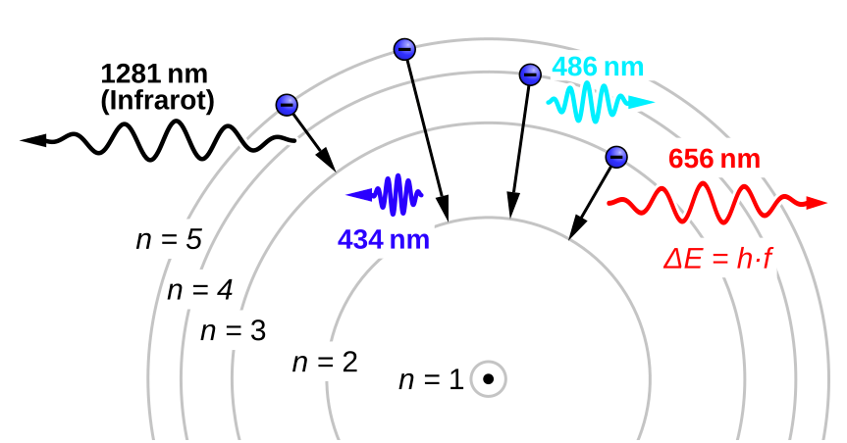
Figure 7.4 Light emission from electron's jump in Hydrogen atom
The energy of an electron existing on an energy level n is determined by:
 | $$E=-\frac{13.6Z^{2}}{n^{2}} eV$$ | (7.4)

where Z is the atomic number. A more negative energy means a more stable electron, meaning that the level of instability, i.e., excitation, increases with the number of the energy level and thus when the electron gets more distant from the nucleus. The energy of the electron for the most stable case corresponds to n=1 and is called the “ground energy”.
The energy difference ΔE when an electron falls from n_{i} to n_{f} is equal to the photon’s energy h⋅f. By elaborating the calculations, one obtains the “Rydberg formula”, which determines the wavelength of the emitted light:
$$E=E_{i}-E_{f}⇒h⋅\frac{c}{λ}=13.6⋅1.6⋅{10}^{-19}Z^{2}(\frac{1}{{n_{f}}^{2}}-\frac{1}{{n_{i}}^{2}})$$
Solving for $\frac{1}{λ}$:
$$\frac{1}{λ}=\frac{13.6⋅1.6⋅{10}^{-19}Z^{2}}{h∙c}(\frac{1}{{n_{f}}^{2}}-\frac{1}{{n_{i}}^{2}})$$
Grouping all values except energy levels:
 | $$\frac{1}{λ}=R⋅(\frac{1}{{n_{f}}^{2}}-\frac{1}{{n_{i}}^{2}})$$ | (7.5)

R being the “Rydberg constant” expressed in m⁻¹:

 | $$R=\frac{13.6⋅1.6⋅{10}^{-19}Z^{2}}{h∙c}=\frac{3.282⋅{10}^{15}Z^{2}}{c}$$ | (7.6)

It should be noted that the absorption of light leads to the escape of an electron toward a further energy level; if the electron leaves the atom completely, “ionization” will occur. Mathematically, this corresponds to the electron escape from a known initial energy level $n_{i}$to a final level $n_{f}=∞$ with the absorbed energy always being h⋅f.

X-rays
X-rays are also electromagnetic waves, classified as invisible light produced by phenomena applied to electrons. They have been named X-rays since their real source is unknown. They were discovered in 1895 by Wilhelm Conrad Roentgen. X-rays can be produced in a tube as shown in the figure below.
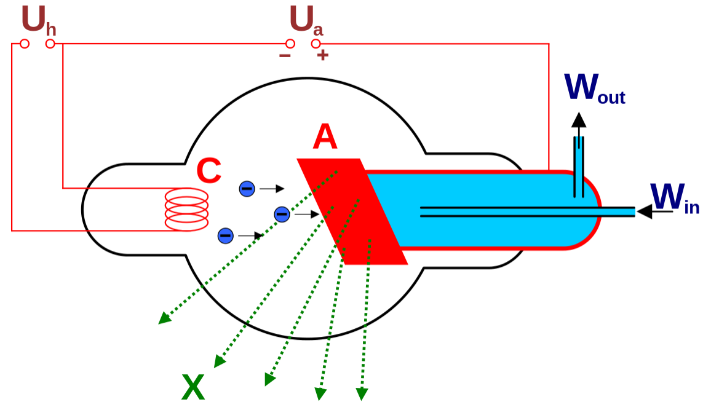
Figure 7.5 X-ray tube
First, a metallic piece called a “cathode” C is subjected to a voltage in order to generate an electric current. This current heats the cathode and thus excites its electrons until ionization occurs leading to electrons escaping, a process termed “thermionic emission”. The second step consists of inducing the emitted electrons to move at a rapid speed by applying a very high voltage between the cathode (negatively charged) and another metallic plate, called an “anode”, A (positively charged); this will force the electrons to quickly accelerate until hitting the anode, causing a sudden deceleration leading to the emission of X-rays. The metallic anode is cooled continuously by water flows that enter and exit the cooling region of the anode. The intensity of the X-rays is increased by increasing the number of electrons and hence the electric current on the cathode. The X-ray’s energy is increased by increasing the acceleration of the electrons and hence the high voltage applied to the electrons once emitted.
Despite being invisible, X-rays can penetrate the human body. This property has been used to benefit medical science through the invention of devices used to scan internal organs of the human body to detect illness and injury.
Application 7.1. Calculate the rate of photons emitted by a 70 W power lamp if the wavelength of the emitted light is 575 nm. If each emitted photon then hits the surface of a cadmium plate (Φ = 4.8 eV) check the occurrence of the photoelectric effect.
Solution 7.1. The total energy is equal to the single energy times the number of photons: $E_{total}=N⋅E_{phot}=N⋅h⋅\frac{c}{λ}$. Dividing both members by the duration t, one gets the total power on the left side and the rate of photons on the right side:
$$P_{total}=\dot{N}⋅h⋅\frac{c}{λ}⇒\dot{N}=\frac{70⋅575⋅{10}^{-9}}{6.63⋅3⋅{10}^{-26}}=2.024⋅{10}^{20} photons/s$$
The energy carried by one photon is: $E_{phot}=6.63⋅{10}^{-34}⋅\frac{3⋅{10}^{8}}{575⋅{10}^{-9}}=3.46⋅{10}^{-19 }J$
This energy in eV is $\frac{3.46}{1.6}=2.1625 eV<Φ$ hence there is no photoelectric effect.
Application 7.2. The red light of the Balmer series is generated when a hydrogen’s electron falls from level 3 to 2, calculate the frequency of this wave.
Solution 7.2. Apply Rydberg’s formula:

$\frac{1}{λ}=\frac{3.282⋅{10}^{15}⋅1^{2}}{c}\left(\frac{1}{4}-\frac{1}{9}\right)⇒f=\frac{c}{λ}=455.83 THz$

Self-check questions

- Choose the correct answer
The cutoff wavelength to excite an electron of cadmium (Φ = 4.8 eV) is:
443 nm 259 nm 392 nm 288 nm

Details: The cutoff frequency is: $f_{0}=\frac{c}{λ_{0}}=\frac{Φ}{h}⇒λ_{0}=\frac{6.63⋅{10}^{-34}⋅3⋅{10}^{8}}{4.8⋅1.6⋅{10}^{-19}}=259 nm$
- Answer by true or false and justify your answer
The ionization energy of a hydrogen-like atom (Z = 3) from its ground level measures 54.4 eV. False, since $E_{ion}=13.6⋅3^{2}⋅\left(-\frac{1}{∞}+\frac{1}{1^{2}}\right)=122.4 eV$.

Radioactive Radiation

Radioactivity
In the previous section, the analysis was purely focused on the electron cloud of the atom: the electron’s movement, jump, and fall throughout the energy level, and their interaction with photons. Contrarily, this section deals with reactions of atomic nuclei, namely the unstable nuclei that emit rays to reach a more stable status. The emission of rays from a nucleus, in other words, the “disintegration” of a nucleus, is called “radioactivity”. (Özdin, 2021)
Radioactive reactions lead to the appearance of new elements since the nucleus morphology is changing. Atoms exhibiting an equal number of protons and neutrons are strongly stable and the related elements are not radioactive. In the periodic table, all elements after ${}_{20}^{40}{Ca}$ show different numbers of neutrons and protons. Most of the radioactive elements are those that have at least 1.5 times more neutrons than protons and have an atomic number greater than 83. (Özdin, 2021)
Nevertheless, it should be noted that the isotopes of the elements having Z<20 may be radioactive.
Isotopes: variants of a chemical element having the same atomic number but a different atomic mass. Example: ${}_{17}^{35}{Cl}$ and ${}_{17}^{37}{Cl}$
The emitted radioactive rays are called “radioactive decays”. There are three main radioactive decays: alpha (α), beta (β⁻), and gamma (γ). In addition, a nucleus may disintegrate and emit neutrons, however, this reaction occurs rarely.

Alpha Particles
Alpha particles (${}_{2}^{4}α$) are heavy particles that are twice positively charged, similar to the helium nucleus; they may be denoted by ${}_{2}^{4}{{He}^{++}}$. Their speed is estimated to be 10% of light speed. Their penetration ability is low meaning that a thin metallic sheet can stop their motion.
The original unstable nucleus, called a “parent nucleus”, (${}_{Z}^{A}X$) disintegrates into a “daughter nucleus” (${}_{Z'}^{A'}Y$) by emitting one alpha particle according to the following nuclear equation, where the balance of the atomic number and mass number is always conserved:
 | $${}_{Z}^{A}X→{}_{Z'}^{A'}Y+{}_{2}^{4}α+energy$$  A=A’+4  Z=Z’+2 | (7.7)

In case the daughter nucleus Y is itself unstable, it should be denoted by $Y^{*}$.

Beta Particles
Beta particles (${}_{-1}^{0}β$) are light particles that are negatively charged, similar to an electron; they may be denoted by ${}_{-1}^{0}e$. They are fast radiations being able to penetrate a few millimeters of a metallic sheet. Practically, the emission of a $β^{-}$ particle is equivalent to transmutation of one neutron (${}_{0}^{1}n$) to one proton (${}_{1}^{1}p$) in the nucleus and it never affects the electron cloud. It has been found that the emission of $β^{-}$ is accompanied by the emission of another particle, very light and electrically neutral, denoted by ${}_{0}^{0}{\overline{ν}}$ and called an “antineutrino”, where the word “neutrino” means ‘’the little neutral one’’. (Knight, 2016)
$${}_{0}^{1}n→{}_{1}^{1}p+{}_{-1}^{0}β+{}_{0}^{0}{\overline{ν}}$$
The general nuclear equation of disintegration emitting $β^{-}$ particle is:
 | $${}_{Z}^{A}X→{}_{Z'}^{A'}Y+{}_{-1}^{0}β+energy$$  A=A’  Z=Z’-1 | (7.8)

Inversely, in the nucleus a proton may be converted into an electron by the emission of a $β^{+}$ particle called a positron and denoted by (${}_{+1}^{0}β$) or (${}_{+1}^{0}e$). This emission is also accompanied by the emission of another very light and electrically neutral particle denoted by ${}_{0}^{0}ν$ and called a “neutrino”.
$${}_{1}^{1}p→{}_{0}^{1}n+{}_{+1}^{0}β+{}_{0}^{0}ν$$
This latter reaction could also be obtained by “electron capture”:
$${}_{1}^{1}p+{}_{-1}^{0}e→{}_{0}^{1}n$$

Gamma Rays
Gamma rays (${}_{0}^{0}γ$) are very high-energy electromagnetic radiations, with nearly zero mass, a neutral charge, and an enormous ability of penetration that reaches many centimeters into a lead block. (Özdin, 2021). Gamma rays do not have an ionizing effect, nor are they emitted from an original parent nucleus; indeed, the resulting unstable daughter nucleus emits gamma rays to reach a more stable status.
 | $${}_{Z'}^{A'}{Y^{*}}→{}_{Z'}^{A'}Y+{}_{0}^{0}γ+energy$$ | (7.9)

Neutron Emission
The neutron emission is a rare nuclear reaction, however, its occurrence changes only the mass number, keeping the same atomic number. In other words, neutron emissions (${}_{0}^{1}n$) result in an isotope and do not generate a new element.
 | $${}_{Z}^{A}X→{}_{Z}^{A-1}X+{}_{0}^{1}n+energy$$ | (7.10)

Nuclear Energy
Unlike chemical reactions characterized by conservation of mass, radioactive reactions exhibit a mass deficit compared to the original reactive elements. This mass gap is converted into a huge amount of energy (which is denoted in equations (7.7)-(7.10)). This generated energy, called nuclear energy, is used in nuclear power plants to produce electricity. Petroleum costs are considerably saved by adopting this method of electricity generation and, according to many, using nuclear energy protects the environment from combustion pollution. However, the safe management of nuclear power plants requires special care; any nuclear leakage may be catastrophic for human health. As an example, consider the accident at the Chernobyl nuclear reactor in Ukraine (ex-Soviet Union) in 1986, which caused thousands of cancer deaths over many years. In addition, one must consider the nuclear waste generated from reactions, which needs considerable time to degrade to a non-radioactive state. Hence, nuclear waste disposal presents a real challenge.
Nuclear energy is calculated by Einstein’s formula:
 | $$E=Δm⋅c^{2}$$ | (7.11)

Where: $Δm=\sum{m_{parents}}-\sum{m_{daughters}}-\sum{m_{particles}}$. Each atomic mass is expressed in “units of atomic mass” (u) where: $1 u= \frac{931.5 MeV}{c^{2}}$

Nuclear Half-life
So far, we have only considered natural radioactivity, meaning that nuclei disintegrate on their own without any externally forced processes. Let N₀ be the initial number of radioactive nuclei at t = 0. When disintegrating, this initial number will decrease and become N at any instant t. Rutherford discovered that the emission of this decrement follows an “exponential decay” law given by the following relationship:
 | $$N=N_{0}⋅e^{-t/τ}$$ | (7.12)

τ is called the “lifetime” of the nucleus. This is the time needed to disintegrate 63% of the initial quantity, i.e., at $t=τ, N≈0.37N_{0}$.
However, it is more practical to measure a more remarkable period of disintegration termed the “half-life” $τ_{1/2}$: it is the time needed to decay half of the existing amount (i.e., $N=0.5N_{0}$). Using this in equation (7.12) we have:
$$\frac{1}{2}=e^{-τ_{1/2}/τ}⇒\ln{(\frac{1}{2})}=-\frac{τ_{1/2}}{τ}$$
 | $$τ_{1/2}=τ⋅\ln{2}≈0.693τ$$ | (7.13)

Nuclear Activity
The nuclear activity A of a radioactive sample is the rate of decay, i.e., the number of disintegrations per unit time (Knight, 2016). It is expressed in decays/s (i.e., s⁻¹) or “becquerel” (Bq). Mathematically, it is the absolute value of the first derivative of N(t):
$$A\left(t\right)=\left|\frac{dN}{dt}\right|=\frac{N_{0}}{τ}e^{-t/τ}$$
 | $$A=A_{0}⋅e^{-t/τ}$$ | (7.14)

The initial activity A₀ at t = 0 is calculated by:
 | $$A_{0}=\frac{N_{0}}{τ}$$ | (7.15)

Another unit, the curie (Ci), may also be used for the activity. The conversion to Bq is given by: $1Ci=3.7⋅{10}^{10} Bq$.
Application 7.3. A radioactive nucleus isotope of thorium ${}_{90}^{230}{Th}$ emits one alpha particle. Write the nuclear equation, identify the daughter element Y, and calculate in J the generated energy from this nuclear reaction. Given: m_{TH} = 230.033132 u; m_{Y} = 226.02541 u; m_{He} = 4.0026 u.
Solution 7.3. The nuclear equation is: ${}_{90}^{230}{Th}→{}_{Z'}^{A'}Y+{}_{2}^{4}α$. From equation (7.7):
$A^{'}=230-4=226$; $Z^{'}=90-2=88$. From the periodic table, $Y={}_{88}^{226}{Ra}$, which is the radium element. To calculate the generated nuclear energy, apply equation (7.11):
$$E=\left(230.033132-226.02541-4.0026\right)⋅\frac{931.5}{c^{2}}⋅c^{2}=4.7711 MeV$$
Converting to J: $E=4.7711⋅{10}^{6}⋅1.6⋅{10}^{-19}=7.634⋅{10}^{-13} J=0.7634 pJ$.
Application 7.4. The half-life of polonium ${}_{84}^{209}{Po}$ is 102 years. It decays by emitting one alpha particle. Consider 20 kg of Po. (i) Write the nuclear equation and identify the daughter element Y. (ii) Calculate the total nuclear energy. (iii) Calculate in Ci the activity of Po and its remaining mass after 25 years of decay. Given: m_{Po} = 208.982405 u; m_{Y} = 204.974457 u; m_{He} = 4.0026 u.
Solution 7.4. (i) The nuclear equation is: ${}_{84}^{209}{Po}→{}_{Z'}^{A'}Y+{}_{2}^{4}α$. From equation (7.7):
$A^{'}=209-4=205$; $Z^{'}=84-2=82$. From the periodic table, $Y={}_{82}^{205}{Pb}$, which is the element lead.
          - The number of moles of Po: $n_{0}=\frac{20000}{209}=95.69378 moles$ hence the initial number of Po nuclei is: $N_{0}=95.69378⋅6.02⋅{10}^{23}=576.076⋅{10}^{23} nuclei$
$$E=N_{0}\left(208.982405-204.974457-4.0026\right)⋅\frac{931.5}{c^{2}}⋅c^{2}=2.87⋅{10}^{32} eV$$
Converting to J: $E=2.87⋅{10}^{32}⋅1.6⋅{10}^{-19}=4.592⋅{10}^{13} J=45.92 TJ$.
          - From equation (7.13): $τ=\frac{102}{0.693}=147.186 years$. The initial activity is found from equation (7.15): $A_{0}=\frac{576.076⋅{10}^{23}}{147.186 y⋅\left(365.25 d\right)⋅\left(24 hr\right)⋅(3600 s)}=1.024⋅{10}^{16} Bq=335.202 kCi$. For t = 25 years apply equations (7.14) then (7.12):
$$A=335.202⋅e^{-\frac{25}{147.186}}=282.84 kCi$$
$$N=576.076⋅{10}^{23}⋅e^{-\frac{25}{147.186}}=486.086⋅{10}^{23 }nuclei$$
The number of moles remaining: $n=\frac{486.086⋅{10}^{23}}{6.02⋅{10}^{23}}=80.745 moles$
The mass remaining: $m=209⋅80.745=16.876 kg$

Self-Check Questions
            - Choose the correct answer
The most radioactive carbon isotope is:
${}_{6}^{11}C$ ${}_{6}^{12}C$ ${}_{6}^{14}C$ ${}_{6}^{15}C$

Details: in ${}_{6}^{15}C$ the number of neutrons is 9, higher than the remaining isotopes; in other words, N_{n}/N_{p} = 9/6 = 1.5 is the highest ratio.
            - Complete the following nuclear reactions
$${}_{36}^{87}{Kr→{}_{…..}^{86}{Kr}}+…$$
$${}_{12}^{23}{Mg→{}_{11}^{23}{Na}}+…$$
Details: in the first equation, it is clear that the element is remaining the same, hence it is an isotope, and its atomic number is always Z = 36. This means that the emitted particle has a zero charge and unit mass, and is thus a neutron ${}_{0}^{1}n$.
In the second equation, it is clear that the missing particle has zero mass and one positive charge to complete the 11 of Na and reach the 12 of Mg; it is thus a positron ${}_{+1}^{0}e$.
            - Answer by true or false and justify your answer
If 891 g out of 1 kg of ${}_{55}^{137}{Cs}$ remain after 5 years, the half-life of cesium is 23 years. False since according to equations (7.12) and (7.13), $\ln{0.891}=-\frac{5⋅0.693}{τ_{1/2}}$ this gives $τ_{1/2}=30 years$.

Nuclear Fission and Fusion

Artificial Radioactivity
Unstable nuclei decay naturally. However, stable nuclei may also emit particles and rays, but they need to be bombarded by high-speed particles. This bombardment of stable nuclei is called “artificial radioactivity”.
One example is the stable nucleus of nitrogen ${}_{7}^{14}N$ bombarded by an alpha particle. This nuclear reaction produces a stable oxygen nucleus and emits a proton particle following the equation:
$${}_{7}^{14}N+{}_{2}^{4}{α→{}_{8}^{17}O+{}_{1}^{1}p}$$

Nuclear Fission
‘’The disintegration of a heavier nucleus into lighter nuclei by neutron bombardment is called “nuclear fission” (nuclear division).’’ (Özdin, 2021, p. 71). The fissionable nucleus is called the “fissile”.
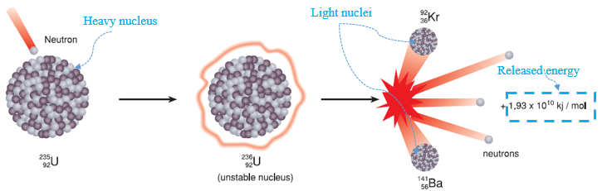
Figure 7.6 Fission reaction of Uranium
The most famous element subjected to nuclear fission is the uranium isotope 92235U, which when bombarded by one neutron generates two lighter nuclei, Kr and Ba, three neutron particles, and an enormous amount of energy as illustrated in the figure above (Özdin, 2021, p. 72). Besides the huge amount of nuclear energy, it is important to note the three neutrons produced by this reaction, which could be used to bombard other uranium nuclei and generate new fission reactions. This process continues as long as available amounts of uranium still exist; for this reason, this process is known as a “chain reaction”. This concept was established by Enrico Fermi in 1942 and constitutes the basis of the atomic bomb. However, a promising aspect of this reaction is the usage of the huge energy released in power plants to produce electricity. Fission of 1 kg of uranium produces 2.5 million times the energy that 1 kg of coal produces.

Nuclear Fusion
‘’The combination of two or more lighter nuclei to form a heavier nucleus is called ‘nuclear fusion’.’’ (Özdin, 2021, p. 74). The most famous nuclear fusion reaction example is the reaction between two hydrogen isotopes, deuterium (${}_{1}^{2}H$) and tritium (${}_{1}^{3}H$) to produce a helium nucleus. This is the basis of the hydrogen bomb.
$${}_{1}^{2}H+{}_{1}^{3}H→{}_{2}^{4}{He}+{}_{0}^{1}n$$
However, the initiation of this reaction requires an amount of energy equivalent to an atomic bomb, since nuclei by nature repel and require a huge amount of energy to merge nuclei. An advantage, however, is that the energy released by fusion reaction is much larger than by fission reaction. A hydrogen bomb releases 1000 times more energy than an atomic bomb. ‘’The energy sources of sun and stars are samples of fusion reactions.’’ (Özdin, 2021, p. 74).
Application 7.5. Calculate the nuclear energy released by a fusion reaction of 1 mole of deuterium and 1 mole of tritium. Given: m_{Deut} = 2.014102 u; m_{Tri} = 3.016049 u; m_{He} = 4.0026 u; m_{n} = 1.008665 u.
Solution 7.5. From equation (7.11):
$E=\left[\left(2.014102+3.016049\right)-\left(4.0026+1.008665\right)\right]⋅N_{A}⋅\frac{931.5}{c^{2}}⋅c^{2}$
$$E=1.06⋅{10}^{31}eV=1.69 TJ$$

Self-Check Questions
- Complete the following sentence
A uranium nucleus (${}_{92}^{235}U$) bombarded by an alpha particle emits one proton and another element having an atomic number Z = 93 and a mass number A = 238.
Details: ${}_{92}^{235}U+{}_{2}^{4}α→{}_{Z}^{A}X+{}_{1}^{1}p$. $Z=\left(92+2\right)-1=93$. $A=\left(235+4\right)-1=238$
- Choose the correct answer
The fusion reaction of two identical deuterium nuclei produces:
Helium and neutron Helium and positron

Helium Helium and gamma
Details: ${}_{1}^{2}H+{}_{1}^{2}H→{}_{2}^{4}{He}$
Summary
An atom is the smallest entity that constitutes a substance while still maintaining its properties. An atom consists of a central entity known as the nucleus and of a cloud surrounding the nucleus. Within this cloud turn continuously around the nucleus negatively charged particles called electrons. The nucleus contains two types of particles: positive charges called protons, and neutral particles called neutrons. An atom is characterized by two numbers: the atomic number (Z) denoting the number of electrons, which is equal to the number of protons, and the mass number (A), denoting the total number of protons and neutrons.
The periodic table contains the symbols along with atomic and mass numbers of all individual elements in nature. Each row constitutes a period that denotes the number of energy levels in the electron cloud. Each column constitutes a group that denotes the number of electrons occupying the last energy level.
Besides the wave theory of light, another theory considers light as a group of particles named photons, each carrying an amount of energy. Light energy is hence quantized. When an electron falls or jumps from one energy level to another, it emits or absorbs, respectively, light photons. This is the photoelectric effect. The work function is the energy needed for an electron to jump to a more excited energy level. If the photon energy exceeds the work function, the electron develops kinetic energy to escape outside the material.
Radioactivity is the disintegration of an unstable nucleus that emits particles and rays creating a new stable nucleus. This is accompanied by the release of huge amounts of energy. This nuclear reaction can be natural or artificial. Artificial radioactivity may consist of either fission, in which a heavy nucleus bombarded with a neutron produces lighter nuclei, or fusion, in which many light nuclei merge leading to a heavier one.

Appendix 1 – References
Alphabetical order
AlfvanBeem. (2009). 3 Hitachi cranes lifting pipe [Illustration]. Wikimedia Commons. https://commons.wikimedia.org/wiki/File:3_Hitachi_cranes_lifting_pipe_(owner_Volker_Stevin).JPG
Amos, E. (2018). Electronic axial lead resistors array [Illustration]. Wikimedia Commons.
https://commons.wikimedia.org/wiki/File:Electronic-Axial-Lead-Resistors-Array.jpg
Andreyanov. (2011). Window air conditioner [Illustration]. Wikimedia Commons. https://commons.wikimedia.org/wiki/File:Window_air_conditioner.jpg
Beer, F. J. (2012). Vector Mechanics for Engineers. Statics. New York: McGraw Hill.
BenFrantzDale. (2010). Field Curvature [Illustration]. Wikimedia Commons.
https://en.wikipedia.org/wiki/File:Field_curvature.svg

BOO109. (2020). Water heater [Illustration]. Wikimedia Commons.
https://commons.wikimedia.org/wiki/File:Ariston_Water_heater.jpg
Britannica, T. E. (2022, April 9). Luminous Intensity. Retrieved from Encyclopedia Britannica: https://www.britannica.com/science/luminous-intensity
BruceBlaus. (2015). Astigmatism [Illustration]. Wikimedia Commons.
https://en.wikipedia.org/wiki/File:Astigmatism_(Eye).png
Caronna Heinz, S. (2008). Kreuzschlüssel [Illustration]. Wikimedia Commons. https://commons.wikimedia.org/wiki/File:Kreuzschl%C3%BCssel.jpg
Cjp24. (2014). Digital multimeter (model Voltcraft 401) [Illustration]. Wikimedia Commons.
https://commons.wikimedia.org/wiki/File:Digital_multimeter.jpg
Cmglee. (2020). Comparison of an ideal image with axial and lateral chromatic aberration [Illustration]. Wikimedia Commons.
https://en.wikipedia.org/wiki/File:Comparison_axial_lateral_chromatic_aberration.svg
Czar. (2006). Grill Pan [Illustration]. Wikimedia Commons. https://commons.wikimedia.org/wiki/File:Grillpanna.jpg
Davidbrim. (n.d.). Tomcar TM5 Rear Suspension System [Illustration]. Wikimedia Commons. https://commons.wikimedia.org/wiki/File:Tomcar_Suspension.jpg

Duque, C. (2020). Kid sitting in swing [Illustration]. Pexels. https://www.pexels.com/photo/kid-sitting-in-swing-3656322/

Fabian, R. (2006). Types of caapcitor [Illustration]. Wikimedia commons. https://commons.wikimedia.org/wiki/File:Verschiedene_Kondensatoren_2.JPG

Fergus, M. (2004). CSIRO Science Image 435 Scientist using microscope [Illustration]. Wikimedia commons. https://commons.wikimedia.org/wiki/File:CSIRO_ScienceImage_435_Scientist_using_microscope.jpg
Foresman, P.S. (2007). Block and tackle system [Illustration]. Wikimedia Commons. https://commons.wikimedia.org/wiki/File:Block_and_tackle_(PSF).png
Grlx. (2018). Lens-Coma [Illustration]. Wikimedia Commons.
https://en.wikipedia.org/wiki/File:Lens-coma.svg
Gross, D. (2013). Engineering Mechanics I. Statics. Dordrecht: Springer.
Gross, D. (2018). Engineering Mechanics 2. Mechanics of Materials. Berlin: Springer.
Helmenstine, A. (2021, November 30). What is Entropy? Definition and Examples. Retrieved from Science Notes: https://sciencenotes.org/what-is-entropy-definition-and-examples/
Hibbeler, R. (2010). Engineering Mechanics. Statics. New Jersey: Prentice Hall.
Hibbeler, R. (2011). Mechanics of Materials. New Jersey: Prentice Hall.
Hibbeler, R. (2016). Engineering Mechanics. Dynamics. New Jersey: Prentice Hall.
HMilch. (2010). X-ray tube [Illustration]. Wikimedia Commons.
https://commons.wikimedia.org/wiki/File:WaterCooledXrayTube.svg
Inductiveload. (2006). A diagram showing n resistors in parallel [Illustration]. Wikimedia Commons.
https://commons.wikimedia.org/wiki/File:Resistors_in_Parallel.svg
Inductiveload. (2006). A diagram to show n resistors in series [Illustration]. Wikimedia Commons.
https://commons.wikimedia.org/wiki/File:Resistors_in_Series.svg
KdYpUvMgT. (2008). Illustration of the right-hand rule for the cross product [Illustration]. Wikimedia Commons. https://commons.wikimedia.org/wiki/File:Right_hand_rule_cross_product.svg
Knight, R. (2016). Physics for scientists and engineers : a strategic approach with modern. London: Pearson Education.
Kraaiennest. (2008). Potential flow around a circular cylinder [Illustration]. Wikimedia Commons.
https://commons.wikimedia.org/wiki/File:Potential_cylinder.svg
Krishnavedala. (2012). Diagram showing wave characteristics [Illustration]. Wikimedia Commons.
https://commons.wikimedia.org/wiki/File:Wave_characteristics.svg
Mack, B. (2020). Girl opening door of wooden house near tree [Ilustration].Pexels. https://www.pexels.com/photo/girl-opening-door-of-wooden-house-near-tree-5707671/
Mglg. (2006). Conceptual ray diagrams of ideal and spherically aberrated lenses [Illustration]. Wikimedia Commons.
https://en.wikipedia.org/wiki/File:Spherical_aberration_2.svg
MikeRun. (2019). Comparison between laminar and turbulent flow of water jet [Illustration]. Wikimedia Commons.
https://commons.wikimedia.org/wiki/File:Compariosn-laminar-turbulent-flow.jpg
MikeRun. (2020). Electric circuit consisting of three resistors in series and parallel [Illustration]. Wikimedia Commons.
https://commons.wikimedia.org/wiki/File:Three-resistors-in-series_and-parallel.svg
MikeRun. (2021). Hydrogen atom electron jump examples [Illustration]. Wikimedia Commons.
https://commons.wikimedia.org/wiki/File:Hydrogen-atom-electron-jump-examples.svg
Monstera. (2020). Book with white hard cover on table [Illustration]. Pexels. https://www.pexels.com/photo/book-with-white-hard-cover-on-table-6373305/
Moran, M. S. (2018). Principles of Engineering Thermodynamics. New Jersey: Wiley.
Nicoguaro. (2011). Image distortion due to a lens [Illustration]. Wikimedia Commons.
https://commons.wikimedia.org/wiki/File:Lens_distorsion.svg
Nightscream. (2013). Sports Challenge by Luigi Novi [Illustration]. Wikimedia Commons. https://commons.wikimedia.org/wiki/File:5.30.13SportsChallengeByLuigiNovi30.jpg
NOAA. (2016). Diagram showing parts of a water wave [Illustration]. Wikimedia Commons.
https://commons.wikimedia.org/wiki/File:Water_wave_diagram.jpg
Ohanian, H. M. (2007). Physics for Engineers and Scientists. New York: W.W. Norton.
Özdin, N. Ö. (2021). The History of the atom, the periodic table and radioactivity. Izmir: Zambak.
Pngkey. (2019). Mini Clip Art [Illustration]. Wikimedia Commons. https://commons.wikimedia.org/wiki/File:Mini_Clip_Art.png
Rao, S. (2011). Mechanical Vibrations. Upper Saddle River: Prentice Hall.
Ross, J. (2007). "Red Barns Spectacular" car show at the Gilmore Car Museum, Hickory Corners, Michigan [Illustration]. Wikimedia Commons. https://commons.m.wikimedia.org/wiki/File:Mid_50%27s_GMC_pickup_pulling_1930%27s_house_trailer_(1144507758).jpg
Rwendland. (2011). Expansion joint, Hayle [Illustration]. Wikimedia Commons.
https://commons.wikimedia.org/wiki/File:Expansion_joint,_Hayle.jpg
Schwarz, B. (2010). Isar nuclear power plant at night [Illustration]. Wikimedia commons. https://commons.wikimedia.org/wiki/File:Nuclear_power_plant_Isar_at_night.jpg
Sheikh_Tuhin. (2010). A green family car [Illustration]. Wikimedia Commons. https://commons.wikimedia.org/wiki/File:Sedan-car.svg
S.J. de Waard. (2009). Cut-away version of an electric motor [Illustration]. Wikimedia Commons. https://commons.wikimedia.org/wiki/File:Cut-away_version_of_an_electric_motor_(1).JPG
Sonarpulse. (2009). Silhouette of a car [Illustration]. Wikimedia Commons. https://commons.wikimedia.org/wiki/File:Car.svg
Stein-Visibone, B. (2007). Earth's longwave (infrared) radiation from clouds, atmosphere, and ground [Illustration]. Wikimedia Commons. https://commons.wikimedia.org/wiki/File:Erbe.gif
Uiki TFPR. (2019). Propagation of sound wave [Illustration]. Wikimedia Commons.
https://commons.wikimedia.org/wiki/File:Representa%C3%A7%C3%A3o_da_Onda_Sonora.png
VideoPlasty. (2018). Patient Care Cartoon [Illustration]. Wikimedia Commons. https://commons.wikimedia.org/wiki/File:Patient_Care_Cartoon.svg
Walker, J. H. (2014). Principles of Physics. Singapore: Wiley.

Appendix 2 – List of Tables and Figures
Figure 1.1 Pipe lifted by three cranes
Source: AlfvanBeem (2009). CC0 1.0.
--------------------------------------------------------------------------------------
Figure 1.2 Air Conditioner in an appartment
Source: Andreyanov (2011). CC BY-SA 3.0.
--------------------------------------------------------------------------------------
Figure 1.3 Quarter section of an electric motor
Source: S.J. de Waard (2009).CC BY-SA 2.5.
--------------------------------------------------------------------------------------
Figure 1.4 Car suspension
Source: Davidbrim (n.d.). Public Domain.
--------------------------------------------------------------------------------------
Figure 1.5 Scientist using a microscope
Source: Fergus (2004).CC BY-SA 3.0.
--------------------------------------------------------------------------------------
Figure 1.6 Nuclear power plant feeding Isar in Bavaria with electricity
Source: Schwarz (2010).CC BY-SA 2.0.
--------------------------------------------------------------------------------------
Table 1.1 Units Prefixes
Source: Challita (2022).
--------------------------------------------------------------------------------------
Figure 2.1 House-trailer connected to a truck
Source: Ross (2007). CC BY-SA 2.0.
--------------------------------------------------------------------------------------
Figure 2.2 Automobile in motion under traction force
Sonarpulse (2009). CC BY-SA 3.0.
--------------------------------------------------------------------------------------
Figure 2.3 Book resting on a table
Source: Monstera (2020). CC0.
--------------------------------------------------------------------------------------
Figure 2.4 Tensile force in cable for crate lifting (a), Vector representation of this force (b)
Source: Foresman (2007).Public Domain; Challita (2022).
--------------------------------------------------------------------------------------
Figure 2.5 External forces applied on the system table-book (a), Internal forces between table and book
Source: Challita (2022).
--------------------------------------------------------------------------------------
Figure 2.6 Weights as concentrated forces (a), as distrubted forces (b)
VideoPlasty (2018). CC BY-SA 4.0.
--------------------------------------------------------------------------------------
Figure 2.7 Parallelogram law for resultant determination
Source: Challita (2022).
--------------------------------------------------------------------------------------
Figure 2.8 Scalar components and direction angles of a force in 3D (a), 2D (b)
Source: Challita (2022).
--------------------------------------------------------------------------------------
Figure 2.9 Couple for nut unscrewing
Source: Caronna (2008). CC BY-SA 3.0.
--------------------------------------------------------------------------------------
Figure 2.10 Moment of an a force to open a door about its hinge
Source: Mack (2020).CC0.
--------------------------------------------------------------------------------------
Figure 2.11 Right-hand rule for vector moment
KdYpUvMgT (2008). CC BY-SA 3.0.
--------------------------------------------------------------------------------------
Figure 2.12 Prallel concentrated forces (a), Parallel distributed forces (b)
Source: Challita (2022).
--------------------------------------------------------------------------------------
Figure 2.13 Member supported by a cable (a), Reaction of a cable (b)
Source: Challita (2022).
--------------------------------------------------------------------------------------
Figure 2.14 Member supported by a smooth plane (a), Reaction of a smooth plane (b)
Source: Challita (2022).
--------------------------------------------------------------------------------------
Figure 2.15 Member supported by a roller (a), Reaction of a roller (b)
Source: Challita (2022).
--------------------------------------------------------------------------------------
Figure 2.16 Member supported by a pin (a), Reactions of a pin (b)
Source: Challita (2022).
--------------------------------------------------------------------------------------
Figure 2.17 Fixed supported member (cantilever) (a), reactions of a fixed support (b)
Source: Challita (2022).
--------------------------------------------------------------------------------------
Figure 2.18 Particle held by two cables
Source: Challita (2022).
--------------------------------------------------------------------------------------
Figure 2.19 FBD solution of application 2.1
Source: Challita (2022).
--------------------------------------------------------------------------------------
Figure 2.20 Solid plate supported by a hinge and a cable
Source: Challita (2022).
--------------------------------------------------------------------------------------
Figure 2.21 FBD solution of application 2.2
Source: Challita (2022).
--------------------------------------------------------------------------------------
Figure 2.22 Coordinate axis (a), Position (b), Displacement (c), Velocity (d), Acceleration (e), Deceleration (f)
Source: Challita (2022), Based on (Walker, 2014)
--------------------------------------------------------------------------------------
Figure 2.23 Position vector (a), Velocity vector (b), Acceleration vector (c)
Source: Hibbeler (2016).
--------------------------------------------------------------------------------------
Figure 2.24 Curvilinear position (a), Radius of curvature (b), Velocity (c), Acceleration (d)
Source: Hibbeler (2016).
--------------------------------------------------------------------------------------
Figure 2.25 Analysis scheme of a projectile (a), Projectile example (b)
Source: Hibbeler (2016), Nightscream (2013). CC BY-SA 3.0.
--------------------------------------------------------------------------------------
Figure 2.26 Accelerated particle under a resultant force
Source: Challita (2022).
--------------------------------------------------------------------------------------
Figure 2.27 Moment of inertia about an axis (a), about an axis parallel to the central axis (b)
Source: Challita (2022).
--------------------------------------------------------------------------------------
Table 2.1 Mass Moment of Inertia of regular bodies
Source: Challita (2022).
--------------------------------------------------------------------------------------
Figure 2.28 FBD of a rigid body in motion (a), Equivalent Kinetic Diagram (b)
Source: Challita (2022).
--------------------------------------------------------------------------------------
Figure 2.29 Work of a force: physical aspect (a), Graphical aspect (b)
Source: Hibbeler (2016).
--------------------------------------------------------------------------------------
Figure 2.30 Work of a force developed in an elastic spring
Source: Hibbeler (2016).
--------------------------------------------------------------------------------------
Figure 2.31 General motion of a body (a), Rotation about a fixed axis (b)
Source: Challita (2022).
--------------------------------------------------------------------------------------
Figure 2.32 Potential energy of the weight
Source: Hibbeler (2016).
--------------------------------------------------------------------------------------
Figure 2.33 Elastic potential energy
Source: Hibbeler (2016).
--------------------------------------------------------------------------------------
Figure 2.34 Angular Momentum about z-axis
Source: Hibbeler (2016).
--------------------------------------------------------------------------------------
Figure 2.35 Kinematics of a moving body (a), Body Momentum Diagram (b)
Source: Hibbeler (2016).
--------------------------------------------------------------------------------------
Figure 2.36 Impact initial and final velocities
Source: Challita (2022).
--------------------------------------------------------------------------------------
Figure 2.37 Impulse and momentum diagrams during impact
Source: Challita (2022).
--------------------------------------------------------------------------------------
Figure 2.38 Impact between two cars
Source: Sheikh_Tuhin (2010).CC0 1.0, Pngkey (2019).CC0 1.0
--------------------------------------------------------------------------------------
Figure 2.39 Baby on a swing
Source: Duque (2020). Public Domain
--------------------------------------------------------------------------------------
Figure 2.40 Pendulum idealization of the system Kid + Swing
Source: Challita (2022).
--------------------------------------------------------------------------------------
Figure 2.41 Cross section (a), Normal stress (b), Internal axial force (c), Oblique section (d), Normal and shear stresses (e)
Source: Challita (2022).
--------------------------------------------------------------------------------------
Figure 2.42 Bar before and after deformation
Source: Challita (2022).
--------------------------------------------------------------------------------------
Figure 2.43 Uniform normal strain
Source: Challita (2022).
--------------------------------------------------------------------------------------
Figure 2.44 Shear distortion
Source: Challita (2022).
--------------------------------------------------------------------------------------
Figure 2.45 Stress-Strain curve of a ductile material
Source: Gross (2018).
--------------------------------------------------------------------------------------
Fig. 2.46 Axial and Transverse Strains
Source?
Figure 2.47 Pressure of a fluid (a), Pressure measurement (b)
Source: Knight (2016).
--------------------------------------------------------------------------------------
Figure 2.48 Variation of atmospheric pressure with the height
Source: Knight (2016).
--------------------------------------------------------------------------------------
Figure 2.49 Barometer experiment
Source: Knight (2016).
--------------------------------------------------------------------------------------
Figure 2.50 Meaurement of gage pressure by a manometer
Source: Walker (2014).
--------------------------------------------------------------------------------------
Figure 2.51 Hydraulic lifter
Source: Walker (2014).
--------------------------------------------------------------------------------------
Figure 2.52 Principle of buoyant force (a), Forces on a stone in a liquid (b), Foces on wood in a liquid (c)
Source: Walker (2014).
--------------------------------------------------------------------------------------
Figure 2.53 Laminar and turbulent flow of water (a), Ideal fluid streamlines (b)
Source: MikeRun (2019). CC BY-SA 4.0, Kraaiennest (2008). CC BY-SA 3.0
--------------------------------------------------------------------------------------
Figure 2.54 Liquid flow through a variable cross-section pipe
Source: Knight (2016).
--------------------------------------------------------------------------------------
Figure 2.55 Dynamic flow of a fluid in an interval of time Δt
Source: Walker (2014).
--------------------------------------------------------------------------------------
Figure 2.56 Water leakage
Source: Walker (2014).
--------------------------------------------------------------------------------------
Figure 3.1 Thermometer measuring water's temperature (a), Temperature scales (b)
Source: Knight (2016).
--------------------------------------------------------------------------------------
Figure 3.2 Joint expansion on a railway
Source: Rwendland (2011). CC BY-SA 3.0.
--------------------------------------------------------------------------------------
Figure 3.3 Heat exchange scenarios: heat loss (a), thermal equilibrium (b), heat gain (c)
Source: Knight (2016).
--------------------------------------------------------------------------------------
Figure 3.4 Energy diagram of a system
Source: Challita (2016).
--------------------------------------------------------------------------------------
Figure 3.5 Gas within a cylinder-piston chamber: equilibrium (a), piston motion (b)
Source: Knight (2016).
--------------------------------------------------------------------------------------
Figure 3.6 p-V diagram for expansion (a), compression (b)
Source: Knight (2016).
--------------------------------------------------------------------------------------
Figure 3.7 Special p-V diagrams cases: isochoric (a), isobaric (b), isothermal (c)
Source: Knight (2016).
--------------------------------------------------------------------------------------
Figure 3.8 Concept of heat engine operation
Source: Walker (2014).
--------------------------------------------------------------------------------------
Figure 3.9 Carnot cycle in p-V diagram (a), T-S diagram (b)
Source: Challita (2022).
--------------------------------------------------------------------------------------
Figure 3.10 Diagram of adiabatic expansion of ideal gases
Source: Walker (2014).
--------------------------------------------------------------------------------------
Figure 3.11 Conduction of heat
Source: Knight (2016).
--------------------------------------------------------------------------------------
Figure 3.12 Pan heated by conduction
Source: Czar (2006). CC BY-SA 3.0.
--------------------------------------------------------------------------------------
Figure 3.13 Distribution of Earth thermal radiation (NASA)
Source: Stein-Visibone (2007). Public Domain.
--------------------------------------------------------------------------------------
Figure 3.14 Heat conduction through double-glass window
Source: Challita (2022).
--------------------------------------------------------------------------------------
Figure 4.1 Electric force, attractive (a), Repulsive (b)
Source: Ohanian (2007).
--------------------------------------------------------------------------------------
Figure 4.2 Vector representation of an electrostatic field
Source: Ohanian (2007).
--------------------------------------------------------------------------------------
Figure 4.3 Dipole electric field lines (a), Dipole moment (b)
Source: Walker (2014).
--------------------------------------------------------------------------------------
Figure 4.4 Electric field through a Gaussian surface involving, a charge +q (a), +2q (b)
Source: Walker (2014).
--------------------------------------------------------------------------------------
Figure 4.5 Charged particles arrangement (a), FBD of particle A (b)
Source: Challita (2022).
--------------------------------------------------------------------------------------
Figure 4.6 Electrostatic field vectors at P1 and P2
Source: Challita (2022).
--------------------------------------------------------------------------------------
Figure 4.7 Work of an electric field (a), Energy switch on a positive charge (b), negative charge (c)
Source: Knight (2016).
--------------------------------------------------------------------------------------
Figure 4.8 Speed of a charged particle within a potential field
Source: Knight (2016).
--------------------------------------------------------------------------------------
Figure 4.9 Different types of capacitors
Source: Fabian (2006). CC BY-SA 3.0.
--------------------------------------------------------------------------------------
Figure 4.10 Capacitors in paralle (a), in series (b)
Source: Knight (2016).
--------------------------------------------------------------------------------------
Figure 4.11 Conventional sense of the electric current (a), Real flow sense of electrons (b)
Source: Ohanian (2007).
--------------------------------------------------------------------------------------
Figure 4.12 Resistors with different resistance values upon color-codes
Source: Amos (2018). Public Domain.
--------------------------------------------------------------------------------------
Figure 4.13 Water bathroom electric heater
Source: BOO109 (2020). CC BY-SA 4.0.
--------------------------------------------------------------------------------------
Figure 4.14 Resistors in parallel (a), in series (b)
Source: Inductiveload (2006). Public Domain.
--------------------------------------------------------------------------------------
Figure 4.15 Charged particles on a square's vertices
Source: Challita (2022).
--------------------------------------------------------------------------------------
Figure 4.16 Compound arrangement of resistors
Source: MikeRun (2020). CC BY-SA 4.0.
--------------------------------------------------------------------------------------
Figure 4.17 Main electric components used in circuits and their symbols
Source: Knight (2016).
--------------------------------------------------------------------------------------
Figure 4.18 Junction law (a), Loop law (b)
Source: Knight (2016).
--------------------------------------------------------------------------------------
Figure 4.19 Current sense and voltage signs
Source: Knight (2016).
--------------------------------------------------------------------------------------
Figure 4.20 Capacitor discharge, at t=0 (a), at any instant (b), Capacitor charging (c)
Source: Knight (2016).
--------------------------------------------------------------------------------------
Figure 4.21 Multimeter
Source: Cjp24 (2014). CC BY-SA 3.0.
--------------------------------------------------------------------------------------
Figure 4.22 Network resistors circuit
Source: Challita (2022).
--------------------------------------------------------------------------------------
Figure 4.23 Scheme of resistors reduction
Source: Challita (2022).
--------------------------------------------------------------------------------------
Figure 4.24 Charging a capacitor
Source: Challita (2022).
--------------------------------------------------------------------------------------
Figure 4.25 magnetic effect of an electric current (a), magnetic field lines (b)
Source: Ohanian (2007).
--------------------------------------------------------------------------------------
Figure 4.26 Current travelling in a solenoid's coils (a), Magnetic field in a solenoid (b)
Source: Ohanian (2007).
--------------------------------------------------------------------------------------
Figure 4.27 Generation of induced emf
Source: Ohanian (2007).
--------------------------------------------------------------------------------------
Figure 4.28 Magnetic flux change by: moving loop (a), changing loop's size (b), rotating loop (c), changing magnetic field strength (d)
Source: Ohanian (2007).
--------------------------------------------------------------------------------------
Figure 4.29 Sense of the induced electric current
Source: Ohanian (2007).
--------------------------------------------------------------------------------------
Figure 4.30 Mutual induction (a), Transformer (b)
Source: Ohanian (2007).
--------------------------------------------------------------------------------------
Figure 4.31 RL circuit with emf source (a), RL circuit after emf source removal (b)
Source: Ohanian (2007).
--------------------------------------------------------------------------------------
Figure 4.32 Wire held by a cable in a magnetic field (a), FBD after current flow (b)
Source: Challita (2022).
--------------------------------------------------------------------------------------
Figure 4.33 Graphical representation of alternating emf (a), Phasor (b)
Source: Knight (2016).
--------------------------------------------------------------------------------------
Figure 4.34 AC circuit involving a resistor (a), a capacitor (b), an inductor (c)
Source: Knight (2016).
--------------------------------------------------------------------------------------
Figure 4.35 RLC circuit (a), Phasor of the current (b), Phasor of voltages at R, L and C (c), Resultant voltage (d)
Source: Knight (2016).
--------------------------------------------------------------------------------------
Figure 5.1 Undamped system status: static (a), dynamic (b); Damped system: dynamic (c), FBD (d)
Source: Rao (2011).
--------------------------------------------------------------------------------------
Figure 5.2 Undamped response (a), Damped responses (b)
Source: Rao (2011).
--------------------------------------------------------------------------------------
Figure 5.3 Free oscillations graphical representation
Source: Challita (2022).
--------------------------------------------------------------------------------------
Figure 5.4 Slender bar pendulum: system (a), FBD (b)
Source: Challita (2022).
--------------------------------------------------------------------------------------
Figure 5.5 Sea water transverse wave
Source: NOAA (2016). Public Domain.
--------------------------------------------------------------------------------------
Figure 5.6 Longitudinal sound wave
Source: Uiki TFPR (2019). CC BY-SA 4.0.
--------------------------------------------------------------------------------------
Figure 5.7 Snapshot of a transverse wave at a known instant
Source: Krishnavedala (2012). CC0 1.0.
--------------------------------------------------------------------------------------
Figure 5.8 Wave propagating at a velocity v
Source: Walker (2014).
--------------------------------------------------------------------------------------
Figure 5.9 Fixed source, moving detector (a), Moving source, fixed detector (b)
Source: Walker (2014).
--------------------------------------------------------------------------------------
Figure 5.10 Phasors of two waves (a), Net wave phasor construction (b)
Source: Walker (2014).
--------------------------------------------------------------------------------------
Figure 5.11 Original waves, in phase (a), out of phase (b), any phase shift (c), net resultant for, in phase waves (d), out of phase waves (e), any phase shift (f)
Source: Walker (2014).
--------------------------------------------------------------------------------------
Figure 6.1 Sketch of a flat mirror with: rays angles (a), virtual image (b)
Source: Ohanian (2007).
--------------------------------------------------------------------------------------
Figure 6.2 Image through a concave mirror (a), Image through a convex mirror (b), Sign convention for mirror equation (c)
Source: Ohanian (2007).
--------------------------------------------------------------------------------------
Figure 6.3 Image construction of an object close to a concave mirror
Source: Challita (2022).
--------------------------------------------------------------------------------------
Figure 6.4 Incident and refracted rays (a), Ray through a parallel faces glass medium (b)
Source: Ohanian (2007).
--------------------------------------------------------------------------------------
Figure 6.5 Image through a convex lens (a), Image through a concave lens (b), Sign convention for lens equation (c)
Source: Ohanian (2007).
--------------------------------------------------------------------------------------
Figure 6.6 Schematic refraction in a prism (a), Coloured light obtained through a prism (b)
Source: Ohanian (2007).
--------------------------------------------------------------------------------------
Figure 6.7 Rock's image in water
Source: Challita (2022).
--------------------------------------------------------------------------------------
Figure 6.8 Normal refraction (a), Spherical aberration (b)
Source: Mglg (2006). Public Domain.
--------------------------------------------------------------------------------------
Figure 6.9 Comatic aberration
Source: Grlx (2018). CC BY-SA 3.0.
--------------------------------------------------------------------------------------
Figure 6.10 Normal view (a), Astigmatism (b)
Source: BruceBlaus (2015). CC BY-SA 4.0.
--------------------------------------------------------------------------------------
Figure 6.11 Curvature of the image field
Source: BenFrantzDale (2010). CC BY-SA 3.0.
--------------------------------------------------------------------------------------
Figure 6.12 Distorted and normal images
Source: Nicoguaro (2011). CC BY-SA 3.0.
--------------------------------------------------------------------------------------
Figure 6.13 Normal, axial and tranverse chromatic aberration
Source: Cmglee (2020). CC BY-SA 4.0.
--------------------------------------------------------------------------------------
Figure 6.14 Young's experimental set-up (a), Path length difference (b)
Source: Walker (2014).
--------------------------------------------------------------------------------------
Figure 6.15 Polarizing filter (a), Polarizing intensity (b)
Source: Knight (2016).
--------------------------------------------------------------------------------------
Figure 7.1 Atomic models: Dalton (a), Thomson (b), Rutherford (c), Bohr (d), Modern (e)
Source: Özdin (2021).
--------------------------------------------------------------------------------------
Figure 7.2 The periodic table of elements
Source: Knight (2016).
--------------------------------------------------------------------------------------
Figure 7.3 Groups of the periodic table (a), Order of orbitals filling (b)
Source: Özdin (2021).
--------------------------------------------------------------------------------------
Figure 7.4 Light emission from electron's jump in Hydrogen atom
Source: MikeRun (2021). CC BY-SA 4.0.
--------------------------------------------------------------------------------------
Figure 7.5 X-ray tube
Source: HMilch (2010). Public Domain.
--------------------------------------------------------------------------------------
Figure 7.6 Fission reaction of Uranium
Source: Özdin (2021).
--------------------------------------------------------------------------------------

