Detailed description of the research program

Making Learning Durable:
Long-term pathways of modeling-based learning about complex systems in science

Scientific Background
Although much attention has been focused on science learning, research on long-term model-based learning using prebuilt or new models is lacking. We propose to investigate the processes of long-term scientific learning. Our approach combines scientific modeling activities and increased conceptual integration of scientific concepts in middle school. To facilitate the study, we will use our computational modeling tool kit that takes advantage of the computational similarity of complex systems in chemistry and physics. Previous studies have examined long-term learning in science, learning about complex systems, and learning by modeling (LbM).
Long-term Studies of Model-based Learning and of Learning in Science
We identified long-term studies in general science education and specific studies regarding student understanding of systems. However, we found no research about long-term model-based learning, in any form of interaction, that explored prebuilt models or constructed new ones.
Long-term projects (up to a year). Elementary student science learning during five months was compared to constructivist and traditional teaching approaches. The first teaching approach resulted in better learning outcomes, increased metacognitive engagement, and the use of information processing strategies (Wu & Tsai, 2005). Eilam and Reiter (2014) explored learning by ninth-grade genetics students over one year and compared two teaching methods, self-regulated learning and teacher-controlled learning. The self-regulated group outperformed the teacher-controlled group. In addition, the self-regulated students gradually became aware of their learning processes and applied appropriate strategies to regulate their learning.
Longer-term research projects (more than one year). Preschool science learning was examined over 1.5 years and related to interactions with their teachers (van der Steen et al., 2019). Higher-scoring children in science learning had more variable and adaptable interactions with their teachers compared to a control group. Novak and Musonda (1991) investigated student concepts in science over 12 years following participation in audio-tutorial science lessons in first or second grade. These students were compared to those who did not participate in this type of learning. The experimental group had more valid concepts and fewer misconceptions than the comparison group. Lofgren & Hellden (2009) researched students for ten years, starting in second grade, when they learned about the particulate nature of matter. However, few of these students continued to use such concepts as they grew older. Bamberger and Tal (2008) investigated the long-term effects of a single science museum visit by interviewing students right after a visit and 16 months later. The students retained details of the experience, appreciated the contribution of the visit to their understanding, and highlighted the social interactions that took place.
The only longitudinal research into understanding complex systems was by Snapir et al. (2017). They explored student concepts of the human body along four-time points in their high-school education, focusing on its systemic character. Snapir et al. used a systems framework named Components-Mechanisms-Phenomena (Hmelo-Silver et al., 2016). They found that students gradually increased their understanding of the three categories, especially at the micro-level for the system and mechanisms.
To summarize, we found that long-term studies in science education are rare. Only one study focused on students’ long-term understanding of complex systems, and none investigated student modeling in science learning.
Learning about Complex Systems
Our proposal seeks to explore and advance systems thinking. This form of reasoning is vital for learning due to the systemic nature of many of the world’s central problems (Wilensky & Papert, 2010; Chen & Stroup, 1993; Jacobson & Wilensky, 2006; Assaraf & Orion, 2005). Complex systems are composed of many interacting elements that self-organize into coherent global patterns (Forrester, 1968, Epstein & Axtell,1996; Holland, 1998; Wolfram, 2002; Strogatz, 2003; Bar-Yam, 2003). The field of complex systems has developed enormously in three decades, contributing to our understanding of a wide range of systemic phenomena across disciplines (Barabasi & Bonabeau, 2003; Nicholis & Prigogine, 1989; Turchin, 2003). The field provides a framework for comprehending and representing the structure and dynamics of complex systems, resulting in higher-order patterns from local behaviors and interactions. For our proposal, we take advantage of this powerful framework as a widely applicable paradigm for interpreting systems.
Multiple biases sway peoples’ reasoning, such as the assumption of central control (Resnick, 1994), confusion among levels (Wilensky & Resnick, 1999), fixation on system structure at the expense of function and mechanism (Hmelo-Silver & Pfeffer, 2004), and a view of causal relations as consecutive chains of causes and effects rather than concurrent interactions (Chi, 2005). Moreover, when the micro- and macro-levels are dissimilar, concepts are difficult to grasp and comprehend (Samon & Levy, 2017). Understanding complex systems addresses these biases and point to the importance of educational support in making sense of systems.
Several innovative learning environments were designed to overcome these biases and understand complex systems, such as constructing and exploring computer models (Blikstein & Wilensky, 2009; Guo et al., 2016; Hashem & Mioduser, 2011, 2013; Levy & Mioduser, 2010; Levy & Wilensky, 2009ab; Louca, Zacharia, Michael & Constantinou, 2011; Sengupta & Wilensky, 2009; Wilensky & Reisman, 2006; Wilensky & Resnick, 1999; Wilkerson-Jerde, Gravel & Macrander, 2015) and participating in role-playing simulations (Colella, 2000; Klopfer et al., 2005; Levy, 2017). Our proposal will support student learning of complex systems by constructing and exploring computer models. We will then study student reasoning from a complexity perspective.
LbM in Science
Computational modeling is a category of computational thinking (Weintrop et al., 2016) that was recently established as central for understanding a worldwide range of practices and domains (Wing, 2006). In recent years, the meaning of computational thinking has evolved from computational problem solving, abstraction, pattern finding, algorithm construction, and decomposition towards a broader view of complex systems beyond computer science. In science education, the STEM and Next Generation Science Standards (NGSS Lead States, 2013) highlight eight core practices, one of which is Mathematics and Computational Thinking (CT). The growing consensus is that CT includes important computation-related competencies applicable in professional and academic settings, such as data science and simulation (Weintrop et al., 2016). This broader definition is more relevant when learning focuses on improving CT and conceptual understanding by computational modeling complex systems. As a result, several studies in educational STEM have addressed the impact of CT on learning within the STEM domains (Basu et al., 2014; Zhang & Biswas, 2019; Guzdial, 2008; Hambrusch et al., 2009; Blikstein and Wilensky, 2009; diSessa 2000; Kaput, 1994; Pei, Weintrop, & Wilensky, 2018). We propose to study the integration of CT into STEM using model construction as a core activity.
Central researchers studying modeling in science education have defined models as “a representation of a phenomenon initially produced for specific purpose” (Gilbert, Boulter & Elmer, 2000). A phenomenon can be simplified by model construction based on its goal or future use and can serve as an explanatory tool (Gobert & Buckley, 2000). There are several approaches to modeling complex systems in science education (Wilensky & Resnick, 1999; Mandinach & Cline, 1994; Assaraf, Dodick, & Tripto, 2013; Eilam & Poyas, 2010; Liu & Hmelo-Silver, 2009). The agent-based modeling approach (ABM) (Bar-Yam, 2003) relies on complexity theory and represents systems through their participating entities, assigning them behaviors and interactions. Simulations permit these entities to act and interact, resulting in an emergent collective pattern arising bottom-up. We propose to utilize ABM to model complex systems because it promotes generativity in science and assists students in relating micro and macro levels (Wilensky & Resnick, 1999; Levy & Wilensky, 2009).

In schools, constructing models is less common than exploring models because building models requires significant early-stage support. Model construction may be discouraged because of the difficulty and time needed to learn and teach programming and the ability of students to represent complex phenomena and reason about them. Constructionist research (Constructionism, 1991; Papert, 1980; Sherin, diSessa & Hammer, 1993; Ackermann, 1996; Kafai, Ching & Marshall, 1997; Kafai, 2006) has demonstrated richly expressive forms for constructing computational models.
The advent of block-based programming circumvents the problem of learning text-based programming (Weintrop & Wilensky, 2017). Block-based programming provides access to younger students in conventional settings due to its visual features. The program resembles a puzzle with blocks that fit and “lock” together. However, block-based programming permits free-form assembly, unlike a puzzle with a single complete picture. The visual nature of the blocks, the graphic symbols, and the immediate scaffolds provided by the platform help students to quickly understand the use of the blocks. Thus, we propose to use a visual block-based programming interface for our studies of LbM in science learning.
An Introduction to the project via the Preliminary Results
To provide a clear background and context to this proposal, we have placed our Preliminary Results before the Objectives and Significance. Moreover, the design of the proposed learning environment and related technology is retained from our previous grant to reduce repetition and improve clarity.
This proposal follows in the footsteps of an ongoing research project now in its last year, “Much.Matter.in.Motion: Learning science through building models of complex systems” (ISF grant #1205/18). We investigated a conceptual framework for learning known as Much.Matter.in.Motion (MMM). Our goal was to integrate CT and modeling practices into learning experiences in middle school science courses while increasing conceptual integration. During the project, our theoretical framework gradually developed into applications to explore the feasibility and contribution of the framework to science learning.
The MMM framework
Our MMM framework focuses on LbM to understand complex systems. This form of learning is powerful because it engages with students’ personal representations, their processes for translating representations into computational objects, and the externalization of these concepts into visual and dynamic representations. This framework results in potent feedback that is dynamic, visual, and immediate. As such, the feedback spurs evaluation, debugging, and revision processes. The social setting of the classroom is an important component because students can present their work informally and formally. Students can share the products of their thoughts and compare, discuss, and possibly revise their models.
Our project LbM is based on constructionist theory that promotes learning by building and sharing personally meaningful objects (Papert, 1980). LbM complex systems have been implemented and researched over years (e.g., Wilensky & Resnick, 1999; Louca, Zacharia, Michael & Constantinou, 2011; Wilkerson-Jerde, Gravel & Macrander, 2015). What makes our MMM framework unique is a combination of two factors. First, it generalizes the computation of systems in chemistry and physics using a small set of elements and principles to construct a wide range of phenomena. Second, MMM allows students to engage in modeling through drawing and construction. This combination simplifies modeling, which enables the creation of more models and increases the accessibility of modeling to teachers and students in science classrooms.

Our MMM framework presents a condensed view of systems based on a complexity perspective but goes beyond this. The framework focuses on chemical and physical systems at the micro level and highlights the similarity of interactions in the different systems. For example, diffusion and heat conduction occur through random motion and collisions, resulting in similar equations. An example from one of our learning units is how the computer code for modeling electrons in electric circuits is the same as gas molecules in a container, except for the addition of a field (Drude’s model of electricity).
The MMM modeling platform
A programming platform was the central component we needed to research the MMM conceptual structure. Our Much.Matter.in.Motion modeling platform (MMM platform) enables computational models of complex systems in chemistry and physics (Levy, Saba & Hel-Or, 2018; Saba, Hel-Or & Levy, 2021; Figure 1). The platform allows students to create computational models by drawing macro-level elements, such as wires and electric fields in an electrical system, and coding micro-level entities, such as electrons and atoms. Programming is done by dragging blocks (on the right side of the screen in Figure 1) that encapsulate code onto a programming board. Well-known programming environments such as Scratch (Resnick et al., 2009) and Alice (Cooper et al., 2000) utilize such block-based coding to circumvent the debugging of textual code, which requires much more support. Student and teacher familiarity with this kind of programming is an additional consideration.
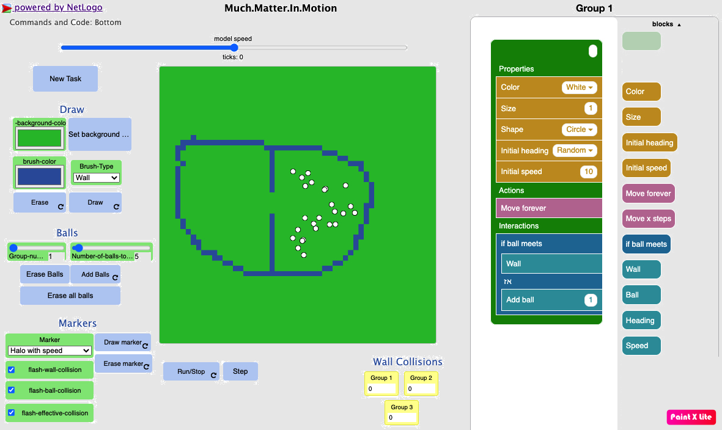
Figure 1: MMM platform screen with a model for exploring gas diffusion. On the left side are the world (green squares), drawing (Draw, Balls), and visualization (Marker) tools and monitors providing numerical information. On the right side is the programming board, where the large green box is filled by dragging colored blocks into one of the three cavities (Properties, Actions, Interactions).
Our MMM platform was designed to highlight (a) a complex systems approach to thinking with agent-based modeling from the micro-level to the group level, and (b) a specific condensed view of physical and chemical systems. The basic entity in the models is a circle named “ball, which represents one micro-level entity. The ball can be an electron, atom, particle, marble, or planet. The code students create operates on the balls independently and guides them to move and interact in particular ways. Each kind of ball, or population in complex systems terms, has its own instructions. To guide student modeling, the coding board is prepared with a pre-existing object that represents a population which is a green shape with three cavities. The cavities encode the population’s properties (i.e., color, size, initial speed), its actions (i.e., moving in a straight line), or its interactions, which are typical of the reasoning in agent-based modeling (Wilensky & Rand, 2015). Interactions can take place between members of the population (electron-electron), with members of another population (electron-atom), with the macro-level objects (electron-conductor wall), or with fields (electrons accelerating along the field vectors). This explicit visual and enactive structure of complex systems is important for helping students generalize from their specific models. This structure simplifies coding choices because each type of code block can populate only one cavity. Thus, each population, such as electrons versus atoms, has its own green programming object.

The MMM platform is based on a model we programmed with NetLogo (Wilensky, 1999) that includes a variety of code applicable to student models, and the NetTango toolkit (Horn, Baker & Wilensky, 2020) that supports the formation of a block-based coding interface. Because the NetTango toolkit is relatively new, we were supported by researchers and programmers at the Center for Connected Learning and Computer-based Modeling at Northwestern, who will also support this proposal (see Wilensky letter of collaboration).
The MMM platform as an investigative tool
We have used MMM for up to four populations of chemical reactions, including reactants and products such as methane combustion CH4 + 2O2 CO2 + 2H2O. Beyond their complexity, the similarity among chemistry and physics systems is seen in the coding blocks. Coding blocks for the properties of balls can be used to develop many models, including size (i.e., mass), initial speed, and heading. Coding blocks for actions are straight-line motions for a limited time or forever, according to Newton’s laws of motion. Coding blocks for interactions are “if-then” statements regarding interactions with other balls (the same or different kind), macro-level walls, or fields. The action part of the statement is a menu that opens with a limited set of choices: nothing, collide, stop, accelerate, decelerate, attract, repel, or attract-repel (Lennard-Jones interactions).

We formed three online digital units on middle school topics in chemistry (structure of matter and gases, chemical reactions) and physics (electricity). Each online unit included presentations with explanations, guides, prompts, challenges, and questions. Content experts advised us on the concepts presented and programmed the units. The duration of each unit was about ten lessons and was co-taught by teachers and researchers. The general scheme of each learning unit included: (1) an introduction through an interesting demonstration or experiment for which students were invited to predict and explain their ideas (one lesson); (2) physical laboratories and demonstrations to provide an array of topics the students could model (two lessons); (3) modeling in pairs and class-wide discussions of student models (six lessons); and (4) class-wide consolidation of the unit (one lesson). Our inclusion of physical experiences was crucial to promoting exchange between the richness and alignment of experience and the parsimonious model representations that encouraged further explorations (Samon & Levy, 2021). Modeling took place in pairs to encourage communication and deliberation of ideas and explanations.
Key results of our existing grant
Our research led to five major conclusions. (1) The MMM framework enhanced conceptual understanding of the science topics compared to normative curricula; (2) The greater understanding corresponded to a deeper comprehension of each system at the micro-level; (3) The transfer of learning was observed; far transfer was impacted independently by CT and the understanding of complexity (Saba et al., under review, b); (4) The conceptual understanding gradually included concepts with higher degrees of integration during modeling; (5) Increased modeling experience was related to greater differences in successive models created in a single session, as students explored different aspects of represented phenomena.
The output of the grant
Thus far, we have presented seven conference papers and submitted five. One published journal article describes the theoretical structure of the design and initial experimental results (Saba, Hel-Or & Levy, 2021). Two additional manuscripts are under review for publication. In one of our papers undergoing a post-revision review (Saba et al.), we report our discovery of a sequence of mental models in electricity that shift from an engineering view to a combined complexity and engineering view of the system, with the two approaches merging for the concept of current. Comparing the pretest and posttest results show a strong shift in the experimental group towards this combined view, which is unique in its integration of functional and causal aspects of the system.
Unanswered questions and new research directions
HERE ------
Research objectives and expected significance

We propose to explore how students develop a sophisticated understanding of scientific systems, modeling, and CT and how this understanding impacts their subsequent learning about new systems in science. We will achieve these goals by engaging students in constructing computational models over a longer term. Our proposal combines two cross-cutting concepts called for in the US science education standards (NGSS, 2013): (1) a complexity perspective for representing diverse chemistry and physics systems, and (2) the practices related to scientific computational modeling.
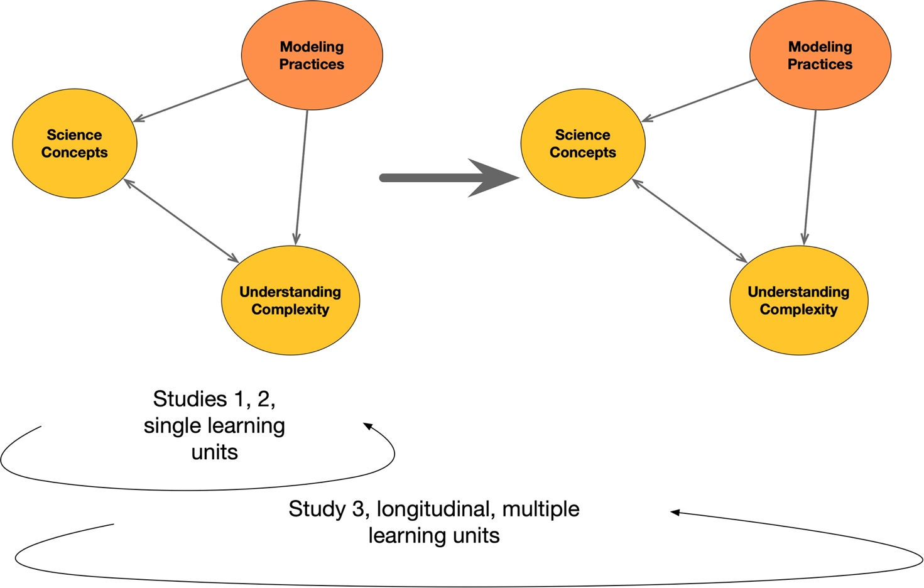
Figure 2: Conceptual framework of the proposed research
Our conceptual framework for the proposed research is described in Figure 2 and includes the key variables and constructs. The main activity students will engage in is modeling. Their modeling practices will be explored and typified for each learning unit and compared across units for changes through extended engagement. We will explore two variables related to student knowledge of science concepts gained through modeling. One variable is the topic of study and its interaction with other systemic topics. The other variable is understanding complex systems. The relationships between these variables are explored within each learning unit. Across six units studied across three years, the changes to each of these variables will be investigated. Furthermore, we will examine the degree to which changes to these variables predict changes in variables in a subsequent unit to define the interrelationships.
The proposal addresses two gaps
Whereas the grant permitted us to establish a systems approach to learning, it could not address the longer-term impacts on science education and knowledge retention, which is critical to gauge the approach’s success. Thus, the first gap is the relative lack of knowledge about the characteristics of long-term learning about complex systems across science topics. Understanding learning over longer terms will enable us to develop supports for learning, generalization, and consolidation to make learning durable. Understanding how modeling of complex systems interacts with science learning over a long term would significantly advance learning about complex systems in science. Research into long-term science learning is scarce in science education. We found one study investigating systems thinking (Snapir et al., 2017) and none about model-based learning. The ISF’s recent change of policy that enables five years of research funding presents a tremendous opportunity to ameliorate this situation and is a significant motivation for forming this research program.
Our proposal builds upon the results and questions discovered in our existing research grant. We will examine not only student systems thinking but their science concepts and modeling practices. The specific learning topic, systems and modeling, presents another unique opportunity. The two constructs are content-general, enabling repeated testing and comparing knowledge over extended periods. The proposal will thus contribute to the study of learning over longer periods in general. Learning through a complex systems approach in Israel is not yet part of normative learning materials. The lack of complex systems teaching is an excellent reason for conducting the research in Israel: the starting point of most of the students will be similar and independent of previous learning. Understanding the long-term effects facilitated by our proposal may support the multi-year design of learning and decisions regarding appropriate frameworks for helping students develop more sophisticated views. More specifically, to the best of our knowledge, classroom learning of complex systems has not been studied for various topics and extended durations, nor has modeling-based learning, so these more specific topics would also be advanced.
The second gap is fragmentation in science learning when each topic is taught separately with few connections across concepts between different phenomena or systems. This fragmentation is related to the lower transfer of learning across science topics (Bybee, 2014). Our proposal continues the development of the Much.Matter.in.Motion conceptual framework to unify the learning of systems in science to identify common principles which have shown promising results, as described in Preliminary Results. Our proposed research advances a unified conceptual framework for learning about systems in chemistry and physics that goes beyond the ongoing project in two ways. It shifts the focus from individual learning units to a more comprehensive approach using this framework across topics and years.
Further, the research will extend the MMM framework to new science topics: liquids and solids, phase change, and the solar system. This extension will permit us to test the applicability of our framework to the full range of chemistry and physics systems learned in middle school science. The proposed research advances the design of new platforms for advancing CT in science education, which can be easily incorporated into science classes, enhancing the learning of science and computation. The significance of our research is in advancing science education by offering simpler and more powerful representations that ease comprehension and engage students in deeper mechanistic reasoning.

Our proposal has two main objectives:
- We will understand long-term classroom-based science learning by modeling complex systems. We will investigate student learning processes, modeling practices, and conceptual learning. This research will lead to an understanding of systems and computational thinking and non-cognitive factors of interest in science. We will also explore self-efficacy during extended science learning related to changes and interactions by constructing complexity-based computational models.
- We will create a unified conceptual framework for model-based learning about systems in science. Through experimentation, we will understand how to design tools and approaches for extended modeling-based learning of science with a complexity perspective, which considers previous and future learning across science topics and age groups.

Detailed description of the proposed research

Working hypotheses
We hypothesize that combining multiple learning units with the MMM approach will result in:
- higher pretest scores in the later units through learning transfer
- higher posttest scores for later units, as more cognitive resources can be allotted to understanding the science concept.
- shorter times until the upward shift in mental models during the learning unit
Research Design and Methods
The project proceeds through four studies, two that use qualitative methods with a small number of students (1 & 4) and two that use quantitative methods with comparisons (2 & 3).
Study 1 - Lab setting learning process of LbM – We will characterize the short-term processes by which middle school students represent and construct models and interact with the programming platform. We will test our research tools by examining student learning about scientific phenomena and complex systems.
Study 2 - Classroom-based learning gains for individual LbM units – We will compare the learning gains by LbM with learning by standard learning materials. We will include a scale-up test in classrooms.
Study 3 - Classroom-based long-term learning gains with multiple LbM units – We will quantify the trajectories of student science and systems learning, modeling, and interactions across a range of systems.
Study 4 - Classroom-based long-term learning process with multiple LbM units – We will characterize the long-term changes in how middle school students use modeling practices to learn science and systems concepts.
Research Variables
Independent Variable
- Learning Environment - Learning by modeling versus standard learning materials, number of LbM units experienced.
Dependent Variables
- Science conceptual understanding - science conceptual understanding of the systems and phenomena modeled in the activities.
- Understanding complex systems - structure of reasoning about system levels, interactions, decentralization, probabilistic behaviors, equilibration processes, and emergence.
- Modeling practices - representing complex phenomena, creating them computationally, debugging, revising, and evaluating models.
- Learning process - time to upward shift in mental model while engaging with a learning unit.
Research Sample
We propose to work with a school in the north of Israel. Long-term research is challenging to organize and deploy, and a good relationship with the school is crucial. We have worked with the intended school in the past and are currently discussing whether and how this research could be implemented. Based on our earlier work, the school adopted complexity as a cross-cutting concept to connect curricula in different courses, creating a more accepting context for conducting the research.
Table 1: Experimental Groups
Exp. Group | Sample Size | Topics of Learning | Learning Environment | Single / Long-term | Participate in Study
1 | 6 | Structure of Matter & Gases | MMM1¹ | Single | 1
2 | 6 | Phases & Transitions | MMM1 | Single | 1
3 | 6 | Electricity | MMM1 | Single | 1
4 | 6 | Energy transfer | MMM1 | Single | 1
5 | 6 | Chemical reactions | MMM1 | Single | 1
6 | 6 | Astronomy | MMM1 | Single | 1
7 | 200 | All topics | MMM2 | Long-term | 3, 4
8 | 60 | Phases & Transitions | MMM2 | Single | 2, 3
9 | 60 | Electricity | MMM2 | Single | 2, 3
10 | 60 | Energy transfer | MMM2 | Single | 2, 3
11 | 60 | Chemical reactions | MMM2 | Single | 2, 3
12 | 60 | Astronomy | MMM2 | Single | 2, 3
13 | 60 | Structure of Matter & Gases | Standard | Single | 2, 3
14 | 60 | Phases & Transitions | Standard | Single | 2, 3
15 | 60 | Electricity | Standard | Single | 2, 3
16 | 60 | Energy transfer | Standard | Single | 2, 3
17 | 60 | Chemical reactions | Standard | Single | 2, 3
¹ MMM1 and MMM2 are initial and improved versions of the experimental learning environment
The total sample size will be about 770 students sub-divided by the independent variable, whether the learning environment includes modeling and prior experience with modeling (Table 1). Fifteen students will be selected from the long-term experiment by random stratified sampling based on gender and the academic ability for interviews and microgentic research. We expect attrition to be high, so the final sample size will probably be 20% smaller. IRB and Education Ministry Head Scientist approval will be obtained, as will the school’s principal and teachers. Parent and student consent will be gained before the studies begin.
Research Design
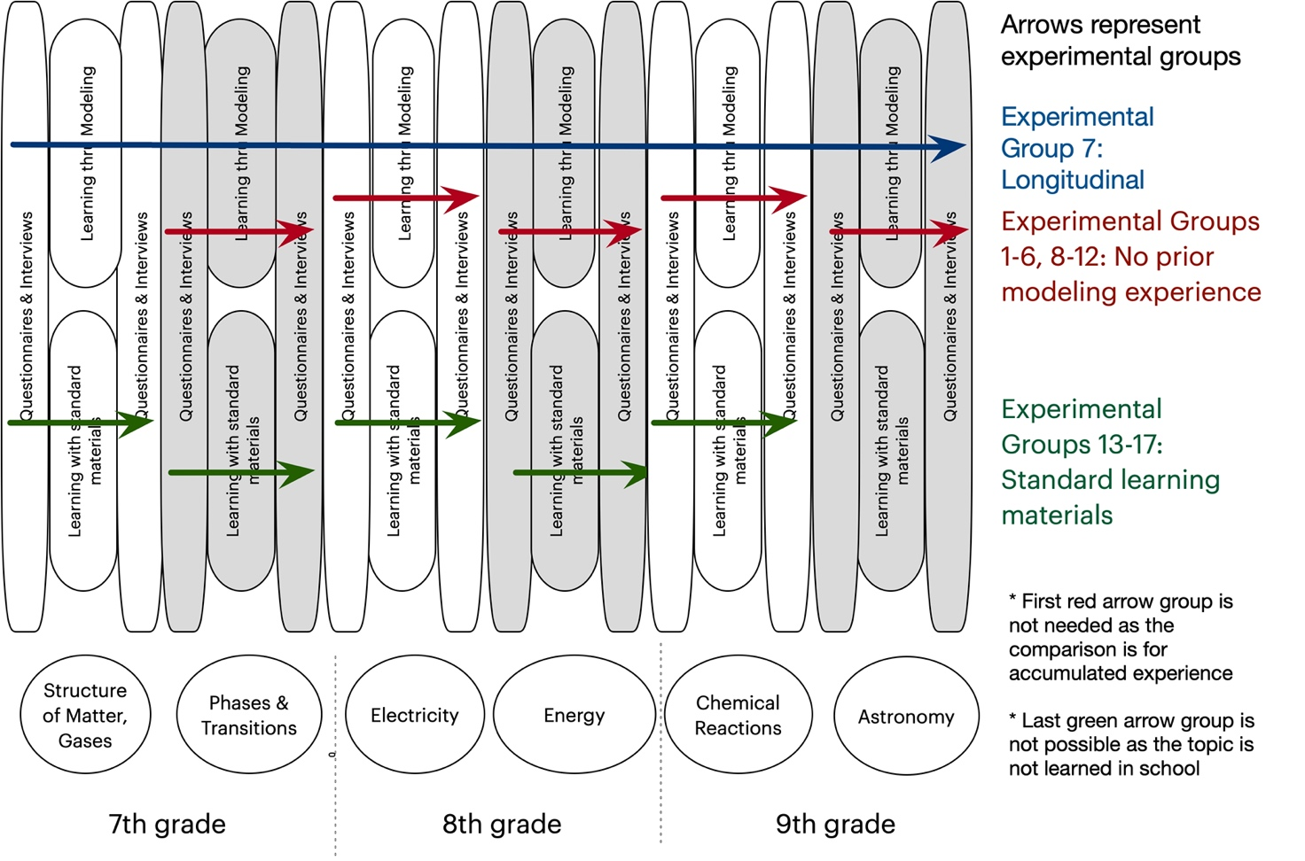
Figure 3: Experimental design of proposed research, which includes the learning units, their pre- and posttests, and participation of each experimental group.
Research instruments
1. Pre and posttest questionnaires. Each test will include two questionnaires. Our demographic information questionnaire will consist of a set of standard questions. For experience in programming and simulations, we will ask the students to write examples. Our conceptual understanding and systems thinking questionnaire will include questionnaires already developed and tested for three of the six topics. We will include approximately 18 closed items and two open-ended items in the questionnaires. Our existing questionnaires will be improved to include more challenging items to prevent a ceiling effect. For three topics, questionnaires will be designed by conducting a two-dimensional analysis of the learning unit challenges posed to the students. A content dimension will describe the main content addressed in the learning unit. A process dimension involves the Shavelson, Ruiz-Primo, and Ayala (2002; Ayala, Shavelson, & Yin, 2002) categories of knowledge: declarative, procedural, schematic, and strategic. The proportion of different challenge types in the two-dimensional array will be used to plan the questionnaire. We will use items from published research and international tests. We will also develop other questionnaires in-house to be reviewed by content experts and the lab members. Teachers will then review the questionnaires to ensure clarity and coverage of the concepts and principles taught with standard learning materials.
2. Interview protocols. We will use two open-ended items in semi-structured interview protocols with scenarios that present a problem the student needs to solve while describing and explaining their thinking in words, moving objects, and drawings. Protocols will be designed as clinical interviews (Ginsburg, 1997) and will be reviewed by members of the lab, then piloted and improved.
3. Logs of student activity with the learning units and modeling platform. We will log students working with the online units. Specifically, we will log texts entered as answers to questions, tables, graphs, drawings, and screenshots of their models created during the unit.
4. Observations. We will record students and computer screens during learning sessions and interviews using screen capture and video software. The interviews will be videotaped.
Procedure
Study 1 - Lab setting learning process of LbM
We will characterize the processes by which middle school students represent and construct models, interact with the programming platform, and learn about scientific phenomena and systems. It will also be used to test the new and improved units, the modeling platform, and the data collection instruments, enabling improvement before the subsequent studies. Specifically, we will explore student modeling practices. These practices include science and systems conceptual learning, mental models and shifts between them, and interaction of these variables. Participants will be from Experimental Groups 1 - 6. Three pairs of students will work with the researcher in a lab setting for each learning unit. By modeling in pairs, student conversations will provide insight into their strategies and understanding. Students will work for four one-hour sessions, fill out pre- and posttest questionnaires and participate in individual semi-structured interviews. We will log and screen-capture each pair’s work, and the questionnaires will be coded for science and systems concepts. Qualitative analysis of interviews will provide an in-depth view of understanding. We will analyze the modeling sessions for practices that include how students design, explore, evaluate, revise, and debug a model. We will also analyze the programs students create and the science and systems concepts they express in writing and words.
Study 2 - Classroom-based learning gains for individual LbM units
We will compare LbM using the MMM approach with standard materials and tests scaling up to classrooms. Experimental Groups 8 - 12 will learn one science topic through modeling. We will compare them to Experimental Groups 13 - 17, who will learn the same topic with standard learning materials and the same duration. The study will be a quasi-experimental comparison group pre-test-post-test design, with students filling out questionnaires before and after the unit. We will code the questionnaires for statistical analyses. We will hand-code modeling practices from student activity data for the units. Screenshots of their models will enable analyses of their programs. Structured activity sections will ask students to plan and draw models before programming, then revise and explain their revisions. Students will use the models to explore the science topics and record their observations in tables and graphs, then reflect and explain their understanding of phenomena. We will create codes for these activities from the top-down based on research literature, the data, and the observed differences.
To detect shifts in student mental models during activities, we will analyze their texts during the unit. In my lab, we are doing the preliminary work needed to automatically analyze student articulated ideas (Samon & Levy, 2019; Zohar & Levy, 2019; Saba et al., under review, a). Our analysis involves noting and analyzing student knowledge elements from their texts. The term “knowledge elements” describe basic concepts or ideas upon which students build their answers, such as p-prims (diSessa, 1993). We hand-coded for knowledge elements and formed a vector describing each student’s mental model. We then used automated and visual clustering methods to detect the mental models. Using these coding tables, we can now automate detection of the knowledge elements. Our analysis is based on Sherin’s work exploring conceptual dynamics in clinical interviews with vector space models and cluster analysis (Sherin, 2013). Once we determine the granularity to capture student explanations, we will compute the time required for students to move between mental models. Hand-coded analysis will be used for verification.
Study 3 - Classroom-based long-term learning gains with multiple LbM units
The heart of our proposal is this long-term study that relates the impacts of understanding and learning after learning different STEM topics. Experimental group 7 will participate in the project for three years. We will compare them to Experimental groups 8 - 12, who will study only one unit without prior experience with the MMM approach. This comparison will allow us to test for cumulative effects. Several analyses will be based on trajectories for each variable. Using the described data analytics and their interactions, we will examine learning transfer by comparing pretest scores, learning value added by comparing posttest scores, and the time to an upward shift of mental models. We will investigate relationships within and across units. With the help of a statistician, our statistical modeling and methods will analyze long-term data with variables measured at successive time points. Linear mixed-effects models will be used because they allow characterization and comparison of changes over time, accommodate incomplete data, and handle unbalanced data. We require this flexibility because students miss classes and tests, and our sample size is limited. Thus, interactions will be grouped and tested within this limitation.
Study 4: Classroom-based long-term learning process with multiple LbM units
The proposed research begins and ends with detailed qualitative studies that intend to characterize the learning processes students undergo over three years of LbM. We will interview fifteen students learning the extended program before and after each learning unit. They will be observed during learning using screen captures of their computer screens and video. Analyses will attend to each research variable and the contexts, processes, and non-cognitive factors that can form a more in-depth understanding of the long-term LbM of complex systems.
Institutional Resources
The Faculty of Education at the University of Haifa is a primary educational research institution, the largest in Israel. It includes 58 senior faculty members and 100 additional staff members, 25 research centers, and laboratories that conduct diverse research incorporating many graduate students. The faculty includes two national centers for mathematics education that provide continuous training and assistance to mathematics teachers across the country. Finally, the faculty includes an IT center that supports faculty members in their research and teaching with technologies. The author’s research group currently includes nine students, two postdocs, a lab director, and a computer science professor. Some group members are experienced in designing novel computational learning environments and regularly assist each other in areas such as data collection tools appraisal and reliability testing. The lab also has most of the needed equipment for data collection.
Expected Results and Pitfalls
Study 1 - Lab setting learning process of LbM. (1) A richly textured multi-faceted analysis of student learning processes that includes an understanding of results regarding the four dependent variables, (2) Recommendations for improvement of the MMM learning environment and learning units, (3) Recommendations for improving the research tools.
Study 2 - Classroom-based learning gains for individual LbM units. (1) Learning gains for each of the four dependent variables, (2) Comparison between LbM and learning with standard learning materials, (3) Comparison of LbM for different topics of learning.
Study 3 - Classroom-based long-term learning gains with multiple LbM units. (1) Trajectories of the dependent variables and their comparison, (2) Transfer rates of learning from earlier units to later units, (3) Depth of understanding in science, systems, and modeling practices, (4) Interactions among variables.
Study 4 - Classroom-based long-term learning process with multiple LbM units. (1) A richly textured, multi-faceted analysis of student learning processes across six units that includes an understanding of the four dependent variables and the situated and non-cognitive aspects of learning.
Addressing possible pitfalls - (1) Attrition. To address attrition, our sample is larger than needed for analysis by about 25%,(2) Technical problems. Software, hardware within the laboratory and piloted prior to research (prior testing of the equipment and software will be extensive), (3) Technological development. Uri Wilensky is consulting us, (4) Loss of data. An analysis is planned for six units which is a relatively large number. However, given our information is stored online and the school’s digital infrastructure is unstable, the units could be reduced in case of data loss.

Bibliography
- Ackermann, E. (1996). Perspective-taking and object construction: Two keys to learning. In Y. Kafai & M. Resnick (Eds.), Constructionism in practice: Designing, thinking, and learning in a digital world (pp. 25 – 37). Mahwah, NJ: Erlbaum.
- Assaraf Ben-Zvi, O. & Orion, N. (2005) Development of system thinking skills in the context of earth system education. Journal of Research in Science Teaching, 42(5), 518–560.
- Assaraf, O. B. Z., Dodick, J., & Tripto, J. (2013). High school students’ understanding of the human body system. Research in Science Education, 43(1), 33–56.‏
- Bamberger, Y., & Tal, T. (2008). An experience for the lifelong journey: The long-term effect of a class visit to a science center. Visitor Studies, 11(2), 198-212.
- Bar-Yam Y (2003). Dynamics of complex systems. Perseus Publishing, New York.
- Barabasi, A.L., and Bonabeau, E. (2003). Scale-free networks. Scientific American, 50-59.
- Basu, S., Kinnebrew, J. S., & Biswas, G. (2014). Assessing student performance in a computational-thinking based science learning environment. In International conference on intelligent tutoring systems (pp. 476-481). Springer, Cham.‏
- Blikstein, P., & Wilensky, U. (2009). An atom is known by the company it keeps: A constructionist learning environment for materials science using multi-agent simulation. International Journal of Computers for Mathematical Learning, 14(1), 81 – 119.
- Chen, D., & Stroup, W. (1993). General system theory: Towards a conceptual framework for science and technology education for all. Journal of Science Education and Technology, 2(3), 447-459.
- Chi, M. T. H. (2005). Commonsense conceptions of emergent processes: why some misconceptions are robust. Journal of the Learning Sciences, 14, 161–199.
- Cooper S., Dann W., & Pausch R. (2000) Alice: a 3-D tool for introductory programming concepts. Journal of Computing Sciences in Colleges 15(5), 107–116.
- Colella, V. (2000). Participatory simulations: Building collaborative understanding through immersive dynamic modeling. The Journal of the Learning Sciences, 9(4), 471-500
- diSessa, A.A. (2000). Changing minds: Computers, learning, and literacy. Cambridge: MIT Press.
- DiSessa, A. A. (1993). Toward an epistemology of physics. Cognition and instruction, 10(2-3), 105-225.
- Eilam, B., & Poyas, Y. (2010). External visual representations in science learning: The case of relations among system components. International Journal of Science Education, 32(17), 2335–2366.‏
- Eilam, B., & Reiter, S. (2014). Long‐term self‐regulation of biology learning using standard junior high school science curriculum. Science Education, 98(4), 705-737.
- Epstein J., & Axtell R. (1996). Growing artificial societies: social science from the bottom up. Brookings Institution Press, Washington.
- Forrester, J.W. (1968). Principles of systems. Pegasus Communications, Waltham, MA
- Gilbert, J. K., Boulter, C. J., & Elmer, R. (2000). Positioning Models in Science Education and in Design and Technology Education. In Gilbert, J. K. & Boulter, C. J.(eds.), Developing Models in Science Education (pp. 3-17). Kluwer Academic Publishers, Netherlands.
- Gobert, J. D., & Buckley, B. C. (2000). Introduction to model-based teaching and learning in science education. International Journal of Science Education, 22(9), 891-894.‏
- Guo, Y., Wagh, A., Brady, C., Levy, S. T., Horn, M. S., & Wilensky, U. (2016). Frogs to Think with: Improving Students’ Computational Thinking and Understanding of Evolution in A Code-First Learning Environment. In Proceedings of the 15th International Conference on Interaction Design and Children (pp. 246-254). ACM.‏
- Guzdial, M. (2008). Paving the way for computational thinking. Communications of the ACM, 51(8), 25–27.
- Hambrusch, S., Hoffmann, C., Korb, J. T., Haugan, M., & Hosking, A. L. (2009). A multidisciplinary approach towards computational thinking for science majors. ACM SIGCSE Bulletin, 41(1), 183-187.‏
- Hashem, K., & Mioduser, D. (2011). Promoting Complex Systems Learning through the use of Computer Modeling. International Journal of Social, Behavioral, Educational, Economic, Business and Industrial Engineering, 5(11).
- Hashem, K., & Mioduser, D. (2013). Learning by modeling (LbM): understanding complex systems by articulating structures, behaviors, and functions. Learning, 4(4).
- Hmelo-Silver, C. E., Jordan, R., Eberbach, C., & Sinha, S. (2016). Systems learning with a conceptual representation: A quasi-experimental study. Instructional Science, 1–20.
- Hmelo‐Silver, C. E., & Pfeffer, M. G. (2004). Comparing expert and novice understanding of a complex system from the perspective of structures, behaviors, and functions. Cognitive science, 28(1), 127-138.
- Holland, J. (1998). Emergence: From chaos to order. New York: Addison-Wesley Longman.
- Jacobson, M., & Wilensky, U. (2006). Complex systems in education: Scientific and educational importance and implications for the learning sciences. Journal of the Learning Sciences, 15(1), 11-34.
- Kafai, Y. B., Ching, C. C., & Marshall, S. (1997). Children as designers of educational multimedia software. Computers & Education, 29, 117–126.
- Kaput, J. (1994). Democratizing access to calculus: New routes using old routes. In A. Schoenfeld (Ed.), Mathematical thinking and problem solving (pp. 77–156). Hillsdale, NJ: Lawrence Erlbaum.
- Klopfer, E., Yoon, S., & Um, T. (2005). Teaching complex dynamic systems to young students with StarLogo. Journal of Computers in Mathematics and Science Teaching, 24(2), 157 – 178.
- Levy, S. T., Saba, J., Hel-Or, H. (2019). Much.Matter.in.Motion (MMM) platform: Block-based platform for constructing computational models in science. Systems Learning & Development Lab, University of Haifa, Israel.
- Levy, S.T. (2017). Learning about Complex Systems from the Bottom Up: Role-playing together in a participatory simulation. I. Levin & D. Tsybulsky (Eds.), Digital Tools and Solutions for Inquiry Based STEM Learning. A volume in the Advances in Educational Technologies and Instructional Design (AETID) Book Series. Hershey, Pennsylvania: IGI Global.
- Levy, S.T. & Mioduser, D. (2010). Approaching complexity through planful play: Kindergarten children’s strategies in programming an autonomous robot. International Journal of Computers in Mathematical Learning, 15(1), 21-43.
- Levy, S.T., & Wilensky, U. (2009a). Crossing levels and representations: The Connected Chemistry (CC1) curriculum. Journal of Science Education and Technology, 18(3), 224-242.
- Levy, S.T., & Wilensky, U. (2009b). Students’ Learning with the Connected Chemistry (CC1) Curriculum: Navigating the Complexities of the Particulate World. Journal of Science Education and Technology, 18(3), 243-254.
- Liu, L., & Hmelo‐Silver, C. E. (2009). Promoting complex systems learning through the use of conceptual representations in hypermedia. Journal of Research in Science Teaching, 46(9), 1023-1040.‏
- Löfgren, L., & Helldén, G. (2009). A longitudinal study showing how students use a molecule concept when explaining everyday situations. International Journal of Science Education, 31(12), 1631-1655.
- Louca, L. T., Zacharia, Z. C., Michael, M., & Constantinou, C. P. (2011). Objects, entities, behaviors, and interactions: A typology of student-constructed computer-based models of physical phenomena. Journal of Educational Computing Research, 44(2), 173 – 201.
- Mandinach, E. B. & Cline, H. F. (1994). Project Components: Systems Thinking, Graphical User Interface, and Modeling. In CLASSROOM DYNAMICS: Implementation a Technology-Baesd Learning Environment (pp. 45-72). Lawrence Erlbaum associates. Hillsdale, New Jersey Hove and London.
- Nicolis, G., & Prigogine, I. (1989). Exploring complexity an introduction. St. Martin’s Press.
- Novak, J. D., & Musonda, D. (1991). A twelve-year longitudinal study of science concept learning. American educational research journal, 28(1), 117-153.
- Papert, S. (1980). Mindstorms: Children, computers, and powerful ideas. New York, NY: Basic
- Pei, C., Weintrop, D., & Wilensky, U. (2018). Cultivating computational thinking practices and mathematical habits of mind in Lattice Land. Mathematical Thinking and Learning, 20(1), 75–89. Peteranetz, M. S., Flanigan,
- Resnick, M. (1994). Turtles, termites and traffic jams: Explorations in massively parallel microworlds. Cambridge: MIT Press.
- Resnick, M., Maloney, J., Monroy-Hernández, A., Rusk, N., Eastmond, E., Brennan, K., Millner, A., Rosenbaum, E., Silver, J., Silverman, B., & Kafai, Y. (2009). Scratch: Programming for all. Communications of the ACM, 52(11), 60–67.
- Saba, J., Hel-Or, H., & Levy, S. T. (2021). Much. Matter. in. Motion: learning by modeling systems in chemistry and physics with a universal programing platform. Interactive Learning Environments, 1-20.‏
- Samon, S., & Levy, S. T. (2017). Micro–macro compatibility: When does a complex systems approach strongly benefit science learning?. Science Education.‏
- Samon, S., & Levy, S.T. (2021). Not without Labs: The role of physical and computer-based experiences in learning science using a complex systems approach. Science & Education, 30, 717-753.
- Sengupta, P., & Wilensky, U. (2009). Learning electricity with NIELS: thinking with electrons and thinking in levels. International Journal of Computers for Mathematical Learning, 14(1), 21–50.
- Sherin, B. (2013). A computational study of commonsense science: An exploration in the automated analysis of clinical interview data. Journal of the Learning Sciences, 22(4), 600-638.
- Sherin, B., diSessa, A., & Hammer, D. (1993). Dynaturtle revisited: Learning physics through collaborative design of a computer model. Interactive Learning Environments, 3(2), 91–118.
- Snapir, Z., Eberbach, C., Ben-Zvi-Assaraf, O., Hmelo-Silver, C., & Tripto, J. (2017). Characterising the development of the understanding of human body systems in high-school biology students–a longitudinal study. International Journal of Science Education, 39(15), 2092-2127.
- Strogatz, S. (2003). Sync: The emerging science of spontaneous order. New York: Hyperion
- Turchin, P. (2003). Historical Dynamics: Why States Rise and Fall. Princeton Studies in
- van der Steen, S., Steenbeek, H. W., Den Hartigh, R. J., & van Geert, P. L. (2019). The link between microdevelopment and long-term learning trajectories in science learning. Human development, 63(1), 4-32.
- Weintrop, D., & Wilensky, U. (2017). Comparing block-based and text-based programming in high school computer science classrooms. ACM Transactions on Computing Education (TOCE), 18(1), 1-25.
- Weintrop, D., Beheshti, E., Horn, M., Orton, K., Jona, K., Trouille, L., & Wilensky, U. (2016). Defining Computational Thinking for Mathematics and Science Classrooms. Journal of Science Education and Technology, 25(1), 127–147.
- Wilensky U, & Rand, W. (2015) An introduction to agent-based modeling: modeling natural, social and engineered complex systems with NetLogo. MIT Press, Cambridge
- Wilensky U. (1999). NetLogo. Center for Connected Learning and Computer-Based Modeling, Northwestern University, Evanston. http://ccl.northwestern.edu/netlogo.
- Wilensky U., & Papert S. (2010). Restructurations: reformulations of knowledge disciplines through new representational forms. In: Clayson J, Kalas I (Eds.) Proceedings of the Constructionism 2010 conference (pp. 97). Paris. 10–14 August, 2010.
- Wilensky, U., & Reisman, K. (2006). Thinking like a wolf, a sheep, or a firefly: Learning biology through constructing and testing computational theories—an embodied modeling approach. Cognition and Instruction, 24(2), 171-209.
- Wilensky, U., & Resnick, M. (1999). Thinking in levels: A dynamic systems perspective to making sense of the world. Journal of Science Education and Technology, 8(1), 3-19.
- Wilkerson-Jerde, M.H., Gravel, B.E., & Macrander, C.A. (2015). Exploring shifts in middle school learners’ modeling activity while generating drawings, animations, and computational simulations of molecular diffusion. Journal of Science Education and Technology, 24(2–3):396–415.
- Wing, J. M. (2006). Computational thinking. Communications of the ACM, 49(3), 33.
- Wolfram, S. (2002). A new kind of science. Wolfram Media, Tokyo
- Wu, Y. T., & Tsai, C. C. (2005). Development of elementary school students’ cognitive structures and information processing strategies under long‐term constructivist‐oriented science instruction. Science Education, 89(5), 822-846.
- Zhang, N., & Biswas, G. (2019). Defining and Assessing Students’ Computational Thinking in a Learning by Modeling Environment. In Computational Thinking Education (pp. 203-221). Springer, Singapore.‏
- Zohar, A. R., & Levy, S. T. (2019). Students’ reasoning about chemical bonding: The lacuna of repulsion. Journal of Research in Science Teaching, 56(7), 881-904.

It’s important to note that MMM was not designed or programmed at Northwestern, but in my laboratory. Support involved was the generous enabling of the early use of NetTango, teaching us how to use this toolkit, advice about various functionalities, and debugging and design fixes due to the early stage of the toolkit.
Using the terms p-prims and mental models in the same work seems contradictory, based on the conflicting use of these terms in different conceptual change theories. However, knowledge-in-pieces theory does not have a good term of describing the ecology of concepts that are elicited in explaining phenomena. My view, which has been accepted by several journals in science education, is that if we don’t view mental models as complete and stable theories, but as ad hoc constructions on the fly, this would work. In fact, original work of mental models (Norman, 1983) highlights the transitory character of mental models.

