Solar urban districts: A generative method for multicriteria solar design of dense urban fabrics

Part 3 - Detailed Description of the Research Program
This project explores a new multicriteria design methodology for solar-driven urban design—one that advances the existing solar-envelope methods towards a holistic multienvironmental criteria exploration. Focusing on hot climatic regions, this proposal offers a climatically robust exploration of future conditions and several climatic subzones by harnessing the potential of cutting-edge, multiobjective optimization and machine-learning, computational methods. This section describes the scientific background, objectives, methodology, significance, and potential pitfalls of this proposal.
- Scientific background
  - Methods and tools for solar urban design
Solar availability has traditionally played a key factor in regard to visual and thermal comfort levels and in turn, energy performance. When solar-energy production, which has emerged as a key factor, is added to the equation, solar availability becomes even more important to consider and at the same time, more subtle to evaluate because it is part of both the problem and the solution, especially in dense urban areas [1].
The tradeoff between high-density, building morphology and solar performance and the generation of tools to explore it have played an important role in state-of-the-art, solar-driven, urban design. The studies of Knowles [2,3] are among the earliest on methods and tools to explore solar exposure at the urban scale. During the 1970s, Knowles introduced the solar-envelope (SE) concept—a spatial boundary that accounts for the solar access of the built environment for a given time frame [2]. In other words, the SE method is a generative concept whereby the largest theoretical spatial boundaries are defined by the solar angles to ensure no overshadowing of the surroundings over a specific time frame (e.g., the winter solstice, during which the sun is at its lowest position). Knowles further developed this concept by adding shadow fences that maximize this volume by defining the vertical height of an imaginary plane above which the solar exposure is desirable in neighboring buildings [3] (Fig. 1). In related work, Capeluto et al. [4,5] developed the computational tool SustArc, which calculates the solar volume (Fig. 2)—a combination of both the solar-rights envelope (i.e., the maximal height that will not compromise the solar rights of neighboring buildings) and the solar-collection envelope (i.e., the minimum height that will ensure solar rights of the building under consideration). Stasinopoulos [6] explored the spatial impact of various criteria (e.g., plot size and proportion, orientation, and ground slope) on solar-envelope designs by using the solar-volume coefficient, which is the volume of a solar envelope per unit plot area. Stasinopoulos concluded that solar-envelope methods generate lower densities than allowed by urban regulations, which in turn can be compensated by other locally based considerations, such as daylight ventilation and views, and can generate so called ‘solar cityscapes’.
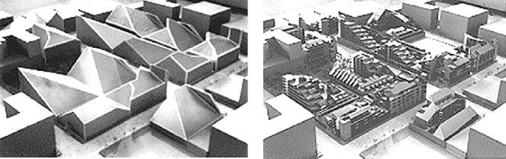
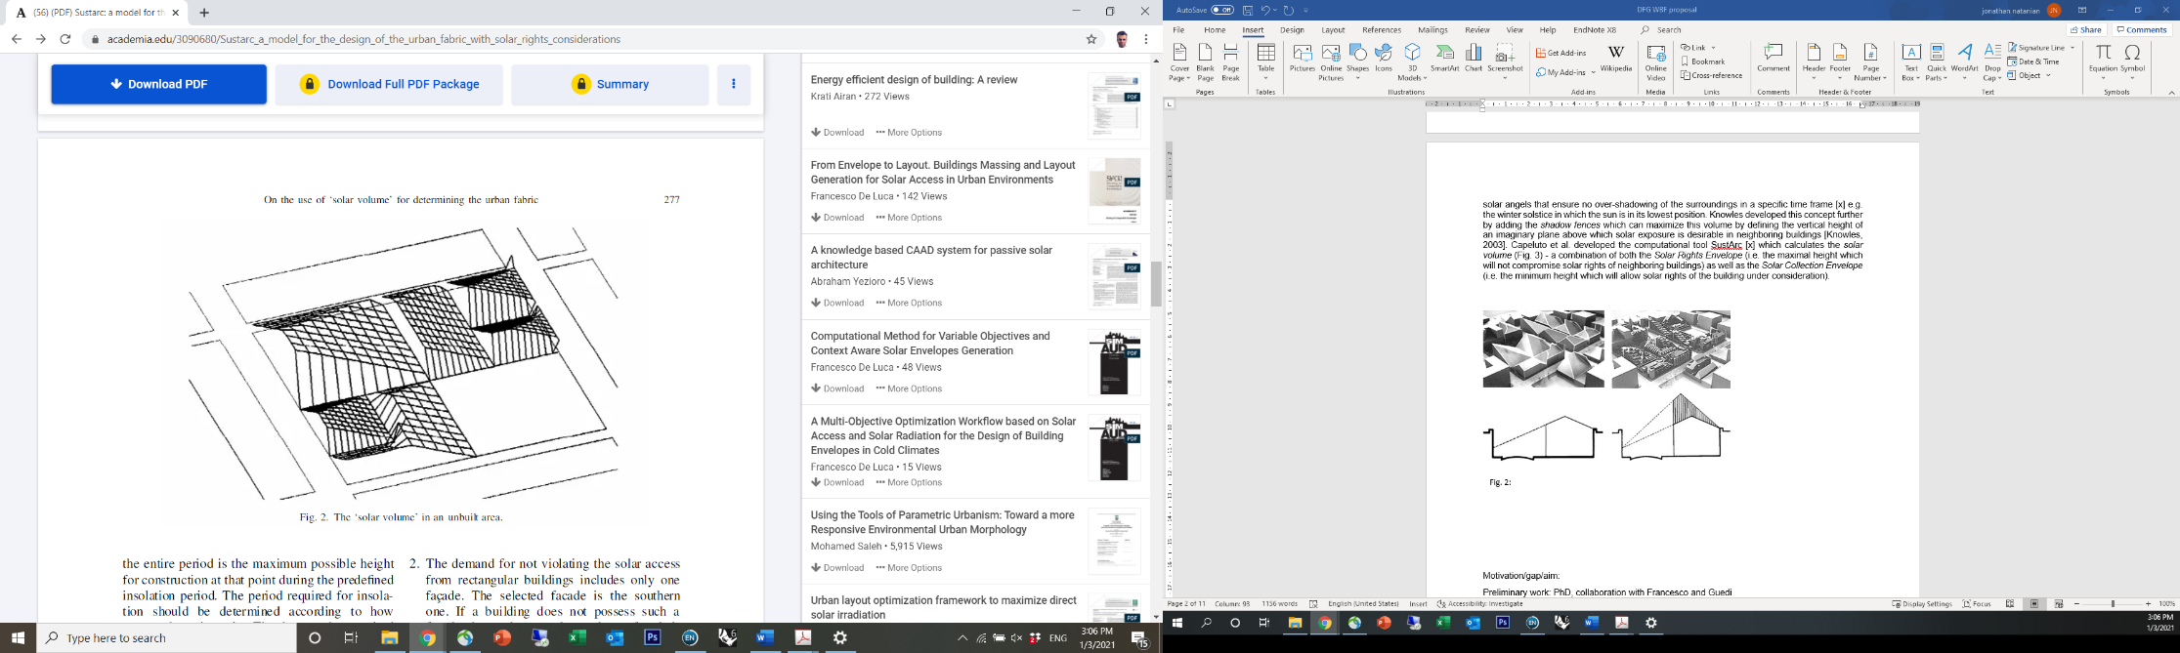

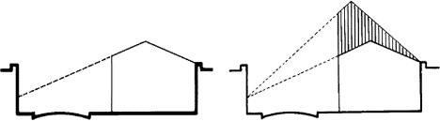
Fig. 2: The solar volume representing solar-exposure considerations for both existing and new buildings [4].

Fig. 1: The solar-envelope concept applied to a typical housing project (top) and space and time constraints for solar envelopes (bottom) [3].

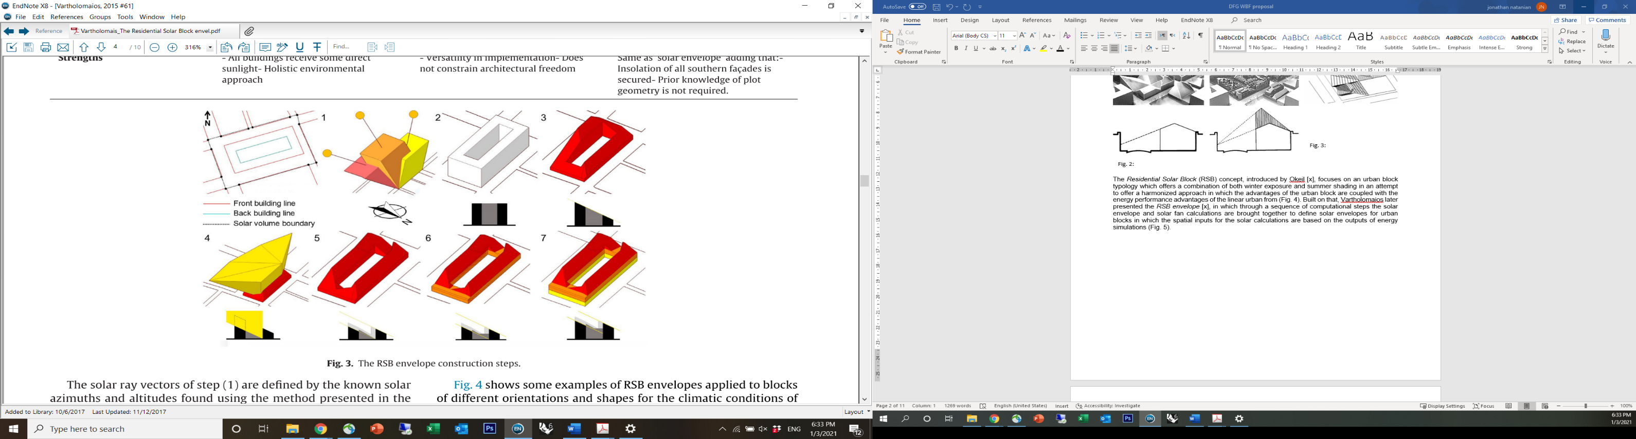
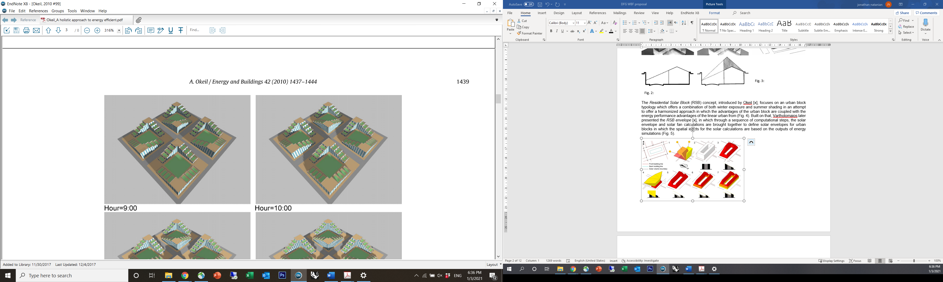
Fig. 3: Example of a residential solar block (RSB) optimized for latitude 48.00 [7].
Fig. 4: The residential solar-block (RSB) envelope concept [8].
The concept of the residential solar block (RSB), introduced by Okeil [7], focuses on an urban block typology that combines both winter exposure and summer shading in an attempt to offer a harmonized approach in which the advantages of the urban block are combined with the energy performance advantages of the linear urban form (Fig. 3). Building on this concept, Vartholomaios presented the RSB envelope [8] in which, through a sequence of computational steps, the solar-envelope and solar-fan calculations are combined to define solar envelopes for urban blocks in which the spatial inputs for the solar calculations are based on the outputs of energy simulations (Fig. 4). These methods can be regarded as ‘static’, meaning that the solar envelope is separately calculated for each building according to the spatial (and sometimes temporal) input data and is thus restricted in its ability to explore a larger number of design variables. Given the rapid global urbanization rates, especially in hot regions, the SE concept, in which a building form follows the boundaries defined by the solar rights of its surroundings, remains relevant. However, further development of environmentally driven design tools and workflows for solar architecture, especially at the urban scale, is still needed [9].

  - Advanced methods and parametric workflows
Solar-driven, evaluation workflows have advanced due to recent advancements in digital workflows and parametric environmental assessment tools [10,11]. As an extension of Capeluto’s solar-envelope studies, Capeluto and Plotnikov [12] introduced the parametric solar-envelope concept, whereby the shape of the solar envelope is simultaneously and seamlessly generated with every modification of weather data, geometry, or programmatic requirements. De Luca devoted several studies to solar envelopes that used the Grasshopper parametric environment. These studies capitalized on the advanced capabilities of the parametric modelling environment to generate solar envelopes using customizable daylight requirements [13,14].

In a later study, De Luca at el. presented the reverse solar-envelope method [15,16], whereby advanced subtractive methods combined with reverse raytracing ‘curve’ out the built form in dense urban contexts to ensure the daylight potential of the surrounding environment (Fig. 5). A recent extension of this method generated a subtractive solar envelope with the support of geometric and radiometric properties stored in point cloud data [17]. These studies correlate well with recent trends in practice (Fig. 6) in which pixelated forms, claimed to be driven primarily by solar considerations, are becoming ever more frequently used in contrast with rigid or pure forms. The shift from the building to the urban scale is another notable trend in advanced solar-design studies, where solar availability at the pedestrian level is considered together with the solar availability on the building facade [18], the interdependencies between urban typology and solar potential are explored [19,20], and urban blocks are designed based on solar potential and energy systems using optimization methods [21].
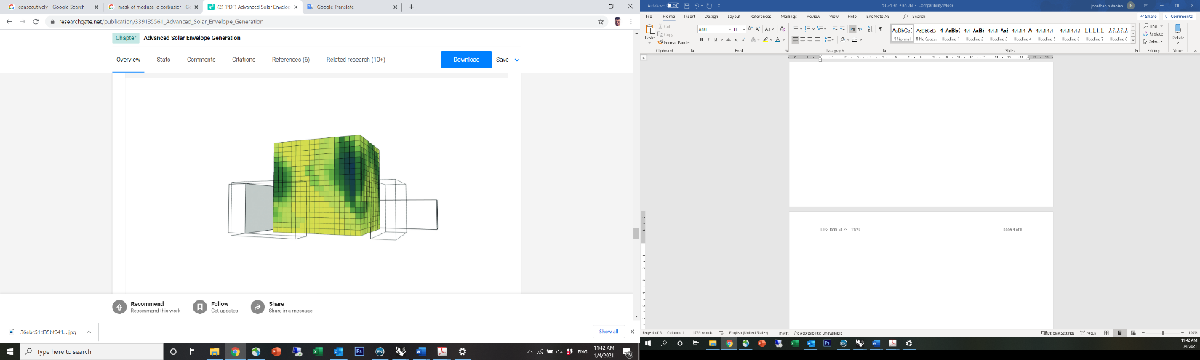
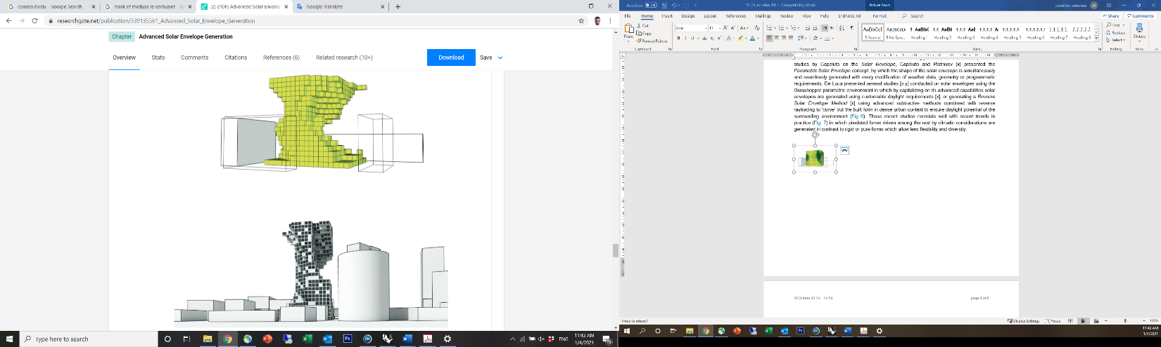
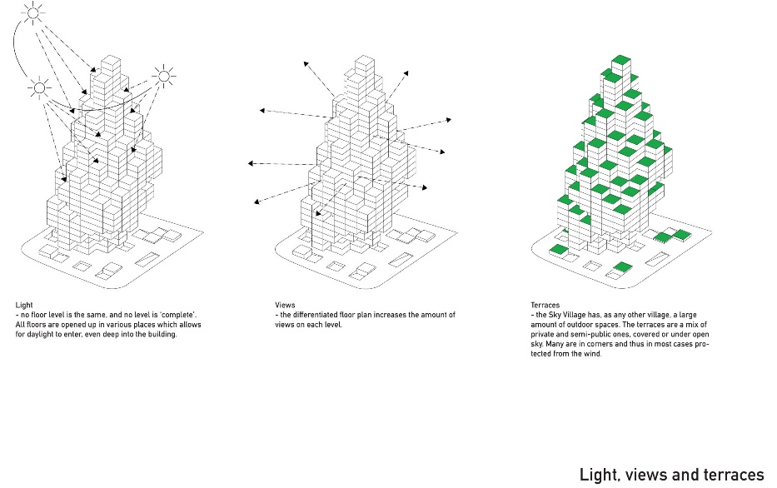
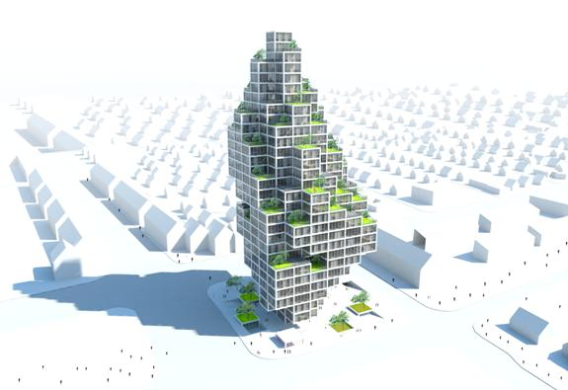

← Fig. 5: The reverse solar-envelope method [15].

↑ Fig. 6: MVRDV’s ‘Sky Village’ design proposal for Copenhagen represents many other pixelated designs claimed to be driven by solar considerations.

  - Machine learning and multicriteria optimization for environmental performance evaluations
In recent years, the use of artificial intelligence for environmental evaluation and optimization is becoming increasingly common by researchers [22]. The integration of algorithms for multiobjective optimization (MOO) addresses the need for a holistic approach to environmental performance in which several, often conflicting, considerations interact, especially at the urban scale [23]. Several studies on the integration of MOO into environmental performance workflows were conducted by the author (see Section 1.3). Emerging analytical workflows are also using machine learning (ML) algorithms, through which metamodels or surrogate models are trained to emulate the physical performance of different environmental criteria (e.g., energy [24], daylight [25], or wind [26]), with the aim to reduce the substantial computational time associated with their evaluation. These two methods can be effectively combined by using ML metamodels to rapidly calculate performance objectives to be used in MOO [27]. However, the integration of these methods is still almost unexplored and requires further exploration, testing and grounding [28]; furthermore, despite the potential, the application of these methods together in solar design is still completely unexplored.
  - Gaps
Given the rapid global urbanization rates, especially in hot regions, the SE concept, in which a building form follows the boundaries defined by the solar rights of its surroundings, remains relevant. However, further development of environmentally driven design tools and workflows for solar architecture, especially at the urban scale, is still needed [29].
Despite the abovementioned recent advancements powered by the integration of digital tools into SE workflows, the application of the SE concept still has several limitations: (1) The outputs of current SE methods include a theoretical spatial boundary, rather than an actual building mass that would be more useful to designers. (2) The SE boundary gives a very general estimate of the trade-off between the desirable and undesirable impacts of solar radiation for a given boundary. (3) The SE approach usually accounts for only the worst-case solar exposure and does not include other key performance indicators (KPIs), such as energy, daylight and outdoor comfort, or the trade-offs between these metrics. (4) The SE approach does not allow for the evaluation of the mutual impacts of neighboring solar envelopes on a larger scale.

- Research objectives
The overarching aim of this study is to thus explore a new approach for generative solar design based on the capabilities of a combination between parametric geometry generation, machine learning and multiobjective optimization tools.
This proposal offers a parametric workflow based on an additive voxelization method by which multiple solar-driven, massing alternatives are generated for a given design challenge. This approach can be applied to either a building addition or a new building mass, corresponding to a variety of environmental KPIs to be defined by the user. This project will examine new methods to use SEs at the district scale by harnessing the potential of computational methods based on simplified indicators to highlight the best-performing solar masses for a given boundary condition. Additionally, the work plan goes beyond the traditional focus on energy KPIs towards the trade-off between several environmental KPIs in which energy performance and environmental quality interact.
The overarching aim will be broken down to the following specific objectives as follow:
- Establish a digital workflow to holistically evaluate urban-scale environmental performance.
- Identify and evaluate solar-driven prediction models and metrics to emulate the environmental performance predictions of several environmental performance criteria.
- Explore the implementation of metamodels and solar-driven metrics in a multiobjective optimization sequence and compare their performances.
- Explore the robustness of the approach by accounting for diverse climatic and morphological constraints and compare them with traditional SE methods.
- Detailed description
  - Working hypothesis
A new computational SE generative approach that is based on machine learning combined with multicriteria optimization methods will provide a higher performing, more holistic and robust outcome compared with traditional SE methods and will generate a diverse collection of design alternatives that will reinforce the interaction between environmental analysis and architectural design.

  - Preliminary results
My preliminary studies were dedicated to exploring holistic urban-scale, environmental performance and asked whether both density and performance can be attained in hot climates by employing multicriteria optimization methods to balance urban form, energy supply, energy demand and environmental quality. More recently, I have started developing generative solar-driven workflows that have already been tested in multiobjective optimization studies. Results from both research paths that will serve as the foundation for this proposal are described in this section.
In preliminary research, I developed an automated Grasshopper-based workflow, which allows evaluating the environmental impact of a wide range of building and urban-scale design parameters, including typology and density [30,31]. Figure 7 shows the early results of this methodology, which was explored in the context of a case study in Tel Aviv [32], where I used my workflow to test the environmental performance trade-offs of four different typological layouts designed by local architects. The results provided visual indications that helped the architects to recalibrate their forms based on environmental performance considerations. More recent developments of this workflow capitalized on the adaptive nature of Grasshopper to include several other key performance indicators (e.g., contact with nature (biophilia) [33], climatic resilience and outdoor comfort [34]), as well as to couple different tools (e.g., for streaming microclimatic evaluation data as an input for energy evaluation [35] or to scale up outdoor comfort evaluation to annual temporal cycles [36]).
The latest addition to the developed methodology was conducted in collaboration with Professor Wortmann and focused on integrating an architectural design optimization module to highlight optimal design solutions based on environmental performance objectives. The preliminary results were presented at the SimAUD 2020 conference [37], and
published in the Energy and Buildings journal [38]. This article introduced simplified solar and geometric-based metrics for energy performance that were used for a MOO study of an urban district in Tel Aviv (Fig. 8). The results of running the optimization using these different metrics (Fig. 9) indicated that these metrics can serve as effective energy-performance indicators for optimization analyses to inform early-stage, morphological decision-making. We later used MOO with some of the simplified solar metrics to explore and optimize the energy load and generation performance of an urban block in a diverse building-use and layout configuration [39]. The dynamic nature of the computational evaluation approach that I

have developed allows it to expand and adapt to different scales and constraints. The current research proposal will further develop the abovementioned holistic workflows into a generative SE approach. One of the natural methodological steps ahead, beyond the application of MOO methods that I have developed in the proposed workflow, will be to explore the combined potential of MOO and ML methods for solar urban design, as offered here.

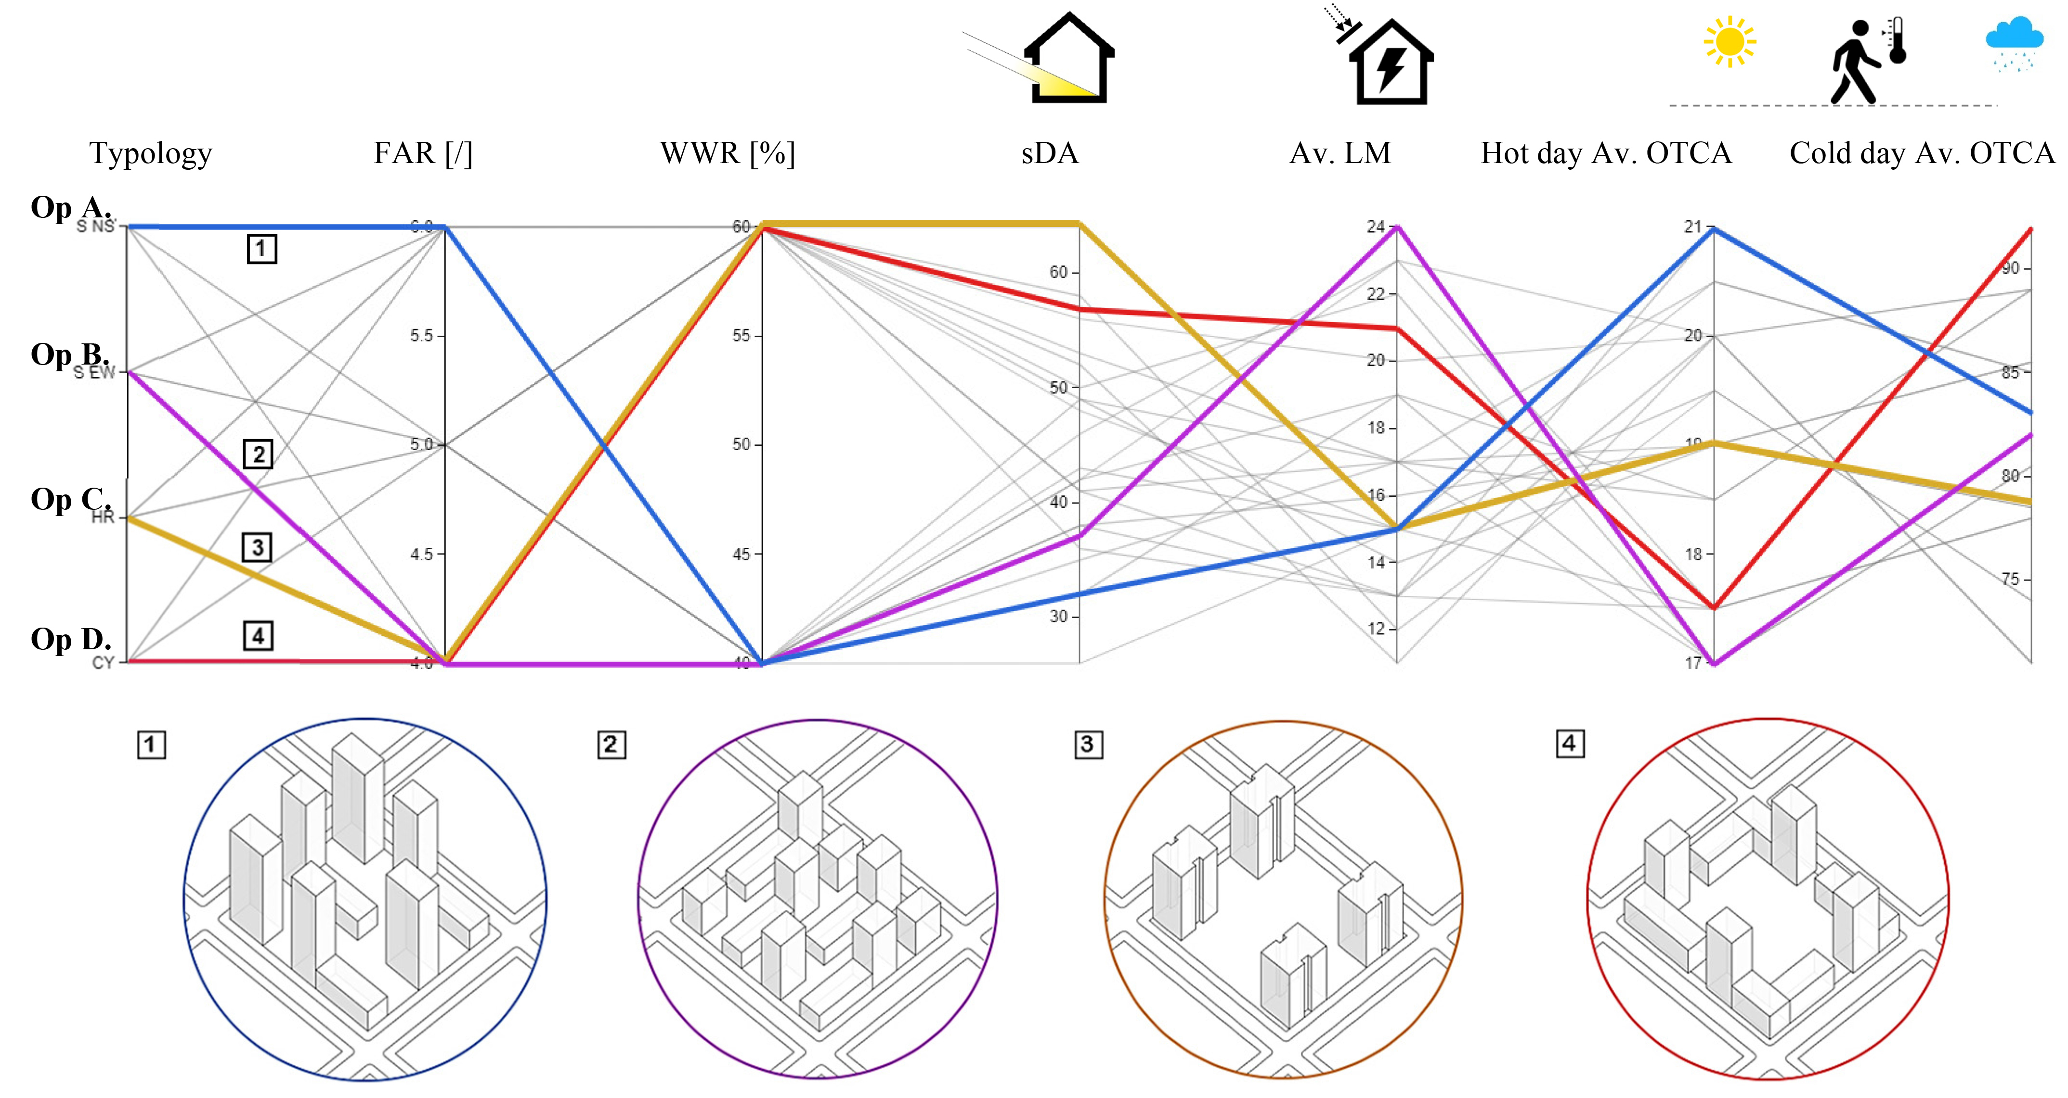

Fig. 7: Visual representation of energy, daylight, and outdoor-comfort simulation results for 24 iterations, including the highlighting of four optimization scenarios and their corresponding input parameters [32].

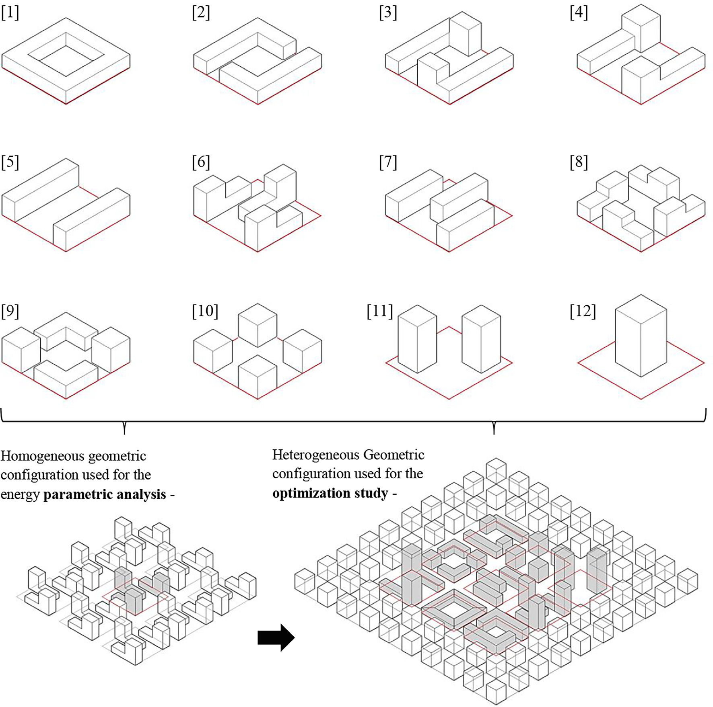
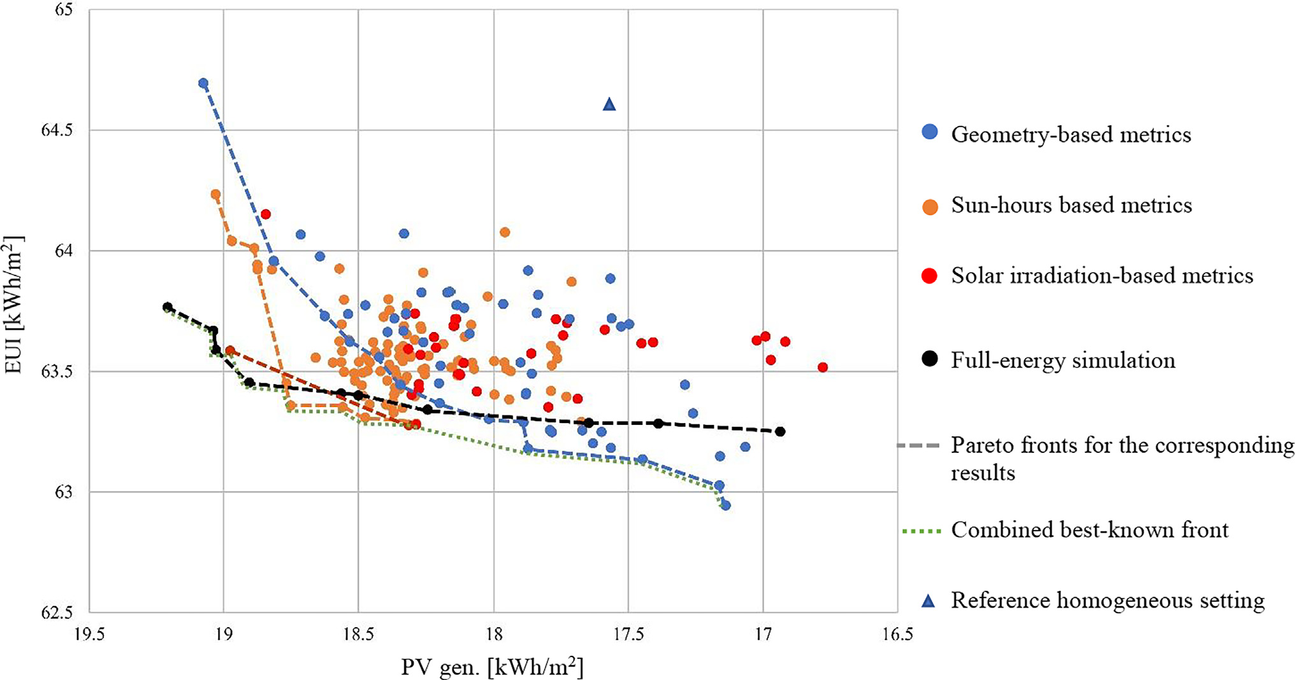
Homogeneous configuration parametric analysis
Heterogeneous configuration optimization analysis
← Fig. 8: Twelve different typologies in block scale and district scale configurations used for the parametric energy analysis and optimization studies [38].

↑ Fig. 9: Simulation results and Pareto front lines of the nondominated solutions from MOO with prediction metrics (in color) and from a MOO run with full simulations
(black) [38].

Geometry-based metrics

Sun-hour-based metrics

Solar irradiation-based metrics

Full-energy simulation

Pareto fronts for the corresponding results

Combined best-known front

Reference homogeneous setting

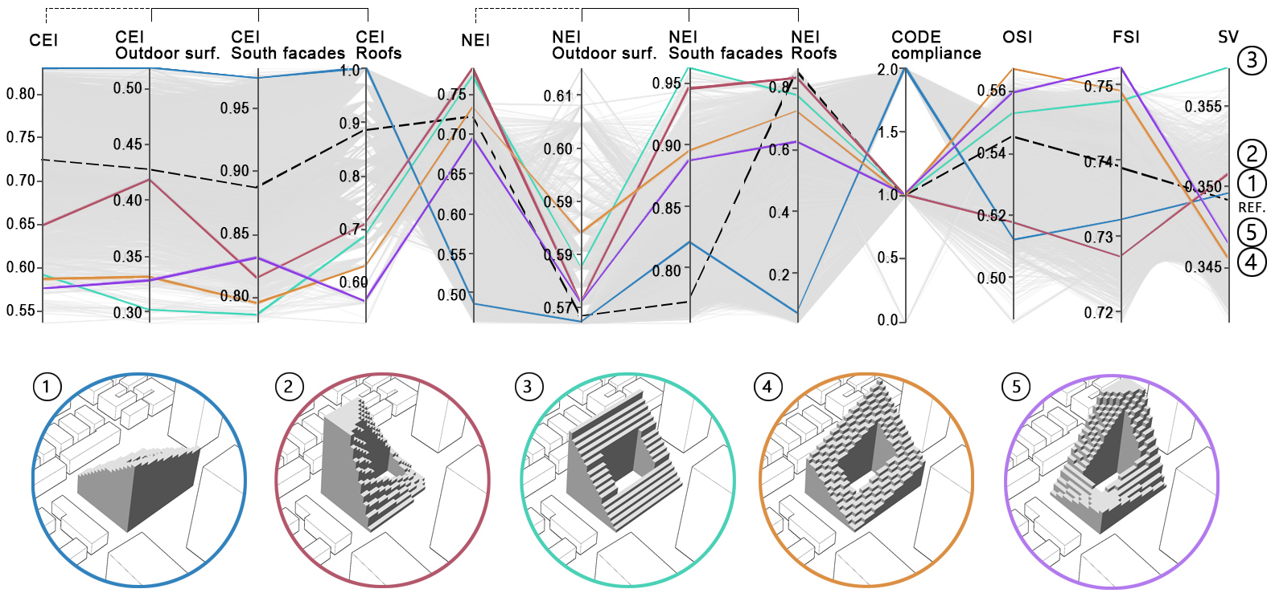

Fig. 10: Five block design alternatives from a 6500-iteration solar block parametric study [40].

The solar-block generation method that will be used here was tested by Wortmann, Francesco, Capeluto, and myself in a preliminary study [40] and focuses on establishing the computational workflow to automatically generate the voxelated forms in Grasshopper and analyze each iteration by using a combination of solar metrics. In this study, we applied the method on a redevelopment case study in Tel Aviv by using a parametric study that included 6500 iterations. The best design configurations are illustrated in Fig. 10 and demonstrate the wide potential of solar-block generation methodology to seamlessly generate a large design space, evaluate each iteration using different analyses and evaluation metrics and plot the results for visual selection by the designer.

Parallel research by Thomas Wortmann and myself [41], based on the same case study, explored a MOO problem with two objectives: maximizing the density (floor-area ratio) and the solar exposure of the surrounding buildings (context exposure index). Here, we benchmarked seven different MOO algorithms for the same site in Tel Aviv (i.e., we evaluated the algorithmic performance) by comparing a courtyard typology to a high-rise, solar-building mass. The benchmark was acquired using convergence, robustness, and Pareto-front comparisons (Fig. 11) for both the courtyard and the high-rise. This study produced two evolutionary algorithms, HypE and SPEA2, and a model-based algorithm, RBFMOpt, as the most efficient and robust MOO algorithms for this type of work. These primary results will serve as the foundation for this research in terms of the urban analytical approach, the choice of environmental metrics, the use of tools to evaluate these metrics and the optimization methods that will help screen the results.
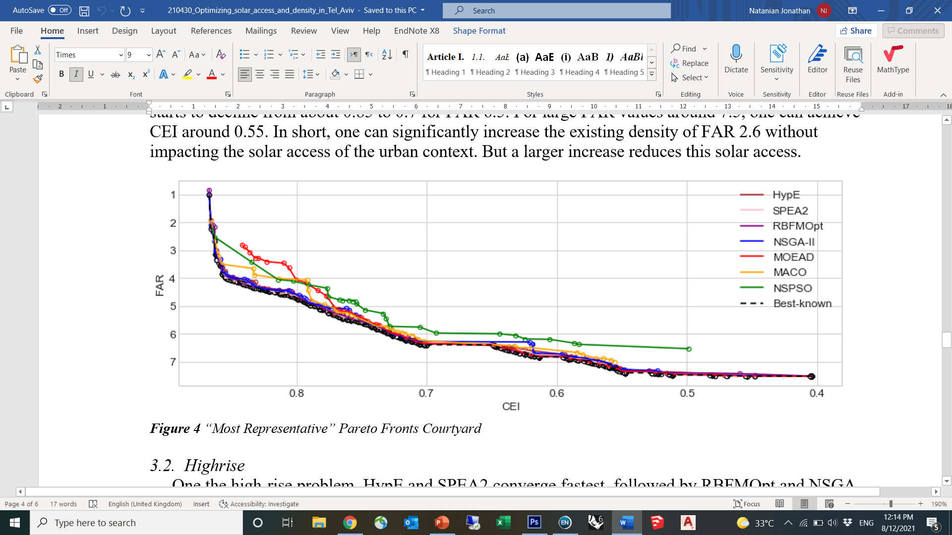
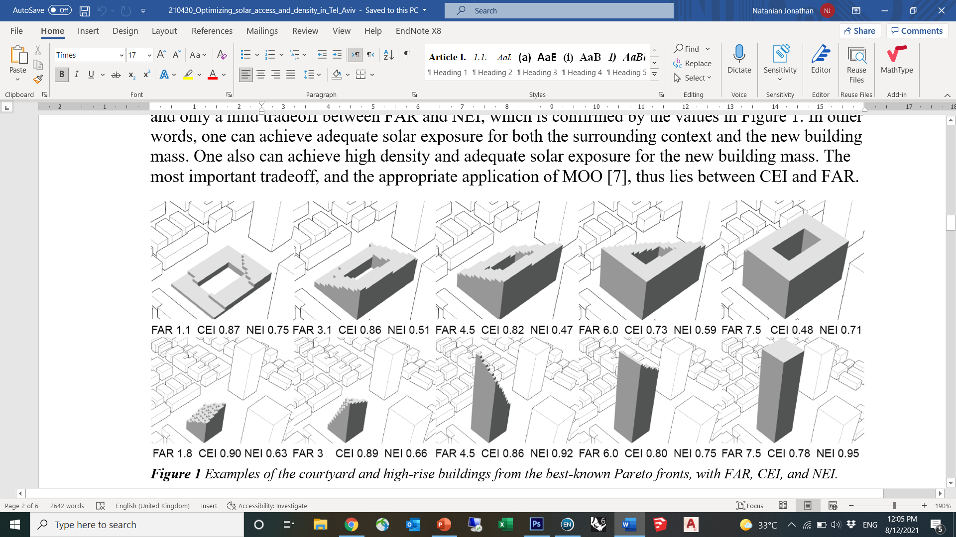
Fig. 11: Pareto-front comparison between seven different MOO algorithms for a solar-driven courtyard block (top) and seven courtyard-design alternatives from the best-known Pareto fronts (bottom) [41].

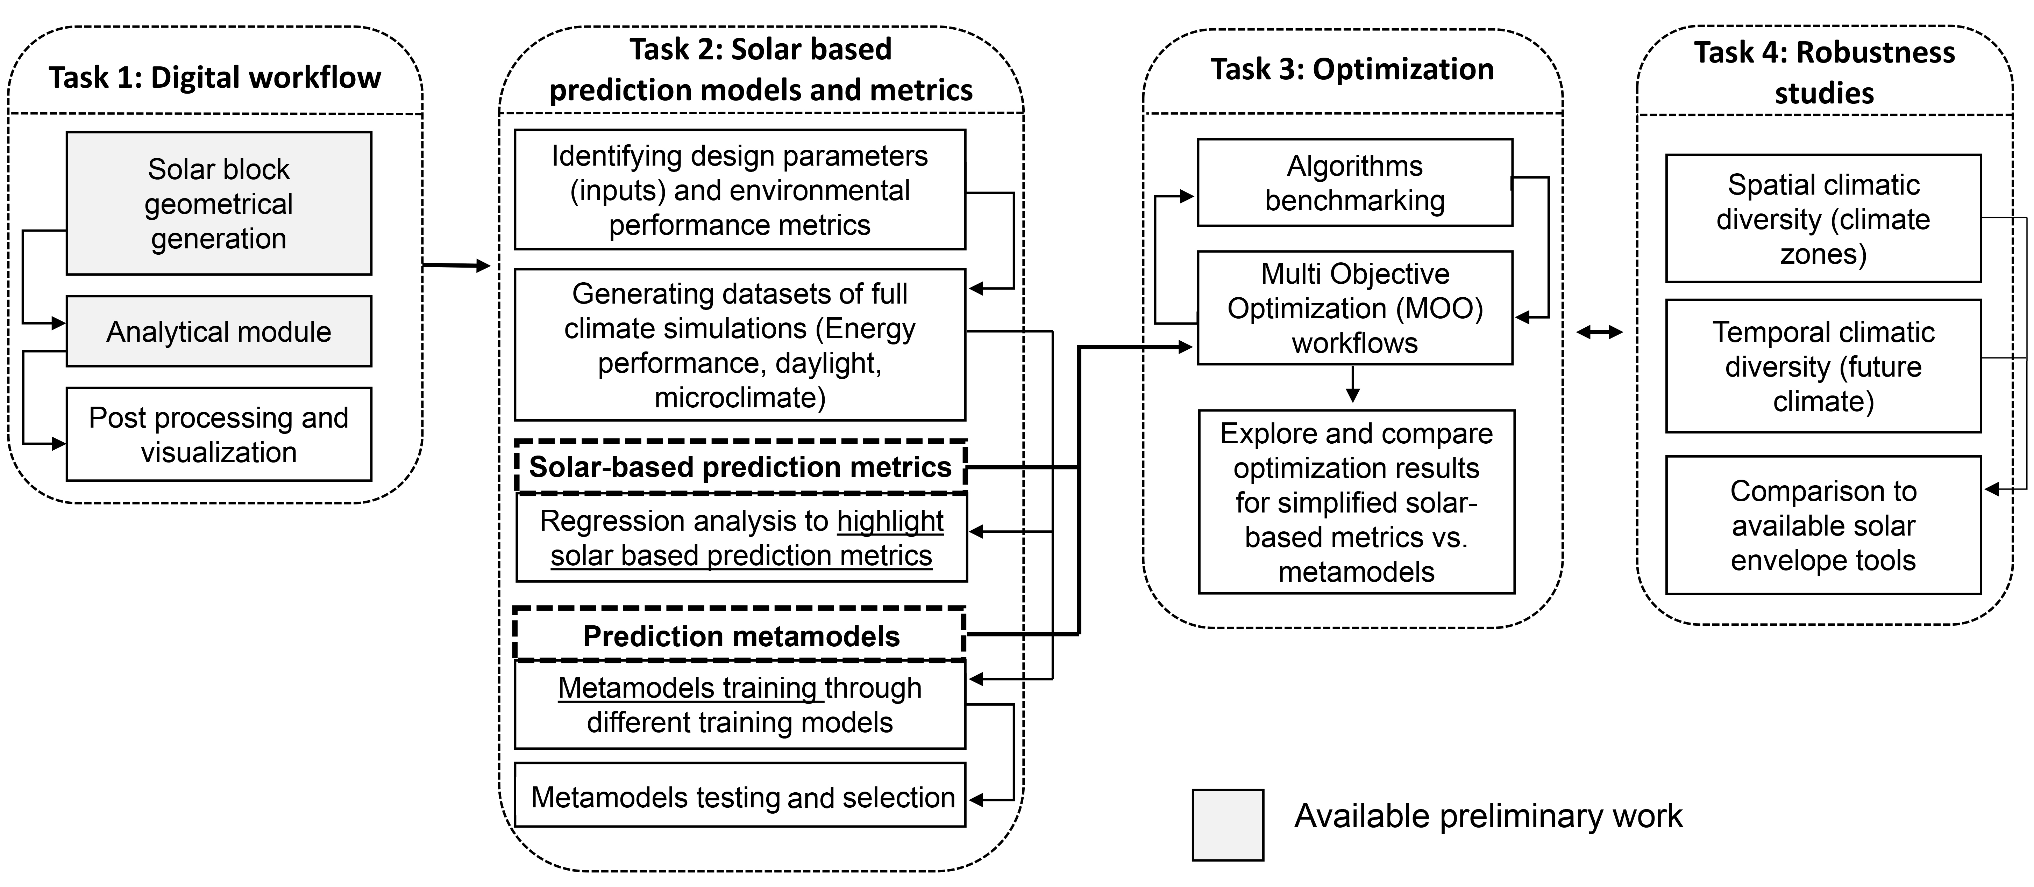

Fig. 12: Research design sequence for the project.

  - Research design and methods
The research will be divided into four tasks (Fig. 12): Task 1 will establish the computational foundation of the project; Task 2 will be dedicated to identifying and exploring solar-based prediction models and metrics; Task 3 will focus on the optimization studies; and Task 4 will conclude with comparisons with different SE methods and explorations of different climatic and urban contexts.
    - Task 1: Establishing a digital workflow
This task focuses on establishing the computational foundation of the project. The previously developed solar-block generator framework [40] will be used here to generate solar-driven building masses at a district scale (Phase 1), seamlessly connect the geometry to different environmental

performance analyses based on selected performance metrics (Phase 2), and stream the results to dedicated data analysis and visualization modules (Phase 3). The digital workflow will be generated in Grasshopper [42]—a parametric interface for the three-dimensional, computer-aided, design-program Rhino [43].
Phase 1 – Solar-district geometry generation is illustrated in Fig. 13. It is based on user-defined inputs that are automatically channeled in Grasshopper into a set of custom-made components that generate the solar masses. For this purpose, the solar-block generator workflow [40] will be adapted (upscaled) to a district scale evaluation.
Phase 2 - The analytical module receives the geometric data for each iteration, samples the relevant numerical and geometric inputs, and streams the data to the relevant environmental simulation engines. This part is conducted using several components under the Ladybug Tools plugin [44] in Grasshopper, in which different environmental metrics (see Task 2) are calculated by using the validated Radiance [45] and EnergyPlus [46] modelling engines.

Phase 3 - Post-processing and visualization are then conducted by streaming the simulation outputs through dedicated Grasshopper components such as Colibri [47], which trigger the iterative process and automatically export the results to Excel in a way that facilitates reading and interacting through the online DesignExplorer platform [48].

This computation workflow will be used for the next stages (tasks) of the project in which it will be applied to a district-scale case study in the Tel Aviv area in which the built area will be doubly projected to meet local demographic challenges. Tel Aviv has a hot-summer, Mediterranean climate [49] in which solar radiation plays a pivotal role in energy demand, energy generation potential and indoor and outdoor environmental quality. Thus, it serves as a suitable testbed for a harmonized approach to solar-driven urban design.

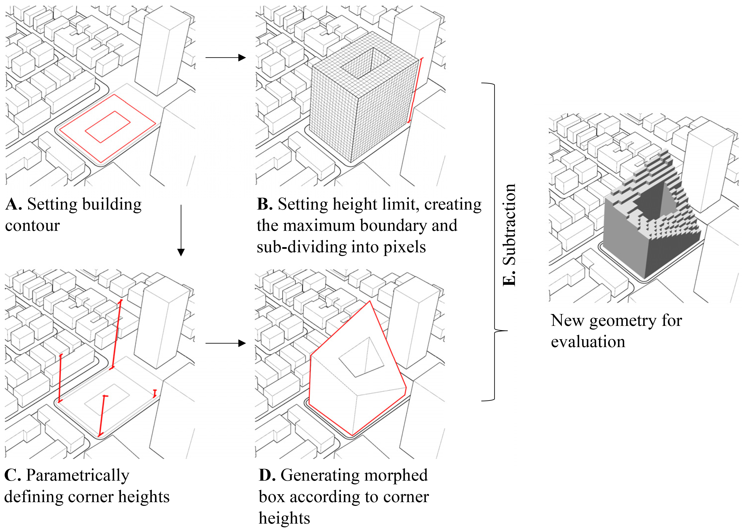

.

Fig. 13: Sequence of solar-block generation (after Ref. [40]).

    - Task 2: Identifying and exploring solar-based prediction models and metrics
This task is dedicated to establishing the suitable prediction indicators for environmental performance optimization. It will start with identifying both the input parameters and the appropriate environmental performance metrics that are used at similar scales and/or in solar-driven approaches. Based on these parameters, a wide environmental performance, parametric analysis will be performed with the aim to establish suitable datasets to support two different analytical approaches that this study will compare–the first approach is the use of simplified solar radiation and geometric metrics and the second approach is the use of prediction metamodels–to serve as effective faster-to-calculate indicators for large-scale, solar urban-design optimization.

Input and output parameter selection and dataset generation
Following the selection of performance metrics based on preliminary research [e.g., 38], relevant input parameters and output metrics will be used for a wide parametric study on several theoretical urban typological models in the climatic context of Tel Aviv. The parametric workflow will run in Pollination – a designated cloud-based platform that facilitates the environmental analysis workflows of Ladybug tools used here. It will generate a large dataset of approximately 5000 iterations that will be used for two different analytical methods: (1) a regression analysis to highlight simplified solar-based metrics, and (2) metamodel training.
Linear regression analysis of solar-based prediction metrics
For the exploration of the first approach, a set of solar-performance metrics that we developed and verified as part of two preliminary studies will be used (Table 1). These metrics showed strong

Table 1: Solar-based metrics used for performance evaluation in a preliminary study by the PI [40].
Metric | Definition | Calculation method | Analysis period | Units
CEI | Context exposure index | The average solar-exposure compliance in percent of the following surfaces according to the respective thresholds taken from Israeli Standard SI 5281  Outdoor surfaces: 0.9 kWh/m² solar irradiation on at least 30% of surfaces  South facades: 1.26 kWh/m² solar irradiation  Roof surfaces: 4 hours of solar exposure on at least 50% of each roof surface | Outdoor surfaces \ south facades - 21st of December  08:00 – 16:00  Roof surfaces - 21st of December  09:00 – 15:00 | [%]
NEI | New-building exposure index
SV | Sky view | The average percentage of the visible sky from each test point across all vertical surfaces – averaged between existing and new masses | N/A | [%]
OSI | Outdoor shading index | The average of the annual irradiation ratio between exposed and obstructed configurations of each point across the outdoor surfaces (in and around the site), subtracted from 1 | Annual | [/]
FSI | East–west facade shading index | East and west facade summer irradiation values (in MW/m²), subtracted from 1 – and averaged between existing and new masses | 1st of June – 31st of October | [1-MW/m²]

correlations with energy performance, visual comfort, and thermal comfort in the local climatic context [37,38]. Here, these metrics, possibly with slight adaptations, will be tested using a regression analysis against the datasets from the parametric analysis.
The exploration of the regression results will help to evaluate how these metrics are related to each other and will highlight a couple of contrasting metrics based on the optimization analyses. A principal component analysis (PCS) [50] will then be conducted to downsize the number of objectives by analyzing any overlaps between them and to generate weighted combinations between exposure and shading metrics. The new developments this project offers in terms of upscaling to a full-scale district, as well as the analyses of the various climatic conditions and the experimentation with weighting methods, will enrich the discussion on solar-driven metrics for multicriteria optimization workflows.
Metamodel training
For the development of solar-based prediction metamodels, two to three suitable metamodel training algorithms will be selected among the several ML training methods available [51] (e.g., random forest (RF), Gaussian process regression (GPR), and neural network (NN)). The decision on the metamodeling technique will be affected by the design parameters, the environmental design metrics, and the size of the design space. Once the metamodeling techniques are selected, the process of the metamodel training using the generated datasets will be repeated for the different performance metrics explored here (e.g., energy use intensity (EUI), energy load match (LM), daylight autonomy (DA), etc.). As a next step, the accuracy of the selected metamodels will be tested and compared to highlight the relevant metamodels for the optimization.

    - Task 3: Setting up an optimization workflow for solar-driven urban design

Task 3 is dedicated to exploring optimization methods for solar-driven design. This task starts by setting up the optimization of the computational workflow in Grasshopper through the Opossum plugin for Grasshopper [52]. The optimization sequence will be explored twice: once by connecting the Grasshopper optimization components to the performance evaluation workflow analyzing the simplified solar metrics highlighted in Task 2, and again using the prediction metamodels. A series of sensitivity optimization studies will test different algorithms and explore their performance in the context of our optimization problem. Figure 14 illustrates one example sequence for processing the outcome of the optimization process: following the optimization run, the best solar-district design configurations will be automatically exported to Excel. Next, the nondominated design configurations (on the Pareto-front graph) will be highlighted and transmitted to the designer for visual screening based on the input (variables) and output (objectives) data graphs.
To test the optimization, as well as the two prediction approaches, i.e., simplified metrics vs. metamodeling, we will conduct full-energy performance (supply and demand) and daylight and outdoor comfort simulations using validated engines. This part of the research compares the best solutions (i.e., nondominated) from the solar optimization study against a ‘standard’ redevelopment by using flat, rigid building volumes with no solar consideration applied. The analytical sequence in Ladybug and Honeybee (to explore energy, daylight, and outdoor comfort) will be adapted to fit the pixelated form of the evaluated masses. A sensitivity analysis will be conducted and will instruct on the best tradeoff between accuracy and speed of calculation, and in turn, on how to divide the voxelated solar masses to analytical units (zones per floors or smaller divisions) for each of the full analyses.

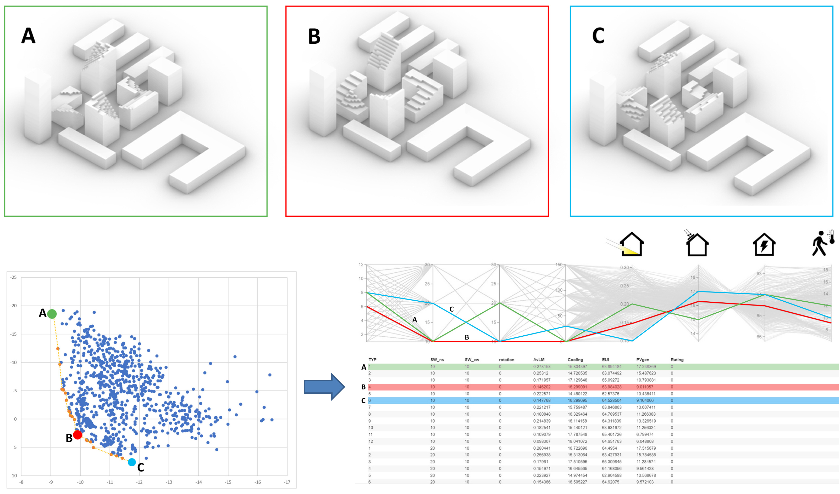

Fig. 14: Demonstration of the interface that will be used in this project to visualize the optimization results. Nondominated design alternatives from the optimization run will be highlighted and streamed for visual selection.

    - Task 4: Comparisons with traditional solar-envelope methods and exploring diverse urban and climatic conditions
The final task is dedicated to experimentation with the workflow in different climatic conditions (regional climates and future climates) and on different scales. This task should finalize the project by providing (i) observations on solar urban design, (ii) the integration of digital tools and optimization methods into the solar-driven design process, and (iii) the robustness of solar urban design in different urban and climatic settings.

Given that solar trade-offs manifest differently in different climatic regions, an additional module will use the two sets of exposure and shading metrics in the same morphological and analytical configuration, but in four different climatic contexts (as defined by Israel Building Code SI 1045 [53]). This part highlights the insights regarding the robustness of the methodology and the metrics and/or their weights that require contextual adaptation. Additionally, a supplemental analytical climate module will be dedicated to future climate calculations by using a 2050 climate

file approximated by Meteonorm weather-generator software [54]. This approach should add the important perspective of climatic adaptation of the solar urban block and trigger a discussion of environmental performance and architectural form in a changing climate.
The results of all analytical scenarios will then be compared with traditional solar-envelope methods by running the same urban or climatic scenario used herein with the help of the existing SE tools (e.g., parametric solar-envelope [12] or reverse solar-envelope [15] methods). This comparison should help establish a wide perspective on the challenges and opportunities of solar design and offer new directions for its future development.

  - Expected results and pitfalls
    - Expected results and dissemination
We expect to establish a new framework to increase the integration of environmental performance evaluation into solar architectural design across several scales. This project will offer a new generative approach in which performative insights directly influence the architectural form-finding process, opening new possibilities to explore large design spaces, analyze several KPIs, and efficiently screen and transmit the best-fit results to the designer. This adds new features to the existing solar-envelope methodologies and offers a new horizon for the interaction between environmental engineering and architectural design, which can enrich the design outcome in terms of architectural form and the environmental performance of buildings and districts.
To ensure a wide impact of the project’s methods, considering their expected significance (see Section 3.6), the dissemination of results will include the initiation of events and workshops for the scientific community and design practitioners, publications in leading journals, and a web interface for the project. A key part of our project’s dissemination will be its open-access measures–and specifically the availability of workflows, tools, and datasets generated throughout the project to the public using the appropriate repositories.
    - Expected pitfalls
Given that the geometric workflow has been tested and performed well, it should not pose any unexpected issues. Some unexpected issues may arise with the performance of a certain solar metric or metamodel, i.e., if one of the metrics or metamodels may not be suitable for use in the optimization. In this case, we would apply sensitivity analyses to test different model settings or model-training techniques in the case of the metamodels or we would fine-tune the definitions and boundaries of the simplified metrics. If the sensitivity analysis still yields unsatisfactory results, we would likely not use that metric or metamodel in our evaluation.
Another issue that might arise is the running time, mostly involving MOO runs. We expect them to run in a reasonable amount of time on our lab’s 64-core machine; but if the runs should exceed our expectations, we will be able to use the Technion’s High-Performance Computing (HPC) services, which offer world-class computation capabilities (e.g., the ZEUS computer cluster of 1920 cores). Our lab has also recently secured access to extensive cloud space through both institutional (Technion) and commercial cloud services that will help with our computational loads. Additionally, we have experience in splitting optimization runs for several segments, which can serve as an additional solution to the running-time problem in case the substantial computer power we have at our disposal proves insufficient.
  - Available resources at the research team’s disposal
1. Assistant Professor Jonathan Natanian (PI) is an experienced architect and environmental design researcher who specializes in computational methods for environmentally driven urban design. The Environmental Performance and Design Lab (EPDL) led by Prof. Natanian at Technion’s Faculty of Architecture and Town Planning is dedicated to exploring the boundary between environmental engineering and architectural design in a cross-contextual, multiscale and cross-disciplinary way. The lab’s equipment includes a 64-core computer, a variety of environmental performance software and simulation engines, and wide access to several institutional and commercial cloud-computing infrastructure.
2. The research will be conducted at the EPDL with the help of a doctoral student who will be dedicated to the project and supervised by the PI. He or she will specialize in environmental design using computational tools. An M.Sc. or March student (with a strong architectural design background) will complement the doctoral student by addressing data collection and characterizing the design of the experiments. A post-doctoral fellow with a strong computational capability will join the effort in the third and fourth years of the project to focus on ML methods and the optimization module.
3. Dr. Thomas Wortmann will support the research as a computational advisor.
Thomas Wortmann is an Assistant Professor at the Institute for Computational Design and Construction (ICD) at the University of Stuttgart. He is an expert on computational design and building simulations and optimization using machine learning methods. He will support the use of Opossum, an award-winning, machine-learning-based optimization tool to be used in this project. Additionally, Prof. Wortmann will support the training and testing of the prediction metamodels developed in the project.

  - Expected significance and contributions
This project introduces a pioneering perspective into the widely used ‘solar-envelope’ method in the field of solar-driven architectural design. This work will appeal to the scientific community and urban designers and policymakers and will establish a new link between them. In a broader sense, the project will trigger new possibilities for both designers and analysts to realize the environmental potential of their designs and to generate buildings and districts driven by a wide range of performance indicators. The scientific significance stems from: (1) the novel holistic analytical approach offered here that combines several environmental performance criteria; (2) the generative methods to design new solar-driven typologies through a bottom-up approach; (3) the optimization module, which introduces new insights on the integration of metamodels into multiobjective environmental design optimization; and (4) the focus on environmental performance in hot climates that is currently underrepresented in contemporary research. The use of open-source tools and open-source data storage and dissemination will ensure that the impact potential of the project and its significance will be fully fulfilled.

As solar design is becoming increasingly important to achieve the objectives of positive energy and zero carbon district design, the project’s results will enable a holistic framework to balance the contrasting solar considerations in the pursuit of these goals. Our methods will ensure onsite renewable energy generation while enhancing energy efficiency and sunlight availability, which in turn will result in self-sufficient buildings within more sustainable and livable indoor and outdoor districts and cities.

- Bibliography
[1] Compagnon, R. (2004). Solar and daylight availability in the urban fabric. Energy and buildings, 36(4), 321-328.
[2] Knowles, R.L., 1981. Sun Rhythm Form. The MIT Press, Cambridge, Massachusetts.
[3] Knowles, R. L. (2003). The solar envelope: its meaning for energy and buildings. Energy and Buildings, 35(1), 15-25. https://doi.org/10.1016/S0378-7788(02)00076-2
[4] Capeluto, I. G., & Shaviv, E. (2001). On the use of ‘solar volume’ for determining the urban fabric. Solar Energy, 70(3), 275-280. https://doi.org/10.1016/S0038-092X(00)00088-8
[5] Capeluto, I. G., Yezioro, A., & Shaviv, E. (2003). Climatic aspects in urban design—a case study. Building and environment, 38(6), 827-835. https://doi.org/10.1016/S0360-1323(02)00063-X
[6] Stasinopoulos, T. N. (2018). A survey of solar envelope properties using solid modelling. Journal of Green Building, 13(1), 3-30.
[7] Okeil, A. (2010). A holistic approach to energy efficient building forms. Energy and Buildings, 42(9), 1437-1444. https://doi.org/10.1016/j.enbuild.2010.03.013
[8] Vartholomaios, A. (2015). The residential solar block envelope: A method for enabling the development of compact urban blocks with high passive solar potential. Energy and Buildings, 99(Supplement C), 303-312. https://doi.org/10.1016/j.enbuild.2015.04.046
[9] Kanters, J., Horvat, M., & Dubois, M. C. (2014). Tools and methods used by architects for solar design. Energy and Buildings, 68, 721-731.
[10] Jakica, N. (2018). State-of-the-art review of solar design tools and methods for assessing daylighting and solar potential for building-integrated photovoltaics. Renewable and Sustainable Energy Reviews, 81, 1296-1328.
[11] Horvat, M., & Dubois, M. C. (2012). Tools and methods for solar design–an overview of IEA SHC Task 41, Subtask B. Energy Procedia, 30, 1120-1130.
[12] Capeluto, I. G., & Plotnikov, B. (2017). A method for the generation of climate-based, context-dependent parametric solar envelopes. Architectural Science Review, 60(5), 395-407. https://doi.org/10.1080/00038628.2017.1331334
[13] De Luca, F., & Voll, H. (2017). Computational method for variable objectives and context aware solar envelopes generation. In Proceedings of the Symposium on Simulation for Architecture and Urban Design - SimAUD, Toronto, Canada.
[14] De Luca, F. (2017). From envelope to Layout. Buildings Massing and Layout Generation for Solar Access in Urban Environments. In Proceedings of the 35th eCAADe conference, Rome, Italy.
[15] De Luca, F., Dogan, T., & Sepúlveda, A. Reverse solar envelope method. A new building form-finding method that can take regulatory frameworks into account. Automation in Construction, 123, 103518. https://doi.org/10.1016/j.autcon.2020.103518
[16] De Luca, F. (2019). Advanced Solar Envelope Generation. In E. Naboni & L. Havinga (Ed.), Regenerative design in digital practice: a handbook for the built environment (pp. 123-128): EURAC Research
[17] Alkadri, M. F., De Luca, F., Turrin, M., & Sariyildiz, S. (2020). An integrated approach to subtractive solar envelopes based on attribute information from point cloud data. Renewable and Sustainable Energy Reviews, 123, 109742. https://doi.org/10.1016/j.rser.2020.109742
[18] Chatzipoulka, C., Compagnon, R., & Nikolopoulou, M. (2016). Urban geometry and solar availability on façades and ground of real urban forms: using London as a case study. Solar Energy, 138, 53-66.
[19] Lobaccaro, G., & Frontini, F. (2014). Solar energy in urban environment: how urban densification affects existing buildings. Energy Procedia, 48, 1559-1569.
[20] Lobaccaro, G., Lisowska, M. M., Saretta, E., Bonomo, P., & Frontini, F. (2019). A methodological analysis approach to assess solar energy potential at the neighborhood scale. Energies, 12(18), 3554.
[21] Waibel, C., Evins, R., & Carmeliet, J. (2019). Co-simulation and optimization of building geometry and multi-energy systems: Interdependencies in energy supply, energy demand and solar potentials. Applied Energy, 242, 1661-1682.
[22] As, I., & Basu, P. (Eds.). (2022). Artificial Intelligence in Urban Planning and Design: Technologies, Implementation, and Impacts. Elsevier
[23] Zhai, Y., Wang, Y., Huang, Y., & Meng, X. (2019). A multi-objective optimization methodology for window design considering energy consumption, thermal environment and visual performance. Renewable Energy, 134, 1190-1199.‏
[24] Vartholomaios, A., Chatzidimitriou, A., & Ioannidis, K. (2021). Estimating the influence of building and urban form on the thermal loads of urban dwellings in the Mediterranean climate using machine learning. Energy Sources, Part B: Economics, Planning, and Policy, 16(8), 687-706.‏
[25] Le-Thanh, L., Nguyen-Thi-Viet, H., Lee, J., & Nguyen-Xuan, H. (2022). Machine learning-based real-time daylight analysis in buildings. Journal of Building Engineering, 52, 104374.‏
[26] Mauree, D., Castello, R., Mancini, G., Nutta, T., Zhang, T., & Scartezzini, J. L. (2019). Wind profile prediction in an urban canyon: a machine learning approach. Journal of Physics: Conference Series, 1343, 012047.
[27] Li, P., Xu, T., Wei, S., & Wang, Z. H. (2022). Multi-objective optimization of urban environmental system design using machine learning. Computers, Environment and Urban Systems, 94, 101796.‏
[28] Miao, Y., Koenig, R., & Knecht, K. (2020). The development of optimization methods in generative urban design: a review. In Proceedings of the 11th Annual Symposium on Simulation for Architecture and Urban Design (pp. 1-8).
[29] Kanters, J., Horvat, M., & Dubois, M. C. (2014). Tools and methods used by architects for solar design. Energy and Buildings, 68, 721-731.
[30] Natanian, J., & Auer, T. (2018). Balancing urban density, energy performance and environmental quality in the Mediterranean: a typological evaluation based on photovoltaic potential. Energy Procedia,152, 1103-8.
[31] Natanian, J., Aleksandrowicz, O., & Auer, T. (2019). A parametric approach to optimizing urban form, energy balance and environmental quality: The case of Mediterranean districts. Applied Energy, 254, 113637.
[32] Natanian, J., & Auer, T. (2020). Beyond nearly zero energy urban design: A holistic microclimatic energy and environmental quality evaluation workflow. Sustainable Cities and Society, 56, 102094.
[33] Natanian, J. (2019). Communal and Biophilic Principles in Regenerative Projects. In E. Naboni & L. Havinga (Ed.), Regenerative design in digital practice: a handbook for the built environment (pp. 370-375): EURAC Research.
[34] Naboni, E., Natanian, J., Brizzi, G., Florio, P., Chokhachian, A., Galanos, T., & Rastogi, P. (2019). A digital workflow to quantify regenerative urban design in the context of a changing climate. Renewable and Sustainable Energy Reviews, 113, 109255.‏
[35] Natanian, J., Maiullari, D., Yezioro, A., & Auer, T. (2019). Synergetic urban microclimate and energy simulation parametric workflow. Journal of Physics: Conference Series, 1343, 012006.
[36] Natanian, J., Kastner, P., Dogan, T., & Auer, T. (2020). From energy performative to livable Mediterranean cities: An annual outdoor thermal comfort and energy balance cross-climatic typological study. Energy and Buildings, 224, 110283.
[37] Wortmann, T., & Natanian, J. (2020). Multi-Objective Optimization for Zero-Energy Urban Design in China: A Benchmark. In Proceedings of SimAUD 2020: Symposium on Simulation in Architecture and Urban Design, Vienna, Austria.
[38] Natanian, J., & Wortmann, T. (2021). Simplified evaluation metrics for generative energy-driven urban design: A morphological study of residential blocks in Tel Aviv. Energy and Buildings, 240, 110916.‏
[39] Natanian, J., De Luca F., & Naboni, E. (2022). From repetition to diversity: A workflow for energy-driven optimization of heterogeneous urban blocks in hot climates. In the upcoming proceedings of PLEA 2022, Santiago, Chile. (Accepted – available upon request from the foundation).
[40] Natanian, J., De Luca F., Wortmann, T., & Capeluto G. (2021). The Solar Block Generator: an additive parametric method for solar driven urban block design. Journal of Physics: Conference Series, 2042, 012049.
[41] Wortmann, T. & Natanian, J. (2021). Optimizing solar access and density in Tel Aviv: Benchmarking multi-objective optimization algorithms. Journal of Physics: Conference Series, 2042, 012066.

[42] McNeel, R. (2010). Grasshopper generative modeling for Rhino, Computer software (2011b), http://www.grasshopper3d.com
[43] McNeel R. Rhinoceros 6. 2020. http://www.rhino3d.com/

[44] Ladybug Tools. http://www.ladybug.tools/
[45] Ward, G. J. (1994). The RADIANCE lighting simulation and rendering system. In Proceedings of the 21st annual conference on Computer graphics and interactive techniques (pp. 459-472).
[46] DOE. (2017). EnergyPlus. Retrieved from https://energyplus.net
[47] Core studio (2017). Colibri, in TT Toolbox for Grasshopper. Retrieved from Available from: http://core.Thorntontomasetti.com
[48] Tomasetti T. Core studio. Design Explorer; 2018. https://tt-acm.github.io/DesignExplorer
[49] Peel, M. C., Finlayson, B. L., & McMahon, T. A. (2007). Updated world map of the Köppen-Geiger climate classification.
[50] Abdi, H., & Williams, L. J. (2010). Principal component analysis. Wiley interdisciplinary reviews: computational statistics, 2(4), 433-459.
[51] Østergård, T., Jensen, R. L., & Maagaard, S. E. (2018). A comparison of six metamodeling techniques applied to building performance simulations. Applied Energy, 211, 89-103.
[52] Wortmann, T. (2017). Opossum: Optimization Solver with Surrogate Models. https://aal.sutd.edu.sg/opossum/
[53] Standards Institute of Israel. SI 1045 - Thermal Insulation of Buildings.
[54] Meteonorm software (2021), version 8. https://meteonorm.com/en/meteonorm-version-8

