**Research Program**

**1. Scientific Background**

Rodents use their whiskers to detect and distinguish among various tactile features in their environment [1, 2], including object position [3-5], shape [2, 6, 7], aperture and gap width [8], and texture [9-15]. Active and receptive interactions between the whiskers and the environment lead to frictional movement and induce whisker bending, vibration, and brief, discrete, high-velocity, high-acceleration micro-motions [16-19]. This deformation is mechanically transformed into stress in the follicle, where sensory mechanoreceptors reside [10, 20, 21] Mechanoreceptors then convert these tactile and whisker movement signals to action potentials in the trigeminal ganglion (TG) neurons [22-28], and this neural activity propagates to the sensory cortices and several lower-level nested loops, evoking tactile sensation and perception. The force and moment at the vibrissal base thus implicitly contain information about whisker location and the location and the nature of an object. In this context, the nervous system serves to decode this information in a manner that allows for the determination of object location, contour, and shape.

The follicle is a heterogeneous structure composed of distinct cell layers, differing in density and viscoelastic properties (Fig. 1[29]). The follicle is populated by receptors with various morphologies and which are located in different cell layers and/or at different depths within the follicle [21, 30, 31][29, 31, 32][21, 30]. Each is densely innervated by the peripheral axons of 100-200 TG sensory neurons [26, 30, 33]. Different TG neurons form distinct specialized sensory endings inside each vibrissa follicle. The functional heterogeneity of these nerve endings may be a consequence of the different locations within the follicle [34, 35] and their biophysical differences [32, 34, 36, 37]. The relationships between morphology, receptor locations, and the detailed characteristics of neuronal responses are an area of active ongoing investigation.

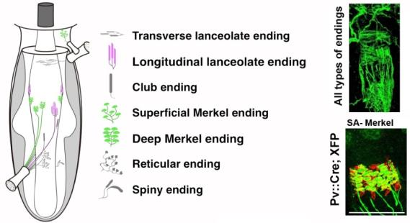

**Figure 1.** **Multiple types of mechanosensory neurons innervate the whisker follicle [29].**

The discovery of genetic markers for different mechanoreceptors, along with the development of intra-axonal recording and optogenetic tagging methods, has enabled the dissection of the anatomical basis for this observed functional diversity [32, 36, 38]. The close association between sensor mechanics and neural coding raises the question of how whisker movement is represented by the spiking activity of individual TG neurons. Severson et. al. [36] addressed this question and found that most recorded TG neurons, including a large majority of identified Merkel afferents, which are mostly slowly adapting (SA), code for both self-motion and active touch.

Delineating how different mechanoreceptors influence the activity of cortical neurons is critical since it provides a baseline for understanding how downstream circuits transform the ascending drive and use it as the basis for behaviorally oriented coding. Previous attempts to address these issues have compared how mechanical signals are encoded in the periphery to how they are encoded in the cortex. In primates, it was originally suggested that rapidly adapting (RA) and SA inputs are segregated into labeled lines [39]. However, more recent work has shown that most neurons in the primate somatosensory cortex receive convergent RA and SA inputs [40, 41].

Previous attempts to decode the complexities of the whisker somatosensory system have similarly compared the cortical and peripheral encoding of mechanical signals [42]. These studies revealed that information about the bending moment and its rate of change is preserved across the ascending pathway, suggesting that these are essential mechanical variables underlying touch-based behavior [19, 43-49]. In contrast, it has been shown on many occasions that the barrel cortex exhibits distinct functions beyond the simple transmission of peripheral self-motion and touch information from the whiskers. *First*, whisking elicits robust ‘self-motion’ activity in mechanoreceptors [23, 36, 47, 50, 51], and these signals are markedly attenuated in extragranular layers of the barrel cortex [46, 52]. *Second*, the activity of cortical neurons is strongly influenced by non-sensory inputs [46], which likely stem from motor origins [53] and S2 contributions [54]. *Third*, in contrast to mechanoreceptors and thalamic neurons, cortical neurons exhibit sensitivity to multiple spatiotemporal tactile features rather than a single one [42, 55]. *Fourth*, barrel cortical neurons in rodents exhibit non-sensory-driven spiking that correlates with animal choice [6, 56-58]. *Fifth,* barrel cortical neuronal responses depend on their location [59] and to where these neurons project [60-62]. *Finally*, Stüttgen et al. [63] devised an alternative approach to study the functional role of mechanoreceptors which suggested that psychophysical channels mediating the detection of whisker deflection are based on the response properties of different mechanoreceptors.

***The proposed study aims to characterize the mechanoelectrical transformation of tactile inputs and whisker motion mediated by two types of mechanoreceptors and their relative contributions to sensorimotor tasks.*** Despite notable advances in the elucidation of the process of mechanoelectrical transformation [36], the specific roles that the various mechanoreceptors that innervate the whisker follicle play remain poorly understood. **We posit that the distributed coding of tactile information is mediated through the different types of mechanosensory neurons. Accordingly, the tactile aspects transmitted through each receptor will be revealed while whisking against objects with complex shapes and textures.**

Some of these channels converge upon arrival at the cortex given that many barrel cortical neurons are sensitive to multiple kinetic and kinematic features [48, 64]. However, some studies support the notion of interspersed separate processing streams for various characteristics of the tactile environment in the somatosensory cortex of rodents [63, 65, 66]. Our preliminary data present new experimental evidence for a model in which ***specific types of mechanoreceptors activate a subset of cortical neurons. These findings support the concept of separate tactile channels reaching the cortex,*** *emphasizing the feasibility of the proposed experiments and our argument that they will yield new insights into the functional circuitry of the somatosensory system.*

**2. Research Objectives and Expected Significance**

###### The collective activity of mechanosensory neurons within the whisker follicle is essential for the processing of tactile information. It has been well established that different mechanoreceptors transmit diverse kinetic and kinematic aspects of whisker motion. However, the roles of these receptors in tactile information processing remain poorly understood.

This project aims to study the role of the different mechanoreceptors on several functional levels in awake-behaving mice. We will use an optogenetic tagging strategy that will allow us to record spikes from single genetically identified TG neurons in the context of specific behaviors. This method will allow us to interrogate mechanoelectrical transformation in various mechanoreceptors in the whisker follicle. By concurrently recording cortical activity, we will be able to examine how the transmission of tactile information through these different mechanoreceptors affects cortical neuronal response properties and their roles in sensorimotor processing in these awake-behaving mice. Using a series of complementary *in vivo* molecular, electrophysiological, and imaging techniques, we will seek to achieve the following specific aims:

**Specific Aim 1: *Analyze Mechanoelectrical Transformation in Different Mechanoreceptors.***

In collaboration with Prof. Fan Wang, we have generated two mouse lines to implement optogenetic tagging that will allow us to record spikes from individual genetically-identified afferents in specific behavioral contexts, including SA-tagged Merkel cell-associated afferents and RA-tagged Club-like and lanceolate receptor afferents (*see preliminary results*). We will obtain electrophysiological recordings from these afferents in awake mice while they whisk freely in the air and against various complex surfaces as they run on a treadmill, generating mechanical signals at the whisker base. This characterization will go beyond a description of responses to passively applied stimuli or whisking against simple objects, instead entailing multiple dynamic representations that are context- and behavior-dependent. *The results of these experiments will provide a quantitative description of the mechanoelectrical transformation in different tactile channels originating from the whisker follicle.*

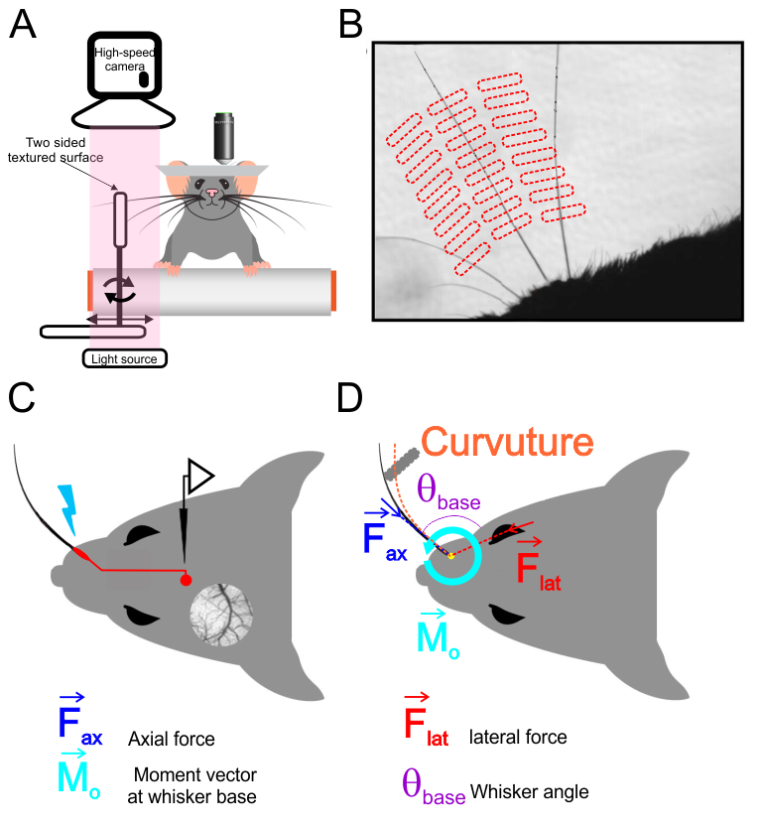

**Figure 2.** **Schematic of the experimental setup**. (A) A mouse whisks against a small vertical surface while head-fixed and running on a treadmill. High-speed video of whiskers is obtained in parallel with electrophysiological recordings from TG neurons or cortical two photon Ca2+ imaging. (B) An image from a high-speed video overlaid with an example grid showing the set of surface locations used during one afferent recording. (C) Schematic overview of the *in vivo* identification of Merkel-associated afferents via optogenetic tagging. (D) Schematic view demonstrating a whisker in contact with the surface. Whisker-pole contact force can be decomposed into several components. The magnitudes of these forces and of the induced bending moment were estimated for each video frame.

**Specific Aim 2: *Evaluate the Influence of the Different Mechanoreceptors on Cortical Neuronal Function.***

Cortical neurons integrate information from multiple sources. Using two-photon Ca2+ imaging and electrophysiological recording from layers 2/3 and 4 cortical neurons, we found that the optical stimulation of different tagged mechanoreceptors leads to an activation of distinct neuronal pools in the barrel cortex (*see preliminary results*). Once we identify the cortical neurons activated by afferent stimulation, we will be able to examine the dissemination of this information throughout the cortex and the spatiotemporal patterns of cortical activation resulting therefrom in awake mice as they whisk freely in the air and against various complex surfaces. Finally, we will use trans-synaptic anterograde tracers to map these mechanosensory channels. *This characterization approach will enable us to decipher the dynamic roles that these different mechanoreceptors play in transforming tactile information into spatiotemporal cortical neuron activation patterns.*

**Specific Aim 3: *Examine the Roles of the Different Mechanoreceptors in Establishing Sensorimotor Behavior.***

To examine the degree to which the different mechanoreceptors play a functional role in shaping sensorimotor behavior, we will use awake, head-fixed animals trained in a rough-smooth surface discrimination task. To assess the functions of these mechanoreceptors in sensory perception and decision-making, we will transiently inactivate these receptors during active touch. We will further use optical activation to create illusory surface patterns and determine whether their activation is sufficient or necessary for perceptual decisions.

Together, these experiments will provide direct information on how the somatosensory system copes with multifaceted and complex tactile signals. Such information is essential to a robust understanding of the functional circuitry that underlies sensory information processing. If completed successfully, this project will provide detailed insight into how sensory systems encode and store information in natural behavioral contexts.

**3. Detailed Description of the Proposed Research**

**Specific Aim 1:** ***The Mechanoelectrical Transformation in the Different Mechanoreceptors.*** TG touch neurons form specialized sensory endings arranged in a stereotyped pattern along each vibrissa follicle (Fig. 1). Functionally, they primarily belong to two main categories: SA and RA touch sensory neurons. In collaboration with Prof. Fan Wang (*see preliminary results and methods sections*), we have developed two mice lines expressing optogenetic tools in two largely non-overlapping populations of touch receptors innervating whisker follicles: The first is a **PVCre** mouse line encoding Cre recombinase driven by the parvalbumin (PV) gene, enabling labeling of Merkel-cell-associated SA afferents [29]. The second is a mouse line encoding Cre recombinase driven by the NetrinG-1 (Ntng1) gene (**Ntng1Cre** mouse) expressed by Club-like and Lanceolate receptor RA afferents (Fig. 3). We crossed these lines with RosaAi32/Ai32 mice expressing the channelrhodopsin-2/EYFP fusion protein (Chr2) fusion protein.

**Sub-Aim 1.1:** ***Record from Mechanosensory Afferents during Whisking and Active Touch and Characterize the Mechanoelectrical Transformation of these Signals.***We will obtain electrophysiological recordings from Merkel cell and club-like/lanceolate afferents that innervate the whisker follicle. Our optogenetic tagging approach will enable us to record spikes from individual genetically identified afferents in awake mice (Fig. 2). Mice will whisk freely in the air and against a textured surface presented at multiple locations and distances as they run on a treadmill, generating mechanical signals at the whisker base (Fig. 2D). We will use this experimental configuration because locomotion significantly enhances barrel cortex activity across layers [67]. Whisker movements will be measured in response to a smooth surface and sandpaper of two different grades (from coarse-grained to fine-grained; grain sizes in parentheses in microns): P220 (68), P800 (21). High-speed (1000 fps) video of the whiskers will be collected, as will electromyogram (EMG) data from two major muscle groups that control whisking [28, 68], the intrinsic protractor and m. nasolabialis muscles.

Post hoc measurements of whisker shape [19, 20] will allow us to estimate mechanical variables expected to cause spiking. We will align spike times from single afferents with mechanical time series of the following kinematic characteristics of whisker movements: whisker angular position, velocity, acceleration, and jerk (the rate of change of acceleration). In addition, we will measure the following kinetic characteristics: axial and lateral forces pushing the whisker into the follicle and along the face, respectively. Finally, we will measure the bending moment resulting from whisker-surface interactions in the plane of video imaging. We will use the generalized additive models (GAMs; see methods section) to quantify the “instantaneous” relationship between spike probability and various mechanical and kinematic variables.

***Possible Outcomes:*** We believe a sizeable tactile stimulus space will give us a more accurate description of tactile transformation. One previous study [36] used whisking and pole touching to characterize such mechanoelectrical transformations. However, whisking against surfaces with more complex shapes/textures and different locations and distances involves dynamic effects such as slip-sticks [69].

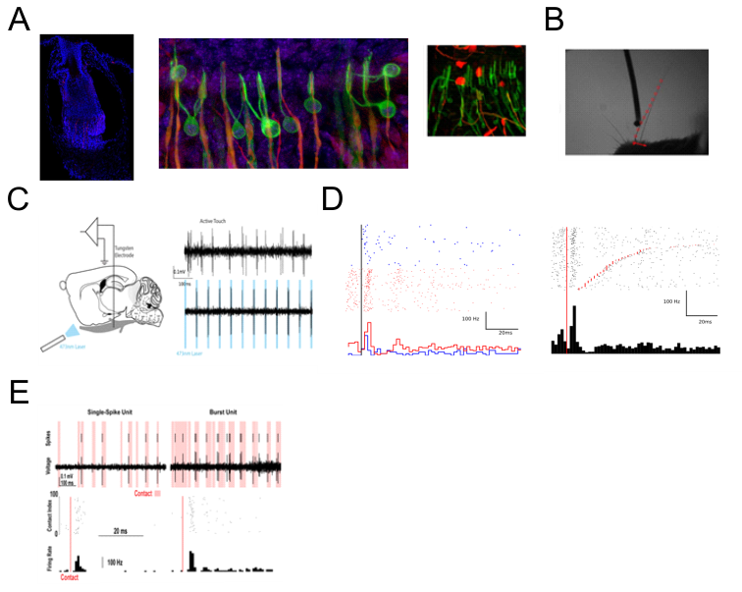

C

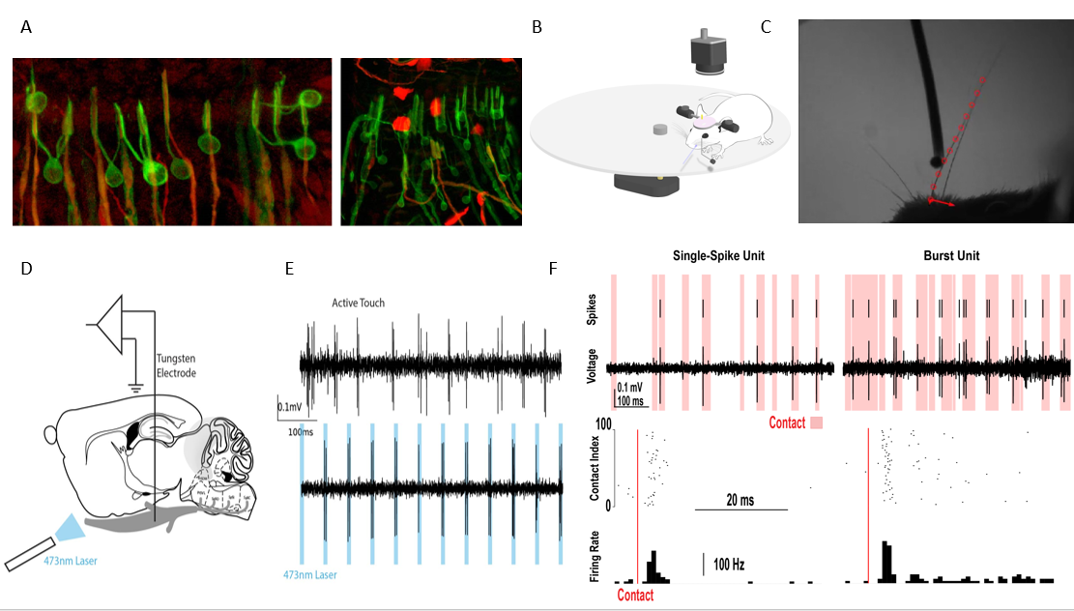

D E

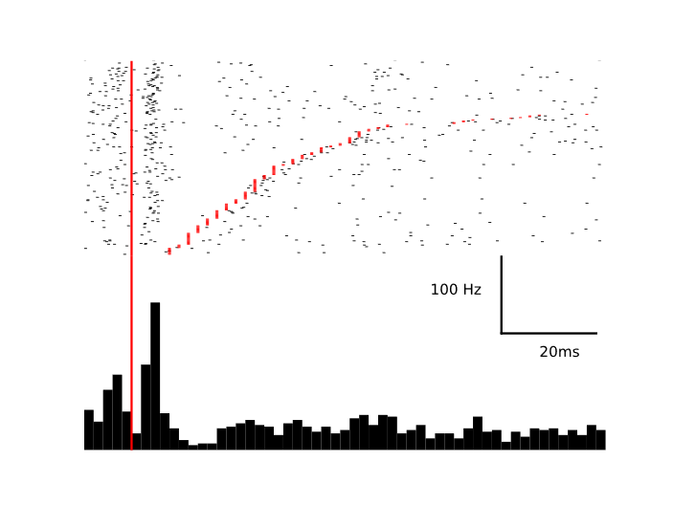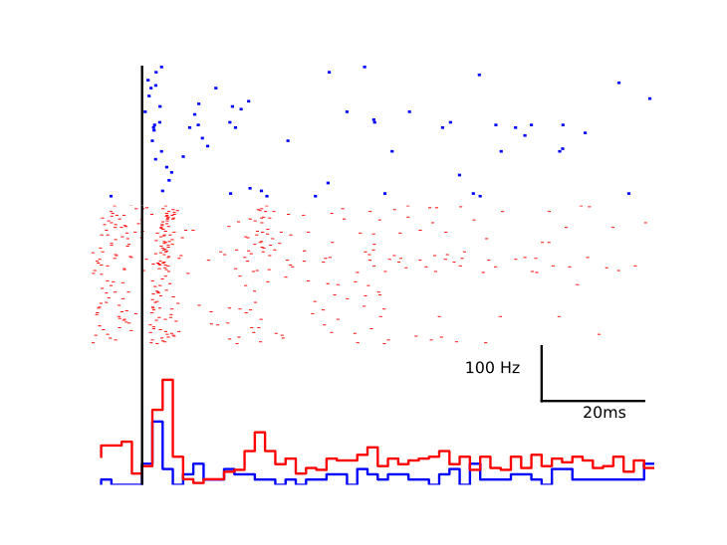

F



**Figure 3.** (**A**) Ntng1Cre labels rapidly adapting mechanoreceptors (left). We crossed Ntng1Cre mice with a tdTomato reporter line to quantify whisker pad expression for different receptors. Most of labeled endings were Club-like (middle) and lanceolate (right) endings shown in red alongside cells that express S100 (green). (**B**) High-speed camera image with tracked mouse whisker (red circles), and force vectors calculated from whisker positions (red arrows). (**C**) Recording scheme showing an electrode in the trigeminal ganglion and a laser directed toward the whisker follicle. A “phototagged” neuron that responds to active touch (top) and laser pulses (bottom). (**D**) Photo-identified Ntng1 neurons show contact induced firing and rapid adaptation. Single trial spike raster (top) and trial average peri-event time histogram (bottom) aligned to pole contact (red line). (**E**) Ntng1+ neurons show direction selectivity to contact. Single trial spike rasters (top) for protraction (blue) and retraction (red) for the same pole location. Trial average responses (bottom) show that while both directions cause an increased firing rate, this neuron fires more frequently with retractive touch. (**F**) Example neuron that responds only during some contacts (left) with a single spike and another example unit that responds with bursts of spikes more frequently (right). Both are rapidly adapting to touch,

A mouse whisked against a small vertical surface while head-fixed and running on a treadmill. High-speed video of whiskers was obtained at the same time as electrophysiological recordings from TG neurons or cortical two photon Ca2+ imaging. (B) Image from high-speed video overlaid with example grid showing the set of surface locations used during one afferent recording. (C) Schematic of in vivo identification of Merkel-associated afferents by optogenetic tagging. (D) Schematic view showing a whisker in contact with the surface. Whisker-pole contact force can be decomposed into several components. The magnitudes of these forces and of the bending moment induced by were estimated for each video frame

***Potential Pitfalls:*** Our experience with these types of recordings over the last 6 months has revealed the yield of these recordings to be somewhat limited. To increase our yield, we will thus keep all whiskers in row C intact, thereby increasing our chances for a recording. Recording from a head-fixed position is inherently problematic given that the whisking strategy in this context may differ from that of free-running mice. As such, we may not fully capture whisker behavior, constraining our insight into the overall process of mechanoelectrical transformation.

***Preliminary Results:***

We have created two mice lines (in collaboration with Prof. Fan Wang) to implement optogenetic tagging that will allow us to record spikes from individual genetically identified afferents in specific behavioral contexts. For these mice, we expressed optogenetic tools in two largely non-overlapping populations of touch receptors innervating whisker follicles: Parvalbumin (PV)-positive and netrin-G1 (Ntng1)-positive receptors. Our collaborator found that PV is primarily expressed in SA Merkel-ending neurons innervating the large whiskers [29], Whereas Ntng1 is primarily expressed in A-fiber touch receptors with club endings, with occasional labeling of lanceolate and reticular endings in the whisker follicle (Fig. 3A) that are likely RA receptors and are largely non-overlapping with PV-expressing neurons [70].

*Club-like RA neurons*

To examine the mechanoelectrical transformation of club and lanceolate endings we crossed Ntng1Cre mice with RosaAi32/Ai32 mice. We then made single-unit recordings from photo-identified neurons in awake-behaving mice. Head-fixed mice were trained to run on a circular treadmill and whisk against a pole. A tungsten electrode was lowered into the TG until a whisker-responsive neuron was well-isolated. After recording neuronal activity and whisker positions during active touch with a high-speed camera, a blue laser was directed at the whisker follicle to photo-identify the unit (Fig. 3C). RA units were found to be light-responsive. ***We recorded from 23 units during active touch that were found to be Ntng1-positive by photo-identification.***

All units exhibited heightened activity during touch. Most units displayed the greatest increase in firing rate immediately after contact (Fig. 3D). However, some units responded most strongly after periods of prolonged contact, or with the initial increase in activity, suppression, and increased activity again before the end of touch. All units displayed sparse firing, consistent with rapid adaptation. Generally, units demonstrated strong directional selectivity (Fig. 3E).

We next examined the kinematic or mechanical variables that could best explain the firing properties of these afferents. This analysis is still ongoing (data not shown). Briefly, we quantified the contact-induced mechanical changes in the follicle during active touch. An active touch against a pole causes a normal force against the contact point of the whisker, which can be decomposed into lateral and axial components at the whisker follicle, and produces a bending moment. These variables have been shown to provide explanatory power for the firing of SA afferents. During contact, the moment at the follicle greatly influenced the spiking probability. However, the probability of spiking of the photo-identified units did not always monotonically increase with movement. There was often a local maximum at small values that would be seen at the onset of touch. Touch induces not only quasi-static forces but also dynamical forces that are proportional to the velocity of the contact. Such velocity tuning may better explain some firing of the photo-identified units. In these cases, the spiking probability was often monotonically related to the speed of the whisker at contact, suggesting that these neurons were more selective for larger dynamical forces. To further extend this analysis, we are now in the process of recording the responses of these neurons to textures (Fig. 2).

*Merkel-ending SA neurons*

To examine the mechanoelectrical transformation of Merkel endings, we crossed PVCre mice with RosaAi32/Ai32 mice. These animals will be subjected to the same experimental approach as detailed for RA neurons above. ***We recorded from 5 units during active touch that were found to be PV-positive by photo-identification.*** These experiments are ongoing. However, we observed that in some sessions, the neurons respond to self-motion and surface touch (Fig. 4).

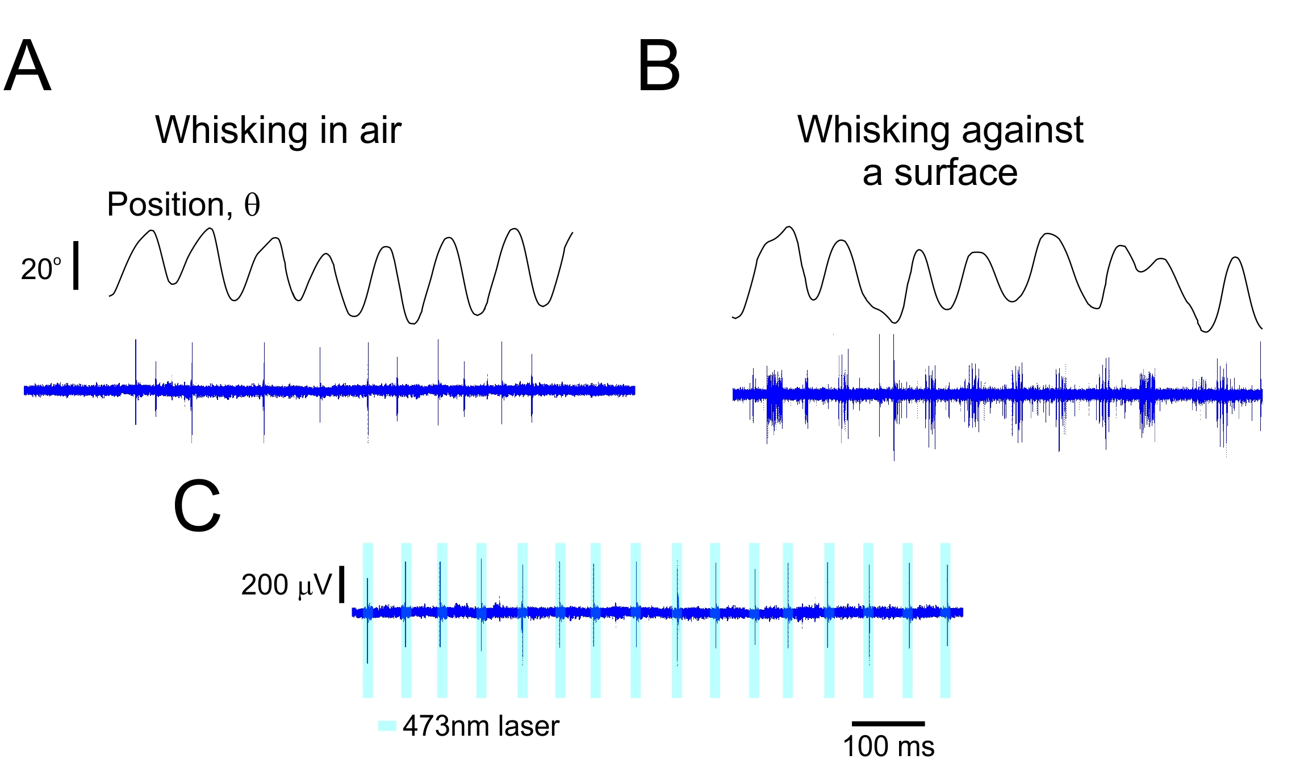

**Figure 4.** **Merkel and Unidentified Afferents Respond to Both Active Touch and Self-Motion.** (**A**) Example time series for a Merkel afferent during whisking in air and against a textured surface. (**B**) The upper panels show the whisker angular position (θ). The lower panels show the responses of PV-tagged TG neurons. (**C**) The response of the neuron to laser stimuli.

**Specific Aim 2:** ***Evaluate the Influence of the Different Mechanoreceptors on Cortical Neuronal Function.*** Intracortical processing integrates, elaborates, and distributes elemental sensory signals to construct perception. We posit that diverse subsets of neurons receive a predominant portion of their inputs from specific mechanosensory channels (see preliminary results). To test this model, will use the two mechanosensory tagged mice lines detailed above, crossing these animals with RosaAi32/Ai32 and RosaAi39/Ai39 mice expressing Halorhodopsin/EYFP (HR) fusion protein. We will initially determine the specific cortical neurons activated directly by stimulating the tagged afferent and the spatiotemporal patterns of cortical activation resulting therefrom. We will then monitor the activity of these neuronal pools in awake mice while they whisk freely in the air and against various complex surfaces as they run on a treadmill, and we will determine the tactile properties conveyed by these neurons and the information they disseminate to nearby neurons. We will employ several recording techniques. Each one examines different spatial and temporal scales, from recording calcium transients from multiple neurons using two-photon Ca2+ imaging and electrophysiological recording from layers 2/3 and 4 cortical neurons. Finally, we will use trans-synaptic anterograde tracers to map these mechanosensory channels.

**Sub-Aim 2.1:** ***Identify and Record from Cortical Neurons Responding to Mechanoreceptor Stimulation using Two-Photon Ca2+ Imaging.*** We will initially determine the specific cortical neurons activated directly by stimulating the tagged afferent and the spatiotemporal patterns of cortical activation resulting from it in awake, non-whisking mice with a *single whisker*. We will determine the "***primary***" neurons activated by the optogenetic stimulus to the follicle. Two main criteria will be used to select these neurons in response to stimulation: response latency and response probability (see preliminary results and methods sections). Once this has been established, we will determine the spatiotemporal relationships between these primary neurons and all activated neurons. The treadmill on which mice are positioned will then begin moving, resulting in whisker movement in the air and across different textures. Post hoc measurements of whisker movement kinematic and kinetic characteristics will allow us to estimate the transformation of mechanical variables into cortical primary activity and other neuronal activity under natural conditions (Fig. 2).

***Possible Outcomes:*** Our preliminary results demonstrate the existence of primary neurons and the fundamental interactions between these neurons and other cortical neurons (Fig. XX). We believe that cortical neurons faithfully transmit mechanoreceptor signals in response to object touch. However, whisker movement and texture responses depend on various dynamic influences such as stick-slip magnitude.

***Potential Pitfalls:*** *Same as Specific Aim 2.* While we can record from multiple neurons within the barrel, which will enable us to evaluate spatial interactions, we are limited in the temporal domain due to the low temporal resolution of the calcium signal (*see experiment set 2*). Moreover, owing to the fact that calcium recording primarily reflects suprathreshold responses, neurons that respond with robust post-synaptic potentials (PSP) but do not spike will be overlooked (*see experiment set 3*). Finally, optogenetic stimuli to the follicle may cause a synchronized afferent volley that may result in an inaccurate estimation of functional connectivity (*see experiment set 3*).

**Sub-Aim 2.2:** ***Identify and Record from Cortical Neuron Responding to Mechanoreceptor Stimulation via Extracellular Recording.***This experimental paradigm will be similar to that for Sub-Aim 2.1, except that we conduct chronic recording with a multi-electrode extracellular recording strategy (see methods section). This technique will enable us to quantify the neuronal responses and interactions at higher temporal resolution.

**Sub-Aim 2.3:*****Examine the Synaptic and Cellular Mechanisms that Mediate Cortical Responses.*** The experimental paradigm for this Sub-Aim is similar to that for Sub-Aim 2.1, except that we will use whole-cell patch recording in layers 2/3 and 4 of the barrel cortex (see methods section) and, in some instances, employ "shadow patching" with two-photon Ca2+ imaging to identify ***primary*** neurons. Using this technique, we will be able to examine the relative synaptic inputs coming from the specific receptors as well as the synaptic and intrinsic mechanisms underlying the responses to natural stimuli. These experiments will add important new information regarding the mechanisms of synaptic integration in cortical neurons *in vivo*. Such information is essential to understanding the organization and function of cortical microcircuits thought to be the building blocks of higher cortical function.

**Sub-Aim 2.4:*****Determine the Anatomical Pathway Linking Different Mechanoreceptors to the Cortex.*** To map the output pathways of genetically marked mechanoreceptors, we will use a Cre-dependent, anterograde transsynaptic viral tracer based on the h129 strain of the herpes simplex virus. Application of this virus to transgenic or knockin mice expressing Cre recombinase in peripheral neurons will reveal viral spread, facilitating the polysynaptic labeling of higher-order neurons in the somatosensory system [71].

***Preliminary Results:***

***Two-Photon Ca2+ Imaging***

***Extracellular recording.***

**Specific Aim 3:** ***Examine the Roles of the Different Mechanoreceptors in Establishing Sensorimotor Behavior.***

In this aim, we will seek to clarify the degree to which the different mechanoreceptors have any functional role in sensory perception and discrimination.

**Sub-Aim 3.1:** ***Assess the Influence of the Different Mechanoreceptors on Grating Discrimination.*** The experimental paradigm used for this Sub-Aim will be similar to that used for Specific Aim 2, except that we will examine neural coding in single-unit recordings from S1 or two-photon Ca2+ imaging while mice perform a rough-smooth surface discrimination task with active whisking [48, 72]. Surfaces will include raised gratings (0.5, 1, 2, and 4 mm spatial period), with 0.5 mm being defined as “Smooth” and all other surfaces being collectively considered “Rough”. *These stimuli were chosen as they will enable us to compare similar stimuli differing in just one respect (spatial frequency).* One randomly chosen surface will be presented per trial. Mice will be operantly trained to lick in response to Smooth stimuli (**Go** stimuli) and withhold licking in response to any of the Rough stimuli (**NoGo** stimulus). In about 10% of trials, the stimulus will be kept just out of reach, allowing mice to whisk in air. Once mice reach a high level of performance (~75% correct; see preliminary data), we will modulate surface location and distance to alter the forces acting on the follicle. For each neuron in general and primary neurons in particular, we will analyze the relationship between spiking and the kinetic and kinematic variable for the whisker and the relationship between these variables and the decision of the mice [6].

**Sub-Aim 3.2: *Explore the Effects of Inactivating Different Mechanoreceptors.*** The experimental paradigm used for this Sub-Aim will be similar to that used for Specific Aim 2, except that we will utilize two mouse lines crossed with the RosaAi39/Ai39 line to enable the inactivation of the specific mechanoreceptors. Once the mice reach high performance (see above), we will examine whether transient inactivation of these different mechanoreceptors alters animals’ acuity in object gratings, location, and distance. We will further assess whether behavioral strategies and whisker kinematics are modified by the separate channels and their temporal constraints.

**Sub-Aim 3.3:** ***Illusory Surfaces.*** The experimental paradigm used for this Sub-Aim will be similar to that used for Specific Aim 2, except that we will utilize two mouse lines crossed with RosaAi32/Ai32 mice to enable the activation of the specific mechanoreceptors. Using optical activation, we can create patterns of illusory surfaces based on the surfaces used in Sub-Aim 3.1 corresponding to Smooth and Rough gratings at different locations and distances. We can then determine whether their activation is sufficient or necessary for grating discrimination and whether the whisking phase and stimulus intensity influence these findings. Alternatively, during smooth-rough discrimination experiments, we will introduce laser pulses, which will activate the receptors and interfere with the patterns sensed by the animal.

***Preliminary Results:***

**General Experimental Methods**

However, if we use PVCre Ntng1Cre to drive ChR2 or HR expression, the opsins will be expressed in both primary afferents and second-order neurons. To overcome this problem, we used the Advillin gene, which is largely restricted to primary sensory neurons [73, 74]. We will use an intersectional strategy by generating the Advillin-Flipase (Advillin-Flp) line. In mice carrying the PvCre or Ntng1Cre allele, an Advillin-Flipase allele, and an Flp/Cre double-dependent allele (triple transgenic mice), the desired gene will be specifically expressed in Pv-expressing (or Ntng1-expressing) mechanosensory neurons.

***Surgery.*** Adult mice (6-8 weeks old; 20-30 gr.) will be implanted with headposts. Briefly, mice will be anesthetized (1-2% isoflurane in O2) and mounted in a stereotaxic apparatus. Body temperature will be maintained with a thermal blanket. For TG recordings, a craniotomy of 0.5 mm×2 mm (medial-lateral, anterior-posterior) will be made over the left hemisphere, centered 1.0 mm anterior and 1.5 mm lateral to the bregma. The dura will be left intact. Craniotomy will be covered with a gelatin sponge under a layer of dental acrylic. For the TPLM recordings, a circular craniotomy will be made over the left barrel cortex (2.5 mm diameter; center relative to the bregma: lateral, 3.5 mm; posterior, 1.3 mm) of mice. The dura will be left intact. After viral injection, the craniotomy will be covered with an imaging window by gluing together two pieces of microscope cover glass. Intrinsic signal imaging will be performed through the window during surgery to localize a barrel column within the cranial window. For chronic electrophysiological recordings, a multielectrode holder will be implanted after the localization of the specific barrel.

***Intrinsic optical imaging.*** The principle whisker will be identified using intrinsic optical imaging [75]. Functional imaging will be performed using a Qcam CCD camera (Q-imaging, Canada) equipped with a tandem lens system. The surface blood vessel pattern will be imaged for reference. Image acquisition of the reflectance changes in the hemodynamic signal and analysis will be made using a frame grabber and custom software written in our lab in the Matlab software. Images will be acquired at a 10 Hz frame rate with a 2 x 2 binning (~300 x 300 pixels, 7.4 μm pixel size).

**AAV-synapsin1-GCaMP6 injection.** Adult mice (P42–56) will be anesthetized and injected with AAV-synapsin1-GCaMP6s (AAV-6s) or AAV-synapsin1-GCaMP6f (AAV-6f) in the barrel cortex (4 injections, 30 nl each; [76]). Mice will be implanted with a cranial window, and injected mice will be used for further experimental analyses 3-4 weeks post-injection.

***Two-photon laser microscopy.*** Two-photon imaging will be performed using a Prairie two-photon laser scanning microscope (TPLSM) platform (Prairie Technologies, Wisconsin, USA) equipped with Ti:sapphire laser excitation (Spectra Physics) and a 40x water immersion objective lens (0.8 NA, Olympus). Combining this method with high-resolution single-cell patch-clamp recordings offers a powerful approach to correlating the activity of single cells with the activity of the overall network.

***Whole-cell recording and staining methods.*** Intracellular voltage and current clamp recordings will be obtained with patch pipette electrodes (5-12 MΏ) using an Axoclamp 2B amplifier (Axon). Patch electrodes will be filled with an intracellular solution consisting of (in mM) 115 K+-gluconate, 20 KCl, 2 Mg-ATP, 2 Na2-ATP, 10 Na2-phosphocreatine, 0.3 GTP, 10 HEPES, pH 7.2. By including biocytin in the intracellular recording electrode, we will be able to recover the morphology and laminar location of the recorded neurons. In all experiments, brains will be fixed with paraformaldehyde, sectioned (60-100 µm), and stained with standard methods to facilitate the reconstruction of the neurons and to determine their locations relative to the barrels via cytochrome oxidase staining.

***Extracellular recordings.*** Neuronexus multielectrode silicone probes will be used for extracellular recordings. The recorded signals will be amplified (1 k), band-pass filtered (LFP: 1Hz-150Hz; Single unit: 500Hz-10kHz), digitized (25 kHz/channel),and stored for off-line spike sorting and analyses.

***Electromyograms.*** To record the vibrissal electromyogram (EMGs), a pair of bipolar EMG electrodes (76 μm Teflon-coated stainless steel wire) will be tunneled subcutaneously into the deep intrinsic muscles through a small incision in the face as previously described [77, 78]. Microwires will be placed subcutaneously in the fibers of the extrinsic musculature [28, 79]. EMG recordings will be sampled at 25 kHz and filtered (0.1 Hz - 10 kHz).

***Anterograde Transsynaptic staining.***

***Behavioral training and apparatus.*** For at least 7 days prior to training, mice will receive 1 mL/day of water. As mice whisk as they run, they will be head-fixed and placed on a custom linear treadmill to promote whisking. Running will be encouraged by providing water as a reward following voluntary bouts of running. Water will be delivered via a custom “lickport” under the control of homemade software. A textured surface or a grating-covered surface will be oriented vertically and placed within range of the whiskers (Figure 2). The top of the surface will be elevated above the remaining whiskers while remaining within the depth of high-speed video focus. The X-Y position of the surface will be controlled with translation stages.

We will employ a modified version of the Go/NoGo task used by O'Connor et al. (2010), in which the mice are required to perform a rough-smooth surface discrimination task with active whisking [48, 72]. Surfaces will include raised gratings (0.5, 1, 2, and 4 mm spatial period), with 0.5 mm being designated as “smooth” while all other surfaces are considered “rough”. One randomly chosen surface will be presented per trial. Mice will be operantly trained to lick in response to Smooth stimuli (**Go** stimuli) and withhold licking in response to any of the Rough stimuli (**NoGo** stimuli). In about 10% of trials, the stimuli will be kept just out of reach, allowing mice to whisk the air. Once mice achieve a high level of performance (~75% correct; see preliminary data), we will modify surface location and distance to alter the forces acting on the follicle.

***Data Analysis***

***Spike extraction and sorting:*** We will separate the recorded signal into local field potentials (LFP; 1-150Hz), and isolated single-unit activity(SUA; 0.5-10Khz). Spike extraction and the sorting of multiple units in tetrode data will be accomplished using a modified version of the MClust-based spike-sorting software (**Fig. 16**).

***Quantification of the forces and moments exerted by whiskers:*** Whisker shape will be extracted from each video. Contact-associated kinematic and mechanical variables will be computed from the whisker shape [20, 80].

***Comparison of neurometric and psychometric sensitivity:*** We will employ the approach used by Stuttgen et al., [81] in which psychophysical data will be analyzed based on response probabilities. This will be converted into sensitivity *d′*. To compare psychometric and neurometric sensitivities, *d′* values will be converted to the area under the receiver operating characteristics curve [82].

***Information theory analyses***: To quantify the information extracted through rat neuronal response function analyses pertaining to different sensory stimulation features and textural features and the way these features interact on a trial-by-trial basis, we will perform mutual information analyses [83].

#### **Generalized additive models:** We used statistical models to quantify the “instantaneous” (in 1 ms time bins) relationship between spike probability and various mechanical and kinematic variables. General additive models will be fitted using the “mgcv” package in the R language [84].

***Available Resources:*** The laboratory has two fully equipped setups appropriate for acute *in vivo* extracellular and whole-cell recording and staining. Each setup includes a stereotactic apparatus and a dissecting microscope. Multiple amplifiers for extracellular and intracellular recordings are available. In addition, the lab has a patch-clamp slice physiology system based on an Olympus fluorescence microscope, Sutter micromanipulators, Axon amplifiers, and the Axopatch software. It is also integrated with an optogenetic setup. A vibratome unit is available for the production of live brain slices for patch clamp experiments. For studies utilizing conscious mice, we have two separate rooms that include in-house constructed head-fixed setups. These setups are equipped with multiple fast-speed cameras and amplifiers for extracellular and whole-cell recordings. One of the setups is additionally equipped with a two-photon imaging system (Bruker) that will enable us to image Ca2+ in the cortex. Finally, we have another setup equipped with an Intrinsic Optical Imaging camera to enable the monitoring of the precise location of virus injection in the cortex. A room used for histological work includes a sliding microtome, a microscope equipped with epifluorescence, and a camera lucida. The laboratory includes the equipment and expertise necessary for preparing and testing all constructs and viruses for optogenetic experiments. In addition, we employ a full-time technician trained in a wide range of anatomical techniques and genotyping procedures.

**BIBLIOGRAPHY**

1. Kleinfeld, D., Ahissar, E., and Diamond, M.E. (2006). Active sensation: insights from the rodent vibrissa sensorimotor system. Current opinion in neurobiology *16*, 435-444.

2. Brecht, M., Preilowski, B., and Merzenich, M.M. (1997). Functional architecture of the mystacial vibrissae. Behavioural brain research *84*, 81-97.

3. Knutsen, P.M., and Ahissar, E. (2009). Orthogonal coding of object location. Trends in neurosciences *32*, 101-109.

4. Mehta, S.B., Whitmer, D., Figueroa, R., Williams, B.A., and Kleinfeld, D. (2007). Active spatial perception in the vibrissa scanning sensorimotor system. PLoS biology *5*, e15.

5. Kleinfeld, D., and Deschenes, M. (2011). Neuronal basis for object location in the vibrissa scanning sensorimotor system. Neuron *72*, 455-468.

6. Rodgers, C.C., Nogueira, R., Pil, B.C., Greeman, E.A., Park, J.M., Hong, Y.K., Fusi, S., and Bruno, R.M. (2021). Sensorimotor strategies and neuronal representations for shape discrimination. Neuron *109*, 2308-2325.e2310.

7. Harvey, M.A., Bermejo, R., and Zeigler, H.P. (2001). Discriminative whisking in the head-fixed rat: optoelectronic monitoring during tactile detection and discrimination tasks. Somatosensory & motor research *18*, 211-222.

8. Krupa, D.J., Matell, M.S., Brisben, A.J., Oliveira, L.M., and Nicolelis, M.A. (2001). Behavioral properties of the trigeminal somatosensory system in rats performing whisker-dependent tactile discriminations. J Neurosci *21*, 5752-5763.

9. Carvell, G.E., and Simons, D.J. (1990). Biometric analyses of vibrissal tactile discrimination in the rat. J Neurosci *10*, 2638-2648.

10. Diamond, M.E. (2010). Texture sensation through the fingertips and the whiskers. Current opinion in neurobiology *20*, 319-327.

11. Jadhav, S.P., and Feldman, D.E. (2010). Texture coding in the whisker system. Current opinion in neurobiology *20*, 313-318.

12. Morita, T., Kang, H., Wolfe, J., Jadhav, S.P., and Feldman, D.E. (2011). Psychometric curve and behavioral strategies for whisker-based texture discrimination in rats. PLoS One *6*, e20437.

13. Diamond, M.E., von Heimendahl, M., Knutsen, P.M., Kleinfeld, D., and Ahissar, E. (2008). 'Where' and 'what' in the whisker sensorimotor system. Nat Rev Neurosci *9*, 601-612.

14. Lottem, E., and Azouz, R. (2009). Mechanisms of tactile information transmission through whisker vibrations. J Neurosci *29*, 11686-11697.

15. Kuruppath, P., Gugig, E., and Azouz, R. (2014). Microvibrissae-based texture discrimination. J Neurosci *34*, 5115-5120.

16. Towal, R.B., Quist, B.W., Gopal, V., Solomon, J.H., and Hartmann, M.J. (2011). The morphology of the rat vibrissal array: a model for quantifying spatiotemporal patterns of whisker-object contact. PLoS computational biology *7*, e1001120.

17. Hires, S.A., Pammer, L., Svoboda, K., and Golomb, D. (2013). Tapered whiskers are required for active tactile sensation. Elife *2*, e01350.

18. Hartmann, M.J., Johnson, N.J., Towal, R.B., and Assad, C. (2003). Mechanical characteristics of rat vibrissae: resonant frequencies and damping in isolated whiskers and in the awake behaving animal. J Neurosci *23*, 6510-6519.

19. Pammer, L., O'Connor, D.H., Hires, S.A., Clack, N.G., Huber, D., Myers, E.W., and Svoboda, K. (2013). The mechanical variables underlying object localization along the axis of the whisker. J Neurosci *33*, 6726-6741.

20. Birdwell, J.A., Solomon, J.H., Thajchayapong, M., Taylor, M.A., Cheely, M., Towal, R.B., Conradt, J., and Hartmann, M.J. (2007). Biomechanical models for radial distance determination by the rat vibrissal system. Journal of neurophysiology *98*, 2439-2455.

21. Ebara, S., Kumamoto, K., Matsuura, T., Mazurkiewicz, J.E., and Rice, F.L. (2002). Similarities and differences in the innervation of mystacial vibrissal follicle-sinus complexes in the rat and cat: a confocal microscopic study. J Comp Neurol *449*, 103-119.

22. Stuttgen, M.C., Kullmann, S., and Schwarz, C. (2008). Responses of rat trigeminal ganglion neurons to longitudinal whisker stimulation. Journal of neurophysiology *100*, 1879-1884.

23. Szwed, M., Bagdasarian, K., and Ahissar, E. (2003). Encoding of vibrissal active touch. Neuron *40*, 621-630.

24. Szwed, M., Bagdasarian, K., Blumenfeld, B., Barak, O., Derdikman, D., and Ahissar, E. (2006). Responses of trigeminal ganglion neurons to the radial distance of contact during active vibrissal touch. Journal of neurophysiology *95*, 791-802.

25. Solomon, J.H., and Hartmann, M.J. (2011). Radial distance determination in the rat vibrissal system and the effects of Weber's law. Philos Trans R Soc Lond B Biol Sci *366*, 3049-3057.

26. Zucker, E., and Welker, W.I. (1969). Coding of somatic sensory input by vibrissae neurons in the rat's trigeminal ganglion. Brain research *12*, 138-156.

27. Gibson, J.M., and Welker, W.I. (1983). Quantitative studies of stimulus coding in first-order vibrissa afferents of rats. 1. Receptive field properties and threshold distributions. Somatosensory research *1*, 51-67.

28. Dorfl, J. (1982). The musculature of the mystacial vibrissae of the white mouse. J Anat *135*, 147-154.

29. Sakurai, K., Akiyama, M., Cai, B., Scott, A., Han, B.X., Takatoh, J., Sigrist, M., Arber, S., and Wang, F. (2013). The organization of submodality-specific touch afferent inputs in the vibrissa column. Cell reports *5*, 87-98.

30. Rice, F.L., Mance, A., and Munger, B.L. (1986). A comparative light microscopic analysis of the sensory innervation of the mystacial pad. I. Innervation of vibrissal follicle-sinus complexes. The Journal of Comparative Neurology *252*, 154-174.

31. Rice, F.L. (1993). Structure, vascularization, and innervation of the mystacial pad of the rat as revealed by the lectin griffonia simplicifolia. Journal of Comparative Neurology *337*, 386-399.

32. Tonomura, S., Ebara, S., Bagdasarian, K., Uta, D., Ahissar, E., Meir, I., Lampl, I., Kuroda, D., Furuta, T., Furue, H., et al. (2015). Structure-function correlations of rat trigeminal primary neurons: Emphasis on club-like endings, a vibrissal mechanoreceptor. Proceedings of the Japan Academy Series B: Physical and Biological Sciences *91*, 560-576.

33. Welker, E., and Van der Loos, H. (1986). Quantitative correlation between barrel-field size and the sensory innervation of the whiskerpad: a comparative study in six strains of mice bred for different patterns of mystacial vibrissae. J Neurosci *6*, 3355-3373.

34. Mitchinson, B., Gurney, K.N., Redgrave, P., Melhuish, C., Pipe, A.G., Pearson, M., Gilhespy, I., and Prescott, T.J. (2004). Empirically inspired simulated electro-mechanical model of the rat mystacial follicle-sinus complex. Proceedings of the Royal Society B: Biological Sciences *271*, 2509-2516.

35. Whiteley, S.J., Knutsen, P.M., Matthews, D.W., and Kleinfeld, D. (2015). Deflection of a vibrissa leads to a gradient of strain across mechanoreceptors in a mystacial follicle. Journal of neurophysiology *114*, 138-145.

36. Severson, K.S., Xu, D., Van de Loo, M., Bai, L., Ginty, D.D., and O’Connor, D.H. (2017). Active Touch and Self-Motion Encoding by Merkel Cell-Associated Afferents. Neuron *94*, 666-676.e669.

37. Furuta, T., Bush, N.E., Yang, A.E.-T., Ebara, S., Miyazaki, N., Murata, K., Hirai, D., Shibata, K.-i., and Hartmann, M.J.Z. (2020). The Cellular and Mechanical Basis for Response Characteristics of Identified Primary Afferents in the Rat Vibrissal System. Current Biology *30*, 815-826.e815.

38. Takatoh, J., Prevosto, V., and Wang, F. (2018). Vibrissa Sensory Neurons: Linking Distinct Morphology to Specific Physiology and Function. Neuroscience *368*, 109-114.

39. Sur, M., Wall, J.T., and Kaas, J.H. (1984). Modular distribution of neurons with slowly adapting and rapidly adapting responses in area 3b of somatosensory cortex in monkeys. Journal of neurophysiology *51*, 724-744.

40. Pei, Y.C., Denchev, P.V., Hsiao, S.S., Craig, J.C., and Bensmaia, S.J. (2009). Convergence of submodality-specific input onto neurons in primary somatosensory cortex. Journal of neurophysiology *102*, 1843-1853.

41. Friedman, R.M., Chen, L.M., and Roe, A.W. (2004). Modality maps within primate somatosensory cortex. Proc Natl Acad Sci U S A *101*, 12724-12729.

42. Bale, M.R., and Maravall, M. (2018). Organization of Sensory Feature Selectivity in the Whisker System. Neuroscience *368*, 70-80.

43. O'Connor, D.H., Peron, S.P., Huber, D., and Svoboda, K. (2010). Neural activity in barrel cortex underlying vibrissa-based object localization in mice. Neuron *67*, 1048-1061.

44. Huber, D., Gutnisky, D.A., Peron, S., O'Connor, D.H., Wiegert, J.S., Tian, L., Oertner, T.G., Looger, L.L., and Svoboda, K. (2012). Multiple dynamic representations in the motor cortex during sensorimotor learning. Nature *484*, 473-478.

45. Petreanu, L., Gutnisky, D.A., Huber, D., Xu, N.L., O'Connor, D.H., Tian, L., Looger, L., and Svoboda, K. (2012). Activity in motor-sensory projections reveals distributed coding in somatosensation. Nature *489*, 299-303.

46. Andrew Hires, S., Gutnisky, D.A., Yu, J., O'Connor, D.H., and Svoboda, K. (2015). Low-noise encoding of active touch by layer 4 in the somatosensory cortex. Elife *4*.

47. Campagner, D., Evans, M.H., Bale, M.R., Erskine, A., and Petersen, R.S. (2016). Prediction of primary somatosensory neuron activity during active tactile exploration. Elife *5*.

48. Sharma, H., and Azouz, R. (2022). Coexisting Neuronal Coding Strategies in the Barrel Cortex. Cereb Cortex.

49. Moore, J.D., Mercer Lindsay, N., Deschênes, M., and Kleinfeld, D. (2015). Vibrissa Self-Motion and Touch Are Reliably Encoded along the Same Somatosensory Pathway from Brainstem through Thalamus. PLoS biology *13*, e1002253.

50. Leiser, S.C., and Moxon, K.A. (2007). Responses of trigeminal ganglion neurons during natural whisking behaviors in the awake rat. Neuron *53*, 117-133.

51. Khatri, V., Bermejo, R., Brumberg, J.C., Keller, A., and Zeigler, H.P. (2009). Whisking in air: encoding of kinematics by trigeminal ganglion neurons in awake rats. Journal of neurophysiology *101*, 1836-1846.

52. Yu, J., Gutnisky, D.A., Hires, S.A., and Svoboda, K. (2016). Layer 4 fast-spiking interneurons filter thalamocortical signals during active somatosensation. Nat Neurosci *19*, 1647-1657.

53. Xu, N.L., Harnett, M.T., Williams, S.R., Huber, D., O'Connor, D.H., Svoboda, K., and Magee, J.C. (2012). Nonlinear dendritic integration of sensory and motor input during an active sensing task. Nature *492*, 247-251.

54. Crochet, S., Lee, S.H., and Petersen, C.C.H. (2019). Neural Circuits for Goal-Directed Sensorimotor Transformations. Trends in neurosciences *42*, 66-77.

55. Estebanez, L., Férézou, I., Ego-Stengel, V., and Shulz, D.E. (2018). Representation of Tactile Scenes in the Rodent Barrel Cortex. Neuroscience *368*, 81-94.

56. Yang, H., Kwon, S.E., Severson, K.S., and O'Connor, D.H. (2016). Origins of choice-related activity in mouse somatosensory cortex. Nature Neuroscience *19*, 127-134.

57. Zuo, Y., Safaai, H., Notaro, G., Mazzoni, A., Panzeri, S., and Diamond, M.E. (2015). Complementary contributions of spike timing and spike rate to perceptual decisions in rat S1 and S2 cortex. Curr Biol *25*, 357-363.

58. Sachidhanandam, S., Sreenivasan, V., Kyriakatos, A., Kremer, Y., and Petersen, C.C.H. (2013). Membrane potential correlates of sensory perception in mouse barrel cortex. Nature Neuroscience *16*, 1671-1677.

59. Garion, L., Dubin, U., Rubin, Y., Khateb, M., Schiller, Y., Azouz, R., and Schiller, J. (2014). Texture coarseness responsive neurons and their mapping in layer 2-3 of the rat barrel cortex in vivo. Elife *3*, e03405.

60. Chen, J.L., Margolis, D.J., Stankov, A., Sumanovski, L.T., Schneider, B.L., and Helmchen, F. (2015). Pathway-specific reorganization of projection neurons in somatosensory cortex during learning. Nat Neurosci *18*, 1101-1108.

61. Chen, J.L., Carta, S., Soldado-Magraner, J., Schneider, B.L., and Helmchen, F. (2013). Behaviour-dependent recruitment of long-range projection neurons in somatosensory cortex. Nature *499*, 336-340.

62. Yamashita, T., Pala, A., Pedrido, L., Kremer, Y., Welker, E., and Petersen, Carl C.H. (2013). Membrane Potential Dynamics of Neocortical Projection Neurons Driving Target-Specific Signals. Neuron *80*, 1477-1490.

63. Stuttgen, M.C., Ruter, J., and Schwarz, C. (2006). Two psychophysical channels of whisker deflection in rats align with two neuronal classes of primary afferents. J Neurosci *26*, 7933-7941.

64. Maravall, M., Petersen, R.S., Fairhall, A.L., Arabzadeh, E., and Diamond, M.E. (2007). Shifts in coding properties and maintenance of information transmission during adaptation in barrel cortex. PLoS biology *5*, e19.

65. Estebanez, L., El Boustani, S., Destexhe, A., and Shulz, D.E. (2012). Correlated input reveals coexisting coding schemes in a sensory cortex. Nat Neurosci *15*, 1691-1699.

66. Martini, F.J., Molano-Mazon, M., and Maravall, M. (2017). Interspersed Distribution of Selectivity to Kinematic Stimulus Features in Supragranular Layers of Mouse Barrel Cortex. Cereb Cortex *27*, 3782-3789.

67. Ayaz, A., Stäuble, A., Hamada, M., Wulf, M.-A., Saleem, A.B., and Helmchen, F. (2019). Layer-specific integration of locomotion and sensory information in mouse barrel cortex. Nature Communications *10*, 2585.

68. Haidarliu, S., Simony, E., Golomb, D., and Ahissar, E. (2010). Muscle architecture in the mystacial pad of the rat. Anat Rec (Hoboken) *293*, 1192-1206.

69. Gugig, E., Sharma, H., and Azouz, R. (2020). Gradient of tactile properties in the rat whisker pad. PLoS biology *18*, e3000699.

70. Usoskin, D., Furlan, A., Islam, S., Abdo, H., Lonnerberg, P., Lou, D., Hjerling-Leffler, J., Haeggstrom, J., Kharchenko, O., Kharchenko, P.V., et al. (2015). Unbiased classification of sensory neuron types by large-scale single-cell RNA sequencing. Nat Neurosci *18*, 145-153.

71. Lo, L., and Anderson, David J. (2011). A Cre-Dependent, Anterograde Transsynaptic Viral Tracer for Mapping Output Pathways of Genetically Marked Neurons. Neuron *72*, 938-950.

72. Isett, B.R., Feasel, S.H., Lane, M.A., and Feldman, D.E. (2018). Slip-Based Coding of Local Shape and Texture in Mouse S1. Neuron *97*, 418-433 e415.

73. Hasegawa, H., Abbott, S., Han, B.X., Qi, Y., and Wang, F. (2007). Analyzing somatosensory axon projections with the sensory neuron-specific Advillin gene. J Neurosci *27*, 14404-14414.

74. da Silva, S., Hasegawa, H., Scott, A., Zhou, X., Wagner, A.K., Han, B.X., and Wang, F. (2011). Proper formation of whisker barrelettes requires periphery-derived Smad4-dependent TGF-beta signaling. Proc Natl Acad Sci U S A *108*, 3395-3400.

75. Grinvald, A., Lieke, E., Frostig, R.D., Gilbert, C.D., and Wiesel, T.N. (1986). Functional architecture of cortex revealed by optical imaging of intrinsic signals. Nature *324*, 361-364.

76. Chen, T.W., Wardill, T.J., Sun, Y., Pulver, S.R., Renninger, S.L., Baohan, A., Schreiter, E.R., Kerr, R.A., Orger, M.B., Jayaraman, V., et al. (2013). Ultrasensitive fluorescent proteins for imaging neuronal activity. Nature *499*, 295-300.

77. Carvell, G.E., Simons, D.J., Lichtenstein, S.H., and Bryant, P. (1991). Electromyographic activity of mystacial pad musculature during whisking behavior in the rat. Somatosensory & motor research *8*, 159-164.

78. Fee, M.S., Mitra, P.P., and Kleinfeld, D. (1997). Central versus peripheral determinants of patterned spike activity in rat vibrissa cortex during whisking. Journal of neurophysiology *78*, 1144-1149.

79. Wineski, L.E. (1985). Facial morphology and vibrissal movement in the golden hamster. J Morphol *183*, 199-217.

80. Quist, B.W., and Hartmann, M.J. (2012). Mechanical signals at the base of a rat vibrissa: the effect of intrinsic vibrissa curvature and implications for tactile exploration. Journal of neurophysiology *107*, 2298-2312.

81. Stuttgen, M.C., and Schwarz, C. (2008). Psychophysical and neurometric detection performance under stimulus uncertainty. Nat Neurosci *11*, 1091-1099.

82. Green, D.M., and Swets, J.A. (1966). Signal detection theory and psychophysics. 1966. New York *888*, 889.

83. Ince, R.A., Mazzoni, A., Petersen, R.S., and Panzeri, S. (2010). Open source tools for the information theoretic analysis of neural data. Frontiers in neuroscience *4*.

84. Wood, S.N. (2006). Generalized additive models: an introduction with R, (Boca Raton, FL: Chapman & Hall/CRC).