Neurodevelopmental encephalopathy, from mutant protein to a spectrum of phenotypes.

Abstract

Disease-causing variants in Syntaxin binding protein 1 (Stxbp1) are among the most common causes for neurodevelopmental disorders and epilepsy, with an adverse developmental course, including neurodevelopmental disorder and early onset epilepsy encephalopathy. Stxbp1 haploinsufficient mice present behavioral deficits and restricted effects on excitatory synaptic transmission. This suggests that major consequences of the molecular defect are represented in the brain or cortical circuits. Stxbp1 haploinsufficient mice model the conditions of protein truncated variants, but may not generally reflect the disease status of patient carriers of missense variants, with consequent protein gain-of-function mutations.

We prioritized modeling human disease-linked Stxbp1 R406H missense mutations that cause a severe phenotypic outcome and have high penetrance in the population in two model systems: humanized Stxbp1+/R406H mouse models and patient Stxbp1 R406H iPSC-derived cortical neurons.

We propose to perform a comprehensive characterization of the humanized Stxbp1+/R406H mouse to trace the developmental trajectories associated with human phenotypes. The humanized Stxbp1+/R406H mouse model will also allow exploration of the mechanisms leading to brain dysfunction and clarify the relationship between neurodevelopment and epilepsy. Finally, we will characterize Stxbp1 R406H iPSC-derived cortical neurons, allowing the study of cellular and circuit function and assisting in the development of future genetic interventions. Specific aims include:

Aim 1: Characterize the developmental trajectories of the humanized Stxbp1+/R406H mouse model.

Aim 2: Define the association between neurodegeneration and Stxbp1+/R406H pathology.

Aim 3: Establish and characterize Stxbp1 R406H iPSC-derived cortical neurons and study cellular vs circuit function.

For the study of the humanized Stxbp1+/R406H mouse model, we will use comprehensive developmental and behavioral characterization, electrophysiological recordings of basal cortical activity, molecular analysis of gene expression, and immunofluorescent analysis of brain neurodegeneration. Within each mouse, correlations across the spectrum of measures and markers of early predictors of later outcomes will be analyzed. Stxbp1 R406H iPSC-derived cortical neurons will be explored with parallel methods and measures to enable the convergence of the data toward finding common molecular/physiological mechanisms of the disorder.

Considering the impact of this specific mutation, generating such disease models is of utmost importance for understanding the disease mechanism, and establishing quantitative biomarkers for diagnosis and assessment of disorder conditions. A mechanistic understanding and potentially non-invasive biomarkers are essential for drug development and validation of novel therapeutic options for Stxbp1-related and other neurodevelopmental encephalopathies.

**Scientific background**

#### Disturbances in action potential properties and synaptic function are key features of many neurological, neurodevelopmental, and psychiatric disorders. Advances in genetic analyses have led to the discoveries of *de-novo* mutations in genes encoding ionic channels and synaptic proteins associated with complex presentations, including the combination of global developmental delay, epileptic encephalopathies, intellectual disability, and autism spectrum disorders. Humans carrying mutations in genes coding for ionic channels; KcnA2, Scn1A, and synaptic proteins; Syngap11, Shank3, SNAP25, and Stxbp1, share a spectrum of clinical presentation and phenotypes (Saitu et al., 2008, REF for each and all). Gene discovery enhanced our understanding of complex disorder etiologies. Combining genetic data and the human phenotype ontology (HPO) terms enabled the extraction of similarities in clinical features of patients diagnosed with neurodevelopmental disorders (NDDs) and developmental epileptic encephalopathies (DEE). Two genes presenting the highest genotypic-phenotypic association were highlighted; Scn1A (Dravet Syndrome) and Stxbp1 {{2749 Galer, P.D. 2020;}}.

*De novo* heterozygous mutations in the gene Syntaxin binding protein 1 (Stxbp1) cause neurodevelopmental deficits with early onset (1:26,000, ref). The clinical presentation includes global developmental delay, movement disorder, intellectual disability, speech impairment, early infantile epileptic encephalopathies, and autistic features.

Stxbp1 protein in health and disease.

The gene Stxbp1 (NM_003165) encodes for the presynaptic protein Munc18-1. This highly conserved evolutionary protein prepares synaptic vesicles for neurotransmitter release and its levels regulate the readily releasable pool in the pre-synapse terminal {{2750 Verhage, M. 2000; 2751 Toonen, R.F. 2006;}}. Munc18-1 interacts with the t-SNARE, syntaxin 1A guiding its integration to the plasma membrane. Specifically, Munc18-1 acts via domain 3A and controls the opening of the syntaxin 1A protein and its engagement with the SNARE complex {{2752 Kasula, R. 2016;}}.

In mouse neuronal cultures, heterozygote expression of disease-linked missense mutations have dependent effects on excitatory transmission, with 5 mutations reducing synaptic transmission and 5 other mutations having no effect {{2753 Kovacevic, J. 2018; 2754 Guiberson, N.G.L. 2018;}}. Of the heterozygous mutations with no effects, homozygote expression of some genes? was associated with lower synapse density and changes in presynaptic but not postsynaptic properties. Interestingly, there is no consistency between variants affecting synapse density and their spontaneous synaptic activity (mEPSC) {{2753 Kovacevic, J. 2018;}}. Elevated synaptic transmission by expression of Stxbp1 disease-linked mutations was reported for the only Stxbp1 homozygous mutation observed in humans. This gain-of-function mutation, when expressed in neuronal cultures, increased the amplitude of evoked excitatory synaptic potentials by enhancing the probability of neurotransmitter release {{2755 Lammertse, H.C.A. 2020;}}.

. However, Stxbp1 haploinsufficiency in mice does not affect excitatory synaptic transmission. On the contrary, it has a suppressive effect on inhibitory postsynaptic currents (IPSCs), with differential effects on cortical parvalbumin and somatostatin interneurons, resulting in decreased inhibition to layer 2/3 pyramidal neurons. In addition, elevated input resistance increases neuron excitability in these mice (Chen et al., 2020). Stxbp1 haploinsufficiency in 5 mice strains present spontaneous epileptic-like events and abnormal EEG, with epileptiform activity {{2753 Kovacevic, J. 2018; 2756 Chen, W. 2020;}}. The adult mouse presents a mild to severe phenotype depending on the mouse strain ({{2753 Kovacevic, J. 2018; 2756 Chen, W. 2020; 2757 Orrock, A. 2018;}} Orrock et al., 2018, Kovacˇevic´ et al., 2018, Chen et al., 2020). Stxbp1 haploinsufficiency in Zebrafish has recapitulated seizure and movement abnormalities, hyperexcitability, and hyper-synchronization of network activity, whereas expression of Stxbp1 human missense mutations in C. elegance neurons has a suppressive effect on firing rate and network activity in 4/5 mutants {{2758 Grone, B.P. 2016; 2759 Liu, J. 2021; 2754 Guiberson, 2018;}}. Suppressed spike and burst rates were also observed in Stxbp1 patient-driven induced pluripotent stem cells (iPSC) GABAergic neurons compared to isogenic cultures at similar age {{2760 Ichise, E. 2021;}}. *One may hypothesize that homeostatic mechanisms preserve synapse activity by intensive regulation of other synaptic proteins, and physiological effects are observed when these regulatory actions were not fully successful or un-concerted.*

Neurodegeneration in Stxbp1 disorder

The primary evidence for the involvement of neurodegeneration in Stxbp1 pathology comes from animal models. Cell death was observed in the Stxbp1-KO mouse brain in the late embryonic stage, furthermore, an *in-vitro* study of neurons from these mice presents neurodegeneration that coincides with the period of synaptogenesis {{2750 Verhage, M. 2000; 2761 Santos, T.C. 2017;}} Santos 2017). In humans, initial findings report abnormal brain structure in Stxbp1 patients with early infantile epilepsy encephalopathy and burst suppression patterns, characterized by the evolution of the clinical presentation and brain structures, indicating structural changes evolving with time {{2762 Saitsu, H. 2010;}}. Additional studies of patient brain-MRI scans show frontal cortex atrophy and/or corpus callosum thinning and/or delayed myelination in about half of patients {{2763 Barcia, G. 2014; 2764 Stamberger, H. 2016; 2765 Balagura, G. 2022;}}. The timeframe of human phenotype suggests that brain atrophy is not directly related to early cell death, as described in developing mice. *In vitro* and *in-vivo* studies of some Stxbp1 disease-linked missense mutations show protein thermolability, instability, accelerated protein degradation, and formation of insoluble cellular Munc18-1 aggregates, with the wild type protein included in the aggregates, suggesting a dominant negative effect {{2766 Martin, S. 2014; 2767 Chai, Y.J. 2016; 2754 Guiberson 2018; 2768 Saitsu, H. 2008;}}. Neurodegeneration, the presence of protein aggregates, and their toxic outcomes were not tested in human brain tissue. Analysis of Stxbp1 haploinsufficient adult mouse brains shows preservation of major cortical neuron populations {{2756 Chen, W. 2020;}}.

In line with the progression of structural changes in aging patient brains {{2762 Saitsu 2010;}}, it is important to note that even in the absence of genetic etiology, early and ongoing seizures have the potential to adversely cause tissue remodeling and impact other aspects of brain development. *Taken together, both mouse and human data suggest that early/embryonic neurodegeneration predisposes the immature brain to damage induced by early-onset seizures.*

Stxbp1 disorder phenotype and developmental trajectories.

Stxbp1-related disorder phenotypes display a complex clinical presentation. Developmental abnormality was the most abundant phenotype among a cohort of > 500 patients (observed in 95% of patients), followed by seizures, (89%), and neurodevelopmental delay (86% of patients). Figure XXX below presents the frequency of the 11 most abundant features {{2769 Xian, J. 2022; 2764 Stamberger 2016;}}.

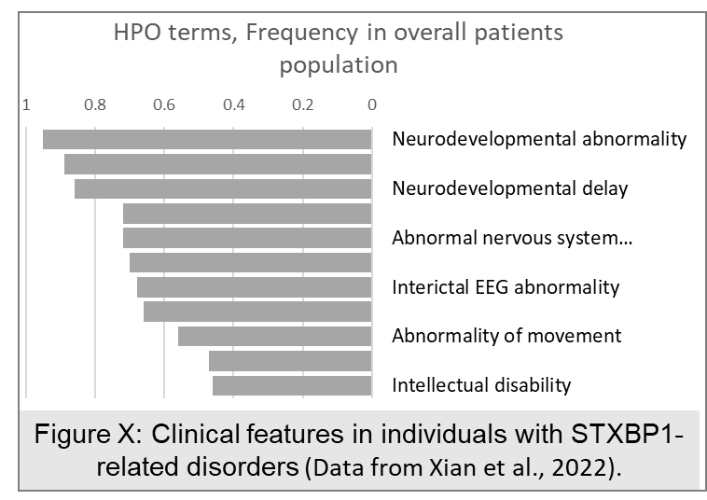

More than 50 features that are observed in >20% of the children elucidate compromised movement, speech, behavior, and intellectual disabilities {{2769 Xian, J. 2022;}}. A common characteristic is an early onset, with developmental abnormalities often preceding seizures (if present), and a high frequency of early-onset epilepsy encephalopathy (EOEE) and infantile spasms (IS). The severity and frequency of seizures decrease with age (30% achieve seizure freedom), and so are some of the other phenotypes. Regression, with the loss of milestones or skills already achieved, is another characteristic of the Stxbp1-related disorder {{2769 Xian, J. 2022; 2764 Stamberger 2016;}}. Phenotype variability is reflected in developmental trajectories, where some features intensify with age, such as intellectual disability and some types of epilepsy, while others lessen with age.

Among the studied populations, more than 200 Stxbp1 variants have been found and half of these are missense variants. Of the 54 recurring variants, the most frequent is the Stxbp1 R406C/H missense mutation in an evolutionarily conserved amino acid, which has been detected in 40 patients {{2769 Xian, J. 2022;}}. Phenotypic characterization of Stxbp1 R406C/H patients present severe phenotypes with significant similarity, with EOEE and neurodevelopmental disorder most frequently observed{{2765 Balagura 2022; 2769 Xian, J. 2022;}}. In two reported descriptions of monozygotic twins, carriers of the Stxbp1 mutation are not necessarily concordant in their outcomes. One study describes identical developmental trajectories and the other diverse patterns of development {{2765 Balagura 2022; 2770 Kobayashi, H. 2022;}}, exemplifying the possible interaction with additional unknown factors. Parallel attempts to define sub-groups, based on seizure type, age of onset-offset, and medications, led to the conclusion that disorder subtypes should relate to developmental trajectories. Collective efforts to analyze rich longitudinal clinical data, from birth to later age, has proven to be critical for the detection of two typical trajectories, where the age of epilepsy onset was the most predictive factor for later developmental outcome {{2765 Balagura 2022;}}.

When looking at patient phenotype, at least 3 concerns should be considered. First, clinical presentations evolve as a consequence of prior brain activity. Second, the majority of patients are medicated, so the outcome reflects the organic disorder and its response to medication. Third, non-seizure phenotypes and diagnosis are deeply affected by patient performance (language, movement, gaze), so that ID and autistic features (about 30% and 20% of patients, respectively) may be misrepresented due to the inability to evaluate.

Broadening the phenotype to include child performance in daily activities has been suggested to increase statistical power and to characterize important behaviors for the evaluation of therapeutic interventions.

Stxbp1 disorder – therapy development.

Among Stxbp1-related disorders, the most devastating phenotype is epileptic seizure (Figure pie). Therefore a large portion of Stxbp1 patients are treated with anti-seizure medication(s) with varying success rates. About 30%-45% of patients become seizure free between the age of 1 month to 4 years {{2769 Xian, J. 2022; 2764 Stamberger 2016;}} and other add), and about 30% are non-responders. It seems that Stxbp1 patients respond to medication by seizure type, regardless of mutation type. The most beneficial medications are ACTH, ketogenic diet, and clobazam {{2769 Xian, J. 2022;}}. Advancements in the understanding of Munc18-1 action as a chaperon protein have led to the idea that other chaperons may replace the missing/defective protein. Indeed, intervention with three chemical chaperones, among them 4-henylbutyrate, reversed the phenotype in animal models (Guiberson et al., 2018). Based on these findings, treatment of Stxbp1 patients with Glycerol Phenylbutyrate is now in Phase I clinical trials (ClinicalTrials.gov Identifier: NCT04937062). Stxbp1 model systems demonstrate that protein instability causes accelerated degradation of the protein, resulting in decreased levels of the Munc18-1 protein. Alternative approaches taken to normalize protein levels utilizing gene therapy and gene regulation are currently being tested (REF).

Pre-clinical studies and clinical trials are moving towards the development of effective therapy from both ends. The lesson learned should be applied while using disease models at all stages. Deep characterization of relevant behaviors at ages significant to the clinical presentation and the medical intervention. That, in addition to measuring significant effects with substantial effect sizes and validation of quantitative assays and biomarkers that are comparable to measuring core symptoms in patients.

To conclude, the clinical presentation is consistent with early-onset seizures. Evidence from animal models suggests major consequences of the molecular defect are represented in brain/ cortical circuit pathology.

GAP OF KNOWLEDGE

Utilizing advances in genetics, electronic records, and data management tools, clinical studies provide an up-to-date understanding of the clinical presentation and contributing factors in patients. Pre-clinical mechanistic studies have identified synaptic deficits in model systems and relevant behavioral phenotypes in adult mouse models of Stxbp1 haploinsufficiency.

In order to move pre-clinical studies further we have identified some open questions.

To what degree does Stxbp1 haploinsufficiency in animal models represent the spectrum of a similar human condition?

What are the developmental trajectories of mice with this neurologic and behavioral phenotype? Do they represent the variable human phenotype and the course of the human disorder?

What is the contribution of neurodegenerative processes to the Stxbp1 disorder?

RESEARCH OBJECTIVES AND EXPECTED SIGNIFICANCE

Adverse developmental trajectories of Stxbp1 disorders include neurodevelopmental disorders and early onset epilepsy encephalopathy with complex and variable presentation.

Here, we propose to perform a comprehensive characterization of the humanized Stxbp1 R406H mouse, to trace the developmental trajectories associated with human phenotypes and dissect the relationship between neurodevelopment and epilepsy. With this goal achieved we will use humanized Stxbp1 R406H mice to explore biomarkers of brain dysfunction associated with aspects of the disorder. Finally, we will establish and characterize Stxbp1 R406H iPSC-derived cortical neurons, which will serve to study cellular vs circuit function and assist future development of genetic interventions.

Aim 1: Characterize the developmental trajectories of the humanized Stxbp1+/R406H mouse model.

Aim 2: Define the association between neurodegeneration and Stxbp1+/R406H pathology

Aim 3: Establish and characterize Stxbp1 R406H iPSC-derived cortical neurons and study cellular vs circuit function as a basis for future development in genetic interventions.

SIGNIFICANCE

Stxbp1 mutations? cause a neurodevelopmental disorder with early onset in one of 26,000 infants. The clinical presentation includes global developmental delay, movement disorder, intellectual disability, speech impairment, early infantile epileptic encephalopathies, and autistic features. Here, we prioritized modeling human gene mutations that cause a severe phenotypic outcome and have high penetrance in the population. Two complementary model systems are suggested: (1) the mouse, capturing in-vivo development, phenotype, brain activity, molecular and structural features; and (2) the patient-derived neural culture that encapsulates the genomic interactions of the mutant gene in the patient and provides a good representation of the immature nervous? system. Considering the impact of this specific mutation, generating such disease models is of utmost importance for understanding the biological mechanism, as well as establishing quantitative biomarkers for diagnosis and assessment of disorder conditions. A mechanistic understanding and potentially non-invasive biomarkers are essential for drug development and validation of novel therapeutic options.

The mechanistic understanding and biological markers will be relevant to the study of other developmental encephalopathies, which expands the impact on a larger number of affected babies and families.

WORKING HYPOTHESIS:

We hypothesize that the mouse model of the Stxbp1 disorder-linked missense mutation R406H, Stxbp1+/R406H, will present phenotypic characterization relevant to humans, with a gene mutation of neurobiological origin.

Accordingly, deep phenotyping of development, behavior, and electrophysiology (Aim 1) will be carried out, as well as molecular and morphological aspects of development and the mature cerebral cortex (Aim 2), which will aid in revealing the developmental origin and the mechanisms behind the devastating phenotype observed in humans.

Second, we hypothesize that some aspects of Stxbp1 R406H disorder severity and profile depend on interactions with other genes expressed in the patient. These interactions and consequent outcomes will be represented in cultured neurons derived from patient cells.

Third, we hypothesize that converging evidence from the two disorder models, mouse, and patient-driven neurons, will have a significant contribution to our understanding of disorder origin and mechanisms. This knowledge will serve for evidence-based biomarkers and treatment development to translational diagnostic measures and drug development.

RESEARCH DESIGN AND METHODS.

**Aim 1: Characterize the developmental trajectories of the humanized Stxbp1 R406H mouse model.**

*Rational:*

Stxbp1 haploinsufficient mice model the conditions of protein truncated variants (PTVs). They may not generally reflect the disease status of patients with Stxbp1 missense variants, and the consequences of mutant protein loss-of-function and/or gain-of-function. Stxbp1 R406H, a recurrent mutation causing a severe phenotype, was suggested to cause a gain of toxic function, therefore, establishing and validating the Stxbp1 R406H mouse model is a highly interesting and indispensable tool in the path to designing diagnostic and therapeutic strategies (biomarkers, medication and treatment protocols/ approach).

*Approach:*

Deep phenotyping of Stxbp1 R406H heterozygote (Stxbp1+/R406H) mice. Developmental milestones from birth to adulthood will be characterized longitudinally with emphasis on early developmental features, as well as neurological and electrophysiological measures. The variables measured will be evaluated for their relations and predictive power of developmental trajectories and later outcomes.

*Developmental characterization of Stxbp1*+/R406H *pups*. Daily evaluation will be completed for the following measures on postnatal days (P) 1-30: Morphogenesis measures (weight, day of eyelid development? and ear canal opening, tooth and fur growth, head position, facial features, eye-eye, and eye-nose distance. Sensory-motor reflexes tests will include: walking, pivoting, homing, grip, righting reflex, geotaxis, cliff avoidance, neonatal rotarod, nest finding test, and preference to maternal odor{{2503 Sadigurschi, N. 2018; 465 Levav-Rabkin, T. 2010; 2673 Haziza, S. 2015; 2771 Dierssen, M. 2002; 412 Crawley 1999; 2772 Kofman, O. 2020;}}. Negative phototaxis, {{2565 Johnson 2010;}}, acoustic startle {{412 Crawley 1999;}} and pup-mother communication during pup isolation {{1309 Scattoni,M.L. 2008; 2670 Shekel Itay 2021;}}. In addition, beginning at P10, the age pups leave the nest most often, pups will be videotaped in their home cage to detect abnormal body twitches/jerks. Adaptation of ECoG recordings….look for reference. Evaluation of each variable is usually done until criteria are met for 3 consecutive days, however, due to observation of regression in patients, we will keep follow-up of all measures for the total age range. When needed, tests will be adapted to age.

*Characterization of Stxbp1+/R406H young and adult behavior*. Mice will be evaluated for the following domains of behavior: general well-being, home cage behavior, motor, coordination, learning and memory, social behaviors, sensory, anxiety, repetitive behavior, dominance, and aggression {{2503 Sadigurschi, N. 2018; 2673 Haziza, S. 2015; 1302 Kezurer, N. 2013; 1404 Golan 2005; 58 Golan 2004;}}. Beginning at P30, continuous basal ElectroCorticoGraphic (ECoG) recording will be performed. Sensitive analysis will include: epileptiform activity, seizures, spectral analysis, PSWE, and the pattern of the circadian rhythm {{2566 Alemany-González 2020; 2567 Bar-Klein 2014; 2668 Milikovsky, D.Z. 2019;}}. Susceptibility to seizures will be tested by exposure to sub-threshold doses of pentylenetetrazole (PTZ). We may consider a smaller set of behavioral phenotyping for the mice that undergo ECoG recording and PTZ analysis.

Brain tissue sampling: Ten days after the last behavioral test, mice will be anesthetized and brain tissue will be sampled for subsequent experiments (see experimental design).

*Preliminary results:* Figure will be unified and harmonized, current version was posted as a support for the text.

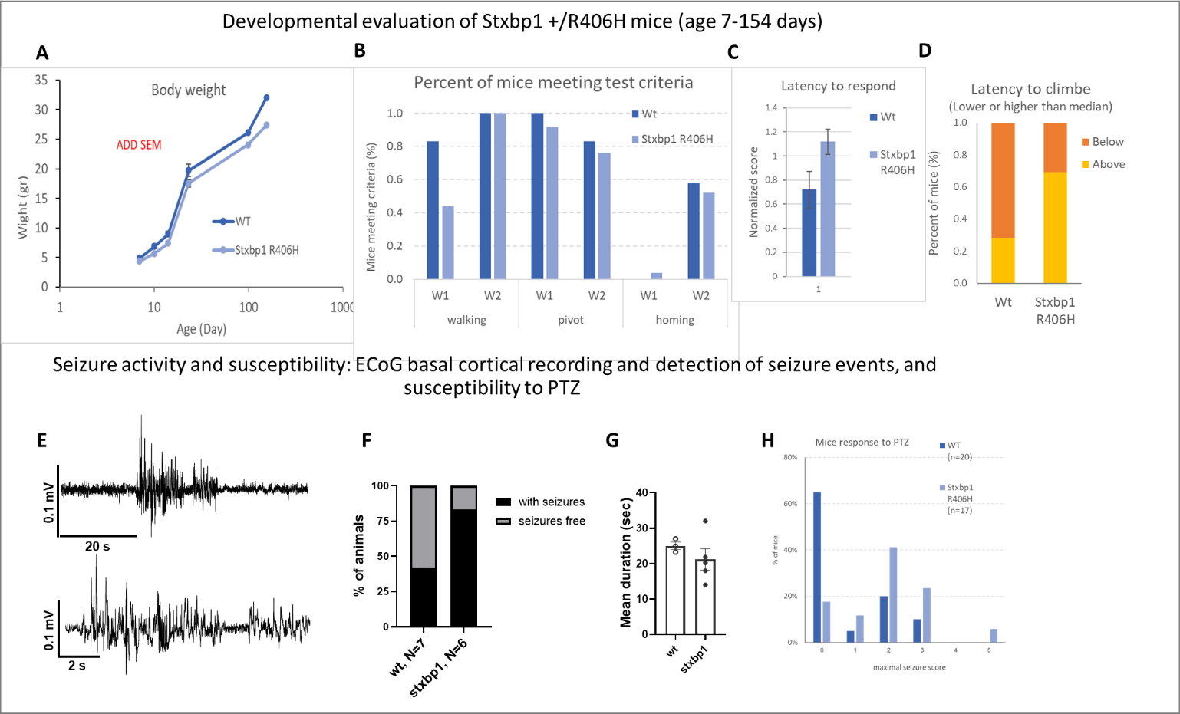*Developmental characterization of Stxbp1*+/R406H *pups* was performed weekly to obtain a primary estimate of the phenotype. (Wt, N=11, *Stxbp1*+/R406H , N=27, add in the figures). *Stxbp1*+/R406H mice had a lower body weight along the whole developmental course, compared to the Wt (Figure X A stat will be added to figure caption). Walking ability was delayed in the *Stxbp1*+/R406H pups compared to the Wt, whereas pivoting and homing behaviors did not show a clear result (Figure XB). Our experience with developmental evaluation indicates that developmental profiles may be delayed or facilitated in a day or two and such a change may be missed with a weekly evaluation as performed here {{2503 Sadigurschi 2018;}}. Thus, the modest difference in pivoting and homing behavior inspired us to perform a daily evaluation of these and other parameters. *Adult mouse evaluation*: Motor function ((Figure XC and D): The latency of mice to respond while hanging to a vertical grid was longer in the mutant mice, reflected by a higher percentage of mice presenting a latency above the median compared to the Wt mice. To correct for the difference in body weight, latency was normalized to body weight, but still indicated significant differences in response latency in the Stxbp1+/R406H mice. At the age of 22 weeks, mice were implanted with electrodes and telemetric wireless transmitters (see methods) and basal brain activity was recorded. Using Matlab-based in-house software (Bar-Klein 2013), we were able to detect epileptic seizures, as shown in figure XE, F Larger percentages of mice of the Stxbp1+/R406H mutation had seizures compared to the Wt group (Fig XG). Seizures were detected during the light and dark phases of the day in both groups. The average duration of each seizure was shorter in the Stxbp1+/R406H group compared to the Wt group. In addition, these mice presented higher susceptibility to the seizure-inducing agent PTZ, reflected by a higher percentage of responders to subthreshold doses (Fig XH) and shorter latency to respond compared to the Wt group (not shown). Altogether, primary developmental evaluation, elevated seizure frequency, and stronger response to PTZ in the adult mouse support the phenotypic relevance of the Stxbp1+/R406H mouse model and the additive value of the suggested study for the understanding of Stxbp1 disorder.

*Expected results and significance:* We expect to capture rich developmental phenotypic characterization of the humanized Stxbp1+/R406H mouse, representing the most frequent recurrent missense variant in the human Stxbp1 disorder. One novelty of the current study is the attention given to the early and continuous age range, which is expected to enhance our ability to distinguish between different developmental trajectories if present. Preliminary data suggest that these mice recapitulate the developmental delay observed in human patients. We expect that by broadening the spectrum of phenotyping characterization and performing longitudinal, daily, evaluations, a rich description of the developmental course may provide early predictors of later outcomes. Preliminary observation of spontaneous epileptic events in the adult Stxbp1+/R406H mice and higher susceptibility to sub-threshold doses of PTZ provides a good indication that additional dysfunction of cortical circuits may be detected. We expect part of these measures to have a biomarker value, with the main focus on EEG recordings, which contrary to molecular measures, can be applied as a non-invasive measure in human studies for diagnosis and drug/treatment evaluation. The findings in the Stxbp1+/R406H model for missense mutations may promote understanding of the pathology in other missense variants of Stxbp1 disorder and other cases with EOEE.

(Fast response to treatment/drugs).

*Limitations and alternatives:*

A robust phenotype and possible causative to later outcome phenotypes is early seizure onset, which is difficult to record in mice pups at early ages. If we fail to distinguish seizures from pup video recordings, we will adapt the ECoG system for recordings of pup basal cortical activity as early as possible with a preference for P14 – P21. Another alternative is to study *in-vivo* recordings of basal and drug-induced activity in cortical slices from pups at early ages (P7, 14). This method is within the expertise and laboratory resources of the PI and collaborating labs. Another limitation, relating to the phenotypic variability of tested mice, is the use of a single line of mice in a particular strain background, which may not represent the variability observed in the human population. To address this limitation, if needed, Stxbp1+/R406H will be bred into different strains, and offspring will be evaluated with similar behavioral protocols as was previously done by Kovacˇevic´ et al., 2018.

**Aim 2: Define the association between neurodegeneration and Stxbp1+/R406H** **pathology**

*Rationale:*

The absence of Munc18-1 proteins causes rapid neuron death around the time of synaptogenesis. Brain structural atrophy has been observed in about half of the patients. 15-30% present cortical atrophy and less show thinning of the corpus callosum and/or hypo-myelination {{2764 Stamberger 2016; 2765 Balagura 2022;}}, with brain atrophy acquired with age (Saitsu 2010). The source and nature of these changes are unknown. By exploring the balance between development – pruning - neurodegeneration and the nature of the changes in cortical tissue, we will shed light on the disease mechanisms and will be able to suggest targets of intervention.

Normal organization of the brain in the absence of Munc 18-1 has been previously reported, with a transition to cell death in the absence of synapse formation. Therefore, preliminary evidence of Stxbp1 R406H mutations is expected upon the rise in synaptogenesis and result in the long-term outcome in adulthood.

*Approach:*

Among patients with brain structural atrophy, the larger proportion is present with cortical atrophy, therefore we will focus our analysis on the cerebral cortex. The expression of genetic markers of synaptogenesis, cell death, and neurodegeneration will be evaluated in mouse cortex tissue at three time periods: 2 times during the early postnatal stage (P4 and P8, active developmental synaptogenesis (REF) and in the adult mouse brain (when atrophied, it will be evident). Three panels of genes will be evaluated. Panel 1: will include markers of synaptogenesis (SNAREs and specific excitatory and inhibitory pre- and postsynaptic markers, list), Panel 2: Syn pruning?? List; Panel 3: cell death and neurodegeneration, list. Gene expression will be compared for the genotypic groups and ages.

Stxbp1 aggregation: Thioflavin-T (Th-T) Aggregation Assay – will be used for the detection and quantification of protein aggregates. The presence of aggregates will be confirmed by western blot of the insoluble fraction {{2773 Alfahel 2022;}}, and in brain sections by immunofluorescent methods.

Gross structural changes and cell death. This study will be performed in the brains of mice that were previously characterized by behavioral and/or electrophysiological tools. Brain sections will be evaluated for the presence of gross structural changes and cell death. In addition, we will use immunofluorescent methods to study the presence, spatial distribution, and cell type specificity of proteins indicative of cell death and neurodegeneration.

Data will be analyzed by genotypic group and correlation with phenotypic measures extracted from experiments in Aim 1.

*Expected results and Significance:*

Based on the reported effects of the Stxbp1 R406H variant on synaptic activity in neuronal culture and animal models, we expect genotype-dependent differences in synaptogenesis markers and interactions with age. However, the nature of change is unknown. The results will indicate what compensatory regulation on gene expression takes place. How synaptogenesis advances with age in the mutant vs the Wt pups. Which component of the synapse is responsive to the deficient protein (presynaptic vs postsynaptic and excitatory vs inhibitory). Whether we will find evidence of cell death and neurodegeneration, above the developmental cell death is our primary question. Any result is extremely informative and can enhance our understanding of the pathology and contribute to the interpretation of the behavioral results (Aim 1). Aggregate formation in animal models of neurodegenerative diseases is difficult to recapitulate. Therefore, the presence of aggregates will be extremely informative, however, failure to observe aggregation will not necessarily be uninformative. Analysis of the adult mutant brain is expected to provide directions for the nature of the pathology associated with seizure susceptibility and the overall phenotype as demonstrated in Aim 1. The information regarding the regulation of the synaptic and neurodegenerative pathways will contribute to our understanding of the electrophysiological data gathered in Aim 1 and will establish a sensitive measure for future translational studies toward drug development.

*Pitfalls and alternatives:* This is a straightforward study, using conventional methods, so we do not expect difficulties. However, the use of brain tissue does not enable linking between early and late pathology in the same brain. If clear evidence of neurodegeneration exists, large effect sizes will be found by analysis of gene expression in the pups through the use of MRI brain scans which would enable a longitudinal study of brain pathology.

**Aim 3: Characterize Stxbp1 R406H iPSC-derived cortical neurons and study cellular vs circuit function as a basis for future development of genetic interventions.**

*Rational:*

Stxbp1 disorder is primarily a neurodevelopmental disorder. Therefore, neuronal cells are an important disease model, and neuronal cells derived from patient tissue encapsulate the entire genetic context. The development of a robust disease model is key to assessing cellular and circuit aspects of the disorder, the developmental course, and for future assessment of candidate drugs.

*Approach:*

To generate a disease model, we will first characterize the Stxbp1 disorder-iPSC-derived neurons using molecular, biochemical, and functional assays. Stxbp1 R406H patient and control -iPSC-derived mixed neuron culture will be generated by differentiation from EZ-spheres (see methods). EZ-spheres generated in Dr. Vatine’s laboratory, (in our department), are available for the proposed research (see letter of collaboration).

Following differentiation, we will characterize the iPSC-derived neurons using the following methods:

Expression analysis: Mutations in Stxbp1 including R406H may cause degradation of the protein (REF 5). Therefore, we will test its expression and protein levels in cultured neurons. We hypothesize that mutant Stxbp1 proteins will induce synaptic remodeling by regulation of other synaptic protein expressions. The expression of genes involved in synaptic function (presynaptic, postsynaptic, excitatory, inhibitory) will be tested by real-time PCR, as in Aim 2 (Synaptogenesis Panel). Analysis of similar genes in both animal models and iPSC-derived neurons will enable the convergence of findings from these two patient-linked model systems. Protein levels and cellular manifestations will be evaluated using immunoblotting and immunofluorescence imaging to analyze proteins whose expression was modified.

Protein aggregates: The presence of protein aggregates will be evaluated as in Aim 2.

Electrophysiological characterization: To test whether patient-derived neurons generate normal functioning networks, EZ-spheres will be seeded onto Multi-electrode array (MEA) plates and their electrophysiological activity will be recorded using the Maestro Edge MEA (Axion BioSystems) system. Recordings will be performed twice a week throughout 2-8 weeks of differentiation. The following variables will be analyzed: spike frequency, burst properties, and frequency, network bursts, and network burst synchronization {{2779 Amin, H. 2016; 2774 Vatine, 2017; 2780 Odawara, A. 2016;}}.

*Preliminary results*:

iPSC-derived neurons differentiated from the control patient's EZ-spheres were characterized. RNA-seq analysis of cultured neurons showed higher expression levels of Stxbp1 and its related genes, including Syntaxin1, VAMP2, and SNAP25. We also detected MUNC18-1 protein in these iPSC-derived neurons by Western blot, as shown in Figures X A and B. Finally, we evaluated electrophysiological activity in the iPSC-derived neurons using MEA systems and showed that they are spontaneously active (Figure XX). These results suggest that we have the necessary expertise and resources to perform the profound characterization of neurons derived from an Stxbp1 R406H missense mutant patient, which would reveal the mechanism leading to aberrant brain activity.

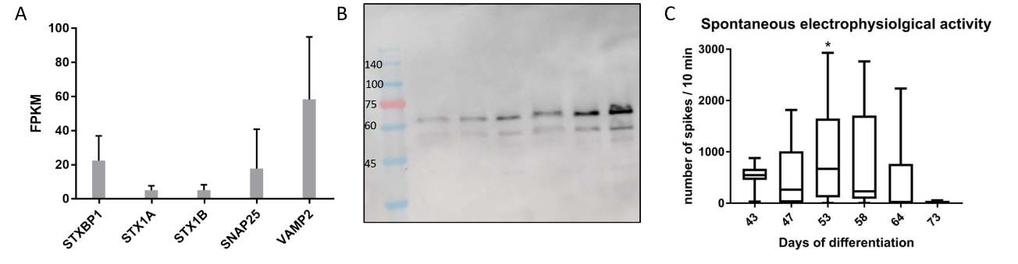

**Figure XXXX. iPSC-derived neurons express Stxbp1 and are spontaneously active.** )A) SNARE-complex genes expression in iPSC-derived cortical cultures, which were differentiated using our well established EZ-sphere protocol. (B) MUNC18-1 was detected by immunoblotting in iPSC-derived neurons. (C) Functional analysis of iPSC-derived neurons by MEA shows that the cells are spontaneously active and spike rates change with age.

*Expected results and Significance:*

In isolated or model systems, Stxbp1 variants produce a protein pruned to degradation, resulting in decreased protein levels (5,6), and/or protein aggregation. Except for a single report of patient-derived iPSC, there is no information regarding the mutant protein function in the context of patient’s "genetic environment". We anticipate remodeling of the neural circuit that begins with compensatory changes in presynaptic gene expression and includes post-synapse genes. By analysis of differential gene expression in control vs patient-derived neurons, we will be able to predict the nature of changes expected in network activity. We will be able to explore that using the multi-channel recording system. Together, this will be a powerful tool to understand how the mutant protein affects the developing circuits.

*Pitfalls and alternatives*

As reported previously, patient-derived neuronal culture may have significantly low activity and synchronization. This scenario is intriguing but may be an authentic representation of the patient’s state at early, immature stages. We will first examine its relation to increased cell death. If this possibility is excluded, we will increase the density of neurons in the culture and re-evaluate. To further explore how this phenotype causes an increased risk for epileptic activity, we will test network response to stimuli, and compare it with the control cultures. stimulate the culture and record its response. The following stimuli? will be considered: electrical stimulus via one of the electrodes, 100mM KCl, block of GABA B receptor.

METHODS:

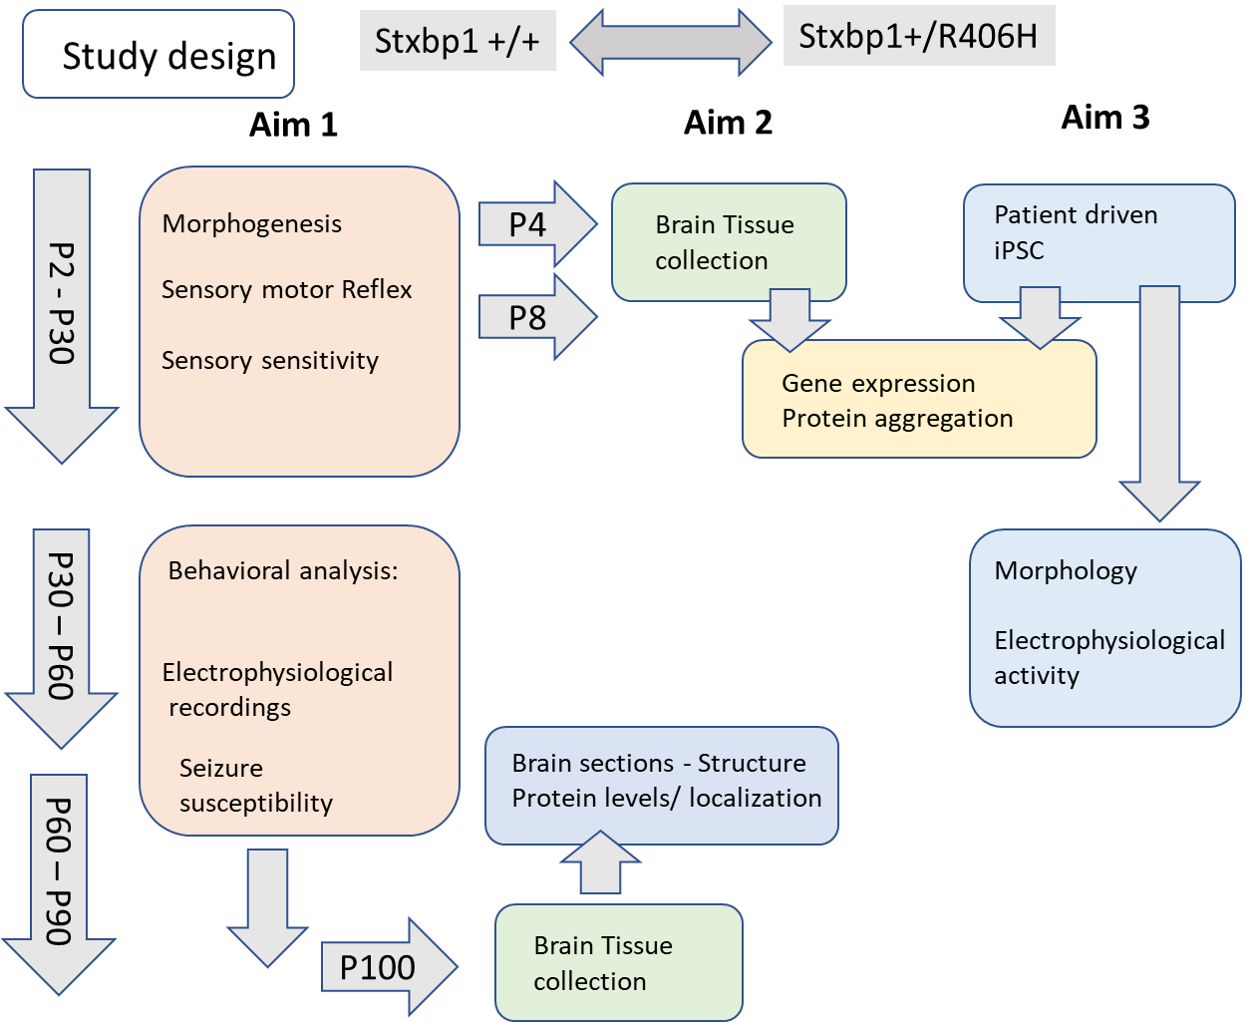Experimental design: Figure XXX. Figure caption will be added.

Animals. Generation of mouse models carrying the common patient-derived R406H point mutation in the Stxbp1 gene. Stxbp1+/R406H mouse was generated by Dr. Rebecca Haffner-Krausz at the Department of Veterinary Resources Core Facility, Weizmann Institute of Science, Rehovot, Israel. Since the mouse and human Stxbp1 proteins are identical, a mouse line carrying the R406H point mutation in exon 14 was produced via CRISPR/Cas9 gene editing in mouse embryos. In addition to the desired G>A mutation (DNA LOCATION??), the repair oligo contained several silent mutations to mutate the PAM site and to avoid early termination of the homologous repair process due to full sequence homology {{2777 Bak, R.O. 2018;}}. Ribonucleoprotein (RNP) complex (4 uM Cas9 Nuclease; IDT + 6uM IVT guide RNA) was electroporated, together with 10uM mutant Stxbp1 repair single stranded oligonucleotides, into one-cell embryos of B6(Cg)-Tyrc-2J/J mice (Jax B6-albino). Electroporated embryos were transferred to CD1 surrogate females. Pups will be genotyped by Sanger sequencing. To exclude the effect of maternal behavior on offspring development and phenotype, and synchronize pup ages, tested mice will be F2 generated by IVF to CD1 surrogate females. In parallel, a colony of Stxbp1+/R406H mice will be established in BGU. Mice of the Stxbp1+/R406H colony will be used to verify phenotype or cross with a different strain (see alternatives in Aim 1).

Behavioral analysis: Mice will be maintained on a 12/12 hour light/dark schedule; food and water will be provided *ad libitum*. All animal experiments will be carried out in accordance with the guidelines of Israel's National Council for Animal Experimentation. Offspring of mutant and Wt groups will be blinded to exclude bias during test performance. Mice from both groups will be assigned to test in random order. After weaning, male and female mice will be tested in separate sessions and the room cleaned and refreshed between female and male sessions.

Phenotypic evaluation: Newborns: Pups will be evaluated daily beginning at postnatal day 2, until postnatal day 30, except when indicated specifically. Morphogenesis: weight, day of the eyelid and ear canal opening, tooth and fur growth, head position, facial features, eye-eye and eye-nose distance {{2503 Sadigurschi, N. 2018; 465 Levav-Rabkin,T. 2010; 2673 Haziza, S. 2015; 2771 Dierssen,M. 2002; 412 Crawley 1999;}}. Sensory-motor reflex: walking, pivoting, homing, grip, righting reflex, geotaxis, cliff avoidance, neonatal rotarod, and the nest finding test as described previously {{2503 Sadigurschi, N. 2018; 465 Levav-Rabkin,T. 2010; 2673 Haziza, S. 2015; 2771 Dierssen,M. 2002; 412 Crawley 1999; 2772 Kofman, O. 2020;}}. Preference of maternal odor: the preference of the pup to move towards nesting materials with maternal odor vs fresh nesting materials will be tested starting at P7- P14 as described by {{2669 Finkler 2020;}}. Negative phototaxis will be evaluated during P6 - P9 (before eye-opening) by pup retraction from light sources at different intensities{{2565 Johnson 2010;}}. Acoustic startle will be used as a measure of auditory sensitivity. A tone with a constant duration of 40ms and random order of intensities (75-100db) and intervals (5-30sec) will be used as a stimulus{{412 Crawley 1999;}}. Mother-pup communication: USV will be recorded during 5min of pup isolation using the UltraSoundGate 116Hm, equipped with Condenser ultrasound microphone CM16/CMPA, and the Avisoft-recorder 4.2.17 software (Avisoft Bioacoustics, Berlin, Germany) {{1309 Scattoni 2008; 2670 Shekel 2021;}}. Analysis of syllable features, usage, and temporal patterns will be extracted by SASLab Pro (Avisoft Bioacoustics®, Berlin, Germany) {{2670 Shekel 2021;}}. Syllable classification will be done using a *Python-based* classification algorithm. In addition, beginning at P10, the age pups leave the nest most often will be recorded and pups will be videotaped in their home cage to detect abnormal body twitches/jerks. The duration of videotaping will be adjusted.

Young and Adult: Mice will be evaluated for the following domains of behavior, in the order listed: general wellbeing (nesting, open field), home cage behavior, motor and coordination (open field, motor neuro score, vertical pole, horizontal pole, grid grip, stride gait), learning and memory (object and location, passive avoidance), social behaviors (3 chambers and direct social interaction), sensory (visual and acoustic), anxiety (open field, plus maze), repetitive behavior (marble), dominance, and aggression (resident intruder) {{2503 Sadigurschi, N. 2018; 2673 Haziza, S. 2015; 1302 Kezurer, N. 2013; 1404 Golan 2005; 58 Golan 2004;}}. Mice will be evaluated using one test per day, with each behavior tested twice; once beginning at P30, and a second evaluation beginning at P60.

Basal brain activity: Beginning at P30, continuous basalElectrocorticographic (ECoG) recordings will be performed using easyTEL_S_ETA mouse-size implants (EMKA) as previously described102. Mice will be placed in a stereotaxic frame under deep isoflurane anesthesia (1–3%) and holes will be drilled in coordinates 3 mm caudal and 2 mm lateral relative to the bregma. Stainless steel screws will be fixed to the holes. After placing a wireless transmitter (Data Science International), the electrodes will be connected to the screws. Before termination of anesthesia, buprenorphine will be administered (i.p., 0.05 mg/kg). ECoG recordings will be performed for seven days using a homemade Matlab-based program after four days of habituation. ECoG activity will be related to the sleep-wakefulness state of the mouse and the circadian rhythm. The analysis will be performed offline using an in-house automated algorithm. Sensitive analysis of basal ECoG activity will include seizure detection, spectral analysis, PSWE, and the pattern of the circadian rhythm {{2566 Alemany-González, M. 2020; 2567 Bar-Klein, G. 2014; }} add ref for PSWE. As an index of excitation-inhibition balance and cortical excitability, DFA will be extracted. Evaluation of brain activity and seizure patterns will be performed in collaboration with Prof. Alon Friedman from our department (see collaboration letter).

Seizure susceptibility: in response to PTZ (30mg/Kg i.p), mice? will be tested as described by Powel et al {{1503 Powel 2003;}}.

Brain tissue collection: pups will be anesthetized by Isofluorane (1-3%). For RNA extraction, aggregate evaluation, and possible protein analysis, the brains will be immediately removed, divided into parts, and fast frozen in liquid N2.

Quantitative real-time PCR and Western blots will be performed as described previously{{1325 Melamed, O. 2014; 1232 Blumkin, E. 2011;}}.

Stxbp1 aggregation: Thioflavin-T (Th-T) Aggregation Assay will be used for detection of protein aggregates {{2773 Alfahel, L. 2022;}}.

Immuno-Fluorescence Analysis**.** Ten days after the completion of the last behavioral test, mice will be anesthetized by inhalation of 30% isoflurane (Minrad Inc, NY, USA), after which they will be transcardially perfused with paraformaldehyde 4%. Brains will be rapidly removed into a 4% paraformaldehyde solution and stored at 4ºC overnight. Each brain will be transferred to sucrose solutions (10% 2h, and 30%, 24h). Brains will be embedded in an OCT compound matrix (Tissue-Tek#4583) and stored at −80ºC. The brains will be sliced into 10-μm thick sagittal sections between the bregma lateral plane, 0.24-0.36mm. Images of the frontal cortex, motor cortex, and retrosplenial cortex will be captured by fluorescent microscope. Cortical images from the pia to the ventricle will be divided into six layers for the evaluation of molecular markers in a layer-specific manner. {{2497 Nisimov, H. 2018; 2503 Sadigurschi,N. 2018;}}. Primary and secondary antibodies will be used following manufacturer instructions.

iPSC-driven mixed neural cultures: Skin punch biopsies were collected from an 8-year-old patient carrying a heterozygous Stxbp1 R406H missense variant and his sex-matched healthy sibling (control). Fibroblasts were produced and reprogrammed using non-integrating episomal vectors. Three iPSC clones from each line were generated and fully characterized. More recently, EZ-spheres from these clones were generated in Dr. Gad Vatine’s laboratory, in our department. EZ-spheres are iPSC-derived early neural progenitor cells that are grown in suspension and are easily expandable {{2774 Vatine, G.D. 2017; 2775 Ebert, A.D. 2013; 2776 Jagadeesan, S. 2020;}}. To generate a stable and scalable cell source for neural studies, including the suggested study, Vatine’s laboratory generated EZ-sphere banks from these clones. Cortical neuronal differentiation through EZ-spheres is routinely used in the Vatine lab to study several other neurological disorders. For the proposed experiments suggested here, EZ-spheres will be further differentiated into cortical cultures containing neural progenitor cells, astrocytes, and neurons.

Characterization of gene expression and proteins in culture will be done with conventional tools as described above, using? brain tissue and immunofluorescent methods.

Electrophysiological properties of iPSC-derived neurons: EZ-spheres will be seeded onto Multi-electrode-array (MEA) plates and neuronal spontaneous activity will be recorded using the Maestro Edge MEA (Axion BioSystems) system. Recording will be performed twice a week throughout 2-8 weeks of differentiation. The analysis will include the number of spikes, bursts, and network bursts and the level of network burst synchronization (REFERENCES).

Statistical Plan: Stxbp1 models and controls will be analyzed using ANOVA and t-tests with Bonferroni correction for multiple comparisons; nonparametric tests will be used when data do not follow a normal distribution. Statistics will be performed and displayed with SPSS and R. We will compare each variable/age between the genetic groups and ages. For categorical variables, Pearson’s x2 test will be used; for continuous variables, we will use one and two way-ANOVA and t-tests with Bonferroni correction for multiple testing and nonparametric tests when needed. Correlation between variables will be tested to explore associations between variables. Significant differences will be considered when P<0.05.

RESOURCES.

Golan's laboratory is equipped with a core facility for immunofluorescent staining and analysis, 1 IX-70 Olympus fluorescent microscope equipped with PD73 Olympus CCD, and cellSense software and hardware. It also includes a forma incubator, a clean bench, a chemical hood, Biometra PCR-thermocyclers, a Sub-Cell GT-cell set, a dry hot plate, a mini centrifuge, a tube-rotator, two shakers, two vortexes, a microwave, two Bio-Rad power supplies, three complete Mini Protean set-ups, two medium speed Epemdorf centrifuges, a Balance, a pH-meter, two hot plates with stirrers, two -20°C freezers, and a refrigerator. In addition, a variety of equipment for the analysis of mouse behavior including arenas, a video system, EthoVision -XT tracking software (Noldus, ND) for the analysis of behavioral data, an Avisoft recorder and analysis software, and a computer system (Koffman lab), and an ECoG system (Data Science International) (Fiedman lab.). Departmental and University resources include: a tissue culture room, Leica cryostat Ag protect CM1860, Real-Time PCR – applied biosystems, Single color Real-time PCR Detection system, Nanodrop 2000, a culture room, two Revko -80°C, a Sorval ultracentrifuge, a Sorval cold centrifuge, a UV gel reader, a Bio-Rad chemi-luminesence reader, a cold room, and a culture room. Mice are housed in the animal facilities at BGU.