**Structuring of 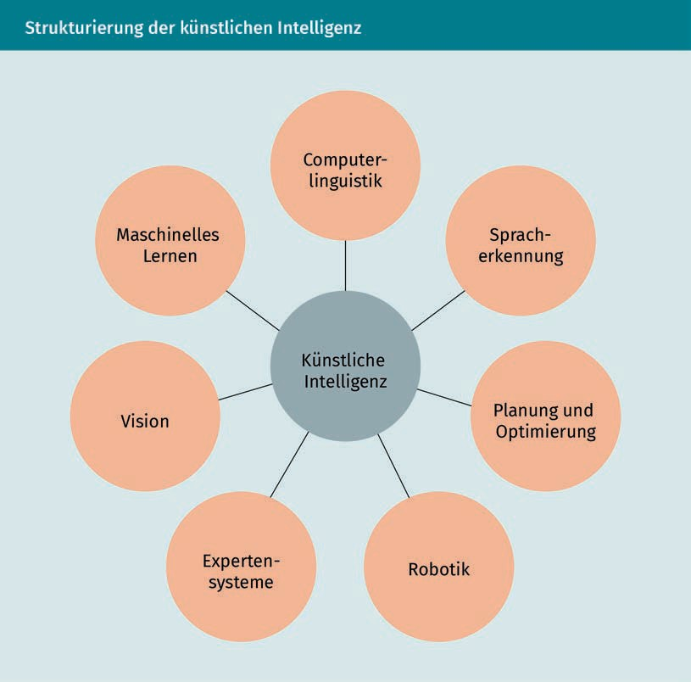Artificial Intelligence**

|  |  |
| --- | --- |
| Computerlinguistik | Computer linguistics |
| Spracherkennung | Speech recognition |
| Planung und Optimierung | Planning and optimization |
| Robotik | Robotics |
| Expertensysteme | Expert systems |
| Vision | Vision |
| Maschinelles Lernen | Machine learning |
| Künstliche Intelligenz | Artificial intelligence |

**Binary Classification Problem (Schematic Representation, Left; Linear Regression of Input Data (Right)**

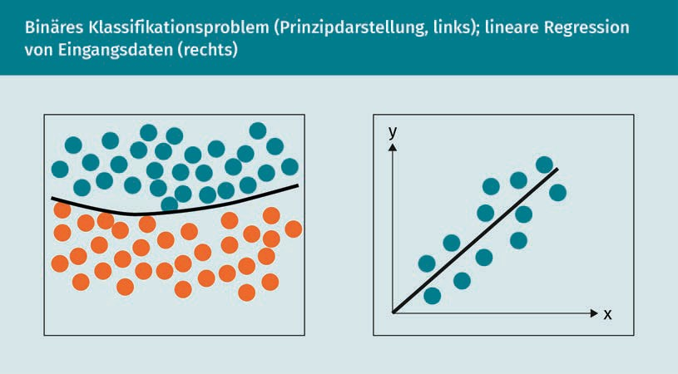

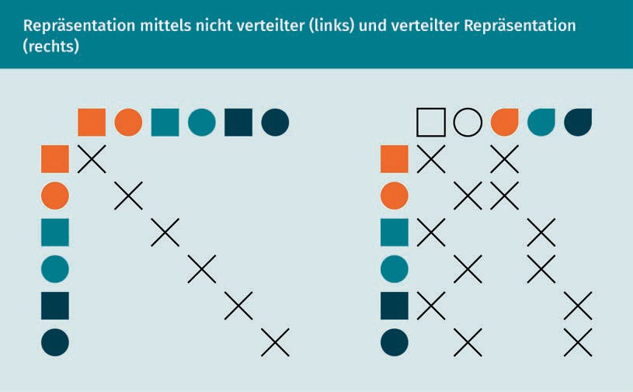**Representation Using Non-Distributed and Distributed Representation (Right)**

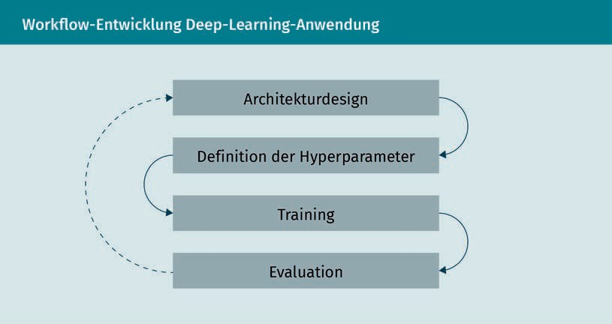**Development of Workflow for Deep Learning ApplicationEntwicklung Deep-Learning-Anwendung**

|  |  |
| --- | --- |
| Archiktekturdesign | Architecture design |
| Definition der Hyperparameter | Definition of hyperparameters |
| Training | Training |
| Evaluation | Evaluation |

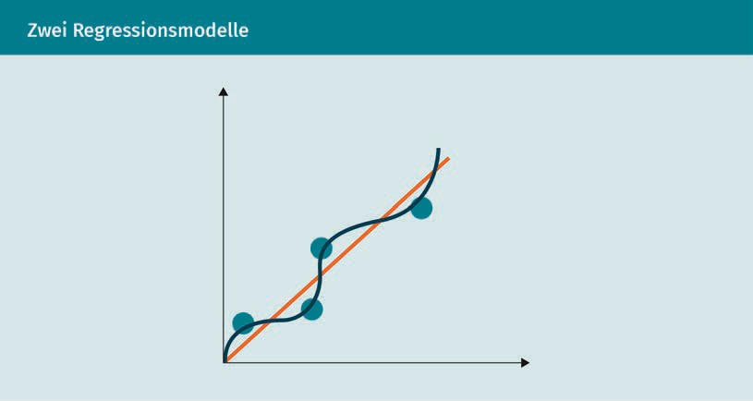**Two Regression Models**

**Sample Representation of the Number of Smartphones Sold as a Function of Invested Advertising Costs**

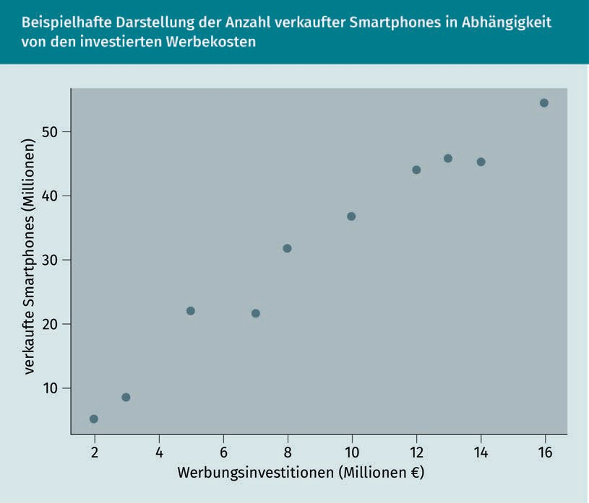

|  |  |
| --- | --- |
| Verkaufte Smartphones (Millionen) | Smartphones sold (in milions) |
| Werbungsinvestitionen (Millionen) | Investment in advertising (in millions) |

**Regression Line of Sample Dataset**

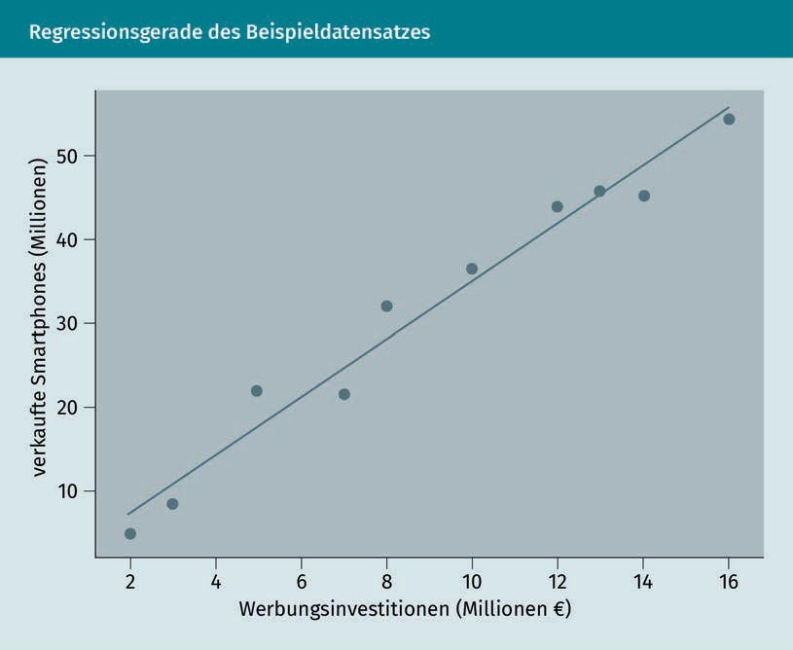

|  |  |  |
| --- | --- | --- |
| Verkaufte Smartphones (Millionen) | Smartphones sold (in milions) |  |
| Werbungsinvestitionen (Millionen) | Investment in advertising (in millions) |  |

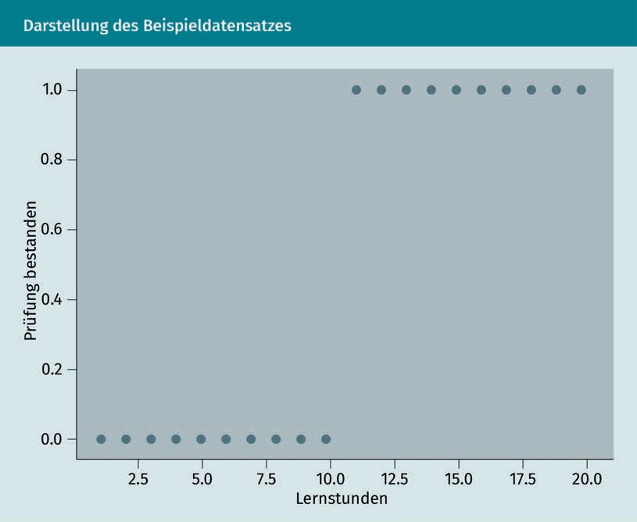**Representation of the Sample Dataset**

|  |  |
| --- | --- |
| Prüfung bestanden | Exam passed |
| Lernstunden | Study hours |

**Regression Line for Sample Dataset**

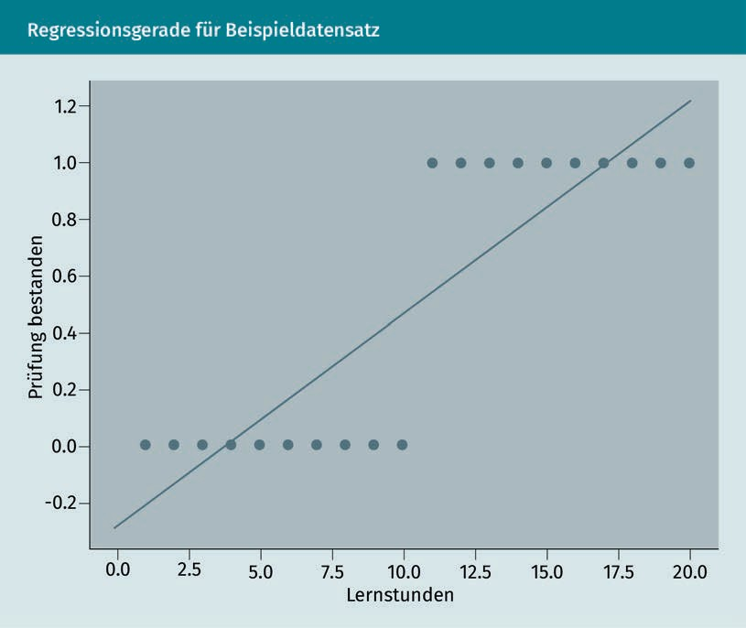

|  |  |
| --- | --- |
| Prüfung bestanden | Exam passed |
| Lernstunden | Study hours |

**Estimated Logistic Function for Sample Dataset**

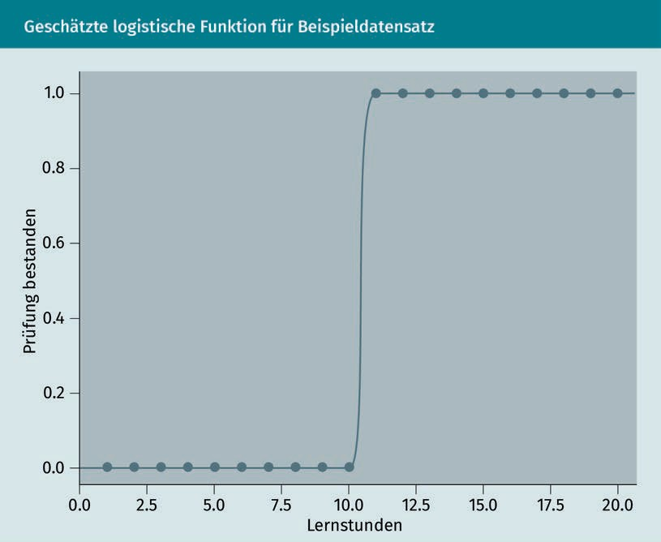

|  |  |
| --- | --- |
| Prüfung bestanden | Exam passed |
| Lernstunden | Study hours |

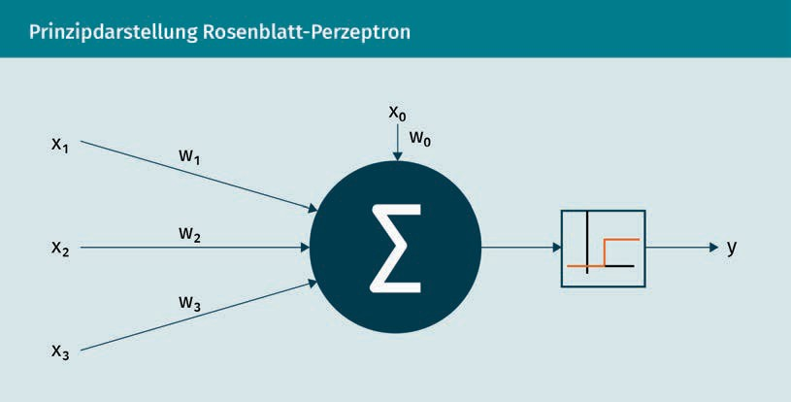**Schematic Representation of the Rosenblatt Perceptron**

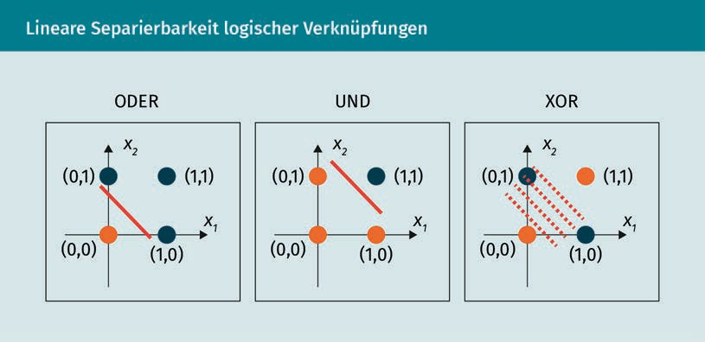**Linear Separability of Logistic Operations**

|  |  |
| --- | --- |
| ODER | OR |
| UND | AND |
| XOR | XOR |

**Schematic Representation of the Expansion to a Multilayer Perceptron**

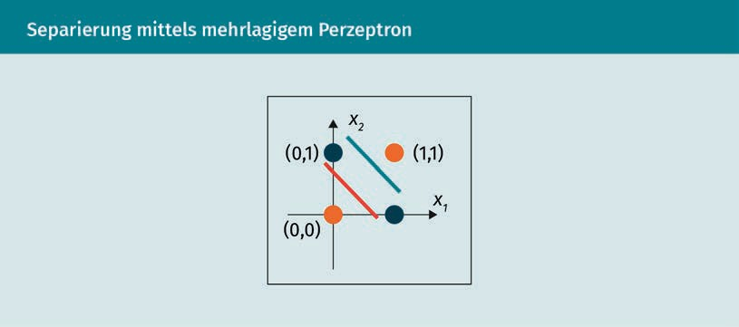**Separation by Multilayer Perceptron**

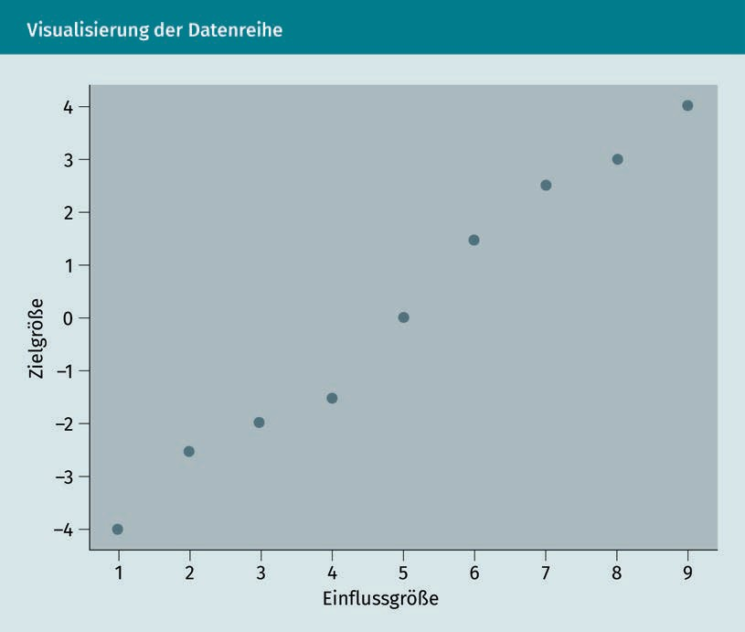**Visualization of the Data Series**

|  |  |
| --- | --- |
| Zielgröße | Target variable |
| Einflussgröße | Influencing variable |

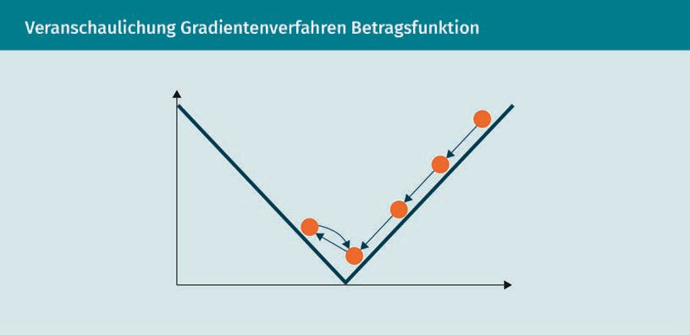**Illustration of the Absolute Value Function in the Gradient Method**

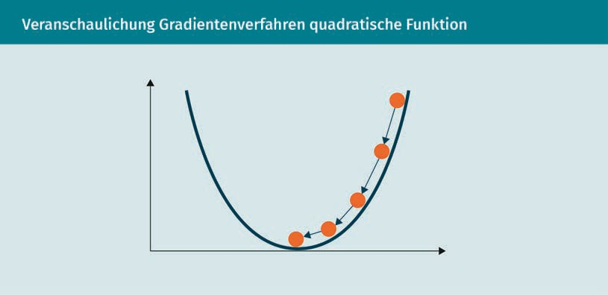**Illustration of the Squared Function in the Gradient Method**

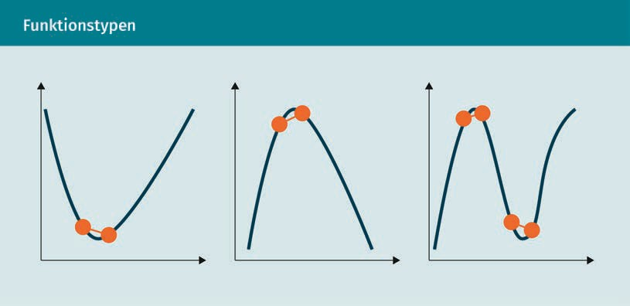**Function Types**

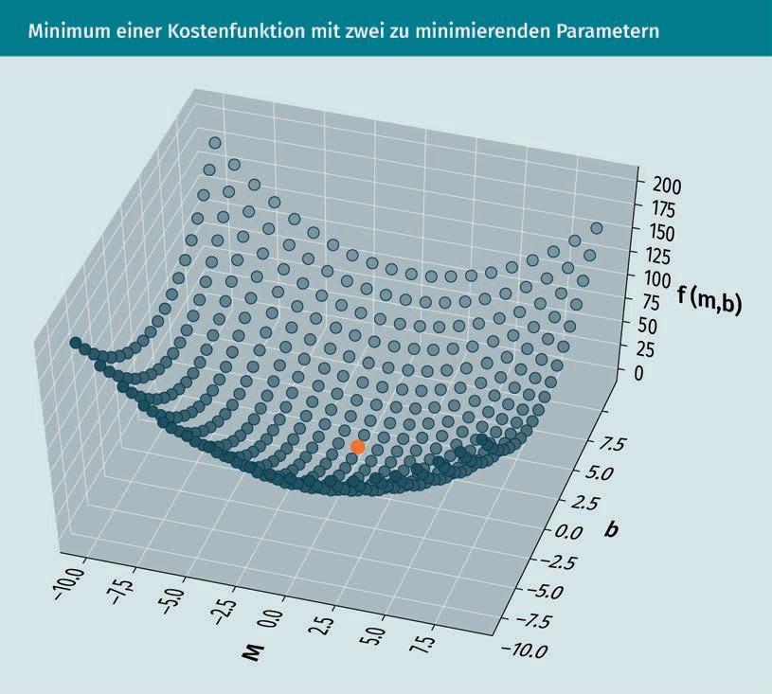**Minimum of a Cost Function With Two Minimizing Parameters**

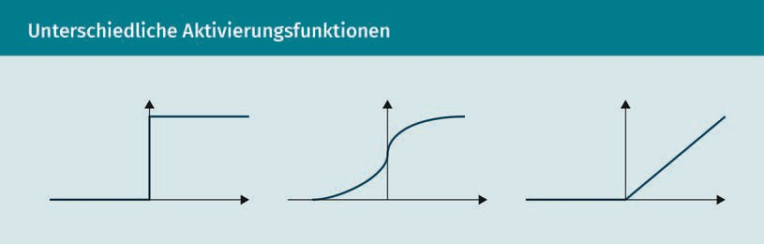**Different Activation Functions**

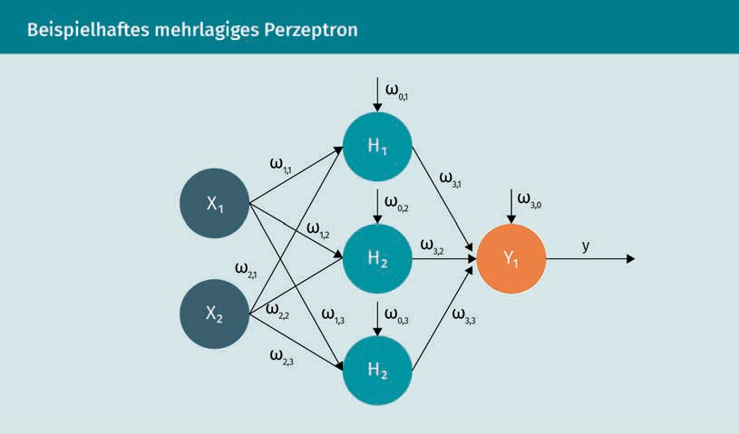**Sample Multilayer Perceptron**

**Sample Multilayer Perceptron**

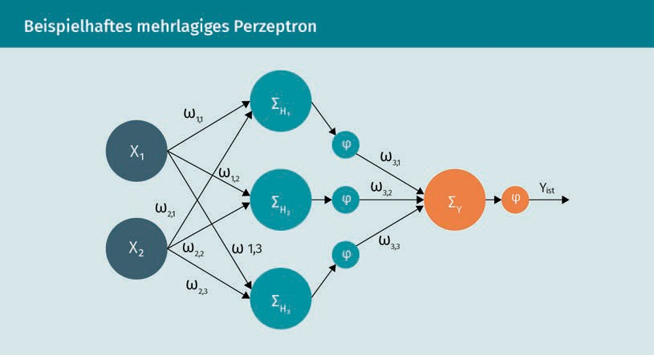

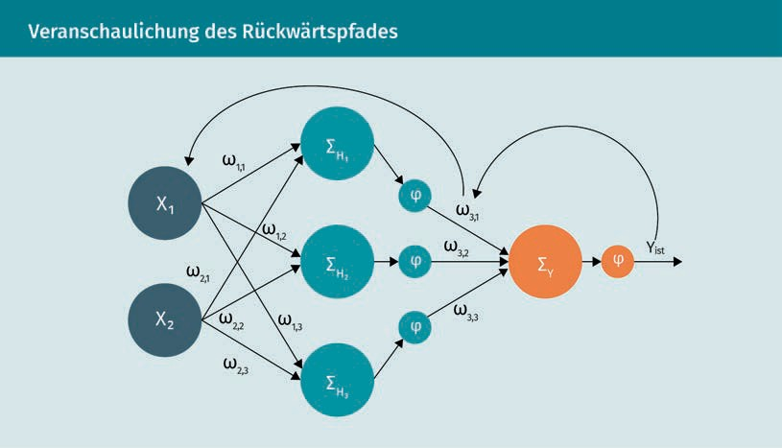**Illustration of the Backward Path**

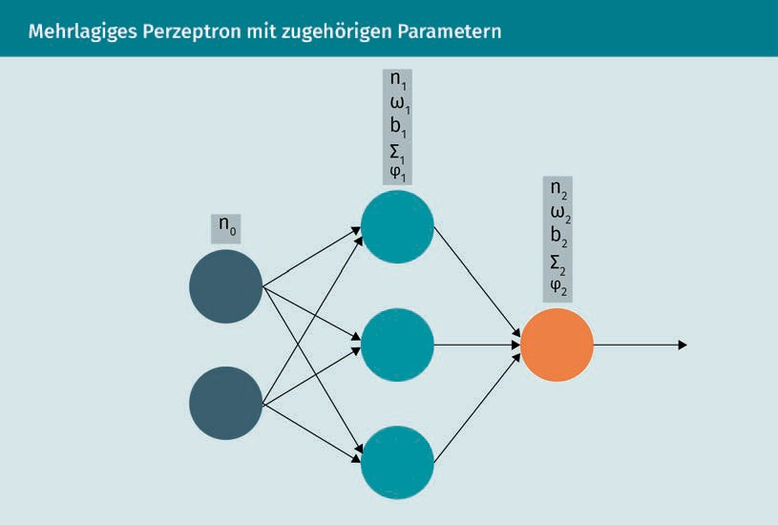**Multilayer Perceptron With Associated Parameters**

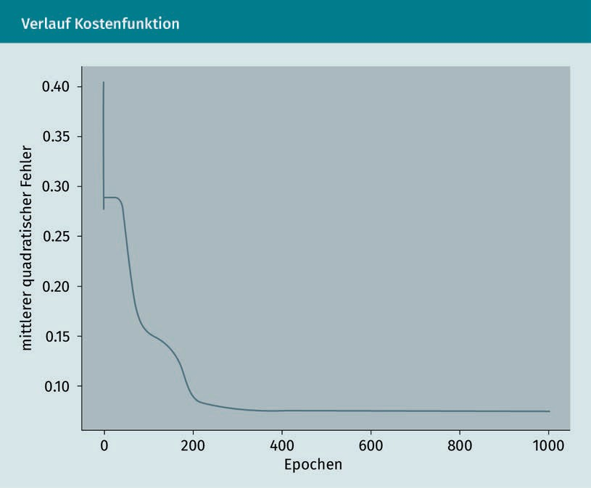**Cost Function Curve**

|  |  |
| --- | --- |
| Mittlerer quadratischer Fehler | Mean squared error |
| Epochen | Epochs |

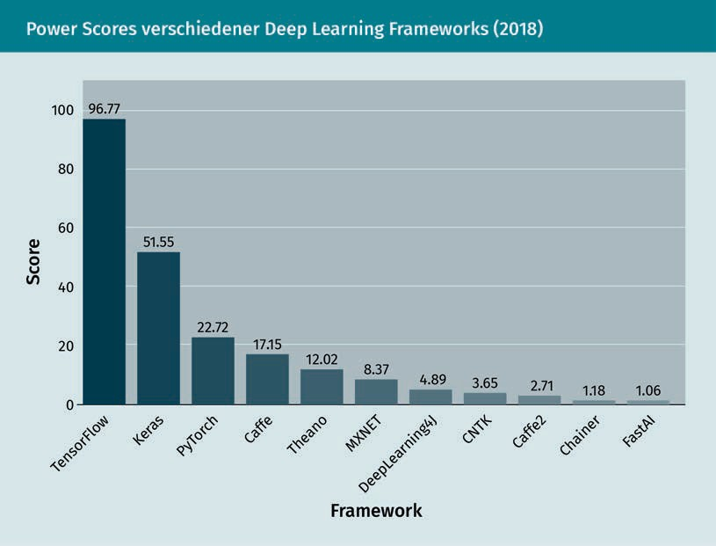**Power Scores of Various Deep Learning Frameworks (2018)**

|  |  |
| --- | --- |
| Score | Score |
| Framework | Framework |
| TensorFlow | TensorFlow |
| Keras | Keras |
| PyTorch | PyTorch |
| Caffe | Caffe |
| Theano | Theano |
| MXNET | MXNET |
| DeepLearning4J | DeepLearning4J |
| CNTK | CNTK |
| Caffe2 | Caffe2 |
| Chainer | Chainer |
| FastAI | FastAI |

**Graph of the Function**

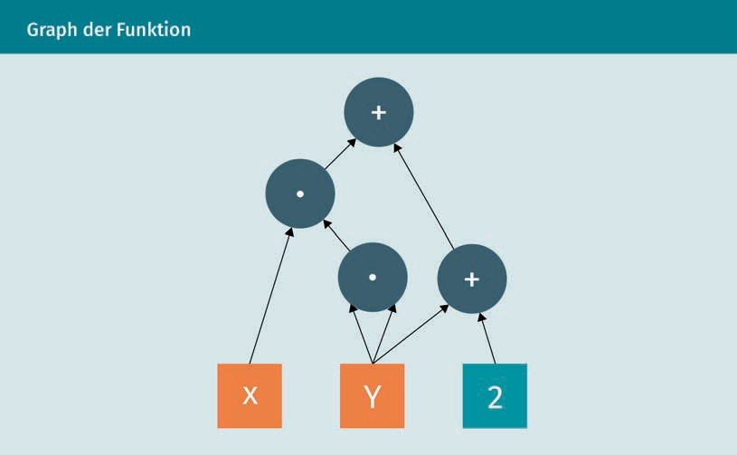

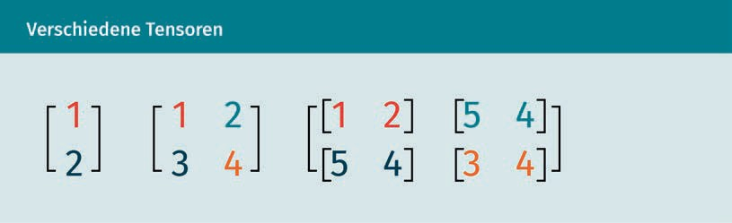**Various Tensors**

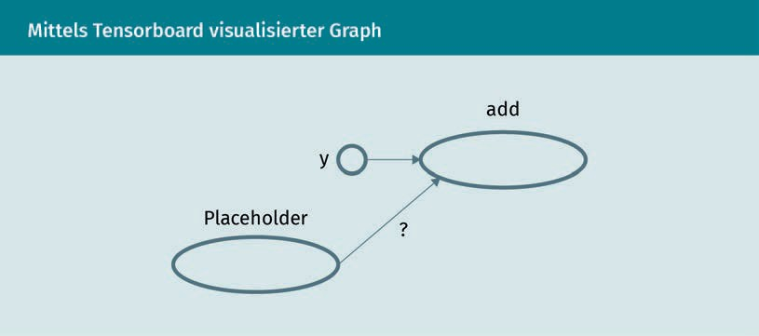**Graph Visualized Using Tensorboard**

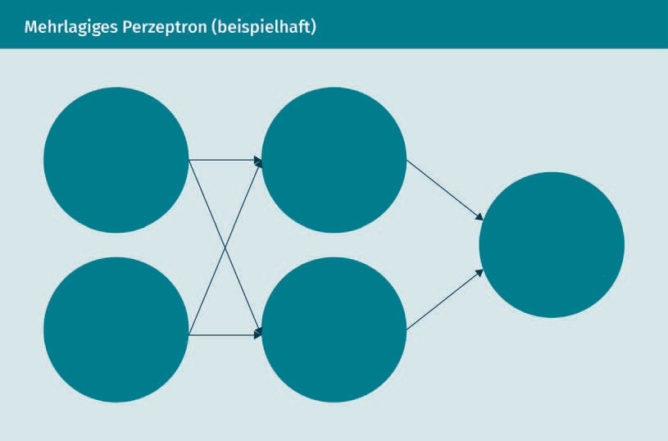**Multilayer Perceptron (Example)**

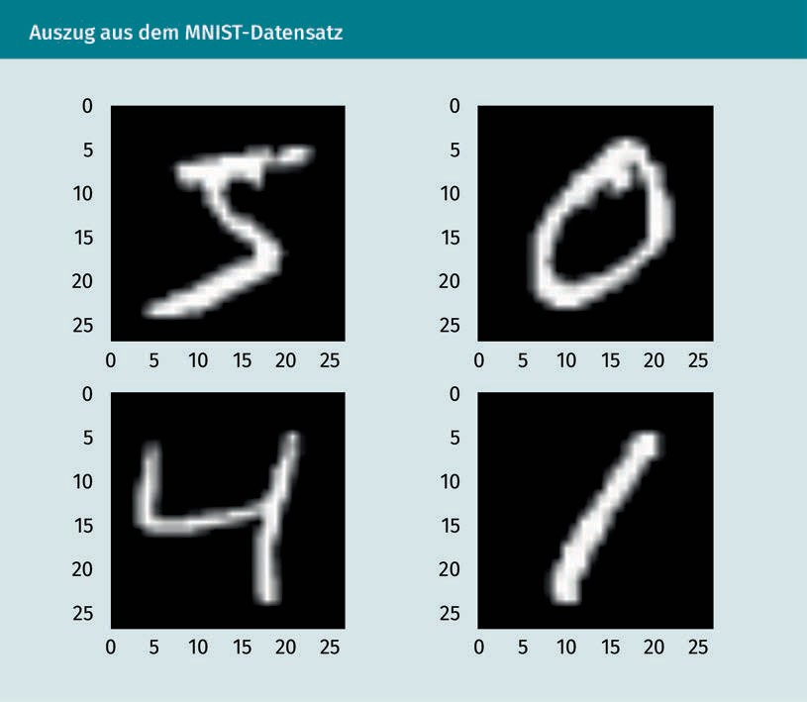**Excerpt From the MNIST Dataset**

**Transformation of the Input Data**

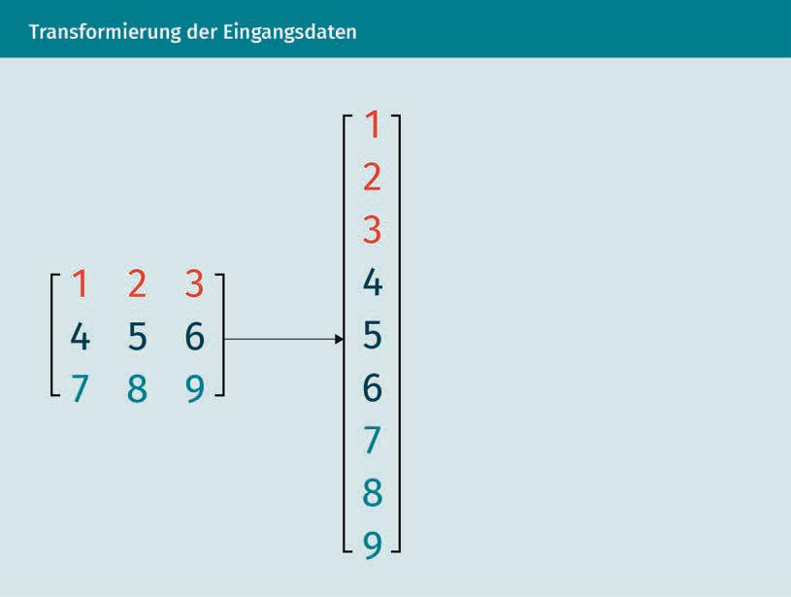

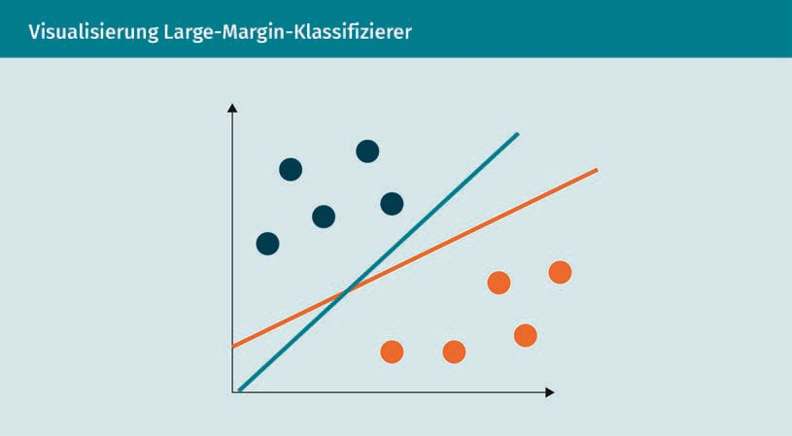**Visualization of the Large Margin Classifier**

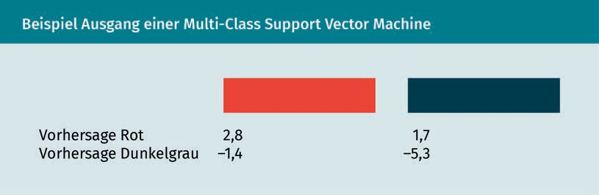**Example of the Output of a Multi-Class Support Vector Machine**

|  |  |
| --- | --- |
| Vorhersage Rot | Prediction, red |
| Vorhersage Dunkelgrau | Prediction, dark gray |

**Comparison of Outputs From Multi-Class SMV and Softmax Classifier**

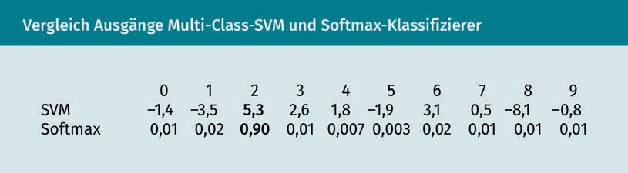

|  |  |
| --- | --- |
| SVM | SVM |
| Softmax | Softmax |

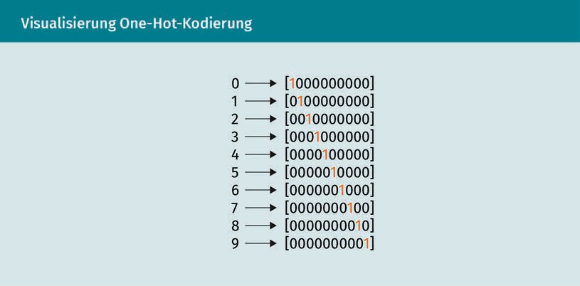**Visualization of One-Hot Coding**

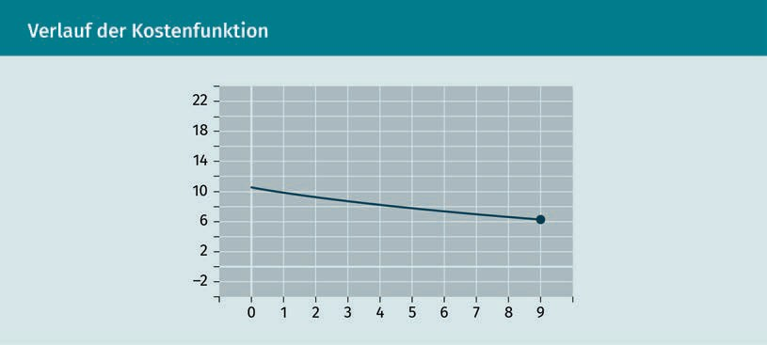**Cost Function Curve**

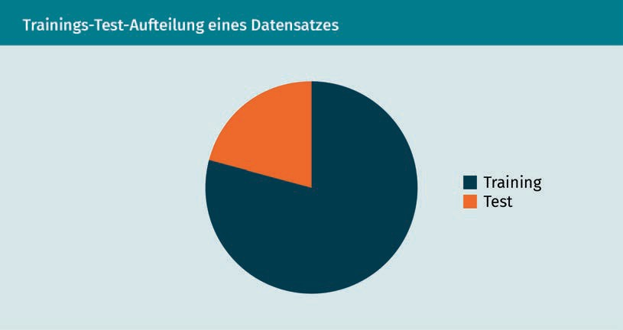**Training/Test Division of a Dataset**

|  |  |
| --- | --- |
| Training | Training |
| Test | Test |

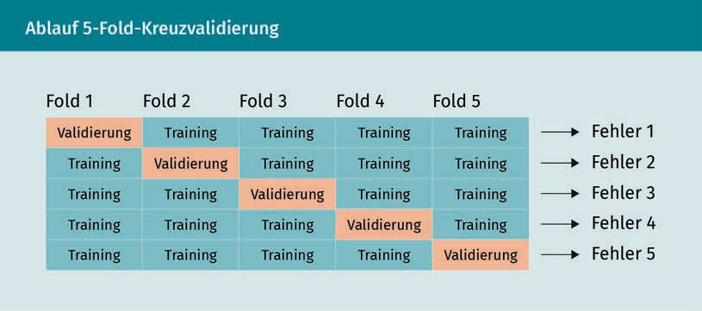**5-Fold Cross-Validation Process**

|  |  |
| --- | --- |
| Fold | Fold |
| Validierung | Validation |
| Training | Training |
| Fehler | Error |

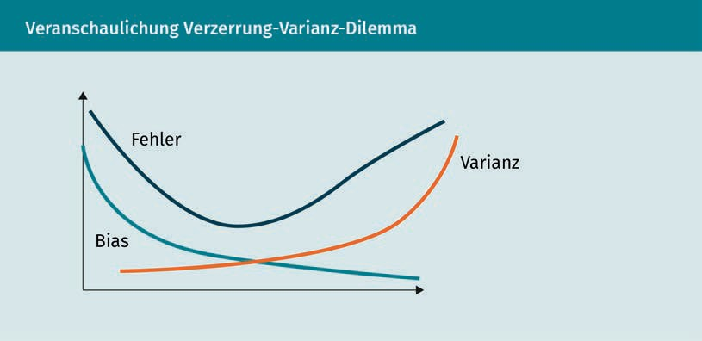**Illustration of the Bias-Variance Tradeoff**

|  |  |
| --- | --- |
| Fehler | Error |
| Bias | Bias |
| Varianz | Variance |

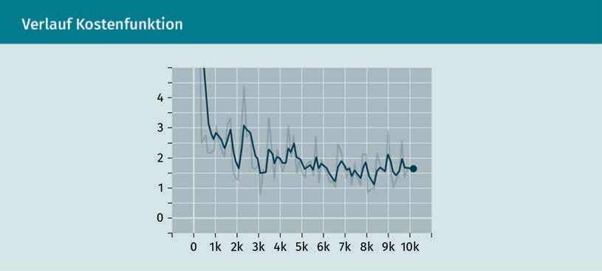**Cost Function Curve**

**Cost Function Curve With Adaptive Learning Rate**

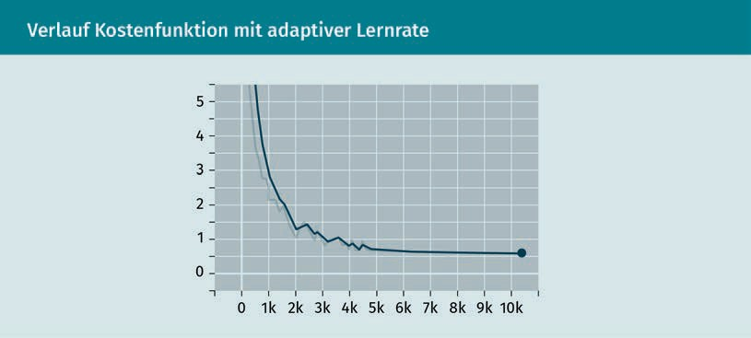

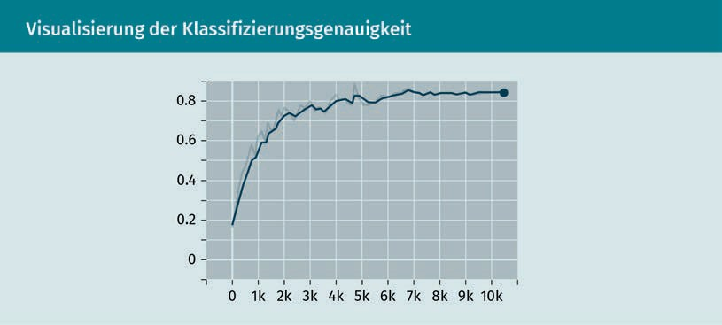**Visualization of the Classification Accuracy**

**Curves of the Various Gradient Methods**

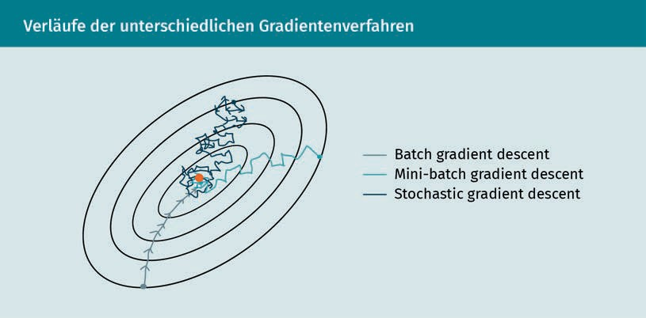

|  |  |
| --- | --- |
| Batch gradient descent | Batch gradient descent |
| Mini-batch gradient descent | Mini-batch gradient descent |
| Stochastic gradient descent | Stochastic gradient descent |

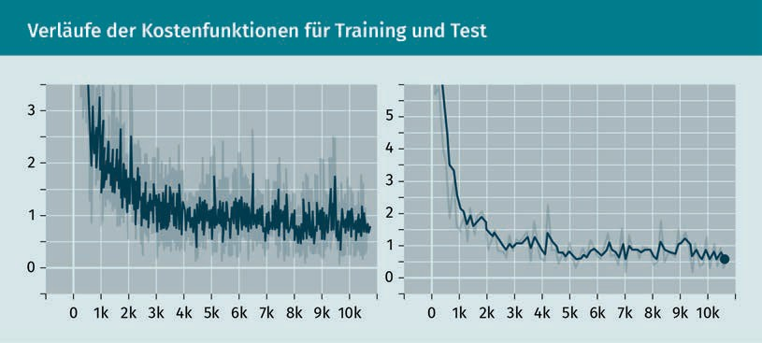**Cost Function Curves for Training and Test**

**Accuracy Curves for Training and Test**

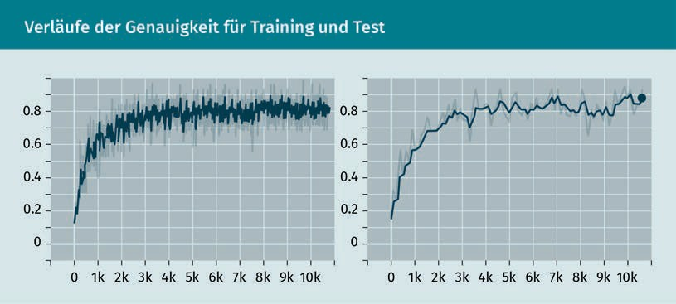

**Box Plot of 10-Fold Cross-Validation**

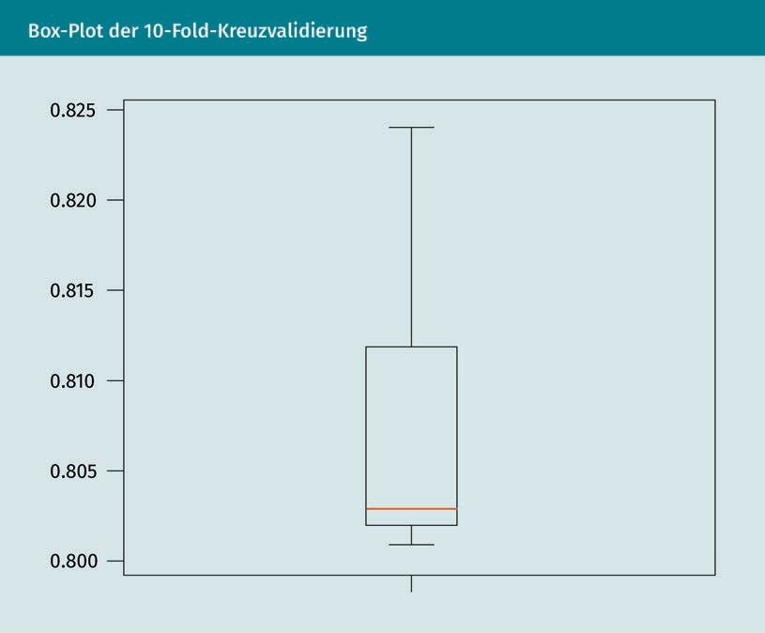

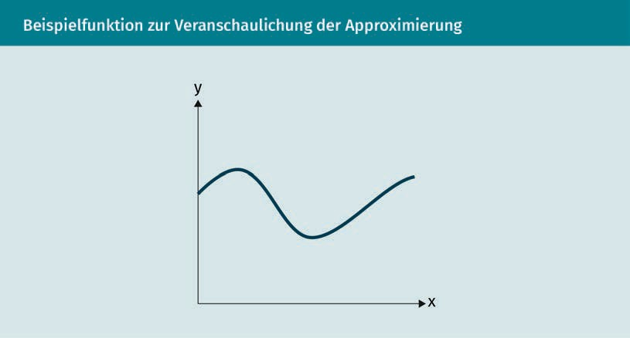**Sample Function to Illustrate Approximation**

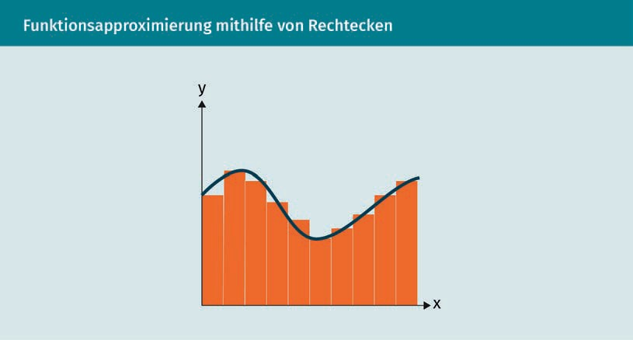**Function Approximation Using Square Waves**

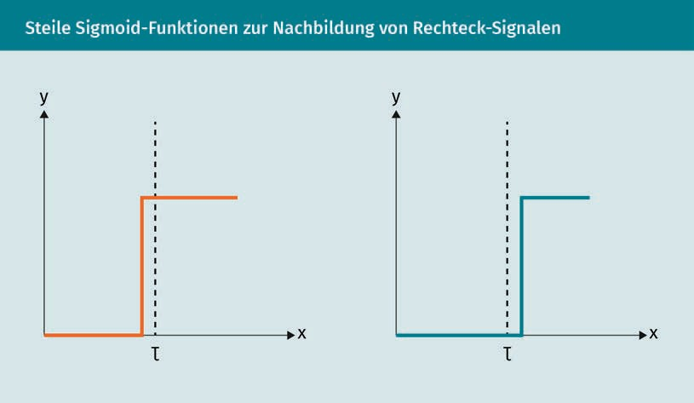**Steep Sigmoid Functions to Simulate Square-Wave Signals**

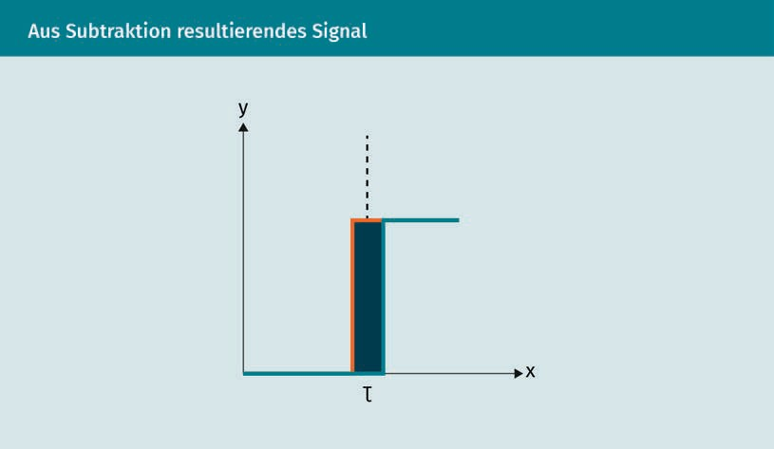**Signal Resulting From Subtraction**

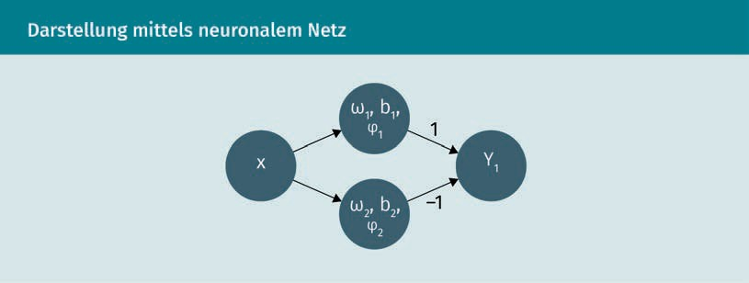**Representation Using Neural Network**

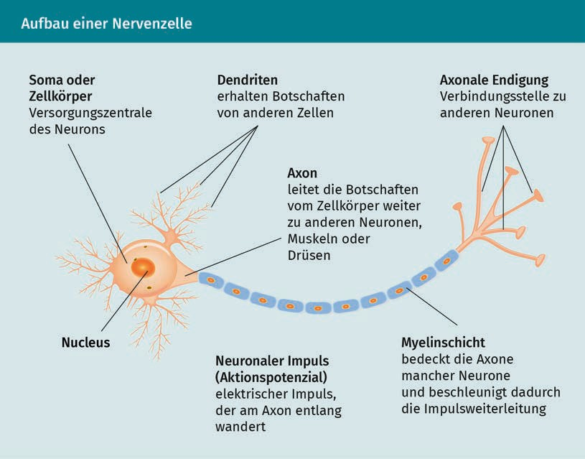**Structure of a Nerve Cell**

|  |  |
| --- | --- |
| Soma oder Zellkörper | Soma or cell body |
| Versorgungszentrale des Neurons | Supply center of the neuron |
| Dendriten erhalten Botschaften von anderen Zellen | Dendrites receive messages from other cells |
| Axonale Endigung | Axon terminal |
| Verbindungsstelle zu anderen Neuronen | Connection point to other neurons |
| Axon | Axon |
| Leitet die Botschaften vom Zellkörper weiter zu anderen Neuronen, Muskeln oder Drüsen | Forwards the messages from the cell body to other neurons, muscles, or glands |
| Nucleus | Nucleus |
| Neuronaler Impuls (Aktionspotenzial) | Neural impulse (action potential) |
| Elektrischer Impuls, der am Axon entlang wandert | Electrical impulse that travels down the axon |
| Myelinschicht | Myelin layer |
| Bedeckt die Axone mancher Neurone und beschleunigt dadurch die Impulsweiterleitung | Covers the axons of some neurons, thereby accelerating impulse transmission |

**Different Activation Functions**

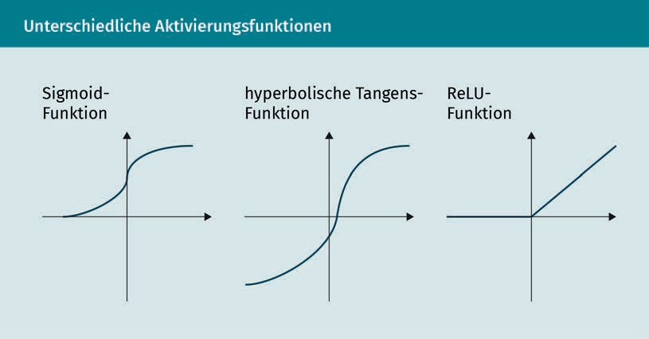

|  |  |
| --- | --- |
| Sigmund-Funktion | Sigmoid function |
| Hyperbolische Tangensfunktion | Hyperbolic Tangent Function |
| ReLU-Funktion | ReLu function |

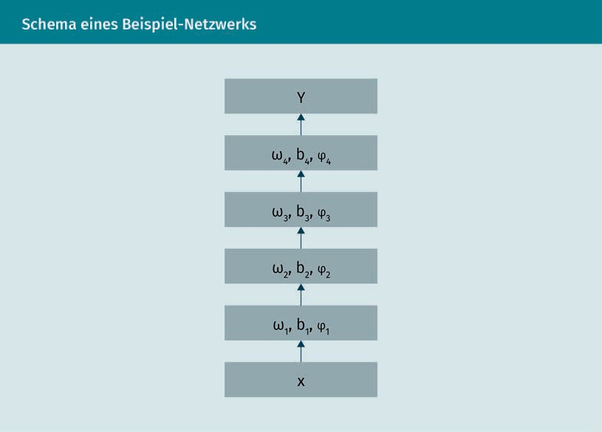**Schematic of a Sample Network**

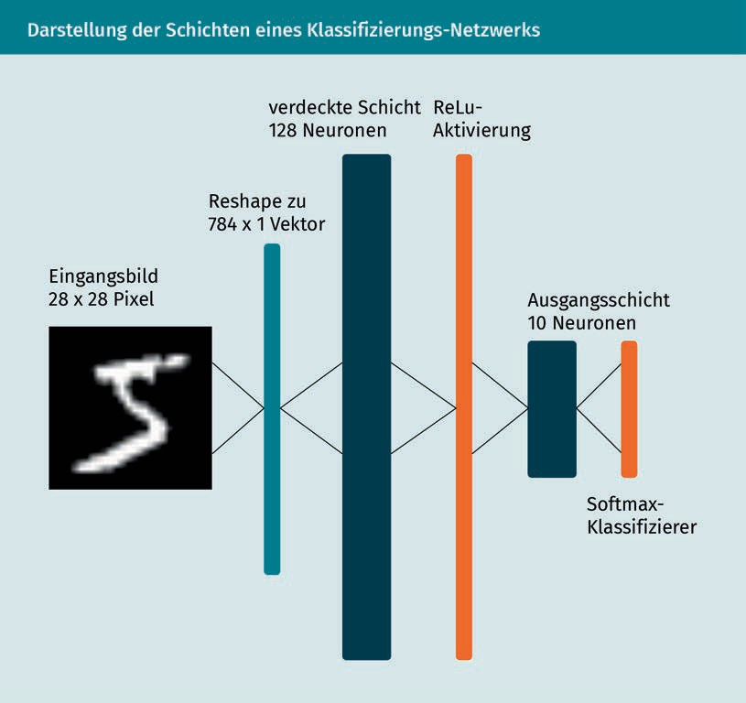**Representation of the Layers of a Classification Network**

|  |  |
| --- | --- |
| Eingangsbild | Input image |
| Pixel | Pixel |
| Reshape zu Vektor | Reshape to vector |
| Verdeckte Schicht Neuronen | Hidden layer neurons |
| ReLu-Aktivierung | ReLu activation |
| Ausangsschicht Neuronen | Output layer neurons |
| Softmax-Klassifizierer | Softmax classifier |

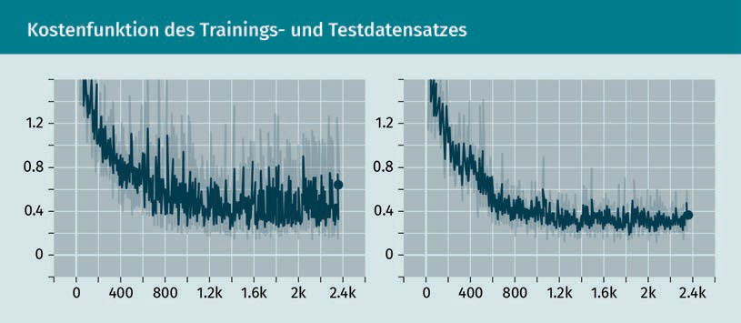**Cost Function of the Training and Test Dataset**

**Classification Accuracies**

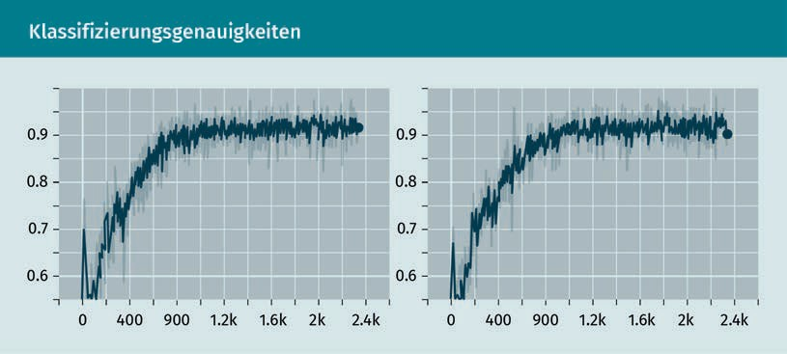

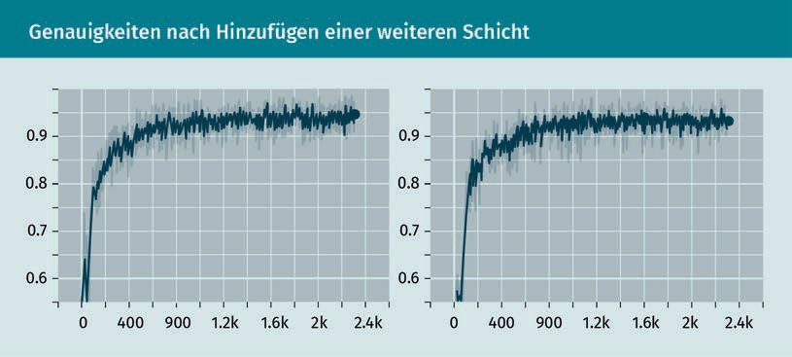**Accuracies Following the Addition of a Further Layer**

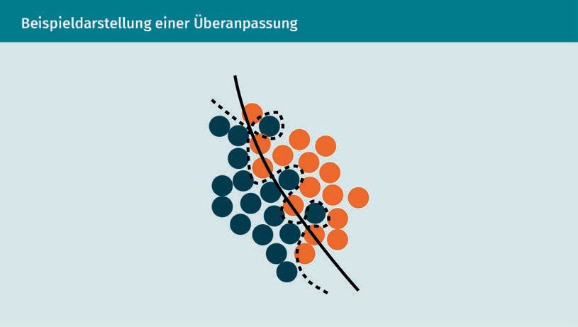**Sample Representation of Overfitting**

**Left: Classification Accuracy for Training (Turquoise), Right: Validation (Dark Gray) and Respective Cost Function Curves**

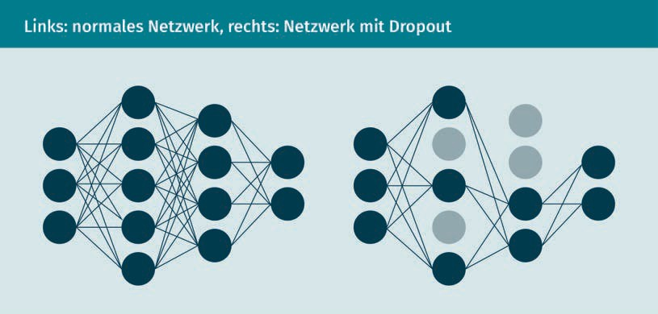**Left: Normal Network, Right: Network With Dropout**

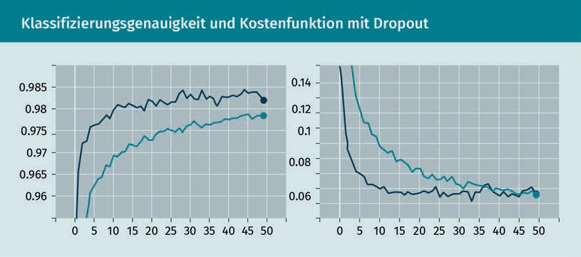**Classification Accuracy and Cost Function with Dropout**

**Examples of Data Augmentation**

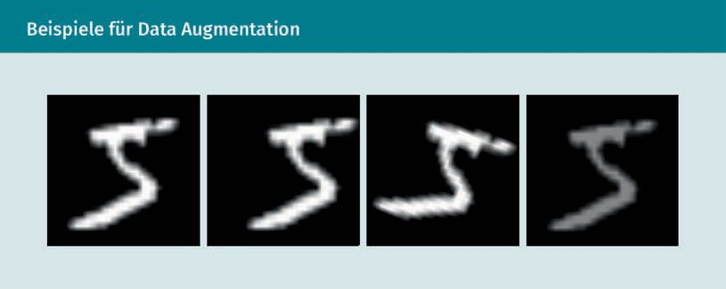

**Convolution Operation**

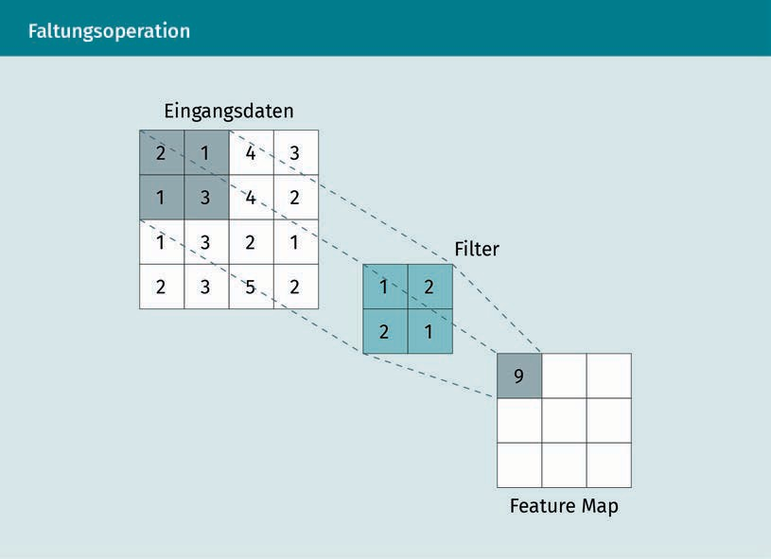

|  |  |
| --- | --- |
| Eingangsdaten | Input data |
| Filter | Filter |
| Feature Map | Feature map |

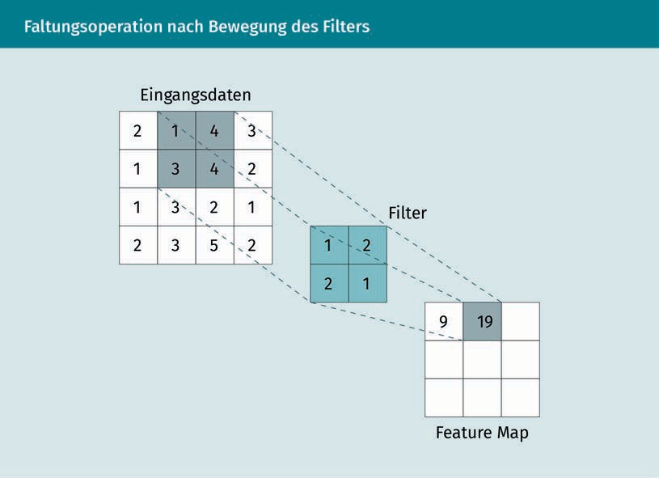**Convolution Operation Following Filter Movement**

|  |  |
| --- | --- |
| Eingangsdaten | Input data |
| Filter | Filter |
| Feature Map | Feature Map |

**Max Pooling**

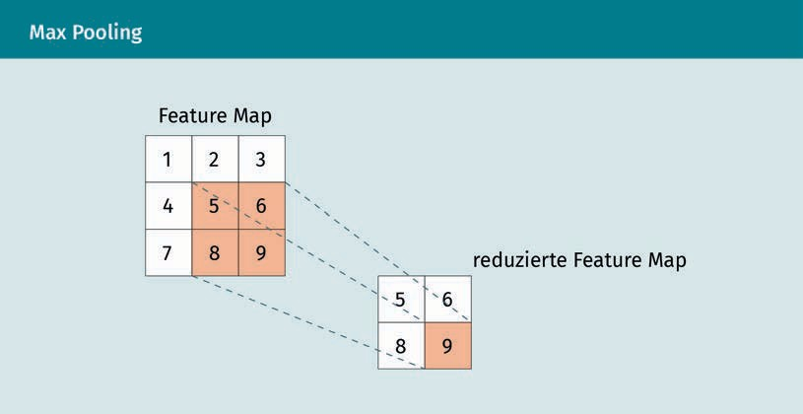

Feature Map

Reduced feature map

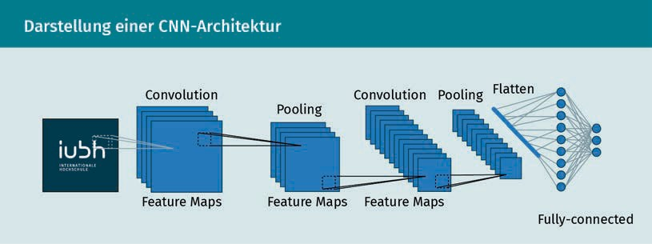**Representation of a CNN Architecture**

|  |  |
| --- | --- |
| Convolution | Convolution |
| Feature Maps | Feature maps |
| Pooling | Pooling |
| Flatten | Flatten |
| Fully-connected | Fully-connected |

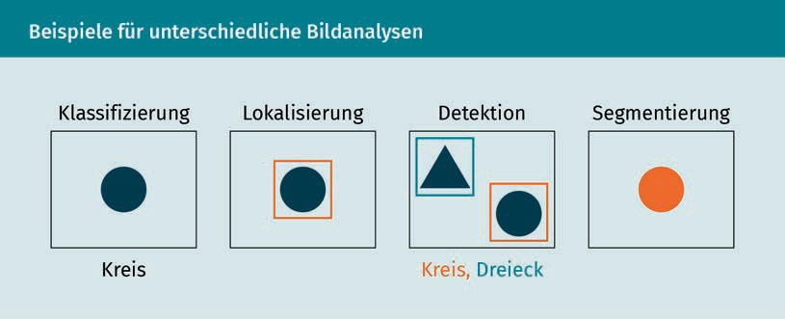**Examples of Different Image Analyses**

|  |  |
| --- | --- |
| Klassifizeirung | Classification |
| Lokalisierung | Localization |
| Detektion | Detection |
| Segmentierung | Segmentation |
| Kreis | Circle |
| Dreieck | Triangle |