IUBH

Deep Learning
DLBDBDL01

Overarching Learning Objectives

Recent technological advances have meant that a number of concepts and methods derived from artificial intelligence can now be applied in practice, with neural networks being a key concept affected by this progress. Thanks to faster and more cost-effective GPUs combined with freely available, well-documented frameworks, neural networks are now being used to solve a wide variety of problems, ranging from pattern recognition in text and images to the automated assessment of insured losses. In the Deep Learning course, students are introduced to the fundamental principles of this technology and equipped with the skills to apply these using simple examples.

Lesson 1 – Introduction to Deep Learning

Learning objectives
After completing this lesson, you will know ...
… how the term “artificial intelligence” is defined.
… what the subareas of artificial intelligence are.
… what machine learning means.
… which subgroups machine learning is divided into.
… what Deep Learning is and how it has developed.
… what types of Deep Learning frameworks are available.

1. Introduction

Introduction
As a concept, Deep Learning has long been viewed as the driving force behind research into artificial intelligence. In fact, artificial intelligence and Deep Learning are often used synonymously, with no distinct boundaries between the two subject areas. So what exactly is artificial intelligence? What defines Deep Learning and how does it relate to machine learning?
The aim of this lesson is to answer these questions and provide a clear definition and breakdown of the various terms used, giving the user an overview of the various aspects of artificial intelligence and presenting the most common methods used in machine learning. In the next stage, Deep Learning is presented in a historical context, the key concept is explained, and key application areas are discussed. Finally, the reader is given an overview of established Deep Learning frameworks, to provide the basis for a more in-depth study of this subject.

1.1 Artificial Intelligence
Artificial Intelligence (AI) is omnipresent in everyday life and, in today’s world, almost impossible to imagine living without. As a subarea of information technology, AI focuses on solving problems which are deemed – from a human perspective – to require intelligence, or attempts to imitate human problem-solving behavior. But how exactly do we define intelligence? There is no categorical answer to this question as no precise or uniform definition actually exists for this term. In the context of artificial intelligence, however, there are a number of features which characterize it:

- Making decisions: Complex decisions can be made correctly, optimally (based on previously defined rules), and precisely on the basis of input factors.
- Verifying results: Decisions which have been made can be substantiated.
- Logical thinking: Problems which are not substantiated mathematically can be assessed using logical thinking.
- Learning and improving: The system learns from existing or new data in order to bring about self-improvement.

This enables an approximate description of the characteristics a system must possess in order to be regarded as “intelligent”.
The field of artificial intelligence can be divided, on the basis of competence type, into three large subgroups, which each have various facets (Kaplan/Haenlein 2019):
Cognitive
Derived from the Latin word “cognoscere”, cognition describes the processing of information.
- Analytical AI: The majority of AI systems encountered today belong to the group of analytical AI systems, which are only consistent with cognitive intelligence. In these systems , a cognitive representation of the environment is generated and learned for the future on the basis of decisions made in the past. Image and speak recognition, autonomous vehicles, and strategic game solving are among the key examples found in this category.
- Human-inspired AI: In addition to cognitive intelligence, this category also includes so-called emotional intelligence, i.e. the comprehension and analysis of human emotions, in the decision-making process. Emotions such as joy or sadness can be detected through face or speech recognition, thus enabling the use of emotionally intelligent applications. Artificial customer services, which can detect customer mood and take specific countermeasures as required, represent one such example of this application.
- Humanized AI: Humanized AI is set to become the next step toward “human behavior” and add a social component to cognitive and emotional intelligence, with the aim of rendering reliable machine-human and human-machine interactions possible in the future. This type of artificial intelligence is not yet available and requires further intensive research. Possible future applications of humanized AI could include use in autonomous assistance systems, which require a high degree of social intelligence.

In addition to grouping based on the competence levels of an intelligent system, a fundamental distinction can also be made between “weak” and “strong” AI. These terms were coined by John Searle and can be illustrated using a thought experiment known as the Chinese Room (Searle 2009). The assumption behind this experiment is that science has advanced to such a degree that it has taught a computer to understand Chinese. The computer accepts Chinese characters as input values and, following the instructions of a computer program, produces other Chinese characteristics, which it presents as output. Suppose the computer then performs this task with such conviction as to convince a Chinese-speaking person that it is itself a live Chinese speaker. It makes appropriate responses to all of the questions that the person asks, leading the Chinese speaker to assume that they are speaking to another Chinese-speaking person.
John Searle
The American philosopher Johne Searle is regarded as one of the most prominent critics of strong artificial intelligence.
The question John Searle is looking to answer is whether the machine literally understands Chinese or is merely simulating the ability to understand Chinese. The former stance is known as strong AI and the latter as weak AI. Weak AI looks to solve specific application problems without generalizing these to a large degree. As part of this process, “anthropomorphic” qualities and thus intelligence are only simulated.
The majority of current AI applications feature a weak AI level. Speech recognition systems controlled using a limited number of pre-programmed examples are one such example. A weak AI system maps input values to a specific output. In contrast, strong AI systems go beyond the scope of simply simulating intelligence and acquire the ability to act with human intelligence, possibly even acquiring consciousness. In this instance, input data is not strictly mapped to output data, but processed on flexible terms by clustering semantic relationships and assignments, with the result that a system creates associations autonomously from related data that it has not previously been taught.
Cluster
In terms of data analysis, a cluster describes the grouping of objects with similar properties.

Furthermore, this system is not confined to a specific remit, but is intended to operate universally and autonomously, as encountered with human intelligence. Strong AI does not exist to date. Scientists have long been unsure whether this would actually be achievable, but are now largely confident that such a system will be developed in the future.
Artificial intelligence can be taken as a generic term, which covers a variety of different methods, the most important of which are shown in the following figure.

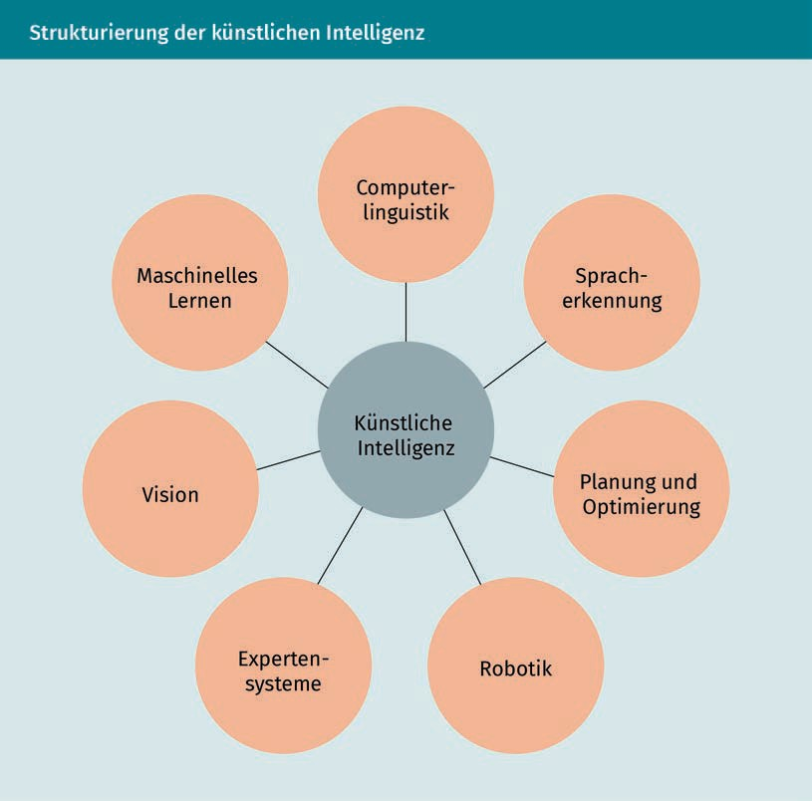

- Machine learning: The term “machine learning” refers to a system that uses sample data to generate a static model, which can then be applied to unknown data for problem-solving purposes, such as in classification or regression. Not only are assignments “committed to memory” during this process, but patterns in the data are recognized and learned so that the problem solution can be generalized.
Generalizability
A model is regarded as generalizing if it exhibits a high performance level with unknown data.
- Speech recognition: Speech recognition is concerned with the detection of human speech, whereby acoustic signals are used to determine which words have been spoken.

- Computational linguistics: Computational linguistics borders on speech recognition, in which the semantics of text and speed data should be “understood”. Factors such as different dialects and incorrect grammar, for example, play a key role in this.
Semantics
Semantics describes the content or meaning of texts.
- Vision: Machine vision refers to the handling of problems which originate from the field of human vision. Important applications relating to this area can be found in object recognition and localization.
- Expert systems: So-called expert systems assist people with problems that would normally require assistance from human experts. These are interactive decision-making systems, which are largely based on “if-then” steps but can also include heuristics in decisions.
Heuristics
Derived from the Greek word “heuriskein”, meaning “to find”, heuristics describe strategies for making decisions with limited knowledge.
- Planning and optimization: The subarea of automatic planning and optimization deals with finding solutions to complex control problems, which can be difficult to solve using conventional methods due to the need for optimization within high-dimensional spaces.
- Robotics: Robotics as a subgroup of artificial intelligence deals with the fusion of physically present, programmable machines and intelligence in order to develop highly autonomous and (in the future) emotionally and socially intelligent robots.

The subgroups of artificial intelligence overlap and also merge to some extent, with the result that the areas are not clearly defined.

Self-Check Questions
- Please mark the correct answers with a cross.
- Analytical artificial intelligence has a higher competence level than humanized artificial intelligence.
- Weak artificial intelligence maps input values to output values based on what has been learned.
- Artificial intelligence is a subgroup of machine learning.

