**Controlled assembly of perovskite nanoparticles by photoswitchable functional ligands**

Tal Binyamin, Orit Cohen, Idan Cohen, Lioz Etgar*

The Hebrew University of Jerusalem, Institute of Chemistry, Casali Center for Applied Chemistry, Jerusalem, Israel

* lioz.etgar@mail.huji.ac.il

**Abstract**

Organic ligands play a crucial role in the properties and functionality of nanostructures. Functional ligands are an interesting research direction that can be utilized to influence the properties and functionality of nanoparticles (NPs). In this work, we demonstrate controlled assembly of CsPbBr3 perovskite NPs as a result of light. Azobenzene derivative molecules were used as the photoswitchable ligands for the NPs. The assembly and disassembly of the NPs were achieved by *cis–trans* isomerization. By utilizing polarization-modulated, infrared reflection–absorption spectroscopy and nuclear magnetic resonance, we were able to track the attachment of the ligands to the surface of the NPs. Absorbance, photoluminescence and high-resolution, transmission electron microscopy followed the assembly and disassembly of the NPs. Moreover, we demonstrated switchable energy transfer in two different systems: (i) azoperovskite NPs–perovskite NWs; and (ii) azoperovskite NPs–PbS NPs. This work demonstrates functional ligands paired to perovskite nanostructures through controlling their assembly and disassembly, which opens the way for sensing and photodetection applications.

**Introduction**

Due to their remarkable optical and physical properties, perovskite nanoparticles (PeNPs) have been intensively investigated in recent years. PeNPs are characterized by a high photoluminescence quantum yield (PLQY), narrow full width at half maximum of emission, and tunable band gap.[1] These properties enable PeNPs to be used in light-emitting diodes (LEDs),[2],[3],[4] lasers,[5],[6] sensors,[7],[8] and photodetectors.[9],[10] The ligands in PeNPs form an organic shell that plays a crucial role and affects the physical and optical properties of the NPs.[11],[12] The organic shell is composed of oleic acid (OA) and oleylamine (OLA). Substitution of the ligands can increase the stability of the NPs under humidity, improve optical properties, and stabilize the composition of the perovskite.[13],[14],[15] One more interesting pathway is using ligands with specific functionality that influences the properties of the NPs. For example, chiral molecules can act as ligands to the NPs, which enables the application of circularity polarized photodetectors based on PeNPs. [16],[17],[18] Another option is to use switchable molecules as the ligands for the PeNPs. Photoswitchable molecules are chromophores that change their physical properties as a result of light. Azobenzene and stilbene derivatives act as good photoswitches; the polarity of the molecules changes during the *cis–trans* isomerization, resulting in a decrease in solubility and formation of aggregates of the molecules.[19] When using these photoswitchable molecules as ligands for NPs, they can influence the assembly and disassembly of the NPs. The use of photoswitchable molecules as ligands for gold (Au) NPs was reported by Klajn et al.[20] Klajn et al. and a few later studies showed the controlled assembly of Au NPs as a result of light, with different photoswitchable ligands.[21],[22] Moreover, previous studies have demonstrated that the isomerization process of functional ligands can change the catalytic activity of the NPs.[23],[24],[25],[26],[27],[28] Here, we demonstrate for the first time controlled assembly of PeNPs due to a reaction with light. The process is based on the isomerization of 4-[4-(2-Phenyldiazenyl)phenoxy]butanoic acid (PDPB) ligands (i.e., azo ligands). We synthesized PDPB molecules with carboxylic acid in order to attach them to the surface of the PeNPs. The polarity of the ligands was changed as a result of the isomerization reaction; the *cis* molecule carried dipole moment as opposed to the *trans* molecule, which was nonpolar. The polarity of the PeNPs changed accordingly and affected the assembly process. The ligand exchange process was studied by following the changes in the optical properties of the PeNPs. Furthermore, we used dynamic light scattering (DLS) and high-resolution, transmission electron microscopy (HRTEM) to follow the assembly process. In addition, due to the possibility of controlling the distance between the NPs, we were able to switch on and off an energy transfer process between the NPs.

**Results and discussion**

We synthesized 4-[4-(2-Phenyldiazenyl)phenoxy]butanoic acid (PDPB) ligands (i.e., azo ligands) that underwent an isomerization reaction from *trans* (E)-PDPB to *cis* (Z)-PDPB upon excitation at certain wavelengths. Figure 1a presents a schematic illustration of the *cis–trans* isomerization, and the wavelengths required for each reaction. The isomers were characterized with different absorbance curves due to different dominant transitions. While both contain π-π* and n-π* transitions, the *trans* was characterized with π-π* and the *cis* with a n-π* transition. The *trans* was the thermodynamically stable isomer, while its main peak had a π-π* transition.[29], [30] Once it was switched from *trans* to *cis* isomerization, the polarity of the molecule changed; from a nonpolar molecule (*trans* isomer) to a polar molecule with dipole moment (*cis* isomer).[31] The polarity affected the solubility of the ligands in nonpolar solvents; therefore, the solubility of the ligand decreased with the *trans* to *cis* transition. As a result, the *trans* isomer stabilized the NPs in nonpolar solvents. When switching to the *cis* isomer, the polarity changed and the ligands remained attached to the NP’s surface thereby preventing coagulation; this provided controlled assembly of the NPs in nonpolar solvents.

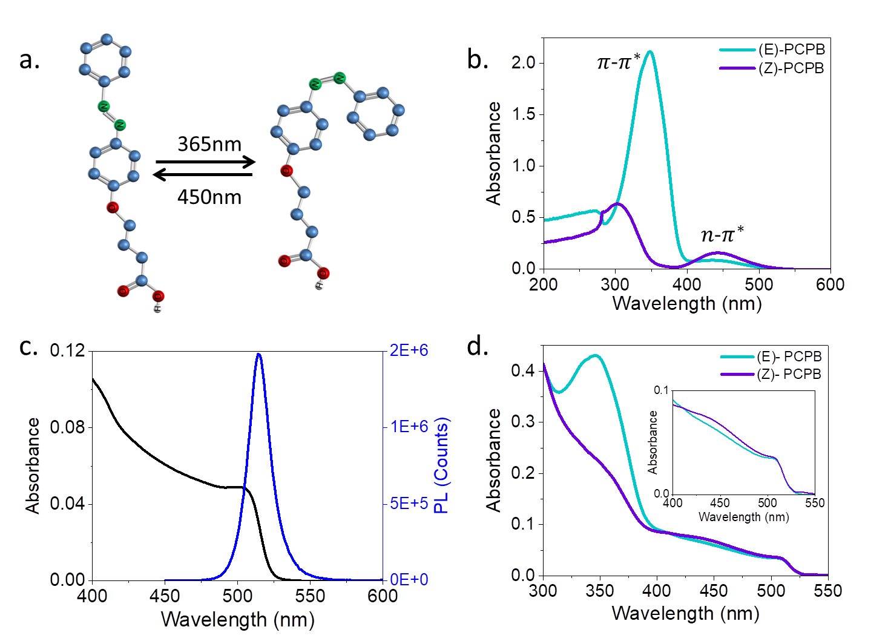

**Figure 1**. a) *cis–trans* isomerization reaction of the molecule 4-[2-(phenylcarbamoyl)phenoxy] butanoic acid. b) Absorbance spectra of the *cis* and *trans* isomers. c) Absorbance and photoluminescence spectra of CsPbBr3 PeNPs with the original ligands. d) Absorbance of CsPbBr3 PeNPs capped with *cis* and *trans* azo ligands.

Figure 1b shows the absorbance spectra of the ligands in both *cis* and *trans* upon excitation. The difference in the absorbance can be clearly observed for the two isomers. Figure 1c presents the absorbance and photoluminescence (PL) of the PeNPs with the original ligands. OA and OLA, in which the absorbance of the PeNPs with the azo ligands before and after excitation by the 365 nm wavelength, are shown in Figure 1d. The change from *trans* to *cis* can be observed due to the decrease in the π-π* peak. The presence of the PeNPs can also be recognized in the absorbance spectra in Figure 1d due to the onset at the 520 nm wavelength (inset in Figure 1d). In order to study in more detail the ligand exchange process, the concentration of the azo ligands added to the PeNP solution was changed. Figure 2a presents the absorbance of the azo ligands and PeNPs at different concentrations of ligands in the solution. As the concentration of the ligands increased from 2 to 8 mg/ml, the absorbance peak n-π* increased significantly. Although it may be suggested that the affinity of the ligands to the surface of the NPs increased at high concentrations, the absorbance peak of the PeNPs became weaker when increasing the ligand concentration. This can be explained due to the screening of the n-π* band and by the fact that less PeNPs participated in the ligand exchange reaction (changes in the PeNP environment and excess of OLA and OA affected their stability and dispersity).[32],[33] Therefore, to observe a more complete picture of this situation, we conducted PL measurements at various concentrations, which showed that the PeNP PL intensity decreased with the increase in ligand concentration (Figure 1S in the Supporting Information–SI). Based on these results, we decided to use a concentration of 5 mg/ml of azo ligands during the remainder of this work, as discussed below.

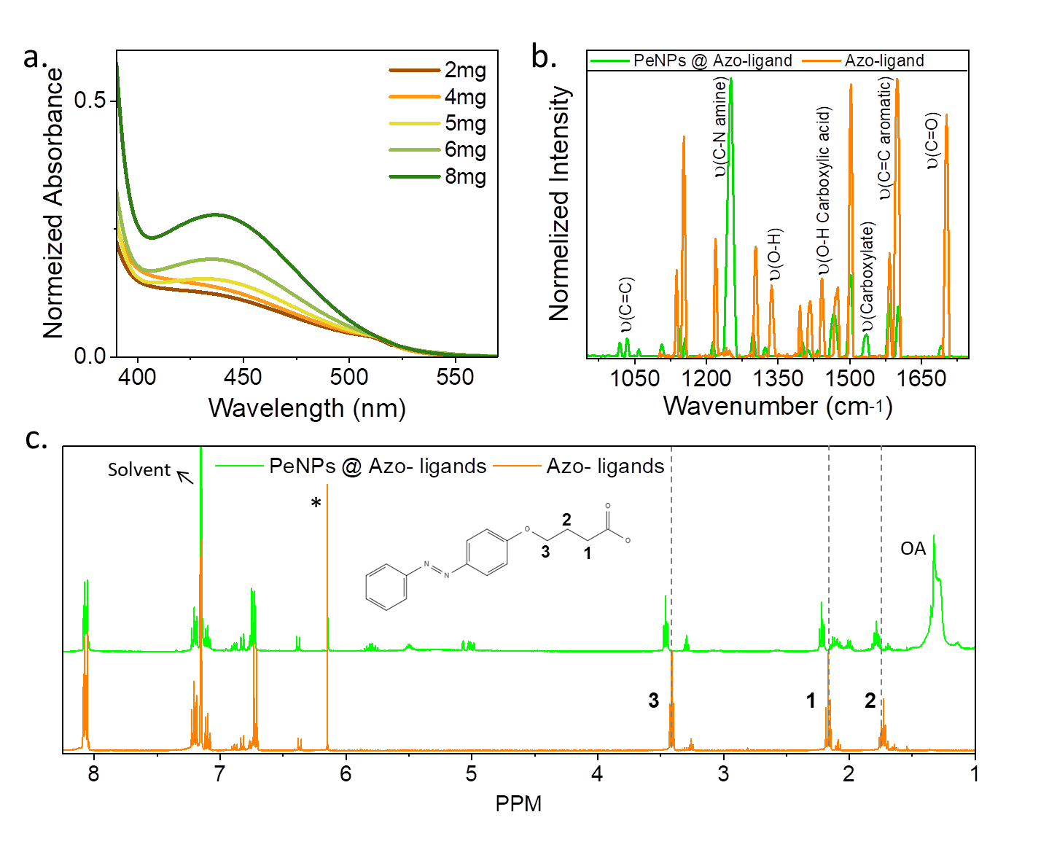

**Figure 2.** a) Absorbance of PeNPs capped with azo ligands treated with different ligand concentrations varying between 2 and 8 mg/ml. Inset: absorbance intensity versus the concentration of the ligands. b) PM–IRRAS FTIR spectra of the azo ligands and the PeNPs capped with the azo ligands. c) H–NMR of the azo ligands and the PeNPs capped with the azo ligands, where ‘*’ is the signal of the internal standard (chloroform).

In order to investigate the ligand attachment to the PeNPs, we used polarization-modulated, infrared reflection, absorption spectroscopy (PM–IRRAS) FTIR. PM–IRRAS was used to measure the pure azo ligands and the PeNPs capped with the azo ligands. The results are presented in Figure 2b. The main differences were the reduction in the peak of O–H bending of carboxylic acid at 1440 cm-1­ and the appearance of the carboxylate ion peak at 1538 cm-1.[34] In order to interact with the NPs, the azo ligands should have undergone acid–base reactions to form the carboxylate ion. These results suggest that the azo ligands interacted with OLA in acid–base reactions; therefore, the three ligands could interact with the PeNP surface. Below a 1050 cm-1 wavenumber, the peaks were related to C=C alkene bending of OA and OLA, while at a 1250 cm-1 wavenumber, the C–N stretching of the OLA could be observed. The stretching of the aromatic C=C bond of the azo (PDPB) could be seen at a 1598 cm-1 wavenumber, and the carbonyl stretching was located at a 1702 cm-1 wavenumber for both the azo ligands and OA.

To further study the interactions between azo ligands and PeNPs, H–NMR measurements were performed. Figure 2c shows the H–NMR spectra of the pure azo ligands and the azo ligands attached to the PeNPs in benzene d6. We used chloroform as an internal standard in order to follow the changes in the azo ligand peaks. Comparing the H–NMR spectra of both cases indicates the changes in the signals of the hydrogens on 1, 2, and 3 carbons (which are the closest to the binding site; see inset in Figure 2c) toward higher chemical shifts after the addition of the PeNPs. These chemical shifts were due to environmental changes that occurred after the binding of the ligands. Furthermore, the peak integration of the ligands decreased after the addition of the PeNPs, indicating ligand exchange (at 8.0 ppm, 7.2 ppm and 3.4 ppm; the full spectra can be found in Figure 2S). This observation indicates that the azo ligands have the ability to attach to the surface of the NPs together with the original ligands.11

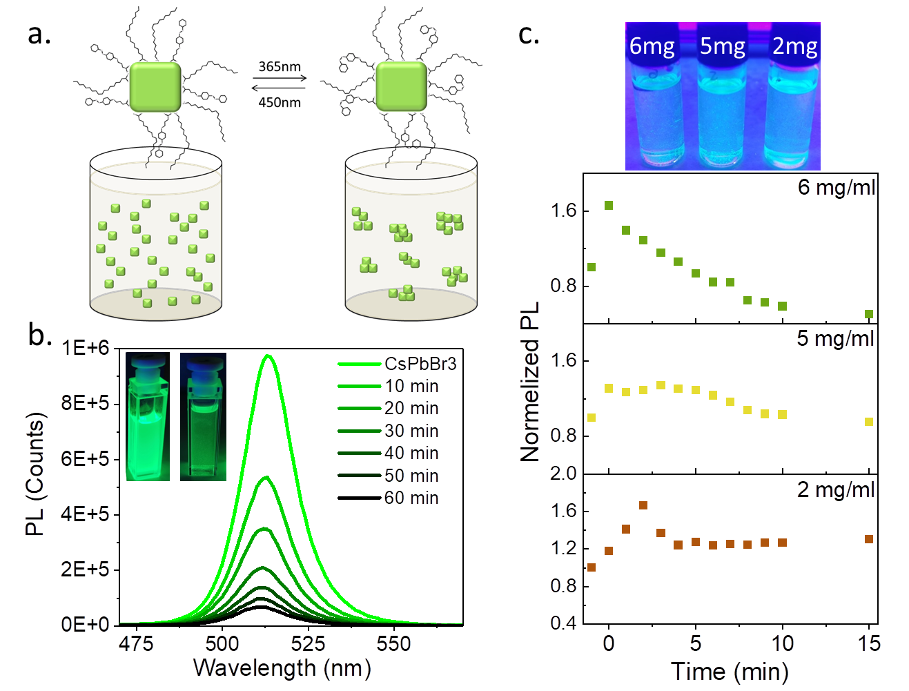

**Figure 3.** a) Schematic illustration showing azo ligands coating PeNPs in the solution. The *cis*–*trans* isomerization is presented based on the excitation wavelength. b) PL measurements with time (from 0 to 60 minutes) of the PeNPs treated with a 5 mg/ml azo ligand solution. Inset: Pictures of the solution before (left) and after (right) illumination with 365 nm wavelength light. c) Normalized PL intensity as a function of time for PeNPs treated with different concentrations of azo ligands (2, 5, and 6 mg/ml) and a picture of the solutions under 365 nm (UV) light.

The optical properties of the PeNPs were used to track the changes in the properties of the azo ligands coating the PeNPs. Upon exposure to 365 nm wavelength light, the azo ligands were transferred to the *cis* isomer and turned to polar ligands. These polar ligands that coated the PeNPs started to form aggregates of PeNPs in the nonpolar solvent, which resulted in sedimentation at the bottom of the vial, as illustrated in Figure 3a. The dilution due to sedimentation was reflected in the reduced PL intensity with time, as shown in Figure 3b. The inset in Figure 3b shows pictures of the PeNPs before and after exposure to 365 nm wavelength light, which clearly shows the formation of aggregates. Figure 3c shows the effect of ligand concentration (2 to 6 mg/ml) on the aggregation. In all concentrations, the PL intensity increased in the first few minutes of 365 nm (UV) illumination starting from t=0. In the case of 2 mg/ml, the PL intensity increased, and at t=3 min, it decreased, while after t=5 min, it reached a constant PL intensity, suggesting that there were not sufficient ligands to coat all the PeNPs and the aggregation was not sufficient for sedimentation.

In the case of 5 mg/ml following the first increase in PL intensity, there was no further increase and the PL intensity was constant for the first 5 minutes. After 5 minutes, a moderate decrease occurred, which supports our previous assumption in which after 5 minutes, the process became irreversible as the aggregates were too large and deposited at the bottom of the vial. The 6 mg/ml concentration had a significant decrease after the first minute of illumination. As the concentration increased, changes in the polarity also increased as a result of the aggregation and sedimentation that formed rapidly, which caused a decrease in the PeNP PL. The image at the top in Figure 3c shows the aggregates and the color changes of the PeNPs treated with 2, 5, and 6 mg/ml of ligands. The PL intensity of the 6 mg/ml concentration was weaker compared with the other concentrations. In addition, we illuminated nontreated PeNPs with 365 nm wavelength light. In this case, contrary to Figure 3c, the PL intensity did not show any specific trend; only small fluctuations, which clearly indicated the effect of the azo ligands (see Figure 3S).

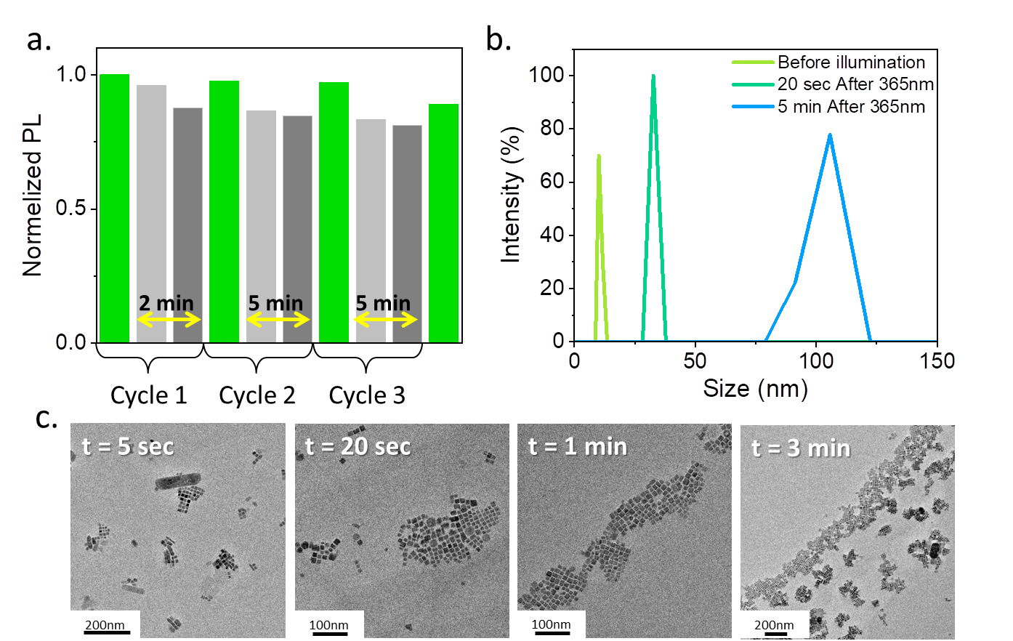

**Figure 4.** a) Normalized PL intensity changes of the treated PeNPs before 365 nm illumination (green), immediately after 365 nm illumination (light grey), and 2 or 5 minutes after 365 nm illumination (dark gray). The next cycle began with 450 nm illumination. The figure shows 3 cycles. b) DLS measurements of the PeNPs with time before 365 nm illumination (light green curve) and 20 sec (dark green curve) and 5 min (blue curve) after 365 nm wavelength illumination. c) TEM images of aggregate formation 5 sec, 20 sec, 1 min, and 3 min after 365 nm illumination.

The next step was to measure the reverse reaction: the disassembly of the PeNP aggregates by exposing them to 450 nm wavelength illumination. Once *cis–trans* isomerization occurred, the PeNPs could disperse again in the nonpolar solvent. We tracked the changes in PL intensity before and after exposure to 365 nm illumination in three cycles. Figure 4a shows the normalized PL intensity of the three cycles, where each cycle had: (i) PL before 365 nm illumination (green); (ii) PL immediately after 365 nm illumination (light grey); and (iii) PL 2 or 5 minutes after 365 nm illumination (dark grey). The next cycle commenced after 450 nm illumination, which is represented by the green bars in the figure. As shown in Figure 4a, PL intensity decreased after exposure to 365 nm illumination, as discussed above. In the first cycle, we exposed the sample to 450 nm wavelength illumination after 2 minutes, in which the PL intensity almost fully recovered (see the green bar at the beginning of the 2nd cycle in Figure 4a). In the second cycle, the waiting time was 5 minutes before the reverse reaction; also, in this case, the PL intensity was very close to the initial PL. However, on the third cycle, the final PL intensity was lower compared with the initial PL, which can be explained by the long waiting time before the reverse reaction. As was shown previously, a longer time was required until sedimentation; therefore, after 5 minutes, the sedimentation was still moderate, while after an additional cycle (with a waiting time of 5 minutes), the PL reduction was more pronounced. The reverse reaction was mainly feasible at short waiting times. The transmission electron microscopy (TEM) images in Figure 4c show the light-modulated assembly. At 5 seconds, there were small arrays (less than 100 nm in size) that became larger (up to several hundreds of nm) after 3 minutes. The images demonstrate the aggregation of small PeNP groups toward one large array of PeNPs. In addition to the assembled NPs, after 3 minutes, we noticed large PeNPs and undefined structures (see Figure 4S). We attribute these structures to the irreversible process of the PeNPs reaching their saturation limit. This explains the decrease in the PL intensity at long waiting times (5 min). Dynamic light scattering (DLS) measurements also assisted in tracking the assembly process and in extracting the size of the assembled PeNPs. Figure 4b shows that immediately after the exposure to 365 nm illumination, the detected size of the PeNP aggregates increased from 12 nm to 30 nm, and then to larger sizes after 5 minutes. The full width at half maximum (FWHM) of the DLS increased after 5 minutes, which suggests an increase in the size distribution.

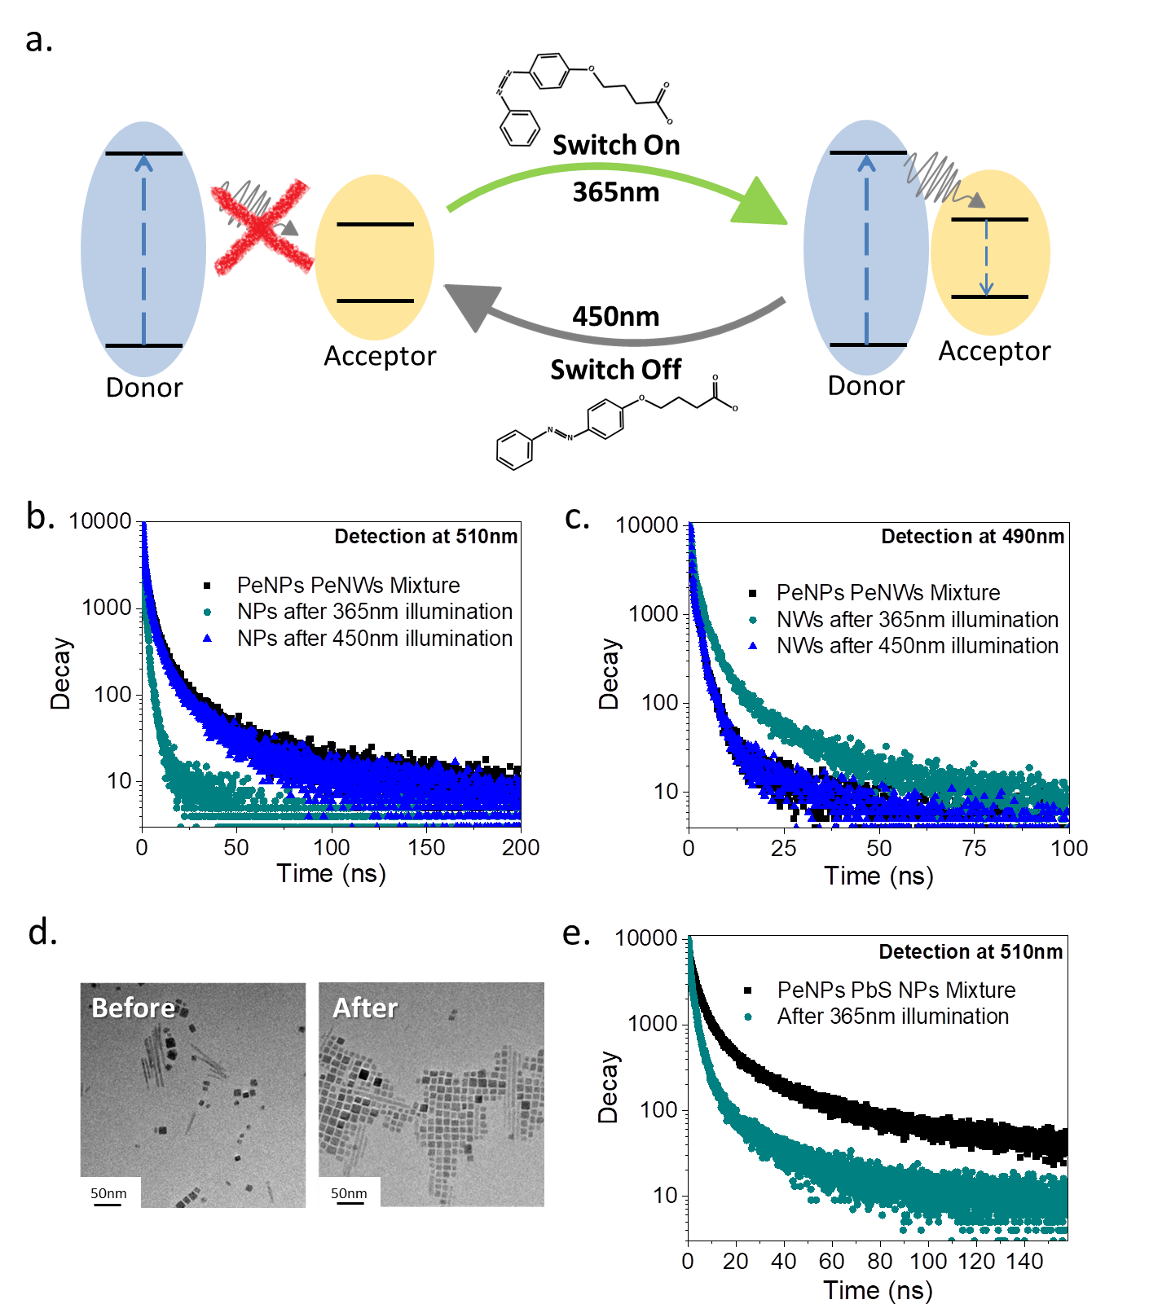

**Figure 5.** a) Schematic illustration of light-induced energy transfer between azo NPs. b) PeNP PL lifetime (detected at 510 nm) and c) PeNW PL lifetime (detected at 490 nm) in a mixture of PeNPs and PeNWs before 365 nm illumination (black curve), after 365 nm illumination (green curve), and after 450 nm illumination (blue curve). d) TEM images of the PeNPs and PeNWs before and after 365 nm illumination. e) PeNP PL lifetime (detected at 510 nm) in a mixture with PbS NPs before 365 nm illumination (black curve) and after 365 nm illumination (green curve).

Light-controlled assembly enables the design of hybrid systems with different NPs and the control of the interactions between them. Such interactions can lead to energy transfer that can be used for enhancing desired properties, improving carrier transfer and charging extraction. Energy transfer requires two conditions: proximity between the donor and acceptor and a spectral overlap between absorbance and PL. As illustrated in Figure 5a, our unique system enables energy transfer between different NPs, which is controlled by the azo ligand reaction at 365 nm illumination. Due to changes in the distance between the NPs (*cis–trans* isomerization), it is possible to switch on and off the energy transfer process. The energy transfer can be detected by changes in the PL lifetime of the donor and acceptor, as described below.

We studied two systems in order to illustrate this switching. The first system is CsPbBr3 NPs–CsPbBr3 nanowires (NWs), and the second system is CsPbBr3–PbS NPs. Figure 5a and 5b present the first system of perovskite NPs and NWs. The PL lifetime before and after 365 nm illumination (which represents before and after the assembly of the NPs–NWs) of each component in the system was measured separately, i.e., NPs and NWs. We separated the signals by detection at different wavelengths: 490 nm for the NWs and 510 nm for the NPs (Figure 5b and 5c). For both NPs and NWs, a change in PL lifetime occurred after exposure to 365 nm illumination. There were, however, different trends. The PL lifetime of the NWs increased while the PL lifetime of the NPs decreased. The changes occurred in both the NPs and NWs, which suggests that there was energy transfer as the distance between the NPs and NWs decreased.

After redispersion of the NPs in the reverse reaction by illumination at 450 nm, the distance between the NPs and NWs increased, which resulted in no indication of energy transfer due to the return of the PL lifetime to its initial state (PL lifetime parameters are summarized in Table 1S). In Figure 5c, the TEM images emphasize the changes in the proximity between the NPs after 365 nm illumination, which enabled the interaction. Figure 5d presents the second system of mixed PeNPs–PbS NPs. Similar observations could be detected in this system. After illumination at 365 nm, the PL lifetime of the perovskite decreased significantly due to the interaction with the PbS NPs.

**Conclusions**

In this work, we show the use of photoswitchable ligands in CsPbBr3 NPs. H–NMR, absorbance, PL and PM–IRRAS FTIR were used to identify the attachment of the ligands to the surface of the NPs. PL intensity and DLS measurements assisted in tracking the assembly and disassembly processes of these NPs. Upon 365 nm illumination, the PeNPs aggregated; upon 450 nm illumination, the reverse reaction occurred, which was proved for several cycles. Moreover, we were able to show control over an energy transfer process in two systems, i.e., PeNPs–PeNWs and PeNPs–PbS NPs. Following the *cis–trans* isomerization, the PL lifetime was changed accordingly, which supports the switchable energy transfer process. This light-controlled, PeNP assembly can be used in advanced inks for 3D printing so that we can utilize the NP properties in the desired product.

**Experimental**

Cesium carbonate (Cs2CO3, 99.9%, Sigma-Aldrich), lead(II) bromide (PbBr2, ≥98%, Sigma-Aldrich), lead(II) oxide (PbO, ≥99.0%, Sigma-Aldrich), hexamethyldisilathiane (TMS2S, Sigma-Aldrich), aniline (≥99.5%, Sigma-Aldrich), phenol (99.0-100.5%, Sigma-Aldrich), sodium nitrite (≥99%, Sigma-Aldrich), potassium carbonate, sodium hydroxide (NaOH, ≥98%, Sigma-Aldrich), ethyl 4-Bromobutanoate (95%, Apollo Scientific), hydrochloric acid (37%, Sigma-Aldrich), oleic acid (OA, 90%, Sigma-Aldrich), oleylamine (OLA, 70%, Sigma-Aldrich), 1-octadecene (ODE, 90%, Sigma-Aldrich), ethyl acetate (≥99.5%, Sigma-Aldrich), hexane (96%, DAEJUNG), toluene (99.7%, DAEJUNG), and acetone AR (CARLO HRBA) were purchased and used as received without any further purification.

**Synthesis of azo ligands**

The 4-[4-(2-Phenyldiazenyl)phenoxy]butanoic acid was synthesized following the procedure of Olivier Renier[35] for similar products. First, three solutions were prepared: (1) 0.05 mol of Aniline was dissolved in 50 ml HCl (3 M) in a round bottom flask; (2) 0.05 mol of NaNO2 was dissolved in 10 ml of water; and (3) 0.05 mol of phenol was dissolved in 25 ml of NaOH (10% in water). Solutions 1 and 3 were cooled to a temperature below $5 ℃$. Then, the solutions, first Solution 2 and then Solution 3, were added dropwise to Solution 1 in the flask while maintaining a low temperature. The orange precipitate was collected and rinsed with water until the water filtrated was neutralized, and the product was dried under vacuum overnight (72% yield). In the next step, the previous product was mixed with K2CO3 and ethyl 4-bromobutanoate (E4B) in a ratio of 1:1:2, respectively, and dissolved in 20 ml of acetone and refluxed for 24 hours. The solids were separated from the liquid by Buchner. Then, the supernatant was dried under vacuum to extract the solid product, which was rinsed with hexane and recrystallized from ethanol (60% yield). The final step was ester hydrolysis to form the carboxylic compound. Ten mmol of the previous product was dissolved in 50 ml of ethanol and 50 ml of NaOH (25% w/w in water) and refluxed overnight. The ethanol was removed by evaporation, and HCl was added to the crude solution to induce the precipitation of the product. The yellow-orange solid was dried under vacuum overnight. The orange solid was recrystallized from ethanol (87% yield) for further use. The product was analyzed by H–NMR in DMSO-d to verify the final product according to a report by Manfred Miller et al.[36] Benzene d6 was used for the analysis of the interaction between the PeNPs and ligands. H–NMR was at (400 MHz, benzene-d6, and δ (ppm)): 8.065 (ArH, 4H), 7.215 (ArH, 3H), 6.721 (ArH, 2H), 3.414 (O**CH2**, 2H), 2.172 (**CH2**COOH, 2H), and 1.724 (OCH2**CH2**CH2COOH).

**Preparation of Cs-oleate**

The Cs-oleate precursor was prepared according to a previously published procedure by Protesescu *et al*. and by us.[37] In a 100 mL 3-neck flask, 1.228 mmol of Cs2CO3 was mixed with 625 μL of oleic acid (OA) and 7.5 mL of 1-octadecene (ODE). The solution was degassed for 1 h under vacuum conditions at 120 °C and then heated to 150 °C under argon flow.

**Synthesis of CsPbBr3 NPs**

The NPs were synthesized by the hot injection method. First, 0.188 mmol of PbBr2 was mixed with 0.5 mL of OA, 0.5 mL of OLA, and 5 mL of ODE in an additional 100 mL 3-neck flask. The solution was degassed for 1 h under vacuum at 120 °C and then heated to 150 °C under argon flow. The reaction was carried out by injecting 0.4 mL of the Cs-oleate precursor solution into the PbBr2 precursor solution using a syringe. The reaction was quenched using an ice bath after a few seconds. Ethyl acetate was added to the crude solution in a volume ratio of 3[thin space (1/6-em)]:[thin space (1/6-em)]1 and the NCs were centrifuged at 6000 rpm for 10 min and the participate was dispersed in toluene. The cleaning process was repeated twice. The purified NCs were dispersed in toluene for further use.

**Synthesis of CsPbBr3 NWs**

The NWs were synthesized according to Amgar et al.[38] A 100 µl of Cs-oleate and 200 µl of PbBr2 (0.4 M in DMF) were added to the reaction vial, which contained 1.25 ml of ODE, 0.125 ml of OA, 0.125 ml of OLA, and 5 µl of HBr. After 10 s, 5 ml of acetone was swiftly added to trigger the crystallization of the CsPbBr3 NWs. The NWs were precipitated by centrifugation at 3000 rpm for 5 min. The purified product was redispersed in hexane.

**Synthesis of PbS NPs**

The NPs were synthesized according to the procedure of Margaret et al.[39] First, 1.2 mmol of PbO with 0.75 ml of oleic acid in 11.25 ml of ODE was degassed in a 3-neck flask for 1 hour at 120oC. After an hour, the temperature was decreased to 80oC under inert gas and 0.126 ml of hexamethyldisilathiane (TMS2S) in 6 ml of ODE was swiftly injected. When the temperature stabilized at 80oC, the crude solution was removed from the flask with a syringe. Acetone was added in a ratio of 4:1 to the particle solution, which was centrifuged for 10 minutes at 6000 rpm. The precipitate was dispersed in hexane. This stage was repeated again with an acetone: hexane solution at a ratio of 2:1 and centrifuged again at 6000 rpm for 10 minutes. Finally, the precipitate was dispersed in hexane at a concentration of 50 mg/ml.

**Ligand exchange**

The amount of 50 µl of CsPbBr3 in toluene (50 mg/ml) was added to the ligand solutions (2-6 mg in 1 ml of toluene) and stirred overnight. The azo-capped NPs were extracted by centrifugation at 6000 rpm for 10 minutes and dispersed in toluene for further characterization.

**High-resolution Transmission Electron Microscopy (HR–TEM)**

The morphologies of the NPs were analyzed with a HR–TEM (high-resolution, transmission electron microscope) Tecnai F20 G2 (FEI Company, USA). Samples were prepared as follows: 2.5 µl of the NC dispersion were dropped on an ultralight copper grid coated with amorphous carbon film.

**Optical measurements**

Absorbance spectra were recorded using a Jasco V-670 spectrophotometer. Photoluminescence (PL) and the PL lifetimes were measured with a Horiba Scientific Fluoromax-4 spectrofluorometer. For PL measurements, the NPs were excited at 350 nm. PL lifetime was measured with excitation at 375 nm; emissions were collected at 490 nm for the NWs and 523 nm for the NPs.

**PM–IRRAS measurement**

Polarization–modulation infrared reflection absorption spectroscopy (PM–IRRAS) measurements were performed with PMA-50 coupled to a Vertex 70 Bruker spectrometer at room temperature and under a nitrogen atmosphere in a reflection–absorption cell (Harrick, Inc.). Approximately 2048 scans were performed with a resolution of 4 cm-1 while using a mercury–cadmium–telluride (MCT) detector.

**H–NMR measurement**

H–NMR spectra were measured at 400.13 MHz on a Bruker AMX 400 spectrometer using benzene-*d*6 ( with chloroform as an internal standard ($δ 6.15)$.

**DLS measurement**

DLS measurements were conducted with Nanosizer Nano S (Malvern Instruments, Malvern, UK) at room temperature. Each measurement was repeated 3 times with 12 cycles.

**Acknowledgments**

We would like to thank the Israel Science foundation and the Air Force Research Laboratory (AFRL) for their financial support. We would like to thank Iris Berg from Professor Elad Gross’ research group for performing the PM–IRRAS measurements.

**TOC**

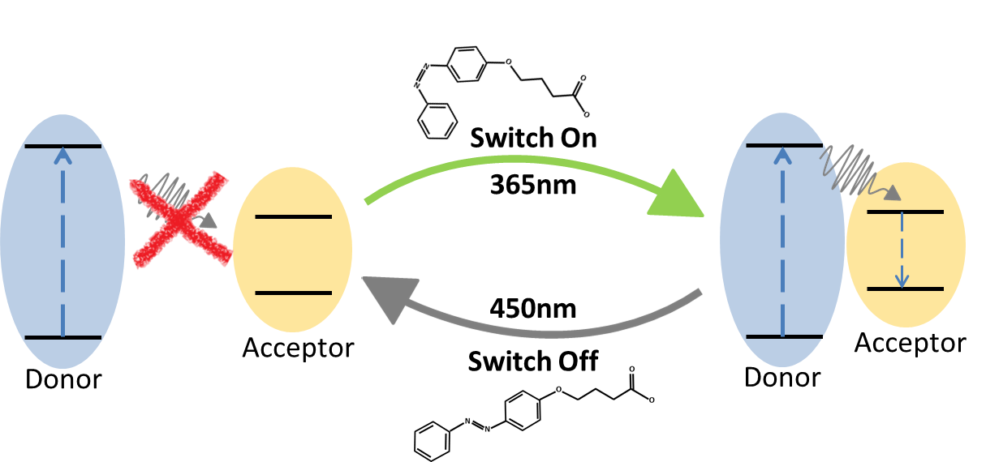

**References**

1. Protesescu, L.; Yakunin, S.; Bodnarchuk, M. I.; Krieg, F.; Caputo, R.; Hendon, C. H.; Yang, R. X.; Walsh, A.; Kovalenko, M. V. Nanocrystals of Cesium Lead Halide Perovskites (CsPbX3, X = Cl, Br, and I): Novel Optoelectronic Materials Showing Bright Emission with Wide Color Gamut. *Nano Lett.* **2015**, *15* (6), 3692–3696. https://doi.org/10.1021/NL5048779/SUPPL_FILE/NL5048779_SI_001.PDF.
2. Li, G.; Rivarola, F. W. R.; Davis, N. J. L. K.; Bai, S.; Jellicoe, T. C.; De La Peña, F.; Hou, S.; Ducati, C.; Gao, F.; Friend, R. H.; Greenham, N. C.; Tan, Z. K. Highly Efficient Perovskite Nanocrystal Light-Emitting Diodes Enabled by a Universal Crosslinking Method. *Adv. Mater.* **2016**, *28* (18), 3528–3534. https://doi.org/10.1002/ADMA.201600064.
3. Tan, Y.; Zou, Y.; Wu, L.; Huang, Q.; Yang, D.; Chen, M.; Ban, M.; Wu, C.; Wu, T.; Bai, S.; Song, T.; Zhang, Q.; Sun, B. Highly Luminescent and Stable Perovskite Nanocrystals with Octylphosphonic Acid as a Ligand for Efficient Light-Emitting Diodes. **2018**. https://doi.org/10.1021/acsami.7b17166.
4. Vashishtha, P.; Halpert, J. E. Field-Driven Ion Migration and Color Instability in Red-Emitting Mixed Halide Perovskite Nanocrystal Light-Emitting Diodes. **2017**. https://doi.org/10.1021/acs.chemmater.7b01609.
5. Wang, Y.; Li, X.; Nalla, V.; Zeng, H.; Sun, H. Solution-Processed Low Threshold Vertical Cavity Surface Emitting Lasers from All-Inorganic Perovskite Nanocrystals. *Adv. Funct. Mater.* **2017**, *27* (13), 1605088. https://doi.org/10.1002/ADFM.201605088.
6. Huang, X.; Guo, Q.; Kang, S.; Ouyang, T.; Chen, Q.; Liu, X.; Xia, Z.; Yang, Z.; Zhang, Q.; Qiu, J.; Dong, G. Three-Dimensional Laser-Assisted Patterning of Blue-Emissive Metal Halide Perovskite Nanocrystals inside a Glass with Switchable Photoluminescence. *ACS Nano* **2020**, *14* (3), 3150–3158. https://doi.org/10.1021/ACSNANO.9B08314/SUPPL_FILE/NN9B08314_SI_002.MP4.
7. Wu, Z.; Yang, J.; Sun, X.; Wu, Y.; Wang, L.; Meng, G.; Kuang, D.; Guo, X. Z.; Qu, W.; Du, B.; Liang, C.; Fang, X.; Tang, X.; He, Y. An Excellent Impedance-Type Humidity Sensor Based on Halide Perovskite CsPbBr3 Nanoparticles for Human Respiration Monitoring. *Sensors Actuators B Chem.* **2021**, *337*, 129772. https://doi.org/10.1016/J.SNB.2021.129772.
8. Kakavelakis, G.; Gagaoudakis, E.; Petridis, K.; Petromichelaki, V.; Binas, V.; Kiriakidis, G.; Kymakis, E. Solution Processed CH3NH3PbI3-XClx Perovskite Based Self-Powered Ozone Sensing Element Operated at Room Temperature. *ACS Sensors* **2018**, *3* (1), 135–142. https://doi.org/10.1021/ACSSENSORS.7B00761/ASSET/IMAGES/LARGE/SE-2017-007612_0005.JPEG.
9. Hasanzadeh Azar, M.; Mohammadi, M.; Rezaei, N. T.; Aynehband, S.; Shooshtari, L.; Mohammadpour, R.; Simchi, A. Stable Photodetectors Based on Formamidinium Lead Iodide Quantum Well Perovskite Nanoparticles Fabricated with Excess Organic Cations. *ACS Appl. Nano Mater.* **2021**, *4* (8), 7788–7799. https://doi.org/10.1021/ACSANM.1C01093/ASSET/IMAGES/LARGE/AN1C01093_0009.JPEG.
10. Liu, B.; Gutha, R. R.; Kattel, B.; Alamri, M.; Gong, M.; Sadeghi, S. M.; Chan, W. L.; Wu, J. Z. Using Silver Nanoparticles-Embedded Silica Metafilms as Substrates to Enhance the Performance of Perovskite Photodetectors. *ACS Appl. Mater. Interfaces* **2019**, *11* (35), 32301–32309. https://doi.org/10.1021/ACSAMI.9B10706/SUPPL_FILE/AM9B10706_SI_001.PDF.
11. Pan, A.; He, B.; Fan, X.; Liu, Z.; Urban, J. J.; Alivisatos, A. P.; He, L.; Liu, Y. Insight into the Ligand-Mediated Synthesis of Colloidal CsPbBr3 Perovskite Nanocrystals: The Role of Organic Acid, Base, and Cesium Precursors. *ACS Nano* **2016**, *10* (8), 7943–7954. https://doi.org/10.1021/acsnano.6b03863.
12. Udayabhaskararao, T.; Kazes, M.; Houben, L.; Lin, H.; Oron, D. Nucleation, Growth, and Structural Transformations of Perovskite Nanocrystals. *Chem. Mater.* **2017**, *29* (3), 1302–1308. https://doi.org/10.1021/acs.chemmater.6b04841.
13. Krieg, F.; Ochsenbein, S. T.; Yakunin, S.; Ten Brinck, S.; Aellen, P.; Süess, A.; Clerc, B.; Guggisberg, D.; Nazarenko, O.; Shynkarenko, Y.; Kumar, S.; Shih, C. J.; Infante, I.; Kovalenko, M. V. Colloidal CsPbX3 (X = Cl, Br, I) Nanocrystals 2.0: Zwitterionic Capping Ligands for Improved Durability and Stability. *ACS Energy Lett.* **2018**, *3* (3), 641–646. https://doi.org/10.1021/acsenergylett.8b00035.
14. Pan, J.; Shang, Y.; Yin, J.; De Bastiani, M.; Peng, W.; Dursun, I.; Sinatra, L.; El-Zohry, A. M.; Hedhili, M. N.; Emwas, A. H.; Mohammed, O. F.; Ning, Z.; Bakr, O. M. Bidentate Ligand-Passivated CsPbI 3 Perovskite Nanocrystals for Stable Near-Unity Photoluminescence Quantum Yield and Efficient Red Light-Emitting Diodes. *J. Am. Chem. Soc.* **2018**, *140* (2), 562–565. https://doi.org/10.1021/jacs.7b10647.
15. Bi, C.; Kershaw, S. V.; Rogach, A. L.; Tian, J. Improved Stability and Photodetector Performance of CsPbI3 Perovskite Quantum Dots by Ligand Exchange with Aminoethanethiol. *Adv. Funct. Mater.* **2019**, *29* (29), 1–9. https://doi.org/10.1002/adfm.201902446.
16. Kim, Y. H.; Zhai, Y.; Gaulding, E. A.; Habisreutinger, S. N.; Moot, T.; Rosales, B. A.; Lu, H.; Hazarika, A.; Brunecky, R.; Wheeler, L. M.; Berry, J. J.; Beard, M. C.; Luther, J. M. Strategies to Achieve High Circularly Polarized Luminescence from Colloidal Organic-Inorganic Hybrid Perovskite Nanocrystals. *ACS Nano* **2020**, *14* (7), 8816–8825. https://doi.org/10.1021/ACSNANO.0C03418/ASSET/IMAGES/LARGE/NN0C03418_0004.JPEG.
17. Debnath, G. H.; Georgieva, Z. N.; Bloom, B. P.; Tan, S.; Waldeck, D. H. Using Post-Synthetic Ligand Modification to Imprint Chirality onto the Electronic States of Cesium Lead Bromide (CsPbBr 3 ) Perovskite Nanoparticles †. **2021**. https://doi.org/10.1039/d1nr04274b.
18. Li, M.; Fang, F.; Huang, X.; Liu, G.; Lai, Z.; Chen, Z.; Hong, J.; Chen, Y.; Wei, R.-J.; Ning, G.-H.; Leng, K.; Shi, Y.; Tian, B. Chiral Ligand-Induced Structural Transformation of Low-Dimensional Hybrid Perovskite for Circularly Polarized Photodetection. **2022**. https://doi.org/10.1021/acs.chemmater.1c03622.
19. Eastoe, J.; Vesperinas, A. Self-Assembly of Light-Sensitive Surfactants. *Soft Matter* **2005**, *1* (5), 338–347. https://doi.org/10.1039/b510877m.
20. Klajn, R.; Bishop, K. J. M.; Grzybowski, B. A. Light-Controlled Self-Assembly of Reversible and Irreversible Nanoparticle Suprastructures. *Proc. Natl. Acad. Sci. U. S. A.* **2007**, *104* (25), 10305–10309. https://doi.org/10.1073/pnas.0611371104.
21. Kundu, P. K.; Samanta, D.; Leizrowice, R.; Margulis, B.; Zhao, H.; Börner, M.; Udayabhaskararao, T.; Manna, D.; Klajn, R. Light-Controlled Self-Assembly of Non-Photoresponsive Nanoparticles. *Nat. Chem.* **2015**, *7* (8), 646–652. https://doi.org/10.1038/nchem.2303.
22. Manna, D.; Udayabhaskararao, T.; Zhao, H.; Klajn, R. Orthogonal Light-Induced Self-Assembly of Nanoparticles Using Differently Substituted Azobenzenes. *Angew. Chemie - Int. Ed.* **2015**, *54* (42), 12394–12397. https://doi.org/10.1002/anie.201502419.
23. Lawrence, R. L.; Scola, B.; Li, Y.; Lim, C.-K.; Liu, Y.; Prasad, P. N.; Swihart, M. T.; Knecht, M. R. Remote Optically Controlled Modulation of Catalytic Properties of Nanoparticles through Reconfiguration of the Inorganic/Organic Interface. **2016**. https://doi.org/10.1021/acsnano.6b04555.
24. Wei, Y.; Han, S.; Kim, J.; Soh, S.; Grzybowski, B. A. Photoswitchable Catalysis Mediated by Dynamic Aggregation of Nanoparticles. *J. Am. Chem. Soc.* **2010**, *132* (32), 11018–11020. https://doi.org/10.1021/JA104260N/ASSET/IMAGES/JA-2010-04260N_M001.GIF.
25. Lawrence, R. L.; Hughes, Z. E.; Cendan, V. J.; Liu, Y.; Lim, C.-K.; Prasad, P. N.; Swihart, M. T.; Walsh, T. R.; Knecht, M. R. Optical Control of Nanoparticle Catalysis Influenced by Photoswitch Positioning in Hybrid Peptide Capping Ligands. **2018**. https://doi.org/10.1021/acsami.8b10582.
26. Zhao, H.; Sen, S.; Udayabhaskararao, T.; Sawczyk, M.; Kučanda, K.; Manna, D.; Kundu, P. K.; Lee, J.-W.; Král, P.; Klajn, R. Reversible Trapping and Reaction Acceleration within Dynamically Self-Assembling Nanoflasks. *Nat. Nanotechnol. |* **2016**, *11*. https://doi.org/10.1038/NNANO.2015.256.
27. Neri, S.; Martin, S. G.; Pezzato, C.; Prins, L. J. Photoswitchable Catalysis by a Nanozyme Mediated by a Light-Sensitive Cofactor. **2017**. https://doi.org/10.1021/jacs.6b12932.
28. Zhu, L.; Yan, H.; Ang, C. Y.; Nguyen, K. T.; Li, M.; Zhao, Y. Photoswitchable Supramolecular Catalysis by Interparticle Host-Guest Competitive Binding. *Chem. - A Eur. J.* **2012**, *18* (44), 13979–13983. https://doi.org/10.1002/CHEM.201202711.
29. Lednev, I. K.; Ye, T. Q.; Matousek, P.; Towrie, M.; Foggi, P.; Neuwahl, F. V. R.; Umapathy, S.; Hester, R. E.; Moore, J. N. Femtosecond Time-Resolved UV-Visible Absorption Spectroscopy of Trans-Azobenzene: Dependence on Excitation Wavelength. *Chem. Phys. Lett.* **1998**, *290* (1–3), 68–74. https://doi.org/10.1016/S0009-2614(98)00490-4.
30. Griffiths, J. 1. Photochemistry of Azobenzene and Its Derivatives.
31. Crecca, C. R.; Roitberg, A. E. Theoretical Study of the Isomerization Mechanism of Azobenzene and Disubstituted Azobenzene Derivatives. *J. Phys. Chem. A* **2006**, *110* (26), 8188–8203. https://doi.org/10.1021/JP057413C/ASSET/IMAGES/LARGE/JP057413CF00020.JPEG.
32. Udayabhaskararao, T.; Houben, L.; Cohen, H.; Menahem, M.; Pinkas, I.; Avram, L.; Wolf, T.; Teitelboim, A.; Leskes, M.; Yaffe, O.; Oron, D.; Kazes, M. A Mechanistic Study of Phase Transformation in Perovskite Nanocrystals Driven by Ligand Passivation. *Chem. Mater.* **2018**, *30* (1), 84–93. https://doi.org/10.1021/ACS.CHEMMATER.7B02425/ASSET/IMAGES/LARGE/CM-2017-02425U_0009.JPEG.
33. Liu, Z.; Bekenstein, Y.; Ye, X.; Nguyen, S. C.; Swabeck, J.; Zhang, D.; Lee, S. T.; Yang, P.; Ma, W.; Alivisatos, A. P. Ligand Mediated Transformation of Cesium Lead Bromide Perovskite Nanocrystals to Lead Depleted Cs4PbBr6 Nanocrystals. *J. Am. Chem. Soc.* **2017**, *139* (15), 5309–5312. https://doi.org/10.1021/JACS.7B01409/ASSET/IMAGES/LARGE/JA-2017-01409D_0004.JPEG.
34. Smith;, B. C. The C=O Bond, Part III: Carboxylic Acids. *Spectroscopy* **2018**, *33* (1), 14–20–14–20.
35. Renier, O.; Bousrez, G.; Stappert, K.; Wilk-Kozubek, M.; Adranno, B.; Pei, H.; Spielberg, E. T.; Smetana, V.; Mudring, A.-V. Photoisomerization and Mesophase Formation in Azo-Ionic Liquids. **2019**. https://doi.org/10.1021/acs.cgd.9b01018.
36. Miiller. M, Zentel. R. Azo‐dyes as labels and as photoisomerizable units in chiral polyisocyanates. Makromol. Chem. 194, 101-116 (1993) https://onlinelibrary.wiley.com/doi/epdf/10.1002/macp.1993.021940108 (accessed 2022-09-08).
37. Protesescu, L.; Yakunin, S.; Bodnarchuk, M. I.; Krieg, F.; Caputo, R.; Hendon, C. H.; Yang, R. X.; Walsh, A.; Kovalenko, M. V. Nanocrystals of Cesium Lead Halide Perovskites (CsPbX3 , X = Cl, Br, and I): Novel Optoelectronic Materials Showing Bright Emission with Wide Color Gamut. *Nano Lett.* **2015**, *15* (6), 3692–3696. https://doi.org/10.1021/nl5048779.
38. Amgar, D.; Stern, A.; Rotem, D.; Porath, D.; Etgar, L. Tunable Length and Optical Properties of CsPbX3 (X = Cl, Br, I) Nanowires with a Few Unit Cells. *Nano Lett.* **2017**, *17* (2), 1007–1013. https://doi.org/10.1021/acs.nanolett.6b04381.
39. Hines, M. A.; Scholes, G. D. Colloidal PbS Nanocrystals with Size-Tunable Near-Infrared Emission: Observation of Post-Synthesis Self-Narrowing of the Particle Size Distribution. *Adv. Mater.* **2003**, *15* (21), 1844–1849. https://doi.org/10.1002/adma.200305395.