COURSE BOOK



## Smart Mobility I

DLBINGSM01

Learning Objectives

##### Introduction 9



This course will give you a basic understanding of the underlying concepts of smart mobility and how it differs from conventional mobility solutions and other smart concepts. It will familiarize you with the current debate on smart mobility, the objectives it is intended to achieve (from cutting carbon emissions to improving road traffic safety), and the associated challenges.

Once you have acquired a basic understanding of the idea of smart mobility together with its objectives and forms, strengths, and weaknesses, we will explore the associated technologies. We will conclude with a selection of projects that are already using smart mobility solutions.



# Unit 1

## Definitions and Relevance of Smart Mobility

#### STUDY GOALS

After working through this unit, you will be familiar with ...

... the technological developments that fall under the heading of “smart mobility”

... the objectives of smart mobility

... how smart mobility interacts with other smart concepts

... the problems associated with implementing smart mobility.

DL-D- DLBINGSM01-L01

1. Definitions and Relevance of Smart Mobility

### Introduction

Constructed in the late 1950s in the country’s uninhabited interior, Brazil’s capital Brasilia is a prime example of how quickly a dazzling utopia can descend into a disturbing dystopia. When planners first set out their vision for this city of half a million inhabitants, the car was king. Little did they know that, rather than symbolizing the country’s financial prosperity, widespread car ownership would one day become a massive problem, one which this city, today the core of a three-million-inhabitant conurbation, is now battling with.

Local public transport

The local transport infrastructure (road, rail, and waterways).

During rush hour, the city’s wide streets are as congested as any other major world city, but in Brasilia, the problem is further compounded by the fact that the city planners largely ignored **local public transport,** focusing instead on their vision of complete separation between transport infrastructures. Any resident wishing to leave their *superquadra* (a neighborhood of around 5,000 inhabitants) would find it almost impossible to do so on foot, by bicycle, or by train. Their reliance on cars is absolute (Marti 2009; Schorsch 2015).

Brasilia typifies the problems faced by urban planners around the globe, all of whom have arrived at the same conclusion: Long-established approaches are failing. We need to understand why this is the case, then investigate possible solutions, one of which may be smart mobility.

### Challenges in Urban Development

While cities such as Hamburg and Manila, New York and Mumbai, or Rome and Tokyo have little in common superficially, they are in fact all facing the same fundamental problems, which are replicated across countless cities and megacities on every continent. The challenges of urban development may be broadly summarized as follows (Costa et al. 2017, p. 3646):

* + - Cities and conurbations are growing faster than in the past and more rapidly than anyone could have predicted.
    - In many cases, their growth is unchecked.
    - There is a mismatch between the escalating volume of private cars and a wholly inadequate infrastructure which was never designed to cope with this many cars or people and which cannot be expanded *ad infinitum*.
    - The result is a continuous deterioration in the transport situation, accompanied by ever-worsening environmental and health problems.

Definitions and Relevance of Smart Mobility

Given that a reversal in the current growth trend for large cities and conurbations seems unlikely, and a trend reversal in people’s travel behavior in general is equally improbable, these problems will not simply go away by themselves. On the contrary, they will become far more severe over the next few years.

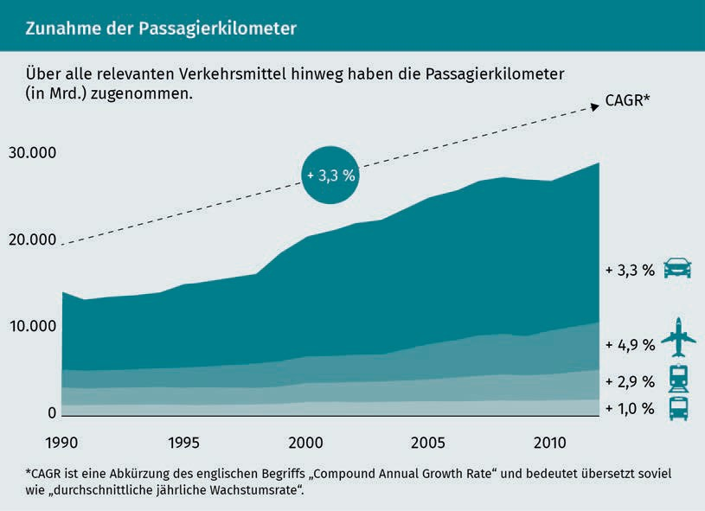

As cities expand, albeit in a mostly planned way, far beyond their originally intended limits, mobility needs are changing. It is almost impossible for the transport infrastructure to keep pace with the number of new neighborhoods springing up, all of which must be connected to the rest of the city or conurbation. The EU Commission has issued three recommendations for tackling this challenge: Create alternatives to car ownership, improve interconnections between the different (public and private) modes of transport, and introduce smart traffic controls to minimize congestion (Baucells Aletà 2017, p. 165). Over the coming years and decades, implementing these recommendations in practice and deciding which technological developments to use will be a topic of intense debate.

### Regulatory Environment

The immediate reaction when faced with escalating transport problems in conurbations is to focus on local public transport. However, merely investing in local public transport capacity is not enough; nor is offering financial incentives to use public transport rather than private cars, for example. There are many different factors at play here, as seen during the recent emotive debate about free local transport. As well as the issue of how these types of initiatives should be funded, it is also a matter of fairness. People who live in city centers have access to a much wider range of free buses and trains than those in the countryside. If subsidized or free local transport is funded from tax revenues, country-dwellers are effectively subsidizing their city-dwelling counterparts (Schmidbauer 2018). It would also create an additional (and counterproductive) incentive to relocate to the city.

Existing problems would also be further exacerbated. Local and regional buses and trains are already operating at or above capacity. In Germany, passengers on the Deutsche Bahn (DB) national railway without a reserved seat often have to leave the train due to overcrowding (Stuttgarter Nachrichten 2016).

The DB example deserves closer scrutiny. A combination of factors are at play here, and politicians and administrations are at least partly to blame. Firstly, there has been an unexpected upturn in demand. In 2017, the company recorded its third successive year of record-breaking passenger numbers, with 142 million tickets sold – an increase of two percent on the previous year (Schlesiger 2018). Against this backdrop, the coalition government’s political target of doubling the number of rail passengers by 2030, as set out in a rail pact between government and industry, appeared realistic (Bundesregierung 2018, p. 77).

However, the rail infrastructure is already nearly at capacity, and expanding the existing network in a densely populated country like Germany will be difficult to say the least. The new section of track between Berlin and Munich took 25 years to be completed. At the initial planning stage in 1992, Deutsche Bahn AG (then Deutsche Bundesbahn) code-named the project VDE 8 and slated it a “German reunification transport project”. By the time of its inauguration in 2017, a full 27 years after the reunification of East and West Germany, this was long-forgotten (Thomas 2017).

Definitions and Motivation

Politicians are partly to blame for the lengthy planning process and for making extra requests, such as

the then-governor of Thuringia’s insistence on rerouting the line via Erfurt at an additional cost to tax-payers of around € 2 billion (Doll 2017). Deliveries of new trains are often delayed, partly due to the licensing authorities’ ever-changing requirements (Busse/Kuhr 2013).

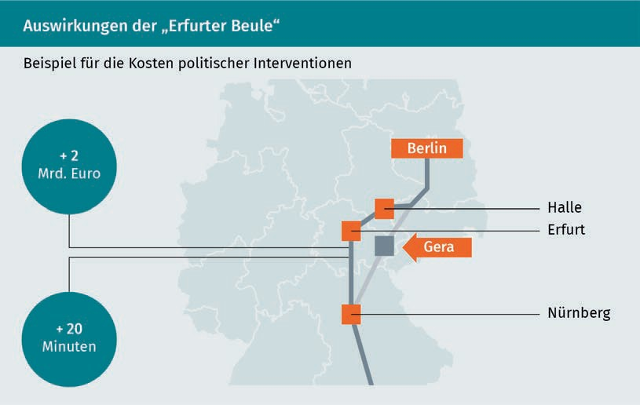

In times of radical transformations and with new phenomena such as self-driving cars on the horizon, the long service lives and amortization periods of trains are a major headache for the DB management, who must anticipate and place orders for the trains they will need in ten or twenty years’ time, when they will be competing with technologies and modes of transport which haven’t even been invented yet.

As these examples have shown, the debate has yet to depart from the well-trodden path. While there is an awareness of technological developments that will transform mobility, their impact cannot be fully predicted.

### Smart Mobility Concepts

When discussing visions of the future, certain words crop up time and again. Alongside neologisms like the Internet of Things, Industry 4.0, digitalization, and “Mobile First”, the word “smart” is gaining traction across an ever-expanding number of segments. With the smartphone now a permanent feature of everyday life for accessing digital offerings on the move, other concepts such as the “smart grid”, “smart city”, and of course “smart mobility” have also become ubiquitous, but unlike the smartphone, there is a lack of consensus over their precise meanings and correlations.