COURSE BOOK



## Smart Mobility I

DLBINGSM01

Learning Objectives

##### Introduction 9



This course, Smart Mobility I, will give you a basic understanding of the underlying concepts of smart mobility and how it differs from conventional mobility solutions and other smart concepts. It will familiarize you with current debates on smart mobility, its intended objectives (from cutting carbon emissions to improving road traffic safety), and the associated challenges.

Once you have acquired a basic understanding of the idea of smart mobility together with its objectives and formats, its strengths and weaknesses, we will explore the associated technologies. We will conclude with a selection of projects that are already using smart mobility solutions.



# Unit 1

## Definitions and Relevance of Smart Mobility

#### STUDY GOALS

After working through this unit, you will be familiar with ...

... the technological developments that fall under the heading of “smart mobility”.

... the objectives of smart mobility.

... how smart mobility interacts with other smart concepts.

... the problems associated with implementing smart mobility.

DL-D- DLBINGSM01-L01

1. Definitions and Relevance of Smart Mobility

### Introduction

Constructed in the late 1950s in the country’s uninhabited interior, Brazil’s capital Brasilia is a prime example of how quickly a dazzling utopia can descend into a disturbing dystopia. When planners first set out their vision for this city of half a million inhabitants, the car was king. Little did they know that, rather than symbolizing the country’s financial prosperity, widespread car ownership would one day become a massive problem, one which this city, today the core of a three-million-inhabitant conurbation, is now battling with.

Local public transport

The local transport infrastructure (road, rail and

waterways).

During rush hour, the city’s wide streets are as congested as any other major world city, but in Brasilia, the problem is further compounded by the fact that the city planners largely ignored **local public transport**, focusing instead on their vision of complete separation between transport infrastructures. Any resident wishing to leave their *superquadra* (a neighborhood of around 5,000 inhabitants) would find it almost impossible to do so on foot, by bicycle, or by train. Their reliance on cars is absolute (Marti 2009; Schorsch 2015).

Brasilia typifies the problems faced by urban planners around the globe, all of whom have arrived at the same conclusion: Long-established approaches are failing. We need to understand why this is the case, then investigate possible solutions, one of which may be smart mobility.

### Challenges in Urban Development

While cities such as Hamburg and Manila, New York and Mumbai, or Rome and Tokyo have little in common superficially, they are in fact all facing the same fundamental problems, which are replicated across countless cities and megacities on every continent. The challenges of urban development may be broadly summarized as follows (Costa et al. 2017, p. 3646):

* + - Cities and conurbations are growing faster than in the past and more rapidly than anyone could have predicted.
    - In many cases, their growth is unchecked.
    - There is a mismatch between the escalating volume of private cars and a wholly inadequate infrastructure that was never designed to cope with this many cars or people and that cannot be expanded *ad infinitum*.
    - The result is a continuous deterioration in the transport situation accompanied by ever-worsening environmental and health problems.

Definitions and Relevance of Smart Mobility

Given that a reversal in the current growth trend for large cities and conurbations seems unlikely, and a trend reversal in people’s travel behavior in general is equally improbable, these problems will not simply go away by themselves. On the contrary, they will become far more severe over the next few years.

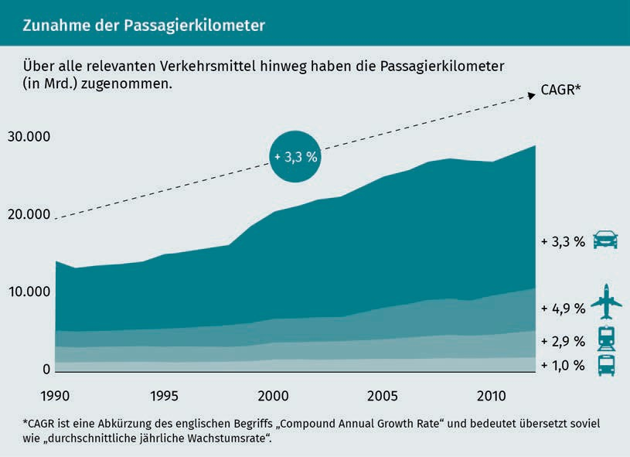

As cities expand, albeit in a mostly planned way, far beyond their original intended limits (or the limits originally considered possible), mobility needs are changing. It is almost impossible for the transport infrastructure to keep pace with the number of new neighborhoods springing up, all of which must be connected to the rest of the city or conurbation. The EU Commission has issued three recommendations for tackling this challenge: create alternatives to car ownership, improve interconnections between the different (public and private) modes of transport and introduce smart traffic controls to minimize congestion (Baucells Aletà 2017, p. 165). Over the coming years and decades, implementing these recommendations in practice and deciding which technological developments to implement will be a topic of intense debate.

### Regulatory Environment

The knee-jerk reaction when faced with escalating transport problems in conurbations is to focus on the public transport system. However, merely investing in public transport capacity or offering financial incentives to use public transport rather than private cars, for example, is not enough. There are many different factors at play here, as we saw during the recent emotive debate in Germany about free local transport. As well as the issue of how to fund these types of initiatives, it is also a matter of fairness. People who live in city centers have access to a much broader range of free buses and trains than those in the countryside. If subsidized or free local transport is funded from tax revenues, country-dwellers are effectively subsidizing their city-dwelling counterparts (Schmidbauer 2018). Moreover, this creates an additional (and counterproductive) incentive to relocate to the city.

Existing problems would also be further exacerbated. Local and regional buses and trains are already operating at or above capacity. In Germany, for example, passengers on the Deutsche Bahn (DB) national railway without a reserved seat are often forced to leave the train due to overcrowding (Stuttgarter Nachrichten 2016).

The DB example deserves closer scrutiny. There is a combination of factors at play here, and part of the blame must be ascribed to politicians and local government. Firstly, there has been an unexpected upturn in demand. In 2017, the company recorded its third successive year of record-breaking passenger numbers, with 142 million tickets sold – an increase of 2% on the previous year (Schlesiger 2018). Against this backdrop, the coalition government’s policy target of doubling the number of rail passengers by 2030, as set out in a railways pact with industry, seems realistic (Bundesregierung 2018, p. 77).

However, the rail infrastructure is already almost at capacity, and expanding the existing network in a densely populated country like Germany will be challenging to say the least. For example, the new section of track between Berlin and Munich took 25 years to complete. When the project was first planned back in 1992, Deutsche Bahn AG (then Deutsche Bundesbahn) gave it the name “VDE 8”, heralding a “German reunification transport project”, but a full 27 years had passed since the reunification of East and West Germany by the time it was eventually inaugurated in late 2017 (Thomas 2017).

Definitions and Relevance of Smart Mobility

Politicians are at least partly to blame for the lengthy planning process and for tacking on extra requests, such as the then-governor of Thuringia’s insistence on rerouting the line via Erfurt at an additional cost to the taxpayer of around € 2 billion (Doll 2017). Deliveries of new trains are often delayed, partly due to the regulatory authorities’ ever-changing requirements (Busse/Kuhr 2013).

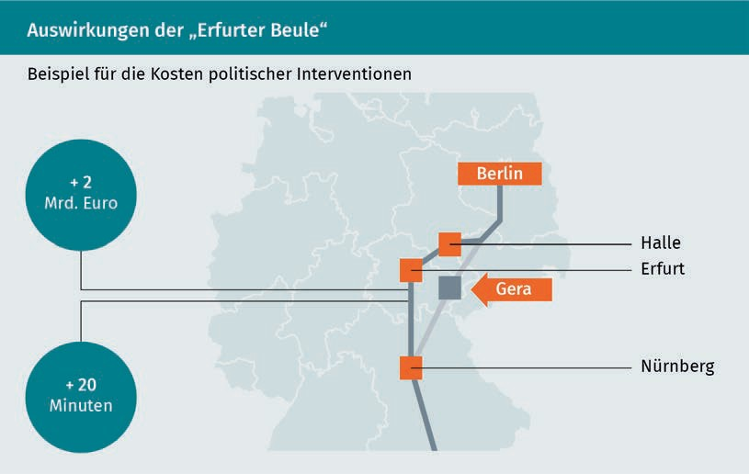

In a radically changing world with new phenomena such as self-driving cars on the horizon, the long service lives and amortization periods of trains create a major headache for the DB management, who must anticipate and place orders for the trains they will need in 10 or 20 years’ time, which will by that time be competing with other technologies and modes of transport that have not even been invented yet.

As these examples illustrate, the debate often lacks a more imaginative approach. There is an awareness that technological developments will transform mobility, but their impact cannot be fully predicted.

### Smart Mobility Concepts

Any public debate about future visions is likely to be peppered with the same few buzzwords. Alongside neologisms like the “Internet of Things”, “**Industry 4.0**”, “digitalization” and “mobile first”, the term “smart” is gaining traction across a growing number of segments. With the smartphone now a permanent feature of everyday life, allowing users to access digital offerings on the move, related concepts like the “smart grid”, “smart city” and of course “smart mobility” have also become ubiquitous. Unlike the smartphone, however, there is a lack of consensus over what exactly these terms mean and how they relate to each other.

Industry 4.0 Industry

4.0 refers to the digital technologies that have helped to improve the flexibility of automated production processes.

This is of course partly due to the rapid rate of development in these sectors and their unpredictable outcomes. Below, we outline some of the basic requirements for transport and mobility technology to qualify as “smart”.

###### Definitions

The term “smart mobility” is still in its infancy, and definitions in the relevant literature vary. Some academics interpret it as a social vision: “A visionary yet feasible mobility of the future. Applicable to and usable by everyone regardless of location and region, regardless of utilization period and duration, and regardless of individual abilities and budgets” (Flügge 2016a, page 2). Others see it as more of a convergence between technological factors (Jeekel 2017, p. 4305), including:

* New vehicle technologies such as electromobility
* Intelligent transport systems (ITS) that create interconnections between infrastructures and transport users
* Data-based real-time services for both individuals and companies
* New mobility services that improve market transparency for more efficient use of transport capacity.

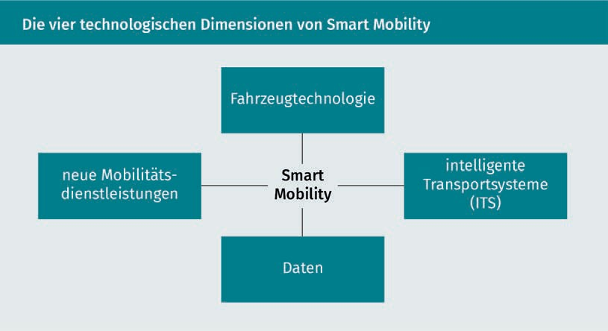

Definitions and Relevance of Smart Mobility

The social and technological dimensions may appear contradictory at first glance, but a closer look reveals a broad consensus on the four key aspects and drivers of smart mobility (Sprei 2018):

1. Mobility behavior needs a radical rethink, particularly in the context of the expanding conurbations on all seven continents.
2. This transformation will rely on assistance from current technological developments.
3. Only the combined advancement of approaches, such as the electrification and automation of mobility alongside improved transport capacity utilization through shared use (shared mobility), can bring about a tangible improvement.
4. Alongside the technological component, the human component must also be taken into account: Unless broad swathes of the (urban) population are willing to forego old values, even the most promising developments will fail.

###### Key Trends

Interestingly, there is a broad consensus among mobility managers about which areas of mobility will become smarter over the next years and decades. In order of relevance, these are shared mobility and enhanced transport efficiency, a proliferation of integrated mobility service providers, accelerated urbanization and smart cities, the liberalization of public local transport, and the development of self-driving vehicles (Oliver Wyman 2016, page 5).

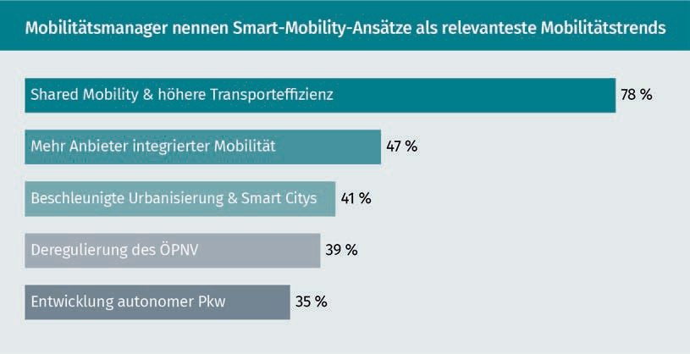

It is also interesting to note that the mix of topics and priorities will vary significantly in different environments. For example, in densely populated towns in newly industrializing and developing countries, experts see the first priority as the rapid electrification of transport and the promotion of sharing models to enhance the air quality in inner cities and limit the number of vehicles (the message being “clean and shared”).

There is currently little point in focusing on self-driving vehicles in cities like Delhi, Mexico City, or Mumbai, for example (McKinsey/Bloomberg 2016, p. 6).

By contrast, the situation is very different in cities like Los Angeles, where the city limits are continuously being pushed outwards and commuters are traveling ever greater distances, albeit with access to a decent infrastructure. In this type of scenario, carsharing (car2go, DriveNow) and ride-hailing (Uber, Lyft) are best viewed as a substitute for, rather than an addition to, privately owned cars. The focus here is more on “private autonomy”, i.e., self-driving, electrified cars (McKinsey/Bloomberg 2016, p. 7).

In densely populated cities where income levels are comparatively high (from Chicago to Hong Kong and from London to Singapore), a range of smart mobility technologies is expected to develop more or less simultaneously. The same applies to the implementation of a comprehensive smart mobility concept. “Seamless mobility” that spans as many providers and transport modes as possible – electrified, self-driving and shared, private and public – looks set to become a reality in these cities in the not-too-distant future (McKinsey/Bloomberg 2016, p. 7), firstly out of necessity, but secondly because it is feasible. By contrast, cities like Mumbai will need to resolve some very deep-seated problems before they are able to take such a step.

### Smart Mobility and the Smart City

Debates about smart mobility tend to center on major cities and conurbations. With cities all over the world expanding, and up to three-quarters of the global population predicted to live in cities by 2050, this is understandable. “Smart” solutions are needed if we are to tackle the challenges associated with a growing number of people concentrated in a limited space, not just in the area of mobility but in all aspects that impact the ways people live and coexist.

When it comes to inner-city traffic, smart mobility is just one dimension of the much broader concept of the “smart city”. Back in the year 2000, scientists had calculated that traffic congestion costs European cities 2.69-4.63% of GDP each year. Given that the situation has deteriorated still further since then, it is undoubtedly one of the top concerns (Pflügler et al. 2016, p. 200).

Definitions and Relevance of Smart Mobility

“Intelligent (‘smart’) cities conserve their resources and are organized into small-cell urban structures with an emphasis on neighborliness, environmental awareness and livability,” says Andreas Flückiger, Head of Technical Operations for the city of St. Gallen (Flückiger 2016, p. IX), outlining his vision of a smart city. Crucially, he also adds, “Technology helps cities and people to achieve a high quality of life, conserve resources and advance society.”

This practitioner’s definition reflects the key realization, pivotal to any debate on smart mobility, that smart concepts should never be an end in themselves when technologizing or digitalizing a particular segment of industry or society. Instead, their role is to find a “smart” solution for relevant problems by using new technologies or applying existing technologies in a new way: “The term smart city or ubiquitous city refers to the use of information and communications technologies to sustainably develop the social and ecological environment in a city or **agglomeration**, such as projects to improve mobility, create smart water and energy supply systems, promote social networks, broaden political participation, expand entrepreneurship, protect the environment, improve safety, and enhance quality of life” (Meier/Zimmermann 2016, p. 4).

The objectives of the smart city model may be categorized into the following developmental dimensions: smart governance, smart citizen, smart education, smart living, smart environment, smart economy, and, last but not least, smart mobility (Meier/Zimmermann 2016, p. 5ff.)

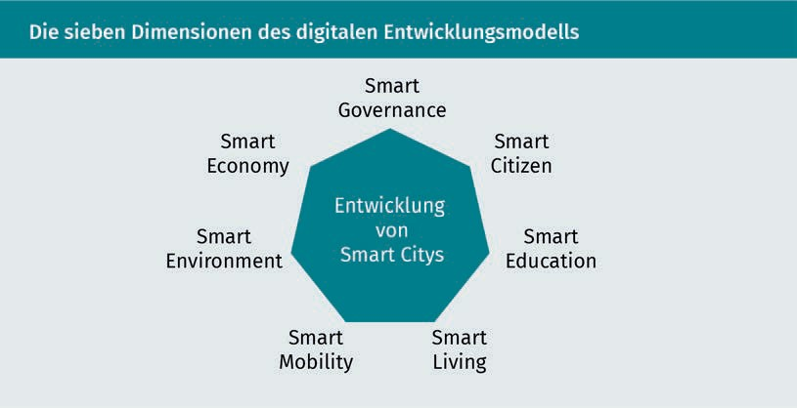

Different smart cities can be compared by assessing each of these dimensions and scoring them according to how well-developed they are. The key task is to establish a fundamental description of the seven dimensions of the digital development model for smart cities in order to gain a better understanding of smart mobility and how it is embedded into the smart city context (Meier/Zimmermann 2016, p. 5ff.).

Agglomeration

An agglomeration is a conurbation.

Blockchain process Blockchain is a cryptographic process to document transactions in an inalterable manner.

* Smart governance: New technologies often necessitate modifications to control and regulatory systems. Smart governance entails adapting legal framework conditions, introducing innovative organizational structures and encouraging politico-social initiatives and new forms of public-private collaboration to meet the aforementioned objectives.
* Smart citizen: A smart city must allow its citizens to participate in “smart” processes on equal terms. The term “smart citizen” encompasses all communication and information systems, including voting systems that help to interconnect citizens and address joint requirements and challenges more effectively.
* Smart education: The technologization and digitalization of society places new demands on people, not just in the work environment but in everyday life as well. Smart education refers to modern learning scenarios that provide access to relevant digital learning content at any time and from any location.
* Smart living: Digital technologies are expanding into even the most intimate spheres of human life. Smart living encompasses intelligent automation systems to maintain maximum independence and quality of life, particularly for those with physical or mental limitations due to illness or old age. It also includes innovative e-health programs.
* Smart environment: As cities grow, they face unprecedented challenges in the areas of energy and water supply, sanitation and waste management. A smart environment controls the underlying processes intelligently and largely autonomously using networks of wireless sensors, big data and **blockchain** technologies (such as smart grid initiatives).
* Smart economy: As cities become ever more densely populated, space is a scarce commodity – be it housing, public spaces, or even parking spaces. The smart economy offers intelligent, technology-driven solutions to these challenges, for example, by using sharing-economy approaches.

### Smart Mobility Solution Requirements

In market economies, progress is achieved either by developing novel and superior solutions to existing problems or by devising solutions for new problems. Developments in the smart mobility sector cover both, but the latter pose a far greater challenge, especially in large cities. This is one of the reasons why smart mobility tends to focus primarily on conurbations.

Definitions and Relevance of Smart Mobility

While it is true that the mobility needs of the rural population are also changing, the impacts are less pronounced than for their urban counterparts.

The key challenges associated with smart mobility solutions mirror the problems faced by large cities and conurbations. The need to improve energy efficiency and minimize emissions are inextricably linked to the problems of exhaust and particulate pollution and the relentless noise pollution present in large cities. The demand for enhanced comfort directly reflects the pressures associated with congestion and a lack of transparency about and availability of interconnections between different modes of transport. There is also a need to cut costs, given the rising cost of living in cities, coupled with escalating mobility costs in recent years and decades.

However, there is no conclusive answer as to whether combining the various components of smart mobility – electrification, self-driving vehicles, shared mobility, and the creation of integrated mobility platforms – is an equitable way to achieve these objectives, and if so, to what extent. For example, measures to reduce the number of vehicles in city centers (and hence minimize emissions and congestion) may well contribute directly to shared mobility solutions, while integrated mobility platforms may in fact be thwarted by more widespread electrification and a proliferation of self-driving vehicles.

This was the hypothesis put forward in a joint study by management consultants McKinsey and analysts at Bloomberg New Energy Finance *An Integrated Perspective on the Future of Mobility* (McKinsey/Bloomberg 2016, p. 15ff.). They argued that a sharp increase in the number of e-cars could drive down the price of batteries and make driving cheaper in the medium term, encouraging people to make additional journeys that would otherwise have been too costly. The more widespread availability of self-driving vehicles could lead to a similar scenario. As well as driving around empty to avoid parking charges, self-driving vehicles could also entice current non-drivers – the young, the elderly, the disabled and those without a driving license – onto the roads.

While it is difficult to predict the extent to which combinations of smart mobility solutions might meet the targets of energy efficiency, reduced emissions, increased levels of comfort and reduced costs, it is nevertheless worth considering the potential of each individual development.

###### Energy Efficiency

Scarce resources and political instability in oil and gas-producing countries, coupled with the relentless rise in energy prices and transport costs, mean that energy efficiency is a crucial consideration on many different levels. Essentially, there are three levers for boosting energy efficiency (Sauer 2016, p. 12):

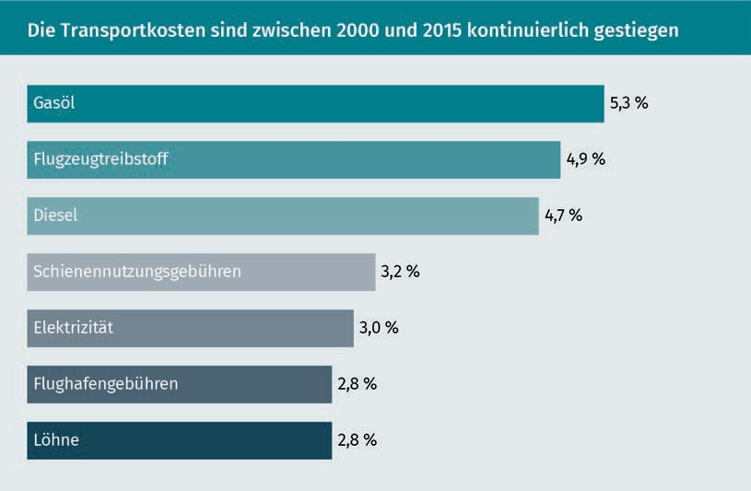

Those in charge of mobility tend to have little influence over the circumstances in which energy is produced. Energy storage is a separate issue, which we will consider in greater depth under “Emissions”. Focusing on the aspect of demand, experts predict that e-cars could account for 3% of the global energy demand by 2030, and as much as 4% in Europe (McKinsey/Bloomberg 2016, p. 7). This may not sound like much, but it poses a very real challenge, especially during peak times. Electric cars have two advantages over many other fuel types: Firstly, charging is not usually time-critical, provided the vehicle is charged regularly rather than waiting until the battery is drained; and secondly, vehicles can be conveniently charged overnight. Intelligent energy networks (smart grids) can be used to control charging so that it occurs during low-demand periods. As an incentive, discounted electricity prices could be offered for these periods (McKinsey/Bloomberg 2016, p. 7).

Definitions and Relevance of Smart Mobility

###### Emissions

There are many reasons why electric cars have not asserted themselves over their combustion engine rivals in all areas. Until now, there has been a limited range of models available, the number of public charging stations remains limited and charging is still a comparatively long process compared with filling with petrol or diesel. The high cost of the lithium-ion batteries fitted in electric cars is a key factor. As a result, electric vehicles are currently significantly more expensive to buy than their combustion engine counterparts (McKinsey/Bloomberg 2016, p. 22). In light of all these factors, it is hardly surprising that the majority of people shy away from buying an electric car, even though the variable costs per kilometer driven are already lower than those of a conventional vehicle (McKinsey/Bloomberg 2016, p. 22).

Tesla has disrupted the market by committing to the production of electric cars only, despite having a comparatively small market share of just 2.31% in 2017 (Torcasso 2018). However, in the medium term this should suffice to allow the technology to take off. Thanks to Tesla and other private and public operators, the e-car charging infrastructure in Germany is continuously expanding. Every additional car on the road helps to advance battery technology. Extrapolating the historical data suggests that each cumulative doubling in the number of lithium-ion batteries could reduce the cost of each battery produced by 16-20% (McKinsey/Bloomberg 2016, p. 25).

As buying and driving e-cars becomes (financially) more attractive, their market share will increase significantly and, in turn, help to substantially reduce noise pollution and exhaust gas emissions in inner cities. As the energy mix shifts in favor of renewables over the next few years and decades and reduced production costs for e-cars enable the more widespread use of (more expensive) renewable energies without negating these cost benefits, all other things being equal, we can reasonably expect smart mobility to achieve a noticeable reduction in emissions (McKinsey/Bloomberg 2016, p. 26).

###### Comfort and Safety

Apart from being a financially attractive market, the advances in self-driving vehicles are primarily due to the availability of ever more advanced technologies (such as high-speed Internet), coupled with a growing interest in exceptionally comfortable and safe mobility solutions (McKinsey/Bloomberg 2016, p. 18).

Experts predict that high-quality, fully self-driving vehicles will be available on the market by the mid-2020s (McKinsey/Bloomberg 2016, p. 18).

Definitions and Relevance of Smart Mobility

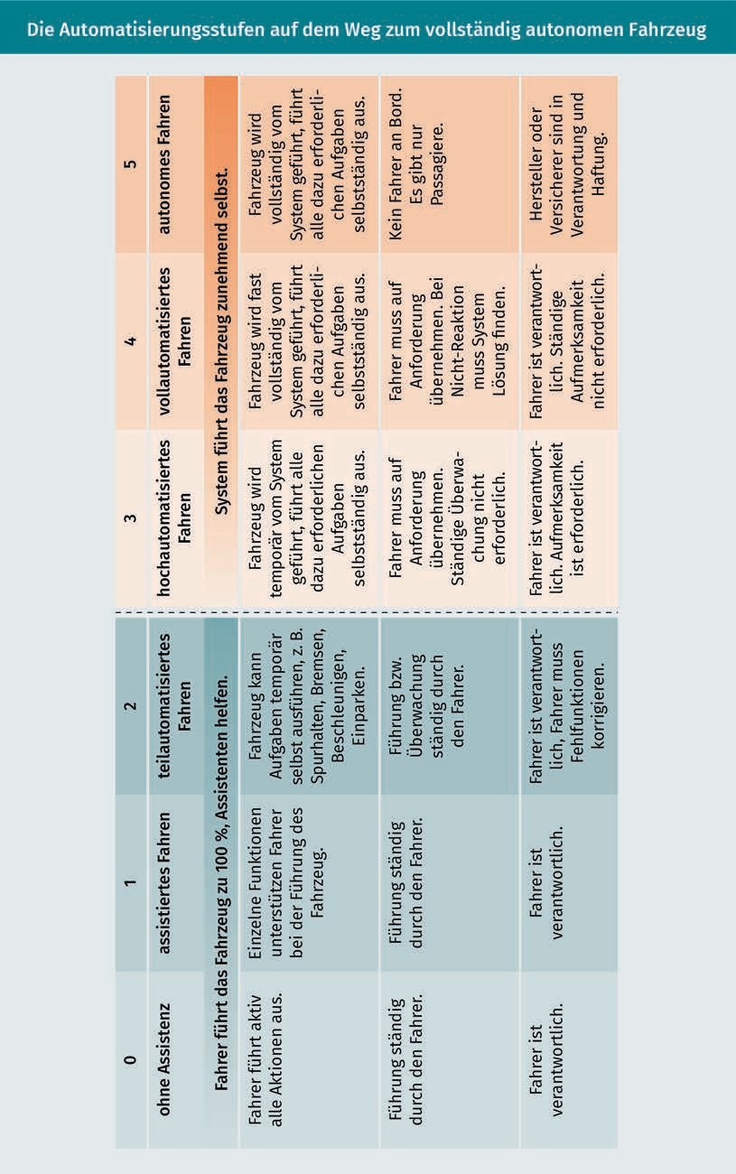

As well as liberating us from the pressures of driving, self-driving cars will become an extension of our homes, a place to do something useful, interesting, practical, or entertaining. Consequently, car interiors and designs are likely to see a radical revamp, particularly in terms of on-board entertainment and information electronics (McKinsey/Bloomberg 2016, p. 19).

Assuming they are allowed to circulate empty, self-driving cars would eliminate trips to pick up and drop off friends and family at the airport, or for school or sporting events, for example, meaning greater freedom and comfort for many parents (McKinsey/Bloomberg 2016, p. 19). Self-driving vehicles would undoubtedly be more convenient for point-to-point journeys and are expected to improve road safety as well. However, countless questions remain unanswered. For example, adverse changes in user behavior could in fact cause traffic in city centers to worsen – for example, due to vehicles circling around to avoid parking charges (McKinsey/Bloomberg 2016, p. 19).

###### Cost Savings

Until now, a financial decision not to buy a car had to be weighed up against the comparatively high variable costs (per unit of time or distance) of taking a taxi, carsharing, or ride-hailing. As the production costs of e-car batteries continue to fall and given the superior capacity utilization of shared vehicles versus private cars, carsharing costs are expected to decrease significantly over the next few years. Even then, however, the unit cost would still be higher than with private car ownership. The trend toward self-driving vehicles is the major lever for cutting costs. Experts calculate that a shared, driverless vehicle with a low-cost electric drive could be 30-60% cheaper than using your own car, depending on how many users share the ride (McKinsey/Bloomberg 2016, p. 25).

Once again, it is important to remember that these positive developments could encourage undesirable behavioral changes. If the cost of sharing an electric, self-driving car with other passengers were similar to or even lower than using public transport, there would be an incentive to travel by car rather than the less convenient buses and trains (McKinsey/Bloomberg 2016, p. 25), leading to even more cars on the roads, albeit with significantly fewer privately owned vehicles.

Definitions and Relevance of Smart Mobility

Summary

The massive population growth in major cities and conurbations around the world poses a huge challenge for transport and urban planners. Traditional approaches will not be capable of handling future mobility requirements, as a result of which companies, policymakers and local governments are pinning their hopes on smart mobility.

Smart mobility is one of seven key elements in the smart city concept and combines four technological dimensions: new vehicle technologies such as electric mobility, intelligent transportation systems (ITSs) for connecting road users with each other and with the infrastructure, data-based real-time services, and new mobility services.

Provided they can achieve the required level of acceptance among potential users, the hope is that these technologies will enable significant advancements in the areas of energy efficiency, emissions, comfort, safety, and costs, to the benefit of liveable cities and mobile citizens.



# Unit 2

## Alternative Mobility Offerings

#### STUDY GOALS

After working through this lesson, you will be familiar with ...

… the new mobility offerings that have emerged in recent years.

… the similarities and differences between related concepts.

… the strengths and weaknesses of alternative mobility offerings.

… some of the particularly innovative ideas that are poised for a breakthrough.

DL-D-DLBINGSM01-L02

1. Alternative Mobility Offerings

### Introduction

Over the last decade, many innovative (and sometimes radical) approaches to mobility have emerged. The response has been euphoric from some, while the more radical innovations have provoked fierce opposition from others. Some of their concerns may well be justified, for example, when new technologies threaten people’s livelihoods. Similarly, the impacts of new technological infrastructure on local residents and their quality of life should not be underestimated.

When a Singaporean company flooded the market with rental bicycles, it triggered violent protests that were probably partly to blame for its eventual insolvency. In Hamburg, a citizens’ action group successfully reversed plans to build a cable car line. Local objections could also cause other future projects, such as the hyperloop and air taxis, to fail. The prospect of ugly tubes and the relentless buzz of capsules every few seconds or an army of drones carrying one or two passengers flying over your balcony, casting shade and violating your privacy, could well provoke fierce resistance. Given the angry protests against wind turbines and mobile phone masts, it seems reasonable to expect that hyperloops and air taxis might provoke a similar response.

Leaving aside issues of social acceptance, there are various other challenges that remain unanswered. With any new mode of transport, the routing and the legal framework are pivotal considerations, alongside the issue of whether it can realistically coexist with established modes of transport. For example, even the use of smaller, unmanned drones is likely to unleash a fierce debate about safety. Aviation expert Elmar Giemulla warns, “The mass transport of large vehicles through inhabited areas affects human lives” (Rosenbach/Balances 2018, p. 61).

Andreas Knie, Managing Director of the Innovation Center for Mobility and Social Change (InnoZ) and Professor at TU Berlin, sees another risk arising from particularly visionary projects: “These utopian visions distract from the acute transport problems that politicians, industry and society have thus far failed to address” (Rosenbach/Balances 2018, p. 61). Perhaps he is right? At the very least, we should heed his warning when weighing up the opportunities and risks of alternative mobility offerings.

Alternative Mobility Offerings

### Sharing, Pooling, and Shipping

In recent years, a range of transport-sharing schemes such as car-, bike- and ride‑sharing have enjoyed explosive popularity in the cities of the developed world. Apart from the mode of transport used, the main difference between them is whether they are used simultaneously or sequentially (Behrend/Meisel 2017, p. 338).

Car- and bike-sharing schemes, now widely established, entail the sequential use of a vehicle by several people. When one person has finished with the car, bike, or (increasingly) scooter or moped, it becomes available for the next person to use. Ridesharing (also known as pooling) refers to the simultaneous use of a vehicle – usually a car. The purpose of bringing together travelers with similar itineraries and schedules is to increase capacity utilization of the individual vehicle and save money for all participants (Behrend/Meisel 2017, p. 339).

The idea of a group of people sharing a car, rather than each of them having a vehicle standing idle in front of their home, workplace or elsewhere for a large part of the day, depreciating continuously in value, predates the start of the digital age by several decades. The first documented carsharing organization was the Swiss Self-Drive Association (SEFAGE) in Zurich, founded in 1948. Germany followed 40 years later with the market launch of StattAuto Berlin in 1988 (Breitinger 2014). Now known as “carsharing”, the practice has become an established part of life, especially in larger cities, and shared vehicles are visible everywhere in ever increasing numbers.

However, there are multiple interpretations of this generic term. In recent years and decades, several new and more advanced concepts have emerged, which coexist quite happily (Clewlow/Mishra 2017, p. 3ff.).

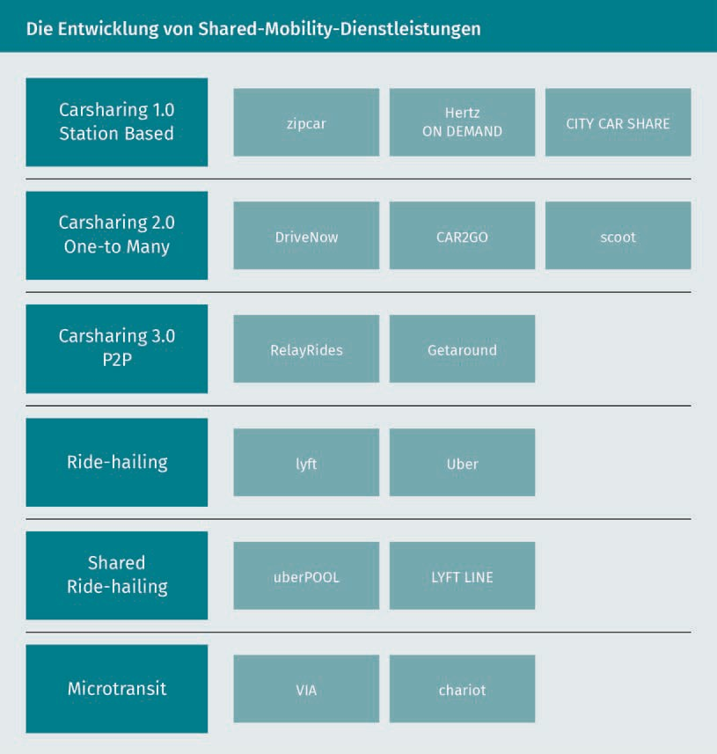

When the scheme was first launched, cars had to be collected from and returned to the same location (Carsharing 1.0). Bookings were usually made in advance by telephone (later via the Internet), and cars were rented by the hour. This early format has since been largely replaced by other carsharing concepts, probably because it was quite an inflexible system requiring extensive planning by customers both before and during their journey.

The best-known form of carsharing in Germany is operated by providers such as car2go or DriveNow (Carsharing 2.0) on a one-to-many basis, i.e., the vehicles can be picked up from one location and dropped off at any other location within the contractual territory. These services are billed on a per-minute basis. Bookings are made by smartphone, usually because of a spontaneous decision before starting the journey.

Alternative Mobility Offerings

The widespread availability of mobile devices with GPS sensors paved the way for this form of carsharing by eliminating the need for customers to go to a centralized parking lot to pick up the vehicle.

This form of sharing is no longer limited to cars but also extends to other motorized vehicles. Many cities offer a similar service for electric scooters (Köhler 2018). Apart from eliminating exhaust gases, scooters are much easier to park, a major challenge for carsharing users in many cities. Some studies have estimated that vehicles searching for parking spaces account for up to 30% of all traffic in selected cities (Pflügler et al. 2016, p. 199).

This form of “free-floating” carsharing uses GPS tracking and real-time booking via an app. Other more recent variations on the sharing concept use the same technology. One alternative model based on the original Airbnb concept is less widely used. While huge numbers of people now rent out their homes to strangers via Airbnb, the idea of doing the same with private cars has yet to take off. The jury is still out on whether Carsharing 3.0 (peer-to-peer carsharing) will become a relevant factor over the next few years.

Despite the success of recent years and a history of continuous growth, driven by companies like Daimler (car2go) and BMW (DriveNow) entering the market, conventional carsharing remains something of a niche product (albeit a reasonably sized niche). In 2016, there were an estimated three million carsharing users in Europe, and just two million in North America (Automotive World 2017) – not what you would describe as a resounding breakthrough.

### Ride-Hailing and Intercity Buses

Sharing and pooling refer to the shared use of available or commercially supplied vehicles. Other concepts such as ride-hailing and (on the German market, at least) intercity buses are variations on existing business models, the former being a mutation of the taxi concept and the latter a broadening of the local and regional bus concept.

Uber and Lyft are the best-known ride-hailing names, alongside Sidecar in the English-speaking world (Flores/Rayle 2017). The idea is that users “flag down” a car and driver from the app. The term “ride-hailing” originates from the word “hail” (meaning “to call a taxi”) and is used for both private and professional providers. Unlike sharing concepts, ride-hailing is a transport service, rather than just a vehicle. Unlike pooling, where users rely on another driver opting to travel the same route at the same time, ride-hailers are customers who determine the location and route themselves (Clewlow/Mishra 2017, p. 4f.).

Sounds a lot like a taxi? That’s because it is. It is also one of the reasons why ride-hailing has yet to take off in some European countries, as we will see toward the end of this chapter. The service got off to a flying start, however, with an estimated 250 million users joining in the first five years alone. Its appeal was twofold: It increased the capacity utilization of private cars, while at the same time reducing mobility costs for drivers and their passengers. However, some of its ambitions have failed to materialize – such as reducing the number of cars in inner cities. On the contrary, some of the larger US cities are actually seeing an increase in city center traffic, which is thought to be a direct result of services such as Uber and Lyft.

A much-quoted study by the Institute of Transportation Studies at the University of California at Davis (Clewlow/Mishra 2017) offers a plausible explanation: While commercial, paid ridesharing is in part a substitute for your own car, it is also a solution to one of the biggest problems with inner-city driving, namely finding (and paying for) parking spaces (Clewlow/Mishra 2017, p. 13). Using someone else’s car rather than your own is therefore more attractive than taking the bus or the train.

The study also found that 49-61% of all journeys on services such as Uber or Lyft would not have been taken at all, or the customer would have walked, cycled, or taken public transport (Clewlow/Mishra 2017, p. 27). Other studies produced similar results, concluding that ride-hailing compares unfavorably with sharing concepts due to the additional traffic generated (Behrend/Meisel 2017, p. 340).

Apart from ride-hailing, the transport services market has seen a number of widely debated changes in recent years. The liberalization of Germany’s intercity bus market enabled providers to compete directly with the German railway (Deutsche Bahn). While the market was initially flooded with a large number of operators, these have since been whittled down to just a few intercity bus companies, with Flixbus dominating the market; nevertheless, intercity buses have managed to secure a significant share of the passenger market.

Alternative Mobility Offerings

By 2015, the German Federal Statistical Office calculated the number of passengers on intercity buses at 23.2 million, compared with 15.9 million in 2014 and just 8.2 million in 2013. This equates to a market share of 15% (Statistisches Bundesamt 2016b).

Legislative and policy changes have had a significant influence on the development of intercity buses and ride-hailing. For decades, intercity buses were prohibited in the Federal Republic of Germany. While commonplace in Europe and in other parts of the world, in Germany the intercity travel market was dominated by the railway (Deutsche Bahn), which had successfully invoked a clause from the 1934 Passenger Transport Act to keep “**Greyhounds**” and their ilk out of the market (Doll 2011).

Intercity buses are now a common sight on Germany’s roads, but Deutsche Bahn’s campaign against its unwanted competitors (particularly market leader Flixbus) continues unabated, albeit on a different playing field. No sooner had Flixbus started turning a profit than politicians began lobbying for the introduction of a bus toll, while simultaneously reducing the costs of rail transport (n-tv 2017). At the same time, Flixbus announced plans to compete with rail operators on their home turf with the launch of FlixTrain. There is no sign of a resolution to this conflict any time soon (Doll 2018).

Ride-hailing, particularly Uber, faces similar problems. Uber has faced some form of opposition from taxis and from the authorities and legislators in almost every country where it operates. Some of the concerns would appear to be justified; Uber has been found guilty of breaking the law in just about every country where it is present (Flors/Rayle 2016, p. 3757).

The contentious issues range from accusations of wage dumping to a failure to meet legal safety standards. Uber has long opposed any form of regulation, on the grounds that it is not a transport service provider but a technology company, and, therefore, does not fall under the same regulation as taxis, for example – a view not shared by the European Court of Justice (Spiegel Online 2017). Its ruling, together with other factors, virtually killed off the Uber Pop service, which allowed private individuals to carry passengers using the Uber app. Ride-hailing in many European countries is heading in the same direction.

### Cable Cars

Recently, there has been a renewed upturn in demand for a technology previously considered extinct: the cable car. Though growth potential in ski resorts is largely exhausted, cable cars are now being hailed as an alternative mode of transport in cities around the world (Menn 2014). Demand is particularly high in South America, prompted by the rapid, largely unchecked growth of its metropolises – from La Paz in Bolivia to the Colombian cities of Manizales and Medellín, and from Caracas in Venezuela to Rio de Janeiro in Brazil (Erb 2014; Menn 2014).

Greyhounds

Greyhound buses have existed in the USA for decades. The term is often used generically to refer to any type of intercity bus.

Cable cars are also planned or already operational in other parts of the world, including Ankara (Turkey), Hong Kong, and the Georgian capital of Tbilisi (Menn 2014).

The arguments in favor of cable cars over conventional modes of transport, such as buses, trams, and subways, reflect the typical problems of a global conurbation:

* + - Short planning times: Construction of a new tram line may take up to 15 years, whereas the cable car in Koblenz was built in just 18 months, and a similar project in Ankara took only six months (Menn 2014). In La Paz, signing of the contract to the opening of the first line took just two years (Erb 2014).
    - Minimal space requirements: The most precious commodity in any fast-growing city is space, making cable cars an ideal choice. Apart from the footprints of the stations where passengers embark and disembark, only minimal space is required along the route to construct the pilings (Erb 2014; Menn 2014).
    - Low operating costs: Cable cars have several advantages over buses, for example, when it comes to minimizing energy consumption per passenger and kilometer, such as less friction, more direct routing, and the fact that only one engine is required for multiple gondolas. As a result, cable cars can be up to 80% more energy-efficient than buses. Moreover, cable cars are driverless, which translates into low personnel costs and low maintenance frequency (Menn 2014).
    - Minimal harmful emissions: The gondolas are usually electrically powered and do not produce noise pollution or exhaust fumes (Menn 2014), a winning argument for many cities dogged by extreme levels of noise and fine dust pollution.
    - Low planning and construction costs: Financial resources are often particularly limited in regions with fast-growing cities (in developing and newly industrializing countries), so the comparatively low construction costs of cable cars are a persuasive argument. The cable car in La Paz cost € 183 million, for a route three times as long and around one-third of the cost of the Berlin underground line currently under construction from Alexanderplatz to the Brandenburg Gate (Erb 2014).
    - Direct links: The construction of road and rail links must give special consideration to the pre-existing infrastructure, ownership structure, and geographical peculiarities such as rivers or mountain slopes, whereas cable cars usually allow direct, point-to-point links (Menn 2014). Because they operate on a completely new transport level (Erb 2014), they are not competing with other interests, projects, or uses.

There have also been reports of other positive side effects from some projects. For example, since the first cable car began operation in Medellín in 2004, crime in the districts it connects has fallen significantly. Similar effects have been observed in Caracas, where the first line opened in 2010 (Erb 2014).

Alternative Mobility Offerings

Cable cars may appear to be the only sensible option for urban development in fast-growing conurbations (in the areas surrounding the heavily built-up slums), but they are no magic bullet. In La Paz, for example, the maximum transport capacity per hour is 3,000 people on each line (Erb 2014).

Cable cars can, therefore, complement but not replace a conventional urban transport infrastructure, and they do offer some promising prospects in individual cases, including a comparatively fast and easy way of connecting neighborhoods to the existing bus, train, and metro networks and bridging physical obstacles such as rivers, slopes and heavily built-up areas. The range of potential applications cannot be underestimated. In Germany alone, there are thousands of conceivable routes that might lend themselves to such a solution (Menn 2014). However, cable cars alone cannot solve the traffic problems in fast-growing cities and conurbations.

### Air Taxis

Alongside the well-established modern mobility concepts already considered, public debate over the future of (metropolitan) mobility is often fueled by futuristic-sounding visions, studies, and claims. The **Transrapid** of the 1990s and early 2000s is one such example. This project never made the leap from sci-fi to commercial use in Europe and was terminated following a serious accident on the official test track in the Emsland district of Lower Saxony, in which 23 people died. However, the same technology has been operational in China since 2004, where the Transrapid connects Shanghai with Pudong Airport (Hacking 2017). More recently, the debate has turned to schemes like the hyperloop and air taxis. Rather like Transrapid, their feasibility and appropriateness are endlessly and inconclusively debated.

During an interview with the *ZDF heute journal* current affairs program, the German Federal Government Commissioner for Digitalization, Dorothee Bär, surprised listeners by referencing air taxis as a key project for the next few years. A furious backlash followed, with critics citing the current weaknesses of Germany’s digital infrastructure (BAU 2018). However, while many of us still struggle with the idea of traveling in a huge (unpiloted) electric drone, others find it fascinating, and the first test flights have already been successfully completed.

While colloquially known as “air taxis” or “passenger drones”, the correct technical term is “eVTOL”, which stands for “electrical vertical take-off and landing” (Rosenbach/Salden 2018, p. 61).

Transrapid

The Transrapid is a magnetic levitation train that can reach speeds of up to 450 km/h.

Critics may dismiss them as electrified versions of the helicopter shuttles used by the very wealthy for decades in cities like New York, São Paulo, or Monaco, but investors and tech reporters have a different take on the air taxi. In early 2018, Joby Aviation’s passenger drone project raised $ 100 million from investors, including a number of high-profile names such as JetBlue, Toyota, and Intel (Hawkins 2018). Meanwhile, Daimler, another big name, is part of the consortium that invested € 25 million in the German start-up Volocopter in 2017 (Hegmann 2017). Technology journal *Techcrunch* is convinced that the next billion-dollar start-up will be in the aviation industry (Chopard 2017). Porsche Consulting also finds “vertical mobility” so promising that it published a 36-page study on the topic (Porsche Consulting 2018).

Despite their many differences, previous concepts, studies, and prototypes by companies, such as Volocopter, Lilium, and Ehang, do share one conclusion: Air taxis are only designed to accommodate a few passengers and cannot usually transport more than two people at a time (Rosenbach/Balances 2018, p. 62).

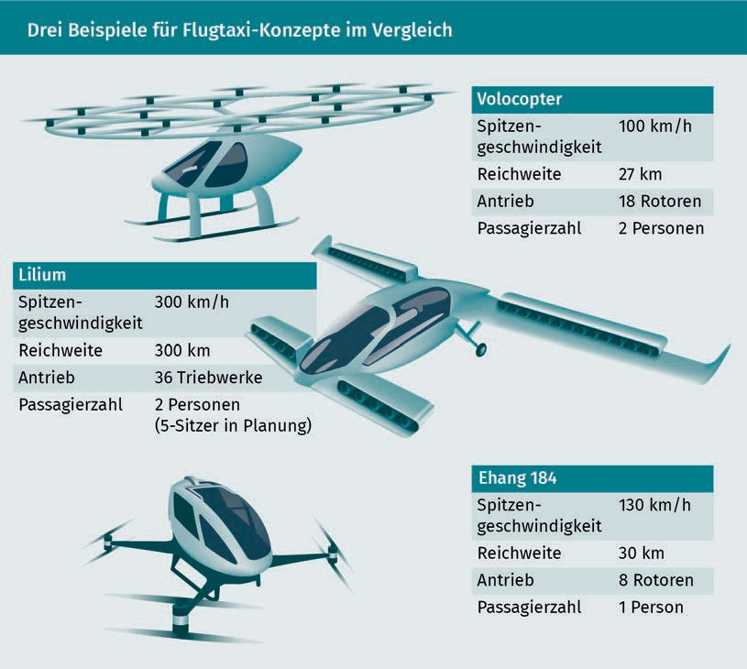

Alternative Mobility Offerings

Most of the projects are based on a similar concept to the increasingly popular small drones, although these are not yet able to transport passengers. Lilium stands out from its competitors by using engines instead of rotors. The collaboration between Airbus and Audi known as “Pop.Up.Next” is an even more radical concept that can be used both as a car (on four wheels) and as a taxi (with a propeller) (Rosenbach/Salden 2018, p. 62). It is impossible to predict which, if any, of these concepts will ultimately prevail.

Interestingly, in Germany, these schemes are being considered for the same applications as were originally planned for the Transrapid, such as transfers between Munich’s outlying airport and the city center. The calculated ten-minute flight time is certainly attractive compared with the current 40-minute train journey, albeit at a grossly disproportionate cost compared to public transport.

An additional mode of transport will still be needed to bring passengers to the nearest air taxi departure point, and again to their final destination after landing (known as the “last mile”). Waiting, check-in, boarding, and disembarking times may also be incurred, therefore, significantly limiting the benefits of air taxis on many short routes (Porsche Consulting 2018, p. 15). As with the various predecessor concepts, vertical mobility appears most attractive if it can be efficiently integrated into existing public transport networks, motorized private transport, and other modes of transport. Even then, air taxis are only likely to be relevant for a small, wealthy segment of the population.

### Hyperloop

The word “hyperloop” is inextricably linked with the name Elon Musk. While controversial, the man who brought us PayPal, the SpaceX space program, and, last but not least, the Tesla electric car has an undisputed ability to transform entire industries with his visions. His white paper of August 2013 outlining his concept for the hyperloop and his intention to use **open-source** standards to develop it rocked the industry (SpaceX 2018).

On the surface, the approach does not seem overly complex. Rather than using rails, capsules carrying people are propelled through a tube, reaching speeds of more than 1,000 km/h using a combination of magnetic levitation technology (as used in the Transrapid) and a vacuum inside the tube to eliminate air resistance (Schneiders 2018, p. 22).

Open-source

The term “open-source” usually refers to software

that is made freely available to allow further modification.

Despite being extensively tested by various companies, the technology has yet to reach Musk’s predicted speeds. The current speed record is held by a team of researchers from the Technical University of Munich who developed a lightweight pod for the design competition and reached a top speed of 324 km/h (Schischka 2017). While much faster than any of their competitors, it is actually on par with existing high-speed trains like the ICE or Shinkansen.

Despite rather sobering interim results, several companies are still competing to run the first commercial hyperloop track. Hyperloop Transportation Technologies (HTT) has signed several letters of intent. Back in 2016, after the contracts had been signed for a test track in Texas, it signed an agreement with the Slovak government for a hyperloop line linking Bratislava with Vienna and Budapest. The first section of the route was due to be completed by 2020 (Bergert 2016). It also announced a test track in Toulouse in April 2018 (Brien 2018) as well as a contract for a ten-kilometer hyperloop track in the United Arab Emirates (Hyperloop Transportation Technologies 2018). Its latest project for a test track in China was announced in July 2018 (Bloomberg 2018).

Meanwhile, its competitor Virgin Hyperloop One, led by Virgin’s billionaire founder Richard Branson, has also been busy. In early 2018, it too announced an agreement with the Indian state of Maharashtra to build a test track followed (by no later than 2025) by a hyperloop connecting Mumbai and Pune, which it claimed would cut the journey time from just over three hours to 25 minutes (Kolokythas 2018).

Provided the outstanding technical issues can be resolved, the hyperloop vision seems unlikely to be hampered by financial constraints. Estimated construction costs of $ 40 million per mile put the Hyperloop roughly on a par with the Beijing-Shanghai high-speed rail link completed in 2011 ($ 40.4 million, with an overall cost of $ 33.1 billion) and significantly cheaper than other projects like the Channel Tunnel linking the UK and France ($ 490 million per mile/$ 15.4 billion in total) or even the Öresund bridge between Denmark and Sweden ($ 1 billion per mile/$ 7.8 billion in total) (Upbin 2015).

Summary

A plethora of innovative mobility-providers have established themselves on the market in recent years, and more will follow over the coming years and decades. All of them are filling a gap in the market, either because regulatory requirements had not been met (as with intercity buses in Germany), because no-one had thought of it (cable cars) or because the technological requirements had not been achieved.

Alternative Mobility Offerings

In particular, the development of smartphones paved the way for concepts like car- and bike-sharing, carpooling and ride-hailing. Despite their many differences, they all share certain features, creating additional transparency and options for the transportation of passengers and goods.

The next potential market disruptors, such as air taxis and the hyperloop, are already on the horizon. However, whether any of them will ultimately take off, which companies will succeed and how long it will take remains uncertain.

Given the active involvement of several financially powerful players, it is clear that the market is evolving – and will continue to do so.

# Unit 3

## Smart Mobility and

## Established

Transport Infrastructures



#### STUDY GOALS

After working through this lesson, you will understand ...

… the challenges faced by smart mobility solutions.

… the requirements placed on smart mobility solutions.

… the problems associated with infrastructure planning.

… the weaknesses of isolated infrastructures.

DL-D-DLBINGSM01-L03

1. Smart Mobility and Established Transport Infrastructures

### Introduction

In an increasingly globalized and interconnected society, mobility is essential, and something for which people are willing to pay. The German Federal Statistical Office estimates that in 2013, each private household spent an average of € 342 per month on transport, equivalent to 14% of available consumer expenditure income. The figures are even more startling when compared with expenditure on food, drinks, and tobacco, which totaled just € 337 per month, or 13.8% of consumer expenditure (Statistisches Bundesamt 2016a, p. 157). This suggests that changes relating to transport and mobility, especially when they affect household expenditure, are a long-term concern for many citizens, and not just a niche issue.

### Deciding on a Mode of Transport

The definition of mobility as “the ability of individuals or goods to move or be moved within one or more geographical areas” (Flügge 2016a, p. 1) may sound straightforward enough, but a multitude of factors come into play when selecting an appropriate mode of transport for a particular situation. Aspects such as general availability, cost, comfort, speed, and social considerations are intuitively incorporated into the decision-making process, but decisions are not always made rationally. While travel time is usually an important criterion, people often forget about the planning process itself, which varies from one mode of transport to another and may be very time-consuming. A study of business travelers found that it may take an hour to plan a one-day or two-day trip (Flügge 2016b, p. 7).

Fundamental decisions made at a higher level can significantly influence the individual’s decision-making framework. Hans Arby, CEO of the Gothenburg-based start-up UbiGo, sees mobility as more than just a series of independent decisions about the best way of getting from A to B. Instead, he argues, the various individual requirements must be viewed as a complex system on which fundamental decisions, such as car ownership, are based – January to December, Monday to Sunday, and morning to evening. Car ownership, not car usage, is the key to defining alternative mobility offerings (Flügge 2016c, p. 212).

Smart Mobility and Established Transport Infrastructures

This becomes even more obvious when you consider the cost aspects: If you are already paying car-running costs – taxes, insurance, depreciation in value – then the additional cost of using alternative services, such as public transport, carsharing, or taxis, will make them relatively unattractive. Arby, therefore, argues that new mobility offerings should focus on providing a reliable service that is suitably structured to persuade customers to opt out of car ownership completely, rather than as an alternative to using their own car (Flight 2016c, p. 212).

### Features of MaaS

The complexity of attempting to replace car journeys with a mix of public transport, car- and bike-sharing, intercity buses, and taxis is a major obstacle to the more widespread popularity of smart mobility solutions. Having to use a range of different platforms (websites and/or apps) just to plan a single journey from A to B, invariably with different payment methods and, in some cases, multiple long-term contracts with different providers, often deters people (Kamargianni et al. 2016, p. 3295).

“Mobility-as-a-Service” (MaaS) is one possible solution to this problem. Kamargianni et al. describe the three essential elements of MaaS as follows (Kamargianni et al. 2016, p. 3295):

* + - Integrated tickets that are valid for multiple modes of transport
    - The option of tailoring a mobility package to individual usage patterns
    - All required information being combined in a single platform or app.

In recent decades, many cities in the West have introduced subscription models with varying degrees of integration, some of which could almost be considered MaaS. Regardless of how these projects are structured, they all seem to produce similar results to those obtained by a research team from the UCL Energy Institute in London (Kamargianni et al. 2016, p. 3298):

* + - * Offering combined tickets for different modes of transport makes the process faster, easier, and more attractive to users.
      * Intermodal subscription models can help to reverse the trend away from public transport (Paris is a case in point), or at least promote the use of buses and trains.
      * If people have access to attractive, intermodal subscription models, they are far more likely to forego having their own car.
      * Eliminating additional ticket controls between different modes of transport can significantly increase – or even double – throughput rates at train stations.
      * Providing transparency in real time about departure times, tracks, and platforms, as well as delays and possible alternatives, both before and during the journey itself, is the key to success.

There are at least two fundamentally different MaaS business models. In the first model, the platform acts as a broker for all individually bookable services (where possible), where users can buy tickets for their preferred connections. The platform provides transparency, acts a one-stop shop, and charges a certain percentage commission on each transaction. In the second model, the platform purchases volume packages from individual mobility service providers and then resells them to customers under contract. It charges a markup to customers but is still cheaper than purchasing each segment individually (Flügge 2016c, p. 214).

The MaaS business model may seem very up-to-the-minute, but its relevance may have a limited lifespan. As soon as the concept of self-driving cars becomes acceptable, many services currently included in MaaS concepts (such as taxi services or car rental) could disappear altogether, either in the short or long term. However, the CEO of MaaS provider UbiGo, Arby, predicts that MaaS itself will prevail but in a far less complex format (Flügge 2016c, p. 213).

### Challenges of Implementing MaaS

To recap, Mobility-as-a-Service is the option to purchase...

* + - Different mobility services
    - As bespoke packages
    - Spanning multiple vendors
    - From a single platform and with a single payment.

Smart Mobility and Established Transport Infrastructures

The platform should also offer an intermodal travel planner, ideally backed up by real-time information about the relevant modes of transport, especially buses and rail services. Where car- and bike-sharing are also integrated into the platform, the GPS locations of individual vehicles are also provided.

This is a highly complex issue, and a comprehensive MaaS application is subject to a multitude of requirements. **Usability** is also a challenge.

Even accessing essential data is a major issue because it entails linking together multiple different systems. There is often a lack of free-flowing data between business and data partners (for example, between mobility platforms and the service providers they represent, or between individual service providers covering individual sections of a journey or transport route).

Furthermore, a lack of vital information about external factors such as geodata, weather, and traffic jams (Flügge 2016b, p. 8) invariably leads to bad decisions concerning mobility management at an overarching level, as well as among individual users. The result can be a waste of time and money as well as considerable irritation.

Finally, the political aspirations associated with smart mobility are not necessarily aligned with the financial objectives of individual service providers. For example, a carsharing provider may not be motivated to be transparent about the fastest, cheapest or most comfortable transport because this could threaten their own position. Even companies that do not offer services to end customers may have their own financial agenda that is at odds with the interests of policymakers, local governments, and residents. While the latter tend to see smart mobility as a way of eliminating traffic from inner cities, easing congestion and parking problems, and reducing exhaust and particulate pollution, the manufacturers of sensors, e-cars and their ilk are driven by very different interests (Docherty et al. 2017, p. 2). For example, smarter parking lot control systems are designed to entice more cars into city centers, rather than reduce them.

As an aside, various pilot projects have shown that end-users are willing to incorporate attractive alternatives into their existing mobility mix, provided they can be seamlessly integrated. A trial in Sweden suggests that companies and organizations are much more of an obstacle to the comprehensive and successful implementation of MaaS concepts than the users themselves (Karlsson et al. 2017, p. 3272).

Usability

Usability refers to the user-friendly design of software solutions.

### Infrastructure Planning Challenges

Smart mobility demands a holistic approach. Simply enabling road users to communicate with one other and with the relevant technological platforms is not enough; communication with the individual components of the traffic infrastructure, such as traffic lights or signage, is also vital (Baumann/Püschner 2018, p. 97f.). The long-debated comprehensive broadband coverage is nowhere near sufficient, and the transport infrastructure itself needs extensive investment in a digital upgrade. The imminent rollout of the 3GPP (or 5G) mobile standard is part of the solution, as it should meet some of the critical requirements not yet addressed by 4G, such as low latency, improved reliability, and comprehensive availability, plus energy-efficient communication protocols (Baumann/Püschner 2018, p. 98). However, this will not resolve the challenges within the transport infrastructure itself.

Transport infrastructure is a major and complex issue, especially in a large, centrally located, federal state like Germany. The German Institute for Economic Research estimated the total value of the German transport infrastructure at € 773 billion in 2013 (Statistisches Bundesamt 2013, p. 19). For the sake of comparison, this equates to around 224% of the total federal budget for 2018. In 2012, the Daehre Commission established by the Federal Government and the Federal States identified a € 4.7 billion annual shortfall in road construction and a further € 2 billion shortfall in railway maintenance alone, despite annual investments of billions of euros (Przybilla 2015). In 2015, more than one-third of all rural roads in Germany were found to be in poor or very poor condition; 8% of all motorway kilometers were also rated as “very poor”. In other words, of a total of 13,000 kilometers of motorway, around 1,000 kilometers were in a dilapidated state (Przybilla 2015).

These figures are the key to understanding one of the major problems associated with a smarter transport infrastructure: Government funding is not even sufficient to maintain the status quo, let alone cover the required technical upgrades to roads and railways. The 2018 federal budget earmarked some € 1 billion for the “Clean Air 2017-2020” emergency program spread over four years (2018 to 2022), in response to the fact that many German cities and municipalities had exceeded EU nitrogen dioxide (NO2) emission limits. Of this amount, € 500 million was designated for the digitalization of municipal transport systems (€ 54 million of which in 2018) (Bundesﬁnanzministerium 2018, p. 8).

If there is a sea change in mobility usage by the residents of cities and conurbations, financing of the infrastructure will need to be rethought. In 2017, Germany received around € 9 billion in car taxes (Statista 2018), which are not in any way linked to individual road usage.

Smart Mobility and Established Transport Infrastructures

In a society where fewer and fewer people own cars, this form of taxation may become obsolete. The country also generated around € 41 billion in energy tax (on petroleum) in 2017. If all future cars were electric, “energy tax revenues would plummet by 90%,” according to the CEO of the Petroleum Management Association, Christian Küchen (Nicolai 2018).

While this scenario is unlikely to become a reality for many years, it is nevertheless indicative of future trends, especially as taxes on e-cars contribute far less to the public coffers: “For an electric car that consumes 15 kilowatt hours per 100 kilometers, the state currently receives 31 cents in electricity taxes, while a conventional car with a fuel consumption of six liters generates revenues of € 3.93 over the same distance” (Nicolai 2018). Governments worldwide will undoubtedly be considering an imminent rethink of their tax legislation and will also utilize advancing interconnection to introduce usage-based charges for existing and new infrastructure (McKinsey/Bloomberg 2016, p. 7).

Summary

Deciding to use alternative mobility offerings rather than your own car is largely dependent on the perceived attractiveness of the alternatives. Mobility-as-a-Service applications (MaaS) aim to make the alternatives so attractive and easy to use that, in a best-case scenario, users will opt out of car ownership altogether.

The key objectives are to integrate a range of different providers – from public transport to car- and bike-sharing and pooling – and facilitate easy booking processes across multiple providers. Ideally, the apps would also incorporate other relevant information, from the real-time traffic situation to weather forecasts.

Implementing a fully integrated MaaS system is a complex technical undertaking and potential conflicts of interest with suppliers must also be considered. Technological progress will ultimately prevail, but it could take some time before it is widely accepted.



# Unit 4

## Smart Mobility Services

#### STUDY GOALS

After working through this lesson, you will understand ...

… the different business and pricing models for sharing.

… the situations where car owners prefer alternative mobility solutions.

… the challenges associated with the issue of reservation in smart mobility solutions.

… the importance of a greater understanding of customers’ specific intentions.

DL-D-DLBINGSM01-L04

1. Smart Mobility Services

### Introduction

Early users of one of the car- or bike-sharing schemes and taxi apps will undoubtedly remember their first experiences with a wry smile. There are stories of people using the myTaxi app on a first-generation smartphone who found themselves incorrectly auto-located in a parallel street, leading to a very long wait. Earlier versions of car2go used the chip on the user’s paper driving license to open the car, which must have been a challenging experience on a rainy day. If you have ever stood in front of an array of city bikes only to be told by the app that there are no rental bicycles available, you might be forgiven for thinking you were the butt of a Candid Camera-style joke.

These days, the established systems are reasonably reliable. The business models have been tweaked, and the technology used for authorization, reservation, payment, navigation and security upgraded, but development is still ongoing. Countless suppliers in many different countries are working to find a solution whereby all transport options can be offered via a single app. So far, efforts have failed due to a lack of interest among selected market players, but it is only a matter of time before such a product is launched. Once successful, it would then oligopolize, if not monopolize, the market as platforms in other sectors have done. It comes as no surprise that most of the big players in the automotive industry and beyond have thrown their own caps into the ring, mostly via investments or group subsidiaries. Daimler’s project is called “moovel” (Bay 2017), Volkswagen’s is “Gett” (Handelsblatt 2018) and the Swiss supermarket chain Migros has “sharoo” (Kortus-Schultes 2017, p. 103). Deutsche Bahn is also working on an integrated concept linking all modes of transport into one, digital “Germany ticket”. These are just a few examples of ongoing projects (Tagesspiegel 2016).

### Registration, Pricing, and Payment

Registration solutions (with subsequent validation of the individual’s driving license, where applicable), pricing policies, and payment systems for mobility services differ widely depending on the mode of transport and business model and are constantly evolving. Below, we consider similarities and differences between three providers of carsharing services – the market leaders car2go, together with DriveNow and Greenwheels (successor to the German carsharing pioneer StattAuto of 1988).

Smart Mobility Services

|  |  |  |  |
| --- | --- | --- | --- |
| Similarities and Differences Between Carsharing Concepts | | | |
|  | car2go | DriveNow | Greenwheels |
| Registration fee | Yes | Yes | No |
| Credit check | No | No | Yes |
| Monthly fee | No | No | Depending on the contract |
| Utilization period | Flexible | Flexible/specified in advance | Specified in advance |
| Packages | Minutes | Minutes/ hours/days | Hours/days/ weeks |
| Return | Any | Any | Collection location |

It is immediately apparent that the car2go and Greenwheels models are very different, while DriveNow shares some common features with both. The Daimler and BMW subsidiaries car2go and DriveNow are currently more successful than Greenwheels. The number of Greenwheels customers is well below the 2.97 million of car2go (car2go 2018) and 1 million of DriveNow (Heise 2018). This is probably due in part to the fact that the latter two models are intended partly as marketing vehicles for major car manufacturers and are attractively priced accordingly.

The following information was taken from the relevant company websites as of August 31, 2018.

###### car2go

car2go operates a membership model only. Anyone using the company’s services must first complete the registration and validation process. This is partly due to the legal requirement for carsharing users to hold a valid driver’s license, but it is also a liability issue for most sharing services.

After paying a one-time registration fee of € 19, users must have their driving license validated, either via the app or at a car2go shop or any of its designated validation centers.

Customers can choose from various membership models based on the number of minutes, or alternatively, have their actual usage period calculated to the exact minute. The longer the rental period, the lower the price per minute. Packages with a defined number of minutes are a cheaper option, but minutes will expire if unused. There are only two payment options with this company: credit card or direct debit (via the SEPA system). Customers need only select a payment method and enter the relevant data once. The charges are deducted automatically upon completion of a trip and documented on a monthly invoice posted to the customer’s online account.

###### DriveNow

DriveNow is likewise limited to a membership model but with a one-time registration cost of € 29. After registration, the user’s driving license is validated either via the app or at one of the company’s registration offices.

Customers can choose from various minute-based membership models and packages. There is a wider selection on offer than at car2go, including some daily and hourly packages that are bookable in advance and must be used up in one go. The costs per minute with these packages are significantly lower, but any unused time is not reimbursed. Customers may also opt to be charged by the minute rather than purchasing daily, hourly or minute packages; the price per minute remains the same however long the rental period. This company likewise only offers two methods of payment: credit card or direct debit (via the SEPA system). Customers need only select their preferred mode of payment and enter the relevant data once. The charges are deducted automatically upon completion of a trip and documented on a monthly invoice posted to the customer’s online account.

###### Greenwheels

Unlike car2go and DriveNow, Greenwheels does not charge a registration fee but new customers must undergo a SCHUFA credit check. If they do not pass the credit check, customers can still use Greenwheels by opting to pay a deposit of € 200.

The company offers three package models, two of which include a monthly basic fee with cheaper time-based rates. As well as hourly and daily packages similar to DriveNow, Greenwheels is the only one of the three to offer weekend and weekly rates, placing it in direct competition with conventional car rental companies. Greenwheels customers must always rent their cars from the same location, indicate their planned usage period in advance, and return them to their original location.

Smart Mobility Services

### Information and Advice

In the medium term, the German railway company Deutsche Bahn is committed to streamlining the rail ticket booking and payment process, while creating an integrated service that extends far beyond the railway. It has been given the working title of “Germany-Ticket”, and there are plans to incorporate bicycles, buses, and taxis. Instead of being charged individually for each journey, customers will be invoiced monthly, rather like a telephone account (Tagesspiegel 2016).

The rail operator is on-trend with this move toward integrated usage and information. Research in this field is developing along similar lines. A study by scientists at Duisburg-Essen University found that even with digital decision-making and booking processes, the provision of additional and enriched information can significantly alter the end customer’s ultimate decision (Loepp/Ziegler 2017, p. 418). When offered two possible routes, assuming that each tester owned their own car and had access to **intermodal** options (car- or bike-sharing, public transport, own bicycle), 88% of testers initially opted for the faster option (their own car) in the absence of any other information.

However, this changed significantly if testers were told that the intermodal route might be more advantageous. An indication that the intermodal option was a more eco-friendly or attractive routing produced a moderate change (the proportion of those who favored the car fell to 74% and 72% respectively), while references to parking problems at the destination reduced this to 40% and traffic congestion to 36% (Loepp/Ziegler 2017, p. 419).

Interestingly, in this hypothetical example, there were clear behavioral differences between participants depending on whether they were already in possession of an intermodal transport ticket. If no further information was given, 100% of those without a ticket chose the car, compared with only 77% of those with a ticket (Loepp/Ziegler 2017, p. 419). These results clearly show that intermodal options benefit from transparency (especially regarding the weaknesses of private car travel) and from subscription models.

If cities want to encourage people to switch from cars to alternative modes of transport, they need to make them the self-evident choice. It is also worth remembering that most of the routes traveled are routine, meaning there is no active use of information systems (Loepp/Ziegler 2017, p. 424). An active approach is needed here, like the Google smartphone, which offers unsolicited journey times and routes for the journey it expects you to make to work.

Intermodal

The term “intermodal” means that the journey is interrupted to switch from one mode of transport to another.

The findings from this study also show that decisions can vary depending on different situations and travel events. In this instance, researchers were focusing on the differences in usage patterns between business and private travel (Loepp/Ziegler 2017, p. 422), but the distinction is likely to be far more granular. The next step when developing smart mobility and smart city solutions will be to recommend transport chains tailored to the reason for travel (Loepp/Ziegler 2017, p. 425).

### Reservation

Crowded and full public transport is a fact of daily life in major cities. Passengers ultimately make it to their destination, but not in comfort. While conventional modes of transport such as buses, suburban trains and underground trains are rarely so full that passengers have to be turned away, availability is a highly relevant issue for the other elements in a smart mobility solution, such as the number of bicycles available at bike-sharing stations or the number of carsharing vehicles within walking distance. Regulating access and controlling reservation options are key considerations here.

In most cases, vehicles are allocated on a first-come, first-served basis (FCFS) (Behrend/Meisel 2017, p. 341). Snaffling the last remaining bicycle at the city bike station may make you feel lucky, but less fortunate travelers are left standing in the rain, missing their train and ultimately reverting to their own car because the planning is too difficult.

Most mobility-sharing providers allow you to make reservations a short time in advance in order to avoid a wasted walk. car2go allows you to reserve 20 minutes in advance for free, while at DriveNow it is 15 minutes. DriveNow also offers the option of reserving a car up to eight hours in advance in exchange for a fee (all information is from August 2018).

Smart Mobility Services

Other than these solutions, however, users have few opportunities to increase their odds of securing a sought-after car or bike. Other potential allocation methods include the auction-based systems used by some taxi app providers such as myTaxi or Uber (Behrend/Meisel 2017, p. 341).

The established service providers may well come up with some alternatives over the next few years. DriveNow, Germany’s second-biggest carsharing provider with a fleet of 6,000 cars, announced that it would be extending its business model in 2018 to include other application areas. There has been much speculation about a possible merger between DriveNow and market leader car2go (14,000 cars) using a shared platform, which could lead to a modified business model (Heise 2018).

Summary

With the market continually evolving, business and pricing models changing monthly, and processes in a state of flux (mainly as new digital possibilities open up), it is tricky to give a comprehensive and up-to-date analysis of smart mobility services.

The carsharing sector is a good example. While providers, such as car2go, DriveNow, and Greenwheels, may be categorized under the same generic umbrella, they differ considerably in the details and have achieved varying levels of success.



# Unit 5

## Relevant Technologies and Standards

#### STUDY GOALS

After working through this unit, you will be familiar with ...

… the relevant technology levels available for achieving smart mobility.

… the challenges faced at each of these levels.

… the developments currently driving them.

… how the “Green Wave” may finally become a reality.

DL-D-DLBINGSM01-L05

1. Relevant Technologies and Standards

### Introduction

A functioning smart city – especially one with a functioning smart mobility solution – needs appropriate, interconnected technological infrastructures. This may sound obvious, but what exactly does it mean? According to the European Telecommunications Standards Institute (ETSI), an effective smart mobility infrastructure should comprise the following technologies as a minimum (ETSI 2018 p. 13):

* Satellite-based systems (in particular GPS/Galileo)
* Terrestrial systems (wireless/radio)
* Mobile systems (telephone/Internet/WLAN/Bluetooth)
* X2X systems (car-to-car, portable-to-car, car-to-infrastructure, infrastructure-to-infrastructure).

This chapter will focus on the first three. Most people will be familiar with these terms and use them as a matter of course. To provide accurate positioning in an integrated smart mobility system, they must be interconnected using shared standards to enable error-free operation and the smooth-running of smart mobility processes. The large number of different systems involved makes this a complex challenge, as illustrated by Günther and Jöst in the following table (Günther/Jöst 2016, p. 128).

|  |  |  |  |  |
| --- | --- | --- | --- | --- |
| Pros and Cons of Different Positioning Systems | | | | |
| Type | Method | Pros | Cons | Costs |
| Satellite-based | GPS, GLONAS, COMPAS, GALILEO | Availability, accuracy | Time 2 Fix, device-dependency, limited indoor use | $ |
| Tele-coms | Cell of origin (COO) | Simple | Device-dependency, accuracy | $ |
|  | GSM/3G/LTE | Non-device-dependency | Carrier required | $$ |

Relevant Technologies and Standards

|  |  |  |  |  |
| --- | --- | --- | --- | --- |
| Type | Method | Pros | Cons | Costs |
| WiFi | Cell of origin (COO) | Non-device-dependency | Robustness, accuracy | $ |
|  | RSS fingerprint |  | Device- dependency, calibration | $$ |
|  | Triangulation (TOA, RSS) | Accuracy | Technically complex | $$$ |
| Location tags | 2D barcodes | Robust | User interaction,  client software | $ |
|  | RFID (active, passive), NFC | Accuracy | Infrastructure required, device-dependent | $$-$$$ |
| Other | Ultra-wideband | High accuracy | Special hardware | $$$ |
|  | Bluetooth | Accuracy | Vulnerable, infrastructure | $$ |
|  | Infrared | Accuracy | Infrastructure required, vulnerable | $$ |
|  | Ultrasonic | High accuracy | Indoor only, infrastructure required | $$$ |
|  | Image recognition | Flexibility | Robustness, set-up | $$ |
| Other | Motion sensors | Flexibility | Accuracy, initial positioning, necessity | $ |
| Network | IP ranges | Simple | Reliability | $ |

|  |  |  |  |  |
| --- | --- | --- | --- | --- |
| Type | Method | Pros | Cons | Costs |
| $ = Cost-effective implementation using existing technologies and infrastructures  $$ = Medium construction, installation, and operation costs  $$$ = High construction, installation, and operation costs | | | | |

As well as meeting certain technological requirements, engineers will also need to make crucial decisions, e.g., regarding the prioritization of different applications running in parallel (ETSI 2018, p. 13). Such decisions cannot be made in isolation, and it is often a lengthy process. Nevertheless, smart mobility is no longer the stuff of “science fiction”, thanks to various ongoing technological developments, some of which we will explore in greater depth below.

### Satellite-Based Systems

Precise positioning of all road users is a pivotal requirement for a robust smart mobility application. A distinction must be made between positioning in open terrain (outdoors) and in closed units (indoors) such as tunnels or parking lots. While the US GPS standard is now well-established for the former, it cannot be used in buildings, rooms, or underground (Junker 2016, p. 92). However, vehicles repeatedly transition between the two, so this area must be given special attention and poses two key challenges for developers (Günther/Jöst 2016, p. 124):

* + - Navigation must continue uninterrupted, even when transitioning between different technologies (e.g., when moving from indoors to outdoors).
    - Offline functions must be available to ensure reliable operation when there is no network connection.

Let’s take a closer look at the GPS standard and related systems to further our understanding of the concept of localization in open terrain. “GPS” stands for “Global Positioning System” and was originally developed by the U.S. Department of Defense but is now available for private providers worldwide to use (Junker 2016, p. 58).

Alternatives are being developed with a view to reducing reliance on GPS. The European Galileo project was launched in late 2016, eight years behind schedule. Once all the planned 30 satellites are in space, Galileo’s predicted accuracy of 30 centimeters will significantly exceed the capabilities of GPS.

Relevant Technologies and Standards

Experts predict that by 2020, when the European system is operating at full capacity, manufacturers will be equipping vehicles with chips capable of receiving both GPS and Galileo signals (Lindinger 2016).

Meanwhile, China and Russia are also working on their own alternatives to GPS, based on essentially the same operating principle. The position of a device fitted with a GPS transmitter – whether it is a mobile phone or a car – is determined by at least three satellites and in three different dimensions (longitude, latitude, and altitude). Depending on the technology used, the signal times between the location and the satellites allow localization with varying degrees of accuracy using a process called triangulation. At present, data is transmitted in ASCII format to the terminal device in accordance with the NMEA 0183 protocol (Junker 2016, p. 58).

Indoor locations pose a different set of challenges, where at least some of the transmitters must be assumed to be potentially unstable or non-functioning. To understand the differences, compare this with pedestrian navigation. Pedestrians (and cars in parking garages) are not subject to three-dimensional limitations on freedom, unlike a car, which is limited by the roads. More recently, attention has turned to mobile telephony solutions where other communication channels may not work (although the risk of running out of smartphone battery is ever-present). Indoor navigation, therefore, relies on a mixture of different systems (“hybrid positioning”), from GPS, WLAN, and beacons to RFID (Günther/Jöst 2016, p. 128). This makes it far more complex than outdoor GPS tracking – and at the same time less accurate. This is the challenge facing future technological developments.

### Terrestrial Systems

Attempts to use traffic lights to control traffic flows in an intelligent way are nothing new. Experts have always known that the only way to minimize stopping and waiting times is to maximize traffic efficiency, which, in turn, leads to minimizing emissions, energy consumption, and journey times (Hoyer 2017, p. 224).

Generations of urban and traffic planners have puzzled over formulae for the

”Green Wave” – and generations of motorists have, in turn, been frustrated at their failure to translate this theory into practice. The problem with this type of traffic control is that traffic lights are programmed using average figures. However, intervals based solely on long-term observations are rarely accurate on roads with their numerous entrances and exits, parking spaces at the side of the road, and zebra crossings, not to mention the problem of double-parked delivery vehicles.

The goal of traffic planning is to “use signaling to create a bunch of vehicles and to coordinate downstream controls so that each bunch passes through the maximum number of nodal points on the route, ideally without braking or accelerating” (Hoyer 2017, p. 224). The issue is how best to achieve this, whether by smart programming of the traffic lights, or perhaps another, more effective, modern solution.

Inspired by the proverb, “If the mountain will not come to Mohammed, then Mohammed must go to the mountain”, researchers worldwide are now working on a fundamentally different approach in order to achieve the most efficient traffic management system yet. Rather than adapting the red and green traffic light phases to the current traffic situation, the idea is to manipulate vehicle behavior to allow drivers to pass critical junctions without stopping. One option would be to install dynamic speed indicators at the roadside, prescribing the exact speed that will save maximum time and fuel in conjunction with other road users. The disadvantage of this option is the extremely high installation and maintenance costs. Alternatively, planners could rely on ever more cars being fitted with onboard computers to relay the current recommended or mandatory speed onto their dashboards.

Bellevue, a city of over 120,000 inhabitants in the US state of Washington, has already implemented a traffic light system that adapts to the traffic situation in real time. It has slashed journey times by 40% during peak hours, saving drivers $ 9-12 million per year (this calculation does not allow for other economic effects) (Oliver Wyman 2016, p. 7).

### Mobile Systems

In the past, information about the current traffic situation was only collated at specific points in space and time, for example by stationary detector systems (Schäfer/Hoyer 2017) or helicopter overflights. The weakness of this approach is obvious: Measurements are only accurate at the precise moment and location that they are made. A disruption just moments later or between two measuring points will not be detected at all, or not until later, by which time it will have already spread to the next measuring point (Schäfer/Hoyer 2017, p. 268). This is irritating for drivers who could have avoided the site of the incident had they been notified earlier (ideally in real time). In the worst case, it could even lead to them becoming involved in an avoidable accident, with all the associated dangers.

Relevant Technologies and Standards

Advances in telematics (GPS positioning) coupled with the widespread availability of data networks – including WLAN, Bluetooth, and mobile telephony – have paved the way for solutions that would have been unimaginable ten years ago (Hoyer 2017, p. 224f.). In the not-too-distant future, almost every new car that rolls off the production line will be fitted with the technology to transmit Floating Car Data (FCD) to enable individual vehicles to be tracked as they travel. Once most or all vehicles are fitted with FCD transmitters, it will be possible to make reliable, quantified statements on traffic conditions in real time (Schäfer/Hoyer 2017, p. 268). eCall has already been mandatory for all EU-approved car models since the end of March 2018. This automatic accident detection system makes an emergency call and establishes a voice connection to the 112-control center when the airbag is triggered. It also transmits the MSD data and the vehicle’s precise position. All cars must also be equipped with SatNav, hands-free calling, etc. Many manufacturers recently began installing proprietary solutions that connect to the manufacturer’s own call center (not necessarily compatible with eCall).

In practice, however, a whole series of problems has caused this concept to fail. Firstly, not enough cars are fitted with the necessary transmitters to produce reliable forecasts. Secondly, the data is usually only available in the form of raw data collected by vehicle manufacturers or navigation service providers. The German Federal Highway Research Institute is keen to pool all the data but has yet to make much headway (Schäfer/Hoyer 2017, p. 268).

One transitional approach would be to add FCO (Floating Car Observer) to FCD. Put simply, the idea is that sensors in the vehicle would collate FCD information and harvest data from other nearby vehicles (Schäfer/Hoyer 2017, p. 269). This would significantly broaden the database to include otherwise inaccessible data from other vehicle brands, as well as from older cars lacking the technological support for FCD.

The next imminent stage of development will be to introduce Car2X communication, enabling cars to communicate with each other as well as with their surroundings. In the best case, within a few decades all available technologies will be interconnected and client-side services will be integrated rather than split between individual providers.

Summary

The technology for smart mobility exists at multiple levels, be it satellite-based, terrestrial, or mobile systems. Crucially, however, none of these technologies individually offers comprehensive support for smart mobility services. Efficient interconnection of the different levels is crucial.

Pioneering developments are being rolled out at all three levels, from the upgrading of FCD systems to FCO systems in the mobile sector, to the reversal of traffic control systems (moving to road user-based decision making rather than infrastructure-based) in the terrestrial sector, and the European Galileo project providing liberation from the US GPS standard in the satellite sector. As a result, we can expect to see significant advancements in mobility services.

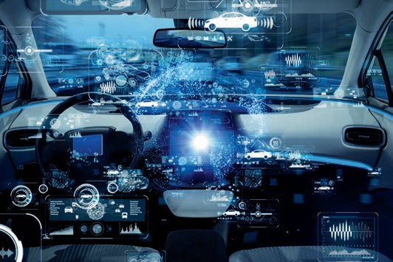

# Unit 6

## Car2X Communication

#### STUDY GOALS

After working through this unit, you will be familiar with ...

… the concept of ”Car2X communication”.

… why vehicles will need to communicate with other vehicles as well as with the infrastructure in future.

… which technologies and standards are currently being considered for Car2X communication.

… the driving forces behind the Car2X communication development.

DL-D-DLBINGSM01-L06

1. Car2X Communication

### Introduction

In recent years, the self-driving car has been a hotly debated topic among traffic planners, car manufacturers and the general public, especially in Western cities. The breathtaking technological advances made during the past decade were the focus of reporting until a fatal accident in March 2018 changed everything (Voss 2018).

Human error had previously been blamed for around 90% of accidents involving self-driving vehicles, none of which were fatal, but the Uber test car case in Arizona was apparently due to a software error in which the system mistook a woman pushing a bicycle for a plastic bag (Voss 2018). These types of image recognition errors are undoubtedly a barrier to fully self-driving vehicles, especially in large cities with their complex surroundings. It is hoped that Car2X systems will help solve this challenge in the future.

### Elements of a Car2X System

As well as optimizing sensors and related software, data exchange between road users is seen as one of the crucial development phases for self-driving cars. The umbrella term “Car2X communication” is commonly used to describe this, with the “X” representing the various partners in automated interaction, be it other vehicles (car-to-car or C2C) or the infrastructure (car-to-infrastructure or C2I) (Junker 2016, p. 26).

The ultimate goal when developing Car2X solutions is to increase safety for all road users. As well as optimizing journey times and fuel consumption for drivers (Junker 2016, p. 26), we should not underestimate the associated opportunities for car manufacturers. Between 2012 and 2019 alone, the global market for driver assistance systems is predicted to grow from € 5 billion to € 16 billion (Statista 2013).

Car2X Communication

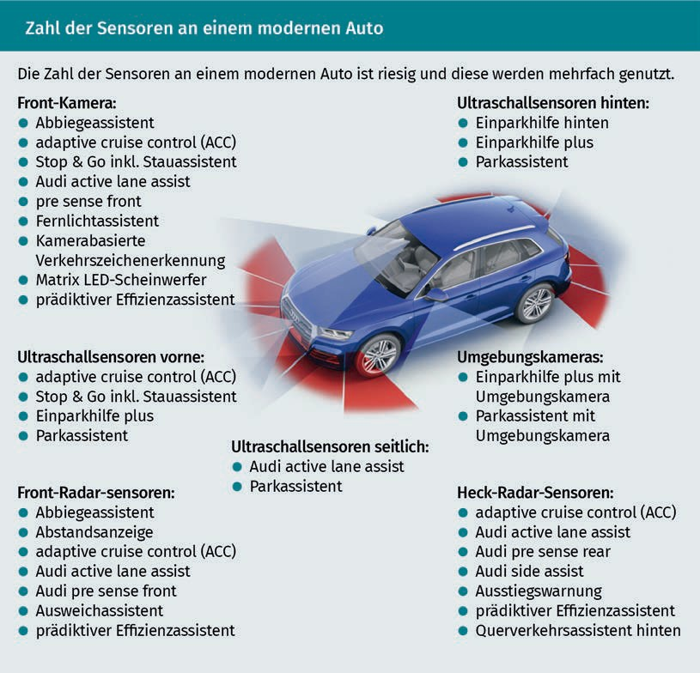

Onboard sensors and communication devices are just a few of the many requirements a functioning Car2X communication system must meet. The vehicles must be integrated into a smart, optimized mobility environment so that situations are analyzed from as many angles as possible, and to ensure that defects in one system can always be absorbed by at least one additional system. Ideally, such an environment would comprise a mixture of satellite, terrestrial and mobile systems (ETSI 2018, p. 13).

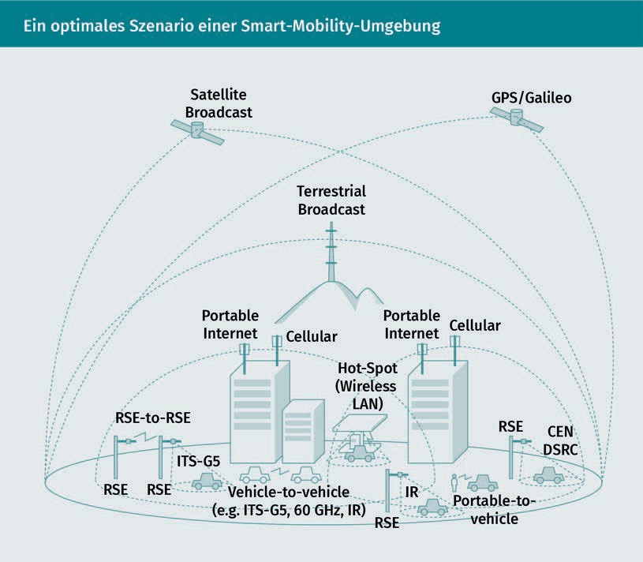

### Utilization Options

In the world of automotive safety, progress has tended to focus on “passive safety systems”, sparking a host of inventions, from seat belts to passenger compartments with crumple zones to airbags. The main aim of these was to ensure human safety in the event of an unavoidable collision. Since the early 1980s, major car manufacturers have turned their attention to active safety systems, which are combined with electronics to mitigate accidents and prevent them from happening in the first place (Junker 2016, p. 14). This area of research has been ramped up still further since the turn of the millennium.

Car2X Communication

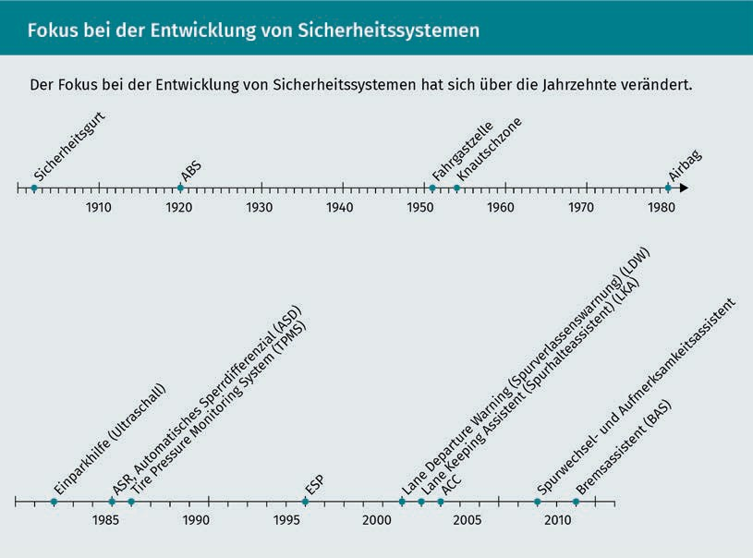

Unsurprisingly, car manufacturers (among others) are considering how they can generate added value from the extensive data collected by these new safety systems. Some potential applications above and beyond the original reason for data collection are outlined below (based on Pflügler et al. 2016, p. 203f.):

* Information about the current parking situation: A service showing the real-time availability of parking spaces. The basic data may be harvested from parking lot operators, from static sensors, or even from on-board mobile communications or assistance systems.
* Information about the current traffic situation: This service is already widely used by applications such as Google Maps. In future, however, free-floating car (FFC) data and static sensors could supply data in addition to smartphones.
* Future parking situation forecasts: This service predicts the real-time availability of parking spaces, based on historical and current parking space data in conjunction with historical and current traffic data, supplemented by weather forecasts, which are then evaluated by intelligent, learning algorithms.
* Future traffic situation forecasts: Analogous to parking space situation forecasts.
  + Real-time information on local public transport, the railways, availability of sharing services, and availability of shared taxis: This is conceivably useful for those who use their own cars to access a smart mobility connection point.
  + Route planning: We are already familiar with this service from navigation systems, but a more advanced incarnation could integrate all modes of transport, rather than optimizing the route for just one (such as the car).

An integrated, multimodal navigator could supply motorists with recommendations, such as the fastest route to their destination and whether to park as close as possible to the destination or to park further away and then take a bus, train, or bicycle (Pflügler et al. 2016, p. 204). It should also provide information about the punctuality and/or predicted availability of the different transport modes. End customers could be supplied with an app by the technology providers themselves or it could be offered to B2B customers via interfaces.

California has already implemented a smart parking solution that shows users the parking situation at their destination in real time via a smartphone application. Prices are also adjusted in real time depending on demand. The more popular an area is, the more expensive the parking space becomes. This, in turn, affects the travel behavior of users. The system relies on information being made available in real time. The more expensive parking becomes, the more worthwhile it is to switch to an alternative mode of transport. This can help reduce traffic volumes. In California, the app has already reduced waiting times for a parking space by 43% and driving distances by 30%, by eliminating the need to drive around looking for a parking space. If they still opt to drive, upon arriving at a parking space motorists can use a convenient app to pay for it (Oliver Wyman 2016, p. 7). In the future, the car itself could do this automatically.

### Development of Standards

Interconnected transport users are known collectively as an intelligent transport system (ITS). For such a system to work, data exchange standards first need to be defined. Back in 2003, a group of European research institutions, car manufacturers, and suppliers joined the CAR 2 CAR Communication Consortium (C2C-CC) to collaborate on these standards (C2C-CC 2018).

Their collaboration is governed by the frequencies allocated by the European Union. The frequency range of 5.875-5.905 GHz has already been released for Car2X communication (Kriegeskotte 2017). It uses the short-range communication standard based on IEEE 802.11p, which allows data to be sent from one car to another or to infrastructures (Junker 2016, p. 27) at speeds of 200 km/h and distances of up to 1,000 meters.

Car2X Communication

However, it is not yet clear whether this standard will ultimately prevail. In 2017 the influential Bitkom association (Bundesverband Informationswirtschaft, Telekommunikation und Neue Medien e.V.) published a position paper promoting the principle of technological neutrality, while also making it clear that its members preferred the 3GPP LTE-V2X standard (Kriegeskotte 2017). Bitkom believes that this next-generation LTE standard offers advantages over IEEE 802.11p in terms of more efficient resource management, enhanced spectral efficiency, and increased radio coverage. This would bring us closer to the goal of fully interconnected mobility by enabling car-2-car and car-2-infrastructure communication even if there is no mobile network available.

The paper also outlines the regulatory requirements for modern emergency call systems on the basis of 3GPP. According to Bitkom, the industry has already made its choice: “The automotive and telecommunications industries are forging resolutely ahead with the standardization and application of LTE-based systems […]” (Kriegeskotte 2017).

Policymakers are hoping that the launch of standardized Car2X system components will lead to availability in other application areas. The German Federal Ministry of Transport and Digital Infrastructure (BMVI) has already awarded a contract worth € 3.81 million to a project aimed at transferring Car2X technology to railway applications. The project partners are hopeful that this will make maintenance of the railways more efficient, enhance passenger comfort with on-demand stops, and above all, improve safety at railway crossings. Train drivers could be notified well in advance whether an approaching railway crossing is safe. Car drivers could also be warned of potential dangers as part of a Rail2X communication between the train and the on-board assistance system (BMVI 2017; Internationales Verkehrswesen 2016).

Summary

Research developments in road safety have seen a radical transformation in recent decades. Whereas in the past, the focus was on safety in the event of an accident (e.g., airbags), the emphasis has now shifted toward active accident prevention.

To enhance these systems still further in future, vehicles will need to communicate with other vehicles and with the surrounding infrastructure. This requires the development of communication standards at an international level and the standardization of data exchange requirements.

Once this has been successfully completed, new opportunities will open up, not only in the area of passenger car safety, but also for other value-added services. The 3GPP mobile standard should aid implementation.



# Unit 7

## Sample Projects

#### STUDY GOALS

After working through this unit, you will be familiar with ...

… what a smart mobility project might look like in practice.

… the differing interpretations of smart mobility.

… the different implementing roles played by public institutions.

… the potential problems associated with practical implementation of smart mobility projects.

DL-D-DLBINGSM01-L07

1. Sample Projects

### Introduction

Countless cities and metropolitan regions around the world are already busy rolling out a series of smart mobility solutions within their individual spheres of influence (Karmagianni et al. 2016, p. 3301). The larger MaaS projects differ not only in terms of their size and sustainability, but also in terms of the range of transport modes included. Nearly all of them include carsharing alongside public transport, but bike-sharing, car rental companies, taxis, and trains are not always offered.

Some cities also include access to ferries, minibuses, and even planes via their end-user interface (usually an app, or at the very least, a website). Optimod in Lyon even incorporates freight logistics (Karmagianni et al. 2016, p. 3301), but this is a rare exception. Below, we take a closer look at two specific smart mobility concepts and their implementation.

### UbiGo in Gothenburg

Between November 2013 and 2014, the Swedish city of Gothenburg conducted a monitored six-month trial of seamless, digital networking between public and private transport systems (Karlsson et al. 2016). The trial, known as UbiGo, involved 195 people in 83 different households. As well as public transport, the project also included various local transport service providers – from taxi companies and car rental companies to carsharing and bike-sharing operators (Karlsson et al. 2016, p. 3266f.). The main aim of the UbiGo trial was not to implement widespread smart mobility technologies, control traffic flows, or encourage the use of electric vehicles, but rather to explore the extent to which more environmentally friendly behavior can be encouraged by incorporating existing mobility service providers.

Interestingly, the authorities did not attempt to control the provider structure (e.g., by granting taxi licenses), but merely acted as “brokers” for the options available. As well as being supplied with an app for booking tickets, checking and topping up their account balance, and amending their contract details, test participants were also offered 24-hour support. This may seem excessive given the small number of participants, but the trial organizers felt users would be unwilling to change their mobility habits unless they made it easy for them, especially as the transport itself was not free (although some financial incentives were offered, e.g., to participants who opted to deregister their car during the trial) (Karlsson et al. 2016, p. 3267).

Sample Projects

While initially hailed a success, with high acceptance levels among participants, UbiGo was discontinued after the six-month trial phase for a number of credible reasons:

* Problems with public sector funding (scaling up the small test group would have necessitated investments in technology and personnel).
* Unresolved issues regarding the legal framework, because if the project had continued with private service providers, it would not have been a non-profit scheme and would have used taxpayers’ money to become a market player.
* Uncertainties among the private test partners, whose long-term integration into UbiGo might have challenged established business models and transformed their companies’ identities.
* Communication was also an issue, because UbiGo had been communicated as a project with fixed start and end dates, and as a result, participants failed to develop a strategy beyond the end of the project.

The accompanying scientific research (Karlsson et al. 2016, p. 3271) identified these factors, which are seemingly not unique to Gothenburg. UbiGo CEO Hans Arby argues that persuading local and regional public transport operators to become open to external resellers and platforms is the biggest challenge facing the comprehensive implementation of MaaS models (Flügge 2016c, p. 215). Other communities considering similar approaches are therefore likely to face similar problems, at least in Europe.

### moovel

In Germany, the Daimler subsidiary moovel is the market leader in mobility-as-a-service, with around five million users. The company also claims to be the North American market leader for mobile ticket apps (Deppe 2018). moovel is keen to move into the B2B sector in parallel with its consumer brand. Below, we consider its cooperation with the Stuttgart tram company SSB as an example.

SSB operates the local public transport system in Stuttgart and has collaborated with moovel to devise two typical new smart mobility approaches. Alongside the standard app for timetable information and ticket bookings (SSB Move), the partners have devised the SSB BestPreis app, which offers a key additional function.

Instead of forcing customers to actively select a short-distance ticket, single ticket, day ticket, or group ticket, which could be annoying if they later discover a more cost-effective option, SSB Bestpreis has devised a different process.

Although customers must still activate an individual ticket on the app for each trip they take, these tickets are saved and converted to the least expensive variant by an algorithm at the end of the billing period. For example, multiple short-distance and individual tickets might be converted into a single monthly ticket or an eco-friendly day ticket if this is found to be cheaper (Schwarz 2018). moovel gives the following example: “A passenger buys four individual zone 10 tickets in one day at a total cost of € 9.48. The algorithm behind the SSB Bestpreis app identifies the eco-day ticket at € 4.50 as the cheapest option and saves the user € 4.98” (Moovel Transit 2018).

This offer is particularly appealing to customers who cannot always predict their local transport journey requirements, who travel a fair amount but not enough to justify a season ticket, and/or who are not fully familiar with various tariffs. It is much quicker to use the app than search for the correct option on the ticket machine, especially for visitors.

Another service developed jointly by moovel and SSB, known as SSB Flex, was trialed and subsequently adopted as a regular feature on 1 June 2018. Designed initially for areas with limited local public transport options, this pooling service links conventional taxis and public transport together to facilitate easier access to existing public transport. Passengers make bookings via the app. Rather than a door-to-door service, customers can book vehicles to nearby pick-up points.

An algorithm bundles different passengers’ travel requirements together and calculates the most favorable route. Alongside the SSB Flex service, the app also displays existing public transport alternatives. The service is designed to minimize the temptation to use a private car rather than a public service (Moovel Group 2018). SSB Flex is the first on-demand service in Germany to be granted a route authorization under the Passenger Transport Act, although initially there was some debate over whether a valid taxi license was required (Schwarz 2018).

The Daimler subsidiary moovel does not publicly participate in this cooperation but operates in the background as an app developer. SSB delivers real-time road traffic and public transport data for the app. The fleet consists of ten vehicles, some of them electric, operating from 6.00 am to 9.00 pm Monday to Wednesday and from 6.00 am to 2.00 am the next day Thursday to Saturday (Moovel Transit 2018).

Sample Projects

Summary

While there have been several interesting smart mobility projects, so far none of them has achieved complete integration of the various pillars.

Nevertheless, the cooperation between SSB in Stuttgart and moovel has survived the test phase and will be continued in two further projects. It is therefore more advanced than UbiGo, an earlier attempt in Gothenburg that failed for various reasons, crucially because it failed to develop a long-term concept that would interest all parties.