Application No. 838/23

PI Name: Victor Yashunsky

*Control of Multicellular Turbulence with Regulated Topological Defect Unbinding*

Abstract

Flocks of birds, schools of fish, groups of bacteria, living tissues and cytoskeletons are all composed of “active” entities that use external energy to generate their own motion and forces. The study of active living systems drives and tests the theories of non-equilibrium statistical physics. The physics of active matter underlies natural life processes including intracellular dynamics, biofilm formation, cancer metastasis, morphogenesis and even herd behavior of animals. Compared to rapid theoretical progress, related experimental research advances at a slower pace and requires a truly interdisciplinary effort.

Multicellular organization exhibits the properties of liquid crystal nematics and exhibits a wide range of dynamics throughout active systems, ranging from jammed state to turbulent chaos. Most attempts to control multicellular nematics have focused on a passive regime, in which organization relaxes to the ordered state. Cell organization is controlled by the confinement of cell ensembles or by direct application of substrate topography to each cell. Highly active, turbulent systems continuously reorganize their orientation and flows by spontaneous unbinding of new defects. Programming of defect unbinding events would make it possible to control the organization of chaotic active turbulent systems, but control of defect unbinding has yet to be demonstrated. Since multicellular migration underlies physiological and pathological processes, understanding the physical principles of multicellular dynamics and the ability to control them is highly important.

The goal of this proposal is to be able to determine the macroscale dynamics of turbulent multicellular systems using pre-programmed defect unbinding configurations. Three aims will be addressed: Aim#1: To determine the location and orientation of a single unbinding event; Aim#2: To enable coupling between flow fields from different unbinding regions; and Aim#3: To demonstrate macroscopic multicellular flows governed by pre-designed arrays of topological defects.

The proposed study will be an interdisciplinary effort at the interface of physics, biology, chemistry and engineering. Microfabricated cell substrates will be designed to control defect unbinding in cell monolayers. Detailed content analysis of multicellular mechanics will rely on automated time-lapse microscopy and include the development of new methods. The experimental results will be compared with theoretical predictions. This work will lead to new possibilities for the control of chaotic active systems, while the control of multicellular dynamics will also enable the control of tissue organization and function with potential applications in tissue engineering.

Application No. 838/23

PI Name: Victor Yashunsky

*Control of Multicellular Turbulence with Regulated Topological Defect Unbinding*

* 1. Scientific Background

Multiple studies over the last decade have demonstrated that organization of many multicellular systems could be described as active liquid crystal [1-9]. My recent work has shown that certain tissue cell types are in a highly active state known as *active turbulence* or *chaos* [8, 9]. There are, however, no experimental systems as yet that allow control of active turbulent systems in general and turbulent multicellular systems in particular. This proposal describes the conceptual strategy and experimental implementation of the manipulation of turbulent multicellular cultures and the design of multicellular dynamics.

Collective cell dynamics and shaping of completely different multicellular systems may be explained within a unified physical framework of active liquid crystal hydrodynamics or *active nematics* [1-9]. Active nematics provides a broad description of velocity and orientation fields, and characterization of mesoscopic variables such as active stress, Frank elastic modulus, viscosity, friction and chiral stress [10]. Prominent examples where active nematics predictions were observed in cell monolayers include spontaneous emergence of shear flows under confinement [2, 5], appearance of counterrotating vortex pairs at comet-shaped, nematic +1/2 defects [7-9] and exponential distribution of vortex areas [9].

The dynamic modes of multicellular systems range from a jammed, solid-like phase, where cells hardly move beyond their own sizes [11-13], to intermediate regimes, in which cells exhibit long-range collective flows [2, 14], and up to a highly active chaotic phase, where cell flows form transient patterns of vortices [8, 9, 15, 16] (Figure 1, left panel). A hallmark of liquid crystalline organization is the existence of singular points of the nematic order, where the director field is discontinuous; these are called topological defects [17, 18] (Figure 1, right panel). In active nematics, defects are the hotspots of flow generation and are suggested to be the potential organizing centers for shape evolution [19, 20]. The importance of topological defects has recently been highlighted in developmental processes in eukaryotic organisms, such as the large-scale cell rearrangements in the *Drosophila* embryo [21] and the growth of tentacles in *Hydra* [6], cell apoptosis and extrusion in epithelia[7], and crisscross multilayering of myoblasts [22]. The evolution of defect populations is an indicator of activity level. Passive cell systems, in which relaxation forces dominate over active stress, annihilate defect pairs of opposite charge, but are not able to unbind new pairs of defects [23]. Highly active systems are able to compete with nematic elasticity and spontaneously unbind defect pairs of opposite signs [8, 9].

***Figure 1:*****Multicellular dynamics modes and flow-structure correlations**

*Left panel:* Schematic diagram of dynamic states in multicellular systems shows different dynamic modes as a function of energy inflow (driving force) and microscopic interaction strength (interaction force).

*Right panel:* Examples of transport modes in active nematic fluids corresponding to topological defects. From left to right: translation at +1/2 defect; rotation at +1 defect; and divergence at -1/2 defect. Gray lines show the orientational nematic field and black arrows show fluid velocity.

Control of multicellular orientation demonstrated in passive cells is dominated by high friction of the cell with the substrate [24]. For example, orientation of fibroblast cells is controlled by a substrate pattern composed of liquid crystal elastomer [25]; mesoscale micron-sized ridge patterns are exploited to generate ±1 and ±1/2 defects in 3T6 fibroblasts and EpH-4 epithelial cells [26]; NIH-3T3 fibroblasts, C2C12 muscles cell or RPE1 retina cells in circular confinements are organized with two facing  +1/2 defects positioned on a diameter [3]; C2C12 confined in smaller disks develop a +1 defect and evolve into a dome shape [27]. In all the above-mentioned examples, cells are organized like passive liquid crystals, the only difference being that collective flow cells are not static and keep flowing. These flows are attributed to the gradients of active stress, and since cells proliferate, the ensemble shape can evolve.

In contrast to passive cells, highly active, turbulent systems continuously reorganize their orientation and flow field by unbinding new defects. In non-cellular active turbulent systems, a few experiments have shown that electric fields and confinements allow manipulation of the organization of tubulin-kinesin active gels [28, 29]. Confinements were also used to generate edge flows in bacterial groups [30-32]. In my recent work, we showed that defect alignment and net flows can be achieved in cancerous human fibrosarcoma using physical boundaries [8].

Here, we propose a concept and experimental realization of controlled unbinding of defects as a strategy to manipulate the dynamics of active turbulent multicellular systems.

The ability to control defect nucleation would enable manipulation of macroscale organization using local cues. Such an approach could naturally be applied for manipulation of unbound cell cultures with minimal intervention, without controlling each cell as is done in contact guiding methods.

Overall, spatial control of defect nucleation would allow rational design of multicellular organization and determine the velocity field. This would make it possible to predesign cell mass transfer and program transformation of multicellular shapes, and, in the long run, to determine biological functionality, which is often tightly linked to multicellular architecture.

* 1. Research Objectives and Expected Significance

The ultimate goal of this proposal is to demonstrate that organization of chaotically moving cell ensembles may be guided by topological mechanisms.

The specific aims below will help to close existing gaps in our knowledge and enable the proposed goal:

**Aim #1:** To develop the ability to determine the position and orientation of defect pair unbinding. Patterned and curved substrates will be developed to generate highly stressed regions in cell monolayers, resulting in hotspots for nucleation of defect pairs.

**Significance of Aim#1:** Defects serve as organizing centers for flow and shape evolution. Unbinding of defects occurs spontaneously and does not allow control of cell dynamics. Determination of defect unbinding regions will be the first step towards controlling multicellular transport, and will open new avenues for the manipulation of active matter.

**Aim #2:** To determine spacing, relative orientation and critical distances for various unbinding site configurations. Different configurations of unbinding regions will be tested to quantify associated flow patterns across different cell types in order to find optimal conditions for coupling between flow fields associated with different defect unbinding regions.

**Significance of Aim#2:** Since defects interact with each other through elastic forces, mapping of interaction between defects is essential for programming integrated performance of defect arrays.

**Aim#3:** To develop the ability to design multicellular flows using predesigned arrays of nucleated defects. Defect arrays that will be predesigned to translate and rotate cells according to knowledge gained from Aim #2 will be used to demonstrate proof-of-concept that chaotic motion in active systems can be controlled via topological defects.

**Significance of Aim#3:** Harnessing the mobility of individual particles to achieve macroscale organization is one of the most important aspects in active matter research. The ability to control and manipulate active materials is essential for their practical use. The possibility of programming the assembly of multicellular shapes, which would open the way to mimicking the self-shaping (morphogenesis) of living tissues, is particularly exciting.

Along with physical motivation and significance, multicellular migration underlies physiological and pathological situations such as embryonic morphogenesis, intestinal epithelial regeneration, wound repair and cancer invasion. Therefore, understanding the physical principles governing multicellular dynamics and the ability to control cell organization is of great importance.

* 1. Detailed Description of the Proposed Research
     1. Working Hypothesis

**Turbulent active nematics in multicellular systems**

Cells in bi-dimensional cultures often acquire elongated shapes and tend to align, forming domains of co-aligned cells [4, 33]. These domains are separated by nematic defects of charge  ±1/2 that prevent them from fusing [3, 5, 7-9, 22]. When the activity that drives deformation in cells is high enough to compete with the nematic elasticity, the unbinding of defect pairs results [34]. Because of their high activity and elongated shape, these cells give rise to a collective state known as “active nematic turbulence” [23, 35, 36], in which cells are locally aligned, yet moving chaotically, and topological defects persistently unbind and annihilate [9]. Defects leave a distinct signature on the flow itself, via backflow mechanism [37, 38]. In particular, +1/2 defects drive a Stokeslet-like flow consisting of two vortices symmetrically counter-rotating about the defect longitudinal direction (Figure 2). Recent experiments in passive cellular systems, in which defects annihilate without unbinding, indicate that topological defects serve as organizing centers in multicellular shape evolution [5, 6, 22, 27]. In our previous studies, we found that in highly active HT1080 cultures, which continuously unbind ±1/2 defect pairs, edge flows arise via co-alignment of +1/2 defects near culture boundaries [8]. We therefore expect that programming of defect unbinding location will allow the motility of chaotically moving cells to be harnessed to a desired global flow pattern.

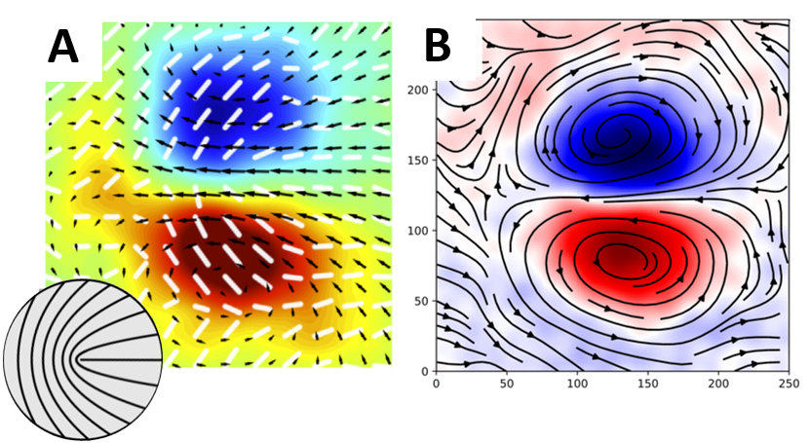

***Figure 2:*****TBD**

Defect unbinding occurs spontaneously in turbulent active nematics, and specifically in HBEC and HT1080 cell monolayers. Pearce *et al*. [39] investigated the effect of curvature on turbulent active nematics using hydrodynamic, particle-based simulations, and found that defect unbinding rates increase on surfaces with negative Gaussian curvature. Negative curvature increases the shear force (Figure 3C), since the streamlines inevitably converge, and therefore increases the rate of defect unbinding (Figure 3B) and defect population (Figure 3A). This result was supported by experimental findings in microtubule-kinesin suspensions in toroidal droplets [39].

The hypothesis behind this proposal is that increments of shear force can be applied locally in highly active multicellular monolayers in such a way that “hotspots” of defect unbinding can be identified. We assume that cell flows could converge through substrate geometry (i.e., cell-repelling patterns and substrate curvature) without using confinement. If true, this would allow us to: (1) define defect unbinding positions and orientation; (2) design multi-defect patterns; and (3) control multicellular transport.

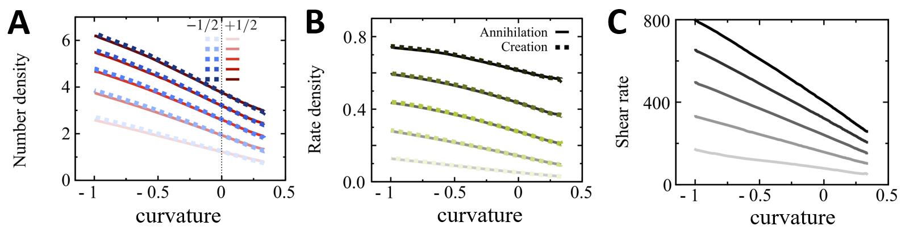

***Figure 3:*****TBD**

* + 1. Experimental Design

**Aim #1:**

To control the position of defect nucleation, we will use highly active cell cultures of human bronchial cells (HBEC) and human fibrosarcoma cells (HT1080). Both cell types have already been identified as turbulent nematics, where spontaneous nucleation of defects occurs [8, 9]. Additional potential cell lines in which defect nucleation or swirling flow patterns have been observed include Madin-Darby canine kidney (MDCK) and human skin keratinocyte (HaCaT) cells. Cell lines will be purchased from the American Type Culture Collection (ATCC) and cultured in a humidity-controlled CO2 incubator. Cell organization will be studied on customized 6- and 9-well plates, where plastic bottoms will be replaced with round glass coverslips (diameter 2-3 cm, thickness 175 µm). Coverslips will be patterned cell-repelling microstructures, coated with a structured thin layer of elastomer (PDMS). The fabrication will take place inside the laboratory cleanroom or in the nanofabrication center of BGU.

PEG-acrylamide cell-repelling microstructures will be prepared by a method developed previously in my research [2, 8, 40]. Glass coverslips will first be cleaned with piranha solution (3:1 mixture of sulfuric acid and hydrogen peroxide), incubated in ATC-silane solution (80:1 mixture of toluene with allyltrichlorosilane 95%), and coated with acrylamide and PEG using a 365 nm UV transilluminator (25W-UVP-TFL 40V, Analytik Jena, Germany). The PEG-acrylamide layer will be coated with positive photoresist (S1813, Shipley, USA) and exposed to UV radiation in a mask aligner (UV-KUB 2, KHLOÉ, France) trough mask containing the desirable microstructure. An alternative method of cell-repellent micropatterning will rely on the PRIMO system (Alvéole, France) – a maskless digital micromirror system designed for UV-photopatterning. The PRIMO module will be attached directly to an inverted epifluorescence microscope and will not require cleanroom conditions. To force formation of +1/2 and -1/2 defect pairs, shape and dimensions will be tuned for each cell type (see examples in Figure 4A).

PDMS microstructures will be prepared by an embossing method. The embossing stamp will be ordered from a laser engraving workshop (Digital-Cut, Israel) and will be made of PMMA. The stamp will be used to make a negatively curved relief on PDMS film (Figure 4B). The PDMS film will be spin-coated onto a coverslip, and cured at 60 °C for 1 h with the PMMA stamp on top, after which the stamp will be peeled off and the PDMS film will be incubated in a 10 µg/mL fibronectin solution for 1 hour. The glass coverslip with structured PDMS film will be glued with PDMS to the bottom of a multi-well plate and cured for 3 hours at room temperature, and will serve as a substrate for cell culture.

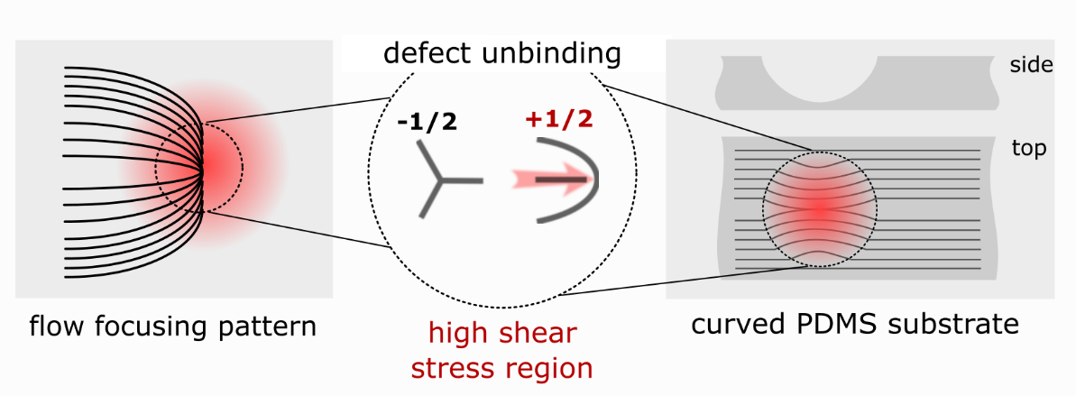

***Figure 4:*****TBD**

Cells will be seeded onto cell-repelling or PDMS substrates, and incubated in a CO2 incubator until they reach full confluence, usually 12-24 hours. Time-lapse (5-30 frames per hour) multi-field (100-300 position) imaging of cell cultures in multi-well plates will be performed in phase contrast and fluorescent channels using 4X or 10X objectives on a fully motorized inverted microscope (Zeiss AxioObserver7) equipped with a thermal, humidity and CO2 regulated chamber (CUBE&BOX, LIS, Switzerland).In case of curved cultures, each position will be imaged with a 10X objective at multiple depth (z-stack) spaced by 5 µm. The microscope experiments will last from 2 to 5 days, depending on the proliferation rate of the cell type, and images will be acquired automatically by imaging the positions defined at the beginning of experiment. Focus will initially be checked every 12 hours and drift will be corrected by manual adjustment of z-position using a remote control connection. Later, an autofocus algorithm developed as part of another project will be integrated into the image acquisition routine. The record of the x-y-z position of each field of view will be stored together with the image to allow detection of cell-repellent features, which are otherwise invisible. MATLAB and Python algorithms recently developed in my research [8, 9] will be employed to detect and classify populations of +1/2 and -1/2 defects together with their flow fields from phase contrast images. Live probes of nuclei (Hoechst 33342, Thermo Scientific) and actin cytoskeleton (CellLight Actin-GFP, Thermo Scientific) will be used for fluorescent imaging. Prior to orientation and velocity analysis, z-stacks of curved cultures will be preprocessed to produce a single image using maximum intensity projection.

**Aim #2:**

Different defect configurations will be tested using cell-repelling and curved microstructures. The spacing and relative position between defect nucleation sites will be tested to define relevant configurations of defect nucleation regions in different cell types (e.g., HBEC, HT1080). New patterns will be fabricated according to the results obtained. Typical distances between defect nucleation regions are expected to range between 100 µm and 500 µm. PEG-acrylamide cell-repelling microstructure patterns will be prepared using the lithography method as described in my previous work [2, 8, 40]. Plastic film masks with the desired pattern design will be ordered from SELBA, Switzerland or produced in the nanofabrication center of BGU. PDMS patterns with curved regions will be produced by a stamping method as explained in Aim #1. Microengraved stamps made of PMMA with custom designs will be ordered from Digital-Cut, Israel. Cell culture and time-lapse imaging will be performed according to the same procedure as described in Aim #1. To observe interaction between nucleation regions, imaging will be performed using a 4X objective to give a field of view of approximately 3x3 cm2 for each position. Structure and dynamics will be extracted from microscopic images using previously developed algorithms for image analysis [8, 9, 22]. Multicellular structures and dynamics will be compared to theoretical prediction with the assistance of the Luca Giomi group (University of Leiden, Netherlands) to determine mechanical property values (e.g., Frank elastic constant, active stress, rotational viscosity).

**Aim #3:**

The results of the two previous aims will make possible rational design of defect nucleating arrays that will enable us to guide multicellular dynamics at long range. For example, to enable linear translation of cells, +1/2 defects will be organized as a unidimensional array, with the alignment of defects tilted by several degrees relatively to array direction (Figure 5A). To produce collective rotation of cells, nucleation regions will be distributed on a circular arc and aligned tangentially to it (Figure 5B). Actual spacing and relative orientation between nucleation regions will be designed according to results measured in Aim #2 and adjusted according to experimental results.

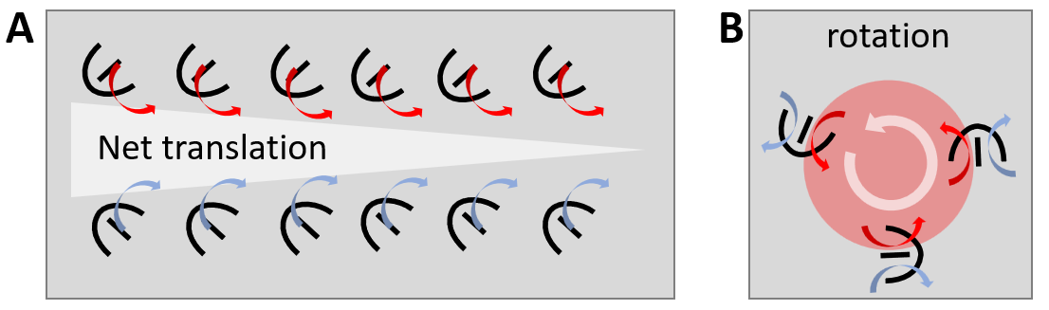

***Figure 5:*****TBD**

* + 1. Preliminary Results

**Imaging conditions:** From experiments already performed with unbound HBEC and HT1080 cell cultures, we measured the conditions required for reconstruction of orientation and velocity fields. Phase contrast imaging with a 10X objective enables orientation reconstruction and segmentation of individual cells (Figure 6). Imaging at 4X is sufficient for cell orientation reconstruction of HBEC cells. HBEC maximal velocities are approximately 70 µm/h, which requires a 5-min delay between frames with a 10X objective to measure velocity field with PIV algorithm. The velocity of HT1080 does not exceed 20 µm/h, which requires a time resolution of 15 min using a 10X objective.

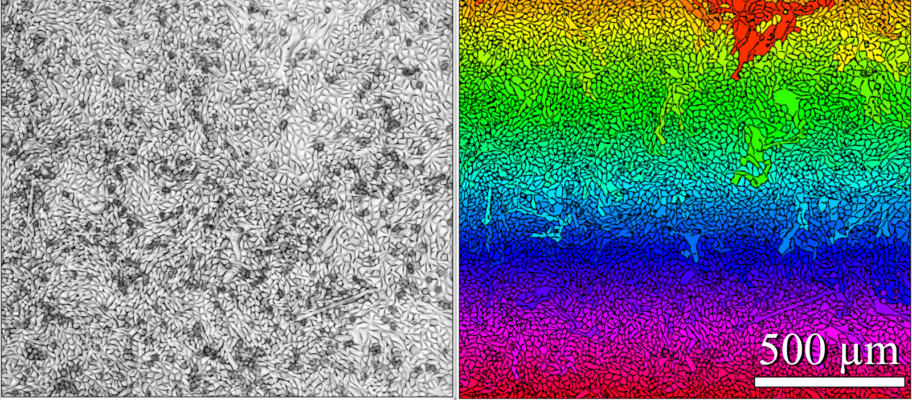

***Figure 6:*****TBD**

**Spontaneous defect unbinding:** Important results were obtained for HBEC cells, showing that even without enforcing unbinding sites for defects, the probability of defect unbinding is not equally distributed in space, but occurs mostly around same regions (Figure 7). We preciously found that collective flows of HBEC cells could be aligned by a cell-repelling line pattern (line width of 4 µm). These findings support the assumption that cell flow can be guided and result in stable regions of defect unbinding.

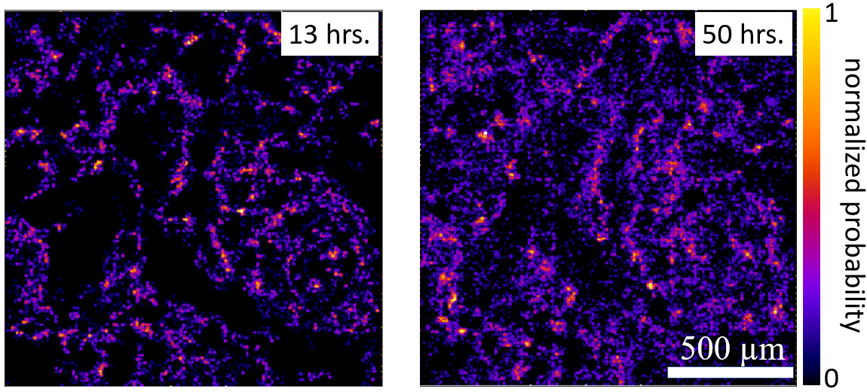

***Figure 7:*****TBD**

**Analysis:** ImageJ plugins and MATLAB codes previously used for measurement of cell orientation and analysis of director field [8, 9] have now been replaced with Python codes. Defect detection and classification, which was previously a time-consuming task, is now carried out by a faster method that directly measures the topological charge of the entire director field. Classification of the defects is now based on measurement of their charge, which is calculated by integration along the path surrounding the core of the defect (Figure 8).

For velocity field analysis, we found that dense *optical flow*, Gunnar Farneback's algorithm [41], outperforms the previously used PIV algorithm [42], allowing greater spatial resolution of the velocity field.

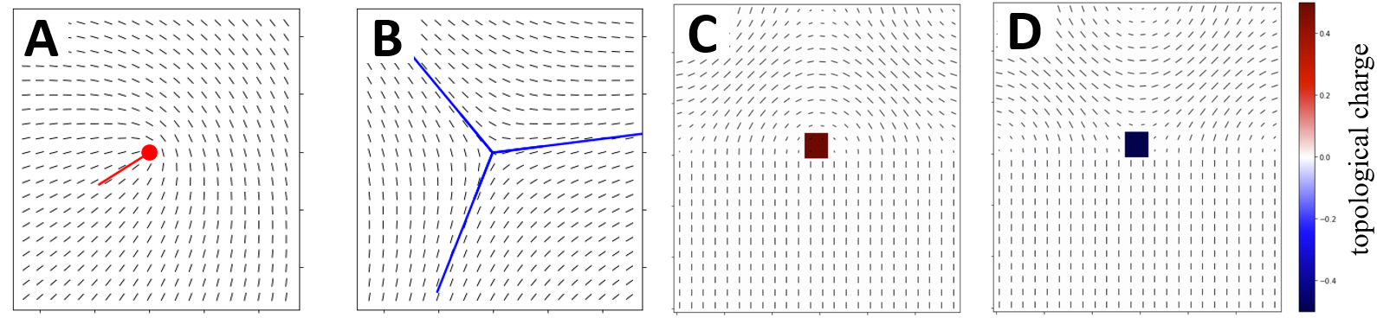

***Figure 8:*****TBD**

* + 1. Conditions Available for Conducting Research

My laboratory comprises a cleanroom, a cell culture room and a microscopy space. The laboratory is equipped with all the basic equipment for the proposed research. An ISO8 level dust-free space in the laboratory allows us to execute a major part of the fabrication processes. The cleanroom is equipped with a chemical hood, spin coater, plasma vacuum chamber and UV transilluminator. High-end equipment for processes such as printing of chromium masks, superfine feature lithography and micromachining is available in the nanofabrication center of BGU. All essential equipment for cell culturing (e.g., CO2 incubator, liquid nitrogen storage, biosafety cabinet) is available in the laboratory. Large refrigerators and freezers (−20°C and −80°C) for reagent storage, autoclaves and a water purification system are available as shared equipment in a nearby building. Our microscopy space is equipped with a fully automated, inverted fluorescent microscope with an environment-regulated chamber suited for prolonged imaging of multicellular organization. For image processing and storage, the laboratory purchased a GPU station and attached network storage.

Additional equipment for this research, such as the PRIMO microscope based photopatterning system and TILT light-sheet microscopy (Mizar Imaging, US) or Clarity (Aurox, UK) spinning disc confocal module for 3D live imaging, will be purchased from a different funding source.

* + 1. Expected Results

**Aim#1:** Predefined regions with cell-repellent structures and negatively curved features are expected to guide and converge the multicellular flows. Flow convergence is expected to increase the probability of defect unbinding due to increased shear stresses in these regions.

**Aim#2:** Controlled defect unbinding should directly allow testing of critical distances for various unbinding site configurations. We expect to identify an optimal configuration to unbind more than one defect pair. Optimal configurations are expected to couple between flow fields. This result will be a preliminary step in generating net flows with defect arrays.

**Aim#3:** Defect arrays that are designed according to results from the two previous aims will employ the optimal defect unbinding method. Using defect arrays, we expect to demonstrate the possibility of generating translational and rotational net flows. Such proof-of-concept will allow designing of a complex flow pattern in a controlled manner.

The present study relies on my research experience in wet biology, microscopy, microfabrication and computer imaging, and specifically, on my recent research on highly active cells directly linked to defect unbinding in HBEC monolayers [9] and defect-generated flow at the edge of the HT1080 colonies [8]. This proposal has several challenging components. Control of defect unbinding relies on increments of shear stress by flow focusing. This theoretical concept has never been tested on cells, which may react in unexpected ways, for example, due to compressibility not accounted for by theory. An alternative approach will be direct generation of stress with pneumatic microvalves used extensively in microfluidic devices [43]. Another challenge is related to imaging and extraction of structure and velocity in non-planar geometries (curved substrates). Image distortion may not allow z‑stack projection and extraction of relevant information. The straightforward solution is confocal imaging (spinning disk), requiring the purchase of additional equipment for the laboratory's controlled environment microscope. However, other imaging modalities, such as reflection bright-field, or epi-fluorescent imaging with deconvolution postprocessing, may provide a solution based on the existing equipment.

Bibliography

1. Balasubramaniam L, Doostmohammadi A, Saw TB, Narayana GHNS, Mueller R, Dang T, et al. Investigating the nature of active forces in tissues reveals how contractile cells can form extensile monolayers. Nature Materials. 2021;20(8):1156-66.

2. Duclos G, Blanch-Mercader C, **Yashunsky V**, Salbreux G, Joanny JF, Prost J, et al. Spontaneous shear flow in confined cellular nematics. Nature physics. 2018;14(7):728-32.

3. Duclos G, Erlenkämper C, Joanny J-F, Silberzan P. Topological defects in confined populations of spindle-shaped cells. Nature Physics. 2017;13(1):58-62.

4. Duclos G, Garcia S, Yevick H, Silberzan P. Perfect nematic order in confined monolayers of spindle-shaped cells. Soft Matter. 2014;10(14):2346-53.

5. Kawaguchi K, Kageyama R, Sano M. Topological defects control collective dynamics in neural progenitor cell cultures. Nature. 2017;545(7654):327-31.

6. Maroudas-Sacks Y, Garion L, Shani-Zerbib L, Livshits A, Braun E, Keren K. Topological defects in the nematic order of actin fibres as organization centres of Hydra morphogenesis. Nature Physics. 2021;17(2):251-9.

7. Saw TB, Doostmohammadi A, Nier V, Kocgozlu L, Thampi S, Toyama Y, et al. Topological defects in epithelia govern cell death and extrusion. Nature. 2017;544(7649):212-6.

8. **Yashunsky V**, Pearce D, Blanch-Mercader C, Ascione F, Giomi L, Silberzan P. Chiral edge currents in confined fibrosarcoma cells. arXiv preprint arXiv:201015555. 2020. (accepted for publication in Physical Review X)

9. Blanch-Mercader C, **Yashunsky V**, Garcia S, Duclos G, Giomi L, Silberzan P. Turbulent Dynamics of Epithelial Cell Cultures. Physical Review Letters. 2018;120(20):208101.

10. Shankar S, Souslov A, Bowick MJ, Marchetti MC, Vitelli V. Topological active matter. Nature Reviews Physics. 2022;4(6):380-98.

11. Palamidessi A, Malinverno C, Frittoli E, Corallino S, Barbieri E, Sigismund S, et al. Unjamming overcomes kinetic and proliferation arrest in terminally differentiated cells and promotes collective motility of carcinoma. Nature Materials. 2019;18(11):1252-63.

12. Atia L, Bi D, Sharma Y, Mitchel JA, Gweon B, A Koehler S, et al. Geometric constraints during epithelial jamming. Nature physics. 2018;14(6):613-20.

13. Park J-A, Kim JH, Bi D, Mitchel JA, Qazvini NT, Tantisira K, et al. Unjamming and cell shape in the asthmatic airway epithelium. Nature Materials. 2015;14(10):1040-8.

14. Leclech C, Gonzalez-Rodriguez D, Villedieu A, Lok T, Déplanche A-M, Barakat AI. Topography-induced large-scale antiparallel collective migration in vascular endothelium. Nature Communications. 2022;13(1):1-11.

15. Vedula SRK, Leong MC, Lai TL, Hersen P, Kabla AJ, Lim CT, et al. Emerging modes of collective cell migration induced by geometrical constraints. Proceedings of the National Academy of Sciences. 2012;109(32):12974-9.

16. Lin S-Z, Zhang W-Y, Bi D, Li B, Feng X-Q. Energetics of mesoscale cell turbulence in two-dimensional monolayers. Communications Physics. 2021;4(1):1-9.

17. De Gennes P-G, Prost J. The physics of liquid crystals: Oxford university press; 1993.

18. Ardaševa A, Doostmohammadi A. Topological defects in biological matter. Nature Reviews Physics. 2022;4(6):354-6.

19. Hoffmann LA, Carenza LN, Eckert J, Giomi L. Theory of defect-mediated morphogenesis. Science Advances. 2022;8(15):eabk2712.

20. Copenhagen K, Alert R, Wingreen NS, Shaevitz JW. Topological defects promote layer formation in Myxococcus xanthus colonies. Nature physics. 2021;17(2):211-5.

21. Streichan SJ, Lefebvre MF, Noll N, Wieschaus EF, Shraiman BI. Global morphogenetic flow is accurately predicted by the spatial distribution of myosin motors. Elife. 2018;7:e27454.

22. Sarkar T, **Yashunsky V**, Brézin L, Mercader CB, Aryaksama T, Lacroix M, et al. Crisscross multilayering of cell sheets. bioRxiv. 2021.

23. Doostmohammadi A, Ignés-Mullol J, Yeomans JM, Sagués F. Active nematics. Nature communications. 2018;9(1):1-13.

24. Doostmohammadi A, Adamer MF, Thampi SP, Yeomans JM. Stabilization of active matter by flow-vortex lattices and defect ordering. Nature Communications. 2016;7(1):1-9.

25. Turiv T, Krieger J, Babakhanova G, Yu H, Shiyanovskii SV, Wei Q-H, et al. Topology control of human fibroblast cells monolayer by liquid crystal elastomer. Science advances. 2020;6(20):eaaz6485.

26. Endresen KD, Kim M, Pittman M, Chen Y, Serra F. Topological defects of integer charge in cell monolayers. Soft matter. 2021;17(24):5878-87.

27. Guillamat P, Blanch-Mercader C, Pernollet G, Kruse K, Roux A. Integer topological defects organize stresses driving tissue morphogenesis. Nature materials. 2022;21(5):588-97.

28. Guillamat P, Ignés-Mullol J, Sagués F. Control of active liquid crystals with a magnetic field. Proceedings of the National Academy of Sciences. 2016;113(20):5498-502.

29. Opathalage A, Norton MM, Juniper MP, Langeslay B, Aghvami SA, Fraden S, et al. Self-organized dynamics and the transition to turbulence of confined active nematics. Proceedings of the National Academy of Sciences. 2019;116(11):4788-97.

30. Lushi E, Wioland H, Goldstein RE. Fluid flows created by swimming bacteria drive self-organization in confined suspensions. Proceedings of the National Academy of Sciences. 2014;111(27):9733-8.

31. Wioland H, Lushi E, Goldstein RE. Directed collective motion of bacteria under channel confinement. New Journal of Physics. 2016;18(7):075002.

32. Beppu K, Izri Z, Sato T, Yamanishi Y, Sumino Y, Maeda YT. Edge current and pairing order transition in chiral bacterial vortices. Proceedings of the National Academy of Sciences. 2021;118(39):e2107461118.

33. Kemkemer R, Kling D, Kaufmann D, Gruler H. Elastic properties of nematoid arrangements formed by amoeboid cells. The European Physical Journal E. 2000;1(2):215-25.

34. Shankar S, Ramaswamy S, Marchetti MC, Bowick MJ. Defect unbinding in active nematics. Physical review letters. 2018;121(10):108002.

35. Bratanov V, Jenko F, Frey E. New class of turbulence in active fluids. Proceedings of the National Academy of Sciences. 2015;112(49):15048-53.

36. Wensink HH, Dunkel J, Heidenreich S, Drescher K, Goldstein RE, Löwen H, et al. Meso-scale turbulence in living fluids. Proceedings of the national academy of sciences. 2012;109(36):14308-13.

37. Giomi L, Bowick MJ, Mishra P, Sknepnek R, Cristina Marchetti M. Defect dynamics in active nematics. Philosophical Transactions of the Royal Society A: Mathematical, Physical and Engineering Sciences. 2014;372(2029):20130365.

38. Pismen L. Dynamics of defects in an active nematic layer. Physical Review E. 2013;88(5):050502.

39. Pearce D, Ellis PW, Fernandez-Nieves A, Giomi L. Geometrical control of active turbulence in curved topographies. Physical Review Letters. 2019;122(16):168002.

40. Duclos G, Deforet M, Yevick HG, Cochet-Escartin O, Ascione F, Moitrier S, **Yashunsky V**, et al. Controlling Confinement and Topology to Study Collective Cell Behaviors. Methods in molecular biology. 2018;1749:387-99.

41. Farnebäck G, editor Two-frame motion estimation based on polynomial expansion. Scandinavian conference on Image analysis; 2003: Springer.

42. Sveen JK. An introduction to MatPIV v. 1.6. 1. Preprint series Mechanics and Applied Mathematics <http://urn> nb no/URN: NBN: no-23418. 2004.

43. Unger MA, Chou H-P, Thorsen T, Scherer A, Quake SR. Monolithic microfabricated valves and pumps by multilayer soft lithography. Science. 2000;288(5463):113-6.