Debra Spero Applebaum

M.S. in Library Science from Case Western Reserve University and a M.A. in Biblical Exegesis from Haifa University in conjunction with the Matan Bellows Bible Program.

Debra works as a docent at the Israel Museum, Bible Lands and Rockefeller Museums.

In honor of HaKohen Baruch Baer, upon reaching בן שמונים לגבורות. With many fond memories of family events, vacations and other adventures, wishing you many years of health and nachat from your family, who במהרה בימינו, will merit to light *The* Menorah!

Seven Face of the Menorah

למה נסמכה פרשת מנורה לחנכת הנשיאים, לפי שכשראה אהרן חנוכת הנשיאים חלשה דעתו שלא היה עמהם בחנוכה לא הוא ולא שבטו, אמר לו הקדוש ברוך הוא חייך שלך גדולה משלהם, שאתה מדליק ומטיב את הנרות בקר וערב, לשון רש"י ממדרש אגדה (רמב"ן במדבר ח, ב)

I. Menorah as Tree of Life

When we read the description of the Menorah (Shemot 37) with its central trunk, six branches, and ornaments of almond blossoms and flowers, what we visualize is actually a stylized tree. The Tree of Life is associated with that fundamental and universal human quest for life and immortality, as well as with man’s dependence upon and interaction with nature. These themes are common in many cultures, as exemplified by an Assyrian relief from the ninth century BCE which features a palm tree in the middle, surrounded by two genies that are pollinating the tree. Unlike this Assyrian pagan myth, Judaism teaches that eternal life is not to be sought in nature, but rather by some special light or illumination associated with the knowledge of G-d, and by His presence in the life forms. The Tree of Life, then, is transmuted into a Tree of Light. It is this fusion of life and light that is Judaism’s answer as to how the expelled Adam and Eve can return to the Garden of Eden. It is the Teachings of Torah that become the Tree of Life. Torah becomes the source of immortality and knowledge, and symbolically, takes the form of the Menorah, whose fruit is light, as it says, כי נר מצוה ותורה אור (משלי ו, כג) and. עץ חיים היא למחזיקים בה (משלי ג, יח)

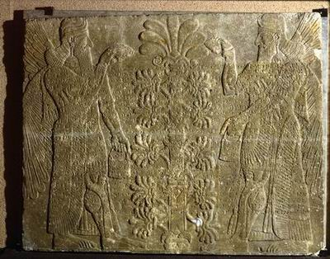

Figure Assyrian Relief, 9th century BCE (Israel Museum)

Interestingly, the aromatic weed *Salvia Palaestina* which is indigenous to Israel, bears an uncanny resemblance to the Menorah. Although this plant doesn’t always have seven branches, it always has an even number of branches growing from a central branch. Botanists Ephraim and Chana Hareuveni suggested that this plant was the inspiration for the shape of the Menorah. From an etymological perspective, they suggested that the Hebrew word *marva* (Hebrew for *salvia*), originated from the word *Moriah*—reflecting the connection between this plant and the Temple vessel. Some species have small apples—called plant galls—that look like a knob or the כפתור —one of the decorative elements on the Menorah.[1] According to the story, the Hareuveni couple found his plant growing wild on Mount Moriah.

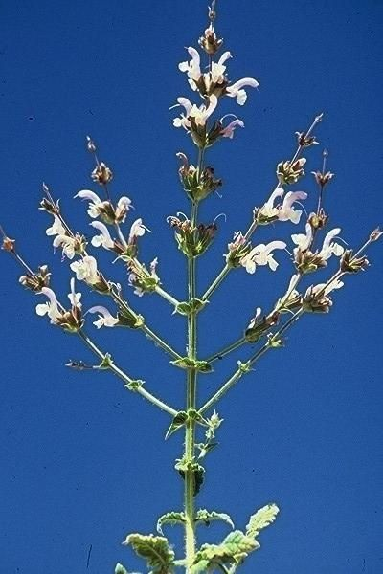

Figure Salvia Palaestina

II. Menorah as a Priestly Symbol

Images in the shape of the Menorah have been uncovered from the end of the Second Temple period. The earliest example appears on a small, bronze *prutah* coin struck by the last Hasmonean King, Antigonus Matityahu in 37 BCE, of which only thirty-two have been published so far. Among the other images, four were etched in private spaces: in a tomb, a refuge cave, a mikvah, and a house. The schematic graffiti of the Menorah on plaster, uncovered in a house not far from the Temple itself, was probably made by a priest for instructive purposes. The other five images were etched on private, moveable objects, such as ossuaries, a sun dial, and a cup. According to archaeologists Roni Reich and Yuval Baruch, the motif of the Menorah at this time was not meant to be decorative nor a national symbol; rather, its association was limited to the Temple service and the priests, specifically to the Hasmoneans, and was adopted by them as their emblem. Hence, Antigonus Matityahu, High Priest and the last Hasmonean king, puts the Temple Menorah on his coin. The weight and the mold of this *prutah* coin is not consistent with any of the other *prutahs* struck by him, which strengthened numismatist Yaakov Meshorer’s opinion that this coin had no commercial value; rather, its purpose was to rally the Jews in the besieged Jerusalem of 37 BCE to protect the Temple, the soul of the nation. With Herod’s rise to power and the Hasmoneans’ fall from power, the priests continued to use the Menorah as their private emblem, while keeping it out of the public eye.

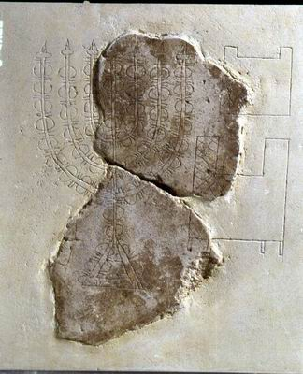

Figure 3 Graffito with Temple vessels, Jewish Quarter, 1st century BCE (Israel Museum)

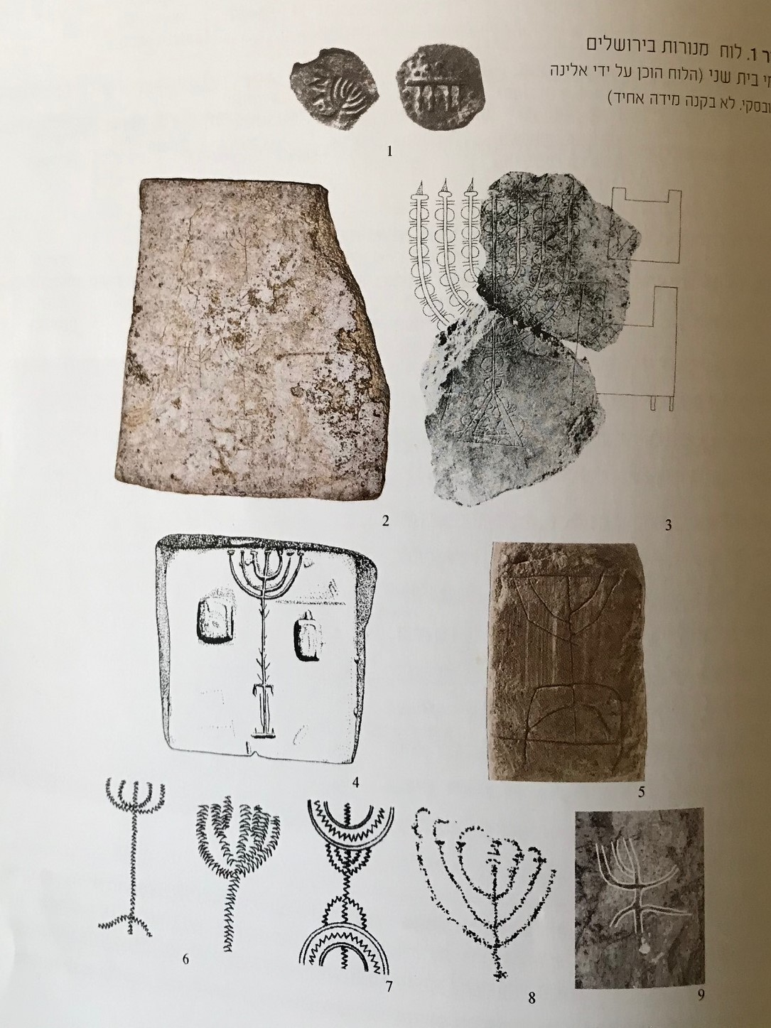

Figure 4 Bronze prutah, 37 BCE (Israel Museum)

III. Menorah as a National Symbol

Situated on the highest point of the Sacra Via, the Arch of Titus, depicting the Menorah and other spoils of Jerusalem triumphantly paraded in Rome, created a powerful visual for generations. After the Jews’ defeat in the Great War against Rome in 70 CE, the Menorah became the most important Jewish symbol for the next two millennia, culminating in the choice of the Menorah as the symbol of the State of Israel.

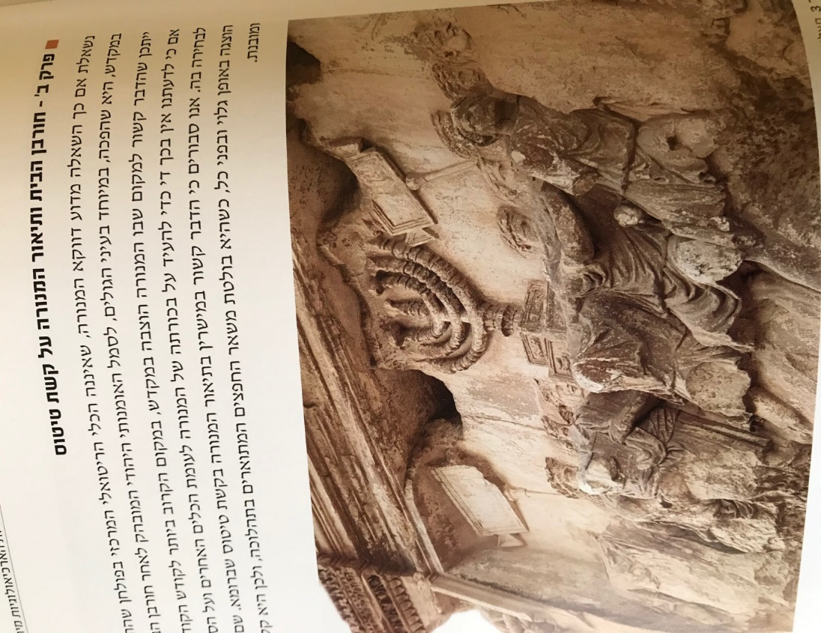

*Arch of Titus, Rome, 1st century CE*

Because Judaism is both a religion and a nationality, the significance of the Menorah takes on different combinations of religious, political, and nationalistic values as it embodies Jewish collective memories and dreams.

I’d like to focus, however, on one specific visual manifestation of the Menorah in Talmudic (Late Roman and Byzantine) period, in which the Menorah appears as a composite icon, combined variously with the lulav, shofar, incense shovels, and the sacred portal—images that symbolize either the Tabernacle, the Temple, the synagogue, or all of the above. With this composite icon, Jewish art creates, for the first time, a pictorial language for a series of objects inspired by the Temple that forms a conceptual whole. For the congregants of the synagogues at Beit Alpha, Tsippori, Beit Shean, or Dura Europas, this motif—whether depicted on a fresco, mosaic, or engraved on capitals—was both a reminder of where the Temple once stood and a dream of what it will be when, according to tradition, a third Temple is built. In addition, I would like to suggest that this composite icon conveyed a message of adjustment to the new, post-Temple reality: although there is no more Temple, these same rituals that were once used in the Temple service would continue to be used in the worship of G-d (albeit with differences). We are all familiar with the rituals of the four species, the shofar, and the role of the synagogue as מקדש מעט in post-Temple Judaism, but where does the Menorah and incense shovel fit in?

Based on references in the Zohar and the Talmud (Zohar Vayekhel 218, Ber. 42a, Ker. 6a, Bec. 43a) it seems that both the Menorah and incense shovels continued to be used in religious rituals even after the Temple was destroyed, though these practices were frowned upon by the Rabbis, and ultimately discontinued. The three-dimensional Menorahs uncovered in synagogues, such as the carved stone Menorah from Ḥammat Tiveria with soot in the lamps, is evidence of their continued use during the Talmudic period כזכר לחורבן. Support for this post-Hurban practice might be found in the commentary of the Tanhuma and Bamidbar Rabbah on Bamidbar 8:2:

דַּבֵּר אֶל אַהֲרֹן וְאָמַרְתָּ אֵלָיו בְּהַעֲלוֹתְךָ את הנרת הַקָּרְבָּנוֹת, כָּל זְמַן שֶׁבֵּית הַמִּקְדָּשׁ קַיָּם הֵן נוֹהֲגִים, אֲבָל הַנֵּרוֹת, לְעוֹלָם

This source was interpreted as referring to the continuous ritual lighting of a seven-branched Menorah, rather than to the future lighting of the Ḥanukkah lights.

The Rabbis’ prohibition to make exact copies of the Temple implements might explain the additional features seen in these Menorahs, such as a horizontal bar under the seven lamps. While this bar would certainly have been useful for placing the wicks or cleaning the Menorah, it may also have been a way to circumvent the Rabbis’ ban against exact replicas.

This composite motif appears on diverse objects uncovered in the Land of Israel and the Diaspora, such as on lead coffins in Bet She’arim, on painted tomb stones from Zoar, and on the gold-glass bases from Rome. The gold and glass bases, embedded in the walls of Jewish catacombs and sarcophagi in ancient Rome, were used as a way to identify with the Jewish people and its mission, and to symbolize the eternity of the soul and the resurrection of the dead.

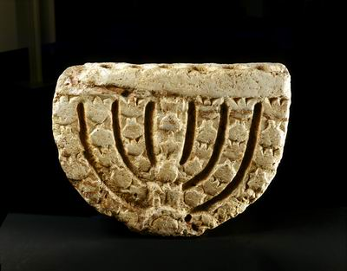

*Synagogue Menorah, Ḥammat Tiveria, 4-5th century CE (Israel Museum)*

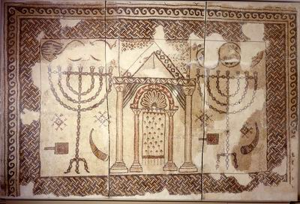

*Synagogue floor, Bet Shean, 5-7th century CE (Israel Museum)*

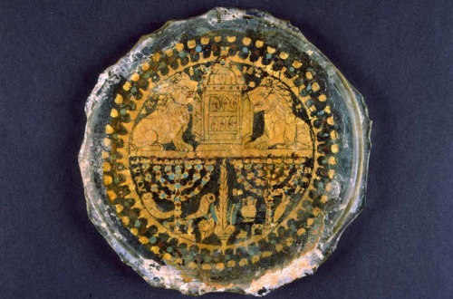

*Gold glass base, Rome, 4th century CE (Israel Museum)*

IV. The Menorah as a Kabbalistic Symbol

The Menorah is also an important symbol in Kabbalistic literature. In the fourteenth century, we begin to see the words of Psalm 67, referred to as the Menorah Psalm, used to the draw images of the Menorah. How do we explain the connection of the Menorah with Psalm 67 and why was their combination seen as so potent? First, if we do not include the superscription, Psalm 67 consists of seven verses, corresponding to the seven branches of the Menorah. Furthermore, the total number of Hebrew words in these verses add up to forty-nine, corresponding to both the total number of decorative elements in the Menorah (42 + 7 branches=49) and G-d’s forty-nine-letter name. Secondly, there is the structural similarity between the layout of the Psalm and the shape of the Menorah: If we count the number of words in each verse in their given sequence, we get the symmetrical arrangement 7,6,6,11,6,6,7, and if we were to plot this arrangement out along a Menorah design, the proportion would be an almost perfect match! More than just structural similarities and numerical equivalents, however, what we have here is the conflation of two traditions. Noting that this Psalm is anonymous, the Zohar explains in the name of Reb Eliezer that Psalm 67 was divinely revealed to David in the form of the Menorah, to which Hasidic sources add that this image was emblazoned on David’s original shield. Rashi comments how Moshe had difficulty visualizing the Menorah until G-d showed him a Menorah of fire, וזה מעשה המנורה—as if God was pointing this image to Moshe. The combination, then, of these two divinely inspired ideas and images creates a symbol whose power is greater than the mere sum of its parts! Psalm 67 written in the shape of a Menorah appears in siddurim, on amulets, and in synagogues, such as on the doors of the Ark from the Ramah synagogue in Cracow, Poland. Many *segulot* are attributed to reciting Psalm 67, especially when read off the image of the Menorah.

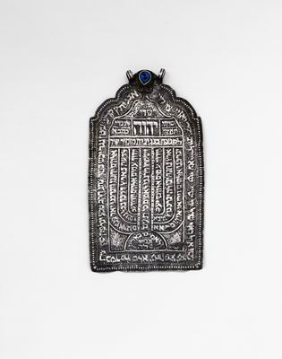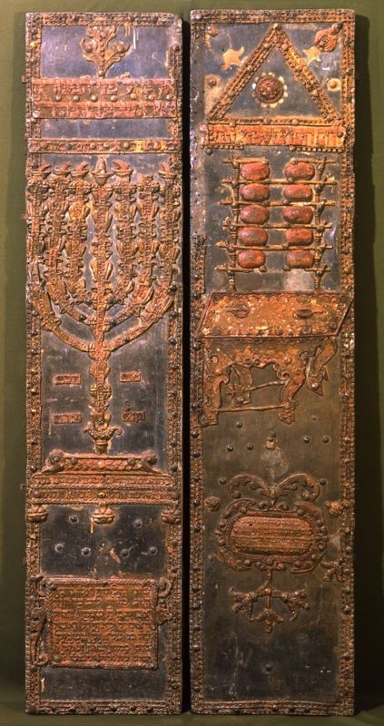

*Ramah Synagogue Ark, Cracow, Poland, 17th (Israel Museum) Shiviti amulet, Persia, 18th century*

V. The Menorah as Prophecy

The Bible of Cervera and the upper part of the Ark from Parur, India features the seven-branched Menorah as described in Zecharyah 4. The prophet’s vision is of a golden Menorah, whose seven lamps are fed with olive oil by way of seven pipes and a bowl, from two olive trees that are positioned on either side of the Menorah. There are many aspects to this vision. This prophecy is about Redemption and about the balance of power during the period of *Shivat Zion*, between the High Priest Yehoshua and the governor, Zerubavel. This prophecy is also about optimism and perseverance in times of challenge. Zecharyah’s audience are those Jews who had just returned to Jerusalem after seventy years of exile in Babylon, and the reality is a sad one: the city and its walls are destroyed, the economic conditions are dire, and although the Jews received permission from Cyrus to rebuild the Temple, the rebuilding had been stopped because of hostility from local populations. The prophet thus affirms לא בחיל ולא בכח כי אם ברוחי אמר ה' צבאות. The prophet also focuses on the Menorah’s maintenance. The Menorah in the Temple could have been lit miraculously, yet the halakhah prescribes how the wicks are to be trimmed and cleaned, and the olives harvested and squeezed, daily, thereby emphasizing the human element—the active participation of the person, the input of the worshipper. As a symbol of peace, the two olive trees on either side of the Menorah were, of course, the inspiration for the design of the emblem of the state of Israel.

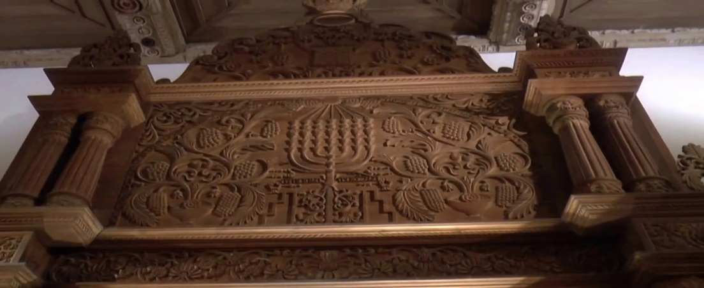

*Synagogue Ark, Parur, India, 1892, (Israel Museum)*

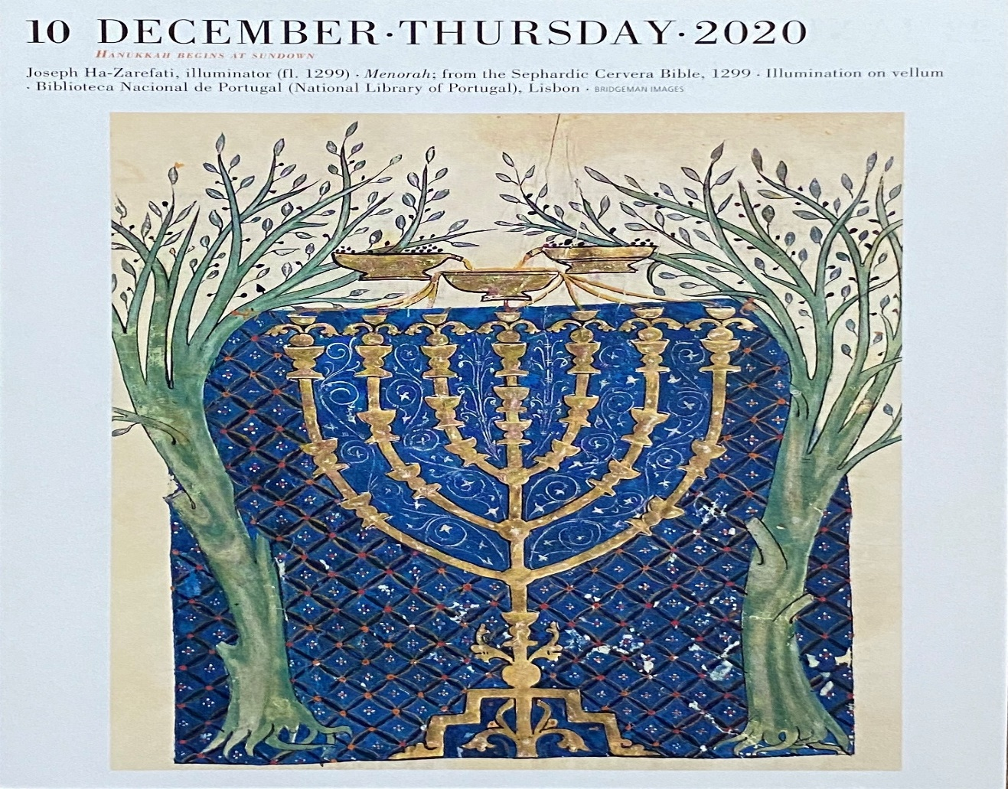

*Bible of Crevera ,1299-1300 (National Library of Portugal, Lisbon)*

VI. Menorah as Ḥanukkiyah

It is not until the end of the Middle Ages that we begin to see ḥanukkiyot in the shape of a candelabra, inspired by the Temple Menorah. The ḥanukkiyah in the shape of the Menorah was first introduced in the synagogue and eventually, on a smaller scale, for the domestic market. Although the connection between the Ḥanukkah story and the Menorah is obvious, it was probably the Rabbis’ admonition against replicating Temple vessels that prevented the appearance of Menorah-shaped ḥanukkiyot until the end of the Middle Ages. An example of a Menorah-shaped ḥanukkiyah is the seventeenth-century silver ḥanukkiyah from Frankfurt-am-Main. Crafted by the silversmith Schuler, it features alternating knobs and flowers and is crowned with the figure of Judith, who holds the head of Holoferenes in her left hand and a sword in her right hand.

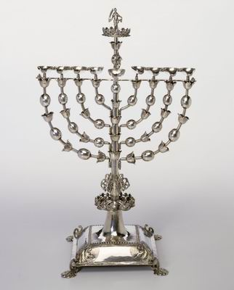

*Ḥanukkiyah, Frankfurt, German, 17th century (Israel Museum)*

VII. Menorah as Heroism.

This visual combination of the Temple Menorah with the ḥanukkiyah became a symbol of Jewish heroism. It is for this reason that Ze’ev Jabotinsky, founder of the Revisionist Zionist movement Beitar, chose the Menorah as the emblem of his movement. Large brass standing ḥanukkiyot in the shape of the Menorah were popular in East European synagogues. Usually positioned next to the Ark, these ḥanukkiyot were lit for the sake of those who were not able to light, and in order to publicize the miracle of Ḥanukkah in a public place, modeled after the Temple. Ironically, these ḥanukkiyot that celebrate the Jews overthrowing the yoke of one nation are often crowned with a symbol of the yoke of a different nation—typically, an eagle representing Poland, Austria-Hungary, Germany, or Russia—as a gesture of thanks or loyalty to the sovereign. Agnon writes in his *Tale* *of a Menorah* that the congregation kept handy a collection of small cast eagles, ready to be exchanged to fit the new ruler at short notice, given the constant shifting of borders among those warring political entities. The single or double eagles were attached to the Menorah with a threaded base for easy installation and removal. Few of these standing Menorah-shaped ḥanukkiyot, which once stood proudly in Polish synagogues, were retrieved from the Nazis. They now stand in museums and synagogues as a memorial to the many hundreds of synagogues and communities destroyed during the Holocaust and as a testimony to Jewish heroism, evoking the heroism of the Maccabbes and of all those Jews who suffered and fought tyranny בימים ההם בזמן הזה .

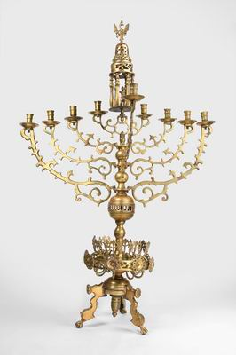

*Synagogue Ḥanukkiyah, Poland, 17th century (Israel Museum)*

1. Nogah HaReuveni, `Teva VeNof BeMoreshet Yisrael,` Neot Kedumim, 1980, pp. 125-130.