Journal: Architectural Science Review

WORD COUNT: 5742

Stefanie Rückrich,a,* Galit Agranati,a and Yasha J. Grobmana

*a Faculty of Architecture and Town Planning, Technion – Israel Institute of Technology, Haifa, 3200003, Israel.*

*\*Corresponding author; E-mail address: stefanie-ru@campus.technion.ac.il*

ORCID

Stefanie Rückrich http://orcid.org/ [0000-0001-7688-5683](https://orcid.org/0000-0001-7688-5683)

Galit Agranati http://orcid.org/ [0000-0001-8003-2878](https://orcid.org/0000-0001-8003-2878)

Yasha J. Grobman http://orcid.org/ [0000-0003-4683-4601](https://orcid.org/0000-0003-4683-4601)

Earth-based additive manufacturing: A field-oriented methodology for evaluating material printability

Abstract

The recent convergence of earth construction with technology focuses on additive manufacturing using extrudable earth-based materials. The printability of these materials can be defined by their pumpability, extrudability, and buildability. We present a field-oriented methodology for the design of printable local mixtures suitable for various printers. Three tests were defined to characterize the flowability, pumpability and extrudability, and buildability of such materials in their fresh or ‘green’ state, and used to optimize the workability of a sample material for printability. Based on the outcomes, two indices are proposed for the classification and control of the printability of earthen mixtures: flowability and green strength. Our results demonstrate that adjusting water content for consistency and adjusting plasticity for cohesiveness are both vital for tuning printability, although the necessary modifications can negatively affect the material's strength in its hardened state; incorporating cellulose microfibres can counter this by increasing flowability, plasticity, and compressive strength.

Keywords: Printability, workability, field-oriented test methods, 3D-printing earth-based materials,clay

1. Introduction

The craft of earth architecture, based on vernacular knowledge using locally available materials, has been evident since 8000 BC (Minke 2006). The use of earthen material is advantageous, being 100% reversible and showing potential for passive indoor climate regulation (Schweiker et al. 2021). Historically, earth-building practices have been based on an open-ended process in which uncertainty and risk are embedded as core precepts (Veliz Reyes et al. 2019). However, a general lack of field-specific knowledge about earth construction in the architecture, engineering and construction (AEC) sector, the variety of materials that can be used and the labour-intensive nature of much earth construction have all hindered its advance into mainstream architecture (Ben-alon 2020).

Presently, the building sector is a major source of environmental problems such as air pollution, toxic waste, and land degradation. Cement production alone is responsible for about 8% of global CO2 emissions (Lavagna et al. 2020). At the same time, technology can facilitate new affordable and sustainable building methods while incorporating and reviving traditional skills and methods.

To overcome the barriers associated with traditional earth construction, novel approaches employ ‘ready-to-use’ mixtures for plasters or rammed earth, prefabricated elements, such as adobe bricks, rammed earth elements and earthen fibrous boards (Claytec 2018; Rauch 2020), and digital construction processes, such as additive manufacturing(Rael and San Fratello 2011; WASP 2021). These industrialized techniques are more controllable and produce high-quality outcomes, although they tend to eliminate the possibility of making changes during construction (Veliz Reyes et al. 2019). Similarly, the convergence of additive manufacturing technology with earth-based materials could further advance implementation strategies for mass customization.

Recent studies have explored the three-dimensional printing of mixtures of earthen material. Thus, Perrot, Rangeard, and Courteille (2018) investigated earth mortar in combination with alginate, Gomaa et al. (2021) with local cob mixture, and Bar-Sinai, Shaked, and Sprecher (2021) with desert soil and silicon binder. These projects focused mainly on printing methods and workflows needed to transform geomaterials into architectural structures. However, integrative strategies still need to be established to identify, describe and convert the diversity of local soil matter into well-defined printable material mixtures (Bar-Sinai, Shaked, and Sprecher 2021).

Thus, printability becomes a characteristic of an earthen mixture, reflecting its pumpability, extrudability and buildability when in its fresh or ‘green’ state, and its compressive, flexural and tensile strength, as well as its high layer-interface strength, in its hardened state. These parameters are also affected by the mechanics, dimensions and set-up of the 3D-printing system.

For good printability, two somewhat contradictory material properties are necessary. First, the printable mixture has to flow, requiring *moderate* yield stress. By contrast, immediately after extrusion, the strength and stability of the mixture should increase through drying and enable the build-up of a layered structure, which requires material with a *high* yield stress (Nerella and Mechtcherine 2019).This contrast highlights the need for a formal method for the development, evaluation and control of printability for earth-based materials.

Two recent reviews have examined existing methods for testing and characterizing earthen building materials (Fabbri et al. 2022) and discussed the potential of digital production and new technologies for contemporary earth construction (Schweiker et al. 2021). **Fabbri** et al. (2022) **showed that existing field tests can be performed quickly and easily and are applied worldwide to control the parameters for vernacular earth construction methods. However, such tests can be conducted only by experienced earth-builders, who are able to analyse materials' properties through accumulated knowledge and comparison, and despite the variety of existing testing methods available, none of them evaluates a material's pumpability, extrudability or buildability.**

**To mitigate fluctuations in material properties during digital fabrication processes, Schweiker et al. (2021) proposed real-time sensor feedback as a quality control mechanism. However, exactly how such a system will work successfully with extrusion-deposition of earth-based materials remains unclea**r.

Thus, both reviews highlight information gaps in relation to the evaluation and optimization of the printability, **particularly** the constant workability, of earth-based materials when using field-oriented tools—common in earth-building practices. In contrast to traditional testing methods, **tests are needed that can be applied without any specific background in earthen construction and that provide measurable indices.**

Hence, this study aims to clarify the composition of printable earthen material, such that it can be codified and provide additional support to academic and professional R&D innovation contexts.It proposes a field-oriented methodology, including three characterization tests to optimize a material’s printability with regard to consistency and cohesiveness. The method and tools will enable designers and manufacturers to define, evaluate and adjust the printability characteristics of earthen mixtures for additive manufacturing.

The first part of the paper provides a brief background on earth-based mixtures. The second part explains the printing technology used in this research. The third part explores the design of a prime mixture: the optimal ratio of clay to sand, the preparation method, and the amount of water to add to the mixture. The main focus of the section is the characterization tests that define the consistency and cohesiveness of the material for printability and enable their adjustment via clay and water content. In addition, we investigate the influence of three vegetal fibrous additives on printability. Finally, printing of the developed mixtures demonstrates the relevance and value of the method. References to standards are provided wherever the same or similar test methods are employed.

On the basis of the results, we identify and discuss two possible indices that could serve to classify and control the printability of earth-based mixtures in their fresh state.

2. Materials and methods

2.1 Background on earth-based materials

The properties of earthen construction materials are typically defined by the nature and proportions of clay (<0.002 mm), various aggregates such as silt (0.002–0.06 mm), sand (0.06–2 mm) and gravel (2–63 mm, <4%), and additives. Aggregates form the granular skeleton of the material, and are added to reduce shrinkage and cracking and to increase stability. Meanwhile, the binding characteristics of the clay minerals are activated by water and movement. Unlike cement-based materials that cure through a chemical hydration process, earthen materials harden by air drying (Lagouin et al. 2021; Minke 2006). This inherent property of the materials is the main reason for their enduring reversibility.

Vernacular earthen building techniques depend on the properties of the soil that is locally available. If necessary, the plasticity of the mixture can be increased by adding clay or reduced by adding sand. The grain-size distribution, water content, type of clay, method of preparation, and additives used all influence the rheological and mechanical properties of the building material. Its subsequent dry density depends heavily on adequate densification within the manufacturing process (Fabbri et al. 2022).

Approaches to additive treatment fall into three groups. In the traditional group, materials of vegetal or animal origin are added in small quantities. Their fermentation and chemical reaction within the earthen mixture, as well as the physical shape of their fibres, can improve the processing, mechanical properties, insulation, and water resistance of the material (Laborel-Préneron et al. 2016; Lagouin et al. 2021). The second approach involves the addition of hydraulic and non-hydraulic binders, such as cement and lime, which have increased in use as stabilizers in the last few decades. Their environmental impact and actual effectiveness have attracted considerable interest and generated some controversy (Ouedraogo et al. 2020; Ferretti et al. 2022). The third approach relates to the recent development in soil mechanics and the ceramics industry of self-compacting clay concrete using known chemical admixtures. This method causes a dispersion of the clay particles followed by flocculation, that is, the particles’ aggregation into soft flakes (‘flocs’) (Landrou et al. 2018).

2.2 Printing equipment and set-up

We used a commercially available Delta WASP 3MT 3D printer for ceramic materials (Figure 1).A pressure of up to 8 bar (1 bar = 100 kPa) can be applied to a hanging 3L container for piston extrusion (inner Ø 1.8 cm). The material is pressed through the container and a 15 cm long pipe (inner Ø 1.8 cm) that connects to the extruder. The original WASP XL extruder includes an inner screw and is designed to ensure homogeneous material deposition of clay. To bypass particle-size limitations, the original extruder is replaced with a **3D-printed screw-less connection part. This enables the extrusion of mixtures with coarse sand for prototyping of on-site soil conditions. The printing speed was set to 100 mm/s.**

The following section describes our approach to creating printable earthen materials.

[Figure 1 here]

2.3 Field-oriented methodology for printable mixture design

Our field-oriented methodology for developing printable material relies on the existence of earthen materials in the vicinity of the construction site and consists of five main stages:

(1) Excavating earth from the ground or reusing material from demolished earth buildings.

(2) Improving the earth by filtering according to a predefined particle size.

(**3) Adjusting the ratio of aggregate(s) to clay either through feel according to earth-builders’ knowledge or a compressive strength test.**

(**4) Performing a set of characterization tests to determine and optimize the workability of the material as a printable mixture. This means, in particular, the specification of the necessary supplements of water and clay, as well as investigation of the influence of additives on the material’s printability**.

(5) Proving the developed methodology by running a sequence of 3D printing tests.

To mimic a local sample for this research, we composed a reference material of coarse sand, kaolinite clay, and tap water. Kaolinite clay has a moderate swelling capacity and less shrinkage than other types of clay (Schroeder 2017). Given that previous studies have suggested a link between a fibre’s cellulose content and its mechanical characteristics in relation to earthen materials, our research investigates the influence of three different vegetal fibre additives on the printability of the reference mixture.

The methodology is assessed and verified by printing the developed mixtures into cylinders (Ø = 15 cm; 10 layers, each of Ø 1.5 cm), a method used in researching 3D printing of concrete (Chen et al. 2020; Panda, Lim, and Tan 2019).

The first two characterization tests evaluate the material's workability and particle size for, first, flowability and, second, pumpability and extrudability. They also allow for the rechecking of the material immediately before printing. In particular, the tests measure consistency (ease of flow) and cohesiveness—segregation characteristics and deformation properties when force is applied (Mehta and Monteiro 2006; Tourtelot et al. 2021). The third characterization test investigates the buildability of a mixture in its fresh state by measuring its ‘green strength’ (i.e. during the first 15 minutes, when still fresh; Panda, Lim, and Tan 2019). ‘Buildability’ refers to the ability of the material to retain its extruded shape and support the build-up of a layered structure. Together, these three tests evaluate the printability properties of a mixture when fresh.

For evaluation, at the end of this research, the hardened prime mixture and adjusted mixtures are compared in terms of their compressive strength.

2.3.1 Determining the optimal clay-to-sand ratio for compressive strength

To attain the highest possible compressive strength when a mixture is dried, it is necessary to determine its optimal clay-to-sand ratio. The compressive strength of our reference material was measured for mixtures of various clay-to-sand ratios: 1:5, 1:4, 1:3, 1:2 and 2:3. Our specimens were 5 cm × 5 cm × 5 cm; they were unmoulded after three days and stored at 21 °C, 54% relative humidity (RH).

The mixture with a clay-to-sand ratio of 1:2 produced the highest compressive strength, about 201 kPa(Figure 2), and we therefore used this ratio as our reference point (our prime mixture) for investigating material printability. In practice, the optimal ratio could also be determined by an experienced earth builder.

[Figure 2 here]

2.3.1.1 Mixing / preparation method

The mixing procedure in this research relies on the preparation methods described by Laborel-Préneron et al. (2016) and Minke (2006). Clay and sand are stored at room temperature (21 °C, 54% RH), and the mixture is prepared in the following stages:

(1) On the basis of the printing set-up (see Section 2.2), the particle size of the sand is decreased by sieving with a No. 4 sieve (*D*max 4.75 mm).The required ratio of clay to sand is calculated as a percentage per volume and then converted to weight (clay 0.7 g/mL; sand 1.7 g/mL).

(2) When centimetre-scale fibres are added, their amount is calculated in terms of percentage per volume of clay and sand. In contrast, microscale fibre amounts are calculated in percentage per amount of added water and are usually immersed in the water for several hours; only after the suspension has rested is it ready to be added to the clay/sand mixture (see stage 4).

(3) All of the clay and aggregates are placed in a bowl and mixed without water for one minute.

(4) After dry mixing, the water—or the suspension containing the cellulose microfibres—is added. Everything is then mixed together manually until a homogeneous material is obtained.

(5) Because storage in the amounts envisioned on construction sites could be difficult, the material is used immediately after preparation. **However, in practice, a longer resting time, from a few hours up to a few days, can improve the plastic and mechanical qualities of the resulting material, for example, through fermentation, and should be included if possible. If this is done, a mixture’s consistency needs to be checked for a second time thereafter; the addition of more water might be necessary.**

2.3.1.2 Addition of water

**Earth-building processes can be classified according to the hydration state of the mixtures used in fabrication, with distinctions made between ‘plastic’, ‘solid’ and ‘liquid’ (Fabbri et al., 2022). The extrusion-deposition of earth-based materials can be classified as a ‘plastic’ process. The mechanical strength of the material is achieved through densification as a result of drying shrinkage.** Added water content is decisive in adjusting the workability of a mixture; that is, to achieve a good consistency for pumpability, extrudability and buildability (Tourtelot et al. 2021).

The complexity of the water issue in relation to earthen materials is associated with the mixture's chemical and physical nature, particularly the characteristics of the clay and changes in local temperature and relative humidity. Water can be chemically or electrostatically bound, absorbed in the microporous structure of the clay through capillary action, or trapped between the particles (Minke 2006). Earth-based materials harden through drying, and only the latter two forms of water content (absorption and entrapment) will vary according to climate. The addition of water activates the plastic performance of the clay minerals (if the material is not already saturated) and influences its flow characteristics.

The amount of water used for the sample preparation is determined by ‘feel’. For moulding, it should be low but still sufficient to activate the clay’s plasticity. In our case, we added 12% of water to the clay/sand mixture. Alternatively, the initial water content can be determined according to the German standard DIN 18952 stiffness test (Minke 2006). This test, however, is laborious and unnecessary for the following procedure.

2.3.2 Characterization tests for field-oriented methodology

Three field tests determine, adjust and evaluate the prime mixture (see Section 2.3.1) and the need for further additions of water, clay and additives to achieve optimized workability in support of printable earthen material mixtures.

The first test evaluates the flowability of the mixture according to its spread. The second test evaluates its pumpability (the capacity of the material to be pumped from a container through a pipe to an exit nozzle) and its extrudability (the capacity of the material to be extruded from the nozzle in a stable line). Together, these two tests assess the necessary consistency, cohesiveness and particle size according to the printer in use.

The third test determines the green strength of the material to estimate and compare its buildability (the capacity of the material to give rise to a layered structure following its extrusion).

In combination, these three tests capture the properties of earth-based materials when fresh to determine their printability.

2.3.2.1 Characterization test for flowability

The objective of the flowability test is to describe a material’s consistency for workability purposes through a modified flow test. Such a test could enable rapid final checks to be made before printing, which is not possible with the standardized tests for mortars (e.g. ASTM C230 / C230M – 21).

A cylindrical mould (Ø 45 mm, height 45 mm) is filled with the material and the material is then manually extruded from the mould to leave a cylindrical sample. The sample is placed in the centre of a wooden plate (20 cm × 30 cm), each long side of which is alternately lifted to the initial height of the sample (45 mm) and then allowed to drop and hit the surface (table) beneath (Figure 3); the sample is impacted in this way a total of 10 times.

[Figure 3 here]

The spread of the material from its initial diameter is measured with a caliper gauge or spacer (Figure 4). The greater the spread diameter, the higher the material’s flowability.

[Figure 4 here]

Quantifying the material’s flowability according to its spread enables the control of the consistency required for pumpability and extrudability immediately before printing. The flowability can be calculated in percentage terms:

$flow [\%]=\frac{spread diameter \left[cm\right]-sample^{'}s base diameter \left[cm\right] }{sample^{'}s base diameter [cm]}$ × 100

To evaluate the test’s performance and to showcase the influence of water and additives (see Section 2.4) on flowability, we investigate the spread of this prime mixture when its initial water content (see Section 2.3.1.2) is increased in steps of 1%.

2.3.2.2 Characterization test for pumpability and extrudability

Pumpability involves many different rheological components. Apparent viscosity can describe pumpability (Matthäus et al. 2021). Adding more clay to an earthen mixture can facilitate pumpability but also increases the risk of shrinkage (Perrot 2019).

We use a triangular-bag test to evaluate pumpability and extrudability. Here, material is manually extruded through an opening in a triangular bag, which is analogous to the pumping and extrusion of the material within the 3D-printing process; the same shear forces are involved in both this test and printing. Specifically, the test provides a reliable assessment of a material’s printability for a given composition and applied force. It simulates the machine nozzle’s size, and acts as a check of consistency, cohesiveness and particle size. The test defines the necessary minimum water content and plasticity of the mixture for pumpability and extrudability. A good extrusion is achieved when the material can be easily and homogeneously extruded into a stable cylindrical line without the water separating out (Figure 5). The mixture’s workability can be adjusted in an iterative process by adding water, clay and/or additives, or decreasing particle size. The extrudable mixture’s fluidity can then be characterized with the test for flowability (see Section 2.3.2.1).

[Figure 5 here]

Together, the two tests can determine the workability, which is necessary as a starting point for investigating green strength.

*2.3.2.3 Characterization test for evaluating green strength*

The buildability of a material can be estimated by measuring its green strength, which describes the strength of a mixture in its fresh state prior to it reaching its final strength (Panda, Lim and Tan 2019). **Specifically, this characterization test investigates the material's capacity to sustain its height immediately after extrusion.**

For each mixture, the samples are prepared (see Section 2.3.2.1) with the water content and the clay-to-sand ratio determined by the extrudability test (see Section 2.3.2.2). The test of green strength needs to be performed within 10 minutes of the preparation. A small plastic sheet of 1.5 mm thickness is placed between the weight above and the sample to prevent sticking and uneven surface deformation. The weight (2 kg) must rest in position for at least 10 s, at which point the sample height is measured with a ruler (Figure 6). **The percentage decrease in the sample's height is calculated and compared to the initial sample's total height (100%) as a measure of green strength.**

[Figure 6 here]

***2.4 Fibres***

Given that vegetal fibres can modify the mechanical and rheological properties of a material and previous studies have suggested a link between cellulose content and the mechanical characteristics of fibres used for earthen materials (see Section 2.1), we investigated the influence of three fibres with high cellulose content. The sample fibres are differently processed and have significantly different physical dimensions: horse manure (1 mm long, 0.5 mm thick), industrially processed hemp shiv fibres (1–1.5 cm long, 1–2 mm thick), and cellulose microfibres (Abocel BE 600-30PU) (40 µm long, 20 µm thick) (Figure 7) (Millogo et al. 2015). These organic fibre types, which permit the earthen mixtures to remain 100% reusable, and their proportions (Tables 1 and 2) were chosen on the basis of the existing literature (Schroeder 2017; Vissac et al. 2018).

[Figure 7 here]

[Tables 1 & 2 here]

We used the printability characterization tests to evaluate the effect of these three different vegetal fibres on the reference (prime) mixture having a clay-to-sand ratio of 1:2 (see Section 2.3.1); the initial water content of the mixtures differs, however, depending on the type and amount of fibres used.

***2.5 Cylind***r***ical test prints***

Following on from the results of our characterization tests, we use the printer to test the capacity of the developed mixtures to build up a cylindrical shape. The digital shape is designed as a spiral (Ø 15.0 cm) of 10 layers, with a layer distance set to 0.8 cm and a layer diameter of 1.5 cm (see Figure 11, Left).

**3. Results**

In this section we present the results of the three characterization tests proposed. All tests were repeated three times, and average values calculated accordingly.

***3.1 Flowability***

Our modified flow test measured flowability in order to describe the consistency of different mixtures. Additions of different amounts of water were examined to evaluate the test’s performance and differences in the spread of the material were clearly measurable, confirming that our sample earth mixtures with kaolinite clay are highly sensitive to minor variations in water content. Furthermore, we found that the spread also depended on the amount and type of fibre added to the mixture. A mixture containing centimetre-scale fibres needed more than 2% more water to produce the same viscosity as a mixture without fibres, while the mixture with cellulose microfibres required over 2% less water (Figure 8).

[Figure 8 here]

The results show that the addition of cellulose microfibres decreased yield stress (water content: 15%; spread: M5 7.5 cm / M1 5.9 cm; resp. 67% / 31%). In contrast, the addition of centimetre-scale fibres increased yield stress: with higher amounts of water added, the mixtures that contained hemp shiv fibres and/or horse manure fibres (M2, M3, M4 and M6) exhibited less deformation. Mixture M3, with horse manure fibres, behaved similarly to the mixture without additives (M1) but had higher water content to start with.

***3.2 Pumpability and extrudability***

Our extrudability test examined the extrusion of the earthen materials through an opening in a triangular bag with a diameter of 1.5 cm (Figure 9). This size was chosen to simulate the inner diameter of the nozzle in the printer set-up.

[Figure 9 here]

The mixture without additives (M1) and the mixture with cellulose microfibres (M5) started to be extrudable when the diameter of their spread samples was measured at between 7.5 and 8.5 cm, equivalent to a flow of 67–89%. All other mixtures—that is, those with hemp shiv fibres and/or fibres of horse manure—were not extrudable into a uniform coiled shape. The fibres jammed up against each other and led to clogging inside the triangular bag, and if the water content was increased, the yield stress became too low to form a stable shape.

When mixtures M1 (19% of added water) and M5 (16% of added water) were extruded, a small amount of water separated out of the mixtures, indicative of low cohesiveness. Thus, the mixtures were tuned for pumpability and extrudability using a second parameter: for mixture M1, the clay content was increased to produce a clay-to-sand ratio of 2:1 (M1adjusted), and for mixture M5 it was adjusted to a 1:1 ratio (M5adjusted) (Table 3). These adjustments enabled extrusion without water segregation characteristics being exhibited.

***3.3 Green strength***

Our third characterization test examined the green strength of the mixtures, with weight applied to the fresh samples and their vertical deformation measured to characterize buildability.

The test was performed with mixtures M1**adjusted** and M5**adjusted**, which had been successfully extruded in our triangular-bag test.

The green strength was measured during the first 10 min of drying. Each sample was loaded with 2 kg.The resulting vertical height of the sample relative to its initial height in percentage terms was taken as its green strength (Figure 10).

[Figure 10 here]

A comparison of mixtures M1adjusted and M5adjusted indicated that the addition of cellulose microfibres to the latter did not produce a significant influence on green strength (51% vs. 56%).

***3.4 Compressive strength of adjusted mixtures***

**When we tested the compressive strength of the adjusted mixtures after three days of drying, we found that a higher clay content resulted in a reduced strength (Table 4 and Figure 2: ratios 1/1 and 2/1), but the presence of the cellulose microfibres increased compressive strength by 17%.**

[Table 4 here]

***3.5 Printing***

Successful 3D printing should be controllable and accomplish a coherent build-up equivalent to the shape of the associated digital model (Nerella and Mechtcherine 2019). Accordingly, t**o verify the results of our characterization tests, we compared the printability of the non-modified mixtures M1 (1:2 clay-to-sand ratio) and M5 (1:2 clay-to-sand ratio, 1.7% cellulose) with that of the adjusted mixtures M1adjusted (2:1 clay-to-sand ratio) and M5adjusted (1:1 clay-to-sand ratio, 1.7% cellulose) via a cylindrical printing test.**

The non-modified mixtures exhibited uneven viscosity during printing and required different pressures to be applied during the process; the pressure was manually adjusted accordingly and varied between 3 and 4 bar. The quality of the print was not acceptable (Figure 11, Right).

[Figure 11 here]

The adjusted mixtures, which were modified on the basis of our field-oriented methodology, successfully exhibited a smooth homogeneous extrusion at a constant pressure of 4 bar (Figure**12, Right).**

[Figure **12** here]

The higher clay content and thus the increased plasticity of mixtures M1adjusted (plasticity index 6.66) and M5adjusted (plasticity index 5.78) improved cohesiveness and led to a smoother extrusion and a more uniform cylindrical shape. However, mixture M5adjusted, containing cellulose microfibres, proved printable with a lower clay content.

Following the test method of Jacquet et al. (2020), we also measured the material filament leaving the nozzle of a vertically downward extruder. The filament of the adjusted printable mixtures was 30–40 cm in length.

To assess the level of conformity of the printed model to the digital model, we measured the height and width of the cylinders and the height and width of the layers both immediately after printing and after drying for three days: the dimensions barely changed (Table 5).

[Table 5 here]

**4. Discussion and conclusions**

We propose a field-oriented methodology for the development of printable earth-based mixtures customized to a printer’s set-up, and taking into consideration pumpability, extrudability and buildability. **More specifically, a material’s workability in support of printability can be determined and adjusted via its water and clay composition through simple characterization tests, which can be of benefit at different stages of the materials manufacturing process:**

a) in designing composition ratios for printable mixtures;

b) in verifying correct water content immediately before printing;

c) in researching the effects of additive incorporation.

**Rechecking the water content required for pumpability and extrudability can be performed with the triangular-bag test and the modified flow test immediately prior to printing (as in b) above). Such tests are essential when preparing large quantities of material in fluctuating climate conditions, and when readjusting flowability after material resting-times or periods of storage.**

**The field test for green strength enables us to tag or calibrate the buildability required for a printable mixture by means of a vertical deformation measure. Together, the triangular-bag and green strength tests are valuable when determining a mixture’s design prior to the preparation of a large quantity of building material (as in a) above) and for researching mixture designs through comparison (as in c) above).**

On the basis of our findings, we propose two field-based measures, of flowability and green strength, that could serve as indices for printability (Table 6).

[Table 6 here]

Together with the characterization tests, these indices could help designers and builders to maintain and ensure consistent printability. Furthermore, they could aid in the standardization of industrially preprocessed earth-based materials. An index for flowability would enable builders to determine the amount of water to add to preprocessed mixtures without having field-specific knowledge, while they would provide a guide for experienced builders in creating and controlling their own mixtures from local materials.

However, it is not yet clear whether the values suggested for flowability and green strength (Table 6) have generic application. They could, in fact, vary depending on the printer set-up (the pumping and extrusion system, nozzle size and printing speed), mixture composition, and the programmed layer distance. Future research should investigate the coherence of these different parameters to establish and refine more widely applicable indices of printability.

The physical shape of the fibre additives and the chemical reactions within the mixture both influenced a material’s printability. A fibre’s performance is related toits stiffness, size, component parts, and capacity to absorb water. For example, centimetre-scale fibres rapidly led to clogging when using a 1.5 cm diameter nozzle size.By contrast, the admixture of cellulose microfibres lowered viscosity and improved extrudability. Thus, as rheological modifying admixtures, microscale vegetal additives show potential when it comes to increasing the cohesiveness of building materials. This finding is consistent with the research of Lagouin et al. (2021): ‘polysaccharides of vegetable origin provide a potential solution as a rheological modifying admixture’. **However, this research did not investigate whether the higher cohesiveness of a mixture exerts a positive influence on the extrusion of centimetre-scale fibres.**

Our research has shown that a material's printability can imply a compromise between the characteristics required of a material when in its fresh state and the ultimate strength obtainable once it has dried. To improve printability from both perspectives, further research into the influences of a clay’s characteristics, grain-size distribution and natural admixtures is necessary. This could reduce the loss in ultimate strength after drying that was observed in some of our samples, and improve performance in thermal and sustainability terms.

The proposed development of indices could be relevant not just for earth-based materials but also for other materials in cognate areas of research that employ 3D extrusion printing technology. Further investigation could result in a schema similar to the consistency classes for fresh concrete specified in European Standard EN 206 (EN 206-1 2000).

In summary, this research reveals the beginning of the procedures necessary to turn earthen 3D-printing into a common field-based practice in building construction, and further emphasizes the need for future research that will promote a more sustainable local building industry in combination with technological developments.

**Acknowledgments / Funding details**

This research was supported by The Israel Science Foundation (grant no. 720/19).

**Disclosure statement**

The authors declare that they have no known competing financial interests or personal relationships that have influenced the work reported in this paper.

5. References

Bar-Sinai, K.L, Shaked, T., Sprecher A. 2021. “Robotic tools, native matter: workflow and methods for geomaterial reconstitution using additive fabrication.” *Architectural Science Review.* https://doi.org/10.1080/00038628.2021.1898324.

Ben-alon, Lola. 2020. “Natural Buildings: Integrating Earthen Building Materials and Methods into Mainstream Construction.” *Doctoral Dissertation*. Carnegie Mellon University.

Chen, Yu, Chaves Figueiredo, Li, Zhenming, Chang, Ze, Jansen, Koen, Çopuroğlu, Oğuzhan, Schlangen, Erik. 2020. “Improving printability of limestone-calcined clay-based cementitious materials by using viscosity-modifying admixture.” *Cement and Concrete Research.* https://doi.org/10.1016/j.cemconres.2020.106040.

European Standard EN 206. 2013. “Concrete – Specification, performance, production and conformity.” Ref. No. EN 206: 2013 (E).

Fabbri, Antonin, Morel, Jean-Claude, Aubert, Jean-Emmanuel, Bui, Quoc-Bao, Gallipoli, Domenico, Reddy, Vekatarma B.V., 2022. “Testing and Characterization of Earth-based Building Materials and Elements.” *State-of-the-Art Report of RILEM TL274-TCE.* <https://doi.org/10.1007/978-3-030-83297-1>**.**

Ferretti, E., Moretti, M., Chiusoli, A., Naldoni, L., de Fabritiis, F., & Visonà, M., 2022. “Rice-Husk Shredding as a Means of Increasing the Long-Term Mechanical Properties of Earthen Mixtures for 3D Printing.” *Materials*, *15*(3), 1–32. https://doi.org/10.3390/ma15030743.

Gomaa, Mohamed, Jim Carfrae, Steve Goodhew, Wassim Jabi, and Alejandro Veliz Reyes. 2019. “Thermal Performance Exploration of 3D Printed Cob.” *Architectural Science Review* 62 (3): 230–237. https://doi.org/10.1080/00038628.2019.1606776.

Jacquet, Yohan, Vincent Picandet, Damien Rangeard, and Arnaud Perrot. 2020. “Gravity Induced Flow to Characterize Rheological Properties of Printable Cement‐based Materials.” *RILEM Technical Letters* 5: 150–156. <https://doi.org/10.21809/rilemtechlett.2020.128>.

Laborel-Préneron, A., J. E. Aubert, C. Magniont, C. Tribout, and A. Bertron. 2016. “Plant Aggregates and Fibers in Earth Construction Materials: A Review.” *Construction and Building Materials* 111: 719–34. http://dx.doi.org/10.1016/j.conbuildmat.2016.02.119.

Lagouin, Méryl, Aurélie Laborel-Préneron, Camille Magniont, Sandrine Geoffroy, and Jean Emmanuel Aubert. 2021. “Effects of Organic Admixtures on the Fresh and Mechanical Properties of Earth-Based Plasters.” *Journal of Building Engineering* 41 (Sep.), 102379. <https://doi.org/10.1016/j.jobe.2021.102379>.

Landrou, Gnanli, Coralie Brumaud, Michael L. Plötze, Frank Winnefeld, and Guillaume Habert. 2018. “A Fresh Look at Dense Clay Paste: Deflocculation and Thixotropy Mechanisms.” *Colloids and Surfaces A: Physicochemical and Engineering Aspects* 539 (Feb.): 252–260. https://doi.org/10.1016/j.colsurfa.2017.12.029.

Lavagna, Giulia, Alessandro Ercolani, Francesca Lionetti, and Andrey Prigov. 2020. “The SDG House. Rethinking Building Practices: Interventions in Building Design, Constructions, Cost Effectiveness and Resource Efficiency.” *UN Habitat, SDG House*.

Matthäus, Carla, Henke, Klaudius, Talke, Daniel, Kränkel, Thomas. 2021. “Leichtbeton-3D-Druck.”Bonn: BBSR-Online-Publication.

Mehta, P. Kumar, and Paulo, J. M. Monteiro. 2006. ”Concrete: Microstructure, Properties and Materials.“ 212: 904_4069. https://doi.org/10.1036/0071462899.

Millogo, Younoussa, Jean-Emmanuel Aubert, Erwan Hamard, and Jean-Claude Morel. 2015. “How Properties of Kenaf Fibers from Burkina Faso Contribute to the Reinforcement of Earth Blocks.” *Materials* 8 (5): 2332–2345. https://doi.org/10.3390/ma8052332.

Minke, G. 2006. “Building with Earth: Design and Technology of Sustainable Architecture.” Basel: Birkhäuser.

Minke, G. 2012. “Handbuch Lehmbau: Baustoffkunde [Manual Earth Building: Building Material Science].“ Staufen bei Freiburg: Ökobuch Verlag.

Nerella, Venkatesh Naidu, and Viktor Mechtcherine. 2019. “Studying the Printability of Fresh Concrete for Formwork-Free Concrete Onsite 3D Printing Technology (CONPrint3D).” *3D Concrete Printing Technology* 333–347. <https://doi.org/10.1016/b978-0-12-815481-6.00016-6>.

Ouedraogo, K., Ambert, A., Tribout, C., Escadeillas, G. 2020. “Is stabilization of earth bricks using low cement or lime contents relevant?” *Construction and Building Materials* 236 (2020): 117578. https://doi.org/10.1016/j.conbuildmat.2019.117578.

Panda, Biranchi, Jian Hui Lim, and Ming Jen Tan. 2019. “Mechanical Properties and

Deformation Behaviour of Early Age Concrete in the Context of Digital Construction.” *Composites Part B: Engineering* 165 (15 May): 563–571. <https://doi.org/10.1016/j.compositesb.2019.02.040>.

Perrot, A., Rangeard, D., Courteille, E. 2018. “3D printing of earth-based materials:

Processing aspects.” *Construction and Building Materials* 172: 670-676. http://dx.doi.org/10.1016/j.conbuildmat.2018.04.017.

Perrot, Arnaud, ed. 2019. “3D Printing of Concrete: State of the Art and Challenges of the Digital Construction Revolution.” London: ISTE Ltd. https://doi.org/10.1002/9781119610755.

Rael, Ronald, and Virginia San Fratello. 2011. “Developing Concrete Polymer Building Components for 3D Printing.” *Integration Through Computation: Proceedings of the 31st Annual Conference of the Association for Computer Aided Design in Architecture, ACADIA 2011*, 152–157.

Rauch, Martin. 2020. “Unstabilisierter Stampflehm – 100% ERDE. Warum ist es so schwer auf die 100% zu vertrauen? [Unstabilized rammed earth construction – 100% Earth: Why is it so difficult to trust the 100%].” 1–8. https://www.dachverband-lehm.de/lehm2020_online/pdf/lehm2020_b_rauch_de.pdf.

Schroeder, Horst. 2010. “Lehmbau: Mit Lehm Ökologisch Planen und Bauen [Earth Building: Ecological Planning and Building with Earth].” Wiesbaden: Teubner Verlag.

Schroeder, Horst. 2017. “Sustainable Building with Earth.” <https://doi.org/10.1007/978-3-319-19491-2_7>.

Schweiker, Marcel, Endres, Elisabeth, Gossler, Joshua, Hack, Norman, Hildebrand, Linda, Creutz, Mascha, Klinge, Andrea, Kloft, Herald, Ulrich, Mahnert, Jan, Roswag-Klinge, Eike. 2021. “Ten questions concerning the potential of digital production and new technologies for contemporary earthen constructions.” *Building and Environment* 206 (2021) 108240. https://doi.org/10.1016/j.buildenv.2021.108240.

Tourtelot, Julia, Imen Ghattassi, Robert Le Roy, Ann Bourgès, and Emmanuel Keita. 2021. “Yield Stress Measurement for Earth-based Building Materials: The Weighted Plunger Test.” *Materials and Structures* 54 (1). https://doi.org/10.1617/s11527-020-01588-4.

Veliz Reyes, Alejandro, Wassim Jabi, Mohamed Gomaa, Aikaterini Chatzivasileiadi, Lina Ahmad, and Nicholas Mario Wardhana. 2019. “Negotiated Matter: A Robotic Exploration of Craft-Driven Innovation.” *Architectural Science Review* 62 (5): 398–408. <https://doi.org/10.1080/00038628.2019.1651688>.

Vissac, Aurélie, Bourgès, Ann, Gandreau, David, Anger, Romain, Fontaine, Laetitia. 2018. “Argiles biopolymères – les stabilisants naturels pour la construction en terre [Clay biopolymers – the natural stabilizers for earth construction].” *HAL* Id: hal-01682536. https://hal.archives-ouvertes.fr/hal-01682536.

WASP. 2019. “WASP ’Gaia’-Project.” 2019. https://www.3dwasp.com/en/3d-printed-house-gaia/.

WASP. 2021. “WASP-Tecla.” 2021. https://www.3dwasp.com/en/.

TABLES ON SEPARATE PAGES

**Table 1. Design of mixtures used for examining ‘flowability’ and ‘pumpability and extrudability’.**

|  |  |  |  |  |
| --- | --- | --- | --- | --- |
| **Mixture** | **Clay [g]** | **Sand [g]** | **Additives [g]** | **Initial water content [g]** |
| M1 | 980 | 4420 | — | 480 (12%) |
| M2 | 980 | 4420 | Hemp shiv fibre, 12 (2.5%) | 560 (14%) |
| M3 | 980 | 4420 | Horse manure, 14 (1.5%) | 560 (14%) |
| M4 | 980 | 4420 | Hemp shiv fibre, 10 (2%) + horse manure, 9 (1%) | 560 (14%) |
| M5 | 980 | 4420 | Cellulose microfibre, 2.5 (1.7%) | 480 (12%) |
| M6 | 980 | 4420 | Hemp shiv fibre, 10 (2%) + horse manure, 9 (1%) + cellulose microfibre, 2.5 (1.7%) | 600 (15%) |

**Table 2. Volume and water loss after drying in an oven for 24 h at 105 °C.**

|  |  |  |  |  |
| --- | --- | --- | --- | --- |
| **Material** | **Water [%]** | **Volume [g/mL]** | **Fibre length [cm]** | **Fibre thickness [cm]** |
| Horse manure | 3.7 | 0.23 | 0.5–1 | 0.05 |
| Hemp shiv fibre | 3.1 | 0.12 | 1–2.5 | 0.1–0.15 |
| Cellulose microfibre | 2.5 | 0.30 | .004 (40 µm) | .002 (20 µm) |

**Table 3. Design of mixtures used for examining green strength.**

|  |  |  |  |  |  |
| --- | --- | --- | --- | --- | --- |
| **Mixture** | **Clay [g]** | **Sand [g]** | **Additives [g]** | **Water [g]** | **Spread [cm]** |
| M1adjusted | 1848 | 2244 | — | 840 (21%) | 1.8 |
| M5adjusted | 1400 | 3400 | 2.5 | 720 (18%) | 1.5 |

**Table 4. Comparison of compressive strength (see Figure 2).**

|  |  |  |  |
| --- | --- | --- | --- |
| **Mixture** | **Clay / sand ratio** | **Additives** | **Compressive strength [kPa]** |
| M1 | 1 : 2 | — | 201 |
| M1adjusted  M5adjusted | 2 : 1  1 : 1 | —  1.7% cellulose microfibres | 69  166 |
| Additional mixture for comparison | 1 : 1 | — | 142 |

**Table 5. Comparison of size: digital model vs. printed model vs. dried printed model.**

|  |  |  |  |
| --- | --- | --- | --- |
|  | **Width [cm]** | **Height [cm]** | **Layer width / height [cm]** |
| **Digital cylinder** | 16.5 | 8.4 | 1.5 |
| **Printed cylinder**  M1adjusted  M5adjusted | 16.6  16.5 | 8.5  8.6 | 2.0 / 1.0  2.0 / 1.0 |
| **Dried printed cylinder**  M1adjusted  M5adjusted | 16.6  16.5 | 8.5  8.6 | 2.0 / 1.0  2.0 / 1.0 |

Table 6. Suggested indices for flowability and green strength.

|  |  |
| --- | --- |
| Flowability [%]* | Green strength [%]*, *a* |
| 67 < *x* < 89 | 50 < *x* < 60 |

Tested according to nozzle size Ø 1.5 cm, pressure 4 bar, printing speed 100 m/s.

* Related parameters: max. mineral particle size, clay-to-sand ratio (kaolinite clay), water content, natural additives.

FIGURES ON SEPARATE PAGES (captions at end)

**[1]**

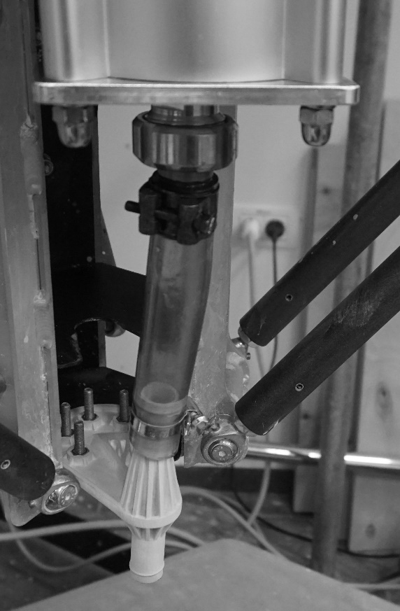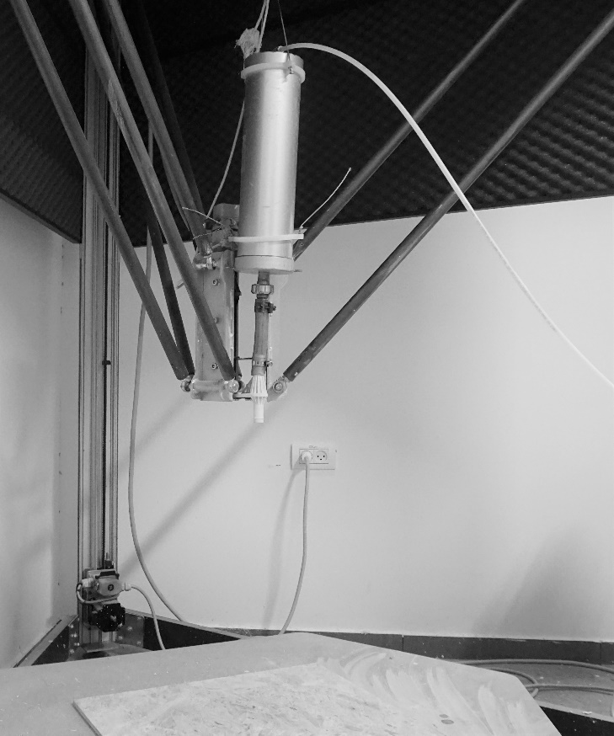

[2]

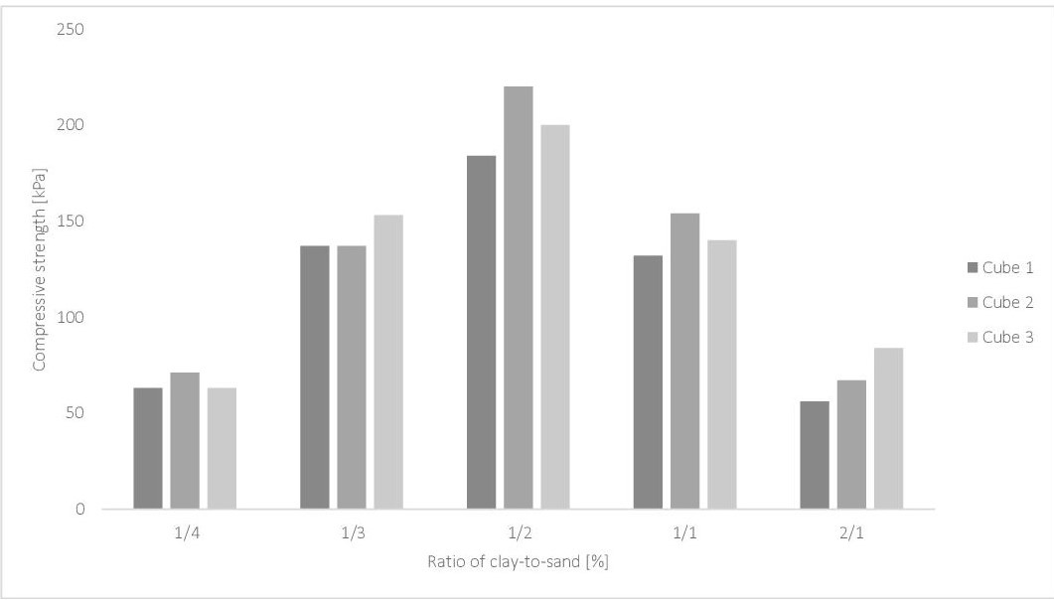

**[3]**

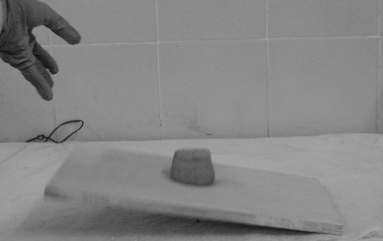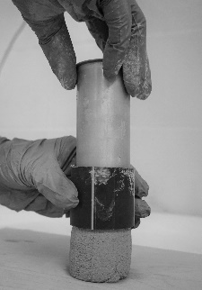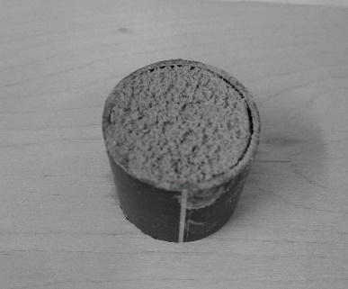

**[4]**

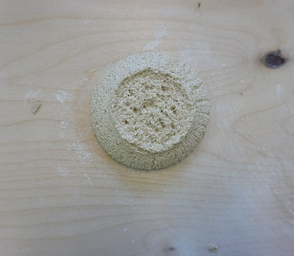

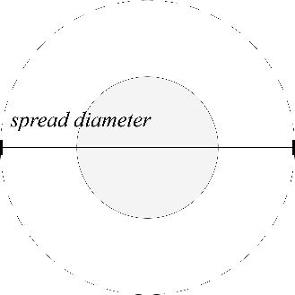

**[5]**

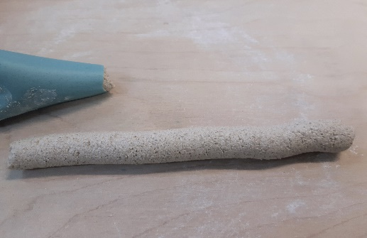

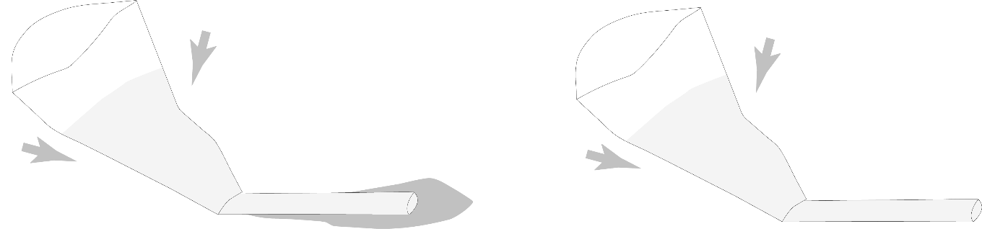

**[6]**

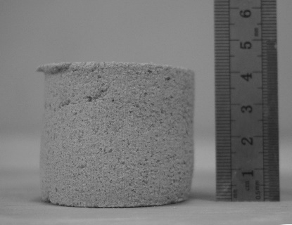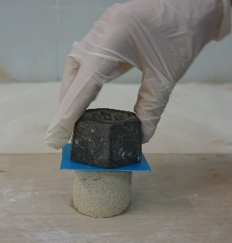

**[7]**

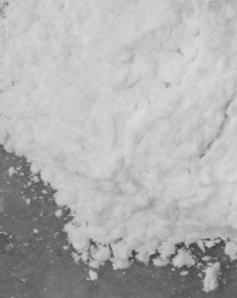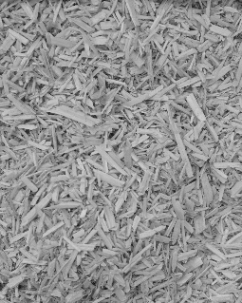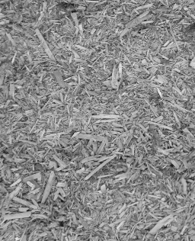

**[8]**

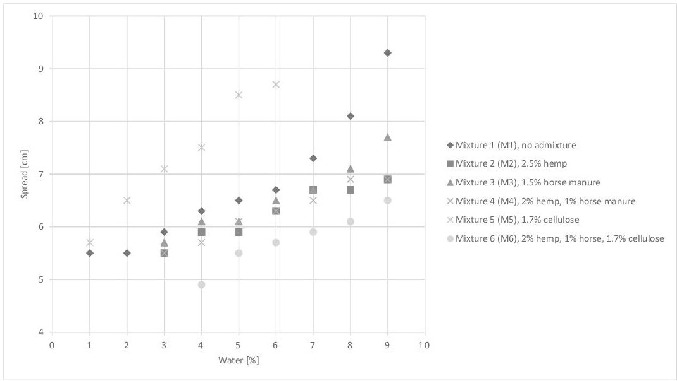

**[9]**

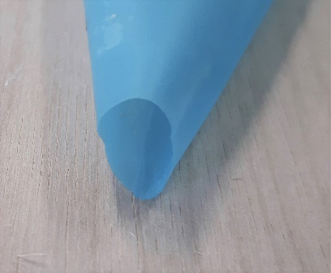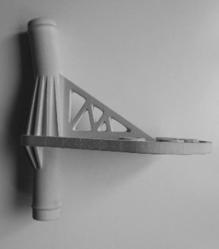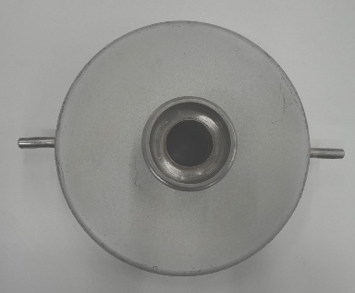

**[10]**

**[11]**

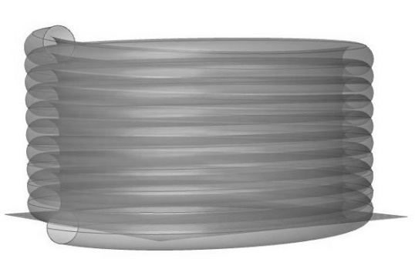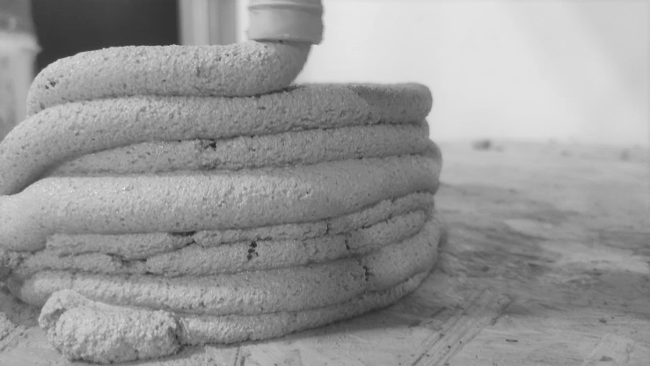

**[12]**

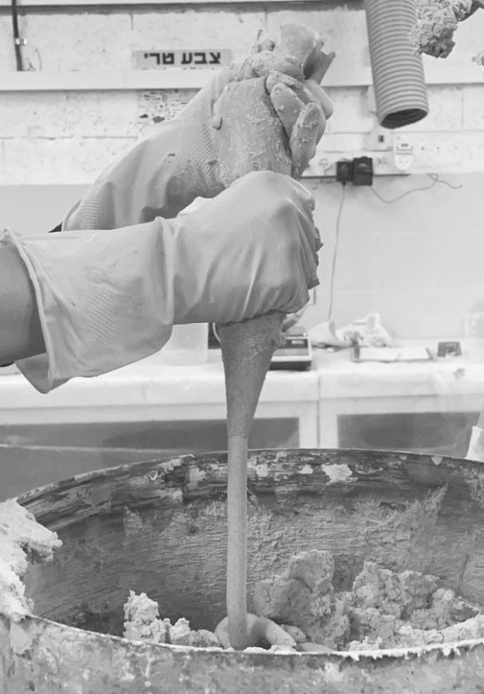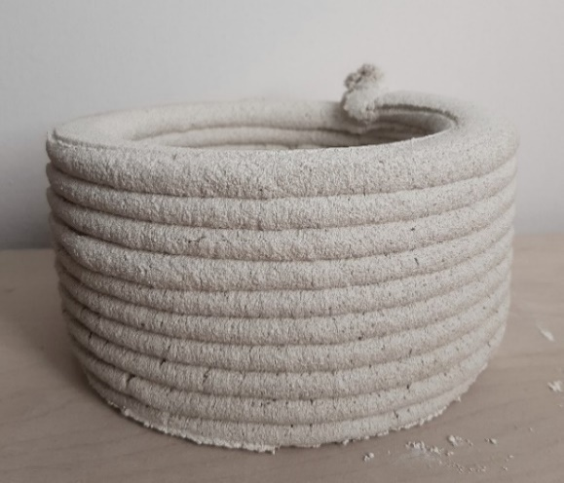

Figure 1. Printer set-up.

Figure 2. Investigating the optimal clay-to-sand ratio for compressive strength after three days of drying.

Figure 3. Left and centre: Preparation of sample; Right: Sample lifted on a wooden plate which is then allowed to fall.

Figure 4. Cylindrical sample used for evaluating workability.

Figure 5. Testing the material’s extrudability and pumpability via manual extrusion through a triangular bag. Left: Incorrect material (separating water indicates low plasticity); Right: Correct material (no separation of water).

Figure 6.1. Left: Applying weight to a sample; Right: Measuring the height of the tested sample after the weight has been applied.

Figure 7. Left: Fibres of horse manure; Centre: Fibres of hemp shiv; Right: Cellulose microfibres. The horse manure fibres are thin and flexible, while the hemp shiv fibres are thicker and more rigid.

Figure 8. Influence of water content on the spread of the mixtures.

Figure 9. Left to right: Opening of container (Ø = 1.8 cm); connection part and nozzle (Ø = 1.5 cm); triangular bag (Ø = 1.5 cm).

Figure 10. Comparison of green strengths of M1adjusted and M5adjusted sampleswhen loaded with 2 kg during the first 15 min of drying.

Figure 11. Left: Digital file cylinder (width Ø 16.5 cm, height 8.4 cm, 10 layers, computed layer distance 0.8 cm, layer’s width Ø 1.5 cm); Right: Failed printed cylinder using mixture M5 (1:2 clay-to-sand ratio + 1.7% cellulose microfibres).

Figure 12. Left: Testing material with triangular bag; Right: Good-quality printed cylinder with mixture M5adjusted (1:1 clay-to-sand ratio + 1.7% cellulose microfibres).