Course Book



## Public Health

**DLMGWPH01**

Learning Objectives

Introduction **11**



This **public health** course provides an overview of the most important principles undergirding the theory and practice of this multidisciplinary field: They deal with basic epidemiological, demographic, statistical, social-scientific, and economic working methods and are sensitized to the ethical aspects of public health issues. In addition, you will learn about the models that are used to explain health and illness and get acquainted with the individual, social, and environmental factors that influence health. In addition, the course provides you with specialist skills in the areas of disease prevention and health promotion. These will allow you to acquire the necessary tools to be able to analyze and evaluate the health situation of populations or population groups as well as to develop and critically evaluate solution strategies for practical public health issues.

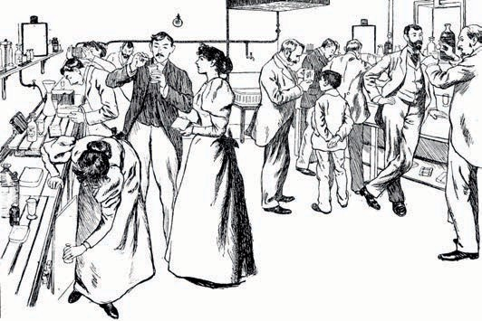

# Unit 1

## Basics of Public Health

#### Study Goals

After completing this unit, you will understand …

... what is meant by the term public health and what goals public health pursues.

… how public health has developed throughout history.

... which actors are involved in promoting the health of the population at national and international levels.

… why public health requires an interdisciplinary approach.

… why ethical issues must be considered when planning public health strategies.

… why the findings of health services research must be considered when assessing public health strategies.

DL-D-DLMGWPH01-L01

1. Basics of Public Health

### Case Study

Anja is studying health management, and she found an interesting article about John Snow (1813–1858) in the university library. John Snow worked on addressing crucial public health issues almost 200 years ago:

* Where do diseases come from?
* How do they spread through the population?
* How can they be avoided?

London was plagued by recurring cholera outbreaks throughout the 19th century. The extremely fast and fatal course of the disease struck fear in the hearts of the population: A cholera patient who got up in the morning without symptoms could die from severe, watery diarrhea within a few hours as it dehydrated the body. At the time, the medical profession believed that cholera was transmitted via bad vapors in the air. However, John Snow doubted this theory and traced all cholera cases on a street map of London. It struck him that most of the cholera cases occurred around Broad Street. There was a water pump there, from which the surrounding residents obtained their drinking water. John Snow suspected that cholera was caused by contaminated drinking water since there was no sewage system at the time and groundwater was often contaminated by feces. Through interviews, he found that all those who died of cholera had obtained their water from the Broad Street pump. He then had the handle of the pump removed and shut down the water source. Soon after, cholera cases decreased dramatically. However, his theory that cholera spreads through drinking water was not accepted by the medical community until after Snow's death (Barton, 2018).

### What is Public Health?

Public health seeks to …

* + - … maintain and promote the health of the entire population or of specific population groups,
    - prevent disease, disability, and death and
    - provide suitable preventive, curative, and rehabilitative services (Egger/Razum/Rieder, 2018a, p. 31).

In contrast to the specific problems of an individual patient and their medical care, public health focuses on the entire population’s health concerns and seeks to devise ethically and economically justifiable measures to solve the population’s health problems.

Basics of Public Health

Typical public health measures include, for example, vaccination programs, screening programs, educational campaigns, food safety and occupational safety measures, and public policy and laws such as a smoking ban in public spaces or mandating the wearing of seat belts (Egger/Razum/Rieder, 2018a, pp. 31 f.).

To understand the concept of "healthcare," we first need to define the term health. The best-known definition of health is contained in the preamble to the constitution of the **World Health Organization** (WHO). The WHO defines health as “a state of complete physical, mental, and social well-being and not merely as the absence of disease or infirmity. One of the fundamental rights of every human being is to enjoy the highest attainable standard of health irrespective of race, religion, political opinion, and economic or social position” (WHO, 2006, p. 1). Health is understood multidimensionally. The WHO definition has often been criticized as utopian due to its inclusion of the adjective "complete." Its great advantage, however, is that it forces us to adopt an integrative perspective: in addition to the aspects of physical health, we must also consider the mental, spiritual, and social dimensions of health. This is one of the main reasons why it is highly relevant to politics, to practical disease prevention, and to health promotion (Franzkowiak/Hurrelmann, 2018).

### Historical Development

When considering the development of the field over time, then we can divide public health into the separate periods of "old public health" and "new public health". The focus of "old public health" was on public hygiene and the implementation of measures to improve the living and working environments of the underserved and socially vulnerable population groups (Franzkowiak 2015, p. 1). In the 19th century, this included workers and their families in particular who lived in the cities in completely unhygienic conditions. Cramped living conditions, lack of sanitary facilities, and contaminated drinking water resulted in cholera epidemics and numerous cases of tuberculosis. Therefore, the reform efforts to improve the social and health situation of the working class included the very first public health measures such as improved sanitary conditions and the construction of water pipelines and sewage systems (Egger/Fenner, 2018, pp. 33 f.). This made a decisive contribution to the prevention of illness and the improvement of mortality rates among the population.

Research into the causes of disease was closely linked to the promotion of hygienic measures. The discovery of bacteria by Robert Koch (1843–1910) was a decisive step forward: In 1882, he successfully identified the bacterium "Mycobacterium tuberculosis" as the clear cause of tuberculosis. Neben der Bakteriologie lieferte die Sozialhygiene, die von Alfred Grotjahn (1869–1931) begründet wurde, einen

World Health Organization

The World Health Organization, which is based in Geneva, is a United Nations agency that monitors global health problems.

wichtigen Beitrag zur multikausalen Erklärung der Krankheitsentstehung. Grotjahn untersuchte die Bedeutung von sozialen Einflüssen wie Wohnverhältnissen, Ernährung oder Einkommen auf die Krankheitsentstehung (Egger/Fenner 2018, S. 35f.).

With the advent of "new public health" in the 1980s, the focus was no longer on just underserved population groups, but rather on the entire population. In addition to the question of the determinants of health and illness and how they are influenced by health promotion measures and healthcare services, questions concerning control over the health system and the monitoring of health expenditures also came into focus (Franzkowiak, 2015, p. 3). Challenges on a global level were also addressed.

### National and International Agents in Health Promotion

Auf nationaler Ebene trägt eine Vielzahl an Akteuren zur Gesundheitsförderung bei. Damit kommt zum Ausdruck, dass Gesundheitsförderung eine Querschnittsaufgabe dar- stellt, zu der unterschiedlichste gesellschaftliche Bereiche auf vielen Ebenen einen Bei- trag leisten können. So sind sowohl Institutionen des Gesundheitswesens als auch aus dem Sozial- und Bildungswesen sowie dem Arbeits- und Freizeitbereich an der Gesundheitsförderung beteiligt. Wie auch in der folgenden Abbildung zu sehen ist, lassen sich die Akteure hinsichtlich der Ebene, auf der sie agieren (Bundesebene, Landesebene, kommunale Ebene), und ihrer Trägerschaft (staatlich, halbstaatlich, nichtstaatlich) unterscheiden (Robert Koch-Institut 2015, S. 240ff.).

Basics of Public Health

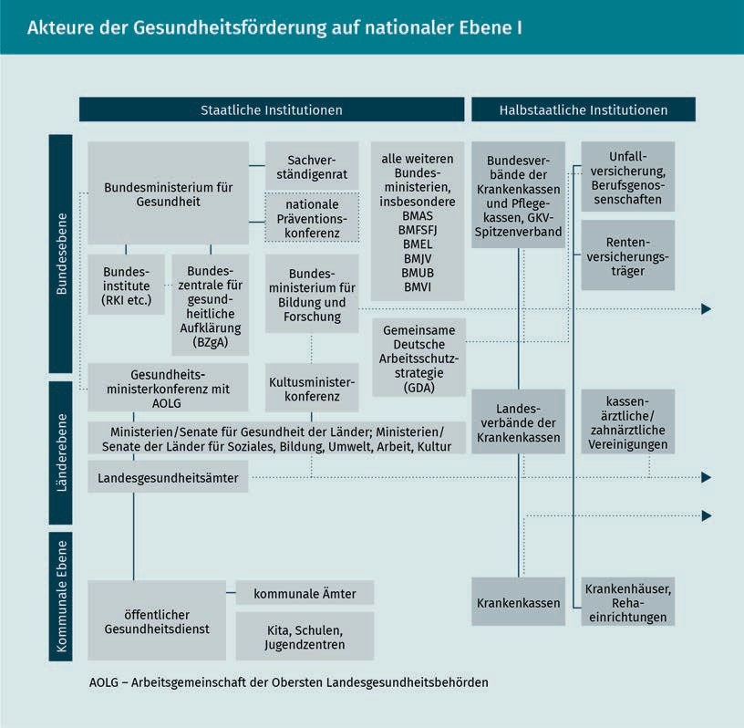

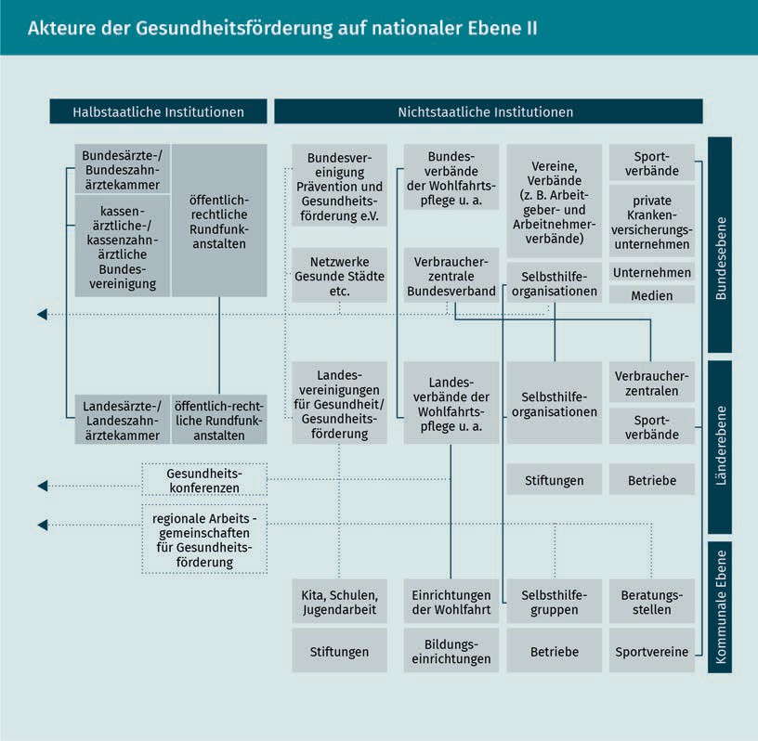

.

Bei den staatlichen Institutionen auf Bundesebene sollen kurz das **Robert Koch-Institut** (RKI) und die **Bundeszentrale für gesundheitliche Aufklärung** (BZgA) herausgegriffen werden. Das RKI stellt die zentrale Einrichtung zur Krankheitsüberwachung und -prävention dar und ist ein entscheidender Akteur auf dem Gebiet der biomedizinischen Forschung. Es berichtet in der Gesundheitsberichterstattung des Bundes (GBE) regel- mäßig über die gesundheitliche Lage der Bevölkerung in Deutschland. Dabei werden die Themen Krankheiten und Beschwerden, Gesundheitsverhalten, Risikofaktoren, medizinische und pflegerische Versorgung sowie Krankheits- und Versorgungskosten beleuchtet. Die Bundeszentrale für gesundheitliche Aufklärung (BZgA) erarbeitet Grundsätze zur praktischen Gesundheitserziehung und trägt zur Entwicklung und Umsetzung nationaler Aktionspläne und Programme bei. Hierzu zählen insbesondere die Prävention von Infektionskrankheiten und Suchtverhalten sowie die Förderung der Kinder- und Jugendgesundheit. Die BZgA erfüllt zugleich gesetzliche Aufgaben im Bereich der Sexualaufklärung und Familienplanung sowie der Aufklärung zum Thema Organ-, Blut- und Plasmaspende.

Basics of Public Health

A key agent at the international level is the World Health Organization (WHO). It is the United Nations coordinating body responsible for international public health. A declared goal of the WHO is to improve the health and well-being of all people. This is reflected, for example, in the WHO strategy “Health for All” (Egger et al., 2018, pp. 601 f.). The WHO's main focus areas are helping countries establish nationwide healthcare systems, providing information on health risks and problems, and coordinating activities to prevent communicable and non-communicable diseases, for instance, by launching vaccination programs. The WHO publishes the annual World Health Report on the state of global health and healthcare.

### The Disciplines of Public Health

Public health requires an interdisciplinary approach and draws on best practices and findings from various scientific disciplines. A distinction can be drawn between medical and scientific disciplines and the social and behavioral sciences (Hurrelmann/Laaser, 2003, p. 31). At the core of the medical and scientific tradition is epidemiology, which deals with the temporal and geographic characteristics of diseases and their risk factors. Another important field is biostatistics, which deals with statistical questions relating to medical care. The insights of this field are supplemented by social medicine, which sheds light on the connections between influential social factors (e.g., income and employment) and health outcomes in the form of illness and death, and occupational medicine, which focuses on work-relatedillnesses and their prevention. Environmental medicine investigates environmental influences on the health of the population, such as air or water pollution, while preventive medicine focuses on vaccinations to prevent infectious diseases or on screening programs for the early detection of chronic diseases (Egger/Razum/Rieder, 2018c, pp. 49 f.).

Medical sociology, demography, health psychology and pedagogy, health economics, health policy, organizational and management sciences, and ethics all fall within the social and behavioral sciences. Medical sociology deals with the social conditions as well as the causes and consequences of health. Demography considers population development and deals with the social effects of a changed population structure. Human experience and behavior are at the heart of health psychology and pedagogy. Health economics analyzes the economic impact of health and disease. Health policy deals with the institutions in the health system and the political framework for the provision of care. Organizational and management sciences focus on the processes and decisions within healthcare organizations. Ethics is concerned with questions of

.

good and right action: A key concern of ethicists is the fair distribution of scarce resources within the healthcare system (Egger/Razum/Rieder, 2018c, pp. 49 f.).

### Public Health Ethics

Public health ethics is a relatively new field of applied ethics that deals with ethical issues in public healthcare. The aim is to evaluate measures taken to monitor, control, and prevent diseases from a moral point of view to evaluate whether they are proper and to develop standards for good and correct action (Egger/Habermann-Horstmeier, 2018, p. 58f.; Kuhn/Wildner, 2018, p. 117).

An important basis for evaluating actions is consequentialist ethics, which considers them based on their consequences. An action is ethically justified if it leads to good consequences. Utilitarianism plays an important role within consequentialist ethics. Under this framework, a measure is considered justifiable if the resulting overall benefit is positive. This includes the possibility that an action may have adverse consequences for some people (Kuhn/Wildner, 2018, p. 118). We will return to this aspect when considering screening measures. From a population-related perspective, screening measures have the advantage of allowing diseases to be detected early and premature deaths to be avoided. Since they are designed to detect as many diseases as possible, screening measures are always very sensitive. This means, for example, that a test will be triggered even if there is only the slightest suspicion of illness. This also leads to false-positive test results, i.e., false alarms, which can entail a high amount of psychological stress for those affected until the results are further clarified on the basis of additional testing. This methodology raises the question of whether screening programs are unethical. From a utilitarian point of view, the answer to the question would be no, since the overall benefit for the population outweighs the concern about the stress it places on the individual.

The principles outlined by Beauchamps and Childress play an important role in medical ethics, as they provide key guidance for the actions of those involved in healthcare, nursing, and research (Beauchamps/Childress, 2001, pp. 57 f.). These are autonomy, beneficence, non-maleficence, and justice. In the area of public health ethics, the principles of interdependence, participation, and scientific evidence are also relevant (Egger/Habermann-Horstmeier, 2018, pp. 59 f.).

Basics of Public Health

|  |  |
| --- | --- |
| **Principles of medical and public health ethics** | |
| Medicine | Public Health |
| ***Respect for autonomy*** | ***Interdependence*** |
| Each person can make decisions freely. The patient must provide informed consent before receiving medical treatment or participating in a study. | A person's actions affect not only themselves, but other people as well. Each person is also affected by the actions of others. |
| ***Beneficence and non-maleficence*** | **Participation** |
| Harmful or risky interventions and treatments should be avoided. The treatment/study should promote the well-being of the patients or study subjects. | Public health measures are planned and implemented with the participation and consent of the affected population. |
| **Justice** | ***Scientific evidence*** |
| The principle of justice demands a fair distribution of health services as well as the risks and benefits of clinical research. | Decisions about public health measures should be based on scientific data and not on mere assumptions and opinions. |

The principle of autonomy states that the individual's freedom of choice must be respected. Each individual must be able to decide freely whether to participate in a measure or not. However, the principle of autonomy must be weighed against the principle of interdependence. This refers to the fact that the actions of the individual usually also have an impact on third parties. When considering this, a smoking ban in public places, for example, can be justified, since smoking not only has negative health effects on the individual smoker, but also on others through secondhand smoking. The principles of beneficence and non-maleficence call for promoting the well-being of people and preventing harm. These obligate the state to become active in the field of public health in order to ensure a healthy life for all

people. The principle of participation states that when designing public health measures, the wishes of those affected must be taken into account and, if possible, no measures should be implemented against the will or without the consent of those affected. The principle of justice demands that all people should have equal access to health services. When designing public health measures, care must be taken to ensure that these are not only used by those with better socio-economic and health statuses, and, therefore, that socio-economic differences in health status are not further aggravated. Finally, the principle of scientific support requires that only scientifically grounded public health measures be carried out (Egger/Habermann-Horstmeier, 2018, pp. 59 f.).

### The Need for Health Services Research

Scientific findings are essential for establishing a needs-based orientation for healthcare. Health services research plays a special role here. Health services research examines the structure and performance of healthcare offerings and assesses them based on the criteria of availability, accessibility, and benefit (Egger/Razum/Rieder, 2018c, p. 51). The focus here is on evaluating the effectiveness of healthcare structures and processes under everyday conditions. This type of research does not evaluate an intervention on the basis of an isolated criterion, as is the case of clinical studies. Rather, it assesses the effectiveness of the intervention when integrated into day-to-day healthcare processes and

structures. Based on these findings, existing healthcare concepts can be further developed or new approaches for care can be designed, tested in everyday healthcare situations, and, if the evaluation is positive, permanently incorporated into everyday practice (Pfaff, 2003, p. 13).

Health services research uses the throughput model to provide a systematic analysis and description of the healthcare system.

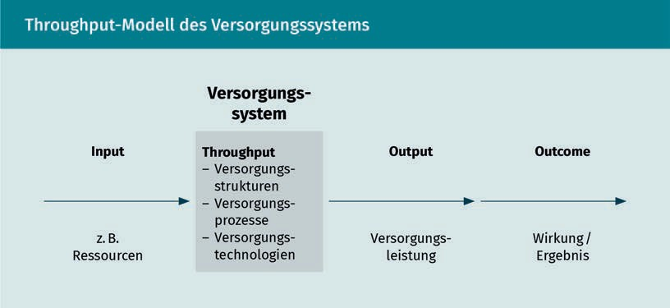

Basics of Public Health

Accordingly, health services research considers the following aspects of the healthcare system (Pfaff, 2003, pp. 16 f.; Schwartz/Busse, 2000, pp. 409 f.):

* The term input identifies factors that influence the healthcare system. These include, for example, financial resources, human resources, and material equipment, but also the state of health of the population to be cared for or organizational and system structures such as the distribution of assignments between the professional groups involved in providing healthcare.
* The term **throughput** summarizes organizational, diagnostic, therapeutic and nursing structures, processes, and technologies. The aim of the throughput analysis is to shed more light on the healthcare process. In order to do this, healthcare processes are examined, whereby the utilized healthcare technologies and the setting are reviewed for their adequacy in meeting current needs.
* The term **output** describes the short-term outcomes of healthcare immediately after the use of such services.
* The term outcome refers to medium- to long-term health results, which we are interested in. These represent the decisive evaluation criterion that can be used to answer many questions, but they can only be determined with a temporal delay. Medical-clinical parameters, such as survival rates, quality of life, and patient satisfaction, are used as indicators to measure the outcomes.

**Summary**

Throughput

This concept considers healthcare processes with their basic conditions.

Output

This concept describes the outcomes of healthcare that can be directly observed.

Public health focuses on the health situation of the population and aims to promote and maintain its health using appropriate measures.

The beginnings of public health can be traced back to the 19th century. Thanks to the introduction of public hygiene measures, such as the construction of sewers and water pipelines, the search for the underlying causes of illnesses, and the introduction of a range of health promotion programs and appropriate healthcare services, the population has benefited from continuous improvement of their health over the years.

Health promotion is an interdisciplinary task that requires the cooperation of a diverse range of agents from the healthcare, social services, and educational systems as well as from the employment and leisure sectors at national and international levels.

The disciplines on which public health is based are just as diverse as the agents involved in health promotion. Best practices from the medical and natural sciences as well as from social and behavioral sciences are used to plan and evaluate public health strategies.

In addition, ethics play a crucial role in the moral evaluation of measures used to monitor and prevent diseases. It is important to take into account the individual's freedom of choice, the impact of individual actions on third parties, and the benefits and risks of measures from a scientific and social point of view and in light of a fair distribution of benefits.

This process requires findings from health services research that consider the structure and performance of the range of available healthcare services as well as their accessibility and use by the population in everyday conditions.