COURSE BOOK



## Global Supply Chain Management

**MWCH01**

### Learning Objectives

###### Introduction **9**



A significant consequence of the intensification of international economic relationships created by so-called “globalization” is reflected in the fact that competitive processes are now being encountered less between individual companies but are becoming a more prevalent occurrence between so-called “global value-creation chains” or supply chains.

The **Global Supply Chain Management** course imparts knowledge about the goals and motives behind the development of globally operating value-creation networks. Systematic typologies, strategically relevant issues, and configuration options in the area of Supply Chain Management (SCM) are explained and developed in order to convey the magnitude and complexity of the subject. This provides the opportunity to present the particularly pertinent instrumental categories of SCM.

During the course, you will use this foundation to learn about the modes of action and problem areas associated with cross-company (global) value-creation networks, and you will obtain answers to questions on common strategic elements.

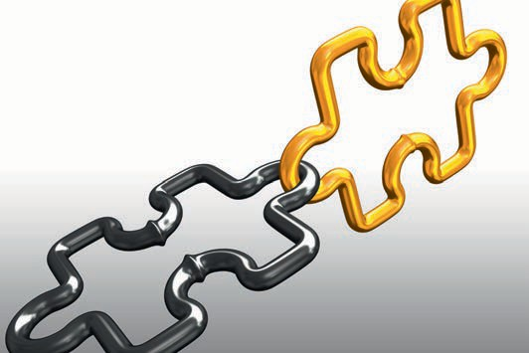

# Unit 1

## Motives and Effects of Logistical Value-Creation Networks

##### STUDY GOALS

After completing this unit, you will know ...

… why Supply Chain Management is becoming increasingly important.

… how Supply Chain Management is defined.

… how to distinguish Supply Chain Management from Logistics Management.

... which motives and effects exist in logistical value-creation networks in the context of Supply Chain Management

DL-D-MWCH01-L01

### Motives and Effects of Logistical Value-Creation Networks

#### Introduction

Increasingly globalized and liberalized markets are experiencing a rapid rise in competitive pressure. Harmonization and deregulation activities are being implemented across the EU and globally, in order to relieve the strain on national budgets when times are difficult. A further reason for this increase is that fewer regulations help to promote competition, and companies work more innovatively in order to maintain their market position. These innovations, in turn, result in an increased willingness to invest within companies as well as in the creation of new jobs and more efficient working methods.

A simultaneous increase in customer power is also experienced, as the opening of new markets offers greater choice and more purchasing alternatives. Product life cycles are shrinking due to rapid technological sequencing and increased market saturation. New forms of information technology are contributing to the increasing creation of virtual marketplaces, with even the smallest providers selling their products via online shops. Customer requirements are increasing at the same time, which can again be attributed to customers being better informed and organized through new media.

The development of global strategies is essential to enable producers and service providers to meet increasing consumer requirements. In particular, this requires intensive collaboration, which can be achieved through the creation of intelligent logistics processes. This means the activities performed by production and/or sales companies are linked, and suppliers and customers are incorporated into their systems. Cost and quality indicators must be kept up-to-date and remain transparent at all times in these systems, in order to ensure efficient process control.

This calls for a holistic logistics management system that goes beyond the mere optimization of transport routes, which is precisely where Supply Chain Management comes in to play: a basic structure is developed in process form, which not only encompasses the actual transport routes, but also covers supply and disposal strategies, and provides a uniform controlling system for all participants in the process chain (Thaler 2011).

Strategies and principles relating to Supply Chain Management were developed by consultants Jones and Houlihan as early as the 1980s (1985), with practical implementation having been influenced by Oliver and Webber (1992). As in the case of theory and practice, the value system applied to SCM was also shaped by numerous consultants, scientists, and managers, predominantly from the USA and England, in the 1980s and 1990s.

However, any form of uniform “schooling” has not existed. The definition of Supply Chain Management varies significantly across specialist literature. Towill regards it as “a chain of systems for order processing” (1996, p. 15 f.), while Fisher describes it as “a link to the customer that connects production with end customers, i.e., a sales channel” (1997, p. 105 f.) According to Harrington, SCM is a “map showing the combined

Motives and Effects of Logistical Value-Creation Networks

flow of material and information” (1995, p. 30 f.) Stevens (1989) states that “The scope of the supply chain begins with the source of supply and ends at the point of consumption” (p. 3).

The approach adopted by Ellram and Cooper, which states that SCM describes the linking of value-creation processes, has gained wide acceptance (Wildemann 2010). In Germany, the first production companies began to implement Supply Chain Management in the early 1990s.

In recent years, the number of surveys, analyses, and academic publications focused on SCM has risen significantly which demonstrates the increasing importance of SCM. Today, Supply Chain Management is an important concept of practical business administration.

#### What does Supply Chain Management Mean?

Supply Chain Management means that integrated logistical chains (the flow of money, information, and material) are developed, managed, controlled, and monitored across the entire value-creation process. This extends from the extraction of raw material and production activities to the various refinement stages and delivery to the end consumer. For this reason, Supply Chain Management is also referred to as the theory of value chains or value chain management.

Supply Chain Management means that processes are configured across a multi-tier logistics network, which ensures that end customers or points of sale are optimally supplied with goods, products, or services. In addition to physical supply, Supply Chain Management also ensures the integration of management processes for the related flow of money and information.

A regular exchange of (planned) data between all participants in the process chain ensures that the procurement, production, and sales plans generated within the different process stages are coordinated on an ongoing basis. This allows any problems to be tracked down immediately and enables the introduction of appropriate countermeasures (see the following figure).

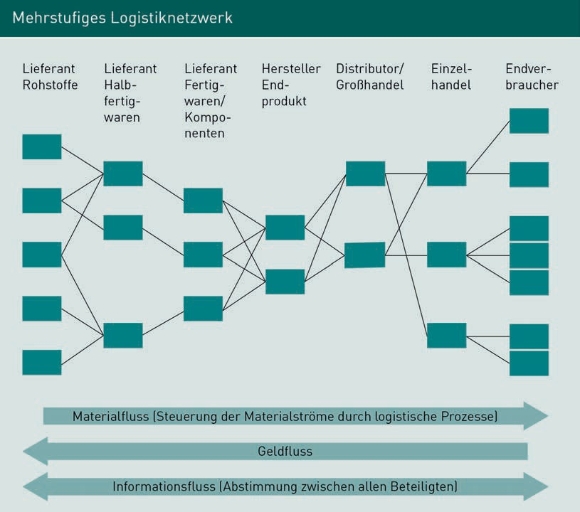

#### What is Logistics Management?

Logistics Management is concerned with the transport of goods as well as the auxiliary and operating materials, raw materials, packaging materials, and all other associated physical goods required for production. It serves to ensure the core task of logistics, which is traditionally defined in accordance with Plowman’s “Seven Rights definition”:

“Logistics means ensuring the availability of the right goods, in the right amount, in the right condition, at the right place, at the right time, for the right customer, at the right costs” (Plowman 1964, quoted from Chankov et al. 2014, p. 596).

The key basis for fulfilling this task is a process-oriented logistics chain that is aligned with the corporate strategy.

Strategic Logistics Management is used, where necessary, to make structural changes to process flows, for the purpose of optimizing the process chain and thereby actively ensuring the company’s success. Strategic

Motives and Effects of Logistical Value-Creation Networks

Logistics Management undertakes planning and forecasting with the aim of ensuring that strategic corporate goals are achieved in the medium and long term, while Operational Logistics Management ensures that the physical implementation of logistics processes runs smoothly, logistics costs remain within the expected range, and coherent quality indicators are available. The aim is to achieve a high level of customer satisfaction by delivering on time and in the right quantity.

Distinguishing Logistics Management from Supply Chain Management

Logistics Management differs from Supply Chain Management in that it deals with the tasks performed by a logistics coordinator (shipping manager, manager of a business unit in the areas of procurement or distribution, logistics manager, or other comparable role) as well as logistical situations. Supply Chain Management, however, additionally incorporates a holistic view of the company – an element that is crucial and far exceeds logistical tasks.

Monitoring the interfaces that exist within logistics is a vital component of Supply Chain Management. These interfaces can include Production, Sales, Purchasing, Human Resources or even Controlling. Interfaces within the logistics chain are also a key focus area, however, and refer to all discontinuities in the flow of material. These discontinuities entail interruptions of the material flow and incur costs since they require certain actions. These actions can include storage to bridge the time until the respective product/raw material is required or transport, i.e. the bridging of space, in order to transport the goods to the required place.

These actions that become necessary as the material flow is disrupted and segmented by interfaces facilitate internal and external division of labor. The exchange of services and goods via interfaces must be initiated, agreed upon, managed, controlled and, where applicable, adjusted for the future.

#### Service Providers in the Supply Chain

In order to assess the performance of companies in the logistics sector (logistics provider) with regard to their role in Logistics Management or Supply Chain Management, they are divided into different categories, ranging from first-party to fifth-party logistics providers. This categorization is described below.

1PL – First-Party Logistics Provider

This term dates back to the 1970s, when manufacturing companies undertook services themselves under the umbrella of Transport, Transshipment, and Warehousing (TTW), hiring their own commercial staff for this purpose. Many companies set up a dedicated vehicle fleet and single-handedly transported the goods they produced

on national and international roads. If other modes of transport were required, the transport would be outsourced, i.e. undertaken by a transport service provider (railway, shipping company, airline).

2PL – Second-Party Logistics Provider

Lean Management Lean Management is concerned with the design of efficient value-creation chains in the production and distribution of industrially manufactured

goods.

Cost-Benefit Sharing

(CBS)

These are procedures for implementing process change projects in

networks.

In the 1980s and 1990s, many companies eliminated their dedicated vehicle fleets, minimized the number of commercial staff, and outsourced TTW services to freight carriers, warehouse companies, package delivery companies, and freight forwarding companies as part of the **Lean Management** program, in a bid to reduce costs.

3PL – Third-Party Logistics Provider

The term 3PL (also “system service provider” or “contract logistics provider”) describes a company that offers transport services as its core area of expertise (formerly 2PL) and has expanded its service portfolio to offer customers additional services (also known as “value-creation services”) that are either directly or indirectly related to the actual transport. These services include document processing for cross-border transportation, warehouse management (picking, processing of customer orders, inventory turnover and management), consignment tracking and tracing, or assisting with logistics planning.

This type of cooperation usually involves long-term contractual commitments in which 3PL providers have considerable leeway and assume responsibility for parts of the value-creation chain.

4PL – Fourth-Party Logistics Provider

This term was coined by Accenture (formerly Anderson Consulting) in the mid-1990s and refers to a network integrator operating on a neutral level, who coordinates the capacities of the individual partners involved in Supply Chain Management, decides on the use of external service providers, and issues them with corresponding orders. The 4PL uses transport, warehousing and information technology as needed by the members of the supply chain and is additionally responsible for **Cost-Benefit Sharing** among those.

If no external service provider is appointed as 4PL, the associated tasks described are undertaken by a dominant partner in the supply chain (manufacturer or retailer, for example). In such cases, the service provider is referred to as a system integrator.

Motives and Effects of Logistical Value-Creation Networks

5PL – Fifth-Party Logistics Provider

The approach taken by 5PLs is to expand and coordinate individual supply chains in order to develop them into supply networks. 5PLs often emerge from e-commerce business and offer their customers a strategic logistics approach, in which they also take on the conceptual development of the network.

To assist them in this conceptual development, these service providers draw on the latest technologies in the field of simulation and forecasting tools, which not only serve to determine the flow of goods but also the utilization of existing capacities. All relevant points in the value-creation chain can be recorded, from the simulation of costs and vehicle schedules through to slot allocations (time of arrival and/or delivery) and quality measurements.

While the general assumption is that Logistics Management is predominantly employed among first-party to third-party logistics providers, the Supply Chain Management approach is integrated into conceptual developments from 4PL onwards. The value-creation chain is viewed holistically with the aim of reducing costs associated with the flow of goods, money, and information – preferably through the generation of synergy effects – and expediting processing.

#### The Importance of Supply Chain Management

For many companies, implementing Supply Chain Management on a practical level is problematic, with differences often being encountered between theoretical approach and practical implementation. Although the Supply Chain Management approach is often equated with Supplier Management in everyday language, the latter is, in fact, only a very small part of the value-creation chain that needs to be considered.

The process orientation of SCM can lead to conflicts with existing operational or function-oriented organizational structures, which, in many cases, are not directly involved in the SCM process and therefore do not view this as a requirement, but must consistently support changes in corporate culture or strategic orientation that are attributable to SCM. It is essential that change effected by Supply Chain Management within the company is appropriately coordinated and communicated so that the individual requirements can be implemented.

Supply Chain Management has played an increasingly important role since the 1990s. According to studies conducted by the University of St. Gallen (Institute of Technology Management) (Corsten/Gabriel 2004), medium-sized companies are also convinced of the necessity and benefits of cross-company optimization along the entire value-creation chain as a means of remaining competitive and continuing to achieve commercial success in the future.

According to the study, more than 70 % of the companies with more than 2,000 employees already have an interdisciplinary team responsible for optimizing the value-creation chain. In addition, almost 60 % of medium-sized companies in Germany with fewer than 500 employees have nominated responsible employees whose tasks include Supply Chain Management.

**Summary**

The development of global strategies is essential to enable producers and service providers to meet increasing consumer requirements. Globalization and growing customer power are rendering optimal logistics increasingly important as a selling point and customer retention tool.

The use of Supply Chain Management as a control instrument for optimizing the value-creation chain leads to potential savings through synergy effects and optimization measures at interfaces as well as through the harmonization and coordination of processes across corporate boundaries.

It is necessary to create a "win-win situation" that motivates all partners in a value chain to cooperate permanently within the framework of supply chain management.

This is the essential prerequisite for tapping long-term synergy effects and the savings potentials that are aimed for, and for improving customer satisfaction, which is essential for the long-term success of the company.



# Unit 2

## Typologies of SCM and Configuration Models

##### STUDY GOALS

After completing this unit, you will know ...

… which SCM typologies exist.

… how an SCM strategy is configured.

… which tools and instruments are used in SCM configuration.

DL-D-MWCH01-L02

### Typologies of SCM and Configuration Models

#### Introduction

According to Bechtel/Jayaram (1990), various schools of thought have developed within Supply Chain Management theories, which view the definition of SCM from different perspectives.

1. The Chain Awareness School deals with the supply chain from the extraction of raw materials through to the delivery of the finished products to the end user.
2. The Linkage School focuses on the logistical connections and relationships between the various organizations involved in a supply chain.
3. The Information School is concerned with the bidirectional flow of information between the various players. On this subject, Bowersox et al. wrote: “In the information or digital age, the reality of connectivity among collaborating business organizations continues to drive a new order of relationships called supply chain management” (Bowersox et al. 2020, p. 23).
4. For representatives of the Integration School, Supply Chain Management is transformed into an abstract process and system view, from which the subprocesses and main processes are analyzed. This model is regarded as particularly transparent because, in addition to the process view, the individual requirements of the individual SCM can also be added at a later stage.

These different approaches result in different supply chain strategies, which are examined in more detail below.

#### Supply Chain Strategy

Supply Chain Strategy means that all performance features, which the supply chain under development is to be characterized by at a later stage, are strategically planned and defined in a company. The aim of efficient supply chains is primarily to reduce waste and utilize production in a cost- and capacity-oriented manner so that there is a high and uniform level of production.

The centralizing of warehousing plays a key role in this. In conjunction with internal transport systems, this ensures that a delivery service is provided at the lowest possible overall cost, and can thus guarantee, for example, optimization of the delivery service between the individual internal warehouses, from production and the central warehouse through to delivery to retail. Both push and pull systems can be used to control the supply chain.

As a rule, process flows are controlled on the basis of the pull or fetch principle. The pull principle is a term from Lean Management. In production processes, the product is “pulled” through the process, from raw material through to completion.

Typologies of SCM and Configuration Models

This procedure generates a flow of information that runs in opposition to the flow of material. Upstream positions are informed respectively when the preliminary product they are to create has been used up by downstream production and therefore needs to be replaced.

In the case of the push or bring principle, the order is “pushed” through the process chains, i.e. always on the basis of planning data and scheduling.

Various business functions are interlinked in Supply Chain Management. These involve the flow of money, information, and goods, both internally and from external areas (suppliers and customers). The Supply Chain Strategy is based on company goals and is defined on a long-term basis by company management.

The first step is the Supply Chain Design phase. Using corporate goals (such as location planning, outsourcing options, expansion) as a foundation, strategic planning of the required supply chain takes place in accordance with market and product requirements.

The design phase is followed by tactical Supply Chain Management, also known as the planning phase. The strategic approach has already been chosen and project planning takes place within the framework of a time agreement.

The operational phase is the third and final phase. The requirements of phases one and two are implemented in day-to-day business, meaning that the company’s employees process existing orders on the basis of strategic requirements. A more detailed description of the specified three phases can be found in Unit 4.1.

In strategic planning, a distinction is made between an intracompany and a company-integrated supply chain.

Intracompany Supply Chain

In the intracompany supply chain, an upstream step or production area always supplies a downstream area. In an internal or inner supply chain, this point of reference is determined by the vertical manufacturing range of the manufacturing company. The more pronounced the vertical range of manufacture within the company, the longer the internal supply chain.

The following figure shows an internal supply chain using vehicle assembly as an example:

Parts are purchased from pre-suppliers and placed into storage. Picking is carried out on a needs basis, which makes the required materials available for pre-assembly. The pre-assembled components are taken to an interim storage facility before being forwarded to final assembly and then shipped on completion.

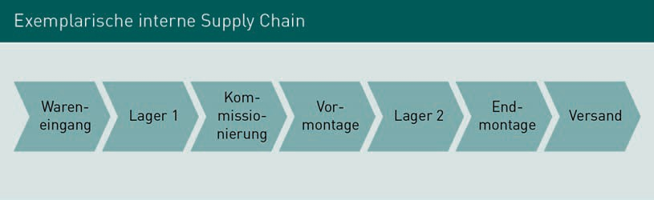

Within this supply chain, value creation increases from one assembly stage to the next. The physical flow of goods runs in one direction only.

Company-Integrated Supply Chain

By contrast, the company-integrated supply chain is a network-oriented supply chain. All organizations participating in the supply chain are closely interlinked. If we assume that a production company is at the heart of the supply chain, then this will not only involve all suppliers, but also their respective suppliers and customers, and then their customers in turn. All activities relating to the product are incorporated into the integrated supply chain.

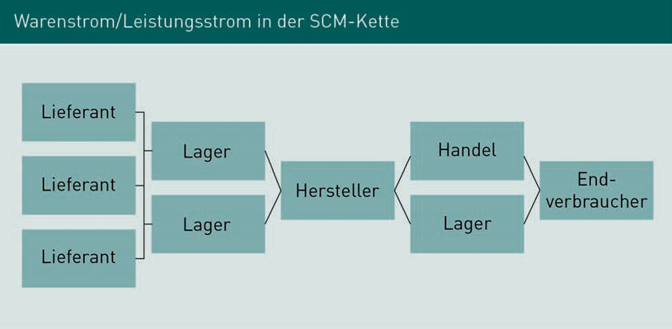

The physical flow of goods/services also runs in one direction here, namely from the supplier to the end user. The supply chain not only involves internal participants, however, but also external participants.

One feature shared by both the intracompany and company-integrated supply chain is that they basically follow the “Order-to-Payment-S”. This is a process chain model which focuses on the continuous flows of the individual process chains (Klaus 2002, p. 104). A distinction is made between three areas:

Typologies of SCM and Configuration Models

The flow of information runs upstream and is plotted from right to left during its progression. If the customer places an order (“pull”), a scheduler organizes the interfaces, and delivery coordination and fine tuning is controlled for each order. Controlling takes place via the IT system and simultaneously generates the KPIs (key performance indicators) for all other business areas involved in order creation. The responsible scheduler compiles the relevant information in the IT system and all interface areas – such as Purchasing for raw material replenishment, the Finance Department for accounting data, and Warehouse Management for picking processes – are informed accordingly.

The physical flow of goods runs downstream and is plotted from left to right. As previously described, value is created with each production step. Within the supply chain, each production process is replenished from an upstream station. The focus here is on executing the order in a timely manner in order to satisfy the customer’s request. The flow of money, in turn, runs upstream, and is controlled from the flow of information.

The product of the above-mentioned interlinked process flows is the

“Order-to-Payment-S”.

#### Tools for Supply Chain Strategies

Tools are defined as tried-and-tested techniques that serve as aids for achieving strategic goals. In the conception phase of a supply chain strategy, the individual supply chain tools and corresponding strategic approaches are considered first. The contents of supply chain tools are identified and assessed. As the orientation of the supply chain determines the tools, and vice versa, there can be no segregation between strategy and tool from the start. Chandler’s “form follows function” principle (Chandler 1962), which applies to many other strategic decisions, is overruled here.

If we consider inventory management, a key component of the supply chain strategy may be to reduce inventory, for which a wide variety of tools can be used: stock cover monitoring, decomposition, consignment analysis, analysis of stock transfer frequency, running time analysis, and setup time analysis. In freight cost reduction, machine-based freight costing or milk run approaches can be applied, with the addition of benchmarking or Reverse Engineering.

Quality assurance uses tools and measures to translate customer requirements into development goals such as Effects Analysis, Quality Function Deployment, and Bottleneck Engineering.

Inventory reduction, freight cost reduction, and quality assurance can therefore constitute factors for success in a supply chain, which, in most cases, is closely associated with IT support.

#### Inventory Reduction in Warehouse Management

As part of the inventory reduction of stored goods, high capital commitments are released and a direct reduction in costs is achieved. However, this point in particular can lead to a so-called conflict of goals, as security of supply in the supply chain must generally be guaranteed. “Out of stock situations” must be avoided at all costs. Due to the dovetailing of all participants, this situation is ruled out in the integrated supply chain, as all parties are working toward common goals. An optimal stock quantity must be identified to prevent the reduction in storage costs leading to an increase in shortage costs. Shortage costs arise when the required materials are not available and may have to be replaced by substitute goods. In addition, shortage costs also arise if time discrepancies are involved in the delivery of required substances and materials, which may lead to a production stoppage. Image and reputation losses caused by time-related shortage costs are also incorporated.

The above statements show that storage costs play a major role in realizing rationalization potential, but close examination of the effects is required from a strategic perspective.

#### Reduction of Freight Costs Under the Transport Cost Policy

In freight cost reduction, inventory costs are weighted against freight costs. The reason for this is that, in order to avoid production bottlenecks, either an average to high stock level of the required goods must be available or a correspondingly higher number of shipments is required in order to ensure supplies for production. Corresponding forecasts and simulations must be generated in order to optimize costs by reconciling both points. This is often outsourced to 3PLs or 4 PLs by operators of internal supply chains, as they have the tools and experience to calculate delivery frequencies, including freight costs, for each specific consignment using appropriate simulations. Seasonal peaks and many other elements are also taken into account. An efficient reduction in freight costs can be achieved by handing over the coordination of storage and transport to a transport network operator, as extensive synergies are realized through a combination of transport methods and a uniform tariff network.

One example of how to achieve synergy effects is the milk run (milkman principle), a special logistical feature of procurement logistics, which refers to the route-optimized transport of goods based on a specific route system. Collection, transit, and delivery times are meticulously defined in advance on the same basis as a schedule. The goods are either transported from one supplier to several recipients, or goods from various senders are

Typologies of SCM and Configuration Models

consolidated for one recipient and delivered together. In addition to pure transport, packaging materials, loading equipment, and similar, are taken over and disposed of as necessary as further services. As a result of the optimized planning, the transport units are utilized to their full extent and the client receives the best possible freight cost rate.

This makes the milk run a simple, fast, and ecologically viable method of optimizing transport and inventory: quick collection results in an increased turnover rate and thus in rapid emptying of the warehouse. The capacity utilization described above and the return of **packing materials** leads to a significant reduction in the number of empty miles and a lower personnel requirement in the transport sector.

Optimized milk run systems include between two and ten suppliers, but involve three to four on average. It is crucial that the route is structured sympathetically to the geographic location of the suppliers. This principle is often applied in the automotive industry, resulting in “just-in-time delivery”. Milk run transport is usually billed using a standardized credit note procedure, which, in addition to the reduction in freight costs, also leads to a reduction in administrative effort.

#### Efficient Replenishment

Efficient Replenishment also focuses on achieving an optimal balance between warehousing and operational costs and maintaining a high level of service. In German, this method of supplying goods efficiently within a supply chain is also referred to as “ongoing replenishment” or “continuous supply of goods”. This involves producing and distributing goods in step with demand on the basis of current stock data using the just-in-time principle. As the customer instigates delivery of the goods according to demand, a pull system is at work here.

Efficient Replenishment methods not only optimize the supply chain, but also the availability of goods and commodities at the point of sale (POS). A close cooperation between industry, logistics and retail is essential for achieving this goal.

Continuous Replenishment

Continuous Replenishment Processes (CRP) can also be assigned to the Efficient Replenishment methodology. In traditional supply chains, orders are placed by retailers when new goods are required. CRP is not a retail-driven process, but a process based on partnership. Based on sales and stock information transmitted promptly by retailers via EDI (Electronic Data Interchange),

Packaging materials

= packaging materials

Joint Forecasting Order forecast created jointly by producers and retailers to determine the anticipated quantity

requirements

and the use of **Joint Forecasting**, the manufacturer replenishes stocks accordingly for retail: deliveries are made automatically based on certain parameters, resulting in an accelerated process chain and greater flexibility.

This principle not only works in the retail sector but can also be applied to supply chains in which suppliers interact with manufacturers. In this relationship, the supplier (e.g. suppliers of packaging materials or raw material suppliers) is responsible for providing the required raw materials or packaging materials to meet demand. This requires an optimized, partnership-based exchange of information between all participants in the supply chain.

Cross-Docking

An important element of Efficient Replenishment is so-called Cross-Docking. Cross-Docking “describes a distribution-based logistics activity that typically takes place at a special location in the logistics channel between manufacturer and individual retailer, and takes account of the flow or just-in-time principle with a rapid throughput rate (Kotzab 1997, p. 156).

In other words, with Cross-Docking, raw materials, packing materials, or other goods are delivered to a specific transfer point (this can take the form of a picking warehouse, logistics center, or similar), where they are pre-picked. Actual storage of the transported goods is rendered superfluous as deliveries to the recipient are precisely coordinated. As a result, a reduction in inventory costs and associated activities, and a reduction in operational transport costs is also achieved with Cross-Docking, as the consolidation of goods flows to one recipient produces considerable synergy effects. Furthermore, the flow of goods is accelerated, as the turnaround time for goods in the warehouse is vastly reduced due to a rapid turnover.

Vendor Managed Inventory

Another method of Efficient Replenishment is so-called Vendor Managed Inventory (VMI), where the responsibility for scheduling and thus for stock is transferred from the recipient (producer or retail company) to the supplier. The ongoing supply of goods is thus ensured in a coordinated process based on current demand – be it by the consumer (in retail) or by processing (in production). Appropriate IT networking plays a key role in all VMI models.

Several concepts exist: in Continuous Replenishment, the supplier physically logs his goods at the customer’s premises at specified intervals. The data determined in this manner is then used to replenish any shortages. This method of recording is used, for example, as part of the delivery of semi-finished goods that are required for production.

Typologies of SCM and Configuration Models

In VMI, as the name suggests, consumption and demand are essentially determined by the customer. In a retail environment, this can be implemented using cash registers, for example, that log the current sale with an IT system, which in turn transmits the data received electronically to the suppliers and triggers a delivery to meet demand without an explicit (active) ordering process being carried out by the retailer.

In industry, the manufacturer calculates his consumption on the basis of certain parameters (one of the best-known pull systems is the **KANBAN principle**) and passes this data on to his suppliers, who determine the requirement and arrange subsequent deliveries using previously defined processes, without an active order being placed by the customer.

The Consignment Inventory is a form of VMI in which the supplier/manufacturer is the veritable owner of a customer warehouse and is responsible for supplying goods in line with demand.

The use of VMI methods is advantageous to the supplier because transport is optimized and transport costs are reduced purely as a result of larger quantities being delivered or accepted. However, there is also a simultaneous increase in responsibility in the context of requirement-based scheduling, and care must be taken to avoid out-of-stock situations.

The advantage for buyers is that they receive more cost-effective lot sizes due to consolidated deliveries, and inventory costs are very low as deliveries are made in line with demand.

Nevertheless, VMI models may not be applicable to an entire range or the whole of production. In retail, special promotions normally call for a separate ordering process and autonomous stock monitoring (for example in the case of limited special offers or seasonal programs), as programming the stocks to be recorded in such cases would prove too costly and time-consuming. The same applies to producers in cases where production is not confined to ready-made items, but also covers custom-made items, project business, or other similar instances. Here too, a separate order is needed for the requirement .

Generally speaking, the ideal scenario within a supply chain is when all participants therein form an integrated system in which all relevant information is accessible to each of the responsible persons, thus enabling processes to be optimized and synergy effects to be utilized to their full extent.

The disadvantage of such a transparent value-creation chain is that all participants also have access to sensitive internal data belonging to the cooperation partners involved, which can lead to the loss of important know-how or the transfer of knowledge to competing companies, at the latest when a cooperation is dissolved.

**KANBAN**

Lean Management method for controlling production processes, pull principle.

**Summary**

There are different approaches involved in the characterization of supply chains. Generally speaking, however, the primary aim of efficient supply chains is to reduce waste and utilize production in a cost- and capacity-oriented manner so that there is a high and uniform level of production. The centralization of warehousing and reduction of transport costs play a key role in this.

The characteristics that should be exhibited by a supply chain are defined in the supply chain strategy. The design phase and tactical phase are followed by the operational phase, in which the desired processes are already implemented within the company. In strategic planning, a distinction is made between an intracompany and a company-integrated supply chain. One feature shared by both supply chain types is that they follow the “Order-to-Payment-S”.

Inventory reduction, freight cost reduction, and quality assurance can constitute factors for success in a supply chain, which in most cases required intensive IT support.

These success factors can be realized, for example, through milk runs in the area of freight costs or Efficient Replenishment approaches such as Cross-Docking or VMI.

An ideal supply chain gives everyone involved the opportunity to utilize the synergy effects that can be achieved through optimized processes to full effect.



# Unit 3

## Problematic Concepts and

Corresponding Management Concepts

##### STUDY GOALS

After completing this unit, you will know ...

… what obstacles are encountered in the implementation and operation of supply chains.

… what the bullwhip effect is.

… what measures can be taken to avoid obstacles.

DL-D-MWCH01-L03

### Problematic Concepts and Corresponding Management Concepts

#### Introduction

In order to implement effective Supply Chain Management, whether from an intracompany or company-integrated perspective, all participating parties must be prepared to undergo, and contribute to the shaping of, necessary change processes.

The initial basic prerequisite for functioning supply chains is the networking of all participating companies or parts thereof, to ensure a functioning flow of information. Traditional processes are also examined in this context and, if classified as unsuitable, are either eliminated or substituted for new processes.

The structures to be created and maintained result in synergy costs within Supply Chain Management, which, however, are substantially outweighed by the synergy benefit if all participants can be convinced of the benefits of the supply chain and networking can be established in a constructive manner. Significant synergy effects are thus achieved by reducing storage and transport costs, reducing throughput and delivery times, and increasing productivity through optimal replenishment management.

#### Problems Within the Supply Chain

Restructuring activities in the configuration of supply chains often leads to opposition that hinders the development of efficient Supply Chain Management.

Noteworthy obstacles include employees rejecting changes or even refusing to participate in the change processes. This reaction is further intensified if the objectives associated with the creation of the supply chain are not clearly defined, or if the company’s present organizational structure does not lend itself to achieving the objectives and has to be completely changed. Furthermore, there may be a lack of willingness on the part of suppliers or customers to participate in networking and intensive exchanges of information.

The development of new interfaces through mutual networking (e.g. between multiple suppliers) can also lead to problems, particularly where data protection issues and sensitive company data are concerned.

Therefore, in order to operate a functioning SCM, a number of fundamental requirements must be met. These include all participants in the supply chain taking part voluntarily, benefitting from the maintenance of the supply chain, engaging in mutual trust, and being equal partners.

Problematic Concepts and Corresponding Management Concepts

SCM-oriented thinking must prevail, particularly within company management, where it must also be decided whether the supply chain should be controlled on a centralized or decentralized basis, and which forms of coordination are to be used.

The functioning of the value-creation chain is only then guaranteed if all participants have clearly defined goals and an incentive to help shape the supply chain. In order to measure the benefit that is generated for and through the participation of each individual involved in the value-creation chain, measurement systems and corresponding key figures systems must be implemented. This can be achieved by using balanced scorecards within Supply Chain Controlling, for example.

#### Interfaces in the Supply Chain

The interfaces within the supply chain present a considerable source of error, which must be reduced through efficient quality management in order to minimize the supply chain’s susceptibility to disruption.

Interfaces are the points in a process chain at which an object to be processed is passed from one participant to the next, or where the next processing stage must take place. Interfaces are neuralgic points as they can halt the entire process chain or cause additional effort if there is a lack of communication or a disrupted flow of information. Interfaces always arise at the points within the process chain where the division of labor begins. Internally, these can take the form of handovers between the areas of Sales, Production, Procurement, Research and Development, and numerous other functional areas. External interfaces exist between producers and suppliers or manufacturers and customers as well as with logistics companies.

Interface problems arise due to a lack of coordination, in other words where individual areas are pursuing dedicated goals or where there is competition between different company areas. Such cases can give rise to partial optimizations, where the areas affected by the problems create isolated solutions that may indeed appear optimal for the individual area but cause damage across the entire value-creation chain. For this reason, it is advisable to set up the organization in a process-oriented manner in Supply Chain Management, thereby creating the smallest possible number of interfaces, which are closely intertwined through timely information and coordination.

Multiple supply chains often flow into one another. In such cases, not only interface problems have to be overcome, but also concepts such as postponement or decoupling points must be taken into account, as these supply chains are divided into areas in which the push or pull principle characterizes planning and the flow of information.

“Postponement” means that management decisions are deferred until the latest possible decision-making time is almost reached so that the largest possible amount of information relating to the decision is available. The clothing industry is one such example of this, in which the decision on fashionable colors can be deferred by initially producing items of clothing undyed. The dyeing process only takes place once the fashion colors of the season have been determined, thereby preventing companies from introducing outdated, unfashionable clothing to the market, which would be poorly received among buyers. This scenario presents a problem for the supply chain if, for example, the required colors cannot be sourced in time due to high market demand or large bottlenecks arise due to delays in the dyeing process.

Geographical postponements are also encountered frequently in the logistics area, whereby goods are stored for as long as possible in a central warehouse and are only delivered when the customer places an order. Reserving sufficient transport capacity is a problem here if a large number of deliveries are to be made within a short period of time due to seasonal demand. These challenges can only be overcome by implementing a superior information policy withing the supply chain.

#### The Bullwhip Effect

The so-called “bullwhip effect” is a prime example of what can happen within a supply chain if the flow of information is not optimized.

The bullwhip effect describes the phenomenon where, with locally limited information and the resulting local decisions, the entire supply chain is rendered imbalanced, with a slight fluctuation in customer requirements resulting in an ever-increasing spread in quantity requirements at every subsequent stage in the supply chain. A “cascade process” is initiated, which leads to upstream value-creation stages receiving an incorrect picture of the demand situation. This ultimately results in a build-up of excess stock across the entire supply chain for the purposes of meeting supposed customer requirements, but can still lead to quantity shortages at the point of sale. In this case, the demands placed by the retailer or a manufacturing company on suppliers no longer matches the actual requirement in any form and, in extreme cases, production is carried out on a “stockpile basis”, which results in considerable capital commitment both in terms of material goods and in storage costs, rendering this absurd from a supply chain perspective.

One tool that can be used to counteract the bullwhip effect is the CPFR concept (see below), the content of which is to determine the actual needs of the end user as accurately as possible on a centralized basis and to make the associated information available to all participants in the supply chain in real time.

Problematic Concepts and Corresponding Management Concepts

#### Collaborative Planning, Forecasting and Replenishment (CPFR)

Collaborative Planning, Forecasting und Replenishment (CPFR) means that all participants in a supply chain operate a collaborative planning, demand forecasting, and inventory replenishment/management system.

CPR represents a progression of the ECR (Efficient Consumer Response) implemented in most major US consumer goods companies in the 1990s. By definition, ECR is a specific Supply Chain Management approach and “a company-wide vision. This vision combines and consolidates strategy and sophisticated technologies and, within the framework of a cooperative partnership characterized by trust between producer and retailer, Efficient Consumer Response then aims to eliminate inadequacies and inefficiencies along the supply chain, taking into account customer needs and maximum customer satisfaction. This benefits all participants, who would not have been able to achieve this result on their own” (von der Heydt 1999, page 4).

CPFR is a standardized collaboration method between two or more companies within a value-creation chain. The primary goal of all participants is to cut costs, with the additional aspects of increasing earnings and also increasing customer satisfaction by improving quality.

In order to act sustainably, all participants are surveyed at regular intervals in the CPFR concept on the basis of a previously determined schedule. Enquiries in retail concern expectations governing the purchase quantity or required quantity for a specific product, for example; queries to producers can relate to anticipated production bottlenecks in times of increased demand.

As a further development of Efficient Replenishment techniques such as CRP and VMI, CPFR is a proven method in Supply Chain Management.

As planning and demand forecasting play a major role, CPFR also includes marketing, sales, and controlling in addition to logistics. Joint planning, determination of requirements, and replenishment control can all be achieved by using CPFR, whereby logistical requirements are controlled by marketing considerations. CPFR thus links the supply of goods to retailers by manufacturers (supply side) directly with the demand from end customers or retailers (demand side). This already gives an indication of how challenging it is to implement the CPFR method successfully in practice.

Increasing customer satisfaction, reducing costs, and increasing earnings is crucial for everyone involved in CPFR. In order to achieve these goals, it must be ensured that there is a high degree of forecasting accuracy.

The higher the forecasting accuracy, the more favorably consumer behavior on the part of the end customer can be influenced, as optimal forecasting means that there are no out-of-stock situations at the point of sale due to improved reaction times and sufficient supply of the product in question.

A high forecasting accuracy also impacts positively on inventory turnover times, and requires less capital commitment and lower storage costs. In addition, sales increases are generated as a result of fewer shortages and better utilization of production capacities is achieved through regularly planned production. The use of a jointly development forecasting tool, which can be accessed by all participants, is vital in CPFR.

The success factors for a successful CPFR were researched in empirical studies in 1999 and 2000 and provide important tips on implementing the model efficiently (Kracklauer/Seifert/Mills 2002, p. 175 f.). The success factors listed below start with the most important factor from an expert’s perspective and finish with the least important factor in descending order of importance.

“TOP Management must be involved in the implementation of CPR. Mutual trust is vital between the cooperation partners involved. The use of modern information technology is equally vital. A joint change to the organizational structure may be necessary. Employees must be involved according to their positions, including education and training. Customer proximity must be created so that successes can be identified at an early stage. The success of the cooperation is continuously measured. Modern cost accounting methods are used” (Seifert 2002, p. 276 f.).

In order to ensure that the correct weighting is applied to the specified success factors, continuous Supply Chain Controlling is required. The Balanced Scorecard can be used here to make customer relationships measurable. SCOR or KPI models also come into play.

The SCOR model (Supply Chain Operations Reference Model) offers a cross-sector industry standard, which can be used to describe, rate, measure, and improve cross-company supply chains. KPI models deal with key performance indicators. These are key figures that are used in Controlling to check performance or the level of goal attainment. The success of the cooperation is documented and analyzed on an ongoing basis using these controlling methods. Appropriate cost accounting methods are used as part of cross-company activity-based costing.

The implementation and operation of a CPFR business model is divided into a total of nine process steps, which are assigned to the three planning phases (process step: 1: Basic framework agreement and 2: Development of a joint business plan), Forecasting (process steps 3 to 8; 3: Preparation of the demand forecast, 4: Identification of

Problematic Concepts and Corresponding Management Concepts

deviations, 5: Updating of the demand forecast, 6: Preparation of the demand forecast, 7: Identification of deviations, 8: Updating of the demand forecast) and 9. Replenishment of goods.

The focus here is on the cooperation between retailers and producers. All of the specified phases are closely linked via data inputs and outputs in the respective process steps.

In summary, it can be stated that CPFR combines many components that are already known from other Supply Chain Management methods, such as the improvement of sales and order forecasts from the VMI or the cooperative, customer-oriented design of processes in the context of ECR.

However, CPFR expands the ECR construct to include the cooperative and standardized procedure for determining demand forecasts. Furthermore, it connects the Planning, Forecasting, and Replenishment areas, which were previously recorded separately, and demonstrates the existential importance of a functional controlling system for measuring performance.

Through continuous monitoring and the timely provision of information to all participants in the supply chain, CPFR ensures that the bullwhip effect is eliminated to the greatest possible extent and that Supply Chain Management actually leads to a win-win situation for all cooperation partners.

**Summary**

An effective flow of information in which all participants are networked is pivotal to the functioning of a supply chain. The successful implementation of supply chains is often hampered or fails due to resistance from employees who, due to insufficient information or a lack of objectives, do not see the need for process changes.

The interfaces in a supply chain, at which poor or incorrect information can lead to effects which impact negatively on the entire value-creation chain, constitute a further sensitive point that can also be mitigated by intelligent management. One such example is the bullwhip effect, which describes a situation where insufficient information on the part of manufacturer leads to an incorrect view of customer requirements. This results in too many or too few goods within the supply chain and a situation where production does not meet actual requirements, leading to high costs in various areas.

The bullwhip effect can be avoided, for example, by consistently aligning the supply chain with the Collaborative Planning, Forecasting and Replenishment (CPFR) model.

In general terms, it can be said that the success of each supply chain hinges on information flow management.

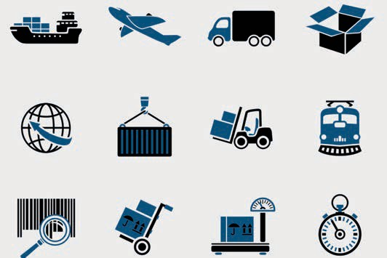

# Unit 4

## Tasks and Goals of SCM

##### STUDY GOALS

After completing this unit, you will know ...

… which tasks are involved in Supply Chain Management.

… what major challenges must be overcome.

… what form the goals in Supply Chain Management take.

… what SSCM means and how it differs from SCM.

DL-D-MWCH01-L04

### Tasks and Goals of SCM

#### Introduction

Unit 4 covers the tasks and goals associated with the value-creation chain and the management thereof.

For clarification: the term Supply Chain Management is defined as the efficient integration and management of suppliers, logistics centers, producers, and distributors. The products and services are purchased, processed or produced, and delivered in the right amount, at the right time, at the right place, at the lowest possible overall cost, and always in due accordance with quality standards. Supply Chain Management is considered a control tool that regulates all information, material, and cash flows, along with the associated processes, with the aid of current technologies. Supply Chain Management is more than a comprehensive supplier management system for reducing purchasing costs. The aim of Supply Chain Management is to map, control, and evaluate the entire process, including all process participants, to retrieve costs at any time, and to be able to provide company management with an overview based on key performance indicators. This calls for transparency across time, cost, and processing KPIs, which is both up-to-date and critical, coupled with the desire to increase both quality and customer satisfaction (Büsch 2008).

#### Tasks in Supply Chain Management

Supply, disposal, and the reutilization of integrated company activities make up the fundamental tasks of Supply Chain Management. Supply Chain Management spans various (all) business units and business functions. These areas or functions are linked via interface descriptions within the processes, with the result that, in some cases, one no longer works “without the other”.

Classic Supply Chain Management is divided into three phases. Phase one is the Strategic Supply Chain Management phase. This is concerned with determining the long-term, appropriate, and sustainable success of the entire company. The aspects to be decided on in the strategic phase are partly general factors such as determining the location, sales markets, the scope of business activity, and horizon planning (time and finances). Outsourcing or insourcing projects can also be planned and defined in this phase. Medium- to long-term goals are set in this phase and repeatedly adapted on a dynamic basis to the market, current business, and developments. This first phase is often referred to in literature as the Supply Chain Design phase, as it is the point at which the company is established and mapped in strategic terms.

The second phase is the Tactical Supply Chain Management phase. As the approximate framework has already been created in the strategy or design phase, this phase is characterized by production decisions (such as the production

Tasks and Goals of SCM

quantity, inventory policy, etc.) and sales strategies – such as the sales market policy and associated relationship trends. Phase two can be described as the medium-term phase. This means that the time frame is set at approximately twelve months (depending on the industry and product). Within this set time period, the planning certainty and forecast accuracy can be adjusted, improved, and steered in the current direction in accordance with developments. This phase is also described in literature as the planning or production phase.

The third phase is geared toward the operational implementation of short-term (> phase 2) decisions. Day-to-day business is mapped on this basis. This phase is characterized by operational procedures and processes such as customer orders, production and process planning, and (logistical) implementation from procurement through to delivery to the end consumer.

As Supply Chain Management is closely interlinked with the various business functions, the transitions between the individual phases are often fluid in areas such as Logistics, Production, Finance, and Research/Development.

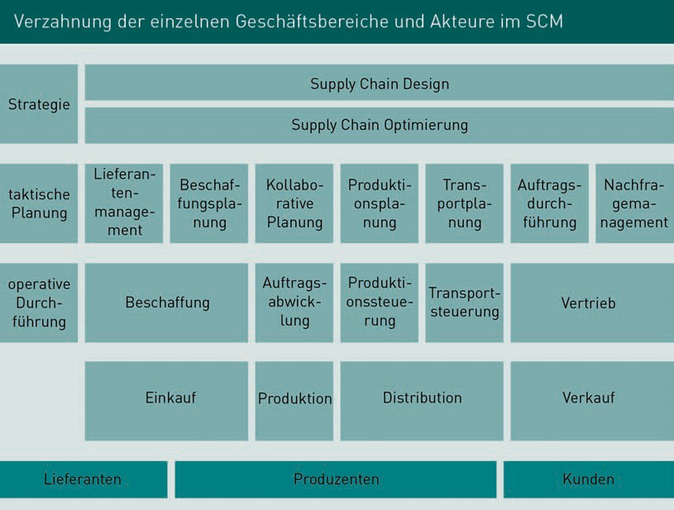

Creating a link between the individual participants – the members and/or stakeholders – presents a challenge in Supply Chain Management. These participants can include the cooperation partners, suppliers, and competitors as well as internal employees. The persons responsible for successful implementation also face major challenges when it comes to assessing responsibility for certain

service processes, cost and financing risks as well as assessing the advantages of cooperative value creation and dividing these among the cooperation partners. Ideally, this all takes place at the start of the collaboration. In addition, there is the configuration of different process cultures to contend with and decisions must be made regarding the use and organization of coordination structures, for example through central planning and control (using incentive systems if necessary), which are linked to defined goals, performance management systems, and measurement systems, and/or through IT transparency. “The “new” company becomes a collective learning unit.

The greater the rate at which cross-company learning and the corresponding behavioral adjustments take place, the faster the joint, interlinked units can generate success. In order to set up a supply chain that is robust, any disruptions, i.e. error sources and potential interference, must be identified (on the basis of quality management) as quickly as possible within the processes but particularly at the interfaces.

By way of clarification, the following figure shows, in simplified form, the links between the flow of goods, cash, and information, as well as the persons involved in these processes.

Tasks and Goals of SCM

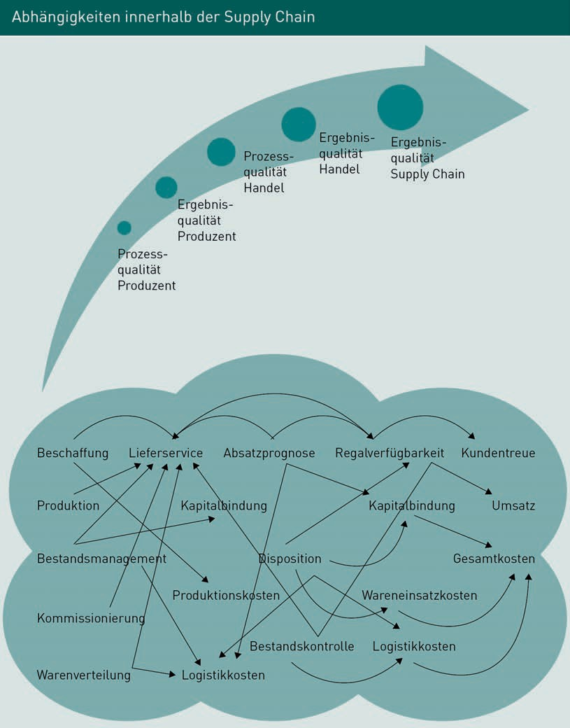

#### Goals of Supply Chain Management

The overarching goal of Supply Chain Management is to reduce costs in order to optimize profits.

The processes of all participants, from the extraction of raw material through to the end customer, are presented transparently with regard to the flow of goods, money, and information, improved in logical terms, and adapted or optimized in their entirety. The supplier network, sales function, raw material suppliers, and end customers are integrated into this process.

Noteworthy objectives for all areas include reducing logistics costs and inventory, shortening throughput times (production, interim storage, final storage, testing, issue or sale), increasing planning certainty and planning quality (time scale from approximate to precise), and increasing flexibility among personnel and suppliers etc. The overall aim is to achieve an improvement in delivery service and on-time delivery performance, in order to increase customer satisfaction.

The Goals of Supply Chain Management Using Retail as an Example

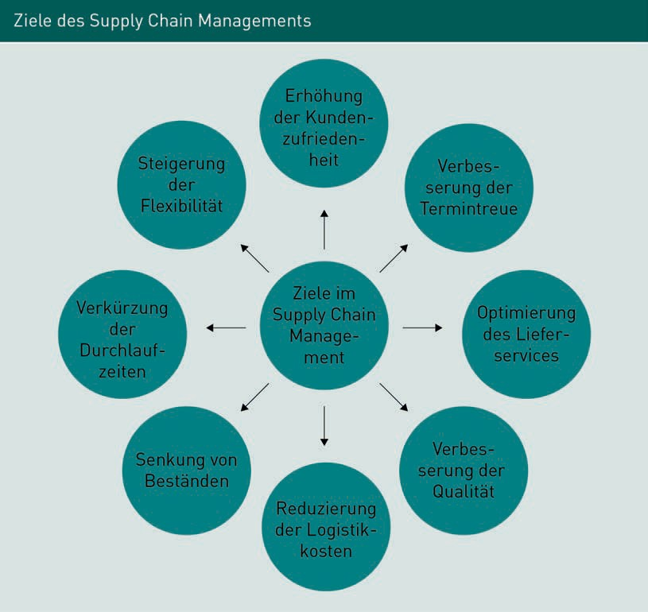

Tasks and Goals of SCM

A wide variety of contract types is available for optimizing the entire supply chain in the retail sector. Once again, the overarching goals of the supply chain network include increasing profits (margins), rapid growth, and improved quality management. In practice, various types of contracts have emerged that serve both to make the risks of a cooperation transparent and to share these risks among the cooperating parties. These contracts typically include repurchase or buyback agreements, revenue sharing, options contracts, and quantity flexibility contracts.

**Buyback Agreements**

These are typical agreements in retail business. The retailer must purchase large quantities from the wholesaler in order to obtain an adequate purchase price, and generates a large surplus inventory as a result. The surplus inventory is known as a “leftover”. This reduces the opportunity costs incurred, meaning that although a reduced revenue will be generated by using the goods on another occasion, this will be a genuine revenue. The manufacturer shares the risk through the buyback agreement. This regulation can also be agreed solely for the portion of the surplus inventories.

**Revenue Sharing**

This enables a sale to a third party. The purchase price is reduced for large quantities, with a contractual agreement arranged for participation in sales.

**Options Contract**

The Options Contract is characterized by uncertainty in demand resulting from a product launch or product modification for example. Manufacturers offer an initial discount to launch the product in retail. The reduced starting price enables retailers to take action. The price for the retailer is usually the same as the production price. If demand increases, the basic price is gradually changed and a margin is granted for initial quantities. This can take the form of a kick-back payment for the manufacturer, or the reimbursement can be linked to subsequent quantities. Taking the example of a product launch, the initial costs are therefore distributed in risk terms between manufacturer and retailer.

**Quantity Flexibility Contract**

Throughout the course of a season, retailers and manufacturers agree a quantity n. The retailer can reorder within a defined fluctuation range. In most cases, leftover quantities are taken back by the manufacturer at full price.

#### Sustainable Supply Chain Management(SSCM)

SSCM, or Sustainable Supply Chain Management, has been an established term in Germany’s supply chain environment since the early 2000s. The addition of the word “sustainable” refers to the cross-company management approach of

controlling, checking, and evaluating the flow of goods, information, and cash in a value-creation chain, with the aim of achieving sustainable development. In addition to the criteria and definitions typically associated with SCM, the basic principle of SSCM is that all resources are used sustainably, taking into account ecological, economic, and social aspects. An essential feature in this regard is that the procurement, use, and disposal of raw materials are included alongside conventional value creation throughout the entire process.

Background to SSCM

Globalization, which has been increasing since the middle of the 20th century, is leading to vast changes in the service markets in procurement, production, and retail. Developing and emerging countries in particular are already experiencing rapid development, as the legislation there, which in terms of ecological and even social conditions is often weak or non-existent for industrialized countries, initially offers huge cost advantages. Cheap and numerous staffing resources, combined with smart location choices and thus faster (more cost-effective) access to raw materials, are enabling many production companies to intervene in these developing and emerging countries. This intervention is both important and harmful to developing and emerging countries. For this reason, it is essential that the participants in the supply chain are substantially involved in decision-making, in order to generate joint and sustainable success.

How necessary is SSCM?

The pressure from those involved, most notably stakeholders such as inventors, banks, and the state, is constantly growing, particularly where the economical use of ecological and social resources is concerned. In this context, sustainability means creating good conditions in dealings with the environment, society, and local situations. In addition to economic incentives (increased turnover and profits and reduced costs), investors are demanding an urgent improvement in awareness and the implementation of environmental protection projects and social aspects. This, in turn, originates from the buyer’s market of “first world” countries. The buyer’s market is largely sensitive to the fair procurement of raw materials and to the creation of socially acceptable conditions for personnel in the production facilities. Furthermore, natural resources, such as fossil fuels, are already being depleted and supplies will soon run out. Once again, both stakeholders and customers expect measures to be put in place to deal with these issues.

The expansion of Supply Chain Management into Sustainable Supply Chain Management therefore serves not only to gain strategic competitive advantages but also to achieve an improvement in image.

The high investment costs associated with implementing suitable support measures from either an ecological or social perspective are often a hindrance. Either entire establishments have to be converted to the needs of the SSCM

Tasks and Goals of SCM

or have to be taken into account in the preliminary stages, as part of strategic planning. Both options are associated with high costs that are only redeemed in the medium to long term. This creates a high degree of uncertainty in many companies, which, despite amortization forecasts and simulations, calls such “protection” projects into question. The larger the company and the greater its global exposure, the sooner and more emphatically sustainability processes and projects must be implemented.

In strategic terms, there are three different avenues available:

Firstly, sustainability can be integrated into an existing (traditional) Supply Chain Management system, whereby the usual cost and service processes are expanded to include social and ecopolitical principles. Typical methods include Reverse Logistics, Product Stewardship or Green SCM.

The second option is the alignment strategy, in which economic, social, and ecological aspects are weighted in equal shares. This differs from the previous approach in that sustainability is not only promoted here at the behest of the customer, but is already firmly rooted in the goals of the individual organization. Viable and typical methods include the Three-Pillar Model and CSR (Corporate Social Responsibility).

The most basic approach is the replacement strategy, in which it is determined by company management that the existing Supply Chain Management concept can not only be expanded to include an alternative approach, but must be completely revamped and put in place. The carbon footprint is a typical method used in the replacement strategy (Halldórsson/Kotzab/Skjøtt-Larsen 2009, p. 83–94).

Definition of the SSCM Methods

Definition of the methods described in the previous paragraph:

The term “Reverse Logistics” means disposal logistics. “The process of planning, implementing, and controlling the efficient, cost effective flow of raw materials, in-process inventory, finished goods, and related information from the point of consumption to the point of origin for the purpose of recapturing value or proper disposal” (Rogers/ Tibben-Lembke 2001, S. 129). This means that use, recycling, and disposal are considered in addition to planning, implementation, and control.

Product Stewardship is characterized by joint responsibility for the product, which is assumed in this instance by the manufacturers and retailers.

The Green Supply Chain encompasses environmental aspects in an integrated form, with the basic idea of reducing environmental impact (deterioration). This method usually features in the integrated strategy.

The Three-Pillar Model juxtaposes all economic, ecological, and social aspects of Supply Chain Management. This means that these three aspects are mutually dependent and are not to be viewed individually (Bartol/Herkomer 2004, p. 1).

CSR (Corporate Social Responsibility) means responsible corporate behavior along the entire SSCM chain, which not only includes the corporate behavior of the respective company but also of the cooperation partners. This applies to stakeholder interests and customer needs. All participants in the chain take responsibility for their actions and conduct. Each individual is entitled to demand transparency from another responsible person for their area of responsibility.

The carbon footprint determines all of a product’s CO2 emissions. This measurand shows what quantity of CO2 emissions are generated by a product throughout its life cycle, thus providing transparency on which climatic and environmental impacts arise for which product and its entire cycle and which are irreparable.

**Summary**

The overarching goal of Supply Chain Management is to reduce costs in order to optimize profits. In order to achieve this objective, all processes need to be incorporated and linked together. In addition to the processes, it is vital to define the interfaces clearly, and to be able to create a fluid structure between the areas of responsibility. As all partners in the supply chain are mapped in the new processes, it is essential that staffing resources are integrated into the value-creation chain at an early stage, along with the associated flows.

The subject of expanding SCM toward SSCM has been a discussion point since the 2000s, with a view to enabling the sustainable implementation of social interaction and environmental aspects, and the progression of projects and processes, within the context of globalization.



# Unit 5

## Cooperation and Coordination

##### STUDY GOALS

After completing this unit, you will know ...

… what key strategic thrusts are involved in Supply Chain Management.

… what essentially lies behind corporate strategies.

… how cooperations are defined and related in terms of strategic alliances, mergers and acquisitions, and other forms of cooperation.

… what form the coordination of cooperations can take and how this affects Supply Chain Management.

DL-D-MWCH01-L05

### Cooperation and Coordination

#### Introduction

The subject of cooperation and coordination consists of two points:

* the internal cooperation and coordination of all companies, divisions, and departments involved in the supply chain and
* cooperation and coordination in line with corporate strategy.

Both subject areas are covered in this unit; for the strategic element, definitions of terms and background information are presented in order that these cooperations and the coordination thereof can be viewed in greater depth in future.

Excursion into Operations

Supply chain collaboration is an important topic that has become an indispensable part of the automotive world.

In a renowned automotive company, 50,000 containers and packages are delivered or moved by around 1,200 suppliers every day. The effort involved on the part of the automotive manufacturer, suppliers, raw material suppliers, and logistics providers is complex. The dovetailing of the individual trades is strictly timed, continuously monitored, and can be measured qualitatively and quantitatively at any time. Making this situation manageable and generating transparency without reducing the ability to act is considered a key competence in the market, by which the success factor is measured.

Just in Sequence

JIS

Sequence synchronicity, expansion of JIT, modules required for production are not only provided on time in the required quantity but also in the right order.

What is the consequence? As before, significant efforts are still being made to reduce all processing expenditure among automotive manufacturers and suppliers, which include the introduction of just-in-time (JIT) and **just-in-sequence (JIS)** delivery. The potential of JIT has been largely exhausted, while good results are still achievable in JIS in terms of reducing effort and thus reducing costs/time.

Optimization in the form of cooperative and cross-company structural improvements therefore offers further potential. In the area of Supply Chain Management, the term “cooperation” is considered a guarantee for maximizing the potential for value creation through seamless links with both internal and external partners.

Cooperation and Coordination

#### The Corporate Strategy

The holistic view of processes across the entire company always forms an essential part of the corporate strategy. The corporate strategy and Supply Chain Management are closely linked as their paths repeatedly cross while also running in parallel. The corporate goals, which are defined in the corporate strategy, are to be managed using a sound, consistent, and holistic process-oriented control system with tools derived from Supply Chain Management. Here, speed and efficiency determine the effective selection of suitable tools, in combination with the desired corporate strategy. For the further achievement of strategic corporate goals, it is vital to establish how sound and basis-oriented the flow of data and information is that has been consistently built up in the supply chain and in supply chain controlling, and how it finds its way into company management, as it is here, with constantly updated key figures, that it serves as the basis for a) measuring the achievement of strategic goals and b) making decisions on the next strategic steps.

Principles of the Corporate Strategy

The corporate strategy identifies the planned and long-term activities of a company with a view to achieving the goals stipulated in advance by company management using the defined resources.

The starting point here is to determine which market or brand position the company can achieve or aim for from a market perspective. Strategic alignment allows the corporate strategy process to be viewed in reverse. To this end, it is helpful to answer the following three questions:

1. Customers: Who are our customers?
2. Offer: What are we offering them?
3. Procedure: How do we go about this?

With this form of strategy development, the questions and unknown factors are viewed from both sides, in order to be composed as a result in different dimensions.

In practice, the decision is made as to which portfolio a company wants to make available on the market. The decision is made in favor of product x and product y. As a result, product A and product B are no longer considered in strategic terms or only to a lesser extent. With each step down, the strategic, future-oriented intersection is more clearly defined. This is followed by further analysis of the production processes, resources and, from a sales and marketing perspective, the competitor and target group processes.

Realistic and strategic goals combined with adapted SCM processes create the basis within companies for navigating a company successfully and, with transparent key figures, for observing both successes and failures and reacting to these promptly. Specific goal formulations concerning market position, portfolio, expansion efforts, and other strategic decisions determine the path of a company and have lasting consequences, as a strategy is usually pursued on a long-term basis.

However, a defined corporate strategy never applies to the entire corporate cycle, but is always dynamic in nature. Adjustments to market conditions, competition, supplier needs and, of course, customer interests, call for regular and scheduled controls and derived adjustments. A corporate strategy is usually divided into short-term, medium-term, and long-term alignments depending on importance, time factors, and cost factors.

Companies that have found and consistently implemented their strategic position in the market can be considered outstanding. These are companies that have pursued defined goals with their own visions and corporate strategy, and have created their position autonomously. A crucial factor in this process was that they wanted to achieve a high degree of differentiation from the competition. A distinctive feature of such extraordinary strategies is that these companies, if successful, are copied by other providers, who then attempt to penetrate the market with identical or similar services. As the corporate management teams of strategic market leaders anticipate such moves, they constantly develop new trends, ideas, and approaches, with the result that these companies are often trailblazers in multiple market cycles. Apple or Microsoft and even eBay or Amazon are examples of such companies from practice. Aggressive competitors or even cooperations of competitors with individual campaigns can be seen trying to challenge these companies for market leadership or to contest the position of the trend barometer.

In conclusion: a corporate strategy is not unchangeable, but needs to be checked at regular intervals and adapted to the conditions. Supply Chain Management provides the basis for ongoing processes and a transparent data base, so that strategic adjustments can be carried out.

#### Useful Corporate Strategies: Tools and Methods

As a result of fast-moving times (changes to the offer due to trends), political and sociopolitical changes (in Germany, Europe, and globally), and the inertia encountered in many companies (due to saturation or downshifts caused by bureaucracy and company policy), it is common for companies to develop new corporate strategies at intervals but not implement them. This also happens when cooperations are formed or dissolved quickly, and entire company management teams are replaced in the short to medium term.

Cooperation and Coordination

One of the oldest and simplest methodologies in corporate strategies is making decisions! Even in current times, commitment and conviction in one’s own actions continue to tie companies, employees, and customers to the market and to each other. Corporate strategies with high success rates are implementing the strategy for the current market, are already assessing tomorrow’s strategy, and have a visionary interest in the third strategy (for the “day after tomorrow”). This approach requires a visionary mindset and a good flair for developments. Today, these capabilities are supported by simulations and analysis tools that are incorporated into decision-making processes and installed within core supply chain processes.

The actual corporate strategies are defined by company management. The strategic planners select the appropriate methods and tools to a) support strategic goals, b) render strategic goals viable, and c) to monitor strategic goals – from simulation to forecasting, from forecasting to implementation, and from implementation to the actual situation. This path is viewed, assessed, and rated both forwards and in reverse by strategic planners in the supply chain.

An example of this is the so-called EKS® (Bottleneck-Focused Strategy) method or one of the early methods, the 635 method.

EKS® Method: The Bottleneck-Focused Strategy by Wolfgang Mewes

The EKS® method is a strategy based on four fundamental principles: specialization, the minimum principle, the statement “the immaterial comes before the material”, and the maximization of utility and profit.

Methodologically, this can be described as a seven-phase model:

1. Analysis of the actual situation and identification of special strengths
2. Identification of the most promising business area
3. Definition of the most promising target group
4. Identification of the target group’s most urgent problem
5. Ongoing innovation
6. Ongoing cooperation strategy
7. Ongoing identification of the constant basic needs of the target group

The processing of the seven-phase model using the basic principles as a guide results in a basic corporate strategy. Core and ancillary processes are derived from this basic framework, which are broken down into time and cost plans and transferred to the planning phase.

635 Method

The 635 method is tried and tested, very simple, extremely effective, and originates from an early phase of strategy development. It is considered a brainstorming method for a team of six project members. In this method, a brainstorming session lasts exactly 30 minutes. Working in a team, brainstorming features a high level of diversification and a large number of overall options.

On the description of the method: the more heterogeneous the group composition, the more valuable the result. Effective and high-quality results are further reinforced by a project leader or facilitator, who walks and guides the group through the method and sets limitations. So-called “idea sheets” are developed, on which each participant writes down and briefly outlines up to three ideas on the subject concerned. After a limited period (approx. five minutes), the idea sheets are passed on to the next team member. The next participant accepts the idea and attempts to develop it further.

In addition to numerous other available methods, there is also an equally large number of established tools. The more rigorously the application is implemented, the more meaningful the measurement results. Industry, competition, and product analyses, for example, are regarded as established and field-tested tools. The Balanced Scorecard, SWOT analysis, and Target Costing are frequently mentioned in connection with the concept of Supply Chain Management and rated as efficient.

Another common corporate strategy is the cost leadership strategy, which is characterized by large production capacities and a high level of capacity diversification with strict cost controls. The constant aim of this strategy is to reduce costs. Optimization is achieved here by increasing the level of technology and making constant organizational adjustments. Let us take ALDI as an example. This company strives for cost leadership and, by not offering a consistent range of branded products, adopts a cost leadership strategy with a differentiation approach. A further noteworthy point in this context is, however, that ALDI is commonly regarded as a brand.

The strategy of differentiation as a second focus area is chosen when the brand name is known and the image has already been developed. Various software companies are examples of this. The customer is offered a high level of quality, coupled with an appropriately set price, in a constantly new (and yet reliable) design.

Thirdly, there is the focus or niche strategy: this is characterized by differentiation or cost leadership within the focus group. Sufficient growth potential exists, but not on a scale that deems it of interest to the market leader or entire competition. Either sizeable or highly specialized expert knowledge is required.

Cooperation and Coordination

The fourth and final example is the strategy of concentration. This is identifiable by individual products, a focus on defined target groups, or special markets. It can also be characterized by transient intervals (trends). Such cases are then also referred to as focus and concentration strategies.

#### Strategic Alliances in the Context of Supply Chain Management

Vast changes across all markets and the constant increase in globalization are leading to increasingly shorter product life cycles, with corporate cooperations increasing at a disproportionate rate. This relationship can be explained by the rapid creation of suitable processes and resources. With falling sales figures (the share of each participant decreases) and reduced profit margins (due to constantly rising costs) mergers seem an appropriate solution and one that may result in a competitor becoming a cooperation partner and can halt an often bitter price war. The need for cooperation is on the rise. Company acquisitions, cooperations, and so-called strategic alliances increase the effectiveness of companies within the actual core businesses of the cooperation partners.

Against the background of the above points, strategic alliances help the companies involved to reduce development process costs and operational costs in areas such as Research and Development, or in Purchasing and Human Resources departments. The reduction of cost and time investments, distribution of risk, consolidation of know-how and existing infrastructures, and full utilization of resources should be exploited. Various questions are raised in this context that need to be answered. This requires clear definitions of the concepts.

Important questions may include: What particular prerequisites and conditions do strategic alliances need in order to be able to act constructively? What are the challenges faced by the management of the strategic alliance? Which company/participant is in charge? Why do strategic alliances fail in practice? How do companies grow together – also within the lower management levels and in the workforce? Are there scientific principles for arriving at solutions?

The Strategic Alliance Defined

In a strategic alliance, two or more partners cooperate voluntarily. The cooperation takes place in defined areas, with defined products or on defined paths. None of the participating companies lose their strategic and economic independence. One example from practice is the cooperation between airlines.

The levels of cooperation can be aligned in different ways and be effective on a horizontal, vertical, and diagonal level. The decisive factor here is the company and division in which the cooperation will take place.

Horizontal strategic alliances are formed between two competing companies within an industry. As such alliances can quickly give rise to a dominant market position in accordance with §§ 22 and 24 of GWB (= Act Against Restraints on Competition), aspects of competition law must be taken into account here.

A vertical cooperation can be formed both with service partners and focus customers from the same industry. To ensure product exclusivity and highlight the importance of the cooperation, these relationships often adopt the formal framework of a strategic alliance.

Diagonally aligned cooperations include the linking of supply chain activities between partners from different areas, or even different industries, to enable utilization of purchasing synergies or research areas, participation in joint logistics centers, and technological exploitation, for example.

The definition used in interpreting the concept of strategic alliances applies from “close to wide”, depending on the future-oriented perspective and nature/scope of cooperation that is required. Clear distinctions are drawn between mergers and acquisitions.

The consumer in the market is often unable to recognize this cooperation and is oblivious of the strategic alliance or even assumes competition. This is due to the fact that the partners retain their own legal status and the strategic alliance is closed for clearly defined areas of cooperation, in which the partners also assume a joint legal front. The goals, market and even the product level can appear substitutable to the end user, although the complete opposite can also be seen.

The term “merger” means that two or more companies are amalgamated. Here, the opportunity exists in tax and legal terms for one company to flow into the other or for the participating companies to establish a new company. Another variant is one in which areas are fed into a (different) existing company.

One hard and fast rule here is that national and international mergers must be approved at cartel authority level, both nationally and internationally. The cartel authorities can impose demands on the new company – such as the sale of parts of the company to prevent the company from assuming a dominant market position – or refuse to approve the merger. Such decisions require new strategic decisions in terms of reduced resource planning, both in the portion that must be put up for sale, and in the remaining business portion of the merger. Resource planning includes the

Cooperation and Coordination

location, funding, and personnel. For mergers that take place in Germany, there is usually a transfer of undertakings in accordance with § 613a of the German Civil Code, which guarantees employees job security for a period of twelve months.

Another expression used in change management is the term “post-merger integration”. This is regarded as one of the most difficult specialized fields in change management, and alludes to a faster, more efficient, but primarily complete integration process, which ensures that joint operational processes are created and introduced within a short timeframe so that the main goal of the merger – rapid synergies and subsequently quick profits – can be generated.

According to the definition in American management literature, the term “acquisitions” denotes that the management of the company to be acquired has agreed to the sale in principle and has responded positively to the sale. The term “(hostile) takeover” is the antonym of this. This term implies that company management has neither agreed to nor been informed about the acquisition.

Principles and Motives of Strategic Alliances

The term “strategic alliance” generally describes the different forms of cooperation between two or more organizations. A distinction is made in terms of manifestation (for example, on the market) and in the overarching objectives (strategy). A characteristic feature of strategic alliances is that at least two legally independent companies enter into a contract in which the cooperation is regulated with defined goals. Defined goals may include the expansion of market shares in segment x or optimization of profit by y %, sales growth etc., all while seeking to preserve existing competitor advantages and achieve advantages for specific products, markets, and target groups. A strategic alliance is never designed for the short term.

The conclusion of a strategic alliance is based on a wide variety of motives on the part of the companies involved, which, among many other examples, can include easier market access, intensive personal contacts, increased know-how, access to new technologies, time advantages, cost reduction, realization of synergy effects, reduction of competition, and circumvention of competition laws or trade barriers, and a proposed long-term market exit from the segment.

The areas that are referred to as parts of the value-creation chain (customers, suppliers, warehouses, etc.) qualify as functional segments of companies.

#### Prerequisites for Successful Cooperations

The success of a cooperation is always focused on achieving defined goals, regardless of whether a cooperation was concluded for the short or long term. In the practice of strategic management and, in some cases, in literature, there are sceptics who do not regard strategic alliances as a useful management tool. It should be mentioned that cooperations are dissolved if the conditions have changed to such an extent that the defined goals can no longer be achieved.

In all forms of cooperation, the configuration of the cooperation combined with the common goals and the implementation of the contributions contained therein is decisive. Meaningful and goal-oriented contributions can be made, for example, through the intake and reduction of resources – in this instance in the form of time, financial means, or personnel. The choice of location, infrastructures, and/or process adjustments should also be mentioned as crucial points. Transparent key figures and seminal forecasts provide the key to success. “Normal” success standards, such as sales, profits, or ROI calculations, are applied here.

It is not sufficient for a company to have made the decision to look for a cooperation partner – this partner must be precisely defined and identified. Aspects such as the question of a compatible corporate culture or a uniform understanding of quality and philosophies are a fundamental issue. The handling and prior definition of target groups can be crucial. What are the interests of the cooperation partner? What happens on the market when x and y enter into a cooperation?

#### Consolidation of Activities and Process Adjustments in Cooperations

As already explained, every cooperation hinges on the definition of meaningful, suitable, and defined goals, which are linked to both cost and time plans. The cooperation partners take their own strategic and operational corporate goals as a starting point and apply these to the future joint objectives, or use these goals to develop objectives for the entire organization. Possible discrepancies between the target and actual status must be equipped with an early warning system in the form of suitable key figures and key figure reports, in order that difficulties can be avoided or promptly identified. Provisions should be made for conflict cases by agreeing escalation levels in advance and assigning areas of expertise. This also defines the decision-making framework.

Cooperation and Coordination

In order to overcome the above-mentioned challenges, the cooperation partners must remain constantly aware of their starting point, their motives, and the common goals. This leads to approximations and a joint language/course of action is developed.

Success is largely dependent on the extent to which management succeeds in integrating and exemplifying the cooperation, in allowing philosophies to become one, and in coordinating resources.

The following components are therefore required in order to consolidate activities and process adjustments successfully: speed, openness and a holistic approach.

* Speed: particularly in strategic planning for the implementation strategy.
* Openness: information from providers of resources and services in order that they can be incorporated into the process as early as possible.
* Holistic approach: i.e. supply chain experience/planning security, cost transparency. Partial approaches may initially allow conclusions to be drawn about a cost increase, but the forecast produces an improved result.

Supply Chain Management is responsible for recording and adjusting processes as per its procedures. The path runs through the recording of actual processes (core processes first, then secondary processes) in all participating organizations. From this, a current general process is created (where necessary, as a transition process), and the corporate divisions are gradually converted to this. This conversion is both strategic and operational. Subsequent to or during this process, the employees are integrated and the interface architecture of the technologies is established. There are companies where the entire technology is replaced. The next steps comprise joint certification manuals, audits, requirement specifications, and all other forms of documentation that must be adapted to the new processes in a timely manner. Supplier, customer, and employee management is then renewed or adjusted in the form of contracts and agreements.

**Summary**

Regardless of whether alliances, mergers, or acquisitions are involved, each cooperation or integration partner has a high and simultaneously sensitive status.

Small and medium-sized companies in particular often have very little other opportunity to survive in the market (nationally and internationally) with their products and services.

In cooperations, these challenges are put to, and managed by, cooperation management, where all challenges and resources are consolidated and coordinated respectively.

The consolidation of tasks and the distribution of time, personnel, and financial resources takes place by means of process mapping in the value-creation chain in Supply Chain Management. Here, the foundations for a transparent organization can be created alongside sound new processes. This creates a control function that enables strategic and/or operational company decisions to be made in good time.



# Unit 6

## Supply, Disposal, and Recovery Strategies

##### STUDY GOALS

After completing this unit, you will know ...

… which supply strategies are available.

… what the term “disposal” means and what tasks this entails, also in connection with the overall processes.

… what form reuse and reutilization strategies take and what they entail.

DL-D-MWCH01-L06

### Supply, Disposal, and Recovery Strategies

#### Introduction

Within supply, disposal, and recovery strategies, there are various logistical aspects and associated requirements that are considered important factors:

* increasing global population,
* shrinking raw material reserves,
* fast-moving and increasingly important technologies.

According to experts, a paradigm shift is necessary in order to be able to overcome these challenges – in summary, the global and holistic development of the 21st century. Until now, the term “growth” has always denoted an increasing need for resources, for example raw materials such as natural gas, ores, grain, and water. In the pioneering visions of researchers, experts, and economists, this is associated with such a vast increase in environmental destruction, not to mention the possible collapse of the entire ecosystem, that growth with the sustained use of resources is ruled out as an option for the future. In the next 40 years – as described in Report 2052 (Randers 2012) – resources will run short to the point they are exhausted, while global warming caused by environmental pollution will lead to catastrophic weather and rising sea levels.

This means that raw materials must be used to optimal effect, pollutant emissions must be drastically reduced, and renewable energy sources must be tapped more swiftly. This presents a major challenge for existing processes and procedures in companies along the supply chain.

Supply, disposal, and recovery strategies must be developed in a visionary manner and incorporated promptly into existing complexes, or factored into sustainable new concepts. This requires company management, developers, and experts to act competently and with foresight.

#### Supply Strategies

From the moment raw materials or individual parts become unavailable in production facilities, neither production nor selling can start. As almost all companies are now under strong competitive pressure, and the competition can supply substitute products, a production stoppage constitutes the latest point in time in a production company for devising and sustainably implementing a systematic supply strategy.

The currently used term “supply logistics” refers to parts of procurement, purchasing, and logistics management. These three key areas influence both the structure and the activities of the company (responsibility for action).

Supply, Disposal, and Recovery Strategies

If the supply of internal processes is interrupted or procurement is insufficient, it is possible that production will stop or only run intermittently. This, in turn, means that deliveries to the end consumer will also be intermittent or even non-existent, and may result in the customer migrating to the competition. The migration rate is dependent on the commodity or service and the trust associated with this, how the product can be substituted, and what form the cost structure takes.

If the competition has identified delivery bottlenecks as a strategic field for generating competitive advantages, it can be assumed that the suppliers of raw materials, etc. will also adopt a systematic approach. In order to ensure a holistic approach to procurement, purchasing, and production management in supply policy terms, and to satisfy the end consumer downstream, the processes, contingency plan, and technologies must be precisely geared to maintaining customer supply. This stipulation can only then be ensured if action plans are combined with forecasting tools, specifically defined processes, and strategic supplier and procurement management. The definition of so-called supply propositions is crucial in this context. In addition, the need for fluctuation ranges is reduced. Supply propositions as a subject means that key customers, their principal product lines, and the procurement of materials to operate these product lines are analyzed, and the supply thereof is ensured through a wide variety of channels. This takes place using simulations and forecasts in accordance with the what-if principle.

A crucial further strategic step in this process is the development of a supplier management system, including quality and service management. The classification of suppliers and the supplier status must be defined and contractually agreed.

#### Disposal Strategies

The importance of disposal has increased significantly in recent years. This is due to the steady rise in environmental awareness within companies and among end users, the emergence of environmental protection as a competitive factor, and increasing backlogs in production. Increasing production backlogs mean increasing costs, which are composed of additional storage capacities, increased use of resources, and various other components.

In addition, numerous laws and regulations associated with disposal logistics have undergone major changes and are now subject to much stricter controls: “They range from environmental constitutional law to general environmental administrative law, the laws on nature and soil protection, water protection, the prevention, recycling, and disposal of waste, and immission control, to laws on radiation protection, energy saving, protection against hazardous substances, and environmental criminal law” (Ehrmann 2017, p. 609). The most significant laws, which have also had the most far-reaching consequences, are the Closed Substance Cycle and

Waste Management Act, and the Packaging Ordinance. The Closed Substance Cycle and Waste Management Act, which came into force on 07.10.1996, replaced the Waste Act and associated legal and administrative regulations of 1986. New changes were introduced in 2012, which came into effect on 01.06.2012.

According to the Closed Substance Cycle and Waste Management Act, waste disposal involves the recycling and disposal of waste (Ehrmann 2017, p. 609–611). In the new version of the Act, a distinction is made between “waste for recycling” and “waste for elimination”.

Movable objects, exhaust air, waste water, and empty packaging are among the usual and thus legally regulated disposal objects. All types of disposal objects are known as residues. This is considered from an operational viewpoint, the role of which must be repeatedly clarified from an economic perspective.

Residues are substances that are inevitably generated in a production process, but which are never the goal of production or consumption. Residues that flow back into production or consumption, in whole or in part, are known as “recyclable materials” or “waste for recycling”. Residues that are not reused are known as “waste for elimination”.

“Residues from consumption processes” are materials or products that can no longer be used by the customer, or packaging material that is no longer fit for use.

Plant, raw, auxiliary, and operating materials or system, air, water and/or soil emissions that are no longer usable and can be assigned to the production process are “residues from production processes”.

Forms of Disposal

In literature, a general distinction is made between “disposal in the narrower sense”, which corresponds to waste disposal, and “disposal in the broader sense”, which also includes use and recycling alongside waste disposal.

With use, the structure of the recyclable material remains virtually intact. A further distinction is made between reuse (the recyclable material is used again according to its original purpose) and reutilization (the recyclable material is not used for its original purpose, but for a different, alternative purpose).

In recycling, the structure of the recyclable material is broken down. Here too, a distinction is made between recovery and reclamation.

In recovery, the structure is broken down and equivalent materials are obtained for reuse in production. With reclamation, the structure is broken down and other substances are obtained from the components and/or the components are used in a different area in production.

Supply, Disposal, and Recovery Strategies

General Tasks in Disposal Logistics

The general tasks involved in disposal logistics can be derived from a short list of questions: What disposal objects are generated? Where and in what quantities are they generated? At what point are residues generated? What is the next step – use, recycle, or dispose of the residues? What destinations and target locations are available? When should disposal take place and at what cost?

The logistical processes involved in disposal are derived from the answers to these questions.

Individual Tasks in Disposal Logistics

The individual tasks involved in disposal logistics are divided into three areas of responsibility:

1. core services,
2. additional services and
3. information services.

Storage, transport, and transshipment are always included in the core services. The determination of the storage facility, allocation of storage areas (e.g. separate or common zones), and the form of construction (outdoor storage areas, closed storage, dangerous goods storage, etc.) are regarded as subtopics and decision-making elements. There are two design alternatives available when determining the storage space: a deterministic option and a stochastic option. In deterministic storage, exact key figures exist for inbound and outbound goods, while in stochastic storage, only statistical quantities are assumed.

The means of transport to be used (use of continuous and discontinuous means of transport) and transport organization are a requirement of the transport core service. The configuration options in transport organization consist of direct traffic, journeys involving hub consolidation, or regular network traffic. The final core service is transshipment, including the use of transshipment materials (once again, continuous or discontinuous use) and transshipment organization. The transshipment organization is characterized by changeover or transfer/emptying procedures.

The changeover procedure means that trailers, containers, or other vessels are always changed by the same tractor units or transfer vehicles. In the emptying or transfer procedure, the containers are unloaded and reloaded. The disadvantage of this is that a transshipment area has to be made available again at short notice.

Additional services comprise the collection and separation of residual materials as well as packaging-related services. In the area of collection and separation, a distinction is made between separate collection, mixed collection with subsequent separation, and mixed collection without subsequent separation. Clean processes and resource planning are essential here for both the process and value creation.

The collection principle runs synchronously, on a regular or irregular basis, according to the residue and its use.

In the case of packaging, a decision on packaging type must be made first. This is broadly broken down into outer packing (e.g. cardboard boxes), final packaging (e.g. foil on a pail) and supporting packaging (e.g. pallets).

Information services ensure that all necessary information is communicated to participants in the process on a priority basis. A distinction is made between inter-organizational and intra-organizational priorities (Stölzle 1993).

In order to identify the interfaces to Procurement, the warehouse, Production, the Sales Department, and upstream to Research and Development, for example, and to develop an implementation concept for the logistical disposal flow, Isermann/Houtmann propose a twelve-stage plan (1998):

* 1. Analysis, actual recording, and documentation of the residues according to their properties
  2. Calculation of the generated quantity based on quantitative, temporal, spatial, and qualitative propositions, according to the source of the residue
  3. Handling instructions for each residue for the entire logistical process
  4. Definition of sinks
  5. Definition of the flow processes of residues from source to sink from point

1. Weighting by frequency, time, intensity, and other criteria, is required here, for example, according to the residue.
2. Outline of the basic framework of disposal logistics
3. Configuration of service processes (disposal logistics)
4. Outline of chains = transfer from process to chain
5. Identification of needs within information flows
6. Analysis of and decision on insourcing or outsourcing of disposal logistics
7. Integration of core (disposal) processes to create one system
8. Integration into the overall process

#### Recovery, Reuse/Reutilization, and the Corresponding Strategies

The majority of the world’s population is concentrated in small spaces and lives in large cities, metropolitan areas, and other densely populated regions. In these urban centers, there is a need to return consumer and convenience goods, or parts thereof/

Supply, Disposal, and Recovery Strategies

residues from their production to a recovery cycle. Huge sources, such as road traffic, private households, and industry or power plants for electricity and energy generation emit air pollutants, generate waste and, according to the World Health Organization, contribute to the fact that various pollutant limit values are significantly exceeded. The scarcity of raw materials, such as water, also plays a role here: not only due to increasing water and waste water costs, but also given the limited quality and availability of untreated water, water as a resource should be sparingly.

Recovery, reutilization, and the associated predictive and proven measures and strategies enable a holistic view, which takes into account a sustainable way of life for people and companies.

The return flow of reusable goods/substances into the production of identical, similar, or other goods is known as recovery. The term “recycling” is also used in places. Recovery is characterized by the fact that the goods/substances used have already contributed to a specific function for a product. In recycling, utilization (also in economic terms) can also take place at the same level of quality that was applicable to the goods/substance on their/its initial use.

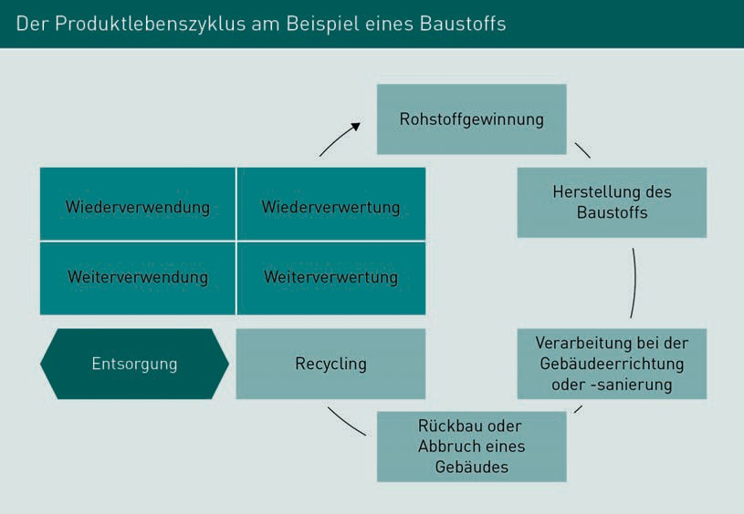

The issue of environmental policy also applies on a social and political level to recovery and reutilization. The subject of the environment and environmental policy is now deeply anchored in both companies and corporate policies. Entire sectors can be certified according to environmental and environmental protection guidelines and on the basis of sustainability (example:

DIN ISO 14001). This, in turn, results from the transparency created by SCM and its associated processes, and from the fact that our society has attached greater importance to environmental protection in recent decades.

Production companies have a particular obligation to operate in a sustainable, environmentally friendly manner. Environmental protection is established in the environmental management system, implemented, and then executed in a continuous improvement process. Environmental protection and sustainability are already present in the SSCM as strategic variables and future-oriented components of the overall process.

The key points for companies include:

* Preventing and reducing environmental pollution through precautionary action. This means that new technologies and substances are being used in new investments and procurement activities, and that preventive measures can be taken at the same time to avoid and limit damage.
* The need for raw, auxiliary, and operating materials is reduced and strategies for recovery/reclamation/reuse/reutilization are developed. This point begins with the economical use of energy and water and ends with the use of renewable raw materials.
* The environmentally oriented development of company management and employees means that management and employees are guided toward environmentally oriented company policy in ongoing training courses and during informative events.
* The current versions of environmentally relevant regulations and laws are complied with. To enable compliance with legal regulations on environmental protection, occupational safety, and plant safety, these must be known, accessible, and implemented. Compliance constitutes the core idea of environmental policies in companies and in SCM/SSCM. Supporting stakeholders in SCM/SSCM processes is a constituent feature of company management where ecopolitical strategies and activities are concerned.
* The continuous improvement and further development of the environmental management system is a constant endeavor and conducive to a successful environmental policy.

Feasible strategies that are relevant to the company are derived from these core points and incorporated into the process.

**Summary**

The subject of supply and disposal, and of recycling and reutilization, is primarily concerned with current environmental policy, and how this leads to a continuous improvement process and the associated sustainable and strategic (economic) corporate decisions.

Supply, Disposal, and Recovery Strategies

The groundwork for effective and sustainable environmental management is laid in the area of supply, which primarily deals with procurement, purchasing, and logistics management, and is where the cycle of economical resource management begins.

Naturally, the issue of disposal in procurement, purchasing and logistics in the form of residues is not only important strategically “on paper”, but is particularly important in physical terms in the form of goods, materials, and waste. Disposal and environmental management processes are developed and implemented on this level and incorporated into the overall process.

Reclamation/recovery and reutilization/reuse raise awareness of the conscientious use of all resources.



# Unit 7

## Quality Assurance

##### STUDY GOALS

After completing this unit, you will know ...

… what motives exist for quality management in Supply Chain Management

… which forms of quality assurance are available.

… which methods and tools are used in quality assurance.

DL-D-MWCH01-L07

### Quality Assurance

#### Introduction

As part of the process of measuring corporate success, EXBA® regularly conducts benchmark studies on various topics. The Excellence Barometer® is the benchmark study on performance in the German economy (study initiated by The Market Research Institute Forum, Marktforschungs GmbH in Mainz). In 2009, the “ExBa Quality” study was carried out, which concluded that quality plays a decisive role when purchasing a service. The companies can use a wide variety of concepts as a basis here, which all lead to success in their own individual way.

#### Quality Management Systems

Certification Demonstrates proof of compliance with certain specifications (standards).

If standard-oriented systems are chosen for quality assurance, companies engage in a catalog of requirements or must fulfil the associated specifications in order to receive **certification** to the chosen standard.

Adherence to these standards is verified by so-called auditors. These are trained professionals who recommend that a certificate be issued upon determining that the management systems introduced by companies are effective in accordance with the chosen standard. The term “good enough model” is also used in conjunction with quality assurance that is based on standard-oriented quality management systems.

The family of DIN EN ISO 9000 standards is one such quality management system. This was developed in the 1980s and stems from companies wishing to create uniform standards in an increasingly globalized market situation and against the backdrop of increasing outsourcing, and to have the option of having these checked by neutral organizations. This not only served to increase customer confidence in the quality capability of a company, which also strengthened the market position of the certified company concerned, but also enabled manufacturers who rely on the purchase of semi-finished goods, such as in the automotive industry for example, to protect themselves against product liability risks, as they would only continue to work with suppliers who demonstrably complied with certain norms and standards (through certification and thus traceable processes).

Further industry standards have been developed from DIN EN ISO 9001, such as TS 16949 in the automotive industry, which has since become the entry requirement for business relationships in a number of industries. TS 16949 was developed by the International Automotive Task Force (IATF) as the fundamental standard for all companies that participate in automotive supply chains, whether as suppliers or manufacturers.

Quality Assurance

As mentioned at the start, DIN EN ISO 9000 f. standards were developed due to the need arising from internationalization and globalization for the standardization of quality management systems, as a means of obtaining usable quality indicators and enabling quality comparisons. Prior to the introduction of these uniform standards, there were countless individual national and industry-specific regulations. A special **ISO** committee was set up with the aim of developing a standard, comprehensive, and collective set of rules.

As the language used in the DIN EN ISO 9000 standards in the 1980s was highly technical, the standards underwent a full revision in the year 2000, particularly as service companies were also being certified to this standard, but the highly technical language made it extremely difficult to apply the standard to their requirements.

The rudimentary principles of quality management systems are described in the newly developed DIN EN ISO 9000:2000. This is a so-called comprehension standard, which does not place demands on quality management itself but lays the foundation for all other standards in the 9000 series. A number of examples can be found below.

DIN EN ISO 9001:2015

ISO 9001:2015 sets the requirements for a company’s internal quality management system (QMS). For example, companies must determine the processes that are required for the QMS. This involves defining and applying criteria that ensure the effective implementation and control of these processes using the associated performance indicators. In operational practice, it is assumed that process control is then only possible if key figures are defined, and regularly monitored and assessed.

ISO 9004:2009

This standard is a guide that companies can refer to in a bid to improve customer satisfaction or increase their own performance.

DIN ISO 19011

Management systems, and hence environmental and quality management systems, require regular inspection in the form of audits. This standard contains guidelines, which stipulate what form the auditing of environmental and quality management systems should take.

ISO

International Organization for Standardization

Total Quality Management (TQM) constitutes a further development of the standard-oriented quality management systems as a holistic model. “Holistic” means that the quality management approach permeates the entire company and, unlike standard-oriented systems, does not apply solely to certain areas, such as production only.

The significance of TQM is summarized in the definition of DIN EN ISO 8402 as a holistic approach: “a management approach for an organization, centered on quality, based on the participation of all its members and aiming at long-term success through customer satisfaction, and benefits to all members of the organization and to society.” (Hummel/Malorny 2011, p. 5).

In addition to product quality, TQM also encompasses management, process, and personnel quality as well as external relationships. Rather than formulating minimal criteria only, TMQ promotes general improvements to the status quo, whereby the entire company with all its employees, departments, and business areas, is involved in improving quality.

The philosophy of TQM refers to how quality is achieved, namely by employees across all hierarchies and levels maintaining customer focus.

Quality not only refers to products but also to services, with quality development being regarded as an active and dynamic process that requires constant adjustment and optimization, rather than a certain type or form of quality being viewed as the end goal.

A continuation and further development of the TQM concept can be found in the European Foundation for Quality Management (EFQM) Excellence Model, which sets customer satisfaction as a top priority, without which sustainable positive corporate development would not be possible. TQM or EFQM models are referred to colloquially as “better and better models”.

#### Quality Assurance in Supply Chain Management

As already mentioned, the change in the competitive landscape is generally the main trigger for the introduction of quality management systems (Rothlauf 2014, p. 40 f.). As the participants in the supply chain are also caught between the conflicting priorities of globalization and ever-increasing competitive pressure, increasing quality to achieve customer satisfaction is of vital importance. Supply Chain Management as a holistic approach therefore requires a quality management system which can be used to plan and control the entire company as a unit, while enabling continuous adjustments and changes to the system that allow a flexible response to variable customer requirements. In this connection, quality management must incorporate both externally sourced products and services as well as global supplier networks.

Quality Assurance

Customer satisfaction can be achieved by supplying the delivery quality required by the customer at a reasonable price and within a reasonable time frame. Quality management within a supply chain therefore serves to ensure that delivery times are met, the material quality of the delivered products is at a level that meets the customer’s requirements and/or demonstrates process capability at the customer’s location (semi-finished products must be able to flow smoothly into the customer’s production operations), and that these products are available in the required quantity (the ability to deliver on time is particularly important if stock reduction measures have been introduced in the warehouse to reduce costs).

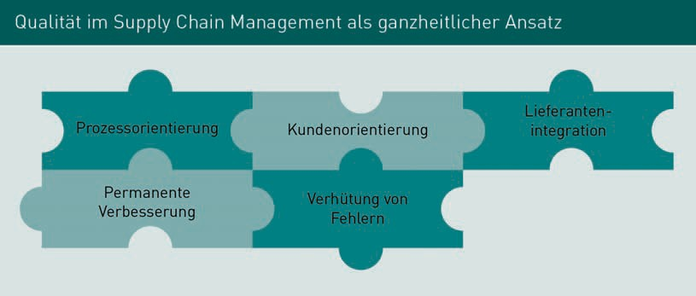

The points that must be included in the quality management of a supply chain as a holistic approach are listed in the figure “Quality in Supply Chain Management as a Holistic Approach” (Rothlauf 2014, p. 65 f.). In addition to process and customer orientation, these include continuous improvement management and error prevention, whereby the integration of suppliers and other participants in the process chain must be taken into account for all points.

The restrictions imposed by the customer form the basis of all quality efforts in the supply chain. As there can be numerous participants in a supply chain, the quality requirements must be meticulously defined in quality handbooks, with increasing consideration given to aspects such as environmental compatibility and sustainability.

Value-creation chains and the underlying quality standards can be stipulated, for example, on the basis of the environmental standards of DIN EN ISO 14001 or, with reference to product quality, on the basis of DIN EN ISO 9001. The regulations laid down here for the individual configuration of the supply chain apply across all companies, must be integrated by all participants into their respective companies, and are checked and audited at regular intervals to determine their effectiveness.

Recall activities, such as those encountered in the automotive sector for example, show what can happen if quality standards are not observed. In the past, recall activities of this nature were initiated due to serious quality defects such as the non-deployment of airbags, accelerator pedals locking at a certain speed and failing

to return to their original position, or braking systems not working. In addition to the high financial expense – amounting to billions in some cases, due to the same parts often being used in different models, particularly in the automotive sector – incurred by the companies initiating the recall activities, as well as the loss of image and associated exodus of customers, such defects can, in the worst case, also lead to the loss of human life.

In the event of such incidents, it can be assumed that the quality standards and/or quality controls were deficient. This demonstrates the vital importance of quality management in supply chains.

#### Methods in Quality Management

There are various ways of integrating quality in Supply Chain Management as a holistic approach. First, all participants in a supply chain must appreciate the importance and value of quality management.

With this in mind, the first step is to set a common objective, clarify the resulting problems, and define the methodical procedure, usually in a project group consisting of the responsible persons from the areas of a company in the case of an intracompany supply chain, and of representatives from the participating companies in the case of company-integrated supply chains. This project group presents the goals to company management along with the resulting approaches, tasks, and processes, as well as the tools selected or proposed to achieve the goals.

Any deficiencies within the supply chain are also recorded, examples of which include poor order quality or inadequate planning on the part of the manufacturer, and bottleneck-oriented production planning or sales fluctuations on the part of the supplier.

The special features of the respective supply chain determine which tools are used in quality management. Examples include the aforementioned ISO standards, Quality Function Deployment (QFD) as a subarea of Total Quality Management (TQM), EFQM, or Six Sigma.

Implementation begins as soon as management has decided on a method. Process chains are recorded, analyzed, and – where necessary – remodeled on this basis. This not only affects production, but all interfaces. Once the processes have been remodeled, the process chains are integrated into the supply chain. In the majority of cases, this also requires new contracts to be drawn up between all participants in the supply chain, to ensure that the changes and quality assurance measures are actually implemented. Examples of points that may be specified in these contracts include:

Quality Assurance

* Catalog of requirements to avoid deficient deliveries;
* Procedure for the incoming inspection of goods/inspection criteria;
* Minimum quality requirements;
* Procedure in the event of complaints and defects

Taking QFD as an example, where the factors of flexibility, cost, and time rank as priorities alongside the key variable of quality, implementation within the supply chain can be configured as follows:

* Definition of customer requirements;
* Identification of competitor advantages created from the delivery of solutions that inspire the customer;
* Harmonization of the varying wishes and requirements of customers, producers, sellers, developers;
* Identification of the intersection and development of possible solutions that best take into account the interests of all participants in terms of wishes and requirements;
* Demonstration of the product features that determine the quality of the product from a customer perspective and are therefore crucial to commercial success;
* Cost-benefit calculation;
* Development and documentation of the resulting processes;
* Methodical communication of the results obtained and the goals pursued with the processes, in order to make the procedure transparent for all participants in the supply chain.

TQM is typically divided into four phases, with the above-mentioned QFD points falling into phases one and two, where TQM is first initialized and then realized. The third phase is the stabilization phase, where the improvement process is further accelerated and the company finds its innovative orientation. In the fourth and final phase, TQM is a fully integrated part of the company and is subject to subtle refinements only. As a result, the fourth phase is also known as the phase of excellence.

As the above list shows, the customer’s wishes constitute the starting point and stipulation in the development of a quality management system based on QFD. The House of Quality (HoQ) is frequently used as a planning and analysis tool in the context of QFD. This tool is a matrix that takes into account six different areas in product development and is reminiscent of a house due to the relative positions of the various elements (see figure “House of Quality”).

Field **A** relates to customer requests. This is where the demands on design and functions that customers want from a product are recorded. Field **B** relates to the competition. This is where differences and similarities with competitive products are recorded. Field **C** deals with how the product design may need to be altered in order to meet customer requirements, while Field **D** is used to define the ways in which the company can fulfil the customer’s wishes. Field **E** contains the cost-benefit calculation and finally, Field **F** contains the calculated target values.

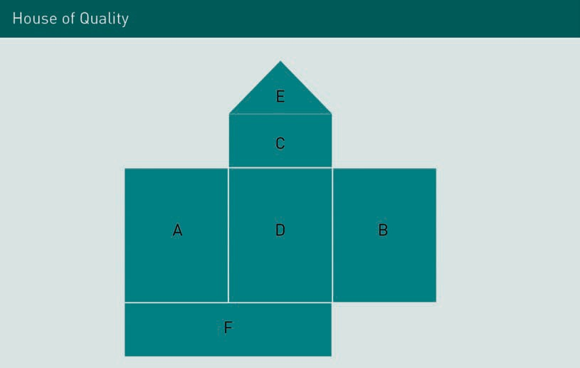

Bottleneck Engineering – another QFD method that serves to translate customer requirements into development goals – is also a quality assurance option in Supply Chain Management. Each of the QFD phases described finishes with a quality evaluation in tabular form. If a quality target cannot be met, a bottleneck situation arises.

With the aid of a matrix, Bottleneck Engineering searches for an answer to the question of whether the desired quality goal is actually achievable with the available resources.

This involves carrying out the following process steps:

* Description of the problem
* Definition of quality goals for the current object under investigation
* Comparison of the values for the quality goals on the basis of predefined benchmarks
* Definition and implementation of countermeasures
* Documentation and explanation of the deviation

An example of a bottleneck situation can be found in the manufacture of table tennis rackets. An important customer requirement is that the racket does not slip out of the player’s hand during the game. As a measure for meeting this requirement, the Design Department suggested wrapping the racket handle in an absorbent material. The machine that wraps the racket handles has previously performed this operation using plastic materials. The tension that the material is placed under during the wrapping operation would cause the material to tear. In order to ensure commercial success, the customer’s requirement must be implemented. Therefore, either a more durable, absorbent material must be sourced or the machine must be replaced.

Quality Assurance

Quality management within the supply chain is playing an increasingly important role overall in the bid to be competitive due to the fact that customers attach great importance to the satisfaction of individual requirements, which can only be achieved if customer needs are identified in good time and implemented in the appropriate quantity at reasonable prices. For this reason, all participants in the supply chain must be involved in quality management.

#### Tools Used in Organizational Configuration

As the description of the quality management methods shows, complex operations must be presented and implemented in qualitative Supply Chain Management. In order to make the required processes and measures transparent for everyone involved, a wide variety of mostly computer-aided tools are used.

Once the required processes have been developed, one of the next steps taken is to introduce a form management system. The forms required for processing within the supply chain are developed on the basis of the processes and made available electronically to all authorized users. Forms are configured on a task basis, to help with the fulfilment of tasks and to document operations, which ultimately facilitates quality control. The same or similar forms are used for the same tasks. For example, the forms that apply to the procurement of raw materials are the same as for semi-finished goods, even if this task is carried out by different areas. This creates a uniform standard in an organization, which makes the processes clearer for everyone involved.

The creation of forms is therefore a central task, which not only serves to ensure configuration in Corporate Design, but also to safeguard against the creation of separate forms, which are not appropriate to the quality management system, in certain areas. In today’s companies, the form management system is accessible to all employees in the company’s or organization’s internal network or in the intranet. As a rule, the forms can also be completed electronically, which simplifies communication within the company or organization, as the documents can then be forwarded electronically. This form of corporate communication also supports the idea of environmentalism, as a paperless flow of forms is achieved.

In addition to the form management system, organizational handbooks are also developed on the basis of defined processes. In order to ensure that these handbooks are kept up-to-date, they are stored in electronic form and also created as physical documents in the form of loose-leaf editions so that any additions, updates, and changes can be incorporated without issue.

Many companies work with organizational handbooks based on DIN EN ISO 9000 f., in which the reason for introducing the quality management system, responsibilities, the area of application, procedure, and the necessary documents and forms are recorded.

The organizational handbook also contains organizational charts, which show the hierarchical structure of a company or organization. This maps the solid- and dotted-line assignment of areas and employees in a graphic representation. Depending on the form of organization, the chart can be structured as a single-line, multiple-line, line-and-staff, or matrix diagram. A common feature of all organizational chart types is that they provide a realistic representation of a company’s structure, and should be configured identically for all areas. Employees at the same hierarchical level should have the same powers. For example, Level 1 managers are authorized to decide on the procurement of office consumables from the internal purchasing tool up to a budget of EUR 250 per month. For customer quotations, approval and/or a signature must be obtained from the next level up in the management chain, i.e. Level 2. Level 2 management personnel can exhaust a budget of EUR 5,000 per month, are authorized to submit quotations to customers of their own accord, and are permitted to undertake business trips within Germany, provided that these require a maximum of one night’s accommodation only, and the journey is made using public transport.

It is not always possible to structure the powers available at management level in the same way. Management Level 2 in the Development Department will very probably have a budget for prototype construction, 3D printing, or simulation calculations in the high-performance data processing center, that would serve no purpose for Management Level 2 in the Internal Sales function.

Following the same principle, incentive structures (remuneration, bonuses, privileges, or special work tools such as a car or smartphone) are ideally configured in a similar way.

If an item description deviates from the desired standard, this must be recorded in the quality handbook.

Quality Assurance

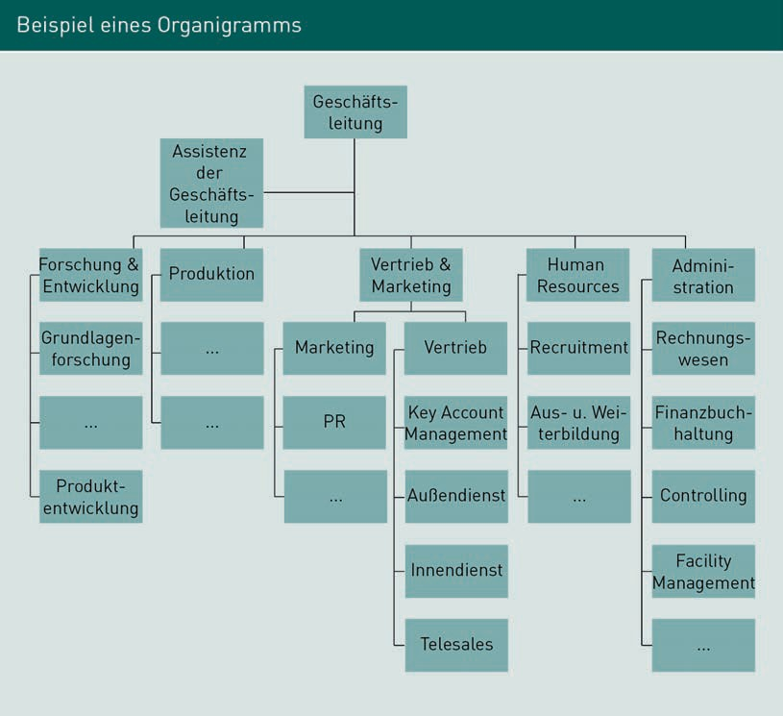

In addition to organizational charts, the organizational handbook also contains graphic representations of process chains and program flows. These often take the form of flow charts, which show related activities in the correct order with the corresponding interdependencies. In addition to showing individual sequences, the flow charts also visualize branches or feedback loops.

A detailed flow chart is often developed from existing function charts. In this connection, it should be noted that most flow charts cannot be drawn up on a short-term basis, but unfold as part of an overall planning process, which is adapted in stages during day-to-day business.

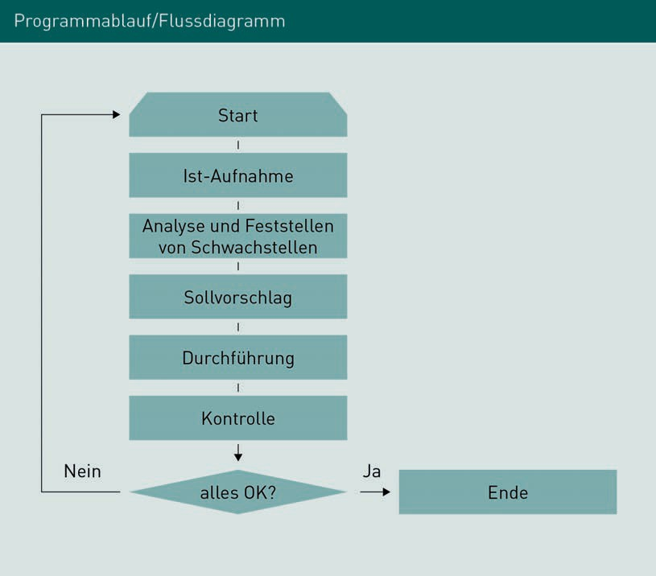

The above flow chart is an example of how existing processes can be analyzed and, where necessary, adapted to new situations, including changes in standards and laws, decisions on the acquisition of new or more powerful technology, and other changes occurring in operations.

Other examples of documents and tools stored in the organizational handbook for the purpose of controlling and monitoring quality management include the job description (a document that describes and defines the mandatory role of a position in the company) and the function chart (here, the overall task of a position, team, department, or entire organization, if complexity allows it).

It is crucial that all of the organizational tools used are an appropriate fit for the organization and the desired quality management, and are compatible with each other. This not only applies to their application but also to their designation. For example, the title used for a position in an organizational chart should also be rigorously applied in other documents and forms, in order to achieve clear traceability of the functions, instructions, and processes that are assigned to this position.

Quality Assurance

If the title “Production Manager” is used in the organizational chart, this must also appear in the job description, function chart, and in all processes that are assigned to this position. Adhering to this system ensures that all leading and subordinate functions in processes are clearly regulated, and that quality control and a functioning escalation management structure have a solid base from which to operate.

**Summary**

Studies show that customers are increasingly viewing quality as a priority in purchasing decisions. This, combined with the ever-increasing competitive pressure encountered in globalized buyer markets, means that participants in supply chains are also having to accommodate the introduction of a quality management system and the most suitable associated tools.

As Supply Chain Management is a holistic approach, the most effective methods and tools from Total Quality Management are used for quality assurance. These can be supplemented by methods and findings from the DIN EN ISO 9000 family of standards.

These range from simple form management systems to organizational handbooks with complex flow and function charts.



# Unit 8

## Information Gathering

##### STUDY GOALS

After completing this unit, you will know ...

… which tools are used for information gathering in Supply Chain Management.

… which business software supports the functions of the supply chain.

… how information gathering contributes to the control of supply chains.

DL-D-MWCH01-L08

### Information Gathering

#### Introduction

Supply Chain Management means that all activities along the value-creation chain are coordinated. It is therefore crucial that the information required to make strategic decisions is always available, both in monetary and physical terms, and in the context of information flow.

Due to the inter-organizational character of the supply chain, this applies to all information chains, from the suppliers to the end customer.

As the information context is highly complex, Supply Chain Management interacts with modern information technologies, which render the plethora of required information usable and manageable.

#### Information Technology in Supply Chain Management

Supply Chain Management and the underlying strategies are promoted, controlled, and accelerated by Information Technology (IT) and the associated systems. Systems such as EDI, EAN and RFID, which are explained below, play a supporting role.

Electronic Data Interchange (EDI)

Electronic Data Interchange or EDI describes the fully automated and seamless electronic exchange of structured business data, in which dispatch notifications, customer orders, purchase orders, complaints, invoices, and other business transactions are exchanged between several computer systems.

The EDI connection in Supply Chain Management must run with point-to-point accuracy between sources (suppliers) and sinks (customers). All participants in the supply chain form interfaces from which data is fed into the IT system and processed by it on the basis of certain parameters.

In an international supply chain, it can therefore be stipulated that the producer in Germany, for example a pharmaceutical company, release current stocks of medicinal productions using EDP. A customer in the USA, in turn, uses EDI to enter his current medication requirements on a piece-by-piece basis or in small quantities. In order to save on freight costs and provided that no urgent requirements are involved, both parties in the supply chain have agreed that goods will only be shipped once a small container can be filled. As soon as the small container is full, a fully automated message is sent to the producer’s warehouse via EDP confirming that the customer’s order

Information Gathering

is being picked, as well as to the forwarding agent confirming that, or when, a shipment can be made from the producer to the customer in the USA. The process is fully automated, with no separate instruction required to set the process in motion. This degree of automation, and thus optimization of the supply chain, can only be achieved if all relevant information is exchanged and compiled using Electronic Data Interchange. The period from which an order is considered closed and a delivery can be made is stored in the EDP system.

Both the communication system and the conversion system play a role in EDI. The conversion system ensures that the messages exchanged with other EDI partners by the communication system are automatically “translated”. When a customer order is placed through an ERP system and transmitted by EDI, the data output of the ERP system must first be translated into the EDI format agreed with the partner company. The conversion system thus ensures that communication is standardized. External interfaces are connected via a port to the system, whereby individual software programming converts the different incoming formats at the interface into a format that is legible to the main system. Communication systems connected to EDI interfaces can have different configurations. For example, it is not only possible to exchange information using conventional e-mails, but also to connect merchandise management programs directly, which feed in relevant content on a fully automated basis using interface programming.

For smaller companies, where the effort involved in EDI programming is too high, there is the option of exchanging data electronically via the Internet or so-called WebEDI. All users need in order to be able to participate in WebEDI is an Internet connection. The connection of external interfaces is web-based on a standard server or “in the cloud” (Internet-based “cloud” with data content) and business transactions are made available in a secure and protected manner by a WebEDI provider This is a cost-effective alternative to standard EDI that does not require a dedicated IT infrastructure with servers, maintenance contracts, and individual programming.

For small and medium-sized companies, WebEDI therefore provides a good option for implementing supply chains in a process-controlled manner. From a certain size and with the corresponding data traffic, however, it is advisable to use the standard solution (EDI), as permanent connections are the safer and faster variant.

Radio Frequency Identification (RFID)/Transponder Technology

Radio Frequency Identification (RFID) is a technology used in the non-contact, comprehensive identification of objects and the collection of all information on the basis of radio waves, both in the storage area and directly in retail. The relevant product information (item number, manufacturer data,

batch or lot sizes, gross and net weight, price) is arranged on labels, which are attached directly to the product. This data can be accessed and retrieved by all stations in the supply chain by reading out the labels.

RFID is a further development and competitor of the European Article Number EAN) barcode. Significantly more information can be stored on the RFID label (RFID tag) than by using the EAN code. Each item can be individually identified through the Electronic Product Code (EPC) – a globally valid serial number. The EAN code identifies the product type only. As the technology is based on radio waves, the RFID tag does not require visual contact with the reading device and, as a result, is quicker to read than the EAN code, but also is also more expensive to use due to the greater production effort involved and the infrastructure required.

As the RFID process can be used in all industries for identification purposes, it is ideal for use in the supply chain and represents a cross-sectional technology. The marking and identification of products can be performed on three levels: the so-called Item Level (identification at item level), Case Level (identification at container level), and Unit Level (identification at load carrier level).

#### Business Software

Company software is composed of software products that are used both in corporations and in small and medium-sized companies. As many applications, such as word processing or spreadsheet programs, are used both privately and commercially, a more in-depth distinction between business software and other software categories is difficult to provide.

ERP systems are commonly encountered in the use of business management software. These map processes that extend beyond the company’s own boundaries. An extension of the classic ERP systems are CRM and SCM systems. The corporate applications of these systems are targeted at strengthening the company’s or organization’s market position and enabling appropriate growth, and are no longer confined to mapping and controlling corporate processes.

Enterprise Resource Planning (ERP) Systems

ERP systems are internal software systems that show the processes of a company. Materials management from procurement to warehousing, production planning and control, and sales processing are typical functional areas that are mapped using ERP software. Other sub-areas covered by an ERP system are Human Resources and Finance, from Accounting through to Controlling.

Information Gathering

All areas of the company are integrated throughout the ERP system so that company-wide processes are handled centrally and in an integrated manner. This also means that these systems must be expanded as soon as processes which are external to the company have to be mapped, such as in the case of cross-company supply chains.

Strategic corporate goals that can be pursued using ERP software include the reduction of operational and process costs. ERP software is a viable option in this context, if its use creates greater transparency, which can be used to consolidate similar activities or optimize the process organization in order to achieve a cost reduction effect. Other key points in the use of ERP systems are the company’s desire to be able to react more flexibly to the market, and to have an authoritative management system with a suitable system of key figures. It is hoped that this will also lead to an improvement in quality and service.

Computer Integrated Manufacturing(CIM)

Computer Integrated Manufacturing is an implementation strategy that can also be found in IT-supported Supply Chain Management. CIM architectures are often part of an ERP strategy, which aims to support all company areas and processes using information technology.

In a company that works with a CIM strategy, all processes, from planning and development to production, are supported by computers. This primarily serves to avoid isolated solutions and to create consistent and coordinated processes along the entire supply chain.

The CIM architecture consists of business and technical components. On the business side, there is computer-aided production planning and control (PPC), the technical components are Computer Aided Engineering (CAE = computer support in the early phase of product design and for certain simulation techniques), Computer Aided Design (CAD = EDP is used directly or indirectly for construction and design activities), Computerized Numerical Control machines (CNC = numerical adjustment and control of machines) and Computer Aided Planning (CAP = computer-aided production planning).

CRM and SCM Systems

Customer Relationship Management (CRM) and SCM systems are used when ERP systems have reached their limits. This often occurs when it becomes necessary to incorporate process chains from external partners

in order to optimize the supply chain. These process chains may involve controlling the entire logistics chain, from supplier to customer, or managing customer relationships.

CRM systems handle all processes that arise in customer relationship management, ranging from market research processes and marketing to new customer acquisition, advertising campaigns, and the integration of production processes in sales strategies or service processes. Such systems are programmed on an individual and company-specific basis.

The change in the market situation, in which corporate success is becoming increasingly dependent on satisfying individual customer requirements, is forcing companies to realign themselves and make allowances for this fact with the implementation of CRM and SCM systems.

Companies receive further support from SCM systems, which help to adapt logistical and supply chains to the increasing globalization of the economy. In order to counteract the effects of increased cost pressure, competition for ever decreasing resources, and continually changing supplier structures, companies must develop new strategies that will strengthen the market situation of their respective organizations and promote healthy growth.

The need to develop new supply chains and the optimization of existing systems from a cost perspective are other main drivers behind the development of CRM and SCM systems.

For all of the systems presented, standardized tools are now available for connecting up the individual control systems, which can also be customized, i.e. tailored to the individual customer, if required.

The process of supporting Support Chain Management through the use of modern information and communication systems, i.e. the use of e-business methods, is also known as E-Supply Chain Management. The use of ERP systems as well as CRM or RFID, to name just a few examples, simplifies and optimizes Supply Chain Management, and particularly in times of rapid order cycles via the Internet, is indispensable.

#### The Balanced Scorecard as a Control Tool

The Balanced Scorecard (BSC) is a strategic tool used to shape, control, implement, and review a company’s strategy. This also allows it to be used successfully as a communication and control tool in Supply Chain Management. The BSC is used to visualize corporate goals and strategies, focusing on several company levels, so that various perspectives can be examined. As the BSC guarantees a continuous overview of a wide variety of

Information Gathering

company key figures and thus of the overall situation, it works as a strategic decision-making tool and shows the extent to which a given strategy can be realized and is implemented in day-to-day business.

The classic Balanced Scorecard describes four basic perspectives: financial perspective, customer perspective, internal process perspective, and the learning and development perspective (Kaplan/Norton 2018). The supplier perspective is now taken into account as the fifth dimension. The comprehensive services of the supply chain from the area of service partners or suppliers are recorded here. The sixth dimension relates to the structural dimension, which captures and evaluates the requirements governing network technology and the integration of supply chain partners.

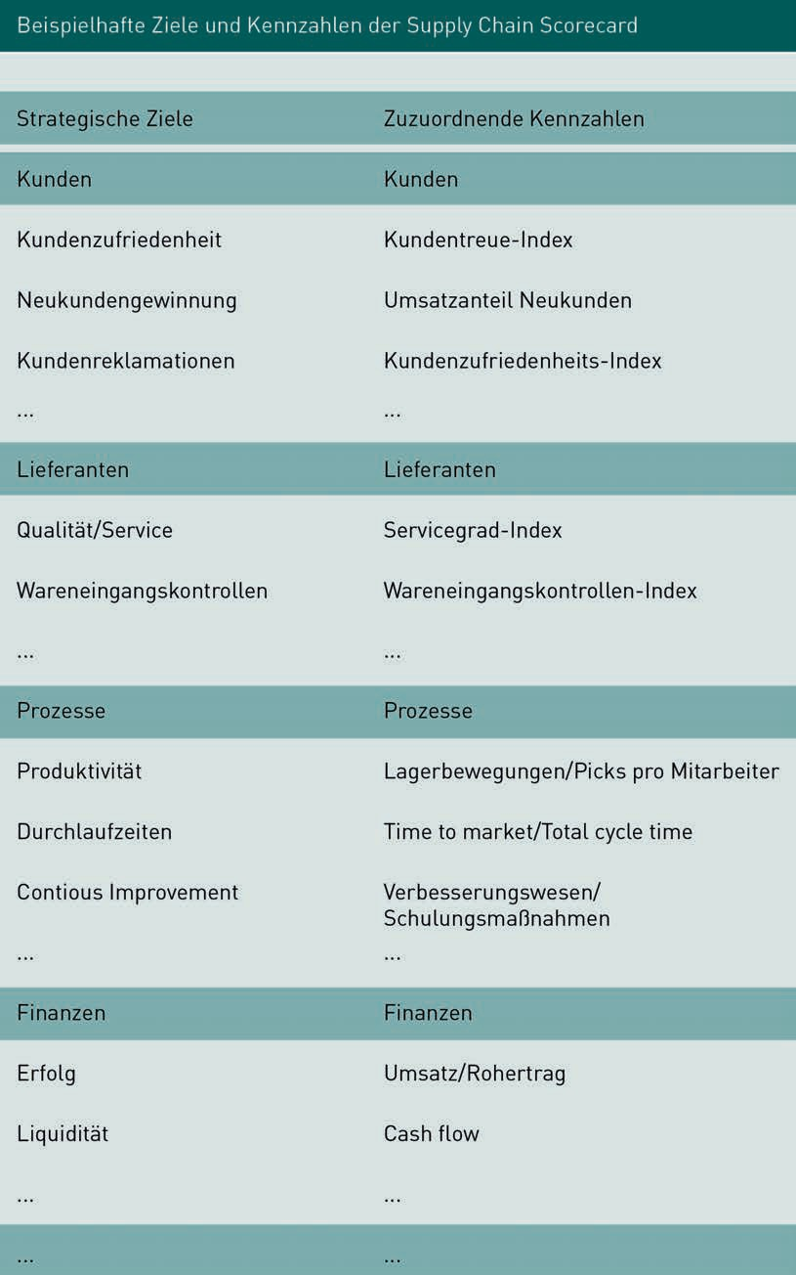

Information Gathering

Precise specifications for goals and activities as well as clear key figures are defined for all perspectives. As a result, the viability of a strategy can be checked as early as the implementation phase and any errors or discrepancies that occur can be corrected as early as the implementation process.

Hence, the BSC does not serve to develop new strategies, but to monitor and realize existing goals and concepts. It provides answers to questions such as “Where does the company stand, what is the goal, and how does the company achieve the goal?”

A Balanced Scorecard that has been specifically aligned to Supply Chain Management is a tool that gives Supply Chain Controlling a clear and comprehensive account of all relevant aspects, and combines the fundamental tasks and goals in a structured manner.

All of the systems, tools, and methods presented ultimately serve one single purpose: to make relevant information accessible to everyone involved in the supply chain in the interests of information sharing, in order to achieve optimal control of the supply chain in terms of costs, and ensure the maximum possible benefit for all participants. This means that the flow of information is kept transparent at all times with the integration of information processing, and thus contributes to the optimization of the link between supply and demand.

**Summary**

Supply Chain Management and the underlying strategies are promoted, controlled, accelerated, and monitored by information technology and the associated systems. Within IT, the tools EDI, EAN, and RFID are used.

These tools are used alongside other e-business technologies and methods within E-Supply Chain Management, including ERP, CRM, SCM, and other operational software. The specified aids simplify and optimize Supply Chain Management.

Another tool used to gather information in Supply Chain Management is the Balanced Scorecard. The information contained therein can be flexibly adapted to the requirements of the supply chain participants. It serves as a clear control tool for Supply Chain Controlling, which combines the fundamental tasks and goals in a structured manner, and guarantees an overview of the current situation in the supply chain at all times.