COURSE BOOK



## SUPPLY CHAIN RISK MANAGEMENT AND CONTROLLING

MWCH02

Learning Objectives

##### Introduction 9



The **Supply Chain Risk Management and Controlling** course is designed to deepen the understanding of the need to develop an effective and efficient controlling system for global value-added networks -and systematic risk management.

Specific requirements for controlling activities in the value-added network and helpful resources for controlling in supply chain management (SCM) will be explained. In the area of risk management in supply chains, appropriate treatment of the problem with relevant categories is presented. You will deal with identifying specific risks in SCM, you will learn relevant forecast and analysis processes as well as how to deal with relevant control and monitoring instruments.



# Unit 1

## Basic Principles for Controlling in and of Supply Chains

#### STUDY GOALS

After working through this unit, you will know, ...

… why classic controlling does not suffice in managing supply chains.

… what difficulties can arise when implementing controlling systems in supply chains.

… the role controlling plays in supply chains.

… the purpose of the cost-tracking approach.

… the types of supply-chain controlling.

DL-D-MWCH02-L01

1. Basic Principles for Controlling in and of Supply Chains

### Introduction

Supply chain management means that integrated logistics chains (flows of money, information, and materials) are developed, administered, controlled, and monitored across all stages in a value-added process. This extends from the extraction of raw materials to production to the various refinement stages right through to delivery to the end user. The desired outcomes of efficient supply chain management include synergy effects and sustainable potential for savings for all parties involved in the process chain as well as improved satisfaction levels in end users, which guarantees business success for the long term. Supply chain management (SCM), therefore, means creating a basic structure of developing processes, which includes all supply, disposal, and logistics operations and culminates in consistent controlling for all parties involved in the process chain.

In some cases, the protagonists’ divergent objectives, which are formative for the supply chain, have to be adjusted to achieve the best outcome for all parties involved. Considerable time in coordination is also required, as the services of the individual value-added stages are provided in different places and at different times.

In order to achieve the aims of supply chain management, efficient controlling of the value-added chain is crucial. Its function is to ensure effective planning, management, and structuring of cross-company activities.

The word stem of the term ‘controlling’ is derived from the French word ”contrerôle” (= counter roll or counter spiral) and “compter” (= to count), and from the English word ”to control” (= to steer, control) and ”roll” (=list). to the derivations allow for identifying the role assigned to controlling in organizations. Controlling is intended to play a ‘counter role’, especially in terms of strategic planning. Due to the objectively determined key figures that controlling provides, it is the antithesis of corporate or organizational management, which must be visionary to execute its operational tasks and, in certain areas, also willing to take risks. In part, it assesses the company results more emotionally than objectively. Controlling entails the objective ”counting” and “listing” of operational data and facts that reflect the impact of strategic planning and its implementation on the business. At the same time, controlling provides the basis for future corporate strategies by providing forecasts for further development based on existing data.

Initial mentions of the term ‘controlling’ in the USA around 1890 referred merely to a summarized description of cost accounting. The expansion of controlling systems in their current significance began in Germany in the 1960s, with Continental Gummi Werke AG taking a pioneering role in Hanover.

Basic Principles for Controlling in and of Supply Chains

In German, controlling is often equated with control due to the similarity of the terms. As the above definition shows, this association is wrong, even if some control is required in corporate planning. The following definitions have prevailed:

“From a functional perspective, ‘controlling’ is the management subsystem that coordinates planning and control as well as the supply of information in a system-building and system-coupling manner with a focus on results, thereby supporting the adaptation and coordination of the overall system.” (Horváth 2020, p. 129).

According to Specht et al. (2002), the aim of controlling is to support management decisions. This includes providing management with the necessary information in the right quality and quantity, in the right place and at the right time, and at a minimal cost.

Since a supply chain as a dynamic and complex construct frequently requires both internal and external adjustments, supply chain controlling covers organizational, personnel, and technical aspects. The classic controlling elements can continue to be used for this purpose within the company. However, they only make a minor contribution to optimizing the cross-company supply chain.

To do justice to the value-added spread among a variety of contributors, it is necessary to extend classic controlling so that not only monetary variables are recorded, but a focus on customers, innovation, and processes is added to the cost-based perspective. In addition to the classically results-based variables, those with a process orientation must also be defined. In this context, supply chain controlling clearly shows which cause-effect relationships exist in the value-added chain and how these relationships have to be modified where necessary. With optimally aligned supply chain controlling, all parties have an early warning system that makes timely intervention possible in the event of errors and their elimination.

“Supply chain controlling is responsible for developing a uniform technical language and a common understanding of processes across all agents in the supply chain.” (Otto/Stölzle 2003, p. 5).

The following diagram summarizes the tasks of supply chain controlling (SCC).

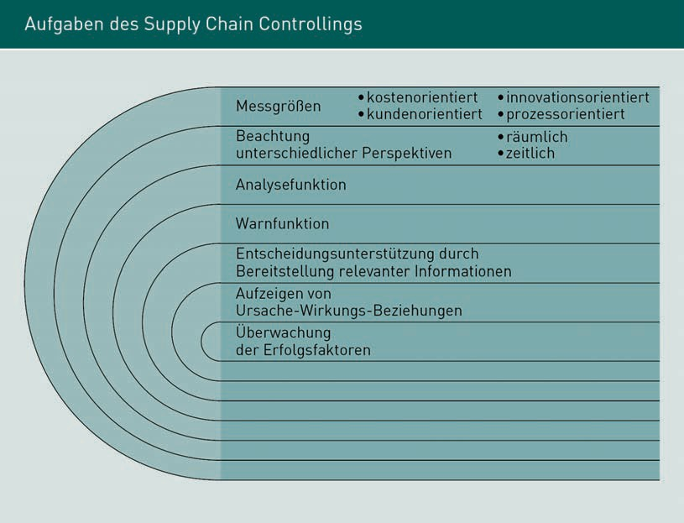

### Conceptual Design of Controlling in Supply Chain Management Systems

In supply chain management systems, there is the problem that in the case of cross-company value chains, not only the processes and procedures but also the controlling systems have to be adapted to each other, as these are rarely comparable across companies. However, to achieve efficient cross-company control of the value-added chain, uniform treatment of company-relevant key data is necessary. This requires the supply chain parties to define the type of key figures responsible for individual parameters and the measurement (time) points as accurately as possible. The main focus is on the binding definition of intervention values or possible tolerances.

The basic problem of introducing efficient supply chain controlling results from one of the most important effects of efficient supply chain management: the constant change in processes in the value-added chain, which arises from continuous monitoring, and the resulting learning effects. For this reason, cross-company target agreements and rules of conduct, which are acceptable to all parties in the supply chain and align with the respective company’s philosophy, must be defined. These agreements and rules should be established for the long term so that they do not have to be re-negotiated

Basic Principles for Controlling in and of Supply Chains

for every order. In this respect, transparency and the communication of the goals in individual companies are particularly important to achieve the participation of employees and to clarify that the goals are sustainable and influenceable. This promotes identification with a shared goal. To achieve and verify the objectives, the participating organizations must regularly monitor their own processes for any potentially occurring errors and their correction.

Supply chain controlling is essentially used to support supply chain management in order to increase the efficiency and effectiveness as well as the adaptability and development capability of supply chain management.

Supply chain controlling is implemented in three steps: firstly, a needs assessment is conducted and this results in the definition of objectives. In this phase, the individual requirements of the companies involved in the supply chain, in particular, must be observed and defined exactly.

The second phase involves the conceptualization of the supply chain controlling approach. Since supply chain controlling is intended to work across companies, all organizations involved in the supply chain, both customers and suppliers, must be included in the concept development. The third phase is the ”go-live” of the developed concept. This often manifests in a pilot phase, in which the conceived structures are tested and modified, if necessary, before they are finally implemented in all participating companies ( or divisions).

The most important point in the implementation of supply chain controlling is, therefore, inter-company communication and coordination with supply chain partners.

Supply chain controlling comprises the following key tasks (cf. Weber/ Bacher/Groll 2003, p. 13f.):

* Establish cross-company and standard key figures;
* Identify the key processes and, as a result, develop a common database for key figures;
* Create a uniform presentation and assessment of both cross-company company and internal processes to achieve a consistent understanding of procedures and processes;
* Determine the so-called ‘soft factors’ that have a vital impact on the success of a supply chain (soft factors include trust between those involved in the supply chain);
* Identify the core elements of the supply chain to gain an overall view of what supports strategic and operational planning. Monitor the achievement of the supply chain's goals and their incorporation into the company.

Based on the above explanation, it is clear that meaningful supply chain controlling requires available and comparable information about the individual process steps at the various companies involved in the supply chain.

If supply chain controlling is used efficiently, it contributes decisively to creating transparency in the company. Based on key figures that mirror processes and results realistically, key success factors for the organization (costs, quality, and time) can be monitored and processes can be adjusted if errors are identified promptly to avoid losses (due to delivery bottlenecks, loss of image because of low quality etc.).

In cross-company value chains, supply chain controlling enables significantly better results and more effectiveness by improving the flow of information and communication.