COURSE BOOK



## SUPPLY CHAIN RISK MANAGEMENT AND CONTROLLING

MWCH02

General Study Goals

##### Introduction 9



The aim of the course **Supply Chain Risk Management and Controlling** is to create a greater understanding of the need to develop an effective and efficient controlling system for global networks that create value and systematic risk management.

Specific requirements will be explained for controlling activities in the value-added network and resources helpful to controlling in supply chain management (SCM). Appropriate treatment of the problem with relevant categories is presented in the area of risk management in the supply chain.

You will be involved in identifying specific risks in SCM, learn relevant forecast and analysis processes and know how to deal with the relevant control and monitoring instruments.

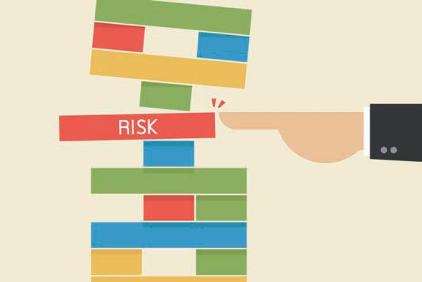

# Unit 1

## Basic Principles for Controlling in and by Supply Chains

#### STUDY GOALS

After working through this unit, you will know, ...

… why classic controlling in the management of supply chains falls short;

… what difficulties can arise when implementing controlling systems in supply chains;

… the role controlling has to play in supply chains;

… the purpose of the cost-tracking approach;

… the types of supply-chain controlling.

DL-D-MWCH02-L01

1. Basic Principles for Controlling in and by Supply Chains

### Introduction

Supply chain management means that integrated logistics chains (flows of money, information, and materials) are developed, administered, controlled, and monitored across all stages in a value-added process. This extends from the extraction of raw materials to production to the various refinement stages right through to delivery to the end user. Synergy effects and sustainable potential savings for all the parties involved in the process chain and an improvement in the levels of satisfaction of end users, which guarantees business success for the long term, are the desired outcome in efficient supply chain management. Supply chain management (SCM) therefore means creating a basic structure by developing processes, which includes all supply, disposal, and logistics operations and culminates in consistent controlling for all the parties involved in the process chain.

The, in some cases, divergent objectives of the protagonists, which have to be adjusted in such a way as to achieve the best outcome for all parties involved, are formative for the supply chain. Considerable time in coordination is also required, as the services of the individual value-added stages are provided in different places and at different times.

Efficient controlling of the value-added chain is crucial if the aims of the supply chain management are to be achieved. Its function is to ensure effective planning, management, and structuring of the company-wide activities.

The term ‘controlling’ is derived, in terms of the word’s origin, from the French ‘*contrerôle*’, which means counter roll or checking register, and ‘*compter*’, which is to count, and from the English ‘to control’ (= to steer, control) and ‘roll’, which means a list. It is possible to identify the role assigned to controlling in organizations from the derivations. Controlling is intended to play the role of a ‘counter roll’, especially in terms of strategic planning. Due to the objectively determined key figures that controlling provides, it is the antithesis of corporate or organizational management, which must be visionary to assume its operational tasks and, in certain areas, also willing to take risks, and which, in part, assesses the company results more emotionally than objectively. Controlling is the objective ‘counting’ and ‘listing’ of operational data and facts that reflect the impact of strategic planning and its implementation on the business. At the same time, controlling provides the basis for future corporate strategies by providing forecasts for further development based on existing data.

The first references to the term ‘controlling’ around 1890 in the USA referred merely to the summary of the description of cost accounting. The distribution of controlling systems in their current significance began in Germany in the 1960s, with Continental Gummi Werke AG taking a pioneering role in Hanover.

Basic Principles for Controlling in and by Supply Chains

In German, controlling is often equated with control due to the similarity of the terms. As the above definition shows, this association is wrong, even if some control is required in corporate planning. The following definitions have prevailed:

“From a functional perspective, ‘controlling’ is the management subsystem that coordinates planning and control as well as the supply of information, forming, and coupling systems in a targeted way, thereby supporting the adaptation and coordination of the overall system.” (Horváth 2020, p. 129).

According to Specht et al. (2002) the aim of controlling is to support management decisions. This includes providing management with the necessary information in the right quality and quantity, in the right place and at the right time, and at minimal cost.

Since adjustments are often necessary both internally and externally in a supply chain as a dynamic and complex construct, supply chain controlling covers both organizational, personnel, and technical aspects. The classic controlling elements can continue to be used for this purpose within the company. However, they only make a minor contribution to optimizing the cross-company supply chain.

To do justice to the value added spread among a variety of contributors, it is necessary to extend classic controlling so that not only monetary variables are recorded, but the customer, innovation, and process orientation is added to the cost-based perspective. In addition to the classically results-based variables, those with a process orientation must also be defined. In this context, supply chain controlling clearly shows which cause-effect relationships exist in the value-added chain and how these relationships have to be modified, where necessary. Optimally aligned supply chain controlling enables all parties involved to have an early warning system that makes timely intervention possible in the event of errors and their elimination.

“Supply chain controlling is responsible for developing a uniform technical language and a common understanding of processes across all stakeholders in the supply chain.” (Otto/Stölzle 2003, p. 5).

The following diagram summarizes the tasks of supply chain controlling (SCC).

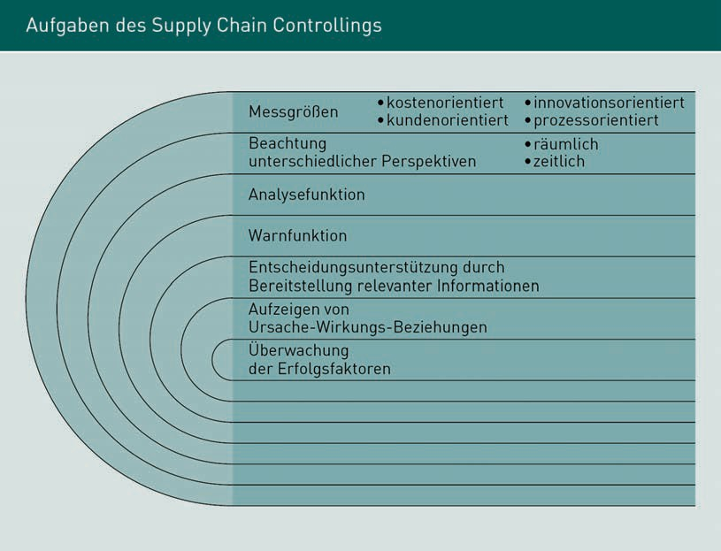

### Concept Design of Controlling in Supply Chain Management Systems

In supply chain management systems, there is the problem that in the case of cross-company value chains, not only the processes and procedures but also the controlling systems have to be adapted to each other, as these are rarely comparable between the companies involved. However, to achieve efficient cross-company control of the value-added chain, a uniform treatment of company-relevant key data is necessary. This requires that the supply chain parties define the type of key figures, those responsible for the individual parameters, and the measurement (time) points as accurately as possible. The main focus is on the binding definition of intervention values or possible tolerances.

The basic problem of introducing efficient supply chain controlling results from one of the most important effects of efficient supply chain management: The constant change in processes in the value-added chain, which arises from continuous monitoring and the resulting learning effects. For this reason, target agreements and rules of conduct must be defined across the entire company, which are acceptable to all parties in the supply chain, and which have to be matched to the respective company philosophy. These agreements and rules are constructed for the long term, so that they do not have to be

Basic Principles for Controlling in and by Supply Chains

for every order. Transparency and the communication of the goals in the individual companies are particularly important in this respect to achieve the participation of employees and to make it clear that the goals are sustainable and can be influenced. This promotes identification with the shared initiative. To achieve and verify the objectives, the participating organizations must regularly monitor their own processes for any errors that may occur and correct them.

Supply chain controlling is essentially used to support supply chain management to increase the efficiency and effectiveness as well as the adaptability and development capability of supply chain management.

Supply chain controlling is implemented in three steps: Firstly, the requirements are analyzed with the resulting definition of objectives. In this phase, the individual requirements of the companies involved in the supply chain, in particular, must be observed and defined exactly.

The second phase involves the initial design of the supply chain controlling approach. Since supply chain controlling is intended to work across companies, all organizations involved in the supply chain, both customers and suppliers, must be included in the concept development. The third phase is the ‘go-live’ for the developed concept. This often takes place as part of a pilot phase, in which the conceived structures are tested and modified, if necessary, before they are finally implemented in all participating companies (divisions).

The most important point in the implementation of supply chain controlling is therefore inter-company communication and coordination with the supply chain partners.

Supply chain controlling comprises the following key tasks (cf. Weber/ Bacher/Groll 2003, p. 13f.):

* Establish cross-company and standard key figures.
* Identify the key processes and, as a result, develop a common database for key figures.
* Create a uniform presentation and assessment of both company and internal processes to achieve a consistent understanding of procedures and processes.
* Determine the ‘soft factors’ that have a vital impact on the success of a supply chain (soft factors include the trust between those involved in the supply chain).
* Identify the core elements of the supply chain to gain an overall view of what supports strategic and operational planning as well as monitor the achievement of the supply chain's goals and how these are incorporated in the company.

From the above, it follows that supply chain controlling is only used in a meaningful way if comparable information about the individual process steps is actually available at the various companies involved in the supply chain.

If supply chain controlling is used efficiently, it contributes decisively to creating transparency in the company. Key figures that realistically map processes and results can monitor the key success factors for the organization (costs, quality, and time) and adjust processes and avoid losses (due to delivery bottlenecks, loss of image because of low quality etc.) by identifying any errors promptly

In cross-company value chains, supply chain controlling enables significantly better results and more effectiveness by improving the flow of information and communication.