Nomadism and Sedentarization Under British and Israeli Rule: The Shehadeh Clan in the Galilee, 1918-1981

This paper addresses the dealings of the British Mandate and the State of Israel with the Shehadeh clan, Bedouins from the Suweid tribe who live on Mount Kammon in the Galilee. It will also discuss how the clan came to live in the middle of a Jewish settlement without being considered residents of that settlement. Two Bedouin villages on Mount Kammon are also populated by members of the Suweid tribe, Kammaneh and Jalassa. These villages were granted the status of municipalities in 1994 while the Shehadeh neighborhood was defined as an illegal settlement until 2018, and suffered from poorly developed infrastructure and building bans.[1] The building of the Jewish village of Kamon around the Shehadeh neighborhood without including it as part of the municipality led to it being cut off from the rest of the tribe. The Shehadeh became a clan that was not connected to any village; they were neglected by both the Jewish and the Bedouin sides in the legalization process of the Bedouin villages on Mount Kammon. The story of the Shehadeh reflects the story of many Bedouin clans in Israel and the process of sedentarization that they underwent under the British Mandate and the State of Israel. In my discussion of the Shehadeh clan, I will relate to the period from the onset of the British Mandate in 1918 until the establishment of Kamon in 1981.

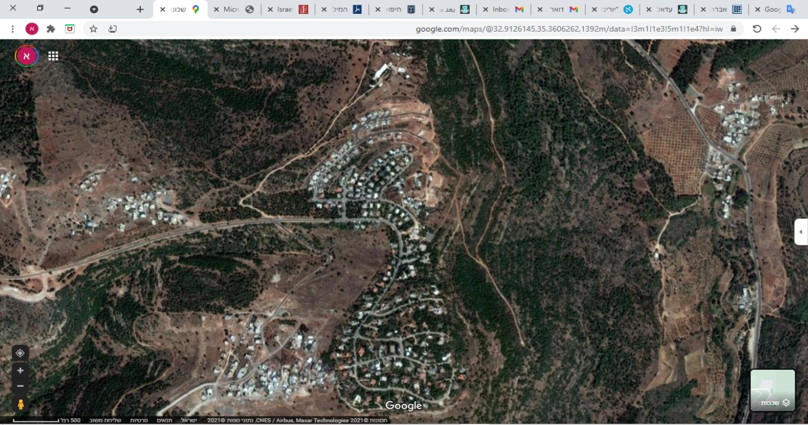

1Map of Kamon, East Kammaneh, Jalassa and Shehadeh, 2021

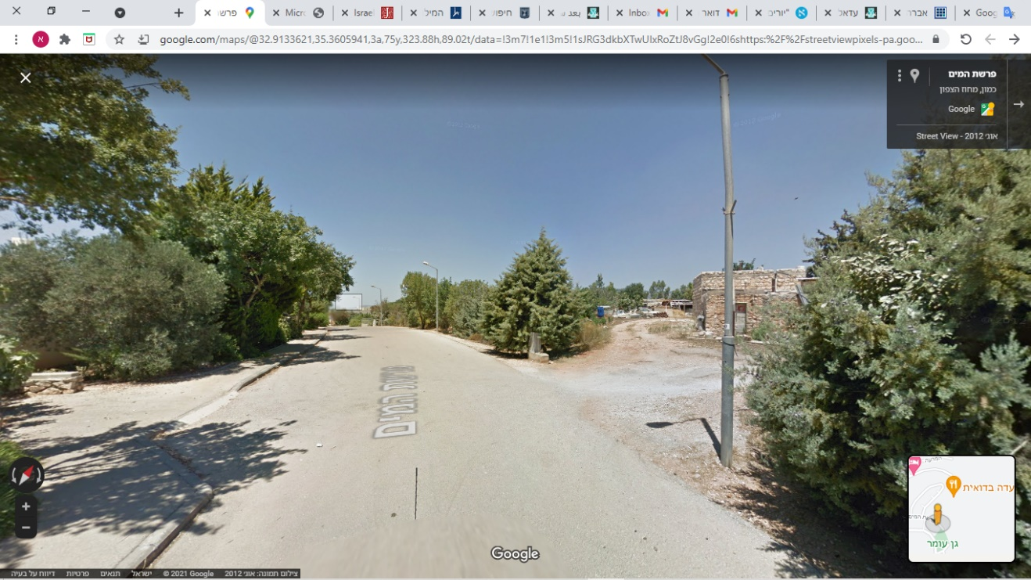

In his article, “Nomads and Sedentary Dwellers in the Middle East” (Hebrew), Emanuel Marx shows how the tribes who did not fit into the tribal model that the State of Israel had created and did not accept the plans that Israel had made for them found themselves on “a limited and deprived ethnic reservation,” a concept that he applied to Negev Bedouin but which also is an apt description of the Shehadah clan’s situation.[2] [3] This paper is based on the analysis of archival sources combined with interviews that I conducted with members of the Shehadah clan and the Suweid tribe as well as Jewish residents of Kamon. As a native of Kamon, I was already familiar with both the Jewish and the Bedouin residents of the area and members of both communities opened their homes to me and also directed me to important archival material. Coming back to Kamon as a researcher who was fluent in Arabic made it possible for me to hear narratives of the history of the place where I grew up that were different from those that I was familiar with. Many of the interviews I conducted were in fact in Arabic, the language my subjects felt more comfortable expressing themselves.

In the second half of the nineteenth century, several clans from the Suweid tribe moved from the Hula Valley to Mount Kammon and the adjacent Wadi Salameh which were forested and remote from the Ottoman authorities.[4] The main reason for the move was the Ottoman land law of 1858 (the Tabu law) which strengthened government control of land ownership and required land owners to pay taxes and also serve in the army. The first member of the tribe to settle on Mount Kammon was Ali Sheban of the Sheban clan.[5] The members of that clan gradually settled in Hirbet Kammaneh (today – East Kammaneh), in the Jalassa and Shehadeh neighborhoods, buying plots of land from the Thiv and Askander clans from Rameh, a village at the bottom of the mountain.[6] Wadha, a member of the Shehadeh clan who lives in the neighborhood today, was born in 1964 in the Shehadeh neighborhood and reports that her grandfather lived in the area in the first half of the twentieth century. Her family were shepherds and farmers whose practice was to move between their land at the top of the mountain and other land belonging to the Suweid tribe in the area.

# The British Mandate: 1918 – 1948. Forced Sedentarization

The British Mandate for Palestine set a policy of sedentarization for the Bedouin. This policy was a continuation of the trend that began with the Ottoman land law.[7] In 1920 the Mandate authorities published the “Forests Ordinance” that established that forested land whose ownership cannot be determined will become a nature reserve in which it is prohibited to build, live, graze flocks, and the like. Between 1925-1947, 805,680 dunam (1 dunam = 1000 m2) in northern Palestine became nature reserves.[8] The British Ministry of Agriculture, which was the ministry responsible for the ordinance, accepted only official documents like deeds of sale or land tax receipts as proof of land ownership. Anyone who could not produce such documents would have his land seized. Many of the Bedouin tribes in the Galilee did not possess such documents, even though they had worked their land for many years and received ownership through oral agreements.[9] The Suweid tribe, which the Palestine Index Gazetteer identified as residents of Mount Kammon between 1931-1948, was banned from grazing their flocks (their main source of livelihood) on large parts of the mountain, most of which had been declared a nature reserve.[10]

Two more steps towards sedentarization were taken in 1942. The first was the Bedouin Control Ordinance:

פקודה המקנה למושלי מחוזות סמכות-פיקוח כללית על שבטים וציבורי בני אדם נודדים בארץ. לרבות הסמכות לחקור בעבירות הנעשות על ידי אנשי השבטים והציבורים האלה, ולענוש אותם על כך.*[11]*

The ordinance granted District Commissioners more flexible powers to deal with nomadic tribes than in the past. It permitted interrogation, seizure of property, and collective punishment, all at the broad discretion of the Commissioners. Its goal was to improve the Mandate’s ability to govern the tribes and improve the efficiency of efforts to prevent theft, enforce the law, and prevent the Bedouin tribes’ nomadic migrations and appropriation of land that was not officially registered as theirs (in the Tabu).[12] The second step was to designate large tracts of land throughout Palestine as firing ranges for military training. One of these was firing range 9 of the British Middle Eastern School for Infantry training which served mostly as an artillery range. During those years, all of Mount Kammon and its environs were part of a firing range, and travel outside of the limited areas set aside for the Bedouin was dangerous.[13] The policy instituted in 1942 testifies to the fact that the sedentarization of the Bedouin in the Galilee had not met the British ambitions.

The Shehadeh clan bought land on Mount Kammon in an area that was somewhat distant from the already existing settlement of the Suweid tribe in East Kammaneh and Jalassa. The British policy to settle the Bedouin in permanent villages and to put an end to their nomadic lifestyle intensified the separation of the Shehadeh neighborhood from East Kammaneh and Jalassa; the clans established permanent settlements in different areas. Wadha claims that the Israeli claim that the distance between the villages indicates that the clans were in conflict is incorrect. Rather, the distance between the land of the different clans matches the normal patterns of the tribe, with both dispersed living areas and each clan living apart in order to enable enough grazing for all. She emphasized that some of her brothers even live in East Kammaneh and that there are marriages between families in Shehadeh, Kammaneh, and Jalassa. Moreover, she claims that it is her tribal identity (Suweid) rather than her clan identity (Shehadeh) that is most important in her life. The distinction between the different Suweid clans is, she claims, the result of the constraints placed on the Suweid by the British and the Israelis and even more so the result of the separation of the different villages resulting from the Israelis establishing Kamon in 1981.

# 1947-1981: The Tightening and Loosening of Relations between the Suweid and the State of Israel

The fighting between the Arabs of Palestine and its Jewish residents broke out in November 1947. Fearing the fighting, many members of the Sheban clan fled north to Beit Jann and Ein Sahala, near the Lebanese border, and only returned several months later. The Suweid who live on Mount Kammon did not actively participate in the fighting and members of the Suweid tribe living beneath the mountain even cooperated with Shai (the Haganah’s intelligence arm) agent Giora Zeid, gathering weapons from Bedouin villages for use by Jewish forces.[14] This cooperation gave rise to a favorable attitude to the Suweid from the Israeli authorities once the state was established. In the context of the significant reduction of Bedouin living in the Galilee, from 20,000 before the war to 6500 after it,[15] the right of the residents of Kammaneh, including the Shehadeh clan, to live there was accepted de facto, although not officially recognized.[16] The Sheban clan in East Kammaneh even set up an elementary school for the children of the area. The members of the tribe had economic and social ties with the villages in the vicinity of Mount Kammon, particularly with Rameh and Nahf.[17]

Despite the good relations that had been established by their cooperation in the 1948 war, the martial law that was imposed upon most of the Arab population in Israel following the war generated many points of tension between the government and the Shehadeh clan. The status of the land under the control of the military government frequently changed. These changes included the designation of certain areas as closed military zones into which entry was prohibited without special permission and the expropriation of land for security reasons that were not made explicit to the local population.[18] Besides continuing to designate Mount Kammon as a firing range, the military government severely limited the Suweid’s movement by requiring that they receive permits for herding the flocks, visiting relatives, and other matters. The map shows that the entire Suweid tribe lived in the firing range[19] until it was closed in the ‘80s.

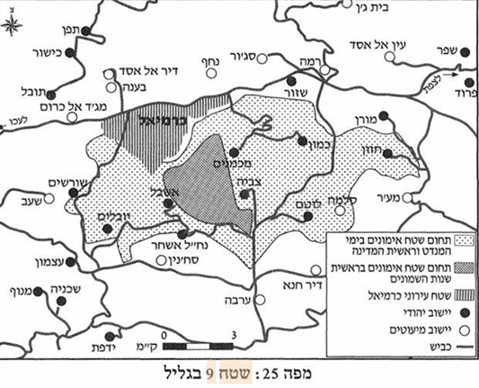

An event in 1956 that was reported upon in the Maariv newspaper describes the tensions between the tribe and the military government:

The Defence authorities are now taking administrative measures against the bedouin tribe of the Sawaid, who live in the hills of Galilee, after their ‘revolt’ against a military order and their refusal to remove their tents, which were pitched in a closed area. The penalties imposed on this Bedouin tribe include the prohibition of its members to move from their place of residence to the neighboring area, the withdrawal of all government permits (for hunting, pasturing, movement, etc.), the closing of the primary school, and a ban on the providing of the tribe with foodstuffs, and on its selling its produce outside its place of residence.[20]

Wadha reports that because the school was closed, she had to walk ten kilometers each day to attend the school in Rameh.[21]

During the ’60s and the ’70s, the Suweid were not allowed to add extensions to their homes, connect them to infrastructure, or build schools or infirmaries. The Israeli military government claimed that the area they lived in is a military zone and that it is dangerous to live there.[22] Wadha reports that when she was a child, they could not even construct a chicken coop without it being destroyed by the authorities soon afterward.[23] The attempt to build a dirt road from the neighborhood to Rameh was also blocked by the military.[24] Ghazi Falah describes how this state policy led to the Suweid losing control of much of their land, from 656 dunam in 1949 to 139 dunam in 1958. This policy was put into place to enable building by Jews in these areas,[25] as is clearly expressed in this statement issued by the Agriculture Ministry in 1960:

The state and the Development Authority and the Keren Kayemet Le Israel are the legal owners of thousands of donums in the Galilee, Triangle and Wadi Ara districts and more than 250,000 donums divided up into small plots are surrounded by the lands of other Arab owners. There is no possibility of exploiting these lands for settlement or development purposes unless the government takes action to concentrate the lands they own in large lots for the purpose of improving, developing and settling them in accordance with requirements of the State.[26]

The success of this policy was manifest in the implementation of the “Lookouts” (Hebrew: *Mitzpim*) plan under which the Jewish settlements of Kamon and Mikhmanim were founded on Mount Kammon.

In 1974, the settlement division of the Jewish Agency proposed a plan to advance the building of Jewish settlements in the Galilee that would serve as barriers between Arab population centers which were regarded by the state as a threat. The plan was named the “Lookouts Plan” and in its framework, 58 settlements were founded in the northern part of Israel. On the top of Mount Kammaneh, whose name was changed to Kammon, two settlements, Kamon and Mikhmanim, were set up as part of a long belt of Jewish settlements that stretched east to west and served as a barrier separating the southern bloc of Arab villages including Sakhnin, Deir Hanna, and Arabeh from the northern bloc that included Rameh, Nahf, and Deir Al Asad.[27]

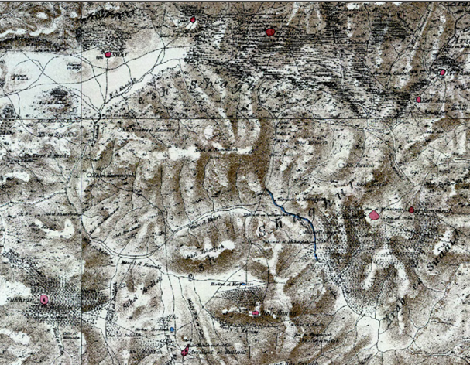

The construction of Kamon and Mikhmanim took place in parallel to attempts by the authorities to remove the Suweid from the mountain. In 1970, the Bedouin village of Salameh had been constructed on the southeastern slopes of the mountain with the purpose of concentrating the entire Suweid tribe in one village. The state offered the families living on the mountain generous economic incentives to move that were rejected in most cases.[28] Alongside the incentives offered to the Suweid to relocate from the mountain, sanctions were imposed on those members of the tribe who stayed. These included the denial of requests for building licenses, the rejection of zoning plans, and the refusal to develop infrastructure while the Jewish settlements were being built and developed and did not face similar obstacles.[29] Firing Range 9 was closed to pave the way for the building of the Jewish settlements.[30] The Shehadeh clan became a prominent hindrance to the construction of Kamon. East Kammaneh and Jalassa were blocs of Arab population next to which the settlement could be constructed, the land belonging to the Shehadeh was the very same land on which the settlement of Kamon was supposed to be built. The Shehadeh did not accede to the suggestions that they move to Salameh or East Kammaneh and let it be known that they had no intention of leaving their land. They claimed that it was not a matter of money and the fact that they had relatives in Kammaneh was irrelevant. This was their land and they refused to relinquish it.[31]

As the Shehadeh resisted moving, a road was paved in 1981 from the Jewish city of Karmiel at the bottom of the mountain to the new Jewish settlements at the top. It is evident that this road was part of the struggle against the Bedouin on the mountain as it did not go into their villages and was not built before the Jewish settlements were founded. Along with the new road, Kamon and Mikhmanin were connected to the water and electric grids. Even though the pipes and cables passed over or under the houses of the Shehadeh clan and East Kammaneh, these homes were not connected to the infrastructure as they were considered illegal by the authorities.[32]

# Conclusions

The story of the Shehadeh clan is an example of how the traditional Bedouin lifestyle clashed with both British and Israeli policy in the land of Israel. The British limited the Suweid lands by designating firing ranges and legislating ordinances that made it easy to sanction them. The State of Israel viewed the Shehadeh as a recalcitrant group that should be moved in order to Judaize the area. When the village of Kamon was constructed around the residences of the Shehadeh, the Shehadeh were perceived as obstructing the development of Kamon rather than the opposite. The artificial disconnection of the Shehadeh from the other members of the Suweid tribe in East Kammaneh and Jalsa inspired the Israeli claim that the Shehadeh should be moved back to their lands in Kammaneh as if they had originally built their homes on land that was not theirs. In practice, the Israeli policy ignored the history of property ownership on Mount Kammon. By making living conditions difficult on the one hand and offering generous economic incentives to relinquish their lands on the other, the State of Israel sought to concentrate the Bedouin of Mount Kammon in areas that were acceptable to the Jewish residents.

The misunderstanding of the Bedouin way of life and the nature of clan ties within the tribe led to the conflict between the Israeli aspirations and the Shehadeh clan. Analysis of this case with the help of Arabic sources and interviews with the Bedouin who present their side of the issue sheds new light on past and present British and Israeli conduct concerning the Bedouin tribes.

1. "بيان الصحافة" *المركز القانوني لحقوق الأقلية العربية في إسرائيل*, يوليو 27, 2005, <https://www.adalah.org/ar/content/view/713>
2. שם, עמ' 22.
3. עמנואל מרקס, *החברה הבדווית בנגב* (תל אביב: הוצאת רשפים, 1974), 13.
4. سواعد, البدو في فلسطين في الحقبة العثمانية (1516- 1914), 28
5. سواعد, عرب السواعد: الترحال والاستقرار, 17, 223, 225
6. יאיר אטינגר, "יורים באוויר והאינדיאנים לא רוצים לברוח," *הארץ*, מאי 23, 2004, <https://www.haaretz.co.il/news/health/1.968974>; בג"ץ 06/ 6176 **כמון- אגודה שיתופית להתיישבות חקלאית נ' המועצה הארצית לתכנון ולבניה** (יולי 26, 2006), <https://www.adalah.org/uploads/oldfiles/admin/DownLoads/SPics/2787434.pdf>; عراف, *بدو مرج ابن عامر والجليلين بين الماضي والحاضر,* 179.
7. عراف, بدو مرج ابن عامر والجليلين بين الماضي والحاضر, 176.
8. Ibid, pp. 32.
9. Falah, "The Processes and Patterns of Sedentarization of the Galilee Bedouin 1800-1982," 230-232.
10. Seth J Frantzman, "The Arab Settlement of Late Ottoman and Mandatory Palestine: New Village Formation and Settlement Fixation, 1871-1948," (PhD diss., Hebrew University of Jerusalem, 2010), 285.
11. "פקודת הפיקוח על הבידואים," *העיתון הרשמי* מס' 1204- תוספת מס' 1 (יוני 25, 1942): 50- 52.
12. Falah, "The Processes and Patterns of Sedentarization of the Galilee Bedouin 1800-1982," 238-239.
13. עמירם אורן ורפי רגב, *ארץ בחאקי: קרקע וביטחון בישראל* (ירושלים: כרמל, 2008), 386
14. Muhammad Youssef Suwaed, "The Bedouins in the Galille in the War of Independence of Israel 1948-1950," *Middle Eastern Studies* 53, no. 2 (2017): 298-300.
15. Suwaed, "The Bedouins in the Galille in the War of Independence of Israel 1948-1950," 310.
16. سواعد, عرب السواعد: الترحال والاستقرار, 132
17. سواعد, عرب السواعد: الترحال والاستقرار, 132
18. Falah, "The Processes and Patterns of Sedentarization of the Galilee Bedouin 1800-1982," 268-269.
19. אורן ורגב, ארץ בחאקי: קרקע וביטחון בישראל, 388.
20. Falah, "The Processes and Patterns of Sedentarization of the Galilee Bedouin 1800-1982," 269.
21. ודחה סואעד, ראיון עם אסף לוי.
22. سواعد, عرب السواعد: الترحال والاستقرار, 133.
23. אורן ורגב, ארץ בחאקי: קרקע וביטחון בישראל, 386
24. سواعد, عرب السواعد: الترحال والاستقرار, 134
25. Medzini, "Tribalism Versus Community Organization: Geography of a Multi-Tribal Bedouin Locality in the Galilee," 242.
26. Falah, "The Processes and Patterns of Sedentarization of the Galilee Bedouin 1800-1982," 276-277.
27. Ghazi Falah, "Israeli Judaization Policy in Galille," *Journal of Palestine Studies* 20, no. 4 (1991): 76-77.
28. דור אברהם, "מפעל המצפים בגליל עשרים שנה אחרי," *עיונים בביטחון לאומי: הקתדרה הגאו-אסטרטגית אוניברסיטת חיפה* 6 (2004): 55.
29. Falah, "The Processes and Patterns of Sedentarization of the Galilee Bedouin 1800-1982," 314
30. Falah, "The Processes and Patterns of Sedentarization of the Galilee Bedouin 1800-1982," 314.
31. ודחה סואעד, ראיון עם אסף לוי.
32. Falah, "The Processes and Patterns of Sedentarization of the Galilee Bedouin 1800-1982," 373.