# Executive Summary and Key Insights: 2022 Annual Summary

2022 was a year in which the Israeli high-tech industry’s business variables returned to the long-term trends (when discounting the figures of 2021 that deviated from the norm):

* The total amount of **Venture Capital (VC) investments** continued the same trend of 2014–2020, amounting to USD 15 billion.
* The **number of transactions** was slightly lower than in 2018–2020, but given the fact that some of the funding rounds are detected later, the year is expected to reach an end with some 800 transactions, similar to the multiannual average.
* 89 **Mergers & Acquisitions (M&As)** of Israeli companies constitutes a slight decline in the multiannual trend that amounts to 100 on average per year.
* 16 **IPOs** (including SPACs) of Israeli companies is a return to the range (10–20) of previous years.

However, it is patently clear to anybody closely monitoring global economic trends along with the Israeli high-tech industry developments, **that the overall story is much more complex.** In essence, 2022 comprises two discrete periods that roughly divide up into its component two half-years. The first half was a continuation of the record-breaking 2021 with extremely high levels of capital funding, astronomical market capitalization (market cap), high demand for workers and rising wages; the second half was already characterized by the plummeting financial markets and concern of deep global recession. During this half we witnessed a decline in the number of transactions and their overall amount, a low number of exits, a sharp decline in the value of publicly-traded tech companies, and a slowdown to almost a complete halt in the “employees’ market” phenomenon that characterized the recent period of economic growth.

Ostensibly there is a clear connection between them – the global slowdown had a direct impact on both the companies’ market value and also on the readiness to invest in Israeli high-tech, leading to the abovementioned decline. In this report; however, we bring an **additional explanation for the decline in activity during the second half of 2022**. Based on a statistical model used to examine the time elapsed between each two investment rounds (between seed and **A**, and **A** & **B**, etc.), we found that at least in some of the cases this involved **funding rounds that had been brought forward rather than a decrease in the amount of capital raised**. In other words, companies, which according to past data were expected to raise investment funding during H2 2022, brought forward the round to the high-growth period of 2021 and H1 2022. From the other direction, the model proposes the explanation, according to which a considerable portion of the decline in investments results from the fact that investors seeking to invest in A rounds during H2 2022, for example, found that the supply of companies looking for such investment was relatively limited.

Some of those investors might have then turned to invest in seed rounds, as this is **the only investment round in which we have seen an increase in investments during H2 2022** – a phenomenon that can be explained, in addition, by the shift of investors from late stage to seed, and by a sharp increase in the average number of investors in each seed round.

However, this explanation does not purport to claim that the emerging global recession did not have an impact on the high-tech industry in 2022. The declines in market cap clearly result from the rising interest rates of the central banks and the forecast of a recession, while the extensive layoffs and freeze on employee recruitment in numerous companies were evidently based on the understanding that the “wild party”, was now over, at least for the time being. However, as mentioned above, in this report we offer a supplementary explanation according to which the global macroeconomic shock was accompanied by a natural decline after two years of increased activity.

# Foreword

When we come to sum up 2022, we need to divide up the year into two distinct halves. The start of the year was to a large extent a direct continuation of the prevailing trends in the high-tech industry during 2020–2021, a peak period in terms of capital raising, employee recruitment etc. The global macroeconomic changes (rising inflation and energy prices, the downturn in the capital markets), that arose in early 2022, only began to influence the Israeli high-tech industry towards the middle of the year, and during H2 we began to see a significant decline in funding rounds, which was compounded by layoffs, and a halt in the recruitment of new employees.

In this report, we shall examine the overall activity during 2022, but our focus will be on analysis of the impacts of the slowdown during H2 on the Israeli high-tech industry.

## The Macroeconomic Environment

Since the beginning of 2021, we have witnessed rising inflation in most developed economies, which towards the end of that year reached considerably higher levels than the upper limits of the inflation targets in the USA, the Euro Bloc, and elsewhere too. Israel too was subject to a similar phenomenon, though the effect was less intense.

The direct damage of inflation on the high-tech sector is lower than on the rest of the economy: first and foremost, inflation adversely affects sales and companies are unable to readily adjust prices (price rigidity). The Israeli high-tech industry, on the other hand, is made up of companies mainly dealing with R&D activity (and thus less dependent on current revenue from sales), and among the companies that are dependent on current revenues, most sell online services that suffer less from price rigidity. Furthermore, as wages in this sector have soared unprecedentedly in the last two years, the ensuing erosion in wages because of inflation might help the companies survive a potential recession.

In parallel, 2022 was a year characterized by a sharp global downturn in the capital markets. This downturn can be attributed to a number of factors: firstly, inflation (and its forecast continuation) led the central banks to begin to raise nominal interest rates by a significant degree during 2022; secondly, additional factors such as the war in Ukraine and its impact on energy prices, raised the level of uncertainty regarding the economic situation in the years ahead, and particularly, increased the probability of a recession in the near future; and thirdly, in the last two years there has been much talk about the fact that the value of assets on the stock markets are inflated, and there is a feeling that many investors “were prepared” for this correction.

Declining markets have considerable effects on the Israeli high-tech industry, mainly as they make it difficult for companies to raise capital. The global recession, which will lead to a decline in demand for Israeli high-tech products, clearly also has a negative effect on the companies, but, as we have explained above regarding inflation, this phenomenon actually harms the high-tech industry less than other export sectors, as the high-tech industry is based to a lesser extent on sales revenues. As we shall see later on, the publicly-traded Israeli high-tech companies did incur a loss of value during this last year, irrespective of the individual performance of these companies. In other words, this decrease in value is explained by macroeconomic factors that have an impact on the market as a whole.

# Methodological Comments

* Analysis of the activity in a tremendously dynamic sector such as the Israeli high-tech industry, so close to the end of the year, poses a genuine challenge in terms of up-to-date data. In particular, data relating to funding rounds in early-stage startups are usually obtained with a several-month delay; thus, these figures are expected to be revised in due course.
* All the data in this report, unless otherwise stated, are based on the Start-Up Nation Finder database. This database began to operate in 2014 so that the annual data in this report commence from that year.

# Investments and Investors

2021 was an exceptional year globally in terms of activity in the technology sector, and Israel was no different, as an unprecedented amount, in excess of USD 27 billion, was invested in tech companies. In 2022 the volume of investments plummeted to almost half that of the previous year, amounting to some USD 16 billion. This phenomenon is not unique to Israel, and for the sake of comparison, in Silicon Valley investments in tech companies declined by 42% (Graph 1). The number of rounds declined accordingly by about one third, both in Israel and in Silicon Valley, so that the overall number of rounds in Israel in 2022 amounted to 727 compared with 1,067 in the previous year (Graph 2).

Indeed, examination of the overall annual data does not tell the full story, and as you look at the year in greater resolution, it is possible to distinguish the initial signs of the recession (Graph 3). The first half of 2022 was a direct continuation of 2021 during which USD 10 billion were raised, constituting two thirds of total capital raised throughout the entire year. Although this figure is 31% lower in comparison to H2 2021, a figure of 482 transactions testifies to the fact that the Israeli high-tech industry was still undergoing a boom period. During H2 2022, only 260 transactions were made, the lowest figure since the start of the Finder database. Despite these declines, the amount of investment in the second half of the year was still the largest ever apart from the four half-years preceding it.

## Investments per Round

In view of the downturn in the financial markets in 2022, it is not surprising that a decline was recorded in the total amount of investment in most types of investment rounds. An unusual and surprising statistic is that seed investments actually recorded an increase in 2022. Graphs 4 & 5 show the absolute amounts of investment, with a breakdown according to investment years, while Graph 6 shows the annual percentage change, with a breakdown of investment rounds.

Increase in Seed Investment

Seed investments in Israeli startups grew by 65% in 2022 in relation to 2021, from USD 1.3 to 1.6 billion (this figure is expected to further rise due to the time lag in the receipt of data regarding transactions that have yet to be published). These figures are especially surprising when we take into account the decrease in the number of startups (which we reported [in previous reports](https://view.storydoc.com/nC6GTH3Y) ) that might have been assumed would lead to a **decline** in the amount of overall investment in seed rounds.

Two factors contributed to the rise in seed rounds:

1. *The shift of late-stage investors to earlier stages*

Some of the increase in seed investments has been caused by a shift to earlier-stage investments by investors who had traditionally only invested in later stages. According to the analysis we conducted on all the investors in the Israeli high-tech industry from 2014, 16 different investors who until 2021 had invested only in A rounds and above, took part in 21 seed transactions during 2022. While there might be a variety of reasons for prioritizing seed investments over later-stage transactions, the main reason for this appears to be the extremely high valuations in the later-stage rounds. To illustrate this point, by the end of 2021, the giant investment firm, Tiger Global, had taken part in 23 late-stage investments with only one seed investment. In comparison, in 2022 Tiger Global invested in three seed investments in Israel, with an average investment of USD 50 million.

1. ***A rise in the number of investors per round***

The average number of investors in each early-stage round is on the rise, and this figure is especially prominent in the seed rounds. Between 2019 and 2022, the average number of investors in each round at this stage almost doubled itself. The most significant increase occurred in 2022, when on average one additional investor was added to each transaction in comparison with the same figure from 2021 (Graph 4).

The Impact on Startups of the Decline in Capital Raising

As we have seen, H2 2022 was characterized by a decrease in the number of rounds, apart from the seed rounds. On the other hand, this half-year came after two years during which investments peaked both in terms of the number of rounds and the investment amount. Therefore, the question that we really should ask is what is the state of those startups founded in different years – did they miss the investment boat or is the opposite true, and they simply jumped aboard earlier on? Are younger startups, which did not succeed in raising capital during the “good period”, now encountering hardship? In this chapter, we shall attempt to answer these questions.

From Seed Round to Round A

We shall commence the analysis with characteristics of the companies’ shift from seed funding rounds to A rounds.

Based on historical data, we built a statistical model describing the breakdown of the duration of time between seed rounds and A rounds, while we take into account two important facts:

(1) Only 40% of companies succeed in raising Round A funding (this figure hardly varies among the different age-groups).

(2) It takes those startups that do succeed in raising Round A funding about three years to reach this milestone, but there is a considerable degree of variance (a standard deviation of 32 months).

In other words, the model must contend with the fact that when we see a company that has not raised Round A funding to date, there is a certain probability that it will never succeed in doing so, which depends on the amount of time that has elapsed since the seed round. [1]

We evaluated the model on all the companies raising seed funding between 2014 and 2017. Afterwards, we used the evaluated model to compare between the actual funding rounds and the model’s forecast for all the companies that raised seed funding from 2014 to 2022. The model results are displayed in Graph 5.

Analysis of the Model Results

Graph 5 shows that while until 2021, the model forecast was a good fit for actual Round A funding, **in the three half-years commencing in 2021 the rate of Round A funding was much higher than anticipated**. This is particularly true of those companies raising seed funding in 2020 and 2021, and which on average raised Round A funding earlier than expected according to the model. Accordingly, **these companies did not raise Round A funding during H2 2022 simply as they had raised this funding earlier** – in 2021 and during H1 2022. Furthermore, it can clearly be seen that the surplus funding created in the three half-years commencing in 2021 exceeds the “deficit” during H2 2022.

**The bottom line** is thus that the number of startups raising Round A funding among all the age-groups is **still similar to or higher than** the forecast based on historical data, as can be seen in the following table:

|  |  |  |  |  |
| --- | --- | --- | --- | --- |
| Seed investment year | Number of  companies | Of which raised Round A funding by the end of 2022 | | |
| Model | Actual | Difference |
| 2014 | 299 | 117.1 | 109 | -7% |
| 2015 | 380 | 146.2 | 149 | 2% |
| 2016 | 356 | 133.4 | 135 | 1% |
| 2017 | 328 | 117.9 | 119 | 1% |
| 2018 | 373 | 125.1 | 117 | -6% |
| 2019 | 330 | 97.0 | 108 | 11% |
| 2020 | 275 | 61.9 | 81 | 31% |
| 2021 | 296 | 36.3 | 55 | 52% |

An alternative explanation to the reduced amount of time between the seed rounds and the A rounds, is that there was an increase in the number of “successful” companies (in the sense of their ability to reach Round A funding). [2] An increase in the number of companies raising funds might also derive from the fact that those companies founded in the most recent years are of higher quality than their predecessors; thus, their chances of success are much higher, or that the quality threshold determined by the investors has been reduced. It will take a number of years before we will be able to discern which of these explanations is more correct, but at this stage, there is no reason to assume that in contrast to the historical stability of this statistic, all of sudden two sequential age-groups will be significantly more successful than their predecessors. Moreover, if there has been a reduction in the quality threshold required for investment, we would expect to see an increase in the number of companies raising funds also among those startups founded in 2018 and 2019 (there are still 200 companies in each of the groups that has not yet gained Round A funding).

An additional point emerging from the analysis is **the decrease in the number of startups set up in Israel in recent years** (in the graph, this is manifested in the downward trend of the red line indicating that the model forecast less A rounds in recent years, due to a decrease in the number of startups reaching the seed stage from the outset). [3]We warned about this trend in previous reports published (one of them together with the Israel Innovation Authority).

From Round A to Round B

We carried out identical analysis also for the shift between Round A and Round B funding. This analysis is more difficult to interpret as the number of companies engaged in Round A funding is much smaller: 228 companies in 2014– 2017 (compared with 1333 that raised seed funding and which comprised the basis for the analysis in the last section), only 54% of which have succeeded in raising Round B funding to date. The average timespan between A and B rounds is slightly less than the time between seed and A rounds (31 months with a standard deviation of 25 months), but this still does not enable us to overcome the problem of the missing observations.

Nevertheless, the results obtained for this analysis are similar to those obtained in the previous section, but due to the small numbers involved the evaluations are not as clear-cut.

In this case too, the analysis points to “surplus” investments (in relation to the model's forecast) in the three half-years commencing in 2021, which is larger than the shortage during H2 2022. The full statistical data of this analysis can be seen in the appendix.

## Exits – Mergers & Acquisitions (M&A)

In comparison to last year, during 2022 there was a 40% decrease both in the overall amount and also in the number of M&As, as may be seen in Graph 6. 89 companies were sold for a total sum of USD 4.9 billion, with the outstanding acquisitions (all of which occurred between March and May) being:

* Granulate that was acquired for a sum of USD 650 million by Intel
* Finaro that was sold to Shift4 for USD 575 million
* Zimperium that was sold to Liberty Strategic Capital for USD 525 million

It is also possible to gain an impression from the number of exits per half-year. The slowdown during H2 2022 is of particular note: the number of M&As during the last half-year was the lowest in recent years, and their overall sum amounted to the third lowest since Finder began its data collection back in 2014.

## Exits – IPOs

In 2022, 12 companies went public with an additional four companies doing so via SPACs (Graph 11). On the one hand, this is a drastic reduction compared with the record number of 76 IPOs (including SPACs) that took place in 2021, and on the other hand it represents a return to the “regular” numbers (between 10 and 20 new IPOs per annum) characterizing the Israeli high-tech industry in recent years (apart from 2021 as stated above).

In this context too, 2022 was far from being a uniform year – the number of IPOs in the second half of the year (Graph 12) amounted to only three (of which one was a SPAC). This figure is hardly surprising in view of the weakness of the financial markets and the raising of interest rates by the central banks.

# Publicly-traded Companies

The change in the value of the publicly-traded companies compared with the change in revenue

Given the declining company values in all the important stock exchanges, which were manifested more strongly in the tech companies, we decided to examine whether the decline in value was linked also to company performance and not just the macroeconomic situation. According to the companies’ financial statements, we examined the change in their revenues between Q4 2021 and Q3 2022 (the most up-to-date statistic available to us at the time of writing the report). The companies’ dispersal can be seen in Graph 13, with the horizontal axis depicting the percentage change in market capitalization (market cap) and the vertical axis showing the percentage change in revenue, between the said quarters.

Among the companies examined, **the majority of companies**, 69 compared with 50, actually **experienced an increase in revenues** between the relevant quarters while **an absolute majority**, 107 compared with 12, of the Israeli publicly-traded companies recorded **a decline in their market cap**.

We found no correlation between these variables, which is indicative of the fact that **the decline in market cap was the result of macroeconomic factors rather than the companies’ performance**.

# Investments per Sector

All the startups in the Finder database are divided into 11 sectors. Graphs X and Y present the 2022 VC investments in a breakdown according to these sectors.

This year too, the leading sectors in terms of investment were software-based, and chiefly: Enterprise Software, Security Tech and FinTech. In most sectors, there is an evident correlation between their share of the overall amount of funds raised and their share of the total amount of transactions. On the other hand, while FinTech accounts for only 10% of all the transactions, more than 15% of the capital belongs to it. In the AgriFood-Tech sector, the opposite is true, a sector that accounts for 10% of the transactions holds only 5% of the VC investments.

## Life Sciences & HealthTech

There are **1,578** active companies as of 2022 in the Life Sciences & HealthTech sector. These companies divide up into three main sub-sectors (some of the companies belong to more than one sub-sector):

* Digital health (mainly software-based services and health service platforms) – 707 companies
* Development and manufacture of medical devices – 608
* Pharma and bio-medicine – 452.

In 2022, startups in these sectors raised USD 2.3 billion, representing a relatively modest decline of 17% compared with 2021. At the same time, the number of funding rounds was the lowest since 2016, mainly due to the second half of the year with the lowest number of funding rounds since 2014.

**The five largest investors** in this sector in 2022 include two specialist ventures in the health sector, which took part in nine different investments each, and they are aMoon Fund and eHealth Venturs. They are followed by the Israeli fund Peregrine, which took part in eight different investments and whose portfolio also includes a number of Israeli HealthTech companies, and the list of five concludes with OurCrowd and the American fund, Insight Partners. Five exits were recorded in this sector in 2022, the most prominent being Shamir Optical Industry, Perflow Medical and the IPO of Stickit Labs.

## Cyber

As of late 2022, there are 676 active cyber companies in Israel, which divide up into the following sub-sectors (some of the companies belong to more than one sub-sector): data protection, network security, cloud security, app security, endpoint security, GRC and vulnerability management.

From a multi-annual perspective at the amounts of overall funding in this sector, it appears that there was a significant decrease in the number of funding rounds in this sector between 2021 and 2022, and this represents a decline of 60%. This figure compares with the annual decline in all the ecosystems that amounts to 42%. Having said that, the number of funding rounds, which ought to be a more significant figure, is stable also in comparison to 2021, and might be indicative of the quality of the companies in this sector.

The distribution into half-years helps to understand this trend, as in both halves of 2022 there was a significant decline in the overall amounts of capital raised. The number of funding rounds during H1 2022 was larger than those 2021, so that the decrease in their number occurred during the second half of the year.

The key investors in this sector in 2022 include Glilot Capital Partners, a veteran Israeli fund investing in various sectors that was involved in 11 investments this year; Kmehin Ventures, a relatively new Israeli fund in the ecosystem that took part in nine investments; the veteran Tiger Global and Insight Partners with eight investments each; and the Israeli fund Team8 with seven investments in cyber companies.

During 2022 there were 20 **exits** of Israeli cyber companies. The largest acquisition was that of Zimperium, which was acquired by the British investment fund, Liberty Strategic Capital for USD 525 million. The second largest was carried out by the Israeli cyber company Claroty, which acquired Medigate for USD 400 million and third was executed by Palo Alto, which acquired Cider Security for USD 300 million.

## AgriFood-Tech

This sector is relatively small but has been experiencing growth in recent years. As of late 2022 there are 624 active startups in the Israel ecosystem in this sector, which divide up into the following spheres (there might be some duplication due to startups belonging to more than one field):

* 167 startups dealing with irrigation-related innovation
* 160 startups in the field of yield optimization harvest
* 104 alternative food startups
* 72 startups involved in the food production chain
* 64 pest pathogens startups
* 63 in agricultural inputs
* 45 in produce preservation and trade.

In accordance with the relative size of this sector within the Israeli ecosystem, the number of funding rounds and their overall amount is significantly smaller than the rest. However, the difference between 2022 and 2021 is the smallest among all the sectors we chose to present in this report, with only a 7% difference emerging between the two years. As a result of the possibility of additional funding rounds that have yet to be discovered, it is possible that the total volume of investments here will be greater than that of the previous year. This is also true of the number of funding rounds that stands at 74 during 2022.

When looking at the investment half-years, we can see the leap forward in amounts goes back to H2 2020. Despite the large difference between the two halves of 2022, it appears that the leap in investment amounts described above, and the number of funding rounds is relatively stable, even in light of the current crisis.

**Outstanding investors** in this sector included OurCrowd, which leads the number of funding rounds in 2022, with participation in ten different funding rounds. It came as no surprise that the two familiar high-tech incubators, The Kitchen and Fresh Start were also among the leading investors, with six and four investments respectively. They are followed by an investment fund from Malta named Peak Bridge, which specializes in companies operating in the field of food impact, and an Israeli fund named Smart Agro, operating since 2020, and which mainly invests in agriculture companies. In 2022 no **exits** were recorded in this sector.

## FinTech

To date, there are 441 companies in this sector, divided up according to the following spheres (there might be some duplication due to startups belonging to more than one field):

* 139 startups engaged in commerce and investment
* 126 dealing with money transfers
* 82 startups engaged in optimization and loans
* 79 dealing with independent financial management
* 62 Insurtech companies.

When we compare between the investment figures of 2021 and 2022, we can see that the decline in the overall amounts in the shift between the years amounts to 47%, and this is a similar decrease to that of the overall ecosystems, and despite a similar decline in the funding round figures in comparison to 2021, it remains more or less identical to that of 2019–2020.

When looking at both halves of 2022, it appears that there is a relatively small difference in terms of the overall amounts, in contrast to the trend in the AgriFood-Tech and Cyber sectors.

The five most **outstanding investors** in this field in 2022 include Viola (all the funds) with participation in 14 funding rounds throughout the year, Team8, which was also a leading investor in the Cyber sector with four investments, and the American venture partner, Lightspeed, with participation in four investments, followed by OurCrowd and Hanco, who each participated in three investments. This year there were a total of four **exits**. The most notable of these was the SPAC merger of Pagaya in June, and the sale of Finaro to the publicly-traded company Shift4 for USD 575 million.

Climate Tech

This sector is not located within the division of the general sectors in the Finder database, mainly as the companies engaged in this sphere operate in diverse fields. As of late 2022, the number of active companies in this field stood at 899. In 2022, there was a decrease in the overall amount of capital raised to USD 1.7 billion in 104 funding rounds. Although this represents a 20% decrease compared with the previous year, in which USD 2.1 billion were raised, this still constitutes an overall trend of growth, beginning in 2014 (with the exception of 2019), when Climate Tech first appeared on the scene and began to attract global attention. Comparison of the two halves of 2022 shows that during the first half of the year, the amount of investment was higher than the average and in essence was a direct continuation of 2021, while during the second half of the year it plummeted by 60%.

The most **prominent investors** in this field in 2022 included Insight Partners and Capital Nature with seven investments each, followed by OurCrowd and Mobilitech Capital with six investments each, and Pitango VC with five investments.

This year there were a total of five **exits**, with the most notable of them being the sale of Seebo by the Israeli startup Augury for a sum of USD 100 million.

# Appendices

Appendix 1 – The Impact on the Startups of the Decrease in the Number of Funding Rounds

The table below sums up the difference between the expected and the actual number of funding rounds in each age-group, as of the date of the data retrieval. The first point that clearly emerges from the table above is that despite the limited number of funding rounds in H2 2022, the number of startups that engaged in Round A funding among all the age-groups is still identical or higher in comparison to previous years. This is evidently due to the large number of funding rounds in these age-groups in the three half-years, H121 to H222.

|  |  |  |  |  |
| --- | --- | --- | --- | --- |
| Seed year | Number of  companies | Of which raised Round A funding by the end of 2022 | | |
| Model | Actual | Difference |
| 2014 | 299 | 117.1 | 109 | -7% |
| 2015 | 380 | 146.2 | 149 | 2% |
| 2016 | 356 | 133.4 | 135 | 1% |
| 2017 | 328 | 117.9 | 119 | 1% |
| 2018 | 373 | 125.1 | 117 | -6% |
| 2019 | 330 | 97.0 | 108 | 11% |
| 2020 | 275 | 61.9 | 81 | 31% |
| 2021 | 296 | 36.3 | 55 | 52% |

A cumulative amount of funding rounds according to time for companies raising funds in seed rounds in 2014–2017 (the population upon which the model was evaluated)

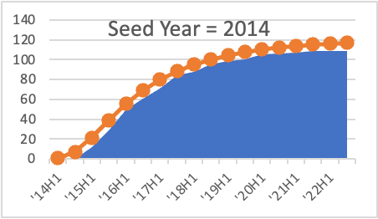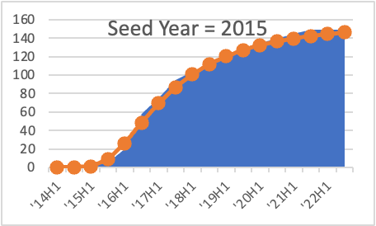

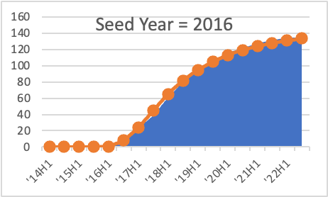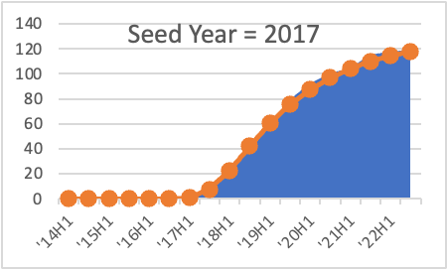

A cumulative amount of funding rounds according to time for companies raising funds in seed rounds in 2018–2021 (out-of-sample)

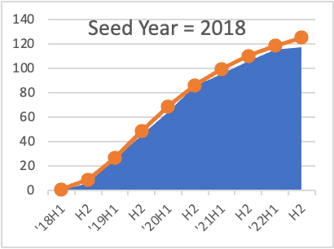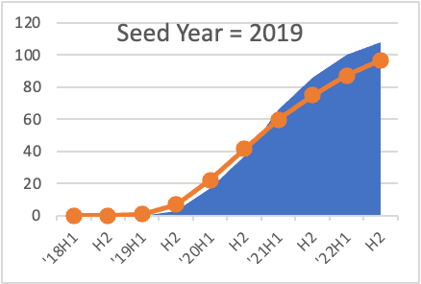

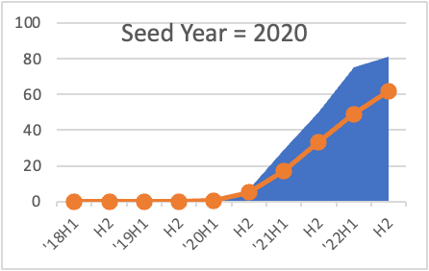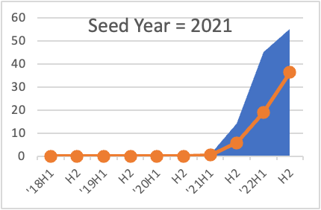גכ

Number of expected funding rounds compared with actual funding rounds in the shift between Round A and Round B:

1. The model assumes that each company has a fixed probability to be a “unsuccessful company”, in other words one that will never raise the funding, and with the complementary probability it will raise Round A funding according to a log-normal distribution. Additional details on the model and the evaluation can be found in the appendix.
2. The small numbers involved and the short amount of time in which these companies have been observed does not enable us to evaluate the parameters of the model separately for each age-group, in a manner that would provide us with useful estimates.
3. On this issue see the decrease in the number of [start-ups](https://view.storydoc.com/nC6GTH3Y)