COURSE BOOK



## Sustainability and Quality Management

**DLBLONQM01**

### Learning Objectives

###### Introduction **9**



In the **Sustainability and Quality Management** course, you will learn the fundamentals and operational concepts of sustainability and quality management and will then be able to work on their practical implementation in a well-founded manner. The importance of sustainability and quality as a corporate task is discussed from the social, corporate, and personal responsibility perspectives, along with others. The tools and methods of implementation in companies are presented and critically questioned. On completion of the course book, you will …

* understand the principles of sustainability and quality management and their importance to a company and society.
* understand the approaches and instruments applied when implementing sustainability and quality concepts in practice.
* be able to reflect on the subject area of sustainability and quality management in the context of corporate responsibility.
* understand the tools and methods for the realization of sustainability concepts, taking economic, ecological, and social aspects into account, and apply them in practice, as well as use them to develop solutions to problems based on sustainability criteria.
* describe the general legal and normative conditions for sustainability and quality management.
* apply quality management procedures and instruments in practice.
* present approaches to solutions in an argumentatively sound and comprehensible manner.
* assess the role of sustainably managed companies and institutions, particularly from a system perspective.
* be able to scientifically classify the subject area on the basis of the course book content, as well as on additional scientific literature, relate these elements to each other, and evaluate them with regard to their significance in practice.



# Unit 1

## Fundamentals of Sustainability

##### STUDY GOALS

On completion of this unit, you will be able to ...

... describe and explain the causes of unsustainable development.

... understand the concepts for sustainable development.

... distinguish essential rules and strategies for promoting sustainable development.

... understand the ethical and moral implications of sustainable development.

... recognize the potential uses of natural models to promote sustainable development.

DL-D-DLBLONQM01-L01

### Fundamentals of Sustainability

#### Introduction

In August 2017, it was that time again: Humanity had used up its annual ration of resources by that month. Planet earth cannot provide more resources annually through renewal and many resources, such as crude oil or bauxite, do not renew at all during periods of time conceivable for humans and are thus only available to a finite extent. Of course, the water, the food, or the fuels—or literally the electricity for the lights, did not run out in August. Production and consumption continue, but then only on credit. The point in time at which the resources of a particular year are used up is also referred to as Earth Overshoot Day. Worldwide, this day is typically in August, and in Germany, it is typically in April of the particular year. This is mainly due to the fact that Germany produces and consumes more than the global average. At the same time, this means that resource consumption is quite unevenly distributed worldwide.

If the earth's resources are limited and their current consumption is obviously not possible forever, what does sustainable consumption look like? This is where the idea of sustainability and sustainable development comes into play. In this context, we address the following questions:

* What are the causes of unsustainable development?
* What are the rules for sustainable development?
* What are the ethical aspects of sustainable development and what is the role of companies in particular?
* What can we learn from nature to manage sustainably?

#### Basic Understanding and Definitions

Causes of Unsustainable Development

First, we turn to the fundamental causes that, from the perspective of economics, can lead to unsustainable development. The causes are related, among other things, to the assumptions made in traditional economics models. The best-known model is the neoclassical idea of the market as the place where products and services are exchanged and prices are formed. This model was established by Adam Smith, David Ricardo, Jean Baptist Say, and John Stuart Mill as early as the 18th and 19th centuries and was also advocated by Nobel Prize-winning economist Milton Friedmann (1912-2006). The key assumptions of this model are (cf. Rogall 2008, p. 53ff.; Binswanger 2010, p. 23ff.):

Fundamentals of Sustainability

* Through supply and demand on the market, a price is formed that optimally (efficiently) distributes production factors for companies and products or services for consumers.
* The agents, who act as suppliers and consumers on markets, only focus on their own self-interest (companies’ profit maximization and consumers’ utility maximization), acting economically, rationally, and individually as sovereigns (human image of homo economicus). The principle of performance and consideration applies here.
* Affluence (also called prosperity) is measured by the products or services and their values that are traded on markets.
* The traded products and services are used exclusively by the owner (exclusion principle) and cannot be used simultaneously by others (consumption rivalry). Products and services are divisible and limited in comparison to human needs (scarce).

Based on the exclusion principle and consumption rivalry, products and services can be divided into the following types of goods (cf. Rogall 2008, p. 55):

|  |  |  |
| --- | --- | --- |
| Types of Goods According to Excludability and Consumption Rivalry | | |
|  | **Consumption rivalry** | **No consumption rivalry** |
| **Exclusion possible** | **Private goods** | **Club/toll goods** |
|  | E.g., bread, pallet space in a truck | E.g., museum visit, streaming services with log-in |
| **No exclusion possible** | **Commons\*** | **Public goods** |
|  | E.g., parks, fish stocks, environmental assets (water, soil, air) | E.g., legal system, flood protection facilities, safety |
| *Commons is the name for a pasture that was owned in common by villages and used by all the villagers. | | |

In the case of private goods, the market is well suited as a place of trade since the principle of performance and consideration applies: I buy a good, pay for it, can use it independently, and exclude others from using it. Examples include bread (product) or the transport of palletized goods in a truck (service).

In the case of club or toll goods, on the other hand, there is no consumption rivalry: if someone uses a good, someone else can do the same without limiting everyone's utility. However, this is only true up to a certain capacity limit. In the case of club or toll goods, simple regulations can exclude consumers from using them. Thus, goods can be made available through a market. For example, entering an art museum is straightforward and several people can view Picasso’s paintings at the same time, unless it is too crowded (capacity limit). The situation is similar with movie streaming services, where any paying user can access the service without impairing others in their enjoyment of the film. The available bandwidth of the movie viewer and the server capacity of the streaming provider can be considered as capacity limits here. Club or toll goods are also found in other online services with exclusive customer log-in.

Externalities The effects of economic decisions on uninvolved parties in the form of costs or revenues.

The situation is different for commons: here, exclusion from the use of a good is not possible without a certain amount of effort (cf. Baumgärtner et al. 2014, p. 274), At the same time, however, consumption rivalry exists. As a large (water) park in the middle of the city, the Außenalster (Outer Alster) lake in Hamburg is freely accessible and could only be fenced in at a very high cost. This open access means that picnic spots on the Außenalster can become very scarce, particularly on sunny days, and the rivalry for the most beautiful spots on the water begins. Similarly, it would be impractical to fence in fish stocks in the sea where fishermen are rivals for the best fish. Access to such goods that cannot be restricted is referred to as the open access problem (OA problem; cf. Baumgärtner et al. 2014, p. 274). This has a decisive effect on the overconsumption of such goods: in terms of utility maximization, consumers weigh up their own utility (e.g., caught fish) and their own costs (e.g., costs for the fishing boat). Every fish that is caught now reduces the fish population today and in the future since these fish are now missing from the continuation of the population. As a consequence, each fish caught by one fisherman also affects another fisherman’s catch. As each fisherman considers this, a race for fish stocks can occur, and the faster fish stocks decline, the more intense the race becomes. Economists refer to this phenomenon as an **externality** (or external effect; cf. Rogall 2008, p. 55): One person’s consumption of a good also has an effect on other people’s consumption of the good. In the case of fish stocks, this involves a negative externality, since fish stocks can be reduced or even eradicated. Negative externalities play a major role in environmental media (particularly air, water, soil); for example, the simultaneous (rival) use of air by automobile drivers and city dwellers, or the use of groundwater as an intake medium for excess fertilizer and as a source of drinking water. In addition, it should be noted here that positive externalities also exist and occur primarily as network externalities. For example, one's own connection charges can be positively affected if one’s friends use the same cell phone provider.

In addition to such capacity rivalries, temporal rivalries between generations (e.g., burning petroleum today and in the future) and material consumption rivalries (e.g., land as a park or residential area; cf. Rogall 2008, p. 62) also occur.

Fundamentals of Sustainability

The occurrence of externalities is also referred to as **market failure**, i.e., a market alone cannot ensure the efficient provision of goods.

The same applies to the use of public goods from which no one can be excluded and no rivalry in consumption exists. The principle of performance and consideration cannot be implemented here, and thus no supplier for such goods will be identified. Alongside this, the phenomenon of the free rider occurs: for example, if the Elbe levee at the landing bridges in Hamburg was to be heightened due to rising sea levels, this would incur costs. Now, some Hamburg residents might say that they live high enough and do not need the levee—and that they, therefore, do not want to pay for it. If many thought that way, the levee might not even be built. However, when the levee is heightened, everyone will be able to benefit without paying for it. They cannot be excluded from the effect of the higher levee at the landing bridges. Public goods are typically provided by government agencies and financed by taxes, e.g., a functioning legal system, a police force for security, income redistribution to promote equity for a cohesive society—or levees.

Consequently, in the case of commons and public goods, the market cannot provide goods satisfactorily, since some of the assumptions mentioned above are either not applicable or desired outcomes do not occur:

* Market prices are not formed by supply and demand.
* Economically purposive action remains ineffective because the principle of performance and return does not apply.
* These meaningful goods are not included in the measurement of affluence because there is no measure of value due to the lack of prices.
* The indivisibility of these goods means that they are overused or not provided by the market at all.

Common goods and public goods are often goods related to environmental consumption or to social, human issues such as security, equity, and human rights. In the case of market failures, it is therefore said that the market is (at least partially) blind to environmental and social aspects. However, it is important to note here that even private goods and club goods are not free of negative externalities: environmental media are involved in every good. If, for example, the private good “transporting goods by truck from A to B” is purchased, the emission of nitrogen oxides and particulate matter, among other things, occurs in the process. Such emissions cause costs elsewhere, e.g., health costs due to more frequent cases of asthma or costs for creating green spaces to bind the emissions. These costs are not reflected in the market for “transporting goods by truck from A to B.”

Other causes of unsustainable development are listed below: (cf. Rogall 2008, p. 65ff.; Meadows et al. 2009, p. 27):

Market failure

This refers to the inability of the market to efficiently provide a good that is in demand.

* + strong growth in the world's population,
  + high growth in the volume of manufactured products and services with corresponding material consumption (resources) and rising consumer demands (affluence), and
  + increased energy consumption in the technical manufacture of products and in services.

In the 1970s, ecologists Paul Ehrlich and John Holdren combined these three causes in a compact formula to describe significant factors of environmental pollution: the IPAT formula.

|  |
| --- |
| The Simple IPAT Formula |
| *I* = *P · A · T* |
| where *I* = Impact, *P* = Population, *A* = Affluence, and *T* = Technology. |

The affluence factor is understood in simplified terms as the quantity of goods demanded and the resources required for this. Energy consumption is representative of technology—considering that technical systems also require resources. The IPAT formula can also be presented in more detail for a deeper understanding. It calculates the environmental impact *I* per year:

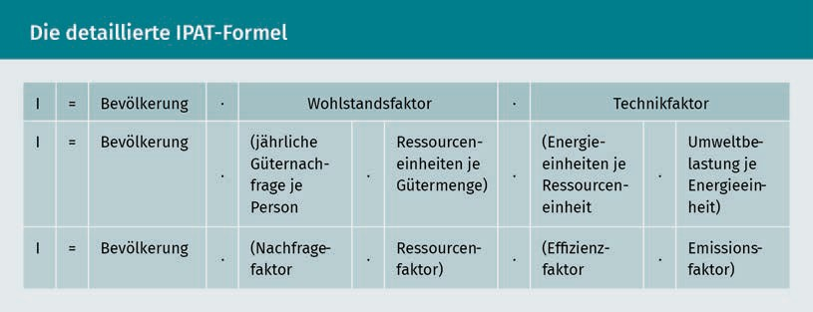

The resource factor is also referred to as the throughput or flow factor to illustrate the amount of resources flowing through the economic system. The resource factor also includes an efficiency consideration—resource efficiency. However, in the IPAT format, efficiency tends to be related to energy consumption, so the efficiency factor would need to be more accurately referred to as the energy efficiency factor.

The IPAT formula clearly and comprehensibly shows that an environmental impact *I* increases when ...

Fundamentals of Sustainability

* the population increases,
* the quantity of goods per person and their required resources increase, or
* energy consumption increases.

A simple example illustrates this using the environmental impact, CO2 emissions per year (= *I*) for the product, a DIN A4 sheet of paper:

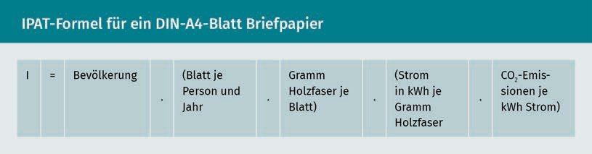

However, the IPAT formula does not state an acceptable environmental impact. Nevertheless, human life and every human activity is accompanied by some kind of environmental impact. As a result, sustainable development must allow for the use of the environment. Considering this, the IPAT formula identifies strategies to reduce an environmental impact in order to promote sustainable development.

Concepts for Sustainable Development

At an international conference of the United Nations in Stockholm in 1972, the world's state representatives had their first discussion of how the increasingly obvious problems of environmental pollution could be solved. Even then, it became clear to all states that ecological problems could only be solved by taking economic and social aspects into account. In particular, less developed countries insisted on a right to economic development, for example, through the development of educational systems and industries. They demanded the right to the same level of prosperity that more developed industrialized countries had already achieved.

The simultaneous consideration of economic, ecological, and social aspects of human trade draws on an old idea from German forestry of the 18th century: the sustainable use of forest resources. In simplified terms, sustainable means: not living on a forest’s capital, but rather on its interest, i.e., regrowing wood. This example makes it clear and comprehensible: sustainable forestry requires that only as much wood is harvested as can grow back. This ensures that in the long term, a forest:

* generates income through the sale of the wood (economic aspect of sustainability), and
* is preserved for the environment, e.g., as a recreational space for people and a habitat for plants and animals (ecological aspect of sustainability).

There is also the social aspect of sustainability because if a forest is used as described above, it will remain a livelihood for the current generation and all that follow. Sustainable consumption can, therefore, be additionally described as *permanently maintainable* or *future-proof* *consumption*, both of which remain true to the term *sustainable*. As simple and plausible as the term sustainability may seem in forestry, it is difficult to apply it to today’s complex human activities. A catchy paraphrase comes from publicist Ulrich Grobers: “Sustainability is the antithesis of collapse” (Grober 2013, p. 14).

In 1987, the final report “Our Common Future” of the World Commission on Environment and Development established by the United Nations got to the core of the global problems: the natural foundations of human life are being consumed in an unsustainable manner, global inequality and poverty are growing, and peace and security are threatened as a result (cf. Michelsen/Adomßent 2014, p. 12; cf. World Commission on Environment and Development 1987, Brundtland Report). The final report understands that the fundamental principles for solving the world's problems include:

* + a global view of the problems,
  + linking environmental and development issues, and
  + equity between the present generation (intragenerational) and responsibility for future generations (intergenerational).

The best-known definition of sustainable development to date was formulated based on these fundamental principles: “To make development sustainable - to ensure that it meets the needs of the present without compromising the ability of future generations to meet their own needs” (World Commission on Environment and Development 1987, p. 8). Sustainable development is the process toward a state of sustainability. This definition does not address a specific actor (e.g., the state, companies, workers, or consumers)—it is applied on a global, societal level.

Three dimensions-

model A sustainable development model that considers economic, environmental, and social aspects.

The economic, ecological, and social aspects of sustainable development are also referred to as dimensions (or pillars). The **three-dimensions model** has become firmly established. In some instances, other dimensions, such as culture and politics, are added by some authors. In order to concretize the concept of sustainable development, the weighting of these three dimensions, as well as whether the dimensions are interchangeable to a limited extent, are discussed. These questions lead to a distinction between weak and strong sustainability.

Weak and strong sustainability essentially differ in terms of what is to be preserved as capital. For this purpose, we return to the example of a forest (= capital). The question arises as to whether the forest should be preserved in its original form, e.g., as a mixed forest, or whether it may be gradually replaced, e.g., with fast-growing pines, to increase the yield. Here, the forest symbolizes the entire capital that humanity needs for economic activity: e.g., raw materials, plants, machines, plantations. Weak sustainability follows the argument of neoclassical economics that capital is exchangeable.

Fundamentals of Sustainability

Natural capital can be largely replaced by manmade (anthropogenic) capital, e.g., bees can be replaced by pollinators or lakes by swimming pools. The crucial point is that the total capital of natural capital plus anthropogenic capital is preserved and available to future generations (cf. Costanza et al. 2001, p. 121ff.). We can then speak of economic sustainability, assuming that anthropogenic capital is unlimited. What may seem a somewhat strange idea (particularly with the lake–swimming pool exchange) can be traced back to, among other things, the progressive fragmentation of scientific disciplines in the 19th century, in the course of which the disciplines of economics and ecology moved away from each other (cf. Costanza et al. 2001, p. 21ff.).

In contrast, strong sustainability assumes that natural capital and anthropogenic capital are only interchangeable to a limited extent, i.e., they are complementary and mutually dependent. Nature has been ascribed a value of its own that cannot be replaced: bees are not only pollinators, but also living creatures, and lakes are not just for swimming but are also habitats for animals and plants. Following this, we can speak of ecological sustainability here. Strong sustainability is represented by the transdisciplinary science of ecological economics, which considers, among other things, ecological and physical findings. For example, ecological economics starts from the physical finding that the earth is a closed, thermodynamic, and materially non-growing system (cf. Costanza et al. 2001, p. 95). There is no material or matter exchange with other systems outside the earth. Energy is only supplied in the form of solar radiation and energy losses occur as heat radiation. Since there is an energy exchange with systems outside the earth, like the sun, the earth is a closed, but not isolated system. The economic system is only a subsystem of this earth. Consequently, ecological economics also considers the scale of the economic system, which is largely not addressed by neoclassical economics. The **scale consideration** of the economic system is illustrated in the figure below.

Scale consideration

The consideration of scale in the representation of economic systems and their outcomes.

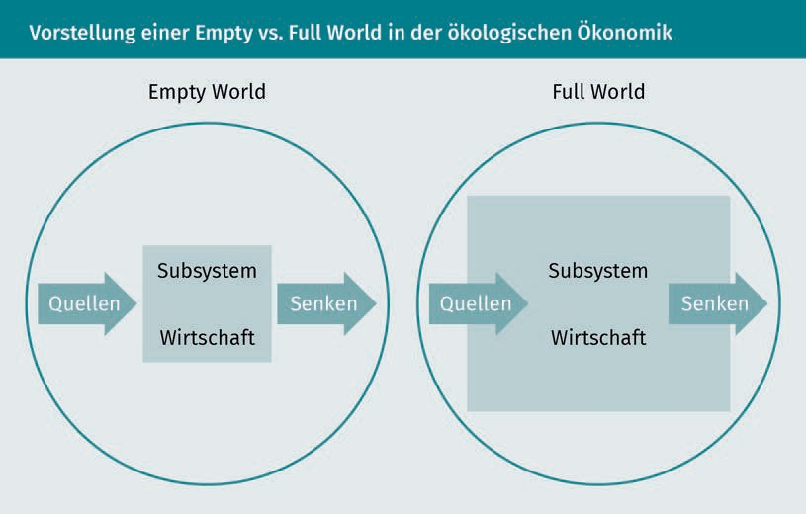

The economic system was previously small and empty (empty world): the consumption of so-called *sources* (resources and energies; left arrow in each case) and the resulting wastes and pollutants (right arrow in each case), which are released into what are known as *sinks* (atmosphere, water, soil), were small when measured against the limitations of the global ecosystem (shown as a circle). The throughput of resources and energy has grown rapidly in the past, so we can now speak of a full world. This pair of terms was coined by the economist and co-founder of ecological economics, Herman E. Daly (cf. Daly 1992). He was the originator of some basic rules that define how sustainable development can be implemented.

Rules and Strategies for Sustainable Development

Daly's Rules Management rules developed by Hermann Daly for implementing sustainable development.

Numerous rules for the sustainable consumption of the world's resources and energies have been established in the past. Based on the thermodynamically closed global ecosystem, Hermann E. Daly established the following three rules that emphasize ecological sustainability (**Daly's Rules**; cf. Daly 1990):

1. The rate of use of renewable resources and energies (e.g., air, water, soil, forest, biomass) is only sustainable if it does not exceed the rate of regeneration or renewal of the respective sources (regeneration rule).
2. The rate of use of non-renewable resources and energies (e.g., minerals, petroleum, natural gas) must not exceed the possibility of replacing them with sustainably used renewable resources and energies (substitution rule).
3. The release of pollutants and wastes must not exceed the rate at which they can be broken down in the sinks (adjustment rule).

Fundamentals of Sustainability

These rules are intended to maintain a constant physical quantity of sources and sinks (constant capital stock) for people and their economic activities. Daly refers to this economy as a steady state economy. In establishing these rules, Daly attempted to operationalize the World Commission on Environment and Development's idea of sustainability, since a steady state economy with a constant capital stock can allow future generations to meet their resource and energy needs.

If we assume that the current consumption of resources and energies is unsustainable, three sustainability strategies tie into Daly's rules: efficiency, sufficiency, and consistency.

The increase in efficiency refers to the resources and energies required for the production of products and services: according to the resource factor and the efficiency factor of the IPAT formula, efficiency increases when the resource and energy input per unit of goods decreases. This strategy has been popularized by Ernst Ulrich von Weizsäcker, among others (cf. Weizsäcker/Lovins/Lovins 1997; Weizsäcker et al. 2010). The Factor 4 and Factor 5 approaches describe ways to increase resource productivity (as the reciprocal of the resource factor) and energy productivity (as the reciprocal of the efficiency factor) by a factor of 4 and a factor of 5, respectively. A selection of examples from various sectors is intended to illustrate this (The examples of improvements in resource and energy productivity provided in the works mentioned typically result from the interaction of several measures and are intended to show existing possibilities. Many of these possibilities have not yet been fully implemented in practice. The following calculation examples are not taken from the source mentioned):

* + The energy demand of a residential building in Germany is currently approx. 80 kWh per m2 and year. Energy productivity (living space per unit of energy) amounts to 1/80 = 0.0125. Approximately five residential buildings in the so-called passive house standard could be supplied with this energy demand (approx. 15 kWh per meter and year) (cf. Weizsäcker et al. 2010, p. 76ff.). Energy productivity amounts to 5/80 = 0.0625, i.e., it is higher by a factor of 5.
  + The global average water requirement for growing one kilogram of potatoes is approx. 1 m3 . By switching from field irrigation to irrigation directly at the plants (drip irrigation) and other measures, resource productivity could be increased by up to 70%. At the same time, yields could be increased by 90%. With 1 m3 of water, 3.23 kg of potatoes could be grown: resource productivity per m3 of water increases by 70% (1 kg + 0.70 kg (corresponds to 70%) = 1.7 kg), and yield increases by 90 % at the same time (1.7 kg + 1.53 kg (corresponds to 90%) = 3.23 kg) (cf. Weizsäcker et al. 2010, p. 172ff.). This corresponds to a factor of 3.23.
  + In the case of trucks, the mileage per liter of fuel can be improved by a factor of 5 by lowering air/rolling resistance and improving drive technology (cf. Weizsäcker et al. 2010, p. 209).

Unfortunately, the efficiency strategy is associated with an unpleasant side effect: the so-called rebound effect or Khazzoom-Brookes postulate (cf. Weizsäcker et al. 2010, p. 289ff.). Accordingly, an increase in efficiency follows a fundamental economic logic: a good that costs less is in greater demand. This means, e.g., that lower gasoline consumption of a car leads to lower costs; therefore, the car is used more often because it is now cheaper. Efficiency gains are thus reduced by the rebound effect. In extreme cases, energy consumption even increases as a result of efficiency gains. We then speak of a backfire (cf. in detail in Pehnt 2010, p. 5ff.).

In contrast, sufficiency ties in with the demand factor of the IPAT formula. A sufficiency strategy questions the meaningfulness of consumption patterns since the environmental impact *I* can be lowered by reducing or foregoing particularly resource- and energy-intensive products and services. Sufficiency can also be translated as frugality (cf. Weizsäcker et al. 2010, p. 356). This strategy is as plausible as it is controversial since it questions the sovereignty of demanders, which is essential in the neoclassical market model. Sufficiency can be strikingly distinguished from the neoclassical rationality of utility and profit maximization as “having enough of having more and more.” In the prevailing growth economy and society, acceptance of sufficiency approaches is rather low (cf. Kanning 2013, p. 35). Nevertheless, even major proponents of the efficiency strategy recognize the need for sufficiency approaches (cf. Weizsäcker et al. 2010, p. 356). For example, sufficiency offerings in the sharing economy are increasingly finding customers for whom the focus is on using rather than owning, as in the case of car sharing.

The consistency strategy aims most clearly at Daly's sustainability rules by attempting to harmonize anthropogenic resource and energy inputs with natural processes of sources and sinks. Therefore, in contrast to efficiency and sufficiency, consistency means an adjustment of resource and energy inputs than a reduction. (cf. Kanning 2013, p. 35). Measures to improve consistency can be applied to the resource factor of the IPAT formula by changing the type of resource, rather than reducing the resource input. One example is the replacement of petroleum-based plastic fibers with natural fibers for seat covers in vehicles.