COURSE BOOK



## Sustainability and Quality Management

**DLBLONQM01**

### Learning Objectives

###### Introduction **9**



In the **Sustainability and Quality Management** course, you will learn the fundamentals and operational concepts of sustainability and quality management and will then be able to work on their practical implementation in a well-founded manner. The importance of sustainability and quality as a corporate activity is discussed from the social, corporate, and personal responsibility perspectives, along with others. The tools and methods of implementation in companies are presented and critically questioned. On completion of the course book, you will …

* understand the principles of sustainability and quality management and their importance to a company and society.
* understand the approaches and instruments applied when implementing sustainability and quality concepts in practice.
* be able to reflect on the subject area of sustainability and quality management in the context of corporate responsibility.
* understand the tools and methods for the realization of sustainability concepts, taking economic, environmental, and social aspects into account, and apply them in practice, as well as use them to develop solutions to problems based on sustainability criteria.
* describe the general legal and normative conditions for sustainability and quality management.
* apply quality management procedures and instruments in practice.
* present approaches to solutions in an argumentatively sound and comprehensible manner.
* assess the role of sustainably managed companies and institutions, particularly from a system perspective.
* be able to scientifically classify the subject area on the basis of the course book content, as well as on additional scientific literature, relate these elements to each other, and evaluate them with regard to their significance in practice.



# Unit 1

## Fundamentals of Sustainability

##### STUDY GOALS

On completion of this unit, you will be able to ...

... describe and explain the causes of unsustainable development.

... understand the concepts for sustainable development.

... distinguish essential rules and strategies for promoting sustainable development.

... understand the ethical and moral implications of sustainable development.

... recognize the potential uses of natural models to promote sustainable development.

DL-D-DLBLONQM01-L01

### Fundamentals of Sustainability

#### Introduction

In August 2017, it was that time again: Humanity had used up its annual ration of resources by that month. Planet earth cannot provide more resources annually through renewal and many resources, such as crude oil or bauxite do not renew at all during periods of time conceivable for humans and are thus only available to a finite extent. Of course, the water, the food or the fuels—or literally the electricity for the lights, did not run out in August. Production and consumption continue, but then only on credit. The point in time at which the resources of a particular year are used up is also referred to as Earth Overshoot Day. Worldwide, this day is typically in August, and in Germany it is typically in April of the particular year. This is mainly due to the fact that Germany produces and consumes more than the global average. At the same time, this means that resource consumption is quite unevenly distributed worldwide.

If the earth's resources are limited and their current consumption is obviously not possible forever, what does sustainable consumption look like? This is where the concept of sustainability and sustainable development comes into play. In this context, we address the following questions:

* What are the causes of unsustainable development?
* What are the rules for sustainable development?
* What are the ethical aspects of sustainable development and what is the role of companies in particular?
* What can we learn from nature to manage sustainably?

#### Basic Understanding and Definitions

Causes of Unsustainable Development

First, we turn to the fundamental causes that, from the perspective of economics, can lead to unsustainable development. The causes are related, among other things, to the assumptions made in traditional economics models. The best-known model is the neoclassical idea of the market as the place where products and services are exchanged and prices are formed. This model was established by Adam Smith, David Ricardo, Jean Baptist Say, and John Stuart Mill as early as the 18th and 19th centuries and was also advocated by Nobel Prize-winning economist Milton Friedmann (1912-2006). The key assumptions of this model are (cf. Rogall 2008, p. 53ff.; Binswanger 2010, p. 23ff.):

Fundamentals of Sustainability

* Through supply and demand on the market, a price is formed that optimally (efficiently) distributes production factors for companies and products or services for consumers.
* The agents, who act as suppliers and consumers on markets, only focus on their own self-interest (companies’ profit maximization and consumers’ benefit maximization), acting economically, rationally, and individually as sovereigns (human image of homo economicus). The principle of performance and consideration applies here.
* Affluence (also called prosperity) is measured by the products or services and their values that are traded on markets.
* The traded products and services are used exclusively by the owner (exclusion principle) and cannot be used simultaneously by others (consumption rivalry). Products and services are divisible and limited in comparison to human needs (scarce).

Based on the exclusion principle and consumption rivalry, products and services can be divided into the following types of goods (cf. Rogall 2008, p. 55):

|  |  |  |
| --- | --- | --- |
| Types of Goods According to Excludability and Consumption Rivalry | | |
|  | **Consumption rivalry** | **No consumption rivalry** |
| **Exclusion possible** | **Private goods** | **Club/toll goods** |
|  | E.g., bread, pallet space in a truck | E.g., museum visit, streaming services with log-in |
| **No exclusion possible** | **Commons\*** | **Public goods** |
|  | E.g., parks, fish stocks, environmental assets (water, soil, air) | E.g., legal system, flood protection facilities, safety |
| *Commons is the name for a pasture that was owned in common by villages and used by all the villagers. | | |

In the case of private goods, the market is well suited as a place of trade since the principle of performance and consideration applies: I buy a good, pay for it, can use it independently, and exclude others from using it. Examples include bread (product) or the transport of palletized goods in a truck (service).

In the case of club or toll goods, on the other hand, there is no consumption rivalry: If someone uses a good, someone else can do the same without limiting everyone's utility. However, this is only true up to a certain capacity limit. In the case of club or toll goods, simple regulations can exclude consumers from using them. Thus, goods can be made available through a market. For example, entering an art museum is straightforward and several people can view Picasso’s paintings at the same time, unless it is too crowded (capacity limit). The situation is similar with movie streaming services, where any paying user can access the service without impairing others in their enjoyment of the film. The available bandwidth of the movie viewer and the server capacity of the streaming provider can be considered as capacity limits here. Club or toll goods are also found in other online services with exclusive customer log-in.

Externalities The effects of economic decisions, on uninvolved parties in the form of costs or revenues.

The situation is different for commons: Here, exclusion from the use of a good is not possible without a certain amount of effort (cf. Baumgärtner et al. 2014, p. 274), At the same time, however, consumption rivalry exists. As a large (water) park in the middle of the city, the Außenalster (Outer Alster) lake in Hamburg is freely accessible and could only be fenced in at a very high cost. This open access means that picnic spots on the Außenalster can become very scarce, particularly on sunny days, and the rivalry for the most beautiful spots on the water begins. Similarly, it would be impractical to fence in fish stocks in the sea where fishermen are rivals for the best fish. Access to such goods that cannot be restricted is referred to as the open access problem (OA problem; cf. Baumgärtner et al. 2014, p. 274). This has a decisive effect on the overconsumption of such goods: In terms of utility maximization, consumers weigh up their own utility (e.g., caught fish) and their own costs (e.g., costs for the fishing boat). Every fish that is caught now reduces the fish population today and in the future since these fish are now missing from the continuation of the population. Consequently, each fish caught by one fisherman also affects another fisherman’s catch. As each fisherman considers this, a race for fish stocks can occur, and the faster fish stocks decline, the more intense the race becomes. Economists refer to this phenomenon as an **externality** (or external effect; cf. Rogall 2008, p. 55): One person’s consumption of a good also has an effect on other people’s consumption of the good. In the case of fish stocks, this involves a negative externality, since fish stocks can be reduced or even eradicated. Negative externalities play a major role in environmental media (particularly air, water, soil); for example, the simultaneous (rival) use of air by automobile drivers and city dwellers, or the use of groundwater as an intake medium for excess fertilizer and as a source of drinking water. In addition, it should be noted here that positive externalities also exist and occur primarily as network externalities. For example, one's own connection charges can be positively affected if one’s friends use the same cell phone provider.

In addition to such capacity rivalries, temporal rivalries between generations (e.g., burning petroleum today and in the future) and material consumption rivalries (e.g., land as a park or residential area; cf. Rogall 2008, p. 62) also occur.

Fundamentals of Sustainability

The occurrence of externalities is also referred to as **market failure**, i.e., a market alone cannot ensure the efficient provision of goods.

The same applies to the use of public goods from which no one can be excluded from using and no rivalry in consumption exists. The principle of performance and consideration cannot be realized here, and thus no supplier for such goods will be identified. Alongside this, the phenomenon of the free rider occurs: For example, if the Elbe levee at the landing bridges in Hamburg was to be heightened due to rising sea levels, this would incur costs. Now, some Hamburg residents might say that they live high enough and do not need the levee—and that they, therefore, do not want to pay for it. If many thought that way, the levee might not have even been built. However, when the levee is heightened, everyone will be able to benefit without paying for it. They cannot be excluded from the effect of the higher levee at the landing bridges. Public goods are typically provided by government agencies and financed by taxes, e.g., a functioning legal system, a police force for security, income redistribution to promote equity for a cohesive society—or levees.

Consequently, in the case of commons and public goods, the market cannot provide goods satisfactorily, since some of the assumptions mentioned above are either not applicable or desired outcomes do not occur:

* Market prices are not formed by supply and demand.
* Economically purposive action remains ineffective because the principle of performance and return does not apply.
* These meaningful goods are not included in the measurement of affluence because there is no measure of value due to the lack of prices.
* The indivisibility of these goods means that they are overused or not provided by the market at all.

Common goods and public goods are often goods related to environmental consumption or to social, human issues such as security, equity, and human rights. In the case of market failures, it is therefore said that the market is (at least partially) blind to environmental and social aspects. However, it is important to note here that even private goods and club goods are not free of negative externalities: environmental media are involved in every good. If, for example, the private good “transporting goods by truck from A to B” is purchased, the emission of nitrogen oxides and particulate matter, among other things, occurs in the process. Such emissions cause costs elsewhere, e.g., health costs due to more frequent cases of asthma or costs for creating green spaces to bind the emissions. These costs are not reflected in the market for “transporting goods by truck from A to B.”

Other causes of unsustainable development are listed below: (cf. Rogall 2008, p. 65ff.; Meadows et al. 2009, p. 27):

Market failure

This refers to the inability of the market to efficiently provide a good that is in demand.

* + strong growth in the world's population,
  + high growth in the volume of manufactured products and services with corresponding material consumption (resources) and rising consumer demands (affluence), and
  + increased energy consumption in the technical manufacture of products and in services.

In the 1970s, ecologists Paul Ehrlich and John Holdren combined these three causes in a compact formula to describe significant factors of environmental pollution: the IPAT formula.

|  |
| --- |
| The Simple IPAT Formula |
| *I* = *P · A · T* |
| where *I* = Impact, *P* = Population, *A* = Affluence, and *T* = Technology. |

The affluence factor is understood in simplified terms as the quantity of goods demanded and the resources required for this. Energy consumption is representative of technology—considering that technical systems also require resources. The IPAT formula can also be presented in more detail for a deeper understanding. It calculates the environmental impact I per year:

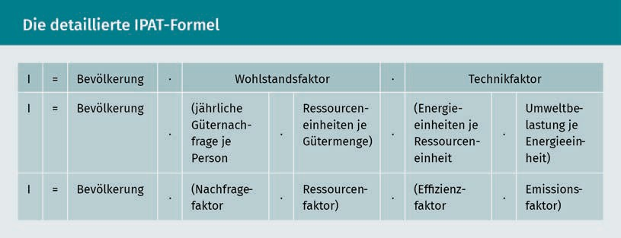

The resource factor is also referred to as the throughput or flow factor to illustrate the amount of resources flowing through the economic system. The resource factor also includes an efficiency consideration—resource efficiency. However, in the IPAT format, efficiency tends to be related to energy consumption, so the efficiency factor would need to be more accurately referred to as the energy efficiency factor.

The IPAT formula clearly and comprehensibly shows that an environmental impact Iincreases when ...

Fundamentals of Sustainability

* the population increases,
* the quantity of goods per person and their required resources increase, or
* energy consumption increases.

A simple example illustrates this using the environmental impact, CO2 emissions per year (= *I*) for the product, a DIN A4 sheet of paper:

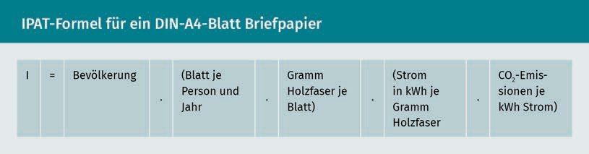

However, the IPAT formula does not state an acceptable environmental impact. Nevertheless, human life and every human activity is accompanied by some kind of environmental impact. As a result, sustainable development must allow for the use of the environment. Considering this, the IPAT formula identifies strategies to reduce an environmental impact in order to promote sustainable development.

Concepts for Sustainable Development

At an international conference of the United Nations in Stockholm in 1972, the world's state representatives had their first discussion of how the increasingly obvious problems of environmental pollution could be solved. Even then, it became clear to all states that ecological problems could only be solved by taking economic and social aspects into account. In particular, less developed countries insisted on a right to economic development, for example, through the development of educational systems and industries. They demanded the right to the same level of prosperity that more developed industrialized countries had already achieved.

The simultaneous consideration of economic, ecological, and social aspects of human trade draws on an old idea from German forestry of the 18th century: the sustainable use of forest resources. In simplified terms, sustainable means: not living on a forest’s capital, but rather on its interest, i.e., regrowing wood. This example makes it clear and comprehensible: Sustainable forestry requires that only as much wood is harvested as can grow back. This ensures that in the long term, a forest:

* generates income through the sale of the wood (economic aspect of sustainability), and
* is preserved for the environment, e.g., as a recreational space for people and a habitat for plants and animals (ecological aspect of sustainability).

There is also the social aspect of sustainability, because if a forest is used as described above, it will remain a livelihood for the current generation and all that follow. Sustainable consumption can, therefore, be additionally described as *permanently maintainable* or *future-proof* *consumption*, both of which remain true to the term *sustainable*. As simple and plausible as the term sustainability may seem in forestry, it is difficult to apply it to today’s complex human activities. A catchy paraphrase comes from publicist Ulrich Grobers: “Sustainability is the antithesis of collapse” (Grober 2013, p. 14).

In 1987, the final report “Our Common Future” of the World Commission on Environment and Development established by the United Nations got to the core of the global problems: the natural foundations of human life are being consumed in an unsustainable manner, global inequality and poverty are growing, and peace and security are threatened as a result (cf. Michelsen & Adomßent 2014, p. 12; cf. World Commission on Environment and Development 1987, Brundtland Report). The final report understands that the fundamental principles for solving the world's problems include:

* + a global view of the problems,
  + linking environmental and development issues, and
  + equity between the present generation (intragenerational) and responsibility for future generations (intergenerational).

The best-known definition of sustainable development to date was formulated based on these fundamental principles: “To make development sustainable—to ensure that it meets the needs of the present without compromising the ability of future generations to meet their own needs” (World Commission on Environment and Development 1987, p. 8). Sustainable development is the process toward a state of sustainability. This definition does not address a specific actor (e.g., the state, companies, workers, or consumers)—it is applied on a global, societal level.

Three dimensions

model A sustainable development model that considers economic, environmental, and social aspects.

The economic, environmental, and social aspects of sustainable development are also referred to as dimensions (or pillars). The **three dimensions model** has become firmly established. In some instances, other dimensions such as culture and politics are added by some authors. In order to concretize the concept of sustainable development, the weighting of these three dimensions, as well as whether the dimensions are interchangeable to a limited extent, are discussed. These questions lead to a distinction between weak and strong sustainability.

Weak and strong sustainability essentially differ in terms of what is to be preserved as capital. In considering this, we return to the example of a forest (= capital). The question arises as to whether the forest should be preserved in its original form, e.g., as a mixed forest, or whether it may be gradually replaced, e.g., with fast-growing pines, to increase the yield. Here, the forest symbolizes the entire capital that humanity needs for economic activity: e.g., raw materials, plants, machines, plantations. Weak sustainability follows the argument of neoclassical economics that capital is exchangeable.

Fundamentals of Sustainability

Natural capital can be largely replaced by manmade (anthropogenic) capital, e.g., bees can be replaced by pollinators or lakes by swimming pools. The crucial point is that the total capital of natural capital plus anthropogenic capital is preserved and available to future generations (cf. Costanza et al. 2001, p. 121ff.). We can then speak of economic sustainability, assuming that anthropogenic capital is unlimited. What may seem a somewhat strange idea (particularly with the lake–swimming pool replacement) can be traced back to, among other things, the progressive fragmentation of scientific disciplines in the 19th century, in the course of which the disciplines of economics and ecology moved away from each other (cf. Costanza et al. 2001, p. 21ff.).

In contrast, strong sustainability assumes that natural capital and anthropogenic capital are only interchangeable to a limited extent, i.e., they are complementary and mutually dependent. Nature is ascribed a value of its own that cannot be replaced: Bees are not only pollinators, but also living creatures, and lakes are not just for swimming, but are also habitats for animals and plants. Following this, we can speak of ecological sustainability here. Strong sustainability is represented by the transdisciplinary science of ecological economics, which considers, among other things, ecological and physical findings. For example, ecological economics starts from the physical finding that the earth is a closed, thermodynamic, and materially non-growing system (cf. Costanza et al. 2001, p. 95). There is no material or matter exchange with other systems outside the earth. Energy is only supplied in the form of solar radiation and energy losses occur as heat radiation. Since there is an energy exchange with systems outside the earth, like the sun, the earth is a closed, but not isolated system. The economic system is only a subsystem of this earth. Consequently, ecological economics also considers the scale of the economic system, which is largely not addressed by neoclassical economics. The **scale consideration** of the economic system is illustrated in the figure below.

Scale consideration

The consideration of scale in the representation of economic systems and their outcomes.

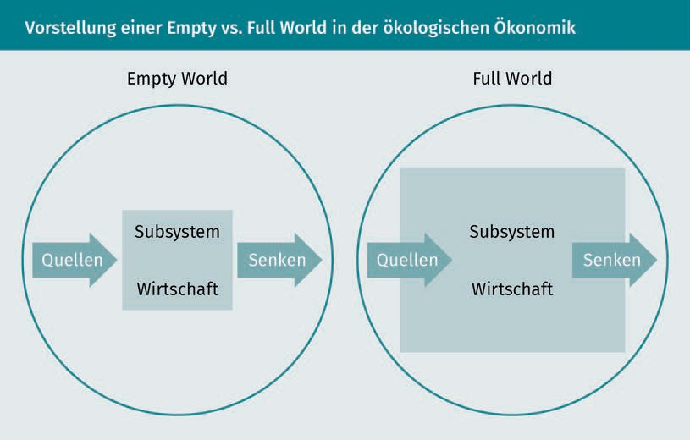

The economic system was previously small and empty (empty world): The consumption of so-called *sources* (resources and energies; left arrow in each case) and the resulting wastes and pollutants (right arrow in each case), which are released into what are known as *sinks* (atmosphere, water, soil), were small when measured against the limitations of the global ecosystem (shown as a circle). The throughput of resources and energy has grown rapidly in the past, so we can now speak of a full world. This pair of terms was coined by the economist and co-founder of ecological economics, Herman E. Daly (Daly 1992). He was the originator of several basic rules that define how sustainable development can be implemented.

Rules and Strategies for Sustainable Development

Daly's Rules Management rules developed by Hermann Daly for implementing sustainable development.

Numerous rules for the sustainable consumption of the world's resources and energies have been established in the past. Based on the thermodynamically closed global ecosystem, Hermann E. Daly established the following three rules that emphasize ecological sustainability (**Daly's Rules**; cf. Daly 1990):

1. The rate of use of renewable resources and energies (e.g., air, water, soil, forest, biomass) is only sustainable if it does not exceed the rate of regeneration or renewal of the respective sources (regeneration rule).
2. The rate of use of non-renewable resources and energies (e.g., minerals, petroleum, natural gas) must not exceed the possibility of replacing them with sustainably used renewable resources and energies (substitution rule).
3. The release of pollutants and wastes must not exceed the rate at which they can be broken down in the sinks (adaptation rule).

Fundamentals of Sustainability

These rules are intended to maintain a constant physical quantity of sources and sinks (constant capital stock) for people and their economic activities. Daly refers to this economy as a steady state economy. In establishing these rules, Daly attempted to operationalize the World Commission on Environment and Development's concept of sustainability, since a steady state economy with a constant capital stock can allow future generations to meet their resource and energy needs.

If we assume that the current consumption of resources and energies is unsustainable, three sustainability strategies tie into Daly's rules: efficiency, sufficiency, and consistency.

The increase in efficiency refers to the resources and energies required for the production of products and services: according to the resource factor and the efficiency factor of the IPAT formula, efficiency increases when the resource and energy input per unit of goods decreases. This strategy has been popularized by Ernst Ulrich von Weizsäcker, among others (cf. Weizsäcker, Lovins & Lovins 1997; Weizsäcker et al. 2010). The Factor 4 and Factor 5 approaches describe ways to increase resource productivity (as the reciprocal of the resource factor) and energy productivity (as the reciprocal of the efficiency factor) by a factor of 4 and a factor of 5, respectively. A selection of examples from various sectors is intended to illustrate this (The examples of improvements in resource and energy productivity provided in the works mentioned typically result from the interaction of several measures and are intended to show existing possibilities. Many of these possibilities have not yet been fully implemented in practice. The following calculation examples are not taken from the source mentioned):

* + The energy demand of a residential building in Germany is currently approx. 80 kWh per m2 and year. Energy productivity (living space per unit of energy) amounts to 1/80 = 0.0125. Approximately five residential buildings in the so-called passive house standard could be supplied with this energy demand (approx. 15 kWh per meter and year) (cf. Weizsäcker et al. 2010, p. 76ff.). Energy productivity amounts to 5/80 = 0.0625, i.e., it is higher by a factor of 5.
  + The global average water requirement for growing one kilogram of potatoes is approx. 1 m3. By switching from field irrigation to irrigation directly at the plants (drip irrigation) and other measures, resource productivity could be increased by up to 70%. At the same time, yields could be increased by 90%. With 1 m3 of water, 3.23 kg of potatoes could be grown: resource productivity per m3 of water increases by 70% (1 kg + 0.70 kg (corresponds to 70%) = 1.7 kg), and yield increases by 90% at the same time (1.7 kg + 1.53 kg (corresponds to 90%) = 3.23 kg) (cf. Weizsäcker et al. 2010, p. 172ff.). This corresponds to a factor of 3.23.
  + In the case of trucks, the mileage per liter of fuel can be improved by a factor of 5 by lowering air/rolling resistance and improving drive technology (cf. Weizsäcker et al. 2010, p. 209).

Unfortunately, the efficiency strategy is associated with an unpleasant side effect: the so-called rebound effect or Khazzoom-Brookes postulate (cf. Weizsäcker et al. 2010, p. 289ff.). Accordingly, an increase in efficiency follows a fundamental economic logic: A good that costs less is in greater demand. This means, e.g., that lower gasoline consumption of a car leads to lower costs; therefore, the car is used more often because it is now cheaper. Efficiency gains are thus reduced by the rebound effect. In extreme cases, energy consumption even increases as a result of efficiency gains. We then speak of a backfire (cf. in detail in Pehnt 2010, p. 5ff.).

In contrast, sufficiency ties in with the demand factor of the IPAT formula. A sufficiency strategy questions the meaningfulness of consumption patterns since the environmental impact *I* can be lowered by reducing or foregoing particularly resource- and energy-intensive products and services. Sufficiency can also be translated as frugality (cf. Weizsäcker et al. 2010, p. 356). This strategy is as plausible as it is controversial since it questions the sovereignty of demanders, which is essential in the neoclassical market model. Sufficiency can be strikingly distinguished from the neoclassical rationality of utility and profit maximization as “having enough of having more and more.” In the prevailing growth economy and society, acceptance of sufficiency approaches is rather low (cf. Kanning 2013, p. 35). Nevertheless, even major proponents of the efficiency strategy recognize the need for sufficiency approaches (cf. Weizsäcker et al. 2010, p. 356). For example, sufficiency offerings in the sharing economy are increasingly finding customers for whom the focus is on using rather than owning, as in the case of car sharing.

The consistency strategy aims most clearly at Daly's sustainability rules by attempting to harmonize anthropogenic resource and energy inputs with natural processes of sources and sinks. Therefore, in contrast to efficiency and sufficiency, consistency means an adjustment of resource and energy inputs than a reduction. (cf. Kanning 2013, p. 35). Measures to improve consistency can be applied to the resource factor of the IPAT formula by changing the type of resource, rather than reducing the resource input. One example is the replacement of petroleum-based plastic fibers with natural fibers for seat covers in vehicles.

#### Ethical Aspects and Corporate Social Responsibility

Ethics and Morals

Milton Friedmann, the 1976 Nobel Prize winner for economics, is credited with the phrase: The business of business is business (cf. Dyllick & Muff 2016, p. 163). Accordingly, the primary task of companies is to conduct business, and their social responsibility is to increase their profits. But can this be correct? This view is fundamentally at odds with the concept of sustainable development and the triad of economic, environmental, and social dimensions.

Fundamentals of Sustainability

But why should people strive for a sustainable society? Is the concept merely that global resources are finite and that the increasing concentration of greenhouse gases in the atmosphere is leading to climate and ultimately weather changes sufficiently convincing?

Such problems can only be solved with a values judgement that provides an answer to the question: What should I do? This question is the second fundamental question of philosophy according to Immanuel Kant and leads us to ethical principles (cf. Oermann & Weinert 2014, p. 63). **Ethics** as a sub-area of philosophy addresses the preconditions of human action and looks for approaches to evaluate them. One way to evaluate this is morality (the word *morality* originates from the Latin term *mos*, which means *custom*, *convention*, or *habit*). Moral evaluations can, for example, take the form of an individual benefit (How does it benefit me?) or a collective benefit (How does it benefit me and others?). In this sense, ethics seeks a basic moral principle to which all evaluations can be traced (cf. Oermann/Weinert 2014, p. 67). The philosopher Kant wrote the categorical imperative for this purpose: Act only according to that maxim through which you can, at the same time, will that it become a universal law. Such guidelines for human action are called normative, i.e., guiding.

The definition of sustainable development can also be described as normative since it contains two imperatives: intra- and intergenerational equity, which are to be achieved in the state of a sustainable society. (Here, the anthropocentric orientation of the definition of sustainability is made clear, since the global ecosystem with its plants and animals is not assigned an intrinsic value of its own. Value and protection are measured according to human standards). The way to achieve this is described by sustainable development, which must be shaped by society with all its actors (e.g., the state, companies, workers, and consumers). A normative-ethical justification for sustainability or sustainable development can, therefore, occur on two levels (cf. Hahn 2013, p. 47):

* + on the overall societal level with sustainability as a goal and
  + on the actor-related level with sustainable development as the way to achieve the goal.

Overall Societal Level

Intragenerational equity can be explained by John Rawls’ theory of justice (cf. Rawls 1975). Accordingly, everyone has the same claim to the same basic rights and freedoms, which are possible for everyone. Here, the focus is on the fact that it is considered equitable if everyone has the same opportunities (opportunity equity). It is up to the individual how to use these opportunities. In addition, every human being is entitled to an inalienable set of general human rights (e.g., freedom, dignity, and inviolability of every person). Furthermore, in order to reduce inequalities, social and economic inequalities must be corrected to bring the greatest benefits to the most disadvantaged (cf. Rawls cited in Hahn 2013, p. 49).

Ethics

Ethics is the study of the moral will and action of humans in different life situations.

Rawls thus distinguishes himself from the common representation that only the total amount of economic output is decisive for equity (e.g., in the form of the gross domestic product of a state or the world), independent of the particular distribution among people. Rawls therefore also argues for distributive equity. Opportunity equity and distribution can also be applied to the equity between generations (cf. Oermann & Weinert 2014, p. 78).

Actor-Related Level

On the actor-related level, the focus is on companies in addition to the state and citizens. An ethical obligation for companies to promote sustainable development (this is then an instance sustainability management) can be derived from two exemplary approaches:

* Human rights-based approach: The protection of human rights is primarily assigned to the state. However, many people are also part of a company as employees. Companies, in turn, are integrated into the economic system, including their customers, suppliers, and subcontractors. Business activities therefore have an impact on people, and companies therefore have an ethical duty to uphold people's fundamental rights.
* Power-based approach: Due to their financial resources, large companies can exert influence on states, employees, and other companies, e.g., through their location decisions or supply conditions. They therefore have a certain amount of power. This position of power gives rise to social responsibility for companies. Today, companies must therefore increasingly justify (legitimize) their influence to the public. This not only applies to the sphere of influence within their own company, but increasingly also to the supply chain, e.g., in the case of clothing manufacturers (working conditions in sewing factories in Bangladesh), high-tech companies (working conditions in mines for rare earth elements in Africa), or container transports (pollutant emissions from container ships in international waters that are not subject to national control).

Corporate social responsibility

This is a term used in applied ethics to describe the social

responsibility

of companies.

The term **corporate social responsibility** (CSR) is used to describe the way in which companies handle their social responsibility for sustainable development. Since this term suggests an exclusive focus on social aspects, it is sometimes more appropriately referred to as *corporate responsibility*. If the CSR approach becomes part of a company's management, positive contributions to sustainable development can be actively shaped (e.g., targeted promotion of equal rights for women and men, integration of handicapped employees) and negative contributions can be reduced or eliminated entirely (e.g., delisting of suppliers who cannot demonstrate sustainability management or who tolerate unacceptable working conditions for their employees).

Fundamentals of Sustainability

Since the 2017 financial year, large capital market-oriented companies in the EU have also been required to prepare a report on the environmental and social impacts of their business model (what is known as the CSR reporting obligation; implemented in Germany in Section 289bff. German Commercial Code).

#### Learning from Nature: a Model for Economic Processes

The cradle-to-cradle (CtC) approach refers to the consistency strategy and can be traced back to Michael Braungart, among others (cf. Braungart et al. 2015). He looks at a product from its manufacture, through to its use, and up to its reuse for new products. The product is thus considered from cradle to cradle. The goal is to recycle all materials in a product. Consequently, product design must ensure that materials do not become waste, but rather always circulate in the economic cycle. The cradle-to-cradle approach knows no waste—just as in nature. The waste generated is always a source of reusable resources. In this sense, waste is even something positive since it provides resources for further products. Following this, the goal is not to reduce the resource factor, but to create a balance between the resource input and its regeneration rate. Such a cycle only needs to be supplied with energy—as in nature, and according to Braungart, this should be solar energy. CtC is a new way of thinking and still seems to be a vision. Nevertheless, a major German clothing retailer has been offering a CtC t-shirt since 2017 that can be composted after use.

In contrast, bionics (bionics is a combination of the words biology and technology) pursues a different approach: Biological insights into nature's processes, construction, and development principles, which have evolved over time, are used for technical applications. The concept is not entirely new. People have long since been observing models in nature and trying to use them for their own purposes, e.g., the flapping of birds' wings as a blueprint for the first flying machines (which nevertheless failed). Bionics is therefore not a 1:1 copy of nature into technology, but rather a creative process of abstraction and modification by humans. Bionics is divided into very different areas such as structural bionics or motion bionics.

In the context of sustainable development, bionics primarily aims at increasing efficiency due to its technical approach. In the case of dolphins, for example, the field of motion bionics is interested in the reasons for their high swimming speed. One of the reasons identified was the dolphin's snout, which prevents an inhibiting bow wave from occurring during swimming. This led to the development of the bulbous bow for ships, which reduces water resistance and thus the amount of power a ship requires during navigation. This reduces fuel consumption and thus pollutant emissions, which are particularly high in deep-sea shipping due to the widespread use of heavy fuel oil.

Structural bionics has provided another insight. Since many marine animals are good at protecting themselves from barnacle and mussel infestation, this phenomenon is also interesting for ships. Until recently, ship hulls needed to be protected from barnacle and mussel infestation at great expense and often with environmentally harmful paints, since these slow the ships down. The surface structure of shark skin offers a good alternative, since it is covered with small tooth-like scales and grooves that prevent parasites from gaining a hold. If ships are equipped with a technically replicated shark skin, they will remain free of barnacles and mussels, be slowed down less, and require less fuel (cf. Neubert 2010).

**Summary**

The causes of unsustainable development are primarily market failures in the provision of common and public goods, negative externalities, strong growth of the world population, increasing quantities of manufactured products and services with corresponding material consumption or increasing consumption demands, and rising energy consumption. These causes can be illustrated with the IPAT formula.

The concepts for sustainable development are based on the recognition that a permanently sustainable way of life can only succeed through the integrative consideration of economic, environmental, and social aspects. An essential component of sustainability is intragenerational and intergenerational equity.

Daly's regeneration, substitution, and adaptation rules are key benchmarks for sustainable development. Strategies for their implementation refer to measures to increase efficiency, sufficiency, and consistency.

The normative-ethical guiding principle of sustainability defines a target state at a societal level. At the actor level, sustainable development involves measures taken by governments, companies, employees, and consumers.

Nature offers models for economic processes that can promote sustainable development with the help of insights from bionics and the concept of recycling resources based on the cradle-to-cradle approach.



# Unit 2

## Sustainability in Three Dimensions

##### STUDY GOALS

On completion of this unit, you will be able to ...

… understand possible limits to growth.

… differentiate the content of the Rio Process as the central response of the international community to the challenges of sustainable development.

… describe the current environmental problems of selected sources and sinks at the global, regional, and local levels.

… identify key economic trends associated with sustainable development.

… explain social developments in the social environment of a company.

DL-D-DLBLONQM01-L02

### Sustainability in Three Dimensions

#### Introduction

Environmental problems are not new. Smog, forest dieback, wild garbage dumps, and polluted rivers were daily phenomena to be observed and endured in Germany in the 1970s and 1980s. Much has happened in the country since then: The air has become cleaner, forests have recovered, many old landfills have been secured or cleaned up, and people can bathe in many rivers again—unthinkable 30 years ago. But environmental problems still exist, they have simply become more global and more differentiated. The all-defining issues here are global greenhouse gas emissions and the climate change expected as a result. Furthermore, particulate matter and nitrogen oxide pollution in cities are being discussed in Germany. In addition, many people are becoming aware that environmental problems have been shifted abroad, since products are now manufactured in South America, Africa, or Asia and imported from there. What has not been shifted, however, are the European environmental and labor standards that have been achieved. Thus, the production of these products is now causing environmental and health problems in many countries similar to those we used to have even in Europe, but no longer know today. For this reason, attempts have been made for some time now to globally implement the guiding concept of sustainable development to solve environmental and social problems, as well as enable economic development. The global public was already startled at the beginning of the 1970s by the thesis on the end of growth in a limited world.

We therefore address these questions in the following sections:

* What is behind the concept of limits to growth?
* What is humanity doing for sustainable development?
* What are the current economic, environmental, and social problem areas with which companies are directly or indirectly confronted?

#### Historical Developments

Limits to Growth

Purpose and structure of the World3 model

In 1972, a study was published in which limits to growth were mentioned for the first time: “Limits to Growth” by environmental scientist Donella Meadows and economist Dennis Meadows (Meadows & Meadows 1972; the authors did not use the terms sustainability or sustainable development at that time). Based on the system analysis approach (system dynamics), they present a complex, highly aggregated, computer-based world model (**World3**). This world model incorporates two central variables and their growth rates: the world population and the global industrial production with its resource/energy consumption. Both variables grew and continue to

Sustainability in Three Dimensions

grow exponentially. In contrast to linear growth with constant increases (e.g., an amount of money grows by € 7 p.a.), exponential growth is characterized by percentage increases (e.g., an amount of money grows by 7% p.a.). Such interest rates or annual percentage increases typically cause exponential growth, e.g., in the form of an annual percentage growth of the gross domestic product. In the model, the sources (renewable and non-renewable resources) and sinks (atmosphere, water, soil) were compared with these stock variables as natural limits. A comprehensive system of mathematical equations was used to simulate how the primary stock variables of population and industrial production would develop in the long term (1900 to 2100) if the natural physical limits of the sources and sinks were exceeded. That is, the model was designed to answer the question of how the variables of population and industrial production would respond to diminishing resources and increasing pollutants in the environment. The results were dramatic: The baseline scenario (Run 1) assumes no change in stock sizes and shows that population will decline around the middle of the 21st century as environmental pollution increases enormously and industrial production declines as non-renewable resources diminish sharply. The message of World3 is that a permanent overshoot of sources and sinks is not sustainable and will lead to collapse. There were no significant changes to this baseline scenario in the 30-year update (cf. Meadows et al. 2009; In the meantime, another update is available and is structurally reorganized. In it, more detailed statements are made on the industrial production and population aggregates and specific recommendations for action are provided. Meadows and Meadows are no longer named as co-authors [cf. Randers 2013]).

Criticism and Replication

The World3 model was explicitly described by the authors as a limited, strongly aggregated model of the entire world, which is based on their own findings, but is well-founded and supported by empirical data. For example, the model does not distinguish between rich and poor countries, it does not recognize wars, and it only simulates the one environmental impact—independent of the many different pollutants and their effects. However, the world model has often been misunderstood as a *forecast* that predicts a collapse of industrial production and a decline in population. Critics of the world model also complain that the potential of technology to increase resource and energy efficiency has not been adequately considered. In addition, they argue that the model fails to consider rising prices in the face of declining resource availability, which would send signals to the market to use resources more sparingly (cf. Erbrich 2004). In turn, the authors refute the alleged positive influence of technology and the market in their update (cf. Meadows et al. 2009, p. 211ff.):

World3

The World3 model is a systems dyna- mics approach to modeling global environmental and social interrelationships.

* Efficiency gains due to technology input are overcompensated by the absolute growth of products and services, i.e., absolute resource and energy input increases somewhat later and possibly more slowly, but it does increase. The limits are therefore only reached later.
* The price signals of the market are insignificant in the long run because the absolute availability of resources is not reflected in the market, e.g., the annual price fluctuations of crude oil have no relation to the absolute reserves of crude oil.

The statements of the limits to growth are still controversial—the phenomena of global population increase, rising goods production, and increasing environmental pollution are less so. Efforts to counteract these phenomena date back to 1992, when the first international resolution to protect the world's climate was passed in Rio de Janeiro.

The Rio Process

The starting point for international policy efforts to initiate sustainable development came in the form of reports by international climate experts who warned in the late 1970s that the limits of a global sink had been exceeded (cf. Michelsen & Adomßent 2014, p. 3ff.). This is because large quantities of greenhouse gases, such as CO2 and methane, accumulate in the atmosphere, i.e., more CO2 or methane is emitted than the global ecosystem can absorb and possibly degrade. Knowledge of possible consequences was still limited in the 1970s and 1980s, but it was suspected that these increasing greenhouse gas concentrations could change the climate or weather regionally. Possible consequences for the global climate were also feared at that time, but not yet specified. The first world climate conference in Geneva in 1979 decided to continue research and founded a world climate research program. In the following years, the Intergovernmental Panel on Climate Change (IPCC) was founded by the United Nations (UN). Since then, it has regularly reported on the state of research on the greenhouse effect and climate change. The second world climate conference took place in Geneva in 1991. Based on the research results, it was recognized here that climate change is becoming increasingly likely. The community of nations determined that the later measures were taken to reduce greenhouse gas emissions, the more expensive it would be. The economic aspect had arrived in the climate discussion. After this conference, the UN decided that countries should begin negotiations on a global climate agreement. Alongside this, the results of the “Our Common Future” report by the World Commission on Environment and Development were to be integrated into the agreement.

The first major conference took place in 1992 and is still groundbreaking for climate protection today, as well for the discussion on sustainable development: the UN Environment and Development Summit in Rio de Janeiro. This environment and development summit is also known as the United Nations Conference on Environment and Development (UNCED), the Rio Conference, and the Earth Summit. This conference was the starting signal for an international dialog process on sustainable development and is commonly referred to as the **Rio Process**.

Sustainability in Three Dimensions

The documents listed below were adopted at the conference, are still of particular significance today, and continue to be at the center of the sustainability discussion (cf. Michelsen & Adomßent 2014, p. 15):

* Rio Declaration on Environment and Development for Sustainable Development.
* Framework Convention on Climate Change to reduce greenhouse gas emissions.
* Agenda 21 (now Agenda 2030) as an action program that mandates actions for sustainable development at the national, regional, and local levels.

The Rio Declaration on Environment and Development for Sustainable Development was the first international recognition of the guiding principle of sustainable development: Economic efficiency, social equity, and the protection of the ecosystem are equally important conditions for sustainable development. This includes, among other things, the responsibility of all states to combat poverty through economic development and to protect the environment in all areas of human life, e.g., through environmental protection laws. In Rio, the decision was made to establish the Commission on Sustainable Development (CSD; today's name: United Nations High-Level Political Forum on Sustainable Development, UN HLPF) at the United Nations to steer the dialog process and follow-up conferences. At the Rio+20 Conference in 2012, the decision was made to draw up general Sustainable Development Goals (SDGs) in order to concretize the guiding principle of sustainable development. The SDGs were adopted in 2015 under the title Agenda 2030. They are divided into 17 individual goals that are considered essential for sustainable development. These include, e.g., goals that are closely related to basic human needs (such as the prevention of famine), as well as goals that are fundamental to economic development (such as educational opportunities).

The SDGs are primarily policy goals that provide guidance for decision-makers at the supranational (e.g., EU), national (e.g., Germany), regional (e.g., Lower Saxony), and local (e.g., Saarbrücken) levels. Two of the SGD are of particular importance for companies, consumers, and employees:

* SDG 8: Creation of decent working conditions and sustainable economic growth; this SDG is measured, e.g., by the average hourly wage or by the reduction of a country's resource factor.
* SDG 12: Sustainable consumption and production. Indicators for target achievement can be, e.g., the amount of waste or the share of recycled waste in a country in a year.

SDG 13 (Action on Climate Change) establishes the link to the UN Framework Convention on Climate Change and addresses a major global problem: the increasing amounts of greenhouse gas emissions.

Rio Process

A policy process for shaping sustainable development.

Framework Convention on Climate Change and Follow-Up Process to Date

The protection of the global climate can be regarded as a key problem of the world community (cf. Baumgärtner et al. 2014, p. 279ff. for the following remarks). It combines the key economic, environmental, and social issues of sustainable development. Economic development to increase prosperity is typically accompanied by higher energy and resource consumption. The environmental consequences of the global demand for energy and resources already exceed the limits of global sources and sinks. And the question of who can or may use how much energy and resources is a global equity issue: Industrialized countries (e.g., USA, Japan, Germany) emit very high amounts of greenhouse gases due to their advanced economic development. Less developed countries therefore see it as the particular duty of industrialized countries to pay attention to ecology and to reduce their CO2 emissions. This is because the less developed countries (e.g., in Africa or Asia) emit small amounts of greenhouse gases, but would also like to develop economically and socially, which is often accompanied by high rates of increase in CO2 emissions. Since the greenhouse effect is already far advanced and likely unstoppable, the industrialized countries, in turn, see this development as a major threat to the global climate.

In 1992, 155 countries signed the United Nations Framework Convention on Climate Change. This made the United Nations Framework Convention on Climate Change (UNFCCC) the first global climate agreement. The Framework Convention on Climate Change emphasizes two approaches that show how people can counter human-induced climate change:

* Avoidance and mitigation of greenhouse gas emissions to stop or at least slow down climate change. We refer to this approach as mitigation. In this convention, for example, the countries committed themselves for the first time to reducing their greenhouse gas emissions to the 1990 level by the year 2000.
* Adaptation to inevitable climate change. That is, attempts are made to compensate for unavoidable greenhouse gas emissions by other measures and to handle the consequences of climate change, e.g., by building higher dikes to protect against the expected rising sea level. This approach is called adaptation.

In the meantime, 195 countries have joined the Framework Convention on Climate Change. These countries meet at UN climate conferences once a year to develop the convention further and discuss the status of the climate protection activities of the individual countries. These conferences are referred to as the Conference of Parties (COP) and are numbered consecutively. The best known and most significant conferences were: COP 3 in Kyoto in 1997 and COP 21 in Paris in 2015 (cf. Staud 2015).

COP 3 in Kyoto (1997)

The first international, legally binding agreement to limit greenhouse gas emissions was concluded at this conference in Kyoto. This agreement is known as the Kyoto Protocol. At that time, the signatory states undertook to reduce greenhouse gas

Sustainability in Three Dimensions

emissions by a total of 5.2% in the years from 2008 to 2012. However, this obligation did not apply to developing countries, since their emissions were considered to be rather low. The reduction is calculated on the basis of emissions in 1990 (base year). In the Kyoto Protocol, all greenhouse gases are taken into account for the first time, i.e., in addition to CO2 emissions, far more climate-damaging substances, such as hydrofluorocarbons, are also included. The Kyoto Protocol also includes specific instruments for reducing greenhouse gas emissions. For example, countries can sell rights (also known as certificates) to companies to emit greenhouse gases. This particular instrument placed a price on greenhouse gas emissions for the first time—since such emissions were previously free. These rights can be traded between companies (emissions trading). The rights are to be gradually reduced by the states, and in this way greenhouse gas emissions are expected to decrease. It also creates the possibility for industrialized countries to carry out projects to reduce greenhouse gas emissions in less developed countries. The idea behind this: It does not matter where greenhouse gas emissions are reduced—what matters is that they are reduced. And at the lowest possible cost.

COP 21 in Paris (2015)

At the COP 21 climate conference in Paris, there was a breakthrough following a long period of preparation: For the first time, all countries in the world committed themselves to taking measures for climate protection. However, concrete climate protection goals were not the subject of the conference. The only common consensus, the Global Climate Treaty, stated: Global warming should be limited to no more than a 2 degrees Celsius increase and, if possible, even to no more than 1.5 degrees Celsius (upper limit of global warming). The basis is the earth's temperature in pre-industrial times, i.e., around the middle of the 19th century. This decision was based on new findings from global climate research, which showed that global warming of more than 2°C could damage the world climate’s essential systems, such as the warm Gulf Stream in the Atlantic.

In order to limit global warming and from 2050 onward, no more greenhouse gases may be emitted than the ecosystem can absorb. This would then be an instance of greenhouse gas neutrality or compliance with the Daly adaptation rule (but only for greenhouse gas emissions).

The climate protection goals are set by the states themselves. Each country thus commits to a climate protection contribution. In addition, the states must submit new, more ambitious climate protection contributions every five years (which is known as the leverage mechanism). Even before COP 21 in Paris, nearly all countries had presented their initial climate protection contributions. If these contributions were fully implemented, global emissions in 2030 would be 55 billion CO2e (greenhouse gas emissions are expressed in CO2 equivalents [CO2e], i.e., emissions of other more harmful greenhouse gases, such as methane, are converted to the greenhouse gas effect of CO2). With this amount of CO2e emissions, however, not even the 2°C goal would be achievable, because for this to happen, global CO2e emissions in 2030 would have to amount to only 42 billion CO2e. Nevertheless, it is noteworthy that the Global Climate Treaty is the first to specify an absolute number of global CO2e emissions as the limit for achieving the goal.

UN Agenda 21

Think globally – Act locally

This is a measure of Agenda

21, which states that global challenges should be addressed through local commerce.

The original idea of Agenda 21 was to call on individual states to implement sustainable development at the national, regional, and local levels. The core idea is a comprehensive public discussion in which all parts of civil society participate: governments, business associations, companies, trades, academia, and non-governmental organizations, as well as the general population. Agenda 21 emphasizes that sustainable development must be supported by all members of a civil society. The motto **Think globally – Act locally** iscentral to this. Examples of the implementation of Agenda 21/2030 in Germany are:

* Inclusion of environmental protection in responsibility for future generations as a state objective in Article 20a of the Basic Law in 1994;
* Adoption of the Sustainability Strategy for Germany in 2017 to implement the 17 SDGs, including indicators to measure them, e.g., SDG 12: increase the number of companies that have introduced an environmental management system in accordance with EMAS (Eco-Management and Audit Scheme of the EU) from 2,000 to 5,000 by 2030 (cf. Federal Government 2017, p. 178);
* As part of a local Agenda 2030, the city of Hannover is focusing on SDG 11 (sustainable cities and communities) with a transportation development plan that promotes local public transport.

#### Developments in the Natural Environment

Developments in the natural environment can be linked to the source and sink considerations of the Limits to Growth model. The current core problems of the ecosystem therefore concern both renewable and non-renewable resource, as well as the atmosphere, water, and soil sinks—this refers to a global, regional, and local level, as well as to the interconnection of all levels due to the complexity of the global ecosystem.

Global Problems

The dominant global environmental problem is anthropogenic greenhouse gas emissions and their consequences for the global climate. The concentration of greenhouse gases in the atmosphere (sink) has increased from 280 parts per million (ppm) in the pre-industrial era of the 18th century to 390 ppm today (cf. Randers 2013, p. 66). This increase is mainly due to the burning of fossil fuels and deforestation, which has made these areas usable for agriculture, infrastructure, and housing development. So-called tipping points (or tipping elements) have become the focus of the current discussion on climate change. Tipping points are a consequence of the fact that ecosystems generally follow non-linear developments:

Sustainability in Three Dimensions

For example, the number of temperature-sensitive fish species does not decrease uniformly and continuously as the result of the slowly increasing temperature of the sea. There are many self-reinforcing processes (feedbacks) in ecosystems that are often unknown and make predictions difficult. As a result, there are tipping points at which an ecosystem can collapse in a short period, e.g., species become extinct. Such a tipping point is assumed to occur, e.g., in the warm Gulf Stream in the northern Atlantic Ocean, which will not gradually slow down, but rather can collapse from an (unknown) tipping point. World climate research has currently identified 13 tipping points (cf. Future Earth 2017, pp. 3–4). Although tipping points initially affect regional or local ecosystems, they are of crucial importance for the global climate.

Climate change is associated with the warming of the world's oceans (source and sink). Higher temperatures lead to the expansion of the oceans and to rising sea levels. This has an impact on all coastal regions of the world and in Germany, particularly on the North Sea region. Measures to raise levees are already being planned there. Rising ocean temperatures also lower oxygen concentrations, limiting fish habitats and reducing populations. The pollution of oceans, including with tiny pieces of plastic (microplastics), means that humans also experience the consequences, e.g., in the form of microplastics in sea salts. In addition, the acidification of the oceans endangers their plant and animal habitats.

Regional Problems

In contrast to the world's oceans, sources of drinking and industrial water for people and companies are not global, but rather regional resources that are interconnected via river or water catchment areas and aquifers (cf. Meadows et al. 2009, p. 67). Water scarcity is therefore a regional or, in some cases, even only local problem, and is caused by disparities between supply and demand. The demand for drinking and industrial water has risen sharply due to the strong population growth in many regions of Africa and Asia, as well as the high demand for water in developed countries. As a result, water is rationed and the production capacity of companies (e.g., beverage producers and farms) is limited. Water scarcity is further worsened by the fact that the use of water resources usually exceeds their regeneration rate. Locally decreasing rainfall due to global climate change further reduces water supply. Alongside this, water is to some extent overused as a sink when wastewater volumes that exceed the self-purification capacity of water are discharged.

Regionally increased demands for use due to high population numbers have further consequences. These can be seen, for example, in the increased clearing of forests and the conversion of natural areas into usable land for agriculture and settlements. Animal and plant species are being lost as a result. This declining biodiversity destabilizes the regional ecosystem. In addition, excessive use of agricultural land (renewable resource) leads to soil degradation in the form of erosion and desertification, and cultivable land for food is lost (cf. Meadows et al. 2009, p. 57).

Local Problems

The overuse of air can be cited as an example of problems at the local level and can be found all over the world. In Germany, for example, the concentration of particulate matter and nitrogen oxides, which are harmful to health, is the focus of interest on numerous intercity roads. As a result, there are already restrictions on commercial traffic, such as bans on the passage of trucks. In contrast, a mixture of several pollutants leads to days of smog in many cities in China and India. Here, too, there are driving bans for vehicles with high emissions and requirements for companies to reduce their production.

Many of the problems mentioned, particularly the on the regional and local levels, are seemingly distant for companies in Europe and Germany. However, an increasing number of European companies have their own sites in affected regions and cities. In addition, they are increasingly integrated into global value chains due to advancing globalization and are indirectly affected by the regional or local environmental problems of their suppliers via their supply chains.

#### Economic Trends

Globalization has been shaping economic activity since around the beginning of the 1990s. Policy efforts to promote world trade, such as the reduction of tariffs on goods and services and the liberalization of financial markets, have opened up new trading opportunities for companies. Numerous technical advances in international communications media (particularly those systems based on the world wide web) and global transport options (e.g., container shipping) led to decreasing costs and promoted this development. This resulted in companies being able to open up new procurement and sales markets abroad. The same applies to foreign companies that are increasingly acting as suppliers in Europe and Germany. As a result, competition between companies has increased, as has the global volume of traded goods. In anticipation of further increases in the amount of goods transported, the forecasts on the greenhouse gas emissions from transport modes are also increasing: from the current level of approx. 8 gigatons to over 14 gigatons in 2050 (cf. Weizsäcker et al. 2010, p. 208).

At the same time, companies are increasingly confronted with having to bear costs for the use of sinks. This applies to water (e.g., wastewater levies) and soil (e.g., levies that are incurred when land is sealed, since precipitation water can no longer infiltrate locally), as well as the atmosphere (e.g., costs for measures to reduce air pollutant emissions). In particular, the consequential costs of greenhouse gas emissions in the EU are transferred to larger companies, such as power plants and aluminum smelters, by requiring them to purchase certificates for their greenhouse gas emissions from states. Emission certificates are also sold for the use of landfills or the emission of nitrogen oxides and sulfur dioxide (cf. Weizsäcker et al. 2010, p. 267f.).

Sustainability in Three Dimensions

In Germany, for example, the revenue from the sale of certificates flows into an energy and climate fund. At present, this fund is primarily used to promote climate change mitigation measures, e.g., energy-efficient building renovations or storage technologies for renewable energies.

The globalization of economic processes is also increasing the number of negative influences that can affect international supply chains. For example, local storms in Southeast Asia can interrupt the transport chain, strikes can lead to a production downtime at a supplier in China, or new legal regulations can restrict exports from Argentina to Europe in order to keep the goods in the domestic market. These negative influences are associated uncertainties, since a company does not know if and when such influences will take hold. An increasing number of companies are trying to counter such risks with targeted management, i.e., risk management. In this process, companies identify potential risks and evaluate them according to how likely it is that an event will occur and how high the potential damage to the company could be as a result. Sustainability-related risks can include, e.g., contaminated products from suppliers or new legal obligations to document greenhouse gas emissions. Social problems can also pose a risk to a company if, for example, globally organized human rights and environmental organizations raise the issue of precarious working conditions at their own company or at their suppliers in the media. Critical questions from major shareholders about the social impact of the business model can also pose a risk if they withdraw a large amount of share capital from the company as a result. As part of a risk management system, a company will determine how it will handle sustainability-related risks. For example, a supplier in Africa could be required to comply with certain standards regarding working conditions (e.g., break times, maximum working hours per day).

#### Social Developments and Social Environment

The world population has grown in the past, and in some cases super-exponentially,

i.e., not only has the world population increased in absolute terms, but the growth rate itself has also risen (cf. Meadows et al. 2009, p. 28). The reason for this was the sharp decline in the mortality rate (due to better medical care, among other reasons), while the birth rate decreased only slightly. This increase in population primarily affected and still affects countries in Africa and Asia. In Nigeria, e.g., the population increased fivefold from approx. 36 to 182 million people between 1950 and 2015 (by comparison, the population in Germany grew from about 69 to 82 million during the same period). Food demand in Nigeria increased accordingly. Even large absolute increases in agricultural yields often cannot keep pace with this growth, so that food production per capita in Africa has remained at a low level for years or is even declining (cf. Meadows et al. 2009, p. 46). As a result, food supply in many African countries cannot be guaranteed. Wars and extreme weather conditions, such as droughts, worsen this problem.

Regions with strong population growth show a pronounced tendency toward urbanization. The population is concentrated in megacities with over 10 million inhabitants, e.g., Manila (13 million) or Lagos (18 million). Such cities are barely governable and infrastructures, such as drinking water supply and sewage or waste disposal, have not grown with them (cf. Evers & Newig 2014, p. 476). Consequently, health risks and environmental pollution occur here due to inadequate hygienic conditions, e.g., through uncontrolled discharge of wastewater into rivers.

Many less developed countries are rich in raw materials, which they export, e.g., crude oil or tantalum as a basic material for capacitors in electrical devices such as smartphones. Raw material companies are primarily state-owned and generate high revenues. However, these revenues are distributed unequally with the population hardly benefiting from them, e.g., in the form of schools or hospitals (cf. Pfaff 2017). In addition, the often low level of state regulation (e.g., lack of provisions on workers' rights or occupational health and safety, or bans on forced labor and child labor and their monitoring) is a cause of inadequate working conditions and human rights violations, such as at oil production facilities in Nigeria or in Congolese mines for coltan ore from which tantalum is extracted.

In addition, global disparities shape the development of countries. The Human Development Index (HDI) of the United Nations Development Programme (UNDP) can be used as a benchmark for assessing a country's development and can assume values between 0 and 1. The HDI focuses on social variables, such as life expectancy and education, as well as on economic figures, such as gross domestic product per capita, as a measure of prosperity. Between 1990 and 2015, for example, top-ranked Norway improved its HDI from 0.849 to 0.949. In countries such as Haiti (0.408 → 0.491) or Swaziland (0.548 → 0.541), on the other hand, the HDI is significantly lower and has hardly improved or is even declining (cf. United Nations Development Programme 2018). In addition to international disparities, there are also intranational disparities, which are not reflected by the HDI as an average value per country.

Summary

Limits to growth can be comprehended when an exponential growth of population and industrial production contrasts with the limited sources and sinks of the global ecosystem.

The Rio Process with the Framework Convention on Climate Change and Agenda 21 represents a response to an unsustainable way of life of the world's population by the international community.

Sustainability in Three Dimensions

Environmental problems can affect sources or sinks and can be located at global, regional, and local levels. The expected climate change due to a sharp rise in greenhouse gas emissions is currently regarded as a primary global problem. Problems may arise regionally, particularly in the use of water resources. Locally, overuse of air is an example of environmental problems in cities.

Globalization brings about increasing networking in the form of international value chains. This results in higher transport volumes of goods and corresponding greenhouse gas emissions. This is associated with increased influences on supply relationships, which can become sustainability-relevant risks for companies.

Population growth in many parts of the world is putting absolute successes in development into perspective. The strong urbanization in less developed countries promotes barely governable structures. International social disparities are reflected in the divergent performance of the countries' Human Development Index.

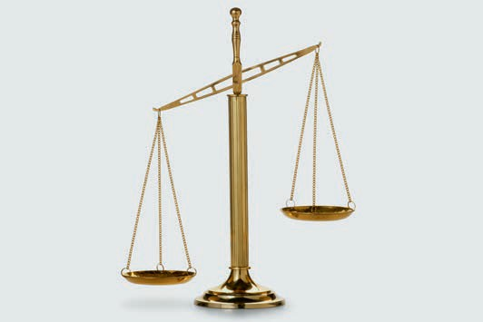

# Unit 3

## Sustainability in Practice

##### STUDY GOALS

On completion of this unit, you will be able to ...

... distinguish the levels of sustainable development.

... describe specific policy dimensions of action as well as the respectively derived targets and

indicators.

... differentiate policy instruments for implementing sustainable development.

... present the typologies and perspectives of sustainability management.

... outline the importance of sustainability management in the corporate functional areas.

... understand the involvement of civil society in the process of sustainable development.

DL-D-DLBLONQM01-L03

### Sustainability in Practice

#### Introduction

Implementing the guiding principle of sustainable development is a challenge for society as a whole. However, in practice, the term sustainability is frequently used in different contexts and therefore often remains blurred. When, for example, people talk about *permanently damaged trust*, *sustainable market growth* or *sustainable commitment*, they are not always referring to sustainable development in the sense of the Rio Process. You certainly know more connotations of sustainability yourself—from your private environment, your company, or the media.

The task therefore remains to further concretize the guiding principle of sustainability and thus avoid misunderstandings. Policy actors and the state have the task of defining the framework conditions for sustainable development. Companies are responsible for aligning their business models with sustainability, and each of us as part of civil society is called upon to reflect on the meaning of this guiding principle for ourselves personally. This unit therefore focuses on the implementation of the guiding principle of sustainable development by three primary groups of actors:

* policy and state,
* companies, and
* civil society.

#### Policy and State

Sustainable Development as a Political Phenomenon

The guiding principle of sustainability can be gradually concretized at various levels to illustrate the design of the sustainable development process in practice. This is shown in the figure below:

Sustainability in Practice

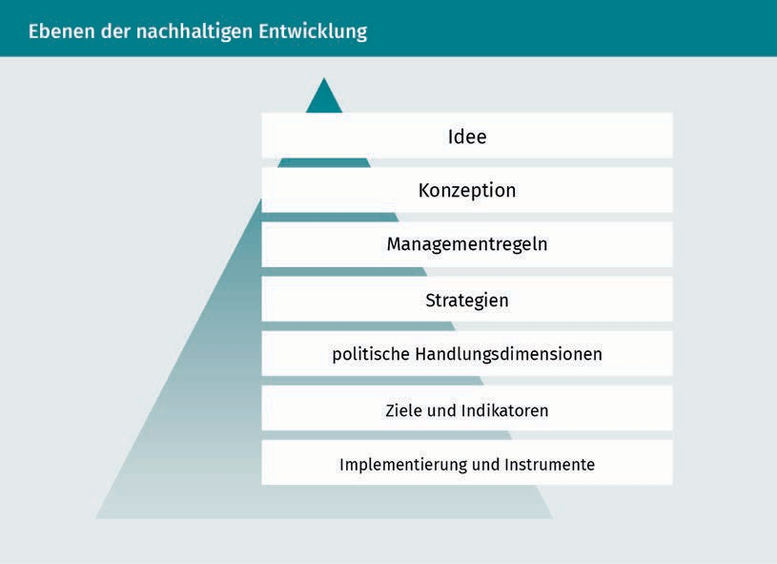

The concept of sustainable development is expressed in the premise of intergenerational and intragenerational equity, which can be interpreted in conceptual form as weak or strong sustainability. Management rules such as Daly's Rules concretize the sustainable use of natural resources, which is to be achieved with the help of the efficiency, sufficiency, and consistency strategies. Even though the concept of sustainable development emphasizes responsibility for society as a whole, it is a policy phenomenon: in policy negotiation processes, sustainable development is interpreted and shaped by state policy, as well as the executive and societal policy actors (companies and civil society) (cf. Baumgärtner et al. 2014, p. 279). Sustainable development is differentiated for various policy dimensions of action, underpinned with targets and their respective indicators, and implemented in the form of measures that then primarily affect companies and civil society.

Policy Dimensions of Action

The policy dimensions of action (also referred to as policy fields of action) of sustainable development have been mapped out by the Rio Process. In this context, Germany has already made international commitments that are described in specific terms by the Sustainable Development Goals (SDGs). In the context of sustainability management, the following three SDGs are considered as examples:

* SDG 8: Create decent working conditions and sustainable economic growth.
* SDG 12: Sustainable orientation of consumption and production.
* SDG 13: Climate protection actions.

States now have the task of implementing these SDGs by formulating national sustainability goals. Appropriate indicators must be determined for these goals in order to make the achievement of the goals measurable (cf. Kanning 2013, p. 38f.).

Targets and Indicators

Resource efficiency This is an assessment criterion for resource use per output variable.

The goal of sustainable growth set out in SDG 8 is related, among other things, to resource consumption: Global **resource efficiency** is to be progressively improved by 2030 in order to decouple economic growth from resource consumption (SDG 8.4). Resource consumption can be represented by the resource factor within the IPAT formula, the reciprocal of which is resource productivity. For Germany, the Resource Efficiency Program II sets the target of increasing total resource productivity (indicator as the ratio of gross domestic product plus imports to resource use) by 33% by 2030. This is illustrated in the figure below:

Sustainability in Practice

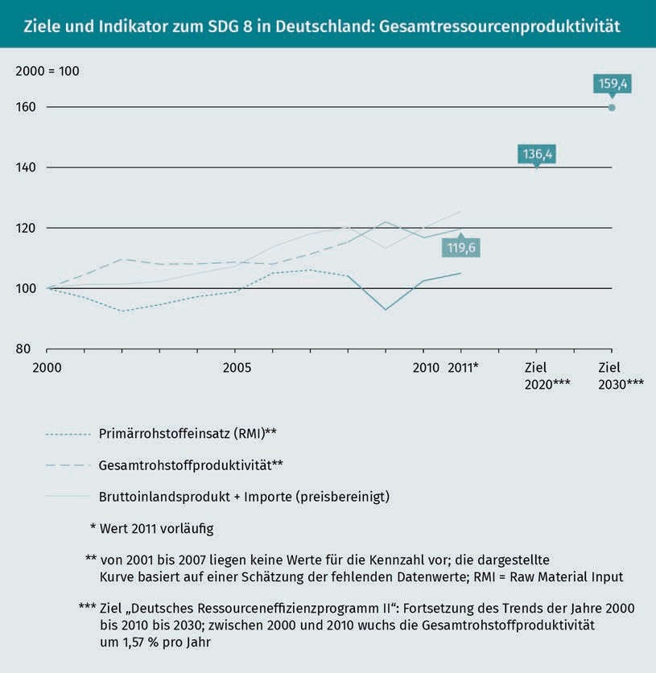

SDG 8 also includes social targets, such as safe working conditions, to reduce the number of fatal occupational accidents (SDG 8.8), prohibition of child labor (SDG 8.7), and equal pay for women and men (SDG 8.5).

The sustainable alignment of consumption and production according to SDG 12 is to be achieved, among other things, by significantly reducing waste generation by 2030 through prevention, reduction, recycling, and reuse (SDG 12.5). Alongside this, the national recycling rate of municipal waste (including paper, glass, plastics, biogenic waste, and electrical appliances) is to be increased. Since recycled resources reduce the need for newly extracted resources, a higher recycling rate has an indirect positive impact on the resource factor of the IPAT formula. The 2020 target of 65% has already been achieved, as shown in the figure below (there is currently no target for 2030):

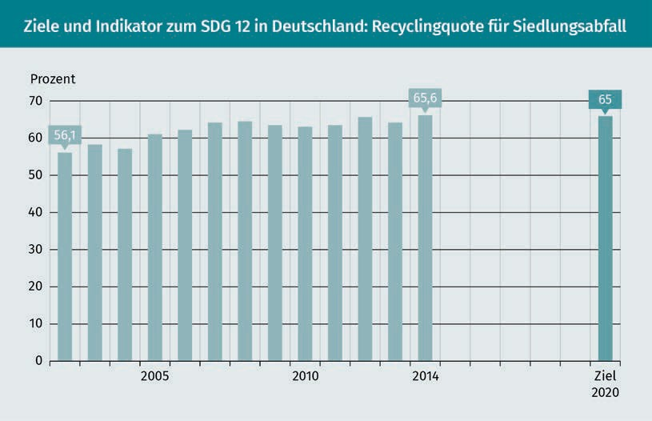

Climate protection actions under SDG 13 are primarily aimed at reducing greenhouse gas emissions. On this point, the different greenhouse effects of the gases are converted to CO2 equivalents. Methane, for example, has a higher greenhouse gas impact than CO2. Therefore, one ton of methane emission is equivalent to 21 tons of CO2 equivalents. The Rio Process has a significant influence on greenhouse gas emission reduction targets, and Germany plans to reduce its greenhouse gas emissions to 563 million metric tons of CO2 equivalents by 2030 (down from 906 million metric tons in 2015). This reduction corresponds with the emission factor of the IPAT formula, whereby absolute values are provided without a reference value (e.g., production volume or gross domestic product) in the figure below.

Sustainability in Practice

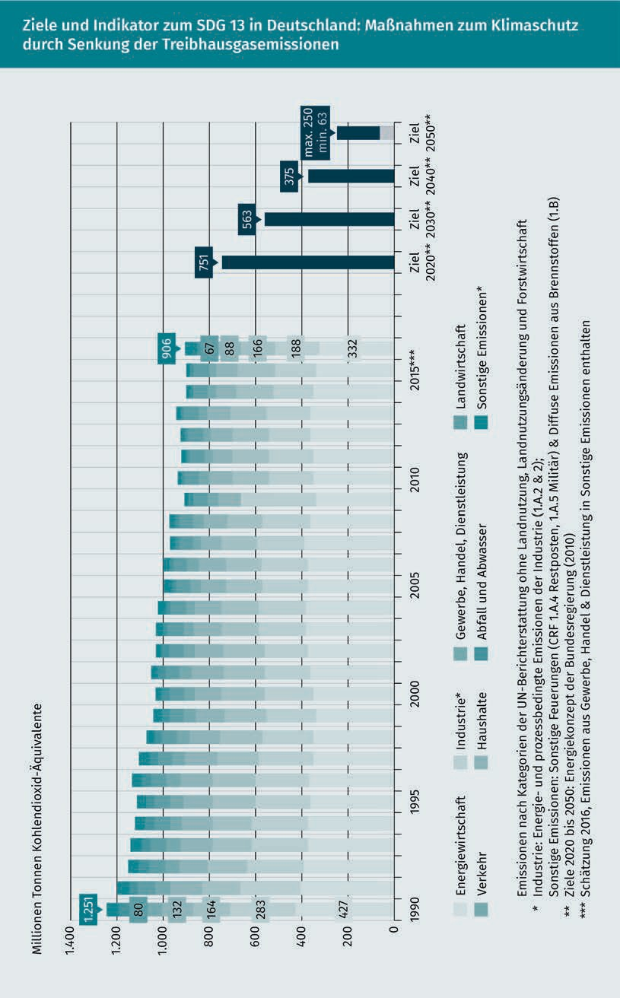

All sectors must contribute to a reduction in greenhouse gas emissions (energy sector, industry, commerce/trade/services, transport, households, waste/wastewater, and agriculture). Targeted actions for all sectors should help to achieve sustainability goals.

Implementation and Tools

A wide variety of actions are being implemented to achieve sustainability goals. The state is the main actor in this process. It provides companies and civil society with the framework for sustainable development (cf. Weizsäcker et al. 2010, p. 242). As the figure below shows, the state has numerous tools at its disposal to implement these actions.

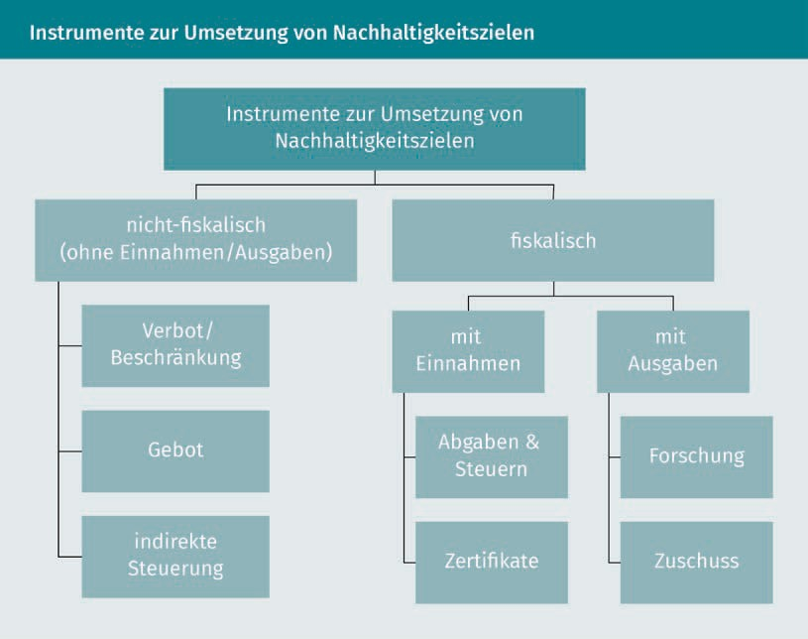

Non-fiscal tools are primarily regulatory instruments. The focus here is on the control of pollutant releases into sinks (cf. Weizsäcker et al. 2010, p. 239). Bans are utilized when the risk to the environment is very high and precaution against damage is critical, e.g., the lead ban in fuels. Restrictions are intended to enable an economy to develop in an environmentally compatible manner, and technical regulations are imposed on specific activities or facilities as to how they are conducted or operated, e.g., emission restrictions for commercial vehicles in the form of nitrogen oxide limits (this is known as European emissions standards). Mandate refers to regulations that require specific performances or permissions in the case of an environmentally hazardous activity.

Sustainability in Practice

Mandates are expressed, among other things, in obligations to provide proof (e.g., proof of training for the carriage of dangerous goods) and recording or inspection obligations (e.g., recording the driving times of vehicle drivers). Furthermore, mandates can also be used to achieve specific efficiency goals, e.g., an increase in energy efficiency in buildings through specifications for new buildings or so-called top-runner approaches, in which the most efficient technology in the market is established as a benchmark and becomes the market standard within a specified period of time (cf. Weizsäcker et al. 2010, p. 243 and p. 248). A further mandate is the CSR reporting obligation according to §§ 289b ff. German Commercial Code.

Indirect control is achieved through tools that provide incentives for specific sustainability-oriented behavior. For example, the self-regulation of companies is promoted in that companies with an environmental management system in accordance with the European standard of the Eco Management and Audit Scheme (EMAS) enjoy certain privileges (particularly administrative simplifications, e.g., in the form of reduced waste disposal reporting obligations to environmental authorities). Another indirect control is achieved through environmental liability under the Environmental Liability Act: The polluter who causes environmental damage must be liable for it, i.e., they must pay compensation for the damage. This liability obligation is intended to lead to particular caution in the case of environmentally hazardous activities. Indirect control can also occur through sustainability-oriented product labeling. Products and services that have proven environmental or social advantages can be awarded a seal or label. Well-known government seals are, e.g., the label indicating the energy efficiency class (e.g., A++) of an electrical appliance or the organic seal for foodstuffs, for which minimum standards apply to the growing conditions on the agricultural land (e.g., no use of artificial fertilizers).

Fiscal instruments are levies and taxes, whereby environmental levies are typically related to a specific environmental problem. The revenues are then specifically used to improve the environmental media, e.g., the wastewater levy under the Wastewater Levy Act. The amount of the levy is based on the harmfulness of the wastewater. The harmfulness is determined based on selected parameters such as oxygen content, nutrients, and heavy metals. The wastewater levy is collected by the German federal states and specifically used for measures that serve to maintain or improve water quality.

The best-known environmental taxes are likely energy taxes, which are often mistakenly referred to as eco-taxes, but do not actually exist in this form. Environmental taxes are levied, e.g., on mineral oils (heating) (= mineral oil tax), electricity (= electricity tax), and natural gas (= natural gas tax). These taxes are intended to increase the price of these energy sources to encourage frugal use of them. At the same time, CO2 emissions from the combustion or generation of these energies are to be reduced. The revenue from these taxes flows into the general state budget.

Environmental certificates are rights for companies to pollute the environment within specific limits. These must either be purchased from an environmental polluter (e.g., a power plant operator with high CO2 emissions) or they are issued by the state.

An environmental certificate then entitles the holder to emit, e.g., one ton of CO2 emissions per year. Interestingly, these environmental certificates can be traded. Thus, a company that has significantly reduced its emissions can sell environmental certificates that are no longer needed. The best-known environmental certificates are the CO2 emission certificates traded throughout Europe. This European Union Emission Trading System is a result of the agreements on climate protection reached at COP 3 in Kyoto.

All measures for implementing sustainable development aim to protect environmental media or to mitigate the system-related negative externalities in the use of environmental media. Their use is then no longer *free of charge* if, for example, levies or taxes must be paid or certificates purchased. This is because these then represent costs for the company. This approach is also referred to as internalization of external effects.

Measures to protect the environment are also promoted through government funding of research projects (e.g., research projects on electricity storage in electric commercial vehicles). Grants (or subsidies) are used to support actions aimed at sustainability-related improvements. Such subsidies can take the form of direct monetary payments (e.g., subsidies for building renovation consultations) or indirectly in the form of lower interest rates on loans (e.g., loan financing under the German Reconstruction Loan Corporation [KfW] environmental program to promote waste recycling facilities).

In Germany, large parts of environment-related legislation are subject to so-called concurrent legislative powers (Art. 74 of the Basic Law). This means that the instruments mentioned are used at the federal level, but implemented at the state level. This also means that regulations can differ in detail depending on the federal state, e.g., in the handling of hazardous waste. In Lower Saxony, e.g., there are special regulations for the loading of waste in seaports. The specific implementation of the instruments is the responsibility of the cities and municipalities (local authorities) on site. They use regulations to determine how, e.g., waste disposal is regulated locally. In the process, companies and private households are given specifications as to which waste containers are to be set up and with what minimum volume.

#### Companies

Typologies of a Sustainability Management

Companies are key actors in society and therefore play a major role in implementing the concept of sustainable development. On the one hand, they operate within the framework conditions established at the policy and governmental level described above, or they help to shape them. On the other hand, they are faced with the challenge of not only reactively adapting their competitiveness within the framework of sustainable development, but also actively shaping it.

Sustainability in Practice

Accordingly, companies are faced with the task of implementing the global guiding principle of sustainability in a corporate context (**corporate and business sustainability**). There is currently a discrepancy between the sustainable development goals (SDGs), which relate to the overall economy, society, or the world, and the goals at the corporate level. To date, there is neither a general definition of corporate sustainability, nor a method for measuring it (cf. Dyllick & Muff 2016, p. 158f.).

Nevertheless, approaches to corporate sustainability can be categorized into types to describe their degree of connection between overall social and corporate goals. Current approaches are described as Business Sustainability 2.0 and 3.0 (Dyllick & Muff 2016, p. 162ff.; Business Sustainability 1.0 refers to an older approach that views the consideration of environmental or social aspects as a means to the end of generating profits).

Business Sustainability 2.0 sustainability management particularly includes the following main tasks (cf. Schaltegger, Petersen & Burritt 2003, p. 63f.; Schaltegger et al. 2007, p. 4):

* Environmental tasks: reduction of the environmental impact caused by a company's activities. The achievement of this task can be described in terms of the so-called eco-effectiveness (e.g., reduction of greenhouse gas missions).
* Social tasks: reduction of undesirable social effects caused by a company's activities. The achievement of this task can be described in terms of socio-effectiveness (e.g., working conditions in the company itself and at suppliers).
* Economic tasks: economic design of eco-effectiveness and socio-effectiveness, e.g., cost reductions through lower energy consumption or increased sales through innovative sustainable products and services. The evaluation of these economic design tasks is expressed as eco-efficiency and socio-efficiency.
* Integration task: integration of environmental and social tasks into conventional, primarily economically oriented management.

The primary challenge is the measurement and evaluation of eco- and social effectiveness, since this is often unclear and is not only carried out via the market. The evaluation of measures to increase eco- or social effectiveness can be carried out via the market and non-market (extra-market) relationships of a company (cf. Schaltegger 2017, p. 85f.). Market relationships are manifested in market processes. For example, customers may choose electronic products with lower energy consumption based on their preferences, and products with genetically modified ingredients may be slow sellers. Likewise, companies have the option of contracting suppliers from Asia only if they undertake not to use child labor. Non-market relationships are shaped through **stakeholders** (or interested parties). Stakeholders, such as local residents, the media, and environmental protection and human rights organizations, can influence a company through social and political processes. At the same time, different stakeholder groups often evaluate a company's measures to increase eco- or socio-effectiveness quite differently:

Corporate and business sustainability

This term refers to the implementation of the guiding principle of sustainable development in a corporate context.

Stakeholders These are persons/groups of persons who can influence a corporate decision or activity or who are influenced by it or feel influenced by it.

a hazardous waste incineration facility, for example, is seen by environmentalists as a sensible facility for reducing the toxicity of waste, while local residents have concerns about the noise caused by delivery traffic and air emissions containing pollutants. These evaluations can have an impact on the company if, e.g., narrow delivery time windows and/or additional emissions cleaning are specified as a result.

Both market and non-market relationships influence a company’s success. If eco- or socio-efficient measures increase the company's success, this is an instance of a “business case for sustainability” (Schaltegger 2017, p. 87). The approach of Business Sustainability 2.0 aims at economic, environmental, and social value creation. This three-faceted perspective is referred to as triple bottom line management. The focus is on the internal management of the external economic, environmental, and social opportunities and risks of a company with the help of sustainability management systems. The perspective of Business Sustainability 2.0 can, therefore, be described as an inside-out perspective (Dyllick & Muff 2016, p. 168).

In contrast, Business Sustainability 3.0 describes a change in perspective: away from the *repair shop* of a company in solving self-inflicted environmental and social problems, and toward companies contributing to solving problems within the framework of sustainable development. The perspective of Business Sustainability 3.0 can be characterized as an outside-in perspective (Dyllick & Muff 2016, p. 168). The sustainability challenges described by the sustainable development goals are seen as a benchmark for corporate activities. Those known as social entrepreneurs particularly illustrate this type of sustainability management. They conduct business as all-profit organizations and want to contribute to the achievement of sustainable development goals, e.g., by ensuring global access to drinking water for all people (SDG No. 6). For example, a Hamburg-based initiative markets bottled water in Germany to raise customer awareness of drinking water supply problems in less developed countries. The proceeds from sales are used to support drinking water projects in these countries. To this end, sustainability management is implemented in all functional areas of the company.

Sustainability Management in Functional Areas

Effective sustainability management relates to all corporate functional areas: Purchasing, production/services, marketing, and logistics. In purchasing, environmental aspects can be taken into account, e.g., by only sourcing raw wood materials with an appropriate seal (e.g., from the Forest Stewardship Council). In production or service provision, the recycling of raw materials or the efficiency of energy supply can be improved. In branding, new products and services can be developed that create an environmental and social added value for customers, e.g., CO2 compensation for air transport.

Sustainability in Practice

Logistics plays a key role in supply chain management as a control system for material and information flows from suppliers to customers (cf. Seuring & Müller 2013, p. 247). Supply chain management is used to design the value chain in an integrated manner across functional areas and company boundaries, both strategically and operationally. Sustainability management within the supply chain can be referred to as sustainable supply chain management (cf. Schaltegger et al. 2007, p. 47f.). Its goal is to efficiently manage the environmental and social challenges within the entire, often global supply chain. The environmental and social impacts are considerable: For example, large amounts of energy and resources are used in a supply chain for inputs, the company's own production, downstream production stages, disposal, and transport. Social problems in the supply chain can arise, e.g., as a result of labor law violations by upstream suppliers or resistance to road or port infrastructure projects. Conflicts between economic and environmental goals can arise in the supply chain. For example, just-in-time delivery reduces the need for storage space. This lowers storage costs and reduces the amount of land required or the amount of sealing on site. At the same time, however, the delivery frequency and thus transport increases. In addition, just-in-time deliveries require an efficient infrastructure, which results in a demand for space, e.g., for roads. Stakeholders, such as local residents and nature conservation associations, can influence the entire supply chain via non-market relationships.

#### Civil Society

All activities that are neither economically motivated (in the sense of income generation), nor party-politically motivated can be described as civil society activities. These include the activities of citizens in clubs, associations, initiatives, and social alliances. Civil society is particularly important in the context of sustainable development when it comes to participating in and shaping the Rio Process through Agenda 21/2030 (cf. Kanning 2013, p. 40). In the city of Lüneburg, for example, various issues were discussed by citizens, scientists, and politicians as part of a dialog on sustainability (DialogN). These included factors for a good life in the city, the origin and quality of school lunches, and community-managed housing (cf. ZukunftsWerkStadt Lüneburg DialogN 2013). Civil society associations often act as stakeholders in environmental and social issues. This can be at the international level (e.g., Amnesty International, World Wide Fund For Nature), the national level (e.g., German Federation for the Environment and Nature Conservation, Environmental Action German), the regional level (e.g., Farms instead of Agrarian Factories Regional Network [Landesnetzwerk Bauernhöfe statt Agrarfabriken] in agriculturally dominated Lower Saxony), and the local level (e.g., Citizens' initiative against the logistics center Langenzersdorf [Bürgerinitiative gegen das Logistikzentrum Langenzersdorf in Austria]). The term nongovernmental organization (NGO) was coined by the United Nations for civil society associations. NGOs can participate in political decision-making processes. A large number of NGOs participate in the Rio Process, e.g., Greenpeace International or German Watch.

Alongside their role in civil society, citizens also act as consumers. Their responsibility for sustainable development is summarized under the term *sustainable consumption*. Sustainable consumption concerns each individual’s personal lifestyle—particularly among citizens with a very high energy and resource use in a global comparison, such as in Europe, the USA, or Japan. In this context, sustainable consumption refers to all areas of a person’s needs, such as mobility, food, housing/household, work, clothing, and leisure (cf. Bundesministerium für Umwelt, Naturschutz und Reaktorsicherheit/Bundesministerium für Justiz und Verbraucherschutz/Bundesministerium für Ernährung und Landwirtschaft 2017, p. 38ff.). Significant policy approaches to action include improved marking of environmentally and socially compatible products and services by means of labels and more environmentally compatible product design through low energy consumption and high recyclability. These approaches also offer companies opportunities to improve their eco- and social efficiency within the framework of sustainability management.

Summary

In practice, the process of sustainable development is shaped by policy and state, company, and civil society actors.

The concept of sustainable development is primarily a policy phenomenon and can be analytically divided into the levels of idea, conceptualization, management rules, strategies, policy dimensions of action, targets/indicators, and implementation/tools. The most relevant policy dimensions of action are the sustainable development goals, which are underpinned by targets and indicators, e.g., on resource efficiency, recycling, and climate protection. The state has legal instruments at its disposal for implementing the goals that can be divided into fiscal and non-fiscal instruments.

In the context of sustainability management, companies implement the global guiding principle of global sustainability in the context of corporate or business sustainability. Market and non-market processes that affect a company and are influenced by their company's stakeholders must be taken into account. Two significant typologies of sustainability management are: Business Sustainability 2.0, which entails a “business case for sustainability” (inside-out) and aims at a consideration of the triple bottom line and the Business Sustainability 3.0 approach, which focuses on companies contributing to solving the challenges of sustainable development (outside–in). Sustainability management must be implemented in all functional areas, with supply chain management playing a key role.

Sustainability in Practice

Civil society is primarily involved in the sustainable development process through non-governmental organizations. Alongside this, citizens play a key role as consumers in their personal spheres of action: mobility, food, housing/household, work, clothing, and leisure, since they can promote sustainable consumption as consumers.



# Unit 4

## Tools and Methods of Sustainability Management

##### STUDY GOALS

On completion of this unit, you will be able to ...

… understand the approaches of system dynamics and technology assessment as ways to describe or evaluate complex systems.

… describe the most significant regulatory areas of German environmental law and their content.

… present the goals and structures of the most common sustainability and environmental management systems.

… outline life cycle assessments and CO₂ footprints as instruments for systematically recording environmental impacts.

DL-D-DLBLONQM01-L04

### Tools and Methods of Sustainability Management

#### Introduction

The question of whether something is sustainable or not is often not so easy to answer when, for example, it comes to evaluating a new product or service. In practice, sustainability generally cannot be described in absolute terms, but rather in relative terms and is characterized by many interactions. For example, a product made of wood has the advantage over plastic that its raw material is renewable, but the plastic product may have a longer useful life. In sustainability management, it is therefore often a question of assessing whether one thing is *more sustainable* than another. Sustainability management tools and methods are intended to help make such assessments regarding systems, companies, and products possible. They can be applied in the following areas:

* overall using system analyses and technology assessments,
* state-based using environmental and social laws, and
* company-based using management systems and decision-making tools.

#### System Dynamics and Technology Assessments

System dynamics methodology is used to analyze dynamic and complex systems. It is based on general systems theory and cybernetics (control theory). Systems are represented as a network of cause-effect relationships that are connected by feedback relationships. Such feedback relationships can be both positive and negative and typically do not act linearly (as it corresponds to the normal way of thinking of a human being), but rather exponentially or logarithmically, among others. The structure of a phenomenon is made clear through a qualitative description of the relationships between the system components. Systems can then be represented in formal mathematical models and the simultaneous behavior of the system components (stock sizes and variables) can be simulated with the help of computers (cf. Ford 1999, p. 14ff.). A well-known application is the World3 model for depicting limits to growth (cf. Meadows et al. 2009, p. 145ff.). In the model below, the stock sizes, population, and agricultural land are considered, among other things. These stock sizes are affected by feedback relationships (e.g., the variables birth rate [positive +] and death rate [negative -]), which in turn are influenced by impact factors. For example, a high utilization rate of agricultural land leads to erosion and thus to lower yields. Lower yields lead to a diminished food supply for the population and thus affect the birth and death rates.

Tools and Methods of Sustainability Management

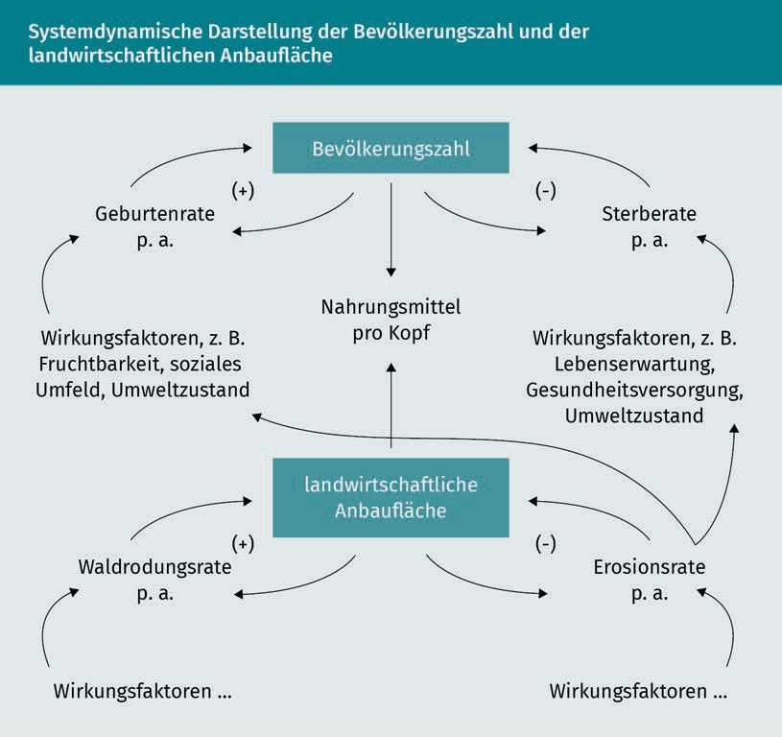

The methodology of system dynamics is used to support decision-making in companies and in policy advising. For example, companies can model their supply chain to show the relationships between demand, variety, inventory costs, and delivery times. Policy advisors can use system dynamics to provide indications of how, e.g., a restriction on granite mining in Germany for nature conservation reasons would affect the supply chain for granite, which would then be primarily supplied by countries such as India or China (cf. Sailer 2016, p. 29).

Technology assessment, also known as technology impact assessment, is also used to provide policy advice. A technology assessment does not simply leave the evaluation of technological developments (innovations) and their introduction entirely to the market, but also considers non-market aspects. Such aspects can be, e.g., environmental and social effects. In technology assessment, the risks or opportunities of an innovation should be made clear in order to weigh the possible benefits or harm. Such a procedure is always based on evaluations that should receive broad social approval through a diverse range of opinions. This occurs in the area of sustainability, e.g., through discussions on the consequences of an expansion of renewable energies in electricity generation.

In Germany, an Office of Technology Assessment (TAB) is located at the German Parliament. This scientific institution is operated by the Institute for Technology Assessment and Systems Analysis (ITAS) of the Karlsruhe Institute of Technology (KIT). TAB investigates the potential of new scientific and technological developments and assesses the associated risks and opportunities. The goal is to promote scientifically based decision-making in the legislature. In 2006, for example, a study was prepared to explore the prospects for low-emission transportation. In the course of this, possible biogenic fuels and new drive technologies were examined. The study also looked at a wide range of interactions, such as the reduction of greenhouse gas emissions while simultaneously increasing the amount of land required for the cultivation of biogenic fuels, or the effects of technical reductions in greenhouse gas emissions on the emission of other air pollutants. In Germany, technology assessments related to sustainable development are required by law. For example, environmental impact assessments (EIAs) must be conducted for certain new constructions, such as large storage facilities or transportation infrastructures like highways or waterways. In an EIA, the potential impacts of new buildings on the protected resources air, soil and water are examined.

#### Environmental Law

Environmental law converts policy decisions into a binding framework for companies. In environmental law, it is primarily the state that takes action to protect the environmental media. Therefore, environmental law is assigned to public law—more precisely, to administrative law (consequently, it is also referred to as environmental administrative law). The areas of environmental law are shown in the figure below.

Tools and Methods of Sustainability Management

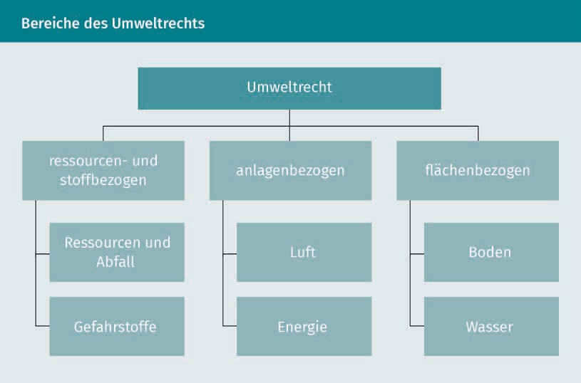

Resources, Waste, and Hazardous Substances

In Germany, many valuable materials and resources continue to be lost because waste is not handled carefully. Waste electronic equipment, end-of-life vehicles, biodegradable waste, and plastic waste contain valuable raw materials. If raw materials can be recovered from waste, this contributes to the conservation of natural resources. In addition, many wastes contain substances that are hazardous to health and the environment and must be disposed of safely. The legal basis for handling resources and waste is the Recycling Management Act (KrWG). In the context of waste management, the KrWG is intended to promote the protection of natural resources and ensure the protection of people and the environment as a whole (air, water, soil, i.e., across environmental media). Waste is defined as any substance or object which the holder discards, intends to discard, or is required to discard. A distinction is made between waste for recovery and waste for disposal.

Management includes the handling of waste itself and the operation of waste treatment facilities. Colloquially, waste management includes all recovery and disposal processes for waste. In Germany, there is a clear priority regulation for waste management, which is also called the **waste hierarchy.**

Waste hierarchy

Is a priority regulation for handling waste in accordance with the Closed Substance Cycle Waste Management Act

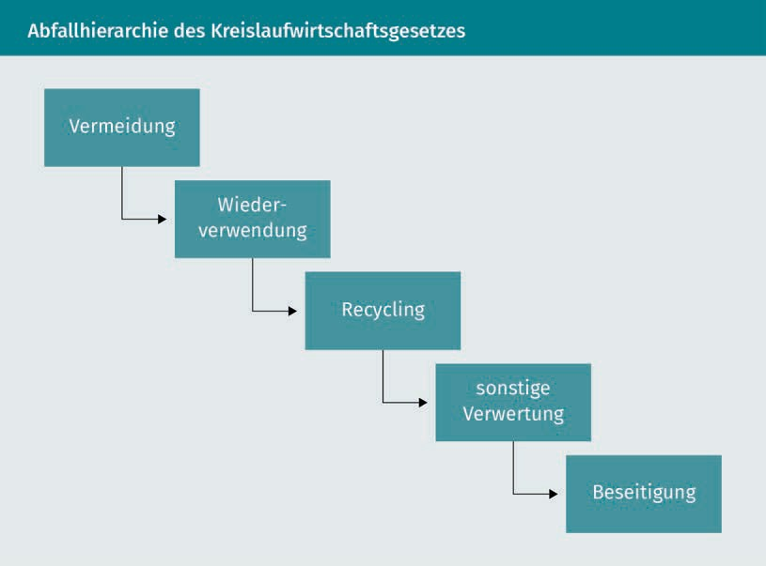

Prevention includes all measures taken before a substance, material, or product becomes waste. These measures serve to reduce the amount of waste, the harmful effects of this waste, or the content of hazardous substances in materials and products. Possible measures include in-facility recirculation of materials, low-waste product design, and the extension of useful life, as well as the purchase of low-waste products.

Reuse refers to any process in which products or components are reused for the same purpose for which they were originally intended, e.g., reusable transport packaging. If a product has a new purpose, this is an instance of further use. Processing usually does not take place.

Recovery is any process in which waste is returned to a useful purpose. The purpose may be to replace other materials or to process the waste in such a way that it can fulfill this function. Recycling is a recovery process that converts waste into products, materials, or substances that are suitable either for the original purpose or for another purpose. Other recovery processes include operations that use waste to generate energy, e.g., the incineration of waste to generate electricity.

Disposal is the last option in the waste hierarchy and the umbrella term for all waste treatment processes that are not recovery. Disposal is also referred to as actual disposal, as there is usually no further use of the waste here. However, an ancillary effect of disposal can be that substances or energy are recovered during the process.

Tools and Methods of Sustainability Management

The KrWG establishes specific basic obligations when handling waste:

* Producers or owners of waste are obligated to recover their waste. The recovery of waste has priority over its disposal.
* The recovery of waste, especially its integration into other products, must be carried out properly (i.e., in accordance with the applicable provisions; also known as proper and professional waste treatment) and safely (i.e., without harming people or the environment).
* The obligation to recover waste must be fulfilled if there is a market for the waste or the energy that can be extracted from it. In addition, recovery must be technically possible (i.e., there is a recognized process for this) and economically reasonable (i.e., the costs for recovery are lower than the costs for disposal).
* Waste must be collected separately and must not be mixed. This particularly applies to waste that has been classified as hazardous in accordance with the Waste List Ordinance (AVV).

Hazardous waste and other hazardous substances or chemicals are used in nearly every company—even if it is *only* waste oils from vehicles or cleaning agents. This is why chemistry is ever-present, but many things would not be possible without chemicals. Nevertheless, numerous chemicals pose a risk to human health and the environment. In order to handle them appropriately, these hazardous substances and their harmfulness must first be recognized to identify potential hazards and take measures that enable safe work for employees.

A chemical is harmful if its nature, extent, and duration are such that it is likely to cause hazards, significant disadvantages, or significant nuisances for people and the environment. Whether a chemical is harmful in this sense is determined in particular by the state of the art in science and technology. This is primarily based on scientific and medical-biological findings. Protection against hazardous substances is regulated by the Chemicals Act (ChemG). The starting point of the law for protective measures is the individual chemical substances and their properties. The Hazardous Substances Ordinance (GefStoffV) has been issued based on ChemG and, provides more detailed specifications for handling hazardous substances. Depending on the hazard posed by a hazardous substance, the GefStoffV prescribes graduated protective measures (§§ 7-10 GefStoffV):

* Basic obligations in the implementation of all protective measures, e.g., wearing protective clothing;
* General protective measures for low and normal hazards, e.g., hygiene requirements or time limits for working with hazardous substances;
* Additional protective measures in case of increased risk, e.g., use of toxic hazardous substances only in clearly demarcated rooms,
* Special protective measures for activities involving carcinogenic, mutagenic, and fertility-endangering hazardous substances, e.g., in restricted-access rooms with warning labels and permanent measurement of substance concentrations in the work rooms.

Air and Energy

The Immission Control Act represents the core of environmental administration law in Germany and first came into force in 1974. At that time, the main focus was on emissions into the air from production facilities. Today, the reduction of particulate pollution is at the center of the discussion and reducing emissions is a focal point of policy efforts to improve environmental protection. The Federal Immission Control Act (BImSchG) and all regulations based on it (Federal Immission Control Ordinances, BImSchV), including the administrative regulations issued (particularly the Technical Instructions on Air Quality Control, TA Luft) serve to implement these policy goals. The numerous BImSchV contain detailed specifications for certain environmental areas, e.g., for small and medium-sized firing installations (including heating systems) in the 1st BImSchV, as well as a list of installations requiring a permit in the 4th BImSchV.

The BImSchG focuses on the protection against harmful effects of installations on the environment. Harmful effects on the environment are immissions which, by their nature, extent or duration, are likely to cause hazards to the general public or the neighborhood. Harmful immissions include air pollution, noise, vibrations, light, heat, radiation, and similar environmental impacts on humans, animals, and plants, the soil, water, the atmosphere/air, and cultural objects and other material goods. Installations include company premises, machines, devices, and other technical equipment, as well as vehicles and properties for the storage or processing of substances that cause emissions. Air pollution refers to changes in the natural composition of the air, particularly through smoke, soot, dust, gases, aerosols, steam, or odorous substances (§ 3 BImSchG).

According to BImSchG, the following basic obligations apply to installation operators:

* Avoidance of harmful effects on the environment and other hazards, significant disadvantages, and nuisances; limit values or guideline values are specified to comply with this obligation to protect (protection mandate).
* Apply best available techniques (BAT) within the industry while considering cost effectiveness;
* Take precautions, particularly through measures such as emergency plans in accordance with the Hazardous Incident Ordinance (12th BImSchV; prevention mandate);
* Avoidance of waste (waste avoidance mandate),
* Economical and efficient use of energy, including the use of waste heat (energy conservation requirement);
* Restoration of a proper condition in the event of facility decommissioning, e.g., in the event of soil contamination (aftercare mandate).

The primary fields of action in energy supply are increasing energy efficiency and using renewable energies to generate electricity and heat. The Renewable Energy Sources Act (EEG) aims to increase the share of renewable energies in electricity generation to at least 35% by 2020, and to at least 80% by 2050.

Tools and Methods of Sustainability Management

Special subsidies are in place to promote facilities in the production of electricity from renewable energies (e.g., photovoltaic systems, wind turbines). The costs of these subsidies are passed on to all electricity consumers in Germany (this known as the EEG levy). The Renewable Energies Heat Act (EEWärmeG) aims to promote the use of renewable energies for heat generation, e.g., through the use of solar thermal energy for heating or hot water supply. The EEWärmeG stipulates that a certain proportion of the heat requirement for new residential and non-residential buildings must be met from renewable energies.

The measures of the Energy Services Act (EDLG) aim to promote the efficiency of energy use. To this end, all end customers in Germany (households, companies, and public institutions) are to reduce their energy costs and emissions with energy services and other energy efficiency measures. Possible energy services and energy efficiency measures are:

* For companies: e.g., requirements for labeling energy-saving electrical appliances (EU energy efficiency labeling), energy audits, energy consulting for SMEs, efficiency program for old heating systems;
* For households: e.g., tax incentives for energy-efficient building renovations, information on energy-efficient products, and the Energy Savings Meter pilot program;
* For public institutions: e.g., CO2 building renovation program, promotion of energy efficiency in wastewater treatment plants/facilities.

Energy audits are particularly important for companies. An energy audit is a systematic procedure for obtaining information regarding the energy consumption of a building, a process in an industrial facility, or a service. This information is the basis for possible measures to reduce energy consumption and increase energy efficiency.

To reduce energy consumption, the German Energy Conservation Act (EnEG) requires thermal insulation in new buildings that is in line with the technical possibilities. It also requires that heating, cooling, lighting, and hot water systems be built and operated in an energy-saving manner. These specifications (energy-saving mandate) are directed at all owners, builders, architects, construction companies, and installers of building services systems. What exactly constitutes *energy-saving* is defined in the supplementary Energy Saving Ordinance (EnEV). For example, it determines maximum values for the permissible energy requirements of new buildings (what are known as low energy house standards or, from 2020, ultra-low energy house standards) and specifies the operation of heating systems in accordance with the current state of the art.

Soil and Water

Alongside air and water, soil is an essential basis of life for humans, animals, and plants. In addition to being a habitat for a large number of living organisms, soil also enables the production of food and biomass. It also provides raw materials such as sand, metals, and natural gas. The core of soil protection is the

Federal Soil Protection Act (BBodSchG). The primary goal of soil protection is to protect or restore the functions of the soil. Soil fulfills three important functions: an ecological function (i.e., habitat for animals and plants), an archival function (for natural and cultural history, e.g., for soil research on climate and settlement history), and a soil use function (e.g., as a raw material deposit, settlement/transport area, and recreation space). Furthermore, the soil must be protected against harmful changes, tangible damage must be averted and existing contamination must be remediated. Soil protection is understood as everyone’s duty, i.e., every person is obligated to protect the soil—not the owners of soil areas alone. Among other things, the BBodSchG stipulates the following aspects:

* + Hazard prevention (e.g., securing of tank installations—together with other regulations),
  + Unsealing (e.g., obligations to restore natural surfaces of permanently unused transport areas),
  + Remediation of contaminated sites (e.g., old, “wild” landfills),
  + Good agricultural practices (e.g., maintaining hedges, field shrubbery, field boundaries, and terracing, or promoting soil biological activity through crop rotation practices).

Water is life and life is water—that is why water (surface waters such as lakes and rivers, marine and coastal waters, and groundwater) is particularly protected in Germany. Through environmentally friendly handling, the waters are to be protected as part of nature, as the basis of human life, as a habitat for animals and plants, and as a usable resource. The Water Act (Wasserhaushaltsgesetz, WHG) was enacted to protect water and contains general principles of water management; a selection is provided below:

* + Preservation and improvement of the function and performance of water bodies and protection against adverse changes in water body characteristics (e.g., a prohibition on using water bodies without official permission and a ban on pollution when threats to water quality are avoidable).
  + Avoid impairments to water-dependent terrestrial ecosystems and wetlands and compensate for unavoidable impairments (e.g., protect habitats for plants and animals).
  + Preserve the potential uses of water bodies, particularly for public water supply (e.g., prioritized protection of water bodies for drinking water production).
  + Creation of natural flow conditions for rivers (e.g., for flood protection).
  + Protection of the marine environment (e.g., also for recreational purposes).

Tools and Methods of Sustainability Management

#### Sustainability and Environmental Management Systems

Fundamentals

There are now numerous *catalogs* of environmental and social criteria and their specific designs that are considered relevant for companies in the context of sustainability management. Such criteria catalogs can be divided into three forms based on their focus (cf. Sailer 2016, p. 50):

* + - Normative frameworks that provide general guidelines as to which environmental and social criteria are relevant in sustainability management. Examples include the United Nations Global Compact and the Guidelines for Multinational Enterprises of the Organization for Economic Cooperation and Development (OECD).
    - Process guidelines that contain specifications on which measures contribute to increasing eco- and socio-effectiveness. Examples include the German Sustainability Code of the German Council for Sustainable Development and the internationally recognized guidelines for the presentation of corporate social responsibility according to DIN ISO 26000.
    - Management systems that provide a systematic framework for planning, implementing, monitoring, and further improving a company's eco- and socio-effectiveness The environmental management standard DIN EN ISO 14001 or the Eco-Management and Audit Scheme (EMAS) and the energy management standard DIN EN ISO 50001 are management systems with reference to sustainable development. These standards are strongly based on already established management system standards such as DIN EN ISO 9001 for quality management.

Guidance on Social Responsibility According to DIN ISO 26000

The guidance on social responsibility according to **DIN ISO 26000** is a process guideline designed to be an action and orientation aid for companies. It does not contain requirements for a specific eco- or socio-effectiveness in a company or any evaluation standards for sustainability management. It is therefore not a certifiable standard. DIN ISO 26000 defines seven core topics that a company should consider as part of its sustainability management (cf. Federal Ministry for the Environment, Nature Conservation and Nuclear Safety 2014, p. 28ff.):

DIN ISO 26000

This standard offers guidance on corporate social responsibility.

* + - * Corporate management: DIN ISO 26000 emphasizes responsible corporate management that commits itself and the company to ethical behavior and establishes appropriate management and control systems (compliance), e.g., in the form of an internal anti-corruption directive.
      * Environment: This core subject is aimed at improving efficiency in the use of energy and resources within the company, but also at responsibility for the products offered over the entire life cycle, including their disposal (product responsibility). Here, in-depth instruments for assessing the environmental impact of products are available, such as life cycle assessments or a product’s carbon footprint.
      * Human rights: This subject is particularly important for companies operating in countries with low regulatory density, political instability, or conflicts. DIN ISO 26000 stipulates that a company must respect the property rights of the local population when investing in such countries, particularly in the case of basic resources such as drinking water.
      * Labor practices: In this area, DIN ISO 26000 provides minimum regulations for a company's own employees (e.g., occupational health and safety at workplaces) and the avoidance of discrimination at all company locations.
      * Fair operating and business practices: The conduct of a company's management should be aligned with ethical standards. This not only applied to a company's own employees, but also to their suppliers, customers, competitors, government institutions, and stakeholders. For example, no misinformation should be provided or threats made in the event of political involvement.
      * Consumer concerns: The focus here is on dealing fairly with customer requirements

and needs, e.g., offering arbitration procedures, transparency measures in the form of information on the origin of products and their components, and the protection of customer health and safety.

* + - * Community involvement: This core subject calls for a company to be involved in its social environment, e.g., by promoting the professional qualifications of its employees or the local culture. The guiding principle is that a company should act as a responsible part of society. This is also referred to as corporate citizenship.

Because environmental and social aspects are considered, DIN ISO 26000 can be understood as a sustainability management standard. In contrast, environmental management standards focus on a company's eco-efficiency performance.

Environmental Management Systems According to DIN EN ISO 14001 and Eco-Management and Audit Scheme (EMAS)

An environmental management system is part of a company’s management system. It includes specifications for the planning, organization, management, and control of all environment-related procedures and processes within a company, as well as the designation of responsibilities and the provision of necessary resources. The DIN EN ISO 14001 and **EMAS** standards set minimum requirements for an environmental management system.

Tools and Methods of Sustainability Management

For example, a corporate environmental policy must be defined, environmental goals must be established, and specifications for processes with environmentally relevant activities must be determined (e.g., work instructions for handling waste).

The structure of an environmental management system according to EMAS is shown in the figure below:

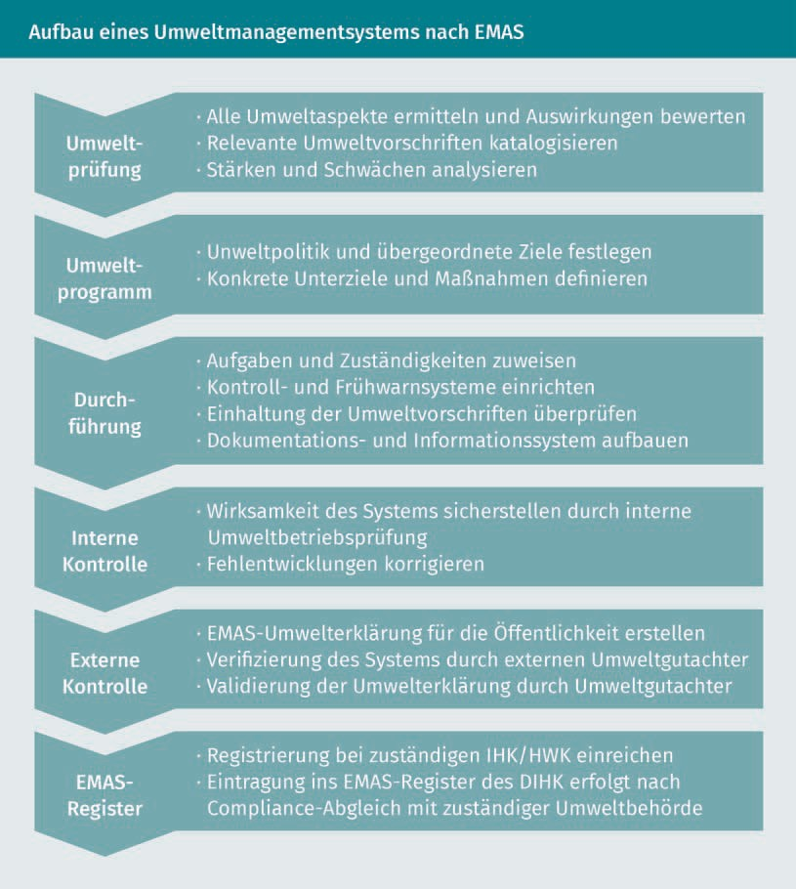

The environmental audit considers all environmental aspects of a company. These are the components of the activities, products, or services that can have an impact on the environment, e.g., the emission of pollutants into the air or wastewater. An environmental policy is a binding statement of the company's intentions and orientations toward improving its environmental performance, such as continually improving the recyclability of its products. A company's environmental policy also commits the company to compliance with all applicable environmental regulations.

EMAS

The European standard for an environmental management system

Environmental goals are detailed performance requirements that are quantified. They must result from the environmental policy, be defined, and adhered to. The specific measures to achieve these goals are recorded in the environmental program. An example of this is increasing the use of biogenic raw materials by 50% within five years. An environmental statement provides the public with comprehensive information about a company's environmental activities. Validation represents confirmation by an external expert (environmental auditor) who has carried out an assessment and considers the environmental statement to be reliable, credible and correct, and in compliance with the requirements of the EMAS standards.

The advantages of an environmental management system according to EMAS are particularly seen in the reduction of costs through the reduction of resource consumption and the emission of pollutants. Alongside this, a lower reporting obligation to authorities, a better image as an environmentally oriented company, and the possibility for large companies to set environmental standards for their suppliers all speak for EMAS (cf. Weizsäcker et al. 2010, p. 260).

EMAS has integrated the DIN EN ISO 14001 requirements and extends beyond them in some respects. For example, it requires a published environmental statement and registration.

An energy management system according to DIN EN ISO 50001 follows a similar approach to DIN EN ISO 14001 and EMAS. The standard focuses particularly on the use of energy within a company. DIN EN ISO 50001 is widely used in Germany, since many companies receive reductions in energy taxes or the levy under the Renewable Energy Sources Act when they introduce it.

Key Figures

Both process guidelines and management systems use key figures in the broadest sense to measure eco- or social effectiveness. These are intended to represent the performance of a company in the context of its sustainability management. Therefore, we can also speak of a company’s sustainability performance. Even in the broadest sense, the key figures can still be differentiated (cf. Gladen 2014, p. 9):

* + - * Key figures in a strict sense: They are used for directly measurable variables, i.e., quantitative statements, e.g., amount of paper waste for recycling in tons per year.
      * Indicators: They are used as a proxy for phenomena that cannot be measured directly and are intended to allow conclusions to be drawn about their development. This concerns, e.g., qualitative statements, such as the ecological status of the Elbe River, which is described by the number of different aquatic animals and plants.

Tools and Methods of Sustainability Management

EMAS specifies six so-called key areas with nine key figures (in the strict sense), which are confusingly referred to as core indicators in the regulation (Regulation of the European Parliament and of the Council of 25 November 2009 allowing voluntary participation by organizations in a community economic management and audit scheme and repealing Regulation (EC) No 761/2001 and Commission Decisions 2001/681/EC and 2006/193/EC [EMAS III], amended on 28 August 2017; Annex IV C):

|  |  |
| --- | --- |
| **Key Areas and Key Figures According to EMAS** | |
| **Key areas** | **Key figures** |
| **Energy efficiency** | Total direct energy consumption, indicating total annual energy consumption expressed in megawatt hours (MWh) or gigajoules (GJ), e.g., for electricity, natural gas, petroleum, coal, fuels; total renewable energy consumption, indicating the percentage of energy from renewable energy sources in total annual consumption (electricity and heat). |
| **Material efficiency** | Annual mass flow of input materials (excluding energy carriers and water) in tons (t), e.g., for metals, ores, woods. |
| **Water** | Total annual water consumption in m³. |
| **Waste** | Total annual waste generation, broken down by waste type in tons; total annual generation of hazardous waste in kg or tons. |
| **Biodiversity** | Land use in m² of built-up area. |
| **Emissions** | Total annual emissions of greenhouse gases (broken down into carbon dioxide [CO2 ], methane [CH4 ], nitrous oxide [N2 O], hydrofluorocarbons [HFCs], perfluorocarbons [PFCs], and sulfur hexafluoride [SF6 ]) in tons CO2 equivalent; total annual emissions into air (broken down by sulfur oxide (SO2), nitrogen oxides (NOX), and particulate matter (PM) in kg or tons. |

These key figures are initially absolute key figures that are specified in the units such as MWh, t, kg, or m³. They are set in relation to a reference value to compare the key figures of different companies and thus become relative key figures.

EMAS defines the gross added value of a company as a standardized reference value, which is simplified as revenue minus the value of non-labor costs inputs (alternatively, the product quantity in tons or the number of employees can also be used as a reference value for small companies). A company's environmental statement must contain all the specified key figures.

Key performance

indicator This is a company’s performance indicator that is classified as critical and applied as a key control parameter.

In the broader sense, a **key performance indicator** (KPI) is defined as an indicator that is considered to be particularly important or critical for a company. An important economic KPI is, e.g., profitability. In the context of the use of environmental media, for example, the amount of water used by a brewery can be a KPI if this amount increases sharply and the permitted withdrawal amount per year is limited due to a shortage of water on site.

#### Life Cycle Assessment and Carbon Footprint

The life cycle assessment is an operational instrument for recording, assessing, and evaluating the resource requirements and environmental impacts of a product, process, company (or operation), or a specific material or substance. The preparation of life cycle assessments is standardized in DIN EN ISO 14040. The structure of a life cycle assessment is shown in the figure below:

Tools and Methods of Sustainability Management

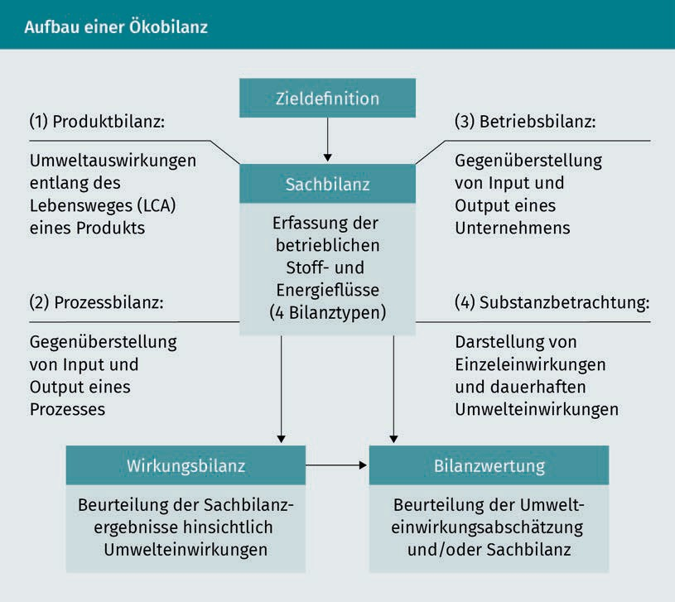

A life cycle assessment includes the following steps:

* + - Goal definition and determination of the **scope** of the study,
    - Inventory analysis, e.g., raw material use, emissions, energy consumption, waste, water consumption.
    - Impact analysis or impact assessment, e.g., significance of emissions for the greenhouse effect, use of scarce, non-renewable raw materials.
    - Analysis interpretation, e.g., weighting of environmental impacts and conclusions.

A life cycle assessment (LCA) is also referred to as a product life cycle assessment when the entire life cycle of a product is defined as the scope (i.e., raw material extraction or processing, production, use, and disposal, including transport). Life cycle assessments are used, e.g., to determine and label the eco-efficiency (*environmental friendliness*) of reusable transport packaging in logistics. A well-known product label based on life cycle assessments is the Blue Angel for reusable transport packaging under the designation RAL-UZ 27. The Blue Angel is supported through a coalition of the Environmental Label Jury, the Federal Ministry for the Environment, Nature Conservation, and Nuclear Safety, the German Environment Agency, and RAL gGmbH.

Scope

This refers to the extent or breadth of a study.

The carbon footprint is a globally valid measure for determining the greenhouse gas emissions of companies or products. Carbon footprints are standardized in DIN EN ISO 14064. Furthermore, a carbon footprint is referred to as a corporate carbon footprint (CCF) if it relates to a company and as a product carbon footprint (PCF) for products. The footprint imagery is intended to illustrate that people and their economic actions in companies leave traces in the form of emissions. These emission traces can have a short-term effect, i.e., emissions are absorbed in sinks and degraded by natural processes. However, such traces can also have a long-term impact and decisively reinforce the well-known greenhouse gas effect. It is assumed that a large carbon footprint is more harmful than a small one. In order to determine the carbon footprint in the form of a CCF, it is necessary to delineate which activities inside and outside a company are to be considered. For this delineation of the emissions under consideration, three scopes are used according to the Scope 3 standard:

* Scope 1 – Direct emissions: These are the emissions caused within the company itself.
* Scope 2 – Indirect emissions: These emissions are not caused by the company itself. Scope 2 considers the emissions associated with a company's energy supply, e.g., electricity, natural gas, and/or district heating purchases.
* Scope 3 – Other indirect emissions: These emissions are not caused by the company itself either, but rather are generated by third parties. A distinction is made between upstream (e.g., raw material extraction, suppliers) and downstream (e.g., transport to retailers, use of products by customers) processes of a company.

The scope of a company's emissions thus increases from Scope 1 to Scope 3. The figure below illustrates the greenhouse gas emissions volumes of the scopes:

Tools and Methods of Sustainability Management

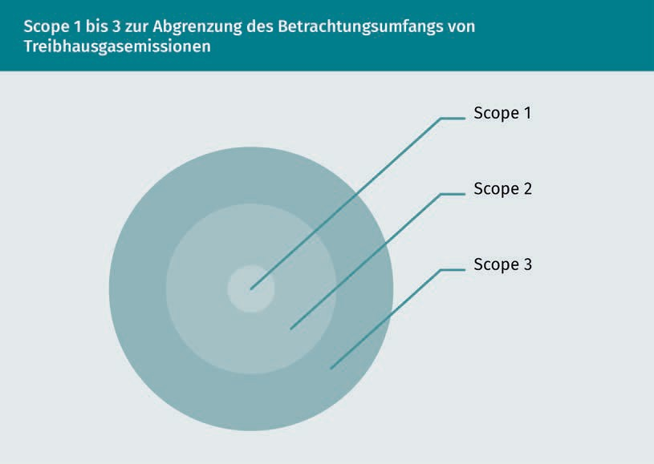

It is only in very few cases that greenhouse gas emissions are actually measured using Scopes 1 to 3. In most cases, these are calculated using emission factors. Such calculations are based on the consumption of materials and substances, e.g., electricity and fuels. The consumption of electricity or fuels is also generally referred to as *activity*. Standardized and flat-rate emission factors have been defined for such activities. These can be found, e.g., in the Greenhouse Gas Protocol Standard of the World Resource Institute or the World Business Council for Sustainable Development (WBCSD) or in the first part of DIN EN ISO 14064. Emission factors are provided in CO2 equivalents and emissions can be determined using simulation models. The Global Emission Model of Integrated Systems (GEMIS) is widely used in Germany.

The DIN EN 16258 standard can be used as a basis for calculating greenhouse gas emissions in freight forwarding and logistics. In this standard, the focus is on transport services. In this context, the following processes are distinguished:

* Tank-to-Wheels (TTW; vehicle processes): recording all direct emissions from vehicle operation. Consumption is referred to as final energy consumption (corresponds to Scope 1).
* Well-to-Tank (WTW; energy processes): recording energy consumption and all indirect emissions of fuel provision from the well to the vehicle tank. Energy consumption also includes losses during the production of energy sources, e.g., in high-voltage lines (corresponds to Scope 2).

Scope 3, comparable to the CCF, is not relevant for DIN EN 16258, as all emissions from contracted carriers and subcontractors must also be considered here as part of the TTW or WTW processes (cf. Deutscher Speditions- und Logistikverband e. V. 2013, p. 20).

The greenhouse gas emissions can be calculated with the aid of these process definitions. For diesel, for example, this results in 2.67 kg CO2 equivalent emissions per liter according to TTW and 3.24 kg CO2 equivalent emissions per liter according to WTW, and for kerosene 3.18 kg CO2 equivalent emissions per kilogram according to TTW and 3.88 kg CO2 equivalent emissions per kilogram according to WTW (cf. Deutscher Speditions- und Logistikverband e. V. 2013, p. 12).

**Summary**

The approaches of system dynamics and technology assessment are ways of systematically representing complex issues and are used, among other things, in policy advising on questions of sustainable development.

The instruments of the state for implementing the environmental dimension of sustainable development are applied in environmental law. The most important areas are resources, waste and hazardous substances, air and energy, soil and water. Environmental regulations contain requirements for the protection and use of ecological sources and sinks, and also include regulations relating to occupational health and safety.

Numerous criteria catalogs are available for the design of corporate sustainability management, which can be divided into normative frameworks, process guidelines, and management systems. Widely used criteria catalogs are the guidelines for social responsibility according to DIN ISO 26000 and environmental management systems according to DIN EN ISO 14001 or the Eco-Management and Audit Scheme. Particularly in management systems, key figures are used to describe the sustainability performance of a company.

Life cycle assessments and carbon footprints are tools that provide more detailed information on the sustainability performance of companies, products, or processes.

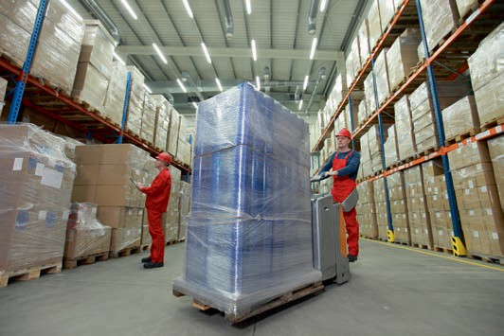

# Unit 5

## Quality of Products, Processes, and Services

##### STUDY GOALS

On completion of this unit, you will be able to ...

... define the term *quality* using the components characteristic, object, and requirement.

... differentiate between compliance requirements and quality requirements.

... describe developments and trends in quality management.

... explain process quality as the core of a service quality.

... understand the gap model for evaluating service qualities.

... recognize the importance of scale of measurements for measurements and measurands in the context of quality management.

DL-D-DLBLONQM01-L05

### Quality of Products, Processes, and Services

#### Introduction

We frequently encounter the term *quality* in everyday language: in advertising, in product labels with seals of approval or quality seals, in connection with a specific technical quality, or in terms such as *quality of life*, *quality of work*, or *quality of leisure*. But how can quality be defined? The difficulty in defining this term lies in the fact that quality is not a fixed, absolute metric. The word quality is derived from the Latin root *qualis* (= what something is; *qualitas* = nature, character) and expresses what something is. In this context, quality is initially non-judgmental and neutral. To approach the term quality, we will address the following questions in this unit:

* How and by what is quality described?
* What is the significance of errors or defects for quality?
* What characterizes quality in services?
* How can quality be measured?

#### Definitions and Terms

Quality is demonstrated by the fact that particular requirements are met: quality is the degree to which a set of inherent characteristics of an object fulfills specific requirements (cf. Deutsches Institut für Normung e. V. 2015a, p. 39). The key terms of this definition are: characteristics, object, and requirements.

Characteristics

Characteristics

A characteristic is a distinguishing property.

**Characteristics** are used to describe a wide variety of properties that are grouped into classes. There are physical (e.g., dimensions of a component in millimeters), behavioral (e.g., politeness of an employee), time-related (e.g., punctuality of a delivery), ergonomic and safety-related (e.g., stability of a pallet rack), and functional characteristics (e.g., maximum payload weight of a transport vehicle in kilograms). Following this, characteristics can describe both quantitative and qualitative properties. A characteristic becomes a quality characteristic if the property is bound or *inherent* in an object itself and relates to a requirement, e.g., to the customer's color request as a requirement. In contrast to this, there are characteristics that are only *assigned* to an object, e.g., the price or the storage location of a product. Assigned characteristics are not quality characteristics. Characteristics that are particularly important from the customer's point of view are referred to as critical to quality characteristics (CTQ).

Quality of Products, Processes, and Services

Objects

**Objects** of a quality description can be, among other things, products, services, and processes. These objects are then assigned a degree to which they fulfill requirements.

Requirements

**Requirements** can be demands or expectations. A distinction is made between the following requirements:

* Mandatory requirements from laws, standards, or other regulations,

e.g., compliance with the Euro VI standard emission limits for newly registered commercial vehicles.

* Fixed requirements from agreements, contracts, or similar documents, e.g., the paint, engine type, and delivery date of delivery vehicles;
* Generally (tacitly) assumed requirements resulting from business practice, e.g., mileage expectations of a 105 kW diesel engine, that are based on empirical values.

Requirements can therefore be explicitly demanded and implicitly expected. In a market economy, requirements for products and services come from private and commercial customers (external customers). Customer requirements are often also referred to as customer expectations. The orientation of the quality of a product or service toward the customer therefore plays a key role. We then speak of an orientation toward customer requirements or of customer orientation. Customer orientation is also applied to internal company processes, e.g., when employees in route planning request support from the IT department for software problems as *internal customers*.

In summary, quality can be described as the conformity between the requirements of an object (target) and its true capacity (actual) (cf. Mockenhaupt 2016, p. 12). Alongside this is the **ability** of a company or its systems and processes to generate this conformity, i.e., to actually deliver the quality.

Processes

The processes within a company in particular are the key building blocks of the product or service provision. Processes are identified by the following characteristics:

Objects

An object is a perceptible entity or an item.

Requirements

These are defined, generally assumed, or mandatory demands or expectations.

Ability

Ability is the capacity of an object to realize a result that meets the requirements.

* + They are triggered by an event (input) and end only when the process result (output) is achieved.
  + In general, they are organized according to the division of labor, i.e., they are broken down into sub-processes that interact with each other.
  + They are designed for repetition.
  + They have defined customers, i.e., each sub-process has internal and external customers (customers in the sense of process orientation are also employees of other sub-processes).
  + Resources are made available for processes.
  + They can be controlled by the process owner.
  + Both the process itself and the process result can be evaluated,

e.g., via audits and key figures or indicators.

* + After the evaluation, necessary changes can be initiated to improve the process results.

In practice, the most frequently used graphic representation form for processes is the flowchart with standardized symbols. Detailed information can be clearly presented with the help of such symbols.

In earlier times, it was quite easy to determine and meet the requirements of customers. For example, a master carpenter discussed the requirements for an oak table for twelve people with a wealthy local gentleman. During the production process, the master carpenter and the journeyman repeatedly checked the fit of the table legs to the tabletop and the stability of the table. Upon delivery, the customer could then verify the suitability of the manufactured oak table (quality). As the economy has become increasingly based on the division of labor, production processes have become much more complex: The activities to produce a product or service are divided among many employees. From then on, the employees only carried out their sub-activity without knowing the other activities or even having an overview of the overall process. In the past, companies were satisfied with checking the requirements for a product at the end of the overall process. If the requirements were not met, these products were labeled *defective* and separated out. This is referred to as downstream quality control. However, producing defective products leads to high costs. Thus, random inspections began to be integrated into the overall process (quality assurance). It became clear that the later a defect was discovered, the more expensive it was to correct it. As a result, the planning of quality came to the forefront, with the goal of avoiding defects. Today, such quality planning is a key component of quality management. In this process, all activities of a company, i.e., not only the production or service provision itself, are oriented toward customer requirements. In addition to planning and implementation, quality management also includes the monitoring and, if necessary, correction of all company processes. Quality targets are an essential instrument in this context, e.g., offering Europe-wide replacement parts logistics for a medical device manufacturer that guarantees delivery within 48 hours. All areas of the company, such as customer service, IT, and technical logistics systems, must be aligned with this quality target.

Quality of Products, Processes, and Services

Quality management focuses on customer orientation in order to determine their requirements for products and services and to make this the starting point for quality planning. The fulfillment of customer requirements is referred to by DIN EN ISO 9000:2015 as conformity, and non-fulfillment corresponds to nonconformity or a defect. The term *compliance* must be distinguished from this, which can be described in more detail as “compliance with rules” and the measures required for this. Legal compliance, for example, refers to the measures taken to comply with statutory or other legal requirements. Another aspect of compliance is measures to comply with a company's internal code of conduct. Although mandatory requirements within the scope of the description of quality can also refer to compliance with legal regulations, alternatively these requirements can also be implicit from the customer's point of view. It therefore presumes the fulfillment of the mandatory requirements. In this understanding, compliance can be regarded more as a “secondary requirement” from the point of view of quality or customer orientation. However, if a customer requirement is explicitly aimed at adherence to a compliance rule, it then becomes a quality characteristic. For example, a company can stipulate in its Code of Conduct that its products must be manufactured at all locations in the world without the use of child labor. If this is violated and a corresponding customer requirement is aimed precisely at the characteristic “without child labor,” this constitutes nonconformity in the sense of quality management. With this understanding, compliance can therefore become a “main requirement” from the point of view of quality or customer orientation.

#### Developments and Trends

With the amendment of the international standards DIN EN ISO 9000f. published in 2015, the risk management of a company moved into a closer relationship with quality management. Risks are described as potential undesirable effects that affect a company. A risk can be described as a function of the following three elements:

Risk = f (Event, Probability of occurrence, Effect)

Events can affect a company from the external context (e.g., currency fluctuations in export business, rising fuel prices, or new customer requirements) or have internal causes (e.g., liability for handling errors or delays, inadequate employee qualifications, or bottlenecks in IT). Such events can cause errors or defects within a company and are therefore directly significant for the quality of its products and services. Quality tools are used to identify potential events and analyze and evaluate their probability of occurrence (e.g., a failure mode and effects analysis, or FMEA in short form). The effects of a risk can be described in monetary terms (e.g., loss of sales due to lost orders) or qualitative terms (e.g., loss of customer confidence in delivery reliability).

Risk management involves determining how risks are to be handled (risk control):

* + - Risk avoidance by, e.g., not accepting high-risk orders with substantial penalties for delivery delays.
    - Reducing risk by lowering the probability of occurrence or effects, e.g., training employees in the handling of hazardous goods or decentralized warehouses to avoid delivery delays.
    - Risk transfer, e.g., via a currency hedging transaction.
    - Risk assumption or acceptance with the formation of corresponding provisions, if necessary.

When choosing risk management measures, the probability of occurrence and the potential effects are weighted against each other. Negative effects of risks are also referred to as potential damages. However, looking only at a company's risks would be a very defensive stance. The counterpart to risk can therefore be seen as opportunity. Opportunities are potential desired or positive effects on the company that have not yet occurred. Like risks, they can be described as a function of possible events and their probability of occurrence. For example, opportunities include shorter delivery times, higher availability of goods, and better qualified employees than a competitor. The management of risks and opportunities can prevent errors and defects and even exceed customer requirements. It is therefore an essential component of quality management.

Defects, Safety, and Liability

Nonconformity This refers to defects or the non-fulfillment of a requirement.

Mandatory requirements for products and services from laws, standards, or other regulations relate, among other things, to safety-relevant characteristics, e.g., protection against electric shocks during the intended use of electrical equipment. If features are not fulfilled, **nonconformity** or defects occur. However, not every defect is safety-relevant:

* Critical defects are nonconformities that can have serious negative consequences for users (e.g., injuries) or for environmental media (e.g., water pollution due to leaking lubricant oils).
* Major defects can have significant consequences and severely affect the usability, e.g., a defective component can cause the total failure of a machine or limit the usability of the machine.
* Minor defects have insignificant consequences that hardly affect the use of an object.

When it comes to safety-relevant characteristics (functional safety; general safety), critical defects can lead to liability of the company for consequential damages. This liability is regulated in the Product Liability Act (ProdHaftG). The statutory liability applies irrespective of any contractual relationship between the manufacturer and the end consumer. § Section 1 (1) ProdHaftG provides: In such a case as a defect in a product causing a person’s death, injury to their body or health (personal injury) or damaging an item of property, the manufacturer of the product has an obligation to

Quality of Products, Processes, and Services

compensate the injured person for the resulting damage. As a result, claims for damages are no longer linked to human error, but rather depend solely on the defectiveness of a product. This now means that a manufacturer must be liable regardless of fault. Here, fault would be, e.g., negligence in the form of carelessness or intent in the form of willful production defects. Strict liability is also referred to as no-fault liability. A distinction must be made between this and the remedy of a material defect in the product under civil law (cf. § 434 BGB), i.e., contractual liability arising from a purchase contract. In addition, there is also the general liability for damages according to § 823 BGB, which states that anyone who, intentionally or negligently, unlawfully injures the life, body, health, freedom, property, or another right of another person is liable to make compensation to the other party for the damage arising from this. A defect in the sense of the ProdHaftG is when a product does not offer the safety that can usually be expected. It is therefore a question of what the general public can expect from a safe product. Product defects can take many forms or have many causes:

* + Inadequate operational organization, e.g., the lack of quality controls.
  + Design defects, e.g., the specified fire resistance of a door is not achieved due to the choice of an unsuitable material.
  + Manufacturing defect, e.g., an incorrectly mounted wheel hub.
  + Instruction errors, e.g., the lack of warning about the flammability of a cleaning agent.

In addition, the manufacturer is obligated to monitor the product. This can lead to a product being recalled, typically via advertisements in daily newspapers or on the radio, if a defect is discovered during commercial exploitation.

Defectsand Six Sigma

Six Sigma has developed from a quality measurement technique up to a work philosophy and through to a quality management approach (cf. Zollondz 2011, p. 395f.). In the Six Sigma technique, the **dispersion** of characteristic values (measured as standard deviation *s*) in products and services around a target value is regarded as the primary cause of errors or defects, e.g., the dispersion of the actual delivery time around the delivery time specified to a customer. For example, it is assumed that customers only accept an actual delivery time of +/- one hour (= upper or lower specification limit; tolerance) from the specified delivery time. When outside the tolerance, an error or defect exists. In order to avoid defects, the dispersion of quality-relevant characteristic values must be measured and reduced. For a manufacturing process to be acceptable or *process capable* in the Six Sigma sense, the difference between the upper or lower specification limit and the target value must be at least + 6 σ or *- 6 σ.* When a delivery process achieves this capability level, 99.999997% of all actual deliveries are within tolerance, i.e., the characteristic values of a process vary little around the target value. The Six Sigma technique therefore aims to achieve a zero defect rate for a process.

Dispersion

This is the statistical measure for describing frequency distributions around a central tendency.

As a working philosophy, however, Six Sigma goes even further and transfers the zero-defect approach to all business processes from the supplier to the customer. The aim is to reduce the number of repairs and customer complaints. As a strategic quality management approach, Six Sigma aims to achieve quality at the highest level for the entire value chain. Six Sigma can be described by three core elements (cf. Zollondz 2011 p. 399ff.): management according to the DMAIC cycle, management concept in stages, and implementation phases.

The DMAIC cycle describes an improvement cycle through the following phases:

* Define: This is where projects that target improvements in meeting customer requirements are defined.
* Measure: By continually measuring the processes, their capabilities are monitored.
* Analyze: In the event of deviations from the defined targets, the causes are determined.
* Improve: After analyzing the causes, measures are introduced to improve the processes.
* Check: This is where the effect of the measures is reviewed.

As a management concept, Six Sigma is understood as a team task within the company—from the company management to the project team members. All members of Six Sigma teams are assigned specific functions, which are described by ranks borrowed from Japanese martial arts. For example, managers are referred to as champions, who define projects, and black belt employees take on leadership tasks in the operational implementation of projects, e.g., statistical analysis to determine process capabilities.

Six Sigma is implemented within a company in different stages so that a Six Sigma culture that promotes the use of this technique throughout the company is gradually established. However, it is not the achievement of a zero defect rate that is seen as decisive for the successful use of Six Sigma, but rather the systematic examination of customer requirements and the corresponding sensitization of employees (cf. Zollondz 2011, p. 403).

#### Quality of Service Features

Service Quality as Process Quality

Compared to products, services have an entire range of features (cf. Bruhn 2016, p. 20ff.):

Quality of Products, Processes, and Services

* Services are largely intangible. However, many services generally require the provision of material resources. For example, logistics services, such as transport processes or order picking processes, depend on technical equipment such as vehicles or IT hardware.
* Services are characterized by their intangibility: the potential quality of services is often only perceivable to the customer to a limited extent before, during, and after consumption. The logistical efforts required for the punctual overnight delivery of a package to the correct recipient are usually only apparent to the customer to a limited extent.
* Services are indivisible, i.e., production and consumption occur simultaneously (*uno actu* principle), e.g., the transport process of replacement parts by express freight in an airplane.
* It follows that services cannot be stored. For example, unoccupied container slots on an ocean-going container ship cannot be shifted to periods of high demand.
* Services are often created in direct contact between the service provider and the customer. Customers are described as an external factor of a service, without which a service would not even be possible in some cases, e.g., in the case of passenger transportation by rail. Employees are in direct contact with the customer.
* The *uno actu* principle means that services are individual and variable. They are created anew for each customer and can therefore always vary in quality.

Based on these specifics, services can be described in four different ways (cf. Bruhn 2016, p. 22): A very general description is the characterization of services as activity-oriented, i.e., they are provided by people. However, this also applies to products. A potential-oriented view of services focuses on the ability of a company to provide specific services. The *uno actu* principle focuses on services as a process-oriented activity. In contrast, a result-oriented understanding of services focuses only on the result of an activity.

However, a service is only fully described by considering the potential, process, and result. In this way, the elementary relationship is made clear: The service provider’s ability to provide a service (potential) meets the integration of the customer as a process-triggering and process-accompanying factor (process) and leads to a service outcome (result).

This description of services ties in directly with the concept of quality, since a potential is related to the ability of a company and its processes to deliver results that meet customer requirements.

Service Level Agreements

The ability of processes to produce the required results is of great importance in logistics services, particularly when a supplier-customer relationship is designed for repetition and thus for the long term. The quality of logistics services

Service level agreements

These are agreements on the determination of recurring

services.

can be described using service levels, e.g., the provision of capacities, lead times, delivery times, and availability of replacement parts. A quality agreement on service levels between a customer and a supplier is known as a **service level agreement** (SLA) (cf. Minner 2007, p. 13). A company should only enter into such SLAs if its own processes are capable of meeting the defined service levels. In the automotive industry, potential suppliers often even have to prove their own process capability before signing a contract. In an SLA, key figures or tolerance ranges of a service level are defined and possibly linked to penalties. For example, maximum permissible incorrectly picked (wrong or defective component) deliveries and maximum delivery times are defined. Penalties are often due if these tolerance ranges are exceeded

Gap Model

The gap model can be used to assess the quality of service processes. To this end, the gap model draws on the service quality model of Parasuraman, Zeithaml, and Berry (cf. Zollondz 2011, p. 214f.). This service quality model focuses on the customer's perception of a service. For a customer, service quality results from the comparison of the expected and the perceived service. Alongside this, a service is described in the following five dimensions: pleasantness of the environment, reliability, responsiveness, performance competence, and empathy.

The gap model identifies discrepancies or gaps that occur when the customer's expectations and actual perceptions are compared with the service provider's performance. If the customer's expectations or requirements are not met, this can be referred to as a nonconformity or defect.

Quality of Products, Processes, and Services

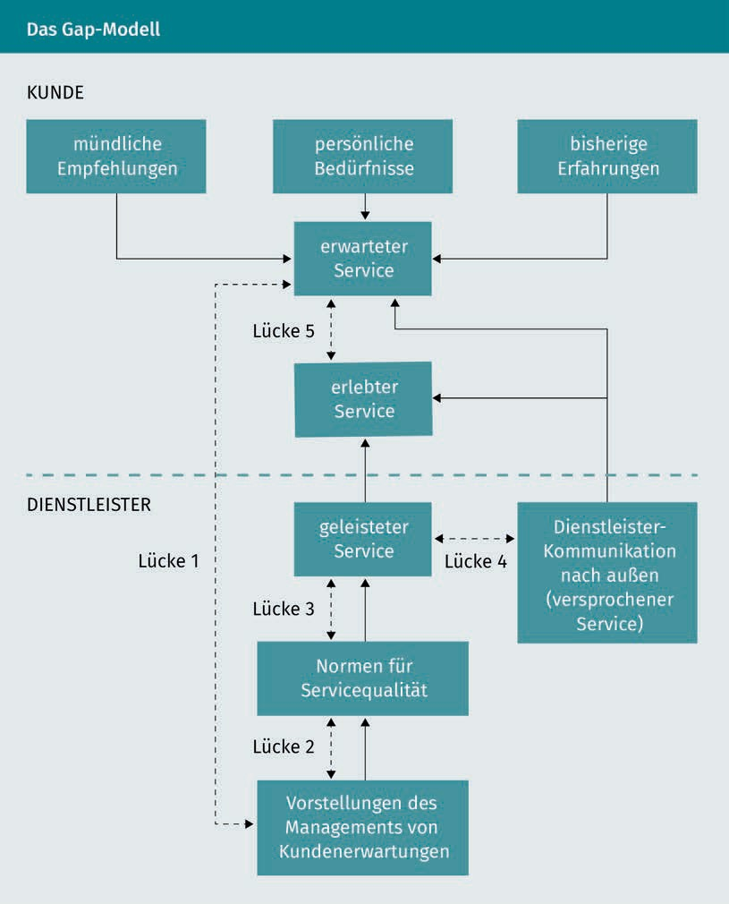

The figure depicts the influencing factors on the customer’s expected or perceived service and the service provider's factors influencing the service provision in solid lines. The gaps are highlighted by dashed lines. For example, Gap 1 reveals a discrepancy between the customer's actual service expectations and the service provider's perceptions of the customer's expectations, which were not or not correctly determined by customer surveys (perception gap). Gap 2 describes a planning discrepancy, i.e., the service provider has inadequately implemented or standardized the perceived customer expectations in its services (development gap). Gap 3 describes a discrepancy between the planned (normalized) service and the actual

service provided: before, during, and after customer contact (execution or performance gap). Gaps between the external communication of the service provider (e.g., via advertising or PR) regarding its services and the actual service provision represent Gap 4 (communication gap). Gaps 1 to 4 interact and manifest themselves in the key gap, Gap 5, which is the gap between the expected and the experienced service. Closing Gap 5 is the primary task for service quality management. The precise analyses and closing of Gaps 1 to 4 are necessary prerequisites for this.

#### Metrics and Key Figures Systems

Measurements

Measurements play a key role in quality management for determining customer requirements, process capability, and product and service outcomes. Thus, quality assessment examines whether the results meet the requirements. Metrology makes a distinction between the following key terms:

* + - Measurement is a process that determines a quantity value, e.g., a measurement of fuel consumption in vehicles.
    - The object of measurement is the subject of the measurement, e.g., a delivery vehicle of the XY brand.
    - The measurand is the property of the measured object that is of interest in the measurement, e.g., diesel consumption per 100 kilometers of mileage.
    - Quantity value is the value that a measurand assumes (other terms are measured value or measurement result). The quantity value consists of the measurement number and the unit, e.g., 14.7 liters per 100 kilometers.

Which measurements can be made at all in the context of a quality assessment is determined, among other things, by the scale of measurement of the measurand.

Scale of Measurement

The scale of measurement of a measurand describes which statements can actually be derived from a measurement. For example, if we measure the punctuality of a delivery, it can be punctual or unpunctual. This is a qualitative statement and we can only determine the frequency of punctual or unpunctual deliveries. The punctuality/unpunctuality measurand is on a nominal scale. In contrast, the measurement of delivery time can be specified in a much more differentiated way, e.g., in hours. Comparisons can also be made: A delivery time of two hours is twice as long as a delivery time of one hour. This is not possible with punctuality at a nominal scale of measurement. The delivery time is on a higher scale of measurement, the ratio scale of measurement**.** The following four scales or types of measurements are distinguished:

Quality of Products, Processes, and Services

|  |  |  |  |  |
| --- | --- | --- | --- | --- |
| **Scale of Measurement and Measurement Options** | | | | |
| **Scale of measurement** | **Possible measurements** | **Measurable characteristics** | **Statement** | **Example of key figures in the broader sense** |
| **Nominal scale** | Frequencies | Qualitative | Assessment | Punctuality in yes/no |
| **Ordinal scale** | Frequencies, ordered rankings | Qualitative | Assessment | Rating of importance with high, medium, low |
| **Interval scale** | Frequencies, ordered rankings, differences | Quantitative | Measurement, counting | Warehouse temperature in degrees Celsius or Fahrenheit |
| **Ratio scale** | Frequencies, ordered rankings, differences (with natural zero point) | Quantitative | Measurement, counting | Delivery time, accidents per year (with zero as minimum quantity value in each case) |

The measurement of quantitative characteristics at the interval or ratio level is generally uncritical and practicable. The limits of measurability are more apparent in the measurement of qualitative characteristics at nominal or ordinal scale of measurement (cf. Binswanger 2010, p. 67ff.). Here, usually only indicators for a measurand are presented and whether a causality between the measurand and the phenomenon behind it really exists must always be questioned. Furthermore, the measurands must be precisely defined. For example, Deutsche Bahn AG's definition of punctuality (arrival punctuality = maximum 5:59 minutes past the scheduled arrival time) is of little help to a passenger with a transfer time of 5 minutes if they miss their connecting train with a *punctuality* of + 5:30 minutes. The limitations of measurements are also shown by the fact that measurements in a system change the system itself (which is known as measurability illusion).

Key Figure Systems

Balanced scorecard The balanced score card is a control instrument for linking strategy development and implementation by means of

key figures.

Within the framework of quality management, key figures can also be built up into key figure systems that are related to it as so-called context concepts (cf. Zollondz 2011, p. 430), e.g., the **balanced scorecard** (BSC). A BSC is a control instrument to operationalize strategic (quality) goals. A BSC takes the following perspectives of a company into account:

* The financial perspective focuses on the costs and revenues and thus the profit or profitability of a company.
* The customer perspective describes, among other things, a company’s target groups with their views of the company and its products.
* The process perspective involves designing internal processes to meet customer requirements and differentiate a company from competitors.
* The learning and development perspective describes the resources that a company needs in order to survive in the future, e.g., qualified and motivated employees.

For all four perspectives of the BSC, the key figures that are of particular importance as KPIs for a company are now defined and are to be controlled in a targeted manner. In the context of quality management, these can be the following KPIs (cf. Brunner & Wagner 2016, p. 66):

* Financial: audit costs, committee costs.
* Customers: complaint rate, customer satisfaction (determined via SERVQUAL).
* Processes: Lead times, average inventory levels.
* Learning and development: suggestions for improvement per employee and year, innovations per year.

SERVQUAL (a word combination of service and quality) is a standardized, cross-industry measurement instrument for determining the quality of services. SERVQUAL is based on Gap 5 in the Gap Model. Gap 5 is used as an indicator for service quality (cf. Brunner & Wagner 2016, p. 273):

Service quality = Perception – Expectation

The Gap 5 indicator is operationalized by the five quality dimensions. For example, customer surveys are conducted as a method of measurement for a particular service. The focus is on the pleasantness of the environment, reliability, responsiveness, performance competence, and empathy. Customers can, for example, rate the reliability of a supplier on an ordinal scale of 1 to 5 (high to low) that is separated according to the expectation of the respective quality dimension and its degree of fulfillment.

Quality of Products, Processes, and Services

Summary

Quality is defined as the degree to which a set of inherent characteristics of an object fulfills specific requirements. The characteristics can be of a physical, behavioral, time-related, safety-related, or functional nature. Quality objects are primarily products, services, and processes. The requirements originate particularly from customers and are contractually defined (explicit) or implicitly assumed. In addition, there are mandatory requirements from laws, standards, or other regulations. The ability of a company and its systems and processes defines the way in which quality is produced. The view of quality has evolved from quality control as a downstream process, via process-integrated quality assurance, to systematic quality planning within the framework of quality management.

The consideration of shifting risks and opportunities external to the company has become an important part of quality management, since it is assumed that the corporate context is highly dynamic. The avoidance of errors or defects reduces costs, increases safety in the case of critical errors, and reduces liability risks. Six Sigma has established itself as an approach to establish a zero defect strategy.

Due to specifics such as immateriality and the *uno actu* principle, the quality of services is primarily characterized by process quality. In logistics, process results are the subject of service level agreements.

The gap model based on the service quality model of Parasuraman, Zeithaml, and Berry represents a tool to evaluate the quality of services.

Measurements are used in quality management to determine customer requirements, process capabilities, and results. The meaningfulness of measurement results is primarily determined by the scale of measurement. Measurement results can be used to define key figures and to build up key figure systems. The balanced scorecard and SERVQUAL are context concepts that use measurement results in the framework of quality management.

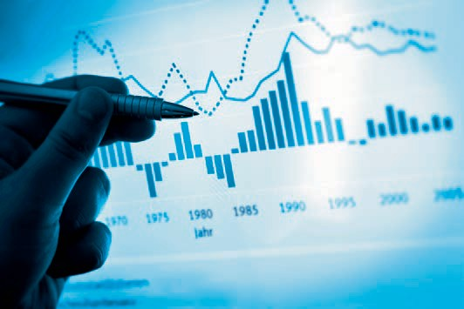

# Unit 6

## Procedures, Methods, and Quality Tools

##### STUDY GOALS

On completion of this unit, you will be able to ...

... characterize the concept of continuous improvement.

... understand the structure and process of a failure mode and effects analysis.

... distinguish the seven common quality tools according to their purpose.

... differentiate audits according to the audit participants and audit objects.

... classify certifications as third-party audits.

DL-D-DLBLONQM01-L06

### Procedures, Methods, and Quality Tools

#### Introduction

A famous quote by Samuel Beckett is: “Ever tried. Ever failed. No matter. Try again. Fail again. Fail better” (cited in Zollondz 2011, p. 286). This quote can be related to key aspects of the topic of quality, even if the reference to failure seems a bit exaggerated. Nevertheless, it points out an important aspect of the work: handling (small and large) errors and defects and continuous improvement in daily work. To this end, numerous methods and tools have been developed in the past to identify and avoid potential errors or defects during the development of new products and services. Because practice shows: Preventive error or defect avoidance is generally more cost-effective than subsequent error or defect correction. In addition, a number of methods and tools have been developed that make it possible to record, display, and analyze errors or defects that have occurred and learn from them, i.e., to improve. The most common procedures, methods, and tools used in practical quality work are presented in this unit.

#### Continuous Improvement

The Kaizen Concept

The word kaizen consists of the word parts Kai (= change) and Zen (= good). Kaizen can thus be understood as “changing the good with something better.” The term originates from Japan and kaizen is omnipresent in Japanese society. The continuous change for the better refers to the private and professional environment of many Japanese (cf. Zollondz 2011, p. 287). Kaizen starts from the basic assumption that something achieved is not satisfactory. That is, kaizen does not know a state of self-satisfaction. It involves small steps rather than disruptive approaches as in business process reengineering. Kaizen is a long-term process that is designed to bring about changes in behavior and thinking among all those involved—in companies and particularly among employees. Furthermore, kaizen describes a process of continuous improvement, e.g., of products, processes, and movements. Kaizen is generally equated with the continuous improvement process (CIP).

In the corporate context, kaizen pursues the goal of continuously increasing customer satisfaction (cf. Brunner & Wagner 2016, p. 300). The results of high customer satisfaction are customer loyalty and retention. To achieve this goal, the focus of improvement efforts is on improving quality, reducing costs, and increasing speed. Kaizen is based on four principles (cf. Zollondz 2011, p. 297f., who speaks of axioms, i.e., unprovable truths):

Procedures, Methods, and Quality Tools

* Problem and solution orientation at all levels of a company.
* Customer orientation externally and within the company.
* Process orientation to transform requirements into results.
* Employee orientation, those who are the engine of all activity.

Improvement in Quality Management

In quality management, according to DIN EN ISO 9000, an improvement is understood as an activity that increases performance. In this context, performances are measurable quantitative and qualitative results. Such results can relate to the following areas in a company:

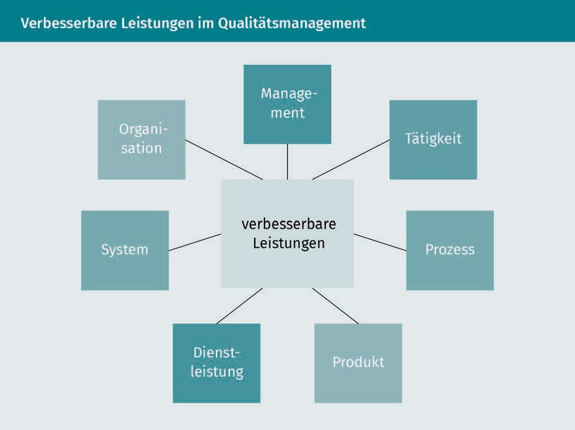

The services that can be improved are very broadly defined and yet, it is not only services that can be improved (e.g., increasing delivery punctuality), but also management (e.g., more comprehensible quality objectives) or organization (e.g., more clearly defined responsibilities). In quality management, performance is a means to an end and thus the CIP concept is related to quality improvement, i.e., to all improvements within a company that are aimed at increasing the ability to meet quality requirements. While these quality requirements also refer to legal standards and regulations, compliance tends to be somewhat in the background of CIP.

The PDCA Cycle

The management control cycle (Deming cycle) of Plan, Do, Check, and Act (PDCA) formulated by the American physicist and statistician William Edwards Deming is regarded as the standard for the thought and action pattern of all improvements (cf. Zollondz 2011, p. 297).

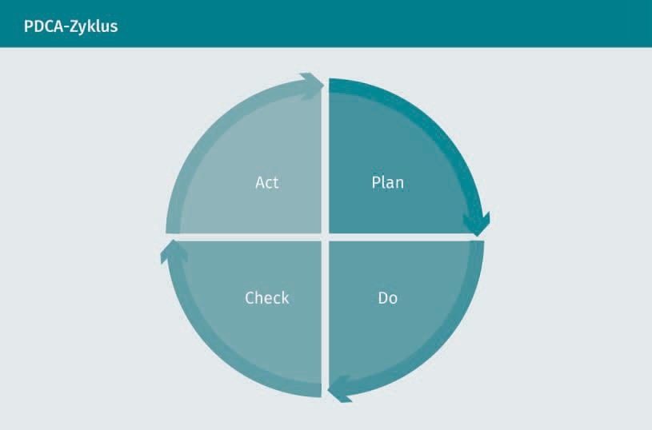

According to this representation, every activity can be understood as a process and thus also be improved. Accordingly, each activity is analytically divided into the four phases:

* + Improving a result requires a plan (Plan) to determine what changes are needed and should be implemented.
  + These changes are implemented in the second phase (Do).
  + Subsequently, there is a review of whether the results have improved (Check).
  + If the results have not developed as desired, further changes are necessary and are incorporated back into the planning (Act).

This cycle can also be applied to private activities, which the following scenario illustrates: If you resolve to improve your grade in the subject of quality management from 2 to 3 (Plan), you can plan a wide variety of changes (e.g., study additional textbooks or analyze best practice cases from quality management practice). Then you actually carry out your good intentions (Do) and prove your skills in an exam (Check). You improved your grade to 2.7, but you are not yet satisfied. You study the errors in the exam closely and realize that further efforts are necessary (Act). For example, you

Procedures, Methods, and Quality Tools

resolve to establish a learning community to discuss and dig deeper into the quality management content. This action is the starting point of your new planning.

Significance of Improvements

But where does the goal of kaizen come from? Is what has been achieved not good enough or is standing still a step backwards? Continuous improvement is of great significance for a company when it comes to changes inside and outside the company. These can be risks as well as opportunities that a company must adapt to, e.g., high employee turnover with loss of know-how or new competitors on the market. A continuous improvement process can enable a company to act proactively rather than reacting passively. Continuous improvement can also promote internal learning processes and innovation. For example, Japanese and Koreans invest around 75 minutes per week in improvement activities (cf. Brunner & Wagner 2016, p. 299; no time is mentioned here for Germany, but consider for yourself how much time you personally spend on improvements in the workplace). At the same time, the number of operational improvement proposals and their realizations in Japan is significantly higher than comparable values in Germany or the USA. A continuous improvement process also offers the opportunity to actively involve employees in the development of a company using quality tools. This requires appropriate training and continuing education for employees, which facilitates their acquisition of skills for designing quality management.

Quality Management Maturity Models

However, effective quality management in a company does not occur automatically or is not perfectly developed immediately. The handling of errors or defects and continuous improvements develops or *matures*. In this context, it is also possible to refer to the maturity of a quality management system (quality management maturity). An initial description of such maturity levels of quality management was made by Philip B. Crosby (cf. Crosby 1979). He first described the following quality management fields of action:

* Management's understanding and attitude toward quality.
* Organizational anchoring of quality management within a company.
* Handling problems.
* Quality costs as a percentage of revenue.
* Measures to improve quality.

These five fields of action are qualitatively evaluated on the basis of descriptions in five gradations, resulting in a matrix or a maturity grid of quality management (Quality Management Maturity Grid; QMMG). The five gradations can be paraphrased as a striking representation of a company's attitude toward quality problems (Crosby 1979, p. 32f.):

Stage 1: Uncertainty–“We don't know why we have quality problems.”

Stage 2: Awakening–“It is inevitable that we have quality problems.”

Stage 3: Enlightenment–“We identify and solve problems through quality improvement and management commitment.”

Stage 4: Wisdom–“Defect prevention is a routine part of our activities.”

Stage 5: Certainty–“We know why we don't have quality problems.”

The way problems are handled within a company can be used to illustrate the gradation: At Stage 1, problems (e.g., in the form of defects) are only addressed as soon as they occur. In contrast, problems are prevented (apart from exceptional occurrences) at Stage 5. Current maturity grids or maturity models are based on Crosby's basic approach and are intended to assist managers in the further development of companies, quality management, and processes. A significant example of a maturity model is the Capability Maturity Model Integration (CMMI), which is used to identify potential for improvement in product development (cf. Geers, Landgraf, & Jochem 2010, p. 116 and p. 126).

#### Failure Mode and Effects Analysis (FMEA)

Failure mode and effects analysis (FMEA) is a method of risk analysis and evaluation used in quality planning. An FMEA is carried out during the development of a new product and its subsequent manufacture or assembly to anticipate possible failures in all processes. An FMEA thus places its focus on prevention (cf. Brunner & Wagner 2016, p. 152.). Particularly in the case of services, failure prevention takes on a special role because, in contrast to products, failures in services cannot be “repaired” due to the *uno actu* principle. A service FMEA is concerned with possible weak points in the process of service provision.

Types

There are three types of FMEA:

* + - System FMEA examines the functionality of a planned overall system in the interaction of its subsystems and interfaces, e.g., the system of a distribution logistics company with the subsystems of outbound warehouse, picking, packaging/shipping preparation, transport, and handover.
    - Subsystem FMEA considers individual planned subsystems with regard to potential failures during production and assembly, or during realization , e.g., only the transport.
    - Process FMEA identifies sources of failure in individual planned processes within the subsystems, e.g., in the loading process, the conveyance, and the unloading process during transportation.

Procedures, Methods, and Quality Tools

Requirements

The success of FMEA is primarily determined by the experience and knowledge of those involved. Accordingly, the composition of a FMEA team plays a decisive role. It is therefore important to ensure that employees from all affected areas are represented in the FMEA team (e.g., logistics managers, warehouse forepersons, and employees in the outgoing goods department). A moderator should be familiar with the FMEA method and be able to control the work processes within the team.

Process

An FMEA is standardized according to DIN EN 60812 and goes through the following steps: describing possible failures, assessing potential risks of the failures, finding adequate solutions, and recording results.

In order to describe possible failures, all potential process failures are first recorded in a detailed failure analysis. The failure consequences and possible causes for all failures are then explored. The general rule of thumb is: “one possible failure–two failure consequences–four failure causes” (Brunner & Wagner 2016, p. 155). A structuring aid for failures, failure consequences, and causes is provided by fault trees or cause-effect diagrams. Possible measures are identified for each failure and its causes in order to avoid the failure.

In a second step, potential risks of the failure are assessed. The assessment refers to the following aspects:

* The probability of occurrence of the failure (Factor A) is graded on an ordinal scale based on the expected frequency from “unlikely” to “high.” An expected frequency of zero is equated with Factor A = 1. What is rated as high frequency heavily depends on the type of failure and how critical it is. In the case of a non-critical failure, a high frequency may only be assumed for one failure in ten cases, while for a critical failure, a probability of one failure in 10,000 or even more cases may already be considered high. For high frequencies, Factor A is set equal to 9 or 10.
* The significance of the failure effects from the customer's point of view (Factor B) is indicated on an ordinal scale: from no significance (Factor B = 1) to insignificant (Factor B = 2 or 3) to safety-relevant significance (Factor B = 9 to 10).
* The probability of detecting the failure before delivery or customer contact (Factor E) is weighted higher the more concealed and difficult to detect the failure is. A high probability of detection is evaluated on an ordinal scale, for example, with Factor E = 1 and a low probability of detection is evaluated with Factor E = 10.

A risk priority number (RPN) is calculated from the combined consideration of these three aspects:

Risk priority number = A · B · E

Example Calculation of a Risk Priority Number

In picking, a possible error in the size of a garment is identified, e.g., quantity 1 of a t-shirt is picked in size M instead of the ordered size L. This error could be evaluated by the FMEA team as follows:

* Probability of occurrence: moderate → Factor A = 7
* Significance of error effects: high → Factor B = 8
* Probability of detection: low → Factor E = 6

This results in:

Risk priority number = 7 · 8 · 6 = 336

Risk priority numbers can assume the values 1 (1 · 1 · 1) to 1,000 *(10* · *10* · *10)* Depending on the RPN of a potential failure, adequate solutions must be found and measures prioritized. No monetary valuation is used for the RPN (e.g., failure valuation in €). It is assumed that failures with a high RPN can also cause high costs. The results are then recorded and documented. After the introduction of a product or implementation of a service process, the FMEA should be repeated according to the listed scheme. The goal is to reduce the RPN of failures with high values.

However, the FMEA has some obvious shortcomings. For example, the multiplication of ordinally scaled values from Factors A, B and E is not mathematically defined. Furthermore, the similarity of risks is only mathematically expressed by the RPN. However, this does not necessarily mean a similarity of the risks, which receive the same priority with the same RPN. Furthermore, the RPN does not make statements regarding the acceptance of a risk in the context of risk management.

#### 7Q–The Seven Quality Tools

Numerous quality tools have been developed and established for measuring the performance of a company, which can relate to quantitative and qualitative results. Quality tools are used to record *characteristics* that can make different statements depending on the scale of measurement of the measurand. The focus is often on **testing**, i.e., conformity with requirements is to be determined. Conformity can be discrete (conforming, i.e., in order, or nonconforming, i.e., defective) or continuous

Procedures, Methods, and Quality Tools

(degree of conformity). In testing, the focus is therefore on faults. The common seven quality tools can thus be differentiated according to their use: in fault recording or representation and in subsequent fault analysis to generate indications and eliminate the causes of faults. However, the distinction between fault recording, representation, and analysis is not always entirely clear.

Fault Recording and Representation

Fault Collection Chart

The fault summary list is the simplest type of fault recording. The prerequisite is that exactly what constitutes a fault is defined. Fault types are also defined. Several fault types can be arranged in fault categories. A fault collection chart is then used to record how often a fault occurs in a certain period of time (fault frequency). Fault collection charts can be created for several time periods. Even at this early stage, first analyses are possible, e.g., which type of fault occurs most frequently and how the frequency of a fault develops between the different periods (which can be referred to as a sample here). To calculate a percentage (relative) of faults, the absolute frequency of performance must also be known, e.g., the share of picking errors in the number of picks performed. Fault collection charts record faults on a discrete, nominal scale of measurement and are suitable for qualitative characteristics.

Histogram

Histograms can be used to represent characteristics and their frequencies. In general, however, the measurands must at least be available at an ordinal scale of measurement (at a nominal scale of measurement, a histogram would be limited to the comparison of characteristic values, which could nevertheless be carried out in any order).

Testing

A test is the determination of conformity with specified requirements.

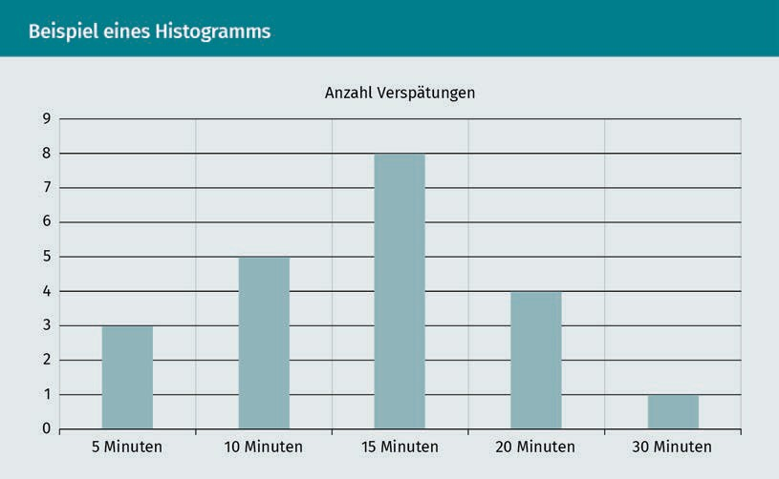

This representation shows a classified frequency distribution in which the recorded delays have each been combined into a class (e.g., delays from 0 to 5 minutes are assigned to the 5 minutes class). Frequency distributions can also be represented in an unclassified display of all measurands, e.g., 1, 2, 3 picking errors, etc.

Process Control Chart

Process control charts are used for quantitative characteristics. They are not only used for fault detection, but also have a regulating effect by introducing specific control limits during measurement. A defined action must be taken if a control limit is reached. Control charts can therefore be used for the targeted control of processes. In the case of control limits, warning and intervention values are defined within the tolerance (described by an upper and lower limit value). In the figure below, this is illustrated by a fictitious delivery time window, which is set at a tolerance range of +/- 20 minutes by an SLA.

Procedures, Methods, and Quality Tools

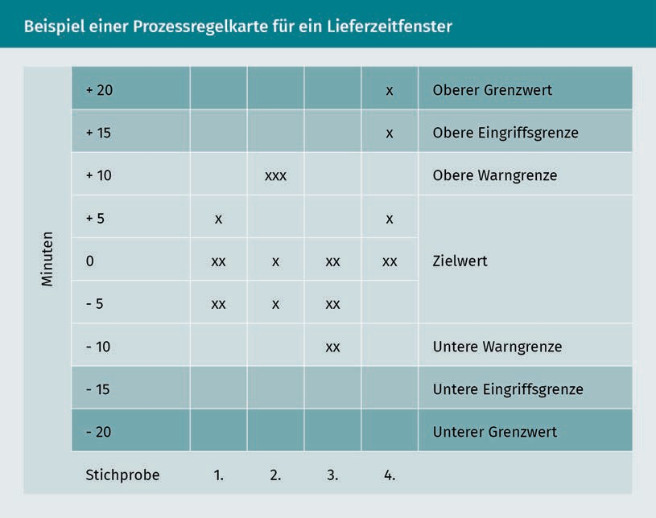

In Sample 1, no measures are necessary because no warning limits have yet been reached. In Sample 2, the upper warning limit has been reached in three cases and the causes of the overrun should be reviewed. When the upper intervention limit or the upper limit value is reached, measures are necessary. Fault collection charts can also be understood as process control charts—but for qualitative characteristics.

Fault Analysis

Pareto Analysis

The Pareto analysis (or ABC analysis) is based on a completed fault recording and is a procedure for fault analysis and evaluation. At the same time, it offers a graphic representation of this fault analysis and evaluation. It is based on the Pareto rule, according to which 20% of the faults cause 80% of the costs, whereby the fault removal should therefore concentrate on this 20% of the faults. After the scope of the analysis (e.g., the process and the time period) has been determined, the Pareto analysis goes through five steps:

Step 1: Conduct fault recording, e.g., by means of fault collection charts.

Step 2: Evaluation of the types of faults with their costs.

Step 3: Sort by cost.

Step 4: Create a bar chart by cost;

Step 5: Display as a Pareto progress chart with classification A, B, or C.

Errors in a picking process are considered in the example below. For this consideration, the following fault types, their frequencies, and the resulting costs were recorded:

|  |  |  |  |  |  |
| --- | --- | --- | --- | --- | --- |
| **Pareto Analysis Output Data** | | | | | |
| Fault type | Frequency | Relative share | Cost per fault | Fault costs | Relative share |
| Incorrect items | 54 | 17 % | 53 € | 2,862 € | 24 % |
| Too few items | 42 | 14 % | 42 € | 1,764 € | 15 % |
| Too many items | 95 | 31 % | 12 € | 1,140 € | 10 % |
| Forgotten items | 24 | 8 % | 30 € | 720 € | 6 % |
| Defective items | 83 | 27 % | 60 € | 4,980 € | 42 % |
| Incorrectly labelled items | 13 | 4 % | 34 € | 442 € | 4 % |
| Total | 311 | 100 % |  | 11,908 € | 100 % |

It is clear here that the faults that occur most frequently (too many items with 31%) do not cause the highest costs (only 10%). If the fault types are then sorted according to their relative share of the total fault costs and the relative shares are cumulated, we arrive at the table below:

Procedures, Methods, and Quality Tools

|  |  |  |  |
| --- | --- | --- | --- |
| **Pareto Analysis Prepared Data** | | | |
| Fault type | Fault costs | Relative share | Cumulative share |
| Defective items | 4,980 € | 42 % | 42 % |
| Incorrect items | 2,862 € | 24 % | 66 % |
| Too few items | 1,764 € | 15 % | 81 % |
| Too many items | 1,140 € | 10 % | 90 % |
| Forgotten items | 720 € | 6 % | 96 % |
| Incorrectly labeled items | 442 € | 4 % | 100 % |

This can now be visualized as a bar chart and in the form of a Pareto progress chart:

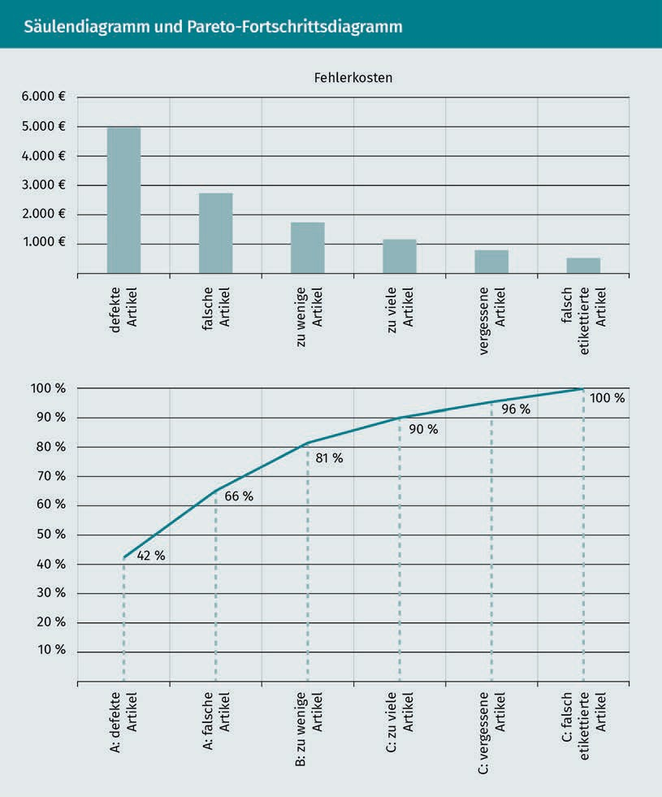

In the Pareto progress chart above, the fault types are now classified according to their cumulative share:

* + A faults are faults that cause up to approx. 70% of the cumulative costs.
  + B faults are faults that account for approx. 70% to 85% of cumulative costs.
  + C faults are faults that cause approx. 85% to 100% of the cumulative costs.

The percentage class limits are sometimes specified differently, e.g., A faults up to 75%. However, the decisive factor is the evaluation of the faults with their costs. The processing of A faults should have the highest priority to reduce the error costs.

Procedures, Methods, and Quality Tools

The Pareto analysis makes no statement regarding the evaluation of the faults by the customers or regarding the safety relevance of the faults for employees and customers. The Pareto analysis primarily evaluates qualitative characteristics.

Fault Tree Analysis Diagram

A fault tree analysis diagram places a clearly defined fault at the beginning of a qualitative analysis. Usually as a team, an attempt is then made to get to the bottom of a fault and its causes. In the course of this, the potential causes are described as precisely as possible and further sub-causes for these causes are searched for. This is done in a discursive process. The causes are brought into a causal relationship, as the figure below illustrates:

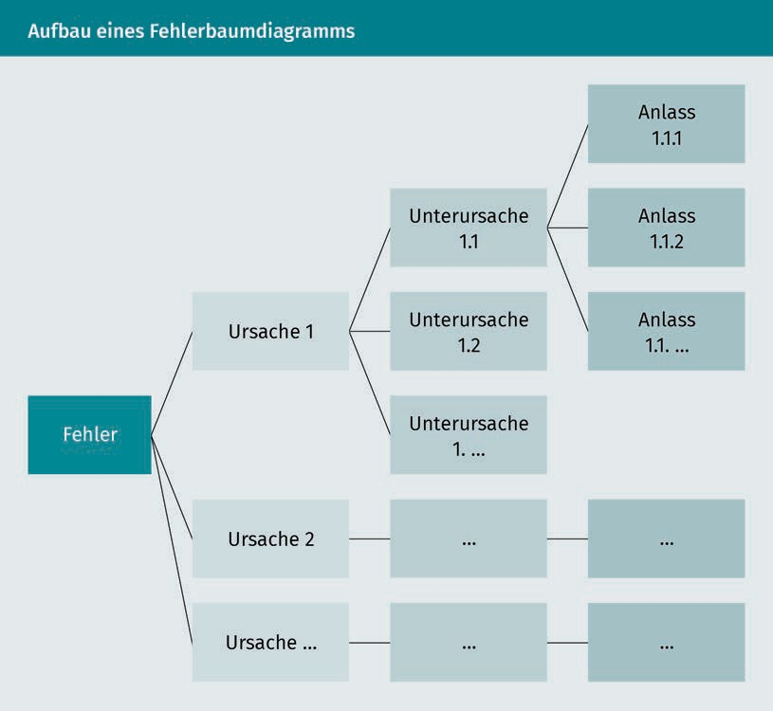

Root causes are causes that are at the end of a chain of causes and are not further differentiated. Root causes are starting points for systematically eliminating the causes of faults through targeted measures. The fault tree analysis does not initially provide for a ranking, since the causes are not evaluated. However, prioritization could be based on the costs of the measures, so that the measures with the lowest costs are

implemented first. The fault tree analysis can be understood as *open brainstorming*, since no categories of causes or similar are specified.

Correlation and Scatter Diagrams

In correlation and scatter diagrams, the dependency of characteristics is shown. This is usually done in pairs to keep the complexity of the representation low. This method of representation can clarify:

* + whether there is a dependency between the selected characteristics,
  + how strongly the characteristics are dependent on each other,
  + whether a dependency is positive (increasing) or negative (decreasing), and
  + whether a dependency is linear or follows another function.

Correlation diagrams can provide food for thought when determining the cause of faults. They also help to illustrate relationships between characteristics and their development. Correlations must be taken into account if, e.g., individual causes of faults are eliminated as part of a fault tree analysis, but this in turn can have a negative effect on other fault causes. For example, the storage conditions for sensitive, technical equipment can be improved by lowering the humidity. As a result, less or no equipment is damaged in the warehouse. However, lower humidity can have a negative impact on the health of warehouse employees, who may then make errors during picking.

The goal is to test cause-effect relationships. The diagram explained below is also used for this purpose.

Cause-Effect Diagram

The cause-effect diagram (also called the Ishikawa or fishbone diagram) is a tool for the systematic investigation of fault causes. In contrast to the freely designable fault tree analysis, the cause-effect diagram specifies the seven main disturbance variables as categories for fault causes:

* + Manpower, e.g., operator error;
  + Method, e.g., functional principle, procedure;
  + Machine, e.g., maintenance errors, mechanical failures;
  + Management, e.g., lack of information;
  + Mother nature, e.g., excessively high temperatures, dust generation;
  + Material, e.g., brittleness; and
  + Measurability, e.g., methodological errors due to incorrect scale of measurement.

Fault causes are determined for these categories, to which further causes can be assigned. In this way, chains of causes can be clarified by multiple links within a category. It is not always necessary to consider all categories in a cause-effect diagram.

Procedures, Methods, and Quality Tools

The figure below shows a cause-effect diagram for quantity errors in order picking. Only the categories *Manpower*, Method, and *Mother Nature* (referred to here as environment/setting) are considered and an *Other* categoryis added:

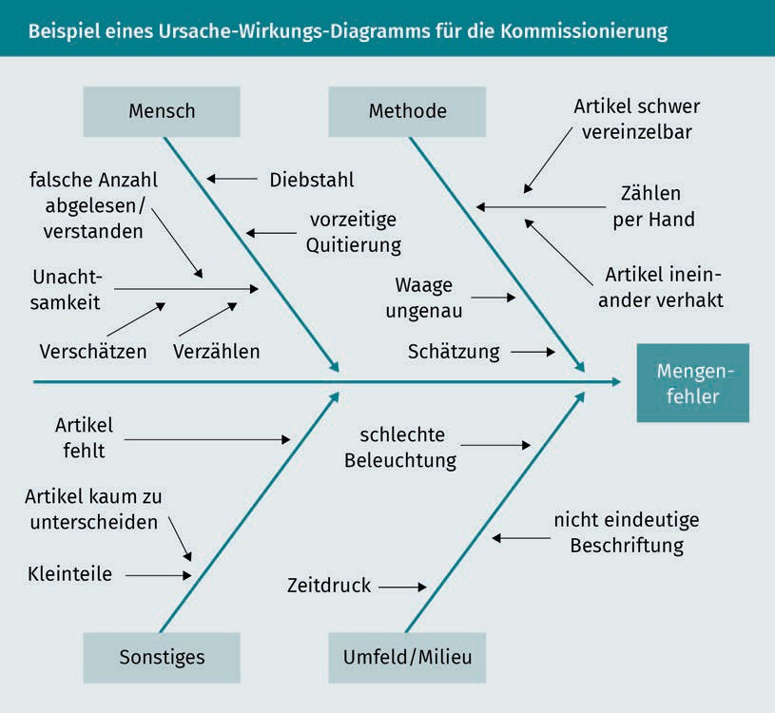

The *Other* category helps to classify faults that do not seem appropriate for the further categories provided. However, the *Material*s category could also have been used here. The cause-effect diagram can now be read as follows: A quantity error (too many or too few pieces) occurs when an employee (manpower) miscounts due to carelessness during picking (branch at the top left of the diagram). Reasons for why the employee miscounts are not considered in more detail here (root cause).

#### Audits and Certifications

Concept of the audit

Audit An audit is a process to obtain evidence that the audit criteria have been met.

An **audit** is a systematic, independent, and documented process to determine whether and to what extent an actually found condition (actual condition) corresponds to a reference (target condition). The audit process involves documenting the findings and subsequently evaluative them. Therefore, an audit is not a test for determining conformity and measurements. Audits literally aim at *audire* (Latin: *to listen*), i.e., listening by the auditor. The goal is to examine complex interrelationships within a company and its processes. Audits are fact-based and objective and are suitable for identifying possible improvements within a company. For example, the result of an audit may be that the measurement and testing procedures for determining quality requirements should be improved.

Audit Participants

Depending on who is involved in an audit, a distinction can be made between first-party, second-party, and third-party audits.

A first-party audit is conducted internally within a company. It is therefore also referred to as an internal audit. The internal auditor can be a trained employee of the company, but not an employee of the area being audited. However, an internal audit can also be conducted by a special service provider such as a quality or environmental management consultant. However, this service provider is not allowed to perform a third-party audit. Internal audits are mandatory in quality management systems (e.g., according to DIN EN ISO 9001). The results of these audits are included in the management review.

Second-party audits involve two companies. This is the case when a company is looking for a new supplier, for example. A second-party audit is then part of the supplier review, in which the supplier's capabilities, e.g., delivery times and reliability, are checked. Second-party audits in the form of supplier audits are often a prerequisite for concluding a contract and are also carried out from time to time during the term of the contract. Supplier and customer audits are two sides of the same coin, since a supplier audit of a company is a customer audit from a supplier's point of view. The difference, however, is that in a supplier audit, the company itself is the initiator of the audit and (actively) carries it out. In a customer audit, the company itself is audited (passively). Supplier and customer audits are also referred to as external audits.

Procedures, Methods, and Quality Tools

A third-party audit is performed by an independent third party with whom the company has neither a supplier nor a customer relationship in the core business. This service provider examines the area to be audited (e.g., systems, processes) from the outside and is therefore also referred to as an external auditor. If a third-party audit is intended to certify the compliance (i.e., conformity) of an object with specified standards or regulations (e.g., quality management system according to DIN EN ISO 9001 or specifications of the German Association of the Automotive Industry according to VDA 6.1 for automotive suppliers), this is referred to as a certification audit.

The following figure illustrates the relationship between different audits from a company's perspective:

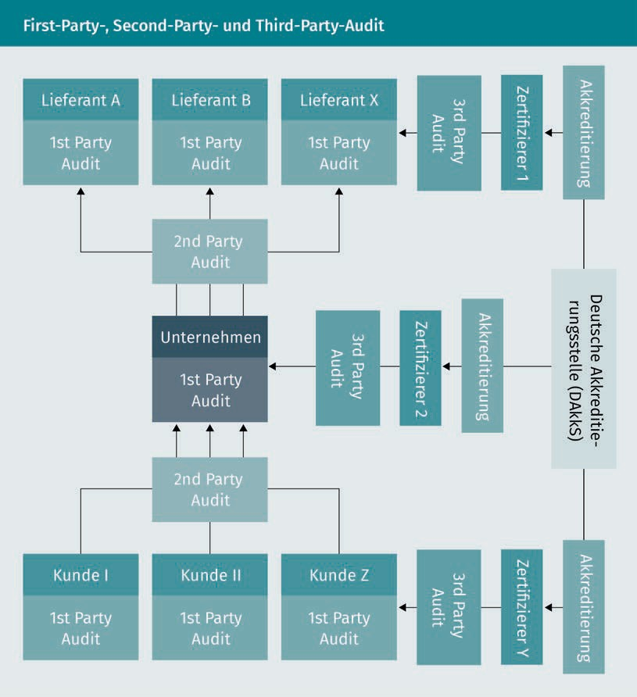

The German Accreditation Body (DAkkS) is responsible for the approval of certifiers (conformity assessment body). This approval is referred to as accreditation and relates to a specific area (e.g., quality management, environmental management) and a specific industry (e.g., vehicle manufacturing or transport).

Management review

A management review is a recurring evaluation of a management system by top management.

Internal audits help companies identify weaknesses in their quality management systems. The goal is not to find *culprits*, but rather to uncover, identify, and eliminate weaknesses. In order to be able to audit effectively, an audit process must be introduced, implemented, and maintained within the framework of quality management. The results of internal audits are primarily addressed to top management or the executive board, since they are responsible for quality planning. A systematic evaluation of audit results occurs in a so-called **management review**, i.e., in a documented, written evaluation of the quality management system. The process of a management review can be described as follows:

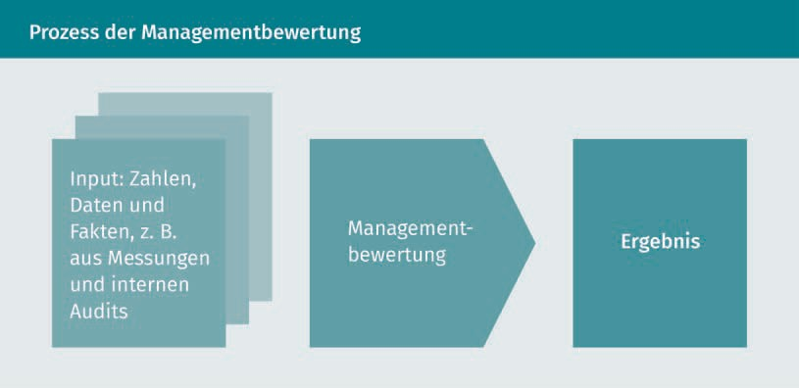

As input for the management review, the company needs figures, data, and facts from quality management. These include the following:

* The status of measures from previous management reviews.
* Changes in the context of the company, resulting risks or opportunities, and measures implemented.
* Information on the performance and effectiveness of quality management, e.g., results from the measurement of customer satisfaction and audit results.
* Initial suggestions for ways to improve.

The management review process results in the identification of specific improvement measures (e.g., faster processing of complaints), possible changes in quality management (e.g., further development of quality targets), and the decision to allocate additional resources (e.g., hiring of additional employees).

Procedures, Methods, and Quality Tools

Audit Objects and Types

Audit objects are defined as facts and circumstances to which audits can be applied. The following audit types, which have different objectives, are therefore distinguished:

* A system audit refers to defined structures and functions within the entire company. A system audit for quality management, e.g., determines whether a company is aware of the requirements placed on it and what measures are taken to meet these requirements. System audits are, e.g., certification audits for a quality management system according to DIN EN ISO 9001.
* Process audits examine individual processes of an overall system with regard to their effectiveness. Second-party audits in the form of supplier audits that relate to logistics processes are examples of process audits. The employees, the planning software, and the measuring equipment used can be considered.
* Product or service audits focus on either the manufacture of the products and the end result or the performance of a service. For example, in a product audit, the design documents, material testing, and packaging specifications may be the object of an audit. In the case of a service audit, one of the factors considered is whether the necessary resources are available for the service or whether the employees are aware of the instructions (e.g., restaurant staff actively checking customers’ satisfaction with their food around 5 minutes after it has been served).

If persons or employees are examined for their ability to produce specific results, this is referred to as personal certification (the term personal audit is not commonly used). In the case of personal certification, a person’s suitability to carry out particular activities is certified, e.g., via their training or qualification. In certain areas, the qualifications of employees are even prescribed by law. For example, when transporting dangerous goods in accordance with the Carriage of Dangerous Goods Act and the Dangerous Goods Officer Ordinance, a dangerous goods officer who has knowledge of the classification of dangerous goods must be appointed within a company.

**Summary**

Kaizen describes the idea that something good can be replaced by something better. This is done in continual, small gradual steps and can be described as a continuous improvement process, which is firmly rooted in quality management through the PDCA cycle. A continuous improvement process can enable a company to reliably deal with constantly changing risks and opportunities.

Maturity models can be used to describe the anchoring of quality thinking and quality management in a company on a graduated basis.

Failure mode and effects analysis is used as a quality planning tool. It can refer to systems, subsystems, or processes. Potential failures are comprehensively described, potential risks caused by these failures are assessed, adequate solution measures are outlined, and the results are recorded and reviewed. The failure mode and effects analysis evaluates failures using the risk priority number, which links the probability of occurrence of a failure, the significance of the failure effects from the customer's point of view, and the probability of detecting a failure.

Quality tools are used to record, display, and analyze faults. Fault collection charts, histograms, and process control charts provide an initial overview of fault types and their frequencies, as well as indications of necessary interventions in processes. Pareto analyses, fault tree diagrams, correlation diagrams, and cause-effect diagrams enable a systematic and structured fault analysis.

Audits are systematic processes that determine the extent to which an actual condition corresponds to a reference. Such audits are conducted, e.g., internally as first-party audits. In addition, external audits, such as second and third-party audits, are conducted with the participation of suppliers, customers, and certification companies. Audits can relate to systems, processes, and products or services.

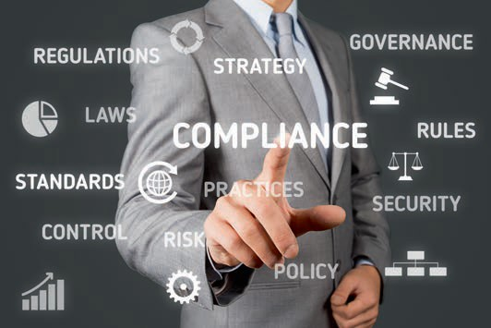

# Unit 7

## Quality Management Systems

##### STUDY GOALS

On completion of this unit, you will be able to ...

... distinguish implicit management systems from standardized management systems.

... understand the principles of quality management.

... relate the structure of a quality management system to DIN EN ISO 9001.

... describe more advanced quality management approaches in the direction of total quality management.

... understand the total quality management approach of the European Foundation for Quality Management.

DL-D-DLBLONQM01-L07

### Quality Management Systems

#### Introduction

*Quality is the best recipe*—this is how a major German food manufacturer advertises. Satisfying customers with high-quality products and services is the goal of many companies that have chosen this strategic option. In our saturated markets, customer satisfaction is a key task for many companies since dissatisfied customers are lost customers. Many companies achieve customer satisfaction through quality. But how can a company’s complex system with its departments, employees, and suppliers ensure that the required quality is actually offered? In other words: How should customers’ quality requirements be managed within a company?

Deming's Plan-Do-Check-Act cycle describes a systematic approach. According to this, management is characterized by planning, implementation, control, and measures for improvement in the event of deviations from a plan. This approach is applied to quality management within a company.

In this unit, we will explore the following questions:

* What are management systems comprised of?
* What principles shape the concept of a quality management system?
* How is a standardized quality management system structured?
* What other quality-related management systems exist?

#### Quality Management According to DIN EN ISO 9000ff.

Management Systems

Management system The term management system refers to interrelated elements of an organization to establish policies, objectives, and processes to achieve goals.

A management system is somewhat abstract. It is the totality of all organizational measures that are suitable for controlling the processes within a company to ensure the achievement of the defined company goals. A **management system** is therefore a link between corporate management and practical implementation in the company. Every company has management systems. These can be explicit, with defined processes and responsibilities (typically in writing), or implicit, i.e., unspoken and anchored in the company's day-to-day business through routines. A system, in whatever form, is automatically created through the interaction of the basic functions of management: planning, controlling, monitoring, and improving. However, an implicit management system lacks transparency and a structured setup. International regulations and standards for the structured development of a management system have been in place for a long time. Standards are intended to provide guidance for management and thus facilitate the introduction and operation of management systems.

Quality Management Systems

Quality Management Systems as Standardized Management Systems

Standardization is carried out by a wide variety of organizations, with the most well-known being the standards of the International Organization for Standardization (ISO). In Germany, the Deutsches Institut für Normung e. V. (DIN) is the national platform for the development of norms and regulations, which now closely follow and adopt the ISO standards. Standards are oriented toward specific goals, e.g., quality, i.e., generating customer satisfaction on the basis of customer requirements by means of a company's own products and services. The DIN EN ISO 9000, 9001, and 9004 standards offer assistance for the structured development of a quality management system (cf. Brunner & Wagner 2016, p. 111ff.):

* DIN EN ISO 9000: This standard describes the fundamental principles for quality management systems and defines terms.
* DIN EN ISO 9001: This standard describes the requirements for quality management systems and is the primary specification for establishing such a management system. It is based on the principles and terms of DIN EN ISO 9000. DIN EN ISO 9001 is the focus of the following explanations. (other management system standards, such as DIN EN ISO 14001, describe the requirements for an environmental management system or, like DIN EN ISO 50001ff, contain the requirements for an energy management system).
* DIN EN ISO 9004: This standard is titled “Quality management – Quality of an organization – Guidance to achieving sustained success” and goes beyond the requirements of DIN EN ISO 9001. For example, this standard contains evaluation criteria for self-assessment and guidance on pricing strategies in marketing. This standard offers an approach to the further development of a quality management system in the direction of Total Quality Management (cf. Section 2 in this unit).

A quality management system includes activities through which a company identifies its goals and determines the processes or resources required to achieve the desired results. To achieve this, a company must:

* regulate responsibilities for the activities (organizational structure),
* describe the intended results (goals),
* define the way in which the activities are to be carried out (process organization), and
* determine the resources to be used (e.g., budgets, materials, personnel, procedures).

Since many companies use several standardized management systems at the same time, most systems have had a uniform structure since 2015. This uniform structure follows what is referred to as a **high level structure** (HLS). This HLS provides a facilitation in that the requirements can be found under the same section numbers of the standards and often include identical text passages. This applies, e.g., to the quality management system according to DIN EN ISO 9001 and to the standard on the environmental management system according to DIN EN ISO 14001.

High level structure This is an overarching, uniform structure of standards for management systems.

Principles of Quality Management According to DIN EN ISO 9000 and 9001

The following principles mainly provide reasoning as to why these topics are particularly important for quality management and what benefits a company can derive from them (cf. Deutsches Institut für Normung e. V. 2015a, p. 13ff.; Deutsches Institut für Normung e. V. 2015b, p. 10):

* Customer orientation: Companies depend on their customers and should therefore understand customers' current and future needs. Companies must know and meet their requirements. With their requirements and influences, interested parties should be understood as indirect customers.
* Leadership: Managers should ensure the stringent goal setting and alignment of a company. They should create a clear orientation and a positive internal environment in which employees can work to achieve the company's goals.
* Involving people: Employees at all levels of an organization are a decisive factor for economic success. They should be comprehensively involved in quality management to be able to use their skills for mutual benefit.
* Process orientation: The process orientation of the standard refers both to the quality management system as a whole and to individual processes (e.g., marketing processes or service provision processes).
* Improvement: The continuous improvement of all processes and services should be a permanent goal of a company. This enables it to respond better to external and internal changes.
* Fact-based decisions: Effective decisions are based on the analysis of data and information. In this way, correlations between cause and effect become clear. Indicators and key figures are typical instruments.
* Relationship management: A company and its relevant interested parties are interdependent. Success is more likely if these relationships are designed for mutual benefit. This includes good cooperation with suppliers throughout the supply chain.

Structure of the Standard

The structure of a quality management system according to DIN EN ISO 9001 follows the Deming management control cycle of Plan, Do, Check, and Act (PDCA). Sections 4 to 10 in the figure below correspond to the high level structure and are assigned to the steps of this control cycle. The content requirements of the standard do not begin until Section 4 of the standard. Section 1 describes the possible area of application of the standard (every organization, regardless of type, size, or products and services offered), Sections 2 and 3 refer to the DIN EN ISO 9000 standard and the terms defined there.

Quality Management Systems

|  |  |
| --- | --- |
| **Structure of the Quality Management Standard DIN EN ISO 9001** | |
| **Section of the DIN EN ISO 9001 standard** | **Reference to the control cycle** |
| 4: Context of the organization | Plan |
| 5: Leadership |
| 6: Planning |
| 7: Support | Do |
| 8: Operation |
| 9: Performance evaluation | Check |
| 10: Improvement | Act |

The structure of a quality management system according to DIN EN ISO 9001 is quite extensive and consists of approximately 50 individual requirements. In the following section, we will focus on the core requirements in each step of the management control cycle.

Plan

Planning a quality management system requires that companies understand the **con- text** of their organization. These are topics that are relevant to the strategic alignment of a company. A topic is relevant if it influences or can influence the results of the quality management system. According to DIN EN ISO 9001, a company has the task of defining such topics, collecting information, and monitoring them on an ongoing basis. These topics can have both negative and positive effects on a company and can be of both an internal and external nature. Internal topics are, e.g., securing the knowledge of employees in the event of staff turnover or changed performance expectations of a new management. Possible external issues are:

* of a legal nature: e.g., new reporting requirements on greenhouse gas emissions in maritime shipping or new regulations on the carriage of dangerous goods by truck, rail, air, or ship.
* of a market-related nature: e.g., increased customer requirements regarding the availability and delivery time of goods.
* of an economic nature: e.g., increasing costs due to the expansion of toll roads or decreasing costs due to more efficient drive technologies for trucks.
* of a social nature: e.g., expectations of fair working conditions and pay in the logistics sector.

Context

Context refers to internal and external issues that have an effect on the development and goal achievement of companies.

Issues of a social nature can also be brought to the attention of a company by so-called stakeholder groups (also referred to as interested parties). Common interested parties are customers, managing directors, employees, and suppliers. Due to the much more strategic approach of DIN EN ISO 9001 since 2015, the fact that companies are confronted with many other interested parties who may have claims on the company is now taken into account. If necessary, such claims can also be asserted without a market or direct business relationship. For example, residents in the vicinity of a distribution center may criticize the noise generated by truck traffic and demand noise abatement measures. Nature and environmental protection associations (e.g., Environmental Action Germany, Greenpeace or Nature and Biodiversity Conservation Union Germany) can criticize such sealing measures, while supervisory and approval authorities can order noise abatement measures if limit values are exceeded (e.g., noise abatement through night flight bans at airports, which restricts air freight traffic). The DIN EN ISO 9001 standard therefore requires:

* + the determination of interested parties’ requirements and their influence on the company, followed by
  + filtering out the requirements that are significant for the quality management system.

Top management

The term top management refers to the person or group of persons at the highest level who direct and control an organization.

.

For the determination of interested parties’ requirements and for all other activities related to the quality management system, a company must now design processes. To do this, the company must establish (i.e., define), realize (i.e., actually implement and use), maintain (i.e., update and adjust as necessary), and continuously improve the processes. For example, a process for order acceptance is defined. This then specifies that an order confirmation is sent to the customer within 24 hours. In addition, delivery of the goods via a shipping company is confirmed on a working day between 8 a.m. and 6 p.m. A customer survey now shows that 80% of customers would like a shorter time window. The company then checks whether it is possible to reduce the time window to 8 a.m. to 1 p.m., taking into account the effects on all other processes (e.g., route planning, employee scheduling). Quality management according to DIN EN ISO 9001 is regarded as a primary management task (**top management**). Therefore, management (or company management, executive offices, board of directors) is of particular importance. Among other things, top management must:

* assume overall responsibility for the quality management system,
* establish a quality policy and quality objectives,
* provide the necessary resources, and
* support all people (particularly employees) so that the quality management system works.

The quality policy contains the fundamental alignment of a company with regard to quality. It must promote the overall company policy and take the company context into account. It also forms a framework for the definition of quality objectives.

Quality Management Systems

Every quality policy must be published internally and should be made available to interested parties, e.g., on the company homepage.

An excerpt from a fictitious quality policy is provided below:

Example of a Quality Policy

“As a family-run logistics company in its third generation, proximity to the customer is the most important thing for us. Short distances and quick decisions with tailored ideas distinguish our company from the standard solutions of large logistics companies. [...] Due to our flexibility, we are able to offer solutions for nearly every logistics problem, including those related to warehouse logistics and packing. Our vehicles, such as semi-trailers, refrigerated bodies, lifting platform vehicles, and sprinters, comprise a fleet that can be flexibly utilized for each of our customers’ requirements.”

Consistent, i.e., coherent, quality objectives must be derived from the quality policy as part of the planning process. Quality objectives should ensure that the quality policy statements are also implemented. They should meet certain basic requirements, such as those formulated in the SMART rule:

**S**pecific – objectives should be clear in terms of requirements.

**M**easurable – the achievement of the objective must be measurable.

**A**ccepted – employees should support the objective.

**R**ealistic – the objective should be achievable.

**T**ime-bound – a deadline for achieving the objective should be established.

The DIN EN ISO 9001 standard also requires that the quality objectives are relevant and relate to the requirements of the quality management system, e.g., to customer requirements. The quality objectives must be monitored and updated when necessary. For example, a quality objective of the above-mentioned family-run logistics company could be that customers receive a quote for storage and packing space for summer campaign goods within 24 hours of request.

When planning the quality management system, risks and opportunities that arise from the context of the company and the interested parties in particular must also be considered. The DIN EN ISO 9001 standard requires that a company define measures for handling risks and opportunities and integrate these into their processes. For the family-run logistics company, the strong competition and prices of the large logistics companies could represent a risk and must therefore be permanently monitored.

One opportunity could be the desire of customers for personal advice on specific requirements, which a small company with short decision-making paths can fulfill faster than its competitors.

After the planning phase is complete, the next step is to implement the plan into the company’s regular operations with the necessary support in place to ensure success.

Do

The necessary support of a management system focuses on a company’s resources. (In contrast to the sustainability concept, this does not refer to renewable or non-renewable natural resources). In addition, it is not sufficient to determine the necessary resources once, but rather it is important to continuously check whether the existing resources are sufficient for a quality promise to customers. The following list shows which resources are meant:

* People: As internal resources, the focus here is on employees. It must be ensured that employees have the necessary skills to perform their tasks in a quality management system. Training measures must be utilized to acquire the (possibly non-existent) skills. In addition, employees should build awareness of the quality management system. One means of achieving this is internal communication regarding all aspects of a quality management system (e.g., on a bulletin board or intranet). In particular, employees must know and understand a company's quality policy and objectives. If internal resources are insufficient, necessary external resources must be determined (e.g., consultants or seasonal staff).
* Infrastructure: A certain infrastructure must be provided to meet customer requirements. This includes, e.g., buildings, machinery, and transport systems, as well as information and communications technology. Infrastructure also includes external services such as building cleaning or maintenance work.
* Process environment: The process environment describes the working conditions within a company. This includes physical (e.g., temperature and humidity in a warehouse), social (e.g., noise in offices or customer service areas), and psychological working conditions (e.g., a high cycle rate of work processes that can trigger stress).
* Means for monitoring and measurement: Regular monitoring and measurement are part of process control. For this purpose, resources must be defined and made available, e.g., suitable software or calibrated measuring equipment.
* Company knowledge: In contrast to employees’ competence, the focus is on the knowledge of a company as an organization, which can be seen, e.g., in the experience of cooperation between employees and departments. The goal here is to safeguard knowledge within a company, protect it from loss (e.g., through employee turnover, errors in recording information), and promote knowledge acquisition within a company (e.g., through internal mentoring).

Quality Management Systems

Documentation plays an important role in supporting a quality management system. Documented information is the umbrella term for all specifications, evidence, and results within the framework of a quality management system. The DIN EN ISO 9001 standard specifies which documented information is mandatory in a company (e.g., a quality policy, quality objectives, an overview of the necessary resources). In addition, a company can determine for itself which documented information it considers necessary (e.g., a compact manual on the quality management system for new employees). A decisive factor for the quality of documented information is that it is unambiguous. For example, the description of a process should have a clear title, a valid-from date, and the creator’s name. In addition, the DIN EN ISO 9001 standard requires a type of management of the documented information (referred to in the standard as control). This regulates, e.g., distribution to employees and protective measures against manipulation.

For regular operations, the DIN EN ISO 9001 standard defines the most comprehensive requirements, which are presented here in summary:

* Operational planning and control focuses on operational planning, e.g., planning delivery dates, determining machinery utilization, and organizing employee deployment.
* Regulations on the requirements for products and services primarily concern communication with the customer, e.g., order acceptance, contract conclusion, and handling of complaints. Particularly in the case of individually manufactured products and services, it is important to clearly define the customer's requirements before accepting the order and to regulate the handling of change requests.
* Requirements for production and service provision describe necessary activities during production, e.g., the provision of production plans with operations, parts lists for production, and measuring equipment.
* Regulations must be established for the release of products or services and for handling non-standard results (e.g., defective products).

In addition, the DIN EN ISO 9001 standard defines requirements for the process of developing new products and services. To fulfill the requirements, a development plan must be documented which, among other things, specifies the necessary resources, employees, and schedule. It could also be decided, for example, that customers will participate in the development process of a new service. This approach is known as co-creation. Customers can help shape particular function and performance requirements for new products and services by providing development input.

Check

Performance is evaluated through defined monitoring, measurement, and analysis. The primary instruments are internal audits and management reviews. Internal audits and management reviews assume the important function of triggering a new PDCA cycle of continuous improvement. The approval for this new planning is determined by the outcome of the management review.

Act

A quality management system in accordance with DIN EN ISO 9001 obligates a company to examine possibilities for improving its products and services and introducing appropriate measures. The focus is on customer satisfaction. Improvement measures can pertain to the following areas:

* Improvement of products and services, e.g., shorter delivery times.
* Reduce or even avoid risks, e.g., reduce competitive disadvantages through shorter delivery times.
* Improve resources, e.g., introduce more powerful software to manage delivery scheduling.

If the requirements placed on a company are not met, the DIN EN ISO 9001 standard refers to this as nonconformity, which must be followed up with corrective actions. Corrective actions include in particular the analysis of the causes and their elimination. In addition, it must be checked whether adjustments to the quality management system are necessary.

In this introduction to a quality management system according to DIN EN ISO 9001, it should now be clear that this standard defines possible and internationally uniform requirements with which companies can generate customer satisfaction. However, this standard only specifies minimum requirements for a management system that involves quality. A more comprehensive concept of quality leads to the total quality approach, which is discussed in more detail below.

#### Total Quality Management

Traditional Quality Management versus Total Quality Management

The approach of total quality management (TQM) goes beyond the exclusive focus on customer satisfaction and the relevant context and is understood as a comprehensive or holistic understanding of quality that includes all internal or external interested parties and all functional areas of a company. Furthermore, TQM expands the understanding of quality-related processes: Not only the capability of processes to fulfill identified requirements is considered, but also concrete results and potentials. Therefore, a quality management system according to DIN EN ISO 9001 is also referred to as a system standard, since no requirements are placed on the content of

Quality Management Systems

products/services. The focus is on the formal structure of a quality management system. Each company can structure its own management system within this standardized framework. Since specific, measurable results are in the foreground, evaluations and comparisons between companies are possible. The approach of a TQM thus makes continuous improvements possible, which is in contrast to the discrete decision *requirements fulfilled* vs. *not fulfilled* of the quality management standard DIN EN ISO 9001.

The quality orientation of a TQM runs through all areas of a company as a central principle of action. The motto is: Quality first. Quality management systems according to DIN EN ISO 9001 are often a first step in the direction of TQM, since in addition to the processes, TQM aims to utilize the potential of a company (e.g., technical know-how [cf. Brunner & Wagner 2016, p. 378], as well as the creativity of the employees). One approach to TQM that is widely used in Europe is the model of the European Foundation for Quality Management (EFQM model), which is currently available in the 2013 revision.

TQM in Practice: The EFQM Model

The EFQM model provides the framework for assessing a company's TQM with the goal of achieving top performance (excellence). For this purpose, the progress of a TQM in the EFQM model is determined via maturity levels. The EFQM model is based on three interrelated building blocks:

* basic concepts,
* criteria model, and the
* RADAR assessment methodology.

Basic concepts

The first part of the EFQM model consists of basic concepts that are regarded as success factors for companies to achieve top performance in the market. According to EFQM, such success factors are, e.g., active engagement with the economic, environmental, and social demands of society placed on the company or a management that demonstrates visions and missions for the company and implements them in an exemplary manner. In doing so, the management also intensively addresses customer and employee requirements (cf. European Foundation for Quality Management 2018b).

An example of the implementation of these basic concepts is the logistics service provider GEODIS. Since 2012, the company has developed a clear mission that serves as a guideline for TQM: We help our customers succeed by overcoming logistical hurdles. Extensive surveys were conducted to gain a more precise understanding of customer and employee requirements. In addition, GEODIS established the Stakeholders Total Satisfaction program and implemented a corporate social responsibility approach to meet the requirements of sustainable development (cf. European Foundation for Quality Management 2017).

The concrete criteria in the following model specify these success factors.

Criteria model

The EFQM model describes a company through nine criteria, which are regarded as central to entrepreneurial excellence. These criteria are assigned to two areas: the enablers and the results. The five enabler criteria ([1] leadership, [2] employees, [3] strategy, [4] partnership and resources, [5] processes, products, and services) can be understood as variables in the model, since their improvement also leads to an improvement in the results. These results are systematically presented and described in four result criteria (employee-related, customer-related results, company-related results, and key results). The EFQM model is also based on the concept of continuous improvement: Goals for the enabler criteria are defined accordingly, and by comparing the goals (target value) with the results (actual value), the processes of learning or creativity and innovation should lead to improvements. The figure below illustrates this approach:

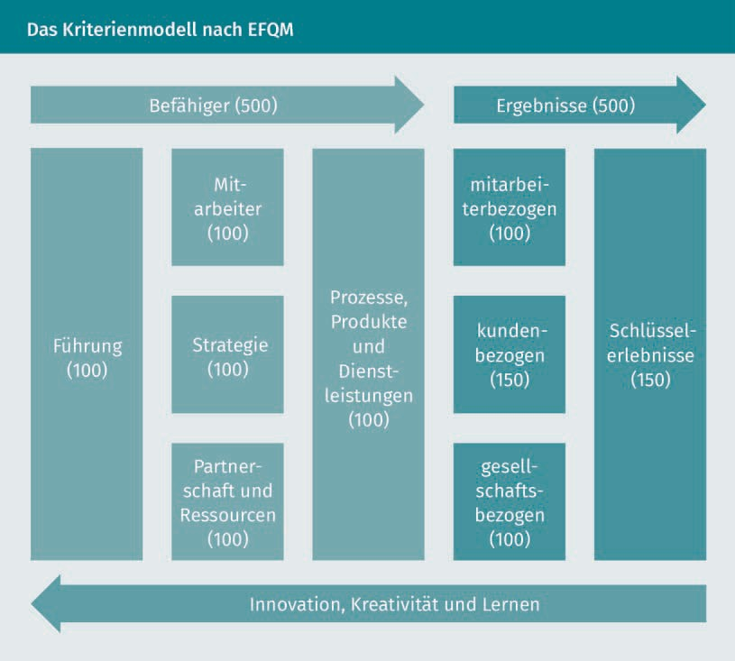

Quality Management Systems

The numerical values provided in the figure reflect the weighting of the individual criteria in the evaluation. A total of 1,000 points can be achieved in a self-assessment, as well as in an external assessment. The customer-related results and the key results are disproportionately weighted to reflect the strong customer orientation of the EFQM model.

The enabler and result criteria are further differentiated through sub-criteria and measured by means of indicators. A selection of important sub-criteria is examined in more detail below:

* Leadership: As a variable or enabler, leadership in the EFQM model has the task of providing direction for the company. For example, this can take the form of a mission or vision. Leadership should also actively approach their company’s interested parties and shape the relationships. This is the path the GEODIS company has taken (as shown above).
* Strategy: The rough guidelines of a mission are implemented in a strategy. Methods such as SWOT analysis (strengths, weaknesses, opportunities, threats) can be used here, since it systematically compares corporate strengths or weaknesses with opportunities and threats. From this, goals can be derived in the form of key results such as the definition of a company's own core competencies, an increase in market share, a focus on brands, or technology leadership.
* Customer-related results: Here, a distinction is made between the customers’ perception of requirements and the actual performance of the company. Customer perception can be determined, e.g., through customer satisfaction surveys. For example, performance indicators can be the response time to inquiries or the processing time for complaints. In order to not only achieve customer satisfaction but also customer enthusiasm, customer expectations must not simply be met, but exceeded—and at a reasonable cost.
* Key results: These results relate to the strategic goals that a company has set for itself. Key results are considered by a company to be particularly important for its business success. A key result for GEODIS, e.g., was the move away from 40 different brands to a single-brand strategy (cf. European Foundation for Quality Management 2017, p. 10).

RADAR Assessment Methodology

The final component of the EFQM model aims at assessing a company’s performance. The assessment is based on what is known as the Results-Approach-Deployment-Assessment-Refinement approach (RADAR in short form), which mirrors the PDCA management control cycle as follows:

* The planned *Results* and *Approach* correspond to the *Plan* in the control cycle.
* The *Deploymen*t of planning corresponds to *Do* in the control cycle.
* The *Assessment* of planning and *Refinement* correspond to *Check* and *Act* in the control cycle.

RADAR assessment matrices are used for the respective sub-criteria of the enablers or results, with the help of which the degree of fulfillment of the sub-criteria can be determined. For example, the planning of a leadership enabler is differentiated into well-founded and integrated (cf. Deutsche Gesellschaft für Qualität 2018, p. 4). By means of an extensive algorithm, all sub-criteria are assessed and converted into numerical values based on the weightings of the criteria model. Due to the complexity of the model, such calculations are typically conducted by experienced EFQM assessors. The assessment is undertaken on a scale of 0 to 1,000 points. This point rating then corresponds to the maturity level of a company: The higher the point value, the better a company fulfills the requirements of the EFQM model and is able to deliver top performance on the market. In an external assessment, a ranking can be created between companies, e.g., in the form of the EFQM Recognition award. Here, companies with 300 points or more are awarded 3 stars, with 400 points or more, four stars, and with 500 points or more, five stars (cf. Sommerhoff 2013, p. 46). Such ratings are the entry point to established quality awards such as the international EFQM Global Award or the German Ludwig Erhard Prize.

**Summary**

Management systems can be divided into implicit and explicit systems. The standards of DIN EN ISO 9000ff. have been established for explicit quality management systems.

The principles of a quality management system are customer orientation, leadership, involving people, process orientation, improvement, fact-based decisions, and relationship management.

The structure of a quality management system according to DIN EN ISO 9001 is based on the Deming management control cycle of Plan, Do, Check, and Act. The standard defines the minimum requirements for a quality management system in the following seven areas: context of the organization, leadership, planning, support, operation, performance evaluation, and improvement.

Total quality management goes beyond the process-related system standard of DIN EN ISO 9001 and also considers the potential and results of a company. A TQM approach that is widely used in Europe is the EFQM model. It is structured around basic concepts that are modeled and concretized in enabler and result criteria in order to assess these criteria by means of the RADAR methodology.