The Stigma Index

Enosh Association 2022

Enosh The Israel Mental Health Association

Research conducted by: Yifat Media Research

Methodology

Research purpose:

To examine the use of expressions related to the world of mental health as they appear in traditional media and online social media networks.

Research framework:

A representative sample from the Israel media: print, digital, and postings on social media.

Analysis method:

Qualitative content analysis, which reliably reflects how the average Israeli perceives the media coverage

Number of articles in the media: 1,450

The number of discussions in social media: 78,399

Indicators:



Number of articles/appearances in the media Number of posts/chats on social media

Structure of the analysis:

Expressions: psychotic (insane, crazy), psychopath, mentally ill, schizophrenic, split personality

Who used the expression: the media, politicians, celebrities, etc.

We classified usage of the expressions use into three categories: correct, incorrect, offensive/damaging

**Correct usage:** a small minority of the total uses; discussion of a diagnosed mental condition.

Example from literature: *Sorrow and Bliss*, a humorous, sensitive glimpse into the mind of a mentally ill person.

**Incorrect Usage:** Common phrases and descriptions that are inaccurate but not offensive.

“As we have said before, we are not excited about the concept of unicorns and we are not looking for companies that recruit at crazy value levels…” (*Calcalist*)

**Offensive/damaging usage**: the vast majority of online usage: the term is used to express something negative.

“Gantz is mentally ill and dangerous to the security of the country.” (Comment on Facebook)

In relation to the previous year’s index, there has been a change in the discourse in both traditional media and online social media.

In the traditional media, there was an increase in the proportion of correct usage, alongside a simultaneous increase in offensive/damaging usage, in comparison to incorrect but non-offensive language. On the internet, we saw a decrease in offensive discourse.

The absolute majority of incorrect use of phrases on social media is offensive.

Correct, Incorrect, and Offensive expressions in the media and online in 2022 as compared to the previous Stigma Index.

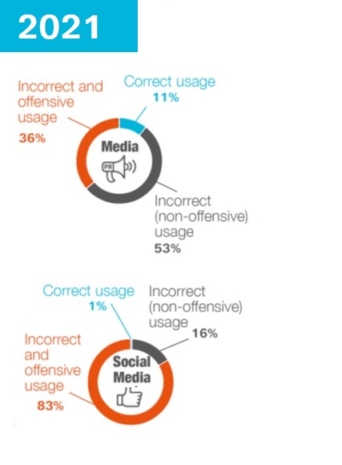 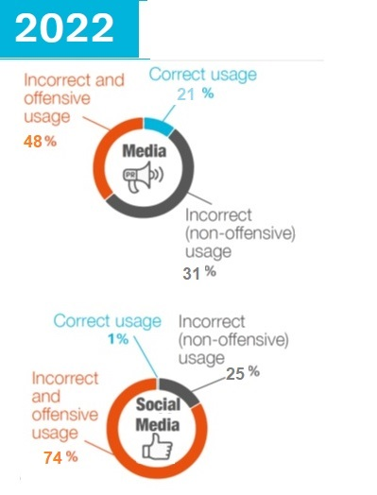

Examples by type of usage

**Correct usage:**

Questions and answers about schizophrenia

[www.rmgcity.co.il](http://www.rmgcity.co.il)

Posted by Bennett Borakasim

“I have a dissociative disorder, which is similar to a split personality.”

“How does it feel?”

FXP Forums

**Incorrect (but not offensive) usage:**

An article in *Haaretz*: “What Instagram doesn’t tell you: Insanely enchanting beaches.”

“Oskar Gluch and Eran Zahavi: This is a crazy combination.”

Tweet on Twitter

“At his peak at Chelsea, he was a bit of a psychopath.”

FXP Forums

**Offensive usage:**

“We are surrounded by psychopaths.”

Coverage of the war in the Ukraine, broadcast stations

“‘People scream at me in the street, they call me a murderer and psychopath.’ Prof. Dan Ariely did not anticipate the outpouring of hatred towards him. What began with entanglements with vaccine opponents and continued with evidence of alleged falsification of data in his studies – this turned into the most difficult period of his life.” Haaretz

137 Yossi 19:47 30.08.22

“Another crazy leftist from Balfour, it’s a shame the Arab didn’t beat him.”

Reply to comment

TalkBack in Walla!

Eliran Lusky

“He’s mentally ill, I swear he has a serious split personality.”

A comment on a Facebook post about Zelensky, who changed direction after his speech at the UN.

**Examples of incorrect use of expressions**

* In the media, the word “crazy” (or “insane” or “psychotic”) is the most popular of the analyzed terms. It is often used to describe anything large or extreme.
* On the internet, “mentally ill” is the most commonly used expression. It is almost always used in a derogatory way.
* On the internet, the word “crazy” is also frequently used to describe extreme things, and is the only one of the analyzed terms that is often used in a non-offensive way.
* Both in the print media and online, the expressions “mentally ill” and “psychopath” are mainly used in a derogatory way.
* Often “psychopath” is used specifically to describe criminals and murderers.
* Crazy (insane, psychotic) is a commonly used adjective, also in a positive way.

For example, about a player for the HaPoel Tel Aviv team: “He constantly had his hand on ball, he is crazy sick about the game.” Mako-N12

Netta Barzilai’s response to Omer Adam’s song: “It’s crazy.” Mako-N12

A story about Gaza City: “On my way back from another crazy trip to the most insane city

in the Middle East.” Local newspaper from Kiryat Gat

In the media, there is frequent use of the word “crazy”.

The scope and nature of the use of expressions in the media

* insane or crazy
* psychopath
* mentally ill
* split personality
* schizophrenic

Offensive usage

Incorrect but not offensive usage

Examples of use of these expressions

**Mentally ill**

If Abbas helps the Left, then he is praised, but if he is connected to Netanyahu, the crazy Left condemns him. That’s how mentally ill the Left is.

Netanyahu and Olmert testify in the “mentally ill” lawsuit.

Safety restraints: forced hospitalization and denial of the freedom of a mentally ill person, to prevent him from harming himself: involuntary medical treatment

**Psychopath**

Reference to criminals: “Dahmer, like many other psychopaths, operated with a clear mind.”

Leonid Nevzlin calling Putin a psychopath: “Putin is a psychopath, if we give him a smack in the face he will go into the corner and shut up.

Tweets about politics on Twitter:

“Another mentally ill psychopath in the service of the head psychopath.”

“Netanyahu, the narcissistic psychopath still isn’t in prison… apparently not.”

**Split personality**

“It depends which personality is writing, because part of narcissistic personality disorder is a kind of split personality.”

“Special: Political polarization is a split personality.”

**Crazy/Insane**

“Did anyone else hear a crazy boom just now in the area of central Tel Aviv?”

“The bus driver drove like a crazy person, save us.”

“Insane prices, the apartment won’t stay on the market for more than seven minutes.”

**Schizophrenia**

“Alma (played by Rosa Salazar in *Alita: Battle Angel*) comes from a family that suffers from schizophrenia: her grandmother was hospitalized several times.”

“Your schizophrenia is out of control.”

“German schizophrenia”

**Who used these expressions in the media**

* Politicians often use these expressions in ways that are incorrect and even offensive. In fact, politicians use these expressions more often than other groups, and account for about a quarter of the incorrect usages.
* Prominent examples: Olmert’s trial for calling Netanyahu “mentally ill” was in the headlines.
* Putin was often called a psychopath during the Russian-Ukraine war.
* In general, polarization and divisiveness in political discourse leads to use of these expressions, not only among politicians (examples on the next slide).
* The media (reporters, broadcasters, columnists) is responsible for about a fifth of the incorrect use of these expressions. Unlike last year, in which most of their usage was not offensive, this year much of it was offensive.
* It is interesting to note that the use of these expressions is mainly characteristic of the print media, especially editorials and opinion columns. They are less common in the broadcast media.
* Politicians often use these expressions offensively.
* Olmert, on calling Netanyahu mentally ill: “We don’t want people in that [mental] state to lead the nation.”
* Knesset member May Golan: “Bennett’s split personality is costing the public millions of shekels.”

The print media leads the use of these expressions; politicians use them in offensive ways

Breakdown according to who used the expressions.

Media outlets are the most prominent in the use of these expressions.

|  |  |  |
| --- | --- | --- |
| Media outlet | Number of articles in which this media outlet used the phrase | Percentage of usages that were offensive |
| Haaretz | 118 | 71% |
| Mako-N12 | 64 | 44% |
| Ma’ariv | 54 | 70% |
| Israel Today (Yisrael HaYom) | 42 | 71% |
| Walla! | 36 | 56% |
| Yediot Aharonot | 28 | 57% |

Politics

* Independent media
* Movies/books
* Celebrities
* Sports
* Crime
* Religion
* Hi-tech
* Business
* Healthcare/medical
* Offensive use
* Incorrect but not offensive use

Examples of offensive discourse in the context of political polarization and divisiveness

**In the traditional media:**

Minister Avigdor Lieberman: “Israel has with a split personality.”

*Arutz 7*

Olmert: “I did not establish a fact.” Netanyahu’s lawyer: “You are cuckoo.”

*Ynet*

MK May Golan: “Bennett’s split personality is costing the public millions of shekels.”

*0404.co.il*

In an interview with *Haaretz*, Zehava Galon called the Netanyahu-Gantz coalition a “Coalition of mobsters.” Netanyahu is described as “a crazed psychopath”, Gantz is called a “flowerpot” and Amir Ohana, a “broom”.

**On social media**

Inon A

“Bennet is mentally ill.”

“With his condition, they’ll surely hospitalize him.”

Gili Gil

“With absolutely no connection to Omer Adam, Michaeli either has a split personality or she’s just a crook.”

Nilya 168 Yarkon

“Netanyahu, the narcissistic psychopath still isn’t in prison… apparently not.”

Idan Ratsabi

“Not just crazy, a complete psychopath. They all got together, Sa’ar, Bennet, Lieberman.”

Dan

“In the end, what will be remembered about Bibi? A narcissist, a sick miser surrounded by mentally ill people and chauvinists who are a distillation of the garbage of Israeli society.”

yaya 21340 Yair B

“In my opinion, it is becoming increasingly clear that Yair Lapid has a twin brother (unmatched). The other possibility, that he is schizophrenic, is no less frightening.”

Victor Lazlo

“Bennet A is boycotting Bennet B; the man is schizophrenic.”

**Division according to social network**

* Most of the uses of these expressions are found on Twitter, where the discourse is more cliquish and focused on politics and issues that arise in daily life.
* This is an interesting statistic, since in general there are fewer conversations on Twitter than on Facebook.
* This is further proof that offensive use of the expressions we analyzed contributes to the polarizing and divisive discourse, which is even more strident in Twitter tweets.
* Many uses of the phrases in online conversations are offensive, especially in replies and TalkBacks.

**Examples of offensive uses of the phrases on Twitter**

replying to Ayelet_Shaked: “You have a split personality, sicko.”

Replying to BarashiKinneret: “What a pathetic child. Your mother taught you to worship a psychopathic narcisstic with narcissistic split personality disorder.”

Giora Levav: “What? You’re crazy. I’m not surprised by anything, you garbage drippings.

Twitter users lead the use of these expressions

TalkBacks are the most offensive

**Breakdown of the use of phrases in the division according to social network**

* Instagram
* Twitter
* Forums
* Facebook
* TalkBack

**Discussions about the correct use of these expressions.**

* Among the many appearances of these expressions in the media and online, there is sometimes also discussion about how they are used.
* This issue mainly comes up after one of the expressions is used offensively, resulting in criticism or lawsuits.
* The most publicized lawsuit of 2022 was, of course, the lawsuit of Bibi (Netanyahu) and concerning Olmert calling him “mentally ill.” This lawsuit received extensive coverage in the print, online, and social media.

Criticism of offensive use of the expression

Twitter tweets:

“Once again, the phrase ‘mentally ill’ starred at the beginning of hot topics on Twitter. Until when?”

“‘Mentally ill’ ‘schizophrenia’ ‘needs to be involuntary hospitalized’. Twitter is full of people making such diagnoses without the slightest understanding of the subject, and that they are using offensive phrases that stigmatize and shut up in a closet people who are actually dealing with a mental disorder. Do us a favor and stop for a second before tweeting such things. Happy holiday.”

*Article in Haaretz*

“Olmert and Netanyahu are intensifying the harm against people dealing with mental illness.”

**Claims resulting from the use of these expressions**

The Clash of the Prime Ministers:

“Former Prime Ministers Netanyahu and Olmert appeared in court for a hearing in the defamation lawsuit filed by Netanyahu against Olmert for calling his family mentally ill. Nir Hefetz and Uzi Arad testified against the opposition leader…”

“If someone would write that I am mentally ill and I had been secretly hospitalized for a mental illness, I would sue. I believe that you would too, if they did something like this to you. By the way, in libel suits are an exceptional case in that the burden of proof is on the defendant, who must prove that his words were true.”

**Criticism of offensive use of an expression towards LGBT people**

Yorai Lahav Hertanu

“On the one hand, the Prime Minister embraces the LGBT community and demands what should be self-evident -- equal rights. On the hand, there is a frustrated Knesset Member who takes refuge in homophobia and calls my friends and members of my community ‘morally weak’. The choice could not be any clearer than that.”

“Being gay in the Palestinian Authority is like a death sentence. Right as I was entering, the guards kicked me. They said I’m not a man, that I’m mentally ill, that they don’t want people like me in Palestine.” *Haaretz*

Enosh The Israel Mental Health Association

074-7556155

https://www.enosh.org.il/

https://www.enosh.org.il/english/