

Summary of Headspace activities for 2022

Headspace Israel is a program of Enosh: The Israel Mental Health Association, which promotes mental health among adolescents and young adults (ages 12-25). This is a summary of our eighth year of activity. Last year, 2022, was a banner year. Naturally, youth continue to face the ongoing challenges presented by the pandemic, as did the team members assisting the youth in various areas, who dealt with distress and burnout. The Headspace team continues to reach out to young people in the early stages of crisis, in order to prevent secondary trauma and the development of emotional and mental distress.

We are pleased to share this report on our work in the past year.

**Headspace Online and the Expansion of Responses and Partnerships**

Throughout the year, we worked to provide direct services to adolescents and young adults in the Headspace centers, and also expanded our services that are offered outside the centers. Headspace Online, which operates with the support of funds from Bituach Leumi (Social Security), expanded its services to reach all areas of Israel, offering responses to emotional needs in an accessible and professional manner. This service works in collaboration with pre-military preparatory schools, national service year programs, the Yated program, youth centers, and more. We worked extensively with teams in the fields of welfare and education to provide them with additional tools and knowledge, and to support and guide them in meeting the challenges they face.

We opened Headspace Jerusalem, which works with the Ministry of Education. We were recognized as an authorized provider in the Ministry of Education’s Geffen (Flexible Pedagogy) program, offering a wide range of meaningful programs. We continued our activities with the Pisgah (teaching staff development) centers. We launched another stage in our fruitful collaboration with the Israel Center on Addiction (ICA), built around the HMA model.

**The Socio-political Arena**

Additionally, this past year, representatives of Enosh in general and Headspace in particular participated in changing legislation and policy, by taking part in Knesset committees, round tables, and coalitions of organizations. We met with government ministers and representatives, and had the privilege of hosting people holding important roles who were willing to talk, listen, discuss, and learn. This promoted action and created meaningful collaborations with various governmental ministries and entities. We are grateful for the heartwarming visit of President Herzog’s wife, Michal Herzog, at Headspace Jerusalem. We see great value in various offices and entities thinking and working together, and thank everyone who is willing to participate.

We would like to thank all our partners and donors for their generosity and involvement, and their willingness to take part in an innovative activity in the field of mental health in Israel.

Thank you from the bottom of our hearts, to our employees and volunteers, for their investment and dedication, and their loving and compassionate action.

**We are ready to begin another year of work!**

**Activity in the Headspace centers**

1557 Service recipients

1057 Focused therapeutic treatments

320 Therapy groups

180 Counseling, guidance, and mentoring sessions

Gender

40% male

60% female

Age

12-15 35%

15-19 29%

19-26 36%

Major issues facing the youth who participated in Headspace programs in 2022:

* Anxiety
* Relationship crises
* Social skills
* Self image
* Sexual identity
* Body image
* Employment
* Crises related to adolescence
* Social anxiety
* Depression and sadness
* Adaptation, acclimatization
* Challenges due to problems with attention and concentration
* Behavior problems
* Violence
* Use of psychoactive substances
* Coping with a traumatic event
* Suicidal thoughts
* Self-harm

**Nationwide distribution**

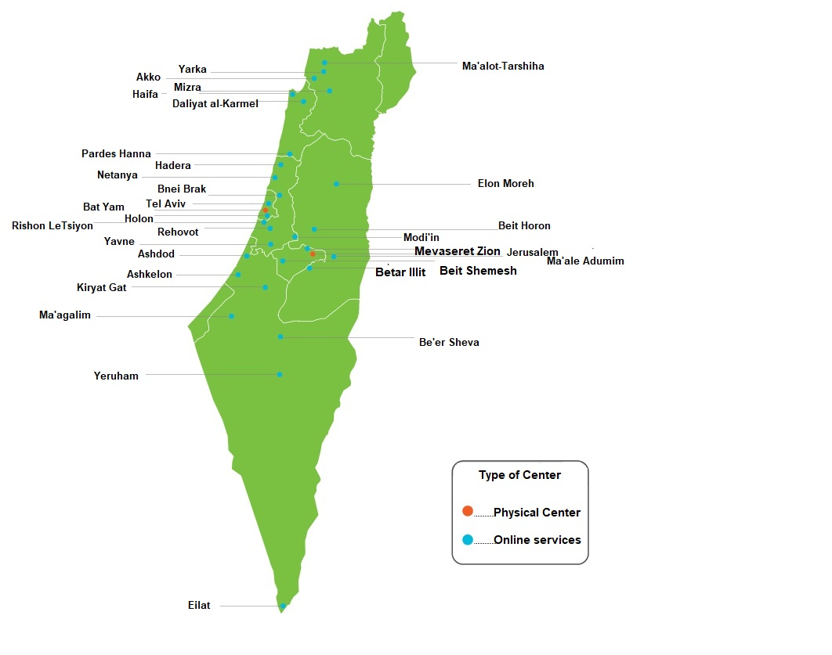

**Knowledge Development**

***Internal trainings for organizations***

Throughout the year, we were active in developing professional knowledge, training teams, conceptualizing the available information, and presenting it to the whole team. Four clinical instructors guide the treatment teams. Additionally, individual trainings were given to students in the therapeutic professions during their practicum, and to volunteers in the mentoring projects.

Alongside these professional training sessions, weekly group trainings were given to the staff members, with the aim of supporting their development and learning process, improving their practice, and expanding their familiarity with new realms of knowledge related to working with adolescents and young adults.

The training sessions offered during 2022 included training in various intervention models and tools adapted to work focused on adolescents and young adults, such as Acceptance and Commitment Therapy (ACT), Cognitive Behavioral Therapy (CBT), short-term therapy, working with victims of sexual abuse, healthy sexuality, addiction and the spectrum of substance use, and more.

**The Academic Headspace – An External Knowledge Source for Organizations**

As a source of professional and high-quality knowledge in the field of mental health for adolescents and young adults, we worked hard throughout the year to make this knowledge accessible in a way that is adapted to the target audience of youth in middle schools and high schools, pre-military preparatory schools, youth movements, national service year programs, and youth centers. At the same time, we conducted trainings and workshops for professional teams in educational, social, academic entities, and among delegations in Israel and abroad. As a recognized and authorized provider in the Geffen system of the Ministry of Education, we have developed six programs in accordance with local needs, making Headspace services available to youth throughout Israel, and supporting educational teams. We gave over 200 hours of workshops, trainings, and lectures on various topics, including: identifying signs of distress, providing first aid, body image and eating disorders, targeted treatment, non-violent communication, and more.

**What Do We Have Planned for the Coming Year?**

Over the next year, we will expand and develop innovative services, offered physically and virtually. We will begin using a kernel system for supporting caregivers and the patient-caregiver connection. We will open a Headspace center in Tel Aviv and a therapeutic unit in Jaffa, in cooperation with the local authority and the Yated program, to help adolescents and young adults deal with the challenges of their age and the spectrum of substance use. We will expand the Big Brother/Sister mentoring program. To further promote health, we will move into into more locations, offering open-door services, lectures, and workshops for the promotion of health, as part of our collaboration with the Israeli Center on Addiction.

**Headspace**

**We’re talking about what’s on your mind**