Research Report:

**Movement, Space, and Group Health (MSG) in a Confined Area**

David Michaeli

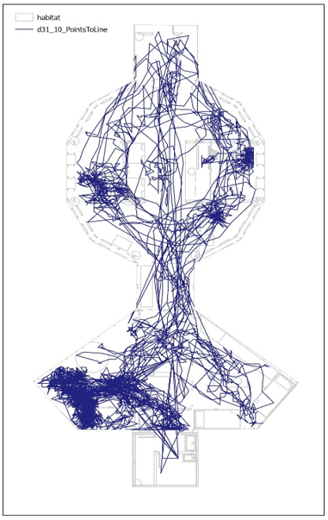

Paths:Points to Line. Example of a daily trajectory of JT tag, 31.10

Research Report

**Movement, Space, and Group Health in a Confined Area**

**Researchers:** David Michaeli, Yossi Friar Dror, Tomer Carmel, Hillel Rubinstein, Debi Sagi, Adi Nissim, Eli Israeli

**Consultants:** Liora Findler, Doron Aurbach, Yitzhak Brickner, Eli Geffen, Gal Yaffe, Dror Walk, Karin Bronman, Miroslav Rozluznik, Leon Nirnblat, Yael Zoran, Guy Ben David

**Editor:** Tamar Parosh

* Statistical analysis of data on basic feelings: Yossi Friar Dror, Tomer Carmel
* GIS statistical analysis of data on movement: Adi Ben-Nun, Israel Tauber, Eli Israeli
* Individual and group interviews about basic feelings: Debi Sagi, Adi Nissim

This study was approved by the ethics committee of the Weizmann Institute

The research was funded by the Field Studies Institute and David Michaeli

Souls act according to the laws of final causes, through appetitions, ends, and means. Bodies act according to the laws of efficient causes or of motions. And these two kingdoms, that of efficient causes and that of final causes, are in harmony with each other.

–Wilhelm Gottfried Leibniz[1]

Nevertheless social relations are frequently correlated with spatial relations, and hence are in a degree measurable.

–Robert Park[2]

Robust systems are stable, not because all components stay unchanged in the face of variable inputs – they don’t – but because the function or output of the system remains stable. To achieve this steadiness, the lower level components of a system must be in constant action – modifying their behaviour and interactions in response to environmental changes.

–Renée A. Duckworth[3]

Since measurement destroys the measured state, the mere measurement of a negative underlying feeling may constitute positive support.

–David Michaeli

**Abstract**

*Movement, Space, and Group Health in a Confined Area* (MSG) is an exploratory study carried out as part of an analog mission that simulated the conditions on Mars. It took place in the Ramon Crater (Makhtesh Ramon), Israel in October, 2021. This study examined the movements and basic feelings of six analog astronauts - five men and one woman - who stayed for 21 days in a 120 m2 closed structure (habitat). The starting premise for the study was that a human group may be studied as a physical system, and that tracking changes in team members’ movement and self-states throughout this time period enables understanding of the development of this system as a sequence of system states that change over time, and this will shed light on the system’s stability and rate of change.

The study combined quantitative and qualitative research methods. It measured group members’ movements using a radio signal tracking system. Their basic feelings were assessed through daily and weekly questionnaires and individual and group interviews before and after the mission. The research questions were: (1) Were there changes in the team members’ movement patterns while in the habitat space during this time period, and if so, what were they? (2) Were there changes in the team members’ patterns of basic feelings while in the habitat space during this time period, and if so, what were they? (3) Is there a connection between any changes in the movement patterns and changes in the basic feeling patterns, and if so, what is it?

The study found that there were indeed changes in the team members’ movement patterns in the habitat space during the mission period. The group members’ level of movement decreased between the first and last day of the mission. Over time, the group differentiated into two subgroups of three members each, one concentrated in the living space and the second in the operations space. Changes were also observed in the team members’ basic feelings during the time they were in the habitat space. The main change was a decrease in their level of positive feelings, starting from the second week. The question regarding a possible relationship between the decrease in the team members’ level of movement and the decrease in their level of positive feelings should be examined in future research. In a preliminary analysis of the interviews, we found that the very act of measuring basic feelings affected the self-state of each group member.

**Keywords:** group, physical system, space-state, self-state, movement, basic feelings

Table of Contents

1. Introduction
2. Description of the study
3. Research methods
4. Measuring movement
5. Measuring basic feelings
   1. Online visuals-based daily questionnaire
   2. Weekly text-based questionnaire
   3. Interviews
6. Results
   * 1. Movement during the 21 days
     2. Feelings assessed through the daily and weekly assessments
7. Results from the daily questionnaire
8. Results from the weekly questionnaire
9. Results from other research tools
10. Discussion and answers to the research questions
11. Questions for further analysis and discussion
    * + 1. Introduction

This text is essentially a philosophical experiment to test the potential correspondence between two conceptual systems, each of which has its own terminology and language. One conceptual system is the behavioural sciences; the second is quantum mechanics. The purpose is to define a human group as a quantum physical system, in order to open a gateway to studying the probabilistic measure of its various states over time.

* + - 1. Description of the study

The study entitled Movement, Space and Group Health (MSG) in a Confined Area is an exploratory study carried out as part of the AMADEE20 Mars Simulation project of the Austrian Space Forum (OeWF) in collaboration with the Israeli Space Agency (ISA). The project simulated the conditions for time spent in a research station on Mars. It was carried out in Israel’s Ramon Crater (Makhtesh Ramon) in October 2021. As part of the project, six analog astronauts (one woman and five men) from different countries stayed for 21 days in a 120 square meter enclosed structure (habitat). While there, they performed various tasks including research, maintenance, communication, eating, resting, and sleeping. Activities outside the simulated spacecraft (extravehicular activities or EVA) were not included in this experiment, and therefore no data was collected about them.

The basic premise of this work is that a group of people staying in a closed habitat comprises a physical system that exists in a given space, and its component parts move from point to point and change from one state to another. Defining the team members as a physical system characterized by its space-states seems legitimate because this group stayed in a closed space of 120 square meters, during which time they moved from point to point within this space, and changed from one type of movement to another, and from one self-state to another.

The main claim of this study is that monitoring changes in the team members’ movement and self-states throughout this period will enable better understanding of the system’s development as a sequence of system states that change over time. This will shed light on the stability and the nature of change in the system, as reflected in the system’s transition between different situations over time. Further, the system’s transition between various states indicates the existence of an operator, whose movements and self-states can be measured by:

* 1. Modelling the operator’s movement as a set of points representing time and location.
  2. Modelling the operator’s states as a set of points consisting of self-states, which in turn represent time and basic feelings.

From this, it follows that it is possible to characterize the entire system by:

* 1. Modelling changes in the system as a set of points indicating the operator’s movements, which indicate time and location.
  2. Modelling system changes as a collection of points indicating the operator’s self-states, which indicate time and basic feelings.

The innovations proposed by the research are:

* 1. Describing a group of people staying in a closed area as a physical system in space;
  2. Quantization of basic feeling-states among a group of people staying in a closed area.

The main research questions were:

* + 1. Were there changes in the team members’ movement patterns while in the habitat space during the mission period, and if so, what were they?
    2. Were there changes in the team members’ patterns of basic feelings while in the habitat space throughout the period, and if so, what are they?
    3. Is there a connection between any changes in the movement patterns and changes in the basic feeling patterns, and if so, what is it?

Another research question arose during the measurements and data analysis:

* + 1. Does the very measurement of basic personal feelings affect group behaviour, and if so, in what way?

The findings and conclusions are:

The data on movement showed changes in the group members’ movement patterns in the habitat space during the mission period. A decrease in the level of movement activity was observed. Also, the group split into two subgroups of three members each, one of which stayed mainly in the living space and the other in the operations space.

The data on basic feelings revealed changes in the group members’ basic feelings while in the habitat space throughout the mission period. Starting in the second week of the mission, the group members reported declining levels of positive feelings.

In a preliminary analysis of the six individual interviews with group members, we found that the very act of measuring basic feelings affected each person’ self-state.

* 1. Research Methods
     + 1. Measuring movement

For 21 days, the research followed the group’s movements. For this purpose, the system was defined as a space-state with six operators, in which operators’ states were measuring in time and space.

Sampling: The sampling observed the movements of the six operators in a closed space measuring 120 square meters. The sampling was conducted 24 hours a day for all 21 days.

Tools: The movements were measurement using a tracking system based on Ultra-Wideband (UWB) radio signals, which transmitted the participants’ movement data continuously, 24 hours a day, throughout the 21 days. The measurement data were collected using 17 permanent motion sensors, which were placed inside the habitat structure (see Figure 1). These sensors picked up signals from personal sensors worn by each of the six analog astronauts.

Procedure: The movement was sampled once per second in the active state, and once every sixty seconds in the resting state. No samples were taken during outdoor activities (EVA). The movement data for the six participants was saved in a separate Excel file for each day, yielding 21 files.

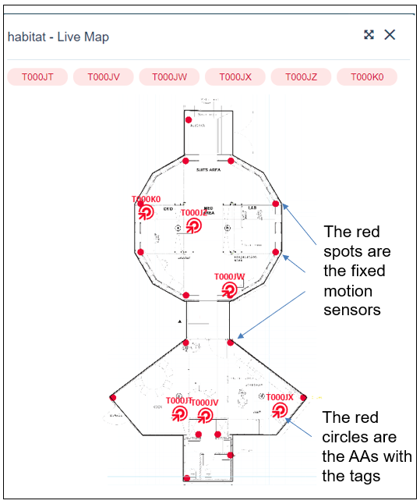

*Figure 1: The structure (the habitat) and location of the motion sensors inside it*

Statistical analysis of movement data using GIS software: a zero point for measurement was set in the building (the beginning of the axes). The building was then divided into 19 areas (see Figure 2).

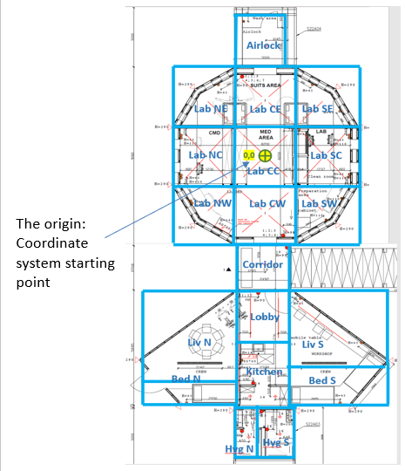

*Figure 2: Division of the building into 19 areas (marked in blue) and location of the beginning of the axes*

For the purpose of analysing the data using GIS software, five aspects of the group members’ movements were defined: 1. location; 2. density (crowdedness); 3. frequency; 4. proximity; 5. domain.

* 1. **Analysis of movement by location**: To analyse location, we defined areas where participants spent time. We identified the location that minimized the total Euclidean distance to features in a data set. The data analysis has not yet been performed.
  2. **Analysis of movement by density**: We defined seven degrees of density. The data analysis has not yet been performed.
  3. **Analysis of movement by frequency**: To calculate the frequency of use of the locations, we defined four levels of frequency between 0 and 1000, according to the number of samples in a 15-minute time period. A preliminary analysis of movement frequency was performed.
  4. **Analysis of movement by proximity**: To calculate proximity we defined five levels of meeting duration. We used a matrix of proximity, distance, and time between individuals meeting. The data analysis has not yet been performed.
  5. **Analysis of movement by domain**: To analyse domains, we used these methods:

1. Calculating a median position to identify the central point that indicates the dispersion of places where time was spent within the space.
2. Calculation using aggregation: where were most of the samples obtained in the space (time spent and movement through). The minimum sample threshold is determined according to the scale: the smaller the scale, the more detailed the aggregation.

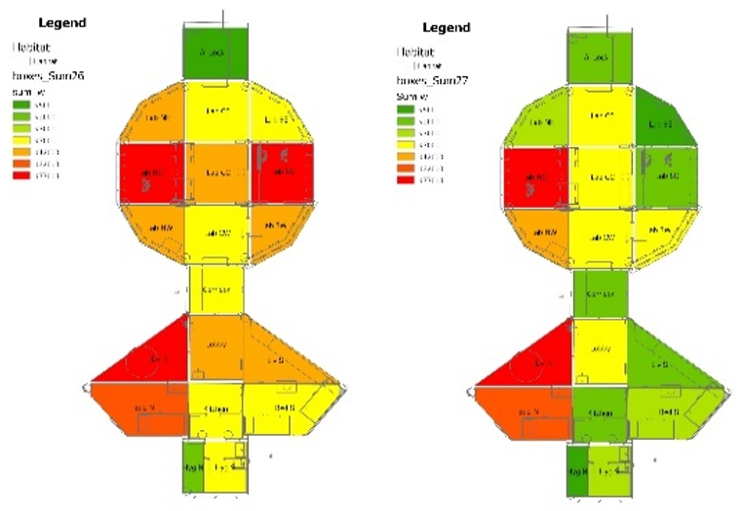

*Figure 3: Mapping using GIS software, level of use of the various areas on October 26 and 27, 2021 (days 16 and 17 of the 21-day mission)*

B. Measuring basic feelings

For 21 days, the research followed the group’s situation, as a system consisting of six operators with changing self-states. For this purpose, the system was defined as a space of self-states of the six operators, where the self-state of an operator was defined through nine basic feelings. The basic feelings were measured using a combination of several methods: an online visual daily questionnaire (see explanation below) filled out by each group member every morning, afternoon, and evening; an online weekly Likert-scale questionnaire filled out by each group member once every seven days; and personal and group interviews.

Online visual daily questionnaire

**Sampling**: The sampling included all six astronauts, and was done on all 21 days the astronauts stayed in the habitat. Each astronaut was asked to fill out the daily questionnaire three times a day during three time slots: morning (06:00-09:00), afternoon (12:00-15:00), and evening (18:00-21:00). Each completed questionnaire represents one time point from the mission’s time sequence (21 days), so that in total 63 samples were taken for each member and 378 samples for all six members (see photo no. 2). A total of 354 responses were received (89% response rate), as detailed in Table 1 and Table 2 below. Table 2 shows data from 24 days, including three trial days prior to the start of the mission on 21.10.21 (trial days are shown in the top row).

Table 1: Data on responses to the daily questionnaire - segmentation by dates

|  |  |  |  |
| --- | --- | --- | --- |
| Time | Responses (N) | % of maximum possible | Feelings reported on (N) |
| Morning | 112 | 85% | 336 |
| Afternoon | 116 | 88% | 348 |
| Evening | 126 | 95% | 378 |
| Total | 354 | 89% | 1,062 |

**

Key:

Yellow: completed in the morning

Orange: completed in the afternoon

Purple: completed in the evening

Blue with a + sign: positive feelings.

White with a - sign: negative feelings.

Unmarked white squares: technical interruptions in the system or activity

**Tool**: Three principles guided the construction of this questionnaire: 1. Binary measurement (positive/negative) of basic feelings; 2. Rapid, random completion to reduce biases; 3. Rapid, convenient completion to minimize disruption in the respondents’ schedule.

The questionnaire consisted of a page with nine squares, each containing a word and an emoji indicating a basic feeling (see Photo 1). Four of the nine feelings had a positive value: safe, good, focus, and connected, and five had a negative value: not safe, not good, no focus, disconnected, and difficulty. The responses to the visual questionnaire were given by choosing three of the nine squares in each completion round.

Procedure: The questionnaire was filled out online using an app. Each completion took between 3 and 10 seconds.

Photo 1: An online visual questionnaire with choices marked (in blue) representing three basic feelings: good, safe, focus

Statistical analyses: In order to examine differences in the frequency of feelings reported in the daily questionnaire, a chi-square test was performed. In order to examine weekly changes in the average number of positive feelings reported in the daily questionnaires, one-way ANOVA tests and post-hoc Least Significant Difference (LSD) tests were performed, where relevant.

To examine the differences in the frequency of the feelings reported in the daily questionnaire, we analysed the data using an Excel Spider (Radar) chart.

Calculation method:

1. The answers were divided into five measures, with two possible answers for each: yes/no or easy/difficult).
2. Yes = 1, No = -1-, lack of response = 0.
3. Average score for each measure was calculated for each group member over the entire period.
4. A standardized score was calculated by subtracting the group member’s average from the answer actually given (1, 0, -1). This is due to the fact that some group members gave the same answer almost all the time (all “good). A participant who gave the same answer all the time would have a standardized score close to 0. The standardized score of a participant who deviated from his/her norm would move away from zero, and the sign (+/-) indicates in which direction of deviation.
5. The resulting star charts show the average of the standardized scores on each dimension, i.e., how much the team deviated above (positive score) or below (negative score) their average reports.
6. To evaluate the responses beyond the common “all good” responses, we subtracted each answer from the average answer of that team member. The result expresses the degree to which the answer deviates from the norm, in either a positive or negative direction.

1. Leibniz (1989), p. 223.
2. Park. (1926), p. 1.
3. Duckworth (2020).