Research Report:

**Movement, Space, and Group Health (MSG) in a Confined Area**

David Michaeli

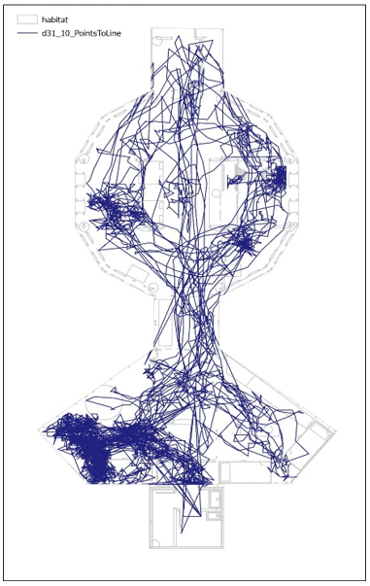

Paths:Points to Line. Example of a daily trajectory of JT tag, 31.10

Research Report

**Movement, Space, and Group Health in a Confined Area**

**Researchers:** David Michaeli, Yossi Freier Dror, Tomer Carmel, Hillel Rubinstein, Debi Sagi, Adi Nissim, Eli Israeli

**Consultants:** Liora Findler, Doron Aurbach, Yitzhak Brickner, Eli Geffen, Gal Yaffe, Dror Walk, Karin Bronman, Miroslav Rozluznik, Leon Nirnblat, Yael Zoran, Guy Ben David

**Editor:** Tamar Parosh

* Statistical analysis of data on basic feelings: Yossi Freier Dror, Tomer Carmel
* GIS statistical analysis of data on movement: Adi Ben-Nun, Israel Tauber, Eli Israeli
* Individual and group interviews about basic feelings: Debi Sagi, Adi Nissim

This study was approved by the ethics committee of the Weizmann Institute

The research was funded by the Field Studies Institute and David Michaeli

Souls act according to the laws of final causes, through appetitions, ends, and means. Bodies act according to the laws of efficient causes or of motions. And these two kingdoms, that of efficient causes and that of final causes, are in harmony with each other.

–Wilhelm Gottfried Leibniz[1]

Nevertheless social relations are frequently correlated with spatial relations, and hence are in a degree measurable.

–Robert Park[2]

Robust systems are stable, not because all components stay unchanged in the face of variable inputs – they don’t – but because the function or output of the system remains stable. To achieve this steadiness, the lower level components of a system must be in constant action – modifying their behaviour and interactions in response to environmental changes.

–Renée A. Duckworth[3]

Since measurement destroys the measured state, merely measuring a negative basic feeling may constitute positive support.

–David Michaeli

**Abstract**

Movement, Space, and Group Health in a Confined Area (MSG) is an exploratory study carried out as part of an analog mission that simulated conditions on Mars. It took place in the Ramon Crater (Makhtesh Ramon), Israel in October, 2021. This study examined the movements and basic feelings of six analog astronauts (five men and one woman) who stayed for 21 days in a 120 m2 enclosed structure (habitat). The starting premise for the current study is that a human group may be studied as a physical system. Tracking changes in team members’ movement and self-states throughout this time period can deepen understanding of the development of this system as a sequence of system-states that change over time. This is expected to shed light on the system’s stability and rate of change.

The study combined quantitative and qualitative research methods. It measured group members’ movements using a radio signal tracking system. Their basic feelings were assessed through daily and weekly questionnaires and individual and group interviews before and after the mission. The research questions are: (1) Were there changes in the team members’ movement patterns while in the habitat space during this time period, and if so, what were they? (2) Were there changes in the team members’ patterns of basic feelings while in the habitat space during this time period, and if so, what were they? (3) Is there a connection between any changes in the movement patterns and changes in the basic feeling patterns, and if so, what is it?

The study found that there were indeed changes in the team members’ movement patterns in the habitat space during the mission period. The group members’ level of movement decreased between the first and last day of the mission. Over time, the group differentiated into two subgroups of three members each, one concentrated in the living space and the second in the operations space. Changes were also observed in the team members’ basic feelings during the time they were in the habitat space, primarily a decrease in their level of positivity in their feelings, starting from the second week. The question regarding a possible relationship between the decrease in the team members’ level of movement and the decrease in their level of positive feelings will be examined through continued data analysis. In a preliminary analysis of the interviews, we found that the very act of measuring basic feelings affected the self-state of each group member.

**Keywords:** group, physical system, space-state, self-state, movement, basic feelings

Table of Contents

1. Introduction
2. Description of the study
3. Research methods
4. Measuring movement
5. Measuring basic feelings
   1. Online daily visual questionnaire
   2. Weekly textual questionnaire
   3. Interviews
6. Results
   * 1. Movement during the 21 days
     2. Feelings measured through daily and weekly assessments
7. Results from the daily questionnaires
8. Results from the weekly questionnaires
9. Results from other research tools
10. Discussion and answers to the research questions
11. Questions for further analysis and discussion
    * + 1. Introduction

This monograph reports on what is essentially a philosophical experiment testing the potential correspondence between two conceptual systems, each with its own terminology and language. One conceptual system is the behavioural sciences, the second is quantum mechanics. The purpose is to define a human group as a quantum physical system, in order to open a gateway to studying the probabilistic measure of its various states over time.

* + - 1. Description of the study

The study entitled Movement, Space and Group Health (MSG) in a Confined Area is an exploratory study carried out as part of the AMADEE20 project conducted by the Austrian Space Forum (OeWF) in collaboration with the Israeli Space Agency (ISA). The project simulated conditions in a research station on Mars. It was carried out in the Ramon Crater (Makhtesh Ramon) in Israel, in October, 2021. As part of the project, six analog astronauts (one woman and five men) from different countries stayed for 21 days in a 120 m2 enclosed structure (habitat). While there, they performed various tasks including research, maintenance, communication, eating, resting, and sleeping. Activities outside the simulated spacecraft (extravehicular activities or EVA) were not included in this part of the current study, and therefore no data was collected about them.

The basic premise of this research is that a group of people staying in a confined habitat comprises a physical system existing in a given space, and its component parts move from point to point and change from one state to another. These members of this team may be defined as a physical system characterized by its space-states because they stayed in a confined area measuring 120 m2, during which time they moved from point to point and changed from one type of movement to another, and from one self-state to another.

The main claim of this study is that monitoring changes in the team members’ movements and self-states throughout this period will enable better understanding of the system’s development as a sequence of system-states that change over time. This will shed light on the stability and the nature of change in the system, as reflected in the system’s transition between different situations over time. Further, the system’s transition between various states indicates the existence of operators, whose movements and self-states can be measured by:

* 1. Sampling the operators’ movements and representing them as time and location points.
  2. Sampling the operators’ self-states, which represent time and basic feelings, and representing them as points.

From this, it follows that it is possible to characterize the entire system by:

* 1. Modelling changes in the system as a set of points indicating the operators’ movements, which indicate time and location.
  2. Modelling system changes as a collection of points indicating the operator’s self-states, which indicate time and basic feelings.

The innovations proposed by the research are:

* 1. Describing a group of people staying in a confined area as a physical system in space;
  2. Quantization of basic feeling-states among a group of people staying in a confined area.

The main research questions were:

* + 1. Were there changes in the team members’ movement patterns while in the habitat space during the mission period, and if so, what were they?
    2. Were there changes in the team members’ patterns of basic feelings while in the habitat space throughout the mission period, and if so, what are they?
    3. Is there a connection between any changes in the movement patterns and changes in the basic feeling patterns, and if so, what is it?

Another research question arose during the measurements and data analysis:

* + 1. Does the very measurement of basic personal feelings affect group behaviour, and if so, in what way?

The findings and conclusions are:

The data on movement showed changes in the group members’ movement patterns in the habitat space during the mission period. A decrease in the level of movement activity was observed. Also, the group split into two subgroups of three members each, one of which stayed mainly in the living space and the other in the operations space.

The data on basic feelings revealed changes in the group members’ basic feelings while in the habitat space throughout the mission period. Starting in the second week of the mission, the group members reported declining levels of positive feelings.

A preliminary analysis of the individual interviews with the six group members revealed that the very act of measuring basic feelings affected each person’s self-state.

* 1. **Research methods**
     + 1. Measuring movement

The research followed the group members’ movements for 21 days. For this purpose, the system was defined as a space-state with six operators, whose states were measured in time and space.

**Sampling**: The movements of the six operators in the confined area measuring 120 m2 were observed 24 hours a day for all 21 days.

**Tools**: Their movements were measured using a tracking system based on Ultra-Wideband (UWB) radio signals, which transmitted the participants’ movement data continuously, 24 hours a day, throughout the 21 days. Data were collected using 17 permanent motion sensors placed inside the habitat structure (see Figure 1). These sensors picked up signals from personal sensors worn by each of the six analog astronauts.

**Procedure**: Their movements was sampled once per second in the active state, and once every sixty seconds in the resting (static) state. No samples were taken during outdoor activities (EVA). The movement data for the six participants were saved in separate Excel files for each day, yielding 21 files.

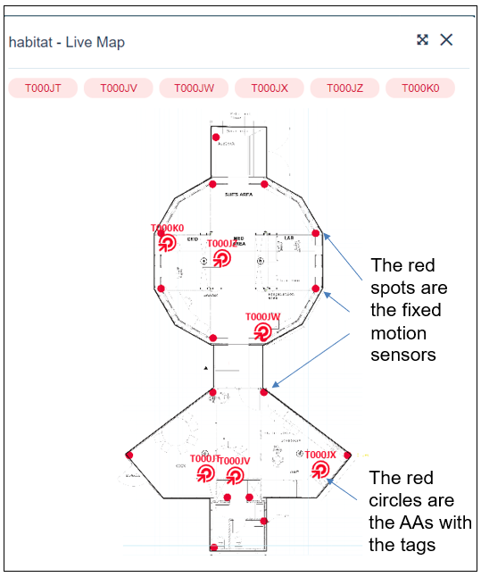

*Figure 1: The structure (the habitat) and location of the motion sensors inside it*

**Statistical analysis of movement data using GIS software**: A zero point for measurement in the building (the axes starting point) was set. The building was then divided into 19 areas (see Figure 2).

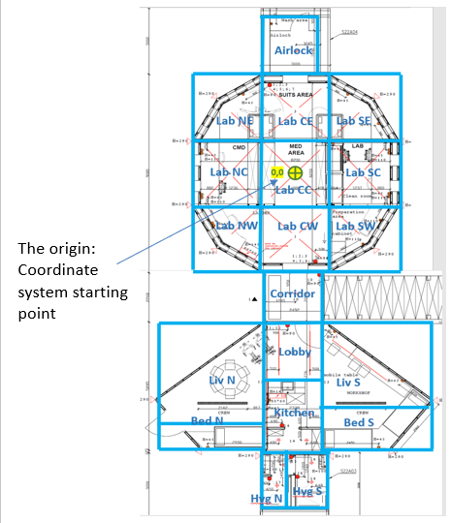

*Figure 2: Division of the building into 19 areas (marked in blue) and location of the axes starting point*

For the purpose of analysing the data using GIS software, five aspects of the group members’ movements were defined: 1. location; 2. density (crowdedness); 3. frequency; 4. proximity; 5. domain.

* 1. **Analysis of movement by location**: We defined areas where participants spent time and identified the location that minimized the total Euclidean distance to features in a data set. This data analysis has not yet been performed.
  2. **Analysis of movement by density**: We defined seven degrees of density. The data analysis has not yet been performed.
  3. **Analysis of movement by frequency**: We defined four levels of frequency between 0 and 1000, according to the number of samples taken in a 15-minute time period. A preliminary analysis of movement frequency has been performed.
  4. **Analysis of movement by proximity**: We defined five aspects of meeting times and created a matrix of proximity, distance, and time between individuals meeting. The data analysis has not yet been performed.
  5. **Analysis of movement by domain**:

1. A median position was calculated to identify the central point indicating the dispersion of places where operators spent time within the space.
2. Calculation using aggregation: where were most of the samples in the space were obtained (places where time was spent or moved through). The minimum sample threshold is determined according to the scale: the smaller the scale, the more detailed the aggregation.

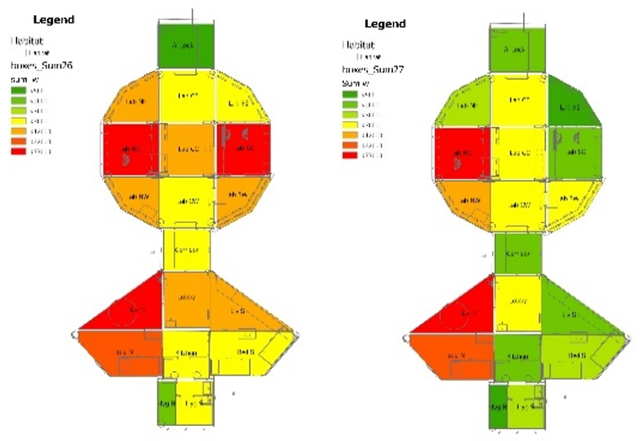

*Figure 3: Mapping using GIS software, level of use of the various areas on October 26 and 27, 2021 (days 16 and 17 of the 21-day mission)*

B. **Measuring basic feelings**

For 21 days, the research followed the group as a system consisting of six operators with changing self-states. For this purpose, the system was defined as a space of self-states of the six operators, where the self-state of an operator was defined through nine basic feelings. The basic feelings were measured using a combination of several methods: an online visual questionnaire completed by each group member every morning, afternoon, and evening; an online weekly Likert-scale questionnaire filled out by each group member once every seven days; and personal and group interviews.

**Online daily visual questionnaire**

**Sampling**: The sampling included all six astronauts, and was done on all 21 days they stayed in the habitat. Each astronaut was asked to complete this questionnaire three times each day: morning (06:00-09:00), afternoon (12:00-15:00), and evening (18:00-21:00). Each completed questionnaire represents one point in the mission’s time duration (21 days), so that a total of 63 samples were taken for each team member and a total of 378 samples for all six members (see Table 2). A total of 354 responses were received (89% response rate), as detailed in Table 1 and Table 2 below.

Table 1: Data on responses to the daily questionnaire - segmentation by dates

|  |  |  |  |
| --- | --- | --- | --- |
| Time | Responses (N) | % of maximum possible | Feelings reported on (N) |
| Morning | 112 | 85% | 336 |
| Afternoon | 116 | 88% | 348 |
| Evening | 126 | 95% | 378 |
| Total | 354 | 89% | 1,062 |

Table 2 shows data from 24 days, including three trial days prior to the start of the mission on 21.10.21 (trial days are shown in the top row).

Table 2: Cumulative reports on the daily basic feelings reported by the six mission participants

|  |  |
| --- | --- |
|  | Key:  **Yellow**: completed in the morning  **Orange**: completed in the afternoon  **Purple**: completed in the evening  **Blue with + sign**: positive feelings.  **White with - sign**: negative feelings.  **White with no marking**: technical interruptions in the system or activity |

**Tool**: The questionnaire was constructed based on three guiding principles: 1. Binary measurement (positive/negative) of basic feelings; 2. Rapid, random completion to reduce biases; 3. Rapid, convenient completion to minimize disruption in the respondents’ schedule.

The questionnaire consisted of a screen with nine squares, each containing a word and an emoji indicating a basic feeling (see Photo 1). Four of the nine feelings had a positive value: Safe, Good, Focus, and Connected, and five had a negative value: Not Safe, Not Good, No Focus, Disconnected, and Difficult. The responses to the visual questionnaire were given by choosing three of the nine squares in each completion round.

**Procedure**: The questionnaire was filled out through an online application. Each completion took between 3 and 10 seconds.

*Photo 1: Online visual questionnaire representing basic feelings with choices marked (in blue) representing: Good, Safe, Focus*

**Statistical analyses**: To examine differences in the frequency of feelings reported in the daily questionnaire, a chi-square test was performed. To examine weekly changes in the average number of positive feelings reported in the daily questionnaires, one-way ANOVA tests and post-hoc Least Significant Difference (LSD) tests were performed, where relevant.

To examine the differences in the frequency of the feelings reported in the daily questionnaire, we analysed the data using an Excel Spider (Radar) chart, using the following calculation method:

1. The questions were divided into five measures, with two possible answers for each: yes/no or easy/difficult).
2. Yes = 1, No = -1-, lack of response = 0.
3. The average score for each measure was calculated for each group member over the entire period.
4. A standardized score was calculated by subtracting the group member’s average from the answer given (1, 0, -1). This was done because some group members gave the same answer virtually every time (all positive). A participant who gave the same answer every time would have a standardized score close to 0. The standardized score of a participant who deviated from his/her norm would move away from zero, and the sign (+/-) indicates in which direction of deviation.
5. The resulting spider charts show the average of the standardized scores on each dimension, i.e., how much the team deviated above (positive score) or below (negative score) their average reports.
6. To evaluate the responses beyond the common “all good” responses, we subtracted each answer from that team member’s average answer. The result expresses the degree to which the answer deviates from the norm, in either a positive or negative direction.

**Online weekly textual questionnaire**

**Sampling**: The sampling included all six astronauts, and was done at the end of each week. The astronauts were asked to refer only to the past week when filling out the questionnaire. 18 responses were received (100% return rate).

**Tool**: This questionnaire was constructed based on the principle of matching the same positive and negative basic feelings as were measured in the daily questionnaire. The weekly questionnaire included 35 questions, representing seven areas: Confidence, Focus, Interest, Difficulty, Commitment, Group comfort & belonging, and Group shared tasks.

**Procedure**: The questionnaire was completed through an online application. Each questionnaire completion took between 7 and 10 minutes.

**Statistical analyses**: To examine differences between the weekly average scores for feelings as reported in this questionnaire, an ANOVA test for repeated measures and post-hoc LSD tests were performed where relevant.

**Online weekly visual questionnaire**

**Sampling:** The sampling included all six astronauts, and was done at the end of each week. The astronauts were asked to refer only to the past week when filling out the questionnaire. 18 responses were received (100% return).

**Tool:** The purpose of this questionnaire was to obtain a weekly snapshot of the participants’ perceptions of the social group structure and of their personal position within that group structure. Each participant was asked to choose one array out of nine possibilities, and to mark where s/he was located in the chosen array. The weekly visual questionnaire was combined with the weekly textual questionnaire (see Photo 2).

**Procedure:** The questionnaire was filled out through an online application. Each questionnaire completion took about 20 seconds.

**Statistical analyses:** No analysis has yet been performed.

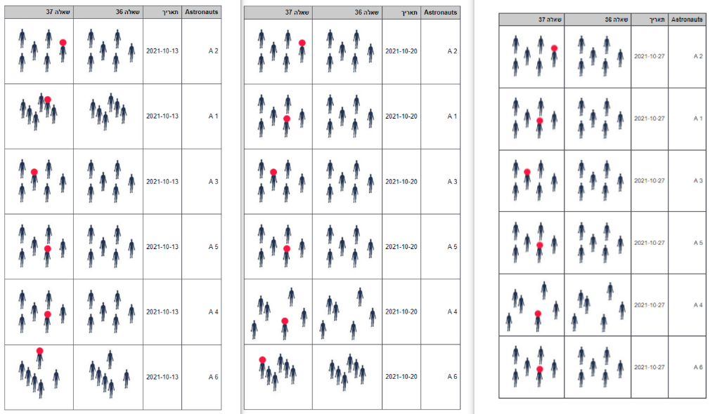

*Photo 2: Screenshot of compilation of responses of the six participants (A1-A6) to the online weekly visual questionnaire, with their choices of the group formations and individual positions within these group formations.*

*Dates of questionnaire completion, from left to right: 13.10.21; 20.10.21; 27.10.21.*

**Interviews**

**Group interview before the mission**

**Sampling:** The sampling included all six astronauts, and was done on the evening of the start of the mission.

**Tool:** Semi-structured interview and open conversation.

**Procedure:** Face-to-face conversation.

**Statistical analyses:** no analysis has yet been performed

**Personal interview before the mission**

**Sampling:** The sampling included all six astronauts. The interviews were conducted the day prior to the start of the mission.

**Tool:** Semi-structured interview and open conversation.

**Procedure:** Face-to-face conversation.

**Statistical analyses:** No analysis has yet been performed.

**Group interview after the mission**

**Sampling:** The sampling included all six astronauts, and was done one month after the end of the mission.

**Tool:** Semi-structured interview and open conversation.

**Procedure:** Online interview.

**Statistical analyses:** No analysis has yet been performed.

**Personal interviews after the mission**

**Sampling:** The sampling included all six astronauts. The interviews were conducted one month after the end of the mission.

**Tool:** Semi-structured interview and open conversation.

**Procedure:** Online interview

**Statistical analyses:** No analysis has yet been performed

* 1. **Results**

Measuring personal movement and basic sensations yielded two data bases for analysis. One contained the personal movement data for the six astronauts over the 21 days of the mission. The second contained 354 responses regarding basic sensations from the six astronauts over the 21 days. With these two databases, we were able to analyse development of the system over time, its stability, and the rate of change in the group as a system.

**A**. **Results from movement data over the 21 days**

We used an aggregation calculation at a scale of 1:50 meter to assess where in the space most of the samplings for time spent in one place and movement through places were received for the six group members during the 21 days. We found that:

1. It is possible to identify a differentiation of two subgroups with three members each. One subgroup was concentrated in the living space and one subgroup was concentrated in the operation space.
2. Among the three members in each subgroup, a distribution of three levels of sample numbers was found: High (more than 100,000 samples for one member); Medium: (between 50,000 and 100,000 samples for the second member); Low: less than 50,000 samples for the third member. See Figure 4.
3. The average percentages were calculated for the level of movement activity samples for the six astronauts throughout the 21 days. This showed a 44.3% decrease in the level of movement activity between the first day and the last day. See Figure 5.

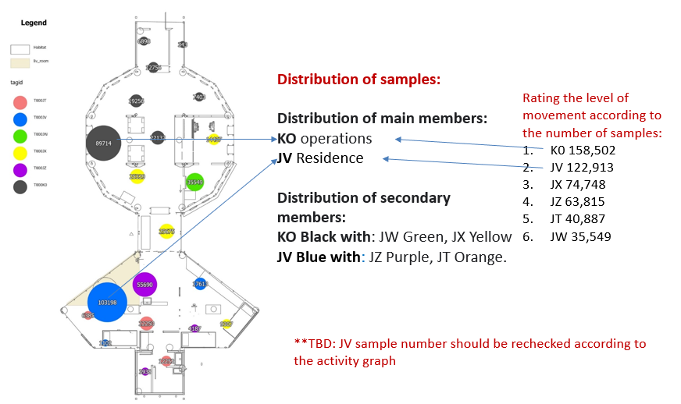

*Figure 4: Differentiation of the astronauts into two groups, with three levels of sample numbers (aggregation calculation)*

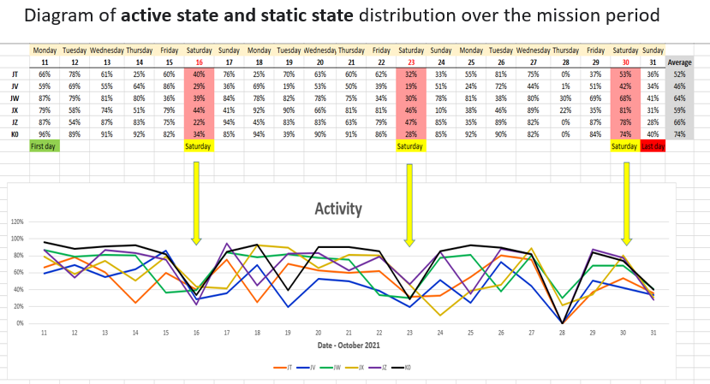

*Figure 5: Distribution diagram of active and static states throughout the mission period. The average percentages of the movement activity level sampled from the participants throughout the 21 days was calculated.*

**B. Results from basic feelings data from the daily and weekly questionnaires**

**Results from the daily questionnaire**

**Findings on feelings over the entire 21 days**

Throughout the period, the astronauts made 1,062 reports on their feelings. Of these, 826 (78%) were positive feelings and 236 (22%) were negative. The most common positive feelings were Good (selected in 78% of the total of 354 responses) and Safe (selected in 73% of the responses). The most common negative feeling was No Focus (selected in 30% of the responses). In fact, this is the only feeling for which the negative choice (No focus) was reported more often than the positive choice (Focus). Table 3 shows the frequency of reports on each feeling, as well as the percentage of responses in which that feeling was one of the three feelings selected.

Table 3: Frequency and percentages of the reported feeling throughout the 21 days

|  |  |
| --- | --- |
| N (%) | Feeling |
| 277 (78%) | Good |
| 27 (8%) | No Good |
| 260 (73%) | Safe |
| 5 (1%) | Not Safe |
| 196 (55%) | Connected |
| 38 (11%) | Disconnected |
| 93 (26%) | Focus |
| 105 (30%) | No Focus |
| 61 (17%) | Difficult |

**Findings for feelings at various times during the day**

Positive feelings were reported more often in the afternoon than in the morning and evening. At noon, an average of 2.5 (±0.74) positive feelings (out of three possible) were reported, compared to 2.2 (±0.95) in the morning and 2.3 (±0.96) in the evening [F(2, 351)[4] = 4.25, P < .05]. Similarly, it was found that Focus was reported more frequently in the afternoon as compared to morning and evening [χ2(1, 2) = 10.40, P < .01]. No other differences were found in the reporting of other feelings at various times during the day.

**Findings for feelings in the various weeks**

More positive feelings were reported in the first week, compared to the second and third weeks. In the first week, an average of 2.5 (±0.82) positive feelings (out of three possible) were reported, compared to only 2.3 (±0.88) in the second week and 2.2 (±0.96) in the third week, F(2, 351)[5] = 4.24, P = . 072, and after connecting the second week with the third t(143) = 2.24, P < .05.

In general, a gradual decline in positive feelings was found starting from the second week. Figure 6 shows the distribution of the frequency of positive and negative feelings throughout the period.

*Figure 6: Distribution of the frequency of positive and negative feelings throughout the 21 days[6]*

In particular, the feeling Focus was selected more frequently in the first week as compared to the second week and the third week. In the first week, Focus was reported in 36% of the cases, compared to only 23% in the second week and 21% in the last week, χ2(1, 2) = 7.45, P < .05 (Table 4). No significant differences were found in the reporting of other feelings between the weeks.

Table 4: Frequency and distribution of positive feelings, by week

|  |  |  |  |  |
| --- | --- | --- | --- | --- |
| Feeling/Week | **First week**  **N = 109** | **Second week**  **N = 113** | **Third week**  **N = 132** | **P-Value** |
| Good | 92 (84) | 81 (72) | 104 (79) | .070 |
| Safe | 87 (77) | 85 (75) | 91 (68) | .318 |
| Connected | 57 (52) | 66 (58) | 73 (55) | .657 |
| Focus | 39 (36) | 26 (23) | 28 (21) | .024 |
| Positive feelings M (SD) | 2.5 (0.82) | 2.3 (0.88) | 2.2 (0.96) | .072 |

**The findings from the daily questionnaire: Spider analysis**

To examine the differences in the frequency of the feelings reported in the daily questionnaire, we analysed the data using Excel Spider. Below are the findings of this analysis.

1. Group members tended to choose certain basic feelings consistently: they seldom selected Difficulty (shown in the figure below as Easiness). They said they felt Good and Safe. These answers are not very informative.
2. For group members, Connection and Focus were the most significant feelings. These two variables were found to be inversely correlated with each other: as one increased, the other decreased.
3. There were some very interesting peaks in the feeling of Connection on days 14 and 23. This should be compared with the daily work plan and the movement data.
4. The data for week 0 (blue) show that the group members started with a strong Focus and relatively low Confidence, and said they felt Good and Connected (Week 0 was a trial run before the start of the experiment during which five group members participated and partially completed the questionnaires). See Figure 7.
5. In the first week, all indices were significantly higher than the average. See Figures 8 and 9.
6. In the second week, there was a significant decrease in Focus and strengthening of the feeling Connection. See Figures 8 and 9.
7. In the third week, all indices were relatively low. See Figures 8 and 9.
8. As seen in Figure 9, there was significant daily fluctuation in the standardized reports. In contrast, the intra-group differences are smaller. In other words, group members’ reports tend to be relatively similar to each other.
9. Focus (green) dropped below average about halfway through the mission, and did not significantly rise again.
10. There is a fairly strong correlation between the feelings Wellbeing, Safe (security), and Easiness (lack of Difficulty).
11. The feeling of Connection fluctuated over time, with prominent peaks and drops on certain days, which returned to the normal state within a day or two.

*Figure 7: Spider analysis of the basic feelings by week*

*Figure 8: Spider analysis of the basic feelings by week. From left to right: Week 1 (red), Week 2 (green), Week 3 (purple)*

*Figure 9: Spider analysis of the six team members’ basic feelings throughout the 21 days*

**Findings from the weekly questionnaire**

The weekly questionnaire indicated an increase in the feeling of Confidence over the three weeks. At the end of the first week, the average score was 3.7 (±0.09), compared to 4.0 (±0.12) at the end of the second week and 4.0 (±0.11) at the end of the third week, F(2, 10) = 4.65, P < .05. Conversely, the feeling of Difficulty declined: in the first week the average score was 2.9 (±0.26), compared to 2.5 (±0.18) in the second week and 2.6 (±0.16) in the third week, F(2, 10) = 4.24, P < .05.

The feeling of Interest peaked at the end of the second week: average score 4.1 (±0.33), compared to 3.6 (±0.23) at the end of the first week and 3.3 (±0.24) at the end of the third week, F(2, 10) = 7.71, P < .01. In the post-hoc LSD test, a significant difference was found both between the first and second week (P < .05) and between the second week and the third week (P < .01).

A similar picture emerged regarding overall satisfaction, which reached a peak at the end of the second week, with an average score of 4.7 (±0.21) compared to 4.0 (±0.26) at the end of the first week and 4.2 (±0.31) at the end of the third week, F(2, 10) = 5.91, P < .05. The post-hoc LSD test only found a significant difference between the first and second week (P < .05).

No significant differences were found for the rest of the feelings during the three weeks. Table 5 shows the averages and standard deviations for the feelings as reported in the weekly questionnaire.

Table 5: Averages and standard deviations of feelings reported in the weekly questionnaires

|  |  |  |  |  |
| --- | --- | --- | --- | --- |
| Feeling/Week | **First week**  **N = 109** | **Second week**  **N = 113** | **Third week**  **N = 132** | **P-Value** |
| Confidence | 3.7 (0.09) | 4.0 (0.12) | 4.0 (0.11) | .037 |
| Focus | 4.1 (0.16) | 3.8 (0.11) | 4.2 (0.08) | .065 |
| Group comfort & belonging | 4.1 (0.16) | 4.1 (0.16) | 4.2 (0.15) | .590 |
| Group shared tasks | 4.6 (0.14) | 4.5 (0.17) | 4.7 (0.15) | .462 |
| Commitment | 4.3 (0.21) | 4.2 (0.26) | 3.9 (0.15) | .316 |
| Difficulty | 2.9 (0.26) | 2.5 (0.18) | 2.6 (0.16) | .046 |
| Interest | 3.6 (0.23) | 4.1 (0.33) | 3.3 (0.24) | .009 |
| Overall satisfaction | 4.0 (0.26) | 4.7 (0.21) | 4.2 (0.31) | .020 |

**Findings from other research tools**

We have not yet conducted systematic analysis of the data from the personal interviews, the group interviews, or the visual part of the weekly questionnaire that assessed the group structure and self-positioning within the group structure.

Below are some preliminary findings from the group interviews regarding using the online application:

* 1. Using the online application to complete the questionnaire was convenient, rapid, and unobtrusive.
  2. Filling out the daily online questionnaire via the app contributed to raising the group members’ awareness of their feelings.
  3. Filling out the daily online questionnaire contributed to raising the group members’ awareness of their fellow members’ feelings.

In all six interviews conducted at the end of the mission, the following points were raised:

* 1. Filling out the daily online questionnaire contributed to raising the group members’ awareness of their feelings.
  2. The group helped each other in times of crisis.
  3. After the mission, there was a change in the participants’ personal perspective.
  4. There were points of friction with the external control centre.
  5. The social role division that developed among the group members resembled a family model (father, mother, firstborn, middle, youngest).

**5. Discussion and Answers to the Research Questions**

The analyses that have been completed offer answers to the first two research questions. Additional analysis is also required to answer the third research question, as well as questions that arose during the research and data collection.

**Answer to research question 1:** Were there changes in the team members’ movement patterns while in the habitat space during this time period, and if so, what were they?

The movement data revealed that there were indeed changes in the team members’ movement in the habitat space during the mission period. In specific:

1. **Differentiation into two subgroups in two spaces**. We identified a differentiation of the group members into two subgroups of three members each. One group was concentrated in the living space and one group was concentrated in the operations space.
2. Similarity between the two subgroups in terms of the content and activity level. In each subgroup, a similar distribution of three levels of the number of samples taken in that subgroup’s preferred space was found: high (over 100,000 samples for one subgroup member), medium (between 50,000 and 100,000 samples for the second subgroup member), low (less than 50,000 samples for the third subgroup member).

**Answer to research question 2:** Were there changes in the team members’ patterns of basic feelings while in the habitat space during this time period, and if so, what were they?

The data revealed changes in the patterns of basic feelings among the team members in the habitat space throughout the period. In specific:

1. All group members showed inter- and intra-participant variability in their responses over time.
2. In the daily questionnaire on basic feelings, the most common response was selecting the three options: Good, Safe, Connected. This combination accounted for 31.1% of all responses.
3. Comfort, Confidence, and Connection decreased over time, while Concentration and Difficulty remained relatively unchanged.
4. Throughout the period, there was a notable decrease in the level of positivity. Throughout the mission period the reported feelings were mainly positive, but there was a decline starting from the second week.
5. Significantly more positive feelings were reported in the afternoon than in the morning. Feelings reported in the evening were in between the other two time slots.

**Answer to research question 3:** Is there a connection between any changes in the movement patterns and changes in the basic feeling patterns, and if so, what is it?

According to the movement data, there was a 44.3% decrease in the level of movement activity among the group members between the first day and the last day. According to the data on basic feelings, the level of positivity declined starting from the second week, and a decline in all the indicators of basic feelings in the third week. This indicates a correspondence between the team members’ decreased movement level during the mission and a decrease in the positivity of their basic feelings, as well as a decrease in the level of feelings they reported in general. In order to establish a possible correlation between these trends, data analysis must continue.

|  |  |
| --- | --- |
|  |  |

*Figure 10: Parallel between the trends of decreased movement among group members in the space (right) and decreasing level of positivity of their basic feelings (left)*

Recommendations for continued statistical analysis of the movement data:

* 1. Continue analysing the movement data for the aspects of: a. Location (the ratio of use between the residential area and the operations area); b. Frequency (cycles); c. Proximity; d. Density. Continued data analysis should be carried out using GIS software and MDS calculations.
  2. Assess the amount of static state (immobility) to understand whether this increased over time and if so, what was the rate of increase.

Recommendations for continued statistical analysis of the data on feelings:

* 1. Analyse the data on basic feelings reported by each operator by summing the averages of the triplets of values obtained (the three choices in each questionnaire completion) into one value.
  2. Calculate cumulative data analysis on the basic feelings reported by all six operators by summing the averages of the triplets of values obtained into one value.

Recommendations for continued statistical analysis of the relationship between the movement data and the feelings data:

* 1. On the basis of the quantitative data and the interview data, clarify a possible connection between the trend of decreased movement among the six group members throughout the 21 days and the trend of the decrease in the level and intensity of their positive feelings during that time period.
  2. **Questions for Further Analysis and Discussion**

The basic premise of this research is that a group of people staying in a habitat is a physical system that exists in space, moving from point to point, and from one situation to another. Since the members of this group lived in a confined space measuring 120 m2, moved from point to point within this space, changed from one state of movement to another and from one self-state to another throughout the period, it is possible to define them as a physical system characterized by its space-states. The space-state in this study was characterized through movement states and basic feeling-states as self-states of the operators.

The study is based on the assumption that changes in the team members’ movement patterns and self-states throughout the period show the system’s development over time, and that the system’s stability and rate of change could be characterized through a description of its transition between various states over time. Therefore:

* The **system’s space-state** was described through sampling the operators’ movements samples and basic feelings.
* **Measuring** the system’s space-states was carried out by measuring the operators’ movements and basic feelings.
* The system’s **development over time** was described through the changes in the operators’ movements and basic feelings throughout the period.

The findings revealed changes in the team members’ movement patterns in the habitat space and their basic feelings throughout the period. The level of movement activity decreased between the first day and the last. The level of positivity of basic feelings declined starting from the second week. In a preliminary analysis of the personal interviews, we found that the act of measuring the basic feelings affected the self-state of each member of the group.

Analysis of the findings raises several additional questions for research and discussion.

The findings from the movement data raise the following questions, concerning the description of the group as a physical system in space:

* 1. The differentiation of the group into two subgroups in two spaces raises the questions: Is this a pattern of development over time? Is this an indicator of stability? What is the rate of change in the group system over time?
  2. The differentiation into three activity levels among the members in each subgroup raises the questions: Is this a pattern of development over time? Is this an indicator of stability? What is the rate of change in the group system over time?
  3. The decline in the group’s activity level between the first day and the last raises the questions: Is this a pattern of development over time? Is this an indicator of stability? What is the rate of change in the group system over time?

The initial findings from the interviews raise the following questions, concerning the differentiation of the group into two subgroups:

1. Did the participants themselves notice the formation of two subgroups?

2. What was the basis for this differentiation?

3. Was there a clear common denominator for each subgroup?

4. Who was the dominant member in each subgroup? Were these the same two members who stayed more frequently in each of their respective spaces?

The data on basic feelings raise the following questions, concerning the description of the group as a system in space:

1. Is the decreased level of positivity throughout the period a pattern of development over time?
2. Is the decreased level of positivity throughout the period related to the stability of the system?
3. Is the decrease in the level of positivity throughout the period related to the rate of change in the system?
4. Is it possible to calculate the rate of change in the group system over time?
5. Is there a connection between the decreased level of positivity of the group members’ basic feelings and the decrease in their movement level?
6. Based on the findings from the interviews: Did the participants themselves describe a decrease in their feelings of positivity during the mission? How did they describe, in retrospect, their feelings and moods throughout the period?

Can measuring movements and basic feelings represent quantization (measured portions) of social group behaviours?

This study claims that:

* Changes in team members’ movement and self-states throughout the mission period will characterize the development of the system over time as a collection of changing system states;
* These changes characterize the stability and rate of change in the system by describing changes in the system between various states over time;
* Changes in the system between various states indicates the existence of an operator;
* It is possible to measure the movement and self-state of the operator by:
  + 1. Sampling the operators’ movements as a collection of points representing time and location;
    2. Sampling the operators’ states as a collection of points consisting of self-states, which in turn consist of time and basic feelings.

Therefore, according to the collected samples on the operators’ movements and self-states, the system-states can be measured by:

1. Sampling system change as a set of points indicating the operators’ movements, which consist of time and location.
2. Sampling system change as a collection of points indicating the operators’ self-states, which consist of time and basic feelings.

Since the findings revealed changes in the team members’ movements and self-states throughout the mission, this data may describe development of the system over time, as claimed. In light of this, sampling the system as points representing time and space, together with points representing time and basic feelings, as done in this experiment, can provide a proposed basis for the quantization and measurement of social group behaviour states as a physical system.

The findings regarding movement and basic feelings, therefore, raise a series of questions concerning the description of the system-states over time:

1. Is the system’s rate of change over a daily time period a pattern that will be replicated on the scale of a weekly time period?
2. Is the rate of change of the system over a daily time period a pattern that will be replicated on the scale of a 21-day period?
3. Is the rate of change of the system over a given period of time cyclical?

Given that measurements can be used to describe the social group’s behaviour states as a physical system, will it be possible to calculate changes in the system-states over time by using the wave function (state function) for the system? Can this calculation define the probability of the system being in a given state?

Trial runs of calculations must be performed using the wave function of the system in order to check the feasibility of reasonable results. If the results are reasonable, we can proceed to examine the probability of the system being in a given state.

According to the hypothesis that a group is a physical system, and according to the aforementioned findings, it is possible to ask:

1. Is it possible to measure the rate of change in the system using the three Lorenz differential equations?
2. Is it possible to describe the probability of a body’s movement from one point to another using Feynman’s path integrals?
3. Is it possible to characterize the system using the Hamiltonian (H) function, to calculate how the system will develop over time, and what its state will be at each moment?

Possible question for future research: Is there a relationship between heart rate variability (HRV) indicators and movement and feelings?

<https://link.springer.com/article/10.1023/A:1014866501535>

References

Duckworth, R. A. (2020). Catastrophes and Calms. *Aeon*, August issue.

Leibniz, G. W. (1989). *Philosophical Essays.* Edited and translated by Roger Ariew and Daniel Garber. Indianapolis: Hackett.

Park, R. E. (1926). The Concept of Position in Sociology. *Papers and Proceedings of the American Sociological Society, 20* (1926): 1-14

**Questionnaire on Perceptions and Feelings**

In regards to the past week alone, please mark to what extent you have felt each of the following. Please note that some of the questions are worded positively and others negatively.

[Answer scale: 1 – not at all; 2 – to a small extent; 3 – somewhat; 4 – to a large extent; 5 – very much]

**Security**

1. To what extent did you feel a sense of danger while performing the tasks?
2. To what extent did you feel stress or pressure while performing the tasks?
3. To what extent did you feel that the physical environment provided a sense of security while performing the tasks?
4. To what extent did you feel that the system provided a sense of security while performing the tasks?
5. To what extent did you feel that the people around you, the team, provided a sense of security while performing the tasks?
6. To what extent did you experience a sense of success in performing the tasks?
7. To what extent did you feel safe while performing the tasks?

**Focus**

1. To what extent did you feel that the tasks were clear to you?
2. To what extent did you feel you were getting lost in space?
3. To what extent did you feel you had a good grasp of time?
4. To what extent did you feel able to stay focused on the tasks?

**Group: Comfort and Belonging**

1. To what extent did you feel you had privacy when you wanted it?
2. To what extent did you feel part of the group?
3. To what extent did you feel comfortable with the group?
4. To what extent did you feel tension during meetings with the group members?
5. To what extent did you have trouble with the group?

**Group: Collaborating on Tasks**

1. To what extent did you experience friction with team members while performing the tasks?
2. To what extent did you experience friction with the team as a whole while performing the tasks?
3. To what extent did you feel comfortable asking team members for help while performing the tasks?
4. To what extent did you feel comfortable offering help to team members?
5. To what extent did you feel you wanted to perform the tasks with these people?

**Commitment**

1. To what extent did you identify with the goals of the general task (the project)?
2. To what extent did you feel the tasks were contributing to your development?
3. To what extent did you feel committed to the team?
4. To what extent did you feel committed to the tasks?

**Difficulties**

1. To what extent did you feel tired?
2. To what extent did you feel you needed to take a break from the tasks?
3. To what extent did you have trouble with the physical environment?
4. To what extent did you have trouble with the tasks?
5. To what extent did you have trouble with the timetables?  
   [Difficulty with the team belongs in the Comfort and Belonging section and therefore is not addressed here.]

**Interest**

1. To what extent did you feel the tasks were interesting?
2. To what extent did you feel the tasks were diverse (rather than routine)?
3. To what extent did you feel the tasks were challenging and brought out the best in you?
4. To what extent did you feel a sense of joy or positive emotion about performing the tasks?

**Overall experience**

1. To what extent are you satisfied with your participation in the project/task?

1. Leibniz (1989), p. 223.
2. Park. (1926), p. 1.
3. Duckworth (2020).
4. In the post-hoc test, the difference was found to be significant only between afternoon and morning
5. Trend only
6. Three days were taken out due to low return.