The Society for the Protection of Nature in Israel (SPNI), the largest and oldest environmental organization in Israel, has been active for 70 years in promoting the environment in Israel.

The SPNI wishes to notify the Rothschild Bank (N. M. Rothschild & Sons Limited) of a legal proceeding pending at Tel Aviv Magistrate’s Court (procedure number: TA 22-08-40859 *Society for the Protection of Nature in Israel v the Media Network*; a copy of the suit is attached to this letter).

Among other issues, this legal proceeding relates to claims raised in a journalistic investigation against the Rothschild Bank, and is liable to entail various legal determinations concerning the Bank and its operating methods.

Accordingly, it is important to us to update the relevant persons in the Bank regarding this proceeding and to discuss with them its potential ramifications for the Bank and its reputation in Israel.

In brief, the case involves an outrageous conspiracy theory broadcast in March 2022 under the guise of a journalistic investigation on a key television channel in Israel, alleging the following spurious claim ([link to the report](https://www.facebook.com/AnglersMeeting/videos/%D7%AA%D7%97%D7%A7%D7%99%D7%A8-%D7%94%D7%A6%D7%99%D7%A0%D7%95%D7%A8-%D7%94%D7%90%D7%9E%D7%AA-%D7%9E%D7%90%D7%97%D7%95%D7%A8%D7%99-%D7%94%D7%90%D7%A8%D7%92%D7%95%D7%A0%D7%99%D7%9D-%D7%94%D7%99%D7%A8%D7%95%D7%A7%D7%99%D7%9D-%D7%9E%D7%99-%D7%9E%D7%99%D7%9E%D7%9F-%D7%90%D7%AA-%D7%A7%D7%9E%D7%A4%D7%99%D7%99%D7%9F-%D7%94%D7%97%D7%91%D7%A8%D7%94-%D7%9C%D7%94%D7%92%D7%A0%D7%AA-%D7%94%D7%98%D7%91%D7%A2-%D7%97%D7%9C%D7%A7/1199467527549494/) – the references to the Bank begin at 1:50):

1. The Rothschild Bank served as a financial advisor to the Energean gas company, which is active in Israel and owns the Karish and Tanin gas reserves ([links to documents testifying to this fact](https://www.energean.com/media/2513/energean-oil-gas-plc-announcement-of-offer-price.pdf)).

2. Fishing activities in the Mediterranean Sea damage the interests of the gas companies – including Energean – due to the risk that shipping boats will damage the gas pipes.

3. The SPNI acted through a public campaign funded by Yad Hanadiv to impose strict regulation on fishing activities in Israel, against the background of the environmental damage fishing causes to the maritime environment.

4. The Rothschild Bank is the body that effectively stood behind the SPNI’s activities in this field. According to the report, the **Rothschild Bank** indirectly – through another branch of the Rothschild family (Yad Hanadiv) – funded an aggressive campaign by the SPNI that led to strict regulation of the fishing industry. It did so in order to advance the interests of its client Energean, which will benefit from the imposition of restrictions on fishing in the vicinity of its gas rigs and pipes.

In other words, according to the above-mentioned investigation, the Rothschild Bank actively funded activities of the SPNI, through Yad Hanadiv, with the goal of tarnishing the image of the fishing industry in public opinion and in government ministries and leading to the enactment of regulations which, under the guise of environmental protection, served the interests of the gas companies.

We are of course aware that these are entirely groundless allegations that are tantamount to grave libel against the SPNI, Yad Hanadiv, and also – and perhaps primarily – against the Rothschild Bank.

Among other allegations, the report explicitly stated:

**“It emerges that the Rothschild family and its Bank are serving as financial advisors for the Energean company, which owns the Tanin and Karish reserves; one branch of the family that funded the campaign served the financial interests of another branch involved in the gas business.”**

Screenshot from the report, including the Bank’s logo:

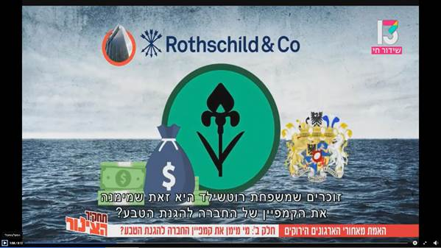

Following the broadcasting of the investigation, the SPNI submitted a suit for libel against the channel that broadcast the report.

As part of this claim, factual questions can be expected to arise concerning the involvement of the Rothschild Bank in the regulation of fishing in Israel, and concerning the allegation that the Bank indirectly funded the SPNI’s activities on this subject, through Yad Hanadiv. Accordingly, the court is liable to make factual and normative determinations concerning the Rothschild Bank, which is liable – Heaven forfend – to damage the Bank’s good name.

In light of the above, we will be pleased to meet with the relevant persons in the Rothschild Bank, to present the situation to them, and to discuss the subject with them. We propose this given the common interests of the Bank and the SPNI, which together were targets of wild and mendacious slurs by parties with their own interests.

We would be happy to forward any information or document as required and assist you with any question or clarification.