COURSE BOOK



## International Consumer Behavior

DLMBCBR01



Learning Objectives

##### Introduction 9



In a global economy characterized by increasingly greater competition, internationally operating companies need to develop comprehensive market-driven strategies to survive. To design such strategies, companies need to ﬁrst understand their markets and customers. Understanding the customers and their purchasing behavior is essential to developing an effective marketing strategy. **International Consumer Behavior** will explore how the study of consumers assists organizations in communicating with and targeting their customers effectively.

Throughout this course, you will learn about the purchasing process of consumers and the factors inﬂuencing their behavior. You will develop a deeper understanding of the psychological aspects impacting consumer decision-making. You will explore the decision-making processes occurring throughout the pre-purchase, purchase, and post-purchase stages. The course will explore internal inﬂuences on consumer behavior and the role of motivation, perception, and attitude as well as external inﬂuences such as culture, subculture, families, and groups. Examples regarding differences in cultural dimensions across various consumer groups will be provided and the role of social media on consumer behavior will be discussed in detail.

The course will use various case studies to demonstrate how consumer behavior should be considered in the development of the marketing mix and actively inform product, communication, pricing, and distribution strategies.



# Unit 1

## Consumer Behavior

#### STUDY GOALS

On completion of this unit, you will have learned …

… what consumer behavior is and what it comprises.

… what is involved in consumer decision-making.

… the relationship between consumer behavior and international marketing strategies.

DL-E-DLMBCBR01-U01

1. Consumer Behavior

### Case Study

In 2016, Google releases its contributions to the $400 billion smartphone hardware market: the Pixel smartphone and its larger sibling, the Pixel XL (Gurman, 2016). In a market dominated by Apple iPhones and numerous Android players such as Samsung, Google’s Pixel is potentially the ﬁrst real threat to the dominance of Apple’s iPhone. Google had previously ventured into the smartphone market with its co-branded Nexus devices; however, the Pixel represents a different approach for the company, which conceptualized, designed, engineered, and tested the products completely in-house. It is launched in September 2016 by Google along with a suite of compatible consumer devices including a home speaker system, a virtual reality headset, a Wi-Fi router system, and a video streaming stick under the slogan “#MadebyGoogle.” Google Pixel was attempting to outpace competitors with distinct features such as Google Assistant (its “intelligent” personal assistant), advanced camera technology, and Android’s newest operating system “Nougat.”

Maria is a recent MBA graduate looking to secure a graduate position with Google, specifically in the team responsible for overseeing the marketing strategy for the Pixel smartphone. She is preparing for her upcoming interview and decides that her best approach for standing out as a job applicant is to fully understand the market that Google is entering with the Pixel and how a potential consumer might react to this product. She creates a list of questions to answer in her research about consumer behavior:

* How is consumer behavior relevant for Google and Pixel?
* What exactly is consumer behavior as it relates to purchasing and using a smart- phone?
* How can the marketing management of the Pixel products be optimized by under- standing consumer behavior?
* How does the behavior of potential consumers of the Pixel products vary across different markets and how does this affect both the product and its marketing?

Similar questions were no doubt considered by Google long before the conception of the Pixel. Understanding consumer behavior is vital to the development and marketing of any product in today’s global market as consumer behavior and marketing management are inextricably linked. In this unit, we will provide answers to some of Maria’s questions by deﬁning consumer behavior and its components, exploring its relationship with international marketing, and looking at the complex processes involved in consumer decision-making.

### Consumer Behavior and International Marketing

We are all consumers. From what we eat for breakfast to where we sleep at night, we constantly make choices about our consumption of products and services. Consumer behavior is “the study of the processes involved when individuals or groups select, purchase, use, or dispose of products, services, ideas, or experiences to satisfy needs and desires” (Solomon, 2014, p. 6). Why consumers make the decisions they do, what internal and external factors inﬂuence these decisions, and how marketers utilize this information to sell products and services are all within the realm of research into consumer behavior.

Consider the following questions:

* + - Do consumers prefer to purchase a well-known brand of medication or a generic brand recommended by the pharmacist? Does this vary for different types of medicines? Does the price affect this type of consumer decision? Does this vary across different markets? What would make a consumer with a particular preference change their mind?
    - Which consumers prefer to add items to their Amazon shopping basket, and which would prefer to drive to their local shopping mall or walk to their local corner store? What circumstances would lead a consumer to change their preference?
    - Are consumers more likely to buy a book from the New York Times Best Seller List or a book recommended by a loved one? Which consumers will buy the Kindle version versus the print copy?
    - Which consumers prefer to eat a familiar Big Mac when traveling versus trying the local cuisine? Does it make a difference if the consumer has tried a similar type of cuisine before or read about it in their online travel guide? What about if the consumer is joined by a group of friends?
    - What are the most critical features consumers consider when purchasing a new mobile phone? The service coverage? The accessories? The battery life? The durability? How does the importance placed on such features vary across different markets?
    - When purchasing a new car, which of the following has the greatest inﬂuence on a consumer’s decision: the type of vehicle their neighbor/boss/father drives or a recent article in Forbes magazine about the most energy efﬁcient vehicle models?

The study of consumer behavior is multifaceted, exploring components of consumer decision-making; internal inﬂuences on consumer behavior such as emotions, attitudes, and perceptions; external inﬂuences on behavior such as culture, society, and groups; economics; and legal and regulatory frameworks as well as multiple processes involved in purchasing behavior. Understanding consumer behavior is ultimately about knowing why consumers make the decisions they do, how these decisions vary from one consumer to the next, and what inﬂuence marketing has on consumptive choices.

Consumer behavior inﬂuences the marketing activities of companies and vice versa. Understanding consumer behavior is critical for any company seeking to offer products or services in single or multiple markets. Companies need to understand how consumers behave, what motivates their purchases, what their expectations are, what Consumer Behavior Consumer behavior is the study of the processes involved when individuals or groups select, pur- chase, use, or dis- pose of products, services, ideas, or experiences to sat- isfy needs and desires.

factors inﬂuence their decision-making, how they use speciﬁc products and services, and what speciﬁc meaning they attach to their purchases. Knowledge about such aspects of consumer behavior is the basis for planning and implementing any marketing activities.

Let’s look at consumer behavior in practice. From the streets of Abu Dhabi to Zagreb, locals wear Levi’s jeans, eat at McDonald’s, talk on their iPhones, and drive Toyotas. These locals are often grouped into a single segment of global consumers, participants in a “global consumer culture.” Global consumer culture transcends both country and culture of origin. Much of the consumer behavior exhibited within this global culture is shaped by multinational corporations (MNCs) and their marketing activities. Yet it would be erroneous to assume that consumers and the products and services available to them did not differ across the globe. Local brands like Fulla, Mecca Cola, Jolibee, and Xiaomi are being developed everywhere in attempts to address the needs of speciﬁc sectors of consumers.

MNCs often vary their product offerings to ﬁt the local culture. McDonald’s products provide a good example of diversifying products to suit the preferences of consumers in different markets: “McChocolate potatoes” in Japan, “McHotDog Classic” in the Philippines, “McSpaghetti” in Singapore, “McRice Burger” in Malaysia, “Bubur Ayam” (chicken rice porridge) in Israel, “McFalafel” in the Middle East, “Pizza McPuff” in India, and “Laksi (salmon) wrap” in Finland. The differences between McDonald’s restaurants are certainly not limited to food products: in Sweden, you can ﬁnd a ski-through restaurant called “McSki” where skiers can pick up their meal as though moving through a regular drive-through; in Hong Kong, “McWeddingland” allows people to get married while enjoying a Happy Meal. McDonald’s is not the only MNC calibrating their products for locals: Starbucks offers a “red bean cream frappuccino” in South Korea, a “red bean green tea frappuccino” and “coffee jelly frappuccino” in Japan, while the “standard frappucino” and “expresso” are popular in the US. MNCs also adjust product size to match the market demand: the food portions served in Asia are generally smaller than those in the US, e.g., a serving of coffee in McDonald’s in Japan is approximately half the serving typically found in the US, while most countries outside of the US do not offer the standard free reﬁll on soft drinks or hot beverages.

What do these differences in products tell us about individual consumers? Do the individual needs of consumers dictate the offers from marketers? Does individual consumer behavior exist within a given group or society? We can start to answer this question by looking at the different macro-level factors that affect consumer behavior and, in turn, affect international marketing strategies. Consumers vary across countries in terms of their consumptive choices and decision-making processes largely due to differences in economic resources, institutional factors such as legal and regulatory frameworks at the country level, and the unique history and geography of a country or region. This is represented in the following ﬁgure.

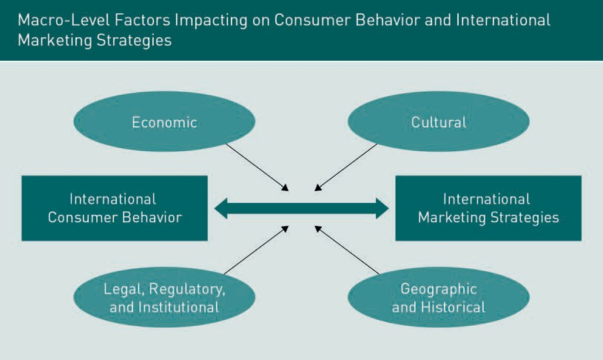

International marketing efforts can directly respond to some of the factors in the preceding ﬁgure to attempt to inﬂuence international consumer behavior. However, many aspects of these factors extend beyond the direct control of individual marketers. Let’s explore some of the factors in more detail.

Economic Factors

Economic differences around the world can be quantified by comparing the economic productivity of each nation as measured by gross domestic product adjusted for purchasing power parity (PPP). An excellent example of differences in purchasing power is reﬂected in the relative cost of a Big Mac around the world. The Economist’s Big Mac Index was developed in 1986 as an informal measure of what consumers in that country are willing to pay or able to afford for this universal burger and thus provides a price index of purchasing power parity or, simply, a measure of the standard of living in these countries (The Economist, 2017).

Purchasing power parity

Purchasing power parity is a measure of the relative value of a “basket of goods”; it can be used to estimate the value of a currency relative to its pur- chasing power.

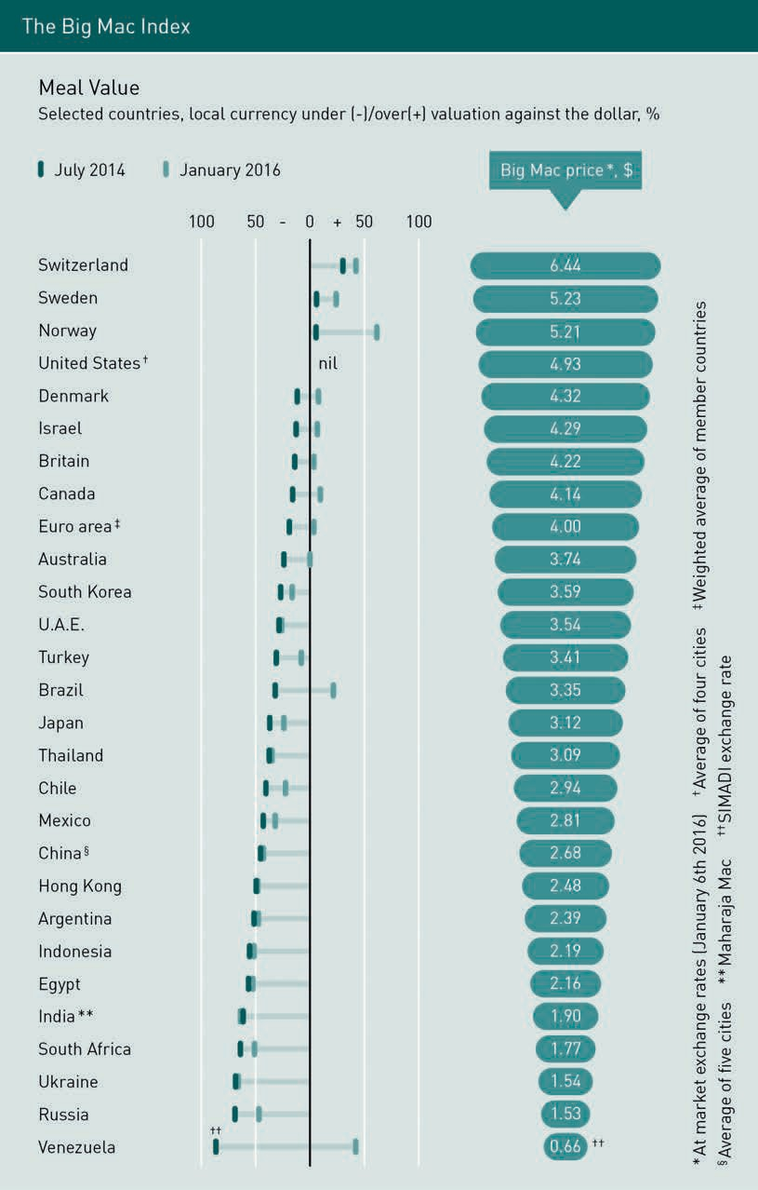

Cultural Factors

Another important factor is culture. Although a huge number of deﬁnitions for culture exist, for our purposes, we will deﬁne culture as “the complex whole that includes knowledge, beliefs, art, laws, morals, customs, and any other capabilities acquired by humans as members of society” (Mothersbaugh & Hawkins, 2016, p. 40). Consider Star- buck’s “red bean green tea frappuccino” offered in Japan. For a German consumer, this might taste peculiar and have an unfamiliar texture, but for many Japanese consumers, this type of drink could be considered delicious. In reverse, a German beer hall with its many local beers and spirits might be completely foreign to a Japanese consumer who may be more familiar with the consumption of rice wine. This is the nature of culture: one person’s preference is the result of their cultural inﬂuences.

Legal, Regulatory, and Institutional Factors

Besides calibrating product features to adjust to consumers’ tastes, MNCs often adjust the price of the same product offered in different markets because of differences in tax structures and distribution costs. For example, the price of an imported US vehicle in Singapore is twice that paid in the US because of heavy import taxes. Regulations play an important role in impacting how people consume products in various parts of the world. For example, varying regulations make Uber and Airbnb available in some countries but not in others. Telecommunication-related consumption provides another good example of differences in consumer behavior arising from variations in regulations. Many countries such as Japan, Thailand, the UK, Russia, and South Korea allow consumers to purchase local SIM cards for their mobile phones at a local convenience store such as 7-Eleven. However, some countries such as Morocco require a person to go to a telecom company and register for a SIM card by supplying personal identiﬁcation.

Another often neglected but equally important factor impacting global consumer behavior is the role of institutions. Institutions include established laws, practices, or customs, and can also refer to legal and regulatory issues. They can have a signiﬁcant impact on international marketing strategies and global consumer behavior. In the case of mobile phone SIM cards, purchasing requirements differ around the world: some countries require identiﬁcation and registration as part of the purchasing process while others do not. In the case of motor vehicles, a 2014 Toyota Corolla will cost approximately twice as much in Singapore than in the US because of an institutional difference: Singapore imposes a hefty tax on imported cars which is passed on to consumers in the purchase price.

Geographic and Historical Factors

The geography and history of a country or area can have a large impact on consumer behavior that neither international marketers nor consumers can directly control. Consumer culinary taste, for instance, is often a result of a country’s history. For example, Peruvian culinary tastes reﬂect the historical inﬂuence of Chinese immigration on their cooking style and choice of ingredients.

Culture

Culture is the com- plex whole that includes knowledge, beliefs, art, laws, morals, customs, and any other capabili- ties acquired by humans as members of society.

### Consumer Decision-Making in the Marketplace

The study of consumer behavior is an applied discipline. It involves the development of knowledge about the behavioral patterns of consumers that can be directly utilized for practical purposes. Three main applications for information regarding consumer behaviors are as follows (Mothersbaugh & Hawkins, 2016, p. 8):

Social marketing Social marketing is the application of marketing strategies and tactics to alter or create behaviors that have a positive effect on targeted individuals or society as a whole.

1. Marketers can utilize knowledge of consumer behavior to develop marketing strategies.
2. Policy makers can use information about consumer behavior to regulate markets with the intent to protect and aid consumers.
3. Researchers or practitioners in social marketing can utilize knowledge about consumer behavior to alter or create behaviors that have a positive effect on targeted individuals or society as a whole.

Knowledge about consumer behavior can be drawn from a wide range of disciplines. We can categorize such disciplines according to the focus of their inquiry, i.e., toward the individual (the micro perspective of consumer behavior) or toward society (the macro perspective of consumer behavior).

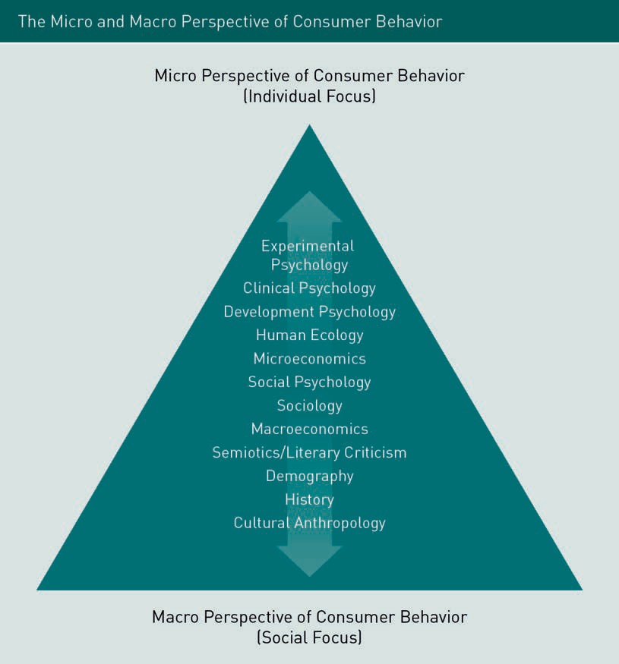

The micro perspective seeks to understand consumer behavior to solve the problems faced by an individual ﬁrm or organization and help the ﬁrm or organization accomplish its objectives. Advertising managers, product designers, sales coordinators, and others working in proﬁt-oriented businesses are interested in understanding consumers so that they can be more effective in their roles. Those working in various nonproﬁt organizations are no less interested in the behavior of consumers and beneﬁt greatly from such knowledge. United Way and American Red Cross are two examples of not-for-proﬁt companies that have been effective in applying knowledge of consumer behavior to enhance their charitable business activities.

The macro perspective entails applying knowledge of consumer behavior to problems faced by larger groups or by that of an entire society. It is an approach adopted by pol- icy makers and social marketers. On the macro level, economic and social conditions shape consumer preferences and habits and at the same time, consumers shape a society’s culture. In a free market-based system where individual choices are emphasized, consumers strongly inﬂuence production. As a result, under such a system, consumers impact and shape the quality and standard of living of a society. Thus, understanding consumer behavior from a macro perspective can provide insight into the economic and social composition of a society.

###### Components of Consumer Behavior

Consumer behavior is a complex phenomenon that results from an interaction between consumer decision-making, various internal and external inﬂuences on consumer behavior, and the context in which consumer behavior occurs. We can thus divide consumer behavior into multiple components represented in the following ﬁgure.

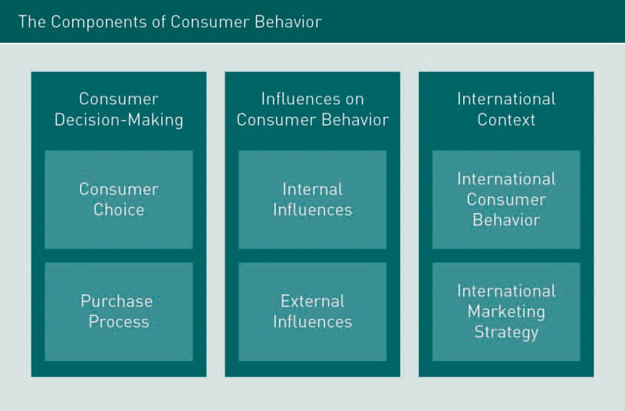

Let’s look at each of these six components in more detail.

* Consumer choice: This component refers to the choices made by consumers regarding which products are purchased, from which brands, via which vendors, and when these purchases are made. Decision-making is quite straightforward in one sense as consumers essentially have three options: buy, don’t buy, or buy later. The time that it takes to make decisions related to purchases can take seconds, days, or weeks depending on the product.
* Purchase process: This process can be divided into three phases: pre-purchase, purchase, and post-purchase, which can involve a small number of simple decisions versus multiple complex and interconnected decisions.
  + Internal inﬂuences: This component considers consumers as individuals and includes factors such as individual learning, values, self-concept, memory, emotions, perception, personality, attitudes, motivation, and other factors typically associated with personal psychology.
  + External inﬂuences: This component looks at inﬂuences from social groups, media, and marketers, and draws from the ﬁelds of sociology, social psychology, and demography. External inﬂuences include demographics, reference groups and families, social status, culture and subculture, and marketing activities.
  + International consumers: This component encompasses cross-cultural differences, macroeconomics, history, global consumer culture, and nationalism.
  + International marketing strategy: This component looks at whether a company is seeking to standardize, localize, or “glocalize” products and services.

###### Consumer Behavior and Marketing Management

A sound understanding of consumer behavior is the cornerstone of all marketing management activities. Marketing management is deﬁned as the process of setting marketing goals for an organization, considering internal resources and market opportunities, planning and executing activities to meet these goals, and then measuring progress toward their achievement. The process of marketing management should be “ongoing and repetitive (as within a planning cycle) so that the organization can continuously respond to internal and external changes that create new problems and opportunities” (Marketing Dictionary, 2017a).

One of the major goals of marketing management is to continuously satisfy consumers’ wants and needs. Identifying the desires and requirements of customers and then ensuring that the products and services provided address these desires and requirements is a primary task of marketing. As consumers’ wants and needs can be extensive, ﬁrms need to concentrate on satisfying a small proportion of consumer desires by effectively utilizing resources (i.e., time, budget, and capabilities). Without a thorough understanding of consumer behavior, firms can’t anticipate and react to customers’ needs, wants, and desires.

At the core of customer satisfaction is value. To be successful, a company must ask: “Does the product or service that we offer provide more value than the same product or service offered by competitors?” Importantly, ﬁrms must evaluate “value” from the customers’ perspective. Customer value propositions are “the total sum of beneﬁts that a customer is promised to receive in return for his or her patronage and the associated payment or other value transfer” (Marketing Dictionary, 2017b). In other words, customers view value according to what is promised by a product or service offered by a company and evaluate whether such a promise is fulﬁlled by the delivery of the product or service.

Example

Let’s look at the components of consumer behavior and the corresponding response by marketing management. Anaya is a twenty-three-year-old female from London purchasing a pair of Ray-Ban sunglasses. We will look brieﬂy at four components of

Glocalize

To glocalize (global- ize + localize) is to adapt international products to a spe- ciﬁc local culture.

Marketing manage- ment

Marketing manage- ment is the process of setting marketing goals for an organi- zation, considering internal resources and market opportu- nities, planning and executing activities to meet these goals, and then measuring progress toward their achievement.

Customer value propositions Customer value propositions are the total sum of beneﬁts that a customer is promised to receive in return for his or her patronage and the associated pay- ment.

consumer behavior: 1) consumer choice, 2) the consumer purchasing process, 3) internal inﬂuences on the consumer, and 4) external inﬂuences on the consumer. For each of these components, we will look at the corresponding response of Ray-Ban regarding its marketing management.

Consumer Choice

* + - Consumer Behavior
      * Anaya can choose from a multitude of sunglasses brands available from different retailers.
      * The import duties and sales taxes will affect the price of Ray-Bans in different countries.
      * Anaya is intending to attend several music festivals over the summer and con- siders new prescription sunglasses both a necessity and a fashion accessory.
    - Marketing Management
      * Marketers need to offer products or services that are competitive in multiple markets. Customers must ﬁnd value in their products and the product must meet a need or a desire.
      * Ray-Ban sells a large range of sunglasses and is constantly changing the catalog of products they offer.
      * Ray-Ban has entered the prescription sunglasses market, which in 2015, accounted for 30 % of their revenue (Wahba, 2016).
      * Ray-Ban has promoted the brand as a contemporary fashion accessory, and it is a well-recognized brand name worldwide.

Purchasing Process

* + - Consumer Behavior
      * Pre-purchase: Anaya seeks information such as warranty, polarization of the lenses, and frame durability directly from the retailer, Ray-Ban website, and from various fashion blogs that she regularly reads.
      * Purchase: Anaya can choose to purchase sunglasses from a Ray-Ban ﬂagship store, a sunglasses retailer, or online via the Ray-Ban website.
      * Post-purchase: Anaya is unsure about her purchase and is not satisﬁed with the look of the sunglasses and investigates the free returns via the online shop.
    - Marketing Management
      * Marketers need to present information to potential consumers and provide sup- port throughout the purchase process to customers.
      * Ray-Bans are sold via multiple different channels, across many countries worldwide.
      * Ray-Ban has a website that offers consumers online purchasing, personalization of sunglasses, a “virtual mirror” where consumers can “try on” sunglasses using their camera, information about the product components, and information about delivery and their returns policy.

Internal Inﬂuences

* + - Consumer Behavior
* Anaya considers Ray-Bans to be a stylish brand that produces good-quality eyewear.
* Anaya considers the purchase of Ray-Ban prescription sunglasses to be a luxury purchase and is therefore less concerned with the monetary value of the purchase and more interested in the aesthetic value of the product.
  + Marketing Management
* The marketer can appeal to consumers’ emotions by linking their product with a certain lifestyle and promoting the brand according to consumer needs, i.e., being fashionable.
* Ray-Ban has produced advertising campaigns that feature young, vibrant people enjoying various leisure activities.
* Ray-Ban offers personalized products, allowing consumers to customize their frames, materials, and styles in a tool known as “Re-Mix.”

External Inﬂuences

* + Consumer Behavior
* Anaya follows several fashion bloggers on Instagram who post pictures of themselves with different Ray-Bans.
* Anaya’s parents do not place a high value on fashion and do not spend over 20 GBP on their sunglasses, but they do recommend that Anaya gets prescription sunglasses.
* Anaya’s best friend is traveling to visit family in India and offers to purchase a cheap, non-genuine version of Anaya’s preferred Ray-Ban sunglasses.
  + Marketing Management
* Marketers need to identify the groups that inﬂuence consumers (i.e., cultural, familial, and friendship) and craft messages that indirectly inﬂuence consumers.
* Ray-Ban sponsors posts by popular Instagrammers.
* Ray-Ban has cultivated an image of luxury by being sold in high-end stores.
* Ray-Ban parent company Luxottica has launched GLOW (a tracing system that uses RFID technology) and allows customers to report fakes online.

As you can see from this example, consumer behavior directly inﬂuences marketing management and vice versa. It is easy to see here why the two are considered inextricable.

###### Case Study: Uniqlo

In a blog post in 2014, branding expert David Aakar attributed the widespread success of the global clothing brand Uniqlo to its strategy of providing “made-for-all”, innovative, high-quality, and performance-enhanced products at the lowest prices. The Japanese clothing designer, manufacturer, and retailer has made some critical decisions that have facilitated its rapid international growth and retail success; at the time of writing, Uniqlo has 1,400 stores in 16 countries (Wikipedia, 2016).

Let’s look at the components of consumer behavior and marketing management as they relate to Uniqlo. At this point, if you are not already familiar with the Uniqlo concept, it would be useful to visit a Uniqlo store in person or visit one of their online stores to answer some of the following questions:

* + How was the in-store layout relative to your product search? If you visited the online store, how easy or difﬁcult was it to search for a product?
  + If you visited the store and purchased something, what was your experience of the purchase process? Were the store employees helpful? What was your experience of the online purchase process? Did any features of the website aid your decision- making?
  + What is your impression of the brand? Do you have any emotional attachment to the brand? Do you have friends or family members who wear Uniqlo clothes?
  + What is your perception of the value that Uniqlo products represent? Are you/would you be comfortable wearing their brand? Why or why not? How do/would others perceive you when wearing the Uniqlo brand?

The aim of this exercise is for you to have an experience of connecting consumer behavior to marketing management. It is important to realize that our experience as a consumer in the marketplace is shaped by both our own unique experiences and influences on our purchasing patterns and by marketing efforts that seek to shape our experience and create favorable internal and external inﬂuences on us as consumers. We will now attempt to explore some of the factors impacting your experience and decision-making at Uniqlo using some hypothetical examples.

Experience of Decision-making as a Consumer

Let’s consider your experience as a consumer. Imagine you are at a Uniqlo store in Manhattan, New York. You see the latest seasonal offering: a lightweight down vest. You already own a heavier down vest that you bought last year from Marks and Spencer. Should you buy a new one this year? If so, what color? You try on a navy one which ﬁts nicely. The price is half of the Muji brand which you just tried on half an hour ago. However, H&M has a similar one that is 25% cheaper but is of a lower quality. You pick up the vest and move toward the cash register. The queue has ten customers waiting to be served and only one service assistant. It is Sunday afternoon. You do not feel like queuing for an unknown length of time. Do you proceed with the purchase?

Internal and External Inﬂuences on Consumer Experience

Imagine that before ever visiting a Uniqlo store or shopping online, you discussed the clothing range with one of your closest friends who a) loves the brand and wears a lot of their products, or b) dislikes the brand and scoffs at others wearing it. Does your friend’s attitude toward the brand inﬂuence your decision to buy Uniqlo products? If your father already wears a Uniqlo down jacket and has worn it for several seasons without it looking worn or being damaged, will this impact your decision to buy a Uniqlo item? What value does the brand represent to you? What about the group of friends you hang out with who mostly wear H&M? Will their preferences impact yours? What if they see you shopping at Uniqlo?

Impact of Uniqlo’s Marketing on Consumer Decision-making

Uniqlo aims to create products that can be differentiated from its competitors. The owner of Uniqlo, Tadashi Yanai, wants to surpass Zara as the top private-label clothing retailer in the world (Aakar, 2014). In line with this vision, Uniqlo has developed its unique HeatTech, Lifewear, and AIRism products and created products that are fashion- able but not necessarily trendy. The brand’s down jackets have become symbolic of the brand. Uniqlo products are priced very competitively, higher than H&M but lower than Muji and comparable to Zara. You will ﬁnd Uniqlo stores strategically positioned near these competitors. Uniqlo management trains its staff members to provide outstanding in-store customer service, aiming to reﬂect “kaizen”: the Japanese concept of perfection, using speciﬁcally designed phrases and speciﬁc policies regarding customer interaction (Davis, 2014).

Impact of Uniqlo’s Marketing on Internal and External Inﬂuences on Consumer Experience

Uniqlo has a ﬁrmly established reputation in Asia, evidenced by the huge number of stores in Japan and nearby countries. It has employed celebrities and social media inﬂuencers such as musician Pharrell Williams, fashion editor Carine Roitfeld, and Irish designer Orla Kiely to create limited edition collections to create a contemporary image (Sarma, 2015). The company has focused on “fabric over fashion,” developing a reputation for high-quality garments that are wearable beyond fashion trends. Uniqlo has built a social media presence using Facebook, Twitter, and Google+ in the US and UK but largely engaged with Chinese consumers using Renren, a social networking platform popular with Chinese students. It has a large online as well as retail presence.

Summary

Consumer behavior is the processes involved when individuals or groups select, purchase, use, or dispose of products, services, ideas, or experiences to satisfy needs and desires. Studying consumer behavior requires that marketers explore components of consumer decision-making; internal inﬂuences on consumer behavior such as emotions, attitudes, and perceptions; external inﬂuences on behavior such as culture, society, and groups; economics; and legal and regulatory frameworks as well as the multiple processes involved in purchasing behavior. Companies need to understand how consumers behave, what motivates their purchases, what their expectations are, what factors inﬂuence their decision-making, how they use specific products and services, and what speciﬁc meaning they attach to their purchases. Knowledge about such aspects of consumer behavior is the basis for planning and implementing any marketing activities.

Consumers vary across countries in terms of their consumptive choices and decision-making processes largely due to differences in economic resources and institutional factors such as legal and regulatory frameworks at the country level as well as the unique history and geography of a country and region. It is important to realize that our experience as a consumer in the marketplace is shaped by both our marketing



# Unit 2

## The Consumer Decision-Making Process

#### STUDY GOALS

On completion of this unit, you will have learned …

… what inﬂuences pre-purchase decision-making.

… what omnichannel purchase behavior is.

… what affects post-purchase satisfaction and why.

… why consumer decision-making is not always rational.

DL-E-DLMBCBR01-U02

1. The Consumer Decision-Making Process

### Case Study

Maria, an MBA graduate, is preparing for her interview with the marketing team responsible for marketing the Pixel, Google’s new smartphone. She knows that it is essential to understand the consumer decision-making process to understand and explain why a consumer would select the Google Pixel over an Apple iPhone or a Samsung Galaxy. She breaks the consumer decision-making process into three steps: the pre-purchase, purchase, and post-purchase stages. She tries to develop a picture of what different potential consumers might experience in each of these stages. She develops a list of questions for each stage.

The Pre-Purchase Stage:

* How do consumers know about the Pixel?
* Where do they get their information from?
* What features of Pixel would they ﬁnd most attractive?
* How would they evaluate the features of Pixel compared to other phones?
* How easy is it to use the Pixel compared to other phones?
* What is the reaction of consumers to the price of the Pixel compared to other phones?

The Purchase Stage:

* Where can consumers purchase the Pixel?
* Can the Pixel be purchased online or from a retail location?
* Is the Pixel immediately available or is it ordered into stores following each purchase?
* Is there ﬁnancing available for the phone?
* Are there associated data plans and preferred service carriers?

The Post-Purchase Stage:

* Does the performance of Pixel meet customers’ expectations?
* How satisﬁed are customers with the speciﬁc features of the Pixel?
* Do the expectations created by mass media and promotional materials match the experience of consumers?
* How satisﬁed are the customers with Pixel compared to their previous phones?
* If customers are not satisﬁed, do retailers or online stores offer return policies? Are there avenues available for consumers to provide feedback to Google?
* Are there after-sales support mechanisms for the Pixel?
* Are there online communities to support users of the Pixel?

Maria’s questions are the types of questions that a company would typically ask when trying to understand the purchasing behavior of its potential consumers. Ultimately companies want to optimize as many factors as possible in the pre-purchase, purchase,

and post-purchase stages to increase sales and build customer loyalty. The following ﬁgure illustrates these stages and some of the sub-processes involved in each. We will explore each of these stages throughout this unit.

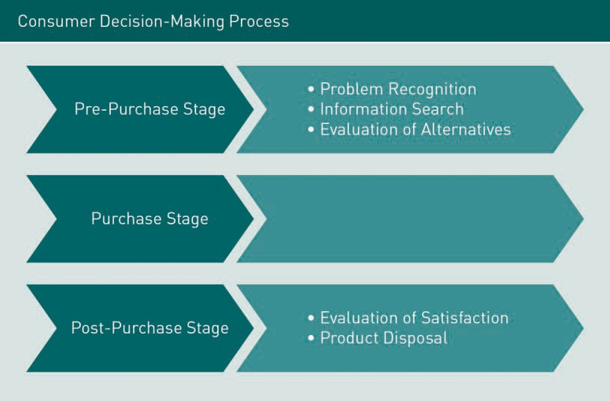

### The Pre-Purchase Stage

Decision-making often implies a complex and detailed process of deliberation: researching, scrutinizing, and evaluating all available options, mentally negotiating between choices, and then justifying the ﬁnal decision. Some forms of decision-making do indeed follow such a structure—consider the process of buying your last vehicle and the multitude of factors that you took into consideration when making this purchase. However, many decisions follow an opposite structure. Some forms of consumer decision-making are, in fact, so routine that they occur almost automatically and require very little attention, effort, or conscious processing. The process of making decisions and acting without conscious thought is referred to as automaticity.

The concept of automaticity was ﬁrst proposed by American social psychologist John Bargh following his research on automatic, non-conscious processing of information and related behavior. A classic example of automatic decision-making for most people is the decision to purchase fuel for their vehicle. While some consumers will conduct regular research to locate the cheapest available fuel, for most consumers, this process involves going to the same fuel station on their regular route, swiping their credit card, and ﬁlling their car with fuel with very little contemplation of the consumer process. This simple decision-making results in what is known as a low-involvement purchase.

Automaticity Automaticity is the process of making decisions without conscious thought, resulting from learn- ing, repetition, and practice.

Purchase involve-

ment Purchase involve- ment is the level of concern for or inter- est in the purchase process triggered by the need to consider a particular pur-

chase.

Contrast this type of decision-making with the process of buying an apartment. When contemplating such a purchase, most consumers would spend much more time and effort considering prices, location, convenience, proximity to workplaces and schools, neighborhood, investment potential, distance to relatives, etc. before reaching a decision. This is an example of a high-involvement purchase. Purchase involvement is the level of concern for or interest in the purchase process, triggered by the need to consider a purchase. Purchase involvement, of course, varies with everyone but is generally correlated with the perceived cost of the decision and the frequency with which a consumer makes this type of purchasing decision. The following ﬁgure illustrates the relationship between cost and frequency and purchase involvement.

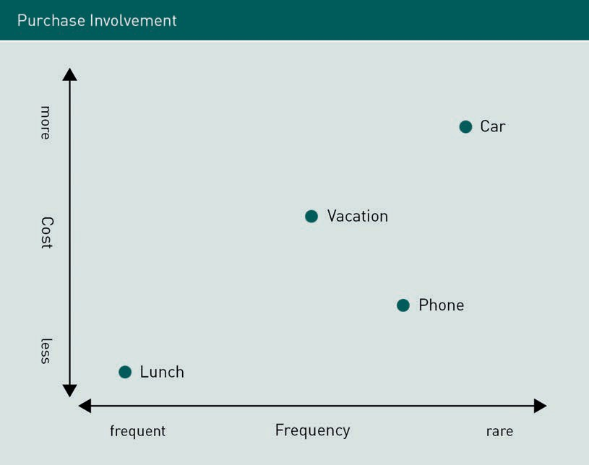

Low-cost, high-frequency purchases such as buying lunch involve a low level of purchase involvement whereas purchases that are infrequent such as buying a car involve a high level of purchase involvement. Purchase involvement is fundamental in the pre-purchase stage of a consumer purchase as it affects each of the three steps involved in this stage: a) problem recognition, b) information search, and c) evaluation of alternatives.

###### Problem Recognition

The ﬁrst step in the consumer decision-making process is problem recognition. Problem recognition results from a discrepancy between an actual state and a desired state that is sufﬁcient to arouse and activate the decision-making process. An actual state is what an individual perceives his or her feelings and situation to currently be whereas a desired state is what an individual wants to currently feel or be.

Let’s look at the example of Lee. Lee realizes that the following Friday will be a public holiday and that he doesn’t want to be alone or unoccupied for the entire long week- end. He treats this as a problem because his anticipated actual state (being bored and alone) is different from his desired state (being pleasantly occupied with company). He then contemplates whether to go on a short camping trip with his work colleagues, visit family in another state, or ask a friend to help him repaint his apartment. However, if Lee had been extremely stressed at work and was busy attending multiple functions with potential business clients, his desired state for the upcoming long weekend could be to remain unoccupied and free of social engagements. In this alternate set of circumstances, there would be no discrepancy between his anticipated actual state and his desired state; with no difference between his actual and desired states, Lee does not have to make a decision regarding his long weekend. In summary, if a consumer does not recognize that there is a problem, there is no need for them to make a decision.

It is important to note that there is no objective actual or desired state that drives problem recognition; Lee’s actual and desired states in both scenarios are entirely subjective. How one perceives their actual state or identiﬁes their desired state is dependent on the internal workings of that individual’s perception of reality, self-concept, and lifestyle.

Problem recognition is the ﬁrst and most important step in the buying process; it precedes the subsequent consumer-initiated transactional activities of information searching and evaluating alternatives. Simply put, if there is no problem, there is no need, and thus no purchase.

Problem recognition is usually preceded by an event or series of events that initiate thoughts about the purchase of a product or service. In the example of Lee, the preceding event was a long weekend, leading him to contemplate the purchase of camping equipment (for a camping trip with his colleagues), a plane ticket (for an interstate family visit), or painting equipment (to repaint his apartment). In general, three types of events lead to problem recognition (Mittal, 2008):

Problem recognition Problem recognition results from a dis- crepancy between an actual state and a desired state that is sufﬁcient to arouse and activate the decision-making process.

Actual state

An actual state is what an individual perceives his or her feelings and situa- tion to be at the present time.

Desired state

A desired state is what an individual wants to feel or be at the present time.

Variety-seeking

behavior Variety-seeking behavior occurs when a consumer switches products out of boredom or curiosity rather than dissatisfaction with a product or service.

Information search Information search is the process by which we survey the environment for appropriate data to make a reasonable

decision.

Internal search Internal search takes place as we scan our memory banks to assemble informa- tion about different product alternatives.

1. Stock depletion: When required or desired goods or services are reduced or exhausted, we encounter a problem. Identifying that your car is low in fuel, discovering that your insurance policy is about to expire, and realizing that you don’t have any Christmas presents for your family members are examples of stock depletion leading to problem recognition.
2. Changes in life stage: New problems arise with new life conditions. A newly single divorcee may suddenly be in the market for a new apartment. An adolescent reaching the legal drinking age can purchase alcohol and develop drinking preferences. A new job may warrant the purchase of a new uniform.
3. Development of new preferences: Consumers have values and tastes that inﬂuence their purchasing patterns. But these are by no means static and unchanging. Preferences change over time in response to speciﬁc antecedents but also in response to variety-seeking behavior. Research has found that consumers can become bored with certain foods such as cereal or pretzels, not necessarily because of any issues with the brands, but simply because they wish to have a different sensory experience (Hebb, 1955; Leuba, 1955). This can even occur when a consumer is very satisﬁed with a product.

###### Information Search

Information search is the process by which we survey the environment for appropriate data to make a reasonable decision (Solomon, 2014). Once a problem or need has been identiﬁed, the consumer must then seek information about possible solutions that will solve that problem or satisfy that need. Typically, the consumer will search for more or less information depending upon the complexity of the choices that have to be made to make the purchase. For instance, selecting a meal from a restaurant menu is far less complex and requires considerably less information than choosing a new car or a house. We will discuss three main search strategies here: a) internal search, b) external search, and c) ongoing search.

Internal Search

An information search usually begins with an internal search of one’s long-term memory to assemble information already known about different product alternatives. An internal search seeks to answer questions such as:

1. Do I already know of a satisfactory solution to this problem?
2. What are the characteristics of any potential solutions?
3. What methods can I use to compare potential solutions?

Information that is internal to the consumer generally provides the starting point to search for answers to solve the problem. For example, when seeking information to inform the purchase of a new laptop, you might ﬁrst scan your memory about previous experiences with speciﬁc brands. Internal information is often sufﬁcient for simple, everyday purchase decisions but major decisions, because of the inherent uncertainty regarding their outcome, require considerably more information and necessitate more extensive consideration of external sources of information.

Regarding our case study with Maria, a potential consumer might consider the following in their internal search for information about the Pixel:

* + previous experiences with different mobile phones and plans
  + advertising from various media sources
  + past conversations with family and friends regarding mobile phones and Google.

External Search

An external search comprises seeking information from multiple sources including independent sources, personal sources, and/or marketing-based information. A popular source of external information is word-of-mouth (WOM), which is information about a product or brand provided by acquaintances or strangers either face-to-face or online (eWOM). The relationship that a consumer has with the provider of WOM information can mediate its inﬂuence on consumers: typically, WOM information from close acquaintances is assigned greater value than WOM from strangers. However, consumers are increasingly gleaning information from other consumers via online reviews and recommendations, which can have a powerful inﬂuence on consumption patterns. For example, inclusion on the New York Times bestseller list or Oprah’s Book Club (leading to what is known as the “Oprah effect”) can dramatically increase the sale of books (Krakovsky, 2004).

External information can come from a variety of sources including content from media, e.g., advertising, reviews, and product/brand websites. It should come as no surprise that non-marketer sources of product information are viewed more credibly than marketer sources. The apparent popularity of a product, i.e., how many other consumers have purchased a product, can be an important source of external information. An interesting study in Finland reported that when one of a person’s ten nearest neighbors bought a car, that person’s odds of buying a car of the same make during the next week and a half jumped by 86% (Grinblatt, Keloharju, & Ikaheimo, 2004). This means that some of our external information may come simply from being surrounded by other people. In the ﬁeld of marketing, this is known as the bandwagon effect or social contagion effect.

Of course, online searching is one of the major sources where consumers can ﬁnd product information from multiple vendors. Search engines and shopbots have made external searches for information much faster and easier for consumers.

Regarding our case study with Maria, a potential consumer might consider the following in their external search for information about the Pixel:

* + product website for the Pixel
  + recommendations or reviews from family and friends
  + WOM from others
  + review websites or comparison-shopping tools
  + observations about which phones are used by different individuals
  + online technology reviews such as techradar.com.

External search External search refers to sourcing external information that is relevant to the problem.

Bandwagon effect The bandwagon effect or social con- tagion effect occurs when beliefs, ideas, fads, and trends, are adopted by others at a rate that is propor- tional to their uptake by others.

Shopbots Shopbots search the Internet for pricing information on products and serv- ices and then present it via a com- parison shopping website for consum-

ers.

Ongoing search Ongoing search where someone acquires information for possible later use and/or because the process itself is intrinsically pleasur-

able.

Ongoing Search

Another search behavior is an ongoing search where someone acquires information for possible later use and/or because the process itself is inherently pleasurable. For example, some individuals involved in playing golf continue to acquire information about golf-related products without having a recognized problem with their existing golf equipment.

Regarding our case study with Maria, a potential consumer might consider the following in their ongoing search for information about the Pixel:

* reading news articles about the Pixel launch or reviews in technology-related magazines
* watching YouTube videos comparing different phones or completing speciﬁc tests, e.g., scratch test, water test, or speed test
* visiting a Google pop-up store to look at the Pixel phone

###### Evaluation of Alternatives

Continuing the example of a mobile phone, once a consumer has recognized a problem and has conducted a search for information about different types of mobile phones (i.e., via an internal and external information search), they need to do something with all the information they have gathered. How do they categorize their options? What information is most important? Should they select a familiar brand such as an iPhone or select the newer Pixel? Is it OK for a consumer to choose a handset based simply on its aesthetics and slim-line design? Or is price, warranty, weight, and additional features more suitable criteria for deciding on a phone? As evidenced here, the process of arriving at a consumer choice can be quite complex.

There are three types of consumer choice processes: affective, attitude-based, and attribute-based (Mothersbaugh & Hawkins, 2016, p. 555).

* Affective choice is primarily or exclusively driven by a consumer’s immediate emotional response to the product without evaluating the attributes of the product. This is sometimes called an emotional choice. This type of choice is usually holistic and cannot always be rationally articulated (Mittal, 2008). The product is not analyzed according to its constituent components, rather a consumer chooses the product largely based on how they feel when they are using it.
* Attitude-based choice involves the use of general attitudes, summary impressions, intuitions, or heuristics. Brand recognition and perception play an important role in attitude-based choices.
* Attribute-based choice involves attribute-by-attribute comparisons across brands and requires detailed knowledge about speciﬁc product features. Decisions based on a comparison of attributes can be based on the number, types, or importance of speciﬁc features, or a combination of all three.

The attribute-based choice model is a little more complex and warrants some additional explanation. Since this model relies on a comparison between different products, there are many dimensions, features, or beneﬁts that a consumer can look for when making a comparison. In an attribute-based choice model, to arrive at a ﬁnal choice, consumers use evaluation criteria and judgment models. Evaluation criteria are standards against which consumers evaluate a product. Judgment models are procedures and rules for considering the various qualities of an alternative; they are the decision models or “choice rules” that a consumer uses to make their decision (Mittal, 2008).

Judgment models can be either compensatory or non-compensatory.

* + A compensatory decision rule is when a consumer evaluates a product according to all the attributes they have identiﬁed prior to and throughout their information search. For example, when choosing a smartphone, a potential consumer could evaluate battery life, sound, screen quality, memory, camera quality, compatible apps, operating system, and the weight of the phone. If our consumer was comparing Samsung, LG, iPhone, Huawei, HTC, Sony, and Google models, they would compare the attributes of all these products.
  + A non-compensatory decision rule takes a different approach to comparison. It is best explained by looking at the three main non-compensatory models or decision rules: conjunctive, lexicographic, and elimination-by-aspects.
    - The conjunctive decision rule establishes minimum required performance standards for each evaluative criterion and products are then selected that meet or exceed these minimum standards. If a smartphone fails to reach the minimum standard (e.g., data storage of 64GB or hands-free personal assistant), it will immediately be dropped from the list of smartphones being considered.
    - A lexicographic decision rule is when a consumer rank orders product attributes in terms of importance. A consumer might rank desired product attributes from most important to least important as 1) data storage > 64GB, 2) highest possible camera quality, and 3) extended battery life.
    - Using an elimination-by-aspects decision rule, the consumer ranks the attributes in the order of their importance and at the same time establishes a minimum requirement for each attribute. For example, a consumer might consider camera quality to be the most critical feature of a smartphone and establishes that the minimum requirement is 12 megapixels.

We have explored various types of processes for making consumer choices. However, all these models of consumer choice assume that consumers are rational. Rational choice theory posits that consumers make choices based on three assumptions:

1. Consumers seek one optimal solution to a problem rather than multiple solutions.
2. Consumers have the necessary skills and motivation to ﬁnd the optimal solution.
3. The optimal solution does not change as a function of situational factors such as time pressure, task deﬁnition, or competitive context.

Evaluation criteria Evaluation criteria are standards against which con- sumers evaluate a product.

Judgment models Judgment models are procedures and rules for considering the various qualities of an alternative.

Compensatory deci- sion rule

A compensatory decision rule is when a consumer evaluates a product according to all the attributes they have identiﬁed prior to and throughout their information search.

Rational choice

theory Rational choice theory assumes con- sumers seek one optimal solution, have the skills and motivation to ﬁnd an optimal solution, and that an optimal choice does not change as a function of situational factors.

Framing effect The framing effect is an example of cogni- tive bias in which people react to a particular choice in different ways depending on how it

is presented.

Prospect theory Prospect theory pos- its that for the same value, people con- sider a loss to be larger than a gain.

Anchoring effect Anchoring effect refers to people making decisions based on their initial piece of information.

Bounded rationality Bounded rationality proposes that there are limitations to the capacity of an indi- vidual to make rational decisions.

Under the rational choice theory, once a consumer has collected sufﬁcient information about the product or service, they will be better able to evaluate the available alternatives and choose the product or service most suitable for their needs. The question we have to ask at this point is does this happen in reality, or is this just a theory?

Let’s look at some examples of how rational consumers really behave. Which option would you pay more for: a glass of juice that is two-thirds full or a glass of juice that is one-third empty? Consumer research has found that most people prefer the option that is stated in positive terms, despite both options giving people the same amount of juice (Tversky & Kahneman, 1981). This is a phenomenon known as the framing effect. The framing effect is an example of cognitive bias in which people react to a particular choice in different ways depending on how the choice is presented to them. Why people prefer information presented as a gain rather than a loss can be explained by prospect theory (Tversky & Kahneman, 1992). Prospect theory posits that for the same value (e.g., 50 % survival rate versus 50 % mortality rate), people consider the loss (mortality) larger than the gain (survival). Recent research shows that framing, speciﬁcally related to scarcity and limited resources, impacts the value that a consumer ascribes to a product, which ultimately impacts their decision-making (Shah, Shaﬁr, & Mullainathan, 2015). In various experiments related to monetary, caloric, and time scarcity, Shan and colleagues found that scarcity frames decisions in such a way that people are more likely to trade-off one choice over another (i.e., where buying one thing means giving up another) in conditions of scarcity than when there is no scarcity.

Another challenge to the assumption that consumers are rational is the anchoring effect. Anchoring occurs when decisions are based on an initial or a speciﬁc piece of information that distorts individual judgment. In the case of purchasing a new smartphone, a consumer’s previous phone is an anchor. Of course, an initial anchoring point can be adjusted to a new anchoring point when new information is acquired; when a consumer considers two choices and anchors on the ﬁrst choice, an introduction of a third choice can adjust their original anchor.

The framing and anchoring effects are two examples that oppose the assumption that consumers are always rational in their decision-making. Consumers are, in fact, subject to bounded rationality; when individuals make decisions, their rationality is always limited by the information available, the tractability of the problem, their own cognitive capacities and limitations, and the time available to make the decision (Simon, 1957). In other words, people have a limited capacity to make rational decisions, and often seek a satisfactory solution rather than an optimal one.

The reality is that for many products, consumers are often faced with too many choices. How many ﬂavors of yogurt or ice cream can one choose from in a supermarket? A greater number of choices has actually been found to be demotivating (Iyengar & Lep- per, 2000). Researchers have even suggested that the proliferation of potential options in today’s markets inclines consumers to “pick” or “grasp” choices rather than evaluate options and “select” choices (Schwartz, 2004). When tired or pressed for time, we use short-cut or heuristics to make decisions rather than undertake the lengthier process

of choosing the optimal solution. When we look closely, we ﬁnd that many consumer decisions are often circular, emotional, and incomplete, which runs counter to the assumptions made in rational choice theory.

Recently researchers began to expand further into the emotional component of decision-making. Kidwell and his colleagues (2008) developed an 18-item scale known as the Consumer Emotional Intelligence Scale (CEIS) based on the original Mayer-Salovey-Caruso Emotional Intelligence Test (MSCEIT). It was designed to measure individual differences speciﬁc to how consumers use emotional information to make decisions. It is a validated and reliable measure of consumer emotional intelligence (Kidwell, Hardesty, & Childers, 2008). The concept of consumer emotional intelligence is growing in importance in the ﬁeld of consumer behavior as economists collate more information about the role of perceiving, facilitating, understanding, and managing emotions in inﬂuencing consumption patterns. Traditional models of consumer purchasing patterns are being thrown into question by research ﬁndings such as those from Peter and Krishnakumar (2010) who found a positive correlation between emotional intelligence, impulse buying, and self-esteem.

### The Purchase Stage

After evaluating the alternative brands and products, the consumer is ready to make a purchase decision. However, deciding to make a purchase does not guarantee that the consumer will actually make a purchase. Have you ever abandoned a basket of groceries when the queue was too long for the supermarket check-out? Or have you taken a clothing item to the register and left the store after ﬁnding that the only available payment option was cash? What about the vacation packages that you researched for weeks on Expedia.com but abandoned? While you may have had the intent to make a purchase, searched for relevant information, and even made a decision to make a purchase, the actual implementation of your purchase hinges on many situational factors related to the retail environment (both online and ofﬂine) and your actual shopping experience (i.e., the store atmosphere, image, displays, salespersons, service, terms of payment, methods of taking possession of the product, etc.).

The purchase stage can lead to various types of deviations from the perspective of the consumer:

1. Many situational factors can lead consumers to deviate from their original product selection. Examples of such factors include: 1) preferred stock is not available, 2) new information re-opens the evaluation process, and 3) ﬁnancing terms are unacceptable to the consumer.
2. Unplanned purchases happen when consumers engage in different types of spontaneous shopping such as impulse buying, or responding to point-of-purchase stimuli, in-store promotions or sales, or a salesperson’s persuasion.
3. Consumers may end up delaying purchases because of time pressure, the perceived risk of making the wrong choice (also known as “buyer-perceived risk”), an expectation of a future discount of the same product, the need to gain the consent of others, or simply because the shopping experience is unpleasant.

Omni- or multi- channel shoppers Omni-channel or multi-channel shop- pers are consumers who browse and/or make purchases via more than one channel simultane-

ously.

In recent years, purchase implementation has become increasingly complex with the emergence of omni-channel or multi-channel shoppers who browse and/or make purchases via more than one channel simultaneously. A typical form of omni-channel shopping behavior involves searching for information and products online but going into a store to make the purchase; many multi-channel shoppers utilize this strategy. Additionally, most Internet shoppers utilize two or more channels to browse and buy, e.g., a consumer may read the reviews of a book on Amazon or their preferred online newspaper but purchase the book directly from the publisher or from another online book seller such as Book Depository. Similar patterns of multi-channel shopping exist across countries.

An obvious challenge for marketers is to adapt product information across multiple channels. This task is made more challenging by the fact that omnichannel consumers often have more information about a product than those marketing the product. This phenomenon is called the “reversal of information asymmetry”; in the past, sellers had more information than buyers, but now omnichannel consumers quite often have more information than vendors. For instance, Amazon offers a mobile shopping app that allows consumers to compare prices by scanning the QR code of the product in- store and comparing it with online prices. Omnichannel consumers can realize savings in their purchases as a result of sourcing additional information. Many retail stores offer competitive price matching where if you ﬁnd another retail outlet selling the product for less, the store will offer you the same price. The empowerment of information-rich consumers is so important that it has been suggested that instead of a salesperson approaching a consumer by asking “What can I do for you today?” they should switch their approach to “Tell me what you know (about this product)” (Sussan, as cited by Arora, 2016).

For online shoppers, recent research found that 70% of online shopping carts are started but abandoned prior to purchase (Mothersbaugh & Hawkins, 2016). The main rea- son (44 %) was that the shipping and handling costs were too high. Other reasons for not proceeding with the purchase include wanting to compare prices on other websites or saving products in carts for later consideration. As we know, online shopping lacks the in-store atmosphere that consumers often prefer and that facilitates the purchase process. For fashion shoppers, an in-store sensory experience in stores like Anthropologie is simply not comparable to shopping online from the same store. Industry experts describe the Anthropologie store experience as highly effective at a

time when many retailers are struggling. Their meticulous hand-made store displays create an atmosphere where “customers will want to take their time, look around at the quirky, and feel comfortable. People will buy into that promise of discovery and purchase a dress, even if it’s on-trend and something everyone else has, because they feel what the brand stands for” (Lieber, 2014). This work is called atmospherics, which is the conscious designing of space and its various dimensions such as color, scent, and sound to evoke certain desired effects in buyers (Solomon, 2014, p. 350).

Online stores sometimes attempt to marry the digital and the physical world by entering into the brick-and-mortar retail space through pop-up stores. Pop-up stores are temporary installations that do business only for a few days or weeks and then disappear. In 2016, Amazon planned to open 100 pop-up retail stores across the country that would sell Amazon’s hardware including the Echo, Fire Tablets, Kindle, Fire TV, and Dash Button, following a model already employed by tech giants Apple and Microsoft (Somaney, 2016). Brick-and-mortar brands, new and old, are also using pop-up stores to reach customers they were previously unable to reach from their traditional locations. Examples of pop-up stores using this model in the US include the Swatch Instant stores, Nespresso pop-up boutiques, Victoria’s Secret’s Pink stores, and the pop-up stores from the sustainable clothing brand RVL7.

### The Post-Purchase Stage

Post-purchase behavior occurs after the consumer has purchased a good or service. This stage consists of consumers correlating their expectations with the perceived value of their purchase, which in turn inﬂuences their next purchase decision related to that good or service. If the product has led to a high level of consumer satisfaction, the resultant brand loyalty means that the information search and alternative product evaluations conducted by that consumer will be minimized for future purchases of this product. On the contrary, should the consumer’s experience with the product be mediocre or below expectations, then the full consumer decision-making process will be repeated during the next purchase cycle, omitting the disappointing brand from any consideration of alternatives.

Post-purchase consumer evaluations have important consequences for brands. Whereas a satisﬁed customer is likely to become a loyal repeat customer, an unhappy customer can signiﬁcantly damage a brand’s image. Many consumers are increasingly inclined to share their opinion of brands and brand experiences through word-of-mouth , especially though social networks or on product review websites. Interestingly, research has suggested that the degree of customer satisfaction is more important than simply the state of being satisﬁed. For speciﬁc industries with low switching costs, completely satisﬁed customers are much more loyal than customers that express that they are simply satisﬁed with the service; that is, customers that are moderately satisﬁed with a product are more inclined to product switch (Jones & Sasser, 1995).

Atmospherics Atmospherics is the conscious designing of space and its vari- ous dimensions such as color, scent, and sound to evoke cer- tain desired effects in buyers.

Pop-up stores Pop-up stores are

temporary installa- tions that do busi- ness only for a few days or weeks and then disappear before they get old.

###### Evaluation of Satisfaction

Net promotor score Net promotor score is an indirect meas- urement of satisfac- tion obtained by asking “How likely is it that you would recommend Com- pany x to a friend or

colleague?”

Expectancy discon- ﬁrmation model Expectancy discon- ﬁrmation model is the difference between the expect- ation of product per- formance and the perceived perform- ance that will result in a level of satisfac- tion or dissatisfac-

tion.

Post-purchase satisfaction is one of the most important metrics for marketers. The Harvard Business Review article entitled “The One Number You Need to Grow” emphasizes the importance of satisﬁed customers (Reichheld, 2003). This article discussed how to derive a net promotor score that indirectly measures customer satisfaction obtained by asking “How likely is it that you would recommend Company x to a friend or colleague?” Since the cost of acquiring a customer is high, ﬁrms that can retain their customers for repeat purchases nurture brand loyalty, decrease the “churn rate,” and better still, generate positive word-of-mouth to bring in new customers, which enhances their capacity to remain competitive.

When is a customer satisﬁed or dissatisﬁed? Based on the theory of the expectancy disconﬁrmation model, the difference between the expectation of product performance and the perceived performance will result in a level of satisfaction or dissatisfaction. Simply put, perceived performance minus expectation equals the level of satisfaction.

* When perceived performance > expectation = customer is satisﬁed.
* When perceived performance = expectation = customer is not satisﬁed.
* When perceived performance < expectation = customer is dissatisﬁed.

Most brands aim to deliver a product or service that exceeds a customer’s expectations. Related to the anchoring effect described earlier, marketers are largely responsible for creating the expectations that consumers develop during the pre-purchase stage. If a brand promises more than it can deliver, customers will likely be dissatisfied. To psychologically minimize customers’ concerns about post-purchase dissatisfaction, many marketers use the phrase “satisfaction guaranteed” (e.g., Walmart) and offer product returns known as “money-back guarantees.”

There are three typical responses that customers have when they are dissatisﬁed:

1. A voice response is where a consumer appeals directly to a retailer for redress post- purchase.
2. A private response is where a consumer expresses dissatisfaction to friends and boycotts the product or store where the product was purchased.
3. A third-party response often occurs through public channels such as an ombuds- man or consumer affairs advocacy body or via an online review (e.g., Twitter hashtag #unitedsucks is a feed of tweets from unhappy United Airlines customers). This response can result in WOM that can severely damage brands.

Expressions of consumer dissatisfaction will vary depending on several factors. Consumer demographics (e.g., a lack of resources such as income and education), consumer personality (e.g., traits of introversion and agreeableness), and company policies and practices (e.g., a difﬁcult and unpleasant complaint process) will all reduce consumer complaints.

When customers are dissatisﬁed, they experience what is known as post-purchase dissonance, which is the reaction one has after making a difﬁcult, relatively permanent decision that results in doubt and anxiety. This is a result of 1) the degree of commitment or irrevocability of the decision, 2) the difﬁculty in choosing one product from among multiple alternatives, or 3) the individual’s tendency to experience anxiety. For low involvement and limited decision-making products, post-purchase dissonance tends not to occur. It occurs in high-involvement products that require an extended decision-making process.

A related concept is that of consumption guilt in which a consumer has negative emotions or feelings of guilt aroused by the use of a product. A common example of consumption guilt is the experience that many people have after eating unhealthy food; you may feel good while eating it but may become somewhat remorseful afterward when contemplating the implications of such a meal for your health or for prior resolutions that you have now broken.

###### Product Disposal

After purchase and consumption, the disposal of products occurs. This is a big area of research within the ﬁeld of consumer behavior. Product disposal doesn’t just refer to throwing a product away; it also refers to behavior such as never using a product and abandoning it, recycling or upcycling it, and reselling or exchanging it with another consumer. The following list, while not comprehensive, describes some of the contemporary practices and issues regarding the disposal of consumer goods.

* The process of product disposal sometimes involves divestment rituals, practices that a consumer undertakes when relinquishing possession of items. These rituals are steps that consumers take to distance themselves from things that they once treasured so that they can sell them or give them away. Three main types of such rituals exist: 1) iconic transfer rituals (e.g., taking pictures of items before selling them or throwing them away), 2) transition-place rituals (e.g., putting items in an out-of-the-way location such as a garage or an attic), and 3) cleansing rituals (e.g., washing, ironing, and wrapping the item prior to storage or re-gifting).
* Consumer waste is a growing concern in the modern age. Research found that 12% of the grocery products purchased in the US are never used (Solomon, 2014). E-waste is a particular concern. Electrical equipment or electronic devices which are destined for reuse, resale, salvage, recycling, or discharging are considered e-waste. The US Environmental Protection Agency estimated in 2009 that more than 438 mil- lion electronic products were sold in the US and 2.4 million tons were ready for end-of-life management (EPA, 2016).
* Environmental recycling has become a major issue in post-consumption waste management. Motivated by environmental concerns, frugality, anti-consumption, economics, or politics, consumers participate in recycling through purchasing products in thrift and second-hand stores, consumer-to-consumer exchange sites (e.g., NeighborGoods and Gumtree), and reselling outlets (e.g., eBay and Craigslist).

Consumption guilt Consumption guilt in which a consumer has negative emo- tions or feelings of guilt that are aroused by the use of a product.

Upcycling Upcycling involves

reusing a product to create another prod- uct of equal or greater value than the original.

Divestment rituals Divestment rituals are practices that consumers under- take when relin- quishing possession of items.

* + The term “freegans” describes anti-consumerists who engage in lateral cycling; they behave more like modern-day scavengers who live off discards as a political statement against corporations and consumerism. “Dumpster diving” is a colloquial term for the practice of salvaging waste from large commercial, residential, industrial, and commercial containers.
  + Upcycling is the idea of taking an existing product that one owns and creating a new product that has a greater value than the original, e.g., sewing together a shirt and skirt to create a dress or repurposing older furniture to create a new table.

Summary

The consumer decision-making process is complex, and companies need to optimize as many factors as possible in the pre-purchase, purchase, and post-purchase stages of decision-making to increase sales and build customer loyalty.

Purchase involvement is the level of concern for or interest in the purchase process triggered by the need to consider a purchase. In the pre-purchase stage, purchase involvement is fundamental as it affects the three steps involved in this stage: a) problem recognition, b) information search, and c) evaluation of alternatives. Problem recognition can occur as the result of 1) stock depletion, 2) changes in life stage, and 3) the development of new preferences. Once a problem or need has been identiﬁed, the consumer must then seek information about possible solutions that will solve that problem or satisfy that need. Typically, the consumer will search for more or less information depending upon the complexity of the choices that have to be made to make the purchase via a) an internal search, b) an external search, and c) an ongoing search. In general, consumer choice processes can be identiﬁed as either affective, attitude-based, or attribute-based. Under the rational choice theory, once a consumer has collected sufﬁcient information about the product or service, they will be better able to evaluate the different available alternatives and choose the product or service most suitable given their speciﬁc needs. However, consumers operate with bounded rationality, as cognitive biases such as the framing effect and the anchoring effect limit rational decision-making.

In the purchase stage, the actual implementation of consumer purchases depends on many situational factors related to the retail environment (both online and offline) and actual shopping experience (i.e., the store atmosphere, image, displays, salespersons, service, terms of payment, methods of taking possession of the product, etc.). In recent years, purchase implementation has become increasingly complex with the emergence of omnichannel or multi-channel shoppers who browse and/or make purchases via more than one channel.

The post-purchase stage consists of consumers correlating their expectations with the perceived value of their purchase resulting in a level of satisfaction, which in turn inﬂuences their next purchase decision related to that good or service. Post-purchase consumer evaluations have important consequences for brands: whereas a satisﬁed customer is likely to become a loyal repeat customer, an unhappy

customer can signiﬁcantly damage a brand’s image via the WOM effect. Product disposal is also important in the post-purchase stage, and involves behavior such as never using a product and abandoning it, recycling or upcycling it, reselling or exchanging it with another consumer, or throwing it away.

# Unit 3

## Internal Inﬂuences Behavior

## on Consumer



#### STUDY GOALS

On completion of this unit, you will have learned …

… the importance of motivation in the consumption decision-making process.

… the role of perception and how this contributes to our understanding of consumer behavior.

… the complexity of attitudes and how attitudes can be inﬂuenced by marketing.

DL-E-DLMBCBR01-U03

1. Internal Inﬂuences on Consumer Behavior

### Case Study

Maria has just purchased a new Google Pixel smartphone. In preparing for her upcoming interview with the team responsible for marketing the Pixel smartphone, she thought that it was important to at least purchase and use this phone. She goes through the set-up process, noting the difference between her previous iPhone 7 and her new Pixel XL. She contemplates what would lead a consumer to make the same consumer choice as her. In her case, it was simple: she bought the Pixel so that she understood the product and hopefully improved her chances of an interview with the marketing team. But what would lead another consumer to make this same purchase?

The marketing team for the Google Pixel would have started this process of thinking about consumer motives, perceptions, and attitudes very early in the development of the Pixel. Maria looks at one of the advertisements produced by Google that appears to hint at some internal inﬂuences that could inﬂuence a customer to purchase a Pixel smartphone. The advertisement “Introducing Pixel, Phone by Google” released by Google on its YouTube channel, highlights the phone features, one after another, using text followed by footage illustrating each feature.

Introducing Pixel, Phone by Google

Need a new phone? Like new new?

Like doesn’t have a version number new

A battery that charges 7 hours in 15 minutes new The highest rated smartphone camera ever new A blue so blue we created it new

Built from scratch for VR new Ooooooooo

Unlimited storage for videos and photos new That’s 4k videos backed up in 4k new

3.5 mm headphone jack satisfyingly not new

The ﬁrst phone with the Google Assistant new

Introducing Pixel

Phone by Google Who knew?

By looking at the text in this advertisement, Maria guesses at some of the reasons consumers might purchase the Pixel over another phone:

* Novelty: There is a strong emphasis on “new” in the advertisement. Google has sought to highlight that this phone is a completely new product, so new that it doesn’t even have a “version number.” The ability of the phone to support VR (virtual reality) technology could be very interesting to technophiles or early adopters of new technology.
* Functionality: The battery life and reduced charging time are an advantage for many consumers and the unlimited storage would also have a similar appeal. These features address speciﬁc problems that many consumers have with their current phones.
* Aesthetics: Google refers to the color of its new smartphone “A blue so blue we created it new.” This is a light-hearted suggestion from Google about the visual appeal of the phone. It has also been suggested that Google is having fun with its color names “quite black,” “really blue,” and “very silver,” appealing to a media-savvy consumer who can deconstruct advertising jargon, or possibly just poking fun at Apple who released the iPhone 7 in “black” and “jet black.” (Gallucci, 2016).
* Brand capital: The focus on “made by” has the potential to appeal to consumers who are already familiar with the brand from their experiences with the Google search engine, Gmail, or Google Play store.
* Dissatisfaction with other brands: The tongue-in-cheek reference to the unoriginal headphone jack could be considered to directly reference the issue that many iPhone users had when the Apple iPhone 7 was released without the standard inbuilt headphone jack and users were required to use an adapter for their standard headphones.

This is by no means an exhaustive list of attempts by Google to appeal to consumers with their new smartphone, but it does illustrate the importance of understanding what inﬂuences consumer purchasing behavior. In this unit, we cover the interrelated topics of motives and motivation, sensation and perception, and attitudes as they relate to consumer behavior. In the ﬁrst section, we explore why marketers put so much research and effort into producing products that satisfy a wide range of consumer needs. In the second section, we learn that perception is a three-stage process that translates raw environmental stimuli gathered by the senses into meaning and explore how marketers use this information to effectively sell us products and services. The ﬁnal section of this unit explores why consumer researchers strive to understand the nature and power of attitudes, and we begin to understand that attitudes are far more

complex than they appear. We will look at the ways in which we form attitudes and get a feel for how marketers inﬂuence us into forming attitudes about their products such that we come to perceive their products as our own.

### Motives and Motivation

Motives Motives drive people to satisfy needs and wants, both physio- logical and psycho-

logical.

Motivation Motivation is the process that leads people to behave as

they do.

Drive Drive is deﬁned as the desire to satisfy a biological need in order to reduce physiological

arousal.

Motives drive people to satisfy needs and wants, both physiological and psychological, through the purchase and use of products and services. Motives range from basic concerns such as needing water, food, shelter, and safety to survive, to more complex desires such as wanting a life partner or desiring esteem and status.

Motives can drive perception. People tend to perceive the things they need or want in their environment. This is intuitive: when you are hungry, you tend to notice food present in your environment. In general, there is a heightened awareness of stimuli that are relevant to one’s needs and interests and a decreased awareness of stimuli that are irrelevant to those needs; the stronger the need, the greater the tendency to ignore unrelated stimuli in the environment. The need may be utilitarian (e.g., hunger, thirst, or the need for nutrition) or hedonic (e.g., desiring a sports car, designer purse, or a scenic, Caribbean scuba diving vacation). Such hedonic needs are emotional or experiential needs that involve imagination and fantasy.

Motivation is the process that leads people to behave as they do. It occurs when a need is aroused that a consumer wants to satisfy. The aroused need creates a state of tension within the consumer that drives their attempts to reduce or eliminate it. Thus, motivation is an internal state that activates or drives goal-oriented behavior. Motivation, like intelligence or learning, cannot be directly observed. Instead, motivation can only be inferred by observing a person’s behavior. Researchers have proposed multiple theories to try to explain human motivation.

A further concept related to motivation is drive. Drive is deﬁned as the desire to satisfy a biological need in order to reduce physiological arousal. This concept is based on drive theory which posits that biological needs produce unpleasant states of arousal. Reaching the desired goal corresponds to returning from a state of arousal and tension to one of balance: homeostasis. Speciﬁcally, homeostasis is the state of being in which the body is in physiological balance. Goal-oriented behavior attempts to reduce or eliminate an unpleasant motivational state and return the body to a balanced one.

###### Motivation in Consumer Behavior

From a marketing perspective, motivation can be described as the drive to satisfy wants and needs, both physiological (biogenic) and psychological (psychogenic), through the purchase of products and services. Seen through the lens of marketing, the consumer’s desired end state related to a utilitarian or hedonic need is reaching their goal to satisfy that need and relieving the unpleasant state of arousal related to their

unmet need. Marketers strive to create products that satisfy needs and help the consumer reduce this tension. Marketing also strives to create new needs that consumers may not have previously recognized.

Customer motivation is one of the most important factors when considering how to increase customer retention and activity. By understanding the motives of customers, a business can increase customer motivation to purchase products and remain loyal to the brand or company.

Motivation is largely driven by raw emotions, or what social scientists call affect. At the most basic level, we are driven to heighten our positive emotions or mood and reduce our negative feelings. This is why so many marketing activities and messages focus on altering mood and linking products or services to affect. This role of emotional attachment explains to some degree the popularity of soap operas, novellas, and reality TV shows. Such shows are designed to get viewers to engage emotionally with the characters and develop “relationships” with them. Consumer products are no different. In short, marketers and producers harness consumers’ emotions and convert them into capital by building loyalty to the product. Marketers know that our emotional reactions inﬂuence the likelihood that we will choose to engage in an activity that we have previously experienced. There are many tools used by marketers to collate this type of information. Some of these tools are listed in the following table.

|  |  |  |  |
| --- | --- | --- | --- |
| Quantitative Emotion Measurement Scales | | | |
| Scale | Author | Categories/dimen- sions | Subcategories |
| DES II (Differen- tial Emotions Scale) | Izard (1977) | Interest, surprise, joy, anguish, fear, shame, disgust, rage, con- tempt, distress (sad- ness) | 30 adjective items to measure the ten basic emotions |
| Emotions Proﬁle Index | Plutchik (1980) | Fear, anger, joy, sad- ness, acceptance, disgust, expectancy, surprise | 62 emotion descriptor pairs |
| PAD (Pleasure-Arousal-Dominance) | Mehrabian & Russell (1974) | Pleasure/displeasure state, dominance/ submissiveness, arousal/non-arousal | 18 semantic dif- ferential items – six each for PleasureArousal- Dominance |

|  |  |  |  |
| --- | --- | --- | --- |
| Scale | Author | Categories/dimen- sions | Subcategories |
| PANAs (Positive and Negative Affect Scale) | Watson et al. (1988) | Positive, negative | Ten items per fac- tor |
| “Feelings Toward Ads” | Edell & Burke (1987) | Upbeat feelings, neg- ative feelings, warm feelings | 52-item measure |
| CES (Consump- tion Emotions Set) | Richins (1997) | Anger, discontent, worry, sadness, fear, shame, envy, loneli- ness, romantic love, love, peacefulness, contentment, opti- mism, joy, excite- ment, surprise, other | 47 emotion descriptors |
| Print Apparel Advertising Scale | Oh (2005) | Warm, negative feel- ing, upbeat, sensual, bored | 14 descriptors |
| Full Service Res- taurant Scale | Han et al. (2010) | Excitement, comfort, annoyance, romance | 32 items |

Another technique that marketers use to monitor the emotional responses of consumers to products or services (also known as the consumer pulse) is sentiment analysis. Sentiment analysis is a sophisticated, multi-dimensional, high-tech form of opinion mining that uses text mining algorithms to scour social media to create a dictionary of the words and phrases people use when describing a speciﬁc product or company. When people have a strong emotional reaction to a product, they are likely to choose certain words that are related to or are associated with that emotion. For instance, if a camera was described by multiple consumers as having a good aperture and excellent resolution, this would indicate that many consumers experienced the camera positively. Text mining software can be used to collect these and other responses to paint a picture of how consumers are discussing products across various dimensions. Companies often focus marketing efforts on responding to consumer sentiments. For example, in 2011, Kraft Heinz Company announced plans to randomly send coupons to customers tweeting about their Jello products when the percentage of smiley faces to frowns used on Twitter in the US fell below 51 % (Schultz, 2011).

As consumers, we typically direct our behavior toward goals that help us to achieve positive outcomes and experiences. However, consumers are often equally motivated to pursue goals that avoid negative outcomes as they are motivated to achieve goals that lead to positive outcomes. For instance, antiperspirant deodorant can be purchased to smell pleasant (positive outcome) or avoid unpleasant social reactions from peers (negative outcome). Similarly, a pre-packaged holiday can be chosen to visit multiple holiday destinations (positive outcome) or avoid the stress associated with an extensive information search and multiple decisions to book a holiday independently (negative outcome).

Consumers often ﬁnd themselves in situations where their positive and negative motives are in conﬂict, or they are attempting to achieve the most optimal outcome when choosing between multiple positive or multiple negative outcomes. Based on the work of social psychologist Kurt Lewin, we can identify three main types of conﬂict that consumers experience, and marketers attempt to provide possible solutions to.

1. Approach-approach conﬂict: This type of conﬂict occurs when one must choose between two desirable alternatives. A student may be torn between going home for the holidays or going on a camping trip with friends. We can understand this conflict a little better by looking at the concept of dissonance. The theory of cognitive dissonance is based on the premise that people require consistency in their beliefs and that when something arises that creates an inconsistency (dissonance) with a belief, we go through a process called cognitive dissonance reduction where we look for a way to reduce the inconsistency (dissonance), thus eliminating the unpleasant tension. Dissonance can occur when a consumer feels compelled to choose between two products, both of which possess good qualities. After purchasing one product over another, the consumer experiences the good qualities of that product but loses out on the good qualities of the product they did not buy. To reduce the experience of dissonance, the consumer may rationalize why the purchased product was the better option and perhaps ﬁnd ﬂaws with the one they didn’t select. Marketers endeavor to anticipate and ameliorate consumer dissonance by bundling several good qualities into a single product. For example, the beer Miller Lite claims two often opposing features: “Great taste… less ﬁlling,” employing the advertising slogan, “Everything you’ve always wanted in a beer. And less.”
2. Approach-avoidance conﬂict: This type of conﬂict occurs when we face a decision to pursue or avoid something that simultaneously has both advantages and disadvantages. A consumer may wish to experience the luxury of a real fur coat but avoid the social stigma associated with killing animals for clothing. Another consumer may wish to experience pleasure and satiation in their meal choices but avoid gaining weight. Marketers attempt to ease the conﬂict experienced by consumers by offering speciﬁc products, e.g., a fake fur jacket has the appearance of a luxury item but is not made from animal fur; Weight Watchers diet foods promise ﬂavor without containing excess calories. Marketing efforts can help consumers overcome negative outcomes associated with speciﬁc purchases, e.g., the beauty products manufacturer

L’Oreal promotes products using the slogan “Because you’re worth it” to ease the conﬂict associated with any expenditure that might otherwise be perceived as overly hedonic or excessive.

1. Avoidance-avoidance conﬂict: This type of conﬂict arises whenever we face a choice between two undesirable alternatives. In the case where the cost of repairing your current car (the ﬁrst undesirable outcome) begins to exceed your car’s value, purchasing a new or newer one (the second undesirable outcome) becomes an increasingly pressing, necessary, and inevitable outcome. Here too, marketers stand by, ready to ease the intensity of the reluctant consumer’s internal conﬂict by offering special credit plans or offering bonus features that ease the mental anguish associated with the purchase.

###### Psychogenic Needs

Classifying consumer needs is of concern to marketers. Many inventories of needs have been developed that attempt to explain all human behavior, but of course, such inventories are inherently imperfect. One early inventory was developed by psychologist Henry Murray, who delineated a set of twenty psychogenic (psychological) needs that are said to result in speciﬁc behaviors. As well as inﬂuencing the work of Abraham Maslow and his better-known hierarchy of needs, Murray’s framework became the basis for several personality tests used by contemporary clinical psychologists such as the Thematic Apperception Test (TAT). In the TAT, subjects are shown four to six ambiguous pictures and asked to write answers to four questions. These answers are then analyzed for reference to certain needs.

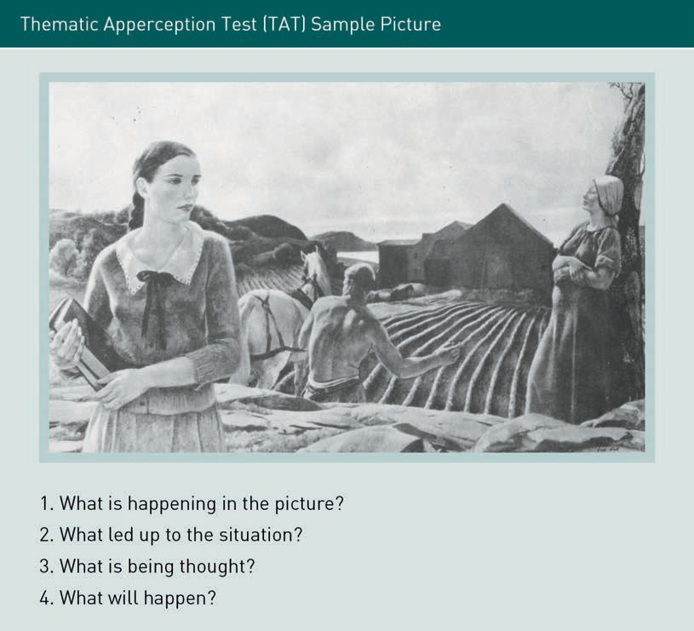

The theory behind the TAT test is that one’s responses to the test are a projection of one’s true needs, such as the need for achievement, the need for afﬁliation, the need for power, or the need for uniqueness. Murray believed that everyone has this same basic set of needs but that individuals vary in their prioritization of them.

Marketers can apply this theory by placing a premium on products and services that signify success because the consumption of these products provides feedback to the consumer that they are realizing their goals. The marketing of luxury goods is particularly attentive to these psychological needs, using marketing campaigns to develop mental associations between speciﬁc products and perceptions of success; “luxury goods are associated with success, satisfying needs of social integration, and membership of groups perceived as elitist, consumer ethnocentrism, and vanity” (Zaharia & Zaharia, 2015, p. 200).

###### Maslow’s Hierarchy of Needs

Motivation is viewed as a means of satisfying human needs. Abraham Maslow’s hierarchy of needs is a model that was popularized in the West after WWII represented by a pyramidal structure with ﬁve levels or types of needs, each level supported and made possible by satisfying those of the underlying level.

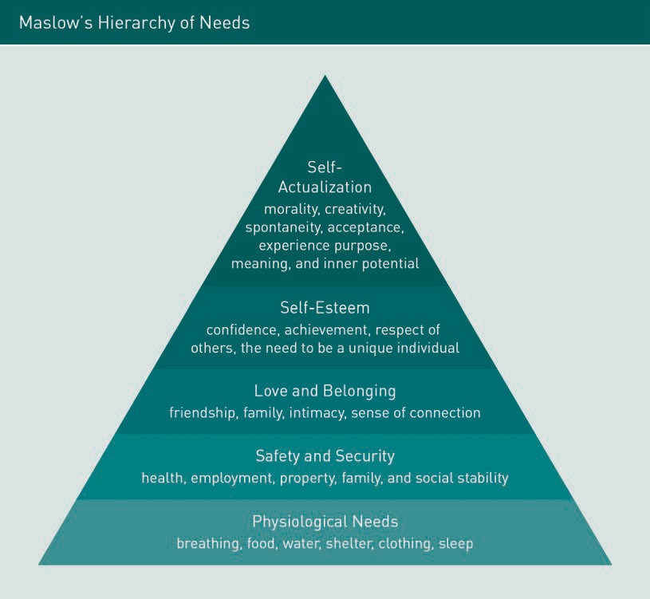

In an idealized set of life circumstances, self-actualization is said by proponents of this model to be the highest state to which a human being can aspire. However, while this hierarchy is used by marketers today, it is not directly applicable across all cultures. For instance, in the East, the importance of the group takes precedence over that of the individual. Despite this limitation, Maslow’s hierarchy continues to be an important model for understanding many aspects of motivation.

Successful marketing persuades consumers to purchase a product or service. One of the most effective ways to accomplish this is to directly appeal to one or more of the consumers’ basic needs. Many business students are taught to view Maslow’s hierarchy as a guide for targeting their marketing efforts; the suggestion is that the success of a product depends on effectively targeting one of Maslow’s identiﬁed needs. These needs

naturally vary from one market to another as well as within markets. Different conditions within a country can easily skew the expected hierarchy of needs. For instance, in stable, wealthier countries, sports cars, designer brands, and other hedonic purchases that are higher on the list of needs might be purchased by the average consumer, while countries undergoing privation or war may have more immediate utilitarian needs such as clean water, food, safety, and shelter.

As mentioned earlier, Maslow’s hierarchy of needs was developed in the West and, as such, is culture-bound in its perspective. People in other cultures may question the order that Maslow speciﬁed. Many Asian cultures value the welfare of the group (belongingness needs) over the needs of the individual (esteem needs). The point is that this hierarchy, although widely applied by marketers, is helpful primarily because it reminds us that consumers may have different needs and priorities in different consumption situations and at different stages in their lives, not because it provides an accurate measure of a consumer’s progression up the ladder of needs.

###### Consumer Involvement

The way that consumers evaluate and choose a product depends upon many factors – the marketing of that product, the marketing message, and/or the purchase situation – but one of the most fundamental factors that inﬂuences consumer behavior is a consumer’s degree of involvement with the product. Consumer involvement describes the state of awareness that motivates us to seek out, attend to, and consider product information prior to making a purchase. When consumer involvement is high, the consumer’s attention and memory are increased and more importance is attached to the product they are considering. Highly involved consumers also tend to place greater importance on attaining multiple sources of information about the product.

The level of a consumer’s involvement reﬂects just how personally interested they are in consuming a product and how much information is needed to make a purchasing decision. The level of involvement in purchasing decisions can be viewed as a continuum ranging from routine decisions (such as purchasing a beverage) to decisions that require considerable thought and a high level of involvement (such as purchasing a car or home). Whether low, high, or limited, consumer involvement varies by consumer, not by product. That said, some products, such as the purchase of a home, require a high level of involvement on the part of all consumers. Additionally, consumers with little or no experience purchasing a product are likely to have more involvement than someone who is simply replacing a product with which they are well acquainted.

The following ﬁgure illustrates some of the common factors associated with the level of customer involvement and the effects on buying behavior. It is evident from the ﬁgure that the degree of problem solving required is related to the level of consumer involvement.

Consumer involve- ment

Consumer involve- ment describes the state of awareness that motivates us to seek out, attend to, and consider prod- uct information prior to making a pur- chase.

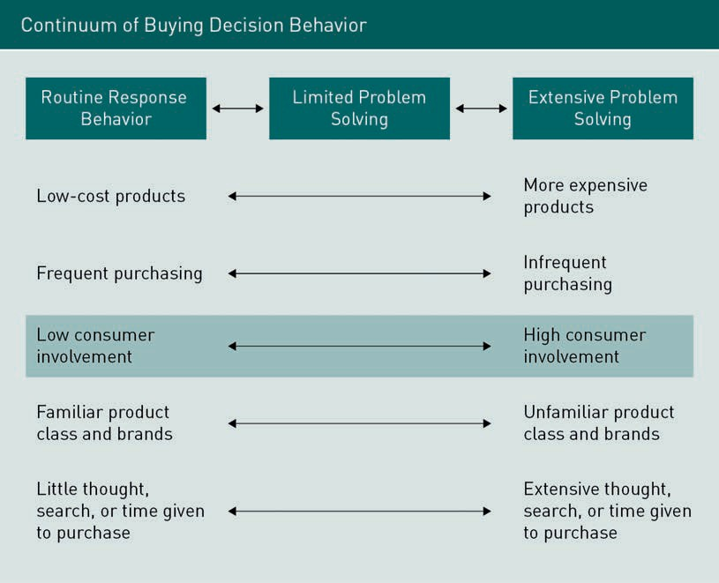

Consumer involvement ranges from inertia to passion, from a total lack of interest and simply processing only the basic message to that of a ﬂow state, which is a situation in which a consumer is truly involved with a product, ad, or website.

Purchase situation involvement refers to differences in motivation during the process of interacting with a store or website. One method of increasing purchase situation involvement is to personalize the message that shoppers receive at the time of their purchase. Traditional forms of collecting customer data via loyalty programs, point-of-sale records, and other sources are now being augmented by emerging applications that make use of facial recognition technology to collect data and personalize the shopping experience. Some forms of such technology can classify shoppers based on their approximate age, facial dimensions, and gender, comparing them against databases to best categorize these prospective consumers for targeted marketing, preferred treatment, or enhanced customer service (Hawkins, 2017). Cookies are a recognized method for online businesses to track their customers’ experiences and optimize the online environment for the consumer.

### Perception

In addition to motivation, consumer behavior is also a function of underlying physio- logical processes, speciﬁcally human sensation and perception.

Sensation is the process of receiving stimuli (information) from the environment through receptors in the human body. A stimulus can be any unit of input from the environment to any of these senses. Sensory receptors are the human organs that receive sensory inputs; we have receptors to see, hear, smell, taste, and feel. All of these receptors are activated individually or in various combinations when experiencing most consumer products. The sources of sensory stimuli include products, packages, store displays, brand names, customer service, advertisements, and commercials; there is ample sensory information encountered throughout the consumer experience.

Perception is the physiological process of organizing that sensory information in a way that makes it meaningful to us. Perception is a three-stage process that translates raw stimuli into meaning: we are exposed to sensory input, then we focus our attention on that information, and ﬁnally our brain interprets that information to assign the input some meaning.

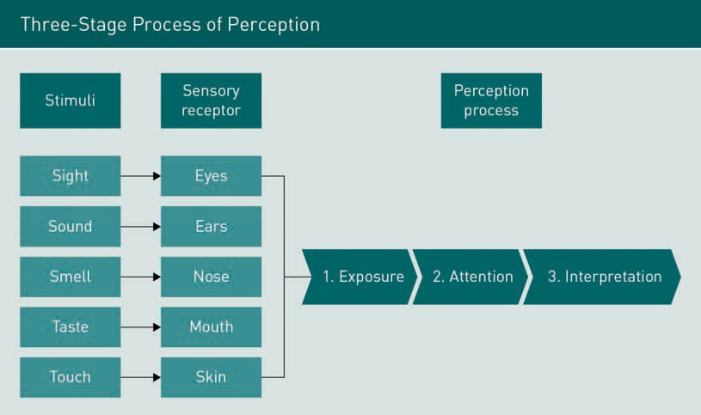

We are continually bombarded with stimuli every second of our day. Our world consists of a seemingly inﬁnite number of discrete sensations. However, most of the incoming stimuli that impinge upon us are blocked at an unconscious level because of our attentional “software”: our brains determine what sensory input is relevant to our conscious mind and focus our attention on the most salient information. Our perception of the world is an approximation of reality generated within our brain that occurs within the ﬁeld of our awareness. Our cumulative life experiences allow our brains to make sense of and respond to the stimuli to which it is exposed. Reality is thus a totally personal phenomenon based on our individual needs, wants, feelings, values, and personal experiences.

Perception Perception is the process of translat- ing raw sensory stimuli into mean- ingful information.

Marketers make a point of understanding the nuances of consumer perception and adroitly leveraging that knowledge to successfully sell us products and services. To understand how this can happen, we need to look at the nature of perception itself and explore a few elements that have been studied by psychologists and marketers.

Our interpretation of sensory input is not objective; while most individuals can correctly identify a friend from several hundred feet away through factors such as gait, posture, body proportion, and height, we can easily misidentify objects or quantities. The following ﬁgure illustrates such a misidentiﬁcation through the example of the familiar Müller-Lyer illusion. Looking closely, we can see that the lines are of equal length despite our initial perception that they are not.

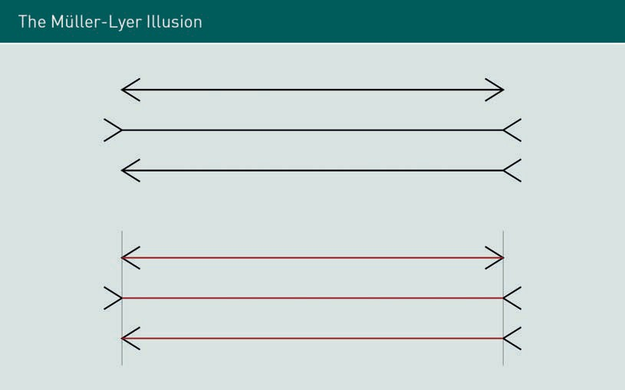

Similarly, the classic motion illusion shown in the following ﬁgure further underscores how our sensory perception does not always correspond with reality. In this illustration, the eye perceives a sense of movement when in fact no movement occurs.



People also tend to organize their perceptions into ﬁgure and ground relationships as illustrated by the classic ﬁgure-ground organization shown in the following ﬁgure. Depending on one’s perspective, the ﬁgure-ground is most often perceived as shifting back and forth between two faces and a vase.



How a ﬁgure ground pattern is perceived can be inﬂuenced by prior pleasant, neutral, or aversive associations with one or the other element in isolation. The essence of the ﬁgure ground principle is that one part of a stimulus conﬁguration tends to dominate a situation whereas other parts recede into the background. Marketers use the ﬁgure ground principle to make a stimulus the focal point of their marketing message or merely embed it in the surrounding focal context.

The Weber-Fechner law (also called Weber’s law of just noticeable difference) is a historically important psychological law that quantiﬁes the perception of change for a given stimulus. The law states that a change in a stimulus—a just noticeable difference (JND) —is a constant ratio of the original stimulus. For instance, if you are holding an object weighing 500 grams in your hand, you are quite likely to notice when that weight is doubled to 1 kg. However, if you are holding 10 kg, you are not likely to notice an additional 500 grams—a change you can readily detect when the initial weight is 500 grams. Whereas you may be able to eliminate 30 ml from a 300 ml container without noticing the change, you cannot as easily get away with reducing a 90 ml container to 30 ml without detecting the difference. To accomplish that, you must instead do it incrementally, say from 90 ml to 60 ml to 30 ml.

An obvious application of Weber’s law for marketers is the area of product discounting. If a retailer believes that a markdown should be at least 20 % for the reduction to make an impact on shoppers, the cost of a pair of socks that retails for $10 should be reduced to $8 for shoppers to realize a difference. However, the same $2 discount for a sports coat that retails for $200 will not result in a consumer perception of saving. Ironically, Weber’s law presents challenges for green marketers who try to reduce the size of packages when they produce more concentrated and earth-friendly detergents. Consumers still have the perception that a large amount of detergent is required, thus negating the beneﬁts of the more concentrated product. One perceptual trick to address this issue is to redesign the bottle cap. For instance, both Procter & Gamble and Church & Dwight use a cap with a broader base and shorter sides to convince customers that they need a smaller amount of detergent to wash a typical load of clothes.

###### The Basics of Sensation and Perception

How are these different concepts regarding perception relevant to the marketing of products and services? We need to understand that consumers act based on their perceptions and not based on any quantiﬁable objective reality. Reality, as we mentioned earlier, is a personal phenomenon, based on an individual’s needs, wants, values, and personal experiences. Perception is a ﬁeld of study unto itself, and the marketer’s understanding of this concept intersects with numerous disciplines such as psychology, physiology, and biology. The following glossary has been created to explain some fundamentals of sensation and perception and provide you with a basic understanding of how marketers approach and leverage these elements to successfully sell products and services.

* Exposure is the extent to which we encounter a sensory stimulus. For instance, when driving, the average consumer is often exposed to a ﬂurry of commercial messages such as billboards, radio advertisements, bumper-stickers, and pop-up ads on our phones as well as signs and banners strategically placed in and around shopping areas. Most of our exposure to such messaging is random: we don’t seek it out and we tend to ignore much of it. However, if we are considering a speciﬁc purchase such as a new car, we will likely be more attuned to and seek out commercial messages to further inform ourselves about different options as well as to look for the best terms and conditions available.
* Threshold is the level of the stimuli required for a person to register and perceive it. Absolute threshold is the lowest level at which anyone can experience a sensation. The point at which a person can detect a difference between “something” and “nothing” is that person’s absolute threshold for that stimulus. For example, humans have a less acute sense of smell compared with other animals and would need to be quite near a bakery to smell the scent of freshly baked bread. The differential threshold, or just noticeable difference, is the minimal difference that can be detected between two similar stimuli.
* Subliminal perception occurs when people perceive stimuli without being consciously aware that they are doing so. The stimuli are too weak or brief to be consciously seen or heard yet strong enough to be perceived by one or more receptor cells. This process is called subliminal perception because the stimulus is beneath the threshold of conscious awareness, though not beneath the absolute threshold of the receptors involved. Thus, a consumer can be motivated below their level of conscious awareness.
* Perceptual selection is where consumers unconsciously exercise considerable selectivity as to which aspects of their environment they perceive. People receive only a small fraction of the stimuli to which they are exposed. Consumers’ previous experience affects their expectations and their motives at the time. Marketing stimuli include a multiplicity of variables that affect the perception of consumers including the nature of the product, its physical attributes, the packaging design, the brand name, advertisements, and the position of the ad or commercial within the context of the medium in which it is presented.
  + Selective exposure occurs when consumers seek out messages that they ﬁnd pleasant or with which they are attuned while avoiding unpleasant ones. Consumers are more likely to notice ads for products that would satisfy their needs and disregard those in which they have no interest.
  + Perceptual defense occurs when consumers ignore stimuli that they ﬁnd to be uncomfortable, despite having been exposed to such uncomfortable stimuli on past occasions.
  + Perceptual blocking occurs when consumers buffer themselves against marketing and advertising stimuli by simply “tuning out” and blocking such stimuli from their awareness. The phenomenon of blocking out stimuli is a result of the overwhelming visually stimulating nature of our contemporary world. Perceptual blocking-enabling technologies such as TiVo and Replay TV are examples of popular devices that allow viewers to easily skip past TV commercials.
  + Perceptual organization occurs when consumers do not experience advertising stimuli as separate and discrete, but rather, organize them into groups or clusters that they perceive as uniﬁed wholes. Instead of perceiving discrete bits of

information, consumers undertake the (often unconscious) process of perceptual grouping to mentally organize it into groups or chunks, thereby facilitating their memory and recall. This grouping phenomenon is often effectively exploited by marketers to impart meanings to consumers that are associated with their products.

* + - Closure is achieved by organizing the perceptions that one has into a uniﬁed and complete picture. Even if the pattern of stimuli to which we are exposed is incomplete, we still tend to perceive it as a uniﬁed whole because we consciously or unconsciously ﬁll in any missing pieces.
    - Perceptual interpretation occurs as a result of unambiguous stimuli. For example, some stimuli are weak because of brief exposure, low visibility, or ﬂuctuating noise levels. Even strong stimuli are prone to ﬂuctuation due to factors such as the angle at which someone is looking at the stimuli, varying distances from the source stimuli, and changing levels of sound or illumination.
    - Perceptual distortion occurs in the form of stereotypes, physical appearance, initial impressions, jumping to conclusions, and the halo effect (whereby people often tend to respond to unrelated similar stimuli the same as they did to the original stimulus).
    - Consumer imagery refers to the enduring images or perceptions consumers hold. For instance, the iconography of products and brands has high symbolic value and consumers tend to view this value in terms of just how closely it approximates or corresponds to their self-perception.
    - Product positioning, the hallmark of successful marketing, is the image that a product or brand has in the consumer’s mind. It involves creating a perception of the product, often based on the sensory characteristics of the product. A product’s positioning is more important to the ultimate success of a product than its actual characteristics, although products that appear attractive but do not perform well generally fail in the long term. Product repositioning may occur in response to unexpected market events such as market share encroachment by a similar brand or too many brands claiming to have the same attributes.
    - Perceptual mapping is used by marketers to visualize/measure the way products are positioned in the minds of consumers. Typically, marketers will juxtapose their products and services against similar ones offered by competitors. In the following ﬁgure, soft drink products are compared along a two-dimensional axis (caffeine and sugar content).

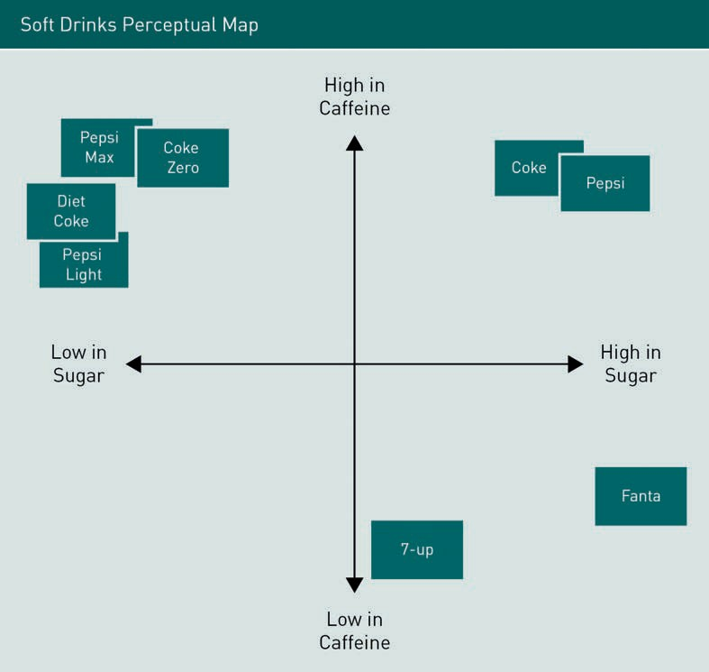

* Perceived price is the idea that the consumer has about the price of the product or service and whether they see it as high, low, or fair. A reference price is any price that a consumer uses as a basis for comparison when judging the price of a product or service.
* Perceived quality is judging the quality of a product or service relative to other attributes associated with it. With a product, perceived quality is usually judged according to the physical characteristics of the product such as size, color, ﬂavor, aroma, etc. A service is more difﬁcult for a consumer to evaluate as services are intangible, variable, and perishable; they are produced and consumed at the same time.
* Price-quality relationship is important as consumers largely rely on price as an indicator of product quality, often attributing different values to identical products with different prices. Consumer characteristics such as age and income affect the perception of price-quality value.
* Consumer risk is the perceived degree of risk associated with a purchase. People invest more time reviewing and considering information about the product when there is a high degree of risk associated with a purchase, seeking additional information from friends, family, and others. When consumers have no experience with a product, they tend to choose a brand name product or service that they feel they can trust.

### Attitude

Attitude Attitude is a lasting, general evaluation of people (including oneself), objects, or

issues.

Attitude is a lasting, general evaluation of people (including oneself), objects, or issues. An attitude is lasting because it endures over time. Of course, attitudes can and do change but overall, they tend to persist. Attitude involves three interrelated components that are often referred to as the ABC of attitude:

* affect
* behavior (intention)
* cognition (belief).

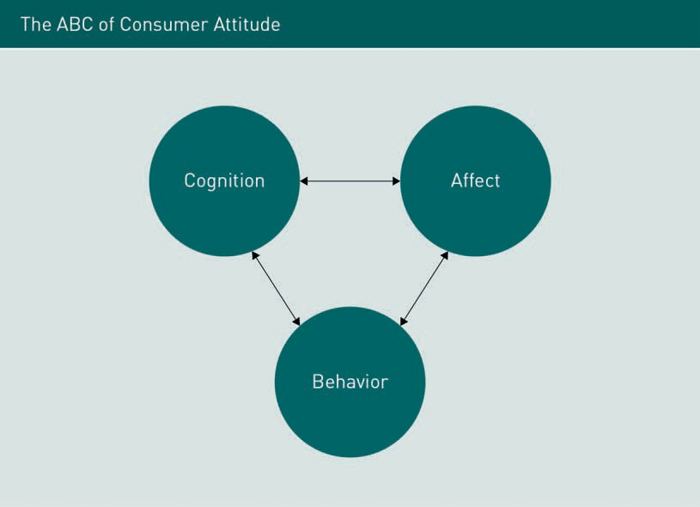

Consumer attitudes within the context of marketing consist of a consumer’s affect (feelings), cognitions (beliefs), and behavior (intentions) toward brands and products. These components are viewed together since they are interdependent. Consumers have a wide range of attitudes that are expressed in speciﬁc feelings/thoughts/behaviors (such as purchasing only a speciﬁc brand of toothpaste recommended by their dentists) to more general consumption-related feelings/thoughts/behaviors (such as having a speciﬁc daily routine regarding the frequency of tooth brushing).

###### ABC: Affect, Behavior, and Cognition

We will explore affect, behavior, and cognition in greater detail to understand why consumer researchers strive to understand the nature and power of attitudes, learn why attitudes are far more complex than they appear, understand some of the ways we form attitudes, and learn how marketers inﬂuence our formation of attitudes about their products.

Affect refers to how a consumer feels about a person, object, or issue. Research indicates that consumers can hold multiple feelings about products and brands: feelings based on beliefs or independent of beliefs or feelings that even contradict one another. For example, a person may believe that killing animals for food is morally wrong but may not consider that feeling when selecting a steak from the menu of their local restaurant. A defense contractor may view war as morally wrong but not give it much thought when managing the contractual and budgetary intricacies of a defense system contract.

In the context of marketing, behavior/intention refers to whether a consumer intends to or actually purchases a product. As with affect, a consumer’s behavior is sometimes the logical consequence of speciﬁc thoughts about or feelings toward a product, but at other times it may reﬂect other circumstances. For example, although a person may not be fond of a certain nightclub, they might go there because they are meeting friends there; a mother might object to a speciﬁc doll and the messages it conveys to young girls but purchase it regardless of her objections because she doesn’t want to disappoint her daughter. Consumers sometimes behave in a manner inconsistent with their attitudes for reasons such as:

* Ability: A young couple may want to purchase a family home but may not have sufficient income.
* Competing demands for resources: A teenager would like to buy a new car when she receives her driving license, but she also wants a new computer and only has enough money to make one major purchase.
* Social inﬂuence: A student who is a fan of 1930s noir detective movies thinks that smoking represents sophistication but since his friends think smoking is an unpleasant habit, he does not smoke.
* Measurement problems: Consumers do not typically go around categorizing their positive and negative feelings about products. When asked for nuanced opinions about a product by a market researcher, they tend to give unreliable answers. As a result, consumers may act consistently with their true attitudes when making a purchase despite the prior analysis of their feelings by a market researcher.

Cognition/beliefs refer to the acceptance by a consumer that something exists or is true, which may or may not be based on facts, and can polarize a person, object, or issue. Let’s look at some beliefs that a consumer could hold about coffee. A consumer can have positive beliefs (e.g., I am more awake after a cup of coffee), negative beliefs (e.g., coffee drinking is not a productive task), neutral beliefs (e.g., an espresso is served

Affect

Affect refers to how a consumer feels about a person, object, or issue.

Behavior/intention Behavior/intention refers to whether a consumer intends to or actually purchases a product.

Cognition/beliefs Cognition/beliefs refer to the accept- ance by a consumer that something exists or is true, which may or may not be based on facts, and can polar- ize a person, object,

or issue.

without milk), or simultaneous positive and negative beliefs (e.g., coffee tastes good but caffeine is overstimulating). Some beliefs may differ in valence depending on the person or situation (e.g., coffee is hot and wakes me up on a cold winter morning, but coffee is not good on a hot summer night before bed). Consumers can also hold incorrect beliefs (e.g., coffee causes heart disease, which is contradicted by cardiologists) or contradictory (e.g., the stimulating effect of coffee is good for weight loss, however, research has found that coffee drinkers might actually gain a little more weight than their non-coffee drinking counterparts).

Since consumers generally hold multiple beliefs about a product, as a marketer, concluding whether a product is seen positively or negatively by consumers can be difﬁcult. Multiattribute attitude models are one method utilized by marketers to determine how consumers perceive products. They attempt to summarize overall consumer attitudes with a single score. These models assume that a consumer’s attitude toward or evaluation of a product depends on the beliefs they have about the attributes of a product. The following table is an example of a multiattribute attitude model. A speciﬁc model known as the Fishbein model has been used here to calculate a single score for various US supermarkets based on a rating of speciﬁc attributes (Dean, 2015).

|  |  |  |  |  |  |  |
| --- | --- | --- | --- | --- | --- | --- |
| Multiattribute Analysis Using Fishbein Model | | | | | | |
|  | Beliefs | | | | | |
| Attributes | Impor- tance | Wal- Mart | Target | Kmart | Sears | Costco |
| Price | 4 | 8 | 4 | 3 | 1 | 7 |
| Quality | 1 | 6 | 7 | 3 | 6 | 3 |
| Convenience | 5 | 8 | 6 | 6 | 4 | 0 |
| Variety | 3 | 6 | 7 | 4 | 8 | 5 |
| Satisfaction/ guarantees | 3 | 7 | 7 | 5 | 8 | 4 |
| Wages/bene- ﬁts | 7 | 5 | 6 | 3 | 7 | 5 |
| Opportunities | 10 | 8 | 6 | 4 | 8 | 3 |

|  |  |  |  |  |  |  |
| --- | --- | --- | --- | --- | --- | --- |
|  | Beliefs | | | | | |
| Attributes | Impor- tance | Wal- Mart | Target | Kmart | Sears | Costco |
| Job security | 9 | 7 | 8 | 4 | 6 | 5 |
| Environmen- tally protective | 6 | 3 | 5 | 4 | 6 | 3 |
| Good neighbor | 8 | 8 | 9 | 5 | 4 | 2 |
| Total score |  | 371 | 364 | 229 | 321 | 197 |

Using a multiattribute attitude model implies that an attitude toward a product or brand can be predicted by identifying speciﬁc positive and negative beliefs and combining them to derive a measure of a consumer’s overall attitude. However, in actual practice, consumers hold many beliefs, each of which must be factored into such an equation to obtain a meaningful measurement, and like all models, it is not perfect.

###### Changing Attitudes

Changing attitudes is often difﬁcult, particularly when consumers suspect that the marketer has a motive in trying to bring about a change in their attitude to get them to buy or switch brands. Let’s have a look at some strategies that marketers typically employ to induce change in a consumer’s affect, behavior, and/or cognition.

Changing Affect

Three main strategies are utilized to change consumers’ affect toward brands and products: 1) classical conditioning, 2) increasing the likability of a brand, and 3) increased exposure.

* Classical conditioning is “teaching” a consumer to associate a product with a familiar positive stimulus. Classical conditioning is the learning that occurs when a stimulus eliciting a response is paired with another stimulus that initially does not elicit a response on its own but will cause a similar response over time because of its repeated association with the ﬁrst stimulus. For example, in automobile commercials or product placement ads in movies, an attractive sophisticated woman and a handsome, conﬁdent, successful man are paired with a desirable car in some dynamic, intriguing, and suggestive context.
* Another approach used by marketers is to make their advertisements appeal to the point where the mere likability of the brand translates into sales of their product. For example, while the Pillsbury Doughboy did not convey any relevant

Product placement

ads Product placement ads refer to the exposure of a prod- uct by having it inserted into a movie, television show, or other

medium.

Likability Likability refers to the connection that a consumer has with a person or object based on a quality such as “friendli-

ness.”

information about the Pillsbury Company products, he did create a warm, pleasing image in the mind of the consumer. Likewise, when the old Eveready Battery Company commercials were touting the ability of their batteries to “keep going and going,” they utilized the likable Energizer Bunny in their marketing materials.

* Finally, through constant exposure, marketers can change the affect of the average consumer toward a product. It is well-known in the advertising industry that better-known products are often preferred by consumers. That is, the more frequently a product is advertised and seen by consumers, the more likely they are to buy it.

Changing behavior

People like to believe that their behavior is rational and that they select products based on their objective features (e.g., price, value for money, quality). However, once accustomed to a product, consumers will likely continue using that product unless they are convinced to try a new one (product switching). One way that marketers lure consumers to try new products is through temporary price discounts and coupons that incentivize them to switch brands. Another way to get consumers to switch to a marketer’s desired brand is to temporarily secure a better position in the store shelving so that their branded product is more visible. Marketers generally prefer that vendors position their products at eye level so their brands will usually be seen by the consumer ﬁrst. While this strategy can be effective with some products, consumers may continue to buy their usual product even when it is less conveniently shelved.

Changing beliefs

Attempting to change consumers’ beliefs is an obvious method for pursuing attitude change, especially when consumers hold unfavorable or inaccurate beliefs about a brand or product. There are several approaches used when attempting to change consumer beliefs.

* Changing current beliefs: Changing someone’s strongly held or inaccurate beliefs can be a daunting task. Attempting to change an existing belief is generally difﬁcult as people tend to resist externally forced change. For example, there is a prevailing belief in the US that petroleum companies make huge proﬁts at the consumer’s expense. However, petroleum companies make on average only about $0.07 USD per gallon at the petrol station, while the US government takes in about $0.48 USD per gallon in fuel taxes at the petrol station. Despite these facts, many American petrol consumers remain dubious and disbelieving (Bradley, 2011).
* Changing the importance of beliefs: Although the sugar industry would undoubtedly like to play down the importance of healthy teeth and the dangers of obesity, any attempt at making such beliefs less important is doomed to failure. However, it may be possible to strengthen beliefs that favor the use of a company’s products. For instance, a nutritional supplement manufacturer may point out how important it is for women to replace iron lost through menstruation. While most consumers already agree with this, the belief can be reinforced by the brand, thereby increasing the association with the brand.
* Adding new beliefs: Consumers are less likely to resist assimilating new beliefs if they do not conﬂict with existing beliefs. Extending the previous example, nutritional supplement manufacturers might attempt to add the belief that an athletic lifestyle and work stress can cause vitamin depletion,

something that sounds quite plausible to most health-conscious consumers. This belief may be easier to proliferate than the belief that a healthy diet does not supply all the necessary vita- mins and minerals.

The elaboration likelihood model (ELM) posits that there are two possible routes to persuasion: central vs. peripheral. The route taken is determined by the relative importance of the message content versus other characteristics such as source attractiveness. According to the ELM, when we ﬁnd the information in a persuasive message relevant or interesting, we pay close attention to it (central route). When we ﬁnd the information compelling, we focus on the arguments that the marketer is making and generate responses to what they are telling us. This model is illustrated in the following ﬁgure.

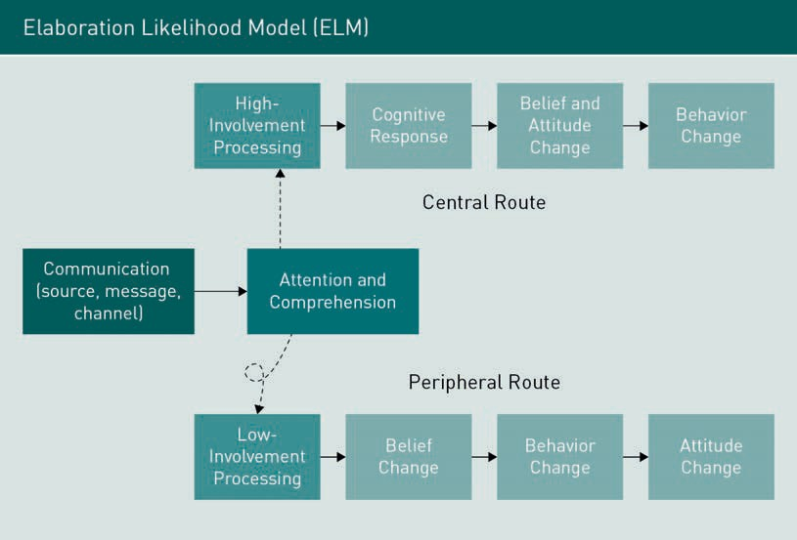

The ELM suggests that for “unimportant” products, elaboration will be low, e.g., Taylor Swift can effectively endorse Coca-Cola without having any special credentials. How- ever, for products which are either expensive or important for some other reason (e.g., a pain reliever given to a child who could potentially be harmed by the medication or the underlying illness), elaboration is likely to be more extensive, and the endorser (e.g., a respected pediatrician) is expected to be “congruent” or compatible with the product. For example, an athlete is likely to be an effective endorser of athletic shoes but is not likely to be successful endorsing construction machinery. A backhoe operator could be successful in endorsing heavy equipment but not athletic shoes. However, either of these endorsers could be a spokesperson for a fast-food restaurant.

Emotional versus rational appeals are another consideration. Which is better: appealing to the mind or the heart? Colgate was the ﬁrst toothpaste to claim that it ﬁghts gingivitis, which helped it move ahead of Crest for the ﬁrst time in decades. In later Crest ads,

former model and actress Brooke Shields is shown with two young children against a backdrop of soft music and says, “Having a healthy smile is important to me. Not just as an actress but as a mom.”

Marketers will often appeal to humor. Overall, they do get attention. An amusing ad will often be effective if it serves as a distraction and inhibits counterarguments. As a general rule, subtle humor usually works better than overt humor, as does humor that does not make fun of the potential consumer. Lastly, the type of humor used should be compatible with the product’s image.

Fear appeals cater to possible negative consequences that can occur unless a person changes a behavior or attitude, e.g., not having life insurance can leave your family at risk, or driving a Volvo or BMW could make the difference between a trip to the hospital or walking away from an accident unscathed. Fear appeals are common in advertising and appear frequently in political advertising and public health campaigns, e.g., when promoting road safety or smoking cessation. This tactic is most effective when advertising focuses on a moderate threat; a dire threat will often lead consumers to simply tune out the message because they assume that no action taken will adequately address the threat.

Which aspect is most important when persuading consumers to change their minds: the arguments that the marketer presents or the consumer’s responses to them? The answer is: it depends. As explained in this unit, consumer involvement determines which of their cognitive processes will be activated when they see a message, which in turn, inﬂuences which part of the message they will internally process. In summary, audience characteristics largely determine whether the nature of the message source or the message itself is most effective.

Summary

Internal inﬂuences include motives and motivation, perception, and attitude. Motives drive people to satisfy needs and wants, both physiological and psychological, through the purchase and use of products and services. Motivation is the process that leads people to behave as they do; it occurs when a need is aroused that a consumer wants to satisfy. By understanding the motives of customers, a business can increase customer motivation to purchase products and remain loyal to the brand or company. Motivation is largely driven by raw emotions: this is why so many marketing activities and messages focus on altering mood and linking products or services to affect. Marketers utilize tools such as psychogenic tests and models like Maslow’s hierarchy of needs to try to understand and meet consumer needs. Marketers are also interested in understanding the level of a consumer’s involvement regarding purchases as this often dictates how personally interested they are in consuming a product and how much information they need to make a purchasing decision.

Perception is a three-stage process that translates raw sensory stimuli into meaning: we are exposed to sensory input, then we focus our attention on that information, and ﬁnally our brain interprets that information to assign the input some meaning. Marketers make a point of understanding the nuances of consumer perception and adroitly leveraging that knowledge to successfully sell us products and services.

Attitude is a lasting, general evaluation of people (including oneself), objects, or issues. Attitude involves three interrelated components that are often referred to as the ABC of attitude: affect, behavior (intention), and cognition (belief). Three main strategies are utilized to change consumers’ affect toward brands and products: classical conditioning, increasing the likability of a brand, and increased exposure. Offering temporary price discounts or coupons, and increasing the visibility of a product via product placement strategies are some techniques utilized by marketers to entice consumers to change their behavior. There are several approaches used when attempting to change consumer beliefs: changing current beliefs, changing the importance of beliefs, adding new beliefs, attempting persuasion via central or peripheral routes, making emotional versus rational appeals, or using humorous or fear-based marketing messages.

# Unit 4

## External Inﬂuences Behavior

## on Consumer



#### STUDY GOALS

On completion of this unit, you will have learned …

… the role of culture and subculture in inﬂuencing our behavior as consumers.

… how reference groups and conformity to a group impact our consumption decisions and behavior.

… how communication within groups occurs and the importance of word-of-mouth.

… what the diffusion of innovation theory and the diffusion process are.

DL-E-DLMBCBR01-U04

1. External Inﬂuences on Consumer Behavior

### Case Study

MBA graduate Maria was preparing for her upcoming interview with the Google team responsible for marketing the new Pixel product. She began looking at some of the advertising materials that had been created and circulated on social media when the product launched. Many of the video advertisements seemed to hint at the importance of culture, subculture, groups, and families, and their potential inﬂuence on consumer behavior. All the following YouTube advertisements began with the iconic search bar recognizable from the Google website and concluded when the images morphed into the Pixel screen.

* “Together by you, Phone by Google” is an overhead shot of a colorful ensemble of stylish young people in a group looking up at the camera and singing a cappella in a choreographed sequence. The participants are dressed in brightly colored attire and the group appears to be made up of individuals from various ethnic and cultural backgrounds.
* “Life by you, Phone by Google” is a montage of images of different activities and occasions such as a young woman stargazing, an African man doing the limbo at a party, Asian businessmen celebrating, young women doing jump rope with a neon rope, and a family gathered around a child’s cot.
* “Memories by you, Phone by Google” is a photo montage of a young Indian girl smiling toward the camera as she journeys down a street in different outﬁts suggesting that the photos are taken on different days across the seasons.

While all these advertisements draw attention to the features of the Pixel product, Maria concludes that they all focus more so on social and cultural experiences, appealing to potential consumers by drawing attention to shared interests, hinting at a sense of belonging, and drawing associations between creating memories, celebrating, and capturing important occasions and the Pixel. The advertisements are emotive, highlighting relationships between family members, friendship groups, and people with shared interests such as the a cappella group.

In this unit, we explore how these types of images can inﬂuence consumers because of the role that culture, subculture, groups, and families have in inﬂuencing people in their consumption-related decision-making.

### Culture

According to anthropologist Edward Tylor (1871), culture is “that complex whole that includes knowledge, beliefs, art, laws, morals, customs, and any other capabilities acquired by humans as members of society” (Mothersbaugh & Hawkins, 2016, p. 40). Simply put, culture is a society’s personality. Things that we learn and do as a member of a society can be considered cultural. Culture varies from society to society as each society has a different way of doing things, i.e., different learned behaviors that are explicitly and implicitly shared and adopted by members of that society. Individual idiosyncratic behavior does not constitute culture. Similarly, behavior of a biological nature, experiencing hunger, yawning, and wearing clothes to protect oneself from the cold are not cultural practices. However, how people speciﬁcally do these things can be considered cultural; using a fork or chopsticks to eat one or multiple meals per day, covering one’s mouth when yawning, and wearing a hijab or burqa are practices speciﬁc to particular societies.

###### Elements of Culture

To understand the multifaceted dimensions of culture, we ﬁrst need to deﬁne the elements of culture. Here, we will speciﬁcally explore values, norms, rituals, knowledge and myths, and art as elements of culture.

Values

Values are the ideas a society has about what in life is worthy of pursuit and how those pursuits should be conducted; values are desirable ends as well as desirable means to those ends. Values often characterize a society: democratic and modern societies generally value liberty, equality, and individual rights while in many traditional societies, individual rights and liberties are deemed subservient to the rights of the group, tribe, or clan. The link between values and consumer behavior is exempliﬁed in the value-attitude-behavior hierarchy model, in which researchers posit that values affect attitudes that lead to speciﬁc consumer behaviors (Arnould, Price, & Zinkham, 2004). An example provided by Arnould et al. suggests that a culture that puts a high value on security and self-conﬁdence is more likely to have positive attitudes about preventive dental care, resulting in more consumers seeking toothpaste that provides preventive beneﬁts.

Values that have the most impact on consumer behavior can be divided into three categories: 1) self-oriented, 2) other-oriented, and 3) environment-oriented (Mothersbaugh

& Hawkins, 2016).

Self-oriented values stem from an individual who reﬂects the objectives and approaches they ﬁnd desirable in life.

* Religiosity: What roles do religion and secularism play in everyday consumer behavior? Thailand is a country that highly values religion and religious practices. During school holidays in Thailand, it is common for young students to be ordained as novice monks for a short time and study ethics (Barrow, 2009). Contrast this with the school holidays in the US, where it is common for young students to attend camps for sporting activities or performing arts (Global Youth Village, 2014). Many religious practices can be observed in the preparation and consumption of food: Muslims

Values

Values are the ideas of society about what in life is worthy of pursuit and how those pursuits should be conduc- ted.

Self-oriented values Self-oriented values stem from an indi- vidual who reﬂects the objectives and approaches they ﬁnd desirable in life.

Instrumental materi-

alism Instrumental materi- alism is the acquisi- tion of things to enable one to do

something.

Terminal materialism Terminal materialism is the acquisition of items for the sake of owning the item

itself.

Other-oriented val-

ues Other-oriented val- ues within a society depict the relation- ships between indi- viduals and groups.

around the world consume halal food and fast during Ramadan, practicing Jews consume kosher food, and many Buddhists in Asia consume vegetarian meals on the ﬁrst and ﬁfteen day of each lunar month.

* Work ethic: What importance is placed on work versus leisure? Is working beyond what is economically necessary appreciated? For consumers in parts of Latin America, work is mostly viewed by older generations as a negative pursuit (100% of older generations compared to 28% of younger generations) (Paul, 2002). In contrast, in the US and Hong Kong, both younger and older generations shared a perception of work as a negative pursuit (50% of older and younger generations).
* Gratiﬁcation: What does society value regarding instant versus delayed gratiﬁcation? Is it more important to “live for today” or “save for a rainy day”? The acceptance and use of credit are very much determined by a society’s position on the value of postponed versus immediate gratiﬁcation.
* Sensual gratiﬁcation versus abstinence: What importance is placed on the pleasure of consuming food, drink, or sex? Muslim cultures are conservative in this domain, as are many Asian cultures. According to these authors, 37% of Saudis indicated that modesty is important compared to 9% of Americans. Marketing strategies thus aim to reﬂect differences in consumer behavior in these countries, e.g., Brazilian and European advertisements contain nudity and blatant appeals to sensual gratiﬁcation in contrast to Asian and Muslim cultures where such images are not shown.
* Materialism: Is materialism or minimalism valued more highly? How important is the accumulation of wealth? The value that groups of people place on material possessions has a signiﬁcant impact on consumption patterns. Materialism can be categorized into two types: instrumental and terminal. Instrumental materialism is “the acquisition of things to enable one to do something” whereas terminal materialism is “the acquisition of items for the sake of owning the item itself” (Mothersbaugh & Hawkins, 2016, p. 52). Owning a piece of art is an example of terminal materialism while owning skis is an example of instrumental materialism; a car could be either depending on how it is used and what it means to the consumer. Several scales used to measure materialism were developed by Belk (1984). They attempt to measure the relationship of people to material objects. Belk’s scale addresses three dimensions of materialism: possessiveness, non-generosity, and envy. Higher scores on these dimensions suggest that a person places more value on materialism.

The second category of cultural values related to consumer behavior is other-oriented values. Other-oriented values within a society depict the relationships between individuals and groups.

* Individualism versus collectivism: Is individual activity and initiative valued more highly than collective activity and conformity? People from cultures that highly value cooperation in groups over individual initiatives tend to make consumption decisions based on group consensus or recommendations than individualized decisions. According to Mothersbaugh and Hawkins (2016), consumers from cultures that

emphasize the importance of the group or collectivism tend to be less innovative in their purchases. This value expresses itself in consumer attitudes toward foreign products and advertising.

* + Diversity versus uniformity: Does the culture embrace diversity in religious belief, ethnic background, and political views? Diversity refers to the degree that people embrace variety in religion, ethnicity, and political beliefs. Societies that value uniformity over diversity are unlikely to accept a wide array of tastes and product preferences.
  + Extended versus nuclear family: To what extent does one have a lifelong obligation to various family members? The strength of obligations to a family, extended or limited, varies from culture to culture. For example, in India, people tend to shop with their families. Biyani (a large discount store similar to Walmart) has U- and C-shaped aisles designed speciﬁcally to provide private corners where families can discuss their purchasing decisions.
  + Youth versus age: Is family life organized to meet the needs of children or adults? Are younger or older people viewed as leaders and role models? Some societies value older members of the society, recognizing that wisdom comes with age, e.g., Asian societies appear to value the role of the older generation more than American society.
  + Competitiveness versus cooperation: Does one obtain success by excelling above others or by cooperating with them? Societies that encourage competition (e.g., US, UK, and Australia) tend to accept comparative advertisements whereas societies that encourage cooperation (e.g., Japan) tend to ﬁnd comparative advertisements distasteful (Mothersbaugh & Hawkins, 2016).

The third category of values is environment-oriented values, which are a society’s relationship to its economic and technical environment as well as its physical environment.

* + Cleanliness: To what extent is cleanliness pursued beyond the minimum need for health? According to an environmental performance index, Iceland is the cleanest country in the world (Helman, 2010). Because of its emphasis on personal hygiene in the US, germ-ﬁghting liquid soaps are a multi-billion-dollar market (Mothersbaugh & Hawkins, 2016, p. 49).
  + Tradition versus change: Are existing patterns of behavior considered to be inherently superior to new patterns of behavior? Some societies are less comfortable accepting changes. US consumers generally accept changes easily, compared to consumers in the UK and China; new products are often accepted more quickly in countries like the US.
  + Risk-taking versus security: Are those who risk established positions to overcome obstacles or achieve high goals admired more than those who do not? For societies that emphasize status based on one’s family, position, or class (e.g., Japan, China, and India), consumers tend to welcome ads that appeal to status or wealth (Mothersbaugh & Hawkins, 2016, p. 49).
  + Problem-solving versus fatalism: Are people encouraged to overcome all problems or do they take a “what will be, will be” attitude? Some societies tend to view uncontrollable events as something to be overcome, while other societies take a

Environment-orien- ted values Environment-orien- ted values relate to a society’s relationship to its economic and technical environ- ment as well as its physical environ- ment.

fatalistic view and let things happen. Extending this value to consumer behavior, people in societies that are more fatalistic tend to make fewer formal complaints when faced with an unsatisfactory purchase (Mothersbaugh and Hawkins, 2016, p. 50).

* + - Nature: Is nature regarded as something to be admired or overcome? Americans consider nature as something to be overcome or improved, while northern Euro- pean countries tend to place a high value on the environment. This affects aspects of consumer behavior such as packaging preferences and recycling.

On a global scale, the World Values Survey has conducted a comparison of values across almost 100 countries since 1981. Their research methodology, questionnaire, data, and results can be accessed from their website (World Values Survey).

Norms Norms are the “do’s and don’t’s” of a society that are more speciﬁc than

values.

Sanctions Sanctions are penal- ties or punishments associated with the transgression of a formal or informal norm or regulation.

Norms

Norms are based on values. Norms are the “do’s and don’t’s” of a society and are more speciﬁc than values. They are the unwritten rules of behavior that guide people within that society about what is acceptable and unacceptable behavior. Violations of norms can result in sanctions or penalties that may include being punished by or even banished from a group. The relationship between values, norms, sanctions, and consumption patterns is illustrated in the following ﬁgure. Consumption patterns are the basic processes by which consumers identify, purchase, and use products and services to meet their needs repeated over time.

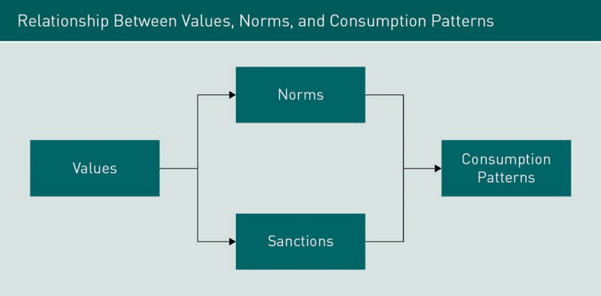

As norms are mostly unwritten, they simply develop as a tradition or cultural habit within each society. We ﬁnd major differences in norms in the East and in the West. In Eastern cultures, when people go out in a group, people generally ask what others would like and order for everyone, in contrast to people in Western cultures who order individually in a group setting without consulting others (Mittel, 2008).

Rituals

Sets of practices are rooted in the traditions and history of a cultural group. These practices include rituals, customs, and myths. A ritual is a set of activities performed in a ﬁxed sequence and repeated periodically, e.g., holiday rituals, gift-giving rituals, rites

of passage that marks a change in social status. A ritual can be utilitarian or symbolic. Rituals involve consumption in many cases. An example of a ritual is a wedding; from the preparation of a wedding gown to the wedding cake, the wedding ritual includes a series of consumption events that can vary from a single event to a month-long celebration, as in India.

Customs

Another practice is customs. Customs are ways of doing something. While customs can be tied to an event in the same way as a ritual, they can also be independent of an event. For example, wearing a black tie for a formal dinner is a custom rather than a ritual. A custom is tied to consumption. An example is the wearing of the kimono among the Japanese. A kimono is a traditional Japanese item of clothing and, although no longer worn for everyday wear, is nevertheless worn for special occasions and it varies according to season, event, age, and marital status (Mittel, 2008).

Myths

A myth is a story with symbolic elements that represent a culture’s ideals (Solomon, 2014). For example, Santa Claus is a myth in much of the Christian world. The myth of Santa Claus is tied to the consumption of many goods and services related to Christmas, from gift-giving to big holiday events. The functions of myths are varied:

* + Myths are metaphysical: they help explain the origins of existence.
  + Myths are cosmological: they emphasize that all components of the universe are part of a single picture.
  + Myths are sociological: they maintain social order because they authorize a social code for members of a culture to follow.
  + Myths are psychological: they provide models for personal conduct.

Sacred and Profane Consumption

Sacred consumption occurs when we “set apart” objects and events from normal activities and treat them with respect and awe. These can be places (e.g., Mecca, Stonehenge), people, or events. Profane consumption refers to objects and events that are considered ordinary and regularly consumed.

###### Acculturation

How culture is transmitted depends on one’s position as an insider or outsider within that society. Acculturation is the process of learning a new culture. There are two ways people engage in acculturation: 1) living in a new society, or 2) spending a considerable amount of time with people from other cultures. Enculturation is the process of learning one’s own culture.

The topic of acculturation and its impact on consumer behavior is interesting considering immigration trends across countries and migration from rural areas to large cities occurring in many countries. Do immigrants take on the consumptive culture of the country they reside in, or do they seek to maintain their previous patterns of consumption? There is much to learn from the experience of migrants about the process of

Ritual

Ritual is a set of activities preferred in a ﬁxed sequence and repeated peri- odically.

Customs

Customs are ways of doing something.

Myth

A myth is a story with symbolic ele- ments that represent a culture’s ideals.

Acculturation Acculturation is the process of learning a new culture.

Enculturation Enculturation is the process of learning one’s own culture.

acculturation. Three research projects from a symposium “Acculturation and Consumer Behavior: Building Cultural Bridges Through Consumption” summarized by Penaloza (2009) are discussed here to illustrate how consumption is affected by acculturation and vice versa.

1. Lindridge examined the acculturation of three religious groups of Indian immigrants (Hindu, Sikhs, and Muslims) in British society, highlighting the role of religion in their daily consumption and their reaction to UK culture. All these religious groups experienced a similar level of acculturation regarding language, food, clothing, and media consumption but all experienced difﬁculties and noted the complexity of navigating their religious identity and their acculturated identity.
2. Shoham, Segev, and Rivio studied the acculturation of US Hispanic consumers and their loyalty to Hispanic brands and Hispanic stores. Their results found Hispanics who lean toward US culture tend to be loyal to Anglo stores and brands and disloyal to Hispanic stores but not Hispanic brands. Individuals’ sense of pride, belonging, and satisfaction with their original culture appeared to reduce their adoption of the host culture.
3. Ruvio, Gianfranco, and Segev surveyed adult immigrants from the Soviet Union living in Israel and conﬁrmed the hypothesis that ethnic identities and reference groups have an impact on immigrants’ consumption choices and acculturation strategies. Individuals with high host culture (i.e., they had embraced Israeli culture) had a strong desire for unique Russian products and a high level of shopping innovativeness for Israeli and Russian products while immigrants who chose to preserve their original culture had a strong desire for unique products and innovative shopping for Russian products only.

###### Popular Culture

Popular culture Popular culture or pop culture is a col- lection of ideas that permeates the everyday lives of the society and is heavily inﬂuenced by

mass media.

Subculture A subculture is a segment of a larger culture whose mem- bers share distin- guishing values and patterns of behavior.

When we discuss culture, we cannot ignore the concept of popular culture. Popular culture, or pop culture, is a collection of ideas that permeates society and is heavily influenced by mass media. Pop culture is not created by a single designer, company, or advertising agency; it is the accumulation of perspectives and attitudes that place value on aspects of daily life. Pop culture permeates and, to some extent, dictates entertainment (movies, music, TV, and games), sports, news (people, places, and events that are deemed newsworthy), politics, fashion/clothes, technology, and slang.

### Subculture

A subculture is “a segment of a larger culture whose members share distinguishing values and patterns of behavior” (Mothersbaugh & Hawkins, 2016, p. 149). Subcultures are mostly based on 1) nationality (e.g., Argentinian, Brazilian, Mexican, Norwegian, Peruvian), 2) ethnicity (Basque, Bengali, Chechens, Hispanic, Hmong), 3) age (teens, Generation X and Y, baby boomers), 4) geographic region (Nile valley, the Ruhr, Ural), and 5) religion (Amish, Buddhist, Catholic, Jewish, Muslim). Other categorizations of subcultures

are based on reference groups such as gender, family or household type, occupation, community type, or income level. Individual consumers typically belong to multiple subcultures and thus assigning consumers to a speciﬁc subculture is complex.

What about people with the same ethnicity? Do they behave similarly and belong to one subculture? Let’s examine Hispanics in the US. According to the Census Bureau, a Hispanic is a person of Cuban, Mexican, Puerto Rican, South or Central America, or other Spanish cultural origin. Originating from so many countries, it is obvious that His- panics cannot belong to a single subculture. In fact, each group speaks a slightly different version of Spanish and has somewhat distinct values and lifestyles. We also know religious subcultures exhibit different behavior. Even within Christian culture, Roman Catholics, Protestants, and born-again Christians all have distinct subcultures.

###### Consumption Subcultures

A consumption subculture is a distinctive subgroup of society that self-selects based on a shared commitment to a particular product class, brand, or consumption activity. These groups have 1) an identiﬁable, hierarchical social structure, 2) a set of shared beliefs or values, and 3) unique jargon, rituals, and modes of symbolic expression. Examples of these subculture groups are hip-hop, gardening, skydiving, golﬁng, and other sporting and hobby groups. Consumption need not be shared physically but they share jargon, rituals, and other symbolic expressions that make it possible to sustain a group identity. For example, a consumption subculture surrounding golf does not require the consumers to play together; they share their enthusiasm through their similar or, at times, uniform style of clothing, afﬁrming their unique identity through symbolic consumption.

### Groups and Families

Apart from being inﬂuenced by culture and subculture, consumers are inﬂuenced by groups. A group is deﬁned as two or more individuals who share a set of norms, values, or beliefs and have certain implicitly or explicitly deﬁned relationships to one another such that their behaviors are interdependent. A reference group is a group whose presumed perspectives or values are used by an individual as the basis for his or her current behavior. A dissociative reference group refers to a group one wishes to avoid becoming a member of whereas an aspirational reference group refers to a group that one does not belong to but wishes to become a member of. There are primary and secondary reference groups: primary reference groups are usually small and involve close and enduring relationships while secondary reference groups are usually based on interests and activities and the relationships are more temporary. Some groups are formal, and some are informal.

Although most consumers purchase products on their own, they often rely on the opinions, recommendations, advice, and experiences of others such as their family members, friends, colleagues, and fellow consumers. The advent of Internet technologies,

Group

A group is deﬁned as two or more individ- uals who share a set of norms, values, or beliefs and have cer- tain implicitly or explicitly deﬁned relationships to one another such that their behaviors are interdependent.

Web 2.0 social media, and ubiquitous mobile phone adoption have resulted in easy access to other consumers’ experiences available in online reviews on almost all products and services ranging from movies to doctors. This new phenomenon called electronic word-of-mouth (eWOM) provides consumers with many dimensions of product information and product experiences. This poses a challenge to marketers because sellers of products or services are no longer the only dominant sources providing information to customers on any given product.

###### How Do Reference Groups Inﬂuence Us?

Although we do not like to think of ourselves as conformists, most of us seek a sense of belonging and intentionally or unintentionally conform to group expectations most of the time. There are three dimensions of such inﬂuences:

* Information inﬂuence occurs when an individual uses the behaviors and opinions of reference group members as potentially useful bits of information. How useful the information is will rely on source credibility, source similarity, and source expertise combined with a consumer’s susceptibility to inﬂuence.
* Normative inﬂuence, also called utilitarian inﬂuence, occurs when an individual fulfills group expectations to gain a direct reward or to avoid a sanction. A consumer’s desire to belong to or to be approved by the group will impact the degree of influence.
* Identiﬁcation inﬂuence, also called value-expressive inﬂuence, occurs when individuals have internalized the group’s values and norms. This occurs naturally when a consumer is already a solid member of the group, and such behavior is expected and conducted almost automatically.

Thus, to what extent a consumer conforms to a group’s opinion or behavior largely depends on the following factors:

* the level of commitment the individual feels to the group
* the relevance of the behavior to the functioning of the group
* the individual’s conﬁdence in his or her own judgment in the area
* the visibility of the usage situation
* the level of necessity reﬂected by the nature of the product

Because of the variety of products that most consumers purchase, it is almost impossible to be inﬂuenced by the same reference group for every product or service that one consumes. For example, a consumer may rely on different reference groups for information concerning travel, clothing, food, career, electronic gadgets, and buying a vehicle.

###### How Do Communications Take Place Within a Group?

Unlike internal inﬂuences where a consumer searches through their memories and knowledge, external inﬂuences occur via verbal and non-verbal communication: verbal communication within a group involves word-of-mouth where consumers seek and receive information from others while non-verbal communication in a group includes observation of others. An example of non-verbal communication is a consumer interpreting the length of a queue as a signal of a desirable product such as movies, eateries, and retail stores. Sometimes consumers use past sales volume as a signal of the quality of a product. An example of this is the sales volume of a new movie after its release in a theater: moviegoers often view high sales revenue for the ﬁrst weekend release as an indicator of a blockbuster movie that is worthy of watching.

Another phenomenon we often observe in the adoption of fashion items and other consumer products is the social contagion or bandwagon effect. Social contagion is deﬁned as “the spread of affect or behavior from one crowd participant to another; one person serves as the stimulus for the imitative actions of another” (Lindzey & Arons- son, 1985). The spread and consumption of mass media mean that the size of the crowd is not limited to people that we encounter face-to-face. Consumer researchers investigating the contagion effect have suggested that consumer behavior regarding the adoption of certain products follows the same pattern as an inﬂuenza epidemic. Pokémon Go released in 2016 is an excellent example of a consumer product that grew rapidly because of the contagion effect.

In verbal communications, consumers use word-of-mouth (WOM) to seek and receive information/advice before, during, and after their purchases. In the classic two-step ﬂow communication theory, one person receives information from mass media or other sources and then passes it on to others. The ﬁrst group of people who do this is labeled opinion leaders: individuals who actively ﬁlter, interpret, or provide product and brand-relevant information to their family, friends, and colleagues. Another group of inﬂuencers is “market mavens” who have general knowledge about many kinds of products available in the consumer marketplace.

###### Diffusion of Innovation

Two-step ﬂow communications theory forms the basis of the theory of innovation diffusion. Innovation, deﬁned as an idea, practice, or product perceived to be new by the relevant individual or group, can be classiﬁed into three categories: 1) continuous innovation, 2) dynamically continuous innovation, and 3) discontinuous innovation. Continuous innovation involves minor changes in behavior that are unimportant to the consumer. Dynamically continuous innovation requires a moderate change in an important behavior or a major change in a behavior of low or moderate importance to the individual. Discontinuous innovation requires major changes in a behavior of signiﬁcant importance to the individual or group.

Social contagion Social contagion is deﬁned as “the spread of affect or behavior from one crowd participant to another; one person serves as the stimu- lus for the imitative actions of another.”

Innovation Innovation is an idea, practice, or product perceived to be new by the rele- vant individual or group.

Diffusion process The diffusion proc- ess is the way innovations spread throughout a

market.

The diffusion process is the way innovations spread throughout a market. The market can be of any size from a school to an entire society. Interestingly, whatever the market size, the pattern of diffusion remains similar: beginning with a period of relatively slow growth, followed by a period of rapid growth, followed by a ﬁnal period of slow growth. As to the rate of growth or the speed of diffusion, it varies from product to product but is usually impacted by the following factors:

* Compatibility: When the purchase and use of the innovation are consistent with the individual’s or group’s values or beliefs, the diffusion process is more rapid.
* Relative advantage: The better the innovation is perceived to meet the relevant need compared with existing methods, the more rapid the diffusion.
* Complexity: The less difﬁcult the innovation is to understand and use, the faster the diffusion.
* Observability: The more easily consumers can observe the positive effects of adopting an innovation, the more rapid its diffusion is through the group.
* Trial-ability: The easier it is to have a low-cost or low-risk trial of the innovation, the more rapid its diffusion.
* Perceived risk: The less risk associated with trying an innovation, the faster the diffusion. Risk can be ﬁnancial, physical, or social. Perceived risk includes:
  + the probability that the innovation will not perform as desired
  + the consequences of it not performing as desired
  + the ability (and cost) to reverse any negative consequences.

Since an innovation can’t reach all possible buyers or adopters at the same time, multiple categories of adopters commence consuming a new product over time. In sequence, they are innovators, early adopters, early majority, late majority, and laggards. The following ﬁgure illustrates their respective percentages over time.

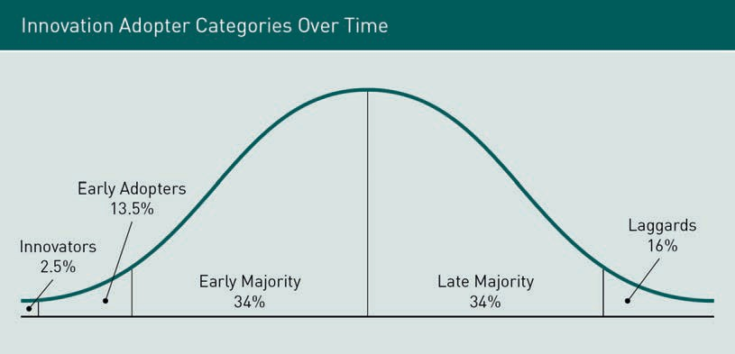

* + - Innovators are risk-takers; they are willing to pay monetary and social costs even when the new products they adopt fail. They tend to use other innovators outside of their groups as a reference group and use a variety of sources (e.g., sales people, media, professional sources) to learn about new products. They are generally more educated and socially mobile than their peers.
    - Early adopters are opinion leaders in their local reference groups. After gathering information from advertising, professional sources, and interpersonal sources such as innovators, they adopt an innovation and then provide word-of-mouth to others.
    - Early majority consumers are cautious about innovations, and they adopt new products only after innovators and early adopters. Consumers in this group are generally older, less well-educated, and less social mobile than the previous two groups. They obtain information about new products mainly through interpersonal communications.
    - Late majority members are skeptical about innovations. They adopt innovations as a response to social pressure rather than based on their positive attitude toward an innovation. This class of adopters is usually older and has lower social status and social mobility.
    - Laggards are reluctant to adopt an innovation. They have limited access to social interaction and most of their daily activities and contacts are based within a local community.

###### How Do Marketers Utilize Groups?

Marketers often utilize groups to propagate WOM. There are sectors of consumers that the mass media is not able to affect due to their skepticism toward advertising, or their aversion to risk; they are persuaded more so by other peoples’ actual experiences. Some of the stimulants marketers use to generate WOM are:

* + - Advertising: Exciting and interesting ads stimulate WOM. Sometimes marketers offer free products to anyone who recommends the product to their friends. People who recommend new products are usually opinion leaders.
    - Product sampling: Sampling, often called “seeding,” involves providing samples to groups of potential customers. Samples are often provided to opinion leaders who are selected to generate WOM.
    - “Buzz” is deﬁned as the exponential expansion of WOM. Marketers provide opinion leaders/celebrities with information and samples ahead of a product launch and sponsor “on-trend” events to court publicity and generate excitement and mystique about the brand. Guerilla marketing, a nonconventional communications strategy, utilizes buzz as a marketing tool. An example of guerilla marketing would be when a company hires attractive actors to pose as tourists using new digital cameras in

metro areas. These actors then ask passersby to take a picture for them to get the cameras into their hands and get them talking about it. Guerilla marketing practice is sometimes controversial with its questionable ethical and legal implications.

* + - * Brand community: Building a brand community is a successful method to reach groups of consumers. A brand community is a non-geographically bound community based on a structured set of social relationships among owners of a product and the psychological relationship they have with the brand, the product, and the company behind the brand.

Nejad, Sherrell, and Babakus (2014) conducted a literature review looking at the role of “inﬂuencers” or “inﬂuentials” in product diffusion and the relevance of this role to marketing management. They included “lead users,” “market mavens,” “experts,” “heavy/ light users,” “social hubs,” “social connectors,” “boundary spanners,” and “inﬂuential, opinion leaders” under the umbrella term “inﬂuentials.” The authors discussed four mechanisms by which inﬂuentials had an impact on the consumption choices of others: contact, socialization, status competition, and social norms.

* + - * Contact is when a consumer becomes aware of a new product via contact with another adopter.
      * Socialization refers to a situation in which a consumer discusses the new product with others and develops a normative understanding of the related beneﬁts and costs.
      * Status competition is when a consumer adopts a new product to maintain social status.
      * Social norms are when consumers adopt a new product to conform to their groups. The researchers found that the inﬂuence of social norms on a consumer’s new product adoption is a complex process. Firstly, a consumer’s decision to adopt an innovation depends on their perception of what their peer group would approve of. Secondly, products that are related to social identity are subject to higher normative inﬂuence than products that are not. Thirdly, there are two different social norms: descriptive (what others in a social group would do) and injunctive (what others in a social group would approve of).

The authors also reviewed the various ways in which marketers identify inﬂuentials. The ﬁrst method is through communications by either letting consumers self-identify (i.e., using a scale to rate themselves as inﬂuential) or via peer identiﬁcation (i.e., using sociometric or snowball data, or using a key informant to identify from whom they seek advice). The second method uses observation-based data such as an online social networking website or referral program. Despite being able to identify inﬂuentials, marketers still face difﬁculty targeting them. Methods of targeting inﬂuentials include using mass media, seeding (i.e., giving away free products or discounts to inﬂuentials), and communicating with inﬂuentials and tracking their reactions to marketing activities (i.e., providing free products to bloggers and documenting their reactions). Marketers can also create their own inﬂuentials by utilizing people who have the mobility, status, and conﬁdence to promote products.

Summary

External inﬂuences on consumer decision-making include culture, subculture, groups, and families. Culture is the complex whole that includes knowledge, beliefs, art, laws, morals, customs, and any other capabilities acquired by humans as members of society. It varies from society to society because each society has different learned behaviors that are explicitly and implicitly shared and adopted by members of that society. Elements of culture include values (self-oriented, other-oriented, and environment-oriented), norms, rituals, customs, myths, and sacred and profane consumption. Acculturation is the process by which people learn a new culture.

Subcultures are segments of a larger culture whose members share distinguishing values and patterns of behavior. Subcultures are typically based on nationality, ethnicity, age, geographic region, and religion. A consumption subculture is a distinctive subgroup of society that self-selects based on a shared commitment to a particular product class, brand, or consumption activity.

A group is deﬁned as two or more individuals who share a set of norms, values, or beliefs and have certain implicitly or explicitly deﬁned relationships to one another such that their behaviors are interdependent. A reference group is a group whose presumed perspectives or values are used by an individual as the basis for his or her behavior. The extent to which a consumer conforms to a group’s opinion or behavior depends on the level of commitment the individual feels to the group, the relevance of the consumption behavior to the functioning of the group, the individual’s conﬁdence in his or her own judgment, the visibility of the usage situation, and the level of necessity reﬂected by the nature of the product. Groups inﬂuence the consumptive behavior of people within them via verbal communication, e.g., word-of-mouth (WOM), and non-verbal communication, e.g., observation of others. Social contagion is the spread of affect or behavior from one crowd participant to another where one person serves as the stimulus for the imitative actions of another. Patterns of product adoption within and across groups can be explained via the diffusion process. The pattern of product/innovative diffusion begins with a period of relatively slow growth, followed by a period of rapid growth, followed by a ﬁnal period of slow growth. Product diffusion occurs as the result of the behavior of different types of consumers: innovators, early adopters, early majority, late majority, and laggards. Some of the stimulants marketers use to generate WOM within groups include advertising, product sampling, creating buzz, and building a brand community.



# Unit 5

## International Consumer Behavior

#### STUDY GOALS

On completion of this unit, you will have learned …

… what universal cultural dimensions are and how consumer behavior varies worldwide.

… what cross-cultural communication differences exist and what their impact is on consumer behavior.

… the relevance of cross-cultural perceptions of time, space, colors, and symbols for consumer behavior.

… what inﬂuence social media has on consumer decision-making.

DL-E-DLMBCBR01-U05

1. International Consumer Behavior

### Case Study

Preparing for her upcoming interview with the Google Pixel marketing team, MBA graduate Maria looks at some of the social media marketing for the Pixel undertaken by Google thus far. She looks at three videos circulating social media created by Google that feature three prominent YouTubers (Google, 2016):

* “Glamping by Alisha Marie, Phone by Google”
* “Puppies! by Connor Franta, Phone by Google”
* “The Perfect Piece by Todrick Hall, Phone by Google”

Each of these advertisements highlights a speciﬁc feature of the Pixel: the video with Alisha Marie highlights the camera and video features on a glamorous camping experience that she has with friends, the video with Connor Franta highlights the Knock Knock video calling feature that he uses to call friends to show them the adorable pup- pies crawling over his couch, and the video with Todrick Hall shows the versatility of Google Assistant as Todrick utilizes this feature to design and manufacture a customized jacket.

Maria considers the use of these prominent vloggers and video creators a strategic move to promote the Pixel smartphone to a younger generation of consumers, who include many early adopters of new technology and consumers of popular culture. But what about other cultural groups? Maria wonders whether the same advertisements will appeal to older generations or consumers outside of the US. What would be the advantages or disadvantages of creating other advertisements to appeal to other cultural groups? Should additional advertisements focus on the same features? Maria formulated the following questions:

* Are the various features of Pixel perceived differently by consumers from country to country depending on their culture?
* Are the features of the Pixel used differently around the globe?
* Can cultural theories provide any insight into what might drive variance in how consumers use the Pixel in different parts of the world?

Despite the proliferation of global citizens living in global villages consuming global brands, consumer behavior still deviates from one country to another at the national level. Cultural differences are the main driver for such deviations. In this unit, various cultural dimensions will be discussed and serve as a tool for gauging and comparing how consumer behavior differs around the globe. We will then explore the role of social media in inﬂuencing consumer decision-making.

### Cultural Dimensions

Because culture is learned within the boundaries of a society, we often compare cultural differences from one society/country/region to another. However, before we can objectively identify that cultural differences exist between such societies or countries, we must ﬁrst establish some criteria for comparison. Researchers have derived some universal criteria for undertaking cultural comparisons. The work of researchers such as Edward Hall, Geert Hofstede, and Harry Triandis provides examples of cultural concepts often utilized by international market researchers to undertake strategic analyses.

In this section, we will investigate the work of Edward Hall and the notion of high- versus low-context cultures before looking at the ﬁve dimensions popularized by works of Geert Hofstede: individualism/collectivism, power distance, uncertainty avoidance, masculinity/femininity, and long-/short-term orientation. These ﬁve dimensions have been used to measure cultural differences across more than 70 countries.

###### High- Versus Low-Context Culture

The general terms “high-context” and “low-context” are used to describe broad-brush cultural differences in communications that exist between societies. Cultural anthropologist Edward Hall is credited with popularizing this term in his 1976 book “Beyond Culture.” In high-context cultures, many aspects of cultural behavior are not made explicit because most members know what to do and what to think from years of interacting with one another. To understand something that occurs within such a culture, you must understand the context, for much is left unexplained and may only be intelligible to select members of an in-group. Behind each communicative action, there are layers of meaning that are not immediately apparent to the outsider. In general, people in high-context cultures use symbols and non-verbal cues to communicate with one another, are much more polite to one another, use less explicit verbal and written communication, and are indirect when conveying any type of displeasure. In interpersonal relationships, people from high-context cultures tend to have multiple crosscutting ties, value the development of strong, long-term relationships, and establish strong boundaries regarding who is an “insider” and “outsider.” Asian societies are examples of high-context cultures.

In contrast, low-context cultures refer to societies in which cultural behavior and beliefs are explicit so that those entering this cultural environment know how to behave. In these societies, to understand the meaning of any communicative gestures, you don’t have to look at the context: it will be self-explanatory and based on what was explicitly communicated. In low-context cultures, people are direct in their messages; communication is not based on an internalized understanding or speciﬁc knowledge that is drawn from a common background. People in these societies tend to have many connections but of shorter duration or for a speciﬁc purpose and generally value individualism. Western societies are generally categorized as low-context cultures.

High-context cul- tures

High-context cul- tures are those where many aspects of cultural behavior are not made explicit because most members know what to do and what to think from years of interacting with one another.

Low-context culture Low-context culture refers to societies where cultural behavior and beliefs may need to be spelled out explicitly so that those coming into that cultural environment know how to behave.

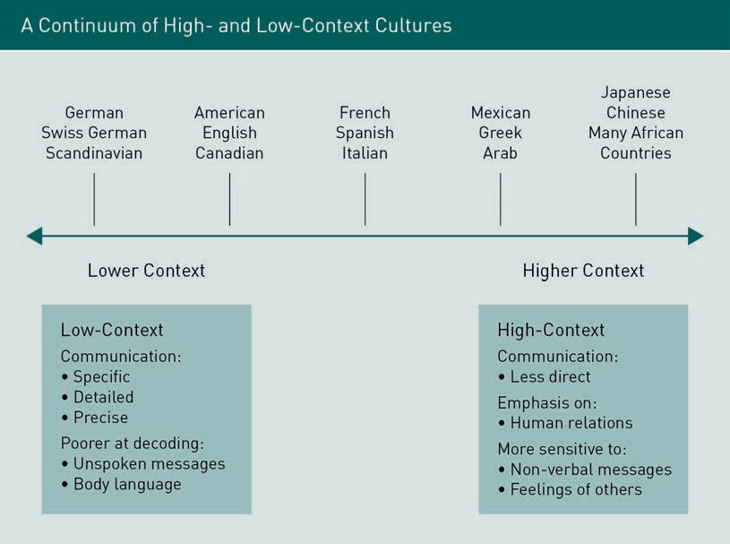

In the context of international marketing, marketers operating in low-context cultures can effectively use explicit messaging in their marketing communications. When it comes to knowledge within the context of consumer behavior, consumers from low- context cultures view knowledge as codiﬁed, public, external, and accessible whereas consumers from high-context cultures view knowledge as situational and relational. In a sense, knowledge for individuals in low-context cultures is more transferable. Because of the explicitness of communications, individuals in a low-context culture are more task-centered with decisions and activities focusing on what needs to be done, and with a clearer division of responsibilities. Similarly, individuals in low-context cultures tend to be more rule-oriented, i.e., they play by external rules.

Examples

* When an American consumer does not like a product, they will often inform the salesperson directly that they do not like it in contrast to a Japanese consumer who, in the same circumstance, will often say that they will “think about it.”
* Asian consumers within their high-context cultures tend to express less emotion than Westerners when they are dissatisﬁed with a product (Watkins & Lui, 1996).
* Marketers advertising in low-context cultures can effectively use explicit messaging in their marketing communications. However, in high-context cultural environments, marketers tend to be more indirect in their messaging. A study of the websites of global brands in six countries conﬁrmed that marketers from low-context cultural groups (US, UK, and Germany) and high-context cultural groups (Japan, Korea, and China) differ in their visual presentations of advertisements (An, 2007). In analyzing

the content of 253 ads, the researcher found that ads from high-context countries rely more on visual symbols and indirect portrayals while ads from low-context countries rely more on literal texts and direct messages.

###### Individualism Versus Collectivism

The next cultural dimension international marketers often consider is the continuum of individualism and collectivism. In an individualistic society, individual differences are appreciated, autonomy and personal freedom are highly valued, and rewards and status are given to individuals. The well-being of an individual in these cultures is generally considered to be more important than the well-being of the group. Thus, self-interest is valued more than group-interest. While variations always exist, Western societies such as the US, Australia, the UK, Canada, New Zealand, and Sweden are relatively individualistic. In contrast, a collective society emphasizes the importance of group-interest rather than self-interest. Pursuing personal freedom at the expense of group cohesiveness is frowned upon. Therefore, conformity to and cooperation within a group is more highly valued than individual rewards. Countries such as China, Japan, Russia, and Mexico are examples of collective cultures.

This cultural dimension has a signiﬁcant inﬂuence on the self-concept of individuals and, in turn, has a signiﬁcant impact on consumer behavior. Consumers from collective societies are generally less individualistic and as a result, marketers place less emphasis on the individualistic appeal of a product in marketing materials. Since collective societies tend to be tighter-knit groups and sub-groups that emphasize collective group values, consumers in these societies are more imitative and less innovative in their purchases when compared to consumers in individualistic societies. Consumers in collectivist societies tend to make purchase decisions based on what they think is right for a situation and will act according to the collective group attitude. Consumers in individualistic societies tend to have strong self-identity and tend to make purchase decisions based on their individual evaluations.

Examples

* + - Researchers found consumers from individualistic cultures are more likely to engage in impulse buying than consumers in collectivist cultures (Kacen & Lee, 2002).
    - Luxury items are viewed as a means of self-expression or a means to stand out in individualistic cultures, whereas the same luxury items are symbols to convey “I am just like you” in collectivist cultures.
    - Wearing fashionable clothing items in individualistic cultures is often an attempt to convey a sense of individuality. However, in collectivist cultures, being well-dressed means dressing appropriately to avoid losing face in front of in-group members.

###### Power Distance

Power distance Power distance refers to the extent to which the less powerful members of a society accept the authority of those with greater

power.

Power distance refers to the extent to which the less powerful members of a society accept the authority of those with greater power. Cultures low on the power distance dimension tend to be more egalitarian in their outlook and feel that everyone is equal. In high power distance cultures, people with less power are expected to be subservient to the more powerful. The source of power can take many forms: money, education, political position, social position, family status, birth order, etc. Power distance does not refer to the “absolute” power differences that exist among people, rather it is about the submissive role the less powerful willingly accept toward those more powerful. For example, in the US, there is a great divergence in power just as there is in Bangladesh or Thailand, but psychologically, the typical American feels equal, and the less resourceful feel no need to submit to the more resourceful when compared to the average person from Bangladesh or Thailand. Extending this cultural dimension to the domain of international marketing, consumers in high power distance cultures often appeal to authority (e.g., royalty and celebrity) to sanction or promote a product whereas consumers in low power distance cultures make their appeal to fellow consumers.

While conventional work has conﬁrmed the existence of differences in consumer behavior worldwide based on this dimension, we must ask if the advent of the Internet, coupled with the economic growth seen in many of the countries once studied in the pre-Internet era, may have changed this prevailing cultural dimension behavior. For example, both Russia and China have been traditionally considered collectivist societies. Empowered by ubiquitous access to information via the Internet, do consumers today still exhibit such cultural differences in their behaviors? Do online consumers in Russia or China exhibit more of a collectivist orientation toward decision-making than their counterparts in the highly individualistic US where reference groups of strangers are abundant? Or is it possible that consumers from individualistic cultures rely more on other consumers’ online opinions than consumers from collectivist cultures? Could a reversal of the characteristics of the cultural dimension result from social media usage? Could consumers from individualist societies become more interdependent because of online community interactions than consumers from collectivist societies? Because of the one-way broadcasting capabilities of the social web, are consumers from collectivist societies becoming more individualistic and exhibiting more individualistic styles of decision-making behavior? Answers to questions such as these are yet to be fully determined as the role of the Internet changes and grows in all cultures.

Examples

* + - In high power distance cultures, a person’s social status needs to be conveyed to others all the time, so global brands serve the purpose of conveying such status.
    - Global brands convey “prestige” in high power distance cultures, whereas in low power distance cultures, global brands convey “friendliness.”
    - Consumers from low power distance cultures will proactively acquire more information through the media while consumers from high power distance cultures tend to acquire information through interpersonal communications.

###### Uncertainty Avoidance

Uncertainty avoidance refers to the extent to which people in a society feel threatened by ambiguous situations and wish to avoid them. In societies where people are socialized to accept some degree of uncertainty, people are unsurprisingly more tolerant of uncertainty and ambiguity. On the contrary, some societies value knowing as much as possible and like to plan for possible contingencies, which leads people to be generally more risk-averse, and potentially less innovative and less entrepreneurial. Consumers in societies that have a high tolerance for uncertainty are often more likely to welcome new brands, new products, new channels of distribution, and other new marketing activities.

Researchers investigating cross-cultural new product adoption have used the dimension of uncertainty avoidance to explore consumer beliefs and practices. It is worth considering how Internet-enabled new products, e.g., apps, may level out previous differences in this cultural dimension. In other words, when an app is easy to adopt and delete, will consumers from countries like Greece, where uncertainty is ﬁercely avoided, remain hesitant to adopt a new product when compared with consumers from countries such as the US, who traditionally welcome uncertainty?

Examples

* + - Global brands use “trustworthy” messages for high uncertainty avoidance cultures, whereas for low uncertainty avoidance cultures, they use “innovation” messages.
    - Controlling for GDP per capita, low uncertainty avoidance cultures tend to have more PCs, engage in more Internet use, and maintain a more active attitude toward health by focusing on ﬁtness and sports.
    - High uncertainty avoidance cultures were found to consume more mineral water, have higher expenditure on medical care, have a higher number of physicians and pharmacies per capita, and consume more doses of antibiotics.
    - Consumers in societies that have a high tolerance for uncertainty are more likely to welcome new brands, new products, new channels of distribution, and other new marketing activities.

Uncertainty avoid- ance

Uncertainty avoid- ance refers to the extent to which peo- ple in a society feel threatened by ambiguous situa- tions and wish to avoid them.

###### Masculinity Versus Femininity

Societies that value such things as wealth, success, power, mastery of the environment, and qualities such as assertiveness are categorized as having masculine cultures. In contrast, those societies that value such things as harmony, peace of mind, caring for others, and quality of life, are said to have more feminine cultures. In the context of consumer behavior, people from feminine cultures tend to reject environmentally unfriendly products and services that are primarily materialistic, in contrast to people from more masculine cultures who tend to seek products that promote and reﬂect material success. According to Hofstede’s ﬁndings, Scandinavian countries tend more toward a feminine culture than countries such as the US, UK, Italy, and Japan.

As societies become more aware of issues such as quality of life, sustainability, harmony, and so on, corporations operating in these countries tend to engage in activities reﬂecting these societal values. Increasingly, these types of issues seem to be more prevalent in advanced economies than in emerging economies.

Examples

* + - * Marketers will portray their products as “winning,” “prestigious,” or “best performing’ when they communicate with their customers in highly masculine cultures. On the contrary, when approaching customers in highly feminine cultures, they portray their products as “nurturing,” “environmentally friendly,” and “caring.”
      * Heavy usage of the Internet and use of the Internet for leisure purposes correlates with low masculinity.
      * Ownership of luxury goods such as expensive watches and jewelry is related to masculinity, and this relationship is relatively stable over time. The percentage of business people who reported the main watch they owned cost more than €750 or who bought jewelry over €1,500 correlated with their culture of origin being more masculine.

###### Long-Term Versus Short-Term Orientation

According to Hofstede, every society has links to its past while facing challenges at present and in the future. Societies prioritize the past, present, and future differently. Some societies place more emphasis on traditions and norms and view social changes as suspicious. These societies or countries tend to score highly on long-term orientation (LTO) and have characteristics of perseverance, orderly relationships, and thrift; they are also well-ordered and have a sense of shame (Bearden, Money, & Nevins, 2006). Societies with a long-term orientation have a pragmatic approach that encourages thriftiness and emphasizes making provisions for the future. This cultural dimension is often correlated with whether people emphasize shorter- or longer-term beneﬁts. Cultures with an orientation toward the short-term (STO) tend to prefer securing immediate beneﬁts and pleasures rather than waiting for long-term future beneﬁts and rewards.

Researchers found that people from the UK, the US, and Australia tend to have a shorter-term orientation than their counterparts in Hong Kong, China, Brazil, India, and Hungary. Not surprisingly, researchers report that consumers from long-term orientation countries are less likely to use credit cards for purchases and prefer using cash and debit cards.

Examples

* + - Consumers in STO cultures tend to make decisions based more on immediate desires, with no contemplation of future consequences (e.g., debt incurred to ﬁnance current purchases). Hence, such consumers are more likely to “buy now.”
    - Consumers from LTO cultures are more likely to “plan ahead” before making large purchases and are less tempted by immediate desires. Higher levels of LTO are associated with lower levels of compulsive buying.
    - Consumers from cultures with high degrees of LTO view unethical behavior negatively while consumers from cultures with a low degree of LTO orientation have less concern for ethical behavior as they focus on short-term consequences.

###### Cultural Ethnocentrism

Ethnocentrism is the belief that one’s own culture is superior to others. Researchers use a tool to measure general ethnocentrism by asking individuals to rate their level of agreement to questions such as “I have no desire to learn about other cultures” and “The world would be better off if all countries adopted the culture of my country or group.”

In international marketing, this cultural dimension is critical when seeking to under- stand the attitudes of global consumers toward foreign brands. Market researchers use a consumer ethnocentrism scale called the Consumer Ethnocentrism Tendencies Scale (CETSCALE) to gauge how likely consumers are to purchase products made by foreign countries (Shimp & Sharma, 1987). The CETSCALE, which can be adapted to speciﬁc products from speciﬁc countries, includes statements like those in the following list. In this example from Pentz, Terblanche, and Boshoff (2013), the CETSCALE has been designed to measure consumer ethnocentrism regarding the purchase of products from South Africa.

1. Only those products that are unavailable in South Africa should be imported.
2. We should purchase products manufactured in South Africa instead of letting other countries get rich off us.
3. South African products ﬁrst, last, and foremost.
4. South Africans should not buy foreign products because this hurts South African businesses and causes unemployment.
5. Purchasing foreign-made products is un-South African.
6. It may cost me in the long run, but I prefer to support South African products.
7. It is not right to purchase foreign products because it puts South Africans out of jobs.

Ethnocentrism Ethnocentrism is the belief that one’s own culture is superior to others.

1. We should buy from foreign countries only those products that are unobtainable in our own country.
2. A real South African should always buy South African-made products.
3. South African consumers who purchase products made in other countries are responsible for putting their fellow South Africans out of work.

Cultural ethnocentrism still prevails in the Internet era. Contrary to the belief that the Internet will ﬂatten the world, what we have seen is a resurgence in nationalism over the past decade around the world. On the one hand, we see proponents of one world, one voice, and one village and on the other, we see the rise of nationalistic viewpoints. From BREXIT to the US presidential elections in 2016, we see many consumers around the world wanting national sovereignty with controlled borders, limits on immigration, and a popularly elected local government rather than a globalized world administered by a perceived supranational elite of unelected administrators as in the case of the European Union (EU).

Examples

* + Chinese consumers boycotting Japanese products over past disputes from WWII and squabbles over territorial claims have become common. That said, it is almost impossible to know the true identity of a product when it is a Japanese brand manufactured in China and sold in China or when it is a Chinese brand bought by a Japanese ﬁrm.
  + Many movements around the world promote consuming locally grown or locally made products. Brands such as McDonald’s (India), Starbucks (Columbia), and Walmart (US) have promoted themselves as sustainable brands using locally sourced materials through speciﬁc programs and campaigns.

###### Time Dimension

Monochronic per- spective of time

A monochronic per- spective of time means that time is considered linear

and limited.

Polychronic perspec-

tive of time A polychronic per- spective of time views time as renew- able and cyclic.

Societies that have a monochronic time perspective view time almost as though it were a physical object: we can schedule it, waste it, lose it, and so forth. Believing that a person does one thing at a time, these societies have a strong orientation toward the present and the short-term future; lateness and interruptions are not tolerated. Societies that have a polychronic perspective of time view time as less concrete and more cyclic; scheduling is thus more ﬂuid. People in these cultures view simultaneous engagement in multiple activities as natural. They engage in many things at once and can be highly distractible and subject to interruptions. They consider deadlines and schedules to be secondary to people and relationships, and activities occur at their own pace rather than according to some predetermined timetable. Germany provides an excellent example of a country where people largely share a monochronic perspective of time while neighboring country Italy is stereotypically known as operating according to a polychronic perspective of time.

How then does consumer behavior vary between monochronic and polychronic cultures? Convenience foods have limited success in cultures with a polychronic time perspective as saving time is not a cultural predilection. Contrast this with consumers from

cultures that are oriented toward more monochronic time perspectives that emphasize promptness and may expect rapid product delivery (e.g., next-day delivery in the US).

Examples

* + - In Argentina, fast food is viewed as representing modern values rather than a convenience that “saves time” as it is perceived in the US.
    - While there are multiple reasons why Amazon Prime (Amazon’s membership-only two-day delivery service) was ﬁrst launched in the US, Germany, Japan, and the UK, interestingly, these are all countries whose society has a monochronic perspective of time.

### The Inﬂuence of Social Media on Consumer Decision- Making

The advent of the Internet has empowered consumers across many dimensions. Information is now available to individuals on a scale previously unimaginable. The penetration of smart phone technology around the globe has made information increasingly ubiquitous, available to anyone at any time and in any place. The result is that billions of consumers now have information available instantaneously from vendors.

Knowledge is power and the balance of power between vendors and consumers has tilted decidedly in favor of consumers. Until recently, vendors had the upper hand since they possessed more information about products and brands than consumers. Now, consumers have more information than both the vendors and their competitors. As a result, a “reverse asymmetry” of information now exists between consumers and vendors as the information dominance has shifted to the consumer.

Equally as signiﬁcant, Web 2.0 technologies have made interactions among vendors and consumers much easier, seamless, and continual. Most vendors now have a strong web presence that competes for consumers’ time. It has become almost essential that vendors have a strong social media presence and regularly update content and engage consumers online.

The impact of Web 2.0-enabled social media on the consumer decision-making process reﬂects the increasing presence and impact of consumers’ choices and opinions. In addition, Web 2.0 has made it easier for consumers to observe other peoples’ behavior. Aware of this, vendors use algorithms to automatically present consumers with other purchasers’ choices along with post-purchase feedback that gives the individual consumer additional information when making their own purchase decisions. Consumers can readily ﬁnd product information from websites hosted by vendors (e.g., Subaru’s website), third-party independent sources (e.g., JD Power), and competitors for making product comparisons. Shopbots also help consumers make quality decisions.

Web 2.0 technologies

Web 2.0 technologies are world wide web websites that emphasize user-gen- erated content, usa- bility, and interoper- ability.

Information over-

load Information over- load occurs when the amount of input exceeds the capacity to adequately proc- ess that information, thereby compromis- ing the quality of decision-making.

Given the growing stream of information, it is reasonable that researchers begin to seriously investigate the growing information overload and understand how it affects consumer decision-making. Given the limitations of the human cognitive processing capacity, information overload occurs when the amount of input exceeds the brain’s capacity to adequately process that information, thereby compromising the quality of decision-making. Research ﬁndings suggest that the huge amount of information available on the Internet makes “recency” or freshness of information a key determinant in decision-making. Consumers use the quantity of information on a webpage and the aesthetics of the site (e.g., color, layout, fonts, pixels) as heuristics for decision-making. Websites with stale or unchanging content and design quickly lose their appeal and site visitors will soon look elsewhere.

The effect of social media has reshaped the conﬁguration of the classic social group. Before the Internet, social groups consisted primarily of people that we knew. After the rise of the Internet, social group inﬂuence began to stem from strangers we had never met. When researchers investigated the perception of trustworthiness in online com- munities and other online groups, they discovered a “kindness of strangers” phenomenon, where people provided other consumers with information and support in areas ranging from the purchase of cars to cancer drugs and treatments (Constant, Sproull, & Kiesler, 1996; Riding & Gefen, 2004). The emergence of the “kindness of strangers” phenomenon revolutionizes the way we think of word-of-mouth source credibility, source expertise, source likability, source similarity, and trustworthiness. As everyone suddenly has the chance to become an expert in the online environment (e.g., write a product review), we have yet to fully understand clearly how consumer behavior will change with Web 2.0 and beyond.

Social media-created reference groups that consist of strangers instead of traditional social networks formed through face-to-face interactions are growing in what seems to be a worldwide phenomenon. The consumer world is no different. Whether in the US or China, consumers widely use social media in their interactions with vendors when purchasing either online or ofﬂine. In addition to a website, many small-medium businesses today maintain an online social media presence, typically using Facebook, Instagram, and Twitter as regular platforms to engage with consumers.

Web 2.0 technology has also facilitated the emergence of relationships that are exclusively online, resulting in interactions via subscribed written, image, and video content using YouTube, Instagram, and Twitter. These online relationships are extremely effective forms of brand promotion through social referencing. Especially for younger generations, marketing directly from brands or celebrity brand spokespeople is not nearly as effective as brand advocacy from YouTubers, vloggers, and bloggers. “Inﬂuencer marketing is the practice in which brands collaborate with social inﬂuencers across social platforms such as YouTube and Instagram to promote their products through branded content. A $240 m industry as measured by Technorati, and with 92 % of people trusting recommendations from people they know, it’s no wonder that it is one of the fastest growing marketing medium in the past ﬁve years.” (The Guardian, 2015)

The intersection of social media and Hofstede’s cultural dimensions is interesting to consider as it relates to consumer behavior. Do consumers in individualist countries tend to rely more on Facebook and other social media sites as part of their purchase decision-making process? Or do consumers in collectivist countries rely more on social media given their strong group-oriented culture? Does the use of social media have an impact on the cultural dimension of power distance? Are high power distance countries more likely to use celebrities on social media to sell their brands than low power distance countries? And what about online communities? These are communities that interact over time about topics of interest on the Internet, supported by a social media presence. Do these communities function better under certain cultural dimensions in terms of inﬂuencing consumer behavior?

While this is still a developing area of research, we know that, worldwide, consumers expect the social media posts of vendors to be transparent and genuine. Fake blogs or ﬂogs are not well-received. US bloggers who work for ﬁrms (i.e., sponsored content) have a legal obligation to disclose their afﬁliations according to the Federal Trade Commission (FTC). We also expect that vendors from around the world who participate in social media need to become a genuine part of the community and not just act as mere vendors. Although marketing managers initially viewed social media as a mere marketing tool, they soon discovered that consumers expect them to be involved in the community to help solve consumers’ problems. About two-thirds of US consumers believe that companies should ramp up their social media usage to identify serv- ice/support issues and contact consumers to resolve them (Mothersbaugh & Hawkins, 2016, p. 224).

The following preferences were identiﬁed by a recent study regarding consumers’ social media interactions with ﬁrms (Cone Communications, 2010). Consumers were asked to specify the type of interaction with companies via social media that they preferred.

* Providing incentives such as free products and coupons = 77 %
* Providing information or solutions to my problems = 46 %
* Asking for my feedback on products and services = 39 %
* Entertaining me = 28 %
* Finding new ways to interact with me = 26 %
* Marketing to me = 21 %

No doubt, vendors have been successful in acquiring customers through their social media presence. Most consumers who use social networking sites use them to share information, including information about brands and products. Sixty-eight percent of vendors on Facebook indicated that they have acquired customers through this channel (HubSpot, 2010). It is instructive to note that two-thirds of consumers who interact with a brand via social media are more likely to recall that brand, share information about that brand with others, feel connected to it, and ultimately, make a purchase (Cone Communications, 2010).

Online communities Online communities are communities that interact over time about topics of interest on the Internet, supported by a social media presence.

Summary

International consumer behavior is shaped signiﬁcantly by cultural dimensions and the inﬂuence of social media. An understanding of cultural differences can be developed by applying Hall’s notion of high- versus low-context cultures and Hofstede’s ﬁve cultural dimensions: individualism/collectivism, power distance, uncertainty avoidance, masculinity/femininity, and long/short-term orientation. Each of these dimensions help to explain some of the differences in consumer behavior and marketing management for different cultural groups.

The proliferation of social media means that consumer behavior is signiﬁcantly inﬂuenced by online platforms, Web 2.0 technologies, and mobile phones. A reverse asymmetry of information means that consumers often have more information about products than vendors. Consumers can readily ﬁnd product information from websites hosted by vendors, third party independent sources, shopbots, and competitors for making product comparisons. Social media-created reference groups are increasingly playing a role in consumer decision-making and marketers are utilizing YouTubers, vloggers, and bloggers to promote brands. Acquiring customers through a robust social media presence is becoming increasingly important, how- ever, businesses need to understand that consumers have speciﬁc preferences regarding their interactions with brands via social media platforms.



# Unit 6

## International Marketing Strategy and Consumer Behavior

#### STUDY GOALS

On completion of this unit, you will have learned …

… how global consumer culture has emerged and how global consumers are segmented by marketers.

… what the standardization, localization, and glocalization of marketing strategies involve in the context of consumer behavior.

… what cultural, demographic, and economic factors are relevant for international marketing.

DL-E-DLMBCBR01-U06

1. International Marketing Strategy and Consumer Behavior

### Case Study

MBA graduate Maria is considering how the marketing team responsible for the Google Pixel might take the information it has about the behavior of potential consumers and apply it to the marketing mix it creates for different consumer segments. For example, how exactly does understanding the consumer purchasing patterns of a 25-year-old Indian male living and working in Delhi affect the four Ps of marketing relative to the Pixel? Maria looks at some of the marketing initiatives that Google has undertaken specific to the Indian market. Market estimates in 2016 suggest that 10 million smartphone units are shipped in India each month, although the market for premium segment smartphones is only 3.3 % of the total Indian smartphone market (Misra, 2016). Maria ﬁnds that Google undertook some of the following marketing measures in an attempt to capture a market share in India:

* exchange programs for older mobiles
* discounted pre-ordering programs via Flipkart
* interest-free ﬁnancing via equal monthly installments (EMI) for all online and off- line purchases
* cashback programs for HDFC Bank card holders
* advertisements targeted toward users in metro and tier cities in India.

Despite implementing some specialized marketing measures speciﬁc to the Indian market, the Pixel product, pricing (INR 57,000 for the Pixel is equivalent to US $799), and some of the advertisements were the same in India as they were elsewhere in the world.

Maria considers why Google may have implemented these strategies and asks herself the following questions:

* How does consumer behavior drive marketing strategies?
* How do marketers develop strategies in response to global consumer culture or varied consumer behavior?

We will attempt to answer Maria’s questions throughout this unit. We begin by investigating how marketers undertake consumer segmentation and product positioning, looking speciﬁcally at global consumer culture and then at consumer segments. We then look at product, promotion, distribution, and pricing strategies and how knowledge of consumer behavior inﬂuences the creation and implementation of the marketing mix.

### International Market Segmentation and Product Positioning

###### Global Consumer Culture

There has been a long and unresolved debate about the existence of global consumer culture. Global consumer culture describes a market segment of consumers who perceive themselves as global citizens living within a global village and who adopt global brands as an expression of this identiﬁcation (Strizhakova, Coulter, & Price, 2008; Alden, Steenkamp, & Batra, 1999). This culture transcends country and culture of origin. It is believed that multinational corporations (MNCs) such as Coca-Cola, Microsoft, and Samsung and their marketing activities shape much of the consumer behavior exhibited within this culture (Cleveland & Laroche, 2007).

The internal workings of the consumer mind are complex, and we often do not under- stand why consumers who wear Levi’s jeans, eat at McDonald’s, and seemingly embrace global consumer culture also protest the dominance of multinational corporations in the global marketplace. Should we consider the spread of Starbucks and Ikea to every corner of the world an imperial-style cultural invasion of Western values polluting indigenous cultures? Who is to say whether people living in the mountains of Tibet need Red Bull? Who is to judge whether bringing the ubiquitous smartphone into the jungles of Thailand is cultural pollution or a sign of civilization? Some marketers strongly believe that the introduction of advanced technology products improves the quality of life. Other marketers propose sustainable consumption and ask consumers not to purchase products unless they need to. One example of such an approach is the outdoors clothing brand Patagonia. It launched an innovative advertising campaign in 2011 titled “Don’t Buy This Jacket” where the company detailed the expenses to the environment of producing a speciﬁc jacket and implored consumers to reduce their over-consumption with the text: “Don’t buy what you don’t need. Think twice before you buy anything.” (Nudd, 2011) However, for the average for-proﬁt business, marketing’s aim is to maximize sales by maximizing the number of consumers and increasing the quantity of their purchases. Such an agenda encourages the spread of products and services worldwide.

From a global marketer’s perspective, a universal global consumer culture is helpful to diffuse its goods or services. The costs for marketers (i.e., money, effort, time) are lowest when offering the same goods, same pricing structure, using the same advertising materials, and distributing products in the same way in every market. Standardization is deﬁned as “the process of extending and effectively applying domestic target- market-dictated product standards—tangible and/or intangible attributes—to markets in foreign environments” (Medina & Duffy, 1998, pp. 229–330). Standardization of the overall marketing strategy is economically efﬁcient, e.g., offering the same iPhone with the same advertising message around the world requires the least amount of work to calibrate the product or message for each market, and thus theoretically costs less than implementing multiple, diverse marketing strategies. Standardization can be applied to all or selective marketing strategies (i.e., the 4Ps). For example, Coca-Cola not

Global consumer culture

Global consumer culture describes a market segment of consumers who believe that by adopting global brands, they become global citizens living in a global village.

Standardization Standardization is the process of extending and effec- tively applying domestic target-mar- ket-dictated product standards—tangible and/or intangible attributes—to mar- kets in foreign envi-

ronments.

Localization Localization is a strategy of adapting marketing mix ele- ments to various national markets.

Glocalization Glocalization is the combination of standardization and

localization.

International mar- keting segmentation International mar- keting segmentation is the process of identifying speciﬁc segments of poten- tial customers with homogeneous attributes who exhibit similar responses to a com- pany’s marketing

mix.

only offers standardized products around the world, in 2016, it announced its strategy to use a “one brand” marketing strategy and launched its global campaign titled “Taste the Feeling” to unite all its trademark brands (Moye, 2016). However, standardization is only one approach adopted by marketers; localization is a strategy of adapting marketing mix elements to various national markets while glocalization is the combination of standardization and localization: global localization.

###### Segmenting Consumers

While global consumer culture exists, marketers cannot view all seven billion people on earth as a single market. There is more than one global consumer culture. Managers who design marketing mix strategies need to know exactly who their customers are for their strategies to be effective; if a manager knows that customers in Saudi Arabia do not eat pork, then offering a pulled pork sandwich in the local Burger King is a poor strategy. Therefore, dividing the world into groups of countries or groups of potential customers across countries is necessary to target a speciﬁc customer group. International marketing segmentation is the categorization of segments of potential customers with common characteristics.

Within a segment, people have a shared set of consumption-related symbols with common meanings and desirability among members. An example is the global youth culture, composed of consumers aged 14–29, sometimes referred to as “millennials.” Their tastes are highly inﬂuenced by mass media, social media, work, and education. Their consumption of music, food, sports, and fashion are replicated across continents with brands like Rihanna and Lady Gaga, Sean John (the clothing brand from Puff Daddy with estimated annual sales of $400 million), iPhone and Samsung Galaxy, anime and manga (Japanese animation and comics), Uniqlo, Zara, H&M, Nike, Netﬂix, Facebook, and Instagram. Trends identiﬁed regarding this group of consumers include: 1) being information and communications technology (ICT) users who are perpetually connected, 2) group leaders tend to be Europeans, and 3) top brands are Japanese (Sony) and Adidas (Germany) (Mothersbaugh & Hawkins, 2016). Additional trends identiﬁed by research agency Voxburner in their 2016 “Youth Trends Report” indicated that some of the trends identiﬁed in this age group include: 1) embracing virtual reality, 2) preferring instantly available products and services such as click-and-collect, and 3) engaging with “inﬂuencers” on Instagram, Snapchat, and YouTube and their brand endorsements more than traditional marketing sources. Marketers further dissect the youth group into urban centers and smaller cities because middle-class teens living in urban areas tend to behave differently than teens in rural areas.

However, millennials are only one segment of global consumers. Identifying and categorizing groups of customers across the globe according to their common characteristics is no easy task. So how do marketers go about segmenting the globe? Four seg- mentation criteria used by marketers are:

1. Demographic (based on the size, structure, and distribution of a population)
2. Psychographic (based on the characteristics of people)
3. Behavioral (based on consumers’ use of products)
4. Beneﬁt sought (based on those values and beneﬁts sought by consumers)

Global Demographic Segmentation

Demographics segmentation involves characterizing consumers according to size (number of individuals in the society), structure (age, income, education, and occupation), and distribution (physical location of individuals in terms of geographic region and rural, suburban, and urban locations).

Population growth does not take place evenly across the globe. Most advanced economies have negative population growth (e.g., Japan and Germany) if they do not rely on immigration. Longevity also tilts the distribution of population, with many economies having a disproportionally large segment of “baby boomers,” the demographic group born after WWII. However, on a global scale, there is substantial growth in the <16-year-old population. In the Philippines, more than 40% of the population is under 25, compared to about 25% in the US (Fattah, 2002). Marketers are often interested in the inﬂuence and reach they have to this younger population as their attitudes toward brands and products are not as established as older generations.

When discussing consumption, income distribution is important for segmentation. One country with a relatively low average income can have a sizable middle- income segment while another country with the same average income may have most of the wealth concentrated in the hands of a few individuals. Take Brazil and Romania: in Brazil, 45% of the income generated goes to 10% of the population while in Romania, only 21% of the country’s income goes to the top 10% of the population (Mothersbaugh & Hawkins, 2016, p. 63). This uneven distribution has led marketers to utilize purchasing power parity (PPP), i.e., the cost of living, to evaluate a market’s potential rather than per capita income or average income.

Psychographic Segmentation

This type of segmentation is another method for categorizing groups of consumers around the world. Marketers gather information about consumers regarding their attitudes, values, resources, opinions, and preferred and actual activities. There are many well-recognized psychographic surveys and studies of consumers created to separate consumers into segments according to commonalities in their lifestyles, attitudes, and values. Finland’s Nokia is a well-cited example of a ﬁrm that relied on psychographic segmentation to derive sales in speciﬁc customer segments (“trendsetters,” “social contact seekers,” “poseurs,” and “highﬂiers”) when it was promoting its mobile phone in the early 1990s (Steinbock, 2001, p. 282).

One well-known survey utilized for psychographic segmentation is the Values and Lifestyles framework (VALS) by SRI International. SRI International, a leading market research organization, developed the VALS in the late 1970s to segment consumers according to resources and primary motivation. The VALS classiﬁes consumers as “innovators,” “thinkers,” “believers,” “achievers,” “strivers,” “experiencers,” “makers,” and “survivors.” This methodology is widely used by industry. Another well-known study similarly segmenting consumers was the Euroconsumer study conducted by a research team at D’Arcy Masius Benton & Bowles that resulted in a report titled “The

Demographics seg- mentation Demographics seg- mentation criteria include income, population, age dis- tribution, gender, education, geo- graphic location, and occupation.

Euroconsumer: Marketing Myth or Cultural Certainty?” (Keegan & Schlegelmilch, 2000). According to this report, there are four types of Euroconsumers: the successful idealist (5–20% of the population who are high ﬁnancial and social achievers with a high degree of social consciousness), the afﬂuent materialist (who are successful professionals that actively display their wealth), the comfortable belonger (25–50% of a country’s population who are conservative in their purchasing behavior), and the disaffected survivor (who lacks power and resources).

Behavior Segmentation

This form of segmentation focuses on consumer purchasing behavior, i.e., which consumers buy speciﬁc products and what their purchasing patterns are. Consumers are segmented based on how often they buy or use a product and their rate of consumption. For example, in the context of an airline, behavior segmentation would involve categorizing consumers according to how often they ﬂy with the airline (e.g., once a week, once a month, or once a year) and what their purchasing patterns are relative to other products (e.g., ex-user, ﬁrst-timer, or frequent ﬂyer on a competitor). Customer loyalty can be a criterion of behavioral segmentation; brands will often distinguish between brand-loyal customers, new customers, and those with wavering loyalty and utilize different marketing strategies for each of these groups (Bhasin, 2016).

Beneﬁt sought segmentation is a speciﬁc sort of behavior segmentation where consumers are divided according to the beneﬁts they seek from the purchase of a product, i.e., the problem that consumers are seeking to solve via their purchase. For example, the beneﬁts sought by customers purchasing toothpaste may differ from one consumer to the next; dental hygiene, cavity prevention, teeth whitening, oral sensitivity, and breath freshening are only a few beneﬁts that different consumers might seek when purchasing toothpaste. This type of segmentation is closely related to a consumer’s perception of value, which can be expressed as the following equation:

Value = Benefits

Price

In general, the number of beneﬁts is not nearly as critical as the importance of the potential beneﬁts to the consumer.

###### Targeting Selected Markets

Once a segment has been deﬁned, marketers need to target selected segments with appropriate marketing mix strategies. For example, if segmenting consumers according to demographics, a marketing message designed to target global youth would differ from the marketing message designed for baby boomers. The key for marketers is to effectively, efﬁciently, and proﬁtably reach the selected segment. Three main approaches can be adopted to target segments globally: 1) standardized marketing, 2) niche marketing, and 3) multiple-segment marketing.

* Standardized global marketing is mass marketing on a global scale. Here, the marketing strategy is undifferentiated and a standardized marketing mix with minimal product adaptation is used. Coca-Cola is one company that uses standardized marketing to target multiple markets and segments.
* Niche global marketing aims to reach only one segment of the global market. Marketers seek depth not breadth in the local market. Luxury brands such as Aston Martin primarily use niche marketing strategies to promote their products.
* Multiple-segment global marketing aims to reach two or more distinct markets. Inditex is an example of a company that utilizes multiple brands including Zara, Pull and Bear, and Bershka to attract consumers from different segments.

###### Product Positioning

After segmentation and targeting, the next task to consider is how to position the brand in the minds of potential customers. Marketers need to consider where a brand is placed in terms of attributes, beneﬁts, quality, price, and ease of use, particularly relative to competitors. For example, in the global apparel market, Uniqlo clothing is perceived as good quality and good value by global consumers while C&A clothing might be perceived as lower quality but excellent value relative to Uniqlo.

There are several strategies for positioning:

* The simplest is standardization based on the proliferation of global consumer culture. In other words, the product is perceived more or less the same in every market. The Apple iPhone is a good example.
* The second strategy is to emphasize its country of origin. The beer company Foster Lager utilizes this type of positioning with its tagline: “Foster’s. Australian for beer.” Brand-of-origin is a related strategy where companies emphasize the origin of the concept and design rather than the actual place of manufacture, e.g., “MadebyGoogle.”
* The third strategy is positioning the brand so that it is accepted by the local culture as a product that represents a particular culture. For example, the carbonated soft drink Almdudler represents mountain culture whereas the energy drink Red Bull represents extreme sports and adventure culture.

To explore how consumers perceive brands differently around the world, let’s look at the example of discount or dollar stores in various countries. In the US, dollar stores are usually stocked with lower-end or discount merchandise and are perceived as inexpensive retailers with lower-quality products. This is in stark contrast to dollar stores in India, which are perceived as selling higher quality products that are “made in the US.” Most of the dollar stores in the US stock household cleaning or food items while in Japan, similar stores such as the 100-yen shops stock items that serve as a source for consumers acquiring gifts, hobby supplies, and DIY project materials.

Perceptions about and attitudes toward particular countries often extend to products and brands known to originate in those countries. Such perceptions contribute to the country-of-origin (COO) effect; they become part of a brand’s image and contribute to brand equity. This is particularly true for automobiles, electronics, fashion, beer,

Country-of-origin

effect The country-of-ori- gin effect stems from consumers’ positive or negative percep- tions about and atti- tudes toward par- ticular countries that extend to products and brands known to originate in those

countries.

recorded music, and certain other product categories. Perceptions and attitudes about a product’s origins can be positive or negative. On the positive side, COO branding can result in a “halo” effect, where consumers assume that a product is of higher quality because of the country in which it is made.

There are many examples of country-product category pairing when it comes to a positive country-of-origin effect:

* Japan → electronics and robotics
* Germany → quality engineering, luxury cars
* Italy → leather goods and fashion
* Belgium and Switzerland → chocolate
* China → silk

There is one ﬁnal consideration regarding product positioning. It is important to consider which segment is most important to target to promote product diffusion. Product diffusion is the process by which a product is accepted and popularized within a market. Various models explain the pattern and rate of diffusion of consumer products and services. One model is the trickle-down effect where a product is originally positioned as an expensive, luxury item with the aim to attract resource-rich consumers followed by those less well-off. This makes intuitive sense as most people prefer to imitate people who are better off than they are. The workings of social psychology in new product diffusion indicate that most new products are initially adopted by a class of consumers who are economically more well-off. The diffusion of new products rarely occurs in reverse from lower economic classes to higher economic classes (except perhaps in the case of denim jeans).

### Consumer Behavior and Product Strategy

For multinational corporations, the important decisions of which products to offer and in which markets rely heavily on a marketer’s understanding of differences in consumer behavior and the reason for these differences. Consumers around the world differ in tastes because of cultural, historical, and geographical differences. There are also substantial economic differences among people from one country to the next that impact standards of living and the availability of disposable income; what may be considered a luxury for consumers in one economy may be viewed as a necessity for consumers in another. Marketers essentially have three choices when it comes to product strategy: standardize, adapt, or create.

###### Product Standardization

Marketers who choose to standardize or extend existing products to a new foreign market cannot assume that consumer behavior in a foreign country is identical to the home country. The Spanish clothing brand Zara is an interesting example of a company that chose to standardize products, deciding not to change or add to its product lines

when entering the US market despite a long history of foreign fashion brands failing to successfully penetrate the US market. At times, marketers choose to sell existing products to a foreign market in the hope of introducing a new habit or need or changing an existing habit in the selected foreign country. For example, Unilever launched a sustainable living plan that included their Lifebuoy soap brand, which aimed to reduce childhood mortality through education about the simple act of handwashing (Weed, 2012).

###### Product Adaptation

While many ﬁrms use standardized strategies or create new products, many adjust products according to local market needs and customs. The extent of adjustment varies from very minor to major changes. For example, a slight adjustment is made by Coca-Cola for their products sold in the US and UK: Coca-Cola is less sweet in the UK compared with the US because UK consumers generally drink it without ice. Hollywood movies provide another example of a product that is largely standardized but adapted slightly to each different market by including subtitles and audio dubbing in a speciﬁc language. Ingredients in food products may be adjusted according to regulatory requirements: in the UK, Coca-Cola uses sugar in its product but corn syrup in the US. In general, the EU has stricter regulations on food products than in the US. Another example of product adjustment occurred after soft drink manufacturers realized that the standard two-liter bottles supplied to the US did not match consumer requirements in Brazil where most refrigerators cannot accommodate bottles of this size.

More major changes may be required for products or services in industries such as the car industry and telecom industry as regulations related to emissions and safety vary from country to country. Telecom service providers and cell phone manufacturers need to adjust their services and products from one market to the next as infrastructures (e.g., spectrum allotment) and industry standards (e.g., GSM vs. CDMA) vary among countries. Packing and labeling are also affected by regulations. For example, in Asia, most imported food products require a stick-on label in local languages while the actual information required on food labels varies from country to country.

Product adaptations can be critical to the success of a product in a new market. Aesthetics are important to consider as cultural variances exist from country to country regarding what is pleasing to the eyes and what is not. Color is a major issue: white represents death in some countries but weddings in others while purple represents royalty in the West but mourning in Thailand. Product add-ons can also be the target of adaptations. A case in point is the South Korean automotive manufacturer Hyundai and its warranty policy. In the late 1990s, realizing that American car buyers were skeptical of Korean cars because they were accustomed to Japanese cars, Hyundai offered consumers a 10-year, 100,000-mile warranty program. This warranty program was the most aggressive of its kind and offered the most comprehensive coverage in the auto industry. As a result, sales jumped, and Hyundai established itself as one of the major players in the automotive industry in the US.

Examples

The following are some examples of how multinational companies (MNCs) have adapted their product strategy to account for local consumer behavior.

* India: The Coca-Cola Company created a 200 ml bottle for the Indian market because it realized that its 300 ml bottle cost the equivalent of an entire day’s wages for many consumers. Many MNCs operating in India offer single-use shampoo packets (sachets), loose tea or rice, and individual cigarettes to reﬂect the purchasing patterns of Indian consumers (Sheth, Sinha, & Shah, 2016).
* Brazil: Procter & Gamble (P&G) noticed that their customers in Brazil were “misusing” their cold and ﬂu over-the-counter medicine NyQuil as an aid for sleeping. Responding to the usage patterns of customers, P&G took the antihistamine diphenhydramine which causes drowsiness, left out the ingredients used to treat colds, and repackaged and renamed the original NyQuil product as ZzzQuil. Without investing in further R&D, P&G created a new product and thus a new market for itself (PwC, 2015).
* Brazil: Unilever created a detergent brand “Ala” to replace the undesired attributes of its costly laundry powder “Minerva” being sold in Brazil. Unilever studied how women washed their clothes in Brazil’s Northeast region (an area known for its large population of lower-income earners). They used bars of laundry soap to do most of the cleaning and at the end of their washing added bleach for whitening and a little detergent to make the clothes smell nice. The Ala product was created to meet these two needs without the additional expensive ingredients required for cleaning (PwC, 2015).
* India: Gillette conducted a year of intensive research observing how Indian men used and purchased razors. Gillette came up with Gillette Guard, a low-weight, plastic, disposable razor that offered a close shave without the frequent cuts that occur- red with the quick-rusting, double-edged products offered by competitors. Gillette Guard was able to capture 50% of the Indian shaving market, many of which were from India’s large rural market (Sheth, Sinha, & Shah, 2016).

###### Product Creation

When product standardization or adaptation is not sufﬁcient to meet consumer needs and purchasing patterns, product creation is an optimal strategy. Companies will create a new product when they realize there is a strong demand for products that are speciﬁc to indigenous tastes (e.g., pasta or congee for breakfast in some Asian McDonald’s restaurants). In 2014, McDonald’s Singapore responded to consumer preferences to create new products. In response to Singaporeans’ increasing awareness of and demand for healthier food alternatives (i.e., lighter, lower-calorie foods made from better quality ingredients), McDonald’s Singapore partnered with Singapore’s Health Promotion Board and spent almost a year developing more than twenty meals to speciﬁcally appeal to these consumers (DDB Asia Singapore, 2014). The new products, all under 500 calories, were all labeled “Delight 500” and appealed to health-conscious consumers with quality ingredients and a seal of approval from the Health Promotion Board.

### Consumer Behavior and Communication Strategy

Many multinational companies such as Coca-Cola and McDonald’s engage in global marketing communications campaigns (i.e., ads, promotions) using uniform slogans, images, and promotions for all their products around the world. A standardized communication strategy creates a consistent and universal image of a brand while at the same time creating an economy of scale. As long as consumers around the world share a common global consumer culture, standardized marketing communication works. Coca-Cola and McDonald’s have successfully used English-based slogans all around the world together with local language translations in some select countries (e.g., China). However, these companies are not in the majority: most global brands adapt their communication strategy, e.g., by creating ads using local celebrities and indigenous slogans.

When should marketers change a company’s communication strategy? There are two schools of thought on this. Global consumer culture supporters believe in “one world, one voice.” The assumption is that consumers everywhere are similarly persuaded by the same message and that consumer preferences are increasingly the same in today’s converging global village. Researchers and practitioners in the localization camp are skeptical of the global village argument. They assert that consumers still differ from country to country and are best reached by advertising tailored to their respective countries. Proponents of localization point out that blunders easily occur when advertisers fail to understand and adapt to foreign cultures.

One simple strategy for adaptation is to create a basic pan-regional or global communication concept for which copy, artwork, and other elements can be adapted as required for individual countries. In other words, companies create a template with modules that can be plugged in or changed depending on local needs.

###### Thinking Versus Feeling

One interesting theory surrounding cultural differences affecting communication strategy is whether people in a speciﬁc culture are more likely to be persuaded by emotion or rationality. “Thinking” versus “feeling” describes the fundamental approach that marketers adopt when crafting a persuasive marketing message. A rational approach means that marketers depend on logic and speak to the consumer’s intellect and base their message on the consumer’s need for information. An emotional approach means that marketers tug at the heartstrings of consumers or use humor in their marketing communications. Although both dimensions co-exist within most individuals, i.e., individuals can be persuaded by both emotions and rational thought, it is the salience of one dimension compared to the other that is relevant to this discussion. Measured at the national level, people in some countries are simply more receptive to rational arguments while others are more receptive to emotional messages. The following ﬁgure depicts how consumers in various countries measure up according to rational and emotional dimensions.

Rational approach A rational approach means that market- ers depend on logic and speak to the

consumer’s intellect.

Emotional approach

An emotional approach means that marketers tug at the heartstrings of consumers or use humor in their mar- keting communica-

tions.

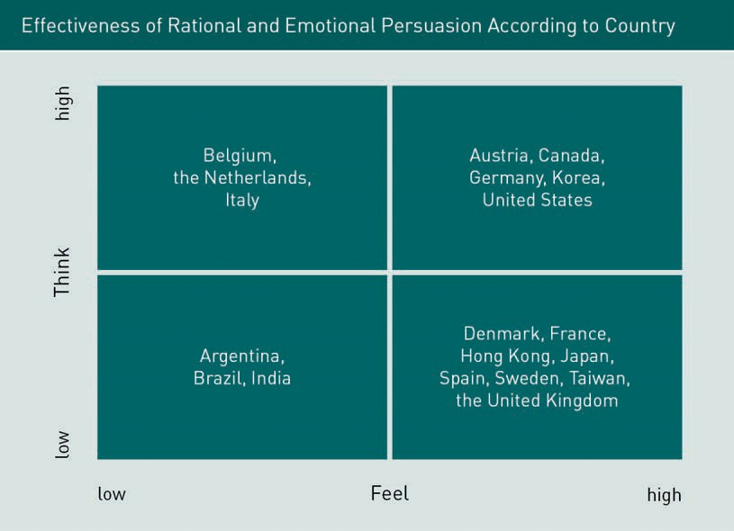

To understand whether countries differ in their marketing communications in terms of using rational or emotional appeal, scholars analyzed 200 print ads each from four countries (US, Taiwan, Mexico, and Brazil) in four publications (Business Week, Tienhsia, Expansion, and Exame) (Albers-Miller & Stafford, 1999). The researchers concluded that rational appeals for both goods and services were strongest in the US, whose ads also had quantitatively the most content. For emotional appeals, Taiwan was rated the highest, although the results indicated that Taiwanese communications used emotional appeals for services and rational appeals for goods. The researchers concluded that the use of emotional and rational appeals in advertisements is reﬂective of consumer behavior speciﬁc to each cultural group.

###### Communication Media

Another issue that marketing communications managers have to consider is variation in media use around the world. Most consumers have access to some form of print media (local and international daily and weekly newspapers, magazines, and business publications), and electronic media (broadcast television, cable, radio, and the Internet). Additionally, advertisers may utilize various forms of outdoor, transit, and direct mail advertising. Globally, media decisions must consider country-specific regulations and variances in media consumption patterns across countries. Television is the number one medium in both the US and Japan; by contrast, newspapers are the leading medium in Germany. Even when media availability is high, its use as an advertising vehicle may be limited, e.g., television advertising is limited in many parts of Europe. The use of text-based advertising in mass media or Internet-based

marketing faces hurdles in some less developed countries. For instance, India has more than a 50% illiteracy rate, and thus dance, songs, the “town crier,” and the “gongman” are methods used to convey marketing messages rather than newspapers or written forms of publications.

###### Public Relations

Public relations (PR) is that part of the marketing team responsible for gauging, creating, and evaluating public opinion about, and attitudes toward the organization, its products, and its brands. Public relations personnel are responsible for fostering goodwill, understanding, and acceptance among a company’s various constituents and the public. One of the tasks of the PR practitioner is to generate favorable publicity.

###### Promotional Strategies

Apart from advertising and PR, marketing communications include sales promotion (e.g., coupons), personal selling, sponsorships, direct marketing, and infomercials. Depending on the country, marketers’ use of coupons can be subject to regulations as seen in the following table.

|  |  |  |  |  |
| --- | --- | --- | --- | --- |
| Coupon Use in Various Countries | | | | |
| Country | Coupons by mail | Home deliv- ery coupons | On-pack cou- pons | In-pack cou- pons |
| England | Legal | Legal | Legal | Legal |
| France | Legal for dis- | Legal for dis- | Legal for dis- | Legal for dis- |
|  | count on | count on | count on | count on |
|  | same prod- | same prod- | same prod- | same prod- |
|  | uct. No cross | uct. No cross | uct. No cross | uct. No cross |
|  | coupons. | coupons. | coupons. | coupons. |
| Germany | Legal for | Legal for | Price reduc- | Prohibited in |
|  | samples only. | samples only. | tion cannot | most cases. |
|  | Price-off | Price-off | be made by |  |
|  | coupons not | coupons not | retailer. Con- |  |
|  | allowed. | allowed. | sumers mail |  |
|  |  |  | coupon with |  |
|  |  |  | on-pack code |  |
|  |  |  | directly to |  |
|  |  |  | manufac- |  |
|  |  |  | turer. |  |

|  |  |  |  |  |
| --- | --- | --- | --- | --- |
| Country | Coupons by mail | Home deliv- ery coupons | On-pack cou- pons | In-pack cou- pons |
| Sweden | Legal to per- | Legal to per- | Legal | Legal |
|  | sons age 16 | sons age 16 |  |  |
|  | and older; | and older; |  |  |
|  | illegal to | illegal to |  |  |
|  | send to per- | send to per- |  |  |
|  | sons younger | sons younger |  |  |
|  | than 16. | than 16. |  |  |
|  | Restrictions | Restrictions |  |  |
|  | when send- | when send- |  |  |
|  | ing to | ing to |  |  |
|  | parents of | parents of |  |  |
|  | new baby. | new baby. |  |  |
| US | Legal. | Legal. | Legal; all | Legal; all |
|  | Restrictions | Restrictions | terms must | terms must |
|  | on alcohol, | on alcohol, | be disclosed. | be disclosed. |
|  | tobacco, and | tobacco, and | Minimum 6- | Minimum 6- |
|  | drugs. | drugs. | month | month |
|  |  |  | redemption | redemption |
|  |  |  | period | period |
|  |  |  | required. | required. |

The US is one country where marketers use coupons extensively. In some countries, coupons are illegal. Consumers in Asian countries, although very thrifty, for reasons of “saving face,” do not use coupons, fearing that they would “shame” their families by using coupons. For example, researchers found that Malaysians have a considerable fear of public embarrassment associated with using coupons (Peck & Shu, 2009). Interestingly, these researchers also reported that the mere fact of possessing a coupon, but not necessarily redeeming it, generated an “endowment” effect resulting in a more positive attitude toward a brand. It is unclear how stable this ﬁnding is among consumers around the world.

Personal selling is a useful marketing communication tool, especially in countries that have strict restrictions on advertising. For example, because of the difﬁculty in obtaining permission to present any type of product comparisons in advertising in Japan, personal selling can involve side-by-side comparisons of competing products via face-to-face interactions with customers. Personal selling is also a good choice for countries where wages are lower (e.g., India) as large local sales forces can be employed to conduct door-to-door sales. Many US-based ﬁrms use personal selling methods to market products around the world (e.g., P&G in India sell sachets of shampoo via door-to-door sales). There are also differences in acceptable personal sales tactics across various cultures. For example, American-style persuasion via persistence during the negotiation

stage can be considered rude and offensive by some foreign customers. Such a negotiation style can be perceived as a display of self-perceived superiority, which then must be countered aggressively by bringing an immediate end to a potential business deal. In some countries, foreign vendors are expected to patiently invest months or years before reaching an actual sale (e.g., in Japan, three or more years to establish a business partnership is common).

Infomercials are another promotional strategy that varies in success across countries. They are typically thirty minutes in length and often feature studio audiences and celebrity announcers, many viewers believe they are watching regular talk show-type programming. Infomercial advertising originated in the US with sales of personal care, ﬁtness, and household products, and was even extended to sales of used cars. Infomercials are also playing a part in the development of China’s market sector and are endorsed by the Chinese government, which allows China Central Television, the state-run channel, to air infomercials and give Chinese consumers access to Western goods. China Shop-A-Vision is in the vanguard, signing up 20,000 "TV shopping members" in its ﬁrst year of airing infomercials.

### Consumer Behavior and Pricing Strategy

There are essentially three theoretical pricing options available to international marketers: 1) keep the same price for all markets, 2) set minimum or maximum prices for selected markets, or 3) establish an optimal price decided by supply and demand. Many factors impact managers’ decisions regarding the price of a product when entering or operating within a foreign market. Factors include the company strategy to standardize or localize prices, transfer pricing, proﬁt, sales volume, market share, the competitiveness of the market, competitor pricing, product life cycle, subsidies and regulations, degree of market penetration sought, tax structures, marketing costs, the potential for arbitrage, and the existence of gray markets. Many of these factors have an inﬂuence on consumer behavior, however, there are also aspects of consumer behavior that directly inﬂuence how companies price their products and services.

One factor is the psychology of pricing. Marketers often use odd pricing patterns (e.g.,

$2.99 instead of $3) as consumers perceive such prices to be lower than they are (Holdershaw, Gendall, & Garlan, 1997). This pricing model is based on prospect theory, which suggests that consumers reference the price of $2.99 against $3 and view $2.99 as the better deal. However, recent research does suggest there are limits to this effect. When gathering data from New York self-service gasoline purchases, researchers found more than 50% of consumers prefer paying for an amount ending in a whole-dollar number (Palmquist, 2013). Cultural superstitions also impact the pricing of products. For example, according to traditional Chinese superstition, the numerical digit four rhymes with death and thus represents bad luck while the numerical digit eight rhymes with fortune and thus represents good luck (Simmons & Schindler, 2003). In a study of retail prices of products listed on local websites in different countries, researchers found that high-context culture countries such as China, Hong Kong, India,

Japan, Brazil, and Argentina have more product prices ending in 0 while low-context culture countries such as the US, Australia, and Norway have more product prices ending in 9 (Nguyen, Heller, & Taran, 2007).

The psychology of pricing may vary from culture to culture. While it is common for consumers to equate high prices with high quality, researchers found that a positive correlation between price and perceived quality is much more signiﬁcant among Japanese consumers than Australian consumers (Jo & Sarigollu, 2007). The researchers manipulated ﬁve pricing levels for tourist packages (e.g., a seven-day holiday in the South Paciﬁc Islands for $1600) and found that price increases substantially enhanced the perceived quality of the tourist packages for Japanese consumers but not for Australians. The authors concluded that consumers from higher collectivistic cultures perceive higher quality in line with higher prices more so than consumers from an individualistic culture. Another relevant research ﬁnding regarding pricing psychology indicated that people are more likely to consume a product when they are aware of its total cost. Conventional wisdom is that packages or bundled costs have more appeal for consumers, e.g., annual memberships for a health club and cruise-liner holiday packages. However, research suggests that all-inclusive bundled fees in fact deter consumption (Gourville & Soman, 2002). It is unclear how stable this ﬁnding is across different cultural groups.

Different cultural groups will perceive value differently. A ﬁve-year longitudinal study was conducted on retail prices in groceries stores and the purchasing patterns of two different cultural groups in Southern California. After controlling for demographic differences for two groups of consumers—Chinese Americans and non-Chinese Americans—the researchers argued that cultural differences accounted for the pricing differences between Chinese supermarkets and mainstream American supermarkets: packaged goods were on average 37% cheaper while meat and seafood were on average 100 % cheaper in Chinese supermarkets (Ackerman & Tellis, 2001). The researchers concluded that consumers from collectivist cultures, in this case, Chinese culture, exhibit greater frugality in private consumption and are thus highly price-sensitive consumers. They further argued that because of their price consciousness, Chinese consumers will search for lower prices, which has a greater effect on the pricing strategy of businesses.

### Consumer Behavior and Distribution Strategy

Depending on the consumer behavior of a speciﬁc society, marketing distribution strategies utilized by companies will vary. In many emerging economies, consumers are familiar with small-sized retailers (e.g., in Egypt and Indonesia), are accustomed to street food carts instead of formal restaurants (e.g., in Thailand), and conduct their shopping at local bazaars (e.g., in Morocco). Foreign companies attempting to participate in these economies often face challenges penetrating these markets. When facing a lack of large-scale systematic distribution networks in Indonesia, the Japanese company Unicharm developed close relationships with traditional “mom-and-pop” retailers to sell Unicharm’s diapers MamyPolo Pants Standar (Ichii, Hattori, & Michael, 2012). By adopting this distribution strategy, their diaper market share rose from 23% to 30%, which

represented a large market share gain. We can contrast this example with distribution channels in Japan, which has the highest number of vending machines per capita in the world; even eggs can be bought from vending machines there (DeHart, 2014). Companies can even create new distribution channels based on consumer purchasing patterns: Coca-Cola was reported to have increased sales in Costa Rica with the implementation of “new non-traditional channels in areas of high pedestrian trafﬁc to stimulate impulse consumption” (Lydersen, 2002).

Another consumer behavior difference that impacts distribution strategies worldwide is the perception of time. Perception of time can impact the consumer’s level of satisfaction with the time taken for product delivery or post-purchase customer service. In an experiment where subjects were asked to choose from various delivery times, researchers predicted and found consumers from Western cultures to be less patient and valued immediate consumption more than people from Eastern cultures, who were on average more patient (Chen, Ng, & Rao, 2005). These results support the theory that there is a correlation between cultures characterized by self-oriented values and a preference for instant gratiﬁcation. In another experiment, researchers found that when waiting for a customer service response, French consumers are the least patient (73% expect a resolution within 30 minutes) and Japanese consumers are the most patient (50% expect a resolution within 30 minutes) (Zendesk, 2013). This research supports the relationship proposed by cultural theory between consumer behavior and the long- and short-term orientation, time perspective, and self-oriented values within a culture.

The recent popularity of omni-channel purchasing also highlights how consumer behavior around the world impacts distribution strategy. One research study indicated that Brazilians are the most active omni-channel consumers with 86% reporting having conducted a product search on more than one channel while 67% of German consumers, 62% of French consumers, and 51% of US consumers reported the same (Zendesk, 2013). One study looking at consumer behavior across four countries found that sales techniques used with omni-channel consumers varied in response to local consumer behavior (Yurova, Rippe, Weisfeld-Spolter, Sussan, & Arndt, 2017). For example, the researchers reported the need for control in omni-channel consumers is higher in Russia than in Singapore.

Finally, the timing of when to introduce new products in the international market is also inﬂuenced by consumer behavior. Two strategies can be adopted here: the waterfall/cascade strategy or the sprinkler strategy. The sprinkler strategy is a simultaneous introduction of a new product in all markets whereas a waterfall strategy is the sequential introduction of a new product in one market after another. While the decision to use one strategy or the other is based on many company-speciﬁc factors, consumer behavior can influence this choice. Consumer demand will naturally affect such a decision. Take, for example, Hollywood movies. In the past, most blockbuster movies opened first in the US since it was the largest single market for Hollywood movies. The movies were then launched in various other countries. However, in recent years, strong demand for Hollywood movies in China has resulted in some blockbusters opening in China before opening

in the US. In general, the cascade strategy assumes that the ﬁrst market to launch the product is the most important market in terms of generating positive adoption signals or positive word-of-mouth.

Summary

Knowledge about consumer behavior is used to develop effective marketing mix strategies. International marketing segmentation is the categorization of segments of potential customers with common characteristics to target speciﬁc groups of potential customers. Consumers can be segmented using demographic, psychographic, or behavioral criteria or beneﬁts sought. Standardized marketing, niche marketing, and multiple-segment marketing are the three main approaches used to target segments globally. Marketers also consider how to position the brand in the minds of potential customers, using standardization and country-of-origin strategies or aligning a product with a speciﬁc culture.

Product strategy is informed by a marketer’s understanding of the differences in consumer behavior and the reason for these differences, resulting in a decision to standardize, adapt, or create a product for a speciﬁc market. A communication strategy can also be standardized or localized or a combination of the two using pan-regional communication adapted from a global communication concept. Depending on whether people are persuaded by emotions or rational thoughts, marketers will choose either a rational approach that relies on logic and speaks to the consumer’s intellect or an emotional approach that tugs at the heartstrings or uses humor to speak to the consumer’s emotions. Communication media, public relations, and promotional strategies all vary depending on consumer attitudes, laws and regulations, and economic factors among others.

Pricing strategy can be either to 1) implement the same price for all markets, 2) set minimum or maximum prices for selected markets, or 3) establish an optimal price decided by supply and demand. The psychology of pricing and the perception of value and quality also play a role in pricing strategy as these vary from one culture to the next. Marketing distribution strategies utilized by companies will vary according to consumer behavior in a speciﬁc society and their familiarity with different retail options, consumer perception of time, the popularity of omni-channel purchasing, and consumer demand for speciﬁc products.