COURSE BOOK



## Management Accounting

DLBMAE01



Learning Objectives

##### Introduction 9



Decision-making is an essential managerial task and activity in businesses and other organizations. A major source of information guiding decisions of far-reaching importance are accounting data. Management Accounting provides and processes such data in order to provide a sound basis for managerial decisions.

In this course book, you will discover different perspectives on cost and related accounting data. You will become familiar with proven concepts of cost analysis in support of managerial decision-making. Furthermore, you will gain insight into various techniques that help management make decisions.

You will also consider major aspects of the contemporary business environment as contextual background. After examining real-life occurrences presented as short introductory stories at the beginning of each unit, you will learn to apply basic managerial accounting methods.

Moreover, you will acknowledge the complexity of the ﬁeld. You will come to understand managerial accounting as a task full of ambiguities despite some clear-cut approaches to deriving ﬁgures. You will acknowledge the need to interpret data and the requirement of understanding contextual factors and speciﬁcs along with the need to adapt the basic tools to each respective business or situation.



# Unit 1

## Introduction to Management Accounting

#### STUDY GOALS

On completion of this unit, you will have learned …

… the purpose of management accounting.

… the deﬁnition of cost.

… the difference between ﬁxed and variable costs.

… the concepts of step cost and mixed cost.

… to calculate and distinguish between total and per-unit cost methodologies.

1. Introduction to Management Accounting

### Introduction

Management or managerial accounting, often referred to as cost accounting, is a task most managers or responsible experts within businesses and other organizations must conduct to facilitate, support, and contrast decisions and decision alternatives based on ﬁnancial data. There are many potential forms and sources within their business that managers can use to derive financial data. Organizational decision-makers receive information from data generated in ﬁnancial accounting databases and reports as well as information derived from enterprise resource software, which measures operational processes.

Managers retrieve and interpret information relevant to making decisions. Data tell stories through numbers with obvious and sometimes more obscure meanings, so understanding the data sometimes requires interpretation. It is important to be aware that there is no such thing as the truth in ﬁnance or accounting data. There is just plentiful information compiled following certain rules or logic that requires interpretation to derive responsible decisions that will affect the future of the organization. This course book explores basic concepts and typical cost analysis techniques of business processes to provide not only a toolset but also a way of thinking.

### Deﬁnition of Management Accounting

The information provided by accounting is important for internal users within a company as well as for external stakeholders (i.e., shareholders and creditors). Thus, there are two different types of accounting, each providing different types of information. Whereas management accounting provides information for people within an organization to help them to make better decisions and to improve the effectiveness and efficiency of a company's operation, ﬁnancial accounting has the task of providing information (e.g., an annual report) primarily to external stakeholders (Drury, 2018).

Therefore, Atkinson et al. (2012) deﬁne management accounting as follows: “Management accounting is the process of supplying the managers and employees in an organization with relevant information, both ﬁnancial and nonﬁnancial, for making decisions, allocating resources, and monitoring, evaluating, and rewarding performance” (p. 26). Typical ﬁnancial information provided in management accounting are costs and revenues. Typical nonﬁnancial information provided in management accounting includes measures that are related to customer satisfaction and customer loyalty, employee motivation, and process and product quality.

As illustrated in the following table, ﬁnancial accounting and management accounting are mainly distinguished according to their users, the provided information, the time dimension, and the existence of formal requirements.

|  |  |  |
| --- | --- | --- |
| Overview of Major Differences between Management and Financial Accounting | | |
|  | Management accounting | Financial accounting |
| Audience | Internal (e.g., managers and other decision-mak-ers) | External (e.g., tax author-ities, investors) |
| Emphasis of information | Relevance for the pur-pose of decision-making | Precision, conformity/ compliance, and reliabil-ity of ﬁnancial data |
| Time horizon | * Future orientation * Flexible time horizons | * Coverage of the past * Deﬁned periods (e.g., a business year) |
| Formal requirements | * Not mandatory * No formal rules | * Mandatory * Deﬁned by law and rulesets (e.g., US GAAP or IFRS) |

When looking at ﬁnancial data it is important to keep in mind that it is not objective and is mostly a matter of interpretation. On the one hand, the data provided in ﬁnancial accounting are collected according to different accounting laws and rulesets that, at least partly, reﬂect cultural traditions and political interests. Moreover, the balance sheet policy of a company is reﬂected in these data. On the other hand, the internally produced information in management accounting reﬂects mainly the values and attitudes of company managers. Therefore, to be able to understand ﬁnancial data – regardless of whether it is conducted for internal or external purposes – they always need to be put into a context and interpreted.

### Deﬁnition of Cost

At the outset, it is important to have a closer look at costs. Generally speaking, cost is “the amount or equivalent paid or charged for something” (Merriam-Webster, n.d.). There are two ways that cost is incurred in organizations. Firstly, cost is incurred when an organization consumes an asset. The consumption of an asset occurs through its use, for example, printing paper used in the copy machine and sent out as letters, or raw material transformed into a ﬁnished product when used in a manufacturing company’s production line. The consumption of an asset also occurs

Asset An asset is a resource with an economic value that is controlled by a business expecting that it will provide a future beneﬁt.

Depreciation This is an accounting method to allocate the costs of tangible or physical assets over their useful life and represents how much of an asset’s value has been

used.

Services Services are typically intangible products or activities such as accounting, banking, consulting, insurance, or banking.

through depreciation, which is the allocation of the purchase price of a ﬁxed asset (such as a car, machine, or building) over its useful lifetime. This allocation procedure must be performed following the accounting ruleset valid in the respective country.

The second way of incurring cost is the use of a paid service. Companies use various services while conducting business. Examples include utilities (e.g., electricity, water, and gas), work performed by employees who receive salaries or by external service providers (e.g., repair or maintenance work), ﬁnancial services for which the respective institution typically charges fees or interest (e.g., insurance or bank loans), and consulting (e.g., IT or business consulting).

It is worth noting that cost incurred does not mean the same as money being paid out. There is a difference between costs or expenses and cash payments. For example, organizations may purchase some goods or services against an invoice, which means that while they incur a cost at the point of purchase, they do not have to make a cash payment at that time. In addition, some costs are non-cash items. This is the case with depreciation, where a cost is incurred on the ﬁnancial statement of an organization without any cash transaction taking place.

There are different types of costs. One can, for example, distinguish between

* direct and indirect costs,
* period and product costs,
* ﬁxed and variable costs, and
* relevant and irrelevant costs (Drury, 2018).

Some of these cost types are considered in this course book.

### Cost Behavior: Fixed and Variable Costs

As mentioned before, there is no obligation for the internal analysis of costs. Managers and consultants brought in to provide organizations with advice will have to develop their own systems and rationality to make sense of cost-related data. There are, however, widely used basic categorizations of cost and cost behavior helpful for in-depth analysis. To be able to make essential decisions managers must understand how costs and revenues will vary with different activity levels (different units of production or sales). One such method of categorization is the distinction between ﬁxed and variable costs. This information is required to answer questions, such as

* + - How will costs and revenues change if volume is increased/decreased by X percent?
    - What is the impact on proﬁts if the selling price is reduced by X percent?
    - How many product units must be sold to break even?

In this context, ﬁxed and variable costs can be differentiated (Drury, 2018).

###### Deﬁnition of Fixed and Variable Costs

Costs that remain constant in their total amount regardless of the level of organizational activity within a certain period are called ﬁxed costs (FC). For example, if a company has committed to paying a monthly rent of $3,500 for an ofﬁce building, this cost is not affected by how many customers are served by the sales representatives working at that ofﬁce. Even if the company does not conduct any business in the ofﬁce, the rent still must be paid, but, in the long run, there are no ﬁxed costs because any contract forcing the company to pay rent, salaries, license fees, etc., can be terminated or can expire according to its terms and conditions. Insofar as payment obligations are part of the contracts in question, any new contract signed, contract alteration, or termination will change an organization’s total amount of ﬁxed costs. Management accounts can express the total ﬁxed costs on a monthly, quarterly, or annual basis or deﬁne a different time horizon that is meaningful for their analysis (Atkinson et al., 2012).

When looking at ﬁxed costs, there is a special feature to consider. Costs that remain ﬁxed within a certain range and then increase in increments are referred to as step costs (Drury, 2018). For example, a gate at the airport with ﬁxed costs of $6,000 can process up to 2,000 passengers per day. If an airline wants to operate additional ﬂights and handle more passengers at this airport, they must add another gate. Increasing the capacity in this manner will lead to a doubling of ﬁxed costs (2 · $6,000 = $12,000) but will allow the airline to process a maximum of 4,000 passengers per day.

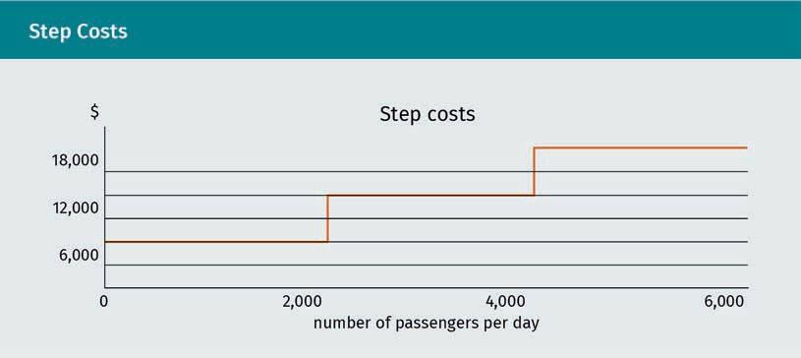

Fixed costs

These costs remain constant regardless of the level of out-put within a certain time period.

Operating at capacity is most attractive from a management perspective in step cost scenarios. Management will typically be reluctant to add capacity even if there is more demand potential unless it is likely that the increased capacity can be fully utilized within the foreseeable future. In the airport example, assuming ﬁxed cost is also shown daily, the actual handling of 2,000 passengers per day results in the following:

FC per unit = Total FC = $6,000 = $3 per passenger

output 2, 000

If the airport wants to fully capitalize on, for example, a 2,500-passenger demand potential, the required additional gate doubles ﬁxed cost to $12,000. The extra passengers, therefore, amount to per-unit ﬁxed cost of $12,000/2,500 = $4.80 per passenger. That means to increase the passenger capacity by 25 percent (2,000⋅1.25 = 2,500), the ﬁxed costs rise by 60 percent ($4.80 compared to $3.00). Hence, managers will often stretch the existing capacity as far as possible to squeeze the higher demand into the existing infrastructure before they will commit to enlarging their capacities.

Variable costs These costs vary in direct proportion to the level of output.

Costs that vary in direct proportion to the level of activity are called variable costs (VC). For example, if a restaurant incurs $5.50 of food costs for each meal served, the total food cost will equal $5.50 multiplied by the number of guests who ordered meals. Variable costs are also valid for speciﬁc time horizons that become input in the production or service provision process at the negotiated price. A change in that price resulting from a new or adapted contract will translate into an altered variable cost level (Atkin- son et al., 2012).

The following ﬁgure shows the graphic representation of ﬁxed costs (FC) and variable costs (VC). Fixed costs are shown on the left side of the graph as a straight line parallel to the x-axis. That axis shows the output or activity level. At the y-axis, the ﬁxed cost line shows that the total ﬁxed cost amount does not change; it remains $3,500 regardless of the number of guests served because the rent will not change until the contract is altered. Variable costs are shown on the right side of the graph as a line with a linearly increasing slope. With each additional output, the company incurs additional variable costs.

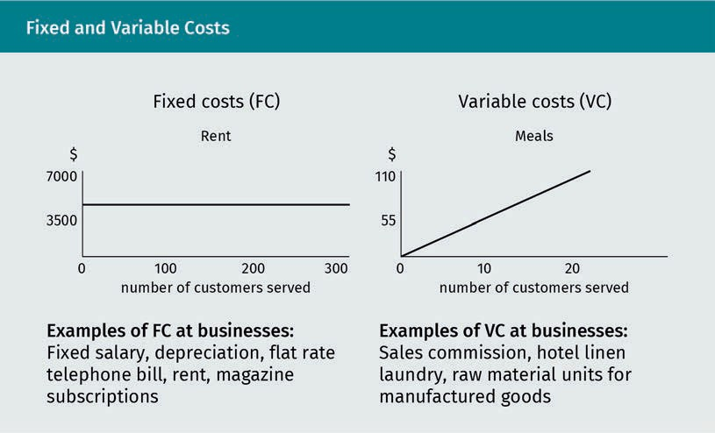

Please note that the linear function of variable cost is a simpliﬁcation of reality. In many real-life business settings, the rate of change in costs with increasing activity or output is typically curvilinear. The following ﬁgure illustrates the standard relationship between production and variable costs. The following graph on the left side shows decreasing variable cost as would be the case with volume discounts where additional units can be purchased at lower unit prices if speciﬁed thresholds are reached. The following graph on the right shows increasing variable costs that could apply when increasing wages/bonuses are paid for higher production output. For reasons of simpliﬁcation, however, a linear cost trend is assumed throughout this course book.

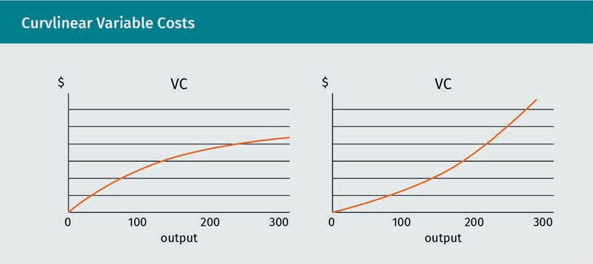

###### Total Costs

Total costs (TC), also referred to as mixed costs, include both ﬁxed costs and variable costs. Note that the total cost line in the graph starts with the ﬁxed costs at output level zero at the y-axis because even with no output, ﬁxed costs are incurred (Atkinson et al., 2012). Total costs are calculated with the following formula:

Total costs = total fixed costs + variable costs per unit · output

TC = FC + vc · x

The following example shows the development of the total costs with a rising output.

|  |  |  |  |
| --- | --- | --- | --- |
| Total Costs Example | | | |
| Number of guests | Fixed costs | Variable costs | Total costs |
| 100 | $1,000.00 | $5.00 | $1,500.00 |
| 150 | $1,000.00 | $5.00 | $1,750.00 |
| 200 | $1,000.00 | $5.00 | $2,000.00 |

|  |  |  |  |
| --- | --- | --- | --- |
| Total Costs Example | | | |
| 250 | $1,000.00 | $5.00 | $2,250.00 |
| 300 | $1,000.00 | $5.00 | $2,500.00 |
| 350 | $1,000.00 | $5.00 | $2,750.00 |
| 400 | $1,000.00 | $5.00 | $3,000.00 |

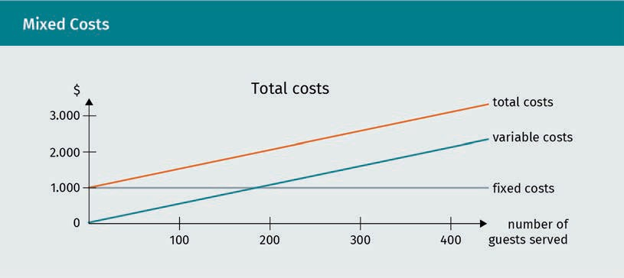

The ﬁxed cost portion of mixed cost or total cost remains constant regardless of the activity level. The variable cost portion of mixed cost or total cost increases linearly so that the cost increase of mixed cost or total cost with an increased number of units corresponds exactly with the change in total variable cost.

###### Per Unit Costs

The cost characteristics of ﬁxed and variable costs in terms of their relationship to the level of organizational activity invert when we consider the per-unit costs instead of the total costs.

In the previous example, we looked at the relationship between ﬁxed and variable costs and total output. When total output costs are calculated, ﬁxed costs remain static while variable costs are proportional to the number of units produced. However, the relationship between ﬁxed and variable costs changes when costs per unit produced are determined. In this calculation, ﬁxed costs become proportional to the number of units produced, while variable costs remain the same (Drury, 2018). In other words, ﬁxed costs per unit change depending on the output while variable costs do not change.

This perspective is often important for cost analysis. Pricing decisions rely upon accurate cost information. A product’s price per unit is the ﬁrst step in setting a proﬁtable sale price. In fact, the cost per unit strongly inﬂuences sale price feasibility. For example, a total rent of $3,500 per month divided by 100 customers equals $35 rent per customer. If the business has 200 customers, this turns into $17.50 per customer. The formula to calculate FC per unit is as follows:

FC per unit = total FC

output

However, variable costs per unit do not change with increasing activity levels. The following illustration provides an overview of ﬁxed cost per unit versus variable cost per unit cost behavior:

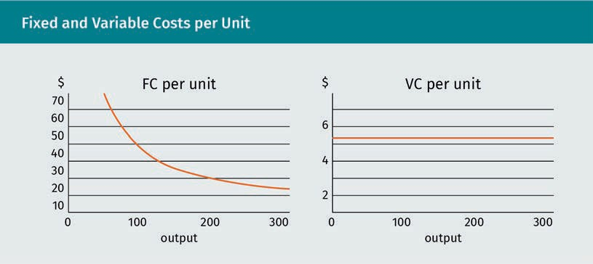

To evaluate whether a company can afford a certain amount of ﬁxed costs, this kind of analysis is essential. If the ﬁxed costs are due monthly, the output should also be converted to monthly ﬁgures to provide meaningful comparability. Unlike ﬁxed costs that change per unit according to the activity level, variable costs remain constant. However, sometimes there are exceptions. Consider a contract with a supplier that factors in volume discounts; if the company purchases at least 2,000 goods per month, the purchase price offered by the supplier may fall from $100 to $95 per unit.

### External Factors Inﬂuencing Costs

In the constantly changing contemporary business environment, there is a strong emphasis on costs. In the past, companies mainly focused on producing as many units as possible or gaining/increasing market share. Nowadays controlling and cutting costs has become the major driving force behind management activity in many corporate cultures. The reasons for such a paradigm shift include, but are not limited to, (1) global competition and supply chains, (2) shortening product life cycles, and (3) technology.

###### Global Competition and Supply Chains

In the past, competition in certain market segments was limited to local or regional competitors. Nowadays businesses must compete with providers from all over the world. And there is always someone offering a cheaper product. Supply chains have also become globalized. Thus, products and product components are shipped around the world at minimal per-unit costs in large container vessels granting global availability (Drury, 2018).

Nowadays, due to globalization, sourcing the cheapest input units has become common practice for many organizations. Every cent saved per unit produced can contribute to a competitive advantage or a substantially higher proﬁt generated on aggregate. Many companies buy their products or product components abroad to make sure they get the cheapest price.

###### Shortening Product Life Cycles

In many industries, new generations of products are rolled out faster each year. Previously, new designs and upgrades often went to market a few years apart; this development period has now been shortened drastically. Occasionally, it will be enough to update a few design features to keep up with the competition and maintain customer loyalty (e.g., feature improvements such as more power or improved energy efﬁciency). The development of new features or even entirely new products or product generations is costly. Expenses associated with product development typically include the salaries of personnel responsible for product innovation such as engineers or software programmers, specialized facilities like laboratories or ofﬁce buildings, and materials consumed in the process of experimentation. This trial-and-error process is required to prepare a product for mass production and distribution. Cost control and an understanding of the cost-beneﬁt relationship of each product version over its expected lifetime is therefore vital for an organization to remain competitive and avoid loss-making projects (Drury, 2018).

###### Technology

Enterprise resource and workﬂow software with integrated counting and measuring applications have especially enabled managers to obtain precise and almost endless streams of data. That allows for a more sophisticated cost pattern analysis of even the most complex manufacturing or service delivery processes. Smart and mobile tools with massive storage capacity and online communication capabilities, referred to by Friedman (2006) as the steroids of a globalized business world, transmit all relevant data to managers in near real-time, whether they are sitting in their ofﬁce, waiting for their connecting ﬂight at the airport, or networking at the golf course. Furthermore, the results of digitization and increased connectivity have yet to be fully realized. Due to the massive surge in data creation and availability, online processes hold the potential for more targeted managerial analysis (Drury, 2018).

Summary

Management accounting or cost accounting is an important function that supports the decision-making process within organizations. It relies on internal ﬁnancial data as well as published ﬁnancial reports. Unlike ﬁnancial accounting, which is governed by national laws and even international rulesets to protect various external stakeholders, there are no formal guidelines for management accounting.

However, there are some proven basic concepts and ways of thinking about costs. Fixed costs do not change in in response to activity level, whereas variable costs do change proportionally with the level of activity.

It is important to acknowledge that data selected for decision-making require interpretation. Furthermore, thorough understanding of internal processes is essential to ﬁnding meaningful answers to urgent business questions.

Management accounting has elevated in importance over recent years. The strong focus on costs in most businesses nowadays is owed to a business' environment. It is characterized by technological advances and by competition putting pressure on companies to be cost-efﬁcient.

# Unit 2

## Cost-Volume-Proﬁt

## Analysis



#### STUDY GOALS

On completion of this unit, you will have learned …

… what the break-even point is.

… how to apply a break-even analysis.

… the concept of contribution.

… to perform basic cost-volume-proﬁt analysis calculations.

… how to distinguish the cost structures of organizations.

… what operating leverage is.

… why many businesses try to transform ﬁxed costs into variable costs.

1. Cost-Volume-Proﬁt Analysis

### Introduction

Generally speaking, higher selling prices are more attractive for businesses because they lead to higher revenue when selling goods or services. This means that either higher proﬁts are achievable or – if costs also rise – products that would otherwise be loss-making may still be proﬁtable. Many businesses cannot inﬂuence the selling price because it is determined in a world market where supply and demand meet on a huge scale. A world market that is always closely monitored because of its importance to the world economy is the crude oil market. Since the market began, there have been considerable price ﬂuctuations due to changing demand patterns, global economic/ﬁnancial crises, and complex politics involving the Organization of the Petroleum Exporting Countries (OPEC), a cartel of major oil-producing and exporting countries (e.g., Grifﬁn & Teece, 2018). In addition, the ideologically loaded peak-oil debate has sparked doubts about whether a world economy driven by oil is viable considering that crude oil, like all natural resources extracted from Earth, is a ﬁnite resource and that its consumption damages the environment (e.g., Schneider-Mayerson, 2015). On the one hand, visionary and/or environmentally concerned people try to outline a future without oil amid our still oil-dependent era; on the other hand, economic thinkers point out that there may still be much more oil than we envisioned but that its extraction is not proﬁtable because of the high costs associated with extracting it from difﬁcult terrains. Recently, global oil prices have recovered after a decline for several years. Costly shale oil extraction projects become viable at around $70 per barrel (*The Economist* Daily Chart, 2018), and the prospect of achieving that price sparked new production highs. This context illustrates the core of cost-volume-proﬁt (CVP) analysis that will be examined in this unit.

In this unit, break-even analysis and cost structure, with a special focus on operation leverage and variabilization, are discussed in detail.

### Break-Even Analysis

This type of analysis works with both ﬁxed costs and variable costs. Break-even analysis is useful in understanding the relationship between sales revenues, costs, and proﬁts in scenarios of changing activity or output levels. Based on the assumption that the management of a company can decide the activity level (i.e., how many units to produce or to sell), calculations can be made to understand how changes in volume will yield proﬁt or loss.

###### Break-Even Point (BEP)

The activity level resulting in zero proﬁt or loss – which means that the amounts of both total revenues and total costs are equal – is referred to as break-even. In a graphical display, the BEP is located at the point where the volume or quantity (Q) shown on the

x-axis and the cost/revenue shown on the y-axis results in neither a proﬁt nor a loss. Total costs and revenues are equal; hence the BEP represents the intersection of the total costs (TC) and total revenue (TR) lines (Drury, 2018).

The total cost line corresponds to the mixed cost line shown before. It intersects with the y-axis at the amount of the ﬁxed costs (FC), as even at zero output ﬁxed cost is still incurred. The total revenue line (TR) starts at zero/zero because zero sales will result in zero revenues. Each additional unit sold will add to the revenue by the corresponding sales price per unit. For a matter of simpliﬁcation, it is assumed that the total cost and the total revenue line are both linear functions.

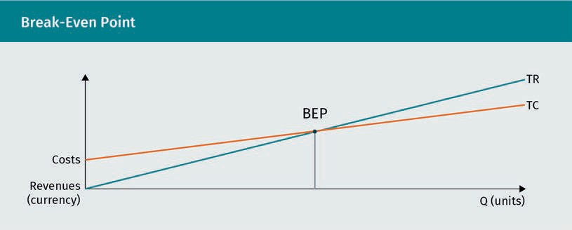

###### Contribution Margin

Another essential concept in management accounting is called contribution margin. It is the amount remaining from revenue after variable costs (VC) are deducted. It is called contribution because this amount contributes to covering the ﬁxed costs (FC) of the organization (Drury, 2018).

To distinguish the per-unit variable cost from the total amount of variable costs (VC), the lowercase acronym of (vc) is introduced. The following example illustrates the idea of the contribution margin: A company sells a product for $250 per unit, and vc amounts to $175. The contribution margin per unit is $250 – $175 = $75. Hence, with each unit the company sells it contributes $75 toward covering the ﬁxed costs.

Break-even

This means that total revenue equals total cost, so that neither a proﬁt nor a loss shows at the bottom line.

### 2.2 CVP-Calculations

The following sections will show major calculations that can be made in CVP analysis by using the appropriate formulas. However, it is important to note the calculations rest on several assumptions simplifying the complexity of real-world business situations to aid in understanding and interpreting costs. The following assumptions apply (Atkinson et al., 2012):

* + - Total costs and revenues are linear functions of volume.
    - All costs can be accurately distinguished as either ﬁxed or variable costs.
    - The analysis applies to a relevant range (determined by, e.g., capacity).

If these simpliﬁcations are applied, CVP analysis can be used to understand the costs and revenues of a business. An example is used to illustrate the following calculations and approaches. For a speciﬁed period, a business has total ﬁxed costs (FC) of

$135,000. It sells products at $12 per unit. The selling price is shown as (P) in CVP formulas and calculations. Furthermore, each unit sold incurs variable costs (vc) of $7.50.

###### Break-Even Point in Units

This calculation determines how many units a company must sell to break even (Drury, 2018, p. 176):

BEP in units = FC

P − vc

For the example, the calculation of BEP in units is as follows:

BEP in units = $ 135, 000

$ 12 − $ 7 . 50

BEP in units = 30, 000

In this example, the company would need to produce 30,000 units to break even.

###### Break-Even Point in Revenue

To calculate the break-even point in revenue (i.e., currency value resulting from sales instead of volume or quantity), the formula is as follows:

BEP in revenue =

FC

profit − volume − ratio PVR

with PVR = P − vc

P

BEP in revenue = FC · P

P − vc

For our example, the calculation of BEP in revenue is as follows:

BEP in revenue = $ 135, 000 · $ 12

$ 12 − $ 7 . 50

BEP in revenue = $ 360, 000

Total cost for this example is calculated as follows:

TC = FC + VC TC = $ 135, 000

30, 000 $ 7 . 50



+

TC = $ 360, 000 neither profit nor loss

In this example, the company would need to earn revenue of $360,000 to break even.

###### Units Required for Targeted Proﬁt

To determine how many units a company must sell to achieve a specific proﬁt ﬁgure, add the targeted profit to the ﬁxed cost amount. The logic behind this is that companies do not just need to cover all costs through sales, but they also must earn a proﬁt (Atkinson et al., 2012, p. 92):

Units sold for target profit = FC + target profit

P‐vc

In the example, the management of our business examines the possibility of generating a proﬁt of $45,000. The calculation then looks like this:

Units sold for target profit = $ 135, 000 + $ 45, 000

$ 12 − $ 7 . 50

Units sold for target profit = 40, 000

To reach its target proﬁt, the company would have to sell 40,000 units.

###### Proﬁt from the Sale of Predetermined Volume

This calculation makes sense if the management of a company relies on market analysis data indicating how large the demand is, i.e., how many units the company will be able to sell at the current price.

Profit = P · x − FC + vc · x = P − vc ·x − FC

In the example, market research leads to the optimistic outlook of selling 50,000 units. To determine how much proﬁt would yield, the calculation would be:

Profit = 50, 000 · $ 12 − $ 7 . 50 − $ 135, 000

Profit = $ 90, 000

With a predetermined sales volume of 50,000 units, the company would be able to make a proﬁt of $90,000.

###### Price to Charge for Predetermined Proﬁt and Volume

Provided that management relies on market research indicating how many units can be sold in the market and that a certain proﬁt level is targeted, this approach determines the selling price per unit required.

Formulas:

P = revenue required

X

with revenue required = FC + vc · x + target profit

Regarding the previous example, 50,000 units can be sold to add a target proﬁt of

$100,000. The calculation of the selling price per unit is as follows:

P = $ 135, 000 + $ 7 . 50 · 50, 000 + $ 100, 000 = $ 12 . 20

50, 000

If proﬁt and volume are predeﬁned, the company needs to sell its products for $12.20 per unit.

###### Margin of Safety

The margin of safety is a valuable consideration for business managers in volatile markets or ones prone to periods of economic downturn where a drop in demand is always possible. It shows how much sales may decrease before a loss occurs by connecting the expected revenue ﬁgure to the one required to break even (Drury, 2018, p. 179).

Margin of safety = expected sales−break‐even sales

expected sales

$ 100

Taking up our previous example, the expected sales volume is 40,000 units, which then amounts to a revenue of $480,000 (40,000 units ⋅ $12).

Since the BEP is reached at 30,000 units (see above), the revenue needed to break even will be $360,000 (equals 30,000 units ⋅ $12).

Margin of safety = $ 480, 000 − $ 360, 000 $ 100

$ 480, 000

Margin of safety = 0 . 25 25 %

The amount by which the expected sales exceed the break-even sales is expressed as a percentage; in this case, it is 25 percent. In general, higher margins of safety are associated with lower risk of business activity.

###### Graphical Representation

To show a complete graphical representation of a typical CVP analysis, the previous business example is again referred to:

* FC = $135,000 (for a speciﬁed period)
* P = $12
* vc = $7.50

BEP is reached at a volume of x = 30,000 units. The total costs and the total revenue are both $360,000.

Total revenue = P · x = $ 12 · 30, 000 = $ 360, 000

Total costs = FC + vc · x = $ 135, 000 + $ 7 . 50 · 30, 000 = $ 360, 000

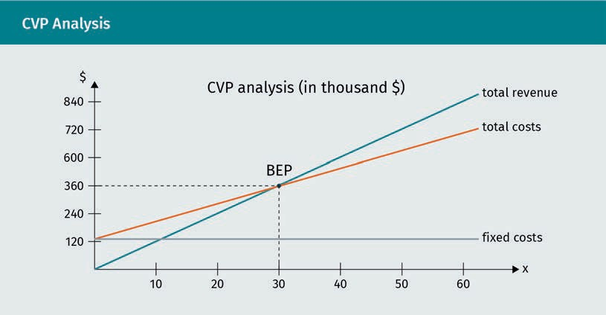

The graph illustrates that with a quantity above 30,000 units a proﬁt is generated, whereas a quantity below 30,000 will result in a loss. However, the maximum quantity depends on the capacity of the business. Assuming the maximum quantity is 60,000, the proﬁt at that point would be $135,000:

Total revenue = P · x = $ 12 · 60, 000 = $ 720, 000

Total costs = $ 135, 000 + $ 7 . 50 · 60, 000 = $ 585, 000

Profit = total revenue − total costs = $ 720, 000 − $ 585, 000 = $ 135, 000

### 2.3 Cost Structure and Operating Leverage

For analytical purposes, it is helpful to not just look at the total cost of an organization but to distinguish how much of the total cost are ﬁxed costs and variable costs. That differentiation is a simple step in looking at a company’s cost structure. An organization with total costs of $750,000 in any given year, $500,000 of which are ﬁxed costs and

$250,000 of which are variable costs, operates with two-thirds ﬁxed costs and one-third variable costs. Whether two-thirds is a high ﬁxed cost proportion and if that is a favorable position cannot be answered easily. As mentioned in the introduction, accounting data are a matter of perspective, subject to interpretation, which also depends on context-speciﬁc aspects.

The nature of companies and industries determines to some degree typical cost structures. A company that needs ofﬁce or retail buildings or manufacturing machinery to operate tends to have higher ﬁxed costs because of rent, depreciation, maintenance/ repair costs, and ﬁxed salaries than, for example, a business providing software that programmers could design from home. However, in almost every industry there are cases of higher and lower ﬁxed cost proportions reﬂecting managerial decision- making and strategic choices rather than being part of a certain industry.

Operating leverage Operating leverage is a measure of sensitivity of proﬁts to changes in sales/

revenues.

Operating leverage, for example, helps measure how sensitively the bottom line result responds to changes in revenues (Drury, 2018). The sensitivity is higher in cases of a high ﬁxed cost, as the following example illustrates. A massage parlor employs a masseur who can treat a maximum of ﬁve patients per shift. The following data are known:

* FC (per shift; consisting of rent, insurance premium, salary, etc.): $120
* vc (per patient, consisting of massage oil and towel laundry): $5
* Price per massage: $49

Experience shows that, on average, four patients book a massage per masseur per shift. Hence, the corresponding data are considered a standard scenario for calculations. To understand the implications of differing demand levels, the management of the parlor compares three scenarios: the standard of four clients per masseur and the variations of three or ﬁve clients for one masseur per shift are inserted into the following table to compare the different outcomes.

|  |  |  |  |  |  |
| --- | --- | --- | --- | --- | --- |
| Operating Leverage | | | | | |
| Data per masseur/shift | Scenario (mini- mum)  3 patients | % change  ← | Scenario (average) 4 patients | % change  → | Scenario (maxi- mum)  5 patients |
| Revenue $  (Q · P) P = $49 | 147 | -25 % | 196 | +25 % | 245 |
| FC per shift  $120 | 120 |  | 120 |  | 120 |
| VC (Q · vc) vc = $5 | 15 |  | 20 |  | 25 |
| Proﬁt $ (Rev. – FC – VC) | 12 | -78.6 % | 56 | +78.6 % | 100 |

We notice that the percentage change in revenue (25% either up or down from the standard/average perspective of four clients) is much smaller than the resulting percentage change in proﬁt (approximately 78% in both directions). Hence, small changes in demand have a dramatic effect on the bottom line. Mathematically, we can explain that quite simply: the base ﬁgure for the application of the respective percentages is much smaller in the case of proﬁt compared to revenue ($196 for the standard scenario equals 100% of revenue, but only $56 equals 100% of proﬁt). The absolute change, however, is almost the same ($49 revenue per client and $44 proﬁt). That phenomenon is typical in organizations with a high proportion of ﬁxed costs leveraging proﬁts up or down. In the case of the massage parlor – assuming the standard scenario of four patients – the following cost structure is shown:

Total costs = FC + vc · x = $ 120 + $ 5 · 4 = $ 140

FC share = $ 120 · 100 = 85 . 71 % high FC proportion

$ 140

VC share = $ 20

$ 140

· 100 = 14 . 29 %

### 2.4 Cost Structure and Variabilization

The previous section on the operating leverage effect illustrated how a change in revenue results in a much more substantial change in proﬁt or loss. This effect is true both ways, i.e., for revenue increases as well as decreases, and it is stronger the higher the ﬁxed cost proportion of a company. If managers are convinced that their business operates in a permanently growing market with ever-increasing revenues it would be a wise decision to build a cost structure with a high ﬁxed cost proportion to beneﬁt from the positive operating leverage effect. On the other hand, if managers are convinced that their business is operating in declining markets with revenue decreases, a cost structure characterized by a high variable cost proportion would be more favorable to reduce the negative operating leverage effect (although the overall situation in a declining market is, of course, unfavorable).

Obviously, neither managers nor other stakeholders can realistically foresee the future, despite thorough market analyses and economy outlook reports published by various experts. The reality of the business world is that unforeseen developments occur and there is ﬂuctuation in demand behavior. In many markets, there is a considerable degree of volatility, which means that the demand for goods and services is subject to frequent and/or unpredictable changes. Furthermore, prices may frequently change due to competitive pressures so that a decrease in revenue is not only triggered by fewer customers willing or able to buy goods and services but also by selling the same quantity as before at lower unit prices.

Variabilization This is the attempt to transform ﬁxed costs into variable

costs.

Outsourcing This is the process of contracting out activities so that goods are purchased from external suppliers instead of being produced in-house.

To reduce the risk resulting from revenue ﬂuctuations, especially from downturns or even short-term decreases, many companies nowadays try to convert ﬁxed costs into variable costs – a process called variabilization. Unlike ﬁxed costs, variable costs are usually covered directly by revenues, as they are incurred only when there is output to be sold. Particularly, businesses facing seasonal (e.g., European beach resorts with booming business during summer holidays and weak demand during the winter months) or other typically recurring ﬂuctuations in their industry due to the nature of their product or service practice variabilization. One way of achieving it is outsourcing. This means services or products previously provided in-house, i.e., by departments and employees belonging to the organization, are now purchased from third-party suppliers. Instead of internal departments, the suppliers are external business partners supplying what is purchased based on business contracts. Own employees typically mean ﬁxed costs due to ﬁxed salaries, social security duties, etc. In addition, buildings and machinery owned in-house result in ﬁxed costs, such as rent, depreciation, and maintenance. Purchasing from outside suppliers makes costs variable.

Outsourcing by Variabilization

The hotel sector provides a good example of this trend – many hotels have contracted out housekeeping to specialized service ﬁrms. The hotel orders the cleaning service only for rooms actually sold and pays per room cleaned. That makes the personnel cost of housekeeping variable, as only rooms sold cause housekeeping cost – and that cost is covered by the revenue generated through guests. Employing their own staff would mean ﬁxed costs that become problematic whenever not enough rooms are sold to cover their salaries.

Summary

Cost-volume-proﬁt analysis draws on the differentiation of ﬁxed and variable costs. It is useful to understand the relationship between sales revenue, costs, and proﬁt in scenarios of changing activity levels. Based on the assumption that the management of a company can decide the activity level, i.e., how many units to produce or sell, calculations can be made to understand how changes in volume will result in changes in proﬁt or loss.

A key concept to that end is the break-even analysis in whichtotal revenue and total cost amounts are equal so that neither proﬁt nor loss is incurred. Calculations within the break-even analysis determine how many units must be sold to break even or to achieve a predetermined proﬁt or to calculate a price for which price units have to be sold for a certain proﬁt, etc.

Many businesses are concerned about their cost structure (i.e., the proportion of ﬁxed and variable costs). There is a trend toward converting ﬁxed costs into variable costs wherever possible. Fixed costs are considered a higher risk in times of volatile demand and potential disruptions in the market because ﬁxed costs are not matched by revenues and thereby put pressure on the ﬁnancial bottom line in times of decreasing sales.

# Unit 3

## Simplistic Methods

## of Cost Allocation



#### STUDY GOALS

On completion of this unit, you will have learned …

… to distinguish direct from indirect costs.

… to distinguish product from period costs.

… which costs need to be allocated and why.

… the meaning of cost objects.

… how to allocate costs based on simple approaches.

3. Simplistic Methods of Cost Allocation

### Introduction

This unit examines the problem of dividing total costs fairly and appropriately so that all cost is accounted for and no unit (a product, a department, etc.) bears too much or too little cost in the end. Such a result could lead to deﬂected management decisions with a high likelihood of negative consequences. It is a bit like splitting a virtual pie so that each person gets their share, whereas the intuitive practice for real pies – cutting the pie into equal slices – may not be the best solution. On the contrary, in management practice, this approach would almost always represent the worst solution.

To understand this problem, we resort to another challenge known from everyday life: distributing utility costs among the tenants of an apartment building. Besides the vested interests of landlords and leasers, there are complex legal regulations. In Germany, there is, for example, a law requiring the regular testing of central-heating/water tanks or boilers for *Legionella*. Who bears the cost of this? It can be distributed among the tenants as ancillary expenses (e.g., real estate tax, waste collection fees), but what if the hot water consumption pattern varies widely across the ten- ants? Some families use the washing machine more often, some people take a hot bath every day, and others are hardly at home because they often go on business trips. Investors buying apartment buildings just as a safe, easy-care investment are likely to hit a “moment of truth” when the ﬁrst clearing is due (e.g., Schütrumpf, 2012).

### 3.1 Cost Behavior: Direct and Indirect Costs

Besides the categorization of costs as ﬁxed and variable, there is another widely used approach that is helpful for certain types of cost analyses: the distinction between direct and indirect costs.

Direct costs These can be traced back to a speciﬁc output.

###### Direct Costs

Costs that can be traced to a speciﬁc output of a company are referred to as direct costs. In a further step of categorization, direct costs are often divided into direct labor (DL) and direct material (DM) costs. The former includes all costs incurred due to labor activity performed directly on output, for example, the salary of a worker at the assembly line of a manufacturer or the salary of a service person directly working with customers. The latter includes the costs of all materials arising from the output, for example, the steel that becomes part of a car (Drury, 2018).

###### Indirect Costs

Indirect costs cannot be traced to a specific output of an organization. Once more there is the subcategorization of indirect labor and indirect materials. The former encompasses costs of labor activity that go beyond working on a specific output, such as the salaries of supervisors in charge of several production lines. The latter refers to materials that do not directly become part of the output, such as lubricants used for machines that in turn are deployed to produce different output types in a factory (such as different car models or different pieces of furniture). In addition, there is manufacturing overhead. This sub-type of indirect costs denotes costs incurred in operations that are not adequately captured as either labor or material. These include, for example, rent or insurance costs for production buildings or costs for utilities such as electricity. If electricity is used at a manufacturer to operate machines that produce different types of output or at a bakery for an oven baking different types of bread and cakes, the costs cannot be associated with a speciﬁc output. All the aforementioned costs are related to the production of goods or services and can therefore be summarized as product costs. Furthermore, some costs are not even related to production such as selling and administrative expenses. These costs include, for example, salaries of salespeople, rent and depreciation for ofﬁce buildings, or human resource management department costs. All these costs are unrelated to the core activity of a business and are often referred to as period costs to differentiate them from costs incurred in operations (Drury, 2018). The following table provides an overview of these direct, indirect, and period costs.

Indirect costs These costs cannot be clearly traced back to a speciﬁc output.

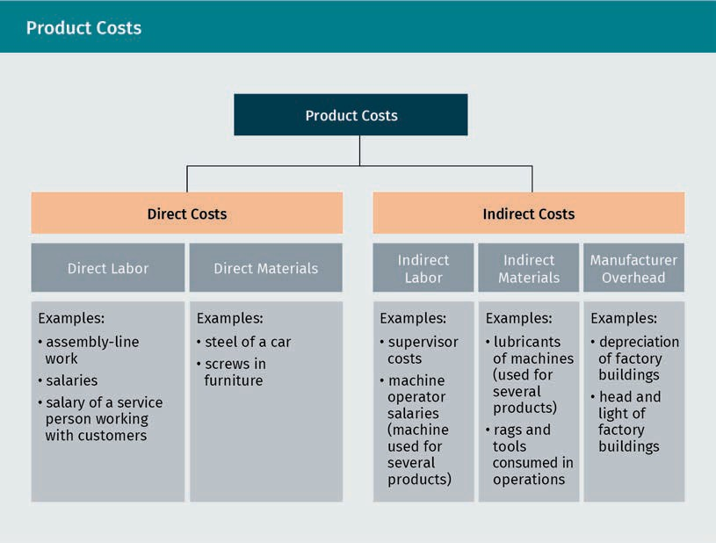

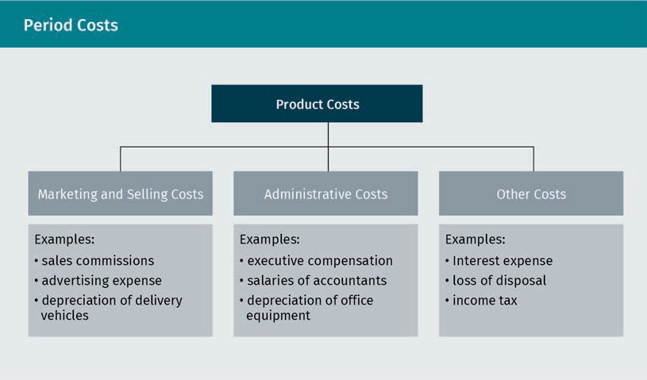

If a company only provided exactly one speciﬁc product or one service without variations – a rather hypothetical case – all costs could be considered direct costs because they all are fully caused by that one product/service. The need to differentiate direct, indirect, and period costs arises through the variety in goods and services offered.

### 3.2 The Need for Cost Allocation

Most cost analysis and cost accounting activities within organizations deal with the challenge of allocating indirect (and period) costs to speciﬁc (units of) products or services. Knowing the costs of one unit of a certain output as precisely as possible enables management to make better decisions. One example would be pricing since managers usually want to know at which minimum price the products offered will be proﬁtable. Whereas direct costs can be associated with a speciﬁc output, indirect costs cannot. Therefore, cost allocation is required. That means these costs are allocated to cost objects such as products in some systematic way.

The factual starting point of cost analysis is usually the ﬁgure of total costs. These are exact and known, e.g., from the invoices the organization has to pay or from the cash already paid for expenses. Total costs are also featured in income statements produced in the domain of ﬁnancial accounting as required by law or by international rulesets depending on the size, legal form, and ﬁnancial market context of the organization. What is not known is how much of the total costs belong to speciﬁc products or departments. As soon as there are several cost objects in an organization, there is no uniﬁed natural logic for determining how much of the total indirect and period cost belongs to each one. No cost allocation approach is 100 percent accurate; there is always a notion of arbitrary intervention. The terminology featured in the table below is essential for subsequent cost analysis.

|  |  |
| --- | --- |
| Important Cost Terminology | |
| Cost | incurred through the consumption of an asset or the use of a service |
| Cost object | The target of which managers want to know the price incurred to build/have/operate it. For example, products manufactured in the company, departments of the organization, or customers of company services |
| Cost alloca- tion | The process of allocating costs that cannot be traced to cost objects |
| Cost driver | An object, activity, or phenomenon that causes a change in the costs incurred |

### 3.3 Overhead Rates

###### Predetermined Overhead Rate

To allocate indirect or period costs systematically, there must be a basis of cost allocation, a so-called cost driver. This term points to the underlying assumption that the use of a cost driver will also increase costs. The most simplistic way of allocating costs to cost objects is to use the same cost driver across an organization. Such cost drivers are often volume-based, as they refer to an amount produced or provided in operations. For example, the number of units produced can be a volume-based cost driver, as can the number of direct labor hours worked. There are four steps involved in establishing a predetermined overhead rate (Accountingformanagement, 2020). These are as follows:

1. Estimate the total amount of overhead for the operating period.
2. Select the cost driver.
3. Estimate the total volume of the cost driver for the operating period.
4. Divide the estimated overhead ﬁgure by the estimated cost driver volume.

To allocate overhead based on this rate, multiply the rate by the number of cost driver units applied in production.

Consider the following example: a company estimates a total overhead of $700,000 and a total of 87,500 direct labor hours (DLH) for the next operating year. The predetermined overhead rate then is $700,000⁄87,500 = $8 per DLH. The company produces three different products: A, B, and C. The following table shows the respective DLH for all three products and the company-wide overhead rate, which is sometimes also referred to as the blanket rate.

|  |  |  |  |  |
| --- | --- | --- | --- | --- |
| Predetermined Overhead Rate Example Dataset | | | | |
|  | Total | A | B | C |
| Overhead costs $ | 700,000 |  |  |  |
| Direct labor hours | 87,500 | 22,250 | 33,050 | 32,200 |
| Overhead rate ($ per DLH) | 8 |  |  |  |

With the following calculation, we can allocate the total overhead to the three products based on the predetermined rate of $8 per DLH:

A: 22,250 DLH · $8 = $178,000 B: 33,050 DLH · $8 = $264,400 C: 32,200 DLH · $8 = $257,600

→ total overhead allocated = $178,000 + $264,400 + $257,600 = $700,000

###### Departmental Overhead Rate

Continuing with the previous example, the company now wants to achieve a more precise cost allocation with a little more information available. The number of direct labor hours in the different departments is known for each product, as shown in the table below.

|  |  |  |  |  |
| --- | --- | --- | --- | --- |
| Departmental Overhead Rate Example Dataset 1 | | | | |
|  | A | B | C | Total |
| DLH in department I | 2,500 | 1,800 | 8,200 | 12,500 |
| DLH in department II | 4,750 | 7,250 | 13,000 | 25,000 |
| DLH in department III | 15,000 | 24,000 | 11,000 | 50,000 |

|  |  |  |  |  |
| --- | --- | --- | --- | --- |
|  | A | B | C | Total |
| Total DLH | 22,250 | 33,050 | 32,200 | 87,500 |

Moreover, the following overview of department overhead and DLH, which leads to a separate overhead rate per department, is known.

|  |  |  |  |  |
| --- | --- | --- | --- | --- |
| Departmental Overhead Rate Example Dataset 2 | | | | |
|  | Dept. I | Dept. II | Dept. III | Total |
| Overhead costs $ | 150,000 | 450,000 | 100,000 | 700,000 |
| Direct labor hours | 12,500 | 25,000 | 50,000 | 87,500 |
| Overhead rate ($ per DLH) | 12 | 18 | 2 | 8 |

This leads to a new calculation of overhead allocation to products. Differentiating the DLH each product requires in each of the departments, respectively:

The total amount allocated remains the same. But there is a shift between the products. Product C absorbs much more of the total cost as it did with the blanket rate because it requires the most hours in department II, which has the highest rate. Products A and B each absorb much fewer of the total costs as with the predetermined overhead rate.

|  |  |  |  |
| --- | --- | --- | --- |
| Comparison of Predetermined Overhead Rate and Departmental Overhead Rate | | | |
| All amounts in $ | Predetermined overhead rate | Departmental overhead rate | Difference |
| A | 178,000 | 145,500 | – 32,500 |
| B | 264,400 | 200,100 | – 64,300 |
| C | 257,600 | 354,400 | + 96,800 |
| Total allocated | 700,000 | 700,000 | 0 |

###### Over- and Under-Application of Overhead

Companies often rely on budgeted overhead rates for the upcoming operating year rather than waiting until the actual ﬁgures are available at the end of the period. This delay would be a major disadvantage, for example, by hindering management from making accurate pricing decisions. At the latest, a selling price needs to be calculated when sales start. It can still be adjusted later if necessary.

Example: A business estimates its overhead and activity for the following period as

* activity of 400,000 DLH
* total overhead of $8 million

The predetermined overhead rate is $8,000,000⁄400,000 = $20 per DLH.

As production goes along, the company’s accountant will apply this rate and allocate $20 of overhead whenever one DLH is worked on a product. Assuming that the actual data at the end of the period are

* activity of 425,000 DLH (more than planned) and
* overhead incurred: $8 million (as planned)

then the overhead applied is 425,000 · $20 = $8,500,000.

In this case, there is an over-application of overhead, which means that more costs were allocated to products than were incurred.

If the actual data at the end of the period are assumed to be as follows:

* activity of 375,000 DLH (less than planned) and
* overhead incurred: $8 million (as planned).

The overhead applied is 375,000 DLH · $20 = $7,500,000.

In this case, there is an under-application of overhead, which means that not all costs incurred were allocated to the products.

The following table provides an overview of various scenarios to illustrate how either over- or under-application of overhead can occur. Even though an exact application is possible, it is rather unlikely.

|  |  |  |  |  |
| --- | --- | --- | --- | --- |
| Overhead Over-/Under-Application Scenarios | | | | |
| Actual DLH | Predeter- mined rate  $ per DLH | Overhead applied $ | Actual over- head $ | Consequence |
| 250,000 | 20 | 5,000,000 | 7,750,000 | Under-application of $2,750,000 m |
| 350,000 | 20 | 7,000,000 | 8,500,000 | Under-application of $1,500,000 m |
| 450,000 | 20 | 9,000,000 | 9,000,000 | Exact application |
| 500,000 | 20 | 10,000,000 | 7,250,000 | Over-application of  $2,750,000 m |

Any misapplied overhead will have to be adjusted. That can either be done by using the so-called costs of goods sold (COGS) account, which is used in ﬁnancial accounting, or by using production-related accounts such as work-in-process (WIP) or ﬁnished goods inventory. It is important that all costs incurred are absorbed by appropriate accounts. Usually, such adjustments will be made only at the end of the year as seasonal ﬂuctuations during the year are likely to lead to over- and under-applications offsetting each other.

Adjustments in this domain show a strong link between ﬁnancial and managerial accounting: the total cost ﬁgures are factual and therefore appear in both systems. For accurate reporting as required by ﬁnancial accounting rules, however, it does not matter how you internally allocate the factual cost ﬁgures to your cost objects, such as departments, products, or units of a product.

Summary

Another differentiation of costs separates direct from indirect costs. The former can be traced directly to a speciﬁc output such as one product out of the product range of a factory, whereas the latter cannot be traced to a speciﬁc output as it is caused indirectly by the entire product range or the manufacturing facility itself. Whenever a business produces more than one product or provides more than one service, there is no natural way of knowing how much of the known total cost incurred is caused by each single one. Therefore, there is a need for cost allocation.

Cost allocation is deﬁned as the process of assigning costs to cost objects, especially to products produced or services provided. There are simplistic cost allocation methods like the predetermined overhead rate however, this approach tends to deliver imprecise results that are inappropriate for decision-making. The more differentiated cost and process-related information is available, the more precise allocation procedures can be.

The goal of each cost allocation procedure is to gain a precise understanding of how much it costs a business to produce and sell its products or services.

This foundational concept is important to understanding how to make appropriate pricing decisions. The more accurate the results, the more likely a business is to make meaningful decisions.



# Unit 4

## Activity-Based Costing

#### STUDY GOALS

On completion of this unit, you will have learned …

… how to split business processes into activities.

… the assumption underlying the implementation of activity-based costing.

… how to implement activity-based costing.

… to understand different outcomes in terms of proﬁt or loss ﬁgures resulting from different approaches to cost allocation.

… why activity-based costing tends to be more accurate than simplistic cost allocation methods.

4. Activity-Based Costing

### Introduction

Low-cost airlines offer hundreds of routes from and to Germany throughout the sum- mer. Most routes connect Germany to Spain, Italy, and the UK. For an airline, every route is a product and is under scrutiny for its proﬁtability. Low-cost airlines face very intense cost pressure and tough competition. They cannot afford to hold on to loss-making routes so they frequently change their routes and timetables.

Every business that has several product lines needs an overview of how proﬁtable each of these product lines is. With many products, or even product types, on offer and with complex manufacturing or service delivery operations it is not easy to determine the contribution of each product to the overall bottom line. Simplistic cost analysis, such as the predetermined overhead rate approach, often generates a distorted cost picture and may provide data that lead the management to misguided decisions. Activity-based costing is more complex to perform than simplistic overhead allocation methods, but it also promises a much more accurate and more reliable result so it is preferred by most companies with complex operations and a variety of different products or product lines.

### 4.1 Basics of Activity-Based Costing

Activity-based costing is a cost analysis approach that promises a much more precise and accurate allocation of overhead to cost objects. It is widely considered state-of- the-art in terms of cost allocation methods in today’s business world. The idea of this approach is to break down production/service provision processes analytically into all the activities involved in it. This allows the analyst to apply a separate cost driver to each of these activities. The simplistic overhead allocation methods are based on just one cost driver, which does not allow for a differentiated picture and tends to generate potentially distorted cost allocations (Drury, 2018).

Of course, there are multiple activities involved in business operations, and the exact activities involved will be unique to each business. An understanding of these activities is crucial to working with activity-based costing. While each organization requires individual analysis, there are some typical activities you will ﬁnd in certain industries or among certain types of business. The following table provides a few examples.

|  |  |
| --- | --- |
| Activities of Businesses | |
| Manufacturing companies | Service companies |
| * Ordering supplies * Handling materials * Setting up machines * Assembly * Inspection * Transport | * Ordering supplies * Scheduling * Greeting/meeting clients * Customer registration * Providing core service * Billing customers |

For cost analysis of processes, it is useful to classify activity levels at which costs are incurred. In this context, four levels are usually distinguished (Drury, 2018). These are as follows:

1. Facility-level activities. The costs of these activities are incurred to sustain the entire organization, which means that they are incurred independent of separate products produced. These costs are mostly ﬁxed costs, such as factory building depreciation, management salaries, accounting department salaries, or insurance premiums.
2. Batch-level activities. The costs related to these activities are incurred in the production of product batches rather than individual units, which means that a certain number of units is produced together in a certain step or sequence of steps, for instance, 30 loaves of bread baked as a group in the oven. Examples of typical costs related to batches include machine setup costs, machine running costs, and packing shipments of goods.
3. Product-level activities. These activities relate to speciﬁc products. Costs incurred at this level are, for example, product design costs or product-testing costs.
4. Unit-level activities. These activities relate to individual units of a product. Costs incurred in this category are mostly direct labor or material (which are direct costs and therefore irrelevant for cost analysis aimed at overhead allocation).

Winery example

At a winery, the different activity levels apply as follows: each barrel or each bottle to sell can be seen as a unit. Barrels of the same production age together before the wine is ready to be bottled form a batch. Each red or white wine the winery pro- duces is a separate product.

Facility-level activi- ties

The facility-level activities are neces- sary for sustaining the whole business.

Batch-level activities These activities are costs incurred every time a group of units is produced.

Product-level activi- ties

The product-level activities are those activities that sup- port a speciﬁc prod- uct or an entire product line.

Unit-level activities These activities relate to a single unit of a product or a service.

### 4.2 Implementing Activity-Based Costing

To implement activity-based costing, a thorough understanding of the organization’s processes is required. A detailed, often consultant-aided, internal process analysis must precede the design of activity-based costing. As a result of a preliminary analysis, inefﬁcient, non-value-adding or redundant activities or steps in the production/manufacturing or service delivery process are discovered so that the process can be economized. That should result in an overall cost-saving effect. The implementation of activity-based costing requires a lot of effort and is only feasible if the company has sophisticated data analysis tools at hand, such as enterprise resource software tracing the ﬂow of materials, power consumption, machine hours, etc., even in complex and/or fast-paced settings (Drury, 2018).

To illustrate how activity-based costing can provide a much more accurate picture than simplistic overhead allocation methods, a furniture manufacturer can be used as an example. This small-town company currently manufactures two lines of seating furniture: a large sofa bed that has become very popular among students and is produced in large quantities, and a classy, calfskin ofﬁce swivel chair that has found its niche market among young, dynamic managers and is only produced in small quantities. The following data from last year are available.

|  |  |  |  |
| --- | --- | --- | --- |
| Initial Data | | | |
|  | Sofa bed | Ofﬁce chair | Total |
| Units produced | 1,200 | 240 |  |
| DLH | 5,000 | 1,500 | 6,500 |
| Overhead $ |  |  | 520,000 |
| Direct labor $ | 75,000 | 25,500 | 100,500 |
| Direct material $ | 180,000 | 264,000 | 444,000 |

So far, the company has used a predetermined overhead rate based on DLH to allocate the overhead. Last year, the overhead rate was $520,000/6,500 DLH = $80 per DLH. After adding the respective revenue data, the proﬁtability analysis featuring the two products is below.

|  |  |  |
| --- | --- | --- |
| Predetermined Overhead Rate | | |
|  | Sofa bed | Ofﬁce chair |
| Price per unit $ | 499 | 2,499 |
| Units sold | 1,200 | 240 |
| Revenue $ | 598,800 | 599,760 |
| DLH | 5,000 | 1,500 |
| Overhead rate | 80 | 80 |
| Overhead allocated $ | 400,000 | 120,000 |
| Direct labor $ | 75,000 | 25,500 |
| Direct material $ | 180,000 | 264,000 |
| Proﬁt $ | –56,200 | 190,260 |

The overall proﬁt generated last year was $190,260 – $56,200 = $134,060. According to this analysis, the only proﬁt generator was the ofﬁce chair, whereas the sofa bed accumulated a loss. The manufacturer does not want to drop the sofa bed and thinks that increasing its selling price would turn many customers away. The company would certainly regret losing this customer base either way. Thus, the business brings in an expert who suggests implementing activity-based costing to get a more precise picture of product proﬁtability and then reconsider its options.

Activity-based costing is done in six steps (Drury, 2018, p. 263):

1. Identify all separate activities involved in the production process.
2. Determine how much of the total overhead belongs to each activity.
3. Deﬁne a cost driver for each activity and establish its total volume.
4. Calculate a separate overhead application rate for each activity.
5. Determine the cost driver volume each cost object consumes for each activity.
6. Apply all activity rates to the cost objects.

In the case of this furniture manufacturer, the analysis of steps one to four is provided as follows.

|  |  |  |  |  |
| --- | --- | --- | --- | --- |
| Activity Analysis | | | | |
| Activity | Overhead | Cost driver | Volume | Rate in $ |
| Materials han- dling | 57,720 | DM worth | 444,000 | 0.13 |
| Machine setup | 203,392 | Set-up hours | 10,119 | 20.10 |
| Assembly | 179,400 | DLH | 6,500 | 27.60 |
| Quality inspec- tion | 34,992 | Units produced | 1,440 | 24.30 |
| Shipment | 44,496 | Units produced | 1,440 | 30.90 |
|  | 520,000 |  |  |  |

The activity cost driver volume consumption of both cost objects (sofa bed and ofﬁce chair) is determined (step ﬁve) and provided in the following table.

|  |  |  |  |
| --- | --- | --- | --- |
| Activity Analysis with Cost Driver Volumes | | | |
| Activity | Cost driver | Cost driver volumes | |
|  |  | Sofa bed | Ofﬁce chair |
| Materials han- dling | DM worth | 180,000 | 264,000 |
| Machine setup | Set-up hours | 2,100 | 8,019 |
| Assembly | DLH | 5,000 | 1,500 |
| Quality inspec- tion | Units produced | 1,200 | 240 |
| Shipment | Units produced | 1,200 | 240 |

In the ﬁnal sixth step, the respective activity rates are applied to the cost objects to allocate the overhead accordingly. To retrieve the total cost ﬁgures, the direct costs must not be forgotten – they feature in the last lines of the following overview.

|  |  |  |  |
| --- | --- | --- | --- |
| Cost Driver Rate Application (Sofa Bed) | | | |
| Cost position | Cost driver | | Cost |
| Rate | Volume |
| Handling materials | $0.13 | 180,000 | $23,400.00 |
| Machine setup | $20.10 | 2,100 | $42,210.00 |
| Assembly | $27.60 | 5,000 | $138,000.00 |
| Quality inspection | $24.30 | 1,200 | $29,160.00 |
| Shipment | $30.90 | 1,200 | $37,080.00 |
| Total overhead |  | | $269,850.00 |
| Direct materials |  | | $180,000.00 |
| Direct labor |  | | $75,000.00 |
| Total |  | | $524,850.00 |

|  |  |  |  |
| --- | --- | --- | --- |
| Cost Driver Rate Application (Ofﬁce Chair) | | | |
| Cost position | Cost driver | | Cost |
| Rate | Volume |
| Handling materials | $0.13 | 264.000 | $34,320.00 |
| Machine setup | $20.10 | 8.019 | $161,182.00 |
| Assembly | $27.60 | 1.500 | $41,400.00 |

|  |  |  |  |
| --- | --- | --- | --- |
| Cost position | Cost driver | | Cost |
| Rate | Volume |
| Quality inspection | $24.30 | 240 | $5,832.00 |
| Shipment | $30.90 | 240 | $7,416.00 |
| Total overhead |  | | $250,150.00 |
| Direct materials |  | | $264,000.00 |
| Direct labor |  | | $25,500.00 |
| Total |  | | $539,650.00 |

Based on this activity-based costing implementation, a new proﬁtability table can be constructed. The following table shows the calculated proﬁt of the two products according to the predetermined overhead rate and the activity-based costing.

|  |  |  |  |  |
| --- | --- | --- | --- | --- |
| Predetermined Overhead Rate versus Activity-Based Costing | | | | |
|  | Predetermined overhead rate | | Activity-based costing | |
|  | Sofa bed | Ofﬁce chair | Sofa bed | Ofﬁce chair |
| Price per unit  $ | $499.00 | $2,499.00 | $499.00 | $2,499.00 |
| Units sold | 1.200 | 240 | 1.200 | 240 |
| Revenue $ | $598,800.00 | $599,760.00 | $598,800.00 | $599,760.00 |
| Overhead allocated $ | $400,000.00 | $120,000.00 | $269,850.00 | $250,150.00 |
| Direct labor $ | $75,000.00 | $25,500.00 | $75,000.00 | $25,500.00 |

|  |  |  |  |  |
| --- | --- | --- | --- | --- |
|  | Predetermined overhead rate | | Activity-based costing | |
| Direct mate- rials $ | $180,000.00 | $264,000.00 | $180,000.00 | $264,000.00 |
| Proﬁt per product $ | $—56,200.00 | $190, 260.00 | $73,950.00 | $60,110.00 |
| Total proﬁt |  | $134,060.00 |  | $134,060.00 |

According to activity-based costing, both products are proﬁtable, and the sofa bed con- tributes even more to the total bottom line proﬁt than the ofﬁce chair. The manufacturer will decide to continue both products. Note that the factual total ﬁgures, such as the total revenue ($598,800 + $599,760 = $1,198,560), the total allocated overhead ($520,000), and the total costs ($1,064,500), as well as the overall proﬁt (revenue – cost = $134,060) have not changed. They are independent of how overhead is allocated to the cost objects within the company.

In this example, the dramatic differences in the overhead allocated mainly come from the setup costs. That is a typical result: costly setup procedures preparing machines for production runs are unfavorable if only a small number of units are produced. Under DLH-based simplistic allocation methods, high-volume products often look unproﬁtable and low-volume products, with few DLH required, look proﬁtable, but that can be misleading as it provides only part of the whole picture.

But one must keep in mind that there is no fully accurate cost allocation method. Some arbitrariness remains in all methods, even in activity-based costing, due to the need to determine cost drivers. However, activity-based costing is much more precise than simplistic cost allocation methods and therefore delivers more reliable results for management decisions, such as pricing or keeping/abandoning product lines.

Summary

Activity-based costing is a state-of-the-art cost analysis approach that enables more precise and accurate allocation of overhead to cost objects. The essence is to break down production or service provision processes into the individual activities involved. This allows us to apply a separate cost driver to each of these activities, unlike simplistic overhead allocation methods that rely on only one cost driver for the entire process.

The implementation of activity-based costing requires a thorough analysis of the internal production or service provision processes. In this context, there is the potential for streamlining and optimizing various activities by identifying and getting rid of redundancies. In complex production settings, however, activity-based costing is not trivial, and quite likely a substantial investment into IT and software will be necessary in order to gather the sufﬁciently differentiated and real-time information required for analysis.

As a tendency, activity-based costing tends to show high-volume, i.e., mass-produced goods, in a more favorable light than simplistic, old-fashioned cost allocation methods. It reveals that low-volume jobs tend to be more expensive per unit because certain ﬁxed costs, like machine setup in preparation of production runs, can only be split between a few units of output. Activity-based costing therefore helps to evaluate the proﬁtability of individual products more accurately than simplistic approaches.



# Unit 5

## Overhead Analysis Sheet

#### STUDY GOALS

On completion of this unit, you will have learned …

… the meaning of company-wide cost allocation to cost objects.

… the rationale of proﬁt centers in organizations.

… the three phases of the overhead analysis sheet procedure.

… two different approaches to the overhead analysis sheet.

5. Overhead Analysis Sheet

### Introduction

It is a widespread phenomenon in the corporate world to scrutinize the contribution of every branch or segment to the organization’s bottom line. Some corporations are known for quickly dropping unproﬁtable business lines or closing/outsourcing internal service departments that are considered to be too costly. General Electric and Siemens are two often-quoted examples of global players that frequently reassess their corporate structures. Business ﬁelds and departments are rapidly opened or closed in efforts to optimize efﬁciency and proﬁtability. Such an approach contributes to streamlining organizations and puts pressure on managers. It can also reduce bureaucracy. However, it can also be unproductive. If, eventually, every department is declared to be a proﬁt center, coming under pressure to prove its positive contribution to the overall bottom line of the business, the overall strategy and common goal of the organization are easily lost. In the worst case, internal and reciprocal invoicing and questioning of tasks hinder efﬁcient processes (Stocker, 2006). Eventually, a cost-/proﬁt-center obsession can ruin the corporate culture of a business with everyone focused on justifying their existence within the organization and/or on denying other departments’ justiﬁcation of existence.

### 5.1 Departmental Cost Allocation

Many departments, functions, or activities are not directly related to operations and yet are required to sustain the organization, such as human resource management, legal departments, and accounting. Large companies with multi-branch operations often concentrate such administrative or supporting functions at centralized places, servicing all branches or outlets. This is predominantly a cost-saving effort, as maintaining these services at every location of operation would be costlier but does not add any value, unlike operational activities that generate revenues. These internal support services are often referred to as shared services since several branches or outlets share the service provided by the centralized departments (Drury, 2018).

Over the past few decades, management paradigms like the focus on core competencies, competitive pressures, and the focus on proﬁt maximization, have led to the out- sourcing of assorted support functions. In some cases, however, support functions have even become separate legal entities providing their services as spin-offs to not only the parent company but also any interested player in the market and possibly even the parent company’s competitors. Lufthansa, for example, has entities such as Lufthansa Technik, which provides aircraft maintenance services both for Lufthansa and for many airlines that do not have the competency or have decided that maintaining it in-house would not be efﬁcient. Even LSG SkyChefs, another Lufthansa spin-off, provides catering serv- ices for many airlines in need of meals for their passengers.

Wherever administrative or support services are still provided in-house, the challenge of allocating their costs along with the product costs to the ﬁnal output of the business arises. This entails a process usually consisting of three phases.

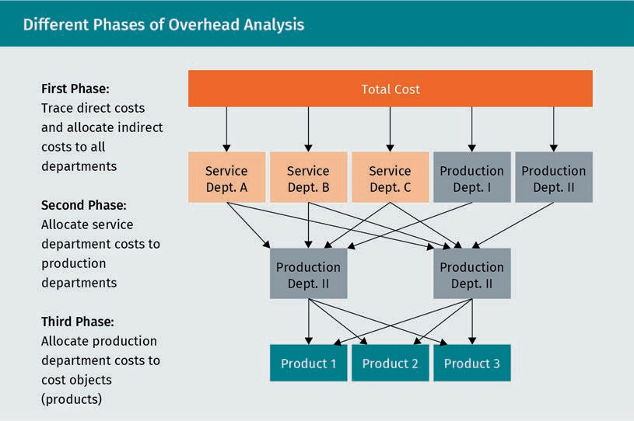

### 5.2 Reciprocal Method

This method allows for integrating the costs of service departments that not only provide their support activities for production departments but also for other service departments considering their reciprocal proportions (Drury, 2018). The following example will illustrate the application of this method. The initial data of the business is shown below.

|  |  |  |  |  |  |
| --- | --- | --- | --- | --- | --- |
| Reciprocal Method: Initial Data | | | | | |
|  | Serv 1 | Serv 2 | Prod 1 | Prod 2 | Total |
| Labor hours | 2,400.00 | 3,500.00 | 1,400.00 | 6,200.00 | 13,500.00 |
| Machine hours | 0.00 | 0.00 | 8,600.00 | 2,800.00 | 11,400.00 |
| Direct labor costs $ |  | | $40,000.00 | $180,000.00 | $220,000.00 |

|  |  |  |  |  |  |
| --- | --- | --- | --- | --- | --- |
|  | Serv 1 | Serv 2 | Prod 1 | Prod 2 | Total |
| Direct material costs $ |  | | $50,000.00 | $20,000.00 | $70,000.00 |
| Indirect labor costs $ |  | | | | $90,000.00 |
| Indirect material costs  $ |  | | | | $45,000.00 |
| Total costs $ | | | | | $425,000.00 |

The ﬁrst phase of this analysis requires the allocation of all costs to all departments. The company allocates indirect labor costs based on labor hours and indirect material costs based on machine hours to all departments.

|  |  |  |  |  |  |
| --- | --- | --- | --- | --- | --- |
| Phase One Overhead Analysis Sheet | | | | | |
| Phase 1 | Serv 1 | Serv 2 | Prod 1 | Prod 2 | Total |
| Labor hours | 2,400.00 | 3,500.00 | 1,400.00 | 6,200.00 | 13,500.00 |
| Proportion of total | 17.78% | 25.93% | 10.37% | 45.93% |  |
| Machine hours | 0.00 | 0.00 | 8,600.00 | 2,800.00 | 11,400.00 |
| Proportion of total | 0.00% | 0.00 % | 75.44% | 24.56% |  |
| Direct costs traced & indirect costs allocated based on labor/machine hours propor- tion | | | | | |
| Direct labor costs $ | $ - | $ - | $40,000.00 | $180,000.00 | $220,000.00 |
| Direct material costs $ | $ - | $ - | $50,000.00 | $20,000.00 | $70,000.00 |
| Allocated indirect labor $ | $16,000.00 | $23,333.33 | $9,333.33 | $41,333.33 | $90,000.00 |
| Allocated indirect material $ | $ - | $ - | $33,947.37 | $11,052.63 | $45,000.00 |

|  |  |  |  |  |  |
| --- | --- | --- | --- | --- | --- |
| Phase One Overhead Analysis Sheet | | | | | |
| Total costs $ | $16,000.00 | $23,333.33 | $133,280.7 | 0 $252,385.96 | $425,000.00 |

The second phase requires the allocation of the service department costs to the pro- duction departments while considering a reciprocal service department provision. The reciprocal cost absorption of Serv 1 and 2 is performed ﬁrst before moving on to allocate the derived ﬁgures to Prod 1 and 2. In this context, the business has analyzed the work pattern of Serv 1 and 2, deriving the proportions in the following table.

|  |  |  |  |  |
| --- | --- | --- | --- | --- |
| Phase Two Additional Information | | | | |
|  | Serv 1 | Serv 2 | Prod 1 | Prod 2 |
| Serv 1 works for … | n/a | 20 % | 30 % | 50 % |
| Serv 2 works for … | 30 % | n/a | 40 % | 30 % |

Therefore, Service 1 department accounting for 17.78% of labor hours gets allocated 17.78% of the indirect labor cost of $90,000, which amounts to $16,000 and so on. Keep verifying that the total cost ﬁgure of the company of $425,000 never changes because that is factual and not impacted by allocations. That leads to the following two cost allocation equations:

* + - Serv 1 = $16,000 (allocation from phase 1) +30 % of Serv 2
    - Serv 2 = $23,333.33 (allocation from phase 1) +20 % of Serv 1

We now have two simultaneous equations, i.e., two equations with the same two variables. One approved way of solving this mathematical problem is to substitute one into the other:

Now insert x as Serv 1 into the second equation:

The cost ﬁgures of Serv 1 and 2 plus the already known cost ﬁgures from phase one are accumulated to derive the costs allocated to Prod 1 and 2. For example, Prod 1 gets allocated 30% of Serv 1 because Serv 1 works 30% for it. 30% of $24,468.09 equals

$7,340.43.

|  |  |  |  |  |  |  |  |  |  |
| --- | --- | --- | --- | --- | --- | --- | --- | --- | --- |
| Phase Two Overhead Analysis Sheet | | | | | | | | | |
| Phase 2 |  |  | | | Prod 1 | Prod 2 | |  | |
| Phase Two Overhead Analysis Sheet | | | | | | | | | | | |
| Cost from Phase 1 $ | | |  |  | | | $133,280.70 | | $252,385.96 | |  |
| Allocated from Serv 1 $ | | | 30 % | $24,468.09 | | | $7,340.43 | |  | |
| 50 % |  | | $12,234.05 | |
| Allocated from Serv 2 $ | | | 40 % | $28,226.95 | | | $11,290.78 | |  | |
| 30 % |  | | $8,468.09 | |
| Total costs $ | | |  |  | | | $151,911.91 | | $273,088.0 | | 9 $425,000.00 |

The third phase requires the allocation of the production costs of the departments to cost objects. The business produces Gadget A and Gadget B. The costs of Prod 1 are allocated based on machine hours; the costs of Prod 2 are allocated based on labor hours. The table below contains all the necessary information.

|  |  |  |  |
| --- | --- | --- | --- |
| Phase Three Overhead Analysis Sheet | | | |
| Phase 3 | Gadget A | Gadget B | Total |
| Labor hours | 7,020.00 | 6,480.00 | 13,500.00 |
| Proportion of total | 52.00% | 48.00% |  |
| Machine hours | 3,876.00 | 7,524.00 | 11,400.00 |
| Proportion of total | 34.00% | 66.00% |  |
| Cost of Prod 1 $ | $51,650.05 | $100,261.86 | $151,911.91 |
| Cost of Prod 2 $ | $142,005.81 | $131,082.29 | $273,088.09 |
| Total costs $ | $193,655.86 | $231,344.15 | $425,000.00 |

For example, Gadget A causes 34% of all machine hours, and Prod 1 department costs of $151,911.91 (derived in the previous phase) are allocated to the products based on machine hours so that Gadget A gets 34% of $151,911.91, amounting to

$51,650.05.

Please note that the complexity of the reciprocal method increases considerably the more departments or functional areas an organization has. The accurate capture of all reciprocal uses of services the departments provide requires reliable and measurable data that tend to come in large volumes and still need ﬁne differentiation. To that end, IT systems with the capacity to trace various processes in real-time are necessary.

### 5.3 Step Method

This method is mostly applied, as it forms the basis of performing the three phases of cost allocation. Costs are allocated step by step until the cost objects absorb all costs incurred within the business. Even the reciprocal method exercised in the previous section performs essentially the same steps of cost allocation through the phases. The major difference is that the step method does not consider the reciprocal work relationships of service departments in the second phase. The step method will be illustrated with another example focusing on the typical complexity of various overhead cost positions that need to be allocated and also through the availability of various potential cost drivers (Drury, 2018).

A manufacturer runs two production departments, a machine hall where largely automated production steps are performed, and a ﬁnishing department performing mostly manual labor in the ﬁnalization of assembly and inspection of ﬁnished goods. There are also two service departments, material storage in charge of handling materials, and technical support providing help for staff in the production departments. The following cost overview is available:

|  |  |  |  |  |  |
| --- | --- | --- | --- | --- | --- |
| Cost Overview | | | | | |
|  | Total $ | Machine hall | Finishing | Materials storage | Tech support |
| Direct labor | 3,850,000 | 250,000 | 3,600,000 | 0 | 0 |
| Direct materials | 3,700,000 | 2,400,000 | 1,300,000 | 0 | 0 |
| Indirect labor | 2,100,000 | 350,000 | 250,000 | 400,000 | 1,100,000 |

|  |  |  |  |  |  |
| --- | --- | --- | --- | --- | --- |
|  | Total $ | Machine hall | Finishing | Materials storage | Tech support |
| Indirect materials | 4,370,000 | 360,000 | 230,000 | 3,000,000 | 780,000 |
| Deprecia- tion | 1,010,000 | 920,000 | 77,000 | 7,000 | 6,000 |
| Building insurance | 250,000 |  |  |  |  |
| Machine insurance | 520,000 |  |  |  |  |
| Rent for buildings | 1,800,000 |  |  |  |  |
| Heating, lighting, cooling | 2,400,000 |  |  |  |  |
| Total cost | 20,000,000 |  |  |  |  |

There are no direct costs shown for the service departments, as these costs are by deﬁnition incurred in operations and traceable there. When looking at the three phases of cost allocation, the total cost of $20,000,000 will never change. To allocate the last four cost positions of the table above, the following information is provided.

|  |  |  |  |  |  |
| --- | --- | --- | --- | --- | --- |
| Overview of Potential Cost Drivers | | | | | |
|  | Total | Machine hall | Finishing | Materials storage | Tech sup- port |
| DLH | 192,000 | 12,000 | 180,000 | 0 | 0 |
| Area (sqm) | 3,350 | 1,800 | 800 | 500 | 250 |
| Machine hours | 6,500 | 6,000 | 500 | 0 | 0 |

|  |  |  |  |  |  |
| --- | --- | --- | --- | --- | --- |
|  | Total | Machine hall | Finishing | Materials storage | Tech sup- port |
| Book value of mach. $ | 3,400,000 | 2,750,000 | 620,000 | 12,000 | 18,000 |
| Power con- sumption | 100 % | 62 % | 23 % | 6 % | 9 % |

This second table provides a list of potential cost drivers. To allocate the remaining costs to all departments in phase one of the allocation process, the cause-and-effect relationship must be considered. For each cost position, we need to determine which of the ﬁve available parameters is most closely causally linked to the respective cost position to allocate to all departments. Although there is no perfect cost driver to use, consider the following assignment of cost drivers:

* + - Building insurance is allocated based on the area occupied by each department, which is based on the assumption that each sqm is insured at the same premium.
    - Machine insurance is allocated based on the book value of the machinery.
    - Rent for buildings is allocated based on the area in sqm.
    - Heating, lighting, and cooling are allocated based on power consumption.

Once the cost drivers are selected, the costs can now be allocated. Each department absorbs each cost position in question in the same proportion as it uses the cost driver. The calculation applied in the table below, therefore, inserts direct proportion. For example, to allocate the appropriate building insurance amount to the machine hall department, the calculation is

total costs · sqm occupied by the machine hall total sqm

= $ 250, 000 · 1, 800sqm

3, 350sqm

Finally, the following cost allocation is the result of phase one:

|  |  |  |  |  |  |
| --- | --- | --- | --- | --- | --- |
| Phase One Cost Allocation for Overhead Analysis Sheet | | | | | |
| Phase 1 (in $) | Machine hall | Finishing | Materials storage | Technical support | Total |
| Direct labor | 250,000.00 | 3,600,000.00 | $ - | $ - | 3,850,000 |

|  |  |  |  |  |  |
| --- | --- | --- | --- | --- | --- |
| Phase 1 (in $) | Machine hall | Finishing | Materials storage | Technical support | Total |
| Direct materials | 2,400,000.00 | 1,300,000.00 | $ - | $ - | 3,700,000 |
| Indirect labor | 350,000.00 | 250,000.00 | 400,000.00 | 1,100,000.00 | 2,100,000 |
| Indirect materials | 360,000.00 | 230,000.00 | 3,000,000.00 | 780,000.00 | 4,370,000 |
| Deprecia- tion | 920,000.00 | 77,000.00 | 7,000.00 | 6,000.00 | 1,010,000 |
| Building insurance | 134,328.36 | 59,701.49 | 37,313.43 | 18,656.72 | 250,000 |
| Machine insurance | 420,588.24 | 94,823.53 | 1,835.29 | 2,752.94 | 520,000 |
| Rent for buildings | 967,164.18 | 429,850.75 | 268,656.72 | 134,328.36 | 1,800,000 |
| Heat, light, cooling | 1,488,000.00 | 552,000.00 | 144,000.00 | 216,000.00 | 2,400,000 |
| Total costs | 7,290,080.77 | 6,593,375.77 | 3,858,805.44 | 2,257,738.02 | 20,000,000 |

In phase 2, the service department costs are allocated to production departments. Material storage costs are reallocated based on direct material values, and technical support costs are reallocated based on machine hours. Again, the costs to distribute are allocated in the same proportion as the cost driver used by the production departments. For example, to calculate the cost the machine hall absorbs from materials storage, we would use

total costs of materials storage · costs for direct materials machine hall total costs for direct materials

= $ 3, 858, 805 . 44 · $ 2, 400, 000

$ 3, 700, 000

|  |  |  |  |  |  |
| --- | --- | --- | --- | --- | --- |
| Phase Two Cost Allocation for Overhead Analysis Sheet | | | | | |
| Phase 2 (in $) | Machine hall | Finishing | Materials storage | Technical support | Total |
| Total costs phase 1 | 7,290,081.77 | 6,593,375.77 | 3,858,805.44 | 2,257,738.02 | 20,000,000.00 |
| From materials storage | 2,503,008.94 | 1,355,796.51 | -3,858,805.44 |  | $ - |
| From sup- port | 2,084,065.86 | 173,672.16 |  | -2,257,738.02 | $ - |
| Total Costs | 11,877,155.57 | 8,122,844.43 | $ - |  | 20,000,000.00 |

The sum of the costs from phase 1 and the costs allocated from the service departments is still $20,000,000.

In phase 3, the costs will ﬁnally be allocated to cost objects. Instead of products, in this case the manufacturer wants to know the total costs per DLH or machine hour. The costs of the machine hall are allocated to machine hours, as automated production is strongly machine-based and features only a few DLH in comparison, whereas the costs of ﬁnishing are allocated to DLH.

|  |  |  |  |
| --- | --- | --- | --- |
| Phase Three Cost Allocation for Overhead Analysis Sheet | | | |
| Phase 1 (in $) | Machine Hall | Finishing | Total |
| Total costs phase 2 | 11,877,155.57 | 8,122,844.43 | $20,000,000.00 |
| Machine hours | 6,000.00 |  |  |
| DLH |  | 180,000.00 |  |
| Costs per hour | 1,979.53 | 45.13 |  |

The total costs per hour are $1,979.53 for the machine hall and $45 for the ﬁnishing.

Summary

An overhead analysis sheet allows the inclusion of all costs of a (large) company into the cost analyses of individual products or product ranges. Even cost positions that are completely unrelated to operations, such as the rent paid for administrative ofﬁces are considered and thus can become part of the analysis. In a three-stage process all costs are re-allocated to the cost objects in consideration.

Firstly, all costs incurred and registered by ﬁnancial accountants are allocated to all departments of the organization. In the second step, support or service department costs are re-allocated to operating or production departments. In the ﬁnal step, costs are allocated to speciﬁc cost objects, usually products produced by the company.

In the process of this analysis, department or functional unit costs for the company become transparent. However, there is still the potential problem that the cost allocation methods applied are not fully without error or are at least debatable due to some unavoidable arbitrariness in cost driver selection. As many organizational cultures spark internal competition, department heads may ﬁnd themselves under attack for lack of cost efﬁciency in an internal competition. Conﬂicts of interest may arise particularly where departments are treated unfairly through inappropriate cost allocation approaches.



# Unit 6

## Relevant Cost Concepts

#### STUDY GOALS

On completion of this unit, you will have learned …

… the deﬁnitions of relevant and irrelevant revenue and cost data.

… the major criteria to consider in outsourcing decisions.

… the most important quantitative and qualitative criteria in make-or-buy decisions.

… to differentiate when the acceptance of special orders is viable.

… to evaluate whether dropping a product line improves the bottom line.

6. Relevant Cost Concepts

### Introduction

In past decades, following the rise of China to the “workbench of the world,” many companies all over the world outsourced and offshored production to Chinese factories. They were attracted by low wages, huge availability of labor, and tremendous production capacities of suppliers willing to provide the desired quantity and speciﬁcation of any goods. During recent years, however, an increasing number of European manufacturers’ production has returned to their home countries as cost advantages diminish. Labor costs in China are still lower than in Western European countries but are sharply rising – and other costs such as logistics, transportation, and direct material (to be purchased at the same price worldwide) diminish labor cost advantages.

A German case in point is the plush toys company of Steiff, known as a premium brand. In 2009, the company halted some of its overall production in China because the Chinese supplier often missed delivery deadlines and had a high staff turnover, leading to quality problems detrimental to a high-quality and tradition-rich brand (Erling et al., 2008). With labor costs in China increasing by 20% per year, and many miscalculated offshoring ventures, fears that manufacturing would disappear from Germany altogether were premature (Schlandt, 2012). China still is an option for offshore production despite diminishing cost advantages, but it is much more interesting as a sales market

– especially for export-driven nations such as Germany.

### 6.1 Foundational Cost Concepts

There are many decisions managers face in their daily business. Some decisions have a bigger impact than others, and some have long-term consequences. Closing factories, outsourcing departments, expanding production, and investing in new business segments are examples of larger decisions with consequences. Cost data are a major source of information when making such decisions. In an extension of that idea, both cost and revenues are important to consider because the relationship between revenues and costs determines the bottom-line outcome of proﬁt or loss. For a reasonable picture of likely outcomes of decisions, current data and projections of future beneﬁts are often required.

Relevant costs These costs differ between decision

alternatives.

The concept of relevant costs refers to the consideration only of data that are relevant for the speciﬁc decision in question and ignoring all irrelevant data. In terms of costs, only the costs that differ between decision alternatives are relevant. All other costs are considered to be irrelevant (Drury, 2018).

A typical case of irrelevant costs are sunk costs. These are costs incurred or committed in the past that cannot be changed. Such costs would include for example license fees already paid for a product that cannot be recovered regardless of the use of the license to produce this product (Drury, 2018).

### 6.2 Cost Decisions

###### Replacement of Equipment

One classic type of decision relying on relevant cost data is the replacement of equipment, which may entail a signiﬁcant investment. Major criteria to consider in such decision scenarios include

* + - calculating and deciding on the purchase price and ﬁnancing options (incorporating

opportunity costs and the time value of money).

* + - power/fuel consumption (new machines tend to be more efﬁcient).
    - the difference in other operating costs (new equipment tends to promise efﬁciency gains but may require additional staff training).
    - modiﬁcation requirements at existing factory buildings.
    - the projected lifetime of old versus new equipment.
    - the projected development of the market, demand, and economic environment.

There is no optimum time to replace equipment, or it would at least be almost impossible to know it if there was one. Replacing equipment too early means that the remaining lifetime of the old machines is given up along with the proﬁt potential of fully depreciated assets. A major ﬁnancial/investing burden would also be incurred. Replacing equipment too late means that frequent or costly repairs of old equipment are incurred, probable downtime or disruption in production can happen, and efﬁciency gains of new generations of machines are likely missed (Drury, 2018).

The following example illustrates the application of relevant costs in the case of replacement decisions. A business has encountered a machine breakdown. The equipment in question can be repaired rather quickly, but the management is now also considering replacing the old machine to prevent another breakdown. Thus, the data the machine manufacturer provide for the new machine and the internal data for the old machine must be compared to make a decision.

Sunk costs

These are costs that cannot be recovered with a decision alter- native and are there- fore considered irrel- evant.

Opportunity costs These costs repre- sent the beneﬁts a business misses out on when choosing one alternative over another.

Time value of money This assumes that the same amount of money is more val- uable today than it is in the future.

|  |  |  |
| --- | --- | --- |
| Replacement of Equipment (Full Cost Analysis) | | |
| (in $) | Repairing the old machine | Buying the new machine |
| Revenue  (15,000 units sold at 1,200) | 18,000,000.00 | 18,000,000.00 |

|  |  |  |  |
| --- | --- | --- | --- |
| (in $) | | Repairing the old machine | Buying the new machine |
| Operating costs | Staff costs (9,500 hours at  $35 each) | 3,325,000.00 | - |
| Staff costs (5,000 hours at  $35 each) | 0 | 1,750,000.00 |
| Power costs | 84,000.00 | 75,000.00 |
| Staff training costs | | - | 240,000.00 |
| Repair costs | | 8,000.00 | --- |
| Deduction of the machine | | 11,500.00 | 11, 500.00 |
| Current disposal value of old | | - | -4,500.00 |
| Price of new machine | | - | 125,000.00 |
| Total costs | | 436,000.00 | 406,000.00 |
| Operating income | | 1,364,000.00 | 1,394,000.00 |

This table includes some irrelevant information, which will not change according to the chosen decision. The table yields the same bottom line when only considering the relevant cost positions.

|  |  |  |
| --- | --- | --- |
| Replacement of Equipment (Relevant Cost Analysis) | | |
| (in $) | Repairing the old machine | Buying the new machine |
| Operating costs (summarized) | 416,500.00 | 250,000.00 |
| Staff training costs | - | 24,000.00 |

|  |  |  |
| --- | --- | --- |
| (in $) | Repairing the old machine | Buying the new machine |
| Repair costs | 8,000.00 | - |
| Current disposal value of old | - | -4,500.00 |
| Price of new machine | - | 125,000.00 |
| Total costs | 424,500.00 | 394,500.00 |

The decision whether to keep and repair the old machine results in $30,000 higher cost (or less operating income) than the replacement decision. We achieve the same overall difference by considering only the relevant positions. The revenue is irrelevant, as it does not change with either decision. The book value of the old machine is irrelevant because it can be considered sunk costs (either it is depreciated as a lump sum when replaced now or periodically if repairing and keeping it). Relevant costs include the different operating costs, repair versus staff training costs, the current disposal value of the old machine (which will be a beneﬁt realized in case of replacement), and the price of the new machine. Note that for reasons of simpliﬁcation and a focus on relevant information, we ignore the time value of money in this example and that the actual useful lifetime for both machines from the time of decision is assumed the same for both decision alternatives.

###### Make-or-Buy

Another type of decision relying on relevant cost data is the make-or-buy scenario. Companies with the capacity and expertise to manufacture products or components nevertheless often consider contracting out production to suppliers and purchasing the goods/parts needed if this move has cost-saving effects. Beyond mere cost-saving, sometimes additional aspects, such as freed-up capacity and resources, can be beneﬁcial. Various strategic considerations may also drive outsourcing decisions. One important basis of make-or-buy decisions is relevant cost information (Atkinson et al., 2012). Consider the following example: McMullen Ltd. of Galway, Ireland requires 5,000 units of an electronic component for their manufacturing process. Currently, these components are produced in-house. The management considers an outsourcing move, and a ﬁrst offer from a supplier is received to buy the components at $30 each. The cost data of the currently practiced in-house production are as follows:

Outsourcing

This is the process of paying to have a part of a company's work done by another company.

|  |  |  |  |
| --- | --- | --- | --- |
| Make-or-Buy: Initial Data | | | |
| (in $) | | Total costs | Costs per unit |
| Fixed costs | Rent | $25,000.00 | $5.00 |
| Depreciation | $12,500.00 | $2.50 |
| Variable costs | Direct materials | $20,000.00 | $4.00 |
| Direct labor | $100,000.00 | $20.00 |
| Total | | $157,500.00 | $31.50 |

When looking at the initial data, the external offer of $30 per unit looks more attractive, as it seems to save $1.50 per unit produced. However, a closer look at only the relevant costs of the outsourcing option changes the picture.

|  |  |  |
| --- | --- | --- |
| Make-or-Buy: Cost Comparison | | |
| Costs (in $) | Make | Buy |
| Variable costs | $24.00 | 30 |

Neither ﬁxed cost positions are relevant for this decision because, in the short run, these costs cannot be avoided even if outsourcing and stopping in-house production is chosen. The contract for the rent is still running and depreciation continues, assuming the machines in use so far for production cannot be sold immediately. Thus, only the variable cost of production could be avoided, assuming that the workforce so far performing direct labor can be released (or deployed otherwise in the company). A total cost comparison would therefore add the ﬁxed costs per unit of $7.50 to the offer of$30, making it $37.50 versus $31.50 for continued in-house production. The relevant cost analysis is sufﬁcient to get the same bottom line: a difference of $6 per unit in favor of continuing the production. Based on this information, the company could, of course, renegotiate with the supplier to possibly get an offer below $24 per unit, which would turn the picture around.

But a business needs to be aware that cost should not be the only criterion in favor of outsourcing. As mentioned before, such a short-sighted or limited view can and most likely will backﬁre. Problems can arise in areas such as

* quality. Foreign suppliers may not meet a company's quality standards. Especially at the beginning of a new supply relationship, much time and many trial production runs may be required before the deﬁned parameters are met.
* reliability. It cannot always be taken for granted that suppliers will be punctual in delivery and/or capable of delivering the promised goods or services.
* logistics. The coordination of international supply chains is complex, especially in the case of just-in-time patterns. In addition, there may be costly disruptions to international transportation due to regional material shortages, volcano ashes hindering air cargo, piracy threatening ships, local workforce strikes, etc.
* image. Many customers of high-priced goods wonder why they should pay so much for goods “made overseas” (i.e., in low-cost countries) and may refrain from consuming that brand or at least react critically.

###### Special Order

The third type of decision relying on relevant cost data is related to whether exceptional offers should be made in response to special requests. The typical challenge is to decide whether a one-time batch is sold at a lower price than normally calculated and offered (Atkinson et al., 2012). Consider the following case: a manufacturer produces, as part of their standard product range, a high-quality table that is sold via exclusive furniture retailers at

$2,500. The company has the capacity to manufacture 1,000 units of this table per year and currently operates at 75% of its capacity (750 units per year). The following costs apply.

|  |  |  |
| --- | --- | --- |
| Special Order: Initial Data | | |
| Variable costs | Direct materials ($600 each) | $450,000.00 |
| Direct labor (1,000 each) | $750,000.00 |
| Fixed costs | | $375,000.00 |
| Total costs | | $1,575,000.00 |

It is assumed that a furniture retailer, looking for a one-time special product to sell at their 150th company anniversary, approaches the manufacturer and wants to buy 150 units of the table at $1,800. To analyze whether accepting this request is viable, the following analysis is conducted, comparing the difference in the bottom line resulting from the varying cost and revenue ﬁgures for the two options.

|  |  |  |  |
| --- | --- | --- | --- |
| Special Order Cost Analysis (Scenario 1) | | | |
| (in $) | | Without spe- cial order | With special order |
| Revenue | Regular | 1,875,000.00 | 1,875,000.00 |
| Special order | — | 270,000.00 |
| Costs | Variable costs | 1,200,000.00 | 1,440,000.00 |
| Fixed costs | 375,000.00 | 375,000.00 |
| Gross proﬁt | | 300,000.00 | 330,000.00 |

In this case, it is only relevant to regard the difference in gross proﬁt as with the special order the revenue increases by $270,000, and the total costs increase by $240,000. Thus, the special order generates an additional proﬁt of $30,000 and is therefore attractive and should be realized. As long as an extra order’s revenues exceed its variable costs, the result will always be an increased income.

Be aware that the result would look different if a special order resulted in production exceeding capacity. In this case, the regular production would have to be cut to fulﬁll the extra batch, reducing regular revenue. Consider the following alteration of the example: the regular sales now are 1,000 units, meaning that the company already operates at full capacity utilization. Accepting the special order would result in regular production being reduced from 1,000 units to 850 to ﬁt the 150 units for the special order into the production schedule. Hence, regular unit revenue is cut.

|  |  |  |  |
| --- | --- | --- | --- |
| Special Order: Cost Analysis (Scenario 2) | | | |
| (in $) | | Without special order | With spe- cial order |
| Revenue | Regular | 2,500,000.00 | 2,125,000.00 |
| Special order | — | 270,000.00 |

|  |  |  |  |
| --- | --- | --- | --- |
| (in $) | | Without special order | With spe- cial order |
| Costs | Variable costs | 1,600,000.00 | 1,600,000.00 |
| Fixed costs | 375,000.00 | 375,000.00 |
| Gross proﬁt | | 525,000.00 | 420,000.00 |

In this scenario, the schedule with the special order only leads to diminished overall revenue. Fixed and variable costs are identical under either schedule because the number of units produced would be the same. In this scenario, the company should not accept the additional order. That is a very typical outcome of these types of analysis. Whenever capacity constraints require a special order to give up at least some portion of a company's regular production and sales, the lower contribution of the special offer units compared to their regular counterparts’ contribution bites into the proﬁt. If a company runs at 100 percent capacity utilization with regular products, accepting a special offer will never be more proﬁtable if the sales price for the special order is lower than the regular sales price. However, if there is some capacity left, while the special offer still requires a cut in regular production, only the analysis will show whether accepting the offer yields a better bottom line.

###### Drop Product Line

A similar logic applies in the case of the fourth type of decision relying on relevant cost data, which is whether to drop or hold on to product lines (Drury, 2018). Consider the following example: the management of a manufacturing company is looking at the current product proﬁtability analysis table.

|  |  |  |  |  |
| --- | --- | --- | --- | --- |
| Drop Product Line: Initial Data | | | | |
| (in $) | Product 1: Holiday sandal | Product 2: Busi- ness loafer | Product 3: Hik- ing boot | Total |
| Units sold | 16,000 | 10,000 | 14,000 | 40,000 |
| Selling price per unit | 29.50 | 89.50 | 99.50 |  |

00

|  |  |  |  |  |  |
| --- | --- | --- | --- | --- | --- |
| (in $) | | Product 1: Holiday sandal | Product 2: Busi- ness loafer | Product 3: Hik- ing boot | Total |
| Revenues | | 472,000.00 | 895,000.00 | 1,393,000.00 | 2,760,000. |
| Variable costs | Direct materials ($11 each) | 176,000.00 |  |  | 176,000.00 |
| Direct materials ($33 each) |  | 330,000.00 |  | 330,000.00 |
| Direct materials ($44 each) |  |  | 616,000.00 | 616,000.00 |
| Direct labor ($8 each) | 128,000.00 |  |  | 128,000.00 |
| Direct labor ($55 each) |  | 550,000.00 |  | 550,000.00 |
| Direct labor ($42 each) |  |  | 588,000.00 | 588,000.00 |
| Fixed costs | | 120,000.00 | 75,000.00 | 105,000.00 | 300,000.00 |
| Operating income | | 48,000.00 | – 60,000.00 | 84,000.00 | 72,000.00 |

Being unhappy with the loss-making business loafer, the management considers dropping this product. That would leave the company with the holiday sandals and the hiking boots as their remaining products. The resulting scenario analysis (with all other data remaining the same) would be as follows.

|  |  |  |  |  |
| --- | --- | --- | --- | --- |
| Drop Product Line: Analysis | | | | |
| (in $) | | Product 1: Holiday sandal | Product 3: Hiking boot | Total |
| Units sold | | 16,000 | 14,000 | 30,000 |
| Selling price per unit | | 29.50 | 99.50 |  |
| Revenues | | 472,000.00 | 1,393,000.00 | 1,865,000.00 |
| Variable costs | Direct mate- rials ($11 each) | 176,000 | 616,000.00 | 716,000.00 |
| Direct mate- rials ($44 each) |  |  | 616,000.00 |
| Direct labor ($8 each) | 128,000 |  | 128,000.00 |
| Direct labor ($42 each) |  | 588,000.00 | 588,000.00 |
| Fixed costs | | 160,000.00 | 140,000.00 | 300,000.00 |
| Operating income | | 8,000.00 | 49,000.00 | 57,000.00 |

Now the two remaining products are both proﬁtable – but the overall operating income will decrease from $72,000 to $57,000. This is because dropping product 2 means that both its revenue and its variable costs are eliminated. The revenue given up is $895,000, while the variable costs saved amount to $880,000. As revenue minus variable cost is the contribution, one can say that product 2 contributes $15,000. That is exactly the difference between the two operating income ﬁgures.

Note that ﬁxed costs in total remain the same but are now distributed over just two instead of three products. Therefore, the ﬁxed costs per unit went up from $7.50 to $10. Thus, keeping the loafer in the production program is advisable. But in the long run, dropping the product could change ﬁxed cost.

Summary

The concept of relevant costs represents a speciﬁc view of costs in decision-making situations. It assumes that only those costs that differ across available alternatives are relevant for consideration when trying to make an appropriate decision. Any costs that don't differ are considered irrelevant. This perspective is not limited to costs, but also applies for revenues. Thus, revenue ﬁgures that differ across alter- natives should be considered.

In most cases, ﬁxed costs are irrelevant, at least in the short run. For that reason, any decision taken now will not change them. For example, the rent a business has committed to pay for a year cannot be altered even if the management decides right now not to use the rented building any longer. But there are no ﬁxed costs and no irrelevant costs in the long run because at some point each con- tract ends or can be terminated.

Typical decision scenarios where relevant cost concepts are applied include the replacement of old equipment, the (non-)acceptance of special orders at discount selling prices, make-or-buy decisions, and dropping or continuing product lines. Potential alternative uses of freed-up resources, ﬁnance principles such as the time value of money, and long-term qualitative consequences make such decisions more complex than the basic relevant cost analysis suggests.



# Unit 7

## Budgets

#### STUDY GOALS

On completion of this unit, you will have learned …

… the major characteristics of a budget.

… the components of a master budget.

… the interdependence of budgets within the master budget.

… how to assemble operating budgets.

… the importance of liquidity.

… the components of a cash budget.

… how to derive budgeted cash collections and payments resulting from operating budgets.

7. Budgets

### Introduction

For some time now, budgeting has been one of the central instruments of success-oriented corporate management in many companies. This management tool was developed to keep increasingly complex and diversiﬁed companies controllable. Therefore, the introduction of budgets was a reaction to the growing complexity of companies and makes it possible to handle the planning process by systematically comparing the various knowledge bases (centralized: overall company view, decentralized: detailed production and market knowledge).

A budget can be deﬁned as follows: “budgets in organizations reﬂect in quantitative terms how to allocate ﬁnancial resources to each part of an organization […] based on planned activities and short-run objectives of that part of the organization” (Atkinson et al. 2012, p. 420). Based on this, budgets fulﬁll different functions including:

* coordinating,
* initiating,
* motivating,
* planning,
* allocating resources,
* indicating, and
* controlling.

### 7.1 The Budgeting Process

Budget A budget is a plan to show how much money a business will earn and how much it will be able

to spend.

Budgeting is a crucial activity in businesses. A budget is the quantiﬁed formulation of a plan of an organization’s activities for the following business period(s). Hence, budgets largely consist of ﬁgures of units, revenues, and costs into which the planned activity is translated. Budgeting is crucial insofar as it directs the activity of the following month, quarter, or year (sometimes even several years), which will have consequences, such as costs incurred, staff hired or ﬁred, and capacity build-up or reduction. Major aspects to consider in the budgeting process include (Drury, 2018):

* vision and mission of the organization,
* long-term and short-term strategic objectives, and
* external environment.

The budgeting process is quite complex. A large amount of interdependent data, much of which consists of projections of an insecure future, is evaluated and generated. Even the organizational culture is considered in this process. In some companies, a top-down approach is practiced. Only a secluded circle of executives devises the targets everyone else must live with for the period covered. The opposite approach, bottom-up, considers input from the shop-ﬂoor (i.e., front-line employee) level. In reality, most organizations practice an in-between approach with an emphasis on goals deﬁned and devised from the top ﬂoor but integrating input from operational departments to some degree. The budget is like an overarching stage direction guiding the activity of ultimately every section, branch, department, and employee of a company. To be meaningful and effective, budgets should be:

* + ambitious (setting targets too high triggers frustration and setting them too low results in little motivation to go the extra mile),
  + realistic (setting targets beyond reach leads to capacity build-up and causes signiﬁcant costs that cannot be covered as sales lag behind),
  + crafted with the input of operating departments (omitting the know-how of operational staff will result in less realistic data),
  + well-communicated (to avoid rumors, frustration, and lack of orientation and to enable department heads to organize resources).

The way of deriving, building, interacting with, and communicating budgets and related information reveals a lot about organizational cultures. Highly hierarchical companies will more or less “dictate” targets top-down. Lower levels must comply with the rules and deliver what higher levels (or just the top ﬂoor) want to be delivered. Start-ups will frequently adjust budgeting data, especially in dynamic growth phases, and possibly play more by ear than by accurate analysis. Corporations listed in stock markets usually have a short-term orientation, and investors want to read optimistic if not enthusiastic sales and particularly proﬁtable forecasts. Even warnings if there are indications that budgeted proﬁts will most likely not be achieved in the current market situation have to be proclaimed timely according to stock market rules and regulations. In contrast, family-owned traditional businesses tend to look at longer terms since they try to protect the family business and therefore plan more cautiously (Atkinson et al., 2012).

The budgeting process requires the alignment of interdependent data to prepare for the next business period. The package of interrelated budgets covering separate business functions or activities is often referred to as the master budget. Within it, we can distinguish between operating budgets (schedules of activities) and ﬁnancial budgets (ﬁnancial data, in particular, vital projections of cash ﬂows). The overview of a simpliﬁed master budget can look as follows.

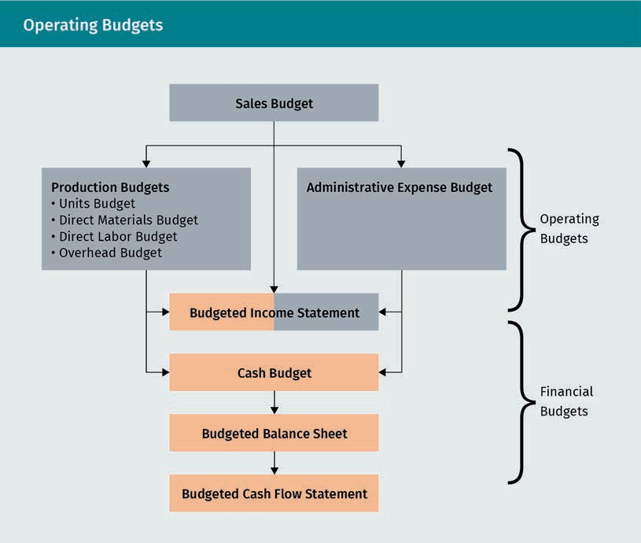

The master budget consists of operating and ﬁnancial budgets. The operating budgets usually include

* + - the sales budget,
    - the production budgets, and
    - the administrative expense budget.

The cash budget, the budgeted balance sheet, and the budgeted cash ﬂow statement are part of ﬁnancial budgeting. The budget income statement lies in between (Atkinson et al., 2012).

### 7.2 Different Types of Operating Budgets

###### Sales Budget

The ﬁrst budget to draft is the sales budget. It drives all other budgets, since, generally, all activities and expenditures depend on how many units a company intends to sell in the next period. The sales budget contains quantities of output and the resulting revenue (which means the sales price also needs to be decided or projected at that point) (Drury, 2018). In the following example, the budget is designed for the next year, and the data are shown per quarter.

|  |  |  |  |  |
| --- | --- | --- | --- | --- |
| Sales Budget Example | | | | |
|  | Q1 | Q2 | Q3 | Q4 |
| Units | 5,000 | 6,000 | 5,000 | 4,000 |
| Price per unit  $ | 350 | 350 | 350 | 350 |
| Revenue $ | 1,750,000 | 2,100,000 | 1,750,000 | 1,400,000 |

As the starting point of the budgeting process and the initial component of the master budget, meaningful content is crucial for the sales budget. There is much leeway for the key decision-makers of the company to set the sales goals and translate them into their respective budget ﬁgures. There is considerable responsibility in setting targeted sales ﬁgures, as the characteristics of meaningful budgets mentioned before need to be considered thoroughly.

Besides the decision-makers’ leeway, much of the data are derived from previous periods through forward-projection of past data, which helps the process remain realistic. However, in new markets no such data are available. In any case, market research may feed data into the budgeting process. Furthermore, knowledge of the market context and (anticipated) behavior of competitors such as their pricing moves, market share ambitions, or planned capacity changes are relevant.

###### Production Budgets

Knowing intended sales, the company must now determine how many units need to be produced. Consider a company that wants to sell 500 units of its product in the ﬁrst quarter of next year. In principle, that is the number of units they need to produce. However, there may be another variable: inventory reserve. It is a typical policy to have some inventory of ﬁnished units in reserve in case there is a disruption of production/logistics or to prevent lost sales opportunities in case the demand is higher than anticipated. Let’s assume the policy is to have 10% of the following period’s budgeted units as a reserve inventory on hand at all times. The units budget would look like this:

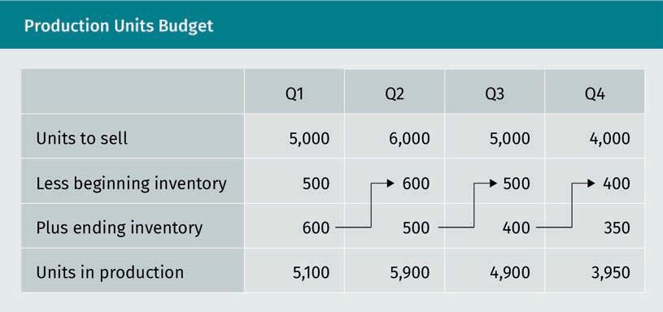

Once the number of units to produce is known, the direct material budget (DM budget) can be extrapolated. The information required is the volume of raw material needed to produce each unit expressed in gallons, tons, kilograms, or whatever is applicable (Drury, 2018). In this example, three kilograms of raw material are needed per product unit. Again, there is a policy of stocking 10% of the following quarter’s need as ending inventory each quarter. Furthermore, the cost of the material is considered (if no contracts have been negotiated yet with suppliers, this ﬁgure is also a projection or an estimate). Each kilogram of the raw material is expected to be procured at $8. The bottom line of the budget shows the cost incurred for the purchase of the raw material corresponding to the intended sales and production:

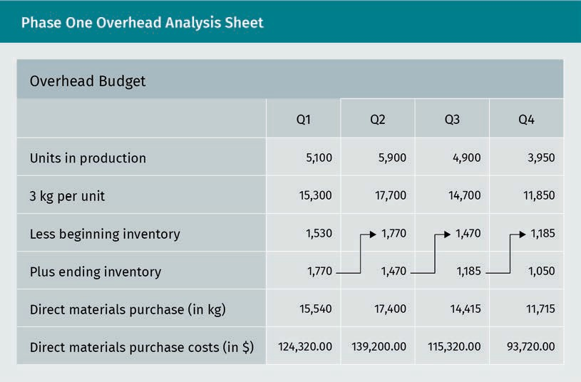

In the next step, the direct labor budget (DL budget) is conducted. Effectively, a company could build this one parallel to the DM budget because it likewise draws its essential information from the units budget. Once a company knows how many units to produce, the corresponding labor force can be planned (Drury, 2018). The following information is available for this case: each unit to be produced requires ﬁve direct labor hours at $20 of semi-skilled labor and two direct labor hours at $25 of skilled labor. The bottom line of the DL budget will show the projected total cost of direct labor for each quarter.

|  |  |  |  |  |  |
| --- | --- | --- | --- | --- | --- |
| Direct Labor Budget | | | | | |
|  | | Q1 | Q2 | Q3 | Q4 |
| Units in production | | 5,100 | 5,900 | 4,900 | 3,950 |
| Semi-skil- led hours | Number of hours | 25,500 | 29,500 | 24,500 | 19,750 |
| Costs ($20 per hour) | 510,000.00 | 590,000.00 | 490,000.00 | 395,000.00 |
| Skilled hours | Number of hours | 10,200 | 11,800 | 9,800 | 7,900 |
| Costs ($25 per hour) | 255,000.00 | 295,000.00 | 245,000.00 | 197,500.00 |
| Total direct labor hours | | 35,700.00 | 41,300 | 34,300 | 27,650 |
| Total costs in $ | | 765,000.00 | 885,000.00 | 735,000.00 | 592,500.00 |

The last production budget is the (factory) overhead budget. The company assumes from experience that, per direct labor hour, $3.25 of variable overhead is incurred (consisting of indirect materials). The budgeted number of direct labor hours is taken from the direct labor budget. Fixed overhead costs are also projected. These include depreciation, which is deducted to get the disbursement amounts for each quarter. Remember that depreciation is a non-cash expense and therefore relevant for income projections but not for cash ﬂow planning (Drury, 2018). The factory overhead budget would look as follows.

|  |  |  |  |  |
| --- | --- | --- | --- | --- |
| Overhead Budget | | | | |
| (in $) | Q1 | Q2 | Q3 | Q4 |
| Direct labor hours | 35,700 | 41,300 | 34,300 | 27,650 |
| Variable over- head | 116,025.00 | 134,225.00 | 111,475.00 | 89,862.50 |
| Fixed overhead | 150,000.00 | 150,000.00 | 170,000.00 | 170,000.00 |
| Total overhead | 266,025.00 | 284,225.00 | 281,475.00 | 259,862.50 |
| Less depreciation | 35,000.00 | 35,000.00 | 55,000.00 | 55,000.00 |
| Total disburse- ment | 231,025.00 | 249,225.00 | 226,475.00 | 204,862.50 |

###### Administrative Expense Budget

The next budget is the administrative expense budget. It includes all administration-related, selling, and marketing expenses; it is essentially grouping all expenses that are not production-related. Besides variable selling expense, cost data are not derived from any other operating budget but are projected as a separate activity for the respective departments. Variable selling expense may contain several items, but it primarily refers to sales commissions or bonus payments granted to employees, retailers, or other sales force partners in direct relation to how much they sell during the deﬁned time. Therefore, such positioning of the administrative expense budget depends on sales budget ﬁgures, although it cannot be directly retrieved. The total budgeted sales ﬁgure does not yet differentiate who sells how much of it, and some bonus/commission schemes would require more detailed input in this regard to determine the total variable selling expense (Drury, 2018).

Bad debt expense This is a provision for uncollectable receivables, e.g., due to insolvent customers who cannot pay their invoices anymore.

Once again, there is a position of non-cash expenses, consisting of depreciation plus bad debt expense. For this example, it is assumed that there is $2.50 of variable selling expense per unit sold (e.g., for packaging). The total expense ﬁgures will be relevant for the budgeted incomes statement, whereas the disbursement ﬁgures will be needed for the cash budget.

|  |  |  |  |  |
| --- | --- | --- | --- | --- |
| Administrative Expense Budget | | | | |
| (in $) | Q1 | Q2 | Q3 | Q4 |
| Variable selling expenses | 12,500 | 15,000 | 12,500 | 10,000 |
| Fixed selling expenses | 89,500 | 89,500 | 89,500 | 89,500 |
| Total expense | 102,000 | 104,500 | 102,000 | 99,500 |
| less non-cash | 14,000 | 15,200 | 13,000 | 12,450 |
| Total disburse- ment | 88,000 | 89,300 | 89,000 | 87,050 |

###### Budgeted Income Statement

Having finished all the operating budgets, companies can use their respective bottom lines to compile a summary of the projected revenues and expenses to be generated or incurred during the budgeted period. Compiling all revenue and cost-related information, i.e., all sales and expense data, they receive the expected proﬁt or loss for the budgeted period. Hence, the document is referred to as a budgeted income statement. It corresponds with a normal income statement with the exception that the latter is assembled at the end of the business period being reported and therefore contains actual instead of projected data.

The budgeted income statement shows in a summarized format the bottom line, i.e., proﬁt or loss, to expect if business is conducted according to budgets. If the result is not satisfying, the budgeting process will have to be started anew. Remember to keep in mind that realistic data are key to meaningful budgeting. However, there are adjustable elements, such as negotiable purchase prices of input or stacking up capacities for any planned expansion, that can play a role in achieving more desirable results in the budgeted income statement (Drury, 2018).

In this example, the following result is achieved by incorporating all operating budgets as a budgeted income statement. The costs of goods sold comprise direct material,

direct labor, and overhead, i.e., the typical three components of product costs. In the example below, a 30% income tax rate is assumed.

Income statement The income state- ment is a ﬁnancial statement featuring all revenues and costs of an organiza- tion for a speciﬁed period.

|  |  |  |  |  |
| --- | --- | --- | --- | --- |
| Budgeted Income Statement | | | | |
| (in $) | Q1 | Q2 | Q3 | Q4 |
| Sales revenue | 1,750,000.00 | 2,100,000.00 | 1,750,000 | 1,400,000 |
| Cost of goods sold | 1,130,808.82 | 1,333,042.37 | 1,157,219.39 | 959,151.90 |
| Admin expenses | 102,000.00 | 104,500.00 | 102,000.00 | 99,500.00 |
| Income before tax | 517,191.18 | 662,457.63 | 490,780.61 | 341,348.10 |
| Income tax (30%) | 155,157.35 | 198,737.29 | 147,234.18 | 102,404.43 |
| Net income | 362,033.82 | 463,720.34 | 343,546.43 | 238,943.67 |

### 7.3 Financial Budgets

”Cash is king” is a famous motto in the business world. It holds a truth: without liquidity, companies cannot meet their obligations, such as paying bills, taxes, and salaries. Liquidity is even more important than proﬁtability, at least in the short run. Especially for start-ups with little to no experience in a market they enter, it is difﬁcult to come up with meaningful projections. Monthly planning is advisable, and frequent updates of budgets upon reality checks are helpful. Successful budgeting depends on accuracy and on the ability to enact it. Many businesses get into trouble due to budgeted cash from customer collections that do not materialize and ultimately fail to be paid.

###### Cash Budget

The cash budget projects the availability, generation, and use of cash throughout the budgeted period. It is a crucial source of information because it helps identify whether (and if so, when) cash shortages threaten the viability of a business. Early knowledge about expected cash gaps helps companies to arrange ﬁnancial options well ahead of trouble. If the projected cash situation is unviable at any time covered by the budget, the entire planning process might either have to restart or adjustments may be required to steer the company toward a more viable path (Drury, 2018). The ﬁgures generated in the cash budget result directly from the previous example.

The cash budget summarizes all receipts and disbursements. In the basic scenario, col- lections are only generated from sales, so the data are transferred from there. All other operating budgets provide information on how much cash will be spent for various purposes, such as production or administration.

Cash collections build the ﬁrst part of the cash budget.

Revenue (from the sales budget) is expected to be collected. However, depending on collection policies and terms of payment extended to customers, it is not granted that the revenue ﬁgure and the collections in the same quarter are identical. In this context, the following information is available:

* Eighty percent of sales are made on account, and 20 percent are made against cash.
* Of the sales on account, 75 percent of the collections happen in the same quarter as the sales are made, 23 percent happen in the next quarter, and the remaining 2 percent are likely to be bad debt.
* The revenues in the fourth quarter of the previous year were $1,300,000.

This information can be displayed as follows.

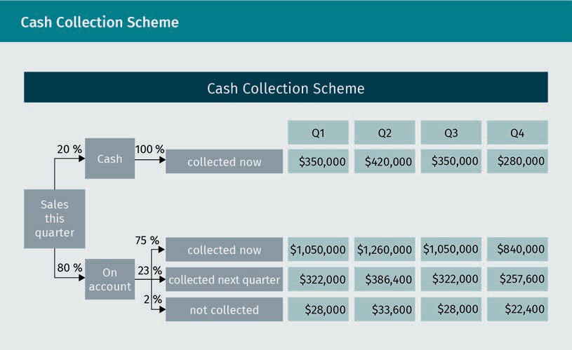

The resulting cash collections part of the cash budget is assembled as follows.

|  |  |  |  |  |
| --- | --- | --- | --- | --- |
| Cash Collections | | | | |
| (in $) | Q1 | Q2 | Q3 | Q4 |
| From same quarter | 1,400,000 | 1,680,000 | 1,400,000 | 1,120,000 |
| From previ- ous quarter | 239,200 | 322,000 | 386,400 | 322,000 |
| Total | 1,639,200 | 2,002,000 | 1,786,400 | 1,442,000 |

In addition to the cash collection, the cash disbursements must be calculated. The data needed for the overview of cash payments come from the direct materials (purchase) budget, the direct labor budget, the overhead budget, and the administrative expense budget.

In the case of DM purchases, the total cash disbursement for the quarter does not equal the actual value of purchases. That is once again owed to the payment pattern as follows:

* Seventy percent of the purchases are made on account, and 30 percent are made against cash.
* Of the purchases on account, 75 percent of payments happen in the same quarter as the purchase is made; the other 25 percent in the next quarter.
* The DM purchase value in the fourth quarter of the previous year was $125,000.

The cash disbursement scheme for DM purchases is displayed as follows.

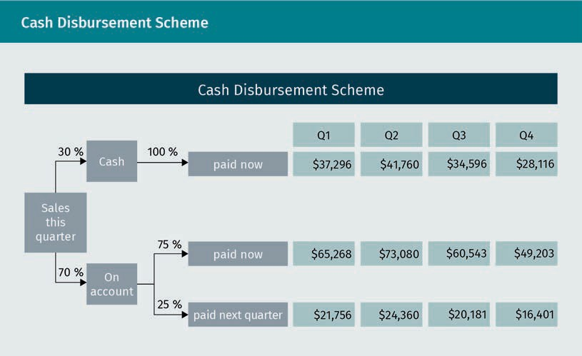

The resulting cash disbursement section of the cash budget looks as follows.

|  |  |  |  |  |
| --- | --- | --- | --- | --- |
| Direct Materials Cash Disbursement | | | | |
| (in $) | Q1 | Q2 | Q3 | Q4 |
| For the same quarter | 102,564 | 114,840 | 95,139 | 77,319 |
| For the last quarter | 21,875 | 21,756 | 24,360 | 20,181 |
| Total | 124,439 | 136,596 | 119,499 | 97,500 |

It is assumed that all further disbursements are made in the same quarter as the related cost is incurred. Additional disbursements are summarized as follows.

|  |  |  |  |  |
| --- | --- | --- | --- | --- |
| Further Cash Disbursement | | | | |
| (in $) | Q1 | Q2 | Q3 | Q4 |
| Direct labor budget | 765,000.00 | 885,000.00 | 735,000.00 | 592,500.00 |
| Overhead budget | 231,025.00 | 249,225.00 | 226,475.00 | 204,862.50 |
| Admin expense budget | 88,000.00 | 89,300.00 | 89,000.00 | 87,050.00 |
| Total | 1,084,025.00 | 1,223,525.00 | 1,050,475.00 | 884,412.50 |

To assemble the overall cash budget, the following additional information is provided:

* The cash balance at the beginning of the ﬁrst quarter is $250,000.
* At the beginning of the third quarter, a new machine is purchased for $200,000 and paid for in cash.

With this information, the cash budget is completed through the assembly of all relevant portions.

|  |  |  |  |  |
| --- | --- | --- | --- | --- |
| Completed Cash Budget | | | | |
| (in $) | Q1 | Q2 | Q3 | Q4 |
| Cash balance (beginning) | 250,000.00 | 680,736.00 | 1,322,615.00 | 1,739,041.00 |
| Collections | 1,639,200.00 | 2,002,000.00 | 1,786,400.00 | 1,442,000.00 |
| Direct materials budget | 124,439.00 | 136,596.00 | 119,499.00 | 97,500.00 |
| Direct labor budget | 765,000.00 | 885,000.00 | 735,000.00 | 592,500.00 |
| Overhead budget | 231,025.00 | 249,225.00 | 226,475.00 | 204,862.50 |

|  |  |  |  |  |
| --- | --- | --- | --- | --- |
| (in $) | Q1 | Q2 | Q3 | Q4 |
| Cash balance (beginning) | 250,000.00 | 680,736.00 | 1,322,615.00 | 1,739,041.00 |
| Admin expense budget | 88,000.00 | 89,300.00 | 89,000.00 | 87,050.00 |
| Machine pur- chase | - | - | 200,000.00 | - |
| Total | 680,736.00 | 1,322,615.00 | 1,739,041.00 | 2,199,128.50 |

The budgeted cash-ﬂow statement will correspond with the cash budget. Please note that conducting the budgeted balance sheet here is not part of this course.

Summary

A budget is the quantiﬁed formulation of a plan of an organization’s activities for the following business period(s). Budgeting is crucial for business insofar as it directs the activity of the budgeted period, which will have consequences such as costs incurred, staff hired or ﬁred, and capacity build-up or reduction. Major aspects to consider in the budgeting process include the vision and mission of the organization, long-term and short-term strategic objectives, and the external environment.

The budgeting process is quite complex, as a lot of data are generated and evaluated. The organizational culture is important in the process as it determines how important hierarchy is within a company. To achieve realistic projections, which in turn are vital for allocating appropriate resources, the incorporation of operating staff input is also advisable.

The budgeting cycle starts with the setup of the sales budget determining how much the business intends to sell during the budgeted period. Production-related budgets follow in logical sequence, and then the administrative expense budget is provided. These operating budgets lead to the assembly of a pro-forma income statement showing how much proﬁt or loss is expected resulting from the projected business activity.

“Cash is king” – without liquidity, companies cannot meet their obligations such as paying bills, taxes, and salaries. At least in the short run, liquidity is even more important than proﬁtability. Therefore, the cash budget is highly important. It projects the cash inﬂows and outﬂows of the budgeted period. Thus, it also helps detect potential cash shortages, which can then be prevented by arranging short-term loans or through collection or payment policy changes.

The cash budget comprises both cash collections and disbursements. The former result from projected sales, the latter from projected production, procurement, and administration activity, which all lead to expenses that will have to be paid. It is important to be ambitious, yet realistic; if the projected sales ﬁgures are too high, the projected cash collections may not materialize.